Prykhodko Stanislav
Personal data:  Date of birth: 03 April 1985.  Nationality: Ukraine  Mob. number.: (066) 879-20-33  Home number. (044) 484-15-49  E-mail: StasPrykhodko@gmail.com | 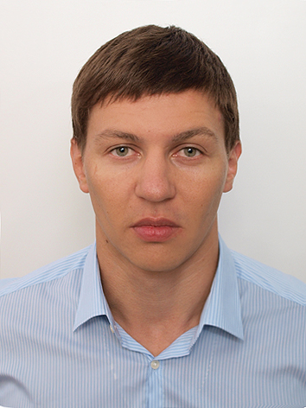

QALIFICATIONS SUMMARY
Financial Analyst with more than 5 years of increasingly responsible employment with main governmental financial institutions with previous bank employment seeks position of Finance Analyst. Diversified, progressive experience in the analysis of financial/ economic data, financial planning and forecasting, modeling; company valuation and portfolio management.

Education:
- 2010 – Kiev National Economic University named after Vadim Hetman
Speciality: finance (master's degree);
- 2008 – Kiev National Polytechnical University
Speciality: industrial heat power engineering (bachelor).

Additional education:
Certificate of completion of an accounting courses.

Work Experience:
10.08.2011 – State financial inspection in Kiev;
post: leading state financial inspector of the local budgets department
- participation in comprehensive revisions and thematic inspections of financial and economic activity of enterprises and organizations on the purposeful and efficient use of budget funds, as well as the preservation of state property, the reliability of accounting bookkeeping;
- drafting of acts and reports on the basis of the results of audits and inspections;
- developing proposals for elimination of revealed violations and penalties to the budget funds spent with violation of the State legislation of Ukraine;
10.08.2010-10.05.2011 – Desnyanskoe regional Treasury in Kiev;
post: chief Treasurer of the costs division
- opening accounts for budgetary funds managers;
- processing supporting documents;
- controlling the direction of budgetary funds;
- controlling observation of the Ukrainian legislation in the public purchases sphere;
- 14.07.2008-20.11.2008 - Joint-stock commercial Bank «PRAVEX-BANK».
post: consumer lending Manager
- data acquisition;
- drafting credit agreements;
- documents packages preparation;
- registers documentation keeping;
- work with individuals.

Knowledge and skills:
PC user:
- User: WINDOWS, MS Office (MS Word, MS Excel), Internet;
WEB design courses:
- Fundamentals. Graphics for Web design;
- HTML/CSS
language skills:
- ukrainian – native;
- russian - fluent;
- english. Incl. business English – advanced.

Personal qualities:
Sociable, responsible, punctual, disciplined, hardworking, adequate response to criticism, the aspiration for self-realization and enhancement of personal knowledge and self-demanding, clearly see the goal and find the best ways to achieve it.

