Звіт по лаборатній роботі на тему “kd dimensional tree”
Виконав Дзундза Станіслав
A K-D Tree(also called as K-Dimensional Tree) is a binary search tree where data in each node is a K-Dimensional point in space. In short, it is a space partitioning(details below) data structure for organizing points in a K-Dimensional space.
A non-leaf node in K-D tree divides the space into two parts, called as half-spaces.
Points to the left of this space are represented by the left subtree of that node and points to the right of the space are represented by the right subtree. We will soon be explaining the concept on how the space is divided and tree is formed.
For the sake of simplicity, let us understand a 2-D Tree with an example.
The root would have an x-aligned plane, the root’s children would both have y-aligned planes, the root’s grandchildren would all have x-aligned planes, and the root’s great-grandchildren would all have y-aligned planes and so on.
Generalization:
Let us number the planes as 0, 1, 2, …(K – 1). From the above example, it is quite clear that a point (node) at depth D will have A aligned plane where A is calculated as:
A = D mod K
How to determine if a point will lie in the left subtree or in right subtree?
If the root node is aligned in planeA, then the left subtree will contain all points whose coordinates in that plane are smaller than that of root node. Similarly, the right subtree will contain all points whose coordinates in that plane are greater-equal to that of root node.

(3, 6), (17, 15), (13, 15), (6, 12), (9, 1), (2, 7), (10, 19)
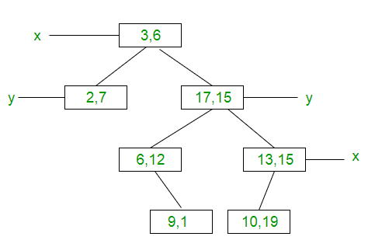

Memory – O(N)
Building Tree – O(N log(N))
