**МІНІСТЕРСТВО ОСВІТИ І НАУКИ УКРАЇНИ**

**НАЦІОНАЛЬНОМУ УНІВЕРСИТЕТІ “ЛЬВІВСЬКА ПОЛІТЕХНІКА”**

**Лабораторна робота №6**

з дисципліни

«Людино-машинна взаємодія»

**Виконав:**

студент групи КН-308

Келемен Станіслав

**Викладач:**

Маркелов О.Е.

Львів - 2019

**Мета виконання лабраторної роботи**

Метою роботи є ознайомлення зі способами, методами та засобами програмування користувацьких інтерфейсів та набуття студентами практичних навичок програмування спеціалізованою мовою XAML інтерактивної взаємодії користувача, опису функціонування діалогів інтерфейсів із наборів програмних елементі інтерфейсу користувача. У результаті виконання лабораторної роботи студенти повинні:

• знати методи та підходи для створення користувацьких інтерфейсів спеціалізованою мовою програмування XAML;

• вміти правильно задавати значення властивостей програмних елементів для різних типів інтерактивної взаємодію; правильно вибирати керуючі події елементів.

**Завдання**

Створити новий проект для десктопної програми.

І у редакторі візуальних форм вікон створити вікна для свого варіанта на основі нових придуманих із ескізів із лаб.4. Експортувати програмний код форм у XAML коді. Зробити скріни побудованих віконних форм.

Код файлів проекту:

**Tablet**

<Page

x:Class="App1.MainPage"

xmlns="http://schemas.microsoft.com/winfx/2006/xaml/presentation"

xmlns:x="http://schemas.microsoft.com/winfx/2006/xaml"

xmlns:local="using:App1"

xmlns:d="http://schemas.microsoft.com/expression/blend/2008"

xmlns:mc="http://schemas.openxmlformats.org/markup-compatibility/2006"

mc:Ignorable="d"

Background="{ThemeResource ApplicationPageBackgroundThemeBrush}" Width="1015" Height="662">

<Grid HorizontalAlignment="Right" Width="1015" Height="662" BorderThickness="1,1,1,1" BorderBrush="Black">

<Grid.ColumnDefinitions>

<ColumnDefinition Width="153*"/>

<ColumnDefinition Width="862*"/>

</Grid.ColumnDefinitions>

<SplitView Margin="0,0,0,612" Grid.ColumnSpan="2">

<SplitView.Pane>

<Grid/>

</SplitView.Pane>

<Grid Margin="328,0,0,0" BorderThickness="0,0,0,1" BorderBrush="Black">

<TextBlock HorizontalAlignment="Center" Text="General" TextWrapping="Wrap" VerticalAlignment="Top" FontFamily="Montserrat" FontSize="18" FontWeight="Normal" Margin="0,16,0,0"/>

</Grid>

</SplitView>

<SplitView Margin="0,0,685,0" Grid.ColumnSpan="2">

<SplitView.Pane>

<Grid/>

</SplitView.Pane>

<Grid BorderBrush="Black" BorderThickness="0,0,1,0">

<TextBox HorizontalAlignment="Center" Margin="0,10,0,0" Text="" TextWrapping="Wrap" VerticalAlignment="Top" CornerRadius="20,20,20,20" Width="310" TextChanged="TextBox_TextChanged" PlaceholderText="Search" HorizontalContentAlignment="Center" HorizontalTextAlignment="Center" TextAlignment="Center" FontFamily="Montserrat"/>

<Button Content="General" Margin="0,55,0,0" VerticalAlignment="Top" BorderBrush="{x:Null}" Background="#FFDDDDDD" Width="330" Grid.ColumnSpan="2" Click="Button_Click" Height="45" HorizontalContentAlignment="Left" HorizontalAlignment="Left" Grid.Row="0" RenderTransformOrigin="0.5,0.5" FontFamily="Montserrat" Padding="65.1,4,8,5"/>

<Button Content="History" Margin="0,100,0,0" VerticalAlignment="Top" BorderBrush="{x:Null}" Background="{x:Null}" Width="328" Grid.ColumnSpan="2" Click="Button_Click" Height="45" HorizontalContentAlignment="Left" FontFamily="Montserrat" Padding="65.1,4,8,5"/>

<Button Content="Tabs" Margin="0,145,0,0" VerticalAlignment="Top" BorderBrush="{x:Null}" Background="{x:Null}" Width="328" Grid.ColumnSpan="2" Click="Button_Click" Height="45" HorizontalContentAlignment="Left" FontFamily="Montserrat" Padding="65.1,4,8,5"/>

<Button Content="Events" Margin="0,190,0,0" VerticalAlignment="Top" BorderBrush="{x:Null}" Background="{x:Null}" Width="329" Grid.ColumnSpan="2" Click="Button_Click" Height="45" HorizontalContentAlignment="Left" FontFamily="Montserrat" Padding="65.1,4,8,5"/>

<Button Content="Lock" Margin="0,235,0,0" VerticalAlignment="Top" BorderBrush="{x:Null}" Background="{x:Null}" Width="329" Click="Button_Click" Height="45" HorizontalContentAlignment="Left" FontFamily="Montserrat" Padding="65.1,4,8,5"/>

<Button Content="Groups" Margin="0,280,0,0" VerticalAlignment="Top" BorderBrush="{x:Null}" Background="{x:Null}" Width="328" Click="Button_Click" HorizontalAlignment="Center" Height="45" HorizontalContentAlignment="Left" FontFamily="Montserrat" Padding="65.1,4,8,5"/>

<Button Content="Sounds" Margin="0,325,0,0" VerticalAlignment="Top" BorderBrush="{x:Null}" Background="{x:Null}" Width="328" Click="Button_Click" HorizontalAlignment="Center" Height="45" HorizontalContentAlignment="Left" FontFamily="Montserrat" Padding="65.1,4,8,5"/>

<Button Content="Keyboard Shortcuts" Margin="0,370,0,0" VerticalAlignment="Top" BorderBrush="{x:Null}" Background="{x:Null}" Width="328" Click="Button_Click" HorizontalAlignment="Center" Height="45" HorizontalContentAlignment="Left" FontFamily="Montserrat" Padding="65.1,4,8,5"/>

</Grid>

</SplitView>

<Image HorizontalAlignment="Left" Height="30" Margin="20,153,0,0" VerticalAlignment="Top" Width="30" Source="/Assets/3.png" Stretch="Fill"/>

<Image HorizontalAlignment="Left" Height="30" Margin="20,107,0,0" VerticalAlignment="Top" Width="30" Source="/Assets/2.png" Stretch="Fill"/>

<Image HorizontalAlignment="Left" Height="30" Margin="20,65,0,0" VerticalAlignment="Top" Width="30" Source="/Assets/9.png" Stretch="Fill"/>

<Image HorizontalAlignment="Left" Height="30" Margin="20,198,0,0" VerticalAlignment="Top" Width="30" Source="/Assets/4.png" Stretch="Fill"/>

<Image HorizontalAlignment="Left" Height="30" Margin="20,243,0,0" VerticalAlignment="Top" Width="30" Source="/Assets/5.png" Stretch="Fill"/>

<Image HorizontalAlignment="Left" Height="30" Margin="20,289,0,0" VerticalAlignment="Top" Width="30" Source="/Assets/6.png" Stretch="Fill"/>

<Image HorizontalAlignment="Left" Height="30" Margin="20,333,0,0" VerticalAlignment="Top" Width="30" Source="/Assets/7.png" Stretch="Fill" RenderTransformOrigin="-1.333,0.933"/>

<Image HorizontalAlignment="Left" Height="30" Margin="20,379,0,0" VerticalAlignment="Top" Width="30" Source="/Assets/8.png" Stretch="Fill"/>

<ToggleSwitch Grid.Column="1" OnContent="Open window in the working space" Margin="231,80,0,0" VerticalAlignment="Top" IsOn="True" FontFamily="Montserrat"/>

<ToggleSwitch Grid.Column="1" OffContent="Send windows to Task Tray on minimized" Margin="231,112,0,0" VerticalAlignment="Top" FontFamily="Montserrat"/>

<ToggleSwitch Grid.Column="1" OffContent="Save windows transperancy" Margin="231,144,0,0" VerticalAlignment="Top" FontFamily="Montserrat"/>

<ToggleSwitch Grid.Column="1" OffContent="Maximize horyzontally" Margin="231,176,0,0" VerticalAlignment="Top" FontFamily="Montserrat"/>

<ToggleSwitch Grid.Column="1" OnContent="Hide menu bar" Margin="231,208,0,0" VerticalAlignment="Top" FontFamily="Montserrat" IsOn="True"/>

<ComboBox Grid.Column="1" Margin="231,251,0,0" Width="305" PlaceholderText="Languages" FontFamily="Montserrat" Height="29" CornerRadius="4,4,4,4"/>

<ComboBox Grid.Column="1" Margin="231,285,0,0" Width="305" PlaceholderText="Avaliable Updates" FontFamily="Montserrat" Height="29" CornerRadius="4,4,4,4"/>

<Button Content="Restore Defaults" Grid.Column="1" Margin="231,337,0,0" VerticalAlignment="Top" Background="{x:Null}" BorderBrush="Black" CornerRadius="15,15,15,15" FontFamily="Montserrat" BorderThickness="1,1,1,1" Width="226" Height="32"/>

</Grid>

</Page>

**Phone**

<Page

x:Class="App1.Phone"

xmlns="http://schemas.microsoft.com/winfx/2006/xaml/presentation"

xmlns:x="http://schemas.microsoft.com/winfx/2006/xaml"

xmlns:local="using:App1"

xmlns:d="http://schemas.microsoft.com/expression/blend/2008"

xmlns:mc="http://schemas.openxmlformats.org/markup-compatibility/2006"

mc:Ignorable="d"

Background="{ThemeResource ApplicationPageBackgroundThemeBrush}" Width="360" Height="640">

<Grid BorderThickness="1,1,1,1" BorderBrush="Black">

<Border BorderThickness="0,1,0,1" BorderBrush="Black" Margin="0,478,0,94">

<Image HorizontalAlignment="Left" Height="11" VerticalAlignment="Top" Width="12" Source="/Assets/10.png" Margin="323,14,0,0" RenderTransformOrigin="1,0">

<Image.RenderTransform>

<CompositeTransform ScaleX="-1"/>

</Image.RenderTransform>

</Image>

</Border>

<TextBlock HorizontalAlignment="Left" Height="21" Margin="27,488,0,0" Text="Languages" TextWrapping="Wrap" VerticalAlignment="Top" Width="132" TextAlignment="Left" SelectionChanged="TextBlock_SelectionChanged" FontFamily="Montserrat" FontSize="14"/>

<Border BorderThickness="0,0,0,1" BorderBrush="Black" Margin="0,0,0,596"/>

<Button Content="Back" Margin="27,13,0,0" BorderBrush="{x:Null}" FontFamily="Montserrat" Background="{x:Null}" VerticalAlignment="Top" FontSize="14"/>

<TextBlock HorizontalAlignment="Center" Height="21" Margin="0,18,0,0" Text="General" TextWrapping="Wrap" VerticalAlignment="Top" Width="126" TextAlignment="Center" SelectionChanged="TextBlock_SelectionChanged" FontFamily="Montserrat" FontSize="16"/>

<TextBox HorizontalAlignment="Center" Margin="0,90,0,0" Text="Jimbo iPhone" TextWrapping="Wrap" VerticalAlignment="Top" Width="360" BorderBrush="Black" FontFamily="Montserrat" BorderThickness="0,1,0,1" Padding="20,6,6,6"/>

<TextBlock HorizontalAlignment="Left" Height="21" Margin="21,64,0,0" Text="Device name:" TextWrapping="Wrap" VerticalAlignment="Top" Width="132" TextAlignment="Left" SelectionChanged="TextBlock_SelectionChanged" FontFamily="Montserrat" FontSize="14"/>

<Slider HorizontalAlignment="Center" Margin="0,173,0,0" VerticalAlignment="Top" Width="285" ValueChanged="Slider_ValueChanged" Value="15"/>

<TextBlock HorizontalAlignment="Left" Height="21" Margin="21,141,0,0" Text="Brightness:" TextWrapping="Wrap" VerticalAlignment="Top" Width="120" TextAlignment="Left" SelectionChanged="TextBlock_SelectionChanged" FontFamily="Montserrat" FontSize="14"/>

<Slider HorizontalAlignment="Center" Margin="0,244,0,0" VerticalAlignment="Top" Width="285" ValueChanged="Slider_ValueChanged" Value="70"/>

<TextBlock HorizontalAlignment="Left" Height="21" Margin="21,218,0,0" Text="Volume:" TextWrapping="Wrap" VerticalAlignment="Top" Width="120" TextAlignment="Left" SelectionChanged="TextBlock_SelectionChanged" FontFamily="Montserrat" FontSize="14"/>

<ToggleSwitch OnContent="Open window in the working space" Margin="21,296,0,0" VerticalAlignment="Top" IsOn="True" FontFamily="Montserrat" Width="384"/>

<ToggleSwitch OffContent="Send to Task Tray on minimized" Margin="21,328,0,0" VerticalAlignment="Top" FontFamily="Montserrat" Width="384"/>

<ToggleSwitch OffContent="Save windows transperancy" Margin="21,360,0,0" VerticalAlignment="Top" FontFamily="Montserrat" Width="384"/>

<ToggleSwitch OffContent="Maximize horyzontally" Margin="21,392,0,0" VerticalAlignment="Top" FontFamily="Montserrat" Width="384"/>

<ToggleSwitch OnContent="Hide menu bar" Margin="21,424,0,0" VerticalAlignment="Top" FontFamily="Montserrat" IsOn="True" Width="384"/>

<TextBlock HorizontalAlignment="Left" Height="21" Margin="27,517,0,0" Text="Avialiable Updates" TextWrapping="Wrap" VerticalAlignment="Top" Width="132" TextAlignment="Left" SelectionChanged="TextBlock_SelectionChanged" FontFamily="Montserrat" FontSize="14"/>

<Image HorizontalAlignment="Left" Height="11" Margin="21,23,0,0" VerticalAlignment="Top" Width="11" Source="/Assets/10.png"/>

<Image HorizontalAlignment="Left" Height="11" VerticalAlignment="Top" Width="12" Source="/Assets/10.png" Margin="323,522,0,0" RenderTransformOrigin="1,0">

<Image.RenderTransform>

<CompositeTransform ScaleX="-1"/>

</Image.RenderTransform>

</Image>

</Grid>

</Page>

**TV**

<Page

x:Class="App1.TV"

xmlns="http://schemas.microsoft.com/winfx/2006/xaml/presentation"

xmlns:x="http://schemas.microsoft.com/winfx/2006/xaml"

xmlns:local="using:App1"

xmlns:d="http://schemas.microsoft.com/expression/blend/2008"

xmlns:mc="http://schemas.openxmlformats.org/markup-compatibility/2006"

mc:Ignorable="d"

Background="{ThemeResource ApplicationPageBackgroundThemeBrush}" Width="3840" Height="2160">

<Grid>

<Border BorderThickness="1,0,0,0" BorderBrush="Black" Margin="1109,0,2715,0" Height="2160" RenderTransformOrigin="0.5,0.5">

<Border.RenderTransform>

<CompositeTransform ScaleX="-1"/>

</Border.RenderTransform>

</Border>

<TextBlock Text="General" TextWrapping="Wrap" FontFamily="Montserrat" FontSize="72" Margin="1433,125,2123,1958"/>

<TextBox HorizontalAlignment="Left" Margin="15,25,0,0" Text="" TextWrapping="Wrap" VerticalAlignment="Top" Width="1095" PlaceholderText="Search" HorizontalContentAlignment="Center" HorizontalTextAlignment="Center" TextAlignment="Left" FontFamily="Montserrat" Height="145" FontSize="72" Padding="60,26,0,0" BorderBrush="Black" PlaceholderForeground="Black"/>

<Image HorizontalAlignment="Left" Height="100" Margin="1014,48,0,0" VerticalAlignment="Top" Width="58" Source="/Assets/11.png" NineGrid="3,0,0,0" Stretch="Fill"/>

<Image Source="/Assets/settings.png" Stretch="Fill" Width="165" Height="165" Margin="70,248,3605,1747"/>

<Button Content="GENERAL" HorizontalAlignment="Stretch" VerticalAlignment="Stretch" Margin="15,195,2730,1695" FontFamily="Montserrat" FontSize="72" CornerRadius="10,10,10,10" Height="270" Width="1095" BorderBrush="Black" Padding="100,4,8,5"/>

<Button Content="HISTORY" HorizontalAlignment="Stretch" VerticalAlignment="Stretch" Margin="15,469,2730,1421" FontFamily="Montserrat" FontSize="72" CornerRadius="10,10,10,10" Height="270" Width="1095" BorderBrush="Black" Padding="100,4,8,5" Background="White"/>

<Button Content="TABS" HorizontalAlignment="Stretch" VerticalAlignment="Stretch" Margin="15,743,2730,1147" FontFamily="Montserrat" FontSize="72" CornerRadius="10,10,10,10" Height="270" Width="1095" BorderBrush="Black" Click="Button_Click" Padding="100,4,8,5" Background="White"/>

<Button Content="EVENTS" HorizontalAlignment="Stretch" VerticalAlignment="Stretch" Margin="15,1018,2730,872" FontFamily="Montserrat" FontSize="72" CornerRadius="10,10,10,10" Height="270" Width="1095" BorderBrush="Black" Padding="100,4,8,5" Background="White"/>

<Button Content="APPEARANCE" HorizontalAlignment="Stretch" VerticalAlignment="Stretch" Margin="15,1293,2730,597" FontFamily="Montserrat" FontSize="72" CornerRadius="10,10,10,10" Height="270" Width="1095" BorderBrush="Black" Padding="100,4,8,5" Background="White"/>

<Button Content="GROUPS" HorizontalAlignment="Stretch" VerticalAlignment="Stretch" Margin="15,1568,2730,322" FontFamily="Montserrat" FontSize="72" CornerRadius="10,10,10,10" Height="270" Width="1095" BorderBrush="Black" Padding="100,4,8,5" Background="White"/>

<Button Content="SOUNDS" HorizontalAlignment="Stretch" VerticalAlignment="Stretch" Margin="15,1843,2730,47" FontFamily="Montserrat" FontSize="72" CornerRadius="10,10,10,10" Height="270" Width="1095" BorderBrush="Black" Padding="100,4,8,5" Background="White"/>

<Image Source="/Assets/history.png" Stretch="Fill" Width="165" Height="165" Margin="70,522,3605,1473"/>

<Image Source="/Assets/tabs.png" Stretch="Fill" Width="165" Height="165" Margin="70,796,3605,1199"/>

<Image Source="/Assets/thunder.png" Stretch="Fill" Width="165" Height="165" Margin="70,1071,3605,924"/>

<Image Source="/Assets/eye.png" Stretch="Fill" Width="165" Height="165" Margin="70,1346,3605,649"/>

<Image Source="/Assets/star.png" Stretch="Fill" Width="165" Height="165" Margin="70,1621,3605,374"/>

<Image Source="/Assets/sounds.png" Stretch="Fill" Width="165" Height="165" Margin="70,1896,3605,99" AllowDrop="True"/>

<Image Source="/Assets/settings.png" Stretch="Fill" Margin="1245,98,2462,1929"/>

<Image Source="/Assets/on.png" Stretch="Uniform" Margin="1212,330,2394,1750"/>

<Image Source="/Assets/off.png" Stretch="Uniform" Margin="1210,438,2396,1642"/>

<Image Source="/Assets/off.png" Stretch="Uniform" Margin="1212,541,2394,1539"/>

<Image Source="/Assets/off.png" Stretch="Uniform" Margin="1212,645,2394,1435"/>

<Image Source="/Assets/on.png" Stretch="Uniform" Margin="1210,752,2396,1328"/>

<TextBlock Text="Open window in the working space" TextWrapping="Wrap" FontFamily="Montserrat" FontSize="72" Margin="1455,326,1097,1742"/>

<TextBlock Text="Send windows to Task Tray on minimized" TextWrapping="Wrap" FontFamily="Montserrat" FontSize="72" Margin="1454,434,888,1634"/>

<TextBlock Text="Save window transparency" TextWrapping="Wrap" FontFamily="Montserrat" FontSize="72" Margin="1455,537,887,1531"/>

<TextBlock Text="Maximize horyzontally" TextWrapping="Wrap" FontFamily="Montserrat" FontSize="72" Margin="1457,641,885,1427"/>

<TextBlock TextWrapping="Wrap" FontFamily="Montserrat" FontSize="72" Margin="1454,744,888,1324"><Run Text="Hide menu bar"/><LineBreak/><Run/></TextBlock>

<TextBlock TextWrapping="Wrap" FontFamily="Montserrat" FontSize="72" Margin="1245,913,2237,1155" Text="Set focus"/>

<TextBox HorizontalAlignment="Left" Margin="2672,889,0,0" Text="none" TextWrapping="Wrap" VerticalAlignment="Top" Height="135" Width="660" FontSize="72" FontFamily="Montserrat" BorderBrush="Black" Padding="30,15,6,6"/>

<Image Source="/Assets/arowDown.png" Stretch="Uniform" Margin="3223,917,520,1163"/>

<Button Content="Restore defaults&#xD;&#xA;" Margin="2672,1736,0,0" VerticalAlignment="Top" Height="161" Width="660" FontSize="72" FontFamily="Montserrat" Click="Button_Click_1" Background="{x:Null}" BorderBrush="Black" Padding="8,30,8,5"/>

<Button Margin="3392,1736,0,0" VerticalAlignment="Top" Height="161" Width="196" FontSize="72" FontFamily="Montserrat" Click="Button_Click_1" Background="{x:Null}" BorderBrush="Black" Padding="8,30,8,5">

<Image HorizontalAlignment="Left" Height="103" Margin="6,-23,0,0" VerticalAlignment="Top" Width="106" Source="/Assets/qm.png"/>

</Button>

</Grid>

</Page>

**Watch**

<Page

x:Class="App1.Watch"

xmlns="http://schemas.microsoft.com/winfx/2006/xaml/presentation"

xmlns:x="http://schemas.microsoft.com/winfx/2006/xaml"

xmlns:local="using:App1"

xmlns:d="http://schemas.microsoft.com/expression/blend/2008"

xmlns:mc="http://schemas.openxmlformats.org/markup-compatibility/2006"

mc:Ignorable="d"

Background="{ThemeResource ApplicationPageBackgroundThemeBrush}" Width="500" Height="500" CornerRadius="100,100,100,100">

<Grid>

<Border BorderThickness="1" BorderBrush="Black" Margin="10,5,10,10" CornerRadius="25,25,25,25">

<Ellipse Margin="446,133,16,313" Fill="#FF444444"/>

</Border>

<TextBox HorizontalAlignment="Center" Margin="0,23,0,0" Text="Search" TextWrapping="Wrap" VerticalAlignment="Top" CornerRadius="20,20,20,20" Width="422" PlaceholderText="" HorizontalContentAlignment="Center" HorizontalTextAlignment="Center" TextAlignment="Center" FontFamily="Montserrat" Height="48" FontSize="20" Padding="10,9,6,0" PlaceholderForeground="Black"/>

<Image HorizontalAlignment="Left" Height="36" Margin="300,27,0,0" VerticalAlignment="Top" Width="20" Source="/Assets/11.png" RenderTransformOrigin="0.283,0.611"/>

<Button Content="General" Margin="0,97,0,0" VerticalAlignment="Top" BorderBrush="{x:Null}" Background="{x:Null}" Width="330" Height="45" HorizontalContentAlignment="Left" Grid.Row="0" RenderTransformOrigin="0.5,0.5" FontFamily="Montserrat" Padding="65.1,4,8,5" FontSize="20" HorizontalAlignment="Center"/>

<Button Content="History" Margin="0,175,0,0" VerticalAlignment="Top" BorderBrush="{x:Null}" Background="{x:Null}" Width="328" Height="45" HorizontalContentAlignment="Left" FontFamily="Montserrat" Padding="65.1,4,8,5" FontSize="20" HorizontalAlignment="Center"/>

<Button Content="Tabs" Margin="0,250,0,0" VerticalAlignment="Top" BorderBrush="{x:Null}" Background="{x:Null}" Width="328" Height="45" HorizontalContentAlignment="Left" FontFamily="Montserrat" Padding="65.1,4,8,5" FontSize="20" HorizontalAlignment="Center"/>

<Button Content="Events" Margin="0,325,0,0" BorderBrush="{x:Null}" Background="{x:Null}" Width="329" Height="45" HorizontalContentAlignment="Left" FontFamily="Montserrat" Padding="65.1,4,8,5" FontSize="20" VerticalAlignment="Top" HorizontalAlignment="Center"/>

<Button Content="Sounds" Margin="0,403,0,0" VerticalAlignment="Top" BorderBrush="{x:Null}" Background="{x:Null}" Width="328" Height="45" HorizontalContentAlignment="Left" FontFamily="Montserrat" Padding="65.1,4,8,5" FontSize="20" HorizontalAlignment="Center"/>

<Image HorizontalAlignment="Left" Height="45" Margin="63,97,0,0" VerticalAlignment="Top" Width="45" Source="/Assets/9.png" RenderTransformOrigin="0.289,0.363"/>

<Image HorizontalAlignment="Left" Height="45" Margin="63,175,0,0" VerticalAlignment="Top" Width="45" Source="/Assets/2.png" RenderTransformOrigin="0.289,0.363"/>

<Image HorizontalAlignment="Left" Height="45" Margin="65,250,0,0" VerticalAlignment="Top" Width="45" Source="/Assets/3.png" RenderTransformOrigin="0.289,0.363"/>

<Image HorizontalAlignment="Left" Height="45" Margin="65,325,0,0" VerticalAlignment="Top" Width="45" Source="/Assets/4.png" RenderTransformOrigin="0.289,0.363"/>

<Image HorizontalAlignment="Left" Height="45" Margin="66,403,0,0" VerticalAlignment="Top" Width="45" Source="/Assets/7.png" RenderTransformOrigin="0.289,0.363"/>

<Image HorizontalAlignment="Left" Height="45" Margin="383,76,0,0" VerticalAlignment="Top" Width="45" Source="8c9a5413-f0d7-46e5-b90e-2f4cbd1e6861" RenderTransformOrigin="0.289,0.363"/>

<Image HorizontalAlignment="Left" Height="30" Margin="452,100,0,0" VerticalAlignment="Top" Width="30" Source="/Assets/scrollArrow.png" RenderTransformOrigin="0.289,0.363" UseLayoutRounding="False" d:LayoutRounding="Auto">

<Image.RenderTransform>

<CompositeTransform Rotation="-90.009"/>

</Image.RenderTransform>

</Image>

<Image HorizontalAlignment="Left" Height="30" Margin="458,431,0,0" VerticalAlignment="Top" Width="30" Source="/Assets/scrollArrow.png" RenderTransformOrigin="0.289,0.363" UseLayoutRounding="False" d:LayoutRounding="Auto">

<Image.RenderTransform>

<CompositeTransform Rotation="89.713"/>

</Image.RenderTransform>

</Image>

</Grid>

</Page>

**Скріншоти програми**

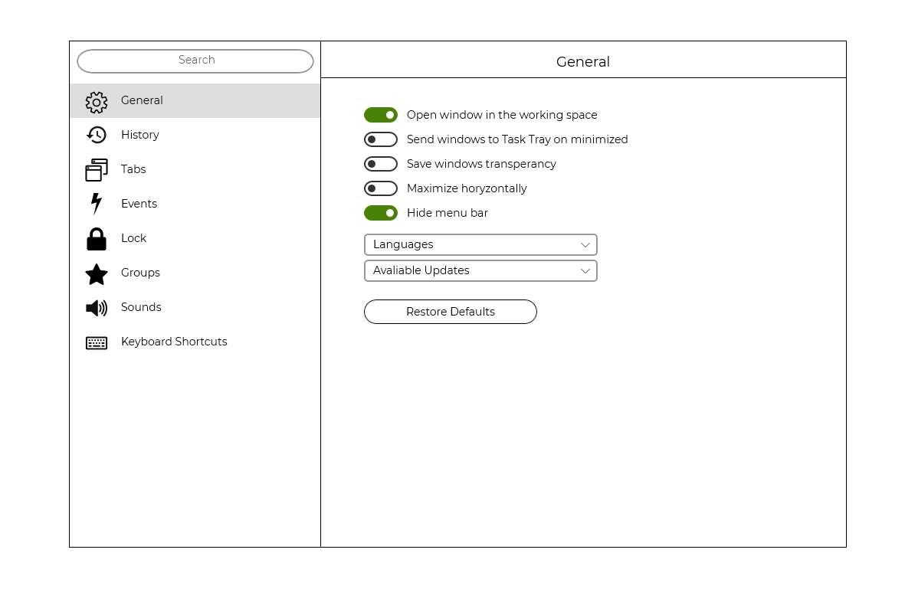

Рис.1. Tablet

Рис.2. Phone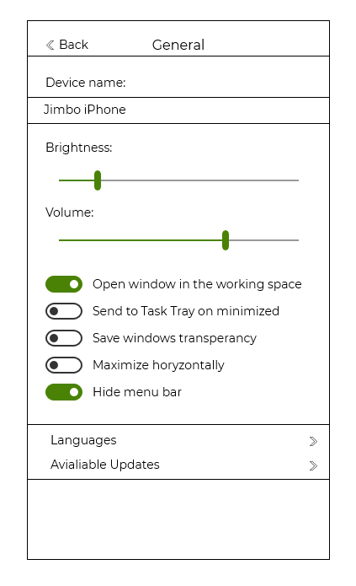

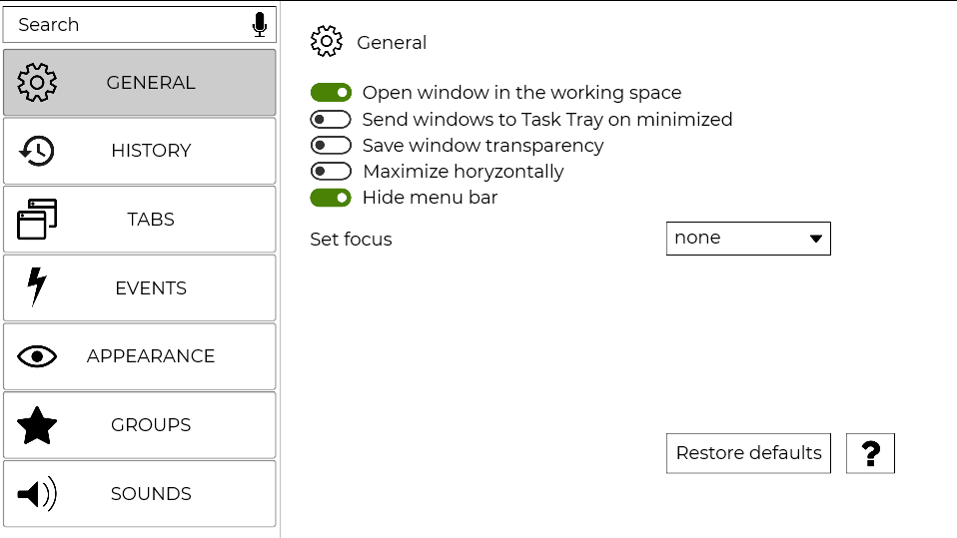

Рис.3 TV

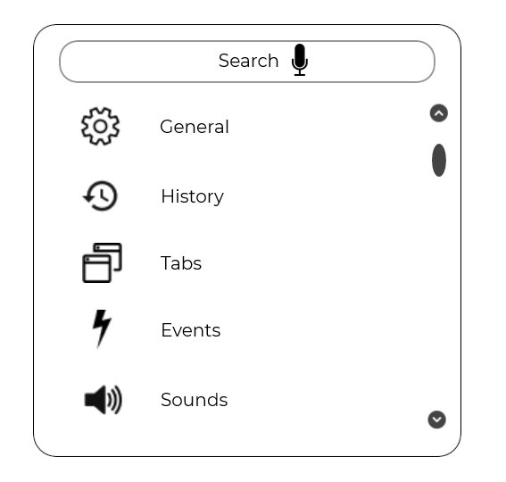

Рис.4. Watch

**Висновок**

У цій лабораторній роботі яознайомився зі способами, методами та засобами програмування користувацьких інтерфейсів та набув практичних навичок програмування спеціалізованою мовою XAML інтерактивної взаємодії користувача, опису функціонування діалогів інтерфейсів із наборів програмних елементі інтерфейсу користувача.