CREATE SEQUENCE S1

  START WITH 1000

  INCREMENT BY 10

  NOMAXVALUE

  NOCYCLE

  NOCACHE

  ORDER;



  BEGIN

DBMS_OUTPUT.PUT_LINE(S1.NEXTVAL);

DBMS_OUTPUT.PUT_LINE(S1.NEXTVAL);

DBMS_OUTPUT.PUT_LINE(S1.NEXTVAL);

END;

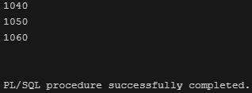

  BEGIN

DBMS_OUTPUT.PUT_LINE(S1.CURRVAL);

END;

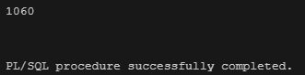

CREATE SEQUENCE S2

  START WITH 10

  INCREMENT BY 10

  MAXVALUE 100

  NOCYCLE;



BEGIN

  WHILE S2.NEXTVAL <= 100 LOOP

    DBMS_OUTPUT.PUT_LINE(S2.CURRVAL);

  END LOOP;

END;

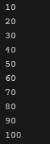

BEGIN

DBMS_OUTPUT.PUT_LINE(S2.NEXTVAL);

END;

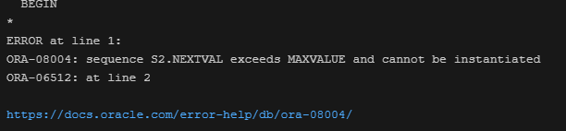

CREATE SEQUENCE S3

  START WITH 10

  INCREMENT BY -10

  MINVALUE -100

  MAXVALUE 10

  NOCYCLE

  ORDER;



  BEGIN

  WHILE S3.NEXTVAL >= -100 LOOP

    DBMS_OUTPUT.PUT_LINE(S3.CURRVAL);

  END LOOP;

END;

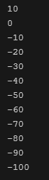

BEGIN

DBMS_OUTPUT.PUT_LINE(S3.NEXTVAL);

END;

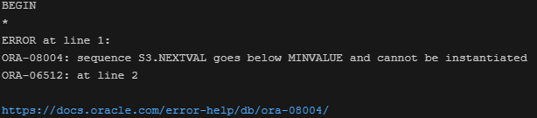

CREATE SEQUENCE S4

  START WITH 1

  INCREMENT BY 1

  MINVALUE 1

  MAXVALUE 10

  CYCLE

  CACHE 5;



  BEGIN

  FOR i IN 1..10 LOOP

    DBMS_OUTPUT.PUT_LINE(S4.NEXTVAL);

  END LOOP;

END;

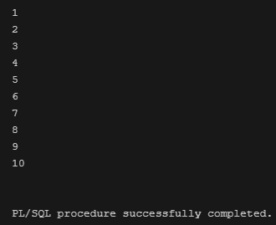

create table T1 (

  N1 NUMBER(20),

  N2 NUMBER(20),

  N3 NUMBER(20),

  N4 NUMBER(20)

) storage(buffer_pool keep) tablespace users;

BEGIN

  FOR i IN 1..7 LOOP

    INSERT INTO T1 VALUES (S1.NEXTVAL, S2.NEXTVAL, S3.NEXTVAL, S4.NEXTVAL);

  END LOOP;

END;

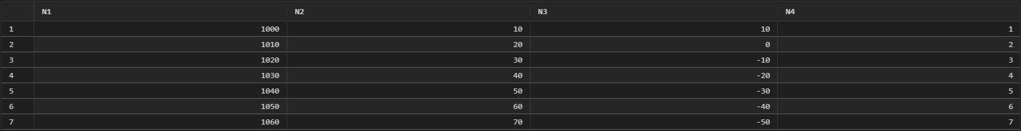

CREATE CLUSTER ABC (

  X NUMBER(10),

  V VARCHAR2(12)

) SIZE 200 HASHKEYS 200;

