Result

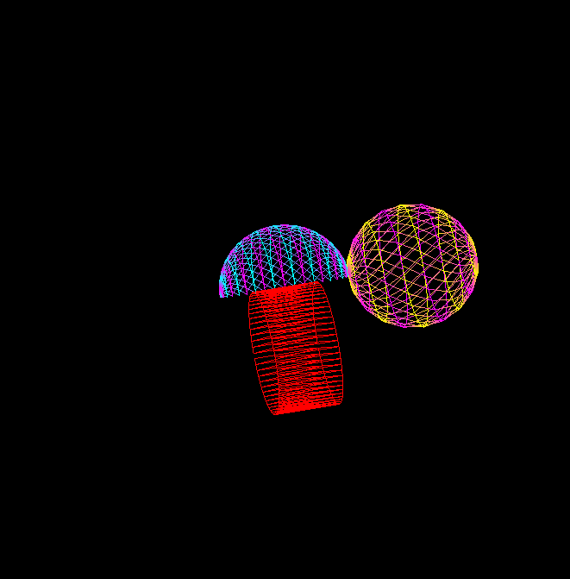

Created by Pavel Stashchenko, group 10701118