Curved Moulding Order Form

HALF-CIRCLE | Profile  _______________  _______________  _______________  _______________  _______________  _______________ | Material  _______  _______  _______  _______  _______  _______ | Qty.  ____  ____  ____  ____  ____  ____ | Radius  ________  ________  ________  ________  ________  ________ |  |  | Reveal  _________  _________  _________  _________  _________  _________ |  | 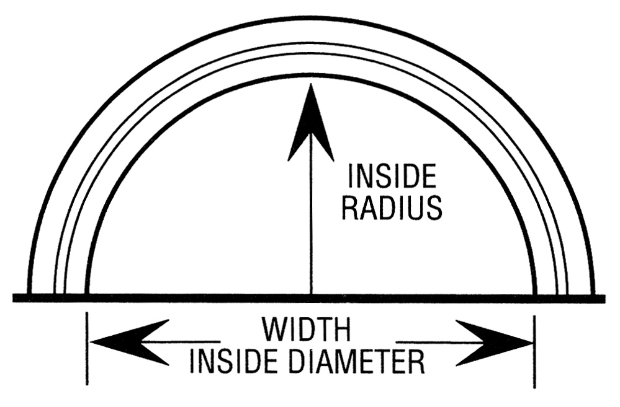 |  | Phone: 800.816.8703 Fax: 905.727.1050  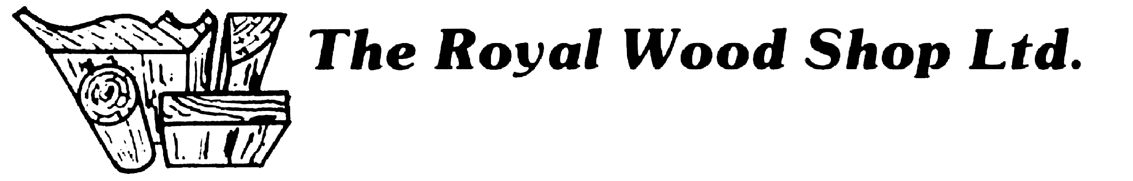  ___________________________________  Date  ___________________________________  P.O. #  ___________________________________  Purchasing Agent  Ordered By  ___________________________________  Company  ___________________________________  Address  ___________________________________  City/Prov./Postal  ___________________________________  Telephone #  ___________________________________  Fax #
EYEBROW | Profile  _______________  _______________  _______________  _______________  _______________  _______________ | Material  _______  _______  _______  _______  _______  _______ | Qty.  ____  ____  ____  ____  ____  ____ | Height  _____  _____  _____  _____  _____  _____ | Width  _____  _____  _____  _____  _____  _____ |  |  | Reveal  _____  _____  _____  _____  _____  _____ | 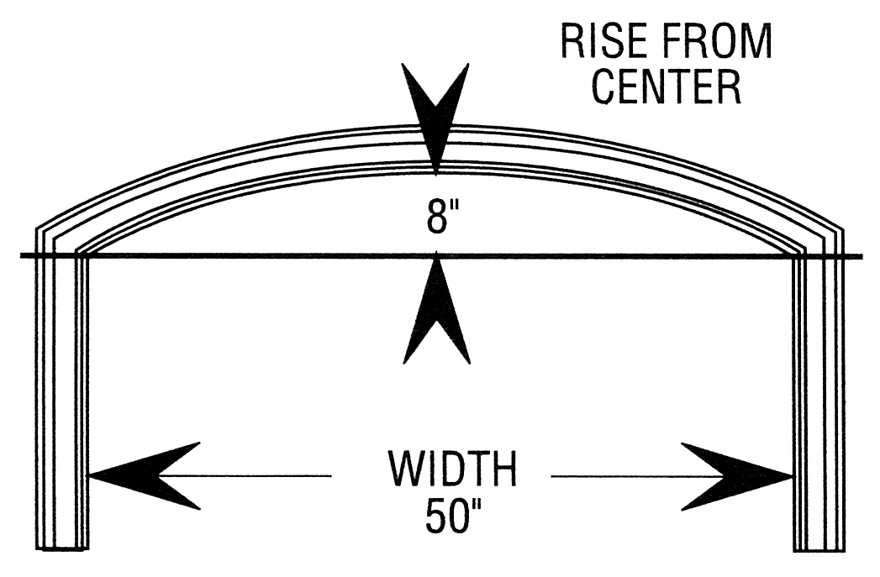
ELLIPTICAL | Profile  _______________  _______________  _______________  _______________  _______________  _______________ | Material  _______  _______  _______  _______  _______  _______ | Qty.  ____  ____  ____  ____  ____  ____ | Temp #  ________  ________  ________  ________  ________  ________ |  |  | Reveal  _________  _________  _________  _________  _________  _________ |  | 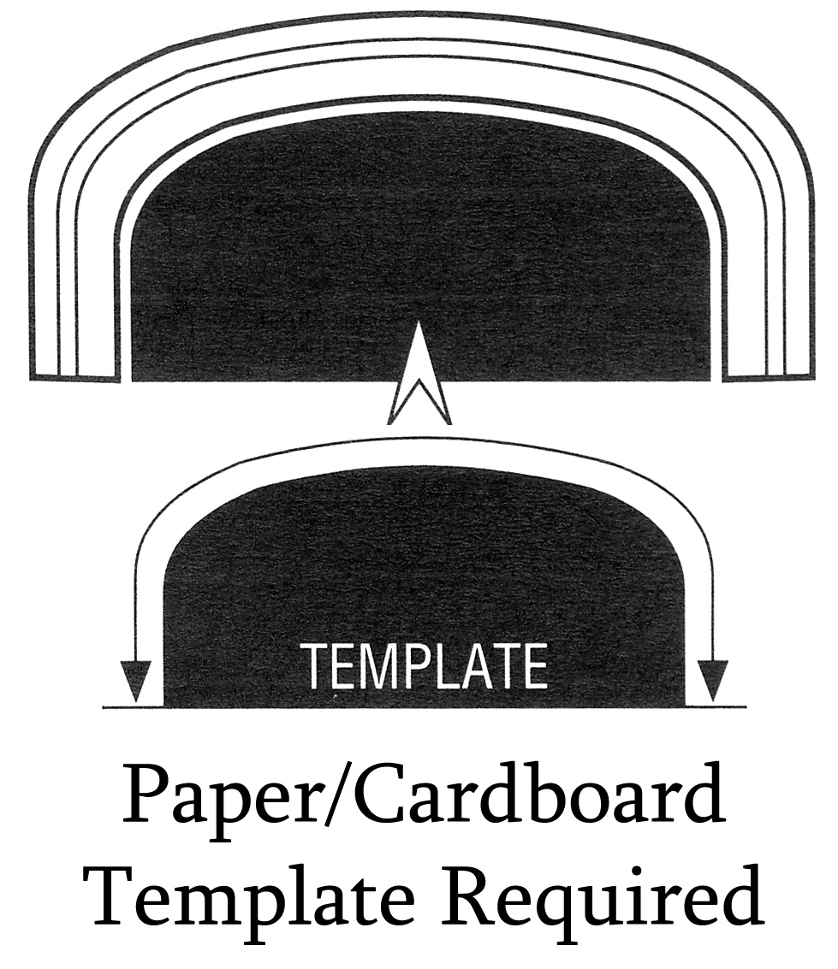
CROWN | Profile  _______________  _______________  _______________  _______________  _______________  _______________ | Material  _______  _______  _______  _______  _______  _______ | Qty.  ____  ____  ____  ____  ____  ____ | Length  ________  ________  ________  ________  ________  ________ |  | Radius (circle one)  __________ Convex / Concave  __________ Convex / Concave  __________ Convex / Concave  __________ Convex / Concave  __________ Convex / Concave  __________ Convex / Concave |  |  |  | 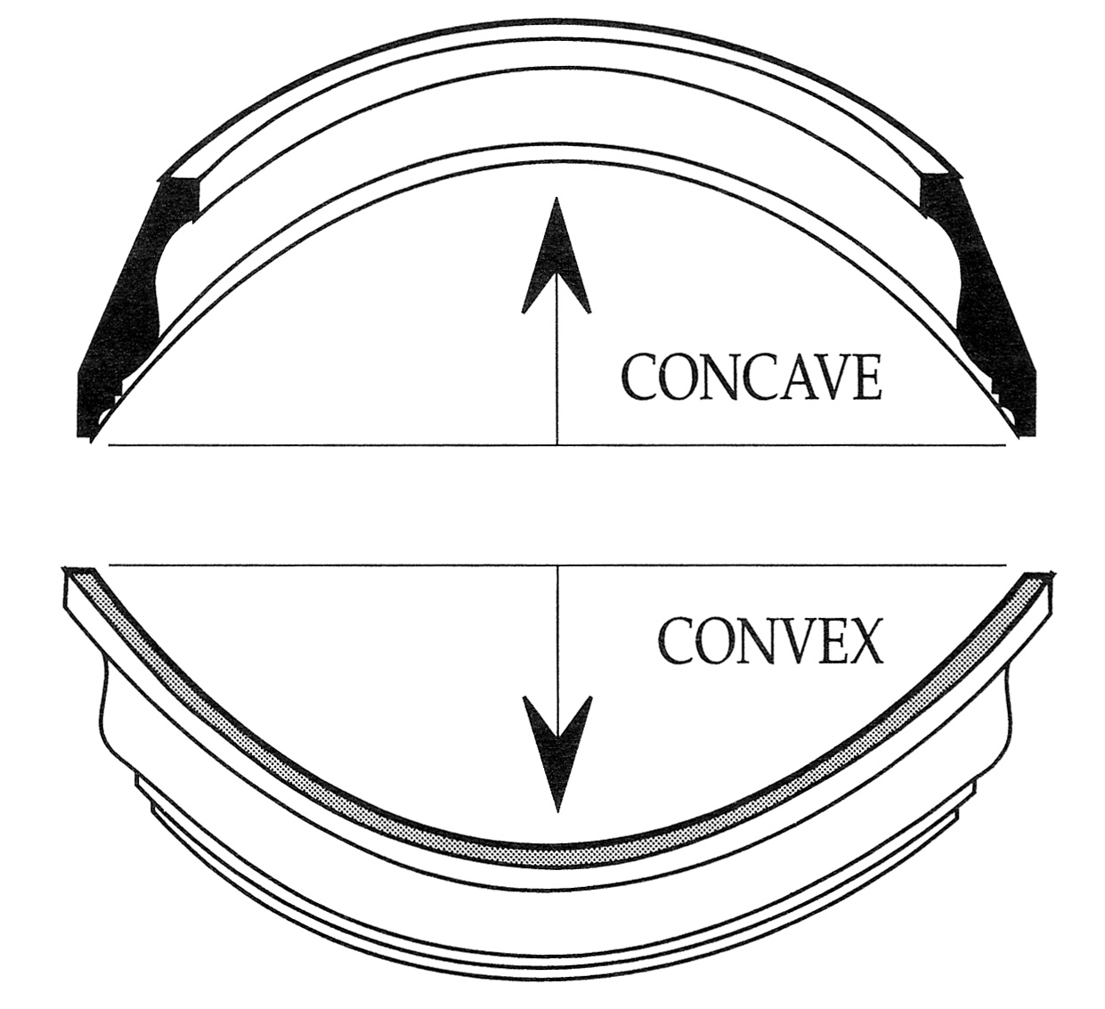 |  | Draw crown as it will be installed
  Wall | Ceiling
 | Please ensure all of the required information is filled in, including: Radius of the wall, Convex/Concave, and a profile drawing to show how the crown mould is going to be installed. |  |  |  |  |  |  |  |  |  |  | Draw crown as it will be installed
Handling charges will apply for curves requiring templates.

