- explain definition:
CPI, inflation rate

- Research topic（goal）:

Part 1: Our project examines how the U.S. food inflation rate has changed over time. Specifically, I analyze the year-over-year percent change in the “All food” Consumer Price Index (CPI) from 2005 to 2024, and I summarize the USDA forecasts for 2025–2026. The goal is to understand how fast food prices have been rising in the past two decades and how they are expected to change in the near future.

Part 2: for specific 4 foods: eggs, pork, beef and veal, fresh fruits.

- Measure and Data Sources
The main variable we use is the year-over-year percent change in the “All food” CPI, which represents the food inflation rate. Each value shows how many percent food prices in a given year are higher (or lower) than in the previous year.
- Historical data (2005–2024) come from historicalcpi.csv, which reports the annual percent change in the All food CPI.
- Forecast data (2025–2026) come from CPIForecast.csv, using the rows labeled “Mid point of prediction interval 2025” and “Mid point of prediction interval 2026” for the All food category. These midpoint values are treated as USDA’s point forecasts of future food inflation.
- Both datasets are downloaded from the USDA Economic Research Service (ERS) Food Price Outlook:
https://www.ers.usda.gov/data-products/food-price-outlook

- Needs
Software & environment
- R and RStudio.
R packages
- tidyverse (especially dplyr, ggplot2, readr, stringr).
Key data wrangling functions / verbs
- Import: readr::read_csv()
- Inspect: dplyr::glimpse(), head()
- Filter rows: dplyr::filter()
- Select/rename columns: dplyr::select(), rename(), transmute()
- Create / modify variables: dplyr::mutate()
- Combine tables: dplyr::bind_rows()
- Sort: dplyr::arrange()
- Handle missing values: tidyr::drop_na()
- String handling for forecast years: stringr::str_detect(), readr::parse_number()
Key plotting functions
- Base: ggplot()
- Lines & points: geom_line(), geom_point()
- Optional reference lines / annotations:
geom_vline(), geom_hline(), annotate()
- Line types / legend: scale_linetype_manual()
- Labels: labs() (title, subtitle, axis labels, caption)
- Theme: theme_minimal(), theme() (legend position, text size)
Accessibility & explanatory text
- Short alt text for the figure (1–2 sentences describing what the chart shows).
- A longer narrative description in the report body (interpretation of trends).
- Clear distinction in text between historical values and forecast values.

- Steps
part1:

- Install and load required packages
  - Install (if needed): install.packages("tidyverse")
  - Load: library(tidyverse)
- Load the two CSV files and inspect the data
  - Use read_csv() to import historicalcpi.csv and CPIForecast.csv.
  - Open both datasets in spreadsheet view (RStudio)

- Filter and clean each dataset separately
  - From historicalcpi.csv:
    - Keep only rows where Consumer Price Index item == "All food".
    - Restrict years to 2005–2024.
    - Keep and rename relevant columns (e.g., Year, Percent change → pct_change).
    - Add a new variable type = "Historical".
  - From CPIForecast.csv:
    - Keep only the All food top-level row (no subcategories).
    - Select rows where Attribute is
"Mid point of prediction interval 2025" and
"Mid point of prediction interval 2026".
    - Extract the year (2025, 2026) from the Attribute column.
    - Rename the forecast value column to pct_change.
    - Add type = "Forecast".
- Merge the historical and forecast tables into one tidy table
  - Use bind_rows() to stack the historical and forecast datasets.
  - Ensure there are three main columns: Year, pct_change, type.
  - Sort by Year with arrange(Year).
  - Confirm that the final table covers 2005–2026 and includes both “Historical” and “Forecast” types.
- Create the visualization (line chart)
  - Use ggplot() with aes(x = Year, y = pct_change, linetype = type).
  - Plot the line and points with geom_line() and geom_point().
  - Use scale_linetype_manual() to show:
    - Solid line for Historical (2005–2024).
    - Dashed line for Forecast (2025–2026).
  - Use scale_color_manual() so that:
    - Historical = black.
    - Forecast = a contrasting color (e.g., blue).
  - Make sure the forecast line starts from the 2024 point and continues through 2025–2026.
- Add labels, explanatory text, and accessibility elements
  - Use labs() to set:
    - Title (e.g., “U.S. Food Inflation Rate (All food CPI Percent Change), 2005–2026”).
    - Subtitle explaining that 2005–2024 are historical values and 2025–2026 are USDA forecasts.
    - X and Y axis labels.
    - Data source caption.
  - Adjust theme with theme_minimal() and theme() for readability (font size, legend position).
  - Write alt text for the figure (1–2 sentences describing the main pattern in the chart). Line chart showing the year-over-year percent change in the U.S. All food CPI from 2005 to 2026. Food inflation is moderate in the mid-2000s, falls to low levels around 2015–2016, then rises sharply to a peak near 10% in 2022. After 2022 the rate declines but remains positive, and USDA forecasts for 2025–2026 (blue dashed line) show food inflation returning to more typical mid-single-digit levels.
  - In the report, include a longer explanation of:
    - How the food inflation rate changes over 2005–2024.
    - How the forecast for 2025–2026 compares to recent years and to the long-run average.
Figure X plots the year-over-year percent change in the All food CPI from 2005 to 2026, which represents the U.S. food inflation rate. From 2005 through the early 2010s, food inflation fluctuates around moderate positive values, with occasional spikes and dips. Around 2015–2016, the rate falls to relatively low levels, indicating very slow growth in food prices. Starting in 2020, food inflation accelerates and reaches a sharp peak of nearly 10 percent in 2022, reflecting a period of unusually high price increases. After 2022, the inflation rate declines but remains above zero, meaning prices are still rising but more slowly. The blue dashed segment for 2025–2026 shows USDA forecast values, suggesting that food inflation is expected to return to more typical mid-single-digit levels rather than stay at the extreme 2022 peak.
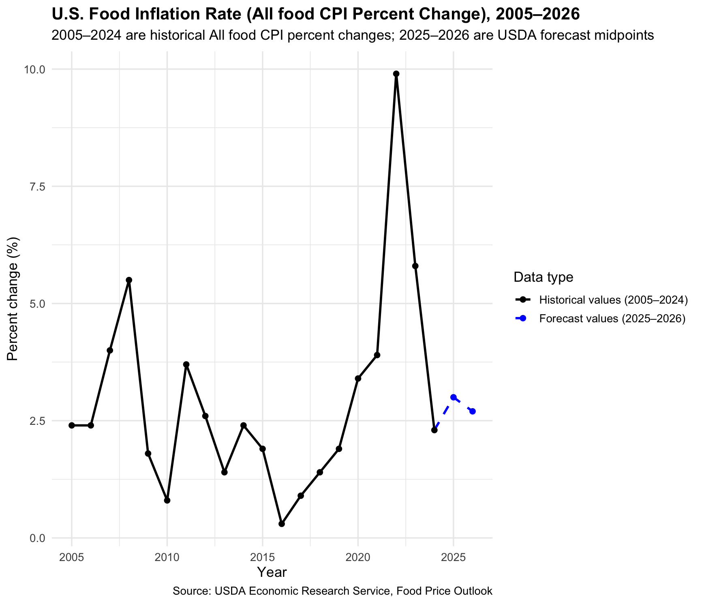
part 2:
goal: “The second visualization extends the analysis by comparing four specific food categories (eggs, pork, beef and veal, fresh fruits) using the same CPI percent change measure and USDA forecasts, highlighting that food inflation patterns differ substantially across categories.”

Needs (for 4-category visualization)
- Package
  - tidyverse（already loaded for the All food plot）
- Main functions / verbs
  - Data wrangling:
    - filter(), mutate(), rename(), select(), bind_rows(), str_detect(), parse_number()
  - Visualization (ggplot2):
    - ggplot(), geom_line(), geom_point()
    - scale_linetype_manual(), scale_color_manual(), scale_shape_manual()
    - labs(), theme_minimal(), theme()

Steps (4 food categories: Eggs, Pork, Beef and veal, Fresh fruits)
- Filter historical CPI for four items (2005–2024)
  - From historicalcpi.csv, keep only rows where Consumer Price Index item is one of:
"Eggs", "Pork", "Beef and veal", "Fresh fruits".
  - Restrict Year to 2005–2024.
  - Rename Percent change to pct_change.
  - Add item (category name) and type = "Historical".
  - Keep only item, Year, pct_change, type → this gives hist_4items.
- Extract 2025–2026 forecast midpoints for each item
  - From CPIForecast.csv, filter by the correct hierarchy for each category, e.g.:
    - Eggs: Top-level = "All food", Aggregate = "Food at home", Mid-level = "Eggs".
    - Pork / Beef and veal: Mid-level = "Meats, poultry, and fish", Low-level = "Meats", Disaggregate = "Pork" or "Beef and veal".
    - Fresh fruits: Mid-level = "Fruits and vegetables", Low-level = "Fresh fruits and vegetables", Disaggregate = "Fresh fruits".
  - Keep only rows where
    - Unit == "Percent change", and
    - Attribute contains "Mid point of prediction interval" (2025 & 2026).
  - Use parse_number(Attribute) to extract Year (2025, 2026).
  - Create item, Year, pct_change = Value, type = "Forecast" and keep these four columns.
  - Bind the four item tables together → fc_4items.

- Combine historical and forecast data for plotting
  - For lines:
    - Take all historical rows (hist_4items).
    - Add a “forecast line” segment that starts from the 2024 value and then continues through the 2025–2026 forecasts (bind 2024 rows with fc_4items and label as type = "Forecast").
    - Combine to create lines_4items, and convert type to a factor with levels "Historical", "Forecast".
  - For points:
    - Combine hist_4items with fc_4items to get points_4items.
  - Make sure item is a factor with four levels (Eggs, Pork, Beef and veal, Fresh fruits).
- Create the multi-line visualization
  - Use ggplot(lines_4items, aes(x = Year, y = pct_change, color = item, linetype = type)).
  - Add lines and points:
    - geom_line() for continuous lines (2005–2024 solid, 2024–2026 dashed).
    - geom_point(data = points_4items, aes(shape = item, color = item)).
  - Use scales to distinguish meaning:
    - scale_linetype_manual() → solid = historical (2005–2024), dashed = forecast (2025–2026).
    - scale_color_manual() and scale_shape_manual() → give each food category its own color and point shape.
  - Add title, subtitle, axis labels, and source caption with labs().
  - Apply theme_minimal() and adjust legend position and text size with theme().
Alt text:
Line chart showing the year-over-year percent change in the CPI for four food categories—eggs(orange line), pork(pink), beef and veal(green), and fresh fruits(yellow)—from 2005 to 2026. All four lines move over time, but eggs are much more volatile, with several large negative dips and very high spikes, especially around 2007, 2015, and 2022. Pork and beef and veal generally show moderate positive inflation with some ups and downs, while fresh fruits fluctuate around small positive or slightly negative values. Dashed segments at the right side of each line represent USDA forecast values for 2025–2026.

Long text – Figure 2
Figure 2 compares food inflation for four categories—eggs, pork, beef and veal, and fresh fruits—from 2005 to 2026. The lines show that eggs are by far the most volatile category, with deep negative percent changes in some years and very large positive spikes around 2022, followed by a forecast of another strong increase in 2025 and a decline in 2026. Pork and beef and veal also experience noticeable inflation, especially around 2020–2022, but their swings are smaller than those for eggs and remain mostly positive. Fresh fruits fluctuate around zero with much smaller movements, and their 2025–2026 forecasts stay close to zero. Overall, this figure shows that recent food inflation pressures have been strongest and most unstable for eggs, while fresh fruits have remained relatively stable compared with meat products.

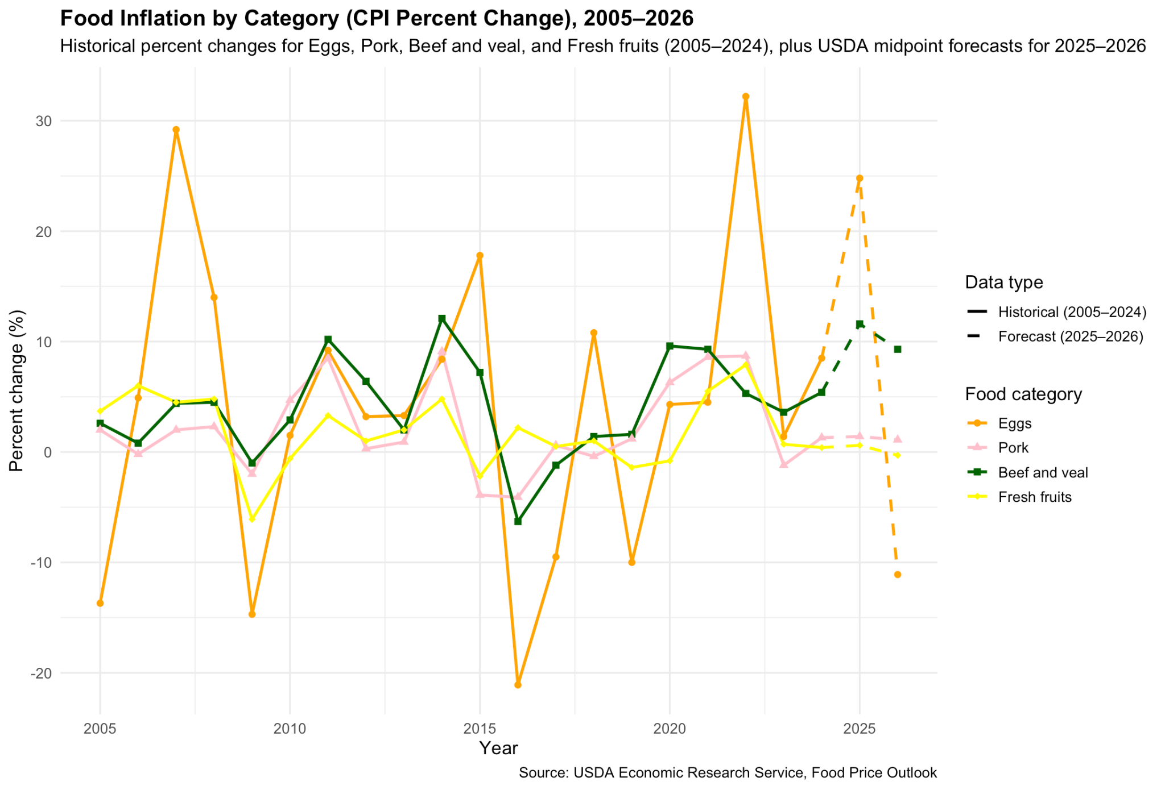

another way to show the same data change
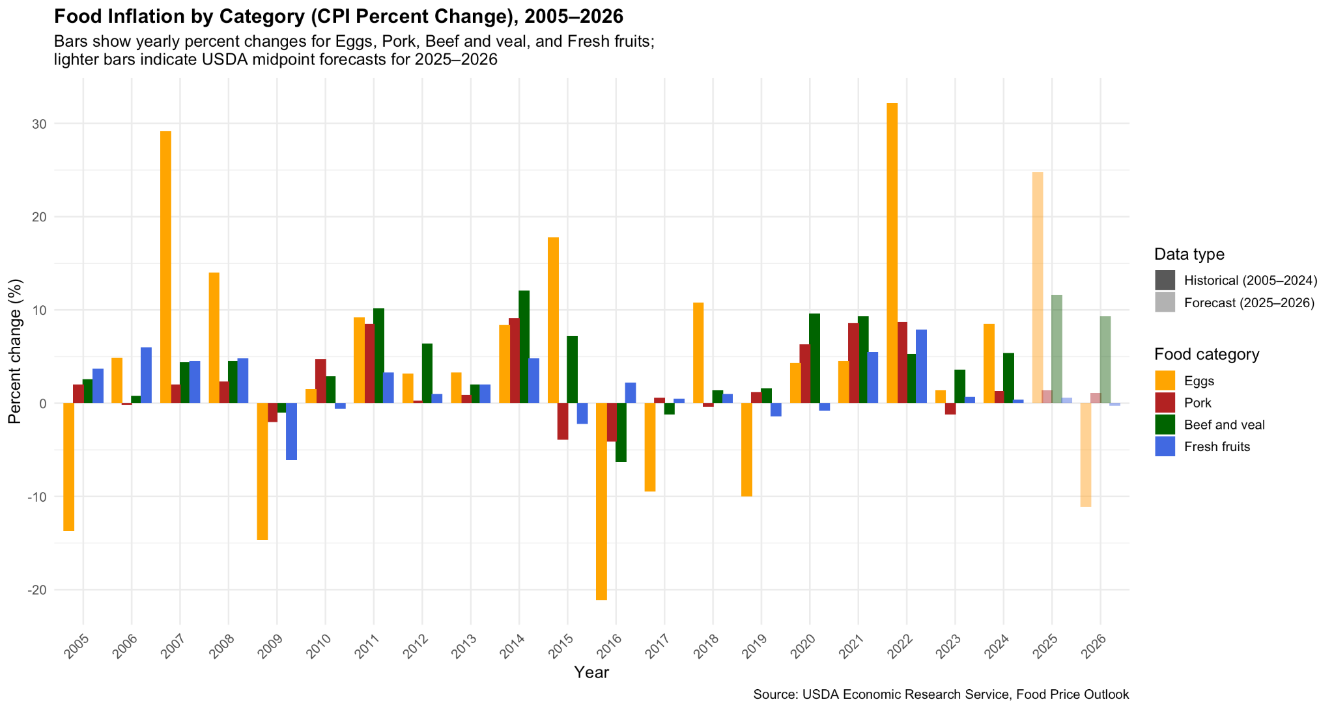
Alt text – Figure 2 (bar chart)
Grouped bar chart showing the year-over-year percent change in the CPI for four food categories—eggs, pork, beef and veal, and fresh fruits—from 2005 to 2026. For each year there are four bars side by side. Egg bars are the most extreme, with several very high positive bars and some negative bars. Pork and beef and veal bars are usually positive but less extreme, while fresh fruits bars stay close to zero. Lighter-colored bars for 2025–2026 indicate USDA forecast values.

Long text – Figure 2 (bar chart)
Figure 2 uses a grouped bar chart to compare food inflation for eggs, pork, beef and veal, and fresh fruits from 2005 to 2026. The height of each bar represents the annual percent change in the CPI for that category. The bars show that eggs experience the largest swings, with some years of strong price decreases and very large increases, especially around 2022, followed by relatively high forecast inflation in 2025 and a decline in 2026. Pork and beef and veal also show noticeable inflation, particularly in the early 2010s and 2020–2022, but the bars are generally more moderate and remain mostly above zero. Fresh fruits have bars that stay close to zero, indicating much smaller price movements. The lighter bars at the right side of the chart show USDA forecasts for 2025–2026, which suggest continued volatility for eggs, modest positive inflation for meats, and relatively stable prices for fresh fruits.

Make summary table
The goal of this table is to summarize and compare food inflation across four categories (eggs, pork, beef and veal, and fresh fruits) by showing their historical averages and future forecasts in one professional-looking summary. To create it (needs), we use the cleaned data frames hist_4items and fc_4items plus the tidyverse package (mainly dplyr and tidyr). The main steps are: first, filter the historical CPI data to those four categories and years 2005–2024; second, use group_by(item) and summarise() to compute the mean, minimum, and maximum annual percent change (pct_change) over 2005–2024 for each category; third, reshape the forecast data so that the 2025 and 2026 percent changes become separate columns with pivot_wider(); fourth, join the historical summary and the forecast columns by item using left_join(); fifth, round all numeric values to one decimal place and rename the columns to clear presentation names (e.g., “Mean 2005–2024 (%)”, “Forecast 2025 (%)”); finally, view this tidy summary table in RStudio (using View()) and treat it as a formatted statistical table that supports the bar chart and line chart visualizations.
Title: Summary of food inflation by category: historical averages (2005–2024) and USDA forecasts (2025–2026).
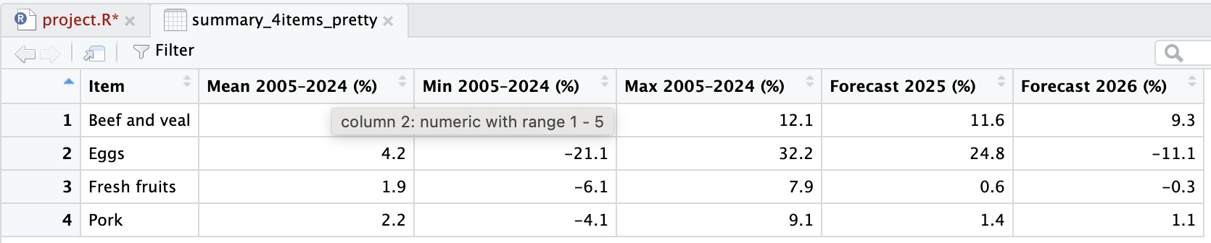
The table reports the mean, minimum, and maximum annual percent change in the CPI for each food category from 2005–2024, along with midpoint forecast values for 2025 and 2026.
Table X shows that food inflation differs substantially across categories. Beef and veal has a relatively high positive mean inflation rate and a large positive maximum, indicating sustained upward pressure on prices. Eggs have a similar or even higher average inflation rate but an extremely wide range between the minimum and maximum values, confirming that egg prices are highly volatile over time. Pork shows moderate average inflation with less extreme highs and lows, while fresh fruits have the lowest mean and a narrow range, suggesting comparatively stable prices. The 2025–2026 forecasts continue this pattern: forecast inflation remains strong for beef and veal, relatively high but unstable for eggs, modest for pork, and close to zero for fresh fruits.

