Prompt: Create a data visualization that will help me understand these data. Calclium.csv
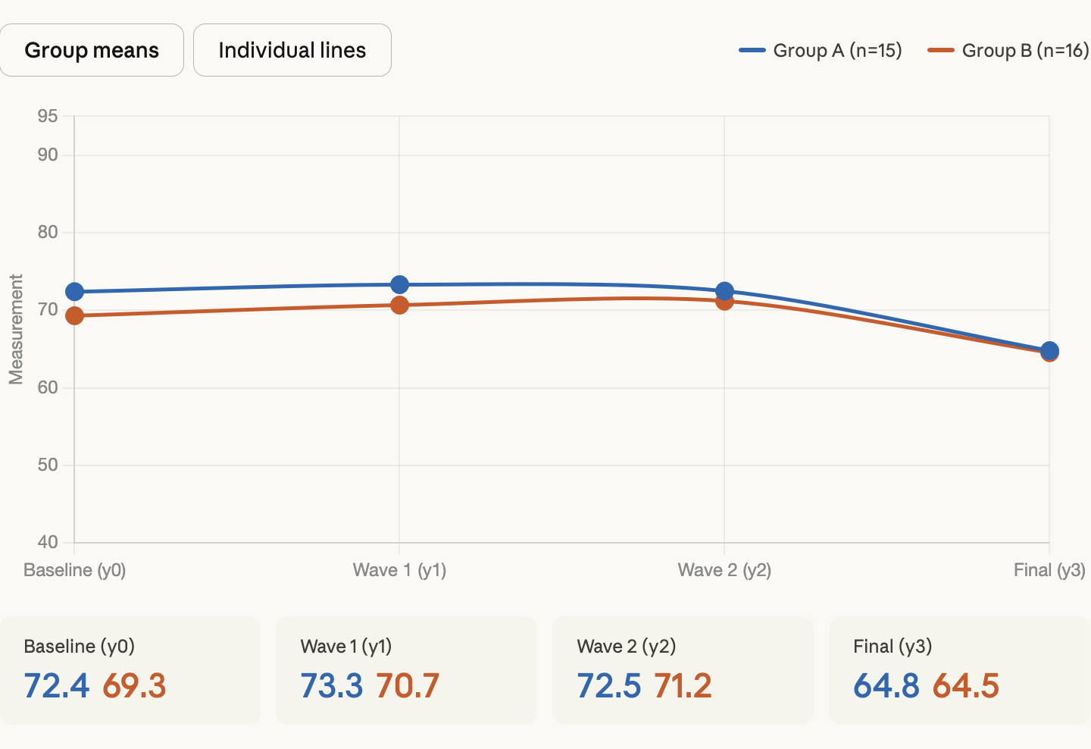
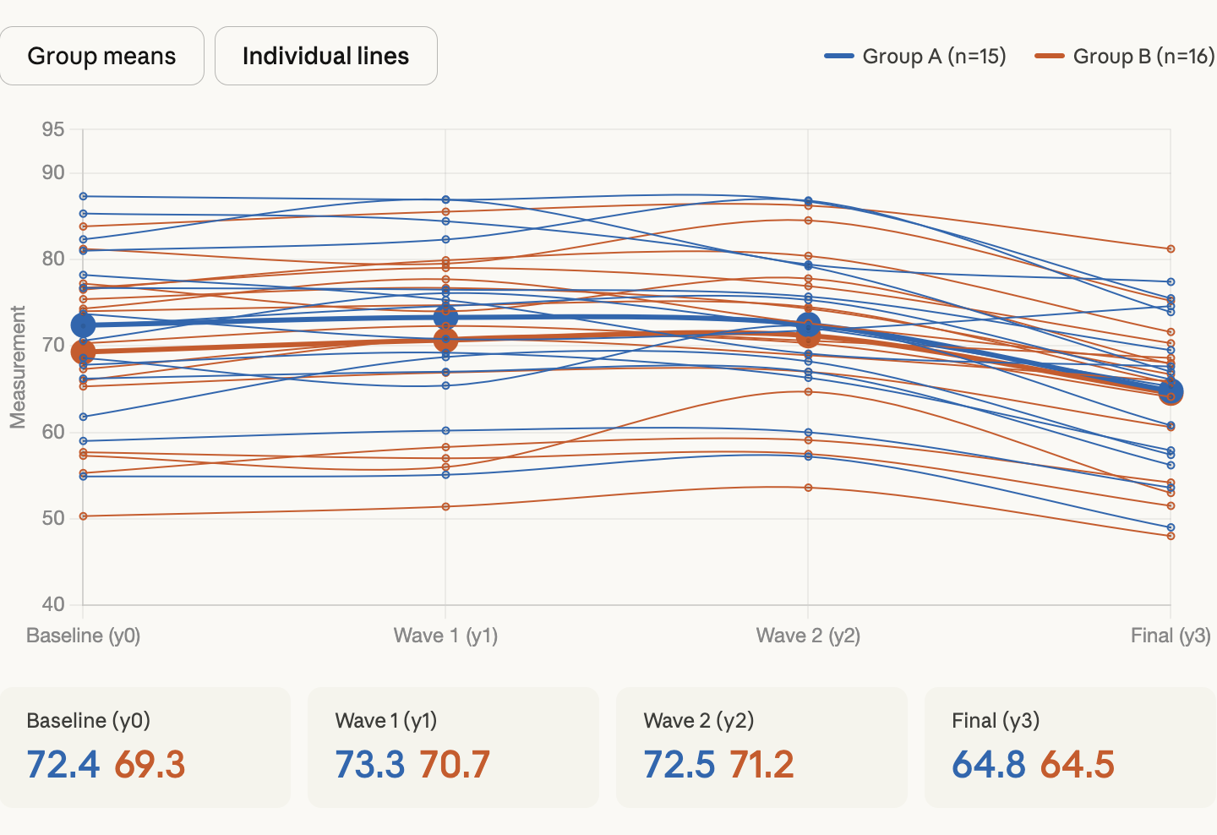
Here's what stands out in the data:
Both groups follow the same pattern — values stay relatively stable across the first three waves (y0→y1→y2), then drop noticeably at the final measurement (y3). This sharp decline at y3 is the dominant signal.
Group A starts slightly higher (baseline mean ~72.4 vs. ~69.3 for Group B), but both groups converge to nearly identical final values (~64.8 and ~64.5). That convergence is interesting — Group A drops about 7.5 points while Group B drops about 4.8.
There's substantial individual variation — hit the "Individual lines" toggle to see this. Some participants stay high throughout, others are consistently low, and a few show unusual trajectories (one in Group A actually rises at y3 while most fall).
If you can share what the groups represent (e.g., treatment vs. control, or different diets/supplements) and what's being measured, I can dig into the statistics more precisely — things like whether the group difference at y3 is significant, or which individuals are outliers.
Version: Claude Sonnet 4.6 Extended
(This chat took place on Tuesday, March 31st, 2026.)

