Data and Point Plots

StatPREP Class Lesson

# Orientation

Data can be many things, but one of the most common formats is a data frame, a kind of spreadsheet of rows and columns. We’ll work with the data frame Births_2014, which is based on data published by the US Centers for Disease Control. Births_2014 has 100,000 rows. Each row reports a live birth in the US in 2014. There are dozens of variables, a few of which are shown below.

|  |  |  |  |  |  |
| --- | --- | --- | --- | --- | --- |
| sex | baby_wt | gestation | delivery | age_mother | wic |
| M | 4479 | 41 | spontaneous | 28 | n |
| F | 3203 | 39 | vacuum | 28 | n |
| F | 3590 | 39 | spontaneous | 31 | y |
| F | 3771 | 41 | cesarean | 34 | n |
| F | 3335 | 39 | cesarean | 38 | NA |
| M | 3750 | 41 | spontaneous | 19 | y |

It’s hard to draw much of a conclusion by looking directly at a large data frame. But a graphical display of data can help.

A *point plot* is a basic statistical graphic that displays two variables from a data frame. Point plots[1]. One variable is represented on the vertical axis, another variable on the horizontal axis. Like the following point plot of the baby’s weight (in grams) and the length (in weeks) of the pregnancy (gestation).

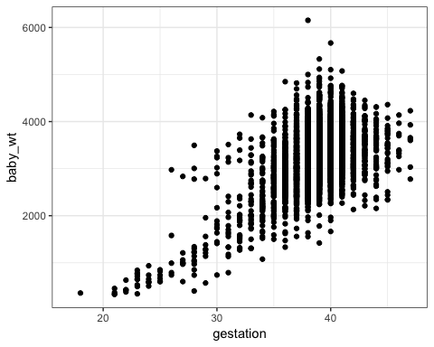

# Activity

1. Find in the graph the dot corresponding to the first row in the data table above, the one for a male baby delivered spontaneously to a 28 year-old mother.
2. Describe the overall pattern shown in the graph as a whole. Use whatever form of description you think is appropriate.
3. Of course, weight differs from one baby to another. In other words, weight *varies*. Describe how much *variation* there is in babies’ weight, according to the graph.
4. Describe how much *variation* there is in gestation length.
5. At which length of gestation are the heaviest babies born?

## Activity

Open the [Point Plot Little App](https://dtkaplan.shinyapps.io/LA_point_plot/).

1. Set the data source to Births_2014 and choose baby_wt as the response variable and gestation as the explanatory variable. The resulting plot should look much like the graph seen in the introduction to this lesson. But plot seen in the Little App will have many fewer points. Change the sample size to $n=5$.
2. Open the “Statistics” tab under the main graph. This tab displays the same data as in the plot, but in data-frame format.
   * For each of the $n=5$ rows of the data frame, find the corresponding point in the graphic.
3. Change the *explanatory* variable to sex.
   * For each of the $n=5$ rows of the data frame displayed in the Statistics tab, find the corresponding point in the graphic.
   * Change $n$ to 500. In the baby_wt versus sex graph, all the points are lined up in two columns. Explain why.
4. Change the *response* variable to delivery, keeping the explanatory variable as sex.
   * For a few of the rows of the data frame shown in the Statistics tab, find the corresponding point in the graphic.
   * Make sure that $n$ is something large, say $n=500$. There aren’t 500 points in the delivery versus sex graph. Explain why?
5. Check the “jitter categorical variables” box in the controls. The display changes and now there are many more points in the plot.
   * For a few of the rows in the data frame shown in the Statistics tab, find the corresponding point in the graphic. Are you able to uniquely identify in the graph the specific point corresponding to each row? Explain how you can do this or why it’s not possible.

Version 0.1, 2019-04-15, Daniel Kaplan

1. Sometimes referred to as “scatterplots”