(i) Training Images (ii) Modified training images (iii) Estimated parametric maps (iv) A few predicted Images

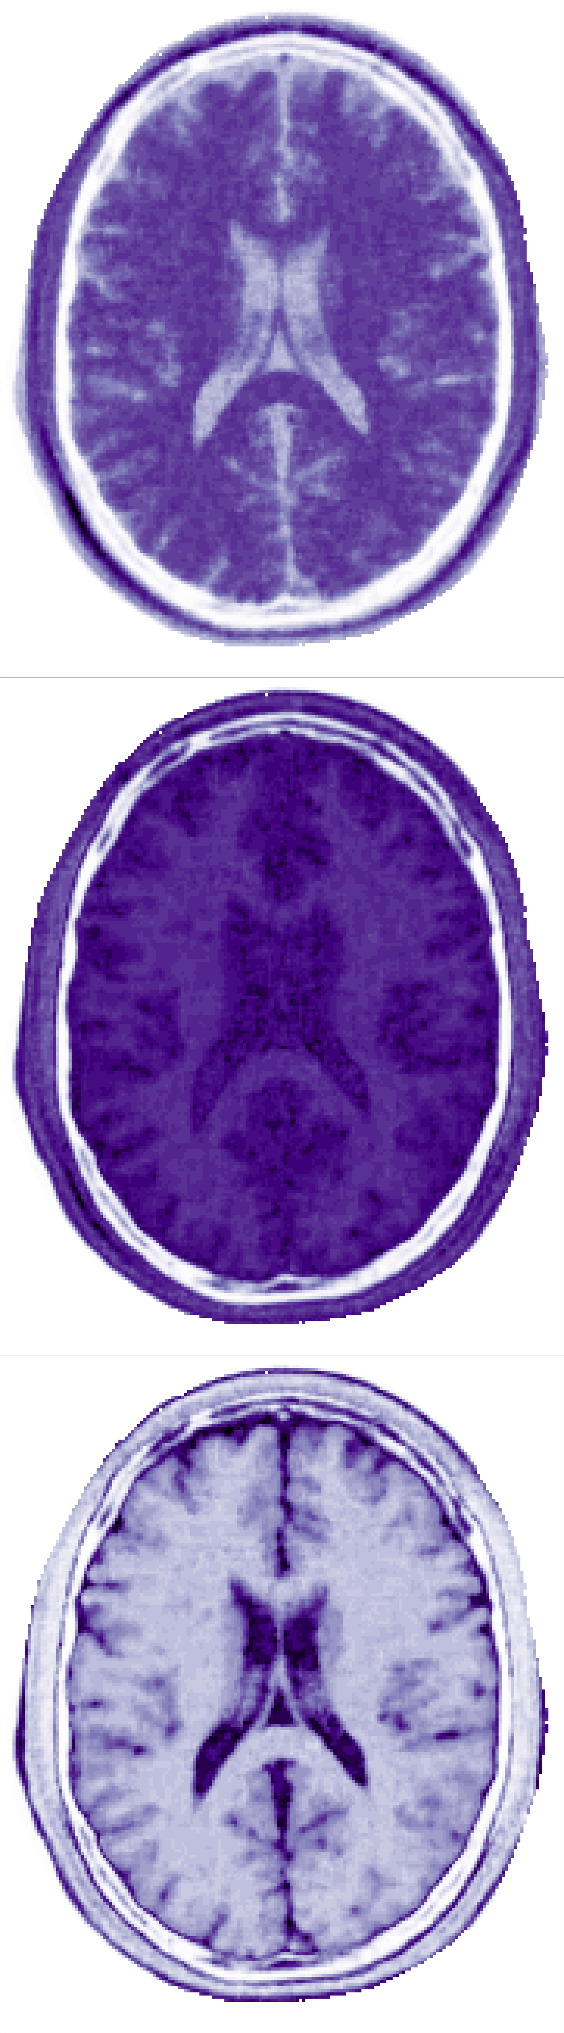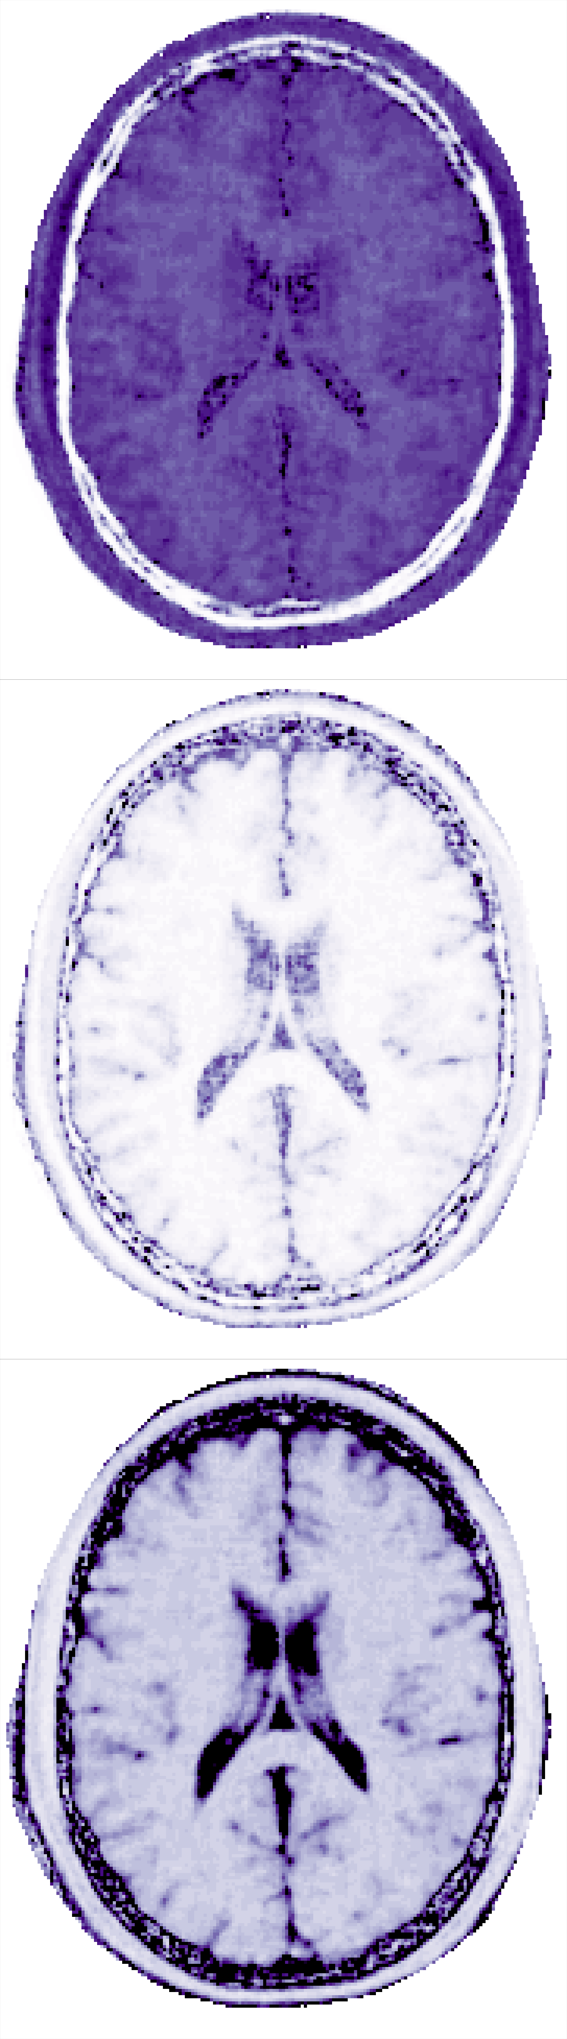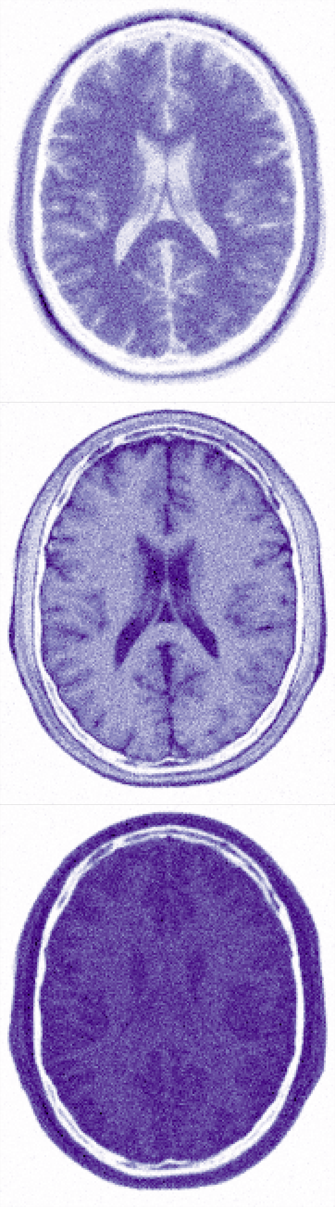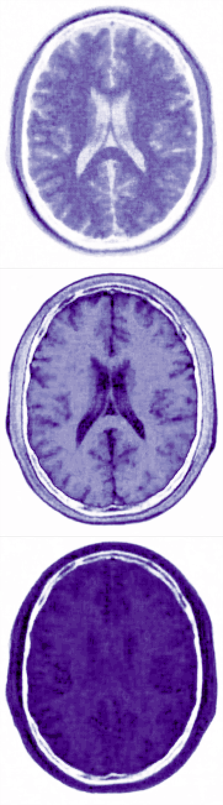

$$ρ$$

$$T_{1}$$

$$T_{2}$$

Deep Image Prior Estimated parametric maps Forward Bloch Equation

(Spatial regularization) (Bloch Equation + Least Square) Prediction

.......

$$ϱ$$

What are the image numbers for the last case?