Volume 06 Robot Hands and Dexterous Grasping

15. Case Studies

15.01 Shadow Dexterous Hand
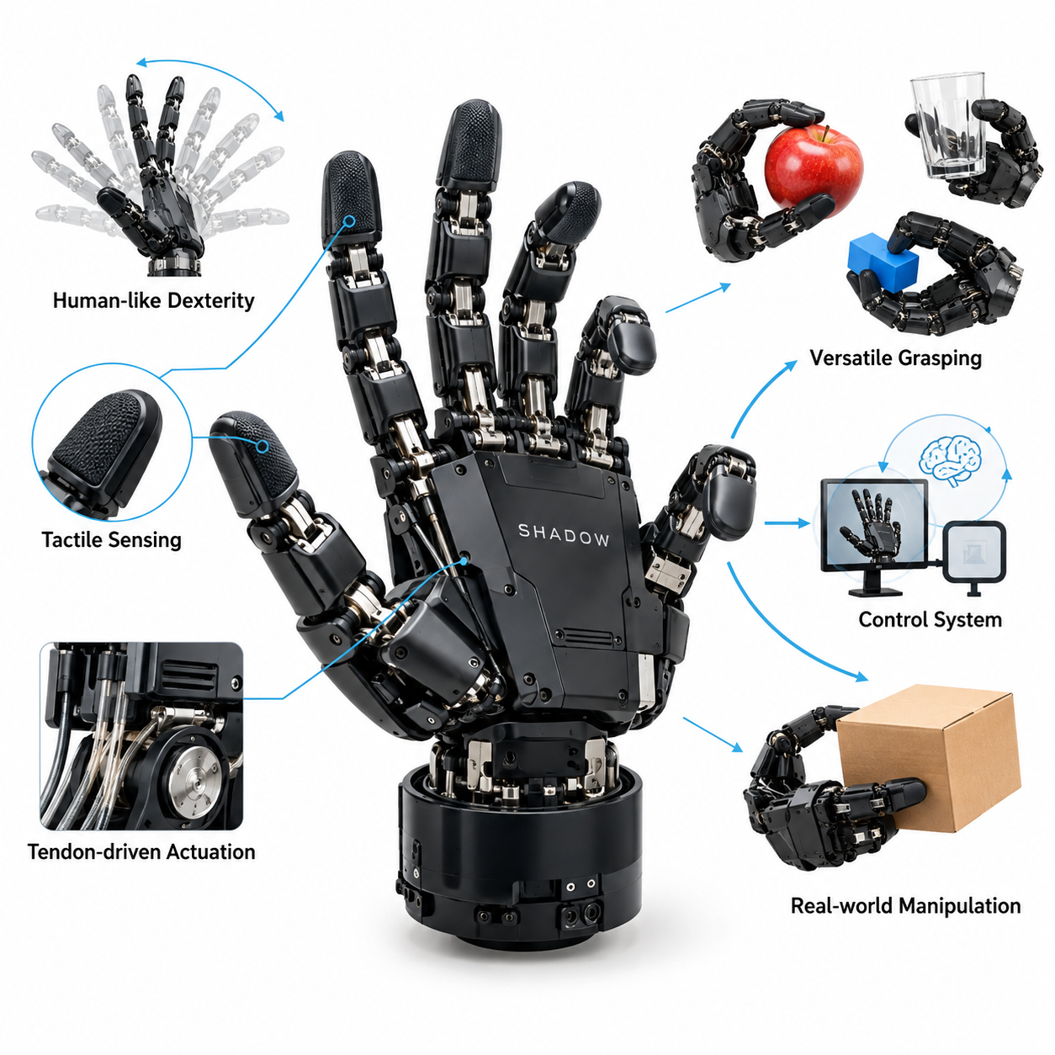
The Shadow Dexterous Hand represents an important case study in anthropomorphic robotic manipulation, demonstrating how human-inspired mechanical design can support complex grasping and object manipulation. Developed by Shadow Robot Company, the platform has been widely used in robotics research to investigate finger coordination, tactile perception, manipulation planning, and learning-based control. Its significance lies in providing a sophisticated experimental platform for studying human-like dexterity.
Unlike conventional industrial grippers that primarily execute opening and closing motions, the Shadow Dexterous Hand incorporates five articulated digits, including an opposable thumb. Its kinematic structure provides approximately 20 independently controllable degrees of freedom, depending on the configuration, with additional mechanically coupled joints. This arrangement enables complex finger postures, coordinated contact formation, and manipulation strategies that are difficult to achieve with simple parallel-jaw mechanisms.
The mechanical architecture emphasizes anatomical similarity while accommodating the practical constraints of robotic actuation. Multiple joints distributed across the fingers and palm allow the hand to perform precision pinching, enveloping grasps, and coordinated object repositioning. The thumb plays a particularly important role because opposition against the other fingers creates diverse contact geometries. This versatility expands the range of objects and manipulation tasks that researchers can investigate.
Shadow hand platforms have employed different actuation technologies, including pneumatic artificial muscles and electric motor-driven tendon systems. In tendon-driven configurations, actuators transmit mechanical forces through cable mechanisms that resemble biological tendons. This approach allows actuators to be positioned away from certain finger joints, reducing local packaging constraints. However, tendon friction, elasticity, backlash, and mechanical coupling introduce challenges for precise control and calibration.
The relationship between joint motion and actuator displacement is a fundamental consideration in controlling the Shadow Dexterous Hand. Tendon routing and joint geometry determine how actuator commands translate into finger movement, while mechanical compliance influences force transmission. Accurate manipulation therefore requires appropriate kinematic models, actuator calibration, and feedback control. Researchers must account for nonlinear behavior and differences between commanded joint positions and actual physical configurations.
One of the most valuable characteristics of the platform is its ability to support sophisticated fingertip contact strategies. Multiple fingers can establish distributed contact points around an object, generating forces that resist translation and rotation. Stable manipulation depends on contact geometry, friction conditions, and coordinated force distribution. The Shadow Dexterous Hand provides a useful environment for studying force closure, grasp wrench space, and the relationship between grasp configuration and mechanical stability.
Tactile sensing significantly extends the capabilities of dexterous robotic hands by providing information that cannot be obtained reliably from vision alone. Shadow hand research platforms have been integrated with fingertip sensing technologies, including BioTac sensors and other tactile systems. Depending on the sensor configuration, these devices can provide information about contact pressure, deformation, vibration, or contact dynamics. Such measurements support contact localization, grasp monitoring, and manipulation feedback.
Slip detection is particularly important when manipulating objects with uncertain friction properties or changing contact conditions. A robotic hand must distinguish between stable contact and the early stages of object movement to avoid dropping or damaging the object. Tactile signals can reveal changes in pressure distribution and dynamic contact behavior. By integrating these measurements into a feedback controller, researchers can investigate corrective actions such as increasing grip force or repositioning individual fingers.
Force control presents another major engineering challenge because multiple fingers interact with the same object simultaneously. Excessive force can damage fragile objects, while insufficient force can produce unstable grasps. The controller must regulate contact forces while maintaining desired object motion and preventing undesirable finger interactions. Impedance control, compliant control, and internal force regulation provide complementary approaches for balancing manipulation accuracy with mechanical adaptability.
In-hand manipulation represents one of the most demanding capabilities investigated using the Shadow Dexterous Hand. Rather than releasing an object and grasping it again, the robot attempts to change its position or orientation through coordinated finger movements. These operations may involve rolling, pivoting, controlled sliding, and finger gaiting. Successful execution requires continuous coordination between finger kinematics, contact mechanics, object dynamics, and feedback from available sensors.
The Shadow Dexterous Hand became especially prominent through its use in OpenAI's Dactyl research, which investigated learned robotic manipulation using reinforcement learning. In this research, a Shadow robotic hand learned to manipulate a cube through extensive simulated training. Domain randomization introduced variations in physical parameters and environmental conditions to improve transfer from simulation to hardware. The project demonstrated the potential of learned policies for complex dexterous manipulation.
The Dactyl experiments also highlighted the importance of training environments capable of representing difficult contact-rich interactions. Accurate simulation of friction, collisions, joint dynamics, and object movement is challenging because small modeling errors can accumulate during manipulation. Instead of relying exclusively on highly accurate physical models, randomized training exposes policies to diverse conditions. This strategy can improve robustness, although successful transfer still depends on suitable training distributions and hardware characteristics.
Learning-based manipulation differs from traditional analytical grasp planning because control policies can discover coordinated behaviors through repeated interaction. Reinforcement learning can optimize actions according to objectives such as maintaining object stability, achieving a target orientation, or completing a manipulation sequence. However, training dexterous policies is computationally demanding and often requires carefully designed observations, rewards, and simulation procedures. Policy reliability must also be evaluated beyond the conditions encountered during training.
The integration of vision and proprioception provides another important dimension of Shadow hand research. External cameras can estimate object position and orientation, while joint encoders provide information about finger configuration. Combining these observations allows the controller to relate object motion to finger movement. Tactile feedback can further improve state estimation when fingers obscure visual observations or when subtle contact changes are difficult to detect through cameras alone.
For mobile manipulation systems, integrating a Shadow Dexterous Hand introduces additional mechanical and computational requirements. The robot arm must provide suitable positioning accuracy, payload capacity, and wrist orientation while accommodating the hand's mass and actuation infrastructure. The overall controller must coordinate arm trajectories with finger movements and object contact states. Mobile platforms additionally introduce localization uncertainty, base vibration, and workspace constraints that can influence grasp reliability.
The platform illustrates an important tradeoff between dexterity and engineering complexity. Increasing the number of controllable joints expands the manipulation workspace and potential contact configurations, but also increases actuator requirements, calibration effort, sensing complexity, and control dimensionality. Mechanical maintenance becomes more demanding when tendon systems, articulated joints, and sensitive fingertip components require periodic inspection. These considerations distinguish research-oriented dexterous hands from simpler industrial end effectors.
Evaluating the Shadow Dexterous Hand requires more than measuring whether an object can be lifted successfully. Meaningful benchmarks should examine grasp success rate, object orientation accuracy, manipulation completion time, contact stability, and recovery from disturbances. Tests involving different object shapes, materials, masses, and friction properties reveal how performance changes across operating conditions. Repeated trials are necessary to distinguish consistent capabilities from isolated successful demonstrations.
Reliability and operational efficiency are particularly important when considering industrial applications. A highly dexterous hand may perform manipulation tasks that conventional grippers cannot accomplish, but its advantages must justify additional hardware cost, power consumption, maintenance, and computational requirements. Industrial evaluation should therefore consider task coverage, cycle time, mean time between failures, and total operating cost. The appropriate hand architecture depends on the diversity and complexity of the target application.
The Shadow Dexterous Hand also provides valuable lessons for the development of foundation models for robotic manipulation. Its high-dimensional action space and rich sensor observations create opportunities for learning representations that connect visual perception, tactile information, and motor control. Demonstration learning, reinforcement learning, and multimodal policy architectures can potentially exploit these capabilities. Generalization across objects, tasks, and hardware configurations remains an important research challenge.
From a system engineering perspective, the central lesson of the Shadow Dexterous Hand is that mechanical sophistication alone does not guarantee useful dexterity. Successful manipulation emerges from the integration of hand kinematics, actuator dynamics, tactile sensing, contact modeling, perception, and adaptive control. The platform demonstrates both the potential and the difficulty of reproducing human-like manipulation. It remains a valuable reference for designing future robotic hands capable of increasingly general physical interaction.

15.02 Robotiq Grippers
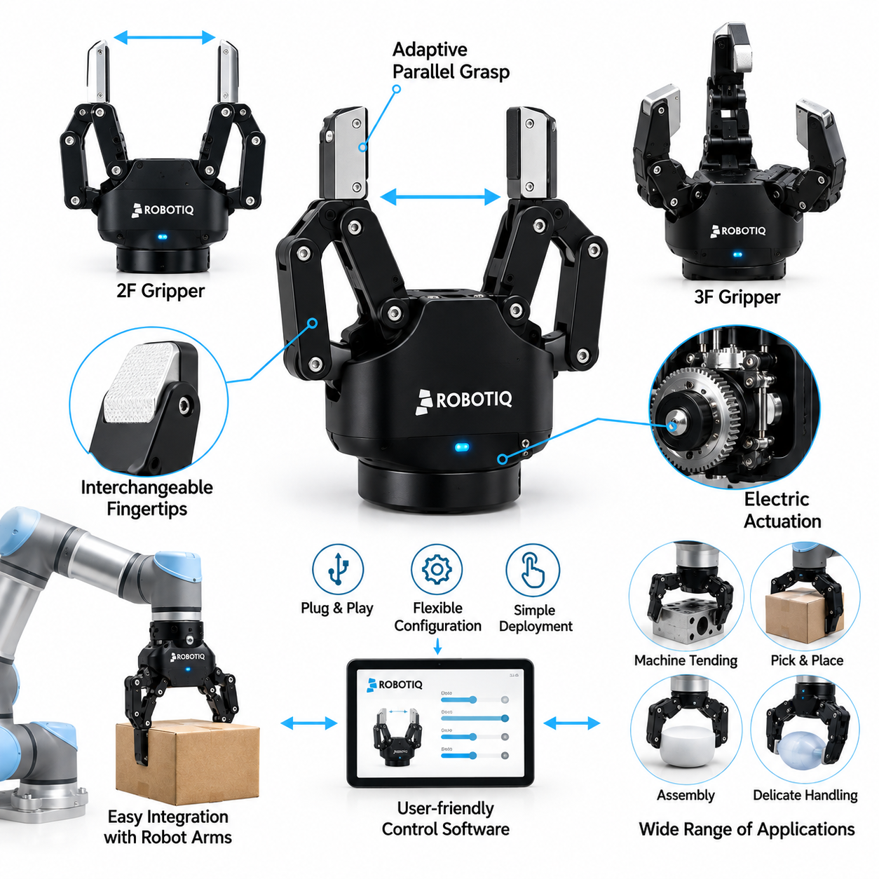
Robotiq grippers represent a practical approach to industrial robotic manipulation, emphasizing adaptability, ease of integration, and reliable operation rather than reproducing the full complexity of the human hand. Developed by Robotiq, these end effectors are widely associated with collaborative robotics and flexible automation. Their significance lies in enabling robots to handle diverse objects without requiring highly specialized gripping mechanisms for every individual application.
The Robotiq product family includes adaptive two-finger and three-finger grippers designed for different manipulation requirements. Two-finger models are particularly suitable for common pick-and-place operations, machine tending, and material handling, while three-finger adaptive designs support more varied grasp configurations. These products demonstrate how relatively compact mechanical architectures can achieve useful grasp versatility through carefully designed linkages, actuation systems, and control interfaces.
A defining characteristic of Robotiq adaptive grippers is their use of underactuated mechanical principles. Rather than independently controlling every finger joint, a smaller number of actuators drives mechanically coupled finger segments. This arrangement allows the fingers to conform to different object geometries through passive mechanical adaptation. Underactuation reduces actuator count, control complexity, and packaging requirements while preserving useful flexibility during grasp formation.
The adaptive gripping mechanism is especially valuable when objects vary in size, shape, or positioning accuracy. During closure, finger segments can establish contact sequentially, allowing the gripper to accommodate certain geometric variations without requiring a detailed object model. This capability reduces dependence on highly accurate perception and positioning. However, successful adaptation remains constrained by finger geometry, available stroke, object friction, and the mechanical properties of the target object.
Robotiq two-finger adaptive grippers are commonly associated with compact electric actuation and programmable gripping parameters. Depending on the model, users can command finger position, closing speed, and gripping force within supported operating ranges. These controls allow a single gripper to handle different object categories through software adjustments. The combination of mechanical adaptability and configurable actuation makes such devices attractive for manufacturing environments with frequent product changes.
Three-finger adaptive grippers extend this concept by supporting multiple grasping configurations through coordinated finger arrangements. Their mechanisms can accommodate cylindrical objects, irregular shapes, and selected precision manipulation tasks. Different operating modes may provide encompassing, pinch, or other application-specific grasp patterns. Although these grippers resemble simplified robotic hands, their mechanical coupling and limited independent joint control distinguish them from fully actuated anthropomorphic dexterous hands.
The distinction between adaptive gripping and dexterous manipulation is important when evaluating Robotiq technology. Adaptive grippers are designed primarily to establish and maintain reliable object contact, whereas highly dexterous hands can perform complex finger-level object repositioning. Robotiq mechanisms generally prioritize robust grasp acquisition over independent fingertip trajectory control. Consequently, they provide an efficient solution for many industrial tasks but are less suitable for unrestricted in-hand manipulation.
Grasp stability depends on the interaction between finger geometry, contact forces, object surfaces, and external disturbances. Robotiq grippers can achieve stable grasps through mechanical conformity and controlled closing forces, but stability is not guaranteed for every object. Smooth surfaces, unusual mass distributions, and deformable materials can introduce uncertainty. Proper application engineering therefore requires consideration of friction, object weight, center of mass, and expected acceleration during robot motion.
Force regulation is particularly important when handling delicate or deformable objects. Programmable gripping force allows operators to select settings appropriate for different materials, reducing the risk of excessive compression. Nevertheless, commanded force settings do not necessarily provide direct measurement of individual fingertip contact forces. The relationship between actuator effort and actual contact force depends on mechanism geometry, friction, and contact configuration, making empirical validation necessary for sensitive applications.
Robotiq grippers also illustrate the practical value of embedded sensing and operational feedback. Depending on the product, available information may include actuator position, motion status, object detection, and fault conditions. These signals help robot controllers determine whether a grasping sequence has completed successfully. However, such feedback should not be confused with high-resolution tactile sensing, which provides detailed information about contact distributions, local deformation, and incipient slip.
Integration with collaborative robot systems is a major advantage of the Robotiq approach. Compatible grippers can be configured through supported robot interfaces, communication protocols, and application software. This reduces the engineering effort required to implement basic gripping operations. Nevertheless, compatibility must be verified for each robot model, controller version, communication interface, and gripper configuration because integration capabilities differ across hardware generations and software environments.
In practical automation systems, gripper control is coordinated with robot arm trajectories and task execution logic. A typical operation involves approaching an object, positioning the gripper, closing the fingers, confirming grasp status, transporting the object, and releasing it at the destination. Each stage introduces potential failure conditions. Reliable implementations incorporate status monitoring, timeout handling, collision avoidance, and recovery procedures rather than assuming every commanded grasp will succeed.
Robotiq grippers are particularly relevant to flexible manufacturing because production environments frequently require handling multiple components with different dimensions. Adaptive fingers can reduce the need for dedicated tooling when the object range falls within the gripper's mechanical capabilities. This flexibility can shorten changeover procedures and simplify automation deployment. However, specialized fixtures or custom fingertips may still be necessary when precise positioning, unusual geometry, or high gripping forces are required.
Custom fingertip design provides an important method for extending gripper performance. Contact surfaces can be modified to improve friction, distribute pressure, or accommodate specific component geometries. Appropriate materials may reduce scratching and localized deformation, while shaped fingertips can improve object alignment. Such modifications must be evaluated carefully because additional fingertip mass, altered contact geometry, and increased dimensions can affect gripping performance and collision clearance.
The use of Robotiq grippers in mobile manipulators introduces additional considerations beyond stationary industrial applications. Mobile platforms may experience localization errors, vibration, and variations in object approach geometry. Adaptive gripping can compensate for some positioning uncertainty, but it cannot replace accurate arm control or reliable object localization. Successful integration requires coordinated perception, navigation, manipulation planning, and grasp verification within the overall robotic system.
For warehouse and logistics applications, Robotiq grippers provide a useful reference for handling structured or moderately variable objects. Their mechanical simplicity can support repetitive picking, transfer, and sorting operations when object properties are compatible with the selected gripper. Performance depends on object diversity, available gripping surfaces, cycle-time requirements, and placement accuracy. Highly irregular items or densely packed environments may require additional perception, specialized tooling, or alternative end effectors.
Benchmarking Robotiq grippers requires evaluating performance under representative operating conditions rather than relying exclusively on nominal product specifications. Relevant measurements include grasp success rate, cycle time, gripping repeatability, object damage, and recovery from failed grasps. Testing should cover variations in object dimensions, mass, orientation, and surface properties. Repeated trials help determine whether adaptive behavior consistently improves performance across the intended application range.
Reliability evaluation should also consider mechanical wear, actuator loading, electrical connections, and environmental exposure. Repeated gripping cycles can introduce wear in moving joints, transmissions, and fingertip materials. Operating conditions such as dust, moisture, temperature, and vibration may influence service life. Preventive maintenance and periodic inspection are therefore important for maintaining consistent gripping performance, especially in applications requiring extended unattended operation.
From an economic perspective, Robotiq grippers illustrate how standardized end effectors can reduce system integration effort and support flexible automation. Their value depends not only on purchase price but also on installation time, programming effort, maintenance requirements, and production flexibility. A moderately priced adaptive gripper may provide substantial operational benefits when it replaces multiple dedicated tools. Conversely, simpler fixed grippers may remain preferable for highly repetitive tasks involving uniform objects.
The Robotiq case study demonstrates that practical robotic manipulation does not always require human-level dexterity. Carefully engineered underactuated mechanisms, configurable electric actuation, and accessible integration interfaces can deliver useful performance across many industrial applications. The central engineering lesson is to match mechanical complexity and control capability to actual task requirements. Robotiq grippers provide a representative example of balancing adaptability, reliability, integration simplicity, and operational cost in robotic grasping systems.

15.03 Schunk SVH Hand
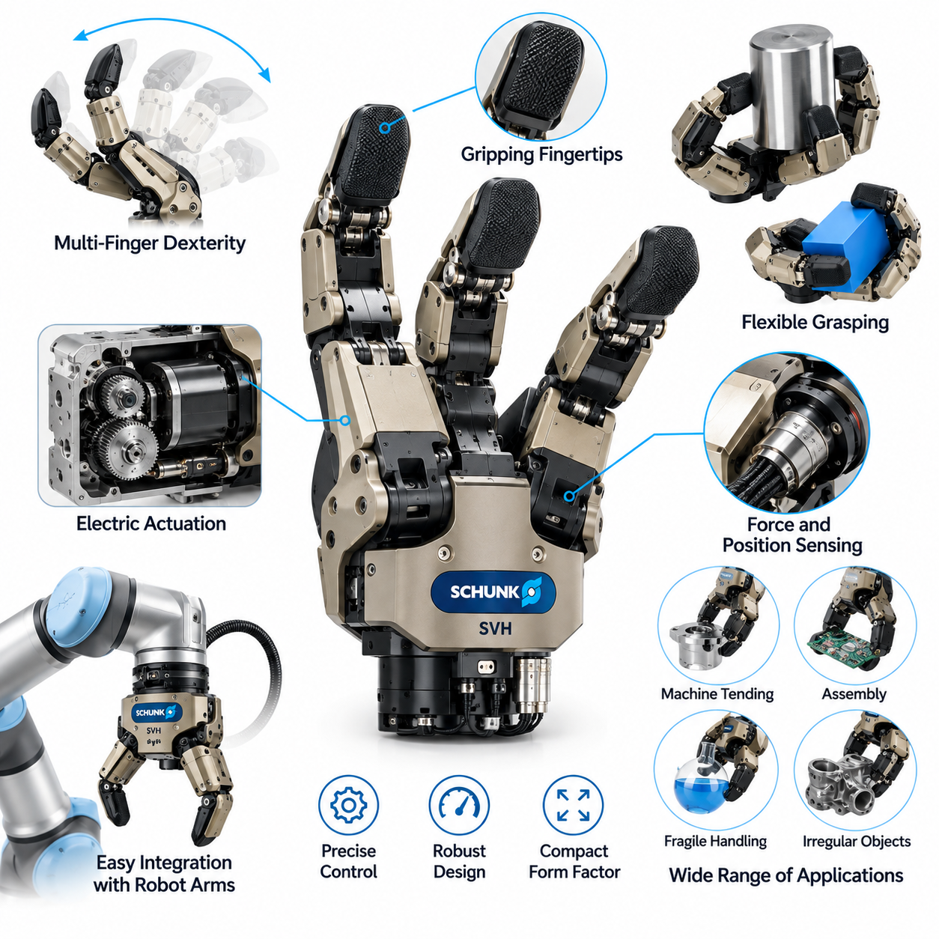
The SCHUNK SVH Hand represents an important development in anthropomorphic robotic manipulation, combining human-inspired finger geometry with electrically actuated joints and integrated control capabilities. Developed by SCHUNK, the SVH, or Servo Electric 5-Finger Gripping Hand, was designed to investigate and support complex grasping tasks. Its significance lies in demonstrating how a compact electromechanical architecture can provide coordinated multifinger manipulation within a robotic system.
Unlike conventional parallel-jaw grippers, the SCHUNK SVH incorporates five articulated fingers arranged in a human-like configuration. Its design provides nine independently actuated degrees of freedom, with additional mechanically coupled joint movements contributing to the overall hand articulation. This arrangement supports multiple grasp postures, including power grasps, precision pinches, and coordinated finger configurations. The architecture balances mechanical complexity against practical integration requirements.
The mechanical structure of the SVH emphasizes compactness, repeatability, and controlled finger articulation. Individual finger segments are connected through joint mechanisms that transmit actuator motion into coordinated movement. The thumb provides opposition against the other fingers, enabling different contact arrangements for objects of varying dimensions. Although the hand resembles human anatomy, its available joint motions and actuation structure remain more constrained than those of a biological hand.
Electric actuation is a defining feature of the SCHUNK SVH architecture. Integrated servo-driven mechanisms provide controlled finger movement without requiring the external pneumatic infrastructure associated with some anthropomorphic hands. This arrangement simplifies certain aspects of installation and system integration. However, actuator packaging, transmission efficiency, thermal management, and mechanical loading remain important engineering considerations when operating multiple fingers within a compact enclosure.
The relationship between actuator commands and finger motion depends on the hand's mechanical transmission and joint coupling. Since not every anatomical joint is independently actuated, coordinated movement must account for predefined mechanical relationships between finger segments. Joint position control provides a practical foundation for generating repeatable grasp configurations. Nevertheless, differences between commanded positions and actual contact conditions can arise from friction, compliance, object geometry, and external forces.
The SVH demonstrates the practical distinction between anthropomorphic appearance and unrestricted dexterity. Five fingers provide a broad range of grasp configurations, but the number of independently controlled joints limits arbitrary fingertip positioning. The hand is therefore particularly relevant to structured multifinger grasping rather than unrestricted human-like manipulation. Its design illustrates how carefully selected degrees of freedom can support useful grasp diversity without reproducing every anatomical capability.
Grasp planning for the SCHUNK SVH requires selecting finger configurations that match object geometry and task requirements. Cylindrical objects may benefit from encompassing contact, while smaller components can require coordinated fingertip pinching. Successful grasp formation depends on the relative positions of the thumb and fingers, available joint ranges, and accessible contact surfaces. The robot arm must also position the hand appropriately before finger closure begins.
Contact mechanics play an essential role in evaluating the SVH's manipulation performance. Multiple fingers can distribute forces across an object's surface, potentially improving stability compared with limited-contact grippers. However, grasp quality depends on friction coefficients, contact geometry, and the direction of external loads. A visually convincing grasp posture does not necessarily guarantee force closure or resistance to disturbances. Analytical models and experimental measurements are therefore necessary for reliable grasp evaluation.
Force regulation presents challenges because actuator effort does not always correspond directly to individual fingertip contact forces. Mechanical coupling and transmission losses can influence how forces are distributed between contact points. For delicate objects, excessive gripping effort may produce deformation or damage, while insufficient effort can cause slipping. Practical control strategies should therefore combine suitable motion limits, conservative force settings, and experimentally validated grasp parameters.
Sensing and feedback are important for determining whether a commanded grasp has been completed successfully. Joint position information and actuator status can support monitoring of finger motion and operating conditions. Additional external sensing may be required when applications demand detailed contact force measurements or slip detection. The SVH should not be assumed to provide the same tactile information as research hands equipped with dense fingertip sensor arrays.
The SCHUNK SVH has been associated with research and development involving humanoid robots, service robotics, and advanced manipulation systems. Its anthropomorphic configuration makes it suitable for investigating interactions with objects designed around human hand geometry. Potential tasks include grasping household items, handling selected tools, and manipulating components with different shapes. Actual performance depends on the specific object, grasp strategy, and surrounding robotic system.
Integration with a robotic arm introduces requirements involving wrist interfaces, payload capacity, communication, and control coordination. The manipulator must accommodate the hand's mass and physical dimensions while maintaining sufficient positioning accuracy. Finger movements should be synchronized with arm trajectories to avoid unintended contact or object displacement. Mechanical mounting, electrical connectivity, and software compatibility must be verified for the selected robot platform.
In mobile manipulation applications, the SVH provides a useful example of how anthropomorphic hands can extend the range of possible grasping tasks. A mobile robot equipped with such a hand may interact with objects that are difficult to handle using simple two-finger grippers. However, navigation uncertainty, platform vibration, and limited workspace access can reduce grasp reliability. Coordinated perception, arm positioning, and finger control remain essential for successful deployment.
The hand's electrical architecture offers advantages for applications where pneumatic supply systems would introduce additional complexity. Electric actuation can simplify infrastructure requirements and enable programmable motion control through compatible interfaces. Nevertheless, electrical power consumption, actuator heating, and sustained loading must be considered during system design. Compact finger mechanisms can experience thermal and mechanical constraints during repeated or prolonged gripping operations.
Compared with highly actuated research platforms such as the Shadow Dexterous Hand, the SCHUNK SVH emphasizes a more constrained electromechanical configuration. The Shadow platform offers greater independent joint control in certain configurations, while the SVH uses fewer actuated degrees of freedom to achieve coordinated anthropomorphic grasping. This comparison highlights the tradeoff between dexterity, actuator count, control dimensionality, and integration complexity. Neither architecture is universally superior across all tasks.
Benchmarking the SVH requires evaluating grasp success under representative object and environmental conditions. Relevant metrics include successful grasp completion, object retention, positioning repeatability, grasp execution time, and resistance to disturbances. Testing should involve objects with different dimensions, masses, surface materials, and geometries. Repeated trials are important because mechanical adaptability and coordinated finger movement do not automatically guarantee reliable grasping across unfamiliar objects.
Reliability assessment should examine joint wear, actuator performance, transmission integrity, and the effects of repeated grasping cycles. Compact electromechanical mechanisms may experience changes in friction, backlash, and mechanical alignment over time. Environmental conditions such as dust, temperature, and vibration can further influence operating performance. Periodic inspection, calibration, and appropriate operating limits help preserve repeatability and reduce the risk of unexpected mechanical failures.
From an industrial perspective, the SVH illustrates both the potential and limitations of anthropomorphic gripping systems. Its multifinger architecture can support object diversity and complex grasp postures, but additional mechanical and control complexity may not be justified for highly repetitive operations. Conventional industrial grippers often remain preferable when objects have standardized geometries and high cycle-time efficiency is required. The SVH becomes more attractive when task flexibility and human-oriented object interaction are important.
The SCHUNK SVH case study demonstrates that useful anthropomorphic grasping can be achieved through a carefully constrained number of independently actuated joints. Its design combines human-inspired finger arrangements, electric actuation, coordinated joint movement, and robotic system integration. The central engineering lesson is that effective manipulation depends on matching mechanical freedom, control complexity, sensing capability, and application requirements. The SVH remains a valuable reference for evaluating practical multifinger robotic hand architectures.

15.04 Allegro Hand
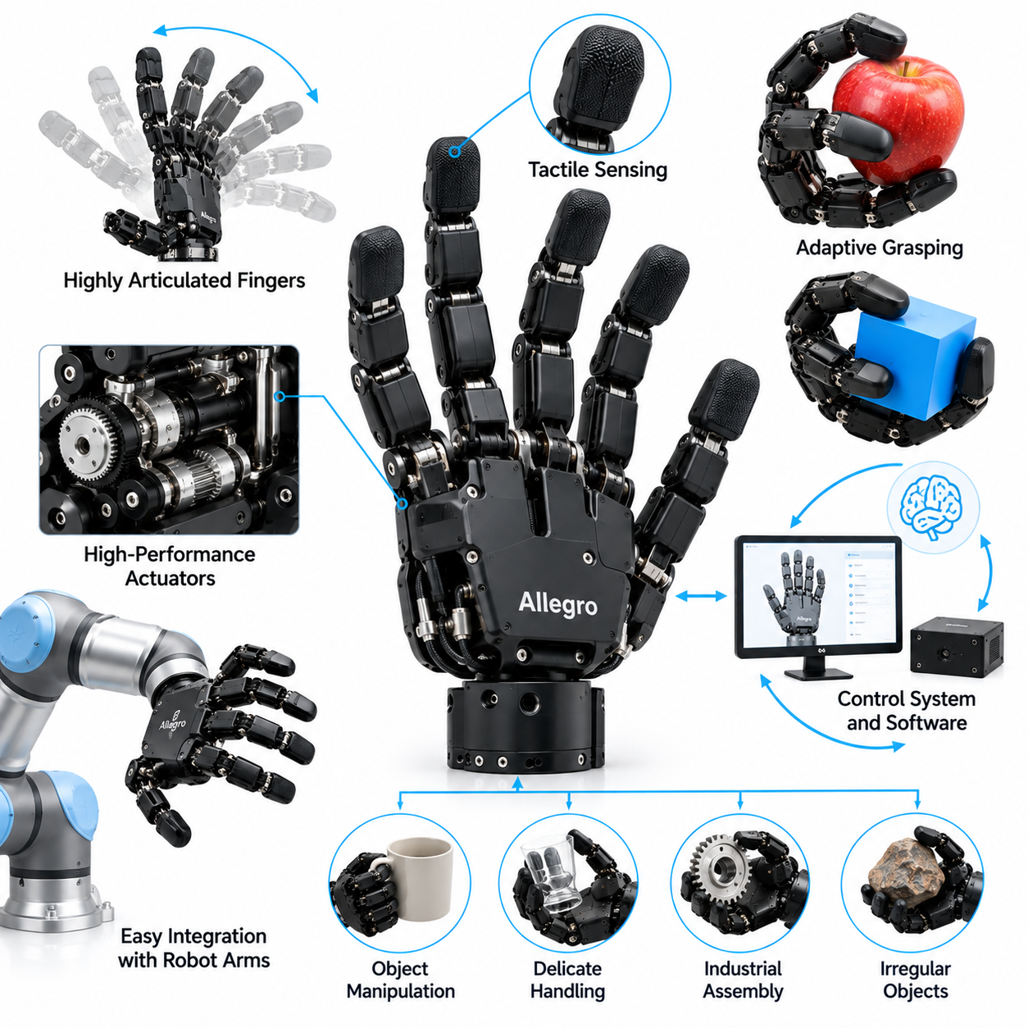
The Allegro Hand represents a significant platform for research in dexterous robotic manipulation, combining a compact mechanical structure with independently actuated finger joints and programmable control. Developed by Wonik Robotics, the hand is widely used in academic and industrial research involving grasp planning, reinforcement learning, and coordinated finger manipulation. Its importance lies in providing a relatively accessible experimental platform for studying complex multifinger control.
The Allegro Hand features four articulated fingers, including an opposable thumb, with four independently actuated joints per finger. This configuration provides sixteen actuated degrees of freedom, allowing researchers to investigate coordinated fingertip positioning and object manipulation. Although it has fewer fingers than a human hand, its joint arrangement supports diverse grasp postures. The architecture offers a practical balance between mechanical capability and control complexity.
The mechanical design emphasizes compactness, relatively low mass, and modular electromechanical construction. Each finger contains articulated segments connected through rotary joints, allowing controlled flexion and coordinated positioning. The palm provides structural support and establishes the relative arrangement of the fingers. Different hand configurations, including left-handed and right-handed versions, support integration with robotic arms and experimental manipulation platforms.
Electric motor actuation is a defining feature of the Allegro Hand. Its joints are driven through compact motor and transmission mechanisms that enable programmable position and torque-related control. Independent actuation provides greater flexibility than mechanically coupled adaptive grippers because individual finger joints can follow separate control commands. However, actuator limits, transmission friction, mechanical backlash, and thermal behavior must be considered when designing demanding manipulation tasks.
The hand's sixteen-dimensional joint configuration creates a challenging control problem. Even relatively simple grasping tasks require coordinated movement across multiple fingers, while object manipulation introduces additional contact constraints. Joint-space control provides a foundation for positioning the fingers, but accurate fingertip motion also requires forward and inverse kinematic models. Researchers must consider joint limits, reachable workspaces, and potential collisions between fingers and surrounding objects.
Fingertip trajectory planning is particularly important when the Allegro Hand performs precision manipulation. Each fingertip must approach the intended contact region while avoiding unintended collisions. The controller must coordinate multiple trajectories so that fingers establish contact at appropriate moments. Because the object may move during contact formation, purely open-loop positioning is often insufficient. Feedback and adaptive correction can improve reliability when object geometry or initial pose is uncertain.
The Allegro Hand supports a wide range of grasp configurations, including fingertip pinching, multidigit contact, and enveloping grasps within its mechanical workspace. Different objects require different combinations of finger placement and contact force. Small components may benefit from precision contacts, while larger objects may require distributed support across several fingers. Successful grasp planning therefore depends on object geometry, friction properties, and the intended manipulation objective.
Contact mechanics are central to understanding the hand's capabilities. Multiple fingertip contacts can generate forces and moments that stabilize an object against external disturbances. Grasp quality depends on contact locations, friction coefficients, and the available joint torques. Analytical concepts such as force closure and grasp wrench space provide useful evaluation methods. Nevertheless, actual performance may differ from idealized models because physical contacts involve compliance, friction uncertainty, and deformation.
Force and torque control are essential when manipulating objects with different mechanical properties. The controller must provide sufficient gripping force to prevent slipping while avoiding excessive pressure that could damage delicate materials. Joint torque commands or estimates can support force regulation, but they do not necessarily provide direct measurement of individual fingertip contact forces. Accurate contact-force estimation may require mechanical models, calibration, and additional sensing.
Tactile sensing is an important extension for Allegro Hand research. Standard configurations should not automatically be assumed to include dense tactile sensor arrays, but researchers can integrate compatible fingertip or surface sensors for contact-rich tasks. These sensors may provide information about contact location, pressure distribution, or slip-related changes. Combining tactile observations with joint feedback and visual perception can improve grasp monitoring and manipulation decisions.
In-hand manipulation is one of the most important research applications of the Allegro Hand. The robot can attempt to change an object's orientation or position through coordinated finger movements without fully releasing it. Such operations may involve rolling, pivoting, finger gaiting, and controlled regrasping. These tasks require careful management of contact transitions because changing one finger's position can destabilize the object if the remaining contacts are insufficient.
The Allegro Hand has become a useful platform for reinforcement learning research because its independently actuated joints provide a rich action space. Learning algorithms can explore coordinated finger behaviors that are difficult to design manually. Policies may be trained to rotate objects, maintain stable grasps, or recover from disturbances. However, learning high-dimensional manipulation policies requires substantial training data, carefully designed objectives, and reliable simulation or experimental environments.
Simulation plays a major role in developing Allegro Hand manipulation policies. Physics-based environments can represent joint dynamics, collisions, friction, and object motion, allowing researchers to conduct repeated experiments without continuously using physical hardware. Simulation also supports parameter variation and systematic testing. Nevertheless, differences between simulated and real contact behavior can reduce performance when policies are transferred directly to the physical hand.
Sim-to-real transfer is therefore an important consideration in Allegro Hand research. Domain randomization can expose learning policies to variations in friction, mass, actuator behavior, and object geometry during simulated training. System identification can further improve model accuracy by estimating relevant hardware parameters. Combining these techniques with real-world calibration and feedback control can improve robustness, although reliable transfer remains dependent on the target task and operating conditions.
The integration of visual perception provides additional capabilities for object-centered manipulation. External cameras or depth sensors can estimate object position, orientation, and surrounding geometry before grasp execution. During manipulation, visual feedback can help detect unexpected object movement or deviations from the target pose. Combining vision with proprioceptive joint information supports more complete state estimation, particularly when the controller must coordinate finger movements around changing contact configurations.
For robotic arm integration, the Allegro Hand requires suitable mechanical mounting, electrical interfaces, and communication compatibility. The arm must support the hand's mass while maintaining appropriate wrist positioning and motion accuracy. Manipulation planning must coordinate arm movement with finger trajectories, especially during object acquisition and placement. The combined system should account for reachable workspace, collision constraints, actuator limits, and the stability of the grasped object.
In mobile manipulation systems, the Allegro Hand can extend the range of tasks beyond those supported by conventional parallel-jaw grippers. A mobile robot equipped with the hand may investigate tool handling, object reorientation, and manipulation of irregular components. However, platform vibration, localization uncertainty, and restricted access to objects introduce additional challenges. Effective operation requires coordinated navigation, perception, arm control, and dexterous hand manipulation.
Benchmarking the Allegro Hand requires evaluation across both grasping and manipulation tasks. Relevant metrics include grasp success rate, object orientation accuracy, manipulation completion time, joint tracking error, and recovery from disturbances. Experiments should include objects with different geometries, masses, and surface properties. Repeated trials under controlled conditions help distinguish reliable capabilities from isolated demonstrations and support comparisons between analytical and learning-based controllers.
Reliability and maintenance considerations include joint wear, actuator heating, transmission performance, and electrical connectivity. Repeated high-load manipulation can increase mechanical stress and influence control accuracy over time. Calibration procedures and appropriate torque limits help maintain consistent operation. For extended research experiments, monitoring actuator conditions and recording failures are important for separating hardware limitations from weaknesses in manipulation algorithms.
The Allegro Hand case study demonstrates how a compact, independently actuated multifinger platform can support advanced research in robotic grasping and dexterous manipulation. Its sixteen actuated degrees of freedom create opportunities for investigating coordinated control, tactile integration, reinforcement learning, and sim-to-real transfer. The central engineering lesson is that useful dexterity emerges from the integration of mechanical design, sensing, contact modeling, and intelligent control rather than joint count alone.

15.05 OpenAI Dactyl
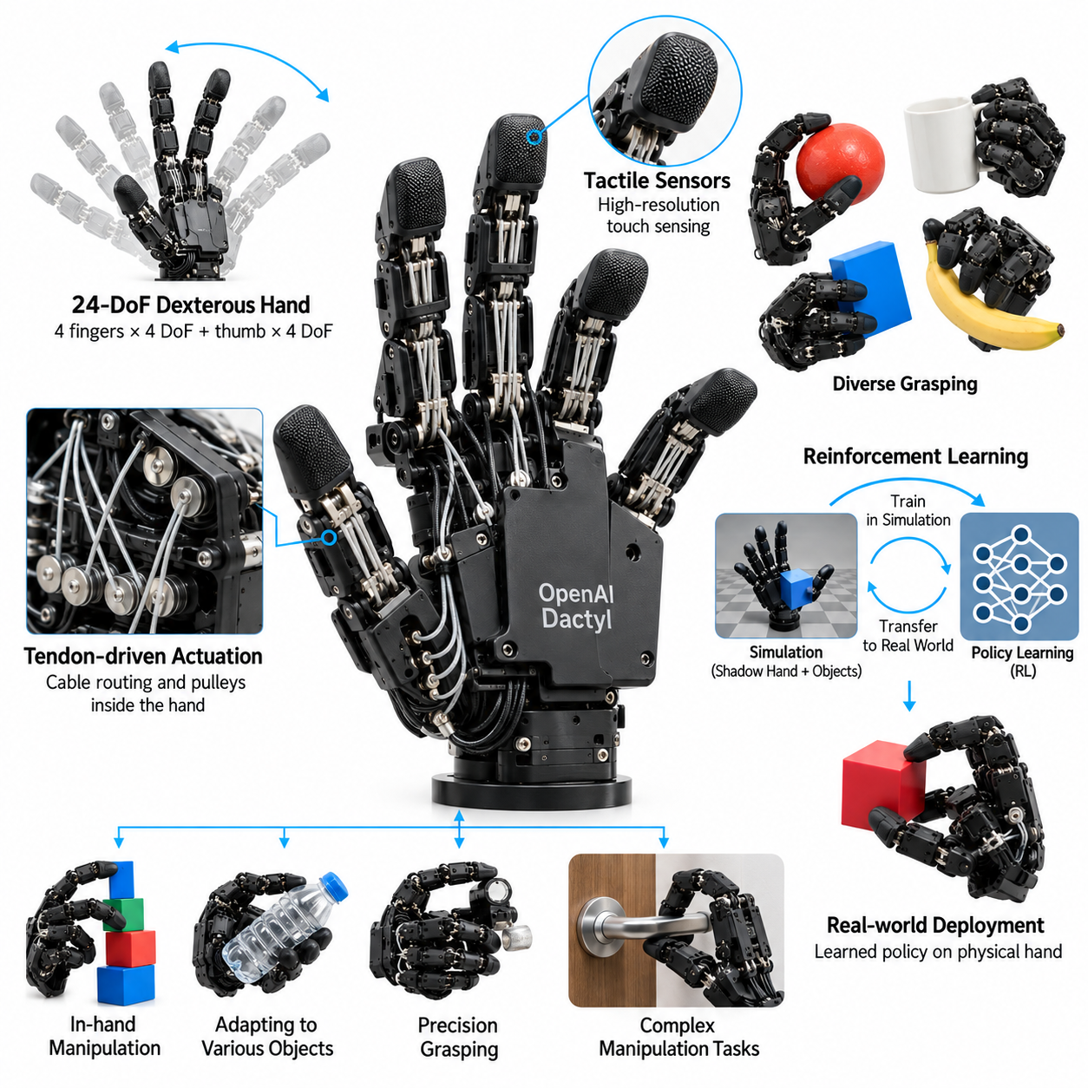
The OpenAI Dactyl project represents a major milestone in learning-based dexterous robotic manipulation, demonstrating how reinforcement learning can control a complex robotic hand through extensive simulation training. The project used a Shadow Dexterous Hand to manipulate physical objects without relying entirely on manually programmed finger trajectories. Its significance lies in connecting high-dimensional robotic control, simulation, domain randomization, and real-world manipulation.
The central objective of Dactyl was to develop a robotic system capable of manipulating objects through coordinated finger movements. Unlike conventional grasping systems that primarily acquire and transport objects, Dactyl investigated continuous object reorientation within the hand. This task requires maintaining contact stability while adjusting finger positions and forces. The resulting control problem combines complex hand kinematics, nonlinear contact dynamics, and uncertainty in physical interactions.
The experimental platform incorporated a five-finger Shadow Dexterous Hand with multiple articulated joints and independently controllable motions. The hand provided a challenging action space because coordinated manipulation required simultaneous control of numerous joints. External sensing and joint feedback supplied information about the object and hand state. This hardware configuration enabled researchers to investigate manipulation policies that would be difficult to construct using conventional rule-based control.
Reinforcement learning formed the foundation of the Dactyl control strategy. A policy learned to select actions by interacting with simulated environments and receiving feedback based on manipulation objectives. Training encouraged the hand to rotate an object toward a desired orientation while maintaining sufficient control to prevent failure. Rather than explicitly programming every contact transition, the learning process discovered coordinated behaviors through repeated simulated experience.
One of the project's most important innovations was its extensive use of domain randomization. During training, simulation parameters were varied to expose the policy to different physical conditions. These variations included object properties, friction, actuator behavior, and other environmental factors. By learning across a distribution of simulated environments, the controller became less dependent on any single physical model and more capable of tolerating discrepancies between simulation and reality.
The Dactyl research demonstrated that accurate simulation alone is not sufficient to guarantee successful physical manipulation. Contact-rich tasks are particularly difficult to model because small differences in friction, compliance, or collision behavior can produce large changes in object motion. Domain randomization addressed this limitation by emphasizing robustness across uncertain dynamics. This approach provided an alternative to relying exclusively on highly precise system identification and handcrafted contact models.
The initial Dactyl research demonstrated learned in-hand manipulation of a cube using a physical robotic hand. The system was trained primarily in simulation and transferred to hardware without requiring equivalent amounts of physical trial-and-error training. The results showed that reinforcement learning could discover coordinated finger movements capable of producing controlled object rotations. However, the demonstrated capability remained task-specific rather than representing unrestricted human-level dexterity.
A subsequent development, commonly associated with solving a Rubik's Cube using a robot hand, extended the research toward more demanding manipulation sequences. This work combined learned robotic control with additional perception and planning components. The hand executed physical cube rotations while higher-level logic determined the required sequence of transformations. The achievement illustrated the importance of integrating learned motor skills with structured task planning.
Automatic domain randomization further extended the training methodology by adjusting the difficulty of simulated environments during learning. Instead of using only a fixed distribution of randomized parameters, the training process progressively explored more challenging conditions as policy performance improved. This approach helped expose the controller to increasingly diverse dynamics. It also demonstrated how training environment design can influence the robustness of learned manipulation policies.
The project highlighted the distinction between high-level task objectives and low-level motor control. A high-level system can specify the desired orientation or transformation of an object, while a learned control policy determines the finger movements needed to achieve it. This separation reduces the need to manually specify every joint trajectory. Nevertheless, successful execution still depends on reliable state estimation, suitable action representations, and carefully defined task objectives.
Visual perception played an important role in estimating object state during manipulation. Camera-based observations provided information about object orientation, while proprioceptive measurements described the robotic hand's joint configuration. Combining these information sources allowed the controller to relate hand motion to object movement. Perception errors, occlusion, and sensor delays remained important challenges because inaccurate state estimates could destabilize manipulation.
The Dactyl experiments also demonstrated the importance of observation and action timing. Robotic manipulation requires continuous interaction between sensing, policy inference, and actuator control. Delays or inconsistencies in this loop can affect contact stability, particularly when objects move rapidly or contact points change. Training procedures therefore need to account for relevant control frequencies, actuator response characteristics, and observation uncertainty.
From a mechanical perspective, Dactyl illustrated how complex robotic hardware can support behaviors that are difficult to derive analytically. The Shadow Dexterous Hand offered many controllable joints, enabling diverse contact configurations and object movements. However, the same mechanical freedom created a high-dimensional control problem. Reinforcement learning provided a method for exploring coordinated joint behaviors without requiring a complete manually designed manipulation strategy.
The relationship between simulation and physical hardware was central to the project's engineering methodology. Simulated training environments allowed large numbers of manipulation attempts without subjecting the physical robot to equivalent mechanical wear. Hardware experiments were then used to evaluate whether the learned policy generalized to real conditions. This workflow reduced dependence on expensive physical data collection, although real-world testing remained necessary for validating performance.
Dactyl also revealed important limitations of reinforcement learning for dexterous manipulation. Training required substantial computational resources, carefully designed objectives, and sophisticated simulation infrastructure. Policies could remain sensitive to unfamiliar objects, extreme physical conditions, or perception failures outside the training distribution. Consequently, success on a demanding benchmark did not automatically establish general-purpose manipulation capability across arbitrary objects and environments.
The project's relevance extends beyond anthropomorphic robotic hands. Domain randomization, simulation-based learning, and robust policy transfer can also support robotic arms, mobile manipulators, and other contact-rich systems. Applications involving uncertain friction, changing payloads, or complex interactions may benefit from similar methods. However, the effectiveness of these techniques depends on whether simulated variability adequately represents the disturbances encountered during actual operation.
For mobile manipulation systems, the Dactyl approach suggests a layered architecture combining perception, task planning, learned manipulation policies, and low-level actuator control. A mobile robot must additionally coordinate navigation, arm positioning, and hand manipulation. Uncertainty in platform localization and object pose can propagate into grasp execution. Robust policies may compensate for some variability, but reliable deployment still requires system-level coordination and safety mechanisms.
Benchmarking Dactyl-style manipulation should examine more than isolated task completion. Relevant measurements include object orientation accuracy, successful manipulation sequences, recovery from disturbances, execution time, and robustness under changes in physical parameters. Evaluation should distinguish performance in simulation from performance on real hardware. Repeated trials across controlled variations are essential for determining whether learned policies generalize beyond familiar training conditions.
The OpenAI Dactyl project provides a foundational case study in the convergence of reinforcement learning, robotic simulation, and physical manipulation. It demonstrated that complex finger coordination can emerge from simulated experience and transfer to real robotic hardware through robust training methods. The central engineering lesson is that successful dexterity depends not only on sophisticated mechanisms but also on learning systems capable of handling uncertainty, contact dynamics, and changing physical conditions.

15.06 Google RT-2 Grasping
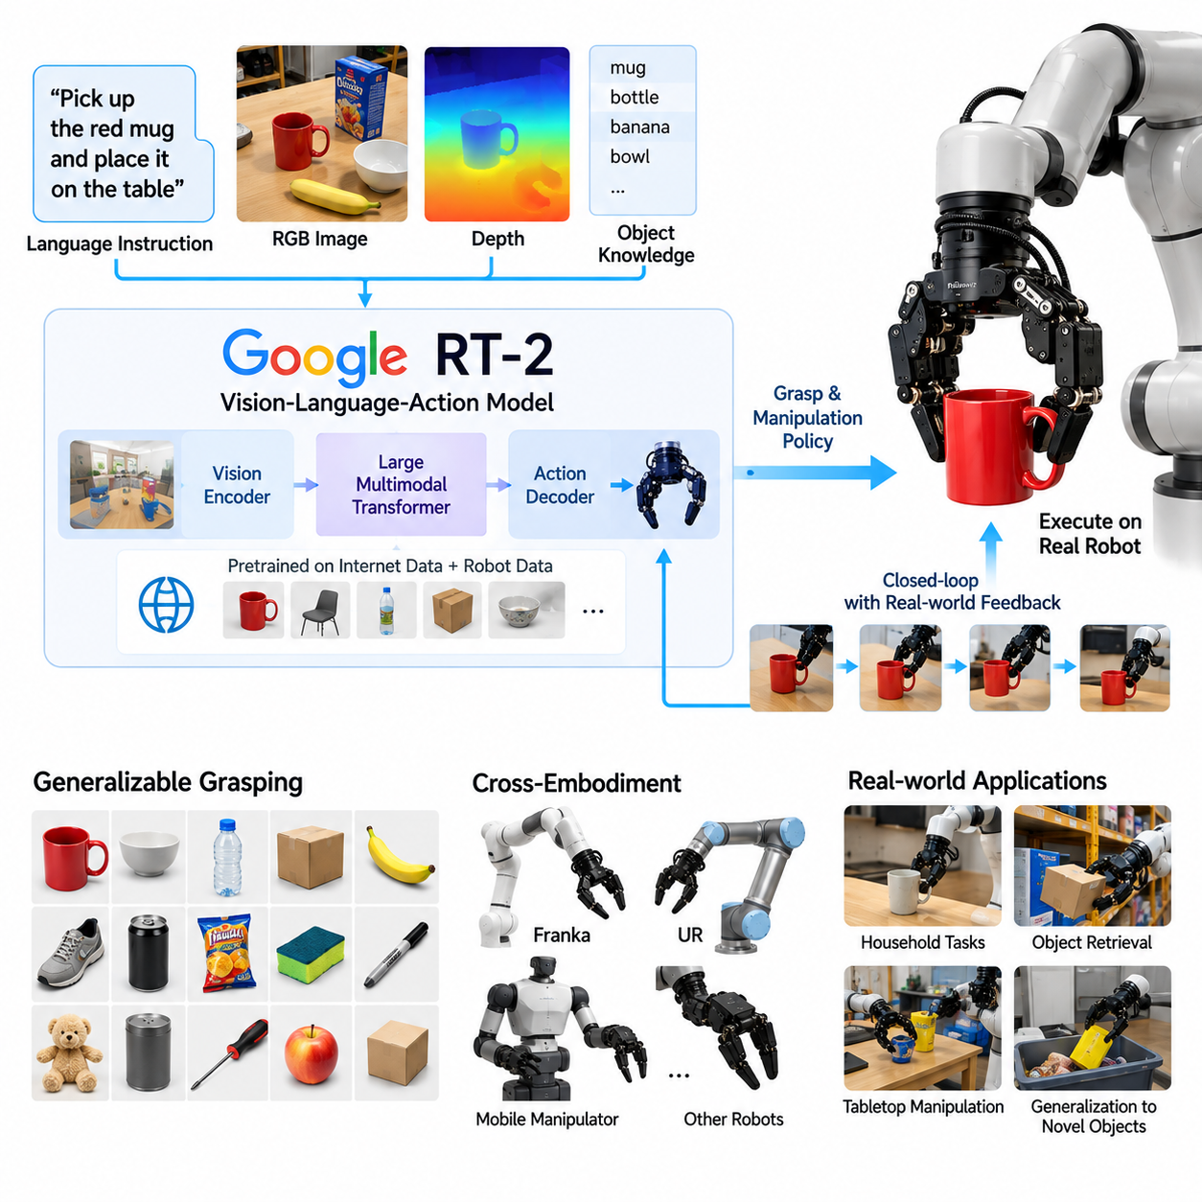
Google RT-2 represents an important development in vision-language-action learning, demonstrating how knowledge acquired from large-scale vision-language pretraining can support robotic manipulation. Introduced by Google DeepMind in 2023, RT-2 extends the capabilities of vision-language models by connecting visual observations and natural-language instructions to robot actions. Its significance lies in improving the generalization of robotic behaviors beyond narrowly defined training tasks.
Traditional robotic grasping systems often depend on explicitly programmed perception pipelines, geometric grasp planners, and task-specific controllers. RT-2 explores a different approach by learning relationships between visual scenes, linguistic instructions, and executable actions. Instead of treating perception, semantic reasoning, and action generation as completely separate components, the model integrates them within a shared learning framework. This enables more flexible interpretation of manipulation requests.
RT-2 belongs to the vision-language-action model family, commonly abbreviated as VLA. Its architecture builds upon pretrained vision-language models, including PaLI-X and PaLM-E variants investigated in the original research. These models process visual and textual information while learning to produce representations suitable for robotic action prediction. The approach transfers semantic knowledge from broad visual and language datasets into manipulation tasks.
A defining feature of RT-2 is its representation of robotic actions as tokens. Continuous robot commands are discretized and expressed in a format compatible with language-model training. Action dimensions can describe end-effector translation, rotation, gripper operation, and related control variables. By predicting action tokens, the model connects language-style sequence generation with physical robot execution, although low-level controllers remain necessary to realize the commands.
The training strategy combines robot demonstration data with large-scale vision-language information. Robot trajectories teach the model relationships between observations, instructions, and successful actions, while internet-scale visual and textual data contribute broader semantic understanding. Joint fine-tuning helps preserve general knowledge while adapting the model to robotic control. This combination reduces exclusive dependence on narrowly collected manipulation datasets.
For grasping applications, RT-2 interprets object identity and task intent from visual observations and language instructions. A request to pick up a particular object requires recognizing the target, distinguishing it from surrounding items, and selecting an appropriate manipulation behavior. The model can exploit semantic relationships learned during pretraining, including object categories and functional associations. However, semantic understanding alone does not guarantee mechanically stable grasp execution.
The original RT-2 demonstrations used robotic manipulation platforms equipped with camera-based perception and gripper-equipped arms. The system generated action commands for these platforms rather than directly controlling every joint of a highly articulated anthropomorphic hand. This distinction is important when interpreting RT-2 as a grasping case study. Its principal contribution concerns semantic generalization and action generation, not the demonstration of advanced multifinger in-hand manipulation.
One important capability investigated in RT-2 was generalization to objects and instructions not explicitly represented in robot training examples. The model could use knowledge acquired from vision-language pretraining to interpret unfamiliar categories and relationships. For example, an instruction involving an object associated with a particular purpose could require semantic reasoning beyond visual shape recognition. Such behavior illustrates the value of combining pretrained knowledge with embodied action learning.
RT-2 also demonstrated forms of reasoning that connect language understanding with physical tasks. Instructions may involve spatial relationships, object functions, or simple symbolic associations. The model must translate these concepts into actions that can be executed in the observed environment. This capability differs from conventional grasp planning, where the target object and desired grasp configuration are typically specified through more explicit geometric representations.
The relationship between semantic reasoning and physical feasibility remains a central engineering challenge. A model may correctly identify the requested object while selecting an action that fails because of poor approach geometry, inadequate gripping force, or environmental obstruction. Reliable grasping therefore requires coordination between high-level action prediction and physical constraints. Collision avoidance, reachable workspace limits, and grasp stability remain essential considerations.
Visual perception strongly influences RT-2 performance because action predictions depend on the observed scene. Camera images provide information about object appearance, relative position, and surrounding context. However, occlusion, reflective surfaces, changing illumination, and ambiguous object boundaries can reduce perception reliability. Additional depth sensing, geometric estimation, or tactile feedback may improve downstream execution, although these capabilities are not automatically supplied by the RT-2 architecture.
The action-token formulation offers a practical connection between foundation models and robotic control. A model can predict a structured action sequence using a learning framework originally developed for multimodal sequence prediction. Nevertheless, discretization introduces tradeoffs involving action resolution, control frequency, and computational latency. Physical execution still requires conversion of predicted actions into actuator-compatible commands through the robot's control infrastructure.
RT-2 provides an example of transferring knowledge from web-scale data into embodied intelligence. Large visual-language datasets contain information about object categories, everyday activities, and semantic relationships that may be difficult to collect through robot demonstrations alone. Such knowledge can support task interpretation and object selection in unfamiliar environments. However, internet-derived information does not directly encode precise contact dynamics, actuator limitations, or grasp forces.
From a learning perspective, RT-2 highlights the importance of combining broad pretraining with task-specific robotic experience. Vision-language pretraining provides semantic representations, while robot trajectories establish the connection between those representations and executable movements. Neither source is sufficient by itself for reliable physical manipulation. The effectiveness of the combined model depends on data quality, training distribution, action representation, and the capabilities of the target hardware.
Generalization should be evaluated separately from task completion on familiar objects. Relevant experiments include unseen-object grasping, novel language instructions, changes in background appearance, and variations in object placement. Metrics may include task success rate, target selection accuracy, execution time, and recovery from failed attempts. Comparisons should distinguish semantic generalization from improvements caused by better hardware, perception, or conventional control.
RT-2 also raises important deployment considerations involving computational requirements and response latency. Large multimodal models can demand substantial processing resources, while physical robots require timely action generation. System designers must balance model capacity against inference speed, communication reliability, and energy consumption. Local inference, optimized execution, and suitable control hierarchies may be necessary for applications that cannot tolerate unpredictable network delays.
For mobile manipulators, RT-2 suggests an architecture in which language instructions and visual observations guide object-oriented actions. Navigation and arm positioning can establish a suitable manipulation workspace before the action model commands the gripper. However, the original RT-2 results should not be interpreted as proof of complete autonomous mobile manipulation. Navigation, safety supervision, force regulation, and task recovery require additional system-level capabilities.
The distinction between RT-2 and dexterous-hand platforms such as Allegro Hand or Shadow Dexterous Hand is especially important. Allegro and Shadow provide physical mechanisms for independently controlling multiple fingers, whereas RT-2 provides a learned method for connecting multimodal observations to robot actions. These technologies address different layers of the manipulation problem. Integrating VLA reasoning with dexterous hardware is a promising direction, but requires appropriate action representations and training data.
The Google RT-2 grasping case study demonstrates how foundation-model knowledge can improve the flexibility of robotic task interpretation and action generation. Its main contribution is the transfer of semantic understanding from vision-language learning into embodied manipulation. The central engineering lesson is that intelligent grasping requires both meaningful task understanding and reliable physical execution. Future systems must integrate semantic generalization, geometric reasoning, contact-aware control, and robust real-world feedback.

15.07 Tesla Optimus Hand
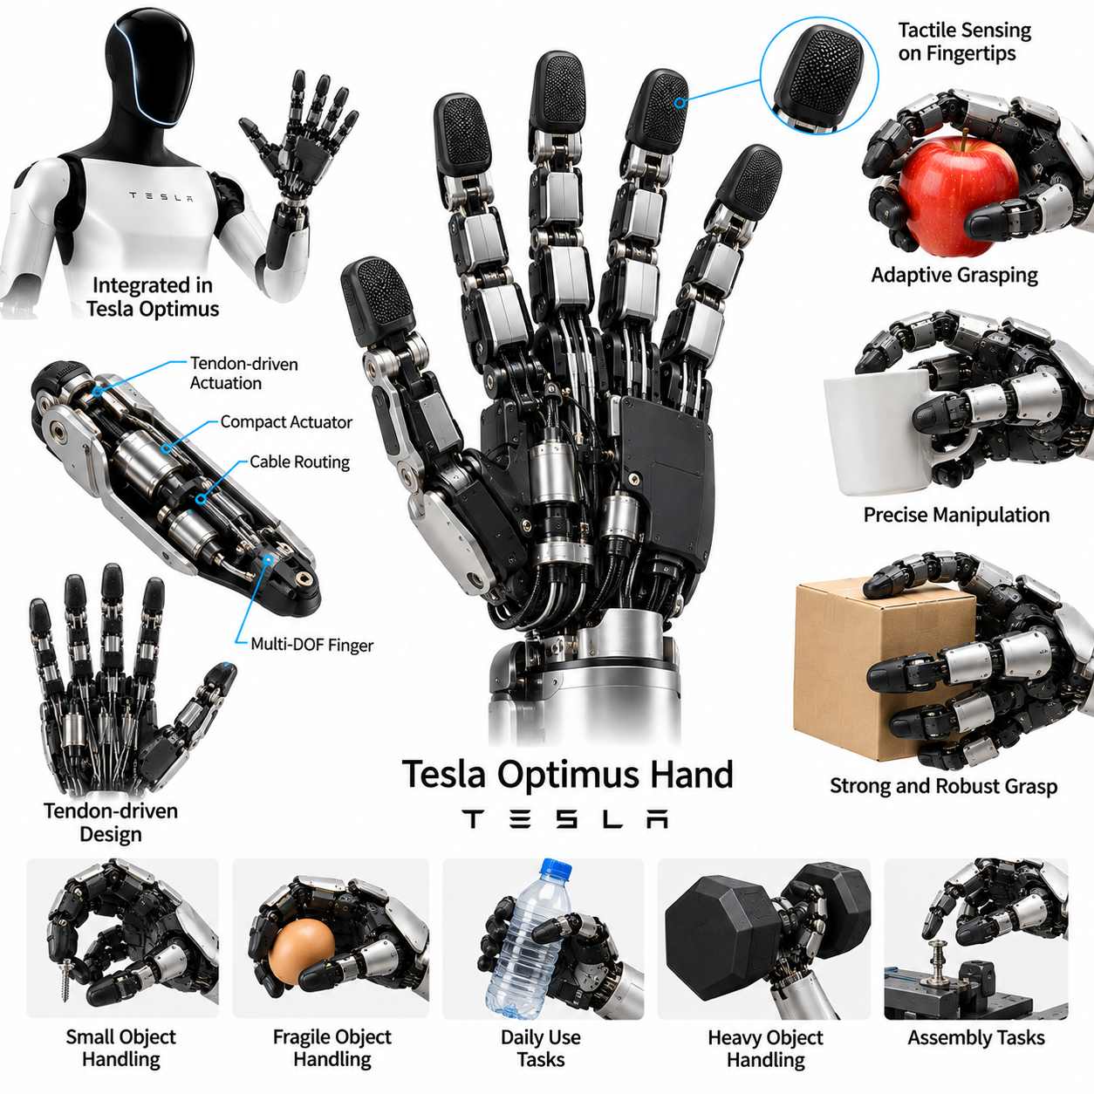
The Tesla Optimus Hand represents an important approach to humanoid robotic manipulation, emphasizing the integration of anthropomorphic finger mechanisms, electric actuation, sensing, and learned control. Developed as part of Tesla's Optimus humanoid robot program, the hand is intended to support everyday object handling and industrial tasks. Its significance lies in the effort to combine dexterity, manufacturability, reliability, and system-level autonomy.
The Optimus hand has evolved through successive hardware prototypes rather than remaining a fixed mechanical design. Public demonstrations have shown increasingly sophisticated finger movements and object manipulation capabilities. Tesla has described newer hand designs incorporating additional degrees of freedom and tendon-driven mechanisms. However, detailed specifications, production configurations, and independently verified performance characteristics remain limited in publicly available technical documentation.
Anthropomorphic geometry is central to the Optimus hand concept because many tools, containers, and workplace objects are designed for human interaction. Five-finger arrangements can provide different grasp patterns, including fingertip pinching, cylindrical grasping, and broader enveloping contact. The opposable thumb plays an important role in establishing stable contact configurations. Nevertheless, human-like appearance does not automatically imply human-equivalent joint mobility or manipulation capability.
The mechanical architecture must balance finger articulation, actuator packaging, structural stiffness, and overall hand mass. Compact joints and transmission mechanisms allow multiple fingers to operate within a constrained volume. Tendon-driven arrangements can relocate some actuator mass away from the fingertips, potentially improving distal inertia. However, tendon routing, friction, tension maintenance, and mechanical wear introduce additional engineering challenges.
Electric actuation is particularly relevant to the Optimus platform because the robot must operate using an integrated electrical power system. Motors and associated transmissions convert electrical energy into controlled finger motion. Position, velocity, and force-related commands must respect actuator limits and mechanical constraints. Efficient actuation is important because hand operation contributes to the overall power consumption and thermal load of a battery-powered humanoid robot.
Finger coordination requires a control architecture capable of managing multiple joints and contact conditions simultaneously. Joint-level controllers regulate actuator motion, while higher-level manipulation policies determine desired grasp configurations. Coordinated control becomes particularly challenging when fingers contact an object at different moments. Stable operation requires appropriate motion timing, contact detection, and adjustments that account for uncertainty in object geometry and placement.
Grasp planning for the Optimus hand must accommodate objects with different shapes, masses, and surface characteristics. Small components may require precise fingertip placement, while larger objects may benefit from distributed contact across several fingers. Successful grasp execution depends on approach direction, finger configuration, and available friction. A general-purpose humanoid hand must therefore support multiple grasp strategies rather than relying on one predefined closing motion.
Tactile sensing is a critical capability for manipulation in environments where visual information alone cannot determine contact conditions. Sensors located within fingers or contact surfaces can potentially provide information about pressure, contact location, and changing loads. Such feedback can support grip adjustment and slip prevention. Although Tesla has discussed tactile capabilities, the exact sensing architecture and performance should be distinguished from assumptions based on demonstrations.
Visual perception provides complementary information about object identity, position, orientation, and surrounding obstacles. Camera observations can guide the hand toward suitable contact regions before grasp formation. During manipulation, visual feedback may reveal unexpected object movement or errors in placement. Combining visual observations with joint feedback and tactile measurements offers a path toward more reliable state estimation and closed-loop manipulation.
Learning-based control is an important direction for the Optimus program because general-purpose manipulation involves many tasks that are difficult to program individually. Demonstration learning and imitation learning can associate observed tasks with appropriate robot actions. Reinforcement learning may further support adaptation and contact-rich control. However, the precise training methods used for particular public demonstrations should not be inferred without supporting technical disclosures.
Teleoperation and human demonstrations can provide valuable data for developing humanoid manipulation policies. Human operators may guide robotic movements while recording visual observations, joint trajectories, and task outcomes. These demonstrations can help initialize policies for grasping, sorting, and object placement. Nevertheless, successful teleoperated performance must be distinguished from autonomous execution because the two require different levels of perception, planning, and decision-making.
In-hand manipulation represents a demanding objective for anthropomorphic robotic hands. Changing an object's orientation without releasing it requires coordinated finger repositioning and careful management of contact forces. Potential behaviors include controlled rolling, pivoting, and regrasping. Such capabilities would increase the versatility of a humanoid robot, but their reliable execution across unfamiliar objects requires more than visually convincing demonstrations.
The Optimus hand must function as part of a complete humanoid manipulation system rather than as an isolated gripper. Arm trajectories, wrist orientation, torso posture, and balance influence the forces experienced during object handling. A grasp that is stable during stationary testing may become unreliable when the robot walks or changes posture. Whole-body coordination is therefore essential for integrating dexterous manipulation with humanoid mobility.
Industrial applications provide a potential environment for evaluating the practical value of the Optimus hand. Tasks such as component transfer, material sorting, and handling objects designed for human workers may benefit from anthropomorphic manipulation. However, many repetitive industrial operations remain better served by specialized grippers. The economic justification for a humanoid hand depends on task diversity, cycle time, reliability, maintenance requirements, and integration costs.
Safety is particularly important when a humanoid robot operates near people or handles fragile objects. Finger mechanisms must avoid excessive contact forces, unintended pinching, and uncontrolled motion. Appropriate force limits, collision monitoring, and fault handling can reduce risk during manipulation. Safety design must also consider the entire robot, since arm movement and body motion may create hazards that cannot be addressed through hand control alone.
Manufacturability and maintenance distinguish commercial humanoid hand development from purely experimental research platforms. A deployable design must consider component count, assembly complexity, calibration effort, replacement procedures, and production consistency. Tendon-driven mechanisms may require attention to tension adjustment and wear. The practical value of increased dexterity must therefore be evaluated against manufacturing cost, serviceability, and long-term operational reliability.
Benchmarking the Optimus hand requires standardized tests rather than relying exclusively on selected demonstration videos. Relevant metrics include grasp success rate, object diversity, manipulation accuracy, execution time, sustained operating performance, and recovery from disturbances. Tests should distinguish teleoperated, scripted, and autonomous behaviors. Independent repetition under controlled conditions is necessary to establish reliable comparisons with other robotic hand platforms.
The Optimus approach differs from research platforms such as the Allegro Hand and Shadow Dexterous Hand in its emphasis on integration into a potentially scalable humanoid product. Research hands often prioritize experimental flexibility and access to detailed control interfaces. A commercial humanoid hand must additionally satisfy constraints involving manufacturing, power consumption, maintenance, and fleet operation. These different priorities influence mechanical design and control architecture.
The Tesla Optimus Hand case study illustrates the broader challenge of translating dexterous manipulation research into practical humanoid robotics. Anthropomorphic mechanisms, electric actuation, multimodal sensing, and learned policies must operate together within strict physical and economic constraints. The central engineering lesson is that useful robotic dexterity depends on measurable task performance, robust system integration, and reliable autonomous operation rather than mechanical sophistication or demonstration quality alone.

15.08 Figure AI Hand
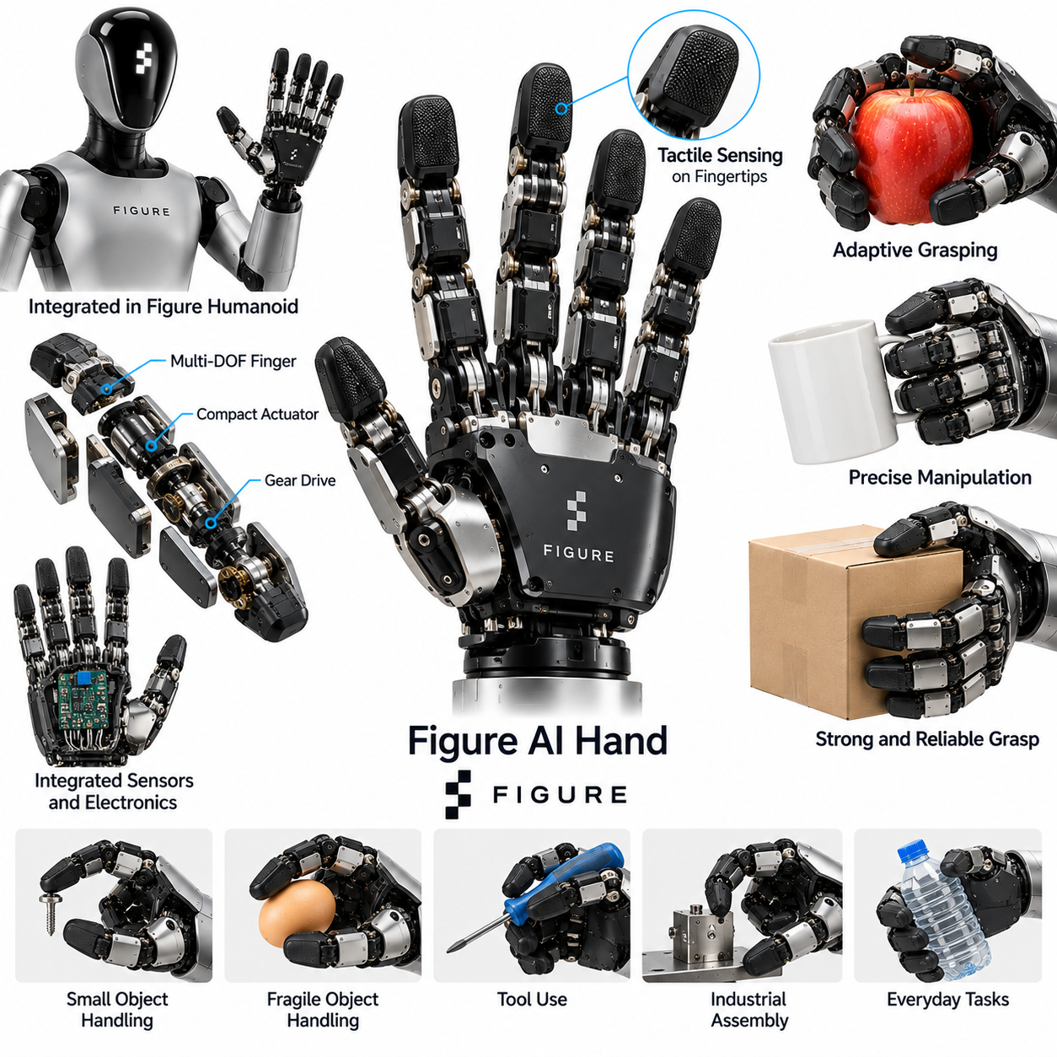
The Figure AI Hand represents an important development in humanoid robotic manipulation, combining anthropomorphic finger design with electric actuation and learning-based control. Developed for Figure AI's humanoid robot platforms, the hand is intended to support object handling in environments designed for human workers. Its significance lies in the effort to integrate dexterous manipulation with whole-body autonomy, practical deployment, and scalable robotic operations.
Figure AI has developed successive humanoid platforms with evolving hand mechanisms and manipulation capabilities. Public demonstrations have included object grasping, sorting, and coordinated handling tasks. However, the exact mechanical specifications and sensing configurations vary across hardware generations. Published demonstrations should therefore be distinguished from independently verified performance, particularly when evaluating finger dexterity, force control, and sustained reliability.
The hand's anthropomorphic configuration reflects the importance of interacting with objects designed for human use. Multiple articulated fingers allow different contact arrangements for cylindrical objects, containers, tools, and irregular components. Thumb opposition supports precision grasping and broader object stabilization. Nevertheless, human-like finger geometry does not automatically provide human-equivalent dexterity, because joint mobility, actuator capability, and sensing resolution impose practical limitations.
Mechanical design must balance finger articulation, structural strength, compact packaging, and overall mass. Each additional controlled joint can expand manipulation possibilities while increasing actuator count, transmission complexity, and maintenance requirements. Compact electromechanical mechanisms are particularly important for humanoid hands because excessive distal mass can reduce arm efficiency. The resulting architecture must balance grasp flexibility with durability and manufacturability.
Electric actuation provides a practical foundation for integration with a battery-powered humanoid robot. Motors and transmission mechanisms convert electrical energy into controlled finger movements. Joint commands must account for mechanical limits, actuator response, and load-dependent behavior. Efficient actuation is essential because repeated grasping contributes to overall energy consumption and thermal loading, particularly during extended industrial operation.
Finger coordination requires a control system capable of managing several simultaneous contacts. Individual fingers may encounter an object at different moments, producing changing force distributions and contact constraints. A coordinated controller must adjust finger motion to maintain grasp stability while avoiding excessive pressure. These requirements become more demanding when the object geometry is uncertain or when the robot must manipulate items with unfamiliar physical properties.
Grasp planning begins with estimating the target object's position, orientation, shape, and accessible contact regions. The robot must choose a suitable approach direction and finger configuration before establishing contact. Small components may require fingertip pinching, while larger objects may benefit from distributed contact across multiple fingers. Successful grasp execution depends on the relationship between perception accuracy, mechanical reachability, friction, and available gripping force.
Tactile sensing can improve manipulation by providing information unavailable from external cameras. Contact measurements may reveal pressure distribution, unexpected collisions, and changes associated with slipping. Such information supports adaptive grip regulation and object stabilization. Figure AI has publicly emphasized tactile capabilities in its evolving robotic systems, but specific sensor layouts and measurement performance should be evaluated according to the relevant hardware generation.
Visual perception provides the information required to identify objects and estimate their spatial relationships. Camera observations can guide approach trajectories, determine suitable grasp locations, and monitor object movement during execution. Visual feedback becomes especially important when objects are partially occluded or repositioned. Combining visual observations with joint feedback and tactile information offers a foundation for closed-loop manipulation under uncertain environmental conditions.
Learning-based control is central to Figure AI's approach to developing general-purpose humanoid behavior. Rather than programming every grasping task through fixed rules, learning systems can associate sensory observations with appropriate robotic actions. Demonstration-based learning can provide examples of successful manipulation, while policy training can improve coordination across tasks. However, performance depends on training coverage, data quality, and the robustness of the deployed control system.
Figure AI's Helix vision-language-action framework illustrates the integration of high-level task understanding with robot control. Such systems aim to translate visual observations and language instructions into coordinated physical behavior. The manipulation controller must connect object selection and task intent with executable arm and hand movements. This approach highlights the importance of integrating semantic reasoning with continuous motor control rather than treating grasping as an isolated mechanical operation.
Human demonstrations and teleoperation can provide useful training data for manipulation policies. Recorded examples may include object acquisition, repositioning, sorting, and placement. These demonstrations help learning systems identify relationships between visual conditions and successful actions. Nevertheless, teleoperated demonstrations and autonomous execution should be evaluated separately, because autonomy requires independent perception, decision-making, error detection, and recovery.
The Figure AI Hand must operate as part of a coordinated humanoid manipulation system. Arm movement, wrist orientation, torso posture, and balance influence the conditions under which objects are grasped and transported. A stable grasp during stationary testing may become less reliable when the robot moves or changes posture. Whole-body coordination is therefore essential for combining dexterous hand operation with locomotion and industrial material handling.
Industrial environments provide a practical setting for evaluating Figure AI's manipulation approach. Potential applications include component transfer, material handling, sorting, and repetitive workplace operations. Anthropomorphic hands may offer advantages when task requirements change frequently or when objects are designed for human workers. However, specialized industrial grippers may remain preferable for high-speed repetitive tasks requiring limited grasp diversity.
Reliability becomes particularly important when humanoid hands operate continuously in production environments. Finger joints, transmissions, actuators, and electrical connections experience repeated mechanical loading. Wear, backlash, temperature changes, and calibration drift can gradually influence manipulation accuracy. Maintenance procedures should therefore include condition monitoring, periodic inspection, and verification of grasp performance under representative operating conditions.
Safety requirements extend beyond the hand's individual finger mechanisms. A humanoid robot operating near workers must manage unintended contact, excessive gripping force, and unexpected arm or body movement. Force limits, collision detection, controlled stopping, and fault handling contribute to risk reduction. The complete system must also consider object dropping, unstable loads, and interactions between manipulation actions and whole-body balance.
Benchmarking the Figure AI Hand requires systematic evaluation of grasping and manipulation performance. Relevant metrics include grasp success rate, object diversity, manipulation accuracy, cycle time, recovery from disturbances, and sustained operating reliability. Testing should distinguish autonomous behavior from teleoperated or scripted execution. Independent experiments across varied objects and environmental conditions are necessary for reliable comparison with other humanoid manipulation platforms.
The Figure AI approach differs from research-oriented hands such as Allegro and Shadow in its emphasis on integration into a deployable humanoid robot. Research platforms often prioritize experimental access to joint control and manipulation algorithms. Commercial humanoid development must additionally consider manufacturing cost, energy efficiency, serviceability, and fleet scalability. These requirements influence both mechanical architecture and the design of learning-based control systems.
The Figure AI Hand case study illustrates the transition from isolated dexterous manipulation research toward integrated humanoid intelligence. Anthropomorphic mechanisms, multimodal sensing, learned policies, and whole-body coordination must function together to perform useful physical tasks. The central engineering lesson is that practical dexterity depends on reliable task execution, adaptable perception, robust control, and operational scalability rather than finger complexity alone.

15.09 Warehouse Picking Applications
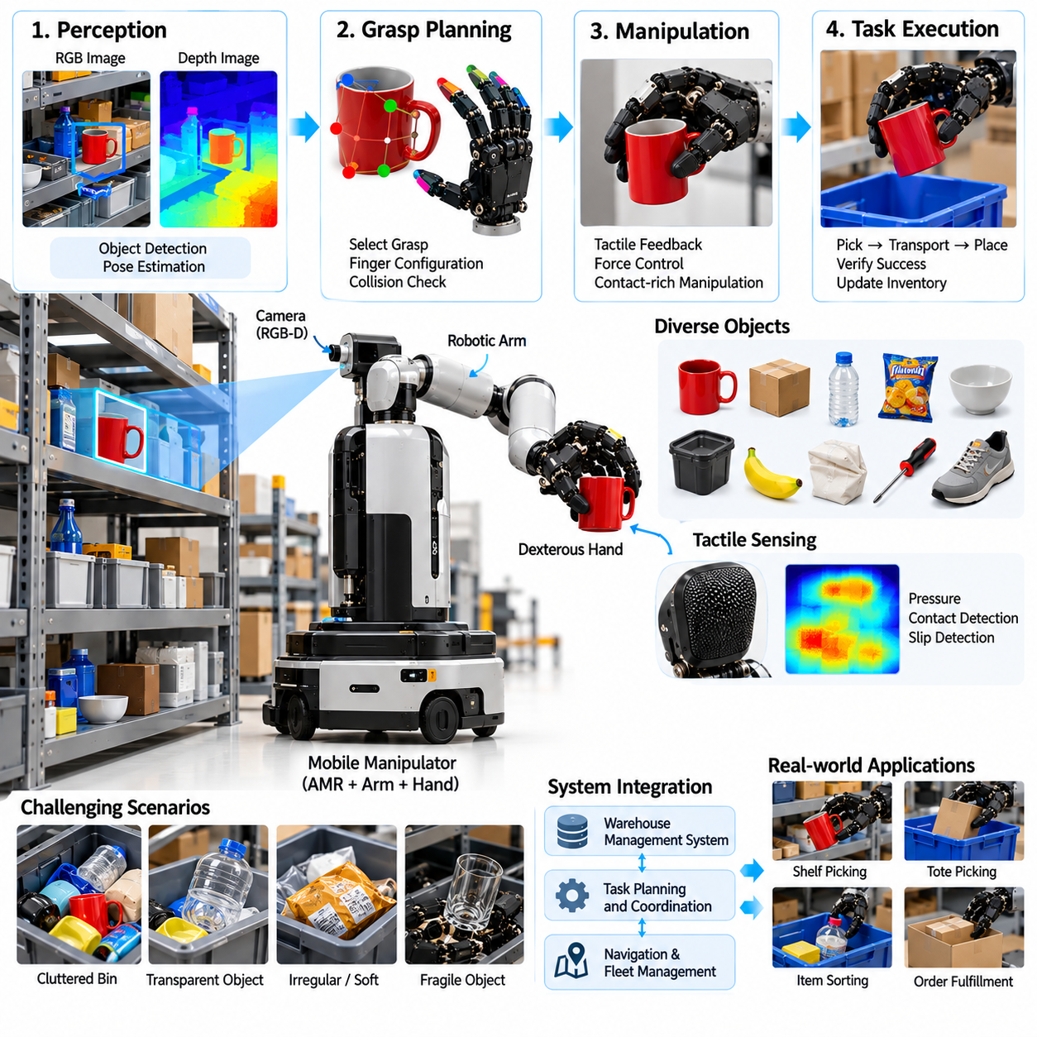
Warehouse picking with dexterous robotic hands represents an important application of physical artificial intelligence in logistics automation. Unlike conventional grippers designed for standardized packages, dexterous hands can potentially manipulate objects with diverse shapes, sizes, and surface properties. Their value lies in handling mixed inventory where rigid automation becomes difficult. Successful deployment requires integration of perception, grasp planning, contact control, and warehouse management systems.
Warehouse environments present substantial manipulation challenges because inventory frequently changes and objects are stored in cluttered bins, shelves, or containers. Products may be transparent, reflective, deformable, fragile, or irregularly shaped. Packaging materials can also change the friction and stability of a grasp. A dexterous picking system must therefore recognize individual objects, estimate accessible contact regions, and select manipulation strategies appropriate to their physical characteristics.
A typical warehouse picking system combines robotic arms, dexterous end effectors, cameras, computing hardware, and task coordination software. The robotic arm positions the hand near a target item, while the fingers establish and maintain contact. Vision systems identify objects and estimate their locations within storage spaces. Higher-level software coordinates picking orders, destination containers, and inventory updates, connecting physical manipulation to warehouse operations.
Visual perception is fundamental because the robot must distinguish target products from surrounding inventory. RGB cameras provide appearance information, while depth sensors estimate three-dimensional geometry and spatial relationships. Object detection and segmentation identify candidate items, and pose estimation supports grasp planning. However, occlusion and tightly packed objects can limit visibility, requiring active perception or alternative viewpoints before manipulation begins.
Grasp planning determines how the robotic hand should approach and secure an object. The planner evaluates candidate contact points, finger configurations, collision constraints, and expected grasp stability. Precision grasps may be suitable for small products, while enveloping grasps can support larger or irregular items. Dexterous hands offer additional configurations compared with simple parallel-jaw grippers, but this flexibility also increases planning complexity and computational requirements.
Tactile sensing provides information that external cameras cannot reliably capture during contact. Finger sensors may measure pressure distribution, contact location, and changes associated with object slipping. This feedback enables the controller to adjust grip forces and compensate for uncertain material properties. For fragile merchandise, tactile control can reduce the risk of damage, while heavier objects require sufficient force to prevent accidental release during transportation.
Contact-rich manipulation becomes particularly important when objects are difficult to grasp directly. A robot may need to push neighboring items aside, rotate a product, or reposition it before lifting. Dexterous fingers can potentially perform these preparatory movements without changing end effectors. However, such operations require accurate contact reasoning and careful force regulation to avoid damaging inventory or disturbing nearby objects unnecessarily.
Learning-based grasping methods can improve adaptability across diverse product categories. Demonstration learning provides examples of successful picking actions, while reinforcement learning can optimize manipulation policies through repeated interaction. Simulation environments allow training across variations in object geometry, friction, and placement. Nevertheless, transferring policies to physical warehouses requires attention to sensor noise, mechanical differences, and unexpected contact dynamics.
Foundation models and vision-language-action systems offer another approach to warehouse picking. These models can interpret instructions involving product categories, attributes, or semantic relationships. A request to retrieve a specific item may require combining visual recognition with task-level reasoning. However, semantic understanding must be connected to reliable grasp execution, and low-level controllers remain necessary for contact stability, collision avoidance, and actuator safety.
A practical picking cycle begins when the warehouse management system assigns a retrieval task. The robot identifies the storage location, approaches the target, and evaluates candidate grasps. After establishing contact, the hand lifts the object and transports it toward a designated destination. The system verifies successful placement and updates the inventory record. Each stage must support error detection because failures can propagate into incorrect orders or damaged products.
Mobile manipulators extend warehouse picking beyond fixed robotic workstations. An autonomous mobile platform can travel between storage locations while a robotic arm and dexterous hand perform item retrieval. This configuration may reduce the need for extensive conveyor infrastructure. However, navigation accuracy, localization, platform stability, and arm reachability must be coordinated to maintain reliable manipulation in narrow aisles and crowded operating environments.
Warehouse picking requires robust recovery strategies because unsuccessful grasps are unavoidable in diverse inventory conditions. A robot may detect slipping, incomplete lifting, object misidentification, or unexpected collisions. Recovery actions can include adjusting finger positions, selecting another grasp, changing camera viewpoints, or requesting human assistance. Effective recovery reduces operational interruptions and improves the practical value of autonomous picking systems.
Safety considerations involve both the manipulation hardware and the surrounding logistics environment. Robots may operate near warehouse workers, mobile equipment, and densely packed inventory. Force limits, collision monitoring, controlled stopping, and safe motion planning help reduce physical risks. Object dropping and unintended contact with shelving must also be considered, especially when handling heavy, sharp, or fragile products.
Performance evaluation should extend beyond grasp success rate to include complete operational outcomes. Relevant metrics include successful picks per hour, cycle time, item damage rate, order accuracy, recovery frequency, and system availability. Testing should cover representative product distributions rather than only carefully selected objects. Sustained operation across multiple shifts provides more meaningful evidence of deployment readiness than short demonstrations.
The economic value of dexterous picking depends on whether increased manipulation flexibility offsets higher hardware and control costs. Multifinger hands may require additional actuators, sensors, calibration, and maintenance compared with simpler grippers. Their advantages become more significant when a warehouse handles many product types that cannot be efficiently manipulated by a single specialized tool. Utilization, throughput, and maintenance expenses therefore influence the return on investment.
System integration is essential because robotic picking must interact with warehouse management systems, order processing, and inventory databases. Task assignments should include product identity, storage location, destination, and handling constraints. Execution feedback must report successful retrieval, placement confirmation, and detected exceptions. Reliable data exchange prevents discrepancies between physical inventory and digital records, supporting traceability and operational coordination.
A major engineering challenge is balancing manipulation versatility with execution speed. Dexterous hands can support complex grasps, but additional finger movements and contact verification may increase cycle time. Hybrid solutions can combine dexterous hands with suction or specialized gripping tools when appropriate. The optimal end-effector strategy depends on product diversity, required throughput, damage sensitivity, and the cost of handling exceptions.
Scalability introduces additional requirements involving fleet coordination, predictive maintenance, and consistent performance across robotic units. Calibration differences and mechanical wear can cause identical policies to behave differently on separate hands. Centralized monitoring can identify recurring failures and support systematic improvement. Standardized interfaces, modular hardware, and reproducible testing procedures help reduce the complexity of expanding warehouse automation.
Warehouse picking with dexterous hands illustrates the transition from rigid industrial automation toward adaptable physical intelligence. Successful systems must combine visual perception, semantic understanding, grasp planning, tactile feedback, and reliable operational integration. The central engineering lesson is that dexterity creates value only when it improves measurable warehouse outcomes. Future progress will depend on robust generalization, efficient control, reliable recovery, and economically sustainable deployment.

15.10 Hospital Logistics Applications
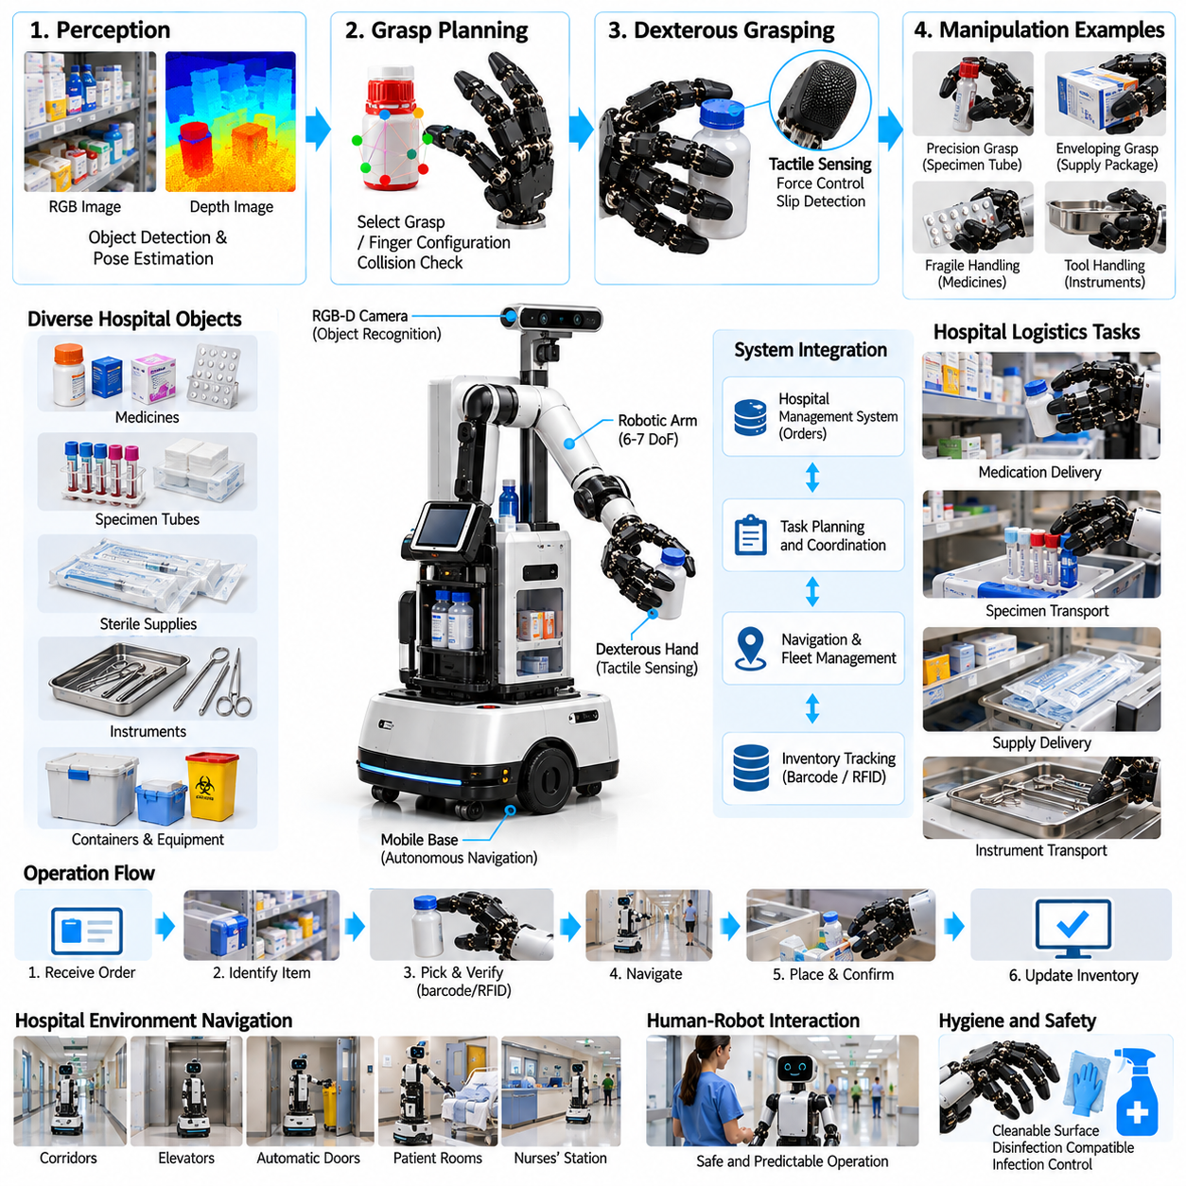
Hospital logistics represents a promising application of dexterous robotic hands within healthcare automation. Hospitals require continuous transportation and handling of medicines, laboratory samples, sterile supplies, and medical equipment. Unlike conventional industrial environments, these operations involve diverse objects, strict hygiene requirements, and frequent human interaction. Dexterous robotic hands can potentially improve handling flexibility when integrated with autonomous mobile manipulation systems.
Hospital logistics tasks vary considerably in object geometry, packaging, fragility, and handling constraints. Medication containers, specimen tubes, supply packages, and instrument trays require different grasp configurations. Some objects must remain upright, while others require careful orientation or limited contact force. A general-purpose robotic hand must therefore adapt its grasp strategy to the physical characteristics and operational requirements of each item.
A hospital logistics robot typically combines a mobile base, robotic arm, dexterous end effector, perception sensors, and task management software. The mobile platform transports materials between designated locations, while the robotic arm positions the hand for object acquisition and placement. Higher-level software coordinates delivery requests, destination verification, and task completion records. Reliable operation requires integration between physical manipulation and hospital workflow systems.
Visual perception enables the robot to identify target objects and estimate their positions within storage cabinets, carts, or delivery stations. RGB cameras provide appearance information, while depth sensors support geometric estimation and grasp planning. Object detection and segmentation distinguish requested items from surrounding materials. However, transparent containers, reflective packaging, and partially occluded objects can reduce perception accuracy and require additional sensing or verification.
Grasp planning must account for object shape, weight, surface friction, and accessibility. A small specimen tube may require a precision pinch grasp, while a larger supply container may benefit from an enveloping grasp. The robot must select contact regions that avoid labels, seals, and sensitive surfaces whenever necessary. Stable grasp execution also depends on appropriate approach geometry, collision avoidance, and sufficient clearance within crowded storage areas.
Tactile sensing can improve handling reliability by detecting contact forces and changes in object stability. Finger-mounted sensors may provide information about pressure distribution, contact location, and slipping. This feedback allows grip forces to be adjusted according to object properties. Fragile containers require limited pressure, while heavier equipment may demand stronger gripping forces. Contact sensing is especially valuable when visual observations cannot reveal the exact interaction conditions.
Hygiene and contamination control impose additional requirements on robotic hand design. Contact surfaces should be compatible with approved cleaning procedures and selected disinfectants. Mechanical joints, exposed cables, and complex finger structures can create areas that are difficult to clean. Materials and protective coverings must therefore be evaluated for cleanability, durability, and compatibility with hospital infection prevention procedures rather than assuming that a dexterous mechanism is inherently suitable for clinical use.
Sterile supplies require particularly careful handling because maintaining package integrity is essential. A robotic hand may transport sealed sterile packages, but it must avoid puncturing, compressing, or damaging protective barriers. Contact with the exterior of a sterile package does not establish sterility of the robotic hand. Tasks involving direct interaction with sterile fields require separate validation, controlled procedures, and compliance with applicable clinical requirements.
Medication logistics introduces identification, traceability, and access-control challenges. A robot handling medication packages must verify that the selected item matches the authorized delivery request. Barcode or RFID systems can supplement visual recognition and support inventory tracking. However, object identification alone does not establish medication correctness or authorization. Hospital procedures must govern dispensing, custody, delivery confirmation, and exception handling.
Laboratory specimen transportation requires attention to container stability, leakage prevention, and handling conditions. Specimen tubes and transport containers may need to remain upright or within specified environmental limits. The robotic hand should avoid excessive compression and sudden acceleration during lifting and placement. Where biological hazards are involved, approved secondary containment and institutional biosafety procedures remain necessary regardless of the robot's manipulation capabilities.
Mobile manipulation enables hospital logistics robots to retrieve and deliver materials without requiring fixed conveyor infrastructure. Navigation systems guide the robot through corridors and designated service areas, while the arm and hand perform local handling tasks. Elevators, automatic doors, and access-controlled spaces may require additional infrastructure integration. Reliable operation depends on coordinated navigation, positioning, manipulation, and communication with hospital systems.
Human-robot interaction is particularly important because hospital environments contain patients, clinical staff, visitors, and mobile medical equipment. Robots must operate predictably and avoid obstructing critical workflows. Speed limits, obstacle detection, controlled stopping, and appropriate human supervision contribute to operational safety. Manipulation tasks should also minimize the risk of dropped objects, unintended contact, and interference with nearby medical activities.
Learning-based manipulation may help robots adapt to variations in medical packaging and supply arrangements. Demonstration learning can provide examples of successful grasping and placement, while simulation can support training across different object configurations. Nevertheless, hospital deployment requires controlled validation because learning-based policies may fail under unfamiliar conditions. Safety-critical handling should incorporate explicit constraints and reliable fallback procedures.
Task execution should include verification before and after each manipulation operation. The robot may confirm object identity, inspect the intended destination, execute the grasp, and verify successful placement. Sensors can detect incomplete lifting, unexpected motion, or object release. If confidence is insufficient, the system should stop or request assistance rather than continue uncertain handling. Such procedures support traceability and reduce the consequences of manipulation errors.
Performance evaluation must consider both robotic capability and hospital workflow outcomes. Relevant metrics include successful delivery rate, object damage rate, identification accuracy, task completion time, recovery frequency, and system availability. Additional measures may address cleaning time, contamination-control compliance, and staff intervention requirements. Testing should reflect realistic operating conditions rather than relying only on selected demonstrations in controlled environments.
Economic feasibility depends on the relationship between automation benefits and total system costs. Dexterous hands may increase handling flexibility but introduce additional actuators, sensors, maintenance requirements, and control complexity. Hospitals must evaluate whether this flexibility improves throughput or reduces manual handling sufficiently to justify the investment. Specialized grippers or secured transport compartments may remain preferable for standardized deliveries that do not require dexterous manipulation.
Reliability and maintainability are essential because hospital logistics services may operate across extended shifts. Repeated handling can cause mechanical wear, sensor drift, and calibration changes. Preventive maintenance should include inspection of finger mechanisms, verification of force limits, and evaluation of cleaning-related material degradation. Modular replacement and diagnostic monitoring can reduce downtime while supporting consistent handling performance.
System integration must connect robotic task execution with hospital logistics software, inventory records, and authorized workflow procedures. Delivery requests should specify item identity, destination, handling constraints, and confirmation requirements. Execution records should capture successful transfers, exceptions, and interventions without exposing unnecessary patient information. Cybersecurity, access control, and data protection are important because hospital operations involve sensitive systems and regulated information.
Hospital logistics hand applications illustrate how dexterous manipulation can extend healthcare automation beyond simple material transportation. Successful deployment requires coordination among perception, grasp planning, tactile control, hygiene engineering, workflow integration, and human safety. The central engineering lesson is that robotic dexterity creates practical value only when it improves reliable, traceable, and clinically appropriate material handling within established hospital procedures.

15.11 Factory Assembly Applications
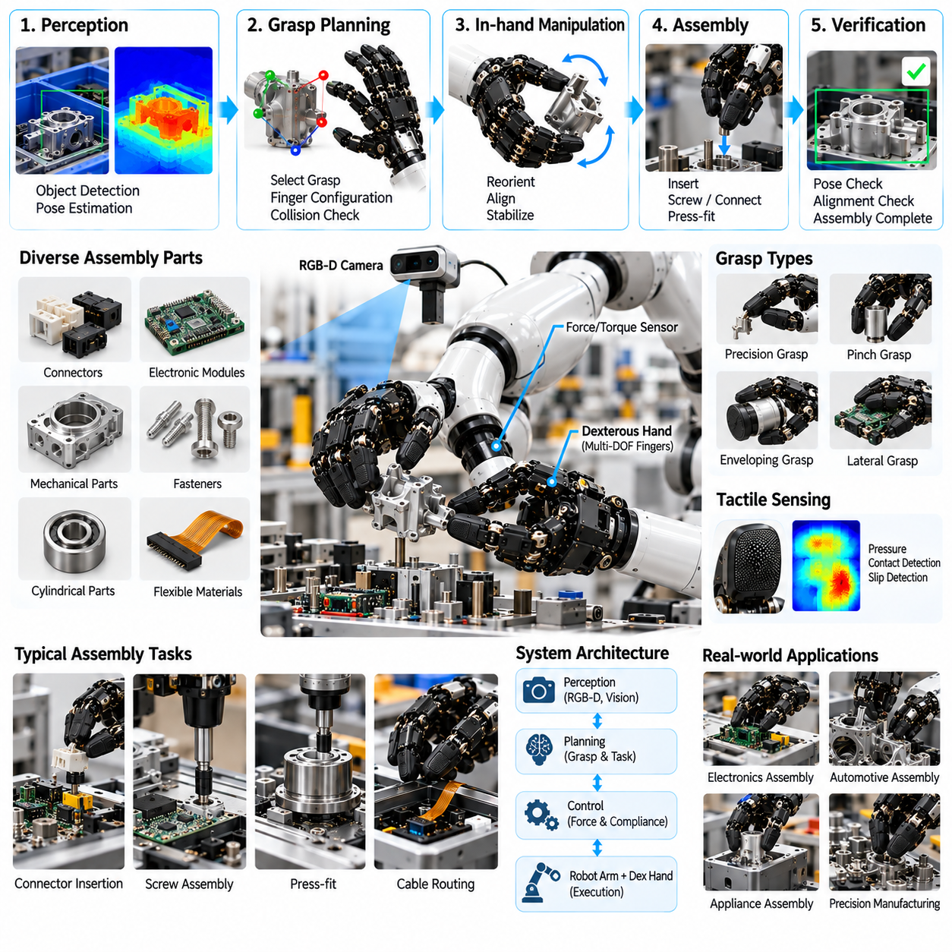
Factory assembly with dexterous robotic hands represents an important application of physical artificial intelligence in advanced manufacturing. Unlike conventional grippers designed for repetitive handling, dexterous hands can potentially manipulate components with diverse geometries and assembly requirements. Their principal advantage is adaptability across changing production tasks. Practical deployment requires coordinated perception, grasp planning, force control, and integration with industrial automation systems.
Assembly environments demand greater manipulation precision than many transportation tasks because components must be positioned and joined within defined tolerances. Operations may involve inserting connectors, aligning mechanical parts, handling fasteners, or positioning flexible materials. Small geometric errors can cause interference or damage. A dexterous hand must therefore coordinate finger motion with arm positioning while maintaining appropriate contact forces throughout the assembly process.
A typical dexterous assembly system combines a robotic arm, multifinger hand, visual sensors, force sensing, and industrial control software. The arm establishes the working position, while individual fingers grasp, stabilize, and reposition components. Cameras estimate object location and orientation before manipulation. Higher-level controllers coordinate task sequences and communicate with production equipment, enabling assembly operations to function within established manufacturing workflows.
Mechanical hand design strongly influences the range of assembly tasks that can be performed. Multiple articulated fingers provide alternative contact configurations for small components, cylindrical parts, and irregular objects. Thumb opposition supports precision pinching, while distributed finger contact improves stability for larger components. However, increased articulation also introduces actuator complexity, mechanical compliance, calibration requirements, and additional maintenance considerations.
Precision grasping is particularly important when handling connectors, electronic modules, and small mechanical components. The robot must select contact locations that avoid damaging sensitive surfaces while maintaining sufficient stability for insertion. Finger positioning accuracy, repeatability, and controlled gripping force determine whether the component remains properly oriented. Successful assembly requires coordination between local finger adjustments and the larger motion of the robotic arm.
Visual perception supports component identification, pose estimation, and inspection of assembly conditions. RGB cameras provide appearance information, while depth sensors and structured illumination may improve geometric measurements. Machine vision can identify alignment features, mating surfaces, and potential obstructions. Nevertheless, reflective metals, small clearances, and partially hidden contact regions can limit visual accuracy, making additional sensing necessary for reliable assembly.
Force and tactile sensing are essential when assembly operations involve physical contact between components. Wrist-mounted force-torque sensors measure interaction loads, while finger sensors can detect local pressure and contact changes. These measurements help distinguish successful engagement from unexpected resistance. Closed-loop force control can reduce excessive loading during insertion, although sensor resolution, mechanical stiffness, and control latency influence achievable performance.
Compliance control allows robotic systems to accommodate small positioning errors during assembly. Impedance control regulates the relationship between motion and interaction force, while admittance control adjusts commanded movement in response to measured forces. These methods can support connector insertion, alignment, and controlled surface contact. However, stable implementation requires careful tuning of controller gains, actuator dynamics, and the mechanical properties of the manipulated components.
In-hand manipulation expands assembly flexibility by allowing components to be repositioned without releasing them. Coordinated finger movements can rotate, translate, or reorient an object within the grasp. Such capabilities may reduce repeated pick-and-place operations and improve access to difficult assembly orientations. However, reliable in-hand manipulation requires accurate contact estimation, friction management, and planning across changing finger-object contact configurations.
Learning-based manipulation provides an alternative to programming every assembly movement through fixed trajectories. Demonstration learning can capture successful handling strategies, while reinforcement learning may improve adaptation to variable contact conditions. Simulation can support policy development across geometric and material variations. Nevertheless, industrial deployment requires validation because policies trained under simplified conditions may fail when exposed to real mechanical tolerances and unexpected disturbances.
Assembly planning must account for both the geometry of individual components and the sequence in which they are joined. A robot may need to orient a part, establish temporary support, align mating features, and apply controlled insertion force. Each stage changes the contact conditions and available motion. Hierarchical planning can coordinate task-level decisions with grasp selection, motion generation, and contact-aware control, reducing dependence on rigid predefined sequences.
Bimanual manipulation becomes valuable when assembly requires one component to be stabilized while another is inserted or attached. Two robotic hands can distribute holding and manipulation responsibilities, potentially replacing some dedicated fixtures. However, coordinated bimanual control introduces additional challenges involving relative positioning, force distribution, and collision avoidance. The entire system must maintain stable object support while both manipulators execute synchronized actions.
Industrial safety requires careful consideration of interactions between robotic hands, workers, components, and surrounding machinery. Pinch points, unexpected finger motion, dropped parts, and excessive contact forces can create hazards. Risk reduction may involve guarded workspaces, safety-rated monitoring, emergency stopping, and controlled motion limits. Collaborative operation requires application-specific risk assessment and appropriate protective measures rather than relying solely on low gripping forces.
Quality assurance must verify that successful grasping results in correctly assembled products. Inspection may involve dimensional measurements, connector engagement checks, torque verification, or functional testing. Sensor records can provide evidence of insertion forces, alignment conditions, and execution outcomes. Integrating these measurements with manufacturing execution systems supports traceability and enables defective assemblies to be identified before subsequent production stages.
Performance benchmarking should evaluate complete assembly outcomes rather than isolated grasp success. Relevant metrics include assembly success rate, positional accuracy, cycle time, component damage, rework frequency, and sustained system availability. Tests should include realistic tolerance variations and representative production conditions. Comparisons with conventional grippers must account for both manipulation flexibility and the additional complexity introduced by multifinger control.
Economic feasibility depends on whether dexterous hands reduce tooling changes, manual intervention, and production reconfiguration costs. Multifinger mechanisms typically introduce additional actuators, sensors, calibration, and maintenance requirements. Their advantages become more significant in high-mix, low-volume manufacturing where component diversity changes frequently. For stable, high-volume production, specialized grippers and fixtures may remain more economical and achieve faster cycle times.
Reliability engineering is essential because assembly systems must maintain consistent performance across repeated production cycles. Finger joints, transmissions, tactile sensors, and electrical connections experience wear and environmental stress. Calibration drift and backlash can reduce positioning accuracy over time. Preventive maintenance, condition monitoring, modular component replacement, and periodic performance verification help maintain repeatability and reduce unplanned production interruptions.
System integration connects dexterous manipulation with programmable logic controllers, manufacturing execution systems, and quality databases. Task instructions should specify component identity, assembly sequence, geometric tolerances, and process constraints. Execution feedback should report completed operations, detected faults, and inspection results. Standardized interfaces and reliable communication enable robotic assembly stations to participate in coordinated production workflows and support systematic process improvement.
Factory assembly with dexterous hands illustrates the transition from rigid robotic automation toward adaptable, contact-aware manufacturing intelligence. Successful systems must combine mechanical dexterity, visual perception, tactile sensing, precision control, and production-level verification. The central engineering lesson is that useful dexterity must be measured through assembly quality, repeatability, operational reliability, and economic performance rather than finger complexity alone.

