Volume 06 Robot Hands and Dexterous Grasping

14. Benchmarking and Performance Evaluation

14.01 Benchmarking Fundamentals
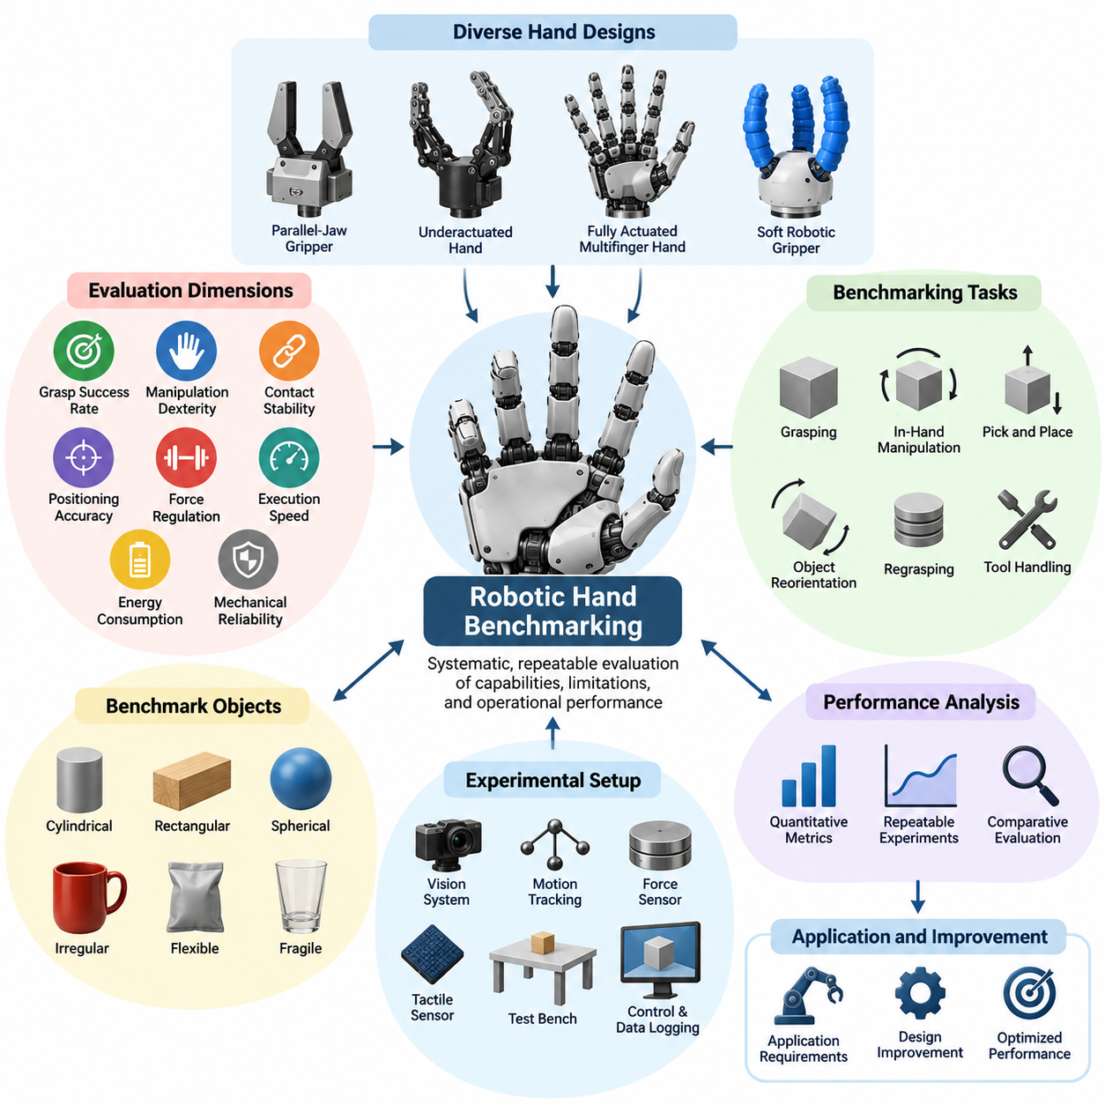
Hand benchmarking provides a systematic framework for measuring the capabilities, limitations, and operational performance of robotic hands and grippers. Rather than relying on isolated demonstrations, benchmarking establishes repeatable experiments that quantify grasping, manipulation, sensing, and control performance. Its primary objective is to support objective comparisons between different hand architectures, control strategies, and application requirements.
The diversity of robotic hand designs makes standardized evaluation particularly important. Parallel-jaw grippers, underactuated hands, fully actuated multifinger hands, and soft robotic grippers possess fundamentally different mechanical characteristics. A meaningful benchmark must account for these differences while maintaining consistent evaluation conditions. Performance should therefore be interpreted relative to intended tasks rather than reduced to a single universal ranking.
A comprehensive benchmarking framework examines several complementary dimensions of robotic hand performance. These include grasp success rate, manipulation dexterity, contact stability, positioning accuracy, force regulation, execution speed, energy consumption, and mechanical reliability. Each dimension represents a different aspect of operational capability, and their combined evaluation provides a more informative assessment than any individual metric.
Grasping performance is one of the most fundamental evaluation categories because object acquisition represents the starting point of many manipulation tasks. A typical grasp benchmark measures whether a robotic hand can approach, secure, lift, transport, and release an object without unintended loss of control. Repeated trials across objects with different geometries, masses, materials, and surface properties reveal the robustness of the grasping mechanism.
Dexterity benchmarking extends beyond successful object acquisition to evaluate the ability to manipulate objects after initial contact. Relevant tasks include object rotation, translation, finger gaiting, regrasping, and controlled changes in object orientation. These capabilities are especially important for multifinger robotic hands intended for assembly, tool handling, and contact-rich manipulation where simple grasp-and-release operations are insufficient.
Benchmark objects should represent a sufficiently diverse range of physical properties to prevent evaluation bias. Common object categories include cylindrical components, rectangular blocks, spherical objects, irregular household items, flexible materials, and fragile products. Object dimensions, mass distribution, friction characteristics, and deformation behavior influence grasp difficulty and should be documented as part of the experimental configuration.
Standardized object collections improve reproducibility by providing consistent physical references across laboratories and robotic platforms. The Yale-CMU-Berkeley object set, commonly known as the YCB Object Set, is an established example used in robotic manipulation research. Such collections support controlled comparisons, although differences in experimental protocols, object placement, perception systems, and success criteria can still influence reported results.
GraspNet and related grasping benchmarks contribute another important evaluation perspective by emphasizing grasp detection, candidate generation, and prediction quality. These benchmarks are particularly relevant when robotic hands operate with vision-based grasp planning systems. However, predicted grasp quality should be distinguished from physical execution success because perception accuracy does not automatically guarantee stable contact or reliable manipulation.
Tactile sensing introduces additional benchmarking requirements because contact information directly influences manipulation stability and force control. Evaluation may include contact localization accuracy, pressure measurement error, spatial resolution, sensitivity, response latency, and sensor repeatability. For tactile arrays, performance should also be examined under distributed loading, changing contact geometries, and repeated mechanical deformation.
Slip detection benchmarking evaluates whether a robotic hand can recognize and respond to incipient or actual object movement within its grasp. Important measurements include detection accuracy, false alarm rate, detection latency, and the effectiveness of corrective control actions. Experiments should distinguish between successful slip recognition and successful grasp recovery, since detecting instability does not necessarily prevent object loss.
Force and torque control performance represents another essential benchmarking dimension. A robotic hand must generate sufficient contact force to maintain stability while avoiding excessive pressure that could damage objects or deform sensitive materials. Force tracking error, overshoot, settling time, contact force distribution, and disturbance rejection provide useful measurements for evaluating the quality of closed-loop grasp regulation.
Speed and cycle time metrics determine whether a robotic hand can satisfy the throughput requirements of practical applications. A complete manipulation cycle may include object detection, grasp planning, hand positioning, finger closure, lifting, manipulation, placement, and release. Measuring individual stages helps identify performance bottlenecks and distinguishes limitations caused by mechanical actuation from those caused by perception or planning.
Reliability benchmarking examines whether performance remains consistent over extended operation rather than only during short experimental demonstrations. Repeated grasping cycles can expose actuator wear, transmission backlash, tendon degradation, sensor drift, and thermal limitations. Reliability indicators may include failure frequency, mean time between failures, maintenance intervals, and performance degradation across accumulated operating cycles.
Energy efficiency is particularly important when robotic hands operate on battery-powered mobile manipulators. Benchmarking should measure electrical consumption during idle operation, finger movement, sustained grasping, and repeated manipulation cycles. Energy per successful task provides a useful application-level indicator, although comparisons must account for payload, grasp duration, actuator architecture, and differences in task complexity.
Benchmark environments must be designed to control experimental variability without eliminating realistic operating challenges. Relevant conditions include object placement uncertainty, lighting variation, surface friction, environmental temperature, vibration, and external disturbances. Controlled laboratory experiments establish baseline performance, while progressively less structured environments reveal the limitations encountered during practical deployment.
Experimental repeatability requires clearly defined procedures for initialization, calibration, object positioning, trial execution, and outcome recording. The number of trials should be sufficient to characterize performance variability, and randomized object configurations can reduce systematic bias. Statistical reporting should include sample sizes, uncertainty estimates, and failure distributions rather than presenting isolated success percentages without experimental context.
Fair comparison between robotic hands requires careful separation of hardware capability and supporting system performance. A highly capable hand may appear ineffective when paired with inaccurate perception or poorly tuned control software. Conversely, sophisticated planning algorithms may compensate for mechanical limitations. Benchmark reports should identify the contribution of the hand mechanism, sensing system, controller, and external manipulation platform.
Simulation-based benchmarking offers an efficient method for evaluating large numbers of grasp configurations and control policies before physical testing. Simulated environments can provide precise measurements of contact forces, object trajectories, and failure conditions. Nevertheless, discrepancies in friction, compliance, actuator behavior, and contact modeling mean that simulation results must be validated against physical experiments before deployment claims are made.
Learning-based robotic hands introduce additional requirements concerning training data, generalization, and evaluation integrity. Benchmark objects and task configurations should be separated appropriately from training examples to avoid misleading performance estimates. Evaluation should also examine unfamiliar objects, altered physical conditions, and distribution shifts, since high success rates on previously encountered tasks may not indicate general manipulation competence.
Safety must remain an explicit consideration when benchmarking hands intended for human environments. Relevant evaluations include excessive gripping force, unintended finger motion, collision response, object release behavior, and recovery following sensing or control failures. Safety-related measurements should be distinguished from ordinary performance metrics because successful task completion cannot justify unacceptable mechanical or operational hazards.
Application-specific benchmarking translates laboratory measurements into operational requirements. Industrial assembly emphasizes precision, repeatability, contact force regulation, and cycle time, whereas warehouse handling prioritizes object diversity and throughput. Healthcare and service applications may place greater emphasis on gentle interaction, predictable behavior, and reliable handling of delicate objects. Evaluation criteria should reflect these different priorities.
A structured benchmark report should document the robotic hand configuration, actuator specifications, sensor arrangement, control architecture, object dataset, experimental environment, and evaluation procedures. It should also identify the definitions of successful and failed trials, statistical analysis methods, and observed limitations. This documentation enables other researchers and engineers to reproduce experiments and interpret reported performance consistently.
The ultimate purpose of hand benchmarking is not simply to identify the robotic hand with the highest numerical score. It is to establish a reliable relationship between measurable technical capabilities and practical manipulation requirements. By combining grasp success, dexterity, sensing, speed, reliability, and environmental robustness, benchmarking supports informed design decisions and provides a foundation for continuous improvement in robotic hand engineering.

14.02 Dexterity Metrics
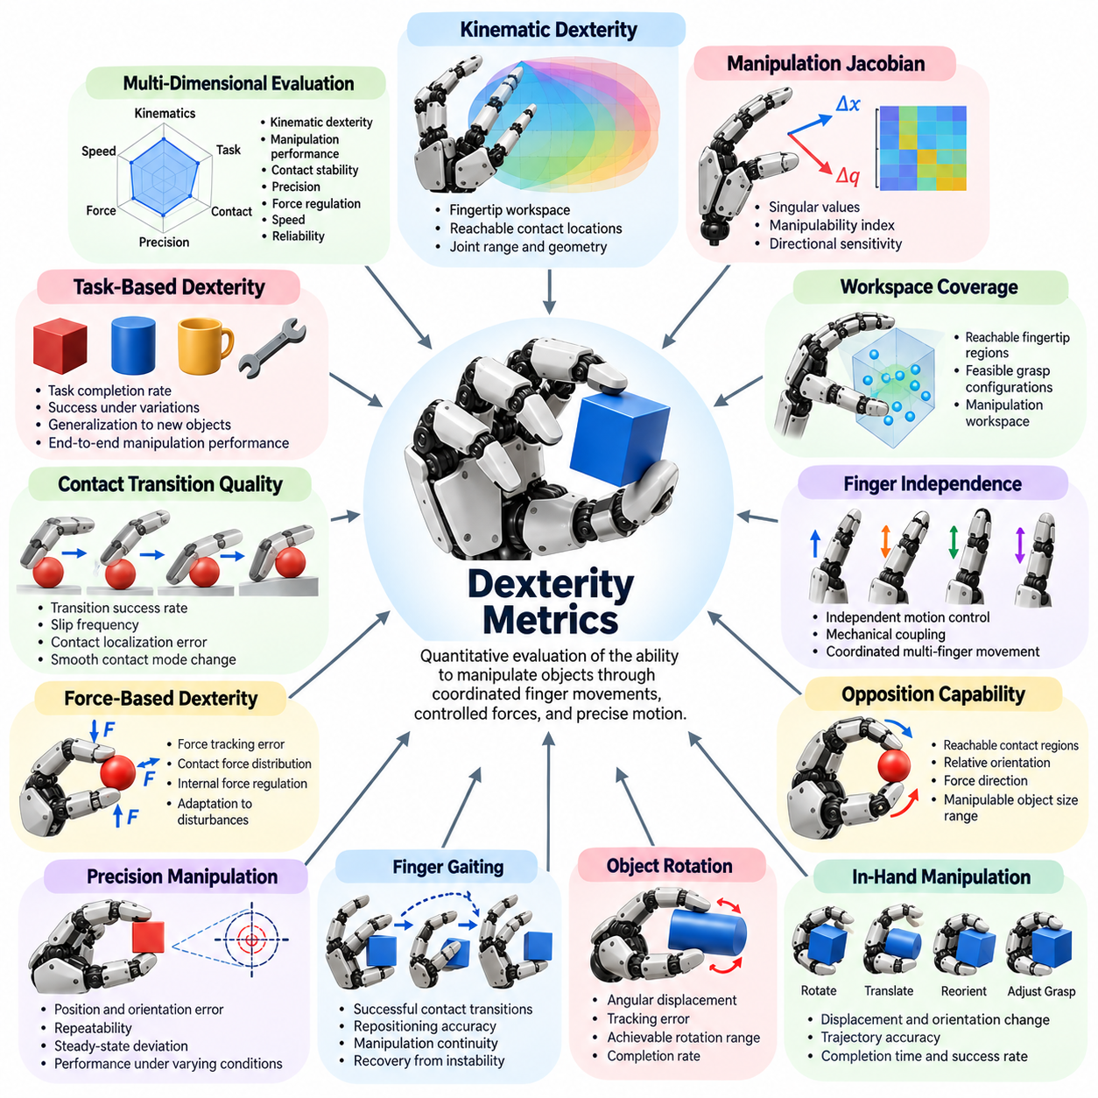
Dexterity metrics provide quantitative methods for evaluating the ability of robotic hands to manipulate objects through coordinated finger movements, controlled contact forces, and precise motion. Unlike basic grasp success measurements, dexterity evaluation focuses on how effectively a hand changes object position, orientation, and contact configuration. These metrics are essential for comparing robotic hands intended for complex manipulation rather than simple object holding.
Robotic hand dexterity is a multidimensional capability involving mechanical design, actuation, sensing, control, and task planning. A hand with many independently actuated joints may offer extensive motion possibilities, but mechanical complexity alone does not guarantee effective manipulation. Dexterity metrics must therefore distinguish between theoretical mechanical capability and demonstrated task performance under controlled experimental conditions.
Kinematic dexterity describes the ability of a robotic hand to generate diverse fingertip positions and orientations within its reachable workspace. Joint ranges, finger lengths, linkage geometry, and mechanical constraints determine the available configurations. Evaluation commonly considers fingertip workspace volume, reachable contact locations, and the ability to coordinate multiple fingers without encountering collisions or restrictive joint limits.
The manipulation Jacobian provides a mathematical relationship between joint velocities and fingertip motion. Its singular values can be used to evaluate local motion capabilities, directional sensitivity, and proximity to singular configurations. Manipulability indices derived from the Jacobian characterize how effectively joint movements produce fingertip velocities, although their interpretation depends on coordinate scaling, normalization, and the selected hand configuration.
Workspace coverage is another important indicator of dexterity because a hand must access appropriate contact regions to manipulate objects effectively. A large fingertip workspace does not necessarily imply high functional dexterity if useful contact configurations are difficult to establish. Benchmarking should therefore examine the intersection of reachable fingertip regions, feasible grasp configurations, and the object manipulation workspace.
Finger independence measures the extent to which individual fingers can move or apply forces without unintentionally affecting neighboring fingers. Fully actuated hands generally provide greater independent control authority, while underactuated mechanisms deliberately couple finger movements to simplify hardware. Evaluation should consider controllable motion dimensions, mechanical coupling, and the ability to execute coordinated movements required by representative manipulation tasks.
Opposition capability is particularly important for anthropomorphic robotic hands because stable precision manipulation often requires coordinated contact between the thumb and other fingers. Opposition metrics may evaluate reachable fingertip contact regions, relative orientation, contact force direction, and the range of object sizes that can be manipulated. Effective opposition depends on both mechanical geometry and the ability to regulate contact during motion.
In-hand manipulation performance measures the ability to change an object's pose while maintaining control through finger contacts. Representative tasks include rotating a cube, reorienting a cylinder, translating a small object across the fingertips, and adjusting grasp configurations. Evaluation should record achieved displacement, orientation change, trajectory accuracy, completion time, and whether the object remains under controlled manipulation.
Object rotation capability provides a practical measure of dexterity because rotational manipulation requires coordinated contact transitions and force redistribution. Rotation benchmarks can measure angular displacement, angular tracking error, achievable rotation range, and successful completion rate. Continuous rotation may require finger gaiting or repeated regrasping, making the benchmark sensitive to both mechanical capability and control strategy.
Finger gaiting describes the process of repositioning individual fingers while other fingers maintain sufficient object support. Dexterity evaluation can measure the number of successful contact transitions, repositioning accuracy, manipulation continuity, and recovery from unstable intermediate configurations. These measurements reveal whether a robotic hand can expand its effective manipulation range beyond the limits of a single fixed grasp.
Precision manipulation metrics examine how accurately a robotic hand can achieve a desired object pose or fingertip trajectory. Position error, orientation error, repeatability, and steady-state deviation are commonly relevant measurements. Precision should be evaluated under different object masses, contact conditions, and movement speeds because mechanical backlash, compliance, sensor noise, and control latency can influence the final result.
Force-based dexterity concerns the ability to regulate multiple contact forces while producing desired object movements. A dexterous hand must maintain sufficient grasp stability without generating excessive internal forces that could damage the object. Evaluation can include force tracking error, contact force distribution, internal force regulation, and the ability to adapt contact forces when external disturbances occur.
Contact transition quality is essential for manipulation tasks involving rolling, sliding, pivoting, and controlled release. These operations require changes in contact location or contact mode without losing object control. Relevant metrics include transition success rate, unintended slip frequency, contact localization error, and the ability to maintain stable object motion during changes between contact states.
Manipulation efficiency evaluates how effectively a robotic hand completes dexterous tasks using available motion, time, and energy resources. Metrics may include task completion time, number of corrective movements, total joint travel, energy consumption, and successful operations per unit time. Efficiency should be interpreted alongside accuracy and stability because faster execution may increase manipulation errors or require greater contact forces.
Robustness metrics determine whether dexterous manipulation remains successful when operating conditions differ from nominal assumptions. Experiments may introduce variations in object mass, friction coefficient, initial pose, external disturbances, and sensing uncertainty. Performance degradation across these conditions reveals how effectively the robotic hand adapts to uncertainty and whether its manipulation strategy generalizes beyond carefully prepared demonstrations.
Task diversity is an important component of dexterity evaluation because performance on a single manipulation task cannot represent the complete capability of a robotic hand. Benchmark suites should include object translation, rotation, regrasping, tool repositioning, and contact-rich manipulation. Each task probes different combinations of mechanical mobility, force regulation, sensing accuracy, and planning capability.
The choice of benchmark objects strongly influences measured dexterity. Spherical objects emphasize rolling and contact coordination, while cubes and rectangular objects introduce edges and discrete contact transitions. Cylindrical objects support rotational manipulation, and irregular objects challenge grasp adaptation. Standardized object sets such as the YCB Object Set can improve comparability when task definitions and experimental conditions are consistently documented.
Dexterity evaluation must distinguish between intrinsic hand capability and the performance of the complete robotic manipulation system. Wrist movement, arm repositioning, environmental support, and external fixtures can substantially improve task completion. Benchmarks should specify whether manipulation is performed exclusively through finger motion or whether extrinsic dexterity and additional degrees of freedom are permitted.
Learning-based robotic hands introduce further considerations because dexterity may depend on training experience, object familiarity, and learned control policies. Evaluation should distinguish performance on training distributions from performance on unfamiliar objects and manipulation conditions. Generalization metrics can examine success rates, adaptation requirements, and performance degradation when the hand encounters previously unseen task configurations.
Statistical reliability is necessary for interpreting dexterity measurements. Each task should be repeated across multiple initial conditions, objects, and trials, with success criteria defined before testing. Reports should include sample sizes, success proportions, error distributions, and uncertainty estimates. Aggregated scores can support comparison, but they should not conceal weaknesses in specific manipulation capabilities.
A comprehensive dexterity assessment combines kinematic, force-based, task-level, and robustness measurements into a coherent evaluation framework. Normalized composite scores may be useful when comparing multiple robotic hands, provided that metric definitions, weighting factors, and experimental conditions are transparent. The resulting assessment should explain which capabilities contribute to observed performance rather than presenting an unexplained numerical ranking.
Ultimately, dexterity metrics connect the mechanical and computational capabilities of robotic hands to practical manipulation requirements. By evaluating reachable motion, finger coordination, object reorientation, contact regulation, precision, efficiency, and robustness, engineers can identify meaningful design tradeoffs. These measurements support hardware optimization, controller development, benchmark comparison, and the deployment of robotic hands in increasingly complex environments.

14.03 Grasp Success Metrics
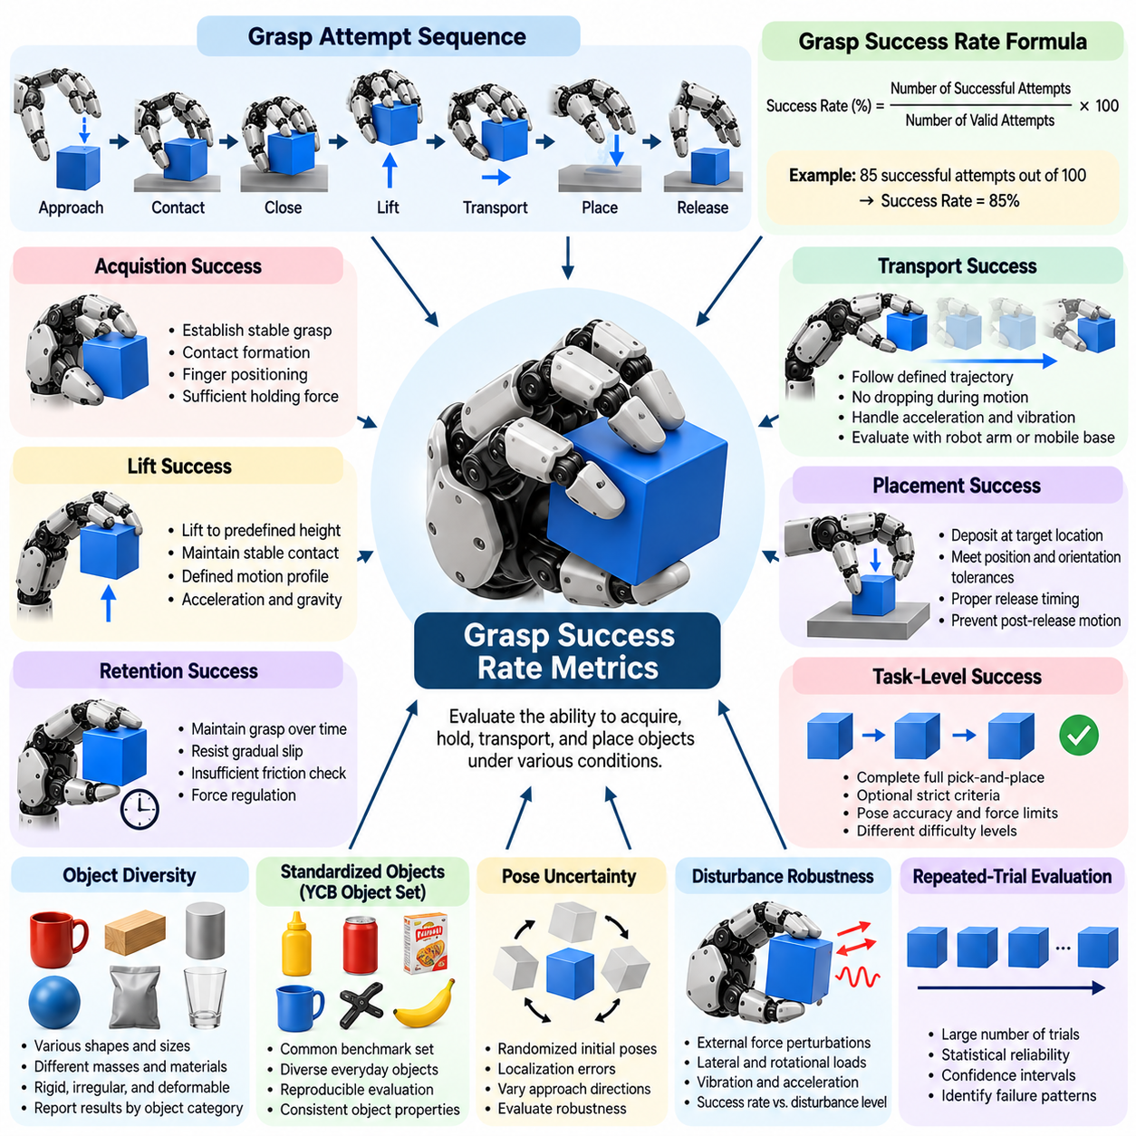
Grasp success rate is one of the most widely used performance metrics for evaluating robotic hands and grippers. It measures the proportion of grasp attempts that satisfy predefined success conditions under controlled experimental procedures. Although the metric appears simple, its interpretation depends on how a grasp attempt is defined, which operations are included, and what constitutes successful object acquisition and retention.
The basic grasp success rate is calculated by dividing the number of successful grasp attempts by the total number of valid attempts and multiplying the result by one hundred. For example, if a robotic hand successfully completes 85 out of 100 attempts, its reported success rate is 85 percent. This calculation provides an intuitive performance indicator, but meaningful comparisons require consistent definitions of success, failure, and valid experimental trials.
A grasp attempt typically consists of approaching an object, establishing contact, closing the fingers, lifting the object, and maintaining a stable hold for a specified duration. Some benchmarks additionally require transportation, controlled placement, or object release. These variations significantly affect measured performance, making it essential to document the complete evaluation sequence rather than reporting a success percentage without operational context.
Success criteria should be established before experimentation and applied consistently across all trials. A basic criterion may require the object to remain securely held after lifting, while a stricter criterion may require successful transportation without slipping or dropping. Advanced benchmarks may include object pose accuracy, allowable deformation, force limits, and successful placement. Different criteria represent different levels of manipulation difficulty.
Grasp acquisition success measures whether the robotic hand establishes an initial stable grasp around the target object. This metric focuses on contact formation, finger positioning, and the ability to generate sufficient holding force. It is useful for separating failures during grasp establishment from failures occurring during subsequent lifting or manipulation, allowing engineers to identify specific weaknesses in the grasping process.
Lift success rate evaluates whether a robotic hand can raise an object to a predefined height while maintaining stable contact. The required lifting distance, motion profile, acceleration, and holding duration should be standardized. A grasp that succeeds during stationary holding may fail during lifting because inertial forces, gravitational loading, or changes in contact geometry exceed the available grasp stability margin.
Grasp retention success measures the ability to maintain object control over a specified time interval or during a prescribed movement. Retention tests can expose gradual slip, insufficient friction, actuator compliance, and force regulation errors. The duration and disturbance conditions must be reported because a hand capable of holding an object for several seconds may not maintain the same reliability during prolonged operation.
Transport success rate extends evaluation beyond lifting by requiring the robotic hand to move an object along a defined trajectory without dropping it. Transport tasks introduce acceleration, deceleration, vibration, and changes in orientation that challenge grasp stability. Performance should be evaluated across representative motion profiles, particularly when the hand is integrated with a robot arm or mobile manipulation platform.
Placement success rate measures whether the robotic hand can deposit an object at a specified destination while satisfying positional and orientation tolerances. Successful grasping does not necessarily imply successful placement because release timing, residual contact forces, and object motion after release can introduce errors. Placement metrics therefore provide a more complete representation of practical pick-and-place performance.
Object diversity strongly influences grasp success measurements because different shapes, dimensions, masses, and materials create different contact conditions. Cylindrical objects, spheres, boxes, irregular components, and deformable products present distinct mechanical challenges. Benchmark datasets should represent the intended application domain, and results should be reported by object category to prevent favorable object selections from inflating overall performance.
The YCB Object Set provides a standardized collection of everyday objects that can support reproducible grasp evaluation. Its diversity allows researchers to investigate how object geometry, surface characteristics, and mass influence grasping outcomes. However, the use of standardized objects alone does not guarantee comparable results, since grasp protocols, object placement, sensing configurations, and success definitions may differ between experiments.
Grasp success under pose uncertainty evaluates the robustness of a robotic hand when object position and orientation are not precisely known. Experiments may randomize initial object poses, introduce localization errors, or vary approach directions. These conditions reveal whether grasp planning and control remain effective beyond idealized laboratory configurations, particularly when perception uncertainty influences contact placement.
Disturbance robustness can be evaluated by applying controlled external forces or movements after a grasp has been established. Disturbances may include lateral loading, rotational perturbations, vibration, or changes in acceleration. Success rates under increasing disturbance levels reveal the limits of grasp stability and help distinguish robust grasping strategies from those that succeed only under stationary conditions.
Repeated-trial evaluation is necessary because individual grasp outcomes may be affected by random variations in object placement, friction, sensor measurements, and actuator behavior. A sufficiently large number of trials should be conducted for each experimental condition. Reporting sample size, success count, and uncertainty intervals provides a more reliable assessment than presenting a percentage obtained from only a few demonstrations.
Statistical confidence intervals help characterize uncertainty in estimated grasp success rates. A reported success rate of 90 percent based on ten attempts provides much weaker evidence than the same percentage based on hundreds of independent trials. Wilson score intervals or other appropriate binomial methods can quantify sampling uncertainty, while repeated testing across objects and sessions helps reveal additional sources of variability.
Failure classification provides valuable diagnostic information beyond the overall success rate. Common failure categories include missed contact, incorrect finger positioning, insufficient grip force, object slip, collision, premature release, and unsuccessful placement. Recording failure causes allows engineers to determine whether performance limitations originate from perception, grasp planning, mechanical design, sensing, or closed-loop control.
Grasp success rate should also be evaluated alongside execution time and resource consumption. A robotic hand may achieve high reliability through slow, conservative movements, while another system may operate faster with slightly lower success probability. Metrics such as successful grasps per minute, average cycle time, and energy per successful grasp provide additional insight into operational efficiency and practical productivity.
Learning-based grasping systems require careful separation between training and evaluation conditions. Success rates measured on familiar objects may overestimate performance on previously unseen objects or environments. Evaluation should therefore distinguish known-object performance, novel-object generalization, and robustness to changes in lighting, clutter, friction, and object pose. These distinctions are essential when assessing learned grasp policies.
Simulation-based grasp success metrics enable large-scale testing across numerous object configurations and control strategies. Simulated experiments can accelerate development and identify promising grasp candidates before physical execution. Nevertheless, inaccurate contact mechanics, friction models, actuator dynamics, and object properties can produce misleading success estimates. Physical validation remains necessary for confirming real-world grasp reliability.
Comparative grasp benchmarking requires consistent hardware and experimental assumptions whenever possible. Differences in fingertip materials, sensor availability, object presentation, robot arm motion, and controller tuning can significantly influence outcomes. When identical conditions are impractical, benchmark reports should explicitly document these differences and avoid interpreting success-rate comparisons as direct measures of intrinsic hand superiority.
A comprehensive grasp success evaluation should combine acquisition, lifting, retention, transport, and placement results with object-specific and disturbance-dependent measurements. Reporting these stages separately prevents a single aggregate score from concealing important weaknesses. Ultimately, grasp success rate metrics provide a practical foundation for improving robotic hand design, validating control strategies, and determining readiness for reliable manipulation in real operating environments.

14.04 YCB Object Benchmark
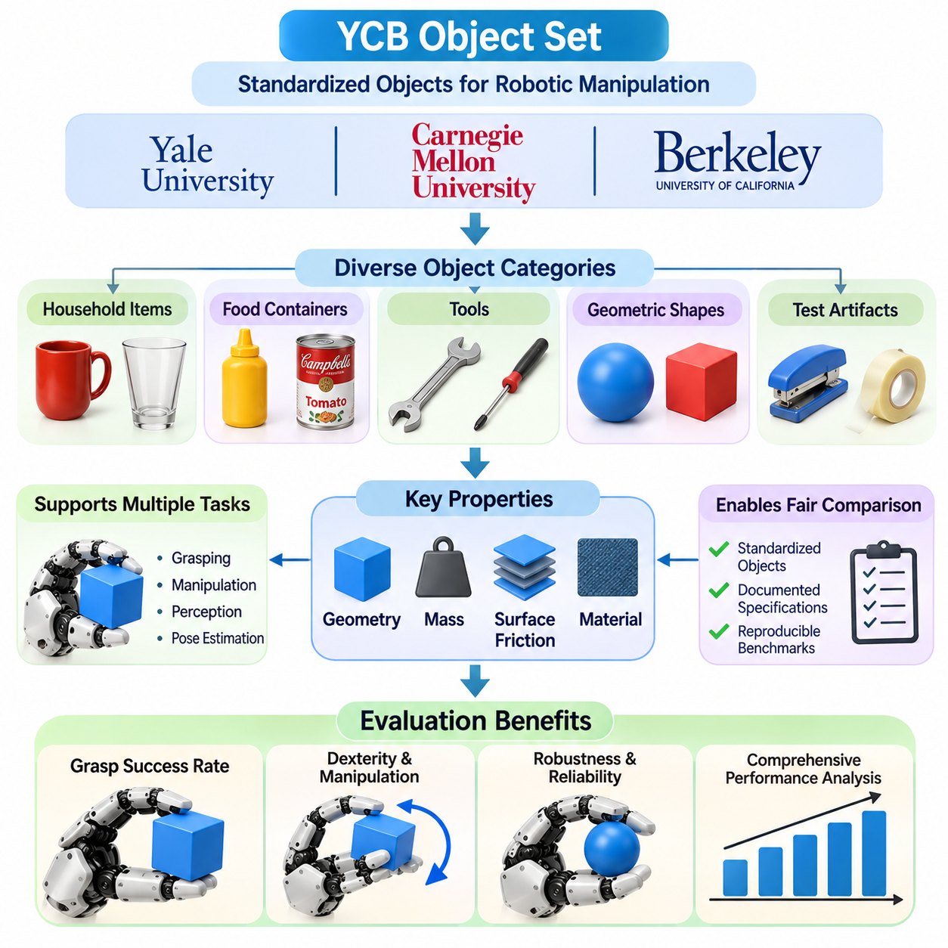
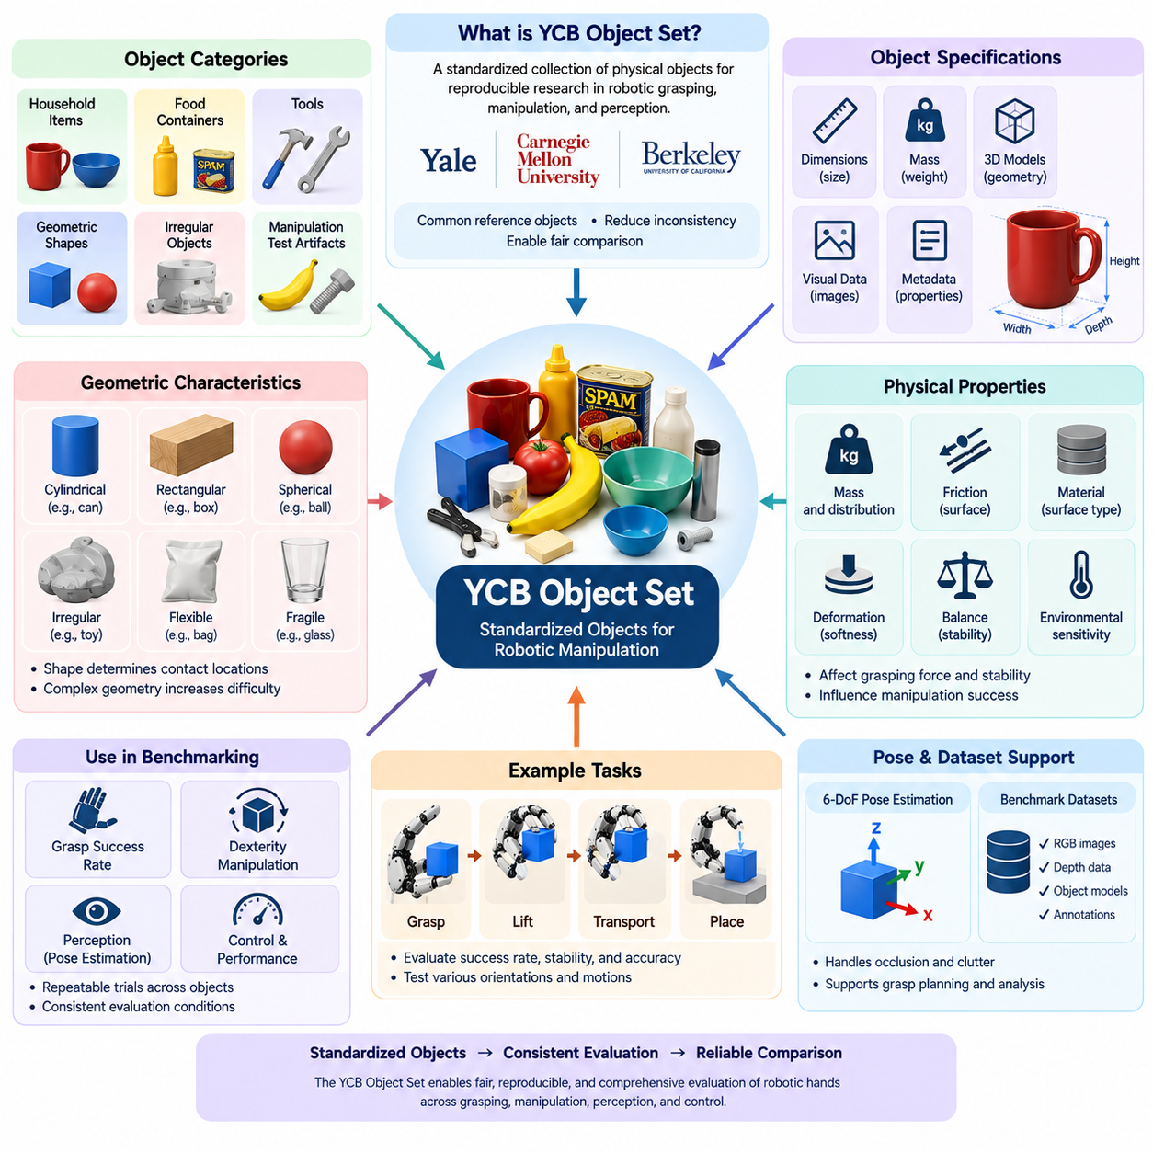
The YCB Object Set is a standardized collection of physical objects developed to support reproducible research in robotic grasping, manipulation, and perception. Created through collaboration among Yale University, Carnegie Mellon University, and the University of California, Berkeley, it provides common reference objects for evaluating robotic systems. Its primary purpose is to reduce experimental inconsistency and enable meaningful comparisons across different robotic platforms.
Robotic grasping research traditionally relied on laboratory-specific objects, making direct comparisons between experiments difficult. Differences in object geometry, material properties, mass, and surface friction often produced inconsistent evaluation conditions. The YCB Object Set addresses this problem by providing a documented collection of objects that researchers can use to establish common experimental conditions and more reproducible manipulation benchmarks.
The collection contains objects representing everyday household items, food containers, tools, geometric shapes, and manipulation-specific test artifacts. These categories provide diverse physical characteristics that challenge robotic hands in different ways. Cylindrical containers emphasize grasp stability, irregular tools require adaptive finger placement, and geometric objects support controlled experiments involving contact mechanics and object reorientation.
One important characteristic of the YCB Object Set is the availability of physical object specifications and digital representations. Depending on the object and released resources, these may include dimensions, mass information, geometric models, and visual data. Such information supports experimental preparation, perception algorithm development, grasp planning, and simulation-based evaluation while improving consistency between physical and virtual environments.
Object geometry strongly influences grasping difficulty because shape determines feasible contact locations and finger configurations. Simple cylindrical objects often permit multiple grasp orientations, while irregular objects may require precise contact positioning. Thin objects, narrow handles, and complex surfaces introduce additional challenges. Evaluating these geometric variations helps reveal the adaptability and limitations of robotic hand mechanisms.
Mass and mass distribution are equally important because they determine gravitational loading and influence the forces required for stable manipulation. Lightweight objects may be easy to lift but difficult to handle without excessive force, while heavier objects require greater grip strength. Objects with asymmetric mass distributions can introduce rotational moments that challenge force coordination and grasp stability during movement.
Surface properties introduce another dimension of difficulty because friction determines the relationship between normal contact force and resistance to sliding. Smooth plastic, metal, cardboard, and textured surfaces can produce different grasping behavior. Benchmark procedures should document contact materials and environmental conditions because surface contamination, wear, and humidity may alter friction and affect experimental repeatability.
The YCB Object Set supports grasp success rate evaluation by allowing repeated trials across a consistent group of objects. A robotic hand may attempt to grasp, lift, transport, and release each object under predefined conditions. Success rates can then be reported for individual objects, object categories, or the complete evaluation set. This approach helps identify whether performance limitations are associated with particular geometries or physical properties.
Dexterity evaluation extends beyond object acquisition by examining how robotic hands manipulate YCB objects after grasping. Relevant tasks include controlled rotation, translation, reorientation, and regrasping. Objects with distinct geometric features are useful for measuring orientation accuracy and contact transitions. Such experiments reveal whether a robotic hand can perform coordinated manipulation rather than merely maintaining a static grasp.
The collection also supports perception research because robotic systems must recognize objects and estimate their positions before manipulation. RGB images, depth measurements, and three-dimensional object models can be used to develop object detection and pose estimation algorithms. When combined with grasp execution experiments, perception benchmarks help determine how localization accuracy influences physical manipulation performance.
Six-degree-of-freedom object pose estimation is particularly relevant for robotic hands operating in cluttered environments. A perception system must estimate object translation and orientation despite occlusion, lighting changes, and overlapping objects. YCB objects are used in datasets and experimental frameworks addressing these challenges. Pose estimation errors can subsequently be analyzed in relation to grasp planning failures and manipulation inaccuracies.
Benchmark protocols must clearly define how objects are presented to the robotic hand. Experimental conditions may include isolated objects on a table, randomized object orientations, or cluttered arrangements containing multiple items. Each condition introduces different levels of difficulty. Consistent placement procedures, camera configurations, robot calibration, and workspace boundaries are necessary for meaningful comparisons between systems.
The number of trials performed on each object significantly affects the statistical reliability of reported results. Repeated grasp attempts should include variations in initial pose and approach direction when appropriate. Researchers should report successful attempts, total valid attempts, failure categories, and uncertainty estimates. Object-level reporting is particularly valuable because an aggregate success rate may conceal poor performance on difficult object categories.
The YCB Object Set is also useful for evaluating different robotic hand architectures under common conditions. Parallel-jaw grippers, adaptive underactuated hands, soft grippers, and dexterous multifinger hands may employ fundamentally different grasp strategies. Comparative experiments should therefore distinguish between identical task requirements and architecture-specific control methods, ensuring that evaluation procedures do not unfairly favor one mechanism.
Simulation environments can incorporate digital representations of YCB objects to support grasp planning, reinforcement learning, and manipulation policy development. Object models enable virtual contact experiments and large-scale testing before physical execution. However, accurate simulation requires appropriate mass, inertia, friction, and contact parameters. Differences between simulated and physical object behavior must be considered when interpreting simulation-to-real transfer performance.
Learning-based grasping systems benefit from standardized objects because they provide consistent references for training, validation, and testing. Nevertheless, evaluating only objects encountered during training can produce misleading estimates of generalization. Experimental designs should separate training and evaluation conditions when testing unfamiliar-object performance. Novel-object benchmarks are necessary to determine whether learned grasp policies transfer beyond memorized geometries.
The YCB Object Set can also support contact-rich manipulation and assembly-oriented research when suitable objects and task definitions are selected. Tasks involving object alignment, insertion, repositioning, and tool handling require coordinated sensing and force control. Such evaluations extend traditional grasp success measurements toward more demanding dexterous manipulation capabilities, although specialized assembly benchmarks may be required for comprehensive assessment.
A limitation of standardized object collections is that they cannot represent the full diversity of objects encountered in real environments. Industrial components, deformable materials, fragile products, and highly reflective surfaces may introduce challenges not adequately covered by a general-purpose collection. Consequently, YCB-based evaluation should be complemented by application-specific objects when validating robotic hands for manufacturing, logistics, healthcare, or service applications.
Physical object condition is another important consideration because repeated experiments can change surface properties, dimensions, or mechanical integrity. Packaging damage, deformation, contamination, and wear may affect grasping behavior over time. Laboratories should inspect benchmark objects periodically and document significant changes. Maintaining consistent object conditions helps prevent unintended experimental variation and improves long-term reproducibility.
A comprehensive YCB benchmarking report should describe the selected objects, experimental environment, robotic hand configuration, sensing system, control strategy, and success criteria. Results should include object-specific performance, repeated-trial statistics, and relevant failure analysis. When comparing different systems, researchers should also document differences in perception, arm motion, fingertip materials, and environmental support.
Ultimately, the YCB Object Set provides a practical foundation for standardized robotic grasping and manipulation evaluation. Its combination of physical objects, documented characteristics, and supporting digital resources enables more systematic experimentation across robotic platforms. By integrating YCB-based tests with dexterity metrics, grasp success measurements, robustness analysis, and application-specific validation, engineers can develop a more reliable understanding of robotic hand capabilities.

14.05 GraspNet Benchmark
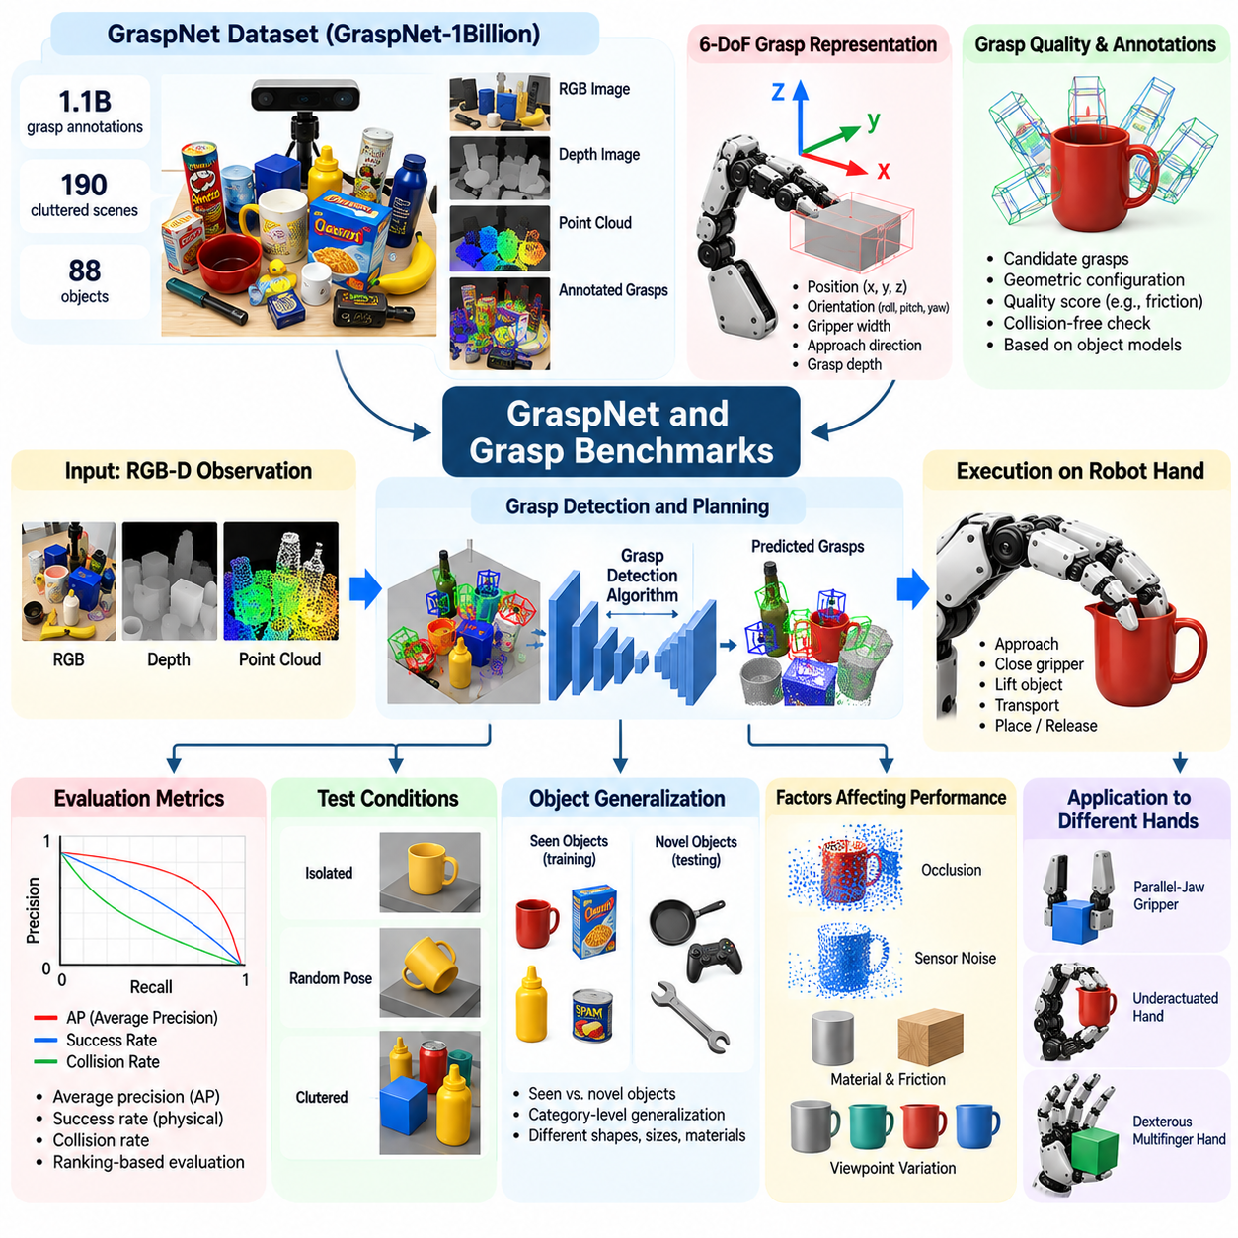
GraspNet and related grasp benchmarks provide standardized frameworks for evaluating robotic grasp detection, planning, and execution. These benchmarks measure how effectively robotic systems identify feasible grasp configurations from visual or geometric observations. Unlike simple grasp success tests, they examine the relationship between perception, predicted grasp quality, and physical manipulation, enabling systematic comparison of grasping algorithms.
GraspNet-1Billion is a large-scale benchmark designed for general object grasping in cluttered environments. It provides RGB-D observations, annotated grasp candidates, and object information for evaluating six-degree-of-freedom grasp detection. The benchmark contains approximately 1.1 billion grasp annotations across 190 cluttered scenes involving 88 objects, offering extensive supervision for learning-based grasp prediction and systematic evaluation.
A central objective of GraspNet is to evaluate whether grasp detection algorithms can identify reliable grasp poses from incomplete and noisy sensory information. In practical environments, objects may overlap, become partially occluded, or appear under unfamiliar orientations. These conditions complicate grasp planning because the system must infer suitable contact configurations despite limited visibility and uncertainty in object geometry.
Six-degree-of-freedom grasp representation describes the three-dimensional position and orientation of a candidate grasp. For parallel-jaw grippers, additional parameters may specify gripper opening width, approach direction, and grasp depth. These representations allow algorithms to generate executable grasp hypotheses in three-dimensional space. However, compatibility with a particular robotic hand depends on its geometry, actuation limits, and contact characteristics.
Grasp annotations provide reference information for evaluating predicted grasp candidates. In GraspNet, candidate grasps are associated with geometric configurations and quality-related information derived from object models and grasp analysis. Such annotations enable algorithms to learn relationships between observed object geometry and feasible grasp configurations. Their usefulness depends on the assumptions embedded in contact modeling and grasp quality estimation.
Grasp detection performance is commonly evaluated using average precision and related ranking-based metrics. Predicted grasps are assessed against benchmark-defined quality conditions, often involving friction-based grasp feasibility. Average precision summarizes the ability to rank useful grasp candidates across evaluation thresholds. These metrics characterize prediction quality but should not be interpreted as direct measurements of physical grasp execution success.
Collision checking is an essential component of grasp benchmarking because geometrically promising grasp poses may be physically inaccessible. A candidate grasp can intersect neighboring objects, the supporting surface, or the robot itself. Evaluation pipelines therefore examine whether the gripper can approach and close around the target without unacceptable collisions. Collision-aware grasp prediction is particularly important in cluttered manipulation environments.
Point cloud processing plays a major role in GraspNet-based evaluation because depth sensors provide three-dimensional information about visible object surfaces. Neural networks can analyze local geometry, surface orientation, and spatial relationships to predict candidate grasps. Point cloud density, sensor noise, missing depth measurements, and occlusion influence prediction accuracy, making perception quality an important factor in benchmark performance.
RGB-D grasp detection combines color information with depth measurements to improve object understanding and grasp candidate generation. Color images can provide semantic and appearance information, while depth data supports geometric reasoning. Multimodal perception may improve performance when either modality is incomplete, although lighting variation, reflective surfaces, and sensor calibration errors can still introduce significant uncertainty.
GraspNet evaluation includes distinct testing conditions intended to examine generalization beyond training observations. Benchmark protocols distinguish familiar objects from novel object categories or instances, allowing researchers to analyze performance under different degrees of object familiarity. This separation is important because strong results on previously encountered geometries do not necessarily indicate reliable grasp prediction for unfamiliar objects.
Grasp benchmark comparisons must distinguish object-level recognition from geometry-based grasp generalization. An algorithm may predict successful grasps by learning familiar object shapes, while another may infer grasp configurations from local contact geometry. Both approaches can perform well under selected conditions, but their robustness may differ when objects have unfamiliar shapes, textures, or physical properties.
The relationship between grasp prediction and robotic hand execution introduces an important evaluation boundary. A grasp pose considered feasible for a parallel-jaw gripper may not be directly applicable to an underactuated or dexterous multifinger hand. Finger arrangement, contact distribution, actuator limits, and available degrees of freedom affect execution feasibility. Consequently, benchmark results must be interpreted in relation to the intended end-effector architecture.
Physical grasp execution benchmarks complement prediction metrics by testing whether generated grasps succeed on actual robotic hardware. Typical procedures involve selecting a predicted grasp, moving the robot to the target, closing the gripper, lifting the object, and checking retention. Repeated trials reveal failures caused by calibration errors, contact uncertainty, friction variation, and mechanical limitations that may not be captured by offline evaluation.
Grasp success rate remains a necessary companion metric because high prediction accuracy does not guarantee reliable physical manipulation. Offline benchmarks often evaluate candidate quality using geometric or analytical approximations, whereas real execution depends on actuator behavior, object compliance, sensor feedback, and environmental disturbances. Reporting both prediction performance and physical success provides a more complete assessment of grasping capability.
Other grasp benchmarks contribute complementary evaluation perspectives. The Cornell Grasping Dataset supports image-based grasp rectangle prediction, while Jacquard provides a large synthetic dataset for grasp detection research. Dex-Net emphasizes analytical grasp quality and synthetic training data. These resources differ in annotation methods, object diversity, grasp representations, and evaluation procedures, making their reported scores unsuitable for direct comparison without methodological alignment.
Simulation-based grasp benchmarks enable extensive evaluation of candidate generation and grasp planning strategies before physical deployment. Simulated environments can vary object geometry, placement, friction, and robot configurations while recording detailed contact information. However, simulation fidelity depends on contact models, material parameters, and actuator dynamics. Physical validation is necessary to establish whether simulated performance transfers to real robotic systems.
Learning-based grasping algorithms require careful control of training and testing data to avoid misleading benchmark results. Data leakage may occur when closely related object models, scenes, or observations appear in both training and evaluation sets. Researchers should follow official dataset partitions, document preprocessing procedures, and report any additional training data. These practices improve reproducibility and support fair algorithm comparisons.
Inference latency and computational efficiency are important when grasp detection models operate within real-time robotic systems. A highly accurate network may be unsuitable for deployment if grasp prediction requires excessive processing time or memory. Benchmarking should therefore include inference time, hardware configuration, memory consumption, and candidate generation throughput alongside accuracy measurements, particularly for embedded and edge computing platforms.
Robustness evaluation examines how grasp detection performance changes under sensor noise, object occlusion, clutter density, and environmental variation. Controlled perturbations can reveal sensitivity to incomplete point clouds, inaccurate depth measurements, or unfamiliar object arrangements. Performance should be reported across multiple difficulty levels because average benchmark scores may conceal substantial weaknesses under challenging operating conditions.
A comprehensive grasp benchmarking report should document the dataset version, evaluation split, grasp representation, prediction metrics, collision checking procedure, computational platform, and physical execution protocol. It should distinguish offline grasp detection performance from real-world manipulation results and identify assumptions concerning friction, object geometry, and gripper design. Such documentation supports reproducible comparisons and meaningful interpretation.
Ultimately, GraspNet and related grasp benchmarks establish a foundation for measuring progress in robotic grasp perception and planning. Their standardized datasets, annotations, and evaluation protocols enable researchers to compare algorithms and identify generalization limitations. By combining offline prediction metrics with physical grasp success, robustness testing, and application-specific validation, engineers can develop more reliable grasping systems for practical robotic manipulation.

14.06 In-Hand Manipulation Benchmark
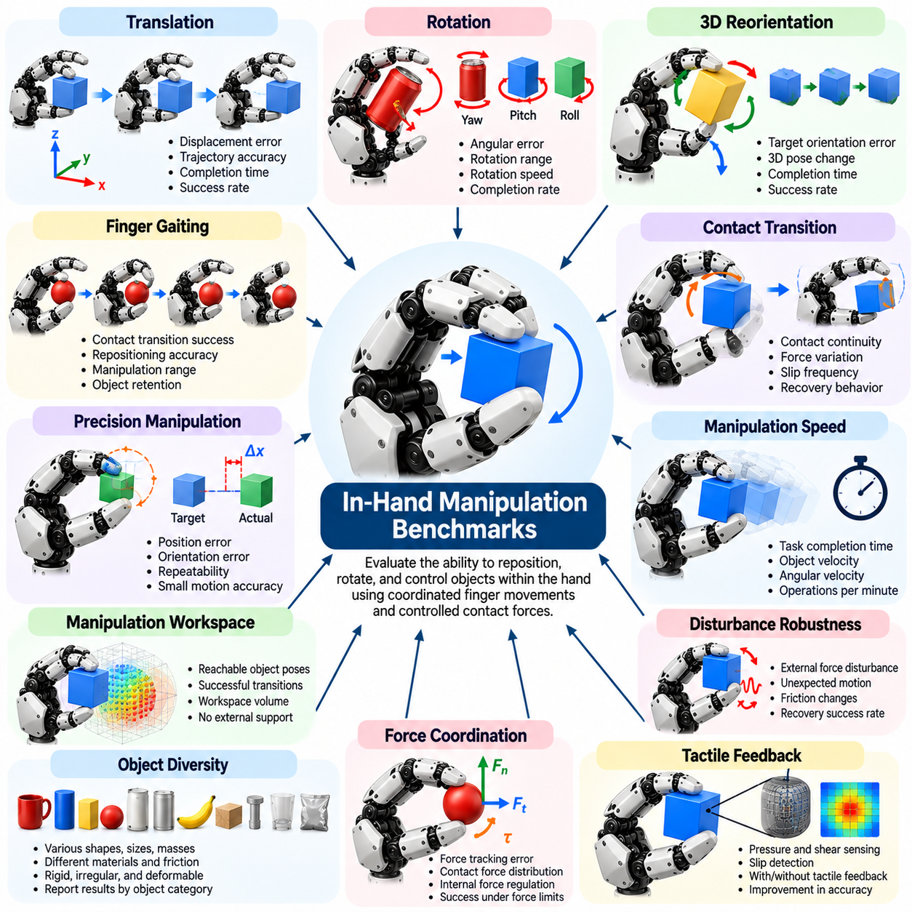
In-hand manipulation benchmarks evaluate the ability of a robotic hand to reposition, rotate, and control an object while maintaining it within the hand. Unlike conventional grasping benchmarks, which primarily measure object acquisition and retention, these evaluations examine coordinated finger movements, controlled contact transitions, and precise object motion. They provide important evidence of dexterity beyond basic grasp stability.
In-hand manipulation requires a robotic hand to generate controlled object motion through coordinated fingertip forces and changing contact configurations. The object may translate, rotate, or undergo combined movements without being released. Benchmark design must therefore distinguish manipulation performed entirely by the fingers from motion produced by the robot arm, wrist, gravity, or external environmental support.
Object translation benchmarks measure how accurately a robotic hand moves an object between specified positions relative to the palm. Typical tasks involve shifting an object along one or more axes while maintaining stable contact. Performance can be evaluated through displacement error, trajectory tracking accuracy, completion time, and failure frequency. These measurements reveal the hand's ability to coordinate multiple fingers during controlled repositioning.
Object rotation benchmarks evaluate the ability to change an object's orientation around specified axes. Tasks may include rotating a cube, turning a cylindrical component, or continuously spinning an object using fingertip contacts. Rotation accuracy is commonly measured through angular error between target and achieved orientations. Additional metrics include rotation speed, accumulated angular displacement, and successful completion rate.
Three-dimensional reorientation tasks require coordinated rotation around multiple axes rather than movement around a single predefined direction. These tasks are particularly demanding because contact locations and force distributions change continuously. Benchmark protocols should specify target orientations, initial object poses, allowable execution time, and whether temporary environmental contact is permitted during manipulation.
Finger gaiting benchmarks examine how a robotic hand changes individual finger contacts while preserving overall object stability. A finger may release, reposition, and reestablish contact while other fingers maintain support. Successful finger gaiting expands the manipulation workspace beyond the limits of fixed fingertip contacts. Evaluation metrics include contact transition success, repositioning accuracy, manipulation range, and object retention.
Contact transition quality is a central factor in dexterous manipulation because fingers must redistribute forces without losing control of the object. Poorly coordinated transitions can produce unintended slipping, excessive force, or complete grasp failure. Benchmarks may measure contact continuity, force variation, slip events, and recovery behavior. These measurements help identify limitations in tactile sensing and closed-loop finger control.
Precision manipulation benchmarks evaluate whether a robotic hand can achieve small, accurately controlled object movements. Examples include fine rotational adjustments, incremental translation, and alignment with a target pose. Position and orientation errors should be measured using calibrated tracking systems. Precision must be evaluated together with repeatability because a single accurate trial does not demonstrate consistent manipulation capability.
Manipulation speed is another important benchmark dimension because dexterous tasks must often be completed within operational time constraints. Metrics include task completion time, average object velocity, angular velocity, and successful operations per minute. Faster manipulation can increase productivity but may reduce stability and precision. Benchmark reports should therefore describe the relationship between execution speed and successful task completion.
Manipulation workspace measures the range of object positions and orientations achievable without releasing the object or relying on external support. A robotic hand with a large manipulation workspace can accommodate more diverse tasks and reduce the need for arm repositioning. Workspace evaluation may sample reachable object poses and record successful transitions between them, producing a practical estimate of manipulation capability.
Force coordination benchmarks assess how effectively multiple fingers generate the contact forces needed to move an object while preventing unwanted motion. Manipulation requires balancing normal forces, tangential forces, and object moments. Excessive gripping may damage fragile objects, while insufficient force can cause slip. Relevant metrics include force tracking error, peak contact force, and manipulation success under force constraints.
Tactile feedback can significantly improve in-hand manipulation by providing information about contact pressure, shear forces, and incipient slip. Benchmarks may compare performance with and without tactile feedback under otherwise identical conditions. Improvements in slip prevention, contact adjustment, and manipulation accuracy can then be quantified. Such comparisons help determine the practical contribution of tactile sensing to dexterous control.
Robustness benchmarks introduce disturbances during manipulation to evaluate whether the hand can maintain or recover object control. Disturbances may include unexpected object motion, external forces, friction changes, or uncertainty in object properties. Recovery success rate, maximum tolerated disturbance, and time required to restore the intended object trajectory provide useful measures of manipulation resilience.
Object diversity is essential because manipulation difficulty depends on geometry, mass distribution, friction, size, and surface compliance. Spheres, cubes, cylinders, tools, and irregular objects require different contact strategies. Standardized object collections such as the YCB Object Set can support reproducible evaluation, although specialized manipulation objects may be necessary for measuring continuous rotation and complex finger gaiting.
Benchmark protocols should carefully control the initial grasp configuration because different starting contacts can substantially affect manipulation difficulty. Experiments should document initial object pose, finger placement, actuator state, and contact conditions. Randomized initial configurations can evaluate adaptability, while fixed configurations support controlled comparisons. Both approaches provide complementary information about manipulation performance.
Simulation-based in-hand manipulation benchmarks enable extensive testing of control policies, contact strategies, and learning algorithms. Simulated environments can provide precise object state information and repeatable disturbance conditions. However, contact-rich manipulation is highly sensitive to friction, compliance, and collision modeling. Results obtained in simulation should therefore be validated through physical experiments before claims of real-world reliability are made.
Learning-based manipulation benchmarks evaluate whether robotic hands can acquire coordinated control policies through reinforcement learning, imitation learning, or other data-driven methods. Evaluation should separate training objects and conditions from unseen test cases. Success rates on novel object geometries, altered friction conditions, and unfamiliar target orientations reveal whether learned policies generalize beyond their training distributions.
Long-horizon manipulation tasks require a robotic hand to execute sequences of coordinated actions without dropping or losing control of an object. Examples include repeated reorientation, continuous rotation, and multi-stage repositioning. Benchmark metrics may include sequence completion rate, cumulative pose error, number of contact transitions, and recovery frequency. These tasks expose limitations that short, isolated manipulation trials may overlook.
Comparative benchmarking must account for differences in robotic hand architecture, including finger count, joint arrangement, actuation strategy, tactile sensing, and mechanical compliance. A task that is straightforward for one design may be difficult or infeasible for another. Fair evaluation requires common task objectives, transparent hardware descriptions, and clear separation between hand-only manipulation and assistance from external mechanisms.
A comprehensive in-hand manipulation benchmark should report task success, object pose accuracy, manipulation speed, workspace coverage, contact stability, robustness, and repeatability. Results should be presented across multiple objects, initial configurations, and disturbance conditions. By integrating these measurements, engineers can assess the practical dexterity of robotic hands and identify the sensing, mechanical, and control improvements needed for reliable manipulation.

14.07 Tactile Benchmark
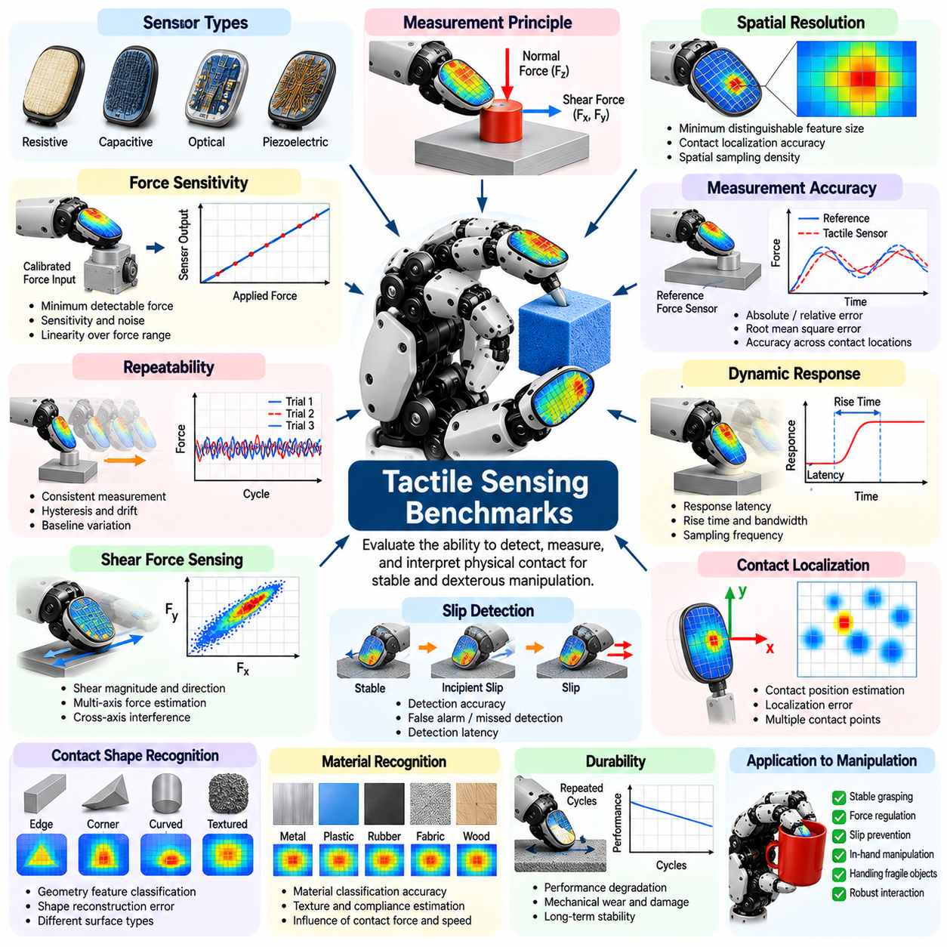
Tactile sensing benchmarks evaluate how effectively robotic hands detect, measure, and interpret physical contact during grasping and manipulation. Unlike vision-based evaluation, tactile benchmarking focuses on information generated directly at contact interfaces. These measurements reveal whether a robotic hand can recognize contact conditions, regulate interaction forces, detect slip, and maintain stable manipulation when visual information is incomplete.
Tactile sensors convert mechanical interactions into measurable electrical, optical, or other signals. Depending on sensor technology, these signals may represent normal pressure, shear force, deformation, vibration, or contact location. Benchmark design must distinguish raw sensor performance from the effectiveness of algorithms that interpret tactile information. A sensor with excellent resolution does not necessarily produce superior manipulation performance.
Spatial resolution measures the ability of a tactile sensor to distinguish neighboring contact locations or pressure distributions. High-resolution tactile arrays can identify small contact features and support precise fingertip interaction. Evaluation may use calibrated indenters applied at known positions and separations. Results should report spatial sampling density, effective localization accuracy, and the minimum distinguishable feature size under specified loading conditions.
Force sensitivity measures the smallest change in applied force that a tactile sensor can reliably detect. High sensitivity is particularly important when manipulating lightweight or fragile objects that require gentle contact. Benchmark procedures apply controlled force increments and compare sensor outputs with calibrated reference measurements. Sensitivity should be evaluated alongside noise because apparent signal changes may not represent actual contact variations.
Measurement accuracy describes how closely tactile sensor outputs correspond to known reference forces or pressures. Calibration experiments typically apply loads across the intended operating range and compare estimated values with reference instruments. Metrics may include absolute error, relative error, and root mean square error. Accuracy should be assessed at multiple contact locations because sensor response can vary across the sensing surface.
Repeatability evaluates whether a tactile sensor produces consistent measurements when identical contact conditions are applied repeatedly. Experiments may involve repeated loading and unloading cycles at fixed positions and force levels. Measurement dispersion, hysteresis, and baseline variation provide information about sensor consistency. High repeatability is essential for reliable closed-loop grasp control and meaningful comparison between experimental sessions.
Dynamic response determines how quickly a tactile sensor reacts to changing contact conditions. Important measurements include response latency, rise time, sampling frequency, and usable bandwidth. Rapid response is necessary for detecting sudden contact events and initiating corrective control actions. Benchmark procedures should distinguish sensor response time from communication delays, signal processing latency, and the overall control-loop response.
Shear force sensing is especially important because tangential contact forces influence slip and object stability. Benchmarks evaluate whether sensors can estimate shear magnitude and direction under controlled loading. Combined normal and tangential forces should be tested because real manipulation rarely involves isolated force components. Cross-axis interference and estimation errors reveal limitations in multidirectional tactile sensing.
Slip detection benchmarks measure the ability to identify relative motion between an object and the robotic fingertip. Tests may gradually increase tangential loading until slipping begins or introduce controlled object movement. Detection accuracy, false alarm rate, missed detection rate, and detection latency are relevant metrics. Early identification of incipient slip can enable corrective grip adjustments before complete grasp failure occurs.
Contact localization benchmarks assess whether a tactile sensing system can determine where an object touches the finger or palm. Known contact points are generated using calibrated mechanical fixtures, and estimated positions are compared with reference locations. Localization error can be expressed as distance or distribution overlap. Accurate contact localization supports grasp planning, finger repositioning, and estimation of object motion within the hand.
Contact shape recognition extends tactile evaluation beyond individual force measurements by examining whether sensors can distinguish geometric surface features. Experiments may use edges, corners, curved surfaces, and textured materials. Classification accuracy and reconstruction error provide measures of tactile perception capability. These benchmarks are particularly useful for robotic hands that must manipulate objects under partial visual occlusion.
Material recognition benchmarks evaluate whether tactile measurements can distinguish surface characteristics such as texture, hardness, and compliance. Controlled contact and sliding procedures generate signals associated with different materials. Performance depends on contact force, movement speed, and environmental conditions. Evaluation should separate material classification accuracy from the influence of object geometry and experimental setup.
Sensor durability is an important benchmark dimension because robotic fingertips experience repeated compression, shear loading, abrasion, and occasional impacts. Accelerated testing can apply repeated contact cycles while monitoring measurement accuracy and signal stability. Relevant indicators include performance degradation, mechanical damage, and calibration drift. Durability evaluation helps determine whether a tactile sensing system is suitable for continuous robotic operation.
Environmental robustness measures tactile sensor performance under changes in temperature, humidity, vibration, and surface contamination. Such conditions can alter sensor materials, electrical characteristics, and contact behavior. Benchmark procedures should quantify measurement drift and detection reliability across representative operating environments. Robustness testing is especially important for industrial and mobile robotic systems operating outside controlled laboratories.
Tactile calibration procedures establish relationships between physical contact quantities and sensor outputs. Calibration may require force references, spatial mapping, temperature compensation, and correction of nonlinear responses. Benchmark reports should document calibration methods, reference equipment, uncertainty, and recalibration frequency. Without consistent calibration, comparisons between tactile sensing technologies may reflect measurement differences rather than actual capability.
Tactile data processing introduces additional performance considerations because raw measurements often require filtering, feature extraction, and state estimation. Neural networks and other learning-based methods may infer contact geometry, slip state, or object properties from tactile signals. Benchmarks should distinguish sensing hardware capability from algorithmic inference performance and report computational latency, training conditions, and generalization to unfamiliar contacts.
Closed-loop grasping benchmarks evaluate the practical contribution of tactile sensing by integrating sensor feedback into robotic hand control. Experiments may compare tactile-enabled grasping against vision-only or open-loop control under matched conditions. Grasp success rate, slip frequency, force regulation accuracy, and object damage can be measured. Such comparisons demonstrate whether improved tactile measurements translate into meaningful manipulation benefits.
In-hand manipulation benchmarks provide a demanding environment for evaluating tactile sensing because finger contacts change continuously during object rotation and repositioning. Sensors must detect contact transitions, estimate force distribution, and support corrective control. Performance can be measured through manipulation success, pose accuracy, contact stability, and recovery from disturbances. These tasks reveal limitations that static pressure measurements may overlook.
Benchmark reproducibility requires standardized contact objects, loading procedures, sensor mounting conditions, and reference measurement systems. Differences in fingertip compliance, contact area, and mechanical integration can strongly influence tactile signals. Researchers should report these conditions together with sensor specifications and statistical uncertainty. Consistent experimental documentation enables more meaningful comparisons across laboratories and robotic platforms.
A comprehensive tactile sensing benchmark should combine static accuracy, spatial resolution, force sensitivity, dynamic response, slip detection, durability, and task-level performance. No single metric adequately describes tactile sensing capability because sensing requirements vary across manipulation tasks. By integrating sensor-level measurements with closed-loop grasping and dexterous manipulation tests, engineers can determine how tactile feedback improves robotic hand reliability and adaptability.

14.08 Speed and Cycle Time Metrics
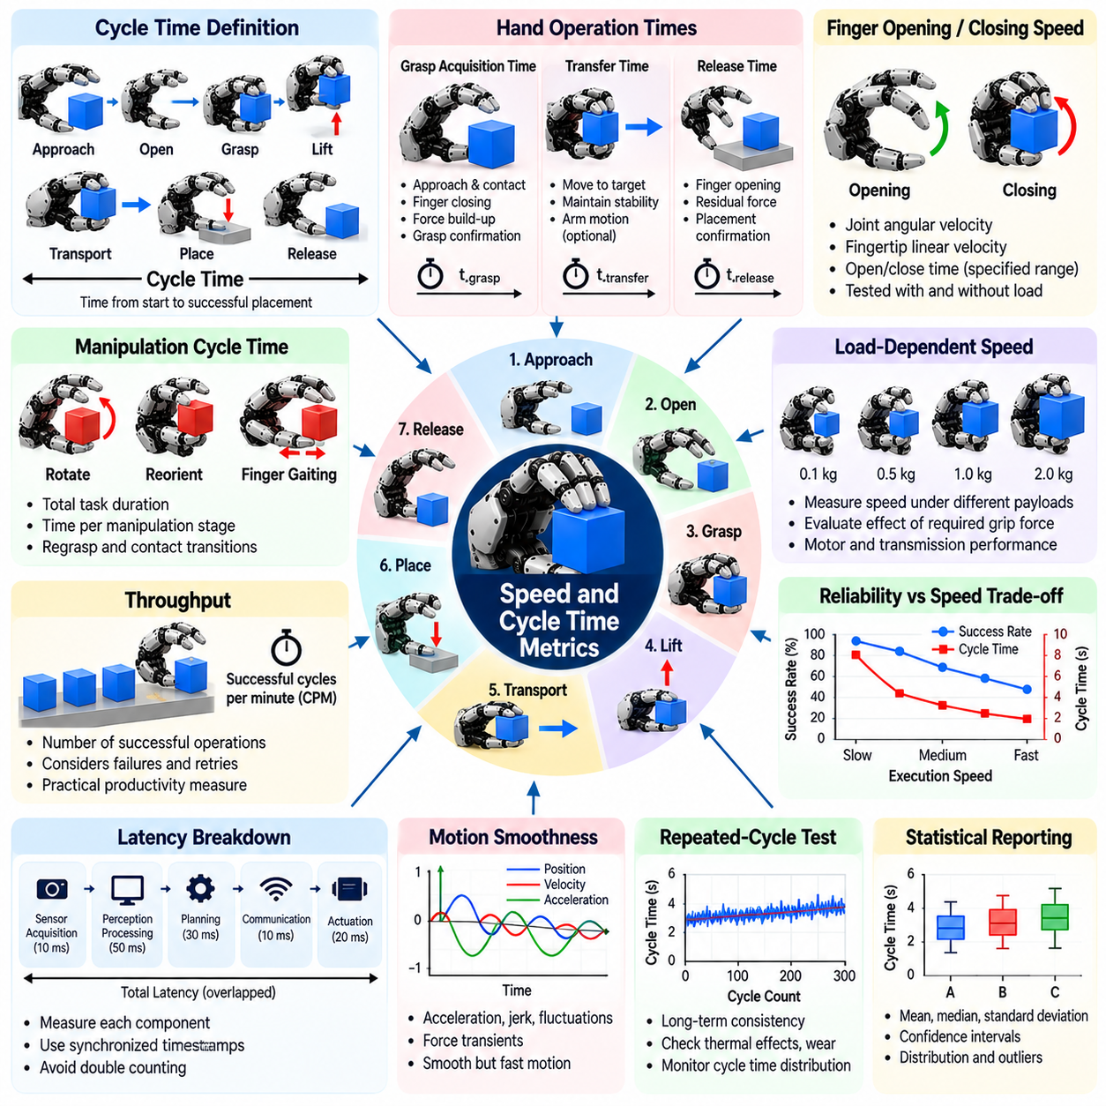
Speed and cycle time metrics evaluate how efficiently a robotic hand performs grasping, manipulation, and release operations. These measurements are essential for determining whether a hand can satisfy the productivity requirements of industrial automation, logistics, and service robotics. Unlike grasp success rate, which emphasizes reliability, speed metrics quantify execution time and reveal the relationship between operational efficiency and manipulation performance.
Cycle time represents the total duration required to complete a predefined manipulation sequence. A typical pick-and-place cycle includes object approach, finger opening, grasp acquisition, lifting, transportation, placement, and release. Benchmark protocols must define the starting and ending events precisely because including or excluding robot arm motion, perception, or communication delays can significantly change the reported cycle time.
Grasp acquisition time measures the interval between initiating a grasp command and establishing a stable object hold. This interval may include finger approach, initial contact, force buildup, and grasp confirmation. Acquisition time depends on actuator speed, finger travel distance, sensing latency, and control strategy. Benchmark results should distinguish mechanical closing time from the complete process required to verify grasp stability.
Finger opening and closing speed provides a direct measure of hand actuation performance. Relevant metrics include joint angular velocity, fingertip linear velocity, and time required to move between specified configurations. Testing should use standardized motion ranges and loading conditions. Maximum unloaded speed alone is insufficient because actuator performance may decrease substantially when the hand operates against contact forces.
Object transfer time measures how long a robotic system takes to move a grasped object between predefined locations. Although transfer speed is strongly influenced by robot arm motion, hand stability can constrain allowable acceleration and velocity. Benchmarks should separate arm-dependent transportation time from hand-specific control delays. This distinction prevents overall robot motion performance from being incorrectly attributed to the hand.
Release time measures the duration required to disengage the fingers and establish a stable object placement. Release performance depends on finger opening dynamics, residual contact forces, surface adhesion, and control synchronization. A rapid opening command does not necessarily produce immediate object separation. Benchmark procedures should define release completion using observable physical events rather than actuator command termination alone.
Manipulation cycle time becomes more complex when a task requires object reorientation, finger gaiting, or repeated contact transitions. These operations may involve multiple coordinated finger movements and intermediate stabilization periods. Evaluation should record both total task duration and the time spent in individual manipulation stages. Such measurements identify bottlenecks that cannot be detected through simple opening and closing tests.
Throughput measures the number of successfully completed manipulation operations within a specified time interval. It is commonly expressed as successful cycles per minute or hour. Throughput depends on both execution speed and reliability because failed attempts, retries, and recovery operations consume additional time. Consequently, throughput often provides a more practical productivity measure than the minimum achievable cycle time.
Speed and grasp reliability frequently involve competing requirements. Increasing finger velocity may reduce acquisition time but can introduce impact forces, object displacement, and unstable contacts. Similarly, aggressive arm acceleration may increase slip risk during transportation. Benchmark experiments should measure success rate across multiple speed settings to identify operating regions that balance rapid execution with acceptable reliability.
Latency measurements help explain delays between sensing, decision-making, and physical actuation. Relevant components include sensor acquisition latency, perception processing time, grasp planning time, communication delay, and actuator response latency. These delays may overlap rather than occur sequentially. Accurate benchmarking requires synchronized timestamps and clear definitions to avoid double counting within the overall cycle.
Motion smoothness is relevant because rapid but poorly controlled finger movements can generate vibration and excessive contact forces. Acceleration, jerk, velocity fluctuations, and force transients provide additional indicators of motion quality. Smoothness metrics should be interpreted alongside completion time and grasp stability. A slower trajectory may be preferable when handling fragile objects or performing precision assembly.
Load-dependent speed testing evaluates how hand performance changes with object mass, required gripping force, and actuator loading. Motors and transmissions may exhibit reduced velocity under high torque demand, while compliant mechanisms may require additional settling time. Benchmark protocols should specify representative payloads and contact forces. Results obtained without loads should not be assumed to represent practical operating conditions.
Repeated-cycle testing reveals whether speed performance remains consistent during prolonged operation. Actuator heating, battery voltage changes, mechanical wear, and controller limitations can affect execution time. Experiments should record cycle time distributions over extended sequences rather than reporting only initial measurements. Increasing cycle duration may indicate thermal derating, mechanical degradation, or emerging control problems.
Statistical analysis is necessary because cycle times vary across objects, grasp configurations, and environmental conditions. Mean and median duration describe typical performance, while standard deviation and percentile values characterize variability. High-percentile cycle times are particularly relevant when occasional delays disrupt production scheduling. Reports should include sample size, failed attempts, and the treatment of incomplete cycles.
Energy efficiency provides an additional perspective on speed because faster manipulation can increase peak power consumption and actuator heating. Relevant measurements include energy per completed cycle, average electrical power, and peak power demand. Comparisons should use equivalent tasks and payload conditions. The most productive operating speed may differ from the speed that minimizes energy consumption per successful operation.
Benchmark environment design strongly influences measured cycle time. Object placement, workspace geometry, sensor positioning, robot calibration, and communication architecture can introduce systematic differences. Standardized starting configurations and task distances are therefore necessary for fair comparisons. When hardware platforms differ, reports should separate intrinsic hand performance from complete system-level execution time.
Real-time control requirements become especially important for robotic hands performing rapid contact-rich manipulation. Control frequency, feedback bandwidth, and computation scheduling influence the ability to maintain stability during fast movements. Benchmarking should examine whether control loops meet timing requirements under realistic computational loads. Average latency alone may conceal occasional delays that cause manipulation failures.
Learning-based grasping systems introduce additional timing considerations because neural network inference and policy execution may consume substantial computational resources. Model size, processor architecture, memory bandwidth, and inference optimization affect response time. Evaluation should distinguish offline planning from online decision-making and report the hardware used. This information is essential when assessing deployment on embedded robotic controllers.
Comparative speed benchmarking should account for differences in hand architecture, actuator technology, finger count, and mechanical transmission. A parallel-jaw gripper may complete simple grasping cycles faster than a dexterous multifinger hand, while the latter may perform complex manipulation without external repositioning. Fair comparison therefore requires equivalent task objectives rather than relying exclusively on actuator speed or isolated cycle measurements.
A comprehensive speed and cycle time evaluation should combine grasp acquisition time, actuation speed, manipulation duration, release time, throughput, latency, and timing variability. These measurements should be interpreted together with grasp success, payload capacity, energy consumption, and reliability. By evaluating complete task performance under representative conditions, engineers can identify practical operating limits and optimize robotic hands for efficient, dependable manipulation.

14.09 Reliability and MTBF
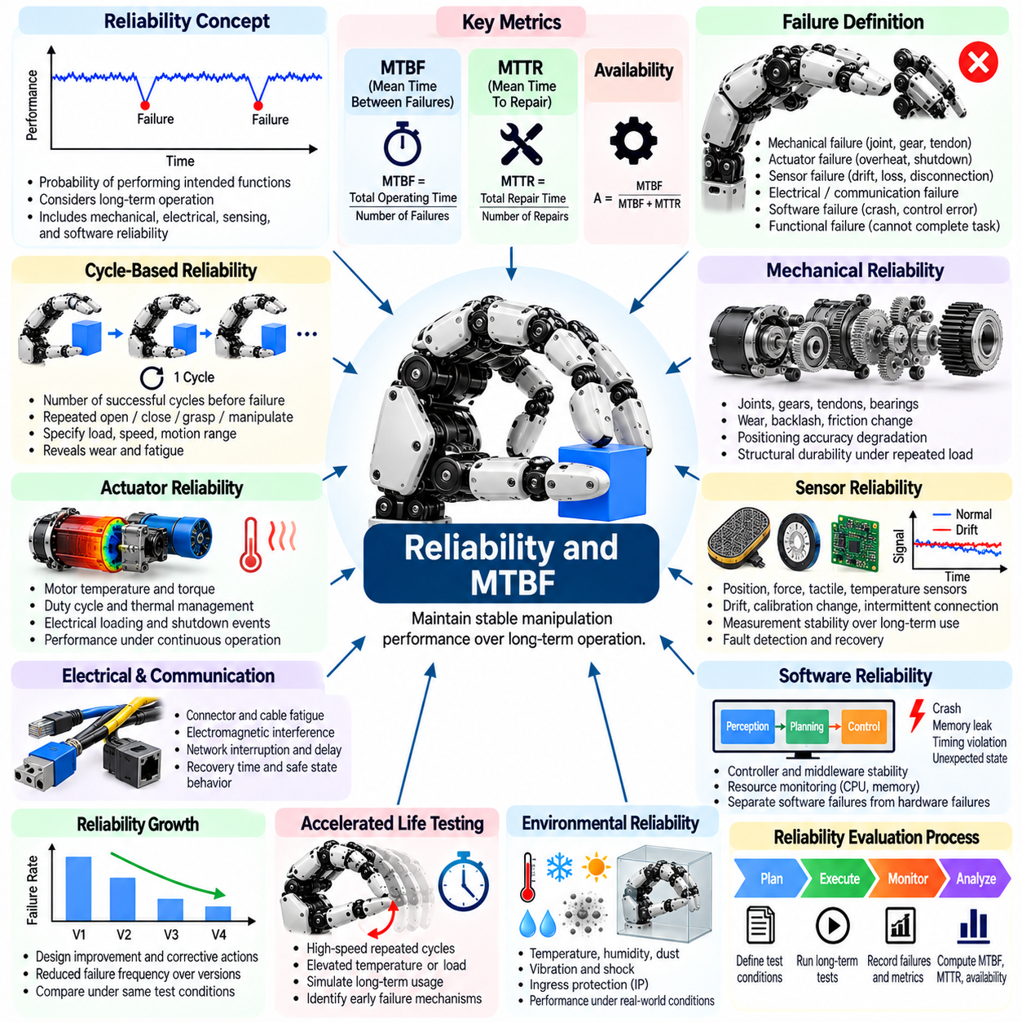
Reliability is a fundamental performance characteristic of robotic hands because successful manipulation must be maintained over extended periods of operation. Reliability benchmarks evaluate the probability that a hand performs its intended functions without failure under specified conditions. Unlike short-term grasp success tests, reliability evaluation considers mechanical wear, actuator degradation, sensor faults, control instability, and the cumulative effects of repeated manipulation cycles.
Mean Time Between Failures, or MTBF, represents the average operating time between successive failures of a repairable robotic hand system. It is commonly estimated by dividing accumulated operating time by the number of observed failures during a defined test period. MTBF provides a useful maintenance planning indicator but does not guarantee that an individual hand will operate without failure for that duration. Its interpretation depends on the failure definition and operating conditions.
Failure definition is essential because robotic hands can experience mechanical, electrical, sensing, and software-related problems. A failure may involve a broken transmission, actuator shutdown, sensor malfunction, communication loss, or inability to complete a required manipulation task. Benchmark protocols should distinguish functional failures from temporary performance degradation. Clear failure criteria prevent inconsistent reliability measurements across different robotic platforms.
Mean Time To Repair, or MTTR, measures the average time required to restore a failed robotic hand to an operational state. Repair activities may include fault diagnosis, component replacement, recalibration, software recovery, and functional verification. MTTR reflects maintainability rather than intrinsic failure resistance. When MTBF and MTTR are measured consistently, their relationship can help estimate operational availability for repairable systems.
Operational availability describes the proportion of time a robotic hand is capable of performing its required functions. Under simplified assumptions, inherent availability can be estimated as MTBF divided by the sum of MTBF and MTTR. Actual operational availability may also depend on scheduled maintenance, spare-part availability, and logistical delays. Reliability benchmarks should therefore distinguish inherent availability from availability observed during practical deployment.
Cycle-based reliability is particularly relevant because robotic hands experience repeated opening, closing, gripping, and manipulation operations. Instead of measuring only operating hours, benchmarks may report the number of successful cycles before failure. Cycle counts can reveal fatigue and wear mechanisms associated with repetitive motion. Results should specify load, speed, motion range, and environmental conditions because these factors strongly influence component lifetime.
Mechanical reliability depends on the durability of joints, gears, tendons, bearings, linkages, and structural components. Repeated loading can produce fatigue, backlash, friction changes, and transmission wear. Benchmark testing may involve accelerated cycling under representative forces while monitoring mechanical performance. Changes in positioning accuracy, joint stiffness, and transmission efficiency can indicate progressive degradation before complete failure occurs.
Actuator reliability is influenced by motor temperature, torque demand, duty cycle, electrical loading, and thermal management. Continuous gripping or rapid repetitive motion can generate substantial heat and reduce component lifetime. Reliability tests should monitor temperature, current, torque, and protective shutdown events. Thermal derating and intermittent actuator faults should be documented because they can reduce operational capability without causing permanent hardware damage.
Sensor reliability is critical because robotic hands depend on position, force, tactile, and sometimes temperature measurements for closed-loop control. Sensor drift, intermittent connections, calibration changes, and signal loss can degrade manipulation accuracy. Benchmarks should evaluate measurement stability during extended operation and repeated contact events. Fault detection and recovery capabilities should also be tested to determine whether sensing failures cause unsafe or unsuccessful manipulation.
Electrical and communication reliability affects the coordination of distributed actuators and sensors. Connector degradation, cable fatigue, electromagnetic interference, and network interruptions can cause intermittent faults. Benchmark procedures may introduce controlled communication delays or disconnections while monitoring system behavior. Recovery time, fault detection accuracy, and the ability to enter a safe state provide important indicators of system resilience.
Software reliability includes the stability of motion controllers, communication middleware, perception algorithms, and manipulation planning systems. Memory leaks, timing violations, unexpected state transitions, and unhandled exceptions can interrupt operation. Long-duration tests should monitor computational resource consumption and controller behavior. Software failures should be recorded separately from hardware failures to support accurate diagnosis and targeted improvement.
Reliability growth testing evaluates whether design modifications and corrective actions reduce failure frequency over successive development stages. Engineers identify failure mechanisms, implement improvements, and repeat representative operational tests. Reliability trends can reveal whether changes produce measurable benefits. Comparisons must account for differences in test duration, operating conditions, and sample size to avoid overstating improvements based on limited evidence.
Accelerated life testing applies elevated stresses to reveal failure mechanisms within shorter experimental periods. Increased cycle frequency, load, temperature, or vibration may accelerate wear and fatigue. However, excessive stress can introduce failure mechanisms that would not occur during normal operation. Benchmark design must therefore justify acceleration conditions and validate their relationship to realistic robotic hand usage before extrapolating service life.
Failure Mode and Effects Analysis, or FMEA, provides a structured method for identifying potential failure mechanisms and their consequences. Components and functions are examined to determine how failures affect grasp stability, manipulation capability, and operational safety. Severity, occurrence likelihood, and detectability may guide engineering priorities. FMEA complements reliability testing by identifying risks that may not appear during limited experimental observation.
Fault tolerance describes the ability of a robotic hand to continue operating or transition safely when individual components fail. Examples include detecting actuator overload, compensating for a failed tactile sensor, or reducing manipulation speed after abnormal feedback. Benchmark evaluation should distinguish continued functional operation from controlled shutdown. A system that fails safely may provide better practical reliability and safety than one that attempts uncontrolled recovery.
Statistical reliability analysis is necessary because failure events are uncertain and may occur infrequently. Reliability estimates should include the number of tested hands, accumulated operating hours, observed failures, and confidence intervals. Survival analysis and lifetime models, including Weibull distributions, can characterize failure behavior when sufficient data are available. Tests with no observed failures still require uncertainty bounds rather than claims of unlimited reliability.
Maintenance strategies influence long-term robotic hand performance by preventing minor degradation from developing into major failures. Preventive maintenance may include lubrication, inspection, tendon adjustment, recalibration, and replacement of wear components. Predictive maintenance uses condition monitoring to identify abnormal vibration, temperature, current, or positioning behavior. Benchmark studies should evaluate whether maintenance interventions improve availability and reduce unexpected downtime.
Environmental reliability testing examines performance under temperature variation, humidity, dust, vibration, and mechanical shock. Industrial and mobile robotic hands may encounter conditions that accelerate corrosion, contamination, and mechanical wear. Tests should use representative environmental profiles and document any protective measures. Environmental qualification helps determine whether laboratory reliability results remain applicable to real operating environments.
System-level reliability depends on interactions among mechanical components, actuators, sensors, controllers, and communication systems. A highly reliable actuator does not guarantee reliable manipulation if sensing or control frequently fails. Benchmark protocols should evaluate complete robotic hand operation using representative tasks and realistic duty cycles. Component-level results remain valuable for diagnosis but cannot independently establish overall system reliability.
A comprehensive reliability benchmark should combine MTBF, MTTR, operational availability, cycle-based lifetime, degradation trends, fault tolerance, and maintenance requirements. Results should be reported with clearly defined failure criteria, operating conditions, and statistical uncertainty. By integrating long-duration testing with failure analysis and condition monitoring, engineers can develop robotic hands capable of dependable operation throughout their intended service life.

14.10 Comparative Hand Evaluation
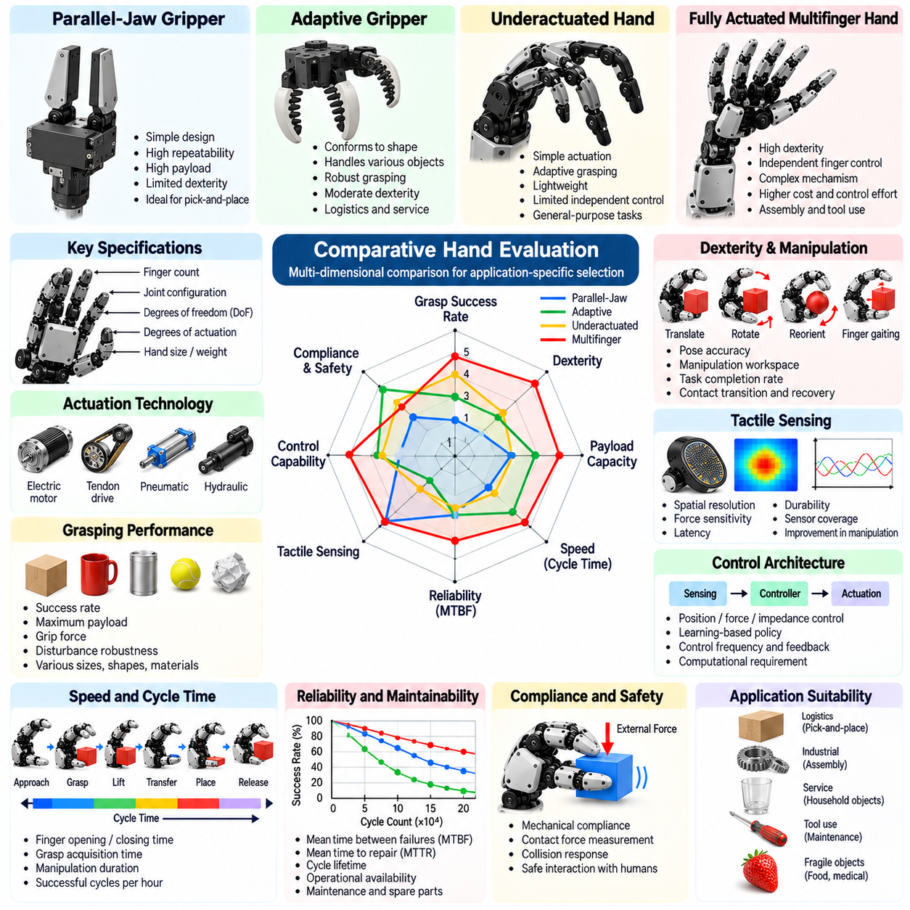
Comparative hand review evaluates robotic hand designs through consistent technical, functional, and operational criteria. The objective is not to identify a universally superior hand but to determine which architecture best satisfies specific manipulation requirements. Differences in dexterity, payload, sensing, speed, reliability, and cost must be considered together. A meaningful comparison connects measurable hardware capabilities with performance in representative real-world tasks.
Robotic hands can be classified into parallel-jaw grippers, adaptive grippers, underactuated hands, and fully actuated multifinger systems. Parallel-jaw designs emphasize simplicity and repeatability, while adaptive mechanisms accommodate varying object geometries. Multifinger hands provide additional manipulation possibilities but introduce mechanical and control complexity. Comparisons should recognize these architectural differences before interpreting benchmark results.
Finger count and joint configuration strongly influence the manipulation capabilities of a robotic hand. Additional fingers may increase contact flexibility, grasp stability, and opportunities for in-hand repositioning. However, finger count alone does not determine dexterity because joint mobility, finger geometry, and control coordination are equally important. Comparative reviews should evaluate achievable contact configurations rather than relying only on structural specifications.
Degrees of freedom describe the independent joint motions available within a robotic hand, while degrees of actuation indicate how many movements can be controlled independently. These quantities may differ substantially in tendon-driven or underactuated mechanisms. A hand with many joints but few actuators may achieve adaptive grasping without precise independent finger control. Reviews should distinguish mechanical mobility from independently controllable motion.
Actuation technology affects force generation, movement speed, precision, and mechanical integration. Electric motors, tendon transmissions, pneumatic systems, and hydraulic mechanisms offer different performance characteristics. Motor-driven hands often provide convenient electronic control, while compliant or fluid-powered designs may offer advantageous interaction behavior. Fair comparison requires measurements under equivalent loading and operating conditions.
Grasping performance should be evaluated across objects with different sizes, shapes, masses, and surface properties. Relevant measurements include grasp success rate, maximum supported payload, grip force, and resistance to external disturbances. A hand that performs well on rigid industrial components may struggle with deformable or fragile objects. Standardized object sets and repeated trials provide stronger evidence than isolated demonstrations.
Dexterity evaluation extends beyond acquiring objects to include controlled translation, rotation, finger gaiting, and complex contact transitions. Fully actuated multifinger hands may offer advantages in these tasks, but actual performance depends on sensing and control quality. Benchmark comparisons should measure object pose accuracy, manipulation workspace, task completion rate, and recovery behavior. Mechanical complexity alone does not establish superior dexterity.
Tactile sensing capabilities vary considerably between robotic hand platforms. Some systems rely primarily on joint position and motor current, while others integrate fingertip pressure arrays, force sensors, or distributed tactile skins. Comparative assessment should consider spatial resolution, sensitivity, latency, durability, and sensor coverage. The practical value of tactile sensing should also be demonstrated through improvements in closed-loop manipulation.
Control architecture influences how effectively mechanical capabilities translate into useful manipulation behavior. Position control, force control, impedance control, and learning-based policies offer different advantages. Hands with similar mechanical specifications may exhibit substantially different performance because of controller design. Reviews should document control frequency, feedback availability, computational requirements, and the degree of autonomy used during testing.
Speed and cycle time are important when robotic hands operate in production environments. Comparisons should include finger opening time, grasp acquisition time, manipulation duration, release time, and successful cycles per hour. Maximum actuator speed is not equivalent to task throughput because sensing, planning, and recovery consume time. Evaluations must separate hand-specific delays from robot arm motion and external processing.
Reliability and maintainability determine whether a robotic hand can sustain performance during extended deployment. Relevant indicators include mean time between failures, mean time to repair, cycle lifetime, and operational availability. Tendons, gears, sensors, and flexible components may exhibit different wear mechanisms. Comparative reviews should consider maintenance accessibility, replacement procedures, spare-part availability, and evidence from long-duration testing.
Mechanical compliance and safety are especially important for hands interacting with people or delicate objects. Compliant structures can reduce contact forces and accommodate geometric uncertainty, but excessive compliance may compromise positioning accuracy. Rigid mechanisms may offer precision while requiring more sophisticated force regulation. Comparative evaluation should measure contact forces, collision response, and controlled behavior during unexpected interactions.
Payload capacity must be interpreted together with hand mass, grasp geometry, and actuator power. A high maximum payload may be achieved only under favorable object orientations or grasp configurations. Useful comparisons should report payload-to-hand-mass ratio, continuous gripping capability, and performance under dynamic loading. Static holding tests alone cannot establish suitability for rapid manipulation or mobile robotic operation.
Energy consumption and thermal behavior influence integration with battery-powered robots and continuously operating automation systems. Measurements should include average power, peak demand, energy per successful grasp, and temperature rise during repeated cycles. High-performance actuators may require substantial electrical and cooling resources. Comparative analysis should therefore consider complete operating conditions rather than isolated peak specifications.
Physical dimensions and integration requirements affect the suitability of a hand for different robotic platforms. Palm size, finger reach, wrist interface, wiring, communication protocols, and controller placement influence installation complexity. Compact hands may be advantageous in confined environments, while larger designs may support greater payload or manipulation range. Reviews should assess compatibility with existing arms, power systems, and software frameworks.
Cost comparison should extend beyond the initial purchase price to include controllers, sensors, installation, maintenance, and replacement components. A lower-cost hand may become expensive if frequent repairs or specialized integration are required. Conversely, advanced dexterous hands may justify higher acquisition costs when they replace multiple specialized grippers. Total cost of ownership should be evaluated against measurable task performance and expected utilization.
Benchmark fairness requires equivalent task definitions, object sets, environmental conditions, and success criteria. Different hands may require distinct control strategies, but experimental assistance must be documented transparently. Operator intervention, external fixtures, and robot arm contributions can substantially influence results. Comparative reports should identify these factors and avoid treating demonstrations performed under different conditions as directly equivalent.
Published specifications and laboratory demonstrations should be distinguished from independently validated operational results. Manufacturer data can provide useful design information, but measurement methods and test conditions may differ. Independent benchmarking should report trial counts, uncertainty, failure cases, and reproducibility. Missing measurements should remain explicitly unverified rather than being inferred from marketing claims or mechanical appearance.
Application-specific comparison is more informative than a single universal ranking. Industrial assembly may prioritize precision, cycle time, and reliability, while service robotics may emphasize adaptability, safety, and object diversity. Research platforms may prioritize controllability and sensor access over acquisition cost. Weighted evaluation criteria can support selection, provided that weighting assumptions and performance tradeoffs are disclosed.
A comprehensive comparative hand review should integrate architecture, actuation, dexterity, sensing, speed, reliability, safety, integration, and lifecycle cost. Results should identify strengths, limitations, and application suitability without assuming that greater mechanical complexity always produces better performance. By combining standardized benchmarks with operational requirements, engineers can select robotic hands that provide the most appropriate balance of capability, efficiency, and dependability.

14.11 Benchmark Environment Design
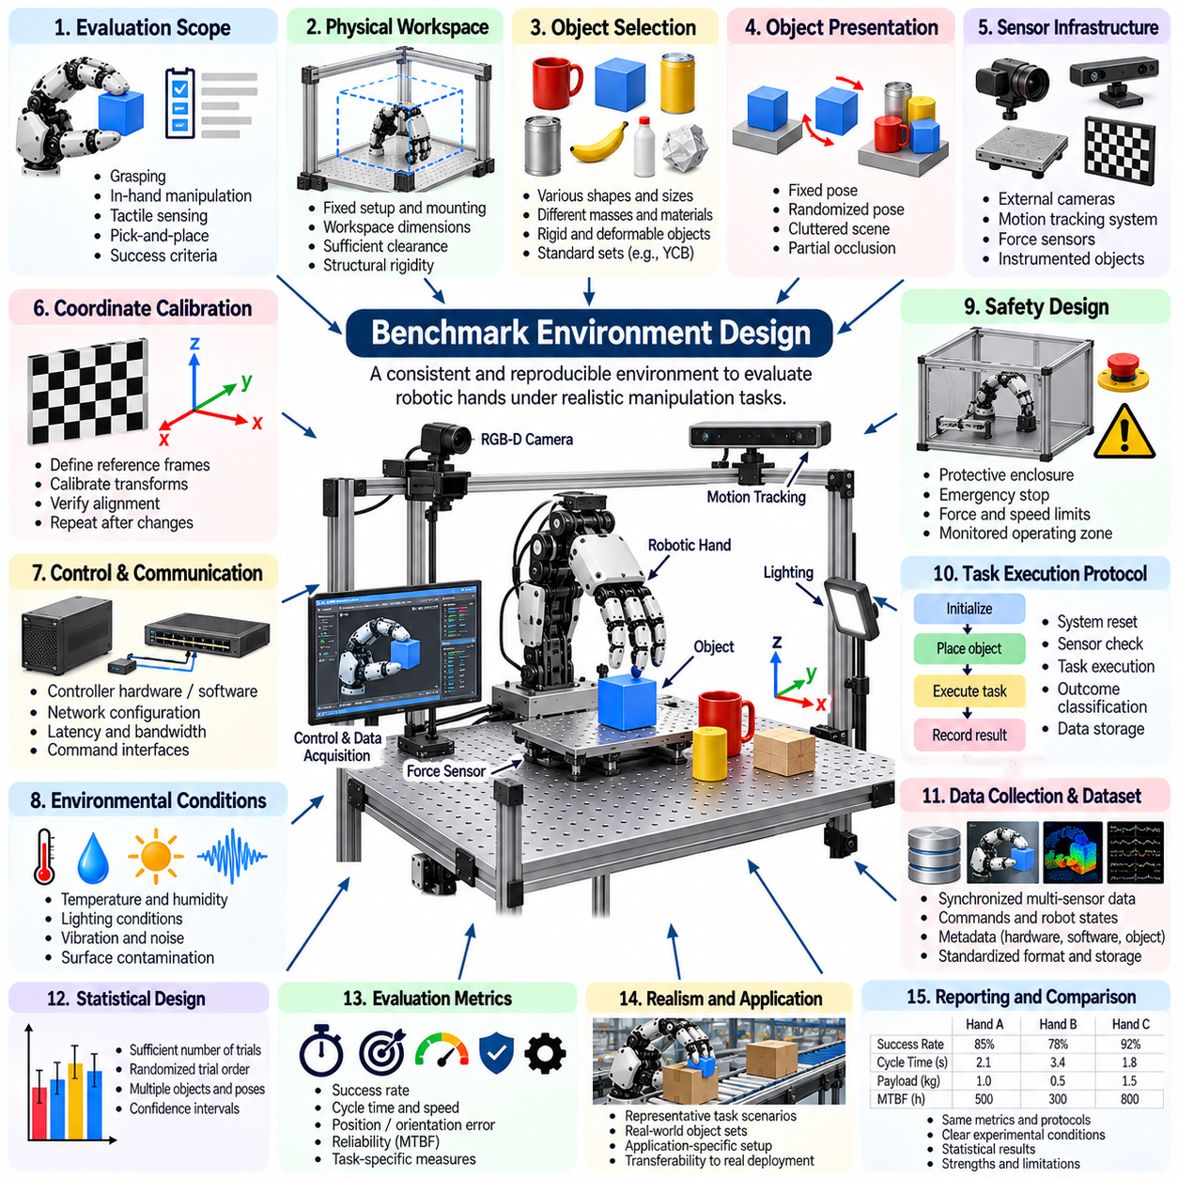
Benchmark environment design establishes the physical, computational, and procedural conditions required to evaluate robotic hands consistently. A well-designed environment enables meaningful comparisons of grasping, dexterity, sensing, speed, and reliability across different systems. Its primary objective is to reduce uncontrolled variation while preserving realistic manipulation challenges. Benchmark quality depends as much on experimental design as on the performance metrics themselves.
The first requirement is a clearly defined evaluation scope that identifies the capabilities and tasks under investigation. A benchmark may focus on static grasp stability, object acquisition, in-hand manipulation, tactile feedback, or complete pick-and-place operations. Each task requires explicit success criteria, starting conditions, and termination rules. Without these definitions, experimental results may reflect differences in interpretation rather than actual robotic hand performance.
Physical workspace design determines the geometry and accessibility of the experimental environment. Test benches should provide stable mounting, repeatable object placement, and sufficient clearance for finger and arm movements. Workspace dimensions, fixture locations, and approach directions must be documented. Mechanical alignment and structural rigidity are important because small positioning errors can significantly influence contact-rich manipulation results.
Object selection is fundamental to benchmark representativeness. Test collections should include variations in geometry, size, mass, surface friction, and compliance. Standardized collections such as the YCB Object Set support comparisons across research groups, while specialized objects may be needed for delicate grasping or continuous rotation. Each object's physical properties and condition should be recorded to ensure reproducible experiments.
Object presentation conditions strongly influence grasping difficulty. Objects may be positioned in fixed orientations, randomly sampled poses, cluttered scenes, or partially occluded configurations. Benchmark protocols should distinguish controlled placement from randomized presentation. Randomization distributions and sampling procedures must be specified so that different systems encounter comparable task difficulty rather than unintentionally favorable conditions.
Sensor infrastructure provides the reference measurements needed to evaluate robotic hand behavior objectively. External cameras, motion tracking systems, force sensors, and instrumented objects can measure object pose, contact forces, and manipulation outcomes. Reference instruments should be calibrated independently of the hand under evaluation. Measurement accuracy, sampling frequency, synchronization, and uncertainty must be documented.
Coordinate frame calibration is essential when combining measurements from cameras, robot arms, hands, and external tracking devices. Inconsistent transformations can produce apparent positioning errors unrelated to actual manipulation performance. Benchmark environments should define reference frames and verify transformations through repeatable calibration procedures. Calibration checks should be performed whenever equipment mounting or workspace geometry changes.
Control and communication infrastructure can influence benchmark outcomes through latency, bandwidth limitations, and synchronization errors. Experimental systems should document controller hardware, operating software, network configuration, and command interfaces. Timing measurements must distinguish sensor acquisition, computation, communication, and actuation delays. Common interfaces are useful, but differences in supported control modes should remain transparent.
Environmental conditions must be controlled because temperature, humidity, lighting, vibration, and surface contamination can affect sensing and manipulation. Lighting is especially relevant to vision-based grasp planning, while temperature and contamination can change friction and tactile response. Benchmark protocols should define acceptable environmental ranges and record deviations. Robustness experiments may deliberately vary these conditions using documented procedures.
Safety design is necessary when evaluating robotic hands capable of generating substantial forces or executing rapid movements. Protective enclosures, emergency stops, force limits, and monitored operating zones reduce risks to personnel and equipment. Tests involving unexpected contact or component failure require additional safeguards. Safety mechanisms should remain active during benchmarking, and their effects on performance must be reported.
Task execution protocols should establish a repeatable sequence from initialization to result recording. Each trial may include system reset, object placement, sensor verification, task execution, outcome classification, and data storage. Reset procedures are particularly important because residual object motion or actuator state can influence subsequent trials. Automated execution reduces operator variability, although manual intervention must be documented when unavoidable.
Benchmark datasets should contain synchronized records of commands, sensor observations, object states, and task outcomes. Metadata should identify hardware configuration, software version, calibration parameters, environmental conditions, and object properties. Consistent data formats support independent analysis and future replication. Raw measurements should be preserved where practical so that alternative metrics can be calculated without repeating experiments.
Statistical design determines how many trials are needed to support meaningful conclusions. Repeated measurements across objects, poses, and operating conditions help characterize variability. Randomized trial ordering can reduce systematic bias caused by heating, wear, or operator adaptation. Results should report sample sizes, confidence intervals, failure classifications, and any excluded observations. Experimental uncertainty must remain visible.
Benchmark fairness requires comparable task objectives without assuming that different robotic hands possess identical mechanical capabilities. A parallel-jaw gripper and a dexterous multifinger hand may require different grasp strategies. Evaluations should therefore distinguish universal task outcomes from architecture-specific measurements. External assistance, specialized fixtures, and human intervention must be disclosed to prevent misleading comparisons.
Simulation environments can complement physical benchmarks by enabling repeatable experiments and extensive parameter variation. Simulated contact models should represent friction, compliance, object inertia, and actuator constraints with appropriate fidelity. Domain randomization can explore sensitivity to uncertain physical properties. However, simulation results should be reported separately from hardware measurements until their correspondence has been experimentally validated.
A comprehensive benchmark environment should support both isolated component tests and integrated manipulation tasks. Component-level experiments measure actuator speed, tactile accuracy, force generation, and mechanical repeatability. Integrated tasks evaluate grasp success, in-hand manipulation, cycle time, and recovery behavior. Combining these levels helps engineers identify whether performance limitations originate in hardware, perception, planning, or control.
Long-duration testing requires additional infrastructure for automated cycling, condition monitoring, and fault recording. Temperature sensors, current monitors, vibration measurements, and event logs can reveal gradual degradation. Test systems should detect unsafe states and stop operation when predefined limits are exceeded. Reliability measurements must include operating hours, cycle counts, maintenance actions, and clearly defined failure events.
Reproducibility depends on documentation detailed enough for another laboratory to reconstruct the experiment. Protocols should specify object models, fixture dimensions, calibration methods, software configurations, trial sequences, and scoring rules. Version-controlled benchmark definitions reduce ambiguity when procedures evolve. Publicly available datasets and reference implementations can further improve transparency, provided that privacy and intellectual property constraints are respected.
Benchmark environments should also consider practical deployment conditions rather than relying exclusively on ideal laboratory setups. Industrial workcells, mobile manipulators, and service robots encounter different constraints involving space, vibration, lighting, and human interaction. Representative scenarios reveal limitations hidden by simplified tests. Evaluation should distinguish controlled baseline performance from robustness under realistic operational disturbances.
An effective benchmark environment integrates standardized tasks, calibrated instrumentation, reproducible procedures, safety controls, and statistically sound analysis. It should support fair comparison while exposing the limitations of different robotic hand architectures. By combining controlled laboratory measurements with representative operational scenarios, engineers can produce credible evidence of dexterity, reliability, and deployment readiness.

