Volume 06 Robot Hands and Dexterous Grasping

13. Tool Use and Assembly

13.01 Tool Use in Robotics
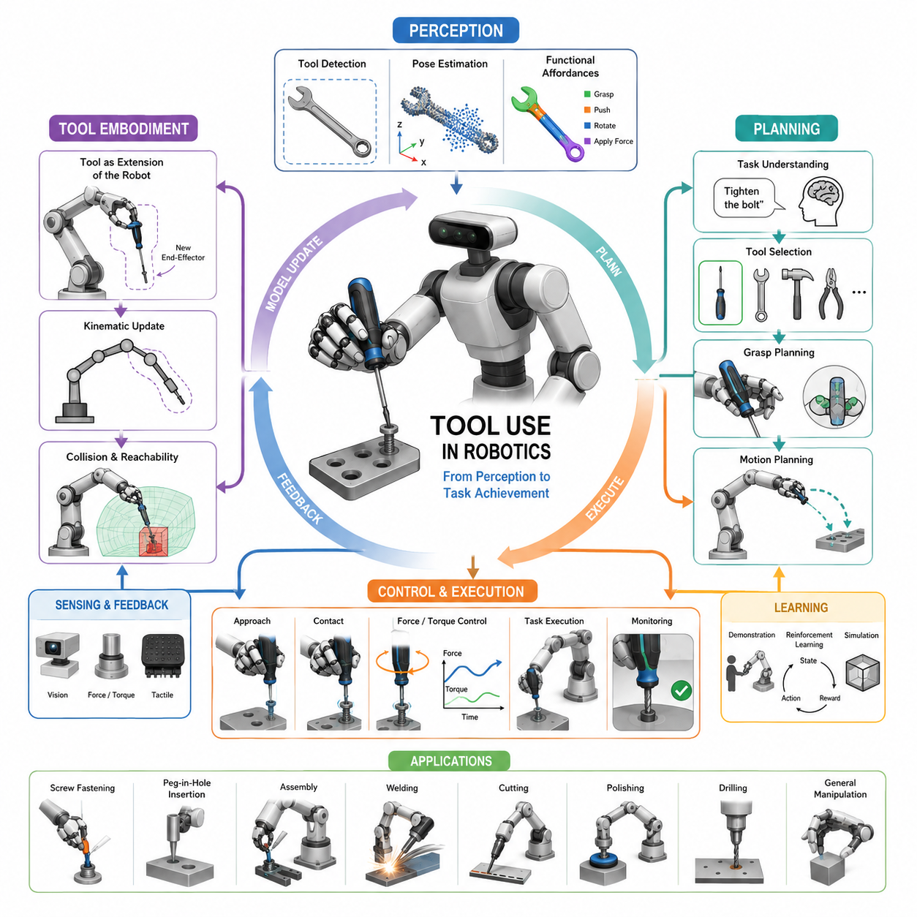
Tool use is one of the defining capabilities that separates advanced robotic manipulation from simple grasp-and-release operations. While basic grasping focuses on acquiring and holding objects, tool use requires a robot to understand how an external object can extend its physical capabilities and modify its interaction with the environment. Humans routinely use tools to amplify force, increase reach, improve precision, and accomplish tasks that would otherwise be impossible. In robotics, achieving comparable capabilities represents a major milestone toward general-purpose manipulation, autonomous assembly, industrial automation, and embodied intelligence. Within the broader context of dexterous grasping and robot hands, tool use occupies a unique position because it combines perception, grasp planning, force control, reasoning, task planning, and physical interaction into a unified manipulation framework.
A tool can be defined as an external object intentionally manipulated to achieve a desired effect on another object or environment. Unlike ordinary grasping tasks, where the goal is simply to hold an object securely, tool-use tasks require understanding functional affordances. The robot must recognize not only the geometry of the tool but also its intended purpose. A screwdriver is not merely a cylindrical object with a handle; it is an instrument designed to transmit rotational torque. A hammer is not simply a rigid body; it is a force amplification device. A wrench is a torque transfer mechanism, and pliers are force-concentrating tools capable of gripping and manipulating other objects. Successful robotic tool use therefore requires reasoning about function in addition to shape.
Historically, industrial robots performed tool-related tasks through highly structured automation. Welding robots, painting robots, drilling robots, and assembly robots have used tools for decades. However, these systems typically operate within carefully engineered environments where tool positions, object locations, and task sequences are predetermined. The robot does not truly understand the tool. Instead, engineers encode task-specific motions and trajectories. Modern robotics research aims to move beyond such rigid automation toward adaptive tool use in dynamic and unstructured environments. The objective is to create robots capable of identifying tools, selecting appropriate manipulation strategies, and executing tasks without extensive manual programming.
One of the fundamental challenges in robotic tool use is the distinction between grasp affordances and task affordances. A grasp affordance describes how a robot can securely hold a tool, whereas a task affordance describes how the tool should be used after grasp acquisition. These two requirements are often conflicting. The grasp that maximizes stability may not be the grasp that enables effective tool operation. For example, grasping a screwdriver near its tip may provide a stable hold, but it prevents insertion into a screw. Grasping the handle enables functionality but may reduce stability under certain conditions. Consequently, robotic systems must optimize grasp selection based on both grasp quality and downstream task requirements.
The concept of affordances, originally introduced in ecological psychology, has become central to robotic tool-use research. Affordances describe actionable possibilities offered by objects within a given environment. For a robot, recognizing affordances means identifying which parts of an object can be grasped, manipulated, pushed, pulled, rotated, or used as a tool. Modern vision systems often employ deep neural networks to infer affordances directly from visual observations. These systems learn that a handle affords grasping, a blade affords cutting, and a hammerhead affords striking. Such representations enable robots to generalize across previously unseen tools.
Tool use significantly increases manipulation complexity because the robot's kinematic chain effectively changes when a tool is grasped. Once a tool becomes attached to the robot hand, the operational endpoint is no longer the fingertip or gripper. Instead, the functional tip of the tool becomes the new end-effector. This transformation introduces new geometric relationships, collision constraints, and control requirements. The robot must estimate the tool's dimensions, orientation, mass properties, and interaction points. Errors in these estimates can lead to task failure or damage.
Tool embodiment represents another important concept. Humans naturally incorporate tools into their body schema after sufficient experience. A person using a tennis racket or screwdriver begins to perceive the tool as an extension of the arm. Robotics researchers seek similar capabilities in artificial systems. Tool embodiment allows robots to update their internal models so that the tool becomes part of the manipulator representation. This adaptation improves motion planning, collision avoidance, and force control. Instead of treating the tool as an external object, the robot treats it as an integrated component of its body.
Perception plays a critical role throughout the tool-use pipeline. The robot must first detect the tool within the environment. Detection involves identifying candidate objects and distinguishing tools from other items. Once detected, the robot must estimate the tool's pose, orientation, dimensions, and operational features. Modern approaches often employ RGB cameras, depth sensors, stereo vision systems, and point cloud processing techniques. Deep learning models trained on large-scale datasets can classify tool categories and predict functional regions. In industrial settings, fiducial markers and CAD-based matching techniques may also be used to improve reliability.
After tool detection, localization accuracy becomes essential. Many assembly and manufacturing tasks require sub-millimeter precision. Slight misalignment between the estimated and actual tool pose can cause insertion failures, screw stripping, or component damage. Consequently, robotic systems often combine vision-based localization with tactile feedback, force sensing, and compliance control to compensate for perception errors.
Grasp planning for tool use differs substantially from ordinary object grasping. Traditional grasp planning seeks stable force closure and resistance to disturbances. Tool-oriented grasp planning must additionally consider task execution. The robot must determine where to grasp, how firmly to grasp, and how the grasp will affect the subsequent operation. For example, using pliers requires maintaining a grasp that allows actuation of the plier handles. Using a hammer requires positioning the grasp to maximize striking efficiency while maintaining control. These considerations introduce task-dependent optimization objectives.
Force and torque control are particularly important in tool-use applications. Many tools are designed to transfer forces to external objects. A screwdriver applies rotational torque, a hammer generates impact forces, and a wrench applies sustained torque. The robot must regulate these forces accurately to achieve task objectives without damaging components. Force control algorithms often operate alongside impedance control and compliance control strategies. These methods allow the robot to adapt to environmental uncertainties and maintain stable contact during interaction.
Contact-rich manipulation is closely associated with robotic tool use. In contact-rich tasks, success depends on maintaining continuous interaction with the environment. Examples include insertion, scraping, polishing, drilling, fastening, and assembly. Unlike free-space motion, contact-rich manipulation requires continuous monitoring of forces, torques, and contact states. Small deviations can accumulate and cause failure. Consequently, robotic systems often employ hybrid position-force control architectures that simultaneously regulate motion and interaction forces.
Assembly operations represent one of the most economically important applications of robotic tool use. Modern manufacturing environments require robots to perform tasks such as inserting components, tightening screws, connecting cables, and assembling complex products. These tasks involve multiple stages of perception, manipulation, and force-controlled interaction. Even seemingly simple operations such as inserting a peg into a hole require precise alignment, compliance management, and error recovery strategies.
Peg-in-hole insertion has become a canonical benchmark for robotic assembly research. The task appears straightforward but embodies many of the challenges associated with tool use. The robot must localize the target hole, align the insertion axis, detect contact conditions, and regulate insertion forces. Variations in tolerances, material properties, and environmental conditions further increase complexity. Researchers frequently use peg-in-hole tasks to evaluate manipulation algorithms, force control methods, and learning-based assembly systems.
Screw fastening is another representative tool-use task. Successful screw insertion requires coordination between translational and rotational motion. The robot must align the screwdriver with the screw head, apply appropriate downward force, maintain engagement, and regulate rotational torque. Excessive torque may damage components, while insufficient torque may result in incomplete fastening. Advanced systems integrate vision, tactile sensing, and force feedback to achieve reliable screw-driving performance.
The emergence of dexterous robot hands has significantly expanded tool-use capabilities. Multi-fingered hands provide greater flexibility than traditional parallel-jaw grippers. They enable regrasping, in-hand manipulation, and dynamic adjustment of grasp configurations. Such capabilities are particularly valuable when manipulating complex tools that require precise orientation changes during operation. Dexterous hands also facilitate transitions between grasp types, allowing robots to adapt their manipulation strategies to evolving task requirements.
Learning-based approaches have transformed the field of robotic tool use. Traditional systems relied heavily on manually engineered rules and task-specific programming. Modern robots increasingly learn manipulation skills from demonstrations, simulation, reinforcement learning, and large-scale datasets. Learning enables robots to discover effective tool-use strategies that may not be obvious to human designers. Reinforcement learning agents can optimize tool trajectories through trial and error, while imitation learning allows robots to reproduce expert demonstrations.
Simulation environments have become essential for tool-use research. Physical experimentation with real robots is expensive, time-consuming, and potentially hazardous. Simulation platforms provide scalable environments for generating large quantities of training data. Physics engines model contact interactions, rigid-body dynamics, friction, and collisions. Researchers can evaluate thousands of manipulation scenarios before transferring policies to physical robots. Domain randomization techniques further improve robustness by exposing learning algorithms to diverse environmental conditions.
Recent advances in foundation models and embodied AI have opened new directions for robotic tool use. Vision-language models can associate textual descriptions with visual observations, enabling robots to understand tool names, functions, and instructions. Vision-language-action models extend this capability by connecting perception directly to manipulation behavior. Instead of programming every task explicitly, users can provide high-level commands such as “tighten the bolt,” “cut the cable tie,” or “assemble the bracket.” The robot interprets the instruction, selects appropriate tools, and executes the required actions.
Generalization remains one of the most important research challenges. Human beings can often use unfamiliar tools after minimal observation. Robots, by contrast, frequently struggle with novel objects. Developing representations that capture functional similarities across tool categories is therefore a major objective. Researchers investigate affordance learning, relational reasoning, causal inference, and world modeling techniques to improve generalization. The ultimate goal is to enable robots to infer how an unfamiliar tool should be used based on prior experience with related objects.
Safety considerations are particularly important in robotic tool use. Many tools are inherently hazardous. Cutting tools, drilling tools, grinders, welding equipment, and powered actuators pose significant risks to humans and equipment. Robots operating in collaborative environments must detect nearby humans, monitor tool states, and enforce safety constraints. Risk-aware planning algorithms evaluate potential hazards before executing actions. Safety-certified control architectures further reduce the likelihood of accidents.
Tool-use capability is increasingly viewed as a key indicator of robotic intelligence. A robot capable of selecting, grasping, and using tools demonstrates an understanding of functional relationships between objects, actions, and goals. Such behavior reflects a deeper level of embodied cognition than simple pick-and-place operations. Tool use requires integrating perception, reasoning, planning, control, learning, and physical interaction into a coherent system.
Looking toward the future, robotic tool use is expected to become a foundational capability for mobile manipulators, humanoid robots, industrial automation systems, healthcare robots, service robots, and domestic assistants. As advances in dexterous manipulation, tactile sensing, foundation models, and embodied AI continue to accelerate, robots will increasingly perform complex tool-mediated tasks with levels of adaptability approaching those of human workers. The progression from simple grasping to sophisticated tool use represents not merely an incremental improvement in manipulation capability, but a fundamental step toward general-purpose robotic intelligence and autonomous physical problem solving.

13.02 Tool Taxonomy
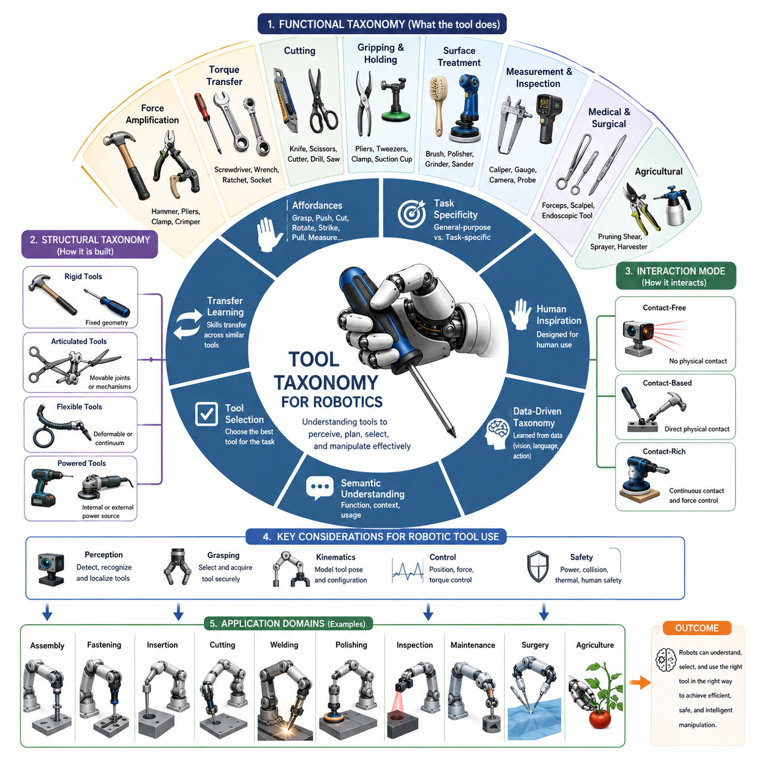
Tool taxonomy is the systematic classification of tools according to their physical structure, functional purpose, interaction characteristics, and manipulation requirements. In robotics, a well-defined tool taxonomy serves as a foundational framework for perception, grasp planning, task planning, manipulation learning, assembly automation, and embodied intelligence. Human beings naturally categorize tools based on experience and functional understanding. A person immediately recognizes that a hammer belongs to a different category than a screwdriver, even though both are handheld tools. Robots require similar organizational structures to reason about tools, predict their behavior, select appropriate manipulation strategies, and generalize knowledge across previously unseen objects.
The importance of tool taxonomy has increased significantly with the emergence of dexterous robot hands, autonomous mobile manipulators, foundation models, and embodied AI systems. Traditional industrial robots were often programmed to use a small set of dedicated tools in highly structured environments. Modern robotic systems, however, must operate in dynamic and unstructured environments where they encounter a wide variety of tools, accessories, fixtures, and assembly devices. A robot that understands the taxonomy of tools can infer functional properties, estimate manipulation requirements, and transfer learned skills across related categories.
From a robotics perspective, a tool can be defined as an external object intentionally manipulated to modify the robot’s ability to interact with the environment. A tool extends physical capabilities by amplifying force, increasing reach, improving precision, changing contact geometry, or enabling entirely new interaction modes. Unlike ordinary grasped objects, tools possess functional intent. Their value lies not in being moved but in being used to accomplish a task.
One of the most fundamental classifications divides tools according to their primary function. This functional taxonomy closely resembles the way humans conceptualize tools. Force amplification tools form one of the largest categories. These tools increase the force that can be applied to a target object. Examples include hammers, pliers, nutcrackers, clamps, and crimping devices. In robotic applications, force amplification tools require accurate force control and impact management because their effectiveness depends on transferring mechanical energy efficiently.
A second category consists of torque transfer tools. These tools are designed to apply rotational force to another object. Screwdrivers, wrenches, ratchets, socket tools, and Allen keys belong to this class. Torque transfer tools are particularly important in industrial assembly because fastening operations account for a significant portion of manufacturing tasks. Robots using torque transfer tools must understand rotational alignment, torque limits, tool engagement, and fastening quality.
Cutting tools represent another major category. Knives, scissors, wire cutters, milling cutters, drills, saws, and shearing devices are all designed to remove material or separate objects. Cutting operations introduce additional challenges because the robot must regulate contact forces while maintaining precise trajectories. Material properties strongly influence tool behavior, requiring robots to adapt manipulation strategies according to object stiffness, thickness, and geometry.
Gripping and holding tools form a separate category. Pliers, tweezers, forceps, clamps, suction cups, and magnetic grippers fall into this group. Unlike conventional robot grippers, these tools act as intermediate devices that allow more specialized interactions with target objects. Robotic systems must coordinate both the grasp of the tool itself and the operation of the tool mechanism.
Surface treatment tools include brushes, polishing pads, grinders, sanding devices, paint sprayers, and cleaning tools. These tools interact continuously with surfaces and require controlled contact conditions. Successful use often depends more on force consistency and trajectory quality than on precise positioning. Such applications are common in manufacturing, maintenance, aerospace inspection, and service robotics.
Measurement and inspection tools form another important category. Calipers, gauges, probes, laser scanners, cameras, thermal imagers, and ultrasonic sensors are examples. Unlike force-producing tools, measurement tools primarily gather information from the environment. Robotic manipulation of these tools emphasizes positioning accuracy, stability, calibration, and sensing reliability.
Medical and surgical tools constitute a highly specialized taxonomy. Surgical forceps, scalpels, endoscopic instruments, needle drivers, and cauterization tools possess strict precision and safety requirements. Surgical robotics requires extremely accurate manipulation, force regulation, and procedural planning. Tool classification in medical robotics often incorporates regulatory considerations and procedural workflows.
Agricultural tools represent a growing area of robotic tool-use research. Pruning shears, harvesting cutters, digging implements, pollination devices, and spraying tools are designed specifically for interactions with plants, soil, and biological materials. These environments introduce uncertainty due to natural variation, deformability, and changing environmental conditions.
Another important dimension of tool taxonomy is based on kinematic structure. Rigid tools are the simplest category. Their geometry remains constant during operation, making them easier to model and control. Hammers, screwdrivers, wrenches, and chisels are typical examples. The robot only needs to estimate pose and orientation because tool geometry remains fixed.
Articulated tools contain movable joints or mechanisms. Scissors, pliers, tongs, bolt cutters, and adjustable wrenches belong to this category. Articulated tools require the robot to control not only the tool pose but also internal degrees of freedom. This significantly increases manipulation complexity because multiple coordinated motions are required.
Flexible tools introduce even greater challenges. Cables, hoses, ropes, brushes, whips, and deformable medical instruments exhibit continuously changing geometry. Traditional rigid-body models become inadequate, and the robot must estimate shape states dynamically. Flexible tools remain one of the most difficult areas in robotic manipulation research.
Powered tools form another important category. Drills, electric screwdrivers, grinders, welding guns, pneumatic actuators, and powered cutting devices contain internal energy sources or external power inputs. The robot must manage additional considerations such as activation control, power delivery, vibration effects, thermal behavior, and operational safety.
Tool taxonomy can also be organized according to interaction mode. Contact-free tools interact without direct physical contact. Examples include laser cutters, projectors, thermal imaging systems, and optical scanners. These tools primarily require accurate positioning and line-of-sight management.
Contact-based tools interact through direct physical contact. Most industrial tools belong to this category. Contact-based interaction introduces force transmission, friction effects, compliance requirements, and contact-state monitoring.
Contact-rich tools represent a specialized subset in which continuous physical interaction dominates task execution. Examples include polishing tools, welding torches, screwdrivers, insertion tools, and grinding systems. Performance depends on precise regulation of contact forces and relative motion between the tool and environment.
Robotics researchers increasingly classify tools according to affordances. Affordance-based taxonomy focuses on actionable possibilities rather than geometry alone. A handle affords grasping. A blade affords cutting. A hammerhead affords striking. A hook affords pulling. Affordance representations allow robots to generalize across tools with different appearances but similar functionality.
For example, a conventional screwdriver, powered screwdriver, and torque-controlled industrial screwdriver differ significantly in shape and complexity. However, they all share the affordance of rotational torque transfer. By recognizing this functional similarity, robots can transfer manipulation knowledge across tool categories.
Another useful classification dimension is task specificity. General-purpose tools can be used across many applications. Examples include hammers, pliers, screwdrivers, and knives. These tools support diverse manipulation tasks and appear frequently in human environments.
Task-specific tools are optimized for narrow applications. Examples include torque wrenches, medical biopsy tools, specialized assembly fixtures, semiconductor handling tools, and aerospace inspection devices. Such tools often require domain-specific knowledge and highly specialized manipulation strategies.
Human-inspired taxonomy plays an increasingly important role in humanoid robotics. Anthropomorphic robots frequently use tools designed originally for human hands. Human tools implicitly encode assumptions about finger geometry, grasp configurations, wrist mobility, and force generation capabilities. Understanding these assumptions helps robotic systems select appropriate grasping and control strategies.
The rise of machine learning has introduced data-driven tool taxonomies. Instead of manually defining categories, robots learn latent representations of tools directly from data. Deep neural networks analyze geometry, appearance, functionality, and manipulation outcomes to discover relationships among tools. These learned taxonomies often reveal functional similarities that are not immediately apparent from human-defined classifications.
Foundation models and vision-language-action systems further extend this concept. Large-scale models trained on images, videos, text, and demonstrations can associate tools with their functional descriptions and usage contexts. A robot may learn that scissors are used for cutting, brushes are used for cleaning, and screwdrivers are used for fastening, even without explicit programming. Such semantic understanding enables more flexible reasoning and improved generalization.
Tool taxonomy is particularly important for autonomous tool selection. When multiple tools are available, the robot must determine which tool best satisfies task requirements. Effective selection depends on understanding relationships among tool capabilities, environmental constraints, object properties, and desired outcomes. A robot assembling electronic components may choose precision tweezers rather than pliers. A maintenance robot may select a ratchet wrench instead of a standard wrench when operating in confined spaces.
Taxonomy also supports transfer learning in robotic manipulation. Skills acquired using one tool can often be adapted to related tools within the same category. A robot trained to use one screwdriver may rapidly learn to use another screwdriver with different dimensions. Similarly, experience with one cutting tool may accelerate learning for other cutting tools. This capability reduces data requirements and improves scalability.
Benchmarking and evaluation frequently rely on tool taxonomies as well. Researchers compare performance across representative tool categories to assess generalization capabilities. Evaluation datasets often include tools from multiple functional classes to ensure that systems do not overfit to a single category. Metrics such as task success rate, manipulation efficiency, force regulation quality, tool acquisition time, and adaptation capability are commonly measured.
Despite substantial progress, tool taxonomy remains an active research area. Many real-world tools exhibit characteristics that span multiple categories simultaneously. A powered screwdriver is both a torque-transfer tool and a powered tool. Surgical instruments may combine cutting, grasping, and sensing functions. Multi-functional tools blur category boundaries and challenge traditional classification systems.
Future robotic systems will likely employ hierarchical and dynamic taxonomies rather than rigid category structures. Such taxonomies will integrate geometry, function, affordance, semantics, and task context into unified representations. Robots will not merely recognize that an object belongs to a particular category; they will understand how it can be used, under what conditions it should be selected, and how its functionality relates to broader task objectives.
Ultimately, tool taxonomy serves as the conceptual bridge between perception and action. It provides the structured knowledge necessary for robots to move beyond simple object manipulation toward intelligent tool-mediated interaction with the physical world. As dexterous hands, tactile sensing, embodied AI, and foundation models continue to evolve, sophisticated tool taxonomies will become increasingly central to the development of general-purpose robotic manipulation systems capable of operating effectively across diverse environments and applications.

13.03 Tool Detection and Localization
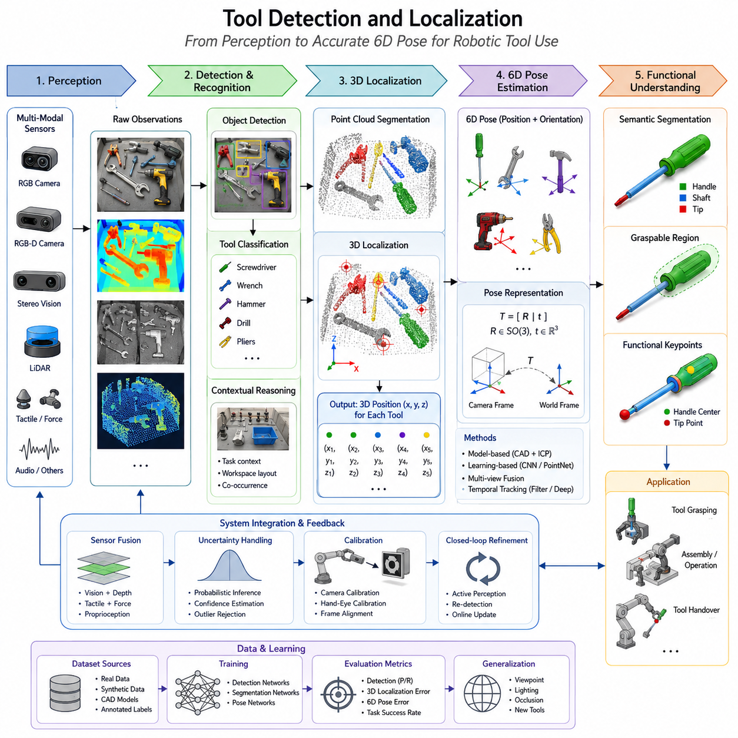
Tool Detection and Localization is one of the most fundamental capabilities required for robotic tool use and automated assembly. Before a robot can successfully manipulate a screwdriver, wrench, hammer, drill, cutter, gripper extension, or any specialized industrial tool, it must first perceive the existence of the tool, identify its category, estimate its pose, understand its geometric structure, determine its functional regions, and localize it accurately within the robot’s coordinate system. In practical robotic systems, perception errors occurring during tool detection frequently propagate throughout the manipulation pipeline and often become the primary cause of grasp failures, insertion failures, assembly errors, and task execution instability. Therefore, robust tool detection and localization serve as the foundation upon which all higher-level tool-use intelligence is built. The topic belongs to the Tool Use and Assembly section of the Robot Hand and Dexterous Grasping volume and forms the critical bridge between visual perception and physical interaction.
Unlike ordinary object detection, tool detection introduces several unique challenges. Many industrial tools exhibit elongated structures, reflective metallic surfaces, partial occlusions, deformable components, interchangeable accessories, and highly similar appearances across multiple product variants. A wrench may appear in different sizes but maintain the same functional geometry. Screwdrivers may differ only in tip configuration while sharing similar handles. Power tools often contain detachable modules that alter their visual characteristics. In addition, tools are frequently stored in cluttered environments such as toolboxes, shelves, assembly stations, maintenance carts, and workbenches where overlapping objects complicate perception. Consequently, tool detection systems must combine object recognition, geometric reasoning, pose estimation, and contextual understanding rather than relying solely on conventional image classification.
The first stage of tool localization is tool recognition. Recognition aims to determine whether a particular object belongs to a known tool category. Traditional approaches relied heavily on handcrafted visual features such as SIFT, SURF, ORB, edge descriptors, contour matching, and template-based recognition. While these methods performed adequately under controlled lighting and viewpoint conditions, they often struggled when tools appeared in varying orientations, experienced partial occlusions, or exhibited surface reflections. Modern robotic systems therefore increasingly employ deep learning-based detectors capable of extracting robust visual representations directly from data.
Convolutional Neural Networks have significantly improved tool recognition performance. Architectures such as Faster R-CNN, YOLO, SSD, RetinaNet, and DETR can identify multiple tool categories simultaneously while maintaining real-time inference speeds. These detectors learn discriminative features associated with handles, jaws, shafts, blades, trigger mechanisms, and other characteristic tool structures. By training on large annotated datasets, robots can achieve reliable recognition across a wide variety of industrial environments. The ability to distinguish between visually similar tools such as Phillips screwdrivers, flat-head screwdrivers, hex drivers, and torque drivers becomes essential when task-specific manipulation is required.
Beyond category recognition, robotic tool use requires localization. Localization determines the spatial position of a tool relative to the robot. Two-dimensional localization identifies pixel coordinates within an image, while three-dimensional localization estimates physical coordinates in Cartesian space. Most industrial manipulation tasks require accurate three-dimensional localization because grasp planning and motion planning depend directly on spatial measurements. Localization systems therefore integrate camera calibration, depth sensing, geometric reconstruction, and coordinate transformation.
RGB cameras represent the simplest sensing modality for tool localization. Using a calibrated camera, object detectors can identify tool positions within image coordinates. However, image coordinates alone are insufficient for robotic grasping because depth information is missing. To overcome this limitation, robots often employ RGB-D cameras that combine color imaging with depth sensing. Popular RGB-D sensors generate dense depth maps that enable three-dimensional point reconstruction. By associating each detected pixel with depth measurements, robots can estimate tool centroids, surface geometry, and approximate grasp locations.
Stereo vision provides an alternative approach for three-dimensional localization. Two calibrated cameras observe the scene from different viewpoints, allowing depth estimation through triangulation. Stereo systems are particularly useful in large workspaces where depth sensors may have limited range. Industrial stereo systems can achieve millimeter-level accuracy when properly calibrated, making them suitable for assembly operations involving medium-sized tools and fixtures.
LiDAR-based localization is increasingly used in large industrial environments. Although LiDAR typically provides lower resolution than cameras, it offers reliable geometric measurements under varying illumination conditions. When combined with vision systems, LiDAR contributes robust spatial information for tool localization on large workbenches, warehouses, and outdoor maintenance platforms.
Point cloud processing plays a central role in modern tool localization. Once depth information becomes available, robots generate three-dimensional point clouds representing the observed scene. Point cloud segmentation algorithms separate tools from background structures and neighboring objects. Geometric descriptors such as surface normals, curvature features, and shape histograms help identify candidate tool regions. More recently, neural networks operating directly on point clouds have demonstrated remarkable performance in recognizing and localizing tools under challenging conditions.
A particularly important capability in robotic tool use is six-degree-of-freedom pose estimation. Knowing only the position of a tool is insufficient. The robot must also understand the orientation of the tool. Six-degree-of-freedom pose estimation determines the three translational coordinates and three rotational coordinates that fully describe a tool’s spatial configuration. For example, a screwdriver lying flat on a table and another standing upright may share the same position but require completely different grasping strategies. Accurate pose estimation allows the robot to align its end effector appropriately and execute task-specific manipulations.
Model-based pose estimation techniques utilize CAD models of tools. By comparing observed sensor data with known geometric models, algorithms estimate the transformation that best aligns the model with observations. Iterative Closest Point algorithms have historically been used for this purpose. More advanced registration techniques incorporate robust optimization and probabilistic reasoning to handle noise and partial observations. Model-based methods can achieve very high accuracy when precise CAD models are available.
Learning-based pose estimation approaches have emerged as powerful alternatives. Deep neural networks directly predict object poses from images or point clouds without requiring explicit geometric registration. Architectures trained on synthetic and real-world datasets learn invariant representations capable of generalizing across viewpoints, lighting conditions, and background variations. These methods often achieve real-time performance and exhibit greater robustness in cluttered environments.
Tool localization becomes significantly more challenging when tools are partially occluded. In industrial workstations, tools are frequently stacked, overlapping, or partially hidden beneath other components. Occlusion introduces ambiguity because only portions of the tool are visible. To address this problem, modern systems employ multi-view perception, probabilistic inference, and shape completion networks. By integrating observations from multiple viewpoints, robots can reconstruct hidden regions and improve localization accuracy.
Functional localization represents another critical aspect of tool perception. Unlike ordinary objects, tools contain specific regions associated with distinct functions. A screwdriver includes a handle region and a tip region. A wrench includes a handle and jaw region. A hammer includes a handle and striking head. Successful manipulation requires the robot to distinguish between graspable regions and operational regions. Grasping a screwdriver by its tip would prevent its intended use. Therefore, robots must not only localize the tool but also identify its functional anatomy.
Semantic segmentation methods are increasingly used to identify functional tool regions. Pixel-level labeling allows robots to classify different components of a tool according to their purpose. Combined with geometric reasoning, semantic segmentation enables the generation of grasp candidates that avoid interfering with task-relevant regions. This capability is particularly important in assembly applications where precise tool orientation directly affects task success.
Tool localization also benefits from contextual reasoning. Human workers rarely identify tools solely from visual appearance. Instead, they consider surrounding objects, workspace organization, and task requirements. Modern robotic systems increasingly incorporate similar contextual information. If a robot is performing a screw-tightening task, candidate objects near a screw tray are more likely to be screwdrivers than unrelated objects. Contextual reasoning improves robustness when visual ambiguity exists.
Recent advances in foundation models and vision-language models have transformed tool detection capabilities. Large-scale pretrained models can recognize previously unseen tools using semantic descriptions rather than task-specific training. Open-vocabulary detection allows robots to identify tools specified through natural language instructions. A user may instruct the robot to “pick up the adjustable wrench” or “find the torque screwdriver,” and the system can localize the corresponding tool even if it was not explicitly represented during training. This significantly expands the flexibility of robotic tool-use systems.
Multi-modal perception further enhances localization performance. Visual information may be combined with tactile sensing, force sensing, audio signals, and proprioceptive feedback. For example, if visual localization becomes uncertain during grasp execution, tactile feedback can refine the estimated contact location. Such sensor fusion improves robustness in real-world environments where perception uncertainty is unavoidable.
Tool tracking extends localization from static scenes to dynamic environments. Once a tool has been detected, robots often need to continuously estimate its pose while it moves. Tracking algorithms maintain temporal consistency and reduce localization noise. Kalman filters, particle filters, Bayesian estimators, and deep learning-based tracking networks are commonly employed for this purpose. Continuous tracking becomes essential when tools are handed between humans and robots or transported by moving platforms.
Calibration plays a crucial role in localization accuracy. Camera calibration, hand-eye calibration, sensor synchronization, and coordinate frame alignment directly influence pose estimation quality. Even highly sophisticated perception algorithms can fail if calibration errors exceed acceptable limits. Industrial deployments therefore devote significant attention to calibration procedures, verification routines, and long-term maintenance strategies.
Simulation environments have become valuable tools for developing localization systems. Synthetic datasets generated in simulation provide large-scale annotated training data without requiring expensive manual labeling. Domain randomization techniques expose learning algorithms to diverse appearances, lighting conditions, textures, and backgrounds. When combined with sim-to-real transfer methodologies, simulation-based training substantially reduces development costs while improving generalization.
Performance evaluation of tool detection systems typically considers detection precision, recall, localization accuracy, pose estimation error, robustness under occlusion, runtime latency, and task success rate. Industrial assembly applications often require millimeter-level positional accuracy and sub-degree rotational accuracy. High-speed production lines additionally impose strict real-time constraints, requiring localization pipelines to operate within tens of milliseconds.
Future tool localization systems are expected to evolve toward unified perception architectures capable of integrating object detection, pose estimation, functional understanding, task reasoning, and manipulation planning within a single framework. Foundation models, world models, and embodied AI systems will likely enable robots to understand not only where a tool is located but also how it should be used, why it is needed, and what outcomes it can produce within a broader task context. Such capabilities will move robotic tool use beyond simple perception toward genuine physical intelligence, enabling dexterous robots to operate effectively in manufacturing, maintenance, logistics, healthcare, construction, and service environments. The ability to reliably detect and localize tools will remain a cornerstone technology supporting the next generation of autonomous manipulation systems and intelligent robotic assembly platforms.

13.04 Tool Grasp Planning
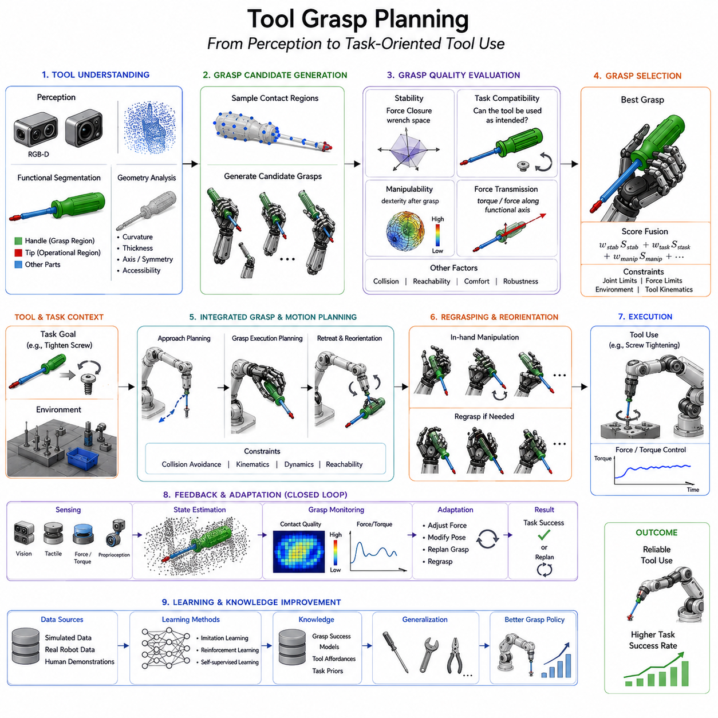
Tool Grasp Planning is the process of determining how a robot should grasp a tool so that the tool can subsequently be used to perform a desired task. Unlike conventional object grasping, where the primary objective is to securely pick up and transport an object, tool grasp planning must consider not only grasp stability but also the future functionality of the tool. A successful grasp for tool use requires the robot to understand the geometry of the tool, the intended operation, the contact mechanics between the tool and the robot hand, the interaction between the tool and the environment, and the sequence of actions that will follow after grasp acquisition. As a result, tool grasp planning occupies a unique position at the intersection of perception, manipulation, grasp theory, motion planning, task planning, and embodied intelligence. Within the Tool Use and Assembly section of Robot Hand and Dexterous Grasping, tool grasp planning serves as the critical link between tool detection and actual task execution.
The fundamental challenge of tool grasp planning arises from the fact that the optimal grasp for holding a tool is often different from the optimal grasp for using a tool. A hammer provides a simple example. A robot may grasp the hammer head securely, but such a grasp would prevent the hammer from being used for striking operations. Conversely, grasping the handle enables the hammer to function correctly but may introduce additional challenges related to balance, force transmission, and stability. Similar considerations apply to screwdrivers, pliers, wrenches, drills, scissors, and numerous industrial assembly tools. Therefore, tool grasp planning must always incorporate an understanding of tool functionality.
Traditional robotic grasp planning primarily focused on force closure and form closure principles. Force closure refers to the ability of contact forces generated by the robot fingers to resist arbitrary external disturbances. Form closure refers to the geometric confinement of an object through contact constraints. While these concepts remain important, they are insufficient for tool use because they do not explicitly account for the future purpose of the grasped object. Tool grasp planning introduces an additional layer of reasoning known as task-oriented grasping.
Task-oriented grasping seeks to identify grasp configurations that maximize the likelihood of successful task completion rather than merely maximizing grasp stability. In this framework, the robot evaluates potential grasp candidates based on their compatibility with the intended operation. A screwdriver intended for screw insertion requires a grasp that permits torque transmission. A wrench intended for bolt tightening requires a grasp that allows rotational leverage. A paintbrush intended for coating applications requires a grasp that supports smooth trajectory execution. Thus, the quality of a grasp is evaluated not only by stability metrics but also by task performance metrics.
A critical prerequisite for tool grasp planning is tool understanding. Before selecting a grasp, the robot must identify the functional structure of the tool. Most tools contain at least two major regions: a grasp region and an operational region. The grasp region is intended for holding, while the operational region interacts directly with the environment. In a screwdriver, the handle serves as the grasp region and the tip serves as the operational region. In a pair of pliers, the handles serve as the grasp region while the jaws serve as the operational region. Successful grasp planning requires these regions to be explicitly distinguished.
Functional part segmentation has become an important component of modern robotic perception systems. Semantic segmentation networks can classify different portions of a tool according to their purpose. By identifying handles, tips, blades, jaws, triggers, and articulation mechanisms, the robot gains a functional understanding of the tool. This information significantly narrows the search space for grasp planning and increases the likelihood of selecting an effective grasp configuration.
Geometric analysis provides another important source of information. Tools often exhibit distinctive geometric characteristics that influence grasp selection. Handles typically have elongated cylindrical or ergonomic shapes that naturally support grasping. Operational regions often contain sharp edges, precision surfaces, or contact interfaces that should remain unobstructed. Geometric descriptors such as curvature, thickness, symmetry, accessibility, and surface orientation help identify candidate grasp regions. Robots frequently combine geometric reasoning with semantic understanding to generate robust grasp hypotheses.
The planning process begins with grasp candidate generation. A grasp candidate represents a possible configuration of the robot hand relative to the tool. Candidate generation algorithms explore the object surface and identify locations where stable contact can be established. In simple parallel-jaw grippers, candidate generation may focus on identifying opposing surfaces suitable for pinch grasps. In dexterous multi-finger hands, candidate generation becomes substantially more complex because finger placement, contact distribution, and hand posture must all be considered simultaneously.
Sampling-based methods have traditionally been used for grasp candidate generation. These approaches randomly sample contact points on the object surface and evaluate their suitability according to grasp quality metrics. While conceptually simple, sampling-based methods often require extensive computation when dealing with complex tools. More advanced approaches incorporate geometric heuristics that guide sampling toward likely grasp regions such as handles and gripping surfaces.
Optimization-based grasp planning formulates grasp selection as an optimization problem. The planner seeks a configuration that maximizes an objective function while satisfying physical constraints. Objectives may include grasp stability, force transmission efficiency, manipulability, collision avoidance, and task compatibility. Constraints may include joint limits, finger workspace boundaries, contact force limits, and environmental obstacles. Optimization techniques allow robots to systematically explore the grasp space and identify high-quality solutions.
Grasp quality evaluation represents a central component of the planning process. Numerous metrics have been proposed to quantify grasp quality. Classical metrics evaluate force closure properties, wrench resistance capabilities, and disturbance rejection performance. For tool use applications, additional metrics assess functional effectiveness. A grasp that maximizes force closure may not necessarily maximize task performance. Therefore, modern systems often employ hybrid metrics that combine stability considerations with task-specific objectives.
The concept of manipulability plays an important role in tool grasp planning. Manipulability describes the ability of the robot to generate desired motions and forces after grasp acquisition. A grasp may be stable but restrict the robot's ability to orient the tool effectively. Conversely, a slightly less stable grasp may provide significantly greater maneuverability. Tool-oriented manipulation frequently requires large orientation changes, precise positioning, and controlled force application. Therefore, manipulability is often treated as a key optimization criterion.
Contact mechanics significantly influence grasp planning decisions. Different tools require different contact characteristics. Heavy tools may require high-friction grasps capable of resisting gravitational loads. Precision tools may require delicate contact forces that minimize deformation and preserve alignment accuracy. Understanding the contact interactions between the robot fingers and the tool surface enables more accurate prediction of grasp stability and task performance.
Tool grasp planning becomes more challenging when tools possess articulated components. Pliers, scissors, adjustable wrenches, ratchets, and power tools contain moving mechanisms that alter their geometry during operation. The planner must account for these kinematic changes and ensure that the grasp does not interfere with tool functionality. In some cases, the robot may intentionally reposition its grasp during execution to accommodate changes in tool configuration.
Environmental context also influences grasp planning. Tools rarely exist in isolation. They are often located within cluttered workspaces, storage racks, assembly stations, or maintenance environments. Nearby objects may restrict approach directions and limit feasible grasp configurations. Consequently, grasp planning must incorporate collision avoidance and accessibility analysis. A theoretically optimal grasp may be physically unreachable due to environmental constraints.
Motion planning and grasp planning are closely interconnected. Selecting a grasp that cannot be reached by the robot arm is of little practical value. Modern robotic systems increasingly perform integrated grasp-motion planning in which grasp selection and arm trajectory generation are optimized simultaneously. This integrated approach improves overall task feasibility and reduces planning failures.
Tool reorientation is another important consideration. The initial pose of a detected tool often differs from the pose required for task execution. The robot may need to grasp the tool, lift it, rotate it, and reposition it before use. Tool grasp planning therefore frequently incorporates regrasping strategies. Regrasping involves changing the grasp configuration during manipulation to achieve a desired final orientation. Advanced dexterous hands can perform in-hand manipulation that reorients the tool without placing it down.
Learning-based methods have transformed the field of tool grasp planning. Instead of relying solely on analytical models and handcrafted heuristics, robots can learn grasping strategies directly from data. Large datasets containing successful and unsuccessful grasp examples allow neural networks to predict grasp quality and generate candidate grasps. Deep learning approaches have demonstrated remarkable performance in complex environments where traditional methods struggle.
Behavior cloning provides one learning paradigm for tool grasp planning. Human demonstrations are recorded and used to train models that imitate expert behavior. Through observation of human tool use, robots learn how task requirements influence grasp selection. This approach is particularly valuable for tasks involving subtle functional considerations that are difficult to encode analytically.
Reinforcement learning offers another powerful framework. In reinforcement learning, robots learn grasping policies through trial and error interactions with simulated or real environments. Successful task completion generates rewards that guide policy optimization. Over time, the robot discovers grasp strategies that maximize long-term task success rather than immediate grasp stability. Reinforcement learning has proven particularly effective for complex tool-use scenarios involving sequential decision making.
Simulation environments have become indispensable for training grasp planning systems. Large-scale simulation enables robots to experience millions of grasp attempts without physical wear or safety concerns. Domain randomization techniques expose learning algorithms to diverse object appearances, lighting conditions, textures, and environmental variations. These experiences improve robustness when transferring learned policies to real-world systems.
Recent advances in foundation models and vision-language-action architectures are enabling a new generation of grasp planning systems. These models integrate visual perception, language understanding, and action generation within a unified framework. A robot may receive instructions such as “pick up the screwdriver and tighten the screw” and automatically infer an appropriate grasp configuration. Rather than relying on explicitly programmed grasp rules, the system reasons about tool functionality and task objectives using knowledge acquired during large-scale pretraining.
Open-vocabulary grasp planning further extends flexibility. Traditional grasp planners require predefined tool categories. Open-vocabulary systems can generalize to previously unseen tools using semantic descriptions and visual similarities. This capability is particularly important in industrial environments where new tools are frequently introduced.
Multi-modal sensing improves planning reliability. Visual information provides geometric and semantic understanding, while tactile sensing offers direct feedback regarding contact quality. Force sensors measure interaction forces during grasp acquisition. Proprioceptive sensors monitor hand configuration and joint states. By integrating information from multiple sensing modalities, robots can adapt grasps dynamically and compensate for perception uncertainty.
Human-robot collaboration introduces additional requirements. In collaborative workspaces, robots may receive tools directly from human workers or hand tools back after use. Tool grasp planning must therefore consider ergonomic handover configurations that facilitate safe and efficient exchanges. Shared manipulation scenarios require the robot to anticipate human actions and adjust grasp selection accordingly.
Industrial assembly operations represent one of the most demanding applications of tool grasp planning. Tasks such as screw fastening, bolt tightening, cable routing, component insertion, adhesive application, and precision alignment require highly reliable tool handling. Small errors in grasp configuration can propagate into significant assembly inaccuracies. Consequently, industrial systems often combine perception, planning, force control, and online feedback within tightly integrated architectures.
Evaluation of tool grasp planning systems involves multiple performance dimensions. Researchers commonly measure grasp success rate, task completion rate, force efficiency, cycle time, robustness to pose uncertainty, adaptability to new tools, and computational efficiency. Real-world deployment additionally requires evaluation under varying lighting conditions, clutter levels, environmental disturbances, and long-term operational scenarios.
Future developments in tool grasp planning are expected to move beyond isolated grasp optimization toward holistic task-centric reasoning. Robots will increasingly reason about the entire sequence of tool acquisition, manipulation, usage, and return. World models and embodied AI systems may enable robots to predict the consequences of alternative grasp choices before physical execution. Foundation models will likely provide broader commonsense understanding regarding tool affordances and usage patterns. As a result, future robotic systems will not simply grasp tools securely but will select grasps that maximize overall task effectiveness, efficiency, safety, and adaptability.
Ultimately, tool grasp planning represents a cornerstone capability for intelligent manipulation. It transforms tool perception into purposeful action and enables robots to bridge the gap between recognizing a tool and using it effectively. As robotic systems become increasingly autonomous and dexterous, advances in tool grasp planning will play a decisive role in enabling sophisticated tool use across manufacturing, logistics, healthcare, service robotics, maintenance, construction, and future embodied AI applications.

13.05 Peg-in-Hole Tasks
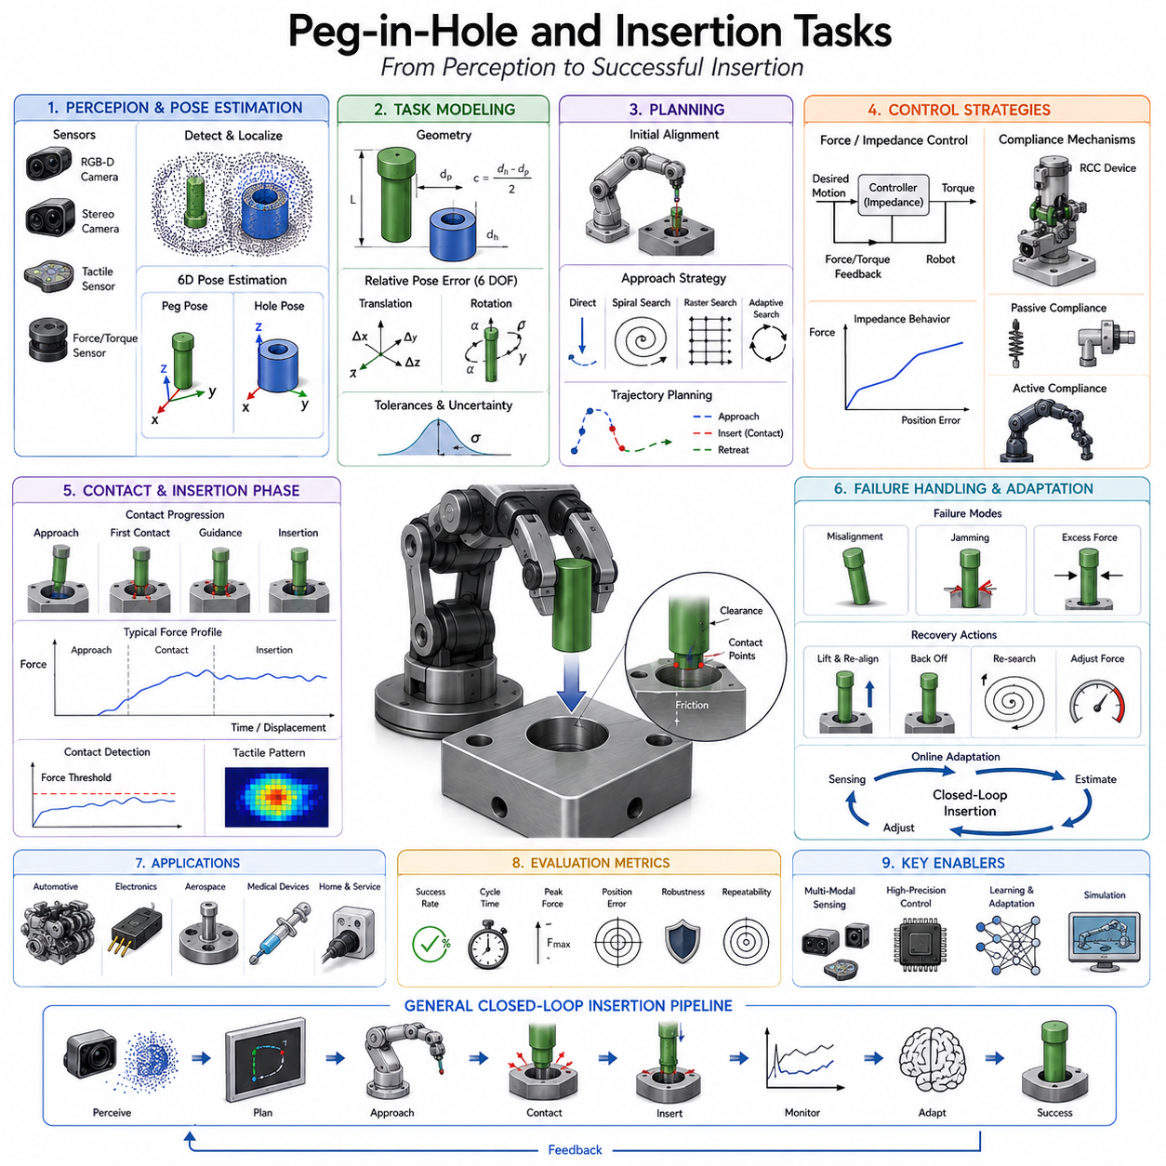
Peg-in-Hole and Insertion Tasks represent one of the most fundamental yet challenging problems in robotics, manufacturing automation, and dexterous manipulation. At first glance, inserting a peg into a hole appears to be a simple operation. Humans perform such actions effortlessly when plugging a charger into a socket, inserting a key into a lock, assembling furniture, installing mechanical components, or connecting electronic modules. However, for robotic systems, insertion tasks are significantly more complex because they require the precise coordination of perception, motion planning, force control, contact reasoning, and real-time adaptation under uncertainty. As a result, Peg-in-Hole problems have become one of the most widely studied benchmark tasks in robotic manipulation research and industrial automation. Within the Tool Use and Assembly section of Robot Hand and Dexterous Grasping, insertion tasks represent the transition from free-space manipulation to contact-rich manipulation, where physical interactions with the environment become dominant factors in task execution.
The classical Peg-in-Hole problem involves moving a cylindrical peg toward a matching hole and inserting it successfully without causing jamming, excessive contact forces, or structural damage. While the geometric definition appears simple, successful insertion depends on numerous factors including positional accuracy, angular alignment, surface friction, material properties, manufacturing tolerances, sensor quality, controller responsiveness, and environmental disturbances. Even a small positional error of a few tenths of a millimeter can cause insertion failure in high-precision assemblies.
Insertion operations are ubiquitous across modern industries. Automotive manufacturing relies heavily on shaft insertion, bearing installation, connector assembly, and component fitting. Electronics manufacturing involves inserting pins into sockets, connectors into interfaces, and components into printed circuit boards. Aerospace assembly requires extremely precise insertion of fasteners and structural components. Medical device manufacturing depends on delicate insertion tasks involving miniature parts and precision instruments. Service robots also encounter insertion problems when plugging in charging connectors, operating household devices, or manipulating everyday objects.
From a robotics perspective, insertion tasks differ fundamentally from ordinary pick-and-place operations. During pick-and-place tasks, the robot primarily operates in free space where motion can be planned using geometric trajectories. In insertion tasks, contact between the manipulated object and the environment becomes unavoidable and often essential. Once contact occurs, the dynamics of the system change dramatically. Small errors can generate large contact forces, causing instability, misalignment, or jamming. Therefore, insertion tasks require robots to reason about contact interactions rather than relying solely on geometric positioning.
Geometric alignment is the first prerequisite for successful insertion. The peg must be positioned near the entrance of the hole with sufficient accuracy. This requires accurate localization of both objects and precise estimation of their relative poses. Traditional industrial robots often achieve this through carefully calibrated fixtures and structured environments. In modern flexible manufacturing systems, however, robots must perform insertion under less predictable conditions where components may exhibit positional variations and orientation uncertainties.
The relative pose between the peg and the hole can be described using six degrees of freedom. Three degrees correspond to translational displacement, while three correspond to rotational misalignment. Successful insertion requires reducing all six errors to acceptable levels. Translational errors cause lateral offset, while rotational errors cause angular mismatch. Both forms of error increase insertion difficulty and may lead to contact-induced failure.
Tolerance plays a critical role in insertion planning. Clearance refers to the difference between hole dimensions and peg dimensions. Large clearances simplify insertion but reduce assembly precision. Small clearances improve final assembly quality but require significantly greater alignment accuracy. Many industrial applications involve tight-tolerance assemblies where clearance may be measured in micrometers. In such cases, even highly accurate robotic systems must employ advanced sensing and control techniques to achieve reliable insertion.
The contact mechanics of insertion tasks have been extensively studied. As the peg approaches the hole, contact forces begin to emerge at the interface. Depending on the relative alignment, contact may occur at a single point, multiple points, or along extended surfaces. Contact forces generate moments that influence object orientation and can either assist or hinder insertion. Understanding these interactions is essential for developing robust insertion strategies.
One of the most common failure modes in insertion tasks is jamming. Jamming occurs when contact forces create mechanical constraints that prevent further motion. The peg becomes wedged against the hole surface, generating increasing resistance. Jamming is particularly problematic in tight-tolerance assemblies because it may damage components or overload robotic actuators. Researchers have developed analytical models describing the conditions under which jamming occurs, allowing planners to avoid dangerous configurations.
Another important phenomenon is wedging. Wedging occurs when frictional forces prevent relative motion between contacting surfaces. Unlike simple geometric interference, wedging is strongly influenced by material properties and friction coefficients. Even when geometric clearance exists, excessive friction may prevent successful insertion. Therefore, insertion planning often incorporates friction models and force control strategies.
Force sensing has become a cornerstone technology for insertion tasks. Vision systems can provide coarse alignment, but force sensors provide direct measurements of physical interactions during contact. Wrist-mounted force-torque sensors are commonly used to detect insertion forces and moments. By analyzing these signals, robots can infer alignment errors, identify contact locations, and adjust trajectories dynamically. Force sensing enables robots to compensate for uncertainties that cannot be resolved through vision alone.
Compliance is another essential concept in insertion robotics. A perfectly rigid robot may generate large contact forces when alignment errors exist. Compliance allows the robot to adapt passively or actively to environmental constraints. Mechanical compliance can be achieved through elastic elements, compliant joints, or flexible structures. Control-based compliance can be achieved through impedance control and admittance control algorithms. Both approaches help absorb positioning errors and facilitate successful insertion.
Remote Center Compliance (RCC) devices represent a classic solution to insertion problems. RCC mechanisms are designed to allow small passive adjustments in position and orientation during contact. When the peg encounters the hole entrance, the RCC mechanism guides the peg toward proper alignment. Despite being developed decades ago, RCC devices remain widely used in industrial assembly systems because of their simplicity and effectiveness.
Impedance control has become one of the most influential approaches for robotic insertion. Instead of commanding strict position trajectories, impedance controllers regulate the dynamic relationship between force and motion. The robot behaves like a virtual mass-spring-damper system, allowing controlled interaction with the environment. This approach enables smooth adaptation to contact conditions while maintaining stability.
Admittance control provides a complementary strategy. In admittance control, measured forces are converted into motion commands. When excessive forces are detected, the robot adjusts its trajectory accordingly. This approach is particularly effective when force sensing quality is high and actuator dynamics permit rapid response.
Search strategies are often necessary when precise alignment cannot be guaranteed. Human workers frequently perform small exploratory motions during insertion. Similar strategies can be implemented in robots. Spiral search patterns are among the most common approaches. The robot moves the peg along a gradually expanding spiral trajectory until the hole entrance is located. Once contact conditions indicate successful alignment, insertion proceeds.
Raster search patterns, circular search motions, oscillatory probing, and adaptive exploration strategies have also been developed. The choice of search strategy depends on task geometry, sensor availability, and required insertion speed. Advanced systems dynamically switch between search modes based on real-time feedback.
Vision-guided insertion combines perception and control. Cameras provide initial alignment information before contact occurs. High-resolution vision systems can estimate hole locations, detect orientation errors, and identify assembly features. Marker-based systems, fiducial tags, structured light scanners, stereo vision systems, and RGB-D cameras are commonly employed. Vision significantly reduces the search space and improves insertion efficiency.
Three-dimensional pose estimation plays a particularly important role in insertion tasks. The robot must estimate both the peg pose and hole pose with high accuracy. Modern deep learning approaches have improved pose estimation performance, enabling robots to perform insertion tasks in less structured environments. Neural networks can learn robust pose representations that generalize across variations in lighting, appearance, and occlusion.
Learning-based insertion methods have attracted significant attention in recent years. Traditional insertion systems relied heavily on analytical models and handcrafted controllers. While effective in structured environments, these approaches often struggle when uncertainty increases. Learning-based methods allow robots to acquire insertion skills directly from experience.
Behavior cloning uses human demonstrations to teach insertion strategies. By observing expert operators, robots learn how successful insertions are performed under varying conditions. Demonstration data captures subtle corrective motions and force modulation behaviors that are difficult to model analytically.
Reinforcement learning offers another powerful framework. In reinforcement learning, robots repeatedly attempt insertion tasks and receive rewards based on success. Through trial and error, the system discovers policies that maximize insertion reliability. Modern reinforcement learning methods have achieved impressive performance in simulated and real-world insertion benchmarks.
Simulation has become a critical tool for insertion research. High-fidelity physics engines allow researchers to model contact interactions, frictional effects, compliance, and uncertainty. Millions of insertion attempts can be generated in simulation, providing training data for learning algorithms. Domain randomization techniques help bridge the gap between simulation and reality by exposing models to diverse conditions during training.
Tactile sensing is emerging as a valuable complement to force sensing. Tactile sensors provide distributed contact information rather than aggregate force measurements. By analyzing tactile patterns, robots can estimate contact locations, detect edge alignments, and identify insertion progress. Tactile feedback is particularly useful in tasks involving small components where precise contact information is essential.
Multi-modal perception further enhances insertion performance. Visual sensing provides global information about object locations, force sensing provides interaction dynamics, tactile sensing provides local contact details, and proprioception provides information about robot configuration. By fusing these modalities, robots achieve greater robustness under uncertainty.
Insertion tasks become significantly more challenging when flexible or deformable components are involved. Electrical connectors, cables, seals, gaskets, and soft medical devices introduce nonlinear deformation behaviors. Traditional rigid-body models become insufficient, requiring more sophisticated representations of contact and material mechanics.
Assembly planning provides the broader context for insertion operations. In many manufacturing processes, insertion represents only one step within a larger assembly sequence. The order of operations, accessibility constraints, tool availability, and fixture configurations all influence insertion planning. Integrated assembly planners therefore consider insertion requirements alongside other manipulation tasks.
Human-inspired insertion strategies have also attracted research interest. Humans rarely rely on perfect geometric accuracy. Instead, they use exploratory contact, tactile perception, compliance, and adaptive corrections. Replicating these capabilities in robots remains a major goal of dexterous manipulation research. Future robotic systems are expected to incorporate increasingly sophisticated sensory feedback and adaptive reasoning mechanisms inspired by human motor control.
Foundation models and embodied AI are beginning to influence insertion robotics. Large-scale models trained on manipulation data can learn generalized representations of contact-rich interactions. Rather than learning a separate controller for each assembly task, future systems may develop transferable insertion skills that generalize across diverse geometries and applications. Natural language instructions may guide insertion behavior, while world models predict the consequences of contact interactions before execution.
Evaluation of insertion systems typically considers insertion success rate, completion time, force efficiency, positional accuracy, robustness to uncertainty, tolerance to misalignment, and adaptability to environmental variation. Industrial applications often require success rates exceeding 99.9%, particularly in high-volume manufacturing environments where even small failure rates can produce significant economic costs.
Future insertion systems will likely combine high-precision perception, real-time force control, tactile intelligence, adaptive compliance, learning-based policies, and foundation-model reasoning within unified manipulation frameworks. These systems will move beyond rigid automation toward flexible assembly intelligence capable of operating in dynamic environments with minimal task-specific programming.
Ultimately, Peg-in-Hole and Insertion Tasks represent far more than a simple benchmark problem. They embody many of the core challenges of robotic manipulation, including perception uncertainty, contact dynamics, force regulation, dexterous control, sensor fusion, and adaptive decision making. Mastery of insertion tasks is therefore widely regarded as a key milestone on the path toward truly capable robotic assembly systems, intelligent manufacturing platforms, and future embodied AI agents capable of performing complex physical work in the real world.

13.06 Screw and Fastener Operations
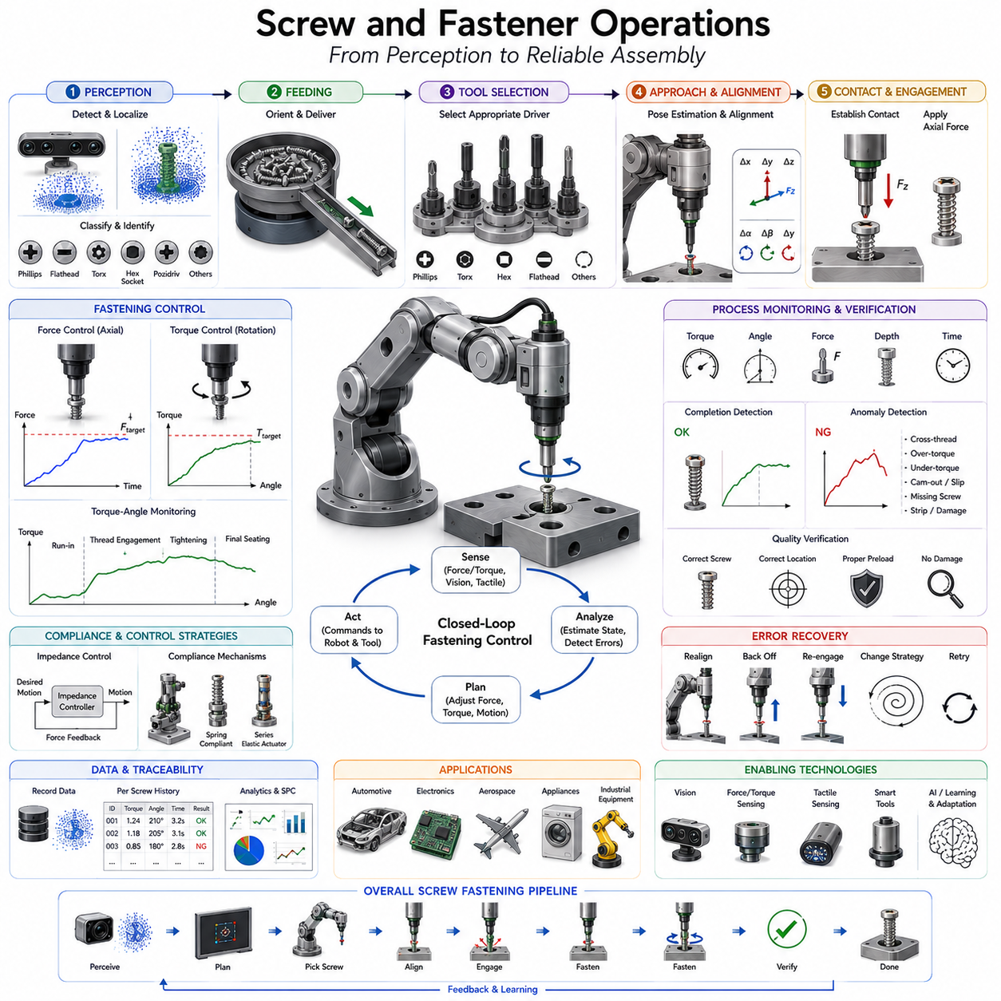
Screw and Fastener Operations represent one of the most important categories of assembly activities in industrial robotics, manufacturing automation, maintenance systems, and service robotics. Nearly every engineered product, from consumer electronics and automobiles to aircraft, industrial machinery, medical devices, and construction equipment, relies on fasteners to create secure mechanical connections between components. Among the many fastening technologies available, screws remain the most widely used because they provide a combination of strength, reliability, ease of installation, removability, and cost effectiveness. For robotic systems, however, screw manipulation is considerably more complex than it appears. A successful fastening operation requires precise perception, tool handling, pose estimation, force control, torque regulation, contact-rich manipulation, error recovery, and process verification. As a result, Screw and Fastener Operations have become a central topic within robotic assembly and dexterous manipulation research. Within the Tool Use and Assembly section of Robot Hand and Dexterous Grasping, this topic represents one of the most practical and commercially significant applications of robotic tool use.
Fasteners are mechanical elements used to join two or more components together. While screws are the most common fasteners encountered in robotic assembly, many other fastening mechanisms exist, including bolts, nuts, rivets, pins, clips, anchors, threaded inserts, retaining rings, and specialized industrial locking mechanisms. Each fastening technology presents unique manipulation challenges. Nevertheless, screws provide an ideal starting point because they combine insertion, alignment, force application, rotational control, and verification within a single task.
From a robotics perspective, screw fastening is a multi-stage operation. The robot must first identify the fastener and the target location. It must then acquire the appropriate tool, position the tool correctly, establish contact with the fastener head, apply axial force, generate controlled torque, monitor insertion progress, detect completion, and verify assembly quality. Failure at any stage can result in assembly defects, damaged components, stripped threads, tool wear, or production delays.
The perception phase plays a critical role in fastening automation. Before a screw can be manipulated, the robot must detect its location, orientation, type, and size. Screws are often small objects with reflective metallic surfaces, making visual detection challenging. They may be partially occluded, randomly oriented, or located in cluttered trays. High-resolution cameras, structured light systems, stereo vision systems, and RGB-D sensors are commonly used to identify screws and estimate their poses.
Screw classification is another important perception problem. Different screw types require different tools and fastening strategies. Common screw head designs include Phillips, Flathead, Torx, Hex Socket, Pozidriv, Robertson, and various security screw configurations. Accurate classification enables the robot to select the correct screwdriver and avoid tool mismatch. Advanced vision systems increasingly employ deep learning models capable of recognizing fastener categories under varying lighting and environmental conditions.
Pose estimation is particularly important for screw manipulation. The robot must determine the position and orientation of both the screw and the target hole. Even small angular misalignments can prevent engagement between the screwdriver and the screw head. In precision assemblies, pose estimation errors measured in fractions of a degree may significantly affect fastening reliability.
Fastener feeding represents another major challenge. Human workers can easily pick up individual screws, but robotic systems require specialized mechanisms to present screws in predictable configurations. Vibratory bowl feeders, tape-and-reel systems, tray feeders, magnetic feeders, vacuum delivery systems, and flexible feeding solutions are commonly used in industrial environments. Modern smart feeders often integrate sensing systems that provide real-time information regarding screw availability and orientation.
Tool selection is a critical aspect of robotic fastening. Different fasteners require different drivers and end effectors. A robotic assembly cell may contain multiple screwdriver tools designed for specific screw geometries. Automatic tool changers allow robots to switch between drivers without human intervention. Tool selection algorithms consider fastener type, torque requirements, accessibility constraints, and assembly specifications.
The robotic screwdriver itself is a highly specialized tool. Unlike ordinary gripping tools, screwdrivers must generate controlled rotational motion while maintaining alignment with the screw axis. Industrial robotic screwdrivers often integrate electric motors, torque sensors, force sensors, depth sensors, and communication interfaces. These systems provide closed-loop control capabilities that improve fastening accuracy and reliability.
Alignment is one of the most critical requirements for successful fastening. Before rotation begins, the screwdriver must align precisely with the screw head. Misalignment may cause cam-out, a phenomenon in which the screwdriver slips out of the screw recess. Cam-out not only prevents successful fastening but can also damage the screw head and reduce assembly quality. Therefore, robots often employ fine alignment procedures before initiating torque application.
Contact establishment represents the transition from free-space motion to contact-rich manipulation. During this phase, the screwdriver approaches the screw head and establishes physical contact. Force sensing is commonly used to detect contact and regulate insertion depth. Excessive contact force may damage components, while insufficient force may prevent reliable engagement.
Axial force control is essential during screw driving. Unlike simple rotational tasks, fastening requires simultaneous control of both force and torque. The robot must apply sufficient downward force to maintain engagement between the screwdriver and the screw head while simultaneously generating rotational motion. The required force depends on screw geometry, material properties, friction characteristics, and assembly conditions.
Torque control is perhaps the most important aspect of fastening operations. Torque represents the rotational force applied to the fastener. Insufficient torque may result in loose connections that compromise structural integrity. Excessive torque may strip threads, damage components, or deform assemblies. Industrial fastening systems therefore incorporate highly accurate torque control mechanisms that ensure each fastener is tightened according to specification.
Torque-angle relationships provide valuable information during fastening. As a screw advances into a threaded hole, torque typically follows a characteristic profile. Initial insertion generates relatively low torque. As clamping forces increase, torque rises. Eventually, the desired preload is achieved and tightening should stop. Monitoring torque-angle curves allows robots to detect anomalies and verify assembly quality.
Preload is a key engineering concept in fastening operations. Preload refers to the tensile force generated within the fastener after tightening. Proper preload ensures secure connections and prevents loosening under vibration and dynamic loading. Because preload cannot usually be measured directly during assembly, torque is often used as an indirect indicator. However, friction variations can affect torque-preload relationships, motivating the development of advanced sensing and estimation techniques.
Thread engagement is another critical process. The screw must properly engage the mating threads before significant torque is applied. Cross-threading occurs when the screw enters the threaded hole incorrectly, causing damage and preventing proper fastening. Detecting and preventing cross-threading remains a major challenge in automated assembly systems.
Compliance plays an important role in screw insertion and fastening. Mechanical compliance and control-based compliance allow robots to accommodate small alignment errors. Without compliance, rigid systems may generate excessive forces that damage threads or prevent engagement. Impedance control and admittance control are widely used to regulate interactions between the screwdriver, fastener, and assembly components.
Force-torque sensing provides valuable feedback throughout the fastening process. Wrist-mounted force-torque sensors measure interaction forces and moments, allowing robots to monitor assembly conditions in real time. Force signatures often reveal important information regarding thread engagement, insertion depth, friction changes, and fastening completion.
Tactile sensing is emerging as a complementary technology for robotic fastening. While force sensors provide aggregate measurements, tactile sensors provide spatially distributed contact information. Tactile feedback can improve alignment, detect slippage, identify tool engagement quality, and support adaptive control strategies.
Vision-guided fastening combines perception and control within a unified framework. Cameras monitor screw positions, hole locations, tool alignment, and assembly progress. High-resolution imaging systems can detect defects, verify component placement, and identify fastening errors before they become critical. Machine vision is increasingly integrated with force control to create robust multi-modal fastening systems.
Error detection and recovery are essential for reliable industrial deployment. Fastening operations are susceptible to numerous failure modes including missing screws, incorrect screw types, cross-threading, stripped heads, tool slippage, incomplete tightening, excessive torque, and damaged components. Advanced robotic systems continuously monitor sensor signals to identify these failures and execute corrective actions automatically.
Process monitoring has become increasingly important in modern manufacturing environments. Every fastening operation generates valuable data regarding torque, force, angle, time, tool status, and assembly conditions. This data can be stored for traceability, quality assurance, predictive maintenance, and process optimization. Digital manufacturing systems often maintain complete fastening histories for each product.
Collaborative robots are expanding the scope of fastening automation. Traditional fastening systems operated within isolated industrial cells. Modern collaborative robots can perform screw driving operations safely alongside human workers. This capability enables flexible production systems in which robots handle repetitive fastening tasks while humans focus on higher-level assembly activities.
Learning-based approaches are increasingly influencing robotic fastening. Traditional systems rely heavily on predefined process parameters and rule-based control. Machine learning methods enable robots to adapt to variations in materials, geometries, and environmental conditions. By analyzing historical assembly data, robots can optimize fastening strategies and improve reliability over time.
Behavior cloning allows robots to learn fastening skills from human demonstrations. Human operators naturally adapt force, torque, and alignment during assembly. Demonstration-based learning captures these behaviors and transfers them to robotic systems. Such approaches are particularly valuable when analytical modeling becomes difficult.
Reinforcement learning offers another promising direction. Robots learn fastening policies through repeated interactions with simulated or real environments. Successful fastening operations generate rewards, encouraging the discovery of robust manipulation strategies. Reinforcement learning has shown significant potential for handling complex assembly tasks involving uncertainty and variability.
Simulation environments play a crucial role in fastening research and development. High-fidelity simulators model contact dynamics, thread engagement, frictional effects, compliance, and sensor responses. Large-scale simulation enables rapid testing of fastening strategies while reducing development costs and minimizing hardware wear.
Foundation models and embodied AI are beginning to influence robotic assembly operations. Large-scale models trained on manipulation data may eventually understand fastening tasks at a semantic level. Instead of programming specific screw-driving routines, future robots may receive natural language instructions such as “assemble the panel using the designated screws” and autonomously determine appropriate tools, fastening sequences, and verification procedures.
Industrial applications of robotic fastening are extensive. Automotive production lines perform thousands of fastening operations per vehicle. Consumer electronics manufacturing relies heavily on miniature screw assembly. Aerospace manufacturing requires extremely precise fastening under strict quality standards. Medical device production demands reliable fastening within highly regulated environments. Construction robotics increasingly employs automated fastening technologies for modular building assembly.
Fastening quality verification is the final stage of the process. Successful completion is not simply defined by reaching a target torque value. Robots must verify that the correct fastener was installed in the correct location, that proper preload was achieved, that no damage occurred, and that assembly specifications were satisfied. Verification may involve torque analysis, visual inspection, depth measurement, force monitoring, and non-destructive testing techniques.
Performance evaluation of robotic fastening systems typically considers fastening success rate, cycle time, torque accuracy, preload consistency, defect rate, tool wear, energy consumption, and adaptability to process variations. High-volume manufacturing environments often require success rates exceeding 99.99%, making reliability a critical design objective.
Future Screw and Fastener Operations will likely integrate advanced perception, high-precision force control, tactile intelligence, adaptive compliance, digital twins, learning-based optimization, and foundation-model reasoning within unified assembly platforms. These systems will move beyond repetitive automation toward intelligent assembly capabilities capable of handling diverse products with minimal reprogramming.
Ultimately, Screw and Fastener Operations represent a perfect example of contact-rich robotic manipulation. They require the integration of perception, planning, force regulation, tool use, process monitoring, and adaptive intelligence within a single task. Mastering robotic fastening is therefore not merely an industrial requirement but also an important milestone toward achieving general-purpose robotic assembly systems and future embodied AI agents capable of performing complex physical work in real-world environments.

13.07 Cable Handling
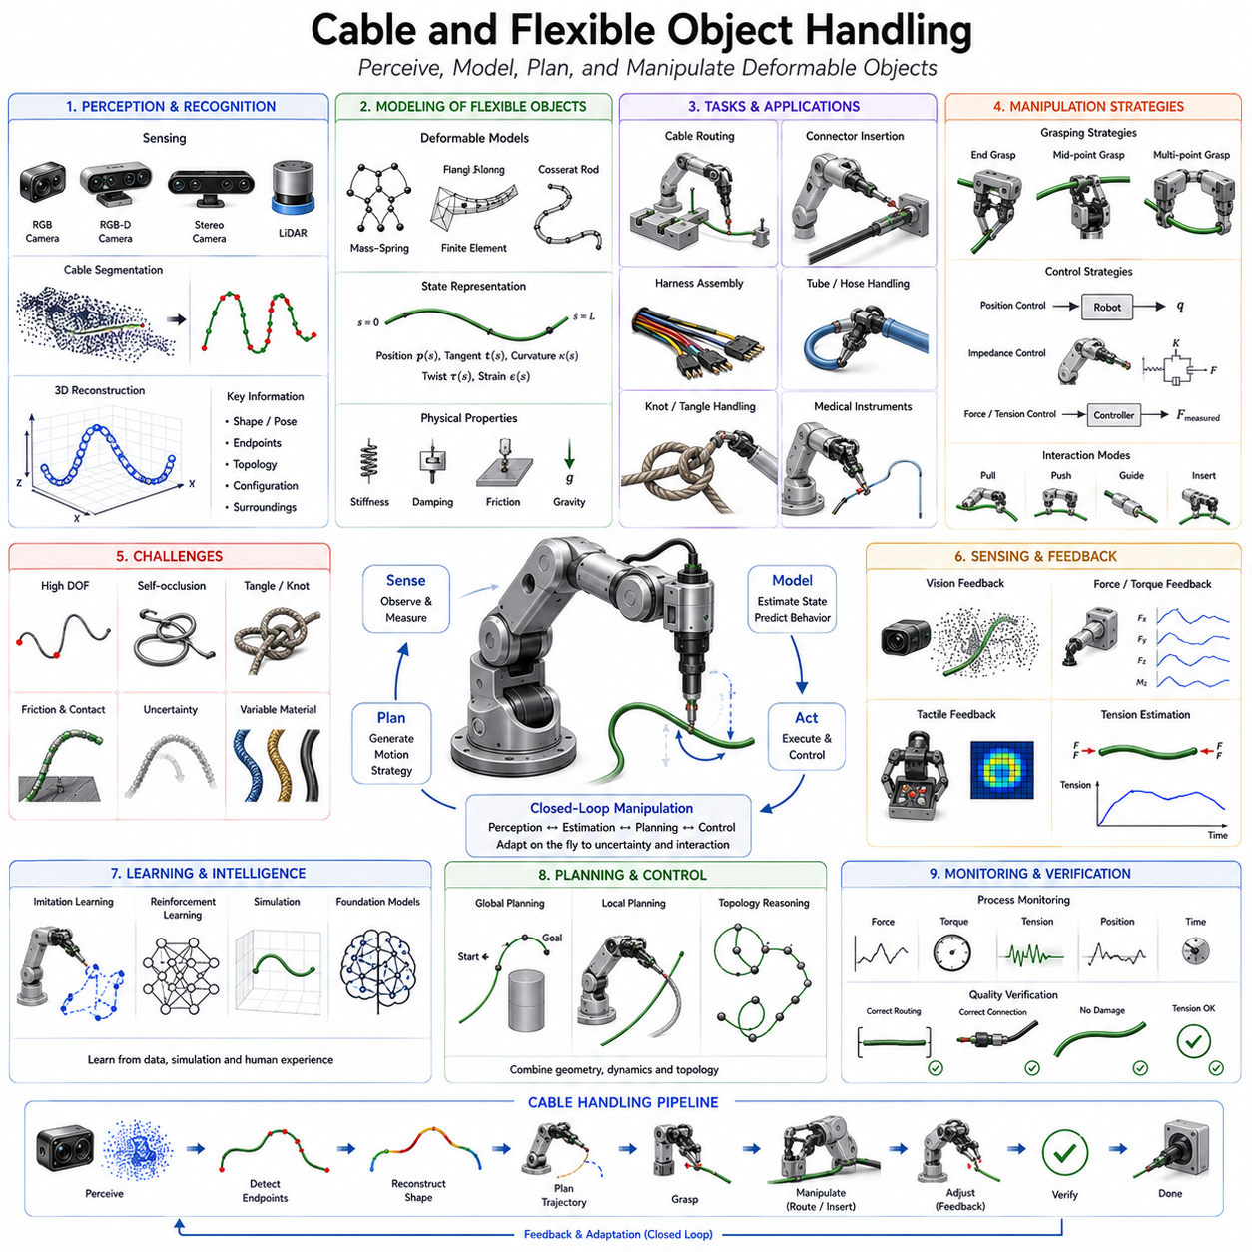
Cable and Flexible Object Handling is one of the most challenging areas in robotic manipulation because it involves objects whose shape continuously changes during interaction. Unlike rigid objects, which maintain a predictable geometry and can be described using fixed kinematic and geometric models, flexible objects exhibit highly dynamic behavior influenced by gravity, contact forces, friction, elasticity, bending stiffness, torsion, material memory, and environmental constraints. As a result, tasks that humans perform naturally, such as plugging in a charging cable, routing a wire through a machine, folding a hose, organizing electrical harnesses, inserting medical catheters, or manipulating ropes and textiles, remain among the most difficult challenges in robotics. Within the Tool Use and Assembly section of Robot Hand and Dexterous Grasping, Cable and Flexible Object Handling represents a major transition from rigid-body manipulation to deformable object manipulation, requiring advanced perception, modeling, planning, control, and learning capabilities.
Flexible objects are ubiquitous in industrial and everyday environments. Electrical wiring harnesses are present in automobiles, aircraft, industrial machinery, consumer electronics, and communication systems. Flexible tubes transport fluids and gases throughout factories and medical facilities. Fiber optic cables support communication networks. Medical procedures frequently involve flexible instruments such as catheters, guidewires, and endoscopes. Household environments contain power cords, charging cables, hoses, ropes, fabrics, and numerous deformable materials. The ability to manipulate such objects reliably is therefore essential for the next generation of autonomous robots.
The primary difficulty of flexible object manipulation originates from the object's virtually infinite degrees of freedom. A rigid object can be represented by six degrees of freedom corresponding to its position and orientation. In contrast, a cable can bend, twist, stretch, coil, loop, and deform continuously along its length. Every point along the cable may potentially move independently. Consequently, the state space of a flexible object is dramatically larger than that of a rigid object, making perception and control substantially more difficult.
Mechanical properties play a central role in flexible object behavior. Different cables exhibit different levels of stiffness, elasticity, damping, friction, and torsional resistance. A thin electrical wire behaves very differently from a hydraulic hose. A fiber optic cable requires careful handling to avoid excessive bending, while a power cable may tolerate significant deformation. Understanding material properties is therefore essential for predicting object behavior during manipulation.
One of the first challenges in cable handling is perception. Before manipulation can begin, the robot must identify the cable, estimate its shape, locate its endpoints, determine its configuration, and understand its relationship to the surrounding environment. Unlike rigid tools, whose geometry is relatively fixed, cables continuously change shape. This means that perception systems must track not only object position but also object deformation.
Vision-based perception has become the dominant approach for flexible object recognition. High-resolution RGB cameras provide detailed visual information about cable appearance and configuration. However, cables often present challenges such as self-occlusion, overlapping segments, reflections, complex backgrounds, and varying lighting conditions. Advanced computer vision algorithms are therefore required to segment cables accurately and reconstruct their geometry.
Three-dimensional sensing further improves cable perception. RGB-D cameras, stereo vision systems, structured light sensors, and laser scanners enable robots to reconstruct the spatial shape of flexible objects. Point cloud processing algorithms can identify cable trajectories, estimate curvature distributions, and locate critical features such as endpoints and connectors. Three-dimensional perception is particularly important when cables are suspended in space or routed through complex environments.
Endpoint detection represents a critical capability in cable manipulation. Many cable handling tasks begin by grasping one or both ends of a cable. However, endpoints are often partially hidden, tangled, or difficult to distinguish from intermediate segments. Modern perception systems use deep learning models and geometric reasoning techniques to identify cable endpoints robustly even in cluttered environments.
Shape reconstruction is another major challenge. The robot must estimate the current configuration of the cable to predict future behavior. Shape reconstruction algorithms convert visual observations into mathematical representations such as splines, curves, graphs, or finite element models. These representations provide a compact description of cable geometry and support planning and control processes.
Mathematical modeling of flexible objects is significantly more complex than rigid-body modeling. Classical rigid-body dynamics assume fixed geometric relationships between object components. Flexible objects require continuous deformation models. Researchers have developed numerous representations including mass-spring systems, finite element methods, Cosserat rod models, elastic rod formulations, and continuum mechanics approaches. Each model offers different tradeoffs between accuracy and computational efficiency.
Mass-spring systems provide one of the simplest representations. The cable is modeled as a series of masses connected by springs and dampers. This approach captures basic deformation behavior while remaining computationally manageable. However, it may not accurately represent complex bending and torsional effects.
Finite Element Methods provide higher accuracy by dividing the cable into many small elements and solving deformation equations numerically. These models can represent complex material properties and contact interactions but often require substantial computational resources. As computing power continues to increase, finite element approaches are becoming increasingly practical for robotic manipulation.
Cosserat rod models have gained significant attention in recent years because they provide a powerful balance between physical realism and computational efficiency. These models represent bending, twisting, stretching, and shearing within a unified mathematical framework. Cosserat theory is particularly useful for robotic manipulation of cables, wires, catheters, and other elongated flexible structures.
Grasp planning for flexible objects differs fundamentally from grasp planning for rigid objects. In rigid object manipulation, grasping a specific location typically provides predictable control over the entire object. In cable manipulation, grasping one point affects only a portion of the object and may cause unpredictable deformation elsewhere. The robot must therefore consider both local and global effects when selecting grasp points.
Single-point grasping is sufficient for simple transportation tasks. However, many cable handling operations require multi-point manipulation. Two robotic hands may grasp different sections of a cable simultaneously. Multi-point manipulation provides greater control over object shape and enables complex tasks such as routing, threading, knot tying, and assembly.
Cable routing is one of the most important industrial applications of flexible object handling. During assembly operations, cables must often be routed through constrained pathways, clips, brackets, channels, and protective conduits. Routing requires precise control of cable shape while avoiding excessive tension, twisting, and bending. Automated cable routing remains an active research area because of its practical importance in automotive, aerospace, and electronics manufacturing.
Connector insertion represents another critical application. Many assembly processes require inserting cable connectors into mating sockets. This task combines flexible object manipulation with precision insertion. The robot must control cable deformation while simultaneously aligning the connector accurately. Small disturbances in cable shape can significantly affect insertion accuracy.
Cable harness assembly is among the most challenging industrial automation tasks. Wiring harnesses may contain dozens or even hundreds of interconnected cables with complex branching structures. Manipulating such assemblies requires understanding both local cable behavior and global topology. Advanced robotic systems must reason about cable organization, routing constraints, assembly sequences, and quality requirements simultaneously.
Tension control plays a crucial role in flexible object manipulation. Excessive tension may damage cables or alter their intended configuration. Insufficient tension may lead to slack, tangling, or loss of control. Force sensors are commonly used to monitor cable tension and regulate interaction forces during manipulation.
Contact interactions significantly influence cable behavior. Flexible objects frequently interact with surrounding surfaces, fixtures, guides, and other cables. Frictional effects often dominate system behavior. Accurate prediction of contact forces remains one of the most difficult challenges in flexible object modeling. Modern simulation environments increasingly incorporate advanced contact models to improve realism.
Tangling is a particularly difficult problem. Cables naturally form loops, knots, and entangled structures during storage and handling. Untangling requires sophisticated perception and reasoning capabilities. The robot must identify topological relationships, determine the sequence of required actions, and execute manipulation strategies that progressively reduce entanglement complexity.
Topological reasoning has emerged as an important research direction. Traditional robotic planning focuses primarily on geometry. Cable manipulation additionally requires understanding topology, including loops, crossings, knots, and connectivity relationships. Topological representations help robots reason about entanglement and support planning for complex manipulation tasks.
Learning-based approaches have significantly advanced the field of flexible object handling. Traditional model-based methods often struggle because flexible object dynamics are difficult to model accurately. Machine learning provides an alternative by allowing robots to learn manipulation strategies directly from experience.
Behavior cloning enables robots to imitate human demonstrations. Human operators naturally understand how to manipulate cables, route wires, and avoid tangles. Demonstration data captures these skills and transfers them to robotic systems. This approach is particularly useful for tasks where analytical models are incomplete or difficult to construct.
Reinforcement learning has also demonstrated promising results. Through repeated interaction with simulated environments, robots can discover manipulation policies that maximize task success. Reinforcement learning is especially valuable for cable routing, connector insertion, and knot manipulation tasks where long sequences of actions must be coordinated.
Simulation plays a central role in learning-based cable manipulation. Flexible object simulations allow robots to experience thousands or millions of manipulation scenarios without physical hardware. Advances in physics simulation have significantly improved the realism of cable dynamics, enabling more effective transfer of learned policies to real-world systems.
Tactile sensing provides valuable information during cable manipulation. Vision systems may lose visibility due to occlusion or complex object configurations. Tactile sensors provide direct measurements of contact conditions, grip quality, and cable movement. Combining visual and tactile information significantly improves manipulation robustness.
Force sensing is equally important. Monitoring interaction forces helps prevent cable damage and provides feedback regarding tension, contact, and insertion progress. Force-based control strategies are widely used in connector assembly, cable routing, and medical applications involving flexible instruments.
Medical robotics represents a particularly important application domain. Catheters, guidewires, endoscopes, and flexible surgical tools exhibit many of the same challenges as cable manipulation. Medical robots must navigate flexible instruments through complex anatomical pathways while maintaining precise control and minimizing tissue damage. Research in medical robotics has therefore contributed significantly to the development of flexible object manipulation techniques.
Foundation models and embodied AI are beginning to influence this field as well. Large-scale manipulation models trained on diverse datasets may eventually learn generalized representations of flexible object behavior. Rather than requiring task-specific programming, future robots may reason about cables, hoses, ropes, and deformable objects using transferable physical knowledge. Natural language instructions may specify desired cable configurations while underlying models determine appropriate manipulation strategies.
Industrial applications continue to drive progress in this area. Automotive manufacturers seek automated wiring harness assembly. Aerospace companies require reliable cable routing within aircraft structures. Electronics manufacturers aim to automate connector insertion and cable management. Logistics systems increasingly handle flexible packaging materials. Service robots must manipulate charging cables, household cords, and deformable objects in unstructured environments.
Performance evaluation of cable manipulation systems typically considers task success rate, routing accuracy, insertion accuracy, deformation control, tension regulation, execution speed, robustness to uncertainty, and adaptability to new cable types. Because flexible objects exhibit highly variable behavior, robustness and generalization are often more important than raw speed.
Future Cable and Flexible Object Handling systems will likely integrate advanced perception, real-time physics modeling, tactile intelligence, force control, topological reasoning, simulation-driven learning, foundation models, and embodied AI within unified manipulation frameworks. These systems will move beyond simple cable transport toward sophisticated flexible object intelligence capable of handling the enormous diversity of deformable materials encountered in the real world.
Ultimately, Cable and Flexible Object Handling represents one of the final frontiers of robotic manipulation. While rigid-object manipulation has achieved remarkable maturity, flexible-object manipulation remains a grand challenge that demands breakthroughs across perception, modeling, control, planning, and learning. Solving this challenge will significantly expand the range of tasks robots can perform and will play a critical role in enabling future autonomous assembly systems, advanced service robots, intelligent manufacturing platforms, and general-purpose embodied AI agents.

13.08 Deformable Object Manipulation
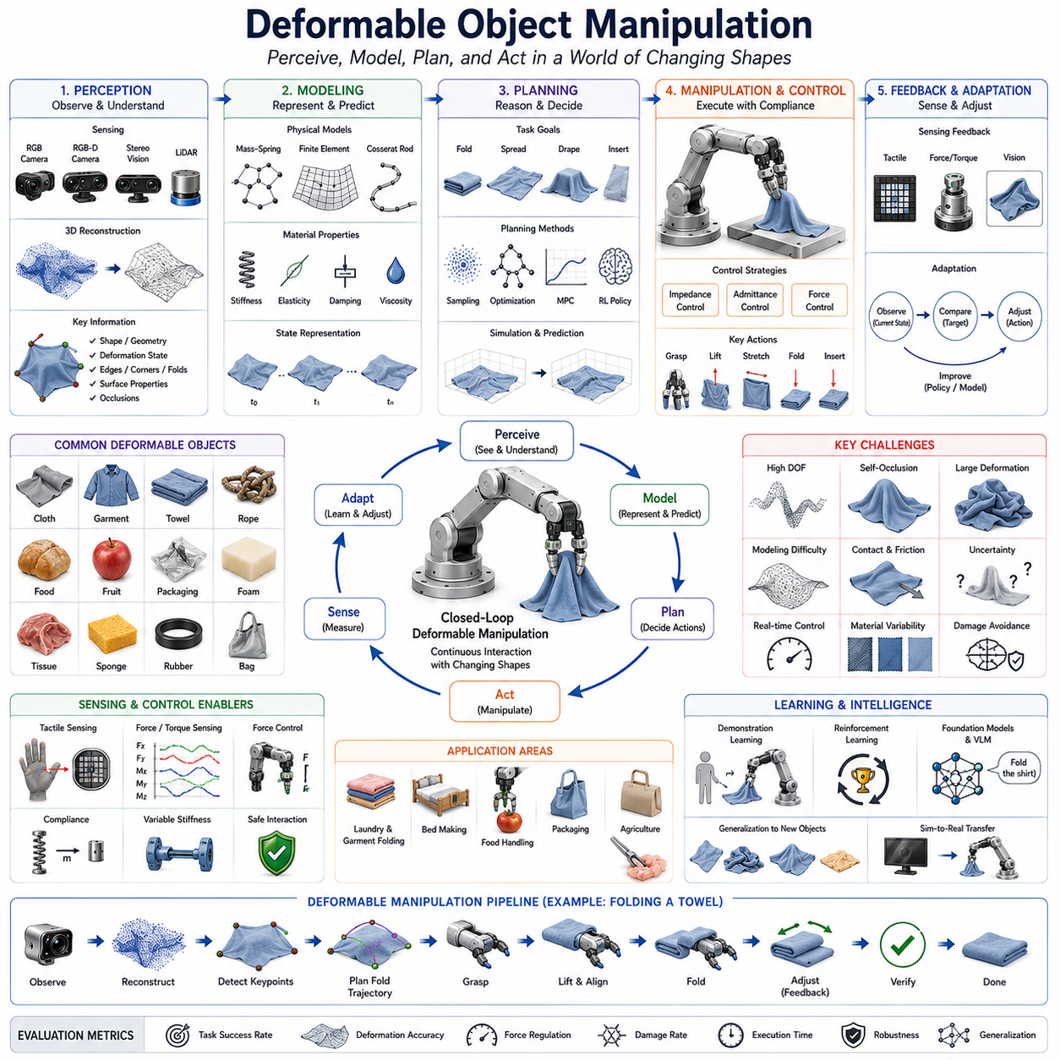
Deformable Object Manipulation refers to the robotic capability of perceiving, grasping, controlling, transforming, and interacting with objects whose shape changes continuously during manipulation. Unlike rigid objects, which preserve their geometry under normal operating conditions, deformable objects exhibit dynamic and often nonlinear changes in shape when subjected to forces, environmental interactions, gravity, or contact constraints. Examples include cloth, garments, paper, food products, biological tissues, foam materials, rubber components, flexible packaging, soft industrial parts, agricultural products, medical materials, and many everyday objects encountered in human environments. As robotics advances beyond structured industrial settings and enters homes, hospitals, warehouses, agriculture, construction sites, and service environments, the ability to manipulate deformable objects has become one of the most important frontiers of intelligent robotics. Within the Tool Use and Assembly section of Robot Hand and Dexterous Grasping, deformable object manipulation represents a natural extension beyond rigid-body assembly, requiring robots to reason not only about object position and orientation but also about continuously evolving shape states.
The difficulty of deformable object manipulation originates from the fact that the object's state can no longer be described using a simple six-degree-of-freedom representation. A rigid object can be represented by its position and orientation, allowing relatively straightforward modeling and planning. A deformable object, however, possesses effectively infinite degrees of freedom because every point on the object may move independently. The shape of a piece of cloth, for example, may change dramatically depending on how it is grasped, folded, stretched, compressed, or draped over surrounding surfaces. This enormous state space creates significant challenges for perception, modeling, planning, control, and learning.
Deformable objects are present in nearly every practical application domain. In manufacturing, robots encounter rubber seals, flexible plastic parts, gaskets, composite materials, wiring bundles, and packaging materials. In logistics, robots handle bags, parcels, shrink-wrap films, and deformable containers. In agriculture, fruits, vegetables, plants, and harvested crops exhibit varying levels of deformability. In healthcare, surgical robots manipulate tissues, organs, sutures, and medical dressings. Domestic robots must interact with clothing, towels, bedsheets, food products, and cleaning materials. Consequently, solving deformable object manipulation is essential for achieving truly general-purpose robotic intelligence.
One of the first challenges in deformable object manipulation is perception. Unlike rigid objects with predictable geometry, deformable objects continuously change appearance. Their shape may vary depending on lighting, viewing angle, contact conditions, and previous manipulation history. Traditional object recognition methods often struggle because the same object may appear dramatically different from one moment to the next.
Computer vision plays a central role in deformable object perception. High-resolution RGB cameras provide detailed visual information regarding object texture, color, folds, wrinkles, edges, and contours. However, visual interpretation becomes significantly more difficult when objects self-occlude or exhibit complex deformations. Advanced perception systems therefore employ deep neural networks capable of recognizing deformable objects across a wide range of configurations.
Three-dimensional sensing further improves understanding of deformable objects. RGB-D cameras, stereo vision systems, structured light sensors, and LiDAR-based perception systems can reconstruct object surfaces and estimate shape geometry. Point cloud representations allow robots to analyze folds, curvature distributions, surface topology, and deformation patterns. These capabilities are particularly valuable when manipulating large cloth objects or irregular soft materials.
State estimation represents a major research challenge. The robot must estimate not only object position but also object configuration. In cloth manipulation, this may involve identifying corners, edges, folds, wrinkles, and hidden regions. In food handling, it may involve estimating internal deformation and structural integrity. In medical applications, it may require understanding tissue shape and elasticity. Accurate state estimation is critical because manipulation decisions depend heavily on the current deformation state.
Physical modeling of deformable objects is considerably more complex than rigid-body modeling. Classical robotics relies heavily on rigid-body mechanics, where geometric relationships remain fixed. Deformable objects require representations capable of capturing elastic deformation, plastic deformation, bending, stretching, compression, twisting, and material-specific behaviors.
Mass-spring models provide one of the earliest approaches to deformable object simulation. The object is represented as a network of masses connected by springs and dampers. This approach captures basic deformation behavior while remaining computationally efficient. Mass-spring systems have been widely used for cloth simulation, soft material modeling, and interactive graphics applications.
Finite Element Methods provide significantly greater accuracy. In FEM-based models, objects are divided into many small elements, and deformation is computed by solving physical equations across the entire structure. FEM enables accurate modeling of material properties, stress distributions, and nonlinear deformations. However, the computational requirements can be substantial, particularly for real-time robotic applications.
Continuum mechanics provides the theoretical foundation for many deformable object models. Instead of treating objects as collections of discrete components, continuum models represent deformation as continuous fields of displacement, strain, and stress. Such models are particularly important for medical robotics and soft material manipulation where accurate physical behavior is essential.
Material properties strongly influence manipulation strategies. Different deformable objects respond differently to applied forces. A towel behaves differently from a sheet of paper. A rubber gasket behaves differently from a surgical tissue. Material characteristics such as elasticity, stiffness, viscosity, compressibility, plasticity, damping, and fracture resistance determine how objects deform under manipulation.
Grasp planning becomes substantially more complicated when dealing with deformable objects. In rigid object manipulation, a stable grasp generally allows predictable control over the object. For deformable objects, grasping itself changes the object configuration. A cloth corner may stretch when lifted. A sponge may compress when squeezed. A food product may deform under excessive pressure. Consequently, grasp planning must consider both immediate grasp stability and future deformation effects.
Adaptive grasping strategies are therefore required. Rather than maintaining fixed grasp forces, robots continuously adjust grip strength based on object response. Tactile sensing and force sensing play essential roles in this process. Real-time feedback enables the robot to avoid excessive deformation while maintaining secure control.
Cloth manipulation represents one of the most extensively studied examples of deformable object handling. Folding garments, spreading towels, making beds, sorting laundry, and handling textile materials require sophisticated perception and planning capabilities. A seemingly simple task such as folding a shirt involves detecting corners, identifying folds, estimating fabric configuration, and executing coordinated manipulation sequences.
Garment handling presents additional challenges because clothing items often begin in highly unstructured configurations. A crumpled shirt may appear entirely different from its unfolded state. Robots must first identify grasp points that enable progressive unfolding before higher-level manipulation can occur.
Food handling is another important application area. Many food products are highly deformable and fragile. Fruits, vegetables, baked goods, meat products, and prepared meals may bruise, tear, crush, or permanently deform if manipulated improperly. Robotic food handling therefore requires careful force regulation and adaptive grasp control.
Medical robotics introduces some of the most demanding deformable object manipulation problems. Surgical robots interact directly with biological tissues that exhibit highly nonlinear mechanical behavior. Tissues deform continuously under contact, and excessive force may cause irreversible damage. Consequently, medical manipulation requires precise force control, tactile sensing, and predictive modeling.
Soft robotics has emerged as a particularly promising approach for deformable object manipulation. Soft grippers naturally conform to object surfaces and distribute contact forces across larger areas. This compliance reduces the risk of damage and improves grasp robustness. Soft robotic hands are especially effective for handling fragile and irregularly shaped objects.
Force control is fundamental to deformable object manipulation. Position-based control alone is often insufficient because object behavior depends heavily on interaction forces. Impedance control and admittance control allow robots to regulate the relationship between force and motion, enabling safer and more adaptive interactions.
Tactile sensing provides critical information regarding contact conditions. Unlike vision systems, tactile sensors directly measure pressure distributions, contact locations, slip events, and local deformation patterns. Tactile feedback enables robots to adjust grasp forces dynamically and detect changes that may not be visible externally.
Multi-modal perception combines visual, tactile, force, and proprioceptive sensing. Each modality provides complementary information regarding object state. Vision offers global shape information, tactile sensing provides local contact details, force sensors measure interaction dynamics, and proprioception tracks robot configuration. Integrating these information sources significantly improves manipulation performance.
Motion planning for deformable objects differs fundamentally from rigid-body planning. Traditional planners search for collision-free trajectories through configuration space. Deformable object planners must additionally predict how object shape will evolve during execution. This often requires coupling planning algorithms with physical simulation models.
Model Predictive Control has become increasingly popular for deformable object manipulation. MPC repeatedly predicts future object states using dynamic models and optimizes control actions over a moving time horizon. This approach allows robots to respond adaptively to changing object configurations and environmental conditions.
Learning-based methods have transformed the field of deformable object manipulation. Analytical models are often difficult to construct because deformable objects exhibit highly complex behavior. Machine learning enables robots to acquire manipulation skills directly from data rather than relying exclusively on explicit physical models.
Behavior cloning allows robots to learn manipulation strategies from human demonstrations. Human operators naturally understand how to fold cloth, handle food, manipulate flexible materials, and interact with soft objects. By observing demonstrations, robots can acquire policies that capture expert behavior.
Reinforcement learning provides another powerful framework. Through repeated interaction with simulated environments, robots learn policies that maximize task success. Reinforcement learning has demonstrated impressive performance in cloth folding, rope manipulation, deformable object sorting, and soft material handling.
Simulation plays a critical role in learning-based approaches. Modern physics engines increasingly support realistic deformable object simulation, enabling large-scale data generation. Simulated training environments allow robots to experience millions of manipulation scenarios before deployment in the real world.
Digital twins are becoming important tools for industrial deformable object applications. A digital twin maintains a virtual representation of the object and manipulation process. Real-time sensor data continuously updates the model, enabling predictive control and process optimization.
Foundation models and embodied AI are beginning to reshape this field. Large-scale manipulation models trained across diverse tasks may eventually learn generalized representations of deformation physics. Rather than requiring separate solutions for cloth, food, tissue, and packaging manipulation, future systems may reason about deformable objects using shared physical knowledge acquired through large-scale learning.
Language-conditioned manipulation further expands capabilities. A user might instruct a robot to “fold the towel neatly,” “place the blanket on the bed,” or “package the fragile item carefully.” The robot must interpret these instructions and translate them into deformation-aware manipulation strategies.
Industrial applications continue to drive significant investment in deformable object manipulation. Textile manufacturing seeks automated garment handling. Food processing requires reliable manipulation of delicate products. Medical robotics demands safe tissue interaction. Logistics operations increasingly involve flexible packaging materials. Service robots must handle everyday deformable objects within human environments.
Performance evaluation typically considers task success rate, deformation accuracy, force regulation quality, damage rate, execution speed, robustness to uncertainty, adaptability across object types, and generalization to unseen objects. Because deformable objects exhibit high variability, robustness and adaptability are often more important than raw execution speed.
Future deformable object manipulation systems will likely combine advanced perception, real-time physics simulation, tactile intelligence, adaptive force control, learning-based planning, foundation models, digital twins, and embodied AI within unified manipulation architectures. These systems will progressively bridge the gap between human dexterity and robotic capability.
Ultimately, Deformable Object Manipulation represents one of the grand challenges of robotics. It requires the integration of perception, mechanics, control, planning, learning, and reasoning at a level far beyond traditional rigid-body manipulation. Success in this field will dramatically expand the range of tasks robots can perform and will serve as a critical milestone toward intelligent manufacturing systems, advanced service robots, autonomous healthcare platforms, and future general-purpose embodied AI agents capable of interacting effectively with the complex physical world.

13.09 Assembly Planning
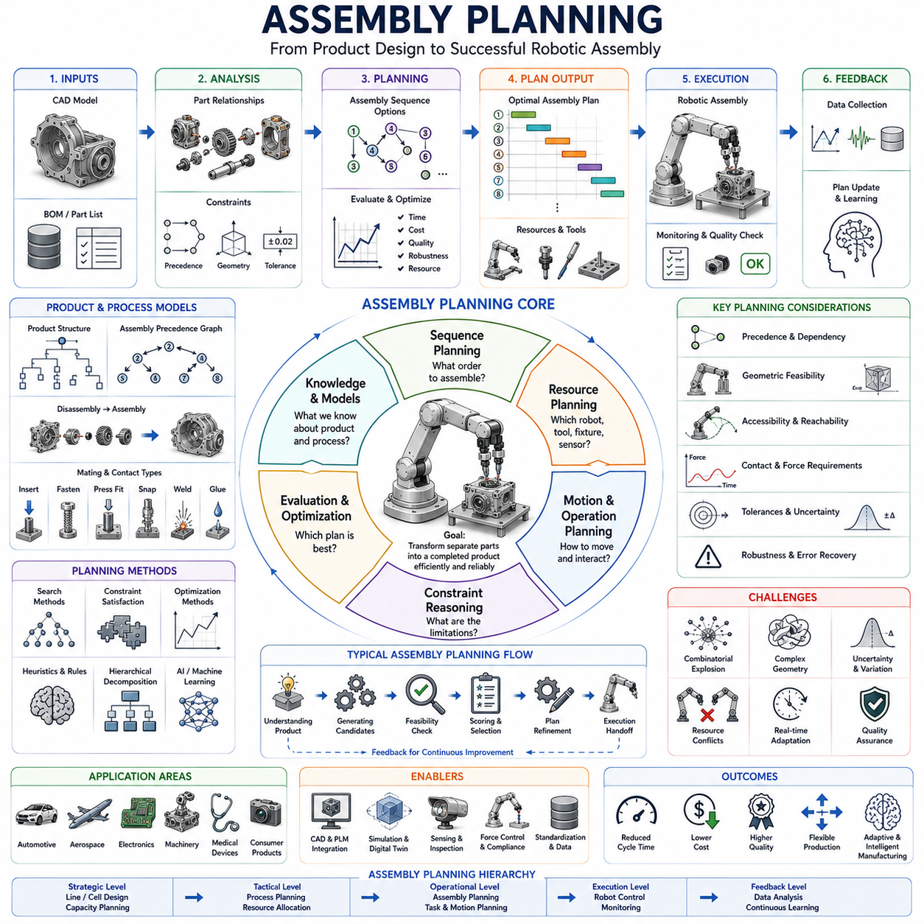
Assembly Planning is the process of determining how individual parts, components, tools, fixtures, and robotic resources should be coordinated to transform a collection of separate objects into a completed product. It serves as the bridge between product design and physical manufacturing, defining not only what must be assembled but also the sequence, methods, resources, motions, and interactions required to achieve successful assembly. In robotic systems, assembly planning is one of the highest-level decision-making processes because it connects perception, manipulation, motion planning, grasp planning, tool use, force control, task planning, and execution monitoring into a unified framework. Within the Tool Use and Assembly domain of Robot Hand and Dexterous Grasping, assembly planning provides the overall intelligence that organizes individual manipulation skills into coherent manufacturing operations.
Historically, assembly planning emerged from industrial manufacturing, where engineers manually defined assembly procedures for products such as automobiles, aircraft, consumer electronics, and machinery. Human experts analyzed component relationships, determined assembly sequences, specified tooling requirements, and created work instructions for production workers. As manufacturing systems became more complex and product lifecycles became shorter, manual planning became increasingly difficult. Robotic assembly systems therefore required computational methods capable of automatically generating assembly plans from digital product descriptions.
At its core, assembly planning answers several fundamental questions. It determines which part should be assembled first, which components depend on others, what tools are required, how components should be grasped, how they should be positioned, what assembly constraints exist, what motions are feasible, how quality should be verified, and how errors should be handled. These questions appear simple when assembling a small object but become extremely challenging when dealing with products containing hundreds, thousands, or even millions of components.
A complete assembly process can be viewed as a transformation from an initial state, where all components are separate, to a final state, where the product exists as a fully assembled structure. Between these two states lies a vast space of possible assembly sequences. Some sequences are efficient and physically feasible, while others are impossible due to geometric constraints, accessibility limitations, or dependency relationships. Assembly planning seeks to identify sequences that are both feasible and optimal according to specific objectives.
One of the most important concepts in assembly planning is precedence relationships. Many products contain components that must be installed before others. For example, a bearing must often be inserted into a housing before a shaft can be installed. Electronic components may need to be mounted before an enclosure is closed. Wiring harnesses may need to be routed before structural covers are attached. These dependency relationships create a partially ordered set of assembly operations that must be respected.
Precedence constraints are commonly represented using graphs. In an Assembly Precedence Graph, nodes represent assembly operations or components, while edges represent dependency relationships. Graph representations provide a convenient mathematical framework for reasoning about assembly sequences and identifying feasible operation orders.
Assembly sequence planning is a central subproblem of assembly planning. Given a product structure and its constraints, the system must determine the order in which components should be assembled. Multiple valid sequences may exist for the same product. Some sequences minimize assembly time, while others minimize tool changes, reduce robot motions, improve accessibility, or increase robustness. The planner must evaluate alternatives and select the most appropriate sequence according to manufacturing objectives.
Geometric reasoning plays a critical role in assembly planning. Components must be physically movable into their final positions without colliding with surrounding parts. This requires analysis of assembly directions, insertion paths, clearance requirements, and accessibility conditions. Even when dependency constraints are satisfied, geometric constraints may render an assembly sequence infeasible.
Disassembly analysis is often used to support assembly planning. Rather than directly searching for assembly sequences, planners may begin with the completed product and determine how it can be disassembled. The resulting disassembly sequence can then be reversed to obtain a valid assembly sequence. This approach simplifies many planning problems because removal operations are often easier to analyze than insertion operations.
Assembly planning must also consider contact interactions between components. Many assembly operations involve insertion, fastening, alignment, mating, press fitting, snapping, welding, gluing, or deformable interactions. Contact-rich operations require more sophisticated planning than simple placement tasks because force control, compliance, and error recovery become important factors.
The complexity of assembly planning increases dramatically as product size grows. A product containing only ten components may already have thousands of possible assembly sequences. A product containing hundreds of components may have astronomically many alternatives. Exhaustive search quickly becomes computationally impossible. Consequently, assembly planning relies heavily on optimization methods, heuristics, constraint reasoning, and hierarchical decomposition techniques.
Hierarchical assembly planning addresses complexity by decomposing products into subassemblies. Instead of planning every component simultaneously, the system first plans smaller assemblies and then combines them into larger structures. This hierarchical approach mirrors how humans naturally approach complex assembly tasks. For example, a gearbox may be assembled from several subassemblies, each of which is planned independently before final integration.
Product structure information provides valuable guidance for planning. Modern Computer-Aided Design systems contain detailed descriptions of component geometry, mating relationships, tolerances, materials, and assembly constraints. Assembly planners increasingly utilize CAD data directly, enabling automated generation of assembly plans from digital product models.
Computer-Aided Assembly Planning emerged as an important research area with the rise of digital manufacturing. These systems analyze CAD models, identify assembly relationships, generate feasible sequences, evaluate alternatives, and support manufacturing engineers. Modern assembly planning software often integrates tightly with Product Lifecycle Management systems and Digital Twin environments.
Resource planning is another important aspect of assembly planning. Assembly operations require robots, tools, fixtures, sensors, workstations, and human operators. The planner must determine which resources are needed for each task and how those resources should be allocated. Efficient resource utilization directly impacts manufacturing cost and productivity.
Tool planning represents a specialized component of assembly planning. Different assembly operations require different tools such as grippers, screwdrivers, welding devices, insertion tools, inspection instruments, or force-control end effectors. Tool selection affects assembly quality, speed, accessibility, and robustness. In robotic systems, tool planning often includes automatic tool changing strategies.
Fixture planning is equally important. Fixtures stabilize components during assembly and improve positioning accuracy. However, fixtures increase manufacturing costs and reduce flexibility. Modern robotic systems increasingly seek fixtureless assembly approaches in which robots actively control components without dedicated fixtures.
Motion planning and assembly planning are closely interconnected. A theoretically valid assembly sequence may be impossible if the robot cannot physically execute the required motions. Therefore, assembly planners increasingly incorporate robot kinematics, reachability analysis, collision checking, and trajectory generation directly into the planning process.
Human-robot collaboration introduces additional planning requirements. Collaborative assembly systems must coordinate tasks between human workers and robotic agents. Some operations may be assigned to robots due to precision or repeatability requirements, while others may remain better suited for human dexterity and judgment. Effective assembly planning therefore includes task allocation and workload balancing.
Force-aware assembly planning has become increasingly important in precision manufacturing. Many assembly operations involve tight tolerances and contact-rich interactions. The planner must anticipate force requirements, insertion strategies, compliance settings, and sensing requirements. Examples include peg-in-hole operations, connector insertion, bearing installation, and fastener assembly.
Tolerance analysis is another critical consideration. Manufacturing variations inevitably introduce uncertainty into component dimensions and positions. Assembly planners must ensure that planned sequences remain feasible despite these variations. Robust assembly planning accounts for uncertainty and seeks solutions that tolerate realistic manufacturing deviations.
Flexible manufacturing systems require highly adaptive assembly planning. Traditional mass production relied on fixed assembly lines designed for a single product. Modern manufacturing increasingly demands rapid product changes, customization, and low-volume production. Assembly planners must therefore generate new plans quickly and adapt to changing requirements.
Reconfigurable manufacturing systems extend this concept further. Robots, workstations, tools, and production cells may be dynamically reconfigured to support different products. Assembly planning becomes a continuous optimization process rather than a one-time engineering activity.
Artificial intelligence has significantly influenced assembly planning. Traditional planning systems relied on rule-based approaches and manually encoded expertise. While effective for structured environments, these systems struggled with complexity and uncertainty. AI-based methods provide greater flexibility and scalability.
Constraint satisfaction techniques represent one of the earliest AI approaches. Assembly planning can be formulated as a constraint satisfaction problem in which feasible plans satisfy geometric, temporal, resource, and precedence constraints. Constraint solvers efficiently eliminate invalid solutions and focus search on feasible alternatives.
Graph search algorithms have also been widely applied. Assembly planning can be represented as a search problem where each state corresponds to a partially assembled product. Search methods explore alternative assembly sequences and identify optimal solutions according to specified objectives.
Optimization-based approaches formulate assembly planning as a mathematical optimization problem. Objectives may include minimizing cycle time, reducing cost, minimizing tool changes, maximizing throughput, improving quality, or balancing workloads. Modern optimization methods can simultaneously consider multiple objectives and constraints.
Machine learning is increasingly used to improve planning performance. By analyzing historical manufacturing data, planners can learn which assembly strategies tend to succeed and which tend to fail. Learning-based systems can adapt to new products and environments more effectively than purely rule-based approaches.
Reinforcement learning has shown particular promise in assembly planning. Rather than relying solely on explicit models, reinforcement learning agents discover assembly strategies through interaction and experience. Over time, these agents learn policies that maximize long-term assembly efficiency and success.
Simulation plays a critical role in modern assembly planning. Digital environments allow planners to evaluate assembly sequences before physical execution. Virtual simulations can detect collisions, identify accessibility problems, estimate cycle times, evaluate force requirements, and validate assembly procedures. This significantly reduces development costs and accelerates deployment.
Digital Twins further enhance planning capabilities. A Digital Twin maintains a continuously updated virtual representation of the physical assembly system. Real-time sensor data allows the planner to monitor progress, predict problems, and adapt plans dynamically as conditions change.
Foundation models and embodied AI are beginning to transform assembly planning. Large-scale models trained on manufacturing knowledge, robotic manipulation data, and multimodal information may eventually reason about assembly tasks at a level similar to human experts. Rather than requiring explicit programming, future systems may understand assembly objectives through natural language instructions and generate complete assembly plans autonomously.
Language-guided assembly planning represents an emerging direction. A user might specify, “Assemble the gearbox using the fastest available process while minimizing tool changes,” and the system would automatically generate an optimized assembly strategy. Such capabilities require integration of language understanding, engineering knowledge, physical reasoning, and robotic execution.
Multi-agent assembly planning is another growing area of interest. Future manufacturing systems may involve teams of robots working together on complex assemblies. Coordinating multiple robotic agents requires planning task allocation, synchronization, communication, workspace sharing, and conflict resolution.
Assembly verification and quality assurance remain essential components of the planning process. The planner must define inspection points, measurement procedures, acceptance criteria, and error recovery strategies. Quality verification ensures that the final product satisfies design specifications and regulatory requirements.
Performance evaluation of assembly planning systems typically considers planning time, assembly cycle time, resource utilization, assembly quality, plan robustness, adaptability, scalability, computational efficiency, and success rate. Industrial applications often prioritize reliability and repeatability over theoretical optimality because production interruptions can be extremely costly.
Future Assembly Planning systems will likely integrate CAD intelligence, physics-based simulation, digital twins, force-aware planning, learning-based optimization, foundation models, embodied AI, and autonomous decision-making within unified manufacturing architectures. These systems will continuously adapt to changing products, environments, and production requirements while maintaining high levels of efficiency and quality.
Ultimately, Assembly Planning serves as the cognitive layer that transforms isolated robotic skills into complete manufacturing processes. It connects perception, grasping, tool use, insertion, fastening, manipulation, inspection, and quality control into a coherent workflow. As robotic systems become increasingly autonomous and intelligent, assembly planning will remain one of the most critical technologies enabling advanced manufacturing, adaptive production systems, collaborative robotics, and future embodied AI capable of constructing complex products in real-world environments.

13.10 Contact-Rich Manipulation
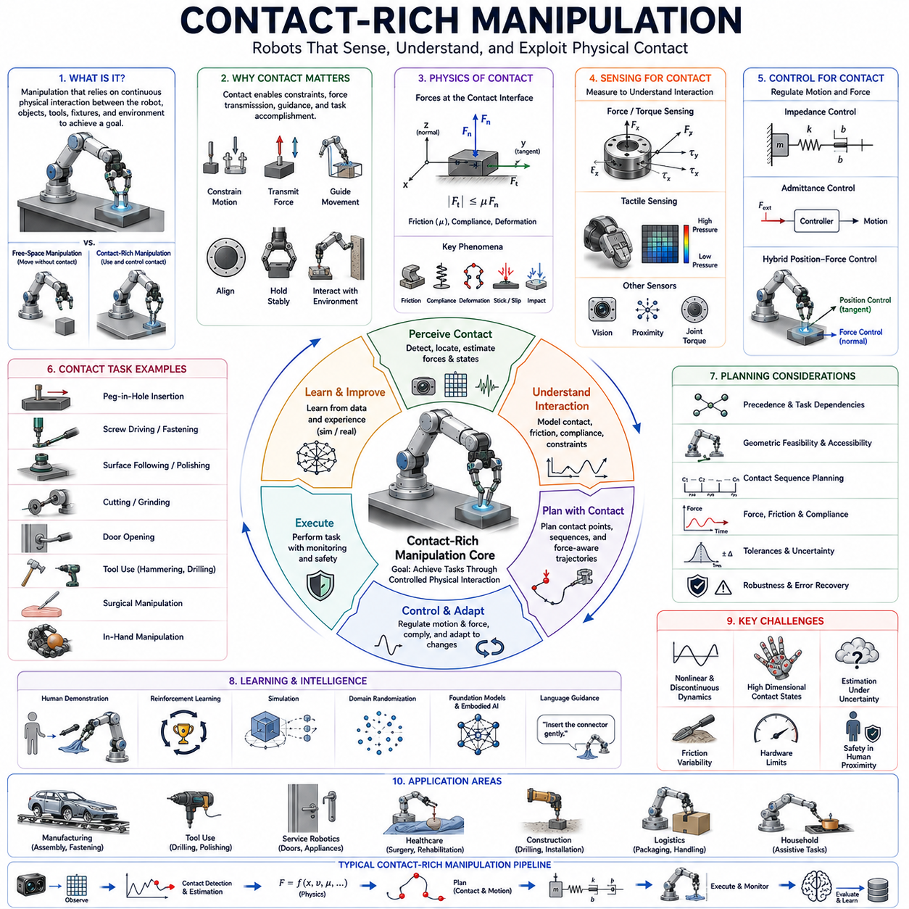
Contact-Rich Manipulation refers to a class of robotic manipulation tasks in which continuous physical interaction between the robot, the manipulated object, tools, fixtures, and the surrounding environment plays a central role in task execution. Unlike free-space manipulation, where the robot primarily moves objects without significant environmental interaction, contact-rich manipulation relies on controlled physical contact to achieve desired outcomes. Many of the most important human activities—including assembly, insertion, fastening, tool use, writing, polishing, cutting, opening doors, operating machinery, dressing, cooking, and surgical procedures—are fundamentally contact-rich in nature. Consequently, mastering contact-rich manipulation is widely regarded as one of the most important challenges in robotics and a critical milestone toward general-purpose embodied intelligence.
Traditional industrial robotics achieved remarkable success in structured environments by focusing on highly repeatable tasks involving rigid objects and carefully controlled conditions. In such environments, robots could often rely on accurate position control and preprogrammed trajectories. However, as robots move into more dynamic, unstructured, and human-centered environments, purely position-based approaches become insufficient. Contact introduces uncertainty, friction, compliance, force transmission, deformation, and complex physical interactions that cannot be handled solely through geometric planning. Contact-rich manipulation therefore requires robots to reason about both motion and force simultaneously.
At a fundamental level, contact-rich manipulation involves interactions governed by contact mechanics. Whenever two physical bodies touch, forces are exchanged across the contact interface. These forces depend on material properties, surface geometry, friction coefficients, compliance characteristics, relative motion, and environmental conditions. Understanding and controlling these interactions is essential for successful task execution.
One of the defining characteristics of contact-rich tasks is the presence of constraints. During free-space motion, the robot enjoys relatively unrestricted movement. Once contact occurs, however, environmental constraints begin to influence robot behavior. For example, when inserting a peg into a hole, the surrounding hole geometry constrains possible motions. During door opening, hinge mechanics restrict movement to specific trajectories. During polishing or grinding, surface geometry guides tool motion. Contact-rich manipulation therefore requires the robot to understand and exploit environmental constraints rather than simply avoiding them.
Peg-in-hole insertion represents one of the most widely studied examples of contact-rich manipulation. Although the task appears simple, successful insertion requires precise alignment, force control, compliance management, friction handling, and error recovery. Small positioning errors may cause jamming, wedging, or excessive contact forces. As a result, peg insertion has become a standard benchmark for evaluating robotic manipulation capabilities.
Fastening operations provide another representative example. Screw driving, bolt tightening, connector insertion, and snap-fit assembly all involve continuous contact between multiple components. During these operations, robots must regulate force, torque, alignment, and insertion depth while responding to changing interaction conditions. Successful execution requires integration of perception, force sensing, planning, and control.
Tool use significantly expands the complexity of contact-rich manipulation. Humans routinely use tools to amplify force, extend reach, modify interactions, and achieve complex objectives. Robots performing hammering, drilling, cutting, sanding, polishing, painting, or writing must understand how contact forces propagate through tools and affect task outcomes. Tool-mediated interactions introduce additional dynamics that must be modeled and controlled.
Contact modeling forms the theoretical foundation of contact-rich manipulation. Contact models describe how forces arise when objects interact. The simplest models assume rigid contact with Coulomb friction, where tangential forces are proportional to normal forces. More advanced models incorporate compliance, deformation, adhesion, viscoelastic behavior, and nonlinear friction effects. Accurate contact modeling is essential for simulation, planning, and control.
Friction plays a particularly important role in contact-rich tasks. Friction can be both beneficial and problematic. It enables stable grasping, prevents slipping, and supports force transmission. However, excessive friction may cause jamming, wear, energy loss, and unpredictable behavior. Many contact-rich manipulation tasks require deliberate exploitation of friction while simultaneously managing its negative effects.
Compliance is another key concept. Compliance refers to the ability of a system to deform or yield under applied forces. Humans naturally exploit compliance when performing contact-intensive tasks. Muscles, tendons, and soft tissues absorb impacts and accommodate positioning errors. Robotic systems increasingly incorporate both mechanical compliance and control-based compliance to achieve similar capabilities.
Mechanical compliance may be introduced through soft materials, elastic joints, flexible structures, passive mechanisms, or compliant end effectors. These components physically absorb disturbances and reduce sensitivity to uncertainty. Mechanical compliance is particularly useful for assembly, human-robot interaction, and delicate manipulation tasks.
Control-based compliance provides flexibility through software rather than hardware. Impedance control and admittance control are among the most widely used approaches. Impedance control specifies desired relationships between motion and force, allowing robots to behave as virtual springs, dampers, or mass-spring-damper systems. Admittance control uses measured forces to modify motion commands dynamically. Both approaches enable safe and adaptive contact interactions.
Force sensing is a critical enabler of contact-rich manipulation. Force-torque sensors provide direct measurements of interaction forces and moments. These sensors allow robots to detect contact events, estimate environmental properties, regulate applied forces, and identify anomalies during task execution. Without force feedback, many contact-rich tasks become significantly more difficult or impossible.
Tactile sensing provides complementary information. While force-torque sensors measure global interaction forces, tactile sensors measure local contact distributions across surfaces. Tactile sensing can reveal pressure patterns, contact locations, slippage events, texture characteristics, and object deformation. Combining force and tactile sensing significantly improves manipulation performance.
Contact state estimation is an important challenge. The robot must determine whether contact exists, where contact occurs, how many contact points are active, and what forces are being transmitted. Contact states often change rapidly during manipulation. Accurate state estimation enables appropriate control actions and supports robust task execution.
Hybrid position-force control represents one of the foundational control paradigms for contact-rich manipulation. Some directions of motion are controlled using position commands, while others are controlled using force commands. For example, during surface following, the robot may control motion tangentially while regulating force normal to the surface. Hybrid control enables simultaneous achievement of motion and force objectives.
Constraint-based control builds upon this concept by explicitly incorporating environmental constraints into control formulations. Rather than avoiding contact, the controller treats contact as a useful source of information and guidance. Constraint-aware approaches often achieve greater robustness and efficiency than purely position-based methods.
Motion planning becomes substantially more difficult when contact interactions are involved. Traditional planning assumes collision-free motion through free space. Contact-rich manipulation requires planners to intentionally create, maintain, modify, and exploit contact states. The planner must predict not only geometric outcomes but also force interactions and physical consequences.
Contact planning addresses this challenge by explicitly reasoning about contact sequences. The planner determines where contact should occur, when contact transitions should happen, what forces should be applied, and how interactions contribute to task completion. Contact planning is particularly important in assembly, locomotion, dexterous manipulation, and tool use.
Multi-contact manipulation introduces additional complexity. In many tasks, robots interact with objects through multiple simultaneous contacts. Human hands routinely exploit multiple fingers, palm surfaces, environmental supports, and tool interfaces. Multi-contact strategies significantly increase manipulation capability but also create more complex control problems.
Dexterous robotic hands are especially relevant to contact-rich manipulation. Unlike simple grippers, multi-fingered hands can create and regulate numerous contact points simultaneously. This enables in-hand manipulation, object reorientation, force redistribution, and sophisticated interaction strategies. However, controlling many contact points requires advanced planning and sensing capabilities.
Environmental exploitation is an emerging area of research. Rather than treating the environment as an obstacle, robots can use external surfaces to support manipulation. Humans routinely slide objects along tables, use walls for alignment, and exploit environmental constraints to simplify tasks. Contact-rich manipulation increasingly incorporates such strategies to improve efficiency and robustness.
Learning-based methods have transformed the field of contact-rich manipulation. Traditional analytical approaches often struggle because contact dynamics are highly nonlinear, discontinuous, and difficult to model accurately. Machine learning enables robots to learn successful interaction strategies directly from data and experience.
Behavior cloning allows robots to imitate human demonstrations. Human operators naturally adapt force, compliance, and motion during contact-rich tasks. By observing demonstrations, robots can acquire manipulation policies that capture these complex behaviors without requiring explicit physical modeling.
Reinforcement learning has achieved remarkable success in contact-intensive manipulation tasks. Through repeated interactions, robots learn policies that maximize long-term rewards. Reinforcement learning has demonstrated promising results in insertion, assembly, tool use, object reorientation, and dexterous manipulation. The ability to learn directly from interaction experience is particularly valuable when analytical models are incomplete.
Simulation plays a central role in learning-based contact manipulation. Modern physics engines increasingly support realistic contact modeling, friction simulation, deformation effects, and force interactions. Large-scale simulation enables robots to acquire millions of interaction experiences before deployment in physical environments.
Domain randomization further improves transfer from simulation to reality. By exposing learning systems to variations in friction, mass, compliance, sensor noise, and environmental conditions, robots develop policies that generalize more effectively to real-world situations.
Foundation models and embodied AI are beginning to influence contact-rich manipulation research. Large-scale models trained on diverse manipulation experiences may eventually develop generalized physical reasoning capabilities. Rather than learning each contact task independently, future robots may acquire broad understanding of force interactions, material behavior, and environmental constraints.
Language-guided manipulation introduces additional opportunities. A human might instruct a robot to “insert the connector gently,” “tighten the screw carefully,” or “push until resistance is felt.” These instructions implicitly reference contact dynamics and force interactions. Future embodied AI systems may translate such language into sophisticated force-aware control policies.
Industrial applications of contact-rich manipulation are extensive. Manufacturing systems perform assembly, fastening, welding, polishing, grinding, inspection, and packaging operations. Service robots interact with appliances, furniture, doors, switches, and household objects. Medical robots manipulate tissues, instruments, and implants. Construction robots perform drilling, fastening, cutting, and installation tasks. Virtually every practical robotic application eventually encounters contact-rich interactions.
Performance evaluation typically considers task success rate, force regulation accuracy, insertion accuracy, assembly quality, contact stability, robustness to uncertainty, adaptation capability, execution speed, energy efficiency, and safety. Because contact interactions often involve uncertainty and physical risk, robustness and reliability are especially important evaluation criteria.
Future contact-rich manipulation systems will likely combine high-resolution tactile sensing, force-aware perception, real-time physics reasoning, compliant actuation, adaptive control, simulation-driven learning, foundation models, digital twins, and embodied intelligence within unified architectures. These systems will move beyond predefined contact strategies and develop the ability to understand, predict, and exploit physical interactions in general environments.
Ultimately, Contact-Rich Manipulation represents one of the defining challenges of intelligent robotics. It requires robots to understand not only where objects are but also how forces flow through physical interactions. Mastering contact-rich manipulation will enable robots to perform assembly, tool use, maintenance, healthcare, household assistance, and countless other tasks with a level of competence approaching human dexterity. As a result, progress in this field is widely viewed as a critical step toward achieving truly capable embodied AI systems that can interact effectively with the physical world.

13.11 Learning Tool Use
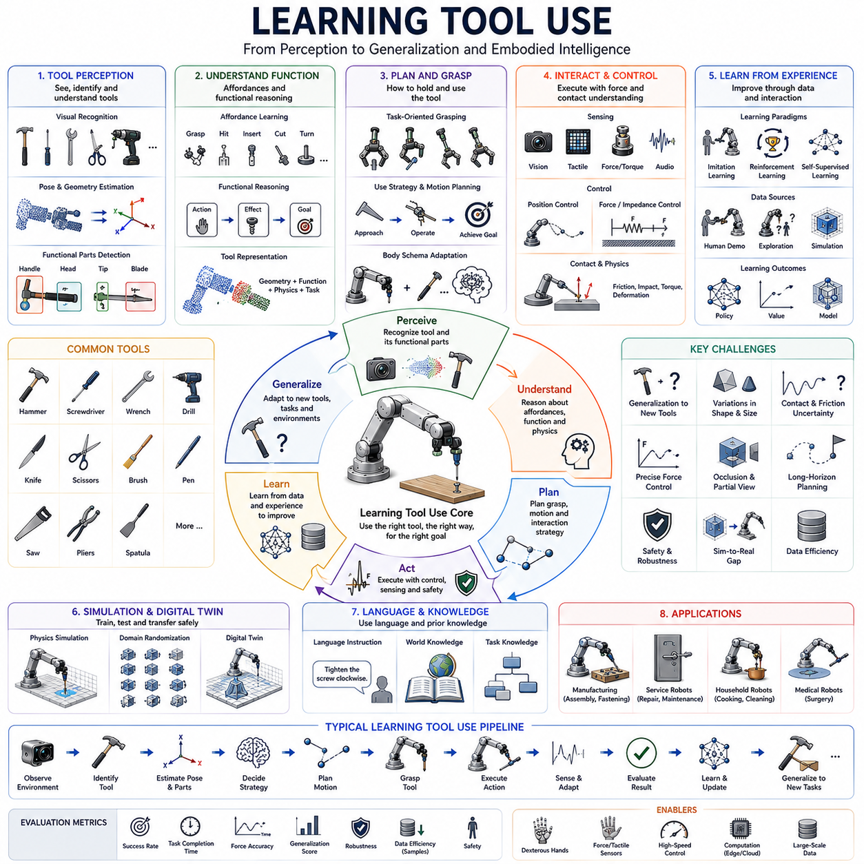
Learning Tool Use refers to the capability of robotic systems to acquire, understand, adapt, and generalize the use of tools through experience, observation, instruction, simulation, and interaction with the environment. Tool use has long been considered one of the defining characteristics of advanced intelligence because it requires an agent to understand how external objects can be employed to extend its physical capabilities beyond the limitations of its own body. Humans routinely use tools such as hammers, screwdrivers, knives, wrenches, scissors, pens, brushes, drills, and countless specialized instruments without consciously thinking about the underlying mechanics. For robots, however, tool use represents a highly complex challenge involving perception, reasoning, manipulation, planning, physics understanding, and learning. Within the Tool Use and Assembly domain of Robot Hand and Dexterous Grasping, Learning Tool Use serves as the bridge between predefined manipulation skills and adaptive embodied intelligence capable of operating in dynamic real-world environments.
The significance of tool use extends beyond industrial applications. In cognitive science and developmental psychology, tool use is often regarded as a hallmark of higher intelligence. Humans, great apes, crows, dolphins, and several other species demonstrate various forms of tool use. These behaviors indicate an understanding that external objects can be manipulated to achieve goals that would otherwise be impossible. Similarly, a robot capable of learning how to use previously unseen tools exhibits a level of physical reasoning and adaptability that approaches more general forms of intelligence.
Traditional robotic systems relied heavily on predefined tool models and manually programmed behaviors. Engineers specified the geometry of tools, defined contact points, created motion sequences, and designed task-specific controllers. This approach worked well in structured industrial environments where tools and tasks remained constant. However, such systems lacked flexibility. Any change in tool geometry, task requirements, or environmental conditions often required significant reprogramming. As robotics moves toward unstructured environments, robots must increasingly learn tool use rather than relying exclusively on handcrafted rules.
Tool use can be viewed as an extension of embodied action. A robot normally interacts with objects directly through its end effector. When using a tool, the robot must reason about an additional object inserted between itself and the environment. This creates a chain of interactions in which forces, motions, and information propagate through the tool. Understanding this extended body representation is a central challenge of tool use learning.
One of the first requirements for learning tool use is tool perception. Before a tool can be used, the robot must identify it, estimate its geometry, understand its functional components, and determine how it should be grasped. Unlike ordinary objects, tools possess functional structures specifically designed to produce effects in the environment. A hammer contains a handle and a striking surface. A screwdriver contains a handle and a driving tip. Scissors contain two articulated blades. Recognizing these functional features is essential for successful tool use.
Computer vision plays a central role in tool perception. Modern perception systems employ deep neural networks to recognize tool categories, estimate poses, identify grasp points, and locate functional regions. Vision-based methods can classify tools even under varying lighting conditions, cluttered backgrounds, and partial occlusions. However, visual recognition alone is often insufficient because effective tool use requires understanding functionality rather than merely identifying appearance.
Affordance learning provides a framework for understanding functionality. The concept of affordances describes the possible actions that an object enables. A handle affords grasping. A blade affords cutting. A hammer head affords striking. Learning tool affordances allows robots to reason about how objects can be used rather than simply what they look like. Affordance representations bridge perception and action by connecting object properties to potential behaviors.
Functional reasoning extends this idea further. A robot must understand not only individual affordances but also how those affordances contribute to task completion. For example, when using a screwdriver, the robot must understand that rotational motion applied to the handle generates torque at the tip, which can rotate a screw. Such reasoning requires understanding cause-and-effect relationships within physical systems.
Tool representation is another important challenge. Traditional approaches represent tools using geometric models. While geometry is important, learning-based systems increasingly employ richer representations that incorporate functional properties, contact dynamics, material characteristics, and task relevance. These representations allow robots to reason about tool behavior in a more flexible manner.
Body schema adaptation plays a significant role in tool use learning. Humans often incorporate tools into their body representation. A tennis racket feels like an extension of the arm. A cane becomes part of a person's perception of space. Robots similarly benefit from updating internal models to include tools as extensions of their manipulators. Such adaptation improves motion planning, control accuracy, and task performance.
Grasp planning for tool use differs from ordinary object grasping. A stable grasp alone is insufficient. The grasp must also support the intended task. A hammer may be grasped near the end of the handle to maximize striking force, while a screwdriver may be grasped closer to the center for precise rotational control. Tool-oriented grasp planning therefore considers both stability and functionality.
Task-oriented manipulation forms the core of tool use. The robot must coordinate tool motion, force application, contact interactions, and environmental responses to achieve desired outcomes. This requires integrating perception, planning, and control within a unified framework. Tool use often transforms simple manipulation problems into contact-rich interaction problems involving complex dynamics.
Physical reasoning is essential for successful tool use. The robot must understand how forces propagate through tools, how contact interactions generate effects, and how environmental constraints influence outcomes. A hammer strike depends on momentum transfer. A cutting operation depends on blade geometry and applied force. A lever amplifies force through mechanical advantage. Learning these relationships is critical for generalized tool use.
Simulation environments provide valuable opportunities for learning tool behavior. Modern physics simulators model rigid-body dynamics, contact interactions, friction, deformation, and force transmission. Through simulation, robots can explore thousands or millions of tool interactions without physical risk. This accelerates learning and reduces the cost of experimentation.
Behavior cloning represents one of the most common approaches to learning tool use. Human demonstrations provide examples of successful behavior. By observing how humans manipulate tools, robots can learn grasp strategies, motion patterns, force profiles, and task sequences. Demonstration-based learning is particularly useful when explicit programming becomes difficult.
Imitation learning extends beyond direct copying. Modern systems attempt to infer underlying task objectives from demonstrations rather than simply reproducing observed motions. This allows learned behaviors to generalize across different tools, objects, and environmental conditions.
Reinforcement learning has emerged as a powerful framework for tool use acquisition. Rather than relying exclusively on demonstrations, robots learn through trial and error. Successful tool interactions generate rewards, while failures produce penalties. Over time, the robot discovers strategies that maximize task performance. Reinforcement learning has demonstrated success in hammering, pushing, cutting, object retrieval, assembly, and many other tool-use scenarios.
Exploration is particularly important in reinforcement learning. Robots must discover how actions influence outcomes through interaction. Tool use introduces large action spaces because both robot motion and tool dynamics must be considered. Efficient exploration strategies significantly influence learning performance.
Curriculum learning can improve training efficiency. Rather than immediately attempting difficult tasks, robots begin with simpler scenarios and gradually progress toward more complex challenges. For example, a robot might first learn to grasp a hammer, then strike stationary targets, and eventually perform complex assembly operations.
Transfer learning plays a key role in scalable tool use. Once a robot learns how to use one tool, it should ideally transfer relevant knowledge to similar tools. Knowledge acquired from one hammer may generalize to other hammers. Experience with one screwdriver may facilitate learning of related tools. Transfer learning reduces data requirements and accelerates adaptation.
Generalization remains one of the central goals of tool use research. Traditional systems often perform well only on tools encountered during training. Truly intelligent systems must generalize to previously unseen tools. This requires learning abstract principles rather than memorizing specific object configurations.
Meta-learning offers a promising approach to this challenge. Rather than learning individual tool-use tasks directly, the robot learns how to learn. Meta-learning frameworks aim to acquire adaptable representations and learning strategies that facilitate rapid adaptation to novel situations.
Multi-modal perception significantly enhances tool learning. Visual information provides shape and appearance. Tactile sensing provides contact information. Force sensors reveal interaction dynamics. Audio sensing may detect impacts, cutting sounds, or assembly events. Combining these modalities creates richer representations of tool behavior.
Language-guided tool learning is an emerging area of research. Human instructors often describe tool functions using language. Instructions such as “use the hammer to drive the nail,” “turn the screwdriver clockwise,” or “cut along the edge” provide semantic information that complements sensory observations. Large language models increasingly enable robots to incorporate linguistic knowledge into tool-use learning.
Foundation models are beginning to transform tool use research. Large-scale models trained on vast amounts of visual, textual, and interaction data can acquire broad knowledge about tools and their functions. Such models may provide priors that significantly reduce the amount of task-specific learning required.
Embodied AI extends these ideas further by integrating perception, reasoning, memory, planning, and action within a unified framework. An embodied agent must not only recognize tools but also understand when to use them, why they are useful, and how they contribute to broader task objectives. Tool use therefore becomes part of a larger cognitive architecture rather than an isolated manipulation skill.
Causal reasoning is increasingly recognized as essential for advanced tool use. Rather than merely associating actions with outcomes, robots must understand why outcomes occur. Causal models enable prediction, planning, adaptation, and error recovery. Such reasoning supports robust behavior in unfamiliar situations.
Tool invention represents one of the most advanced forms of tool intelligence. Humans sometimes create new tools when existing tools are unavailable. Future robotic systems may similarly identify opportunities to repurpose ordinary objects or construct improvised tools. This capability requires deep understanding of functionality, physics, and task objectives.
Collaborative tool use introduces additional complexity. In many industrial and service environments, robots must share tools with humans or coordinate tool use among multiple agents. This requires communication, intention understanding, safety awareness, and synchronized action planning.
Industrial applications of learning-based tool use are extensive. Manufacturing robots use drills, welders, screwdrivers, grinders, and inspection instruments. Service robots operate appliances, cleaning tools, cooking utensils, and maintenance equipment. Medical robots manipulate surgical instruments. Construction robots employ cutting, fastening, and installation tools. In all these domains, learning-based approaches promise greater adaptability and reduced programming effort.
Performance evaluation of tool-use learning systems typically considers task success rate, learning efficiency, generalization capability, adaptability to novel tools, robustness to uncertainty, execution speed, force regulation quality, and safety. Generalization and adaptability are particularly important because they distinguish true learning from simple memorization.
Future Learning Tool Use systems will likely integrate foundation models, embodied AI, causal reasoning, multimodal perception, reinforcement learning, imitation learning, simulation-driven training, digital twins, and language-guided planning into unified architectures. These systems will move beyond executing predefined tool behaviors and develop the ability to understand, adapt, and invent tool-use strategies across a wide range of environments.
Ultimately, Learning Tool Use represents a critical step toward general-purpose robotic intelligence. It requires robots to understand functionality, reason about physical interactions, adapt to new situations, and extend their capabilities through external objects. Mastering tool use is therefore not only an important practical objective for robotics but also a fundamental milestone on the path toward embodied AI systems capable of operating autonomously and intelligently in the complex physical world.

13.12 Industrial Assembly Case Studies
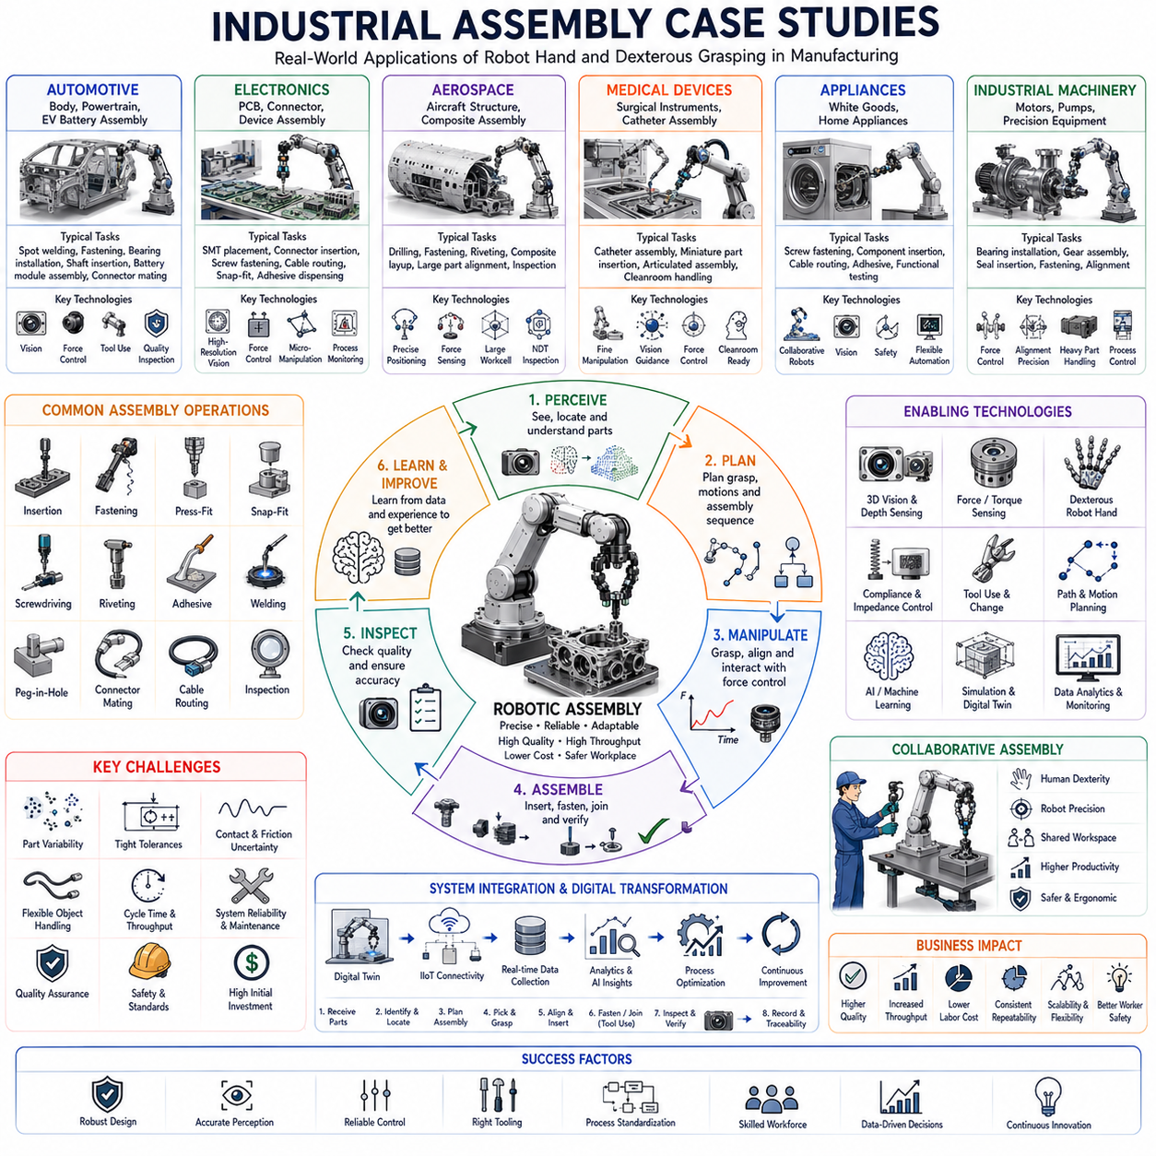
Industrial Assembly Case Studies represent the practical application of robotic manipulation, dexterous grasping, tool use, force control, perception, planning, and learning technologies within real manufacturing environments. While theoretical research provides the foundation for robotic assembly, industrial case studies demonstrate how these technologies perform under actual production constraints involving cost, speed, reliability, safety, scalability, and quality requirements. Within the Tool Use and Assembly domain of Robot Hand and Dexterous Grasping, industrial assembly case studies serve as the bridge between laboratory research and real-world deployment, illustrating how robotic systems create measurable value in manufacturing operations.
Assembly remains one of the most important activities in global manufacturing. Products ranging from smartphones and laptops to automobiles, aircraft, medical devices, industrial machinery, and consumer appliances require the integration of hundreds or thousands of components. Historically, assembly has relied heavily on human labor because many assembly operations involve complex perception, fine manipulation, force-sensitive interactions, and adaptation to variability. However, advances in sensing, computation, robotics, artificial intelligence, and automation have enabled increasingly sophisticated robotic assembly systems capable of performing tasks that were once considered exclusively human.
Industrial assembly environments impose unique requirements that differ significantly from research laboratories. A laboratory demonstration may focus on achieving a single successful assembly, while industrial systems must operate continuously for thousands of hours with minimal downtime. Manufacturing systems are evaluated not only by technical feasibility but also by throughput, cost efficiency, reliability, maintainability, and return on investment. Consequently, successful industrial assembly solutions require careful integration of mechanical engineering, robotics, software, controls, quality assurance, and production management.
One of the most influential examples of robotic assembly can be found in the automotive industry. Automotive manufacturing has historically driven many advances in industrial automation because vehicles contain thousands of individual parts requiring precise assembly. Modern automotive factories employ large numbers of robots for welding, fastening, painting, handling, inspection, and assembly operations. Robotic systems are particularly valuable because they provide high repeatability, consistent quality, and the ability to operate continuously.
Body-in-White assembly represents one of the earliest large-scale successes of robotic assembly. In this process, sheet metal components are positioned and joined to create the vehicle body structure. Industrial robots perform spot welding operations with high precision and repeatability. The success of Body-in-White automation demonstrated the economic viability of large-scale robotic assembly and established many of the standards that continue to influence modern manufacturing systems.
Powertrain assembly provides another important case study. Engines, transmissions, electric drive units, and related components require precise alignment and insertion of bearings, shafts, gears, seals, and fasteners. These operations often involve contact-rich manipulation and tight tolerances. Advanced robotic systems combine vision guidance, force sensing, and precision motion control to achieve reliable assembly despite manufacturing variations.
The rise of electric vehicles has introduced new assembly challenges. Battery packs contain large numbers of cells, electrical connections, thermal management systems, and structural components. Robotic assembly systems must handle delicate electrical components while maintaining strict quality standards. Battery module assembly often requires precise placement, connector insertion, adhesive application, and inspection operations that demand sophisticated robotic capabilities.
Electronics manufacturing provides another rich source of industrial assembly case studies. Consumer electronics products such as smartphones, tablets, laptops, and wearable devices contain numerous miniature components assembled with extremely high precision. Traditional industrial robots often struggle with such tasks because small components require fine manipulation and careful force control.
Surface Mount Technology assembly lines represent one of the most highly automated manufacturing environments in the world. High-speed placement machines position thousands of electronic components onto printed circuit boards with extraordinary accuracy. Although these systems are highly specialized, they demonstrate the power of combining precision mechanics, machine vision, and real-time control within assembly operations.
Connector insertion remains a challenging problem within electronics manufacturing. Flexible cables, miniature connectors, and delicate components require force-sensitive manipulation. Many modern assembly systems combine visual servoing, force control, and compliance strategies to achieve reliable connector mating while avoiding damage to components.
Consumer electronics final assembly presents additional challenges. Products often involve snap-fit connections, adhesive bonding, screw fastening, flexible cable routing, and quality inspection. Robotic systems must coordinate multiple assembly techniques while maintaining high throughput. The increasing complexity of electronic products continues to drive innovation in robotic manipulation technologies.
The aerospace industry provides examples of assembly operations involving extreme precision and quality requirements. Aircraft structures contain millions of components, many of which must be assembled with strict tolerances and rigorous documentation. Unlike automotive manufacturing, aerospace production volumes are relatively low, making flexibility particularly important.
Aircraft fuselage assembly illustrates the challenges of large-scale precision assembly. Components may span several meters and require accurate alignment before fastening. Robotic systems often perform drilling, fastening, inspection, and positioning operations while coordinating with human workers. Because aerospace components are expensive and safety-critical, assembly systems must achieve exceptional reliability.
Composite material assembly has become increasingly important in aerospace manufacturing. Carbon fiber structures require specialized handling techniques due to their material properties. Robotic systems are frequently used for material placement, trimming, inspection, and joining operations. These applications demonstrate the growing importance of advanced perception and manipulation technologies.
Medical device manufacturing represents another important domain for robotic assembly. Medical products often contain miniature components, precision mechanisms, and strict cleanliness requirements. Robotic systems provide advantages in consistency, contamination control, and traceability.
Catheter assembly provides an excellent example of flexible-object manipulation within industrial assembly. Catheters consist of long, flexible structures that must be accurately assembled and inspected. Robotic systems handling such products require sophisticated perception, force control, and deformable object manipulation capabilities.
Surgical instrument assembly introduces additional complexity because devices often contain articulated mechanisms, miniature fasteners, and precision alignments. Quality requirements are extremely stringent because assembly errors may directly affect patient safety. Consequently, robotic assembly systems must integrate comprehensive inspection and verification procedures.
The appliance industry demonstrates the challenges of assembling large consumer products. Washing machines, refrigerators, ovens, and air conditioners contain numerous mechanical, electrical, and structural components. Robotic systems perform tasks such as screw fastening, component insertion, cable routing, adhesive application, and functional testing.
White goods manufacturing has increasingly adopted collaborative robots for assembly assistance. Collaborative systems provide flexibility while allowing human workers to perform tasks requiring dexterity and judgment. These deployments illustrate the growing importance of human-robot collaboration within industrial assembly environments.
Industrial machinery assembly presents another class of applications. Products such as pumps, motors, compressors, and manufacturing equipment often require precision assembly of mechanical components. Robotic systems must handle heavy parts, perform accurate alignments, and manage complex assembly sequences.
Bearing installation serves as a common example of contact-rich assembly within industrial machinery manufacturing. Bearings often require controlled insertion forces and precise alignment. Advanced robotic systems use force sensing and compliance control to achieve reliable installations without damaging components.
Fastener assembly represents one of the most widespread assembly operations across industries. Screws, bolts, rivets, clips, and other fastening mechanisms are used extensively in manufactured products. Robotic fastening systems combine vision guidance, torque sensing, force control, and process monitoring to ensure assembly quality.
Automated screwdriving systems have become increasingly sophisticated. Modern systems monitor torque profiles, insertion depth, rotational speed, and tool behavior to detect assembly anomalies. These systems illustrate how sensing and analytics enhance assembly reliability.
Cable harness assembly remains one of the most difficult industrial automation challenges. Wiring harnesses contain numerous flexible cables that must be routed through complex pathways and connected to multiple endpoints. Human workers continue to perform many harness assembly tasks because flexible object manipulation remains difficult for robots.
Recent advances in perception, machine learning, and dexterous manipulation are beginning to change this situation. Experimental systems have demonstrated automated cable routing, connector insertion, and harness assembly capabilities. These developments highlight the growing role of AI-driven manipulation technologies.
Logistics and warehouse assembly applications have also expanded significantly. Packaging operations often involve assembling cartons, inserting products, applying labels, sealing packages, and preparing shipments. Robotic systems must adapt to diverse product types and packaging configurations.
E-commerce growth has accelerated demand for flexible assembly and packaging automation. Unlike traditional manufacturing, e-commerce environments frequently encounter high product variability. Robots operating in these environments require greater adaptability and perception capabilities.
Collaborative assembly systems represent one of the most important trends in modern manufacturing. Rather than replacing human workers entirely, many industrial deployments combine human strengths and robotic strengths within shared workspaces. Robots provide precision, endurance, and repeatability, while humans contribute flexibility, problem-solving, and contextual understanding.
Assembly assistance applications demonstrate the benefits of collaboration. Robots may present components, hold parts in position, perform repetitive fastening operations, or transport materials while humans execute tasks requiring dexterity and judgment. Such systems often improve productivity while reducing worker fatigue.
Digital transformation has significantly influenced industrial assembly. Modern factories increasingly employ digital twins, industrial Internet of Things technologies, cloud computing, and advanced analytics to optimize assembly processes. Digital assembly systems continuously collect operational data and use it to improve performance.
Digital twins provide virtual representations of assembly lines, robots, products, and processes. Engineers can evaluate assembly sequences, detect bottlenecks, predict failures, and optimize operations before implementing changes in physical systems. This capability reduces risk and accelerates deployment.
Artificial intelligence is becoming increasingly important in industrial assembly. Machine learning supports predictive maintenance, quality inspection, process optimization, anomaly detection, and adaptive control. AI enables assembly systems to respond more effectively to variability and uncertainty.
Learning-based robotic assembly represents a particularly active area of research and development. Traditional assembly systems relied on carefully engineered procedures. Learning-based systems aim to acquire assembly skills through demonstration, simulation, reinforcement learning, and experience. Such approaches promise greater flexibility and reduced engineering effort.
Foundation models and embodied AI may significantly influence future assembly systems. Large-scale models trained on manufacturing knowledge, assembly procedures, CAD data, videos, and robotic experiences may eventually provide generalized assembly intelligence. Rather than programming each assembly task separately, future systems may reason about assembly objectives and generate strategies autonomously.
Performance evaluation within industrial assembly focuses on practical metrics. Cycle time measures production speed. Throughput measures overall output. First-pass yield evaluates assembly quality. Mean time between failures measures reliability. Resource utilization reflects efficiency. Cost per unit quantifies economic performance. Safety metrics assess risk to workers and equipment.
Successful industrial case studies demonstrate that robotic assembly is not simply a technological challenge but also an economic and organizational one. Deployment requires integration of hardware, software, production planning, workforce training, maintenance strategies, and quality systems. Organizations that effectively combine these elements achieve substantial benefits in productivity, consistency, scalability, and competitiveness.
Future industrial assembly systems will likely integrate advanced perception, dexterous robotic hands, force-sensitive manipulation, flexible automation, collaborative robotics, digital twins, reinforcement learning, foundation models, and embodied AI within unified manufacturing architectures. These systems will increasingly move beyond fixed automation toward adaptive assembly intelligence capable of handling product variability, environmental uncertainty, and changing production requirements.
Ultimately, Industrial Assembly Case Studies demonstrate the practical realization of robotic manipulation technologies in real manufacturing environments. They reveal how concepts such as grasp planning, contact-rich manipulation, force control, tool use, learning, and embodied intelligence contribute to production systems that create tangible economic value. As robotics continues to evolve, industrial assembly will remain one of the most important proving grounds for advanced manipulation technologies and a critical pathway toward truly intelligent autonomous manufacturing systems.

