Volume 06 Robot Hands and Dexterous Grasping

16. Checklists and Templates

16.01 Hand Selection Checklist
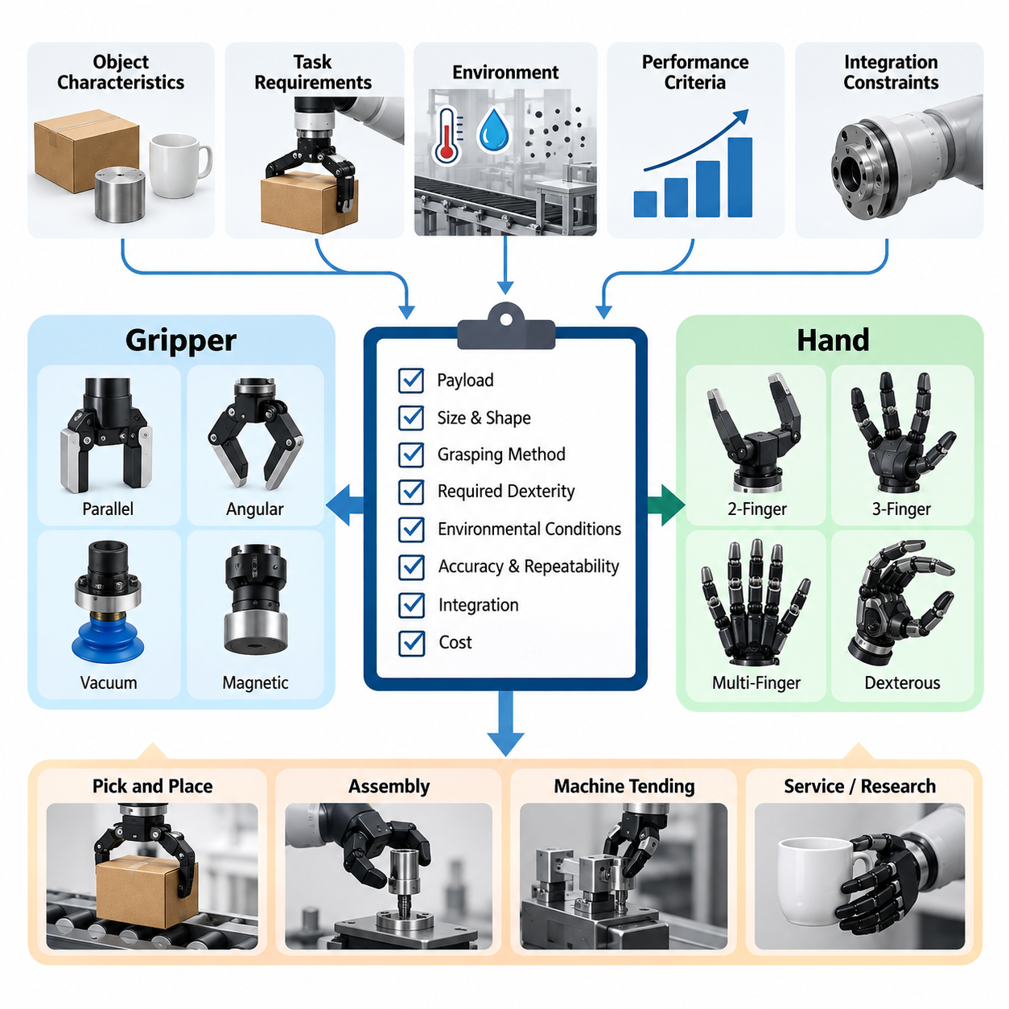
Selecting an appropriate robotic gripper or dexterous hand requires a systematic evaluation of task requirements, object characteristics, mechanical capabilities, sensing functions, and operational constraints. The selection process should begin with a clearly defined application profile rather than a preference for a particular mechanism. A structured checklist helps engineers compare alternatives consistently and document the technical justification for each decision.
The first evaluation concerns the intended manipulation tasks and operating environment. Engineers should identify whether the system performs simple pick-and-place operations, warehouse sorting, precision assembly, tool handling, or complex in-hand manipulation. Each application imposes different requirements for gripping precision, adaptability, speed, and force regulation. Environmental factors such as dust, humidity, temperature, vibration, and human proximity must also be documented.
Object characteristics form the foundation of gripper selection because they determine the required contact geometry and gripping strategy. The checklist should record minimum and maximum object dimensions, mass, center of gravity, surface friction, rigidity, fragility, and geometric variability. Special attention is necessary for transparent, reflective, deformable, irregular, or slippery objects because their physical properties can significantly influence grasp reliability and sensor performance.
The next consideration is the appropriate end-effector category. Parallel-jaw grippers are suitable for many structured industrial tasks involving predictable object geometries, while angular and three-finger grippers provide alternative contact configurations. Multifinger dexterous hands support more complex manipulation but introduce additional mechanical and control complexity. The checklist should establish whether the application genuinely requires dexterity beyond conventional gripping.
Actuation architecture must be evaluated according to force requirements, positioning accuracy, response speed, and mechanical complexity. Electric servo actuators provide controllable motion and convenient integration with digital controllers, while pneumatic systems may offer lightweight mechanisms and rapid gripping actions. Tendon-driven, cable-driven, and elastic actuation systems introduce additional design possibilities. Each candidate should be assessed for efficiency, backlash, thermal behavior, and maintenance requirements.
Underactuated and fully actuated mechanisms represent different engineering compromises. Underactuated hands can adapt passively to variations in object geometry while reducing actuator count and control complexity. Fully actuated hands provide greater independent finger control and support sophisticated manipulation sequences. The checklist should compare required degrees of freedom, actuator independence, mechanical coupling, and the relationship between achievable dexterity and system cost.
Rigid, soft, and hybrid gripping structures should be evaluated against object sensitivity and contact requirements. Rigid fingers provide predictable geometry and efficient force transmission, whereas soft fingers distribute contact pressure and accommodate geometric uncertainty. Hybrid designs combine structural stiffness with compliant contact surfaces. Material durability, surface friction, elastic recovery, contamination resistance, and replacement intervals should be considered when selecting the final configuration.
Mechanical compatibility with the robot arm is another essential selection criterion. The end effector must satisfy wrist payload limits, mounting interface dimensions, allowable moments, and available installation space. Engineers should calculate total mass, including actuators, sensors, cabling, adapters, and protective structures. The checklist should also verify whether the selected hand restricts arm reachability, creates collision risks, or shifts the effective center of gravity beyond acceptable limits.
Finger kinematics and workspace characteristics determine whether a hand can achieve the necessary grasp configurations. The evaluation should examine finger reach, joint limits, fingertip trajectories, opening width, and accessible contact regions. Multifinger hands additionally require analysis of coordinated motion and potential kinematic singularities. Engineers should confirm that the required grasp poses are achievable without excessive joint motion, self-collision, or unfavorable mechanical configurations.
Grasp stability must be evaluated using contact mechanics and force transmission principles. The checklist should consider contact locations, friction coefficients, normal forces, external disturbances, and expected object acceleration. Force closure and grasp wrench space analysis provide useful theoretical measures of grasp capability. However, analytical feasibility alone does not guarantee reliable operation, making physical validation under representative loading and motion conditions essential.
Force and torque control capabilities become especially important when manipulating fragile or mechanically sensitive objects. The selected system should provide sufficient force resolution, controllable gripping pressure, and appropriate response to contact disturbances. Impedance control, compliant grasping, and variable stiffness strategies may be necessary for contact-rich operations. Engineers should verify that force regulation remains stable across the intended operating range and does not damage handled objects.
Tactile sensing requirements should be derived from the information necessary for successful manipulation. Basic applications may require only grasp confirmation, whereas advanced dexterous manipulation can benefit from distributed pressure measurements and contact localization. Capacitive, piezoresistive, optical, and other tactile sensing technologies offer different performance characteristics. The checklist should assess spatial resolution, sensitivity, sampling frequency, calibration effort, and integration complexity.
Slip detection and grasp adjustment capabilities should be evaluated when objects experience variable loading or uncertain friction. Tactile signals, vibration measurements, visual observations, and learned estimators can provide evidence of impending or active slip. A suitable system must detect relevant disturbances and respond before object retention becomes unreliable. Engineers should assess detection latency, false alarm rates, recovery effectiveness, and the stability of corrective gripping actions.
In-hand manipulation requirements should be explicitly separated from basic object acquisition and retention. Tasks involving object rotation, translation, reorientation, finger gaiting, or controlled regrasping demand coordinated contact transitions and sufficient independent motion. The checklist should identify the required manipulation primitives and their allowable errors. When simpler alternatives such as wrist rotation or external fixtures can accomplish the task, additional hand complexity may be unnecessary.
Software and control integration must be considered before hardware procurement. Engineers should verify communication protocols, controller interfaces, supported operating systems, device drivers, and compatibility with the robot's motion planning framework. Feedback signals should be available at the required control frequency, with documented timing behavior. Integration with ROS 2, manipulation planning software, and perception systems should be evaluated according to the actual deployment architecture.
Learning-based grasping introduces additional requirements for observation quality, data collection, and computational resources. Systems employing grasp detection networks, reinforcement learning, imitation learning, or vision-language-action models must provide appropriate sensory inputs and executable control interfaces. The checklist should verify dataset relevance, training requirements, inference latency, and robustness to unfamiliar objects. Simulation-to-real transfer limitations should also be included in the evaluation.
Safety assessment should cover mechanical hazards, excessive contact forces, unintended motion, dropped objects, and actuator or communication failures. The hand should support appropriate protective behavior during emergency stops, power interruptions, and unexpected collisions. Engineers must determine whether releasing or retaining an object represents the safer failure response for each application. Safety requirements should be established through system-level risk assessment rather than assumed from component specifications.
Reliability and maintainability directly influence the practical value of a selected gripper or hand. The checklist should evaluate actuator lifetime, transmission wear, cable fatigue, sensor degradation, sealing effectiveness, and resistance to repetitive loading. Modular fingers, replaceable contact pads, accessible connectors, and straightforward calibration procedures can reduce maintenance effort. Mean time between failures and repair duration should be measured under representative operating conditions.
Energy consumption and thermal management are particularly important for battery-powered mobile manipulators. Engineers should estimate peak electrical demand, average operating power, idle consumption, and energy required per manipulation cycle. Continuous gripping may introduce thermal loads even when finger motion is minimal. The checklist should confirm that actuator heating, power distribution, and cooling arrangements remain compatible with the platform's available energy and thermal capacity.
Performance benchmarking should use representative objects, grasp configurations, and environmental conditions. Important measures include grasp success rate, object retention reliability, manipulation accuracy, cycle time, force consistency, and recovery performance. Standardized object sets such as the YCB collection can support comparative experiments, but application-specific objects remain necessary. Repeated trials should capture variability rather than relying on isolated successful demonstrations.
Economic evaluation should include the complete lifecycle cost rather than the initial purchase price alone. Relevant factors include actuators, sensors, controllers, mechanical adapters, software integration, calibration, replacement components, maintenance labor, and operational downtime. Highly dexterous hands may justify greater investment when their capabilities enable valuable tasks. Conversely, simpler grippers may provide better economic performance when the required manipulation operations are limited and predictable.
The final selection checklist should combine mandatory requirements, preferred capabilities, measurable acceptance criteria, and supporting test evidence. Each candidate should receive a documented assessment covering mechanical compatibility, grasp performance, sensing, control, safety, reliability, and cost. Requirements that cannot be satisfied should be distinguished from characteristics that merely reduce comparative scores. This prevents attractive secondary features from concealing critical engineering deficiencies.
A practical decision process should progress from requirement definition to candidate screening, prototype evaluation, and final validation. Initial screening eliminates incompatible mechanisms, while laboratory testing establishes measurable performance under controlled conditions. Subsequent trials should reproduce realistic object variation, motion disturbances, and operating constraints. Any unresolved technical risks should be documented together with proposed mitigation measures and verification responsibilities.
The completed selection record should identify the chosen end effector, its intended applications, verified operating limits, integration dependencies, and remaining development risks. It should also preserve the rationale for rejecting alternative designs, allowing future engineers to reconsider decisions when requirements change. By treating gripper and hand selection as an evidence-based engineering process, development teams can improve manipulation reliability, control complexity, maintainability, and overall system suitability.

16.02 Mechanism Design Template
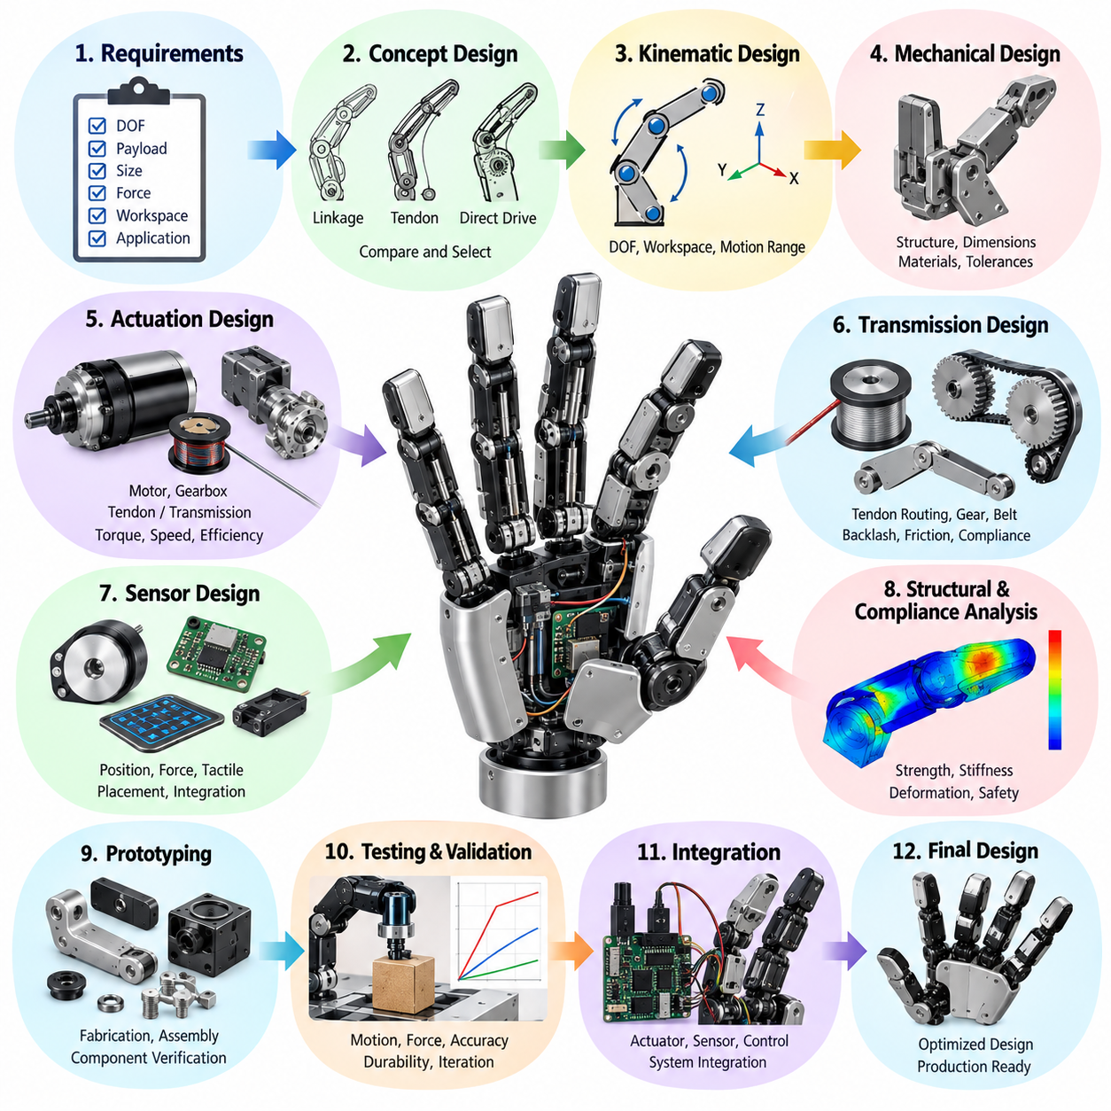
A hand mechanism design template provides a systematic framework for transforming manipulation requirements into a manufacturable robotic hand architecture. It organizes mechanical specifications, kinematic relationships, actuation choices, structural constraints, and validation procedures within a consistent engineering document. The template should support design traceability, allowing each mechanical decision to be connected to functional requirements and measurable performance objectives.
The design process begins by defining the intended application and operational objectives. Engineers should describe whether the hand will perform industrial gripping, precision assembly, tool manipulation, object reorientation, or general-purpose dexterous tasks. The description should identify target objects, expected manipulation sequences, environmental conditions, and required interaction forces. These requirements establish the foundation for selecting the appropriate mechanical configuration.
A functional specification should translate application objectives into measurable engineering parameters. Important characteristics include the number of fingers, required degrees of freedom, finger opening range, maximum payload, gripping force, positioning accuracy, and allowable mechanism mass. The template should distinguish mandatory performance thresholds from desirable capabilities. Each requirement should include an evaluation method and an acceptance criterion that can be verified experimentally.
The overall hand architecture should be documented before detailed component design begins. Engineers should define the number and arrangement of fingers, palm geometry, thumb opposition capability, wrist interface, and actuator placement. Alternative configurations may include parallel gripping mechanisms, three-finger adaptive hands, and anthropomorphic multifinger structures. The selected architecture should balance manipulation versatility against mechanical complexity, weight, cost, and reliability.
Finger mechanism design requires a clear description of joint arrangement and motion transmission. Each finger should be represented by its link lengths, joint axes, allowable rotation ranges, and mechanical constraints. Linkage-based mechanisms provide coordinated motion through rigid mechanical connections, while tendon-driven mechanisms enable compact actuation arrangements. The template should document how each mechanism transforms actuator motion into fingertip displacement and contact force.
The kinematic model should establish the relationship between joint coordinates and fingertip positions. Forward kinematics determines fingertip pose from joint configurations, while inverse kinematics estimates the joint values required to achieve desired contact locations. Engineers should identify relevant coordinate frames, joint limits, workspace boundaries, and potential singularities. The resulting model provides a foundation for mechanical optimization and subsequent motion control development.
Underactuated mechanisms should be evaluated when passive adaptation to object geometry is desirable. Such designs use fewer independently controlled actuators than mechanical degrees of freedom, allowing finger joints to redistribute motion during contact. The template should describe coupling relationships, differential mechanisms, elastic elements, and contact-dependent behavior. Particular attention should be given to repeatability, grasp stability, and limitations in independent joint positioning.
Fully actuated designs require a different assessment of actuator allocation and control independence. Each independently driven joint increases potential dexterity but also introduces additional motors, transmissions, sensors, wiring, and control requirements. Engineers should determine whether independent joint control is necessary for the intended manipulation primitives. The design document should justify actuator count through demonstrated task requirements rather than assuming that additional degrees of freedom always improve performance.
Transmission architecture strongly influences mechanical efficiency, accuracy, and durability. Gear trains, pulley systems, cable drives, tendon transmissions, and direct-drive mechanisms should be compared according to torque capacity, backlash, friction, compliance, and packaging requirements. The template should specify transmission ratios, expected losses, cable routing, pretension requirements, and mechanical adjustment procedures. Transmission characteristics must remain compatible with the desired force and position control behavior.
Actuator selection should follow quantitative estimates of required joint torque, velocity, acceleration, and duty cycle. Electric motors, servo actuators, pneumatic systems, and alternative compact actuation technologies offer different combinations of power density, controllability, and integration complexity. Engineers should document continuous and peak operating limits, thermal constraints, and electrical requirements. Safety margins should be justified using realistic loading conditions rather than arbitrary oversizing.
The palm structure provides the mechanical foundation for finger attachment, actuator integration, and load transfer to the wrist. Its design should consider structural stiffness, internal component packaging, cable passages, sensor placement, and accessibility for maintenance. The template should identify critical load paths and mounting interfaces. Palm geometry must also preserve sufficient clearance for finger movement while supporting the intended grasp configurations and object dimensions.
Wrist integration requires verification of mechanical compatibility with the supporting manipulator. The design should specify mounting dimensions, interface orientation, allowable forces and moments, cable routing, and the location of the assembled hand's center of mass. Additional wrist degrees of freedom may improve manipulation reachability but increase mass and control complexity. Engineers should evaluate whether required object orientations can be achieved through existing arm motion before adding wrist mechanisms.
Material selection should reflect structural loading, manufacturing constraints, friction behavior, and environmental exposure. Aluminum alloys, engineering polymers, composite materials, elastomers, and specialized surface coatings may be appropriate for different components. The template should document material properties, expected wear mechanisms, thermal effects, and compatibility with manufacturing processes. Contact surfaces should be evaluated separately from load-bearing structures because their functional requirements often differ.
Weight and payload optimization should consider the complete assembled mechanism rather than individual components in isolation. Finger links, actuators, transmissions, sensors, fasteners, wiring, and protective covers all contribute to total mass and rotational inertia. Engineers should evaluate the influence of component placement on wrist loading and dynamic performance. Lightweight construction must not compromise structural stiffness, impact resistance, or the ability to maintain stable grasping forces.
Structural validation should include analytical calculations and finite element analysis where appropriate. Critical components should be examined under maximum gripping loads, external disturbances, accidental impacts, and repeated operating cycles. Stress concentration, elastic deformation, fatigue resistance, and joint bearing loads require particular attention. Simulation assumptions, boundary conditions, material properties, and safety factors should be documented so that structural predictions can be reproduced and verified.
Mechanical compliance should be introduced deliberately rather than treated solely as an undesirable deformation. Elastic joints, compliant fingertips, flexible transmissions, and series elastic elements can improve contact adaptation and reduce impact forces. However, excessive compliance may reduce positioning accuracy and complicate force estimation. The template should specify desired stiffness characteristics, allowable deformation, hysteresis behavior, and methods for measuring compliance under representative loading conditions.
Sensor integration requirements should influence mechanical design from the earliest development stages. Joint encoders, fingertip force sensors, tactile arrays, and wrist force-torque sensors require appropriate mounting surfaces, protected wiring paths, and calibration access. Engineers should identify sensor placement constraints and possible interference with finger motion. The design should also consider connector durability, electromagnetic compatibility, and replacement procedures for sensors exposed to repeated contact.
Manufacturability should be evaluated through the selected fabrication and assembly processes. Machining, additive manufacturing, molding, and sheet-metal fabrication impose different constraints on tolerances, surface quality, material selection, and production cost. The template should document critical dimensions, geometric tolerances, fastening methods, and assembly sequences. Components requiring frequent replacement should be designed for accessibility without extensive disassembly of the entire hand.
Modularity and replaceability can substantially reduce development and maintenance effort. Finger modules, contact pads, tendon assemblies, actuators, and sensor units should be evaluated for independent removal and replacement. Standardized interfaces simplify configuration changes and allow alternative mechanisms to be tested using a common palm or wrist structure. The design document should define interface dimensions, alignment features, connector specifications, and procedures for restoring calibration after component replacement.
Mechanical safety considerations should address pinch points, exposed transmissions, sharp edges, uncontrolled joint movement, and structural failure. Protective covers, mechanical stops, compliant contact surfaces, and overload protection mechanisms may reduce operational risks. Engineers should also consider the consequences of power loss or actuator failure while holding an object. The template should identify hazardous failure modes and define appropriate mechanical safeguards consistent with the overall robotic system.
Prototype development should proceed through controlled design iterations. Early prototypes may focus on individual finger mechanisms, transmission efficiency, or actuator integration before a complete hand is assembled. Each iteration should have defined objectives, measurable test conditions, and documented design changes. Experimental observations should be compared against analytical and simulation predictions to identify modeling errors, unexpected friction, structural deformation, and manufacturing limitations.
Mechanical performance validation should measure fingertip workspace, gripping force, positioning repeatability, transmission efficiency, structural deflection, and mechanism response under load. Repeated cycling should reveal wear, backlash growth, cable relaxation, and changes in contact behavior. Tests should include representative object geometries and manipulation conditions. Results should be recorded using consistent procedures so that successive design revisions can be compared objectively.
The completed design template should consolidate requirements, architecture decisions, kinematic models, component specifications, material selections, manufacturing information, and validation results. Drawings, interface definitions, revision records, and unresolved technical risks should remain traceable throughout development. A well-maintained template transforms hand mechanism design from an isolated mechanical activity into a repeatable engineering process supporting integration, verification, production, and future improvements.

16.03 Tactile Integration Checklist
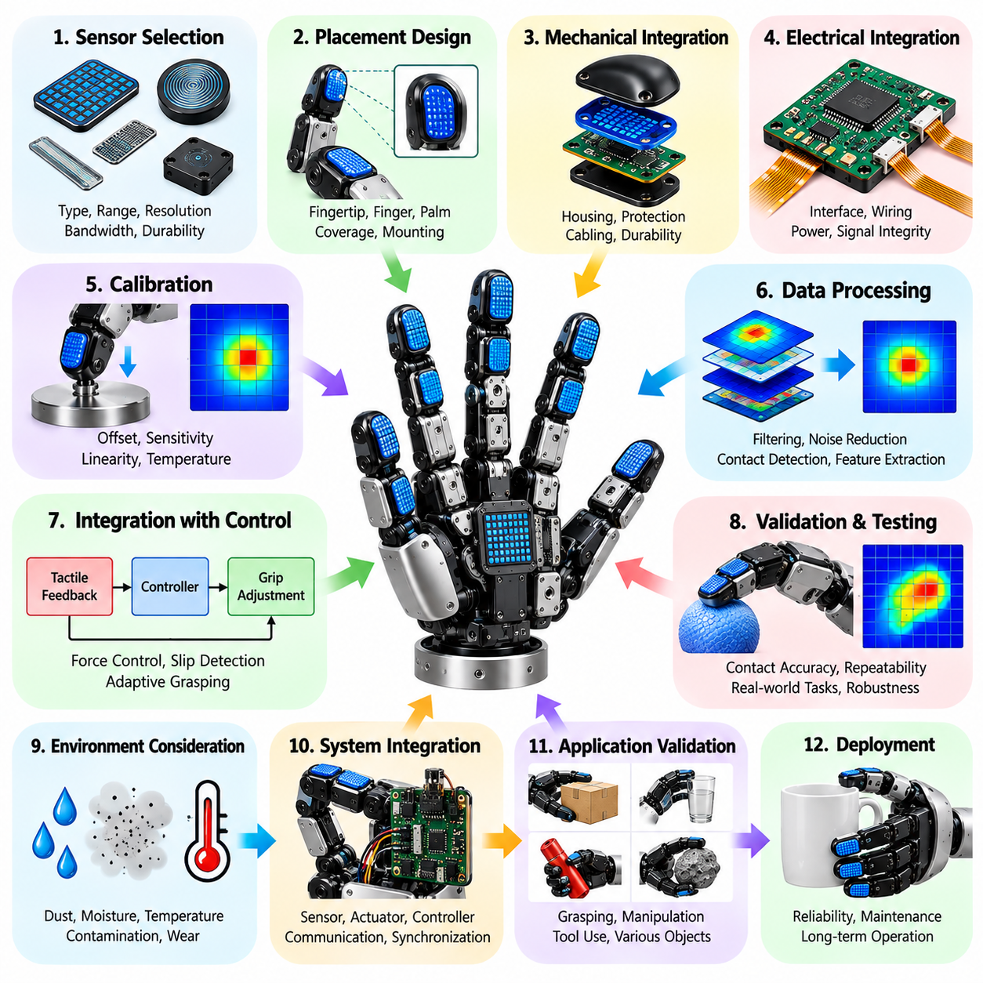
Tactile sensor integration is a critical engineering process for robotic hands that require reliable contact perception, force regulation, and adaptive grasping. A structured integration checklist ensures that sensing requirements, mechanical interfaces, electrical connections, calibration procedures, and control functions are evaluated consistently. The objective is to establish a sensing system that provides accurate and timely contact information under realistic manipulation conditions.
The integration process begins with defining the tactile information required by the intended application. Basic gripping operations may require contact detection and force estimation, while dexterous manipulation demands spatial pressure distribution, contact localization, and slip recognition. Engineers should identify the manipulation tasks, expected contact conditions, and necessary feedback variables. These requirements determine sensor technology, placement, resolution, and processing complexity.
Sensor technology selection should consider the physical principles and limitations of available sensing methods. Piezoresistive sensors measure resistance changes associated with applied pressure, while capacitive sensors detect changes in electrical capacitance. Optical tactile sensors infer deformation through image-based measurements, and barometric sensors estimate pressure through enclosed sensing structures. Each technology presents different trade-offs involving sensitivity, durability, packaging, and environmental robustness.
The sensing range must be matched to the forces and pressures expected during manipulation. Sensors should detect initial contact without excessive noise while remaining operational under maximum anticipated gripping loads. Engineers should specify minimum detectable force, maximum measurable pressure, resolution, and overload tolerance. The checklist should also distinguish normal-force measurement from shear-force sensing because slip detection and contact stabilization may require information about tangential loading.
Spatial resolution determines how precisely the system can identify contact locations and pressure distributions. High-resolution tactile arrays can reveal local contact patterns, but they increase data bandwidth, wiring complexity, and computational requirements. The checklist should specify sensing element dimensions, spacing, active coverage area, and expected contact patch size. Resolution should be selected according to task requirements rather than maximizing sensor density without considering practical benefits.
Sensor placement should reflect the actual contact regions of the robotic hand. Fingertips generally require precise sensing because they frequently establish initial contact and perform fine manipulation. Finger pads, lateral surfaces, and palm regions may also need coverage when enveloping grasps or complex object interactions are expected. Engineers should evaluate whether sensor placement introduces blind spots, mechanical interference, or inconsistent contact sensitivity across different grasp configurations.
Mechanical integration requires careful consideration of sensor thickness, flexibility, mounting methods, and protective structures. Tactile elements must remain mechanically coupled to the contact surface while avoiding excessive deformation or localized stress concentrations. Adhesive bonding, embedded mounting, and replaceable sensor modules provide different maintenance and manufacturing advantages. The checklist should verify that installation does not restrict finger motion or compromise the intended compliance of the gripping surface.
Contact materials and protective layers influence the relationship between applied forces and sensor measurements. Elastomer coatings can improve friction and distribute pressure, but their thickness and stiffness may alter sensitivity and spatial resolution. Engineers should document material properties, surface texture, wear resistance, and expected aging behavior. Protective layers should preserve sufficient mechanical transmission for reliable sensing while preventing damage from repeated contact, abrasion, and contamination.
Electrical integration should address supply voltage, current consumption, signal conditioning, grounding, and electromagnetic compatibility. Analog sensors may require amplification, filtering, and analog-to-digital conversion, while digital sensor modules introduce communication protocol and synchronization requirements. The checklist should document connector assignments, cable specifications, shielding arrangements, and power distribution. Electrical design must prevent motor switching noise from corrupting low-amplitude tactile measurements.
Communication architecture determines how tactile measurements reach the robot controller and higher-level manipulation software. Common interfaces include I2C, SPI, UART, CAN, and Ethernet, depending on sensor complexity and system architecture. Engineers should evaluate bandwidth, transmission reliability, synchronization, and communication latency. The checklist should verify that the selected interface supports the required sensor update rate without creating unacceptable delays in force control or slip detection.
Sampling frequency and response time must be appropriate for the dynamics of contact events. Slow pressure changes may be captured with moderate sampling rates, whereas rapid slip onset and impact detection can require substantially faster measurements. Engineers should distinguish sensor response time, acquisition interval, communication delay, and processing latency. End-to-end timing should be measured experimentally because nominal sensor sampling specifications do not necessarily represent usable control feedback performance.
Calibration procedures are essential for converting raw tactile signals into meaningful physical measurements. Calibration should establish relationships between sensor outputs and applied forces or pressures across the expected operating range. Engineers should examine offset errors, gain variation, nonlinearity, hysteresis, and temperature dependence. The checklist should define calibration equipment, reference measurements, repeatability criteria, and recalibration intervals. Calibration records must remain traceable to individual sensor modules.
Signal processing should remove measurement artifacts while preserving information necessary for manipulation control. Filtering methods can suppress electrical noise and mechanical vibration, but excessive filtering may delay detection of rapid contact changes. Engineers should evaluate baseline correction, temperature compensation, normalization, and spatial interpolation. The processing pipeline should provide stable contact estimates without concealing transient events that are important for slip detection and collision response.
Contact detection algorithms should identify the onset, location, and approximate magnitude of physical interaction. Threshold-based methods provide simple implementations, while spatial and temporal processing can improve robustness under uncertain conditions. The checklist should evaluate false contact detections, missed events, and sensitivity to changing environmental conditions. Contact localization accuracy should be validated using known loading positions and representative object surfaces.
Slip detection integration requires careful interpretation of tactile changes associated with relative motion. Variations in pressure distribution, shear force, vibration, and contact deformation can indicate incipient or active slip. Engineers should determine which sensing features are available and whether they provide sufficient information for reliable classification. The checklist should include detection latency, false alarm rate, missed slip events, and the effectiveness of corrective grasp adjustments.
Tactile feedback should be integrated with grasp force control and finger motion planning. Contact measurements can support force regulation, compliant interaction, impedance control, and adaptive grasp stabilization. Engineers should define how tactile information modifies actuator commands and how control authority is distributed between local finger controllers and higher-level planners. Stability must be verified under changing contact stiffness, object geometry, and sensor uncertainty.
Multimodal sensing can improve manipulation reliability by combining tactile measurements with vision, joint encoders, and wrist force-torque sensors. Vision provides geometric context before contact, while tactile sensing supplies local interaction information after contact occurs. The checklist should verify coordinate transformations, timestamp alignment, and consistency between sensing modalities. Sensor fusion should account for differences in uncertainty, measurement frequency, and spatial reference frames.
Software integration should provide standardized access to tactile measurements and diagnostic information. In ROS 2 environments, sensor data may be distributed through dedicated topics and processed by contact estimation or grasp control nodes. Engineers should define message structures, timestamps, coordinate frames, and error reporting mechanisms. The checklist should verify compatibility with existing manipulation software and ensure that communication failures are detected and handled appropriately.
Environmental robustness must be evaluated against the conditions expected during deployment. Temperature changes, humidity, dust, liquids, chemical exposure, and mechanical abrasion can affect tactile sensor performance. Engineers should identify sealing requirements, contamination risks, and cleaning procedures. The checklist should include tests for environmental drift, protective layer degradation, and sensor functionality after repeated exposure to representative operating conditions.
Reliability testing should examine sensor performance over repeated grasping cycles and prolonged operation. Mechanical fatigue, connector degradation, adhesive failure, and changes in sensing material properties may gradually reduce measurement quality. Engineers should monitor calibration drift, failed sensing elements, signal noise, and response consistency. Accelerated testing may support durability assessment, but results should be compared with realistic loading patterns and environmental conditions.
Safety considerations should address the consequences of inaccurate, delayed, or unavailable tactile information. A sensor fault may cause excessive gripping force, unexpected object release, or unstable manipulation. The checklist should define fault detection thresholds, diagnostic coverage, and appropriate fallback behavior. Tactile sensing should not be assumed to provide certified protective functions unless the complete sensing and control architecture has been validated for the applicable safety requirements.
Performance validation should use controlled experiments involving known forces, contact locations, object materials, and manipulation trajectories. Important metrics include force estimation error, spatial localization accuracy, repeatability, response latency, slip detection performance, and long-term stability. Tests should include both isolated sensor characterization and complete robotic hand operation. Results must distinguish laboratory sensor performance from system-level manipulation effectiveness.
The completed integration checklist should consolidate sensor specifications, placement decisions, mechanical interfaces, electrical architecture, calibration procedures, software configuration, and validation evidence. Each requirement should have a documented acceptance criterion and associated test result. Unresolved limitations and maintenance requirements should remain visible throughout development. A systematic integration process enables tactile sensing to become a dependable component of intelligent robotic grasping and dexterous manipulation.

16.04 Grasp Planning Evaluation Template
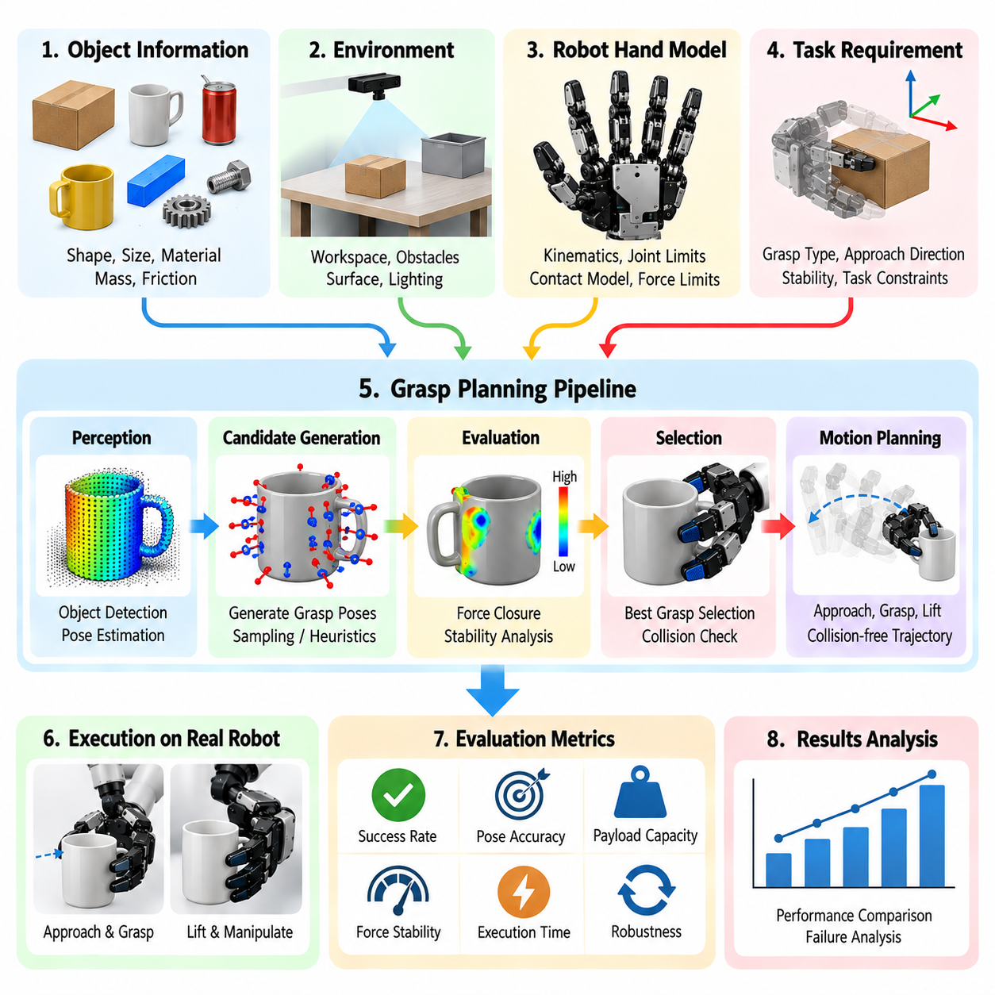
A grasp planning evaluation template provides a systematic framework for assessing how effectively a robotic hand generates, selects, and executes stable grasps. The evaluation should connect planning algorithms with object characteristics, contact mechanics, robot kinematics, and task requirements. Its primary objective is to establish reproducible criteria for measuring grasp feasibility, stability, execution reliability, and computational efficiency across different manipulation scenarios.
The evaluation begins with a clear definition of the manipulation task and expected operating conditions. Engineers should document target objects, grasp objectives, environmental constraints, and required post-grasp operations. A grasp intended for simple object transportation may differ substantially from one required for precision assembly or in-hand manipulation. The template should distinguish task-specific success criteria from general grasp quality indicators.
Object characterization establishes the physical foundation for grasp planning. Relevant parameters include object geometry, dimensions, mass, center of gravity, surface friction, material stiffness, and potential deformation. Engineers should identify whether object models are obtained from CAD data, depth sensing, point clouds, or reconstructed geometry. Uncertainty in these properties should be recorded because inaccurate object representations can significantly affect grasp predictions.
The perception evaluation should examine how reliably the system identifies objects and estimates their poses before grasp generation. RGB cameras, depth sensors, and point-cloud processing systems provide different levels of geometric information. The template should document detection confidence, pose estimation accuracy, occlusion conditions, and sensor calibration quality. Perception errors should be evaluated independently from planning errors to identify their respective contributions to grasp failure.
Grasp representation determines how candidate configurations are described and evaluated. Parallel-jaw systems commonly represent grasps using contact positions, approach directions, gripper orientation, and opening width. Multifinger hands require additional joint configurations, fingertip contact locations, and coordinated finger postures. The template should define coordinate frames, parameter conventions, and configuration constraints so that grasp candidates can be compared consistently.
Candidate grasp generation should be evaluated according to coverage, diversity, and computational cost. Analytical planners may sample contact configurations using geometric and mechanical constraints, while learning-based methods predict promising grasps from sensory observations. Engineers should measure how many valid candidates are generated within a specified computation budget. The evaluation should also determine whether candidate diversity is sufficient to handle changes in object orientation and environmental accessibility.
Geometric feasibility assessment should verify that candidate grasps satisfy finger reachability, joint limits, and collision constraints. The planner must account for interference between the hand, object, surrounding obstacles, and supporting robot structure. Engineers should examine whether the selected approach direction permits collision-free access to the intended contact regions. The template should distinguish geometrically valid grasps from those that are executable by the complete robotic system.
Contact mechanics evaluation should consider friction, contact geometry, and achievable force distributions. Force closure analysis determines whether available contact forces can resist arbitrary external wrenches within the assumed contact model. Form closure and grasp wrench space analysis provide additional measures of mechanical constraint and disturbance resistance. The template should document friction assumptions, contact models, and the sensitivity of predicted stability to parameter uncertainty.
Grasp quality metrics should be selected according to the physical requirements of the application. Common measures include force closure feasibility, grasp wrench space properties, contact distribution, minimum required gripping force, and resistance to external disturbances. No single metric captures every aspect of grasp performance. Engineers should explain the relevance of each metric and avoid comparing numerical scores derived from incompatible assumptions or normalization methods.
Kinematic feasibility must be evaluated for both the robotic hand and its supporting manipulator. A grasp may be mechanically stable but unreachable because of arm joint limits, wrist orientation restrictions, or obstacles. The template should verify inverse kinematics solutions, joint configurations, and approach trajectories. Reachability should be assessed throughout the complete grasp execution sequence rather than only at the final contact pose.
Grasp ranking and selection should incorporate task requirements alongside mechanical stability. A highly stable grasp may obstruct an assembly interface, interfere with tool operation, or prevent subsequent object reorientation. Engineers should define ranking criteria that account for accessibility, manipulation objectives, execution time, and expected recovery difficulty. The evaluation should document how competing objectives are weighted and how the final candidate is selected.
Uncertainty analysis should examine the effects of imperfect perception, object property variation, and actuator positioning errors. Small deviations in estimated pose or contact location may significantly alter grasp stability, particularly for narrow contact regions. Engineers should evaluate candidate robustness through perturbation tests, probabilistic models, or repeated simulation trials. The template should record uncertainty assumptions and distinguish nominal performance from performance under realistic disturbances.
Trajectory planning evaluation should consider the complete sequence of approach, contact establishment, closure, lifting, transportation, and release. Each phase introduces different collision, force, and timing constraints. Engineers should verify that planned trajectories remain dynamically feasible and compatible with actuator limits. The template should also examine whether contact transitions produce excessive impact forces or unintended object motion.
Force control and tactile feedback should be evaluated as components of grasp execution rather than isolated control functions. Tactile measurements can confirm contact, estimate force distribution, and detect incipient slip. Adaptive controllers may modify gripping force or finger posture when disturbances occur. The evaluation should measure whether feedback improves grasp retention without producing excessive force, unstable oscillation, or damage to sensitive objects.
Learning-based grasp planning requires additional assessment of model generalization and training-data dependence. Neural grasp predictors may perform well on familiar objects but degrade under unfamiliar shapes, materials, or sensor conditions. Engineers should distinguish training, validation, and test objects and prevent data leakage between evaluation partitions. The template should document model versions, dataset characteristics, inference latency, and performance on previously unseen objects.
Simulation-based evaluation provides a controlled environment for testing large numbers of grasp candidates. Physics engines can approximate contact forces, object motion, and collision behavior under specified material assumptions. However, simulated friction, compliance, and sensor noise may differ from physical conditions. Engineers should document simulator configuration, contact parameters, and model limitations. Simulation results should be validated through representative physical experiments before deployment decisions.
Experimental benchmarking should use standardized procedures and representative object collections. The YCB Object Set and grasp-oriented benchmark datasets can support reproducible comparisons, while application-specific objects provide practical relevance. Engineers should define object placement distributions, trial counts, environmental conditions, and success definitions before testing. Consistent experimental protocols are essential for comparing planning methods without introducing uncontrolled procedural differences.
Grasp success rate is a fundamental performance indicator but requires a precise operational definition. Successful contact does not necessarily imply successful lifting, transportation, or task completion. The template should distinguish initial grasp acquisition, stable lifting, sustained retention, and final placement success. Engineers should report the number of successful trials relative to total attempts and include statistical uncertainty when interpreting measured success rates.
Computational performance should be evaluated against the real-time requirements of the manipulation system. Relevant measurements include perception processing time, candidate generation latency, grasp scoring duration, trajectory planning time, and total decision latency. Engineers should identify whether computation occurs on embedded processors, edge computers, or external servers. The evaluation should verify that planning remains responsive under realistic workloads and communication constraints.
Failure analysis should classify unsuccessful grasps according to their underlying causes. Typical categories include perception errors, unreachable configurations, collisions, insufficient friction, unstable contact, excessive object deformation, and control failures. Engineers should preserve relevant sensor recordings, planner outputs, and execution logs. Structured failure classification helps distinguish algorithmic weaknesses from mechanical limitations and provides evidence for targeted system improvements.
Robustness testing should introduce controlled variations in object pose, surface properties, lighting, clutter, and external disturbances. Repeated trials under changing conditions reveal whether planning performance depends excessively on idealized assumptions. The template should establish acceptable performance degradation limits for each disturbance category. Recovery behavior should also be assessed when the robot must replan, adjust contact locations, or attempt another grasp.
Safety evaluation should consider the consequences of incorrect grasp selection and execution failure. Dropped objects, excessive gripping forces, unexpected collisions, and unstable load transfer can create hazards for nearby people and equipment. Engineers should define protective constraints, execution monitoring requirements, and safe responses to detected failures. Grasp quality scores should never substitute for independent system-level safety assessment and validation.
Comparative evaluation should apply identical task definitions, object sets, hardware constraints, and measurement procedures to competing planners. Results should distinguish grasp prediction quality from complete system execution performance. Engineers should report both average performance and variability across objects and conditions. Comparisons should also account for computational resources, sensing requirements, and integration complexity rather than relying exclusively on grasp success percentages.
The completed evaluation template should consolidate task specifications, object characteristics, perception quality, grasp representations, planning configurations, stability metrics, execution results, and failure analyses. Every performance claim should be supported by documented test conditions and reproducible evidence. Unresolved limitations and improvement priorities should remain traceable. This structured approach enables grasp planning systems to be evaluated consistently and improved through measurable engineering feedback.

16.05 Force Control Tuning Checklist
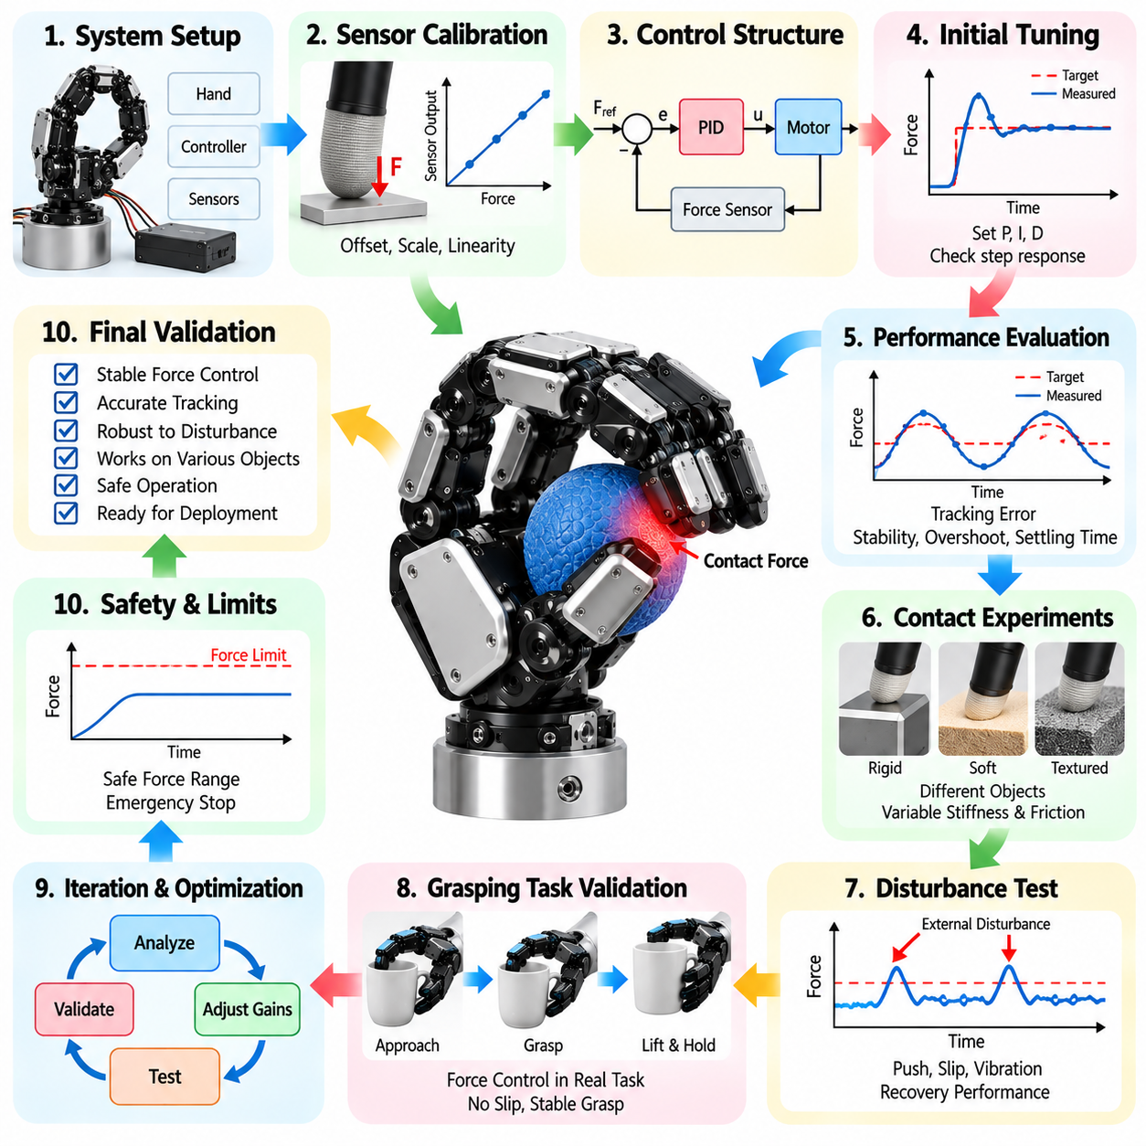
Force control tuning is a critical engineering process for robotic hands that must regulate contact forces while maintaining stable and responsive manipulation. A structured tuning checklist establishes consistent procedures for configuring controllers, validating sensor feedback, and evaluating interaction performance. The objective is to achieve accurate force tracking, stable contact behavior, and reliable object handling across different grasp configurations and environmental conditions.
The tuning process begins with defining the force control requirements of the intended manipulation tasks. Engineers should specify target gripping forces, allowable contact pressure, force accuracy, response time, and acceptable overshoot. Fragile objects may require gentle force regulation, while heavy or slippery objects demand stronger and more adaptive gripping. Each requirement should be associated with measurable acceptance criteria and representative operating conditions.
The mechanical characteristics of the robotic hand must be evaluated before controller parameters are adjusted. Joint friction, transmission backlash, tendon elasticity, structural compliance, and actuator limitations influence force control behavior. Engineers should identify nonlinearities and mechanical disturbances that may affect force transmission. The checklist should distinguish limitations caused by hardware from those that can be corrected through controller tuning.
Actuator characterization should establish the relationship between command signals and generated joint torque or fingertip force. Motor current, torque constants, gear ratios, transmission efficiency, and thermal limits determine achievable force output. Engineers should measure continuous and peak force capabilities under realistic loading conditions. The checklist should verify that commanded forces remain within actuator ratings and that force estimation accounts for transmission losses.
Force sensing accuracy must be verified before closed-loop tuning begins. Fingertip sensors, tactile arrays, joint torque sensors, and wrist force-torque sensors provide different measurements of physical interaction. Engineers should examine sensor calibration, resolution, noise, hysteresis, and temperature drift. The checklist should confirm that sensor measurements correspond to the intended contact forces and that measurement uncertainty is acceptable for the application.
Control architecture selection should reflect the mechanical system and manipulation objectives. Direct force control regulates measured interaction forces, while impedance control establishes a desired relationship between motion and contact force. Admittance control converts measured forces into motion commands and may be appropriate for suitable position-controlled systems. Engineers should document the selected architecture, feedback variables, actuator interfaces, and expected operating limitations.
Controller timing and communication performance should be evaluated before increasing control gains. Sampling frequency, sensor acquisition delay, computation time, and actuator command latency influence closed-loop stability. Engineers should measure timing jitter and identify communication bottlenecks. The checklist should verify that the control update rate is appropriate for the mechanical bandwidth and that delayed measurements do not produce unstable force corrections.
Initial controller tuning should begin with conservative gains and controlled contact conditions. Proportional control can establish basic force responsiveness, while integral action may reduce steady-state tracking error. Derivative action or additional damping may improve transient behavior when implemented with appropriate noise filtering. Engineers should adjust parameters systematically and record the effect of each change rather than relying on uncontrolled trial-and-error tuning.
Force tracking evaluation should compare commanded forces with measured contact forces over representative operating ranges. Step responses, gradual force ramps, and repeated loading sequences can reveal tracking errors and nonlinear behavior. Engineers should measure rise time, settling time, overshoot, steady-state error, and force oscillation. The checklist should define acceptable thresholds for each metric and identify operating regions where controller performance deteriorates.
Contact transition behavior requires particular attention because free-space motion and constrained contact exhibit different dynamics. Rapid contact establishment may produce impact forces, overshoot, or unstable controller responses. Engineers should evaluate contact detection thresholds, approach velocity, force ramping, and transitions between position and force control. The checklist should confirm that the controller enters contact smoothly without excessive force or unnecessary delays.
Mechanical compliance and contact stiffness strongly influence controller stability. Soft fingertips and elastic transmissions can absorb disturbances, but they may introduce additional dynamics and reduce force estimation accuracy. Rigid contacts can create rapid force changes that challenge controller bandwidth. Engineers should test representative combinations of object stiffness and gripping surface compliance. Controller settings should remain stable across the expected range of contact conditions.
Friction compensation should address resistance within joints, transmissions, and contact interfaces. Static friction, Coulomb friction, and velocity-dependent effects can cause force tracking errors, particularly during small adjustments. Engineers should characterize friction behavior and determine whether compensation improves performance without introducing instability. The checklist should verify that compensation remains effective under changing temperatures, loading conditions, and mechanical wear.
Integral windup prevention is essential when force commands exceed actuator capabilities or contact conditions prevent the requested force from being achieved. Accumulated integral error can produce excessive force when constraints change or contact is restored. Engineers should implement appropriate saturation handling, anti-windup mechanisms, and controller state management. The checklist should include tests involving actuator limits, contact loss, and recovery from prolonged force errors.
Tactile feedback can improve force control by providing localized contact information and early indications of slip. Pressure distribution and shear-force measurements may reveal uneven loading that cannot be detected through joint torque alone. Engineers should evaluate how tactile signals influence force commands and finger coordination. The checklist should verify that feedback integration improves grasp stability without causing excessive corrections or unstable interactions.
Multifinger force coordination requires consistent distribution of contact forces across the robotic hand. Independent finger controllers may create conflicting forces if their objectives are not coordinated. Engineers should consider grasp geometry, friction constraints, object equilibrium, and internal force distribution. The checklist should evaluate whether coordinated control maintains stable object positioning while minimizing unnecessary gripping forces and excessive actuator loading.
Adaptive force control may be necessary when object properties or contact conditions vary significantly. Gain scheduling, online parameter estimation, and adaptive control methods can adjust controller behavior according to estimated stiffness, friction, or loading conditions. Engineers should establish limits on parameter adaptation and verify stability during transitions. The checklist should distinguish demonstrated adaptive improvements from performance changes caused by uncontrolled experimental conditions.
Disturbance rejection testing should examine how the controller responds to external forces, object movement, and unexpected contact changes. Controlled disturbances can reveal insufficient damping, delayed feedback, or excessive force correction. Engineers should measure recovery time, peak force deviation, and grasp retention performance. The checklist should include disturbances representative of actual manipulation tasks rather than relying exclusively on idealized laboratory conditions.
Force control during object lifting and transportation should account for gravitational loading, acceleration, and changing object orientation. Dynamic motion can alter required gripping forces and contact distributions. Engineers should evaluate whether force commands remain sufficient to prevent slip without damaging the object. The checklist should verify stable force regulation during acceleration, deceleration, trajectory changes, and transitions between manipulation phases.
Safety constraints must remain active throughout controller tuning and operation. Excessive contact forces can damage objects, mechanical components, or nearby equipment and may create hazards for people. Engineers should define force limits, actuator saturation thresholds, emergency responses, and safe behavior following sensor or communication failures. The checklist should verify that protective functions operate independently of experimental controller settings where required by the system safety architecture.
Thermal and energy constraints should be evaluated during prolonged force regulation. Maintaining continuous gripping force may increase motor current, actuator temperature, and electrical consumption. Engineers should measure sustained force capability, temperature rise, and performance degradation under extended loading. The checklist should verify that thermal protection and duty-cycle limitations do not cause unexpected loss of gripping force during normal operation.
Experimental validation should use standardized objects, calibrated reference instruments, and repeatable loading procedures. Tests should cover different object materials, sizes, stiffness levels, and friction conditions. Engineers should perform multiple trials to quantify variability and distinguish repeatable controller behavior from isolated successful results. Measurement records should include controller parameters, sensor calibration status, operating conditions, and relevant software versions.
Performance comparison should examine alternative controller configurations using identical hardware and experimental conditions. Relevant metrics include force tracking accuracy, response latency, overshoot, disturbance rejection, energy consumption, and grasp success rate. Engineers should evaluate trade-offs between responsiveness, stability, and mechanical stress. Comparative results should identify which configurations satisfy application requirements rather than selecting parameters solely through a single performance metric.
The completed tuning checklist should consolidate force requirements, actuator characteristics, sensor calibration, control architecture, tuning parameters, stability assessments, and validation results. Each parameter change should be documented with its rationale and measured consequences. Unresolved limitations, operating boundaries, and maintenance considerations should remain traceable. This systematic approach supports reliable force regulation and repeatable deployment of robotic grasping and dexterous manipulation systems.

16.06 In-Hand Manipulation Test Template
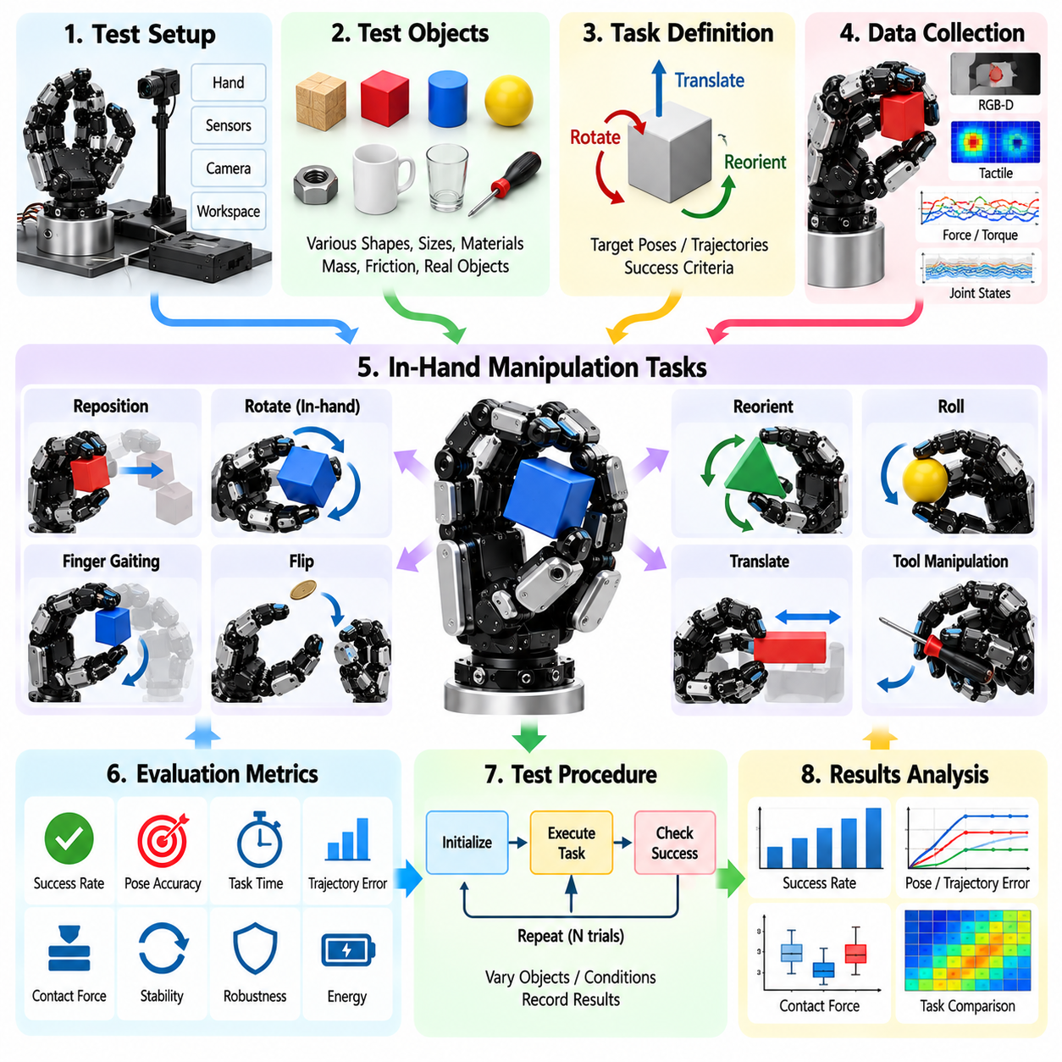
An in-hand manipulation test template provides a systematic framework for evaluating how effectively a robotic hand changes an object's position and orientation while maintaining controlled contact. Unlike conventional grasping, in-hand manipulation requires coordinated finger motion, contact transitions, and continuous object stabilization. The template establishes reproducible procedures for measuring dexterity, accuracy, stability, and manipulation reliability.
The testing process begins by defining the intended manipulation tasks and operational objectives. Representative activities include object rotation, translation, reorientation, finger gaiting, rolling, and controlled repositioning. Engineers should specify initial and target object poses, allowable motion errors, completion time, and contact constraints. Each task should have measurable acceptance criteria that distinguish successful manipulation from partial execution.
Object selection should represent the geometric and physical diversity expected during deployment. Relevant characteristics include dimensions, mass, center of gravity, surface friction, stiffness, and shape complexity. Cylindrical, spherical, polygonal, and irregular objects may produce different contact behaviors. The template should document object properties and identify whether test objects are familiar to the control system or intentionally selected to evaluate generalization.
The robotic hand configuration must be recorded before experimentation. Important parameters include finger count, degrees of freedom, joint limits, actuator capabilities, fingertip geometry, and available tactile sensors. Engineers should document transmission compliance, force control modes, and mechanical constraints. This information establishes the physical capabilities and limitations that influence the interpretation of manipulation results.
Initial grasp conditions should be standardized to support reproducible comparisons. The template should specify finger contact locations, initial joint configurations, gripping forces, and object orientation. Small variations in initial contact geometry may substantially affect manipulation outcomes. Engineers should determine whether experiments use fixed starting configurations or randomized initial conditions and record the distribution of permitted variations.
Manipulation primitives should be evaluated individually before testing complex sequences. Rolling involves controlled relative motion between contact surfaces, while sliding changes contact locations through tangential displacement. Finger gaiting redistributes contacts by releasing and repositioning selected fingers. The template should describe the intended contact sequence and verify that each primitive maintains sufficient object support throughout execution.
Kinematic evaluation should measure whether the robotic hand can achieve required object motions within its joint and workspace limits. Finger reachability, joint coordination, and available contact configurations determine feasible manipulation trajectories. Engineers should identify singularities, mechanical interference, and configurations requiring excessive joint motion. The template should distinguish limitations of the mechanical design from deficiencies in the motion planning algorithm.
Contact mechanics evaluation should examine friction constraints, normal forces, tangential forces, and object equilibrium. Stable manipulation requires appropriate force distribution during changes in contact geometry. Engineers should verify whether contact forces remain within feasible friction limits and whether internal forces are unnecessarily excessive. The template should document assumptions about contact models, friction coefficients, and object deformation.
Force control performance should be evaluated during both continuous manipulation and discrete contact transitions. Controllers must maintain sufficient gripping force while allowing intended object movement. Excessive force can prevent sliding or damage objects, whereas insufficient force may cause unintended slip. Engineers should measure force tracking error, transient overshoot, contact stability, and recovery behavior under representative manipulation conditions.
Tactile sensing evaluation should determine whether the system accurately detects contact locations, pressure distributions, and changes in contact state. Tactile arrays may provide information about local deformation, shear loading, and slip onset. Engineers should assess sensing resolution, update frequency, calibration accuracy, and detection latency. The template should verify that tactile feedback contributes meaningfully to manipulation decisions rather than merely recording contact information.
Object pose estimation is essential for measuring manipulation progress and correcting accumulated errors. External cameras, depth sensors, tactile observations, and joint measurements may contribute to object tracking. Engineers should compare estimated poses against calibrated reference measurements. The template should report position error, orientation error, estimation latency, and tracking failures, particularly during occlusion or complex finger movements.
Trajectory tracking evaluation should compare commanded object motion with actual displacement and rotation. Tests may include fixed-angle rotations, controlled translations, and multi-axis reorientation. Engineers should measure final pose error, trajectory deviation, completion time, and motion smoothness. The template should distinguish errors arising from planning, sensing, and control while identifying conditions that produce accumulated drift.
Contact transition testing should examine how reliably fingers release, relocate, and reestablish contact without destabilizing the object. Each transition changes the available support configuration and may introduce temporary instability. Engineers should measure contact interruption duration, object displacement, force redistribution, and transition success rate. The template should identify whether failures originate from timing errors, inadequate support, or inaccurate contact localization.
Manipulation stability should be assessed throughout the entire task rather than only at its completion. An object may reach the target pose after experiencing uncontrolled slip or excessive intermediate motion. Engineers should monitor contact continuity, unintended rotation, force fluctuations, and near-drop events. The template should establish stability thresholds and document whether the controller can recover from disturbances without restarting the manipulation sequence.
Robustness testing should introduce controlled variations in object mass, friction, initial pose, and external disturbances. Changes in contact properties can reveal weaknesses that remain hidden under ideal laboratory conditions. Engineers should perform repeated trials across representative operating ranges. The template should quantify performance degradation and identify the conditions under which manipulation becomes unreliable or requires controller adaptation.
Learning-based manipulation systems require additional evaluation of training dependence and generalization. Policies trained through reinforcement learning, imitation learning, or simulation may perform differently on unfamiliar objects and contact conditions. Engineers should separate training and evaluation datasets and document policy versions. The template should measure success on unseen configurations and assess whether performance transfers from simulation to physical hardware.
Computational performance should be evaluated alongside mechanical manipulation accuracy. Relevant metrics include sensing latency, state estimation time, planning duration, control update frequency, and total task execution time. Engineers should identify processing hardware and communication dependencies. The template should verify that real-time control requirements remain satisfied during complex finger coordination and unexpected contact changes.
Failure analysis should classify unsuccessful trials according to their underlying mechanisms. Common categories include object dropping, uncontrolled slip, excessive contact force, unreachable finger configurations, pose estimation errors, and unsuccessful contact transitions. Engineers should preserve sensor recordings, actuator commands, object trajectories, and controller states. Structured failure analysis supports targeted improvements to hardware, perception, planning, and control.
Safety testing should address the consequences of unexpected object motion, excessive force, actuator faults, and communication failures. Protective limits should remain active during experimental manipulation, particularly when rigid or heavy objects are involved. Engineers should verify safe stopping behavior and appropriate responses to sensor faults. The template should distinguish experimental performance limits from independent safety requirements governing the complete robotic system.
Benchmark design should include standardized object sets, predefined manipulation tasks, consistent initial conditions, and repeatable measurement procedures. Performance indicators should include task success rate, pose accuracy, completion time, contact stability, force efficiency, and recovery capability. Engineers should report trial counts and variability rather than relying on isolated demonstrations. Comparisons between robotic hands should account for differences in sensing and actuation capabilities.
The completed test template should consolidate hardware specifications, object properties, manipulation objectives, controller configurations, experimental conditions, measured results, and failure records. Each test should include acceptance criteria and sufficient information for independent reproduction. Unresolved limitations and recommended design improvements should remain traceable. This structured process enables reliable assessment and progressive improvement of dexterous in-hand manipulation capabilities.

16.07 Learning-Based Grasping Project Template
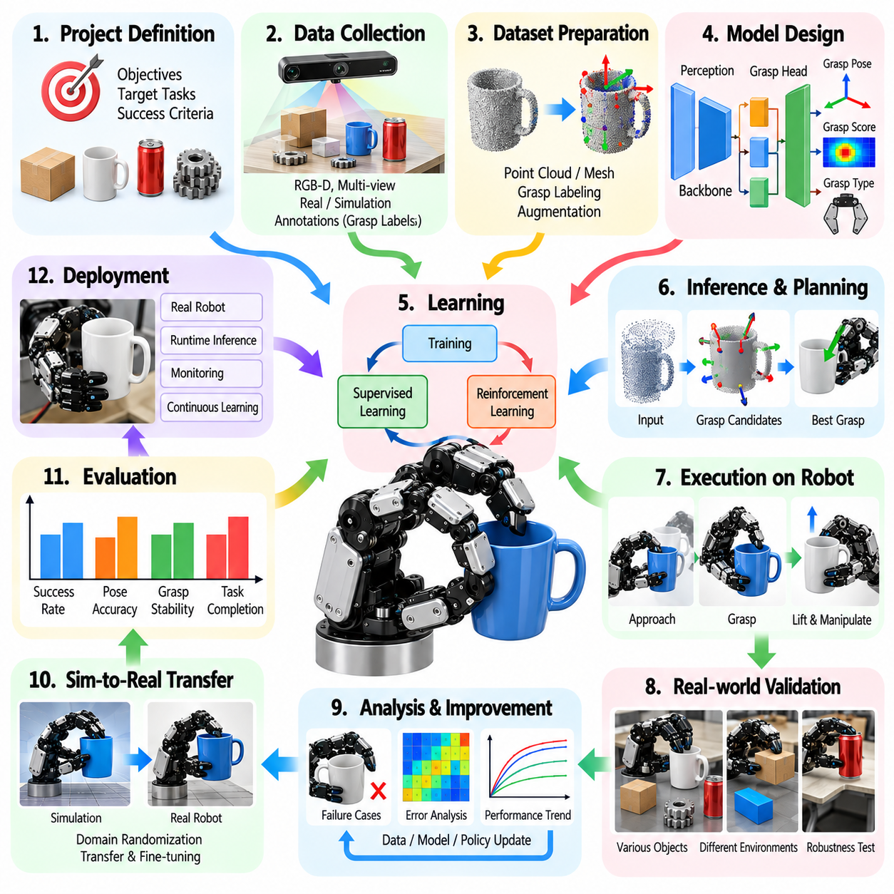
A learning-based grasping project template provides a structured framework for developing robotic systems that acquire grasping capabilities from data and experience. It connects task requirements, dataset preparation, model development, training, evaluation, and deployment into a reproducible engineering workflow. The objective is to achieve reliable grasp generation and execution while maintaining traceability between learning methods and measured manipulation performance.
Project definition begins with identifying the target application, robotic platform, and expected operating environment. Engineers should specify object categories, grasp types, manipulation objectives, and environmental constraints. Warehouse picking, industrial assembly, and service robotics may require different learning strategies. The project template should establish measurable success criteria, technical boundaries, and deployment assumptions before model development begins.
System architecture should describe how perception, grasp prediction, motion planning, and robot control interact. RGB cameras, depth sensors, tactile arrays, and proprioceptive measurements provide complementary information about objects and contacts. Engineers should document sensor placement, coordinate frames, processing hardware, and communication interfaces. The architecture should identify which components use learned models and which retain conventional control methods.
Dataset planning should establish the information required for effective grasp learning. Training examples may include object images, point clouds, contact locations, grasp poses, joint configurations, and execution outcomes. Engineers should define labeling conventions, data formats, and collection procedures. The template should record dataset provenance, object diversity, environmental conditions, and potential sampling biases that could influence model generalization.
Data acquisition should combine representative physical experiments with suitable synthetic or simulated observations. Robotic demonstrations, teleoperation, automated grasp trials, and physics simulation can provide complementary training examples. Engineers should document acquisition hardware, calibration procedures, and data synchronization. The template should distinguish measured outcomes from simulated labels and identify limitations associated with each data source.
Data preprocessing should ensure consistency between training inputs and real-world sensor measurements. Typical operations include coordinate transformation, point-cloud filtering, image normalization, object segmentation, and removal of invalid records. Engineers should preserve calibration metadata and prevent preprocessing from introducing unrealistic assumptions. The template should specify reproducible processing pipelines and maintain versioned records of dataset transformations.
Training, validation, and test partitions should be designed to measure genuine generalization. Randomly dividing individual observations may create misleading results when nearly identical object instances appear across partitions. Engineers should consider object-level, scene-level, and environment-level separation. The template should document partition criteria and establish dedicated evaluation sets containing unfamiliar objects, poses, and contact conditions.
Model selection should reflect the available sensing modalities and required grasp representations. Convolutional networks, point-cloud encoders, transformers, and multimodal architectures can support different prediction objectives. Models may estimate grasp quality, candidate poses, contact configurations, or complete manipulation actions. Engineers should document architecture choices, input dimensions, output conventions, and computational requirements.
Supervised learning approaches can train grasp predictors using labeled examples of successful and unsuccessful interactions. Classification models estimate grasp feasibility, while regression models predict grasp parameters or quality scores. Engineers should define loss functions, label confidence, and strategies for handling class imbalance. The template should examine whether training objectives correspond to actual execution success rather than relying exclusively on prediction accuracy.
Reinforcement learning can optimize grasping policies through repeated interaction with simulated or physical environments. Reward functions may consider grasp acquisition, object lifting, stable retention, and task completion. Engineers should specify state representations, action spaces, episode termination rules, and exploration constraints. The template should document training efficiency, reward design, and the risk of policies exploiting unintended simulator behavior.
Imitation learning can accelerate grasp policy development by transferring behavior from expert demonstrations. Demonstrations may originate from human teleoperation, scripted controllers, or previously validated planning systems. Engineers should assess demonstration quality, coverage, and consistency. The template should identify how behavioral cloning or interactive correction methods address distribution shifts between demonstrated trajectories and autonomous execution.
Training configuration should be recorded to support reproducibility and systematic experimentation. Relevant parameters include optimizer selection, learning rate, batch size, training duration, regularization, augmentation, and random initialization. Engineers should track software dependencies, hardware resources, and model checkpoints. The template should require consistent experiment identifiers and preserve configuration files associated with reported results.
Simulation environments should reproduce the physical interactions most relevant to grasping performance. Object mass, friction, compliance, actuator dynamics, and sensor noise influence learned behavior. Domain randomization can expose models to variations that improve robustness, although unrealistic parameter ranges may reduce training effectiveness. Engineers should document simulator assumptions and validate representative contact behavior against physical measurements.
Model evaluation should distinguish offline prediction performance from closed-loop robotic execution. Offline metrics may include classification accuracy, grasp pose error, and ranking quality, but these do not guarantee successful physical manipulation. Engineers should evaluate actual grasp acquisition, lifting, retention, and placement. The template should define standardized testing conditions and report both prediction metrics and task-level success rates.
Generalization testing should examine performance on objects and environments not encountered during training. Novel geometry, reflective surfaces, deformable materials, clutter, and partial occlusion can expose weaknesses in learned representations. Engineers should measure performance changes across clearly defined test categories. The template should distinguish interpolation within familiar conditions from transfer to genuinely unfamiliar manipulation scenarios.
Sim-to-real transfer evaluation should determine whether policies trained in simulation remain effective on physical hardware. Differences in friction, contact stiffness, actuator response, and sensing can produce substantial performance degradation. Engineers should compare simulated and physical outcomes using matched tasks. The template should document adaptation procedures, calibration adjustments, and residual discrepancies that limit reliable deployment.
Closed-loop grasp execution should integrate learned predictions with feedback from tactile sensors, joint encoders, and force measurements. Initial grasp proposals may require correction when contact locations differ from predictions. Engineers should evaluate feedback latency, replanning behavior, and recovery from unsuccessful contact. The template should establish whether adaptive execution improves grasp reliability compared with fixed open-loop commands.
Computational performance should be evaluated against deployment hardware and timing constraints. Model inference latency, memory consumption, accelerator utilization, and communication delays can affect manipulation responsiveness. Engineers should assess whether quantization, pruning, or architectural simplification preserves sufficient accuracy. The template should record the relationship between model complexity, execution speed, and grasping performance.
Safety requirements should constrain both learning experiments and autonomous operation. Exploration policies must respect actuator limits, collision boundaries, force thresholds, and emergency stopping mechanisms. Engineers should implement protective supervision independently of learned policy outputs where required. The template should document failure handling, operator intervention procedures, and validation of safety-related constraints before physical deployment.
Experiment tracking should preserve the relationship between datasets, model versions, training configurations, and evaluation results. Each experiment should include reproducible identifiers, performance metrics, and relevant diagnostic records. Engineers should use controlled comparisons and ablation studies to determine which architectural or training changes provide measurable improvements. The template should prevent unsupported conclusions from isolated successful demonstrations.
Deployment planning should address integration with robot middleware, sensor pipelines, motion controllers, and operational monitoring. Engineers should establish model update procedures, rollback capabilities, and performance monitoring under changing conditions. Data collected during operation may support future improvement, but updates require controlled validation. The template should distinguish research prototypes from systems qualified for sustained autonomous use.
The completed project template should consolidate application requirements, system architecture, dataset specifications, learning methodology, training configurations, validation procedures, deployment constraints, and measured outcomes. Each development milestone should have explicit acceptance criteria and traceable evidence. Remaining limitations and future research priorities should be documented. This structured approach supports reproducible development and continuous improvement of learning-based robotic grasping systems.

16.08 Benchmarking Report Template
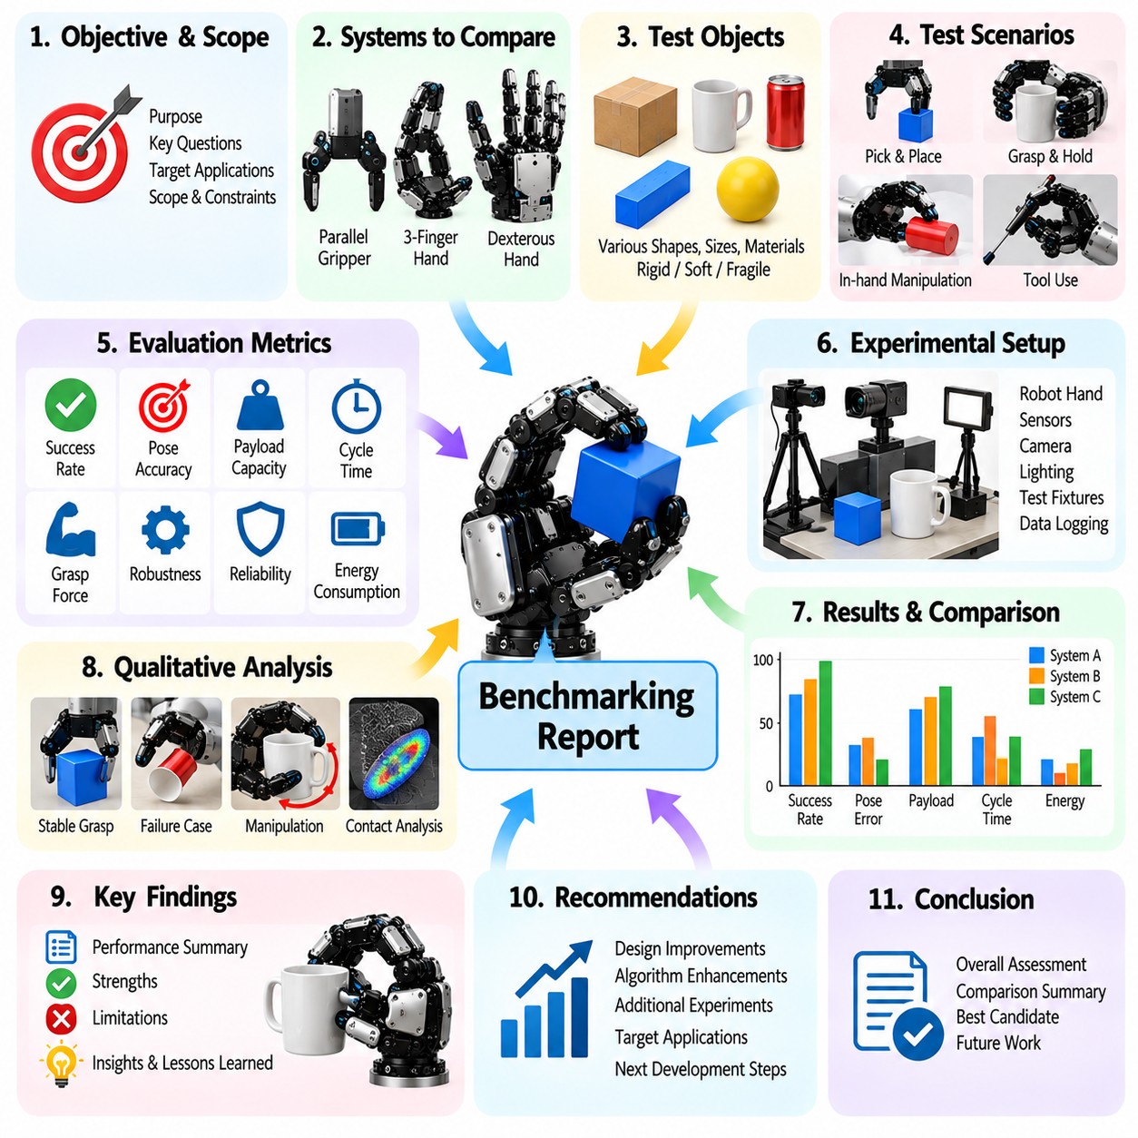
A benchmarking report template provides a standardized framework for evaluating and comparing robotic hands, grippers, and dexterous manipulation systems. It connects hardware specifications, experimental procedures, performance metrics, and observed results into a reproducible assessment process. The objective is to establish transparent evidence of system capabilities while identifying performance limitations and opportunities for engineering improvement.
The report should begin by defining the evaluation objectives and intended application scenarios. Industrial assembly, warehouse picking, service robotics, and precision manipulation impose different performance requirements. Engineers should identify the primary functions being evaluated, including grasp acquisition, object retention, force regulation, and in-hand manipulation. Each objective should correspond to measurable acceptance criteria and clearly defined operating conditions.
System identification should document the hardware and software configurations used during testing. Relevant information includes robotic hand type, finger count, degrees of freedom, actuator technology, transmission mechanisms, sensors, and control architecture. Engineers should record firmware versions, software dependencies, and computing hardware. Configuration traceability is essential because small system changes can influence benchmarking results.
Benchmark selection should reflect both standardized research practices and practical application requirements. Established object collections, including the YCB Object Set, can support comparisons across research platforms. Application-specific objects may be necessary to represent industrial parts or specialized tools. The report should explain why each benchmark was selected and identify limitations in its coverage of real operating conditions.
Test object characterization should establish the physical properties that influence grasping performance. Engineers should record object dimensions, mass, geometry, center of gravity, surface friction, stiffness, and susceptibility to deformation. Object categories should include representative variations in shape and material. The report should distinguish measured properties from estimated values and document uncertainties that may affect experimental interpretation.
Experimental setup documentation should describe the physical environment and measurement infrastructure. Camera placement, lighting, work surface geometry, object positioning, and calibration procedures can influence results. Engineers should identify external tracking systems, force measurement instruments, and data acquisition equipment. The report should provide sufficient setup information for independent reproduction of the experimental conditions.
Test procedures should define the sequence of operations performed during each trial. A grasping benchmark may include object detection, candidate generation, approach, contact establishment, lifting, transportation, and placement. Engineers should specify initialization procedures, allowable retries, reset conditions, and termination rules. Consistent execution protocols prevent procedural differences from distorting comparisons between systems.
Performance metrics should be selected according to the capabilities under investigation. Common indicators include grasp success rate, pose accuracy, force tracking error, manipulation completion time, and object retention reliability. Additional measures may evaluate energy consumption, actuator temperature, and computational latency. The report should define every metric mathematically or operationally to prevent ambiguous interpretation.
Grasp success evaluation should distinguish successful contact from complete task execution. A robotic hand may establish contact but fail during lifting, transportation, or placement. Engineers should report success rates separately for relevant manipulation stages. The report should identify whether failures result from perception errors, inadequate contact forces, mechanical limitations, or control instability.
Force control benchmarking should examine the accuracy and stability of commanded contact forces. Step responses, force ramps, and sustained loading tests can reveal tracking errors, overshoot, oscillation, and drift. Engineers should measure force regulation under different object stiffness and friction conditions. The report should include actuator limits and sensor calibration information when interpreting force control performance.
Dexterous manipulation benchmarking should evaluate object translation, rotation, reorientation, and finger gaiting within the robotic hand. Relevant measures include final pose error, trajectory deviation, contact transition success, and manipulation time. Engineers should examine whether objects remain stable during intermediate motions. The report should distinguish completed manipulation tasks from attempts involving uncontrolled slip or excessive corrective movements.
Tactile sensing performance should be assessed when tactile feedback contributes to grasping or manipulation. Evaluation criteria may include contact detection accuracy, spatial resolution, force sensitivity, slip detection latency, and signal stability. Engineers should compare tactile measurements with calibrated references where possible. The report should identify whether tactile feedback produces measurable improvements in manipulation reliability.
Robustness evaluation should introduce controlled variations in object pose, lighting, surface friction, mass, and environmental clutter. Disturbance tests may include external loading, object movement, and changes in contact conditions. Engineers should measure performance degradation relative to nominal conditions. The report should document the range of disturbances tested and avoid extending conclusions beyond demonstrated operating boundaries.
Computational benchmarking should measure the processing requirements of perception, grasp planning, control, and learning-based inference. Relevant indicators include processing latency, control frequency, memory utilization, and accelerator workload. Engineers should distinguish average execution time from worst-case timing behavior. The report should specify computing hardware and communication architecture to support meaningful comparisons.
Reliability testing should examine performance across repeated trials and extended operating periods. Mechanical wear, actuator heating, sensor drift, and communication interruptions can influence long-term behavior. Engineers should record failure frequency, recovery time, and performance changes during sustained operation. The report should distinguish short-duration laboratory demonstrations from evidence supporting continuous deployment.
Statistical analysis should quantify uncertainty and variability in reported measurements. Success rates should include trial counts and suitable confidence intervals, while continuous metrics should include measures of dispersion. Engineers should evaluate whether observed performance differences exceed experimental variability. The report should document sampling procedures and avoid treating small or unrepresentative datasets as conclusive evidence.
Comparative benchmarking should apply equivalent tasks, object sets, environmental conditions, and evaluation procedures to competing systems. Differences in hand morphology, sensing capabilities, and actuator power may complicate direct comparison. Engineers should report these differences rather than concealing them through aggregated scores. The report should distinguish hardware advantages from improvements attributable to planning or control algorithms.
Learning-based system evaluation should document training datasets, model architectures, and exposure to benchmark objects. Data leakage between training and evaluation can produce misleading performance estimates. Engineers should distinguish familiar objects from previously unseen objects and report generalization performance separately. The report should also describe simulation-to-reality discrepancies when policies are trained using synthetic environments.
Failure analysis should classify unsuccessful trials according to identifiable causes. Categories may include missed contacts, unstable grasps, excessive force, unintended slip, unreachable configurations, perception errors, and software faults. Engineers should preserve relevant logs, sensor recordings, and experimental observations. The report should connect recurring failure patterns to potential corrective actions and future development priorities.
Safety assessment should document protective limits, emergency stopping behavior, and responses to unexpected system conditions. Excessive gripping forces, dropped objects, and uncontrolled movements can create hazards for operators and equipment. Engineers should verify that benchmarking procedures respect established safety constraints. The report should distinguish measured task performance from independent evidence of system-level safety compliance.
Result presentation should provide clear relationships between experimental conditions, measured performance, and observed limitations. Tables, statistical summaries, and concise technical explanations can support interpretation, although the underlying data should remain accessible. Engineers should identify missing measurements and incomplete trials. Conclusions should be proportional to the evidence rather than relying on selected successful demonstrations.
The completed benchmarking report should consolidate evaluation objectives, system configurations, benchmark definitions, experimental protocols, performance measurements, statistical analysis, and failure records. Each result should remain traceable to its test conditions and software or hardware version. Unresolved limitations and recommended improvements should be documented. This framework supports reproducible comparison and evidence-based advancement of robotic grasping systems.

16.09 Tool Use Validation Checklist
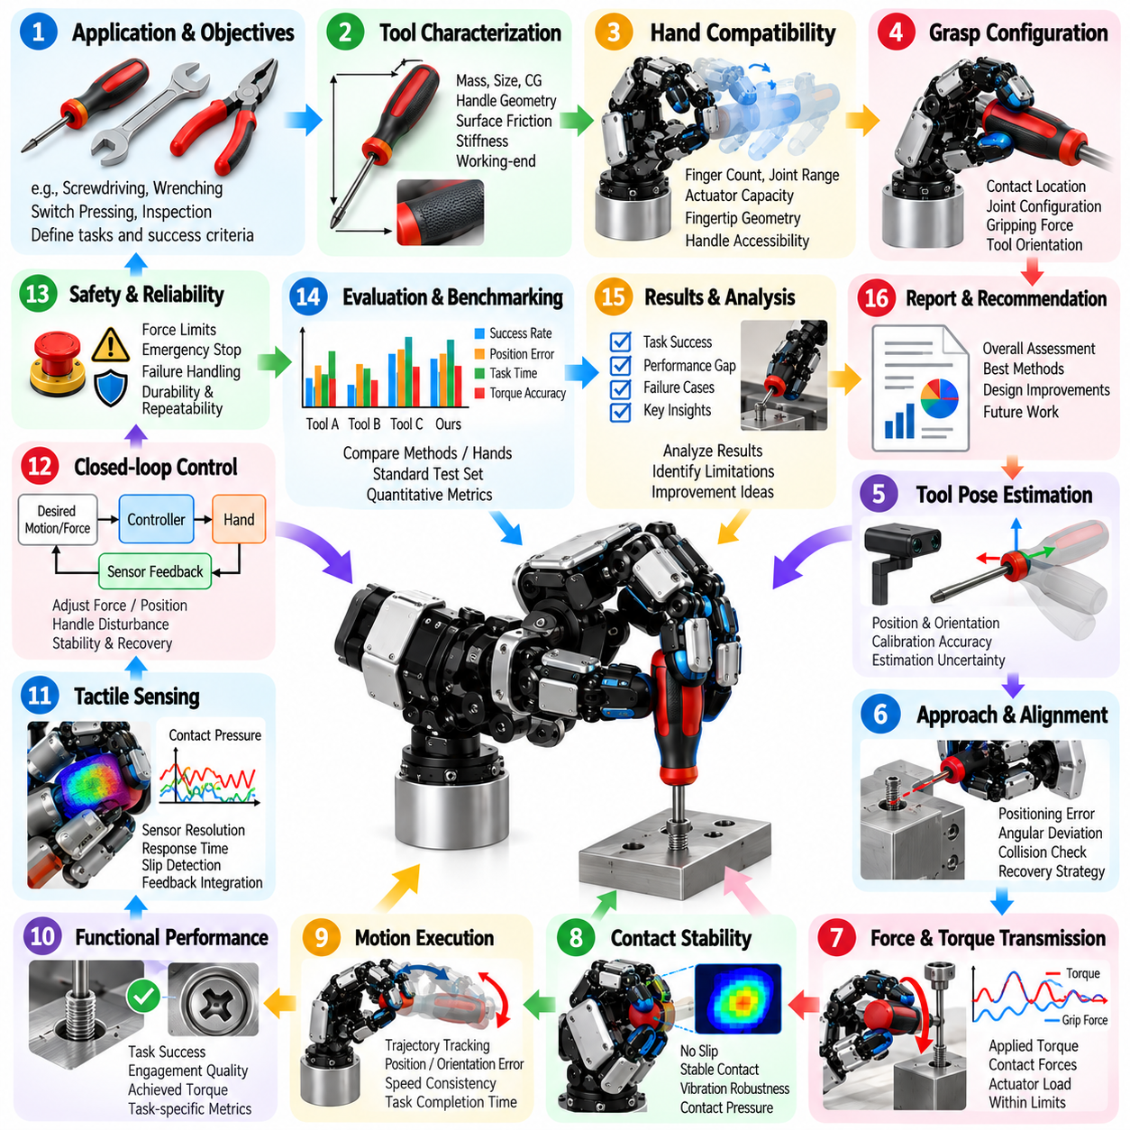
A tool-use validation checklist provides a systematic framework for verifying whether a robotic hand can grasp, manipulate, and operate external tools reliably. Unlike conventional object grasping, tool use requires the robot to maintain stable contact while transmitting forces and motions to an external environment. Validation must therefore address grasp stability, tool orientation, functional execution, interaction forces, and operational safety under realistic task conditions.
Tool-use validation begins by defining the intended application and functional objectives. Representative tasks include turning screwdrivers, operating wrenches, manipulating pliers, pressing switches, and handling inspection instruments. Engineers should specify the required tool motions, working directions, force ranges, and completion criteria. Each task should have measurable acceptance conditions that distinguish successful operation from simple tool retention.
Tool characterization should document the physical and functional properties that influence manipulation. Relevant parameters include tool mass, dimensions, center of gravity, handle geometry, surface friction, stiffness, and working-end configuration. Engineers should identify moving components, mechanical constraints, and required operating forces. The checklist should also record whether the tool was designed for human use or specifically adapted for robotic manipulation.
Robotic hand compatibility should be evaluated before tool operation begins. Finger count, joint range, actuator capacity, fingertip geometry, and available sensing determine whether the hand can establish a functional grasp. Engineers should examine handle accessibility, contact distribution, and possible finger interference. The checklist should identify mechanical limitations that prevent reliable tool positioning or force transmission.
Grasp configuration validation should verify that the selected contact arrangement supports both tool retention and functional operation. A grasp that prevents dropping may still be unsuitable for applying torque or performing precise movements. Engineers should record contact locations, joint configurations, gripping forces, and tool orientation. The checklist should evaluate whether the grasp remains stable throughout the complete working motion.
Tool pose estimation should establish the position and orientation of the tool relative to the robotic hand and target environment. Camera observations, joint encoders, tactile sensors, and known tool geometry can support pose estimation. Engineers should evaluate calibration accuracy, coordinate transformations, and estimation uncertainty. The checklist should determine whether pose errors remain within acceptable limits for the intended operation.
Approach and alignment validation should examine how the robot positions the tool before establishing task contact. Screwdriver engagement, wrench placement, and insertion operations require appropriate alignment between the tool and target features. Engineers should measure positioning error, angular deviation, and approach consistency. The checklist should identify collision risks and determine whether corrective movements can recover from initial misalignment.
Force and torque transmission should be evaluated under representative operating loads. The robotic hand must maintain sufficient grip while the tool transfers forces or moments to the environment. Engineers should measure contact forces, applied torque, internal grasp forces, and actuator loading. The checklist should verify that functional loads remain within mechanical limits without causing unintended tool slip or excessive deformation.
Contact stability validation should examine whether the tool remains securely constrained during changing loads and motion directions. Dynamic interactions may introduce vibration, impacts, and sudden resistance. Engineers should monitor tool displacement relative to the fingers, changes in contact pressure, and slip events. The checklist should distinguish harmless compliance from motion that compromises accuracy or operational safety.
Motion execution validation should compare commanded tool trajectories with actual tool movement. Relevant measurements include position error, orientation error, trajectory deviation, speed consistency, and task completion time. Engineers should evaluate both free-space movement and constrained motion involving environmental contact. The checklist should determine whether mechanical backlash, actuator limits, or control delays reduce execution accuracy.
Functional performance validation should assess whether the tool accomplishes its intended physical task. For screwdriving, relevant outcomes include engagement quality, achieved torque, and fastening completion. For gripping tools, performance may involve jaw positioning and applied force. Engineers should establish task-specific measurements rather than relying exclusively on generic grasp success rates. The checklist should connect tool motion to verified functional outcomes.
Tactile sensing validation should determine whether contact feedback improves tool handling and task execution. Tactile measurements can reveal grip pressure, contact migration, local deformation, and early slip. Engineers should assess sensor resolution, response time, calibration, and integration with force control. The checklist should verify whether tactile feedback supports timely correction when tool loads or contact conditions change.
Closed-loop control validation should evaluate the ability to adjust tool position, gripping force, and applied motion during operation. Unexpected resistance or target displacement may require immediate correction. Engineers should measure feedback latency, control stability, replanning behavior, and recovery performance. The checklist should confirm that adaptive control improves task reliability without introducing oscillation or excessive force.
Tool exchange and regrasping should be evaluated when the application requires multiple tools or changing grasp configurations. Engineers should examine tool acquisition, release, storage, and transfer between working positions. Regrasping may require temporary contact redistribution while preserving tool orientation. The checklist should record transition success, positioning repeatability, and failures associated with incomplete engagement.
Environmental interaction validation should reproduce realistic contact conditions and workspace constraints. Surface hardness, target geometry, fixture compliance, lighting, and nearby obstacles may influence tool operation. Engineers should introduce controlled variations in target position and resistance. The checklist should identify environmental conditions that cause degraded performance and establish the boundaries of reliable operation.
Robustness testing should examine tool use across repeated trials and changing physical conditions. Variations in handle friction, tool mass, target alignment, and external resistance can reveal limitations that remain hidden during nominal testing. Engineers should quantify success rates and performance degradation across defined test ranges. The checklist should distinguish isolated failures from systematic weaknesses in perception, grasping, or control.
Learning-based tool-use systems require additional validation of generalization and policy reliability. Models trained through demonstrations or reinforcement learning may perform well on familiar tools but fail on unfamiliar geometries or contact conditions. Engineers should separate training and evaluation scenarios and document model versions. The checklist should assess adaptation to unseen tools and identify failures caused by distribution shifts.
Computational and communication performance should be evaluated when tool control depends on real-time perception or learned policies. Processing latency, control update frequency, sensor synchronization, and communication interruptions may influence interaction stability. Engineers should measure timing behavior during demanding contact operations. The checklist should verify that computational delays do not compromise force regulation or task execution.
Safety validation should address hazards associated with tool motion, sharp edges, high contact forces, and unexpected environmental interactions. Engineers should establish force limits, collision boundaries, emergency stopping behavior, and procedures for handling dropped tools. Protective mechanisms should remain effective during sensor or actuator faults. The checklist should distinguish successful task execution from independent verification of safety requirements.
Failure analysis should classify unsuccessful tool-use attempts according to their underlying causes. Common categories include unstable grasps, tool misalignment, insufficient torque, excessive force, uncontrolled slip, sensing errors, and control instability. Engineers should preserve sensor logs, tool trajectories, force measurements, and relevant observations. The checklist should connect failure patterns to corrective design or control actions.
Validation reporting should consolidate tool specifications, robotic hand configurations, task definitions, experimental conditions, performance measurements, and failure records. Results should include trial counts, success rates, accuracy measures, and relevant uncertainty estimates. Engineers should document limitations and avoid generalizing beyond tested conditions. The completed checklist should provide traceable evidence that robotic tool use meets defined functional, reliability, and safety criteria.

16.10 Development Milestone Template
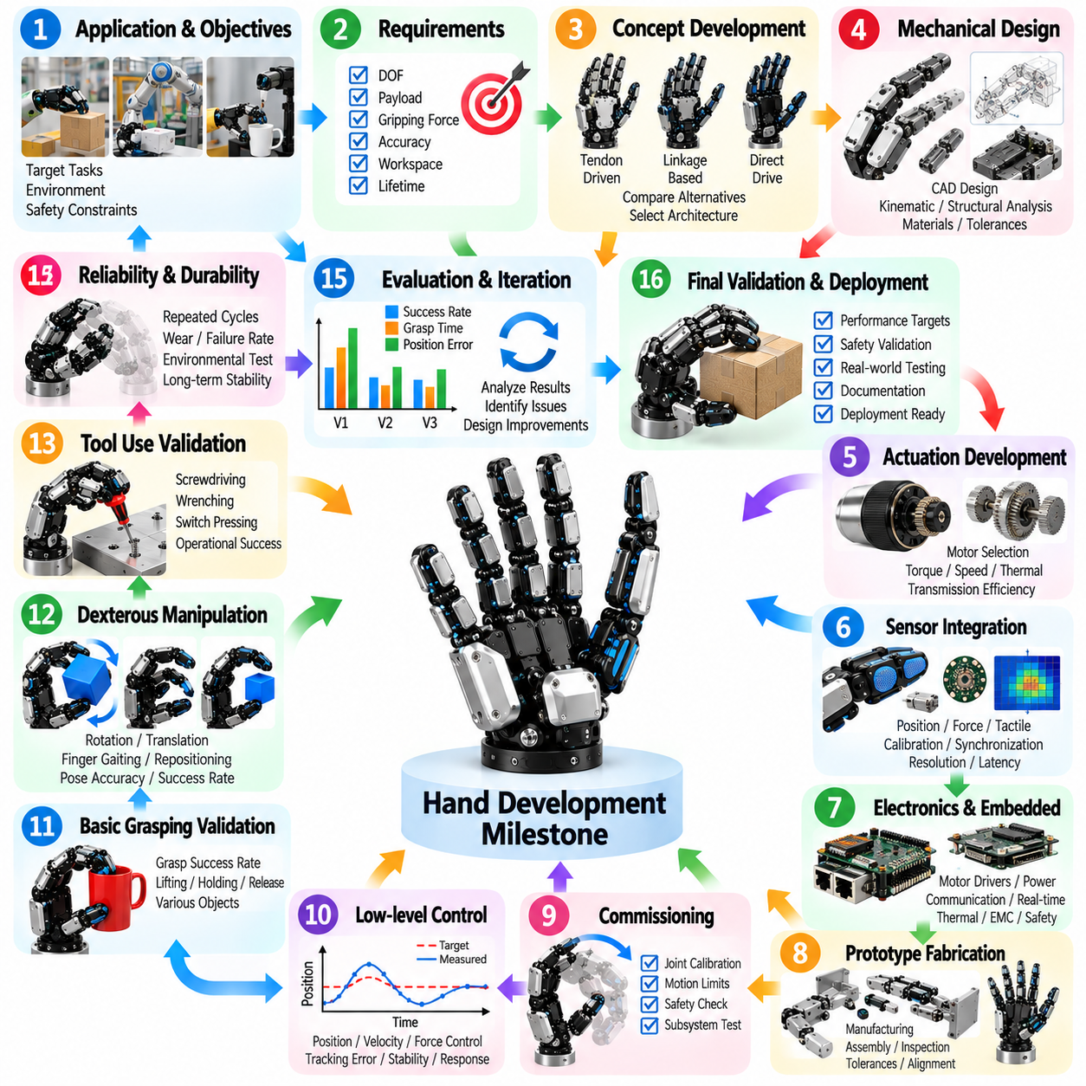
A hand development milestone template provides a structured framework for planning, monitoring, and validating the engineering progress of robotic hands and dexterous manipulation systems. It connects technical requirements, mechanical design, sensing, actuation, control, and experimental verification through measurable development stages. Each milestone should establish clear deliverables, acceptance criteria, dependencies, and documented evidence of completion.
Development planning begins with defining the intended application and overall system objectives. Industrial grasping, precision assembly, service robotics, and humanoid manipulation require different levels of dexterity, payload capacity, sensing, and reliability. Engineers should identify target objects, operating environments, manipulation tasks, and safety constraints. The milestone template should translate these requirements into measurable technical specifications.
The initial requirements milestone should establish the functional and performance boundaries of the robotic hand. Relevant specifications include finger count, degrees of freedom, workspace, gripping force, payload, positioning accuracy, and expected operating life. Engineers should distinguish mandatory requirements from desirable capabilities. The milestone should be completed only when requirements are reviewed, technically feasible, and traceable to application needs.
Concept development should compare alternative hand architectures before detailed engineering begins. Tendon-driven, linkage-based, direct-drive, and underactuated mechanisms offer different tradeoffs in complexity, force transmission, compliance, and maintenance. Engineers should evaluate mechanical feasibility, manufacturability, and expected control performance. The milestone should document the selected architecture and the rationale for rejecting alternatives.
Mechanical design milestones should verify the geometry, structural integrity, and motion capabilities of fingers, joints, palms, and transmission components. Computer-aided design models should define dimensions, tolerances, materials, assembly interfaces, and service access. Engineers should perform relevant kinematic and structural analyses. Completion requires reviewed drawings, documented design assumptions, and resolution of critical mechanical interference risks.
Actuation development should validate motor selection, transmission efficiency, torque capacity, speed, and thermal behavior. Engineers should examine actuator sizing against expected grasping forces and dynamic manipulation requirements. Gear backlash, tendon friction, compliance, and mechanical losses can affect control accuracy. The milestone should demonstrate that selected actuators satisfy representative load conditions without exceeding operating limits.
Sensor integration milestones should establish reliable measurement of joint positions, contact forces, tactile distributions, and relevant system states. Engineers should verify sensor placement, electrical interfaces, calibration procedures, and synchronization. Measurement resolution, drift, noise, and latency should be quantified. Completion requires evidence that sensor outputs remain sufficiently accurate under representative operating conditions.
Electronics and embedded system development should validate power distribution, motor drivers, communication interfaces, and real-time processing capabilities. Engineers should assess electrical protection, thermal management, wiring reliability, and electromagnetic compatibility where applicable. Firmware should support deterministic control and fault monitoring. The milestone should require verified subsystem communication and documented electrical safety checks.
Prototype fabrication should convert approved designs into an assembled robotic hand suitable for controlled testing. Engineers should inspect component tolerances, assembly alignment, tendon routing, joint friction, and mechanical clearances. Manufacturing deviations should be recorded rather than concealed through undocumented adjustments. The milestone should confirm that the prototype matches the approved configuration and is ready for commissioning.
Commissioning milestones should establish safe and repeatable operation of individual fingers and the complete hand. Engineers should verify joint calibration, motion limits, actuator direction, emergency stopping, and communication integrity. Initial movements should occur under controlled loads and conservative operating parameters. Completion requires documented functional checks and resolution of faults that could compromise subsequent experiments.
Low-level control development should demonstrate stable position, velocity, and force regulation where supported by the hardware. Engineers should tune controllers using repeatable reference trajectories and loading conditions. Tracking error, overshoot, oscillation, response time, and steady-state behavior should be measured. The milestone should establish validated control parameters and identify operating regions where performance remains insufficient.
Basic grasping validation should demonstrate that the robotic hand can acquire and retain representative objects. Engineers should evaluate contact establishment, gripping force, object lifting, and release behavior across predefined object categories. Success rates should be measured through repeated trials rather than isolated demonstrations. The milestone should define acceptable grasp reliability and document failure mechanisms requiring correction.
Dexterous manipulation development should extend basic grasping toward coordinated finger motion and controlled object repositioning. Tasks may include object rotation, translation, finger gaiting, and contact redistribution. Engineers should measure pose accuracy, manipulation time, contact stability, and recovery performance. Completion should depend on demonstrated task execution under standardized conditions rather than visual impressions of dexterity.
Perception and grasp planning milestones should integrate object detection, pose estimation, candidate grasp generation, and motion planning. Engineers should evaluate accuracy, computational latency, and robustness to occlusion or object variation. Planned grasps must be verified through physical execution. The milestone should establish traceability between perception outputs, selected grasp configurations, and measured task outcomes.
Learning-based capability development should introduce data-driven grasp prediction or manipulation policies when justified by application requirements. Engineers should define datasets, training procedures, evaluation partitions, and model versioning. Generalization should be tested using objects or conditions excluded from training. Completion requires evidence that learned methods provide measurable benefits over established baseline approaches.
System integration milestones should verify coordinated operation across mechanical, electrical, sensing, perception, planning, and control subsystems. Engineers should evaluate timing dependencies, communication reliability, and fault propagation. Integration testing should include representative manipulation sequences and recovery procedures. The milestone should confirm that subsystem interactions do not introduce unacceptable instability or performance degradation.
Reliability and durability milestones should assess performance under repeated cycles and extended operating periods. Joint wear, transmission degradation, actuator heating, sensor drift, and connector failures can reduce long-term effectiveness. Engineers should define representative duty cycles and maintenance inspection intervals. Completion should be supported by documented endurance results and identified service-life limitations.
Safety validation milestones should examine foreseeable hazards during grasping, manipulation, and interaction with surrounding equipment or people. Engineers should verify force limits, mechanical stops, fault responses, emergency stopping, and relevant protective functions. Safety-related validation should remain distinct from task success evaluation. Completion requires evidence that defined safety requirements are satisfied within the intended operating conditions.
Benchmarking milestones should establish reproducible performance comparisons against project targets and relevant reference systems. Metrics may include grasp success rate, payload, force accuracy, manipulation precision, cycle time, energy consumption, and reliability. Engineers should document test objects, environmental conditions, trial counts, and uncertainty. The milestone should identify performance gaps and determine whether corrective development is necessary.
Development reviews should connect technical progress with schedule, cost, resources, and project risks. Each milestone should identify responsible personnel, planned completion dates, dependencies, and required deliverables. Engineers should record deviations and corrective actions when acceptance criteria are not met. Advancement to the next stage should depend on documented evidence rather than completion dates alone.
Design iteration milestones should incorporate findings from testing, failure analysis, and operational feedback. Mechanical modifications, controller updates, sensor improvements, and software changes should be evaluated through controlled regression testing. Engineers should maintain configuration histories and assess the impact of modifications on previously validated functions. The milestone should prevent improvements in one capability from introducing unrecognized failures elsewhere.
Final system qualification should demonstrate that the integrated robotic hand satisfies the agreed functional, performance, reliability, and safety requirements. Engineers should execute representative end-to-end tasks under documented conditions and preserve supporting evidence. Remaining limitations, maintenance requirements, and deployment restrictions should be identified. Qualification should distinguish demonstrated capability from performance that remains experimental.
The completed milestone template should consolidate development objectives, technical specifications, responsible teams, schedules, dependencies, verification methods, acceptance criteria, and supporting records. Each milestone should have a defined status and traceable approval decision. Unresolved risks and future improvement priorities should remain visible. This structured approach supports accountable development and systematic maturation of robotic hand technology.

