Volume 22. Hills Robotics Engineering Standards

Chapter 06. HRS-006 Communication

06.01. Protocol Selection Matrix
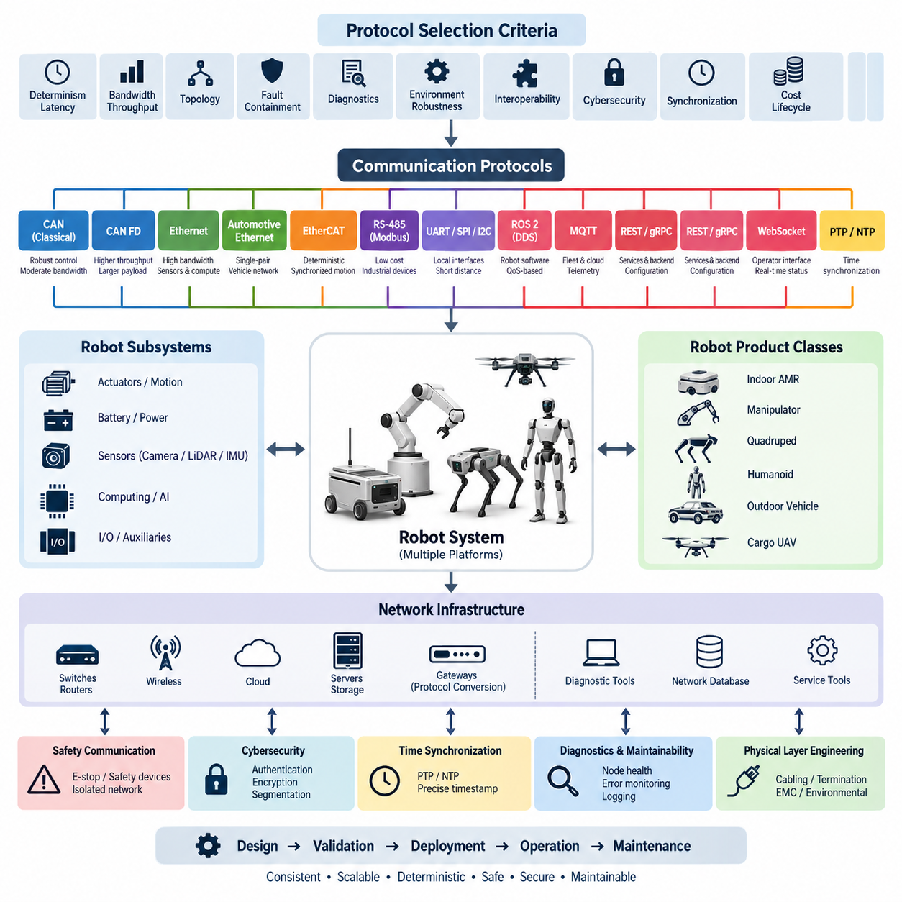
The protocol selection matrix defines the approved communication technologies and the engineering criteria used to assign them to robot subsystems. Protocol selection shall not be driven only by bandwidth or component availability. Designers shall evaluate determinism, latency, topology, fault containment, diagnostic capability, environmental robustness, interoperability, cybersecurity, synchronization, implementation cost, and lifecycle support for the intended product.
CAN shall be the preferred control network for distributed embedded devices requiring robust communication with moderate bandwidth. Typical applications include motor controllers, battery management systems, power distribution units, steering controllers, braking interfaces, actuator controllers, and intelligent I/O modules. Classical CAN is appropriate for compact command, status, and diagnostic traffic where its payload and data-rate limitations do not constrain system performance.
CAN FD shall be selected when a CAN-based architecture requires larger payloads or higher effective data throughput while retaining familiar arbitration and physical-layer characteristics. It is preferred for next-generation controllers that exchange richer diagnostics, configuration data, state information, and moderately sized control messages. Migration from Classical CAN to CAN FD shall consider compatibility of every node, transceiver, gateway, termination element, diagnostic tool, and network database.
Ethernet shall be used for high-bandwidth communication among computing platforms, perception sensors, gateways, storage devices, and network infrastructure. Cameras, 3D LiDARs, edge computers, GPU systems, and high-rate logging equipment are typical Ethernet endpoints. The selected Ethernet variant shall provide sufficient sustained throughput with engineering margin for protocol overhead, traffic bursts, future expansion, diagnostics, synchronization traffic, and simultaneous sensor operation.
Automotive Ethernet should be considered where single-pair cabling, reduced harness mass, automotive environmental robustness, and standardized vehicle networking are important. 100BASE-T1 or 1000BASE-T1 may be applied according to bandwidth requirements and component availability. Conventional 100BASE-TX, 1000BASE-T, or higher-rate Ethernet may remain appropriate inside protected computing compartments where commercial or industrial network equipment provides lifecycle, serviceability, and cost advantages.
EtherCAT shall be preferred for tightly synchronized distributed motion systems requiring deterministic cyclic communication and low jitter. Typical applications include manipulators, humanoid joints, quadruped actuators, servo drives, and coordinated multi-axis mechanisms. Its use shall be justified by control-cycle requirements rather than bandwidth alone. Network topology, distributed clock performance, cycle time, node count, fault behavior, and recovery characteristics shall be verified at the complete machine level.
RS-485 and Modbus RTU may be used for low-cost industrial devices, legacy equipment, instrumentation, chargers, environmental sensors, and auxiliary modules that do not require high bandwidth or hard real-time behavior. Their simplicity makes them suitable for slowly changing process values and configuration parameters. Designers shall nevertheless control addressing, baud rate, termination, biasing, cable length, grounding, timeout behavior, retry policy, and gateway ownership through the system specification.
UART, SPI, and I2C shall primarily remain local board-level or short-distance interfaces rather than vehicle-wide or robot-wide networks. UART may support debug ports and simple peripheral interfaces, while SPI is suitable for high-rate communication between closely coupled electronic devices. I2C is appropriate for low-speed sensors and configuration devices located within controlled electrical boundaries. External routing shall require explicit review of noise immunity, distance, grounding, and failure propagation.
ROS 2 communication shall normally operate above the underlying IP network and shall not replace the engineering definition of the physical and data-link architecture. DDS-based communication may be used among robot computers for perception, localization, planning, control coordination, and distributed software services. Quality-of-Service settings shall be defined according to message criticality, including reliability, durability, history depth, deadline, liveliness, and resource behavior rather than relying on defaults.
DDS shall be considered when scalable publish-subscribe communication, distributed discovery, configurable Quality of Service, and multi-computer software integration are required. It is particularly suitable for modular robotic systems in which producers and consumers evolve independently. Safety-critical or hard real-time functions shall not automatically be assigned to DDS merely because ROS 2 uses it; deterministic behavior, resource bounds, failure handling, middleware implementation, and platform qualification shall be assessed separately.
MQTT may be selected for fleet, cloud, telemetry, maintenance, and supervisory communication where asynchronous publish-subscribe messaging is advantageous. It shall not be the primary mechanism for time-critical actuator control. Topic hierarchy, retained-message policy, Quality of Service level, authentication, encryption, broker redundancy, reconnect behavior, offline buffering, and message expiration shall be defined so that loss or restoration of cloud connectivity cannot create unsafe robot behavior.
REST APIs and gRPC may be applied to configuration, fleet services, backend integration, data access, software management, and non-hard-real-time service interfaces. REST provides broad interoperability and straightforward resource-oriented integration, while gRPC can provide efficient typed interfaces and streaming between controlled software components. Neither technology shall be assumed suitable for deterministic motion control without separate timing analysis, bounded execution behavior, and an appropriate real-time transport architecture.
WebSocket may be used when persistent bidirectional communication is required between robot services, operator interfaces, dashboards, or remote supervisory applications. It is suitable for interactive status updates and commands that exceed the efficiency of repeated HTTP transactions but do not require deterministic fieldbus behavior. Command authorization, heartbeat mechanisms, reconnect handling, sequence management, stale-data rejection, rate limiting, and secure transport shall be explicitly specified for operational deployment.
Time synchronization requirements shall be evaluated independently from application protocol selection. Systems performing sensor fusion, multi-camera processing, LiDAR-camera alignment, distributed control, event reconstruction, or high-quality data logging may require PTP or equivalent synchronized timing. NTP may be sufficient for supervisory computers without precision requirements. Required timestamp accuracy, clock hierarchy, grandmaster behavior, hardware timestamp support, holdover, and failure detection shall be documented at architecture level.
Safety communication shall be separated logically or physically from ordinary application traffic whenever the safety concept requires independence, deterministic response, or certified communication mechanisms. Emergency stop, protective stop, safety LiDAR, drive disable, and related functions shall use architectures compatible with the required safety integrity. A standard CAN, Ethernet, ROS 2, MQTT, or software heartbeat connection shall not be treated as a safety network unless the complete implementation satisfies the applicable safety requirements.
Protocol selection shall also consider the robot product class. Indoor AMRs generally benefit from CAN or CAN FD for embedded control and Ethernet for perception and compute integration. Manipulators, quadrupeds, and humanoids may require EtherCAT or another deterministic servo network for coordinated motion. Outdoor autonomous vehicles require robust control networks combined with high-bandwidth sensor Ethernet, while cargo UAV communication shall additionally consider avionics determinism, redundancy, weight, certification, and fault-containment requirements.
Gateways shall be introduced only where different communication domains require controlled interoperability. A gateway may translate CAN, CAN FD, Ethernet, DDS, Modbus, or other approved interfaces, but it shall not become an undocumented dependency between critical functions. Gateway specifications shall define message mapping, update rates, buffering, timeout behavior, timestamp treatment, diagnostic propagation, startup sequence, overload response, cybersecurity boundaries, and behavior when either connected network becomes unavailable.
The matrix shall classify each interface using at least functional criticality, required bandwidth, maximum acceptable latency, jitter tolerance, synchronization accuracy, node count, topology, cable distance, environmental exposure, redundancy requirement, and serviceability. The resulting protocol assignment shall then be checked against hardware availability and software support. This approach prevents a convenient development interface from becoming a production architecture without evidence that it satisfies system-level requirements.
Bandwidth calculations shall use realistic worst-case traffic rather than nominal message rates. Engineering analysis shall include payload efficiency, frame overhead, retransmission, diagnostic sessions, discovery traffic, synchronization packets, logging, firmware update activity, and foreseeable expansion. Networks carrying perception data shall additionally consider simultaneous sensor streams and burst behavior. A utilization margin shall be retained so that normal operation remains stable when diagnostic or maintenance traffic is introduced.
Latency and determinism shall be evaluated according to the receiving function rather than the nominal speed of the network. A high-bandwidth Ethernet connection does not inherently provide deterministic control, while a lower-bandwidth fieldbus may provide predictable timing for small cyclic messages. The protocol decision shall therefore connect communication performance directly to control-loop periods, sensor deadlines, actuator response requirements, watchdog timing, state-machine transitions, and defined degraded operating modes.
Physical-layer engineering shall be included in every protocol decision. Cable type, characteristic impedance, shielding, termination, connector selection, bend radius, grounding, common-mode tolerance, isolation, electromagnetic compatibility, and maximum segment length shall match the deployment environment. Communication architecture cannot compensate for an unstable physical layer. Prototype validation shall therefore reproduce representative harness lengths, routing, motor switching noise, power transients, connector interfaces, and expected environmental conditions.
Cybersecurity shall be incorporated when the selected network can connect to external computers, wireless infrastructure, fleet systems, service tools, or cloud services. Interfaces shall follow the principle of minimum required exposure, with authentication, authorization, encryption, segmentation, secure configuration, and controlled diagnostic access applied according to risk. Network bridges between safety-related embedded domains and externally reachable Ethernet domains shall receive particular architectural review and protection.
Diagnostics and maintainability shall influence protocol selection from the beginning of development. The selected technology should support identification of nodes, communication faults, timeout conditions, error counters, software versions, configuration states, and network health using approved engineering tools. Service personnel shall be able to isolate failures without uncontrolled probing of production networks. Logging and diagnostic mechanisms shall preserve sufficient timestamps and context to reconstruct intermittent field communication failures.
Protocol choices shall be documented as controlled architecture decisions and linked to interface specifications, network databases, wiring drawings, software interface definitions, cybersecurity requirements, and validation plans. Changes to protocol type, bit rate, addressing, topology, QoS configuration, synchronization method, or gateway mapping shall undergo impact assessment before release. The review shall identify effects on hardware, harnesses, software, diagnostics, safety, EMC, production tests, service tools, and backward compatibility.
The protocol selection matrix is therefore a system-level decision mechanism rather than a simple comparison of communication speeds. Its purpose is to establish consistent communication boundaries across electrical hardware, embedded control, perception, computing, robotics middleware, fleet services, and external infrastructure. Applying the matrix consistently allows each interface to use the simplest technology that satisfies its requirements while preserving deterministic behavior, scalability, diagnosability, safety, security, and long-term product maintainability.

06.02. CAN DBC Standard
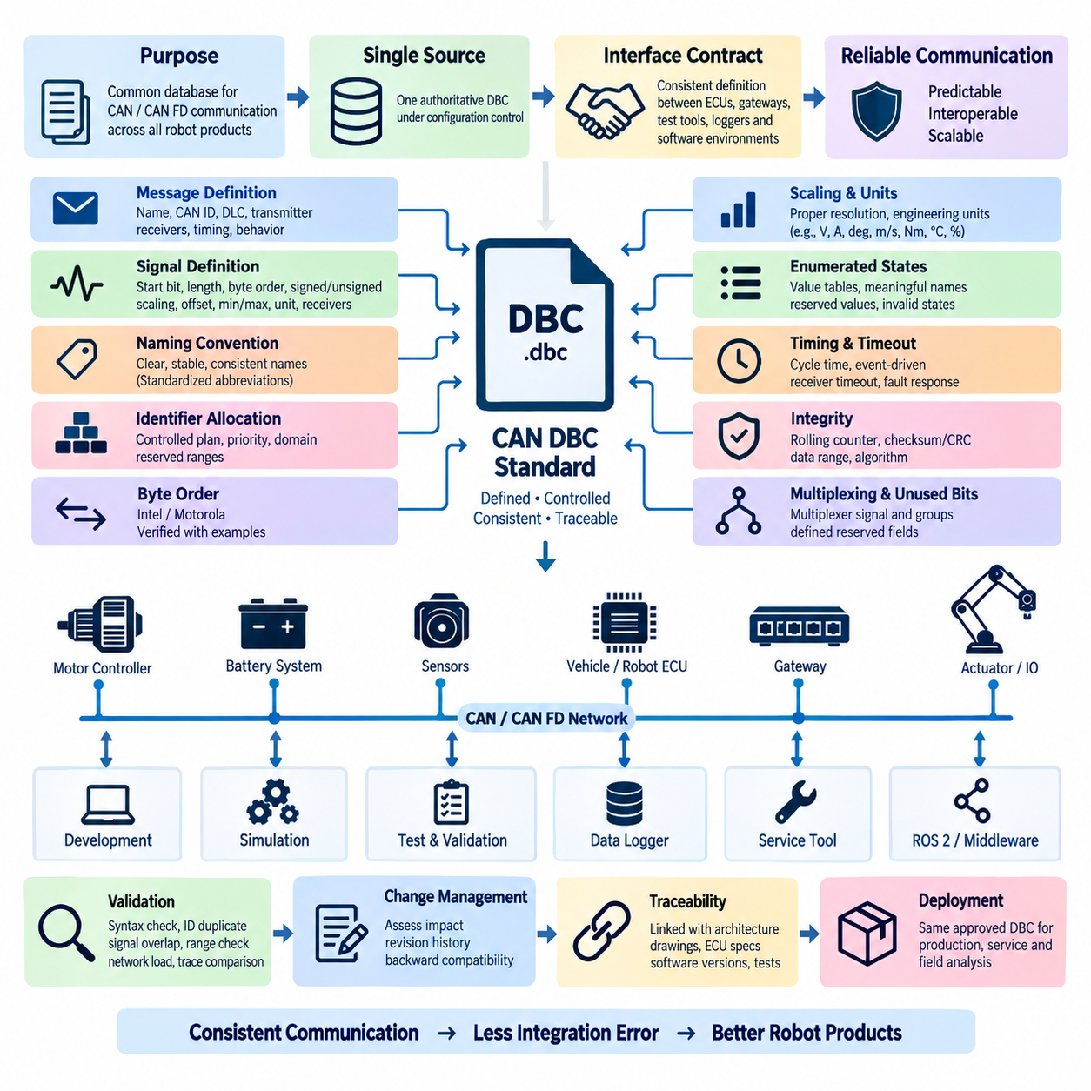
The CAN DBC standard defines the common database rules used to describe CAN and CAN FD communication across robotic products. A DBC file shall serve as the controlled machine-readable definition of messages, signals, transmitters, receivers, scaling, units, timing, and diagnostic attributes. It shall provide a consistent interface contract between embedded controllers, gateways, test systems, simulation tools, data loggers, and software development environments.
Every production CAN network shall have one authoritative DBC source under configuration control. Copies embedded in ECU projects, test scripts, logging applications, or supplier packages shall not become independent master versions. The released DBC shall be associated with a defined product, network channel, revision, and compatibility state so that engineers can determine exactly which communication definition applies to a specific hardware and software release.
DBC naming shall use clear, stable, and implementation-independent terminology. Message and signal names shall describe engineering meaning rather than temporary software variables, developer initials, or internal debugging terminology. Names should remain readable across embedded software, ROS 2 gateways, calibration tools, test systems, and service environments. Abbreviations shall be standardized, and identical concepts shall use identical terminology throughout the product family.
CAN identifiers shall be allocated through a controlled network design process rather than independently by individual ECU developers. The identifier plan shall consider message priority, arbitration behavior, functional domain, network load, future expansion, gateway routing, and diagnostic traffic. Standard and extended identifiers shall not be mixed without an architectural reason, and reserved identifier ranges shall be documented to prevent conflicts between internal modules and supplier devices.
Each DBC message shall define a unique message name, CAN identifier, payload length, transmitter, expected receivers, transmission behavior, and applicable timing information. For CAN FD, the payload length shall reflect the actual communication design rather than automatically selecting the maximum frame size. Message grouping shall minimize unnecessary bandwidth while avoiding excessive coupling between signals that require significantly different update rates, priorities, or fault responses.
Signal definitions shall include the start bit, bit length, byte order, signed or unsigned representation, scaling factor, offset, physical minimum, physical maximum, engineering unit, and receiver information where applicable. These attributes shall reflect the actual physical or logical meaning of the signal. Placeholder ranges or arbitrary scaling values shall not be retained in a released DBC when they could cause ambiguous decoding, overflow, saturation, or incorrect engineering interpretation.
Intel and Motorola byte order conventions shall be applied consistently and verified using known encoded examples. Particular attention shall be given to multi-byte signals because incorrect start-bit interpretation can produce values that appear plausible while being technically invalid. DBC implementation reviews shall therefore include representative raw frames and expected physical values for critical signals, especially steering, velocity, torque, battery, braking, actuator, and safety-related status information.
Scaling shall provide sufficient resolution over the required operating range without wasting payload capacity. Physical values shall be represented using engineering units appropriate to the function, such as volts, amperes, degrees, radians, meters per second, newton-meters, degrees Celsius, or percentages. Unit conventions shall remain consistent across products, and conversion between different unit systems should occur at defined software boundaries rather than through undocumented interpretation by receiving applications.
Enumerated states shall use value tables where discrete numeric values represent operating modes, commands, faults, or status conditions. State definitions shall include meaningful names and shall reserve values where future expansion or invalid-state detection is required. Boolean signals should use consistent conventions for active and inactive states. Undefined numeric values shall not silently map to valid operating states, particularly when the signal influences motion, power, safety, or supervisory control.
Periodic messages shall define a nominal cycle time appropriate to the dynamics of the transmitted information. Control and actuator status may require short periods, while temperature, configuration, or maintenance information can use slower rates. Event-driven and mixed transmission strategies may be used where justified. The DBC timing definition shall remain consistent with ECU implementation, network-load calculations, watchdog settings, gateway behavior, and communication validation criteria.
Receivers shall implement timeout supervision for messages whose absence can affect functional behavior. Timeout values shall be derived from the expected transmission period, communication jitter, startup behavior, and required fault-detection time rather than selected arbitrarily. The system specification shall define the response to missing messages, including data invalidation, fallback values, degraded operation, controlled stop, or diagnostic reporting according to the criticality of the affected function.
Rolling counters may be included in control or status messages when receivers must detect repeated, missing, or incorrectly sequenced frames. Counter width and rollover behavior shall be standardized for the network. Where end-to-end integrity protection is required, a checksum or CRC may also be defined. The protected data range, calculation sequence, initialization value, polynomial or algorithm, counter relationship, and treatment of unused bytes shall be documented so independent implementations produce identical results.
Invalid and unavailable values shall be explicitly defined where a signal can legitimately have no valid measurement or command. Reserved raw patterns may represent initialization, sensor failure, unavailable data, or not-configured conditions, provided these patterns cannot be confused with valid physical values. Receiving software shall distinguish communication loss from an explicitly transmitted invalid value because these conditions can require different diagnostics, fallback behavior, and system responses.
Multiplexed messages may be used when several logically related data sets share one CAN identifier and are not required simultaneously. Multiplexing shall not be used merely to avoid allocating identifiers if it complicates deterministic control, diagnostics, logging, or gateway processing. The multiplexer signal, valid values, associated signal groups, update behavior, and receiver expectations shall be completely represented in the DBC and verified by automated decoding tests.
Message ownership shall be unambiguous. Under normal operation, each CAN identifier shall have one defined transmitting function unless a specifically engineered redundant or multi-source architecture requires otherwise. ECU replacement, redundant controllers, bootloaders, and service tools shall not create simultaneous identifier ownership conflicts. If transmitter authority can change during operation, the arbitration mechanism and transition conditions shall be specified outside the DBC and referenced by the interface documentation.
The DBC shall support gateway engineering by preserving signal semantics across network domains. When a gateway forwards or transforms CAN information to CAN FD, Ethernet, DDS, ROS 2, or another interface, the mapping shall identify the source message, destination interface, scaling transformation, update policy, timeout handling, and timestamp behavior. Gateways shall not silently reinterpret signal meaning, substitute units, or change invalid-state semantics without a controlled interface requirement.
Diagnostic information transported through normal CAN messages shall follow the same naming, scaling, timing, and ownership rules as functional communication. Diagnostic Trouble Codes and UDS services may be managed through separate diagnostic specifications, but DBC status signals may expose summarized health states, fault flags, temperatures, voltage conditions, communication status, or subsystem availability. Duplication between diagnostic mechanisms shall be intentional and traceable rather than accidental.
Network management and startup behavior shall be considered when defining DBC timing. Receivers shall not assume that every transmitter becomes available immediately after power is applied. Boot time, initialization, calibration loading, bus synchronization, and application readiness can create legitimate delays. Communication monitoring shall therefore distinguish startup conditions from runtime communication faults, and messages that communicate operational readiness shall have clearly defined state semantics.
Unused payload bits shall have a defined treatment. Reserved fields should be initialized to a specified value and shall not carry undocumented development data in production releases. Future signal allocation shall preserve compatibility with existing receivers whenever practical. Developers shall not repurpose previously released bits, enumeration values, or identifiers without evaluating whether older ECUs, gateways, loggers, and service tools could interpret the new information incorrectly.
The DBC shall contain sufficient comments and attributes to allow an engineer unfamiliar with the originating ECU software to understand the interface. Descriptions should explain signal purpose, important validity conditions, relevant timing, and exceptional behavior without duplicating complete software requirements. Critical interpretation rules that cannot be represented directly by standard DBC syntax shall be maintained in controlled interface documentation linked to the same communication release.
DBC validation shall include syntax checking, duplicate identifier detection, signal overlap checking, payload-boundary verification, scaling and range checks, transmitter and receiver consistency, timing review, and network-load assessment. Automated tools should decode representative CAN traces using the candidate database and compare the results with expected engineering values. Critical messages shall additionally be checked against ECU source configuration or generated communication code before release.
Communication testing shall verify both nominal and abnormal behavior. Tests should include expected cyclic transmission, minimum and maximum signal values, enumerated states, counter rollover, checksum behavior, missing frames, delayed frames, corrupted data, bus-off recovery, ECU restart, and gateway interruption where applicable. The objective is not merely to prove that a DBC can decode traffic, but to demonstrate that the database accurately represents the behavior implemented by the complete network.
Changes to identifiers, signal positions, lengths, scaling, offsets, units, enumeration meanings, message periods, or integrity mechanisms shall be treated as interface changes. Compatibility impact shall be evaluated before approval. Additive changes using previously reserved resources may remain backward compatible, while reinterpretation of an existing signal can require coordinated software updates. Revision history shall identify the technical reason, affected products, responsible owner, validation status, and release baseline.
Released DBC files shall be linked to electrical architecture documents, ECU interface specifications, CAN network diagrams, software versions, test specifications, and gateway definitions. Production, validation, service, and field-analysis teams shall use the same approved baseline whenever possible. This traceability ensures that recorded CAN data can be interpreted correctly after deployment and prevents communication failures caused by mismatched databases across development and operational environments.
The CAN DBC standard therefore establishes a single semantic contract for CAN communication throughout the robotics engineering lifecycle. Consistent identifier allocation, signal encoding, timing, integrity protection, diagnostics, validation, and configuration control allow independently developed controllers to exchange information predictably. A disciplined DBC process reduces integration errors, supports automated testing and logging, simplifies gateway development, and preserves compatibility as AMR, manipulator, outdoor vehicle, quadruped, humanoid, and cargo UAV platforms evolve.

06.03. Ethernet Network Standard
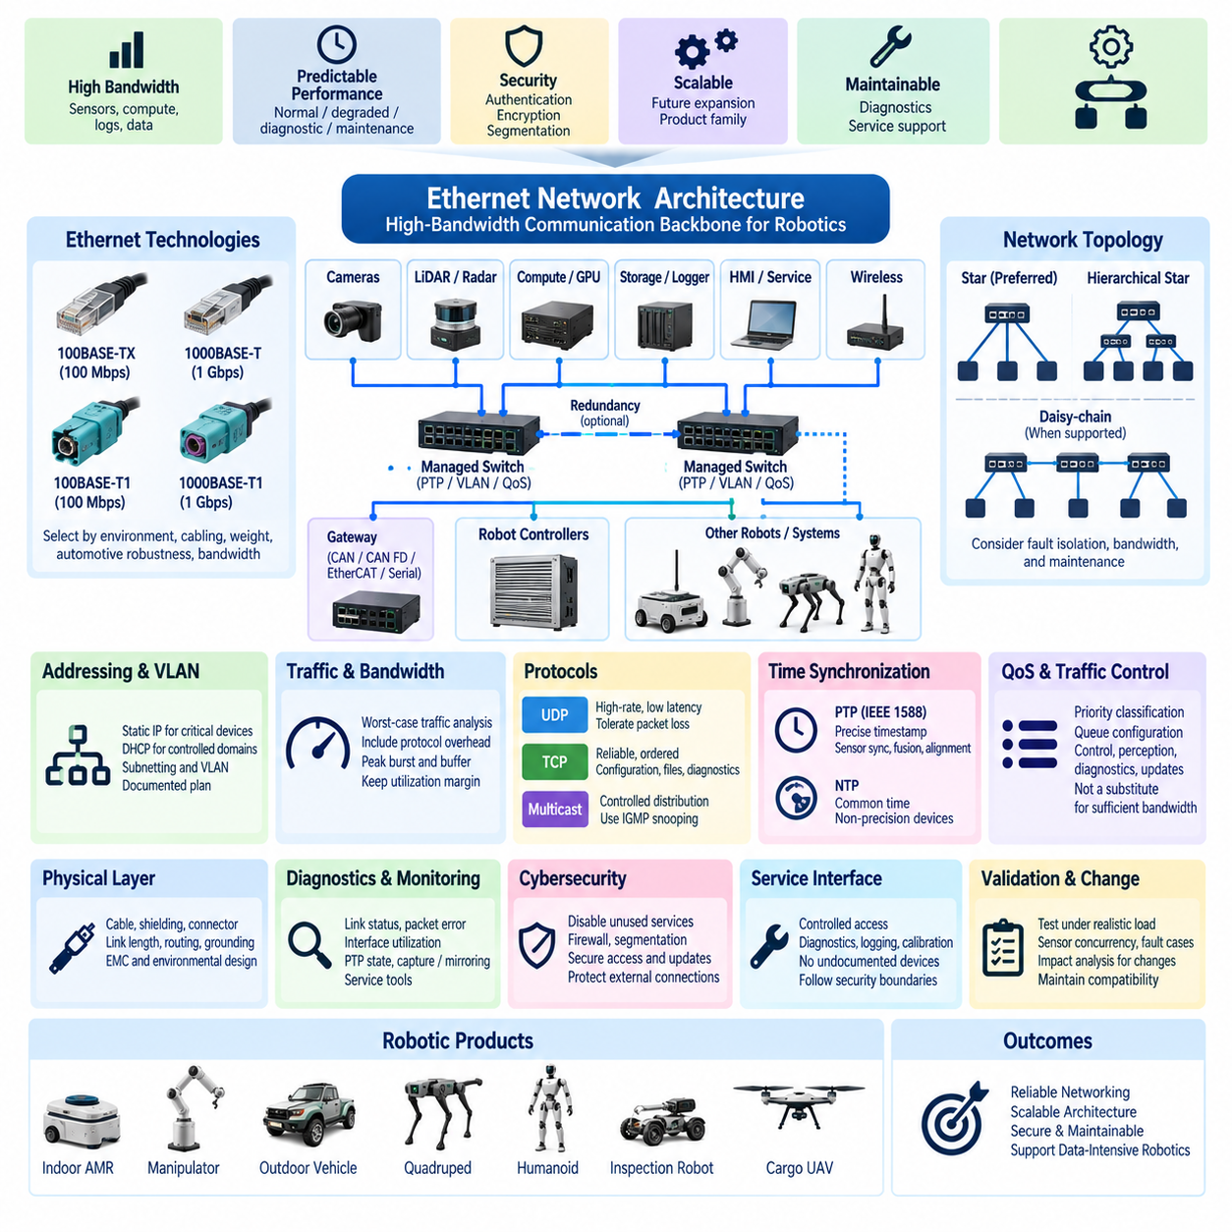
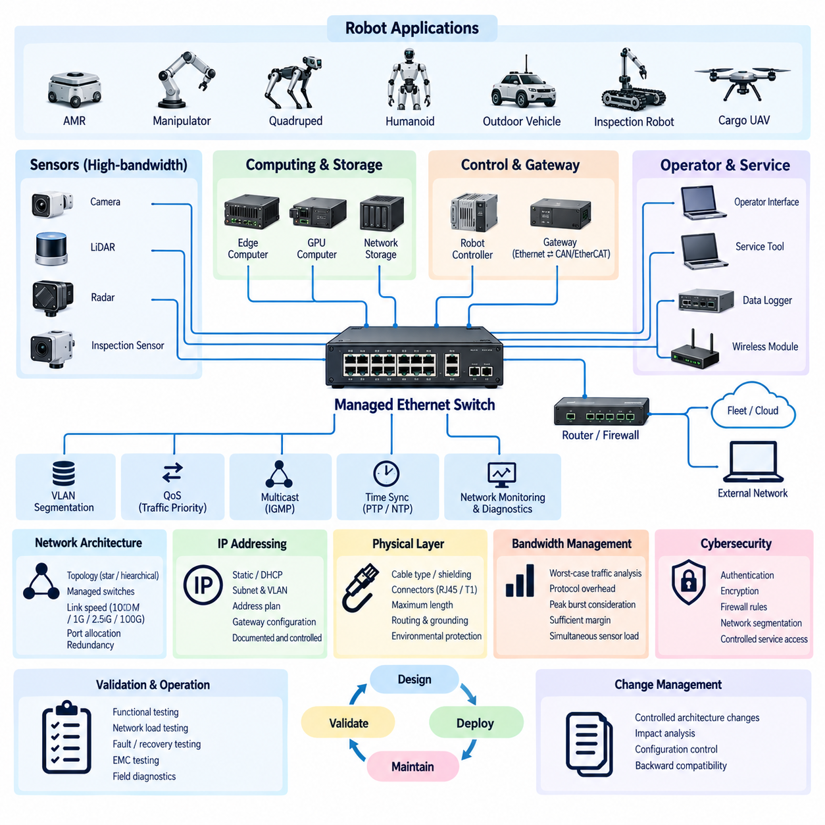
The Ethernet network standard defines the architecture, physical interfaces, addressing, switching, bandwidth management, timing, diagnostics, and cybersecurity rules for Ethernet communication across robotic products. Ethernet shall provide a controlled backbone for high-bandwidth sensors, edge computers, gateways, operator interfaces, data loggers, and service equipment while maintaining predictable performance under normal, degraded, diagnostic, and maintenance operating conditions.
Ethernet shall primarily be used where CAN, CAN FD, or other embedded control networks cannot efficiently support the required data volume. Typical endpoints include cameras, 2D and 3D LiDARs, radar interfaces, high-rate inspection sensors, Jetson or edge computing platforms, GPU computers, network storage, gateways, and wireless communication modules. Selection shall consider sustained traffic, peak traffic, latency, synchronization, environmental requirements, and future expansion rather than nominal link speed alone.
The approved physical Ethernet technology shall be selected according to installation environment and system architecture. 100BASE-TX and 1000BASE-T may be used inside protected computing or equipment compartments, while 100BASE-T1 or 1000BASE-T1 should be considered where single-pair cabling, reduced harness mass, automotive robustness, or vehicle-oriented connectors are required. Higher-rate Ethernet may be introduced for aggregated perception or logging traffic after bandwidth and thermal requirements are verified.
Every Ethernet network shall have a documented topology identifying switches, routers, gateways, computing nodes, sensors, wireless interfaces, service ports, and external connections. Star or hierarchical-star topologies are generally preferred because they simplify fault isolation, bandwidth analysis, and maintenance. Daisy-chain connections may be used when supported by the device architecture, but the effect of an intermediate device failure on downstream communication shall be evaluated before approval.
Managed Ethernet switches shall be preferred for production networks requiring traffic monitoring, VLAN segmentation, redundancy, diagnostics, multicast control, or time synchronization. Switch selection shall consider port count, link speed, forwarding capacity, packet buffer size, operating temperature, supply voltage, environmental rating, management interface, PTP capability, and lifecycle availability. Consumer-grade switches shall not be used in critical production architectures without explicit qualification for the intended environment.
IP addressing shall follow a controlled product-level allocation plan. Static addressing is preferred for deterministic embedded devices such as sensors, controllers, gateways, and compute platforms whose identity must remain stable across power cycles and service operations. DHCP may be used in controlled domains where dynamic assignment provides an operational advantage. Address ranges, subnet masks, gateways, reserved addresses, service interfaces, and externally routable networks shall be documented and configuration-controlled.
Subnetting and virtual LANs shall be used when separation improves performance, cybersecurity, fault containment, or maintainability. Perception sensors, robot control computers, service interfaces, fleet communication, and externally accessible networks should not automatically share one unrestricted broadcast domain. VLAN design shall define membership, tagged and untagged ports, routing boundaries, allowed inter-domain traffic, diagnostic access, and recovery procedures so that segmentation remains understandable during development and field service.
Bandwidth engineering shall use realistic worst-case traffic models rather than adding nominal sensor data rates. Analysis shall include Ethernet, IP, UDP or TCP overhead, multicast duplication, protocol discovery, retransmission, PTP traffic, diagnostics, logging, software updates, and simultaneous sensor operation. Peak bursts and switch buffering shall also be considered. Sufficient utilization margin shall remain so maintenance or diagnostic activity does not destabilize perception or control communication.
Camera and LiDAR networks shall receive particular bandwidth attention because several sensors can simultaneously produce sustained high-rate streams. Resolution, frame rate, pixel format, compression, packet size, LiDAR return mode, and sensor configuration directly affect network loading. Aggregated links from switches to perception computers shall therefore be sized for simultaneous worst-case operation rather than assuming sensors reach peak throughput at different times.
UDP may be used for high-rate sensor streams and latency-sensitive data where occasional packet loss can be detected or tolerated by the receiving application. TCP may be used where ordered and reliable delivery is more important than bounded latency, such as configuration, file transfer, diagnostics, or software management. Transport selection shall reflect application behavior, and receiving software shall explicitly handle packet loss, duplication, reordering, disconnection, and reconnection where relevant.
Multicast traffic shall be controlled to prevent unnecessary distribution across the entire robot network. Systems using DDS, discovery protocols, cameras, or other multicast-based services should use managed switching features such as IGMP snooping where appropriate. Multicast group behavior, expected subscribers, network boundaries, and startup traffic shall be considered during architecture validation because uncontrolled multicast can consume bandwidth and processing resources on devices that do not require the data.
Quality of Service mechanisms may be applied where mixed traffic classes share network infrastructure. Time-sensitive control, synchronization, perception streams, diagnostics, software updates, and background logging do not necessarily require equal forwarding priority. Priority classification and queue configuration shall be documented and validated under congestion. QoS shall not be used as a substitute for adequate bandwidth, because an undersized network remains vulnerable even when critical packets receive preferential treatment.
Time synchronization shall be engineered as part of the Ethernet architecture whenever distributed sensors or computers require correlated timestamps. IEEE 1588 Precision Time Protocol may be used for camera synchronization, LiDAR alignment, sensor fusion, inspection data, and distributed event reconstruction. The architecture shall define the grandmaster, boundary or transparent clock behavior where applicable, hardware timestamp support, synchronization accuracy, startup convergence, holdover, and response to loss of the master clock.
NTP may be used for devices that require common wall-clock time but do not need precision synchronization. PTP and NTP shall not be treated as interchangeable merely because both distribute time. Sensor fusion and multi-sensor calibration may require microsecond-level or otherwise tightly bounded timestamp relationships, whereas logs, maintenance records, or fleet events may tolerate substantially larger errors. Timing requirements shall therefore be allocated according to the consuming function.
Physical-layer design shall specify cable category, shielding, characteristic impedance, connector type, maximum link length, bend radius, routing, strain relief, and environmental protection. Ethernet cables shall be routed with appropriate separation from motor phase wiring, inverter outputs, high-current battery cables, and other major electromagnetic noise sources. Shield termination and grounding shall follow the approved grounding architecture to avoid degrading signal integrity or creating unintended ground-current paths.
Connectors shall match the environmental exposure of the installed location. Standard RJ45 connectors may be acceptable inside protected cabinets or compute enclosures, while industrial, automotive, or sealed connectors should be used where vibration, dust, moisture, repeated service, or outdoor exposure is expected. Connector and cable assemblies shall be evaluated as a complete channel because a high-performance cable cannot compensate for poorly terminated contacts, shielding discontinuity, or mechanically unstable interfaces.
Network startup behavior shall be defined so applications do not interpret normal link establishment as a system fault. Switch boot time, Ethernet auto-negotiation, sensor initialization, IP configuration, PTP synchronization, middleware discovery, and application readiness may occur at different times. Supervisory software shall distinguish initialization from runtime communication loss and shall apply appropriate startup grace periods before declaring network or endpoint failures.
Link supervision shall detect failures that affect required system functions. Managed switches, operating systems, and applications may provide link state, packet counters, dropped-frame statistics, interface errors, latency measurements, or heartbeat information. Critical receivers shall additionally supervise expected application data rather than relying only on physical link status, because an Ethernet link can remain electrically active while the remote application has stopped producing valid information.
Network diagnostics shall provide sufficient visibility to investigate intermittent field failures. Engineers should be able to determine port status, negotiated speed, packet errors, dropped packets, multicast behavior, PTP state, interface utilization, and endpoint connectivity using approved tools. Diagnostic capture ports or switch mirroring may be provided where appropriate. Production service procedures shall avoid uncontrolled network changes that could alter timing, routing, or cybersecurity behavior during troubleshooting.
Gateways between Ethernet and CAN, CAN FD, EtherCAT, serial networks, or wireless systems shall have controlled interface definitions. Gateway requirements shall specify source and destination data, transmission rates, buffering, timeout behavior, timestamp handling, invalid-data treatment, startup sequence, and overload response. Gateway latency shall be included in end-to-end timing analysis, particularly when Ethernet information contributes to motion commands, safety supervision, localization, or real-time perception functions.
Cybersecurity shall be integrated into Ethernet design because IP networks can expose significantly broader attack surfaces than isolated embedded buses. Unnecessary services and open ports shall be disabled. Authentication, authorization, encrypted communication, firewall rules, network segmentation, secure service access, and software update mechanisms shall be applied according to system risk. External wireless, fleet, cloud, and maintenance connections shall not receive unrestricted access to internal robot networks.
Service interfaces shall be explicitly defined rather than created informally during development. A service Ethernet port may provide diagnostics, logging, calibration, software deployment, or network capture, but its addressing, authentication, access permissions, and operational restrictions shall be controlled. Temporary development switches, unmanaged routers, or engineering laptops shall not become undocumented production dependencies, and field service connections shall not bypass established cybersecurity boundaries.
Ethernet validation shall reproduce representative system loading and environmental conditions. Testing shall include simultaneous sensor traffic, maximum expected bandwidth, multicast operation, PTP synchronization, endpoint restart, switch restart, cable disconnection, packet loss, congestion, gateway interruption, and recovery behavior. EMC testing shall be performed with representative harness routing and active motors or power electronics where practical, because communication robustness depends on both protocol configuration and physical installation.
Changes to topology, switch type, port allocation, IP address, VLAN configuration, link speed, QoS policy, multicast behavior, PTP hierarchy, cable type, or gateway routing shall be treated as controlled network architecture changes. Impact analysis shall consider software configuration, sensor operation, timing, bandwidth, cybersecurity, diagnostics, harness design, EMC, manufacturing tests, service procedures, and backward compatibility before the modified architecture is released.
The Ethernet network standard therefore establishes a scalable and maintainable high-bandwidth communication backbone for AMR, manipulator, outdoor vehicle, quadruped, humanoid, inspection robot, and cargo UAV platforms. By controlling physical interfaces, topology, addressing, switching, bandwidth, synchronization, diagnostics, gateways, and cybersecurity as one architecture, Ethernet can reliably support increasingly data-intensive perception and Physical AI systems without sacrificing integration discipline or lifecycle maintainability.

06.04. ROS2 Interface Standard
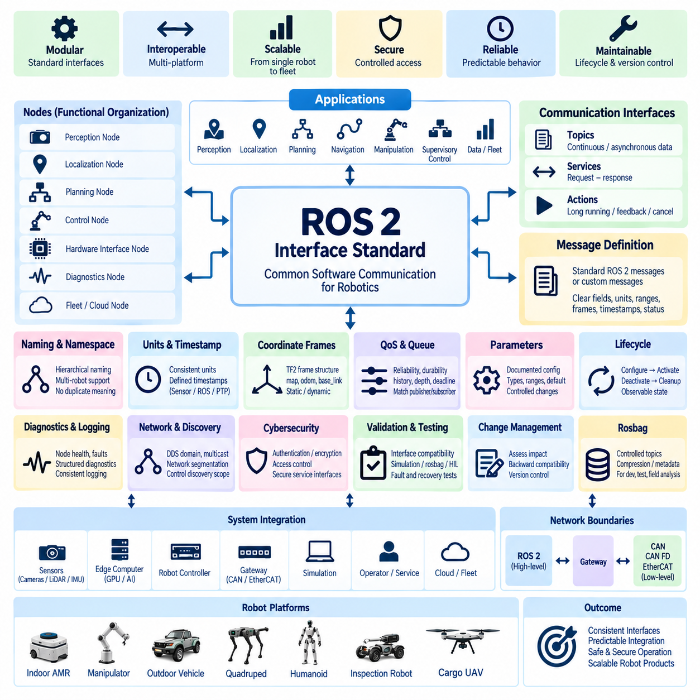
The ROS 2 interface standard defines the rules for communication among software components running on robot computers, edge processors, gateways, simulation environments, and external engineering systems. ROS 2 interfaces shall provide a stable software contract independent of individual node implementations. Interface design shall address topic structure, message semantics, Quality of Service, timing, coordinate frames, units, lifecycle behavior, diagnostics, compatibility, and cybersecurity.
ROS 2 shall primarily support distributed perception, localization, planning, navigation, sensor fusion, supervisory control, robot state management, and integration between computing platforms. It shall not automatically replace CAN, CAN FD, EtherCAT, or dedicated safety networks used for deterministic embedded control. The boundary between ROS 2 and lower-level networks shall be explicitly defined through controlled gateway or hardware-interface components.
Nodes shall be organized according to functional responsibility rather than arbitrary software package boundaries. A node should expose only the interfaces required by other components and shall avoid unnecessary coupling to internal implementation details. Perception, localization, motion planning, hardware abstraction, diagnostics, fleet communication, and system management should remain separable so that components can be developed, tested, replaced, or upgraded with limited impact on the complete robot.
Topic names shall follow a consistent hierarchical naming convention that identifies the robot, subsystem, function, and data purpose where appropriate. Names shall describe semantic meaning rather than developer-specific implementation. Duplicate names with different meanings shall not be permitted within the same operational domain. Namespace rules shall support multi-robot operation so that several AMRs, manipulators, quadrupeds, humanoids, or other platforms can operate without topic collisions.
Message definitions shall use standardized ROS 2 message types whenever they accurately represent the required information. Custom messages may be introduced when product-specific data cannot be represented without ambiguity. Custom interfaces shall use clear field names, documented units, valid ranges, coordinate-frame references, timestamps, and status information. Messages shall not contain undocumented fields whose interpretation depends on knowledge of a particular node implementation.
Engineering units shall be consistent across ROS 2 interfaces. SI units should be preferred for distance, velocity, acceleration, force, torque, time, and related physical quantities unless an approved interface requirement specifies otherwise. Unit conversion shall occur at controlled boundaries rather than being performed independently by multiple consuming nodes. Ambiguous fields such as speed, angle, temperature, or position shall not rely solely on naming conventions to imply their units.
Every sensor or state message requiring temporal correlation shall contain an appropriate timestamp. The timestamp shall represent the defined measurement or state event rather than simply the time at which a processing node publishes the message. Systems performing camera-LiDAR fusion, localization, mapping, inspection, or distributed perception shall maintain a documented relationship between sensor hardware time, operating-system time, ROS 2 time, PTP synchronization, and simulation time where applicable.
Coordinate frames shall follow a controlled TF2 frame architecture. Frame names, parent-child relationships, orientation conventions, and reference origins shall be defined at product level. Common frames such as map, odom, base_link, sensor frames, manipulator bases, and end-effectors shall have unambiguous meanings. Static transforms shall represent fixed mechanical relationships, while dynamic transforms shall be published only by the component responsible for the corresponding estimated or measured motion.
Topics shall be used for continuous or asynchronous data streams such as sensor measurements, robot states, transforms, diagnostics, and perception outputs. Services shall be reserved for bounded request-response interactions where the requester expects a direct result. Actions shall be preferred for operations that require measurable progress, cancellation, feedback, or potentially long execution times, such as navigation goals, docking, calibration procedures, manipulator tasks, or automated inspection sequences.
Quality of Service settings shall be explicitly selected according to interface requirements rather than left to middleware defaults. Reliability, durability, history, depth, deadline, lifespan, liveliness, and resource behavior shall be considered according to data criticality and update characteristics. High-rate sensor streams may tolerate best-effort delivery, while configuration or important state information may require reliable delivery. Publisher and subscriber QoS compatibility shall be verified during integration.
Queue depth shall be selected to balance data continuity against latency and memory consumption. Excessive queue depth can cause a consumer to process obsolete sensor or command information after a temporary slowdown, while insufficient depth may cause avoidable data loss. Interfaces related to motion or perception shall define whether the newest data has priority over complete historical delivery. Stale data shall be detected and rejected when using it could produce incorrect robot behavior.
ROS 2 command interfaces shall define ownership and authority. Multiple nodes shall not publish conflicting commands to the same actuator or motion-control interface unless an explicit arbitration architecture exists. Command sources such as autonomous navigation, teleoperation, docking, safety supervision, or service tools shall pass through a defined command-selection mechanism. Loss of the active command source shall result in a documented fallback, timeout, hold, or controlled-stop behavior.
Hardware interfaces shall isolate ROS 2 software from device-specific communication details. Drivers or gateway nodes may translate ROS 2 data to CAN, CAN FD, EtherCAT, serial protocols, or proprietary sensor interfaces, but the translation shall preserve units, timestamps, validity states, and error semantics. Hardware communication failures shall be represented through defined diagnostic or status interfaces rather than appearing only as console messages or undocumented exceptions.
Lifecycle-managed nodes should be used where controlled configuration, activation, deactivation, cleanup, and recovery are required. Complex robotic systems shall not depend solely on uncontrolled process startup order. Supervisory software should determine when sensors, localization, planning, hardware interfaces, and motion functions are ready before enabling autonomous operation. Lifecycle transitions and failures shall be observable so that startup and recovery behavior can be diagnosed consistently.
Parameter interfaces shall be used for controlled runtime configuration rather than as substitutes for well-defined message interfaces. Parameters shall have documented names, types, units, ranges, default values, and persistence requirements. Safety-sensitive or architecture-critical parameters shall not be changed without authorization and validation. Configuration files shall be version-controlled and linked to the applicable software release so that deployed robot behavior can be reproduced.
Diagnostics shall provide structured information about node health, communication status, sensor availability, timing, resource utilization, and subsystem faults. Critical failures shall not rely exclusively on human-readable log messages. Diagnostic information should identify the affected component, severity, current state, and relevant fault context. Logging shall use consistent severity levels and timestamps, while excessive repetitive logging shall be controlled to avoid consuming CPU, storage, or network resources.
ROS 2 discovery and DDS communication behavior shall be considered during network architecture design. Discovery traffic can increase significantly as node and robot counts grow, particularly in fleet or laboratory environments. DDS domains, namespaces, discovery configuration, multicast boundaries, and network segmentation shall therefore be planned together. Nodes that do not require mutual communication should not automatically participate in one unrestricted discovery domain.
Multi-robot systems shall provide explicit robot identity and namespace separation. Topics, services, actions, TF frames, diagnostics, and parameters shall remain distinguishable for each robot while allowing selected fleet-level interfaces to aggregate information. Robot-local control shall remain functional when fleet or cloud connectivity is unavailable unless the product requirements explicitly define otherwise. Fleet communication shall not create an undocumented dependency for basic safe robot operation.
Real-time requirements shall be identified separately from general ROS 2 communication. Functions requiring tightly bounded latency and jitter may require real-time operating-system configuration, deterministic executors, memory preallocation, appropriate DDS settings, or migration to a lower-level control network. A successful ROS 2 message exchange under nominal laboratory conditions shall not be considered evidence that an interface satisfies hard real-time control requirements.
Cybersecurity shall be incorporated where ROS 2 networks connect to wireless systems, service laptops, fleet servers, cloud infrastructure, or external applications. Unnecessary discovery exposure and network access shall be restricted. Authentication, encryption, access control, segmentation, secure configuration, and controlled service interfaces shall be applied according to system risk. Development convenience shall not justify unrestricted access to production ROS 2 communication domains.
Interface validation shall include publisher-subscriber compatibility, message field verification, unit and coordinate-frame checks, timestamp behavior, QoS compatibility, queue behavior, timeout handling, node restart, network interruption, and recovery. Tests shall also evaluate malformed or unavailable data where relevant. Simulation, recorded rosbag data, hardware-in-the-loop systems, and representative robot operation may be combined to verify interfaces before production release.
Rosbag recording shall use controlled topic sets appropriate to development, validation, and field diagnostics. Recording every available topic without bandwidth and storage analysis can affect system performance and produce unmanageable data volumes. Required topics, compression, storage duration, timestamp quality, metadata, software version, and robot identity should be defined so recorded datasets can later reproduce events and support reliable engineering analysis.
Changes to topic names, message structures, field meanings, units, QoS policies, frame definitions, service contracts, action definitions, or parameter semantics shall be treated as controlled interface changes. Compatibility with existing nodes, recorded datasets, simulation systems, fleet software, diagnostic tools, and gateways shall be assessed before release. Deprecated interfaces should remain available for a defined migration period when backward compatibility is required.
ROS 2 interface definitions shall be maintained together with software architecture, Ethernet network definitions, gateway specifications, coordinate-frame documentation, timing requirements, and validation plans. Interface packages shall have identifiable versions and release baselines. Automated build and integration pipelines should verify interface dependencies so incompatible message or service definitions cannot silently enter a production software configuration.
The ROS 2 interface standard therefore establishes a common software communication framework across AMR, manipulator, outdoor vehicle, quadruped, humanoid, inspection robot, and cargo UAV platforms. Consistent semantics, timing, QoS, coordinate frames, lifecycle management, diagnostics, network boundaries, and change control enable modular software components to interoperate predictably while preserving the separation between high-level robotics communication and deterministic embedded or safety-critical control.

06.05. Communication Security
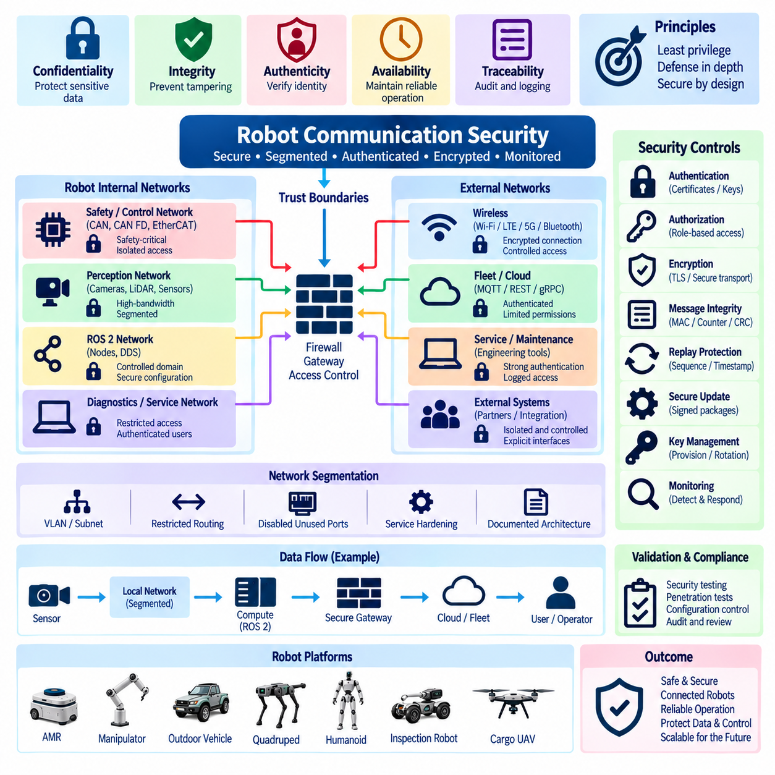
Communication security defines the controls required to protect data exchanged among robot controllers, sensors, computing platforms, gateways, service tools, fleet systems, and external infrastructure. Security shall preserve confidentiality, integrity, authenticity, availability, and traceability without compromising required control performance. Protection mechanisms shall be selected according to interface exposure, functional criticality, network architecture, and the consequences of unauthorized access or corrupted communication.
The communication architecture shall establish explicit trust boundaries between embedded control networks, high-bandwidth Ethernet domains, ROS 2 systems, wireless interfaces, service networks, fleet infrastructure, and cloud connections. Networks shall not be considered trusted merely because they are physically located inside the robot. Every transition between domains shall identify permitted communication paths, responsible gateways, security controls, and expected behavior when connectivity becomes unavailable.
Network segmentation shall be used to limit unnecessary communication and contain failures or attacks. Safety-related control, motion control, perception, diagnostics, service access, fleet communication, and external connectivity should be separated logically or physically according to system risk. VLANs, subnets, gateways, firewall rules, and dedicated interfaces may be combined to enforce these boundaries. Segmentation shall remain documented and reproducible across development, production, and service configurations.
The principle of least privilege shall apply to every communication endpoint. Controllers, computers, applications, users, and service tools shall receive only the network access and permissions necessary for their defined functions. A perception computer should not automatically obtain unrestricted access to actuator-control interfaces, and an external maintenance connection should not expose the complete internal network. Default configurations shall deny unnecessary communication rather than relying on operators to avoid unintended access.
Authentication shall be required where the identity of a device, application, service, or user must be trusted before communication is accepted. Authentication mechanisms may use certificates, cryptographic keys, credentials, or approved platform security functions according to the interface. Shared default passwords and permanently embedded universal credentials shall not be used in production. Device identity shall remain manageable throughout manufacturing, commissioning, maintenance, replacement, and decommissioning.
Authorization shall be applied after authentication to determine which operations an authenticated entity may perform. Read-only monitoring, calibration, software deployment, diagnostic control, configuration changes, motion commands, and administrative functions shall not automatically share identical permissions. Privileged operations shall require stronger access control where appropriate. Authorization rules shall be associated with defined roles or system functions so permissions remain understandable and auditable during the product lifecycle.
Encryption shall protect communication where interception could expose sensitive information, credentials, proprietary data, operational details, or control interfaces. TLS or equivalent approved secure transport mechanisms should be used for applicable Ethernet, fleet, cloud, web, API, and service connections. Encryption requirements shall consider computational load, latency, certificate management, hardware acceleration, and failure behavior. Security shall not be disabled in production merely to simplify integration or troubleshooting.
Message integrity shall protect important communication against unauthorized modification, corruption, replay, or substitution. Depending on the network and criticality, protection may include authenticated transport, message authentication codes, sequence counters, rolling counters, checksums, CRCs, freshness values, or end-to-end protection mechanisms. A checksum designed only for random transmission errors shall not be treated as cryptographic authentication against intentional manipulation.
Replay protection shall be considered for commands and state transitions whose repeated execution could affect robot behavior. Sequence numbers, freshness counters, timestamps, nonces, or authenticated session mechanisms may be used according to the protocol. Receivers shall distinguish valid retransmission from malicious or stale replay where necessary. Motion enable, configuration changes, remote commands, software update requests, and privileged diagnostic operations require particular attention to freshness and authorization.
CAN and CAN FD networks shall be protected according to their architectural limitations. Because conventional CAN does not inherently provide strong authentication or encryption, exposure shall be minimized through physical protection, gateway filtering, controlled diagnostic access, and separation from externally reachable networks. Critical CAN messages may additionally use counters, integrity fields, or higher-layer protection. External Ethernet or wireless interfaces shall never bridge unrestricted traffic directly into control buses.
Ethernet security shall use controlled addressing, segmentation, managed switching, firewalling, restricted routing, and service hardening. Unused switch ports and unnecessary network services should be disabled or restricted. Externally reachable interfaces shall not provide unrestricted Layer 2 or Layer 3 access to internal robot networks. Management interfaces for switches, routers, gateways, and computers shall require controlled credentials and shall not remain exposed through undocumented default configurations.
ROS 2 and DDS communication shall be restricted to the intended participants and network domains. DDS discovery shall not automatically expose all robot nodes to every reachable host. Domain configuration, namespace separation, network segmentation, multicast boundaries, and DDS security mechanisms should be applied according to deployment risk. Authentication, access control, and encryption shall be considered when ROS 2 communication extends beyond a physically controlled development environment.
Wireless interfaces such as Wi-Fi, LTE, 5G, Bluetooth, or other radio links shall be treated as externally exposed communication boundaries. Wireless access shall use approved authentication and encryption, and unnecessary radio services shall be disabled. Loss of wireless connectivity shall not create unsafe robot behavior. Remote fleet or cloud functions shall degrade predictably when communication is interrupted, and basic safety or local control shall not depend on continuous external connectivity unless explicitly required.
Fleet and cloud communication shall be isolated from time-critical robot control through defined interfaces. MQTT, REST, gRPC, WebSocket, VPN, or other remote communication mechanisms shall use authenticated and encrypted sessions where applicable. Remote systems shall receive only the information and command authority required by their role. Cloud connectivity shall not provide an undocumented route to embedded control networks, and remote commands shall pass through defined validation and arbitration mechanisms.
Service and diagnostic interfaces shall receive the same security consideration as normal operational interfaces. Engineering laptops, USB-to-network adapters, diagnostic applications, and maintenance ports can bypass architectural controls if left unmanaged. Service access shall therefore define authentication, authorization, allowed operations, session behavior, logging, and physical access expectations. Temporary development interfaces shall be removed, disabled, or formally controlled before production release.
Software update communication shall protect the authenticity and integrity of update packages. Robot controllers and computing platforms should verify approved digital signatures or equivalent trust mechanisms before installing executable software, firmware, configuration, or security-critical data. Update transfer channels shall be protected against unauthorized substitution or modification. Failed or interrupted updates shall result in a defined recovery state rather than leaving communication or control functions unpredictably configured.
Cryptographic keys, certificates, and credentials shall be managed as lifecycle assets rather than static development artifacts. Provisioning, storage, renewal, rotation, revocation, replacement, backup, and decommissioning shall be defined according to product requirements. Private keys shall not be stored in publicly accessible source repositories or ordinary configuration files. Hardware-backed secure storage should be considered where device identity or high-value credentials require stronger protection.
Secure startup and device identity should be coordinated with communication security. A correctly authenticated network connection has limited value if the communicating computer can boot unauthorized software. Platforms supporting secure boot, trusted execution, hardware security modules, or trusted platform modules may use these capabilities to establish confidence in software and credential integrity. The required level of protection shall reflect the criticality and external exposure of the robot platform.
Availability shall be treated as a communication security property. Security mechanisms shall consider denial-of-service conditions, broadcast storms, malformed traffic, excessive connection attempts, resource exhaustion, and overloaded gateways. Rate limiting, traffic filtering, queue management, network segmentation, watchdogs, and bounded resource allocation may be used to protect essential services. Security controls themselves shall not introduce a single failure that unnecessarily disables required local robot functions.
Logging and audit mechanisms shall record security-relevant events with sufficient context for investigation. Examples include authentication failures, privileged access, configuration changes, software updates, unexpected network connections, firewall violations, certificate errors, and repeated communication faults. Logs shall include reliable timestamps and device identity where practical. Security logging shall be sized and managed so that excessive events cannot exhaust storage or interfere with real-time robot operation.
Security monitoring shall distinguish normal communication failures from potentially abnormal behavior. Unexpected traffic rates, unknown devices, repeated rejected connections, unusual service requests, or changes in communication patterns may indicate configuration errors or security events. Monitoring functions shall support engineering diagnosis without automatically converting every network anomaly into a safety action. Escalation behavior shall reflect system criticality and the confidence of the detected condition.
Security requirements shall be integrated with functional safety rather than developed as an unrelated layer. A cybersecurity event can affect safety if it changes actuator commands, sensor information, system configuration, or availability of required functions. Conversely, aggressive security responses can create hazards if they unexpectedly remove control capability. The architecture shall therefore define safe behavior for authentication loss, communication isolation, gateway failure, credential errors, and rejected remote commands.
Communication security validation shall include both normal and abnormal operating conditions. Testing should verify authentication, authorization, encryption, segmentation, firewall rules, service restrictions, certificate handling, invalid credentials, unauthorized access attempts, replay handling, malformed traffic, connection loss, endpoint restart, and recovery. Security testing shall also confirm that protection mechanisms do not violate required latency, bandwidth, startup time, synchronization, or deterministic control behavior.
Configuration control shall apply to firewall policies, certificates, access-control rules, VLANs, network addresses, enabled services, DDS security settings, remote endpoints, and diagnostic permissions. Changes shall undergo impact assessment before release because apparently minor communication changes can alter both cybersecurity and functional behavior. Production security configuration shall be linked to software, network architecture, gateway, service, and validation baselines.
The communication security standard therefore establishes defense in depth across embedded buses, Ethernet, ROS 2, wireless communication, service interfaces, fleet systems, and cloud connections. Authentication, authorization, encryption, integrity protection, segmentation, secure updates, credential management, monitoring, validation, and controlled lifecycle processes shall operate together. This approach allows robotic platforms to remain connected and serviceable while preserving predictable operation, safety, data integrity, and resistance to unauthorized communication.

