Volume 22. Hills Robotics Engineering Standards

Chapter 07. HRS-007 Calibration

07.01. Calibration Procedure Standard
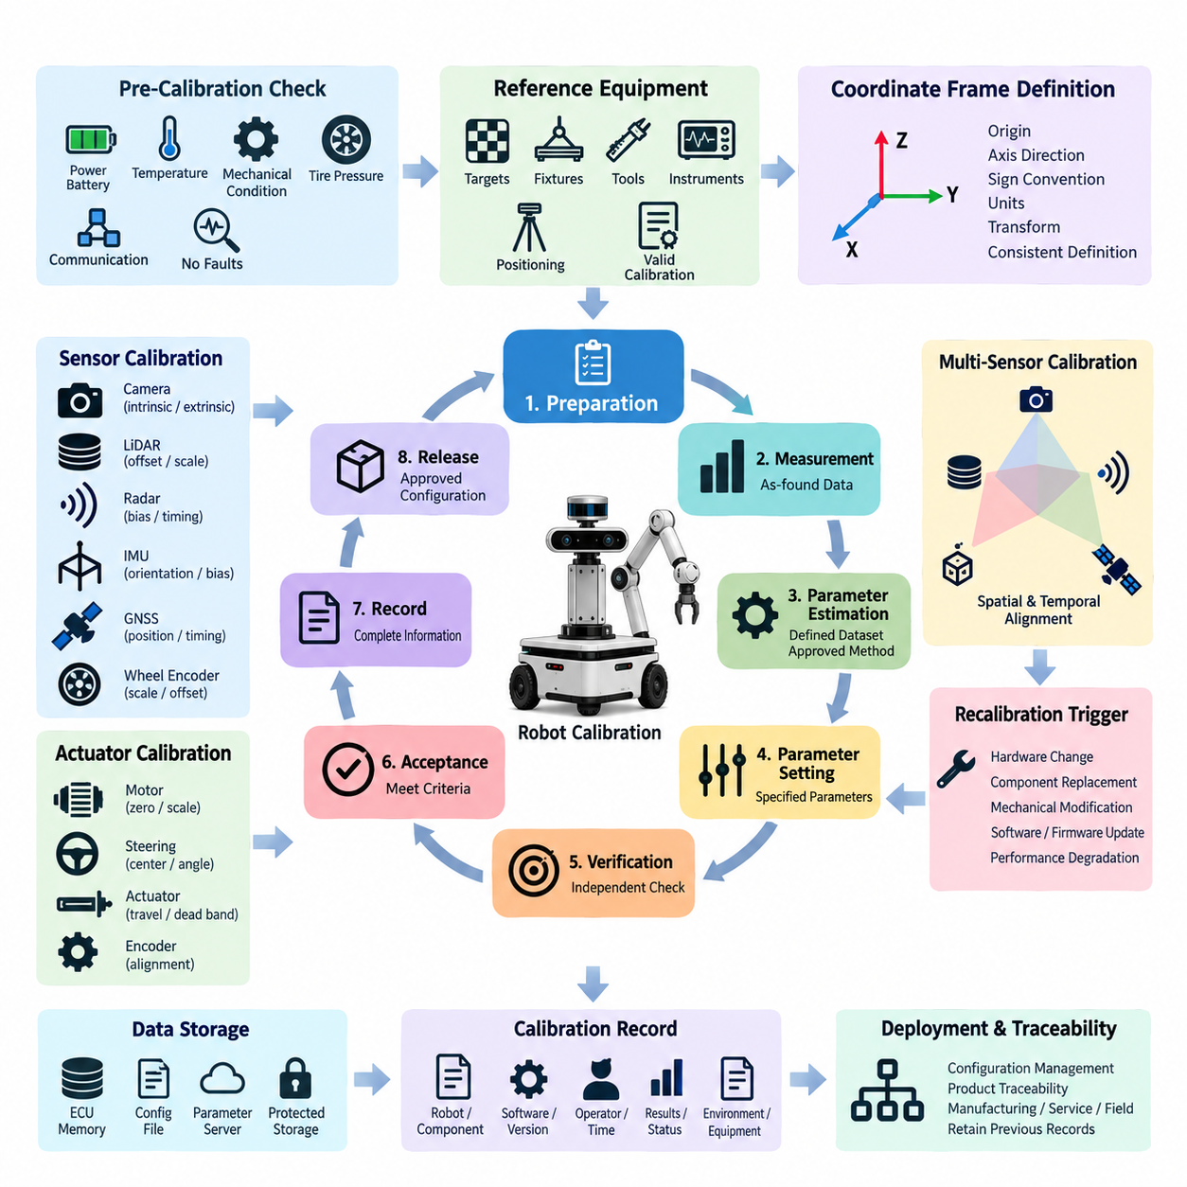
Calibration shall be performed through a controlled procedure that establishes traceable relationships between sensor outputs, actuator responses, physical reference quantities, and the coordinate frames used by the robot. The procedure shall define preparation, reference setup, measurement, parameter estimation, verification, approval, and recording so that calibration results are repeatable across production, service, and field operations.
Before calibration begins, the robot shall be placed in a known and stable configuration appropriate to the subsystem being calibrated. Power supply, battery state, temperature, mechanical loading, tire pressure, mounting condition, and communication status shall be checked when they can influence the result. Sensors and actuators shall complete their specified warm-up period, and no calibration shall proceed while active diagnostic faults could invalidate measurements.
All reference equipment used during calibration shall have accuracy and resolution appropriate to the required robot performance. Reference targets, measurement fixtures, alignment tools, torque tools, electrical instruments, positioning systems, and calibration software shall be identified before use. Where traceability is required, the reference equipment shall have a valid calibration status and shall not be used beyond its approved calibration or verification interval.
The calibration procedure shall identify the coordinate frames, reference origins, axis directions, sign conventions, units, and transformation relationships applicable to the subsystem. Mechanical drawings and software configuration shall use consistent definitions so that calibration parameters cannot be interpreted differently by manufacturing, software, validation, or service teams. Frame identifiers shall remain controlled configuration items throughout the product lifecycle.
Initial measurements shall be collected before new calibration parameters are applied whenever practical. These measurements establish the as-found condition and provide evidence of drift, assembly error, replacement effects, or mechanical damage. Raw measurement data shall be preserved when required for engineering analysis. The procedure shall distinguish raw observations, calculated parameters, filtered values, compensation terms, and final parameters written to the robot.
Calibration algorithms shall use a defined dataset and an approved estimation method suitable for the parameter being determined. The number of samples, operating range, target positions, robot poses, excitation conditions, and data rejection criteria shall be sufficient to avoid a solution based on an unrepresentative operating point. Automated routines shall detect incomplete datasets, numerical instability, excessive residual error, and physically unreasonable parameter values.
Sensor calibration may include offset, scale, bias, orientation, intrinsic, extrinsic, timing, or environmental compensation parameters according to sensor type. Actuator calibration may include zero position, mechanical center, steering angle, current or torque relationship, travel limits, dead band, encoder alignment, and commanded-to-actual response. Only parameters explicitly defined by the applicable subsystem specification shall be modified during an approved calibration operation.
For multi-sensor systems, calibration shall preserve a common spatial and temporal reference across cameras, LiDARs, radars, IMUs, GNSS receivers, wheel encoders, and other perception or localization devices. Extrinsic transformations shall correspond to the installed mechanical configuration, while timing parameters shall correspond to the implemented synchronization architecture. A geometrically correct solution shall not be accepted if timestamp or synchronization errors make fused observations inconsistent.
Calibration parameters shall be stored in controlled locations with protection against unintended modification. The implementation may use ECU nonvolatile memory, sensor memory, configuration files, parameter servers, or other approved storage, but each parameter set shall be associated with the applicable hardware and software configuration. Parameter names, units, data types, ranges, default values, and version identifiers shall remain consistent with the released interface definition.
Verification shall be independent from the parameter estimation step whenever feasible. The calibrated system shall be evaluated using reference positions, trajectories, targets, or operating conditions that were not solely used to derive the calibration solution. Verification shall assess the performance quantity relevant to the robot function, such as positioning error, angular error, reprojection error, point-cloud alignment, steering accuracy, bias stability, or actuator tracking performance.
Acceptance criteria shall be defined before execution and shall be expressed using measurable limits. A calibration result shall be accepted only when required residuals, repeatability, consistency, and subsystem performance remain within the approved specification. Software reporting a successful optimization shall not by itself constitute acceptance. Engineering limits shall determine whether the physical system is suitable for release, operation, or subsequent validation.
If calibration fails, the operator shall not repeatedly overwrite parameters until an acceptable numerical result appears. The failure shall be investigated for incorrect setup, loose mounting, damaged hardware, unsuitable targets, environmental interference, communication faults, synchronization errors, incorrect software configuration, or degraded reference equipment. Recalibration shall begin only after the identified cause has been corrected or an authorized disposition has been issued.
Changes affecting sensor position, actuator geometry, mounting brackets, wheels, steering components, suspension, compute hardware, synchronization, firmware, calibration algorithms, or coordinate-frame definitions shall be evaluated for calibration impact. Replacement of a calibrated component shall not automatically inherit the previous parameter set unless interchangeability has been demonstrated. The applicable recalibration trigger rule shall determine the required calibration scope.
Production calibration shall be designed for repeatability, controlled cycle time, operator guidance, and automated detection of incorrect setup. Service calibration shall provide equivalent technical validity while accounting for field tools and replacement procedures. Engineering calibration may permit additional diagnostics and experimental parameters, but experimental results shall not be released to production robots until the method, limits, software, and configuration have completed the required approval process.
Every completed calibration shall generate sufficient information to reconstruct what was calibrated, how it was calibrated, and whether it passed. Records shall identify the robot or subsystem, relevant component identifiers, software and calibration versions, procedure revision, reference equipment, operator or automated station, execution time, environmental conditions when relevant, measured results, acceptance status, and approved parameter set.
Calibration data shall support configuration management and product traceability throughout manufacturing, integration, validation, deployment, maintenance, and incident investigation. The released parameter set shall correspond to the physical configuration installed on the robot. When a parameter set is replaced, previous approved values and associated records shall remain recoverable according to the applicable retention and change-control requirements.
The calibration process shall conclude with controlled release rather than parameter generation alone. Successful verification, record completion, parameter storage, configuration consistency, and required approval shall be confirmed before the robot is declared calibrated. This approach ensures that calibration functions as an engineering quality process connecting mechanical assembly, electrical hardware, sensing, control software, perception, localization, and system-level robot performance.

07.02. Sensor Calibration Spec
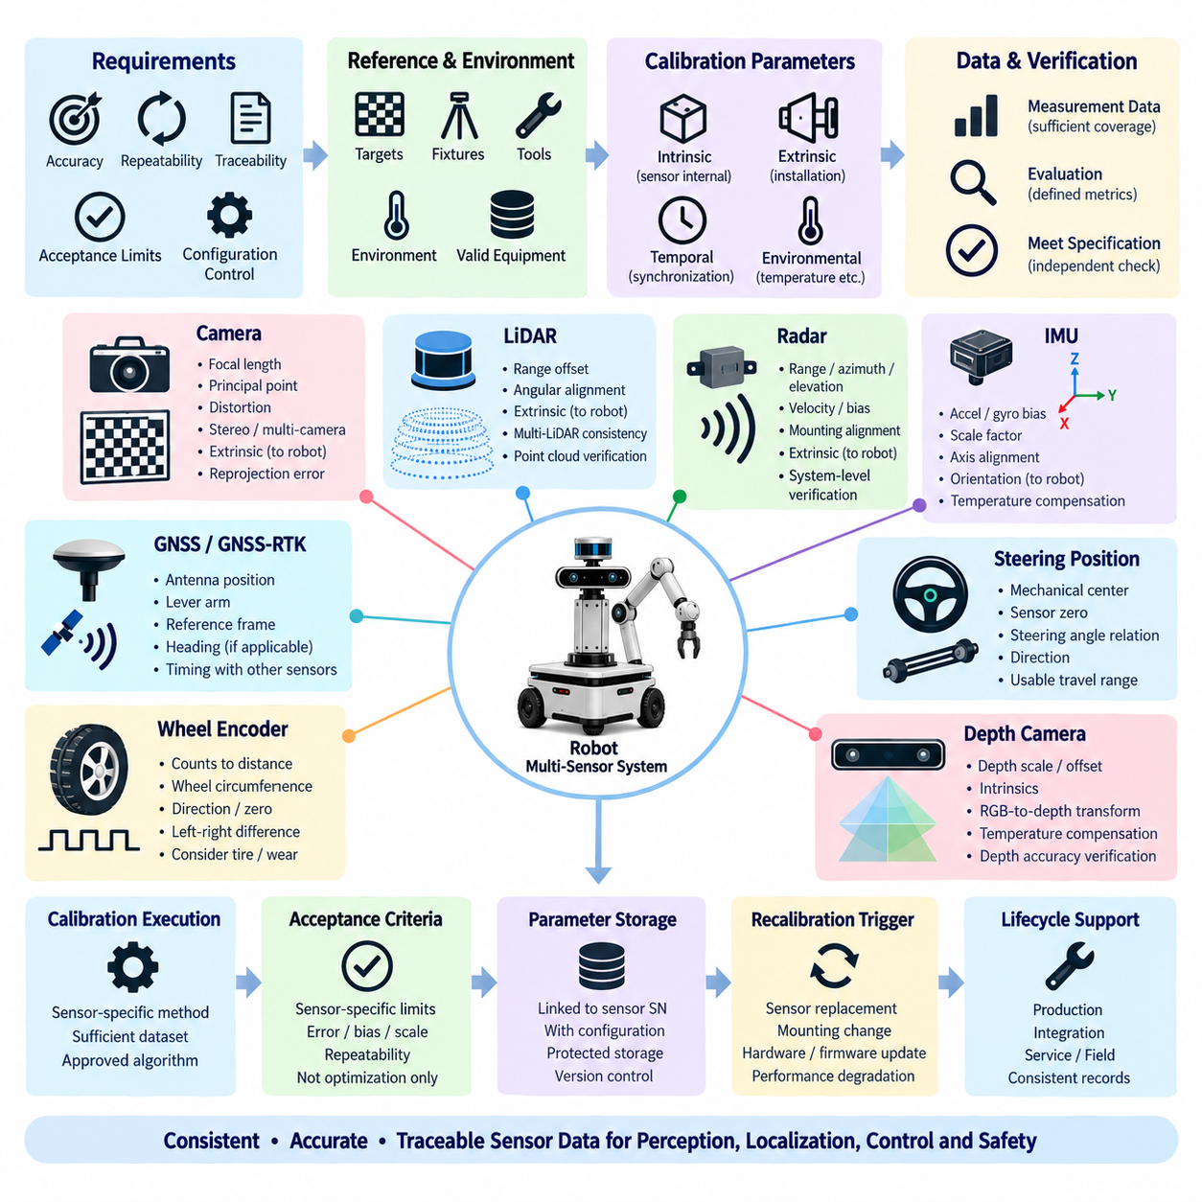
The sensor calibration specification shall define the technical requirements used to establish accurate, repeatable, and traceable sensor outputs across robotics products. It shall apply to sensors supporting perception, localization, navigation, motion control, safety, and monitoring functions, and shall define the parameters, reference conditions, acceptance limits, verification methods, and configuration controls required for each sensor class.
Each sensor shall be calibrated according to its measurement principle, installation geometry, interface characteristics, and functional role within the robot. Calibration requirements shall distinguish parameters inherent to the sensor from parameters created by installation on the platform. Intrinsic characteristics, mounting relationships, timing behavior, environmental compensation, and system-level transformations shall therefore be controlled as separate but related calibration elements.
Camera calibration shall define intrinsic parameters including focal length, principal point, pixel geometry, and applicable lens distortion coefficients. Stereo or multi-camera configurations shall additionally define relative rotation, translation, baseline, and synchronization requirements. Calibration shall use approved targets and image datasets covering sufficient portions of the field of view, distance range, and orientation range to prevent poorly constrained solutions.
Camera extrinsic calibration shall establish the transformation between the camera coordinate frame and the designated robot, body, sensor, or reference frame. The calibration process shall account for actual mounting position and orientation rather than nominal CAD geometry alone. Reprojection error and independent geometric observations shall be evaluated against specified acceptance limits before the resulting transformation is released for perception or sensor-fusion functions.
LiDAR calibration shall address range offset, angular alignment, coordinate-frame orientation, and installation-dependent extrinsic parameters as applicable to the device. Multi-LiDAR configurations shall establish consistent transformations between individual sensors and the common robot reference frame. Verification shall evaluate geometric alignment using known surfaces, targets, structures, or overlapping point clouds over representative distances and viewing directions.
Radar calibration shall define applicable range, azimuth, elevation, velocity, bias, and mounting-alignment parameters according to the radar technology and intended function. Calibration targets and test geometry shall provide sufficient observability of the required parameters. When radar information is fused with cameras, LiDAR, or vehicle motion data, the spatial transformation and timestamp relationship shall be verified at system level rather than considering radar accuracy independently.
IMU calibration shall address accelerometer and gyroscope bias, scale factor, axis alignment, orientation, and other compensation parameters required by the selected device. Stationary measurements and controlled motion may be used to characterize zero-rate and gravitational references. Where temperature materially affects sensor performance, the approved calibration dataset or manufacturer compensation model shall cover the operating conditions required by the robot specification.
The installed IMU coordinate frame shall be related explicitly to the robot body frame or other designated navigation frame. Axis direction and sign conventions shall be verified physically and through software measurements because incorrect frame interpretation can produce apparently valid numerical data while corrupting localization and control. Orientation calibration shall therefore be verified using known robot attitudes or controlled motion after parameter estimation.
GNSS and GNSS-RTK calibration shall define antenna position, lever-arm relationship, reference-frame convention, heading configuration where applicable, and timing relationship with other navigation sensors. Antenna coordinates shall represent the actual installed configuration and shall be updated when antenna brackets or platform geometry change. Validation shall compare position and heading behavior with appropriate references under conditions suitable for the required localization performance.
Wheel encoder calibration shall establish the relationship between encoder counts and physical wheel motion. Parameters may include effective wheel circumference, pulse or count scale, direction convention, zero reference, and left-to-right differences where relevant. Calibration shall consider the installed tire or wheel condition because dimensional variation, pressure, wear, mechanical transmission ratio, and assembly tolerances can influence the effective odometry scale.
Steering-related position sensors shall be calibrated to establish mechanical center, sensor zero, steering-angle relationship, direction, and usable travel range. The calibrated value shall correspond to the actual steering geometry rather than an electrical midpoint alone. Verification shall compare commanded, measured, and physical steering states at multiple positions so that offset, nonlinear behavior, incorrect direction, or mechanical asymmetry can be detected.
Depth cameras and other active ranging sensors shall be calibrated according to their imaging and distance-measurement principles. Requirements may include camera intrinsics, depth scale, depth offset, RGB-to-depth transformation, and applicable temperature or distance compensation. Verification shall use reference objects or surfaces at representative ranges and field positions to confirm that both geometric alignment and measured depth satisfy the intended perception accuracy.
Multi-sensor extrinsic calibration shall establish a consistent spatial relationship among cameras, LiDARs, radars, IMUs, GNSS antennas, encoders, and other sensors participating in perception or localization. Transformations shall use approved parent and child frame definitions and shall be stored with explicit units and conventions. Calibration shall provide sufficient geometric constraints to estimate translation and rotation without relying on ambiguous or degenerate observations.
Temporal calibration shall be required when sensor-fusion performance depends materially on measurement timing. The specification shall distinguish sensor acquisition time, hardware timestamp, communication latency, software reception time, and synchronized system time where applicable. Sensors using PTP, hardware triggering, GNSS time, or other synchronization mechanisms shall be verified against the implemented timing architecture under representative operating conditions.
Calibration acceptance criteria shall be sensor-specific and measurable. Appropriate metrics may include reprojection error, range error, angular error, bias magnitude, scale error, point-cloud registration error, position error, heading error, timing offset, repeatability, or other quantities directly associated with functional performance. Passing an optimization routine shall not replace verification against engineering limits defined for the sensor and robot application.
Calibration parameters shall be associated with the specific sensor, mounting configuration, robot configuration, software release, and applicable procedure revision. Parameters shall be stored in an approved configuration location and protected against uncontrolled modification. Sensor serial number or equivalent identification should be retained where required to prevent calibration data from being unintentionally transferred between components whose individual characteristics are not interchangeable.
Sensor replacement, bracket movement, mechanical impact, structural repair, firmware changes affecting measurement behavior, synchronization changes, or detected performance degradation shall be evaluated as potential recalibration triggers. Recalibration scope may be limited to the affected sensor relationship when technical independence has been demonstrated; otherwise, dependent multi-sensor transformations and system-level localization or perception performance shall also be verified.
The sensor calibration specification shall support production, integration, service, and field maintenance through consistent methods and records. A sensor shall be considered calibrated only when required parameters have been estimated, independently verified against the applicable limits, stored under configuration control, and linked to the corresponding calibration record. This ensures that sensor data entering perception, localization, control, and safety functions remains geometrically, temporally, and physically consistent.

07.03. Calibration Record Format
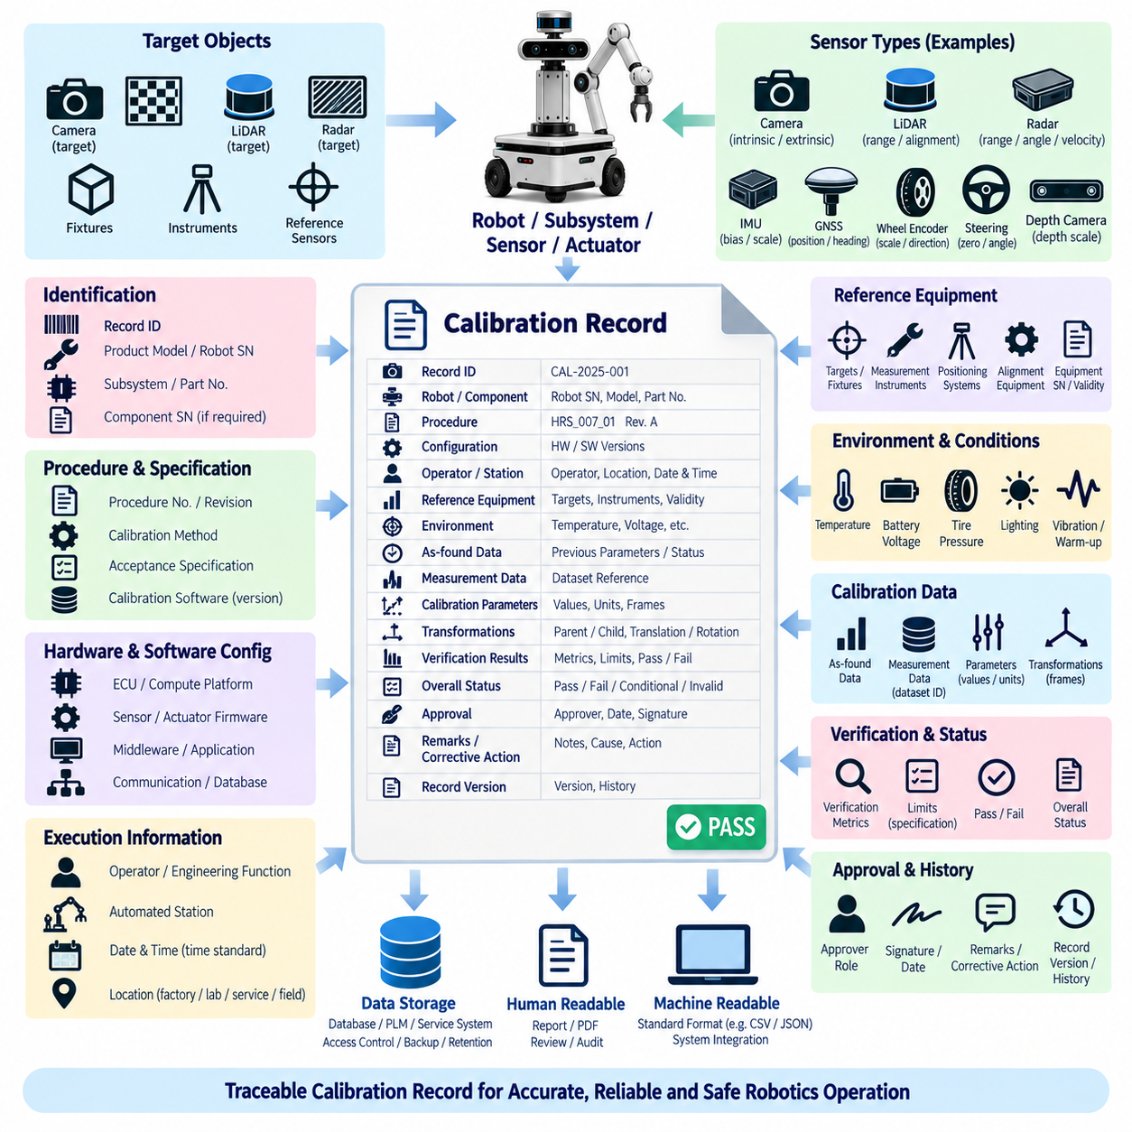
The calibration record shall provide a controlled and traceable representation of every calibration activity performed on a robot, subsystem, sensor, or actuator. Its purpose is to preserve sufficient technical evidence to determine what equipment was calibrated, which procedure and configuration were used, what parameters were produced, how performance was verified, and whether the calibrated system satisfied the applicable engineering acceptance criteria.
Each record shall contain a unique calibration record identifier linked to the applicable robot, subsystem, or component. Identification information shall include the product model, robot serial number, subsystem designation, component part number, and component serial number where individual traceability is required. For multi-sensor calibration, the record shall identify every participating sensor whose spatial, temporal, or functional relationship is represented by the resulting calibration parameters.
The record shall identify the calibration procedure and specification used during execution. Procedure document number, revision, calibration method, applicable acceptance specification, and relevant engineering configuration shall be captured so that the calibration can later be reproduced or investigated. When automated calibration software is used, the software name, version, algorithm revision, configuration file, and applicable parameter package shall also be recorded.
Hardware and software configuration information shall represent the actual system state at the time of calibration. The record shall identify relevant ECU, compute platform, sensor firmware, actuator firmware, middleware, application software, communication configuration, and calibration database versions where they can influence the result. Configuration information shall be sufficiently detailed to distinguish valid calibration data from parameters generated for a different product configuration.
The calibration record shall identify the operator, automated station, or responsible engineering function that executed the procedure. The execution date and time shall be recorded using the approved time convention, together with the manufacturing, laboratory, service, or field location when required. For automated stations, station identification and software revision shall provide equivalent traceability to an operator-controlled calibration process.
Reference equipment used during calibration shall be documented when its accuracy affects the validity of the result. The record shall identify relevant targets, fixtures, measurement instruments, positioning systems, alignment equipment, reference sensors, and synchronization devices. Equipment identification or serial number and calibration validity status shall be retained where necessary to demonstrate that measurements were obtained using approved and traceable references.
Environmental and operating conditions shall be recorded when they can materially influence calibration results. Depending on the subsystem, this may include ambient temperature, sensor temperature, battery voltage, tire pressure, mechanical load, surface condition, lighting, GNSS reception condition, vibration state, or warm-up duration. The record format shall avoid unnecessary data while ensuring that conditions required to interpret or reproduce the result remain available.
The as-found condition shall be retained whenever the procedure requires evaluation of drift or changes from a previous calibration. Existing offsets, biases, transformations, alignment errors, diagnostic states, or other relevant measurements shall be recorded before new parameters are applied. This information enables engineering teams to distinguish normal calibration adjustment from component degradation, mounting movement, mechanical damage, or configuration error.
Raw or intermediate measurement data shall be referenced when required for technical verification or future investigation. The record does not need to duplicate large image, point-cloud, waveform, or log datasets when they are maintained in an approved repository, but it shall provide an unambiguous dataset identifier or storage reference. Data relationships shall allow the calibration result to be traced back to the measurements used to estimate and verify the parameters.
The resulting calibration parameters shall be recorded with explicit parameter names, values, units, coordinate-frame conventions, and applicable precision. Parameters may include sensor bias, scale factor, offset, orientation, intrinsic coefficients, extrinsic transformations, timing offsets, encoder scale, steering center, actuator zero, or other approved values. The record shall distinguish estimated values from default, inherited, manually entered, or subsequently modified parameters.
Coordinate transformation records shall identify the applicable parent frame and child frame together with translation and rotation representations. Units, axis conventions, rotation convention, and transformation direction shall be unambiguous. For multi-sensor systems, the recorded transformations shall correspond to the released robot frame hierarchy so that camera, LiDAR, radar, IMU, GNSS, and other sensor data can be reconstructed consistently during later analysis.
Verification results shall be documented separately from the generated calibration parameters. The record shall contain the applicable verification metric, measured result, acceptance limit, and pass or fail status. Depending on the sensor or actuator, metrics may include reprojection error, range error, angular error, bias, scale error, point-cloud alignment, position error, heading error, timing offset, steering accuracy, repeatability, or actuator tracking performance.
The overall calibration status shall use a controlled result such as pass, fail, conditional approval, or invalid, according to the applicable quality process. A pass shall only be assigned when all mandatory acceptance criteria have been satisfied. Failed or incomplete calibration shall remain visible in the record rather than being overwritten by subsequent attempts, allowing the history of repeated calibration, troubleshooting, corrective action, and final disposition to be reconstructed.
When calibration fails, the record shall provide a reference to the identified cause and corrective action when available. Relevant information may include incorrect fixture setup, damaged components, loose mounting, synchronization faults, unsuitable environmental conditions, communication errors, or software configuration problems. A subsequent recalibration record shall reference the previous failed record where practical, preserving continuity between detection, correction, and verification.
Approval information shall identify the person, role, automated authority, or quality function responsible for releasing the calibration result when formal approval is required. Electronic approval shall provide equivalent traceability to a controlled manual signature. Approval status shall be associated with the exact calibration parameter set and verification results so that later parameter modification cannot unintentionally retain the approval of an earlier configuration.
Calibration records shall be stored in an approved repository with access control, backup, retention, and change protection appropriate to the product lifecycle. Records may be linked to manufacturing databases, configuration-management systems, service systems, or fleet platforms, but the authoritative source shall be identifiable. Modification after approval shall be controlled, and previous approved versions shall remain recoverable when required by engineering, quality, safety, or regulatory processes.
The record format shall support both human review and automated processing. Field names, units, timestamps, identifiers, status values, and parameter definitions should use standardized representations so that production tools, calibration software, engineering analysis, service applications, and fleet systems can exchange information without manual reinterpretation. Machine-readable records should remain linked to a human-readable summary when engineering review or auditability requires it.
Calibration history shall remain associated with the physical product throughout manufacturing, integration, validation, deployment, maintenance, component replacement, and field operation. By linking identification, configuration, procedure, measurements, parameters, verification, acceptance, approval, and recalibration history within a controlled record structure, the calibration record provides the traceability required to demonstrate that robot sensing and actuation performance corresponds to the released system configuration.

07.04. Recalibration Trigger Rule
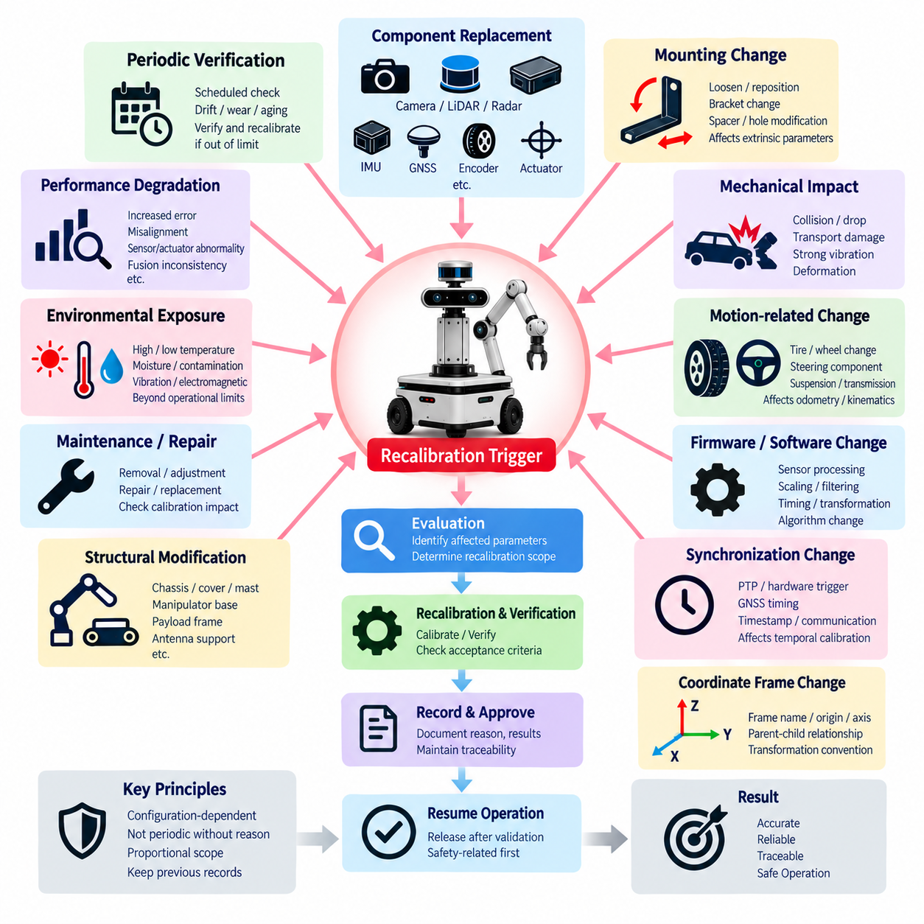
Recalibration shall be initiated whenever a change, event, or detected condition can invalidate the relationship between a sensor or actuator output and its physical reference. The trigger rule shall apply throughout manufacturing, integration, validation, deployment, service, and field operation. Recalibration is therefore treated as a configuration-dependent engineering action rather than a periodic adjustment performed without technical justification.
Component replacement shall be considered a primary recalibration trigger when the replaced device contains individual calibration characteristics or affects an established spatial, electrical, or mechanical relationship. Replacement of cameras, LiDARs, radars, IMUs, GNSS antennas, encoders, steering sensors, actuators, or similar devices shall require evaluation before previous parameters are reused. Parameter inheritance is permitted only when interchangeability has been demonstrated and formally approved.
Movement or removal of a sensor mounting bracket shall trigger evaluation of all calibration parameters dependent on the affected mounting geometry. Loosening fasteners, repositioning sensors, replacing brackets, modifying mounting holes, adding spacers, or changing mechanical interfaces may alter translation or rotation relative to the robot reference frame. Even small changes shall be considered significant when the resulting angular or positional error can exceed the applicable perception or localization tolerance.
Mechanical impact shall be treated as a recalibration trigger when it could change sensor alignment, actuator geometry, chassis reference dimensions, or structural relationships. Collisions, drops, transportation damage, wheel impacts, excessive vibration, or deformation of mounting structures shall prompt inspection and calibration assessment. Recalibration shall be performed when inspection cannot demonstrate that the original calibrated relationship remains within the approved tolerance.
Changes to wheels, tires, steering components, suspension, transmissions, or other motion-related hardware shall trigger recalibration when they affect odometry or vehicle kinematics. Tire diameter, pressure specification, gear ratio, encoder relationship, steering center, steering-angle mapping, or mechanical travel may change after replacement or modification. The affected wheel, encoder, steering, and motion-control parameters shall therefore be identified and verified before operational release.
Firmware or software changes shall trigger recalibration assessment when they modify sensor processing, scaling, filtering, timing, coordinate transformation, actuator interpretation, or calibration algorithms. A version change alone does not necessarily require physical recalibration, but the engineering release process shall determine whether measurement behavior has changed. When compatibility with existing calibration parameters cannot be demonstrated, recalibration and subsequent verification shall be required.
Changes to synchronization architecture shall trigger recalibration when sensor fusion depends on temporal alignment. Modifications to PTP configuration, hardware triggering, GNSS timing, timestamp generation, communication routing, clock sources, middleware, or acquisition pipelines may introduce timing offsets without changing mechanical installation. Temporal calibration shall be repeated whenever the existing timing relationship cannot be demonstrated to remain valid after such changes.
Coordinate-frame changes shall be treated as configuration changes affecting calibration. Modification of frame names, origins, axis directions, parent-child relationships, transformation conventions, or robot reference definitions shall require review of all dependent calibration parameters. Existing numerical transformations shall not be reused automatically because an unchanged value can represent a different physical relationship when the associated coordinate-frame definition has changed.
Structural modification of the robot shall trigger recalibration assessment when sensor or actuator reference geometry may be affected. Changes to chassis structures, covers carrying sensors, masts, manipulator bases, payload frames, antenna supports, suspension attachment points, or other structural interfaces may propagate into multiple transformations. The recalibration scope shall include all dependent relationships that cannot be shown to remain geometrically unchanged.
Performance degradation detected during operation shall constitute a recalibration trigger even when no hardware change has been reported. Indicators may include increasing localization error, inconsistent point-cloud alignment, camera reprojection deviation, IMU bias drift, GNSS heading disagreement, odometry scale error, steering offset, actuator tracking error, or repeated sensor-fusion inconsistency. Diagnostic thresholds shall distinguish normal operating variation from conditions requiring engineering evaluation.
Periodic verification may be specified for sensors or systems susceptible to long-term drift, wear, thermal cycling, vibration, or environmental aging. A verification interval does not automatically require parameter replacement; instead, the existing calibration shall first be checked against the applicable acceptance criteria. Recalibration shall be performed when verification demonstrates that the current parameter set no longer provides the required accuracy, repeatability, or system-level performance.
Environmental exposure shall trigger calibration assessment when conditions may permanently alter sensor characteristics or mechanical alignment. Excessive temperature, thermal shock, moisture ingress, contamination, severe vibration, electromagnetic events, or operation beyond specified environmental limits may affect calibrated behavior. The system shall be inspected and verified after significant exposure, with recalibration required when continued compliance with the approved limits cannot be demonstrated.
Maintenance and repair activities shall include an explicit calibration-impact assessment before the robot is returned to service. A maintenance action that disconnects, removes, adjusts, repairs, or replaces a calibrated component shall identify the affected calibration relationships. Service procedures shall specify whether verification alone is sufficient or whether full recalibration is required, preventing technicians from relying on previous parameters after configuration-changing work.
The recalibration scope shall be proportional to the technical dependency of the change. A local component change may permit calibration of only the affected sensor or actuator when independence from other parameters has been demonstrated. Changes involving common reference frames, multi-sensor geometry, synchronization, robot kinematics, or shared mounting structures may require recalibration of multiple subsystems followed by system-level verification of perception, localization, navigation, or control performance.
Recalibration shall not erase evidence of the previous calibrated state. The existing parameter set, associated calibration record, trigger event, affected configuration, and as-found verification results shall be retained according to the applicable record-control requirements. A new calibration record shall identify the reason for recalibration and establish traceability between the previous configuration, the triggering event, corrective action, new parameters, and verification results.
When a trigger event occurs, the robot or affected function shall be restricted from release if continued operation depends on calibration validity that has not yet been demonstrated. Engineering or service personnel shall perform the required inspection, verification, or recalibration before restoring normal status. Safety-related sensors and actuators shall receive priority where calibration uncertainty could affect obstacle detection, motion limitation, emergency behavior, or other protective functions.
The recalibration decision shall conclude with documented evidence that the affected calibration relationships are valid for the released hardware and software configuration. Verification without parameter changes may close the trigger when all required limits remain satisfied. When recalibration is performed, the new parameter set shall pass the applicable acceptance criteria, be stored under configuration control, and be linked to an approved calibration record before the robot returns to normal operation.

07.05. Calibration Tool Standard
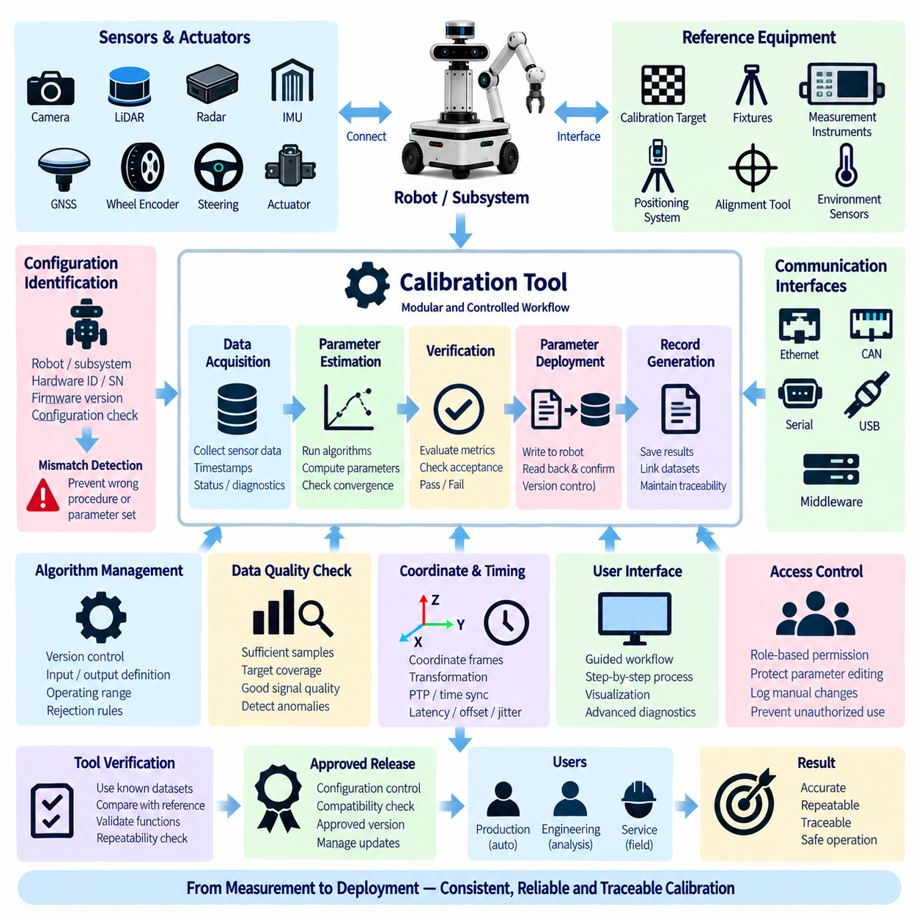
Calibration tools shall provide a controlled technical environment for executing, verifying, recording, and maintaining robot calibration activities. The toolset shall support applicable sensors, actuators, coordinate frames, timing relationships, and system configurations without introducing uncontrolled parameter changes. Tool design shall prioritize measurement integrity, repeatability, traceability, configuration consistency, and protection against incorrect operation.
The calibration tool architecture shall separate data acquisition, parameter estimation, parameter deployment, verification, and record generation into identifiable functions. These functions may be integrated within one application, but their logical boundaries shall remain clear. A calculated calibration result shall not automatically become an approved robot parameter unless the required verification and release conditions have been successfully completed.
Calibration software shall identify the connected robot, subsystem, sensor, or actuator before modifying calibration data. Where practical, hardware identifiers, serial numbers, interface addresses, firmware versions, and robot configuration information shall be read automatically. The tool shall detect configuration mismatches that could cause a calibration procedure or parameter set intended for one hardware configuration to be applied incorrectly to another.
The tool shall provide controlled interfaces to cameras, LiDARs, radars, IMUs, GNSS receivers, wheel encoders, steering sensors, actuators, and other supported devices. Communication interfaces may include Ethernet, CAN, serial communication, USB, or approved middleware interfaces. Acquisition functions shall preserve relevant measurement values, timestamps, status information, and diagnostic indicators required to determine whether collected data is suitable for calibration.
Calibration tools supporting spatial calibration shall use explicitly defined coordinate frames, units, axis directions, transformation conventions, and parent-child relationships. Visualization of sensor observations, reference targets, point clouds, image projections, or frame relationships may be provided to assist verification. The software shall prevent ambiguous transformation definitions and shall clearly distinguish translation, rotation, intrinsic parameters, and extrinsic parameters.
Tools used for temporal calibration shall support the implemented synchronization architecture and shall distinguish acquisition time from communication or software reception time. Where applicable, the tool shall support PTP, hardware triggers, GNSS time, device timestamps, or synchronized system clocks. Timing analysis shall provide sufficient information to identify offset, latency, jitter, dropped measurements, or synchronization instability that can invalidate sensor-fusion calibration.
Reference targets, fixtures, measurement instruments, positioning systems, alignment devices, and other physical calibration equipment shall have defined interfaces to the applicable procedure. The tool configuration shall identify the type and relevant characteristics of the reference equipment being used. When measurement traceability is required, equipment identification and calibration validity shall be captured or referenced before an approved calibration result can be released.
Calibration algorithms shall be implemented as controlled and versioned functions. The tool shall identify the algorithm version, required input data, parameter definitions, operating range, initialization conditions, convergence criteria, and applicable rejection rules. Numerical convergence alone shall not be interpreted as calibration success. Residual errors, physical plausibility, dataset quality, and independent verification metrics shall be evaluated before parameters are accepted.
Automated data-quality checks shall identify conditions that can produce unreliable calibration results. Examples include insufficient samples, poor target coverage, limited motion excitation, blurred images, weak feature detection, sparse point-cloud overlap, unstable GNSS status, excessive vibration, communication loss, timestamp inconsistency, or sensor diagnostic faults. The tool shall prevent or clearly warn against parameter release when mandatory input-quality requirements are not satisfied.
The calibration user interface shall guide operators through the approved sequence without requiring unnecessary interpretation of engineering parameters. Required preparation, sensor warm-up, target placement, robot pose, movement sequence, data collection, calculation, verification, and completion steps should be presented consistently. Operator guidance shall reduce the possibility of skipped steps while still allowing authorized engineering users to access advanced diagnostic information when necessary.
Parameter editing shall be protected according to user role and calibration state. Production and service operators should normally use approved automated or guided workflows rather than manually modifying numerical parameters. Engineering access may permit controlled manual adjustment for development or investigation, but manually modified values shall be identified in the resulting record. Unauthorized parameter editing shall be prevented through appropriate access-control mechanisms.
Calibration parameters shall be written only to approved storage locations and shall be verified after deployment. The tool shall confirm parameter names, units, data types, ranges, target hardware, configuration version, and write status before completing the operation. Where technically practical, the parameter set shall be read back from the robot or device and compared with the intended values to detect incomplete writes, corruption, or incorrect destination selection.
Verification functions shall evaluate calibrated performance against predefined acceptance criteria. Depending on the subsystem, the tool may calculate reprojection error, range error, angular error, point-cloud alignment, bias, scale error, position error, heading error, timing offset, steering accuracy, repeatability, or actuator tracking error. Acceptance limits shall be configuration controlled so that operators cannot arbitrarily modify pass or fail thresholds during normal execution.
The tool shall generate a calibration record containing the information required by the applicable record format. This shall include identification, procedure revision, software and algorithm versions, relevant configuration, operator or station, reference equipment, execution time, measurement references, generated parameters, verification results, acceptance status, and approval information where required. Failed and incomplete attempts shall remain distinguishable from successfully released calibration results.
Calibration data and logs shall be stored using controlled naming, identification, and retention methods. Large images, point clouds, measurement sequences, and diagnostic logs may be maintained separately from the summary calibration record, provided an unambiguous relationship is preserved. The tool shall support reconstruction of the calibration event by linking the record to the datasets, parameter files, software versions, and system configuration used during execution.
Calibration tool releases shall be managed through software configuration control. Changes to algorithms, coordinate-frame handling, communication interfaces, parameter formats, acceptance criteria, or record generation shall be reviewed for calibration impact before deployment. Tool versions used for production or service shall be approved versions, and compatibility with supported robot hardware, firmware, and software configurations shall be defined and maintained.
The calibration tool itself shall be verified before operational release and after changes that can affect calibration results. Verification shall use known datasets, reference configurations, simulated inputs, controlled hardware, or comparison against independently established results as appropriate. The objective is to demonstrate that acquisition, computation, parameter handling, verification, and record generation behave correctly and repeatably within the intended operating environment.
Production, engineering, and service calibration tools may provide different levels of functionality while maintaining common parameter definitions and acceptance logic. Production tools shall emphasize repeatability and automation, engineering tools shall support analysis and diagnostics, and service tools shall support controlled field procedures. All variants shall preserve compatibility with the released calibration specification, record format, recalibration rules, and configuration-management process.
Calibration tools shall therefore function as controlled engineering assets rather than general-purpose parameter editors. A compliant tool shall connect approved equipment and procedures with validated algorithms, protected parameter handling, measurable verification, and traceable records. By maintaining this controlled chain from measurement through release, the toolset ensures that robot sensing, localization, perception, and actuation remain consistent with the approved physical and software configuration.

