Volume 22. Hills Robotics Engineering Standards

Chapter 05. HRS-005 Grounding

05.01. Grounding Architecture Rules
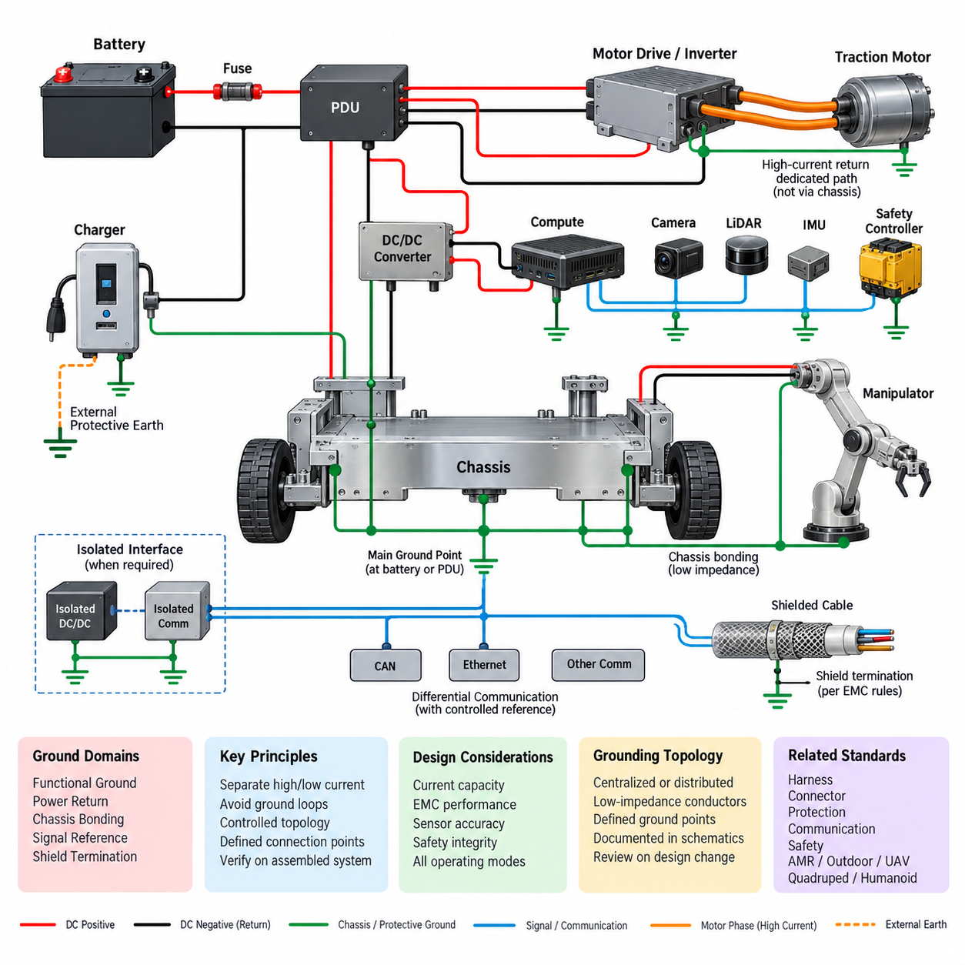
The grounding architecture shall establish a controlled electrical reference for every power, control, communication, sensing, and computing subsystem used in the robot. Grounding shall not be treated as an incidental wiring detail. It shall be defined at system architecture level together with voltage rails, power distribution, harness routing, shielding, communication interfaces, and functional safety boundaries.
The robot electrical system shall distinguish functional ground, power return, protective chassis bonding, signal reference, and shield termination according to their electrical purpose. These functions shall not be combined arbitrarily simply because they operate near the same nominal potential. Any intentional connection between different ground domains shall be explicitly represented in the electrical architecture and verified during design review.
Power return paths shall be designed to carry the maximum expected continuous and transient current without creating unacceptable voltage differences between interconnected devices. High-current loads such as traction motors, steering actuators, manipulators, pumps, heaters, inverters, and motor drivers shall use dedicated return paths sized according to their operating and fault currents rather than relying on the mechanical chassis as the normal current return.
Sensitive electronics shall be protected from voltage disturbances generated by high-current switching loads. Computing platforms, cameras, LiDAR, radar, IMUs, GNSS receivers, communication gateways, safety controllers, and precision analog circuits shall not share uncontrolled return impedance with motors or power converters. Ground topology shall therefore minimize common-impedance coupling between noisy power equipment and low-level electronic circuits.
A centralized or controlled distributed grounding topology shall be selected according to robot size and electrical architecture. Small platforms may use a principal grounding point near the battery or PDU, while larger distributed robots may require multiple local ground nodes connected through engineered low-impedance conductors. Distributed ground points shall never be introduced without analysis of current flow, potential difference, and possible ground-loop formation.
The primary DC power source shall have clearly defined positive and negative distribution paths. The battery negative connection, PDU return structure, DC/DC converter returns, charger interface, and major load returns shall be documented so that fault current paths can be predicted. The location of any connection between DC negative and chassis shall be intentionally selected and shall not result from mounting hardware or unintended conductive contact.
Chassis bonding shall provide a reliable low-impedance connection among conductive structural elements that require a common reference for EMC or electrical safety. Painted, anodized, coated, oxidized, or mechanically floating surfaces shall not be assumed to provide dependable electrical continuity. Where bonding is required, dedicated bonding conductors, approved bonding hardware, or specifically prepared conductive interfaces shall be used.
Ground loops shall be avoided wherever circulating current could degrade sensor accuracy, communication integrity, EMC performance, or system reliability. Multiple conductive paths between two ground domains shall be reviewed as potential loop paths, including harness returns, cable shields, Ethernet equipment, mounting structures, external chargers, diagnostic equipment, and communication cables connected to grounded infrastructure.
Signal reference design shall consider the characteristics of each interface. Differential communication networks such as CAN, RS-485, Ethernet, and other balanced interfaces shall preserve their intended common-mode operating range and shall not depend on uncontrolled chassis current paths. Where a reference conductor is required by the interface design, its routing and connection shall be defined together with the signal pair and connector pin assignment.
Analog sensors and low-level measurement circuits shall use reference paths that minimize offset caused by load current. Sensor ground shall not be connected at arbitrary points along high-current power returns. Load cells, current sensors, force/torque sensors, analog position sensors, battery measurement circuits, and similar devices shall be evaluated for ground offset, common-mode voltage, shielding, and susceptibility to switching noise.
Cable shields shall not be treated as ordinary signal-return conductors. Shield termination shall follow the EMC function of the cable and the frequency range of the expected interference. The connection strategy shall be coordinated with HRS_005_03_Shield_Termination_Rules so that shield current is directed through controlled low-impedance paths without creating unintended signal-ground or chassis-ground connections.
High-frequency grounding behavior shall be considered separately from low-frequency DC continuity. A conductor that provides an acceptable DC resistance may present significant impedance at switching frequencies because of its inductance and geometry. EMC-critical bonding connections shall therefore be short and physically appropriate for the required frequency range, with connection area and routing considered in addition to conductor cross-sectional area.
Motor drives, inverters, DC/DC converters, switching power supplies, and other high-dV/dt or high-dI/dt devices shall be treated as primary noise sources. Their power returns and chassis connections shall be arranged to contain switching currents locally wherever practical. Noise current shall not be allowed to propagate through sensor reference networks, computing grounds, communication interfaces, or mechanically remote chassis paths.
Grounding architecture shall remain valid during all operating modes, including normal driving, charging, docking, maintenance, diagnostic connection, emergency stop, regenerative braking, and external equipment connection. Particular attention shall be given to charging stations and service equipment because external protective earth or grounded instruments can introduce an additional electrical reference and create a ground path that does not exist during autonomous operation.
Isolated DC/DC converters, isolated communication interfaces, and galvanic isolation may be applied when required to separate incompatible ground domains or interrupt problematic common-mode current paths. Isolation shall not be introduced without defining its purpose, voltage rating, transient requirements, insulation boundary, and behavior under fault conditions. Any intentional bridging components across an isolation boundary shall also be documented.
Ground connections associated with safety functions shall be designed so that a single loose fastener, corroded terminal, damaged harness, or high-resistance bond does not silently defeat the required safety behavior. Safety controllers, emergency-stop circuits, contactor control circuits, braking systems, and safety sensors shall use grounding arrangements consistent with the system safety architecture and applicable fault-detection requirements.
Every designated ground or bonding point shall be identifiable in schematics, harness drawings, installation drawings, and applicable bills of material. Ground-point identifiers shall remain consistent across engineering documents so that manufacturing and service personnel can trace the intended electrical path. Undocumented grounding through brackets, enclosure screws, cable glands, or mounting bolts shall not be accepted as an engineered connection.
Grounding performance shall be verified on the assembled robot rather than inferred solely from component specifications. Verification shall include continuity and resistance checks of required bonds, inspection of ground-point construction, confirmation of return-path routing, and evaluation for unintended conductive paths. EMC testing shall additionally confirm that the implemented architecture controls conducted and radiated disturbances under representative operating conditions.
Design changes affecting batteries, PDUs, converters, motor drives, computing units, sensors, communication equipment, harness routing, chassis construction, or charging interfaces shall trigger review of the grounding architecture. A mechanically minor change can alter return impedance or introduce a new conductive loop. Grounding shall therefore be included in engineering change control whenever electrical connectivity or physical current paths can be affected.
The final grounding architecture shall provide traceability from system-level electrical requirements to physical implementation and validation. Each intentional ground-domain connection, chassis bond, isolation boundary, shield interface, and major return path shall have a defined engineering purpose. The architecture shall support the broader Hills Robotics standards structure by coordinating grounding with harness, connector, protection, communication, safety, AMR, outdoor vehicle, quadruped, humanoid, and UAV requirements.

05.02. EMC Design Checklist
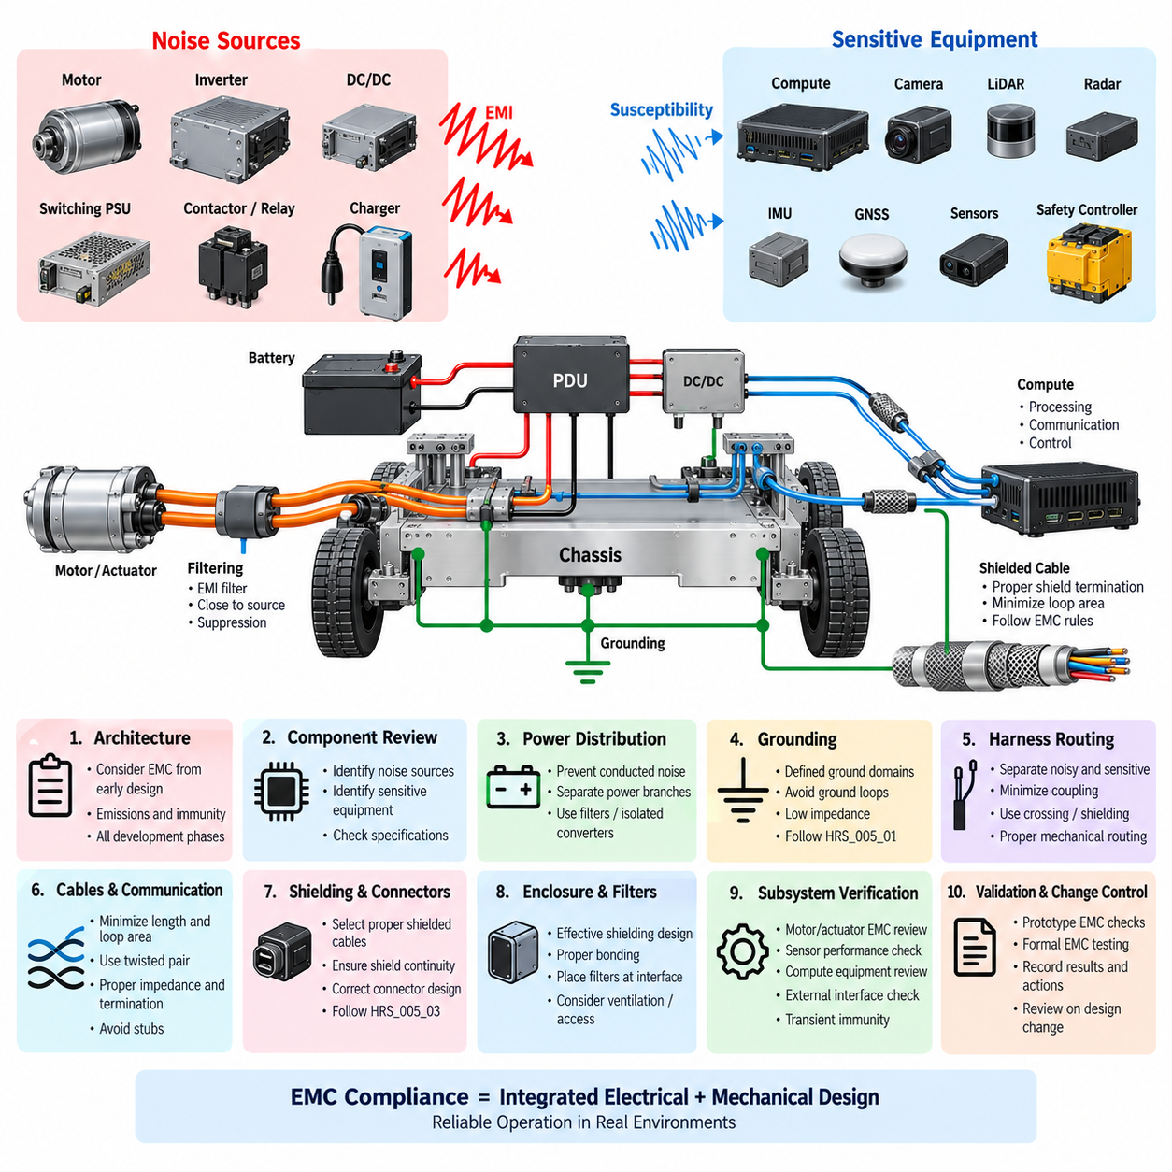
Electromagnetic compatibility shall be evaluated as an integral part of the robot electrical architecture rather than as a final-stage compliance activity. The EMC design checklist shall be applied during architecture definition, schematic design, harness development, mechanical packaging, prototype integration, and design validation. Each review shall consider both electromagnetic emissions generated by the robot and susceptibility of its electronic systems to external or internally generated disturbances.
Every major electrical component shall be classified according to its expected noise generation and susceptibility. Motors, inverters, motor drivers, switching power supplies, DC/DC converters, contactors, relays, chargers, and high-current switching circuits shall be treated as potential noise sources. Cameras, LiDAR, radar, IMUs, GNSS receivers, analog sensors, safety controllers, communication interfaces, and computing systems shall be evaluated as potentially sensitive equipment.
Power distribution shall be reviewed for conducted noise propagation between subsystems. High-current and rapidly switched loads shall not share uncontrolled supply or return impedance with sensitive electronic equipment. Where necessary, separate power branches, local filtering, dedicated return paths, isolated converters, or other suppression techniques shall be used to prevent switching disturbances from propagating through the PDU, harness, or common power rails.
Grounding architecture shall be checked before detailed EMC countermeasures are approved. Functional ground, power return, signal reference, chassis bonding, and shield termination shall have clearly defined purposes and connection points. The design shall avoid unintended parallel return paths and ground loops while maintaining sufficiently low impedance for fault currents and high-frequency noise. Grounding implementation shall remain consistent with HRS_005_01_Grounding_Architecture_Rules.
Harness routing shall maintain appropriate physical separation between noisy and sensitive circuits. Motor phase cables, inverter power lines, high-current battery conductors, switching power wiring, and contactor circuits should be routed separately from sensor, analog, communication, and low-level signal wiring wherever practical. When separation cannot be maintained, crossing geometry, shielding, twisting, filtering, and mechanical routing shall be reviewed to minimize coupling.
Cable length and loop area shall be minimized for circuits carrying high-frequency or rapidly changing currents. Power and return conductors shall be routed together so that the magnetic field generated by one conductor is substantially cancelled by the corresponding return current. Large current loops shall be avoided because they increase both radiated emissions and susceptibility to external magnetic fields, particularly around motor drives and power converters.
Differential communication networks shall preserve their intended transmission-line characteristics throughout the harness. CAN, CAN FD, RS-485, Ethernet, and similar interfaces shall use the required twisted-pair geometry, characteristic impedance, termination, and connector arrangement. Pair separation, excessive untwisting near connectors, inappropriate stubs, and inconsistent reference connections shall be reviewed because these conditions can degrade both signal integrity and EMC performance.
Shielded cables shall be selected according to the electromagnetic environment and interface requirements rather than applied universally. Shield effectiveness depends on shield construction, transfer impedance, connector design, termination geometry, and frequency. Shield connections shall be implemented according to HRS_005_03_Shield_Termination_Rules, and long pigtail terminations shall be avoided where they create excessive high-frequency impedance.
Connector design shall preserve EMC performance across harness interfaces. Shield continuity, chassis connection, signal pin assignment, power-return placement, unused pin treatment, and separation between noisy and sensitive circuits shall be reviewed. Connectors carrying motor power or high-current switching signals shall not create unnecessary coupling into adjacent sensor or communication contacts, particularly where multiple electrical domains share one connector housing.
Electronic enclosures shall be evaluated as part of the shielding architecture. Conductive housings, seams, covers, cable entries, ventilation openings, display interfaces, and service access points can significantly influence shielding effectiveness. Where an enclosure is intended to provide electromagnetic shielding, bonding between enclosure sections and cable shield termination shall provide a controlled high-frequency path rather than relying only on incidental mechanical contact.
Filters shall be located close to the interface where unwanted electromagnetic energy enters or leaves a circuit. Input filters positioned far from connectors may allow noise current to propagate through internal wiring before suppression occurs. Filter components shall be selected with consideration of source impedance, load impedance, operating current, transient conditions, frequency range, component parasitics, and possible resonance rather than nominal capacitance or inductance alone.
Decoupling capacitors shall be placed close to the power pins of processors, communication transceivers, sensors, memory devices, and other high-speed electronics. The connection between the capacitor, device, and reference plane shall minimize parasitic inductance. Bulk capacitance and high-frequency decoupling shall be coordinated so that the power distribution network maintains acceptable impedance over the relevant operating frequency range.
Motor and actuator systems shall receive dedicated EMC review because they combine high current, fast switching edges, long cables, and mechanically distributed loads. PWM frequency, inverter switching behavior, motor cable routing, phase conductor geometry, chassis bonding, encoder wiring, brake wiring, and feedback interfaces shall be evaluated together. Suppression measures shall address both common-mode and differential-mode noise mechanisms.
Sensor interfaces shall be checked under realistic robot operating conditions rather than only with stationary power systems. Camera image corruption, LiDAR communication errors, IMU bias disturbances, GNSS degradation, analog sensor offsets, encoder errors, and intermittent communication faults may appear only while motors, actuators, chargers, or high-power converters are operating. EMC validation shall therefore include simultaneous operation of representative noisy and sensitive subsystems.
High-speed computing equipment shall be reviewed for both emissions and immunity. CPUs, GPUs, memory interfaces, high-speed Ethernet, USB, PCIe-related hardware, and switching regulators can generate broadband electromagnetic energy. Compute enclosure bonding, connector shielding, cable routing, local filtering, thermal openings, and power entry design shall be coordinated so that computing performance does not compromise nearby perception or control electronics.
External interfaces shall be treated as potential paths for electromagnetic energy and ground disturbances. Charging connectors, service ports, diagnostic interfaces, external Ethernet, USB, antennas, docking contacts, and auxiliary power connections shall be reviewed for transient protection, filtering, shielding, and grounding. The EMC behavior of the robot may change significantly when connected to grounded external equipment, charging infrastructure, or laboratory instruments.
Transient immunity shall be considered together with continuous EMC behavior. Relay and contactor switching, inductive load interruption, motor regeneration, emergency-stop operation, battery connection, charger connection, and electrostatic discharge can generate short-duration disturbances capable of resetting controllers or corrupting communication. Protection shall be coordinated with circuit voltage ratings, functional safety requirements, and expected operating environments.
Mechanical changes shall be included in EMC design control because seemingly minor packaging modifications can alter electromagnetic behavior. Moving a cable, replacing a conductive bracket, changing enclosure material, modifying ventilation openings, adding a sensor, or relocating a ground point can change coupling paths and shielding effectiveness. EMC impact shall therefore be reviewed whenever electrical packaging, harness routing, grounding, or enclosure construction changes.
Prototype EMC checks shall be performed before formal qualification testing whenever practical. Near-field probing, conducted-noise measurements, communication error monitoring, sensor stability checks, and subsystem activation tests can identify dominant coupling mechanisms early. Debugging shall focus on locating the source, coupling path, and affected receiver rather than adding suppression components without understanding the underlying electromagnetic mechanism.
Formal EMC validation shall exercise representative worst-case operating configurations, including maximum compute load, motor acceleration, braking, actuator movement, charging, communication traffic, sensor operation, and simultaneous subsystem activity where applicable. Test results, anomalies, corrective actions, and configuration information shall be recorded so that EMC performance can be traced to a defined hardware, harness, software, and mechanical configuration.
The completed EMC design checklist shall demonstrate that noise sources, coupling paths, susceptible circuits, grounding, shielding, filtering, harness routing, connectors, enclosures, external interfaces, and validation requirements have been systematically reviewed. EMC compliance shall be treated as a system property resulting from coordinated electrical and mechanical design, supporting the broader HRS grounding, communication, safety, AMR, outdoor vehicle, UAV, quadruped, and humanoid engineering standards.

05.03. Shield Termination Rules
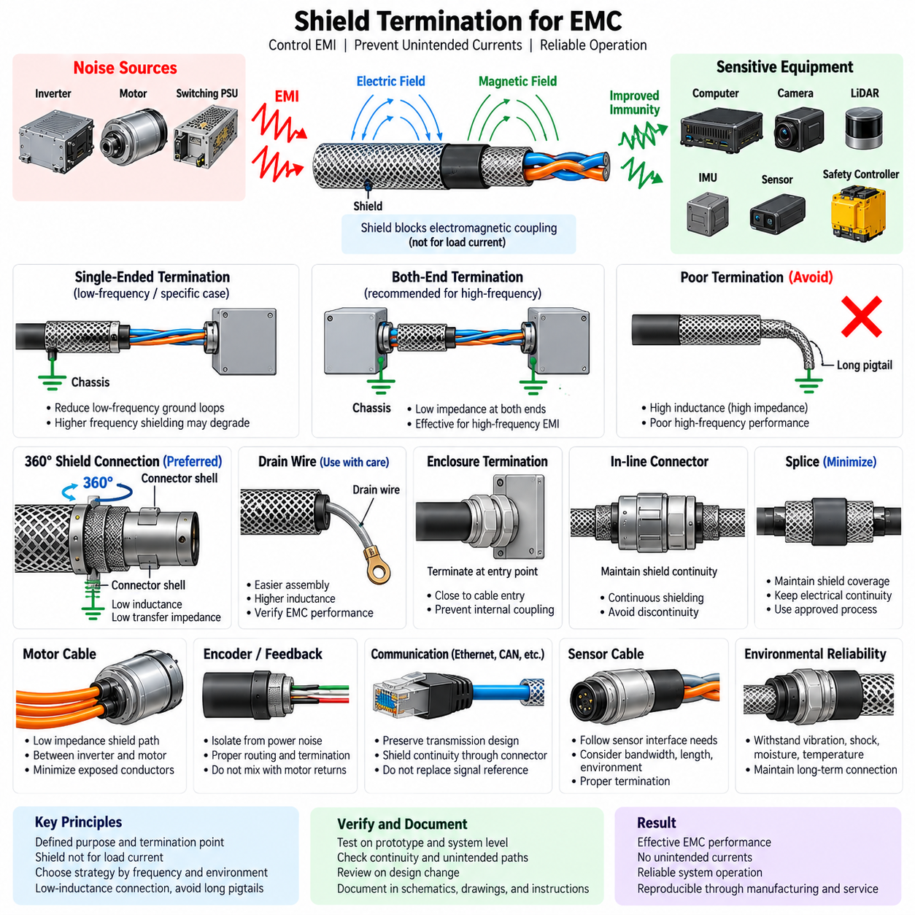
The shield termination architecture shall provide a controlled path for electromagnetic interference currents while preventing cable shields from becoming unintended signal-return or power-return conductors. Shielding shall be treated as part of the complete EMC and grounding architecture rather than as an isolated cable feature. Every shield connection shall therefore have a defined purpose, termination location, frequency requirement, and relationship to chassis and signal reference.
Cable shields shall primarily control electric-field and high-frequency electromagnetic coupling between the protected conductors and the surrounding environment. A shield shall not normally carry functional load current. Signal return, power return, protective bonding, and shield current paths shall remain electrically distinguishable unless a specific interface architecture requires an intentional connection that has been documented and validated.
Shield termination strategy shall be selected according to signal type, frequency range, cable length, equipment grounding arrangement, and expected electromagnetic environment. Single-ended termination may be appropriate for certain low-frequency analog applications where ground-potential differences dominate. High-frequency and broadband interfaces generally require low-impedance termination at both ends to maintain effective shielding over the relevant frequency range.
Both-end shield termination shall be considered where cables connect chassis-referenced equipment and high-frequency immunity or emission control is required. The resulting current path through the shield and chassis shall be evaluated to ensure that low-frequency circulating currents do not create unacceptable interference. Where significant ground-potential differences are expected, isolation, controlled bonding, or alternative termination techniques shall be considered.
Single-ended shield termination shall not be adopted as a universal method for preventing ground loops. Although it can interrupt low-frequency shield current, the unterminated end may substantially reduce shielding effectiveness at high frequencies. The engineering decision shall therefore consider the dominant interference mechanism rather than applying a fixed rule based only on DC continuity or traditional instrumentation practice.
High-frequency shield connections shall use low-inductance termination geometry. A 360-degree circumferential connection between the cable shield and conductive connector shell or enclosure is preferred where the interface supports it. This configuration minimizes transfer impedance and prevents electromagnetic energy from bypassing the shield termination through exposed internal conductors near the connector entry.
Long shield pigtails shall be avoided for high-frequency interfaces because their inductance can significantly increase termination impedance. A pigtail that appears electrically adequate in a DC continuity test may perform poorly at radio frequencies. When a pigtail is unavoidable, its length shall be minimized and its EMC suitability shall be verified under representative operating and test conditions.
Connector shells used for shield termination shall provide reliable electrical continuity to the intended chassis or enclosure reference. Conductive backshells, cable glands, clamps, and mounting interfaces shall maintain sufficient contact area and mechanical retention. Paint, anodized coatings, corrosion, contamination, loose hardware, or insulating mounting structures shall not be allowed to unintentionally interrupt the designed shield-current path.
Shield termination to a conductive enclosure shall occur as close as practical to the cable entry point. Allowing a shielded cable to enter an enclosure and continue internally before termination can permit common-mode current to radiate or couple into internal circuitry. The shield current shall be transferred to the enclosure before the protected conductors are exposed to sensitive electronics whenever the mechanical architecture permits.
Shield drain wires shall be distinguished from full circumferential shield termination. Drain wires can simplify assembly and provide convenient electrical contact with foil shields, but they introduce additional inductance and may not provide adequate high-frequency performance. Their use shall be based on cable construction, frequency requirements, environmental conditions, manufacturing constraints, and verified EMC performance.
Motor phase cables and inverter output cables shall receive particular attention because they can carry high-frequency common-mode currents generated by rapid switching transitions. Where shielded motor cables are used, the shield should provide a low-impedance path between the inverter enclosure and motor housing. Termination geometry shall minimize exposed phase conductors and prevent switching current from coupling into nearby sensor or communication harnesses.
Encoder, resolver, brake, and motor feedback cables shall be routed and terminated so that power-stage noise does not enter low-level feedback circuits. Their shields shall not be casually interconnected with motor phase returns or signal references. Connector design, shield continuity, separation, grounding, and termination location shall be coordinated as one interface rather than designed independently for each conductor.
Communication cable shields shall preserve the intended physical-layer architecture of the network. Ethernet, industrial Ethernet, high-speed serial links, and other shielded differential interfaces may require chassis-referenced shield continuity through connectors and equipment housings. Shield connections shall not unintentionally alter differential termination, common-mode reference, or galvanic isolation provided by communication transceivers.
CAN, CAN FD, RS-485, and similar networks shall distinguish cable shielding from the communication reference conductor. The shield shall not replace a required network reference or signal return. If shielded twisted pair is selected because of a severe electromagnetic environment, termination shall be coordinated with network topology, node grounding, isolation strategy, connector design, and the common-mode capability of each transceiver.
Sensor cable shielding shall reflect the characteristics of the sensor interface. Low-level analog sensors, load cells, force/torque sensors, encoders, cameras, LiDAR, radar, GNSS equipment, and IMUs may require different termination strategies. Shielding decisions shall consider signal bandwidth, source impedance, cable length, enclosure construction, sensor mounting, and the location of the associated signal-conditioning electronics.
Cable shields shall remain continuous through intermediate connectors whenever continuous shielding is required by the interface design. Shield discontinuities at bulkhead connectors, junction boxes, service connectors, or harness transitions can create local coupling points. Where continuous shielding cannot be maintained, the discontinuity shall be intentionally designed and its effect on emissions and immunity shall be evaluated.
Splices in shielded cables shall be minimized. When unavoidable, the splice shall preserve shield coverage and electrical continuity to the extent required by the cable's EMC function. A splice that reconnects only the internal signal conductors while leaving a large opening in the shield can significantly degrade performance. Shield repair and splice methods shall therefore be controlled through approved harness manufacturing procedures.
Shield termination hardware shall withstand the robot's mechanical and environmental conditions throughout its service life. Vibration, shock, repeated flexing, temperature cycling, moisture, dust, corrosion, and maintenance activity shall not degrade the electrical connection below acceptable performance. Mobile robots and manipulators shall additionally consider repeated cable motion and strain near termination points when selecting clamps, glands, backshells, and flexible shielding.
Shield connections shall not create uncontrolled fault-current paths. The current capability of shields, connector shells, and termination hardware is normally determined by EMC requirements rather than power fault current. Electrical protection and grounding architecture shall therefore ensure that battery, motor, or other high-energy fault currents use designated protective paths instead of relying on cable shielding.
The implemented shield architecture shall be verified during prototype and system-level EMC testing. Verification shall include inspection of termination geometry, continuity checks, identification of unintended shield connections, and operation of representative noise-producing and sensitive subsystems. When EMC problems occur, shield current paths and termination impedance shall be investigated together with grounding, filtering, harness routing, and enclosure bonding.
Any design change affecting cable type, connector family, backshell, enclosure material, cable gland, harness routing, grounding point, motor drive, sensor interface, or communication equipment shall trigger review of the associated shield termination. Shielding performance depends strongly on physical implementation, so mechanically minor modifications can produce significant changes in high-frequency electromagnetic behavior.
The final shield termination design shall be documented in schematics, harness drawings, connector specifications, installation drawings, and manufacturing instructions wherever applicable. Documentation shall identify shield type, termination end or ends, connection method, chassis reference, special hardware, and intentional exceptions. This ensures that the EMC architecture defined by HRS_005 remains reproducible through manufacturing, service, modification, and future product development.

05.04. Ground Point Standard
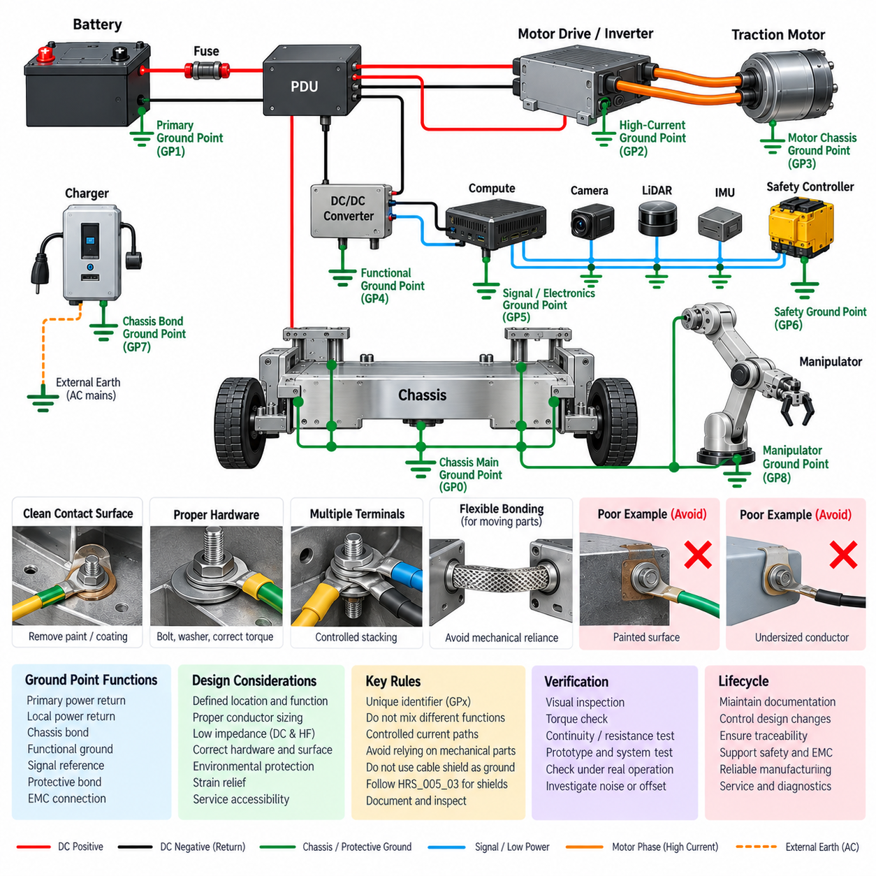
Ground points shall provide defined, repeatable, and electrically reliable connections between power returns, functional grounds, chassis structures, protective bonding conductors, and designated EMC paths. Every ground point shall be treated as an engineered electrical interface rather than incidental mechanical contact. Its electrical function, location, conductor capacity, hardware, surface preparation, and inspection requirements shall be defined during system design.
Each ground point shall have a unique identifier that remains consistent across electrical schematics, harness drawings, mechanical drawings, installation instructions, manufacturing records, and service documentation. The identifier shall allow engineers and technicians to determine which circuits are connected to the point and its intended function. Unidentified or undocumented ground connections shall not be permitted in production hardware.
Ground points shall be classified according to function, such as primary power return, local power return, chassis bond, functional ground, signal reference, protective bond, or EMC connection. Different functions shall not be combined at one physical location unless the architecture intentionally requires the connection. Such combined points shall be explicitly documented so that current paths and possible common-impedance coupling can be evaluated.
The primary system ground point shall be located according to the battery, PDU, and power distribution architecture. High-current battery return and major load returns shall converge through controlled conductors rather than through arbitrary chassis structures. Where a principal connection between DC negative and chassis is required, it shall be established at a defined location so that normal, transient, and fault-current paths remain predictable.
Ground conductors shall be sized for the maximum continuous current, transient current, and applicable fault current expected at the connection. Conductor sizing shall also consider voltage drop, temperature rise, installation length, bundling, ambient temperature, terminal capability, and protection coordination. A ground conductor shall never be reduced in size solely because it normally carries little current if it must safely conduct a significant fault current.
Ground-point impedance shall be sufficiently low for the intended electrical and EMC functions. DC resistance alone shall not be used to characterize connections required to carry high-frequency currents because conductor length, geometry, contact area, and inductance can dominate impedance at higher frequencies. EMC bonding paths should therefore be short, direct, and physically broad where practical rather than unnecessarily long and narrow.
Ground points installed on painted, coated, anodized, oxidized, or contaminated conductive structures shall receive controlled surface preparation. The electrical contact area shall expose suitable conductive material where required by the design. Surface preparation shall not unnecessarily compromise corrosion protection, and approved protective treatments shall be applied after assembly where needed while preserving the intended metal-to-metal electrical contact.
Fasteners used for electrical grounding shall provide stable mechanical clamping force throughout the expected service life. Bolt or stud diameter, washer arrangement, terminal orientation, locking method, tightening torque, and material compatibility shall be specified where necessary. A connection shall not depend solely on uncontrolled thread contact when a defined contact surface is required for reliable low-resistance electrical bonding.
Ring terminals, lugs, bonding straps, busbars, or equivalent grounding hardware shall be selected according to conductor size, current requirement, mechanical load, vibration environment, temperature, and corrosion exposure. Terminals shall be installed using approved crimping or attachment processes. Stacking excessive numbers of terminals on a single stud shall be avoided because it can reduce clamping consistency, serviceability, and connection reliability.
When multiple terminals must share one ground point, the permitted terminal quantity and stacking order shall be defined. High-current returns, sensitive signal grounds, safety-related connections, and EMC bonds shall not be stacked arbitrarily. Terminal arrangement shall prevent removal or servicing of one circuit from unintentionally loosening or disconnecting another critical ground connection.
Chassis bonding points shall be positioned so that current does not depend on bearings, hinges, sliding joints, painted mechanical interfaces, or other unreliable conductive paths. Moving assemblies requiring electrical bonding shall use dedicated flexible bonding conductors where necessary. Doors, covers, sensor masts, manipulators, articulated structures, and removable modules shall be reviewed for electrical continuity across their mechanical interfaces.
Ground points associated with motors, inverters, and high-current actuators shall be separated from sensitive signal reference connections where common impedance could introduce noise. Motor and inverter return currents shall follow designated high-current paths. Camera, LiDAR, radar, IMU, GNSS, encoder, analog sensor, communication, and computing grounds shall be connected according to the controlled grounding topology defined by the system architecture.
Safety-related ground points shall be designed so that foreseeable mechanical or electrical failures do not silently defeat the required safety function. Grounding associated with emergency-stop circuits, safety controllers, braking systems, contactor controls, safety sensors, and protective bonding shall be identified as safety-relevant where applicable. Accessibility, retention, inspection, and diagnostic coverage shall reflect the safety significance of the connection.
Ground points shall be located where they can be assembled, inspected, measured, and serviced without excessive disassembly of unrelated equipment. Service access shall allow verification of fastener condition, corrosion, terminal damage, and conductor integrity. Critical ground points hidden permanently behind structural components shall be avoided unless their reliability is demonstrated and alternative verification methods are provided.
Ground wiring shall include adequate strain relief so that vibration, harness motion, maintenance activity, or connector movement does not transfer excessive mechanical force into the terminal. Conductors shall not be installed under continuous tension. Bend radius, terminal orientation, harness support, and local flexibility shall prevent fatigue near the crimp barrel or lug interface, particularly on mobile and articulated robot structures.
Environmental protection shall be appropriate for the ground-point location. Ground connections exposed to water, condensation, salt, cleaning chemicals, dust, outdoor contaminants, or temperature cycling shall use compatible materials and protective measures. Galvanic corrosion between dissimilar metals shall be considered when selecting chassis material, terminals, washers, fasteners, coatings, and bonding hardware.
Ground points shall not rely on cable shields as substitutes for designated power or protective grounding conductors. Shield termination is an EMC function and shall follow HRS_005_03_Shield_Termination_Rules. Likewise, a signal-reference conductor shall not automatically be treated as a chassis bond or fault-current conductor. Each electrical path shall retain the function assigned by the grounding architecture.
Manufacturing inspection shall confirm that each required ground point is installed at the correct location with the specified conductor, terminal, hardware, surface preparation, and tightening condition. Visual inspection shall identify missing hardware, incorrect stacking, damaged terminals, contamination, paint intrusion, corrosion, or insufficient strain relief. Torque verification or process-controlled tightening shall be applied where specified.
Electrical verification shall include continuity and resistance measurements appropriate to the function of the ground point. Measurement methods shall account for test-lead resistance and contact effects when low-resistance bonds are evaluated. Where a numerical resistance requirement is defined, the measurement equipment, probe locations, acceptance limit, and environmental condition shall be controlled sufficiently to produce repeatable results.
Prototype and system validation shall confirm that the complete grounding network performs correctly during representative robot operation. Measurements and functional checks should be performed while motors, inverters, computing equipment, sensors, communication networks, chargers, and actuators operate in relevant combinations. Unexpected ground offsets, noise coupling, communication errors, sensor disturbances, or excessive bond voltage shall trigger investigation of the associated current paths.
Any modification to chassis structure, battery location, PDU, power converter, motor drive, harness routing, sensor installation, enclosure, connector, or mechanical module shall trigger review of affected ground points. Relocation by even a short physical distance can change current-loop geometry, high-frequency impedance, accessibility, or corrosion exposure. Ground-point changes shall therefore be controlled through the engineering change process.
Ground-point documentation shall define identifier, location, function, connected circuits, conductor specification, terminal type, hardware, surface treatment, assembly requirements, and inspection criteria as applicable. Critical points should also be represented in service information so that maintenance personnel can restore the original electrical architecture after repair, replacement, or modification without creating undocumented alternative ground paths.
The completed ground-point implementation shall maintain traceability from HRS_005_01_Grounding_Architecture_Rules through physical installation and verification. Together with the EMC design checklist and shield termination requirements, this standard shall establish reproducible grounding across AMR, manipulator, outdoor vehicle, UAV, quadruped, and humanoid platforms while supporting electrical safety, EMC performance, manufacturing consistency, diagnostics, and long-term reliability.

05.05. EMC Test Requirement
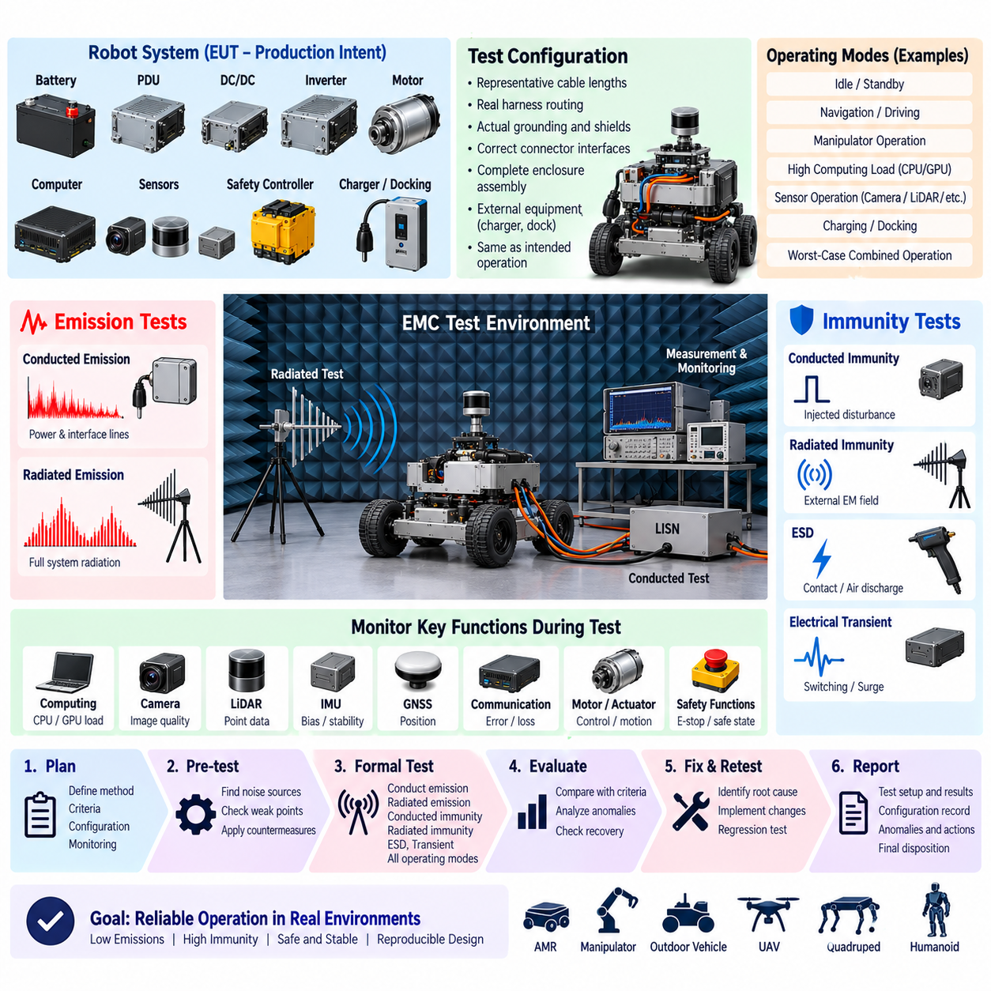
EMC testing shall demonstrate that the robot operates reliably in its intended electromagnetic environment without generating unacceptable electromagnetic disturbances. Verification shall address both emissions and immunity at component, subsystem, and complete-system levels as appropriate. Testing shall represent realistic electrical configurations and operating modes rather than evaluating electronics only under simplified laboratory conditions.
The EMC validation plan shall be established before formal qualification begins and shall identify the applicable product configuration, interfaces, operating states, test methods, acceptance criteria, monitoring parameters, and required documentation. Test planning shall be coordinated with the grounding architecture, shield termination rules, harness design, power distribution, communication interfaces, safety functions, and intended deployment environment.
The equipment under test shall be representative of the production-intent configuration. Batteries, PDUs, DC/DC converters, motor drives, motors, computing units, sensors, communication equipment, harnesses, connectors, enclosures, grounding points, shields, filters, and software shall match the configuration intended for release wherever practical. Any deviation shall be recorded and assessed for its potential influence on EMC performance.
The test configuration shall reproduce representative cable lengths, harness routing, grounding, shield termination, connector interfaces, enclosure assembly, and peripheral connections. Artificially shortened cables or simplified bench wiring shall not be used when they materially change electromagnetic coupling. External chargers, docking equipment, service cables, antennas, and communication links shall be included when they are part of the intended operating configuration.
Conducted emission testing shall evaluate electromagnetic disturbances transferred through power and external interface conductors. Measurements shall consider switching power supplies, DC/DC converters, motor drives, computing equipment, chargers, and other significant noise sources. The test shall identify whether conducted energy can propagate through battery, charging, auxiliary power, communication, or service interfaces beyond the applicable acceptance limits.
Radiated emission testing shall evaluate electromagnetic energy produced by the complete electrical system and its harnesses. Representative worst-case operation shall include high processor and GPU activity, communication traffic, sensor operation, motor control, actuator switching, and other relevant functions. Cable orientation, enclosure configuration, grounding, and shield termination shall remain consistent with the defined test configuration during measurement.
Conducted immunity testing shall demonstrate that disturbances coupled onto power and signal conductors do not cause unacceptable degradation, reset, communication failure, unsafe behavior, or loss of required functionality. Power inputs, communication interfaces, sensor lines, and externally accessible conductors shall be evaluated according to their expected exposure and applicable test methods. Critical functions shall be continuously monitored throughout exposure.
Radiated immunity testing shall demonstrate that external electromagnetic fields do not cause loss of control, corrupted perception, communication instability, unintended actuator behavior, or degradation of safety functions. The robot shall be exercised in operating states that activate representative sensitive electronics, including computing platforms, cameras, LiDAR, radar, IMUs, GNSS receivers, safety controllers, and communication networks.
Electrostatic discharge testing shall evaluate accessible conductive and insulating surfaces, connectors, service interfaces, controls, displays, charging interfaces, and other locations that may experience human or environmental contact. Both direct and indirect discharge mechanisms shall be considered where applicable. The system shall not exhibit hazardous motion, permanent damage, uncontrolled reset, or unacceptable loss of required functions following exposure.
Electrical transient testing shall consider disturbances generated by relay switching, contactor operation, inductive load interruption, motor regeneration, battery connection, charger connection, emergency-stop operation, and other rapid electrical events. Where external power or long conductors are present, appropriate transient immunity methods shall be applied. Protection performance shall be evaluated together with functional recovery and diagnostic behavior.
Motor and inverter operation shall be included as a primary EMC stress condition because PWM switching, high phase current, rapid current transitions, and long motor cables can generate substantial common-mode and differential-mode noise. Tests shall include representative acceleration, deceleration, regenerative braking, direction changes, and actuator loading where applicable while monitoring sensors, communication networks, computing systems, and safety functions.
Charging and docking modes shall be evaluated separately when they introduce external grounding, protective earth, power conversion equipment, or communication connections. The EMC behavior of a battery-powered robot can change significantly after connection to grounded infrastructure. Testing shall therefore verify that charging, docking, and transition between autonomous and externally connected states do not introduce unacceptable interference or ground-related malfunction.
Communication performance shall be monitored during EMC exposure rather than evaluated only by visual observation of robot operation. CAN, CAN FD, RS-485, Ethernet, industrial Ethernet, USB, wireless links, and other relevant interfaces shall be checked for frame errors, packet loss, link interruption, excessive retries, bus-off conditions, latency changes, or unexpected reconnection behavior according to the system architecture.
Sensor performance shall be monitored quantitatively where practical. EMC exposure may create disturbances that do not immediately stop operation but degrade perception accuracy. Camera artifacts, LiDAR point corruption, radar anomalies, IMU bias shifts, GNSS position degradation, encoder errors, analog sensor offsets, and force or load measurement instability shall be evaluated against defined functional acceptance criteria.
Computing equipment shall be operated at representative or worst-case processing load during relevant EMC tests. CPU, GPU, memory, storage, high-speed interfaces, and switching regulators may behave differently under maximum activity than during idle operation. Test workloads shall therefore exercise realistic perception, planning, control, AI inference, logging, and communication functions where these are part of the released robot configuration.
Safety-related functions shall receive explicit monitoring throughout EMC testing. Emergency stop, safety controller status, braking commands, contactor control, protective stop, speed limitation, safety sensors, and other applicable functions shall remain within their defined safe behavior. An EMC disturbance shall not result in uncontrolled motion or defeat a required safety mechanism, even when temporary degradation of a noncritical function is permitted.
Functional performance criteria shall be defined before testing. Acceptance may distinguish between normal operation without degradation, temporary degradation that automatically recovers after the disturbance, and unacceptable behavior requiring operator intervention or hardware reset. The permitted criterion shall reflect the safety significance and operational importance of each function rather than applying one generic response requirement to the entire robot.
Pre-compliance testing should be performed during prototype development to identify dominant emission sources and susceptibility paths before formal qualification. Near-field probing, current-probe measurements, conducted-noise measurements, temporary shielding, subsystem activation, and controlled cable-routing experiments may be used for diagnosis. These activities shall support root-cause identification rather than substitute for the required final system tests.
Formal qualification shall use a controlled test configuration with documented hardware, software, firmware, calibration, harness, grounding, shield, and mechanical revisions. Photographs or equivalent configuration records should capture cable placement, enclosure state, ground connections, peripheral equipment, and test instrumentation. This information shall enable failed tests to be reproduced and successful configurations to be maintained during production.
All significant functions shall be monitored before, during, and after each EMC exposure. Monitoring shall detect both obvious failures and latent degradation, including resets, watchdog events, diagnostic trouble codes, communication errors, corrupted sensor data, timing faults, storage errors, degraded localization, or abnormal actuator commands. Logs shall be time-correlated with the applied electromagnetic disturbance whenever practical.
If a test failure occurs, corrective action shall identify the disturbance source or exposure mechanism, coupling path, affected receiver, and system-level consequence. Changes to filters, grounding, shield termination, harness routing, connector bonding, enclosure design, software recovery, or component selection shall be documented. Testing shall then be repeated to demonstrate that the corrective action resolves the failure without creating a new EMC problem.
Regression testing shall be considered whenever design changes can alter electromagnetic behavior. Changes to motor drives, converters, processors, sensors, communication hardware, cables, connectors, enclosures, grounding points, shields, filters, or harness routing may require partial or complete EMC retesting. The scope of regression shall be determined by engineering analysis and documented as part of design change control.
The EMC test report shall identify the equipment under test, configuration, applicable requirements, test setup, instrumentation, operating modes, performance criteria, measured results, anomalies, corrective actions, and final disposition. Test records shall provide traceability to the released product configuration and retain sufficient information for later investigation, certification support, manufacturing changes, and field issue analysis.
Completion of EMC validation shall demonstrate that the grounding architecture, ground points, shield terminations, filtering, harness routing, connectors, enclosures, power distribution, communications, sensors, computing systems, and safety functions operate as an integrated electromagnetic system. The resulting evidence shall support reliable deployment of HRS platforms across AMR, manipulator, outdoor vehicle, UAV, quadruped, and humanoid applications.

