Volume 22. Hills Robotics Engineering Standards

Chapter 14. HRS-014 Humanoid

14.01. Humanoid EE Architecture Standard
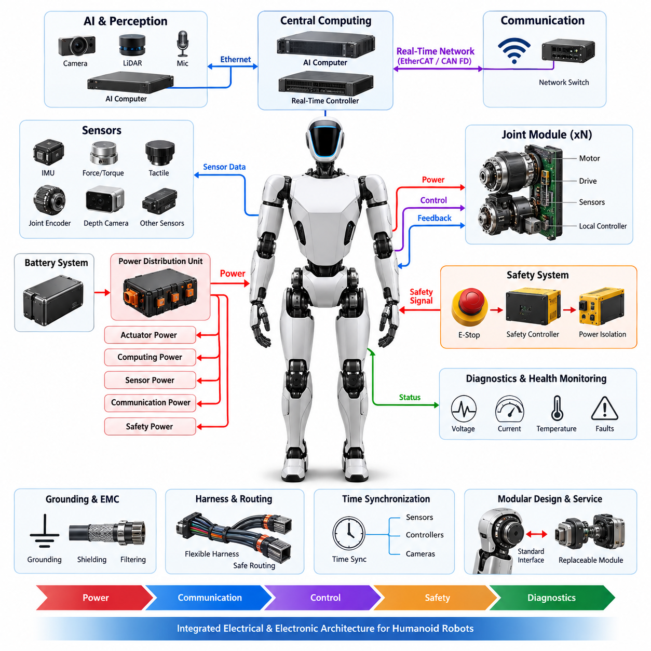
The humanoid electrical and electronic architecture shall define a unified system framework for distributing power, computation, communication, sensing, actuation, and safety functions throughout the robot. The architecture shall support highly articulated structures containing the torso, head, arms, hands, legs, and distributed joint modules while maintaining clear electrical boundaries between subsystems.
The architecture shall use a hierarchical organization consisting of system-level power distribution, central computing, real-time control networks, distributed joint electronics, perception devices, and independent safety functions. Interfaces between these domains shall be explicitly defined so that electrical, communication, and functional dependencies can be traced from the main power source to every actuator, sensor, controller, and peripheral device.
Primary electrical power shall originate from the humanoid battery system and shall be distributed through a protected power distribution unit. Separate voltage domains should be established for high-power actuators, computing equipment, sensors, communication devices, and safety electronics where appropriate. Each branch shall include coordinated overcurrent protection, isolation, monitoring, and controlled shutdown provisions according to its electrical load and criticality.
The power architecture shall account for the highly dynamic load profile produced by simultaneous operation of hip, knee, ankle, shoulder, elbow, wrist, hand, and torso actuators. Peak current, regenerative energy, voltage sag, transient response, thermal loading, and battery state shall be considered during architecture design. Energy returned by regenerative joints shall be safely absorbed, stored, limited, or redistributed without destabilizing shared power rails.
Joint modules shall be treated as standardized distributed electromechanical nodes whenever practical. Each module should integrate or interface with the motor, inverter or servo drive, position sensing, temperature sensing, current measurement, local control electronics, and communication interface. Standardized electrical boundaries shall enable replacement and scaling while reducing differences among arm, leg, torso, neck, and other articulated joint implementations.
Humanoid communication shall separate deterministic motion-control traffic from high-bandwidth perception and supervisory traffic. Real-time actuator networks may use EtherCAT, CAN FD, or another validated deterministic interface, while cameras, LiDAR, depth sensors, AI computers, and data recorders may use Ethernet-based networks. Network topology, bandwidth, latency, jitter, synchronization, and fault-containment requirements shall be defined before subsystem integration.
The computing architecture shall distinguish high-level AI computation from deterministic motion and safety control. Central AI computers may execute perception, localization, planning, embodied intelligence, and multimodal inference, while dedicated real-time processors shall execute joint control, balance control, state estimation, and hardware supervision. Safety-critical reactions shall not depend solely on nondeterministic AI processing or general-purpose operating-system behavior.
Sensor architecture shall support distributed proprioceptive and exteroceptive sensing across the humanoid body. Joint encoders, motor current sensors, force/torque sensors, IMUs, tactile sensors, cameras, depth cameras, LiDAR, microphones, and other perception devices shall be assigned defined power, communication, synchronization, calibration, and diagnostic interfaces. Sensors required for balance or protective functions shall receive appropriate integrity and availability consideration.
The head and upper torso should provide structured interfaces for perception and AI equipment because these regions commonly contain cameras, depth sensing, microphones, inertial devices, networking hardware, and central compute resources. High-bandwidth sensor links shall be physically and electrically separated from noisy actuator power paths where necessary. Cable routing shall consider electromagnetic compatibility, heat generation, mechanical motion, and service access.
Harness architecture shall reflect continuous articulation and repeated mechanical motion. Harnesses crossing the neck, shoulder, elbow, wrist, waist, hip, knee, and ankle shall be designed for the expected bending radius, torsion, flex cycles, strain relief, abrasion exposure, and connector retention. Routing shall prevent interference with joint travel and shall provide sufficient service loops without allowing cables to enter pinch, shear, or high-temperature zones.
Grounding, bonding, shielding, and electromagnetic compatibility shall be engineered as system-level properties rather than resolved independently by individual modules. High-current motor switching, DC/DC converters, computing platforms, high-speed Ethernet, cameras, and sensitive inertial sensors can create interacting noise paths. Power return, chassis bonding, shield termination, cable separation, filtering, and grounding topology shall therefore follow controlled architecture rules.
Functional safety shall be integrated into the electrical architecture through independent emergency-stop paths, actuator disable mechanisms, power isolation, fault detection, and controlled transition to safe states. Critical failures such as uncontrolled joint torque, communication loss, processor failure, sensor disagreement, overtemperature, overcurrent, or abnormal battery conditions shall result in predefined reactions appropriate to the robot's operating condition and stability requirements.
Because abrupt removal of actuator power may cause a standing humanoid to collapse, safe-state design shall consider the physical consequences of electrical shutdown. The architecture should support coordinated torque reduction, controlled posture transition, mechanical holding mechanisms where applicable, and selective isolation of failed subsystems. Emergency behavior shall balance electrical isolation requirements with the need to prevent secondary hazards caused by falling or uncontrolled motion.
Diagnostics shall be distributed throughout the architecture and consolidated into a system-level health-management function. Battery status, rail voltage, current, temperature, communication errors, actuator faults, sensor validity, insulation or grounding abnormalities, and computing health should be continuously observable. Diagnostic information shall support fault localization to replaceable modules and provide timestamped records for maintenance, validation, and field analysis.
Time synchronization shall provide a common temporal reference for perception, state estimation, motion control, diagnostics, and data recording. Cameras, IMUs, force sensors, joint feedback, and distributed controllers shall maintain synchronization accuracy appropriate to their functions. Where Ethernet-based synchronization is used, the architecture shall define clock hierarchy, synchronization sources, fallback behavior, and monitoring of synchronization quality.
The architecture shall support modular manufacturing and service by defining replaceable electrical units with controlled interfaces, connector identification, addressing rules, firmware compatibility, calibration records, and configuration data. Replacement of a joint, limb module, sensor assembly, battery, controller, or computing unit should not require uncontrolled modification of unrelated subsystems. Configuration management shall maintain compatibility among hardware, firmware, and electrical revisions.
Humanoid electrical architecture shall finally be validated as an integrated cyber-physical system rather than as a collection of independently compliant components. Verification shall cover nominal operation, peak dynamic loads, degraded power conditions, communication faults, sensor failures, actuator faults, emergency shutdown, thermal stress, electromagnetic disturbance, repeated joint motion, and recovery behavior. The resulting architecture shall provide a scalable foundation for safe, maintainable, and reliable embodied AI humanoid platforms.

14.02. Joint Module Electrical Standard
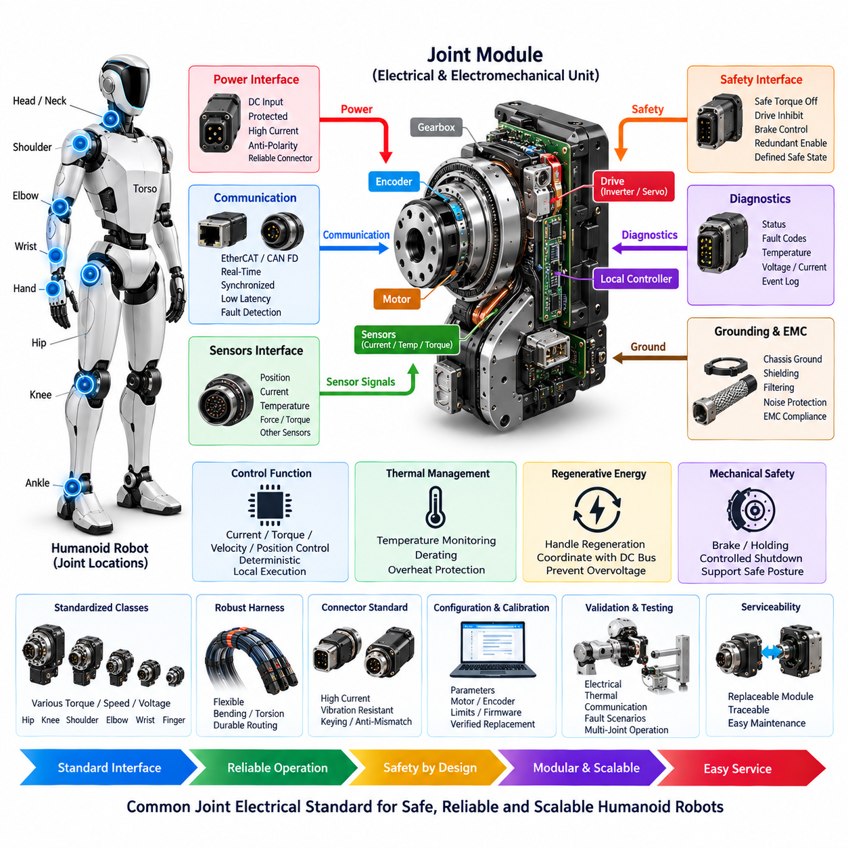
The humanoid joint module electrical standard shall define a common electrical architecture for rotary and linear joints used throughout the neck, torso, shoulders, arms, wrists, hands, hips, legs, knees, and ankles. Each joint module shall provide controlled interfaces for electrical power, motor drive, sensing, communication, diagnostics, and safety so that modules can be integrated without redesigning the surrounding robot electrical architecture.
A joint module shall be treated as a self-contained electromechanical subsystem containing or interfacing with the actuator motor, servo drive or inverter, position sensing, current sensing, temperature monitoring, braking or holding mechanisms where required, and local control electronics. Electrical boundaries shall be clearly defined between the joint module and the humanoid system so that power, communication, safety, grounding, and service connections remain consistent across different joint classes.
Joint modules shall be classified according to operating voltage, continuous and peak current, torque capability, rotational speed, duty cycle, thermal characteristics, mechanical range, and functional criticality. High-torque joints such as hips, knees, and shoulders may require higher power capacity than wrist, finger, neck, or auxiliary joints. The electrical interface shall therefore support standardized classes while allowing controlled variations in actuator power ratings.
Each module shall receive actuator power through a protected power interface designed for the maximum expected electrical load and transient conditions. Cable gauge, connector current rating, contact resistance, voltage drop, fuse or electronic protection, and thermal derating shall be coordinated with continuous and peak motor current. Power connectors shall prevent accidental polarity reversal and shall provide sufficient mechanical retention for repeated humanoid motion and vibration.
The servo drive or inverter shall provide controlled motor excitation and shall incorporate current measurement, voltage monitoring, temperature supervision, and fault detection appropriate to the actuator technology. Switching devices and gate-drive circuits shall tolerate expected regenerative and transient conditions. Where regenerative energy is returned to the common DC bus, the module shall coordinate with system-level energy management to prevent excessive bus voltage or unstable interactions among simultaneously operating joints.
Joint position sensing shall provide the resolution, accuracy, update rate, and reliability required by the associated motion-control function. Absolute encoders are preferred where startup position must be known without executing a homing movement, while redundant or secondary sensing may be required for joints whose incorrect position could create significant instability or hazards. Encoder power and signal interfaces shall remain electrically compatible with the local controller and system diagnostic architecture.
Motor current, winding temperature, drive temperature, and other available actuator health parameters shall be monitored within the joint module. Additional torque, force, strain, or load sensing may be incorporated when required by balance control, contact detection, manipulation, or safety functions. Sensor signals shall be protected against electrical noise generated by motor switching and shall maintain sufficient integrity during rapid torque changes and high-current operation.
The local joint controller shall execute deterministic low-level functions such as current, torque, velocity, or position control according to the system control architecture. High-rate control loops should remain close to the actuator to reduce communication latency and central computing load. Supervisory commands may originate from higher-level motion controllers, but loss of communication shall trigger a defined local behavior rather than uncontrolled continuation of the last received command.
The joint communication interface shall use an approved deterministic network such as EtherCAT, CAN FD, or another validated real-time protocol selected for the humanoid platform. Each module shall have a unique logical identity and controlled addressing method. Network design shall specify command and feedback cycle time, latency, jitter, synchronization accuracy, error detection, timeout behavior, and recovery mechanisms required for coordinated multi-joint motion.
Time synchronization shall ensure that joint command execution and feedback acquisition can be correlated across the humanoid body. Position, velocity, torque, current, and diagnostic information should use a consistent timing reference when required by balance and whole-body control. Distributed clocks or equivalent synchronization mechanisms shall be monitored so that loss of synchronization can be detected before timing errors significantly affect coordinated motion.
Safety functions shall provide a defined method for disabling or limiting actuator torque independently of normal motion commands when required by the system safety architecture. Depending on joint criticality, this may include safe torque off, drive inhibit, contactor control, brake control, current limitation, or redundant enable paths. Safety-related interfaces shall have defined electrical states so that open circuits, communication loss, or power faults do not unintentionally command hazardous motion.
A humanoid joint shall not assume that immediate electrical shutdown always produces the safest mechanical condition. Hip, knee, ankle, torso, and other load-bearing joints may require controlled torque reduction, braking, or coordinated posture transition to prevent collapse. Electrical design shall therefore support the system-level safe-state strategy while ensuring that a severe electrical fault can still isolate a failed actuator when continued energization would create greater risk.
Grounding and electromagnetic compatibility shall be addressed within every joint module because high-frequency inverter switching and rapidly changing motor current can disturb encoders, communication links, force sensors, and nearby perception electronics. Power return paths, chassis bonding, cable shielding, connector shield termination, filtering, and physical separation between power and signal conductors shall follow the humanoid grounding and EMC architecture.
Joint harnesses shall tolerate repeated bending, torsion, vibration, and movement throughout the specified service life. Connections passing through rotating or articulated structures shall maintain minimum bending radius and avoid pinch, abrasion, shear, and excessive tensile loading. Where continuous rotation is required, an appropriately qualified rotary electrical interface or slip-ring solution shall be used instead of permitting uncontrolled twisting of conventional harnesses.
Connectors shall be selected according to current capacity, voltage rating, contact count, environmental exposure, vibration resistance, mating-cycle requirement, packaging constraints, and service accessibility. Power and communication interfaces should be mechanically or visually distinguishable to reduce assembly errors. Connector keying and pin assignment shall prevent incompatible joint variants from being connected where electrical differences could damage hardware or create unsafe operation.
Each joint module shall provide standardized diagnostic information including supply voltage, motor current, position, velocity, temperature, communication state, controller state, warning status, and fault codes where applicable. Diagnostic records should distinguish electrical, sensing, communication, thermal, and mechanical-related faults. Critical events shall be timestamped so that joint behavior can be correlated with system logs during validation, maintenance, and field failure analysis.
The module shall support controlled configuration of parameters such as joint identity, motor characteristics, encoder calibration, current limits, torque limits, motion limits, communication settings, firmware revision, and safety-related configuration. Production parameters shall be protected against unintended modification. Replacement modules shall be verified against the robot configuration before full actuator enable to prevent incorrect hardware or calibration data from producing unintended motion.
Thermal design shall consider losses from motor windings, bearings, gearing, inverter switching devices, connectors, and local electronics under realistic humanoid duty cycles. Temperature sensors shall be positioned to detect critical thermal conditions before component damage occurs. Warning, derating, and shutdown thresholds should provide progressive protection so that temporary thermal stress can be managed without unnecessary abrupt loss of a load-bearing joint.
Joint modules shall be designed as replaceable and traceable service units wherever practical. Module identification should associate hardware revision, serial information, firmware compatibility, calibration data, and applicable electrical ratings with the installed joint location. Service procedures shall define safe power isolation, connector handling, replacement verification, calibration restoration, and post-service functional checks before the joint is returned to normal operation.
Electrical validation shall include nominal operation, startup and shutdown, continuous and peak loading, voltage variation, regenerative operation, communication interruption, sensor faults, overcurrent, overtemperature, actuator disable, grounding integrity, electromagnetic disturbance, and repeated articulation. Testing shall verify both individual module performance and interactions among multiple joints operating simultaneously because shared power and communication resources can expose faults not observable during isolated testing.
The standardized joint module interface shall ultimately allow humanoid platforms to scale from a limited number of large actuators to many distributed high-degree-of-freedom joints while preserving predictable electrical behavior. Consistent power, communication, sensing, diagnostics, safety, configuration, and service interfaces shall enable modular development and replacement while providing the deterministic performance required for coordinated whole-body control and embodied AI operation.

14.03. Humanoid Sensor Standard
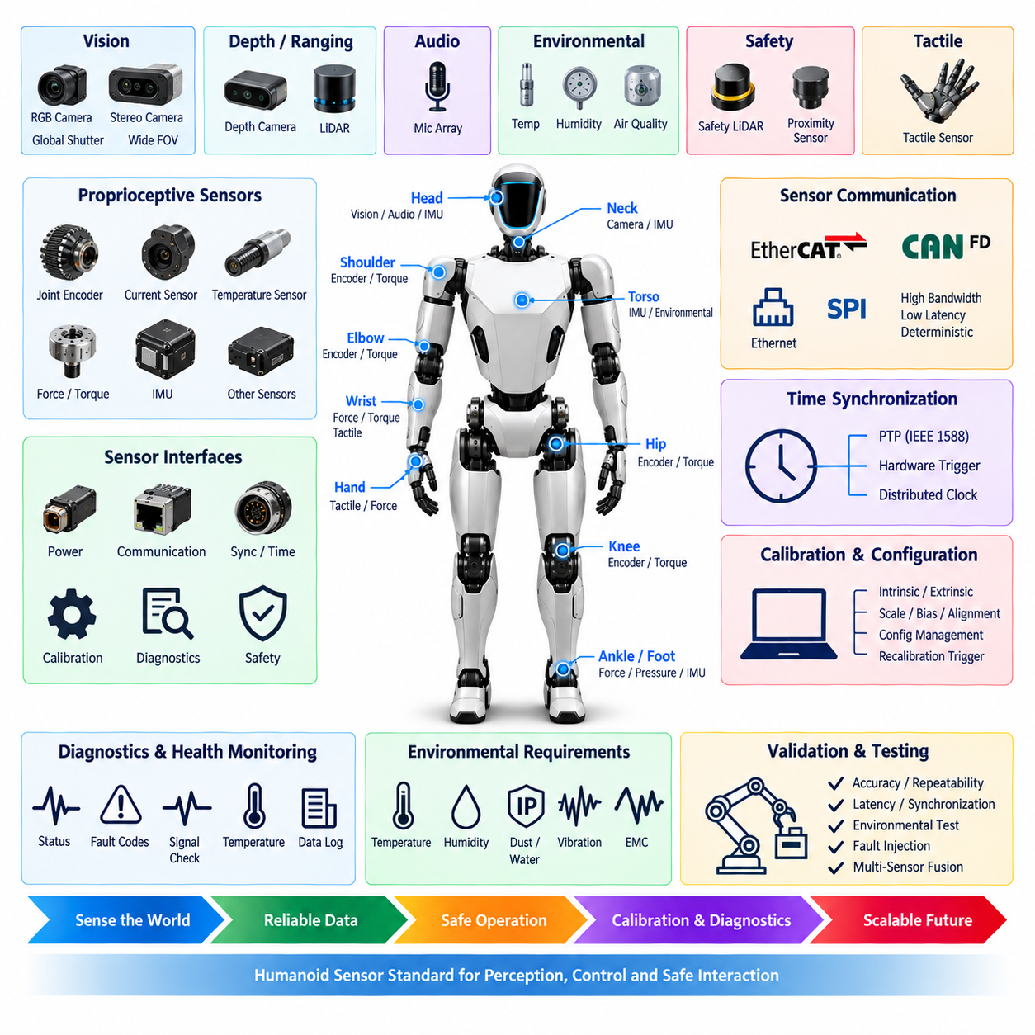
The humanoid sensor standard shall define common requirements for sensing devices used to perceive robot state, human interaction, contact conditions, and the surrounding environment. The sensor architecture shall support distributed proprioceptive and exteroceptive sensing across the head, torso, arms, hands, legs, feet, and joint modules while providing consistent interfaces for power, communication, synchronization, calibration, diagnostics, and safety.
Humanoid sensors shall be classified according to their primary function, including joint state sensing, inertial sensing, force and torque measurement, tactile sensing, vision, depth perception, ranging, audio sensing, environmental monitoring, and safety-related detection. Each sensor class shall have defined performance requirements appropriate to its role rather than applying identical accuracy, bandwidth, latency, redundancy, or environmental requirements to every sensing device.
Proprioceptive sensors shall provide the internal state information required for posture estimation, balance, motion control, manipulation, and actuator protection. Joint encoders, motor current sensors, temperature sensors, force or torque sensors, and inertial measurement units shall provide deterministic and sufficiently frequent feedback for the associated control loops. Sensors directly affecting dynamic stability shall be assigned higher requirements for availability, latency, integrity, and fault detection.
Joint position sensors shall provide sufficient resolution, repeatability, absolute accuracy, and update rate for the mechanical characteristics and control requirements of each joint. Absolute encoders should be used where joint position must be known immediately after startup without requiring potentially hazardous homing motion. Load-bearing or safety-relevant joints may use redundant sensing or independent plausibility information to detect incorrect, frozen, discontinuous, or drifting position measurements.
Inertial measurement units shall measure angular velocity and linear acceleration for body orientation, dynamic state estimation, balance control, and motion analysis. A primary IMU should be installed at a structurally appropriate location such as the torso, while additional IMUs may be distributed across the pelvis, head, limbs, or feet when required. Mounting orientation, structural vibration, temperature effects, sampling frequency, and synchronization shall be controlled because these factors directly influence state-estimation performance.
Force and torque sensors shall be used where physical interaction, load estimation, contact detection, manipulation, or whole-body control requires direct mechanical feedback. Wrist force/torque sensors may measure interaction forces during manipulation, while ankle or foot sensing can provide information about ground contact and load distribution. Sensor overload capacity shall account for transient impacts and abnormal contact conditions beyond the nominal operating force range.
Tactile sensing may be integrated into hands, fingertips, palms, feet, forearms, or other surfaces expected to contact humans or objects. Tactile sensors should provide spatial and temporal resolution appropriate to contact detection, grasp control, slip detection, pressure distribution, or collision awareness. Their electrical architecture shall accommodate potentially large numbers of sensing elements without allowing wiring complexity, communication traffic, or power consumption to become impractical.
Vision sensors shall provide image information required for object recognition, human perception, navigation, manipulation, localization, and embodied AI functions. Mono, stereo, RGB, global-shutter, or other camera technologies may be selected according to application requirements. Camera placement shall consider field of view, occlusion by robot structures, motion blur, vibration, illumination range, lens protection, and the relationship between sensor coordinates and the humanoid mechanical reference frame.
Depth perception may be provided by stereo vision, structured-light cameras, time-of-flight devices, LiDAR, or other validated ranging technologies. Depth sensors shall be selected according to required range, minimum detection distance, field of view, accuracy, resolution, update rate, surface characteristics, and environmental conditions. Multiple technologies may be combined when a single sensor principle cannot provide reliable perception across the complete humanoid operating environment.
LiDAR or other ranging sensors may be integrated into the head, torso, or other locations to support obstacle detection, localization, mapping, and surrounding-space awareness. Installation shall minimize self-occlusion and interference caused by moving limbs while protecting the sensing aperture from mechanical damage. Sensor placement shall also consider the changing geometry of the humanoid because arm, hand, and body motion can temporarily block or distort external perception.
Audio sensing shall support speech interaction, acoustic event detection, localization, or multimodal perception when required by the product function. Microphone arrays should be positioned to achieve the required spatial coverage while reducing contamination from cooling fans, gearboxes, motors, structural vibration, and loudspeakers. Audio channels used for localization shall maintain controlled timing relationships so that phase and arrival-time information remains meaningful.
Foot and contact sensing shall provide information needed to determine ground contact, load transfer, center-of-pressure behavior, and stability conditions. Force sensors, pressure arrays, strain elements, or equivalent technologies may be used according to mechanical design. Sensors in feet and lower limbs shall tolerate repeated impacts, vibration, contamination, and high mechanical loads while preserving sufficient sensitivity for balance and gait estimation.
Sensor power interfaces shall use controlled voltage rails with appropriate protection, filtering, grounding, and current capacity. Sensitive perception and measurement devices should be isolated from high-noise actuator power paths where practical. Power-up sequencing shall prevent undefined outputs from being interpreted as valid measurements, and brownout or undervoltage conditions shall be detectable so that corrupted sensor data is not silently propagated into control or AI functions.
Sensor communication shall be selected according to bandwidth, latency, determinism, distance, topology, and reliability requirements. High-rate cameras and LiDAR may use Ethernet or dedicated high-speed links, while joint sensors and distributed measurement devices may use EtherCAT, CAN FD, SPI, or other approved interfaces. Communication architecture shall prevent high-bandwidth perception traffic from degrading deterministic feedback required for balance and actuator control.
Time synchronization shall establish a common temporal reference across cameras, IMUs, joint encoders, force sensors, LiDAR, tactile arrays, and distributed controllers. Hardware triggering, Precision Time Protocol, distributed clocks, or equivalent methods may be applied according to required accuracy. Sensor data used for fusion shall include valid timestamps so that measurements acquired at different physical times are not incorrectly interpreted as simultaneous observations.
Calibration shall define the intrinsic, extrinsic, scale, bias, alignment, and offset parameters required by each sensor type. Camera intrinsic calibration, camera-to-robot transforms, IMU alignment, joint encoder offsets, force sensor zero points, and LiDAR coordinate relationships shall be controlled configuration data. Calibration results shall be traceable to the specific sensor and robot configuration and shall not be replaced without verification after service or hardware modification.
Recalibration shall be triggered when sensor replacement, mechanical disassembly, collision, mounting adjustment, structural deformation, firmware change, abnormal diagnostic behavior, or validation results indicate that existing calibration may no longer be valid. Calibration status shall be available to the system so that uncalibrated or expired sensor configurations can be identified before autonomous operation requiring accurate perception or control is enabled.
Sensor diagnostics shall detect communication loss, invalid ranges, saturation, frozen values, excessive noise, implausible rates of change, temperature abnormalities, synchronization errors, and internal device faults where supported. Cross-sensor plausibility checking should be used when independent measurements describe related physical states. Diagnostic logic shall distinguish sensor failure from genuine rapid robot motion or unusual environmental conditions whenever practical.
Safety-related sensing shall be sufficiently independent from non-safety perception where required by the humanoid safety architecture. AI perception alone shall not be assumed to provide a safety-rated protective function unless the complete sensing and processing chain has been developed and validated for that purpose. Emergency-stop devices, protective sensors, actuator state feedback, and other safety channels shall maintain defined behavior during failures of general-purpose computing or perception systems.
Sensor mounting and harness design shall account for repeated humanoid articulation, shock, vibration, cable flexing, connector retention, electromagnetic interference, heat, and service access. Sensor brackets shall preserve mechanical alignment throughout the specified operating life. Harness routing shall prevent power cables, motor switching nodes, and moving structures from degrading sensitive signals or mechanically stressing sensor connectors during full-range body motion.
Environmental requirements shall reflect the intended humanoid operating domain and may include temperature, humidity, dust, water exposure, lighting variation, vibration, shock, electromagnetic disturbance, and contamination. Sensors exposed at the head, hands, feet, or outer body surfaces shall receive protection appropriate to their location. Environmental protection shall not significantly degrade optical, acoustic, tactile, thermal, or ranging performance.
Sensor data interfaces shall provide consistent metadata describing sensor identity, measurement units, coordinate frame, timestamp, calibration revision, validity state, and diagnostic condition where applicable. This information shall allow perception, control, logging, simulation, and service tools to interpret measurements consistently. Changes to sensor models or firmware shall be configuration-controlled when they can alter scaling, timing, calibration, or measurement behavior.
Validation shall evaluate sensors individually and as an integrated humanoid perception and control system. Testing shall include nominal accuracy, repeatability, latency, synchronization, calibration stability, communication interruption, electrical disturbance, temperature variation, vibration, dynamic motion, occlusion, saturation, and representative fault conditions. Multi-sensor fusion shall also be verified under conditions where individual sensing technologies become temporarily degraded.
The standardized sensor architecture shall ultimately provide reliable and temporally consistent information for whole-body control, balance, manipulation, navigation, human interaction, diagnostics, and embodied AI. Consistent electrical interfaces, synchronization, calibration, health monitoring, environmental qualification, and configuration management shall allow sensors to evolve across humanoid generations without compromising system-level safety, maintainability, or deterministic control.

14.04. Humanoid Safety Requirement
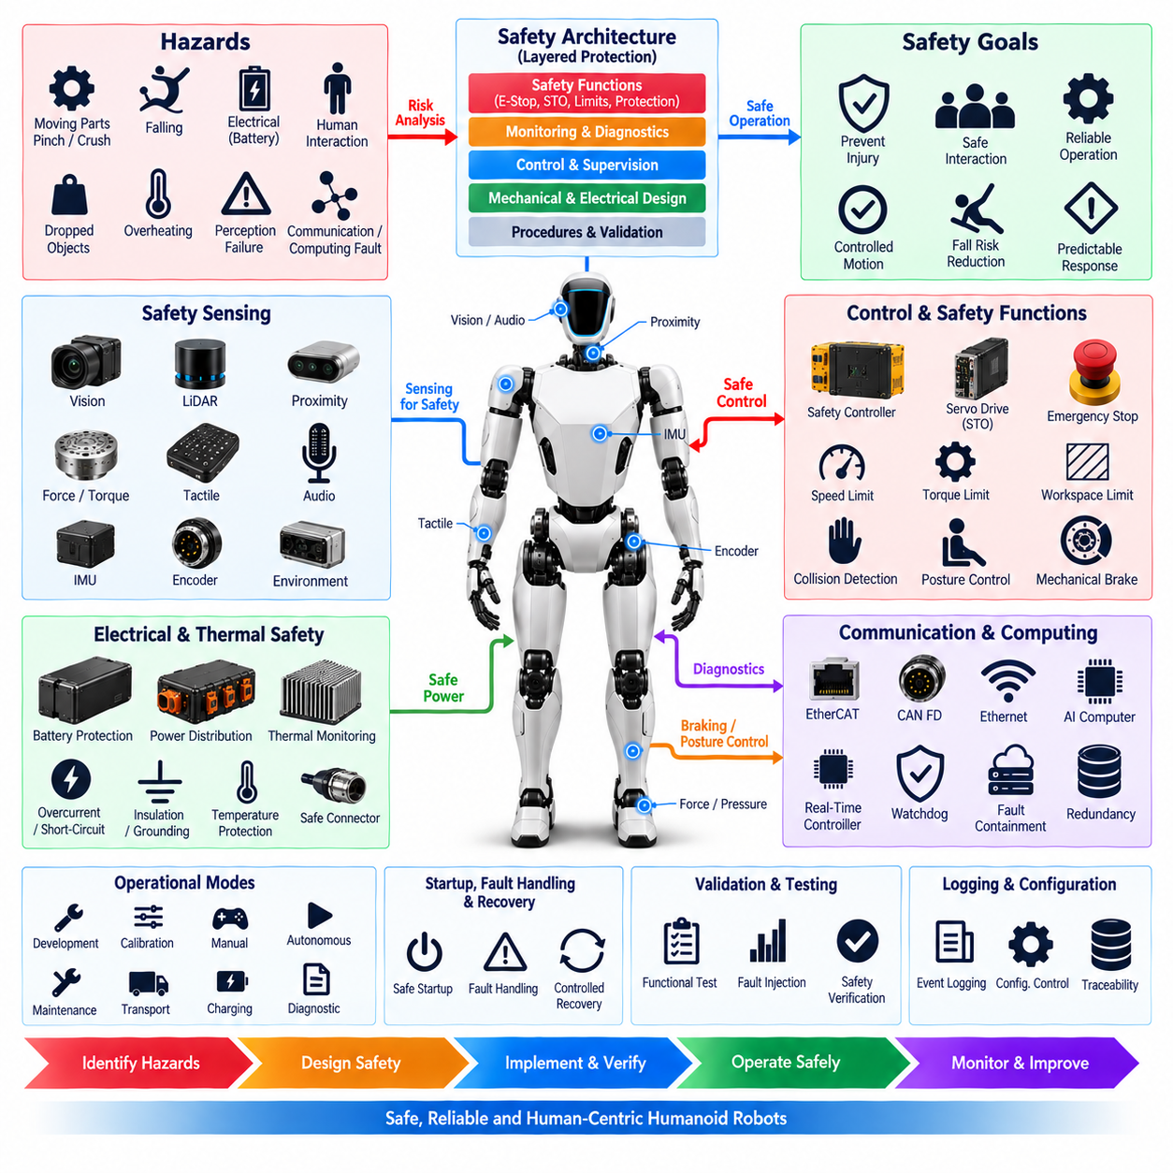
Humanoid safety requirements shall define system-level principles for preventing unacceptable risk arising from electrical energy, actuator motion, loss of balance, physical contact, perception failures, communication faults, computing faults, and stored mechanical energy. Safety shall be treated as an integrated property of the complete humanoid platform rather than as an isolated function implemented only by individual actuators, sensors, or controllers.
The safety architecture shall consider hazards associated with the humanoid body structure, including high-torque joints, articulated limbs, grasping mechanisms, pinch and crushing zones, unexpected movement, falling, dropped objects, battery faults, and interaction with humans. Hazard analysis shall consider normal operation, foreseeable misuse, maintenance, transportation, charging, startup, shutdown, degraded operation, and recovery from abnormal system states.
Safety functions shall be allocated according to the severity of potential hazards and the required independence from normal control functions. Protective measures may include emergency stopping, safe torque off, controlled torque limitation, speed limitation, workspace restriction, collision detection, protective sensing, mechanical braking, power isolation, and controlled posture transition. Safety functions shall have clearly defined activation conditions, response times, and resulting safe states.
The emergency-stop system shall provide a direct and recognizable means of stopping hazardous robot behavior. Emergency-stop commands shall not depend solely on AI software, cloud connectivity, general-purpose operating systems, or non-safety communication paths. Activation shall initiate the predefined safety response and prevent automatic restart until the emergency condition has been cleared and an intentional reset and restart sequence has been completed.
Immediate removal of actuator torque shall not automatically be considered the safest response for every humanoid condition. A standing or load-bearing robot may collapse if hip, knee, ankle, or torso torque disappears without coordination. The safety architecture shall therefore distinguish situations requiring immediate torque removal from those requiring controlled deceleration, posture stabilization, braking, kneeling, sitting, or another validated transition toward a mechanically safer condition.
Joint-level safety shall prevent uncontrolled torque, velocity, position, and motion beyond defined limits. Servo drives and local controllers shall monitor command validity, current, temperature, position, velocity, communication state, and internal faults where applicable. Safety-related joints may require independent enable paths, safe torque off, mechanical holding mechanisms, redundant position information, or additional supervision according to the hazard associated with joint failure.
Whole-body motion safety shall consider interactions among multiple joints because individually valid commands can create hazardous combined motion. The system shall supervise body velocity, acceleration, joint limits, reachable workspace, self-collision, balance margin, and interaction forces where required. Motion planning and control shall respect safety constraints continuously rather than relying only on collision checking performed before movement begins.
Balance and fall risk shall be explicitly addressed because a humanoid can become hazardous even when individual electrical and control components remain functional. State estimation shall monitor conditions relevant to stability, including body orientation, joint state, foot contact, and support conditions. When stability deteriorates beyond defined thresholds, the system shall initiate an appropriate protective response before uncontrolled falling becomes unavoidable whenever technically feasible.
Human-robot interaction shall use operating limits appropriate to the expected proximity and type of contact with people. Speed, torque, force, momentum, and reachable workspace may be restricted according to the operating mode and environment. Contact-sensitive applications should use force, torque, tactile, vision, proximity, or other suitable sensing to identify unintended interaction and command a validated reduction, stop, retreat, or other protective behavior.
Safety-related sensing shall be selected according to the protective function rather than assuming that general perception automatically provides safety integrity. Sensors used for protective detection shall have defined coverage, range, latency, diagnostic behavior, environmental limits, and failure responses. Where required, independent or diverse sensing shall reduce the possibility that a single sensor technology, obstruction, calibration error, or processing failure defeats the protective function.
AI and embodied intelligence functions may provide perception, behavior generation, planning, interaction, and adaptive decision support, but safety-critical limits shall remain enforceable independently where required. AI-generated commands shall pass through deterministic supervision before reaching actuators when hazardous motion is possible. Invalid, out-of-range, temporally stale, or inconsistent commands shall be rejected or constrained according to predefined safety rules.
Communication safety shall address message loss, delay, corruption, duplication, incorrect addressing, synchronization failure, and network interruption. Safety-related commands and state information shall include mechanisms appropriate to their criticality for detecting invalid communication. Loss of the normal motion network shall lead to a defined degraded or safe behavior, and the robot shall not continue indefinitely using stale commands when communication with supervisory control has been lost.
Computing faults shall be considered across central AI computers, real-time controllers, joint controllers, gateways, and safety controllers. Watchdogs, heartbeat monitoring, execution supervision, memory protection, fault containment, and redundant processing may be applied according to criticality. A failure of high-level AI computation shall not disable independent protective functions required to stop or constrain hazardous actuator behavior.
Electrical safety shall include battery protection, overcurrent protection, short-circuit protection, insulation, grounding, controlled power distribution, connector protection, and safe servicing provisions. High-current actuator circuits shall be isolated from low-power control and sensing circuits where appropriate. Battery, PDU, converter, drive, and harness faults shall be detected and contained so that a local electrical failure does not unnecessarily propagate throughout the humanoid system.
Thermal safety shall monitor components capable of reaching hazardous temperatures, including batteries, motors, servo drives, power converters, computing devices, connectors, and charging equipment. Warning, derating, controlled shutdown, and isolation thresholds shall be coordinated according to component characteristics. Thermal protection shall consider that excessive derating of load-bearing joints can itself affect balance and therefore may require coordinated system-level behavior.
Mechanical safety shall address pinch points, shear zones, crushing hazards, sharp edges, stored spring energy, gravity-loaded mechanisms, and unexpected movement during service. Covers, guards, mechanical stops, compliant structures, brakes, and controlled maintenance procedures shall be used where appropriate. Service personnel shall be able to establish a verified condition in which hazardous motion or unexpected energization cannot occur during maintenance.
Operational modes shall have explicitly defined safety behavior. Development, calibration, manual control, autonomous operation, maintenance, transport, charging, and diagnostic modes may require different motion limits and permissions. Transition between modes shall be controlled so that entering a less restrictive state requires deliberate authorization, valid system status, required safety functions, and confirmation that incompatible commands are not active.
Startup shall include checks sufficient to determine whether safety-critical hardware, communication, sensors, actuators, calibration data, and configuration are suitable for operation. The robot shall not enter unrestricted motion when required safety functions are unavailable or critical faults remain active. Startup behavior shall avoid unexpected joint movement, and any necessary actuator alignment or initialization movement shall be constrained according to the surrounding hazard.
Fault handling shall classify detected conditions according to their effect on continued operation. Some faults may permit degraded operation with reduced speed, torque, workspace, or functionality, while others shall require controlled stopping or immediate isolation. Fault reactions shall avoid unnecessary escalation where possible, but continued operation shall not be permitted when the remaining system cannot maintain the defined safety constraints.
Safety diagnostics shall continuously monitor the availability and integrity of protective functions where technically appropriate. Emergency-stop circuits, actuator enable paths, safety sensors, communication channels, braking devices, power isolation elements, and relevant controller functions shall be checked for detectable faults. Diagnostic coverage and test intervals shall be selected so that latent failures do not remain undetected long enough to create unacceptable accumulated risk.
Reset and recovery shall be deliberately controlled after a safety event. Clearing a fault or releasing an emergency-stop device shall not by itself initiate robot motion. The system shall verify relevant safety conditions, actuator states, communication status, sensor validity, posture, and operating mode before motion is re-enabled. Recovery sequences shall account for the possibility that the humanoid has changed posture, fallen, contacted an object, or become mechanically constrained.
Safety-related configuration shall be protected from unauthorized or accidental modification. Parameters such as torque limits, velocity limits, workspace boundaries, stopping thresholds, safety sensor settings, and actuator enable configuration shall be version controlled and associated with the applicable hardware and software configuration. Changes affecting safety behavior shall require defined review, verification, validation, and release procedures.
Safety event logging shall record information needed to reconstruct significant incidents and protective interventions. Relevant records may include timestamps, robot mode, joint states, actuator commands, sensor status, fault codes, emergency-stop state, power condition, communication health, and safety-controller decisions. Logs shall support engineering analysis without becoming part of a control dependency required for the immediate execution of protective functions.
Validation shall demonstrate safety behavior under nominal, boundary, degraded, and representative fault conditions. Testing shall include emergency stopping, communication loss, sensor failure, actuator faults, excessive torque, overtemperature, power disturbances, balance degradation, human contact scenarios, mode transitions, startup, shutdown, and recovery. Tests shall verify both individual protective functions and their interaction during realistic whole-body operation.
The humanoid safety architecture shall ultimately establish layered protection combining inherently safer mechanical and electrical design, deterministic control limits, protective sensing, independent safety functions, diagnostics, fault containment, and validated recovery behavior. These layers shall allow advanced perception and embodied AI capabilities to operate within enforceable system boundaries while maintaining predictable responses to faults, human interaction, and changing physical conditions.

14.05. Humanoid Test Requirement
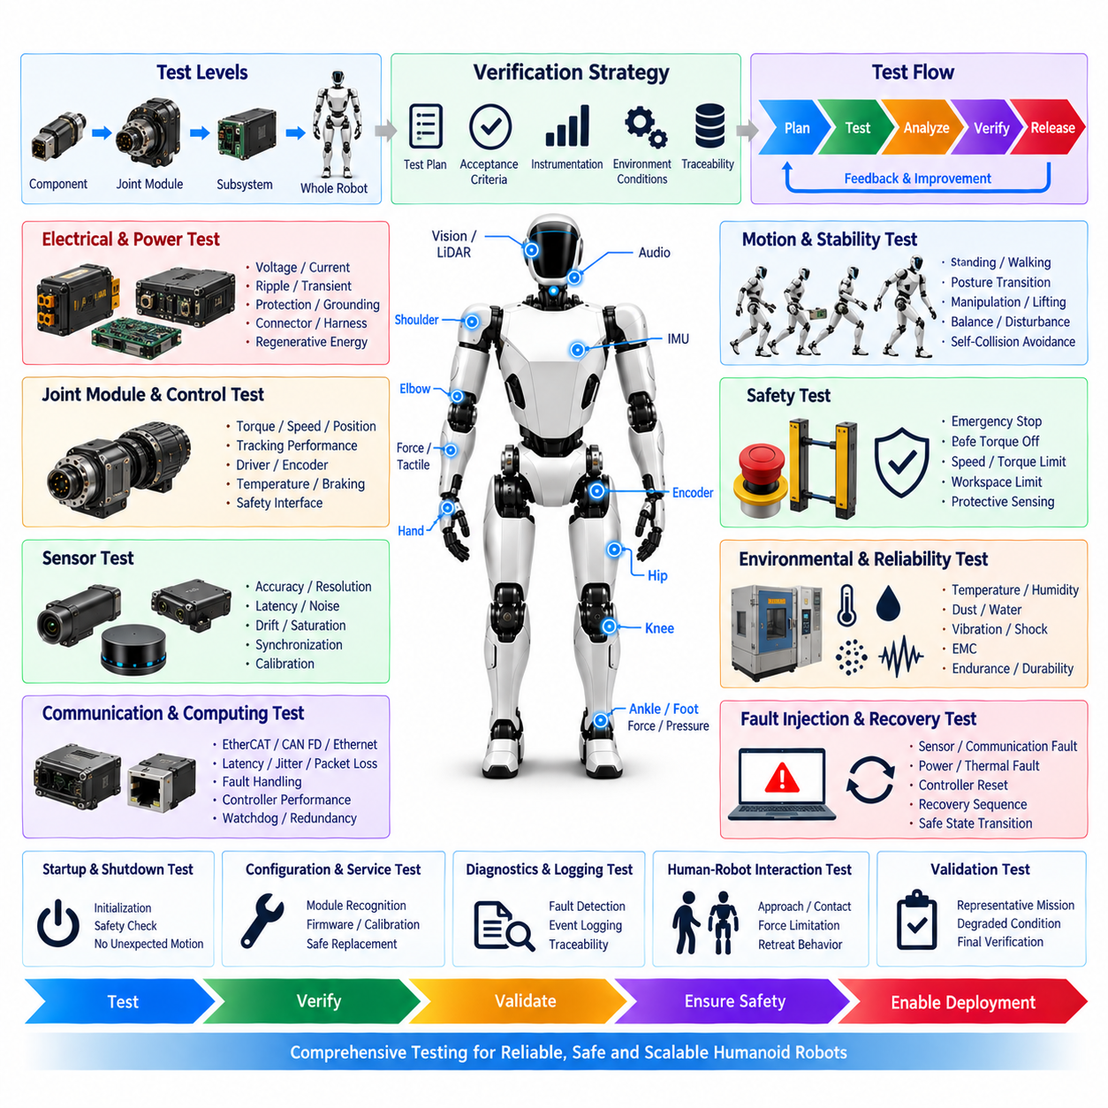
Humanoid testing shall verify that the integrated electrical, electronic, sensing, actuation, communication, computing, and safety architecture satisfies defined requirements throughout the intended operating envelope. Testing shall address individual components, joint modules, distributed subsystems, and the complete humanoid platform because failures may emerge only when power, communication, control, perception, and mechanical motion interact during whole-body operation.
The verification strategy shall define test levels, acceptance criteria, required instrumentation, environmental conditions, configuration control, and traceability between requirements and test results. Component and subsystem tests should identify faults before system integration, while robot-level testing shall demonstrate correct interaction among joints, sensors, computers, power systems, communication networks, safety functions, and software under representative operating conditions.
Electrical testing shall verify battery interfaces, power distribution units, voltage rails, DC/DC converters, protection devices, grounding, connectors, harnesses, servo drives, and distributed electronics. Measurements shall include nominal and worst-case voltage, continuous and peak current, voltage drop, ripple, transient behavior, inrush current, regenerative energy, power consumption, and protection response under realistic combinations of humanoid motion and computing load.
Power distribution testing shall reproduce dynamic load changes created by simultaneous acceleration and deceleration of multiple joints. Hip, knee, ankle, torso, shoulder, elbow, wrist, and hand actuators may produce rapid changes in current demand or regenerative energy. Tests shall confirm that shared DC buses remain within defined voltage limits and that one actuator or power branch cannot destabilize unrelated control, sensing, or computing equipment.
Joint module testing shall verify motor drive performance, encoder feedback, current measurement, temperature sensing, communication, local control, diagnostics, braking, and safety interfaces. Each joint class shall be tested across its specified torque, speed, position, acceleration, and duty-cycle ranges. Load-bearing joints shall receive additional evaluation because unexpected torque loss, excessive torque, braking failure, or position error can directly affect whole-body stability.
Joint control tests shall evaluate current, torque, velocity, and position control performance under static and dynamic loads. Tests should measure tracking error, overshoot, settling behavior, control-loop stability, latency, and response to rapidly changing commands. Mechanical limits, software limits, torque limits, and velocity limits shall be verified to ensure that commanded motion remains within the approved electrical and mechanical operating envelope.
Sensor testing shall verify joint encoders, IMUs, force/torque sensors, tactile sensors, cameras, depth sensors, LiDAR, microphones, pressure sensors, temperature sensors, and other installed sensing devices. Evaluation shall include accuracy, repeatability, resolution, update rate, latency, noise, saturation, drift, communication integrity, and diagnostic behavior according to each sensor's intended function within control, perception, interaction, or safety systems.
Sensor synchronization testing shall confirm that measurements used for state estimation, sensor fusion, balance, manipulation, and perception share an adequate temporal reference. Hardware triggers, Precision Time Protocol, distributed clocks, or other synchronization mechanisms shall be evaluated for offset, jitter, drift, startup convergence, and recovery after interruption. Timestamp integrity shall also be verified during high network and computing loads.
Calibration testing shall confirm that joint offsets, IMU alignment, camera intrinsic parameters, sensor extrinsic transforms, force-sensor zero points, and other calibration data remain valid after assembly and configuration. Calibration shall be checked after sensor replacement, joint replacement, mechanical adjustment, collision, firmware modification, or other defined recalibration triggers to ensure that stored parameters correspond to the installed hardware.
Communication testing shall evaluate EtherCAT, CAN FD, Ethernet, and other approved interfaces under nominal and stressed conditions. Tests shall measure cycle time, bandwidth, latency, jitter, packet or frame loss, error detection, synchronization, bus loading, and recovery behavior. Communication interruption, delayed messages, corrupted data, duplicate messages, incorrect addressing, and stale commands shall be introduced where appropriate to verify fault handling.
Computing tests shall verify central AI computers, real-time controllers, joint controllers, gateways, and safety controllers individually and as an integrated processing architecture. Processor loading, memory utilization, communication load, thermal behavior, startup sequencing, watchdog operation, heartbeat monitoring, and fault containment shall be evaluated. High AI workload shall not prevent deterministic control or independent safety functions from meeting their timing requirements.
Whole-body motion testing shall evaluate coordinated operation of the humanoid rather than only isolated joint performance. Representative activities should include standing, posture transition, walking where applicable, reaching, manipulation, lifting, turning, and coordinated arm-leg movement. Tests shall verify joint coordination, state estimation, balance margin, self-collision avoidance, motion limits, actuator loading, power stability, and communication performance during these behaviors.
Balance and stability testing shall evaluate the robot under changing support conditions, center-of-mass movement, external disturbance, payload variation, sensor uncertainty, and actuator performance limits. Foot contact, force distribution, body orientation, joint state, and recovery response shall be monitored. The system shall demonstrate defined protective behavior when stability approaches or exceeds validated operating boundaries.
Human-robot interaction testing shall evaluate operation near people and physical interaction where intended by the product design. Tests may include approach behavior, speed and torque limitation, contact detection, force limitation, tactile response, collision detection, retreat behavior, and emergency intervention. Representative human interaction scenarios shall be conducted under controlled conditions with predefined acceptance limits and protective measures.
Safety testing shall verify emergency-stop functions, safe torque off, actuator inhibit, braking, protective sensing, workspace limits, speed limits, torque limits, power isolation, controlled stopping, and safe-state transitions. Testing shall confirm that protective functions remain effective when normal AI, perception, communication, or supervisory control is unavailable where independence is required by the safety architecture.
Emergency-stop testing shall evaluate robot behavior from representative operating states rather than only from stationary conditions. Tests shall include standing, moving, manipulating, and load-bearing configurations where applicable. Stopping time, stopping distance, torque behavior, brake response, power isolation, posture stability, restart prevention, reset behavior, and recovery sequence shall be measured and compared with predefined acceptance criteria.
Fault-injection testing shall intentionally introduce representative electrical, sensing, communication, computing, and actuator faults to verify detection, containment, and system response. Examples include encoder loss, IMU failure, communication interruption, processor reset, overtemperature, overcurrent, undervoltage, drive fault, sensor disagreement, synchronization loss, and actuator disable. Fault injection shall not create uncontrolled hazards for personnel or test equipment.
Thermal testing shall evaluate batteries, motors, servo drives, power electronics, computing equipment, connectors, and harnesses under representative continuous and peak workloads. Temperature rise, cooling performance, warning thresholds, derating behavior, and shutdown thresholds shall be measured. Testing shall verify that thermal protection does not unexpectedly destabilize the humanoid when multiple load-bearing joints simultaneously approach thermal limits.
Electromagnetic compatibility testing shall evaluate susceptibility and emissions associated with motor switching, high-current conductors, DC/DC converters, Ethernet, computing devices, cameras, sensors, and communication networks. Tests shall confirm that electromagnetic disturbance does not cause unacceptable sensor errors, communication faults, controller resets, unintended actuator behavior, or loss of safety functions within the defined operating environment.
Harness and connector testing shall address continuity, insulation, voltage drop, contact resistance, retention, strain relief, bending, torsion, abrasion, vibration, and repeated articulation. Harnesses routed through the neck, shoulders, elbows, wrists, waist, hips, knees, and ankles shall be exercised over representative motion cycles. Testing shall identify intermittent electrical faults that may appear only after repeated mechanical movement.
Environmental testing shall reproduce relevant temperature, humidity, dust, water exposure, vibration, shock, contamination, illumination variation, and other conditions associated with the intended operating domain. Exposed sensors, connectors, joints, cooling interfaces, and electrical enclosures shall be evaluated according to their installation locations. Environmental protection shall remain effective without unacceptable degradation of perception, control, communication, or safety performance.
Endurance and reliability testing shall expose representative robots or modules to repeated operating cycles sufficient to identify wear-related electrical and electromechanical degradation. Joint cycling, harness flexing, connector use, thermal cycling, repeated startup and shutdown, battery cycling, and representative whole-body motion shall be considered. Diagnostic trends should be monitored to identify gradual changes before they develop into functional failures.
Diagnostic testing shall verify detection and reporting of voltage, current, temperature, sensor, communication, actuator, computing, synchronization, and safety-related faults. Fault codes shall identify the affected subsystem with sufficient detail for maintenance and engineering analysis. Timestamped logs shall be checked against external instrumentation to confirm that event sequences can be reconstructed accurately after abnormal operation.
Startup, shutdown, and recovery testing shall verify that the humanoid enters and leaves operational states without unexpected motion or unsafe energization. Startup checks, actuator initialization, safety-controller status, sensor validity, calibration state, communication readiness, and operating-mode selection shall be evaluated. Recovery after emergency stops, power interruptions, controller resets, falls, or degraded operation shall require defined verification before unrestricted motion resumes.
Configuration and service testing shall verify correct recognition of replacement joints, sensors, controllers, batteries, and other modular components. Hardware identity, firmware compatibility, calibration data, electrical ratings, communication addresses, and safety configuration shall be checked before operation. Incorrect, incompatible, or uncalibrated modules shall be detected and shall not silently enter unrestricted operation.
Test instrumentation and data acquisition shall provide sufficient accuracy and sampling rate to correlate electrical, mechanical, communication, thermal, sensing, and software behavior. Important measurements should use a common time reference where practical. Test records shall identify robot configuration, hardware and firmware revisions, calibration state, test conditions, instrumentation, acceptance criteria, anomalies, corrective actions, and final results.
Final system validation shall combine representative missions, environmental conditions, dynamic loads, human interaction, degraded states, and selected fault scenarios to demonstrate integrated behavior. Acceptance shall require not only successful nominal operation but also predictable detection, containment, transition, and recovery when abnormalities occur. Results shall provide objective evidence that the complete humanoid satisfies its defined electrical, functional, performance, and safety requirements.
The humanoid test program shall ultimately establish traceable evidence that standardized joint modules, distributed sensors, power systems, communication networks, computing platforms, safety functions, harnesses, and control systems operate reliably as one integrated cyber-physical system. Verification and validation shall support design release, manufacturing, service, future configuration changes, and continued development of safe and scalable embodied AI humanoid platforms.

