Volume 14. Perception and Sensor Fusion

Chapter 09. Perception for Physical AI

09.01. Perception Requirements for Physical AI Systems
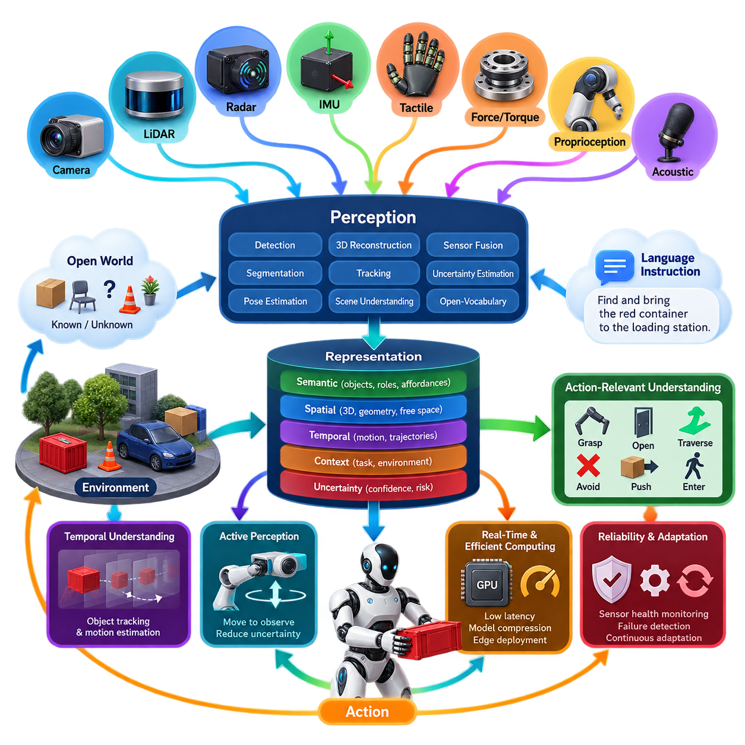
Physical AI systems require perception to serve as an active interface between intelligence and the physical world rather than as a passive sensing subsystem. A conventional perception pipeline may focus on detecting objects, estimating geometry, or recognizing predefined classes. Physical AI must additionally determine what environmental states mean for the robot’s current goal, what interactions are possible, and which observations are relevant to future actions.
The required representation therefore extends beyond geometric reconstruction and semantic labeling. A Physical AI agent must combine spatial structure, object identity, motion, physical properties, relationships, uncertainty, and task context into representations that can support reasoning and action. Metric information such as position, distance, orientation, velocity, and free space must coexist with semantic concepts such as object roles, functional regions, hazards, tools, containers, destinations, and interaction targets.
Perception must also operate under an open-world assumption. Robots deployed in homes, factories, hospitals, warehouses, outdoor infrastructure, or public spaces inevitably encounter objects, configurations, and events that were not represented explicitly during training. The system must distinguish between known observations, unfamiliar but interpretable observations, and situations for which confidence is insufficient. This requirement motivates open-vocabulary recognition, vision-language representations, novelty detection, and uncertainty-aware reasoning.
Physical AI perception is fundamentally multimodal because no individual sensor provides sufficient information across all operating conditions. Cameras provide appearance and semantic richness, LiDAR supplies accurate spatial geometry, radar contributes robust range and velocity information, and inertial sensors capture high-rate platform motion. Tactile, force, torque, proprioceptive, acoustic, and other sensors may become equally important when the robot physically interacts with objects or operates near humans.
Temporal understanding is another essential requirement. A robot cannot treat every sensor frame as an independent snapshot because the physical world evolves continuously. Perception must maintain object identities, estimate trajectories, recognize changes, distinguish static structures from dynamic agents, and preserve useful information when observations become temporarily unavailable. Temporal fusion allows the system to infer persistent state rather than repeatedly reconstructing reality from isolated measurements.
Unlike purely visual AI, Physical AI requires perception to be tightly coupled with action. The significance of an observation depends on what the robot intends to do next. A chair may represent an obstacle during navigation, a landmark during localization, or an interaction target for a manipulation task. Perception should therefore expose action-relevant information and support affordance reasoning that estimates where an object can be grasped, traversed, pushed, opened, entered, avoided, or otherwise physically manipulated.
Three-dimensional spatial consistency is particularly important because actions must be executed in physical coordinates. Semantic recognition alone cannot reliably guide locomotion or manipulation unless recognized entities are associated with position, orientation, scale, geometry, and surrounding free space. Physical AI perception must consequently connect image-space features and language-level concepts with metric 3D representations such as point clouds, voxels, meshes, occupancy fields, object poses, and scene graphs.
The perception system must furthermore communicate uncertainty rather than presenting every estimate as equally reliable. Sensor noise, occlusion, adverse weather, reflective surfaces, motion blur, calibration drift, domain shift, and unfamiliar objects can all degrade observations. Confidence should propagate from sensing and inference into mapping, planning, reasoning, and control so that downstream components can slow the robot, request another viewpoint, select another sensor, or invoke a safe fallback behavior when evidence is inadequate.
Active perception becomes necessary when the current observation does not provide enough information for a reliable decision. Instead of accepting ambiguity, the robot can move its camera, reposition its body, approach an object, illuminate a region, change viewpoint, or physically probe an environment. Perception therefore becomes part of a closed perception-action loop in which sensing influences action and action deliberately improves subsequent sensing, reducing uncertainty before consequential physical interaction.
Physical AI also introduces language-conditioned perception requirements. Instructions such as “bring the damaged red container near the loading station” require the robot to connect linguistic descriptions with visual observations, spatial relationships, object attributes, and task context. Vision-language models can provide broad semantic grounding, but their outputs must ultimately connect to geometrically consistent entities and physically executable actions rather than remaining abstract textual descriptions.
A robust system must preserve multiple levels of representation simultaneously. Fast geometric representations may support collision avoidance and local control, object-level representations can support manipulation and tracking, semantic maps provide task context, while vision-language embeddings enable flexible recognition and reasoning. These representations operate at different spatial scales, update rates, and computational costs, so the architecture must determine which information requires immediate processing and which can be evaluated asynchronously.
Real-time behavior imposes strict computational requirements because perception lies directly in the control loop. High-resolution cameras, dense point clouds, multimodal fusion, foundation models, and temporal reasoning can easily exceed available edge-computing resources. Physical AI perception therefore requires explicit latency budgets, scheduling, hardware acceleration, model compression, selective inference, asynchronous pipelines, and graceful degradation so that computational complexity never prevents the robot from maintaining essential safety-related environmental awareness.
Perception must remain reliable when individual sensors or algorithms degrade. Redundant sensing alone is insufficient if multiple modules share correlated failure modes or if the system cannot identify which estimate has become unreliable. Sensor-health monitoring, calibration validation, plausibility checking, cross-modal consistency tests, failure detection and isolation, and fallback representations should therefore be integrated into the perception architecture rather than added only after nominal performance has been achieved.
Continuous adaptation is also required because real deployment environments differ from training datasets and continue changing after deployment. Lighting, weather, floor conditions, object appearance, sensor aging, camera contamination, facility layouts, and operational routines can create persistent distribution shifts. Physical AI systems should detect these changes and support controlled adaptation through updated models, few-shot learning, map maintenance, experience replay, or human-assisted correction without sacrificing previously validated behavior.
The ultimate requirement is not maximum recognition accuracy in isolation but sufficient situational understanding for reliable physical decision making. A useful perception system must answer not only “What is present?” but also “Where is it?”, “How is it changing?”, “What can the robot do with it?”, “How certain is the estimate?”, and “What should be observed next?” This action-oriented interpretation distinguishes Physical AI perception from conventional computer vision and connects sensing directly with reasoning, planning, control, and embodied intelligence. :chatgpt-content-reference{index=“0”}

09.02. Open Vocabulary Detection GDINO OWL ViT [w/Code]
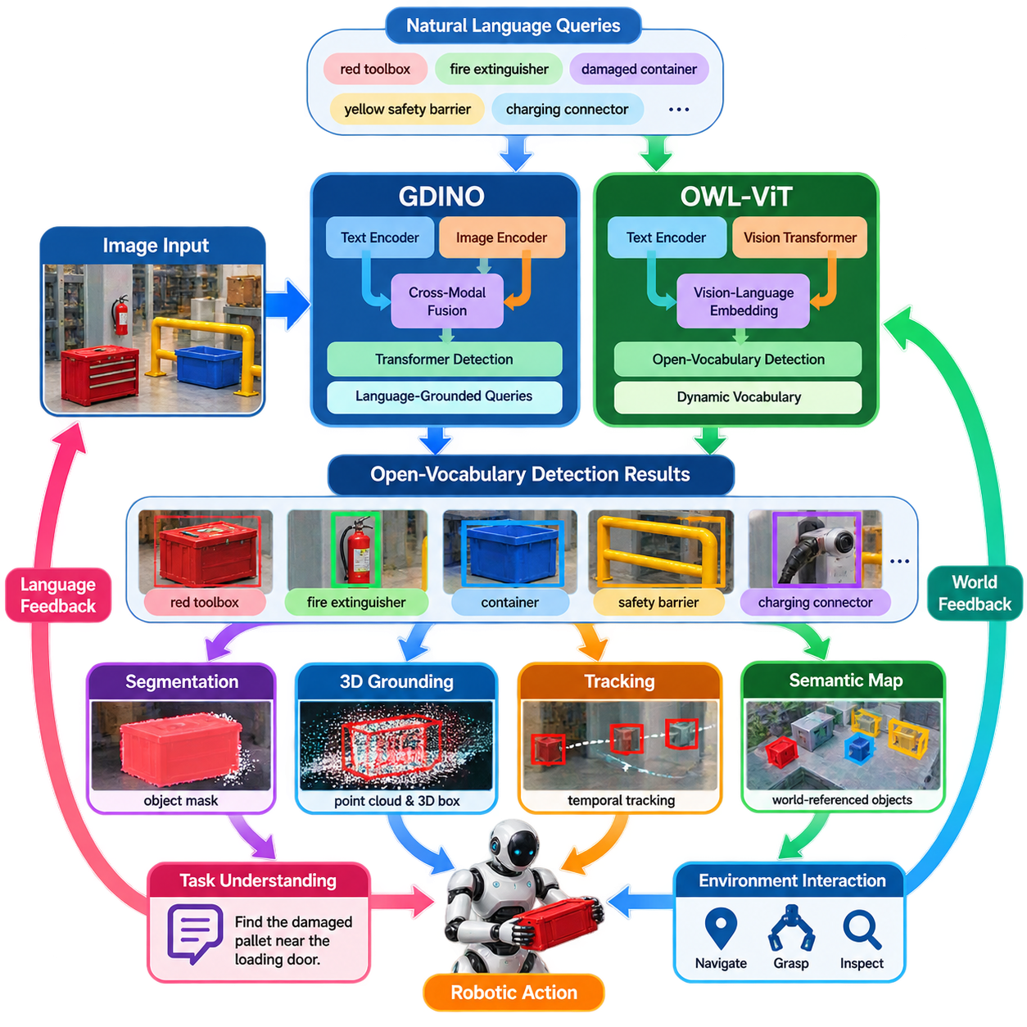
Open-vocabulary detection extends conventional object detection beyond a fixed set of categories defined during model training. Instead of predicting only labels such as person, car, or chair from a closed vocabulary, the detector accepts natural-language concepts as queries and attempts to localize corresponding regions in an image. This capability is especially important for Physical AI systems that must operate in environments containing unfamiliar objects and task-specific concepts.
Traditional detectors usually learn a classification head whose output dimensions correspond directly to predefined training categories. This architecture performs efficiently when deployment conditions match the training taxonomy, but adding a new category commonly requires additional labeled data and retraining or fine-tuning. Open-vocabulary detection replaces this rigid category interface with vision-language representations that compare visual regions against semantic embeddings derived from textual descriptions.
The fundamental mechanism is cross-modal alignment between visual and linguistic feature spaces. An image encoder extracts representations describing candidate objects or spatial regions, while a text encoder transforms words or phrases into semantic vectors. Training encourages visually corresponding and linguistically corresponding representations to become compatible. At inference time, arbitrary textual queries can therefore function as dynamically supplied categories without modifying the detector's output layer.
Grounding DINO, commonly abbreviated as GDINO, combines transformer-based object detection with grounded language understanding. Rather than treating category labels as fixed classifier indices, it processes textual prompts and image features jointly to associate language tokens with spatial object candidates. The model can consequently receive phrases such as “red toolbox,” “damaged container,” or “yellow safety barrier” and return bounding boxes whose visual content corresponds to those descriptions.
The GDINO architecture inherits important concepts from DETR-style detection, including transformer representations and object queries, while introducing language-aware feature interaction. Image features provide spatial evidence and text features specify what the system should search for. Cross-modal fusion allows object localization to depend on linguistic context, enabling the same image to produce different detections when the prompt changes. This makes detection directly configurable by task-level semantic requirements.
Prompt formulation strongly affects open-vocabulary detection behavior. A query containing several object names can request multiple categories simultaneously, while descriptive phrases can narrow the semantic target. However, natural-language flexibility does not guarantee perfect grounding. Ambiguous descriptions, visually similar objects, uncommon terminology, small targets, severe occlusion, and domain-specific equipment can reduce reliability, requiring threshold tuning and downstream geometric or temporal validation.
OWL-ViT approaches open-vocabulary detection through vision-transformer and language-image embedding mechanisms. Its design builds upon large-scale image-text pretraining, allowing textual queries to be compared against visual representations without requiring a conventional fixed-category classifier. Image patches encoded by a Vision Transformer are used to predict object locations and query-dependent classification scores, providing a relatively direct connection between semantic language embeddings and spatial detection.
A major advantage of OWL-ViT is that the category vocabulary can be constructed dynamically at inference time. A robot may search for “fire extinguisher,” “charging connector,” or “plastic storage bin” even when these concepts are not represented as fixed deployment classes. Multiple textual formulations can also describe similar concepts, enabling applications to construct query sets according to mission context rather than maintaining one permanently defined detector taxonomy.
GDINO and OWL-ViT share the principle of language-conditioned detection but differ in architectural details and practical behavior. GDINO emphasizes grounded text-image feature interaction and transformer-based localization, whereas OWL-ViT derives much of its flexibility from vision-language embedding alignment and Vision Transformer representations. For robotics, model selection should therefore consider target-domain accuracy, prompt sensitivity, inference latency, memory consumption, object scale, and integration complexity rather than vocabulary size alone.
Open-vocabulary detection becomes particularly valuable when integrated with segmentation. A detector can first convert a textual concept into one or more bounding boxes, after which a segmentation model can estimate precise object masks. This detector-to-segmenter pipeline transforms language such as “the blue container beside the robot” into spatially explicit image regions that can subsequently support depth association, point-cloud extraction, pose estimation, grasp planning, or obstacle reasoning.
For Physical AI, a two-dimensional bounding box is rarely sufficient as the final representation. Detection results should be associated with depth, 3D geometry, robot pose, temporal tracks, and semantic maps. Camera detections may be projected into LiDAR or depth measurements to estimate object position, while repeated observations can establish persistent identities. This converts transient language-grounded detections into world-referenced entities that planners and manipulation systems can use.
Open-vocabulary detection also provides an important bridge between language instructions and embodied execution. If a user requests “inspect the damaged pallet near the loading door,” a language model can extract relevant concepts and spatial relationships, while the detector grounds candidate objects in sensor observations. Scene understanding can then evaluate relationships such as “near the loading door,” allowing linguistic task specifications to become physically meaningful targets for navigation and interaction.
Despite its flexibility, open-vocabulary detection should not be interpreted as unlimited object recognition. Zero-shot performance depends heavily on the visual-language knowledge acquired during pretraining, and semantic similarity can produce false positives between related concepts. Confidence scores are not necessarily calibrated for safety-critical robotic decisions. Unknown industrial components, unusual viewpoints, transparent materials, visually repetitive structures, and specialized terminology may therefore require domain adaptation or additional verification.
Temporal consistency can substantially improve reliability in robotic deployment. A single-frame prediction may fluctuate because of viewpoint changes, motion blur, illumination, or partial occlusion, whereas tracking allows detections to accumulate evidence over time. A robot can combine open-vocabulary scores with motion models, depth consistency, geometric constraints, and historical observations. Persistent disagreement can then trigger re-observation, alternative prompts, or a conservative decision instead of immediate physical action.
Real-time deployment introduces another important constraint because large vision-language detectors can consume significant GPU memory and computational bandwidth. Input resolution, number of text queries, backbone size, precision, batching strategy, and inference frequency all affect latency. Edge systems may therefore run open-vocabulary detection at a lower semantic update rate while conventional lightweight perception maintains high-frequency obstacle detection, tracking, occupancy estimation, and safety monitoring.
A practical Physical AI architecture consequently treats open-vocabulary detection as one component within a hierarchical perception system rather than as a replacement for every specialized detector. Fast closed-set models can handle known safety-critical categories, while GDINO, OWL-ViT, or related models provide flexible semantic discovery for novel and mission-dependent concepts. Their outputs can feed segmentation, 3D grounding, tracking, semantic mapping, VLM reasoning, and ultimately VLA-based action selection.
The broader significance of open-vocabulary detection is that perception categories no longer need to be completely determined when the robot is designed. Language can dynamically specify what information matters for the current task, allowing the perceptual interface to evolve with instructions and environmental context. When combined with geometric grounding, uncertainty estimation, temporal reasoning, and action validation, this capability provides a key transition from fixed-purpose robot vision toward adaptable Physical AI perception.

09.03. Vision Language Model VLM Based Scene QA [w/Code]
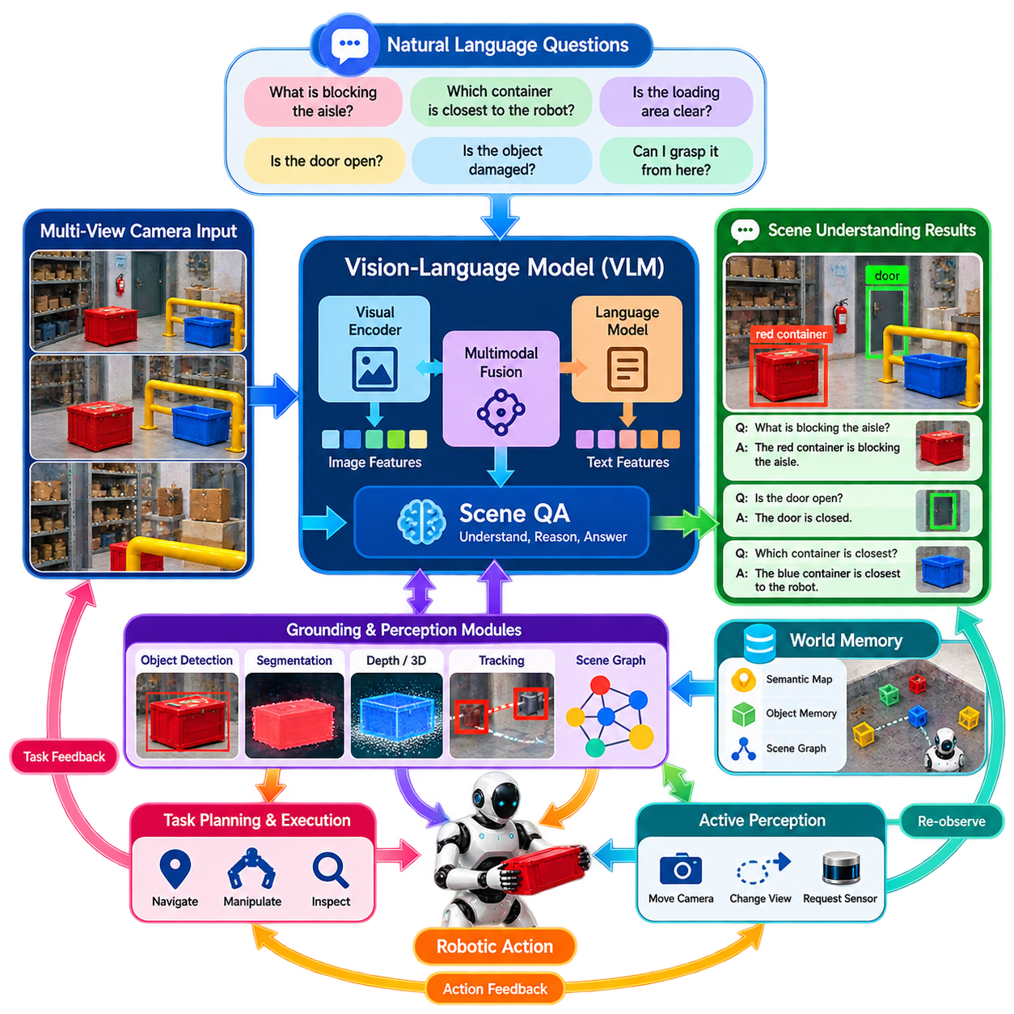
Vision-Language Model based Scene Question Answering extends robotic perception from recognizing visible entities toward interpreting scenes through natural-language interaction. A VLM receives visual observations together with textual questions and generates answers grounded in the observed environment. For Physical AI, this enables a robot to query its surroundings semantically, asking not only what objects exist but also where they are, how they relate, and whether they matter to the current task.
A typical Scene QA pipeline begins with one or more camera observations processed by a visual encoder. The resulting visual features are aligned or fused with language representations inside a multimodal model, allowing textual tokens to attend to relevant image regions. Questions such as “What is blocking the aisle?”, “Which container is closest to the robot?”, or “Is the loading area clear?” transform raw perception into task-oriented semantic queries that can support reasoning and action.
The visual encoder converts image content into compact feature representations containing information about objects, attributes, spatial structure, and scene context. Depending on the VLM architecture, these features may originate from Vision Transformers, contrastively pretrained vision encoders, or other foundation-model components. A projection or multimodal adapter commonly maps visual features into a representation that can interact effectively with the language model responsible for interpreting questions and generating responses.
Scene QA differs fundamentally from conventional image classification because the required output is determined dynamically by the question. The same warehouse image may be queried about obstacles, equipment, colors, spatial relationships, safety conditions, or possible interaction targets. Instead of producing one predefined label set, the model interprets visual evidence according to linguistic context, making perception adaptable to changing mission requirements without redesigning a dedicated classifier for every possible semantic question.
For robotics, spatial reasoning is one of the most important capabilities of Scene QA. Questions involving “left of,” “behind,” “inside,” “nearest,” or “between” require more than recognizing individual objects. The system must understand relationships among entities and ideally connect image-space reasoning with metric geometry. Depth cameras, LiDAR, object poses, occupancy maps, or 3D scene representations can therefore complement VLM outputs when accurate physical distances and coordinates are required.
Scene QA can also provide relational and functional understanding. A robot may ask whether a door is open, whether a pallet blocks a passage, whether a container appears damaged, or which object could be used for a requested task. These questions connect visual semantics with state, relationships, and potential affordances. Such reasoning is particularly useful for Physical AI because successful behavior depends on understanding how perceived entities influence navigation, manipulation, inspection, and human instructions.
Temporal context becomes important when questions concern events rather than static appearance. A robot may need to determine whether an object has moved, whether a person entered a restricted zone, or whether a previously clear path has become obstructed. Processing isolated images cannot reliably answer many such questions. Scene QA should therefore incorporate tracked objects, recent observations, event histories, or temporally aggregated visual features when reasoning about changing environments.
A VLM can serve as a semantic interface above specialized perception modules rather than replacing them. High-frequency detectors, segmentation networks, depth estimation, tracking, and occupancy mapping can continue producing structured environmental information, while the VLM interprets selected observations at a higher semantic level. This hierarchical architecture combines deterministic geometric processing with flexible language reasoning and avoids requiring a computationally expensive VLM to execute every perception operation at control-loop frequency.
Grounding is essential because a linguistically plausible answer is not necessarily physically correct. When the VLM states that “the red container beside the door is blocking the path,” the robot should ideally associate the phrases “red container,” “door,” and “path” with identifiable spatial entities. Object detectors, open-vocabulary models, segmentation, depth sensing, and scene graphs can provide explicit grounding so that language-level conclusions remain connected to measurable environmental evidence.
Hallucination represents a major limitation when Scene QA is used for Physical AI. A VLM may generate an answer consistent with common knowledge or linguistic patterns even when the corresponding evidence is absent or ambiguous in the sensor data. Such behavior is inconvenient in general visual question answering but potentially dangerous in robotics. The architecture should therefore distinguish observed facts, inferred relationships, uncertain interpretations, and information that cannot be determined from available observations.
Confidence management should consequently be integrated into the Scene QA process. Instead of forcing a definitive answer, the system should permit responses equivalent to “not visible,” “uncertain,” or “additional observation required.” These outcomes can trigger active perception, such as moving the camera, approaching the target, changing viewpoint, or requesting another sensor measurement. Scene QA then becomes part of a perception-action loop rather than a one-directional question-answer interface.
Language questions may originate from humans, planners, autonomous agents, or VLA systems. A human operator might ask “What is in front of the charging station?”, while a planner could internally formulate “Is the target graspable from the current pose?” An autonomous reasoning module can similarly generate intermediate questions to resolve uncertainty before selecting an action. Scene QA therefore provides a common semantic interface through which different components can request task-relevant information from perception.
Efficient deployment requires separating semantic reasoning frequency from safety-critical sensing frequency. Large VLMs may require substantial GPU memory, bandwidth, and inference time, whereas obstacle avoidance and motion control often demand much faster updates. A practical Physical AI platform can maintain lightweight perception continuously and invoke Scene QA when semantic interpretation is required. Cached visual embeddings, region selection, reduced image resolution, and event-triggered inference can further reduce computational load.
Scene QA becomes more powerful when connected to persistent world representations. Instead of answering exclusively from the current camera image, the VLM can access semantic maps, object memories, scene graphs, tracked identities, and previously observed states. The robot can then answer questions about objects outside the current field of view, provided that stored information remains valid. This transforms Scene QA from image question answering into query-based access to an embodied world model.
Integration with navigation and manipulation converts Scene QA results into operational decisions. If the system determines that a requested container is behind an obstacle, the planner can select an alternative approach path. If a manipulation query indicates that the visible side of an object is not suitable for grasping, active perception can seek another viewpoint. Semantic answers therefore become useful only when their referenced entities, confidence, and spatial information can be consumed by downstream action modules.
A robust architecture should validate important VLM conclusions using independent perception evidence whenever practical. Object existence can be checked through detection, spatial relationships through geometry, motion through tracking, and free space through occupancy estimation. This cross-checking reduces dependence on unconstrained language generation and allows the system to exploit VLM flexibility while retaining the measurable structure required for reliable robotic operation.
Ultimately, VLM-based Scene QA provides Physical AI with a language-accessible layer of environmental understanding. It allows perception to be queried according to the robot’s current goals rather than exposing only predetermined outputs. When combined with grounding, 3D geometry, temporal memory, uncertainty handling, active perception, and specialized real-time modules, Scene QA becomes a practical bridge connecting multimodal sensing with reasoning, planning, human communication, and embodied action.

09.04. Affordance Perception for Manipulation [w/Code]
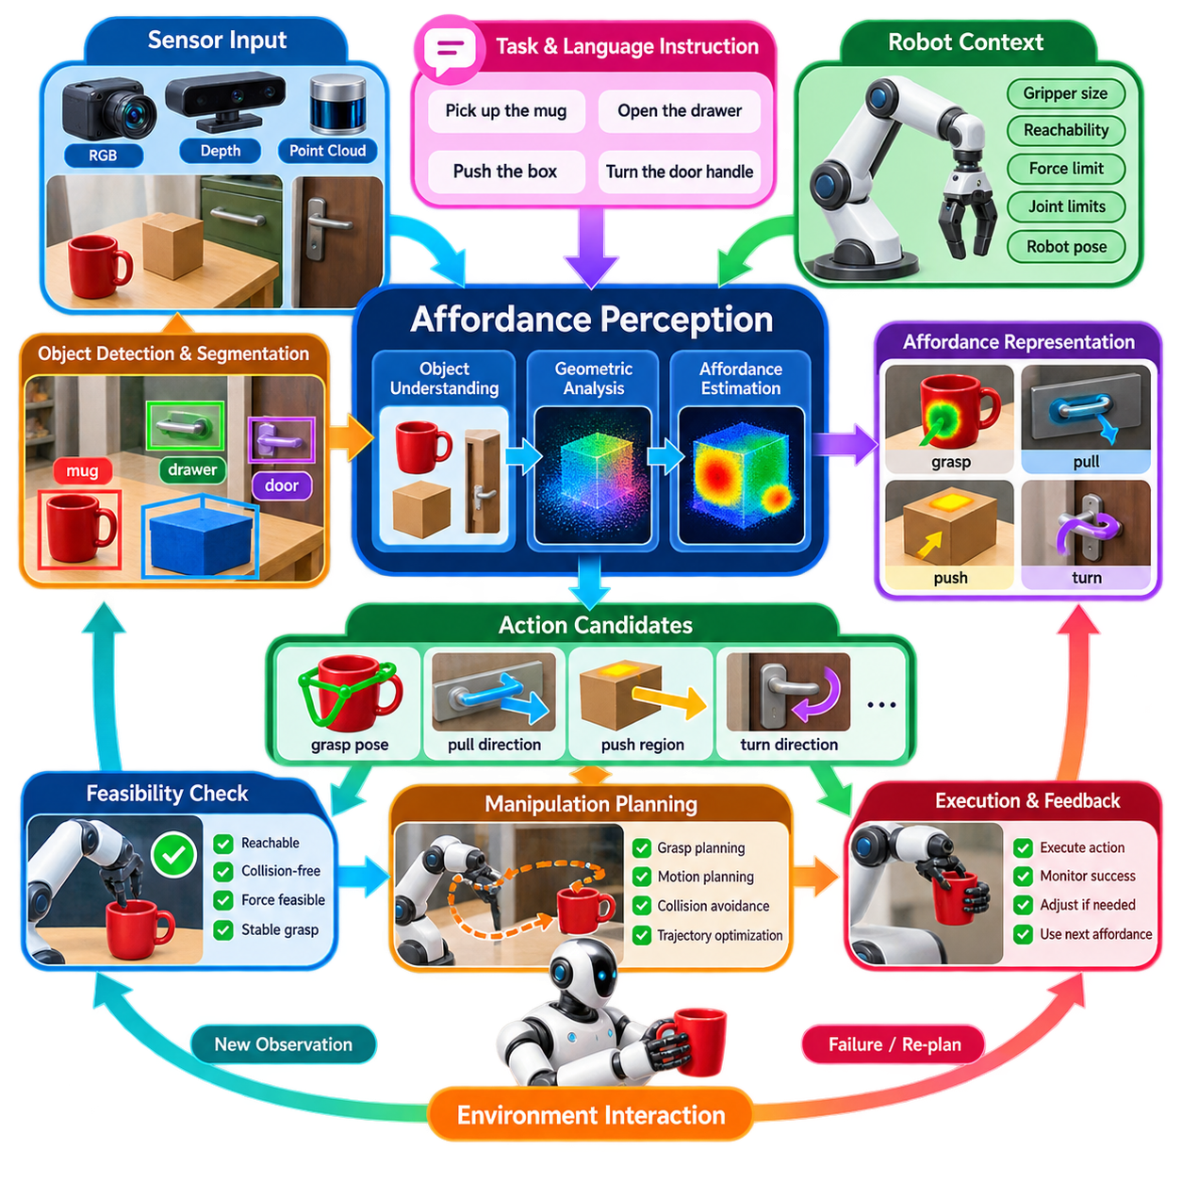
Affordance perception extends robotic perception from identifying what an object is to estimating what can be physically done with it. In manipulation, recognizing a cup, box, handle, or door is only the first step. The robot must also determine whether an object can be grasped, pushed, pulled, opened, inserted, lifted, or otherwise interacted with. Affordance perception therefore connects visual understanding with physically executable actions and provides a semantic layer between perception, manipulation planning, and control.
An affordance describes an action possibility that emerges from the relationship between an object, its geometry, its physical properties, the robot embodiment, and the current environment. The same object may provide different affordances depending on the robot and task. A handle may support pulling for one manipulator, while another robot may be unable to reach or generate sufficient force. Affordance perception must therefore consider not only object identity but also accessibility, reachability, graspability, orientation, and task context.
A conventional object detector usually produces a category and bounding box, while affordance perception produces action-relevant spatial information. Instead of simply recognizing a door, the system may identify its handle as a graspable region and estimate a suitable pulling direction. For a container, it may distinguish surfaces suitable for grasping from regions that should not be contacted. This transforms perception from passive recognition into an interpretation of how the robot can interact with the observed environment.
Affordance representations can be expressed at several levels of abstraction. A coarse representation may classify an object as graspable, pushable, movable, or unusable. A more detailed representation can identify pixel-level affordance maps, keypoints, contact regions, surface normals, grasp poses, approach directions, or action-conditioned geometric features. For manipulation systems, these representations should ultimately provide information that can be transformed into candidate end-effector poses and motion trajectories.
Visual affordance perception commonly combines RGB images with depth or three-dimensional sensing. Appearance provides information about object identity, material, and semantic context, while depth provides geometry needed to estimate surfaces, distances, and approach directions. Point clouds or reconstructed meshes can further identify collision boundaries and contact surfaces. Combining semantic and geometric information is particularly important when the robot must execute precise manipulation rather than merely describe the scene.
The relationship between affordance and object geometry is highly significant. A graspable region must have appropriate size, shape, clearance, and orientation for the end effector. A pushable surface must permit stable contact and provide sufficient access for the robot. An opening may be traversable only from a particular direction, while a handle may require a specific approach orientation. Affordance perception therefore needs to represent local geometric structure rather than relying exclusively on object-level semantic labels.
Affordances are also conditioned by task objectives. The same object may provide multiple possible actions, but only some are relevant to the current goal. A box can be grasped, pushed, opened, stacked, or inspected, while the appropriate action depends on the task specification. A Physical AI system should therefore combine perception with task context and language instructions so that affordance estimation can prioritize action possibilities that contribute directly to the current objective.
Language can provide an additional semantic interface for affordance perception. Instructions such as “pick up the handle,” “open the cabinet,” or “place the object inside the container” imply specific interaction requirements. A vision-language model can interpret these instructions and connect them with detected objects and regions, while geometric perception determines whether the proposed interaction is physically feasible. This creates a pathway from language-conditioned goals to grounded manipulation actions.
Affordance perception must account for uncertainty because interaction failures can result from small perception errors. Occlusion may hide a grasp point, reflective surfaces may corrupt depth measurements, and unusual object configurations may produce ambiguous action regions. Instead of producing a single unquestioned affordance, the system can estimate confidence and generate multiple candidate interaction hypotheses. Manipulation planning can then evaluate these candidates using reachability, collision constraints, force limits, and task success criteria.
Temporal information is useful when affordances depend on changing object states. A door that is closed may become traversable after opening, while a moving object may no longer provide a stable grasp location. The robot can use tracking and sequential observations to determine whether an interaction surface is stationary, whether an object has shifted, and whether the environment remains consistent with the previous affordance estimate. This supports safer manipulation in dynamic environments.
Affordance perception should be integrated with grasp planning and motion planning rather than operating as an isolated classification module. Perception can propose graspable regions or interaction points, grasp planning can generate candidate end-effector configurations, and motion planning can determine whether those configurations are reachable without collision. The resulting feasibility information can be fed back to perception, allowing the robot to reconsider alternative interaction regions when the initially selected affordance cannot be executed.
For Physical AI, affordance perception can also become an intermediate representation for learning-based manipulation. Instead of directly mapping raw images to motor commands, a system can learn structured relationships between observations, affordances, and actions. Demonstrations or interaction data can teach which visual patterns correspond to successful grasping, opening, pushing, or insertion. This intermediate representation can improve interpretability and allow the same perceptual knowledge to support multiple downstream manipulation policies.
Robust affordance perception requires integration with the robot's embodiment and physical capabilities. The system must know the dimensions and workspace of the end effector, joint limits, available force and torque, collision geometry, and relevant contact constraints. An affordance that is theoretically visible may still be unusable because the robot cannot reach it, cannot generate sufficient force, or cannot approach it from a safe direction. Consequently, affordance should be understood as a feasible interaction possibility rather than merely a semantic property of an object.
Ultimately, affordance perception provides a critical bridge between scene understanding and physical manipulation. It converts objects and surfaces into potential interaction opportunities that can be evaluated according to geometry, task requirements, robot capabilities, uncertainty, and environmental constraints. When integrated with language understanding, 3D perception, grasp planning, motion planning, and feedback control, affordance perception enables Physical AI systems to move beyond recognizing the world toward understanding how they can physically act within it.

09.05. Semantic Goal Specification from Language [w/Code]
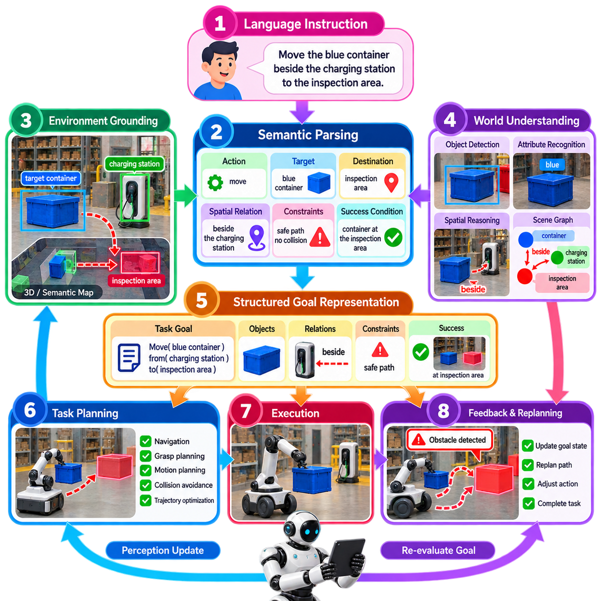
Semantic goal specification from language enables a Physical AI system to convert human instructions expressed in natural language into structured objectives that can be interpreted by perception, planning, and action modules. Instead of defining every robot task through fixed programs or predefined command identifiers, the system accepts descriptions such as “inspect the damaged container near the loading area” and derives the relevant objects, properties, spatial relationships, desired outcomes, and constraints required to execute the task.
A language instruction usually contains more than a simple action verb. It may describe an object, its attributes, a destination, a spatial relationship, a temporal condition, or an expected final state. A robust goal specification process therefore separates concepts such as action, target, location, relation, constraint, and success condition. The resulting representation should preserve the meaning of the original instruction while converting it into information that downstream robotic modules can process consistently.
The first stage is semantic parsing of the instruction. A language model can identify important entities and relationships from the command and transform them into structured semantic elements. For example, “move the blue container beside the charging station to the inspection area” contains an action, an object category, a color attribute, a spatial reference, and a destination. These elements provide a bridge between natural-language communication and machine-interpretable task specifications.
Goal specification must remain grounded in the physical environment. A language model may identify the concept “blue container,” but the robot must associate that concept with an actual object detected by its perception system. Open-vocabulary detection, scene understanding, object tracking, semantic maps, and 3D grounding can connect language-level entities with physical objects. This grounding process prevents a semantic goal from remaining an abstract instruction disconnected from measurable environmental states.
Spatial language is particularly important for mobile and manipulation robots. Expressions such as “near the door,” “behind the pallet,” “inside the storage area,” or “to the left of the robot” describe relationships rather than absolute coordinates. The goal specification layer should convert these relationships into constraints that can be evaluated against spatial representations. Depending on the task, these constraints may be resolved using camera observations, depth information, point clouds, localization data, occupancy maps, or semantic scene graphs.
A semantic goal should also describe the desired state rather than only the immediate action. “Open the cabinet” implies that the cabinet should transition from a closed state to an open state. “Place the box on the table” implies that the box should end at a suitable location with an acceptable orientation and stable support. Representing goals as desired world states allows planning and execution modules to determine whether the requested objective has actually been achieved rather than assuming success when an action command has been issued.
Task constraints are another essential component of semantic goal specification. A command may implicitly or explicitly require the robot to avoid certain regions, maintain a safe distance from humans, use a particular object, preserve an object orientation, or complete an operation within a specified area. These constraints should be represented separately from the primary objective so that planners can incorporate them during trajectory generation, manipulation planning, and execution monitoring.
Ambiguity must be handled explicitly. A phrase such as “bring the container over there” may be understandable to a human who shares the surrounding context but insufficient for a robot. The system should identify missing references and determine whether they can be resolved using environmental context, previous dialogue, stored world state, or additional perception. When ambiguity remains significant, the robot should be able to request clarification rather than silently selecting an arbitrary interpretation.
Semantic goal specification should therefore maintain uncertainty when appropriate. If several objects satisfy the description “the red box,” the system can retain multiple candidates and allow downstream reasoning to evaluate them. Confidence values, alternative interpretations, and unresolved references can become part of the goal representation. This approach is preferable to forcing an uncertain language interpretation into a single deterministic target that could cause an incorrect physical action.
The goal representation should connect naturally with perception and planning. Perception determines which physical entities satisfy the semantic description, while planning determines how the robot can achieve the specified objective. For navigation, the goal may become a target pose or semantic destination. For manipulation, it may become an object, an affordance, a grasp requirement, and a desired final state. For inspection, it may specify an object and the observations that must be obtained before the task is considered complete.
Hierarchical goals are useful for complex Physical AI tasks. A high-level instruction such as “prepare the loading area for inspection” may contain several subordinate objectives, including locating obstacles, moving specified objects, checking equipment, and confirming that a required region is accessible. A semantic planner can decompose the high-level objective into executable subgoals while preserving dependencies between them. This creates a structured connection between language-level intent and lower-level robotic behaviors.
Language-based goals can also be combined with feedback from the physical world. During execution, perception may reveal that an expected object is missing, an obstacle has appeared, or an intended manipulation is infeasible. The system should then update the semantic task state and reconsider the corresponding subgoal. This creates a closed-loop architecture in which language specifies the objective, perception evaluates the current state, planning selects actions, and execution feedback determines whether the goal representation must be updated.
Safety is particularly important when language-derived goals control physical actions. A semantically valid instruction may still imply an unsafe or physically impossible operation. Before execution, the goal should therefore be checked against robot capabilities, workspace limits, collision constraints, environmental hazards, and safety policies. High-level language interpretation should not bypass lower-level safety mechanisms; instead, semantic goals should be translated into constrained objectives that remain subject to validated planning and control layers.
Ultimately, semantic goal specification from language provides an interface between human intent and embodied robotic intelligence. It allows people to describe desired outcomes using flexible natural language while enabling the robot to transform those descriptions into grounded objects, spatial relationships, constraints, states, and executable subgoals. When integrated with perception, open-vocabulary understanding, affordance estimation, planning, world models, and feedback control, language becomes not merely a command channel but a structured mechanism for specifying what the robot should accomplish in the physical world.

09.06. Action Conditional Perception Prediction [w/Code]
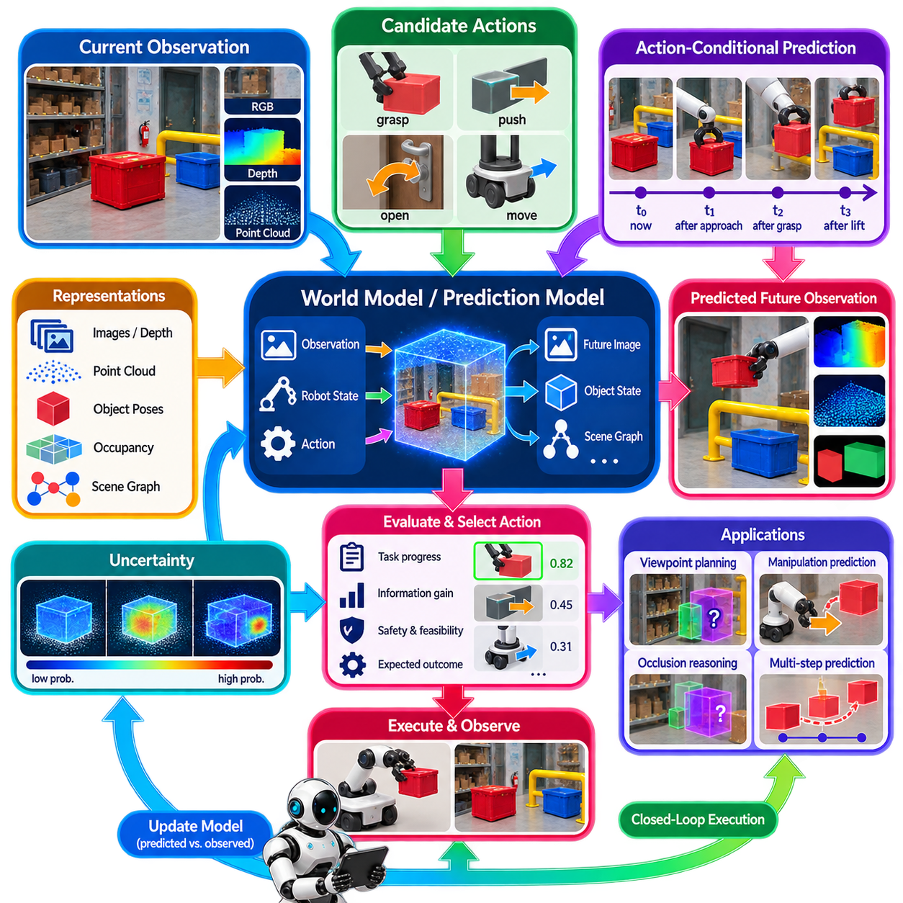
Action-conditional perception prediction extends robotic perception from describing the current environment to predicting what will be observed under a possible future action. Conventional perception estimates the present state from sensor observations, whereas action-conditional perception asks how the scene may change if the robot moves, grasps, pushes, opens, approaches, or otherwise interacts with it. This creates a direct connection between perception, action selection, planning, and future-state estimation.
The central idea is to condition future perception on both the current observation and a candidate action. Given an image, point cloud, robot state, and proposed action, the system predicts a future observation, object configuration, scene representation, or task-relevant state. The prediction does not need to reproduce every pixel or sensor measurement. Instead, it should estimate the aspects of the future environment that are important for subsequent decision making, such as object motion, visibility, contact state, free space, or task progress.
This formulation changes perception from a purely passive process into a predictive component of embodied intelligence. A robot deciding whether to grasp an object may evaluate how the scene is expected to look after the grasp. A mobile robot approaching an occluded region may predict which objects will become visible from a new viewpoint. A manipulator pushing an object may estimate its future position and orientation. These predictions allow actions to be evaluated partly by their expected perceptual consequences before physical execution.
Action-conditional prediction can operate at multiple representation levels. At the lowest level, a model may predict future images, depth maps, optical flow, or point clouds. At a higher level, it may predict object poses, trajectories, occupancy states, contact relationships, or semantic scene graphs. For Physical AI, structured predictions are often more useful than purely photorealistic predictions because planning requires physically meaningful information rather than an exact reproduction of sensor appearance.
The action representation must contain enough information to describe the intended intervention. For mobile robots, this may include velocity, steering commands, target poses, or short motion trajectories. For manipulators, it may include end-effector position, orientation, grasp configuration, force, or motion sequence. A useful action-conditional perception model must also consider the robot state, because the same nominal action can produce different outcomes depending on the robot's pose, contact configuration, velocity, or available workspace.
The environment itself must be represented in a form that supports prediction. Objects, surfaces, free space, dynamic agents, and spatial relationships can be encoded using feature maps, point clouds, voxels, object-centric representations, scene graphs, or latent world-model states. Combining these representations with robot state and candidate actions allows the prediction model to estimate how the environment is likely to evolve. This establishes an important connection between perception models and world-model-based Physical AI architectures.
Occlusion provides an especially important application. A robot often cannot directly observe the complete state of an object because another object, the robot itself, or the environment blocks the sensor view. An action can deliberately change the viewpoint and reveal previously hidden information. Action-conditional perception prediction can estimate which regions or objects are likely to become visible after the robot moves, allowing the planner to select actions that improve both physical progress and environmental observability.
This concept is closely related to active perception, but the two should not be treated as identical. Active perception selects actions partly to obtain better information, while action-conditional perception predicts the perceptual consequences of candidate actions. The prediction model can therefore provide information to an active perception or planning module, which compares alternative actions according to expected information gain, task progress, safety, and execution cost.
Manipulation provides another important application. Before pushing a box, the robot can predict its likely future position and orientation. Before opening a drawer, it can estimate how the drawer and its contents will move. Before grasping an object, it can predict whether the planned contact will change the object's configuration. These predictions can be combined with geometric and physical constraints to reject actions whose expected outcomes are inconsistent with the desired task state.
Temporal prediction is essential because physical actions unfold continuously rather than producing an instantaneous state transition. The system may therefore predict a sequence of future states rather than a single endpoint. Such predictions can include object trajectories, robot motion, contact transitions, visibility changes, and evolving occupancy. A planner can then evaluate candidate action sequences using predicted intermediate states rather than considering only the final result.
Prediction uncertainty must be explicitly represented because physical environments are inherently stochastic and perception is imperfect. Object dynamics may be unknown, friction may vary, contacts may be difficult to model, and other agents may behave unpredictably. Instead of producing one deterministic future state, the model can represent multiple possible outcomes or estimate a probability distribution over future states. Planning can then account for uncertainty when selecting actions and can favor behaviors that remain robust across plausible outcomes.
Action-conditional prediction can also support counterfactual reasoning. The robot can ask what is likely to happen if it moves left rather than right, grasps one side rather than another, or approaches an object from a different direction. These hypothetical predictions allow the system to evaluate alternatives without physically executing every candidate action. Such counterfactual reasoning can reduce unnecessary interaction, improve planning efficiency, and provide a mechanism for selecting actions based on their predicted consequences.
For Physical AI, perception prediction should be connected to task objectives rather than treated as an isolated forecasting problem. A prediction is valuable when it helps determine whether a candidate action will advance the task. For example, a predicted object displacement matters because it may indicate whether the object reaches its target location. A predicted visibility change matters because it may reveal information required for subsequent manipulation. Task-conditioned prediction therefore provides a mechanism for aligning perceptual forecasting with high-level goals.
Learning-based approaches can acquire action-conditioned prediction from demonstrations, interaction trajectories, simulation, or real-world experience. The training data should associate observations with actions and subsequent states so that the model learns how interventions influence the environment. World models, video prediction models, latent dynamics models, and action-conditioned transformers can provide different implementations of this principle. The appropriate architecture depends on the required prediction horizon, representation, computational budget, and physical complexity.
Simulation can play an important role because collecting large amounts of real robotic interaction data is expensive and potentially unsafe. A simulator can generate diverse action-observation trajectories covering manipulation, navigation, collisions, object motion, and environmental changes. However, the prediction model must account for the simulation-to-real gap because real-world friction, deformability, sensing noise, and unexpected object behavior may differ from simulated assumptions. Real observations should therefore remain part of validation and adaptation.
Action-conditional perception prediction should ultimately participate in a closed-loop architecture. The robot observes the current state, generates candidate actions, predicts their perceptual and physical consequences, evaluates the predicted outcomes, executes an appropriate action, and then observes the actual result. Differences between predicted and observed states provide valuable information for updating the model or revising the plan. This creates a continuous cycle in which perception informs action, action changes the world, and the resulting observation improves subsequent prediction.
The broader significance of action-conditional perception prediction is that it transforms perception from an observation-only capability into a forward-looking component of Physical AI. Instead of asking only “What is happening now?”, the system can evaluate “What will I see or what will change if I perform this action?” When integrated with world models, active perception, affordance estimation, semantic goals, planning, and feedback control, this capability provides a foundation for robots that can reason about the perceptual consequences of their own actions before committing them to the physical world.

09.07. Embodied Perception Ego Centric Feature Extract [w/Code]
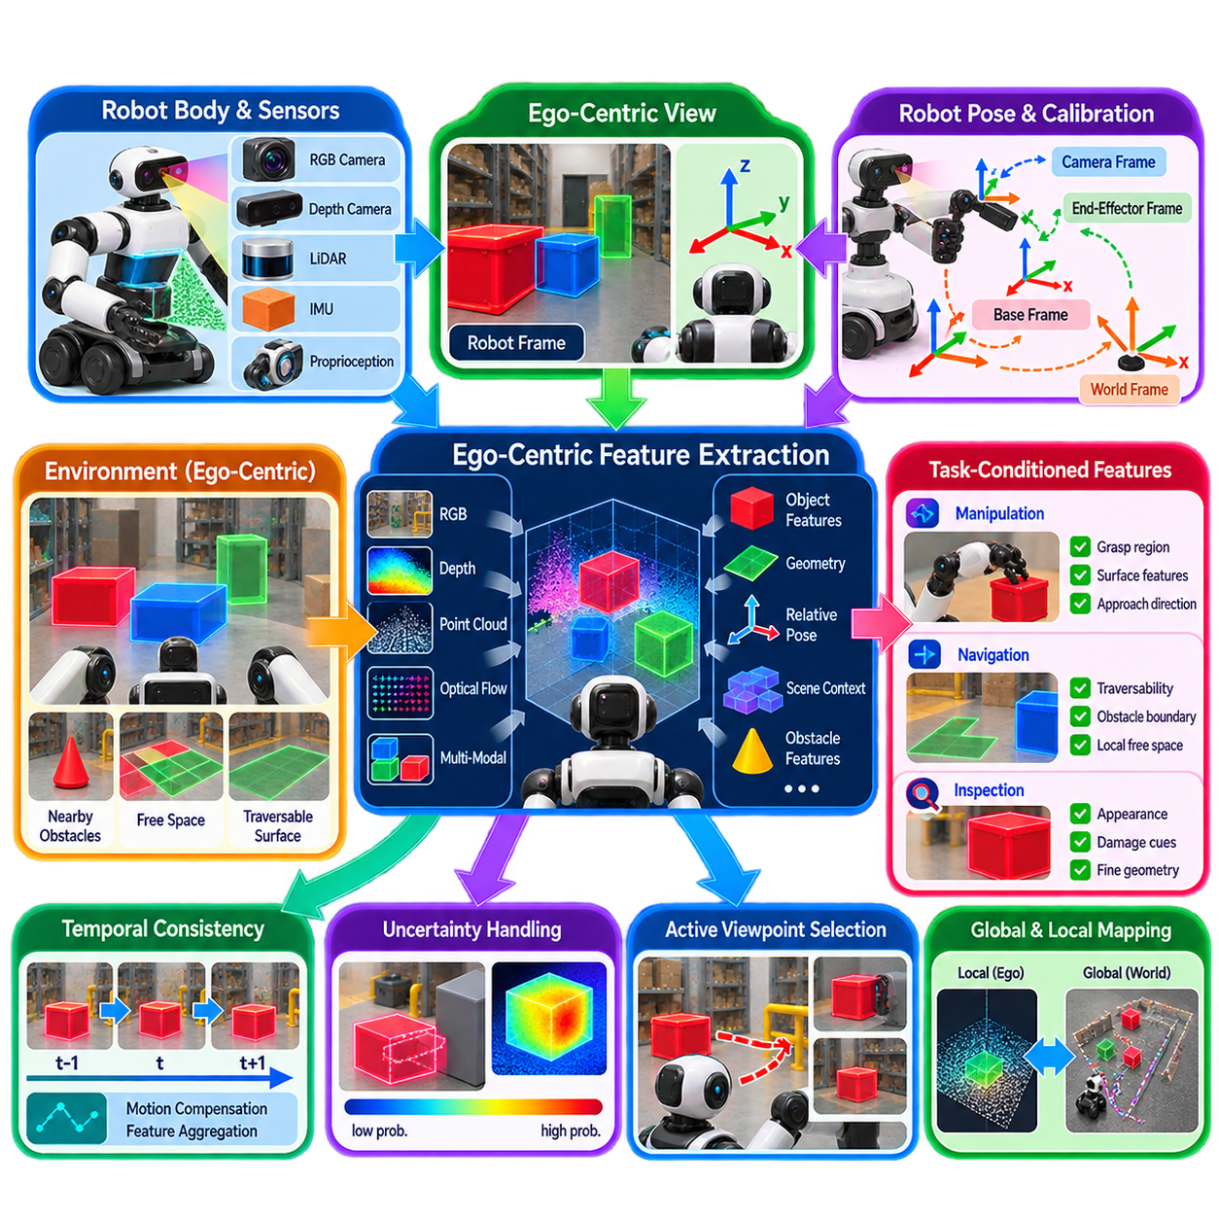
Embodied perception extends conventional perception by making visual features explicitly dependent on the robot’s own body, viewpoint, motion, and interaction capabilities. An external observer may describe a scene from a fixed world-centered perspective, but an embodied robot perceives the environment through sensors mounted on its moving body. Consequently, the same physical object can generate very different observations depending on the robot pose, camera orientation, field of view, motion, and current task.
Ego-centric perception uses the robot’s own coordinate frame as a primary reference for interpreting observations. Camera images, depth measurements, LiDAR returns, and proprioceptive information can be transformed into representations centered on the robot or its active sensor. This provides a direct relationship between what the robot currently observes and what it can physically reach, avoid, manipulate, or inspect. Ego-centric features are therefore particularly useful for connecting perception with immediate action.
The feature extraction process should preserve information that is relevant to embodied interaction rather than treating every visual feature as equally important. Object identity, local geometry, relative position, surface orientation, depth, motion, and nearby obstacles can be encoded together with the robot state. Features may be extracted from RGB images, depth images, point clouds, optical flow, or multimodal sensor representations and then transformed into a common latent space suitable for downstream reasoning and action.
Robot pose and sensor configuration strongly influence the resulting feature representation. A feature describing an object at a particular image location is incomplete unless the system knows the camera pose, sensor calibration, and relationship between the sensor and robot body. Extrinsic calibration therefore becomes an important foundation for embodied perception. Transformations between camera, LiDAR, base, end-effector, and world frames allow local observations to be interpreted consistently across movement and interaction.
Ego-centric features are especially valuable for manipulation because the robot must understand objects relative to its own end-effector and reachable workspace. A detected object may be visually clear but physically inaccessible because it is outside the manipulator workspace or blocked by another structure. By representing object features together with hand or end-effector pose, distance, approach direction, and local obstacles, the perception system can produce representations that are directly useful for grasp selection and manipulation planning.
For mobile robots, ego-centric perception supports local navigation and dynamic obstacle understanding. The robot needs to know not only where an obstacle exists in the environment but also where it is relative to the robot's current trajectory, footprint, velocity, and stopping distance. Features extracted around the robot can therefore emphasize nearby free space, obstacle boundaries, dynamic agents, traversable surfaces, and local semantic context. These representations can be updated rapidly as the robot moves through the environment.
Embodied perception should also maintain a connection between local ego-centric information and persistent world-centered representations. A local feature map is useful for immediate action, while a global map provides longer-term spatial consistency. The robot can transform ego-centric observations into a world frame using localization and sensor fusion, while simultaneously maintaining a local representation centered on its current body pose. This combination supports both immediate reaction and long-term navigation or task reasoning.
Temporal consistency is important because the robot's own motion continuously changes the observation. Features extracted independently from successive frames may appear different even when the physical environment remains unchanged. Motion estimation, visual odometry, inertial measurements, tracking, and temporal feature aggregation can help distinguish changes caused by robot motion from actual changes in the environment. This allows the system to maintain more stable representations while operating continuously.
The robot's actions should also influence which features are extracted and retained. When approaching an object for grasping, features related to handles, contact surfaces, free space, and approach direction become more important. During navigation, traversability and obstacle features may dominate. During inspection, surface appearance, damage indicators, or fine geometric details may receive greater attention. Embodied feature extraction can therefore be conditioned on task goals rather than using a single fixed representation for every situation.
Attention mechanisms and feature selection can provide an efficient way to implement this task dependence. A perception system may process broad scene information initially and then allocate greater computational resources to regions that are relevant to the current action. For example, a manipulation task may focus attention on a target object and its immediate surroundings, while a navigation task may emphasize the forward corridor and potential collision regions. This reduces unnecessary computation while preserving task-critical information.
Multimodal fusion can further improve ego-centric feature quality. RGB information provides appearance and semantic context, depth provides distance and local geometry, LiDAR contributes robust three-dimensional structure, and IMU or proprioceptive signals provide information about the robot's own motion. When these measurements are aligned through calibrated coordinate transformations, the resulting representation can capture both environmental state and the robot's relationship to that state.
Embodied feature representations should account for uncertainty and incomplete observation. A robot may observe only part of an object, experience temporary sensor degradation, or encounter severe occlusion during manipulation. Rather than treating missing information as a definitive absence, the system can preserve uncertainty or maintain latent representations of partially observed entities. This is particularly important when the robot must decide whether to move closer, change viewpoint, or perform another action to obtain additional evidence.
Active viewpoint selection can naturally emerge from ego-centric perception. If the current feature representation is insufficient to determine whether an object is graspable or whether a passage is traversable, the robot can evaluate alternative viewpoints. Moving the camera or robot body changes the available visual evidence and may expose previously hidden geometry. Ego-centric features therefore provide the state information required to connect perception quality with viewpoint planning and active perception.
Learning-based embodied perception can use demonstrations and interaction data to discover which features are predictive of successful actions. Instead of learning only object categories, a model can associate ego-centric observations with grasp success, navigation outcomes, contact events, or task completion. Vision encoders, transformer-based architectures, contrastive learning, and multimodal representation learning can provide mechanisms for learning such relationships. The resulting features can serve as inputs to planners, policies, world models, or VLA systems.
A critical distinction is that ego-centric does not mean purely camera-centric. The most useful embodied representation should reflect the relationship between the robot, its sensors, its environment, and its possible actions. Camera-centered image features may be valuable, but they become more useful when combined with robot pose, end-effector state, spatial geometry, motion, and task context. The goal is therefore an action-relevant representation of the environment from the robot's current physical perspective.
Ultimately, embodied perception and ego-centric feature extraction provide a foundation for connecting sensing with physical interaction. They transform raw observations into representations that describe not only what exists in the environment but also where it is relative to the robot, how it may affect the robot's actions, and which information is relevant to the current task. When integrated with multimodal sensing, localization, affordance perception, active perception, planning, world models, and VLA systems, ego-centric features become a key representation layer for Physical AI operating continuously in the physical world.

09.08. Online Perception Adaptation Few Shot Learning [w/Code]
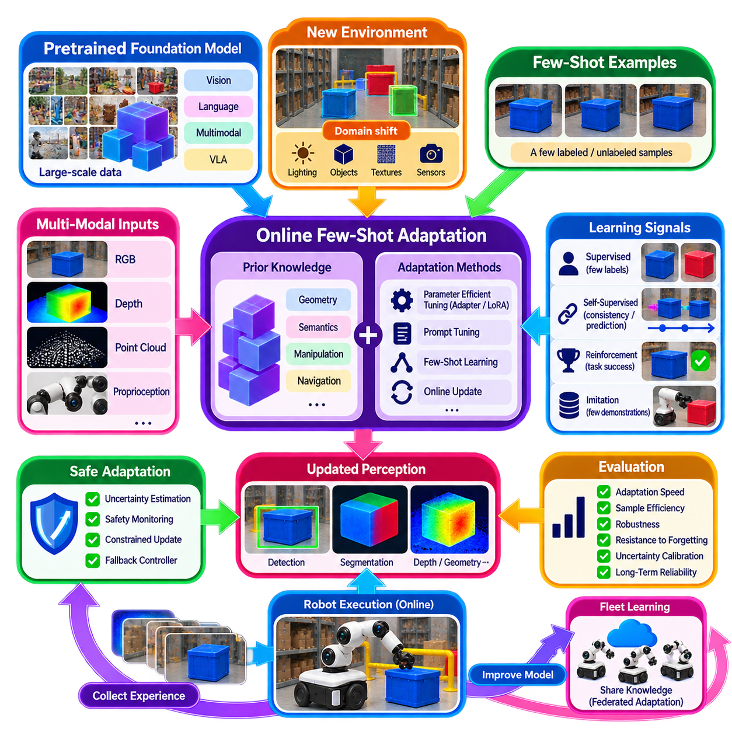
Few-shot online perception adaptation enables a Physical AI system to adjust its perceptual capabilities to a new environment using only a small number of observations or examples collected during deployment. Conventional machine learning assumes that training data adequately represents future operating conditions, but real robots encounter changes in lighting, objects, surfaces, sensor characteristics, human behavior, weather, and workspace organization. Online adaptation addresses this gap by allowing perception models to continue learning after deployment rather than depending entirely on a fixed pretrained representation. :chatgpt-content-reference{index=“0”}
The central principle combines few-shot learning with continuous online adaptation. Few-shot learning allows a model to acquire useful information from a very small number of examples, while online adaptation allows those observations to influence the model while the robot is actively operating. This is particularly important for Physical AI because collecting and labeling thousands of new examples for every deployment environment is expensive and often impractical. A robot should instead exploit its existing knowledge and specialize it rapidly using limited local experience. :chatgpt-content-reference{index=“1”}
The need for adaptation becomes clear when a robot moves between environments that perform similar tasks but differ in physical conditions. A manipulator installed in another factory may encounter different camera positions, illumination, conveyor speeds, fixtures, products, and workstation organization. A service robot entering a new building may encounter unfamiliar furniture, floor materials, layouts, and household objects. Although the robot's general perception capabilities remain useful, local adaptation can compensate for environmental differences without requiring complete retraining of the original model. :chatgpt-content-reference{index=“2”}
Online adaptation differs from conventional transfer learning because the timing of learning is fundamentally different. Transfer learning normally uses a predefined target-domain dataset before deployment, whereas online adaptation continues learning while the robot is operating. New observations can therefore influence model parameters, representations, or decision policies during actual deployment. This makes adaptation an ongoing process rather than a separate preparation stage and creates the possibility of continual improvement as the robot accumulates experience. :chatgpt-content-reference{index=“3”}
Successful few-shot adaptation depends strongly on prior knowledge. The robot should not begin learning from random initialization when it encounters a new environment. Instead, it starts from representations acquired through extensive pretraining across diverse environments, tasks, and object categories. These representations can encode general information about geometry, semantics, physics, manipulation, navigation, and perception. Adaptation then specializes this broad knowledge toward local environmental characteristics using a small amount of additional experience. :chatgpt-content-reference{index=“4”}
Representation quality is therefore critical because transferable features reduce the amount of new data required for adaptation. Features that capture general object geometry may remain useful when textures or lighting change, while language representations can generalize across different expressions of similar intentions. Manipulation representations can similarly encode reusable grasp affordances across related objects. The objective is not simply to maximize benchmark accuracy but to develop representations that preserve general knowledge while allowing rapid specialization to new conditions. :chatgpt-content-reference{index=“5”}
Foundation models provide an important basis for efficient adaptation. Large pretrained vision, language, multimodal, and Vision-Language-Action models already contain broad knowledge acquired from large datasets. Rather than relearning basic concepts during deployment, a robot can adapt existing representations toward local conditions. Parameter-efficient methods such as adapters, low-rank adaptation, prompt tuning, and lightweight fine-tuning can reduce computational requirements while helping preserve previously acquired capabilities. :chatgpt-content-reference{index=“6”}
Online adaptation can occur at several levels of a robotic system. Perception modules may improve recognition under local lighting conditions, while localization systems refine maps as new observations arrive. Navigation policies can learn local traffic patterns, floor characteristics, and obstacle configurations, while manipulation systems can adapt grasp forces, insertion trajectories, and contact models from observed interactions. Higher-level modules can also acquire knowledge about workspace organization and task-specific conventions, creating a progressively more specialized robotic system. :chatgpt-content-reference{index=“7”}
Different learning signals can support adaptation depending on what feedback is available. Supervised adaptation can use a small number of examples labeled by a human operator, while self-supervised adaptation can exploit temporal consistency, geometric constraints, sensor agreement, predictive modeling, or cross-modal correspondence without explicit labels. Reinforcement learning can use task outcomes as feedback, and imitation learning can adapt behavior from a limited number of demonstrations. These approaches can also be combined within a unified online adaptation architecture. :chatgpt-content-reference{index=“8”}
Self-supervised adaptation is especially valuable because continuous human labeling is difficult during deployment. A robot can exploit repeated observations of the same object from different viewpoints, consistency between sensors, temporal relationships, and geometric constraints as sources of supervisory information. Contrastive learning can further organize related observations close together in latent representation space while separating unrelated experiences. These mechanisms allow the system to improve representations from operational experience without requiring extensive manual annotation. :chatgpt-content-reference{index=“9”}
Few-shot adaptation must be designed carefully because learning during physical operation can temporarily reduce performance. Unconstrained parameter updates may cause an adapted model to behave worse before improvement occurs. Safe adaptation therefore requires mechanisms such as uncertainty estimation, safety monitoring, constrained optimization, runtime verification, and fallback controllers. The learning process should remain subordinate to independently validated safety mechanisms so that incomplete or incorrect adaptation does not directly produce unsafe physical behavior. :chatgpt-content-reference{index=“10”}
Evaluation of online few-shot adaptation should consider more than final recognition accuracy. Important characteristics include adaptation speed, sample efficiency, computational cost, robustness to distribution shift, resistance to forgetting, uncertainty calibration, energy consumption, and long-term operational reliability. Evaluation can examine performance after very small numbers of adaptation examples, such as one, five, ten, or twenty observations, because the central question is how rapidly useful performance emerges from limited deployment experience rather than only how well the system performs after extensive convergence. :chatgpt-content-reference{index=“11”}
Fleet-level learning can extend few-shot adaptation beyond an individual robot. Experiences collected from different deployments can be aggregated within shared learning infrastructure and used to produce improved initialization models for subsequent robots. Federated adaptation provides another approach in which robots exchange parameter updates, adaptation statistics, or learned representations rather than directly sharing raw sensor observations. This enables knowledge acquired in one environment to contribute to broader robotic capability while reducing the need for every robot to independently relearn the same environmental variations. :chatgpt-content-reference{index=“12”}
Ultimately, online few-shot perception adaptation provides a mechanism for transforming a pretrained Physical AI system into an environment-aware and continuously improving system. Transferable representations provide the initial capability, limited local observations provide deployment-specific evidence, online learning specializes the model, uncertainty and safety mechanisms constrain adaptation, and accumulated experience can contribute to future deployments. When combined with continual learning, meta-learning, world models, multimodal foundation models, and Vision-Language-Action architectures, few-shot online adaptation becomes an important foundation for robots that must operate reliably across diverse real-world environments without exhaustive retraining for every new deployment.

09.09. Perception for Physical AI Latency Constraints
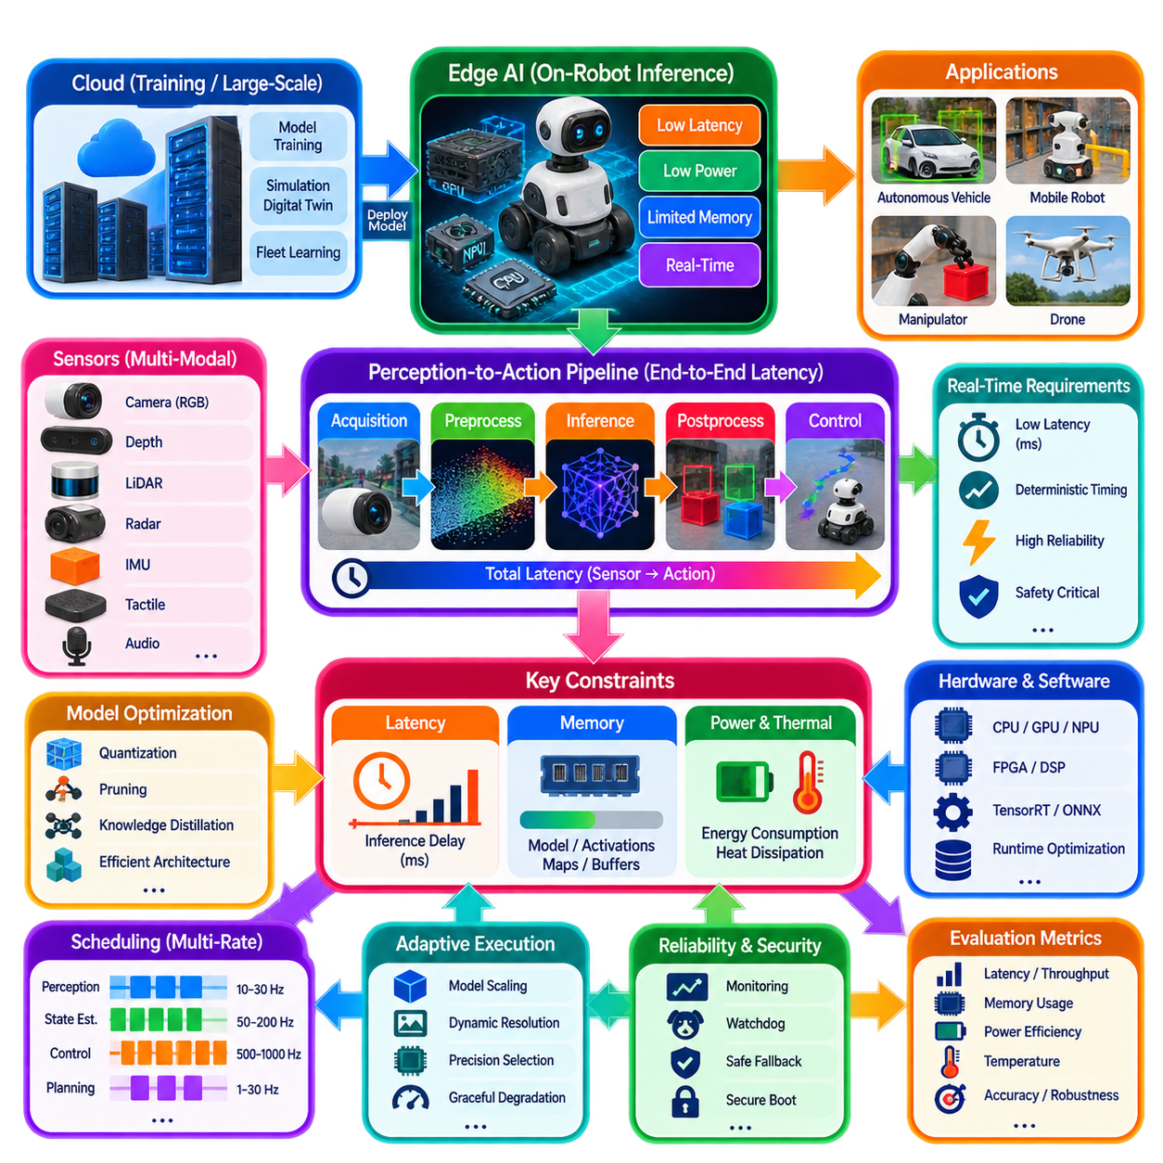
Edge AI has become one of the foundational technologies enabling Physical AI because intelligent robots must make decisions directly within the physical world under strict real-time constraints. While cloud computing provides enormous computational resources for large-scale model training, simulation, digital twins, and fleet learning, many robotic decisions cannot depend on remote servers. A mobile robot navigating among pedestrians, an autonomous vehicle avoiding collisions, or a manipulator grasping a moving object may need to react within milliseconds. Network communication, cloud processing, or unreliable connectivity can introduce delays that degrade performance or create unsafe conditions. Consequently, inference increasingly needs to execute on computing devices located directly on or near the robot.
The distinction between AI training and AI inference is fundamental to this architecture. Training optimizes millions or billions of parameters through repeated exposure to large datasets and normally requires powerful GPU clusters or specialized accelerators. Inference applies an already trained model to new observations and produces predictions or decisions. Although inference generally requires fewer computations than training, it must satisfy much stricter requirements for response time, memory usage, reliability, energy consumption, and hardware efficiency. For continuously operating autonomous robots, inference performance therefore becomes a direct determinant of operational capability.
Edge computing devices operate under substantially tighter constraints than cloud servers. Embedded processors provide limited computational throughput, memory capacity, thermal dissipation, electrical power, physical volume, and cost. Every additional watt increases battery consumption, every additional gigabyte of memory increases hardware requirements, and every additional millisecond of processing delay reduces responsiveness. Physical AI therefore cannot optimize predictive accuracy independently from deployment constraints. Practical architecture requires a balanced design in which model capability, computational resources, energy consumption, and timing requirements are considered together.
Latency represents one of the most important requirements for real-time Physical AI perception. Latency is the elapsed time between receiving an input and producing a usable output. In robotics, this determines how rapidly perception can influence action. If an approaching obstacle is detected but the resulting navigation decision requires hundreds of milliseconds, the obstacle may already have moved significantly before the response becomes available. Similarly, a manipulator tracking a moving object requires very short delays because the target configuration changes continuously. Real-time perception therefore depends not only on model accuracy but also on minimizing the complete inference delay.
The acceptable latency depends strongly on application dynamics. High-speed autonomous vehicles may require perception and planning updates within tens of milliseconds because the distance traveled during a delay increases rapidly with velocity. Industrial manipulators operating at high speed similarly require rapid feedback to maintain precision and safety. Warehouse robots moving at lower speeds may tolerate somewhat greater delays while still requiring smooth obstacle avoidance. Medical robots may prioritize deterministic timing over maximum computational throughput because predictable behavior is important during interaction with humans. Each Physical AI system therefore needs a latency requirement derived from its own dynamics and downstream consumers.
Latency is produced by the complete perception-to-action pipeline rather than neural-network execution alone. Sensor acquisition introduces delay as cameras, LiDAR, radar, and inertial sensors capture observations. Preprocessing performs resizing, normalization, point-cloud filtering, synchronization, coordinate transformation, and sensor fusion. Neural inference then produces predictions, followed by postprocessing such as object filtering, pose estimation, tracking, trajectory generation, or command construction. Communication between computational modules adds additional overhead, while actuator controllers introduce further delay before physical movement occurs. End-to-end latency must therefore be measured across the complete chain rather than reported only as neural-network inference time.
Deterministic latency can be more important than average latency. A perception system that normally responds within twenty milliseconds but occasionally requires one hundred milliseconds can create problems for a closed-loop controller even if its average latency appears excellent. Physical systems depend on predictable feedback intervals. Real-time operating systems, dedicated hardware accelerators, deterministic scheduling, priority-based execution, and bounded communication paths are therefore important for maintaining predictable timing. The objective is not simply high throughput but reliable delivery of useful perception information before its validity expires.
Memory is another major constraint shaping Edge AI deployment. Large foundation models may contain billions of parameters and require memory capacities that exceed those available on embedded robotic platforms. Edge hardware must share memory among perception, planning, mapping, localization, operating systems, middleware, communication stacks, and application software. Consequently, the relevant measure is not the neural-network parameter count alone but the total memory footprint of the complete robotic system. A model that fits theoretically into available memory may still be impractical if its runtime activations and supporting software leave insufficient capacity.
Memory consumption occurs at several levels simultaneously. Model parameters occupy memory during inference, while intermediate activation tensors consume additional space during forward computation. Images, point clouds, radar data, sensor histories, maps, and multimodal inputs require buffering. Middleware, localization, mapping, planning, and operating-system processes also compete for memory. Efficient memory reuse, streaming, buffering, shared-memory architectures, and careful allocation are therefore essential for practical deployment. Zero-copy communication and direct memory access can further reduce unnecessary data movement between software components.
Model size strongly influences deployment feasibility. Large transformer architectures can provide strong predictive performance but may require substantially more memory and computation than compact convolutional networks or lightweight transformer variants. Physical AI systems therefore increasingly use parameter-efficient architectures designed for embedded execution. Compact Vision Transformers, MobileNet-family networks, MobileViT, TinyViT, efficient multimodal encoders, and other optimized models attempt to balance predictive capability with practical resource requirements. The objective is to achieve sufficient perception quality within the available memory, power, and timing budget.
Memory bandwidth is also a critical but frequently overlooked factor. A processor may provide very high arithmetic throughput while remaining limited by the speed at which data can move between memory and computational units. AI accelerators therefore use high-bandwidth memory, on-chip caches, tensor-oriented execution units, and optimized memory hierarchies to reduce unnecessary data movement. In many workloads, improving memory access efficiency can provide a larger practical inference improvement than simply increasing the number of arithmetic operations available.
Model compression provides important methods for reducing these resource requirements. Quantization reduces numerical precision from thirty-two-bit floating point toward sixteen-bit, eight-bit, four-bit, or other lower-precision representations while attempting to preserve acceptable accuracy. Lower precision reduces both memory consumption and computational complexity, allowing larger models to execute on embedded hardware. Mixed-precision inference can assign different numerical formats to different parts of a model according to their sensitivity, balancing accuracy, memory requirements, and execution speed.
Pruning provides another optimization strategy. Neural networks frequently contain parameters that contribute relatively little to final predictions. Structured pruning can remove channels, layers, attention heads, or neurons, while unstructured pruning removes individual weights with limited contribution. The resulting networks may require fewer operations and less memory. Structured sparsity is particularly attractive for embedded deployment because specialized hardware can exploit predictable reductions in computation more effectively than arbitrary sparse structures.
Knowledge distillation offers a further method for reducing model complexity. A large teacher model transfers useful behavior to a smaller student model through training on teacher predictions or related representations. The student can retain a substantial portion of the teacher's useful capability while containing far fewer parameters. For Edge AI, distillation can therefore provide a practical compromise between large-model accuracy and the limited memory, power, and computational capacity available on robotic platforms.
Power consumption forms another fundamental constraint. Mobile robots, drones, autonomous vehicles, wearable systems, service robots, agricultural platforms, and inspection robots often depend on batteries. Every watt consumed by AI inference reduces operational endurance. High power consumption also produces additional heat, which may require larger cooling systems and further increase weight, size, and energy demand. Power-efficient inference therefore affects not only battery life but also the overall mechanical and thermal architecture of the robot.
The relationship between computational performance and electrical power creates a central engineering tradeoff in Physical AI. High-performance GPUs can provide exceptional inference capability but may consume hundreds of watts, while embedded accelerators can operate at substantially lower power with reduced computational throughput. Designers must balance accuracy, response speed, battery life, physical size, cooling requirements, and cost according to the application. A warehouse robot expected to operate for many hours may prioritize energy efficiency differently from an autonomous vehicle with a much larger onboard power budget.
Thermal management is closely connected to power consumption. Electrical power ultimately becomes heat, and excessive temperature can reduce hardware reliability, computational stability, and component lifetime. Edge platforms therefore employ heat sinks, heat pipes, vapor chambers, fans, liquid cooling where appropriate, thermal throttling, and workload scheduling to maintain acceptable temperatures. Peak hardware specifications do not necessarily represent sustainable inference performance because prolonged workloads may be limited by thermal conditions. Sustained performance must therefore be evaluated under realistic operational workloads.
Hardware acceleration has become central to Edge AI because general-purpose CPUs alone may not satisfy modern inference requirements efficiently. Embedded systems can combine CPUs, GPUs, Neural Processing Units, Digital Signal Processors, Field-Programmable Gate Arrays, and dedicated AI accelerators. CPUs can manage control logic, middleware, communication, and sequential processing, while GPUs or NPUs execute highly parallel neural workloads. DSPs can process specialized signals, and FPGAs can implement deterministic pipelines for selected latency-critical operations. This heterogeneous architecture allows each workload to execute on hardware appropriate to its characteristics.
Software optimization is equally important. Frameworks such as TensorRT, ONNX Runtime, TensorFlow Lite, OpenVINO, TVM, and hardware-specific AI runtimes can transform trained networks into optimized execution graphs. Graph optimization, operator fusion, memory reuse, kernel selection, layer scheduling, and precision optimization can reduce inference latency and resource consumption without fundamentally changing the neural architecture. Practical Edge AI performance therefore depends on the interaction between model design, compiler optimization, runtime software, and target hardware.
Workload partitioning provides another method for balancing edge and cloud resources. Latency-critical perception, obstacle avoidance, localization, safety monitoring, and low-level planning generally remain local because they must continue operating even when communication is unavailable. Computationally intensive long-horizon reasoning, large-scale model inference, fleet learning, digital-twin synchronization, and large optimization problems can be performed in on-premise or cloud infrastructure when network conditions permit. Such architectures combine local responsiveness with access to greater computational resources.
Communication latency strongly influences where a workload should execute. A round trip to a remote server may require tens or hundreds of milliseconds depending on network conditions. Such delay can be unacceptable for collision avoidance, visual servoing, force control, or high-speed manipulation. These functions therefore normally require local execution. Less time-critical functions such as mission-level reasoning, semantic retrieval, report generation, fleet analytics, or large-scale model updates can tolerate longer delays and benefit from remote computational resources.
Multimodal Physical AI increases the memory and bandwidth challenge because modern robots may simultaneously process RGB images, depth, point clouds, radar, IMU data, tactile information, audio, language instructions, maps, and historical observations. Efficient buffering, asynchronous execution, compression, streaming, shared-memory transport, and zero-copy data paths can reduce unnecessary duplication. Sensor synchronization and coordinate transformation must also be performed efficiently because excessive preprocessing overhead can consume a significant portion of the available latency budget before neural inference even begins.
Scheduling determines how multiple AI models share limited computational resources. A robot may need object detection, semantic segmentation, localization, obstacle tracking, human detection, language understanding, manipulation planning, and anomaly detection at the same time. These workloads do not necessarily have identical deadlines or importance. Safety-critical perception should receive priority over less urgent semantic or generative processing. Dynamic resource allocation can adjust model execution according to mission context, environmental complexity, battery state, available compute capacity, and current system load.
A multi-rate architecture is particularly useful for Physical AI. Perception may operate at approximately 10–30 Hz depending on the sensor and model, state estimation may operate at substantially higher rates, and low-level motor control may operate at hundreds or thousands of hertz. These loops should not be forced into a single execution frequency. Instead, the system can use the latest valid perception result while high-frequency estimation and control continue operating independently. Prediction, interpolation, temporal filtering, and uncertainty estimation can bridge differences between the update rates.
Deadline-based scheduling is more meaningful than simply maximizing frame rate. A perception result is useful only if it reaches the downstream consumer before the information becomes too stale for the intended action. For example, a perception module producing twenty frames per second has a nominal period of fifty milliseconds, but the useful deadline depends on robot velocity, object dynamics, controller behavior, and the consumer of the information. Scheduling should therefore consider information validity and action deadlines rather than treating every frame as equally important.
Mixed-criticality operation becomes necessary when computational demand exceeds available resources. Actuator control, safety monitoring, and state estimation should remain protected because their failure can directly affect physical stability and safety. Perception inference, mapping, visualization, or generative AI can often degrade more gracefully by reducing inference frequency, skipping obsolete frames, switching to smaller models, reducing resolution, or temporarily stopping noncritical processing. Protecting critical functions under overload is therefore more important than maintaining every AI workload at its nominal performance.
Dynamic adaptation can further maintain system responsiveness. The robot can monitor GPU utilization, memory pressure, thermal state, battery condition, queue length, and deadline misses, then dynamically change model size, input resolution, precision, or inference frequency. When computational demand increases, a system may switch from a large model to a compact model or process only the latest observation. When resources become available again, higher-quality inference can resume. Such graceful degradation maintains useful intelligence instead of allowing overload to propagate into critical control functions.
Reliability and observability are essential for validating latency behavior. Engineers need to measure sensor-to-inference delay, inference time, preprocessing time, postprocessing time, middleware delay, queueing delay, and total perception-to-action latency. Average latency alone is insufficient; percentile latency, maximum delay, deadline misses, jitter, resource utilization, and thermal behavior provide a more complete picture. Runtime monitoring and recorded traces allow engineers to identify whether latency originates from the model, memory system, communication path, scheduler, or competing workload.
Edge AI reliability also requires fault containment. Hardware overload, inference failure, timeout, stale data, memory exhaustion, or communication failure should not automatically propagate into uncontrolled physical behavior. Watchdog mechanisms can detect missing or delayed outputs, while embedded controllers can hold, slow, stop, or transition the robot into a safe state. The AI perception layer should therefore operate within a larger architecture in which deterministic safety and control mechanisms remain capable of maintaining safe operation when high-level AI becomes unavailable.
Security and reliability must also be considered because Edge AI directly influences physical systems. Sensor manipulation, model modification, adversarial inputs, compromised communication, or unauthorized software updates can affect perception and therefore physical behavior. Secure boot, authenticated software, protected model storage, runtime monitoring, and communication security provide additional safeguards. These mechanisms must be implemented without introducing unacceptable latency or computational overhead into the critical path.
Evaluation should therefore extend beyond neural-network accuracy. Practical Edge AI benchmarking should include inference latency, deterministic timing, memory consumption, computational throughput, energy efficiency, thermal behavior, battery endurance, startup time, deadline misses, reliability, scalability, and complete end-to-end responsiveness. A model that achieves slightly higher accuracy while doubling power consumption or exceeding the available memory may be unsuitable for a practical robot despite performing well on an isolated benchmark.
Different Physical AI applications impose different resource priorities. Autonomous drones emphasize weight, battery efficiency, and low latency. Autonomous vehicles require deterministic perception and planning under stringent safety constraints. Industrial manipulators require precise low-latency visual and force feedback. Medical robots place strong emphasis on predictable timing and reliability. Warehouse robots balance perception quality, compute efficiency, and long operational endurance. Edge AI architecture must therefore remain application-specific while preserving common principles of bounded latency, efficient resource usage, and graceful degradation.
Future Edge AI systems are likely to combine compact foundation models, efficient multimodal architectures, adaptive model scaling, dynamic precision selection, on-device continual learning, specialized AI accelerators, and heterogeneous computing. Rather than executing one static model at all times, a Physical AI system can dynamically adjust computational complexity according to available resources, environmental difficulty, battery condition, task urgency, and operational priorities. The objective is to optimize mission-level performance rather than any single hardware or model metric.
Edge AI inference requirements therefore extend far beyond simply executing neural networks efficiently. Latency determines whether perception information arrives in time to influence a physical action. Memory determines whether increasingly sophisticated perception, reasoning, mapping, and planning models can coexist within embedded hardware limits. Power determines operational endurance, thermal stability, physical size, and deployment feasibility. Together, latency, memory, and power form a fundamental engineering constraint set for Physical AI, enabling advanced computational intelligence to operate directly at the edge where perception becomes decision, decision becomes action, and AI continuously interacts with the physical world

09.10. VLA Perception Module Integration Case [w/Code]
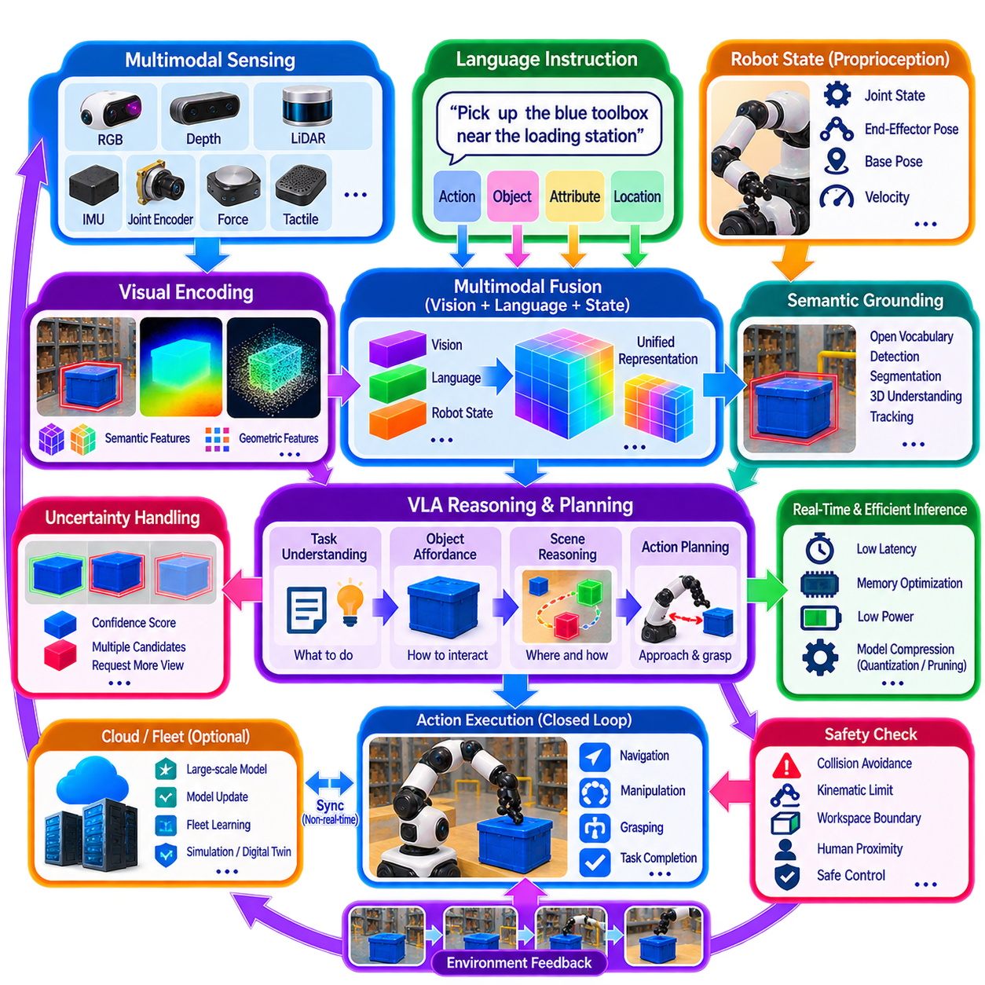
VLA-based perception integration connects visual observations, language instructions, robot state, and action-oriented reasoning within a unified Physical AI architecture. Instead of treating perception as an isolated module that produces object labels or geometric measurements, the VLA system converts multimodal observations into representations that can directly support task interpretation and action selection. This allows the robot to understand not only what is visible but also which observed entities are relevant to the requested task and how they may influence subsequent behavior.
The perception front end typically combines multiple visual and physical sensing sources. RGB cameras provide appearance and semantic information, while depth cameras and LiDAR contribute three-dimensional geometry. Additional information from IMU, joint encoders, force sensors, tactile sensors, or other proprioceptive sources provides the robot's own physical state. These heterogeneous observations must be synchronized, calibrated, and transformed into representations that can be processed jointly with language and action-related information.
Visual encoders transform raw images or multimodal observations into compact feature representations. Models derived from large-scale vision-language pretraining can provide semantic features that connect visual regions with concepts expressed in natural language. Rather than requiring every possible object category to be predefined, the encoder can support open-ended semantic associations. This capability is important when a VLA system receives instructions involving previously unseen objects, attributes, spatial descriptions, or task-specific concepts.
Language provides the semantic context required to interpret visual information according to the current task. An instruction such as “pick up the blue toolbox near the loading station” contains an action, object category, attribute, and spatial relationship. The perception module must therefore identify candidate visual entities corresponding to these concepts and establish their relationships within the scene. Language should not replace geometric perception; instead, it provides task-level semantic conditioning for selecting and interpreting relevant visual evidence.
Multimodal fusion combines visual features, language representations, robot state, and additional sensor information into a common representation. Fusion may occur at the feature level, token level, cross-attention level, or through a shared latent space. The objective is to preserve complementary information while allowing one modality to influence the interpretation of another. For example, language can focus visual attention on a particular object, while depth and robot-state information determine whether that object is physically reachable.
The integrated representation then supports reasoning and planning. A VLA system can infer which object satisfies the instruction, estimate its relevant affordances, determine an appropriate approach, and construct an action sequence. For navigation, the output may correspond to a semantic destination and movement objective. For manipulation, it may include a target object, grasp region, approach direction, and desired final state. The perception module therefore becomes part of a larger reasoning pipeline rather than an independent image-understanding component.
Grounding is a central requirement for successful VLA perception. Semantic concepts extracted from language must be associated with actual physical entities and locations. Open-vocabulary detection, segmentation, tracking, depth estimation, and 3D scene understanding can provide the necessary grounding mechanisms. A language model may understand the concept “blue toolbox,” but the robot must identify which physical object corresponds to that description and determine its location relative to the robot, workspace, and surrounding obstacles.
Ego-centric and embodied representations further connect perception to physical action. The same object can have different practical meanings depending on the robot's current position, end-effector configuration, viewpoint, and available workspace. A VLA perception module should therefore preserve relative position, orientation, depth, local geometry, visibility, and robot-state information. These features allow downstream policies to distinguish between an object that is semantically correct and one that is actually accessible and manipulable.
Temporal information is also important because robotic perception occurs continuously rather than as independent images. Objects move, the robot changes viewpoint, people enter or leave the scene, and manipulation changes object configurations. Tracking, temporal feature aggregation, video representations, and world-model states can maintain continuity across observations. This enables the VLA system to reason about changes over time and to evaluate whether an action has produced the expected state transition.
The perception module should also support uncertainty estimation. Visual observations may be incomplete because of occlusion, reflections, poor lighting, sensor noise, or limited viewpoints. Language instructions may contain ambiguous references, and multiple objects may satisfy the same semantic description. Rather than forcing an uncertain interpretation into a single deterministic result, the system can maintain confidence values and alternative candidates. Planning can then use these uncertainties when selecting actions, requesting additional observations, or deciding whether clarification is necessary.
VLA perception must remain compatible with real-time robotic constraints. Large multimodal models can require substantial computation, memory, and energy, while physical actions may require predictable response times. Edge deployment can therefore use quantization, pruning, knowledge distillation, parameter-efficient adaptation, model compression, caching, and hardware acceleration. A practical architecture may execute latency-critical perception and control locally while assigning computationally intensive reasoning, model updates, or fleet-level learning to more powerful on-premise or cloud infrastructure.
Safety requires an additional layer between VLA-generated decisions and physical execution. A semantically reasonable action is not necessarily physically feasible or safe. Before execution, proposed actions should be checked against collision constraints, kinematic limits, dynamic limits, workspace boundaries, human proximity, object stability, and other operational policies. Runtime monitoring and deterministic control layers should remain capable of rejecting, modifying, slowing, or stopping an action when the VLA output conflicts with physical or safety constraints.
The VLA perception module should operate as part of a closed-loop system rather than a one-way pipeline. The robot observes the environment, interprets language, grounds relevant entities, predicts or selects an action, executes that action, and observes the resulting state. Differences between expected and actual outcomes can trigger replanning, additional perception, or adaptation. This feedback loop allows perception to remain connected to task progress and enables the system to recover when assumptions about the environment prove incorrect.
A practical integration architecture can therefore be organized around multimodal sensing, visual-language representation, semantic grounding, embodied feature extraction, multimodal fusion, reasoning, planning, action decoding, and feedback. Each component contributes a distinct capability while sharing representations and state information through well-defined interfaces. Conventional perception modules can continue providing deterministic geometric information, while VLA components add semantic interpretation and flexible task conditioning. This hybrid structure allows existing robotics software to coexist with emerging foundation-model capabilities.
Ultimately, VLA-based perception integration transforms perception from a system that merely recognizes the environment into one that understands the environment in relation to human intent and possible physical action. Visual observations provide evidence, language specifies task context, robot state establishes embodiment, multimodal fusion creates a shared representation, reasoning connects observations to goals, and action policies convert the resulting interpretation into behavior. When combined with 3D perception, affordance estimation, world models, online adaptation, planning, and safety control, VLA perception becomes a central interface between semantic intelligence and reliable physical action.

