Volume 14. Perception and Sensor Fusion

Chapter 05. IMU and Inertial Perception

05.01. IMU Measurement Model Accelerometer Gyroscope [w/Code]
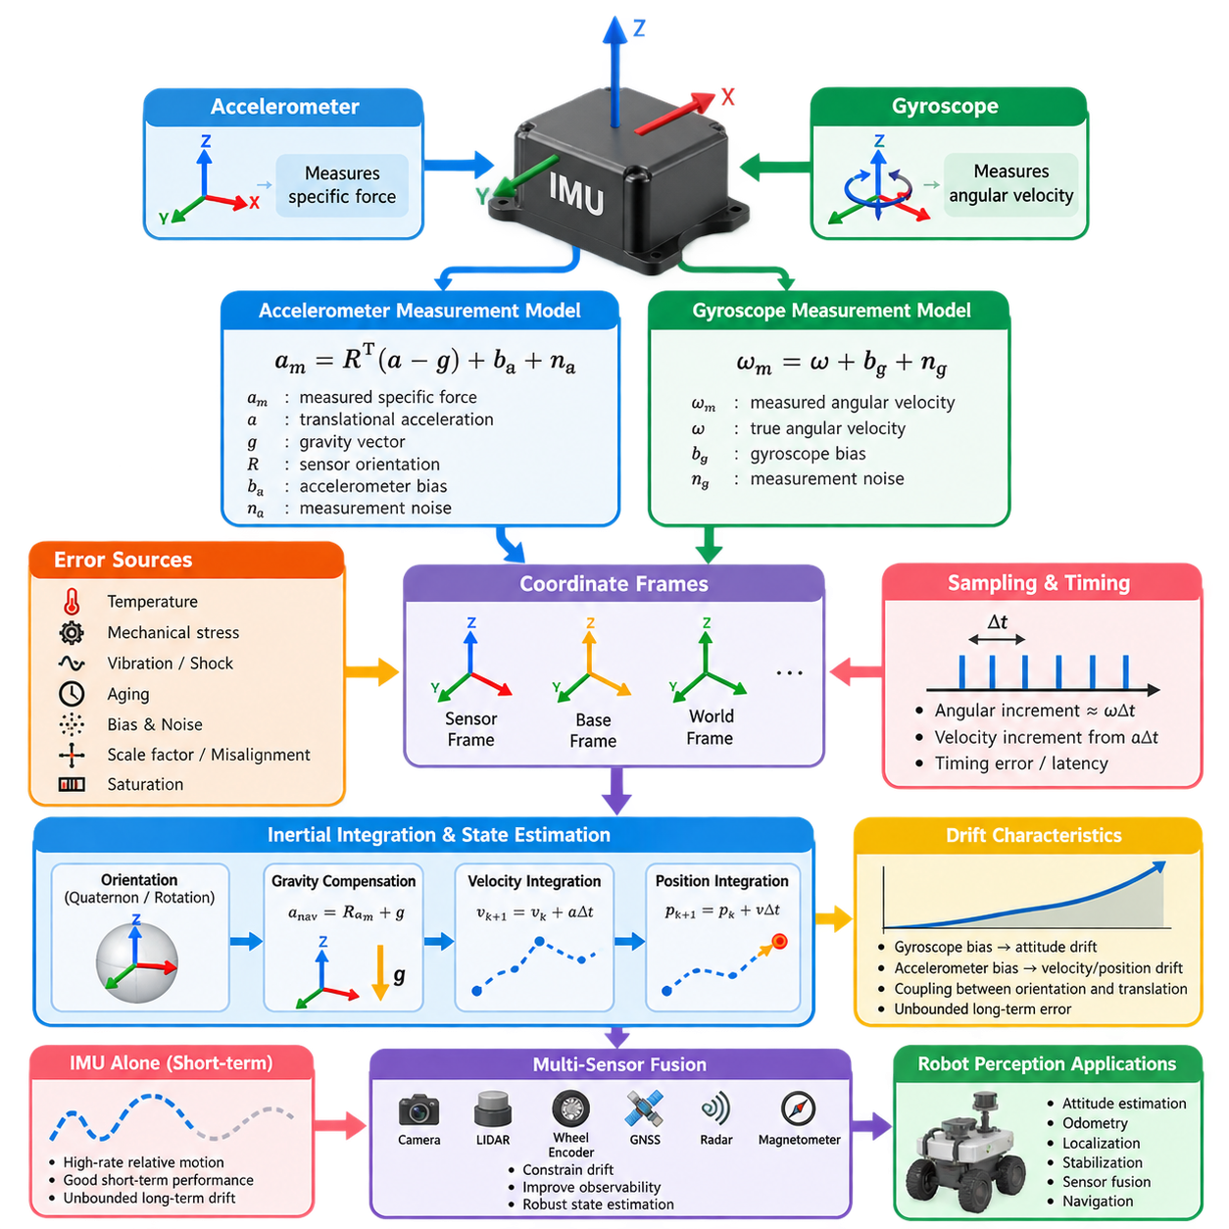
An inertial measurement unit provides a compact representation of short-term robot motion by measuring specific force and angular velocity. The two primary sensing elements are the accelerometer and gyroscope, typically arranged as three orthogonal axes each. Together they produce six-degree-of-freedom inertial observations that support attitude estimation, odometry, localization, stabilization, and sensor fusion throughout a robot perception system. :chatgpt-content-reference{index=“0”}
An ideal three-axis gyroscope measures the angular velocity of the sensor body relative to an inertial reference frame, expressed in the IMU body coordinate frame. If the true angular velocity is denoted by ω, the practical measurement can be modeled as ω_m = ω + b_g + n_g, where b_g represents gyroscope bias and n_g represents measurement noise. This simple equation forms the basis of most inertial state-estimation models.
Gyroscope bias is particularly important because angular velocity is integrated over time to estimate orientation. Even a small constant offset therefore produces continuously increasing attitude error. Real MEMS gyroscopes also exhibit slowly varying bias caused by temperature, mechanical stress, aging, and stochastic processes. Practical estimators consequently treat gyroscope bias as a state that must be calibrated initially and often estimated continuously during operation.
The accelerometer does not directly measure ordinary kinematic acceleration. Instead, it measures specific force, which is the non-gravitational force per unit mass acting on the sensor. A common model is a_m = Rᵀ(a − g) + b_a + n_a, where a is translational acceleration in the reference frame, g is the gravity vector, R describes sensor orientation, and b_a and n_a represent accelerometer bias and measurement noise respectively.
This distinction explains an important characteristic of inertial sensing. A stationary accelerometer resting on a horizontal surface normally reports approximately one gravitational acceleration along its vertical sensing axis rather than zero. The supporting surface generates a force opposing gravity, and the accelerometer detects this specific force. Correct interpretation therefore requires knowledge of sensor orientation and a consistent convention for coordinate frames and gravity direction.
The accelerometer and gyroscope complement each other. Gyroscope measurements provide rapid and locally smooth information about rotational motion but accumulate drift after integration. Accelerometer measurements contain information related to gravity and translational dynamics but are strongly affected by robot acceleration, vibration, impacts, and sensor noise. Reliable inertial perception therefore depends on interpreting both signals according to the robot's motion state.
Coordinate frames are fundamental to the measurement model. Raw IMU measurements are normally expressed in a sensor-fixed frame whose axes are determined by the physical package and mounting orientation. Robot algorithms may instead operate in a base, vehicle, world, map, or navigation frame. Rotations between these frames must be explicitly defined because an incorrect axis direction, handedness convention, or mounting transformation can create systematic estimation errors.
A more realistic accelerometer model extends the ideal equation with scale-factor error, axis misalignment, cross-axis sensitivity, and nonlinear effects. It can be expressed conceptually as a_m = M_a Rᵀ(a − g) + b_a + n_a, where M_a represents imperfections in the three-axis sensor geometry and gain. Equivalent terms can be introduced for the gyroscope, allowing calibration procedures to identify systematic errors before inertial measurements enter the estimator.
Bias and noise have different implications and should not be treated as a single error source. Bias introduces a persistent or slowly changing offset, whereas measurement noise produces rapid random variations around the underlying signal. Bias instability, random walk, quantization, temperature dependence, vibration sensitivity, and sampling effects further shape real IMU behavior. Their statistical properties determine the uncertainty assigned to inertial observations during estimation.
Sampling time is another essential component of the model because inertial navigation derives motion by integrating measurements. For a sampling interval Δt, angular increments are approximately related to ωΔt, while velocity increments are obtained from acceleration over the same interval. Timing errors, irregular sampling, packet latency, and inaccurate timestamps can therefore appear as motion errors even when the physical sensing elements themselves operate correctly.
Orientation cannot safely be updated by simply integrating three Euler-angle rates for arbitrary three-dimensional motion. Practical systems commonly represent attitude using rotation matrices or unit quaternions and propagate orientation using gyroscope observations on the rotation manifold. The estimated orientation then allows measured specific force to be transformed into a navigation frame, gravity to be compensated, and translational acceleration to be integrated into velocity and position.
Accelerometer integration is especially sensitive to attitude error. If the estimated gravity direction is slightly incorrect, part of the approximately 9.81 m/s² gravitational acceleration is interpreted as horizontal motion. The resulting false acceleration is integrated into velocity and subsequently position, causing rapid drift. This coupling between orientation and translation is one reason accurate gyroscope modeling is critical even when the final objective is position estimation.
MEMS IMUs used in robots operate in mechanically demanding environments. Wheel vibration, drivetrain harmonics, suspension impacts, manipulator motion, propeller vibration, structural resonance, and shock can contaminate measurements or even exceed the sensor range. Saturation is particularly problematic because clipped measurements no longer represent the actual motion. Selecting suitable accelerometer and gyroscope ranges therefore involves balancing dynamic range against resolution and noise performance.
The measurement covariance supplied to an estimator should reflect actual sensor characteristics rather than arbitrary constants. Accelerometer and gyroscope noise densities can be characterized from stationary recordings, while longer datasets can reveal bias instability and random-walk behavior. These parameters become process and measurement uncertainty terms in Kalman filters, factor graphs, pre-integration algorithms, and other probabilistic estimation frameworks.
An IMU alone provides excellent high-rate relative motion information but does not normally provide bounded long-term position and heading estimates. Integration converts small measurement errors into progressively larger state errors, while gravity provides only partial orientation observability. Cameras, LiDAR, wheel encoders, GNSS, radar, magnetometers, or external references are therefore commonly fused with inertial measurements to constrain drift and recover globally meaningful motion.
The measurement model is consequently the foundation for the subsequent inertial perception pipeline described in this volume. Calibration estimates intrinsic and extrinsic parameters, pre-integration summarizes high-rate samples between optimization states, attitude filters combine inertial observations with references, and inertial odometry propagates robot motion. Later multi-sensor fusion stages then use these modeled measurements and their uncertainty to build robust state estimates. :chatgpt-content-reference{index=“1”}

05.02. IMU Calibration Intrinsic and Extrinsic [w/Code]
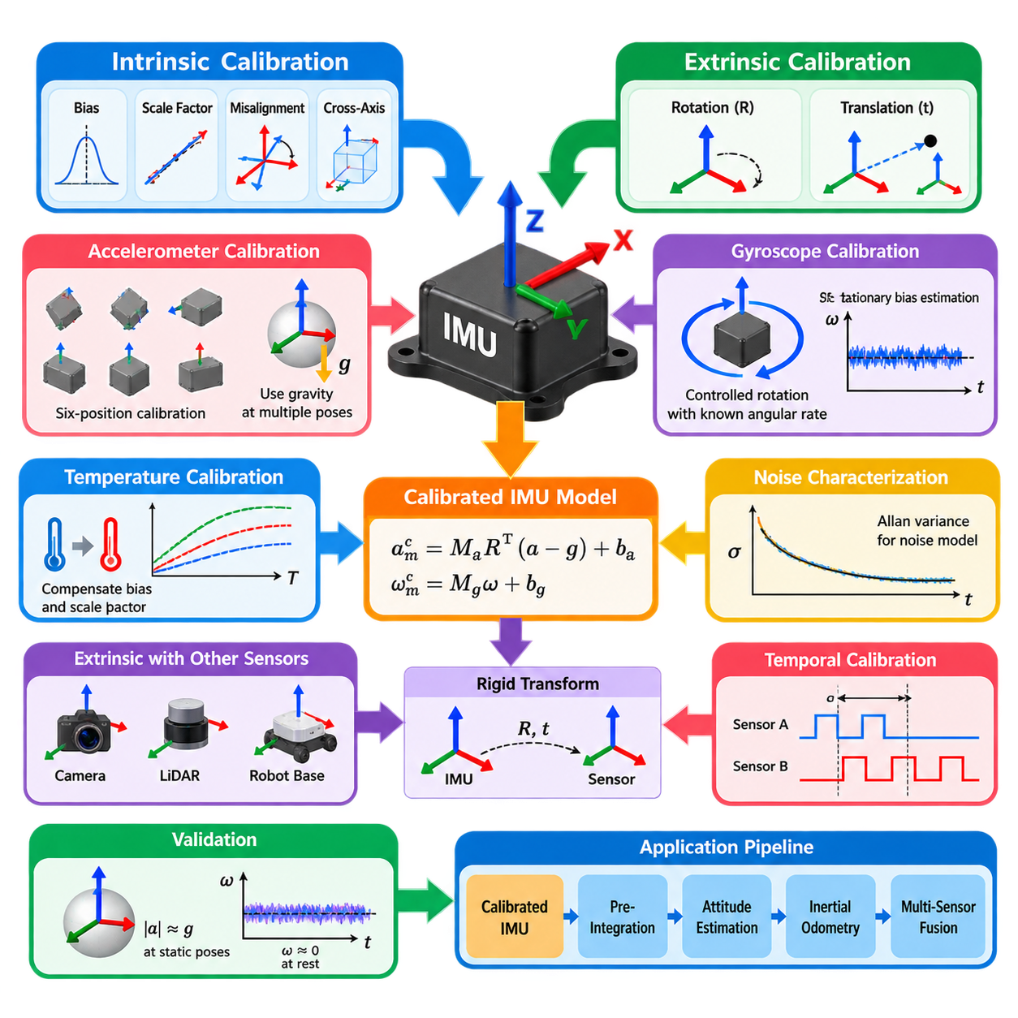
Intrinsic calibration characterizes errors generated inside the IMU itself, while extrinsic calibration determines how the IMU is geometrically related to the robot or other sensors. Both are essential because inertial measurements are integrated over time. Small systematic errors that appear insignificant in individual samples can accumulate into substantial attitude, velocity, and position errors during navigation and state estimation.
A practical intrinsic model extends the ideal accelerometer and gyroscope equations with bias, scale-factor error, axis misalignment, and cross-axis coupling. Instead of assuming three perfectly orthogonal sensing axes with identical gains, calibration introduces matrices that map raw sensor outputs into corrected physical measurements. These parameters represent manufacturing tolerances and sensor imperfections that cannot be removed reliably by simple offset subtraction.
Accelerometer bias can initially be estimated from measurements collected while the IMU is stationary. Because the expected specific-force magnitude is approximately equal to gravity, measurements obtained at multiple static orientations provide constraints for separating bias, scale factors, and axis alignment errors. Six-position or multi-orientation calibration procedures therefore rotate the sensor through different known poses and optimize parameters so that corrected measurements satisfy the gravity model.
Gyroscope bias is commonly estimated during stationary periods because the true angular velocity should approach zero. Averaging many samples suppresses high-frequency measurement noise and reveals the approximately constant bias component. More complete calibration uses controlled rotations with known angular rates to identify scale-factor and cross-axis errors. The resulting correction converts raw gyroscope output into a more accurate representation of body angular velocity.
Temperature strongly influences MEMS inertial sensors and can change both bias and scale factor. A calibration obtained at room temperature may therefore become inaccurate after the robot heats internally or operates outdoors. Thermal calibration records accelerometer and gyroscope behavior across the expected operating temperature range and constructs compensation functions or lookup models that modify calibration parameters according to measured sensor temperature.
Noise cannot be eliminated through deterministic calibration, but its statistical characteristics must still be identified. Stationary datasets can be used to estimate short-term measurement variance, while long-duration recordings reveal bias instability and random-walk behavior. Allan variance or Allan deviation analysis is widely used to distinguish major stochastic error processes and to obtain parameters needed by Kalman filters, pre-integration models, and probabilistic estimators.
Extrinsic calibration addresses a different problem: the IMU sensing frame rarely coincides perfectly with the robot reference frame. The sensor may be translated from the robot origin and rotated because of mechanical mounting. This rigid transformation is represented by a rotation and translation between the IMU frame and the robot base, vehicle, camera, LiDAR, or navigation frame used by the perception and localization system.
Rotational extrinsic error is especially critical because it changes the direction in which measured acceleration and angular velocity are interpreted. A small mounting-angle error can project gravity into an incorrect axis and generate artificial acceleration. Accurate estimation of the rotation between the IMU and robot body frame is therefore necessary before gravity compensation, inertial propagation, or multi-sensor fusion can operate consistently.
Translation between the IMU and robot reference point becomes important when the platform rotates. An IMU positioned away from the rotation center experiences additional centripetal and tangential acceleration caused by the lever arm. Ignoring this displacement may be acceptable for slow, compact platforms, but it can produce significant errors on rapidly rotating robots, UAVs, manipulators, large vehicles, or systems with sensors mounted far from the body origin.
Camera–IMU calibration estimates the rigid transformation between the camera optical frame and IMU frame and often estimates temporal offset at the same time. During sufficiently rich rotational and translational motion, visual feature trajectories provide geometric constraints while inertial measurements provide high-rate motion information. Optimization then determines the transformation that makes the visual and inertial descriptions of motion mutually consistent.
LiDAR–IMU calibration follows the same geometric principle but derives motion constraints from three-dimensional point-cloud registration or LiDAR odometry. The calibration estimates the rotation and translation connecting the LiDAR and IMU frames so that motion inferred from both sensors agrees. Accurate extrinsics are particularly important for LiDAR-inertial odometry because even modest rotational misalignment can degrade scan compensation and map consistency.
Temporal calibration should be considered together with spatial extrinsic calibration. Camera frames, LiDAR scans, encoder messages, GNSS observations, and IMU samples may originate from different clocks or communication paths. A timestamp offset causes measurements representing different physical instants to be fused as though they were simultaneous. During fast motion, this temporal misalignment can resemble a spatial calibration error and significantly degrade estimation.
Calibration motion must sufficiently excite the parameters being estimated. Rotating only around one axis or moving primarily along a straight line can leave some calibration variables weakly observable. A good procedure includes rotations around multiple axes and, when translation must be estimated, sufficiently diverse translational acceleration. Optimization quality therefore depends not only on the calibration algorithm but also on the trajectory used to collect calibration data.
Calibration parameters are usually estimated through nonlinear least-squares optimization, filtering, or dedicated batch-calibration algorithms. Residuals compare sensor observations against known physical constraints or motion estimates, and the optimizer adjusts biases, scale factors, misalignment terms, transformations, and sometimes time offsets. Parameter covariance or residual statistics can then indicate whether the dataset provided enough information for a trustworthy solution.
Validation must be performed independently from parameter estimation. Corrected stationary accelerometer measurements should reproduce the expected gravity magnitude across different orientations, and corrected stationary gyroscope outputs should remain close to zero. For extrinsic calibration, motion reconstructed independently by the connected sensors should agree after transformation. Residual patterns can expose remaining axis errors, timestamp offsets, vibration effects, or poor observability.
Production robots require calibration management rather than a one-time laboratory procedure. Sensor replacement, mechanical impact, mounting changes, temperature cycles, structural deformation, and long-term aging can invalidate previously estimated parameters. Calibration values should therefore be versioned with hardware configuration, checked during maintenance, and monitored through operational diagnostics so that changes in inertial behavior can be detected before they compromise navigation.
A robust inertial perception pipeline ultimately combines intrinsic correction, thermal compensation, spatial extrinsics, temporal alignment, and uncertainty characterization before IMU measurements reach higher-level estimation. These calibrated measurements provide the foundation for IMU pre-integration, attitude estimation, inertial odometry, and multi-sensor fusion, which are the subsequent stages of the IMU and inertial perception architecture. :chatgpt-content-reference{index=“0”}

05.03. IMU Pre Integration Theory and Implementation [w/Code]
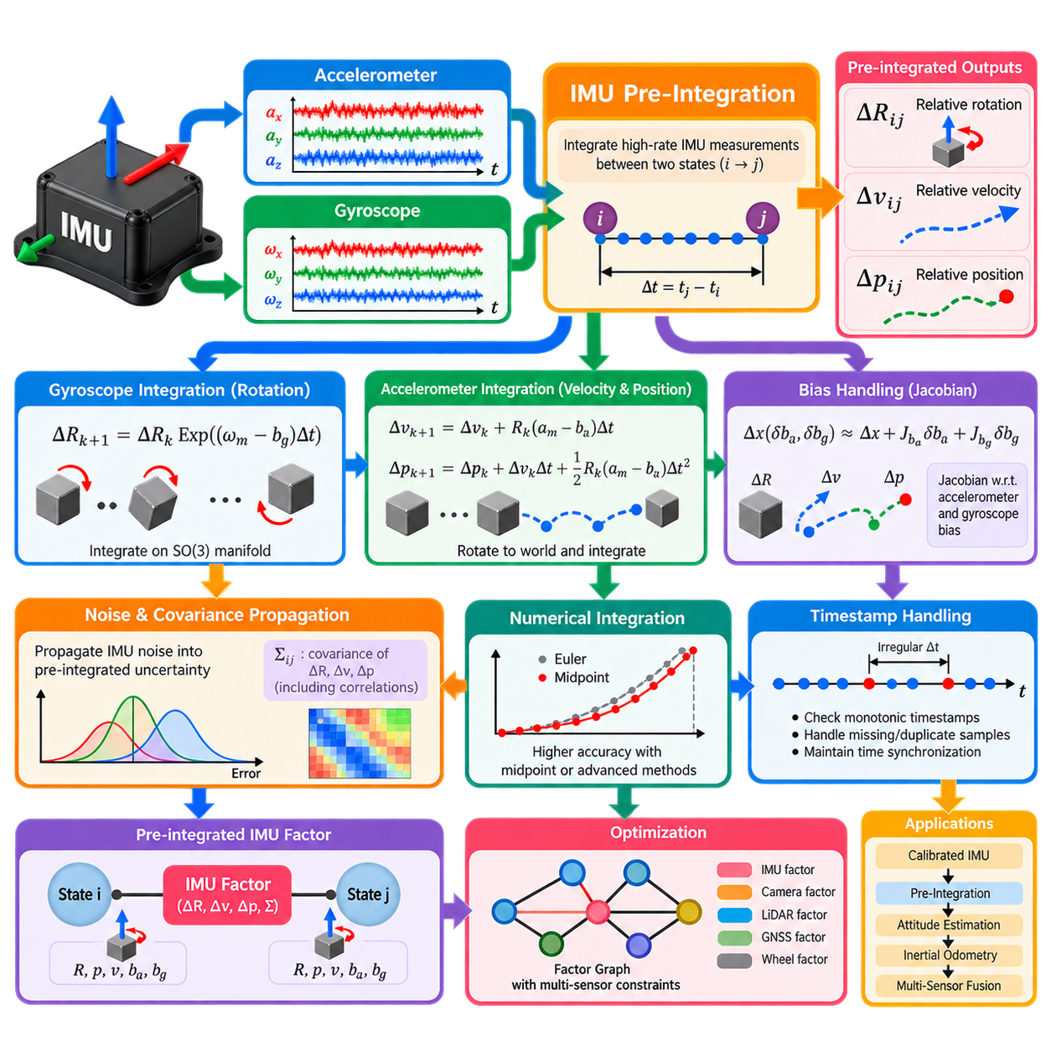
IMU pre-integration is a computational technique that summarizes many high-rate inertial measurements into a compact relative-motion constraint between two estimation states. An IMU may operate at hundreds or thousands of samples per second, while cameras, LiDAR, GNSS, or optimization states update much more slowly. Processing every inertial sample directly during repeated optimization would therefore create unnecessary computational cost.
The basic idea is to integrate accelerometer and gyroscope measurements locally between two selected times, commonly denoted i and j. Instead of repeatedly propagating the complete global navigation state, pre-integration constructs relative changes in rotation, velocity, and position. These quantities are usually written as ΔRᵢⱼ, Δvᵢⱼ, and Δpᵢⱼ and summarize the accumulated inertial motion over the interval.
Gyroscope measurements primarily determine the relative rotation increment. After subtracting the estimated gyroscope bias, angular velocity is integrated on the three-dimensional rotation manifold. Conceptually, each small increment updates the accumulated rotation according to ΔRₖ₊₁ = ΔRₖ Exp((ωₘ − b_g)Δt), where Exp maps a rotation vector into a valid rotation matrix or equivalent quaternion representation.
Accelerometer measurements contribute to both velocity and position increments. Because acceleration is measured in the moving IMU frame, each corrected accelerometer sample must be rotated using the accumulated relative orientation before integration. The pre-integrated velocity accumulates acceleration over time, while the position increment performs a second integration that incorporates both the current velocity increment and the acceleration contribution over each sampling interval.
A major advantage of pre-integration is that the resulting relative measurements can be constructed largely independently of the global position, velocity, and orientation at the beginning of the interval. Gravity and the initial navigation state are introduced later when the pre-integrated constraint is evaluated. This separation allows an optimizer to change global states repeatedly without reintegrating all raw IMU samples after every iteration.
Bias handling remains essential because pre-integrated quantities depend on accelerometer and gyroscope bias estimates. Recomputing the complete integration whenever a bias estimate changes would reduce the computational benefit. Practical formulations therefore propagate Jacobians describing how ΔR, Δv, and Δp vary with small changes in gyroscope and accelerometer biases, allowing first-order bias correction during optimization.
If the bias estimate changes from the value used during pre-integration, the stored increments can be corrected approximately using these Jacobians. Rotation receives a correction associated with gyroscope bias, while velocity and position are affected by both accelerometer and gyroscope bias. When the bias change becomes too large for the linear approximation to remain accurate, the raw IMU sequence can be reintegrated using the updated bias estimate.
Measurement uncertainty must also be propagated throughout pre-integration. Accelerometer and gyroscope noise enters every integration step and accumulates into uncertainty in relative rotation, velocity, and position. A covariance matrix is therefore propagated together with the nominal pre-integrated quantities. This covariance captures not only individual uncertainties but also correlations created between rotation, velocity, and position errors during integration.
The error-state formulation provides an efficient way to propagate this uncertainty. Instead of directly representing uncertainty on the full nonlinear state, small perturbations are defined around the nominal rotation, velocity, and position increments. Linearized state-transition and noise-injection matrices propagate the covariance from one IMU sample to the next, producing the uncertainty required to weight the final inertial constraint statistically.
Pre-integration must respect the geometry of three-dimensional rotation. Rotations cannot generally be accumulated by ordinary vector addition because SO(3) is a nonlinear manifold. Rotation matrices, unit quaternions, exponential maps, and logarithmic maps are therefore commonly used. Manifold-aware integration avoids inconsistencies that can arise from treating orientation as an unconstrained Euclidean vector, particularly during large or complex rotational motion.
Numerical integration quality depends on the integration method and IMU sampling rate. Simple Euler integration may be adequate when the sampling interval is very small, while midpoint integration can improve accuracy by using information from adjacent samples. More sophisticated schemes can further reduce discretization error, but computational complexity must be balanced against the sensor rate, motion dynamics, and accuracy requirements of the robot.
Timestamp accuracy is as important as the numerical equations. Each integration interval Δt is derived from IMU timestamps, so missing samples, duplicated timestamps, clock drift, communication latency, or irregular sampling directly distort the accumulated motion. Implementations should therefore validate timestamp monotonicity, detect abnormal intervals, and maintain consistent time synchronization between the IMU and the sensors defining optimization keyframes.
In a factor-graph system, the pre-integrated IMU measurement becomes an inertial factor connecting consecutive robot states. Each state may contain orientation, position, velocity, and IMU bias variables. The factor predicts how state i should evolve into state j under the accumulated inertial measurements, while a residual expresses the disagreement between this prediction and the current state estimates. The propagated covariance determines the residual weighting.
The rotation residual compares the estimated relative orientation with ΔRᵢⱼ, while velocity and position residuals compare state differences with the corresponding pre-integrated increments after accounting for gravity and elapsed time. Bias evolution can additionally be represented by random-walk constraints. Optimization then combines these inertial residuals with camera, LiDAR, GNSS, wheel-odometry, or other sensor constraints to estimate a consistent trajectory.
Implementation normally maintains a pre-integration object for the current interval. As each IMU sample arrives, the algorithm subtracts current bias estimates, updates relative rotation, integrates velocity and position increments, propagates Jacobians, and updates covariance. When a new camera frame, LiDAR keyframe, or optimization state is created, the accumulated object is finalized and attached as a constraint between the corresponding states.
Real-time systems often maintain two related propagation paths. One pre-integrator provides high-rate state prediction for control or odometry output, while another accumulates measurements for graph optimization. When optimized states and biases become available, the real-time propagation path can be reset and replayed from the corrected state. This architecture combines low-latency inertial prediction with globally corrected multi-sensor estimation.
IMU pre-integration therefore acts as the bridge between high-frequency inertial sensing and lower-frequency probabilistic state estimation. It compresses large sequences of accelerometer and gyroscope samples while preserving relative motion, bias sensitivity, and uncertainty. Within the inertial perception architecture, it naturally follows IMU measurement modeling and calibration and provides the mathematical foundation for attitude estimation, inertial odometry, and multi-sensor fusion. :chatgpt-content-reference{index=“0”}

05.04. Attitude Estimation AHRS Mahony Madgwick EKF [w/Code]
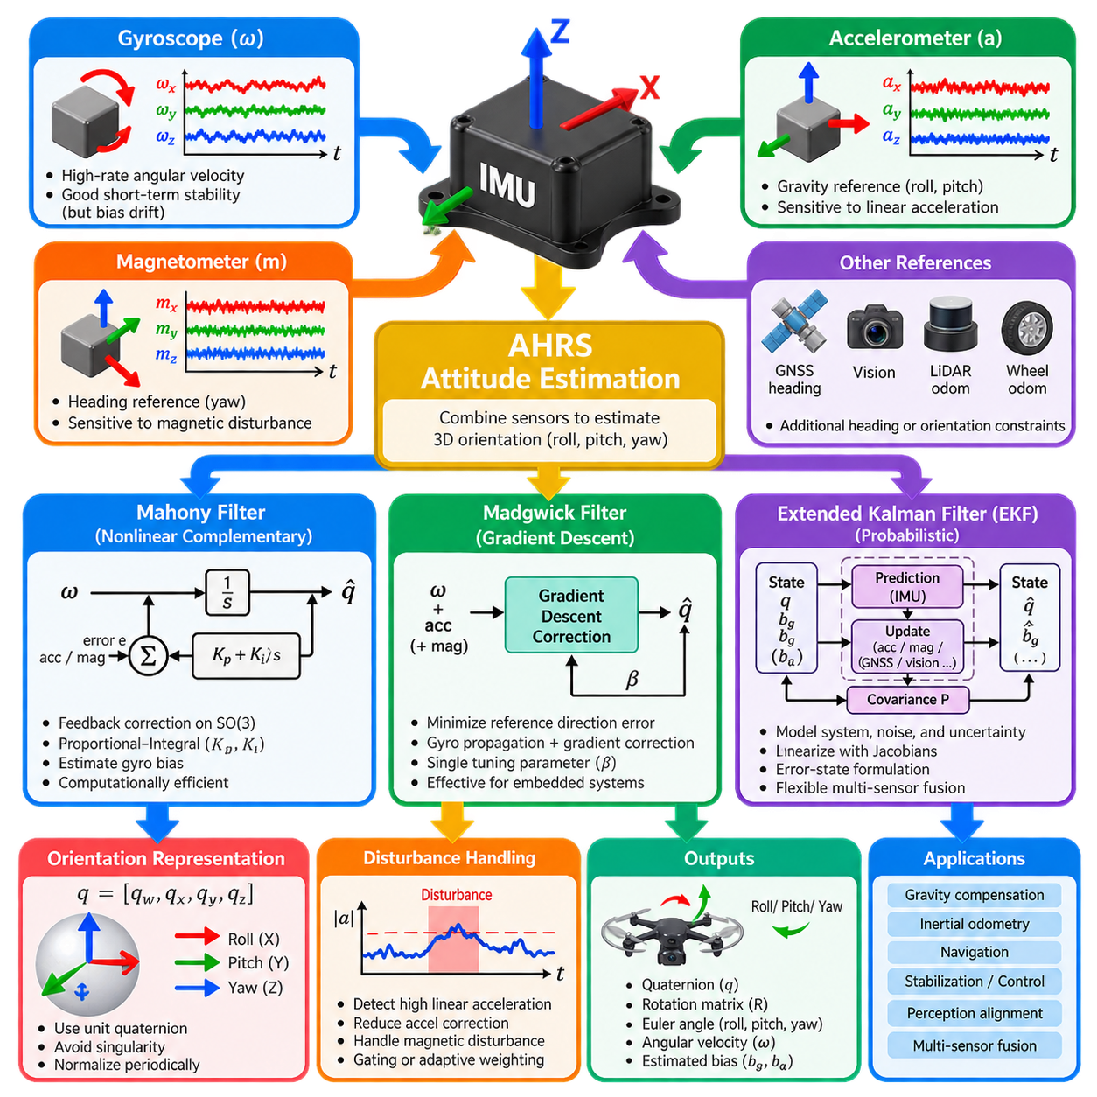
Attitude estimation determines the three-dimensional orientation of a robot or sensor body relative to a reference frame. An attitude and heading reference system, commonly called AHRS, estimates roll, pitch, and yaw by combining high-rate gyroscope measurements with gravity information from accelerometers and, when available, heading observations from magnetometers or other external references.
Gyroscopes provide excellent short-term rotational information because measured angular velocity can be integrated continuously to propagate orientation. However, even a small gyroscope bias produces orientation drift that grows with time. Accelerometers and magnetometers provide absolute directional references that can correct this drift, although their measurements are vulnerable to translational acceleration, vibration, magnetic disturbances, and environmental interference.
An AHRS therefore combines complementary sensor characteristics rather than relying on any single measurement source. Gyroscope data dominates rapid attitude changes, while accelerometer observations provide a long-term gravity reference for roll and pitch. A magnetometer can provide a heading reference for yaw by observing the Earth's magnetic field, but magnetic disturbances often require rejection, weighting, or temporary exclusion of magnetometer measurements.
Orientation is commonly represented using a unit quaternion because quaternions avoid the singularities associated with Euler angles and support efficient composition of three-dimensional rotations. The quaternion is propagated using angular velocity measured by the gyroscope and normalized periodically to preserve its unit-length constraint. Rotation matrices are also widely used, while Euler angles are usually retained mainly for visualization, interfaces, and human interpretation.
The Mahony filter is a nonlinear complementary attitude observer that operates directly on rotational geometry. It predicts orientation using gyroscope measurements and constructs an attitude error from differences between measured reference directions and directions predicted from the current orientation. This error is fed back to correct angular velocity before quaternion or rotation-matrix integration, providing a computationally efficient closed-loop estimator.
A key strength of the Mahony approach is its proportional-integral correction structure. The proportional component rapidly corrects orientation disagreement, while the integral component can estimate slowly varying gyroscope bias. Appropriate gains determine the balance between responsiveness and noise sensitivity. Excessively strong correction may react to accelerometer disturbances, whereas weak correction allows inertial drift to persist for longer periods.
The Madgwick filter also estimates orientation using gyroscope, accelerometer, and optionally magnetometer measurements, but formulates reference alignment as an optimization problem. A gradient-descent correction step minimizes an objective describing disagreement between measured and predicted gravity or magnetic-field directions. The resulting correction is combined with gyroscope-based quaternion propagation to obtain the updated attitude estimate.
Madgwick filtering is attractive for embedded and resource-constrained systems because it provides effective attitude estimation with relatively modest computation. Its principal tuning parameter controls the magnitude of the gradient-based correction relative to gyroscope propagation. Strong correction improves convergence but can increase sensitivity to disturbed reference measurements, while weaker correction produces smoother behavior at the cost of slower drift correction.
Both Mahony and Madgwick filters depend on an important assumption: accelerometer measurements should approximately represent the gravity direction when they are used as an attitude reference. During strong translational acceleration, impact, wheel vibration, or aggressive maneuvering, this assumption becomes invalid. Practical implementations therefore monitor acceleration magnitude or consistency and reduce the influence of accelerometer correction during dynamically disturbed periods.
The extended Kalman filter, or EKF, provides a probabilistic alternative that explicitly models system states, process dynamics, sensor observations, and uncertainty. An attitude EKF may estimate orientation together with gyroscope bias and potentially accelerometer bias or other variables. Gyroscope measurements propagate the state at high frequency, while accelerometer, magnetometer, GNSS, vision, or other observations provide correction updates when available.
Because orientation dynamics and sensor observation equations are nonlinear, the EKF linearizes them around the current estimate using Jacobian matrices. State covariance is propagated during prediction according to process uncertainty and then reduced or reshaped during measurement updates according to measurement uncertainty. This probabilistic structure allows different sensors to be weighted systematically according to their expected accuracy and current measurement quality.
Many robotic systems use an error-state EKF rather than placing an unconstrained quaternion directly inside a conventional additive state. The nominal quaternion represents the current orientation, while a small three-dimensional rotation error is maintained in the linearized error state. After each correction, this small rotation is injected into the nominal attitude and the error state is reset, preserving the geometry of three-dimensional rotation more naturally.
Accelerometer correction within an EKF compares the measured specific-force direction with the gravity direction predicted from the current attitude. Under approximately static or low-dynamic conditions this provides strong roll and pitch observability. During significant linear acceleration, however, the measurement contains motion acceleration in addition to gravity, so adaptive covariance, innovation gating, or measurement rejection may be required to prevent incorrect attitude corrections.
Yaw presents a different observability problem because gravity does not provide information about rotation around the vertical axis. Without a magnetometer or another heading reference, yaw therefore drifts according to accumulated gyroscope error. Robots operating near motors, steel structures, electrical systems, or reinforced buildings may find magnetometers unreliable and instead constrain heading using vision, LiDAR odometry, GNSS heading, wheel motion, or map-based localization.
Innovation monitoring is important for robust AHRS operation. The difference between predicted and observed reference measurements indicates whether incoming data is consistent with the current state estimate. Large innovations can indicate acceleration disturbances, magnetic anomalies, sensor saturation, incorrect calibration, or timing problems. Robust implementations gate or down-weight suspicious measurements instead of allowing them to immediately corrupt the orientation estimate.
The choice between Mahony, Madgwick, and EKF methods depends on system requirements rather than a universal ranking. Mahony provides an efficient feedback-observer structure, Madgwick offers compact gradient-based correction, and EKF methods provide explicit uncertainty propagation and flexible multi-sensor integration. Embedded controllers may favor lightweight filters, while autonomous robots with multiple asynchronous sensors often benefit from probabilistic filtering architectures.
A production attitude-estimation pipeline begins with calibrated and time-aligned IMU measurements, applies appropriate filtering and bias compensation, propagates orientation from gyroscope data, and introduces trustworthy external references for drift correction. The resulting attitude estimate becomes a fundamental input to gravity compensation, inertial odometry, navigation, stabilization, perception alignment, and subsequent multi-sensor fusion stages within the inertial perception architecture. :chatgpt-content-reference{index=“0”}

05.05. IMU Aided Odometry and Dead Reckoning [w/Code]
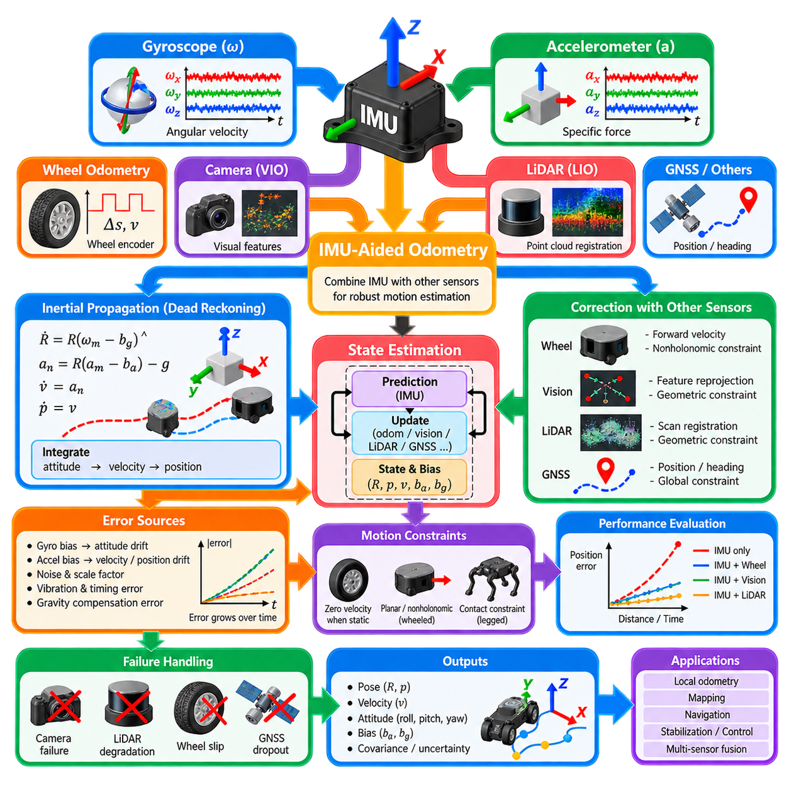
IMU-aided odometry estimates robot motion by combining high-rate inertial measurements with another source of relative displacement or velocity information. The IMU continuously measures angular velocity and specific force, allowing rapid propagation of orientation, velocity, and position between slower observations. This provides smooth motion estimates even when cameras, LiDAR, wheel encoders, or other odometry sensors update at lower frequencies.
Dead reckoning determines the current state by propagating motion from a previously known state without requiring continuous absolute positioning. Given an initial position, velocity, and orientation, gyroscope measurements update attitude while accelerometer measurements are transformed into a navigation frame, compensated for gravity, and integrated into velocity and position. The resulting trajectory is locally continuous but accumulates error over time.
Orientation accuracy is fundamental to inertial dead reckoning because acceleration measurements are expressed in the moving IMU frame. The estimated attitude determines how specific force is transformed into the navigation or world frame before gravity is removed. Even a small orientation error projects part of gravity into horizontal acceleration, creating false velocity that subsequently integrates into rapidly increasing position error.
Gyroscope bias is one of the dominant sources of dead-reckoning drift. A small angular-rate offset accumulates into attitude error, which then indirectly corrupts translational motion through incorrect gravity compensation. Accelerometer bias directly generates velocity error and approximately quadratic position growth during integration. Accurate calibration, online bias estimation, and appropriate uncertainty models are therefore essential for useful inertial odometry.
Pure inertial navigation can provide excellent short-term motion propagation but generally cannot maintain bounded position estimates using low-cost MEMS IMUs. Measurement noise, bias instability, scale-factor errors, vibration, timing errors, and imperfect gravity compensation accumulate continuously. IMU-aided odometry addresses this limitation by periodically constraining inertial propagation with independent motion observations from other sensors.
Wheel odometry is a natural complementary source for wheeled robots and AMRs. Encoder measurements estimate wheel rotation and vehicle displacement, while the IMU provides rapid rotational dynamics and acceleration information. Their fusion improves short-term motion estimation and can maintain smooth pose updates during temporary encoder irregularities, but wheel slip, uneven terrain, tire deformation, and skid steering can introduce systematic odometry errors.
A common wheeled-robot estimator represents position, velocity, orientation, accelerometer bias, and gyroscope bias as system states. IMU measurements drive the prediction stage at high frequency, while wheel-derived forward velocity or incremental displacement provides correction observations. Nonholonomic constraints can additionally express that lateral and vertical vehicle velocities should remain small under normal ground-contact conditions.
Visual-inertial odometry combines cameras with IMU measurements to exploit complementary sensing characteristics. Cameras provide geometric constraints from tracked visual features, while the IMU supplies high-rate motion information during rapid rotation, motion blur, or intervals between image frames. The inertial data also provides metric acceleration and gravity information, helping resolve motion dynamics that are difficult to infer reliably from images alone.
LiDAR-inertial odometry follows a similar principle by combining inertial propagation with geometric constraints obtained from point-cloud registration. IMU measurements predict motion between scans and support deskewing of points acquired at different times within a rotating LiDAR scan. LiDAR registration then corrects accumulated inertial drift by aligning geometric structures in consecutive scans or against a maintained local map.
State estimation can be implemented using an extended Kalman filter, error-state Kalman filter, sliding-window optimizer, or factor graph. Filtering methods propagate the current state and covariance sequentially, while optimization approaches jointly refine multiple historical states using inertial and odometry constraints. IMU pre-integration is particularly useful in optimization because it summarizes high-rate inertial samples between consecutive keyframes into compact relative-motion factors.
The prediction stage propagates the state using calibrated accelerometer and gyroscope measurements. Orientation is integrated first, measured specific force is transformed into the navigation frame, gravity is applied according to the selected convention, and acceleration is integrated into velocity and position. Simultaneously, the estimator propagates covariance to represent increasing uncertainty caused by IMU noise, bias evolution, and imperfect motion modeling.
Correction observations reduce the uncertainty accumulated during inertial propagation. Wheel velocity, visual reprojection, LiDAR registration, GNSS position, or other measurements generate residuals between predicted and observed motion. The estimator uses these residuals to correct pose, velocity, and often IMU biases. Consequently, external odometry does more than correct position; it can indirectly improve future inertial propagation by making sensor bias estimates more accurate.
Zero-motion and motion constraints can significantly improve dead reckoning when applicable. If a robot is known to be stationary, measured velocity can be constrained to zero, allowing the estimator to correct velocity drift and improve bias estimates. Ground robots can exploit planar-motion or nonholonomic constraints, while legged robots can use contact information. Such constraints introduce physical knowledge that reduces otherwise weakly observable inertial errors.
Sensor failures must be considered because IMU-aided odometry is often expected to bridge temporary degradation of another perception source. A camera may fail in darkness or textureless areas, LiDAR registration may degrade in geometrically repetitive scenes, and wheel odometry may become unreliable during severe slip. The IMU can maintain short-duration propagation through these intervals, but uncertainty should increase until reliable external constraints return.
Time synchronization and extrinsic calibration directly affect fused odometry quality. An incorrect transformation between the IMU and another sensor causes their independently observed motions to disagree, while timestamp offsets associate measurements from different physical instants. These errors become particularly significant during rapid rotation or acceleration and can appear as unexplained bias, poor registration, or persistent residuals within the estimator.
Dead-reckoning performance should therefore be evaluated not only by instantaneous pose error but also by drift rate over distance and time. Relative pose error, trajectory error, heading drift, velocity consistency, and covariance behavior provide complementary indicators. Testing should include straight motion, turns, acceleration, stopping, vibration, slopes, wheel slip, sensor dropout, and other conditions representative of the robot's intended operating environment.
A robust IMU-aided odometry architecture consequently combines calibrated inertial sensing, accurate attitude estimation, bias tracking, motion constraints, uncertainty propagation, and complementary odometry observations. It provides high-rate locally continuous state estimates while acknowledging that inertial dead reckoning alone accumulates drift. Within the inertial perception pipeline, this capability connects IMU pre-integration and attitude estimation to subsequent multi-sensor fusion and navigation functions. :chatgpt-content-reference{index=“0”}

05.06. Zero Velocity Update ZUPT for Legged Robots [w/Code]
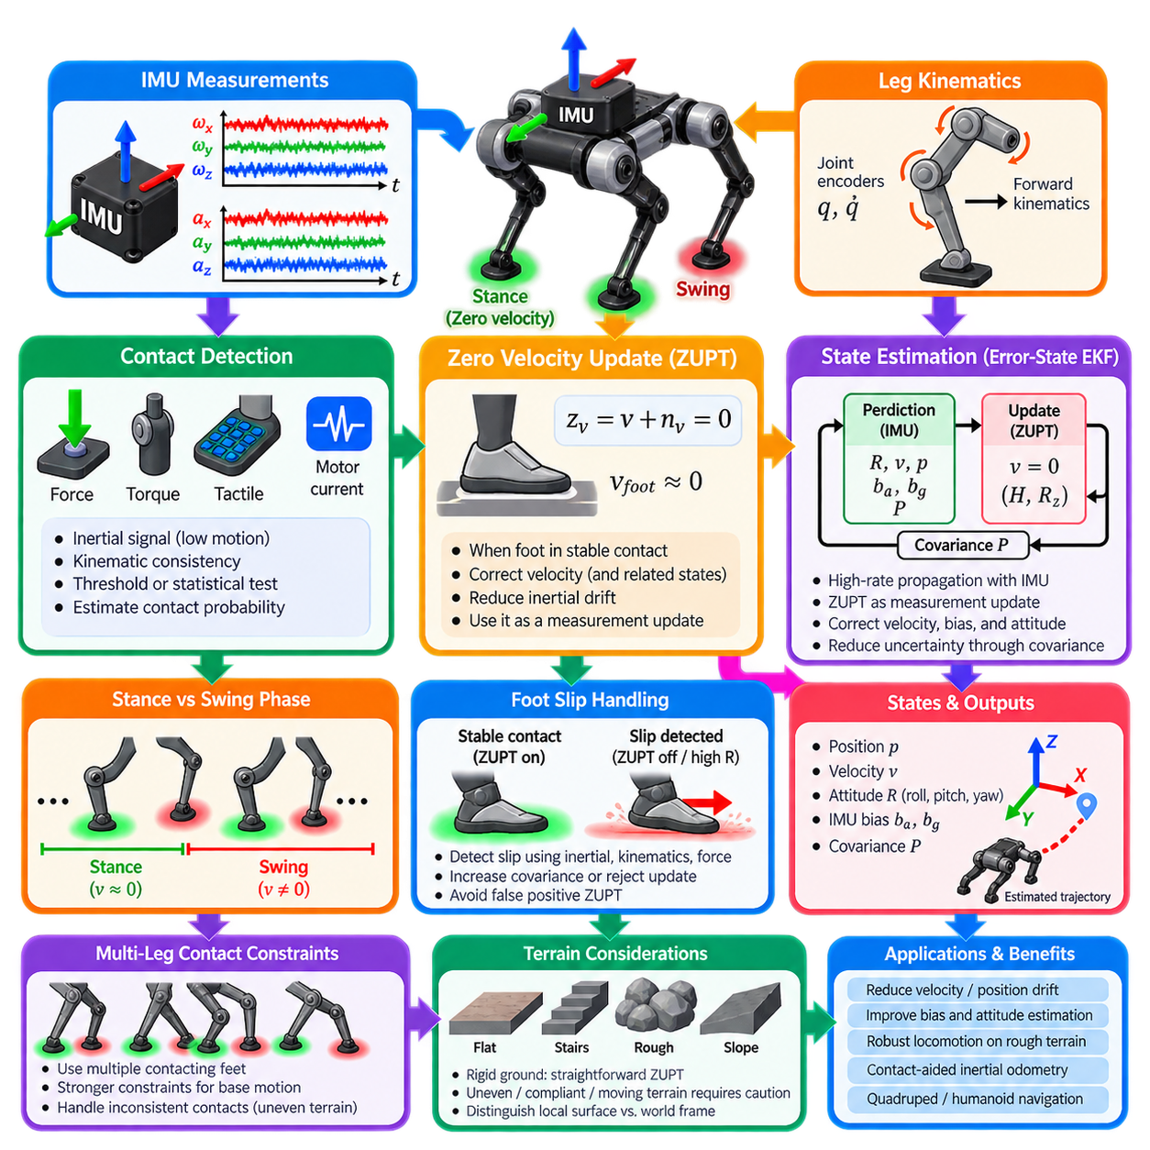
Zero-Velocity Update, commonly abbreviated as ZUPT, is a state-estimation technique that exploits periods when part of a robot is known to be stationary. In legged robots, each foot repeatedly transitions between swing and ground-contact phases. When a foot establishes stable contact without slipping, its velocity relative to the ground should approach zero, creating a strong physical constraint that can reduce accumulated inertial drift.
Inertial navigation continuously integrates gyroscope and accelerometer measurements to propagate orientation, velocity, and position. Small sensor biases and measurement noise accumulate through integration, causing velocity and position estimates to drift. ZUPT interrupts this error growth by introducing a zero-velocity observation whenever a reliable stationary condition is detected, allowing the estimator to correct velocity and indirectly improve other correlated state variables.
The fundamental ZUPT measurement can be expressed conceptually as z_v = v + n_v = 0, where v represents the velocity of the constrained point and n_v represents measurement uncertainty. The estimator compares the predicted velocity with the expected zero value and generates an innovation. This residual is then used to correct the estimated state according to the confidence assigned to the detected stationary condition.
For a foot-mounted IMU, the interpretation is direct. During the stance phase, a firmly planted foot should remain nearly stationary with respect to the supporting surface. Gyroscope magnitude and accelerometer behavior can therefore be monitored to identify stationary intervals. Once detected, the estimated foot velocity is forced toward zero, preventing the velocity error from growing freely over successive walking steps.
A legged robot often places its primary IMU on the torso rather than on each foot, making ZUPT more indirect. The body itself continues moving even while one or more feet remain stationary. In this case, joint encoder measurements and forward kinematics relate the body state to the contacting foot. The zero velocity of the contact point can then be converted into a kinematic measurement constraint on the robot's base velocity and motion.
Reliable contact detection is therefore fundamental to ZUPT performance. Foot-force sensors, joint torque estimates, tactile sensors, motor current, contact switches, kinematic consistency, or inertial signatures may be used to determine whether a foot is supporting the robot. A contact flag alone is not always sufficient because touchdown, liftoff, impact, compliant deformation, or partial contact can violate the assumption of a perfectly stationary foot.
Threshold-based stationary detection provides a simple implementation. The magnitude of angular velocity can be required to remain below a selected threshold while accelerometer magnitude remains close to the expected gravity level. These conditions may be evaluated over a short temporal window rather than a single sample. Windowed tests reduce sensitivity to measurement noise and prevent isolated samples from repeatedly activating or deactivating the zero-velocity constraint.
More sophisticated detectors formulate stationary recognition statistically. Generalized likelihood ratio tests, probabilistic contact estimators, learned classifiers, or multi-sensor contact models can evaluate whether the observed inertial and mechanical signals are consistent with a stationary foot. Such methods are useful for dynamic locomotion, where fixed thresholds may perform poorly across walking, trotting, running, climbing, and rough-terrain behaviors.
A false positive ZUPT can be more damaging than temporarily missing an update. If a sliding foot is incorrectly assumed to have zero velocity, the estimator receives a physically incorrect constraint and may distort base velocity, orientation, or position. Robust implementations therefore assign uncertainty according to contact confidence and may reject updates when residuals become inconsistent with predicted robot dynamics or other sensor observations.
Foot slip is especially important on loose soil, wet surfaces, slopes, gravel, or low-friction flooring. A foot may remain in contact while moving relative to the ground, meaning contact does not imply zero velocity. Slip detection can compare joint kinematics, inertial motion, force measurements, and estimated base motion. When slip is suspected, the ZUPT covariance can be increased or the constraint can be disabled until stable contact returns.
Within an error-state Kalman filter, the IMU normally performs high-rate state propagation while ZUPT acts as a measurement update. The state may include base orientation, position, velocity, accelerometer bias, and gyroscope bias. Because these quantities are correlated through covariance propagation, correcting velocity can also reduce errors in sensor bias and attitude, improving subsequent inertial propagation even after the zero-velocity interval has ended.
ZUPT also improves observability of otherwise weakly constrained inertial states. Accelerometer bias produces velocity drift, while gyroscope bias creates attitude errors that eventually contaminate translational estimates. Repeated stationary constraints provide information that helps distinguish real robot motion from accumulated sensor error. The benefit becomes particularly significant during long operation without continuous GNSS, vision, or externally referenced localization.
For multi-legged systems, several simultaneous contacts provide additional constraints. A quadruped may have two, three, or four feet in contact depending on its gait, while a humanoid may alternate between single-support and double-support phases. Multiple stable contacts can constrain base motion more strongly, but inconsistent contact assumptions must be handled carefully because terrain deformation or slip can make individual foot constraints mutually incompatible.
Contact-aided inertial odometry extends the ZUPT concept beyond a simple zero-velocity event. Stable foot contacts can be treated as temporary landmarks whose positions remain fixed in the local world frame during stance. The estimator can jointly track the robot base and contact locations, using leg kinematics to constrain their relative geometry. When a foot lifts, its constraint is removed and a new contact state can be introduced at the next touchdown.
Terrain geometry influences how these constraints should be interpreted. On rigid, level ground, stationary-contact assumptions are relatively straightforward, whereas stairs, rocks, compliant surfaces, moving platforms, and deformable terrain require greater caution. The estimator should distinguish between a stationary contact relative to the local surface and an absolute stationary point in the world, particularly when the supporting environment itself may move.
Timing accuracy is also critical because contact events, joint encoder measurements, and IMU samples must describe the same physical motion. A delay between detected touchdown and the actual contact instant can apply a zero-velocity constraint while the foot is still moving. Hardware timestamps, synchronized sensor clocks, appropriate buffering, and careful treatment of contact transitions are therefore necessary for accurate high-dynamic legged locomotion.
ZUPT should be evaluated under complete locomotion scenarios rather than only during static tests. Walking speed, gait transitions, turning, running, slopes, stairs, impacts, uneven terrain, deliberate foot sliding, and sensor disturbances should be included. Useful metrics include velocity drift, position drift, attitude stability, bias convergence, false stationary detections, missed contacts, and estimator recovery after incorrect or unavailable constraints.
A robust ZUPT architecture therefore combines calibrated inertial sensing, reliable contact detection, leg kinematics, uncertainty-aware measurement updates, and explicit slip handling. Rather than eliminating inertial drift permanently, it repeatedly anchors the estimator whenever trustworthy physical contact becomes available. Within the IMU and inertial perception pipeline, ZUPT provides a practical bridge from general inertial odometry toward contact-aided state estimation for quadruped and humanoid robots. :chatgpt-content-reference{index=“0”}

05.07. High Rate IMU for Impact Shock Detection [w/Code]
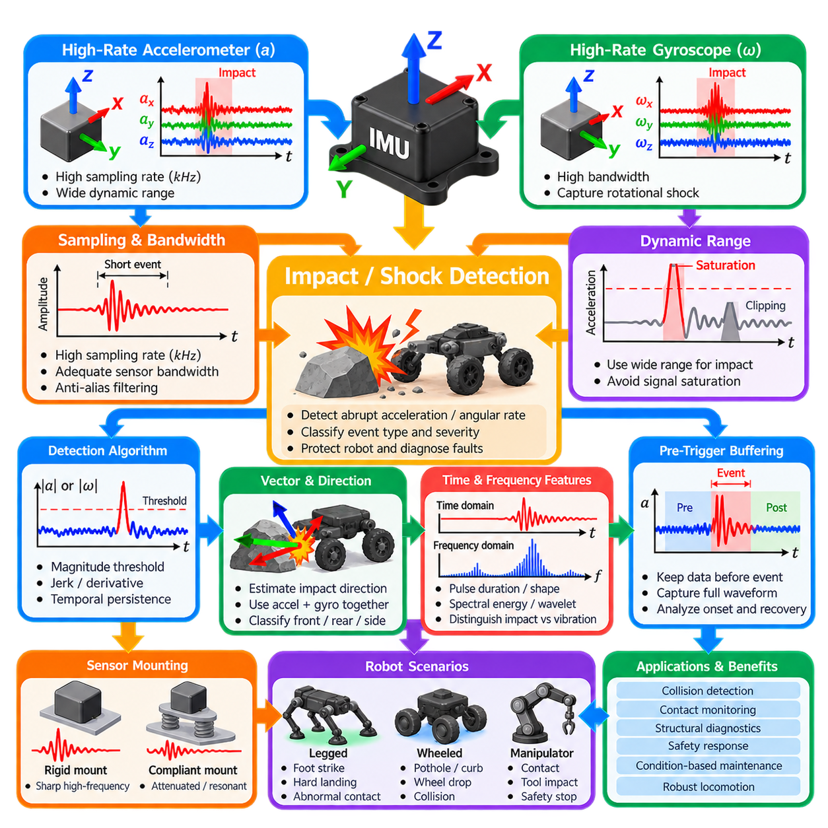
High-rate IMUs are used when a robotic system must observe mechanical events that occur much faster than ordinary navigation motion. Impacts, shocks, collisions, foot strikes, wheel hits, hard landings, and structural contacts may develop within only a few milliseconds. Sampling inertial signals at high frequency preserves these short-duration transients and enables detection before their information is lost through temporal averaging.
Impact detection differs from conventional inertial navigation because the objective is not only to estimate smooth body motion. The system must recognize abrupt changes in acceleration and angular velocity whose amplitude and frequency content may be substantially higher than normal locomotion. A high-rate accelerometer captures translational shock, while a high-rate gyroscope reveals rotational impulses generated when contact forces act away from the robot's center of mass.
Sampling frequency determines the shortest event that can be represented reliably. According to sampling principles, the measurement rate must exceed twice the highest signal frequency of interest, but practical impact monitoring normally requires additional bandwidth margin. An IMU operating at several hundred hertz may detect moderate contacts, whereas kilohertz-class sampling can better resolve rapid shocks, structural vibration, and contact transitions in dynamically moving robots.
Sensor bandwidth must be considered together with sampling rate. A device may output data at several kilohertz while its internal analog or digital filtering limits the physical bandwidth to a much lower value. Increasing output rate alone therefore does not guarantee improved impact observation. The complete sensing chain, including the mechanical structure, sensor bandwidth, anti-alias filtering, digital filters, communication interface, and timestamping, determines usable transient information.
Dynamic range is another critical design parameter because impacts can produce acceleration far beyond the range required for normal navigation. A navigation IMU configured for high sensitivity may saturate during a collision or hard landing. Once clipping occurs, peak magnitude and waveform shape cannot be reconstructed reliably. Impact-oriented systems may therefore use wider acceleration and angular-rate ranges or combine sensitive and high-range sensors.
A basic detector can monitor the magnitude of the three-axis acceleration vector and trigger when it exceeds a selected threshold. Angular-rate magnitude, acceleration derivative, or jerk can provide additional evidence of sudden mechanical events. Thresholds should exceed the distribution of normal robot motion and vibration while remaining low enough to detect meaningful contacts. Temporal persistence conditions help reject isolated electrical or numerical spikes.
Vector information provides more insight than magnitude alone. The direction of the acceleration impulse can indicate the approximate direction of contact, while simultaneous angular acceleration or angular-rate change can reveal an off-center impact. When the IMU location and robot geometry are known, the combined translational and rotational response can support classification of front, rear, side, vertical, or oblique mechanical events.
Impact duration and impulse shape provide useful classification features. A rigid collision may generate a narrow high-amplitude pulse followed by structural ringing, whereas contact with a compliant object may produce a broader lower-frequency response. Foot touchdown, wheel curb contact, manipulator collision, and chassis impact can therefore exhibit different temporal signatures even when their peak acceleration magnitudes are similar.
Frequency-domain analysis can separate impacts from persistent vibration. Motor rotation, gear meshing, propellers, wheels, and structural resonance often produce repetitive spectral components, whereas a sudden shock generates broadband transient energy. Short-time Fourier transforms, band-energy measurements, wavelets, or appropriately designed digital filters can characterize these differences while preserving enough temporal resolution to identify the event time.
Filtering requires careful tradeoffs because aggressive low-pass filtering can suppress the very transient that the detector is intended to observe. Navigation and impact detection may therefore use different processing paths from the same raw IMU stream. A filtered low-frequency path supports attitude and odometry estimation, while a higher-bandwidth path preserves shock and vibration content for event detection, diagnostics, and safety monitoring.
Pre-trigger buffering is valuable because the system often recognizes an impact only after the transient has begun. A circular buffer continuously stores a short history of high-rate IMU samples. When a trigger occurs, the system preserves data from both before and after the event. This provides the complete waveform needed to determine approach motion, impact onset, peak response, structural ringing, and recovery behavior.
Accurate timestamps are essential when impact data must be correlated with other robot signals. Motor current, joint torque, force sensors, tactile sensors, wheel encoders, cameras, contact switches, and controller states may help determine the cause of an event. Hardware synchronization or accurately aligned clocks allow engineers to reconstruct whether a commanded motion, environmental contact, actuator anomaly, or mechanical failure occurred first.
Legged robots particularly benefit from high-rate impact sensing because each touchdown generates a transient mechanical event. Expected foot strikes can be distinguished from abnormal collisions by combining IMU signals with gait phase, joint kinematics, contact estimates, and force measurements. Excessive touchdown shock may indicate poor foothold selection, inappropriate impedance, unexpected terrain height, control error, or a developing mechanical problem.
For wheeled outdoor robots, shock events can originate from potholes, curbs, stones, suspension bottoming, wheel drop, chassis contact, or collisions with obstacles. Event severity should therefore be interpreted together with vehicle speed, suspension state, wheel motion, and terrain perception. Repeated shock statistics can also reveal routes or operating conditions that produce excessive mechanical loading even when no single event causes immediate failure.
Humanoid and manipulation systems require distinction between intended contact and hazardous impact. Grasping, placing, stepping, sitting, or tool use naturally generates contact transients, while unexpected human contact or collision with surrounding equipment may require rapid reaction. Context from task state and contact location can therefore be combined with inertial thresholds to avoid treating every mechanically significant event as a fault.
Event severity can be represented using peak acceleration, peak angular rate, jerk, pulse duration, integrated acceleration, spectral energy, or combinations of these quantities. No single metric describes every impact because structural response depends on sensor location, mass distribution, compliance, and mounting stiffness. Calibration experiments should therefore relate measured inertial signatures to known mechanical events across the expected operating envelope.
Sensor mounting strongly affects the observed waveform. An IMU mounted near a rigid chassis connection may capture sharp high-frequency shocks, while one attached to a compliant bracket can observe attenuated or resonant motion. Placement near the center of mass emphasizes translational response, whereas locations farther from the center can exhibit stronger rotational effects. Mechanical integration is therefore part of the measurement design.
Robust high-rate impact detection ultimately combines sufficient sampling frequency, physical sensor bandwidth, appropriate dynamic range, low-latency processing, event buffering, synchronized timestamps, and context-aware classification. Within an inertial perception architecture, this capability extends the IMU beyond navigation and odometry into collision detection, contact monitoring, structural diagnostics, safety response, and condition-based maintenance for mobile, legged, and manipulation robots.

05.08. MEMS IMU Thermal Calibration and Compensation [w/Code]
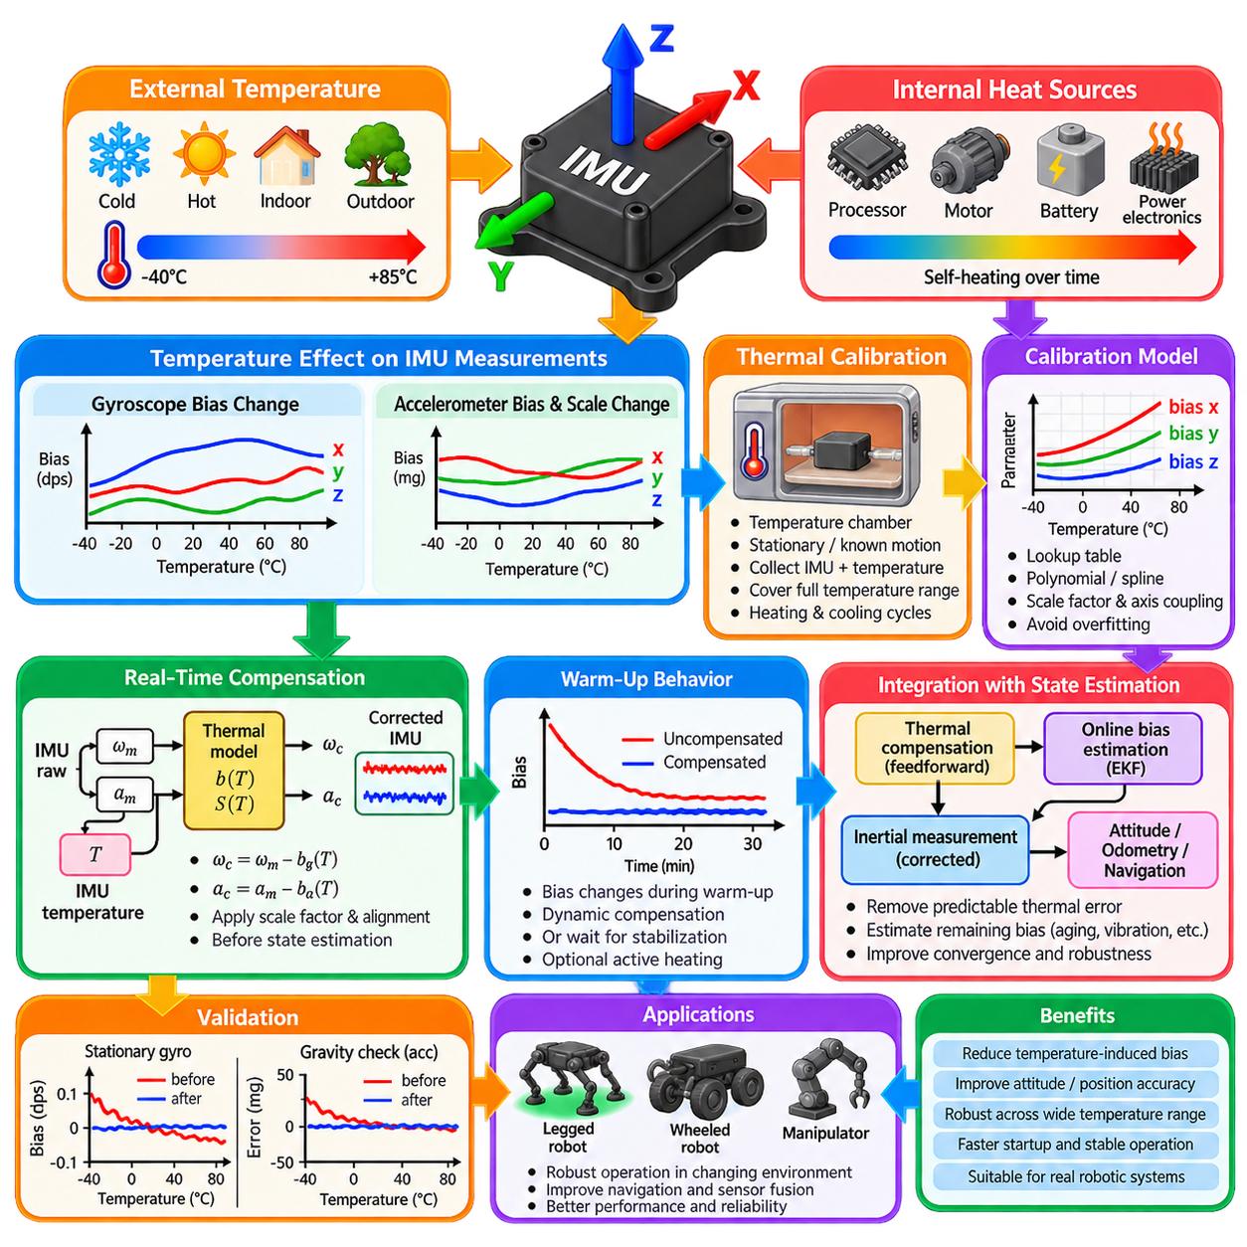
MEMS IMU performance is strongly influenced by temperature because the mechanical and electronic properties of accelerometers and gyroscopes change as the sensor heats or cools. Bias, scale factor, noise characteristics, and axis alignment may vary across the operating range. Since inertial measurements are integrated over time, even small temperature-dependent errors can become significant orientation, velocity, and position drift.
Temperature variation originates from both the external environment and the robot itself. Outdoor platforms may experience cold starts, direct sunlight, seasonal changes, or rapid transitions between indoor and outdoor conditions. Internal processors, motors, batteries, power electronics, and enclosure heating can also raise IMU temperature after startup, producing systematic measurement changes even when the surrounding ambient temperature remains nearly constant.
Gyroscope bias is particularly sensitive to thermal variation. A stationary gyroscope should ideally report zero angular velocity, but its zero-rate output typically changes with temperature. When this temperature-dependent bias is integrated, it produces continuously increasing attitude error. The resulting orientation error also corrupts gravity compensation, allowing a small thermal effect in the gyroscope to generate much larger velocity and position errors indirectly.
Accelerometer bias similarly changes with temperature and can create false translational acceleration. Scale factors may also vary, causing the same physical acceleration to produce different digital outputs at different temperatures. Although individual deviations may appear small, double integration makes accelerometer errors especially damaging to position estimation. Thermal compensation must therefore address both offset and sensitivity changes rather than only removing a constant bias.
Thermal calibration characterizes these relationships by observing the IMU over the temperature range expected during operation. The sensor can be placed in a temperature-controlled chamber and gradually driven through cold and hot conditions while stationary or subjected to known motions. Accelerometer, gyroscope, temperature, and timestamp data are recorded continuously so that measurement errors can be associated with the sensor's internal temperature.
A useful calibration procedure should cover the complete operational range rather than only a few nominal temperatures. Data may be collected during both heating and cooling because MEMS behavior can exhibit thermal hysteresis, meaning the sensor response at a given temperature may depend partly on its previous thermal state. Repeated temperature cycles also help distinguish reproducible thermal behavior from random noise, drift, aging, or experimental variation.
Stationary thermal calibration provides a direct method for identifying gyroscope zero-rate bias. At each temperature, gyroscope outputs can be averaged over a suitable interval to suppress random noise. Accelerometer calibration requires consideration of gravity and sensor orientation. Measurements collected at known static orientations allow temperature-dependent bias and scale-factor effects to be separated from the expected gravitational acceleration acting along each sensing axis.
The resulting calibration data can be represented using lookup tables, piecewise interpolation, polynomial functions, splines, or other regression models. For example, gyroscope bias may be modeled as a function b_g(T), while accelerometer bias becomes b_a(T). Scale factors can similarly be expressed as temperature-dependent functions. The appropriate model should capture real sensor behavior without fitting random measurement noise or producing unstable extrapolation.
Polynomial compensation is convenient when thermal behavior changes smoothly over the operating range. A bias term can be represented conceptually as b(T) = c₀ + c₁T + c₂T² + …, where coefficients are estimated from calibration data. Higher polynomial order can improve fitting flexibility but may overfit the dataset. Piecewise or spline-based models can be preferable when sensor behavior contains localized nonlinearities that are poorly represented by one global polynomial.
Lookup-table compensation provides a straightforward alternative suitable for embedded implementation. Calibration parameters are stored at discrete temperature points, and values between them are obtained through interpolation. This approach avoids imposing a specific global mathematical shape on the thermal response. Memory requirements are generally modest, but calibration-point spacing must be sufficiently dense to represent important changes without unnecessary table complexity.
Real-time compensation reads the IMU temperature and applies the corresponding correction before inertial measurements enter attitude estimation, pre-integration, or odometry. Conceptually, corrected angular velocity can be expressed as ω_c = ω_m − b_g(T), with analogous correction for acceleration. If temperature-dependent scale factors and axis coupling are modeled, the compensation stage additionally applies the appropriate calibration matrix for the current temperature.
The temperature reported by the IMU is not always identical to the actual temperature of the MEMS sensing structure. Thermal gradients and sensor-package dynamics introduce delay between environmental changes, internal electronics, and the sensing element. Rapid heating can therefore create transient errors that a purely static temperature-to-bias relationship does not fully explain. Calibration should consider thermal time constants when such behavior is significant.
Warm-up behavior is especially relevant for robotic systems that must operate immediately after power-on. An IMU may begin near ambient temperature and gradually approach a higher equilibrium temperature as nearby electronics generate heat. During this period, biases can change continuously. Systems may compensate dynamically from startup, delay high-accuracy operation until thermal stabilization, or use controlled heating to maintain the sensor near a predictable operating point.
Active thermal stabilization can reduce calibration complexity by maintaining the IMU at a nearly constant elevated temperature. A heater, temperature sensor, and feedback controller keep the sensing package above the expected environmental maximum or within a narrow controlled region. This approach can improve repeatability but increases power consumption, mechanical complexity, warm-up requirements, and thermal design constraints, making it unsuitable for some compact robots.
Temperature compensation should be integrated with online bias estimation rather than viewed as a replacement for it. Thermal models remove predictable systematic variation, while an EKF or other estimator tracks remaining bias caused by aging, mechanical stress, vibration, imperfect calibration, and stochastic drift. Combining feedforward thermal compensation with online estimation reduces the burden on the estimator and improves convergence during changing thermal conditions.
Validation must use temperature trajectories and operating conditions that were not used to fit the calibration model. Corrected stationary gyroscope output should remain close to zero across the specified range, while corrected accelerometer measurements should remain consistent with gravity. Dynamic validation should verify that attitude, velocity, and position errors remain controlled during heating, cooling, startup, and realistic robot motion rather than only at steady temperature points.
Production deployment requires calibration data to be associated with the specific IMU or hardware configuration from which it was obtained. Sensor replacement, PCB redesign, mounting changes, enclosure modifications, or altered heat sources can change thermal behavior. Calibration coefficients should therefore be versioned and traceable, while diagnostics can monitor residual bias versus temperature to identify degradation or determine when recalibration is necessary.
A robust MEMS thermal-compensation pipeline consequently combines temperature characterization, multi-temperature calibration, suitable regression or lookup models, real-time correction, warm-up management, validation, and online bias estimation. By removing predictable thermal errors before higher-level processing, it improves attitude estimation, IMU pre-integration, inertial odometry, and multi-sensor fusion across the changing environmental and internal temperatures encountered by real robotic systems.

05.09. UAV IMU Vibration Filtering and Isolation [w/Code]
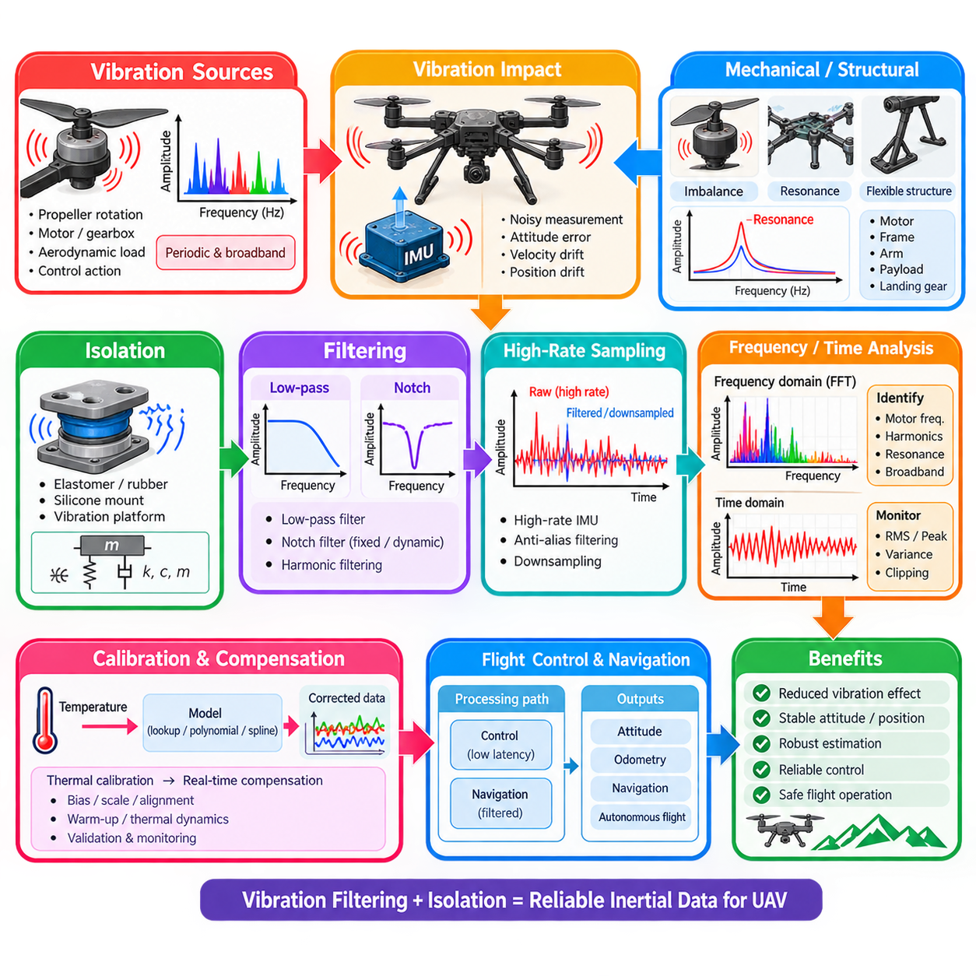
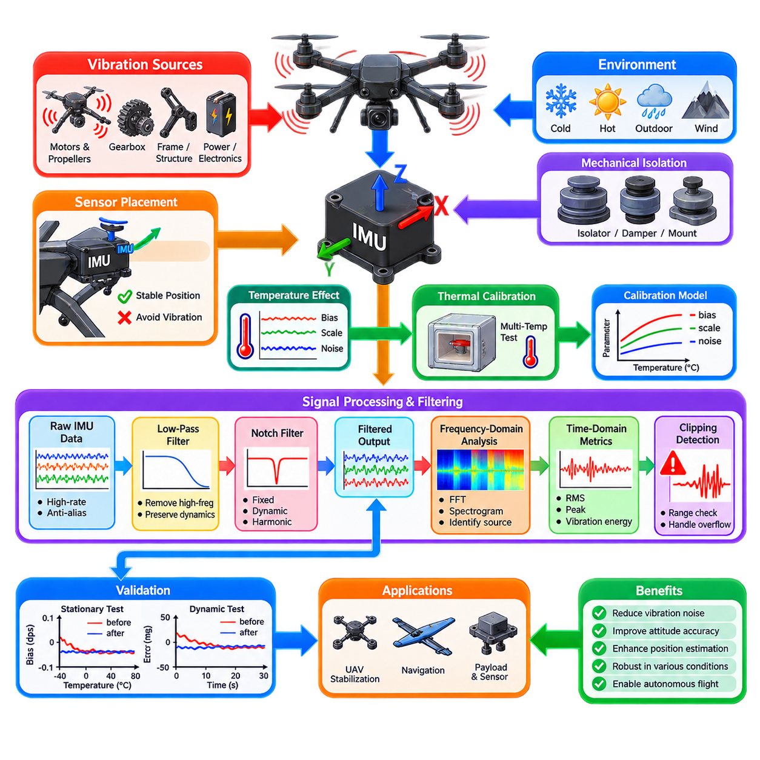
UAV inertial sensing is strongly affected by vibration because propulsion systems generate periodic and broadband mechanical excitation that can propagate through the airframe into the IMU. Motors, propellers, gearboxes, aerodynamic loading, structural resonance, and rapid control actions create acceleration and angular-rate disturbances. If these signals enter the estimator without proper treatment, attitude, velocity, altitude, and position estimates can become noisy or unstable.
Propeller rotation is one of the dominant vibration sources in multirotor UAVs. Each rotor produces periodic forces related to rotational speed, blade count, aerodynamic imbalance, and motor characteristics. A rotor operating at thousands of revolutions per minute can therefore generate fundamental and harmonic frequencies extending well into the IMU measurement bandwidth. Slightly different rotor speeds can additionally create complex combined vibration patterns.
Mechanical imbalance significantly increases vibration amplitude. Propeller manufacturing tolerance, blade damage, contamination, bent motor shafts, worn bearings, or inaccurate assembly can shift the rotating mass away from its ideal axis. These defects generate centrifugal excitation that increases with rotational speed. Vibration mitigation should therefore begin with mechanical inspection and balancing rather than relying entirely on signal-processing algorithms.
Structural resonance can amplify relatively small excitation into large local IMU motion. UAV frames, arms, avionics plates, payload mounts, landing structures, and sensor brackets possess natural frequencies determined by mass, stiffness, and damping. When motor or propeller excitation approaches one of these frequencies, resonance may substantially increase measured acceleration even when the original excitation force has not changed significantly.
IMU placement consequently influences vibration sensitivity. Mounting the sensor near a rigid and structurally stable region of the vehicle can reduce flexible-body motion, whereas installation near vibrating arms, motors, or compliant structures may expose it to stronger disturbances. Placement should also consider the UAV center of mass because locations farther from the rotational center can experience additional acceleration caused by angular motion and structural deformation.
Mechanical isolation attempts to prevent high-frequency vibration from reaching the IMU. Elastomer pads, rubber dampers, silicone mounts, foam structures, or dedicated vibration-isolation platforms can introduce compliance and damping between the airframe and sensor assembly. The isolator behaves approximately as a mass-spring-damper system whose stiffness, damping, and supported mass determine its transmissibility across frequency.
Isolation is not equivalent to making the mount as soft as possible. An excessively compliant mount can introduce low-frequency motion, delayed sensor response, large displacement, or a new resonance inside the control bandwidth. The isolation system should instead place its natural frequency sufficiently below the dominant vibration frequencies while maintaining enough stiffness for accurate low-frequency rigid-body motion measurement and stable sensor alignment.
The transmissibility of an isolation mount changes strongly around its resonance frequency. Below resonance, the sensor tends to follow airframe motion. Near resonance, vibration may be amplified rather than attenuated. At frequencies sufficiently above resonance, isolation becomes effective and transmitted vibration decreases. Damping reduces the resonance peak but also changes high-frequency isolation performance, so mount design requires an appropriate compromise.
Digital filtering complements mechanical isolation by suppressing vibration remaining in the measured signals. A low-pass filter removes frequency components above the bandwidth required for vehicle dynamics and attitude control. The cutoff frequency must remain high enough to preserve legitimate UAV motion while being low enough to attenuate structural and propulsion vibration. Excessive filtering introduces phase delay and can degrade feedback-control stability.
Notch filters are particularly useful when vibration energy is concentrated around known frequencies. A notch strongly attenuates a narrow frequency band while preserving signals outside that region. Fixed notch filters can target predictable motor or structural frequencies, but rotor speed changes with throttle and maneuvering. Consequently, a fixed notch may become less effective when the dominant vibration frequency moves significantly during flight.
Dynamic notch filtering addresses changing propulsion frequencies by adapting the rejected frequency band during operation. Motor rotational speed can be estimated from electronic speed controller telemetry, RPM sensors, or spectral analysis of IMU data. The filter center frequency then follows the motor fundamental or important harmonics, allowing strong attenuation without unnecessarily removing a broad range of useful inertial information.
Harmonic filtering is valuable because propulsion vibration rarely appears only at the fundamental motor frequency. Blade passage, motor electromagnetic effects, structural coupling, and nonlinear mechanical behavior can generate second, third, and higher harmonics. An adaptive filtering architecture may therefore track several related frequency bands simultaneously while retaining lower-frequency rigid-body motion required by the flight controller and state estimator.
Aliasing must be prevented before vibration reaches frequencies that cannot be represented correctly by digital sampling. If mechanical vibration contains energy above half the sampling frequency, that energy can fold into lower frequencies and appear as false motion that ordinary digital filtering cannot easily remove. Sufficient IMU sampling rate, analog bandwidth control, and anti-alias filtering are therefore fundamental parts of UAV vibration management.
High-rate IMU sampling provides more separation between legitimate vehicle dynamics and high-frequency vibration. Raw measurements can be acquired at kilohertz-class rates, filtered appropriately, and then downsampled for control or state estimation. This architecture allows vibration components to be attenuated before decimation and reduces the risk that high-frequency propulsion signals contaminate the lower-frequency inertial data used by the navigation system.
Frequency-domain analysis is useful for diagnosing vibration problems. Fast Fourier Transform analysis can reveal dominant motor frequencies, harmonics, structural resonances, and broadband disturbances. Spectrograms extend this analysis over time and show how vibration frequencies move as rotor speed changes. Comparing spectra across throttle levels, flight modes, payload configurations, and mounting arrangements helps identify the physical source of excessive vibration.
Time-domain metrics provide complementary information for onboard monitoring. Root-mean-square acceleration, peak acceleration, angular-rate variance, clipping frequency, and short-window vibration energy can indicate whether the IMU environment remains within acceptable limits. Monitoring each axis separately is useful because vertical vibration, lateral structural modes, and torsional motion may have different sources and require different mitigation strategies.
Sensor clipping is especially dangerous because filtering cannot reconstruct information lost through saturation. Severe vibration may repeatedly exceed the accelerometer or gyroscope measurement range, producing distorted waveforms and biased averages. Appropriate sensor range, mechanical mitigation, and vibration monitoring should therefore prevent sustained clipping. Systems may also detect clipping events and temporarily reduce confidence in affected inertial measurements.
Vibration rejection should be coordinated with the flight-control and navigation architecture rather than designed independently. The control loop may require relatively high bandwidth for stabilization, while navigation estimation can often tolerate stronger filtering. Separate processing paths can therefore be useful: a low-latency path preserves sufficient dynamics for control, while a carefully filtered path supplies lower-noise measurements to attitude, velocity, and position estimators.
Validation should combine bench testing and representative flight experiments. Motor run-up tests, propeller balancing checks, frequency sweeps, different throttle levels, aggressive maneuvers, payload changes, wind disturbance, takeoff, landing, and long-duration flight should be evaluated. The objective is not simply to minimize measured vibration, but to maintain stable control and reliable inertial estimation throughout the UAV operating envelope.
A robust UAV vibration-management architecture therefore combines mechanical balancing, structural design, appropriate IMU placement, tuned vibration isolation, adequate sampling bandwidth, anti-alias protection, low-pass and adaptive notch filtering, clipping detection, and spectral diagnostics. Together these measures preserve true rigid-body motion while suppressing propulsion and structural disturbances, providing reliable inertial data for attitude control, odometry, navigation, and autonomous flight.

05.10. IMU ROS2 Driver and Integration Best Practices [w/Code]
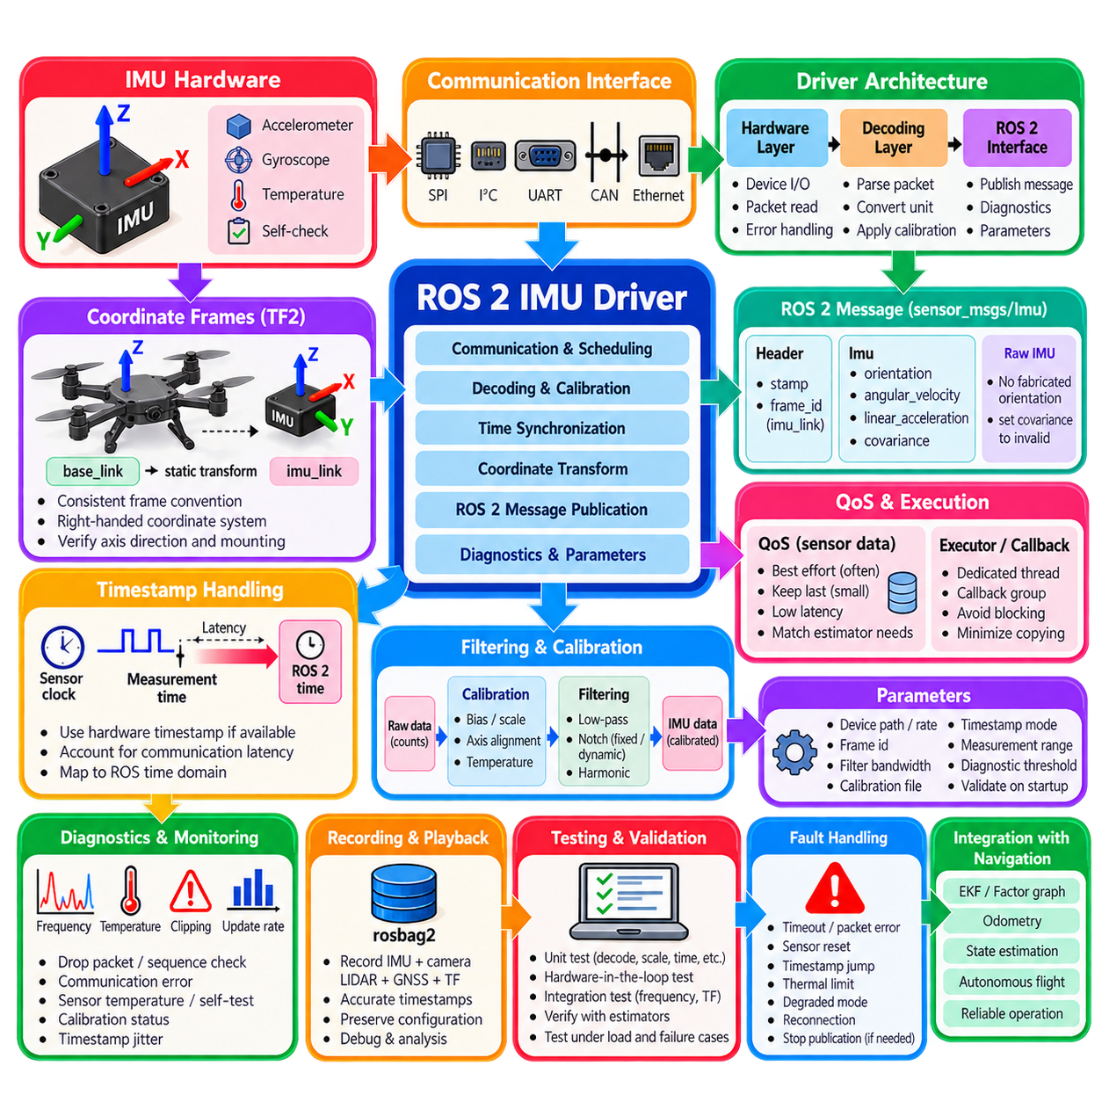
A ROS 2 IMU driver forms the software boundary between inertial sensing hardware and the robot’s perception, localization, control, and navigation stack. Its responsibility extends beyond reading accelerometer and gyroscope registers. A production-quality driver must preserve measurement timing, coordinate conventions, calibration status, uncertainty, diagnostic information, and deterministic data delivery while isolating hardware-specific details from downstream software.
The driver architecture should separate hardware communication from ROS 2 message publication and higher-level processing. A hardware layer manages interfaces such as SPI, I²C, UART, CAN, or Ethernet, while a decoding layer converts device packets into physical units. A ROS 2 interface layer then publishes standardized messages. This separation simplifies sensor replacement, testing, fault diagnosis, and reuse across different robot platforms.
The primary ROS 2 interface for inertial data is sensor_msgs/msg/Imu, which contains orientation, angular velocity, linear acceleration, and covariance information. A raw IMU that does not internally estimate orientation should not fabricate an attitude value. Instead, the orientation field and its covariance should indicate that orientation is unavailable, while angular velocity and linear acceleration contain the calibrated measurements provided by the sensor.
Coordinate-frame conventions must be defined consistently throughout the system. The IMU measurement axes originate from the physical sensor frame, which may differ from the robot base frame because of mounting orientation. The message header frame_id should identify the coordinate frame in which the measurements are expressed. Static transformations can then describe the rigid relationship between imu_link, base_link, and other sensor frames through the ROS 2 TF2 framework.
Axis direction and handedness errors can produce failures that appear similar to estimator or calibration problems. ROS conventions generally use right-handed coordinate systems, while some IMUs or vendor protocols may use different axis definitions. Driver integration should explicitly verify positive acceleration and positive angular-rate directions for all three axes rather than assuming that device documentation, mounting geometry, and robot coordinate definitions automatically agree.
Timestamp handling is one of the most important driver responsibilities. The timestamp should represent the physical measurement time as closely as possible, not simply the time at which a ROS 2 callback publishes the message. Serial transport, buffering, operating-system scheduling, and packet decoding can introduce variable latency. Hardware timestamps or sensor clocks should therefore be preserved whenever available and mapped carefully into the ROS time domain.
High-rate IMUs require efficient data paths because hundreds or thousands of messages may arrive every second. The driver should minimize unnecessary memory allocation, copying, conversion, logging, and blocking operations inside the acquisition path. Hardware reads and packet parsing should remain predictable so that bursts of computation elsewhere in the ROS 2 system do not cause excessive jitter, queue growth, or loss of inertial samples.
ROS 2 Quality of Service, or QoS, should match the real-time characteristics of IMU data. In many high-rate pipelines, recent measurements are more valuable than delayed historical samples, making sensor-oriented QoS profiles appropriate. Queue depth, reliability, durability, and history settings should be selected according to transport quality and estimator requirements. Excessively deep reliable queues can increase latency when consumers cannot maintain the publication rate.
Executors and callback organization also influence timing behavior. IMU acquisition should not be unnecessarily blocked by slow diagnostics, parameter services, visualization, file writing, or computationally expensive processing. Callback groups, multithreaded executors, or dedicated acquisition threads can separate time-critical sensor handling from lower-priority operations. The architecture should be measured under realistic processor load rather than evaluated only in an idle system.
Calibration should be applied at a clearly defined point in the data pipeline. Raw sensor counts are first converted into physical units, after which intrinsic corrections may compensate for bias, scale factor, axis misalignment, and temperature effects. Extrinsic rotation into another robot frame can be performed explicitly when required, although preserving measurements in the native calibrated IMU frame and describing geometry through TF often produces a cleaner and more traceable architecture.
Covariance values should represent actual measurement uncertainty rather than arbitrary constants copied from example code. Angular-velocity and linear-acceleration covariance may be derived from sensor characterization, stationary experiments, Allan deviation analysis, or validated manufacturer specifications. Downstream EKF, factor-graph, and sensor-fusion systems use these values to determine measurement weighting, so unrealistic covariance can significantly distort estimation behavior.
Parameterization improves portability across hardware and robots. Device path, communication rate, frame identifier, publication frequency, measurement range, filter bandwidth, calibration files, timestamp mode, and diagnostic thresholds can be exposed as ROS 2 parameters. Parameters should be validated when configured because unsupported sampling rates, invalid frame names, or incompatible filter settings can otherwise create silent integration errors that are difficult to diagnose.
Lifecycle management is useful for production robotic systems. A lifecycle-aware IMU node can separate configuration, activation, deactivation, cleanup, and fault recovery. Hardware communication can be established and validated during configuration before measurements are published. This makes startup sequencing more deterministic and allows supervisory software to verify that calibration, communication, and sensor health are acceptable before enabling localization or autonomous motion.
Diagnostics should monitor more than whether the ROS 2 topic exists. Useful health indicators include actual publication frequency, timestamp jitter, dropped packets, sequence discontinuities, communication errors, sensor temperature, saturation, clipping, self-test status, and calibration validity. Comparing expected and measured update rates helps distinguish a functioning sensor from a driver that is publishing irregular or stale information.
Raw and processed topics can be separated when both are valuable. A raw topic preserves measurements close to the sensor output for debugging, calibration, and offline analysis, while a calibrated topic provides corrected data for operational estimation. Additional temperature or diagnostic topics may expose supporting information. Clear topic naming prevents downstream components from accidentally mixing raw, calibrated, filtered, and fused inertial measurements.
ROS 2 integration should also support reproducible recording and playback. rosbag2 can capture IMU messages together with camera, LiDAR, GNSS, wheel encoder, joint-state, and TF data for debugging and algorithm development. Accurate timestamps are essential because replay cannot repair synchronization errors already introduced by the driver. Recorded datasets should therefore preserve enough metadata to reconstruct sensor configuration, calibration, and frame relationships.
Testing should include unit tests for packet decoding, scale conversion, axis mapping, timestamp conversion, and calibration equations. Hardware-in-the-loop tests can verify communication recovery, packet loss, reconnect behavior, and sustained high-rate operation. Integration tests should confirm topic frequency, TF consistency, covariance validity, and compatibility with downstream estimators under realistic CPU, memory, and communication loads.
Fault handling must avoid silently publishing plausible but invalid measurements. Communication timeout, corrupted packets, sensor reset, timestamp discontinuity, thermal limit violations, or repeated saturation should produce explicit diagnostic states. Depending on system safety requirements, the node may continue with degraded status, attempt controlled reconnection, deactivate publication, or notify supervisory software so that localization and motion functions can respond appropriately.
A robust ROS 2 IMU integration therefore combines hardware abstraction, standardized messages, accurate timestamps, consistent coordinate frames, meaningful covariance, calibration management, suitable QoS, efficient execution, lifecycle control, diagnostics, recording, and systematic testing. When these practices are applied together, the IMU driver becomes a dependable foundation for attitude estimation, pre-integration, odometry, sensor fusion, navigation, and real-time autonomous robot operation.

