Volume 15. Motion Planning and Navigation

Chapter 10. Navigation2 Stack

10.01. Nav2 Architecture BT Navigator Planner Controller
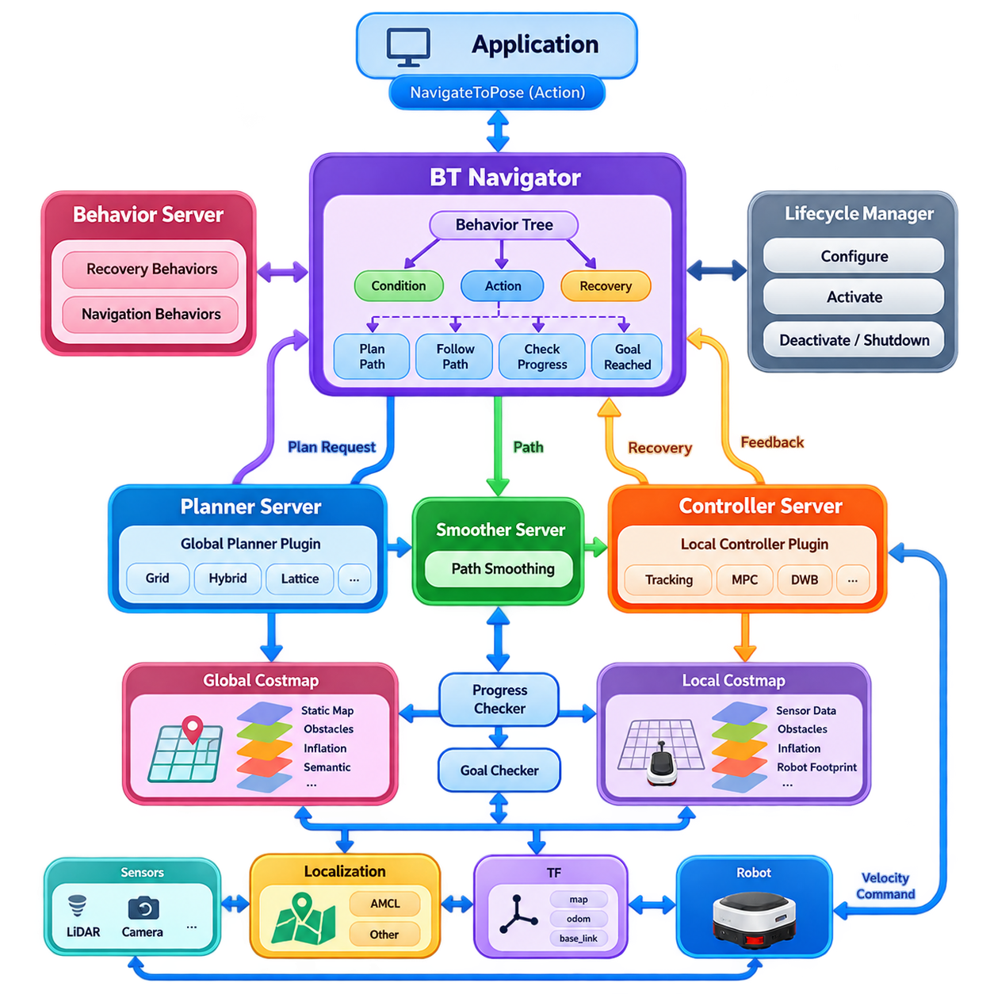
Navigation2, commonly called Nav2, is the ROS 2 navigation framework designed to provide autonomous mobile robots with modular capabilities for goal-directed movement. Rather than implementing navigation as a single monolithic algorithm, Nav2 organizes navigation into cooperating servers responsible for planning, control, recovery, mapping interfaces, and mission execution. This architecture allows individual algorithms to be replaced while preserving a consistent system-level workflow.
The Nav2 architecture follows a distributed server-based design built on ROS 2 communication mechanisms. Major functions execute as lifecycle-managed nodes and communicate through topics, services, and actions. Long-running navigation operations are primarily represented through ROS 2 actions because planning and motion may require continuous feedback, cancellation, or preemption. Lifecycle management provides deterministic configuration, activation, deactivation, and shutdown behavior for navigation components.
At the highest execution level, the BT Navigator coordinates navigation behavior through a Behavior Tree, or BT. Instead of embedding navigation logic in a fixed procedural sequence, the tree expresses navigation as hierarchical combinations of conditions, actions, fallbacks, retries, and recovery operations. This makes the navigation policy explicit and configurable, allowing complex mission behavior to be modified without redesigning the underlying planner or controller algorithms.
A typical navigation request begins when an application submits a target pose through an action interface such as NavigateToPose. The BT Navigator receives this objective and executes the configured Behavior Tree. Tree nodes may request a global path, initiate path following, evaluate progress, detect failures, clear costmaps, or trigger replanning. The Behavior Tree therefore acts as an orchestration layer connecting high-level navigation intent with specialized navigation servers.
The Planner Server is responsible for computing a feasible global path from the robot's current state toward the requested goal. It operates primarily with the global costmap and one or more planner plugins. Depending on the robot and environment, these plugins may implement grid search, hybrid-state search, lattice planning, or other planning methods. The server abstraction allows the planning algorithm to change without modifying the BT Navigator or downstream controller.
Global planning depends strongly on the representation maintained by the global costmap. Static map information, sensed obstacles, inflation regions, semantic restrictions, and other navigation constraints can be represented through configurable costmap layers. The planner searches this representation while respecting occupied or high-cost regions. Consequently, navigation performance depends not only on the search algorithm but also on map quality, robot footprint configuration, and costmap parameters.
The Controller Server converts a planned path into commands that can be executed by the mobile base. While the Planner Server addresses relatively long-range route generation, the controller repeatedly evaluates local robot state, nearby obstacles, kinematic constraints, and path geometry at a much higher frequency. Its output is typically a velocity command or equivalent motion reference transmitted toward the robot's lower-level drive control system.
Controller functionality is implemented through plugins, allowing different local motion strategies to operate within the same Nav2 framework. Depending on the platform, a controller may emphasize path tracking, predictive optimization, trajectory sampling, curvature regulation, or dynamic obstacle response. This separation is especially important because differential-drive, omnidirectional, Ackermann-steered, and other mobile platforms exhibit substantially different feasible motion characteristics.
The Planner Server and Controller Server therefore operate at complementary spatial and temporal scales. The planner determines where the robot should travel through the broader environment, while the controller determines how the robot should move during the immediate execution interval. Nav2 can periodically regenerate the global path while the controller continues tracking updated references, enabling the system to adapt when obstacles, localization estimates, or environmental conditions change.
Between planning and control, Nav2 may employ path-processing components such as the Smoother Server. A path that is geometrically feasible can still contain abrupt heading changes, unnecessary curvature, or discrete artifacts introduced by grid-based planning. Smoothing can improve the path before execution while preserving collision constraints. This reduces the burden placed on the controller and can improve motion quality, especially for robots with limited steering or acceleration capabilities.
Navigation requires continuous assessment of whether commanded motion is producing meaningful progress. Progress checking mechanisms determine whether the robot is advancing toward its objective, while goal checkers determine whether position and orientation tolerances have been satisfied. These mechanisms prevent the navigation system from indefinitely executing commands when the robot is blocked, oscillating, localized incorrectly, or physically unable to reach the requested pose.
Failures are handled through coordinated recovery and behavior mechanisms rather than through a single emergency routine. When planning or control repeatedly fails, the Behavior Tree can invoke behaviors such as waiting, rotating, backing up, or clearing selected costmap information before retrying navigation. The tree can distinguish local failures from broader navigation failures, enabling recovery to occur at an appropriate scope instead of immediately terminating every unsuccessful navigation attempt.
Nav2's Behavior Server provides reusable behaviors that can be invoked by Behavior Tree nodes. These behaviors complement planning and path following by supporting deliberate actions needed during difficult navigation situations. Because recovery logic is represented at the orchestration level, the system can combine algorithmic failure information with retry policies and operational context. This creates a more robust navigation workflow than simply restarting failed nodes.
Costmaps form a shared environmental abstraction connecting perception, planning, and control. Nav2 commonly maintains separate global and local costmaps because the two navigation scales have different requirements. The global costmap supports route planning across a larger region, whereas the local costmap emphasizes recent obstacle observations around the robot. Sensor observations from LiDAR, depth cameras, or other perception systems can continuously modify these representations.
Localization supplies the transform relationship required to connect the robot, map, odometry, and sensor coordinate frames. Nav2 itself can operate with localization systems such as AMCL or with other pose-estimation pipelines that provide the required ROS 2 transforms and pose information. Accurate and temporally consistent transforms are essential because planners, controllers, costmaps, and sensors must interpret geometry within compatible reference frames during continuous robot motion.
The transform hierarchy commonly connects a global map frame to an odometry frame and then to the robot base frame. The odometry layer provides locally smooth motion estimates, while the global localization layer corrects accumulated drift relative to the environment. Nav2 consumes these relationships rather than requiring a particular localization algorithm. This interface-based design allows visual, LiDAR, GNSS-assisted, or multi-sensor localization systems to support the same navigation stack.
Nav2 makes extensive use of plugin interfaces to separate architectural roles from algorithm implementations. Global planners, controllers, goal checkers, progress checkers, costmap layers, behaviors, smoothers, and Behavior Tree nodes can be selected or extended independently. This modularity is important for robotics development because the navigation architecture can remain stable while individual algorithms evolve according to platform capabilities and operational requirements.
ROS 2 lifecycle management adds another architectural layer to this modular structure. Navigation nodes can transition through defined states such as unconfigured, inactive, and active. A lifecycle manager coordinates these transitions so that dependent components become operational in a controlled order. This is particularly valuable in deployed robots where sensors, localization, maps, and navigation services must reach valid states before autonomous movement is permitted.
The Behavior Tree also provides a natural mechanism for continuous replanning. A navigation tree can periodically request a new global path while the controller follows the current path, allowing newly detected obstacles or updated localization information to influence future motion. Replanning frequency must nevertheless be selected carefully because excessive replanning consumes computation and may create unstable route changes, while insufficient replanning can reduce responsiveness.
Navigation actions can also be preempted when a new objective arrives. Instead of treating every goal as an isolated command that must run to completion, the architecture can cancel or replace active navigation operations. This property is important for fleet management, human interaction, patrol robots, and mission-level orchestration, where destinations may change according to task priorities, environmental events, or supervisory commands.
From a systems perspective, the BT Navigator, Planner Server, and Controller Server should not be viewed as three independent algorithms. They form three architectural layers of decision making. The BT Navigator determines what navigation operation should occur next, the Planner Server determines a feasible route through the environment, and the Controller Server determines executable short-horizon motion commands. Feedback continuously connects these layers during navigation.
This separation also creates clear integration boundaries for advanced autonomy. Learning-based planners can replace conventional planning plugins, predictive controllers can replace classical tracking methods, and semantic or AI-generated information can enter through maps, costs, or Behavior Tree conditions. Higher-level task planners can issue Nav2 goals without directly controlling wheel motion, preserving a useful boundary between mission reasoning and real-time navigation execution.
For industrial robots, architecture alone does not guarantee reliable navigation. Planner frequency, controller frequency, costmap resolution, sensor update rates, transform tolerances, footprint geometry, acceleration limits, and recovery policies must be configured as a coherent system. A controller operating faster than usable perception updates, for example, does not necessarily improve safety. Timing relationships across perception, localization, planning, and actuation must therefore be engineered together.
Safety-critical motion should additionally remain separated from ordinary navigation decision making. Nav2 may generate paths and velocity commands, but hardware-level emergency stopping, safety-rated obstacle detection, drive limits, watchdogs, and independent protective mechanisms should constrain the final executable motion. This layered arrangement prevents a navigation software failure from becoming the sole determinant of whether physical motion is allowed.
The resulting architecture can be understood as a closed navigation loop rather than a linear planning pipeline. A goal enters the BT Navigator, planning produces a global route, control generates executable motion, sensors update costmaps, localization updates robot state, and execution feedback returns to the Behavior Tree. Failures trigger recovery or replanning, while successful goal checking terminates the navigation action and reports completion to the requesting system.
Nav2 therefore provides more than a collection of path-planning algorithms. Its principal value is an extensible ROS 2 architecture that separates mission-level navigation logic, global planning, local control, environmental representation, recovery behavior, and execution management while defining standardized interfaces between them. This structure enables the same navigation framework to scale from research robots to configurable industrial AMRs and more advanced autonomous mobile platforms.

10.02. Nav2 Behavior Tree Design Custom BT Nodes [w/Code]
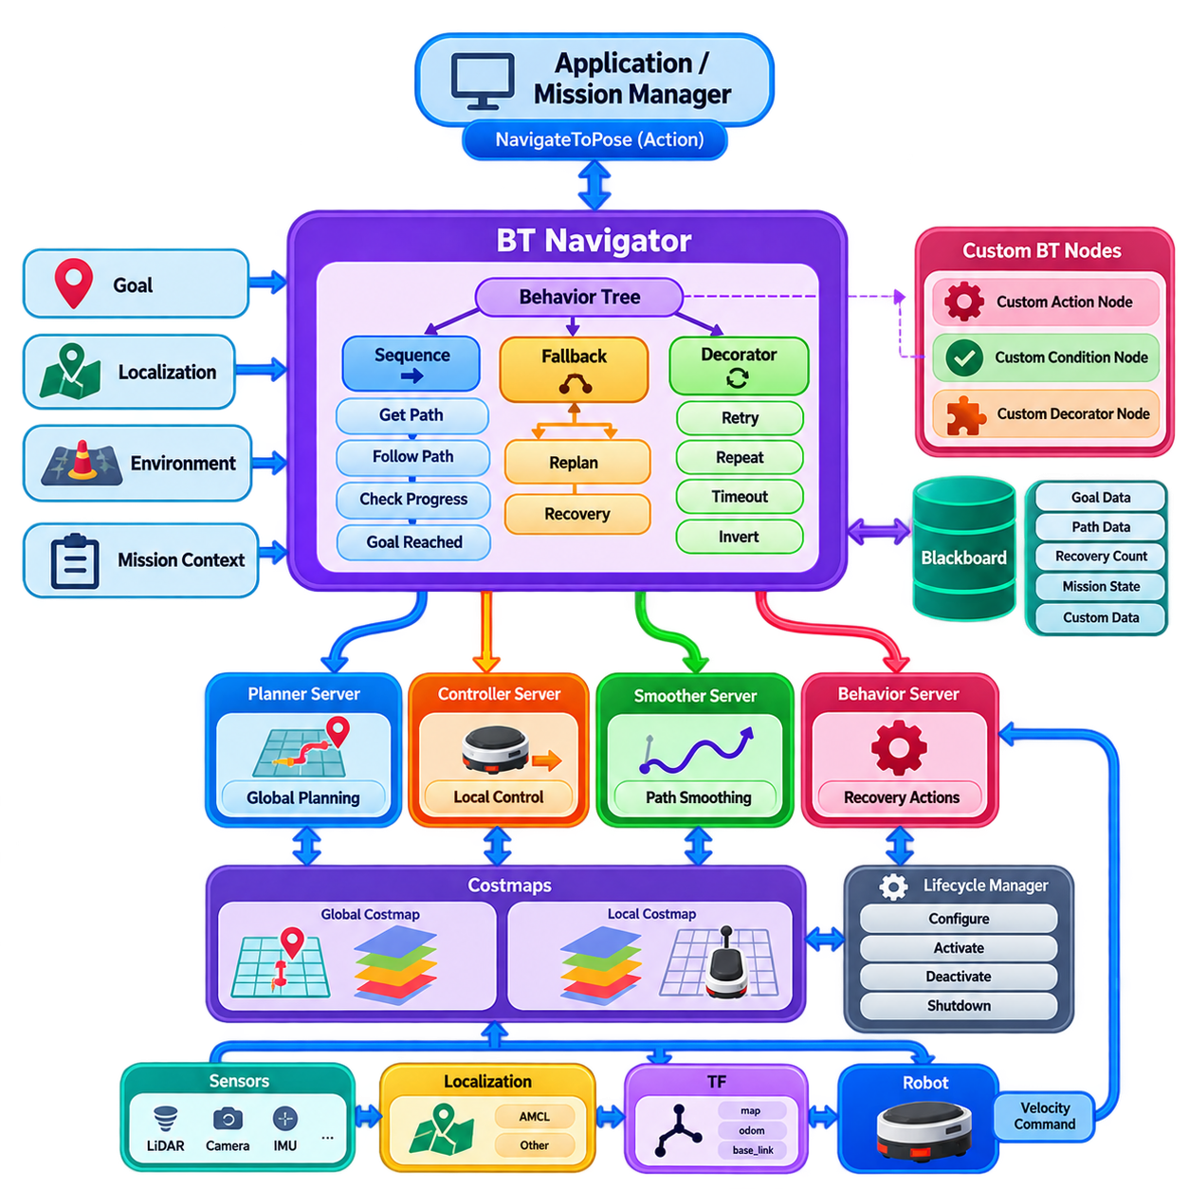
A Behavior Tree (BT) in Nav2 provides a structured execution model for autonomous navigation. Instead of hard-coding navigation behavior into one procedural program, the tree represents navigation as a hierarchy of conditions, actions, sequences, selectors, decorators, and recovery branches. The BT Navigator executes this structure while interacting with Nav2 servers such as the Planner Server, Controller Server, Smoother Server, and Behavior Server. This separation makes navigation behavior explicit, inspectable, replaceable, and extensible.
A typical Nav2 navigation tree begins with a high-level sequence that receives a goal, obtains or updates the required path, follows that path, evaluates progress, and verifies goal completion. The tree can contain fallback branches that attempt alternative behaviors when a primary operation fails. For example, if path following becomes unsuccessful, the tree may first request replanning and then execute a recovery behavior if repeated replanning cannot produce progress. The resulting structure represents navigation as a controlled decision process rather than a simple linear pipeline.
The Sequence and Fallback control nodes are fundamental to BT design. A Sequence succeeds only when its required child operations succeed, making it suitable for ordered operations such as computing a path followed by executing it. A Fallback attempts alternatives until one succeeds, making it useful for recovery strategies or optional behaviors. These control nodes allow complex navigation policies to be constructed from relatively small reusable components, while the execution semantics remain understandable to engineers responsible for system integration.
Decorator nodes modify how their child nodes are executed without changing the child's internal implementation. Common concepts include retrying an operation, repeating an operation while a condition remains valid, introducing timing constraints, or inverting a condition. In Nav2, decorators are particularly useful for implementing controlled replanning, retry limits, periodic checks, and conditional execution. Careful use of decorators is important because an incorrectly designed retry or repetition structure can create excessive computation, oscillatory behavior, or an apparently successful tree that never reaches its terminal state.
Custom BT nodes allow a Nav2 application to introduce domain-specific behavior that is not available in the standard navigation tree. A custom node can represent an operation such as checking docking readiness, validating a semantic destination, requesting an external perception result, verifying a payload state, or communicating with a mission-management system. The node should normally expose a clear interface and limited responsibility so that higher-level mission logic does not become unnecessarily embedded inside navigation-specific implementation code.
A custom action node is appropriate when an operation requires time to complete and may produce intermediate states. The node can initiate an asynchronous operation, remain in a running state while the operation progresses, and eventually return success or failure. Cancellation must also be considered because the Behavior Tree may be interrupted by a new goal, a safety event, or a higher-priority mission. A well-designed asynchronous node therefore manages initialization, execution, completion, failure, and cancellation as distinct operational states.
Condition nodes provide information to the tree without directly performing long-running actions. They can evaluate whether a goal is valid, whether localization quality is sufficient, whether an obstacle is blocking the planned route, whether the robot is docked, or whether a mission-level permission has been granted. Conditions should preferably be fast, deterministic, and side-effect free. Keeping them lightweight prevents the Behavior Tree from becoming coupled to slow external operations and makes the resulting navigation policy easier to analyze.
Custom nodes communicate through the Behavior Tree blackboard, ROS 2 interfaces, or dedicated application interfaces. The blackboard provides a convenient mechanism for sharing execution data between nodes, such as the current goal, selected path, recovery count, or contextual parameters. However, the blackboard should not become an uncontrolled global data store. Data ownership, naming conventions, lifecycle, and update responsibility should be clearly defined so that custom nodes remain understandable as the navigation system grows.
Nav2 custom BT nodes are commonly implemented using the BehaviorTree.CPP framework and integrated with Nav2 through its plugin mechanisms. The implementation must provide the appropriate node registration and port definitions so that the Behavior Tree XML can instantiate the node. Input and output ports establish the data contract between the XML tree and the C++ implementation. This separation allows system behavior to be modified at the configuration level while preserving reusable software components.
The XML representation of the Behavior Tree is an important engineering artifact because it expresses the navigation policy in a form that can be inspected independently from the node implementation. A well-structured tree should use meaningful subtree boundaries and descriptive node names. Repeated navigation patterns should be encapsulated into reusable subtrees rather than copied throughout the entire XML. This improves maintainability and makes differences between nominal navigation, replanning, and recovery behavior easier to understand.
Custom BT design becomes particularly valuable when Nav2 is integrated into industrial or mission-oriented robotic systems. A warehouse AMR may require conditions related to traffic zones, charging stations, elevator interfaces, or task reservations. An inspection robot may need to verify scan-ready conditions, payload status, target visibility, or inspection completion before continuing. These operations should be represented as explicit behavioral decisions rather than hidden inside a conventional local planner, because they concern mission execution and operational state rather than pure geometric motion.
A useful architecture separates navigation behavior from mission orchestration. The Behavior Tree should determine how a navigation objective is executed, while a higher-level mission manager can determine why the robot is navigating and what should happen after navigation completes. For example, a mission system may request movement to an inspection station, while the Nav2 tree handles path planning, obstacle avoidance, recovery, and goal verification. Once the robot arrives, control can return to the mission layer for scan execution or subsequent task selection.
Behavior Trees also provide a practical mechanism for integrating semantic navigation. A destination can be represented not only as a geometric pose but also as an operational target such as a loading station, inspection cell, charging area, or restricted zone. A custom condition can verify semantic validity before movement begins, while custom actions can request additional information when the robot reaches a designated area. This enables Nav2 to participate in a broader semantic navigation architecture without forcing the underlying planner to understand every application-level concept.
Recovery design should be treated as part of the primary behavior architecture rather than as an afterthought. A recovery branch can distinguish temporary blockage from persistent planning failure and can apply progressively stronger responses. For example, the tree may first wait for a transient obstacle to disappear, then clear selected local costmap information, request replanning, and finally perform a controlled backup or rotation. Recovery actions should have bounded retries and explicit termination conditions so that the robot cannot remain indefinitely trapped in a recovery loop.
Replanning logic should also be designed around meaningful triggers rather than maximum possible frequency. A tree may replan when the current path becomes invalid, when progress falls below an expected threshold, when significant environmental changes are detected, or after a recovery action. This event-oriented approach can reduce unnecessary planner execution while preserving responsiveness. In larger fleets, it also helps control computational load because navigation behavior becomes related to actual environmental and operational changes rather than indiscriminate periodic processing.
Custom BT nodes should respect the real-time characteristics of the navigation system. Heavy computation, blocking I/O, long service calls, or external AI inference should not unnecessarily block the BT execution loop. If an operation requires significant processing time, it should normally be implemented asynchronously or delegated to an appropriate ROS 2 component. This is especially important when Nav2 is integrated with perception, semantic reasoning, world models, or cloud-connected services whose response times may be less deterministic than local navigation operations.
Testing a custom Behavior Tree requires more than verifying that the robot eventually reaches a goal. Individual nodes should be tested for success, failure, running, cancellation, timeout, invalid input, and repeated execution. The complete tree should then be tested under representative environmental conditions such as temporary obstacles, blocked corridors, localization disturbances, planner failure, controller failure, and communication loss. Logging and introspection are valuable because they reveal which branch was executed and why the tree transitioned between behaviors.
A mature Nav2 Behavior Tree should therefore be regarded as a policy layer between navigation services and mission-level autonomy. Standard nodes provide proven navigation capabilities, while custom nodes encode application-specific knowledge and operational rules. Planner and controller algorithms remain responsible for geometric and dynamic motion decisions, whereas the Behavior Tree determines when those capabilities should be invoked, repeated, interrupted, or replaced by recovery behavior. This division keeps the architecture modular while allowing substantial customization.
For an advanced Physical AI navigation architecture, the Behavior Tree can serve as a deterministic execution boundary around more adaptive AI components. Learning-based perception, semantic reasoning, world-model inference, or AI-based planning can provide information or candidate decisions, while the BT maintains explicit execution conditions, fallback paths, recovery policies, and safety-related gates. In this arrangement, AI contributes adaptive intelligence without eliminating the structured control logic required for predictable robotic operation.
The key principle of custom BT design is therefore controlled extensibility. A custom node should be introduced when a meaningful application behavior cannot be expressed cleanly using existing Nav2 capabilities, and its interface should remain narrow enough to preserve architectural clarity. The Behavior Tree should make operational decisions visible, bounded, testable, and recoverable. When these principles are followed, Nav2 can evolve from a conventional navigation stack into a flexible execution framework that connects motion planning and control with semantic navigation, mission orchestration, and higher-level Physical AI systems.

10.03. Nav2 Costmap 2D Plugin Development [w/Code]
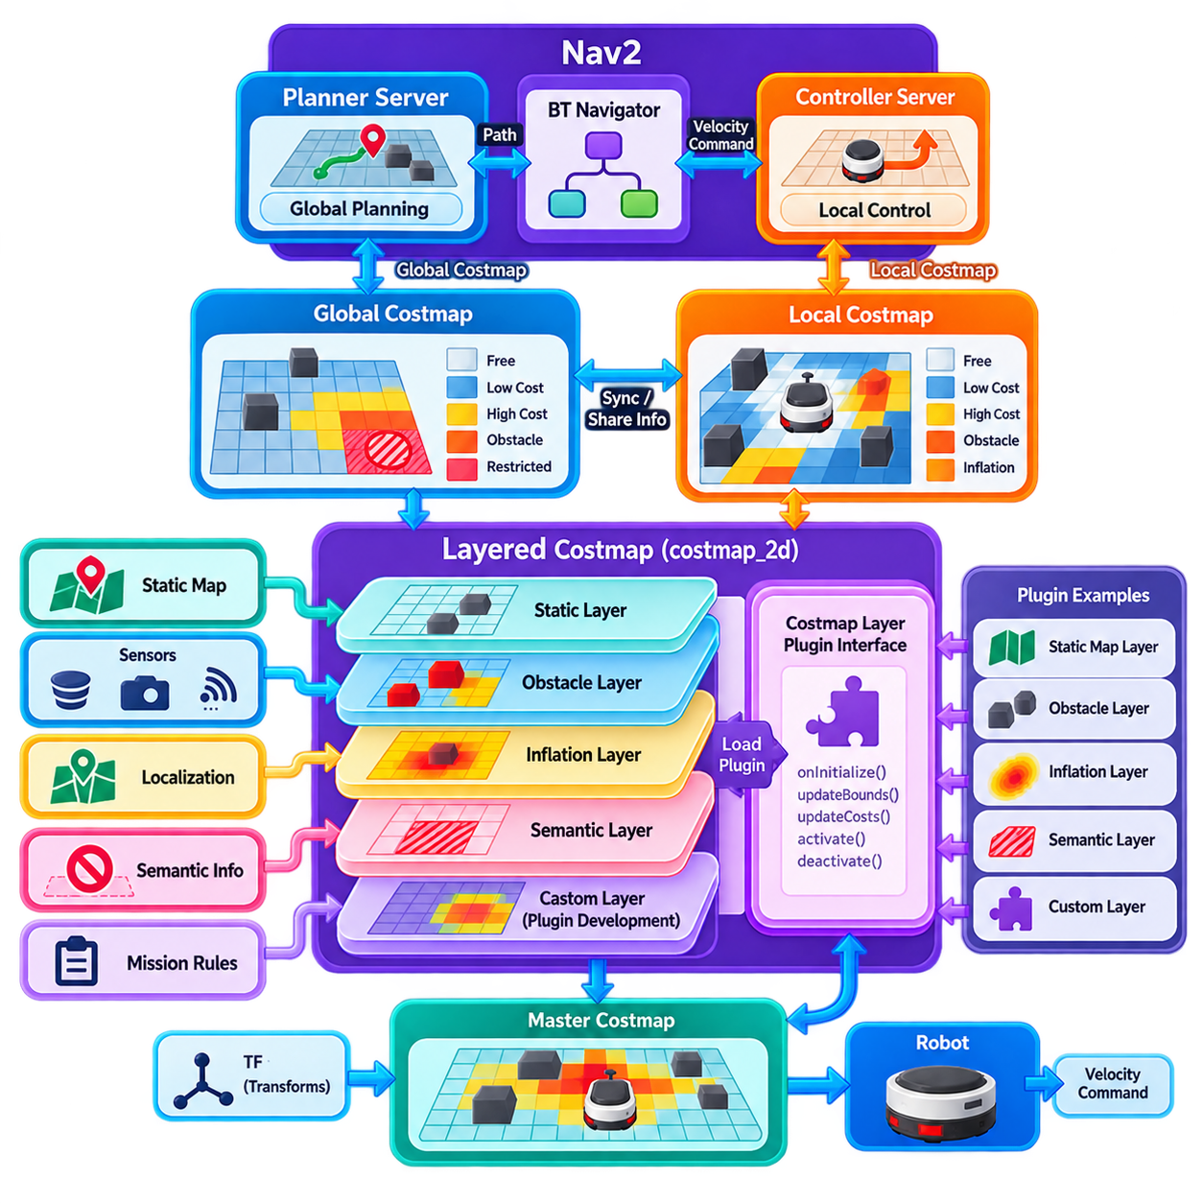
A Nav2 costmap is a central environmental representation used to support collision-aware planning and control for mobile robots. It converts information about free space, obstacles, and navigation constraints into a two-dimensional grid in which each cell contains a cost value. The Planner Server primarily uses the global costmap for long-range route generation, while the Controller Server uses the local costmap for short-horizon motion decisions. This separation allows navigation to combine broad environmental knowledge with rapidly changing local observations.
The Nav2 costmap architecture is designed around a layered plugin model. Instead of implementing every environmental rule inside one large costmap component, individual layers contribute different types of information to the resulting grid. Typical layers include static map information, obstacle observations, inflation around obstacles, and application-specific constraints. The layered architecture allows developers to add, remove, or replace environmental representations without modifying the core costmap implementation, making it suitable for both research and industrial navigation systems.
A costmap plugin normally inherits from the appropriate Nav2 costmap layer interface and implements the lifecycle and update behavior required by the framework. The plugin is responsible for determining which region of the master costmap it needs to modify and then writing its calculated values into that region. This design separates the calculation of a particular environmental effect from the management of the complete costmap. A custom layer can therefore focus on one well-defined responsibility while the costmap framework handles composition with other layers.
The update cycle is one of the most important concepts in costmap plugin development. During navigation, the costmap repeatedly receives sensor information, updates relevant layers, and combines their results into the master grid. A plugin should efficiently identify the region affected by new information rather than recomputing the entire map whenever possible. The update bounds and update costs operations provide a mechanism for limiting computation to changed areas. This becomes increasingly important as map resolution and operating area increase.
A custom obstacle layer can convert external perception results into navigation costs. For example, a perception system may detect objects using LiDAR, cameras, radar, or an AI-based detector and provide their positions in a robot or world coordinate frame. The plugin can transform these observations into the costmap coordinate system and mark corresponding cells as occupied or high cost. The quality of this transformation is critical because errors in coordinate alignment can produce incorrect obstacle locations and consequently unsafe or unnecessarily restrictive navigation behavior.
Costmap values should be interpreted as navigation costs rather than simply binary occupancy states. A cell can represent free space, an obstacle, an inflated obstacle region, or another intermediate navigation condition. This enables planners and controllers to prefer safer routes rather than merely searching for geometrically collision-free paths. A custom plugin should therefore define its cost semantics carefully and ensure that its values are compatible with the assumptions made by downstream planners and controllers.
Inflation provides an important connection between environmental representation and robot geometry. A physical robot has a nonzero footprint, and navigating directly beside an obstacle may be technically collision-free according to a point representation while remaining unsafe for the actual platform. Inflation assigns increasing costs around obstacle boundaries so that planning and control naturally prefer greater clearance. For specialized robots, the standard inflation model may need to be complemented by a custom layer representing platform-specific clearance, payload dimensions, or operational safety margins.
Semantic costmap plugins extend this concept beyond physical obstacles. A semantic layer can represent restricted zones, preferred lanes, charging areas, inspection regions, pedestrian spaces, loading stations, or other operational information. Instead of treating every traversable region as equivalent, the costmap can encode preferences and constraints that influence route selection. This approach allows semantic information from a higher-level world model or facility-management system to participate in conventional Nav2 planning without requiring the planner itself to understand every semantic concept.
A dynamic costmap plugin must also manage information persistence and expiration. Sensor observations may disappear because an object moves away, a sensor loses visibility, or an observation becomes too old to remain reliable. If the plugin permanently marks every historical observation, the costmap can gradually become filled with obsolete obstacles. Developers therefore need explicit policies for observation lifetime, clearing, temporal decay, and invalidation. These policies should reflect the sensing characteristics and operational speed of the robot rather than relying on arbitrary timeout values.
Coordinate frames and transform timing are fundamental to reliable plugin operation. Sensor observations may arrive in frames such as a LiDAR frame, camera frame, or robot base frame, while the costmap may operate in a map or odometry frame. The plugin must obtain appropriate transforms and account for the timestamp associated with each observation. A spatially correct observation with an incorrect timestamp can still produce an incorrect obstacle position, particularly when the robot or obstacle is moving. Robust plugin development therefore requires explicit attention to transform availability and temporal consistency.
The plugin must also respect the distinction between global and local costmaps. A global layer may operate over a relatively large area and emphasize persistent environmental information, while a local layer generally operates over a smaller rolling window and emphasizes current sensor observations. A semantic restriction that applies to an entire facility may be appropriate for the global costmap, whereas a rapidly changing pedestrian or obstacle representation may be more appropriate for the local costmap. The same conceptual information may therefore require different implementations at different navigation scales.
Performance engineering is essential because costmap updates occur continuously while planning and control are also consuming computational resources. A plugin that performs expensive image processing, large-scale graph searches, or neural-network inference inside the costmap update loop can introduce latency into the navigation pipeline. Computationally intensive AI processing should normally be performed by a separate perception or inference component, with the costmap plugin consuming a compact representation of the resulting information. This keeps the costmap focused on spatial representation and reduces coupling with high-cost computation.
Thread safety and data ownership should be considered when a plugin receives information from external ROS 2 topics or other asynchronous components. Sensor callbacks may update internal data while the costmap update cycle is simultaneously reading that information. Appropriate synchronization or carefully designed lock-free data exchange may therefore be required. The goal is to avoid race conditions without introducing long blocking sections into the navigation update loop. In high-rate systems, stale but internally consistent information can sometimes be preferable to blocking the navigation thread.
A well-designed custom costmap plugin should expose configuration parameters rather than hard-coding operational assumptions. Parameters can define topics, thresholds, update rates, observation ranges, decay times, cost values, semantic classes, or spatial boundaries. ROS 2 parameter mechanisms allow these values to be adjusted for different robots and environments without recompiling the plugin. Parameter validation is equally important because invalid values can produce pathological behavior such as excessive obstacle marking, unstable clearing, or computational overload.
Plugin lifecycle behavior should be aligned with Nav2 lifecycle management. The plugin should initialize resources during configuration, establish subscriptions and required interfaces at the appropriate stage, activate processing when navigation becomes operational, and release resources during deactivation or cleanup. This is particularly important for deployed robots because navigation may be restarted or reconfigured without restarting the entire robot software stack. A lifecycle-aware plugin makes the custom layer easier to integrate into the operational state machine of the complete navigation system.
Testing a custom costmap layer should begin with isolated functional tests before integrating it with the complete Nav2 stack. Developers should verify coordinate transformation, cell marking, clearing behavior, cost assignment, update bounds, parameter handling, and observation expiration independently. Integration tests should then evaluate the plugin together with the Planner Server and Controller Server. Representative scenarios should include static obstacles, moving obstacles, sensor dropouts, localization changes, narrow passages, map boundaries, and rapidly changing environmental conditions.
Visualization and introspection are especially valuable during development. The generated costmap should be inspected together with the underlying sensor observations and robot footprint so that discrepancies between perception and navigation representation can be identified. Developers should examine whether obstacles appear at the expected positions, whether clearing occurs correctly, and whether semantic costs produce the intended route preferences. Monitoring update frequency and processing latency can also reveal performance problems that may not be visible when the robot is operating in a simple environment.
A custom costmap layer should not become a substitute for safety-rated obstacle detection or emergency stopping. Nav2 costmaps are navigation representations intended to support planning and control, whereas protective systems may require independent sensing, certified logic, or hardware-level intervention. A costmap plugin can provide conservative navigation behavior and useful environmental constraints, but the final authority over whether physical motion is permitted should remain within the appropriate safety architecture. This separation is particularly important for industrial AMRs operating near people and machinery.
For advanced Physical AI systems, the costmap can become an important interface between learned perception and deterministic navigation. AI models can identify objects, semantic regions, traffic patterns, or context-dependent hazards, while the custom costmap plugin converts these outputs into spatial costs that conventional Nav2 planners and controllers can consume. This creates a practical bridge between adaptive intelligence and structured navigation. The AI system does not necessarily need to replace the navigation stack; instead, it can enrich the environmental representation used by established planning and control components.
The resulting architecture can support progressively richer navigation representations while preserving the basic Nav2 execution model. A conventional static map can be augmented with sensor obstacles, inflation, semantic restrictions, dynamic-object information, and application-specific risk fields. Each layer can remain independently configurable and testable, while the master costmap provides a unified spatial representation to downstream navigation components. This layered design is particularly useful when the same robot must operate across warehouses, campuses, inspection facilities, and other environments with different operational rules.
The key principle in Nav2 costmap plugin development is to treat the costmap as a carefully defined contract between environmental information and motion decision making. A plugin should have a clear semantic purpose, well-defined coordinate and timing behavior, bounded computational complexity, explicit lifecycle management, and testable cost semantics. When these principles are followed, custom layers can extend Nav2 from basic obstacle avoidance toward semantic, dynamic, and risk-aware navigation while maintaining modularity, operational transparency, and compatibility with the broader ROS 2 navigation architecture.

10.04. Nav2 Custom Global Planner Plugin [w/Code]
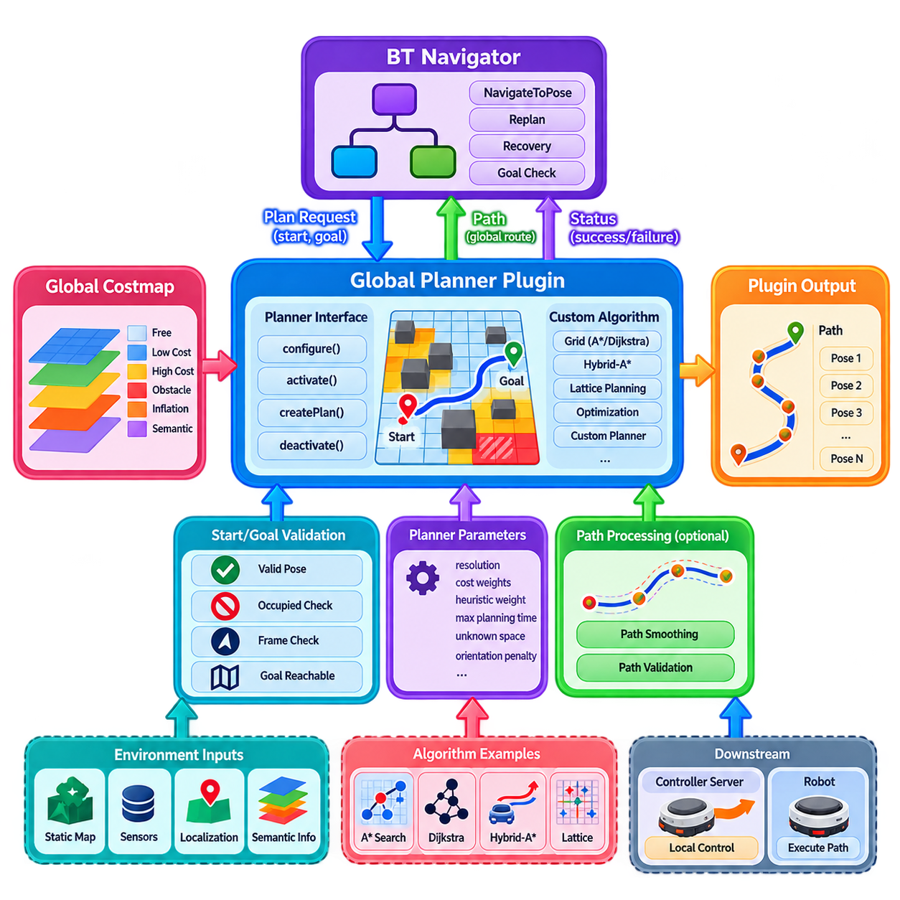
A Nav2 global planner plugin is responsible for generating a collision-aware route from a robot's current pose toward a navigation goal using the global costmap. It operates above the local controller and provides a path that represents the desired route through the environment. The plugin architecture separates the global planning algorithm from the rest of Nav2, allowing grid search, graph-based planning, Hybrid-A*, lattice planning, optimization-based methods, or application-specific planners to be integrated without changing the BT Navigator or Controller Server.
The global planner operates within a clearly defined interface between the navigation framework and the planning algorithm. The planner receives the current start pose, goal pose, and costmap representation, then produces a path expressed as a sequence of poses. The returned path must be consistent with the coordinate frame and geometry expected by downstream components. The planner should also correctly report whether planning succeeded, failed, or cannot currently produce a valid solution, because these states directly influence Behavior Tree execution and subsequent recovery or replanning behavior.
A custom planner is normally implemented as a plugin conforming to the Nav2 global planner interface. Its lifecycle includes initialization, configuration, activation, deactivation, and cleanup so that it can operate correctly within the managed Nav2 system. During configuration, the plugin obtains references to required resources such as the costmap and ROS 2 node interfaces and reads planner parameters. During active navigation, it executes planning requests and returns paths. Lifecycle separation allows the planner to be safely restarted or reconfigured without rebuilding the entire navigation system.
The core planning method should remain separated from ROS 2 communication and lifecycle management. The plugin interface should act as an adapter between Nav2 and the actual planning algorithm. This separation makes the algorithm easier to test independently and allows the same planning implementation to be evaluated with recorded maps, simulation environments, or different robot platforms. It also prevents application-specific communication logic from becoming embedded inside the mathematical or search-based portion of the planner.
A global planner typically receives a two-dimensional costmap containing free cells, obstacles, inflated regions, and potentially semantic or risk-related costs. The planner must interpret these values according to a clearly defined cost model. A binary interpretation may be sufficient for simple environments, but industrial robots often benefit from treating costs as a continuous measure of traversal preference. The planner can then prefer wider corridors, maintain greater obstacle clearance, or avoid operationally undesirable regions even when those regions remain physically traversable.
Grid-based planners provide a common starting point for custom global planner development. Algorithms such as Dijkstra or A* search nodes or cells in the costmap and evaluate alternative routes according to distance and traversal cost. A* can improve search efficiency by using a heuristic that estimates the remaining distance to the goal. The quality of the heuristic and the cost function strongly influence planner performance. A custom implementation should therefore distinguish geometric distance, obstacle cost, semantic cost, and any platform-specific penalties rather than combining them without a clear rationale.
For robots with nonholonomic or car-like motion constraints, a simple grid path may not adequately represent feasible motion. A Hybrid-A* planner can incorporate vehicle orientation into the search state and generate paths that better respect steering and curvature constraints. Lattice-based planners can similarly search among predefined motion primitives that represent feasible vehicle movements. Such approaches are particularly relevant for outdoor AMRs, autonomous vehicles, towing platforms, and other systems where the robot cannot arbitrarily change its heading while translating.
The planner should consider the robot footprint when evaluating collision conditions. Treating the robot as a single point can produce paths that pass through obstacles once the actual dimensions of the platform are considered. A collision-checking mechanism should evaluate the configured footprint or an appropriate geometric approximation against the costmap. For robots carrying variable payloads or operating with attachments, the effective footprint may change during operation, and the planner architecture should provide a controlled mechanism for representing these changes when required.
Path quality is not determined only by whether the route avoids obstacles. A path may be collision-free but contain excessive curvature, unnecessary oscillation, sharp heading changes, or poor clearance. Consequently, a custom planner may include path post-processing or connect to a dedicated smoother. Keeping smoothing conceptually separate from global search is often useful because it allows the planning algorithm to focus on finding a feasible route while another component improves geometric continuity. The resulting path should remain collision-safe after smoothing.
Planning performance is particularly important because global planning may be triggered repeatedly during navigation. A planner that performs a computationally expensive search over a large map can introduce unacceptable delays if replanning occurs frequently. Developers should therefore consider map resolution, search-space size, heuristic quality, memory consumption, and the expected replanning frequency together. Incremental planning, hierarchical planning, search reuse, or spatially restricted replanning may be appropriate for large environments where complete recomputation is unnecessary.
A global planner should also behave predictably when no solution exists. Failure may result from a completely blocked corridor, an unreachable goal, invalid start or goal poses, insufficient map information, or constraints that make the route infeasible. The plugin should distinguish these cases when practical and return an appropriate failure state. The Behavior Tree can then decide whether to retry, clear relevant information, request a different goal, execute a recovery behavior, or report failure to the mission layer.
Start and goal validation should occur before expensive planning whenever possible. The planner should verify that the poses are valid, lie within the usable planning region, and are not located in clearly occupied cells. Additional checks may be required for robot orientation, footprint collision, map availability, or semantic restrictions. Early validation reduces unnecessary computation and provides more meaningful failure information to the higher-level navigation system.
Coordinate-frame consistency is essential for global planning. The input poses and generated path must use the frame expected by Nav2, while the costmap itself must be interpreted using its associated transform information. Incorrect frame handling can produce a path that appears visually plausible but is physically displaced from the actual environment. Developers should therefore explicitly verify frame identifiers, transform availability, timestamp behavior, and numerical precision during both unit testing and integrated navigation testing.
A custom global planner can also incorporate semantic information without forcing the entire Nav2 architecture to become semantic. For example, a planner can assign additional costs to pedestrian areas, restricted zones, maintenance regions, or preferred transport corridors. This allows the planner to choose between multiple geometrically feasible routes according to operational priorities. Such semantic costs should be represented consistently in the costmap or planner input so that the resulting behavior remains explainable and configurable.
For advanced Physical AI systems, the global planner can become an interface between a world model and deterministic path execution. A higher-level reasoning system may identify a preferred corridor, destination context, temporary restriction, or mission-specific route preference. The planner can translate this information into search constraints or cost adjustments and then produce a conventional geometric path. This approach allows higher-level intelligence to influence route selection without requiring the final motion controller to directly interpret complex semantic reasoning.
Planner plugins should expose important parameters through ROS 2 configuration rather than embedding them directly in source code. Useful parameters may include search resolution, traversal weights, obstacle thresholds, heuristic weights, maximum planning time, unknown-space handling, orientation penalties, smoothing options, and semantic cost coefficients. Parameter validation should prevent values that could produce unstable or excessively expensive planning. Configuration files can then define platform-specific behavior while preserving the same planner implementation.
The planner must respect the computational and temporal requirements of the navigation stack. A global planner should not block critical ROS 2 execution for an uncontrolled period, particularly when planning requests can be cancelled or replaced. If planning can take significant time, the implementation should support appropriate cancellation and bounded execution behavior. This becomes increasingly important when AI-based planning, large graph searches, or world-model queries are incorporated into the global planning process.
Testing should evaluate both algorithmic correctness and Nav2 integration. Unit tests can verify path validity, collision checking, heuristic behavior, parameter handling, start and goal validation, and failure conditions. Integration tests should evaluate the planner with real costmaps, transforms, the BT Navigator, and the Controller Server. Representative environments should include open areas, narrow corridors, dead ends, disconnected regions, obstacle changes, unknown space, and goals located near environmental boundaries.
Visualization provides an effective way to validate planner behavior. Generated paths should be inspected against the global costmap, robot footprint, obstacle locations, and goal pose. Developers should examine not only whether the path reaches the goal but also why a particular route was selected. Excessive detours, insufficient clearance, repeated route changes, or unexpected preference for high-cost regions can reveal errors in cost interpretation or heuristic design. Recorded navigation data can further support repeatable evaluation across planner versions.
A custom global planner should not be treated as an isolated replacement for all navigation intelligence. The planner determines a route at the global scale, while local control remains responsible for executing that route under immediate environmental and dynamic constraints. The BT Navigator determines when planning should occur and how planning failures should be handled. Costmaps provide the environmental representation, while localization and transforms establish the spatial reference. Preserving these boundaries makes the complete navigation architecture easier to maintain and evolve.
Safety considerations must also remain explicit. A global planner can reject paths through known obstacles and incorporate conservative clearance costs, but it should not be considered the sole safety mechanism. Local obstacle avoidance, controller constraints, emergency stopping, safety-rated sensing, and hardware-level protective functions may operate independently. The planner should therefore produce paths that are suitable for safe execution while recognizing that final physical safety depends on multiple layers of the robot system.
The most useful custom global planners are those that provide a clear improvement for a specific platform or operating environment rather than simply replacing a standard planner with a more complicated algorithm. An outdoor AMR may require terrain-aware or curvature-constrained planning, while a warehouse robot may benefit more from semantic lane preferences and efficient large-scale graph search. The appropriate architecture should therefore be selected according to robot kinematics, environment scale, obstacle characteristics, mission requirements, and computational resources.
For a Physical AI navigation architecture, the global planner can ultimately serve as a controlled boundary between adaptive route reasoning and deterministic robot execution. World models, semantic perception, learned policies, or mission systems can influence planning constraints and route preferences, while the planner remains responsible for producing a spatially coherent and collision-aware path. When implemented with clear interfaces, bounded computation, explicit cost semantics, and robust lifecycle behavior, a custom Nav2 global planner becomes a modular foundation for scalable, semantic, and platform-aware autonomous navigation.

10.05. Nav2 Custom Controller Plugin [w/Code]
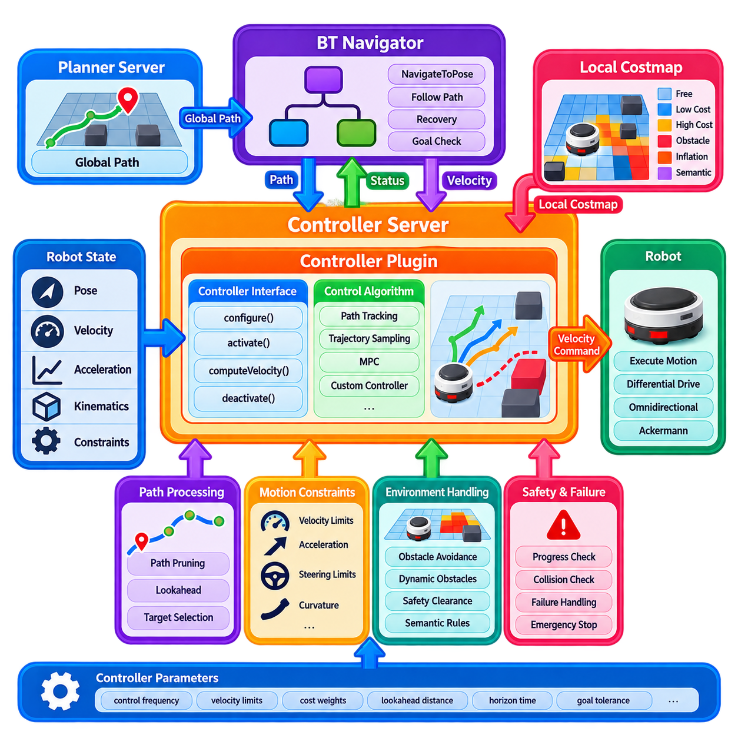
A Nav2 custom controller plugin is responsible for converting a planned global or local path into executable motion commands for a mobile robot. While the global planner determines where the robot should travel, the controller determines how the robot should move along that path while considering its current pose, velocity, acceleration limits, kinematics, and nearby obstacles. The plugin architecture allows different control strategies to be integrated into Nav2 without modifying the BT Navigator, Planner Server, or broader navigation framework.
The Controller Server provides the execution environment for controller plugins and manages the interface between Nav2 and the selected control algorithm. A custom controller receives the current robot state, local costmap information, and reference path, then calculates an appropriate velocity command. Depending on the robot platform, the command may contain linear and angular velocity for differential drive, multiple planar velocity components for omnidirectional robots, or steering and velocity commands for Ackermann-type platforms.
A custom controller normally implements the Nav2 controller interface and participates in the Nav2 lifecycle. During configuration, the plugin obtains required node interfaces, reads parameters, and prepares internal resources. During activation, it becomes available for motion execution, while deactivation and cleanup release operational resources. This lifecycle structure allows the controller to be managed consistently with other Nav2 components and makes it possible to restart or reconfigure navigation without rebuilding the complete robot software system.
The central controller operation evaluates the robot's current state against a reference path and generates a short-horizon motion command. Unlike global planning, which may reason about a large environment, local control operates continuously at a relatively high frequency. The controller repeatedly observes where the robot is, where the reference path lies, what obstacles are nearby, and what motion is dynamically feasible. It then produces a command that attempts to maintain path tracking while avoiding immediate collisions and respecting platform constraints.
Different robot kinematics require different controller strategies. A differential-drive AMR can directly control linear and angular velocity, while an omnidirectional platform can independently command lateral motion. An Ackermann-steered vehicle must consider steering angle, turning radius, wheelbase, and curvature constraints. A custom controller should therefore explicitly model the platform's feasible motion space instead of assuming that every robot can execute arbitrary planar velocity commands.
The local costmap provides an important environmental input to the controller. It represents nearby obstacles, inflated safety regions, dynamic observations, and potentially semantic or risk-related costs. A controller can use this information to reject unsafe trajectories, penalize low-clearance motion, or adapt its short-horizon command. However, the controller should not duplicate the entire perception pipeline. Its responsibility is generally to interpret the spatial representation provided by Nav2 and convert it into a motion decision that is consistent with the robot's current state.
A controller can use different mathematical approaches to generate motion commands. A simple tracking controller may calculate velocity errors relative to a target point or path segment. A trajectory-sampling method may generate multiple candidate trajectories and score them according to path tracking, obstacle clearance, velocity limits, and other criteria. Model Predictive Control, or MPC, can optimize a sequence of future commands using a model of robot dynamics and constraints. The appropriate method depends on platform dynamics, environment complexity, computational resources, and required motion quality.
Path tracking should consider both positional and orientation errors. A robot that reaches the correct position with an inappropriate heading may still be poorly aligned for docking, inspection, towing, or narrow-passage traversal. Conversely, aggressively minimizing orientation error at every point can produce unnecessary rotation or oscillation. A well-designed controller therefore balances lateral error, longitudinal progress, heading error, curvature, obstacle clearance, and terminal alignment according to the operational requirements of the platform.
Controller frequency and computational latency are critical because motion commands directly affect physical robot behavior. A controller that executes too slowly may react inadequately to changing obstacles or localization updates, while excessive computational complexity can introduce command latency and unstable response. The controller should therefore provide predictable execution time and avoid blocking operations. Heavy perception or AI inference should normally be performed outside the controller loop, with the controller consuming compact state or environmental representations.
A custom controller should explicitly enforce the robot's motion constraints. Maximum and minimum velocity, acceleration, deceleration, angular velocity, angular acceleration, steering limits, and other platform-specific constraints should be incorporated into command generation. These limits should not be treated merely as configuration values that are checked after the command has already been calculated. They should influence trajectory generation or optimization itself so that the resulting command is physically achievable and consistent with the robot's drive system.
Progress monitoring and failure handling are also part of effective controller integration. The controller may encounter situations in which the path is technically available but the robot cannot make meaningful progress because of an obstacle, localization error, actuator limitation, or unfavorable geometry. It should return appropriate status information so that the BT Navigator can initiate replanning or recovery. A controller should not continuously produce small commands that leave the robot oscillating or trapped without providing a meaningful failure signal.
A custom controller should also support path pruning and local reference selection. The complete global path may contain thousands of poses, but the controller usually needs only the portion relevant to the robot's current position and short-horizon future motion. Removing already traversed sections reduces computational cost and simplifies local trajectory generation. The controller can then identify a local target or reference segment according to lookahead distance, curvature, velocity, or environmental conditions.
Dynamic obstacles introduce an additional challenge because the path itself may remain geometrically valid while the immediate future trajectory becomes unsafe. A controller can respond by increasing obstacle penalties, reducing speed, selecting alternative local trajectories, or temporarily stopping. More advanced controllers may incorporate estimated obstacle velocity and predict future interactions. Nevertheless, the controller should maintain a clear distinction between immediate local avoidance and global route changes, allowing the Planner Server and Behavior Tree to handle broader navigation replanning when necessary.
For industrial AMRs, controller behavior should also account for operational constraints that are not purely geometric. Payload mass, towing conditions, floor friction, turning space, docking precision, human proximity, and equipment-specific limitations can affect the acceptable motion profile. A controller may therefore expose operational parameters that change velocity, acceleration, clearance, or terminal alignment requirements according to the current task. Such parameters should be explicit and configurable rather than hidden within controller-specific heuristics.
Custom controllers can incorporate semantic information when required. A warehouse robot may use lower speed limits in pedestrian zones, while an inspection robot may require precise alignment near an inspection station. A towing AMR may need special control behavior when reversing toward a coupling mechanism. These requirements can be represented through controller parameters, contextual state, or higher-level commands. The controller should interpret such information as explicit constraints or objectives rather than embedding broad mission logic into low-level motion control.
For advanced Physical AI systems, the controller can act as a deterministic execution layer between adaptive decision making and physical actuation. A world model or learning-based planner may provide a preferred path, target velocity, or contextual constraint, while the controller verifies whether the requested motion is feasible under current kinematic and environmental conditions. This creates a useful separation in which higher-level intelligence can influence motion without directly bypassing the real-time constraints required for stable and safe robot control.
Learning-based control can also be integrated carefully into a custom Nav2 controller. A learned policy may predict a velocity command, trajectory, or control correction from sensor and state information. However, the learned output should normally pass through explicit constraint and safety checks before reaching the robot base. Velocity limits, collision constraints, command validity, watchdog behavior, and emergency stopping should remain independent of the learned component. This architecture allows adaptive control while preserving deterministic boundaries around physical actuation.
Testing a custom controller requires evaluation of both tracking quality and failure behavior. Unit tests should examine command generation, kinematic constraints, parameter handling, target selection, path pruning, and invalid-state handling. Simulation and hardware tests should evaluate straight paths, curves, narrow corridors, obstacle encounters, sudden goal changes, localization disturbances, acceleration limits, and stopping behavior. Quantitative measurements such as cross-track error, heading error, command latency, stopping distance, clearance, oscillation frequency, and computational load provide useful evidence for controller tuning.
Visualization and recorded data are particularly valuable during controller development. Developers should compare the reference path, robot trajectory, local costmap, generated velocity commands, and actual motion over time. Unexpected oscillation can indicate excessive gains or conflicting objectives, while excessive path deviation may indicate inadequate lookahead or poor state estimation. Sudden velocity changes can reveal discontinuities in trajectory selection or constraint handling. Replaying recorded scenarios can make these problems easier to reproduce and diagnose.
A custom controller should remain distinct from hardware-level drive control. Nav2 determines an appropriate navigation command, while the robot's base controller converts that command into motor, steering, braking, or actuator-level behavior. This separation allows the navigation controller to remain portable across platforms while the lower-level system handles actuator feedback, motor control, drive synchronization, and hardware protection. The interface between these layers should have clearly defined units, limits, timing, and command validity rules.
Safety architecture must remain independent from ordinary navigation control. A custom controller can reduce speed near obstacles, reject unsafe trajectories, and stop when navigation conditions become invalid, but it should not be the only mechanism responsible for preventing physical harm. Safety-rated sensing, emergency stop systems, protective fields, hardware interlocks, and independent drive supervision may provide additional layers. The controller should therefore operate conservatively within a broader safety architecture rather than being treated as a safety-certified component by default.
The most effective custom controller is not necessarily the most mathematically complex one. A simple and well-tuned controller may be appropriate for a stable indoor AMR operating on predictable floors, while an outdoor platform with high speed, significant payload, or nonholonomic constraints may require predictive or optimization-based control. Controller selection should therefore consider robot dynamics, operating speed, environment variability, path characteristics, compute resources, and required tracking precision rather than algorithmic sophistication alone.
For a Physical AI navigation architecture, the Nav2 custom controller can ultimately serve as the final software boundary between planned intelligence and physical motion. Global planning determines the desired route, the Behavior Tree determines execution policy, the local costmap provides immediate environmental constraints, and the controller transforms these inputs into feasible motion commands. When the controller is implemented with explicit kinematic constraints, bounded computation, robust failure handling, clear interfaces, and independent safety mechanisms, it becomes a modular foundation for reliable local autonomy across AMRs and other mobile robotic platforms.

10.06. Nav2 Recovery Behavior Plugin Design [w/Code]
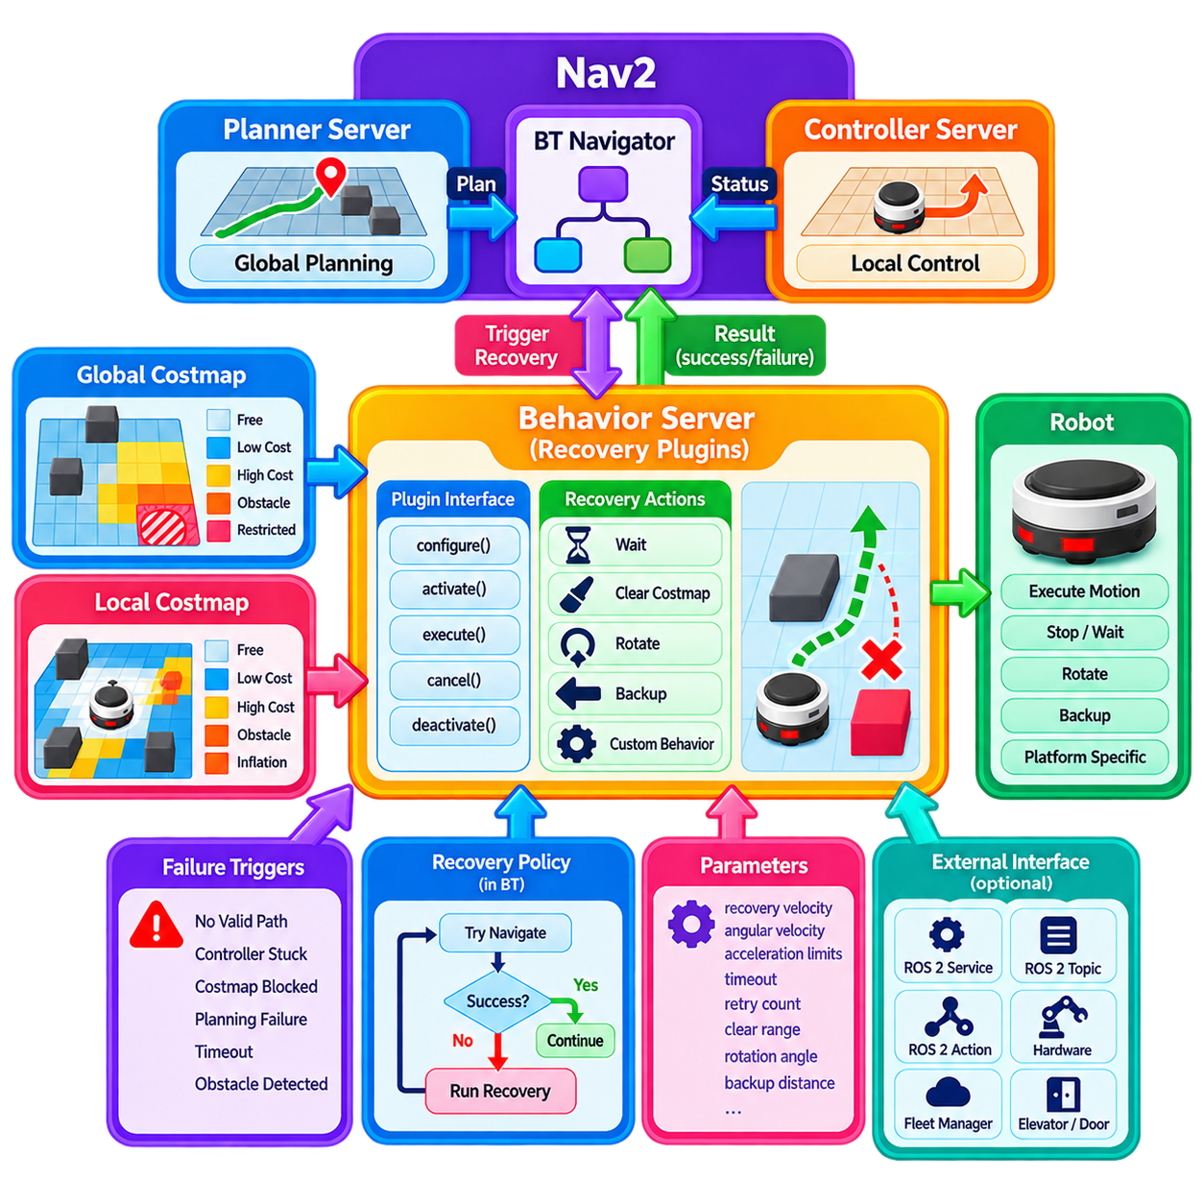
A Nav2 recovery behavior plugin provides a structured mechanism for responding to navigation failures or temporarily unfavorable operating conditions. Recovery behavior is not simply an emergency routine executed after navigation has failed; it is an intentional action that helps restore a state in which planning or control can continue. Typical recovery actions include waiting, clearing costmap information, rotating, backing up, or performing a platform-specific maneuver. The Behavior Tree determines when these behaviors should be invoked and how their results affect subsequent navigation.
Recovery behavior operates through the Nav2 Behavior Server and is normally implemented as a plugin. The plugin provides a defined interface through which the Behavior Tree can request execution and receive a result. This separation allows recovery logic to remain independent from the global planner and local controller. A planner can report that no route is currently available, while the recovery plugin determines how the robot should respond before another planning attempt is made. This creates a clear architectural boundary between failure detection and recovery execution.
A custom recovery plugin participates in the Nav2 lifecycle and should follow the same configuration, activation, deactivation, and cleanup principles used by other Nav2 components. During configuration, the plugin obtains required node interfaces, reads parameters, and prepares internal resources. During execution, it performs the recovery action while reporting its current state. When navigation is stopped or reconfigured, the plugin must terminate safely and release resources. Lifecycle compliance is particularly important when recovery behavior directly commands physical robot motion.
A recovery action should have clearly defined execution states rather than being implemented as an uncontrolled blocking function. The behavior normally begins with initialization, performs its primary operation while remaining in a running state, and eventually returns success or failure. Cancellation must also be supported because a new navigation goal, safety event, or higher-priority mission may interrupt the recovery operation. A well-designed plugin therefore treats execution, cancellation, timeout, and failure as explicit states with deterministic transitions.
Waiting is one of the simplest recovery behaviors but can be highly effective in dynamic environments. A temporary obstacle, pedestrian, forklift, or another robot may block the current route without requiring a new navigation strategy. A wait behavior allows the environment to change before more computationally expensive recovery actions are attempted. The waiting duration should be configurable, and the behavior should normally terminate when the timeout expires rather than remaining indefinitely in an uncertain state.
Costmap clearing is another common recovery behavior. Sensor artifacts, stale obstacle observations, or incorrect marking can occasionally prevent a valid path from being generated. A recovery plugin can request clearing of selected costmap regions or layers and then allow the planner to retry. However, clearing should not be treated as a universal solution. Removing legitimate obstacle information can make the navigation representation less conservative, so clearing policies should distinguish between stale information and persistent physical obstacles whenever possible.
Rotation and backup behaviors provide physical methods for escaping local navigation difficulties. A controlled rotation may improve sensor visibility, change the local costmap configuration, or allow the controller to find a feasible direction. A controlled backup can move the robot away from a tight obstacle configuration or recover from a poor local pose. These behaviors must account for the robot footprint, surrounding obstacles, velocity and acceleration limits, and the actual kinematic capabilities of the platform. Recovery motion should never assume that a simple command is automatically safe.
Recovery behavior can also be platform-specific. A warehouse AMR may need to release a traffic reservation before retrying navigation, while a towing robot may need to verify that its trailer or coupling mechanism remains correctly aligned. An inspection robot may need to reposition itself to regain sensor visibility, and a hospital robot may need to wait for an elevator or human traffic condition. Such behaviors should be implemented as explicit recovery plugins rather than hidden inside the controller, because they represent operational recovery decisions rather than ordinary path tracking.
A recovery plugin can interact with external ROS 2 services, topics, actions, or hardware interfaces when required, but these interactions should remain bounded and well defined. Long blocking service calls can prevent the Behavior Tree from responding to cancellation or other events. If an external operation requires significant time, the recovery plugin should preferably use asynchronous communication and maintain an explicit running state. Timeouts should be applied to external operations so that a communication failure does not cause the robot to remain indefinitely inside a recovery state.
Recovery behavior should be designed as part of a broader recovery policy rather than as an isolated action. The Behavior Tree can organize several recovery levels, beginning with low-risk actions and progressing toward stronger interventions. For example, the system may first wait for a transient obstacle, then clear stale local information, request replanning, perform a controlled backup, and finally report failure if the situation remains unresolved. The exact order depends on the robot and environment, but every recovery branch should have bounded retries and explicit termination conditions.
The distinction between navigation recovery and safety intervention is especially important. A recovery behavior may attempt to restore autonomous navigation, but it should never override an independent safety system. If a safety-rated sensor detects a person inside a protective field, the appropriate safety controller may stop the robot regardless of what the Behavior Tree is requesting. Once the safety condition is cleared, the navigation system may resume or perform recovery according to its state. This separation prevents recovery logic from becoming an unintended bypass around protective mechanisms.
Custom recovery behaviors should provide meaningful status information to the Behavior Tree. A behavior may return success when the robot has been repositioned successfully, failure when the recovery maneuver cannot be completed, or another appropriate state when execution is still in progress. These results allow the tree to select the next operation. A recovery plugin should avoid reporting success merely because a command was issued; success should represent achievement of the recovery objective, such as restoring a valid planning condition or reaching a defined recovery pose.
Parameters should be used to expose recovery behavior that may legitimately vary between platforms and environments. Useful parameters can include recovery velocity, angular velocity, acceleration limits, timeout, clearance threshold, retry count, search distance, or costmap clearing scope. Parameter validation is important because an unsafe recovery configuration can directly produce physical motion. Parameters should therefore be checked during configuration, and values that violate known platform limits should be rejected or constrained.
Testing recovery behavior requires more than confirming that the robot can execute the recovery motion in an empty environment. Developers should test recovery initiation, completion, cancellation, timeout, failure, repeated execution, sensor degradation, localization disturbances, and communication loss. Representative scenarios should include blocked corridors, temporary obstacles, stale costmap observations, narrow spaces, poor initial orientation, and situations in which recovery itself cannot safely be performed. Simulation provides a useful first stage, but physical testing is necessary because friction, actuator behavior, sensor occlusion, and mechanical constraints can affect recovery outcomes.
Logging and introspection are particularly valuable because recovery problems are often caused by interactions between several navigation components. Developers should be able to determine which recovery behavior was selected, why it was triggered, how long it executed, what result it returned, and what operation followed. Recording Behavior Tree transitions, costmap state, robot pose, velocity commands, and recovery status provides a useful basis for diagnosing repeated failures. This information can also support later optimization of recovery policies.
For advanced Physical AI systems, recovery behaviors can serve as a controlled interface between adaptive reasoning and deterministic physical actions. A higher-level world model may identify that a route is blocked by a temporary operational condition, while the Behavior Tree selects a recovery strategy and the recovery plugin executes a bounded physical maneuver. Similarly, semantic information can determine whether the robot should wait, reroute, return to a safe staging area, or request human assistance. The key is to keep the adaptive decision and physical execution clearly separated.
A recovery architecture can also support fleet-level coordination when local recovery alone is insufficient. An AMR that repeatedly encounters the same blocked corridor may need to release a reservation, request another route, notify a fleet manager, or temporarily move to a staging position. These operations can be exposed through custom recovery nodes while the underlying navigation stack remains unchanged. This makes recovery an extensible operational capability rather than a fixed collection of low-level escape maneuvers.
The most effective recovery plugin is therefore not necessarily the most sophisticated one. Its value comes from having a clearly defined purpose, predictable execution, appropriate safety constraints, bounded duration, meaningful status reporting, and clean integration with the Behavior Tree. Recovery actions should progressively restore navigation capability while avoiding unnecessary physical risk. When these principles are followed, Nav2 recovery behavior becomes a structured mechanism for maintaining autonomy under changing environmental conditions rather than merely a final response to navigation failure.
For a Physical AI navigation architecture, the recovery layer can ultimately form an important bridge between navigation autonomy, semantic reasoning, and operational resilience. The Planner Server provides route generation, the Controller Server provides local motion execution, the costmaps provide environmental constraints, and the Behavior Tree determines when recovery should occur. Custom recovery plugins then provide platform- and mission-specific actions within explicit boundaries. This architecture enables AMRs and other mobile robots to respond systematically to blockage, uncertainty, temporary failures, and operational disturbances while preserving modularity and independent safety control.

10.07. Nav2 Simple Commander Python API [w/Code]
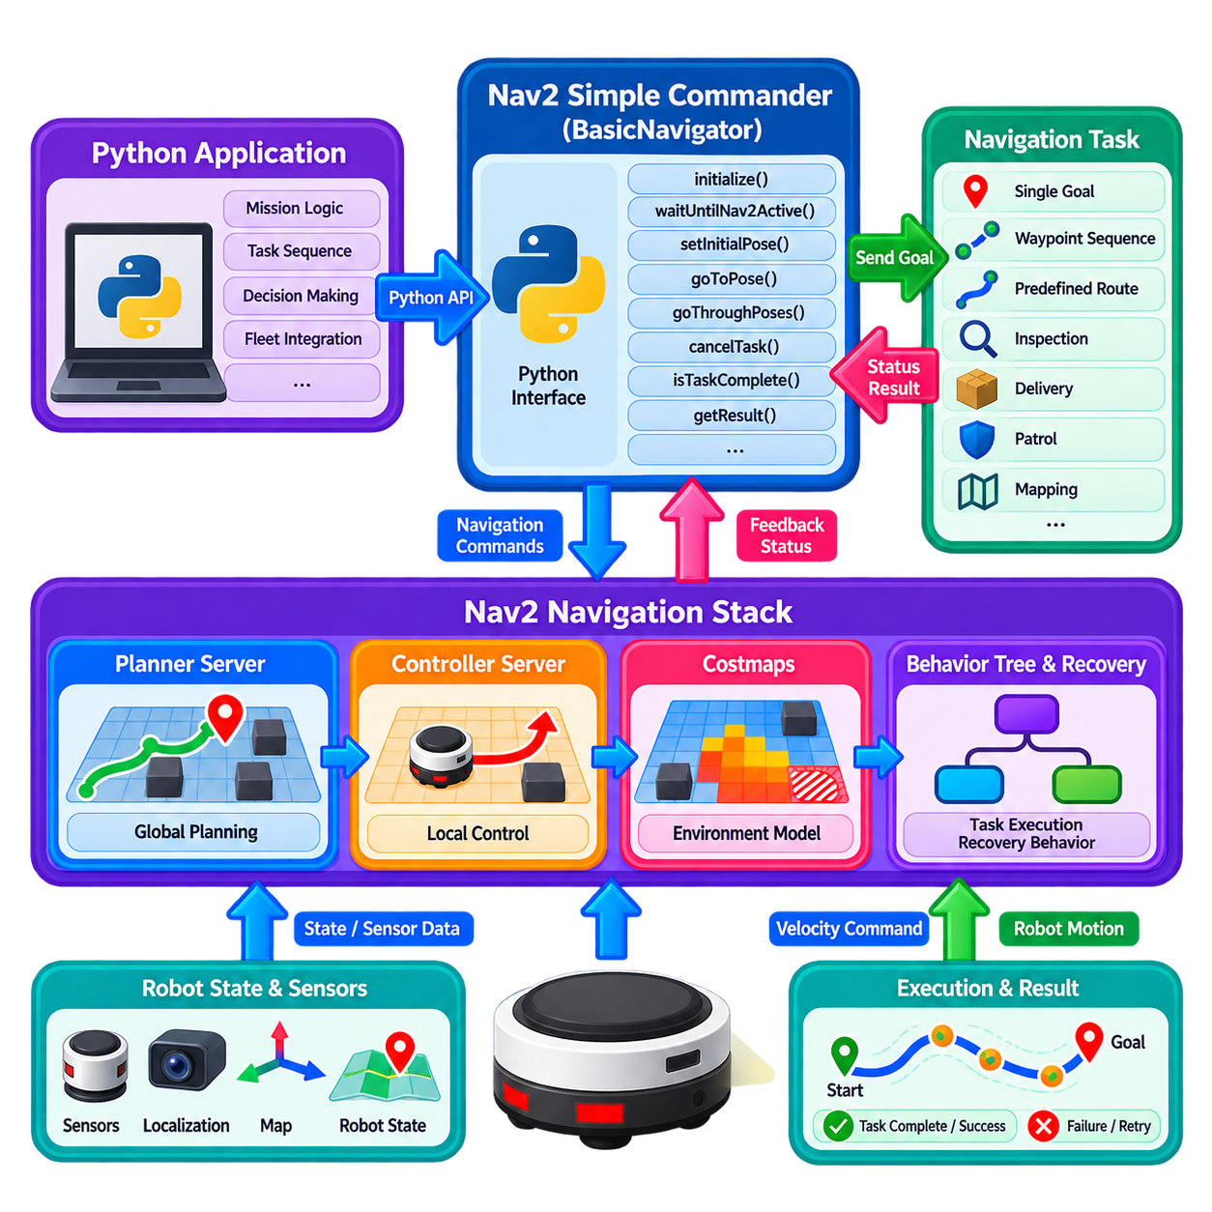
Nav2 Simple Commander provides a Python-based application interface for controlling a Nav2 navigation system without requiring application developers to directly manage the internal ROS 2 action, service, and lifecycle interfaces. It is particularly useful for mission-level applications in which a Python program needs to send navigation goals, monitor progress, control task execution, and coordinate navigation with other robot functions. The interface therefore provides a practical boundary between high-level mission logic and the underlying Nav2 navigation stack.
The central component is the `BasicNavigator` interface, which provides high-level methods for common navigation operations. An application can initialize the navigator, wait for Nav2 to become available, provide an initial pose, send a navigation goal, monitor task completion, and retrieve the final result. Instead of manually constructing ROS 2 action clients for every navigation operation, the application can use concise Python method calls. This makes Simple Commander especially suitable for prototyping, application development, testing, demonstrations, and mission orchestration.
Before navigation begins, the application should establish the required navigation state. The initial robot pose normally needs to be provided when localization requires an explicit starting estimate. The application can configure the initial pose in the appropriate map coordinate frame and then allow the localization system and Nav2 to establish a consistent navigation state. The navigator can also wait for Nav2 activation before issuing commands. This startup sequence prevents higher-level Python logic from assuming that planners, controllers, costmaps, and localization are already ready when they are not.
A typical navigation application follows an asynchronous task pattern. A Python program requests navigation to a pose or a sequence of poses, while Nav2 continues executing the underlying planning and control processes. The application periodically checks whether the task is complete rather than blocking indefinitely on a single function call. This allows the Python layer to perform additional monitoring, update mission state, respond to external events, or make decisions while navigation is progressing. The separation is useful for applications that require continuous mission-level supervision.
Simple Commander supports several navigation patterns beyond a single point-to-point goal. A mission may send a robot through multiple waypoints, navigate through a predefined route, or combine navigation with other operations. Waypoint-oriented execution is useful for inspection, delivery, patrol, mapping, and facility operations. The Python application can therefore represent a mission as a sequence of navigation objectives while Nav2 remains responsible for the detailed path planning, local control, obstacle handling, and recovery behavior required to reach each objective.
The interface also supports monitoring of navigation progress and task results. A mission application can determine whether a navigation operation is still running, has completed successfully, or has failed. This information should be interpreted at the mission level rather than simply displayed as a user interface status. For example, successful arrival at a waypoint may trigger inspection, payload handling, charging, docking, or another operational task. A navigation failure may instead cause the application to retry, select an alternative destination, request human assistance, or terminate the mission according to predefined operational rules.
Cancellation is an important part of the Simple Commander programming model. A running navigation task may need to be stopped because the mission has changed, a new priority task has arrived, an external safety condition has occurred, or the robot is no longer required to reach the original destination. The Python application should therefore treat navigation requests as interruptible tasks rather than irreversible commands. Cancellation should also be distinguished from successful completion because the next mission action may depend on why the navigation operation ended.
Simple Commander can also be used to coordinate navigation with lifecycle and system-level operations. A Python application may wait for Nav2 to become active, configure the navigation environment, or verify that the required navigation services are available before beginning a mission. This is valuable for autonomous systems that start several software components independently. However, the Python application should not attempt to reproduce the internal lifecycle management of every Nav2 server. Its responsibility is generally to coordinate application-level readiness while Nav2 manages its own internal component lifecycle.
Navigation commands can be combined with application-specific logic to create mission-level behaviors. For example, an inspection application can navigate to a station, wait for arrival, trigger an inspection process, evaluate the result, and then continue to the next location. A warehouse AMR can navigate to a pickup location, wait for a loading operation, move to a delivery destination, and then return to a charging station. In these cases, Simple Commander acts as an orchestration interface rather than a replacement for the Nav2 Behavior Tree or navigation servers.
The Python API is particularly useful when a mission is naturally expressed as sequential application logic. A developer can maintain variables representing mission state, destination identifiers, task results, retry counters, or external equipment status while using Nav2 commands as individual navigation operations. This approach can make early system integration much faster than implementing a complete custom Behavior Tree. However, as the mission becomes highly reactive, concurrent, safety-critical, or deeply integrated with navigation recovery, a dedicated Behavior Tree or mission orchestration layer may provide stronger structure and observability.
Simple Commander should not be confused with a replacement for the Nav2 planning and control architecture. The Python interface ultimately requests navigation behavior from Nav2, while the Planner Server determines suitable global routes, the Controller Server generates local motion commands, costmaps represent environmental constraints, and the Behavior Tree manages navigation execution and recovery. This separation is important because the Python application should express what the robot needs to accomplish, while Nav2 continues to determine how that navigation objective is executed safely and efficiently.
For industrial AMR systems, the Python API can provide a useful bridge between robot applications and a higher-level mission management system. A warehouse management system, inspection scheduler, hospital workflow system, or fleet manager may generate a task containing a destination and operational context. A Python application can translate that task into Nav2 navigation commands and then report the resulting status back to the mission system. This creates a lightweight integration layer while preserving the modularity of the underlying ROS 2 navigation stack.
Error handling should be designed explicitly when Simple Commander is used in production applications. A navigation task can fail because the goal is invalid, a path cannot be generated, the robot becomes blocked, localization becomes unreliable, communication is interrupted, or a controller cannot maintain progress. The application should not assume that every failure has the same meaning. Some failures may justify an immediate retry, while others require replanning, a different destination, a recovery procedure, or escalation to a fleet-level system. Mission logic should therefore interpret Nav2 results within the operational context.
Timing and responsiveness are also important in Python-based mission applications. Python is well suited to orchestration and decision logic, but a Simple Commander application should not be used as the primary real-time control loop for motor-level or safety-critical actuation. High-frequency control remains the responsibility of Nav2 controllers and lower-level robot control systems. The Python layer should issue goals, monitor state, coordinate tasks, and respond to meaningful events at an appropriate application-level frequency. This separation prevents high-level scripting from interfering with deterministic motion control.
Simple Commander is particularly valuable during development because it provides a relatively small amount of code through which a complete navigation workflow can be exercised. Developers can use Python scripts to validate localization, waypoint navigation, planner behavior, controller behavior, recovery actions, and mission sequencing before building a larger production application. It can also support repeatable test scenarios in simulation and on physical robots. Recorded task results and navigation metrics can then be used to compare configuration changes and identify system-level problems.
For advanced Physical AI systems, Simple Commander can serve as a high-level execution interface between intelligent mission reasoning and deterministic Nav2 navigation. A world model, semantic reasoning system, or AI-based task planner can determine that a robot should inspect a particular area, deliver an object, revisit a location, or change its mission sequence. The Python application can translate that decision into Nav2 navigation requests while preserving a clear boundary between adaptive reasoning and navigation execution. Nav2 then remains responsible for path planning, local control, obstacle handling, and recovery.
As a result, Simple Commander is best understood as an application-oriented control interface rather than simply a convenient Python wrapper. It reduces the complexity of connecting mission software to Nav2 while preserving the underlying architecture of planners, controllers, costmaps, Behavior Trees, localization, and recovery behaviors. When used with clear task boundaries, explicit failure handling, cancellation support, and appropriate separation from real-time and safety functions, the API provides a practical foundation for building Python-based robot applications, industrial workflows, and higher-level Physical AI mission orchestration.

10.08. Nav2 Parameter Tuning Guide and Tooling [w/Code]
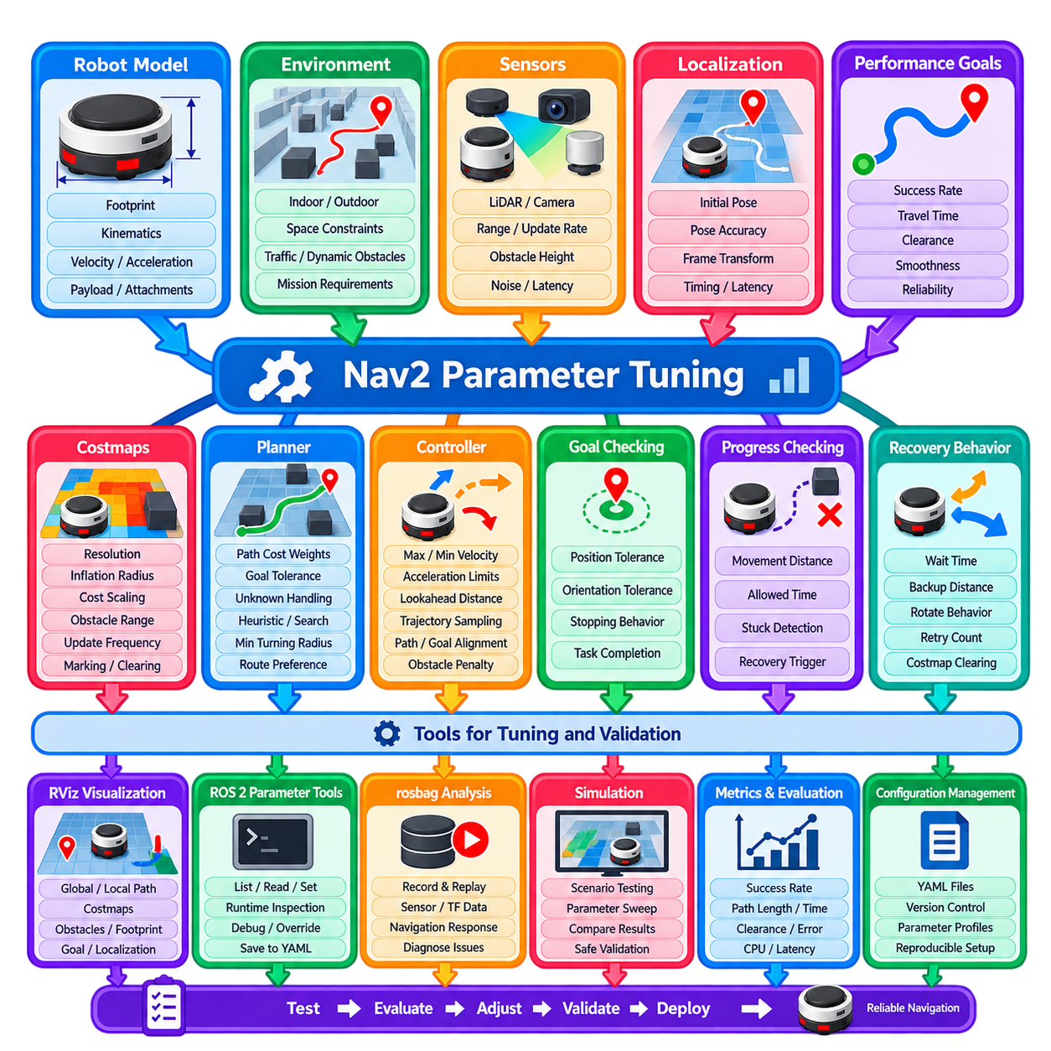
Nav2 parameter tuning is the process of adjusting navigation behavior so that the complete system matches the physical robot, operating environment, sensing characteristics, and mission requirements. Parameters should not be tuned as isolated numerical values because planner, controller, costmap, localization, behavior, and velocity constraints interact with one another. Effective tuning therefore begins with a stable baseline configuration and proceeds through controlled experiments in which measurable navigation behavior is compared against clearly defined performance objectives.
The first requirement is an accurate robot model. Footprint dimensions, wheelbase, minimum turning radius, maximum linear and angular velocity, acceleration, deceleration, and stopping capability should represent the real platform rather than convenient nominal values. Incorrect physical parameters can cause later tuning to compensate for modeling errors, producing a configuration that works only under limited conditions. Payload changes, towing configurations, or attachments may require separate parameter profiles because they can significantly alter dynamics and clearance requirements.
Costmap tuning establishes how Nav2 represents the environment for planning and control. Important variables include map resolution, robot footprint, inflation radius, cost scaling behavior, obstacle ranges, ray-tracing ranges, observation persistence, and update frequency. Excessive inflation can make narrow passages appear unusable, while insufficient inflation can generate paths with poor obstacle clearance. Sensor marking and clearing behavior should also be validated so that real obstacles appear reliably while stale observations disappear at an appropriate rate.
Global costmap and local costmap parameters should be tuned according to their different responsibilities. The global costmap normally supports long-range route selection and can emphasize persistent map information, while the local costmap operates over a smaller region and must respond quickly to current sensor observations. Rolling-window dimensions, update frequency, publish frequency, resolution, and obstacle sources should therefore be selected independently when appropriate. Copying identical settings between both maps can produce unnecessary computation or poor responsiveness.
Planner tuning determines how Nav2 selects routes through the global environment. Relevant parameters depend on the selected planner but may include obstacle cost weighting, tolerance near the goal, unknown-space handling, heuristic characteristics, minimum turning radius, motion-model selection, and search limits. The objective should not simply be to minimize path length. Industrial navigation often benefits from routes that provide greater clearance, fewer sharp turns, predictable corridor usage, and stable behavior across repeated planning cycles.
Controller tuning directly affects the visible motion quality of the robot. Parameters commonly influence maximum and minimum velocities, angular rates, acceleration limits, deceleration limits, lookahead distance, trajectory sampling, prediction horizon, path alignment, goal alignment, obstacle penalties, and stopping behavior. Tuning should begin at conservative speeds so that tracking behavior can be evaluated independently from high-speed dynamics. Velocity can then be increased gradually after stable path following, turning, stopping, and obstacle response have been demonstrated.
Controller parameters should be evaluated as interacting groups rather than independently. Increasing maximum velocity without increasing available braking distance or improving prediction may degrade safety margins. Increasing path-tracking weight can reduce geometric error while producing aggressive steering near obstacles. Increasing obstacle penalties can improve clearance but create oscillation in narrow corridors. Parameter tuning should therefore search for balanced behavior across tracking accuracy, smoothness, clearance, responsiveness, and computational stability rather than optimizing a single metric.
Goal-checking parameters determine when Nav2 considers a navigation task complete. Position tolerance and orientation tolerance should reflect the operational purpose of the destination. A delivery robot stopping in an open staging area may tolerate relatively large pose error, while docking, inspection, charging, or automatic coupling may require much tighter terminal alignment. Setting tolerances unnecessarily small can cause repeated corrective motion near the goal, whereas excessively large tolerances can report success before the robot is operationally positioned.
Progress-checking parameters provide an important mechanism for detecting situations in which the robot is commanded to navigate but is not making meaningful progress. Required movement distance and allowed movement time should reflect robot speed, environmental congestion, and expected maneuvering behavior. If thresholds are too strict, legitimate slow movement can be classified as failure. If they are too permissive, the robot may remain oscillating or blocked for excessive periods before recovery begins. Progress checking should therefore be tuned together with controller and recovery behavior.
Recovery parameters determine how the system responds when normal navigation cannot continue. Waiting duration, backup distance, backup speed, rotation behavior, retry counts, and costmap-clearing policies should be conservative and bounded. Recovery should progress from low-risk interventions toward stronger actions rather than immediately commanding aggressive physical maneuvers. The tuning objective is not to maximize the number of recovery attempts but to restore navigation efficiently while recognizing when continued autonomous attempts are unlikely to succeed.
Behavior Tree parameters and timing values also affect overall navigation performance. Replanning frequency, retry limits, recovery ordering, timeout values, and condition checks determine how quickly the system responds to changes or failures. Excessive replanning can consume computational resources and create unstable route changes, while insufficient replanning can leave the robot following an outdated path. Timing should therefore reflect environmental dynamics and planner cost rather than being selected solely from generic example configurations.
Sensor-related tuning should be performed before attempting to compensate through planner or controller parameters. LiDAR range, depth-camera filtering, obstacle height limits, scan quality, transform latency, timestamp consistency, and sensor update rate directly affect the costmaps. A controller cannot be expected to behave consistently when obstacle information appears intermittently or at incorrect positions. Similarly, excessive localization noise can create apparent tracking errors that are incorrectly attributed to controller tuning.
Transform and timing validation is a fundamental tuning prerequisite. The relationships among `map`, `odom`, `base_link`, and sensor frames should be stable, and transform tolerances should reflect actual communication and processing delays. Excessively large transform tolerance can conceal timing problems, while overly restrictive settings can cause otherwise valid data to be rejected. Developers should inspect transform latency and sensor timestamps directly rather than treating transform-related errors as parameters to suppress.
ROS 2 parameter files provide the primary mechanism for maintaining repeatable Nav2 configurations. Parameters should be organized according to subsystem and tracked under version control so that changes can be associated with test results. Production robots should avoid uncontrolled manual parameter modification because it becomes difficult to determine which configuration produced a particular behavior. Separate configuration profiles can be maintained for simulation, laboratory testing, production operation, payload states, or different robot models.
Runtime parameter inspection is useful for verifying that the active system actually contains the values expected from configuration files. ROS 2 command-line parameter tools can list, read, describe, and modify parameters where supported. This is valuable when debugging namespace problems, launch-file overrides, dynamically changed values, or incorrect configuration loading. Runtime modification can accelerate experiments, but successful values should ultimately be returned to controlled configuration files so that the system remains reproducible after restart.
Visualization tools such as RViz are essential because numerical parameters must be connected to observable navigation behavior. Developers should simultaneously inspect the global path, local path or trajectory, global and local costmaps, robot footprint, obstacle observations, goal pose, and localization estimate. A path passing too close to walls may indicate costmap or planner weighting problems, while a correct path combined with poor physical tracking more strongly suggests controller or localization issues. Visualization therefore helps identify which subsystem should actually be tuned.
Recorded ROS 2 data can transform parameter tuning from trial-and-error into repeatable engineering. Representative scenarios can be captured in rosbag recordings and replayed to examine localization, sensor data, transforms, costmaps, and navigation responses. Although physical motion cannot always be reproduced solely through replay, recorded information is extremely useful for diagnosing perception and timing problems. Standardized simulation scenarios can additionally provide repeatable comparisons among parameter sets before changes are deployed to hardware.
Quantitative metrics should accompany visual judgment. Useful measures include navigation success rate, planning time, path length, travel time, minimum obstacle clearance, cross-track error, heading error, stopping distance, recovery count, replanning count, command latency, CPU utilization, and costmap update latency. The appropriate metrics depend on the application. A hospital robot may prioritize smoothness and human clearance, while an outdoor logistics AMR may place greater emphasis on speed, curvature feasibility, and stopping performance.
A disciplined tuning process changes a limited group of related parameters at one time and records the resulting behavior. Changing planner weights, controller gains, inflation radius, velocity limits, and recovery settings simultaneously may produce an apparently improved result without revealing which modification was responsible. Controlled experiments make regression analysis possible and allow engineers to return to a known baseline. Parameter tuning should therefore be managed similarly to software development, with configuration versions, test scenarios, metrics, and acceptance criteria.
Simulation provides an efficient environment for broad parameter exploration, but final tuning must account for physical effects that simulation may not represent accurately. Wheel slip, drivetrain backlash, floor transitions, tire deformation, payload movement, sensor vibration, communication jitter, and braking behavior can significantly influence navigation. A useful workflow narrows the parameter space in simulation, validates behavior in a controlled physical environment, and only then evaluates the system under representative operational conditions.
Different operational modes may justify different parameter sets. A robot carrying a heavy payload may require lower acceleration and greater stopping margins than the same platform operating empty. A towing AMR may require larger turning clearance and different controller constraints. Precision docking may use a slower terminal control profile than normal navigation. Such mode changes should be explicit, validated, and bounded rather than implemented through arbitrary runtime parameter changes scattered throughout application code.
Automated tuning can assist with large parameter spaces, but optimization objectives must be selected carefully. A parameter search that minimizes travel time alone may produce aggressive motion with poor clearance or excessive control effort. Multi-objective evaluation can consider travel time, tracking error, smoothness, clearance, recovery frequency, and computational load together. Automated methods are most valuable when combined with safety constraints and standardized scenarios rather than being allowed to explore unrestricted robot behavior directly on physical hardware.
For advanced Physical AI systems, parameter tuning defines an important boundary between adaptive intelligence and deterministic navigation behavior. AI components may recommend route preferences, contextual speed limits, or operating modes, but the permissible parameter ranges should remain governed by validated platform constraints. Learned adaptation should not freely modify braking limits, safety margins, or other critical settings. A controlled parameter layer allows contextual intelligence to influence navigation while preserving predictable physical behavior.
A mature Nav2 tuning process therefore produces more than a single YAML file that appears to work. It creates a traceable relationship among robot characteristics, environmental assumptions, configuration parameters, test scenarios, measured results, and operational acceptance criteria. When parameter management, visualization, recorded data, quantitative metrics, simulation, and hardware validation are combined, Nav2 tuning becomes a systematic engineering process. This approach enables reliable navigation performance to be reproduced across robots, software versions, deployment sites, and increasingly complex Physical AI applications.

10.09. Nav2 Continuous Integration Test Setup [w/Code]
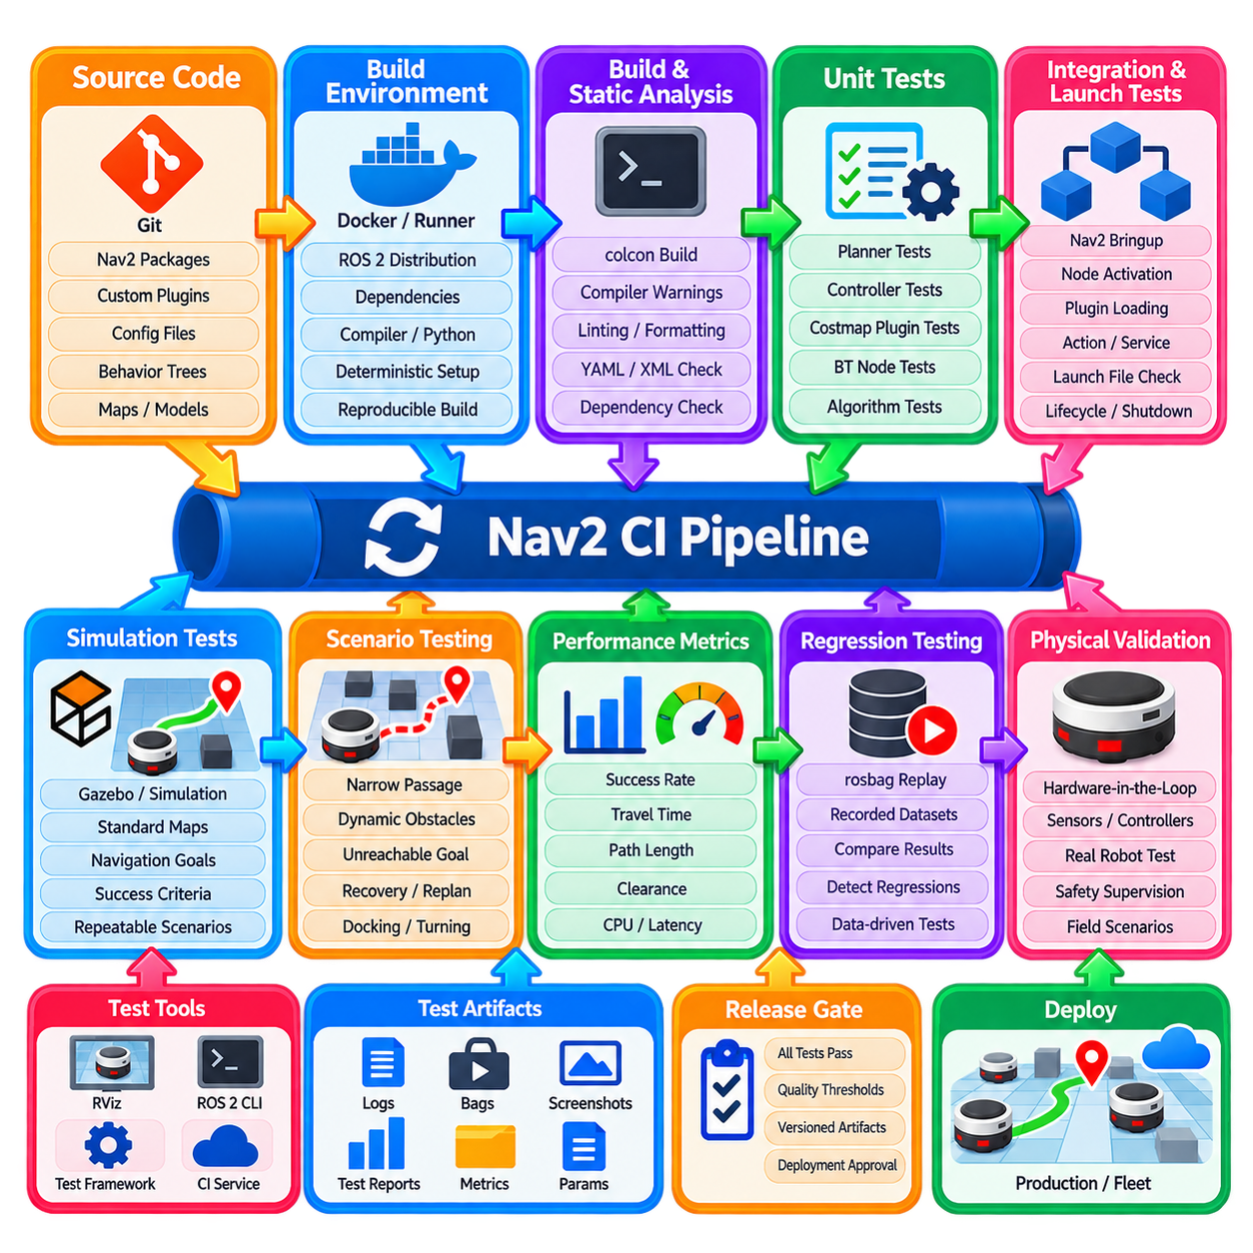
Continuous Integration for a Nav2-based robotics system provides an automated mechanism for verifying that navigation software remains buildable, testable, and behaviorally consistent as the codebase evolves. Unlike ordinary application CI, navigation CI must validate interactions among ROS 2 packages, plugins, configuration files, Behavior Trees, transforms, costmaps, simulation environments, and robot-specific interfaces. The objective is to detect regressions before software changes reach physical robots or operational deployments.
A practical CI architecture begins with a reproducible ROS 2 build environment. The operating system, ROS 2 distribution, compiler, Python environment, dependency versions, and middleware assumptions should be explicitly defined. Containers or standardized runner images can reduce differences between developer machines and CI servers. Dependency installation should be deterministic so that a successful build can be reproduced later rather than depending on packages that happened to be available on a particular machine.
The source workspace should be organized so that navigation packages can be built independently while preserving their dependency relationships. A CI job normally retrieves the source, resolves ROS dependencies, builds the workspace with `colcon`, and reports compiler warnings or failures. Build testing should cover both clean builds and relevant incremental conditions. Custom planner, controller, costmap, Behavior Tree, and recovery plugins should be compiled as first-class components rather than being tested only indirectly through a complete robot application.
Static analysis should occur before expensive simulation tests whenever possible. Formatting checks, linting, compiler warnings, Python quality checks, XML validation, YAML validation, and plugin configuration checks can identify many defects quickly. ROS 2 packages can integrate appropriate linting through the package test infrastructure. The purpose is not merely stylistic consistency; malformed configuration files, incorrect plugin identifiers, missing dependencies, or invalid launch descriptions can prevent the navigation system from starting correctly.
Unit tests should isolate algorithmic and component-level behavior. A custom planner can be tested for valid path generation, unreachable goals, map boundaries, and collision conditions. A controller can be tested for command limits, path tracking calculations, invalid inputs, and stopping behavior. Costmap plugins can verify layer updates and cost interpretation, while custom Behavior Tree nodes can test success, failure, running, timeout, and cancellation transitions. Fast unit tests should execute on every relevant code change.
Integration tests verify interactions that unit tests cannot adequately represent. Nav2 servers may be launched together with lifecycle management, transforms, localization, maps, and test nodes so that interfaces can be exercised under realistic conditions. Tests should confirm that required nodes activate correctly, plugins load successfully, actions and services become available, and navigation requests propagate through the expected components. Startup and shutdown behavior should also be tested because lifecycle and initialization defects often appear before navigation itself begins.
Launch testing is particularly important in ROS 2 systems because launch files encode substantial system architecture. Automated tests can verify that expected nodes appear, namespaces are correct, parameters are loaded, transforms become available, and processes remain alive for the required period. Separate launch configurations may be tested for simulation, development, and production-oriented profiles. This reduces the risk that a package passes unit tests while the complete Nav2 system fails because of launch or configuration errors.
Simulation provides the next level of validation by exercising navigation behavior in a controlled virtual environment. A CI runner can start a simulator, spawn a robot, initialize localization, activate Nav2, send navigation goals, and evaluate whether the robot reaches the expected destinations. Standard maps and scenarios should be version controlled so that identical conditions can be reproduced across commits. Simulation tests should remain deterministic enough to distinguish software regressions from random environmental variation.
Scenario-based tests should cover more than successful navigation through an empty map. Representative cases can include narrow corridors, turns, blocked paths, dynamic obstacles, unreachable goals, temporary obstruction, recovery execution, replanning, and goal cancellation. Platform-specific cases may include reverse motion, docking approach, towing geometry, or constrained turning. The scenario library should reflect failures observed during real development so that each important field problem can eventually become a repeatable regression test.
Navigation success should be evaluated using explicit acceptance criteria rather than simply checking whether the simulation process exited normally. Tests can measure whether the goal was reached within position and orientation tolerances, whether execution completed within a time limit, and whether the robot maintained required obstacle clearance. Additional metrics may include path length, travel time, number of recoveries, replanning frequency, tracking error, command saturation, and computational load. These measurements allow CI to detect behavioral degradation even when navigation technically succeeds.
Configuration files should be treated as versioned software artifacts. Changes to Nav2 YAML parameters, Behavior Tree XML files, maps, plugin definitions, and robot descriptions can alter navigation behavior as significantly as source-code changes. CI should therefore validate configuration syntax and execute representative tests whenever these files change. Maintaining known-good configuration baselines also makes it possible to compare performance between software revisions and determine whether a parameter modification introduced a regression.
Behavior Tree validation deserves specific attention because navigation behavior may change substantially without modifying planner or controller code. CI should verify that required BT plugins can be loaded, XML structures are valid, expected recovery branches exist, and important navigation outcomes produce the intended tree transitions. Where practical, individual custom BT nodes should be unit tested separately from complete navigation trees. This helps distinguish errors in node implementation from errors in mission-level tree composition.
Timing-related tests are important because a navigation stack can produce correct logical results while failing operationally due to excessive latency. CI can monitor planner execution time, controller loop timing, costmap update latency, transform availability, and startup duration. Thresholds should be realistic for the intended deployment hardware. Shared CI runners may have variable performance, so strict real-time guarantees should not be inferred from cloud CI alone, but large performance regressions can still be detected effectively.
Test isolation is necessary to prevent one navigation test from contaminating another. ROS domains, namespaces, temporary files, simulation processes, and generated maps should be cleaned between tests. Every job should terminate launched nodes and simulator processes even after failure. Uncontrolled processes can occupy ports, publish stale transforms, or interfere with subsequent jobs. Reliable cleanup is therefore part of CI architecture rather than merely a convenience for the test environment.
Test data and artifacts should be preserved when failures occur. Useful CI artifacts include console logs, test reports, launch logs, parameter snapshots, generated paths, selected metrics, and rosbag recordings from failed scenarios. Screenshots or visualization outputs may also help when supported by the test environment. A developer should be able to inspect a failed pipeline and understand what happened without reproducing the complete environment immediately on a local workstation.
Rosbag-based regression testing can complement simulation by preserving sensor and system data from representative situations. Recorded LiDAR, odometry, localization, transform, or other ROS 2 data can be replayed against selected components to examine whether software changes alter perception or navigation-related processing. Replay does not reproduce every closed-loop physical interaction, so it should not replace simulation or hardware testing. Nevertheless, it provides a repeatable mechanism for diagnosing data-driven regressions and validating processing pipelines.
A layered CI pipeline can control computational cost by executing fast checks first and expensive tests only after earlier stages succeed. Static analysis and unit tests can run on every commit, followed by integration and launch tests. Simulation scenarios may run for pull requests, protected branches, scheduled builds, or release candidates depending on available compute resources. More expensive long-duration scenarios can be executed periodically rather than making every small code change wait for the complete validation suite.
Parallel execution can significantly reduce CI duration when navigation scenarios are properly isolated. Independent unit-test groups, maps, robot configurations, or simulation scenarios can run on separate workers. However, parallelism should not be introduced before deterministic isolation is established. Shared ROS domains, simulator resources, GPU devices, or network ports can create intermittent failures that are difficult to diagnose. Stable sequential execution is preferable to fast but unreliable parallel testing.
Hardware-in-the-loop testing extends CI beyond simulation by including representative robot controllers, sensors, compute platforms, or communication interfaces. These tests can verify CAN, EtherCAT, serial, Ethernet, GNSS, IMU, LiDAR, and drive interfaces under conditions closer to the deployed system. Because hardware resources are limited, such tests are commonly reserved for scheduled validation, release candidates, or deployment gates. CI can automatically dispatch a test to a dedicated hardware runner and collect standardized results.
Physical robot testing remains necessary even with comprehensive simulation and hardware-in-the-loop coverage. Real platforms introduce wheel slip, mechanical backlash, sensor vibration, communication jitter, floor conditions, payload effects, and emergency-stop interactions that may not be represented accurately elsewhere. Automated physical tests should therefore focus on carefully bounded scenarios with independent safety supervision. Passing software CI should be considered a prerequisite for robot testing, not evidence that physical validation is unnecessary.
Release gating connects CI results directly to deployment discipline. A navigation software version should advance toward field deployment only after required build, unit, integration, simulation, and platform-specific tests have passed. Critical failures should block release automatically, while noncritical performance warnings may require engineering review. Versioned binaries, container images, parameter sets, robot descriptions, and test reports should be associated with the same release identifier so that deployed behavior remains traceable.
For multi-robot products, CI should test more than a single reference platform when architecture and resources permit. Different AMR geometries, sensor suites, kinematic models, or parameter profiles may expose assumptions hidden in shared navigation software. A matrix-based pipeline can build and test representative configurations without duplicating the entire CI definition. This becomes particularly important when the same Nav2 framework supports differential-drive AMRs, towing robots, outdoor platforms, or other heterogeneous mobile systems.
Continuous Integration should also connect with field feedback. When a deployed robot encounters a reproducible navigation failure, the engineering process should attempt to convert that event into a map, simulation scenario, rosbag dataset, unit test, or integration test. Once added to the CI suite, the failure becomes part of the permanent regression boundary. Over time, this creates a growing navigation validation library derived from actual operational experience rather than relying only on scenarios imagined during initial development.
For advanced Physical AI systems, CI must preserve the boundary between adaptive intelligence and deterministic navigation execution. World models, learned policies, semantic planners, or AI mission systems may influence Nav2 goals and constraints, but their outputs should be tested against validated navigation interfaces and safety envelopes. CI can verify schemas, command limits, timeout behavior, fallback paths, and failure handling so that changes in intelligent components do not silently bypass established navigation assumptions.
A mature Nav2 CI system therefore becomes more than an automated build server. It forms a continuous verification framework connecting source code, configuration, simulation, recorded data, hardware interfaces, physical validation, and deployment decisions. By combining layered testing, reproducible environments, measurable acceptance criteria, preserved artifacts, release gating, and regression scenarios derived from field experience, the development team can evolve navigation software rapidly while maintaining confidence that each change preserves the reliability required for real robotic operation.

10.10. Nav2 Production AMR Deployment Case Study
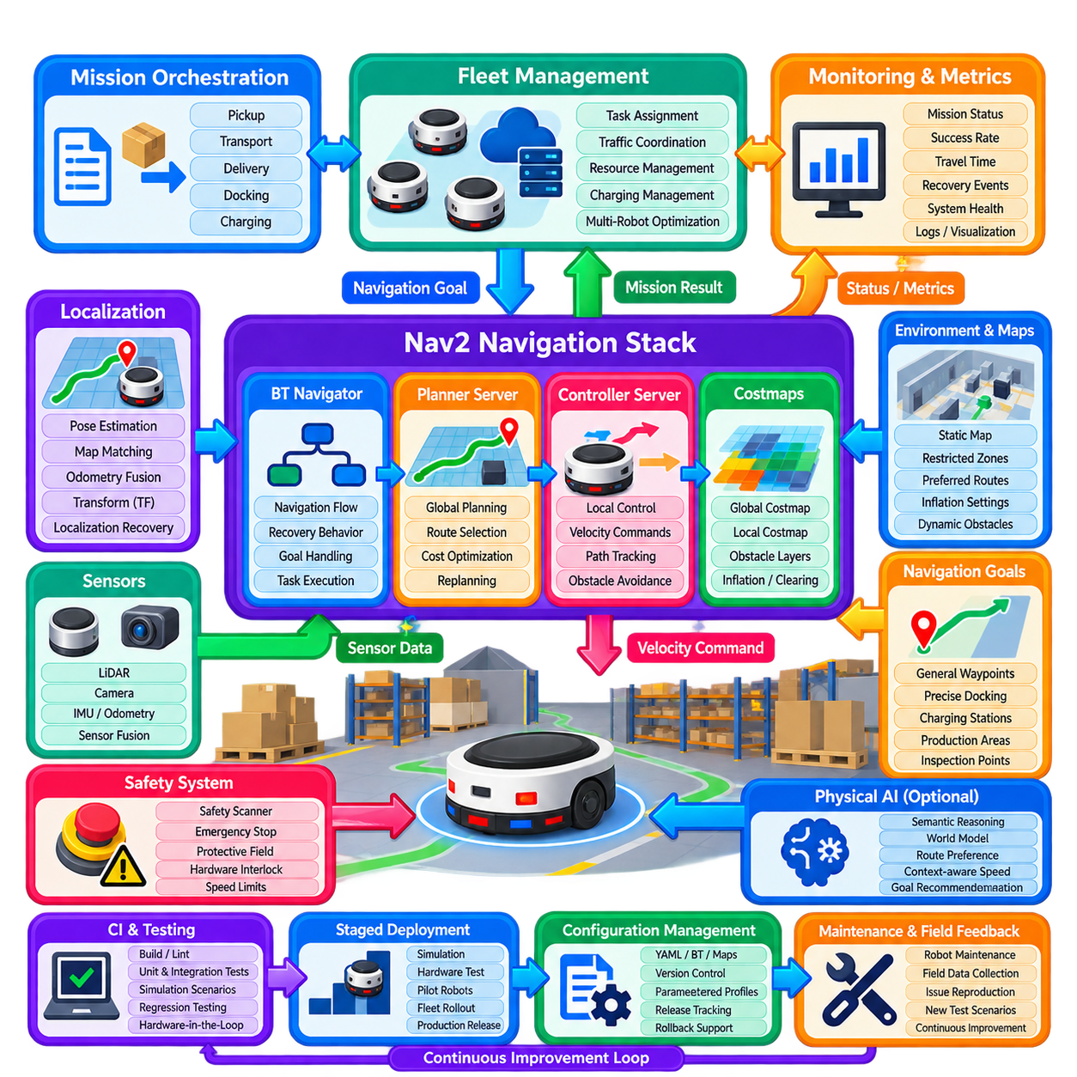
A production AMR deployment using Nav2 differs fundamentally from a laboratory navigation demonstration. The objective is not merely to prove that a robot can travel from one pose to another, but to maintain predictable autonomous operation across thousands of missions, changing traffic conditions, sensor disturbances, software updates, and operational exceptions. A production architecture therefore combines Nav2 navigation with mission orchestration, fleet coordination, safety systems, monitoring, configuration control, and disciplined deployment procedures.
Consider an indoor logistics AMR operating continuously between storage, production, inspection, and charging areas. The robot receives transport missions from a fleet or warehouse management layer, while Nav2 remains responsible for robot-level navigation. Mission software converts business tasks into destinations and operational states, the BT Navigator coordinates navigation execution, the Planner Server generates routes, the Controller Server produces local motion commands, and costmaps maintain the spatial representation required for collision-aware movement.
The production robot model must accurately represent the physical platform. Footprint dimensions, wheel geometry, velocity limits, acceleration, braking performance, payload conditions, and minimum turning capability are validated on hardware before deployment. Conservative values are initially used because nominal mechanical specifications do not always represent loaded operation on real floors. Separate operating profiles may be introduced for empty travel, loaded travel, precision docking, or other modes when the physical behavior differs significantly.
Localization is treated as a continuously monitored production service rather than a one-time startup function. The system evaluates pose quality, map consistency, odometry behavior, transform availability, and localization recovery conditions throughout operation. Areas with repetitive geometry, glass surfaces, changing inventory, or long feature-poor corridors receive particular attention. If localization confidence becomes unacceptable, mission execution can be suspended before navigation errors propagate into unsafe or operationally incorrect movement.
The global costmap combines persistent environmental information with operational restrictions relevant to route selection. Walls, fixed infrastructure, restricted zones, preferred corridors, and other map-based information establish the long-range navigation structure. Inflation parameters maintain appropriate clearance from obstacles, while semantic or operational layers can discourage undesirable routes. The objective is not always the mathematically shortest path; production systems often prefer predictable routes with adequate clearance and lower interaction risk.
The local costmap emphasizes current sensor observations and immediate motion constraints. LiDAR, depth sensing, or other obstacle sources continuously update nearby free and occupied space. Sensor ranges, observation persistence, marking, clearing, update frequency, and transform timing are tuned using recorded field data. Excessive persistence can create ghost obstacles, while overly aggressive clearing can remove valid information. Stable costmap behavior is therefore considered a prerequisite for controller tuning rather than something the controller should compensate for.
Global planning is configured according to the facility layout and AMR kinematics. A conventional grid-based planner may be sufficient for a differential-drive robot in structured indoor environments, while larger or constrained platforms may require curvature-aware planning. Route quality is evaluated using path length, clearance, turning complexity, planning latency, and consistency across repeated missions. Frequent unnecessary route changes are undesirable because predictability is important for both fleet coordination and human interaction.
The local controller is tuned on physical hardware after conservative simulation validation. Straight tracking, cornering, narrow passages, stopping, obstacle response, and final approach behavior are evaluated separately before full mission testing. Maximum speed is increased only after stable tracking and braking have been demonstrated. Controller tuning balances path accuracy, smoothness, obstacle clearance, command stability, and travel time rather than maximizing speed as an isolated objective.
Goal tolerances depend on the operational destination. A general transfer waypoint may permit moderate position and orientation error, while charging, conveyor interaction, docking, inspection, or automatic coupling can require significantly tighter alignment. Production systems therefore distinguish ordinary navigation completion from precision terminal operations. In many cases Nav2 brings the robot into an approach region, after which a dedicated docking or alignment controller completes the final maneuver using local sensors.
Behavior Trees organize navigation execution and recovery policies. Normal navigation may include path computation, path following, progress monitoring, replanning, and goal validation, while recovery branches handle temporary blockage or degraded conditions. Recovery actions progress from low-risk responses such as waiting or replanning toward costmap clearing, controlled repositioning, or mission escalation. Every recovery sequence has bounded retries so that the robot cannot remain indefinitely trapped in repeated autonomous attempts.
Dynamic traffic is one of the major differences between laboratory and production navigation. Workers, forklifts, carts, manually operated equipment, and other AMRs can temporarily block otherwise valid routes. The local controller handles immediate interactions, while longer blockages may trigger replanning or fleet-level decisions. The system distinguishes transient obstacles from persistent route unavailability so that a short human crossing does not cause unnecessary global rerouting while a genuinely blocked corridor does.
Fleet coordination operates above individual Nav2 instances. Each AMR performs local navigation, while the fleet system manages mission assignment, traffic reservations, shared resources, congestion, charging, and potentially intersection priorities. Nav2 should not independently solve problems that require knowledge of the complete fleet. Conversely, the fleet manager should avoid directly controlling low-level robot motion. A clean interface between fleet decisions and robot navigation improves scalability and failure isolation.
Mission orchestration translates operational tasks into robot actions. A transport mission may include navigating to a pickup point, confirming arrival, waiting for material transfer, validating payload state, navigating to a destination, unloading, and reporting completion. Nav2 Simple Commander, ROS 2 actions, or a dedicated mission layer can provide this interface. Navigation results become mission events, allowing business workflow logic to remain separated from path planning and motion control.
Operational safety remains independent from ordinary Nav2 navigation. Safety scanners, emergency stops, protective fields, drive-level limits, and hardware interlocks can stop motion regardless of navigation commands. Nav2 contributes collision-aware planning and obstacle response but is not treated as the sole safety mechanism. The production design explicitly defines the relationship between functional navigation behavior and safety-rated control so that software recovery or mission logic cannot bypass protective functions.
Observability is essential once robots operate without continuous engineering supervision. The system records mission state, navigation results, planner failures, controller failures, recovery events, localization status, costmap conditions, velocity commands, resource utilization, and selected diagnostic information. Operators receive concise operational alarms, while engineering teams retain deeper logs for root-cause analysis. Event timestamps and robot identifiers allow navigation incidents to be reconstructed across multiple distributed software components.
Production metrics extend beyond navigation success rate. Useful measures include mission completion rate, intervention frequency, average travel time, blocked time, recovery frequency, replanning frequency, minimum clearance, docking success, localization faults, emergency-stop events, charging utilization, and software-related downtime. Trends are often more informative than isolated failures. A gradual increase in recovery frequency, for example, may reveal sensor contamination, map drift, environmental change, or an unsuitable software configuration before complete mission failure occurs.
Configuration management is treated with the same discipline as source-code management. Nav2 YAML files, Behavior Trees, maps, robot descriptions, plugin versions, safety-related interfaces, and mission configurations are associated with controlled software releases. Engineers can identify exactly which configuration was running when an incident occurred. Parameter changes tested successfully on one robot are not immediately propagated to the entire fleet without staged validation because small configuration changes can alter physical behavior.
The deployment process normally progresses through simulation, controlled hardware testing, pilot robots, limited fleet rollout, and full production release. A new Nav2 configuration may first pass automated CI scenarios and hardware validation before being installed on one or a small number of representative AMRs. Operational metrics are then compared with the previous release. Only after predefined acceptance criteria are satisfied does the software expand to the wider fleet, reducing the impact of unexpected regressions.
Rollback capability is therefore a production requirement. Every deployed robot should have a known-good combination of software, configuration, maps, and dependent components that can be restored if a release produces unacceptable behavior. Rollback should not depend on engineers manually reconstructing previous settings. Versioned deployment artifacts and automated installation procedures allow the fleet to return to a validated baseline quickly while the problematic release is investigated.
Field failures become inputs to the engineering process rather than isolated operational events. When a robot repeatedly fails in a particular corridor or maneuver, logs, maps, rosbag data, and mission context are collected. Engineers reproduce the condition in simulation or a controlled test environment and convert it into a regression scenario whenever possible. The resulting test is added to CI so that future software revisions cannot silently reintroduce the same failure.
Maintenance also influences navigation reliability. Dirty LiDAR windows, damaged wheels, altered tire diameter, mechanical alignment changes, loose sensors, or payload modifications can appear as software problems. Production diagnostics therefore connect navigation metrics with hardware maintenance information. Persistent tracking error may indicate controller tuning, but it may also reveal wheel wear or odometry degradation. Reliable deployment requires the software and physical robot to be treated as one operational system.
For larger fleets, software versions and navigation configurations may temporarily differ between robots during staged deployment. Fleet management and monitoring systems must therefore know each robot's active version and capabilities. Compatibility rules prevent mission software from requesting functions unavailable on older versions. This becomes increasingly important when new planners, controller modes, semantic layers, or mission behaviors are introduced gradually rather than through a simultaneous fleet-wide update.
Physical AI capabilities can be added above this production foundation without removing deterministic navigation boundaries. A semantic reasoning system may recommend a different destination, route preference, operating mode, or contextual speed policy. A world model may identify congestion or predict temporary route restrictions. These decisions are converted into validated navigation goals and bounded constraints, while Nav2 continues to provide deterministic planning, local control, recovery, and execution interfaces.
The production case demonstrates that reliable AMR navigation is ultimately a system-engineering problem rather than a planner-selection problem. Planner quality, controller performance, localization, costmaps, Behavior Trees, fleet coordination, mission logic, safety, observability, CI, deployment, rollback, and maintenance all contribute to operational autonomy. Weakness in any one layer can reduce fleet availability even when every individual navigation algorithm appears technically successful.
A mature Nav2 production deployment therefore establishes a continuous operational loop: configure, validate, deploy, observe, measure, diagnose, reproduce, improve, and redeploy. Each field event increases the evidence available for engineering decisions, while CI and staged deployment prevent improvements from introducing uncontrolled regressions. With these practices, Nav2 becomes more than a navigation demonstration framework; it becomes a stable robot-level autonomy foundation capable of supporting production AMRs, fleet operations, and increasingly sophisticated Physical AI systems.

