Volume 15. Motion Planning and Navigation

Chapter 07. Multi Robot Navigation

07.01. Multi Robot Navigation Architectures Centralized Decentralized
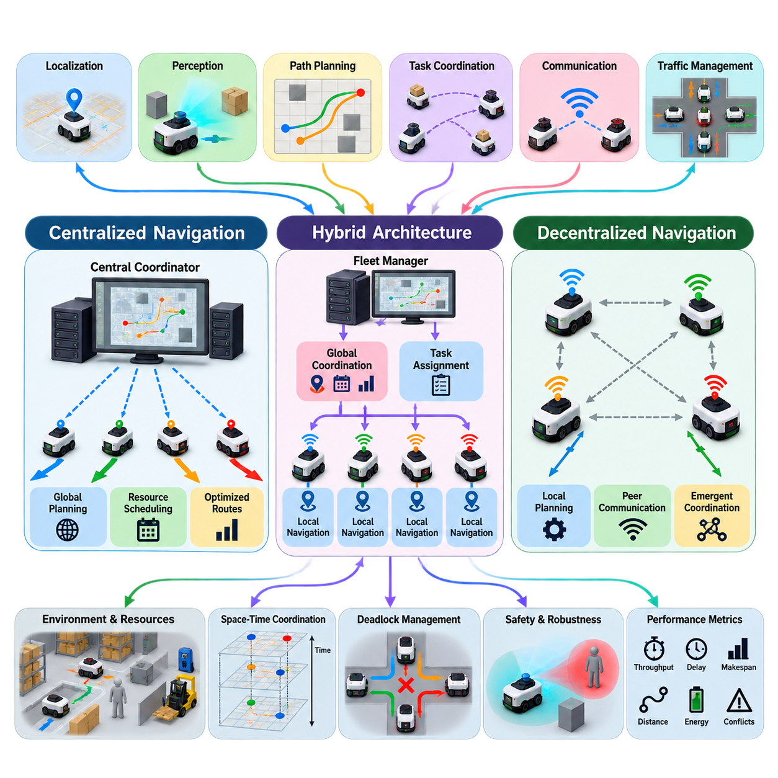
Multi-robot navigation extends single-robot motion planning into a shared environment where several autonomous robots must reach individual or collective goals without collisions, deadlocks, or inefficient interference. The problem combines localization, perception, path planning, task coordination, communication, and traffic management. Its difficulty grows rapidly because each robot becomes both an intelligent agent and a dynamically changing obstacle for the others.
A multi-robot navigation architecture defines where navigation decisions are computed, how information is exchanged, and how conflicts between robots are resolved. The two fundamental architectural models are centralized and decentralized navigation. Practical systems frequently adopt hybrid forms between these extremes, selecting different coordination mechanisms according to fleet size, communication quality, computational resources, safety requirements, and operational environment.
In a centralized architecture, a central coordinator maintains information about the robots, their goals, maps, planned paths, and relevant environmental conditions. Individual robots periodically transmit their states to this coordinator, which calculates globally coordinated routes or trajectories. Because the coordinator has a system-wide view, it can explicitly consider interactions among robots rather than allowing each robot to optimize its motion independently.
Centralized navigation can formulate the fleet as a joint planning problem. If robot i has state x_i and control input u_i, the planner considers the combined state X = [x_1, x_2, ..., x_N] and searches for motions satisfying obstacle, kinematic, and inter-robot collision constraints. This representation enables global optimization of objectives such as travel distance, mission completion time, congestion, energy consumption, or total fleet throughput.
A major advantage of centralized coordination is its ability to manage shared resources systematically. Narrow corridors, intersections, elevators, docking stations, charging areas, loading zones, and restricted passages can be modeled as resources whose use must be scheduled. The coordinator can assign priorities, reserve spatial or temporal regions, and modify routes before conflicts physically occur, making centralized control attractive for structured warehouses and factories.
Centralized planning nevertheless faces significant scalability challenges. As the number of robots increases, the joint configuration space expands dramatically and the number of possible interactions grows. Exact multi-agent path finding can therefore become computationally expensive for large fleets. Practical implementations reduce complexity through hierarchical planning, prioritized planning, reservation tables, graph decomposition, rolling-horizon optimization, or local replanning around detected conflicts.
Communication is another important dependency. A central coordinator requires sufficiently current robot states to make valid decisions, while robots must receive updated plans with acceptable latency. Packet loss, network congestion, temporary disconnection, or delayed state information can cause the central representation to differ from physical reality. Robust architectures therefore include timestamps, state prediction, communication-health monitoring, local safety controllers, and degraded operating modes.
The central server can also become a logical single point of failure unless redundancy is deliberately designed. Industrial implementations may employ replicated fleet managers, failover servers, persistent mission databases, and distributed safety functions. Importantly, collision prevention should not depend entirely on the central computer. Each robot normally retains local perception and emergency behavior so that unexpected obstacles or communication failures can be handled immediately.
In a decentralized architecture, navigation decisions are distributed among individual robots rather than determined by one global coordinator. Each robot estimates its local environment, plans its motion, observes or receives information about neighboring robots, and adjusts its trajectory accordingly. Coordination emerges from local interactions, shared protocols, negotiation, or distributed optimization instead of a single authority computing every robot's movement.
Decentralized navigation offers strong scalability and fault tolerance because computational work is naturally distributed. Failure of one robot does not necessarily disable the remaining fleet, and robots can continue operating when connectivity to infrastructure is unavailable. This property is valuable for outdoor robots, exploration systems, search-and-rescue platforms, agricultural machines, heterogeneous robot teams, and other environments where reliable centralized communication cannot be guaranteed.
The principal difficulty of decentralization is achieving globally efficient behavior from locally available information. Two robots may independently choose routes that are individually optimal but mutually incompatible. Multiple robots can enter symmetric conflicts, repeatedly yield to one another, create oscillations, or form deadlocks around constrained passages. Decentralized systems therefore require explicit rules for priority, right-of-way, negotiation, conflict resolution, and recovery from coordination failures.
Local collision avoidance provides one layer of decentralized interaction. Robots can predict neighboring trajectories and select velocities that preserve separation while maintaining progress toward their goals. Methods based on velocity obstacles, reciprocal collision avoidance, model predictive control, or distributed trajectory optimization can support this behavior. However, purely reactive avoidance cannot always solve structural conflicts involving narrow corridors, bottlenecks, or long-duration resource contention.
Information sharing determines how much coordination decentralized robots can achieve. Robots may exchange pose, velocity, planned trajectory, destination, priority, intent, uncertainty, or reserved regions. Sharing future intent is especially valuable because another robot can react before a physical conflict becomes imminent. Communication protocols must nevertheless tolerate missing messages and inconsistent estimates, since safety cannot assume that every neighboring robot always provides correct and timely information.
Centralized and decentralized architectures therefore represent different distributions of knowledge and authority rather than simply different planning algorithms. Centralization favors global visibility, predictable traffic management, and fleet-level optimization, while decentralization favors autonomy, scalability, resilience, and operation under imperfect communication. The appropriate choice depends strongly on whether the environment is structured and infrastructure-rich or open, dynamic, geographically distributed, and communication-constrained.
Hybrid architectures combine both approaches and are increasingly important for practical robot fleets. A fleet manager may assign missions, global routes, traffic priorities, and resource reservations, while each robot independently performs localization, short-horizon trajectory generation, obstacle avoidance, and emergency stopping. This division prevents the central system from processing every control decision while preserving enough global coordination to reduce congestion and deadlock.
Hierarchical coordination extends the hybrid concept by dividing navigation across multiple spatial and temporal levels. A global layer can allocate destinations and major route segments, a regional coordinator can manage intersections or zones, and individual robots can execute local trajectories. Large facilities may further partition robots into groups or operational regions, allowing coordination complexity to grow more slowly than in a completely centralized fleet-wide planner.
The distinction between static obstacles and other robots is essential in multi-robot navigation. Another robot is not merely a moving obstacle; it has goals, planning capability, and potentially communicable intent. Treating cooperative robots exactly like unpredictable dynamic objects wastes information. Multi-robot systems can instead exploit shared plans, reservations, predicted arrival times, and negotiated priorities to coordinate motion more efficiently than independent obstacle avoidance would permit.
Temporal coordination is as important as geometric path planning. Two robots may safely use the same corridor if they occupy it at different times, meaning navigation should often reason in space-time rather than space alone. Reservation-based systems associate path segments, graph nodes, intersections, or regions with time intervals. This converts many collision conflicts into scheduling problems and enables dense fleets to share constrained infrastructure efficiently.
Deadlock management must be considered at the architectural level. A deadlock occurs when robots remain collision-free but cannot make progress because their planned movements mutually block one another. Detection may use wait-for graphs, timeout conditions, progress metrics, reservation dependencies, or repeated replanning patterns. Recovery can involve priority reassignment, route reversal, temporary retreat, reservation cancellation, or centralized intervention when local negotiation cannot resolve the conflict.
Navigation architecture must also distinguish coordination safety from functional safety. Cooperative planning attempts to prevent conflicts under normal operation, whereas safety mechanisms must protect against localization errors, communication failures, unexpected human motion, controller faults, or incorrect predictions. Independent sensing, speed supervision, protective stopping, minimum separation policies, and conservative fallback behavior provide additional protection when coordination assumptions are violated.
Heterogeneous fleets introduce further architectural complexity because robots may have different footprints, speeds, turning radii, payloads, sensing capabilities, or locomotion mechanisms. A shared navigation representation must therefore describe more than simple point occupancy. Centralized systems can incorporate heterogeneous constraints directly into scheduling, while decentralized systems require common conventions through which robots can interpret one another's motion capabilities and intentions.
System performance should ultimately be evaluated at both robot and fleet levels. Individual travel time alone can be misleading because aggressive shortest-path behavior may increase congestion for everyone else. Useful measures include mission throughput, average delay, makespan, distance traveled, energy consumption, conflict frequency, deadlock rate, communication load, planning latency, and recovery time. Architecture selection should therefore be driven by operational performance rather than algorithmic elegance alone.
For real-world deployments, the most robust pattern is often centralized strategic coordination combined with decentralized tactical autonomy. Global information is used where it provides genuine fleet-level value, while time-critical sensing and collision response remain close to each robot. This architecture allows a fleet to exploit shared intelligence without making every movement dependent on uninterrupted connectivity or a continuously available central planner.
As fleets evolve toward large-scale autonomous systems, multi-robot navigation increasingly becomes an orchestration problem rather than only a path-planning problem. Robots must coordinate motion with missions, infrastructure, charging, human activity, and other autonomous agents. Centralized, decentralized, and hybrid architectures provide complementary mechanisms for distributing this intelligence, and successful systems select their boundaries according to latency, scale, uncertainty, safety, and operational objectives.

07.02. Conflict Based Search CBS for Multi Robot [w/Code]
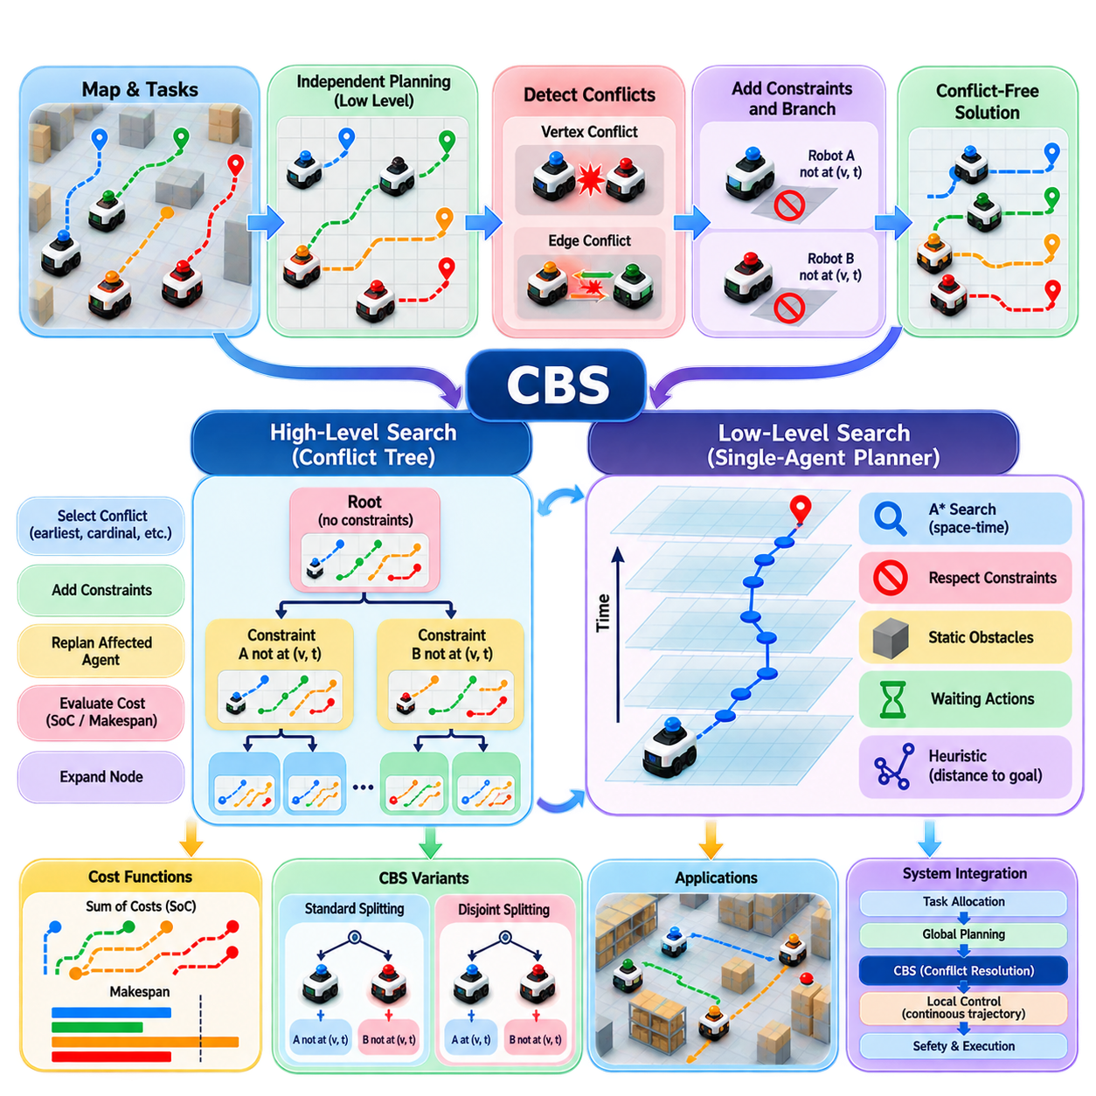
Conflict-Based Search (CBS) is a two-level algorithm for Multi-Agent Path Finding (MAPF) that separates global conflict resolution from individual path planning. Instead of searching directly through the enormous joint configuration space of all robots, CBS initially plans a path for each robot independently and then detects conflicts among those paths. When a conflict is found, CBS adds constraints that force the involved robots to make different decisions and recursively resolves the resulting conflicts.
The central idea of CBS is to represent multi-robot coordination through a Conflict Tree (CT). Each node of this tree contains a set of constraints and a corresponding collection of individually planned robot paths. The root node begins with an empty constraint set, so every robot receives its independently optimal path. The resulting paths are then examined for collisions. If no conflict exists, the solution is valid; otherwise, the detected conflict becomes the basis for expanding the conflict tree.
A typical conflict occurs when two robots occupy the same location at the same time or attempt to exchange positions through the same edge in opposite directions. A vertex conflict can be represented as robot A occupying location v at time t while robot B also occupies v at time t. An edge conflict occurs when the two robots traverse the same connection in opposite directions during the same time interval. These conflicts provide precise information about where and when coordination has failed.
When CBS identifies a conflict between two robots, it creates child nodes by adding alternative constraints. For example, if robot A and robot B both attempt to occupy location v at time t, one child node may prohibit robot A from occupying v at t, while the other prohibits robot B from doing so. Each child therefore resolves the specific conflict in a different way. The affected robot then replans its path under the newly introduced constraint.
The lower level of CBS performs Single-Agent Path Finding (SAPF) for individual robots. A common implementation uses A* search on a space-time representation, where a state contains both spatial position and time. The planner considers static obstacles, robot-specific constraints, and movement capabilities while searching for a feasible path. Because only the robot affected by a newly added constraint normally needs to be replanned, CBS avoids repeatedly recomputing all robot paths.
The high level of CBS searches through the Conflict Tree according to a cost function. A common objective is the Sum of Costs (SoC), which adds the path costs of all robots. Another objective is Makespan, which minimizes the time required for the entire fleet to finish. The selected objective changes the behavior of the planner because minimizing total travel cost can produce a different solution from minimizing the completion time of the slowest robot.
CBS is attractive because it decomposes a difficult combinatorial problem into manageable components. Individual path planning remains relatively simple, while conflicts are handled explicitly at the high level. This structure also provides an interpretable explanation of why a solution changes: a particular robot is replanned because a specific spatial-temporal conflict generated a corresponding constraint. Such explicit reasoning is useful when debugging or validating multi-robot navigation behavior.
The effectiveness of CBS depends strongly on the number and structure of conflicts. If independently generated paths rarely interact, the root node may already provide a solution or require only a few conflict resolutions. In dense environments, however, many robots can repeatedly compete for the same corridors, intersections, or bottlenecks. The Conflict Tree may then grow rapidly because each conflict creates alternative branches, increasing the computational burden of the high-level search.
Conflict selection therefore has an important influence on practical performance. A planner may select the earliest conflict in time, the most constrained conflict, or a conflict expected to divide the search space effectively. Modern CBS variants introduce the concept of conflict cardinality. Cardinal conflicts are those where resolving the conflict necessarily increases the cost of at least one involved path, while non-cardinal conflicts may sometimes be resolved without increasing the objective value. Prioritizing important conflicts can substantially reduce unnecessary exploration.
Constraint propagation is another important consideration. A constraint should be expressed precisely enough to prevent the identified conflict without unnecessarily restricting other feasible solutions. Overly restrictive constraints can eliminate useful paths and increase the search effort, while insufficient constraints may allow the same conflict to reappear. The quality of the constraint representation therefore directly affects both correctness and computational efficiency.
CBS can be extended through techniques such as disjoint splitting, which assigns constraints in a way that can partition the solution space more effectively. Standard splitting generally creates one constraint for each conflicting robot. Disjoint splitting introduces positive and negative constraints so that one branch explicitly requires a particular robot to perform a specific action while the other branch prohibits it. This can reduce duplicated search effort in some problem structures.
The single-agent planner also has a major impact on overall CBS performance. Efficient heuristics can reduce the number of states explored during each replanning operation. Space-time A* can incorporate admissible heuristics based on distance to the goal while accounting for waiting actions and temporal constraints. For grid-based warehouse environments, precomputed shortest-path distances, directional costs, and map-specific heuristics can further accelerate repeated low-level searches.
A practical CBS implementation must carefully define the temporal model. Robots may be represented as occupying discrete grid cells at discrete time steps, or as moving along edges between successive states. Waiting in place must be explicitly represented because a robot may resolve a conflict simply by delaying its movement. For physical robots, however, discrete plans eventually need to be converted into continuous trajectories that respect acceleration, velocity, turning-radius, and stopping constraints.
This transition from discrete MAPF to physical navigation is one of the most important engineering considerations. A CBS solution that is collision-free on a grid is not automatically safe for real robots. Localization uncertainty, tracking error, robot dimensions, braking distance, controller latency, and dynamic obstacles must be incorporated through appropriate safety margins or downstream trajectory validation. The CBS layer should therefore be viewed as a coordination planner rather than a complete physical safety controller.
CBS is particularly suitable for environments that can be represented effectively as a navigation graph. Warehouse aisles, factory corridors, structured logistics areas, and indoor transportation networks naturally provide nodes and edges through which robots travel. Intersections and narrow passages become conflict hotspots that can be explicitly identified and managed. This makes CBS useful when the operational environment is relatively structured and robot motion can be discretized without excessive loss of realism.
In large industrial fleets, however, applying classical CBS directly to hundreds of robots can become computationally difficult. Dense traffic generates many conflicts, and the corresponding Conflict Tree can expand exponentially in unfavorable cases. Practical systems therefore combine CBS with hierarchical decomposition, regional planning, prioritized planning, traffic zones, rolling-horizon replanning, or fleet-level scheduling. Robots may first be assigned to regions or corridors before CBS resolves conflicts within a smaller planning problem.
CBS can also be combined with reservation-based traffic management. A high-level fleet system can reserve critical resources such as intersections, charging stations, elevators, or narrow corridors, while CBS handles residual conflicts among robots. This creates a layered architecture in which long-term resource allocation and short-term path conflict resolution are separated. Such separation prevents the CBS search from having to reason simultaneously about every operational decision in the entire facility.
The algorithm also interacts naturally with task allocation. If two robots are assigned tasks that require them to use the same constrained area simultaneously, the resulting navigation conflicts may reflect an upstream allocation problem rather than a purely geometric planning problem. A fleet intelligence system can therefore use CBS conflict information as feedback to task assignment, route selection, or scheduling layers. Persistent conflicts may indicate that tasks should be reassigned or that operational priorities need to change.
Robustness requires consideration of execution uncertainty. A planned CBS path assumes that robots follow their trajectories sufficiently closely. If one robot experiences a delay, localization error, obstacle encounter, or temporary communication problem, the original conflict-free plan may no longer remain valid. Runtime monitoring should therefore compare predicted and actual robot states and trigger local or global replanning when deviations exceed defined thresholds.
CBS can be viewed as a bridge between independent robot autonomy and coordinated fleet intelligence. The low-level planner preserves robot-specific navigation capabilities, while the high-level Conflict Tree provides an explicit mechanism for resolving interactions. This separation makes the method conceptually clean and allows different single-robot planners, cost functions, and constraint models to be incorporated without changing the fundamental coordination principle.
For a Physical AI fleet architecture, CBS is most naturally positioned as a tactical multi-robot coordination layer rather than as the complete navigation stack. Mission orchestration can determine what robots should accomplish, task allocation can determine which robot performs each task, global planning can establish broad routes, CBS can resolve conflicts among those routes, and local controllers can convert the resulting paths into dynamically feasible motion. Safety supervision remains independent of this planning chain.
The main value of CBS is therefore not simply that it produces collision-free paths, but that it provides a structured mechanism for reasoning about why independently planned robot behaviors become incompatible and how those conflicts can be systematically resolved. Its two-level architecture, explicit constraints, conflict-driven branching, and compatibility with graph-based environments make it a powerful foundation for multi-robot coordination, while scalability, continuous dynamics, uncertainty, and real-time execution must be addressed through appropriate extensions and architectural integration.

07.03. Priority Based Planning for Fleet Navigation [w/Code]
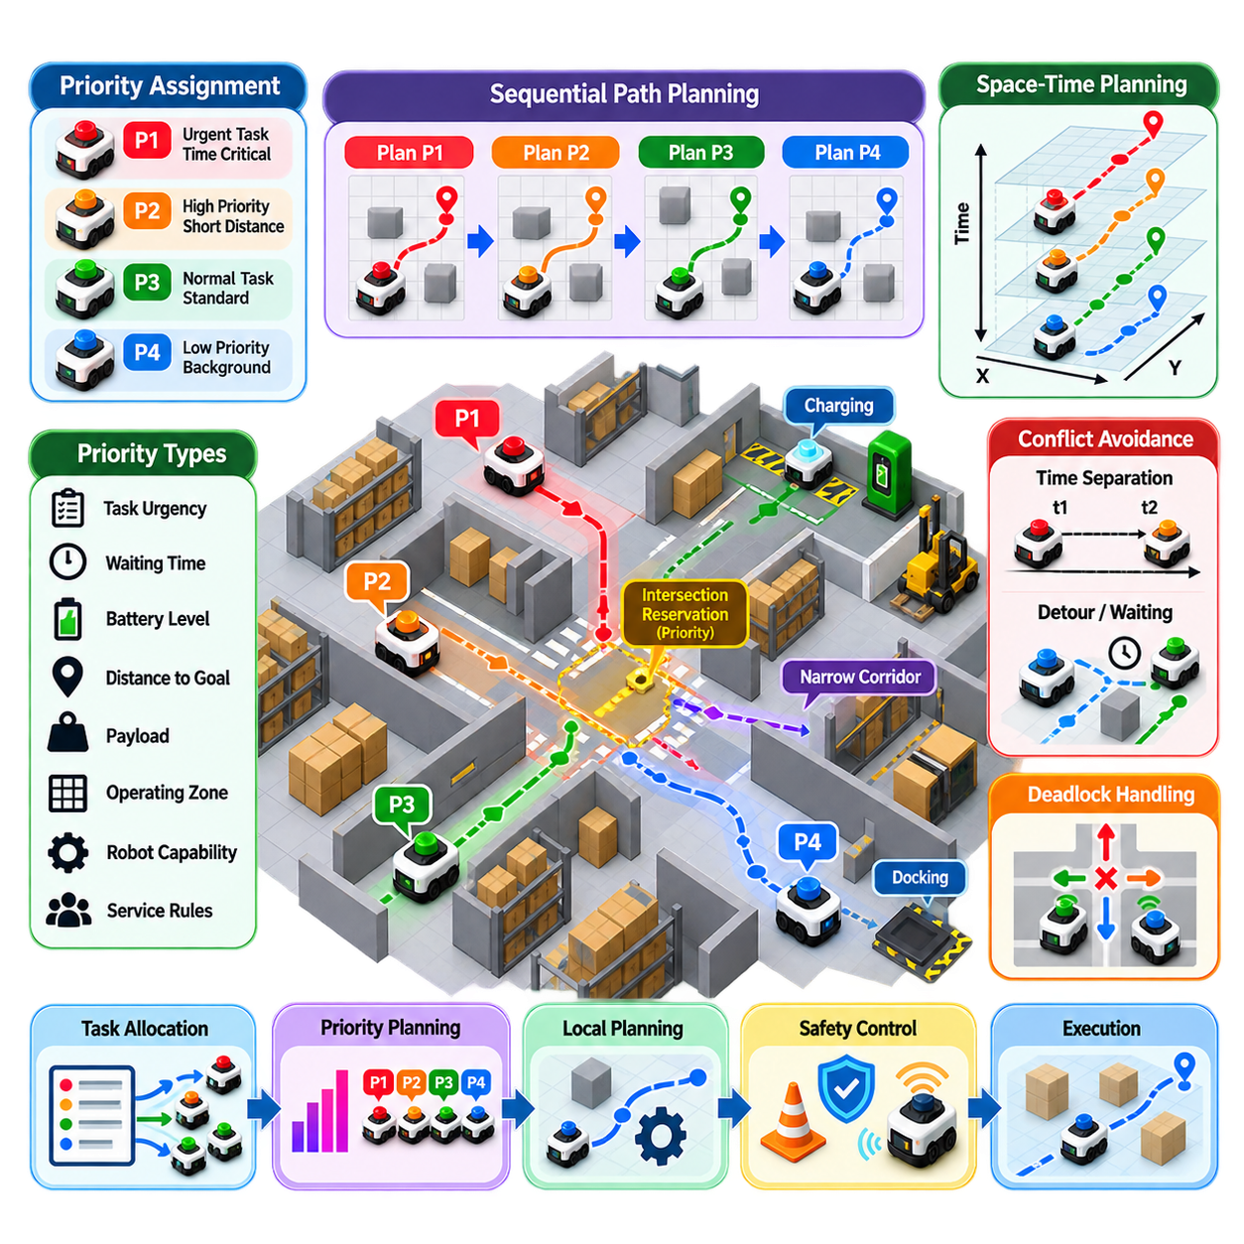
Priority-Based Planning is a practical multi-robot navigation strategy in which robots are assigned explicit or dynamically computed priorities, and higher-priority robots are planned first. Lower-priority robots then generate paths that avoid the trajectories or reserved resources of robots that have already been planned. Rather than solving the entire fleet as one joint optimization problem, the method decomposes coordination into a sequence of single-robot planning problems.
The fundamental motivation is scalability. As fleet size increases, jointly planning all robot trajectories becomes increasingly expensive because every robot can interact with many others. Priority-Based Planning reduces this complexity by establishing an ordering among robots. Once the order is determined, the planner can treat previously planned trajectories as constraints while calculating paths for subsequent robots, making the approach attractive for real-time industrial fleet navigation.
A priority can be static or dynamic. Static priority may be determined from robot identity, mission class, vehicle capability, operating zone, or predefined service rules. Dynamic priority can instead depend on factors such as remaining travel distance, task urgency, battery condition, waiting time, estimated delay, payload requirements, or proximity to a conflict. Dynamic priorities allow the navigation system to respond to changing operational conditions rather than relying on a permanently fixed hierarchy.
The planning process normally begins by assigning priorities to all active robots. The highest-priority robot plans its route without considering lower-priority robots as planning constraints, while subsequent robots must avoid the trajectories already assigned to higher-priority robots. If robot A has higher priority than robot B, the planner first generates a feasible path for A and then searches for a path for B that does not conflict with A. This process continues until all robots have been processed.
Priority-Based Planning can use a space-time representation in which a robot's path specifies both location and time. A lower-priority robot therefore avoids not only locations occupied by higher-priority robots but also locations during the corresponding time intervals. This distinction is important in narrow corridors and intersections because two robots may use the same physical region safely if their passage times are sufficiently separated.
The quality of the priority ordering strongly influences the resulting fleet behavior. An appropriate ordering can produce efficient paths with relatively little waiting, while a poor ordering can force many lower-priority robots to take long detours or wait behind unnecessarily restrictive trajectories. Priority assignment should therefore be treated as a planning variable rather than merely an implementation detail when fleet performance is important.
A common approach is to give priority to robots with urgent or time-critical missions. Emergency transport, safety-related inspection, high-value production tasks, or robots approaching a critical resource may receive temporary priority. Another approach is to prioritize robots that have already waited for a long period. Incorporating waiting time helps prevent starvation, where a robot repeatedly loses priority and remains blocked while other robots continue to receive access to shared routes.
Priority can also be associated with infrastructure resources. At an intersection, for example, one robot may receive a temporary reservation for a critical passage while other robots plan around that reservation. Similar mechanisms can be applied to elevators, narrow aisles, docking stations, charging areas, loading zones, and one-way passages. In this form, priority-based planning becomes closely connected with traffic scheduling and resource management.
One important limitation is incompleteness. A priority ordering can produce a situation in which no feasible path exists for a lower-priority robot even though a solution exists if the robots were planned in another order. The problem is caused by the commitment made by earlier planning decisions. A higher-priority robot may occupy a strategically important corridor or timing window, leaving the lower-priority robot with no feasible alternative.
Priority inversion is another practical concern. A robot with an initially low priority may block a robot with higher operational importance because the priority information does not reflect the current mission state. Dynamic reprioritization can address this problem, but frequent priority changes may introduce instability or cause robots to repeatedly revise their plans. Robust systems therefore require clear rules defining when and how priorities can change.
Deadlock prevention is particularly important in priority-based systems. Two or more robots can become mutually blocked even when each robot individually follows the assigned priority rules. This can occur around narrow passages, closed loops, or shared intersections. Practical implementations can use wait-for graphs, timeout detection, progress monitoring, corridor reservations, or temporary priority escalation to identify and recover from such situations.
Priority-Based Planning can be combined with local reactive collision avoidance. The priority layer determines strategic right-of-way and establishes which robot should proceed through a constrained region, while local planners handle unexpected obstacles and small deviations. For example, a fleet manager may authorize one robot to cross an intersection first, while each robot's local controller continuously adjusts velocity to maintain safe separation from people, obstacles, and other vehicles.
The method is especially useful in structured environments where traffic rules can be expressed clearly. Warehouses, factories, distribution centers, hospitals, and campuses often contain recognizable corridors, intersections, charging locations, and operational zones. A navigation graph can represent these structures, while priority rules determine which robots obtain access to constrained graph resources. This combination can provide predictable behavior without requiring computationally expensive global joint planning.
For large fleets, hierarchical priority planning can further improve scalability. A fleet-level planner can establish priorities between missions or zones, a regional planner can determine priorities at local intersections, and each robot can independently perform short-horizon trajectory planning. This hierarchy prevents a single planner from having to resolve every interaction simultaneously and allows computational resources to be concentrated on regions where traffic density and conflict probability are high.
Priority-Based Planning also provides a useful interface between task allocation and navigation. Task assignment determines what each robot needs to accomplish, while priority planning determines how competing movements should be coordinated. If repeated conflicts occur because several robots are assigned tasks requiring the same constrained resource, the system can provide feedback to the task allocator. Tasks may then be rescheduled, reassigned, or temporally separated rather than repeatedly resolving the same navigation conflict.
The approach should not be confused with a complete safety mechanism. Priority determines operational right-of-way, but it cannot guarantee safety against unexpected people, sensor errors, localization failures, communication loss, or mechanical faults. Each robot should therefore retain independent obstacle detection, speed limitation, emergency stopping, and protective behavior. Priority planning operates above these mechanisms and should never override safety constraints merely to preserve traffic efficiency.
Performance evaluation should consider more than whether every robot eventually reaches its destination. Important measures include mission completion time, average and maximum waiting time, travel distance, fleet throughput, congestion, deadlock frequency, priority changes, computational latency, and fairness among robots. A priority policy that produces excellent throughput but repeatedly delays the same subset of robots may be operationally undesirable, while excessive fairness constraints may reduce overall fleet efficiency.
In practical fleet systems, the most effective architecture is often a hybrid arrangement in which priority-based planning provides a lightweight coordination mechanism while other planners handle cases that require deeper search. Normal traffic can be managed through priorities and reservations, while severe conflicts can be escalated to Conflict-Based Search, optimization-based planning, or centralized intervention. This creates a computational hierarchy in which simple cases remain inexpensive and difficult cases receive additional planning effort.
For a Physical AI fleet architecture, Priority-Based Planning can therefore serve as a tactical traffic coordination layer between global mission orchestration and robot-level navigation. Mission orchestration establishes operational objectives, task allocation determines robot responsibilities, priority planning establishes right-of-way and resource access, local planners generate executable trajectories, and independent safety functions supervise physical execution. This separation provides a practical balance between scalability, responsiveness, predictability, and fleet-level coordination.

07.04. Space Time A Star for Multi Robot [w/Code]
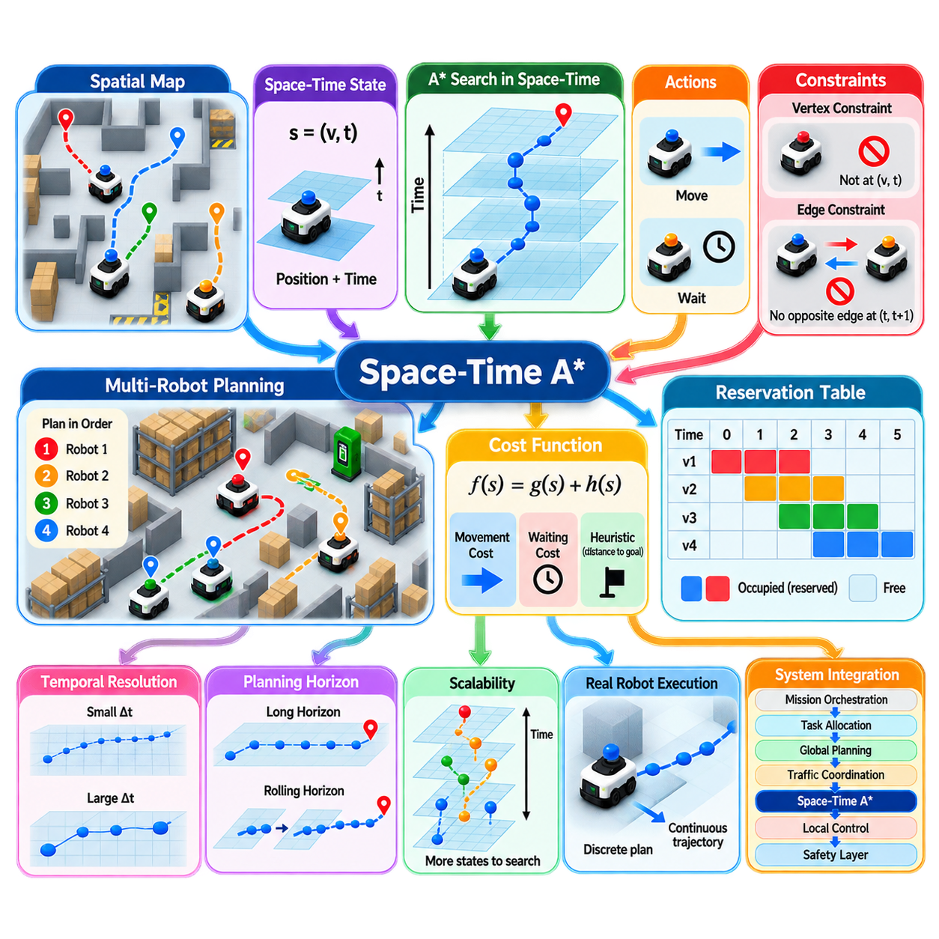
Space-Time A* for Multi-Robot Navigation extends conventional A* search by incorporating time directly into the navigation state. Instead of representing a state only as a spatial position, the planner represents it as a position-time pair, such as (x, y, t). This allows the planner to determine not only where a robot should move, but also when it should occupy each location. Such temporal reasoning is essential when several robots share corridors, intersections, docking areas, or other constrained spaces.
In conventional A* planning, the primary objective is to find a low-cost path from a start position to a goal position while avoiding static obstacles. This representation is insufficient for multi-robot navigation because another robot can occupy the same location at a different time without creating a collision. Space-Time A* therefore expands the search domain from a two-dimensional or three-dimensional spatial graph into a space-time graph. Each transition represents both a spatial movement and a corresponding change in time.
A typical Space-Time A* state can be expressed as s = (v, t), where v represents a spatial node and t represents the associated time step. From this state, the robot may move to a neighboring node or remain at the current node for one or more time steps. The waiting action is particularly important because many multi-robot conflicts can be resolved simply by delaying a robot rather than forcing it to take a long alternative route. The planner therefore treats temporal waiting as an explicit navigation decision.
Collision avoidance is implemented by representing the predicted occupancy of other robots as space-time constraints. If another robot is expected to occupy node v at time t, the current robot cannot enter v at that same time. Edge conflicts must also be considered when two robots attempt to traverse the same connection in opposite directions during the same interval. A valid Space-Time A* planner therefore evaluates both vertex occupancy and edge traversal constraints when expanding candidate states.
The cost function combines movement cost, waiting cost, and heuristic estimates of the remaining distance to the goal. A typical formulation can be written as f(s) = g(s) + h(s), where g represents the accumulated cost from the start and h estimates the remaining cost. The heuristic can often use the shortest spatial distance to the goal while ignoring other robots. When the heuristic remains admissible, A* can preserve optimality with respect to the defined discrete planning model.
Temporal planning creates an important tradeoff between search-space size and planning accuracy. If the planner uses a very small time step, it can represent motion more precisely but must search through many more states. A larger time step reduces computational requirements but may miss important timing relationships or produce trajectories that are difficult to execute physically. Practical systems therefore select the temporal resolution according to robot speed, control frequency, map resolution, safety distance, and expected traffic density.
The planning horizon is another important design parameter. A long horizon provides more information about future conflicts and can generate globally consistent paths, but it increases memory and computational requirements. A short horizon supports rapid replanning and adapts well to dynamic environments, but decisions made near the current robot state may create conflicts later. Rolling-horizon Space-Time A* addresses this problem by repeatedly planning a limited future interval and updating the solution as new robot states and environmental information become available.
Space-Time A* becomes particularly useful when combined with reservations. A reservation table records which locations or edges are expected to be occupied during specific time intervals. The planner consults this table while expanding states and rejects transitions that violate existing reservations. Reservations can originate from previously planned robot trajectories, fleet-level traffic management, intersection scheduling, charging operations, elevator access, or other shared-resource mechanisms.
The order in which robots generate their space-time paths can strongly influence the final result. A sequential planner may first create a path for one robot and then treat that path as a reservation when planning the next robot. This approach is computationally attractive because each search remains a single-robot problem, but it can suffer from poor priority ordering. A robot planned later may be forced to wait or take a significant detour even though a different planning order could have produced a more efficient fleet solution.
Space-Time A* can also operate as the low-level planner within more advanced multi-robot algorithms. In Conflict-Based Search, for example, the high-level Conflict Tree identifies conflicts and introduces constraints, while Space-Time A* can replan the affected robot under those constraints. This separation is powerful because the high-level algorithm reasons about fleet-level conflicts while the low-level planner remains responsible for generating physically and temporally consistent individual paths.
For real robots, a discrete Space-Time A* solution must eventually be converted into a continuous trajectory. The discrete plan may specify that a robot occupies a sequence of graph nodes at particular time steps, but the physical controller must execute corresponding velocities, accelerations, turns, and stopping behavior. Robot dimensions, localization uncertainty, braking distance, control latency, and dynamic obstacles therefore require safety margins around the nominal space-time plan. The planning layer should not be treated as a replacement for independent collision detection and safety control.
The method is especially effective in structured environments where navigation can be represented as a graph. Warehouses, factories, hospitals, airports, and logistics facilities often contain predictable corridors, intersections, doors, elevators, charging stations, and docking locations. These structures can be represented as spatial nodes and edges, while temporal occupancy determines when each resource can be used. Space-Time A* therefore provides a natural bridge between geometric path planning and traffic scheduling.
Scalability remains a major challenge because adding the temporal dimension significantly increases the number of searchable states. A spatial node that could previously be represented once may now need to be considered at many different time steps. Large fleets further increase the number of occupancy constraints that must be checked. Practical implementations therefore use bounded planning horizons, efficient heuristics, hierarchical maps, conflict-focused replanning, reservation compression, and regional decomposition to control computational complexity.
A robust implementation should also account for uncertainty in predicted robot trajectories. A reservation generated several seconds earlier may become inaccurate if a robot slows down, encounters an obstacle, loses localization accuracy, or experiences communication delay. Instead of treating reservations as permanently fixed, the system can associate uncertainty margins and validity intervals with them. Runtime monitoring can then compare predicted and actual states and trigger replanning when deviations exceed predefined thresholds.
Space-Time A* can be integrated into a broader fleet navigation architecture as a tactical trajectory-planning component. Mission orchestration determines the operational objective, task allocation determines which robot performs each task, global planning establishes broad routes, and traffic coordination manages shared resources. Space-Time A* then generates time-consistent local or regional paths that respect the resulting constraints, while a local controller executes the trajectory and an independent safety layer supervises physical motion.
The principal value of Space-Time A* is that it transforms multi-robot navigation from a purely spatial problem into a space-time coordination problem. Two robots do not necessarily need different routes when they can safely use the same route at different times. By explicitly representing waiting, temporal occupancy, edge traversal, reservations, and future conflicts, Space-Time A* provides a practical foundation for coordinated fleet navigation. Its effectiveness ultimately depends on appropriate temporal resolution, search horizon, heuristic design, reservation management, and integration with higher-level fleet intelligence and lower-level safety control.

07.05. Deadlock Detection and Resolution in Fleet [w/Code]
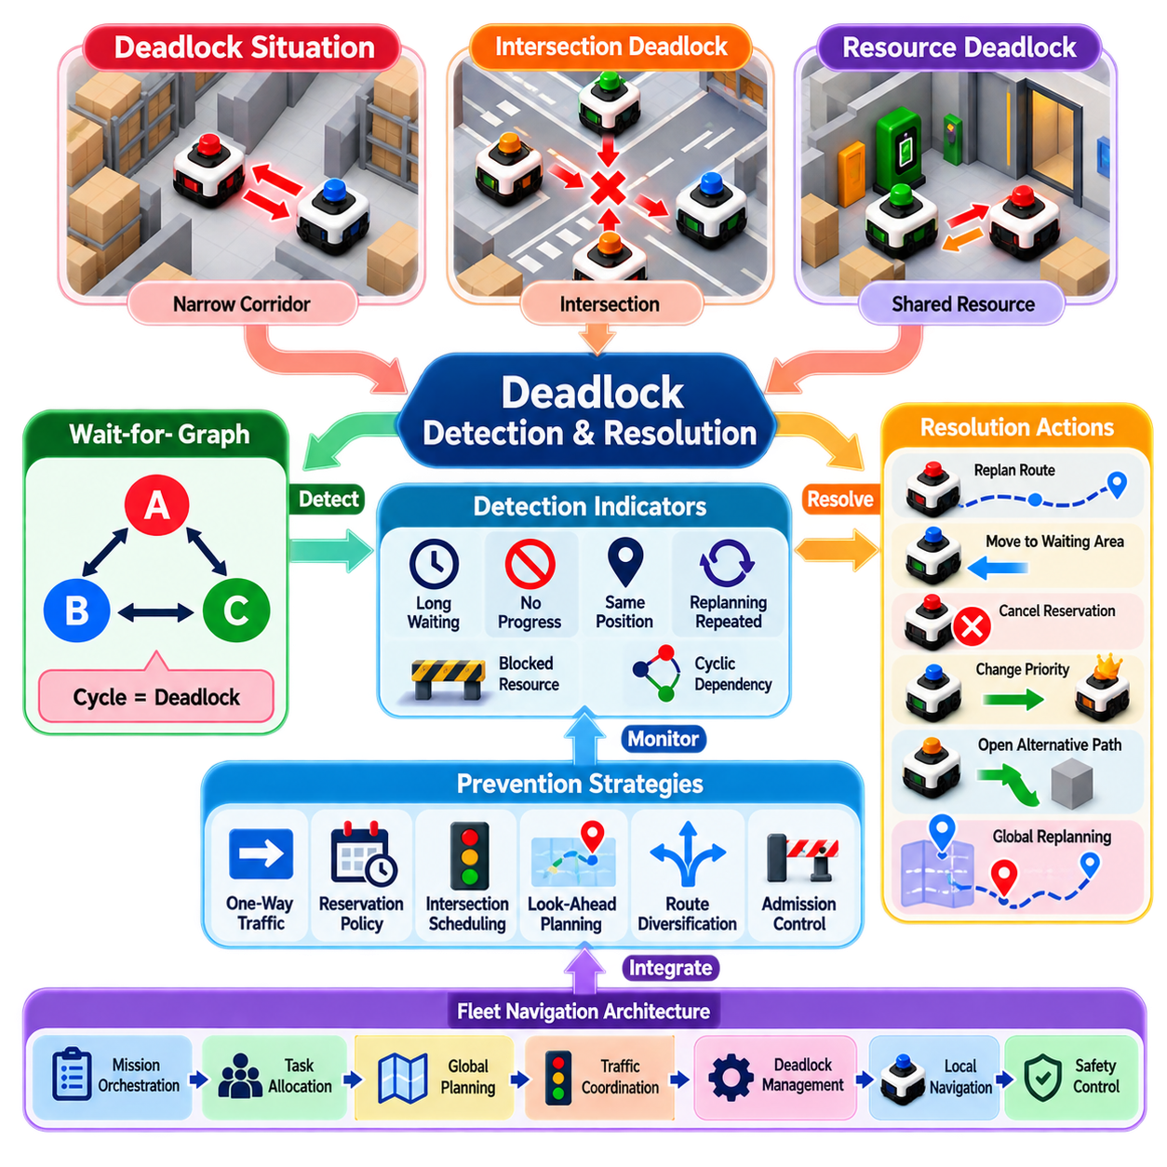
Deadlock in a robot fleet occurs when two or more robots remain operational and collision-free but cannot make meaningful progress because their movements mutually prevent one another. Unlike a direct collision, a deadlock can persist indefinitely without any physical contact. Typical situations include robots facing each other in a narrow corridor, multiple robots waiting at an intersection, or vehicles blocking one another around a shared resource. Deadlock detection and resolution are therefore essential components of reliable fleet navigation.
Deadlock can be understood as a dependency problem among robots. Robot A may be waiting for a passage currently occupied by robot B, while B is waiting for a region controlled by robot C, and C may be waiting for A. Each robot is individually following its navigation rules, yet the combined system has entered a circular dependency. This means that collision avoidance alone is insufficient. A fleet navigation system must also reason about progress, waiting relationships, resource dependencies, and whether the current traffic state can eventually resolve itself.
One of the most useful representations for deadlock analysis is the Wait-for Graph (WFG). Each robot is represented as a node, and a directed edge from robot A to robot B indicates that A is waiting for B to release a required resource or spatial region. If the graph contains a directed cycle, such as A waiting for B, B waiting for C, and C waiting for A, the system has a strong indication of circular deadlock. The graph can be continuously updated as reservations, trajectories, and robot states change.
Not every long waiting period represents a deadlock. A robot may legitimately wait for another robot to clear an intersection, for a door to open, or for a higher-priority vehicle to pass. Deadlock detection must therefore distinguish normal temporary waiting from persistent lack of progress. Useful indicators include waiting duration, repeated failure to advance, unchanged robot position, blocked-resource persistence, cyclic dependencies, and repeated replanning without measurable improvement.
Time thresholds provide a simple mechanism for detecting suspicious behavior. If a robot remains below a defined progress threshold for longer than an expected interval, the fleet manager can mark it as potentially blocked. However, a fixed timeout is insufficient for all environments because expected waiting time differs between a small warehouse intersection and a congested production facility. More robust systems combine timeouts with spatial dependency information, traffic density, task urgency, and historical movement patterns.
Deadlocks can occur at several levels of fleet operation. A local deadlock may involve two or three robots around a single corridor or intersection, while a regional deadlock may involve many robots and multiple connected resources. A system-wide deadlock can occur when congestion propagates across several zones and prevents meaningful fleet progress. The detection architecture should therefore support multiple spatial scales rather than assuming that every deadlock can be solved by modifying one robot's local trajectory.
Resource reservation is a major source of deadlock. A robot may reserve a downstream region before entering a narrow passage, while another robot simultaneously reserves the passage required by the first robot. If both robots retain their reservations while waiting, neither can proceed. This is sometimes described as a hold-and-wait condition. Preventing such situations requires reservation policies that consider not only the resource currently occupied but also the resources that a robot will need to complete its planned movement.
Priority-based navigation can also create deadlocks when priorities are applied too rigidly. A high-priority robot may receive continuous access to shared resources while lower-priority robots accumulate behind it. Conversely, poorly designed dynamic reprioritization can cause priorities to change repeatedly and prevent stable traffic flow. A practical system should therefore allow temporary priority escalation for blocked robots while preventing uncontrolled priority oscillation.
Deadlock resolution begins by identifying which dependency or reservation is preventing progress. The fleet manager can then select one or more robots whose plans should be modified. Possible actions include replanning a route, reversing to a safe waiting position, cancelling a reservation, changing right-of-way, delaying another robot, opening an alternative corridor, or temporarily removing a robot from the congested region. The selected intervention should minimize disruption while restoring a path toward measurable fleet progress.
Local recovery is usually preferable when the deadlock is spatially limited. If two robots meet in a narrow corridor, one robot may be instructed to retreat to a predefined passing area while the other continues. If several robots compete for an intersection, the system may cancel lower-value reservations and establish a new sequence. Local recovery avoids unnecessarily replanning the entire fleet and reduces computational cost, communication load, and operational disruption.
More complex deadlocks may require global intervention. When congestion propagates across several zones, changing one robot's path may simply move the problem to another location. A higher-level planner can then reconsider task allocation, global routes, resource reservations, or robot priorities. Conflict-Based Search, optimization-based planning, or centralized fleet replanning can be invoked selectively when simpler recovery mechanisms cannot restore progress.
Safety must remain independent of deadlock resolution. A recovery action should never instruct a robot to violate collision constraints, enter a forbidden area, exceed its physical limits, or ignore human presence merely to release traffic. The robot must continue to enforce local obstacle detection, emergency stopping, speed restrictions, and minimum separation requirements. Deadlock recovery is therefore an operational coordination function that operates within the boundaries established by the independent safety layer.
Deadlock prevention is often more efficient than repeated deadlock recovery. Systems can reduce the probability of deadlock by using one-way traffic rules, corridor reservations, intersection scheduling, look-ahead planning, limited resource holding, route diversification, and admission control. Before a robot enters a constrained region, the planner can verify whether sufficient downstream space exists for the robot to complete the movement. This prevents a robot from entering a region where it can become permanently blocked.
For large fleets, deadlock management should be integrated with mission orchestration and fleet-level intelligence. A repeated deadlock at the same location may indicate an architectural problem rather than an isolated navigation failure. The system can analyze historical deadlock events to identify problematic intersections, insufficient waiting areas, poor route assignments, excessive task concentration, or inefficient reservation policies. These observations can then be used to improve maps, traffic rules, scheduling policies, and task allocation.
In a Physical AI fleet architecture, deadlock detection and resolution can be positioned between traffic coordination and local navigation. Mission orchestration defines operational objectives, task allocation assigns responsibilities, global planning establishes routes, and traffic coordination manages shared resources. Deadlock monitoring continuously evaluates progress and dependencies, while local planners execute recovery actions when required. If local recovery fails, the problem can be escalated to a higher-level planner for broader replanning.
The ultimate objective of deadlock management is not simply to detect that robots have stopped moving. A robust fleet system should recognize emerging dependency cycles, distinguish legitimate waiting from pathological blocking, select the smallest effective intervention, and verify that progress has actually been restored. By combining Wait-for Graph analysis, temporal monitoring, reservation management, priority control, local recovery, and selective global replanning, deadlock handling becomes an integral part of fleet intelligence rather than an emergency function added after navigation has already failed.

07.06. Traffic Management Rules for Robot Intersections [w/Code]
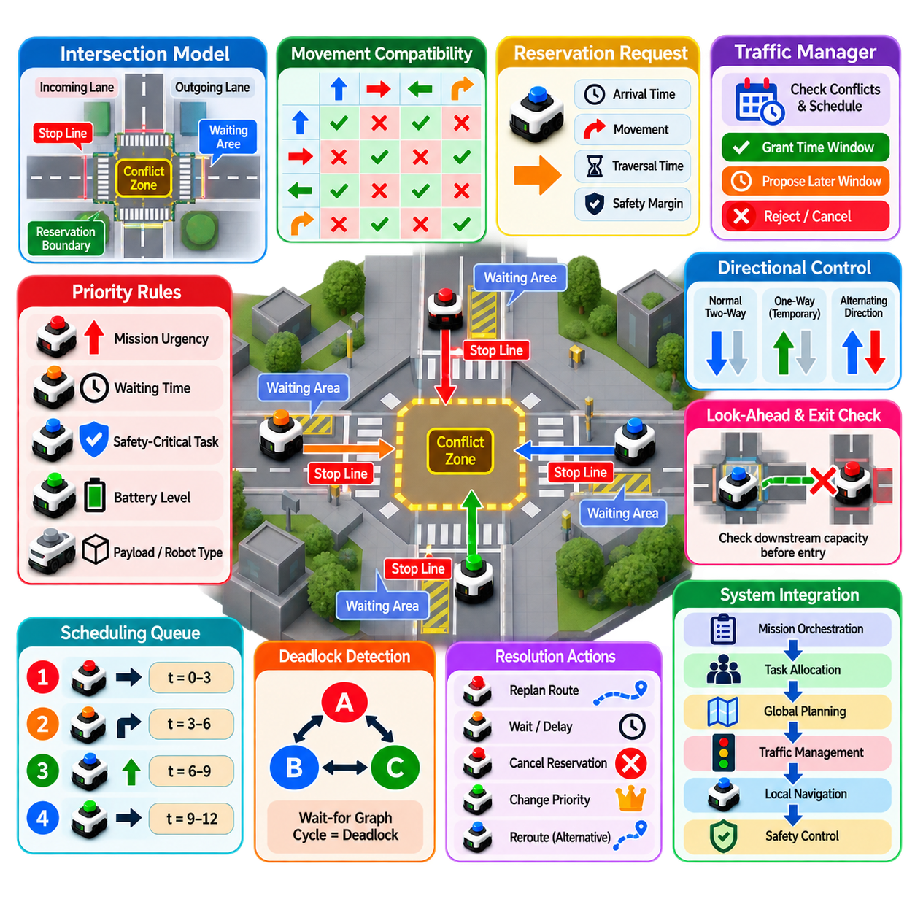
Traffic management at robot intersections is a core component of multi-robot fleet navigation because intersections concentrate multiple trajectories into a limited spatial region. Even when every robot has an individually valid path, simultaneous arrival at the same intersection can create collisions, excessive waiting, or deadlock. An effective traffic management system therefore treats an intersection as a shared operational resource and coordinates access according to spatial occupancy, arrival time, priority, vehicle capability, and safety constraints.
A robot intersection can be represented as a structured resource within a navigation graph. Incoming lanes, outgoing lanes, conflict zones, stop lines, waiting areas, and reservation boundaries are explicitly modeled so that the fleet manager can determine how robots enter and leave the intersection. This representation transforms an apparently continuous navigation problem into a combination of route selection, resource allocation, temporal scheduling, and local trajectory execution. The intersection model should also represent turning movements because different movement combinations can create different conflict patterns.
The fundamental rule is that only compatible robot movements should occupy a conflict zone simultaneously. Two robots traveling through an intersection may be able to proceed at the same time if their trajectories do not intersect, while two crossing trajectories generally require temporal separation. The traffic manager can therefore maintain a conflict matrix describing which movement pairs are compatible. This matrix provides a lightweight foundation for deciding whether a newly arriving robot can enter the intersection or must wait outside the protected region.
Reservation-based intersection management is one practical implementation. A robot requests access to an intersection by providing its estimated arrival time, intended movement, expected traversal duration, and relevant safety margin. The traffic manager evaluates the request against existing reservations and either grants an available time window or proposes a later window. Once granted, the robot receives permission to enter the conflict zone only when the required conditions remain valid. Reservations should have expiration and cancellation rules so that stale plans do not permanently block the intersection.
Priority rules determine which robot receives access when multiple requests compete for the same time window. Priority can depend on mission urgency, waiting time, safety-critical tasks, payload requirements, battery state, operating zone, or predefined service policies. However, priority should not be interpreted as permission to violate safety constraints. A high-priority robot may receive earlier access, but it must still satisfy collision avoidance, speed limitations, stopping distance, and other physical safety requirements.
Fairness is important because a purely priority-driven system can repeatedly favor the same robots. If priority is determined only by mission urgency, lower-priority robots may accumulate waiting time and eventually experience starvation. Waiting time can therefore be incorporated into dynamic priority calculation. A robot that has waited beyond a defined threshold can receive temporary priority escalation, allowing it to pass through the intersection before another cycle of higher-priority requests is processed.
Stop-line management provides a physical boundary between route planning and intersection access. Robots approaching an intersection should not enter the conflict zone merely because their local planner has generated a collision-free trajectory. Instead, the robot should stop at a designated waiting position when access has not been granted. Once authorization is received, the local planner generates a trajectory through the reserved region. This separation makes traffic behavior more predictable and prevents robots from occupying intersection space without a coordinated exit plan.
Look-ahead planning is particularly important for avoiding intersection deadlocks. Before granting access, the traffic manager should determine whether the robot can actually leave the intersection after entering it. A robot should not be authorized to enter a conflict zone when its downstream lane is already blocked by another robot. Otherwise, the robot may stop inside the intersection and prevent other vehicles from moving, creating a gridlock condition. Intersection admission should therefore consider downstream capacity as well as immediate availability.
Traffic rules can also include directional control. One-way movement may be temporarily established during periods of high traffic to simplify coordination and increase throughput. Alternating directions can be used in narrow shared corridors, while dedicated turning windows can separate incompatible movement patterns. These rules reduce the number of simultaneous conflicts that the planner must resolve and can be especially useful in structured warehouses, factories, hospitals, and logistics facilities where traffic patterns are relatively predictable.
For dense fleets, intersection management can use scheduling instead of purely reactive collision avoidance. The manager maintains a queue of upcoming requests and determines an access sequence that balances throughput, waiting time, priority, and fairness. A scheduling horizon can cover the next several seconds or several planned arrivals. The schedule should remain flexible because actual robot arrival times can differ from predictions. Continuous updates allow the system to preserve the overall traffic structure without requiring complete replanning whenever a robot experiences a small delay.
Communication between robots and the traffic manager is essential for reservation-based control. Robots should provide their current state, intended movement, estimated arrival time, and reservation status, while the traffic manager should communicate authorization, updated timing, cancellation, or rerouting instructions. Time synchronization is particularly important when reservations are based on precise temporal windows. Timestamped messages and synchronized clocks reduce ambiguity between planned and actual intersection occupancy.
Communication failure should not result in unsafe behavior. If a robot loses connection while approaching an intersection, it should transition to a predefined safe state, such as stopping before the conflict zone. If a robot loses communication after entering a protected region, the traffic manager and surrounding robots should follow predefined degraded-mode rules. Local perception and safety control must remain active regardless of fleet-level communication because intersection authorization cannot replace independent physical collision prevention.
Intersection management should also account for heterogeneous robots. Different robot types may have different dimensions, speeds, acceleration limits, turning radii, braking distances, and sensor capabilities. A compact AMR may clear an intersection rapidly, while a towing robot or larger outdoor platform may require considerably more space and time. Reservation duration and safety margins should therefore be calculated according to the characteristics of the specific robot rather than using one fixed value for the entire fleet.
The traffic manager can integrate with Space-Time A*, Conflict-Based Search, and Priority-Based Planning. Space-Time A* can generate paths that respect temporal reservations, while Priority-Based Planning can determine which robot should receive access first. Conflict-Based Search can be invoked when local intersection rules cannot resolve a complex interaction. This layered approach avoids using computationally expensive global planning for every ordinary intersection event while retaining the ability to handle difficult traffic configurations.
Deadlock detection is an essential part of intersection management because collision-free traffic can still stop completely. The system can monitor waiting time, unchanged robot positions, reservation dependencies, and wait-for relationships. If robots form a circular dependency or remain blocked beyond an acceptable threshold, the traffic manager can cancel selected reservations, change priorities, request a retreat maneuver, or invoke broader replanning. The recovery mechanism should first attempt the smallest local intervention before escalating to fleet-level replanning.
Performance should be evaluated at both intersection and fleet levels. Useful measures include average waiting time, maximum waiting time, intersection throughput, traversal time, queue length, reservation rejection rate, deadlock frequency, rerouting frequency, and overall fleet mission completion time. High throughput alone is not sufficient because aggressive intersection utilization can increase congestion elsewhere. The objective is to create predictable traffic flow that balances capacity, safety, fairness, and operational efficiency.
In a Physical AI fleet architecture, traffic management can operate as a tactical coordination layer between global planning and local robot control. Mission orchestration defines the operational objective, task allocation determines robot responsibilities, global planning establishes broad routes, and the traffic manager controls access to shared intersection resources. Space-Time A*, priority rules, reservations, and local planners then cooperate to generate executable movements, while independent safety functions continuously supervise physical execution.
The long-term objective of robot intersection management is to make shared-space navigation predictable rather than purely reactive. Instead of allowing every robot to independently negotiate every encounter, the fleet establishes explicit rules for access, reservation, priority, waiting, admission, and recovery. When combined with temporal planning, deadlock management, communication synchronization, and independent safety control, these rules allow intersections to function as coordinated fleet resources and provide a scalable foundation for high-density autonomous robot operations.

07.07. Nav2 Multi Robot Namespace and Fleet Integration [w/Code]
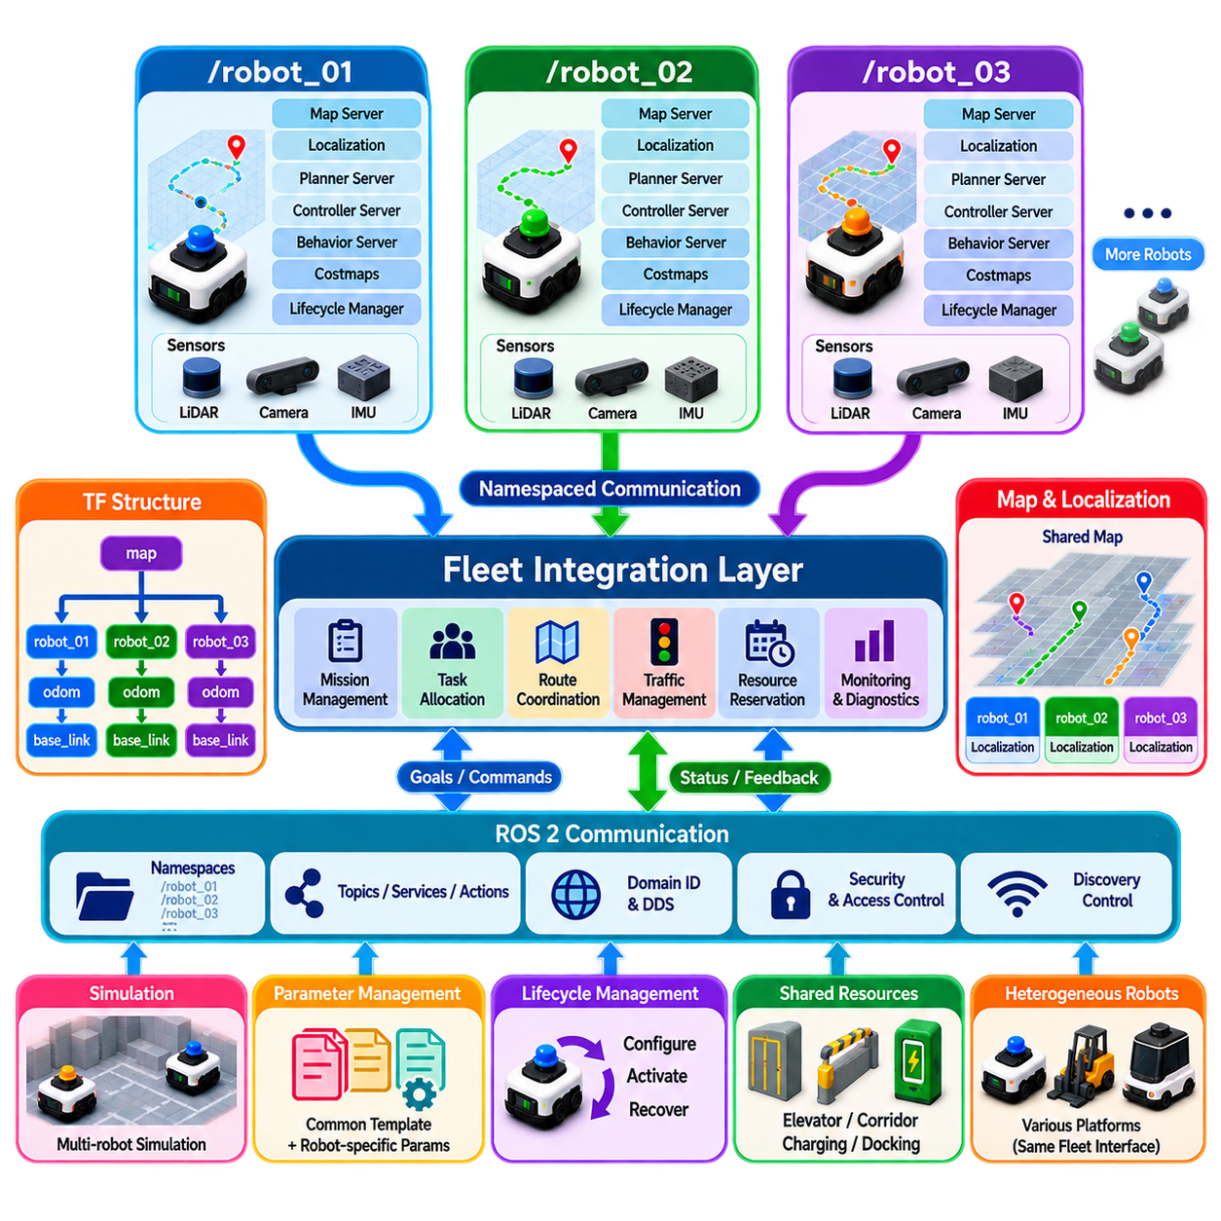
Nav2 Multi-Robot Namespace and Fleet Integration addresses the software architecture required when multiple robots run Navigation2 (Nav2) simultaneously within a shared facility. Each robot needs an independent navigation context while the fleet must still coordinate maps, localization, planning, traffic, missions, and shared resources. The central architectural challenge is therefore to separate robot-local state from fleet-level state without creating duplicated or conflicting system responsibilities. A well-designed namespace architecture provides isolation at the ROS 2 communication layer while allowing controlled interfaces for fleet coordination.
In ROS 2, namespaces provide a fundamental mechanism for separating topics, services, actions, parameters, and node names belonging to different robots. A robot can operate under a namespace such as `/robot_01`, while another operates under `/robot_02`. Nav2 nodes, sensors, localization components, controllers, planners, costmaps, and lifecycle managers can therefore be instantiated independently for each robot. This prevents identical topic names such as `/cmd_vel`, `/scan`, or `/odom` from unintentionally referring to multiple robots at the same time.
A typical multi-robot Nav2 architecture gives every robot its own navigation stack instance. The robot namespace contains components such as the map server, localization system, planner server, controller server, behavior server, waypoint follower, velocity smoother, costmaps, and lifecycle manager. Sensor topics are similarly placed within the robot namespace. This arrangement allows each robot to maintain its own navigation state and local perception while the fleet system communicates with the robot through clearly defined interfaces rather than directly manipulating internal Nav2 components.
The TF architecture requires particular attention because coordinate frames must remain unique and correctly connected. Each robot normally requires its own frame hierarchy, such as `robot_01/base_link`, `robot_01/odom`, and `robot_01/base_footprint`. The global frame may be shared conceptually, but robot-specific transforms must not collide with those of other robots. A carefully designed TF tree allows every robot to localize itself within a common facility map while preserving independent odometry and sensor coordinate systems.
The map and localization architecture can be either shared or partially distributed. A common static map may be provided to all robots because they operate within the same facility, while each robot maintains its own localization estimate relative to that map. In other deployments, different robots may operate in separate zones or use different map layers. The fleet architecture should therefore distinguish between shared environmental information and robot-specific state rather than assuming that every Nav2 component must be centrally shared.
A key design principle is to separate robot-local navigation from fleet-level coordination. Nav2 should remain responsible for local path execution, obstacle avoidance, recovery behaviors, and controller-level navigation decisions. The fleet manager should instead handle mission assignment, robot selection, route coordination, traffic rules, shared-resource reservations, charging schedules, and operational priorities. This boundary prevents fleet logic from becoming tightly coupled to the internal implementation of individual Nav2 stacks.
Multi-robot navigation also requires careful treatment of global planning. If every robot independently plans against the same static map without knowing the intended paths of other robots, the resulting trajectories can conflict at intersections, narrow corridors, docking stations, or shared work areas. A fleet coordination layer can therefore provide route constraints, reservations, temporal restrictions, or priority information to each robot. Nav2 then executes a locally valid path within those fleet-level constraints.
Communication architecture is another important consideration. ROS 2 topics, services, and actions are well suited for robot-local communication, while fleet-level systems may additionally use dedicated coordination interfaces. A fleet manager can publish mission commands and navigation goals into the appropriate robot namespace, while each robot reports status, pose, progress, battery state, navigation state, and faults back to the fleet layer. The interfaces should be explicitly defined so that fleet applications do not depend on undocumented internal Nav2 topics.
The ROS 2 Domain ID and DDS communication configuration also influence multi-robot deployment. Robots operating on the same network may discover one another through DDS, which can be useful for fleet coordination but may also create unnecessary discovery traffic or topic visibility. Namespace separation alone does not automatically create complete communication isolation. Large fleets may therefore use domain segmentation, DDS partitions, topic remapping, access controls, or carefully designed discovery configurations to control which information is visible between robots and fleet services.
Simulation and deployment environments should use the same namespace principles. In simulation, multiple robot models can be spawned with separate namespaces, independent TF trees, sensor streams, and Nav2 instances. This allows the fleet software to be tested with many robots before physical deployment. Maintaining consistency between simulation and real-robot namespace conventions is valuable because it reduces integration differences and allows fleet-level algorithms to be validated under repeatable multi-robot conditions.
Parameter management becomes increasingly important as the number of robots grows. Each robot may share a common Nav2 configuration template while requiring robot-specific parameters for footprint, velocity limits, sensor topics, controller characteristics, and safety constraints. A parameter hierarchy can therefore separate fleet-wide defaults from robot-class parameters and individual robot overrides. This avoids maintaining entirely independent configuration files for every robot while preserving the ability to accommodate heterogeneous platforms.
Lifecycle management must also be coordinated carefully. Nav2 uses lifecycle nodes to control startup, configuration, activation, deactivation, and shutdown. In a fleet deployment, each robot should be able to restart or recover its own navigation stack without unnecessarily affecting other robots. The fleet manager should monitor lifecycle state and distinguish between a robot-local navigation failure and a fleet-level service failure. This separation supports fault containment and allows healthy robots to continue operating while one robot is undergoing recovery.
A fleet integration layer should expose a stable robot abstraction above the individual Nav2 implementations. From the fleet perspective, a robot can be represented through capabilities, current pose, mission state, availability, battery condition, navigation status, and fault state. The underlying robot may use different Nav2 planners, controllers, sensors, or compute platforms without changing the fleet-level interface. This abstraction becomes especially valuable for heterogeneous fleets containing indoor AMRs, towing robots, outdoor platforms, or specialized service robots.
Shared resources require an additional coordination mechanism because Nav2 alone does not provide complete fleet-level traffic management. Elevators, narrow corridors, intersections, docking stations, charging areas, loading zones, and restricted workspaces can be represented as fleet resources. The fleet manager can issue reservations or temporal constraints while the individual Nav2 stack remains responsible for executing the resulting navigation plan. This creates a clear hierarchy between resource coordination and physical trajectory execution.
Multi-robot recovery should also be divided between local and fleet levels. A Nav2 behavior tree can recover from local navigation failures by clearing costmaps, replanning, backing up, waiting, or selecting another recovery behavior. However, if the failure is caused by another robot blocking a shared corridor, the appropriate solution may require fleet-level intervention. The fleet manager can change priorities, cancel a reservation, reroute another robot, or invoke deadlock resolution rather than repeatedly triggering the same local recovery behavior.
For large fleets, namespace design should be combined with observability and operational monitoring. Each robot should expose consistent metrics for navigation state, planner latency, controller status, localization quality, obstacle conditions, communication health, and recovery events. Centralized dashboards and logging systems can aggregate these signals without merging the robots' internal namespaces. This enables fleet-level diagnosis while preserving the independence of each robot's navigation stack.
In a Physical AI fleet architecture, Nav2 should therefore be treated as a robot-level execution layer rather than the complete fleet intelligence system. Mission orchestration determines operational objectives, task allocation assigns responsibilities, fleet planning establishes global routes and priorities, traffic coordination manages shared resources, and each robot's namespaced Nav2 stack performs local planning and execution. This separation creates a scalable interface between collective fleet intelligence and individual robot autonomy.
The resulting architecture provides three complementary properties: isolation, coordination, and interoperability. Namespace isolation prevents robots from interfering with one another at the ROS 2 software level. Fleet coordination allows robots to share routes, resources, priorities, and operational information. Interoperability allows different robot platforms and Nav2 configurations to participate through common fleet interfaces. When these principles are combined with appropriate DDS configuration, TF isolation, lifecycle management, reservation mechanisms, monitoring, and safety controls, Nav2 can serve as a robust execution foundation for large multi-robot fleets.

07.08. Heterogeneous Fleet Navigation AMR Forklift AGV [w/Code]
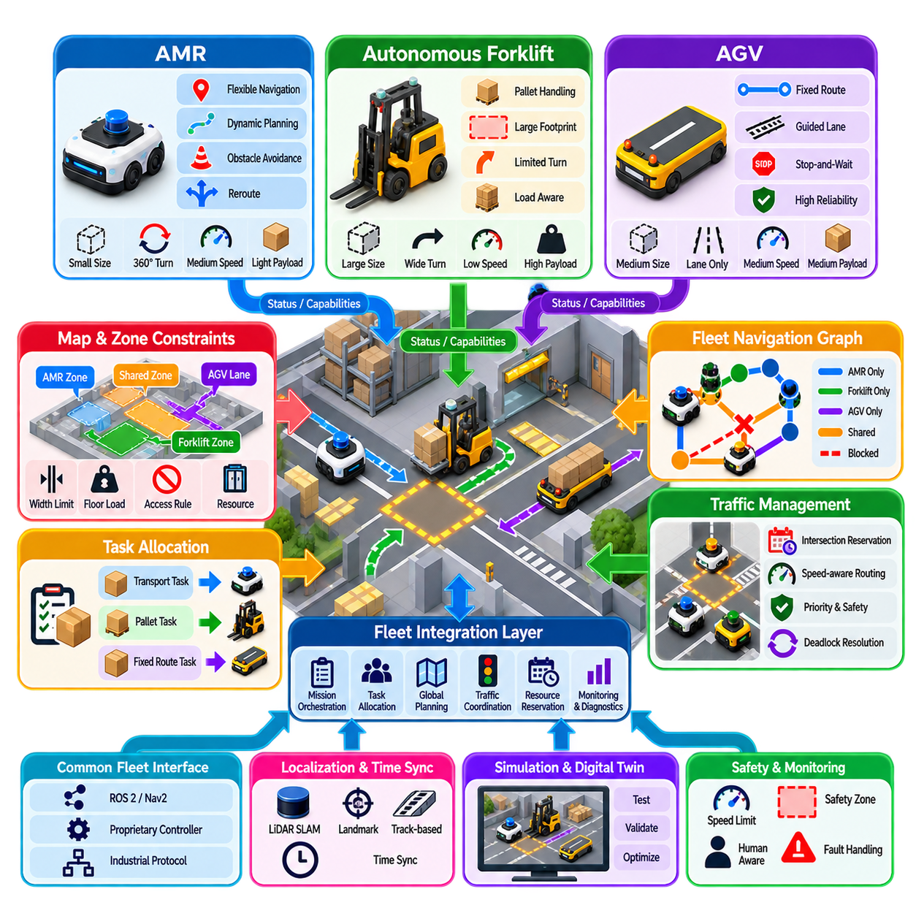
Heterogeneous fleet navigation coordinates multiple robot classes such as Autonomous Mobile Robots (AMRs), autonomous forklifts, and Automated Guided Vehicles (AGVs) within the same operational environment. Unlike homogeneous fleets, these platforms differ in dimensions, kinematics, sensing, payload, speed, turning behavior, and autonomy. The navigation architecture must therefore coordinate shared traffic without assuming that every vehicle can follow the same route or execute the same maneuver.
An AMR typically provides flexible navigation based on localization, mapping, obstacle detection, and dynamic path planning. It can often reroute around temporary obstacles and adapt its trajectory according to local conditions. An AGV may instead depend more strongly on predefined lanes, magnetic or visual guidance, virtual tracks, or fixed route networks. An autonomous forklift adds another level of complexity because its footprint, load geometry, steering characteristics, and material-handling operations directly influence navigation.
A common fleet representation should describe each robot through capabilities rather than treating platform identity as the primary planning variable. Relevant capabilities include maximum velocity, acceleration, minimum turning radius, footprint, payload capacity, allowed zones, localization method, docking capability, reverse-motion capability, and supported tasks. The fleet manager can then determine whether a robot is physically and operationally suitable for a requested route, resource, or mission before assigning navigation responsibilities.
Footprint differences are particularly important in heterogeneous traffic. A compact AMR may safely pass through a narrow corridor that cannot accommodate a loaded forklift, while an AGV may require a predefined lane with fixed clearance. The planner should therefore associate each navigation edge and operational zone with geometric constraints. Route feasibility becomes dependent on both map connectivity and vehicle geometry rather than assuming that every graph edge is universally traversable.
Kinematic constraints further differentiate navigation behavior. Differential-drive AMRs can often rotate in place, whereas Ackermann-steered vehicles and many forklifts require additional space to change direction. Some platforms can reverse efficiently, while others should minimize reverse travel because of sensing or operational restrictions. Fleet-level route planning should therefore use robot-specific motion models when estimating route feasibility, traversal time, intersection occupancy, and maneuvering requirements.
Forklift navigation requires special consideration because the vehicle configuration changes when carrying a load. A pallet can alter the effective footprint, visibility, stopping distance, center of mass, and maneuvering clearance. Raised forks may introduce additional operational restrictions, while different load dimensions can affect route eligibility. The fleet system should therefore treat vehicle state and payload state as part of the navigation context rather than relying only on the unloaded vehicle model.
Traffic coordination must account for different speeds and acceleration profiles. A fast AMR following a slower AGV through a narrow lane may be unable to overtake safely, producing queues even when no geometric conflict exists. The traffic manager can reduce such effects through lane assignment, speed-aware routing, passing zones, temporal reservations, or route diversification. Estimated traversal time should therefore reflect robot-specific dynamics rather than using a uniform edge cost for every platform.
Shared intersections become more complex when different vehicle classes require different occupancy times and safety margins. A small AMR may clear an intersection quickly, whereas a loaded forklift may require a wider turning envelope and longer reservation window. Intersection management should calculate reservations according to the expected swept volume, approach speed, turning motion, braking capability, and downstream clearance of each vehicle. Priority alone is insufficient when physical compatibility differs.
A heterogeneous navigation graph can represent platform-specific access rules directly. An edge may be available to AMRs but prohibited for forklifts because of width or floor-loading restrictions. Another route may be reserved for AGVs because it contains dedicated guidance infrastructure. Elevators, ramps, automatic doors, loading bays, and docking stations can similarly include capability requirements. Route planning then becomes a constrained graph search based on both topology and robot attributes.
Task allocation and navigation should be tightly connected because the best robot for a task depends partly on route feasibility. A forklift may have the required payload capability but be unable to reach a destination through the available route. A smaller AMR may reach the location but lack the required handling capacity. The fleet system should therefore evaluate task capability and navigation accessibility together before committing a mission to a specific robot.
A common fleet interface is essential when individual platforms use different navigation software. AMRs may use ROS 2 and Nav2, while an AGV or forklift may expose a proprietary controller or industrial protocol. The fleet integration layer should normalize commands and status into common concepts such as mission, goal, route, pose, velocity, availability, battery state, fault state, and task progress. Platform-specific adapters can translate these abstractions into native robot interfaces.
Localization differences must also be accommodated. One robot may use LiDAR SLAM, another may use reflectors or landmarks, while an AGV may obtain position from track-based infrastructure. The fleet system does not necessarily need identical localization technology across all platforms, but it requires a consistent spatial reference. Robot poses should therefore be transformed into a common facility coordinate system with sufficient accuracy and timing consistency for fleet-level traffic coordination.
Time synchronization becomes increasingly important when heterogeneous vehicles participate in reservation-based navigation. Estimated arrival times, intersection reservations, trajectory predictions, and event logs depend on consistent timestamps. Networked robots and infrastructure should therefore maintain a coherent time reference where required by the coordination architecture. Uncertain or delayed state information should be identified so that the traffic manager does not treat stale vehicle positions as reliable planning inputs.
Safety responsibilities must remain clearly separated from fleet optimization. The fleet manager may determine route access, right-of-way, priority, and reservations, but each platform must enforce its own applicable protective functions and physical operating limits. A fleet command should never require a forklift, AMR, or AGV to exceed its safe speed, violate protective separation, or execute an unsupported maneuver merely to improve throughput. Fleet intelligence coordinates operation within platform safety boundaries.
Deadlock handling must consider vehicle capabilities when selecting a recovery action. Asking a compact AMR to reverse into a nearby waiting area may be simple, while the same maneuver may be impossible for a loaded forklift. Recovery planning should therefore evaluate available clearance, reverse capability, turning requirements, payload condition, and alternative routes before selecting which robot should yield. Capability-aware recovery can prevent a traffic conflict from becoming a physically impossible instruction.
Dynamic obstacles and human interaction further increase heterogeneity. An AMR may possess sophisticated local perception and navigate around people, while a legacy AGV may depend on more conservative stop-and-wait behavior. The fleet manager should not assume identical obstacle-handling performance. Instead, route policies and traffic rules can reflect autonomy level, sensor capability, operating zone, and expected human density while local safety systems continue to control immediate physical responses.
Simulation and digital twins are particularly valuable for heterogeneous fleet integration because many conflicts arise from combinations of vehicle geometry and behavior that are difficult to predict analytically. Representative AMR, forklift, and AGV models can be tested in shared intersections, narrow corridors, loading areas, and peak traffic conditions. Simulation can reveal unsuitable route rules, insufficient waiting areas, unrealistic reservation durations, and throughput bottlenecks before deployment.
Fleet performance should be evaluated by robot class as well as across the entire system. Useful measures include mission completion time, travel distance, waiting time, intersection delay, route utilization, congestion, energy consumption, deadlock frequency, and task throughput. Class-specific analysis is important because an optimization that improves average fleet performance may disproportionately delay forklifts, overload particular AMR routes, or create inefficient operating patterns for AGVs.
For large deployments, hierarchical coordination can separate facility-wide planning from zone-level traffic management and robot-local execution. The fleet layer assigns missions and major routes, regional coordinators manage intersections and constrained resources, and each robot executes motion according to its platform-specific navigation stack. This hierarchy allows heterogeneous vehicles to share a common operational system without forcing every robot to use identical planning algorithms, sensors, or controllers.
In a Physical AI fleet architecture, heterogeneous navigation should therefore be organized around common semantic capabilities and shared operational constraints. Mission orchestration defines objectives, task allocation matches work with platform capability, fleet planning selects feasible routes, traffic management coordinates shared resources, and platform adapters translate fleet intent into robot-specific execution. Local navigation and independent safety functions remain responsible for physical motion on each platform.
The central objective is not to make AMRs, forklifts, and AGVs behave identically, but to make their differences explicit and manageable. A scalable heterogeneous fleet system preserves platform-specific strengths while providing common abstractions for missions, capabilities, routes, resources, traffic, status, and recovery. By combining capability-aware planning, vehicle-specific constraints, common spatial references, standardized fleet interfaces, and independent safety enforcement, diverse robots can operate as one coordinated fleet without sacrificing their individual navigation characteristics.

07.09. Multi Robot Navigation Scalability Analysis
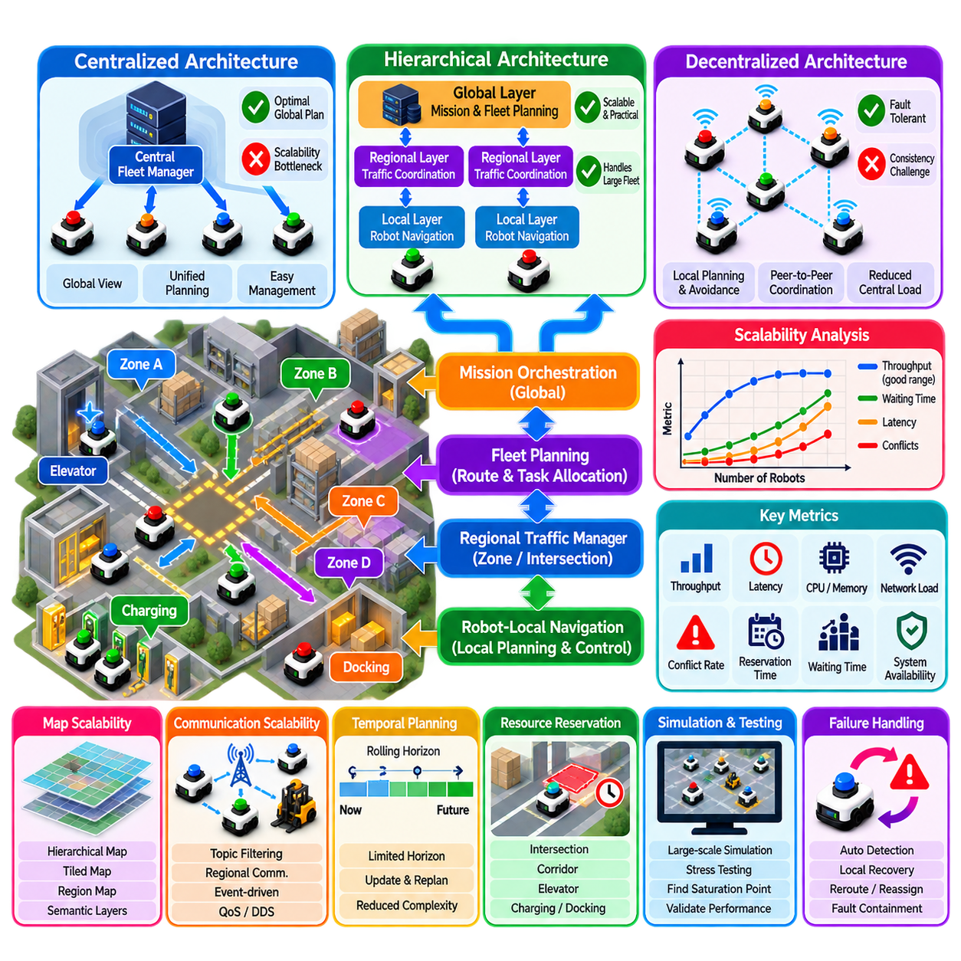
Multi-robot navigation scalability describes how effectively a fleet navigation architecture maintains planning quality, responsiveness, safety, and operational throughput as the number of robots increases. Scalability is not determined only by computational speed. Communication traffic, map complexity, conflict frequency, resource contention, localization updates, monitoring load, and recovery operations can all become limiting factors as a system grows from a few robots to tens, hundreds, or potentially thousands of mobile platforms.
The computational challenge originates from interaction complexity. If every robot must explicitly consider every other robot, the number of possible relationships grows rapidly with fleet size. Joint-state planning becomes especially difficult because the search space combines the possible states of all robots. Exact multi-agent planning algorithms can provide high-quality solutions for moderate problems, but direct global optimization becomes impractical when dense fleets operate across large environments with frequent conflicts and dynamic changes.
Conflict density is often more important than robot count alone. One hundred robots distributed across independent zones may be easier to coordinate than twenty robots competing for several narrow corridors. Scalability analysis should therefore measure spatial concentration, route overlap, intersection demand, shared-resource utilization, and temporal concurrency. The effective complexity of a fleet depends on how frequently robot trajectories interact rather than simply on the total number of registered robots.
Centralized architectures provide a convenient baseline for scalability analysis. A central fleet manager can maintain global robot states, assign missions, coordinate routes, and optimize shared resources using a unified view of the facility. This architecture simplifies global reasoning but creates increasing computational, communication, and availability requirements as the fleet expands. The central service can become a bottleneck if every pose update, planning request, reservation, and recovery event must be processed through the same coordination point.
Decentralized navigation distributes decision-making among robots or regional coordinators. Each robot can perform local planning and obstacle avoidance while exchanging only information required for coordination. This reduces dependence on a single global planner and can improve fault tolerance. However, decentralized architectures introduce challenges in consistency, negotiation, distributed deadlock detection, synchronization, and global optimization. Scalability therefore requires balancing centralized intelligence with distributed execution rather than selecting one extreme universally.
Hierarchical coordination provides one of the most practical approaches for large fleets. Facility-wide planning can determine missions and major routes, regional coordinators can manage traffic within zones, and robot-local planners can execute short-horizon trajectories. This decomposition reduces the number of robots considered by each planning problem. Interactions are handled at the lowest architectural level capable of resolving them, while difficult or cross-regional conflicts can be escalated to higher levels.
Spatial decomposition can divide a facility into regions based on topology, traffic patterns, operational functions, or computational boundaries. Robots operating within one region primarily interact with the corresponding regional planner. Boundary transitions are coordinated through gateways or shared resources. Proper decomposition reduces planning complexity, but poorly selected boundaries can simply move congestion to region interfaces. Scalability analysis should therefore include inter-region traffic and boundary contention.
Temporal decomposition provides another mechanism for limiting complexity. Instead of planning complete trajectories from current positions to distant goals, robots can use rolling-horizon planning over a limited future interval. Only interactions expected within the active horizon require detailed coordination. As robots move and new information becomes available, the horizon advances and plans are updated. This reduces state-space size while preserving responsiveness to dynamic traffic conditions.
Reservation systems can scale efficiently when shared resources are explicitly represented. Rather than comparing every trajectory against every other trajectory, robots reserve intersections, corridors, elevators, charging stations, or docking areas for specific time windows. Conflict detection can then focus on competing reservations. Efficient indexing of spatial and temporal reservations is important because a poorly implemented reservation database can itself become a bottleneck as fleet activity increases.
Planning algorithm selection has a major impact on scalability. Priority-Based Planning and reservation-based methods are computationally lightweight but may produce suboptimal solutions or fail under difficult interactions. Conflict-Based Search can provide stronger solution quality but may experience rapid search-tree growth in dense environments. Optimization-based methods can coordinate complex traffic but may require substantial computation. Practical systems therefore often combine several planners and escalate only difficult cases to expensive algorithms.
Communication scalability must be evaluated independently from planning scalability. A fleet of hundreds of robots can generate large volumes of pose updates, sensor summaries, mission states, reservation messages, diagnostics, and event logs. Broadcasting all information to every robot is rarely necessary. Topic filtering, regional communication, event-driven updates, state aggregation, quality-of-service policies, and carefully selected update frequencies can reduce network load without sacrificing coordination quality.
ROS 2 and DDS deployments require particular attention to discovery and message distribution as fleet size grows. Large numbers of nodes, topics, publishers, and subscribers can increase discovery traffic and middleware overhead even when application-level planning remains efficient. Namespace design alone does not eliminate this issue. Domain segmentation, discovery servers, communication gateways, selective subscriptions, and controlled data interfaces can reduce unnecessary connectivity between unrelated robot subsystems.
Map scalability also affects navigation performance. Large facilities can contain millions of grid cells, extensive semantic information, multiple floors, and numerous dynamic zones. Providing every robot with every map layer at maximum resolution may be unnecessary. Hierarchical maps, tiled maps, local costmaps, graph abstractions, and region-specific semantic layers can reduce memory and update traffic. Robots should receive the spatial information required for their current mission and operational region.
Fleet state management must distinguish between high-frequency control data and lower-frequency operational information. Local velocity control and obstacle avoidance should remain close to the robot, while fleet-level systems generally require poses, route progress, resource status, and mission events at lower rates. Sending control-frequency information to the fleet manager creates unnecessary network and processing load. A scalable architecture therefore assigns each data stream to the architectural layer that actually requires it.
Traffic throughput does not increase linearly with robot count. Beyond a certain density, additional robots can reduce total productivity because congestion, waiting, and interference increase faster than useful transport capacity. Scalability analysis should identify this saturation point for each facility or zone. Metrics such as throughput per robot, average waiting time, congestion ratio, intersection utilization, and mission completion time can reveal when adding robots no longer improves operational output.
Charging infrastructure introduces another scalability constraint. As fleet size increases, simultaneous charging demand, queue formation, charger availability, and battery scheduling become significant operational problems. Navigation scalability therefore includes the ability to coordinate routes to charging stations without creating new congestion. Fleet planning can distribute charging across time and location while maintaining sufficient active robots to satisfy mission demand.
Failure handling must also scale. In a small fleet, a central operator may manually resolve unusual navigation failures. In a large fleet, repeated human intervention becomes impractical. Automated fault classification, local recovery, deadlock detection, reservation cancellation, rerouting, and selective mission reassignment are required. Failures should be contained so that one robot or regional planner does not cause fleet-wide replanning unless the operational impact genuinely requires it.
Observability can become a hidden scalability problem. Logging every topic from every robot at full frequency produces enormous data volumes and makes diagnosis difficult. Scalable monitoring should use structured events, aggregated metrics, selective high-resolution recording, anomaly-triggered capture, and hierarchical dashboards. Fleet operators need to identify congestion, localization degradation, communication problems, and planner failures without manually inspecting hundreds of individual robot data streams.
Simulation is essential for determining scalability limits before deployment. Large-scale scenarios can vary robot count, task arrival rate, traffic concentration, communication delay, planner latency, and resource availability. The objective is not merely to demonstrate that hundreds of simulated robots can move simultaneously, but to identify where throughput saturates, latency increases, deadlocks emerge, or network utilization becomes unacceptable. Stress testing should deliberately exceed expected operating conditions.
Scalability should therefore be evaluated through multiple dimensions rather than represented by one maximum robot count. Important dimensions include planning latency, CPU and memory utilization, network bandwidth, discovery overhead, conflict frequency, reservation processing time, throughput, waiting time, deadlock rate, recovery latency, and system availability. Measurements should be collected as fleet size and traffic density increase so that nonlinear degradation can be identified before operational limits are reached.
In a Physical AI fleet architecture, scalability is achieved through architectural decomposition rather than by attempting to build one infinitely powerful central planner. Mission orchestration can operate globally, fleet planning can coordinate major flows, regional traffic managers can control constrained resources, and robot-local navigation can execute detailed motion. Shared intelligence should be distributed according to spatial scope, temporal horizon, decision urgency, and computational cost.
The central principle of scalable multi-robot navigation is to minimize unnecessary coupling while preserving the coordination required for safe and efficient operation. Robots that cannot influence one another should not participate in the same detailed planning problem, while robots approaching the same constrained resource must coordinate precisely. Hierarchical planning, regional decomposition, rolling horizons, reservations, selective communication, local autonomy, and systematic performance measurement together provide a practical path from small robot groups to high-density industrial fleets.

07.10. Warehouse 100 Robot Fleet Navigation Case
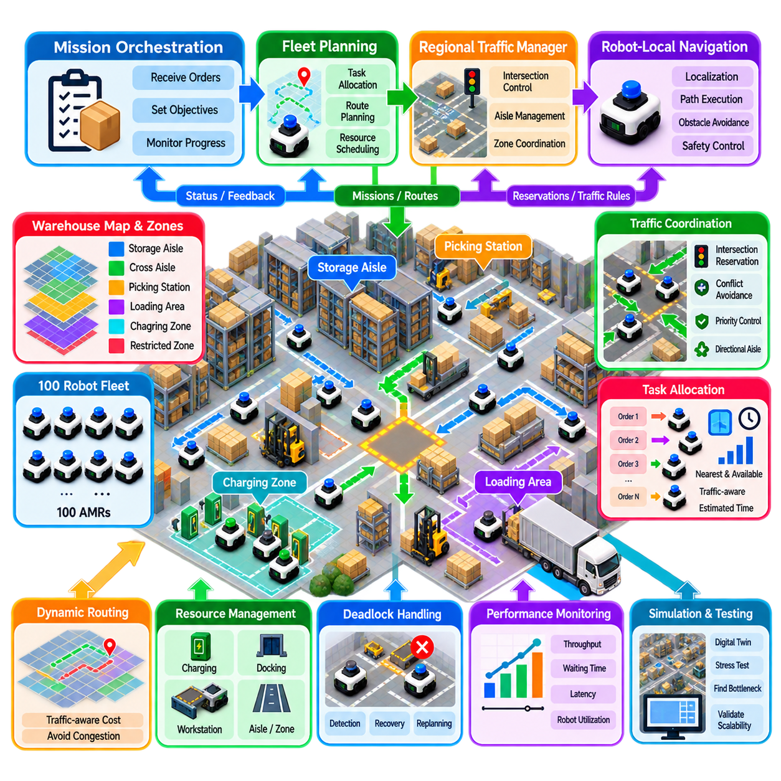
A 100-robot warehouse fleet represents a practical scale at which navigation changes from independent robot motion into coordinated traffic operation. Each AMR may individually localize, plan, avoid obstacles, and execute trajectories, but overall productivity depends on how efficiently the fleet shares aisles, intersections, workstations, charging areas, and docking points. The navigation architecture must therefore optimize collective flow while preserving safe local autonomy for every robot.
The warehouse can be modeled as a structured navigation network composed of storage aisles, cross-aisles, intersections, picking stations, loading areas, charging zones, and restricted regions. A geometric map supports localization and obstacle avoidance, while a higher-level topological graph represents operational connectivity. Important shared resources are explicitly identified so that traffic decisions can be made using route capacity and resource availability rather than treating the entire warehouse as an undifferentiated free-navigation space.
The 100 robots should not participate continuously in one fully coupled planning problem. Instead, mission orchestration maintains warehouse-level objectives while fleet planning assigns tasks and major routes. Regional traffic coordination manages robots that are likely to interact, and each AMR performs detailed local navigation. This hierarchical decomposition limits computational complexity because robots operating in distant or independent areas do not need to be considered in the same high-resolution planning process.
Task allocation begins before detailed navigation. Incoming transport requests are matched with available robots according to position, capability, battery state, current workload, destination, and predicted traffic cost. Selecting the geographically closest robot is not always optimal because its route may cross a congested region. A better assignment evaluates estimated mission completion time, including expected waiting at intersections, shared-resource reservations, and potential congestion along the planned route.
Major routes can be generated over a warehouse graph whose edge costs vary according to traffic conditions. Distance remains important, but route cost can additionally include predicted traversal time, current occupancy, queue length, intersection delay, directional restrictions, and congestion penalties. This prevents all robots from repeatedly selecting the geometrically shortest corridor. Dynamic route costs distribute traffic across alternative paths and improve overall fleet throughput even when individual robots occasionally travel farther.
Intersections require explicit coordination because they are common concentration points for robot conflicts. Approaching robots request access before entering protected intersection regions. The traffic manager evaluates intended movement, arrival time, existing reservations, downstream availability, and priority before granting access. Compatible movements may proceed simultaneously, while conflicting trajectories receive separate time windows. Robots without authorization wait at predefined stop positions rather than entering the intersection and relying solely on reactive collision avoidance.
Narrow aisles require different rules because opposing robots may not have enough space to pass. Aisles can therefore operate as reservable resources with temporary directional ownership. Before entering, a robot verifies that sufficient space exists to complete traversal and that no incompatible reservation is active. In high-demand areas, directional traffic policies or scheduled access windows can reduce repeated negotiation. Passing bays can be incorporated where the physical layout allows bidirectional operation.
Space-Time planning provides temporal coordination when several robots share the same routes. A planned trajectory specifies not only which graph nodes or corridor segments a robot will use but also approximately when they will be occupied. Waiting becomes an explicit planning action, allowing two robots to use the same corridor safely at different times. Rolling-horizon replanning updates these decisions as actual robot arrival times diverge from predictions or unexpected obstacles modify local motion.
Local navigation remains responsible for immediate physical execution. Each robot maintains its own localization, local costmap, obstacle perception, controller, and safety behavior. Fleet-level reservations do not guarantee that the physical environment remains clear. A pallet may protrude into an aisle, a person may cross a route, or another object may appear unexpectedly. The AMR must slow, stop, or locally avoid the obstacle while informing fleet coordination when the resulting delay affects shared reservations.
Deadlock monitoring operates continuously across the warehouse. The system observes prolonged waiting, unchanged positions, reservation dependencies, repeated replanning, and circular wait relationships. If several robots become mutually blocked, the fleet manager first attempts a limited recovery such as cancelling one reservation, changing priority, or instructing one robot to retreat to a safe waiting location. Larger regional replanning is invoked only when the local intervention cannot restore measurable traffic progress.
Congestion management becomes critical as the active robot population approaches warehouse capacity. Adding robots does not guarantee additional throughput because excessive density increases waiting and interference. The fleet system can monitor occupancy and queue formation by zone and temporarily discourage new routes through saturated regions. Mission release can also be controlled so that additional robots are not dispatched into an area faster than its aisles, intersections, and workstations can process them.
Warehouse zoning provides an effective mechanism for controlling coordination complexity. The facility can be divided into several traffic regions, each containing a manageable subset of robots and shared resources. Regional coordinators process ordinary conflicts locally, while cross-zone routes are coordinated at gateways. Robots transferring between zones receive reservations for the required boundary resources. This reduces global planning load while maintaining consistent facility-wide traffic behavior.
Communication architecture should avoid distributing every robot state to every other robot. Each AMR reports operational information such as pose, mission progress, battery state, route status, reservation status, and faults to the appropriate coordination services. High-frequency sensor streams and control loops remain local. Event-driven updates can report meaningful changes immediately, while lower-frequency state summaries support fleet monitoring. This separation reduces network traffic as the fleet approaches continuous 100-robot operation.
A ROS 2 and Nav2 implementation can assign an independent namespace and navigation stack to each AMR while maintaining common fleet interfaces above the individual robots. Robot-local Nav2 handles path execution, controller behavior, local costmaps, and recovery functions. Fleet services handle missions, route constraints, intersection access, and shared-resource reservations. DDS discovery and communication should be configured carefully so that large numbers of nodes and topics do not create unnecessary middleware overhead.
Charging must be integrated into navigation rather than treated as an isolated maintenance activity. If many robots respond to low battery conditions simultaneously, charging stations can become traffic bottlenecks. The fleet manager predicts energy demand and schedules charging according to mission load, battery state, charger availability, and travel time. Staggered charging maintains sufficient active fleet capacity while preventing long queues around charging areas and their surrounding access corridors.
Operational disturbances should be handled through progressive recovery. A temporary obstacle may require only local replanning, while a blocked aisle may trigger regional rerouting. A failed robot occupying a critical intersection may require reservation cancellation and traffic redirection around the affected zone. The architecture should contain failures at the smallest possible scope and avoid replanning all 100 robots whenever a local disturbance occurs. This principle improves both responsiveness and system stability.
The fleet should be evaluated using more than aggregate mission throughput. Average and maximum waiting time, intersection delay, route utilization, planning latency, deadlock frequency, charging queues, network utilization, mission completion time, and robot utilization provide complementary views of performance. Measurements should also be examined by warehouse zone and time period because acceptable facility-wide averages can conceal severe congestion at individual intersections or workstations.
Simulation and digital-twin testing are essential before deploying the complete fleet. Scenarios can progressively increase active robots from small groups toward 100 while varying task arrival rates and traffic concentration. Stress tests should intentionally overload selected intersections, disable routes, introduce communication delays, and simulate robot failures. The objective is to identify throughput saturation, unstable queues, deadlock-prone layouts, insufficient waiting areas, and planning bottlenecks before they affect production.
A useful commissioning strategy introduces fleet scale gradually. Initial operation validates individual navigation and shared-resource rules with a small number of robots. Subsequent stages increase traffic density while monitoring latency, waiting, conflict rates, and throughput. The important threshold is not whether 100 robots can physically move at the same time, but whether increasing the active population continues to improve useful warehouse output without causing disproportionate congestion or instability.
In a Physical AI fleet architecture, the 100-robot warehouse can be organized as a hierarchy of mission orchestration, fleet planning, regional traffic management, and robot-local navigation. Mission intelligence determines what work should be performed, fleet planning distributes tasks and major routes, regional coordination controls intersections and constrained resources, and each AMR executes detailed movement. Feedback from robot execution continuously updates traffic predictions and operational decisions.
The resulting system treats 100-robot navigation as a coordinated flow-management problem rather than one hundred independent path-planning problems. Scalability comes from limiting detailed interaction to robots that can actually influence one another, explicitly managing constrained resources, and keeping immediate motion control close to each robot. Hierarchical planning, dynamic routing, reservations, deadlock recovery, congestion control, selective communication, charging coordination, and continuous performance measurement together provide a practical foundation for reliable high-density warehouse autonomy.

