Volume 15. Motion Planning and Navigation

Chapter 05. Local Planners

05.01. Local Planner Role and Architecture in Navigation
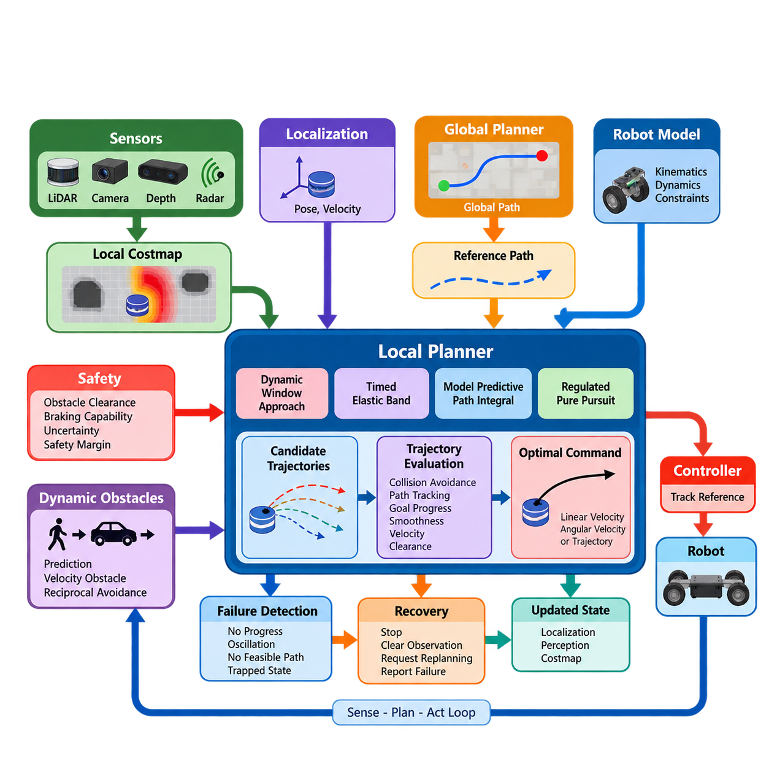
A local planner is the navigation component responsible for converting a higher-level path into motion commands that can be executed safely by the robot in the immediate environment. While a global planner determines how the robot should travel from its current region to a distant goal, the local planner operates over a shorter spatial and temporal horizon and continuously adapts the robot motion to current conditions. :chatgpt-content-reference{index=“0”}
The distinction between global and local planning is fundamental to practical robot navigation. A global path is normally generated from a relatively large map and represents the desired route through free space. It cannot anticipate every short-term event encountered during execution. The local planner therefore interprets this route together with recent sensor observations and generates feasible commands while attempting to preserve progress toward the global objective.
A typical local-planning architecture receives several categories of information. These include the robot pose and velocity estimated by localization, the reference path supplied by the global planner, obstacles represented in a local costmap, and platform-specific kinematic or dynamic constraints. The planner combines these inputs to evaluate candidate motions and produces a command such as linear and angular velocity or a short executable trajectory.
The local costmap provides the planner with a continuously updated representation of nearby navigable space. Static structures may originate from a global map, while recently detected obstacles are inserted using LiDAR, cameras, depth sensors, radar, or other perception sources. Inflation regions around obstacles represent safety margins and discourage candidate trajectories that pass dangerously close to walls, equipment, people, or other robots.
Local planning is inherently a closed-loop process. After a command is generated, the robot moves only for a short interval before localization, perception, and costmap information are updated again. The planner then solves the motion problem using the new state. This repeated sense-plan-act cycle enables navigation to react to localization errors, imperfect models, unexpected obstacles, wheel slip, changing free space, and deviations from the nominal global path.
A useful architectural view separates reference generation, local trajectory generation, trajectory evaluation, and command execution. The reference path describes where the robot should generally travel. Candidate trajectories describe how it could move during the next short horizon. Evaluation determines which candidate provides the best compromise among collision avoidance, path tracking, goal progress, smoothness, velocity, clearance, and other operational objectives.
Different local planners formulate this decision in different ways. Dynamic Window Approach methods search a constrained velocity space, whereas Timed Elastic Band approaches optimize a locally deformable trajectory. Model Predictive Path Integral methods evaluate many sampled control sequences, and Regulated Pure Pursuit modifies geometric path following according to curvature and environmental constraints. These methods occupy subsequent sections of the chapter structure. :chatgpt-content-reference{index=“1”}
Regardless of algorithm, feasibility is essential. A local planner should not request motion that the physical platform cannot execute. Differential-drive robots must respect translational and rotational velocity limits, while Ackermann-steered platforms must consider steering geometry and minimum turning radius. Acceleration, deceleration, jerk, actuator limits, stopping distance, and control latency may also constrain which candidate trajectories can safely become commands.
The relationship between the local planner and low-level controller must therefore be clearly defined. The planner normally operates at a higher abstraction level than motor control and generates velocity references or trajectories rather than direct motor currents or torques. Lower-level control software tracks these references using feedback from encoders, IMUs, steering sensors, or other state measurements, creating a layered architecture from navigation decisions to physical actuation.
Safety modifies the optimization problem rather than existing as an afterthought. A trajectory that makes excellent progress toward the goal is unacceptable if the robot cannot stop before collision. Local planning should therefore consider obstacle clearance, braking capability, uncertainty, command latency, and robot footprint. Conservative margins may be necessary when perception confidence decreases, localization uncertainty increases, or the environment becomes crowded.
Dynamic obstacles create a particularly important architectural boundary. A conventional local costmap can indicate that a location is currently occupied, but safe interaction with moving pedestrians or vehicles may require estimates of velocity and future trajectory. This extends local planning toward explicit dynamic-obstacle avoidance, which the volume treats as a separate chapter containing velocity-obstacle, reciprocal avoidance, prediction-based, and safety-oriented methods. :chatgpt-content-reference{index=“2”}
Local planning also involves balancing competing objectives. Staying exactly on the global path may produce unnecessary oscillation when an obstacle temporarily blocks it, while aggressively maximizing clearance may create large detours. High velocity improves mission throughput but reduces reaction and braking margins. Practical planners encode these compromises through costs, weights, constraints, heuristics, or objective functions appropriate to the selected algorithm.
The planner must also recognize situations in which normal command generation is no longer productive. Repeatedly producing near-zero velocity, alternating steering directions, failing to reduce distance to the goal, or finding no collision-free candidate can indicate that the robot is trapped. Robust navigation therefore monitors planner progress and exposes failure conditions to higher-level recovery logic instead of allowing indefinite oscillation or unsafe attempts to escape.
Recovery establishes another important boundary between local and system-level navigation behavior. A local planner may temporarily stop, clear invalid observations, request replanning, or report failure, but broader decisions such as selecting another route or invoking specialized recovery behaviors generally belong to the navigation architecture above it. This separation keeps local motion generation focused while allowing the overall navigation system to manage exceptional situations systematically.
Real-time performance is critical because environmental information becomes stale rapidly. The planner must complete its computation within the control-cycle budget and provide commands at a sufficiently stable rate. Excessively complex optimization can improve trajectory quality yet become counterproductive if computation delays cause the robot to react to outdated states. Local planning architecture therefore balances planning sophistication, horizon length, sampling density, and available compute resources.
The resulting local planner is best understood as the real-time bridge between strategic path planning and physical robot motion. It transforms a geometrically desirable global route into short-horizon, dynamically feasible, collision-aware commands while continuously incorporating feedback from the environment and the robot itself. This role places local planning directly between planning, perception, localization, safety supervision, and motion control within the broader robotics software architecture. :chatgpt-content-reference{index=“3”}

05.02. Dynamic Window Approach DWA Implementation [w/Code]
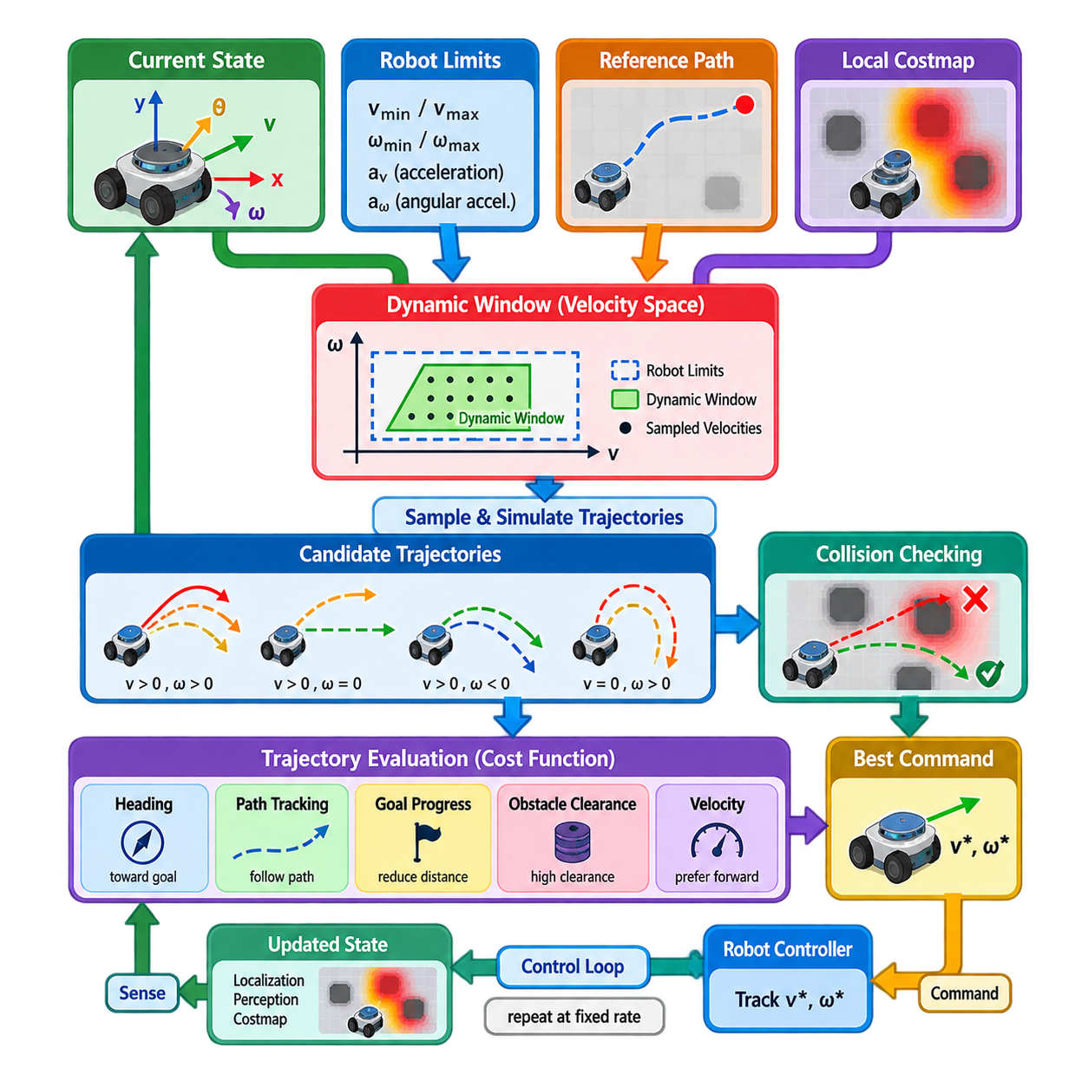
The Dynamic Window Approach (DWA) is a real-time local planning method that selects robot motion directly in velocity space rather than first constructing a complete geometric trajectory. It is particularly suitable for mobile robots that must follow a reference path while reacting quickly to nearby obstacles. The central idea is to restrict the search to velocities that are dynamically reachable during the next control interval and then choose the safest and most useful command.
DWA begins with the robot’s current motion state, typically represented by translational velocity \(v\) and angular velocity \(\omega\). The robot cannot instantaneously change these values because motors, wheels, drivetrain components, and controllers impose acceleration limits. The dynamic window therefore contains only velocity pairs that can be reached from the current state within a short time interval while respecting maximum acceleration, deceleration, and velocity constraints.
The complete velocity space is first bounded by the physical capabilities of the platform. For a differential-drive AMR, this normally includes minimum and maximum linear velocity, maximum rotational velocity, linear acceleration limits, and angular acceleration limits. These physical bounds are intersected with the dynamically reachable region calculated from the current velocity. The resulting window substantially reduces the number of commands that must be evaluated during each control cycle.
Each candidate pair \((v,\omega)\) represents a possible short-term robot motion. Assuming the selected velocities remain approximately constant over a prediction interval, the planner forward-simulates the robot state using its kinematic model. For a differential-drive platform, the resulting motion is normally a straight line when angular velocity approaches zero and a circular arc when angular velocity is nonzero. Sampling many velocity pairs therefore generates a collection of candidate local trajectories.
Trajectory simulation should use the same robot motion assumptions that are relevant to actual execution. A common discrete model propagates pose using \(x_{k+1}=x_k+v\cos(\theta_k)\Delta t\), \(y_{k+1}=y_k+v\sin(\theta_k)\Delta t\), and \(\theta_{k+1}=\theta_k+\omega\Delta t\). Repeating these equations across the prediction horizon creates a sequence of future poses that can be checked against obstacles and evaluated relative to the navigation objective.
Collision checking eliminates unsafe candidates before final command selection. Every simulated pose should be evaluated using the robot footprint rather than treating the platform as an ideal point whenever practical. The footprint may be circular, rectangular, polygonal, or conservatively approximated. Candidate trajectories intersecting occupied or prohibited costmap regions are rejected, while obstacle clearance can additionally be incorporated into the trajectory score.
Stopping capability is another important part of safe DWA implementation. A velocity may be collision-free over the immediate simulated trajectory but still be unsafe if the robot cannot decelerate before reaching an obstacle. An admissible command should therefore provide sufficient stopping distance under the assumed braking capability. This relationship becomes increasingly important as maximum velocity rises because braking distance grows rapidly while perception, computation, and actuator delays consume part of the available safety margin.
After invalid candidates are removed, DWA evaluates the remaining trajectories using an objective function. Typical terms measure progress toward the local or global goal, alignment with the reference path, distance from obstacles, and preference for useful forward velocity. A conceptual score can be expressed as a weighted combination of heading, path adherence, goal progress, clearance, and velocity. The candidate receiving the best valid score becomes the command for the current control cycle.
The weights in the scoring function determine much of the observable navigation behavior. Excessive emphasis on path alignment can cause the robot to resist temporary deviations around obstacles, while excessive clearance weighting may produce unnecessarily wide detours. Strong velocity preference can improve throughput but reduce maneuvering margins in constrained spaces. Effective DWA tuning therefore requires considering the interactions among weights rather than optimizing each parameter independently.
Prediction horizon and sampling resolution also create important engineering tradeoffs. A short horizon reduces computation and enables rapid reactions, but it can produce locally attractive commands that lead toward dead ends or poor approach angles. A longer horizon provides greater foresight but increases computation and depends more strongly on motion assumptions. Similarly, dense velocity sampling can improve command quality while increasing the number of trajectories that must be simulated and checked.
The implementation can be organized as a repeated control loop. The planner obtains the latest robot pose, current velocity, reference path, and local obstacle representation; computes the dynamic window; samples reachable velocity commands; predicts trajectories; rejects collisions and inadmissible motions; scores the surviving candidates; and publishes the best command. At the next cycle, the entire process is repeated using updated localization and perception information.
Efficient implementation is important because trajectory generation and collision checking may be executed hundreds or thousands of times per second across candidate samples. Precomputed footprint information, efficient costmap access, early collision termination, vectorized trajectory calculations, and carefully selected sampling density can reduce computation. The goal is not simply to evaluate the largest possible number of trajectories, but to obtain reliable commands within a deterministic control-time budget.
DWA can exhibit characteristic failure modes in difficult environments. The robot may oscillate between similar left and right turns, become trapped near concave obstacles, stop because all sampled commands receive poor scores, or repeatedly prefer locally safe motions that do not produce meaningful global progress. These limitations arise because DWA primarily solves a short-horizon local decision problem and does not replace the global planner’s responsibility for route-level reasoning.
Narrow corridors and doorways require particularly careful parameterization. Large inflation costs or excessive obstacle-clearance preference can make a geometrically traversable passage appear unattractive, while aggressive settings may place the robot too close to walls. Low-speed sampling, rotational behavior, footprint accuracy, localization uncertainty, and sensor noise all influence performance. Testing should therefore reproduce the actual robot geometry and expected environmental tolerances.
Dynamic obstacles introduce additional limitations because basic DWA commonly evaluates obstacle occupancy using a local representation without explicitly reasoning about long-term human or vehicle motion. Frequently updated sensor observations allow reactive avoidance, but a moving obstacle may require velocity estimation and trajectory prediction for more anticipatory behavior. Such functionality can complement DWA through dedicated dynamic-obstacle prediction or higher-level safety mechanisms.
For production AMRs, tuning should begin from verified physical limits rather than arbitrary planner parameters. Maximum velocity, acceleration, deceleration, rotational rate, footprint dimensions, braking behavior, and controller response should reflect measured platform characteristics. Navigation-quality parameters can then be adjusted systematically using repeatable scenarios such as straight corridors, ninety-degree turns, doorways, obstacle bypass, goal approach, and emergency stopping conditions.
Logging is essential during implementation and tuning. Useful data include the dynamic window bounds, sampled commands, rejected trajectories, individual cost terms, selected velocity, obstacle distance, current pose, controller frequency, and computation time. Visualizing candidate trajectories and their scores often reveals problems that are difficult to diagnose from robot motion alone, such as excessive path bias, incorrect footprint configuration, or inadequate angular-velocity sampling.
DWA ultimately provides a compact connection between local motion planning and executable velocity control. By searching only dynamically reachable commands, predicting their short-term consequences, rejecting unsafe trajectories, and ranking feasible alternatives, it converts the reference path and current environment into immediate robot motion. Its effectiveness depends not only on the algorithm itself but also on accurate robot models, reliable costmaps, realistic safety constraints, disciplined parameter tuning, and stable real-time execution.

05.03. Timed Elastic Band TEB Local Planner [w/Code]
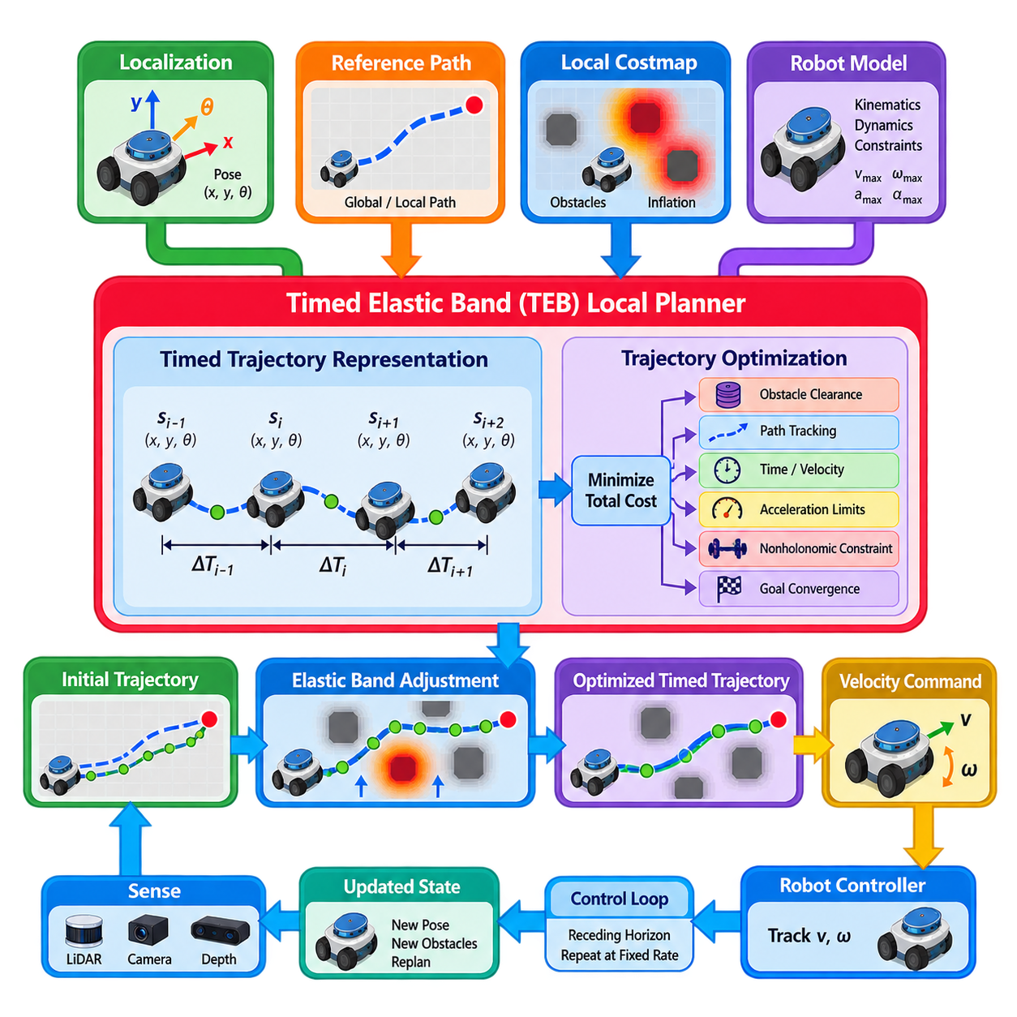
The Timed Elastic Band (TEB) local planner formulates local navigation as a trajectory optimization problem in which both robot poses and the time intervals between them are optimized. Instead of selecting only an instantaneous velocity command, TEB represents the future motion as a sequence of spatial configurations connected by temporal intervals. This allows geometric path shape, velocity, acceleration, obstacle clearance, and travel time to be considered within one optimization framework.
The term elastic band describes the intuitive behavior of the trajectory representation. A path can be imagined as a deformable band stretched from the robot toward a local goal. Obstacles push the band away from unsafe regions, while path-following and goal-related objectives pull it toward desirable configurations. Unlike a purely geometric elastic band, TEB additionally associates time differences with consecutive poses, enabling the optimizer to reason about how quickly the robot should move along each segment.
A typical timed elastic band consists of robot poses \(s_i=(x_i,y_i,\theta_i)\) and time differences \(\Delta T_i\) between neighboring poses. Together they define a discretized trajectory through space and time. Changing a pose modifies the geometry of the trajectory, while changing a time interval modifies the implied velocity and acceleration. Optimization can therefore reshape the path and modify its timing simultaneously rather than treating trajectory generation and velocity assignment as completely separate stages.
The global or reference path normally provides the initial geometric guidance for TEB. A portion of this path near the robot is transformed into an initial local trajectory, which is then adapted according to current obstacle observations and robot constraints. Because the previous optimized trajectory can often be reused and updated during the next control cycle, TEB supports continuous receding-horizon operation rather than repeatedly solving every local planning problem from an entirely new initialization.
Trajectory discretization strongly influences planner behavior and computational cost. If neighboring poses become too widely separated, additional poses can be inserted to preserve sufficient spatial and temporal resolution. Conversely, unnecessary poses may be removed when the trajectory becomes excessively dense. Maintaining an appropriate number of states allows the optimizer to represent turns and obstacle avoidance accurately while preventing the optimization problem from growing unnecessarily large.
TEB expresses navigation requirements as optimization costs or constraints connecting trajectory variables. Obstacle terms penalize insufficient clearance, while velocity and acceleration terms discourage motions exceeding platform limits. Additional terms can encourage short travel time, smooth rotation, nonholonomic motion, preferred turning behavior, and convergence toward the goal. The resulting problem seeks a trajectory that provides a useful compromise among these simultaneously competing requirements.
Obstacle handling is one of the central functions of the planner. Each trajectory pose or relevant segment is evaluated relative to obstacles represented by the local environment model. When the trajectory approaches an obstacle too closely, the corresponding penalty increases and optimization pushes the band toward safer free space. Robot footprint geometry must be represented appropriately because collision-free motion for a point robot does not guarantee collision-free motion for a physical AMR with finite width and length.
Kinematic feasibility is incorporated directly into trajectory optimization. A differential-drive robot cannot normally translate sideways, so neighboring poses should satisfy nonholonomic motion relationships. An Ackermann-steered vehicle introduces steering and turning-radius constraints, while other platforms may permit omnidirectional movement. Configuring the correct motion model prevents the optimizer from producing geometrically attractive trajectories that cannot be followed by the actual robot.
Temporal optimization distinguishes TEB from local planners that primarily search geometric paths. Given displacement between neighboring poses and the associated \(\Delta T_i\), the planner can estimate translational and rotational velocities. Consecutive segments similarly provide information about acceleration. If these values exceed configured limits, penalties influence the optimizer to modify either the spatial trajectory, the timing, or both until a more dynamically feasible solution is obtained.
Travel time can also be incorporated into the objective. Reducing the sum of time intervals encourages efficient motion toward the goal, but minimizing time too aggressively may conflict with obstacle clearance, smoothness, or dynamic constraints. TEB therefore operates as a multi-objective optimization process in which fast traversal is balanced against safety and feasibility. Parameter weights determine how strongly the optimizer values each of these competing properties.
A practical TEB implementation repeatedly updates the local trajectory using current localization, reference-path, and obstacle information. The optimizer performs several iterations, calculates a locally improved timed trajectory, and extracts an executable velocity command from its initial portion. The robot controller applies this command, new sensor information arrives, and the optimization is repeated. TEB therefore remains a closed-loop local planner even though its internal representation covers multiple future states.
Many implementations formulate the optimization as a sparse graph. Robot poses and time differences become optimization variables, while constraints and objective terms become edges connecting the relevant variables. Because individual constraints usually depend on only a small subset of trajectory states, the resulting system has exploitable sparsity. This structure allows nonlinear trajectory optimization to be performed repeatedly within the computational limits of mobile-robot navigation.
TEB can also reason about alternative ways of passing obstacles. Two trajectories that travel around opposite sides of an obstacle may belong to different topological classes and cannot always be transformed smoothly into one another without crossing the obstacle. Implementations supporting homotopy-class planning can maintain several topologically distinct candidate trajectories, optimize them independently, and select the most appropriate solution according to cost and feasibility.
This multi-trajectory capability can improve navigation around large obstacles, corridor junctions, or environments where an initially selected side becomes inefficient. However, evaluating several candidate classes increases computation and may introduce switching behavior when alternatives have similar costs. Practical configuration therefore requires balancing topological exploration against execution stability, particularly when the robot operates in structured industrial environments with predictable traffic patterns.
Dynamic obstacles can be incorporated by associating obstacle positions with time and evaluating the timed trajectory against predicted obstacle motion. This is conceptually well matched to TEB because the robot trajectory already contains temporal information. Nevertheless, performance depends strongly on the quality of obstacle tracking and prediction. Incorrect velocity estimates or rapidly changing human behavior can invalidate predicted interactions, requiring frequent replanning and additional safety supervision.
TEB behavior is sensitive to parameter configuration because many objectives interact through the same optimization problem. Minimum obstacle distance, inflation distance, maximum translational and rotational velocity, acceleration limits, preferred turning radius, trajectory resolution, optimization iterations, and cost weights can all affect the final motion. Changing one parameter may alter several observable behaviors, so systematic tuning is more reliable than adjusting isolated values in response to individual failures.
Narrow passages illustrate these interactions clearly. A robot may physically fit through a doorway, yet conservative obstacle distance, inaccurate footprint dimensions, localization uncertainty, or costmap inflation can prevent the optimizer from finding a satisfactory trajectory. Reducing safety margins indiscriminately is not an appropriate solution. The underlying robot geometry, map accuracy, sensor uncertainty, controller tracking error, and required operational clearance should first be validated together.
Failure detection remains necessary even with trajectory optimization. The optimizer may fail to converge, produce a trajectory with unacceptable cost, repeatedly generate negligible forward progress, or oscillate between alternative solutions. The navigation system should detect these conditions and initiate appropriate responses such as stopping, requesting global replanning, clearing invalid environmental observations, changing recovery behavior, or reporting that the local navigation problem is temporarily infeasible.
For production AMRs, evaluation should combine numerical optimization metrics with physical navigation tests. Useful measurements include optimization time, control frequency, minimum obstacle clearance, path deviation, velocity and acceleration profiles, goal approach accuracy, oscillation frequency, and success rate through constrained environments. Logging the optimized band and individual cost terms helps identify whether undesirable behavior originates from obstacle penalties, dynamic limits, topology selection, or trajectory discretization.
TEB ultimately provides a structured method for transforming a reference path into a short-horizon trajectory that is simultaneously geometric, temporal, and dynamically constrained. Its strength lies in optimizing where the robot should move and how that motion should evolve over time within the same representation. When combined with accurate footprint models, reliable perception, realistic platform constraints, disciplined tuning, and robust failure handling, it can provide smooth and responsive local navigation for mobile robots.

05.04. MPPI Local Planner GPU Parallel Rollouts [w/Code]
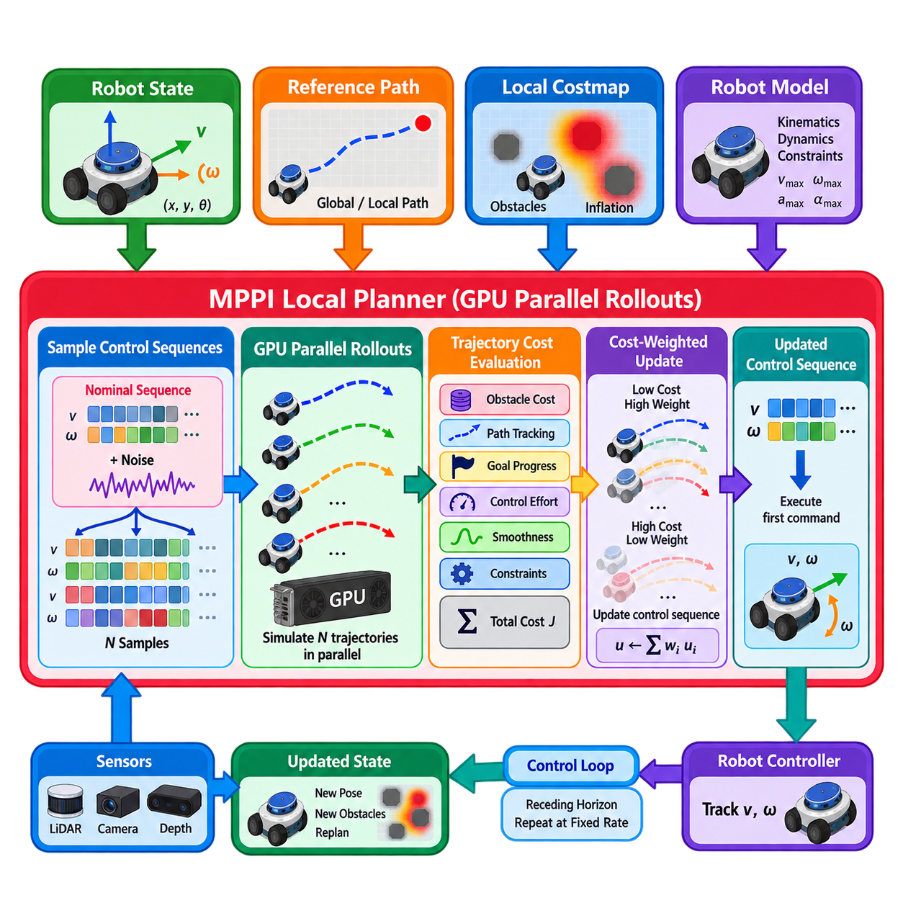
Model Predictive Path Integral (MPPI) control is a sampling-based local planning method that evaluates many possible future control sequences and uses their predicted costs to determine the next robot command. Rather than searching for a single trajectory through deterministic optimization, MPPI generates a population of stochastic rollouts around a nominal control sequence. This formulation is especially attractive for GPU acceleration because thousands of candidate trajectories can be simulated largely independently.
The planner operates over a finite prediction horizon containing a sequence of future control inputs. For a differential-drive mobile robot, each control step may contain linear velocity \(v\) and angular velocity \(\omega\), while other platforms can use acceleration, steering angle, or platform-specific commands. The nominal sequence represents the planner’s current estimate of useful future motion and is repeatedly refined as new localization and perception information becomes available.
At each control cycle, MPPI creates many candidate control sequences by adding sampled perturbations to the nominal sequence. Each perturbed sequence defines one rollout through the robot dynamics over the prediction horizon. The resulting trajectories may turn left or right, accelerate, decelerate, follow the reference path closely, or deviate around obstacles. Sampling therefore converts the local planning problem into evaluation of a broad set of possible future robot behaviors.
Forward rollout requires a motion model that predicts how each candidate control sequence changes the robot state. A differential-drive model can propagate position and orientation using linear and angular velocity, while more sophisticated implementations may incorporate acceleration limits, steering dynamics, actuator response, or other platform characteristics. The accuracy of this model influences how closely predicted trajectories correspond to motions that the physical robot can actually execute.
Each simulated rollout receives a trajectory cost describing its suitability for navigation. Typical terms penalize collision risk, proximity to obstacles, deviation from the reference path, poor progress toward the goal, excessive control effort, rapid command variation, or violation of motion constraints. Additional application-specific critics can represent preferred direction, terminal pose quality, path orientation, velocity limits, or operational zones. The total cost provides a common basis for comparing sampled futures.
Unlike approaches that simply select the lowest-cost sampled trajectory, MPPI uses cost-weighted information from many rollouts to update the nominal control sequence. Lower-cost trajectories receive greater influence, while high-cost trajectories contribute little. A temperature-related parameter controls how sharply the weighting favors the best samples. The resulting update combines information across the sampled distribution and can produce smoother behavior than repeatedly choosing one isolated candidate.
After updating the control sequence, only the first command or short initial portion is normally executed. The prediction horizon is then shifted forward, the robot receives updated state and obstacle information, and another set of rollouts is generated. This receding-horizon process makes MPPI a closed-loop controller: long enough horizons provide foresight, while repeated replanning allows the robot to react continuously to changes in the environment.
The computational structure of rollout evaluation maps naturally to graphics processing units (GPUs). Candidate trajectories are independent during forward simulation and cost evaluation, allowing large batches to be processed in parallel. Instead of calculating thousands of rollouts sequentially on a CPU, GPU threads can propagate many states and evaluate cost terms simultaneously. This parallelism makes high-sample-count predictive local planning practical within demanding control-cycle deadlines.
GPU acceleration does not eliminate computational tradeoffs. Increasing the number of rollouts improves coverage of the control space but requires additional computation and memory bandwidth. Extending the prediction horizon provides greater look-ahead but increases the number of simulated states per rollout. Smaller integration steps improve temporal resolution but further increase workload. Practical MPPI configuration therefore balances rollout count, horizon length, model complexity, and required controller frequency.
Memory organization is important for efficient parallel implementation. Robot states, control sequences, sampled noise, trajectory costs, and environment information should be arranged to support efficient batched access. Repeated host-to-device transfers can reduce the benefit of GPU acceleration, particularly at high control frequencies. Implementations therefore benefit from keeping frequently used planning data on the device and minimizing synchronization between CPU orchestration and GPU rollout computation.
Obstacle avoidance is usually represented through one or more cost terms evaluated along each predicted trajectory. Rollouts entering lethal costmap cells or colliding with the robot footprint can receive extremely large penalties or be treated as invalid. Near-obstacle costs can increase continuously as clearance decreases. This allows MPPI to compare not only collision-free versus colliding trajectories but also different degrees of safety among feasible alternatives.
Robot footprint modeling remains important because a trajectory for the robot center does not describe the swept area of the physical platform. Circular approximations are computationally efficient, while polygonal or oriented footprints provide greater geometric fidelity for rectangular AMRs. The selected representation should reflect the environment and required clearance because footprint errors can either reject usable passages or permit trajectories that place the physical robot dangerously close to obstacles.
Motion constraints can be incorporated by limiting sampled controls or penalizing invalid trajectories. Maximum velocity, angular velocity, acceleration, deceleration, steering rate, and other platform limits should correspond to measurable robot capabilities. Sampling within physically meaningful bounds reduces wasted computation on impossible rollouts. Cost terms can additionally discourage commands near undesirable operating regions even when those commands remain technically feasible.
The stochastic nature of MPPI gives it useful flexibility in complex local environments. Because many different control perturbations are explored simultaneously, the planner can evaluate alternatives around obstacles without explicitly constructing a small deterministic set of motion primitives. However, exploration depends strongly on the noise distribution. Perturbations that are too small may fail to discover useful alternatives, while excessive noise can waste rollouts on unrealistic or highly inefficient motions.
The temperature and noise parameters interact closely with rollout count. Strong concentration on a few low-cost samples can make behavior decisive but sensitive to sampling variation, whereas broader weighting incorporates more trajectories and may produce smoother but less aggressive updates. Large sample populations can reduce stochastic variability but consume additional resources. Parameter tuning should therefore evaluate the complete sampling-and-weighting process rather than treating individual values independently.
Dynamic environments require frequent updates of obstacle information and sufficiently fast replanning. MPPI can react to newly observed obstacles because every control cycle generates fresh predicted trajectories. If predicted motion of pedestrians, vehicles, or other robots is available, time-dependent obstacle costs can evaluate where those objects are expected to be during each rollout. Without reliable prediction, MPPI remains primarily reactive to the latest environmental representation.
Failure modes can arise when all sampled trajectories have similarly poor costs, the sampling distribution does not explore a feasible escape direction, or competing cost terms create undesirable local behavior. The robot may slow excessively, oscillate, or remain trapped near obstacles. Monitoring progress, valid rollout ratios, cost distributions, and command stability allows the navigation system to recognize such conditions and invoke replanning or higher-level recovery mechanisms.
Real-time reliability should be evaluated using more than average computation time. A production controller must satisfy timing requirements under difficult scenes containing many obstacles, dense costmap updates, and large rollout populations. Measuring median, high-percentile, and worst-case planning latency helps determine whether GPU execution remains compatible with the required control frequency. Thermal throttling and concurrent GPU workloads should also be considered when planning shares hardware with perception or AI inference.
Practical tuning should begin with verified robot dynamics and a manageable prediction configuration. Rollout count and horizon can then be increased while monitoring control latency, trajectory diversity, and navigation quality. Reference-path tracking, obstacle clearance, goal convergence, velocity smoothness, and control effort should be evaluated together in repeatable scenarios such as corridors, sharp turns, doorways, cluttered spaces, obstacle bypass, and final goal approach.
Logging and visualization are especially useful because MPPI internally evaluates far more trajectories than the robot ultimately executes. Displaying sampled rollouts, their costs, the weighted trajectory distribution, the nominal control sequence, and the selected command reveals how the planner interprets each situation. These diagnostics can expose inadequate exploration, excessive obstacle penalties, weak path attraction, poor model parameters, or insufficient prediction horizon.
MPPI ultimately transforms local navigation into massively parallel predictive evaluation. The planner samples many possible future control sequences, propagates them through the robot model, evaluates their consequences, and combines the most useful rollouts to update the command sequence. GPU parallelism makes this approach practical at large sampling scales, while receding-horizon feedback keeps the solution responsive. Its performance depends on realistic dynamics, carefully designed costs, effective sampling, reliable environment representation, and predictable real-time computation.

05.05. RPP Regulated Pure Pursuit Controller [w/Code]
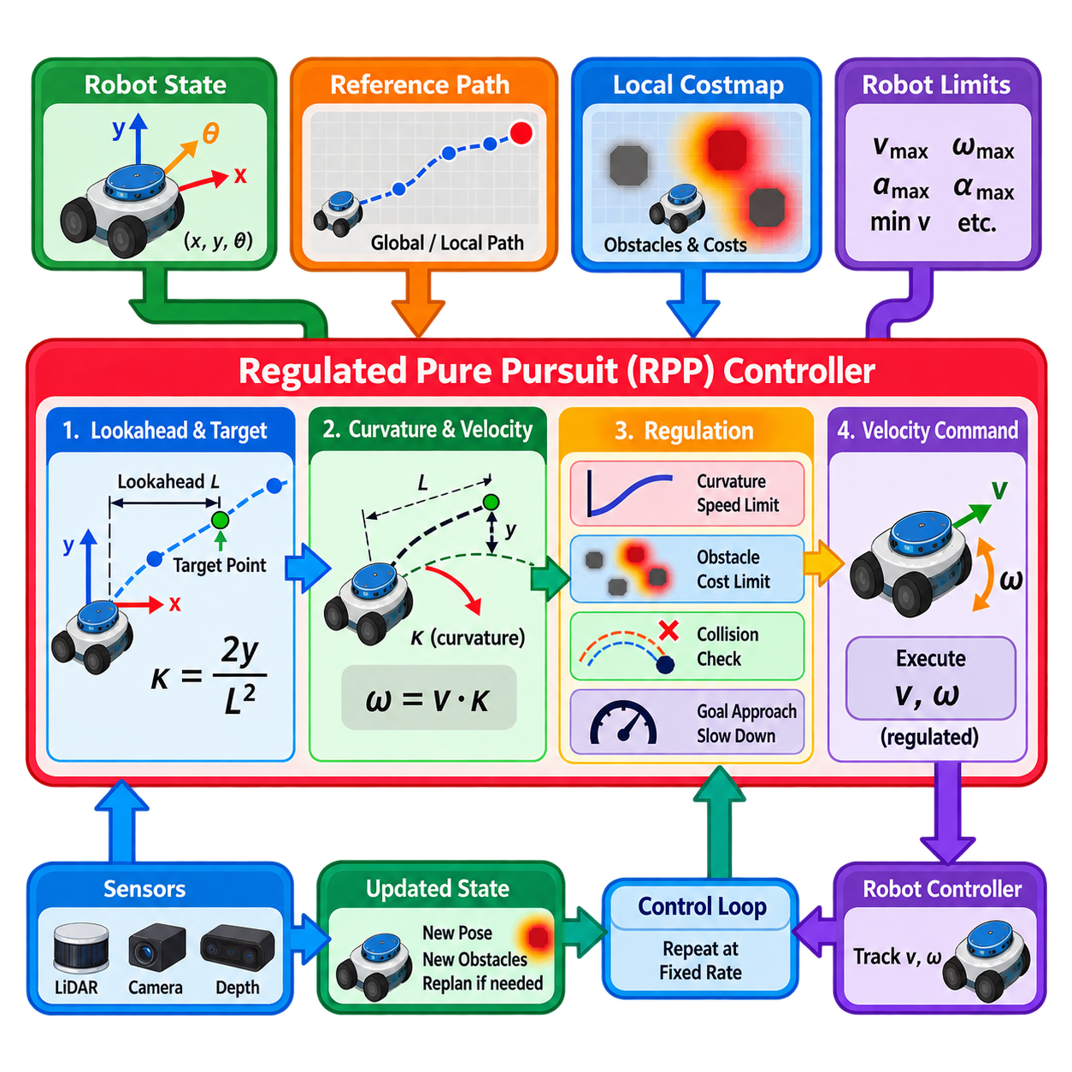
Regulated Pure Pursuit (RPP) is a path-following controller designed to transform a geometric reference path into safe and executable velocity commands for mobile robots. It extends the classical Pure Pursuit method by regulating commanded speed according to path curvature, obstacle proximity, collision risk, and goal approach conditions. This preserves the computational simplicity of geometric tracking while improving behavior in constrained and safety-sensitive navigation environments.
Classical Pure Pursuit selects a target point located ahead of the robot on the reference path and computes the curvature required to steer toward that point. The distance between the robot and this target is called the lookahead distance. Instead of optimizing many candidate trajectories, the controller repeatedly identifies the pursuit point, calculates the required curvature, and generates linear and angular velocity commands that drive the robot toward it.
In the robot coordinate frame, the lookahead point provides the geometric information required for steering. If the target lies directly ahead, the commanded curvature approaches zero and the robot travels approximately straight. As the lateral displacement of the target increases, the required curvature increases. For a lookahead distance \(L\) and lateral target displacement \(y\), a common geometric relationship is \(\kappa = 2y/L^2\), where \(\kappa\) represents path curvature.
Once curvature has been determined, angular velocity can be related to linear velocity through \(\omega=v\kappa\). This relationship makes Pure Pursuit particularly convenient for differential-drive and similar mobile platforms because the path geometry can be converted directly into velocity commands. However, applying a constant or aggressively chosen linear velocity can create problems on sharp turns, near obstacles, or when approaching the final goal.
RPP addresses this limitation by regulating the nominal linear velocity according to navigation conditions. Rather than allowing path geometry to determine steering while maintaining an almost independent speed command, RPP treats velocity as a safety- and feasibility-dependent quantity. The controller can reduce forward speed when curvature becomes large, when nearby obstacles increase risk, or when the robot approaches the destination.
Curvature-based regulation is especially important for mobile robots because high linear speed combined with high curvature produces large angular velocity and demanding lateral motion. A sharp turn that is feasible at low speed may become difficult to track accurately at high speed. RPP therefore decreases commanded linear velocity as curvature increases, improving tracking stability while respecting rotational velocity and platform motion constraints.
Lookahead selection strongly influences path-following behavior. A small lookahead distance makes the controller respond rapidly to local path curvature but can increase steering sensitivity and oscillation. A large lookahead produces smoother motion but may cut corners or react too slowly to tight geometry. Practical RPP implementations can use velocity-scaled lookahead so that the pursuit distance increases at higher speeds and decreases during slower, more precise maneuvering.
The reference path is typically transformed into the robot coordinate frame and pruned so that portions already traversed do not continue influencing control. The controller then searches the remaining path for the appropriate lookahead point. Efficient path pruning and coordinate transformation are important because this process occurs repeatedly at controller frequency and must remain consistent with localization updates and the current robot pose.
Collision regulation adds another safety layer beyond geometric path tracking. The controller can project the commanded motion forward for a limited time or distance and check the predicted arc against the local costmap. If the projected motion intersects an occupied or lethal region, the command can be reduced or rejected. This prevents the robot from blindly following a geometrically valid path when newly detected obstacles make the immediate motion unsafe.
The collision-checking horizon must be selected carefully. Excessively short projection may fail to detect hazards early enough for safe braking, while excessive projection can cause distant obstacles to unnecessarily suppress motion. The horizon should therefore reflect robot velocity, stopping capability, sensing range, controller frequency, and local environmental characteristics rather than being treated as an arbitrary geometric parameter.
Cost-based regulation can further modify velocity according to obstacle proximity represented in the costmap. Even when the projected path does not directly collide with an obstacle, elevated local costs can indicate reduced clearance or increased navigation risk. The controller can progressively lower speed as these costs increase, allowing cautious motion near walls, shelving, machinery, or other structures without immediately declaring the path infeasible.
Goal approach requires additional regulation because a controller operating at normal cruising speed may overshoot the final pose or generate abrupt braking. RPP can progressively reduce velocity as the remaining path distance becomes small. This approach-velocity constraint improves final positioning and provides a smoother transition from path tracking to stopping, particularly for AMRs that require accurate docking, station arrival, or task handoff.
Minimum velocity settings require careful consideration. A very low commanded speed can improve precision but may fall below the velocity that the physical drivetrain can reliably execute. Conversely, an excessively high minimum speed can cause aggressive movement in narrow spaces or near the goal. Controller parameters should therefore reflect measured motor response, friction, drivetrain characteristics, payload conditions, and low-level velocity-control performance.
RPP differs fundamentally from trajectory-optimization methods such as TEB and sampling-based predictive methods such as MPPI. It does not normally construct and optimize a large population of future trajectories. Instead, it relies strongly on the quality of the reference path and applies geometric pursuit together with regulatory mechanisms. This results in relatively low computational complexity and predictable execution, but places greater responsibility on the upstream planner to provide a usable path.
Because RPP follows an existing path rather than extensively searching for alternative local routes, its obstacle-avoidance capability is inherently different from planners that actively deform or sample trajectories around obstacles. If the reference path becomes blocked, velocity regulation and collision checking can stop or slow the robot, but a new feasible route may require replanning by the global or local planning architecture. This separation should be considered when designing the complete navigation stack.
Path quality therefore has a direct effect on controller performance. Sharp discontinuities, unnecessary zigzags, sparse path sampling, or curvature patterns inconsistent with robot capabilities can produce undesirable commands. Smoothing or generating dynamically appropriate reference paths can significantly improve RPP behavior. Controller tuning cannot fully compensate for a path that fundamentally violates the geometry or maneuverability of the physical platform.
RPP is well suited to structured environments where reference paths are reliable and computational predictability is valuable. Warehouse aisles, corridors, predefined logistics routes, and repeatable industrial navigation tasks are representative examples. Its relatively simple computation allows high controller frequencies without requiring large trajectory sampling or nonlinear optimization, which can be advantageous on embedded processors with limited computational resources.
Narrow passages require accurate coordination among footprint configuration, costmap inflation, path placement, and velocity regulation. If the reference path passes close to a wall, cost-based regulation may reduce speed significantly even though the route remains geometrically feasible. This behavior may be desirable for safety, but excessive regulation can cause unnecessary crawling. Physical clearance requirements should therefore guide tuning rather than visual path appearance alone.
Localization noise can also influence pursuit behavior because the relative position of the lookahead point changes with the estimated robot pose. Rapid pose fluctuations may cause corresponding variations in curvature and angular velocity commands. Stable localization, suitable lookahead distance, velocity smoothing, and realistic controller frequency help reduce this sensitivity. Excessive filtering, however, can introduce delay and degrade response to genuine path curvature.
Production tuning should begin with verified platform limits and a representative reference path. Maximum linear and angular velocity, acceleration constraints, lookahead bounds, curvature regulation, collision-checking horizon, obstacle-related scaling, and goal-approach behavior should then be tested systematically. Straight paths, gradual curves, sharp corners, narrow corridors, doorways, obstacle encounters, and final goal approaches provide useful repeatable scenarios.
Logging should include selected lookahead points, path curvature, commanded linear and angular velocities, regulation factors, local cost values, collision projections, remaining goal distance, and controller computation time. These signals make it possible to distinguish whether unexpected behavior originates from path geometry, lookahead selection, curvature regulation, obstacle costs, localization, or the underlying velocity controller.
RPP ultimately provides a computationally efficient bridge between a planned geometric path and real-time robot motion. Pure Pursuit supplies the geometric steering principle, while regulation mechanisms adapt velocity to curvature, obstacles, collision risk, and goal proximity. When paired with a suitable reference path, accurate localization, realistic robot limits, reliable costmaps, and systematic tuning, RPP can provide smooth, predictable, and safety-aware path following for production mobile robots.

05.06. Nav2 Controller Plugin Development [w/Code]
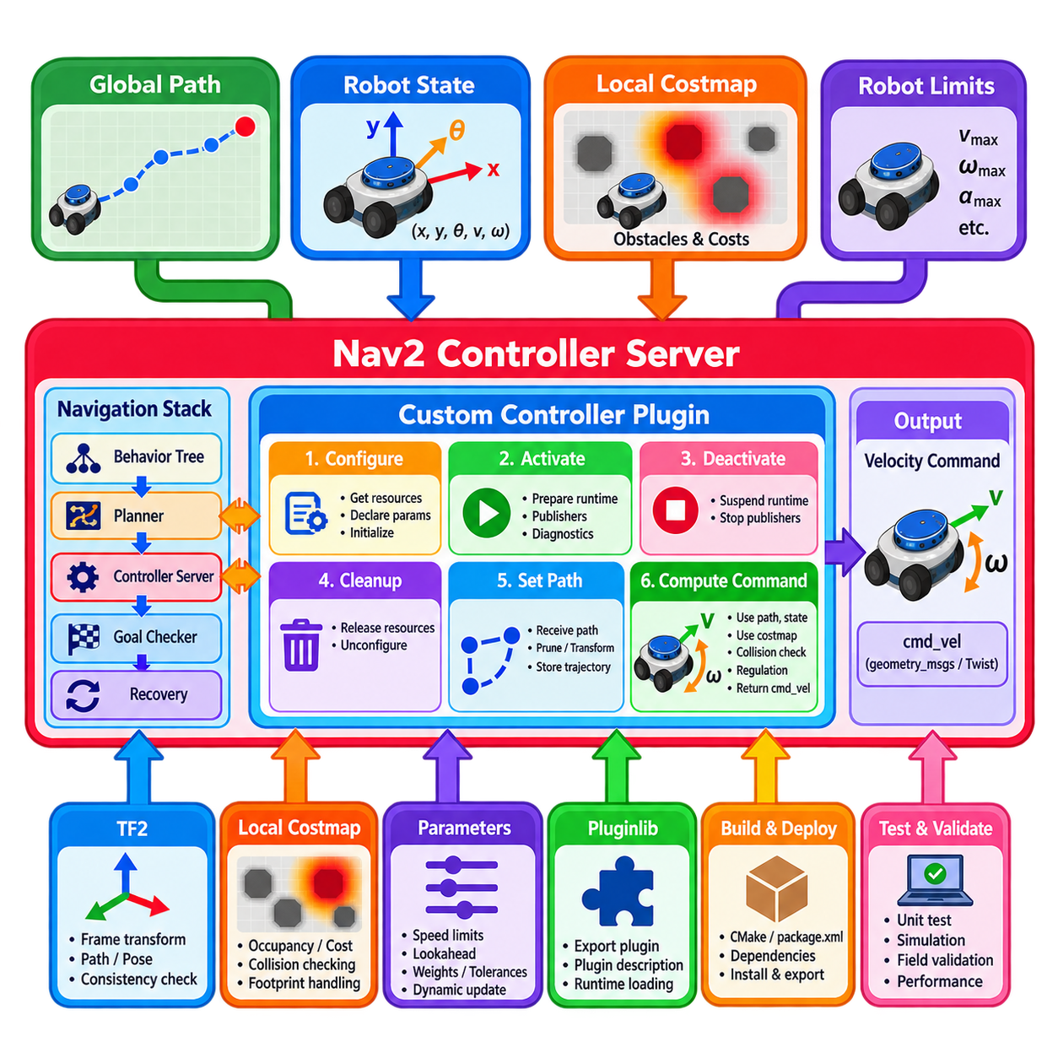
Nav2 controller plugin development provides a standardized mechanism for implementing custom local motion-control algorithms within the Navigation2 architecture. A controller plugin receives a global or locally transformed path together with the current robot state and generates executable velocity commands. This abstraction allows algorithms such as geometric path followers, trajectory optimizers, predictive controllers, and application-specific controllers to operate behind a common navigation interface.
The controller plugin executes under the Nav2 Controller Server, which separates controller lifecycle management and navigation-stack integration from the internal planning algorithm. The server handles interactions with higher-level navigation behaviors while the plugin concentrates on path tracking and local command generation. This separation enables controller implementations to evolve independently without redesigning the complete navigation architecture.
A custom controller is normally implemented as a C++ class conforming to the Nav2 controller interface. The class implements the required lifecycle and control functions defined by the controller API. These functions establish how the plugin is configured, activated, deactivated, cleaned up, supplied with a path, and requested to compute velocity commands. Following this contract allows the Controller Server to treat different algorithms through the same interface.
Configuration occurs when the navigation lifecycle prepares the controller plugin for operation. During this phase, the implementation receives access to resources such as the parent lifecycle node, transform buffer, local costmap, and plugin-specific configuration. Parameters controlling velocity limits, lookahead behavior, optimization weights, tolerances, or other algorithm properties can be declared and retrieved here. Expensive initialization should be completed before real-time command generation begins.
Activation and deactivation support Nav2 lifecycle management. Activation prepares runtime resources required while the controller is actively generating commands, whereas deactivation suspends them without necessarily destroying the plugin object. Publishers, diagnostic interfaces, or other lifecycle-aware resources can follow the same state transitions. Cleanup releases resources when the plugin is returned to an unconfigured state or removed from operation.
The path-setting interface provides the controller with the plan that it should follow. The incoming path usually originates from a global planner and consists of a sequence of poses expressed in a known coordinate frame. A controller may store the complete path, prune already traversed sections, transform relevant portions into the local frame, or derive an internal trajectory representation. The exact processing depends on the controller algorithm.
Velocity-command computation forms the central runtime operation. The Controller Server supplies the current robot pose and velocity, and the plugin calculates the next command according to the stored plan and current environment. Depending on the algorithm, this may involve selecting a lookahead point, sampling velocities, optimizing a trajectory, evaluating predictive rollouts, or applying another control law. The result is returned as a stamped velocity command for downstream execution.
Coordinate-frame handling is critical because the global path, robot pose, costmap, and controller calculations may use different frames. Transform information is typically obtained through TF2 so that relevant path segments and robot states can be represented consistently. Transform failures, stale timestamps, or frame inconsistencies should be detected explicitly because incorrect coordinate assumptions can generate severe path-tracking errors even when the controller mathematics itself is correct.
The local costmap provides environmental information required by controllers that consider obstacles or navigation costs. A custom plugin can access nearby occupancy and inflated cost information through the costmap interface and use it for collision checking, trajectory scoring, velocity regulation, or safety margins. Costmap access should remain computationally efficient because it may occur repeatedly inside a high-frequency control loop.
Robot geometry must be handled consistently with the local costmap configuration. Controllers performing collision prediction should evaluate the robot footprint or an appropriate conservative approximation rather than checking only the robot center. Incorrect footprint assumptions can make a valid passage appear blocked or, more seriously, classify a physically colliding trajectory as safe. Footprint handling should therefore be validated against the actual platform dimensions.
Goal checking is usually separated from controller-specific trajectory generation. Nav2 can use goal-checker plugins to determine whether position and orientation tolerances have been satisfied, while the controller focuses on generating motion toward the goal. Nevertheless, the controller may need awareness of remaining path length or goal proximity to reduce velocity, improve final approach behavior, or prevent overshoot before the goal checker declares completion.
Progress monitoring is similarly part of the broader navigation architecture. A controller can generate valid commands yet fail to produce meaningful movement because of obstacles, localization problems, wheel slip, or poor controller behavior. Nav2 progress checking and higher-level recovery logic can detect such situations. Custom controller development should therefore report failures clearly rather than hiding persistent inability to compute useful motion behind repeated zero commands.
Exception handling is an important part of the plugin contract. Conditions such as unavailable transforms, invalid paths, failed trajectory generation, or inability to produce a safe command should be communicated through appropriate controller failures or exceptions. Explicit failure propagation allows the surrounding navigation behavior to request replanning, invoke recovery actions, stop safely, or terminate the navigation task according to system policy.
Pluginlib provides the mechanism by which Nav2 discovers and loads controller implementations at runtime. The custom class is exported as a plugin and described through plugin metadata so that the Controller Server can instantiate it from configuration rather than through hard-coded dependencies. This runtime loading model allows multiple controller algorithms to be built, deployed, and selected without modifying the core Controller Server implementation.
Build-system integration requires the controller package to declare the appropriate ROS 2 and Nav2 dependencies and export its plugin description correctly. The package configuration, CMake definitions, headers, implementation files, and plugin metadata must remain consistent with the exported class and interface type. Many apparent runtime plugin failures originate from incorrect package exports, class names, library names, or plugin-description configuration rather than from the controller algorithm.
Controller selection is performed through Nav2 configuration. A robot can expose one or several controller plugins under distinct identifiers, with each plugin receiving its own parameter namespace. This enables different navigation behaviors to select controllers appropriate to particular tasks or platforms. For example, one controller may prioritize smooth path following while another is configured for slow maneuvering in constrained operational areas.
Dynamic parameter handling can improve field tuning when implemented carefully. Parameters such as speed limits, gains, lookahead distances, cost weights, or sampling properties may need adjustment without rebuilding the package. However, runtime updates must preserve internal consistency and thread safety. Parameters that fundamentally change data structures or computational requirements may be safer to apply during controlled lifecycle transitions rather than during active command computation.
Real-time performance is a major design consideration because the command-generation function executes repeatedly at controller frequency. Memory allocation, path transformation, costmap access, optimization, and logging all contribute to latency. The implementation should avoid unnecessary work inside the critical loop and should measure not only average computation time but also high-percentile and worst-case latency under representative environmental complexity.
Thread safety becomes important when callbacks, parameter updates, costmap processing, and controller execution can access shared state concurrently. Stored paths, configuration values, diagnostic data, and internal trajectory structures should have clearly defined ownership and synchronization. Excessive locking can harm timing performance, while insufficient synchronization can create intermittent failures that are difficult to reproduce during field testing.
Testing should begin below the complete navigation-stack level. Mathematical functions, path transformations, command limits, collision checks, and special cases can be verified through unit tests. Integration testing can then confirm plugin loading, lifecycle transitions, parameter configuration, path reception, and command generation. Simulation provides a further layer for evaluating behavior across repeatable navigation scenarios before deployment on physical hardware.
Field validation should include straight paths, curves, sharp turns, narrow corridors, doorways, obstacle encounters, goal approaches, blocked paths, localization disturbances, and recovery transitions. Important measurements include tracking error, minimum obstacle clearance, command smoothness, controller frequency, computation latency, failure rate, and navigation success rate. Tests should use realistic robot footprint, velocity limits, acceleration characteristics, and sensor update rates.
Observability is essential for developing and maintaining a production controller plugin. Useful diagnostics include the transformed local path, selected target or trajectory, generated command, controller state, cost values, failure reason, processing time, and relevant safety margins. Visualization through standard ROS 2 tools can make internal controller decisions understandable and greatly reduce the time required to diagnose unstable or unexpectedly conservative behavior.
A well-designed Nav2 controller plugin therefore combines algorithmic motion generation with disciplined software integration. The controller must satisfy the common Nav2 interface, participate correctly in lifecycle management, consume paths and environmental information consistently, respect robot constraints, report failures, and meet control-cycle timing requirements. This plugin architecture allows custom local planning research to be transformed into modular, testable, and deployable navigation software.

05.07. Velocity Smoothing and Acceleration Limiting [w/Code]
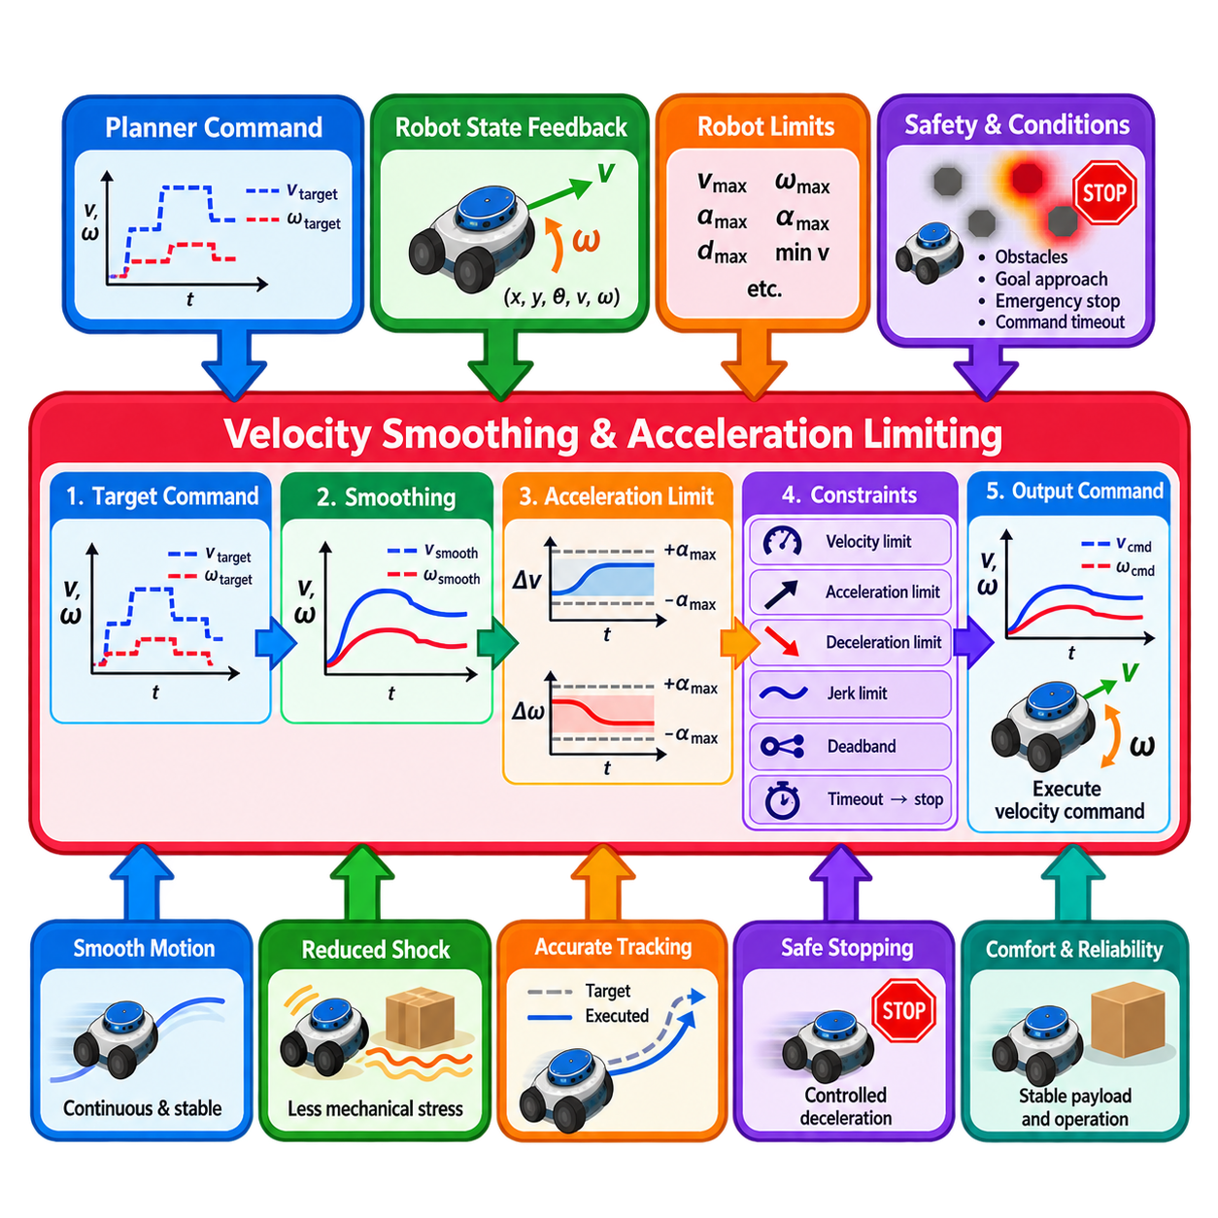
Velocity smoothing and acceleration limiting form the transition layer between motion commands generated by a local planner and commands that can be executed reliably by the physical robot. A planner may produce valid target velocities that change abruptly between control cycles, but motors, drivetrains, payloads, and low-level controllers cannot respond instantaneously. Smoothing reshapes these commands into continuous motion while acceleration limits enforce physically meaningful rates of change.
A mobile robot command can be represented by translational and rotational components such as \(v_x\), \(v_y\), and \(\omega\). Differential-drive robots normally use forward velocity \(v_x\) and angular velocity \(\omega\), while omnidirectional platforms may additionally command lateral velocity \(v_y\). Each component can have independent maximum velocity, acceleration, and deceleration limits reflecting the mechanical and control characteristics of the platform.
Without smoothing, small variations in localization, costmap observations, trajectory optimization, or path geometry can produce rapid changes in commanded velocity. These discontinuities may cause wheel slip, drivetrain shock, oscillatory motion, uncomfortable payload dynamics, and increased tracking error. They can also excite low-level control loops and produce behavior that appears unstable even when the local planner itself generates mathematically valid commands.
Acceleration limiting constrains the difference between consecutive velocity commands. For a control interval \(\Delta t\), a simple linear constraint can be expressed as \(|v_{k+1}-v_k|\leq a_{\max}\Delta t\). Angular velocity can be treated similarly using an angular acceleration limit. Instead of immediately applying a newly requested target velocity, the smoother moves the executable command toward that target at a rate permitted by the configured acceleration bounds.
Deceleration should often be configured separately from acceleration because stopping requirements differ from normal speed increase. A robot may accelerate gradually for smooth operation but require stronger deceleration to respond safely to obstacles or planner commands. The achievable deceleration must nevertheless remain consistent with tire friction, drivetrain capability, payload stability, motor control, and stopping-distance assumptions used elsewhere in the navigation system.
Velocity smoothing can operate as an open-loop process using previously commanded velocity as the current state estimate. This approach is computationally simple and does not require measured velocity feedback. However, commanded velocity may differ from actual robot motion because of wheel slip, actuator delay, slope, payload variation, or low-level tracking error. Accumulated differences can make the smoother’s internal assumption inconsistent with the physical platform.
A closed-loop smoother instead uses measured or estimated robot velocity as feedback when generating the next command. Odometry commonly provides this information. Because the smoothing process begins from observed motion rather than only the previous command, it can better account for actual acceleration and deceleration behavior. Its effectiveness, however, depends on sufficiently accurate, timely, and low-noise velocity estimation.
Feedback quality introduces an important tradeoff. Noisy odometry can cause the smoother to continuously react to small velocity fluctuations, while heavily filtered feedback may introduce delay. The velocity source, update rate, timestamp handling, and filtering characteristics should therefore be considered together with the smoothing frequency. A high-rate smoother cannot compensate for stale or unreliable state feedback and may instead reproduce its errors at a higher frequency.
The smoothing frequency may be higher than the local planner frequency. A planner might generate new target commands at a moderate rate, while the smoother interpolates between them at a faster rate before commands reach the base controller. This architecture reduces step-like changes and provides more regular command timing. The smoother therefore acts not as another path planner but as a temporal conditioning layer between planning decisions and physical execution.
Interpolation alone is not sufficient if physical limits are ignored. A smooth mathematical transition may still require excessive acceleration, angular acceleration, or combined wheel effort. The command update must therefore remain bounded by configured motion constraints. For differential-drive robots, linear and angular limits also interact through wheel velocities, so platform-level validation should ensure that smoothed body commands remain achievable by individual wheel actuators.
Deadband handling can suppress very small commands that the drivetrain cannot execute reliably. Commands below static-friction or motor-control thresholds may cause buzzing, intermittent wheel motion, or repeated attempts to move without meaningful displacement. Applying a carefully selected deadband can improve stationary behavior, although an excessively large threshold may reduce precision during docking, final goal approach, or slow maneuvering.
Command timeout behavior is another essential safety consideration. If new planner commands stop arriving because of software failure, communication delay, lifecycle transition, or computational overload, the smoother should not continue indefinitely using an old nonzero target. A timeout mechanism can drive the output toward zero or otherwise invoke the configured safe behavior. This prevents stale commands from becoming persistent unintended motion.
Zero-velocity commands require special treatment because they may represent an intentional stop rather than merely another target to interpolate toward. In ordinary motion, controlled deceleration can provide smooth stopping. In safety-critical situations, however, an emergency or protective stop may need to bypass normal comfort-oriented smoothing and invoke a faster independent safety response. Navigation smoothing must never be treated as a replacement for certified safety functions.
Acceleration limits also affect path-tracking performance. If the local planner assumes that requested velocity changes are executed immediately while the smoother significantly delays those changes, the robot may lag behind the planner’s predicted motion. This mismatch can become important during sharp turns or rapid obstacle avoidance. Planner dynamics, smoothing parameters, and low-level controller response should therefore be designed as a coordinated control chain rather than tuned independently.
Angular smoothing is particularly important for differential-drive platforms. Abrupt changes in \(\omega\) can produce sudden wheel-speed reversals or large differences between left and right wheel commands. Limiting angular acceleration reduces rotational jerk and mechanical stress while producing more stable heading control. However, overly restrictive angular limits can make the robot unable to follow tight curves generated by the local planner at the requested speed.
Linear and angular commands may therefore require coupled consideration. If curvature is approximately \(\kappa=\omega/v\), independently limiting \(v\) and \(\omega\) can temporarily alter the curvature of the executed motion. This may increase path-tracking error during acceleration or deceleration. Controllers and smoothers should account for this interaction when precise curvature following is required, especially for narrow passages and high-curvature trajectories.
Jerk, defined as the rate of change of acceleration, provides another level of motion-quality control. Acceleration-limited commands can still contain abrupt transitions when acceleration changes instantaneously between its positive and negative bounds. Jerk limiting can create smoother force and torque transitions, improving payload stability and mechanical comfort. It is particularly valuable for heavy AMRs, fragile payloads, and platforms operating at higher speeds.
Payload changes can significantly alter appropriate acceleration settings. An unloaded robot may safely accelerate faster than the same platform carrying its rated payload, while a high center of gravity can impose additional stability constraints. Fixed conservative limits are simple to validate, but advanced systems may use operating modes or payload-dependent profiles. Any adaptive scheme should remain bounded by verified platform safety limits.
Stopping distance provides a practical method for validating deceleration configuration. A simplified estimate includes both reaction distance during sensing and command latency and braking distance during deceleration. As velocity increases, the required stopping distance becomes increasingly significant. The local planner, collision monitor, velocity smoother, and base controller should therefore use compatible assumptions about achievable deceleration and system response delay.
Saturation handling must be predictable when requested commands exceed configured limits. Rather than clipping different components in ways that create unexpected motion geometry, the system should apply a clearly defined limiting strategy. Diagnostic information should indicate when velocity, acceleration, or other constraints are active. Persistent saturation may reveal that planner settings are inconsistent with the actual robot capabilities.
Testing should evaluate both normal transitions and boundary conditions. Representative cases include acceleration from rest, deceleration to zero, forward-to-reverse transitions, straight motion followed by rotation, sharp curvature changes, command timeout, low-speed motion, and emergency-stop interaction. Tests should be repeated under realistic payload, floor-friction, battery, and controller conditions because physical response can vary substantially from simulation.
Logging should capture planner target velocity, smoothed output velocity, measured robot velocity, acceleration estimates, active limits, timestamps, command age, and control-loop period. Comparing these signals reveals whether tracking problems originate in the planner, smoothing layer, communication path, or base controller. High-percentile timing measurements are also useful because irregular update intervals directly affect acceleration calculations based on \(\Delta t\).
Velocity smoothing and acceleration limiting ultimately provide the temporal and dynamic conditioning required to transform ideal navigation commands into reliable physical motion. Properly configured smoothing reduces discontinuities, respects actuator capabilities, improves tracking stability, protects mechanical components, and produces predictable stopping behavior. Its effectiveness depends on coordinating planner assumptions, robot dynamics, feedback quality, timing, safety mechanisms, and experimentally verified motion limits.

05.08. Narrow Passage and Tight Space Local Planning [w/Code]
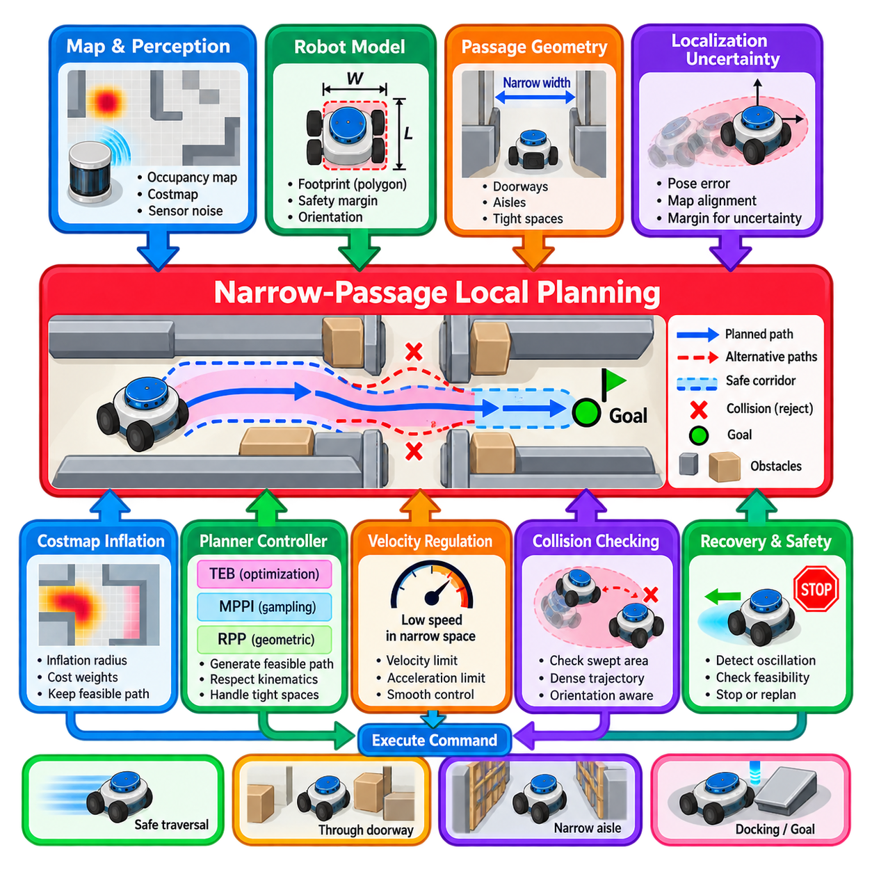
Narrow-passage and tight-space local planning addresses navigation situations in which the available free space is only slightly larger than the physical robot footprint. Typical examples include doorways, warehouse aisles, docking corridors, passages between machinery, elevator entrances, and cluttered industrial workspaces. In these environments, small errors in localization, obstacle representation, trajectory tracking, or footprint configuration can determine whether a motion is feasible.
The fundamental planning problem differs from ordinary obstacle avoidance because maximizing clearance may no longer be possible. In open space, a local planner can maintain generous margins around obstacles while preserving several alternative trajectories. Inside a narrow passage, the feasible region can collapse into a small corridor of configurations. The planner must therefore distinguish between genuinely unsafe motion and motion that is close to obstacles but still physically valid.
Robot footprint accuracy becomes critical as clearance decreases. Approximating a rectangular AMR as an excessively large circle may eliminate feasible passages, while an undersized footprint can permit physical collisions. Polygonal or oriented footprints provide more accurate representations for elongated platforms. The footprint should include relevant structural dimensions while safety margins are represented separately so that geometry and operational clearance are not unintentionally combined.
Configuration-space reasoning provides a useful interpretation of narrow-passage planning. Instead of moving the full robot around obstacles, obstacles can conceptually be expanded according to the robot footprint while the robot is treated as a reference point. For noncircular robots, this expansion depends on orientation, making passage feasibility sensitive to heading. A rectangular robot may fit through a corridor when aligned correctly but become infeasible if rotated significantly.
Costmap inflation strongly influences local planning behavior in constrained spaces. Inflation assigns increasing navigation cost near obstacles, encouraging trajectories to remain farther away. This is useful in open environments but can cause the entire width of a narrow corridor to receive high cost. If the planner interprets these costs too aggressively, a physically traversable passage may become unattractive or effectively unusable even though no lethal collision exists.
For this reason, lethal collision constraints and preference costs should remain conceptually distinct. A trajectory intersecting an obstacle or violating the required physical footprint clearance must be rejected. A trajectory passing through inflated but nonlethal regions may still be necessary when no wider route exists. The local planner should therefore preserve hard safety boundaries while allowing controlled tradeoffs in soft clearance objectives when operating inside constrained geometry.
Localization uncertainty becomes increasingly important as the remaining clearance approaches the magnitude of pose error. A path that appears centered in a narrow aisle may place the physical robot closer to one side because of map alignment error, SLAM drift, sensor bias, or short-term pose noise. Planning margins should therefore account for expected localization uncertainty rather than relying only on nominal robot dimensions and ideal map geometry.
Map and perception accuracy impose similar constraints. Walls represented several centimeters away from their true positions can significantly alter the estimated free width of a doorway. Dynamic costmap observations may also fluctuate because of LiDAR noise, reflections, occlusion, or temporary objects. Excessively reactive planning can respond to these small changes with alternating steering commands, producing oscillation precisely where stable centered motion is most important.
Path quality is particularly important before entering a narrow passage. The reference path should approach the entrance with an orientation that allows the robot to become aligned before clearance becomes restrictive. Entering diagonally may require large corrective rotations inside the passage, increasing the swept footprint and collision risk. A well-designed global or intermediate path should therefore provide sufficient alignment distance before constrained traversal begins.
Local trajectory generation must consider the swept area of the robot rather than checking only discrete poses. Two individually collision-free poses do not guarantee that the motion connecting them is collision-free, especially when the robot rotates. This issue becomes critical for rectangular platforms whose corners sweep outward during turning. Collision checking should use sufficiently dense trajectory sampling or continuous geometric reasoning to detect intermediate collisions.
Velocity should generally decrease as geometric clearance and maneuvering tolerance become smaller. Lower speed reduces stopping distance, improves tracking accuracy, provides more time for perception updates, and limits the consequences of control error. However, simply commanding an extremely low velocity is not always effective because drivetrains may exhibit static friction, quantization, or unstable low-speed control. Narrow-space velocity limits should therefore reflect experimentally verified platform behavior.
Acceleration and angular-acceleration limits also influence tight-space navigation. Sudden command changes can create overshoot, wheel slip, or heading errors that consume valuable clearance. Smooth velocity transitions help preserve predictable motion, but excessive smoothing can delay corrections when the robot begins drifting toward an obstacle. The planner, velocity smoother, and base controller must therefore provide both smoothness and sufficiently responsive corrective authority.
Lookahead-based controllers require special attention because large lookahead distances may cut corners or generate commands that ignore immediate passage geometry. Very short lookahead can increase sensitivity to path noise and produce oscillation. Adaptive lookahead is useful when the robot transitions from open space into a constrained region, allowing longer pursuit distances during normal travel and shorter, more precise tracking during doorway or aisle traversal.
Optimization-based planners such as TEB can reshape trajectories to balance obstacle clearance, path alignment, kinematic feasibility, and travel time. In narrow passages, obstacle-related weights must not overwhelm the optimization to the point that every feasible trajectory receives excessive cost. Accurate footprint modeling, trajectory resolution, and initialization become particularly important because the optimizer may have only a small feasible region in which to find a solution.
Sampling-based controllers such as MPPI face a different challenge. Randomly perturbed rollouts may frequently collide when the valid control region is narrow, leaving only a small fraction of useful samples. Sampling distributions, rollout count, reference-path attraction, and control noise should therefore support concentrated exploration around feasible motion. Excessively broad exploration wastes computation on trajectories that immediately leave the narrow free-space corridor.
Geometric controllers such as Regulated Pure Pursuit can perform effectively when the reference path is accurately centered and dynamically executable. Their relatively predictable tracking behavior is useful in structured corridors, but they do not independently discover major alternative routes when the path becomes blocked. Collision checking and speed regulation can protect immediate motion, while higher-level replanning should handle situations in which the intended passage is no longer traversable.
Differential-drive robots have useful zero-radius turning capability, but rotation inside a narrow corridor can still be dangerous because the footprint corners may sweep into nearby obstacles. A planner should not interpret in-place rotation as universally feasible merely because the kinematic model permits it. Rotation feasibility depends on footprint shape, passage width, robot orientation, and the available clearance around the complete swept geometry.
Goal placement inside constrained spaces also requires care. A goal pose located too close to a wall or obstacle may satisfy point-position requirements while being physically difficult to reach with the required orientation. Docking and workstation goals should be defined together with approach direction and final footprint occupancy. In some applications, a staged approach with an intermediate alignment pose provides more reliable behavior than direct navigation to the final target.
Oscillation is a common failure mode near narrow entrances. The planner may repeatedly prefer slightly different left and right corrections as obstacle costs or localization estimates fluctuate. Hysteresis, trajectory continuity preferences, stable path alignment, and appropriate controller gains can reduce this behavior. Detecting repeated command reversals or negligible progress can also allow the navigation system to stop and request replanning instead of continuing unstable motion.
Passage feasibility should ideally be assessed before the robot commits deeply to a constrained region. If the estimated width, obstacle configuration, or required orientation indicates insufficient clearance, entering the passage can create a difficult recovery problem. A higher-level feasibility check can compare robot geometry, safety margin, localization uncertainty, and map information before allowing the local planner to proceed into a region with limited escape options.
Recovery behavior inside tight spaces must be more conservative than in open environments. Large rotations, aggressive backup motions, or conventional clearing maneuvers may not be physically possible. Recovery actions should first determine which directions remain collision-free and whether controlled reverse motion along the recently executed path is available. When safe autonomous recovery cannot be established, stopping and requesting external assistance may be preferable to exploratory motion.
Testing requires physical scenarios with accurately measured clearances. Useful cases include progressively narrower corridors, centered and offset doorway approaches, turns immediately before or after a doorway, opposing obstacles, elevator entrances, docking lanes, and passages containing temporary obstructions. Tests should vary localization error, payload, speed, approach angle, and obstacle-detection conditions to identify the true operational envelope rather than only demonstrating nominal success.
Performance metrics should include more than navigation success. Minimum physical clearance, lateral tracking error, heading error, passage traversal time, number of command reversals, stop frequency, planner latency, localization uncertainty, and collision-check margin provide a more complete description. Repeated trials are necessary because a planner that succeeds once with minimal clearance may not provide the repeatability required for production operation.
Narrow-passage planning ultimately depends on coordinated treatment of geometry, uncertainty, control, and safety. Accurate footprints define what can physically fit, maps and perception describe the available space, localization determines confidence in the robot pose, and the local planner generates feasible motion within that space. Reliable operation emerges when these elements are validated together with realistic margins, controlled speed, stable tracking, and conservative failure handling.

05.09. Local Planner Failure Detection and Recovery [w/Code]
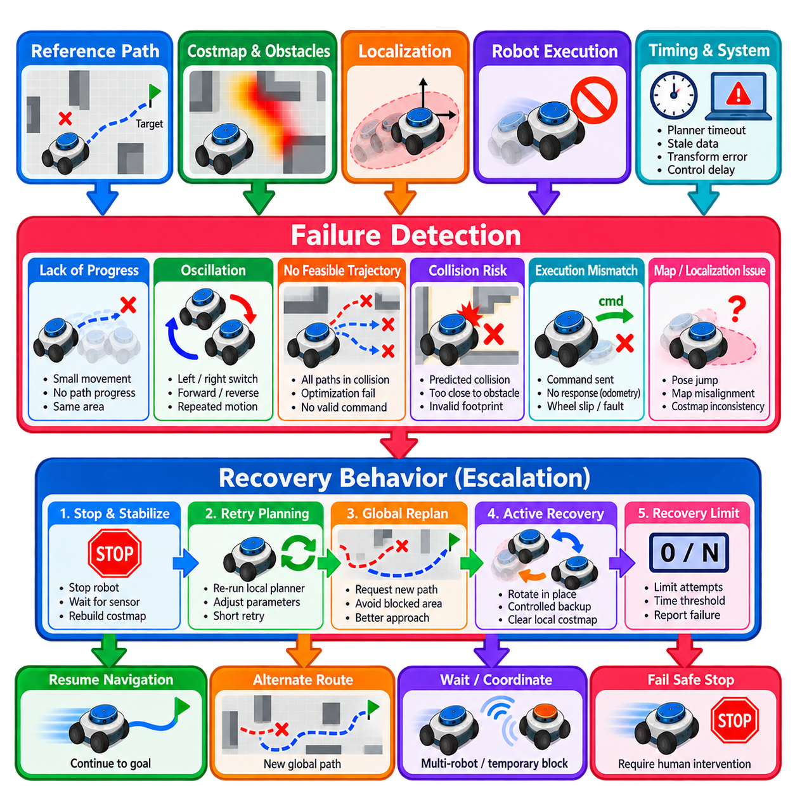
Local planner failure detection and recovery provide the mechanisms that allow a mobile robot to recognize when normal trajectory generation or path following is no longer producing safe and meaningful progress. A local planner can continue generating mathematically valid commands even when the robot is trapped, oscillating, blocked, or unable to execute the requested motion. Reliable navigation therefore requires explicit detection of failure conditions rather than assuming that continuous command generation implies successful movement.
A local planning failure can originate from several layers of the navigation system. The reference path may become blocked, the local costmap may contain unexpected obstacles, localization may become inaccurate, the controller may fail to find a feasible trajectory, or the physical robot may not respond correctly to commands. Distinguishing these causes is important because different failures require different recovery actions rather than a single generic retry mechanism.
One of the most important indicators is lack of progress. The navigation system can compare the robot’s current pose with previous poses over a defined time interval and determine whether sufficient displacement toward the goal has occurred. If commanded motion continues while measured progress remains below a threshold, the robot may be physically blocked, trapped in a local minimum, suffering from wheel slip, or repeatedly generating ineffective control commands.
Progress detection should consider more than Euclidean displacement. A robot may move back and forth over a short distance without making useful progress along the planned route. Measuring reduction in remaining path length, advancement along the reference path, or improvement in goal distance can provide a more meaningful progress signal. Combining several indicators helps distinguish legitimate slow maneuvering from persistent navigation failure.
Oscillation is another characteristic local planner failure. The robot may alternate between left and right steering, forward and reverse commands, or competing trajectories without leaving the same region. Such behavior can arise from symmetric obstacle configurations, noisy costmaps, localization fluctuations, poorly balanced cost functions, or frequent switching between equivalent local solutions. Persistent oscillation wastes time and may increase collision risk in constrained spaces.
Oscillation detection can monitor command sign changes, heading reversals, trajectory switching, or repeated movement within a bounded spatial region. A small number of corrections should not immediately trigger recovery because normal navigation often requires short adjustments. Detection therefore needs temporal persistence and magnitude thresholds so that genuine unstable behavior can be separated from ordinary closed-loop corrections.
Trajectory infeasibility provides a more direct failure signal. Optimization-based planners may fail to converge to a valid trajectory, sampling-based planners may produce too few collision-free rollouts, and geometric controllers may detect that the commanded path intersects an obstacle. When no safe control command exists within the planner’s search space, returning an explicit failure is preferable to repeatedly publishing zero velocity without explaining the underlying condition.
Collision prediction can identify failures before physical contact occurs. If all candidate trajectories intersect obstacles or violate required safety margins, the planner should classify the local situation as blocked or infeasible. The same principle applies when the robot’s current footprint is already too close to an obstacle to execute the requested maneuver safely. Recovery should begin from a verified safe state rather than forcing continued motion through an invalid local solution.
Command execution should also be compared with measured robot response. A planner may continuously request forward velocity while odometry indicates little or no movement. This discrepancy can indicate wheel obstruction, drivetrain faults, excessive payload, floor interaction, emergency-stop conditions, or low-level controller problems. Failure detection should therefore include execution feedback rather than observing only the planner’s internal state.
Timing failures are equally important in real-time navigation. Excessive planner computation time, missed control deadlines, stale costmaps, delayed transforms, or irregular command publication can make otherwise valid trajectories unsafe. Monitoring controller-cycle duration, data age, and transform availability allows the system to distinguish algorithmic infeasibility from infrastructure failures. Repeated timing violations should trigger controlled degradation or stopping rather than silent continuation.
Localization failures can create behavior that resembles controller instability. Pose jumps, covariance growth, map misalignment, or unavailable transforms may cause the local planner to produce rapidly changing commands or incorrectly perceive the robot as deviating from the path. Recovery logic should therefore examine localization health before assuming that trajectory generation itself is defective. Continuing aggressive motion with unreliable pose information can amplify the problem.
Costmap failures can similarly produce false obstacles or remove real ones. Sensor noise, stale observations, incorrect clearing behavior, transform errors, or temporary occlusion may cause the local environment representation to become inconsistent with reality. Recovery mechanisms may refresh or clear appropriate costmap information when justified, but indiscriminate clearing is dangerous because it can erase valid obstacles and temporarily create an unrealistically free planning space.
Recovery should normally follow an escalation strategy rather than immediately executing aggressive motion. The first response may be to stop and allow perception, localization, and costmap information to stabilize. The system can then retry local planning, request a new global path, or adjust the navigation behavior. More active maneuvers such as controlled rotation or backup should occur only after simpler and lower-risk recovery steps have failed.
Global replanning is appropriate when the local path is persistently blocked but another route may exist. The robot should communicate the local failure to the higher planning layer instead of repeatedly attempting the same infeasible trajectory. A newly generated global path may route around the obstruction, approach the constrained region from a better direction, or determine that no alternative route exists. This illustrates why failure propagation between navigation layers is essential.
Rotation can help refresh perception or escape certain local configurations, but it should not be treated as universally safe. A differential-drive robot may be kinematically capable of rotating in place while its rectangular footprint sweeps into nearby obstacles. Before commanding recovery rotation, the system should verify the swept area and available clearance. This requirement is particularly important in narrow passages, docking stations, and crowded industrial environments.
Controlled backup can provide another recovery option when the robot has entered a local dead end or approached an obstacle too closely. The safest reverse trajectory may be the recently executed forward path because that region was previously known to be traversable. Nevertheless, environmental conditions may have changed, so reverse motion still requires current collision checking, sensor coverage, velocity limits, and appropriate stopping margins.
Recovery behaviors should be context dependent. A robot trapped in an open area can safely attempt maneuvers that would be inappropriate inside a narrow aisle or elevator. Similarly, a robot carrying a heavy or unstable payload may require lower acceleration and more conservative rotation than an unloaded platform. Recovery policies should therefore consider robot geometry, payload state, environmental clearance, and available escape directions.
Repeated recovery attempts require explicit limits. An autonomous system should not rotate, clear maps, replan, and retry indefinitely when the underlying problem cannot be resolved. Recovery counters, elapsed-time limits, or repeated-failure histories can determine when autonomous recovery has been exhausted. At that point the robot should enter a safe stopped state and report that external intervention or higher-level task reassignment is required.
Failure classification improves operational diagnostics. Useful categories include blocked path, no feasible local trajectory, insufficient progress, oscillation, localization failure, costmap inconsistency, controller timeout, transform failure, actuator nonresponse, and recovery exhaustion. Structured failure codes allow fleet-management systems and operators to distinguish temporary navigation difficulties from hardware, mapping, localization, or infrastructure problems.
In multi-robot environments, local failure may be caused by another robot rather than a static obstacle. Immediate aggressive replanning can create unnecessary route changes if the blockage is temporary. The system may instead wait, negotiate priority through fleet coordination, or request traffic-level rerouting. Local recovery should therefore interact with fleet-level coordination when shared corridors, intersections, elevators, or docking resources create dependencies among robots.
Safety supervision must remain independent of planner recovery. Collision monitors, protective fields, emergency-stop systems, and certified safety controllers should continue enforcing their own constraints regardless of the recovery state. A recovery behavior must never disable or weaken these protections merely to escape a difficult planning condition. Navigation recovery operates within the safety envelope rather than redefining it.
Testing should intentionally create failure conditions instead of evaluating only successful navigation. Representative scenarios include blocked corridors, sudden obstacles, impossible doorways, oscillatory path choices, localization disturbances, stale sensor data, delayed transforms, wheel obstruction, planner timeout, and unsuccessful recovery attempts. Controlled fault injection makes it possible to verify that failures are detected promptly and that escalation follows the intended sequence.
Logging should capture the robot pose, measured and commanded velocity, planner status, progress metrics, candidate trajectory validity, costmap state, localization health, computation latency, recovery state, and failure reason. A timestamped sequence of these signals makes post-event diagnosis substantially easier. Recovery transitions should be recorded explicitly so that engineers can determine why a particular behavior was selected and whether it improved the situation.
Quantitative evaluation should include failure-detection latency, false-positive rate, recovery success rate, time to resume navigation, distance traveled during recovery, minimum obstacle clearance, number of repeated attempts, and percentage of failures requiring human intervention. These metrics reveal whether the system merely appears robust during demonstrations or can consistently manage abnormal situations during long-term autonomous operation.
Local planner failure detection and recovery ultimately transform navigation from a controller that works under nominal conditions into a resilient autonomous system. The robot must recognize loss of progress, oscillation, infeasible motion, stale information, and execution mismatch; classify the likely problem; stop safely when necessary; and escalate through appropriate recovery actions. Robustness emerges when detection, replanning, recovery, safety supervision, diagnostics, and higher-level coordination operate as an integrated navigation architecture.

05.10. Local Planner Tuning Guide for AMR Platforms
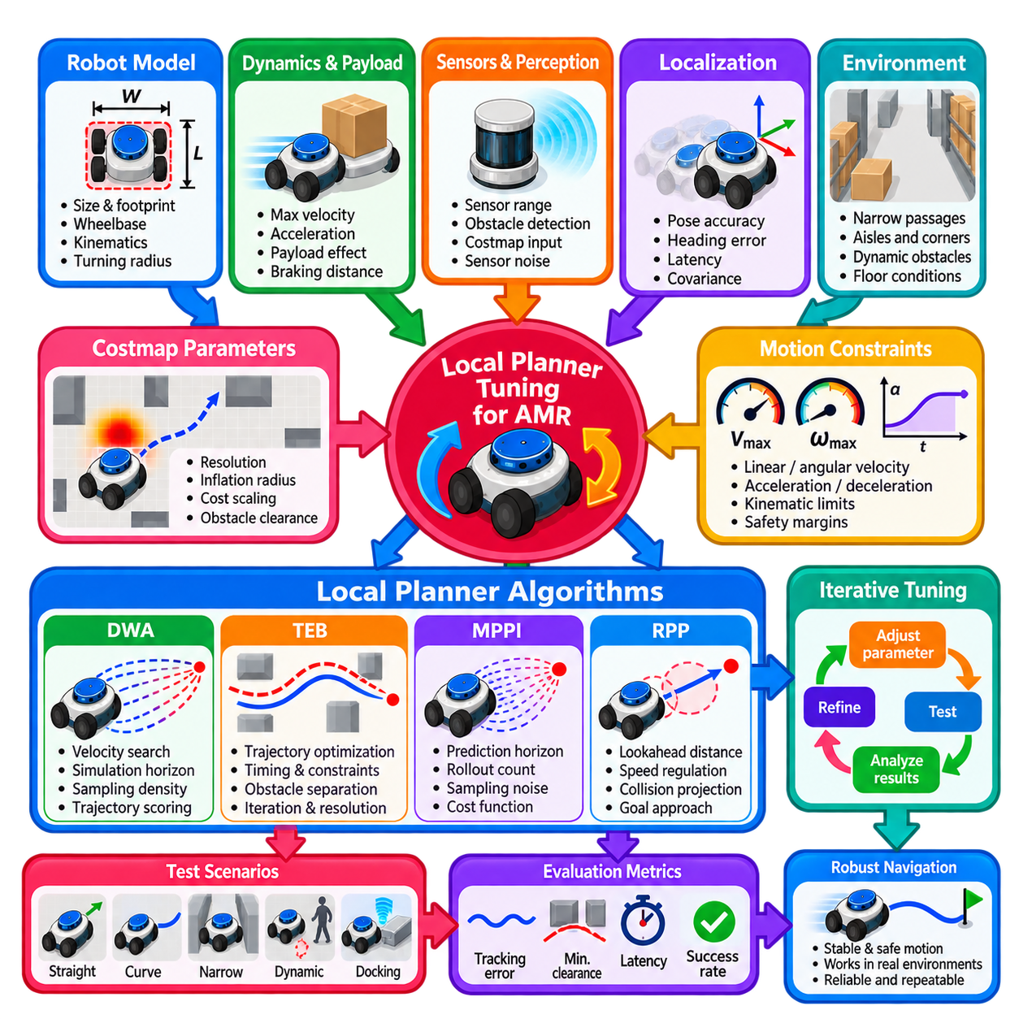
Local planner tuning for Autonomous Mobile Robot (AMR) platforms is the process of aligning trajectory generation and motion-control parameters with the actual geometry, kinematics, dynamics, sensing characteristics, and operating environment of the robot. Effective tuning is not simply a search for parameter values that produce smooth motion. It establishes a consistent relationship among planner assumptions, physical capabilities, safety margins, and navigation performance.
Tuning should begin with a verified physical model of the AMR rather than with planner-specific parameters. Robot length, width, wheelbase, footprint, turning characteristics, maximum steering or rotational capability, ground clearance, and payload configuration define the feasible motion envelope. Incorrect geometry can make later parameter optimization misleading because the planner may evaluate trajectories using assumptions that differ from the physical platform.
The robot footprint is particularly important because it directly influences collision checking and obstacle clearance. A footprint that is too conservative can prevent navigation through valid corridors, while an undersized footprint can create unsafe trajectories. Polygonal footprints generally provide more realistic representations for rectangular industrial AMRs, while additional operational safety margins can be introduced through costmap inflation rather than by arbitrarily enlarging physical dimensions.
Kinematic constraints should next be matched to the actual drive architecture. Differential-drive, omnidirectional, Ackermann-steered, and four-wheel-steering platforms have different feasible velocity and curvature regions. Parameters such as minimum turning radius, maximum angular velocity, allowable lateral velocity, and reverse-motion capability must correspond to the robot model. A controller tuned for incorrect kinematics may produce commands that are geometrically attractive but physically impossible.
Velocity limits should initially be set below the maximum hardware capability. The objective during early tuning is stable and repeatable navigation rather than maximum throughput. Linear and angular velocities can then be increased progressively while observing tracking error, stopping distance, obstacle clearance, and command saturation. The final operating limit should include sufficient reserve for disturbances, payload variation, floor conditions, and low-level controller error.
Acceleration and deceleration parameters must reflect measured platform response. Excessive acceleration can produce wheel slip, payload motion, drivetrain stress, and path-tracking overshoot, while overly conservative values can make navigation unnecessarily slow. Deceleration deserves separate attention because collision avoidance and stopping performance depend on it. Planner assumptions should remain consistent with the velocity smoother and the actual base-controller limits.
Controller frequency determines how often the local planner can react to changes in path geometry, localization, and obstacles. Increasing frequency can improve responsiveness, but only when computation completes reliably within the available cycle time. A nominal 20 Hz controller provides little benefit if complex scenes repeatedly require more than 50 ms for computation. Tuning should therefore evaluate P50, P95, P99, and worst-case execution latency rather than only average performance.
Localization quality should be characterized before aggressive controller tuning. Pose noise, heading error, latency, and occasional jumps can appear as planner instability because the controller reacts to the estimated robot state. Increasing controller gains or obstacle weights cannot correct poor localization and may amplify oscillation. Straight-line tracking and slow curved-path tests provide useful baselines for separating localization problems from controller-specific behavior.
Costmap configuration and controller tuning should be treated as a coupled problem. Resolution determines the spatial detail available to collision checking, while inflation radius and cost scaling determine how strongly the planner reacts to nearby obstacles. Excessive inflation can make narrow passages effectively unusable, whereas insufficient inflation may permit trajectories with inadequate clearance. Parameters should be validated against measured physical clearance rather than visual appearance in a map display.
The global path supplied to the controller should also be examined before tuning local behavior. Sharp discontinuities, unnecessary zigzags, sparse waypoints, or paths incompatible with the robot’s turning capability can force the local planner into unstable corrections. Path smoothing and appropriate global-planner configuration can often solve problems that would otherwise be incorrectly addressed by increasing local controller gains or obstacle penalties.
For Dynamic Window Approach (DWA)-style controllers, the velocity search space, simulation horizon, sampling density, and trajectory scoring weights strongly influence behavior. Excessively broad sampling wastes computation, while insufficient sampling may miss useful commands. Path alignment, goal attraction, obstacle cost, and forward-motion preference should be balanced so that the robot follows the intended route without becoming either dangerously aggressive or unnecessarily conservative.
Timed Elastic Band (TEB)-style planners require careful balancing among trajectory timing, obstacle separation, path consistency, kinematic constraints, and optimization behavior. Excessive obstacle penalties can distort trajectories, while weak penalties may reduce clearance. Optimization iterations and trajectory resolution affect both solution quality and computation time. Tuning should therefore evaluate convergence stability together with control-cycle latency rather than maximizing optimization effort.
Model Predictive Path Integral (MPPI) controllers introduce parameters associated with prediction horizon, rollout count, sampling noise, robot dynamics, and trajectory cost terms. More rollouts or longer horizons can improve search quality but increase computational demand. GPU or highly parallel implementations expand the available search budget, yet tuning should still focus on useful sample efficiency and deterministic latency rather than simply maximizing the number of evaluated trajectories.
Regulated Pure Pursuit (RPP) requires a different tuning strategy because its behavior depends strongly on reference-path quality and lookahead selection. Short lookahead distances increase responsiveness but can amplify path or localization noise, while long distances improve smoothness but may cut corners. Velocity-scaled lookahead, curvature-based speed regulation, collision projection, and goal-approach behavior should be tuned together using representative path geometries.
Obstacle clearance should be tuned using repeatable physical tests. Straight walls, corridor centers, doorway edges, shelving corners, and isolated obstacles provide useful reference geometries. The objective is not necessarily to maximize distance from every obstacle, because industrial AMRs must often operate in constrained environments. Instead, tuning should establish a predictable minimum clearance that remains valid under localization uncertainty and tracking error.
Narrow-passage testing should be performed separately from open-space tuning. Parameters that produce excellent obstacle clearance in open areas may prevent the robot from entering valid narrow corridors. Conversely, settings optimized only for tight spaces may produce unnecessarily close obstacle passing elsewhere. Context-dependent speed regulation or controller configurations can provide a better compromise when the operational environment contains both conditions.
Angular behavior deserves dedicated testing because many AMR navigation problems appear during transitions between translation and rotation. Excessive angular velocity can cause overshoot and footprint sweep near obstacles, while insufficient angular authority can prevent accurate curve tracking. Tests should include gradual curves, sharp corners, in-place rotation where permitted, doorway alignment, and transitions from straight motion into high-curvature sections.
Forward-to-reverse transitions should be evaluated when reverse motion is allowed. Frequent direction switching may indicate poor trajectory scoring or oscillation rather than useful maneuvering. Acceleration limits, minimum velocities, hysteresis, and path geometry influence these transitions. Heavy AMRs should generally avoid unnecessary reversals because drivetrain load, stopping distance, and payload dynamics make repeated direction changes more costly than on small research robots.
Goal approach parameters should be tuned independently from normal cruising behavior. Position tolerance, orientation tolerance, minimum controllable velocity, approach deceleration, and final rotation behavior determine whether the AMR reaches a target smoothly or repeatedly corrects around it. Docking applications may require a staged strategy in which normal navigation ends at an approach pose and a specialized precision controller completes the final alignment.
Payload conditions should be incorporated into tuning because robot dynamics can change significantly between unloaded and fully loaded operation. Acceleration capability, braking distance, wheel slip, turning response, and center-of-gravity stability may all change. A conservative parameter set can cover the complete operating range, while more advanced systems may use validated motion profiles for different payload classes or operational modes.
Parameter tuning should modify a small number of related variables at one time. Changing velocity limits, obstacle weights, lookahead distance, acceleration, and costmap inflation simultaneously makes cause-and-effect relationships difficult to identify. A controlled experimental procedure establishes a baseline, changes one parameter group, repeats the same test scenario, records quantitative metrics, and retains the modification only when measurable improvement occurs.
Representative scenarios should include straight tracking, long curves, sharp corners, narrow corridors, doorway transitions, static obstacles, dynamic obstacle encounters, blocked paths, goal approach, and recovery behavior. Testing only in a large open laboratory tends to produce parameters that fail in production. The test environment should reproduce actual aisle widths, floor properties, sensor visibility, obstacle types, and expected robot speeds whenever possible.
Useful tuning metrics include lateral tracking error, heading error, minimum obstacle clearance, trajectory curvature, commanded and measured velocity, stopping distance, controller latency, oscillation frequency, command reversals, replanning frequency, and navigation success rate. These measurements provide stronger evidence than subjective judgments such as whether the robot appears smooth. Repeated trials are necessary to evaluate variability and operational robustness.
Logging should preserve synchronized planner inputs and outputs so that parameter changes can be compared objectively. Robot pose, global and local paths, costmaps, target and measured velocities, candidate trajectory scores, selected commands, controller computation time, failure codes, and recovery events provide valuable diagnostic information. Versioning the corresponding configuration files makes successful tuning results reproducible across software releases and robot units.
The final parameter set should be validated across the operational envelope rather than against one ideal scenario. Tests should include different payloads, battery conditions, floor surfaces, obstacle densities, localization quality, network or computation loads, and representative mission durations. Long-duration testing is particularly useful because intermittent oscillation, timing overruns, accumulated localization error, and thermal performance limitations may not appear during short demonstrations.
AMR local planner tuning is ultimately a system-engineering activity rather than isolated algorithm adjustment. Robot geometry, kinematics, dynamics, localization, perception, costmaps, global planning, local control, velocity smoothing, safety supervision, and recovery behavior must share compatible assumptions. A production-quality configuration emerges through measured platform characterization, controlled parameter experiments, quantitative evaluation, and repeated validation under realistic operating conditions.

