Volume 15. Motion Planning and Navigation

Chapter 01. Navigation Fundamentals

01.01. Navigation Problem Configuration Space and Path Planning
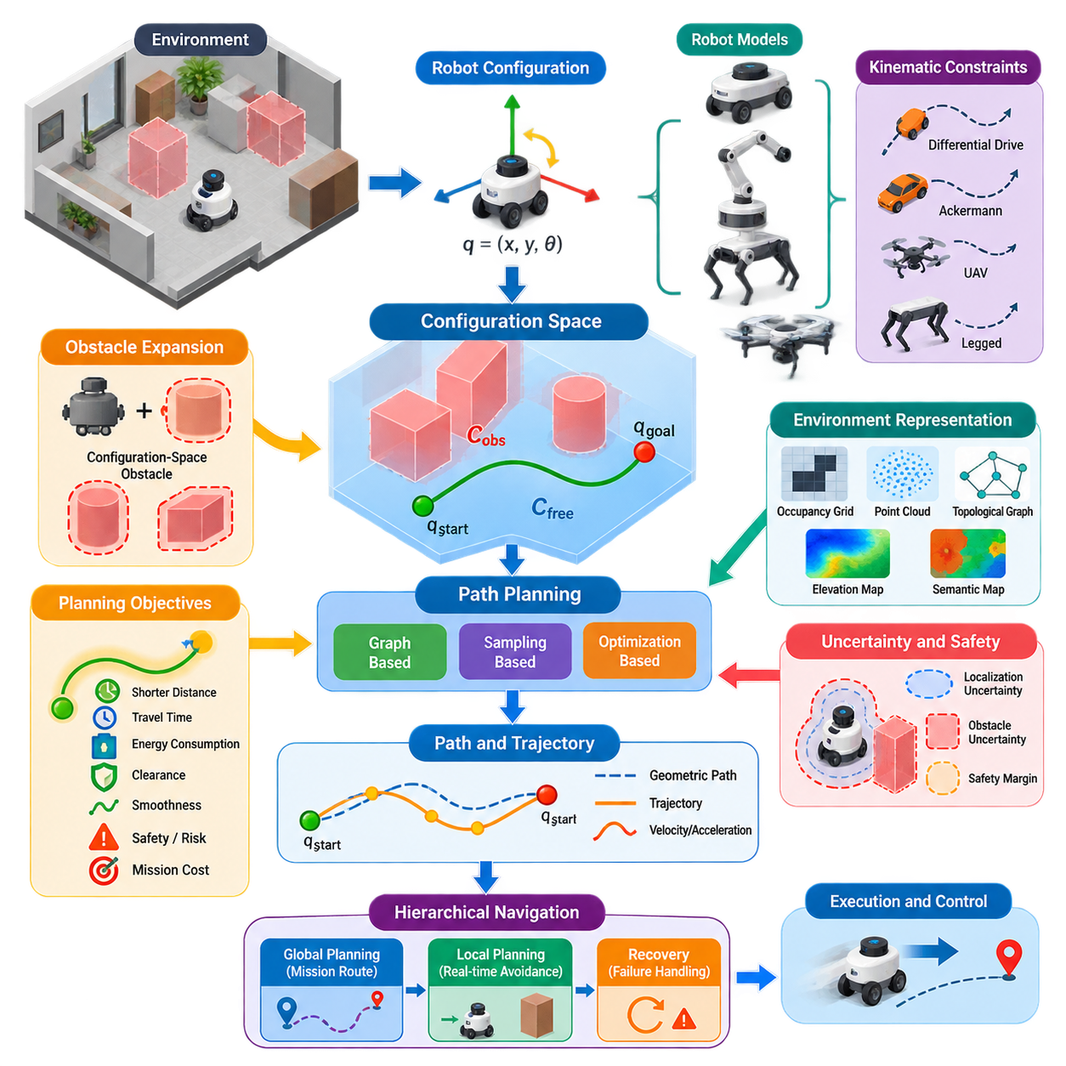
Robot navigation is fundamentally the problem of determining how an autonomous system can move from an initial state to a desired goal while respecting the geometry of the environment, the physical dimensions of the robot, and operational constraints. In this formulation, navigation is not merely movement toward a target. It is a structured reasoning process that transforms spatial information into a feasible sequence of robot configurations.
A robot configuration describes the variables required to specify the robot's pose or physical arrangement. For a planar mobile robot, a configuration is commonly represented as q = (x, y, θ), where x and y describe position and θ represents orientation. More complex robots require higher-dimensional representations. A manipulator may require one variable for each joint, while a mobile manipulator combines base pose and arm joint states into a larger configuration vector.
The configuration space, commonly called C-space, provides a mathematical representation in which every point corresponds to one possible robot configuration. Instead of reasoning directly about the complete physical geometry of a robot moving through Cartesian space, planning algorithms operate on points and trajectories in configuration space. This abstraction establishes a common foundation for mobile robots, manipulators, legged systems, and aerial vehicles.
Obstacles in the physical environment must therefore be transformed into forbidden regions of configuration space. The set of configurations that would cause any part of the robot to intersect an obstacle forms the configuration-space obstacle region, C_obs. The remaining configurations constitute the free configuration space, C_free. Path planning can then be expressed as the search for a continuous path through C_free connecting the initial configuration q_start with the desired configuration q_goal.
For a simple translating robot, configuration-space obstacles can be understood through geometric obstacle expansion. Rather than explicitly moving the robot body around every obstacle, the obstacle boundaries are enlarged according to the robot footprint while the robot is treated conceptually as a point. This transformation makes collision reasoning computationally manageable, although orientation-dependent footprints and non-convex robot geometries require more sophisticated configuration-space representations.
A path can mathematically be represented as a continuous mapping q(s), where the parameter s progresses from the beginning to the end of the route. A valid path must satisfy q(0) = q_start and q(1) = q_goal while remaining inside C_free throughout its domain. This definition separates geometric feasibility from the particular planning algorithm used to discover the path and provides a general criterion for collision-free navigation.
Finding any collision-free path is often insufficient for practical robotics. Navigation systems normally optimize one or more objectives such as travel distance, traversal time, energy consumption, clearance from obstacles, smoothness, risk, or mission-specific costs. Consequently, path planning is frequently formulated as an optimization problem in which the planner searches the feasible solution space for a path minimizing an objective function while satisfying required constraints.
The distinction between a path and a trajectory is important. A geometric path specifies where the robot should move but does not necessarily define when each configuration is reached. A trajectory adds temporal information and therefore includes quantities such as velocity and acceleration. A geometrically valid path may consequently be impossible for a real platform to execute if it violates steering limits, acceleration bounds, turning radius, actuator capability, or dynamic stability constraints.
Robot kinematics strongly influence the structure of the planning problem. Holonomic systems can theoretically command motion independently across their available degrees of freedom, whereas nonholonomic platforms are subject to differential constraints. A differential-drive AMR, Ackermann-steered vehicle, fixed-wing UAV, and legged robot therefore cannot be treated identically even when they occupy the same geometric environment. Feasible motion must reflect the mobility characteristics of the actual platform.
Navigation also depends on how accurately the planner represents the environment. Occupancy grids, geometric maps, point clouds, topological graphs, elevation maps, and semantic maps encode different forms of navigational knowledge. The planning representation should preserve information relevant to collision avoidance and traversability without introducing unnecessary computational complexity. Map resolution therefore becomes an engineering tradeoff between spatial precision, memory consumption, and planning speed.
Real robots require additional safety margins because estimated poses, maps, obstacle boundaries, and robot dimensions contain uncertainty. A path that passes mathematically close to an obstacle may be collision-free in the model but unsafe in deployment. Practical systems therefore enlarge obstacles or assign increasing traversal costs near them. This converts clearance from a purely geometric property into an explicit component of navigation safety and path-quality evaluation.
The classical navigation problem often assumes a known static environment, but deployed robots operate in spaces containing pedestrians, vehicles, doors, carts, other robots, and previously unseen obstacles. The planner must therefore distinguish long-lived environmental structure from transient observations. Global planning can provide a mission-level route through relatively stable map information, while local planning continuously adapts executable motion to current sensor observations and nearby changes.
This separation naturally leads to hierarchical navigation. A global planner searches a comparatively large spatial region and produces a route toward the goal, while a local planner or controller determines short-horizon motions that follow the route and avoid immediate hazards. Recovery mechanisms handle conditions in which normal planning fails. This global-local-recovery decomposition is treated as the next architectural topic in the chapter structure. :chatgpt-content-reference{index=“0”}
Different planning families explore configuration space in different ways. Graph-based methods discretize possible motion into connected states, sampling-based methods construct representations from selected configurations, and optimization-based methods directly improve candidate paths or trajectories. The volume intentionally develops these approaches in separate chapters, followed by local planning, dynamic obstacle avoidance, multi-robot navigation, semantic navigation, and AI-based planning. :chatgpt-content-reference{index=“1”}
The dimensionality of configuration space is one of the fundamental sources of planning difficulty. A planar point robot may require only two variables, whereas orientation, articulation, manipulation joints, or whole-body posture can rapidly increase the number of dimensions. As dimensionality grows, exhaustive discretization becomes increasingly expensive. This motivates sampling, optimization, hierarchical decomposition, learned representations, and other techniques designed to search large state spaces efficiently.
Planning must also account for uncertainty. Localization error means that the estimated configuration may differ from the robot's actual configuration, while perception uncertainty affects the estimated location and classification of obstacles. Dynamic environments add uncertainty about future states. Robust navigation therefore cannot depend exclusively on one deterministic path; it requires continuous sensing, state estimation, replanning, monitoring, and safety intervention as execution progresses.
For industrial robots, path quality must ultimately be evaluated at the system level rather than solely through geometric length. A slightly longer route may be preferable if it offers larger obstacle clearance, fewer sharp turns, lower energy demand, greater localization reliability, or reduced interaction with people. Navigation objectives must therefore reflect the operational mission, platform characteristics, environmental conditions, and safety requirements rather than relying on shortest distance alone.
The configuration-space formulation establishes the conceptual bridge between perception and control. Perception and localization estimate the robot and environment states, planning determines a feasible progression through those states, and control converts the planned motion into actuator commands. Navigation therefore functions as an integrated decision layer connecting environmental understanding with physical action rather than as an isolated shortest-path algorithm.
This foundation also explains why navigation algorithms must be selected according to the robot platform and mission. Indoor AMRs, outdoor autonomous platforms, manipulators, quadrupeds, humanoids, and UAVs possess different configuration spaces and constraints, yet they share the same fundamental problem: represent feasible states, identify forbidden regions, search for safe connectivity between start and goal, and execute the resulting motion while continuously responding to the physical world.

01.02. Navigation Architecture Global Local Recovery
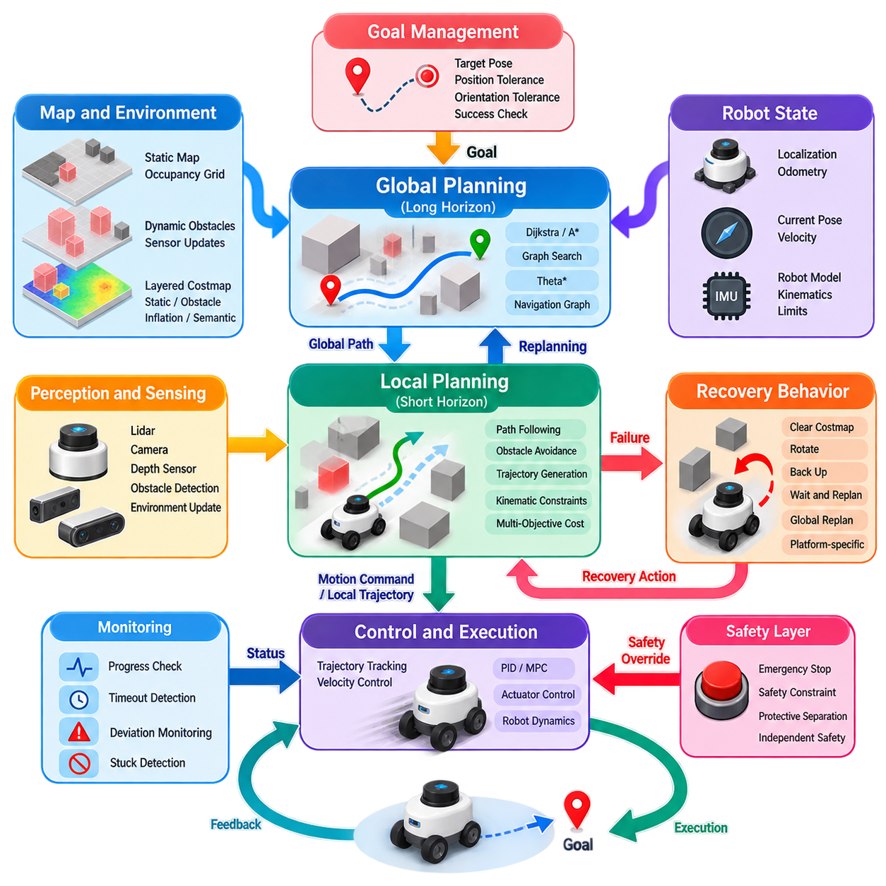
Navigation architecture organizes autonomous movement into cooperating functional layers that operate at different spatial and temporal scales. A practical robot cannot rely on a single planner to solve every navigation condition efficiently. Instead, global planning establishes a mission-level route, local planning converts that route into immediately executable motion, and recovery mechanisms respond when normal navigation becomes blocked, inconsistent, or unable to progress.
The global planning layer reasons over a comparatively large representation of the environment. Given the robot pose, navigation goal, map, and traversability information, it searches for a collision-free route connecting the current location to the destination. Because this route may extend across rooms, corridors, warehouse zones, floors, or outdoor regions, global planning emphasizes connectivity and overall path quality rather than reacting to every short-lived sensor observation.
A global planner normally operates on relatively stable environmental information such as static occupancy maps, navigation graphs, road networks, or persistent costmap layers. Its output is typically a sequence of poses, waypoints, or path segments that describe the desired progression toward the goal. Algorithms such as Dijkstra, A*, Theta*, graph search, or other planning methods can provide this function depending on the representation and requirements of the robot.
Global planning should not be interpreted as producing an immutable route. The environment may change after the initial path has been generated, localization may shift, or another route may become preferable during execution. Navigation architectures therefore support global replanning when relevant conditions change. Replanning can be periodic, event-driven, or triggered when the existing global path becomes invalid, excessively costly, or unreachable from the current robot state.
The local planning layer operates over a shorter horizon and at a substantially higher update rate. It receives the global route as directional guidance while continuously incorporating nearby obstacle observations and the current robot state. Its responsibility is to generate feasible motion commands or short trajectories that advance the robot along the intended route while respecting collision constraints, velocity limits, acceleration bounds, and platform kinematics.
This separation addresses an important computational problem. Recomputing a complete mission-level route whenever a pedestrian, cart, or temporary obstacle appears would often be inefficient and unstable. The local planner can instead react to transient changes while preserving the strategic intent of the global route. If the disturbance disappears, the robot can naturally return toward the original path without requiring the entire navigation problem to be reconstructed.
Local planning combines path following and obstacle avoidance rather than treating them as completely independent objectives. Following the global path too aggressively can cause unsafe motion near newly detected obstacles, while maximizing obstacle clearance without considering the route can lead the robot away from its destination. Practical planners therefore evaluate candidate motions according to multiple costs involving path alignment, goal progress, obstacle distance, smoothness, velocity, and feasibility.
The local planner must also respect the robot's actual motion model. A differential-drive AMR cannot instantaneously move sideways, an Ackermann vehicle has steering and turning-radius constraints, and aerial or legged platforms introduce additional dynamic and stability requirements. Consequently, locally generated motion must be executable by the downstream controller rather than merely geometrically collision-free. This creates a direct architectural connection between planning and control.
Global and local planning commonly rely on different environmental scopes. A global costmap may cover the complete operational area and emphasize persistent map structure, whereas a local costmap usually represents a moving region centered around the robot. The local representation is continuously refreshed from sensors so that recently detected obstacles influence immediate motion. Layered costmaps can combine static, obstacle, inflation, and other application-specific information.
The navigation controller forms the execution interface between planning and the robot's physical actuators. Depending on the architecture, a local planner may directly produce velocity commands or generate a trajectory that a separate controller tracks. Feedback from odometry, localization, and sensors closes the navigation loop. The robot therefore repeatedly observes its state, updates environmental information, evaluates planned motion, issues commands, and measures the resulting movement.
Even well-designed global and local planners encounter conditions in which ordinary navigation cannot make progress. A narrow passage may be incorrectly represented as blocked, the robot may become surrounded by temporary obstacles, localization may become inconsistent, or repeated local trajectories may fail. Recovery behavior provides an explicit mechanism for handling these abnormal states instead of allowing the planner to retry the same unsuccessful action indefinitely.
Recovery mechanisms are usually triggered by measurable failure conditions. Examples include failure to generate a valid global path, repeated local-planning failure, insufficient movement over a specified period, excessive deviation from the route, or detection that commanded motion does not produce expected progress. Progress monitoring is particularly important because a planner can continue producing technically valid commands while the robot remains effectively trapped or oscillates near the same position.
A recovery action should be selected according to the suspected cause of failure. The system may clear transient obstacle information, rotate to improve sensing, stop and wait for a temporary obstruction to disappear, move a short distance away from a problematic location, request global replanning, or perform another platform-specific maneuver. Recovery is therefore better understood as structured fault handling within navigation rather than as one universal emergency motion.
Recovery actions also require escalation logic. A lightweight intervention should generally be attempted before disruptive actions are taken. For example, the architecture may first request local replanning, then refresh environmental information, then invoke a controlled recovery maneuver, and finally regenerate the global route. If repeated attempts fail, navigation can terminate safely and report that the goal is currently unreachable instead of continuing uncontrolled retries.
A robust architecture must distinguish navigation failure from safety intervention. Recovery attempts to restore progress when normal planning cannot continue, whereas a safety layer can override navigation whenever motion violates independent safety conditions. Emergency stopping, protective separation, hardware safety functions, and certified safety logic should therefore not depend solely on the planner's recovery mechanism. Navigation availability and functional safety represent related but distinct concerns.
Goal management provides another important architectural function. Navigation begins with a target pose or mission destination, but successful completion requires more than reaching approximately the correct location. The system evaluates position tolerance, orientation tolerance, final velocity, and other application-specific conditions. Goal checking must coordinate with local control so that the robot can converge reliably instead of oscillating around the destination or declaring success prematurely.
The architecture must also manage interactions between components asynchronously. Sensor updates, localization estimates, map changes, global replanning, controller cycles, progress checks, and recovery decisions occur at different frequencies. Clear interfaces are therefore essential. The global planner should not depend on every control cycle, while the controller should not wait for expensive global computation before reacting to an immediate obstacle or maintaining stable motion.
Navigation can consequently be viewed as a closed-loop hierarchy rather than a linear pipeline. Mission intent generates a goal, global planning establishes strategic connectivity, local planning determines short-horizon feasible motion, and control executes that motion. Perception and localization continuously update the state of the world, while progress monitoring and recovery supervise execution. New information can propagate backward through the hierarchy and trigger replanning at the appropriate level.
For industrial AMRs, this architecture becomes especially important in environments containing narrow aisles, intersections, doors, temporary pallets, forklifts, pedestrians, and other robots. Global planning can determine the preferred corridor or zone sequence, while local planning manages immediate interactions. When congestion or blockage exceeds the capability of local avoidance, recovery and global replanning allow the robot to seek an alternative route or report operational failure.
The global-local-recovery architecture provides the structural foundation on which more specialized navigation functions are built. Costmap design determines how environmental information enters planning, goal specification defines completion conditions, benchmarking measures navigation quality, and kinematic constraints determine executable motion. Later planning algorithms may change how paths are computed, but these architectural responsibilities remain fundamental to reliable autonomous navigation.

01.03. Costmap Design Static Dynamic Inflation Layer [w/Code]
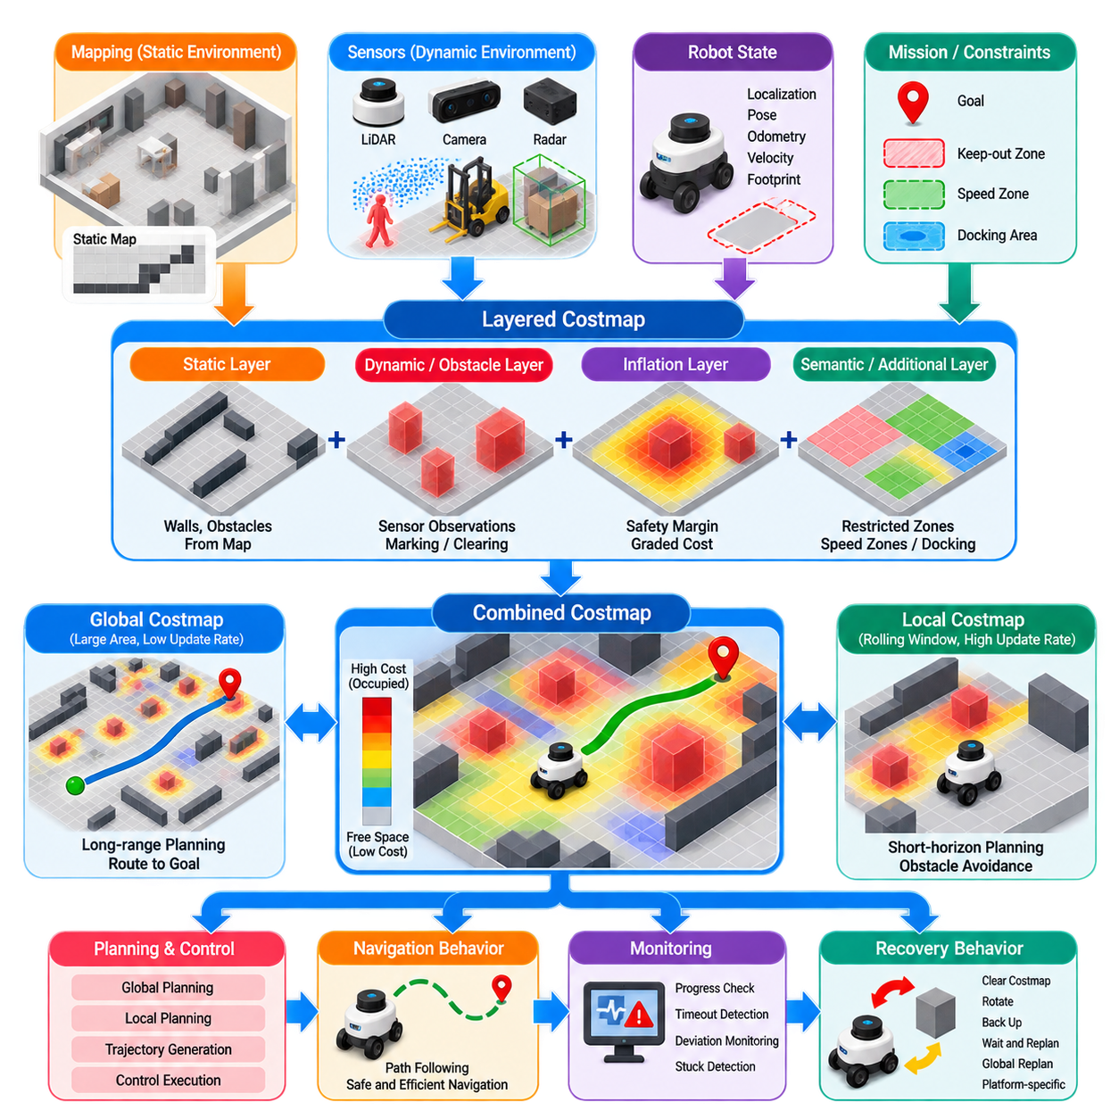
A costmap is a spatial representation that converts environmental information into numerical navigation costs that planners and controllers can evaluate efficiently. Rather than describing the world only as free or occupied, a costmap represents different degrees of traversability and risk. Each cell or spatial element expresses how desirable, dangerous, or impossible it is for the robot to occupy that region during navigation.
Costmaps form an important interface between perception, mapping, and motion planning. Mapping provides persistent knowledge about walls, structures, and known obstacles, while onboard sensors detect temporary or previously unknown objects. The costmap combines these heterogeneous sources into a common representation that planning algorithms can query. This separation allows perception components to change without requiring every planner to understand individual sensor formats.
A typical navigation system distinguishes between global and local costmaps. The global costmap usually covers a large operational area and supports long-range route planning from the current robot position toward the navigation goal. The local costmap represents a smaller region surrounding the robot and is updated more frequently. It supports short-horizon trajectory generation, obstacle avoidance, and immediate responses to environmental changes.
Layered costmap design separates different sources of navigation information into independently configurable processing layers. Instead of constructing one monolithic grid, the system maintains logical layers representing static structures, observed obstacles, safety inflation, or application-specific constraints. These layers are combined into a final cost representation. The approach improves modularity because individual layers can be updated, tuned, enabled, or replaced without redesigning the entire navigation representation.
The static layer represents persistent environmental structure derived from an existing map. Walls, fixed equipment, shelves, columns, restricted structures, and other permanent features can be encoded as occupied or high-cost regions. Free regions indicate locations that are expected to be traversable. Because static information changes relatively slowly, it provides a stable geometric foundation for global path planning and long-range navigation decisions.
Static maps are commonly represented as occupancy grids in which each cell contains information describing whether the corresponding area is free, occupied, or unknown. The grid resolution determines the spatial detail available to the planner. Fine resolution provides more precise obstacle boundaries but increases memory consumption and computation, whereas coarse resolution reduces processing requirements at the cost of geometric accuracy and narrow-passage representation.
The dynamic or obstacle layer represents environmental information obtained from current sensor observations. LiDAR, depth cameras, stereo vision, radar, or other perception systems can identify objects that are not contained in the static map. Pallets, carts, people, vehicles, movable equipment, and newly introduced structures can therefore modify navigation costs while the robot is operating, allowing the navigation system to react to the actual environment rather than only to stored map data.
Sensor observations are commonly transformed into a shared coordinate frame before they update the costmap. Accurate transformations between sensor, robot, odometry, and map frames are essential because even small spatial inconsistencies can create displaced or duplicated obstacles. Timestamp synchronization is also important for moving robots because measurements acquired at different times may otherwise be projected using an incorrect robot pose, degrading the reliability of obstacle representation.
Obstacle processing frequently includes both marking and clearing operations. Marking inserts occupied regions when sensor measurements indicate the presence of an obstacle. Clearing removes obsolete obstacle information when sensor rays or other observations indicate that previously occupied space is now free. Without appropriate clearing behavior, transient objects can remain as persistent false obstacles and gradually reduce the robot's perceived navigable space.
Unknown space requires an explicit navigation policy. In a mapped industrial facility, unknown cells may reasonably be treated as non-traversable because the robot is expected to remain inside verified operational regions. Exploration systems may instead permit movement into unknown areas under controlled conditions. The interpretation of unknown space therefore depends on mission requirements, localization confidence, sensor coverage, and the acceptable level of operational risk.
The inflation layer converts hard obstacle boundaries into graded cost regions surrounding obstacles. Cells close to an obstacle receive higher costs, while cells farther away receive progressively lower costs until the inflation influence disappears. This encourages planners to maintain clearance without converting every nearby location into an absolute collision region. Inflation therefore introduces a practical relationship between geometric obstacle boundaries and preferred navigation behavior.
Inflation should be distinguished from the robot's collision footprint. The footprint describes the physical area occupied by the robot and determines whether a pose would cause an actual collision. Inflation adds navigation cost around obstacles to account for clearance preferences and safety margins. These concepts interact, but they serve different purposes. Incorrectly treating inflation radius as the complete representation of robot geometry can produce overly conservative or unsafe planning behavior.
The shape of the inflation cost decay strongly influences path selection. Rapid cost reduction allows paths to travel relatively close to obstacles, potentially increasing available space but reducing clearance. Slower decay creates broader high-cost regions and encourages routes toward corridor centers or open areas. Inflation parameters should therefore be selected according to robot dimensions, localization uncertainty, environmental geometry, operating speed, and desired safety behavior.
Robot footprint modeling is particularly important for platforms that cannot be approximated adequately by a circle. Rectangular AMRs, long towing vehicles, forklifts, and mobile manipulators may occupy substantially different areas depending on orientation. A planner must account for these dimensions when evaluating collision feasibility. Additional margins may also be introduced to compensate for localization error, control tracking error, mechanical tolerances, and uncertainty in obstacle measurements.
Costmap resolution and update frequency create an important computational tradeoff. High-resolution maps improve geometric precision but contain more cells and increase the workload of planners and collision checkers. High update rates improve responsiveness to dynamic changes but consume additional CPU, memory bandwidth, and sensor-processing resources. Production systems therefore select these parameters according to robot speed, environment density, sensing range, and available computing capacity.
The local costmap is commonly implemented as a rolling representation centered around the robot. As the robot moves, the represented window moves with it while new sensor information enters near its boundaries. This avoids maintaining high-frequency dynamic information for the entire facility. The local planner consequently receives detailed information where immediate decisions are required, while the global costmap can maintain a larger but comparatively stable representation.
Layer combination rules determine how static, dynamic, inflated, and specialized costs contribute to the final costmap. Some information must override lower costs because it represents definite collision hazards, whereas other information may be merged or interpreted as preferences. Semantic zones, speed-restricted areas, keep-out regions, preferred lanes, docking areas, or temporary operational restrictions can be represented through additional layers when the navigation architecture requires richer behavior.
Costmap quality must be evaluated during actual robot motion rather than only by visually inspecting the map. Excessive inflation can make valid corridors appear impassable, insufficient inflation can produce paths dangerously close to obstacles, delayed clearing can create phantom blockages, and noisy sensing can cause unstable cost changes. These problems may appear to be planner failures even though the underlying cause is an inaccurate or poorly tuned environmental representation.
Dynamic environments require particular attention because not every detected obstacle should be treated identically over time. Short-lived observations, sensor noise, moving objects, and occlusions can cause cells to alternate between occupied and free states. Observation persistence, filtering, clearing policies, sensor range, and update timing must therefore be coordinated so that the costmap remains responsive without becoming unstable. The objective is not maximum sensitivity but reliable navigational evidence.
A well-designed costmap ultimately provides a consistent contract between environmental understanding and planning. Static layers describe persistent structure, dynamic layers incorporate current observations, and inflation layers translate obstacle proximity into graded navigation cost. Together with accurate robot footprints, coordinate transforms, update policies, and appropriate resolution, these mechanisms transform raw environmental information into a representation suitable for safe and efficient autonomous navigation.
Costmap design therefore has direct consequences for every downstream navigation function. Global planners use it to select routes, local planners use it to evaluate short-term motion, collision checkers use it to reject unsafe configurations, and recovery behaviors may modify or refresh it when navigation becomes blocked. Reliable navigation depends not only on sophisticated planning algorithms but also on whether the costmap faithfully represents where the robot can, cannot, and preferably should move.

01.04. Navigation Goal Specification and Pose Tolerance
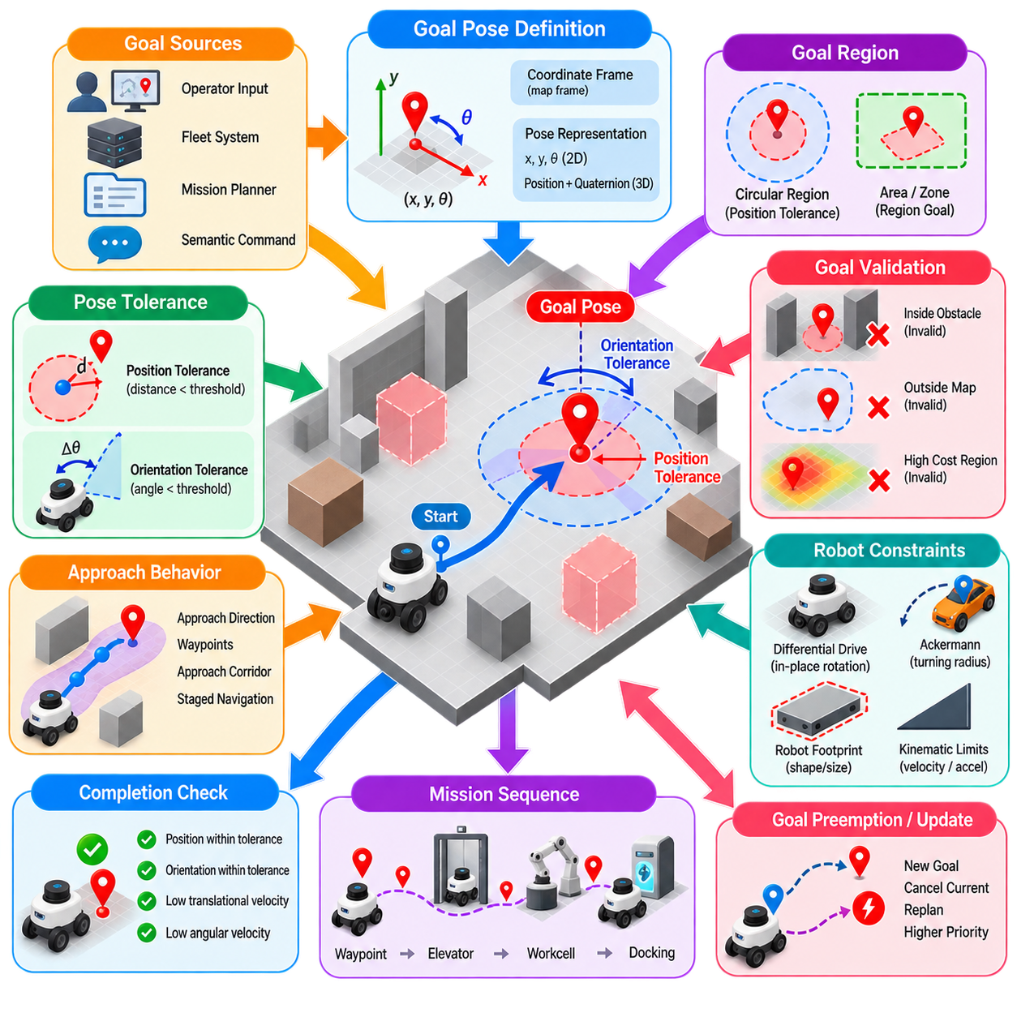
A navigation goal defines the state that an autonomous robot is expected to reach at the completion of a navigation task. Although a goal is often visualized as a point on a map, practical navigation systems usually represent it as a pose containing both position and orientation. Goal specification therefore determines not only where the robot should arrive, but also how it should be positioned when navigation is considered complete.
For a planar mobile robot, a goal pose is commonly represented by coordinates such as x and y together with an orientation θ, or by an equivalent pose representation using position and quaternion orientation. The pose must also belong to a defined coordinate frame, such as a map frame. Without an explicit reference frame, identical numerical coordinates can describe completely different physical locations, making frame consistency essential to reliable goal interpretation.
Goal specification can originate from several sources. An operator may select a point through a graphical interface, a fleet management system may assign a destination, an autonomous mission planner may generate a waypoint, or a semantic command may be converted into a geometric target. Regardless of its origin, the navigation subsystem ultimately requires a representation that can be evaluated against the robot's estimated pose and converted into executable planning objectives.
A goal does not always correspond to one mathematically exact configuration. Real robots operate with localization uncertainty, finite control resolution, mechanical tolerances, sensor noise, and discretized maps. Requiring the robot to reach exactly x_goal, y_goal, and θ_goal would therefore be impractical and could prevent successful completion indefinitely. Navigation systems instead define an acceptable region around the requested goal using pose tolerances.
Position tolerance specifies how close the robot must be to the target location before the positional component of the goal can be considered satisfied. In planar navigation, this is often evaluated using the Euclidean distance between the current position and the target position. If the distance becomes smaller than a configured threshold, the robot satisfies the translational requirement even though its estimated position does not exactly equal the requested coordinates.
Orientation tolerance performs a similar function for heading. The robot's current orientation is compared with the desired goal orientation, and navigation can be considered successful when the angular error lies within an allowed range. Orientation requirements vary significantly by application. A robot arriving in an open waiting area may tolerate substantial heading error, whereas docking, charging, manipulation, inspection, or conveyor interaction may require precise final alignment.
Position and orientation tolerances should therefore be treated as independent design parameters rather than as one generic accuracy value. A mission may permit relatively large positional error while demanding a particular heading, or it may require precise position but allow flexible orientation. The goal checker can combine these conditions according to application requirements, allowing the definition of completion behavior to match the physical task performed after navigation.
Goal tolerance also interacts directly with robot motion constraints. A differential-drive platform may need additional maneuvering to satisfy a tight orientation tolerance, while an Ackermann-steered vehicle may be unable to achieve certain final poses within confined spaces because of its minimum turning radius. The feasibility of a goal must therefore be considered together with the platform's kinematics, footprint, surrounding free space, and approach direction.
The final approach to a goal is often more difficult than traveling through the majority of the route. As the robot approaches its destination, translational and rotational errors become small, velocity must decrease, and the controller must avoid overshoot or oscillation. Poorly selected tolerances can cause repeated corrections around the target. The robot may continuously move forward, rotate, reverse, or reorient even though its practical mission objective has already been achieved.
Excessively tight tolerances can reduce navigation reliability. Localization noise alone may cause the estimated pose to move repeatedly across a narrow acceptance boundary, preventing stable success detection. Control errors and floor conditions may introduce additional variation. A tolerance should therefore reflect the achievable accuracy of the complete navigation system rather than an ideal mathematical requirement that the localization and control subsystems cannot consistently satisfy.
Excessively loose tolerances create a different problem. The navigation system may report success while the robot remains too far from the intended destination or faces an unsuitable direction. This can be unacceptable for docking, automated charging, loading, manipulation, inspection, or human interaction. Tolerance selection is consequently an engineering compromise between completion robustness and the precision required by the downstream task.
Goal checking can include conditions beyond position and orientation. A robot may be required to reduce its translational and angular velocity below specified thresholds before success is declared. This prevents a robot from briefly passing through the acceptable pose region at significant speed and incorrectly reporting completion. Stable goal achievement generally requires both geometric proximity and a motion state consistent with stopping or transitioning safely to the next task.
Some navigation missions are better represented by goal regions rather than single target poses. A service robot may only need to enter a waiting zone, an inspection robot may be permitted to stop anywhere within a valid observation region, and an AMR may approach a staging area from several acceptable orientations. Region-based goals increase planning flexibility by allowing the planner to select a feasible terminal configuration from a set of acceptable states.
Other applications require constrained approach behavior. Docking stations, charging contacts, conveyors, work cells, doors, elevators, and manipulation stations may require the robot to approach from a particular direction. In these cases, specifying only the final pose may be insufficient. Intermediate waypoints, approach corridors, orientation constraints, or staged navigation can guide the robot into a terminal configuration that is both geometrically valid and operationally useful.
Goal validation should occur before and during planning. A requested pose may lie inside an obstacle, outside the known map, within an inflated high-cost region, or in a location inaccessible to the robot footprint. The system can reject the goal, adjust it to a nearby valid pose, or report that planning is impossible. Early validation prevents unnecessary planning attempts and makes navigation failure easier to diagnose.
Dynamic environments may also invalidate a previously acceptable goal. A temporary obstacle can occupy the destination, another robot may block a docking station, or operational restrictions may change while the robot is traveling. Goal management should therefore support reevaluation rather than assuming that a target remains valid after assignment. Depending on mission policy, the robot may wait, replan, select an alternative goal, or report that the destination is temporarily unavailable.
Multi-stage missions often contain a sequence of goals rather than one final destination. A robot may travel through waypoints, enter an elevator, move to another floor, approach a workstation, and finally perform precision docking. Each stage can use different tolerances and completion criteria. Navigation goal specification therefore becomes part of mission management, connecting high-level task intent with the geometric conditions required by motion planning and control.
Goal preemption and cancellation are also important in operational systems. A higher-priority task, safety event, fleet-level decision, or operator command may replace the current destination before completion. The navigation architecture must terminate or supersede the existing goal in a controlled manner, update planning state, and transition toward the new objective without leaving obsolete commands active in lower-level components.
In fleet systems, consistent goal semantics are particularly important because destinations may be generated remotely. A fleet manager may identify logical locations such as Station A, Charger 3, or Loading Zone B, while the robot navigation stack requires geometric poses and tolerances. A location database or semantic map can translate these logical destinations into validated navigation goals, including preferred orientations, approach rules, and task-specific acceptance regions.
Goal specification and pose tolerance ultimately define the contract for navigation success. The planner determines how the robot can reach the destination, the controller reduces pose error during execution, localization estimates the current state, and the goal checker decides when the requested condition has been achieved. Carefully designed tolerances prevent endless precision seeking while ensuring that the final robot pose remains suitable for the physical task that follows navigation.
Reliable autonomous navigation therefore requires goal definitions that reflect both mathematical geometry and operational intent. Position, orientation, velocity, approach direction, environmental validity, robot kinematics, and downstream task requirements may all contribute to completion criteria. By treating the goal as an acceptable terminal state or region rather than merely a coordinate, the navigation system can achieve robust, meaningful, and repeatable task completion.

01.05. Navigation Benchmarking Success Rate Path Quality
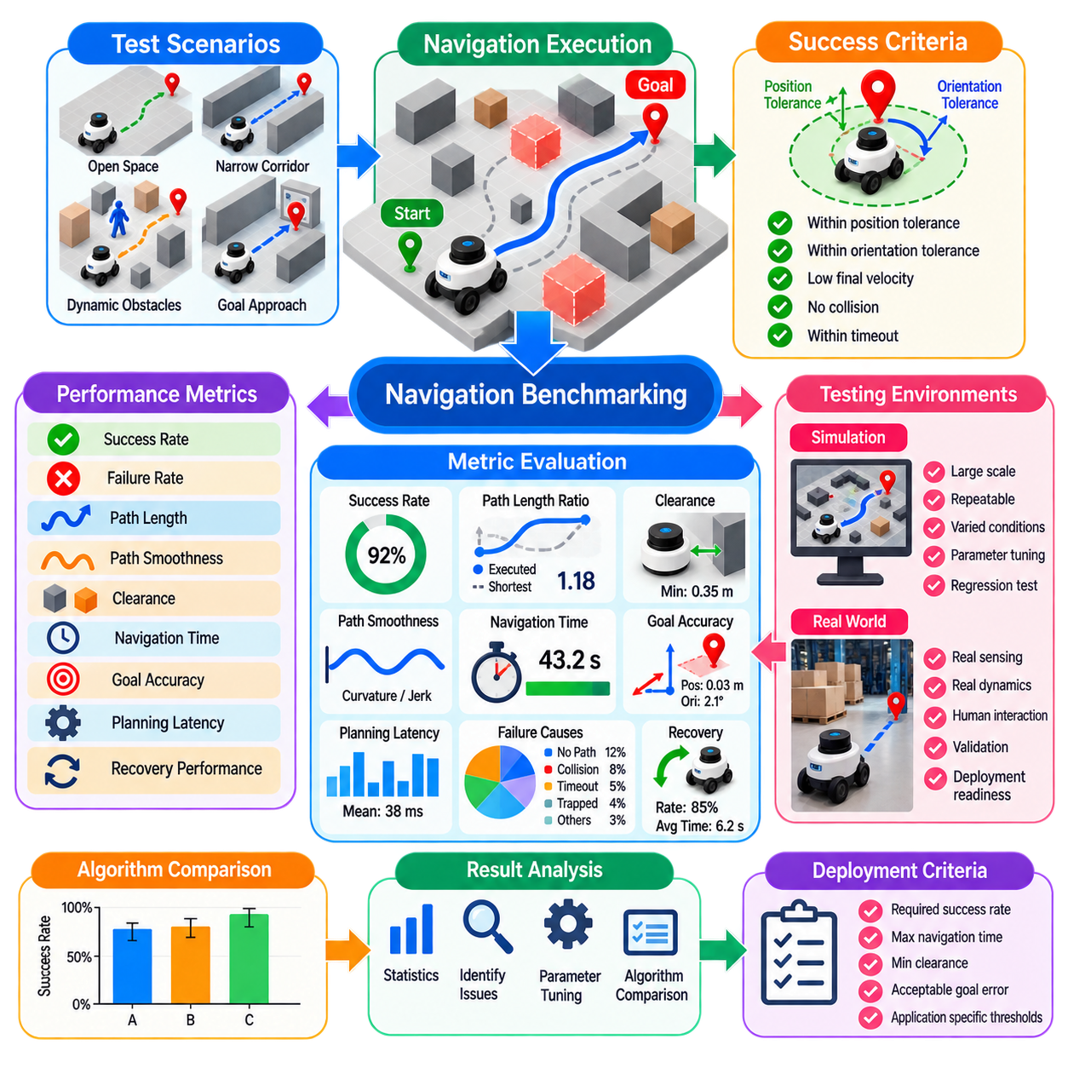
Navigation benchmarking provides a systematic method for measuring how reliably and efficiently an autonomous robot reaches its assigned goals. A navigation system should not be evaluated only by whether it succeeds in a few demonstrations. Meaningful evaluation requires repeatable scenarios, clearly defined metrics, controlled conditions, and sufficient trials to reveal failures that may occur only under difficult environmental or operational conditions.
Success rate is one of the most fundamental navigation metrics. It represents the proportion of navigation trials in which the robot reaches the requested goal while satisfying the specified completion conditions. If N_success trials succeed among N_total attempts, the success rate can be expressed as N_success / N_total. However, the definition of success must include goal tolerance, timeout, collision criteria, and other termination conditions.
A successful trial should normally require more than entering the approximate goal area. Position tolerance, orientation tolerance, final velocity, collision status, and mission timeout may all contribute to the success criterion. Benchmark results become difficult to compare when different experiments use different definitions of completion. The benchmark specification must therefore define precisely when a trial is classified as success, failure, timeout, or aborted execution.
Failure rate provides complementary information because failures can arise from fundamentally different causes. A robot may fail because the global planner cannot generate a path, the local planner becomes trapped, localization is lost, a collision occurs, progress monitoring triggers a timeout, or recovery behaviors are exhausted. Separating failures into categories is more informative than reporting one aggregated failure percentage because it identifies which subsystem limits navigation reliability.
Path length is a basic measure of navigation efficiency. The executed path can be compared with the planned path or with a reference shortest path. A useful normalized measure is path-length ratio, calculated as the executed distance divided by an appropriate reference distance. Values close to one indicate efficient travel, whereas larger values may reveal unnecessary detours, oscillation, repeated avoidance maneuvers, poor global planning, or recovery activity.
Shortest distance alone does not define a high-quality path. A path passing extremely close to walls or obstacles may be geometrically short but operationally undesirable. Clearance metrics measure the distance between the robot footprint and surrounding obstacles throughout navigation. Minimum clearance identifies the most critical encounter, while average or percentile-based clearance can characterize the overall safety margin maintained during the complete route.
Path smoothness measures how gradually the robot changes its direction or curvature. Frequent heading changes, sharp turns, and oscillatory steering can reduce passenger or payload stability, increase mechanical wear, and make trajectory tracking more difficult. Smoothness can be evaluated using heading variation, curvature, curvature change, acceleration, or jerk, depending on the platform and the level at which navigation performance is being analyzed.
Navigation time is another essential benchmark. Total task duration measures the elapsed time from goal acceptance until successful completion or termination. It can be decomposed into actual motion time, stationary waiting, planning latency, recovery time, and delays caused by obstacles. This decomposition helps distinguish a robot that travels slowly from one that loses significant time because of planning inefficiency, congestion, or repeated recovery operations.
Planning latency measures how quickly the navigation software produces decisions. Global planning time indicates the computational cost of generating or regenerating a route, while local planning or controller cycle time determines whether immediate motion decisions can satisfy real-time requirements. Mean latency alone may hide occasional computational spikes, so percentile and worst-case measurements are important when evaluating production navigation systems.
Goal accuracy evaluates the final difference between the achieved robot pose and the requested target pose. Position error and orientation error should be measured independently because different applications impose different requirements. A general transport mission may tolerate moderate final error, while charging, docking, manipulation, inspection, or conveyor alignment can require substantially greater precision. Benchmark tolerances should therefore reflect the intended operational task.
Dynamic obstacle performance requires metrics beyond static path efficiency. Tests can measure collision rate, minimum separation distance, avoidance success, delay introduced by moving obstacles, and the time required to resume nominal path following. Human-populated environments may additionally require evaluation of socially appropriate distances and motion behavior. A planner that reaches the goal quickly but repeatedly creates unsafe interactions cannot be considered high quality.
Recovery performance should also be measured explicitly. Useful indicators include the number of recovery activations, recovery success rate, time spent recovering, repeated recovery cycles, and the fraction of missions that require intervention. Frequent successful recovery may appear positive when considering completion alone, but it can indicate underlying instability in localization, costmap processing, planning, or control that should be addressed directly.
Benchmark scenarios must represent the operational conditions expected in deployment. Open spaces alone are insufficient for evaluating an industrial navigation system. Narrow corridors, doorways, intersections, dead ends, cluttered regions, temporary obstacles, dynamic crossings, localization-challenging areas, and constrained goal approaches should be included. Scenario diversity exposes different failure modes and prevents optimization toward a single easy environment.
Repeatability is essential because navigation contains stochastic and time-dependent behavior. Sensor noise, localization uncertainty, dynamic obstacle movement, sampling-based algorithms, and asynchronous processing can cause different outcomes from nominally identical trials. Each scenario should therefore be executed multiple times, and results should be summarized statistically rather than selecting one representative run. Mean values, distributions, percentiles, and failure counts provide complementary information.
Simulation offers an efficient environment for large-scale navigation benchmarking. Thousands of trials can be executed across controlled maps, obstacle configurations, sensor conditions, and parameter settings without risking physical hardware. Simulation is particularly valuable for regression testing and rare failure scenarios. However, simulation results cannot fully represent real sensing, wheel slip, communication delays, floor conditions, actuator limitations, and human behavior.
Field testing is therefore necessary to validate whether benchmark performance transfers to the physical robot. Real-world evaluation should reproduce representative operational routes and environmental disturbances while recording the same metrics used in simulation whenever possible. Differences between simulation and field performance can reveal model inaccuracies, unrepresented latency, localization problems, sensor artifacts, mechanical effects, or control limitations.
A useful benchmark should preserve experimental configuration together with measured results. Robot model, footprint, map resolution, costmap parameters, planner configuration, controller parameters, sensor configuration, software version, hardware platform, and scenario definition can materially affect performance. Without configuration traceability, later comparisons may attribute changes to an algorithm even though another system parameter actually caused the difference.
Benchmarking is especially valuable for parameter tuning and algorithm comparison. Two planners should be tested under equivalent maps, robot constraints, goals, obstacle conditions, and termination rules. Comparing only success rate may hide differences in path efficiency or safety, while comparing only path length may reward risky behavior. Multi-metric evaluation is therefore necessary to characterize the tradeoffs between reliability, efficiency, safety, smoothness, and computational cost.
For fleet navigation, individual robot metrics can be extended to system-level measures. Mission completion rate, robot throughput, average waiting time, congestion delay, intersection blocking, deadlock frequency, and utilization can reveal whether locally efficient navigation produces efficient fleet behavior. A robot taking a slightly longer route may improve total system performance if that route reduces congestion or avoids interference with other robots.
Benchmark thresholds should ultimately be connected to operational requirements rather than chosen arbitrarily. Required success rate, maximum navigation time, minimum clearance, acceptable goal error, and planning latency depend on robot speed, payload, environment, safety policy, and business process. Benchmarking therefore acts as a bridge between abstract navigation performance and measurable acceptance criteria for deployment.
Continuous benchmarking becomes important as navigation software evolves. Changes to planners, costmaps, perception modules, localization, controller parameters, or robot hardware can improve one metric while degrading another. Automated regression benchmarks can detect these changes before field deployment. Maintaining a stable scenario suite and historical performance baseline allows development teams to determine whether a new software version actually improves overall navigation quality.
Navigation benchmarking should therefore be viewed as multidimensional system evaluation rather than a single success score. Success rate establishes basic reliability, while path length, clearance, smoothness, execution time, goal accuracy, planning latency, recovery behavior, and failure categories explain how that reliability is achieved. Together, these measurements provide the evidence required to compare algorithms, tune systems, detect regressions, and validate navigation for real robotic operation.

01.06. Kinematic and Dynamic Constraints in Planning
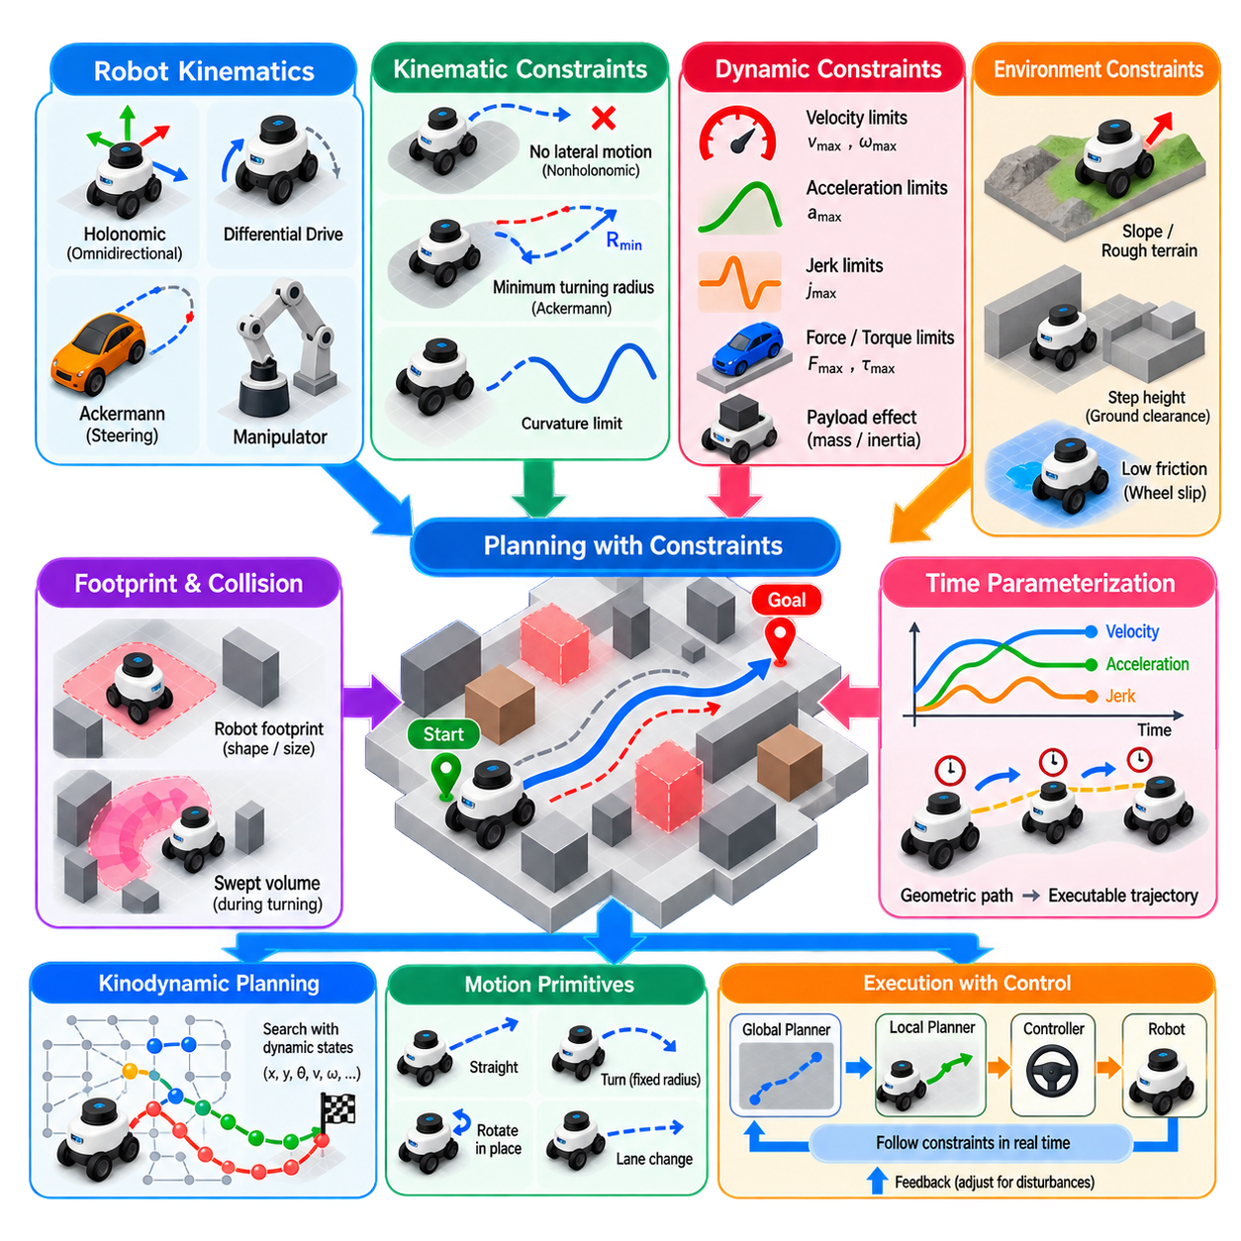
Kinematic and dynamic constraints determine whether a geometrically valid path can actually be executed by a physical robot. A planner may identify collision-free configurations connecting the start and goal, yet the resulting motion can still be impossible because of steering geometry, velocity limits, acceleration capability, actuator forces, or stability requirements. Practical planning must therefore consider not only where the robot can move, but how it can physically move.
Kinematic constraints describe relationships among robot positions, orientations, velocities, and control inputs without explicitly considering the forces that produce motion. They arise primarily from the mechanical structure and mobility characteristics of the platform. Differential-drive robots, Ackermann-steered vehicles, omnidirectional platforms, manipulators, legged robots, and aerial vehicles therefore possess fundamentally different sets of feasible instantaneous motions.
A holonomic robot can independently control motion along all relevant configuration-space dimensions, subject to actuator limits. An omnidirectional mobile base, for example, may translate laterally without first changing its orientation. This capability simplifies some planning problems because geometric paths can often be followed directly. Nevertheless, velocity, acceleration, footprint, wheel-force, and environmental constraints can still restrict executable motion.
Nonholonomic robots are subject to motion constraints that prevent arbitrary instantaneous movement in configuration space. A conventional wheeled vehicle cannot normally translate sideways even though such displacement is geometrically possible. Its motion must follow directions permitted by wheel orientation and steering geometry. Planning must therefore generate paths whose local direction and curvature are compatible with the platform rather than merely connecting collision-free points.
Differential-drive robots provide a common example. Their translational and rotational motion is generated by controlling the velocities of left and right wheels. They can typically move forward, backward, and rotate in place, but cannot directly command lateral velocity. This structure influences corridor navigation, obstacle avoidance, goal alignment, and local trajectory generation, especially when the robot footprint is large relative to available free space.
Ackermann-steered vehicles introduce stronger geometric constraints. Steering angle determines path curvature, and the vehicle usually possesses a finite minimum turning radius. A path containing sharp corners may therefore be collision-free yet physically impossible to follow. Planners for such platforms must consider curvature continuity, steering limits, vehicle dimensions, and often forward-versus-reverse motion when determining whether a candidate path is feasible.
Curvature is an important connection between geometric path shape and vehicle kinematics. Large curvature corresponds to tight turning, while small curvature represents gradual turning. Limiting curvature prevents the planner from generating turns that exceed steering capability. Some applications additionally constrain the rate of curvature change because abrupt steering transitions can produce uncomfortable, unstable, or mechanically demanding motion even when the curvature itself remains feasible.
Robot footprint and orientation must be considered together with kinematic feasibility. A rectangular AMR may safely occupy a narrow corridor when aligned with it but collide with surrounding structures while rotating. Similarly, a long vehicle may require considerably more swept space during turning than its static footprint suggests. Collision checking should therefore evaluate the swept geometry produced by feasible motion rather than considering isolated robot positions alone.
Dynamic constraints extend the planning problem by incorporating the physical evolution of motion. Robot mass, inertia, velocity, acceleration, forces, torques, friction, and actuator capability influence how rapidly motion can change. A trajectory that demands an instantaneous velocity transition may satisfy geometric and kinematic constraints but violate physical dynamics. Dynamic feasibility becomes increasingly important as robot speed, payload, mass, or maneuver aggressiveness increases.
Velocity limits define the allowable translational and rotational speeds of the robot. These limits may originate from actuator capability, mechanical design, localization performance, environmental conditions, safety requirements, or operational policy. Maximum velocity is not necessarily constant throughout a mission. Narrow passages, human interaction zones, turns, docking areas, rough terrain, and uncertain regions may require lower speed limits than open and well-observed areas.
Acceleration constraints determine how quickly velocity can change. Excessive acceleration can cause wheel slip, payload movement, actuator saturation, reduced tracking accuracy, or instability. Deceleration capability is equally important because the robot must be able to stop before reaching an obstacle or restricted region. Planning systems should therefore consider whether sufficient stopping distance exists for the commanded velocity under expected surface, payload, and braking conditions.
Jerk, defined as the rate of change of acceleration, provides another measure of motion quality. Even when velocity and acceleration remain within their limits, abrupt acceleration changes can produce vibration, payload disturbance, passenger discomfort, or mechanical stress. Jerk constraints are particularly relevant for service robots, transport platforms carrying sensitive equipment, autonomous vehicles, and high-precision systems requiring smooth transitions between motion phases.
Dynamic feasibility depends strongly on payload and operating condition. A heavily loaded AMR generally requires different acceleration, braking, and turning behavior from the same vehicle operating without payload. Changes in center of mass can also influence stability. Planning and control parameters may therefore need to adapt according to estimated payload, load distribution, surface friction, slope, and other conditions that affect the physical response of the platform.
Terrain introduces additional constraints for outdoor and field robots. Slope angle, cross-slope, surface roughness, step height, ground clearance, traction, and deformable terrain can determine whether a geometrically open region is actually traversable. A planner may assign terrain-dependent costs or explicitly reject configurations that exceed vehicle capability. In such environments, configuration-space feasibility must be extended beyond simple two-dimensional obstacle avoidance.
Stability constraints become critical for tall robots, heavily loaded vehicles, legged platforms, and systems operating on slopes or during aggressive turns. High lateral acceleration can increase rollover risk, while rapid braking can shift loads or destabilize manipulators mounted on mobile bases. Planning may therefore impose speed limits as a function of curvature, terrain inclination, payload state, or center-of-mass configuration to maintain an acceptable stability margin.
Manipulators and mobile manipulators introduce joint-space constraints in addition to base motion restrictions. Joint position limits, velocity limits, acceleration limits, torque capability, self-collision, singularities, and workspace boundaries must be respected. For mobile manipulation, base and arm motions can be planned separately or jointly, but the complete trajectory must remain feasible for the combined system and preserve collision avoidance throughout execution.
Time parameterization provides a bridge between geometric planning and dynamically executable trajectories. A geometric path defines the sequence of configurations, while time parameterization assigns velocity and acceleration profiles along that path. Appropriate timing can transform a feasible geometric route into a smooth trajectory satisfying motion limits. However, some paths cannot be made dynamically feasible simply by slowing down and must instead be geometrically modified.
Kinodynamic planning addresses geometry, kinematics, and dynamics within the search process itself. Instead of generating arbitrary configurations and connecting them with purely geometric segments, the planner explores states using dynamically feasible motions or control inputs. The resulting search space may include position, orientation, velocity, and additional dynamic variables. This increases computational complexity but produces trajectories more closely aligned with the behavior of the physical system.
Motion primitives offer a practical method for incorporating constraints into planning. A primitive represents a short motion segment known to satisfy selected kinematic or dynamic requirements. Straight movements, fixed-radius turns, rotations, lane changes, or platform-specific maneuvers can be combined during search. By restricting expansion to feasible primitives, the planner avoids producing many geometrically attractive but physically impossible candidate motions.
Local planners and controllers play an important role in enforcing constraints during execution. Even when the global path is primarily geometric, the local planner can generate short-horizon trajectories that satisfy velocity, acceleration, curvature, and obstacle constraints. The controller then tracks the selected trajectory while respecting actuator limits. Feedback allows commands to be adjusted when actual motion differs from predicted behavior because of disturbances or modeling errors.
Constraint handling also affects navigation performance metrics. Aggressive motion may reduce travel time while increasing energy use, tracking error, mechanical stress, or safety risk. Conservative constraints improve smoothness and stopping margin but may reduce throughput. Planning therefore frequently becomes a multi-objective problem balancing travel time, path length, clearance, energy, comfort, stability, actuator utilization, and mission-specific requirements.
Reliable navigation requires consistency between the constraints assumed by planning and the capabilities enforced by control and hardware. If the planner assumes faster acceleration or tighter turning than the robot can achieve, trajectory tracking will degrade and collision margins may disappear. Conversely, unnecessarily conservative planning can waste available performance. Accurate robot models and validated limits are therefore essential interfaces between planning, control, and physical platform design.
Kinematic and dynamic constraints ultimately transform path planning from abstract geometric search into physically grounded motion planning. Robot geometry defines occupied space, kinematics determines allowable motion directions and curvature, and dynamics determines how those motions can evolve over time. Incorporating these constraints allows autonomous systems to generate trajectories that are not merely collision-free, but executable, stable, smooth, safe, and appropriate for real robotic operation.

01.07. Navigation Safety Pedestrian Avoidance ISO 3691
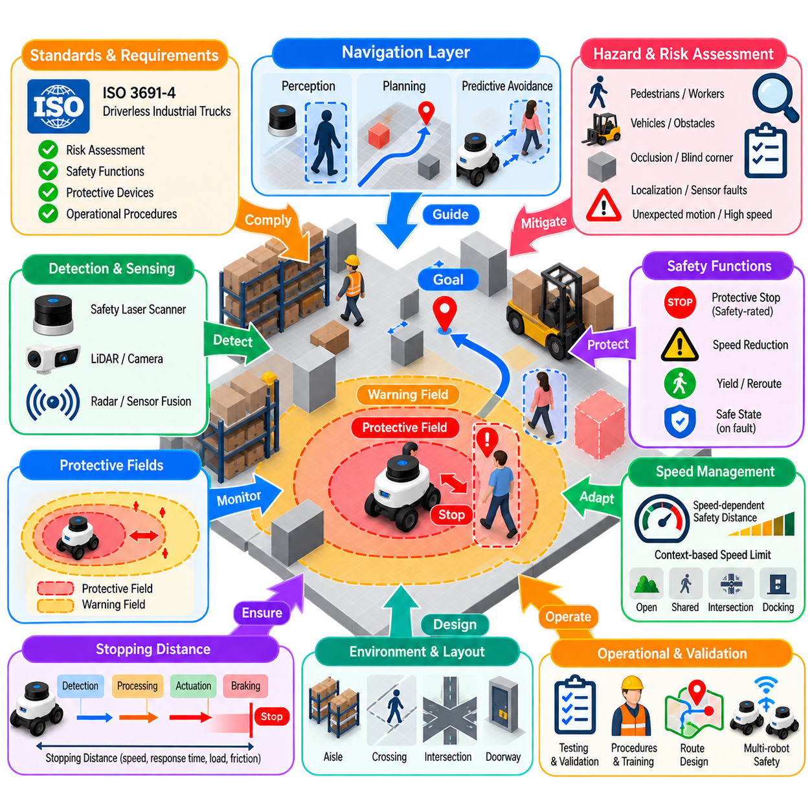
Navigation safety is a fundamental requirement for autonomous mobile robots operating in environments shared with pedestrians, workers, vehicles, and industrial equipment. A navigation system must do more than find collision-free paths under nominal conditions. It must continuously detect hazards, maintain appropriate separation, control speed, stop safely when necessary, and ensure that navigation failures cannot create unacceptable risks to people.
Industrial mobile robot safety is commonly addressed through machinery safety principles and standards applicable to driverless industrial trucks and their systems. ISO 3691-4 is particularly relevant to driverless industrial trucks, including automated guided vehicles and autonomous mobile robots used in industrial environments. Its application should be considered together with system-level risk assessment, protective devices, operational procedures, and other applicable safety standards.
Safety begins with hazard identification and risk assessment rather than with a particular obstacle-avoidance algorithm. Designers must consider foreseeable interactions such as pedestrians crossing the robot path, workers approaching from blind corners, objects entering stopping zones, unexpected obstacles, localization errors, sensor degradation, communication failures, excessive speed, and unintended motion. Each hazard is evaluated according to severity, exposure, and probability so that suitable risk-reduction measures can be selected.
An important architectural principle is the separation between functional navigation and safety-related protection. The normal navigation stack may use perception, costmaps, global planning, local planning, and predictive obstacle avoidance to generate efficient motion. Safety functions should independently ensure that hazardous motion is prevented or stopped when required. A high-performance local planner therefore does not by itself constitute a complete personnel-protection mechanism.
Pedestrian avoidance begins with reliable detection of people and obstacles within the robot's operating environment. Safety laser scanners are widely used because they can monitor defined protective fields around the vehicle. Additional perception using LiDAR, cameras, depth sensors, radar, or sensor fusion can improve environmental understanding and predictive navigation, but safety-related functions must use components, architectures, and validation appropriate to the required safety performance.
Protective fields define spatial regions around the robot in which detected objects trigger specific responses. A warning field may cause the vehicle to reduce speed, while entry into a more critical protective field can initiate a safety-rated stop. The dimensions of these regions cannot be selected arbitrarily. They must account for robot velocity, sensing characteristics, system response time, braking performance, measurement uncertainty, and appropriate safety margins.
Stopping distance is therefore a central concept in pedestrian safety. The robot must detect a hazardous situation early enough to complete sensing, safety processing, command transmission, actuator response, and mechanical braking before reaching the person or obstacle. The required protective distance consequently increases with velocity and response time. Payload, floor friction, slope, tire condition, and braking capability can also influence the actual distance needed to stop safely.
Speed-dependent protective fields provide a practical way to maintain both safety and productivity. At low speed, a robot may operate with relatively compact protective regions, while higher speeds require larger monitored areas because stopping distance increases. Some systems dynamically select or reshape fields according to travel direction, steering state, velocity, and operating mode. Field switching must itself be deterministic and consistent with the validated safety architecture.
Directional monitoring is important because a mobile robot does not present identical risk in every direction. Forward motion, reverse motion, rotation, and curved travel can produce different swept areas. A rectangular AMR rotating near a person may create hazards outside the region directly ahead of the vehicle. Protective sensing should therefore cover the relevant motion envelope, including corners and swept regions that become significant during turning.
Pedestrian avoidance at the navigation level complements these protective safety functions. The local planner can detect people before they enter critical safety fields and modify the trajectory to maintain comfortable separation. It may reduce speed, select an alternative path, yield, or stop temporarily. Predictive avoidance improves smoothness and operational efficiency because the robot can respond before a safety device is forced to initiate a protective stop.
Human motion introduces uncertainty that distinguishes pedestrian avoidance from static obstacle avoidance. A person can abruptly change direction, stop, accelerate, emerge from an occluded region, or behave differently from a planner's prediction. Navigation should therefore avoid depending on a single predicted pedestrian trajectory. Conservative uncertainty margins, short prediction horizons, repeated observation, and continuous replanning help maintain robustness when human behavior differs from expectation.
Occlusion is particularly important in warehouses and factories. Shelves, machines, pallets, doors, and parked vehicles can hide pedestrians until they are close to the robot's route. Navigation systems can reduce risk by lowering speed near blind intersections, maintaining additional clearance, using infrastructure sensing where appropriate, or designing routes that improve visibility. Safe operation should account for what sensors cannot currently observe, not only for detected objects.
Speed management can be linked to environmental context. Open robot-only corridors may permit higher speeds, while shared pedestrian zones, intersections, work cells, doorways, docking areas, and regions with poor visibility may require reduced limits. Semantic maps and operational zones can provide these contextual restrictions to the navigation system. Safety-related speed supervision can independently ensure that commanded velocity does not exceed permitted limits.
Safe stopping must remain available when normal navigation fails. Loss of localization, inconsistent sensor data, planner failure, controller malfunction, safety sensor fault, or communication interruption may require the robot to enter a defined safe state. The appropriate response depends on the system architecture and risk assessment, but uncontrolled continued motion should not be the default response when information essential to safe navigation becomes unreliable.
Emergency stopping and protective stopping serve related but different purposes. A protective stop is normally initiated automatically by a safety function when continued motion would create a hazard, whereas an emergency stop provides a deliberate means of responding to an emergency situation. Their implementation, reset behavior, and integration must follow the applicable machinery safety design requirements rather than being treated as ordinary software commands in the navigation stack.
Restart behavior after a safety stop also requires careful design. The disappearance of an obstacle from a protective field does not necessarily mean that immediate autonomous motion is always appropriate. The system may need to verify safety conditions, apply restart interlocks, require deliberate reset under specified circumstances, or resume only when the operational state permits it. Unexpected restart can itself become a significant hazard around personnel.
Navigation routes can be designed to reduce risk before reactive avoidance becomes necessary. Separating pedestrian and robot traffic, providing sufficient aisle width, controlling intersection priority, avoiding blind corners, defining crossings, limiting access to hazardous areas, and positioning loading stations appropriately can substantially improve safety. Safety is therefore influenced by facility layout and operational organization as well as by onboard algorithms and sensors.
Functional safety engineering considers whether safety-related control functions achieve the required level of reliability when faults occur. Sensor faults, wiring failures, processing faults, actuator failures, and power disturbances must be considered according to the applicable safety architecture. Diagnostic coverage, redundancy, fault detection, safe-state behavior, and validation become important when a function is relied upon to reduce personnel risk.
Validation must verify safety behavior under representative worst-case conditions rather than only nominal demonstrations. Tests should include maximum relevant speed and payload, minimum expected braking performance, obstacle appearance near field boundaries, turning motion, reverse operation, sensor obstruction, localization degradation, and fault conditions. Measured stopping performance should be compared against the assumptions used to establish protective distances and operational limits.
Safety validation and navigation benchmarking have different primary objectives. Navigation benchmarking evaluates properties such as success rate, path quality, goal accuracy, and execution time, whereas safety validation determines whether hazards are controlled within required limits. A robot can achieve excellent navigation performance while still having an inadequate safety design. Conversely, a safe robot may require further navigation optimization to achieve acceptable productivity.
Operational procedures remain part of the complete safety concept. Personnel need appropriate information about robot operating zones, crossings, warning indicators, emergency controls, maintenance conditions, and abnormal situations. Changes to facility layout, payload, speed, software, sensors, braking components, or operating modes may alter the original risk assumptions and should therefore trigger appropriate review and, where necessary, revalidation.
For multi-robot fleets, safety must remain effective even when fleet coordination fails. Traffic management can reduce conflicts by reserving intersections, scheduling routes, and preventing congestion, but personnel protection should not depend solely on centralized fleet communication. Each vehicle should retain the safety functions required by its design so that communication loss or scheduling errors do not automatically result in hazardous vehicle motion.
ISO 3691-4 provides an important framework for considering hazards and safety requirements associated with driverless industrial trucks and their systems, but compliance should not be reduced to installing a safety scanner or configuring one stopping distance. Safe deployment requires integration of risk assessment, vehicle design, protective sensing, safety-related control, braking, navigation behavior, facility design, operating procedures, verification, and validation.
Navigation safety is therefore best understood as a layered engineering problem. Predictive navigation attempts to avoid hazardous interactions early, speed and route management reduce exposure, protective sensing supervises critical regions, safety-related control initiates required responses, and mechanical braking brings the robot to a safe state. Together, these layers allow autonomous robots to operate productively while maintaining personnel protection as a primary system constraint.

01.08. Elevator Door Ramp Navigation Special Scenarios
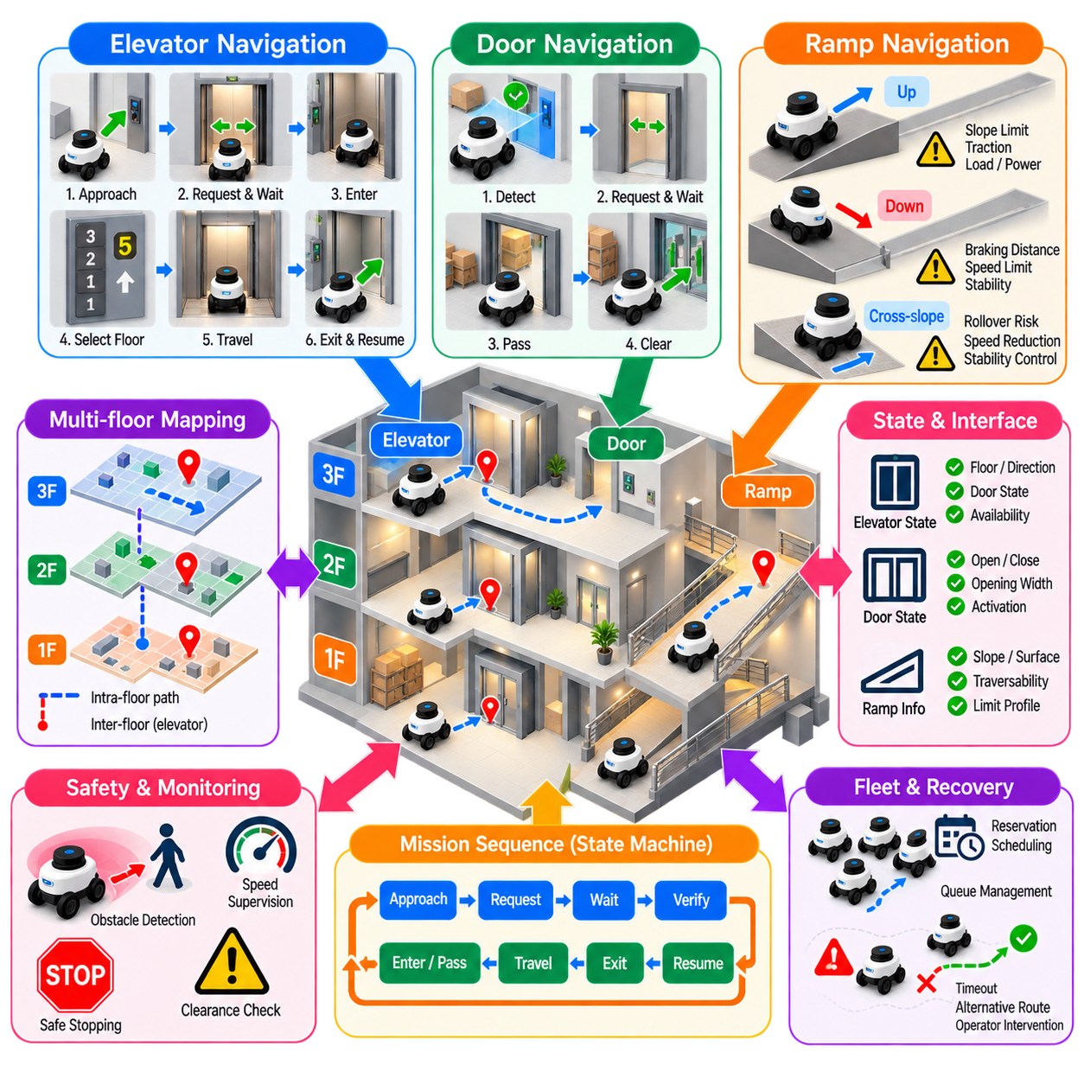
Elevator, door, and ramp navigation represents a class of special scenarios in which ordinary planar motion planning must be coordinated with infrastructure, constrained geometry, and changing environmental states. These situations are common in hospitals, offices, factories, hotels, and multi-floor logistics facilities. Reliable navigation therefore requires the robot to combine geometric planning with state monitoring, communication, sequencing, and recovery behavior.
Elevator navigation extends a robot mission beyond a single continuous map. The robot must approach an elevator waiting area, request service, identify the correct elevator, wait for arrival, verify that the door is open, enter the cabin, request the destination floor, remain safely positioned during travel, exit at the correct floor, and resume navigation. Each step introduces conditions that cannot be handled by ordinary path following alone.
A multi-floor navigation architecture commonly represents each floor with its own map or coordinate frame while maintaining a higher-level topological relationship between floors. Elevator entrances act as transition nodes connecting otherwise separate navigation spaces. Mission planning can therefore treat elevator travel as a special edge in a graph, while conventional navigation handles movement within each floor before and after the transition.
Approaching an elevator requires accurate positioning because the robot must stop where it can enter without blocking passengers or interfering with the door. A predefined waiting pose is often preferable to navigating directly toward the cabin. This staging location allows the robot to align with the entrance, maintain clearance from pedestrians, and wait while the elevator system completes its current operation.
Elevator state information can be obtained through building interfaces, dedicated controllers, fleet infrastructure, wireless communication, or external sensing. Useful states include elevator identity, current floor, travel direction, door state, availability, requested destination, and fault condition. Navigation should not assume that an elevator has arrived merely because a command was issued. Physical or communicated state confirmation is required before progressing to the next mission stage.
Door state verification is especially important during elevator entry and exit. The robot should enter only when sufficient opening has been confirmed and the available passage width is compatible with its footprint and safety margins. A closing or partially opened door must be treated as a changing obstacle. Infrastructure information can improve coordination, but onboard sensing provides additional evidence about the physical state immediately around the robot.
Elevator cabins create challenging localization conditions. LiDAR observations can change dramatically when the doors close, reflective surfaces may degrade sensing, GNSS is unavailable, and a map-based localization system may incorrectly associate cabin geometry with surrounding structures. Navigation architectures may therefore switch localization modes, freeze selected estimates, use odometry and inertial sensing, or apply elevator-specific state handling until the robot reaches the destination floor.
Motion inside the elevator should normally be constrained and conservative. The robot may enter using a predefined approach corridor and stop at a designated cabin pose rather than performing unrestricted local planning. Cabin dimensions, robot footprint, turning capability, other occupants, and door clearance determine feasible motion. In small elevators, reversing out at the destination may be more practical than attempting to rotate inside the cabin.
The transition between floors requires explicit map and localization management. After elevator travel, the navigation system must associate the robot with the destination floor and initialize or confirm its pose in the appropriate map. Premature switching can produce inconsistent localization, while delayed switching can leave the robot referenced to the previous floor. Floor transition logic should therefore be tied to confirmed elevator and environmental states.
Door navigation outside elevators presents similar geometric and state-dependent challenges. A doorway may appear traversable based on its centerline while still being too narrow for the robot footprint with required clearance. The planner should evaluate effective opening width, approach angle, door geometry, localization uncertainty, and the swept area of the robot. Large rectangular platforms can require substantially more clearance during misaligned entry than during straight passage.
Automatic doors introduce temporal behavior into the navigation problem. The robot may need to enter an activation region, send an opening request, wait for confirmation, and pass through before the door closes. The system should distinguish between a closed but operable door and a permanently blocked passage. Treating every closed door as an ordinary obstacle can prevent valid routes, while assuming that every commanded door will open can create unsafe behavior.
Doorways are also common bottlenecks for interactions with pedestrians and other robots. Passing through simultaneously may be unsafe or geometrically impossible. A navigation or fleet system can establish priority, reserve the doorway, or define waiting positions on each side. Local obstacle avoidance remains necessary, but structured coordination reduces oscillation in which two agents repeatedly attempt to yield or enter the same narrow passage.
Ramp navigation introduces continuous changes in elevation rather than discrete floor transitions. A ramp that appears as free space in a two-dimensional map may impose significant physical constraints because of longitudinal slope, cross-slope, surface friction, payload, ground clearance, and braking capability. Traversability should therefore be determined using platform-specific limits rather than only projected obstacle geometry.
Ascending a ramp increases traction and power requirements, particularly for heavily loaded robots. The planner or controller may reduce velocity and acceleration to prevent wheel slip, excessive motor loading, or loss of tracking accuracy. Battery state and thermal limits can also become relevant during repeated ramp operation. A route that is geometrically shorter may therefore be operationally inferior if it contains demanding slopes.
Descending a ramp creates additional braking and stopping-distance concerns. Gravity can increase the distance required to stop and can amplify the consequences of excessive speed. Velocity limits should account for slope, payload, available braking force, and surface conditions. Protective sensing and stopping-distance assumptions may also require adjustment because the robot's dynamic response differs from operation on level ground.
Cross-slope can affect stability even when longitudinal grade is acceptable. A tall robot or vehicle carrying a high center-of-mass payload can experience increased rollover risk when traveling across an inclined surface. Route planning may therefore restrict allowable cross-slope, reduce speed, or require a preferred orientation relative to the gradient. Stability constraints become particularly important for outdoor AMRs and mobile manipulators.
Transitions at the top and bottom of ramps can create geometric problems that are not represented by slope angle alone. Changes in surface gradient can cause low-clearance components to contact the floor or wheels to lose appropriate contact. Approach angle, wheelbase, overhang, ground clearance, and breakover geometry should therefore be considered when evaluating whether a ramp transition is physically traversable.
Special scenarios benefit from behavior-based or state-machine coordination because successful execution depends on ordered conditions. An elevator sequence might contain approach, request, wait, verify, enter, confirm position, travel, verify destination, exit, and relocalize states. Door navigation may contain request, wait, verify opening, reserve passage, traverse, and release states. Explicit sequencing makes failures easier to detect and recover from than a single uninterrupted navigation command.
Timeouts and recovery policies are essential because infrastructure may not respond as expected. An elevator can remain unavailable, a door can fail to open, another robot can occupy the transition zone, or localization can fail after a floor change. The system should define retry limits, alternative elevators or routes, safe waiting behavior, mission escalation, and operator intervention rather than repeating commands indefinitely.
Fleet coordination becomes important when many robots share elevators, doors, or ramps. These resources have limited capacity and can become severe congestion points. Reservation, scheduling, direction control, queue management, and priority policies can prevent multiple robots from competing for the same constrained resource. Fleet-level optimization may deliberately route a robot farther if doing so reduces waiting time and overall system congestion.
Safety functions remain active throughout these special transitions. Infrastructure coordination must not replace onboard obstacle detection, protective sensing, speed supervision, or safe stopping. A door controller reporting an open state does not guarantee that the passage is physically clear, and an elevator reservation does not guarantee that no person is present. Functional coordination and safety-related protection should therefore remain distinct but complementary.
Testing should include abnormal as well as nominal scenarios. Elevator tests should cover delayed arrival, unexpected door closure, incorrect floor information, occupied cabins, communication loss, and localization recovery. Door tests should include partial opening, obstruction, delayed response, and competing traffic. Ramp tests should evaluate representative payloads, slopes, stopping behavior, surface conditions, and transitions between level and inclined terrain.
Elevator, door, and ramp navigation ultimately demonstrates that autonomous navigation is more than continuous motion through free space. Real facilities contain discrete transitions, controllable infrastructure, constrained passages, changing coordinate contexts, and terrain-dependent vehicle limits. Integrating planning, infrastructure interfaces, localization management, state sequencing, fleet coordination, recovery, and independent safety functions enables robots to navigate these special scenarios reliably as part of complete autonomous missions.

01.09. Navigation SW Testing Strategy Sim and Field
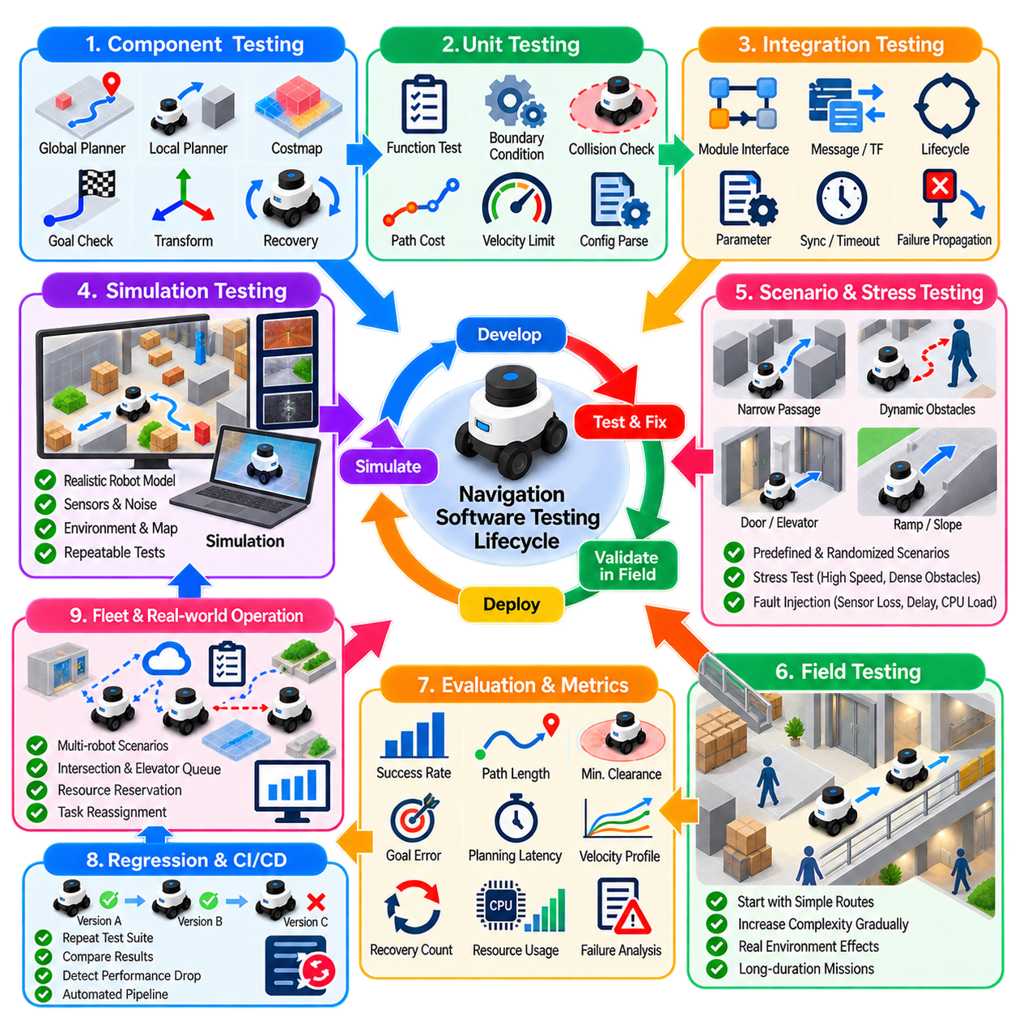
Navigation software testing requires a layered strategy because autonomous navigation is not a single algorithm but a closed-loop system combining localization, mapping, perception, planning, control, recovery, and safety-related interfaces. A navigation stack that performs correctly in isolated demonstrations may still fail under timing variation, sensor uncertainty, dynamic obstacles, or unusual geometry. Testing must therefore progress systematically from software components to complete field operation.
The first testing level focuses on individual software components. Global planners can be tested using predefined maps, start poses, goals, and expected path properties, while local planners can be evaluated against obstacle configurations and motion constraints. Costmap modules, goal checkers, coordinate transformations, progress monitors, and recovery logic should also be tested independently. Component tests make failures easier to reproduce and diagnose before integration introduces additional interactions.
Unit testing verifies deterministic functions and clearly defined interfaces using controlled inputs and expected outputs. Examples include coordinate conversions, footprint collision checks, path-cost calculations, goal-tolerance evaluation, velocity limiting, and configuration parsing. Boundary conditions are particularly important because navigation failures frequently occur near thresholds, such as obstacle boundaries, map edges, angular wraparound, minimum clearances, and numerical tolerances.
Integration testing evaluates whether navigation modules exchange information correctly. A planner may work independently yet fail when costmap timestamps, coordinate frames, or update frequencies differ from its assumptions. Tests should therefore verify message interfaces, frame transformations, lifecycle transitions, parameter loading, asynchronous updates, timeout handling, and failure propagation. Interface correctness is as important as algorithmic correctness in distributed robotic software.
Simulation provides the primary environment for broad and repeatable navigation testing. Virtual robots can execute thousands of missions without damaging hardware or interrupting facility operations. Maps, robot models, obstacles, sensor characteristics, and environmental conditions can be reproduced exactly, allowing software versions or parameter configurations to be compared under equivalent conditions. Simulation is therefore particularly valuable for regression testing and systematic parameter exploration.
A useful simulation environment should reproduce the properties that materially affect navigation. Robot footprint, kinematic limits, acceleration, sensor field of view, obstacle geometry, map resolution, controller timing, and relevant noise should approximate the physical platform. Excessively ideal simulation can produce misleading confidence because perfect localization, noiseless sensors, instantaneous actuation, and unlimited friction eliminate many failure mechanisms encountered by real robots.
Scenario-based testing organizes simulation around representative navigation situations rather than random movement alone. Test scenarios can include long corridors, narrow passages, doorways, intersections, dead ends, cluttered areas, constrained turns, docking approaches, ramps, elevators, temporary obstacles, and pedestrian crossings. Each scenario should define initial conditions, goals, disturbances, expected behavior, termination conditions, and measurable acceptance criteria.
Randomized testing complements predefined scenarios by exposing combinations that engineers may not anticipate manually. Start and goal positions, obstacle locations, pedestrian trajectories, sensor noise, localization error, friction, communication delay, and controller parameters can be varied within realistic ranges. Repeated randomized trials help reveal rare failures such as oscillation, local minima, near-collision behavior, timeout conditions, and unstable recovery sequences.
Stress testing deliberately pushes the navigation system toward its operational boundaries. Dense obstacles, narrow clearances, high robot speeds, delayed sensor updates, CPU load, network latency, degraded localization, and repeated replanning can expose weaknesses that remain hidden during normal tests. The purpose is not merely to force failure, but to determine how the system behaves as available performance margins progressively disappear.
Fault-injection testing evaluates whether the navigation architecture responds predictably when components or information become unreliable. Sensor streams can be delayed or removed, transforms can become temporarily unavailable, localization estimates can degrade, planning requests can fail, and communication can be interrupted. The expected result should be defined in advance, including whether the robot retries, invokes recovery, reduces capability, stops, or reports a fault.
Regression testing ensures that software changes do not unintentionally degrade previously validated behavior. A stable suite of maps and scenarios should be executed whenever planners, controllers, costmaps, localization modules, parameters, dependencies, or hardware interfaces change. Historical results provide a performance baseline. Automated regression pipelines can compare success rate, path length, execution time, clearance, recovery count, and computational performance between software versions.
Simulation tests should record more than final success or failure. Logs should preserve robot poses, commanded and measured velocities, planned paths, local trajectories, costmaps, obstacle observations, localization estimates, planner timing, controller timing, recovery events, and state transitions. These records allow developers to reconstruct the causal sequence leading to failure instead of relying on visual impressions from a simulation display.
Software-in-the-loop testing executes production navigation software against simulated robot and sensor interfaces. This verifies much of the real software architecture without requiring physical hardware. Hardware-in-the-loop testing can extend the approach by introducing actual controllers, compute units, communication networks, or selected sensors. These intermediate stages reduce the gap between ideal simulation and complete field deployment.
Real-time performance must be tested explicitly because navigation behavior depends on timing. A planner that produces correct results but occasionally exceeds its execution deadline may destabilize the complete system. CPU utilization, memory consumption, callback delays, message latency, update rates, and worst-case planning times should therefore be measured under realistic workloads. Average computational performance alone is insufficient for identifying intermittent timing failures.
Field testing begins after simulation and integration tests establish sufficient confidence. Initial physical tests should use controlled environments with low speed, large clearances, simple routes, and appropriate supervision. Complexity can then increase gradually by introducing narrow passages, dynamic obstacles, higher speeds, longer missions, changing payloads, and representative operational traffic. This staged approach limits risk while preserving diagnostic clarity.
The field environment reveals effects that are difficult to reproduce accurately in simulation. Wheel slip, uneven floors, reflective surfaces, vibration, lighting variation, sensor contamination, wireless interference, actuator delay, mechanical tolerances, and changing payloads can alter navigation behavior. Differences between simulated and measured performance should be treated as evidence for improving models, parameters, interfaces, or system assumptions rather than as isolated anomalies.
Field tests should reproduce representative mission cycles rather than evaluating only short point-to-point routes. Industrial AMRs may repeatedly leave charging stations, traverse shared corridors, pass doors, interact with elevators, enter work cells, dock, wait, and return. Long-duration testing reveals accumulated localization drift, memory or resource problems, thermal effects, intermittent communication failures, and low-frequency navigation faults that short demonstrations may never expose.
Simulation and field testing should use common metrics wherever possible. Success rate, navigation time, path length, minimum clearance, goal error, velocity profiles, planning latency, recovery frequency, and failure categories provide a consistent basis for comparison. Significant simulation-to-field differences can then be quantified and traced to particular environmental, mechanical, sensing, or computational effects.
Failure reproduction is a central requirement of an effective testing process. When a field failure occurs, sensor data, robot state, software logs, maps, configuration files, timestamps, and mission context should be preserved. The objective is to reproduce the event in simulation or controlled testing whenever possible. Once reproduced, the failure can become a permanent regression scenario so that the same defect does not reappear in later releases.
Test configuration must be version-controlled together with navigation software. Maps, robot descriptions, planner parameters, controller settings, costmap configurations, sensor calibration, test scenarios, expected outcomes, and software versions should be traceable. Without configuration control, two nominally identical tests may produce different results for reasons unrelated to the software change being evaluated, making performance comparisons unreliable.
Acceptance criteria should be established before deployment testing rather than selected after observing results. Requirements can specify minimum mission success rate, maximum allowed collisions, acceptable goal error, minimum clearance, maximum planning latency, recovery limits, and route completion time. Safety-related acceptance criteria should remain distinct from general navigation-performance targets because successful navigation does not by itself demonstrate adequate safety.
A practical development process forms a continuous loop between simulation and field testing. New functions are first exercised in deterministic tests and simulation, then evaluated under randomized and degraded conditions, and finally validated on physical robots. Field failures are converted into reproducible test cases, models are updated, corrections are implemented, and the complete regression suite is executed again before another deployment candidate is released.
Fleet-scale testing adds another level of complexity because individually reliable robots can still produce system-level failures. Multi-robot simulation can evaluate congestion, intersection conflicts, resource reservation, deadlock, elevator queues, communication load, and task reassignment before large physical fleets are available. Selected scenarios can then be reproduced with progressively larger real fleets to validate whether coordination assumptions remain valid under operational conditions.
Navigation software testing should therefore be treated as a lifecycle activity rather than a final verification step. Unit tests establish local correctness, integration tests verify interfaces, simulation provides scale and repeatability, fault injection exposes degraded behavior, regression testing protects established capability, and field testing validates interaction with physical reality. Together, these layers provide the evidence needed to evolve autonomous navigation software without sacrificing reliability, performance, or operational robustness.

01.10. Platform Navigation Requirements AMR Legged UAV
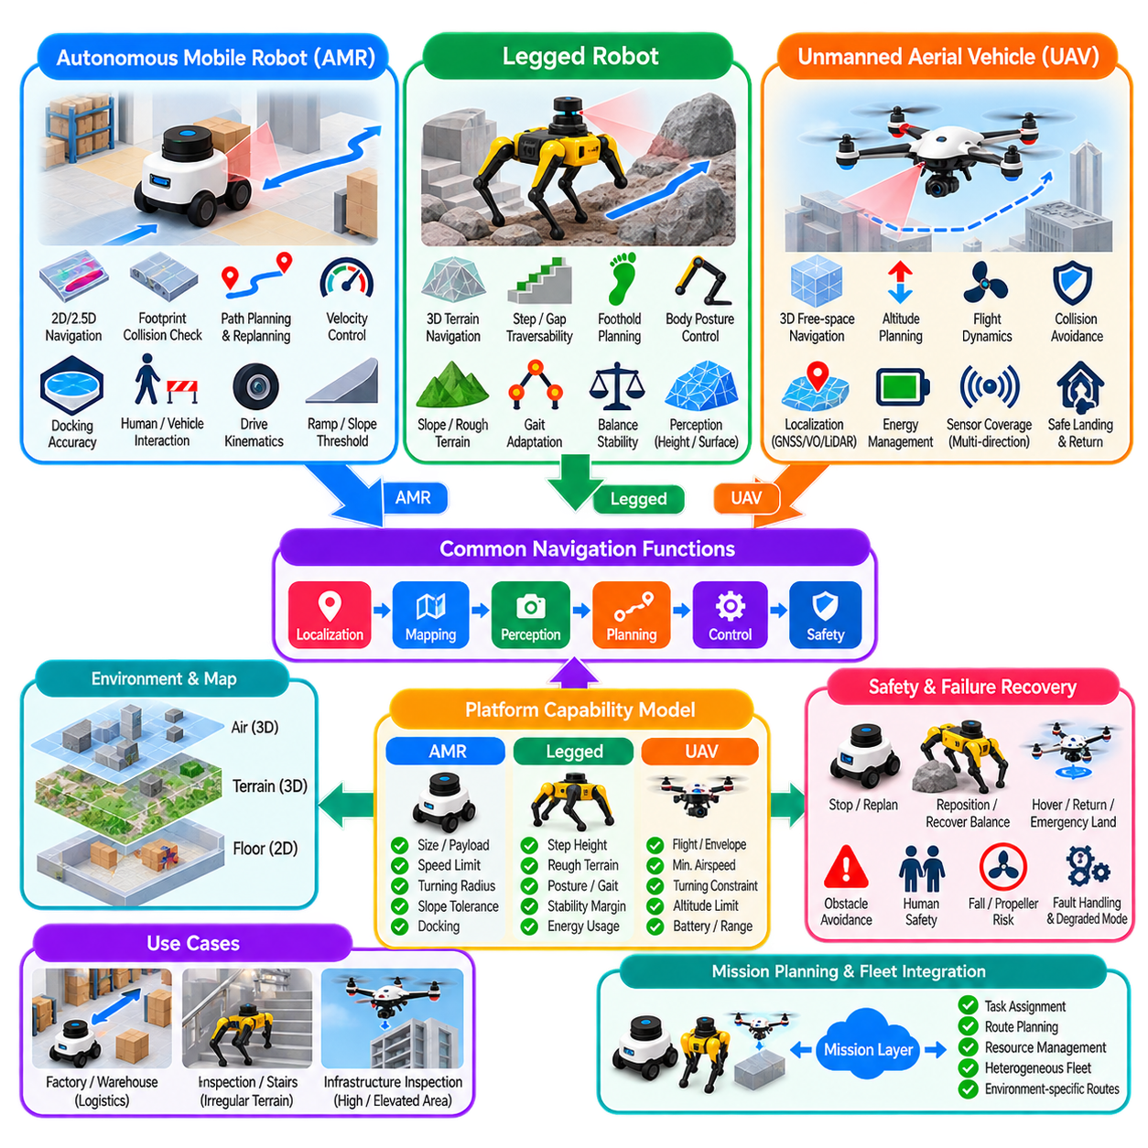
Platform-specific navigation requirements arise because autonomous mobile robots, legged robots, and unmanned aerial vehicles interact with the physical environment through fundamentally different mobility mechanisms. Although all platforms require localization, perception, planning, control, and obstacle avoidance, the definition of traversable space and feasible motion differs significantly. Navigation architecture must therefore reflect the physical capabilities and constraints of each robot rather than applying one universal motion model.
Autonomous mobile robots, or AMRs, primarily navigate over surfaces that can be represented as two-dimensional or moderately three-dimensional traversable regions. Their planning problem commonly focuses on collision-free movement across floors, roads, warehouses, factories, and outdoor pathways. Important requirements include footprint-aware collision checking, reliable localization, obstacle detection, path planning, velocity control, docking accuracy, and safe interaction with people and other vehicles.
AMR mobility is strongly determined by drivetrain configuration. Differential-drive platforms can rotate in place but cannot directly move sideways, while Ackermann-steered vehicles require paths compatible with steering angle and minimum turning radius. Omnidirectional platforms provide greater maneuverability but introduce different wheel and control constraints. The navigation planner must therefore generate trajectories consistent with the actual kinematic structure instead of treating every mobile base as a freely moving point.
The robot footprint is especially important for AMR navigation because industrial platforms may carry payloads extending beyond the chassis. Collision checking should consider the complete operational envelope, including payload geometry, safety margins, and swept area during turns. Narrow aisles, doorways, docking stations, elevators, and intersections may require orientation-aware planning because a configuration that is collision-free in one heading can become infeasible after rotation.
Ground conditions also influence AMR navigation. Indoor systems must consider floor friction, ramps, thresholds, uneven surfaces, and restricted zones, while outdoor platforms may encounter slopes, gravel, water, vegetation, curbs, and changing traction. A purely geometric occupancy map is therefore insufficient for many applications. Traversability information can augment obstacle maps with terrain properties that influence speed, stability, energy consumption, and route feasibility.
Legged robot navigation differs because the platform is not restricted to continuous wheel-supported surfaces. A legged robot can potentially step over obstacles, climb stairs, cross gaps, negotiate irregular terrain, and change body posture to pass through constrained regions. Consequently, navigation must reason not only about where the robot body can travel but also whether suitable contacts and stable configurations exist along the intended route.
Terrain representation becomes central to legged navigation. Elevation maps, surface normals, local slope, roughness, step height, gaps, foothold quality, and obstacle geometry can determine traversability. A region that is blocked for a wheeled AMR may be feasible for a quadruped, while a visually open surface may be unsafe if it provides insufficient support. Perception must therefore estimate terrain characteristics relevant to locomotion rather than simply classify occupied and free cells.
Legged robots also require coordination between navigation and locomotion. A high-level planner may select a route through the environment, but a locomotion controller must generate dynamically stable body and foot motions to execute it. On difficult terrain, these levels become tightly coupled because route feasibility depends on available footholds, gait, body orientation, balance, and contact forces. Navigation commands must remain compatible with the capabilities of the locomotion system.
Stability is a major requirement for legged platforms. Static or dynamic balance must be maintained while climbing, stepping, turning, or recovering from disturbances. Center-of-mass motion, support regions, contact conditions, friction, body attitude, and momentum can constrain feasible trajectories. Navigation may therefore assign higher costs to terrain that is technically traversable but leaves little stability margin or requires aggressive locomotion.
Legged navigation can also exploit posture as part of planning. The robot may lower its body to pass beneath an obstacle, adjust body orientation on a slope, widen its stance, or select a different gait according to terrain. This expands the planning state beyond planar position and heading. However, the larger state space increases computational complexity and creates stronger dependencies between environmental perception, motion planning, and whole-body control.
Unmanned aerial vehicle navigation introduces three-dimensional free-flight motion. Unlike ground robots, UAVs generally plan through volumetric space in which altitude is an explicit navigation variable. Obstacles must be represented in three dimensions, and routes may pass above, below, or around structures. Position, orientation, velocity, acceleration, and flight dynamics therefore become important components of the navigation state.
UAV navigation is highly dependent on vehicle dynamics. Multirotor platforms can hover and move in multiple directions but must generate thrust continuously to remain airborne. Fixed-wing vehicles cannot hover and require minimum airspeed and sufficiently large turning trajectories. The planner must reflect these differences because a geometrically valid three-dimensional path may violate thrust, acceleration, attitude, turning-radius, or aerodynamic constraints.
Localization requirements also differ among aerial environments. Outdoor UAVs can use GNSS, inertial sensing, visual odometry, LiDAR, or combinations of these sources, while indoor or infrastructure inspection missions may operate without reliable GNSS. Vertical accuracy becomes particularly important because altitude errors can produce collisions with floors, ceilings, cables, beams, or equipment. Robust navigation therefore requires consistent three-dimensional state estimation with appropriate uncertainty management.
Obstacle perception for UAVs must provide sufficient coverage around the flight envelope. Forward sensing alone may be inadequate because multirotors can move laterally, vertically, and backward. Cameras, depth sensors, LiDAR, radar, and sensor fusion can provide complementary information, but sensor placement must reflect the directions in which the aircraft can move. Propellers and aerodynamic safety margins also increase the effective collision envelope beyond the central vehicle body.
Energy constraints have different implications across the three platform classes. AMRs typically consume energy through traction, acceleration, onboard computing, and payload operation, while legged robots can expend substantial energy maintaining locomotion over difficult terrain. UAVs face particularly strict energy limits because flight requires continuous power. Navigation should therefore consider route distance, terrain difficulty, velocity, elevation change, mission reserve, and access to charging or recovery locations.
Failure recovery is also platform dependent. An AMR may stop, clear a costmap, replan, reverse, or request assistance when blocked. A legged robot may reposition its feet, change gait, adjust posture, backtrack, or execute a balance-recovery behavior. A UAV may hover, climb to a safer altitude, return home, divert to an alternate landing site, or perform an emergency landing depending on remaining control authority and environmental conditions.
Safety requirements reflect the physical hazards created by each platform. AMRs must manage interactions with pedestrians, vehicles, payloads, and industrial infrastructure while maintaining safe stopping behavior. Legged robots must additionally manage unpredictable body and limb motion during stepping or recovery. UAVs introduce hazards associated with altitude, propellers, falling objects, loss of thrust, and uncontrolled descent. Risk mitigation must therefore be platform specific.
Mission planning should expose these differences through platform capability models. Instead of representing every robot merely by current pose and destination, a capability description can include dimensions, payload, speed limits, turning capability, slope tolerance, step capability, flight envelope, localization requirements, sensor coverage, energy state, and environmental restrictions. Higher-level orchestration can then assign missions and routes according to what each platform can actually accomplish.
Heterogeneous robot systems make such capability models especially important. An AMR may efficiently transport material across a factory floor, a legged robot may inspect stairs or irregular areas, and a UAV may inspect elevated structures inaccessible from the ground. A common mission layer can coordinate these robots while preserving platform-specific navigation and control below it. Standardized task interfaces need not imply identical motion-planning implementations.
Maps may also be shared at a semantic level while retaining platform-specific traversability. A staircase can be classified as inaccessible for a wheeled AMR, conditionally traversable for a legged robot, and irrelevant or avoidable for a UAV. Similarly, an overhead opening may be meaningless to a ground vehicle but critical to aerial navigation. Environmental representation should therefore separate common semantic information from platform-dependent feasibility and cost.
Navigation benchmarking must account for these differences. AMRs may emphasize mission success, path efficiency, stopping distance, docking accuracy, and congestion behavior. Legged robots additionally require measures of foothold success, stability, slip, terrain completion, and recovery. UAV evaluation can include three-dimensional tracking error, obstacle clearance, energy consumption, flight time, localization robustness, and safe landing performance.
Simulation environments should likewise reproduce platform-specific physics. AMR simulation requires credible wheel-ground interaction and drivetrain behavior, legged simulation depends heavily on contact dynamics and terrain interaction, and UAV simulation requires appropriate flight dynamics, aerodynamic effects, and sensor models. A single simplified simulator configuration cannot provide equal validation confidence for all platform types, even when they share higher-level navigation software.
Software architecture should therefore separate reusable navigation concepts from platform-dependent execution. Mission management, semantic goals, route intent, map services, logging, monitoring, and fleet coordination can often be shared, while local planning, trajectory generation, control, terrain evaluation, and safety behavior remain specialized. This separation allows common infrastructure to scale across heterogeneous robots without hiding physically important differences.
Platform navigation requirements ultimately emerge from the relationship between environment, mobility, sensing, dynamics, and mission objectives. AMRs primarily reason about traversable surfaces and constrained ground motion, legged robots combine terrain understanding with contact and stability reasoning, and UAVs navigate volumetric space under flight-dynamic and energy constraints. Robust autonomous systems preserve these distinctions while integrating all three platforms into a coherent navigation and mission architecture.

