Volume 16 Multi Robot and Fleet Intelligence

04. Fleet Communication

04.01 Fleet Communication Protocol Stack MQTT ROS2 REST
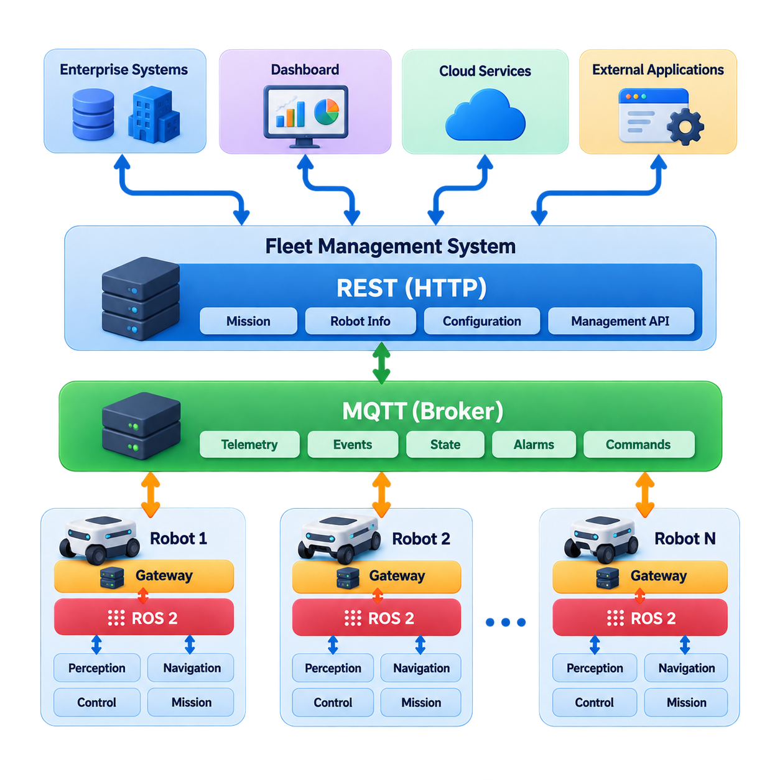
A fleet communication architecture must support several fundamentally different traffic patterns at the same time. Robots continuously exchange state, commands, mission events, diagnostics, and operational data, while fleet servers communicate with dashboards, enterprise systems, and cloud services. A single protocol rarely satisfies all these requirements efficiently. For this reason, practical fleet systems use a layered protocol stack in which ROS 2, MQTT, and REST each serve different communication roles. :chatgpt-content-reference{index=“0”}
ROS 2 is primarily suited to communication inside robots and within tightly coupled robotic systems. Its publish-subscribe model, services, and actions allow perception, localization, navigation, control, and mission components to exchange structured data without direct dependencies between producers and consumers. ROS 2 communication is commonly implemented through DDS, allowing Quality of Service policies to control reliability, durability, history, deadline behavior, and message delivery characteristics.
Within a fleet, ROS 2 can also connect robots and nearby computing infrastructure when the network is controlled and predictable. Robot pose, velocity, navigation state, sensor-derived information, and local coordination messages can be exchanged with low software integration overhead. However, exposing a large ROS 2 graph across an entire factory or cloud network can create discovery, bandwidth, security, and scalability challenges. Fleet architectures therefore usually define explicit communication boundaries rather than treating every robot as part of one unrestricted middleware domain.
MQTT provides a complementary communication layer for asynchronous fleet messaging. Instead of nodes discovering one another directly, publishers send messages to topics managed by a broker, and subscribers receive only the topics they require. A robot might publish operational state under a hierarchical topic representing site, fleet, robot, and message category. Fleet services can then subscribe to selected portions of that hierarchy without maintaining direct connections to every robot.
This broker-centered architecture is particularly useful for telemetry, health information, mission events, alarms, battery state, and other fleet-wide data. MQTT also provides configurable Quality of Service levels, retained messages, persistent sessions, and last-will mechanisms that are useful when robots operate through wireless networks with intermittent connectivity. These characteristics make MQTT suitable as an asynchronous bridge between robot-side systems, fleet management services, edge infrastructure, and cloud platforms.
REST serves a different purpose. It is typically used for request-response operations involving resources whose state can be represented through HTTP endpoints. A fleet management system may expose interfaces for creating missions, querying robot information, retrieving historical records, managing configuration, or integrating WMS, MES, ERP, and external applications. REST is widely supported by enterprise software and therefore forms a practical boundary between robotics-specific infrastructure and conventional information systems.
REST should not normally carry high-frequency robot telemetry or time-critical control loops. Repeated HTTP requests introduce unnecessary overhead for rapidly changing data and do not naturally provide continuous event delivery. Instead, REST is effective for relatively coarse-grained operations such as requesting a mission, registering a robot, obtaining a fleet snapshot, modifying configuration, or retrieving reports. Asynchronous state changes can then be communicated through MQTT or another event-oriented channel.
A useful fleet architecture therefore separates communication according to semantic and temporal requirements. ROS 2 can handle tightly coupled robot execution and real-time-oriented data exchange, MQTT can transport asynchronous operational events and telemetry across fleet boundaries, and REST can provide externally accessible management APIs. The protocols are not competing alternatives. They occupy different positions in a communication hierarchy and can coexist within the same robot and fleet management system.
Consider an AMR receiving a transport mission from a warehouse management system. The WMS may submit the mission to the fleet manager through a REST API. The fleet manager validates and assigns the mission, then delivers the corresponding operational command through MQTT or a dedicated fleet messaging interface. Inside the selected robot, a gateway translates that fleet-level command into ROS 2 actions consumed by navigation and mission-execution nodes. Execution state then propagates upward through the reverse path.
This translation layer is an important architectural component. External systems should not need detailed knowledge of ROS 2 topics, node names, or internal message definitions, while robot software should not depend directly on enterprise API formats. A fleet communication gateway isolates these domains. It converts message schemas, maps identities, validates commands, applies authorization rules, and translates between synchronous requests, asynchronous events, and robot-native communication semantics.
Communication design must also distinguish control-plane traffic from data-plane traffic. Mission commands, emergency operational notifications, reservations, and robot state transitions require predictable delivery and clear acknowledgement semantics. Diagnostic logs, historical telemetry, images, and analytics data can tolerate different latency and reliability characteristics. Separating these traffic classes prevents large data transfers from interfering with messages required for fleet coordination and operational safety.
Message identity and timing are equally important. Fleet messages should normally contain a robot identifier, message type, timestamp, sequence or correlation identifier, schema version, and payload. Commands should support acknowledgement and traceability so that the fleet manager can determine whether a message was received, accepted, rejected, or executed. Idempotent command design is particularly valuable because retransmission after a communication interruption must not unintentionally execute the same physical operation twice.
The protocol stack must also tolerate temporary disconnection. An autonomous robot should not immediately lose safe local operation merely because communication with the fleet server or cloud disappears. Robot-side ROS 2 components can continue essential navigation and safety functions, while the communication gateway buffers appropriate outbound events and reports connectivity status. After reconnection, selected state and events can be synchronized without blindly replaying commands that are no longer operationally valid.
Security must be applied at every boundary rather than delegated to one protocol. Robot identity, authentication, authorization, encrypted transport, certificate management, topic or API access control, and command validation are required across the stack. ROS 2/DDS security mechanisms can protect middleware communication, MQTT can use TLS and authenticated broker sessions, and REST interfaces commonly use HTTPS together with token- or certificate-based authentication. The fleet gateway becomes an important policy enforcement point.
Scalability changes the communication problem significantly. Ten robots may tolerate broad state distribution that becomes inefficient with hundreds or thousands of robots. Large fleets require selective subscriptions, hierarchical topic structures, controlled ROS 2 discovery domains, message aggregation, rate limiting, and carefully defined update frequencies. Fleet communication should therefore scale according to information relevance rather than assuming that every participant needs every state update from every other participant.
The architecture described here also establishes the foundation for the remainder of fleet communication engineering. Real-time state broadcasting, message schema versioning, bandwidth optimization, buffering and retry behavior, secure authentication, latency budgeting, network technologies, QoS policies, and communication diagnostics become separate design concerns once the protocol responsibilities are clearly divided. This progression matches the chapter structure defined for Fleet Communication in the source outline. :chatgpt-content-reference{index=“1”}
Ultimately, MQTT, ROS 2, and REST should be viewed as complementary layers of a fleet communication fabric. ROS 2 connects robot intelligence and execution components, MQTT provides scalable event-oriented communication across distributed fleet infrastructure, and REST exposes stable management interfaces to external systems. A well-designed stack keeps these boundaries explicit while providing controlled gateways between them, allowing robot autonomy, fleet coordination, enterprise integration, and cloud services to evolve independently without fragmenting the overall system.

04.02 Real Time State Broadcast and Subscription Design [w/Code]
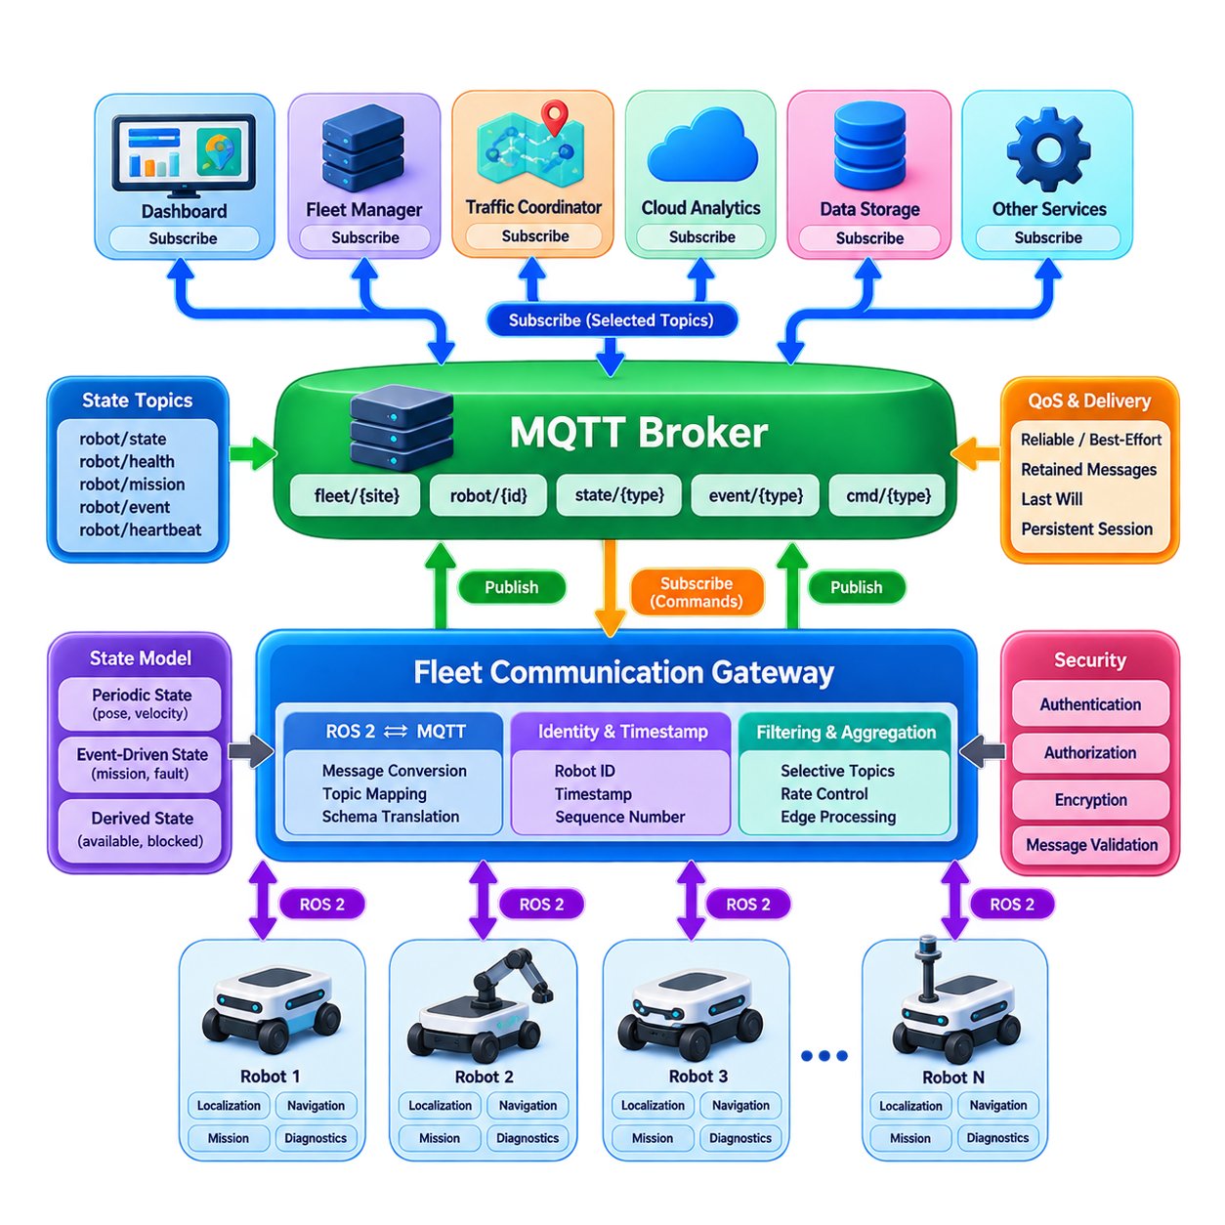
Real-time state broadcasting is the communication mechanism that allows a fleet management system to maintain a continuously updated operational view of distributed robots. Each robot produces changing information such as pose, velocity, navigation mode, battery level, mission progress, safety state, connectivity, and fault conditions. Rather than repeatedly requesting these values, subscribers receive updates whenever relevant state changes or according to defined publication intervals.
A publish-subscribe architecture separates state producers from state consumers. Robots act as publishers of operational information, while fleet managers, traffic coordinators, monitoring services, dashboards, digital twins, and analytics applications become subscribers. Publishers do not need to know which systems consume their data. This loose coupling allows new monitoring or optimization services to be introduced without modifying the software running on every robot.
State information should be classified according to its temporal characteristics and operational importance. Robot pose and motion state may require updates several times per second, while battery condition, temperature, mission progress, and diagnostic information can often be transmitted at lower frequencies. Safety events, emergency stops, localization failures, or critical faults should normally be distributed immediately rather than waiting for the next periodic broadcast cycle.
A practical state model distinguishes periodic state, event-driven state, and derived fleet state. Periodic messages represent continuously changing variables such as position and velocity. Event-driven messages indicate discrete transitions such as mission start, task completion, charging initiation, or fault occurrence. Derived states are generated by fleet services by combining multiple observations, for example determining whether a robot is available, delayed, blocked, disconnected, or requiring maintenance.
ROS 2 provides native publish-subscribe communication for state exchange inside robots and controlled robotic networks. Topics can represent localization, odometry, navigation status, diagnostics, or mission execution state, while Quality of Service policies define reliability and delivery behavior. High-frequency data may favor best-effort delivery when the newest sample is more valuable than retransmitting an old one, whereas important state transitions may require reliable delivery.
Fleet-wide communication commonly introduces a gateway between the ROS 2 domain and an external messaging infrastructure such as MQTT. The gateway subscribes to selected ROS 2 topics, converts internal messages into fleet-level schemas, attaches robot identity and timing information, and publishes them through hierarchical MQTT topics. Incoming fleet commands can travel through the reverse path and be translated into ROS 2 messages, services, or actions appropriate for the robot.
Topic organization becomes increasingly important as the fleet grows. A hierarchical naming structure can represent site, fleet, robot, subsystem, and message category. Subscribers can then select information at different scopes. A monitoring service may subscribe to every robot's health state, while a traffic manager receives only localization and navigation information for robots operating in a particular zone. This prevents unnecessary distribution of unrelated data.
Subscription design should follow the principle that each consumer receives only the information required for its function. Broadcasting every state message to every service may appear simple for a small deployment but creates excessive network traffic and processing overhead as robot count increases. Selective subscriptions, filtering, topic partitioning, and configurable update rates allow communication load to scale more closely with operational requirements.
Update frequency must balance freshness against bandwidth consumption. Increasing the publication rate reduces the age of information available to fleet services, but it also increases wireless traffic, broker workload, serialization cost, and subscriber processing. A useful design therefore assigns different rates to different state classes. Motion-related data may operate at relatively high frequency, while health telemetry and environmental measurements can use slower periodic updates.
Change-based publication can further reduce unnecessary traffic. Instead of broadcasting every field at a fixed rate, a robot may publish when a value changes beyond a defined threshold. Position can be transmitted after a meaningful displacement, battery state after a specified percentage change, and operational mode whenever a transition occurs. Periodic heartbeat messages should still confirm that a robot remains connected even when its operational state has not changed.
Every real-time state message requires sufficient context to determine where it originated and when it was valid. Typical metadata includes robot identifier, timestamp, sequence number, message type, schema version, and state payload. Sequence numbers help identify missing or reordered messages, while timestamps allow subscribers to evaluate data age. Consistent time synchronization across robots and servers becomes especially important when states from multiple robots are compared.
Subscribers must also define how stale information is handled. A fleet manager should not assume that the last received state remains valid indefinitely. Each important state class can have an expiration threshold or time-to-live. If updates stop beyond that threshold, the robot may transition from connected to uncertain or offline. Traffic coordination should then avoid making safety-sensitive decisions based on an outdated robot position or navigation state.
State consistency does not necessarily require every subscriber to observe every intermediate update. For rapidly changing variables, the latest valid state is often more important than complete message history. A slow subscriber can therefore discard superseded samples and process the newest state. In contrast, mission transitions, fault events, and command acknowledgements may require ordered and reliable processing because missing one transition could create an incorrect operational interpretation.
Network interruption requires an explicit recovery strategy. When connectivity disappears, robots should preserve essential local autonomy while the fleet system marks their remote state as stale. After reconnection, the robot should first transmit its current authoritative state rather than indiscriminately replaying every obsolete periodic update. Important buffered events may subsequently be delivered according to retention and ordering policies defined for each message class.
Large fleets benefit from aggregation and regional distribution. Instead of sending all raw robot states directly to a central server, edge gateways can collect information from groups of robots, normalize schemas, filter redundant updates, and forward only required fleet-level information. Site-level brokers or regional fleet services can further partition communication domains, reducing network congestion and preventing a central message infrastructure from becoming an unnecessary bottleneck.
Real-time state communication should also support observability. The system should measure publication frequency, end-to-end latency, dropped messages, reconnect events, queue depth, subscriber lag, stale-state duration, and broker health. These metrics distinguish communication failures from robot failures. For example, a stationary position value may represent an intentionally stopped robot, a localization problem, a blocked publisher, or a network interruption, and the communication layer should provide evidence to differentiate them.
Security requirements apply to both publishers and subscribers. Robots should authenticate before publishing fleet state, and subscribers should receive only topics authorized for their operational roles. Encryption protects state information while in transit, while message validation prevents malformed or unauthorized data from entering fleet decision processes. Critical state transitions may additionally require stronger integrity protection and auditable records for later incident analysis.
The overall design therefore combines local ROS 2 state exchange, gateway-based translation, scalable publish-subscribe messaging, selective subscriptions, differentiated QoS, synchronized timestamps, stale-state detection, and resilient reconnection behavior. This architecture allows a fleet controller to maintain a timely operational picture without forcing every component to process every message. It also establishes the communication foundation required for message schema management, bandwidth optimization, failure recovery, latency control, QoS prioritization, and fleet-scale diagnostics.

04.03 Fleet Message Schema and Versioning Strategy [w/Code]
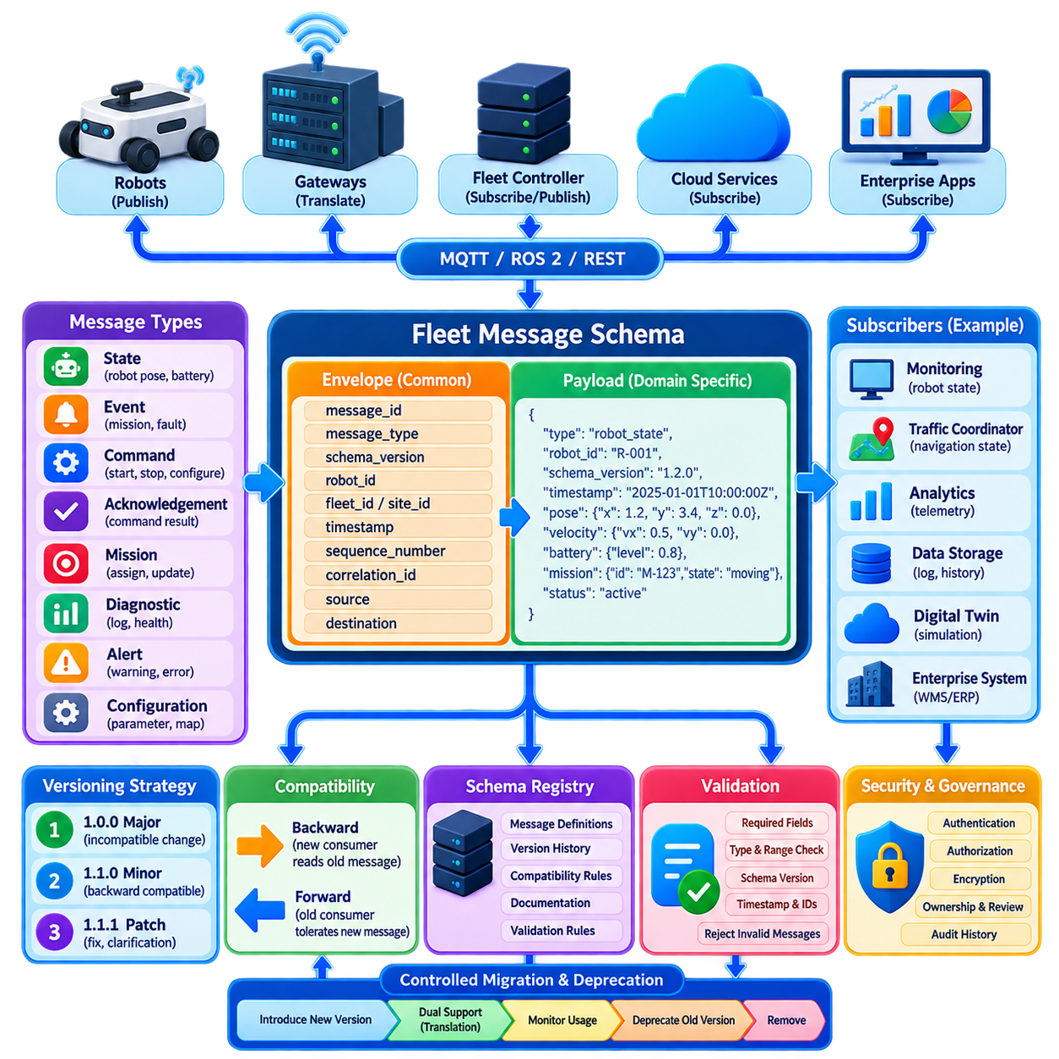
A fleet message schema defines the common structure through which robots, fleet controllers, gateways, cloud services, and enterprise applications exchange operational information. Without a stable schema, each subsystem may interpret identifiers, timestamps, states, commands, or errors differently, creating fragile point-to-point integrations. The schema therefore acts as a communication contract that separates the meaning of fleet information from the transport protocol carrying it.
A practical fleet message usually consists of an envelope and a payload. The envelope contains information required to identify, route, validate, and interpret the message, while the payload contains domain-specific data. Typical envelope fields include message identifier, message type, schema version, robot identifier, fleet or site identifier, timestamp, sequence number, correlation identifier, source, and destination. This structure remains consistent even when payload formats differ substantially.
Message types should represent clear operational semantics rather than implementation details. A fleet may define state, event, command, acknowledgement, mission, diagnostic, alert, and configuration message families. Each family can then contain specialized payloads for robot pose, battery condition, mission assignment, navigation status, charging requests, faults, or maintenance information. Clear semantic boundaries prevent one generic message structure from becoming overloaded with unrelated optional fields.
Identifiers require particular consistency because distributed systems must correlate information generated by many independent components. Robot IDs should remain stable throughout the robot lifecycle, while message IDs distinguish individual transmissions. Correlation IDs connect related interactions such as a command and its acknowledgement. Mission, task, map, zone, and site identifiers should follow documented naming and uniqueness rules so that data can be combined safely across fleet services.
Time representation is equally important. Every message representing an observation or event should identify when that information became valid, rather than relying only on the time at which a server received it. Standardized timestamps and synchronized clocks allow fleet services to order events, estimate communication delay, detect stale information, and reconstruct incidents. Sequence numbers can complement timestamps by revealing missing, duplicated, or reordered messages within a communication stream.
The payload should be strongly defined enough to prevent ambiguous interpretation while remaining extensible. Data types, units, coordinate frames, enumerated values, required fields, optional fields, and valid ranges should be explicitly documented. A velocity field, for example, should identify whether it represents meters per second and which coordinate frame applies. Such semantic precision becomes essential when robots from different platforms or vendors participate in the same fleet.
Schema serialization may use formats such as JSON for readability and broad interoperability, or binary representations such as Protocol Buffers when bandwidth and processing efficiency are more important. The logical fleet schema should remain conceptually independent from serialization whenever possible. This separation allows the same operational meaning to be exposed through MQTT, REST, ROS 2 gateways, data pipelines, or storage systems without redefining the domain model for every transport technology.
Versioning becomes necessary as soon as deployed robots and fleet services evolve independently. A robot may operate for years while server software changes frequently, and large fleets cannot always be upgraded simultaneously. The communication architecture must therefore assume that multiple software and schema versions will coexist. A message should explicitly declare its schema version so that receivers can determine whether they understand the structure and semantics being transmitted.
Backward compatibility means that a newer consumer can continue interpreting messages produced by older publishers. Forward compatibility means that an older consumer can tolerate newer messages when changes do not affect the information it requires. These properties are easier to maintain when new fields are optional, existing field meanings are preserved, sensible defaults are defined, and receivers ignore unknown fields rather than rejecting an entire message unnecessarily.
Breaking changes require stronger control. Renaming or deleting required fields, changing units, modifying coordinate conventions, reusing enumeration values, or changing the semantic meaning of an existing field can silently produce dangerous behavior. Such changes should normally create a new major schema version or a new message type. The older definition should remain available during a controlled migration period rather than being immediately replaced throughout the fleet.
A semantic versioning approach can distinguish major, minor, and patch-level evolution. Major versions represent incompatible changes, minor versions introduce backward-compatible extensions, and patch versions clarify or correct definitions without changing expected behavior. The exact numbering convention is less important than applying it consistently. Version changes should be governed by documented compatibility rules rather than individual developer judgment at deployment time.
Schema evolution should also consider enumerations carefully. Adding a new robot state, fault category, or mission type may technically preserve the message structure while still breaking software that assumes a fixed set of values. Consumers should therefore implement an unknown or unsupported state path instead of assuming every future enumeration is already recognized. This allows newer publishers to coexist more safely with older fleet applications.
A schema registry can serve as the authoritative source for message definitions and compatibility policies. It can store versions, ownership information, documentation, validation rules, and lifecycle status for each message type. Development and continuous integration pipelines can validate proposed schema changes against previous versions before deployment. This prevents accidental incompatible modifications from reaching robots simply because serialized messages remain syntactically valid.
Validation should occur at communication boundaries. A fleet gateway or message broker integration layer can verify required fields, version support, identifiers, timestamps, ranges, and payload structure before forwarding data to decision-making services. Invalid messages should be rejected or isolated with diagnostic information rather than silently interpreted. Validation is particularly important for commands because malformed values may ultimately influence physical robot motion or mission execution.
Migration must be treated as an operational process rather than only a software change. During a fleet upgrade, gateways may need to translate between schema versions while old and new robots coexist. Dual publishing can temporarily provide both representations, although it increases bandwidth and complexity. Compatibility adapters should have defined retirement criteria so that transitional mechanisms do not become permanent architectural dependencies.
Deprecation should therefore be explicit and measurable. A field or message version can first be marked deprecated, followed by monitoring of remaining publishers and consumers. Removal should occur only after telemetry confirms that no required system depends on the obsolete definition. This approach is especially important for geographically distributed fleets where software versions, maintenance windows, network conditions, and hardware generations may differ between sites.
Security and governance are also part of schema design. Message definitions should distinguish trusted identity metadata from application payloads and specify which components are authorized to produce particular command or state types. Sensitive information should not be included merely because the schema makes it convenient. Ownership, review responsibility, change approval, and audit history help prevent uncontrolled message evolution across organizational and supplier boundaries.
Testing should include more than serialization and deserialization. Producers and consumers should be tested across supported version combinations, including missing optional fields, unknown fields, unknown enumeration values, reordered delivery, duplicate messages, and invalid payloads. Recorded fleet traffic and simulation environments can provide representative compatibility tests before new software reaches physical robots. Contract testing is particularly useful for independently developed fleet services.
A well-designed fleet message strategy therefore combines stable envelopes, precise payload semantics, explicit identifiers and timing, compatibility-aware versioning, automated validation, controlled migration, and lifecycle governance. The objective is not to prevent schemas from changing, but to allow them to evolve without requiring synchronized replacement of every robot and service. This foundation enables heterogeneous fleets and long-lived robotic systems to exchange trustworthy information while their software architectures continue to evolve.

04.04 Bandwidth Optimization Message Aggregation [w/Code]
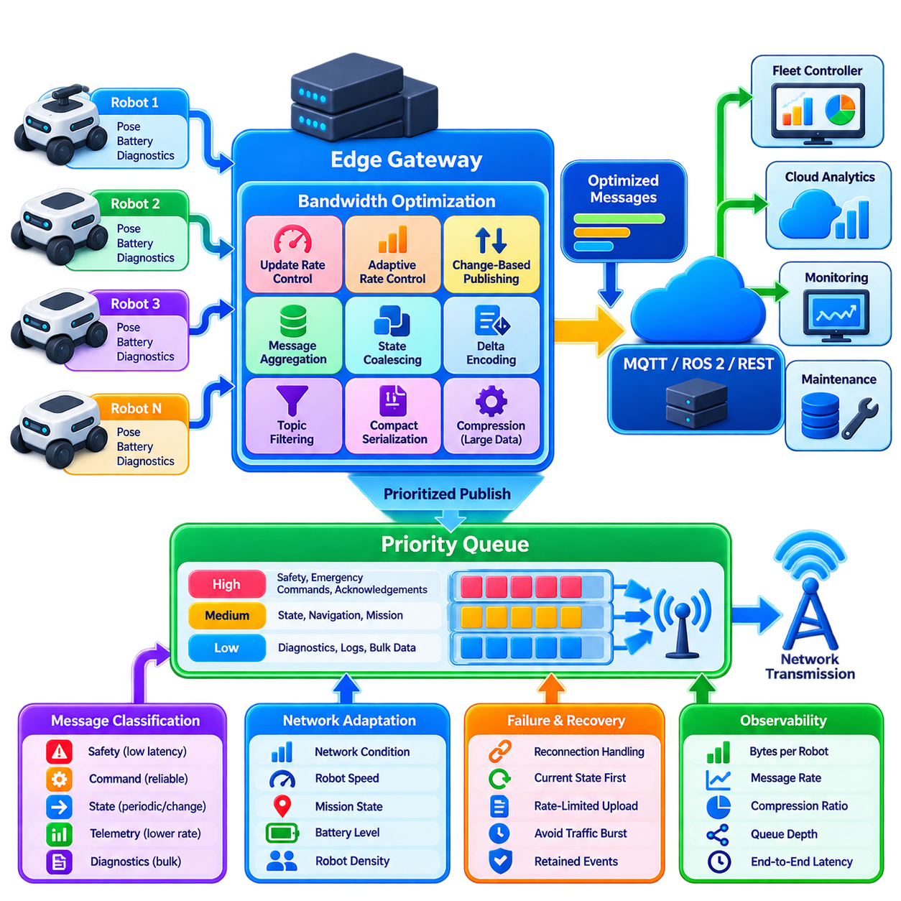
Bandwidth optimization is a fundamental requirement for fleet communication because the amount of network traffic grows rapidly as robot count, sensor complexity, telemetry frequency, and connected services increase. A communication design that works efficiently for ten robots may overload wireless infrastructure when hundreds of robots operate simultaneously. Optimization therefore aims to reduce unnecessary transmission while preserving the freshness, reliability, and semantic completeness required for fleet decisions.
Fleet traffic should first be classified according to operational importance and temporal sensitivity. Safety events, emergency conditions, traffic reservations, mission commands, and critical acknowledgements require low latency and predictable delivery. Robot pose, velocity, battery state, diagnostics, logs, and environmental telemetry tolerate different update rates. Treating every message as equally urgent wastes bandwidth and can allow high-volume background data to interfere with operationally important communication.
Update-rate control provides one of the simplest optimization mechanisms. Different state variables change at different speeds and therefore do not require identical publication frequencies. Motion information may need relatively frequent updates, while battery temperature or component health may change slowly. Publication rates can be configured by message class, operating mode, robot speed, mission state, or network condition rather than being fixed globally for every robot.
Adaptive rate control extends this concept by modifying communication frequency dynamically. A moving robot may publish localization state frequently, while a parked or charging robot can reduce its update rate. When a robot enters a congested intersection, its navigation and reservation information may temporarily receive higher update frequency. If available bandwidth decreases, noncritical telemetry can be throttled while control and safety-related messages retain their required communication characteristics.
Change-based publishing eliminates transmissions that contain little new information. Instead of periodically sending the same battery value, operating mode, or stationary pose, a publisher can transmit only when the value changes beyond a defined threshold. Thresholds should reflect the physical meaning of each variable. Position, heading, battery percentage, temperature, and velocity require different criteria because identical numerical thresholds would not represent equivalent operational significance.
Periodic heartbeats should complement change-based publication. A robot whose state remains unchanged must still demonstrate that its communication channel and software are alive. Heartbeat messages can be significantly smaller and less frequent than complete state messages. Subscribers can use them to distinguish a healthy robot with unchanged state from a disconnected robot whose last state merely remains stored in the fleet system.
Message aggregation combines multiple small updates into a smaller number of network transmissions. Instead of independently sending battery, localization quality, mission progress, temperature, and diagnostic status, a gateway may collect updates during a short aggregation window and construct a consolidated fleet-state message. This reduces repeated protocol headers, connection overhead, broker processing, and packet-level inefficiency, particularly when individual payloads are small.
Aggregation windows must be chosen carefully because bandwidth efficiency competes with latency. A longer collection interval can combine more messages and improve network efficiency, but it delays delivery of the earliest information in the batch. Critical events should therefore bypass aggregation and be transmitted immediately. Aggregation is most appropriate for telemetry whose delay tolerance is known and whose individual updates do not require independent real-time processing.
Spatial aggregation is useful in large distributed fleets. Edge gateways can collect data from robots operating within the same building, zone, production area, or site. The gateway can normalize message schemas, remove redundant information, calculate summaries, and forward only fleet-relevant data to central infrastructure. This hierarchical communication model reduces wide-area traffic while preserving detailed local communication where higher update frequency may still be necessary.
Temporal aggregation combines measurements collected over time. High-frequency measurements may be transformed into minimum, maximum, average, variance, count, or representative samples before transmission to analytics services. For example, raw component temperature measurements may be required locally for protection, while a cloud monitoring system may need only summarized values over a longer interval. Aggregation should therefore reflect the purpose of the downstream consumer.
State coalescing provides another optimization for rapidly changing variables. If several updates accumulate before a subscriber can process them, intermediate values may no longer be useful. A gateway or broker can retain only the newest valid state for variables such as pose, velocity, or battery percentage. Event messages should not normally be coalesced in the same manner because each mission transition, alarm, or fault occurrence may carry independent operational meaning.
Delta encoding can reduce payload size when consecutive messages contain mostly unchanged fields. Instead of transmitting the entire robot state, the publisher sends only fields that changed relative to a known baseline. Periodic full-state messages can reestablish synchronization and limit error propagation if a delta is lost. This method is particularly useful when a state model contains many fields but only a small subset changes during each update cycle.
Serialization format also affects bandwidth efficiency. Human-readable JSON simplifies development, debugging, and integration but introduces field names and textual representations into every message. Compact binary formats can reduce payload size and serialization overhead for high-volume fleet traffic. The appropriate choice depends on robot count, message frequency, computational resources, interoperability requirements, and whether communication occurs locally, over constrained wireless links, or across wide-area networks.
Compression can further reduce large messages, but it should not be applied indiscriminately. Small messages may become larger or consume unnecessary CPU time after compression overhead is included. Compression is more useful for logs, map fragments, structured telemetry batches, or other sufficiently large payloads. Images, video, and many sensor streams usually require media-specific compression strategies rather than generic message compression.
Topic and subscription filtering prevent data from traveling to consumers that do not require it. A traffic coordinator may need position and navigation states but not detailed motor diagnostics, while a maintenance service may require component health without receiving high-frequency localization updates. Hierarchical topics, content filtering, geographic filtering, and role-based subscriptions reduce both network traffic and downstream processing load.
Priority-aware queue management becomes necessary when communication capacity is temporarily insufficient. High-priority command, safety, and coordination messages should be transmitted before low-priority analytics or diagnostic traffic. Queues should also have explicit limits because unlimited buffering simply converts a bandwidth problem into a memory and latency problem. When data becomes obsolete, dropping stale low-priority state may be preferable to delivering it long after it has operational value.
Network optimization should preserve semantic correctness. Removing repeated messages is safe only when consumers do not depend on every occurrence, and aggregating events is safe only when ordering and individual meaning remain recoverable. Optimization rules should therefore be associated with message classes rather than applied blindly to all traffic. State, command, event, acknowledgement, diagnostic, and bulk-data messages require different retention, aggregation, and loss policies.
Bandwidth management must also account for failure and reconnection. A disconnected robot may accumulate substantial buffered telemetry, creating a traffic burst when connectivity returns. Recovery logic should prioritize current authoritative state and critical retained events instead of replaying every obsolete periodic update. Uploading historical diagnostics or logs can be rate-limited and scheduled after operational communication has stabilized, preventing reconnection storms across a large fleet.
Observability is essential for determining whether optimization is effective. Fleet communication infrastructure should measure bytes per robot, message rate, payload size, compression ratio, aggregation efficiency, queue depth, dropped messages, retransmissions, broker throughput, wireless utilization, and end-to-end latency. Measurements should be separated by message class so that reducing total traffic does not conceal degraded performance in critical communication paths.
Optimization policies can ultimately become context aware. Robot density, mission urgency, wireless signal quality, available network capacity, battery condition, and site congestion can influence communication behavior. A fleet controller or edge gateway can dynamically allocate bandwidth budgets and adjust publication rates while preserving minimum requirements for critical traffic. This turns bandwidth management from a static configuration problem into an adaptive fleet resource-management function.
An effective fleet bandwidth strategy therefore combines differentiated update rates, change-based publishing, heartbeats, aggregation, state coalescing, filtering, compact serialization, selective compression, priority queues, and controlled recovery behavior. The objective is not simply to minimize transmitted bytes, but to maximize the operational value carried by each unit of network capacity while ensuring that safety, coordination, and mission-critical information remains timely and dependable.

04.05 Communication Failure Handling Buffering Retry [w/Code]
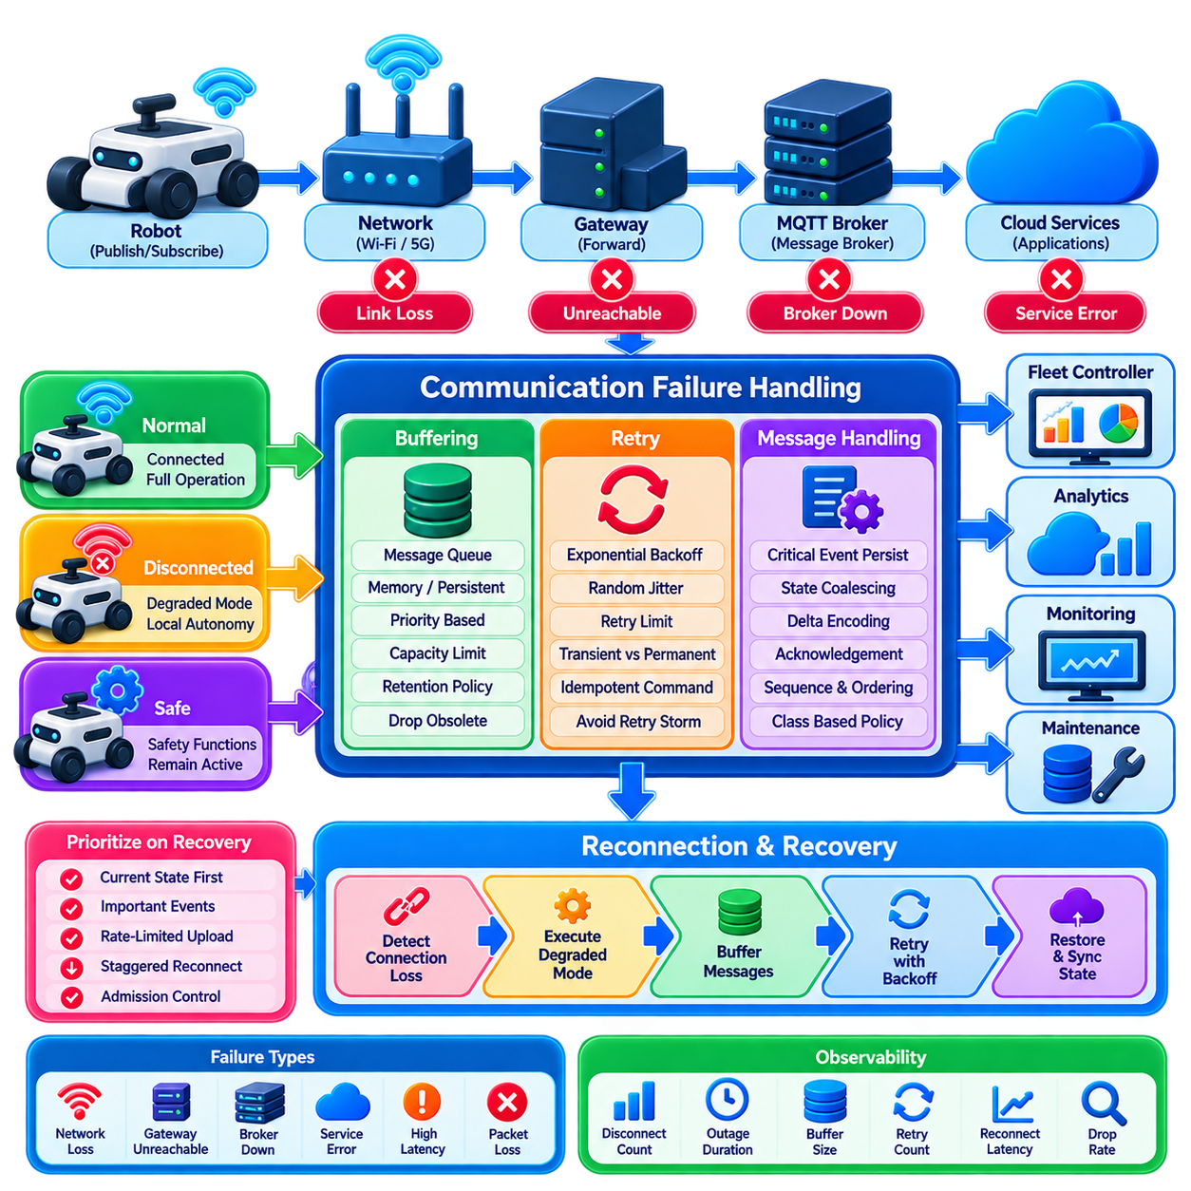
Communication failures are unavoidable in large robot fleets because wireless links, network infrastructure, brokers, gateways, and application services can temporarily become unavailable. A robust fleet architecture must therefore treat disconnection as a normal operating condition rather than an exceptional event. Failure handling should preserve robot safety, maintain essential local autonomy, protect important messages, and restore distributed state predictably after connectivity returns.
Failures can occur at several layers and should be distinguished before recovery actions are selected. A robot may lose Wi-Fi or 5G connectivity, a gateway may become unreachable, DNS or routing may fail, an MQTT broker may restart, or a fleet service may stop responding. Packet loss and excessive latency can also create partial failures in which the connection technically exists but is no longer adequate for operational communication.
Connectivity monitoring normally combines transport status with application-level health signals. TCP sessions or MQTT connections can indicate basic connectivity, while heartbeat messages confirm that the remote application is actually functioning. Timeouts should be defined according to message criticality and expected update frequency. A missing high-rate robot state may indicate failure within seconds, whereas a low-frequency diagnostic stream requires a different timeout threshold.
When communication is lost, the robot should transition into a predefined degraded operating mode rather than immediately becoming uncontrolled. Safety functions, obstacle avoidance, localization, braking, and other essential capabilities should remain locally executable whenever possible. Whether an active mission can continue depends on the application and safety policy. Operations requiring fleet coordination, shared-resource reservations, or remote authorization may need to stop at a safe state until communication is restored.
Buffering allows messages generated during temporary disconnection to be retained for later delivery. However, not every message deserves to be buffered. Critical events, mission transitions, faults, acknowledgements, and audit information may require persistence, while high-frequency pose or velocity updates rapidly become obsolete. Buffering policies should therefore be associated with message classes and define retention duration, maximum capacity, persistence requirements, and overflow behavior.
Memory queues provide fast buffering for short interruptions but disappear if the robot or gateway restarts. Persistent queues store selected messages on durable storage and are more appropriate for operational events that must survive process or power failures. Persistence introduces storage writes, lifecycle management, and recovery complexity, so it should be reserved for information whose loss would affect operational correctness, traceability, maintenance, or regulatory requirements.
Buffers must always have explicit capacity limits. An unlimited queue can consume memory or storage during a prolonged outage and eventually destabilize the robot itself. When capacity is reached, the system needs a deterministic eviction policy. Old periodic telemetry can often be discarded, while critical faults or mission events may require protected storage. Priority-based queues prevent large volumes of low-value data from displacing operationally important messages.
Retry mechanisms attempt to deliver messages or requests that failed temporarily. Immediate repeated retries are dangerous because they can overload an already degraded network or recovering server. A common strategy uses exponential backoff, increasing the interval between successive attempts. Random jitter can be added so that hundreds of robots do not reconnect at exactly the same time after a shared network outage, thereby reducing synchronized retry storms.
Retries should also have clear limits and failure states. Some operations can be retried for a bounded number of attempts, while persistent connectivity recovery may continue at a low frequency indefinitely. The retry policy should distinguish transient failures from permanent errors. Authentication rejection, invalid commands, unsupported schema versions, or authorization failures should not be repeatedly retried as though they were temporary packet-loss conditions.
Command retry requires particular care because communication uncertainty can create duplicate physical actions. If a sender transmits a command but loses the acknowledgement, it cannot immediately know whether the robot executed the operation. Commands should therefore carry unique identifiers and support idempotent processing whenever possible. A robot receiving the same command identifier again can return the previous result instead of executing the physical operation a second time.
Acknowledgement design should distinguish message receipt from operational completion. A robot may acknowledge that a command was received and validated before the commanded mission actually finishes. Later status or completion events can report execution progress and final outcome. Separating accepted, executing, completed, rejected, and failed states prevents a fleet controller from interpreting network delivery as successful completion of a physical task.
After reconnection, recovery should prioritize current operational truth rather than blindly replaying everything accumulated during the outage. The robot can first publish its current pose, mission state, safety condition, battery level, and other authoritative state. Important buffered events can then be delivered in sequence. Obsolete periodic telemetry should normally be discarded because replaying historical positions may confuse subscribers and consume bandwidth without improving current fleet awareness.
Ordering becomes important when buffered events represent state transitions. A mission-start event followed by a mission-complete event must not be processed in reverse order. Sequence numbers, timestamps, message identifiers, and persistent queue ordering can help reconstruct the correct sequence. Consumers should also detect duplicate or unexpectedly old messages because reconnecting networks may deliver retained information that is no longer relevant to current operation.
State reconciliation resolves differences between robot-local state and fleet-server state after communication returns. During an outage, a robot may have completed a local maneuver, stopped for safety, changed battery condition, or entered another operational mode. The fleet controller should not simply overwrite the robot with its previously stored assumptions. Recovery protocols should identify authoritative fields and reconcile mission, task, reservation, and robot state according to defined ownership rules.
Shared resources create additional recovery challenges. A disconnected robot may previously have held a reservation for a narrow aisle, elevator, docking station, or charging point. Fleet infrastructure needs lease or timeout mechanisms so that abandoned reservations do not block operations indefinitely. Conversely, the robot must not assume that a reservation obtained before disconnection remains valid after reconnecting unless the fleet controller explicitly confirms it.
Broker and gateway redundancy can reduce the impact of infrastructure failures. Robots may connect through redundant network paths, multiple access points, clustered MQTT brokers, or replicated fleet services. Failover should nevertheless be tested carefully because redundancy does not automatically guarantee continuity. Session state, subscriptions, retained messages, authentication context, and message ordering must remain sufficiently consistent when communication moves from one infrastructure instance to another.
Recovery traffic itself requires bandwidth control. If hundreds of robots reconnect simultaneously, each may attempt to send state snapshots, buffered events, logs, diagnostics, and subscription requests at once. Staggered reconnect delays, jitter, priority queues, rate-limited backlog uploads, and admission control can prevent this reconnection storm. Safety and current state should receive bandwidth before historical diagnostics or bulk data transfers.
Observability is essential for diagnosing communication failures. Useful metrics include disconnect frequency, outage duration, retry count, reconnect latency, buffer occupancy, dropped messages, duplicate detection, acknowledgement timeout, backlog size, and recovery completion time. Logs should identify transitions between connected, degraded, disconnected, reconnecting, and synchronized states so operators can distinguish network instability from application or robot failures.
Failure handling should be validated through deliberate fault injection rather than waiting for field incidents. Tests can interrupt wireless links, restart brokers, delay packets, introduce loss, exhaust queues, duplicate messages, and disconnect robots during mission execution. Large-scale simulation can evaluate simultaneous recovery of many robots. Such testing reveals retry storms, incorrect timeout assumptions, ordering defects, and unsafe dependencies on continuous connectivity before deployment.
A resilient fleet communication architecture therefore combines connectivity detection, degraded local operation, bounded buffering, persistent storage for critical events, controlled retries, exponential backoff, jitter, idempotent commands, acknowledgements, state reconciliation, and prioritized recovery. The objective is not to guarantee that communication never fails, but to ensure that failure remains bounded, observable, and recoverable without compromising robot safety or fleet consistency.

04.06 Secure Fleet Communication mTLS Auth [w/Code]
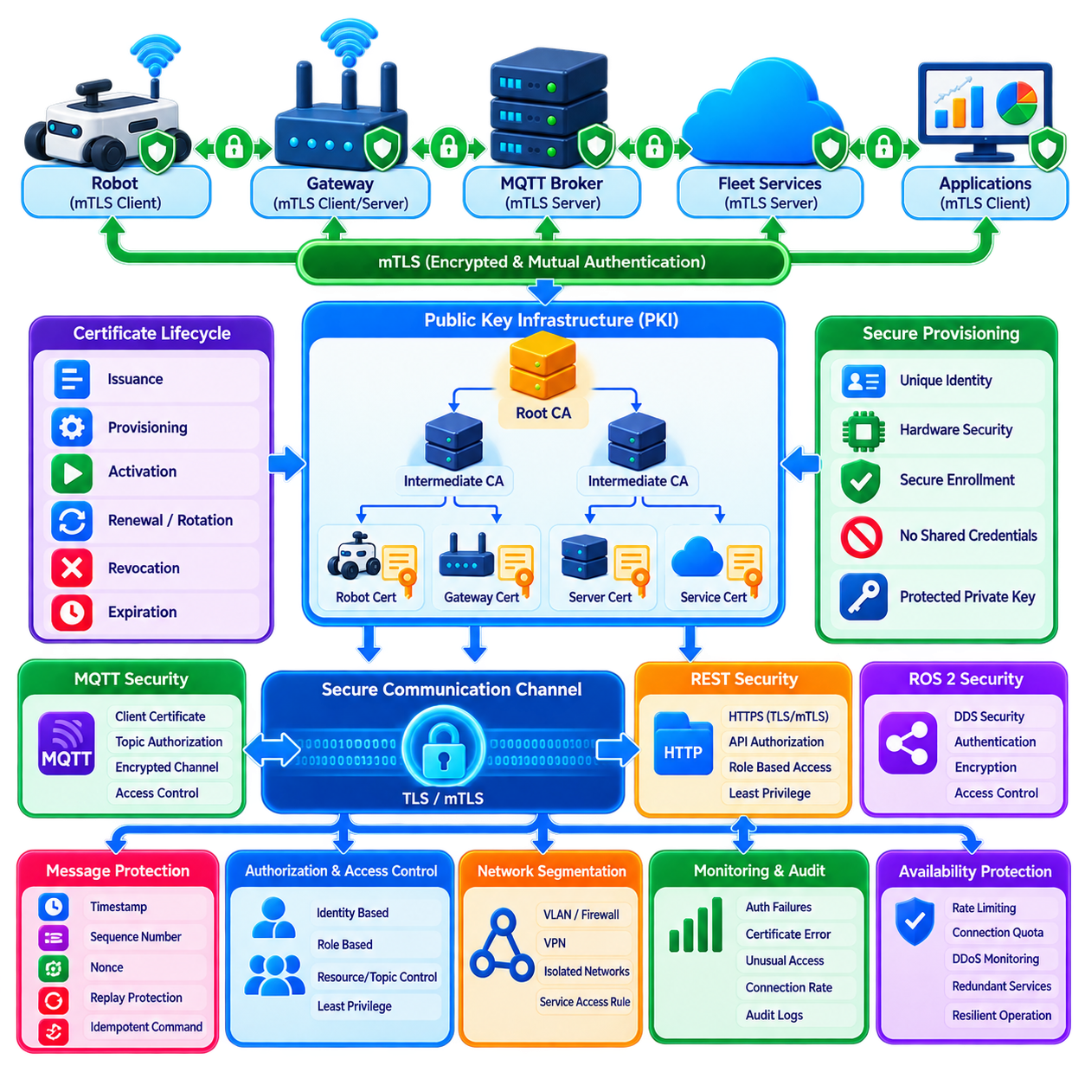
Secure fleet communication must protect commands, telemetry, mission data, robot identities, and operational state while information moves among robots, gateways, brokers, fleet controllers, edge servers, and cloud services. Encryption alone is insufficient because a fleet must also verify who is communicating and what each participant is permitted to do. A robust architecture therefore combines encrypted transport, strong authentication, authorization, credential management, and continuous security monitoring.
Mutual Transport Layer Security, commonly called mTLS, extends conventional TLS by requiring both communication endpoints to authenticate each other. In ordinary HTTPS, the client typically validates the server certificate. With mTLS, the server also validates a certificate presented by the client. This bidirectional verification is particularly valuable in robotic fleets because both robots and infrastructure services must establish trustworthy identities before exchanging operational information.
Each robot should receive a unique cryptographic identity rather than sharing a common fleet credential. A device certificate can bind a robot identity to a public key, while the corresponding private key remains protected on the robot. Gateways, brokers, fleet servers, and other trusted services can use equivalent identities. Unique credentials allow compromised devices to be isolated individually without replacing authentication material across the entire fleet.
A public key infrastructure, or PKI, provides the trust framework required to issue and validate certificates. A certificate authority signs certificates for approved fleet entities, creating a verifiable chain of trust. Production architectures may separate root and intermediate certificate authorities so that the most sensitive root key can remain strongly protected. Certificate policies should define which identities may represent robots, gateways, servers, operators, and software services.
Secure provisioning begins before a robot joins operational networks. Credentials should ideally be installed or generated through a controlled manufacturing, commissioning, or enrollment process. Private keys should not be distributed through source code, configuration repositories, shared files, or manually copied passwords. Hardware-backed storage such as a TPM, secure element, or protected key store can reduce the risk that private keys are extracted from a compromised operating system.
When a robot connects to an MQTT broker through mTLS, the TLS handshake establishes an encrypted channel and validates both identities. The robot verifies that it is communicating with an authorized broker, while the broker verifies the robot certificate against its trusted certificate chain. Only after authentication succeeds should the broker permit the robot to establish a session and interact with fleet topics according to its assigned authorization policy.
Authentication and authorization must remain separate concepts. Authentication answers which robot or service is communicating, while authorization determines what that authenticated identity may access. A patrol robot, charging station, analytics service, and fleet controller may all possess valid certificates but require very different privileges. Compromise of one authenticated component should therefore not automatically grant unrestricted access to the entire communication environment.
MQTT authorization can restrict which topics an identity may publish or subscribe to. A robot may be permitted to publish its own state and events while subscribing only to command topics addressed to that robot. It should not normally publish state on behalf of another robot or subscribe to unrelated command channels. Topic-level access control reduces lateral movement and limits the operational impact of compromised credentials.
REST interfaces require similar protection. HTTPS encrypts communication, while client certificates, signed tokens, or carefully controlled combinations of authentication mechanisms identify callers. API authorization should restrict operations according to roles and resources. A monitoring application may read fleet state without receiving permission to create missions, modify robot configuration, or issue movement-related commands. Least privilege should be applied consistently across every external interface.
ROS 2 communication also requires protection when messages cross security-relevant boundaries. DDS Security mechanisms can provide authentication, encryption, access control, and message integrity within ROS 2 environments. Security domains should be deliberately designed rather than assuming that every discovered node is trusted. Gateways can provide additional isolation between robot-internal ROS 2 communication and fleet-wide MQTT, REST, or enterprise networks.
Certificates have finite lifetimes and therefore require lifecycle management. Fleet infrastructure should track issuance, activation, expiration, renewal, rotation, revocation, and replacement. Shorter certificate lifetimes reduce the period during which stolen credentials remain useful but increase operational demands for automated renewal. A large fleet cannot depend on technicians manually replacing certificates on hundreds or thousands of robots before expiration.
Revocation is necessary when a robot is stolen, decommissioned, compromised, or transferred to another trust domain. The infrastructure must be able to reject credentials that were previously valid. Certificate revocation lists, online status mechanisms, short-lived certificates, or centrally managed authorization policies can contribute to this process. Revocation procedures should be tested so that security teams know how quickly a compromised identity can actually be excluded.
Credential rotation must tolerate intermittent connectivity. A robot may remain offline during part of a renewal window, and an expired certificate can prevent the very connection required to obtain a replacement. Fleet architectures therefore need carefully designed overlap periods, secure enrollment paths, and recovery procedures. Rotation should avoid creating a single moment when simultaneous certificate changes across the entire fleet could interrupt operations.
Secure communication also requires message-level protection against replay and duplication. Encryption prevents passive observers from reading traffic but does not by itself guarantee that an old valid command cannot be reused in an inappropriate context. Message identifiers, timestamps, sequence numbers, command expiration times, nonces, and idempotent processing can help detect repeated or stale commands. Sensitive operations may require stronger freshness validation before execution.
Command authorization should consider both identity and operational context. A valid fleet service may normally be allowed to issue navigation commands, but a command can still be unsafe if it refers to an expired mission, invalid map, unauthorized zone, or outdated reservation. Robot-side validation provides an important final security boundary. Network authentication should never replace local safety checks and command plausibility verification.
Network segmentation further limits attack propagation. Robot networks, management systems, enterprise applications, development environments, and public cloud interfaces should not automatically share unrestricted connectivity. Firewalls, VLANs, VPNs, gateway policies, and service-specific access rules can restrict communication paths. The objective is to expose only the interfaces required for legitimate fleet operation rather than creating a broadly reachable robotic network.
Zero-trust principles are useful for distributed fleet architectures because network location alone should not establish trust. A device connected to an internal wireless network should still authenticate before accessing fleet services. Identity, authorization policy, device status, and communication context can be evaluated independently of physical network position. This becomes increasingly important when robots operate across multiple buildings, sites, edge systems, and cloud environments.
Security monitoring should observe authentication failures, certificate errors, unusual topic access, repeated authorization denials, abnormal connection rates, unexpected identity changes, and suspicious command patterns. These events should be correlated with robot and network logs so operators can distinguish configuration errors from potential attacks. Security telemetry must itself be protected because it can contain detailed information about fleet architecture and operational behavior.
Availability is also a security requirement. Excessive authentication requests, repeated TLS handshakes, connection storms, or malicious traffic can consume broker and gateway resources even when unauthorized access is successfully rejected. Rate limiting, connection quotas, resource isolation, redundant services, and denial-of-service monitoring help preserve fleet operation. Security controls should therefore protect confidentiality and integrity without creating fragile availability dependencies.
Secure fleet communication ultimately requires identity to become a first-class architectural property. mTLS establishes mutually authenticated encrypted channels, PKI manages trust, authorization restricts each identity to necessary resources, secure key storage protects credentials, and lifecycle processes maintain that trust over years of operation. Combined with segmentation, replay protection, monitoring, and local command validation, these mechanisms create a communication fabric capable of supporting heterogeneous and large-scale robot fleets securely.

04.07 Fleet Communication Latency Budget Analysis
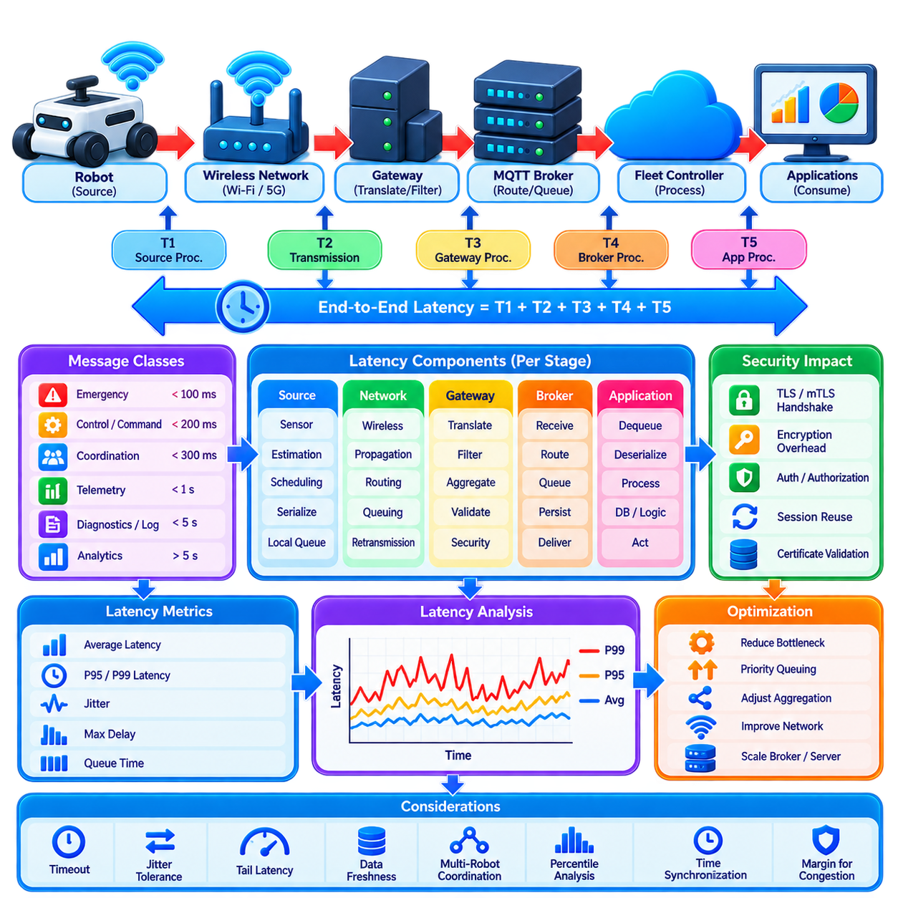
Fleet communication latency budget analysis defines how much end-to-end delay can be tolerated while information travels among robots, wireless networks, gateways, brokers, fleet controllers, and external services. The objective is not to minimize every delay independently, but to allocate a measurable latency allowance to each communication stage so that safety, coordination, mission execution, monitoring, and analytics satisfy their different timing requirements.
Latency requirements begin with message classification because not all fleet information has equal urgency. Emergency notifications, collision-related coordination, shared-resource reservations, and time-sensitive commands require substantially tighter response than battery telemetry, diagnostics, logs, or historical analytics. A meaningful latency budget therefore associates each message class with a target end-to-end latency, acceptable jitter, timeout threshold, and degradation policy.
End-to-end latency should be measured from the instant information becomes available at its source until the intended consumer can act on it. For a robot state message, this path may include local message generation, serialization, operating-system queues, wireless transmission, network routing, gateway processing, broker forwarding, subscriber queues, deserialization, and application processing. Measuring only network round-trip time can therefore hide significant delays elsewhere in the communication chain.
A useful conceptual model expresses total latency as the sum of source processing, local queuing, transmission, propagation, network routing, gateway processing, broker processing, destination queuing, and application processing delays. Additional security operations such as TLS session establishment or cryptographic processing may also contribute. Each component should be measured separately where possible because the same end-to-end delay can originate from very different architectural bottlenecks.
Source-side latency begins before a packet enters the network. Sensor sampling, state estimation, application scheduling, message construction, serialization, and middleware queues can all delay information. A robot publishing localization at 10 Hz already introduces a potential sampling interval of approximately 100 ms between updates. Increasing network performance cannot recover freshness that was lost because information was generated or published too slowly at the source.
Queuing latency is often highly variable and can become more important than physical propagation delay in local fleet networks. Messages may wait inside ROS 2 middleware, gateway queues, operating-system buffers, wireless access points, MQTT brokers, or subscriber applications. Under congestion, these queues grow and create latency spikes. Priority-aware scheduling and bounded queues are therefore important for preventing low-value bulk traffic from delaying operational messages.
Wireless access introduces another variable component. Wi-Fi, private 5G, public cellular networks, and other radio technologies have different scheduling, contention, retransmission, coverage, and handover characteristics. Even when average latency is low, temporary interference or congestion can produce large tail latency. Fleet engineering should therefore evaluate percentile behavior such as the 95th, 99th, or higher percentile rather than relying only on average latency.
Gateway latency includes protocol translation, schema conversion, filtering, aggregation, validation, security enforcement, and routing. These operations are useful for isolating robot and fleet domains, but every additional processing stage consumes part of the latency budget. Aggregation deserves particular attention because an aggregation window intentionally delays messages to improve bandwidth efficiency. Critical traffic should bypass batching when its timing requirement is tighter than the configured aggregation interval.
Message brokers introduce processing and queuing delays while receiving, validating, routing, retaining, and delivering messages to subscribers. Broker latency depends on message rate, payload size, subscription count, persistence settings, Quality of Service, storage performance, and cluster architecture. Reliable delivery may require additional acknowledgements or persistence operations, so the lowest possible latency and the strongest possible delivery guarantee cannot always be achieved simultaneously.
Security mechanisms must also be incorporated into the budget. Establishing a new TLS or mTLS connection can require multiple exchanges and cryptographic operations, while an already established secure session typically adds much less per-message overhead. Persistent connections and session reuse therefore help reduce recurring latency. Authentication and authorization checks should remain strong, but their implementation should avoid unnecessarily repeating expensive operations for every high-frequency message.
Application processing at the destination is part of end-to-end latency even though it occurs after network delivery. A fleet controller may receive a robot state quickly but process it late because its event loop, database, optimization engine, or subscriber queue is overloaded. Communication monitoring should therefore distinguish message arrival time from application consumption time. Otherwise, server-side processing congestion may incorrectly appear to be a network problem.
Jitter describes variation in latency and can be as important as the average value. A control or coordination service may tolerate a stable 80 ms delay better than messages that normally arrive in 20 ms but occasionally require 500 ms. High jitter complicates prediction, synchronization, timeout selection, and multi-robot coordination. Latency budgets should consequently define both expected delay and acceptable variation rather than specifying only a single maximum target.
Tail latency becomes increasingly important as fleet size grows. If hundreds of robots continuously exchange messages, even a small probability of severe delay can occur frequently somewhere in the fleet. A design that meets its target for 99 percent of messages may still generate many late messages during a long operating shift. Fleet validation should therefore examine latency distributions by robot, message class, network region, and operating condition.
Timeout values should be derived from realistic latency distributions rather than arbitrary constants. A timeout that is too short causes healthy but delayed communication to be classified as failure, triggering unnecessary retries and reconnections. A timeout that is too long delays detection of genuine failures. Message frequency, expected jitter, retransmission behavior, network handover, broker processing, and application response time should all influence timeout configuration.
Multi-robot coordination requires particular attention because latency affects several robots simultaneously. Traffic management may use robot position, velocity, route intention, and reservation state to prevent conflicts. If one robot's information is significantly older than another's, the fleet controller operates on an inconsistent temporal picture. Messages should therefore include timestamps and data-age checks so that coordination algorithms can reject or compensate for stale observations.
Latency and data freshness are related but not identical. A message can travel through the network in only a few milliseconds while still representing old information because it waited before publication or originated from a slow sensor update. Conversely, a recently generated message may experience network delay but remain operationally useful. Fleet systems should measure information age at the consumer in addition to transport latency to understand the actual freshness available for decision-making.
Latency budgets should reserve margin for abnormal but expected operating conditions. A system designed to consume its entire timing allowance during normal operation has no tolerance for temporary congestion, roaming, retransmission, CPU load, broker failover, or security processing. Engineering margins allow the fleet to continue meeting operational requirements when individual communication stages temporarily become slower than their nominal values.
Different communication paths may therefore require different budgets. Robot-internal ROS 2 communication can use tight local timing requirements, robot-to-edge communication may allow a larger wireless and gateway allowance, and cloud analytics may tolerate much greater delay. Safety-critical physical control should generally remain local rather than depending on remote communication whose latency cannot be deterministically guaranteed across shared or wide-area networks.
Latency optimization should target the dominant contributors rather than indiscriminately accelerating every component. If wireless contention accounts for most tail delay, reducing JSON serialization time may have little operational effect. If subscriber queues dominate, upgrading network bandwidth alone will not solve the problem. Per-stage timestamps, distributed tracing, queue metrics, and synchronized clocks allow engineers to identify where the latency budget is actually being consumed.
Time synchronization is therefore a prerequisite for accurate one-way latency measurement. Robots, gateways, brokers, edge servers, and fleet controllers need sufficiently aligned clocks to compare timestamps across communication stages. PTP can provide precise synchronization in controlled networks, while other environments may use NTP or GNSS-derived timing where appropriate. Clock offset and drift should themselves be monitored because timing errors can be mistaken for communication delay.
Observability should track average latency, percentile latency, maximum observed delay, jitter, queue residence time, retransmissions, processing duration, data age, and timeout events for each important message class. Dashboards can compare these measurements against allocated budgets and identify stages approaching their limits. Historical trends are equally valuable because gradual latency degradation may indicate increasing fleet load, wireless congestion, or infrastructure saturation.
Testing must reproduce realistic fleet load rather than evaluating a single robot on an idle network. Validation should include simultaneous publishers, dense wireless environments, large subscriber counts, broker persistence, encryption, handovers, packet loss, failover, and background data transfers. Simulation and controlled fault injection can reveal whether latency margins remain sufficient when the communication system experiences the conditions expected during actual fleet operation.
An effective fleet latency budget ultimately connects communication engineering with operational requirements. Each message class receives a timing objective, the objective is decomposed across the complete communication path, every stage is instrumented, and measured distributions are compared with allocated limits. This approach transforms latency from a vague network-performance concern into a quantitative system-design parameter supporting predictable, scalable, and resilient multi-robot fleet operation.

04.08 5G Private Network for Fleet Low Latency [w/Code]
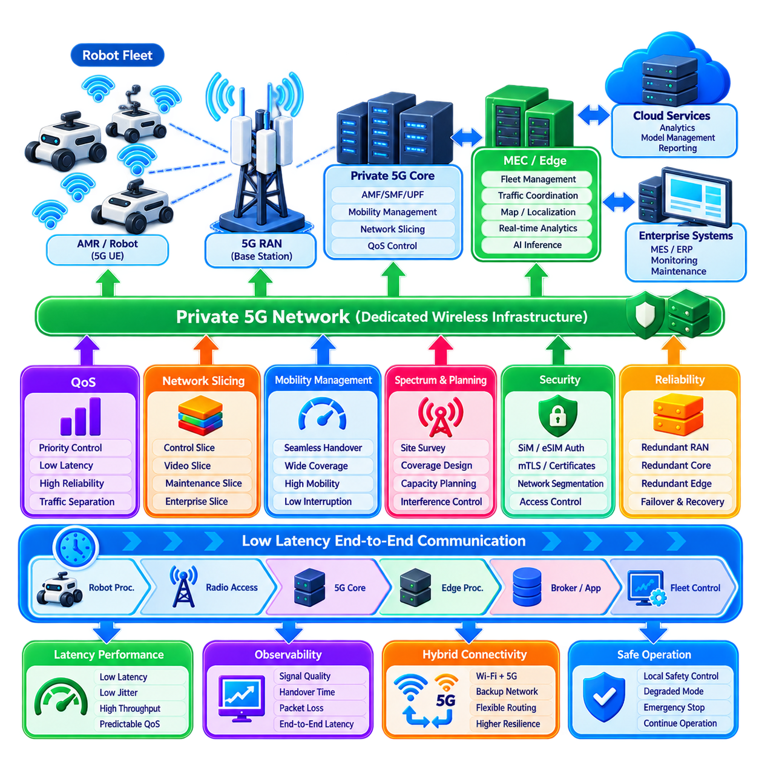
Private 5G networks provide dedicated wireless communication infrastructure for robot fleets operating in factories, warehouses, ports, campuses, logistics centers, and large outdoor facilities. Unlike communication that depends entirely on public cellular infrastructure, a private network can be engineered around the site's coverage, capacity, security, mobility, and latency requirements. This makes private 5G particularly relevant when many mobile robots must exchange operational data continuously.
The primary advantage of private 5G is not simply higher peak bandwidth. Fleet applications benefit from predictable communication behavior, controlled radio resources, mobility support, traffic prioritization, and integration with local edge computing. A robot fleet may include navigation traffic, telemetry, mission commands, video, diagnostics, and maintenance data with very different requirements. Private infrastructure allows these traffic classes to be managed according to operational importance.
A typical architecture connects robots through 5G user equipment to radio access network infrastructure composed of base stations and associated radio components. Traffic then passes through the 5G core toward fleet servers, edge applications, enterprise systems, or external cloud services. For low-latency operation, the most important fleet services can remain inside the local site rather than routing every message through a geographically distant public cloud.
Multi-access edge computing, or MEC, is therefore a major component of low-latency fleet architecture. Fleet management, traffic coordination, map services, telemetry processing, and selected AI inference functions can execute on servers located close to the radio network. Shortening the communication path reduces transport delay and dependency on external networks. Cloud systems can remain responsible for historical analytics, model management, reporting, and other delay-tolerant functions.
Latency must still be treated as an end-to-end property rather than a characteristic of the radio interface alone. Sensor processing, robot middleware, radio scheduling, retransmissions, 5G core processing, edge routing, message brokers, application queues, and fleet-control computation all consume part of the latency budget. A low radio-access delay provides limited benefit if messages spend substantially longer waiting in a gateway, broker, database, or overloaded fleet application.
5G Quality of Service mechanisms allow traffic to receive differentiated treatment according to its requirements. Fleet coordination and operational commands can receive higher priority than routine diagnostics or bulk log uploads. Traffic classes can be associated with different latency, reliability, and throughput expectations. This separation helps prevent high-volume services such as video or software distribution from consuming resources needed by time-sensitive robot coordination.
Network slicing extends the concept by creating logically separated network environments over shared infrastructure. A site may separate robot-control traffic, video monitoring, maintenance services, and enterprise connectivity according to operational and security requirements. Slicing should not be considered a substitute for application-level authorization or safety architecture, but it can provide useful resource isolation and policy separation for complex industrial communication environments.
Mobility management is especially important for AMRs and outdoor autonomous robots because devices continuously move between radio coverage regions. Handover must occur without creating communication gaps that disrupt fleet coordination. Coverage design should therefore consider robot routes, speed, obstacles, building materials, racks, machinery, vehicles, terrain, and areas where radio propagation changes significantly. A network designed for stationary users may not automatically perform well for moving robots.
Radio planning should begin with the operational map rather than with theoretical maximum coverage. Robot paths, intersections, elevators, charging stations, loading areas, narrow passages, outdoor transitions, and high-density operating zones can require different levels of communication performance. Site surveys and propagation modeling help determine base-station placement, antenna configuration, spectrum use, interference conditions, and redundancy requirements before large-scale deployment.
Fleet density also influences network design. Hundreds of robots can create concentrated uplink traffic because mobile systems continuously transmit pose, health, mission, and sensor information. Traditional user networks often emphasize downlink consumption, whereas robotic fleets may require substantial and predictable uplink capacity. Capacity planning should therefore model simultaneous robot traffic and worst-case operational conditions rather than relying only on average data consumption.
Reliability requires redundant communication paths and infrastructure where interruption would significantly affect operations. Critical sites may use overlapping radio coverage, redundant core components, duplicated edge servers, resilient power, and alternative network paths. However, redundancy must be tested through actual failover scenarios. A second component provides little protection if session migration, routing, authentication, or application recovery requires more time than the fleet can tolerate.
Even with a highly reliable private 5G network, safety-critical control should not depend exclusively on remote connectivity. Emergency stopping, collision avoidance, fundamental motion control, and immediate obstacle response should remain executable locally on the robot where feasible. The network supports fleet-level coordination and supervisory control, but loss of connectivity should transition the robot into a defined degraded or safe operating state rather than eliminating its fundamental safety capability.
Private 5G can coexist with Wi-Fi and other wireless technologies rather than replacing them universally. Wi-Fi may remain effective for high-throughput local access, maintenance, commissioning, or facilities with moderate mobility requirements. 5G can serve mobile robots requiring managed handover, wide-area coverage, traffic differentiation, or controlled cellular mobility. Hybrid architectures can assign communication paths according to application requirements and provide additional resilience.
Dual-connectivity strategies can further improve fleet availability. A robot may have private 5G as its primary operational network while retaining Wi-Fi or public cellular connectivity for selected backup functions. Switching policies must define which traffic can move between networks, how sessions are restored, and whether security credentials remain valid across domains. Uncontrolled automatic switching can otherwise introduce inconsistent routing, duplicate sessions, or unpredictable latency.
Security begins with strong device identity and network authentication but should extend throughout the fleet architecture. SIM- or eSIM-based subscriber identity can control network attachment, while mTLS, application certificates, tokens, and role-based authorization can protect fleet services above the cellular layer. Network authentication alone should not authorize a robot to issue arbitrary commands or access unrelated fleet resources. Communication security must remain layered.
Network segmentation can isolate robot communication from office IT, guest devices, development systems, cameras, and other operational technology. Firewalls, routing policies, private addressing, application gateways, and access-control rules can constrain communication paths. Combining 5G identity with application identity creates stronger separation between permission to connect to the network and permission to use a particular robot, topic, API, mission service, or operational function.
Time synchronization remains important even when communication latency is low. Multi-robot coordination, sensor fusion, distributed event reconstruction, latency measurement, and synchronized logging depend on consistent timestamps. PTP, GNSS-derived timing, or other synchronization mechanisms may be integrated according to site requirements. Accurate timing allows engineers to distinguish radio delay from application processing delay and determine the true age of fleet information.
Observability should cover both the cellular network and the robotic application layer. Useful measurements include signal quality, throughput, packet loss, retransmissions, handover duration, radio utilization, session failures, edge-processing delay, broker latency, application queue time, and end-to-end message age. Correlating these metrics is essential because a fleet symptom that appears to be a robot failure may actually originate from coverage degradation or network congestion.
Private 5G deployment should therefore be validated using realistic fleet workloads. Testing should include dense robot operation, simultaneous uplink traffic, video streams, handovers, weak-signal regions, interference, edge-server load, broker congestion, core-network failover, and loss of external connectivity. Percentile and worst-case latency are more meaningful than ideal laboratory averages when determining whether the infrastructure can support continuous industrial operation.
The economic justification should also consider more than radio equipment cost. Private 5G introduces spectrum, base stations, core infrastructure, edge computing, installation, integration, security, monitoring, maintenance, and specialized operational skills. Its value becomes strongest where predictable mobility, large coverage, device density, network control, or service differentiation materially improves robot availability and productivity compared with simpler wireless alternatives.
A well-designed private 5G fleet architecture therefore combines planned radio coverage, controlled spectrum resources, QoS, mobility management, local 5G core functions, edge computing, resilient infrastructure, layered security, precise timing, and end-to-end observability. The objective is not merely to provide robots with a faster wireless link, but to create a managed communication environment in which latency, capacity, reliability, and security can be engineered around the operational requirements of a large autonomous fleet.

04.09 Fleet Communication QoS Priority and Preemption
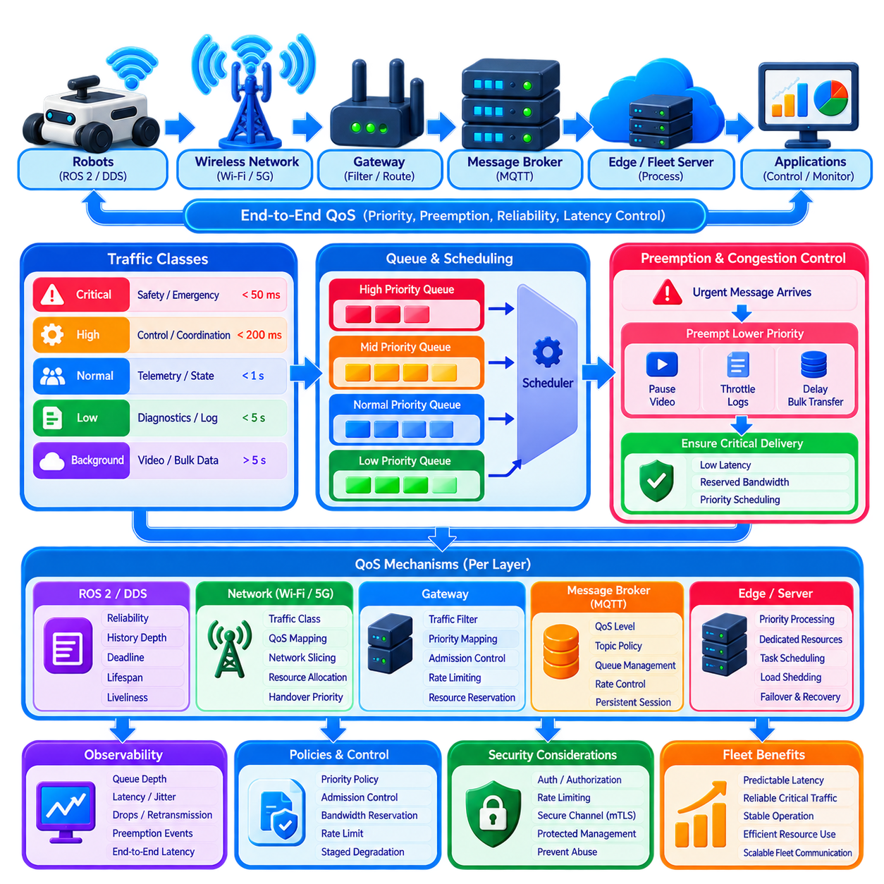
Fleet communication Quality of Service defines how limited network, broker, gateway, and processing resources are allocated among messages with different operational importance. In a multi-robot system, emergency events, coordination messages, mission commands, telemetry, diagnostics, video, and bulk data should not compete equally. QoS therefore provides mechanisms for priority, reliability, latency control, resource reservation, congestion handling, and predictable degradation.
Priority begins with classification of communication according to operational consequence. Safety-related alerts and emergency state changes normally require the highest treatment, followed by time-sensitive coordination, traffic reservations, command acknowledgements, and mission control. Routine robot state, health telemetry, diagnostics, logs, software updates, and historical data can receive progressively lower priority. The classification should reflect operational risk rather than simply message frequency or payload size.
A practical priority model should remain small enough to manage consistently across the fleet. Excessive numbers of priority levels make configuration difficult and encourage every subsystem to claim that its traffic is critical. A limited set such as critical, high, normal, and background can often express the required behavior. Each class can then define latency objectives, queue policy, delivery reliability, retry behavior, bandwidth allocation, and acceptable loss characteristics.
Priority should be preserved across the complete communication path rather than applied only at one component. A high-priority robot message provides little benefit if it enters a low-priority wireless queue, waits behind bulk traffic at a gateway, or becomes blocked in a broker subscriber queue. Robot middleware, operating-system networking, wireless infrastructure, gateways, message brokers, edge servers, and fleet applications should therefore implement compatible traffic treatment wherever technically possible.
Preemption extends priority by allowing urgent communication to obtain resources currently being consumed by lower-priority traffic. When a critical safety or coordination message appears during congestion, background telemetry, log uploads, map transfers, or video traffic may be delayed, throttled, or temporarily suspended. The objective is not to discard lower-priority communication permanently, but to ensure that resource scarcity does not prevent operationally critical information from meeting its timing requirement.
Preemption policies must define exactly what resources can be interrupted and under which conditions. Network bandwidth can be reassigned, queued messages can be reordered, background transfers can be paused, and processing capacity can be reserved for critical subscribers. However, an operation that has already triggered a physical robot action cannot necessarily be safely preempted like a network packet. Communication priority and physical task preemption must therefore remain distinct architectural concepts.
Queue design is central to QoS implementation. Separate queues can be maintained for different traffic classes so that a large backlog of diagnostic messages does not block command or coordination traffic. Strict-priority scheduling always serves the highest-priority queue first, while weighted scheduling allocates controlled capacity among classes. Hybrid approaches can provide immediate service for critical messages while guaranteeing minimum bandwidth for lower-priority traffic.
Strict priority requires protection against starvation. If high-priority traffic remains continuously active, lower-priority queues may never receive service, causing logs, maintenance data, or noncritical telemetry to accumulate indefinitely. Rate limits, weighted fair scheduling, minimum service guarantees, or maximum burst allowances can preserve critical responsiveness while still allowing background functions to progress. QoS design should therefore balance urgency with long-term resource fairness.
Admission control can prevent overload before queues become unstable. A gateway, broker, or network controller can limit new traffic flows when available capacity is insufficient to satisfy existing critical requirements. For example, additional video streams or bulk uploads may be rejected or postponed during periods of high robot density. Protecting known operational traffic is generally more predictable than accepting every flow and attempting to recover after severe congestion develops.
Bandwidth reservation provides another mechanism for predictable behavior. A portion of communication capacity can be protected for command, safety, or coordination traffic so that these messages remain deliverable even when lower-priority services generate substantial load. Reserved capacity should be based on realistic worst-case fleet behavior rather than average utilization. Excessive reservation wastes resources, while insufficient reservation provides little protection during actual congestion.
QoS must consider both latency and reliability because these goals can conflict. Retransmitting a lost message improves delivery probability but consumes time and bandwidth. For rapidly changing position information, the newest update may be more useful than reliable delivery of an older sample. In contrast, a mission command, safety transition, or acknowledgement may require reliable and ordered delivery. Each message class should therefore define its own latency-versus-reliability trade-off.
ROS 2 and DDS provide configurable QoS policies that can support differentiated robot communication. Reliability, history depth, durability, deadline, lifespan, and liveliness can be selected according to the semantics of each topic. High-rate sensor or state streams may use best-effort delivery with shallow history, while important state transitions can use reliable communication. QoS settings should be selected deliberately rather than applying identical defaults to every ROS 2 topic.
MQTT provides another layer of delivery semantics through its QoS levels. Different message classes can select delivery guarantees appropriate to their operational role, but MQTT QoS should not be confused with complete fleet traffic prioritization. Delivery guarantee alone does not determine network scheduling, latency, queue precedence, or application importance. Broker configuration, topic policies, queue management, and underlying network QoS must work together with MQTT delivery behavior.
Private 5G networks can provide traffic differentiation through cellular QoS mechanisms and controlled radio-resource allocation. Robot coordination traffic can receive treatment different from video, maintenance, or background data, while edge computing shortens the path to time-sensitive fleet services. Network slicing can provide further logical separation. These mechanisms are most effective when their traffic classes correspond consistently with the application-level priority model used by the fleet.
Wi-Fi environments can also support differentiated traffic, although actual performance depends on access-point configuration, radio conditions, contention, client behavior, and network design. Mapping application priorities into network-level traffic classes can improve treatment, but wireless QoS cannot guarantee deterministic application latency by itself. End-to-end behavior must still include robot processing, gateway queues, broker load, subscriber scheduling, and fleet-controller execution time.
Priority inversion can occur when a high-priority operation depends on a resource held by lower-priority processing. For example, an urgent command may wait for a shared gateway lock, database transaction, network queue, or application worker occupied by background activity. Monitoring only packet priorities will not reveal this condition. System design should therefore identify shared dependencies and use bounded processing, dedicated resources, or scheduling mechanisms to limit priority inversion.
Message aging should influence queue decisions because priority alone does not determine whether data remains useful. A high-frequency state update that has waited too long may be obsolete by the time it reaches the consumer. Lifespan limits can allow stale state messages to be discarded instead of consuming bandwidth and processing capacity. Event and command messages require different expiration policies because their operational meaning may remain important for longer periods.
Congestion management should degrade services intentionally rather than randomly. Under moderate load, update rates for noncritical telemetry can be reduced. Under heavier load, video quality, diagnostics, or bulk transfers can be throttled. If capacity becomes severely constrained, only critical control, safety, coordination, heartbeat, and essential state traffic may remain fully active. Such staged degradation preserves the most valuable communication as available resources decline.
QoS policies must also account for reconnect and recovery traffic. After an outage, many robots may simultaneously attempt to transmit current state, buffered events, diagnostics, and historical logs. Recovery traffic should not overwhelm ongoing operational communication. Current authoritative state and critical retained events can receive high priority, while old diagnostics and bulk backlog uploads are rate-limited and transferred only when sufficient spare capacity becomes available.
Security-related traffic requires careful classification. Authentication exchanges, certificate renewal, authorization decisions, and security alerts can directly affect fleet availability and trust. However, security mechanisms should not create an uncontrolled high-priority path that can be exploited for denial of service. Rate limiting, authenticated admission, resource quotas, and protected management channels help ensure that security operations receive necessary resources without becoming a source of congestion.
Observability is required to verify that QoS policies operate as intended. Metrics should include queue depth by priority, message waiting time, drops, preemption events, bandwidth consumption, deadline misses, retransmissions, starvation duration, and end-to-end latency by traffic class. Comparing these measurements with configured service objectives reveals whether critical traffic actually receives better treatment during congestion rather than merely being labeled as high priority.
QoS validation should intentionally create resource contention. Tests can combine dense robot operation, simultaneous commands, telemetry bursts, video traffic, software transfers, broker overload, wireless interference, and reconnection storms. Engineers should verify that critical messages continue meeting latency and reliability targets while lower-priority services degrade according to policy. Fault injection and large-scale simulation are valuable for discovering starvation, priority inversion, and incorrect queue configurations.
A mature fleet QoS architecture therefore connects application semantics with communication-resource management from robot to fleet controller. Message classes define operational importance, priority controls scheduling, preemption protects urgent traffic, admission control prevents overload, and staged degradation preserves essential services under scarcity. Combined with observability and realistic testing, these mechanisms allow large robot fleets to maintain predictable communication behavior even when network and computing resources become constrained.

04.10 Fleet Communication Monitoring and Diagnostics [w/Code]
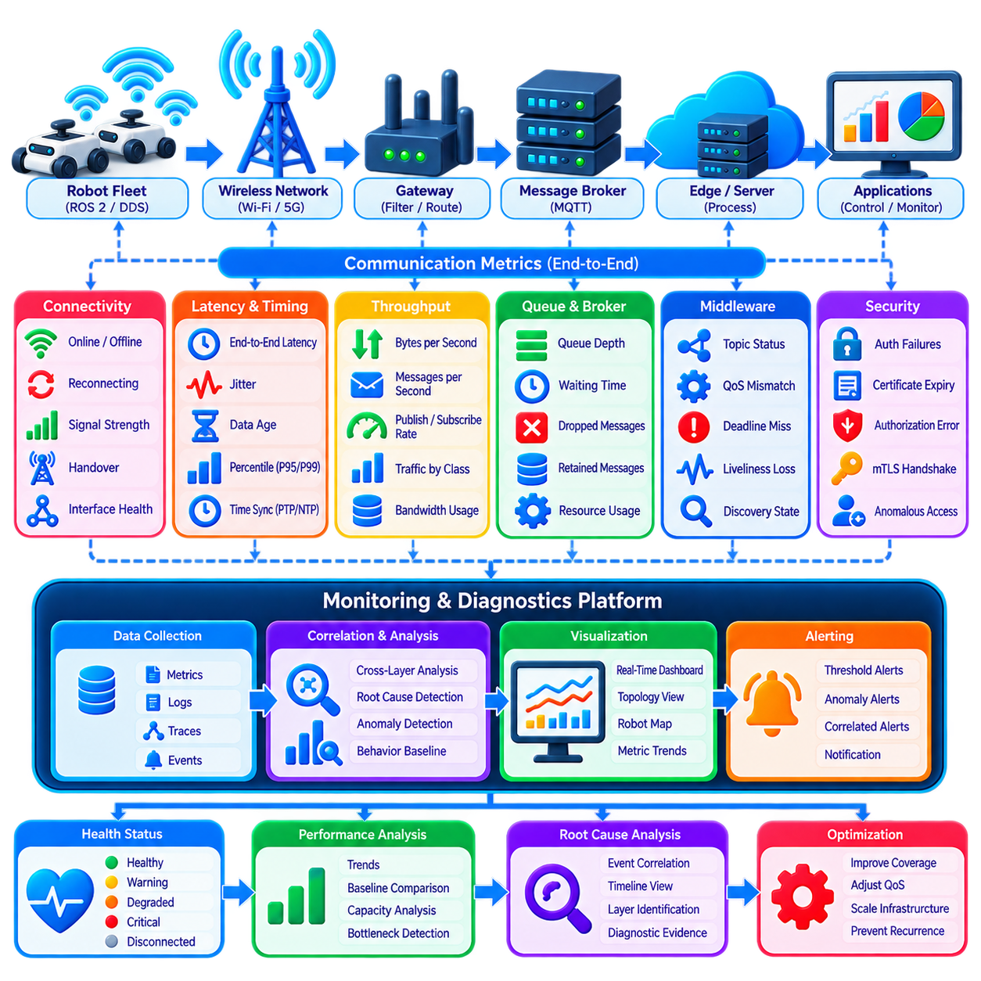
Fleet communication monitoring and diagnostics provide continuous visibility into whether robots, wireless networks, gateways, brokers, edge services, and fleet applications are exchanging information correctly. Communication problems often appear as navigation delays, missing robot states, failed commands, or inconsistent coordination even when the robot itself is healthy. Monitoring must therefore observe the complete communication path rather than treating network connectivity as a simple connected-or-disconnected condition.
A useful monitoring architecture combines infrastructure metrics, message-level telemetry, application health, and robot-side observations. Wireless signal quality alone cannot reveal whether messages are delayed inside a broker, while broker statistics cannot identify radio coverage problems near a particular robot route. Correlating measurements from multiple layers allows operators to determine whether degradation originates in the robot, radio link, network, gateway, middleware, server, or application.
Connectivity state is the most basic diagnostic signal. Each robot should expose whether its primary and backup communication interfaces are connected, degraded, reconnecting, or unavailable. Heartbeat and liveliness mechanisms can confirm that an application remains responsive after the underlying network connection has been established. Monitoring both transport connectivity and application liveliness prevents a technically connected but nonfunctional service from being incorrectly classified as healthy.
Latency monitoring should measure the complete journey of important messages. Timestamps can record message creation, transmission, gateway reception, broker processing, subscriber delivery, and application consumption. These measurements reveal where latency accumulates and whether a delay is caused by networking or processing. Average latency should be supplemented with percentile and maximum values because intermittent tail latency can significantly disrupt multi-robot coordination.
Jitter and data age provide additional information beyond latency. A robot may normally deliver state messages quickly but occasionally experience large timing variations caused by congestion, wireless interference, handover, or processing load. The consumer should also determine how old the information is when it becomes available for decision-making. Data-age monitoring detects stale information even when the final network transmission itself appears fast.
Packet loss, retransmissions, and duplicate messages help characterize communication quality. Increasing retransmissions may indicate radio interference, weak coverage, overloaded infrastructure, or unstable routing. Duplicate messages can result from retry and recovery mechanisms, while missing sequence numbers can reveal loss or unexpected filtering. Message identifiers and sequence counters make these conditions measurable without relying only on low-level network statistics.
Throughput and message-rate monitoring show how communication capacity is being consumed. Measurements should include bytes per second, messages per second, payload size, publish rate, subscription rate, and traffic distribution by message class. A sudden increase in diagnostic, video, or logging traffic can consume resources required by mission-critical communication. Per-robot and per-service measurements help identify abnormal producers before congestion affects the entire fleet.
Queue monitoring is particularly important because congestion frequently appears first as increasing queue residence time rather than complete message loss. Robot middleware, gateways, brokers, subscriber applications, and operating-system networking may all contain queues. Useful indicators include queue depth, waiting time, overflow count, dropped messages, and priority distribution. Persistent queue growth usually indicates that incoming traffic exceeds downstream processing capacity.
Wireless diagnostics should combine signal and mobility information with fleet behavior. Signal strength, signal quality, channel utilization, retransmission rate, cell or access-point association, handover events, and connection failures can be correlated with robot position. Mapping these measurements onto the operational environment can reveal coverage holes, interference zones, overloaded access points, or locations where moving robots repeatedly experience communication degradation.
Gateway monitoring should observe protocol translation, filtering, aggregation, routing, security processing, CPU load, memory consumption, queue utilization, and connection status. A gateway can become a hidden bottleneck because many robots may depend on the same device or service. Per-interface and per-protocol metrics help determine whether problems originate from ROS 2 traffic, MQTT forwarding, REST communication, security processing, or the underlying network.
Message broker diagnostics should include active connections, subscription counts, publish and delivery rates, queue depth, retained messages, acknowledgement delay, persistent-storage latency, dropped messages, and resource utilization. Broker clusters should additionally expose node health, replication status, failover events, and load distribution. Monitoring only whether the broker process is running is insufficient because an overloaded broker may remain available while delivering messages too slowly for fleet operation.
ROS 2 and DDS communication should be monitored at topic and participant level where practical. Topic publication frequency, subscriber availability, deadline misses, liveliness loss, incompatible QoS settings, discovery behavior, and message age can reveal middleware-level problems. These diagnostics are especially valuable when robot applications appear healthy individually but communication between nodes becomes inconsistent because of configuration, discovery, or QoS mismatches.
MQTT monitoring should distinguish transport connectivity from application delivery behavior. Session creation, reconnect frequency, subscription failures, acknowledgement timing, QoS-related retransmissions, topic traffic, and authorization errors provide insight into broker communication. A robot that repeatedly reconnects may still appear online much of the time, yet unstable sessions can produce command delays, duplicated messages, and excessive authentication load.
Security diagnostics form another part of communication monitoring. Authentication failures, certificate expiration, mTLS handshake errors, authorization denials, unexpected topic access, abnormal connection rates, and repeated rejected requests should be recorded. Security events should be correlated with operational telemetry because a configuration error can resemble an attack, while compromised credentials may initially appear as unusual but technically valid communication behavior.
Time synchronization health must also be monitored because distributed diagnostics depend on trustworthy timestamps. Clock offset, synchronization source, PTP state, NTP status, drift, and synchronization loss should be observable across robots and infrastructure. Without sufficiently aligned clocks, one-way latency measurements and event reconstruction become unreliable, making it difficult to determine the actual sequence of failures across distributed fleet components.
Diagnostic logs should use structured information rather than relying entirely on free-form text. Events can include timestamp, robot or service identity, communication interface, message class, severity, connection state, error code, sequence identifier, and relevant network context. Structured logs allow automated filtering and correlation across hundreds of robots. They also make recurring communication patterns easier to detect than manually reviewing independent robot log files.
Distributed tracing can connect individual processing steps into a single end-to-end transaction. A trace identifier propagated through a command or important event allows engineers to follow it from the fleet application through brokers and gateways to the robot and back through acknowledgement or completion messages. This approach is particularly useful when individual components appear healthy but the complete transaction experiences unexpected delay or failure.
Health states should summarize detailed measurements into operationally meaningful conditions. Rather than exposing thousands of raw metrics directly to operators, the system can classify communication as healthy, warning, degraded, critical, or disconnected according to defined thresholds and persistence rules. Short transient anomalies should be distinguished from sustained degradation so that dashboards remain informative without generating excessive alarms.
Alerting should be based on operational impact rather than every individual metric excursion. A brief increase in latency may require no intervention, while sustained command delays affecting multiple robots require immediate attention. Alert policies can combine latency, loss, queue depth, connectivity, robot count, and geographic concentration. Correlated alerts reduce alarm storms by grouping multiple symptoms that originate from the same network or infrastructure failure.
Baseline analysis helps identify gradual degradation that fixed thresholds may miss. Normal latency, throughput, reconnect frequency, wireless quality, and broker utilization can be characterized by site, shift, robot type, and operating zone. Deviations from these baselines may reveal increasing interference, capacity saturation, failing hardware, or software regressions before hard operational limits are exceeded. Historical trends therefore complement real-time alarms.
Diagnostics should support root-cause analysis by preserving enough context around failures. When a communication incident occurs, engineers may need recent network metrics, robot state, queue statistics, broker events, gateway logs, topology information, and configuration versions. A synchronized diagnostic window around the incident allows reconstruction of the event sequence. Without this context, teams may know that communication failed but remain unable to explain why.
Fleet-scale monitoring must itself be designed for scalability. Collecting excessive high-frequency metrics from hundreds or thousands of robots can create substantial network and storage load. Monitoring data should therefore use appropriate sampling, aggregation, retention, and prioritization. Critical health indicators can remain frequent, while detailed diagnostic information can be collected adaptively when abnormal conditions are detected or during targeted troubleshooting.
Communication diagnostics should be validated through controlled failure injection. Engineers can introduce packet loss, latency, wireless disconnection, broker overload, gateway restart, certificate errors, queue saturation, and time-synchronization faults to confirm that monitoring detects and classifies each condition correctly. The objective is to verify not only that failures are observable, but that diagnostic evidence is sufficient to identify the affected layer and guide recovery.
A mature fleet communication monitoring architecture combines connectivity, latency, jitter, data age, loss, throughput, queues, wireless health, middleware status, broker behavior, security events, timing integrity, logs, tracing, and fleet-wide correlation. By transforming these signals into meaningful health states, alerts, trends, and root-cause evidence, the system makes communication performance measurable and diagnosable, supporting reliable and scalable multi-robot fleet operation.

