Volume 16 Multi Robot and Fleet Intelligence

06. Distributed Intelligence

06.01 Distributed Intelligence Architecture Edge Fog Cloud
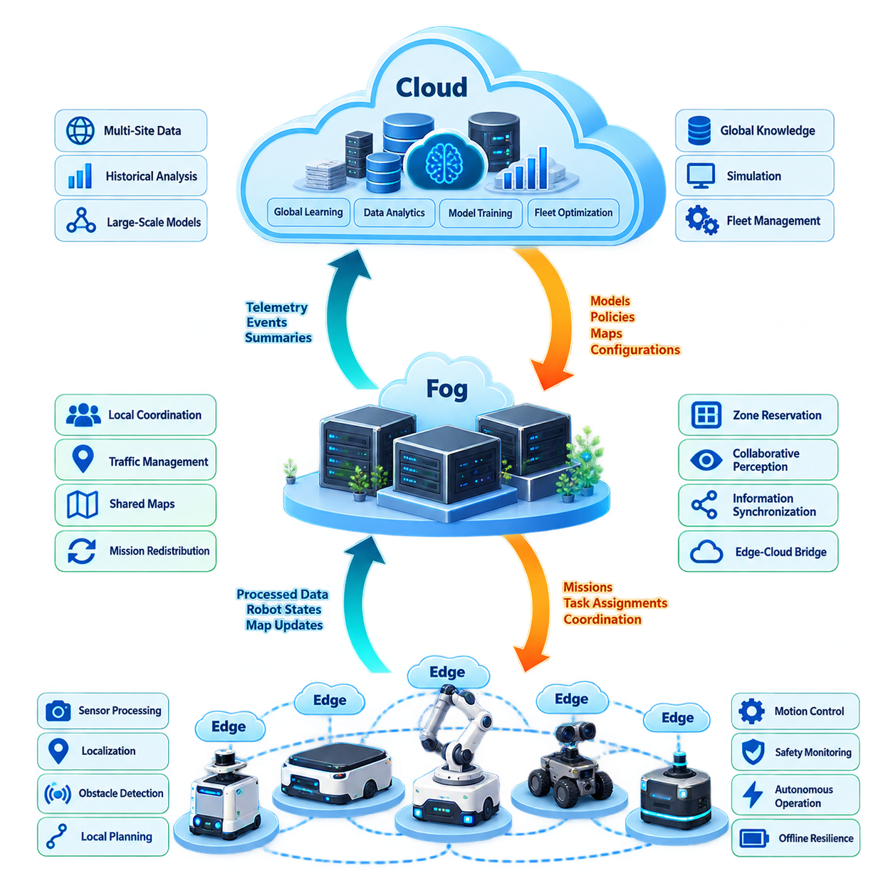
Distributed intelligence in a robot fleet is an architectural approach in which perception, reasoning, learning, and decision-making are placed across multiple computational layers rather than concentrated in a single fleet server. In the structure of multi-robot intelligence, this architecture forms a bridge between robot-cloud integration and more advanced mechanisms such as federated learning, knowledge sharing, hierarchical decision-making, and multi-agent learning. :chatgpt-content-reference{index=“0”}
The fundamental objective is to execute each computation at the location that best matches its latency, bandwidth, reliability, privacy, and computational requirements. A robot must retain enough intelligence to operate safely when disconnected, while nearby infrastructure can coordinate groups of robots and cloud systems can perform computation that benefits from large-scale data, powerful accelerators, or information collected across multiple sites.
The edge layer consists primarily of computation located directly on individual robots or immediately attached controllers. It processes sensors, localization, obstacle detection, local planning, motion control, safety monitoring, and other functions requiring deterministic or near-real-time responses. Because these functions interact directly with physical motion, sending every decision to a remote server would introduce unacceptable communication dependencies and potentially dangerous latency.
Edge intelligence also provides operational autonomy. An AMR should continue navigating, avoiding obstacles, executing safe-stop behavior, and maintaining essential mission state even when communication with higher layers becomes unstable. The edge therefore represents more than a low-latency inference device. It is the minimum autonomous intelligence boundary that allows each robot to remain a functional physical agent rather than becoming a remotely controlled endpoint.
The fog layer introduces computational resources positioned between individual robots and centralized cloud infrastructure. A fog node may reside in a factory server room, warehouse control cabinet, private 5G infrastructure, industrial edge server, or site-level computing cluster. Its physical proximity to robots allows it to aggregate information and perform coordination tasks without requiring every interaction to traverse a wide-area network.
Fog intelligence is particularly valuable for decisions whose scope exceeds one robot but still requires relatively fast responses. Examples include local fleet traffic coordination, shared-map updates, zone reservation, mission redistribution, congestion management, collaborative perception, and synchronization of information among nearby robots. The fog layer therefore transforms isolated edge agents into a coordinated local collective while maintaining lower latency than cloud-centered architectures.
The cloud layer provides the broadest computational and information scope. It can aggregate telemetry from many robots, fleets, facilities, and geographic regions while supporting large-scale storage, historical analysis, model training, simulation, fleet optimization, and global knowledge management. Cloud intelligence is therefore suited to processes where computational scale and information breadth are more important than millisecond-level reaction time.
The three layers should not be interpreted as rigid hardware categories. Edge, fog, and cloud describe logical responsibility boundaries that may be implemented differently depending on deployment scale. A powerful on-premise GPU server can perform fog functions for one facility while simultaneously interacting with cloud services. Likewise, a robot equipped with substantial AI compute may execute functions that would otherwise be assigned to a site-level server.
A useful architectural principle is to assign intelligence according to decision horizon. Immediate physical reactions belong close to the robot. Decisions involving several robots or a local operating area belong primarily at the fog level. Decisions requiring fleet-wide history, cross-site knowledge, large models, or extensive optimization naturally migrate toward the cloud. This creates a hierarchy of increasingly broad spatial and temporal reasoning.
Data moves upward through the hierarchy in progressively more abstract forms. Raw cameras, LiDAR measurements, motor states, and local observations are usually processed at the edge. The fog layer can receive object tracks, semantic events, robot states, map changes, and operational summaries. The cloud can receive compressed telemetry, learned representations, performance statistics, incidents, and selected datasets rather than continuously ingesting every raw sensor stream.
Commands and knowledge flow in the opposite direction. Cloud systems may distribute models, policies, maps, configuration parameters, or fleet-wide objectives. Fog systems translate broader objectives into site-level coordination and resource decisions. Individual robots finally transform assigned missions and contextual information into trajectories, actuator commands, and physical actions. Intelligence therefore circulates bidirectionally rather than following a simple client-server pattern.
Communication failures must be treated as normal operating conditions rather than exceptional events. When cloud connectivity disappears, the fog layer should preserve critical site operations whenever possible. If the fog layer also becomes unavailable, individual robots should degrade gracefully into locally executable behaviors. Mission continuation, controlled stopping, local navigation, buffered telemetry, and later state reconciliation are important mechanisms for preserving operational resilience.
Consistency requirements also vary across layers. Motor control and safety states may demand tightly controlled local timing, whereas fleet analytics can tolerate delayed synchronization. Shared maps, mission ownership, traffic reservations, and distributed task states occupy an intermediate category where stale information can cause conflicts. Distributed intelligence therefore requires explicit decisions about which data demands strong consistency and which information can use eventual consistency.
Latency budgets should consequently be defined by function rather than by network alone. A cloud connection with excellent average latency does not justify placing collision avoidance remotely because jitter, outages, and routing variability remain possible. Conversely, forcing every optimization algorithm onto a robot wastes limited edge resources. Architecture quality depends on matching computational placement to the maximum tolerable delay and failure characteristics of each function.
Resource management becomes another central concern because intelligence competes for CPU, GPU, memory, storage, network bandwidth, and electrical power. Edge nodes prioritize safety-critical and mission-critical workloads, while fog nodes can dynamically allocate larger inference or optimization jobs across local accelerators. Cloud infrastructure provides elastic resources for training, simulation, historical processing, and computationally expensive fleet-wide analysis.
Distributed intelligence also creates a natural foundation for collaborative learning. Robots can collect experience locally, site infrastructure can aggregate or filter knowledge, and cloud systems can build broader models from distributed operational experience. The chapter structure extends this foundation into federated learning, gossip-based knowledge exchange, distributed semantic maps, hierarchical decisions, and multi-agent reinforcement learning. :chatgpt-content-reference{index=“1”}
Security boundaries should follow the computational hierarchy. A robot should authenticate commands received from supervisory infrastructure, fog nodes should verify participating robots, and cloud services should enforce fleet and site identities. Sensitive raw data can remain at the edge when unnecessary elsewhere, while only features, events, gradients, or sanitized summaries are transmitted upward. Distribution can therefore improve privacy, but only when trust boundaries are explicitly designed.
Observability must span all layers because failures in distributed intelligence rarely belong to a single component. Operators need to reconstruct which robot generated an observation, which fog service transformed it, which policy or model influenced a decision, and which command ultimately reached the physical system. Common timestamps, trace identifiers, synchronized logs, model versions, and mission identifiers make cross-layer diagnosis possible.
Scalability is one of the strongest motivations for this architecture. A centralized controller may work well for a small fleet but can become a communication, computation, or availability bottleneck as robot count grows. Hierarchical distribution allows local groups to process much of their own information while higher layers operate on aggregated states. The software tree explicitly positions distributed intelligence within a larger fleet architecture intended to support multi-robot systems. :chatgpt-content-reference{index=“2”}
The resulting system should not be viewed as three independent computers connected by networking. It is a coordinated intelligence continuum in which responsibilities migrate according to urgency, locality, computational cost, connectivity, and operational risk. Edge intelligence protects immediate physical autonomy, fog intelligence enables local collective behavior, and cloud intelligence provides global learning, optimization, and long-term knowledge.
A mature implementation therefore seeks the smallest safe dependency on each higher layer while still exploiting its capabilities. Robots remain independently safe, local fleets remain operational during external network disruption, and cloud services enhance rather than define basic survivability. This principle separates resilient distributed robotic intelligence from architectures that merely relocate conventional centralized software across several machines.
Ultimately, edge-fog-cloud architecture provides the computational foundation for increasingly intelligent robot fleets. It enables individual robots to react locally, groups of robots to reason collectively, and organizations to learn globally from accumulated experience. When latency, consistency, autonomy, security, and resource allocation are designed together, distributed intelligence becomes a mechanism for transforming a collection of autonomous robots into a scalable and resilient fleet-wide intelligence system.

06.02 Federated Learning for Robot Fleet [w/Code]
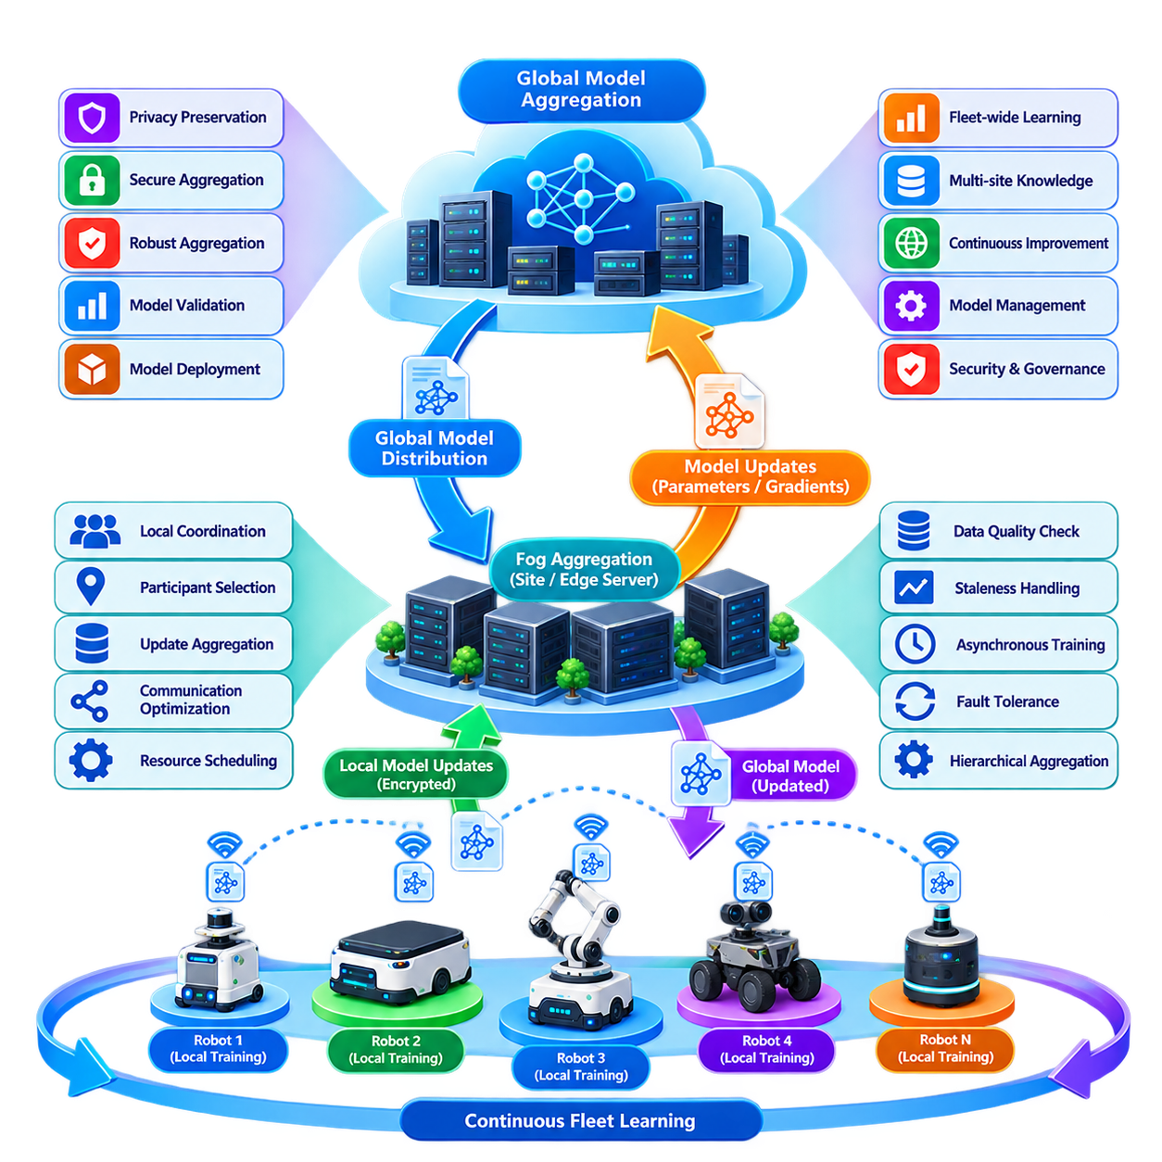
Federated learning enables a robot fleet to improve shared artificial intelligence models without requiring every robot to upload its raw operational data to a centralized training repository. Each robot or local site trains a model using observations collected during operation, while only model parameters, gradients, or compact updates are exchanged with an aggregation service. This approach extends distributed intelligence from distributed execution toward distributed learning.
In a conventional centralized learning pipeline, sensor recordings, trajectories, events, and labels collected by robots are transferred to a central data center where model training occurs. This architecture simplifies training management but can generate substantial network traffic, storage requirements, privacy concerns, and data-governance complexity. Federated learning moves part of the training process toward the robots or local edge infrastructure while preserving fleet-wide collaboration.
A typical federated learning cycle begins when a global model is distributed from a fleet learning server to selected participating robots. Each robot trains or fine-tunes the model using its locally stored dataset for a defined number of iterations. The resulting local model update is transmitted to an aggregation node, which combines updates from multiple participants and produces an improved global model for the next training round.
Federated Averaging, commonly known as FedAvg, represents the fundamental aggregation mechanism. Instead of simply selecting one robot's model, the server combines parameters from participating models, typically weighting their contribution according to the amount of local training data. Repeating this local-training and global-aggregation process allows knowledge obtained by many robots to influence a common model without directly centralizing their underlying datasets.
Robot fleets present a particularly suitable environment for federated learning because individual robots repeatedly encounter different operating conditions. Robots may observe different illumination, floor materials, weather, obstacles, human behaviors, payloads, equipment layouts, or sensor characteristics. Local learning captures these experiences, while aggregation attempts to transform diverse observations into knowledge that can improve performance across the broader fleet.
However, robot data is rarely independent and identically distributed. One warehouse robot may primarily observe narrow aisles, another may operate around loading docks, and an outdoor robot may experience rain, shadows, slopes, or vegetation. This non-IID data distribution is one of the central challenges of fleet federated learning because locally optimized models can move in different directions and make global convergence slower or unstable.
Fleet heterogeneity also exists at the hardware and software levels. Robots may use different processors, GPU capabilities, sensors, firmware versions, battery capacities, and network connections. Federated learning therefore cannot assume that every robot participates equally in every training round. Participant selection should consider computational availability, communication quality, charging state, operational workload, model compatibility, and the relevance of locally available data.
The edge-fog-cloud hierarchy provides a practical deployment structure for federated learning. Individual robots can perform lightweight local training at the edge, while a site-level fog server aggregates updates from nearby robots. The cloud can subsequently aggregate knowledge across multiple facilities or geographic regions. Hierarchical aggregation reduces wide-area communication while preserving the ability to construct models representing experience from a much larger fleet.
Training workloads must remain subordinate to safe robot operation. Localization, perception, planning, control, and safety processes require predictable computational resources, whereas federated training can normally be delayed or interrupted. Local training may therefore be scheduled during charging, waiting periods, maintenance windows, or periods of low GPU utilization. Resource-aware scheduling prevents learning workloads from degrading real-time robotic functions.
Communication efficiency becomes increasingly important as model size and fleet scale increase. Repeatedly transmitting complete neural network parameters from hundreds of robots can consume significant bandwidth. Gradient compression, parameter sparsification, quantization, selective layer updates, reduced communication frequency, and local training over multiple epochs can decrease network requirements. The architecture must balance communication reduction against model accuracy and convergence speed.
Asynchronous federated learning can be valuable when robots cannot participate simultaneously. Instead of waiting for every selected robot to complete local training, an aggregation service can accept updates whenever participants become available. This improves utilization in operational fleets but introduces stale-update problems because some robots may train against older global models. Version tracking and staleness-aware aggregation therefore become important parts of the learning architecture.
Failure tolerance is essential because robots may disconnect, leave service, exhaust their batteries, or become occupied with higher-priority missions during a training round. The global learning process should continue when some participants fail to return updates. Participation thresholds, deadlines, retry policies, checkpointing, and partial aggregation prevent individual robot failures from blocking fleet-wide learning and distinguish production federated systems from idealized laboratory experiments.
Federated learning improves data locality but does not automatically guarantee privacy. Model updates can potentially reveal information about local training data, particularly when sensitive observations are involved. Secure aggregation can prevent the central server from inspecting individual robot updates, while differential privacy can reduce information leakage by adding controlled noise. These techniques introduce additional computational and accuracy trade-offs that must be evaluated for each application.
Security is equally important because a compromised participant can submit malicious or manipulated updates. Model poisoning, backdoor insertion, corrupted gradients, and identity spoofing can influence the shared fleet model. Robot authentication, signed updates, secure communication, anomaly detection, update validation, robust aggregation, and participant reputation mechanisms can reduce these risks. Learning infrastructure must therefore be treated as part of the fleet security boundary.
Not every local update should automatically influence the global model. A robot operating with a damaged camera, incorrectly calibrated LiDAR, unusual software configuration, or corrupted dataset may produce statistically valid but operationally harmful updates. Quality gates can evaluate local dataset characteristics, validation metrics, update magnitude, sensor health, and software configuration before an update becomes eligible for aggregation.
Model personalization addresses situations where a single global model cannot optimally serve every robot. A fleet can maintain a common backbone containing broadly useful knowledge while allowing selected layers, parameters, or calibration components to remain locally adapted. This approach is useful when robots share fundamental tasks but operate under substantially different environmental conditions, hardware configurations, or mission profiles.
Federated learning can support several fleet intelligence functions. Perception models can improve from distributed environmental observations, anomaly detectors can learn patterns from many machines, battery models can incorporate different duty cycles, and navigation-related models can benefit from diverse operating conditions. The most appropriate targets are functions that gain from fleet experience while still allowing meaningful local training and controlled validation.
Validation must remain separate from aggregation. An updated global model should not be deployed automatically merely because the federated optimization objective improved. Candidate models should be evaluated against representative validation datasets, simulation scenarios, regression tests, safety constraints, and potentially shadow-mode operation. Only models satisfying predefined acceptance criteria should progress toward staged deployment across the operational fleet.
Model lifecycle management consequently becomes tightly connected to federated learning. Every global and local model should have identifiable versions, training configurations, participating robot sets, aggregation history, validation results, and deployment status. If performance deteriorates after deployment, operators must be able to determine which training round introduced the change and restore a previously validated model through controlled rollback.
The complete learning loop therefore extends beyond local training and parameter averaging. Operational robots generate experience, local systems curate appropriate training data, edge nodes compute updates, fog or cloud infrastructure aggregates distributed knowledge, validation systems evaluate candidate models, and deployment services return approved intelligence to the fleet. New operational experience then begins another cycle, creating a continuous fleet learning process.
At large scale, federated learning changes the fleet from a collection of robots consuming centrally developed models into a distributed knowledge-producing system. Each robot becomes both an autonomous physical agent and a contributor to collective intelligence. The architectural objective is not simply to decentralize training, but to combine local experience, global knowledge, operational resilience, privacy, security, and controlled deployment into a sustainable learning system.
When properly engineered, federated learning allows fleet intelligence to improve while raw operational data remains primarily close to where it was generated. Edge robots contribute local experience, fog infrastructure coordinates site-level learning, and cloud systems integrate knowledge across the broader organization. This creates a scalable foundation for continuously improving robot fleets in which learning itself becomes a distributed capability of the overall multi-robot system.

06.03 Gossip Protocol Based Fleet Knowledge Sharing [w/Code]
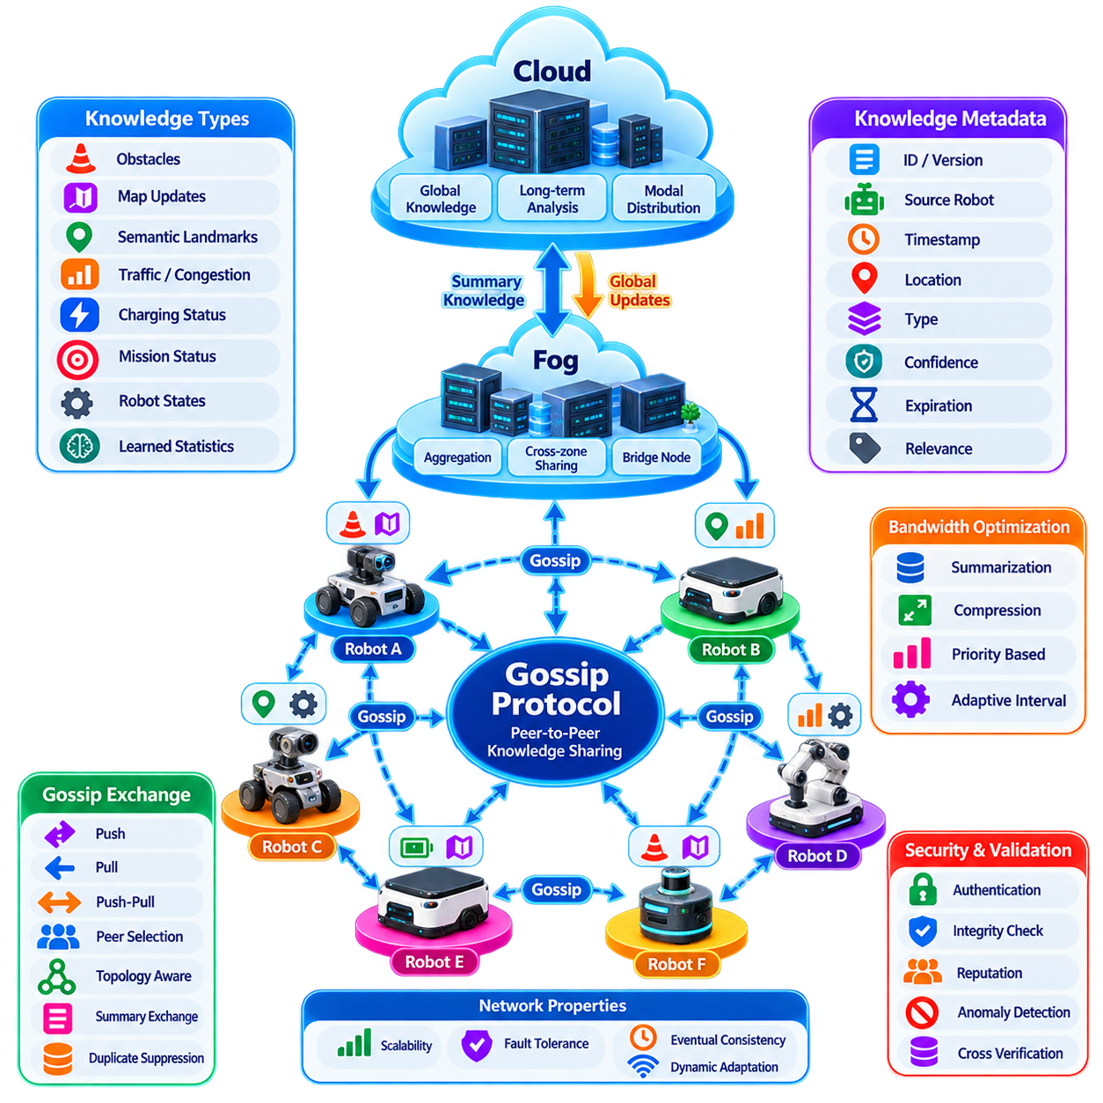
In a large robot fleet, useful knowledge is continuously generated at many locations rather than at a single central server. Each robot observes obstacles, traffic conditions, environmental changes, localization uncertainty, mission outcomes, equipment states, and other operational events. Gossip protocol-based knowledge sharing provides a decentralized mechanism through which this locally generated information can gradually propagate across the fleet without requiring every robot to communicate directly with a central coordinator.
A gossip protocol is inspired by the way information spreads through repeated peer-to-peer exchanges. At each communication opportunity, a robot selects one or more neighboring peers and exchanges a portion of its current knowledge. Those peers subsequently communicate with other robots, causing information to spread throughout the network over multiple rounds. The process is probabilistic rather than centrally scheduled, yet sufficiently repeated exchanges can distribute information to a large fraction of the fleet.
This approach differs fundamentally from centralized publish-subscribe or database synchronization architectures. In a centralized system, robots transmit information to an authoritative service that stores and redistributes it. Gossip-based systems allow knowledge to move directly among participants, reducing dependence on a single communication path or central service. The resulting architecture is naturally compatible with distributed intelligence in which robots must continue cooperating despite intermittent infrastructure connectivity.
Fleet knowledge can contain many different forms of information. Robots may exchange recently detected obstacles, blocked passages, map changes, semantic landmarks, congestion estimates, charging-station availability, localization confidence, mission status, fault observations, or learned operational statistics. Gossip should normally distribute compact knowledge representations rather than continuous raw sensor streams, because unnecessary replication of camera or LiDAR data would rapidly consume communication and storage resources.
Knowledge items therefore require structured metadata. A shared observation can include its origin robot, creation time, spatial location, knowledge type, confidence, version, expiration time, and unique identifier. This metadata allows receiving robots to determine whether an item is new, duplicated, stale, conflicting, or irrelevant to their current mission. Without explicit provenance and temporal information, decentralized knowledge propagation can easily transform outdated observations into misleading fleet-wide information.
A simple gossip cycle consists of peer discovery, peer selection, knowledge comparison, exchange, and local state update. A robot first identifies reachable peers through the available fleet communication network. It then selects a subset of those peers and determines which knowledge differs between them. Missing or newer items are exchanged, validated, and incorporated into the receiving robot's local knowledge store before another gossip cycle begins.
Push, pull, and push-pull mechanisms represent common exchange patterns. In push gossip, a robot proactively sends selected knowledge to another robot. In pull gossip, a robot requests information that it does not currently possess. Push-pull combines both operations during the same interaction and can accelerate convergence because each communication session resolves differences in both directions. The appropriate method depends on bandwidth, knowledge size, network topology, and update frequency.
Random peer selection provides simplicity and resilience, but robot fleets can benefit from topology-aware selection. A robot may prioritize nearby peers, robots operating in adjacent zones, members of the same mission group, or peers possessing different knowledge versions. Communication quality, network cost, physical distance, mission relevance, and previous exchange history can also influence peer selection. This transforms purely random gossip into an operationally aware knowledge dissemination mechanism.
The major advantage of gossip is graceful scalability. If every robot attempted to communicate every update to every other robot, communication complexity would increase rapidly as fleet size grew. Gossip limits each robot to a relatively small number of peer exchanges while still allowing information to propagate through repeated interactions. A fleet containing hundreds or thousands of agents can therefore disseminate knowledge without constructing a fully connected communication topology.
Gossip protocols are also naturally tolerant of failures. A robot that temporarily disconnects does not necessarily prevent information from reaching other participants because multiple propagation paths exist. When the disconnected robot returns, subsequent exchanges can synchronize knowledge that it missed. There is no requirement for every participant to remain continuously reachable, making the approach attractive for outdoor fleets, multi-building operations, temporary network partitions, and mobile ad hoc environments.
This resilience comes with an important trade-off: gossip generally provides eventual rather than immediate consistency. Two robots may temporarily hold different versions of the fleet's knowledge while information propagates. Such behavior is acceptable for many observations and statistical summaries but inappropriate for some safety-critical decisions. Emergency stops, exclusive resource ownership, or immediate collision avoidance should not depend solely on probabilistic gossip propagation.
Knowledge freshness must therefore be managed explicitly. Time-to-live values can remove observations after their operational relevance expires, while timestamps and sequence numbers help distinguish recent information from older copies. A temporary obstacle observation may remain useful for only seconds or minutes, whereas a persistent semantic landmark may remain valid much longer. Expiration policy should consequently depend on the meaning and expected lifetime of each knowledge category.
Duplicate suppression is equally important because the same information can arrive through many propagation paths. Unique knowledge identifiers, version vectors, sequence counters, hashes, or compact membership summaries can help robots recognize information they already possess. Without duplicate detection, gossip traffic can become dominated by repeated retransmission of unchanged knowledge, reducing the scalability advantages that motivated the decentralized architecture.
Conflicting knowledge is unavoidable in real robot fleets. Two robots may report different states for the same passage, object, map region, or charging station because they observed it at different times or with different sensors. Conflict resolution can consider timestamp, confidence, sensor reliability, observation frequency, source reputation, or spatial proximity. Some conflicts should be preserved as multiple hypotheses rather than immediately forcing one observation to become globally authoritative.
Bandwidth optimization becomes important when knowledge grows faster than available communication capacity. Robots can exchange summaries of their local knowledge before transferring complete items, allowing peers to identify only missing or changed information. Batching, compression, priority queues, delta updates, probabilistic filters, and adaptive gossip intervals can further reduce network traffic. High-value operational knowledge can propagate quickly while low-priority historical information spreads more slowly.
The edge-fog-cloud architecture can complement rather than replace gossip communication. Robots can gossip directly within a local operating region, while fog nodes participate as high-capacity peers that aggregate or relay knowledge between groups. Cloud services can periodically receive summarized fleet knowledge for long-term analysis and distribute globally relevant information back toward sites. This creates a hybrid architecture combining decentralized propagation with hierarchical infrastructure.
Network partitions illustrate the value of this design. Suppose two groups of robots temporarily lose connectivity with each other while continuing to operate locally. Each group can continue exchanging knowledge internally rather than stopping because a central server is unreachable. When connectivity is restored, bridge nodes or returning robots propagate the accumulated differences, allowing the separated knowledge states to gradually converge without requiring a complete fleet restart.
Security remains essential because decentralized propagation increases the number of potential information sources. A compromised robot could inject false obstacles, fabricated faults, corrupted map updates, or misleading operational statistics that spread through the fleet. Robot identity, message authentication, digital signatures, authorization rules, integrity checks, and trust policies are therefore necessary to determine whether received knowledge should be accepted, rejected, quarantined, or assigned reduced confidence.
Knowledge validation should also use physical and semantic plausibility. If one robot reports that a permanent wall disappeared while neighboring robots repeatedly observe it, the fleet should not blindly propagate the anomalous claim as truth. Cross-observation verification, confidence accumulation, source diversity, temporal consistency, and local sensor confirmation can help distinguish meaningful environmental changes from sensor errors or malicious information.
Observability is required to understand how knowledge propagates through the fleet. Operators should be able to identify where an item originated, which peers forwarded it, how long propagation required, which versions currently exist, and whether some fleet regions remain unsynchronized. Metrics such as dissemination latency, convergence ratio, duplicate traffic, peer availability, message loss, and knowledge age make gossip behavior measurable rather than treating it as an invisible background process.
Gossip parameters can be adapted dynamically to operational conditions. During stable operation, robots may exchange information at relatively low frequency. When a significant map change, fault pattern, or environmental hazard appears, the dissemination rate can temporarily increase. Similarly, congested networks can reduce fan-out or prioritize only critical knowledge. Adaptive behavior allows communication cost to follow the actual information value and urgency of fleet events.
Gossip-based knowledge sharing also provides a foundation for more advanced collective intelligence. Distributed semantic maps, decentralized anomaly knowledge, collaborative learning statistics, robot capability information, and local policy experience can propagate through the same conceptual mechanism. Combined with federated learning, robots can exchange both operational knowledge and learning-related metadata while preserving a distributed architecture rather than depending entirely on centralized intelligence.
The central design principle is that not all fleet knowledge requires a single authoritative path. Information that benefits from broad dissemination but tolerates temporary inconsistency can spread effectively through repeated local interactions. Critical commands and strongly consistent resource decisions can remain under dedicated coordination mechanisms, while gossip handles decentralized awareness and knowledge diffusion. Separating these information classes prevents probabilistic communication from being used where deterministic guarantees are necessary.
When properly engineered, gossip protocols allow a robot fleet to behave as a distributed knowledge network. Each robot contributes observations, receives information from peers, evaluates relevance and trustworthiness, and forwards useful knowledge to other participants. Through many small local exchanges, information can eventually reach a large population of robots, producing fleet-wide situational awareness without requiring every interaction to pass through a central server.
The resulting architecture improves scalability, resilience, and autonomy while accepting controlled temporary inconsistency as an architectural trade-off. Combined with metadata management, duplicate suppression, conflict resolution, security, adaptive communication, and edge-fog-cloud integration, gossip-based sharing transforms locally acquired robot experience into distributed fleet knowledge and provides an important communication foundation for increasingly decentralized multi-robot intelligence.

06.04 Distributed Map and Semantic Knowledge Sharing [w/Code]
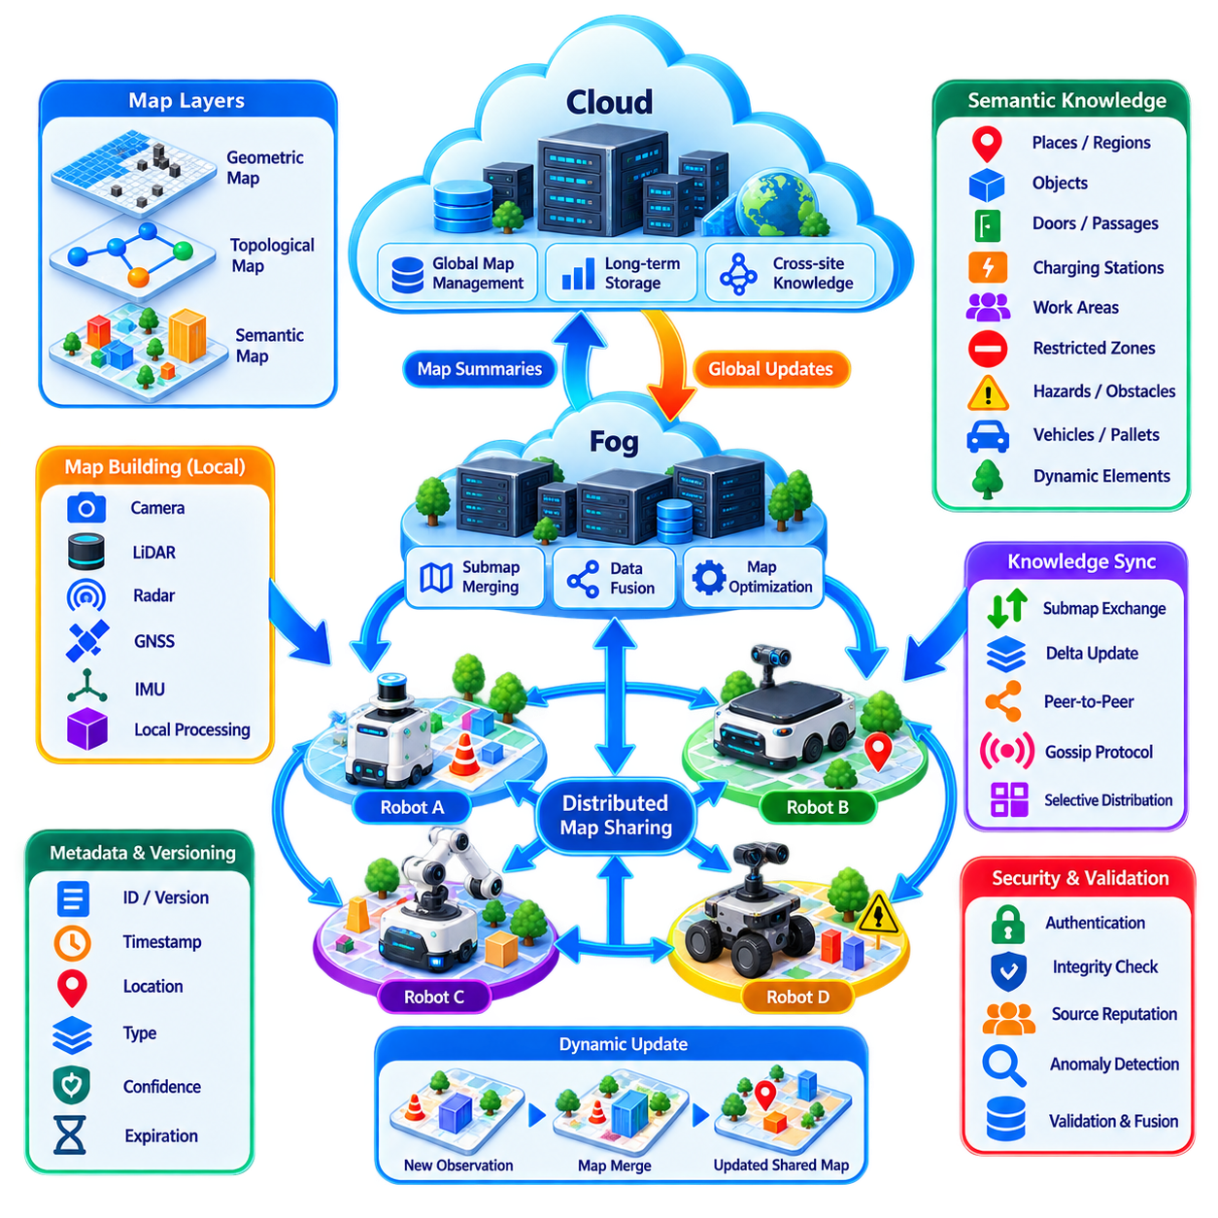
Distributed map and semantic knowledge sharing allows multiple robots to construct, update, and use a common representation of their operating environment without requiring every robot to independently observe the entire workspace. Each robot contributes locally acquired geometric, topological, and semantic information to a distributed knowledge system, enabling the fleet to transform individual observations into a progressively richer collective understanding of space.
A conventional autonomous robot typically maintains maps for localization and navigation using information collected from its own sensors. In a multi-robot fleet, however, this approach duplicates exploration effort and limits situational awareness to locations personally visited by each robot. Distributed mapping allows observations acquired by one robot to become useful to other robots, reducing redundant exploration while extending the effective perception range of the entire fleet.
The shared representation can contain several complementary map layers. Geometric maps describe physical structure using occupancy grids, point clouds, meshes, or other spatial representations. Topological maps describe connectivity among meaningful locations, while semantic maps associate spatial regions and objects with concepts such as corridor, charging station, door, workstation, restricted zone, pallet, vehicle, or temporary obstacle.
Semantic knowledge extends mapping beyond geometry by describing what environmental elements mean and how robots should interact with them. Knowing that a region is physically traversable is different from knowing that it is a pedestrian zone, hazardous area, loading bay, or one-way passage. By combining geometric structure with semantic attributes, robots can make mission and navigation decisions based on operational context rather than distance and collision constraints alone.
Each robot first builds or updates a local map from its onboard sensors and localization system. Cameras, LiDAR, radar, depth sensors, GNSS, IMUs, and other sensing modalities may contribute observations depending on the robot platform and environment. Local processing converts raw measurements into map features, landmarks, occupancy information, detected objects, semantic labels, or environmental events before selected information is shared with other participants.
Sharing raw sensor data continuously is usually impractical because high-resolution cameras and 3D LiDAR can generate large data volumes. Distributed systems therefore benefit from exchanging compact map changes, extracted features, semantic observations, submaps, object tracks, or selected keyframes. The objective is to communicate information that changes collective knowledge rather than repeatedly transmitting measurements that other robots already possess.
Coordinate-frame alignment is fundamental because observations from different robots must refer to a compatible spatial reference. Robots may maintain independent local frames until overlapping observations, shared landmarks, GNSS references, fiducials, or map-matching algorithms establish transformations between them. Incorrect frame alignment can create duplicated structures, shifted obstacles, or inconsistent semantic locations even when each robot's local map is individually accurate.
Submap-based sharing provides a practical approach for scalable distributed mapping. Instead of continuously merging every sensor measurement into one monolithic global map, each robot can generate locally consistent submaps containing geometry, poses, landmarks, and semantic information. These submaps can be exchanged and connected through relative transformations, allowing global knowledge to evolve while preserving the provenance of locally generated information.
Map merging requires detection of overlapping regions between independently generated maps. Feature matching, scan matching, place recognition, loop-closure techniques, or semantic landmarks can identify candidate correspondences. Once a reliable relationship is found, relative poses can be estimated and the map graph can be optimized. Poor correspondences must be rejected because an incorrect merge can distort the shared map and subsequently affect many robots.
Distributed pose-graph optimization becomes important when map relationships span multiple robots. Nodes can represent robot poses, keyframes, or submaps, while edges represent odometry, observations, loop closures, or inter-robot constraints. Optimization seeks a globally consistent configuration that satisfies these relationships as well as possible. The computation can occur on robots, fog infrastructure, or a combination of distributed participants depending on available resources.
Semantic observations require their own fusion strategy because different robots may assign different labels or confidence values to the same object or region. One robot may classify an object as a pallet while another identifies it only as an unknown obstacle. Semantic fusion can combine class probability, observation confidence, sensor quality, temporal persistence, and agreement among independent robots rather than simply accepting the most recent label.
Temporal information is particularly important because many operational environments are dynamic. Walls and permanent infrastructure may remain stable for years, while pallets, vehicles, people, temporary barriers, and construction zones can change within minutes. Shared knowledge should therefore distinguish static, semi-static, and dynamic information so that robots do not treat outdated temporary observations as permanent properties of the environment.
Version management allows robots to determine whether their local map state is synchronized with the broader fleet. Map tiles, submaps, semantic objects, or knowledge regions can carry identifiers, timestamps, revision numbers, and source information. Robots can then request only missing or newer versions rather than downloading complete maps repeatedly. Delta-based synchronization substantially reduces communication cost in large environments where most map regions remain unchanged.
Conflicting map information should not automatically be resolved by overwriting older data. A disagreement may indicate environmental change, localization error, sensor degradation, or an incorrect association between map elements. Conflict resolution can consider observation recency, source confidence, number of confirming robots, localization quality, and persistence over time. Significant conflicts may remain as hypotheses until additional observations establish sufficient evidence.
The edge-fog-cloud hierarchy provides a useful architecture for distributed map management. Individual robots maintain local maps and immediate obstacle information at the edge. Fog infrastructure can merge site-level submaps, perform computationally expensive optimization, and distribute relevant regional updates. Cloud systems can maintain long-term maps, cross-site semantic knowledge, historical versions, and large-scale analytics without becoming necessary for immediate navigation safety.
Knowledge distribution should be spatially and operationally selective. A robot working in one warehouse zone does not necessarily require every detailed update from a distant facility. Map information can be partitioned by geographic region, floor, building, mission area, or semantic relevance. Robots subscribe to knowledge associated with their current location and expected route, reducing memory consumption, processing load, and unnecessary network traffic.
Peer-to-peer and gossip mechanisms can complement hierarchical map servers. Nearby robots can directly exchange recent obstacle observations or semantic changes, allowing useful information to propagate even when central connectivity is degraded. Fog nodes can subsequently reconcile these local updates with the authoritative site map. This hybrid approach combines rapid decentralized awareness with controlled long-term map consistency.
Network interruption should not prevent basic navigation. Each robot must retain enough locally cached map information to continue safe operation when disconnected from other fleet components. Newly observed changes can be stored locally and synchronized when communication returns. If multiple disconnected groups independently modify shared knowledge, reconnection requires controlled reconciliation rather than blindly replacing one group's state with another.
Map quality must be represented explicitly. Geometric uncertainty, localization covariance, semantic confidence, observation age, sensor source, and validation status provide important context for consumers of shared knowledge. A navigation planner can treat a recently confirmed obstacle differently from an uncertain historical observation. Knowledge quality metadata therefore becomes part of the map rather than merely diagnostic information stored elsewhere.
Security is important because shared maps directly influence physical robot behavior. A malicious or corrupted participant could inject false obstacles, remove restricted zones, modify charging-station locations, or create incorrect semantic labels. Robot authentication, message integrity, authorization, signed map updates, provenance tracking, anomaly detection, and validation rules help prevent untrusted information from becoming accepted fleet knowledge.
Privacy may also affect semantic mapping, particularly when cameras observe people, workplaces, or sensitive operational areas. Robots can share derived semantic information instead of raw imagery when detailed visual data is unnecessary. Local processing can transform sensor observations into object categories, occupancy states, anonymized features, or statistical summaries before distribution, reducing exposure while preserving operational value.
Distributed map sharing becomes especially powerful when connected to fleet task allocation and coordination. A newly discovered blocked corridor can influence route planning for robots that have never visited that location. A detected charging-station failure can modify battery-aware scheduling, while a newly identified restricted zone can immediately affect mission assignment. Shared spatial knowledge therefore becomes an input to fleet-wide decision-making rather than merely a navigation resource.
Observability is necessary to diagnose failures in a distributed mapping system. Operators should be able to identify which robot generated a map change, when it was observed, which transformation placed it in the global frame, which participants confirmed it, and which map version currently contains it. Map merge errors can otherwise propagate silently and appear later as localization, planning, or traffic-management failures.
Performance should be evaluated using more than geometric map accuracy. Relevant metrics include inter-robot map alignment error, semantic classification accuracy, update propagation latency, map convergence time, communication bandwidth, stale-information ratio, merge success rate, conflict frequency, and storage growth. These measures reveal whether collective mapping remains useful as fleet size and environmental complexity increase.
A mature system therefore treats the shared map as a distributed knowledge structure rather than a static file. Geometry, semantics, confidence, provenance, temporal validity, versions, and operational rules evolve as robots observe the environment. Different participants may temporarily hold different subsets or revisions, while synchronization and validation mechanisms progressively move the fleet toward a sufficiently consistent shared understanding.
Ultimately, distributed map and semantic knowledge sharing extends the perception capability of each robot beyond its own sensors and travel history. Local observations become collective spatial intelligence, allowing robots to benefit from experiences acquired by other fleet members. When combined with robust localization, semantic fusion, versioning, security, selective synchronization, and edge-fog-cloud processing, the shared map becomes a continuously evolving foundation for coordinated multi-robot autonomy.

06.05 Hierarchical Decision Making Robot Supervisor [w/Code]
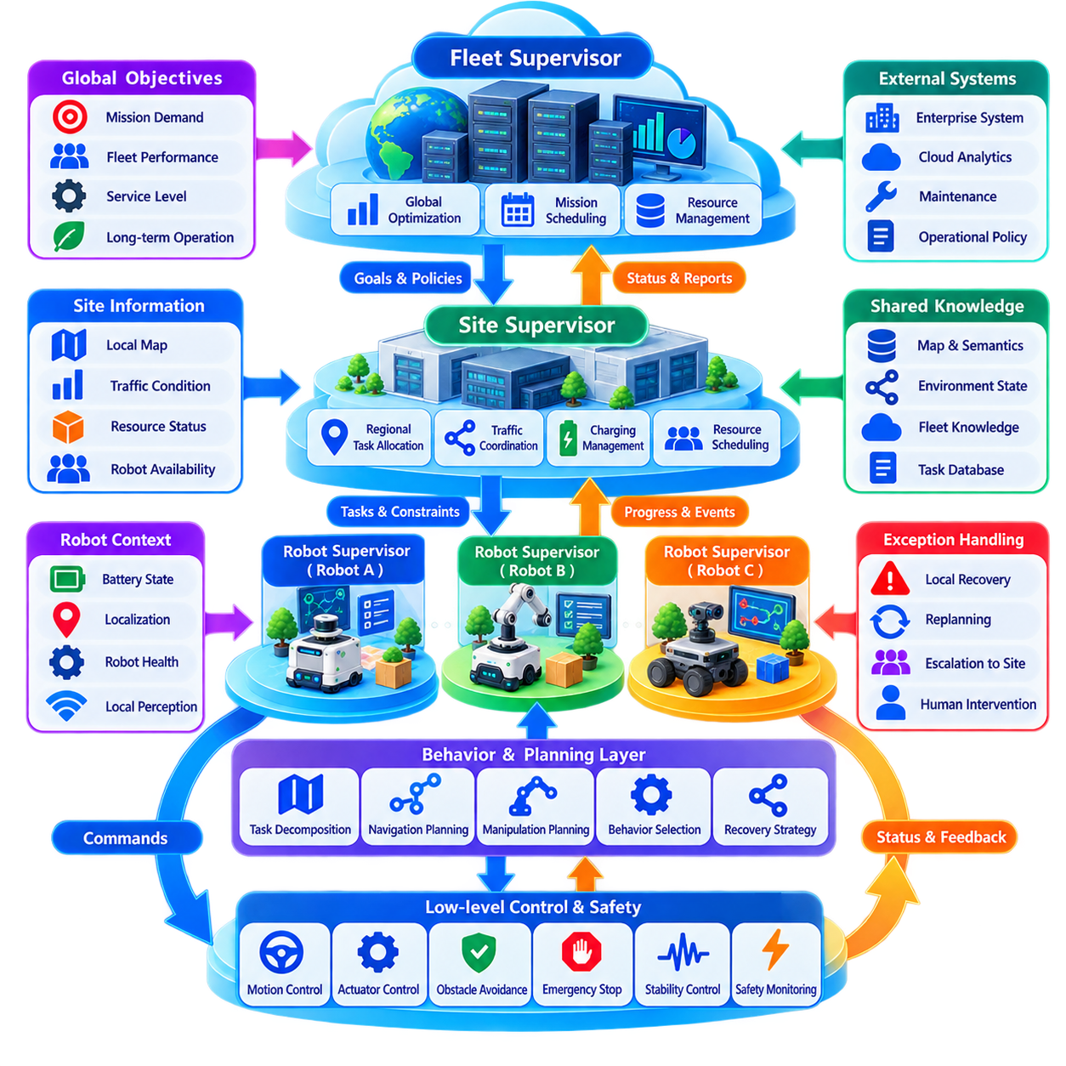
Hierarchical decision-making organizes robot intelligence into multiple levels so that decisions are made at the appropriate spatial, temporal, and operational scope. Instead of allowing one controller to determine every action, responsibilities are divided among fleet-level supervisors, site or group coordinators, individual robot supervisors, and low-level control systems. This structure allows strategic objectives and immediate physical reactions to coexist without forcing them into the same decision cycle.
At the highest level, a fleet supervisor interprets organizational objectives and converts them into operational priorities. It can consider mission demand, robot availability, workload distribution, charging requirements, maintenance status, traffic conditions, and service-level constraints. Its decisions typically operate over minutes or hours rather than milliseconds and influence groups of robots rather than individual actuator commands.
A site or group supervisor occupies the intermediate level between global fleet management and individual robots. It coordinates robots operating within a warehouse, production area, outdoor zone, or mission group. Responsibilities can include regional task allocation, traffic coordination, resource reservation, congestion mitigation, charging coordination, and recovery from local disruptions. This level converts broad fleet objectives into decisions that reflect current site conditions.
The robot supervisor represents the local decision authority responsible for transforming assigned missions into executable robot behaviors. It interprets task goals, evaluates local context, selects navigation or manipulation behaviors, monitors execution, and handles recoverable failures. The supervisor does not normally generate motor currents or steering commands directly; instead, it coordinates lower-level functional modules that perform planning, control, perception, and safety operations.
Below the supervisor, behavior and planning layers determine how a mission should be executed. A delivery task, for example, can be decomposed into navigation to a pickup location, docking, payload acquisition, route traversal, destination approach, unloading, and mission completion. Each behavior can invoke specialized planners and controllers while the supervisor monitors whether expected preconditions, progress criteria, and completion conditions remain satisfied.
The lowest decision level contains time-critical control and safety functions. Motion controllers, actuator loops, obstacle avoidance, emergency stopping, stability control, and other physical reactions must operate with short and predictable latency. These functions should remain locally executable even if higher-level supervisors become temporarily unavailable. Hierarchy therefore separates slower strategic reasoning from fast physical control while preserving clear relationships between them.
Decision authority flows downward through goals, constraints, policies, and task assignments rather than through continuous low-level commands. A fleet supervisor may specify which mission a robot should perform, while the robot determines the detailed trajectory required to execute it. This principle preserves local autonomy and reduces communication requirements because higher levels communicate intent rather than attempting to micromanage every physical action.
Information flows upward in increasingly abstract forms. Low-level controllers report execution status, faults, and safety events to the robot supervisor. Robot supervisors summarize mission progress, localization confidence, battery state, resource usage, and operational conditions for site-level coordination. Higher levels receive fleet states and performance indicators rather than every raw sensor measurement, reducing processing and communication load.
A robot supervisor can be implemented using finite-state machines, behavior trees, hierarchical state machines, rule engines, task planners, or combinations of these mechanisms. Behavior trees are particularly useful when complex missions require explicit sequencing, fallback behavior, retries, and recovery logic. State machines provide predictable transitions, while planning methods can dynamically generate action sequences when the environment or mission cannot be completely predefined.
Supervisory decision-making should explicitly distinguish goals from constraints. A goal describes the desired operational result, such as transporting material to a workstation, while constraints define conditions that must remain satisfied, such as restricted zones, battery limits, payload capability, traffic rules, or safety requirements. A robot can therefore adapt its execution strategy while remaining inside boundaries established by higher-level coordination.
Authority boundaries become important when different hierarchy levels produce conflicting objectives. A global optimizer may prefer a route that maximizes fleet throughput, while a local robot detects conditions that make the route temporarily unsafe. Physical safety must override productivity optimization. Clear precedence rules ensure that emergency and local safety constraints dominate mission execution, while mission-level decisions remain subordinate to fleet-wide policies where no safety conflict exists.
Exception handling is one of the most important responsibilities of the robot supervisor. A mission rarely proceeds exactly as planned in an industrial environment. Paths may become blocked, docking may fail, payload detection may be uncertain, localization quality may deteriorate, or another robot may occupy a required resource. The supervisor should classify failures and select an appropriate response rather than immediately escalating every abnormal condition to a human operator.
Recoverable failures can often be handled locally. The robot may retry an action, select an alternative route, re-localize, wait for a temporary obstacle, or request another resource. If local recovery fails, the problem can be escalated to a site supervisor, which may reassign the mission or coordinate other robots. Only conditions requiring operational judgment, authorization, or unresolved safety decisions need to progress toward human supervision.
This escalation structure improves fleet scalability because human operators do not need to intervene in every minor exception. Local autonomy absorbs routine disturbances, intermediate supervisors handle multi-robot conflicts, and humans concentrate on situations that exceed predefined autonomous capabilities. The hierarchy therefore acts as an exception-filtering mechanism as well as a decision architecture.
Hierarchical decision-making must also remain resilient to communication failures. If connectivity with the fleet supervisor is lost, a site supervisor may continue managing already assigned operations using cached policies and local state. If site coordination becomes unavailable, individual robots should retain sufficient authority to complete safe actions or enter controlled fallback states. Loss of a higher layer should degrade optimization capability before it degrades fundamental safety.
The edge-fog-cloud architecture maps naturally onto this hierarchy, although the two concepts are not identical. Robot-level supervision and physical control are commonly placed at the edge, site coordination can execute on fog infrastructure, and global optimization or long-term planning can operate in cloud or centralized systems. Decision hierarchy describes responsibility, while edge-fog-cloud architecture describes computational placement; separating these concepts allows flexible deployment.
Shared knowledge is necessary because supervisors make decisions at different scopes. Robot supervisors require local maps, sensor-derived context, and immediate resource states, while site supervisors need aggregated traffic, mission, and availability information. Fleet supervisors require broader operational summaries and historical trends. Distributed maps, semantic knowledge, and fleet communication mechanisms provide the information substrate that connects these levels.
Consistency requirements depend on the decision being made. Exclusive access to a narrow corridor or docking station may require strongly coordinated ownership, while performance statistics can tolerate delayed updates. Hierarchical systems should therefore avoid treating all information identically. Safety-critical resource states, mission ownership, and command authority require stronger guarantees than analytics or slowly changing operational knowledge.
Decision latency must similarly match hierarchical scope. A motor controller may operate in milliseconds, a local planner in tens or hundreds of milliseconds, a robot supervisor over seconds, and fleet optimization over substantially longer intervals. Attempting to execute all decisions at one frequency either wastes computational resources or introduces unacceptable delay. Multi-rate decision-making is therefore an inherent characteristic of effective robot supervision.
Resource awareness should influence supervisory decisions. A robot may technically be capable of accepting a mission but have insufficient battery reserve, degraded sensors, limited compute availability, or a pending maintenance requirement. Supervisors should reason about capability and health rather than treating robots as interchangeable task executors. This is especially important in heterogeneous fleets containing different mobility platforms, manipulators, sensors, or payload capacities.
Policy enforcement provides another important hierarchical function. Operational rules such as speed limits, restricted zones, charging thresholds, human-interaction requirements, or mission priorities can be distributed from higher levels and enforced locally. Robots can adapt their detailed behavior while remaining compliant with fleet policy. Versioned policies also allow operators to identify which rules governed a particular decision during later analysis.
Security requires explicit command authority throughout the hierarchy. A robot must determine whether an instruction originated from an authorized supervisor, whether the command is valid for its current operational state, and whether executing it violates local safety constraints. Authentication, authorization, command signing, freshness checks, and audit logging prevent compromised or stale supervisory messages from directly controlling physical behavior.
Observability is essential because a hierarchical system can otherwise make failures difficult to explain. Logs should capture the active mission, supervisor state, selected behavior, decision inputs, policy version, recovery attempts, escalation events, and final outcome. A traceable decision chain allows engineers to reconstruct why a fleet supervisor assigned a mission, why a robot selected a particular behavior, and why a local safety layer modified or rejected that behavior.
Simulation and digital twins can validate supervisory logic before deployment. Large combinations of missions, traffic conditions, robot failures, communication outages, and resource conflicts can be generated to test whether the hierarchy responds appropriately. Testing should include not only successful execution but also degraded modes, contradictory commands, delayed information, supervisor failures, and transitions between autonomous recovery and human intervention.
A mature hierarchical architecture therefore does not create a rigid chain in which every decision requires approval from the level above. Instead, each level receives a defined scope of authority and operates autonomously inside that boundary. Higher levels establish objectives and constraints, while lower levels determine increasingly detailed actions. Escalation occurs when a decision exceeds local authority, available knowledge, or recovery capability.
Ultimately, hierarchical decision-making allows a large robot fleet to combine centralized strategic coordination with distributed local autonomy. Fleet supervisors optimize collective objectives, intermediate supervisors coordinate groups and resources, robot supervisors manage mission execution and recovery, and low-level systems protect immediate physical behavior. Properly designed authority, information flow, fallback behavior, and escalation transform this hierarchy into a scalable supervisory foundation for resilient multi-robot intelligence.

06.06 Multi Agent Reinforcement Learning MARL Intro [w/Code]
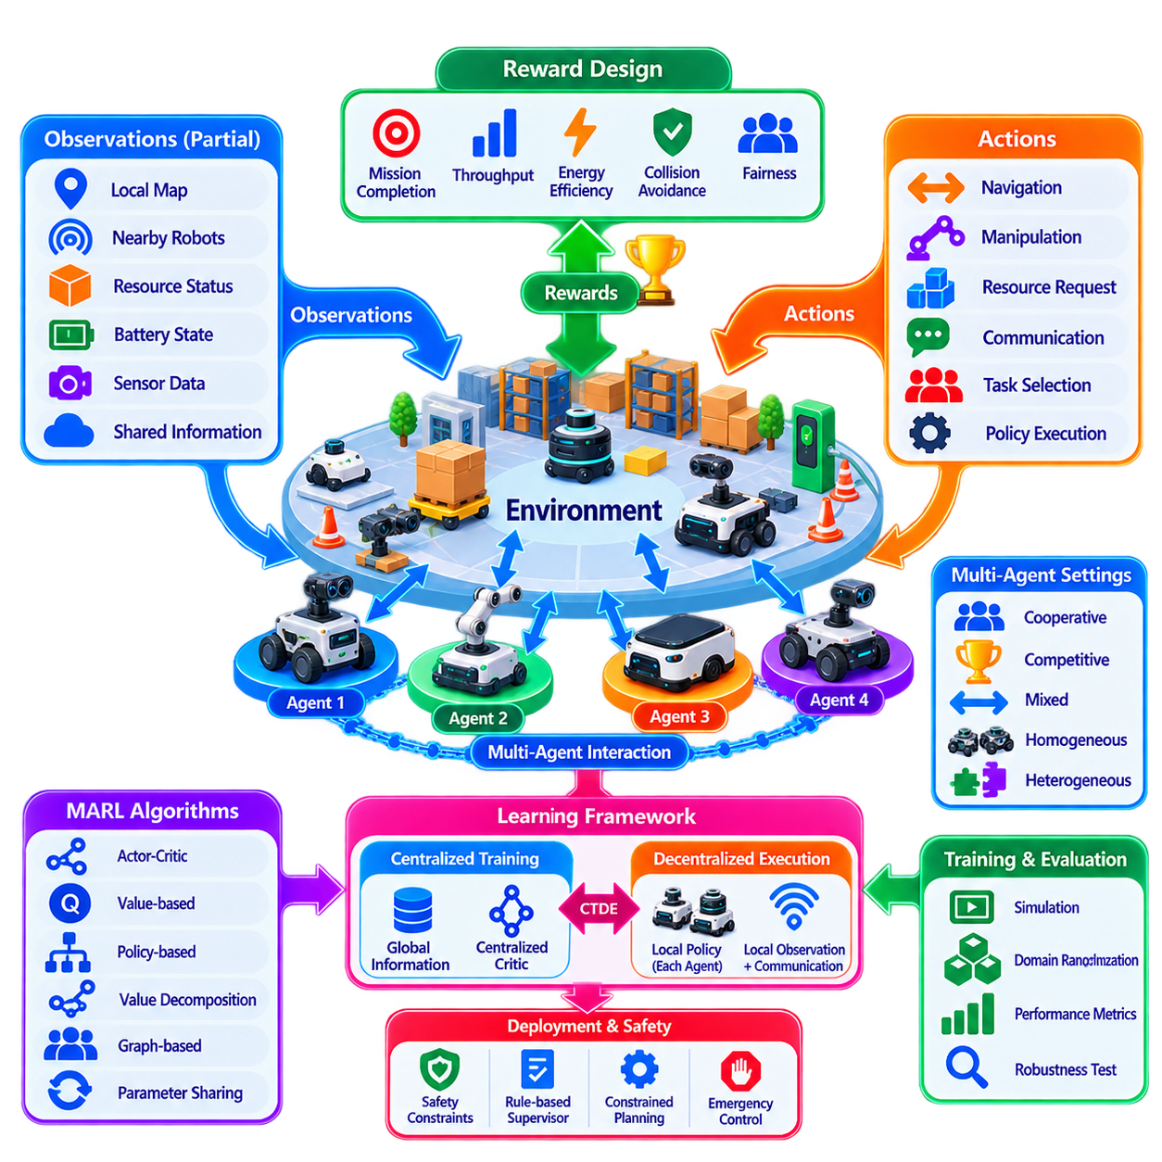
Multi-Agent Reinforcement Learning (MARL) extends reinforcement learning from a single autonomous agent to environments in which multiple agents learn and act simultaneously. In robot fleets, each robot can be modeled as an agent that observes part of the environment, selects actions according to a policy, receives rewards, and adapts its behavior through experience. The important difference is that the environment now includes other learning robots whose decisions continuously influence one another.
In single-agent reinforcement learning, the agent commonly assumes that changes in the environment result from its actions and external dynamics. MARL breaks this assumption because other agents also change their policies during learning. From the perspective of one robot, the behavior of neighboring robots may therefore appear non-stationary. This interaction makes learning substantially more complex but also creates opportunities for cooperation, coordination, competition, and collective adaptation.
A MARL problem can be represented using multiple agents, a shared or partially shared environment, observations, actions, transition dynamics, and reward functions. At each time step, every robot receives an observation based on its sensors and available fleet information. The robots then choose actions, the environment transitions to a new state according to their joint actions, and rewards provide feedback about individual and collective performance.
Partial observability is a natural characteristic of multi-robot systems. A robot usually cannot observe the complete state of a warehouse, factory, outdoor site, or distributed fleet. It sees nearby obstacles, local traffic, mission status, battery state, and selected information communicated by other agents. MARL must therefore learn useful behavior from incomplete observations while exploiting communication or shared knowledge when these mechanisms are available.
The reward function defines what the agents are encouraged to learn. A fleet reward can represent mission completion, throughput, travel efficiency, energy consumption, collision avoidance, congestion reduction, charging efficiency, or balanced workload. Poorly designed rewards can produce unintended behavior even when numerical training performance improves. Reward engineering is consequently a central architectural task rather than merely a mathematical implementation detail.
Cooperative MARL assumes that agents work toward a common objective. Robots may share a global reward based on fleet throughput or jointly receive benefits when missions are completed efficiently. This formulation is suitable for warehouse AMRs, coordinated inspection robots, collaborative transport systems, and other fleets where the performance of the group is more important than maximizing the short-term benefit of an individual robot.
Competitive MARL addresses environments in which agents have opposing objectives, while mixed cooperative-competitive settings contain both shared and conflicting interests. Industrial robot fleets are usually dominated by cooperation, but competition can still appear indirectly when robots request the same corridor, charging station, workstation, communication channel, or other limited resource. Learning must account for these interactions without allowing competition to compromise safety or operational policy.
One major architectural distinction is centralized versus decentralized learning and execution. Fully centralized policies can theoretically use the state of the entire fleet, but their observation and action spaces grow rapidly as robot count increases. Fully decentralized agents scale more naturally but may have insufficient information to coordinate effectively. MARL architectures therefore often seek a balance between centralized information during learning and decentralized autonomy during operation.
Centralized Training with Decentralized Execution (CTDE) is a widely used MARL principle for this purpose. During training, a centralized critic or training process can access information from multiple agents, including global states or joint actions. During deployment, each robot executes its own policy using locally available observations and permitted communication. This allows training to exploit global information without making operational robots continuously dependent on a central decision server.
The actor-critic framework maps naturally onto CTDE. Individual actors determine the actions of robots, while one or more critics estimate the quality of actions using broader information available during training. Algorithms based on this principle can learn coordinated behavior while preserving decentralized execution. The exact algorithm should be selected according to whether actions are discrete or continuous, whether agents are homogeneous, and how strongly they interact.
Value-based MARL provides another family of approaches. In cooperative environments, a global team value can be decomposed into contributions associated with individual agents. Methods based on value decomposition attempt to make decentralized action selection consistent with a useful joint objective. This is attractive for fleet coordination because each robot can execute locally while training encourages actions that collectively improve system performance.
Policy-based and actor-critic MARL approaches are particularly useful when robot actions are continuous or complex. Navigation velocity, acceleration, resource bidding, task preferences, formation parameters, and coordination decisions may not fit simple discrete action spaces. Learned policies can map observations directly to action distributions, while critics and reward signals guide improvement through repeated simulated or recorded interaction.
Communication can itself become part of the learning problem. Agents may exchange positions, intentions, task states, map changes, learned messages, or compressed latent representations. Instead of defining every communication rule manually, some MARL systems learn when to communicate, which peers to contact, and what information to transmit. However, learned communication must still respect bandwidth, latency, security, and failure constraints present in real robot networks.
Scalability is a major challenge because the joint state and action space can increase dramatically with the number of robots. A policy that performs well with five robots may not generalize to fifty or five hundred. Parameter sharing, local observations, neighborhood-based interaction, graph representations, attention mechanisms, hierarchical policies, and mean-field approximations can reduce dependence on exact fleet size and improve scalability.
Homogeneous fleets can often share policy parameters because robots possess similar sensors, dynamics, and capabilities. Each robot executes the same learned policy using different observations, reducing the number of models that must be trained. Heterogeneous fleets require additional representations of robot capabilities because a wheeled AMR, manipulator-equipped robot, inspection platform, and heavy transport robot cannot necessarily interpret identical actions or mission roles.
Graph-based representations are particularly suitable for multi-robot interaction. Robots can be represented as nodes, while communication links, spatial proximity, task relationships, or resource conflicts form edges. Graph neural networks can process this relational structure and generate representations that adapt as robots enter, leave, or move through the fleet. This provides a flexible mechanism for learning coordination without assuming a permanently fixed topology.
Credit assignment presents another fundamental MARL problem. When a fleet receives a shared reward, it may be difficult to determine which robot actions contributed to success or failure. If throughput improves after many simultaneous decisions, an individual robot receives little direct information about the quality of its own action. Counterfactual reasoning, shaped rewards, local auxiliary rewards, and value decomposition can provide more informative learning signals.
Exploration becomes more difficult in multi-agent environments because several robots may simultaneously test unfamiliar actions. Uncontrolled exploration on physical systems can create congestion, inefficient behavior, equipment damage, or safety risks. MARL training for robot fleets should therefore rely heavily on simulation, digital twins, recorded operational data, constrained exploration, and carefully controlled real-world fine-tuning rather than unrestricted trial-and-error learning.
Simulation also enables large numbers of parallel experiences to be generated faster than real-world operation. Different traffic densities, robot failures, mission patterns, sensor uncertainty, communication delays, charging constraints, and environmental changes can be randomized during training. Domain randomization and scenario diversity help prevent policies from overfitting to one idealized fleet configuration and improve their ability to operate under real deployment variability.
Safety constraints must remain separate from learned optimization objectives. A MARL policy may recommend a behavior that appears efficient according to its reward but violates collision margins, restricted zones, speed limits, or other operational requirements. Deterministic safety layers, rule-based supervisors, constrained planners, and emergency controllers should therefore remain capable of rejecting or modifying learned actions before they reach physical actuators.
Hierarchical decision-making can integrate MARL without allowing learned policies to control the entire robotic stack. MARL may optimize task allocation, traffic negotiation, formation behavior, resource selection, or other coordination decisions, while robot supervisors enforce policies and local safety constraints. Lower-level motion controllers then execute validated commands. This creates a controlled boundary between adaptive collective intelligence and deterministic robot operation.
Training stability remains challenging because every learning agent changes the environment experienced by other agents. Experience collected under earlier policies may become less representative as the fleet evolves. Replay buffers, target networks, centralized critics, opponent or teammate modeling, synchronized policy updates, and carefully controlled learning rates can reduce instability, but MARL convergence remains more difficult than comparable single-agent learning.
Evaluation must examine collective behavior rather than only average reward. Relevant fleet metrics include mission throughput, completion time, travel distance, energy consumption, congestion, deadlock frequency, collision or near-miss events, resource utilization, fairness, recovery performance, and communication load. Policies should also be tested under fleet sizes, layouts, traffic patterns, and failure conditions that were not encountered directly during training.
Deployment should normally proceed through staged validation. Candidate policies can first be evaluated offline, followed by simulation, digital-twin testing, shadow operation, limited robot trials, and progressively larger fleet deployment. Model and policy versions should remain traceable, and rollback mechanisms should allow the system to restore a previously validated policy if operational performance deteriorates after deployment.
MARL also connects naturally with the broader distributed intelligence architecture. Federated learning can support distributed improvement of models, gossip protocols can propagate selected knowledge, distributed semantic maps can provide shared environmental context, and hierarchical supervisors can constrain learned decisions. MARL then contributes adaptive coordination policies that use this distributed information to improve collective behavior through experience.
The objective of MARL in robot fleets is therefore not to replace conventional fleet management, planning, or safety systems with unrestricted learned behavior. Its value lies in learning coordination strategies for problems where interactions among many robots make manually designed rules increasingly difficult to optimize. Properly bounded MARL can complement deterministic engineering by adapting decisions to complex traffic, resource, mission, and environmental conditions.
Ultimately, Multi-Agent Reinforcement Learning provides a framework in which a robot fleet can learn not only how individual robots should act, but how their actions should interact. Through cooperative rewards, centralized training, decentralized execution, scalable representations, simulation-based learning, and supervisory safety constraints, MARL can transform distributed robotic agents into an adaptive collective system while preserving the reliability required for real-world multi-robot operation.

06.07 Emergent Behavior in Large Scale Robot Fleets
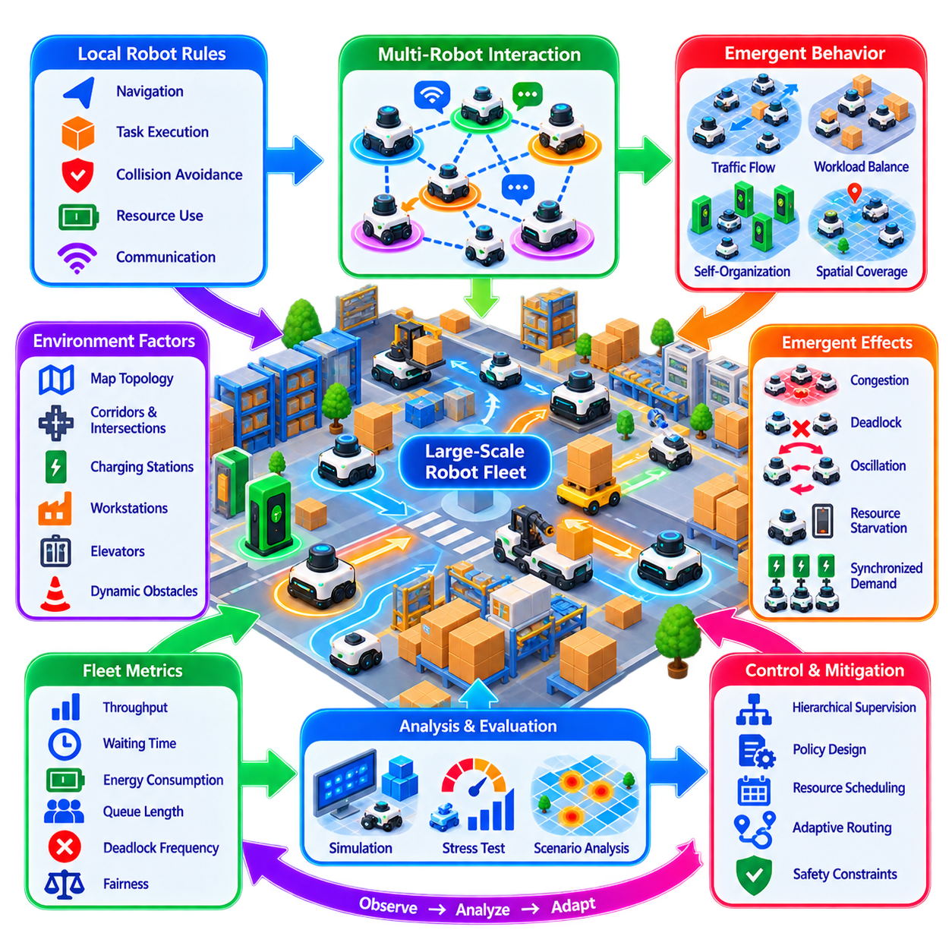
Emergent behavior in large-scale robot fleets refers to collective patterns that arise from interactions among many robots even though those patterns are not explicitly commanded by a central controller. Each robot may follow relatively simple local rules for navigation, task execution, resource use, communication, or collision avoidance, while the combined behavior of hundreds or thousands of agents produces complex fleet-level dynamics that cannot always be predicted from individual rules alone.
Emergence is especially important as fleet size increases because interactions grow faster than an operator's ability to reason about every robot individually. A routing rule that works efficiently for ten robots may create congestion when hundreds use the same corridor. Similarly, individually rational charging decisions may cause many robots to approach charging stations simultaneously. Large-scale operation therefore introduces system behaviors that become visible only at the collective level.
Emergent behavior is not inherently beneficial or harmful. Positive emergence can produce adaptive traffic flow, spontaneous workload balancing, efficient spatial coverage, cooperative exploration, or resilient redistribution after robot failures. Negative emergence can create congestion waves, deadlocks, oscillating task assignments, resource starvation, unstable formations, synchronized charging demand, or repeated competition for the same operational resources.
Local interaction is one of the primary mechanisms through which emergence develops. Robots continuously respond to nearby agents, obstacles, resource states, shared maps, traffic reservations, and communicated intentions. A small behavioral adjustment by one robot changes the environment perceived by neighboring robots, causing them to react in turn. Repeated across the fleet, these feedback loops can amplify small local events into large-scale patterns.
Feedback can be reinforcing or balancing. Reinforcing feedback strengthens an emerging pattern, such as robots repeatedly selecting a route because it initially appears faster, eventually producing congestion on that route. Balancing feedback counteracts excessive concentration, for example when increasing congestion cost causes robots to select alternative paths. Designing appropriate feedback mechanisms is therefore essential for shaping desirable fleet-level behavior.
Density strongly influences collective dynamics. At low robot density, agents can often operate with limited interaction, and simple decentralized rules may perform well. As density increases, robots encounter one another more frequently, compete for shared resources, and create dependencies among routes and schedules. Beyond certain thresholds, small changes in traffic demand can cause sudden transitions from smooth operation to severe congestion or deadlock.
Spatial structure also determines how emergent patterns develop. Narrow corridors, intersections, elevators, docking stations, charging areas, loading zones, and shared work cells create interaction bottlenecks. Even when the overall facility has sufficient capacity, local geometric constraints can concentrate many robots into small regions. Fleet analysis must therefore examine the relationship between robot behavior and environmental topology rather than relying only on average fleet utilization.
Temporal synchronization can create another class of emergence. Robots may begin missions, recharge batteries, perform maintenance, or request shared resources at similar times because they operate under identical policies or schedules. Such synchronization can produce periodic demand peaks that were never explicitly programmed. Introducing randomized timing, staggered schedules, adaptive thresholds, or predictive coordination can reduce harmful synchronization.
Task allocation can also generate emergent workload patterns. If every robot prefers the nearest task, some areas may become overserved while distant tasks accumulate. If task priorities change rapidly, robots may repeatedly abandon or exchange assignments, creating oscillation rather than productive work. Allocation mechanisms therefore require hysteresis, commitment rules, switching costs, or other stabilizing mechanisms that prevent excessive reaction to short-term changes.
Traffic systems provide particularly visible examples of emergent fleet behavior. Local collision avoidance can keep individual robots physically separated while still producing global gridlock. Robots may mutually yield, block intersections, or form queues whose movement propagates backward through the facility. Avoiding collision is therefore not equivalent to maintaining traffic flow; fleet-level coordination must consider throughput, queue formation, and network-wide movement.
Resource contention can generate similar effects. Charging stations, elevators, narrow passages, manipulators, workstations, communication channels, and loading equipment may support only limited simultaneous access. Without appropriate reservation or scheduling mechanisms, many locally reasonable requests can collectively produce starvation or inefficient waiting. Emergent resource behavior should consequently be analyzed as a system-level property rather than an isolated scheduling problem.
Communication topology influences how rapidly collective behavior forms. Robots that communicate only with nearby peers create locally propagated patterns, while centralized or broadcast communication can synchronize large portions of the fleet rapidly. Gossip protocols and distributed knowledge sharing provide resilience but introduce propagation delay and temporary inconsistency. These characteristics can themselves influence emergent coordination, particularly when robots act on different versions of shared knowledge.
Heterogeneous fleets introduce additional complexity because different robots possess different speeds, payload capacities, sensors, maneuverability, energy characteristics, and mission capabilities. A slow heavy transport robot can influence the movement of many smaller AMRs, while specialized inspection robots may require temporary access to regions normally dominated by logistics traffic. Emergence therefore depends not only on agent count but also on the diversity of agent capabilities and roles.
Multi-Agent Reinforcement Learning can intentionally exploit emergence by allowing collective strategies to develop through interaction and reward. Cooperative rewards may encourage agents to discover traffic conventions, resource-sharing strategies, or workload distributions that were not manually specified. However, learned emergence can also produce unexpected shortcuts or fragile conventions, making simulation, interpretability, constraints, and supervisory validation essential before deployment.
Emergent behavior is closely related to self-organization, but the concepts are not identical. Emergence describes global patterns arising from local interactions, whereas self-organization emphasizes the process by which ordered structures form without detailed centralized control. A robot fleet may exhibit emergent congestion without useful organization, while deliberately designed local rules can encourage self-organized formations, coverage patterns, or distributed task specialization.
Large-scale simulation is one of the most important tools for studying emergence because many behaviors appear only beyond particular fleet sizes or operating densities. Digital environments can evaluate hundreds or thousands of robots under different layouts, task distributions, communication failures, charging demands, and traffic policies. Parameter sweeps can reveal critical thresholds that would be difficult, expensive, or unsafe to discover experimentally with physical robots.
Simulation should examine distributions and extreme conditions rather than only average performance. A fleet may achieve acceptable average throughput while occasionally entering severe deadlock states. Rare combinations of robot failures, network delays, traffic peaks, and resource shortages can trigger disproportionately large disruptions. Stress testing and Monte Carlo simulation help expose these low-probability but operationally significant collective behaviors.
Metrics for emergence should capture both efficiency and stability. Throughput, mission completion time, travel distance, waiting time, energy consumption, congestion, queue length, deadlock frequency, resource utilization, workload fairness, and recovery time provide complementary views. Spatial and temporal correlation measures can additionally reveal clustering, synchronization, oscillation, or wave-like patterns that ordinary average metrics may conceal.
Observability becomes more difficult as fleet size grows because operators cannot inspect every robot trajectory manually. Fleet monitoring systems should aggregate local events into higher-level indicators such as congestion heatmaps, resource pressure, queue growth, abnormal synchronization, task imbalance, and interaction density. Detecting changes in these collective indicators can provide early warning before local disturbances evolve into fleet-wide instability.
Control of emergent behavior should generally avoid excessive centralized micromanagement. Central control can become computationally expensive and fragile at large scale, while purely local behavior may lack global awareness. Hierarchical supervision provides a practical compromise: local robots handle immediate interactions, regional supervisors regulate congestion and resources, and fleet-level systems adjust policies, priorities, or capacity according to broader operational conditions.
Policy design can shape emergence by modifying the incentives and constraints experienced by individual robots. Congestion-aware routing costs, reservation rules, minimum task commitment periods, adaptive charging thresholds, fairness penalties, and dynamic resource pricing can change local decisions without specifying every trajectory. The objective is to create local rules whose collective consequences remain stable and beneficial over a wide range of operating conditions.
Safety must remain protected independently of beneficial emergent behavior. A fleet may learn efficient informal conventions, but those conventions cannot replace deterministic collision protection, restricted-zone enforcement, emergency stopping, or verified resource interlocks. Emergent optimization should operate inside a safety envelope established by validated control and supervisory mechanisms so that unexpected collective patterns cannot bypass physical protection.
Resilience can itself emerge when robots possess sufficient local autonomy and distributed knowledge. If one robot fails, neighboring agents may reroute, tasks may be reassigned, and traffic patterns may reorganize without requiring complete fleet replanning. Distributed intelligence can therefore enable graceful adaptation to disturbances, provided that local responses do not amplify the original failure into congestion, oscillation, or cascading resource shortages.
Cascading effects deserve particular attention in large fleets. A blocked corridor may redirect traffic toward another route, increasing congestion there and delaying missions. Delayed robots may reach charging thresholds simultaneously, increasing charger demand and further reducing fleet availability. What begins as a local disturbance can consequently propagate across navigation, scheduling, energy management, and task allocation through interconnected feedback loops.
The engineering objective is therefore not to eliminate emergence, which becomes increasingly unavoidable as fleet complexity grows, but to understand, constrain, and exploit it. Designers should identify interaction mechanisms, critical density thresholds, feedback loops, synchronization risks, and resource bottlenecks before deployment. Simulation and operational telemetry can then verify whether observed collective behavior remains inside acceptable performance and safety boundaries.
Ultimately, emergent behavior reveals that a large robot fleet is more than the sum of its individual robots. Local decisions interact through shared space, resources, communication, tasks, and learned policies to create fleet-level dynamics that no single agent explicitly commands. By combining distributed intelligence, hierarchical supervision, MARL, simulation, observability, and deterministic safety constraints, these dynamics can be guided toward scalable, adaptive, and resilient collective robotic operation.

06.08 Privacy Preserving Fleet Learning [w/Code]
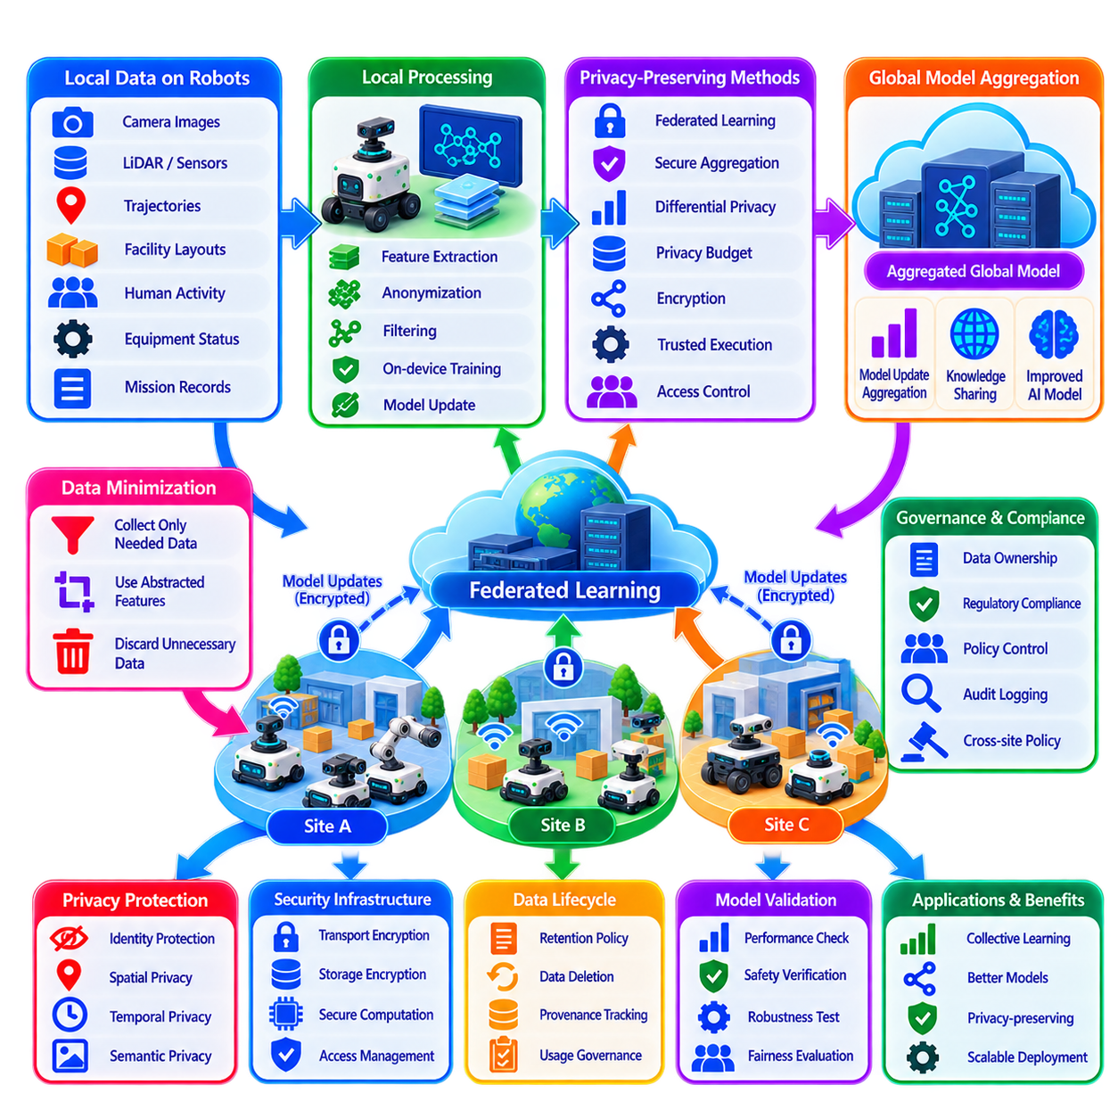
Privacy-preserving fleet learning enables groups of robots to improve shared artificial intelligence models while limiting unnecessary exposure of sensitive operational data. Robot fleets may collect camera images, LiDAR measurements, trajectories, facility layouts, human activity, equipment states, and mission records. A privacy-aware architecture treats these observations as protected assets and minimizes how much raw information leaves the robot or operational site.
The privacy challenge becomes more significant when fleets operate across factories, hospitals, warehouses, public spaces, customer facilities, or geographically distributed sites. Data generated by robots may reveal people, production processes, infrastructure, asset locations, customer activities, or proprietary operating procedures. Fleet learning must therefore balance collective model improvement with requirements for confidentiality, data ownership, regulatory compliance, and operational security.
A fundamental principle is data minimization. Robots should collect, retain, and transmit only the information required for the intended learning objective. If a navigation model requires geometric features rather than identifiable imagery, the system can extract those features locally and discard or restrict the original images. Reducing unnecessary data at the source decreases both privacy exposure and communication and storage requirements.
Local processing provides the first privacy boundary. Sensor streams can be converted on the robot into features, embeddings, labels, statistics, gradients, or model updates before information is transmitted outside the platform. Edge computing therefore supports privacy not only by reducing latency but also by allowing sensitive raw observations to remain close to the location where they were generated.
Federated Learning is a major mechanism for privacy-preserving fleet intelligence. Instead of uploading complete local datasets to a centralized training server, participating robots or site-level edge systems train models using their own data. They then transmit model updates for aggregation into a shared global model. The resulting architecture allows knowledge to move across the fleet while much of the underlying operational data remains locally stored.
Federated learning alone, however, does not guarantee privacy. Model parameters and gradients can sometimes reveal information about the training examples that produced them. An attacker or overly privileged aggregation service may attempt to infer properties of local datasets from transmitted updates. Privacy-preserving fleet learning must therefore protect both raw data and the intermediate information generated during distributed training.
Secure Aggregation addresses part of this problem by preventing the aggregation server from directly inspecting individual participant updates. Cryptographic mechanisms allow updates from multiple robots to be combined so that the server obtains an aggregate result while individual contributions remain concealed. This reduces the amount of information exposed to the central learning infrastructure and limits trust placed in a single aggregation component.
Differential Privacy provides another protection mechanism by introducing carefully controlled randomness into data, statistics, gradients, or model updates. The objective is to reduce the ability to determine whether a particular observation contributed to the learned result. Privacy parameters control the trade-off between information protection and model utility, requiring system designers to determine how much accuracy can be sacrificed for stronger privacy guarantees.
A privacy budget provides a formal way to manage cumulative exposure under differential privacy. Repeated training rounds can gradually consume privacy protection because each update reveals some statistical information. Fleet learning systems should therefore track privacy expenditure over time rather than evaluating each training round independently. Participation may need to stop or change when a robot, user group, dataset, or site approaches its permitted privacy budget.
Noise must be introduced carefully because excessive perturbation can degrade model performance, while insufficient noise provides weak protection. Large fleets can sometimes benefit from aggregation because information from many participants can preserve useful population-level patterns even when individual contributions are protected. The appropriate mechanism depends on fleet size, model sensitivity, training frequency, and the operational consequences of reduced accuracy.
Data anonymization and pseudonymization can further reduce exposure when information must leave the robot. Direct identifiers can be removed or replaced, and unnecessary metadata can be excluded before transmission. However, anonymization should not be treated as absolute protection because trajectories, locations, timestamps, visual features, or combinations of seemingly harmless attributes may still allow individuals or facilities to be reidentified.
Spatial privacy is particularly relevant to mobile robots because movement data can reveal facility layouts and operational patterns. Detailed trajectories may identify restricted areas, production workflows, frequently visited assets, or human routines. Fleet learning pipelines can reduce this risk through spatial aggregation, resolution reduction, region-based statistics, selective retention, or local extraction of navigation knowledge without exporting complete trajectory histories.
Temporal information can create similar privacy concerns. Precise timestamps may reveal work schedules, production cycles, maintenance events, or occupancy patterns. Depending on the learning objective, systems can aggregate events into time windows, remove unnecessary temporal precision, or separate operational identifiers from learning records. Privacy engineering should therefore examine combinations of spatial, temporal, semantic, and identity information rather than individual fields in isolation.
Semantic perception requires special consideration because robots may recognize people, vehicles, equipment, documents, screens, products, or activities. A privacy-preserving perception pipeline can perform detection locally and share only operationally relevant semantic results. For example, a fleet coordination system may need to know that a region is occupied without receiving an image containing identifiable people.
Access control remains necessary even when privacy-enhancing learning techniques are used. Robots, fog nodes, cloud services, developers, operators, and external partners should receive only the permissions required for their roles. Authentication, authorization, least-privilege access, encryption, key management, audit logging, and controlled interfaces provide the security foundation upon which privacy-preserving learning mechanisms operate.
Encryption protects data while it moves between robots and infrastructure and while it is stored. Transport encryption reduces exposure to network interception, while encrypted storage protects retained datasets, checkpoints, and model artifacts. More advanced cryptographic methods, including homomorphic computation or secure multi-party computation, can support selected computations on protected information, although their computational cost may limit real-time robotic applications.
Trusted execution environments can provide an additional isolation boundary for sensitive aggregation or learning workloads. Selected computations can execute inside protected hardware regions designed to restrict access from other software components. Such mechanisms can complement secure aggregation and encryption, particularly when organizations need stronger separation between infrastructure operators and confidential learning data.
Privacy policy should follow the complete data lifecycle. Information is created by sensors, processed locally, possibly retained, transformed into learning artifacts, transmitted, aggregated, used for model development, archived, and eventually deleted. Privacy controls that protect only network transmission are insufficient if raw datasets remain indefinitely stored or if old model artifacts preserve information beyond their intended retention period.
Data retention policies should therefore define how long each category of information remains available and under what conditions it is deleted. Raw sensor data may require shorter retention than derived statistics or validated model updates. Retention duration should reflect operational need, legal requirements, debugging requirements, privacy risk, and the possibility that stored data may become more revealing when combined with future datasets.
Provenance and governance are necessary for determining where training information originated and whether it can legally and operationally be used. A model update can carry metadata describing its source category, consent or authorization state, processing policy, software version, and permitted purpose without exposing unnecessary underlying data. Governance mechanisms prevent data collected for one purpose from silently being reused for unrelated learning activities.
Cross-site fleet learning introduces additional governance challenges. Different factories, customers, countries, or organizations may impose different rules regarding data movement and model training. A hierarchical architecture can keep raw data inside each site while exchanging approved model updates or aggregated knowledge. Policy-aware aggregation can exclude participants whose data-use conditions are incompatible with a particular global learning objective.
Privacy and security must be distinguished even though they overlap. Security protects systems and information from unauthorized access, modification, or disruption, while privacy controls how legitimate systems collect, use, combine, retain, and disclose information. A fleet can be technically secure yet still violate privacy principles by collecting excessive data or retaining information longer than necessary.
Privacy protection must also be balanced against safety and traceability. Removing too much operational information can make incidents difficult to investigate or prevent engineers from validating safety-critical models. The objective should therefore be controlled availability rather than indiscriminate deletion. Safety logs, learning records, and diagnostic evidence can use different retention periods, access permissions, and levels of detail according to their purposes.
Model validation should determine whether privacy mechanisms have degraded operational performance beyond acceptable limits. Candidate models should be evaluated for perception accuracy, navigation performance, anomaly detection quality, robustness, fairness, and safety-related behavior after privacy transformations are applied. Privacy guarantees are valuable only when the resulting model remains sufficiently reliable for its intended robotic function.
Privacy-aware observability should monitor the learning infrastructure without recreating the sensitive dataset that the architecture is intended to protect. Operators need information about participant status, training progress, privacy budget consumption, aggregation success, policy violations, and model performance. Monitoring should therefore rely on carefully selected metadata and aggregate metrics rather than unrestricted access to raw robot observations.
Simulation and synthetic data can reduce dependence on privacy-sensitive real-world datasets. Digital twins can generate navigation, traffic, manipulation, and failure scenarios without recording actual people or customer operations. Synthetic data cannot replace every real observation, but it can reduce the volume of sensitive information required for model development and support testing before limited real-world fine-tuning.
A mature architecture combines several mechanisms rather than relying on a single privacy technology. Local processing minimizes raw-data movement, federated learning distributes training, secure aggregation hides individual updates, differential privacy limits inference, encryption protects communication and storage, and governance controls permitted use. These layers collectively provide defense in depth for distributed fleet intelligence.
Ultimately, privacy-preserving fleet learning allows robot fleets to learn collectively without assuming that collective intelligence requires unrestricted central collection of operational data. By keeping sensitive information near its source, sharing only necessary learning artifacts, controlling cumulative information exposure, and enforcing lifecycle governance, distributed robotic systems can improve from fleet-wide experience while maintaining stronger boundaries around people, facilities, customers, and proprietary operations.

06.09 Distributed Intelligence Latency and Consistency Trade
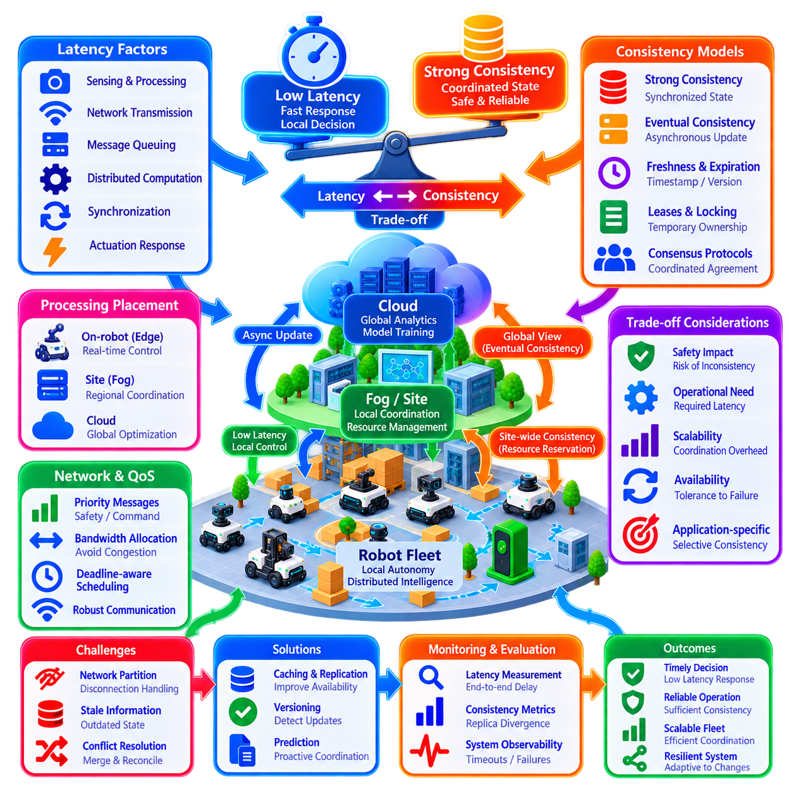
Distributed intelligence in robot fleets requires continuous decisions about where information should be processed, how quickly it must propagate, and how consistently different robots must perceive shared system state. Low latency favors local and asynchronous decisions, while strong consistency often requires coordination, synchronization, or confirmation among multiple participants. These objectives can conflict, making latency–consistency trade-offs a fundamental architectural concern in large-scale multi-robot systems.
Latency represents the time between an event and the moment when relevant components can respond to it. In a robot fleet, latency may include sensor processing, network transmission, message queuing, distributed computation, synchronization, and actuator response. Different functions tolerate very different delays. Emergency braking may require millisecond-scale reactions, while fleet optimization, analytics, or long-term model updates can tolerate seconds, minutes, or longer.
Consistency describes the degree to which distributed participants agree on shared information. Robots may maintain copies of maps, task states, resource reservations, traffic conditions, semantic knowledge, policies, or learned models. Strong consistency attempts to ensure that participants observe a coordinated state before proceeding, whereas weaker consistency allows temporary differences among replicas in exchange for faster response, greater availability, and reduced communication overhead.
Strong consistency is valuable when conflicting decisions could create unsafe or operationally invalid states. Exclusive access to an elevator, narrow corridor, docking station, manipulator, or charging connector may require a clearly defined owner. Two robots must not simultaneously believe that they hold the same exclusive reservation. Consensus, locking, leases, transactional updates, or authoritative coordination can therefore be justified for selected shared resources.
However, enforcing strong consistency everywhere can significantly increase latency and reduce system availability. A robot may need to wait for acknowledgments from remote nodes before acting, and network degradation can delay otherwise safe operations. Large fleets also increase coordination traffic and synchronization cost. Distributed intelligence should therefore apply strong consistency selectively rather than treating every shared variable as requiring immediate global agreement.
Eventual consistency is appropriate when temporary disagreement is acceptable and replicas can converge later. Examples include fleet statistics, historical performance records, noncritical semantic annotations, map metadata, diagnostic information, or learned knowledge that does not directly control immediate physical motion. Robots can continue operating with locally available information while updates propagate asynchronously through the fleet.
The choice between strong and eventual consistency should depend on the operational consequence of disagreement. If inconsistent information can cause collision, duplicate resource ownership, contradictory commands, or violation of a safety constraint, stronger coordination is appropriate. If inconsistency merely produces temporarily suboptimal routing, delayed analytics, or slightly outdated knowledge, lower-latency asynchronous mechanisms may provide better overall performance.
Edge computing reduces latency by placing decision-making close to the physical robot. Collision avoidance, local trajectory control, obstacle response, localization, and immediate safety monitoring should generally remain executable without waiting for remote infrastructure. Local autonomy establishes a critical architectural rule: network consensus should not be placed in the direct control path of physical reactions that must occur within deterministic time limits.
Fog or site-level computing provides an intermediate coordination layer. A local server can maintain traffic reservations, shared maps, regional task states, and resource ownership for robots operating within the same facility. Because network distance is smaller than communication with a remote cloud, stronger coordination can often be achieved with acceptable latency. This makes fog infrastructure useful for decisions requiring site-wide consistency without global synchronization.
Cloud systems are better suited to functions whose value comes from global visibility rather than immediate response. Cross-site analytics, historical optimization, model training, long-term planning, software distribution, and fleet-wide policy management can operate at longer timescales. Attempting to move safety-critical control into the cloud introduces dependence on wide-area network latency and availability that may be unacceptable for physical robotic systems.
Hierarchical consistency follows naturally from edge-fog-cloud distribution. A robot can maintain strongly consistent local control state, a site can maintain coordinated regional resource state, and cloud infrastructure can maintain eventually consistent global summaries. Instead of demanding one consistency model for the entire fleet, each information domain can use the level of coordination appropriate to its operational scope.
Data freshness is related to consistency but should be treated separately. Two robots may hold internally valid information while one copy is significantly older than the other. Timestamps, sequence numbers, version identifiers, leases, expiration times, and freshness thresholds allow robots to determine whether information remains suitable for a decision. Safety-critical information may require strict expiration, while slowly changing knowledge can remain valid much longer.
Stale information can be especially dangerous when the environment changes rapidly. A corridor reported as clear several seconds earlier may now contain a person, vehicle, or obstacle. Distributed systems should therefore avoid assuming that globally shared state replaces local perception. Shared knowledge can guide planning, but immediate physical safety should continue to depend on current onboard sensing and locally validated environmental information.
Network partitions expose the latency–consistency trade-off directly. When communication between fleet components is interrupted, a system can either stop operations that require coordinated state or allow participants to continue using local information. The correct response depends on the function. Exclusive shared resources may require conservative blocking, while independent navigation in previously validated areas may safely continue under local autonomy.
Availability becomes increasingly important as fleet scale grows. If every decision requires communication with a single authoritative server, server or network failure can disable the entire fleet. Distributed architectures can improve availability by caching policies, maps, mission context, and resource information locally. However, cached state introduces the possibility of divergence, so fallback operation must define exactly which decisions remain authorized during disconnection.
Leases provide a practical mechanism for balancing consistency and availability. A robot may receive temporary ownership of a resource for a defined period. During the valid lease, it can act without repeatedly contacting the coordinator. When the lease expires, ownership must be renewed or released. This reduces coordination latency while preventing indefinite reliance on stale resource assignments after communication failure.
Versioning is similarly important for distributed maps, policies, models, and mission data. Each update can carry a monotonically increasing version, logical timestamp, or revision identifier. Participants can detect outdated information and request missing changes rather than transferring complete state repeatedly. Version-aware synchronization also makes reconciliation more controlled when robots reconnect after operating independently.
Conflict resolution becomes necessary whenever asynchronous updates are allowed. Two robots may modify related map elements, semantic labels, task states, or learned information before synchronization occurs. Resolution policies can use timestamps, authority levels, confidence values, provenance, operational priority, or application-specific merge rules. Safety-critical conflicts should not be resolved through arbitrary last-write-wins behavior when physical consequences are possible.
Consensus protocols can provide strong agreement for selected distributed decisions, but they introduce communication and computational overhead. Their use should therefore be limited to information whose correctness genuinely requires agreement among multiple nodes. A fleet does not need distributed consensus for every sensor observation or trajectory sample. Excessive consensus can transform a resilient distributed architecture into a latency-sensitive centralized dependency.
Communication Quality of Service (QoS) can help preserve appropriate latency for different information classes. Emergency events, safety state, command authority, and critical resource coordination should receive higher priority than logs, analytics, map history, or background model updates. Deadline-aware scheduling, message prioritization, bounded queues, and bandwidth allocation prevent low-priority traffic from delaying information required for timely decisions.
Adaptive consistency can further improve fleet performance. The required coordination level does not always need to remain fixed. When robot density is low, local decisions may be sufficient, while congested intersections may require stronger regional coordination. Similarly, degraded communication can trigger more conservative local policies. The system can therefore adjust consistency mechanisms according to risk, traffic density, connectivity, and mission criticality.
Prediction can reduce the apparent cost of distributed latency. Robots can communicate intended trajectories, expected resource usage, or future task transitions before those events occur. Neighboring agents and supervisors can reserve resources or detect conflicts proactively rather than waiting for completed actions. Predictive coordination does not eliminate communication delay, but it provides additional time for distributed participants to reach compatible decisions.
Clock synchronization also affects distributed consistency. Timestamps from unsynchronized robots can make event ordering, sensor fusion, reservation validity, and conflict analysis unreliable. Precision Time Protocol (PTP), GNSS-derived time, or other synchronization mechanisms can provide a common temporal reference. The required synchronization accuracy should match the application rather than imposing unnecessarily expensive timing precision on every component.
Observability is essential for diagnosing latency and consistency failures. Monitoring should capture end-to-end message delay, synchronization time, queue depth, update age, replica divergence, timeout frequency, retransmission, lease expiration, consensus delay, and network partition events. Without these measurements, operators may observe unstable robot behavior without being able to determine whether the root cause lies in planning, communication, or stale distributed state.
Simulation and digital twins should test distributed intelligence under realistic communication conditions rather than ideal networks. Variable latency, packet loss, bandwidth limitation, jitter, node failures, partitions, delayed synchronization, and burst traffic can reveal behaviors that remain hidden during normal testing. Large-scale simulation is especially valuable for determining how coordination overhead changes as robot count and interaction density increase.
Performance evaluation should combine communication metrics with operational outcomes. Lower network latency is not useful if it requires excessive infrastructure, and stronger consistency is not valuable if it unnecessarily reduces fleet throughput. Relevant measures include decision latency, update propagation time, stale-state ratio, synchronization overhead, resource-conflict frequency, mission throughput, recovery time, network utilization, and safety-related intervention frequency.
A mature distributed architecture classifies information according to required latency, consistency, freshness, availability, and authority. Safety control remains local and deterministic, shared physical resources use coordinated ownership, operational knowledge can use bounded or eventual consistency, and long-term analytics can tolerate asynchronous convergence. This classification prevents one distributed-system mechanism from being applied indiscriminately to every fleet function.
Ultimately, latency and consistency should be treated as engineering resources rather than absolute objectives. The fastest system is not necessarily the safest, and the most strongly synchronized system is not necessarily the most scalable or resilient. By combining local autonomy, hierarchical coordination, selective strong consistency, asynchronous knowledge sharing, versioning, QoS, and carefully designed fallback behavior, robot fleets can maintain timely decisions while preserving sufficient agreement for reliable large-scale distributed intelligence.

06.10 Distributed Intelligence Production Case
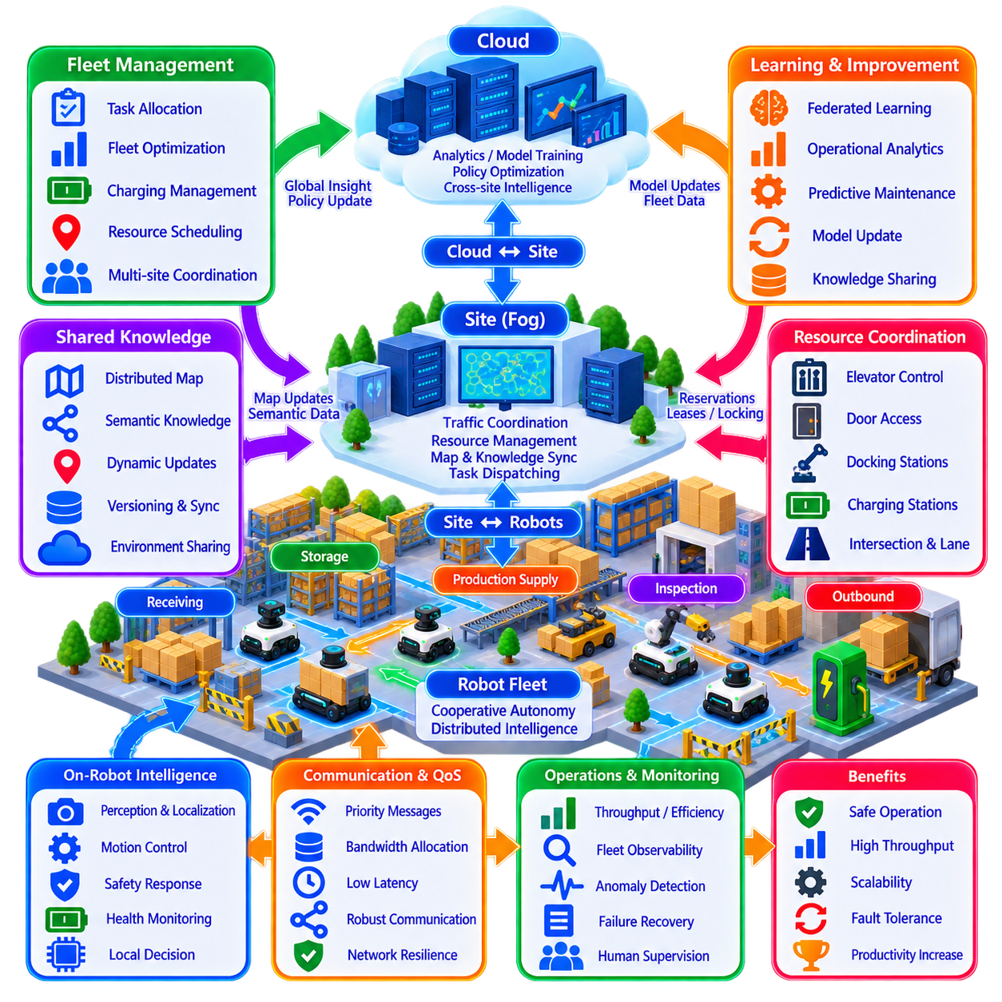
Distributed intelligence in a production robot fleet transforms autonomy from an isolated capability of individual machines into a coordinated operational system. A production deployment may contain mobile robots, manipulators, inspection platforms, charging infrastructure, site servers, and cloud services. Intelligence is distributed according to response time, information scope, computational demand, and operational authority rather than concentrated in one central controller.
Consider a large manufacturing and logistics facility operating hundreds of autonomous mobile robots across receiving, storage, production supply, inspection, and outbound areas. Robots continuously execute transport and inspection missions while sharing corridors, intersections, elevators, charging stations, and work cells. The production objective is not simply to make every robot autonomous, but to maximize safe and reliable facility-level throughput under continuously changing conditions.
Each robot forms the edge layer of the distributed architecture. Onboard computing performs localization, perception, obstacle detection, trajectory generation, motion control, health monitoring, and immediate safety responses. These functions remain operational even when communication with higher-level infrastructure is temporarily degraded. Local autonomy prevents network latency or central-server failure from becoming a direct dependency for basic physical safety.
Robot supervisors convert assigned missions into executable behaviors. A transport mission may involve navigation to a pickup point, docking, payload verification, route execution, destination alignment, unloading, and completion reporting. The supervisor monitors progress and handles routine exceptions such as temporary obstacles, failed docking attempts, localization uncertainty, or minor route changes before requesting assistance from higher coordination layers.
At the site level, fog infrastructure maintains a broader operational view. It receives summarized states from robots and coordinates traffic, task distribution, shared resources, charging demand, map updates, and regional congestion. Because this infrastructure is physically and logically closer to the robots than remote cloud services, it can support site-wide decisions requiring relatively low latency and stronger consistency.
Cloud infrastructure provides long-term and cross-site intelligence rather than immediate motion control. Historical fleet data can support capacity analysis, predictive maintenance, model training, policy optimization, software management, and comparison among multiple facilities. Production continues locally if cloud connectivity is interrupted because the cloud improves fleet intelligence without becoming a mandatory component of real-time safety or basic mission execution.
A distributed map provides a common spatial foundation for the fleet. Individual robots contribute observations of obstacles, blocked passages, changed work areas, and semantic objects. Site infrastructure merges validated updates and redistributes relevant information to robots operating nearby. A robot can therefore benefit from environmental changes detected by another robot without independently visiting the same location.
Semantic knowledge makes the shared map operationally meaningful. A location can be identified not only as free or occupied space but as a loading zone, pedestrian crossing, restricted area, charging station, inspection point, or temporary construction region. Robots use these semantics to adapt route selection and mission behavior while site supervisors use them to enforce facility policies and resource constraints.
Task allocation is distributed between global objectives and local execution capability. The fleet manager considers mission priority, robot position, battery state, payload capability, health, traffic, and workload. Robots can reject or renegotiate assignments that violate local constraints or current capability. This prevents global optimization from treating robots as identical resources when their physical states or operational roles differ.
Traffic coordination illustrates why distributed intelligence is necessary in production. Individual collision avoidance can prevent direct contact but cannot guarantee efficient fleet flow. Site-level coordination manages intersections, narrow corridors, queues, and route reservations, while robots retain immediate obstacle avoidance authority. Local safety and regional traffic optimization therefore operate simultaneously at different decision levels.
Shared resources require stronger coordination than ordinary environmental knowledge. Elevators, automated doors, docking stations, charging connectors, and narrow passages may permit only one robot or a limited number of robots at a time. Reservations, leases, or authoritative ownership prevent conflicting access, while local controllers verify that physical conditions remain safe before entering or using the resource.
Charging management becomes increasingly important as fleet size grows. If robots independently begin charging at identical battery thresholds, synchronized demand can reduce available fleet capacity. Site intelligence can predict energy requirements, stagger charging schedules, reserve chargers, and consider future mission demand. Individual robots still enforce minimum battery safety limits, creating cooperation between fleet optimization and local energy protection.
Communication uses differentiated Quality of Service rather than treating all messages equally. Emergency states, safety information, resource ownership, and critical commands receive higher priority than logs, historical map data, analytics, or background learning updates. This protects time-sensitive coordination when wireless bandwidth becomes congested and prevents noncritical information from interfering with production-critical communication.
Production networks inevitably experience packet loss, variable latency, temporary disconnection, and infrastructure failures. Robots therefore cache required maps, policies, mission context, and recent resource information. During disconnection they continue only operations authorized by fallback rules. Actions requiring current shared ownership may be blocked, while independent navigation and safe completion of already validated actions can continue locally.
Consistency requirements vary across information classes. A charging connector reservation may require strong agreement, whereas a semantic map annotation can tolerate asynchronous propagation. Historical utilization statistics can converge much later without affecting current operation. Classifying information according to latency, freshness, consistency, availability, and authority avoids imposing expensive synchronization on every distributed data exchange.
A practical production system also uses versioning and timestamps extensively. Maps, policies, mission definitions, models, and configuration data carry identifiable revisions. Robots can detect whether locally cached information is outdated and request only required changes. When disconnected robots return to the network, version-aware synchronization allows updates to be reconciled without replacing valid information blindly.
Federated learning can extend the architecture from distributed operation to distributed improvement. Robots or site servers train selected models using locally generated data and exchange model updates instead of transferring complete raw datasets. Fleet experience can therefore improve perception, anomaly detection, or operational prediction while reducing the movement of potentially sensitive production data.
Privacy-preserving mechanisms become relevant when robots observe workers, customer facilities, proprietary processes, or restricted infrastructure. Local processing can convert raw sensor data into features, semantic labels, statistics, or model updates before sharing. Secure aggregation, encryption, access control, retention policies, and data governance provide additional boundaries around information used for fleet-wide learning.
Multi-Agent Reinforcement Learning can be introduced selectively for coordination problems that are difficult to optimize manually. Simulation-trained policies may assist task allocation, traffic negotiation, resource selection, or congestion avoidance. Learned decisions remain bounded by robot supervisors, facility policies, and deterministic safety layers. Production deployment therefore uses MARL as an optimization mechanism rather than as an unrestricted replacement for engineered control.
Emergent behavior must be monitored because large fleets can develop system-level patterns that are invisible at the individual robot level. Congestion waves, synchronized charging, task oscillation, queue growth, and resource starvation may appear even when every robot behaves correctly according to local rules. Fleet observability therefore includes collective indicators in addition to individual robot diagnostics.
Operational telemetry provides the evidence required to understand these effects. The system records mission throughput, completion time, waiting time, traffic density, resource utilization, battery state, communication delay, stale information, recovery attempts, fault frequency, and safety interventions. These measurements connect distributed-computing performance with actual production outcomes rather than evaluating network or AI metrics in isolation.
Failure recovery follows hierarchical escalation. A robot first attempts local recovery through replanning, retry, re-localization, or temporary waiting. If the problem involves multiple robots or shared resources, the site supervisor coordinates recovery or task reassignment. Human operators become involved when autonomous recovery exceeds defined authority, safety limits, or confidence thresholds, reducing unnecessary manual intervention.
A production deployment should degrade gracefully rather than fail as a single centralized system. Loss of cloud connectivity removes global analytics before affecting site operation. Failure of a site coordinator reduces regional optimization while robots retain safe local behavior. Individual robot failures trigger task redistribution rather than fleet shutdown. Distributed authority therefore limits the propagation of failures across architectural layers.
Digital twins and simulation are essential before changes reach the operational fleet. New traffic policies, task-allocation strategies, communication settings, software versions, and learned models can be evaluated under high robot density, network degradation, charger shortages, blocked routes, and equipment failures. Production rollout can then proceed gradually from simulation to shadow testing, limited deployment, and fleet-wide release.
The architecture also requires explicit rollback and configuration control. Every deployed policy, model, map, and software component should have a traceable version and compatibility state. If a new coordination policy reduces throughput or creates unstable behavior, operators must be able to restore a validated configuration rapidly. Distributed intelligence therefore depends as much on disciplined lifecycle engineering as on sophisticated algorithms.
The most important production principle is that intelligence should be placed where its information and timing requirements can be satisfied reliably. Immediate physical reactions belong on the robot, regional coordination belongs close to the site, and computationally intensive long-term intelligence can operate centrally or in the cloud. Shared knowledge connects these layers without forcing every decision through the same infrastructure.
A successful production case is therefore measured not by how decentralized or intelligent the architecture appears, but by operational outcomes. The fleet should maintain safety, throughput, availability, predictable recovery, scalable communication, and manageable human supervision as robot count increases. Distributed intelligence becomes valuable when additional robots increase productive capacity without causing coordination complexity to grow beyond operational control.
Ultimately, production-grade distributed intelligence combines local autonomy, site-level coordination, cloud-scale learning, shared semantic knowledge, selective consistency, resilient communication, hierarchical recovery, and deterministic safety. These mechanisms allow hundreds or thousands of robots to behave as a coordinated operational system while preserving the local independence required for real-time physical control, fault tolerance, and scalable multi-robot production.

