Volume 16 Multi Robot and Fleet Intelligence

05. Robot Cloud Integration

05.01 Robot Cloud Integration Architecture Patterns
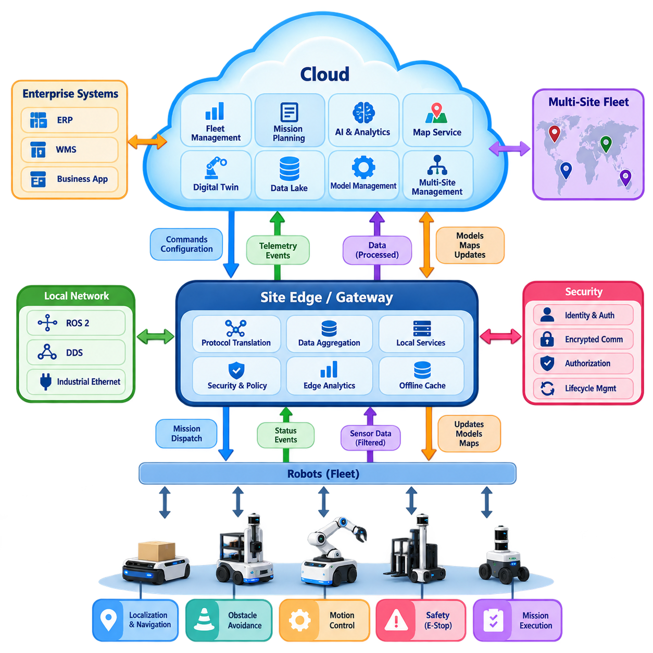
Robot-cloud integration connects autonomous robots operating in physical environments with scalable computing, storage, coordination, and management services outside the robot itself. Within a multi-robot fleet, the cloud should not be treated simply as a remote computer. It becomes a shared service layer that maintains fleet-level information, distributes missions and configuration, aggregates operational data, and provides computational resources that would be inefficient to duplicate on every robot. :chatgpt-content-reference{index=“0”}
A fundamental architectural principle is to separate safety-critical and latency-critical functions from cloud-dependent services. Localization, obstacle avoidance, emergency stopping, low-level motion control, and basic mission continuation normally remain on the robot or nearby edge infrastructure. The cloud handles functions that tolerate longer and less deterministic latency, such as fleet analytics, historical data processing, global optimization, model management, long-term storage, and cross-site coordination. This separation prevents network connectivity from becoming a prerequisite for safe robot operation.
The simplest integration pattern is a direct robot-to-cloud architecture. Each robot establishes a secure connection to cloud endpoints and exchanges telemetry, commands, configuration, diagnostic information, and operational events. This pattern is relatively easy to understand and deploy for small fleets, but its complexity grows as the number of robots increases. Hundreds of independent connections require scalable identity management, message routing, connection supervision, bandwidth control, and mechanisms for handling intermittent communication without corrupting fleet state.
A gateway-based architecture introduces an intermediate edge or site gateway between robots and cloud services. Robots communicate locally using technologies such as ROS 2, DDS, industrial Ethernet, or proprietary interfaces, while the gateway translates selected information into cloud-facing protocols. The gateway can aggregate telemetry, filter high-bandwidth sensor streams, cache commands, enforce security policies, and maintain temporary services during WAN outages. This pattern is especially useful in factories, warehouses, hospitals, ports, and other environments where local operation must continue independently of Internet availability.
A hierarchical edge-cloud architecture extends the gateway concept by distributing computation across robot, site, and cloud layers. Individual robots execute immediate perception and control, an edge cluster coordinates site-level activities, and cloud services perform organization-wide functions. Decisions can therefore be placed according to latency, computational cost, communication bandwidth, safety requirements, and the geographic scope of the information involved. The architecture also provides a natural foundation for scaling from one installation to fleets distributed across multiple facilities.
Event-driven integration is particularly effective for large robot fleets because robots naturally generate streams of state changes and operational events. Instead of continuously invoking tightly coupled services, robots publish events such as mission started, waypoint reached, battery low, localization degraded, charging initiated, or task completed. Cloud applications subscribe only to relevant events and process them asynchronously. This reduces direct dependencies between robot software and backend applications while allowing analytics, monitoring, workflow engines, and fleet services to evolve independently.
A complementary pattern uses request-response interfaces for operations requiring explicit results. REST or gRPC services may be appropriate for robot registration, configuration retrieval, map requests, mission submission, software metadata, and administrative operations, while asynchronous messaging handles continuous telemetry and events. Production architectures therefore rarely depend on a single communication mechanism. They combine synchronous APIs, message brokers, streaming pipelines, and local robot middleware according to the semantics and timing requirements of each data flow. The broader software structure explicitly separates cloud, edge, fleet, and robot API concerns. :chatgpt-content-reference{index=“1”}
The digital shadow pattern maintains a cloud-side representation of each robot's operational state. Instead of every application querying a physical robot directly, applications access a synchronized representation containing properties such as connectivity, pose, battery state, software version, current mission, health condition, and configuration. Desired state may also be recorded so that configuration changes can be delivered when an intermittently connected robot returns online. This decouples application availability from continuous robot connectivity and establishes a consistent interface for fleet-scale management.
Data movement should distinguish between operational telemetry and high-volume sensor information. Robot pose, battery status, faults, mission progress, temperatures, and utilization metrics are compact enough for continuous transmission, while raw camera, LiDAR, radar, or audio streams can overwhelm networks and cloud storage. Edge filtering, compression, event-triggered recording, metadata extraction, and selective upload are therefore essential architectural mechanisms. Cloud integration should move information according to operational value rather than treating every robot-generated byte as equally important.
Cloud-based mission management introduces another important pattern. Business systems submit work requirements to a cloud or fleet service, which converts them into robot-level missions according to robot capability, availability, location, battery state, and site constraints. The assigned mission is then transmitted to a robot or local fleet controller for execution. This division allows enterprise systems to reason about orders and objectives while robots remain responsible for physically feasible execution, creating a clear boundary between business orchestration and real-time autonomy.
Resilient architectures assume that communication failures will occur. Commands and events therefore require identifiers, timestamps, acknowledgement policies, expiration rules, retries, duplicate detection, and persistent local queues. Robots should retain enough mission context and environmental information to enter a defined degraded mode when cloud connectivity disappears. When communication returns, synchronization must reconcile local execution history with cloud state rather than blindly replaying every queued message. The volume structure appropriately treats offline-first resilient integration as a dedicated concern rather than an exceptional failure case. :chatgpt-content-reference{index=“2”}
Security must be embedded in the integration architecture because cloud connectivity expands the robot's attack surface beyond the local facility. Each robot requires a unique machine identity, authenticated communication, authorization policies, protected credentials, and encrypted transport. Cloud services should distinguish permissions for telemetry publication, mission commands, configuration changes, remote intervention, and software deployment. Identity lifecycle management becomes increasingly important when robots are commissioned, transferred between sites, serviced, replaced, or permanently removed from the fleet.
Multi-site operation adds another architectural dimension. A global cloud layer can maintain fleet-wide identity, software versions, analytics, AI models, operational policies, and aggregated performance information, while each site retains a local control plane for missions that cannot tolerate WAN dependency. Site isolation limits failure propagation and enables independent operation during external outages. At the same time, standardized interfaces allow headquarters-level services to compare utilization, reliability, energy consumption, and mission performance across geographically separated fleets.
Cloud integration should therefore be designed as a distribution of responsibilities rather than a migration of robot intelligence into remote servers. Robot autonomy protects immediate physical operation, edge infrastructure provides low-latency coordination and resilience, and cloud infrastructure supplies scalable computation, persistence, global visibility, and cross-fleet intelligence. The most effective architecture deliberately determines where every decision and dataset belongs according to latency, safety, bandwidth, availability, consistency, security, and operational scope.
This layered approach also prepares robot fleets for later capabilities such as cloud AI inference, shared map services, remote intervention, fleet digital twins, distributed learning, and AI-based fleet optimization. These capabilities appear as separate topics in the surrounding volume, indicating that cloud integration serves as infrastructure connecting communication, distributed intelligence, operations, optimization, and digital-twin functions rather than replacing them.

05.02 Robot Device Shadow and Twin Management [w/Code]
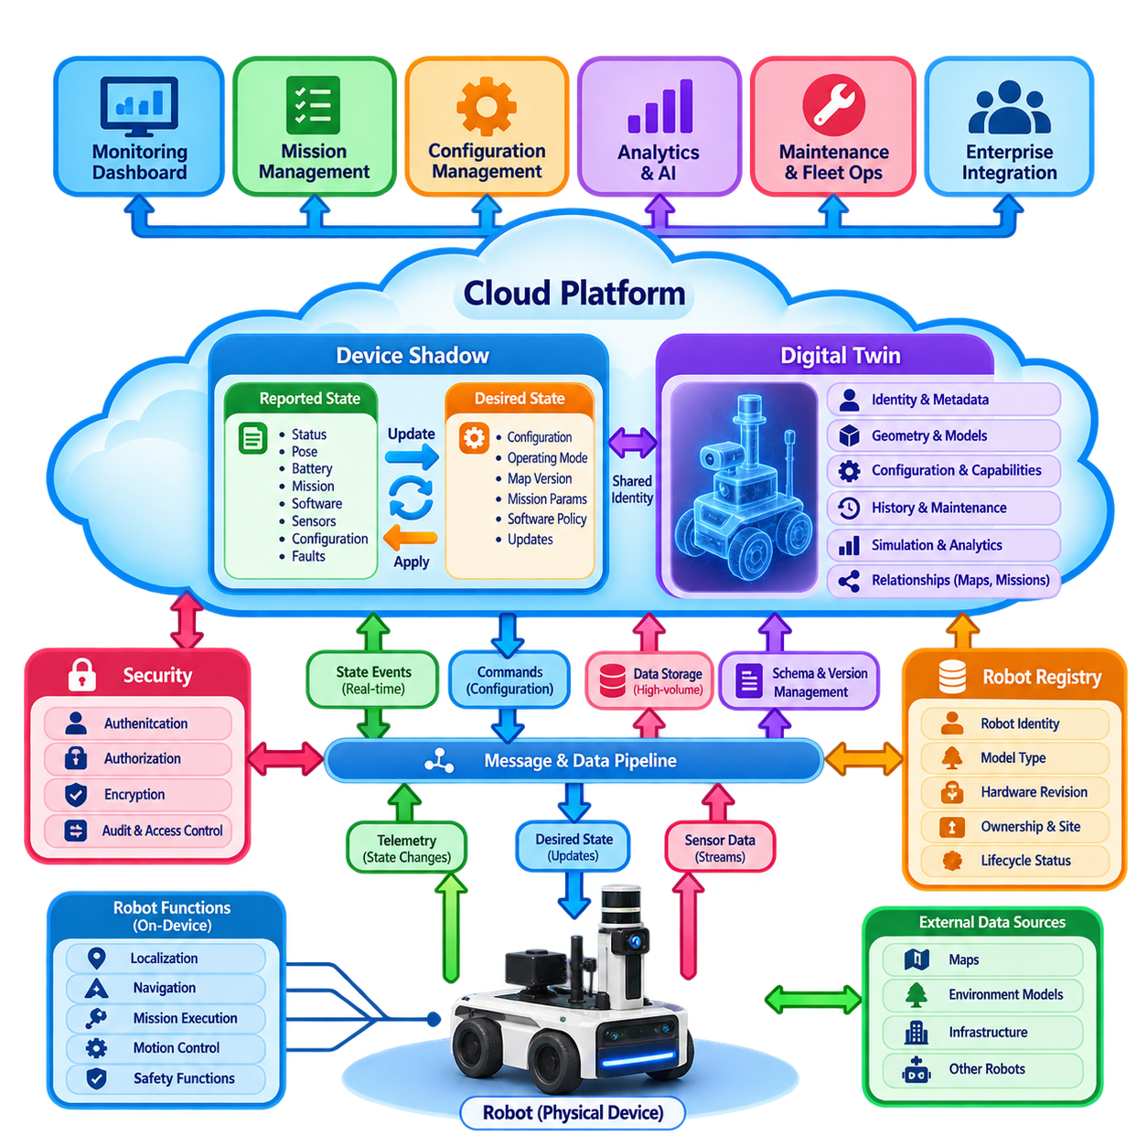
A robot device shadow is a persistent software representation of a physical robot’s operational state maintained outside the robot, typically within a cloud or fleet platform. It allows applications to obtain the latest known robot state even when the physical device is temporarily disconnected. In a fleet architecture, the shadow becomes an abstraction layer separating robot connectivity from management applications, mission services, dashboards, analytics, and enterprise integrations.
The shadow model commonly distinguishes reported state from desired state. Reported state describes what the robot currently believes to be true, including operating mode, pose, battery level, mission status, software version, sensor health, configuration, and fault conditions. Desired state represents what the management system expects the robot to become, such as a new configuration, operating mode, map version, mission parameter, or software policy. The difference between these states forms a synchronization objective.
State synchronization is therefore not simply data replication. The platform must determine whether a newly received value is more recent and authoritative than previously stored information. Each state update may require timestamps, sequence numbers, source identifiers, schema versions, and revision counters. These mechanisms prevent delayed or duplicated network messages from overwriting newer information and enable applications to determine whether the displayed state represents current telemetry or an older last-known condition.
When a robot is online, it periodically or event-wise publishes selected state changes to the shadow service. The cloud updates the reported state and distributes relevant changes to fleet applications through events, subscriptions, or APIs. When an operator or cloud service modifies desired state, the change is delivered to the robot. After applying the requested configuration, the robot reports its resulting state, allowing the platform to confirm convergence between desired and reported values.
The device shadow is especially valuable when communication is intermittent. A cloud application can modify desired state while the robot is offline without requiring an immediate connection. The platform persists the request, and the robot receives the pending change after reconnecting. Conversely, applications can inspect the last reported state while the robot is unavailable. Connectivity status, last-update time, and state freshness must therefore be represented explicitly so that stale information is never mistaken for live robot telemetry.
A digital twin extends this representation beyond a simple state cache. While a device shadow primarily maintains operational state and synchronization, a robot digital twin can combine identity, configuration, geometry, capabilities, maintenance history, mission history, performance characteristics, software composition, sensor configuration, and behavioral models. The twin may also support simulation, diagnostics, predictive maintenance, optimization, and what-if analysis, creating a richer computational counterpart of the physical robot.
Shadow and twin models should therefore be separated conceptually even when implemented within the same platform. The shadow answers questions such as whether the robot is connected, what mission it is executing, what battery level it last reported, and whether its configuration matches the desired configuration. The twin can answer broader questions concerning expected behavior, degradation trends, maintenance requirements, historical performance, simulated response, and relationships with maps, infrastructure, missions, and other robots.
A scalable fleet implementation normally maintains one logical shadow or twin identity for every robot. A robot registry associates this representation with immutable identifiers, model type, hardware revision, certificates, ownership, site assignment, and lifecycle status. Dynamic operational properties are then updated independently from relatively static metadata. Separating identity and metadata from rapidly changing telemetry reduces unnecessary writes and allows different storage technologies to be selected according to access patterns.
Not every sensor value belongs in the device shadow. High-frequency camera frames, LiDAR point clouds, motor waveforms, and raw diagnostic streams should normally be transported through dedicated streaming or storage pipelines. The shadow should contain compact state variables required for coordination and management, while references can point to detailed datasets stored elsewhere. This distinction prevents the shadow service from becoming a high-volume telemetry database and preserves predictable state synchronization performance.
State schemas require explicit governance because robot software evolves throughout the fleet lifecycle. New firmware may introduce properties that older robots do not understand, while legacy robots may continue reporting deprecated fields. Schema versioning, optional attributes, compatibility rules, validation, and migration strategies allow multiple robot generations to coexist. Fleet services should avoid assuming that every robot exposes identical capabilities and instead interpret state according to robot type, software version, and declared feature set.
Conflict resolution becomes important when several actors can modify the same desired state. An operator dashboard, mission planner, maintenance system, automated policy engine, and enterprise application may simultaneously request changes. The architecture should define ownership and precedence for each property rather than relying solely on the latest message. Revision checks, conditional updates, command authority, leases, or policy-based arbitration can prevent competing applications from repeatedly overwriting one another.
Safety-critical commands require stronger treatment than ordinary shadow properties. Emergency stopping, direct motion commands, safety-function modification, and other time-critical actions should not depend on eventual shadow synchronization. They require dedicated authenticated control paths with explicit acknowledgement, timeout, authority, and safety mechanisms. The shadow may record the resulting status or requested operational mode, but it should not be confused with a deterministic real-time control channel.
Twin management also requires lifecycle synchronization with the physical asset. When a robot is commissioned, its digital identity and initial twin are created and associated with the correct hardware and software configuration. Component replacement, sensor calibration, firmware upgrades, map changes, and maintenance actions update the representation over time. When the robot is transferred, retired, or decommissioned, its active credentials and control relationships must be changed while historical records remain available according to retention policies.
Security is fundamental because the shadow provides a logical control interface to physical equipment. Robots must authenticate before reporting state, and applications must be authorized before reading or changing properties. Permissions should distinguish observation from configuration and control. Encryption, certificate-based robot identity, audit logs, revision histories, and least-privilege access policies provide traceability and reduce the possibility that compromised applications can manipulate an entire fleet through shared cloud services.
At fleet scale, shadows and twins become a distributed state-management system rather than a collection of independent JSON documents. Hundreds or thousands of robots can simultaneously update connectivity, battery, mission, health, and configuration properties. The backend must support partitioning, asynchronous processing, subscription fan-out, caching, persistence, and failure recovery while preserving meaningful ordering where required. Applications should consume changes incrementally instead of repeatedly polling every robot.
The combined shadow-and-twin architecture ultimately establishes a controlled relationship between physical robots and their software representations. Device shadows provide resilient synchronization of current and desired operational state, while digital twins add historical, structural, analytical, and predictive context. Together they allow fleet systems to manage intermittently connected robots consistently and provide a foundation for cloud mission planning, remote monitoring, maintenance analytics, simulation, and fleet-wide intelligence.

05.03 Cloud Based Mission Planning and Dispatch [w/Code]
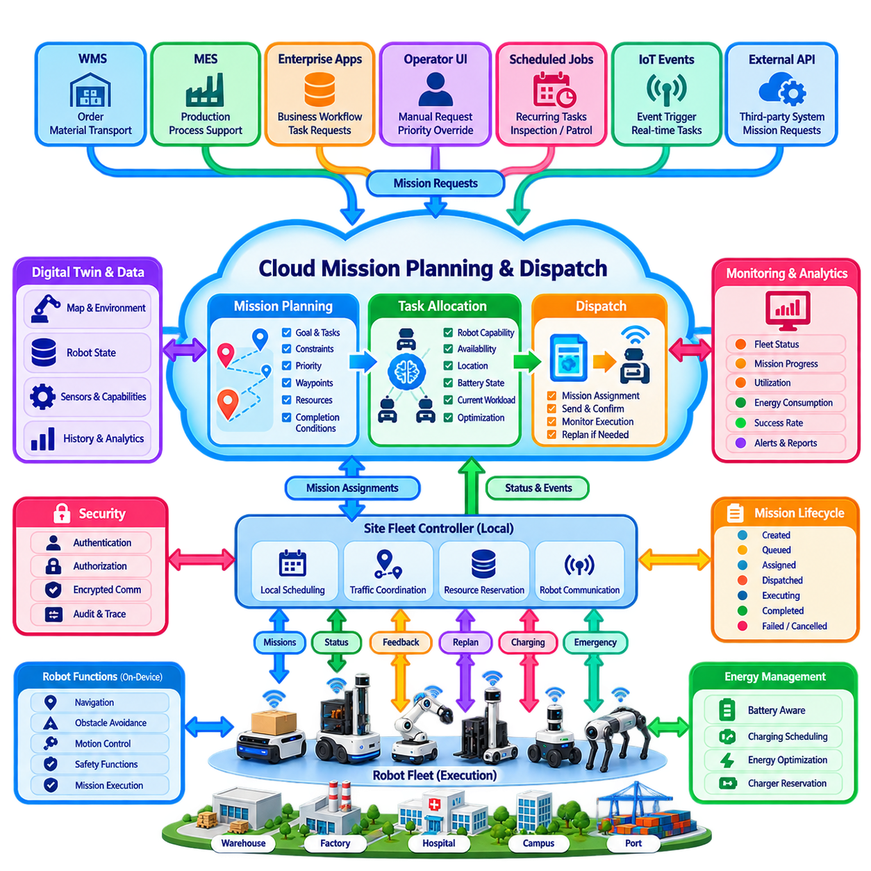
Cloud-based mission planning and dispatch provides a fleet-level coordination layer that converts operational objectives into executable robot missions and assigns them to appropriate robots. Instead of allowing each robot to independently interpret enterprise requests, the cloud maintains a broader view of orders, robot availability, site conditions, priorities, and resource constraints. This enables decisions to consider the state of the entire fleet rather than optimizing only the behavior of individual robots.
A mission represents a structured operational objective rather than a sequence of low-level motor commands. It may describe actions such as transporting material between locations, inspecting designated assets, patrolling an area, collecting sensor data, delivering goods, or supporting a production process. The cloud defines the mission goal, constraints, priority, required capabilities, locations, deadlines, and completion conditions, while the robot remains responsible for translating those requirements into locally feasible navigation and control actions.
Mission requests can originate from many systems. Warehouse management systems, manufacturing execution systems, enterprise applications, operator dashboards, scheduled workflows, IoT events, and external APIs may all generate work. A cloud mission service normalizes these requests into a common mission representation so that robot-specific differences do not propagate into enterprise applications. This abstraction creates a stable boundary between business-level work definitions and heterogeneous robotic platforms.
Before dispatch, the planner evaluates the current fleet state. Relevant information includes robot availability, location, battery state, payload capacity, installed sensors, manipulation capability, current workload, maintenance condition, software compatibility, and connectivity. Environmental information such as restricted zones, charging station occupancy, traffic conditions, map versions, and resource reservations may also influence assignment. A feasible mission must satisfy both robot capability requirements and operational constraints.
Mission planning and task allocation are closely related but should remain logically distinguishable. Planning determines what must be accomplished and may decompose a business request into tasks, dependencies, waypoints, resource requirements, and execution conditions. Allocation determines which robot or group of robots should perform those tasks. Dispatch then communicates the resulting assignment to the selected execution endpoint and supervises whether the mission is accepted, started, progressing, completed, rejected, or interrupted.
The dispatch workflow should use an explicit mission lifecycle rather than treating a command as a one-time message. Typical states include created, validated, queued, assigned, dispatched, accepted, executing, paused, completed, failed, cancelled, and expired. State transitions provide traceability and allow cloud services to distinguish a mission waiting for resources from one that has been transmitted but not acknowledged. This lifecycle is especially important when hundreds of missions and robots operate concurrently.
Dispatch reliability requires every mission and assignment to carry stable identifiers and revision information. Network delays can cause acknowledgements or status events to arrive out of order, while retries may produce duplicate messages. Idempotent processing allows the same dispatch request to be received more than once without executing the mission repeatedly. Sequence numbers, timestamps, acknowledgement states, expiration times, and revision checks help maintain consistency between the cloud planner, local fleet controller, and robot.
A hierarchical architecture is often preferable to direct cloud control. The cloud may optimize work across sites and generate mission assignments, while a site-level fleet controller performs local scheduling, traffic coordination, resource reservation, and robot communication. The robot then executes navigation, perception, obstacle avoidance, and motion control locally. This division keeps long-horizon optimization in the cloud while preserving deterministic and low-latency behavior close to the physical environment.
Mission planning can incorporate multiple optimization objectives. The system may attempt to minimize travel distance, mission completion time, energy consumption, congestion, charging interruptions, or operational cost while maximizing throughput and robot utilization. In practice, these objectives frequently conflict. Sending the nearest robot may reduce travel time but could assign a nearly depleted robot to a long mission, while maximizing utilization can create congestion or eliminate spare capacity needed for urgent work.
Priority management is therefore an essential part of dispatch. Routine transportation, production-critical tasks, safety inspections, urgent deliveries, recovery operations, and operator-requested missions may require different service levels. The scheduler can combine priority classes with deadlines, waiting time, resource availability, and preemption policies. However, uncontrolled preemption can destabilize fleet operation, so the system should explicitly define which missions may be interrupted and how partially executed work is safely resumed or reassigned.
Battery-aware dispatch integrates mission scheduling with energy management. The planner estimates whether a robot has sufficient energy to execute a mission and retain an appropriate safety reserve. Charging may itself become a scheduled task, allowing robots to charge during low-demand periods instead of waiting until batteries reach critical levels. At fleet scale, this coordination can prevent many robots from simultaneously requesting chargers and reduce the loss of available fleet capacity caused by poorly synchronized charging behavior.
Dynamic replanning is required because physical operations rarely follow the original schedule exactly. Robots may become blocked, batteries may discharge faster than predicted, destinations may become unavailable, elevators or doors may fail, and urgent missions may arrive unexpectedly. The cloud planner should continuously evaluate significant state changes and determine whether existing assignments remain valid. Replanning can modify priorities, reassign pending work, select alternate resources, or restructure future missions without unnecessarily disrupting tasks already executing safely.
Cloud disconnection must not immediately stop physical operation. Once a mission has been accepted, the robot or local fleet controller should retain enough mission context to continue according to predefined offline policies. New cloud assignments may be temporarily buffered, while completed missions and state changes are stored locally until connectivity returns. After reconnection, synchronization should reconcile actual execution history with cloud records before additional commands are issued, preventing duplicated or contradictory missions.
Mission execution requires clear authority boundaries. Cloud services should not directly issue arbitrary low-level motion commands through the normal mission dispatch path. Safety-critical control, emergency stopping, collision avoidance, localization, and immediate trajectory execution remain within local robot or site systems. The cloud communicates objectives and constraints, while local autonomy determines physically safe execution. This boundary prevents unpredictable network latency from becoming part of the robot's real-time safety loop.
Security must protect both mission creation and dispatch because unauthorized assignments can directly influence physical equipment. Robot and service identities should be authenticated, and authorization policies should determine which applications or operators may create, modify, cancel, prioritize, or dispatch missions. Mission records should preserve origin, revision, approval, assignment, and execution history. Signed commands, encrypted communication, audit logs, and least-privilege permissions provide additional protection for high-impact fleet operations.
Observability closes the planning and dispatch loop. The cloud collects mission acceptance, progress, waiting time, execution duration, failure reason, energy consumption, reassignment, and completion information. These records support operational dashboards and metrics such as throughput, utilization, mission success rate, queue latency, travel efficiency, and deadline compliance. Historical mission data can subsequently improve scheduling rules, capacity planning, simulation models, and AI-based optimization policies.
Cloud-based mission planning ultimately establishes a hierarchy from business intent to physical execution. Enterprise systems define what must be achieved, cloud services transform objectives into coordinated fleet missions, dispatch mechanisms assign executable work, site controllers manage local resources, and robots perform real-time autonomous actions. When these layers exchange explicit state and maintain clear authority boundaries, the fleet can scale while remaining resilient to communication failures, dynamic environments, heterogeneous robots, and changing operational demand.

05.04 Telemetry Streaming to Cloud Data Lake [w/Code]
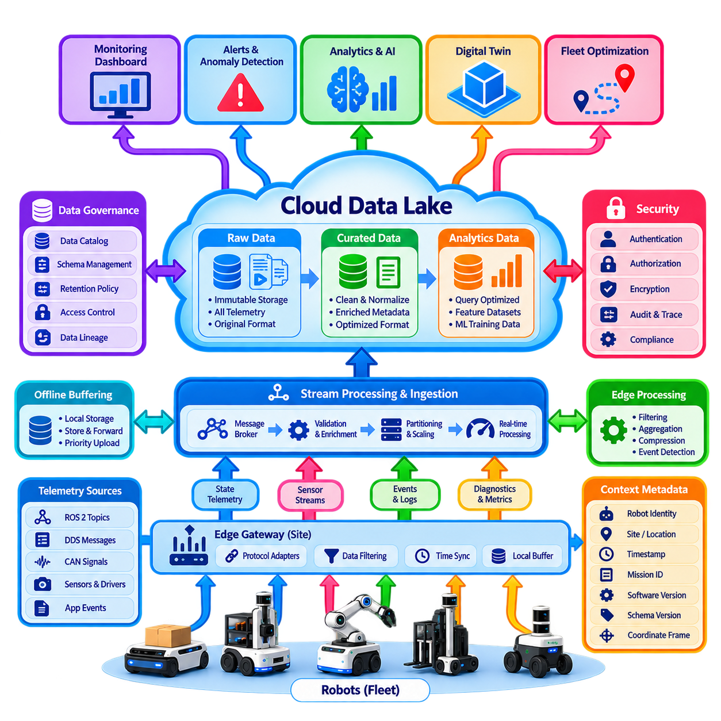
Telemetry streaming to a cloud data lake provides the data foundation for observing, analyzing, and improving large robot fleets. Each robot continuously generates operational information describing its state, missions, motion, energy consumption, sensors, software, faults, and interactions with the environment. A streaming architecture transports selected information from robots and site infrastructure into scalable cloud storage without coupling robot execution directly to analytical applications.
Robot telemetry differs from conventional enterprise data because it combines many data rates, formats, and timing requirements. Low-rate signals may include battery state, operating mode, temperature, mission status, and health indicators, while localization and motion data can arrive many times per second. Cameras, LiDARs, radars, microphones, and other sensors may generate megabytes or gigabytes of raw data. The architecture must therefore distinguish continuous state telemetry from high-bandwidth sensor streams.
Telemetry collection normally begins on the robot with a data acquisition layer that subscribes to relevant software components and hardware interfaces. ROS 2 topics, DDS messages, CAN signals, diagnostic interfaces, application events, and sensor drivers can all become telemetry sources. Rather than transmitting every internal signal, a telemetry agent selects approved data, adds contextual metadata, applies timestamps, and converts information into schemas suitable for downstream processing.
Edge processing is essential for controlling bandwidth and cloud cost. A robot or site gateway can filter unnecessary samples, aggregate measurements over time windows, calculate statistical summaries, compress payloads, and detect events before transmission. High-frequency vibration measurements, for example, may be summarized as statistical features during normal operation while raw samples are retained only when abnormal behavior is detected. This converts indiscriminate data collection into value-oriented telemetry acquisition.
Time synchronization is especially important because fleet analysis frequently combines information generated by different sensors, computers, and robots. Each telemetry record should carry a meaningful event timestamp rather than relying only on cloud arrival time. Clock synchronization using mechanisms such as NTP or PTP can improve temporal consistency, while sequence numbers help detect missing or reordered messages. Accurate timing enables reconstruction of mission execution, failures, traffic interactions, and multi-sensor events.
A telemetry message should include enough context to remain interpretable after leaving the robot. Typical metadata includes robot identity, site, timestamp, software version, mission identifier, message type, schema version, coordinate frame, and quality indicators. Sensor-specific data may additionally include calibration or configuration references. Contextual metadata allows data collected months later to be associated with the correct robot configuration and operational environment instead of becoming anonymous measurements.
Streaming transport is normally asynchronous so that cloud processing does not block robot operation. Robots or gateways publish telemetry to message brokers, event-streaming platforms, or managed ingestion services, while independent consumers process the stream downstream. Partitioning by robot, site, message class, or another stable key allows parallel processing at fleet scale. Buffering and backpressure mechanisms prevent temporary cloud slowdowns from propagating directly into robot control software.
Network connectivity cannot be assumed to remain continuously available. An offline-first telemetry pipeline therefore maintains a local persistent buffer for data that cannot immediately be transmitted. When connectivity returns, buffered records can be uploaded according to priority, age, and available bandwidth. Critical fault events may be transmitted before routine telemetry, while obsolete high-frequency samples may be summarized or discarded according to retention policy. This protects robot operation while preserving important evidence.
The cloud ingestion layer validates incoming records before committing them to long-term storage. Authentication confirms the transmitting robot or gateway, schema validation checks message structure, and integrity controls identify corrupted payloads. Processing services can enrich records with site metadata, robot model information, mission context, or environmental attributes. Invalid records should normally be isolated in a quarantine path rather than silently entering production datasets and contaminating later analysis.
A cloud data lake stores telemetry in scalable object storage while preserving data at multiple processing stages. Raw data can be retained in an immutable landing area, cleaned and normalized information can be stored in a curated layer, and application-ready datasets can be organized for analytics or machine learning. This separation makes it possible to reproduce processing pipelines, investigate failures using original evidence, and generate new derived datasets without repeatedly retrieving data from robots.
Data organization strongly affects usability. Telemetry may be partitioned by site, robot, date, mission, sensor type, or data class, but excessive partitioning can create large numbers of small files and reduce query efficiency. Columnar formats are useful for structured analytical telemetry, while large binary sensor artifacts may remain in specialized files with searchable metadata. The storage design should reflect access patterns rather than simply reproduce the robot's internal directory structure.
Hot, warm, and cold data tiers can reduce storage cost while preserving historical value. Recent operational telemetry may remain available for dashboards and incident investigation, intermediate data may support periodic analytics and model development, and older raw datasets may move to lower-cost archival storage. Retention periods should vary by data class because safety incidents, maintenance evidence, AI training data, routine telemetry, and temporary debugging information have different operational values.
Real-time stream processing complements the long-term data lake. Selected telemetry can feed dashboards, alert engines, anomaly detectors, digital twins, and fleet optimization services before being stored permanently. A battery temperature excursion, repeated localization failure, unexpected motor current, or mission delay may trigger immediate operational action. The same event can later become part of historical datasets used for reliability analysis, predictive maintenance, and model training.
High-bandwidth perception data requires selective collection rather than continuous cloud upload. Raw camera video or LiDAR point clouds may be retained locally and uploaded only around failures, unusual environmental conditions, operator annotations, or AI uncertainty events. Event-triggered capture can preserve a time window before and after the trigger, providing valuable diagnostic context. Dataset sampling policies can also deliberately collect diverse situations needed for future perception and Physical AI model improvement.
Data governance becomes increasingly important as telemetry accumulates across many robots and sites. The platform should maintain schema ownership, dataset lineage, retention rules, access permissions, classification, and processing history. Schema evolution must support multiple robot software generations without destroying historical compatibility. A data catalog can expose what datasets exist, how they were produced, which robots generated them, and whether they are suitable for analytics, debugging, simulation, or machine learning.
Security must protect telemetry throughout collection, transmission, processing, and storage. Robot identities should be authenticated, communication encrypted, and access controlled according to service and user roles. Cloud permissions should separate ingestion, operational monitoring, analytics, model development, and administrative access. Audit records provide traceability for sensitive datasets, while encryption at rest and lifecycle policies reduce the consequences of unauthorized access or unintended long-term retention.
Fleet telemetry becomes particularly valuable when connected with missions, maintenance, maps, software versions, and digital twins. A failure can then be analyzed not merely as an isolated error code but in relation to robot configuration, environmental conditions, preceding missions, battery behavior, and recent software changes. This contextual linkage transforms a data lake from passive storage into an operational knowledge base capable of supporting root-cause analysis and fleet-wide learning.
The complete architecture therefore forms a continuous data loop from physical operation to fleet intelligence. Robots generate observations, edge systems filter and contextualize them, streaming infrastructure transports them reliably, cloud services validate and enrich them, and the data lake preserves them for multiple time horizons. Analytics and AI subsequently convert historical fleet experience into maintenance insights, operational policies, improved models, and optimization strategies that can be deployed back to the robots.

05.05 Cloud AI Inference for Complex Decisions [w/Code]
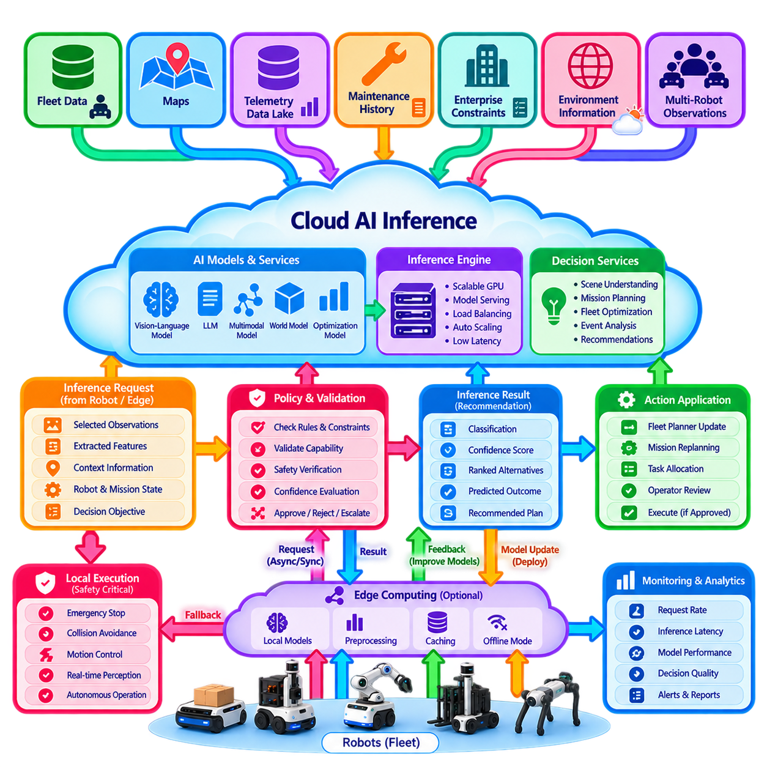
Cloud AI inference extends robot intelligence beyond the computational and memory limits of individual machines by executing selected models and decision services on scalable remote infrastructure. It is most useful for complex, non-immediate decisions that require large models, extensive contextual data, or fleet-wide knowledge. The objective is not to move all robot intelligence into the cloud, but to place each inference function where latency, safety, computational demand, and information scope are best balanced.
A fundamental architectural rule is that cloud inference should not become part of a safety-critical real-time control loop. Emergency stopping, collision avoidance, stabilization, low-level motion control, and immediate obstacle response must continue locally even when external communication is unavailable. Cloud AI is better suited to semantic reasoning, mission optimization, long-horizon planning, fleet-level decisions, complex scene interpretation, and other functions where response times can tolerate network and processing variability.
The inference workflow normally begins when a robot or edge system identifies a problem that exceeds its local decision capability. Instead of transmitting unrestricted raw sensor streams, the robot can construct an inference request containing selected observations, extracted features, environmental context, robot state, mission information, confidence values, and a clearly defined decision objective. This reduces bandwidth while giving the cloud model sufficient information to reason about the operational situation.
Cloud inference can combine information unavailable to a single robot. A decision service may access fleet state, historical missions, maps, digital twins, maintenance records, environmental information, enterprise constraints, and observations from other robots. A robot encountering an ambiguous blocked route, for example, can benefit from knowledge that another robot recently observed the same area or that a facility system has reported a temporary restriction. Cloud intelligence therefore provides contextual breadth as well as computational power.
Large AI models are a major motivation for cloud inference. Vision-language models, multimodal foundation models, large language models, world models, and computationally expensive optimization networks may require memory and accelerator resources that cannot economically be installed on every robot. Centralized GPU infrastructure allows multiple robots to access these capabilities as shared services, while model instances can be scaled according to demand and upgraded without replacing robot hardware.
Complex scene interpretation is one representative application. Local perception can detect objects, people, obstacles, and traversable areas in real time, while uncertain or unusual observations can be escalated to a more capable cloud model. The cloud may combine images, semantic descriptions, maps, mission context, and historical examples to classify the situation or recommend an action. This hierarchical approach reserves expensive inference for cases where additional reasoning provides meaningful operational value.
Mission-level reasoning provides another important use case. A cloud AI service can evaluate alternative mission sequences, resource constraints, robot capabilities, battery conditions, deadlines, congestion, and operational priorities across an entire fleet. Instead of deciding only the next motion of one robot, the model can reason over longer time horizons and multiple interacting resources. Its output can become a recommendation to the fleet planner rather than an immediate physical control command.
The architecture should distinguish inference results from executable commands. A model may return a classification, confidence score, ranked alternatives, predicted outcome, semantic interpretation, or recommended plan. A policy or orchestration layer then validates this result against operational rules, robot capabilities, permissions, and safety constraints before converting it into an action. This separation prevents probabilistic AI output from bypassing deterministic control and fleet-management mechanisms.
Confidence and uncertainty are therefore first-class elements of cloud AI integration. A model should not merely return a decision without indicating how strongly the available evidence supports it. Confidence thresholds, uncertainty estimates, out-of-distribution detection, consistency checks, and rule-based validation can determine whether an inference result is accepted automatically, processed by another model, returned to local autonomy, or escalated to a human operator for review.
Latency budgets must be explicitly defined for each inference service. Total response time includes data acquisition, preprocessing, network uplink, queueing, model execution, post-processing, policy validation, downlink, and robot-side application. A cloud service that executes a model in tens of milliseconds can still produce an unacceptable response if network or queueing delays dominate. Decisions should therefore be classified according to the maximum delay they can safely and operationally tolerate.
Asynchronous inference is often preferable for decisions that do not require an immediate response. A robot can submit a request, continue safe local operation, and receive the result later through an event or message channel. Synchronous inference may be appropriate when the robot can safely wait for a bounded period, but every request should have a timeout and fallback behavior. The robot must know what to do if the cloud result is delayed, unavailable, invalid, or inconsistent with current conditions.
Connectivity-aware operation requires local fallback policies. When cloud inference is unavailable, the robot may use a smaller edge model, apply deterministic rules, postpone a nonessential task, request operator assistance, or enter a defined degraded operating mode. The fallback should depend on the consequence of uncertainty rather than simply retrying indefinitely. Cloud AI should enhance autonomy when available without transforming network loss into an uncontrolled operational failure.
Inference requests also require freshness management because physical environments can change while a model is processing information. Every request should carry timestamps, robot state, mission identifiers, and relevant context versions. When a result returns, the receiving system should verify that the assumptions under which the inference was generated are still valid. A recommendation based on an obstacle observed several seconds earlier may no longer be applicable after the robot or surrounding objects have moved.
Fleet-scale inference introduces resource scheduling challenges. Hundreds of robots may simultaneously request GPU-intensive processing, creating queues and variable latency. The cloud platform can prioritize requests according to mission criticality, service class, deadlines, model size, and expected computational cost. Dynamic batching improves accelerator utilization for compatible workloads, while autoscaling can add inference capacity during peak demand. Admission control prevents excessive load from degrading every service.
Model management must accompany inference serving. Each request and result should be associated with a model identifier, model version, input schema, configuration, and relevant preprocessing version. This allows an operational decision to be reproduced and investigated later. Canary deployment, staged rollout, A/B evaluation, rollback, and performance monitoring can introduce new models gradually rather than replacing fleet-wide inference behavior in a single uncontrolled transition.
Observability should measure both computational performance and decision quality. Infrastructure metrics include request rate, queue depth, accelerator utilization, inference latency, timeout frequency, and service availability. AI-specific metrics include confidence distribution, rejection rate, disagreement with local models, operator overrides, downstream mission outcomes, and changes in data distribution. Combining these measurements helps determine whether a technically available model is actually improving fleet operation.
Security is particularly important because inference services can influence physical behavior. Robots and cloud services must authenticate each other, requests and responses should be protected against modification, and authorization policies should restrict which models and decision services each robot may invoke. Sensitive sensor data may require minimization, encryption, retention limits, and site-specific access policies. Inference outputs should also be logged so that consequential decisions remain auditable.
Cloud inference becomes more powerful when connected to the telemetry and data-lake pipeline. Difficult cases, low-confidence predictions, operator corrections, mission failures, and unusual environmental observations can be stored as learning evidence. These datasets support offline evaluation, model retraining, simulation, and regression testing. Validated model improvements can then be deployed back into cloud or edge inference services, forming a continuous learning loop between fleet operation and AI development.
The resulting architecture is a hierarchical intelligence system rather than a cloud-controlled robot. On-device intelligence protects immediate physical behavior, edge computing supplies low-latency inference and resilience, and cloud AI provides large-scale models, global context, shared acceleration, and long-horizon reasoning. A policy and validation layer connects these levels so that powerful probabilistic models contribute to decisions without assuming direct authority over safety-critical physical control.
Cloud AI inference for complex decisions therefore creates value when computational scale and global knowledge genuinely improve the quality of reasoning. Its success depends less on sending every decision to a large remote model than on selecting the correct decisions for escalation, controlling latency and uncertainty, validating returned results, and preserving local autonomy. Properly designed, it becomes a shared intelligence layer that allows a robot fleet to benefit from increasingly capable AI while remaining resilient, observable, secure, and operationally safe.

05.06 Cloud Map Service HD Map Distribution [w/Code]
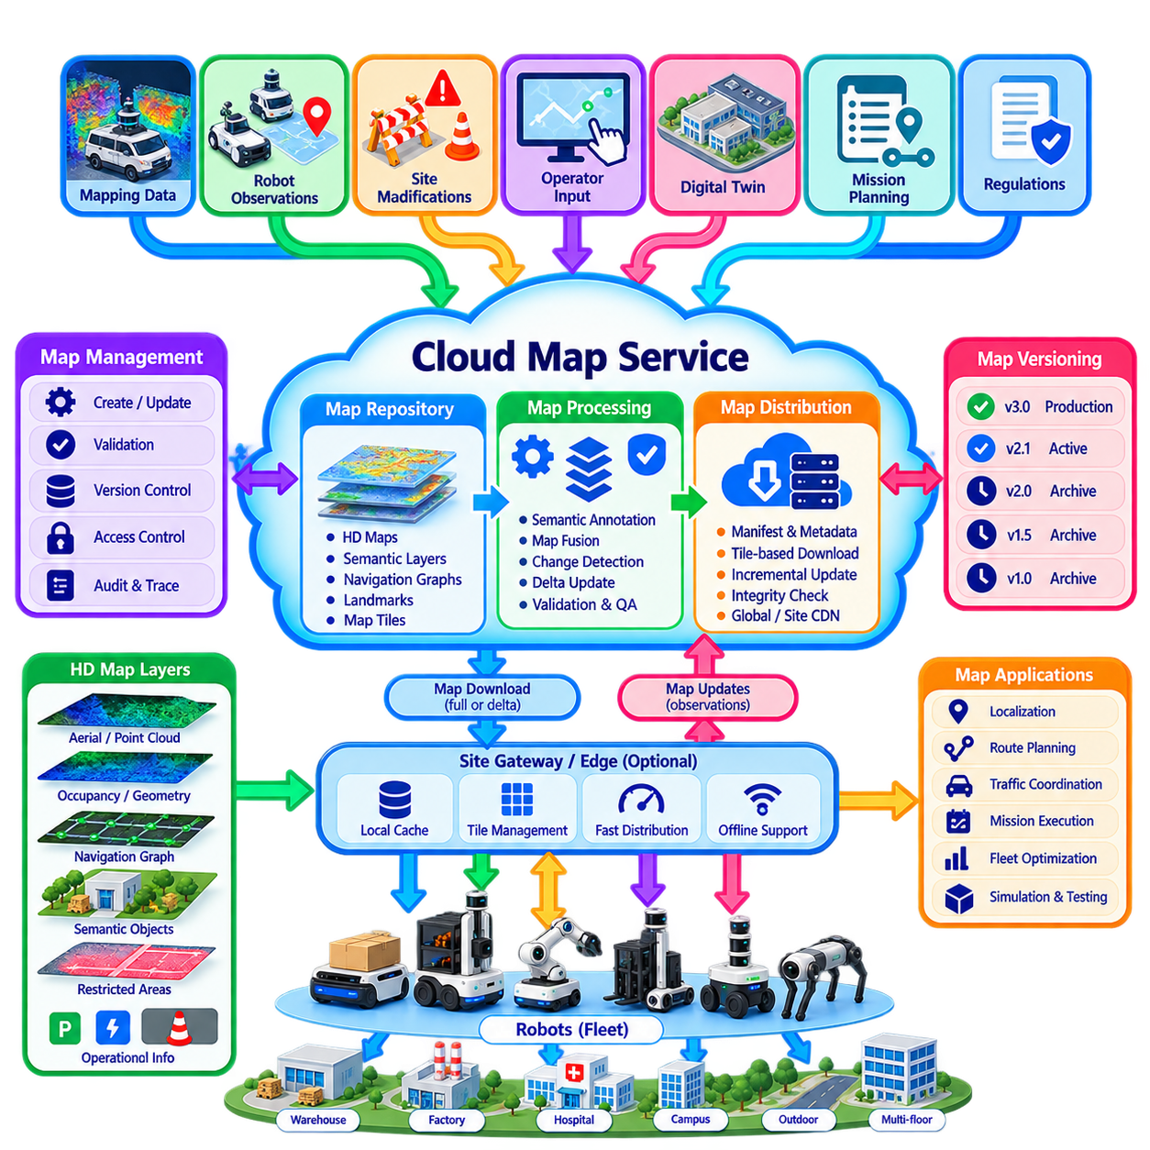
A cloud map service provides a centralized mechanism for creating, storing, versioning, validating, and distributing maps required by autonomous robot fleets. Instead of maintaining independent map files on every robot, the fleet uses a controlled map repository as a common source of truth. Robots and site controllers retrieve the map content appropriate to their location, mission, software configuration, and operational role, enabling consistent navigation across large and heterogeneous deployments.
For autonomous robots, a map is more than a geometric representation of the environment. It may contain occupancy information, point clouds, lane or path networks, landmarks, semantic regions, speed limits, restricted areas, docking locations, charging stations, elevators, doors, intersections, preferred routes, and other operational constraints. An HD map combines sufficiently detailed geometric and semantic information to support accurate localization, route planning, traffic coordination, and mission execution.
The cloud map service should separate map storage from real-time navigation. Localization, obstacle avoidance, trajectory generation, and immediate motion decisions remain on the robot or local edge system because these functions cannot depend on continuous cloud connectivity. The cloud manages authoritative map assets and their lifecycle, while robots download and cache the information required for local execution. This separation combines centralized governance with resilient autonomous operation.
Map data is commonly organized hierarchically according to geographic scope and functional purpose. A global representation may identify sites and large operational zones, while site maps describe buildings, roads, floors, yards, or production areas. More detailed layers can represent navigation graphs, semantic objects, localization landmarks, restricted regions, or robot-specific operational information. Layered organization allows robots to retrieve only the information relevant to their missions instead of downloading an entire mapping database.
Map version management is essential because physical environments and operational rules change over time. Every published map should have a unique identifier, version, creation time, coordinate reference, compatibility information, and lifecycle state. Draft maps may be created and validated before being promoted to production, while previous versions remain available for rollback and incident investigation. Robots should report the map version currently in use so that fleet services can detect inconsistent deployments.
Distribution should be based on explicit map manifests rather than uncontrolled file copying. A manifest can describe required files, layers, versions, dependencies, checksums, sizes, coordinate frames, and compatibility requirements. Before activating a downloaded map, the robot verifies its integrity and confirms that all required components are available. This prevents incomplete transfers or mismatched map layers from silently entering the navigation system and causing inconsistent behavior.
Large HD maps require efficient distribution strategies because repeatedly transferring complete datasets wastes bandwidth and increases deployment time. Maps can be divided into geographic tiles, logical regions, floors, routes, or semantic layers. A robot downloads the portions required for its current operating area and can prefetch neighboring regions before entering them. Frequently used content may be cached at a site gateway or edge server, reducing repeated WAN traffic when many robots operate on the same map.
Incremental update mechanisms further reduce communication overhead. When only a restricted zone, lane attribute, semantic object, or local geometric region changes, the service can distribute a delta instead of replacing the complete map. The robot applies the update against a known base version and verifies the resulting map state. Delta distribution is particularly valuable for large outdoor maps, multi-floor facilities, and geographically distributed fleets where full-map replacement would consume substantial bandwidth.
Map activation should be treated as a controlled operational transition. A newly downloaded map does not necessarily become active immediately because a robot may already be executing a mission using the previous version. The fleet system can define safe activation points, such as mission completion, arrival at a designated zone, robot restart, or operator approval. Coordinated activation prevents interacting robots from unexpectedly using incompatible traffic rules or navigation graphs in the same environment.
Cloud map services must also manage coordinate frames and geospatial references consistently. Indoor robots may use local Cartesian frames tied to building landmarks, while outdoor robots may rely on GNSS-referenced coordinates. Multi-floor facilities introduce additional transformations between floor, building, site, and robot frames. Metadata describing coordinate systems, origins, transformations, and calibration references is therefore as important as the map geometry itself when multiple robots and applications share spatial information.
Semantic map information provides operational meaning beyond geometry. A corridor can be marked as one-way, a doorway can include width and access constraints, a zone can specify speed limits, and a charging station can describe compatible robot types. Other areas may represent human-priority zones, hazardous regions, temporary construction areas, inspection points, or loading locations. Fleet planners can use these semantics to generate routes that satisfy operational policies rather than merely finding geometrically traversable paths.
Dynamic information should normally be distinguished from the relatively stable HD map. Temporary obstacles, moving people, short-term congestion, occupied docking stations, and rapidly changing traffic conditions are better represented through real-time state services or local perception. However, persistent environmental changes detected by robots can become candidates for map updates. Separating static, semi-static, and dynamic information prevents frequent map revisions while preserving awareness of current conditions.
Robots can contribute observations back to the cloud map pipeline. Localization residuals, newly detected structures, repeated path blockages, changed landmarks, or operator annotations may indicate that the current map no longer reflects reality. These observations should not automatically modify the production map. Instead, they can enter a map-change workflow where evidence is aggregated, reviewed, validated, and converted into a candidate revision before controlled publication.
Validation is critical because map errors can directly affect physical navigation. Automated checks can detect disconnected paths, overlapping restricted zones, invalid coordinates, missing dependencies, inconsistent lane directions, or incompatible semantic attributes. Simulation can test representative routes and missions before deployment, while staged rollout can expose a new map to a limited subset of robots. Operational telemetry then provides evidence about localization quality, route success, and unexpected navigation behavior.
Offline operation requires robots to maintain a locally usable map cache. If cloud connectivity disappears, active missions should continue using a validated local map according to defined policies. The robot may defer optional map updates until communication returns, while critical operational changes may require mission restriction or operator intervention. Cached maps should include sufficient metadata to determine their version, validity, expiration policy, and compatibility with the currently installed navigation software.
Security protects the map supply chain because malicious or accidental map modification can redirect robots or alter operational restrictions. Robots should authenticate map services, map packages should be protected by integrity checks or digital signatures, and access control should restrict who may create, approve, publish, or retrieve sensitive map content. Audit logs should record map revisions, approvals, downloads, and activation events so that navigation behavior can later be traced to the exact map configuration.
Multi-site fleets benefit from separating globally managed map governance from site-specific map content. A cloud platform can maintain common schemas, versioning rules, validation workflows, robot compatibility information, and distribution policies while individual sites own their local geometry and operational semantics. This allows hundreds of facilities to follow a consistent map lifecycle without forcing unrelated sites into a single monolithic spatial dataset.
The map service also connects naturally with digital twins, mission planning, telemetry, and fleet optimization. Digital twins can reference the same spatial entities used by navigation, mission planners can reason about zones and resources, and telemetry can be associated with precise map locations. Historical route performance can reveal congestion or unreliable areas, allowing planners and operators to refine map semantics, preferred routes, or operational policies based on accumulated fleet experience.
Cloud HD map distribution therefore forms a controlled spatial knowledge pipeline between physical environments and autonomous fleets. The cloud governs authoritative map versions, edge infrastructure accelerates distribution and caching, and robots retain validated local copies for real-time autonomy. Through versioning, layered representation, incremental updates, validation, secure delivery, and feedback from field operation, the map service enables geographically distributed robots to navigate from consistent spatial knowledge while remaining resilient to network failures and environmental change.

05.07 Remote Monitoring and Intervention System [w/Code]
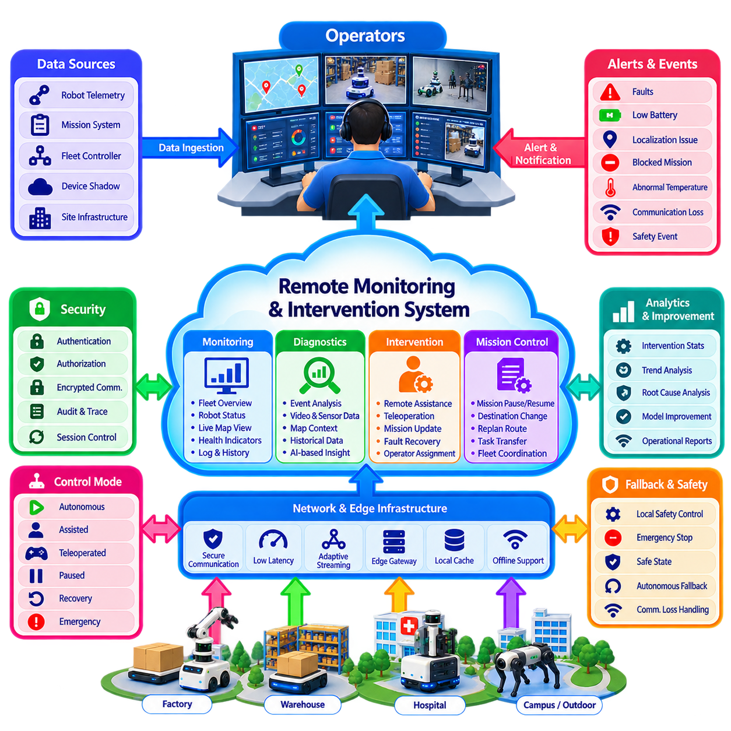
Remote monitoring and intervention systems provide human operators with fleet-level visibility and controlled mechanisms for assisting autonomous robots when normal autonomy cannot safely or efficiently resolve a situation. The objective is not continuous manual supervision of every robot, but exception-based operation in which robots work autonomously while operators focus on faults, uncertainty, blocked missions, safety events, and situations requiring human judgment.
The monitoring layer continuously aggregates robot state from telemetry, device shadows, mission services, fleet controllers, and site infrastructure. Operators need a concise representation of connectivity, operating mode, pose, battery state, mission progress, localization quality, safety status, faults, and software condition. Fleet-wide summaries should identify abnormal robots quickly while allowing an operator to progressively inspect detailed information only when investigation becomes necessary.
A remote operations center may supervise robots distributed across multiple buildings, campuses, factories, warehouses, or outdoor sites. Hierarchical views are therefore important. An operator can begin with organization or site-level status, move to a specific fleet, and then inspect an individual robot. Geographic maps, facility maps, mission overlays, alerts, and health indicators provide spatial and operational context without requiring direct access to every robot interface.
Monitoring information should distinguish live state from last-known state. A robot that has lost communication may still appear at its previous location unless freshness is explicitly represented. Connectivity state, last telemetry timestamp, message latency, and data age should therefore accompany critical information. This prevents operators from interpreting stale information as current reality and helps determine whether intervention is possible or whether local autonomous fallback behavior should remain in control.
Alert management converts large telemetry volumes into actionable operator attention. Battery anomalies, localization degradation, repeated path failures, blocked missions, sensor faults, communication loss, abnormal temperatures, safety events, and mission deadline risks can generate alerts. Severity, persistence, operational impact, and confidence should influence prioritization so that operators are not overwhelmed by large numbers of low-value notifications during fleet-scale operation.
An intervention workflow should begin with diagnosis rather than immediate manual control. The operator can inspect robot state, recent events, mission history, map context, sensor health, and relevant images or video before deciding how to respond. In many cases, intervention may consist of acknowledging an alert, retrying a mission step, changing a destination, clearing a recoverable fault, assigning another robot, or requesting local assistance without directly driving the robot.
Remote assistance and remote control should be treated as different levels of authority. Remote assistance provides high-level guidance such as selecting an alternative route, approving passage, identifying an object, modifying a mission, or confirming a recovery action. Remote control or teleoperation gives the operator more direct influence over robot motion. Systems should prefer the least intrusive intervention capable of resolving the problem, preserving autonomy whenever possible.
Teleoperation requires substantially stronger communication and safety mechanisms than ordinary monitoring. Video, robot state, control commands, and acknowledgements must be delivered with sufficiently predictable latency and quality. Network delay, jitter, packet loss, and bandwidth degradation can directly affect operator performance. The system should continuously evaluate communication quality and restrict or terminate remote driving when conditions fall outside the defined safe operating envelope.
Even during teleoperation, the robot should retain local safety authority. Remote steering commands should pass through onboard safety functions that enforce speed limits, collision avoidance, emergency stopping, geofencing, and actuator constraints. An operator should not be able to bypass certified or safety-critical protections through the normal remote interface. This creates a shared-control architecture in which humans provide intent while local systems preserve immediate physical safety.
Intervention authority should be governed by explicit modes and transitions. A robot may operate in autonomous, assisted, teleoperated, paused, recovery, or emergency states, with clear rules defining who has command authority in each mode. Transitioning from autonomy to remote control should require authentication, authorization, state verification, and acknowledgement. Returning control to autonomy should similarly confirm that the robot is positioned and configured appropriately for safe autonomous continuation.
Video and sensor streaming should be activated according to operational need rather than transmitted continuously from every robot. Routine fleet monitoring can rely on compact telemetry, while detailed camera streams, point clouds, audio, or diagnostic traces are requested when an incident requires deeper inspection. Adaptive bitrate, selective sensor activation, edge compression, and region-of-interest streaming can reduce network load while preserving the information required for effective intervention.
Multi-robot fleets require operator workload management. A remote operator cannot simultaneously perform detailed intervention for many robots, even if monitoring dashboards can display hundreds of devices. Intervention requests should therefore enter a prioritized queue based on safety severity, mission importance, waiting time, available local recovery options, and estimated operator effort. The system can automatically resolve routine cases while reserving human attention for situations where judgment adds value.
Operator-to-robot assignment can itself become a scheduling problem. Different robots, sites, and intervention types may require specialized training or permissions. A system can route requests according to operator availability, certification, language, site responsibility, robot type, and incident category. Escalation rules can transfer unresolved cases to specialists, maintenance teams, site personnel, or engineering support without losing the diagnostic context already collected.
Remote intervention should integrate with mission management rather than operate as an isolated console. If an operator changes a destination, pauses execution, selects an alternative path, or transfers a task to another robot, the mission service should record and propagate the resulting state transition. This prevents the cloud planner, local fleet controller, and operator interface from maintaining contradictory interpretations of what the robot is expected to accomplish.
Recording and auditability are essential because remote actions can affect physical assets and people. Intervention sessions should record operator identity, robot identity, timestamps, commands, mode transitions, mission changes, alerts, acknowledgements, and relevant system state. Where appropriate, selected video or sensor evidence can be associated with the incident. These records support safety investigation, operational improvement, training, accountability, and reconstruction of unusual events.
Cybersecurity must protect remote operations because an intervention interface represents a high-impact control surface. Strong operator authentication, role-based authorization, encrypted communication, device identity, session management, command integrity, and audit logging are fundamental. High-risk actions may require additional confirmation or dual authorization. Access should follow least-privilege principles so that monitoring permission does not automatically grant configuration or teleoperation authority.
Remote operation must also remain resilient to cloud or WAN failures. Robots should continue safe local behavior if the remote center becomes unavailable, while site controllers preserve essential coordination where possible. An active intervention session should define what happens when communication is lost, such as controlled stopping, autonomous recovery, or transition to a safe state. The correct fallback depends on robot type, environment, mission, and operational risk.
Digital twins and historical telemetry can improve intervention quality by providing context beyond current alarms. Operators may compare present motor current, localization uncertainty, battery behavior, or sensor health with historical patterns from the same robot or fleet. Maintenance records and recent software changes can further narrow possible causes. This converts remote monitoring from simple visualization into a diagnostic environment supported by accumulated fleet knowledge.
Intervention outcomes should feed continuous fleet improvement. Repeated operator actions can reveal weaknesses in navigation, perception, maps, mission policies, infrastructure interfaces, or recovery logic. Cases that repeatedly require the same human decision can become candidates for automated recovery rules or AI training data. Measuring intervention frequency, resolution time, operator workload, recurrence, and autonomous recovery success provides evidence for increasing autonomy systematically.
A mature remote monitoring and intervention architecture therefore creates a supervisory human layer above autonomous fleet operation rather than replacing autonomy with remote driving. Robots handle real-time perception and control, site systems coordinate local operations, cloud services provide fleet visibility and mission context, and operators intervene selectively when automation reaches its limits. Clear authority, secure communication, local safety enforcement, diagnostic context, and structured feedback allow human expertise to scale across increasingly large autonomous robot fleets.

05.08 Offline First Resilient Cloud Integration [w/Code]
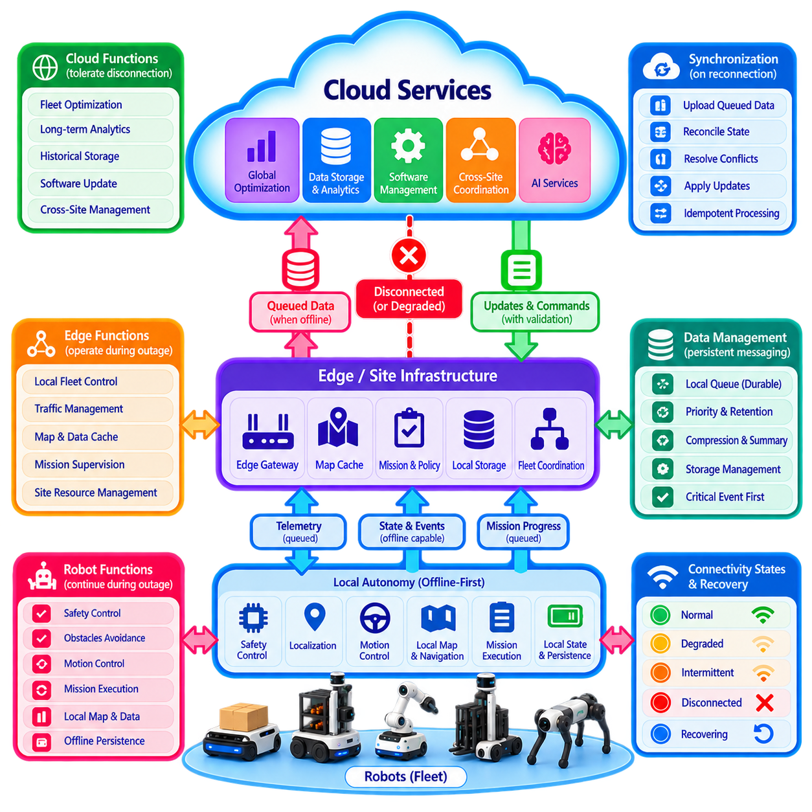
Offline-first resilient cloud integration is an architectural approach in which robots are designed to continue essential operation even when cloud connectivity becomes unavailable, unstable, or severely degraded. The cloud enhances coordination, analytics, storage, and optimization, but it is not treated as a prerequisite for immediate physical autonomy. This principle prevents temporary network failures from automatically becoming robot failures and establishes clear boundaries between local and remote responsibilities.
The architecture begins by classifying functions according to their dependency on connectivity. Safety control, localization, obstacle avoidance, motion control, and essential mission execution normally remain on the robot. Site-level traffic coordination, resource management, and fleet scheduling may operate on local edge infrastructure. Cloud services handle functions such as global optimization, long-term analytics, software management, historical storage, and cross-site coordination that can tolerate temporary disconnection.
Offline-first operation requires robots to maintain sufficient local state to continue meaningful work without continuously querying remote services. This state can include active mission definitions, relevant maps, navigation graphs, configuration, safety policies, robot identity, authorization information, and recently required operational data. Local persistence converts the robot from a thin cloud client into an autonomous execution node capable of maintaining controlled operation during communication interruptions.
A site edge layer can extend this resilience across multiple robots. An edge gateway or local fleet controller may cache maps, missions, configuration, device state, and operational policies while maintaining local robot-to-robot and infrastructure coordination. If the WAN connection to the cloud fails, robots can continue communicating with the site controller through the local network. This allows traffic management, charger allocation, mission supervision, and other site-critical functions to remain available.
Persistent messaging is a fundamental mechanism for resilient integration. Telemetry, mission events, diagnostic records, acknowledgements, and other outbound information that cannot reach the cloud should be written to durable local queues rather than discarded. When connectivity returns, stored messages can be transmitted according to priority and age. Critical safety or failure events may be uploaded first, while routine high-frequency telemetry can be summarized, compressed, or expired according to policy.
Cloud-to-robot communication requires similar protection. Commands, configuration updates, map revisions, and mission assignments should include unique identifiers, timestamps, revisions, expiration times, and acknowledgement requirements. A robot reconnecting after a long outage must not blindly execute every message that accumulated while it was offline. Expired or superseded instructions should be rejected, while still-valid requests should be reconciled against the robot's current physical and operational state.
Idempotency is especially important during reconnection because uncertain delivery frequently causes retries. If the cloud sends the same mission assignment multiple times, the robot should recognize the request identifier and avoid executing the mission repeatedly. The same principle applies to configuration changes, acknowledgements, and state updates. Idempotent interfaces make communication retries safe and reduce the risk that recovery from a network failure creates duplicated physical actions.
State synchronization after reconnection is more complex than simply uploading queued messages. During an outage, the robot may have completed missions, changed position, consumed energy, encountered faults, or entered a different operating mode. Meanwhile, cloud-side applications may have modified desired state or reassigned work. Reconciliation must therefore compare local actual state, cloud desired state, revision history, timestamps, and authority rules before deciding which information should prevail.
Conflict resolution policies should be defined before failures occur. Some properties may use cloud authority, while others must preserve robot-reported physical truth. For example, the cloud may remain authoritative for future mission priorities, but the robot is authoritative regarding its actual pose, battery condition, completed actions, and locally detected faults. Explicit ownership prevents generic last-write-wins logic from replacing physically valid information with stale remote assumptions.
The system should distinguish several connectivity conditions rather than using only online and offline states. Normal, degraded, intermittent, disconnected, and recovering modes can trigger different operational policies. Under degraded connectivity, the robot may reduce nonessential telemetry or disable cloud-dependent features while continuing missions. During complete disconnection, it can rely entirely on local capabilities. Recovery mode can temporarily restrict new assignments until synchronization and consistency checks are complete.
Mission policies determine how much autonomy remains available during an outage. A robot may be allowed to complete an already accepted mission, continue tasks within a validated local map, return to a safe location, or perform predefined repetitive work. Other missions may require cloud authorization or external resources and therefore be suspended. The permitted behavior should depend on mission risk, environment, available local information, and the consequences of operating with potentially outdated global knowledge.
Data freshness becomes critical when cached information is used offline. Maps, credentials, configuration, safety policies, mission parameters, and semantic information should carry versions and validity information. Some data may remain usable indefinitely until replaced, while other data should expire after a defined interval. The robot must be able to determine whether cached information remains acceptable for operation instead of assuming that locally available data is automatically trustworthy.
Storage management is necessary because prolonged disconnection can fill local disks. Offline buffers should therefore apply quotas, priorities, compression, aggregation, and retention policies. Critical incident records and mission evidence may receive protected storage, while redundant telemetry can be downsampled or deleted first. Storage pressure itself should become an observable system condition so that the robot can modify data collection behavior before local resources are exhausted.
Bandwidth-aware recovery prevents reconnection from creating a second failure. If many robots simultaneously reconnect after a site outage, unrestricted synchronization can overload the WAN, cloud ingestion services, or local network. Uploads should therefore be prioritized, rate-limited, and potentially staggered. Current state and critical events can be synchronized first, followed by mission history and operational telemetry, while large sensor datasets are transferred later when sufficient bandwidth is available.
Local fallback must also apply to cloud AI and optimization services. When a large remote model or global planner cannot be reached, the robot may use a smaller local model, deterministic rules, previously validated plans, or edge-hosted services. The fallback may provide lower performance or reduced functionality, but its behavior should remain predictable. Resilience means maintaining a known operational envelope rather than attempting to reproduce every cloud capability locally.
Security requirements remain active during offline operation. Cached credentials, mission data, maps, and configuration must be protected locally, while reconnection should re-establish authenticated and encrypted communication before synchronization begins. Credentials may expire during extended outages, creating a difficult balance between security and availability. Architectures should define renewal, grace-period, recovery, and revocation policies appropriate to the operational risk instead of bypassing authentication when connectivity becomes inconvenient.
Observability must include the behavior of the resilience mechanisms themselves. Useful metrics include disconnection duration, queue depth, dropped or summarized records, local storage consumption, retry counts, synchronization latency, reconciliation conflicts, and time required to return to normal operation. These measurements reveal whether the offline design works under real conditions and help engineers identify hidden cloud dependencies that only appear during network failures.
Resilience should be verified through deliberate fault testing rather than assumed from architecture diagrams. Engineers can disconnect WAN links, introduce latency and packet loss, restart gateways, make cloud services unavailable, exhaust local queues, and reconnect multiple robots simultaneously. Tests should verify safe mission behavior, persistence, duplicate prevention, conflict resolution, synchronization ordering, and recovery. Repeated fault injection exposes dependencies that normal connected operation can conceal.
A robust deployment also considers failures beyond complete Internet loss. DNS failure, expired certificates, unreachable authentication services, partial API outages, message broker disruption, high latency, asymmetric connectivity, and cloud-region failures can each produce different symptoms. Designing around only a simple disconnected state leaves important failure modes untreated. Dependency isolation, local caching, bounded retries, circuit breakers, and explicit degraded modes help contain these partial failures.
Offline-first integration ultimately changes the relationship between robots and the cloud. Robots and site systems remain responsible for maintaining safe and useful physical operation, while the cloud provides scalable intelligence, fleet-wide coordination, historical knowledge, and management capabilities whenever connectivity permits. Synchronization becomes a controlled exchange between independently functioning systems rather than a continuous dependency required for every action.
The resulting architecture provides graceful degradation instead of abrupt loss of capability. During normal connectivity, robots benefit from cloud planning, shared data, AI services, and global optimization. During disruption, they continue within a defined local operational envelope, preserve important state, and record events. When connectivity returns, controlled reconciliation restores a consistent fleet view. This combination of autonomy, persistence, synchronization, fallback, and recovery forms the foundation of resilient cloud-integrated robot fleets.

05.09 Cloud Integration Security IAM Robot Identity
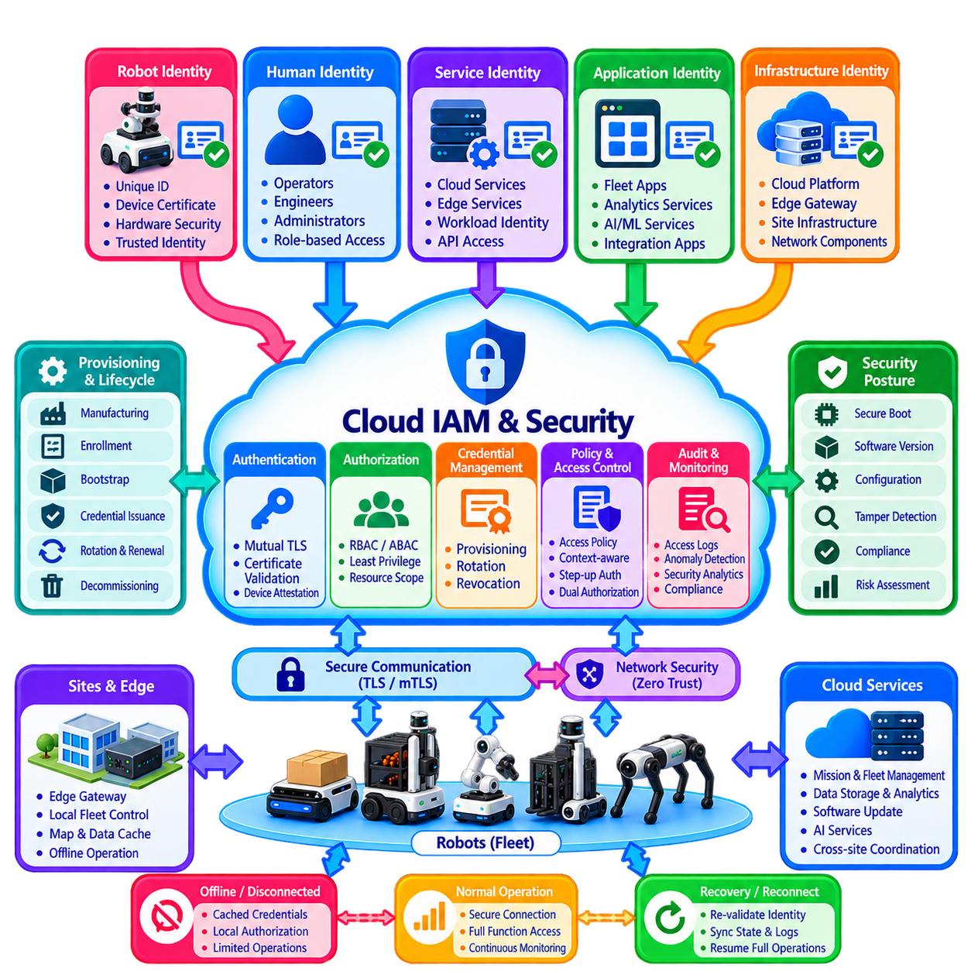
Cloud integration security for autonomous robots begins with a fundamental principle: every robot, service, operator, application, and infrastructure component must have a verifiable identity before it can participate in the system. A robot connected to cloud services is not merely a network endpoint but a physical cyber-physical asset capable of sensing and acting in the real world. Identity and Access Management, therefore, becomes a core architectural layer rather than an administrative feature.
Robot identity should be unique, persistent, and cryptographically verifiable throughout the operational lifecycle. Each robot can be assigned a globally unique device identifier associated with hardware type, ownership, site, fleet, software configuration, and security credentials. Human-readable names may change as robots move between sites or operational groups, but the underlying cryptographic identity should remain controlled so that cloud services can reliably determine which physical device is communicating.
Cryptographic credentials provide stronger identity assurance than identifiers alone. A robot may hold a device certificate and private key stored within a Trusted Platform Module, Hardware Security Module, secure element, or another protected credential store. During connection establishment, the robot proves possession of its private key without transmitting that key. The cloud validates the corresponding certificate chain and determines whether the device is trusted before accepting telemetry, missions, configuration requests, or other interactions.
Mutual authentication should normally protect robot-to-cloud communication. Transport Layer Security can authenticate the cloud endpoint to the robot, while mutual TLS additionally authenticates the robot to the cloud. This prevents a robot from unknowingly connecting to an unauthorized service and prevents an attacker from impersonating a legitimate robot using only a copied device identifier. Authentication establishes identity, while subsequent authorization determines what the authenticated entity is permitted to perform.
Identity and Access Management should distinguish different principal types instead of placing robots, users, and services under one undifferentiated permission model. Robot identities represent physical devices, workload identities represent cloud or edge software services, and human identities represent operators, engineers, administrators, and maintenance personnel. Each principal type has different lifecycle, authentication, privilege, and auditing requirements, even when all ultimately access the same fleet platform.
Authorization should follow the principle of least privilege. A robot that only needs to publish telemetry and receive missions should not automatically receive permission to modify fleet policies, access other robots, or administer cloud resources. Similarly, an analytics service may require read access to historical telemetry without having authority to dispatch missions. Narrow permissions reduce the impact of compromised credentials and prevent accidental operations from propagating across the fleet.
Role-Based Access Control can simplify permission management by assigning privileges according to operational roles such as fleet operator, maintenance engineer, site administrator, security auditor, or robot service. Attribute-Based Access Control can add contextual rules using site, robot type, mission, organization, environment, time, or security posture. Combining role and attribute information enables policies such as allowing an operator to intervene only on robots assigned to authorized sites.
Cloud authorization should also consider resource hierarchy. An organization may contain regions, sites, fleets, robot groups, individual robots, maps, missions, datasets, and applications. Permissions inherited at higher levels can simplify administration, but broad inheritance creates risk if boundaries are poorly designed. Sensitive actions should therefore support explicit scoping so that access to one site or robot group does not unintentionally grant authority over the complete global deployment.
Robot provisioning establishes trusted identity before normal operation begins. During manufacturing, commissioning, or site enrollment, a robot receives an initial identity and securely establishes operational credentials. Bootstrap credentials should have limited purpose and lifetime because they may exist before the robot reaches its final ownership or site context. After successful enrollment, the robot can obtain production credentials associated with its verified device record and approved operational role.
Credential rotation is necessary because long-lived secrets increase security exposure. Certificates, tokens, keys, and service credentials should have defined validity periods and renewal mechanisms. Rotation should occur without unnecessarily interrupting robot operation, while compromised credentials must be revocable before normal expiration. Fleet-scale automation is important because manually replacing credentials across hundreds or thousands of robots creates operational risk and encourages excessively long credential lifetimes.
Offline-first operation introduces additional identity challenges. A robot may remain disconnected long enough for certificates or authorization information to become outdated. Local systems therefore need clearly defined policies for cached credentials, expiration, grace periods, and restricted offline permissions. Offline availability should not become a reason to disable authentication entirely. Instead, robots should continue within a predefined local trust envelope and revalidate cloud authority when secure connectivity returns.
Service-to-service identity is as important as robot identity. Mission planners, telemetry pipelines, map services, digital twins, AI inference systems, remote-operation services, and software deployment components should authenticate using dedicated workload identities rather than shared application secrets. A compromised analytics process should not automatically inherit the privileges of mission control simply because both services execute within the same cloud environment.
Zero Trust principles provide a useful model for robot-cloud integration. Network location alone should not establish trust, whether a request originates from a robot VLAN, site network, VPN, edge server, or cloud subnet. Each request should be evaluated using authenticated identity, authorization policy, device or workload context, and requested resource. This limits lateral movement if one robot, gateway, user account, or cloud workload becomes compromised.
Privileged operations require stronger controls than routine telemetry access. Remote control, emergency policy changes, software deployment, credential administration, map publication, safety-related configuration, and fleet-wide mission modification may justify step-up authentication, approval workflows, short-lived privileges, or dual authorization. Separating routine monitoring privileges from high-impact control privileges reduces the possibility that a compromised operator session can immediately influence physical fleet behavior.
Robot identity should also be connected to device security posture. Authentication proves which robot is communicating, but it does not necessarily prove that the robot remains trustworthy. Cloud services can consider software version, secure boot status, certificate condition, configuration compliance, detected tampering, or other attestation evidence before granting sensitive permissions. A robot with an outdated or compromised software state may retain limited telemetry access while losing authority to perform higher-risk operations.
Secrets should never be treated as ordinary configuration data. Private keys, API credentials, enrollment tokens, and recovery secrets require protected storage and controlled retrieval. Secrets embedded in source code, container images, configuration repositories, or unencrypted robot files are difficult to rotate and easy to expose. Hardware-backed key storage and centralized secrets management reduce unnecessary secret distribution while supporting automated credential lifecycle management.
Auditability connects IAM decisions with operational accountability. Authentication attempts, authorization decisions, credential issuance, revocation, role changes, privileged commands, remote interventions, and policy modifications should generate security records containing identity, time, resource, action, and result. These records allow investigators to reconstruct whether an unusual robot behavior resulted from autonomous operation, an authorized human action, compromised credentials, or an unauthorized request.
Monitoring should identify identity-related anomalies rather than only recording successful access. Repeated authentication failures, access from unexpected sites, abnormal certificate usage, unusual service-to-service calls, rapid privilege changes, or one identity controlling an unexpected number of robots may indicate compromise. Security analytics can correlate IAM events with robot telemetry, mission history, network activity, and software changes to provide stronger evidence than isolated security logs.
Incident response requires the ability to isolate compromised identities without disabling the entire fleet. A single robot certificate can be revoked, an operator account suspended, a workload identity restricted, or a site gateway quarantined while unaffected systems continue operating. Segmentation of identities and permissions therefore improves both security and resilience. Shared fleet-wide credentials should be avoided because compromising one secret can otherwise require emergency replacement across every deployed robot.
The complete security architecture creates a chain of trust from physical robot hardware through edge infrastructure to cloud services and human operators. Robot identity establishes which physical device is communicating, authentication verifies that identity, authorization limits permitted actions, credential management preserves trust over time, and auditing records consequential activity. These mechanisms should operate consistently across telemetry, mission dispatch, maps, AI services, software updates, and remote intervention.
Cloud integration security is therefore not achieved by adding authentication at a single API gateway. It requires lifecycle management of machine and human identities, hardware-protected credentials, mutual authentication, least-privilege authorization, controlled provisioning, automated rotation, revocation, workload identity, security posture assessment, and auditable privileged operations. Together, these mechanisms allow cloud-connected robot fleets to scale without allowing connectivity and centralized management to become uncontrolled paths into physical systems.

05.10 Multi Site Fleet Cloud Integration Case
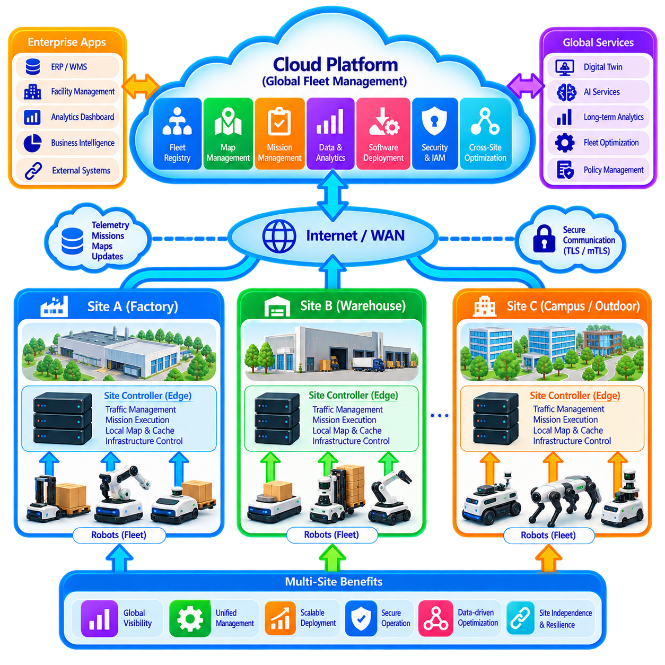
A multi-site fleet cloud integration architecture coordinates autonomous robots operating across geographically separated facilities while preserving the ability of each site to function independently. The cloud provides a global management plane for fleet visibility, identity, software, data, maps, policies, and optimization, while site-level systems manage local execution. This separation enables centralized governance without making every physical operation dependent on continuous wide-area connectivity.
Consider an enterprise operating robot fleets across factories, warehouses, logistics centers, campuses, and outdoor facilities. Each site may contain different robot models, maps, infrastructure interfaces, network conditions, and operational processes. A common cloud platform provides a standardized integration layer above these differences, allowing enterprise applications to interact with sites through consistent APIs, mission models, security policies, telemetry schemas, and lifecycle mechanisms.
Each site contains a local fleet-control layer responsible for immediate operational coordination. Robots perform localization, perception, obstacle avoidance, motion control, and safety functions onboard, while the site controller coordinates traffic, missions, charging resources, elevators, doors, and shared infrastructure. The cloud supervises multiple sites at a higher level but does not participate directly in the real-time motion-control loop of individual robots.
The cloud maintains a global fleet registry describing robots, sites, capabilities, ownership, software versions, operational status, and lifecycle information. Each robot has a persistent identity linked to its assigned organization and site. Site membership can change when equipment is relocated, but the underlying identity and historical records remain traceable. This registry provides the foundation for fleet-wide inventory management, security, configuration, and operational reporting.
Mission integration is divided between global intent and local execution. Enterprise systems can create transportation, inspection, patrol, delivery, or production-support requests through cloud APIs. The cloud identifies the appropriate site and forwards normalized mission objectives to its local fleet controller. The site system then selects robots, reserves local resources, resolves traffic conflicts, and supervises execution according to conditions that may not be visible to the global platform.
Cloud-based optimization can compare demand and capacity across sites without attempting to control every local movement. Historical throughput, robot utilization, charging behavior, mission backlog, failure rates, and maintenance conditions can reveal whether one facility is under-resourced while another has spare capacity. These insights support workforce planning, robot relocation, maintenance scheduling, infrastructure investment, and long-term fleet expansion decisions.
Map management follows a similar global-local division. The cloud provides common schemas, versioning, validation, approval workflows, and distribution mechanisms, while each site maintains its own geometric and semantic map content. Robots download validated map packages appropriate to their operating area and cache them locally. Map revisions can be tested and activated site by site, preventing a change in one facility from unnecessarily affecting unrelated deployments.
Telemetry from every site is streamed toward a shared cloud data platform using common schemas and contextual metadata. Robot identity, site, mission, software version, timestamps, and message type allow records from different deployments to be interpreted consistently. High-frequency sensor data can be filtered or summarized locally, while operational events and selected datasets are transmitted to cloud storage for analytics, diagnostics, AI development, and fleet-wide comparison.
A centralized data lake creates value by combining operational experience from multiple environments. A navigation failure that appears rare at one site may become statistically significant when similar events are observed across dozens of deployments. Maintenance trends, battery degradation, sensor failures, mission delays, and software regressions can be analyzed across robot populations. Multi-site data therefore enables learning that would remain difficult if each facility operated as an isolated data silo.
Software and configuration management also benefit from centralized control. The cloud can maintain approved software releases, configuration baselines, compatibility rules, and deployment groups. New software may first be deployed to a test fleet or selected site before gradually expanding to additional facilities. Canary deployment and staged rollout reduce risk, while rollback mechanisms allow affected sites to return to a previously validated version if operational problems emerge.
Site-specific differences must remain explicit rather than being hidden by standardization. A warehouse may require narrow-aisle traffic policies, while an outdoor patrol site may depend on GNSS, weather information, and larger safety zones. Cloud policy models should therefore support inheritance and override. Enterprise-wide security and lifecycle requirements can remain mandatory, while operational parameters can be specialized according to site, robot type, environment, or mission.
Identity and access management establishes trust boundaries across the deployment. Robots, site gateways, cloud workloads, applications, and human operators use distinct authenticated identities. Authorization can be scoped by organization, region, site, fleet, robot, or service. A maintenance engineer assigned to one facility should not automatically gain control authority over robots elsewhere, while centralized security administrators may retain broader auditing or policy responsibilities.
Remote monitoring provides enterprise operators with global visibility without requiring them to continuously supervise every robot. A global dashboard can summarize site availability, robot health, mission performance, connectivity, incidents, and software status. Operators can drill down from organization level to a site and then to an individual robot. Intervention remains exception-based, with local autonomy and site personnel handling routine physical operation whenever possible.
WAN connectivity is treated as an unreliable dependency rather than a guaranteed control channel. If a site loses cloud connectivity, accepted missions, local maps, robot coordination, charging management, and safety functions continue according to predefined offline policies. Telemetry and mission events are written to persistent local queues. Cloud-dependent functions such as cross-site analytics or centralized optimization may temporarily become unavailable without stopping essential site operation.
When connectivity returns, synchronization occurs in a controlled sequence. The site first re-establishes authenticated communication and reports current robot and mission states. Critical events and operational changes are reconciled before routine historical telemetry is uploaded. Cloud commands accumulated during the outage are checked for revision, validity, and expiration before execution. Idempotent interfaces prevent repeated messages from producing duplicated missions or configuration changes.
Conflict resolution becomes important because both cloud and site systems may change state while disconnected. The site remains authoritative for physical facts such as completed missions, actual robot positions, faults, and energy consumption. The cloud may remain authoritative for future policies, approved software, or enterprise priorities. Explicit ownership rules and revision histories prevent synchronization from replacing valid local reality with stale global assumptions.
Multi-site resilience also requires failure isolation. A software problem, network outage, security incident, or overloaded service affecting one site should not propagate automatically to every facility. Sites can be segmented by identity, network, deployment group, and operational policy. Cloud services should similarly isolate workloads and apply quotas so that abnormal telemetry or request volume from one facility does not exhaust resources required by other fleets.
Security monitoring benefits from the global view. Authentication failures, unusual remote-control activity, unexpected software versions, abnormal service access, or suspicious robot behavior can be correlated across sites. At the same time, containment should remain granular. A compromised robot identity, gateway, user account, or individual site can be restricted without disabling unrelated operations, preserving fleet availability while incident response proceeds.
Digital twins provide a consistent representation of robots and sites above heterogeneous physical implementations. A global twin model can link each robot to configuration, mission history, maintenance records, software state, map references, and operational metrics. Site-specific information remains associated with the same identity structure, enabling enterprise applications to compare performance without assuming that every robot or facility exposes identical hardware or capabilities.
Cloud AI services can exploit multi-site experience while remaining outside safety-critical control. Models may analyze fleet telemetry, identify recurring failures, predict maintenance needs, optimize mission policies, or evaluate unusual operational events. Improvements derived from combined data can be validated centrally and deployed selectively to appropriate sites. Local fallback models and deterministic policies preserve operation when cloud AI services are unavailable.
The resulting architecture creates a hierarchy of responsibility rather than a single centralized robot controller. Robots own immediate physical autonomy and safety, site systems own local coordination and resource management, and the cloud owns global governance, data aggregation, lifecycle management, cross-site visibility, and long-horizon optimization. Enterprise applications interact with this hierarchy through standardized interfaces instead of directly controlling individual robots.
A successful multi-site integration case therefore combines global consistency with local independence. Common identity, telemetry, mission, map, software, security, and data-management mechanisms create an enterprise-wide fleet platform, while local controllers preserve site-specific execution and resilience. This balance allows organizations to expand from a single robot deployment to many geographically distributed fleets without turning the cloud into a single operational dependency or forcing every facility into an identical physical architecture.

