Volume 16 Multi Robot and Fleet Intelligence

03. Multi Robot Coordination

03.01 Multi Robot Coordination Architectures and Patterns
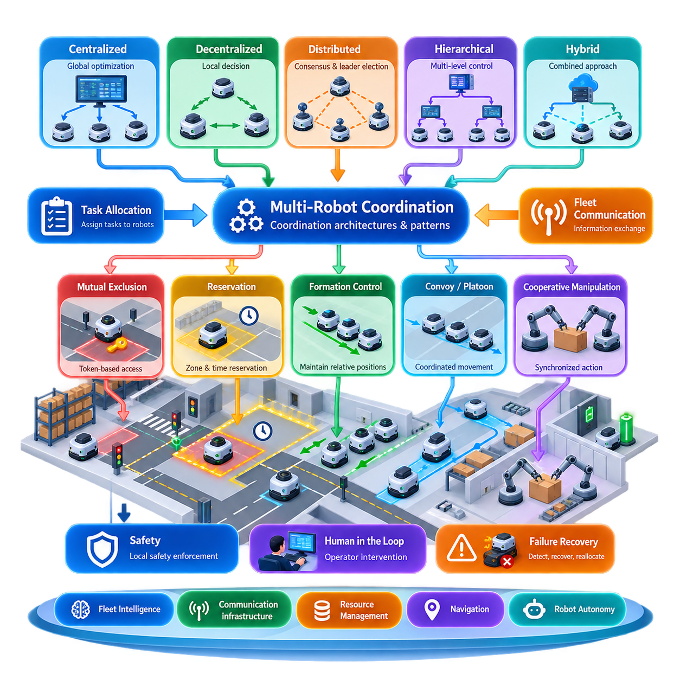
Multi-robot coordination defines the mechanisms through which multiple autonomous robots operate as a coherent system rather than as isolated machines. While task allocation determines which robot should perform a task, coordination determines how robots execute their assigned activities without creating conflicts, deadlocks, unsafe interactions, or unnecessary delays. It therefore connects individual autonomy with fleet-level operational behavior. :chatgpt-content-reference{index=“0”}
A coordination architecture establishes where decisions are made, how information is exchanged, and which authority resolves conflicts. The major architectural patterns are centralized, decentralized, distributed, and hierarchical coordination. These patterns are not merely communication topologies; they define how responsibility for traffic, resources, synchronization, safety constraints, and collective behavior is divided across robots and supervisory systems.
In a centralized architecture, a fleet coordinator maintains a global representation of robot states, missions, routes, and shared resources. Robots report their current state to the coordinator, which evaluates interactions and issues coordination decisions. This model simplifies global optimization because one component can observe the operational system as a whole and resolve competing requests according to fleet-wide priorities.
Centralized coordination is particularly attractive for structured industrial environments such as warehouses, factories, hospitals, and logistics facilities. A central controller can manage intersections, narrow corridors, elevators, loading stations, chargers, and work cells while considering mission priorities. However, increasing fleet size raises computation, communication, and availability requirements, making scalability and fault tolerance essential design concerns.
Decentralized coordination places substantially more decision authority on individual robots. Each robot observes nearby agents, exchanges relevant state information, and determines its behavior according to common coordination rules. Instead of relying continuously on a global controller, robots can negotiate access to resources, adapt their motion, maintain formations, or react to local conflicts using peer-to-peer information and locally executed algorithms.
This pattern can improve resilience because the loss of one coordination node does not necessarily disable the entire fleet. It is also useful when communication with central infrastructure is intermittent or when robots operate across large environments. The difficulty is maintaining globally desirable behavior from local decisions. Incomplete observations, communication delays, inconsistent states, and simultaneous decisions can produce oscillation, congestion, or coordination conflicts.
Distributed coordination combines autonomous decision-making with explicit information sharing among multiple computational participants. Consensus algorithms can establish agreement on shared variables, while leader-election mechanisms dynamically designate a robot or controller to coordinate a particular operation. The chapter structure therefore naturally progresses from architectural patterns toward distributed consensus and leader election as concrete coordination mechanisms. :chatgpt-content-reference{index=“1”}
Hierarchical architectures divide coordination into multiple decision levels. A fleet-level supervisor may assign operational objectives and global constraints, while regional controllers coordinate traffic within zones and individual robots execute local navigation and collision avoidance. Such decomposition allows different decisions to operate at appropriate spatial and temporal scales instead of forcing every interaction through either a completely centralized or completely decentralized mechanism.
Hybrid coordination is often practical for production fleets because different operational problems require different degrees of central authority. Global mission scheduling may be centralized, shared-resource arbitration may use distributed reservation, and immediate collision avoidance may remain entirely local. The architecture can therefore preserve fleet-level optimization while allowing robots to respond rapidly to nearby hazards without waiting for a remote decision.
A fundamental coordination pattern is mutual exclusion. When only one robot can safely occupy or use a resource, the system must guarantee exclusive access. A logical token can represent permission to enter an intersection, narrow aisle, elevator, docking station, or manipulation workspace. Only the robot holding the valid token proceeds, while other robots wait or negotiate for subsequent ownership. Token-based mutual exclusion is explicitly developed as a subsequent topic in this chapter. :chatgpt-content-reference{index=“2”}
Reservation is a related pattern that introduces space and time into resource allocation. Instead of simply locking a resource, robots reserve zones, route segments, or facilities for predicted intervals. A traffic controller can reject overlapping reservations or shift arrival times to prevent conflicts before robots physically encounter one another. Zone-based traffic control is especially useful where predictable industrial traffic flows make shared areas clearly identifiable.
Coordination may also require robots to preserve geometric relationships rather than merely avoid conflicts. Formation control maintains desired relative positions among robots, while convoy and platoon control coordinates robots moving along common routes. These patterns require continuous state exchange and dynamic adjustment because errors in one robot's velocity or trajectory can propagate through the coordinated group. Both appear as dedicated extensions of the chapter architecture. :chatgpt-content-reference{index=“3”}
Cooperative manipulation introduces tighter synchronization requirements. Two or more robots participating in assembly, transport, inspection, or pick-and-place operations may need to coordinate poses, timing, task phases, and shared workspace access. Coordination then extends beyond mobile traffic management into synchronized physical action, where a delayed or incorrectly sequenced robot can invalidate the entire operation or create a safety hazard.
Communication and coordination are consequently inseparable. Robots need sufficiently current information about neighboring positions, velocities, intentions, resource ownership, and operational states. Yet a robust architecture cannot assume perfect communication. Messages may be delayed, reordered, duplicated, or lost, so coordination protocols require timestamps, sequence information, timeouts, leases, acknowledgments, and conservative fallback behaviors where appropriate.
Intent sharing is especially important because current position alone does not reveal what another robot will do next. Broadcasting a planned trajectory, target zone, reservation request, or maneuver state allows other robots to anticipate future interactions. This converts coordination from purely reactive collision avoidance into predictive cooperation, reducing unnecessary stopping and enabling smoother traffic in dense fleets.
Safety must remain locally enforceable even when higher-level coordination exists. A fleet controller may authorize a route or reservation, but the robot should still reject motion that violates its immediate safety constraints. This separation prevents stale global information or network failures from directly commanding unsafe behavior. High-level coordination grants operational permission, while onboard safety and motion control retain final responsibility for physically executable actions.
Human intervention forms another layer of the coordination architecture. Operators may need to stop robots, release blocked resources, modify priorities, reroute missions, or recover abnormal situations. Such intervention must itself be coordinated so that a manual command affecting one robot does not invalidate assumptions held by other robots. The chapter therefore includes human-in-the-loop override as part of coordinated fleet operation rather than treating it as an external exception. :chatgpt-content-reference{index=“4”}
Failure recovery is equally architectural. A robot can fail while holding a token, occupying a reserved zone, leading a formation, or participating in synchronized work. Coordination mechanisms must detect missing heartbeats or expired leases, invalidate obsolete ownership, reconstruct shared state, and safely redistribute responsibilities. Recovery rules should therefore be designed together with the normal coordination protocol rather than added after deployment.
The appropriate architecture ultimately depends on fleet scale, robot heterogeneity, environment structure, communication quality, safety requirements, and the degree of interaction among missions. No single pattern is universally optimal. Effective systems usually compose several mechanisms, selecting centralized optimization where global knowledge matters, distributed agreement where resilience matters, and local autonomy where response latency and physical safety dominate.
Multi-robot coordination should therefore be understood as a layered contract among fleet intelligence, communication infrastructure, resource management, navigation, and robot-level autonomy. The broader volume places it between robot task allocation and fleet communication, emphasizing this bridging role: tasks first establish responsibility, coordination governs collective execution, and communication provides the information pathways required to sustain that execution across the fleet.

03.02 Distributed Consensus and Leader Election [w/Code]
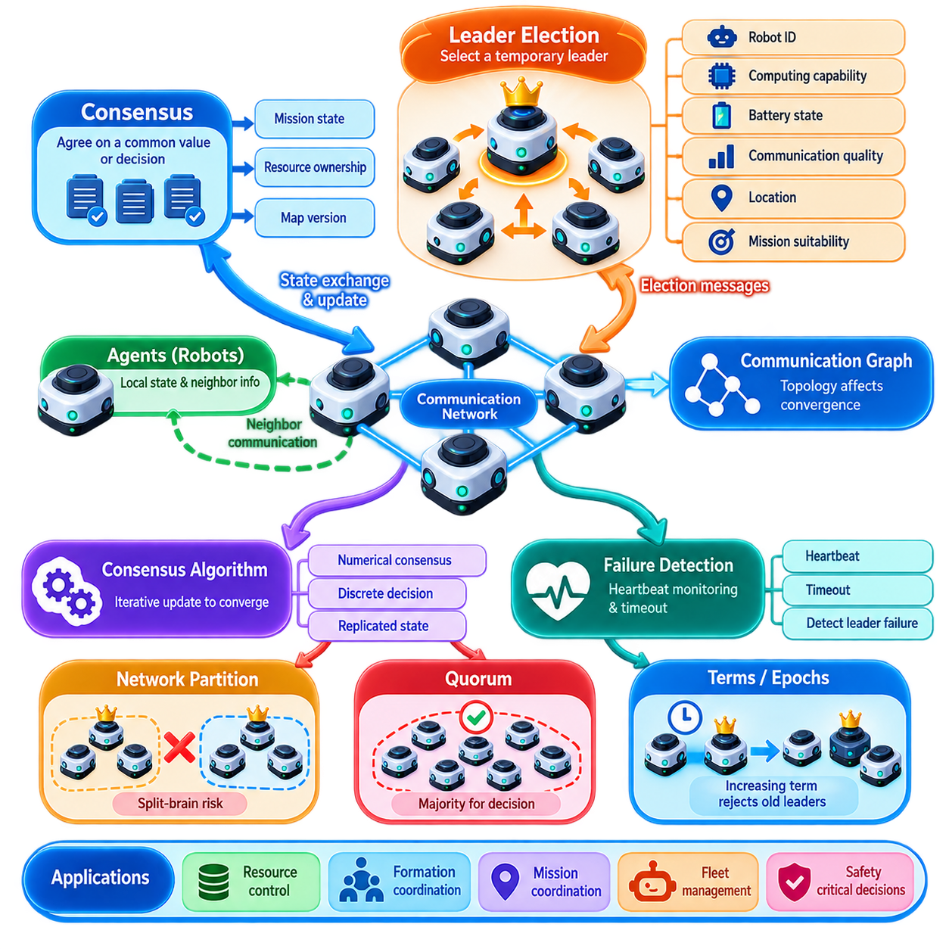
Distributed consensus is the process by which multiple robots or computational nodes establish a sufficiently consistent decision without depending on a permanently centralized authority. In multi-robot systems, consensus may concern a shared mission state, resource ownership, coordination mode, formation reference, map version, or selected coordinator. The objective is not simply communication, but agreement despite asynchronous execution and partial failures.
A distributed robot fleet can be modeled as a network of agents connected by communication links. Each robot maintains local state and receives information from a subset of other robots, often called its neighbors. The resulting communication graph determines which information can propagate through the fleet. Consensus becomes possible when the graph provides sufficient connectivity for relevant states and decisions to reach participating agents.
Consensus algorithms repeatedly combine locally available information so that individual states converge toward a common value or compatible decision. A simple numerical consensus rule updates each robot's estimate using its own value and those received from neighboring robots. Repeated exchanges gradually reduce disagreement. More sophisticated protocols extend this principle to discrete decisions, replicated state, distributed coordination, and fault-tolerant agreement.
The distinction between consensus and synchronization is important. Synchronization attempts to align variables such as time, velocity, phase, or motion, whereas consensus establishes agreement about a value, state, or decision. The two mechanisms frequently interact. A robot formation, for example, may require consensus about the desired formation mode while simultaneously synchronizing motion among participating robots.
Consensus performance depends strongly on communication topology. Fully connected networks can distribute information rapidly but require many communication links, while sparse topologies reduce bandwidth requirements at the cost of slower convergence and greater sensitivity to link failures. Dynamic robot fleets complicate this further because connectivity changes as robots move, obstacles block wireless paths, or robots temporarily leave communication range.
Leader election addresses situations in which one participant must temporarily assume a distinguished coordination role. Instead of configuring a permanent central controller, robots execute a protocol that selects one eligible node as leader. The leader may coordinate a mission, serialize access to a shared resource, provide a formation reference, aggregate information, or represent a robot group when communicating with another subsystem.
A leader-election protocol generally requires each participating robot to possess an identity and sufficient information to determine whether another candidate has higher priority. Selection can use a unique robot identifier, computational capability, battery state, communication quality, mission suitability, location, or a composite priority score. The election policy should reflect operational requirements rather than assuming that the robot with the numerically highest identifier is always the best coordinator.
Leader election begins when robots detect that leadership is required or that the existing leader is no longer valid. Candidates exchange election messages and compare their eligibility according to a deterministic rule. When the protocol terminates, participating robots must agree on the same leader for the relevant coordination domain. The result should also carry an election term, epoch, or generation number so that obsolete leadership information can be rejected.
Failure detection is therefore closely connected to leader election. Robots commonly monitor a leader through periodic heartbeat messages or state updates. When several expected heartbeats are missed, followers may suspect that the leader has failed and initiate a new election. The timeout must be selected carefully because an excessively short timeout can interpret temporary network delay as failure, while an excessively long timeout delays recovery from a genuine fault.
Network partitions create one of the most difficult conditions for distributed coordination. If a fleet is divided into disconnected communication groups, each group may incorrectly conclude that the other side has failed. Independent leader elections can then produce multiple leaders, creating a split-brain condition. Systems handling safety-critical resources must prevent two isolated leaders from simultaneously issuing conflicting permissions based on incomplete knowledge.
Quorum-based decision making is one method for reducing this risk. Rather than allowing any reachable subset of robots to make authoritative decisions, a decision requires approval from a defined majority or quorum. Because two strict majorities cannot be completely disjoint within the same membership configuration, quorum mechanisms can preserve stronger consistency. Their limitation is reduced availability when too few participants remain mutually reachable.
Terms and epochs provide temporal ordering for leadership. Every successful election advances a monotonically increasing logical generation, and messages associated with an older generation are considered stale. If an old leader reconnects after a communication failure, it can observe the newer term and relinquish authority rather than continuing to behave as leader. This simple concept is fundamental to preventing outdated coordination state from re-entering active operation.
Distributed consensus must also distinguish safety from liveness. Safety means that the system does not reach mutually contradictory authoritative decisions, such as assigning exclusive ownership of the same resource to two robots. Liveness means that the fleet eventually continues making progress. A conservative protocol may preserve safety during communication failure by stopping affected operations, but this can temporarily sacrifice liveness until sufficient connectivity is restored.
Strong consistency is not necessary for every fleet variable. Safety-critical ownership, leadership, and shared-resource permissions may require strict agreement, whereas telemetry, local obstacle observations, or approximate traffic density can tolerate temporary differences. Practical architectures therefore classify data according to consistency requirements instead of applying an expensive consensus protocol to every state exchanged among robots.
Consensus latency also affects physical behavior. An algorithm that requires several communication rounds may be acceptable for electing a regional coordinator but unsuitable for millisecond-scale collision avoidance. Immediate safety reactions should remain local, while distributed consensus handles decisions whose time horizon permits network interaction. This separation prevents communication latency from becoming part of the robot's lowest-level safety loop.
Leader election can also be hierarchical. A large fleet may be divided into zones or operational groups, each electing a local leader. Local leaders can coordinate with a higher-level supervisor or elect a representative among themselves. This reduces communication overhead and limits the scope of failures. A warehouse fleet, outdoor robot team, or multi-floor facility can therefore maintain distributed coordination without requiring every robot to participate in every global decision.
The elected leader should not become an uncontrolled single point of failure. Important state can be replicated among followers, and leadership should be transferable when the current leader becomes unavailable or unsuitable. Planned handover may occur because of low battery, maintenance, communication degradation, or movement outside the relevant zone. Unplanned election handles crashes and abrupt disconnections, while graceful transfer minimizes disruption during predictable changes.
Robot heterogeneity introduces additional considerations. A fleet may contain robots with different processors, sensors, mobility characteristics, communication interfaces, and energy reserves. Leader eligibility can therefore incorporate capability constraints. A robot with reliable network connectivity and sufficient computational resources may be preferred for coordination, while a robot performing a critical physical task may deliberately be excluded from leadership to preserve its computational and communication capacity.
Implementation requires explicit management of message identity, sequence, timeout, membership, and state transitions. Election messages should identify the sender, election term, candidate, and relevant coordination group. Duplicate and delayed messages must not reverse a completed election. State machines are commonly used to represent follower, candidate, and leader roles because they make leadership transitions and exceptional conditions easier to reason about and test.
Testing must include more than the normal case in which every robot communicates correctly. Validation should inject packet loss, variable latency, duplicate messages, robot crashes, delayed restarts, leader failures, temporary partitions, and simultaneous election attempts. The important question is not merely whether a new leader is eventually selected, but whether conflicting authority can arise during the transition and whether the fleet returns to a consistent operational state.
In production multi-robot systems, distributed consensus and leader election should be applied selectively as coordination primitives rather than as universal solutions. Local autonomy remains responsible for immediate motion and safety, while consensus establishes shared decisions that genuinely require agreement. Combined with resource reservation, traffic control, task allocation, and resilient communication, these mechanisms allow a fleet to coordinate without making continuous operation dependent on a single permanent decision point.

03.03 Token Based Mutual Exclusion for Shared Resources [w/Code]
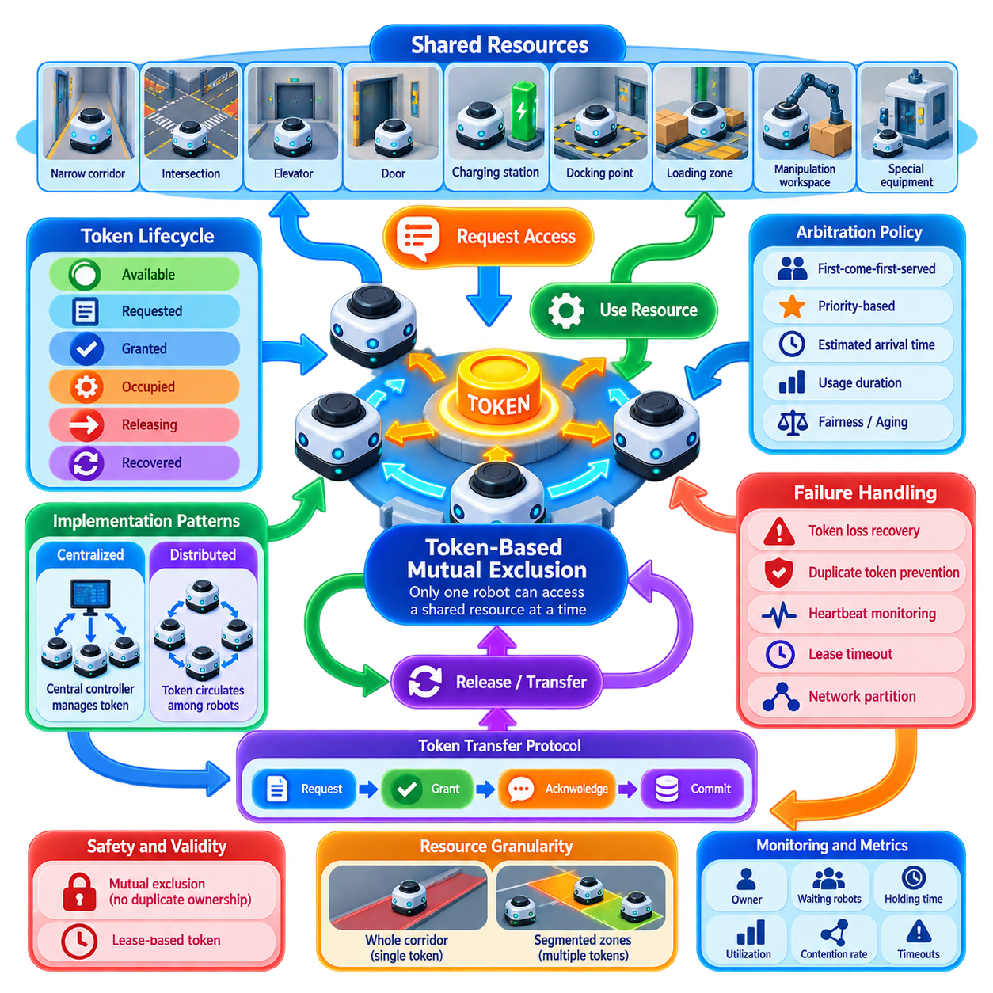
Token-based mutual exclusion is a coordination mechanism that ensures only one robot or authorized agent can access a shared resource at a given time. The fundamental idea is simple: possession of a unique logical token represents permission to enter, occupy, or operate the protected resource. Robots without the token must wait, preventing simultaneous access that could cause collisions, interference, inconsistent operations, or unsafe physical interactions.
Shared resources in multi-robot systems include narrow corridors, intersections, elevators, doors, charging stations, docking points, loading zones, manipulation workspaces, and specialized equipment. Unlike ordinary obstacles, these resources cannot always be handled efficiently through local collision avoidance alone. Multiple robots may independently determine that the resource is available, creating a race condition unless access authority is explicitly coordinated.
A token acts as a distributed representation of exclusive ownership. At any valid moment, exactly one participating robot should possess the token associated with a particular resource or resource group. Before entering the protected area, a robot requests or acquires the token. After completing its operation and leaving the resource, it releases or transfers the token so another waiting robot can proceed.
The mutual exclusion property requires that two robots must never simultaneously believe they hold valid authority for the same exclusive resource. This safety invariant is more important than maximizing throughput because violating it can create physical collisions or conflicting commands. The protocol must therefore define token identity, current ownership, validity period, transfer rules, and recovery behavior clearly enough to prevent duplicate ownership.
A centralized token manager is one practical implementation pattern. Robots send acquisition requests to a fleet controller or resource manager, which maintains the authoritative token state and grants access to one requester at a time. This approach simplifies arbitration and monitoring because the controller has a global view of waiting requests, priorities, robot states, and resource occupancy, although controller availability becomes an important system dependency.
A distributed implementation removes the requirement for a permanent central token authority. The token may circulate among participating robots, or robots may collectively determine which agent receives ownership next. Token-ring concepts are one example, although physical robot communication networks do not necessarily need to form a literal ring. The logical token-transfer topology can be independent of the underlying wireless communication topology.
Token acquisition typically begins before the robot physically reaches the shared resource. A robot approaching a narrow passage, for example, can request access while still positioned at a safe waiting point. If the token is available, ownership is granted and the robot proceeds. If another robot already owns it, the requester remains outside the protected region until ownership is transferred, avoiding unnecessary confrontation inside constrained space.
The token lifecycle can be represented by states such as available, requested, granted, occupied, releasing, and recovered. Separating authorization from physical occupancy is important. A robot may hold permission before entering the resource, and it may physically remain inside the resource after communication conditions change. The coordination system should therefore distinguish logical token ownership from verified physical occupancy when determining whether access can safely be reassigned.
Request arbitration determines which waiting robot receives the token next. A simple first-come-first-served policy offers predictable behavior, while priority-based arbitration can favor urgent missions, high-priority payloads, low-battery robots, or safety-related operations. More advanced policies may consider estimated arrival time, expected resource usage duration, downstream congestion, or the cost created by forcing other robots to stop and restart.
Fairness is necessary because aggressive priority rules can cause starvation. A robot repeatedly losing arbitration may remain blocked indefinitely while higher-priority traffic continues. Aging mechanisms can gradually increase the priority of waiting requests, while maximum waiting-time rules can guarantee eventual service. Industrial implementations often balance mission priority with fairness rather than treating either criterion as absolute.
Deadlock becomes possible when robots require multiple shared resources. Robot A may hold one token while waiting for a token held by Robot B, while Robot B simultaneously waits for the resource owned by Robot A. Preventing such circular dependencies may require ordered resource acquisition, atomic reservation of multiple resources, dependency analysis, or a policy requiring robots to release existing tokens before requesting conflicting resources.
Token granularity strongly affects fleet performance. Protecting an entire corridor with one token provides simple and conservative mutual exclusion but may reduce throughput because only one robot can use the corridor at a time. Dividing the corridor into several independently protected segments increases concurrency but also increases protocol complexity. Resource boundaries should therefore reflect physical safety margins, stopping distances, traffic geometry, and operational density.
Token validity should normally be bounded rather than permanent. A lease-based token remains valid for a specified interval and must be renewed if the operation continues. Leases prevent a crashed or disconnected robot from retaining logical ownership forever. However, expiration alone cannot prove that the physical resource is empty, so a token must not automatically be reassigned when doing so could place another robot into an area still occupied by the failed robot.
Heartbeat monitoring can supplement token leases. While holding a token, a robot periodically reports its operational state, position, and resource usage. Missing heartbeats can trigger a suspected-failure state, but recovery should remain conservative. Depending on the application, the system may stop approaching robots, verify occupancy using infrastructure sensors or neighboring robots, request human inspection, or execute a controlled recovery procedure before releasing the resource.
Token loss is a special failure condition in distributed systems. If the logical token disappears because its owner crashes during transfer or communication state becomes inconsistent, the fleet needs a controlled regeneration mechanism. Creating a replacement token without proving that the previous token is invalid risks duplicate ownership. Epoch numbers, generation identifiers, quorum agreement, or authoritative recovery procedures can distinguish a regenerated token from stale copies.
Duplicate tokens represent the opposite failure and can be particularly dangerous. They may result from network partition, software defects, repeated recovery, or restoration of stale state after a robot restarts. Every token should therefore carry a unique resource identifier and a monotonically increasing term, epoch, or generation. Participants can reject ownership information associated with obsolete generations and prevent an old token from becoming valid again.
Network partitions require explicit policy. If robots lose communication with the token authority or with other participants, continuing operation may increase availability but weaken exclusivity guarantees. For safety-critical resources, the preferred behavior is usually fail-safe: robots that cannot establish valid ownership remain outside the protected region. Local collision avoidance remains active, but it should not be interpreted as a replacement for resource authorization.
Token transfer itself should be treated as a transaction. The current owner should not simply assume that a transmitted message means the next robot successfully received ownership. Transfer can use request, grant, acknowledgment, and commit stages so both participants have a consistent understanding of the ownership transition. Sequence numbers and idempotent message handling prevent retransmissions or duplicated packets from creating unintended state transitions.
Physical completion must also be confirmed before token release. Reaching the nominal end of a path does not necessarily prove that the robot has cleared the protected area, especially when localization uncertainty exists. Release conditions can include pose thresholds, zone-exit events, safety sensor confirmation, or occupancy-map verification. Conservative clearance margins prevent the next robot from entering while part of the previous robot still occupies the resource.
Token-based coordination integrates naturally with zone-based traffic management and reservation systems. A zone can be modeled as a resource whose token grants exclusive access, while time-based reservations can determine when a robot is expected to acquire that token. The reservation layer improves traffic planning, whereas the token layer enforces actual runtime ownership. Combining both mechanisms supports predictive scheduling without sacrificing explicit access control.
Observability is essential in production fleets. Operators should be able to determine which robot owns each token, how long it has been held, which robots are waiting, why a request was denied, and whether any token is suspected of being stale. Metrics such as acquisition latency, waiting time, utilization, timeout frequency, recovery count, and contention rate reveal congestion and coordination problems that may not appear as robot hardware faults.
Testing should deliberately exercise simultaneous requests, message loss, duplicated messages, delayed acknowledgments, robot crashes, network partitions, expired leases, localization errors, and failures during ownership transfer. Particular attention should be given to transitions because most dangerous failures occur not while ownership is stable, but while a token is being granted, transferred, released, regenerated, or recovered after abnormal operation.
Token-based mutual exclusion is therefore best understood as a safety-oriented resource ownership protocol rather than merely a software locking technique. When combined with distributed consensus, leader election, traffic reservation, local safety control, and failure recovery, it provides a clear contract for coordinating scarce physical resources. This allows large robot fleets to share constrained infrastructure while preserving exclusivity, predictable behavior, and recoverable operation.

03.04 Zone Based Traffic Control and Reservation [w/Code]
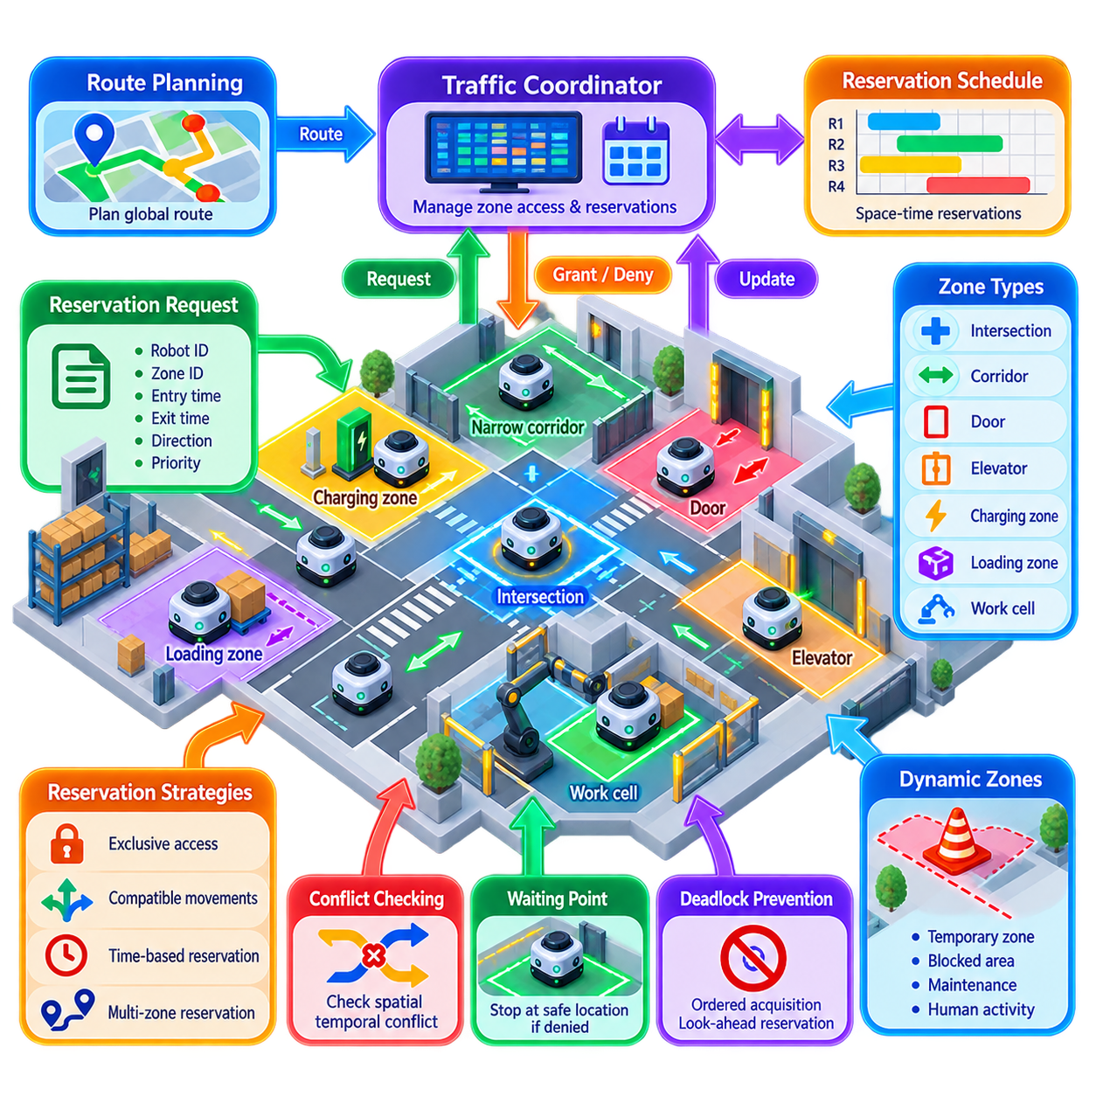
Zone-based traffic control is a coordination method that divides a shared robot operating environment into logical spatial regions and regulates access to those regions. Instead of allowing every robot to independently resolve traffic interactions only through local collision avoidance, the fleet establishes explicit rules governing when a robot may enter, occupy, traverse, and leave a zone. This creates predictable traffic behavior in dense multi-robot environments.
A zone represents an operationally meaningful portion of physical space rather than merely a geometric map segment. Typical examples include intersections, narrow corridors, doorways, elevators, loading areas, charging areas, work cells, merge points, and high-traffic passages. Zone boundaries should reflect robot dimensions, stopping distance, localization uncertainty, sensor coverage, traffic direction, and required safety margins.
The simplest control model treats a zone as an exclusive resource. Before entering, a robot requests permission from a traffic coordinator or distributed resource manager. If no conflicting robot occupies or owns the zone, access is granted. Otherwise, the requesting robot stops at a designated waiting position. This mechanism extends token-based mutual exclusion from abstract resource ownership to spatial traffic management.
Exclusive zones provide strong safety and simple reasoning but can unnecessarily reduce throughput. A large intersection, for example, may support several non-conflicting trajectories simultaneously. More advanced zone models therefore represent permitted movement combinations, allowing multiple robots to occupy the same logical region when their reserved paths do not geometrically or temporally conflict. Traffic control then becomes a scheduling problem rather than simple locking.
Reservation adds a temporal dimension to zone ownership. Instead of requesting only immediate access, a robot reserves a zone for an expected time interval based on its predicted arrival and traversal duration. A reservation can contain the robot identifier, zone identifier, entry time, expected exit time, direction, trajectory class, priority, and validity period. The controller compares new requests with existing reservations before granting access.
Space-time reservation enables the fleet to predict conflicts before robots physically approach one another. If two robots are expected to reach the same intersection at overlapping times, the scheduler can authorize one robot first and delay the other in advance. Early coordination reduces abrupt braking near conflict points and can produce smoother trajectories, lower energy consumption, and more stable fleet throughput.
A robot may need to reserve several consecutive zones to complete a route safely. Reserving only the next zone maximizes flexibility but can trap a robot after entry if the following zone becomes unavailable. Reserving an entire route avoids this problem but consumes excessive capacity. Practical systems commonly use a rolling reservation horizon in which robots secure a limited sequence of upcoming zones and continuously extend reservations as they progress.
The reservation horizon should reflect robot velocity, braking capability, communication latency, and traffic density. A faster robot requires earlier knowledge that downstream space will remain available because its safe stopping distance is greater. Conversely, reserving zones too far ahead can block other traffic unnecessarily. Dynamic horizons can therefore expand at high speed or under uncertain communication conditions and contract when traffic is slow and predictable.
Waiting points are essential components of zone control. A robot denied entry must stop at a location where it does not obstruct another route or prevent the current zone owner from exiting. Poorly placed waiting positions can transform a correctly functioning reservation protocol into a physical deadlock. Waiting points should therefore be modeled together with zone geometry, traffic direction, clearance, and downstream accessibility.
Deadlock prevention becomes more important when robots reserve multiple zones. Robot A may reserve one zone while waiting for another held by Robot B, while Robot B waits for a resource controlled by Robot A. Traffic systems can prevent circular dependencies through ordered zone acquisition, look-ahead reservation, dependency graphs, atomic multi-zone grants, or policies that prohibit entry unless a safe downstream escape zone is available.
Traffic direction is another useful constraint. Bidirectional corridors provide routing flexibility but create difficult encounters when robots approach from opposite directions. Temporarily assigning a corridor to one direction, using directional time windows, or grouping robots into short batches can increase throughput. The controller can dynamically change direction according to queue length, mission priority, or predicted traffic demand.
Priority influences reservation arbitration when multiple robots request conflicting access. Emergency operations, time-critical missions, loaded robots, low-battery robots approaching chargers, or robots carrying high-priority material may receive preferential treatment. However, permanent priority dominance can cause starvation. Aging, maximum waiting-time limits, or fairness scores can gradually increase the priority of repeatedly delayed robots.
Reservation schedules must tolerate uncertainty because predicted arrival and traversal times are never exact. Localization error, obstacle avoidance, wheel slip, human activity, and temporary stops can shift a robot away from its planned schedule. Time windows therefore require suitable buffers. Excessively large buffers waste capacity, while overly narrow windows cause frequent reservation violations and rescheduling.
A reservation should have a clearly defined lifecycle. It can progress through requested, tentative, confirmed, active, completed, cancelled, expired, or recovery states. A tentative reservation may be used during route negotiation, while a confirmed reservation represents committed access. The active state begins when the robot actually enters the zone, and completion should occur only after physical clearance from the protected boundary has been verified.
The distinction between reservation state and physical occupancy is critical. A reservation may expire while a disabled robot remains inside a zone, so expiration cannot automatically imply that the space is safe for another robot. The system should combine logical reservation information with robot localization, zone-entry and exit events, infrastructure sensors, or neighboring observations before reassigning access after abnormal conditions.
Communication failure requires conservative behavior. If a robot cannot confirm a required reservation, it should normally stop before entering the controlled zone. If communication is lost after entry, the robot may continue toward a predefined safe exit when that behavior is demonstrably safer than stopping inside the resource. Such policies must be determined by zone geometry and safety analysis rather than by a single fleet-wide rule.
Traffic coordination should remain separated from onboard collision avoidance. Reservation authority indicates that a robot is permitted to use a region, but it does not guarantee that the region is physically free of humans, unexpected objects, or localization errors. Onboard perception and safety control must retain the ability to slow or stop the robot even when a valid reservation exists.
Hierarchical zone management can improve scalability in large facilities. Local traffic controllers may manage individual intersections or facility regions, while a higher-level fleet coordinator handles route distribution and global congestion. Robots then interact primarily with controllers relevant to their current region. This reduces the amount of state that every participant must process and limits the propagation of local traffic disturbances.
Dynamic zone definitions can further improve utilization. A fixed map may define permanent critical regions, while temporary zones can be created around maintenance work, human activity, blocked aisles, failed robots, or temporary equipment. The fleet can distribute updated zone constraints and reroute traffic accordingly. Dynamic zones transform traffic management from static intersection locking into adaptive spatial coordination.
Congestion management operates above individual reservations. Even when every reservation is valid, too many robots entering the same region can create queues and reduce overall throughput. The system can estimate zone utilization, queue length, travel delay, and downstream occupancy to apply admission control. Routes may then be redistributed toward less congested areas before severe traffic accumulation occurs.
Zone-based control also supports heterogeneous fleets. Robots with different dimensions, turning radii, velocities, payloads, or safety envelopes may require different occupancy footprints and traversal times. Reservation logic can evaluate these robot-specific constraints rather than assuming identical agents. A large towing robot, for example, may reserve a wider area and longer time interval than a compact AMR using the same intersection.
Observability is important for commissioning and fleet operation. A traffic dashboard should expose zone occupancy, reservation queues, current owners, waiting robots, predicted conflicts, reservation violations, and blocked regions. Metrics such as average waiting time, zone utilization, reservation success rate, queue length, conflict frequency, deadlock recovery count, and traversal delay help identify poorly designed traffic geometry or scheduling policies.
Validation should include dense simultaneous arrivals, opposing traffic, delayed robots, emergency stops, localization drift, packet loss, controller failure, blocked exits, expired reservations, and robot failure inside controlled zones. Simulation and digital twins are particularly valuable because rare congestion and deadlock combinations can be reproduced at fleet scale before deployment in a physical facility.
Zone-based traffic control and reservation therefore provide a structured bridge between route planning and physical multi-robot execution. Route planners determine where robots should travel, while zone coordination determines when conflicting portions of those routes may be used. Combined with token-based mutual exclusion, distributed coordination, local collision avoidance, and failure recovery, reservation mechanisms enable dense robot fleets to share infrastructure safely while maintaining predictable and scalable traffic flow.

03.05 Formation Control Theory and Implementation [w/Code]
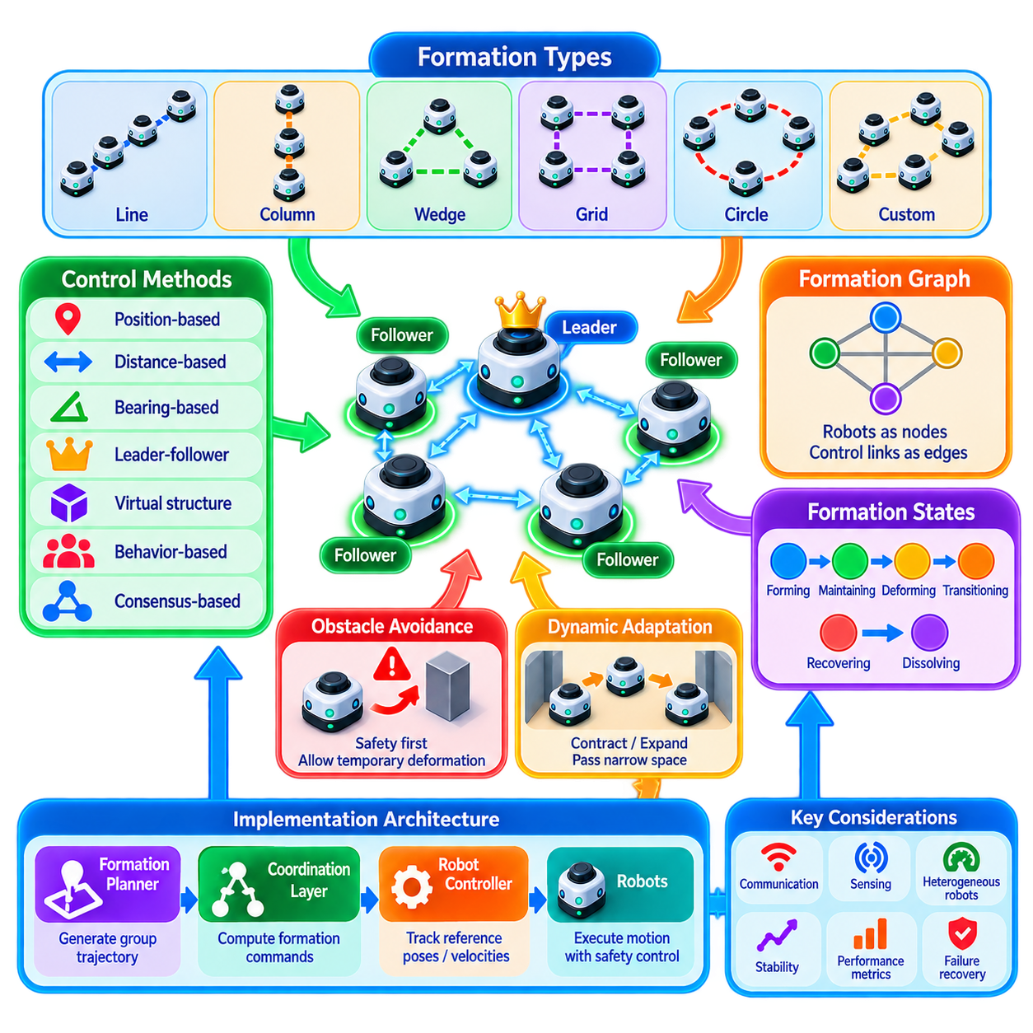
Formation control enables multiple robots to move while maintaining prescribed spatial relationships as a coordinated group. Unlike traffic coordination, which primarily prevents conflicting occupancy, formation control intentionally constrains relative positions, distances, orientations, or geometric patterns among robots. The objective is to make the group behave as a structured multi-agent system while preserving each robot's local motion and safety capabilities.
A formation can be represented by desired relative poses between robots or by a geometric shape defined in a common reference frame. Typical configurations include lines, columns, wedges, grids, circles, and application-specific patterns. The formation may remain fixed during a mission or change dynamically according to corridor width, obstacles, sensing requirements, communication quality, payload geometry, or operational objectives.
The mathematical foundation commonly represents robots as vertices of a graph and coordination relationships as edges. An edge indicates that one robot observes, communicates with, or maintains a geometric constraint relative to another robot. The resulting formation graph defines which relative states are controlled. Graph connectivity is therefore important because insufficient connectivity can prevent the group from maintaining a globally coherent formation.
In position-based formation control, robots attempt to maintain specified relative positions in a global or shared coordinate frame. Each robot computes an error between its current position and the desired formation position, then generates corrective motion that reduces this error. This approach is conceptually straightforward but requires sufficiently consistent localization and coordinate alignment across participating robots.
Distance-based formation control reduces dependence on a common global frame by specifying desired distances between selected robot pairs. Each robot adjusts its motion according to measured or communicated inter-robot distances. If the formation graph contains an appropriate set of constraints, maintaining those distances preserves the desired geometry even when the entire group translates or rotates through the environment.
Bearing-based control uses desired relative directions rather than only distances. Robots regulate the bearings of neighboring robots and can maintain the shape of a formation while allowing its overall scale to change. This is useful when a group must contract to pass through narrow spaces or expand to increase sensing coverage while preserving the basic geometric relationship among members.
Leader-follower control is one of the most intuitive formation architectures. A designated leader follows a mission trajectory while follower robots maintain specified offsets relative to the leader or preceding robots. The architecture simplifies group guidance because global trajectory generation can focus on the leader. However, leader failure, accumulated tracking error, and disturbances propagating through follower chains must be considered.
Virtual-structure control treats the entire formation as if it were a single rigid or deformable object. A virtual reference structure defines desired positions for all members, and the structure itself follows a planned trajectory. Individual robots track assigned points within this structure. This approach produces coherent geometric motion but can become restrictive when local obstacles require individual robots to deviate temporarily from their nominal positions.
Behavior-based formation control combines several local behaviors such as goal seeking, separation, alignment, cohesion, obstacle avoidance, and formation maintenance. Weighted combinations of these behaviors generate robot motion. The method can adapt naturally to changing environments, although interactions among behaviors may produce oscillations or imperfect formation geometry unless priorities, gains, and transition rules are carefully designed.
Consensus-based formation control interprets formation maintenance as agreement among distributed agents. Robots exchange state information with neighbors and iteratively reduce differences relative to desired offsets. Consensus techniques are attractive for decentralized fleets because no permanent central controller is required. Their convergence characteristics depend on communication topology, update rates, delays, and the connectivity of the formation graph.
Formation error is a central implementation variable. It may describe position offset, inter-robot distance error, heading difference, bearing error, or a combination of these quantities. Controllers transform formation errors into velocity, acceleration, steering, or trajectory corrections. Gain selection determines how aggressively robots restore geometry, and excessive gains can create oscillation, actuator saturation, or unstable interactions with lower-level motion controllers.
Formation control should normally operate above the robot's low-level control loops. A coordination layer generates desired poses, velocities, or trajectories, while onboard navigation and motion controllers convert those references into physically executable commands. This separation allows different robot platforms to participate in the same formation architecture while preserving platform-specific steering, drivetrain, and dynamic constraints.
Trajectory generation must consider the geometry of the entire group rather than only the leader's path. A turn that is feasible for the leader may require followers to travel different radii and velocities. Large formations can sweep a significantly wider area than an individual robot. Curvature, turning radius, acceleration limits, and robot dimensions therefore influence whether a desired formation can physically follow a planned route.
Collision avoidance and formation maintenance can produce competing objectives. A robot may need to leave its desired position temporarily to avoid a human, obstacle, or another vehicle. Safety must take priority over geometric accuracy. Practical controllers therefore permit bounded formation deformation and subsequently guide the robot back toward its assigned relationship when the conflict disappears.
Obstacle-rich environments may require coordinated formation transitions. A wide formation approaching a narrow passage can compress into a line, traverse the constrained region, and expand again afterward. Such transitions should be planned rather than emerging accidentally from collision avoidance. Transition logic specifies the target configuration, assignment of robots to new formation positions, synchronization conditions, and completion criteria.
Assignment becomes important when multiple robots can occupy equivalent formation positions. Selecting positions poorly can force robots to cross one another while changing formation. An assignment algorithm can minimize travel distance, crossing risk, energy consumption, or transition time. Once assignments are established, trajectory coordination should ensure that robots reach their new positions without creating internal collisions.
Communication affects formation quality because robots often depend on neighboring positions, velocities, or intentions. Delay introduces errors between the communicated state and the physical state of a moving robot. Timestamping, prediction, interpolation, and bounded-delay assumptions can reduce this problem. Controllers should tolerate temporary packet loss rather than immediately destabilizing the formation when individual updates are missing.
Sensing can supplement or replace communication. Cameras, LiDAR, radar, ultra-wideband ranging, GNSS, or relative localization methods can estimate neighboring robot states directly. Combining communication with relative sensing provides redundancy: transmitted states support coordination beyond sensor range, while local sensing can verify nearby geometry and continue limited operation during communication degradation.
Formation control for heterogeneous robots requires attention to different velocity limits, acceleration capabilities, turning radii, sensing ranges, and communication performance. The group's motion is often constrained by its least agile member. Reference trajectories and formation spacing should therefore be generated using feasible limits for all participants rather than commanding identical dynamics to fundamentally different platforms.
Leader failure requires explicit recovery behavior in leader-follower systems. Followers can stop safely, elect a replacement leader, or transition to another control mode. A new leader should receive or reconstruct the mission trajectory and formation reference before coordinated motion resumes. Dynamic leader selection can also be used proactively when the current leader has low battery, degraded sensing, or poor communication connectivity.
Formation stability describes whether robots return toward the desired geometry after disturbances. Analysis may examine convergence of formation errors, boundedness under disturbances, or asymptotic stability of the collective system. Lyapunov-based methods, graph-theoretic analysis, and control-system stability tools can provide theoretical guarantees, while simulation and physical experiments evaluate behavior under realistic dynamics and communication effects.
Implementation requires clear state management for forming, maintaining, deforming, transitioning, recovering, and dissolving a formation. Robots should agree on formation identity, configuration, member list, reference frame, leader or coordination mode, and current transition state. Versioned formation commands help prevent delayed messages from causing a robot to execute an obsolete configuration after the group has already changed state.
Performance can be measured using average and maximum formation error, convergence time, trajectory tracking error, minimum inter-robot clearance, communication load, energy consumption, and recovery time after disturbances. Mission-level measures such as travel time, sensing coverage, throughput, and task completion rate are also important because extremely accurate formation geometry may provide little value if it significantly reduces operational efficiency.
Validation should include sharp turns, acceleration and braking, narrow passages, dynamic obstacles, communication delay, packet loss, localization drift, member failure, leader replacement, and formation transitions. Simulation enables systematic exploration of large parameter spaces, while field testing reveals drivetrain, sensing, timing, and environmental effects that idealized models may not capture.
Formation control is therefore a layered coordination problem combining graph relationships, distributed information exchange, geometric constraints, trajectory generation, motion control, collision avoidance, and failure recovery. A successful implementation does not merely keep robots at fixed distances; it maintains useful collective geometry while allowing the formation to adapt safely to the environment, robot capabilities, communication conditions, and changing mission requirements.

03.06 Convoy and Platoon Control for AMR [w/Code]
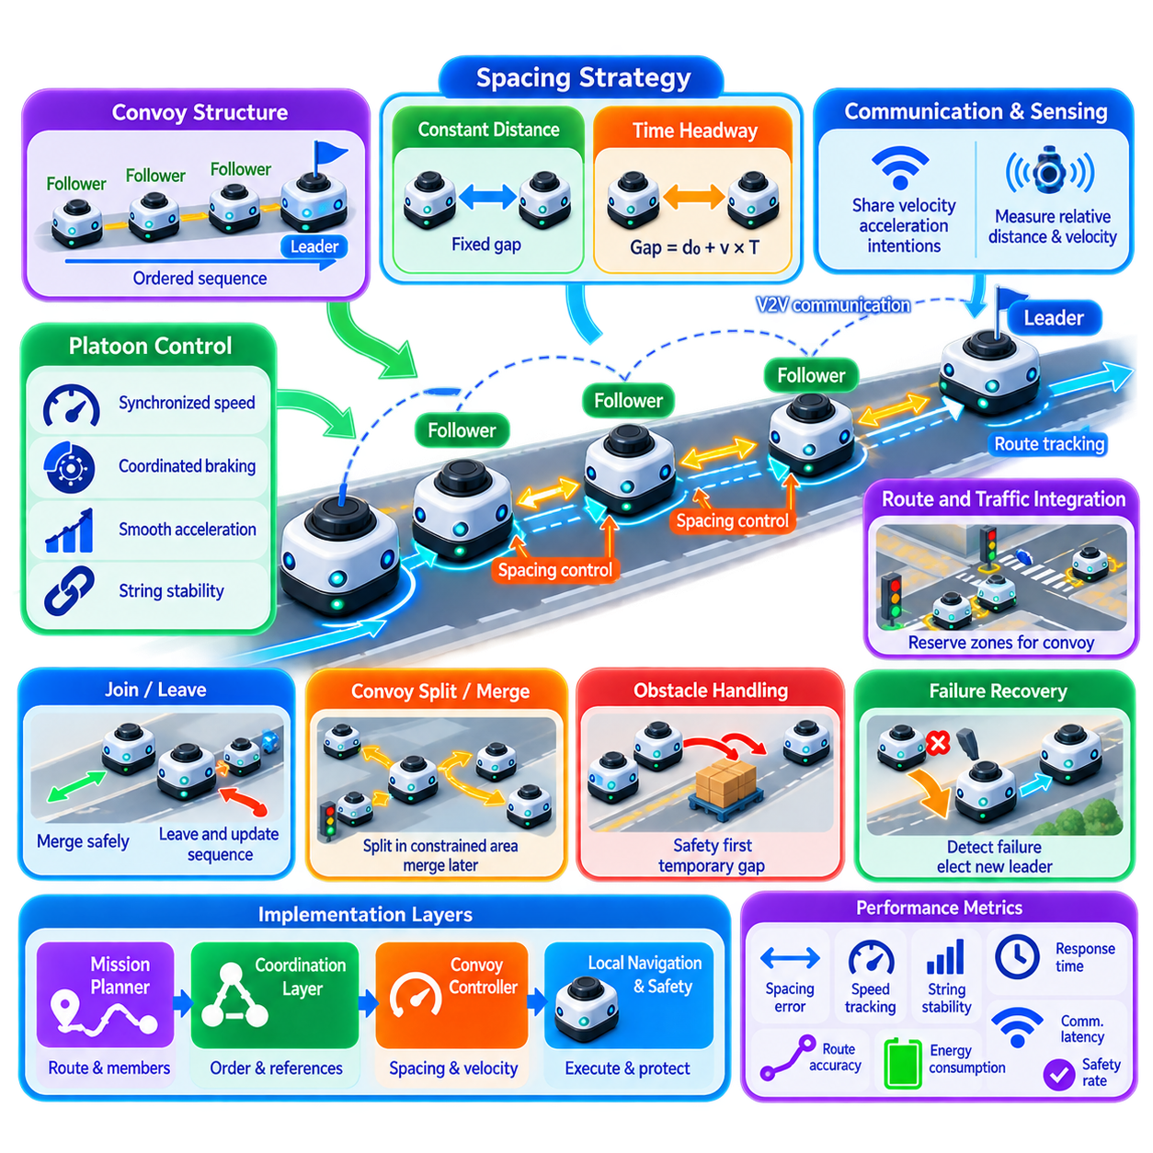
Convoy and platoon control enables multiple autonomous mobile robots to travel along a common route as a coordinated moving group while maintaining controlled longitudinal and, when necessary, lateral relationships. Unlike general formation control, which can preserve arbitrary geometric patterns, convoy control primarily emphasizes ordered movement, safe inter-robot spacing, synchronized velocity, and stable propagation of motion commands through a sequence of robots.
A convoy typically consists of a lead robot followed by one or more follower robots arranged in an ordered sequence. The leader determines or receives the primary route and motion reference, while followers reproduce the overall movement while maintaining desired spacing. This structure is useful for material transport, inspection, patrol, logistics, and operations in which several AMRs must traverse the same infrastructure efficiently.
Platooning is closely related to convoy control but generally emphasizes tighter coordination of longitudinal dynamics. Robots exchange velocity, acceleration, braking, and sometimes planned trajectory information to reduce spacing while maintaining safety. Although the concept resembles vehicle platooning, AMR implementations must additionally consider low-speed maneuvering, indoor intersections, narrow passages, docking areas, pedestrians, localization uncertainty, and frequent stop-and-go operation.
The desired inter-robot spacing can be defined using a constant-distance policy. Each follower attempts to maintain a fixed geometric distance from the preceding robot regardless of speed. This provides compact group movement and can be useful in constrained facilities, but short fixed spacing requires accurate sensing and rapid control response because the available stopping margin does not automatically increase as velocity rises.
A constant-time-headway policy instead defines spacing as a function of velocity. The faster the robot moves, the larger the desired separation becomes, providing additional reaction and braking distance. A basic spacing reference can be expressed conceptually as a minimum standstill distance plus robot velocity multiplied by a desired time headway. This approach naturally adapts convoy geometry to changing operating speed.
Follower control requires estimation of relative distance and relative velocity. LiDAR, cameras, radar, ultra-wideband ranging, or other onboard sensors can measure the preceding robot directly, while wireless communication can provide its velocity, acceleration, and control intentions. Combining direct sensing with communicated state is valuable because local sensing verifies the physical relationship while communication provides predictive information before motion changes become visually apparent.
Predecessor-following control uses information primarily from the robot immediately ahead. This architecture is scalable because each robot interacts with only a small number of neighbors. However, errors and disturbances can propagate downstream. If every follower reacts more aggressively than its predecessor, small velocity fluctuations near the leader may grow into increasingly severe acceleration and braking behavior toward the rear of the convoy.
This phenomenon is addressed through string stability. A convoy is string stable when disturbances introduced by one robot do not amplify as they propagate through the ordered group. String stability is therefore different from the stability of an individual robot controller. Every robot may be locally stable while the convoy as a whole still produces growing oscillations, excessive spacing errors, or repeated stop-and-go waves.
Leader-predecessor following can improve collective behavior by allowing followers to use information from both the immediate predecessor and the convoy leader. The predecessor provides local spacing information, while the leader supplies a global motion reference. Cooperative control can extend this further by sharing states from several neighboring robots, improving anticipation and reducing the propagation of disturbances through long convoys.
Communication enables cooperative adaptive behavior but introduces delay, jitter, packet loss, and temporary disconnection. Each message should therefore contain timestamps and sequence information so receivers can distinguish current data from stale updates. Predictive estimation can compensate for bounded delay, while control logic should define how a follower transitions from communication-assisted operation to sensor-only following when network quality deteriorates.
Safety cannot depend exclusively on wireless communication. A follower should retain onboard perception and independent emergency stopping capability even when cooperative messages indicate that continued motion is permitted. If communication fails completely, the robot can increase spacing, reduce velocity, switch to conservative predecessor tracking, or stop according to the operational risk and available sensing capability.
Braking coordination is especially important because emergency deceleration can propagate rapidly through the convoy. A leader initiating an emergency stop can broadcast braking intent immediately, allowing followers to begin decelerating before their local sensors observe the full reduction in relative distance. Nevertheless, each robot must independently verify obstacles and maintain sufficient stopping margin because communication messages may be delayed or unavailable.
Acceleration coordination requires similar care. If all followers attempt to reproduce the leader's acceleration simultaneously without considering their own drivetrain capabilities, spacing errors can emerge. Robots may have different masses, payloads, motor limits, tire conditions, or controller dynamics. Reference acceleration should therefore respect the feasible envelope of the convoy rather than assuming identical physical behavior.
Curved paths introduce additional complexity because robots cannot simply reproduce the same instantaneous steering command. Each follower must track the spatial path traversed by the preceding robot or follow an appropriately transformed reference trajectory. Accurate path history can be more useful than current leader pose alone, particularly through corners where direct line-of-sight following could cause followers to cut across the intended route.
Route tracking and convoy spacing should be coordinated but remain conceptually distinct. A path controller regulates lateral or geometric tracking relative to the route, while a longitudinal controller regulates velocity and spacing relative to other robots. Coupling becomes significant on sharp curves, slopes, slippery surfaces, or constrained passages, where lateral tracking errors and velocity changes can affect safe separation.
Convoy initialization requires robots to assemble into the correct sequence before coordinated travel begins. The system must identify the leader, determine follower order, assign convoy identifiers, establish communication relationships, and verify minimum safety spacing. Robots may join from different locations, requiring controlled merging behavior rather than immediately activating normal platoon control.
Joining and leaving should be explicit operational states. A robot entering a convoy needs an assigned insertion position and sufficient space to merge without forcing unsafe braking. A robot leaving should announce its intention so neighboring followers can update predecessor relationships and spacing references. Membership changes should be versioned so delayed communication cannot restore an obsolete convoy topology.
Intersections and shared zones require integration with fleet traffic control. A long convoy may not fit entirely inside a reserved intersection or corridor segment. Allowing only part of the group to enter can separate followers or block cross traffic. The traffic manager may therefore reserve sufficient spatial and temporal capacity for the complete convoy, deliberately split the convoy into subgroups, or temporarily dissolve platoon behavior.
Convoy splitting can be useful when infrastructure cannot accommodate the full group. The fleet coordinator can divide a large convoy into smaller units, assign temporary leaders, establish safe separation between subgroups, and later merge them when conditions permit. Such transitions connect convoy control with leader election, formation management, zone reservation, and multi-robot task coordination.
Obstacle avoidance has higher priority than maintaining ideal spacing. If a follower detects a person or unexpected obstacle, it must slow or stop even when doing so disrupts the convoy. Following robots must react to the resulting change while maintaining safe separation. After the obstacle clears, spacing should be restored gradually rather than using aggressive acceleration that could generate another disturbance wave.
Heterogeneous AMRs require convoy references that account for different maximum velocities, braking distances, turning radii, payloads, and sensing capabilities. The practical convoy speed is usually limited by the least capable member under the current conditions. Dynamic ordering may place robots with stronger sensing or communication capability in strategically important positions, although operational task constraints may restrict such rearrangement.
Leader failure requires a defined recovery procedure. Followers may execute a coordinated stop, elect a new leader, reconstruct the remaining route, and resume operation after validating the new convoy topology. A follower failure can require neighboring robots to increase spacing and reconnect their predecessor-successor relationships. Recovery must avoid interpreting a failed or disconnected robot as an active convoy member.
Implementation is naturally layered. A fleet or mission layer establishes the route and convoy membership, a coordination layer manages ordering and shared motion references, and a convoy controller calculates spacing and velocity commands. Local navigation, drivetrain control, perception, and safety systems execute those references while retaining authority to reject motion that violates immediate physical constraints.
Important performance measures include spacing error, velocity tracking error, minimum separation, convergence time, communication latency, disturbance amplification, braking response, route tracking accuracy, and energy consumption. String-stability metrics are particularly valuable for long convoys because acceptable performance near the leader does not guarantee stable behavior at the rear of the group.
Validation should include acceleration and emergency braking, sharp turns, slopes, payload variation, sensor degradation, packet loss, communication delay, leader failure, follower failure, joining, leaving, convoy splitting, intersection traversal, and dynamic obstacles. Testing should increase convoy length progressively because behaviors that appear stable with two or three robots may become problematic as disturbances propagate through a larger sequence.
Convoy and platoon control for AMRs is therefore a specialized form of multi-robot coordination combining formation relationships, longitudinal control, route tracking, cooperative communication, traffic reservation, and local safety. Effective implementation allows robots to move as an organized transport group while preventing disturbance amplification, adapting spacing to operating conditions, and preserving independent safety authority at every robot.

03.07 Coordinated Pick and Place Multi Robot Assembly [w/Code]
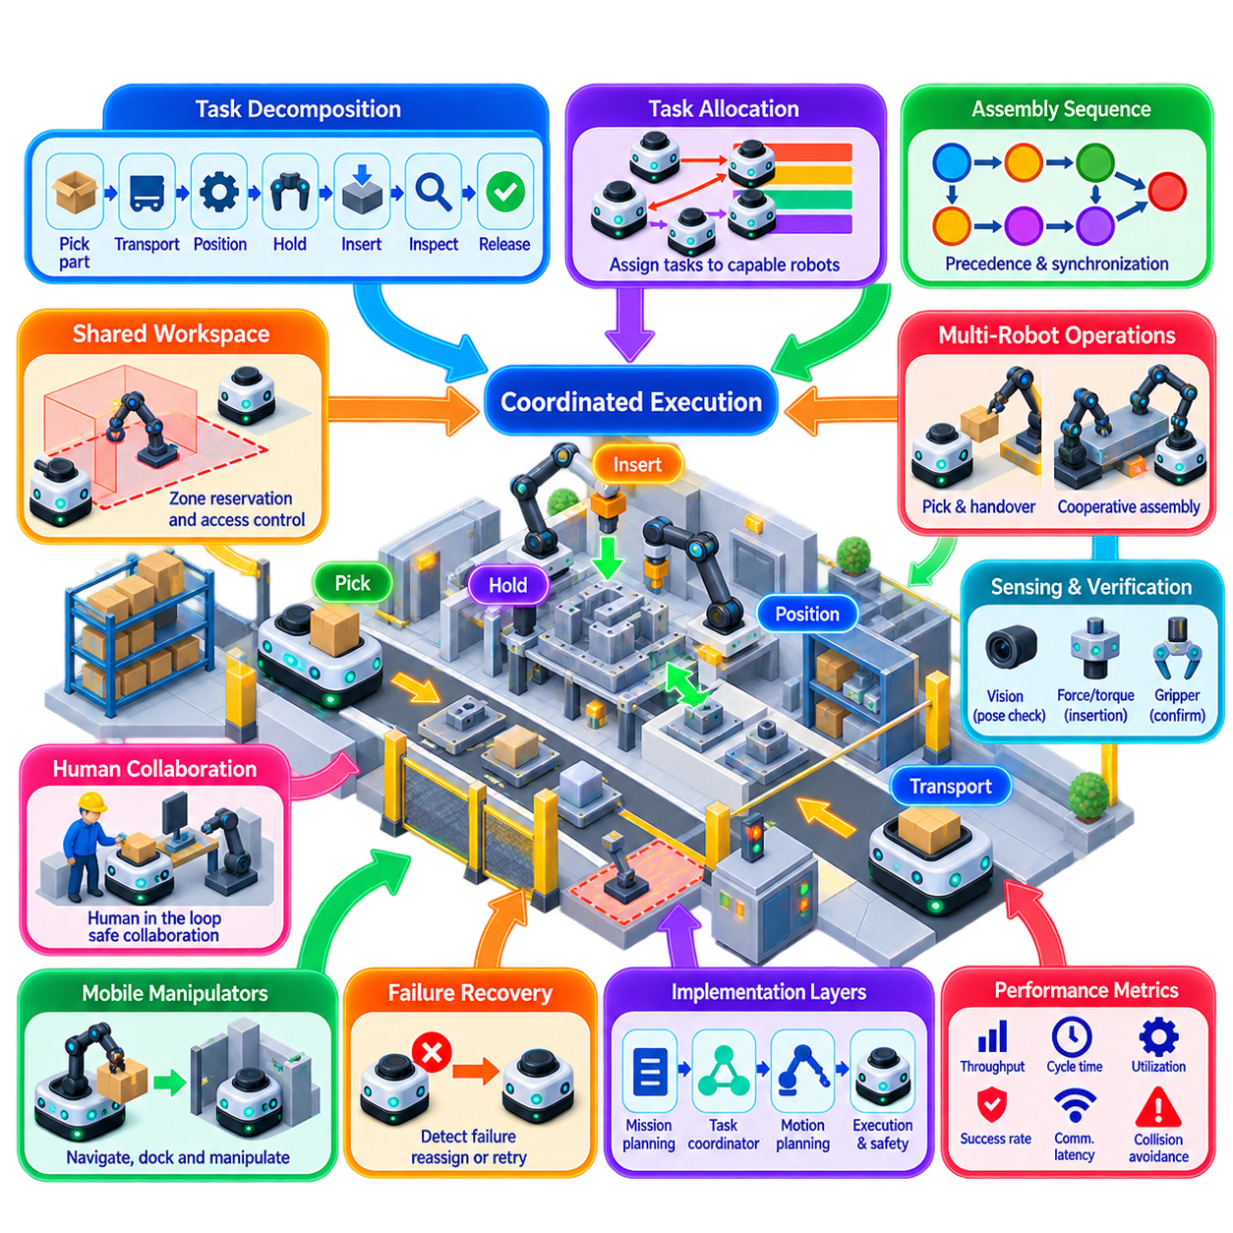
Coordinated pick-and-place in multi-robot assembly extends conventional robotic manipulation from isolated work cells into a synchronized system in which several robots contribute to a common production objective. Robots may retrieve components, transport them between stations, orient parts, hold workpieces, perform insertion, and transfer assemblies. Coordination determines how these actions occur without workspace conflicts, sequencing errors, or unnecessary idle time.
The fundamental problem combines task allocation, motion planning, resource management, and temporal synchronization. A production task must first be decomposed into operations with precedence relationships, such as pick, transport, position, hold, insert, inspect, and release. The coordination system then determines which robot performs each operation, where it occurs, and when execution may begin relative to the progress of other robots.
Assembly precedence is particularly important because many operations cannot be executed independently. A component cannot be inserted before the receiving part is correctly positioned, and a robot cannot release a workpiece until another robot has established a stable grasp or fixture. These dependencies can be represented as a task graph in which nodes describe operations and directed edges define required execution order or synchronization constraints.
Some assembly operations are sequential, while others can proceed concurrently. Increasing parallel execution improves throughput, but only when robots do not compete for the same workspace, fixture, tool, or component. The scheduler must therefore consider both task precedence and resource conflicts. Two operations that are logically independent may still require serialization if their physical trajectories overlap inside a shared manipulation region.
Robot capability influences task assignment. A heterogeneous assembly system may contain manipulators with different payload capacities, reaches, grippers, sensing systems, positioning accuracies, and mobility. An operation should be assigned only to robots capable of satisfying its physical and quality requirements. Assignment can additionally consider execution time, energy use, tool-change cost, travel distance, workload balance, and current robot availability.
Mobile manipulators add another coordination dimension because the manipulation resource itself can move. An AMR may transport a robotic arm to a workstation, position itself within a docking tolerance, stabilize its base, and then execute manipulation. Assembly planning must therefore coordinate navigation, docking, arm motion, and interaction with other robots rather than treating manipulation as an activity performed from a permanently fixed base.
Shared workspaces require explicit access management. When several robots can reach the same assembly area, uncontrolled simultaneous motion may produce collisions even if individual trajectories are valid in isolation. The shared region can be modeled as a protected zone or resource. Robots request ownership before entering, and token-based mutual exclusion or reservation mechanisms can regulate which robot is permitted to occupy the critical workspace.
Exclusive access is not always necessary. Two manipulators can sometimes operate concurrently when their swept volumes remain separated or when coordinated trajectories have been verified as collision-free. This increases utilization but requires more detailed geometric reasoning. The coordination layer must understand not only whether robots share a nominal workspace but whether their predicted motions conflict during overlapping time intervals.
Temporal coordination becomes tighter during cooperative manipulation. One robot may hold a component while another inserts a fastener, connector, or mating part. The supporting robot must reach and maintain the required pose before the second robot begins its operation. Synchronization events, barriers, handshakes, or state transitions can explicitly indicate when prerequisites have been satisfied and when dependent actions are allowed to proceed.
Handover is a common coordinated pick-and-place pattern. The sending robot transports a part to a transfer pose while the receiving robot approaches a compatible grasp configuration. The receiver establishes a secure grasp before the sender releases the object. A reliable handover therefore requires agreement on object identity, transfer pose, grasp state, timing, and release conditions rather than merely commanding two robots to arrive at the same location.
Sensor confirmation improves the reliability of these transitions. Vision can verify object pose and alignment, force-torque sensing can detect contact and insertion conditions, and gripper sensors can confirm successful grasping. Coordination should use these observations as execution conditions. Progressing solely according to nominal timing can propagate an unnoticed pick failure into later assembly operations and potentially create damage or unsafe interaction.
Pose uncertainty is especially important in assembly because small errors can prevent insertion or mating even when collision avoidance remains satisfied. Robots may use visual servoing, force-guided alignment, compliant control, or local pose refinement before completing a placement. The coordination system should distinguish between reaching the nominal operation pose and confirming that the physical assembly condition has actually been achieved.
Cooperative transport requires multiple robots to manipulate or support the same object simultaneously. The robots must maintain compatible motion so that internal forces do not damage the object, grippers, or manipulators. A shared trajectory or object-level reference can define desired object motion, while individual controllers calculate robot-specific motions that preserve grasp constraints and distribute loads appropriately.
In mobile multi-robot assembly, transport and manipulation scheduling should be integrated. A robot carrying a required component must arrive before the assembly operation begins, but arriving excessively early may block the station or consume valuable staging space. Just-in-time coordination aligns material delivery with manipulator availability, reducing congestion and work-in-process while requiring sufficiently accurate predictions of travel and task completion times.
Deadlock can arise when robots simultaneously hold resources required by one another. One robot may occupy an assembly fixture while waiting for a component held by another robot that itself needs access to the occupied area. Resource ordering, atomic multi-resource reservations, dependency analysis, and controlled release policies can prevent these circular waits. Deadlock prevention should be designed into the task scheduler rather than handled only after production stops.
Collision avoidance remains a local safety responsibility even when global scheduling has separated robot operations. Unexpected objects, localization errors, displaced components, or human intervention can invalidate previously collision-free plans. Each robot must retain the ability to slow or stop independently. The coordination system then interprets the interruption, adjusts dependent tasks, and determines whether replanning or resynchronization is required.
Human workers may also participate in collaborative assembly. A human can load parts, inspect results, perform specialized operations, or recover abnormal conditions between robot actions. Human presence changes workspace availability and timing assumptions, so coordination should treat human-dependent operations as explicit workflow states. Safety-rated sensing and control remain separate from productivity-oriented task coordination.
Failure recovery is essential because one failed pick can affect many downstream operations. If a robot fails to grasp a component, the system may retry with an adjusted pose, request another robot, obtain a replacement part, or redirect the assembly sequence. Recovery policies should identify which completed actions remain valid and which dependent operations must be cancelled, repeated, or replanned.
Robot failure can require dynamic reassignment. If another robot has compatible capabilities, unfinished tasks can be transferred without abandoning the entire assembly mission. The scheduler must account for the replacement robot's current location, tooling, calibration, payload capability, and access to the relevant workspace. Redundancy therefore depends on functional compatibility rather than simply having additional robots available.
State consistency becomes important when many robots and controllers participate in the same assembly. The system should maintain authoritative information about task status, component location, grasp ownership, fixture state, robot availability, and assembly progress. Versioned commands and transactional state transitions help prevent delayed messages or repeated commands from causing a completed operation to be executed again.
A hierarchical architecture is practical for implementation. A production or mission layer defines assembly objectives and precedence, a task coordinator assigns operations and resources, and motion planners generate collision-aware trajectories. Individual robot controllers execute manipulation and navigation, while perception and safety systems validate physical conditions. Clear interfaces between these layers make failures easier to isolate and recovery easier to manage.
Digital twins and simulation are particularly useful before physical deployment. Multiple robot trajectories can be tested for reachability, collision, cycle time, resource contention, and synchronization behavior. Rare combinations of delays or failures can also be injected systematically. Simulation does not eliminate commissioning, but it reduces the number of coordination problems that must first be discovered around physical machinery.
Performance evaluation should include more than individual robot cycle time. Relevant measures include total assembly cycle time, robot utilization, waiting time, resource contention, handover success rate, pick and placement success, synchronization delay, collision-avoidance interruptions, recovery time, and overall throughput. These metrics reveal whether adding more robots actually increases production or merely creates additional coordination overhead.
Scalability depends on limiting unnecessary global synchronization. Requiring every robot to wait at every operation creates simple logic but poor utilization. Effective systems synchronize only the robots and resources involved in a dependency while allowing unrelated operations to proceed concurrently. Localized coordination reduces communication and scheduling complexity as the number of robots and assembly tasks increases.
Coordinated pick-and-place multi-robot assembly is therefore a layered integration of task graphs, capability-aware assignment, shared-resource management, synchronized manipulation, perception, motion planning, and failure recovery. The objective is not merely to make several robots move simultaneously, but to ensure that their actions combine into one consistent physical process that improves throughput while preserving assembly quality, recoverability, and safety.

03.08 Inter Robot Communication Collision Avoidance [w/Code]
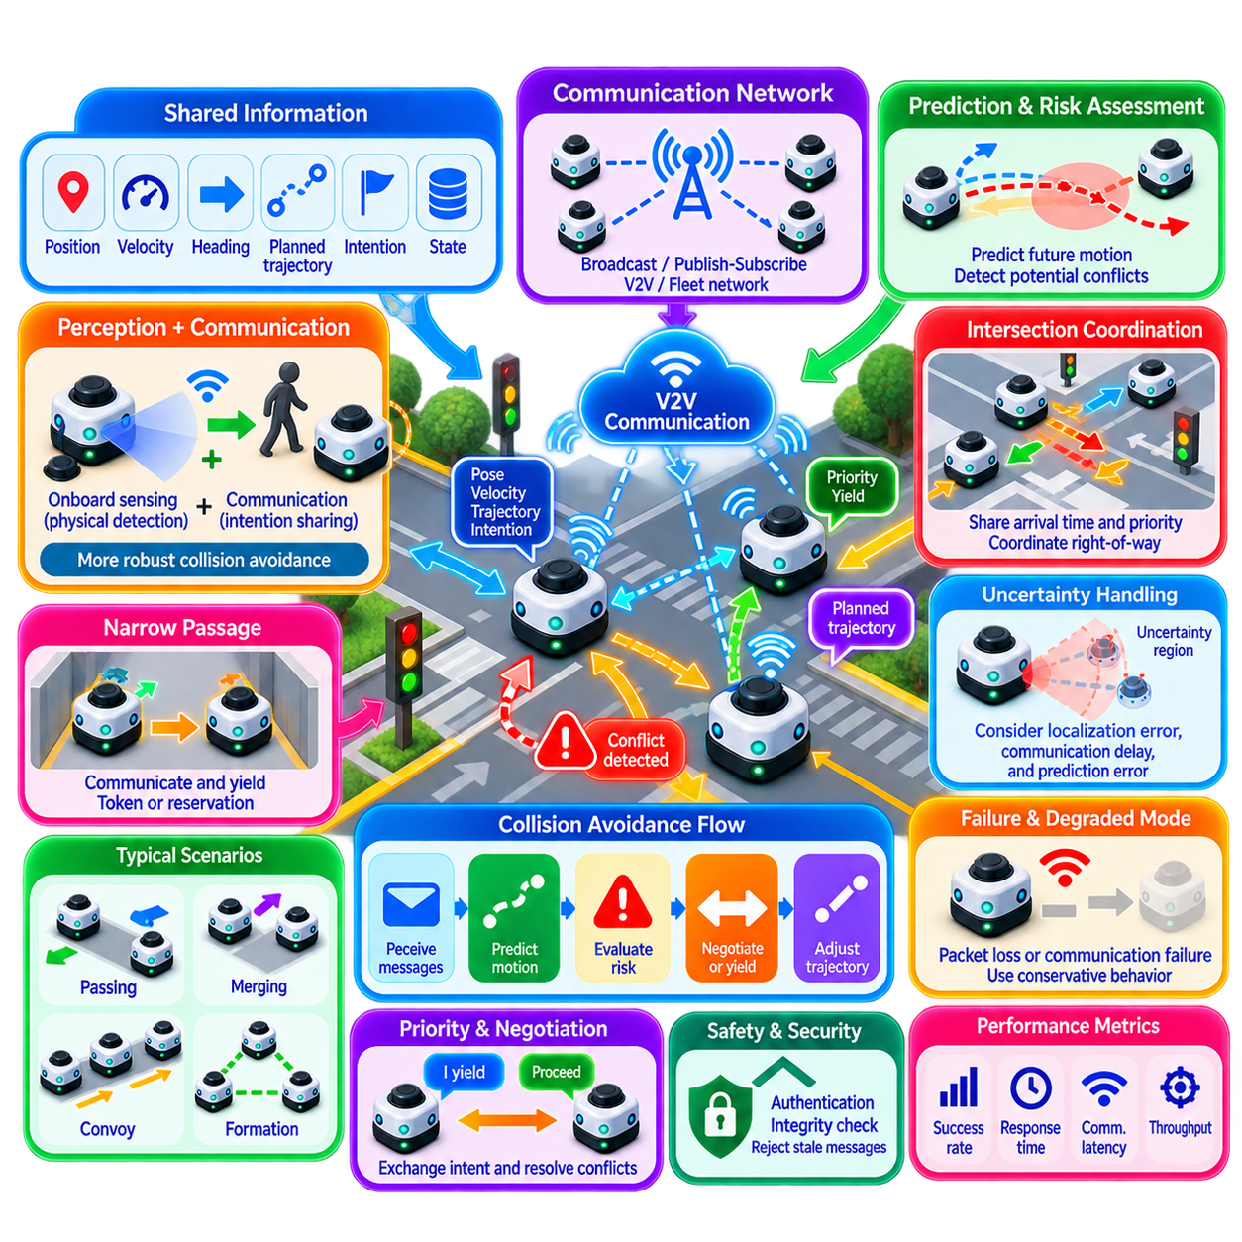
Inter-robot communication is a fundamental coordination mechanism that allows multiple robots to exchange state, intention, and motion information before physical conflicts occur. In collision avoidance, communication complements onboard perception by providing information that may not yet be directly observable. Robots can share position, velocity, heading, planned trajectory, priority, and operational state to improve collective awareness and coordinate safer motion.
Communication-based collision avoidance should not replace local sensing. Cameras, LiDAR, radar, ultrasonic sensors, and other onboard perception systems remain responsible for detecting physical obstacles and unexpected hazards. Communication provides an additional predictive layer by revealing what neighboring robots intend to do, while perception verifies what is actually occurring in the environment. Combining both mechanisms improves robustness against uncertainty.
Each robot can periodically broadcast a compact state message containing its identifier, timestamp, pose, velocity, acceleration, motion mode, and safety status. Depending on the coordination architecture, messages may also contain a short trajectory prediction or intended maneuver. Neighboring robots use this information to construct a local representation of surrounding robot motion and estimate whether future trajectories may conflict.
Trajectory sharing extends communication beyond current-state exchange. A robot can transmit a sequence of predicted poses or a parameterized trajectory over a finite time horizon. Other robots compare this information with their own planned motion and identify overlapping space-time regions. Detecting conflicts before robots physically approach one another provides more time for smooth speed adjustment, yielding, rerouting, or coordinated reservation.
Collision risk can be evaluated using predicted relative motion. Two robots may be far apart at the current instant but moving toward the same intersection or narrow passage. The coordination system estimates quantities such as time to closest approach, predicted separation distance, time to collision, or overlap between future occupancy regions. These measures allow robots to distinguish harmless proximity from genuinely conflicting motion.
Uncertainty must be included in collision prediction because communicated states are never perfectly current or accurate. Localization error, clock offset, communication delay, actuator response, and prediction error can make the actual robot position differ from the transmitted trajectory. Rather than representing future motion as an exact line, practical systems can use uncertainty envelopes or enlarged occupancy regions that grow with prediction horizon.
Time synchronization improves the interpretation of shared motion data. A pose without a reliable timestamp may already be obsolete when another robot receives it. Robots should therefore use synchronized clocks or sufficiently accurate relative timing and attach timestamps to state and trajectory messages. Receivers can compensate for known communication delay by propagating the received state forward before evaluating collision risk.
Communication latency directly affects the useful prediction horizon. When delay is small and bounded, cooperative avoidance can react to shared intentions with high confidence. When delay increases, transmitted trajectories become progressively less representative of current behavior. Collision avoidance should therefore monitor message age and reduce dependence on communicated information as freshness deteriorates, while increasing reliance on onboard sensing and conservative safety margins.
Packet loss must be treated as a normal operating condition rather than an exceptional event. A robot should not immediately become unsafe because one neighboring state message is missed. Short gaps can be bridged using prediction based on the last valid position, velocity, and acceleration. If updates remain unavailable beyond a defined timeout, the neighbor state should be considered uncertain and the robot should transition toward a more conservative motion policy.
Wireless congestion becomes significant as fleet size increases. Broadcasting high-rate trajectories from every robot to every other robot can consume excessive bandwidth and processing capacity. Communication should therefore be localized according to spatial relevance. Robots primarily need detailed information from nearby agents or robots whose planned routes may intersect, while distant robots can be represented with lower update rates or handled by higher-level fleet coordination.
Publish-subscribe communication is well suited to scalable robot fleets. Robots publish state and intention information while interested neighbors or coordination services subscribe to relevant topics. Spatial filtering, multicast groups, region-based channels, or fleet middleware can reduce unnecessary traffic. Message formats should remain compact and clearly versioned so heterogeneous robots can interpret essential coordination information consistently.
Priority and right-of-way information can be exchanged together with motion state. When two robots predict a conflict, both must reach a compatible decision about which robot proceeds and which yields. Priority may depend on traffic rules, mission urgency, current zone ownership, payload, stopping difficulty, or previously granted reservations. Deterministic arbitration rules reduce the possibility that both robots simultaneously decide to proceed or both wait indefinitely.
Negotiated collision avoidance goes beyond unilateral obstacle avoidance. Robots can exchange proposals describing intended speed changes, yielding maneuvers, or alternative trajectories. A conflict can then be resolved through a short coordination protocol in which one motion plan is accepted and the other is modified. Such negotiation is particularly useful in narrow spaces where independently generated avoidance maneuvers could cause oscillation or mutual blocking.
Reciprocal avoidance distributes responsibility among participating robots. Instead of requiring one robot to perform the entire evasive maneuver, both agents can adjust their velocities or trajectories according to agreed rules. This can produce smoother traffic and reduce excessive deviation. However, reciprocal assumptions are valid only when participating robots are known to support compatible coordination behavior and communication quality is sufficient.
Non-cooperative objects must always be handled separately. Humans, manually driven vehicles, dropped materials, and robots outside the communication system may provide no intention messages. The local perception and safety layer must therefore treat communicated robots as only one category of dynamic obstacle. A valid communication relationship must never cause a robot to ignore contradictory physical sensor observations.
Intersections illustrate the value of communication-assisted avoidance. Robots approaching from different directions can exchange estimated arrival times and intended paths before entering the conflict region. They may then adjust velocity, establish right-of-way, or request a zone reservation. This shifts collision handling from emergency reaction near the intersection toward predictive traffic coordination before physical conflict becomes imminent.
Narrow corridors require different behavior because lateral avoidance may be impossible. Robots approaching from opposite ends can communicate their position, direction, priority, and estimated clearance time. One robot can wait at a safe staging point while the other traverses the corridor. Communication therefore connects local collision avoidance with token-based mutual exclusion and zone-based traffic reservation for constrained infrastructure.
Communication is also useful during overtaking, merging, convoy operation, and formation transitions. A robot can announce that it intends to change lane, merge into a flow, leave a convoy, or move toward a new formation position. Neighboring robots can adapt their motion before the maneuver begins. Intent sharing reduces ambiguity and prevents multiple robots from independently selecting incompatible avoidance actions.
Deadlock can still occur even when collisions are successfully prevented. Two robots may repeatedly yield to each other, or several robots may form a circular waiting pattern. Collision avoidance should therefore distinguish immediate geometric safety from traffic progress. Persistent conflicts can be escalated to a coordination layer that applies priority rules, reservation ordering, rerouting, or centralized deadlock resolution.
Safety-related messages require integrity and identity protection. Incorrect robot identity, corrupted state data, duplicated packets, or unauthorized motion messages can produce unsafe coordination decisions. Communication systems should support authentication, integrity checking, sequence numbers, and rejection of stale information. Cybersecurity measures must be designed without introducing unpredictable delays into time-sensitive safety-related coordination.
Communication failure should lead to a defined degraded mode. Depending on operating speed and sensor capability, a robot may increase separation, reduce velocity, disable cooperative maneuvers, rely on local obstacle avoidance, or stop before entering shared critical zones. The degraded policy should preserve physical safety without requiring immediate fleet-wide shutdown when localized communication problems occur.
The architecture should separate cooperative coordination from safety-certified stopping functions. Communication can improve efficiency, predict conflicts, and coordinate right-of-way, but emergency protective functions should remain independently enforceable when required by the application. This separation prevents a network fault, delayed message, or software coordination error from eliminating the robot's final layer of collision protection.
Implementation benefits from a layered structure. The communication layer transports state and intention data, the prediction layer estimates future occupancy, the coordination layer resolves multi-robot conflicts, and the motion layer modifies trajectories or velocities. Local perception and safety supervision continuously verify the physical environment and can override cooperative commands when immediate conditions contradict the shared plan.
Important performance measures include communication latency, jitter, packet delivery rate, message age, trajectory prediction error, minimum separation, conflict-detection time, avoidance success rate, unnecessary stopping frequency, and recovery time after communication loss. Fleet-level measures such as throughput, congestion, average travel time, and deadlock frequency reveal whether cooperative communication improves overall operation rather than merely increasing network traffic.
Validation should deliberately include delayed messages, packet loss, duplicated packets, stale trajectories, clock errors, temporary network partitions, localization drift, simultaneous conflict detection, contradictory sensor observations, and robots entering or leaving communication range. Dense intersections and narrow passages should be tested with increasing fleet size because communication and coordination behavior can change significantly as contention grows.
Inter-robot communication collision avoidance is therefore a predictive coordination layer that connects distributed perception, trajectory intent, conflict detection, negotiation, and motion adaptation. Its value comes from allowing robots to react not only to where neighboring robots are now, but also to where they are likely to move next. Combined with independent onboard sensing, traffic reservation, deterministic arbitration, and fail-safe degraded behavior, it enables safer and more efficient operation of dense multi-robot fleets.

03.09 Human in the Loop Override in Coordinated Fleet
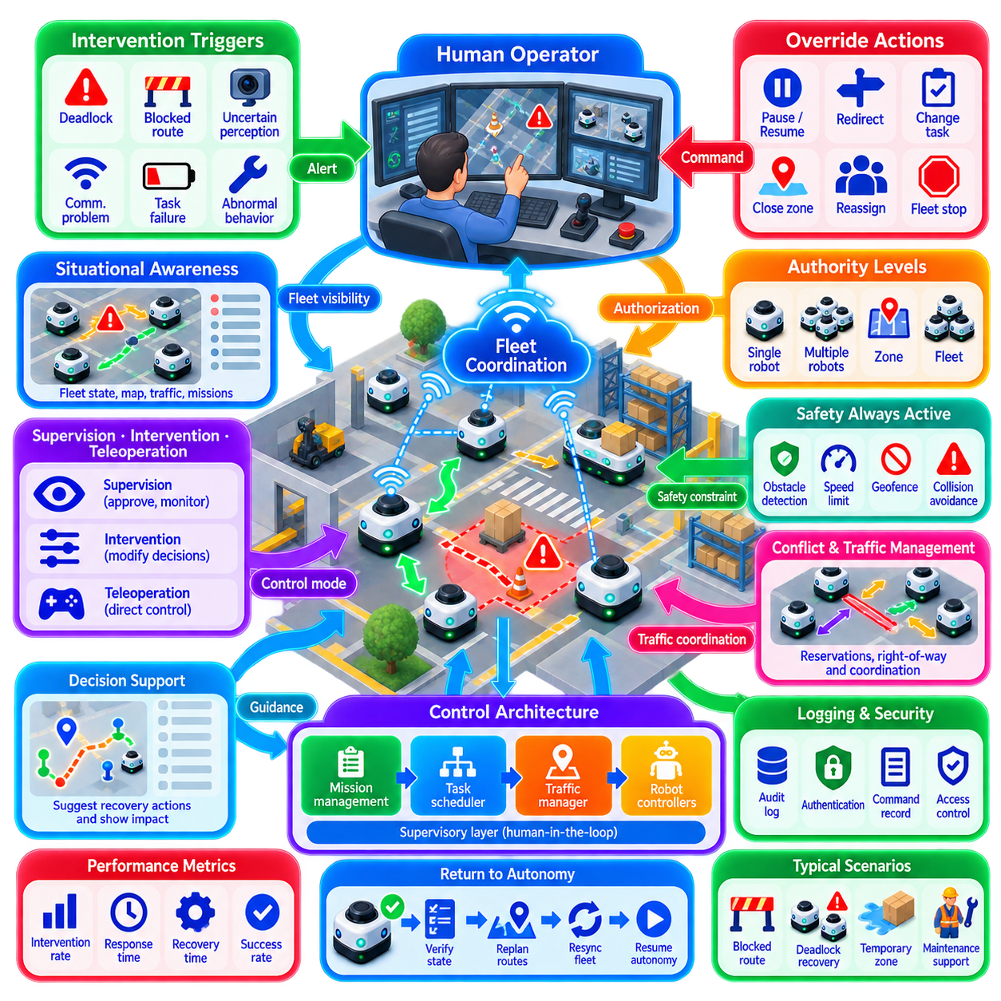
Human-in-the-loop override provides a controlled mechanism through which authorized operators can intervene when a coordinated robot fleet encounters situations that autonomous functions cannot safely, reliably, or efficiently resolve. The objective is not to replace fleet autonomy with continuous manual control, but to introduce human judgment at defined decision boundaries while preserving coordination, safety constraints, and consistent fleet state.
A coordinated fleet normally operates through mission planning, task allocation, traffic management, local navigation, and onboard safety functions. Human intervention should therefore enter through an explicit supervisory layer rather than bypassing the architecture. The supervisory interface can request mission changes, approve exceptional actions, pause operations, redirect robots, or initiate controlled recovery while lower-level safety functions remain independently active.
Override authority should be separated into different levels according to operational impact. A low-level intervention may pause or resume a single mission, while a higher-level command may change task priority, close a traffic zone, redirect several robots, or stop an entire fleet. Separating authority prevents routine operator actions from unintentionally affecting unrelated robots and makes permissions easier to manage, audit, and validate.
The system should distinguish supervision, intervention, and direct teleoperation. Supervision allows an operator to observe fleet conditions and approve proposed actions. Intervention modifies autonomous decisions without continuously controlling robot motion. Teleoperation gives the human more direct control over movement and therefore requires stronger communication, situational awareness, access control, and safety mechanisms than ordinary supervisory interaction.
Intervention can be triggered by conditions such as unresolved deadlock, blocked routes, uncertain perception, repeated task failure, localization degradation, communication problems, unexpected human activity, damaged infrastructure, or abnormal robot behavior. The autonomous system should identify situations in which confidence or operational progress falls below defined thresholds and escalate them rather than repeatedly attempting ineffective recovery actions.
Escalation should provide the operator with sufficient context to make a meaningful decision. Simply reporting that a robot has stopped is rarely enough. The interface should identify the affected robot, mission, location, relevant zone, detected problem, attempted recovery actions, nearby robots, current reservations, and available alternatives. Presenting structured context reduces the time required for the operator to reconstruct the situation manually.
Fleet-wide situational awareness is particularly important because an action applied to one robot can affect many others. Moving a blocked robot may release a traffic queue, while manually sending it into a reserved zone may create a new conflict. The human-machine interface should therefore visualize dependencies between robot state, traffic reservations, shared resources, mission priorities, and neighboring fleet activity before an override is executed.
An override should be treated as a coordinated state transition rather than an arbitrary command injection. Before applying a requested action, the system determines which autonomous behaviors must be paused, which reservations must be modified, and which neighboring robots must be informed. After the transition is confirmed, the operator's command becomes active. This prevents autonomous and human commands from simultaneously competing for control.
Command ownership is necessary to define who currently has authority over a robot or mission. A robot may be under autonomous fleet control, supervisory hold, assisted recovery, or teleoperation. Ownership transitions should be explicit and mutually exclusive where required. Clear ownership prevents a fleet scheduler from assigning new motion while an operator is manually recovering the same robot.
Safety functions should remain active during human override whenever technically possible. An operator requesting motion should not automatically disable obstacle detection, emergency stopping, speed limits, geofencing, or collision protection. If a specialized maintenance procedure requires a safety constraint to be altered, that change should use a separate authorized process rather than being implicitly included in ordinary override authority.
Teleoperation requires particular attention to latency and communication quality. A remote operator cannot safely control a moving robot if video, sensor feedback, or command transmission becomes excessively delayed or unstable. The system should monitor round-trip delay, packet loss, video freshness, and control connectivity. If communication quality falls below acceptable limits, speed can be reduced or the robot can transition automatically to a safe stop.
Shared control can reduce the burden of direct teleoperation. Instead of commanding individual actuator values, the operator may select a local target, indicate a preferred direction, or approve a short maneuver while onboard navigation generates feasible motion. Local obstacle avoidance and safety supervision remain active. This approach combines human semantic judgment with robot-level motion precision and is often more scalable for fleet recovery.
Human intervention must also respect multi-robot traffic coordination. If an operator directs a robot through an intersection, narrow corridor, elevator, or other shared resource, the action should normally pass through the same reservation and ownership mechanisms used by autonomous robots. An override may change priority or authorize exceptional recovery, but it should not silently invalidate the assumptions used by neighboring robots.
Emergency stop and operational pause should be treated differently. An emergency stop is a safety action intended to remove hazardous motion as rapidly as required, while an operational pause is a coordinated mission-management action. A fleet-wide pause may allow robots to decelerate and stop at appropriate locations, whereas emergency protection may require immediate behavior. Mixing these concepts can create unnecessary operational disruption or inadequate safety response.
Deadlock recovery is a common application for human-in-the-loop intervention. When automatic priority rules, rerouting, or reservation recovery cannot restore traffic flow, the system can present the blocking dependency to an operator. The operator may authorize one robot to reverse, release a reservation, move to a recovery position, or temporarily close a route while the fleet coordinator recalculates traffic around the intervention.
Task-level override can modify mission execution without controlling motion directly. An operator may cancel a task, change its priority, assign it to another robot, postpone an operation, or mark a destination temporarily unavailable. The task scheduler should then recompute affected assignments and dependencies. This maintains architectural consistency while still allowing human judgment to respond to production or operational conditions not represented in the autonomous model.
Zone-level override is useful when the environment changes unexpectedly. An operator can designate a temporary blocked area around spilled material, maintenance activity, damaged infrastructure, or an unsafe human workspace. The fleet treats the resulting restriction as a dynamic zone and reroutes robots accordingly. This is preferable to manually steering every affected robot because one human decision can safely modify behavior across the fleet.
Operator workload becomes a major concern as fleet size increases. A single person cannot continuously monitor every robot in a large deployment. The system should therefore operate by exception, presenting only events that require attention and grouping related alarms when possible. Prioritization based on safety impact, mission criticality, number of affected robots, and recovery urgency helps operators focus on the most important situations.
Automation should continue supporting the operator during an intervention. The system can generate candidate recovery actions, estimate their consequences, identify affected reservations, and highlight safety constraints. The human then selects or approves an appropriate option rather than constructing every recovery procedure from scratch. This form of decision support improves response speed while retaining accountable human authority for exceptional cases.
Multiple operators require explicit coordination. Two operators should not unknowingly issue conflicting commands to the same robot or traffic region. Role-based access control, command locking, ownership indicators, and transfer procedures can define who is authorized to intervene. Higher-impact actions such as fleet-wide stops, safety-zone modifications, or restricted recovery procedures may require elevated permissions or additional confirmation.
Every intervention should be traceable. Logs should record the operator identity, affected robot or fleet scope, reason for intervention, commands issued, timestamps, previous autonomous state, resulting state, and relevant alarms or sensor conditions. Auditability supports incident analysis, operational improvement, cybersecurity investigation, and evaluation of whether repeated human interventions indicate weaknesses in autonomous fleet logic.
Cybersecurity is particularly important because override interfaces intentionally provide authority over physical systems. Authentication, authorization, encrypted communication, session management, command integrity, and protection against replayed or stale commands should be incorporated into the control architecture. Remote access should expose only the privileges required for the operator's role rather than unrestricted access to every fleet function.
Returning from human control to autonomy requires an explicit handback procedure. The autonomous system should not simply resume from assumptions that existed before intervention. It should verify robot pose, task state, reservations, local map consistency, payload status, nearby traffic, and communication health. Once the relevant state has been reconciled, control ownership can be transferred back to autonomous fleet management.
Handback may require replanning because the human intervention can leave the robot in a different position or mission state than originally expected. The fleet scheduler may need to regenerate routes, reacquire zones, update task assignments, or cancel obsolete reservations. Explicit resynchronization prevents stale autonomous commands from becoming active immediately after manual recovery.
Performance evaluation should consider intervention frequency, escalation rate, operator response time, recovery duration, teleoperation time, successful handback rate, repeated incident frequency, and number of robots affected per event. A mature autonomous fleet should generally reduce unnecessary human interventions over time while still providing rapid and reliable access to human judgment when exceptional conditions occur.
Validation should include communication degradation, blocked routes, deadlocks, localization failures, repeated task errors, conflicting operator requests, teleoperation disconnects, emergency conditions, and handback after manual movement. Testing should verify not only whether the operator can take control, but whether surrounding robots remain coordinated and whether the fleet returns to a consistent autonomous state afterward.
Human-in-the-loop override is therefore best designed as a governed supervisory capability embedded within coordinated fleet architecture. Humans provide contextual judgment and exceptional decision-making, while automation preserves state consistency, traffic coordination, and scalable execution. By combining explicit authority, safe command transitions, decision support, auditability, and controlled handback, the fleet can retain high autonomy without losing the ability to manage situations beyond its autonomous operating envelope.

03.10 Multi Robot Coordination Failure Recovery Design
Multi-robot coordination failure recovery addresses how a fleet detects, isolates, contains, and recovers from failures without allowing a local problem to propagate into fleet-wide disruption. Failures may originate from individual robots, communication networks, localization, traffic coordination, shared resources, task execution, or supervisory services. Recovery design therefore treats resilience as a system-level coordination property rather than only a robot-level fault-handling function.
A useful recovery architecture begins by distinguishing faults, errors, and failures. A fault is an underlying abnormal condition, such as sensor degradation or network loss; an error is an incorrect internal state caused by that fault; and a failure occurs when the system can no longer provide the expected service. This distinction helps recovery logic respond before a developing fault becomes an operational fleet failure.
Failure detection should combine local robot diagnostics with fleet-level observation. Individual robots can monitor motors, batteries, sensors, localization confidence, controllers, and communication interfaces, while fleet services monitor task progress, heartbeat messages, route execution, traffic reservations, and shared-resource usage. Combining both perspectives improves detection of failures that are difficult to identify from either level alone.
Health information should be represented using explicit operational states rather than a simple healthy-or-failed flag. A robot may be normal, degraded, recovering, unavailable, isolated, or awaiting human intervention. Communication and infrastructure services can use similar state models. Explicit degradation states allow coordination policies to reduce capability gradually instead of treating every abnormal condition as an immediate total failure.
Heartbeat and timeout mechanisms are commonly used to detect missing robots or coordination services. However, a missed message does not necessarily mean that a robot has failed. Wireless interference, congestion, temporary network partitions, or processing delays can produce similar symptoms. Failure detectors should therefore consider message age, repeated loss, local sensing, and service context before declaring a component unavailable.
Once a failure is detected, containment becomes the immediate objective. A malfunctioning robot should not continue occupying shared resources indefinitely or execute stale coordination commands. Depending on the failure, the robot may stop safely, move to a recovery position, release reservations, suspend its task, or announce degraded capability. Containment prevents one uncertain agent from destabilizing otherwise healthy fleet coordination.
Failure isolation determines which component or dependency is responsible for abnormal behavior. A navigation failure may actually originate from localization degradation, map inconsistency, blocked infrastructure, or communication loss. Recovery should avoid repeatedly restarting the wrong subsystem. Diagnostic reasoning can combine event histories, health indicators, dependency graphs, and recent state transitions to narrow the likely source of the problem.
Task recovery begins by determining whether the interrupted task remains valid. Some operations can simply resume from the current state, while others require restart, rollback, or reassignment. A delivery robot that stops during transit may continue after recovery, whereas a partially completed handover or assembly operation may require verification of payload ownership and physical state before execution can safely continue.
Dynamic task reassignment allows another robot to replace a failed fleet member. The replacement should be selected according to capability, location, payload capacity, battery state, tooling, mission priority, and access to required resources. Reassignment should also consider the cost of abandoning the original robot's partially completed work, because transferring a task may require retrieving material or reconstructing mission context.
Traffic recovery is necessary when a failed robot physically blocks a route, intersection, docking station, or narrow corridor. Merely marking the robot unavailable does not remove the obstruction. The fleet traffic manager should update the traversability model, invalidate affected routes, establish a temporary blocked zone, and reroute other robots. Recovery planning must therefore represent both logical failure and physical occupancy.
Reservation recovery prevents abandoned locks from producing persistent deadlock. If a robot fails while holding a zone, elevator, charger, workstation, or other shared resource, the coordination system needs rules for releasing or transferring ownership. Leases and bounded reservation lifetimes are useful because ownership can expire safely when renewal stops, reducing dependence on explicit release messages from failed components.
Care is required when automatically releasing reservations because the failed robot may still physically occupy the resource. Logical ownership and physical occupancy are different states. A zone should not become available merely because its communication lease expired if sensors indicate that the robot remains inside. Safe recovery therefore combines reservation state with occupancy verification before allowing another robot to enter.
Communication failures require degraded coordination modes. When peer-to-peer or fleet communication becomes unreliable, robots may reduce speed, increase separation, suspend cooperative maneuvers, complete only locally safe actions, or stop before entering shared critical zones. The appropriate response depends on whether local perception can maintain safety and whether the mission can continue without globally consistent coordination information.
Network partition creates a particularly difficult consistency problem because different groups of robots may continue operating with incomplete knowledge of one another. Recovery policies should define whether isolated groups may continue local missions, which shared resources become unavailable, and how conflicting state updates are reconciled after connectivity returns. Conservative partition behavior reduces the risk of duplicate assignments or incompatible reservations.
Leader-based coordination requires recovery from leader failure. Followers should detect loss of the leader, enter a defined hold or degraded state, and initiate leader replacement only under controlled conditions. A newly elected leader must reconstruct the relevant coordination state before issuing commands. Immediate leadership without state synchronization can create duplicated decisions, obsolete reservations, or inconsistent formation behavior.
Distributed coordination also requires protection against inconsistent membership. Robots may disagree about which agents are active after communication loss or restart. Membership epochs, generation numbers, or versioned fleet views can identify which configuration is current. Commands associated with obsolete membership versions should be rejected so that a recovered robot cannot accidentally reintroduce an outdated coordination state.
State checkpointing supports recovery of coordination services. Task assignments, reservation ownership, mission progress, robot health, and critical workflow states can be stored periodically or transactionally. After a service restart, the system reconstructs its state from validated records rather than assuming an empty fleet. Checkpoints must be sufficiently consistent to avoid recovering mutually incompatible task and resource information.
Idempotent commands are valuable because recovery often involves retransmission. If a robot does not acknowledge a command, the coordinator may be uncertain whether the command was lost or executed successfully. Commands designed to produce the same result when repeated reduce this ambiguity. Unique command identifiers and execution records further prevent duplicated task execution after communication restoration.
Recovery actions should be organized by severity. Minor transient faults may use automatic retry, while persistent faults can trigger local replanning, task reassignment, robot isolation, or fleet-level reconfiguration. Failures affecting safety, uncertain physical state, or repeated unsuccessful recovery should escalate to human supervision. Escalation thresholds prevent endless autonomous retries from consuming time or creating additional hazards.
Retry policies require limits and context. Repeating the same failed action indefinitely is rarely useful. Recovery logic should track retry count, failure reason, environmental changes, and whether each attempt produced meaningful progress. Backoff intervals or alternative strategies can prevent repeated actions from overloading shared resources or causing several robots to enter synchronized failure loops.
Cascading failure prevention is a central design objective. One stopped robot can block a corridor, which delays several missions, increases traffic density elsewhere, consumes staging space, and eventually creates additional deadlocks. Fleet recovery should therefore evaluate the dependency radius of a failure and intervene before secondary effects grow. Local failure containment can significantly improve overall fleet availability.
Recovery should preserve safety before optimizing productivity. A fleet may temporarily accept lower throughput, longer routes, larger spacing, or fewer active robots while operating in degraded mode. Attempting to maintain nominal performance during uncertain conditions can increase recovery complexity and risk. Once system confidence improves, capability can be restored progressively rather than immediately returning to full-speed operation.
Human-in-the-loop recovery becomes important when physical conditions cannot be inferred reliably. An operator may need to verify a dropped payload, manually move a disabled robot, confirm that a corridor is clear, or authorize release of a disputed resource. The fleet should provide structured failure context and candidate recovery actions while maintaining command ownership, safety constraints, and audit records.
Return to service requires more than restarting the failed component. A recovered robot should verify localization, sensors, payload state, communication, task ownership, map consistency, reservations, and surrounding traffic before rejoining coordinated operation. The fleet should also remove temporary restrictions and reconcile any assignments that changed while the robot was unavailable.
Recovery testing should include sensor faults, localization loss, motor faults, low battery, blocked robots, communication delay, packet loss, network partition, coordinator restart, leader failure, reservation inconsistency, task interruption, and simultaneous failures. Fault injection in simulation allows rare combinations to be tested systematically before equivalent scenarios are evaluated on physical robots.
Useful resilience metrics include failure detection time, isolation time, mean time to recovery, task recovery success rate, percentage of automatically recovered incidents, mission disruption, number of robots affected by each failure, reservation cleanup time, and degraded-mode throughput. Measuring secondary impact is important because rapid recovery of one robot may still represent poor fleet resilience if many other robots were unnecessarily disrupted.
Multi-robot coordination failure recovery is therefore a layered resilience process connecting health monitoring, failure detection, containment, diagnosis, task reassignment, traffic reconfiguration, state consistency, degraded operation, and controlled return to service. A robust fleet does not assume that failures can be eliminated; it assumes that failures will occur and structures coordination so that they remain bounded, observable, recoverable, and safe.

