Volume 17 Manipulation and Grasping AI

Chapter 07. Learning Based Manipulation

07.01. Learning Based Manipulation Overview IL RL Hybrid
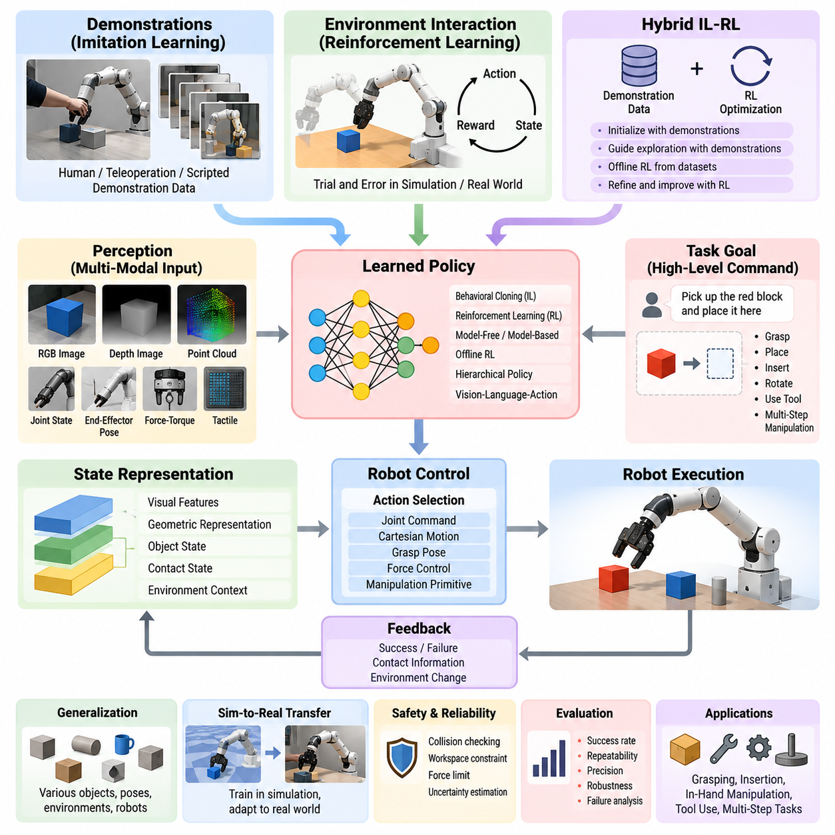
Learning-based manipulation replaces manually specified robot behaviors with policies that acquire manipulation skills from data, interaction, and experience. Instead of defining every grasp, trajectory, contact transition, or recovery rule explicitly, the robot learns mappings from observations and task objectives to actions. This approach is especially valuable when manipulation involves uncertain perception, complex contact dynamics, object variability, or situations that are difficult to model accurately with analytical methods.
A learning-based manipulation system typically combines perception, state representation, policy learning, control, and feedback. Observations may include RGB or depth images, point clouds, joint states, end-effector poses, force-torque measurements, and tactile signals. These heterogeneous inputs are transformed into representations that capture task-relevant information. A learned policy then selects actions such as joint commands, Cartesian motions, grasp poses, forces, or higher-level manipulation primitives according to the current state and desired goal.
Imitation Learning (IL) learns manipulation behavior from demonstrations provided by humans, teleoperation systems, scripted controllers, or previously successful robot trajectories. The central idea is to transfer demonstrated behavior into a policy without requiring the robot to discover the entire solution through trial and error. Behavioral Cloning directly learns observation-to-action mappings from demonstration datasets, while more advanced approaches address distribution shift by allowing additional interaction, corrective demonstrations, or iterative dataset aggregation.
Demonstration quality strongly influences imitation-learning performance. Manipulation demonstrations must capture not only successful trajectories but also meaningful variations in object pose, geometry, contact conditions, robot configuration, and environmental context. Multimodal demonstrations can additionally include vision, proprioception, force, and tactile information. Large and diverse datasets improve generalization, but inconsistent demonstrations may introduce ambiguity, making data filtering, trajectory alignment, action normalization, and representation design important parts of the learning pipeline.
Reinforcement Learning (RL) formulates manipulation as sequential decision making in which an agent interacts with an environment and learns actions that maximize cumulative reward. Unlike imitation learning, RL can discover behaviors beyond those explicitly demonstrated. Rewards may represent grasp success, object displacement, insertion accuracy, task completion, energy consumption, collision avoidance, or manipulation efficiency. Through repeated interaction, the policy learns how actions influence future states and long-term task outcomes.
RL is particularly attractive for contact-rich tasks because manually deriving optimal strategies for friction, compliance, impacts, and uncertain object dynamics can be difficult. Tasks such as peg insertion, in-hand manipulation, pushing, tool use, and dexterous grasping may benefit from policies discovered through extensive exploration. However, real-world exploration is expensive and potentially unsafe. Consequently, simulation, parallel environments, domain randomization, offline datasets, and constrained exploration are commonly used to reduce physical training requirements.
The distinction between model-free and model-based reinforcement learning is important in robotic manipulation. Model-free methods directly optimize policies or value functions from experience and can learn highly complex behaviors, but often require large amounts of interaction. Model-based methods learn or exploit a representation of environment dynamics and use it to predict consequences before acting. Learned world models can improve data efficiency by enabling planning, imagined rollouts, and evaluation of candidate actions without executing every possibility on the physical robot.
Hybrid IL-RL approaches combine the strengths of demonstrations and autonomous optimization. Imitation learning can provide an initial policy that already performs meaningful behavior, substantially reducing the exploration burden of reinforcement learning. RL can subsequently refine this policy, adapt it to physical dynamics, recover from states that were absent from demonstrations, and optimize objectives that human demonstrations did not explicitly maximize. This progression from demonstration toward autonomous improvement is particularly useful for practical robotic systems.
Another hybrid strategy integrates demonstrations directly into reinforcement-learning objectives rather than separating pretraining and fine-tuning. Demonstration transitions can populate replay buffers, guide exploration, regularize policy updates, or provide reference trajectories. Offline reinforcement learning extends this principle by learning policies primarily from previously collected datasets without unrestricted online interaction. Such methods are attractive for industrial manipulation, where historical robot trajectories and production data may be available while uncontrolled exploration on operational equipment is unacceptable.
Learning can occur at several levels of the manipulation hierarchy. Low-level policies may learn force control, impedance behavior, or motor commands, whereas intermediate policies can predict grasp poses, motion segments, or manipulation primitives. Higher-level policies can select skills such as approach, grasp, lift, place, insert, rotate, or recover. Hierarchical learning decomposes long-horizon manipulation into reusable behaviors, reducing the complexity of policy learning while supporting compositional execution across different tasks.
Modern manipulation increasingly integrates language, vision, and action within shared learning architectures. Vision-language-action models can interpret semantic instructions and visual scenes while generating robot actions or skill sequences. Large-scale pretrained representations provide knowledge about objects, spatial relationships, and task semantics that conventional task-specific policies lack. Nevertheless, semantic understanding alone does not guarantee physically valid manipulation, so geometric reasoning, collision constraints, contact feedback, and real-time control remain essential.
Generalization is one of the primary objectives of learning-based manipulation. A useful policy should operate across object instances, poses, backgrounds, lighting conditions, robot states, and moderate changes in task configuration. Data augmentation, domain randomization, representation learning, multitask training, and large heterogeneous datasets improve robustness. Generalization across robot embodiments is more difficult because kinematics, workspace, grippers, sensors, and action spaces differ, motivating embodiment-aware representations and transferable action abstractions.
Sim-to-real transfer provides an important bridge between scalable training and physical deployment. Simulation enables millions of interactions without equipment damage or human supervision, but discrepancies in geometry, friction, actuator behavior, sensing, latency, and contact dynamics create a reality gap. Randomizing simulation parameters can prevent policies from depending excessively on one simulated configuration. System identification, real-world fine-tuning, residual learning, and adaptive control can further reduce the remaining mismatch after deployment.
Safety and reliability distinguish practical manipulation learning from laboratory demonstrations. Learned policies can encounter observations far outside their training distribution and may generate physically unsafe actions with high confidence. Deployment architectures therefore benefit from explicit safety envelopes, collision checking, workspace constraints, force limits, uncertainty estimation, anomaly detection, and supervisory controllers. A learned policy should operate as part of a layered robotic control architecture rather than being assumed to provide all safety guarantees by itself.
Evaluation must extend beyond average task success. Manipulation policies should be tested for repeatability, precision, cycle time, recovery capability, robustness to disturbances, sensitivity to object variation, and behavior under distribution shifts. Failure classification is particularly important because perception errors, planning errors, grasp failures, contact instability, and controller failures require different improvements. Benchmark results become more meaningful when experimental protocols clearly separate training conditions from genuinely unseen evaluation scenarios.
Learning-based manipulation ultimately represents a transition from programming individual motions toward building systems that acquire, adapt, and compose manipulation capabilities. Imitation Learning provides efficient knowledge transfer from demonstrations, Reinforcement Learning enables optimization through interaction, and hybrid IL-RL approaches connect prior experience with autonomous improvement. Combined with multimodal perception, world models, hierarchical skills, and safety-constrained control, these methods form a foundation for increasingly general-purpose robotic manipulation.

07.02. Behavior Cloning from Human Teleoperation [w/Code]
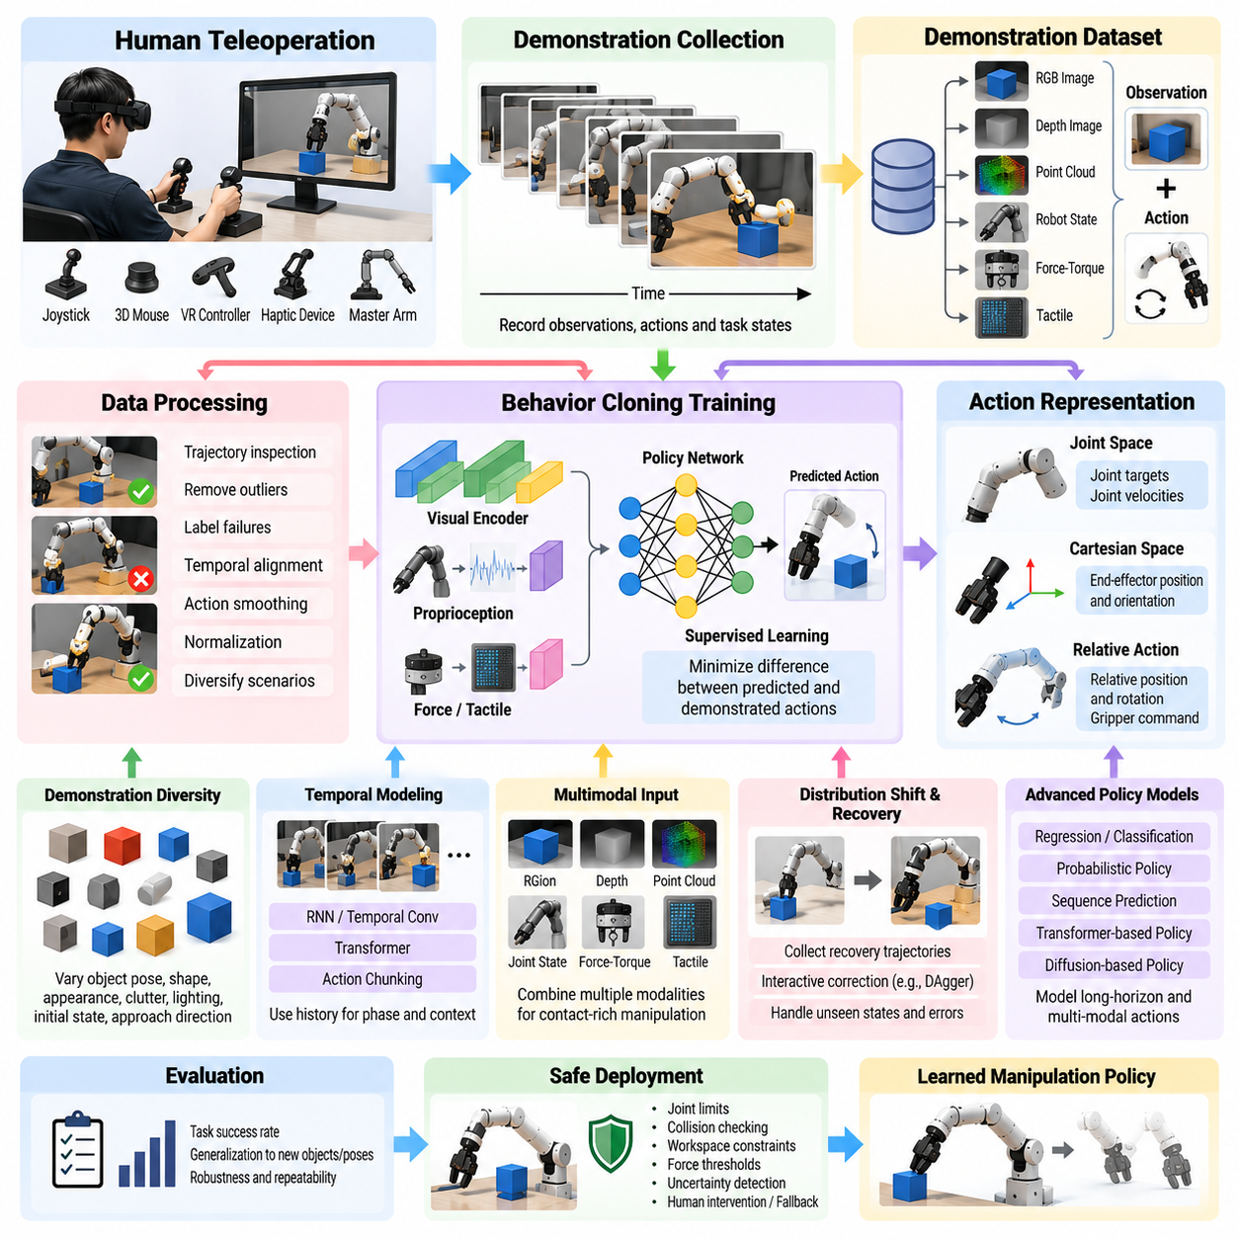
Behavior Cloning (BC) is a direct form of imitation learning in which a robot learns a manipulation policy from demonstrations rather than discovering behavior through autonomous trial and error. In human teleoperation, an operator controls the robot while observations, actions, and task states are recorded as demonstration trajectories. The resulting dataset provides supervised examples showing how appropriate actions should be selected under different manipulation conditions.
A teleoperation system acts as the interface between human manipulation intent and the robot action space. Operators may command the robot using joysticks, 3D mice, motion-capture devices, VR controllers, haptic interfaces, or master manipulators. The interface should allow intuitive control of end-effector position, orientation, gripper state, and sometimes contact force. Good interface design reduces operator workload while producing smooth and consistent demonstrations suitable for policy learning.
Each demonstration can be represented as a sequence of observation-action pairs collected over time. An observation may contain RGB images, depth images, point clouds, robot joint positions, joint velocities, end-effector poses, gripper states, force-torque measurements, and tactile signals. The corresponding action can specify joint targets, Cartesian displacement, end-effector velocity, gripper commands, or other control variables. Accurate temporal synchronization between these modalities is essential for creating valid training samples.
The fundamental Behavior Cloning objective is supervised learning of a policy that predicts the demonstrated action from the current observation. Given demonstration pairs consisting of observations and expert actions, the policy parameters are optimized to minimize the difference between predicted and demonstrated actions. Continuous manipulation commonly uses regression losses, while discrete skill or command selection can use classification objectives. More complex policies may predict probability distributions to represent multiple plausible actions.
Human teleoperation data contains characteristics that differ from automatically generated trajectories. Operators exhibit reaction delays, variable motion speed, corrective movements, hesitation, and individual control styles. These properties can provide useful examples of real recovery behavior, but excessive inconsistency can make the learning target ambiguous. Dataset construction therefore often includes trajectory inspection, unsuccessful-trial labeling, outlier removal, temporal alignment, action smoothing, and normalization while preserving informative corrections.
Demonstration diversity is more important than simply repeating nearly identical successful executions. Training data should cover variations in object position, orientation, shape, appearance, clutter, lighting, initial robot configuration, and approach direction. Contact-rich manipulation additionally requires variations in friction, alignment, grasp quality, and interaction forces. A diverse demonstration distribution helps the learned policy distinguish essential task structure from accidental properties of a particular demonstration environment.
Visual Behavior Cloning learns actions directly from camera observations or from learned visual representations. Convolutional networks, vision transformers, or pretrained visual encoders can transform images into compact features representing objects, geometry, and scene context. These features are combined with proprioceptive robot states before action prediction. Depth and point-cloud information can strengthen geometric reasoning when accurate spatial relationships are required for grasping, insertion, placement, and tool interaction.
Action representation strongly influences policy performance. Joint-space commands provide direct correspondence to robot actuators but are closely tied to a specific embodiment. Cartesian end-effector actions can provide a more transferable representation for manipulation tasks because they describe desired motion relative to the workspace or object. Relative position and rotation increments are frequently useful because they reduce dependence on absolute coordinates and allow demonstrations collected at different poses to share similar action patterns.
Behavior Cloning suffers from distribution shift because the policy is trained primarily on states visited by the human demonstrator. Small prediction errors during autonomous execution can move the robot into states that were rarely or never observed in the training dataset. Subsequent predictions may become increasingly inaccurate, producing compounding errors. This problem is particularly serious in long-horizon manipulation, where small deviations during approach or grasping can eventually cause complete task failure.
Several strategies reduce this distribution mismatch. Demonstrators can intentionally collect recovery trajectories from perturbed states, or the robot can execute its current policy while a human provides corrections when necessary. Dataset Aggregation methods iteratively add observations encountered by the learned policy together with expert actions for those states. Such interactive data collection expands training coverage around failure boundaries and teaches the policy how to recover instead of learning only ideal nominal trajectories.
Temporal context is important because many manipulation actions cannot be inferred from a single observation. The same visual scene may require different actions depending on whether the robot is approaching an object, closing the gripper, lifting it, or preparing to place it. Recurrent neural networks, temporal convolution, transformers, and history-based policies incorporate previous observations and actions. Temporal representations can therefore infer task phase, motion direction, contact progression, and hidden state more reliably.
Multimodal policies become particularly valuable when manipulation depends on physical contact. Vision provides global information about objects and workspace geometry, while force-torque and tactile sensors reveal contact events that may be visually subtle or completely occluded. Proprioception describes the robot's internal configuration and motion. Combining these modalities allows Behavior Cloning policies to reproduce demonstrations for tasks such as insertion, surface following, compliant grasping, connector assembly, and delicate object handling.
Modern Behavior Cloning increasingly uses sequence prediction rather than predicting only the next instantaneous command. Action chunking predicts a short sequence of future actions and can reduce sensitivity to noise while producing smoother robot motion. Transformer-based policies can model long temporal dependencies across observations and actions. Diffusion-based policies can represent multimodal action distributions, which is useful when several distinct but equally valid manipulation trajectories can accomplish the same task.
Data quality and quantity must be considered together. A large dataset containing poorly synchronized, inconsistent, or irrelevant trajectories may perform worse than a smaller but carefully curated collection. Metadata describing task identity, object configuration, operator, success status, robot embodiment, sensor calibration, and environmental conditions improves dataset management. Maintaining raw demonstrations alongside processed training samples also supports reproducibility and future reprocessing when representations or learning algorithms change.
Training and validation datasets should be separated according to the generalization capability being measured. Randomly splitting frames from the same trajectory can produce misleading results because neighboring frames are highly correlated. More meaningful evaluation holds out complete trajectories, object instances, poses, operators, or environmental configurations. This reveals whether the policy has learned transferable manipulation behavior rather than memorizing visual scenes or reproducing narrowly repeated motion patterns.
Real-world deployment requires the learned policy to operate within a controlled safety architecture. Predicted actions can be filtered through joint limits, velocity limits, collision checking, workspace boundaries, force thresholds, and emergency-stop mechanisms. Uncertainty or out-of-distribution detection can trigger slower execution, human intervention, or fallback behavior. These safeguards are especially important because supervised imitation does not inherently guarantee that every predicted action is physically safe.
Behavior Cloning from human teleoperation provides a practical route for transferring manipulation expertise into robots without requiring explicit programming of every motion. Its effectiveness depends on intuitive teleoperation, synchronized multimodal recording, diverse demonstrations, suitable action representations, temporal modeling, and systematic handling of distribution shift. When combined with recovery data, interactive correction, robust evaluation, and safety supervision, BC becomes a strong foundation for scalable learning-based manipulation.

07.03. DAgger Dataset Aggregation for Manipulation [w/Code]
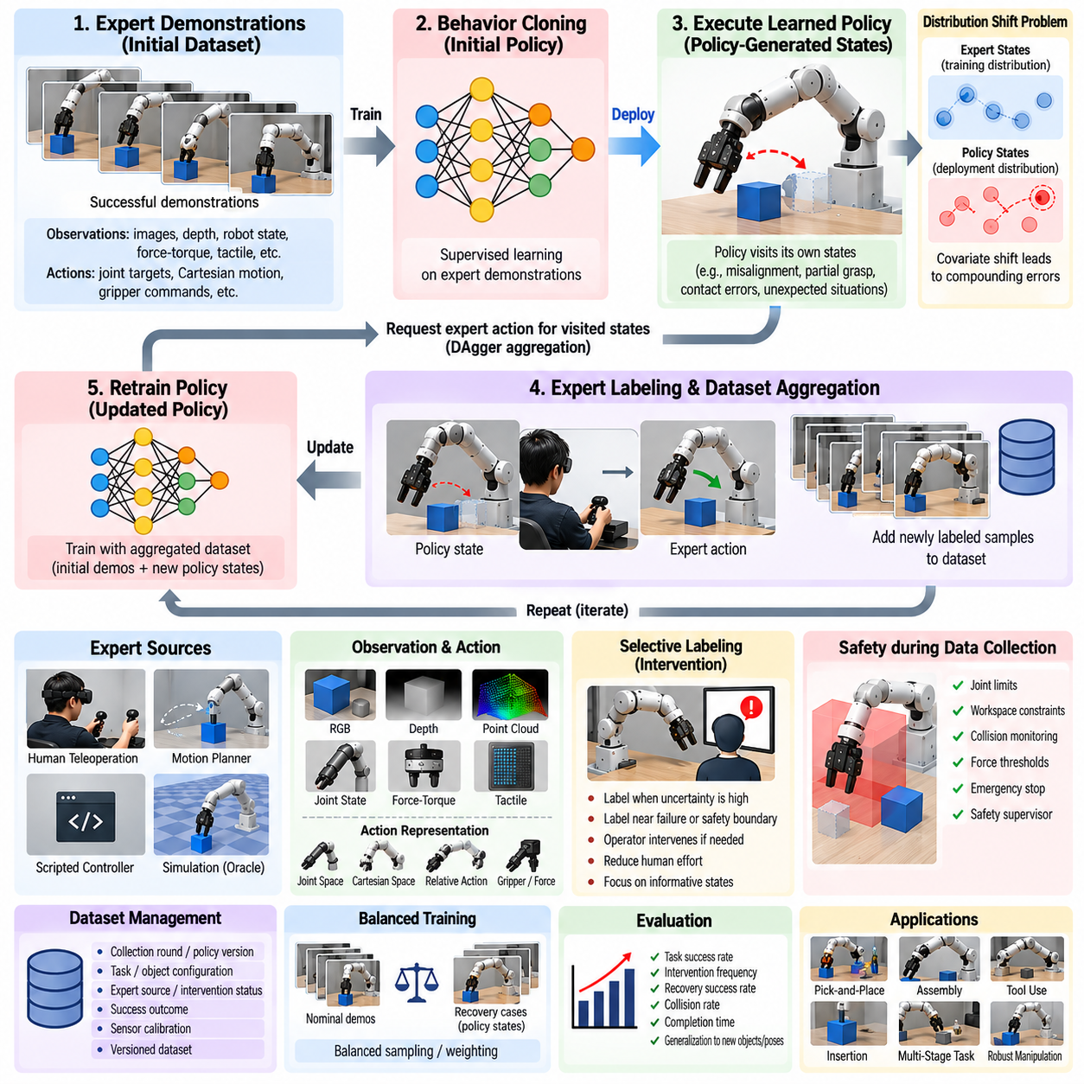
DAgger, or Dataset Aggregation, is an interactive imitation-learning method designed to address one of the fundamental weaknesses of standard Behavior Cloning. A policy trained only on expert demonstrations observes states generated by expert behavior during training, but during autonomous execution its own prediction errors can move the robot into unfamiliar states. DAgger explicitly collects expert guidance in states visited by the learned policy, reducing this mismatch between training and deployment distributions.
The central problem addressed by DAgger is covariate shift between expert trajectories and policy-generated trajectories. In manipulation, a small positional error during approach can alter the subsequent grasp pose, contact geometry, or object motion. The next observation therefore differs from the demonstrations, increasing the probability of another incorrect action. These errors can accumulate over a long manipulation sequence until the robot enters a state for which the original dataset provides little useful supervision.
DAgger changes data collection from a one-time demonstration process into an iterative learning loop. An initial dataset is typically collected from an expert, and a policy is trained using supervised imitation learning. The learned policy is then executed in the task environment, allowing it to visit states produced by its own behavior. For those encountered states, an expert provides the action that should have been taken, and the newly labeled samples are added to the existing dataset.
After aggregation, the policy is retrained or incrementally updated using both the original demonstrations and newly collected policy-state examples. The improved policy is deployed again, producing another set of states that reflects its current strengths and weaknesses. Repeating this cycle progressively shifts the dataset toward the distribution encountered during actual autonomous operation. Training therefore becomes coupled to the robot's evolving behavior rather than remaining limited to trajectories generated by a nearly perfect expert.
In robotic manipulation, the expert can take several forms. A human operator may provide labels through teleoperation, a conventional motion planner may calculate corrective actions, or a reliable scripted controller may act as an oracle in structured tasks. Simulation can provide privileged information unavailable during deployment, allowing an expert controller to generate labels automatically. The choice of expert determines annotation cost, action quality, response latency, and the range of states that can be supervised effectively.
A practical DAgger system does not necessarily require continuous human control. The learned policy can operate autonomously while the operator observes execution and intervenes only when correction is necessary. Intervention-based variants reduce operator workload by concentrating expert effort on uncertain, dangerous, or failure-prone situations. Corrections collected near these critical states can be particularly valuable because they teach the policy behavior that conventional successful demonstrations rarely contain.
State coverage is one of DAgger's major advantages for manipulation. Standard demonstrations often contain smooth approaches, successful grasps, stable transports, and accurate placements, but relatively few examples of recovery. Policy execution naturally exposes misalignment, partial grasps, unexpected contact, object displacement, and approach errors. Expert labeling of these states transforms failures into training information and allows the policy to learn how to return toward a valid manipulation trajectory.
The observation representation used during aggregation should remain consistent with deployment conditions. RGB images, depth maps, point clouds, proprioception, force-torque measurements, and tactile signals can be recorded together with expert actions. Accurate synchronization remains essential because a correction associated with the wrong observation can introduce misleading supervision. Contact-rich tasks may require higher temporal resolution because the state of interaction can change rapidly after collision, slip, insertion, or grasp closure.
Action labeling also requires careful design. An expert can provide absolute joint targets, joint velocities, Cartesian poses, relative end-effector motions, gripper commands, forces, or higher-level skills. Relative Cartesian actions are frequently useful because they express corrective motion directly from the encountered state. Regardless of representation, the expert action must correspond to the policy observation at the correct time, particularly when teleoperation interfaces introduce human reaction delay or communication latency.
Classical DAgger can mix expert and learned-policy actions during data collection. Early in training, stronger expert influence can prevent the robot from immediately entering highly unsafe or meaningless states. As policy quality improves, control can gradually shift toward autonomous execution, exposing the learner to its own state distribution. The balance between expert guidance and policy autonomy determines how aggressively the system explores errors while maintaining manageable safety and data quality.
Safety is especially important when DAgger is performed on physical robots. Allowing an immature policy to explore arbitrary states can cause collisions, excessive contact forces, dropped objects, or hardware damage. Joint limits, workspace boundaries, velocity constraints, collision monitoring, force thresholds, and emergency-stop mechanisms should therefore operate independently of the learned policy. A safety supervisor can terminate or override actions before dangerous states are reached while still preserving useful near-failure samples.
Not every encountered state needs expert labeling. Active-query strategies can request supervision when policy uncertainty is high, when predicted actions differ strongly across an ensemble, or when the robot approaches a safety or task boundary. Selective labeling reduces human effort and focuses dataset growth on informative regions. However, uncertainty estimates must be calibrated carefully because a policy may remain confidently incorrect in states far outside its original training distribution.
Dataset management becomes increasingly important as multiple DAgger iterations accumulate data. Each sample should ideally preserve information about the collection round, policy version, task, object configuration, expert source, intervention status, success outcome, and sensor calibration. These metadata make it possible to analyze which iterations contributed useful recovery behavior and whether newer data are improving coverage. Versioned datasets also support reproducible comparison between successive policies.
Aggregated datasets can become unbalanced because difficult states may be repeatedly collected while simple but essential nominal behavior remains represented mostly by initial demonstrations. Training strategies can therefore sample across expert demonstrations, recovery cases, task phases, and DAgger iterations rather than treating every frame identically. Weighting or prioritization can emphasize informative corrections without allowing rare failure states to overwhelm the basic manipulation behavior the robot must preserve.
DAgger is particularly useful for long-horizon tasks because compounding errors become more severe as the number of decisions increases. In pick-and-place, assembly, tool use, or multi-stage manipulation, an error during one phase changes the initial condition of every subsequent phase. Aggregating corrective examples at intermediate stages allows the policy to learn transitions from imperfect states, increasing the probability that execution can continue rather than requiring a complete restart after every deviation.
Evaluation should measure more than improvement on the aggregated training dataset. The policy should be tested on independent episodes containing unseen object poses, perturbations, environmental variations, and initial robot configurations. Useful metrics include task success, intervention frequency, recovery success, collision rate, completion time, and the number of expert queries required. A decreasing intervention rate across iterations is particularly informative because it indicates that the policy is becoming more autonomous rather than merely accumulating labels.
DAgger can also complement modern sequence and multimodal manipulation policies. Transformer-based policies, action-chunking models, diffusion policies, and vision-language-action systems can all benefit from corrective trajectories collected from their own deployment distribution. The aggregation principle is independent of a specific neural architecture: expose the learner to states it actually creates, obtain appropriate expert behavior for those states, and incorporate that information into subsequent training.
In practical learning-based manipulation, DAgger transforms imitation learning from passive reproduction into an interactive improvement process. Initial demonstrations provide nominal competence, policy execution reveals distribution gaps, expert corrections supply targeted supervision, and repeated aggregation converts encountered weaknesses into training data. Combined with multimodal sensing, selective intervention, disciplined dataset management, and independent safety constraints, DAgger provides a systematic path from fragile Behavior Cloning toward robust autonomous manipulation.

07.04. RL for Dexterous Manipulation PPO SAC [w/Code]
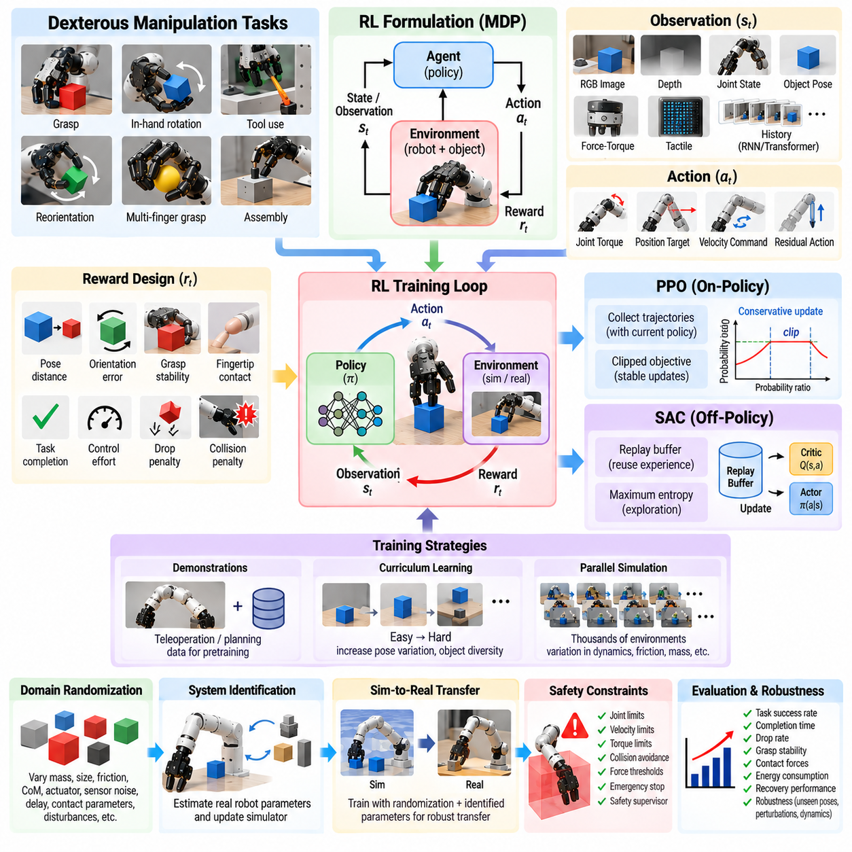
Dexterous manipulation requires a robot to coordinate many degrees of freedom while controlling contact, friction, object motion, and grasp stability over time. Tasks such as in-hand rotation, reorientation, tool handling, and multi-finger grasp adjustment are difficult to describe with fixed trajectories or analytical controllers alone. Reinforcement Learning (RL) provides a framework in which manipulation policies can be optimized through interaction and reward rather than manually specifying every contact transition.
An RL manipulation problem is commonly formulated as a Markov Decision Process containing states, observations, actions, rewards, and transition dynamics. The state may describe joint positions, velocities, fingertip poses, object pose, contact forces, and task variables, while observations contain information available to the policy. Actions can represent joint torques, position targets, velocity commands, or residual corrections applied on top of conventional controllers.
The reward function defines what behavior the robot should learn and is therefore a critical part of dexterous RL. Rewards may measure distance between current and target object poses, orientation error, grasp stability, fingertip contact, task completion, or control effort. Penalties can discourage object drops, excessive joint motion, collisions, unstable forces, and unsafe configurations. Poor reward design can produce unintended strategies that maximize numerical reward without accomplishing the desired physical behavior.
Proximal Policy Optimization (PPO) is widely used for robotic learning because it provides relatively stable policy updates and works effectively with large-scale parallel simulation. PPO is an on-policy actor-critic method that collects trajectories using the current policy and updates the policy while constraining excessive changes between successive versions. Its clipped objective reduces the probability that a single optimization step destabilizes a previously useful manipulation behavior.
For dexterous manipulation, PPO benefits substantially from thousands of simulated environments running in parallel. Different environments can simultaneously expose the policy to variations in object pose, friction, mass, contact conditions, actuator properties, and disturbances. Large batches of experience stabilize gradient estimation and allow complex behaviors to emerge from extensive interaction. The primary limitation is sample efficiency because collected experience becomes less reusable after the policy has been updated.
Soft Actor-Critic (SAC) provides an alternative approach based on off-policy reinforcement learning. Instead of discarding most previously collected experience, SAC stores transitions in a replay buffer and repeatedly samples them during optimization. This reuse can improve sample efficiency, which is particularly valuable when interaction is expensive. SAC learns value functions together with a stochastic policy and can operate effectively in continuous action spaces common to robotic manipulation.
A defining feature of SAC is maximum-entropy reinforcement learning. The objective encourages the policy to maximize both expected reward and action entropy, preventing premature collapse toward a narrowly deterministic behavior. During dexterous manipulation, this controlled stochasticity can promote exploration of alternative contact configurations, finger motions, and recovery strategies. The entropy coefficient determines the balance between task optimization and exploration and may be automatically adjusted during training.
PPO and SAC therefore offer different practical tradeoffs. PPO is often attractive when extremely large amounts of simulation can be generated efficiently and synchronized parallel rollout is available. SAC can be preferable when experience reuse and sample efficiency are important. The choice is not determined solely by benchmark performance; simulator throughput, observation dimensionality, action frequency, reward sparsity, policy architecture, and the cost of real-world interaction all influence the appropriate algorithm.
Action-space design strongly affects the difficulty of RL training. Direct torque control gives the policy high authority but requires learning fast actuator dynamics and stable contact behavior. Position or velocity targets executed through lower-level controllers reduce the learning burden and can improve safety. Another practical option is residual control, where RL predicts corrections to commands generated by an impedance controller, motion planner, or nominal manipulation policy.
Observation design is equally important. Proprioceptive information such as joint position and velocity is usually combined with object state, fingertip contact, force, tactile measurements, or visual features. In simulation, privileged object information may be available for training even when it cannot be measured directly on the physical robot. Teacher-student learning or asymmetric actor-critic architectures can exploit privileged state during training while producing a policy that operates from realistic sensor observations during deployment.
Dexterous manipulation is partially observable because friction, contact state, object motion, and external disturbances cannot always be inferred from a single measurement. Observation history, recurrent networks, or transformer-based temporal models can provide the policy with information about recent interactions. This temporal context is particularly useful for identifying slip, estimating motion trends, distinguishing stable from unstable contact, and coordinating sequential finger adjustments.
Sparse rewards create another major challenge. If reward is provided only when a complex task is completed, random exploration may almost never discover a successful trajectory. Reward shaping can provide intermediate signals for approaching, contacting, grasping, lifting, rotating, and stabilizing an object. Curriculum learning can also begin with easier configurations and progressively increase pose variation, disturbance, object diversity, or task precision as policy competence improves.
Demonstrations can accelerate reinforcement learning without replacing autonomous optimization. Human teleoperation, motion planning, scripted controllers, or previously trained policies can provide initial trajectories for policy pretraining or replay-buffer initialization. Imitation objectives can be combined with PPO or SAC losses during early training. As learning progresses, the influence of demonstrations can decrease while RL explores improvements beyond the behavior contained in the original examples.
Domain randomization is central to transferring dexterous RL policies from simulation to physical robots. Training environments can vary object mass, dimensions, friction coefficients, center of mass, actuator strength, sensor noise, control delay, contact parameters, and external disturbances. Rather than optimizing for one perfectly modeled simulator, the policy learns behavior that succeeds across a distribution of physical conditions and is therefore more likely to tolerate real-world modeling errors.
System identification complements randomization by narrowing simulation parameters toward measured hardware behavior. Actuator latency, joint friction, torque limits, controller response, and sensor characteristics can be estimated from physical experiments and incorporated into the simulator. Excessively broad randomization may make learning unnecessarily difficult, whereas unrealistically narrow randomization produces fragile policies. Effective sim-to-real training therefore balances measured realism with sufficient parameter diversity.
Safety constraints become critical when an RL policy is transferred to hardware. Joint limits, velocity limits, torque limits, workspace constraints, collision avoidance, contact-force thresholds, and emergency stopping should remain outside the learned policy whenever possible. Actions can be projected into safe regions or filtered by supervisory controllers before execution. Initial deployment can also use reduced speed and conservative limits while collecting evidence that the policy behaves reliably.
Evaluation of dexterous RL should include more than the final average reward. Task success rate, completion time, object-drop frequency, grasp stability, contact-force distribution, energy consumption, recovery performance, and robustness to disturbances provide more physically meaningful measures. Evaluation should also use object poses, dynamics, and environmental conditions that were not encountered during training to determine whether the policy has learned transferable manipulation rather than memorized a simulator configuration.
Robustness testing should deliberately expose the policy to perturbations. Object mass can be changed, friction reduced, target poses shifted, observations corrupted, or external forces applied during execution. Failure cases should be categorized according to perception, contact, control, exploration, or dynamics mismatch. Such analysis reveals whether improvement requires additional training data, modified rewards, broader randomization, better sensing, or changes to the underlying controller architecture.
PPO and SAC represent complementary tools rather than universally superior alternatives for dexterous manipulation. PPO provides stable on-policy optimization that scales naturally with massive parallel simulation, while SAC emphasizes off-policy experience reuse and entropy-driven exploration. Combined with appropriate action representations, multimodal observations, demonstrations, curricula, domain randomization, and safety supervision, both methods can support sophisticated contact-rich manipulation.
The broader objective of reinforcement learning for dexterous manipulation is not merely to maximize a numerical reward but to acquire adaptive physical behavior that remains effective under uncertainty. Successful systems integrate learned policies with sensing, low-level control, simulation, safety mechanisms, and systematic validation. Within this architecture, PPO and SAC provide optimization mechanisms through which robots can discover, refine, and generalize manipulation strategies that would be difficult to engineer explicitly.

07.05. Action Chunking with Transformers ACT Policy [w/Code]
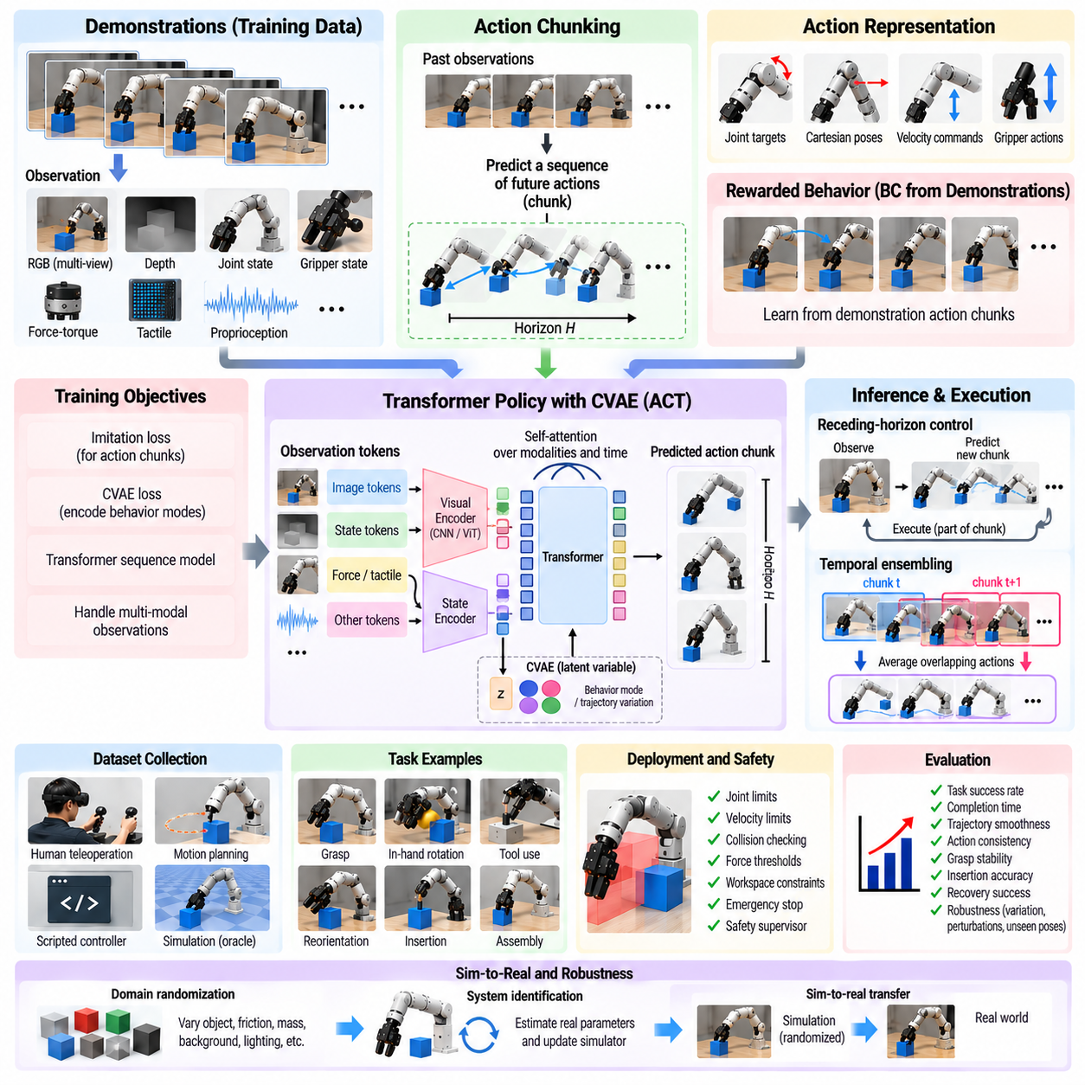
Action Chunking with Transformers (ACT) addresses a central difficulty in imitation-based robot manipulation: predicting reliable behavior over long sequences from demonstrations that may contain noise, hesitation, and multiple valid motion patterns. Instead of predicting only one action at every control step, ACT predicts a short sequence, or chunk, of future actions. This temporal abstraction allows the policy to model coherent motion segments and reduces dependence on unstable frame-by-frame decisions.
Conventional Behavior Cloning commonly learns a mapping from the current observation to the next action. Although simple, this formulation can accumulate small prediction errors over long manipulation horizons. Human teleoperation data also contains correlated actions because operators execute continuous motions rather than independent commands. Action chunking exploits this structure by learning several temporally related actions together, allowing the model to capture the local trajectory rather than treating each control instant as an isolated prediction problem.
An ACT training sample typically contains robot observations together with a future action sequence of fixed horizon. Observations can include multi-view RGB images, depth information, joint positions, end-effector state, gripper configuration, force measurements, or other proprioceptive signals. The target chunk may contain future joint positions, Cartesian commands, gripper actions, or another continuous control representation covering several subsequent time steps.
Transformers are well suited to this formulation because self-attention can model relationships across observations, robot states, and action sequences without assuming that only neighboring time steps are important. Visual features can be extracted by convolutional networks or vision transformers and combined with proprioceptive embeddings. The Transformer then reasons over these representations to produce a temporally structured action sequence conditioned on the current scene and robot configuration.
The chunk horizon is an important design parameter. Very short chunks behave similarly to conventional one-step Behavior Cloning and provide limited temporal abstraction. Longer chunks can represent meaningful manipulation phases such as approaching, grasping, lifting, or inserting, but predictions farther into the future become increasingly uncertain. The appropriate horizon therefore depends on control frequency, task dynamics, demonstration quality, and the amount of environmental change expected during execution.
ACT is particularly useful for human teleoperation datasets because demonstrations often exhibit temporal variability. Two operators may perform the same task at different speeds, pause at different moments, or follow slightly different trajectories. A sequence-based model can represent broader motion patterns instead of fitting every instantaneous action independently. This reduces sensitivity to high-frequency demonstration noise and can produce smoother, more consistent robot execution.
A key component of the original ACT formulation is a conditional variational autoencoder (CVAE) combined with a Transformer policy. During training, the CVAE can encode information about the demonstrated action sequence into a latent variable representing behavioral style or trajectory variation. The policy learns to generate action chunks conditioned on observations and this latent representation. This helps model demonstrations in which several different motion strategies may all be valid.
The latent-variable formulation is valuable because manipulation demonstrations are frequently multimodal. An object may be approached from the left or right, a grasp may use slightly different wrist orientations, and placement may follow multiple collision-free paths. A deterministic regression model can average incompatible actions and produce an undesirable intermediate trajectory. Latent representations allow the policy to preserve distinct behavioral modes rather than collapsing them into a single averaged prediction.
During inference, the robot repeatedly observes the environment and predicts a new chunk of future actions. It is possible to execute an entire chunk before generating another prediction, but doing so reduces responsiveness to unexpected environmental changes. A more robust strategy replans frequently, using newly observed states to generate updated chunks. This combines the temporal coherence of sequence prediction with closed-loop feedback from the physical environment.
Temporal ensembling further improves execution stability. Because chunks predicted at neighboring time steps overlap, several predictions may exist for the same future action. Instead of selecting only one prediction, the controller can combine overlapping estimates using weights that favor more recent or otherwise more reliable predictions. This averaging reduces discontinuities between successive chunks and can suppress noise without eliminating the feedback properties of repeated policy evaluation.
Action representation remains critical in ACT. Joint-position targets are convenient for systems with reliable low-level servo controllers and were important in early demonstrations of the method. Cartesian end-effector commands may provide greater task-level transferability, while relative actions can reduce sensitivity to absolute workspace coordinates. Gripper state is typically included alongside arm commands so that reaching, grasping, transporting, and releasing can be represented within the same temporal action chunk.
Multi-camera observations can substantially improve manipulation performance when objects or robot links become occluded. A fixed camera may provide global workspace context, while wrist-mounted cameras reveal local geometry near the gripper. Image encoders transform each view into compact feature representations before Transformer fusion. Camera calibration, synchronization, exposure consistency, and appropriate viewpoint selection remain important because attention mechanisms cannot recover physical information that was never observed reliably.
ACT can also incorporate nonvisual modalities. Force-torque signals, tactile observations, depth features, and robot proprioception can be embedded as additional tokens or fused with visual representations. Contact-rich tasks such as insertion, connector mating, compliant placement, or delicate grasping benefit from information that vision alone may not reveal. Temporal attention can relate these contact signals to preceding motions and subsequent action adjustments.
Training quality depends strongly on dataset construction. Demonstrations should contain synchronized observations and actions, consistent control conventions, meaningful variation, and sufficient coverage of task phases. Poor demonstrations, severe latency, inconsistent coordinate frames, or incorrect action alignment can corrupt entire chunks rather than isolated labels. Dataset validation should therefore examine temporal synchronization, trajectory continuity, success status, sensor calibration, and the distribution of action magnitudes.
Chunk-based prediction does not eliminate distribution shift. A policy can still encounter states outside the demonstrations after imperfect contact, object movement, or accumulated control error. Recovery demonstrations, corrective teleoperation, DAgger-style dataset aggregation, and perturbation data can expand coverage of these states. Receding-horizon execution also limits the damage from inaccurate long-term predictions because the policy can regenerate actions after observing the consequences of recent motion.
Long-horizon tasks benefit from combining ACT with hierarchical task structure. A high-level planner can select semantic skills or subgoals, while an ACT policy generates temporally coherent low-level motion for each stage. For example, a task can be decomposed into approach, grasp, transport, alignment, insertion, and release phases. This separation allows sequence models to focus on continuous control while higher-level reasoning manages task progression and recovery logic.
Real-time deployment requires balancing model complexity, image processing, chunk length, and control latency. The policy does not need to run at the same frequency as the underlying motor servo if predicted chunks provide intermediate commands, but observations must still be refreshed frequently enough to react to environmental changes. GPU inference, optimized visual encoders, asynchronous sensing, and carefully designed control buffers can help maintain deterministic execution timing.
Safety mechanisms should remain independent of the Transformer policy. Joint limits, velocity and acceleration limits, workspace boundaries, collision checking, force thresholds, and emergency stopping can filter or override predicted actions before they reach the robot. Temporal smoothness does not imply physical safety, and a coherent action sequence may still be incorrect when perception fails or the environment differs substantially from the training distribution.
Evaluation should measure both task-level success and temporal control quality. Useful metrics include completion rate, trajectory smoothness, action discontinuity, execution time, intervention frequency, grasp stability, insertion accuracy, and recovery success. Tests should vary object pose, background, lighting, initial robot configuration, and disturbance conditions. Comparing one-step policies with different chunk horizons can reveal whether temporal abstraction genuinely improves robustness rather than merely smoothing motion.
Action Chunking with Transformers provides a practical bridge between demonstration-based imitation learning and long-horizon robotic control. By predicting coherent future action sequences, representing multimodal behavior through latent variables, and repeatedly updating overlapping chunks through feedback, ACT reduces several weaknesses of frame-by-frame Behavior Cloning. Combined with diverse demonstrations, multimodal sensing, recovery data, hierarchical planning, and independent safety control, it forms a powerful architecture for scalable manipulation learning.

07.06. Diffusion Policy for Robot Manipulation [w/Code]
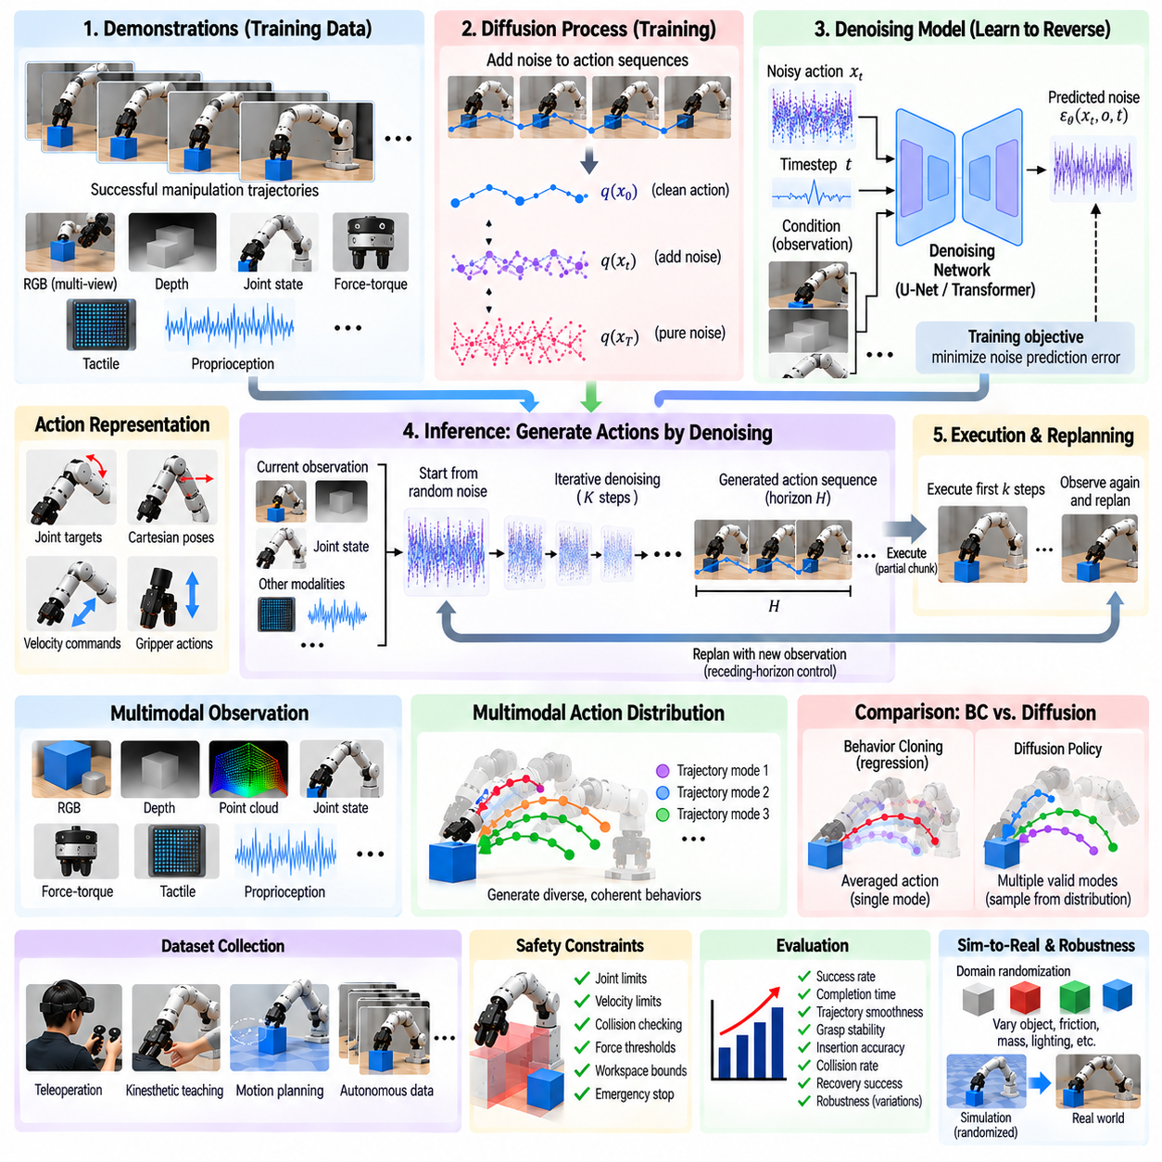
Diffusion Policy applies generative diffusion modeling to robotic manipulation by learning a conditional distribution over actions rather than directly regressing a single deterministic command. This is valuable because manipulation frequently admits several valid behaviors for the same observation. Different grasp approaches, wrist orientations, trajectories, and contact strategies may all solve a task, making multimodal action distributions a natural representation of robot behavior.
Conventional Behavior Cloning with regression often minimizes the average error between predicted and demonstrated actions. When demonstrations contain multiple distinct strategies, this objective can average incompatible actions and produce a command that corresponds to none of the successful behaviors. Diffusion Policy instead models the structure of the action distribution and can generate coherent samples corresponding to different valid modes without forcing them into a single mean trajectory.
The basic diffusion process begins by progressively adding noise to demonstrated action sequences until their original structure is largely destroyed. A neural network is then trained to reverse this process by estimating how noise should be removed while conditioning on observations of the robot and environment. During inference, the policy starts from a noisy action representation and repeatedly denoises it, gradually transforming random values into a structured sequence of manipulation actions.
Conditioning information provides the physical context required for useful action generation. Inputs may include RGB images, depth maps, point clouds, joint states, end-effector poses, gripper states, force-torque signals, and tactile measurements. Visual encoders transform high-dimensional images into compact representations, while robot-state encoders represent proprioception. The denoising network combines these features with the evolving noisy action sequence to generate actions appropriate for the observed situation.
Diffusion policies are commonly trained over action horizons rather than isolated single-step commands. The output can therefore represent a sequence of joint targets, Cartesian poses, relative end-effector motions, velocities, or gripper commands covering several future control steps. Predicting trajectories as structured objects allows the model to capture temporal correlations among actions and encourages smooth, coordinated motion across a manipulation phase.
The distinction between observation horizon, prediction horizon, and execution horizon is important. The observation horizon determines how much recent sensory history is provided to the policy, while the prediction horizon specifies how far into the future actions are generated. The execution horizon determines how much of the predicted sequence is actually executed before the environment is observed again and a new trajectory is generated. These parameters determine the balance between temporal planning and feedback responsiveness.
Receding-horizon control makes Diffusion Policy suitable for dynamic physical interaction. The policy can predict a relatively long future action sequence while executing only its initial portion. New sensor measurements are then collected and another action sequence is generated. This repeated replanning prevents the robot from blindly committing to a long open-loop trajectory and allows it to respond to object displacement, contact errors, disturbances, or changes in the scene.
Multimodality is one of the strongest motivations for diffusion-based manipulation. Consider a robot approaching an object that can be grasped from either side. Both trajectories may appear frequently in demonstrations, yet their intermediate actions can point in opposite directions. A unimodal regression policy may average them and move toward an undesirable region. A diffusion model can preserve the separate modes and sample one internally consistent trajectory.
The denoising architecture must represent both temporal structure and observation conditioning. Implementations may use temporal convolutional networks, U-Net-like architectures, Transformers, or combinations of these components. The network receives the current noisy action sequence together with a diffusion timestep and observation features, then predicts noise or an equivalent denoising target. Repeated application progressively refines the action sequence toward the learned demonstration distribution.
Training requires synchronized demonstration trajectories similar to other imitation-learning methods. Human teleoperation, kinesthetic teaching, scripted controllers, motion planning, or successful autonomous executions can provide data. Each training sample associates observations with corresponding future actions. Accurate timing is especially important because an offset between visual observations and robot commands can cause the model to learn systematically delayed responses that become problematic during contact-rich execution.
Data diversity determines the region of behavior that the diffusion model can represent. Demonstrations should cover variations in object pose, appearance, clutter, lighting, initial robot configuration, approach direction, and task strategy. Contact-rich tasks additionally benefit from variations in alignment, friction, force, and recovery behavior. Diffusion modeling can preserve multiple demonstrated modes, but it cannot reliably generate useful strategies that are absent from the training distribution.
Action normalization is important because diffusion operates directly over numerical action representations. Joint positions, translations, rotations, velocities, and gripper commands can have substantially different scales. Poor scaling can cause the denoising objective to emphasize some dimensions while neglecting others. Consistent coordinate frames, bounded action ranges, normalized units, and appropriate rotation representations improve optimization and make generated trajectories easier to execute reliably.
Observation history can help resolve partial observability. A single image may not indicate whether the gripper is approaching, retreating, sliding, or already in stable contact. Recent visual observations and robot states provide motion and task-phase information. Force and tactile history can reveal contact transitions and slip. By conditioning the diffusion process on temporal context, the policy can generate actions that reflect not only the current appearance but also the recent physical interaction.
Diffusion inference is computationally heavier than direct deterministic policy evaluation because multiple denoising iterations may be required for each generated action sequence. This creates an important real-time engineering tradeoff. Fewer denoising steps reduce latency but may degrade sample quality, while more steps improve refinement at greater computational cost. Accelerated samplers, compact networks, GPU inference, action buffering, and lower policy update rates can help satisfy robot timing constraints.
Diffusion Policy differs from ACT even though both can predict future action sequences. ACT typically uses a Transformer-based sequence model with action chunking and may use latent variables to represent behavioral variation. Diffusion Policy represents the action distribution through iterative generative denoising. Both methods exploit temporal action structure, but diffusion provides a particularly flexible mechanism for representing complex, multimodal continuous distributions without reducing them to a single deterministic output.
Distribution shift remains a challenge despite the expressive generative model. If execution errors move the robot into states absent from demonstrations, the generated actions may become unreliable. Corrective demonstrations, recovery trajectories, perturbation data, and DAgger-style aggregation can extend state coverage. Receding-horizon execution further reduces risk by repeatedly conditioning predictions on the consequences of recent actions rather than trusting one long prediction indefinitely.
Safety constraints should remain external to the learned generative policy. Generated action sequences can be checked for joint limits, velocity and acceleration constraints, workspace boundaries, collision risk, excessive force, or invalid gripper commands. A supervisory controller can modify, reject, or terminate unsafe trajectories. Generative plausibility within the demonstration distribution does not itself guarantee that an action is physically safe under every deployment condition.
Evaluation should examine both task performance and the quality of generated trajectories. Relevant metrics include success rate, completion time, trajectory smoothness, grasp stability, insertion accuracy, collision frequency, recovery success, and sensitivity to disturbances. Because multimodality is a major advantage, evaluation can also determine whether generated actions preserve distinct valid strategies and whether repeated samples remain task-consistent rather than producing arbitrary diversity.
Generalization tests should vary object instances, poses, backgrounds, lighting, robot initial states, and physical parameters beyond the training examples. For contact-rich manipulation, changes in friction, object mass, alignment, and compliance are particularly informative. Failure analysis should distinguish errors caused by perception, insufficient demonstration coverage, denoising instability, control latency, contact dynamics, or low-level tracking so that improvements target the correct component.
Diffusion Policy provides a powerful generative perspective on imitation-based robotic control. Rather than asking a network to select one averaged action, it learns how valid action trajectories are distributed under observed task conditions and generates coherent samples through iterative denoising. Combined with multimodal sensing, action-horizon prediction, closed-loop replanning, diverse demonstrations, recovery data, and independent safety supervision, diffusion models offer a strong foundation for robust and flexible robot manipulation.

07.07. Robot Transformer RT 2 Manipulation Policy [w/Code]
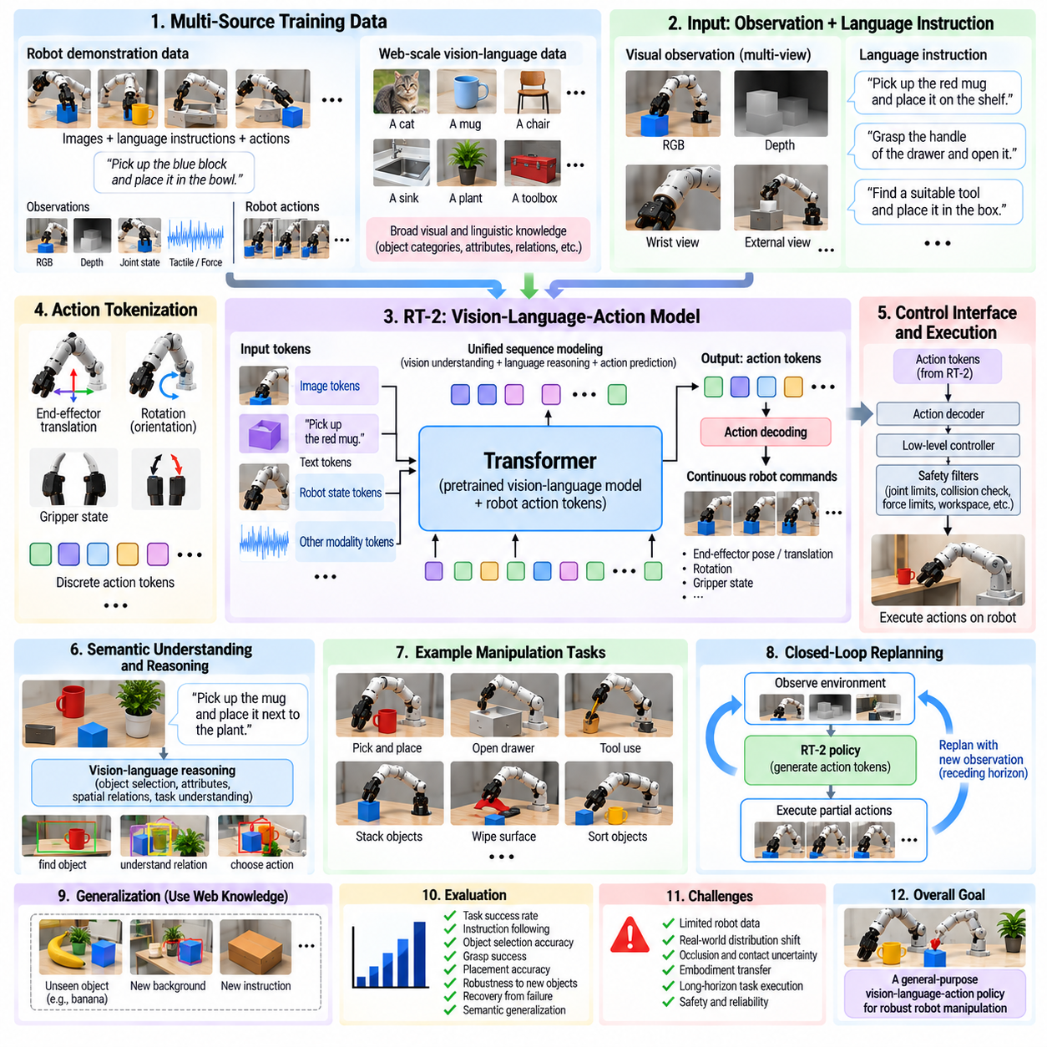
Robot Transformer 2 (RT-2) represents a vision-language-action approach to robot manipulation in which knowledge learned from large-scale visual and linguistic data is connected to physical robot control. Rather than treating perception, semantic reasoning, and action generation as completely separate modules, the policy expresses robot actions within a sequence-modeling framework. This enables semantic knowledge from pretrained vision-language models to influence manipulation decisions.
The central motivation behind RT-2 is that robot demonstration datasets are much smaller than the image-text corpora available for general-purpose artificial intelligence. Training only on robot trajectories can teach physical skills but provides limited knowledge about unfamiliar objects, concepts, symbols, and semantic relationships. RT-2 seeks to transfer broad web-scale visual-language knowledge into robotic behavior while retaining grounding in actions learned from real robot experience.
RT-2 builds on vision-language models that accept images and text and generate token sequences. Robot control is incorporated by representing actions in a form that can also be emitted as tokens. Consequently, the model can process a camera observation together with a natural-language instruction and produce a sequence corresponding to a robot action. The same Transformer machinery can therefore participate in visual interpretation, language understanding, semantic reasoning, and action prediction.
Action tokenization is a key mechanism connecting language modeling with physical control. Continuous robot commands such as end-effector translation, rotation, and gripper state can be discretized into token-like representations. These action symbols become part of the model output vocabulary during robot-policy training. After generation, the predicted action tokens are decoded back into numerical control commands that can be executed by the robot's lower-level controller.
This formulation does not mean that language tokens themselves directly drive motors. The generated representation must pass through an action-decoding and control interface that converts model outputs into physically meaningful commands. Low-level servo loops, kinematic transformations, collision constraints, and hardware safety systems remain necessary. RT-2 primarily operates at the learned policy level, connecting semantic interpretation to action selection rather than replacing the complete robot control stack.
Training combines robotic trajectory data with broader vision-language tasks. Robot examples associate observations and instructions with appropriate actions, while web-derived image-text examples preserve and extend semantic knowledge. Co-training helps prevent the model from becoming narrowly specialized to the robot dataset. The resulting policy can potentially use concepts learned outside robotics when interpreting a new manipulation instruction or deciding which object is relevant to a task.
Language conditioning allows manipulation goals to be expressed semantically instead of only through fixed task identifiers. Instructions can describe objects, spatial relationships, properties, or desired outcomes. A policy may therefore need to interpret not only commands such as picking or placing but also concepts such as choosing an appropriate object for a purpose. This expands manipulation from trajectory reproduction toward behavior conditioned on higher-level meaning.
One important capability associated with RT-2 is semantic generalization. If a model has learned visual-language relationships for concepts that were not explicitly represented in the robot demonstrations, it may still use that knowledge when selecting an action. For example, understanding categories, attributes, symbols, or functional relationships can help identify which object should be manipulated even when the exact combination of instruction and object was absent from robot training.
Another important concept is emergent reasoning in action selection. Because the policy inherits capabilities from large vision-language models, some tasks can require an intermediate semantic inference before physical manipulation. The robot may need to infer which object satisfies an abstract description and then generate an appropriate action toward it. In this sense, reasoning and manipulation become linked because the output of semantic interpretation directly affects the physical action sequence.
However, semantic competence and physical competence remain different requirements. A model may correctly identify an object or understand an instruction while still failing to grasp it because of inaccurate geometry, occlusion, contact uncertainty, or control error. Successful deployment therefore requires semantic reasoning to be combined with reliable spatial perception, calibration, motion execution, feedback, and recovery. Large-scale pretraining does not remove the constraints imposed by physical interaction.
RT-2 is closely related to the broader vision-language-action (VLA) paradigm. A VLA policy receives visual observations and linguistic goals and generates actions within a unified learned representation. This differs from classical robotics pipelines that explicitly separate object detection, task planning, motion planning, and control. Unified policies can reduce hand-engineered interfaces, but they also make systematic diagnosis more difficult because multiple reasoning stages are embedded inside one learned model.
Robot data quality remains critical even when large-scale web knowledge is available. Demonstrations must accurately connect observations, instructions, and executed actions. Poor synchronization, inconsistent language descriptions, control latency, or failed trajectories can weaken physical grounding. Diverse robot experience across objects, viewpoints, backgrounds, tasks, and action outcomes is necessary because semantic pretraining cannot substitute for examples that demonstrate how physical actions affect the real environment.
Embodiment also constrains policy transfer. A robot action representation is tied to properties such as arm kinematics, gripper type, workspace, camera configuration, and controller interface. Semantic knowledge may transfer broadly, while low-level actions often require embodiment-specific adaptation. Relative end-effector representations, standardized action spaces, and additional fine-tuning can reduce this gap, but physical differences between robots remain more difficult than transferring visual or linguistic concepts.
Closed-loop execution is essential because manipulation unfolds through interaction. The robot observes the scene, generates an action, executes it, and receives a new observation reflecting the consequences. Repeated policy evaluation allows the system to adjust after object motion, imperfect grasping, or environmental changes. A VLA model should therefore be viewed as part of a perception-action loop rather than as a system that generates an entire manipulation trajectory once and executes it without feedback.
Long-horizon manipulation may require hierarchical integration. RT-2-like policies can connect semantic goals to short-horizon actions, while higher-level systems maintain task state, sequence subgoals, verify completion, and trigger recovery. A complex instruction can be decomposed into finding an object, approaching it, grasping it, transporting it, and placing it according to a semantic condition. Hierarchical control can prevent a single policy invocation from carrying the full burden of extended task execution.
Safety remains an independent requirement for VLA-based manipulation. A semantically plausible action may still violate joint limits, enter restricted workspace, collide with equipment, or apply excessive force. Robot commands should therefore pass through safety filters, collision checking, velocity and force limits, workspace constraints, and emergency mechanisms. Uncertainty or invalid-output detection can also trigger replanning, human intervention, or a safe stop.
Evaluation must distinguish semantic understanding from physical execution. Tests can measure instruction interpretation, object selection accuracy, task success, grasp reliability, placement precision, recovery capability, and robustness to unseen objects or language formulations. Evaluating only final success makes it difficult to identify whether failure originated from semantic reasoning, visual grounding, action generation, geometric control, or physical interaction.
Generalization testing should deliberately include combinations not present in robot demonstrations. New objects, backgrounds, visual attributes, instructions, semantic relationships, and task compositions can reveal whether pretrained knowledge genuinely contributes to manipulation. Physical variations such as object pose, clutter, lighting, and partial occlusion should also be tested. Strong semantic generalization is useful only when the generated behavior remains physically executable under realistic conditions.
RT-2 also illustrates an important direction for scaling robotic intelligence: robot learning can benefit from knowledge sources that were not originally collected for robotics. Web-scale visual and language data provide semantic structure, while robot trajectories provide physical grounding. Combining these sources creates a path toward policies that understand what a task means while also learning how actions change the physical world, although the quantity and diversity of embodied data remain major limitations.
The broader significance of RT-2 is therefore not simply the use of a larger Transformer for robot control. It demonstrates a framework in which perception, language, learned knowledge, reasoning, and physical action can share a common sequence-modeling architecture. When combined with high-quality robot demonstrations, closed-loop feedback, embodiment-aware control, hierarchical planning, and independent safety mechanisms, this vision-language-action approach provides a foundation for more general-purpose manipulation systems.

07.08. One Shot and Few Shot Manipulation Learning [w/Code]
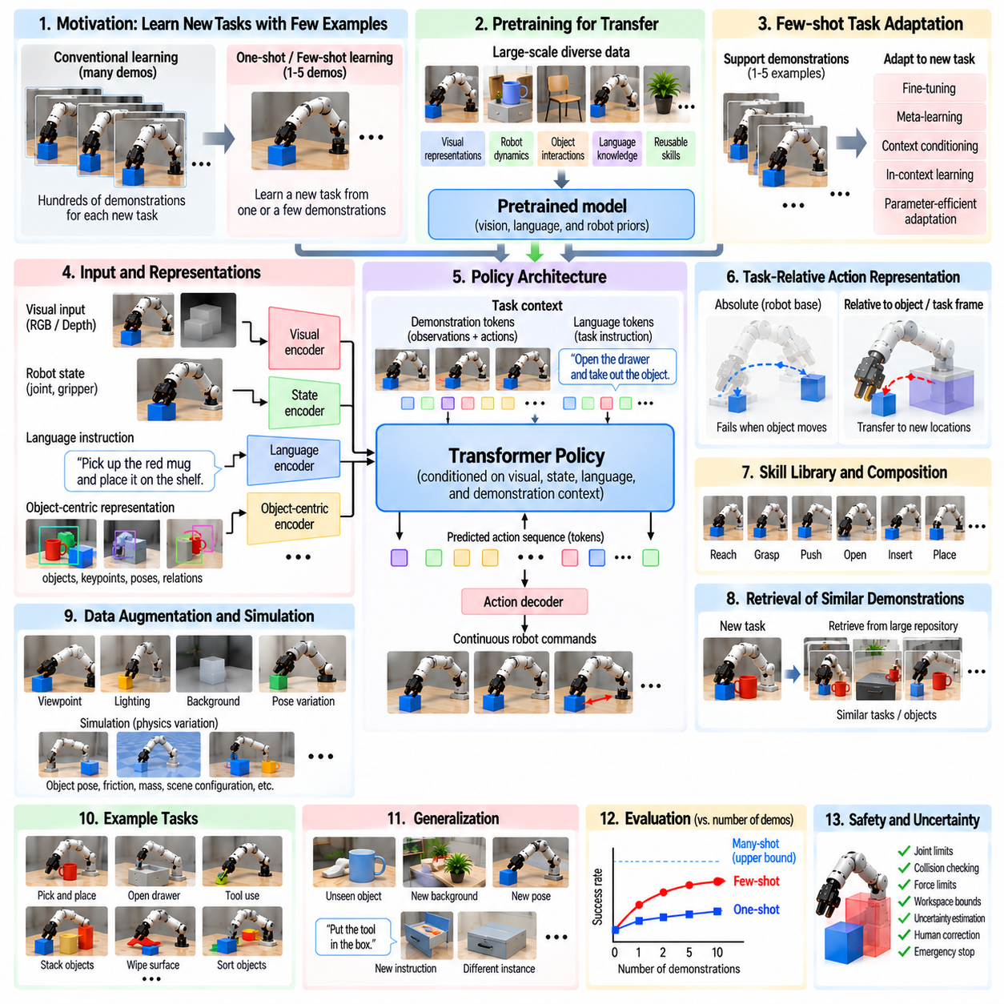
One-shot and few-shot manipulation learning address the problem of acquiring new robotic skills from extremely limited task-specific experience. Instead of requiring hundreds or thousands of demonstrations for every object and task, the robot must infer useful behavior from one or a small number of examples. This capability is important for general-purpose manipulation because real environments continually introduce unfamiliar objects, configurations, tools, and instructions.
Conventional supervised robot learning assumes that training data sufficiently covers the distribution encountered during deployment. This assumption becomes impractical when each new manipulation task requires extensive teleoperation and annotation. One-shot learning attempts to generalize from a single representative example, while few-shot learning uses several examples to estimate task structure and variation. Both approaches depend strongly on knowledge acquired before the new task is presented.
Pretraining is therefore a central foundation for data-efficient manipulation. A model can first learn visual representations, robot dynamics, object interactions, language concepts, or reusable manipulation skills from large and diverse datasets. When a new task appears, the system does not begin from an uninitialized policy. Instead, the limited demonstrations specify how previously learned knowledge should be recombined, conditioned, or adapted to satisfy the new manipulation objective.
A demonstration can provide multiple forms of information beyond the exact trajectory that was executed. It reveals which object is relevant, how the object should be approached, what contact relationship is required, how the gripper interacts with it, and what final state defines success. Effective few-shot systems attempt to extract these invariant task properties rather than memorizing joint positions or absolute coordinates that apply only to one demonstration.
Representation learning strongly influences whether such abstraction is possible. Visual encoders can represent object identity, geometry, pose, affordances, and spatial relationships, while proprioceptive representations describe the robot configuration. Language embeddings can encode task intent and semantic constraints. Combining these representations creates a task context in which a new demonstration can be interpreted relative to previously learned concepts rather than treated as an isolated trajectory.
Object-centric representations are particularly useful for manipulation generalization. Instead of describing an entire scene only as raw pixels, the policy can reason about objects, parts, keypoints, poses, and relationships. A demonstrated action can then be represented relative to a handle, surface, container, or target object. This allows the same manipulation pattern to transfer when the object moves or when a different instance with similar functional structure is introduced.
Relative coordinate systems provide another mechanism for reducing demonstration requirements. A trajectory expressed entirely in robot-base coordinates may fail when the object appears at a new location. Expressing end-effector motion relative to the object, grasp frame, or task frame separates the manipulation pattern from the absolute scene configuration. The robot can transform the demonstrated relationship into the coordinates of a new situation before generating control commands.
Few-shot learning can be implemented through rapid parameter adaptation. A pretrained policy is updated using the small demonstration set so that its parameters specialize to the new task. Fine-tuning must be carefully controlled because aggressive updates from very little data can cause overfitting or catastrophic forgetting. Parameter-efficient adaptation, regularization, frozen visual backbones, or adaptation of only selected policy layers can preserve broad prior knowledge while incorporating new task information.
Meta-learning provides a more explicit framework for rapid adaptation. Instead of training a model only to solve individual tasks, meta-learning trains across a distribution of tasks so that the model learns how to adapt. During meta-training, the system repeatedly receives small support sets and is evaluated on related query examples. This encourages the learned initialization or adaptation mechanism to extract useful task information from only a few demonstrations.
Context-conditioned policies offer an alternative to modifying model parameters. Demonstrations can be encoded into a task embedding or context representation that conditions the policy during execution. When a new task is presented, the model processes the example demonstrations and generates actions without requiring extensive gradient-based retraining. Transformer architectures are especially suitable because demonstration observations, actions, language, and current robot states can be represented as sequences of context tokens.
In-context robot learning extends this idea by treating demonstrations as part of the inference input. A sufficiently pretrained sequence model can observe example interactions and infer how to behave in the current situation from patterns contained in its context. This resembles few-shot prompting in language models, but robotic applications must additionally resolve geometry, embodiment, temporal dynamics, contact, and safety. Physical grounding therefore makes robotic in-context learning substantially more constrained.
Language can further reduce the amount of physical demonstration required. A short demonstration may show how to execute the motion, while a natural-language instruction identifies the intended task, object, or condition. Vision-language-action models can combine semantic knowledge from pretraining with limited robot examples. Language is especially useful when the demonstration alone is ambiguous because similar motions may correspond to different goals depending on task context.
Skill libraries also support few-shot adaptation. A robot can maintain reusable primitives for reaching, grasping, lifting, inserting, pushing, opening, placing, or tool use. A new task may then require learning how to select, parameterize, and sequence existing skills rather than learning motor behavior from the beginning. This compositional approach shifts learning from low-level control toward task structure and can substantially reduce the amount of new demonstration data required.
One-shot learning is more difficult than few-shot learning because a single example provides little evidence about allowable variation. The robot cannot directly determine which aspects of the demonstration are essential and which are accidental. Strong priors from pretraining, object-centric representations, semantic descriptions, known geometry, and task constraints therefore become particularly important. Without such prior structure, reproducing one example is closer to memorization than genuine one-shot generalization.
Data augmentation can expand the effective information contained in a small demonstration set. Images can be transformed through controlled changes in viewpoint, lighting, background, or appearance, while trajectories can be transformed into alternative coordinate frames or perturbed within physically meaningful limits. Simulation can generate variations in object pose, friction, mass, and scene configuration. Augmentation must preserve task semantics because unrealistic transformations can teach invalid manipulation relationships.
Retrieval provides another practical mechanism for few-shot learning. When a new task arrives, the system can search a large repository for demonstrations involving similar objects, instructions, geometries, or manipulation skills. Retrieved examples supplement the small task-specific dataset and provide relevant priors for action generation or fine-tuning. Representation quality is critical because retrieval should reflect functional similarity rather than superficial visual resemblance alone.
Uncertainty estimation becomes important when learning from limited evidence. A policy may appear confident even though the new object or task lies far outside its previous experience. Ensemble disagreement, predictive distributions, distance in representation space, or learned confidence measures can indicate when adaptation is unreliable. High uncertainty can trigger additional demonstrations, human correction, slower execution, alternative planning, or refusal to perform an unsafe action.
Evaluation must distinguish memorization from genuine rapid generalization. Testing should use new object instances, poses, backgrounds, initial robot configurations, and task variations that were not included in the adaptation examples. Performance can be measured as a function of the number of demonstrations, such as one, two, five, or ten examples. This reveals how quickly competence improves and whether additional demonstrations provide meaningful gains rather than merely repeating known conditions.
Safety remains essential because few-shot policies operate with less task-specific evidence than conventionally trained systems. Joint limits, workspace constraints, collision checking, velocity and force limits, and emergency stopping should remain independent of adaptation. Early attempts can use conservative speeds and supervisory monitoring. Failed or corrected trials can subsequently become additional training examples, allowing the system to move from few-shot initialization toward progressively more reliable autonomous execution.
The broader objective of one-shot and few-shot manipulation learning is to make robot adaptation resemble skill transfer rather than complete retraining. A capable robot should arrive with reusable perceptual, semantic, geometric, and motor knowledge, then use a small amount of new evidence to determine what is different about the current task. Pretraining, meta-learning, contextual adaptation, skill composition, retrieval, and multimodal reasoning provide complementary mechanisms for achieving this goal.
For general-purpose manipulation, data efficiency is ultimately a requirement for scalability. It is unrealistic to collect a large dedicated dataset every time a robot encounters a new tool, object, workspace, or instruction. One-shot and few-shot learning seek to convert broad prior experience into rapid physical adaptation. When combined with strong representations, task-relative actions, feedback, uncertainty awareness, and independent safety control, they provide a path toward robots that can acquire useful new manipulation behavior from only limited demonstrations.

07.09. Manipulation Policy Sim2Real Transfer [w/Code]
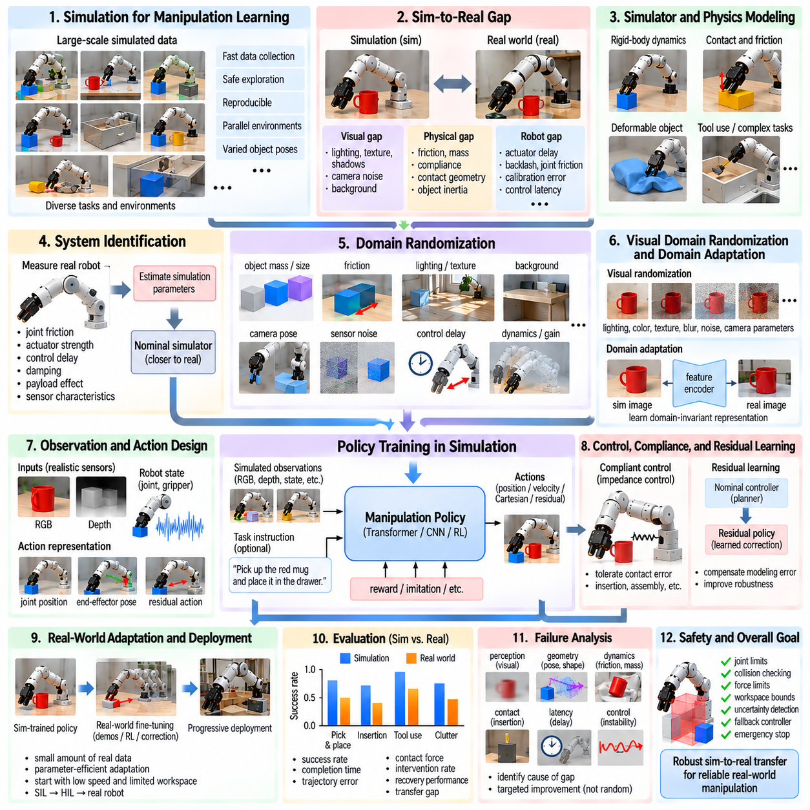
Sim-to-real transfer for manipulation policies addresses the gap between behaviors learned in simulation and reliable execution on physical robots. Simulation can generate large amounts of interaction data quickly, safely, and reproducibly, but simulated sensing, contact, dynamics, and actuator behavior never reproduce reality perfectly. The objective is therefore not to build an absolutely identical simulator, but to train policies that remain effective despite differences between simulated and real environments.
The simulation-to-reality gap appears across multiple parts of the manipulation system. Visual differences include lighting, textures, shadows, reflections, camera noise, and backgrounds. Physical differences arise from friction, mass, compliance, contact geometry, and object inertia. Robot-specific discrepancies include actuator delay, backlash, joint friction, controller response, calibration error, and communication latency. These errors interact during contact-rich manipulation and can produce substantial deployment failures.
Simulation remains valuable because manipulation learning can require enormous numbers of interactions. Reinforcement learning may need millions of transitions, while imitation-learning datasets can benefit from diverse object poses and task configurations. Collecting equivalent experience on physical hardware is expensive and slow and may damage robots or objects during exploration. Parallel simulators can instead generate experience from thousands of environments while systematically varying task conditions.
A useful simulator must represent the aspects of physics that materially influence the target task. Rigid-body dynamics may be sufficient for basic pick-and-place, while insertion, pushing, tool use, or deformable-object manipulation can require more accurate contact, friction, compliance, or material models. Increasing simulator fidelity is not automatically beneficial, because excessive computational complexity can reduce training throughput without eliminating the remaining modeling errors.
System identification reduces the reality gap by estimating simulation parameters from measurements of the physical robot. Joint friction, actuator strength, control delay, damping, payload effects, motor response, and sensor characteristics can be measured through controlled experiments. These estimates define a nominal simulation model closer to the real platform. System identification does not eliminate uncertainty, but it provides a physically meaningful center around which training parameters can be varied.
Domain randomization deliberately exposes the policy to many simulated worlds rather than a single nominal environment. Object mass, dimensions, friction, center of mass, joint damping, actuator gain, sensor noise, control delay, camera pose, lighting, texture, and background can all be randomized. If the real system behaves like one member of this broad training distribution, the policy can succeed without requiring the simulator to reproduce the physical world exactly.
Randomization ranges must be chosen carefully. If they are too narrow, the policy may exploit simulator-specific regularities and fail after deployment. If they are unrealistically broad, learning becomes unnecessarily difficult and the resulting policy may become overly conservative. Measurements from the physical platform, engineering tolerances, and observed environmental variability should therefore guide parameter distributions rather than relying on arbitrary random ranges.
Visual domain randomization is particularly important for policies that consume camera images directly. Training scenes can vary illumination, colors, textures, object appearance, camera exposure, background clutter, shadows, and camera parameters. Synthetic image augmentation can further perturb brightness, contrast, blur, and noise. The objective is to prevent the visual encoder from relying on incidental simulation appearance while preserving geometric and semantic information needed for manipulation.
Domain adaptation provides another strategy when simulated and real observations remain statistically different. Feature encoders can be trained to produce representations that are less sensitive to domain identity, or real images can be used to adapt visual features without rebuilding the entire policy. Image translation may also reduce appearance differences, although translated images must preserve task-relevant geometry. Adaptation is most useful when the residual gap has identifiable structure that randomization alone does not cover.
Action representation strongly affects transferability. Policies that directly output raw motor torques are highly sensitive to actuator and dynamics mismatch. Position targets, velocity targets, Cartesian end-effector commands, or residual actions executed through stable low-level controllers can reduce this sensitivity. Separating learned task-level behavior from high-frequency actuator control allows established feedback controllers to absorb some differences between simulated and physical hardware.
Impedance and compliant control are especially useful for contact-rich sim-to-real manipulation. A policy can generate desired poses or incremental motions while an impedance controller regulates the interaction between position error and contact force. This architecture tolerates small geometric and calibration errors better than rigid position tracking. Insertion, assembly, surface contact, and grasp adjustment often benefit from combining learned policies with compliant low-level control.
Observation design should also avoid unnecessary dependence on simulator-only information. During training, exact object poses, contact states, or velocities may be directly available from the simulation engine, but these signals may not exist on the physical robot. Policies intended for deployment should ultimately operate from measurable observations such as cameras, encoders, force sensors, and tactile sensors. Privileged simulation state can still be used by critics, teachers, or auxiliary objectives during training.
Asymmetric learning provides a practical way to exploit privileged simulation information without requiring it during deployment. For example, an RL critic can receive complete object state and contact information while the actor receives only realistic sensor observations. Teacher-student methods can similarly train a privileged teacher and then distill its behavior into a deployable student. This approach uses simulation efficiently while preserving realistic inference requirements.
Latency modeling is essential because real manipulation systems contain delays that are often negligible in simulation. Camera acquisition, image processing, network communication, policy inference, command transmission, and actuator response all contribute to end-to-end latency. Training can introduce randomized observation and action delays, while policies can use observation history to infer motion under delayed feedback. Ignoring latency can destabilize otherwise successful simulated behaviors.
Sensor modeling should include realistic uncertainty rather than idealized measurements. Camera noise, depth artifacts, encoder quantization, force-sensor bias, tactile uncertainty, dropped frames, and calibration errors can all affect physical execution. Noise injection during training encourages the policy to rely on robust patterns instead of exact simulator values. However, noise distributions should approximate plausible hardware behavior because unrealistic corruption can reduce useful information unnecessarily.
Object and scene diversity are equally important for transfer. Training on one object model or one workspace configuration can produce a policy that overfits geometry even if physics is randomized. Multiple object instances, dimensions, shapes, poses, distractors, surfaces, and clutter configurations should be included when generalization is required. Procedural generation and large object libraries can expand coverage while maintaining precise simulation labels for training and evaluation.
Residual learning can reduce transfer difficulty by combining a reliable conventional controller with a learned correction policy. A motion planner or geometric controller generates a nominal action, and the learned policy predicts a residual that compensates for contact uncertainty, modeling error, or task variation. Because the policy does not need to discover the entire behavior from scratch, the learned component can focus on discrepancies that conventional models handle poorly.
Real-world fine-tuning can close residual gaps after a simulation-trained policy reaches the physical robot. A small amount of real demonstration, reinforcement learning, corrective intervention, or offline robot data can adapt the policy to hardware-specific behavior. Fine-tuning should begin conservatively because an unstable transferred policy can generate unsafe exploration. Parameter-efficient updates or adaptation of selected layers can preserve useful simulation knowledge while correcting systematic real-world errors.
Progressive deployment provides a safer transition from simulation to hardware. Policies can first be tested with software-in-the-loop and hardware-in-the-loop configurations before commanding unrestricted robot motion. Physical tests can begin at reduced speed, limited workspace, low force, and simplified object configurations. As reliability improves, operating envelopes can gradually expand. Each deployment stage provides evidence about which assumptions made in simulation remain valid.
Safety mechanisms must remain independent of transfer performance. Joint, velocity, acceleration, torque, workspace, collision, and force limits should supervise every learned command. Out-of-distribution detection or policy uncertainty can trigger a safe stop, fallback controller, or human intervention. Simulated success does not certify physical safety because unmodeled contacts, sensor failures, calibration errors, and unexpected environmental conditions remain possible.
Evaluation should explicitly measure the transfer gap rather than reporting only simulation or real-world success separately. The same task distribution can be evaluated in both domains using success rate, completion time, trajectory error, contact force, intervention frequency, and recovery performance. A large difference identifies insufficient transfer robustness. Parameter sweeps in simulation can then determine which physical variations are most strongly correlated with observed real-world failures.
Failure analysis should classify discrepancies according to perception, geometry, dynamics, contact, latency, control, and task distribution. A visually driven grasp failure may require camera adaptation rather than broader friction randomization, while unstable insertion may indicate compliance or contact-model mismatch. Structured diagnosis prevents indiscriminate increases in randomization and helps direct engineering effort toward the subsystem responsible for the actual transfer failure.
Effective sim-to-real transfer is therefore not a single algorithm but a coordinated engineering process. System identification establishes a realistic nominal model, domain randomization builds robustness, realistic sensing and latency models reduce hidden assumptions, and stable low-level controllers absorb hardware variation. Real-world adaptation then corrects remaining discrepancies, while staged validation and safety supervision prevent transfer experiments from becoming uncontrolled physical exploration.
The ultimate objective is not zero difference between simulation and reality, which is generally unattainable, but policy invariance to differences that do not change the task itself. A manipulation policy should preserve useful behavior across variations in appearance, physics, sensing, and hardware while remaining responsive to meaningful changes in objects and contacts. Combining diverse simulation, measured hardware models, robust representations, compliant control, limited real adaptation, and systematic validation provides a practical path toward reliable sim-to-real manipulation.

07.10. Learning Manipulation Policy Production Deploy [w/Code]
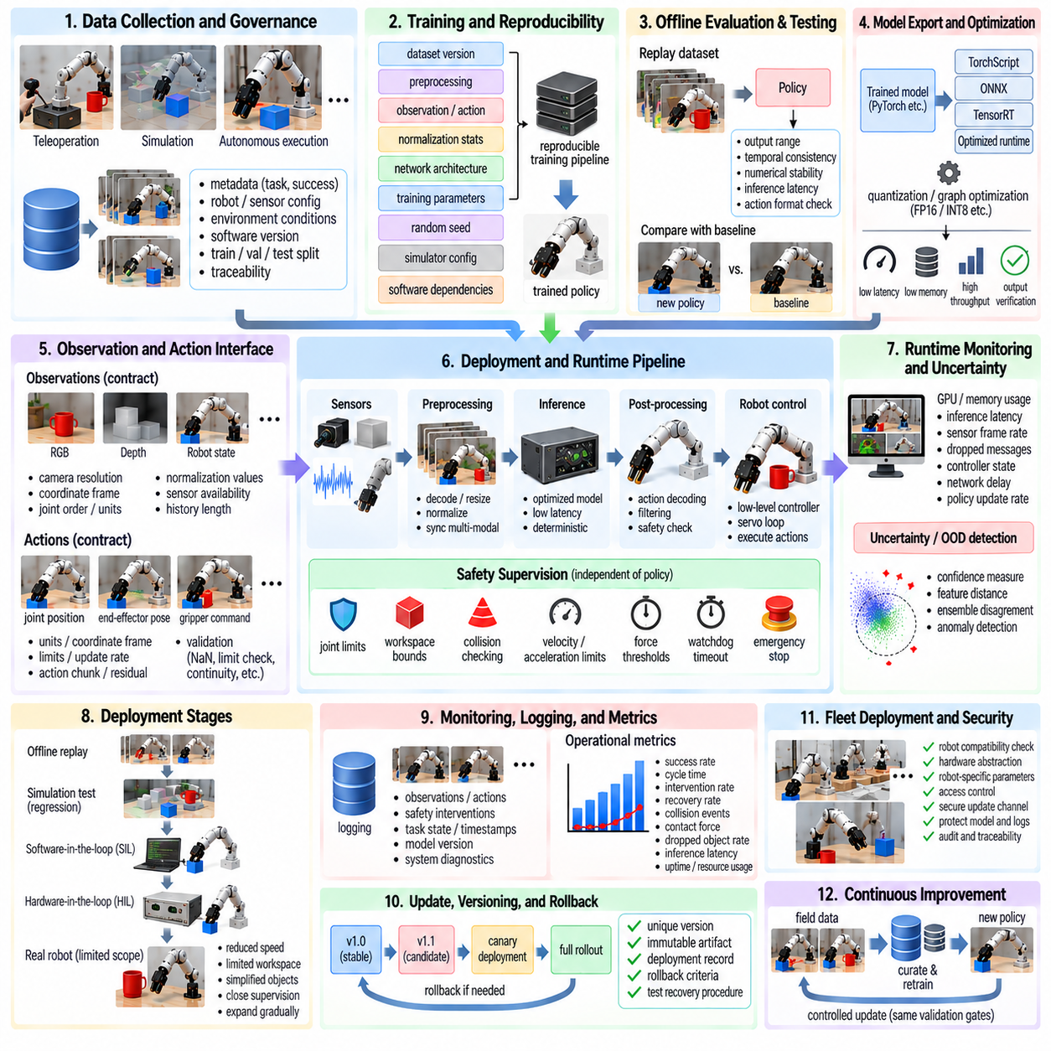
Learning a manipulation policy is only the beginning of building a production robotic system. A policy that performs well during research experiments must be converted into a predictable, maintainable, observable, and safe software component before deployment. Production engineering therefore extends beyond model accuracy and includes data governance, model packaging, inference optimization, hardware integration, runtime supervision, version control, validation, monitoring, and controlled update procedures.
The production lifecycle begins by freezing the complete training configuration rather than storing only model weights. Dataset versions, preprocessing pipelines, observation definitions, action representations, normalization statistics, network architecture, training parameters, random seeds, simulator configuration, and software dependencies should be recorded. Reproducing a policy requires reconstructing the entire computational environment that produced it, not simply loading a checkpoint file.
Dataset governance becomes especially important when policies are trained from teleoperation, simulation, autonomous execution, or mixed sources. Every trajectory should retain metadata describing robot configuration, sensor calibration, task identity, success status, environment conditions, and collection software version. Training, validation, and test partitions must remain traceable so that later improvements can be attributed to actual changes rather than accidental reuse or contamination of evaluation data.
A candidate model should pass offline evaluation before interacting with production hardware. Recorded observations can be replayed through the policy to verify output ranges, temporal consistency, numerical stability, inference latency, and compatibility with expected action formats. Regression tests should compare new policy versions with previously approved versions on a fixed benchmark dataset. Unexpected changes in actions can then be identified before they become physical robot movements.
Model export converts the research representation into a deployment artifact. Training frameworks may store dynamic computation graphs and development-specific components that are unnecessary during inference. Deployment can use formats such as TorchScript, ONNX, TensorRT engines, or other optimized runtimes depending on the hardware platform. Export verification should confirm that the deployed model produces outputs sufficiently consistent with the original training implementation across representative observations.
Inference optimization must consider latency, throughput, memory consumption, and determinism together. Reduced precision such as FP16 or INT8 can improve execution speed and decrease memory requirements, but numerical changes may alter sensitive control outputs. Quantization and graph optimization should therefore be evaluated at both model-output and task-performance levels. A faster policy is not an improvement if reduced numerical fidelity causes unstable grasping, contact, or trajectory behavior.
The production inference pipeline includes more than neural-network execution. Camera acquisition, image decoding, resizing, normalization, depth processing, robot-state collection, multimodal synchronization, policy inference, action decoding, filtering, communication, and controller execution all contribute to end-to-end latency. Profiling should measure each stage separately because optimizing model inference alone may provide little benefit when sensor processing or communication dominates the control cycle.
Timing architecture must match the manipulation task. High-frequency motor servo loops usually remain in deterministic low-level controllers, while learned policies operate at a slower supervisory or task-control frequency. Action chunking, trajectory prediction, or buffered commands can bridge these rates. Timestamped observations and commands are essential so that the policy acts on a coherent estimate of the physical state rather than combining sensor values captured at significantly different times.
Production systems should define an explicit observation contract. Each policy version expects specific camera resolutions, coordinate frames, joint ordering, units, normalization values, sensor availability, and history lengths. These assumptions should be represented as machine-checkable interface definitions whenever possible. A model that receives numerically valid but semantically incorrect input can produce dangerous behavior without generating an obvious software exception.
The action interface requires equally strict definition. Policy outputs may represent joint positions, joint velocities, Cartesian increments, end-effector poses, gripper commands, action chunks, or residual corrections. Units, coordinate frames, limits, update rates, and interpolation behavior must be unambiguous. Action validation should reject NaN values, discontinuities, impossible configurations, excessive velocities, or commands outside the certified operating envelope before transmission to the robot controller.
Safety supervision must remain independent of the learned policy. Joint limits, workspace boundaries, collision constraints, velocity and acceleration limits, force thresholds, watchdog timers, communication timeouts, and emergency stopping should be enforced outside the neural network. The policy should never be treated as the final authority over physical motion. When a command violates a safety constraint, deterministic supervisory logic should modify, reject, or terminate execution according to predefined rules.
Runtime health monitoring should continuously verify both computing and robotic conditions. GPU utilization, memory usage, inference latency, sensor frame rate, dropped messages, synchronization error, controller state, network delay, and policy update frequency can reveal degradation before task failure becomes visible. Monitoring should distinguish transient warnings from conditions that require slowing the robot, switching to a fallback controller, requesting human intervention, or entering a safe state.
Policy uncertainty and out-of-distribution detection can complement conventional system monitoring. Production environments may contain unfamiliar objects, unusual lighting, unexpected clutter, damaged sensors, or robot states not represented during training. Confidence measures, representation-space distance, ensemble disagreement, or dedicated anomaly detectors can identify suspicious inputs. Such signals should not be interpreted as perfect guarantees, but they can provide additional triggers for conservative behavior or human review.
Deployment should proceed through controlled stages rather than moving directly from training to unrestricted operation. A candidate can first undergo offline replay, simulation regression, software-in-the-loop testing, and hardware-in-the-loop testing. Physical execution can then begin with reduced speed, limited workspace, simplified objects, and close supervision. Operating limits should expand only after quantitative evidence demonstrates acceptable performance and safety within the preceding stage.
Shadow-mode evaluation can reduce deployment risk when the existing system remains operational. A new policy receives live observations and generates actions without controlling the robot. Its outputs are logged and compared with the approved controller or human operation. This allows latency, stability, distribution shift, and decision differences to be evaluated under real production conditions before the policy receives authority to command physical motion.
Canary deployment extends this principle by giving a new policy limited real authority. The candidate may initially operate on one robot, one workstation, a restricted task subset, or a small percentage of production cycles. Performance is compared with the established baseline before broader rollout. If failure rates, intervention frequency, latency, or safety events exceed predefined thresholds, the deployment can be stopped without affecting the entire robot fleet.
Every production policy should have a unique version and immutable deployment artifact. The model, preprocessing configuration, safety configuration, runtime version, calibration requirements, and supported robot hardware should be associated with the same release record. This prevents situations in which identical model names refer to different behavior. Version traceability also allows an observed physical failure to be connected back to the exact model, dataset, software, and configuration used during execution.
Rollback is a fundamental production capability rather than an emergency improvisation. The previous validated policy and runtime configuration should remain immediately available whenever a new release is deployed. Rollback criteria can include reduced success rate, excessive interventions, abnormal forces, inference deadline violations, or newly discovered safety problems. Recovery procedures should be tested in advance so that reverting a deployment does not introduce additional configuration errors.
Logging must capture enough information to reconstruct important failures without recording unnecessary data. Relevant records can include synchronized observations, policy inputs, predicted actions, executed actions, controller responses, safety interventions, task state, timestamps, model version, and system diagnostics. High-bandwidth sensor streams may require selective or event-triggered recording. Consistent logs transform field failures into evidence that can support debugging and future policy improvement.
Production evaluation should emphasize operational metrics in addition to benchmark success. Task completion rate, cycle time, intervention frequency, recovery rate, collision events, contact forces, dropped-object rate, inference latency, uptime, and resource utilization describe whether a learned policy is practically useful. Metrics should be segmented by task, object type, robot, environment, and software version so that aggregate averages do not hide localized failure modes.
Field data creates a feedback loop from deployment back to learning. Failed attempts, human corrections, unusual object configurations, recovery sequences, and difficult environmental conditions can be selected for dataset expansion. However, automatically adding every production trajectory can amplify errors or dataset imbalance. Data should pass quality checks, labeling, filtering, and provenance tracking before becoming part of a new training release.
Continuous learning in robotics should therefore be controlled rather than automatically updating the production policy whenever new data arrives. A revised dataset generates a new candidate model, which must pass the same reproducible training, regression evaluation, safety validation, and staged deployment gates as previous releases. Separating data collection from deployment approval prevents unverified learning updates from silently changing physical robot behavior.
Fleet deployment introduces additional configuration challenges because robots may differ in calibration, sensor revision, payload, gripper wear, firmware, or compute hardware. Compatibility checks should determine whether a policy is valid for each robot configuration. Hardware abstraction and standardized observation-action interfaces can reduce variation, but production systems should still record robot-specific parameters and prevent incompatible policy releases from being installed.
Cybersecurity and access control are also part of manipulation-policy deployment. Model artifacts, configuration files, update channels, robot commands, and operational logs should be protected against unauthorized modification. Deployment systems should authenticate releases and restrict who can promote a candidate policy into production. A technically accurate manipulation model cannot be considered production-ready if its software supply chain or control interfaces can be modified without traceability.
A mature production architecture separates learning, validation, deployment, and operation into explicit stages with evidence passed between them. Research training produces candidate policies, validation determines whether requirements are satisfied, deployment packages approved artifacts, and runtime supervision controls their physical authority. This separation allows rapid model development without allowing experimental changes to bypass engineering controls required for dependable robotic operation.
The objective of production deployment is therefore not merely to run a learned neural network on a robot computer. It is to transform a probabilistic learned component into a governed physical system whose inputs, outputs, timing, limitations, versions, failures, and updates are understood and controlled. Reproducible training, optimized inference, strict interfaces, independent safety, staged release, monitoring, rollback, and field-data feedback together provide the foundation for reliable manipulation-policy operation at production scale.

