Volume 17 Manipulation and Grasping AI

Chapter 02. Kinematics and Dynamics

02.01. Forward Kinematics FK Homogeneous Transform [w/Code]
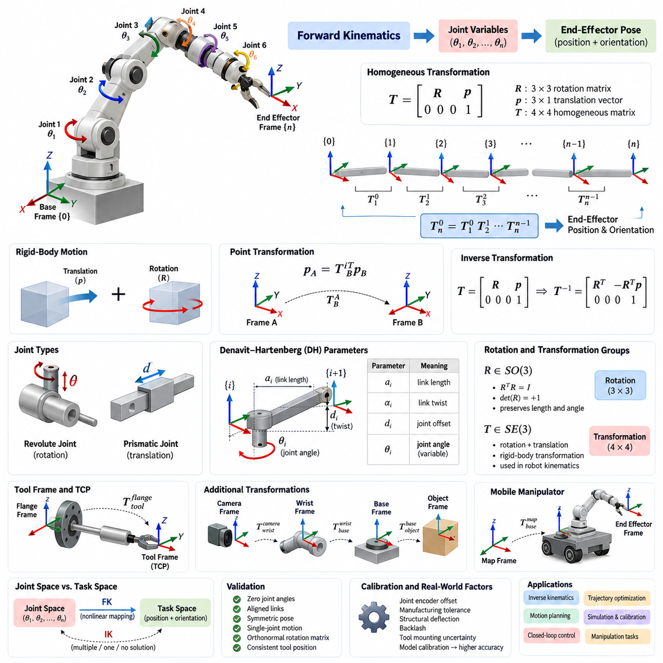
Forward kinematics (FK) is the process of determining the position and orientation of a robot’s end effector from known joint variables and the geometric structure of the manipulator. For a serial robotic arm, the joint angles or linear displacements are propagated through successive links, producing a deterministic mapping from joint space to a Cartesian pose in the robot workspace.
A robotic manipulator can be modeled as a sequence of coordinate frames attached to the base, links, joints, wrist, and end effector. Each frame describes a local reference system relative to another frame. Forward kinematics constructs mathematical transformations between these frames and combines them sequentially, allowing the pose of any link or tool to be expressed relative to the robot base or another selected reference frame.
Rigid-body motion in three-dimensional space consists of translation and rotation. A position vector alone cannot fully represent the pose of a robotic link because its orientation must also be specified. Rotation matrices describe orientation using a 3 × 3 orthonormal matrix, while translation is represented by a three-dimensional vector. Homogeneous transformations integrate both quantities into one mathematical representation suitable for chained transformations.
A homogeneous transformation matrix is typically written as a 4 × 4 matrix containing a 3 × 3 rotation matrix in its upper-left region and a 3 × 1 translation vector in its upper-right region. The final row is conventionally [0 0 0 1]. This structure enables rotation and translation to be applied through ordinary matrix multiplication while preserving a consistent representation of rigid-body transformations.
If frame B is defined relative to frame A, the homogeneous transformation from B to A represents both the orientation of B and the location of its origin as observed from A. A point expressed in homogeneous coordinates can therefore be transformed between coordinate systems through matrix multiplication. This convention provides a systematic method for converting sensor, link, object, and tool coordinates into a common reference frame.
The major advantage of homogeneous transformations appears when several rigid transformations must be combined. For a serial manipulator containing multiple joints, the transformation from the base to the end effector is obtained by multiplying the individual transformations between consecutive frames. The resulting matrix directly provides the end-effector orientation and position for the specified configuration of joint variables.
For an n-joint serial robot, this relationship can be conceptually represented as T₀ⁿ = T₀¹ T₁² ··· Tₙ₋₁ⁿ. Each transformation describes the geometric relationship between two neighboring coordinate frames. Because matrix multiplication is not commutative, the order of these transformations is essential. Reversing transformations or changing their multiplication sequence generally produces a physically different pose.
Individual joint transformations depend on the type of joint. A revolute joint introduces a variable rotation about its joint axis, whereas a prismatic joint introduces a variable translation along its axis. Fixed link geometry contributes constant translations and rotations. Forward kinematics combines these variable and constant transformations so that every valid joint configuration produces a corresponding end-effector pose.
A widely used systematic representation is the Denavit–Hartenberg (DH) convention. It characterizes the geometric relationship between neighboring links using four parameters associated with link length, link twist, joint offset, and joint angle. Depending on whether a joint is revolute or prismatic, one parameter becomes the joint variable. Multiplying the resulting DH transformation matrices generates the complete forward-kinematic model.
The classical DH convention is not the only possible formulation. Modified DH conventions, product-of-exponentials formulations, direct rigid-body transformations, and software-specific frame definitions are also common. These approaches may assign coordinate frames differently while describing the same physical mechanism. Consequently, consistency in frame definitions and transformation direction is more important than selecting one convention universally.
Rotation matrices used inside homogeneous transformations belong to the special orthogonal group SO(3). They preserve vector lengths and angles, have determinant +1, and satisfy RᵀR = I. Complete rigid transformations belong to the special Euclidean group SE(3), which combines rotation and translation. These mathematical structures provide the foundation for modern robot kinematics, state estimation, motion planning, and control.
The inverse of a homogeneous transformation is especially useful when changing the direction of a coordinate relationship. If a transformation contains rotation R and translation p, its inverse contains Rᵀ and the translated term −Rᵀp. This efficient structure follows from the orthogonality of rotation matrices and avoids treating the transformation as an arbitrary 4 × 4 matrix during analytical calculations.
Forward kinematics is generally easier than inverse kinematics because joint variables uniquely determine a pose for a conventional serial mechanism, while a desired Cartesian pose may correspond to several joint configurations, one configuration, or no feasible configuration. FK therefore acts as a fundamental evaluation function within inverse kinematics, trajectory optimization, motion planning, simulation, calibration, and closed-loop robot control.
The distinction between joint space and task space is central to understanding FK. Joint space represents the robot configuration using variables such as θ₁, θ₂, and successive joint coordinates, whereas task space represents quantities such as end-effector position and orientation. Forward kinematics implements the nonlinear mapping from the robot’s joint-space configuration to its corresponding task-space pose.
For a simple planar two-link arm, the end-effector coordinates are determined by the two link lengths and two joint angles. Although this example can be solved directly using trigonometric equations, homogeneous transformations provide a more scalable formulation. The same mathematical procedure extends naturally from a two-link planar mechanism to six-axis industrial manipulators and more complex articulated systems.
Tool frames introduce another important transformation. The final mechanical flange of a robot may not coincide with the operational point of a gripper, welding torch, camera, suction cup, or inspection sensor. A fixed transformation from the flange to the tool center point can be appended to the kinematic chain, enabling FK to calculate the actual operational pose required by the application.
Robotic manipulation frequently requires additional transformations beyond the manipulator itself. An object pose may be expressed relative to a camera, the camera relative to the robot wrist, and the wrist relative to the robot base. Homogeneous transformation chains allow these relationships to be composed into a unified coordinate system, providing the geometric foundation for hand-eye calibration, visual servoing, grasping, and object manipulation.
Mobile manipulators extend the same principle by adding the mobile platform pose to the arm transformation chain. The end-effector pose in a global or map coordinate frame can be computed from the map-to-base transformation, the robot-body transformation, the arm-link transformations, and the tool transformation. Thus, homogeneous transformations provide a common geometric language across navigation and manipulation subsystems.
Numerical implementation requires careful attention to coordinate conventions. Axis directions, right-handed versus left-handed coordinates, intrinsic versus extrinsic rotations, Euler-angle order, quaternion conventions, and active versus passive transformations can produce apparently reasonable but incorrect results. Explicitly documenting every frame and transformation direction is therefore a critical engineering practice in robotic software development.
Forward-kinematic implementations should be validated using configurations whose physical geometry is easy to predict, such as zero joint angles, aligned links, symmetric poses, and individual single-joint motions. Rotation matrices should remain orthonormal, transformation matrices should preserve their homogeneous structure, and computed tool positions should remain consistent with mechanical dimensions and known workspace limits.
In practical systems, the theoretical kinematic model also interacts with calibration errors, joint encoder offsets, manufacturing tolerances, structural deflection, backlash, and tool mounting uncertainty. Nominal FK describes the geometry encoded in the model, whereas calibrated FK incorporates measured corrections to improve Cartesian accuracy. High-precision manipulation therefore depends on both correct transformation mathematics and accurate physical parameter identification.
Forward kinematics ultimately provides the geometric backbone connecting robot configuration to physical action. By representing each rigid relationship as a homogeneous transformation and composing transformations along the kinematic chain, a robot can continuously determine where its links, sensors, tools, and end effector are located and how they are oriented. This capability supports virtually every higher-level manipulation function built upon robot geometry.

02.02. Inverse Kinematics IK Analytical Methods [w/Code]
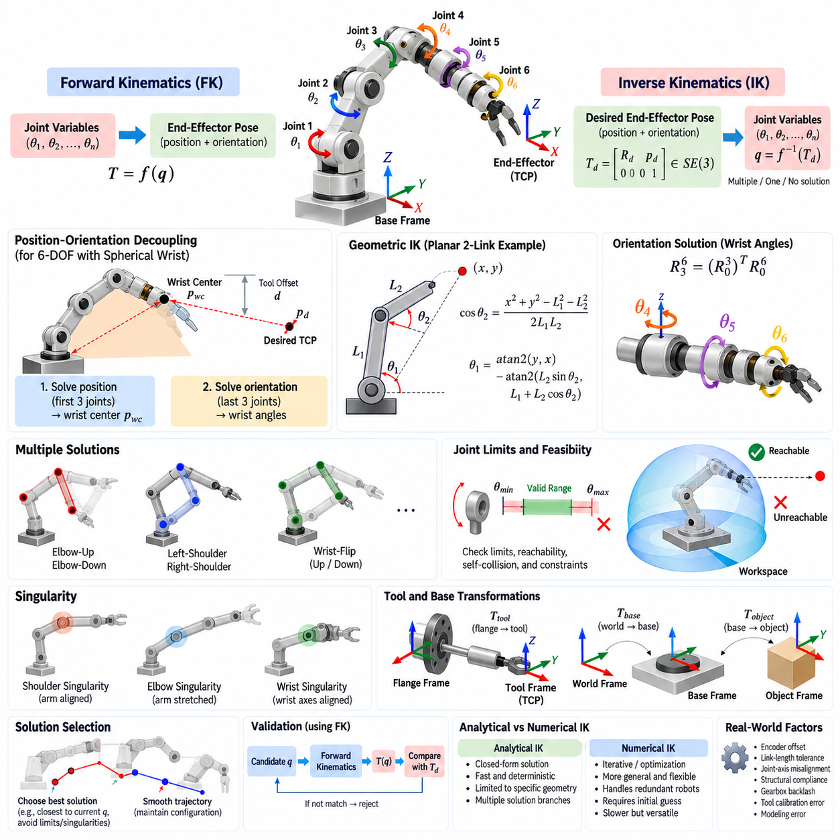
Inverse kinematics (IK) is the process of determining the joint variables required for a robot manipulator to achieve a desired end-effector position and orientation. Unlike forward kinematics, which maps a known joint configuration to a Cartesian pose, IK performs the reverse mapping from task space to joint space. This reverse relationship is generally more difficult because solutions may be multiple, unique, nonexistent, or geometrically singular.
For a manipulator with joint vector q and forward-kinematic mapping T = f(q), the IK problem seeks q such that f(q) equals a desired transformation T_d. The target transformation normally belongs to SE(3) and contains both a desired rotation R_d and position p_d. Therefore, IK must satisfy translational and rotational constraints simultaneously while respecting the geometric structure and degrees of freedom of the robot.
Analytical IK derives joint variables directly from closed-form geometric or algebraic relationships. Instead of iteratively reducing pose error, an analytical solver evaluates explicit equations involving link dimensions, target coordinates, and orientation parameters. When such equations exist, analytical IK can be extremely fast and deterministic, making it attractive for industrial robots that repeatedly execute high-frequency motion commands.
Closed-form solutions are not available for every manipulator architecture. Their existence depends strongly on the arrangement of joint axes and links. Many classical six-degree-of-freedom industrial manipulators were deliberately designed with geometries that simplify analytical IK. A particularly important structure is a spherical wrist, in which the axes of the final three revolute joints intersect at a common point, enabling position and orientation to be solved separately.
The position-orientation decoupling principle reduces a six-dimensional IK problem into two smaller problems. The first stage determines the initial joints required to place the wrist center at the correct Cartesian location. The second stage determines the wrist joint angles required to produce the desired end-effector orientation. This decomposition greatly simplifies the equations and is one of the most widely used analytical strategies for six-axis manipulators.
The wrist center can be obtained from the desired tool pose by subtracting the known tool or final-link offset along the appropriate end-effector axis. Once this point is known, the shoulder and elbow joints can often be solved using planar geometry. Distances between the robot base, shoulder, elbow, and wrist center form triangles whose internal angles can be calculated using trigonometric relationships such as the law of cosines.
Geometric IK interprets the manipulator as combinations of triangles, circles, planes, and rotation axes. For a two-link planar arm, the target point and two link lengths form a triangle, allowing the elbow angle to be derived from the law of cosines. The shoulder angle can then be calculated from the target direction and the internal triangle geometry. This simple example illustrates the basic reasoning used in more complex analytical robot models.
Multiple IK solutions naturally arise because different joint configurations can generate the same end-effector pose. A planar arm may reach one point using elbow-up or elbow-down configurations. A six-axis manipulator may additionally have left-shoulder or right-shoulder and wrist-flip alternatives. Combining these branches can produce several mathematically valid solutions for a single desired Cartesian pose.
An analytical solver must therefore do more than calculate one set of angles. It should systematically enumerate valid solution branches and determine whether each candidate satisfies the original kinematic equations. Depending on robot geometry, a six-axis industrial arm may provide several discrete configurations. Maintaining explicit configuration branches is important because switching unexpectedly between them can cause large joint movements even when Cartesian motion is small.
Joint limits provide the first practical filter for analytical IK solutions. A mathematically valid angle may exceed the mechanical range of a revolute joint or the travel range of a prismatic joint. Candidate solutions must therefore be normalized according to joint periodicity and checked against allowable limits. Additional constraints may include velocity limits, cable routing, self-collision, payload orientation, and application-specific safety restrictions.
Reachability is another fundamental consideration. A desired pose may lie outside the geometric workspace, causing analytical expressions to have no real-valued solution. For example, the cosine-law equation may produce a value outside the interval [−1, 1], indicating that the target cannot be reached by the relevant links. Robust implementations detect these conditions explicitly instead of allowing invalid square roots or inverse trigonometric operations to propagate.
Analytical IK relies heavily on inverse trigonometric functions, and their use requires careful quadrant handling. Functions such as atan2 are generally preferred over a simple arctangent because they preserve sign information and distinguish between geometric quadrants. Similarly, inverse cosine and inverse sine may correspond to multiple angular branches. Correct branch management is essential for generating all physically meaningful robot configurations.
Orientation recovery is commonly performed after the first three joints have positioned the wrist center. Their rotation matrix R₀³ is computed using forward kinematics, while the desired end-effector rotation R₀⁶ is known from the target pose. The remaining wrist rotation can then be obtained conceptually from R₃⁶ = (R₀³)ᵀR₀⁶, after which the final joint angles are extracted according to the wrist’s rotation sequence.
The extraction of wrist angles resembles the decomposition of a rotation matrix into Euler-like rotations. Specific matrix elements provide combinations of sine and cosine terms corresponding to the final joints. Different sign choices generate wrist-flip alternatives. Because rotation parameterizations have singular configurations, the extraction procedure must include special handling when one rotational degree of freedom becomes indistinguishable from another.
Kinematic singularities occur when the manipulator loses instantaneous mobility in one or more Cartesian directions. In analytical IK, singularities often appear as divisions by values approaching zero or as joint angles that become coupled. A wrist singularity, for example, can occur when two wrist axes align. The desired orientation may remain achievable, but infinitely many combinations of two joint angles can represent the same orientation.
Singular configurations require explicit solver policies. Instead of treating every singularity as a complete failure, the solver may preserve one joint near its previous value and calculate another joint to satisfy the remaining orientation constraint. This strategy improves motion continuity. Nevertheless, operation close to singularities can demand high joint velocities, so trajectory planning and control layers must consider more than the existence of a static IK solution.
Solution selection is crucial when several analytical branches are available. A common strategy chooses the candidate closest to the robot’s current joint configuration, minimizing weighted joint displacement. More advanced criteria can penalize proximity to joint limits, singularities, obstacles, or undesirable wrist configurations. Thus, analytical IK generates feasible candidates, while a separate decision process determines which candidate is most appropriate for execution.
Continuity becomes especially important when IK is evaluated along a Cartesian trajectory. Independently selecting the numerically nearest solution at every waypoint can still produce branch changes or discontinuities. Practical systems therefore track configuration identity, unwrap periodic joint angles, compare candidates with the previous solution, and apply hysteresis or branch-locking rules so that smooth Cartesian paths produce correspondingly smooth joint trajectories.
Tool transformations must also be handled correctly. The desired task pose may refer to a tool center point rather than the robot’s mechanical flange. Before solving the arm geometry, the known flange-to-tool transformation is removed from the target pose to obtain the required flange pose. Errors in this transformation directly appear as systematic positioning and orientation errors even when the analytical IK equations themselves are correct.
Base-frame transformations are equally important in robot cells. A target may be specified relative to a workpiece, fixture, camera, mobile platform, or world coordinate system rather than the manipulator base. Homogeneous transformations must first express the target in the coordinate system expected by the IK solver. Analytical kinematics therefore operates as part of a larger transformation chain rather than as an isolated mathematical function.
Analytical IK offers major computational advantages. Once derived and implemented, closed-form equations require a predictable number of arithmetic and trigonometric operations and do not depend on an initial guess or iterative convergence. This makes execution time highly consistent and enables rapid evaluation of multiple configurations, which is valuable for real-time control, trajectory generation, grasp planning, and high-throughput industrial automation.
Its principal disadvantage is limited generality. A solver derived for one robot geometry usually cannot be transferred directly to a different arrangement of links and joint axes. Robots with redundant degrees of freedom, unusual offsets, parallel mechanisms, or complex kinematic structures may not admit convenient closed-form solutions. Derivation and maintenance can also become difficult when mechanical revisions change link dimensions or coordinate conventions.
Analytical and numerical IK should therefore be viewed as complementary rather than competing methods. Analytical approaches are preferred when robot geometry supports reliable closed-form solutions, while Jacobian-based, optimization-based, or hybrid numerical methods provide greater flexibility for general mechanisms and redundant robots. Some practical systems use analytical solutions as fast initial candidates and numerical optimization for refinement or additional constraints.
Validation of an analytical IK implementation should use forward kinematics as an independent consistency check. Every candidate joint solution can be substituted into the FK model, and the resulting position and orientation can be compared with the requested target. Testing should cover normal configurations, workspace boundaries, multiple solution branches, joint limits, angle wrapping, unreachable targets, and configurations near shoulder, elbow, or wrist singularities.
Numerical tolerance is important even in an analytical method because real computations use finite-precision arithmetic. Values theoretically equal to zero may appear as small residuals, and arguments theoretically within [−1, 1] may slightly exceed the interval because of rounding. Robust solvers clamp appropriate quantities, define explicit tolerances, avoid unstable divisions, and distinguish true geometric infeasibility from harmless floating-point error.
In real robotic systems, model accuracy also limits IK accuracy. Encoder offsets, link-length tolerances, joint-axis misalignment, structural compliance, gearbox backlash, and tool calibration errors cause differences between the mathematical model and physical robot. Analytical IK can calculate an exact solution for its model while the real end effector still exhibits pose error. Kinematic calibration is therefore essential for precision manipulation.
Analytical inverse kinematics ultimately converts a desired physical action into executable robot configurations through explicit geometric reasoning. By decomposing position and orientation, solving geometric constraints, enumerating configuration branches, handling singularities and limits, and validating candidates through forward kinematics, analytical IK provides a fast and interpretable foundation for industrial manipulation, motion planning, and precise robotic control.

02.03. Numerical IK Jacobian Pseudo Inverse DLS [w/Code]
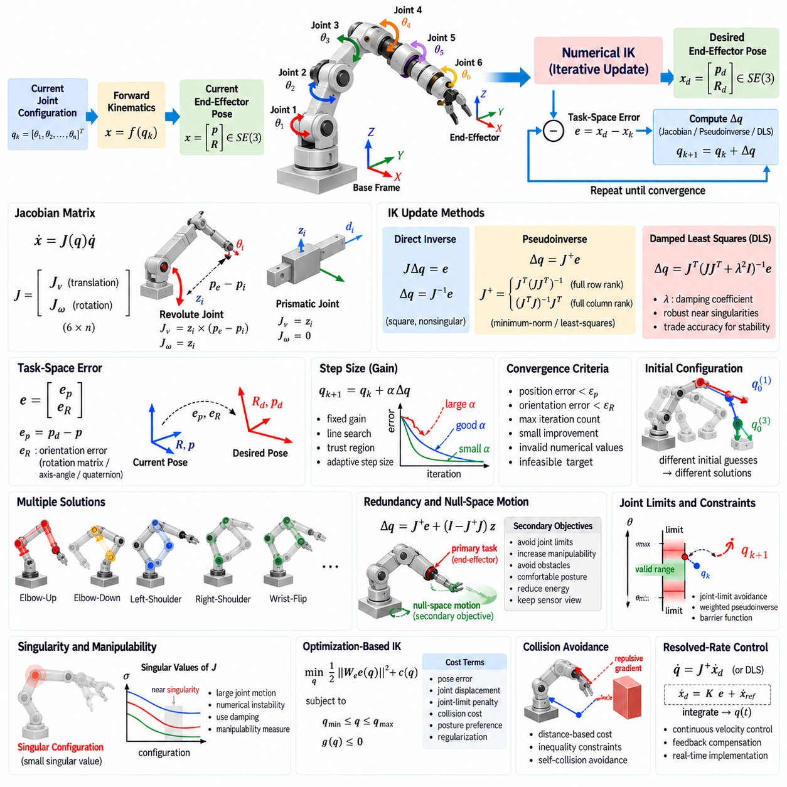
Numerical inverse kinematics (IK) determines joint variables by iteratively reducing the difference between the current end-effector pose and a desired target pose. Unlike analytical IK, it does not require a closed-form geometric solution for a particular manipulator structure. Instead, numerical IK uses local kinematic relationships to update the joint configuration until the Cartesian position and orientation errors become sufficiently small.
For a robot configuration q, forward kinematics produces the current end-effector pose x = f(q). Given a desired pose x_d, numerical IK defines a task-space error e that represents the displacement from the current pose toward the target. Starting from an initial configuration q₀, the solver repeatedly calculates a joint correction Δq and updates the configuration according to qₖ₊₁ = qₖ + Δq until convergence criteria are satisfied.
The Jacobian matrix is the central mathematical object in differential inverse kinematics. It describes the local relationship between joint velocity and end-effector spatial velocity through ẋ = J(q)q̇. For a three-dimensional manipulator task, the Jacobian commonly contains translational and rotational components. Each column represents how motion of one joint contributes instantaneously to the motion of the end effector.
For a revolute joint, a Jacobian column can be constructed from the joint-axis direction and the vector connecting the joint origin to the end-effector position. Its translational component is generated by a cross product, while its rotational component corresponds to the joint axis. For a prismatic joint, the translational component follows the joint axis directly and the rotational component is zero.
The simplest Jacobian-based IK update conceptually solves JΔq = e. If J is square and nonsingular, the correction can be written as Δq = J⁻¹e, possibly multiplied by a step-size factor. However, direct inversion is applicable only under restricted conditions. Robots may be redundant, underactuated, or close to singular configurations, making a generalized inverse formulation necessary for practical numerical IK.
The Moore–Penrose pseudoinverse provides a standard solution for non-square or rank-deficient Jacobians. The joint update is written as Δq = J⁺e, where J⁺ denotes the pseudoinverse. For redundant manipulators, this produces the minimum-norm joint correction that realizes the desired local task displacement, while for overconstrained systems it provides a least-squares solution that minimizes residual task error.
When the Jacobian has full row rank, one common expression is J⁺ = Jᵀ(JJᵀ)⁻¹. For full column rank, J⁺ = (JᵀJ)⁻¹Jᵀ can be used. In implementation, explicit matrix inversion is usually avoided in favor of numerically stable matrix factorizations or singular value decomposition (SVD). SVD also exposes the singular values that reveal directional manipulability and proximity to kinematic singularities.
A major weakness of the basic pseudoinverse method appears near singular configurations. As one or more singular values of J approach zero, the corresponding inverse terms become very large. A relatively small Cartesian error can then generate excessive joint corrections or velocities. This behavior may cause oscillation, numerical instability, joint-limit violations, or physically unrealistic commands even though the requested task displacement is small.
Damped least squares (DLS), also known as the Levenberg–Marquardt-style approach in many IK formulations, improves robustness near singularities. A common update is Δq = Jᵀ(JJᵀ + λ²I)⁻¹e, where λ is the damping coefficient. The damping term prevents very small singular values from producing excessively large joint motions, trading exact local tracking for improved numerical stability.
The damping coefficient strongly influences solver behavior. A small λ makes DLS behave similarly to the pseudoinverse and provides accurate tracking when the manipulator is far from singularities. A larger λ suppresses unstable joint motion but may slow convergence and leave greater residual task error. Adaptive damping methods vary λ according to singular values, manipulability measures, condition numbers, or observed convergence behavior.
Numerical IK also requires an appropriate representation of orientation error. Direct subtraction of Euler angles is generally unreliable because angular coordinates contain discontinuities and depend on rotation order. More robust approaches derive rotational error from rotation matrices, axis-angle representations, rotation vectors, or quaternions. Position and orientation errors are then combined into a task-space error vector suitable for Jacobian-based correction.
Position and orientation components have different physical units, typically meters and radians, so they should not automatically receive equal numerical importance. A weighting matrix can scale translational and rotational errors according to task requirements. For example, an insertion task may require precise position and axis alignment, while rotation around the insertion axis may be less important. Task weighting makes numerical IK reflect such priorities.
Step size is another critical parameter. Applying the entire computed correction may overshoot the solution because the Jacobian describes only a local linear approximation of nonlinear robot kinematics. A gain α can therefore be introduced so that qₖ₊₁ = qₖ + αΔq. Fixed gains are simple, while line search, trust-region strategies, or adaptive step sizes can improve convergence for difficult targets.
Convergence is normally determined using several criteria rather than a single error threshold. A solver may terminate successfully when both position and orientation errors fall below specified tolerances. It may terminate unsuccessfully when the maximum iteration count is reached, progress becomes negligible, numerical values become invalid, or the target is judged infeasible. Explicit termination states are essential for reliable robot software.
The initial joint configuration has a strong influence on numerical IK because the underlying problem is nonlinear and may contain multiple solutions. Different initial guesses can converge to different joint configurations for the same target pose. An initial state close to the current robot configuration usually promotes motion continuity, while multiple seeds can be evaluated when broader exploration of the available solution space is required.
Redundant manipulators contain more controllable joint degrees of freedom than required by the primary Cartesian task. The pseudoinverse solution can therefore be augmented with null-space motion according to Δq = J⁺e + (I − J⁺J)z. The first term performs the primary end-effector task, while the projected vector z changes the internal robot configuration without ideally disturbing that task to first order.
Null-space motion enables secondary objectives such as avoiding joint limits, maintaining comfortable posture, increasing manipulability, reducing energy, avoiding obstacles, or keeping sensors oriented toward important regions. The vector z is commonly generated from the gradient of a secondary cost function. This capability is a major advantage of numerical IK for seven-degree-of-freedom arms and other redundant robotic systems.
Joint limits should be incorporated during iteration rather than checked only after convergence. Simple methods clamp joint values, but this can distort the intended correction and trap the solver. More sophisticated approaches use joint-limit avoidance gradients, weighted pseudoinverses, barrier functions, or constrained optimization. These methods progressively discourage configurations near mechanical boundaries while preserving task performance whenever possible.
Manipulability provides a useful measure of how effectively joint motion can generate Cartesian motion. Measures derived from JJᵀ or the singular values of J become small near singular configurations. A numerical IK system can use this information to increase damping, activate null-space singularity avoidance, reduce commanded Cartesian speed, or reject configurations that provide insufficient control authority for the required task.
Numerical IK can naturally be formulated as an optimization problem. Instead of solving only a local linear equation, the system can minimize a cost containing pose error, joint displacement, joint-limit penalties, collision costs, posture preferences, and regularization terms. Constraints can explicitly represent joint bounds or task requirements. Such formulations are computationally heavier but offer substantial flexibility for complex manipulation.
Collision avoidance can also be integrated into iterative IK. Distances between robot links and obstacles may generate repulsive gradients or inequality constraints that modify the joint update. Self-collision can be treated similarly. However, satisfying a desired end-effector pose while avoiding obstacles is no longer purely a kinematic inversion problem; it becomes a constrained configuration-search problem closely related to motion planning.
Real-time implementations must balance accuracy, stability, and computational cost. Jacobians can be obtained analytically, generated from robot models, calculated through automatic differentiation, or approximated numerically. Analytical or model-derived Jacobians are generally preferred for control because they are efficient and accurate, while finite-difference Jacobians introduce approximation error and require repeated forward-kinematic evaluations.
The pseudoinverse and DLS methods are frequently used in resolved-rate control, where desired end-effector velocities are converted continuously into joint velocities. In this setting, q̇ = J⁺ẋ_d or its damped equivalent is integrated over time. Feedback terms based on pose error can be added to compensate for integration drift and model imperfections, connecting numerical IK directly with operational-space motion control.
Solver validation should cover normal poses, multiple initial configurations, workspace boundaries, joint limits, redundant postures, unreachable targets, and configurations near singularities. Each resulting joint state should be evaluated through forward kinematics to measure position and orientation residuals. Maximum joint updates, iteration counts, convergence rates, and singular values should also be monitored to expose unstable behavior.
Numerical tolerances must be selected according to physical system accuracy rather than arbitrary mathematical precision. Requesting micrometer-level convergence from a robot whose calibration and structural compliance support only millimeter accuracy wastes computation and may amplify noise. Position tolerance, orientation tolerance, damping, iteration limits, and step size should therefore be coordinated with sensing, calibration, control bandwidth, and application requirements.
Numerical IK complements analytical IK by providing a general framework that adapts to complex robot geometries, redundancy, additional objectives, and constraints. The Jacobian pseudoinverse offers an elegant differential solution, while damped least squares improves robustness around singularities. Combined with task weighting, null-space optimization, adaptive damping, and constraint handling, these techniques form a practical foundation for modern robot manipulation and whole-body control.

02.04. Redundancy Resolution Null Space Projection [w/Code]
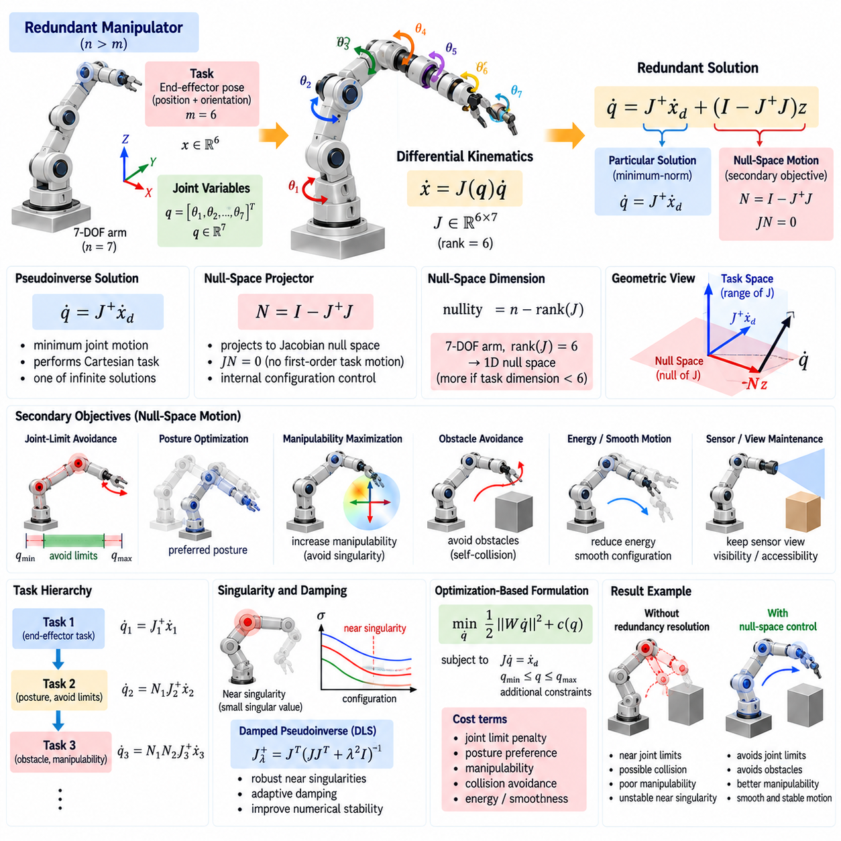
Redundancy occurs when a robot possesses more controllable joint degrees of freedom than are required to perform a specified task. A seven-joint manipulator controlling a six-dimensional end-effector pose is a common example. The additional degree of freedom does not directly increase the dimension of the primary task, but it creates multiple joint configurations capable of producing the same end-effector pose.
For a robot with joint vector q ∈ Rⁿ and task variable x ∈ Rᵐ, the system is kinematically redundant when n > m and the Jacobian J has sufficient rank for the task. The differential relationship ẋ = Jq̇ then contains more joint velocity variables than independent task equations. Consequently, infinitely many joint velocities may generate the same desired end-effector velocity, providing freedom to optimize additional robot behaviors.
The Moore–Penrose pseudoinverse provides a particular solution to this underdetermined relationship. For a desired task velocity ẋ_d, the minimum-norm solution can be written as q̇ = J⁺ẋ_d. This solution performs the Cartesian task while minimizing the Euclidean magnitude of joint velocity, but minimum joint motion is not necessarily the most desirable behavior for a physical robot operating under limits, obstacles, and posture requirements.
The general redundant solution introduces a null-space component according to q̇ = J⁺ẋ_d + (I − J⁺J)z. The first term generates the joint motion required by the primary task. The second term lies in the null space of the task Jacobian and can modify the robot’s internal configuration without changing the commanded end-effector velocity to first order, provided the Jacobian model is locally accurate.
The matrix N = I − J⁺J is called the null-space projector. Applying N to an arbitrary vector z removes components that would affect the primary task and retains components belonging to the Jacobian null space. Because JN is ideally zero, motion generated by Nz does not produce first-order task-space motion. This mathematical separation enables task execution and internal posture regulation to occur simultaneously.
The dimension of the null space depends on the number of joints and the rank of the Jacobian. For an n-joint robot with Jacobian rank r, the nullity is n − r. A seven-degree-of-freedom arm performing a full-rank six-dimensional task normally has one redundant direction. If the task dimension is reduced, such as controlling position without full orientation, additional null-space dimensions become available for secondary objectives.
A common secondary objective is joint-limit avoidance. A cost function can assign increasingly large penalties as joints approach their mechanical limits. The vector z can then be chosen from the negative gradient of this cost so that projected null-space motion moves the robot toward a more centered configuration. The end effector continues performing its primary task while the internal posture is gradually adjusted away from dangerous boundaries.
Posture optimization provides another important application. Human-like or collaborative manipulators may have many configurations that place the tool at the same pose, but some configurations are mechanically preferable. A secondary objective can encourage a desired elbow position, keep the arm close to a nominal posture, reduce joint displacement, or maintain configurations that provide better visibility and accessibility within the workspace.
Manipulability maximization uses redundancy to avoid configurations in which the robot loses Cartesian motion capability. A manipulability measure derived from the Jacobian, such as a function of det(JJᵀ) or its singular values, can serve as a secondary objective. Its gradient drives null-space motion toward configurations with improved directional mobility, reducing the likelihood of encountering singularities during subsequent task execution.
Obstacle avoidance can also exploit redundancy without immediately changing the end-effector task. Distances between robot links and nearby obstacles can define repulsive cost functions or gradients. Projecting these gradients into the null space allows the elbow, shoulder, or intermediate links to move away from obstacles while the tool approximately preserves its commanded trajectory. Self-collision avoidance can be treated using a similar principle.
Null-space control is local rather than globally independent. Although JNz = 0 for the instantaneous linearized model, finite joint motions alter the Jacobian and the robot geometry. Large null-space steps can therefore introduce end-effector drift. Practical controllers use sufficiently small integration steps, feedback correction of primary-task error, updated Jacobians, and appropriate gains to preserve the intended hierarchy during continuous motion.
Task priority becomes important when several objectives must be satisfied simultaneously. The primary task should normally have the highest priority, while secondary behaviors use only the remaining degrees of freedom. Hierarchical inverse kinematics constructs lower-priority motions in the null space of higher-priority tasks, preventing secondary objectives from intentionally degrading constraints that have already been assigned greater importance.
For two tasks, a basic hierarchy may first compute a solution for task 1 and then project the correction for task 2 into the null space of the first task. More complex systems recursively construct projectors for several task levels. This principle is widely used in whole-body control, where balance, contact constraints, end-effector manipulation, gaze direction, posture, and joint-limit avoidance may all compete for the robot’s available degrees of freedom.
Strict task hierarchy differs from weighted optimization. In a weighted method, several task errors are combined into a single objective using numerical weights, allowing one task to trade performance against another. Null-space hierarchy instead attempts to preserve higher-priority tasks exactly before using residual freedom for lower priorities. The appropriate method depends on whether priorities represent preferences or constraints that must not be sacrificed.
Singularities complicate redundancy resolution because the rank and nullity of the Jacobian can change. Near a singularity, the pseudoinverse may generate excessive joint velocities, while the apparent null space can change rapidly. Damped pseudoinverses improve numerical stability but modify the ideal projector property, meaning JN may no longer be exactly zero. Secondary motion can then leak into the primary task and must be carefully regulated.
A damped null-space projector can be constructed using a damped generalized inverse, but its behavior should be interpreted as approximate task separation rather than exact orthogonal projection. Adaptive damping can increase stabilization near singularities and decrease damping in well-conditioned regions. Primary-task feedback is especially important in these conditions because it corrects errors introduced by damping, modeling uncertainty, and discrete integration.
Weighted pseudoinverses extend redundancy resolution by assigning different costs to joint motion. Instead of minimizing ordinary Euclidean joint velocity, a positive-definite weighting matrix can penalize motion of selected joints more strongly. This is useful when joints differ in speed, energy consumption, load capacity, mechanical range, or operational preference. The resulting null-space behavior is defined relative to the chosen metric.
Dynamic consistency becomes relevant when redundancy resolution is used in torque-controlled robots. A purely kinematic pseudoinverse treats all joint motions geometrically, but different joints and links have different inertial properties. Dynamically consistent generalized inverses incorporate the robot mass matrix so that task-space and null-space commands interact appropriately with system dynamics. This concept is central to operational-space and whole-body torque control.
Redundancy can also be resolved at the acceleration level. Desired task acceleration is related to joint acceleration through ẍ = Jq̈ + J̇q̇. Solving this equation requires accounting for the Jacobian derivative term, after which null-space accelerations can be added for posture or constraint objectives. Acceleration-level formulations are useful when inverse dynamics, torque generation, or high-performance trajectory tracking follows the kinematic layer.
Secondary-objective gradients require careful scaling. An aggressive joint-limit or obstacle gradient may produce large null-space velocities, increase actuator demand, or amplify numerical sensitivity. Conversely, a weak gradient may have little practical effect before the robot reaches an undesirable configuration. Gain scheduling, velocity saturation, normalization, and distance-dependent activation are commonly used to produce smooth and physically realistic behavior.
Redundancy resolution must also consider discontinuities caused by changing active objectives. An obstacle-avoidance term that activates abruptly can produce a sudden posture command even if the end-effector trajectory is smooth. Smooth activation functions, hysteresis, filtered gradients, and bounded derivatives help prevent these transitions. Similar treatment is required when joint-limit avoidance or singularity avoidance becomes active.
Optimization-based inverse kinematics generalizes many null-space concepts. A quadratic program can minimize joint velocity, posture error, or energy while imposing the primary Cartesian task as an equality constraint and joint limits, collision distances, or velocity bounds as inequalities. This formulation provides explicit constraint handling, although it requires more computation than a simple pseudoinverse and projector implementation.
Redundancy is especially important in mobile manipulators and humanoid robots because many body joints may contribute to the same operational task. A mobile base, torso, arm, and wrist can cooperate to position a tool while simultaneously preserving balance, visibility, reachability, and collision clearance. Null-space and hierarchical methods provide a systematic framework for distributing motion across these coupled subsystems.
The initial posture and trajectory history influence redundancy resolution even when the end-effector path is fixed. Because secondary objectives continuously reshape the internal configuration, two robots following the same Cartesian trajectory may develop different joint trajectories depending on their starting states, gains, constraints, and cost functions. Redundancy resolution therefore defines robot behavior, not merely mathematical non-uniqueness.
Validation should examine both primary-task accuracy and secondary-objective effectiveness. Tests should verify that null-space motion does not significantly disturb the end-effector, that joint limits and collision margins improve as intended, and that behavior remains smooth near singularities or changing constraints. Monitoring JN, task residuals, singular values, joint velocities, and objective costs helps identify failures in the projection logic.
Redundancy transforms extra degrees of freedom from an ambiguity into a useful control resource. Through pseudoinverse solutions, null-space projection, secondary-objective gradients, and hierarchical task organization, a robot can preserve its primary manipulation objective while simultaneously improving posture, avoiding limits and obstacles, increasing manipulability, and satisfying system-level constraints. These principles form a foundation for advanced manipulation and whole-body robotic control.

02.05. Velocity Kinematics and Jacobian Analysis [w/Code]
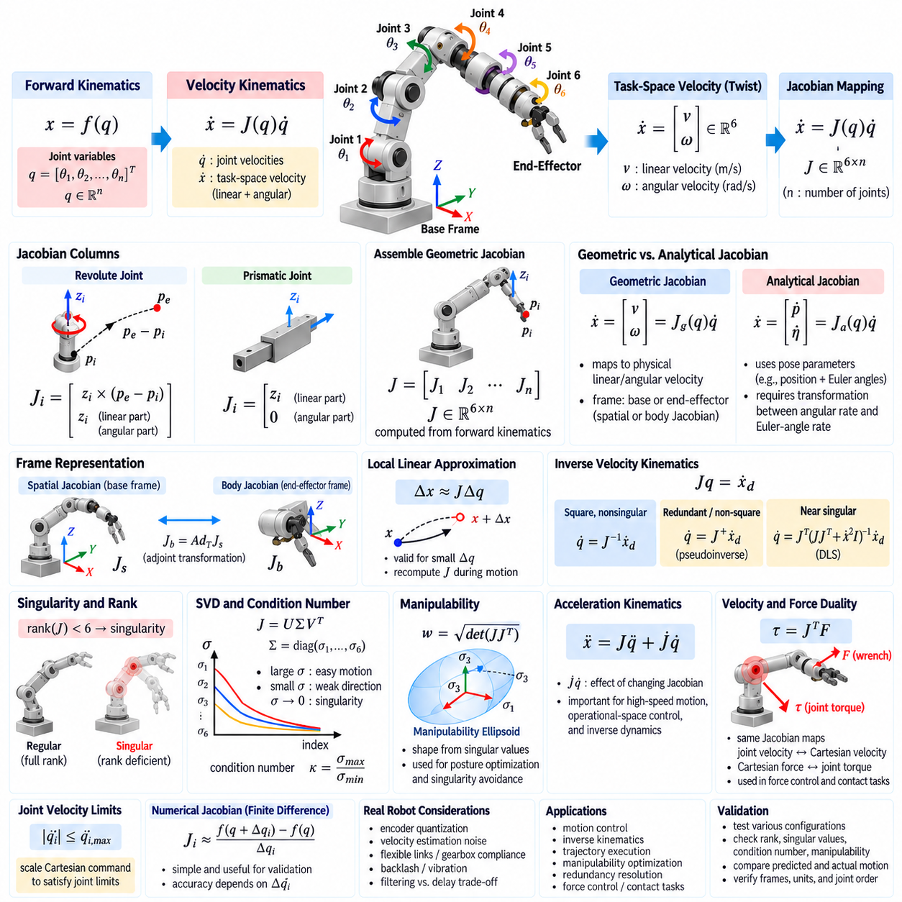
Velocity kinematics describes how joint motion produces instantaneous motion of robot links and the end effector. While forward kinematics maps joint positions to a Cartesian pose, velocity kinematics studies the differential relationship between joint rates and Cartesian linear and angular velocities. This relationship is fundamental to motion control, inverse kinematics, singularity analysis, force transformation, and trajectory execution.
For a manipulator with joint configuration q and task-space coordinates x = f(q), differentiating the forward-kinematic relationship gives ẋ = J(q)q̇. The matrix J(q) is the manipulator Jacobian, q̇ contains joint velocities, and ẋ represents the instantaneous task-space velocity. Because J depends on the current configuration, the mapping between joint motion and Cartesian motion changes continuously as the robot moves.
In three-dimensional manipulation, end-effector motion is commonly represented by a six-dimensional spatial velocity or twist. The upper component contains linear velocity v, while the lower component contains angular velocity ω, giving V = [vᵀ ωᵀ]ᵀ. For an n-joint manipulator, the geometric Jacobian therefore typically has dimensions 6 × n and maps n joint rates into the six components of rigid-body motion.
Each Jacobian column represents the instantaneous contribution of one joint while all other joints are conceptually held fixed. For a revolute joint i with axis zᵢ and origin pᵢ, the translational contribution at end-effector position pₑ is zᵢ × (pₑ − pᵢ), while the angular contribution is zᵢ. This directly expresses the linear and rotational velocity generated by rotation around a spatial axis.
For a prismatic joint, the corresponding Jacobian column has a different structure. Motion along the joint axis directly produces translational velocity, so the linear component equals zᵢ, while the angular component is zero. A manipulator containing both revolute and prismatic joints can therefore be analyzed by assembling the appropriate column type for every joint into one geometric Jacobian.
The geometric Jacobian can be constructed efficiently from forward-kinematic transformations. Each transformation provides the position of a joint origin and the direction of its joint axis in a common reference frame. Once these quantities are known, the Jacobian columns follow directly from the revolute or prismatic formulas. This close connection makes forward kinematics and Jacobian computation naturally integrated operations in robot software.
A distinction exists between geometric and analytical Jacobians. The geometric Jacobian maps joint rates to physical linear and angular velocity, whereas an analytical Jacobian maps joint rates to derivatives of a selected pose parameterization such as position plus Euler angles. Because Euler-angle rates are not generally equal to angular velocity, a transformation is required between the two representations, and that transformation may itself become singular.
The reference frame used to express a Jacobian is also important. A spatial Jacobian may express velocity relative to a fixed base frame, whereas a body Jacobian expresses motion in the end-effector or body frame. These Jacobians describe the same physical motion using different coordinates and can be transformed through rigid-body adjoint transformations. Frame conventions must therefore be documented explicitly in both derivations and software interfaces.
The Jacobian provides the local linear approximation of nonlinear forward kinematics. For a sufficiently small joint displacement Δq, the corresponding task displacement can be approximated by Δx ≈ JΔq. This approximation underlies differential inverse kinematics and many real-time control algorithms. Its accuracy decreases for large steps because the Jacobian changes as the configuration changes, requiring repeated recomputation during motion.
When the desired Cartesian velocity ẋ_d is known, inverse velocity kinematics seeks joint velocities satisfying Jq̇ = ẋ_d. If J is square and nonsingular, q̇ = J⁻¹ẋ_d can be used conceptually. For non-square, redundant, or near-singular systems, generalized inverse techniques such as the Moore–Penrose pseudoinverse or damped least squares provide more practical solutions.
The rank of the Jacobian indicates the number of independent Cartesian velocity directions that the robot can generate instantaneously. A full-rank Jacobian provides all motion directions required by the specified task. When rank decreases, one or more task-space directions become unavailable or dependent. Such configurations are called kinematic singularities and have major consequences for controllability and numerical stability.
At a singularity, a finite desired Cartesian velocity may require extremely large or theoretically unbounded joint velocities. Conversely, certain nonzero joint velocities may produce little or no end-effector motion. These behaviors are visible through the null spaces of J and Jᵀ and through small singular values. Singularity analysis is therefore fundamentally a Jacobian analysis rather than merely a geometric inspection of robot posture.
Singular value decomposition expresses the Jacobian as J = UΣVᵀ. The diagonal entries of Σ are singular values that quantify the strength of motion transmission along particular directions. Large singular values correspond to directions where joint motion efficiently generates Cartesian motion, while small singular values indicate weak directions. A zero singular value identifies an instantaneous loss of mobility in the associated task-space direction.
The condition number of the Jacobian provides another measure of numerical sensitivity. It is commonly related to the ratio between the largest and smallest relevant singular values. A condition number near one indicates relatively uniform velocity transmission, while a large condition number indicates strong anisotropy and proximity to singular behavior. Monitoring this quantity can help controllers reduce speed or increase damping before instability occurs.
Manipulability analysis provides a geometric interpretation of the Jacobian. If joint velocities are constrained to a unit sphere, the Jacobian maps that sphere into an ellipsoid in task space. The principal axes of the manipulability ellipsoid are determined by singular vectors, and their lengths depend on singular values. A collapsed axis indicates a direction in which the end effector cannot generate instantaneous velocity.
Yoshikawa-type manipulability measures summarize this capability using scalar quantities derived from the Jacobian, such as √det(JJᵀ) for appropriate full-row-rank cases. Although a scalar measure cannot describe directional behavior completely, it provides a useful indicator for posture optimization and singularity avoidance. Redundant robots can use null-space motion to move toward configurations with improved manipulability.
Velocity limits introduce practical constraints beyond Jacobian rank. Even in a nonsingular configuration, a desired Cartesian velocity may require one joint to exceed its actuator speed limit. The achievable Cartesian velocity region is therefore determined jointly by the Jacobian and joint-rate bounds. Controllers should scale or reshape Cartesian commands when the corresponding inverse velocity solution violates physical joint capabilities.
Acceleration kinematics is obtained by differentiating the velocity relationship, producing ẍ = Jq̈ + J̇q̇. The first term represents Cartesian acceleration caused directly by joint acceleration, while the second captures acceleration resulting from the changing Jacobian as the robot moves. The J̇q̇ term is essential in high-speed manipulation, operational-space control, inverse dynamics, and accurate acceleration-level task tracking.
Computing J̇ explicitly can be algebraically complex, especially for robots with many joints. Practical systems may derive it analytically, calculate it recursively, use automatic differentiation, or evaluate the product J̇q̇ directly without forming the entire matrix. The chosen approach must provide sufficient numerical accuracy and computational efficiency for the controller update rate.
The Jacobian also establishes a dual relationship between velocity and force. Using virtual work, an end-effector wrench F is mapped into joint torque by τ = JᵀF. Thus, the same matrix that maps joint velocities to Cartesian velocity maps Cartesian forces into joint torques through its transpose. This duality connects kinematics directly to force control, impedance control, contact interaction, and operational-space dynamics.
Near singularities, force transmission exhibits behavior complementary to velocity transmission. Directions that are difficult to achieve through Cartesian velocity may correspond to unusual force amplification or poor controllability. Consequently, singularity analysis matters not only for motion generation but also for manipulation involving contact. A configuration suitable for free-space motion may be undesirable for applying a controlled force in a specific direction.
Jacobian computation must use consistent coordinate frames, units, axis conventions, and joint ordering. Errors in any of these elements can produce plausible but incorrect velocity predictions. A practical verification method applies small known joint perturbations, evaluates the resulting pose change through forward kinematics, and compares the finite-difference result with JΔq. This provides a powerful numerical check of analytical Jacobian implementations.
Finite-difference Jacobians can also be generated directly by perturbing each joint and measuring changes in forward kinematics. This method is simple and useful for validation, but its accuracy depends on perturbation size and pose representation. Very small perturbations amplify floating-point error, while large perturbations violate the local linear assumption. Analytical or automatically differentiated Jacobians are generally preferable for real-time control.
Real robot measurements introduce additional complications. Encoder quantization, velocity estimation noise, flexible links, gearbox compliance, backlash, and structural vibration cause differences between ideal rigid-body velocity kinematics and measured motion. Filtering can reduce noise but adds delay, so velocity-control systems must balance estimation quality against bandwidth and phase lag.
Jacobian analysis is especially important for redundant manipulators, mobile manipulators, humanoids, and whole-body systems. Their large number of degrees of freedom creates many possible ways to realize a Cartesian motion. Pseudoinverse solutions, weighted metrics, null-space projections, and hierarchical task methods use the Jacobian to distribute motion while maintaining balance, avoiding limits, improving posture, or satisfying contact constraints.
Validation should cover representative workspace configurations rather than only nominal poses. Tests should include central configurations, workspace boundaries, stretched or folded postures, singular and near-singular states, and combinations of joint velocities. Rank, singular values, condition number, manipulability, predicted Cartesian velocity, and measured or simulated motion should be compared across these configurations.
Velocity kinematics and Jacobian analysis provide the differential foundation connecting robot joint motion to physical motion in Cartesian space. Through Jacobian construction, rank and singular-value analysis, manipulability evaluation, inverse velocity mapping, acceleration relationships, and force duality, engineers can understand how effectively a robot moves and interacts at each configuration. These concepts underpin modern manipulation, motion control, and whole-body robotics.

02.06. Inverse Dynamics Recursive Newton Euler RNEA [w/Code]
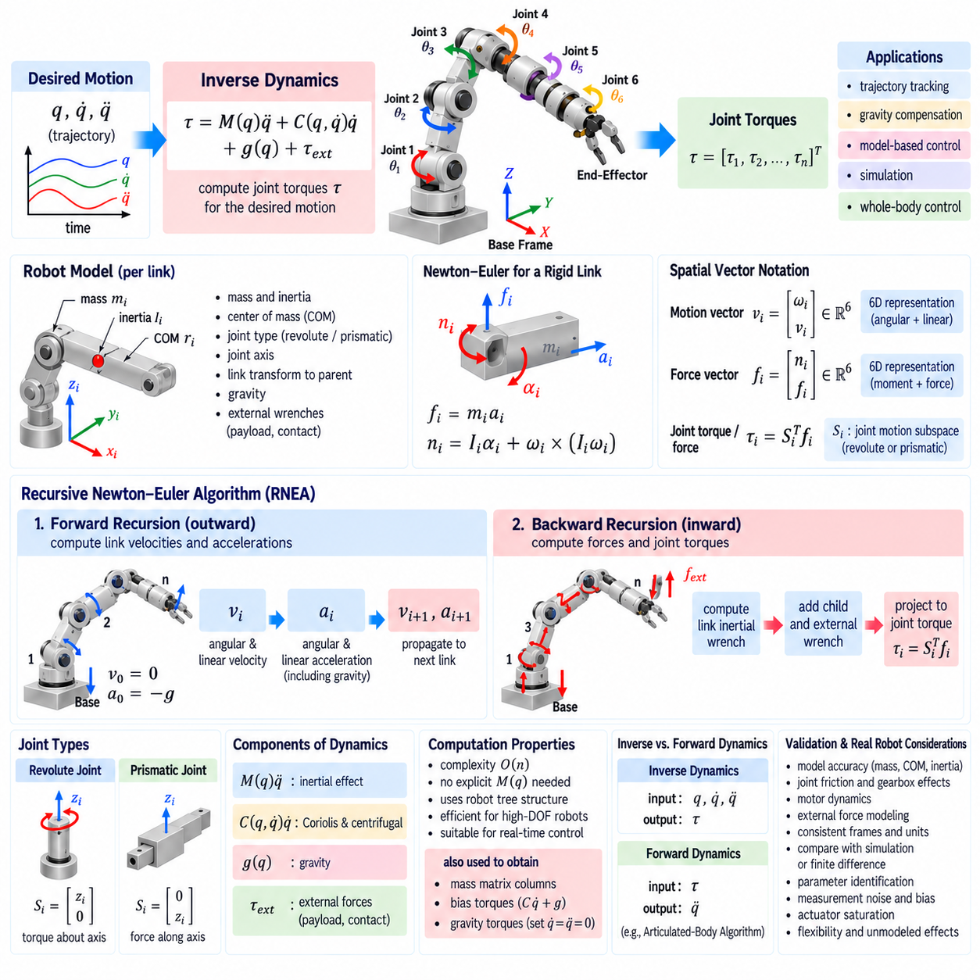
Inverse dynamics determines the joint forces or torques required for a robot to follow a specified motion. Given joint position q, velocity q̇, and acceleration q̈, the inverse-dynamics problem computes actuator effort while accounting for link inertia, Coriolis and centrifugal effects, gravity, and external loads. It therefore connects desired robot motion to the physical actuation needed to produce that motion.
For a rigid serial manipulator, the equations of motion are commonly written as τ = M(q)q̈ + C(q,q̇)q̇ + g(q) + τ_ext. Here M is the configuration-dependent mass matrix, C represents velocity-dependent Coriolis and centrifugal effects, g represents gravitational loading, and τ_ext represents generalized effects of external forces. Inverse dynamics evaluates the right-hand side for a known robot state and desired acceleration.
A direct implementation could explicitly construct the complete dynamic model and evaluate every term. However, symbolic expressions become increasingly complicated as the number of links grows. The Recursive Newton–Euler Algorithm (RNEA) avoids expanding the full equations. Instead, it propagates motion quantities outward through the kinematic tree and then propagates forces inward, exploiting the serial or tree structure of the robot.
RNEA is based on Newton’s law for translational motion and Euler’s law for rotational motion. For each rigid link, linear acceleration determines inertial force through mass, while angular acceleration and angular velocity determine rotational inertial moments through the inertia tensor. By applying these relationships link by link and enforcing force and moment transmission across joints, actuator torques can be calculated recursively.
The algorithm begins with the robot model and current state. Each link requires information such as mass, center-of-mass location, inertia tensor, joint type, joint axis, and rigid transformation relative to its parent. Joint positions determine the current transformations, while joint velocities and accelerations determine relative link motion. Gravity and known external wrenches are also included as boundary conditions.
The first major stage is the outward or forward recursion from the base toward the end effector. Starting from the base spatial velocity and acceleration, the algorithm computes the velocity and acceleration of each successive link. Joint motion contributes additional velocity and acceleration terms, while parent-link motion is transformed into the coordinate frame used for the child link.
For a fixed-base robot, the base velocity is normally zero. Gravity can be incorporated elegantly by assigning the base an acceleration opposite to the gravitational acceleration. This convention allows gravity to propagate through the same recursive acceleration equations as inertial effects, avoiding the need to calculate a separate gravity torque expression for every joint.
During forward recursion, angular velocity accumulates contributions from preceding joints and the current joint rate. Angular acceleration additionally contains the current joint acceleration and velocity-coupling terms. Linear acceleration of each link origin and center of mass depends on parent acceleration, angular motion, link geometry, and joint motion. These quantities provide the inertial state needed for the force calculation.
Once the velocity and acceleration of a link’s center of mass are known, its inertial force can be calculated from mass times linear acceleration. Its inertial moment depends on the inertia tensor, angular acceleration, and the gyroscopic term generated by angular velocity. Together, these form the dynamic wrench associated with accelerating that rigid body according to the commanded trajectory.
The second major stage is the inward or backward recursion from the terminal links toward the base. Each link receives forces and moments transmitted from its children and combines them with its own inertial wrench and any external wrench. The resulting net wrench is then propagated toward the parent joint. This backward accumulation captures how distal payloads and link dynamics influence upstream actuators.
Joint effort is obtained by projecting the transmitted wrench onto the joint’s motion direction. For a revolute joint, the relevant component corresponds to torque about the joint axis. For a prismatic joint, it corresponds to force along the joint axis. In spatial-vector notation, this projection can be expressed compactly as τᵢ = Sᵢᵀfᵢ, where Sᵢ is the joint motion subspace and fᵢ is the link wrench.
External forces are naturally incorporated into RNEA. A contact force at the gripper, payload load, tool reaction, or environmental interaction can be represented as an external wrench applied to the corresponding link. During backward recursion, this wrench propagates through the kinematic chain and contributes to the required joint torques. Correct coordinate transformation of external wrenches is essential.
The recursive structure gives RNEA excellent computational efficiency. For a serial chain with n joints, its computational complexity grows approximately linearly with n, commonly described as O(n). This is substantially more scalable than manipulating large symbolic dynamic expressions and makes RNEA suitable for high-frequency model-based control of manipulators, humanoids, quadrupeds, and other articulated robots.
Spatial-vector formulations make RNEA particularly compact. A spatial motion vector combines angular and linear velocity into one six-dimensional quantity, while a spatial force vector combines moment and force. Spatial transforms propagate these quantities between link frames, and spatial inertia matrices represent each rigid body. This notation unifies translational and rotational dynamics within one consistent algebraic framework.
In spatial form, forward recursion conceptually computes each link velocity vᵢ and acceleration aᵢ from its parent state and joint motion. The link wrench can then be formed from spatial inertia Iᵢ using expressions involving Iᵢaᵢ and velocity-product terms. Backward recursion accumulates child wrenches and projects the resulting wrench onto each joint motion subspace to obtain actuator effort.
RNEA computes inverse dynamics without requiring explicit formation of the mass matrix M(q). Nevertheless, repeated inverse-dynamics evaluations can be used to obtain components of the standard equation of motion. For example, evaluating the algorithm under selected accelerations and with gravity or velocity effects disabled can help identify mass-matrix columns or separate bias terms for analysis and controller development.
The velocity-dependent terms commonly called Coriolis and centrifugal effects arise automatically from recursive rigid-body dynamics. They do not need to be manually assembled into a separate C matrix. This is important because the matrix representation C(q,q̇) is not unique, while the physically meaningful bias torque C(q,q̇)q̇ can be computed directly and consistently through the recursive algorithm.
Gravity compensation is another common use of inverse dynamics. By setting desired joint acceleration and velocity-dependent contributions appropriately, the algorithm computes the torques required to counter gravitational loading at the current configuration. A controller can apply these torques as feedforward compensation, reducing the feedback effort needed to hold a manipulator stationary or move it slowly.
For trajectory tracking, inverse dynamics can provide feedforward torque corresponding to the desired q, q̇, and q̈ trajectory. Feedback terms are then added to compensate for state error and model uncertainty. In computed-torque control, the dynamic model is used to transform desired acceleration behavior into actuator torques, approximately linearizing the closed-loop joint dynamics when the model is sufficiently accurate.
Inverse dynamics depends strongly on the quality of the robot model. Errors in link mass, center of mass, inertia tensor, payload, friction, transmission dynamics, or gravity direction produce torque prediction errors. Industrial systems therefore combine model-based feedforward with feedback control and often perform dynamic parameter identification using measured joint motion, motor currents, force sensors, or torque sensors.
Classical rigid-body RNEA does not automatically capture all physical effects. Joint friction, gearbox losses, motor rotor inertia, elastic transmissions, cable forces, structural flexibility, actuator saturation, and temperature-dependent behavior may require additional models. These effects can be added as generalized torque terms or incorporated into extended dynamic formulations depending on the required fidelity.
The distinction between inverse and forward dynamics is important. Inverse dynamics receives motion and computes torque, whereas forward dynamics receives torque and computes acceleration. Forward dynamics conceptually solves q̈ = M⁻¹(τ − bias), which requires handling the coupled inertia of the robot. Algorithms such as the Articulated-Body Algorithm are commonly used for efficient forward-dynamics computation.
RNEA also extends naturally from simple serial arms to tree-structured multibody systems. A humanoid or quadruped contains branches corresponding to arms and legs, but each body still has a parent-child relationship. Forward recursion propagates motion from the root through the tree, while backward recursion accumulates forces from all branches. Floating-base systems additionally require treatment of the unactuated base dynamics and contact constraints.
Contact-rich robots introduce further considerations because external forces may be unknown rather than prescribed. Standard RNEA can compute joint effort when contact wrenches are known, but determining unknown contact forces simultaneously with actuator torques requires additional constraints or optimization. Whole-body inverse dynamics often combines rigid-body dynamics with contact Jacobians, friction constraints, and optimization methods such as quadratic programming.
Numerical implementation requires consistent conventions for link frames, spatial transforms, inertia tensors, joint axes, gravity, and wrench directions. An inertia tensor expressed at the wrong point or in the wrong frame can produce large errors even if the recursion is coded correctly. Spatial inertia must consistently represent mass, center-of-mass offset, and rotational inertia according to the selected coordinate convention.
Validation can begin with simple physical cases. A stationary robot should produce gravity-compensation torques consistent with its posture. With gravity disabled and zero velocity, torque should reflect only M(q)q̈ and applied external loads. Energy and power consistency, comparison against trusted simulation, and finite-difference or independent dynamics calculations can provide additional checks across representative trajectories.
Torque measurements from physical robots provide another validation layer, although measured motor torque may include friction, gearbox effects, current-control errors, and sensor bias absent from the rigid-body model. Comparison should therefore distinguish model error from actuator and measurement effects. Parameter identification and residual analysis can progressively improve agreement between predicted and observed effort.
The Recursive Newton–Euler Algorithm provides an efficient bridge between robot kinematics and actuation. Through outward propagation of velocity and acceleration followed by inward propagation of forces and moments, it computes the joint effort required for complex articulated motion without expanding the full dynamic equations. Its efficiency and physical interpretability make RNEA a fundamental tool for simulation, feedforward control, inverse dynamics, and whole-body robotics.

02.07. Mass Matrix and Coriolis Gravity Compensation [w/Code]
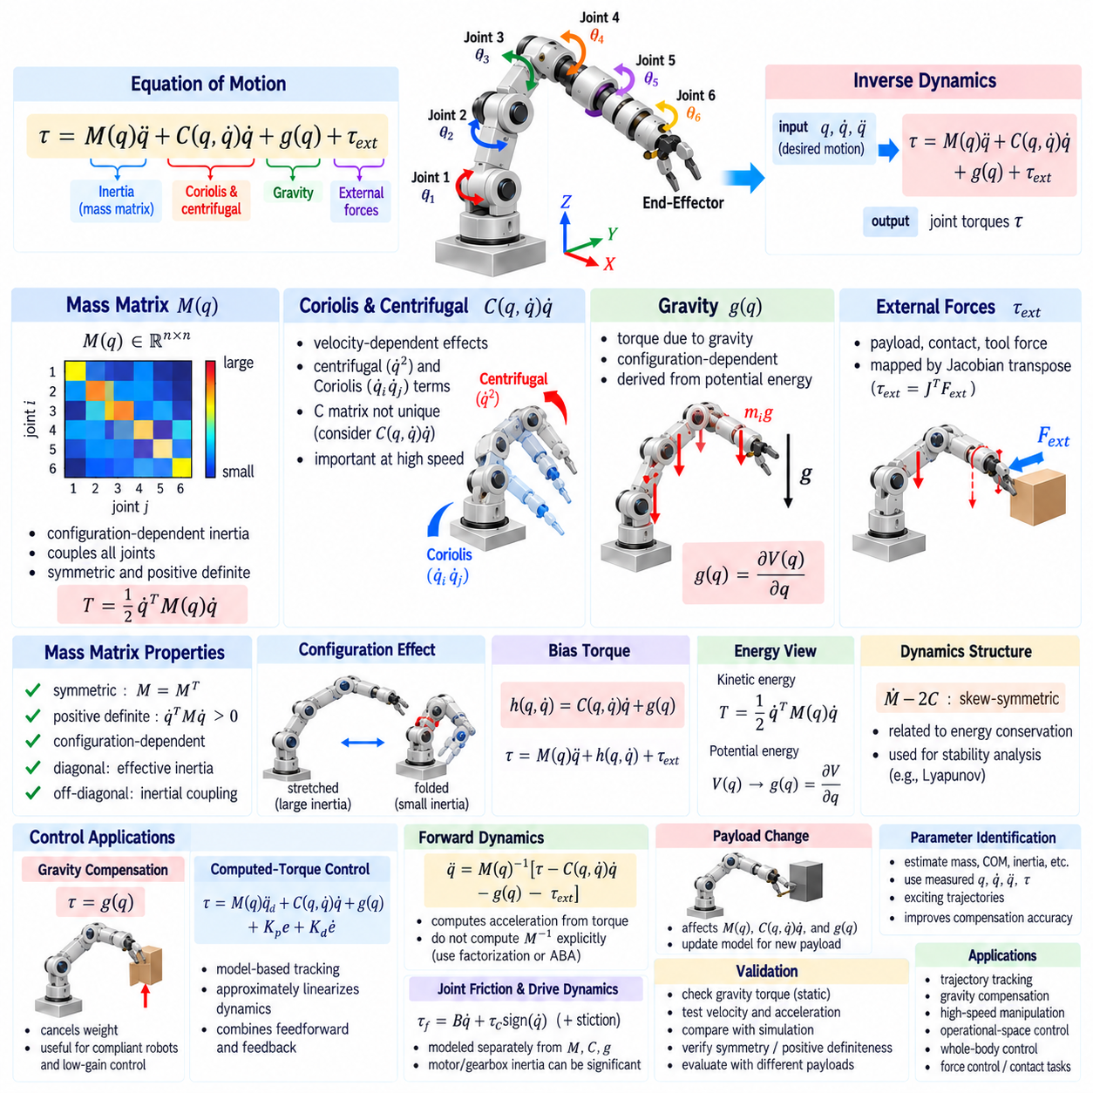
Robot dynamics describes how joint motion, link inertia, velocity-dependent interactions, gravity, and external forces determine the actuator effort required to move a manipulator. A standard rigid-body model is written as τ = M(q)q̈ + C(q,q̇)q̇ + g(q) + τ_ext. Understanding the individual structure of these terms is essential for simulation, inverse dynamics, model-based control, and high-performance trajectory tracking.
The mass matrix M(q), also called the inertia matrix, describes how joint accelerations produce generalized inertial forces and torques. It depends on the current robot configuration because changing joint angles changes the spatial distribution of link masses and inertias. For an n-degree-of-freedom manipulator, M is an n × n matrix coupling acceleration at every joint with actuator effort throughout the mechanism.
Diagonal elements of the mass matrix represent effective inertia associated primarily with individual joint accelerations, while off-diagonal elements describe inertial coupling between different joints. Accelerating one joint can therefore require torque at several other joints. This coupling becomes especially important in long serial manipulators, high-speed robots, humanoids, and systems carrying substantial payloads.
For a physically valid rigid-body model, M(q) is symmetric and normally positive definite for independent generalized coordinates. Symmetry reflects reciprocal inertial coupling, while positive definiteness means that any nonzero generalized velocity corresponds to positive kinetic energy. The kinetic energy can be expressed as T = 1/2 q̇ᵀM(q)q̇, directly connecting the mass matrix to the robot’s mechanical energy.
The configuration dependence of M has important physical consequences. A manipulator stretched outward can present substantially different effective inertia than the same robot folded near its base. Even if joint masses and motor properties remain unchanged, the torque required to produce a given acceleration can vary greatly with posture. Model-based controllers must therefore update dynamic quantities as the robot configuration changes.
The mass matrix can be derived from link Jacobians and inertial properties. Each link contributes translational kinetic energy through its mass and center-of-mass Jacobian and rotational kinetic energy through its inertia tensor and angular Jacobian. Summing these contributions over all links produces the complete system inertia. Recursive rigid-body algorithms can compute equivalent quantities more efficiently without explicitly expanding symbolic expressions.
Velocity-dependent dynamics are represented by the Coriolis and centrifugal contribution C(q,q̇)q̇. These effects arise because the coordinate system describing the robot changes as joints move and because moving masses follow curved trajectories. Centrifugal terms are commonly associated with squared joint velocities, while Coriolis terms describe interactions between velocities of different generalized coordinates.
The matrix C itself is not uniquely defined, so physical interpretation should focus on the resulting generalized bias torque C(q,q̇)q̇ rather than individual matrix entries. Different mathematical constructions can produce different C matrices while yielding the same equations of motion. Recursive inverse-dynamics algorithms often compute the complete velocity-dependent torque directly instead of explicitly constructing C.
One classical construction of Coriolis terms uses Christoffel symbols derived from partial derivatives of the mass matrix. The resulting coefficients combine configuration derivatives of M and multiply products of joint velocities. This formulation reveals the geometric structure of robot dynamics, but direct evaluation can be computationally expensive for large mechanisms compared with recursive algorithms or automatically generated dynamics code.
Coriolis and centrifugal effects become increasingly important as robot speed increases. At low velocity, gravitational and static loading may dominate, allowing velocity-dependent terms to appear relatively small. During rapid manipulation, swinging motions, dynamic locomotion, or aggressive trajectory tracking, these terms can become comparable to inertial and gravitational torques and must be modeled accurately for good tracking performance.
Gravity contributes the generalized torque vector g(q). Each link experiences gravitational force at its center of mass, and the resulting moments propagate through the kinematic structure to the joints. Because link orientations and moment arms change with configuration, gravity torque varies strongly with posture. A horizontal arm configuration can require much greater holding torque than a vertically aligned configuration.
The gravity vector can be derived from potential energy V(q). Generalized gravitational torque is related to the gradient of potential energy with respect to joint coordinates, with the exact sign depending on the adopted equation convention. This energy-based interpretation provides a useful theoretical connection and a practical validation method because gravity should be conservative in the ideal rigid-body model.
Gravity compensation applies actuator torque intended to cancel g(q). If the robot is stationary so that q̇ = 0 and q̈ = 0 and no external load is present, the model predicts that the required holding torque is determined by gravity. Applying an appropriate feedforward gravity-compensation term allows the robot to support its own weight without requiring large position-feedback errors.
Gravity compensation is particularly valuable for collaborative arms, humanoids, exoskeletons, and manipulators designed for compliant interaction. When gravitational loading is accurately compensated, the mechanism can feel mechanically lighter and feedback gains can often be reduced. However, imperfect mass, center-of-mass, payload, or joint calibration causes residual torques, so feedback control remains necessary.
Payload changes directly affect dynamic compensation. A tool or object attached to the end effector modifies total mass, center of mass, inertia, gravity torque, and acceleration-dependent loading. Controllers should therefore update the dynamic model when payload properties change. Using an incorrect payload model can produce substantial tracking errors, especially when the arm is extended or performing high-acceleration motion.
A useful concept is the bias torque h(q,q̇), often defined as h = C(q,q̇)q̇ + g(q), with additional modeled effects included when appropriate. The equations of motion can then be written compactly as τ = M(q)q̈ + h(q,q̇) + τ_ext. Many dynamics libraries and controllers compute M and h rather than separately constructing every theoretical component.
Inverse dynamics uses these terms to predict the torque required for a desired trajectory. Given desired q_d, q̇_d, and q̈_d, a feedforward command can be generated from the modeled inertia, velocity-dependent effects, and gravity. Feedback torque is then added to correct errors caused by disturbances, imperfect parameters, friction, flexibility, sensor noise, and differences between commanded and actual motion.
Computed-torque control uses the dynamic model more explicitly. A desired corrected acceleration can be constructed from trajectory acceleration plus position and velocity feedback, then multiplied by M(q) and combined with bias compensation. With an accurate model, this approximately cancels nonlinear robot dynamics and produces simpler closed-loop error behavior, although robustness still depends on modeling quality and actuator bandwidth.
Feedforward compensation should not be confused with complete cancellation of physical dynamics. The model is always approximate, and aggressive cancellation can expose errors or amplify noise. Practical systems combine dynamic feedforward with stable feedback, torque saturation, filtering, safety limits, and disturbance handling. The objective is to reduce predictable dynamic burden rather than assume that every physical effect can be perfectly removed.
The mass matrix also determines the relationship between generalized force and acceleration in forward dynamics. Neglecting constraints for illustration, q̈ = M(q)⁻¹[τ − C(q,q̇)q̇ − g(q) − τ_ext]. Explicitly computing M⁻¹ is usually unnecessary and often undesirable. Numerical factorization or dedicated recursive algorithms provide more stable and efficient ways to solve the associated linear system.
The conditioning of M influences numerical computation. Although a physically valid mass matrix is positive definite, large differences in link masses, inertias, transmission ratios, or coordinate scaling can create poor numerical conditioning. Cholesky-type factorizations are attractive for symmetric positive-definite matrices, while careful unit conventions and model parameter validation help prevent artificial numerical problems.
Dynamic equations possess important structural properties that can be used for analysis and verification. With a conventional definition of C, the matrix Ṁ − 2C can be chosen to be skew-symmetric. This property is closely connected to energy conservation and passivity arguments. Such mathematical structure is frequently exploited when proving stability of robot controllers based on Lyapunov methods.
Energy consistency provides a valuable model-validation tool. In an ideal system without gravity, dissipation, or external work, changes in kinetic energy should agree with mechanical power supplied by generalized forces. When gravity is included, kinetic and potential energy relationships should remain consistent. Unexpected energy creation often indicates sign errors, frame inconsistencies, incorrect inertial parameters, or implementation mistakes.
Friction is normally modeled separately from M, C, and g because it represents dissipative rather than ideal rigid-body dynamics. Simple models include viscous friction proportional to joint velocity and Coulomb friction dependent on motion direction. Real transmissions may also exhibit stiction, hysteresis, temperature dependence, and nonlinear gearbox behavior. Compensation quality depends on how much of this behavior must be represented.
Motor and transmission dynamics can significantly modify the effective inertia observed at a joint. Rotor inertia reflected through a high gear ratio may become comparable to or larger than link-side inertia. Some robot models therefore augment rigid-body dynamics with reflected motor inertia, gearbox efficiency, elastic elements, or drive-train states. The appropriate model complexity depends on control bandwidth and hardware architecture.
External forces enter the generalized dynamics through Jacobian-transpose relationships. A Cartesian wrench applied to a link or end effector produces generalized joint loading that can be represented through the appropriate Jacobian transpose. Accurate compensation therefore requires both a correct dynamic model and correct force-frame transformations, particularly in contact-rich manipulation and force-controlled applications.
Dynamic parameter identification can improve M, velocity-dependent compensation, and gravity prediction using experimental data. Measured joint positions, velocities, accelerations, and actuator torques are collected over sufficiently informative trajectories. Model parameters are then estimated so predicted torque agrees with observations. Excitation trajectories must activate relevant dynamic modes while remaining within safe hardware limits.
Validation should isolate dynamic components whenever possible. Static configurations are useful for checking gravity torque, constant-velocity motion can expose velocity-dependent and friction effects, and controlled acceleration experiments help evaluate inertia. Predictions should be compared across multiple configurations and payloads because agreement at one posture does not guarantee that masses, centers of mass, and inertia tensors are correct.
Simulation provides another important verification layer. The same robot description can be evaluated using independent rigid-body dynamics software and compared with the controller implementation. Mass-matrix symmetry, positive definiteness, gravity torque, bias torque, energy consistency, and inverse-dynamics predictions can all be checked numerically. Cross-validation is especially useful after modifying robot geometry or payload parameters.
Mass, Coriolis, centrifugal, and gravity terms are not isolated corrections but interacting components of one nonlinear mechanical system. The mass matrix defines configuration-dependent inertia, velocity terms describe dynamic coupling during motion, and gravity represents configuration-dependent potential loading. Their coordinated computation allows controllers to anticipate predictable forces instead of relying entirely on feedback after errors occur.
Accurate dynamic compensation improves trajectory tracking, reduces feedback effort, supports compliant behavior, and provides a foundation for operational-space and whole-body control. By understanding the structure of M(q), C(q,q̇)q̇, and g(q), engineers can design controllers that respect robot physics while remaining robust to modeling uncertainty. These concepts form a central bridge between rigid-body mechanics, actuator control, and advanced robotic manipulation.

02.08. KDL Pinocchio Robot Dynamics Library Usage [w/Code]
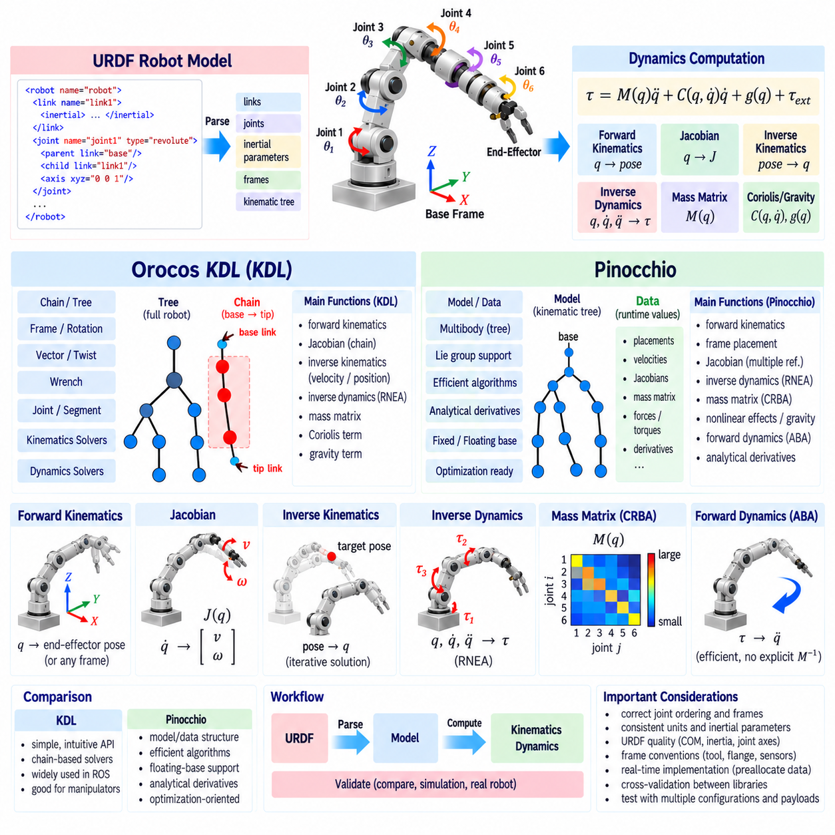
Robot dynamics libraries provide tested computational tools for evaluating kinematics and rigid-body dynamics without requiring engineers to implement every recursive algorithm from first principles. Orocos KDL and Pinocchio are widely used examples in robotics software. Both support model-based computation, but they differ in internal architecture, mathematical abstractions, performance emphasis, and integration patterns.
A dynamics library normally begins with a structured robot model describing links, joints, coordinate frames, inertial parameters, and kinematic relationships. In ROS-based systems, this information is commonly obtained from a URDF model and converted into the library’s internal representation. Correct joint ordering, link names, inertial origins, axis definitions, and units are essential because all subsequent calculations depend on this model.
Orocos Kinematics and Dynamics Library, commonly called KDL, provides kinematic and dynamic algorithms for serial chains and tree-structured robots. Its abstractions include frames, rotations, vectors, twists, wrenches, joints, segments, chains, and trees. These objects make rigid-body calculations relatively intuitive and have historically made KDL a practical choice for ROS manipulation software and conventional industrial robot applications.
A KDL model can be constructed directly or generated from a URDF representation using an appropriate parser. A robot tree represents the complete mechanism, while a chain extracts the sequence of segments connecting a selected base link to a tip link. Many KDL solvers operate on this chain structure, so defining the correct base and tool links is an important step before performing kinematics or dynamics calculations.
Forward kinematics in KDL evaluates the pose of a selected link from a vector of joint positions. Chain-based forward-kinematics solvers recursively propagate segment transformations from the base toward the tip. The resulting frame contains rotation and translation information and can be used to determine flange poses, tool poses, intermediate link configurations, or reference transformations required by higher-level manipulation software.
KDL also provides Jacobian computation for serial chains. Given the current joint configuration, a Jacobian solver calculates how joint velocities map to the twist of the selected endpoint. This Jacobian can support differential inverse kinematics, resolved-rate control, singularity analysis, and force transformation. Users must carefully verify the reference frame and point at which the resulting twist is defined.
Inverse kinematics in KDL is often organized into velocity-level and position-level components. A velocity solver calculates a joint update from a desired Cartesian twist, while a position solver repeatedly combines forward kinematics and differential corrections until the target pose is reached. Numerical convergence therefore depends on the initial configuration, tolerances, iteration limits, joint constraints, and singularity handling.
For rigid-body inverse dynamics, KDL includes a chain-based recursive Newton–Euler formulation. Given joint position, velocity, acceleration, gravity, and optional external wrenches, the solver computes the joint forces or torques required by the specified motion. This provides a practical implementation of RNEA suitable for gravity compensation, trajectory feedforward, simulation checks, and model-based control.
KDL can also provide joint-space inertia information through dedicated dynamics solvers. The mass matrix, Coriolis contribution, and gravity contribution can be evaluated from the robot state. These quantities correspond to the familiar rigid-body equation τ = M(q)q̈ + C(q,q̇) + g(q), subject to the exact conventions used by the API. Understanding those conventions is necessary before combining outputs with a controller.
Pinocchio is a modern rigid-body dynamics library designed for efficient algorithms on articulated systems. It supports fixed-base manipulators, floating-base robots, humanoids, legged robots, and complex kinematic trees. Its design emphasizes computational efficiency, Lie-group representations, recursive algorithms, derivatives, and advanced optimization-oriented robotics workflows.
Pinocchio separates the robot model from runtime computational data. The model stores structural information such as joints, inertial parameters, parent relationships, and frames, while a data object stores quantities generated during algorithm execution. This separation is important because algorithms reuse preallocated data structures, reducing repeated memory allocation and supporting efficient execution in optimization and control loops.
A URDF model can be loaded into Pinocchio and converted into its internal multibody representation. Fixed-base robots can use a conventional anchored root, while mobile, humanoid, or legged systems may be constructed with a free-flyer joint representing the floating base. The resulting configuration dimension and velocity dimension may differ because orientation can be represented on a nonlinear configuration manifold.
This distinction between configuration space and tangent-space velocity is fundamental in Pinocchio. Joint configurations may contain rotations represented through manifold-aware coordinates, whereas velocities belong to tangent spaces. Consequently, configuration updates should use appropriate integration operations rather than blindly applying ordinary vector addition. This becomes especially important for floating-base orientation and other Lie-group variables.
Forward kinematics in Pinocchio recursively computes joint placements from the current configuration. Additional routines update frame placements so that poses of sensors, tools, contact frames, or arbitrary reference frames can be queried. Separating joint and frame concepts allows many application-specific coordinate systems to be attached to the same rigid-body model without changing its underlying joint topology.
Pinocchio provides geometric Jacobians for joints and frames and supports multiple reference conventions. A Jacobian may be expressed in local, world-aligned, or other supported coordinate representations depending on the selected API. Since identical physical motion has different numerical coordinates in different frames, software should explicitly define the convention expected by controllers, estimators, and optimization modules.
Inverse dynamics in Pinocchio is commonly evaluated using RNEA. Given q, q̇, and q̈, the algorithm returns generalized forces associated with the requested motion. Gravity and velocity-dependent effects are automatically included according to the model and gravity settings. External forces can also be incorporated when the selected interface provides link or joint force inputs in the required representation.
The Composite Rigid Body Algorithm (CRBA) is commonly used to compute the joint-space mass matrix efficiently. Rather than obtaining every mass-matrix column through repeated inverse-dynamics calls, CRBA recursively accumulates composite inertias through the multibody structure. The resulting M(q) is useful for forward dynamics, operational-space calculations, optimization, control, and analysis of configuration-dependent inertia.
Pinocchio also provides efficient computation of nonlinear effects and gravity terms. Depending on the desired quantity, dedicated algorithms can evaluate generalized gravity, Coriolis-related quantities, or the complete bias contribution. Selecting the most direct routine avoids unnecessary calculations, which becomes important when dynamics functions are evaluated thousands of times per second inside controllers or optimization solvers.
Forward dynamics can be calculated efficiently using algorithms such as the Articulated-Body Algorithm (ABA). Given generalized torque and the current state, ABA computes generalized acceleration without explicitly forming and inverting the complete mass matrix. This recursive approach is particularly useful in simulation, predictive control, trajectory optimization, and algorithms that repeatedly evaluate candidate system evolution.
One major strength of Pinocchio is support for analytical derivatives of kinematic and dynamic quantities. Optimization-based control and trajectory optimization frequently require derivatives of poses, Jacobians, inverse dynamics, or related functions with respect to configuration, velocity, and acceleration. Efficient derivatives can significantly reduce computational cost compared with repeatedly approximating gradients through finite differences.
KDL and Pinocchio should not be viewed simply as old versus new implementations of the same interface. KDL offers relatively direct chain-oriented abstractions and remains useful for many conventional manipulator tasks. Pinocchio provides a broader algorithmic framework particularly suited to high-performance multibody computation, floating-base systems, optimization, whole-body control, and derivative-intensive applications.
A practical software architecture can isolate the dynamics library behind a robot-model interface. Higher-level modules request forward kinematics, Jacobians, gravity torque, mass matrices, inverse dynamics, or frame transformations without depending directly on library-specific data types. This abstraction makes it easier to validate one backend against another and reduces the cost of changing libraries later.
Cross-validation between libraries is particularly valuable during development. The same URDF and joint state can be evaluated using KDL and Pinocchio, then compared for end-effector pose, Jacobian, gravity torque, mass matrix, and inverse-dynamics torque. Small numerical differences are expected, but large discrepancies usually indicate inconsistent frame definitions, joint ordering, gravity settings, inertial parameters, or external-force conventions.
URDF quality is often more important than the choice of dynamics library. Missing inertial data, incorrect center-of-mass offsets, unrealistic inertia tensors, wrong joint axes, or inconsistent units produce incorrect dynamics regardless of algorithm quality. Visual inspection of geometry alone cannot validate inertial properties, so robot models intended for control should undergo dedicated kinematic and dynamic verification.
Joint indexing deserves special attention when connecting ROS messages to a dynamics library. The order of joints in a JointState message, controller interface, URDF traversal, KDL chain, and Pinocchio model may not automatically match. A robust system constructs an explicit name-to-index mapping and verifies it during initialization rather than assuming that array positions are identical across software components.
Frame conventions require similar discipline. A controller may command a tool-center-point frame while the dynamics library calculates a flange or joint frame. Sensor frames and contact frames may introduce additional offsets. Explicit rigid transformations should connect these definitions, and test cases should verify known poses. Many apparent algorithm errors are actually coordinate-frame errors introduced at software boundaries.
Real-time control imposes additional implementation requirements. Memory allocation, logging, model reconstruction, parsing, and unnecessary object creation should be kept outside the high-frequency control loop. Models and data structures should be initialized beforehand, while the loop updates state and invokes only required algorithms. Deterministic timing can be as important as average computational speed for physical robot control.
Thread safety and data ownership should also be considered. Reusing a mutable data object across multiple concurrent computations may create race conditions depending on library usage. A clean architecture can allocate separate runtime data for control, estimation, planning, or optimization threads while sharing the immutable model when appropriate. This improves predictability and simplifies debugging of complex robotic systems.
Validation should proceed from simple quantities toward complete dynamics. First verify zero and known joint configurations using forward kinematics. Then compare Jacobians against finite differences, confirm static gravity torques, inspect mass-matrix symmetry and positive definiteness, and finally evaluate inverse dynamics along representative trajectories. Tests should include multiple configurations, payloads, and near-singular postures.
KDL and Pinocchio convert theoretical robot mechanics into reusable software building blocks. KDL provides accessible chain-based kinematics and dynamics suited to many established manipulation workflows, while Pinocchio offers efficient multibody algorithms and advanced capabilities for modern optimization and whole-body robotics. Correct modeling, frame discipline, joint mapping, real-time architecture, and systematic validation ultimately determine whether either library produces reliable physical robot behavior.

02.09. Real Time Kinematics Dynamics Computation Opt [w/Code]
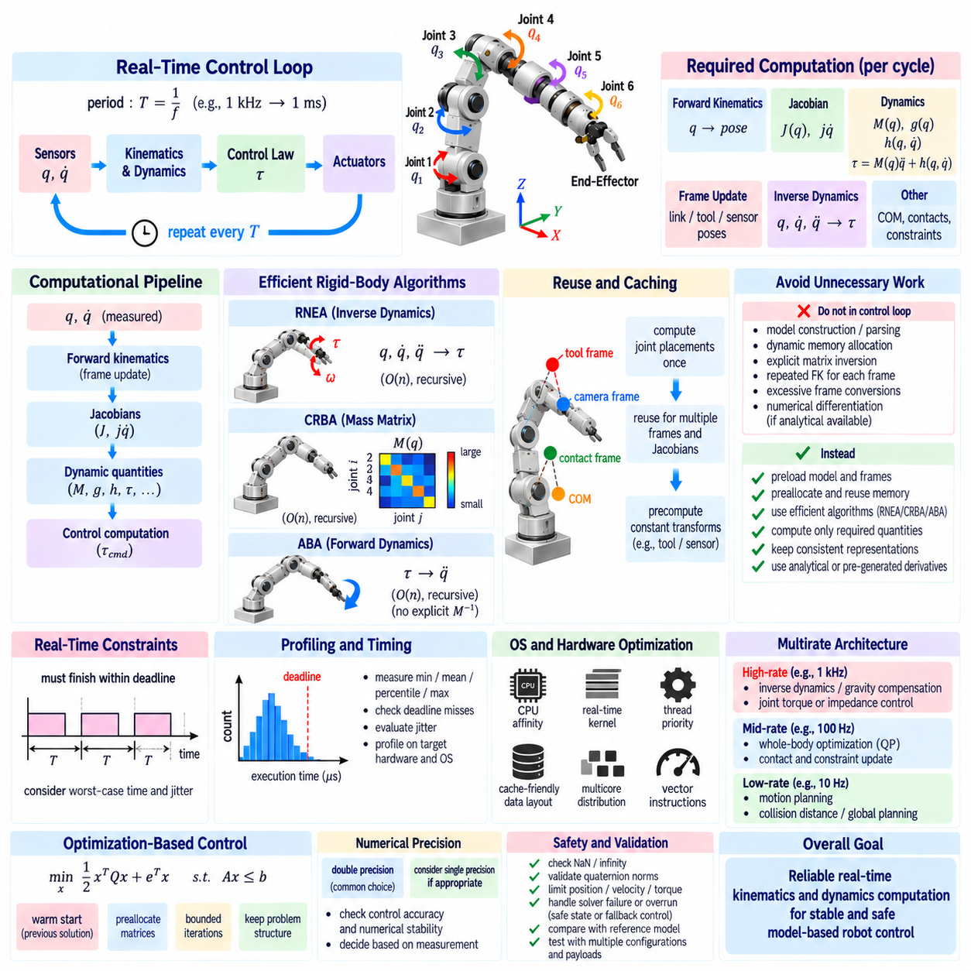
Real-time kinematics and dynamics computation is the process of evaluating robot motion and force models within strict control-cycle deadlines. A physical robot may execute control loops from hundreds of hertz to several kilohertz, leaving only a small time budget for state estimation, kinematics, dynamics, control laws, safety checks, and communication. Optimization must therefore consider both computational speed and deterministic execution.
A real-time controller differs from an ordinary high-performance program because completing calculations quickly on average is not sufficient. Every critical computation should finish before its deadline with bounded timing variation. A dynamics routine that normally requires 50 μs but occasionally requires several milliseconds can destabilize a high-frequency control loop. Worst-case execution time and timing jitter are therefore central engineering concerns.
The computational pipeline commonly begins with measured joint position q and velocity q̇, followed by forward kinematics, frame updates, Jacobians, dynamic quantities, and control calculations. Depending on the controller, required outputs may include end-effector pose, J(q), J̇q̇, mass matrix M(q), gravity g(q), nonlinear effects h(q,q̇), inverse-dynamics torque, or contact-related quantities. Computing only what is required is the first optimization principle.
Repeated model construction should never occur inside a high-frequency control loop. Robot topology, joint relationships, inertial parameters, frame definitions, and fixed transformations are normally loaded and initialized before real-time execution begins. During each cycle, the controller should update only state-dependent quantities. This separation avoids parsing, memory allocation, and structural processing that provide no benefit once the robot model is fixed.
Memory allocation is particularly important because dynamic allocation may have unpredictable execution time. Creating vectors, matrices, containers, strings, or temporary objects inside the control loop can invoke memory-management operations that increase jitter. Real-time implementations therefore preallocate required buffers and reuse them throughout operation. Fixed-size mathematical objects are especially attractive when robot dimensions are known at compile time.
Efficient rigid-body algorithms exploit the articulated structure of the robot rather than treating the mechanism as an arbitrary dense numerical system. Forward kinematics and recursive Newton–Euler inverse dynamics can scale approximately linearly with the number of joints. Algorithms such as RNEA, CRBA, and ABA exploit parent-child relationships and spatial recursion to avoid unnecessary expansion of large symbolic expressions.
Algorithm selection should depend on the required output. If only inverse-dynamics torque is needed, explicitly constructing M(q), C(q,q̇), and g(q) separately may waste computation compared with directly evaluating RNEA. If the controller requires the complete mass matrix, CRBA is appropriate. If generalized acceleration is needed from torque, ABA can avoid explicitly forming and inverting the mass matrix.
Explicit matrix inversion should generally be avoided in real-time dynamics code. Solving a linear system through a suitable factorization is normally more efficient and numerically reliable than calculating an inverse matrix and multiplying by it. Symmetric positive-definite mass matrices can often use specialized factorizations. Exploiting known mathematical structure reduces both arithmetic cost and numerical sensitivity.
Kinematic calculations also contain opportunities for reuse. If several tasks require poses and Jacobians for different frames, the underlying joint placements should be computed once per state update and reused. Repeating complete forward kinematics independently for every tool, sensor, contact point, or task frame duplicates work. A well-designed model cache stores intermediate transformations required by downstream computations.
The same principle applies to Jacobians. A whole-body controller may require Jacobians for hands, feet, cameras, center of mass, and collision points. Computing each quantity independently from the base can produce unnecessary repeated traversal of the kinematic tree. Libraries that expose joint-level intermediate data allow multiple frame quantities to be generated from a shared forward-kinematics pass.
Frame transformations should also be handled efficiently. Constant transforms between rigidly attached frames can be precomputed, while state-dependent transformations should reuse existing kinematic results. Excessive conversion among rotation matrices, Euler angles, quaternions, homogeneous matrices, and spatial transforms increases computational cost and can introduce representation errors. Internal representations should remain consistent whenever possible.
Analytical computation is generally preferable to numerical differentiation inside a high-frequency loop. Finite-difference Jacobians require repeated forward-kinematics evaluations, while finite-difference dynamic derivatives can require many expensive model evaluations. Analytical derivatives, recursive derivative algorithms, or automatic differentiation can provide more efficient and accurate derivatives when optimization or predictive control requires them.
Automatic differentiation must nevertheless be integrated carefully. It can greatly simplify derivative generation, but runtime graph construction, dynamic memory use, or inappropriate data structures may conflict with deterministic control requirements. A common strategy performs code generation or derivative preparation offline and executes the resulting optimized functions online. The correct approach depends on model size, update frequency, and software framework.
The control frequency determines the available computational budget. At 1 kHz, the complete cycle must finish within approximately one millisecond, and only part of that interval can be allocated to model computation. Sensor acquisition, filtering, communication, optimization, actuator commands, diagnostics, and safety logic consume additional time. A practical design therefore assigns explicit timing budgets to major computational stages.
Average execution time should be measured together with maximum latency and statistical jitter. Profiling thousands or millions of control iterations reveals occasional timing spikes that short benchmarks can miss. Useful measurements include minimum, mean, percentile, maximum execution time, deadline misses, and cycle-to-cycle variation. Profiling should be performed on hardware and operating-system configurations representative of deployment.
Operating-system scheduling strongly affects deterministic computation. A real-time or low-latency kernel, appropriate thread priorities, CPU affinity, and controlled interrupt behavior can reduce scheduling jitter. Critical control threads should be isolated from unnecessary background workloads where possible. Computational optimization cannot compensate for a system in which the control thread is frequently preempted by unrelated processes.
CPU affinity can bind a control thread to a selected processor core, reducing migration between cores and improving cache locality. However, the selected core should not be overloaded by communication interrupts or competing high-priority threads. On multicore systems, estimation, planning, perception, logging, and user interfaces can be assigned to separate cores while the primary servo loop retains predictable computational resources.
Cache behavior is another important performance factor. Data structures that are contiguous and accessed predictably improve memory locality. Large pointer-based object graphs can cause cache misses even when arithmetic complexity appears low. Real-time robotics software should therefore consider memory layout as well as algorithmic complexity, particularly for whole-body systems with many links, contacts, and optimization variables.
Parallel computation can improve throughput but does not automatically improve hard real-time behavior. Creating threads, synchronizing tasks, waiting on locks, or transferring data between processors can introduce latency and nondeterminism. Small recursive kinematics and dynamics problems are often efficient on a single core. Parallelization becomes more attractive when independent tasks are sufficiently large to justify synchronization overhead.
Locks and blocking synchronization should be minimized in the servo loop. Shared state can be exchanged using carefully designed lock-free or wait-free mechanisms, double buffering, atomic variables, or real-time-safe communication structures. A high-priority control thread should not wait indefinitely for a lower-priority planning or logging thread that owns a mutex, because this can produce priority inversion and deadline violations.
Logging is another common source of unexpected latency. Formatting strings, writing files, printing to a terminal, or transmitting large diagnostic messages should not occur directly in the critical control path. Instead, the servo loop can write compact numerical data into a preallocated buffer or real-time-safe queue, while a lower-priority thread performs formatting, storage, visualization, and network transmission asynchronously.
Model precision and computational precision should be selected deliberately. Double-precision floating point is commonly used for robot dynamics because accumulated numerical error and conditioning can matter. Reducing precision may improve performance on some processors or accelerators, but the benefit must be validated against control accuracy and numerical stability. Precision changes should be driven by measurements rather than assumptions.
Floating-base and whole-body systems increase computational demands because their state dimension, contact structure, and number of task Jacobians are larger than those of conventional serial arms. However, efficient rigid-body algorithms still exploit sparsity and tree structure. The larger computational burden often comes from constrained optimization, collision processing, and contact management rather than basic forward kinematics itself.
Optimization-based controllers require special attention because solver execution time may vary with active constraints and numerical conditioning. Quadratic programming used for whole-body control should employ warm starts, preallocated matrices, bounded iterations, and problem structures that remain as constant as possible. A theoretically optimal solution is not useful if the solver occasionally exceeds the servo deadline.
Warm starting uses the previous control solution as the initial estimate for the current cycle. Because robot states usually change gradually between adjacent high-frequency iterations, the previous solution can be close to the new optimum. This can reduce solver iterations and improve timing consistency. Similar reuse can be applied to factorizations, active sets, contact modes, and other intermediate computational structures when mathematically valid.
Multirate architectures are useful when different calculations require different update frequencies. Joint-level torque or impedance control may execute at 1 kHz or faster, while whole-body optimization may run at a lower rate and motion planning at an even lower rate. Slowly varying quantities can be updated less frequently, provided the resulting approximation remains stable and sufficiently accurate for the physical system.
For example, gravity compensation and basic inverse dynamics may remain in the fastest loop, while collision-distance calculations, global trajectory planning, or complex model-predictive optimization execute asynchronously at lower frequencies. The fast controller then consumes the latest valid high-level reference. This architecture prevents computationally expensive planning functions from directly determining servo-loop timing.
Real-time safety requires graceful handling of computational overruns. The controller should define behavior for missed deadlines, stale commands, invalid numerical results, or solver failure. Depending on the robot, fallback behavior may hold the previous command, transition to a simpler controller, reduce motion, enter a safe state, or trigger a controlled stop. Computational failure must be treated as a physical safety concern.
Numerical validity checks should therefore be inexpensive and integrated into the runtime path. NaN values, infinities, invalid quaternion norms, unexpectedly singular matrices, excessive torque commands, and unreasonable state changes should be detected before commands reach actuators. Limits on position, velocity, acceleration, torque, and Cartesian motion provide additional protection against software or model failures.
Real-time model validation should compare optimized calculations against a trusted reference implementation. An offline version may use slower but clearer algorithms, higher diagnostic detail, or an independent dynamics library. Identical robot states can then be evaluated by both implementations to confirm that optimization has not changed physical results beyond acceptable numerical tolerance.
Performance regression testing is equally important. Software changes can preserve numerical correctness while significantly increasing computation time or jitter. Automated tests should therefore record execution-time distributions for critical algorithms such as forward kinematics, Jacobian evaluation, RNEA, CRBA, ABA, and control optimization. Performance becomes a testable engineering requirement rather than an informal expectation.
Hardware-specific optimization should be considered only after algorithmic and architectural improvements. Compiler optimization, vector instructions, cache-aware layouts, and processor-specific tuning can provide additional gains, but eliminating unnecessary calculations and allocations usually produces larger and more portable improvements. Profiling should identify actual bottlenecks before low-level optimization begins.
Real-time kinematics and dynamics optimization ultimately combines mathematics, software architecture, operating-system behavior, and hardware execution. Efficient recursive algorithms reduce computational complexity, preallocation and caching reduce runtime overhead, deterministic scheduling limits jitter, and multirate architectures place each calculation at an appropriate frequency. Together, these practices allow advanced model-based robot control to operate reliably within strict physical deadlines.

02.10. Kinematics Dynamics Validation with Simulation [w/Code]
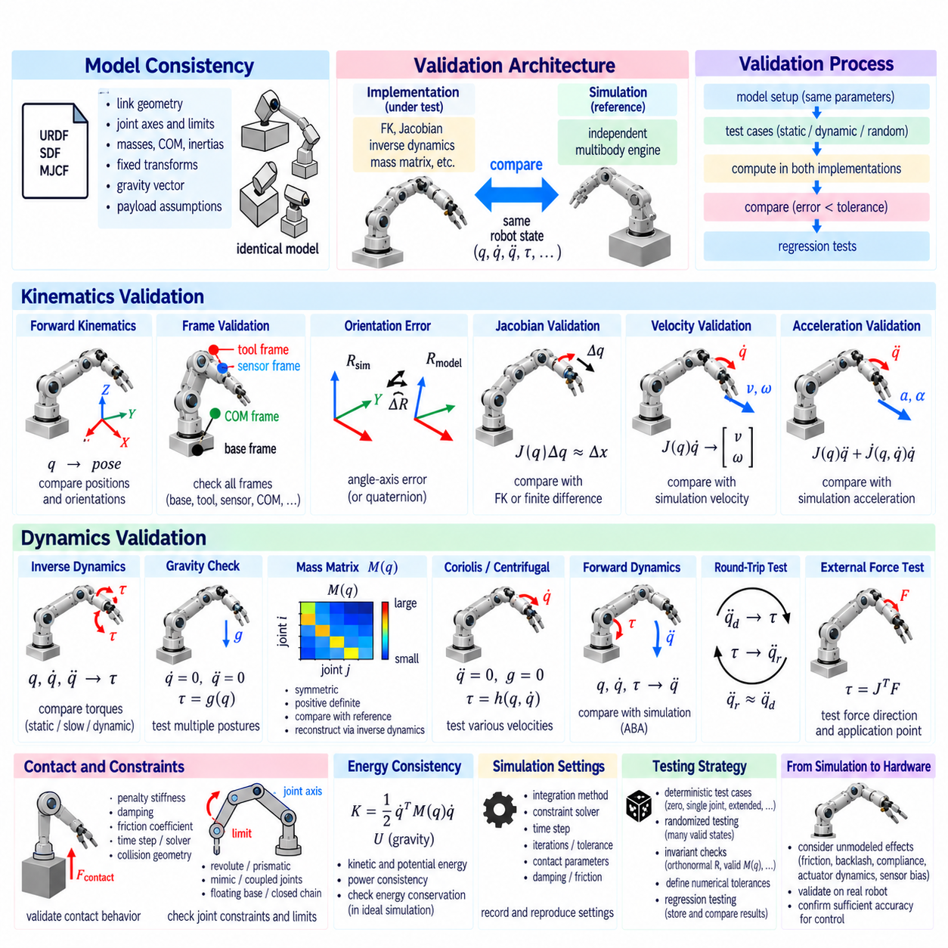
Kinematics and dynamics validation with simulation verifies that a robot model reproduces the intended geometric and physical behavior before the same algorithms are trusted on hardware. Validation should examine not only whether the robot appears to move correctly, but whether joint coordinates, frame transformations, velocities, accelerations, forces, torques, inertial properties, and constraints remain mathematically and physically consistent.
A useful validation architecture separates the implementation under test from an independent simulation reference. The controller or robot-model library computes forward kinematics, Jacobians, inverse dynamics, and related quantities, while a simulator evaluates the same robot state using its own multibody engine. Agreement between independent implementations provides stronger evidence than testing software against calculations derived from the same code base.
Model consistency is the first requirement. The URDF, SDF, MJCF, or equivalent description used by simulation should represent the same link geometry, joint axes, limits, masses, centers of mass, inertia tensors, fixed transforms, gravity vector, and payload assumptions as the control model. Small differences in these parameters can produce apparently plausible motion while creating significant dynamic disagreement.
Forward-kinematics validation begins with carefully selected joint configurations whose expected geometry is easy to interpret. Zero configuration, single-joint rotations, fully extended configurations, folded configurations, and representative operating postures should be evaluated. The position and orientation of the end effector and important intermediate frames should agree between the analytical model and simulation within defined numerical tolerances.
Frame-level validation is essential because many kinematic failures are actually convention errors. Base, world, flange, tool-center-point, sensor, center-of-mass, and contact frames should be compared explicitly. A model can produce a visually correct robot pose while still containing a constant rotation, translation offset, or parent-child frame error that later corrupts Jacobians, force transformations, and controller commands.
Orientation comparisons require appropriate mathematics because Euler-angle differences can become misleading near representation singularities or wrapping boundaries. Rotation matrices, quaternions, or Lie-group orientation errors provide more reliable measures. For two orientations, the relative rotation can be converted into an angle-axis error, allowing orientation discrepancy to be expressed as a physically meaningful angular magnitude.
Jacobian validation checks whether differential kinematics agree with observed motion. For a small joint perturbation Δq, the predicted Cartesian displacement from J(q)Δq can be compared with the displacement obtained from forward kinematics or simulation. Central finite differences provide an independent numerical approximation and are especially useful for detecting incorrect joint axes, frame conventions, or Jacobian reference points.
Velocity validation extends this concept to continuous motion. A known joint-velocity vector q̇ is commanded or replayed, and the predicted end-effector twist J(q)q̇ is compared with the linear and angular velocity reported by simulation. Tests should include isolated joint motion and simultaneous multi-joint motion so that both individual Jacobian columns and coupled behavior are exercised.
Acceleration validation examines second-order kinematics. Cartesian acceleration contains contributions from J(q)q̈ and J̇(q,q̇)q̇, so simply multiplying the Jacobian by joint acceleration is insufficient during moving configurations. Simulation trajectories with nonzero q̇ and q̈ can verify whether acceleration propagation and velocity-product terms are correctly represented by the implementation.
Inverse-dynamics validation evaluates whether predicted joint torque matches the torque required by the simulated rigid-body system. The same q, q̇, and q̈ trajectory should be supplied to both models under identical gravity and external-force conditions. Comparing predicted torque across static, slow, and dynamic trajectories helps separate gravity, velocity-dependent, and inertial contributions.
Gravity is conveniently validated using static postures. With q̇ = 0 and q̈ = 0 and no external wrench, inverse dynamics should reduce to the gravity-compensation torque. Several postures should be tested because an incorrect center of mass or joint axis may accidentally produce the correct torque at one configuration while failing elsewhere. Horizontal and extended poses often provide particularly informative gravitational loading.
Mass-matrix validation provides deeper structural checks. The calculated M(q) should be symmetric within numerical tolerance and positive definite for independent coordinates in a physically valid unconstrained model. Eigenvalue or Cholesky tests can detect invalid inertial parameters or implementation errors. Mass matrices from independent libraries or simulation engines can also be compared at multiple configurations.
The mass matrix can additionally be checked through inverse dynamics. With gravity disabled, joint velocity set to zero, external forces removed, and a selected unit acceleration applied, the resulting generalized torque corresponds to a column of M(q). Repeating this procedure across generalized coordinates creates an independent numerical reconstruction that can be compared with the directly calculated mass matrix.
Coriolis and centrifugal effects can be isolated by setting acceleration to zero and removing gravity and external loads while retaining nonzero joint velocity. The resulting torque represents velocity-dependent rigid-body effects. Tests should include multiple velocity directions and magnitudes because coupling errors may remain hidden when only one joint moves or when symmetric trajectories cause terms to cancel.
Energy consistency provides a system-level validation method. Kinetic energy computed from link motion should agree with 1/2 q̇ᵀM(q)q̇. Potential-energy changes should correspond consistently to gravitational work according to the selected sign convention. In ideal simulations without dissipation, actuator power and changes in mechanical energy should satisfy the expected conservation relationship.
Forward-dynamics validation reverses the problem. Given q, q̇, and actuator torque τ, the implementation predicts q̈, which can be compared with acceleration generated by the simulator. This test evaluates the combined effects of the mass matrix and bias forces rather than individual terms. It is useful for validating ABA implementations, numerical factorization, and complete equations of motion.
Round-trip testing provides another powerful consistency check. A desired q̈ can first be passed through inverse dynamics to calculate τ, and the resulting torque can then be passed through forward dynamics. Under identical assumptions, the recovered acceleration should closely match the original q̈. Significant mismatch indicates inconsistent conventions, missing terms, numerical problems, or incompatible model parameters.
External-force validation should apply known forces or moments to selected links. A wrench at the end effector should produce generalized loading consistent with the appropriate Jacobian-transpose relationship. Tests should vary the force direction, application point, and robot posture. This helps identify errors in wrench sign, frame transformation, moment-arm calculation, and contact-point definition.
Contact simulation introduces additional complexity because the result depends on the contact model as well as rigid-body dynamics. Penalty stiffness, damping, friction coefficients, solver tolerances, time step, and collision geometry influence simulated contact forces. Validation should therefore distinguish errors in robot dynamics from differences caused by the simulator’s contact approximation and numerical solver.
Joint constraints and limits should also be tested. Revolute and prismatic joints must move around or along the expected axes, respect configured limits, and use consistent position and velocity conventions. Mimic joints, coupled joints, transmissions, floating bases, and closed-chain mechanisms require additional checks because their generalized coordinates may not correspond directly to independent actuator coordinates.
Simulation time step can strongly affect validation results. A coarse integration step may create trajectory, energy, or contact errors even when the underlying equations are correct. Dynamic validation should therefore be repeated with progressively smaller time steps. If disagreement decreases with time-step refinement, the dominant problem may be numerical integration rather than an incorrect analytical model.
Solver configuration should likewise be recorded as part of the validation environment. Integration method, constraint solver, iteration count, convergence tolerance, contact parameters, damping, and friction settings can influence results. Reproducible validation requires these settings to be version-controlled or otherwise documented together with the robot model and test trajectories.
Different simulation engines can provide useful cross-validation because they implement multibody dynamics differently. A model may be tested using a robotics simulator and an independent rigid-body library such as KDL or Pinocchio. Agreement across several implementations substantially reduces the probability that identical software assumptions or shared implementation errors are producing misleading results.
Randomized testing expands coverage beyond manually selected configurations. Joint states can be sampled within valid limits, excluding unsafe or numerically problematic regions when necessary. Thousands of randomized states can be evaluated automatically for pose, Jacobian, mass matrix, gravity torque, and inverse dynamics, revealing errors that may not appear in a small set of deterministic examples.
Property-based tests complement numerical comparisons. Rotation matrices should remain orthonormal, homogeneous transformations should preserve rigid-body structure, mass matrices should remain symmetric, kinetic energy should not become negative, and dimensions and units should remain consistent. These invariants can detect failures even when no independent reference value is available for a particular state.
Validation tolerances should be defined according to quantity and purpose rather than using one universal threshold. Position error may be measured in meters, orientation error in radians, torque error in newton-meters, and matrix disagreement using absolute or relative norms. Tolerances should account for floating-point precision, simulator integration error, contact approximation, and the accuracy required by the intended controller.
Regression testing converts validation into a sustainable engineering process. Once a robot model and algorithms pass a trusted test suite, expected outputs can be stored for representative cases. Changes to URDF files, inertial parameters, dynamics libraries, compiler settings, or control software can then automatically trigger comparison tests to detect unintended changes before deployment.
Visualization remains useful even though it cannot replace numerical verification. Displaying coordinate axes, centers of mass, joint axes, contact points, velocity vectors, and force directions can quickly expose modeling mistakes. A misplaced center of mass or reversed joint axis may be obvious visually even when numerical results require substantial analysis to identify the underlying cause.
Simulation validation should eventually be complemented by hardware validation because real robots contain effects that ideal rigid-body simulation may omit. Friction, gearbox backlash, elasticity, actuator dynamics, sensor bias, structural compliance, cable forces, and payload uncertainty can create discrepancies. Simulation establishes algorithmic correctness, while hardware experiments determine whether the model is sufficiently accurate for physical control.
A disciplined validation process progresses from geometry to differential kinematics, rigid-body dynamics, external loading, contact behavior, and finally closed-loop control. Each layer should be verified before more complex behavior is introduced. This staged approach makes failures easier to localize and prevents controller tuning from masking fundamental errors in frames, inertial parameters, or equations.
Kinematics and dynamics validation with simulation ultimately creates confidence that mathematical models, software implementations, and simulated robot behavior describe the same physical system. Independent references, structured test cases, randomized coverage, invariant checks, numerical tolerances, regression testing, and later hardware comparison together form a verification framework suitable for reliable model-based robotic control.

