Volume 17 Manipulation and Grasping AI

Chapter 11. Manipulation Benchmarks

11.01. Manipulation Benchmark Overview YCB NIST OCRTOC
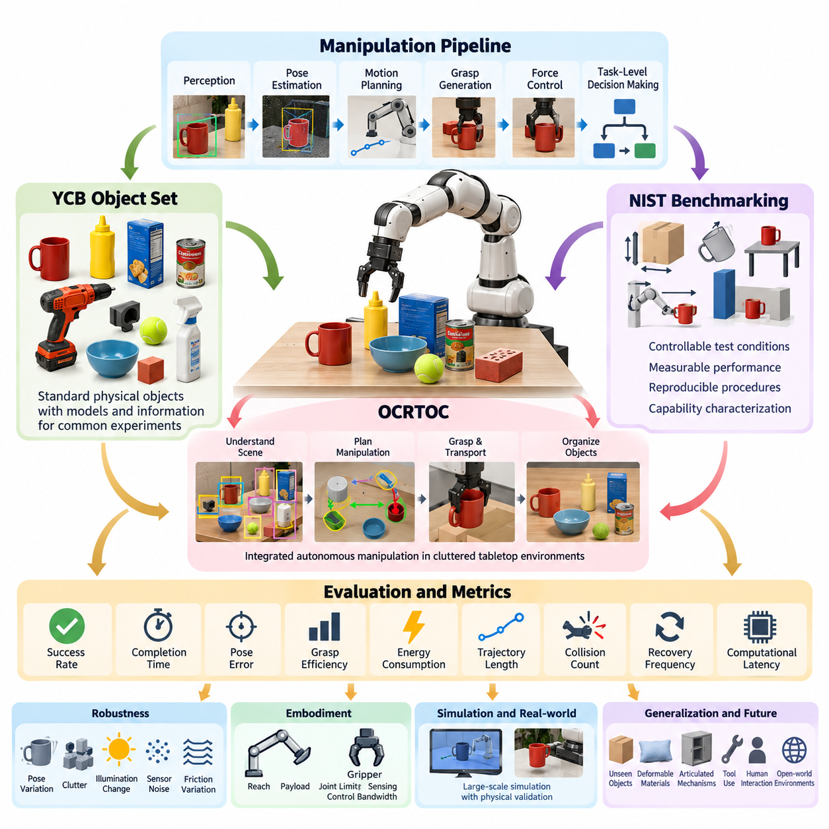
Manipulation benchmarks provide standardized methods for measuring how reliably a robot can perceive, reach, grasp, move, place, and reorient objects under controlled conditions. Unlike demonstrations that emphasize a single successful trial, benchmarks define repeatable objects, tasks, environments, metrics, and evaluation procedures. They make it possible to compare manipulation systems across laboratories and track progress from isolated skills toward robust autonomous operation.
A complete manipulation benchmark evaluates more than grasp success. Modern systems combine perception, pose estimation, motion planning, collision avoidance, grasp generation, force control, and task-level decision making, so failures may originate anywhere in this chain. Benchmark design therefore separates component-level performance from end-to-end task performance while preserving realistic interactions among components. This distinction is important when determining whether improvement comes from better perception, planning, hardware, or integrated intelligence.
The YCB object and model set was developed to provide a common collection of physical objects for robotic manipulation research. It contains objects with diverse shapes, sizes, textures, materials, masses, and manipulation characteristics, including household products, tools, containers, geometric objects, and objects designed specifically for robotic experiments. Because identical or well-characterized objects can be used across laboratories, YCB reduces one major source of experimental inconsistency.
YCB is particularly useful because physical objects are accompanied by models and supporting information that enable experiments involving object recognition, pose estimation, grasping, manipulation, and simulation. Researchers can construct tasks such as pick-and-place, object rearrangement, in-hand manipulation, and cluttered-scene grasping using a shared vocabulary of objects. Consequently, results can be reproduced more systematically than experiments based on arbitrary laboratory-specific object collections.
YCB-based evaluation should nevertheless distinguish between familiarity and generalization. A robot repeatedly trained on known YCB objects may achieve high performance without learning manipulation principles that transfer to unseen objects. Strong evaluation protocols therefore separate training and test conditions, introduce previously unseen poses or clutter arrangements, and may reserve object categories for generalization testing. The benchmark then measures not merely memorization but the ability to infer useful actions from geometric and semantic properties.
NIST approaches robotic manipulation benchmarking from a measurement-science perspective, emphasizing reproducible test methods, measurable performance characteristics, and clearly specified conditions. Test methods can evaluate capabilities such as grasping, object handling, positioning, assembly-related manipulation, mobility-manipulation interaction, and system robustness. Rather than ranking robots by a single score, this approach encourages characterization of capability envelopes under progressively demanding conditions.
A major advantage of structured NIST-style testing is the separation of task complexity into measurable variables. Object dimensions, orientation, placement uncertainty, reach distance, clearance, grasp accessibility, environmental constraints, and required precision can be controlled independently. Performance can then be expressed using success rate, completion time, positional or angular error, repeatability, intervention frequency, and failure modes. Such measurements reveal where a manipulation system approaches its operational limits.
OCRTOC, the Open Cloud Robot Table Organization Challenge, extends benchmarking toward integrated autonomous manipulation in cluttered tabletop environments. Instead of evaluating only an isolated grasp, the robot must understand an initial scene, identify objects, determine their poses, plan manipulation sequences, grasp and transport objects, and organize them according to a specified target arrangement. This structure closely resembles practical rearrangement problems encountered in logistics, service robotics, and flexible automation.
The importance of OCRTOC lies in its system-level character. An object may be correctly detected but inaccurately localized, producing a failed grasp; a successful grasp may be followed by a collision during transport; or individually valid placements may create configurations that prevent later objects from being positioned. Performance therefore depends on coordinated perception, planning, manipulation, and recovery rather than the optimization of one isolated algorithm. Benchmark results expose integration weaknesses that component tests can overlook.
YCB, NIST-oriented test methods, and OCRTOC represent complementary layers of manipulation evaluation. YCB primarily supplies standardized objects and experimental references, NIST contributes disciplined measurement methodology and reproducible test procedures, and OCRTOC emphasizes autonomous execution of integrated manipulation tasks. Together they illustrate how benchmarking can progress from standardized test artifacts through controlled capability measurement to complex task-level evaluation involving perception, reasoning, planning, and physical interaction.
Meaningful benchmark metrics should capture both effectiveness and efficiency. Binary success is fundamental but insufficient because two systems with identical success rates may differ greatly in execution time, trajectory length, energy consumption, number of grasp attempts, placement accuracy, or human intervention. Manipulation evaluation should therefore combine success probability with measures such as cycle time, grasp efficiency, pose error, collision count, recovery frequency, and computational latency where appropriate.
Robustness evaluation introduces controlled disturbances and uncertainty. Objects can be shifted from nominal positions, partially occluded, placed in clutter, rotated into difficult orientations, or presented under varying illumination and background conditions. Manipulation can additionally be tested against calibration errors, friction variation, uncertain mass distribution, sensor noise, and small execution disturbances. A robust system should maintain acceptable performance across a defined range rather than succeed only under carefully prepared laboratory conditions.
Benchmarking must also account for embodiment. Manipulator reach, payload, joint limits, gripper geometry, sensing configuration, and control bandwidth strongly influence task difficulty. Direct comparison between different robots can therefore be misleading unless the benchmark clearly specifies hardware assumptions and environmental constraints. Capability-oriented evaluation addresses this problem by describing what physical and computational resources were available and by comparing performance within explicitly defined operating conditions.
Simulation can greatly increase benchmark scale by generating thousands of object arrangements, randomized physical parameters, and repeatable failure scenarios. However, simulation results should not automatically be interpreted as equivalent to physical manipulation performance. Contact dynamics, friction, compliance, sensor artifacts, actuator behavior, and object deformation are difficult to reproduce perfectly. A strong evaluation pipeline consequently uses simulation for broad exploration and physical experiments for validation of real-world reliability.
For learning-based manipulation, benchmark design must prevent information leakage between training and evaluation. Models may exploit previously observed object meshes, textures, camera configurations, or fixed scene layouts instead of developing transferable manipulation capability. Evaluation should therefore include unseen instances, novel configurations, environmental variation, and clearly documented training resources. Increasingly, the central question is not whether a robot can manipulate a known object, but whether it can adapt its learned representations to unfamiliar physical situations.
Failure taxonomy is another essential element of benchmark interpretation. Failures can be classified into perception errors, pose-estimation errors, unreachable grasp proposals, planning failures, collisions, grasp slippage, unstable transport, inaccurate placement, control instability, or unsuccessful recovery. Recording these categories transforms benchmark results from simple rankings into engineering evidence. Developers can identify bottlenecks and determine which subsystem produces the greatest reduction in overall task reliability.
Repeatability and reproducibility should be treated separately. Repeatability asks whether the same system produces consistent results when an experiment is repeated under similar conditions. Reproducibility asks whether another laboratory or platform can obtain comparable conclusions using the published protocol. Standardized objects such as YCB, precisely described NIST-style procedures, shared datasets, configuration files, and transparent scoring rules collectively improve both properties and strengthen scientific comparisons.
The long-term direction of manipulation benchmarking is moving toward increasingly open-world evaluation. Future systems must handle unfamiliar objects, deformable materials, articulated mechanisms, tool use, human interaction, long-horizon tasks, and continuously changing environments. Evaluation will therefore need to measure adaptation, semantic reasoning, uncertainty management, recovery, and safety alongside conventional grasping accuracy. Benchmark difficulty should increase without sacrificing experimental reproducibility or diagnostic value.
Ultimately, manipulation benchmarks serve as an interface between research progress and deployable robotic capability. YCB establishes common physical references, measurement-oriented frameworks such as those promoted by NIST establish disciplined evaluation principles, and integrated challenges such as OCRTOC test whether perception and manipulation can operate together autonomously. Used collectively, these approaches provide a foundation for measuring the transition from laboratory manipulation skills toward general-purpose physical intelligence.

11.02. YCB Object and Model Set Evaluation Protocol [w/Code]
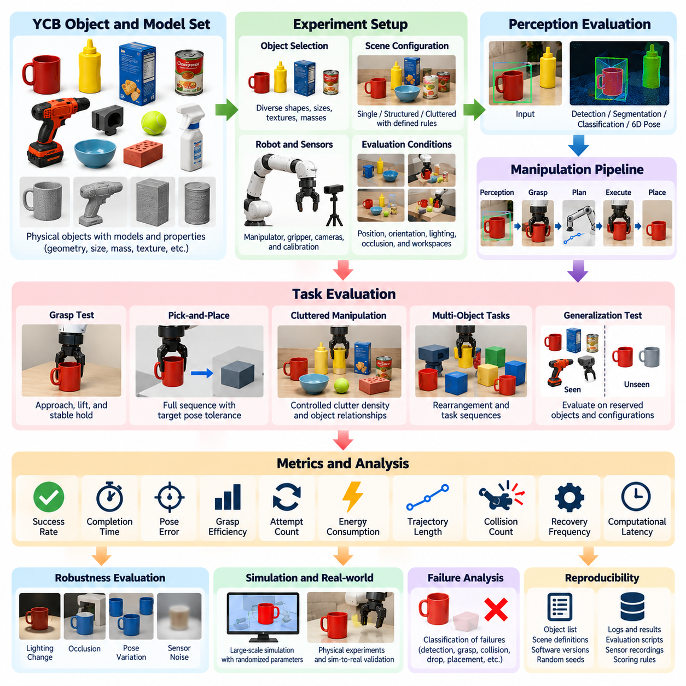
The YCB Object and Model Set provides a standardized physical basis for evaluating robotic manipulation, perception, grasping, and planning systems. Its primary value is not simply the availability of common objects, but the ability to construct repeatable experiments using objects with documented geometry and physical properties. An evaluation protocol built around YCB should therefore define object selection, scene configuration, robot conditions, trial procedures, and performance metrics before experiments begin.
Object selection should represent the manipulation capabilities being investigated rather than using convenient items arbitrarily. YCB includes objects with different dimensions, shapes, textures, masses, rigidity, symmetry, and grasp affordances. Cylindrical containers, boxes, tools, household items, geometric shapes, and deformable objects impose different perception and manipulation requirements. A balanced subset allows evaluation across multiple physical characteristics while keeping the experiment sufficiently controlled for meaningful comparison.
Before testing, each selected object should be associated with a consistent identifier and verified against its available reference information. Geometric models, dimensions, mass properties, texture information, and object coordinate conventions should be recorded when relevant. The experiment should also document which model representation is used by perception, simulation, or planning software. This prevents differences in preprocessing or object representation from being incorrectly interpreted as differences in manipulation performance.
Scene configuration is another essential part of the protocol. Objects may be evaluated individually, arranged in structured groups, or placed within clutter depending on the target capability. Initial position, orientation, support surface, separation distance, visibility, and reachable workspace should be defined or generated according to documented randomization rules. Repeating experiments over multiple configurations prevents the benchmark from becoming dependent on a single favorable arrangement.
Perception evaluation can use YCB objects to measure object detection, segmentation, classification, and six-degree-of-freedom pose estimation. Ground-truth object identity and pose must be established using an appropriate reference method, after which predictions can be compared using position, orientation, detection, or segmentation errors. Testing should include changes in viewpoint, distance, illumination, occlusion, and clutter because manipulation performance depends strongly on the reliability of perception under realistic scene variation.
Grasp evaluation should specify what constitutes a valid attempt and successful grasp. A robot may be required to approach the object, establish contact, lift it to a defined height, maintain stable retention for a specified period, and transport it without dropping or excessive displacement. Success should not be declared immediately after gripper closure. A stability phase provides evidence that the generated grasp can withstand the forces encountered during subsequent manipulation rather than merely creating temporary contact.
Pick-and-place evaluation extends grasp testing by requiring the complete manipulation sequence to succeed. The robot must perceive the object, select a grasp, generate a collision-free trajectory, acquire the object, transport it, and place it inside a specified target region or pose tolerance. Final placement error can be measured in position and orientation. This end-to-end protocol reveals interactions between perception uncertainty, grasp quality, trajectory execution, and placement control that isolated component tests cannot capture.
For cluttered manipulation, the protocol should control both clutter density and object relationships. Objects can partially occlude one another, restrict gripper access, create narrow approach directions, or become physically entangled. Difficulty can be increased systematically by changing the number of objects, minimum spacing, overlap, orientation diversity, and visibility. Such parameterized clutter provides a more informative evaluation than simply labeling scenes as easy or difficult without quantitative definitions.
Trial repetition is necessary because manipulation is inherently stochastic. Sensor noise, contact variation, actuator error, friction, and small differences in object placement can produce different outcomes even under nominally identical conditions. Each experimental condition should therefore contain enough repeated trials to estimate performance distributions rather than reporting a single result. Random seeds and randomized configurations should be preserved when possible so that identical or statistically comparable experiments can be reproduced.
The most fundamental metric is task success rate, but it should be accompanied by diagnostic measurements. Useful metrics include grasp success, completion time, number of grasp attempts, planning time, trajectory length, placement error, collision count, object disturbance, recovery attempts, and human intervention. Computational latency may also be important for real-time systems. Reporting several complementary metrics prevents optimization of one score from hiding weaknesses elsewhere in the manipulation pipeline.
Failure classification should be incorporated directly into data collection. A failed trial may originate from incorrect detection, inaccurate pose estimation, an infeasible grasp, inverse-kinematics failure, collision, premature contact, grasp slippage, dropped objects, trajectory execution error, or inaccurate placement. Recording only success and failure discards this information. A structured failure taxonomy allows benchmark results to guide engineering improvements and identify which subsystem limits overall reliability.
Generalization testing should separate objects and configurations encountered during development from those reserved for evaluation. If the perception or manipulation policy has repeatedly observed every test object, high performance may reflect object-specific memorization. Evaluation can instead reserve selected YCB objects, object categories, orientations, or scene configurations as unseen conditions. This tests whether the system has learned transferable geometric and manipulation principles rather than fixed responses to known examples.
Object symmetry requires special consideration in pose evaluation. For some cylindrical or geometrically symmetric objects, multiple orientations are physically equivalent even though their numerical rotation values differ. Metrics that ignore this property may penalize a correct perception result. The evaluation protocol should therefore identify relevant symmetries and apply symmetry-aware pose metrics where necessary, ensuring that reported errors correspond to meaningful differences for manipulation rather than arbitrary coordinate conventions.
Robot hardware conditions must also be documented because embodiment influences benchmark difficulty. Manipulator degrees of freedom, reach, payload, gripper type, finger geometry, force capability, camera arrangement, calibration method, and control frequency can all affect performance. The purpose is not to force every laboratory to use identical hardware, but to provide sufficient information to interpret results fairly and reproduce equivalent experimental conditions on another platform.
Calibration quality should be verified before benchmark execution. Errors in camera intrinsics, camera-to-robot transformation, tool-center-point location, gripper geometry, or table reference frames can propagate directly into grasp and placement errors. A benchmark should not unintentionally measure poor calibration when its intended target is manipulation intelligence. Calibration procedures and validation tolerances should therefore be recorded, while calibration drift should be checked during long experimental campaigns.
Simulation can complement physical YCB evaluation by using available object models to generate large numbers of scenes and manipulation trials. Object pose, camera viewpoint, lighting, friction, mass, and other parameters can be randomized to investigate robustness efficiently. However, simulation should remain distinguishable from physical evaluation because contact behavior and sensing artifacts may differ substantially. Results should indicate clearly whether trials are simulated, physical, or part of a sim-to-real validation procedure.
A robust protocol introduces controlled perturbations after establishing nominal performance. Pose uncertainty, illumination changes, partial occlusion, calibration offsets, sensor noise, friction variation, and small object displacement can be increased progressively. Performance degradation can then be measured as a function of disturbance magnitude. This produces a capability curve rather than a single benchmark score and provides stronger evidence about whether a system can tolerate conditions expected outside the laboratory.
Reproducibility requires preserving more than final numerical results. Object identifiers, scene definitions, robot configuration, software versions, model checkpoints, camera parameters, random seeds, evaluation scripts, trial logs, and scoring rules should be retained whenever possible. Photographs or recorded sensor streams can provide additional verification of physical experiments. These records create an evidence chain connecting reported benchmark scores to the exact experimental conditions under which they were produced.
The YCB evaluation protocol is most valuable when it functions as a controlled progression from component testing to integrated manipulation. Perception and pose estimation can first be validated independently, followed by grasping, pick-and-place, clutter handling, and increasingly complex task sequences. By combining standardized physical objects with explicit procedures, repeated trials, multidimensional metrics, failure analysis, and generalization tests, YCB becomes a rigorous framework for measuring reliable and transferable robotic manipulation capability.

11.03. RLBench Simulation Manipulation Benchmark [w/Code]
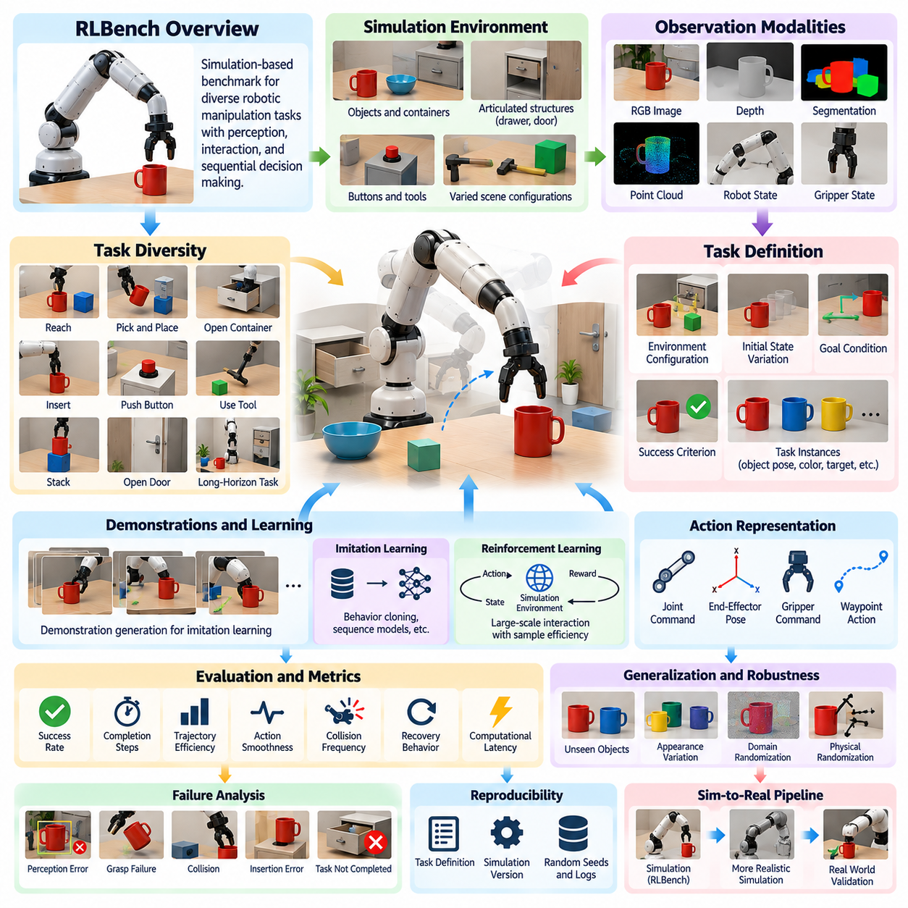
RLBench is a simulation-oriented benchmark and learning environment designed to evaluate robotic manipulation across a broad collection of visually and physically diverse tasks. Rather than measuring only isolated grasping or reaching skills, it represents manipulation as task execution involving perception, motion, interaction, and sequential decision making. This makes it useful for studying imitation learning, reinforcement learning, multi-task learning, and generalization within a standardized simulated environment.
The benchmark is built around physics-based robotic simulation and provides a common manipulation platform in which task conditions can be reproduced systematically. A simulated manipulator interacts with objects, containers, tools, buttons, drawers, doors, and other articulated structures. Because robot state and environment state are directly available from simulation, researchers can generate accurate observations, demonstrations, success labels, and ground-truth information without constructing extensive physical measurement infrastructure.
A major characteristic of RLBench is its large task diversity. Tasks can involve reaching toward targets, picking and placing objects, opening containers, inserting components, pushing buttons, manipulating articulated objects, stacking items, using tools, or completing longer sequences of actions. Different tasks require different combinations of geometric reasoning, grasp selection, trajectory planning, contact interaction, and temporal coordination, allowing evaluation beyond narrowly specialized manipulation policies.
Each task is defined through an environment configuration, manipulable entities, initial-state variation, goal conditions, and success criteria. Instead of evaluating a policy in one fixed scene, task instances can vary object positions, orientations, colors, target locations, and other parameters. This variation is important because a manipulation system should learn the underlying task relationship rather than memorize a single trajectory associated with a fixed arrangement.
RLBench supports multiple observation modalities that can be used individually or jointly. A policy may receive RGB images, depth information, segmentation masks, point-cloud-related observations, robot joint states, gripper states, or other simulator-derived information depending on the experimental configuration. Researchers can therefore compare vision-based learning with state-based learning or investigate multimodal policies that combine visual perception with proprioceptive robot information.
Camera configuration is especially important for vision-based evaluation. Observations can be collected from different viewpoints surrounding the manipulation workspace, including external and robot-associated perspectives. A policy trained with one camera arrangement may perform poorly when viewpoint or calibration changes. Evaluation should therefore document image resolution, camera pose, field of view, observation modalities, and any preprocessing so that performance differences can be interpreted correctly.
Demonstration generation is one of the benchmark's important capabilities. Successful task trajectories can be produced through the task and simulation framework and used as training examples for imitation-learning methods. Demonstrations may contain observations, robot states, actions, and task progress over time. This allows researchers to investigate behavior cloning, sequence models, representation learning, and other approaches without manually teleoperating a physical robot for every training episode.
The availability of demonstrations does not eliminate the need for careful dataset design. Training performance can depend strongly on the number of demonstrations, their diversity, task variation, action representation, and sampling strategy. Benchmark reports should therefore specify how many demonstrations were used per task and how training, validation, and test episodes were separated. Otherwise, improvements caused by additional training data may be incorrectly attributed to a superior learning algorithm.
Reinforcement learning can also be studied by allowing policies to interact repeatedly with the simulated environment. The agent observes the current state, selects actions, receives task-related feedback, and explores strategies over many episodes. Simulation enables substantially more interaction than is usually practical on physical hardware. Nevertheless, sample efficiency remains an important metric because algorithms requiring extremely large numbers of episodes may be difficult to transfer into real-world robotic development.
Action representation has a major influence on benchmark difficulty. Policies may operate through joint commands, end-effector poses, gripper commands, waypoint-like actions, or other control abstractions. High-level action representations simplify learning but delegate more responsibility to underlying controllers and planners, while low-level control exposes the learning system to more of the robot dynamics. Results should therefore be interpreted in relation to the control interface provided to the policy.
Task success rate is the most direct RLBench performance measure. A trial is successful when the simulator-defined task conditions are satisfied within the permitted execution horizon. However, success rate alone does not explain policy behavior. Completion steps, trajectory efficiency, action smoothness, collision frequency, failed grasp attempts, recovery behavior, and computational latency can provide additional information about whether a policy solves tasks efficiently and robustly.
Multi-task learning is particularly relevant because RLBench contains many manipulation tasks within a common framework. Instead of training a separate model for every behavior, a single policy can be conditioned on task identity, observations, or task descriptions and trained across multiple skills. Evaluation can then examine whether knowledge acquired from one task improves learning on another and whether shared representations emerge across grasping, placing, opening, pushing, and tool-interaction behaviors.
Generalization evaluation should distinguish between variations of known tasks and genuinely novel conditions. A policy may be tested on unseen object poses, colors, object instances, initial configurations, or camera conditions while retaining the same underlying task. More demanding evaluation can reserve complete tasks or task families for testing. This distinction separates interpolation within familiar experience from transfer to manipulation problems that were absent during training.
Visual generalization can be strengthened through domain randomization and controlled scene variation. Textures, colors, lighting, camera parameters, object appearances, and background properties can be changed during training or evaluation. Such variation reduces dependence on fixed simulator appearance and can encourage representations based on task-relevant structure. However, randomization ranges should be documented because excessive or unrealistic variation can change the nature of the benchmark rather than simply improve robustness.
Physical randomization is similarly valuable for evaluating contact-sensitive policies. Object mass, friction, damping, initial pose, and other simulation parameters may be varied where the experimental framework permits. A policy that succeeds only under one nominal physics configuration may be exploiting simulator-specific assumptions. Testing across parameter ranges provides stronger evidence that the learned manipulation strategy captures relationships that remain useful under uncertainty.
Failure analysis should accompany aggregate success scores. Failures may arise from incorrect target identification, poor approach direction, unreachable commands, collisions, unstable grasps, premature gripper operation, dropped objects, inaccurate insertion, or failure to satisfy the final task condition. Categorizing these outcomes helps distinguish perceptual errors from planning or control errors and makes benchmark results more useful for improving complete manipulation systems.
RLBench is also useful for studying long-horizon manipulation because some tasks require multiple dependent stages. An agent may need to locate an object, open or move another structure, acquire the target, transport it, and complete a final placement or interaction. Errors accumulate across these stages, making long-horizon success substantially more demanding than isolated motion execution. Such tasks provide a bridge between primitive manipulation skills and task-level robotic intelligence.
Reproducibility requires careful control of the simulation environment. Simulator version, RLBench version, task definitions, robot configuration, observation settings, control mode, random seeds, demonstration generation procedure, training data, model checkpoints, and evaluation episode counts should be recorded. Small differences in software or control configuration can influence results, so benchmark comparisons are meaningful only when experimental conditions are sufficiently transparent.
Simulation provides exceptional scalability but cannot completely reproduce physical manipulation. Contact dynamics, actuator behavior, sensing artifacts, material compliance, calibration errors, and unexpected environmental interactions create a simulation-to-reality gap. Consequently, high RLBench performance demonstrates competence within the benchmark environment rather than guaranteeing equivalent physical-robot performance. Real-world validation remains necessary when the goal is deployable manipulation.
A useful development strategy is to treat RLBench as a controlled intermediate stage between algorithm design and physical experimentation. Large numbers of tasks and randomized trials can first expose weaknesses in perception, policy learning, generalization, and sequential reasoning. Promising approaches can then be transferred to increasingly realistic simulation and finally to physical hardware, where calibration, latency, contact uncertainty, safety, and hardware limitations become part of the evaluation.
Within a broader manipulation benchmark framework, RLBench complements physical object benchmarks such as YCB. YCB emphasizes standardized real objects and repeatable physical experimentation, whereas RLBench enables scalable simulation across many tasks, observations, demonstrations, and environmental variations. Together, these approaches support evaluation from component-level perception and grasping to learned multi-task manipulation and eventually real-world autonomous physical intelligence.

11.04. LIBERO Robot Learning Benchmark [w/Code]
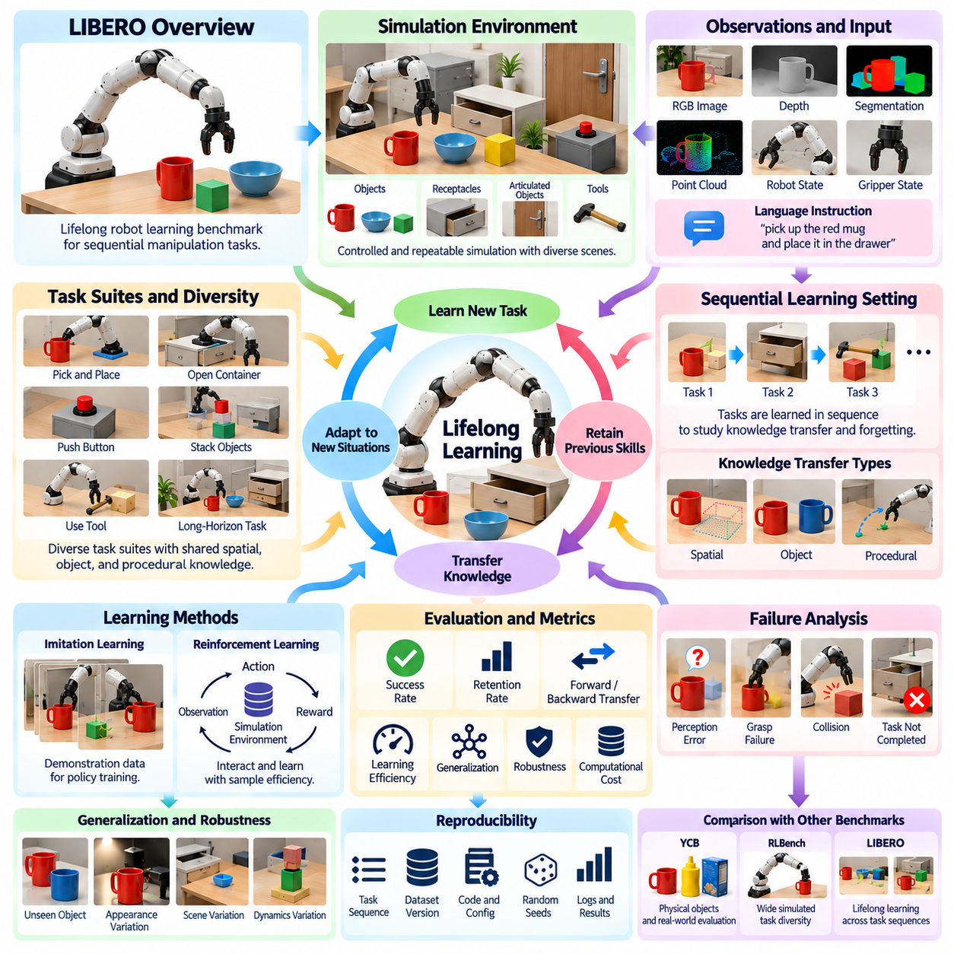
LIBERO is a benchmark for studying lifelong robot learning, with particular emphasis on how manipulation policies acquire new skills while preserving previously learned capabilities. Instead of evaluating a robot only after training on one fixed task distribution, LIBERO organizes manipulation problems into sequences of tasks. This structure allows researchers to measure knowledge transfer, interference, retention, and adaptation as learning progresses over time.
The benchmark addresses a fundamental challenge in general-purpose robotics: a useful robot should not require complete retraining whenever a new task is introduced. It should reuse relevant knowledge from earlier experiences, efficiently learn new behaviors, and avoid catastrophic forgetting of old skills. LIBERO therefore evaluates not only final task performance but also how the internal knowledge of a policy evolves as additional manipulation tasks are encountered.
LIBERO uses simulated manipulation environments containing a robot arm, manipulable objects, receptacles, furniture, and task-relevant spatial arrangements. Tasks can require picking, placing, moving, opening, closing, positioning, or interacting with objects according to specified goals. Simulation provides controlled initial conditions and repeatable evaluation while still supporting sufficiently diverse visual and physical interactions for studying learning across related manipulation problems.
An important characteristic of LIBERO is the organization of tasks into benchmark suites that emphasize different forms of knowledge transfer. Some tasks share spatial relationships, others reuse objects or manipulation skills, and more complex suites combine multiple variations. By controlling what is shared between consecutive tasks, the benchmark can investigate whether a learning algorithm transfers useful representations instead of treating every new problem as completely independent.
Spatial knowledge is particularly important in manipulation because successful behavior often depends on relations such as inside, on top of, beside, behind, or within a designated workspace region. A robot may already understand how to grasp an object but still need to learn where that object should be placed. LIBERO can evaluate whether previously learned spatial representations accelerate acquisition of new tasks that contain familiar relationships in different configurations.
Object knowledge provides another dimension of transfer. Manipulation policies repeatedly encounter objects whose visual appearance, geometry, semantic identity, or interaction properties may be relevant across multiple tasks. Learning a useful representation of an object in one task can potentially reduce the amount of experience required in another. Benchmark evaluation can therefore reveal whether a model retains reusable object representations or repeatedly relearns similar information.
Procedural knowledge concerns reusable manipulation behaviors such as reaching, grasping, transporting, placing, opening, and closing. These behaviors may appear within many different semantic tasks even when the target objects and goals change. A strong lifelong-learning system should preserve these underlying motor and interaction patterns and recombine them when learning subsequent tasks, rather than constructing every policy from an entirely new behavioral foundation.
Language-conditioned task specification is valuable because natural-language instructions provide a scalable interface for describing manipulation goals. A policy may receive an instruction indicating which object should be manipulated and what relationship or action should be achieved. The learning system must connect linguistic concepts with visual observations and robot actions. This creates an evaluation setting that combines semantic understanding with physical task execution.
Demonstration data provides examples of successful manipulation trajectories that can be used to train policies through imitation learning. Each demonstration can contain observations, robot states, actions, and task information over a sequence of time steps. The number and diversity of demonstrations strongly influence learning quality, so experiments should report demonstration counts, sampling procedures, observation modalities, and any data augmentation used during policy training.
Observation design determines what information is available to the learning algorithm. Policies may use images from one or more cameras together with robot proprioceptive information such as end-effector state, joint configuration, or gripper status. Visual observations provide information about objects and scene relationships, while proprioception describes the robot's current physical state. Multimodal representations can integrate these sources to support task-aware manipulation.
Sequential training distinguishes lifelong learning from conventional multi-task training. In multi-task learning, data from many tasks may remain simultaneously available throughout optimization. In lifelong learning, tasks are encountered in an ordered sequence, and earlier data may be limited or unavailable when later tasks are learned. This restriction exposes stability-plasticity tradeoffs: the model must remain plastic enough to learn new tasks while remaining stable enough to preserve earlier capabilities.
Catastrophic forgetting occurs when learning a new task significantly degrades performance on tasks learned previously. LIBERO makes this phenomenon measurable by reevaluating earlier tasks after each stage of sequential training. A policy that performs well immediately after learning every task but rapidly loses previous skills is not an effective lifelong learner. Retention across the complete task sequence is therefore as important as acquisition of the newest behavior.
Forward transfer measures whether previous learning helps a model acquire a new task more effectively. If knowledge of familiar objects, spatial relations, or motor behaviors reduces the demonstrations or optimization required for subsequent tasks, positive forward transfer has occurred. Negative transfer occurs when previous knowledge interferes with new learning. Comparing these effects helps determine whether a representation captures reusable manipulation structure.
Backward transfer describes how learning new tasks influences performance on earlier ones. Later experience can sometimes improve previously learned capabilities when shared representations become more general, producing positive backward transfer. More commonly, interference can reduce earlier performance. Measuring both directions of transfer provides a richer picture of lifelong learning than reporting only average final success across all tasks.
Task success rate remains the primary measure of whether a manipulation policy achieves the requested goal, but aggregate success should be interpreted carefully. Average performance can conceal severe forgetting on particular tasks or unusually strong results on easy tasks. Evaluation should therefore preserve task-wise performance histories across the learning sequence and calculate retention, transfer, and final performance in addition to overall success.
Learning efficiency is another important consideration. Two systems may eventually reach similar success rates while requiring substantially different amounts of demonstration data, optimization, computation, or training time. A general-purpose robot should exploit prior experience to reduce the cost of acquiring new skills. Consequently, sample efficiency and adaptation speed provide important evidence about whether lifelong learning offers practical advantages over repeated task-specific training.
Generalization should extend beyond the exact configurations encountered during demonstrations. Evaluation can vary initial object poses, scene arrangements, target locations, visual appearance, or other environmental factors while preserving the intended task semantics. A policy that succeeds only by reproducing memorized trajectories has limited utility. Robust performance under controlled variation indicates that the model has captured relationships between instructions, objects, goals, and actions.
Failure analysis can identify why lifelong policies lose or fail to acquire capabilities. Errors may originate from incorrect language grounding, object confusion, poor spatial reasoning, inappropriate action selection, grasp failure, accumulated trajectory error, or interference from later tasks. Separating semantic, perceptual, and motor failures is especially useful because identical task-level failure rates can arise from fundamentally different limitations within the learned representation.
Benchmark comparisons require consistent training protocols. Task order, demonstration allocation, initialization, model architecture, observation settings, optimization budget, random seeds, and evaluation frequency can all influence results. Methods that retain previous data through replay should be distinguished from approaches that rely on regularization, parameter isolation, architectural expansion, or pretrained representations because these strategies use different resources to combat forgetting.
Reproducibility requires preserving the complete learning history rather than only the final model checkpoint. Researchers should record task sequences, dataset versions, training configurations, intermediate checkpoints, success histories, transfer measurements, random seeds, and software dependencies. These records allow another experimenter to determine not only where a model finished, but how its capabilities changed as each new manipulation problem was introduced.
LIBERO complements manipulation benchmarks that emphasize individual task execution or standardized physical objects. Benchmarks such as RLBench provide broad simulated task diversity, while YCB supports standardized physical-object evaluation. LIBERO focuses more specifically on the temporal dimension of learning: whether a robot can accumulate manipulation knowledge across tasks without repeatedly destroying or rebuilding what it has already learned.
The broader significance of LIBERO lies in its connection to continuously developing physical intelligence. Robots deployed for long periods will encounter new objects, environments, instructions, and operational requirements after deployment. A scalable system must integrate new experience into an existing knowledge base while preserving dependable capabilities. Lifelong manipulation benchmarks provide a controlled way to measure progress toward robots that learn not only individual tasks, but how to continue learning throughout their operational lifetime.

11.05. DROID and Open X Embodiment Benchmark [w/Code]
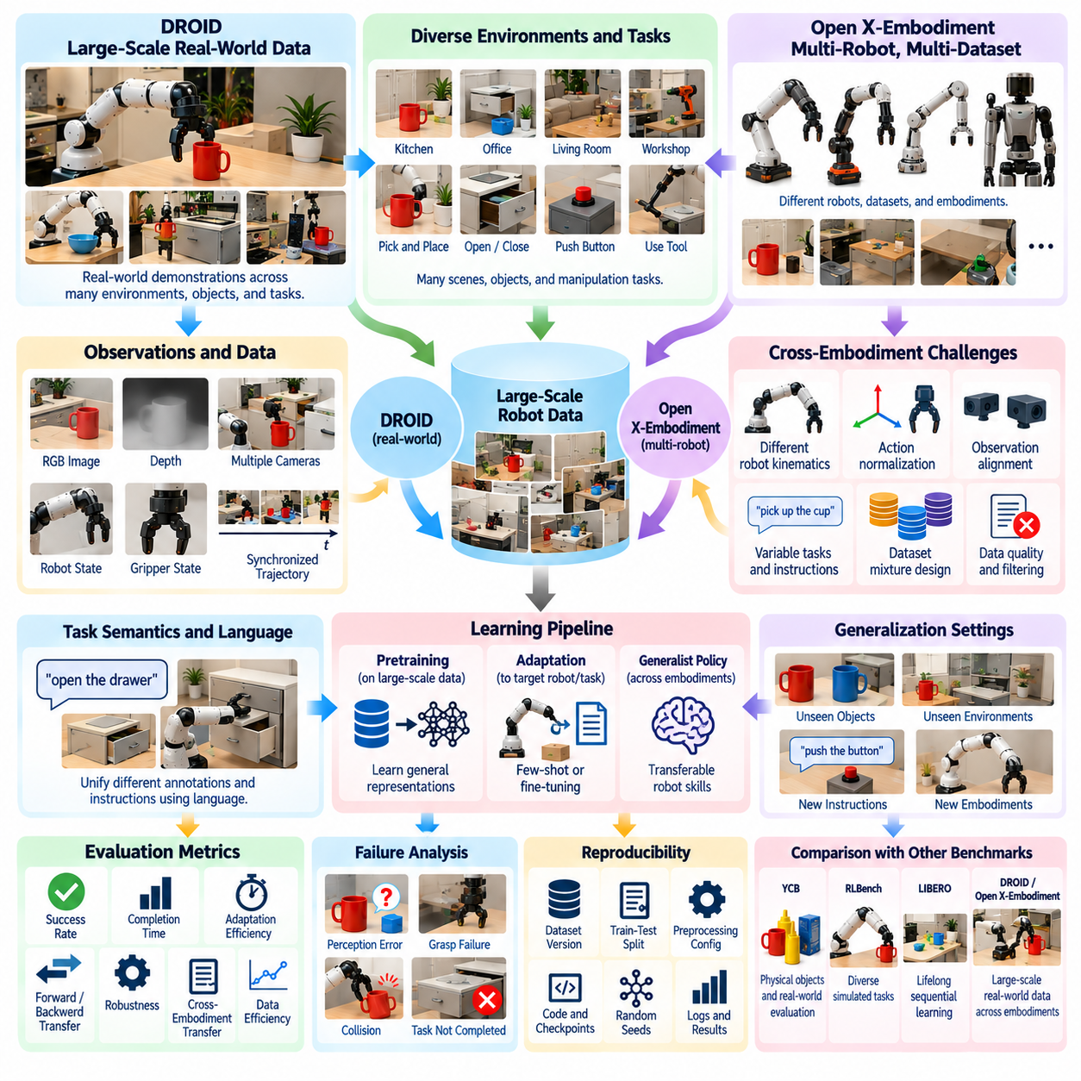
DROID and Open X-Embodiment represent an important shift in robot manipulation benchmarking from narrowly controlled task collections toward large-scale, heterogeneous robot experience. Rather than evaluating only one robot in one laboratory, these resources aggregate manipulation data across tasks, environments, objects, and embodiments. They support research on generalist robot policies that must learn transferable representations from diverse real-world experience.
DROID emphasizes large-scale real-world manipulation data collected across multiple physical environments. Its demonstrations contain robot interactions with everyday objects and scenes rather than relying exclusively on simulation or highly standardized laboratory layouts. This diversity exposes learning algorithms to variations in backgrounds, workspace geometry, lighting, object arrangements, operator behavior, and task execution that naturally occur when data collection is distributed across different locations.
A DROID trajectory can contain synchronized observations describing both the environment and the robot's behavior over time. Depending on the dataset representation, these observations can include multiple camera streams, robot state information, end-effector motion, gripper state, and task-related metadata. The temporal synchronization of these signals is critical because manipulation learning requires connecting what the robot observes with the actions that produce subsequent physical changes.
The value of DROID as a benchmark is closely related to its distributional diversity. A policy trained on demonstrations from many scenes can be evaluated on whether it learns reusable visual-motor relationships instead of memorizing a particular table, camera viewpoint, or object arrangement. Evaluation should therefore separate familiar conditions from held-out environments, objects, tasks, or configurations so that performance reflects generalization rather than repeated exposure.
Open X-Embodiment extends this idea to an even broader cross-embodiment setting by bringing together robot datasets originating from many research projects and robotic platforms. These datasets differ in hardware, sensors, action spaces, tasks, environments, and collection procedures. Their combination creates a large and heterogeneous corpus of embodied experience that can be used to investigate whether shared manipulation knowledge can emerge across physically different robots.
Cross-embodiment learning introduces a fundamental representation problem. Two robots may have different numbers of joints, workspace geometries, grippers, control frequencies, and low-level command interfaces while still performing semantically similar actions such as reaching, grasping, moving, and placing. A general learning system must identify common task structure while respecting embodiment-specific constraints. This makes representation alignment a central challenge in Open X-Embodiment research.
Action normalization is therefore essential when combining heterogeneous robot datasets. Raw joint commands from one manipulator cannot generally be interpreted directly by another. Actions may instead be represented through more comparable abstractions such as end-effector displacement, Cartesian pose change, gripper state, or normalized control tokens. The chosen representation affects how effectively a model can share knowledge across platforms and how much embodiment-specific information must remain explicit.
Observation alignment presents a similar challenge. Datasets may contain different numbers of cameras, image resolutions, viewpoints, proprioceptive signals, depth sensors, and metadata fields. A training pipeline must define which modalities are common, which are optional, and how missing information is handled. Without careful normalization, a model may learn dataset identity or camera-specific shortcuts instead of transferable relationships between visual observations, language, actions, and physical outcomes.
Task semantics provide another layer of unification. Manipulation datasets may describe similar behaviors using different labels, natural-language instructions, metadata conventions, or annotation granularity. Language-conditioned learning can provide a shared semantic interface by mapping diverse task descriptions into a common representation. This enables a model to associate instructions such as picking, placing, opening, or moving with related visual and motor patterns across different datasets.
Dataset mixture design strongly influences training outcomes. Large datasets can dominate optimization simply because they contain more trajectories, while smaller datasets may contain valuable behaviors or embodiments that would otherwise be underrepresented. Sampling ratios, task balancing, embodiment balancing, sequence length, and filtering rules should therefore be documented. Benchmark comparisons are difficult to interpret if improvements result primarily from changing the composition of the training mixture.
Data quality is as important as data quantity. Large robot datasets may contain unsuccessful attempts, inconsistent operator behavior, sensor interruptions, calibration variation, ambiguous instructions, or trajectories with different levels of precision. Quality-control procedures can identify corrupted sequences, incomplete episodes, synchronization errors, or invalid actions. However, excessive filtering can remove realistic variation, so benchmark design should distinguish genuine data corruption from useful behavioral diversity.
DROID and Open X-Embodiment are especially relevant to imitation learning and behavior modeling. Demonstrations provide examples of how actions evolve from observations and task goals, allowing policies to learn mappings from visual and semantic context to robot control. Sequence models can exploit temporal history to infer task progress and predict future actions. Large heterogeneous datasets can additionally support pretraining before a policy is adapted to a specific robot or application.
Pretraining changes the interpretation of manipulation benchmarks. A model trained on broad robot experience may already contain representations of objects, spatial relations, grasp patterns, and common task structures before encountering the target benchmark. Evaluation should therefore distinguish pretrained knowledge from target-specific training. Reporting pretraining datasets, adaptation data, frozen or trainable components, and optimization budgets is necessary for fair comparison between generalist and task-specific approaches.
Generalization can be evaluated along several independent dimensions. A policy may encounter unseen object instances, unfamiliar environments, novel task instructions, changed camera viewpoints, or a new robot embodiment. Success on one dimension does not imply success on another. Benchmark protocols should therefore specify which factors are held out during training and evaluate them separately or compositionally to determine what type of transfer the model actually achieves.
Cross-robot transfer provides one of the strongest tests of embodied generalization. A policy or representation can first be trained using data from several robot platforms and then adapted to a target robot using limited additional demonstrations. If pretraining reduces the amount of target-robot data required, the model has captured reusable embodied knowledge. This transfer efficiency can be measured through adaptation curves rather than only final task success.
Few-shot adaptation is particularly important for practical deployment because collecting large demonstration datasets for every new robot and workspace is expensive. A pretrained manipulation model should ideally acquire a new task or embodiment from a relatively small amount of additional experience. Evaluation can measure success as a function of adaptation demonstrations, optimization steps, or interaction time, providing a direct estimate of how effectively prior robot experience reduces deployment cost.
Zero-shot evaluation represents an even more demanding setting. The model is asked to execute a task, handle an object, or operate under conditions that were not explicitly included in target-specific training. Zero-shot success provides evidence of strong generalization, but failure must be interpreted carefully because embodiment constraints may make an otherwise valid behavior physically impossible. Evaluation should therefore separate reasoning limitations from reachability and hardware limitations.
Robustness evaluation should include realistic variations found in distributed robot data. Changes in illumination, background appearance, object position, clutter, camera pose, and operator style can all shift the observation distribution. Physical factors such as friction, grasp uncertainty, and calibration differences introduce additional variability. Performance across these changes indicates whether large-scale training produces robust manipulation rather than merely expanding the set of memorized scenes.
Failure analysis remains necessary even for very large learned policies. Errors may arise from incorrect task interpretation, object confusion, poor spatial grounding, unsuitable grasp selection, trajectory drift, premature gripper actions, collisions, or failure to adapt to a particular embodiment. Categorizing failures according to perception, semantics, planning, control, and embodiment helps reveal whether scaling data actually resolves specific weaknesses or simply improves average success.
Benchmark metrics should combine task success with transfer and efficiency measures. Useful quantities include success rate, completion time, action horizon, intervention frequency, adaptation data requirement, cross-embodiment transfer gain, and performance on held-out distributions. For large models, computational requirements such as training cost, inference latency, and memory usage may also matter because practical robotic systems must operate within hardware and real-time constraints.
Reproducibility requires explicit tracking of dataset versions and preprocessing pipelines. Large embodied datasets can evolve as trajectories are corrected, metadata is updated, or new subsets are introduced. Researchers should record dataset identifiers, selected subsets, filtering rules, train-test splits, normalization procedures, sampling weights, model checkpoints, and evaluation configurations. Otherwise, apparently identical experiments may use materially different training distributions.
DROID and Open X-Embodiment complement benchmarks such as YCB, RLBench, and LIBERO by addressing another axis of manipulation intelligence: scale and diversity of real robot experience. YCB emphasizes standardized physical objects, RLBench provides diverse simulated tasks, and LIBERO focuses on lifelong sequential learning. DROID and Open X-Embodiment emphasize learning representations that remain useful across broad real-world distributions and, especially, across different robot embodiments.
Their broader significance is the transition from isolated robot policies toward foundation-style manipulation models. Instead of designing a separate model for every robot, task, and environment, large embodied datasets make it possible to investigate shared representations that can be pretrained broadly and adapted locally. The ultimate benchmark is therefore not simply whether a robot reproduces known demonstrations, but whether accumulated experience enables reliable, data-efficient adaptation to new tasks, environments, objects, and physical embodiments.

11.06. Real World Manipulation Evaluation Protocol
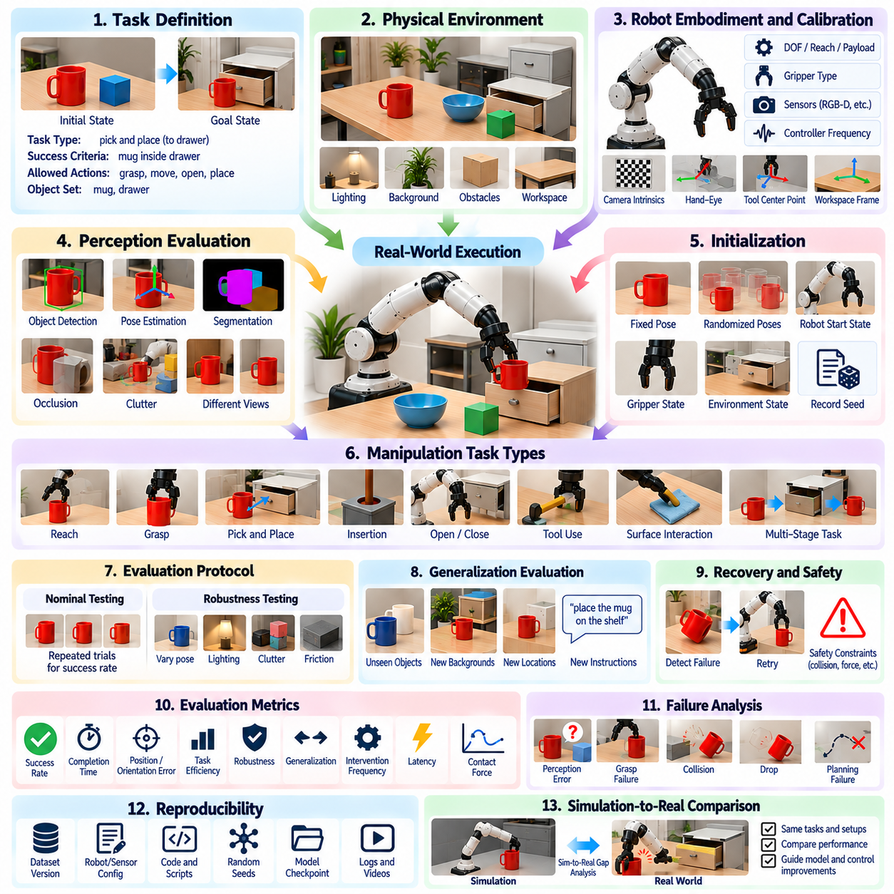
A real-world manipulation evaluation protocol measures whether a robotic system can execute physical tasks reliably under conditions that include sensing uncertainty, contact variation, hardware limitations, and environmental change. Unlike simulation-only evaluation, physical testing exposes the complete perception-action loop to calibration error, friction, latency, object variability, and unexpected interactions. The protocol must therefore measure both nominal task performance and operational robustness.
The evaluation should begin by defining the target manipulation capability and its operational boundaries. A task may involve reaching, grasping, pick-and-place, insertion, opening, tool use, surface interaction, or a multi-stage sequence. The initial state, desired goal, permitted actions, workspace, object set, and completion criteria should be specified before testing. Clear definitions prevent subjective judgments of success and make repeated trials directly comparable.
The physical test environment should be documented in sufficient detail for reproduction. Relevant information includes table or fixture geometry, object locations, lighting, background appearance, obstacles, available workspace, and environmental constraints. If the evaluation represents a factory, warehouse, home, or laboratory scenario, the test setup should preserve the physical characteristics that materially affect manipulation while avoiding unnecessary dependencies on one particular installation.
Robot embodiment must be recorded because hardware characteristics directly influence task difficulty. Manipulator degrees of freedom, reach, payload, joint limits, gripper type, finger geometry, force capability, sensing configuration, and controller frequency should be documented. The same task may be straightforward for one embodiment and difficult or physically impossible for another, so benchmark results must distinguish policy limitations from hardware limitations.
Calibration is a prerequisite for meaningful physical evaluation. Camera intrinsics, camera-to-robot transformations, tool-center-point definitions, robot base frames, gripper geometry, and workspace reference frames should be verified before testing. Calibration error propagates through perception, grasp generation, and motion execution, potentially producing failures unrelated to the intended algorithm. Calibration accuracy and validation procedures should therefore become part of the experimental record.
Perception should be evaluated under the same conditions used for manipulation rather than only through offline datasets. The system may need to detect objects, estimate six-degree-of-freedom poses, segment relevant regions, identify obstacles, or infer task states from live sensor streams. Evaluation should include realistic changes in viewpoint, distance, illumination, occlusion, clutter, and object appearance so that perception reliability reflects the conditions encountered during physical execution.
Each trial should begin from a clearly defined initialization procedure. Object poses may be fixed for repeatability or sampled from documented distributions for robustness testing. Robot configuration, gripper state, environmental state, and sensor initialization should also be controlled. When randomized initialization is used, the sampled parameters and random seeds should be stored whenever practical, enabling failed or unusually difficult trials to be reconstructed and analyzed.
A grasping trial should evaluate more than successful gripper closure. The robot should approach the target without prohibited contact, establish a stable grasp, lift the object, retain it for a defined interval, and, when required, transport it through a specified motion. Slip, unintended object disturbance, excessive force, collision, or dropping should be recorded. This distinguishes mechanically stable manipulation from momentary contact that appears successful in a single image.
Pick-and-place evaluation should cover the complete perception-to-placement pipeline. The robot identifies the target, estimates its state, selects a grasp, plans and executes motion, transports the object, and releases it at the required destination. Final position and orientation errors should be measured relative to defined tolerances. End-to-end testing exposes error accumulation that is hidden when perception, grasping, planning, and placement are evaluated independently.
Contact-rich tasks require additional measurements because binary success may conceal unsafe or inefficient interaction. In insertion, wiping, polishing, assembly, or tool-use tasks, force and torque profiles, contact duration, path deviation, peak load, and task completion quality may be relevant. The protocol should define acceptable contact envelopes so that a system cannot obtain a high task score through excessive forces that would damage objects, tools, or the robot.
Multi-stage tasks should be evaluated both at the final goal and at intermediate milestones. A robot may successfully grasp an object but fail to open a container, or complete several stages before an inaccurate placement makes the remaining sequence impossible. Recording stage-level outcomes reveals where long-horizon execution deteriorates. It also allows researchers to distinguish isolated action failures from errors caused by poor sequencing or accumulated state uncertainty.
Nominal testing should establish baseline performance under controlled and expected operating conditions. The same task should be repeated enough times to estimate success probability and execution variability. A single successful demonstration provides little evidence of reliability. Repeated trials reveal stochastic effects caused by sensor noise, contact mechanics, actuator variation, planning randomness, and small differences in initial object placement.
Robustness testing should then introduce controlled perturbations around the nominal condition. Object pose, illumination, clutter density, obstacle placement, friction, payload, camera viewpoint, and calibration offsets can be varied within realistic ranges. Disturbance magnitude should be recorded so that performance can be represented as a capability curve. Such curves reveal the operating region in which manipulation remains dependable rather than producing only one aggregate success score.
Generalization evaluation should separate familiar conditions from those withheld during system development. Unseen object instances, novel poses, changed backgrounds, new target locations, unfamiliar containers, or alternative task instructions can be introduced systematically. The evaluation should specify exactly which factors are novel. This prevents claims of generalization when the system has merely encountered highly similar configurations during training or engineering development.
Recovery behavior is an important component of real-world autonomy. Physical execution inevitably produces unexpected conditions such as failed grasps, shifted objects, temporary occlusions, or planning failures. A capable system should detect when expected progress has not occurred and attempt an appropriate recovery rather than continuing blindly. Recovery success rate, number of retries, additional execution time, and human intervention frequency provide useful measures of autonomous resilience.
Safety constraints should be integrated into the scoring procedure rather than treated as an external consideration. Collision with forbidden regions, excessive contact force, unstable robot motion, workspace violations, dropped hazardous objects, or emergency stops should be recorded as safety events. A policy that completes tasks rapidly while repeatedly violating safety constraints should not be considered superior to a slightly slower but consistently controlled system.
Evaluation metrics should capture effectiveness, efficiency, precision, robustness, and autonomy. Core measurements may include task success rate, completion time, position and orientation error, grasp attempts, trajectory length, collision count, recovery attempts, intervention frequency, and computational latency. Depending on the application, energy consumption, contact force, cycle-time variance, or throughput may also be relevant. No single metric fully characterizes manipulation quality.
Failure analysis should use a predefined taxonomy to convert unsuccessful trials into engineering evidence. Categories may include perception error, pose-estimation error, grasp-planning failure, unreachable target, motion-planning failure, collision, grasp slip, object drop, control instability, placement error, task-state error, and unsuccessful recovery. Consistent classification enables developers to identify dominant bottlenecks and determine whether improvements occur in perception, planning, control, or integration.
Human intervention must be carefully defined because hidden assistance can substantially inflate apparent autonomy. Resetting objects, correcting perception, selecting grasps, approving trajectories, or manually recovering from failure should be logged if performed during an evaluation episode. Results can distinguish fully autonomous completion from assisted completion. Intervention time and frequency are particularly important for industrial systems where labor reduction is part of the deployment objective.
Timing measurements should separate computation from physical execution when possible. Perception inference, grasp generation, motion planning, controller execution, recovery, and total cycle time provide different information about system performance. A manipulation policy may produce excellent trajectories but require impractical planning latency, while another may operate rapidly with lower precision. Component timing allows optimization decisions to reflect actual deployment requirements.
Reproducibility requires preservation of both digital and physical experiment information. Robot and sensor configurations, software versions, model checkpoints, calibration files, object identifiers, scene layouts, randomization parameters, evaluation scripts, and trial logs should be retained. Video and synchronized sensor recordings provide valuable evidence for diagnosing failures and verifying scoring decisions. The evaluation package should make the experimental history traceable from configuration to final metric.
A strong real-world protocol should connect physical testing with simulation without treating them as interchangeable. Simulation can explore large parameter spaces, generate rare conditions, and identify candidate weaknesses before hardware testing. Physical experiments then determine which conclusions survive real sensing, contact, and actuator behavior. Comparing matched simulation and physical trials can quantify the sim-to-real gap and guide improvements in models, randomization, and control.
Ultimately, real-world manipulation evaluation should answer more than whether a robot can complete a demonstration. It should determine how often the task succeeds, under what conditions performance degrades, how failures occur, whether the system recognizes and recovers from them, and how much human assistance is required. A protocol combining repeatability, controlled variation, safety, failure analysis, and reproducible evidence provides a credible path from experimental manipulation research to dependable physical deployment.

11.07. Benchmark Metrics SR Task Completion Cycle Time
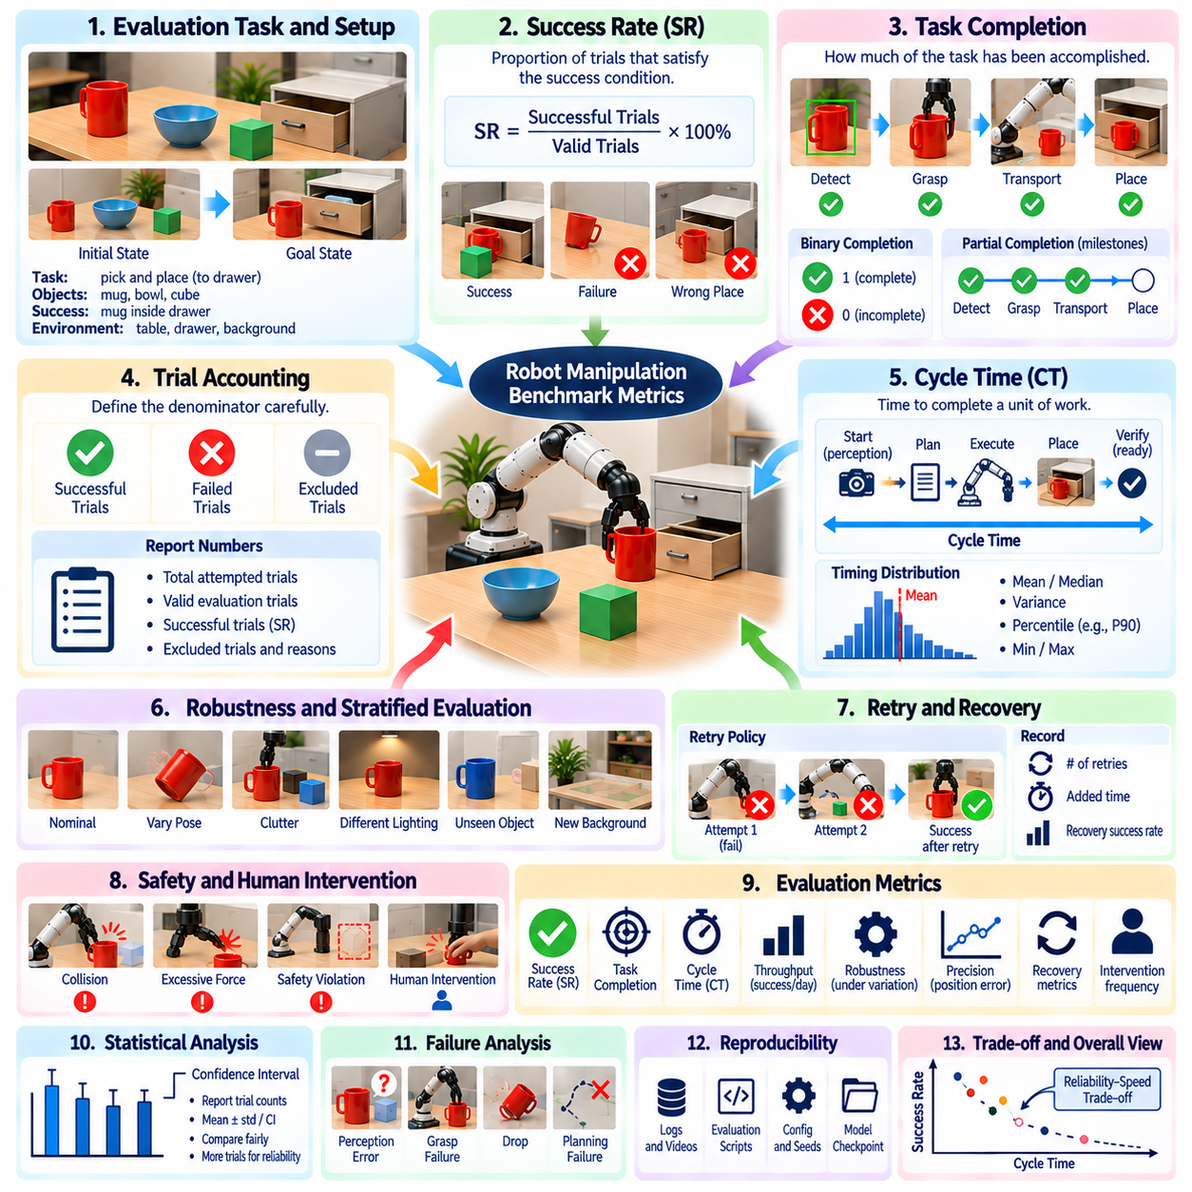
Benchmark metrics convert robot manipulation behavior into measurable evidence that can be compared across algorithms, platforms, and experimental conditions. Three of the most fundamental measures are success rate, task completion, and cycle time. Together they describe whether the robot succeeds, whether the intended task is fully achieved, and how efficiently execution proceeds. Reliable benchmarking requires precise definitions because apparently similar metrics can represent substantially different system characteristics.
Success Rate, commonly abbreviated as SR, expresses the proportion of evaluation trials that satisfy predefined success conditions. If a robot successfully completes 90 of 100 valid trials, its measured SR is 90 percent. Although simple, this metric depends completely on the definition of success. A trial should therefore be classified using objective criteria such as grasp stability, target pose tolerance, assembly completion, or verified final task state rather than subjective visual judgment.
The denominator used for SR must also be defined carefully. Trials excluded because of equipment malfunction, invalid initialization, emergency interruption, or corrupted sensor data should be documented separately rather than silently removed. Otherwise, different exclusion policies can produce misleading comparisons. A benchmark report should state the total number of attempted trials, valid evaluation trials, successful trials, excluded trials, and reasons for exclusion whenever they materially affect the result.
Success can be defined at several levels of a manipulation pipeline. Grasp success may require only stable acquisition and lifting, while pick-and-place success additionally requires transport and correct placement. A long-horizon task may require perception, opening, grasping, transport, insertion, and verification. Reporting only final SR can hide where failures occur, so stage-level success rates are useful for identifying which portion of the execution chain limits overall reliability.
Task Completion measures how much of the required task has been accomplished, which becomes particularly important when tasks contain multiple stages. Binary completion assigns either zero or one depending on whether the final goal is reached. Partial completion instead records progress through defined milestones. For example, a sequence containing detect, grasp, transport, and place stages can distinguish a robot that fails immediately from one that completes nearly the entire procedure before the final placement fails.
Completion criteria should correspond to observable physical outcomes rather than internal policy states. A robot should not receive completion credit merely because it issued a place command; the object must actually satisfy the required target condition. Verification can use object pose, fixture state, contact state, visual inspection algorithms, force measurements, or external sensors. Separating commanded actions from verified outcomes prevents control intentions from being confused with successful physical execution.
Long-horizon task completion can be represented using milestone completion ratios or stage-weighted scores when binary success loses too much information. However, weighting must be defined before evaluation and should reflect task importance rather than being adjusted after observing results. Safety-critical or functionally essential stages may deserve different treatment from optional stages. Both final success and partial progress should be reported when possible to avoid hiding catastrophic failures behind accumulated partial credit.
Cycle Time measures the elapsed time required to execute a defined unit of work. The timing boundary must be specified explicitly because cycle time may begin at sensor acquisition, task command reception, motion initiation, or another event. Similarly, it may end when the robot releases the object, reaches the final pose, verifies completion, or becomes ready for the next task. Different boundaries can produce substantially different values even for identical robot behavior.
End-to-end cycle time should include all processes necessary for autonomous execution when deployment performance is being evaluated. These may include perception inference, pose estimation, grasp generation, motion planning, physical motion, gripper operation, verification, and recovery. Excluding computational delays can make a system appear faster than it is operationally. Component timing can additionally be reported to identify which stages dominate the overall execution time.
Cycle time should generally be analyzed as a distribution rather than only as an average. Manipulation execution can vary because of planning complexity, object pose, collision avoidance, failed attempts, and recovery actions. Mean or median cycle time describes typical behavior, while variance, percentile values, minimum, and maximum values reveal consistency and tail latency. Industrial deployment often depends as much on predictable timing as on the fastest achievable execution.
Success Rate and Cycle Time should not be optimized independently. A robot can reduce cycle time by moving faster, shortening perception processing, or limiting recovery attempts, but these changes may decrease success or increase collision risk. Conversely, a system can achieve very high SR through slow motion and repeated retries while becoming operationally inefficient. Benchmark interpretation should therefore examine the reliability-speed tradeoff rather than ranking systems by either metric alone.
A useful combined measure is successful throughput, which relates reliable task completion to time. A system completing many cycles rapidly but failing frequently may produce lower effective output than a slower system with substantially higher reliability. In industrial manipulation, the relevant question is often how many verified successful operations can be completed per hour rather than how quickly the fastest individual trial can be executed. This connects benchmark metrics directly to production performance.
Retry behavior requires explicit treatment because it affects all three metrics. A benchmark may define a trial as failed after the first unsuccessful grasp, or it may permit a limited number of autonomous retries. If retries are permitted, their number and associated time should be recorded. A system achieving high success through frequent retries is behaviorally different from one succeeding consistently on the first attempt, even if their final task-level SR values are identical.
Human intervention must similarly be separated from autonomous task completion. If an operator repositions an object, corrects perception, approves a trajectory, or resets the robot during a trial, the resulting completion should not automatically be counted as fully autonomous success. Intervention frequency, intervention duration, and assisted success can be reported independently. This distinction is essential when evaluating systems intended to reduce human supervision or operate continuously.
Statistical uncertainty becomes important when comparing success rates. An SR of 95 percent obtained from 20 trials does not provide the same evidence as 95 percent obtained from thousands of trials. Benchmark reports should therefore include trial counts and, where appropriate, confidence intervals or other uncertainty estimates. Increasing the number and diversity of trials improves the ability to distinguish genuine performance differences from random variation in manipulation outcomes.
Evaluation conditions should be stratified rather than collapsed into one aggregate SR whenever task difficulty varies significantly. Success can be reported separately for nominal poses, difficult orientations, cluttered scenes, unseen objects, or disturbed conditions. Cycle time can likewise be conditioned on task complexity. Stratified results reveal whether a system maintains performance as difficulty increases and prevent easy cases from dominating a single average score.
Failure-conditioned timing provides additional diagnostic information. A failed task may terminate rapidly because perception immediately rejects the scene, or it may consume substantial time through repeated planning and grasp attempts before failing. Reporting time-to-failure alongside successful cycle time reveals how efficiently the system recognizes unrecoverable situations. This is particularly relevant for autonomous systems where prolonged unsuccessful behavior reduces throughput and may increase operational risk.
Recovery metrics connect reliability and timing more directly. Useful measurements include recovery attempt count, recovery success rate, added recovery time, and success after recovery. These metrics distinguish systems that merely fail less often from systems that can recognize and correct failures autonomously. In practical deployment, strong recovery may compensate for imperfect first-attempt success, provided the additional cycle-time cost remains acceptable.
Task completion quality should also be considered when success criteria contain tolerances. Two robots may both complete a placement task successfully while one consistently positions objects near the target center and the other barely remains within the acceptable boundary. Position error, orientation error, insertion depth, residual force, or other task-specific quality measurements can therefore supplement binary completion. This prevents tolerance thresholds from hiding meaningful precision differences.
Benchmark timing should use consistent clocks and synchronized event definitions. Sensor timestamps, robot controller clocks, host-computer clocks, and external measurement systems may differ if they are not synchronized. Timing instrumentation should minimize measurement overhead and record events at sufficient resolution for the application. For distributed robot systems, clock synchronization becomes particularly important when perception, planning, and control execute on separate computing devices.
Comparisons across robots require normalization of context as well as metrics. Payload, reach, gripper capability, motion limits, controller settings, perception hardware, object set, and workspace geometry can all affect SR and cycle time. A faster result obtained with substantially different hardware should not automatically be interpreted as an algorithmic improvement. Benchmark reports should therefore pair performance metrics with sufficient system configuration information to support fair interpretation.
Reproducibility requires preserving the raw evidence from which metrics are calculated. Trial identifiers, initial conditions, success labels, milestone states, timestamps, retry counts, intervention records, failure categories, and final object states should be stored whenever practical. Evaluation scripts should compute summary metrics from these records rather than relying on manually entered totals. This allows scoring rules to be audited and metrics to be recalculated when benchmark definitions evolve.
A mature manipulation benchmark should ultimately treat SR, Task Completion, and Cycle Time as complementary dimensions of operational capability. SR measures reliability, Task Completion measures achievement and progress, and Cycle Time measures temporal efficiency. Combined with uncertainty, recovery, intervention, precision, and stratified difficulty, these metrics provide a much stronger characterization than any single score and create a quantitative bridge between laboratory performance and dependable real-world robotic productivity.

11.08. Custom Benchmark Design for Application Specific
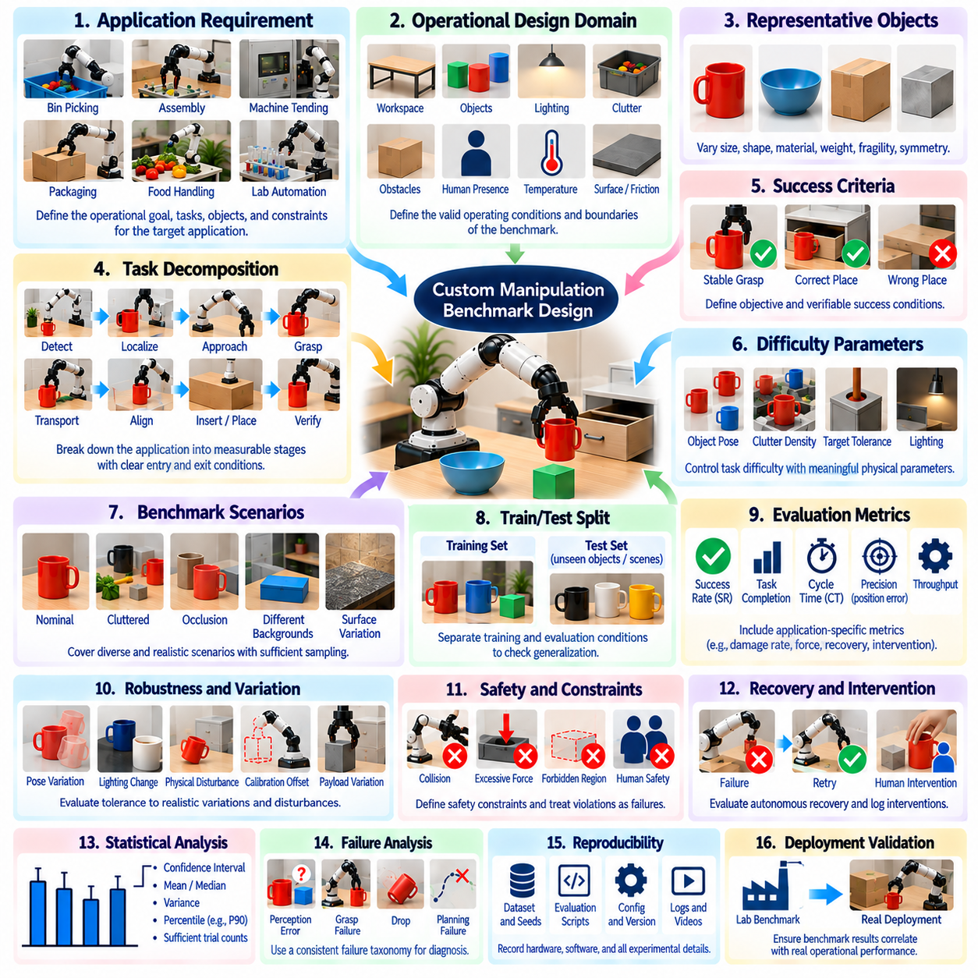
A custom manipulation benchmark is necessary when standardized benchmarks cannot represent the physical constraints, task structure, objects, safety requirements, or performance objectives of a specific application. The purpose is not to create an easier internal test, but to construct a controlled evaluation that reflects the operational problem while remaining measurable and repeatable. A useful benchmark connects laboratory experiments directly to deployment requirements.
Benchmark design should begin with the intended operational capability rather than the available robot or algorithm. The application may require bin picking, assembly, machine tending, packaging, food handling, laboratory automation, maintenance, or mobile manipulation. The benchmark should describe what the system must accomplish in physical terms, under which environmental conditions, and within what limits. This prevents evaluation from becoming optimized around capabilities the current system already performs well.
The operational design domain should define the conditions under which benchmark conclusions are valid. Relevant dimensions can include workspace geometry, object types, payload range, illumination, temperature, surface properties, clutter, obstacle density, human presence, and allowable robot configurations. Explicit boundaries distinguish conditions the system is expected to handle from conditions outside the intended deployment scope and make performance claims more precise.
Representative objects should be selected according to application requirements rather than convenience. Their dimensions, mass, geometry, material, rigidity, surface friction, symmetry, fragility, and grasp affordances may influence manipulation difficulty. Instead of testing every possible production object, representative families can be created using meaningful physical parameters. Held-out objects should also be included to evaluate whether performance generalizes beyond items repeatedly used during development.
Task decomposition converts an application objective into measurable manipulation stages. A production operation may contain detection, localization, approach, grasping, transport, alignment, insertion, release, and verification. Each stage should have observable entry and exit conditions. Stage-level evaluation allows developers to identify whether failures originate from perception, grasp generation, planning, control, or task sequencing instead of treating the complete system as an indivisible success-or-failure process.
Success criteria must be defined before experiments begin. A successful manipulation should correspond to a verified physical outcome such as stable grasping, placement inside a target tolerance, completed insertion, correct assembly state, or successful tool interaction. Merely issuing the intended command is insufficient. Objective success criteria make automatic scoring possible and prevent benchmark results from depending on an operator's subjective interpretation of whether an attempt appeared acceptable.
Difficulty should be parameterized whenever possible. Object pose variation, clutter density, target tolerance, obstacle clearance, visibility, payload, friction, insertion clearance, and required precision can be represented as controlled variables. Instead of assigning informal labels such as easy, medium, and hard, the benchmark can define quantitative difficulty ranges. Performance can then be represented as a function of difficulty, revealing the operational boundary where reliability begins to degrade.
Nominal conditions should establish the baseline capability before robustness is investigated. These conditions should represent normal deployment rather than artificially simplified laboratory arrangements. Repeated trials under nominal settings provide estimates of task success, completion time, precision, and variability. Once baseline behavior is characterized, individual environmental or task parameters can be changed systematically to determine which factors most strongly affect performance.
Robustness scenarios should reproduce realistic disturbances rather than arbitrary random variation. Examples include shifted objects, partial occlusion, illumination changes, calibration offsets, surface friction variation, unexpected obstacles, payload differences, or small fixture misalignment. Disturbances should remain within physically meaningful ranges derived from the application. This produces evidence about tolerance to deployment variability instead of measuring performance under unrealistic conditions unlikely to occur in practice.
Scenario coverage is important because a benchmark containing only a few hand-selected cases can overestimate reliability. The application space can be divided into combinations of object classes, poses, environmental conditions, and task difficulties. Sampling should provide adequate coverage of common situations while also including important boundary conditions. Rare but safety-critical scenarios may require deliberate oversampling even when their expected operational frequency is low.
Randomization should be reproducible. Object positions, orientations, clutter configurations, lighting parameters, or other variables may be sampled automatically, but their values and random seeds should be recorded. Purely manual scene setup can unintentionally introduce experimenter bias and make failures difficult to reproduce. Parameterized generation of evaluation scenes creates a stronger connection between benchmark results and the actual distribution of tested conditions.
Training and evaluation conditions should be separated explicitly. Objects, poses, scenes, or task variations repeatedly used during algorithm development should not constitute the entire final benchmark. A reserved test set can contain unseen combinations, held-out objects, or independently generated scenes. This separation reduces benchmark overfitting and provides stronger evidence that the system has learned transferable manipulation capability rather than memorized engineering test cases.
Application-specific metrics should extend beyond generic task success rate. Industrial assembly may emphasize insertion accuracy and cycle time, warehouse manipulation may emphasize successful picks per hour, food handling may require damage rate and hygiene constraints, and laboratory automation may prioritize placement precision and contamination avoidance. Metrics should reflect the consequences of system behavior in the target application rather than simply adopting familiar research scores.
Success Rate, Task Completion, and Cycle Time remain useful core metrics because they describe reliability, achieved progress, and temporal efficiency. However, they should be supplemented with measurements such as first-attempt success, retry count, intervention frequency, position error, contact force, collision events, object damage, recovery success, or throughput when relevant. A multidimensional scorecard preserves engineering information that would disappear inside one composite benchmark score.
Safety requirements should be represented as explicit constraints and failure conditions. Excessive force, forbidden-region entry, collision, dropped objects, unstable robot motion, or unsafe interaction with people may invalidate a trial even when the task goal is eventually achieved. Safety-critical events should normally be reported separately from ordinary task failures. This prevents high productivity from masking behavior that would be unacceptable in actual deployment.
Recovery should be evaluated because real applications cannot assume every first attempt will succeed. The benchmark can introduce recoverable failures such as grasp slip, shifted objects, blocked trajectories, or temporary perception loss and measure whether the system detects and resolves them autonomously. Recovery success, additional cycle time, number of retries, and escalation to human assistance indicate how resilient the system is when nominal execution breaks down.
Human intervention must be incorporated into the benchmark definition when autonomous operation is a deployment objective. Assistance may include resetting an object, confirming a perception result, selecting a target, approving motion, or manually recovering the robot. Each intervention should be logged and classified. A system with high task success but frequent operator assistance may provide substantially less operational value than its success rate alone suggests.
Statistical design determines how confidently benchmark results can be interpreted. Trial counts should be sufficient to estimate success probabilities and performance distributions across important scenarios. Confidence intervals can accompany success rates, while cycle-time distributions can report median, variance, and percentile values. Repetition across different days, operators, hardware units, or environmental conditions can reveal variability that a single tightly controlled experiment would miss.
Benchmark progression can organize testing into increasingly demanding levels. Initial evaluation may verify individual components and nominal tasks, followed by environmental variation, unseen objects, compound disturbances, long-horizon sequences, and recovery scenarios. Advancement to a higher level can require predefined exit criteria. Such progression creates an engineering validation process in which capability claims are supported by increasingly strong experimental evidence.
Hardware and software configuration must remain traceable throughout evaluation. Robot model, gripper, sensors, compute platform, controller parameters, software versions, perception models, policy checkpoints, calibration data, and benchmark scripts should be recorded. If the configuration changes, results should identify the corresponding version. Otherwise, performance improvements caused by hardware upgrades or configuration changes may be incorrectly attributed to algorithmic progress.
Automation of benchmark execution improves consistency and scalability. Scripts can initialize scenarios, command trials, collect sensor streams, detect completion, assign preliminary labels, and calculate metrics. Automated execution reduces operator-dependent variation and enables larger trial counts. Nevertheless, raw recordings should remain available because automated scoring itself can fail, particularly in contact-rich tasks where physical outcomes may be difficult to infer from a single sensor.
Failure taxonomy should be designed together with the benchmark rather than added after testing. Categories can include perception failure, pose error, grasp failure, unreachable configuration, planning failure, collision, control instability, object slip, placement error, verification failure, and recovery failure. Consistent failure labeling transforms benchmark trials into diagnostic data and helps prioritize development effort according to the dominant causes of unsuccessful operation.
A deployment-oriented benchmark should eventually be validated against actual operational performance. If laboratory benchmark improvements do not correlate with factory throughput, field reliability, intervention reduction, or task quality, the benchmark may be measuring the wrong properties. Periodic comparison between benchmark scores and field results allows scenarios, difficulty distributions, and metrics to be recalibrated as operational knowledge accumulates.
The strongest application-specific benchmark is therefore not a fixed collection of convenient demonstrations but a versioned evaluation system representing the intended operational domain. It combines representative tasks, controlled difficulty, held-out conditions, repeated trials, safety constraints, recovery, multidimensional metrics, and reproducible evidence. Properly designed, it becomes both a scientific measurement framework and an engineering gate for deciding whether manipulation capability is ready for real deployment.

11.09. Manipulation Model Comparison ACT DP RT2
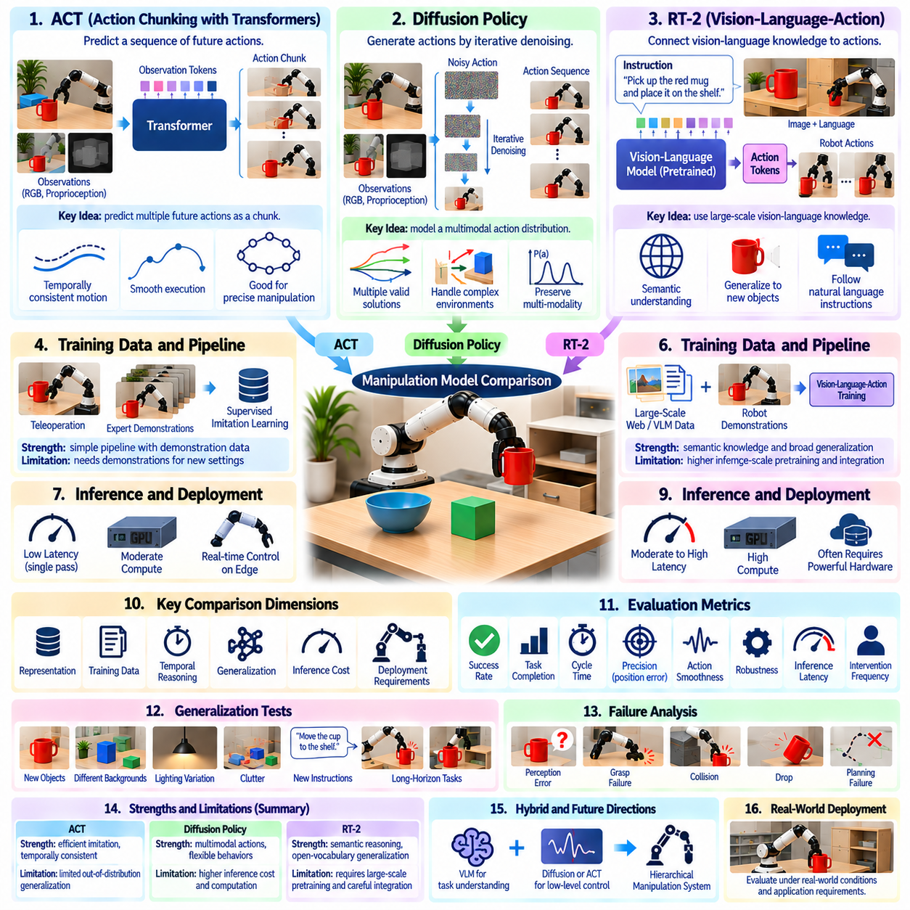
ACT, Diffusion Policy, and RT-2 represent three influential approaches to learned robot manipulation, but they address different levels of the manipulation problem. ACT focuses on efficient imitation of temporally coherent action sequences, Diffusion Policy models complex action distributions through iterative denoising, and RT-2 connects large-scale vision-language knowledge with robotic actions. Comparing them requires examining representation, training data, temporal reasoning, generalization, inference cost, and deployment requirements rather than relying only on task success.
Action Chunking with Transformers, commonly called ACT, was developed to improve imitation learning for manipulation tasks in which individual low-level actions are highly correlated over time. Instead of predicting only the next control command, ACT predicts a chunk containing multiple future actions. This reduces the effective prediction horizon and allows the policy to represent coordinated motion patterns such as reaching, grasping, transporting, and manipulating articulated objects with greater temporal consistency.
ACT typically receives visual observations together with robot proprioceptive information and maps them to sequences of joint or end-effector actions. A Transformer architecture captures relationships among observations and actions, while temporal aggregation can combine overlapping action chunks during execution. This structure is particularly useful for precise manipulation because it reduces sensitivity to isolated prediction errors and creates smoother behavior than independently predicting every control step.
One important strength of ACT is its relatively direct relationship with demonstration data. Human demonstrations can be collected through teleoperation, converted into synchronized observation-action trajectories, and used for supervised imitation learning. The resulting pipeline is conceptually straightforward compared with approaches requiring extensive reward engineering or online reinforcement learning. ACT can therefore provide strong performance when high-quality demonstrations closely represent the target task and robot configuration.
The limitations of ACT become more visible when evaluation moves far outside the demonstration distribution. Although action chunking improves temporal execution, it does not automatically provide broad semantic knowledge or cross-domain reasoning. Changes in objects, backgrounds, instructions, robot geometry, or task structure may require additional demonstrations or adaptation. ACT should therefore be evaluated separately for in-distribution reproduction, environmental robustness, object generalization, and task-level transfer.
Diffusion Policy approaches manipulation from a different probabilistic perspective. Instead of directly regressing one deterministic action or action sequence, the policy learns an action distribution through a diffusion process. During inference, an initially noisy action representation is iteratively denoised while conditioned on observations. This formulation is well suited to manipulation problems where several different trajectories or grasp strategies may all be valid responses to the same physical situation.
Multimodality is a major advantage of Diffusion Policy. Conventional regression can average multiple valid demonstrations and produce an action that corresponds to none of them, particularly when demonstrations contain distinct strategies. A diffusion model can preserve multiple modes of the demonstrated action distribution. This can improve behavior in tasks involving obstacle avoidance, alternative grasp approaches, deformable objects, tool interaction, or other situations where several physically reasonable solutions exist.
Diffusion Policy can predict an action horizon rather than only a single immediate command, giving it temporal structure similar in purpose, though not mechanism, to action chunking. Observation histories can condition the denoising process so that recent robot states and visual information influence future motion. Receding-horizon execution then applies a portion of the predicted sequence before observations are updated and another action sequence is generated.
The principal cost of diffusion-based control is inference complexity. Iterative denoising may require multiple neural-network evaluations for each action prediction, increasing latency and computational demand compared with a single-pass policy. Reduced-step diffusion, optimized schedulers, accelerated networks, and action-horizon execution can mitigate this cost. Nevertheless, real-time benchmarks should report inference frequency, denoising steps, hardware configuration, and end-to-end control latency rather than success rate alone.
RT-2 addresses manipulation from a broader vision-language-action perspective. It builds on vision-language model capabilities and represents robotic actions in a form that can be integrated with token-based prediction. The central idea is that semantic knowledge learned from large-scale vision-language data can contribute to robotic decision making. The model can therefore connect concepts learned outside robot demonstration datasets with physical actions executed by a robot.
This approach changes the role of pretraining in manipulation. ACT and Diffusion Policy are commonly evaluated primarily through robot demonstration learning, although their components may also use pretrained representations. RT-2 explicitly emphasizes transferring knowledge from large-scale web and vision-language training into robotic control. Consequently, comparisons must document pretraining sources and scale because a model's performance may reflect both manipulation data and extensive prior semantic knowledge.
RT-2 is especially relevant to semantic generalization. A robot may be asked to reason about object categories, relationships, attributes, or instructions that are not represented by a narrow set of manipulation demonstrations. Vision-language representations can help connect such concepts with task execution. This makes RT-2-style systems attractive for general-purpose manipulation where natural-language instructions and open-ended object understanding are important components of the task.
However, semantic intelligence does not eliminate the need for accurate low-level physical control. A model may correctly understand which object should be manipulated while still producing inaccurate trajectories, unstable grasps, or unsuitable contact behavior. Evaluation should therefore distinguish semantic task selection from geometric precision and control quality. High-level reasoning and low-level manipulation competence are related but should not be treated as identical capabilities.
ACT, Diffusion Policy, and RT-2 also differ in how they represent uncertainty and alternative behavior. ACT primarily generates temporally structured action chunks based on learned demonstrations. Diffusion Policy explicitly models a potentially multimodal action distribution through stochastic generation. RT-2 places greater emphasis on semantic interpretation and action token prediction derived from vision-language-action learning. These differences affect the types of tasks for which each architecture is naturally suited.
A fair comparison should use matched robot hardware, sensors, control interfaces, task definitions, and evaluation conditions whenever possible. Training data volume must also be controlled or explicitly reported. Comparing a model trained on a small task-specific dataset with another model benefiting from massive heterogeneous pretraining does not isolate architectural quality. Benchmark reports should distinguish data-scale advantages, representation advantages, and algorithmic advantages.
Success Rate remains an important metric but is insufficient for model comparison. ACT may achieve smooth and reliable task reproduction, Diffusion Policy may provide better coverage of multimodal manipulation strategies, and RT-2 may demonstrate stronger semantic transfer. Cycle time, action smoothness, precision, recovery behavior, inference latency, intervention frequency, and generalization should therefore accompany task success to reveal the operational characteristics of each approach.
Data efficiency is another important comparison dimension. A benchmark can train each approach using progressively larger demonstration subsets and measure performance as a function of available robot data. Learning curves reveal whether a model reaches useful performance with tens, hundreds, or thousands of demonstrations. When pretrained models are involved, both robot-specific data efficiency and the amount of external pretraining should be reported so that efficiency claims remain interpretable.
Generalization tests should include controlled changes in object identity, pose, background, lighting, instruction wording, and task composition. ACT can be tested for robustness beyond its demonstration trajectories, Diffusion Policy for whether its learned action distribution remains useful under changed physical conditions, and RT-2 for whether semantic knowledge translates into successful physical behavior. The same perturbations should be applied to all models wherever their interfaces permit direct comparison.
Long-horizon evaluation is particularly valuable because small errors accumulate differently across architectures. Action chunking may improve temporal consistency but can propagate an unsuitable chunk until new observations correct execution. Diffusion policies can replan action horizons but incur repeated generative inference. Vision-language-action models may reason effectively about task stages while still encountering low-level execution failures. Stage-level metrics reveal where these differences become operationally important.
Robustness should also include disturbances during execution rather than only changed initial conditions. Objects can be shifted after grasp planning, obstacles can appear, visual observations can become partially occluded, or a grasp can slip. Evaluation should measure whether the policy reacts to the changed state, continues an outdated action sequence, replans, or requires external recovery. Such tests reveal the practical closed-loop behavior of each model.
Computational efficiency becomes critical when deploying these models on edge robotic hardware. Metrics should include model size, accelerator memory usage, inference latency, control update rate, energy demand, and initialization time when relevant. A model that achieves slightly higher success on a powerful server may be less useful than a compact policy capable of stable real-time control on an embedded GPU. Hardware-normalized evaluation therefore provides important deployment context.
Failure taxonomy provides a deeper comparison than aggregate performance. ACT failures may involve demonstration-distribution mismatch or accumulated action errors. Diffusion Policy may suffer from sampling latency, unsuitable generated trajectories, or sensitivity to observation conditioning. RT-2-style systems may produce semantic errors, action grounding errors, or physical execution errors. Categorizing failures helps determine whether improvements are needed in representation, data, planning, or control.
Hybrid architectures may ultimately be more useful than treating ACT, Diffusion Policy, and RT-2 as mutually exclusive alternatives. A vision-language-action model can provide semantic task understanding, while a diffusion-based or action-chunking controller executes precise physical motion. Hierarchical systems can separate reasoning, task planning, skill selection, and low-level control according to their different temporal and computational requirements. Benchmarking should therefore also consider complementary combinations.
Reproducible comparison requires detailed documentation of demonstrations, preprocessing, observation modalities, action representations, model sizes, training schedules, checkpoints, inference parameters, and hardware. Diffusion denoising steps, ACT chunk length, temporal aggregation settings, language prompts, and action-token definitions can materially change performance. Without these details, results attributed to model architecture may actually arise from different implementation or evaluation choices.
The practical comparison can therefore be summarized through capability emphasis rather than a single ranking. ACT is particularly attractive for efficient imitation of coherent manipulation sequences, Diffusion Policy for representing complex and multimodal physical behaviors, and RT-2-style vision-language-action models for connecting semantic knowledge with robotic action. The strongest model depends on whether the deployment prioritizes precision, behavioral diversity, semantic generalization, computational efficiency, or some combination of these requirements.
A mature manipulation benchmark should evaluate these approaches across matched nominal tasks, controlled perturbations, held-out conditions, long-horizon execution, computational constraints, and real-world trials. The goal is not merely to identify which model obtains the highest average success rate, but to understand where each architecture succeeds, where it fails, how efficiently it learns and executes, and which capabilities remain transferable beyond its training distribution. Such evaluation turns model comparison into evidence for selecting and designing dependable manipulation systems.

11.10. Benchmark Driven Manipulation Model Development
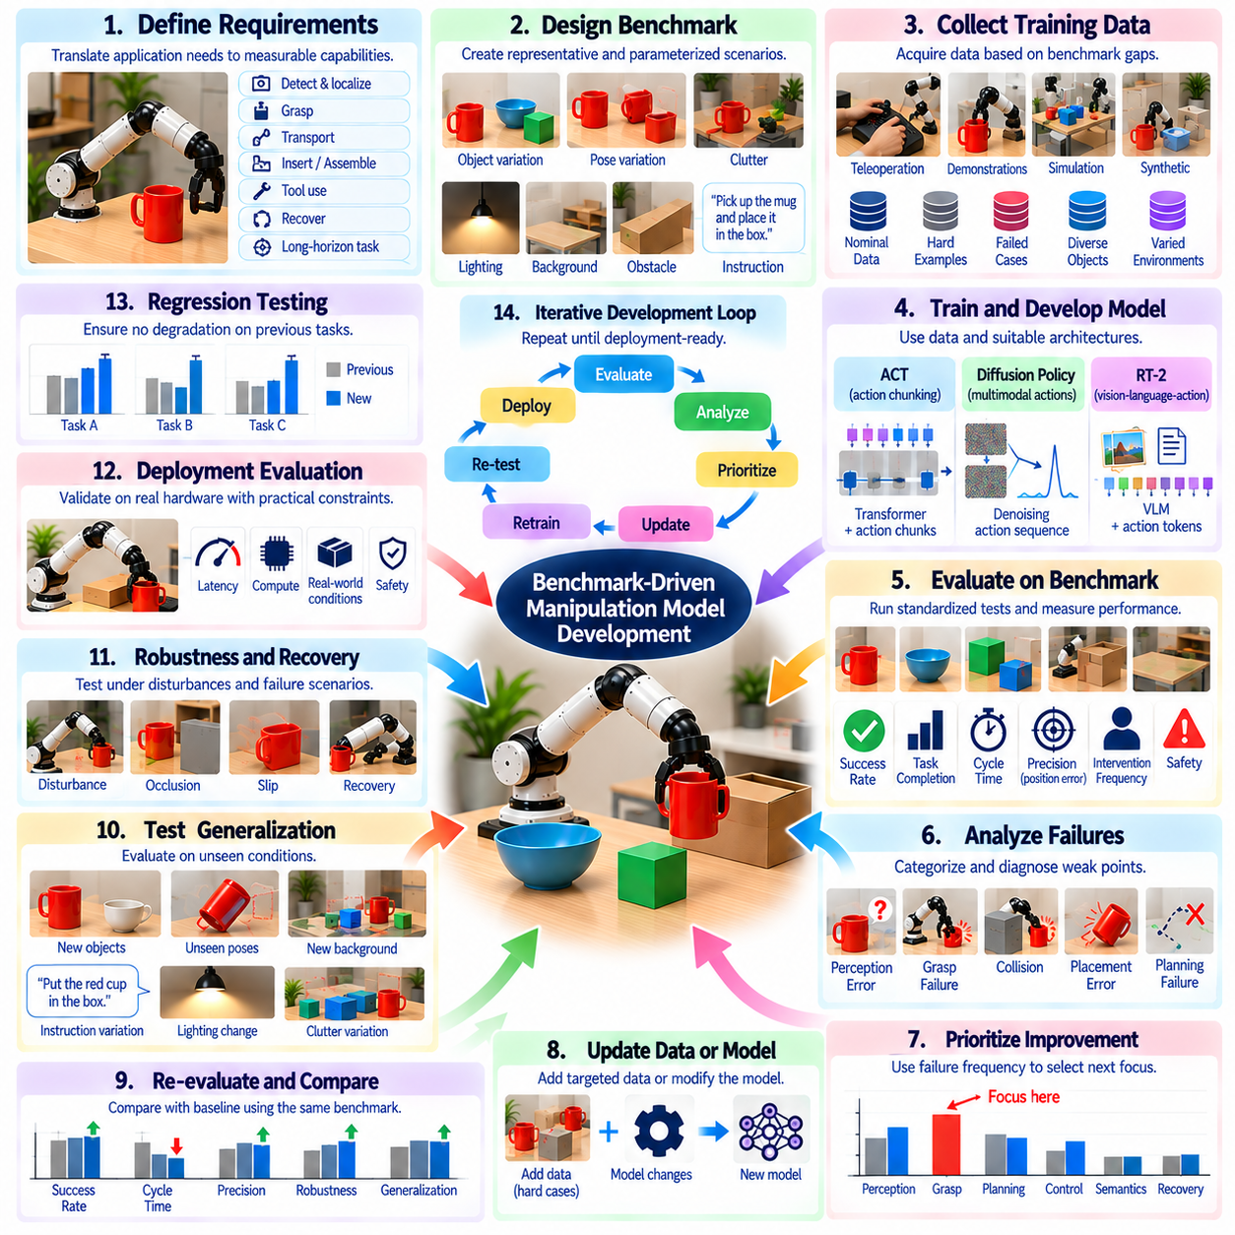
Benchmark-driven manipulation model development treats evaluation not as a final verification step but as a continuous mechanism for directing model improvement. Instead of training a policy until qualitative demonstrations appear satisfactory, developers define measurable capabilities, execute standardized tests, identify performance gaps, modify data or algorithms, and repeat the process. The benchmark therefore becomes part of the development loop connecting requirements, experiments, diagnosis, and deployment readiness.
The process begins by translating application requirements into explicit manipulation capabilities. A target system may require object detection, pose estimation, grasping, transport, insertion, tool use, recovery, or long-horizon task execution. Each capability should be associated with measurable success conditions and operational limits. This prevents development from optimizing only visible demonstrations and establishes objective criteria for determining whether a model has actually improved.
A baseline benchmark should be established before major model optimization begins. The initial policy is evaluated across representative tasks, objects, poses, environments, and difficulty levels using a fixed protocol. Success Rate, Task Completion, Cycle Time, precision, intervention frequency, and failure categories provide a multidimensional baseline. Future model versions can then be compared against the same reference instead of relying on subjective impressions of improved behavior.
Benchmark scenarios should be organized according to the dimensions of variation expected during deployment. Object identity, geometry, pose, clutter, lighting, camera viewpoint, payload, friction, obstacle configuration, and instruction wording may all influence manipulation. Parameterizing these dimensions allows developers to determine not only whether performance improves, but also where the boundary of reliable operation moves as the model evolves.
Training and benchmark data must remain appropriately separated. If developers repeatedly optimize against exactly the same evaluation scenes, benchmark performance can improve without corresponding gains in generalization. Reserved objects, unseen scene combinations, hidden initialization distributions, or independently generated trials should therefore be maintained. A benchmark should function as evidence of transferable capability rather than becoming another training set through repeated engineering exposure.
Every benchmark run should produce structured failure information in addition to aggregate scores. Failures can be classified into perception error, incorrect pose estimation, unsuitable grasp selection, planning failure, collision, slip, control instability, placement error, semantic misunderstanding, or unsuccessful recovery. A failure taxonomy transforms evaluation from a ranking mechanism into a diagnostic instrument that identifies which subsystem or learned behavior should receive development effort.
Failure frequency can be used to prioritize the next development cycle. If most unsuccessful trials originate from pose estimation, collecting more manipulation demonstrations may provide little benefit compared with improving perception or calibration. If perception is reliable but grasps fail on reflective or irregular objects, additional object diversity and grasp examples may be more valuable. Benchmark evidence therefore helps allocate engineering resources according to measured bottlenecks rather than intuition.
Data acquisition can be directly driven by benchmark weaknesses. Failed or low-confidence scenarios identify regions of the task distribution that are insufficiently represented in the training data. Developers can collect additional demonstrations, generate simulation trajectories, create synthetic observations, or deliberately sample difficult object configurations. This creates a targeted data loop in which evaluation determines what new experience the model should receive.
Hard-example mining extends this principle by repeatedly identifying cases near the model's capability boundary. Objects with unusual geometry, partially occluded targets, narrow insertion tolerances, cluttered workspaces, or ambiguous instructions can be emphasized during subsequent training. However, hard examples should supplement rather than replace representative nominal data. Excessive concentration on difficult cases can distort the training distribution and reduce performance on common operating conditions.
Benchmark results can also guide model architecture selection. A policy that performs well on repetitive trajectories but poorly when multiple valid strategies exist may benefit from a multimodal action representation. Weak semantic generalization may motivate vision-language features, while poor long-horizon consistency may require temporal context, action chunking, memory, or hierarchical planning. Architecture changes should therefore be connected to observed failure patterns rather than introduced only because a model family is popular.
A controlled ablation process is essential for determining whether a proposed modification actually causes improvement. Developers can change one factor at a time, such as observation history, action horizon, image encoder, language conditioning, dataset mixture, loss function, or policy architecture. Running the same benchmark after each controlled modification reveals which components contribute meaningful gains and which merely increase complexity without improving operational capability.
Benchmark-driven hyperparameter optimization should focus on deployment-relevant objectives rather than only training loss. Chunk length, learning rate, diffusion steps, image resolution, control frequency, context length, and inference precision can affect both task success and computational performance. Candidate configurations should therefore be evaluated using metrics such as reliability, cycle time, latency, memory consumption, and robustness instead of selecting the configuration with the lowest validation loss alone.
Model scaling should similarly be justified through measured capability gains. Increasing parameter count, encoder size, training data, or compute may improve benchmark performance, but the improvement should be compared against additional inference latency, memory requirements, energy consumption, and deployment cost. A smaller model that achieves nearly equivalent manipulation performance may be preferable for edge deployment where deterministic real-time operation is more important than marginal accuracy improvements.
Generalization benchmarks should remain separate from nominal performance tests. A model may achieve near-perfect success on familiar objects and environments while failing rapidly under modest distribution shifts. Held-out objects, changed backgrounds, novel instructions, altered viewpoints, and unseen task combinations reveal whether improvements transfer beyond development conditions. Tracking nominal and generalization performance together prevents optimization from producing increasingly specialized policies.
Robustness testing introduces controlled disturbances that approximate realistic operational variability. Objects can be displaced during execution, observations can become partially occluded, calibration can be perturbed, lighting can change, or grasp contact can deviate from expectation. Benchmarking the model under progressively stronger disturbances produces robustness curves that show how quickly performance degrades and whether later model versions expand the stable operating region.
Recovery capability should be developed as a measurable behavior rather than an informal demonstration. Benchmark scenarios can intentionally create failed grasps, shifted objects, blocked paths, or incomplete placements and observe whether the model recognizes the failure and selects an appropriate corrective action. Recovery success, retry count, added cycle time, and human intervention provide quantitative evidence of whether the system is becoming more autonomous.
Long-horizon benchmarks expose errors that short isolated skills may conceal. A model may perform individual grasps and placements reliably while failing when these actions must be coordinated over an extended sequence. Stage completion, accumulated pose error, state-estimation consistency, recovery events, and final task success should be recorded. These measurements reveal whether model improvements increase complete task competence rather than only isolated skill accuracy.
Simulation can accelerate the benchmark-development loop by enabling large numbers of controlled experiments. Parameter sweeps can explore object poses, friction, disturbances, sensor noise, and rare failure conditions before expensive physical testing. However, benchmark gains observed in simulation should subsequently be validated on hardware. Differences between simulated and real results become evidence for identifying the remaining sim-to-real gap rather than being treated as equivalent performance.
Real-world benchmark runs provide the final evidence that improvements survive physical uncertainty. Sensor noise, calibration drift, contact mechanics, actuator behavior, communication latency, and object variation can expose weaknesses absent from simulation. Matched simulation and physical scenarios help determine whether failures originate from policy reasoning, inaccurate simulation assumptions, perception, or low-level control, creating a more informative path for subsequent development.
Version control is essential because benchmark-driven development generates many interacting model and dataset variants. Each evaluation result should be linked to the model checkpoint, training dataset version, preprocessing configuration, benchmark version, hardware configuration, and inference parameters that produced it. This creates traceability between an engineering change and its measured consequence and prevents results from incompatible configurations from being compared as though they were equivalent.
Regression testing should accompany every significant model update. Improvements on difficult scenarios can unintentionally reduce performance on previously solved tasks. A stable benchmark suite should therefore contain core scenarios that every candidate model must continue to pass. Automated regression testing can reject versions that improve one capability while producing unacceptable degradation elsewhere, protecting accumulated manipulation competence throughout development.
Performance gates can convert benchmark results into explicit development decisions. A candidate model may be required to exceed minimum success, precision, safety, latency, and intervention thresholds before advancing from simulation to laboratory hardware or from laboratory testing to field trials. Gate criteria should be defined before evaluation whenever possible. This reduces subjective release decisions and connects model maturity to reproducible evidence.
A benchmark dashboard can summarize development progress across model generations without collapsing all information into one score. Reliability, task completion, cycle time, generalization, robustness, recovery, computational cost, and safety can be tracked separately. Trends across versions reveal whether development is producing balanced improvement or merely shifting weaknesses between dimensions. Failure distributions provide additional context behind changes in headline metrics.
The benchmark itself should evolve when field experience reveals missing evaluation dimensions. New object classes, environmental disturbances, failure modes, or operational requirements discovered during deployment can be converted into future benchmark scenarios. However, benchmark versions should remain traceable so historical comparisons remain meaningful. This creates a controlled feedback path in which real-world operation progressively improves the relevance of laboratory evaluation.
The resulting workflow forms a continuous evidence-driven cycle: define capability, establish a baseline, evaluate systematically, diagnose failures, improve data or models, retest, check regression, and validate on physical hardware. Benchmark-driven development therefore transforms manipulation learning from an open-ended model-training activity into an engineering optimization process. Each iteration produces measurable evidence about what changed, why performance changed, and whether the system is closer to dependable deployment.
Ultimately, the strongest manipulation model is not simply the model with the highest score on one benchmark. It is the model whose capabilities remain reliable across representative tasks, held-out conditions, disturbances, long-horizon execution, recovery situations, and real hardware while satisfying computational and safety constraints. Benchmark-driven development provides the structured feedback mechanism required to move from experimental policies toward reproducible, continuously improving, deployment-ready manipulation systems.

