Volume 17 Manipulation and Grasping AI

Chapter 01. Manipulator Fundamentals

01.01. Robot Manipulation Problem Definition and Scope
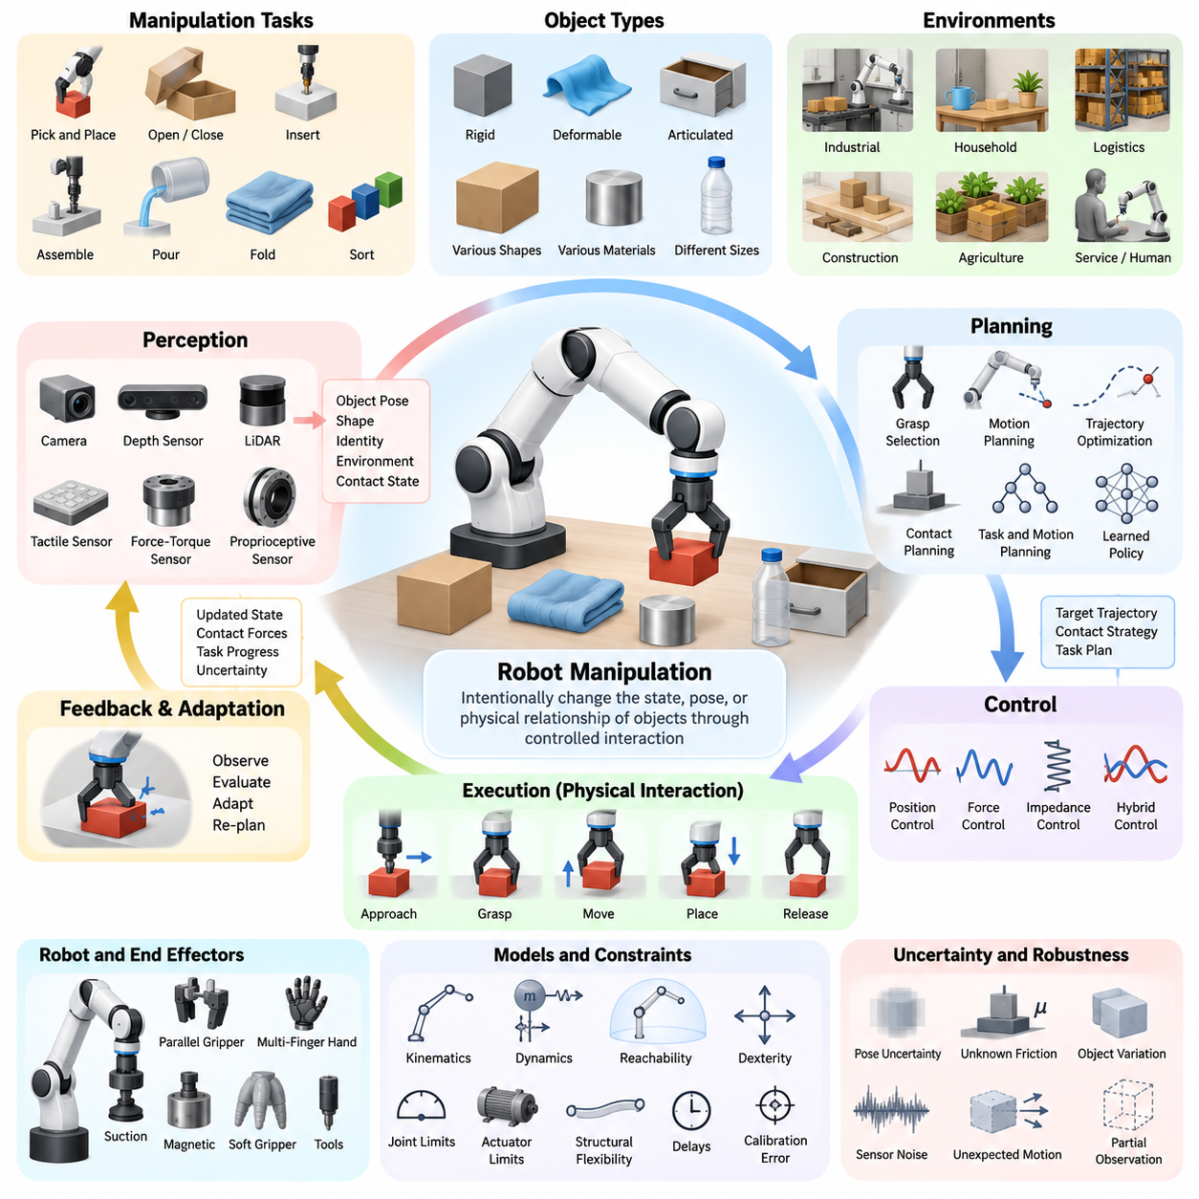
Robot manipulation is the capability of a robotic system to intentionally change the state, pose, configuration, or physical relationships of objects through controlled interaction. Unlike navigation, which primarily concerns moving the robot itself through an environment, manipulation focuses on how a robot reaches, contacts, grasps, moves, transforms, assembles, or otherwise influences objects in its workspace.
A manipulation problem is commonly defined by the relationship among the robot, the target object, the surrounding environment, and the desired task outcome. The robot provides sensing, computation, actuation, and control, while the object introduces geometric and physical properties such as shape, mass, friction, compliance, and inertia. The environment adds obstacles, supports, tools, fixtures, humans, and other constraints that influence feasible actions.
The scope of manipulation extends beyond simply moving a robotic arm from one joint configuration to another. A successful manipulation system must determine what object should be manipulated, estimate where it is located, identify appropriate interaction regions, select a grasp or contact strategy, generate collision-free motion, regulate forces during contact, and verify whether the intended physical state has actually been achieved.
Manipulation tasks can be described in terms of an initial world state, a desired goal state, and a sequence of physical actions that transforms one into the other. For example, a pick-and-place task begins with an object resting at one location and ends when the object is placed at a specified destination. More complex tasks may involve opening containers, inserting components, operating tools, folding materials, or assembling multiple objects.
The manipulation problem therefore spans several levels of abstraction. At the task level, the robot reasons about goals such as placing, inserting, fastening, pouring, or sorting. At the motion level, these goals are converted into trajectories for the end effector and robot joints. At the interaction level, controllers regulate position, velocity, force, torque, impedance, and contact conditions while the robot interacts with the physical world.
A useful distinction exists between free-space motion and contact-rich manipulation. During free-space motion, the primary objective is usually to move the manipulator safely while avoiding collisions and respecting kinematic and dynamic constraints. During contact-rich manipulation, environmental contact becomes intentional and informative, requiring explicit consideration of forces, friction, compliance, uncertainty, and potentially changing contact modes.
Manipulation may also be categorized according to the type of interaction used to control an object. Prehensile manipulation establishes a stable grasp so that the object moves with the robot hand or gripper. Non-prehensile manipulation uses actions such as pushing, pulling, sliding, rolling, pivoting, or throwing. In-hand manipulation changes an object's pose relative to the hand without completely releasing it.
The physical characteristics of manipulated objects strongly determine the difficulty of the problem. Rigid objects can often be represented using relatively compact geometric and dynamic models, whereas deformable objects such as cables, cloth, food, bags, and flexible components possess many degrees of freedom. Articulated objects, including doors, drawers, tools, and mechanisms, introduce additional constraints associated with joints and allowable motions.
Perception forms a fundamental part of the manipulation loop because actions depend on estimates of the physical world. Cameras, depth sensors, LiDAR, tactile arrays, force-torque sensors, proprioceptive sensors, and other modalities may be combined to estimate object identity, geometry, six-degree-of-freedom pose, surface properties, contact state, and environmental structure. These estimates are inevitably incomplete and uncertain.
Planning converts perceptual information and task objectives into executable actions. Manipulation planning may involve grasp selection, inverse kinematics, trajectory optimization, sampling-based motion planning, contact planning, task-and-motion planning, or learned policies. Practical systems frequently combine several methods because no single planning representation efficiently captures semantic goals, geometric feasibility, dynamics, and contact interactions simultaneously.
Control closes the loop between planned behavior and physical execution. Position control can provide accurate trajectory tracking in structured conditions, while force, impedance, admittance, and hybrid position-force control become important when the manipulator interacts directly with uncertain surfaces or mechanisms. High-performance manipulation therefore depends on coordinating planning and feedback rather than treating trajectory generation as an isolated process.
Uncertainty is one of the defining characteristics of real-world manipulation. Object poses may be estimated inaccurately, friction coefficients may be unknown, actuators may exhibit backlash or compliance, and objects may move unexpectedly after contact. Robust manipulation systems continuously observe the consequences of their actions and modify subsequent behavior instead of assuming that the physical world exactly follows a predefined model.
The manipulation workspace is constrained by manipulator geometry and mechanical limits. Reachability depends on link dimensions, joint ranges, degrees of freedom, mounting configuration, and surrounding obstacles. Dexterity further describes whether the manipulator can achieve required end-effector orientations and motions within reachable regions. Consequently, an object being physically close to a robot does not guarantee that a useful manipulation configuration exists.
Kinematics provides the mathematical relationship between joint configurations and end-effector poses, while dynamics describes the relationship among motion, forces, torques, inertia, gravity, and external interaction. These models establish the physical foundation for manipulation. However, real systems must additionally account for actuator limits, structural flexibility, calibration errors, communication delays, sensing latency, and computational constraints.
The end effector defines the physical interface between the manipulator and the task. Parallel-jaw grippers provide simple and reliable grasping for many industrial applications, while multi-finger hands offer greater dexterity at the cost of increased sensing and control complexity. Suction devices, magnetic grippers, soft grippers, specialized tools, and interchangeable end effectors extend manipulation to different materials and operating environments.
Manipulation becomes substantially more difficult in unstructured environments because the robot cannot rely on precisely known object locations, standardized fixtures, or predefined trajectories. Household, logistics, construction, agriculture, inspection, and service applications require systems to operate across changing scenes and previously unseen objects. Generalization therefore becomes an important requirement in addition to precision, speed, and repeatability.
Learning-based manipulation addresses some of these challenges by allowing robots to acquire representations, grasp strategies, motion policies, and interaction skills from data. Imitation learning, reinforcement learning, self-supervised learning, foundation models, vision-language-action models, and world models can complement analytical robotics methods. Their value is greatest when learning is integrated with geometric reasoning, physical constraints, and feedback control.
Robot manipulation can consequently be viewed as a closed perception-action process rather than a collection of independent algorithms. The robot observes the environment, constructs or updates an internal representation, selects an action, executes physical motion, measures the resulting state, and repeats the process. Manipulation intelligence emerges from maintaining this loop reliably under geometric, dynamic, semantic, and environmental uncertainty.
The scope ultimately ranges from precisely engineered industrial operations to general-purpose physical intelligence. Traditional systems achieve exceptional performance when objects, fixtures, trajectories, and process conditions are carefully controlled. Emerging manipulation systems seek broader capabilities in which robots interpret instructions, reason about unfamiliar scenes, select appropriate skills, adapt during interaction, and transfer knowledge across objects and tasks.
A complete manipulation problem definition must therefore specify more than the desired end-effector trajectory. It should identify the task objective, relevant objects, initial and goal states, allowable contacts, environmental constraints, sensing assumptions, uncertainty, safety requirements, performance criteria, and available robot capabilities. This broader formulation provides the foundation for systematically designing perception, planning, control, learning, and execution components.

01.02. Rigid Body Mechanics for Manipulation SO3 SE3 [w/Code]
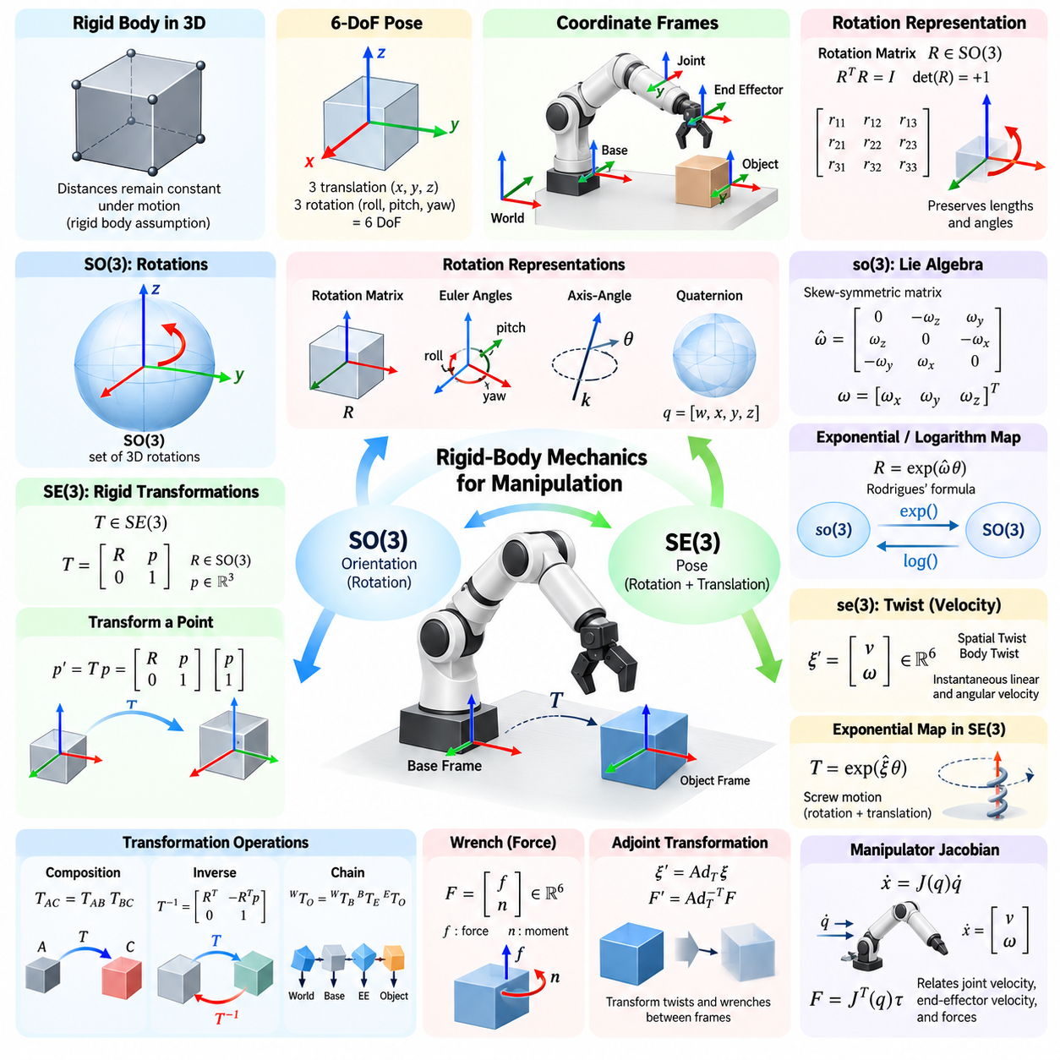
Rigid-body mechanics provides the mathematical foundation for describing how manipulators, end effectors, tools, and objects move in three-dimensional space. A rigid body is idealized as an object whose internal distances remain constant during motion. Although real components deform slightly, this assumption enables robot manipulation to represent position and orientation independently of detailed structural deformation.
The configuration of a rigid body in three-dimensional space requires both translation and rotation. Translation specifies where a reference point on the body is located, while rotation specifies how the body is oriented relative to a reference coordinate frame. Together they define the six-degree-of-freedom pose of the body: three translational degrees of freedom and three rotational degrees of freedom.
Coordinate frames are essential because position and orientation have meaning only relative to a reference. Manipulation systems commonly define a world frame, robot base frame, joint frames, end-effector frame, sensor frames, object frames, and task frames. Transformations among these frames allow measurements and commands originating from different components to be represented consistently within a common geometric framework.
Three-dimensional orientation is naturally represented by the special orthogonal group SO(3). A rotation matrix R belongs to SO(3) when it is a real 3×3 matrix satisfying RᵀR = I and det(R) = +1. The orthogonality condition preserves lengths and angles, while the positive determinant ensures that the transformation represents a proper rotation rather than a reflection.
The columns of a rotation matrix can be interpreted as the axes of one coordinate frame expressed in another frame. Because these axes form an orthonormal basis, each column has unit length and is perpendicular to the others. This geometric interpretation makes rotation matrices particularly useful in robotics, where transformations between coordinate systems must preserve the physical structure of three-dimensional space.
Rotations are fundamentally different from ordinary vectors because their composition is generally noncommutative. If R₁ and R₂ represent two rotations, applying R₁ followed by R₂ usually produces a different orientation from applying R₂ followed by R₁. Matrix multiplication captures this ordering explicitly, making careful frame notation and transformation direction essential when constructing manipulation algorithms.
Although rotation matrices provide a robust representation, orientation may also be expressed using Euler angles, axis-angle coordinates, or unit quaternions. Euler angles are intuitive but can suffer from singularities such as gimbal lock. Quaternions provide a compact, numerically convenient representation for interpolation and estimation, while rotation matrices remain especially convenient for geometric transformation and composition.
The Lie algebra associated with SO(3) is denoted so(3), and it provides a local linear representation of rotational motion. Elements of so(3) are 3×3 skew-symmetric matrices that can be constructed from three-dimensional angular vectors using the hat operator. This relationship connects angular velocity vectors with matrix-based rotational kinematics and enables differential analysis on the nonlinear rotation manifold.
The exponential map transforms an element of so(3) into a finite rotation in SO(3). For a rotation axis and angular magnitude, the matrix exponential produces the corresponding rotation matrix, with Rodrigues' rotation formula providing a practical closed-form expression. Conversely, the logarithmic map converts a rotation matrix into a local rotational coordinate, which is useful for pose errors and optimization.
Rigid-body pose extends rotational geometry by combining orientation with translation. The special Euclidean group SE(3) represents all proper rigid transformations in three-dimensional space. An element of SE(3) is commonly written as a 4×4 homogeneous transformation matrix containing a 3×3 rotation matrix R and a three-dimensional translation vector p, together defining the complete pose of one coordinate frame relative to another.
Homogeneous transformation matrices provide a unified mechanism for applying rotation and translation through matrix multiplication. A three-dimensional point is augmented with a homogeneous coordinate, allowing its coordinates to be transformed between frames using a single matrix operation. This representation is fundamental to forward kinematics, object pose estimation, sensor calibration, grasp planning, and manipulation trajectory generation.
Transformation composition expresses chains of spatial relationships. For example, if the pose of the end effector relative to the robot base and the pose of a grasp frame relative to the end effector are known, multiplication of the corresponding SE(3) transformations determines the grasp-frame pose relative to the base. The multiplication order must follow the frame relationships because rigid transformations are not generally commutative.
Every rigid transformation has an inverse that reverses the direction of the coordinate relationship. If a transformation contains rotation R and translation p, its inverse contains Rᵀ and the translation −Rᵀp. This structure allows efficient conversion between object-to-camera, camera-to-object, base-to-tool, and tool-to-base descriptions without requiring a general-purpose matrix inversion procedure.
Like SO(3), SE(3) possesses an associated Lie algebra, denoted se(3). An element of se(3) combines angular and linear velocity components into a compact representation of instantaneous rigid-body motion. The corresponding six-dimensional vector is often called a twist, providing a powerful representation for manipulator kinematics, screw motion, velocity propagation, trajectory generation, and differential control.
A twist describes the instantaneous translational and rotational motion of a rigid body. Depending on the selected coordinate frame, the same physical motion can have different numerical twist representations. Spatial twists express motion relative to a fixed or world-oriented frame, whereas body twists express it relative to a moving body frame. Maintaining this distinction prevents frame inconsistencies in velocity calculations.
The exponential map from se(3) to SE(3) connects instantaneous velocity with finite rigid-body displacement. If a constant twist is applied for a specified duration, exponentiating its matrix representation produces the corresponding rigid transformation. This formulation reveals that many robot motions can be interpreted geometrically as screw motions combining rotation about an axis with translation along that axis.
Wrenches provide the force-domain counterpart to twists. A wrench combines a three-dimensional force with a three-dimensional moment or torque, producing a six-dimensional description of mechanical loading on a rigid body. In manipulation, wrenches arise at gripper contacts, force-torque sensors, environmental interfaces, and joints, making them central to force control, grasp analysis, and contact mechanics.
Twists and wrenches transform differently between coordinate frames because they represent dual physical quantities. The adjoint representation of SE(3) provides the transformation rule for twists, while the corresponding dual or transpose-related mapping is used for wrenches. These relationships ensure that velocity, force, and power remain physically consistent when manipulation computations are performed across multiple frames.
Rigid-body velocity can also be related directly to the time derivative of pose. Angular velocity determines how the rotation matrix evolves, while linear velocity describes translation of the chosen reference point. Because rotational coordinates lie on SO(3) rather than ordinary Euclidean space, directly differentiating orientation parameters without respecting their geometric structure can introduce mathematical inconsistencies or numerical instability.
In robot manipulation, rigid-body mechanics connects naturally to manipulator Jacobians. A Jacobian maps joint velocities into the linear and angular velocity of an end effector or another body-fixed frame. Its transpose relates external wrenches to generalized joint torques under appropriate assumptions. This velocity-force relationship forms a central bridge between geometric kinematics, differential motion, and physical interaction.
Pose errors must also respect the geometry of SO(3) and SE(3). Subtracting rotation matrices or homogeneous transformations as if they were ordinary vectors does not generally produce a physically meaningful error. Instead, relative transformations and logarithmic maps can express orientation and pose discrepancies in tangent-space coordinates suitable for feedback control, optimization, state estimation, and trajectory tracking.
Interpolation between rigid-body poses requires similar geometric care. Linear interpolation of translation is straightforward, but orientation should follow the structure of SO(3), using methods such as quaternion spherical interpolation or Lie-group interpolation. SE(3)-based interpolation can generate smooth screw-like motion between poses while maintaining valid rotations throughout the trajectory, which is valuable for Cartesian-space manipulation planning.
Contact-rich manipulation further emphasizes the importance of rigid-body mechanics. The location of a contact point determines how applied forces generate moments, and changes in object pose alter contact geometry and feasible motion directions. Grasp stability, pushing, insertion, assembly, and tool use therefore require consistent treatment of coordinate transformations, velocities, forces, and constraints within a shared spatial representation.
SO(3) and SE(3) are not merely mathematical notation for robotics; they encode the actual geometric structure of orientation and rigid-body motion. Algorithms that preserve this structure tend to produce more consistent transformations, estimation procedures, controllers, and optimization methods. They also provide a common language linking perception, kinematics, dynamics, planning, and control throughout a manipulation system.
For practical robot manipulation, mastering rigid-body mechanics means understanding how poses, velocities, and forces are represented, composed, inverted, differentiated, and transformed between frames. SO(3) provides the geometry of orientation, SE(3) provides the geometry of complete pose, and their Lie algebras provide local representations of motion. Together they form the geometric backbone for precise and physically consistent manipulation.

01.03. DH Parameters and Modified DH Convention [w/Code]
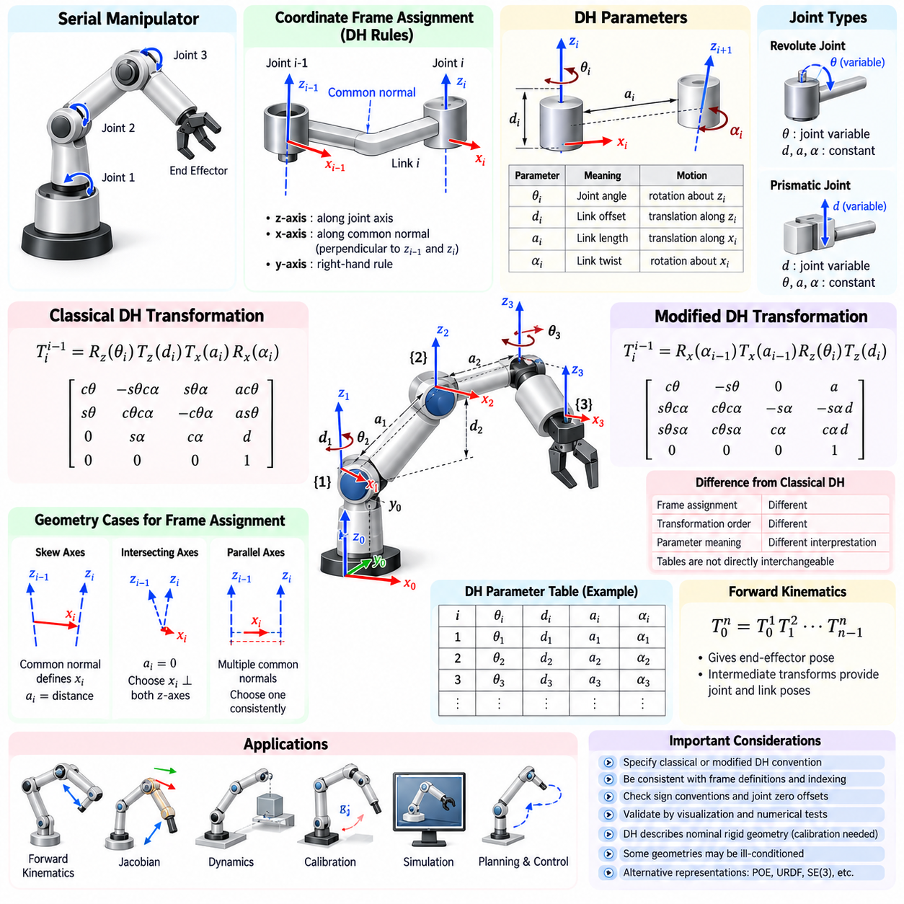
Denavit-Hartenberg parameters provide a systematic method for representing the geometry of serial robotic manipulators. Instead of describing every joint and link with arbitrary three-dimensional transformations, the DH convention assigns coordinate frames according to standardized geometric rules. The relationship between two neighboring frames can then be expressed using only four parameters, greatly simplifying forward kinematic modeling.
The method is particularly useful for manipulators composed of revolute or prismatic joints connected through rigid links. Each joint establishes an axis of motion, and coordinate frames are attached according to the relationships among consecutive joint axes. Once the frame assignment is completed correctly, the manipulator geometry can be summarized as a compact DH parameter table from which homogeneous transformations are constructed.
In the classical DH convention, four quantities describe the transformation associated with each link: the joint angle θ, link offset d, link length a, and link twist α. These parameters represent two rotations and two translations arranged in a prescribed sequence. Their values are determined from the geometric relationship between consecutive coordinate frames rather than selected independently as arbitrary modeling variables.
The joint angle θ represents rotation about a z-axis, while the link offset d represents translation along that z-axis. The link length a measures displacement along the corresponding x-axis, and the link twist α describes rotation about that x-axis. Together these four operations encode the relative pose between adjacent coordinate frames using the geometry of the joint axes and their common normal.
For a revolute joint, θ is normally the joint variable while d, a, and α remain constant parameters determined by the robot geometry. For a prismatic joint, d becomes the joint variable while θ, a, and α are normally constant. This distinction allows the same DH formulation to represent manipulators containing combinations of rotary and linear joints without changing the fundamental transformation structure.
The classical DH transformation can conceptually be interpreted as a sequence involving rotation about z, translation along z, translation along x, and rotation about x. Multiplying the corresponding elementary transformations produces one homogeneous transformation matrix. Chaining these matrices from the robot base to the final link yields the forward kinematics of the complete serial manipulator.
Frame assignment is the most important and error-prone stage of DH modeling. The z-axis is aligned with the associated joint axis, while the x-axis is generally selected along the common normal between neighboring z-axes. The y-axis follows from the right-hand rule. Special geometric cases occur when consecutive joint axes intersect, are parallel, or are coincident, requiring consistent choices that preserve the DH rules.
When two consecutive joint axes are skew, their common normal provides a natural x-axis and the distance along it defines the link length. If the axes intersect, the common-normal distance becomes zero and an appropriate x-axis perpendicular to both axes can be selected. If the axes are parallel, multiple common normals exist, so a convenient choice must be made while maintaining consistency throughout the model.
The resulting DH table provides a compact geometric description of the manipulator. Each row corresponds to a joint-link relationship and contains the four DH parameters, with the active joint variable clearly identified. This tabular representation is convenient for symbolic derivation, numerical computation, documentation, calibration, simulation, and comparison between different manipulator architectures.
Forward kinematics is obtained by multiplying successive link transformations in the correct order. If each transformation describes frame i relative to frame i−1, the product of all transformations determines the end-effector pose relative to the base. Intermediate products also provide the poses of individual joints and links, which are useful for visualization, collision checking, Jacobian calculation, and dynamic modeling.
The Modified Denavit-Hartenberg convention uses the same basic geometric quantities but changes how coordinate frames are attached and how elementary transformations are ordered. This difference may appear minor, yet it changes the mathematical interpretation of each parameter. Therefore, classical DH and Modified DH parameter tables cannot generally be exchanged directly without redefining frames and reconstructing the associated transformations.
In a commonly used Modified DH formulation, link-related operations are associated differently with neighboring coordinate frames compared with classical DH. Rotation and translation about or along the x-axis are applied in a different position within the transformation sequence relative to the z-axis joint operations. This convention often produces frame placements that correspond more naturally to physical robot links and joint structures.
One practical advantage of Modified DH is that coordinate frames can remain closely associated with individual links, which may simplify recursive formulations used in robot dynamics and control. Many robotics textbooks, software libraries, and industrial models adopt Modified DH or closely related conventions. However, its usefulness depends less on inherent superiority than on maintaining a consistent definition throughout the entire model.
A major source of error arises because different references use the term “DH parameters” while silently adopting different conventions. The order of transformations, frame indices, signs, and interpretation of a, α, d, and θ may differ. Consequently, a DH table should always be accompanied by an explicit statement identifying whether classical or Modified DH is used and defining the corresponding transformation equation.
Parameter indexing deserves similar attention. Some formulations associate a and α with link i, whereas others effectively associate them with the preceding or following frame because of their transformation convention. A table can therefore appear numerically shifted even when two models describe the same physical robot. Comparing parameter symbols without examining frame definitions and transformation order can produce incorrect conclusions.
Sign conventions also influence the model. Positive joint rotation follows the right-hand rule about the assigned joint axis, while positive translation follows the positive direction of that axis. Reversing a coordinate axis can change the signs of several parameters simultaneously without changing the physical mechanism. The correctness of a DH model must therefore be evaluated through the resulting transformations rather than parameter appearance alone.
Joint zero positions are another important modeling choice. The mechanical zero indicated by an encoder does not necessarily coincide with the mathematical zero used in the DH model. A joint offset may therefore be introduced so that the kinematic variable becomes the measured joint value plus or minus a constant correction. Properly handling these offsets is essential when connecting theoretical kinematics to real robot hardware.
DH parameters describe nominal rigid geometry, but manufactured robots contain dimensional tolerances, assembly errors, encoder offsets, and structural deformation. Kinematic calibration estimates corrections to nominal model parameters using measured robot poses. Although alternative calibration models may avoid some singularities of standard DH parameterization, the DH framework remains useful for understanding how geometric errors propagate into end-effector positioning errors.
Certain manipulator geometries expose representational limitations of DH parameterization. Nearly parallel joint axes can make some calibration parameters poorly conditioned, and small geometric changes may produce large changes in particular DH values. These issues do not invalidate forward kinematics but demonstrate that a compact geometric parameterization is not always the best numerical representation for estimation or optimization.
DH modeling is also closely connected to Jacobian construction. Once transformations to each joint frame are available, joint-axis directions and joint origins can be expressed in a common base frame. For a revolute joint, these quantities determine its contribution to linear and angular end-effector velocity; for a prismatic joint, the axis directly determines the translational velocity contribution.
The method can additionally support dynamic modeling because link coordinate frames provide reference locations for masses, centers of mass, inertia tensors, forces, and moments. However, DH frames are selected primarily for kinematic convenience and do not necessarily coincide with centers of mass or principal inertia axes. Dynamic models therefore often define additional link-fixed frames connected to the DH frames by known rigid transformations.
Modern robot software frequently allows kinematics to be represented using URDF, transformation trees, product-of-exponentials formulations, or general SE(3) models rather than explicit DH tables. These approaches can describe branched mechanisms and complex sensor or tool frames more naturally. Nevertheless, DH parameters remain important because they provide a compact analytical representation and reveal the geometric structure of serial manipulators.
The product-of-exponentials formulation offers an especially useful comparison. Rather than assigning DH frames and four parameters per joint-link pair, it represents each joint through a screw axis and constructs motion using exponential maps on SE(3). This approach avoids some frame-assignment ambiguities, while DH often remains more intuitive for conventional serial-arm geometry and hand calculations.
For software implementation, the most reliable practice is to generate each homogeneous transformation from a clearly documented convention and verify the resulting chain numerically. Testing should include the zero configuration, several known configurations, joint-limit poses, and independently measured or simulated end-effector poses. Rotation matrices should remain orthonormal and transformation inverses should reproduce expected frame relationships.
Visualization is particularly effective for detecting incorrect DH models. Displaying every coordinate frame, joint axis, and link transformation makes axis reversals, misplaced origins, incorrect twist angles, and indexing errors immediately visible. A model that produces a plausible end-effector position for one configuration may still contain errors, so validation across multiple configurations and intermediate frames is essential.
Classical DH and Modified DH should therefore be regarded as two disciplined but distinct conventions for organizing serial-manipulator geometry. Neither convention eliminates the need for careful coordinate-frame reasoning. Their primary value is that once the convention and frames are fixed, complex chains of three-dimensional joint relationships become reproducible sequences of structured rigid-body transformations.
A robust manipulation model ultimately requires consistency from mechanical drawings through mathematical derivation, software implementation, calibration, and control. The selected DH convention, frame definitions, parameter indexing, joint directions, and zero offsets must remain traceable across these stages. When these rules are maintained, DH and Modified DH provide efficient foundations for forward kinematics, Jacobians, simulation, planning, and precise manipulator control.

01.04. Workspace Analysis Reachability Singularities [w/Code]
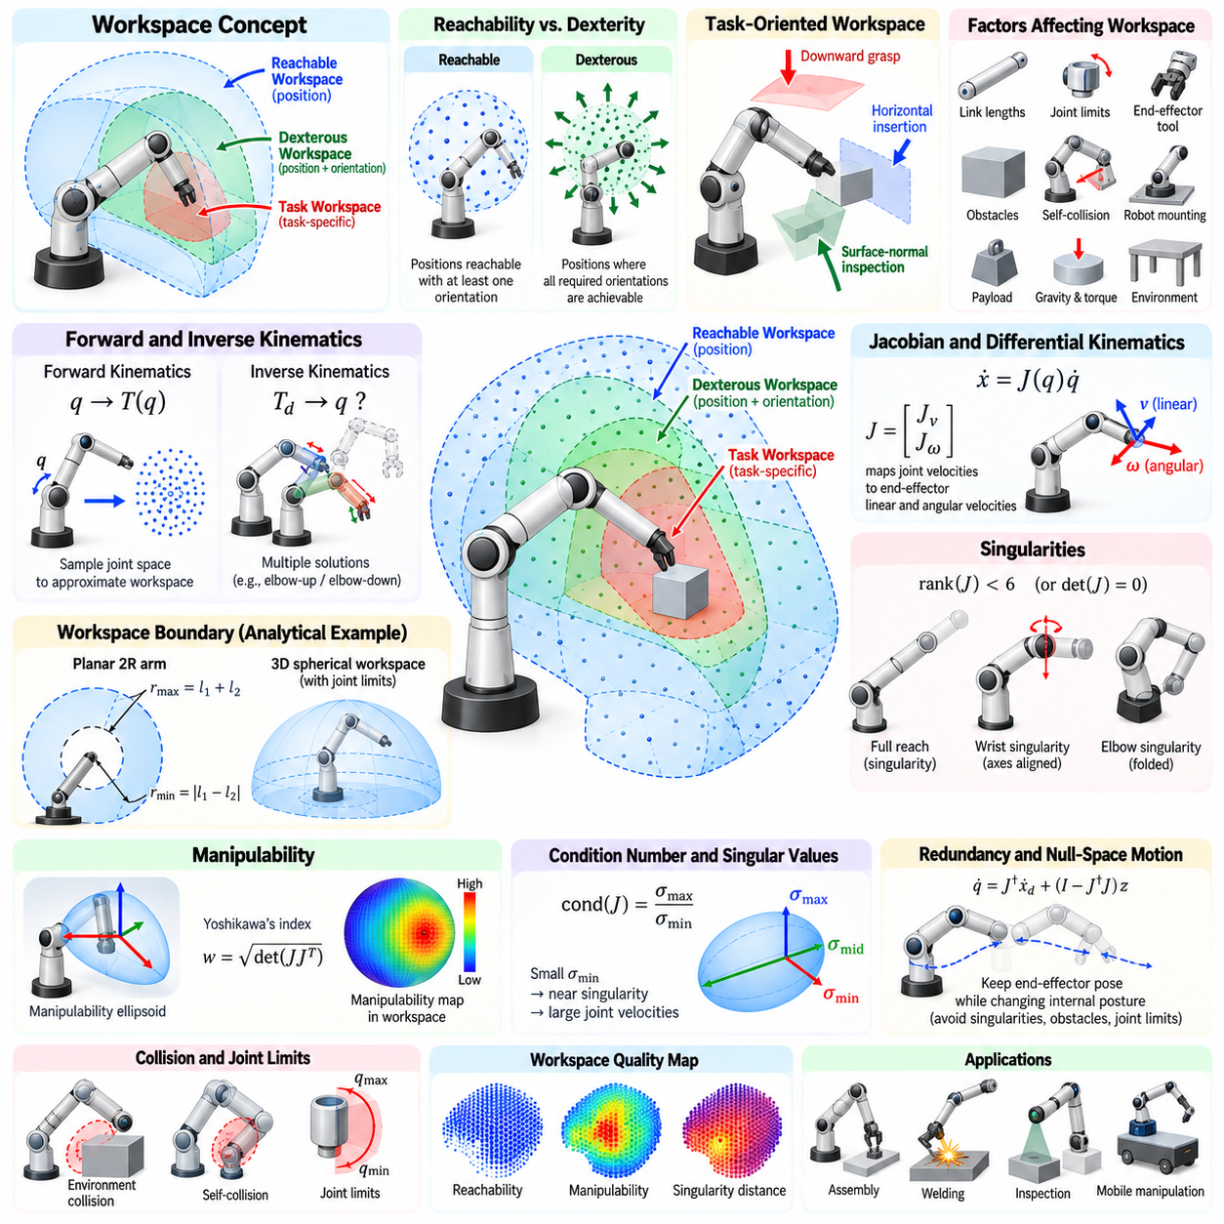
Workspace analysis determines where a robot manipulator can position and orient its end effector while satisfying its mechanical and kinematic constraints. It connects robot geometry with practical task feasibility by answering whether a target pose can be reached, from which directions it can be approached, and whether the manipulator can maintain useful motion capability around that configuration.
The workspace of a manipulator is not simply the volume enclosed by its maximum arm extension. It depends on link lengths, joint types, joint limits, mechanical interference, mounting configuration, end-effector geometry, and orientation requirements. Obstacles and self-collision further reduce the practically usable region, making a distinction necessary between theoretical geometric workspace and operational workspace.
Reachable workspace is commonly defined as the set of positions that the end effector can reach with at least one orientation. A point belongs to this workspace if at least one valid joint configuration places the selected end-effector reference point there. This definition provides a basic measure of spatial coverage but does not indicate whether arbitrary tool orientations are available at that location.
Dexterous workspace applies a stronger condition. It contains positions where the end effector can achieve all orientations required by a specified task or, under an idealized definition, every possible orientation. Consequently, the dexterous workspace is normally smaller than the reachable workspace. This distinction is especially important for assembly, welding, inspection, machining, and object manipulation requiring controlled approach directions.
A task-oriented workspace can be more useful than either general definition. Instead of requiring arbitrary orientations, it evaluates only poses relevant to a particular operation, such as downward grasping, horizontal insertion, surface-normal inspection, or tool alignment. Task-specific analysis prevents unnecessary rejection of locations that are fully adequate for the intended manipulation even though they are not globally dexterous.
Forward kinematics provides one route to workspace analysis by mapping valid joint configurations into Cartesian space. Joint variables can be sampled over their permitted ranges and the resulting end-effector poses collected to approximate the workspace. Dense sampling is straightforward and applicable to complex manipulators, although computational cost grows rapidly with the number of joints and sampling resolution.
Analytical workspace boundaries can sometimes be derived from manipulator geometry. For simple planar arms or structured serial manipulators, link lengths and joint limits produce recognizable boundary surfaces. Analytical methods provide insight into how geometric parameters influence reach, but they become increasingly difficult for redundant robots, coupled joint constraints, offset wrists, collision restrictions, and complicated tool geometries.
Inverse kinematics provides another perspective on reachability. A Cartesian target pose is reachable if at least one inverse-kinematic solution satisfies joint limits and other imposed constraints. Multiple solutions may correspond to different arm postures such as elbow-up and elbow-down configurations. Evaluating all relevant solution branches is important because one branch may be infeasible while another remains valid.
Position reachability alone is insufficient for manipulation because orientation can substantially change feasibility. A target point that is easily reached with a vertical gripper may become unreachable when the tool must approach horizontally. Long tools, cameras, grippers, or payloads can further alter feasible configurations, so workspace analysis should normally be performed using the actual tool-center point and task orientation constraints.
Joint limits create important workspace boundaries. Even when an idealized kinematic chain could mathematically reach a target, physical stops may prevent the required configuration. Joint-limit margins are also operationally important because working very close to a limit reduces available corrective motion. A robust task configuration therefore requires not only reachability but sufficient distance from limiting joint positions.
Self-collision and environmental collision transform the geometric workspace into a constrained workspace. A joint configuration may satisfy forward and inverse kinematics while causing one robot link to intersect another, the base, a fixture, or surrounding equipment. Practical reachability must therefore be evaluated together with collision geometry, particularly in compact workcells and mobile-manipulation systems.
Differential kinematics describes the local motion capability of the manipulator through the Jacobian matrix. The Jacobian maps joint velocities into end-effector linear and angular velocities. Its structure changes with robot configuration, allowing workspace analysis to move beyond the binary question of whether a pose is reachable toward evaluating how effectively the robot can move in different Cartesian directions.
A kinematic singularity occurs when the Jacobian loses rank. At such a configuration, the manipulator loses instantaneous motion capability in one or more Cartesian directions, even though the end-effector pose itself may remain geometrically reachable. Singularities are therefore properties of the local mapping between joint motion and Cartesian motion rather than simply unreachable points in space.
Near a singularity, producing a modest Cartesian velocity may require very large joint velocities. Similarly, certain Cartesian forces may demand excessive joint torques or become difficult to regulate. Numerical inverse-kinematic methods based directly on Jacobian inversion can become unstable in these regions. Singular configurations therefore influence motion planning, control performance, force capability, and safety.
Singularities may occur at workspace boundaries when the manipulator becomes fully stretched or folded into a configuration where independent joint motions produce dependent Cartesian effects. Other singularities can occur inside the workspace because of wrist alignment or particular relationships among joint axes. For common six-axis industrial arms, shoulder, elbow, and wrist singularities are frequently distinguished according to their geometric origin.
A wrist singularity provides a typical example. When two rotational axes of a spherical wrist become aligned, independent control of certain orientation components is lost. The desired end-effector orientation may still exist, but its representation through individual wrist joint angles becomes nonunique or extremely sensitive. A controller may then command rapid compensating joint rotations even while the tool orientation changes only slightly.
The determinant of a square Jacobian can identify singularity when the determinant becomes zero, but this test is limited to appropriate square matrices. More general analysis uses matrix rank or singular value decomposition. Singular values reveal the strength of motion capability along different directions, and the smallest singular value approaching zero provides a useful quantitative indicator of proximity to singularity.
The Jacobian condition number measures directional imbalance in local motion transmission. A low condition number generally indicates relatively uniform mapping between joint and Cartesian velocities, while a large value indicates poor conditioning and proximity to singular behavior. Condition number is therefore useful for selecting robot postures and monitoring trajectories, although its numerical scale depends on how translational and rotational quantities are normalized.
Manipulability provides another measure of local kinematic capability. Measures derived from the Jacobian, such as Yoshikawa's manipulability index, quantify how effectively joint motion can generate Cartesian motion. The associated manipulability ellipsoid shows directions in which the end effector can move easily and directions in which motion capability is weak, providing richer information than a simple reachable-or-unreachable classification.
Velocity manipulability and force manipulability are closely related through kinematic duality. A configuration that permits large Cartesian velocity in a particular direction may provide relatively limited force amplification in that direction, depending on actuator capabilities and Jacobian structure. Manipulation tasks involving pushing, insertion, drilling, or heavy payloads therefore benefit from workspace analysis that includes both motion and force characteristics.
Redundant manipulators provide additional flexibility because more joint degrees of freedom are available than are required to specify the task pose. Null-space motion can change the internal robot posture while maintaining the same end-effector pose. This capability can be exploited to avoid singularities, increase joint-limit margins, improve manipulability, avoid obstacles, reduce torque, or maintain favorable sensor visibility.
Singularity avoidance can be incorporated directly into inverse kinematics and motion planning. Optimization objectives may penalize low manipulability, small singular values, high condition numbers, or configurations near joint limits. Damped least-squares inverse kinematics provides another practical technique by regularizing Jacobian inversion near singularities, trading exact Cartesian tracking for bounded and numerically stable joint motion.
Workspace quality should therefore be represented as more than a binary spatial map. Individual regions can be annotated with orientation coverage, number of inverse-kinematic solutions, manipulability, joint-limit margin, collision clearance, torque capability, and singularity distance. Such maps help designers identify not merely where the robot can reach, but where it can perform tasks reliably and efficiently.
Robot placement strongly affects usable workspace. Moving or rotating the robot base relative to a workstation can convert difficult target poses into highly manipulable ones without changing the manipulator itself. Industrial workcell design therefore often optimizes robot location, pedestal height, fixture orientation, and part placement jointly rather than treating robot reach as a fixed property.
Mobile manipulation extends this idea by allowing the robot base itself to reposition. The combined workspace of a mobile base and manipulator can be much larger than the arm workspace alone, but reachability then depends on base pose, navigation constraints, stability, localization accuracy, and collision clearance. Coordinated base-arm planning can select configurations that improve manipulation dexterity and avoid arm singularities.
Payload and dynamics further restrict operational reach. A pose may be kinematically reachable but unsuitable because gravity generates excessive joint torque, structural deflection reduces accuracy, or actuator thermal limits cannot support sustained loading. Manufacturers therefore often specify payload-dependent reach or allowable wrist moments, emphasizing that practical workspace is simultaneously geometric, kinematic, and dynamic.
Workspace analysis also supports manipulator design. Link lengths, joint ranges, axis arrangements, wrist geometry, and degrees of freedom can be optimized against representative task poses. Excessive reach may increase mass and reduce stiffness, while insufficient reach prevents task completion. Design optimization therefore seeks an appropriate balance among workspace volume, dexterity, manipulability, payload, accuracy, and mechanical complexity.
Simulation provides an effective environment for evaluating these factors before hardware deployment. Large sets of candidate poses can be tested for inverse-kinematic feasibility, collisions, joint limits, singularity metrics, and dynamic constraints. Visualization using point clouds, volumetric grids, pose samples, or manipulability distributions allows engineers to identify weak workspace regions and redesign robot placement or task geometry.
For manipulation planning, the most valuable workspace is ultimately the region in which the robot can complete an entire action sequence rather than merely touch a target. Grasping may require pre-grasp, approach, grasp, lifting, transfer, and placement poses, all connected by feasible trajectories. A target that is individually reachable can still be operationally unusable if no safe and nonsingular approach or departure path exists.
A comprehensive workspace analysis therefore integrates reachability, orientation feasibility, joint limits, collision constraints, differential kinematics, singularities, manipulability, force capability, and task trajectories. This transforms workspace from a simple geometric envelope into a measure of manipulation capability. Reliable robot deployment depends on selecting regions where sufficient kinematic margin remains throughout the complete physical task.

01.05. Manipulator Dynamics Newton Euler Lagrange [w/Code]
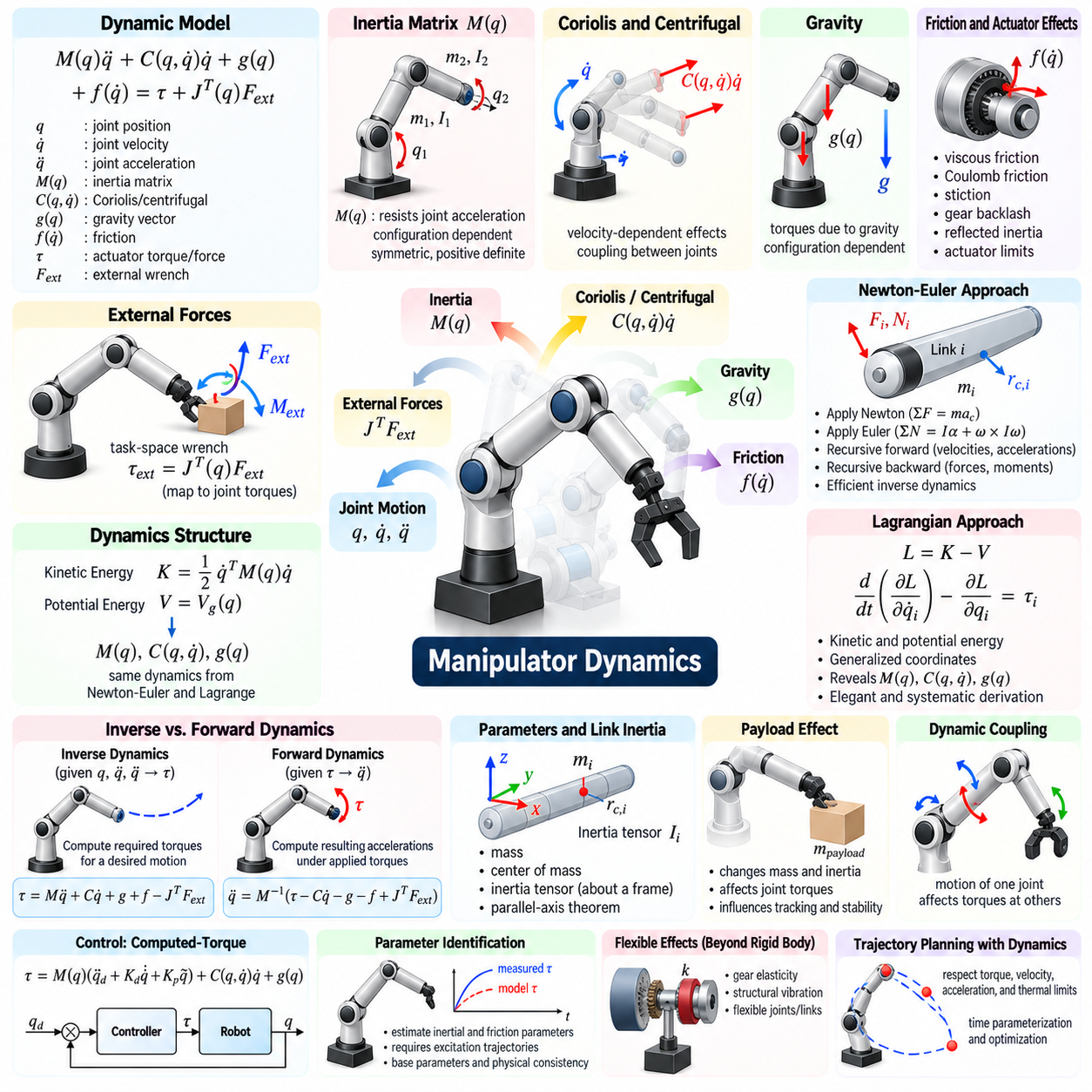
Manipulator dynamics describes the relationship among joint motion, actuator effort, link inertia, gravity, friction, and external forces acting on a robotic arm. While kinematics determines motion without considering its causes, dynamics explains what joint torques or forces are required to produce that motion. It therefore provides the physical foundation for simulation, control, actuator sizing, trajectory optimization, and interaction analysis.
For an n-degree-of-freedom manipulator, the equations of motion are commonly expressed as M(q)q̈ + C(q,q̇)q̇ + g(q) + f(q̇) = τ + Jᵀ(q)Fext. Here q, q̇, and q̈ denote joint position, velocity, and acceleration, M is the inertia matrix, C represents velocity-dependent effects, g is the gravity vector, f models friction, τ is actuator effort, and Fext represents an external wrench.
The inertia matrix M(q) captures how the robot's distributed masses and rotational inertias resist joint acceleration. It depends on configuration because changing joint angles changes the spatial arrangement of the links. For a physically valid rigid-body model, the inertia matrix is symmetric and positive definite away from pathological parameterizations, properties that are important for energy interpretation, numerical simulation, and controller design.
Velocity-dependent dynamics are commonly represented by Coriolis and centrifugal terms. These effects arise because the manipulator's coordinate frames and mass distribution move as the joints rotate. Their magnitude generally increases with joint velocity, and coupling means that motion of one joint can generate torque requirements at other joints. High-speed manipulators therefore require accurate treatment of these terms for precise control.
The gravity vector g(q) represents joint torques or forces caused by gravitational loading. Its value varies with configuration because link centers of mass change position relative to gravity. A horizontally extended arm may require substantially more holding torque than a vertically aligned configuration. Gravity compensation is consequently a fundamental component of many manipulator controllers, particularly for heavy or compliant robotic arms.
Friction and actuator effects add another layer to the dynamic model. Joint friction may include viscous friction, Coulomb friction, stiction, and more complex velocity-dependent behavior. Gear trains introduce reflected inertia, backlash, elasticity, and transmission losses, while electric motors contribute rotor inertia and torque limits. High-fidelity models may also include temperature-dependent friction and nonlinear actuator characteristics.
External forces enter manipulator dynamics through contact with objects, tools, humans, or the environment. A Cartesian wrench applied at the end effector can be mapped into generalized joint torques through the Jacobian transpose JᵀFext. This relationship links task-space interaction to joint-space dynamics and forms a basis for force control, impedance control, collision response, payload handling, and contact-rich manipulation.
Two classical approaches dominate analytical manipulator dynamics: Newton-Euler mechanics and Lagrangian mechanics. Both describe the same underlying rigid-body physics and should produce equivalent equations when formulated consistently. Their differences concern how forces, moments, velocities, energies, and constraints are organized during derivation rather than representing fundamentally different physical models.
The Newton-Euler approach applies Newton's translational law and Euler's rotational law directly to every rigid link. For each link, the resultant force equals mass multiplied by center-of-mass acceleration, while the resultant moment relates angular acceleration, angular velocity, and the inertia tensor. Joint forces and moments connect neighboring links, creating a recursive structure well suited to serial manipulators.
Recursive Newton-Euler algorithms typically perform an outward and an inward pass through the kinematic chain. During the outward recursion, angular velocities, angular accelerations, and linear accelerations are propagated from the base toward the end effector. These quantities determine each link's inertial force and moment based on its mass, center of mass, and inertia tensor.
During the inward recursion, forces and moments are propagated from the end effector back toward the base. External loads and link inertial effects are accumulated, and the component of the resulting wrench associated with each joint axis determines the required joint torque or force. This recursive organization avoids unnecessarily expanding large symbolic expressions and provides excellent computational efficiency.
The recursive Newton-Euler algorithm is particularly important for inverse dynamics. Given q, q̇, and q̈ together with robot inertial parameters and external loads, inverse dynamics computes the actuator torques required to realize the specified motion. Efficient inverse-dynamics calculations are widely used in computed-torque control, feedforward compensation, trajectory evaluation, simulation, and model-based optimization.
Lagrangian mechanics approaches the same problem through energy. The kinetic energy K of the manipulator is constructed from the translational and rotational motion of all links, while the potential energy V usually includes gravitational potential. The Lagrangian is defined as L = K − V, allowing the equations of motion to be derived systematically using generalized joint coordinates rather than explicitly tracking every internal reaction force.
For each generalized coordinate qᵢ, the Euler-Lagrange equation relates the time derivative of ∂L/∂q̇ᵢ and the derivative ∂L/∂qᵢ to the corresponding generalized force. Applying this equation to every joint produces the complete manipulator dynamics. The method is conceptually elegant because internal constraint forces often disappear naturally from the formulation when appropriate generalized coordinates are selected.
The Lagrangian approach exposes important structural properties of robot dynamics. Kinetic energy can be written as one-half q̇ᵀM(q)q̇, directly revealing the inertia matrix. Gravitational terms follow from derivatives of potential energy, while Coriolis and centrifugal terms emerge from derivatives involving M(q). This structure is valuable for theoretical analysis, stability proofs, and model-based control development.
Newton-Euler and Lagrange methods therefore offer complementary advantages. Newton-Euler recursion is typically attractive for efficient numerical implementation because it exploits the serial structure of the robot. Lagrangian derivation is often attractive for symbolic analysis because it organizes dynamics through scalar energy functions. Modern robotics software may use spatial-vector algorithms that generalize recursive rigid-body dynamics even further.
Inverse dynamics should be distinguished from forward dynamics. Inverse dynamics starts with a desired motion and determines the required actuator effort. Forward dynamics starts with joint torques or forces and determines the resulting joint acceleration, commonly expressed conceptually as q̈ = M⁻¹(τ − Cq̇ − g − f + JᵀFext). Forward dynamics is fundamental to physics simulation and prediction of robot motion under applied inputs.
Directly computing the inverse of the inertia matrix is not always the most efficient implementation of forward dynamics. Recursive algorithms such as the articulated-body algorithm can calculate accelerations without explicitly forming and inverting the complete mass matrix. This becomes increasingly important for high-degree-of-freedom robots, branched mechanisms, humanoids, and real-time simulation where computational efficiency matters.
Dynamic parameters originate from the physical properties of each link. A rigid link requires mass, center-of-mass location, and an inertia tensor defined about a specified frame. Accurate frame transformations are essential because inertia depends on both orientation and reference point. The parallel-axis theorem is used when transferring rotational inertia between parallel frames located at different points on a rigid body.
Payload changes modify the manipulator dynamics and cannot always be treated as a minor disturbance. An object held by the gripper adds mass, shifts the effective center of mass, and changes rotational inertia at the end of the kinematic chain. These changes propagate through the required joint torques, particularly at proximal joints, and can affect acceleration capability, tracking accuracy, energy consumption, and stability margins.
Dynamic coupling is a defining property of multi-joint manipulators. Accelerating one link can create reaction torques at several joints because all links are mechanically connected. Consequently, independently controlling each joint as if it were an isolated actuator becomes increasingly inaccurate at high speed or under heavy payloads. Model-based controllers compensate for this coupling using estimates of the full manipulator dynamics.
Computed-torque control uses the dynamic model to cancel or compensate for nonlinear robot behavior. Desired accelerations are converted into joint torques using estimates of M, C, and g, while feedback terms correct remaining tracking errors. With an accurate model, the closed-loop behavior can approximately resemble a set of simpler decoupled systems, although modeling errors and actuator limitations prevent perfect cancellation.
Energy provides another important interpretation of manipulator dynamics. Actuators inject mechanical power through joint torque and velocity, while gravity, friction, damping, and contact redistribute or dissipate energy. Energy-based reasoning is useful for stability analysis, passive control, impedance behavior, collision safety, and physical human-robot interaction because it directly reflects the exchange of mechanical energy.
Dynamic modeling inevitably contains uncertainty. Link masses may differ from nominal values, centers of mass may be inaccurately known, payloads may change, and friction is difficult to model precisely. Parameter identification estimates inertial and friction parameters from measured joint positions, velocities, accelerations, and actuator efforts. Carefully designed excitation trajectories are required to make relevant dynamic parameters observable.
Not all physical parameters can necessarily be identified independently from joint measurements. Manipulator dynamics often depend on combinations of masses, centers of mass, and inertia components known as base parameters. Identifying a minimal or well-conditioned parameter set can improve numerical robustness and reduce overfitting. Physical consistency constraints can additionally ensure estimated masses and inertia tensors remain realistic.
Real robotic systems also contain flexible effects that rigid-body dynamics does not fully represent. Gear elasticity, belt compliance, harmonic-drive deformation, structural vibration, cable forces, and flexible links can introduce additional states and resonances. Rigid-body models remain the primary foundation, but high-performance manipulators may require flexible-joint or structural models when operating at high acceleration or precision.
Dynamic constraints are important during trajectory planning. Even if a path is kinematically feasible, executing it too rapidly may exceed joint torque, motor current, velocity, acceleration, thermal, or structural limits. Time parameterization and trajectory optimization therefore use dynamic models to determine how quickly a geometric path can be executed while respecting actuator and mechanical constraints.
Simulation offers a practical way to validate dynamic models before deploying controllers on hardware. Predicted joint torques, accelerations, energy consumption, contact forces, and payload effects can be compared with experimental measurements. Discrepancies reveal calibration errors, missing friction, incorrect inertial parameters, actuator dynamics, or unmodeled flexibility and guide progressive improvement of model fidelity.
Manipulator dynamics ultimately connects geometric motion to physical effort. Newton-Euler mechanics explains dynamics through recursive balances of forces and moments, while Lagrangian mechanics derives the same behavior through kinetic and potential energy. Together with Jacobians, actuator models, contact forces, and parameter identification, these formulations provide the foundation for physically accurate simulation, control, planning, and manipulation.

01.06. Manipulator HW Overview Serial Parallel Delta [w/Code]
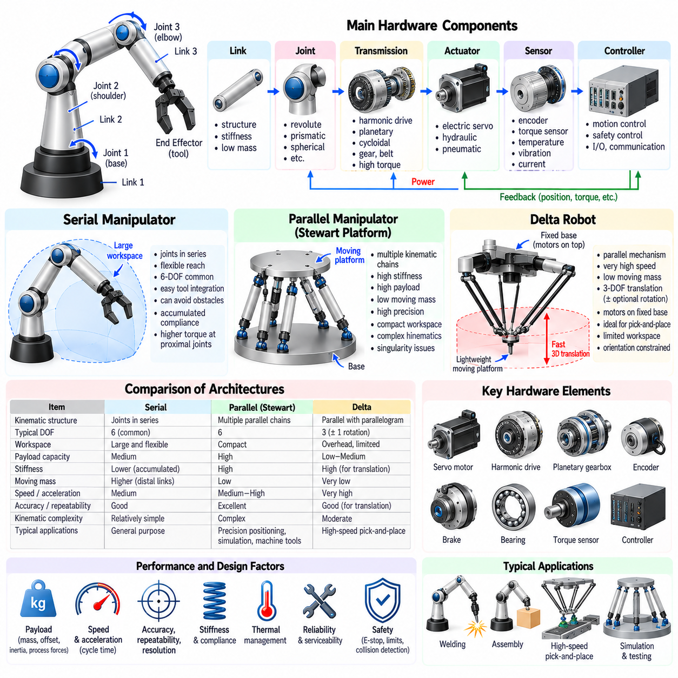
Manipulator hardware converts mathematical motion commands into controlled physical interaction with the environment. Its architecture determines reachable workspace, payload, stiffness, speed, accuracy, dynamic response, and maintainability. Although many specialized mechanisms exist, industrial and research manipulators are commonly organized around serial, parallel, or Delta-type structures, each offering a different balance of mechanical capability.
A complete manipulator consists of more than links and joints. Structural members carry mechanical loads, actuators generate motion, transmissions convert motor output into useful torque or force, bearings constrain motion, encoders measure joint state, brakes maintain safe positions, and controllers coordinate the system. Cabling, thermal management, lubrication, mechanical stops, and safety devices are also integral hardware elements.
Manipulator links provide the structural geometry connecting successive joints. Their design balances stiffness, mass, inertia, manufacturability, and internal routing requirements. Aluminum alloys, steels, carbon-fiber composites, and cast structures are commonly used depending on payload and performance requirements. Lightweight links reduce dynamic loads, but insufficient stiffness can increase vibration, deflection, and positioning error.
Robot joints create controlled relative motion between links. Revolute joints provide angular motion and dominate articulated manipulators, while prismatic joints generate linear displacement. More specialized mechanisms may use spherical, universal, flexure, or compound joints. Joint architecture influences degrees of freedom, workspace topology, singularities, mechanical complexity, and the type of actuators and transmissions that can be integrated.
Electric servo motors are the dominant actuators in many modern manipulators because they provide precise controllability, high efficiency, and convenient integration with digital control systems. Permanent-magnet synchronous motors and brushless DC motors are widely used. Hydraulic actuation remains attractive for extremely high force density, while pneumatic actuation can provide simple, fast motion for lower-precision applications.
Motors rarely drive robot joints directly when high torque is required. Gear transmissions increase torque while reducing output speed and can improve effective resolution. Harmonic drives provide high reduction ratios and compact packaging, planetary gearboxes offer high efficiency and load capacity, and cycloidal reducers provide high stiffness and shock resistance. Each transmission introduces tradeoffs involving backlash, friction, inertia, compliance, and cost.
Joint sensing is fundamental to closed-loop control. Absolute or incremental encoders measure motor or output-shaft position, while velocity is obtained through direct sensing or numerical estimation. Torque can be estimated from motor current or measured using strain-based sensors, joint torque sensors, or series elastic elements. High-performance systems may also monitor temperature, vibration, current, and bearing condition.
A serial manipulator connects joints and links sequentially from a fixed or mobile base to the end effector. Each joint carries the structures located downstream, producing a tree branch with a single primary chain in conventional articulated arms. This architecture closely resembles a human arm and provides flexible positioning and orientation within a relatively large workspace compared with the physical footprint of the mechanism.
Six-axis serial manipulators are especially common because six independent degrees of freedom can define a general rigid-body pose in three-dimensional space. A typical architecture combines shoulder and elbow joints for positioning with a three-axis wrist for orientation. Additional joints create redundancy, allowing the robot to modify its internal posture while maintaining the same end-effector pose.
Serial architectures offer excellent workspace flexibility and can reach around obstacles when sufficient degrees of freedom are available. They also provide a natural platform for interchangeable grippers, welding torches, cameras, force sensors, and other tools. Their modular chain structure simplifies conceptual design and kinematic modeling, which has contributed to their widespread use in manufacturing, logistics, laboratories, and service robotics.
The principal mechanical disadvantage of a serial manipulator is accumulated compliance. Deflection or backlash at a proximal joint affects every downstream link, and the distal actuators and structures become payload carried by upstream joints. Consequently, the base and shoulder joints often require significantly greater torque capacity than wrist joints, and reducing distal mass is an important design objective.
Errors can also accumulate through a serial kinematic chain. Joint encoder errors, gearbox compliance, link deformation, bearing clearance, and assembly tolerances propagate toward the end effector. Calibration can compensate for systematic geometric errors, but load-dependent elastic deformation requires structural or model-based compensation. High-precision serial robots therefore demand careful mechanical design in addition to accurate sensing.
A parallel manipulator connects the moving platform to the base through multiple independent kinematic chains. Rather than transmitting all loads through one serial chain, several legs share the forces and moments applied to the platform. This closed-loop mechanical structure can provide high stiffness, excellent load capacity, low moving mass, and favorable dynamic performance compared with similarly sized serial mechanisms.
The Stewart platform is a representative parallel mechanism in which six variable-length or actuated legs connect a base to a moving platform. It can control six-degree-of-freedom platform motion within a relatively compact region. Such mechanisms are widely associated with motion simulators, precision positioning systems, machine tools, testing equipment, stabilization platforms, and specialized robotic applications.
Parallel mechanisms can place many actuators close to or directly on the fixed base, reducing moving inertia. Mechanical loads are distributed across multiple branches, enabling high structural stiffness and potentially excellent positioning repeatability. These properties are valuable when rapid response, precise motion, or high payload relative to moving mass is more important than obtaining a very large workspace.
However, parallel manipulators generally have more complicated kinematics and workspace geometry. Multiple chains constrain the same platform simultaneously, creating closed-loop relationships that must remain geometrically consistent. Their workspace may be limited by leg interference, joint limits, link collisions, actuator stroke, and singular configurations. Orientation capability can also vary significantly across the workspace.
The singularities of parallel robots require particular attention because they differ structurally from those of conventional serial arms. Certain configurations may cause the moving platform to lose stiffness or gain uncontrollable instantaneous motion even when actuators are locked. Other configurations may prevent actuators from producing motion in a desired direction. Safe design therefore requires detailed analysis of both workspace and constraint singularities.
Delta robots form a specialized class of parallel manipulator optimized for extremely fast translational motion. A typical Delta robot uses three actuated arms mounted around a fixed base and connected through parallelogram linkages to a lightweight moving platform. The parallelograms constrain platform orientation so that the primary mechanism produces three-dimensional translation while keeping rotational inertia low.
A major advantage of the Delta architecture is that heavy motors can remain on the fixed base. Lightweight arms and forearms move rapidly, allowing exceptionally high acceleration and cycle rates. This makes Delta robots well suited to high-speed pick-and-place operations in food processing, packaging, pharmaceutical handling, electronics, and sorting systems where many lightweight objects must be transferred quickly.
The basic Delta mechanism typically provides three translational degrees of freedom. Some systems add a rotational axis through a lightweight shaft, belt, or separate wrist mechanism, enabling orientation of the picked object. Unlike a general six-axis articulated robot, however, a Delta robot is optimized for rapid motion within a specific overhead workspace rather than arbitrary orientation throughout a large spatial volume.
Delta robot links are frequently designed as low-mass rods or composite structures connected by spherical or universal joints. Parallelogram assemblies maintain the orientation of the moving platform while transmitting motion from the actuated upper arms. Because dynamic performance is a primary objective, link inertia, joint friction, structural vibration, cable routing, and end-effector mass must be minimized carefully.
The workspace of a Delta robot is characteristically located below its fixed base and is shaped by arm geometry, link lengths, joint limits, and interference constraints. Although smaller and less flexible than the workspace of many serial arms, it can provide outstanding performance within its intended operating region. Workcell layout therefore places conveyors and product flow where the mechanism has favorable speed and manipulability.
Serial, parallel, and Delta mechanisms consequently occupy different regions of the manipulator design space. Serial robots emphasize broad reach, orientation flexibility, and general-purpose tool use. Parallel robots emphasize stiffness, payload distribution, and precise platform motion. Delta robots emphasize low moving mass, high acceleration, and short cycle time. Architecture selection should follow the task rather than a universal ranking.
Payload specifications must also be interpreted carefully. Rated payload describes more than object mass because the end-effector mass, payload center-of-gravity offset, inertia, and applied process forces all affect joint loading. Manufacturers may specify allowable wrist torque and moment of inertia in addition to nominal payload. A lightweight but long tool can impose greater mechanical demand than a compact object of similar mass.
Speed and acceleration are similarly architecture-dependent. Maximum joint speed does not directly determine end-effector cycle time because Cartesian performance depends on robot configuration, path geometry, acceleration limits, vibration, and controller tuning. High-speed hardware must combine powerful actuators with lightweight moving structures, rigid transmissions, suitable bearings, fast sensing, and sufficient control bandwidth.
Accuracy, repeatability, and resolution describe different hardware characteristics. Accuracy indicates closeness to the commanded absolute pose, repeatability describes the ability to return consistently to the same pose, and resolution describes the smallest measurable or commandable change. A robot may have excellent repeatability but lower absolute accuracy until geometric and load-dependent errors are calibrated.
Stiffness and compliance strongly affect manipulation performance. High stiffness improves positioning under load and is desirable for machining, insertion, and precision assembly. Controlled compliance can improve safety and contact behavior in collaborative or uncertain environments. Hardware may provide compliance through structural elasticity, series elastic actuators, torque-controlled joints, passive mechanisms, or actively controlled impedance.
Thermal behavior is another important hardware consideration. Motors, gearboxes, brakes, bearings, and power electronics generate heat during repeated motion and sustained loading. Temperature changes can affect lubrication, motor resistance, sensor offsets, gearbox dimensions, and structural geometry. Continuous-duty manipulator design therefore requires thermal paths, cooling strategies, derating rules, and temperature monitoring.
Reliability and serviceability influence the practical value of an architecture. Bearings, seals, cables, reducers, brakes, and connectors experience repeated mechanical stress and eventually require inspection or replacement. Modular joint units can simplify maintenance, while internal cable routing protects wiring but may complicate service. Industrial designs must balance compact packaging with accessibility and predictable component life.
Safety hardware operates independently of high-level manipulation intelligence. Emergency stops, safe torque off, mechanical brakes, joint limits, collision detection, protective enclosures, and redundant monitoring can prevent uncontrolled motion. Collaborative systems may additionally use torque sensing, force limiting, speed monitoring, and rounded mechanical structures to reduce risk during human-robot interaction.
Manipulator hardware selection should ultimately begin with the required task envelope: workspace, degrees of freedom, payload, cycle time, precision, force capability, environmental conditions, and expected interaction. These requirements determine whether serial flexibility, parallel rigidity, Delta speed, or a hybrid mechanism provides the most appropriate solution. The hardware architecture establishes the physical limits within which perception, planning, and control must operate.

01.07. Actuator Selection and Joint Module Design
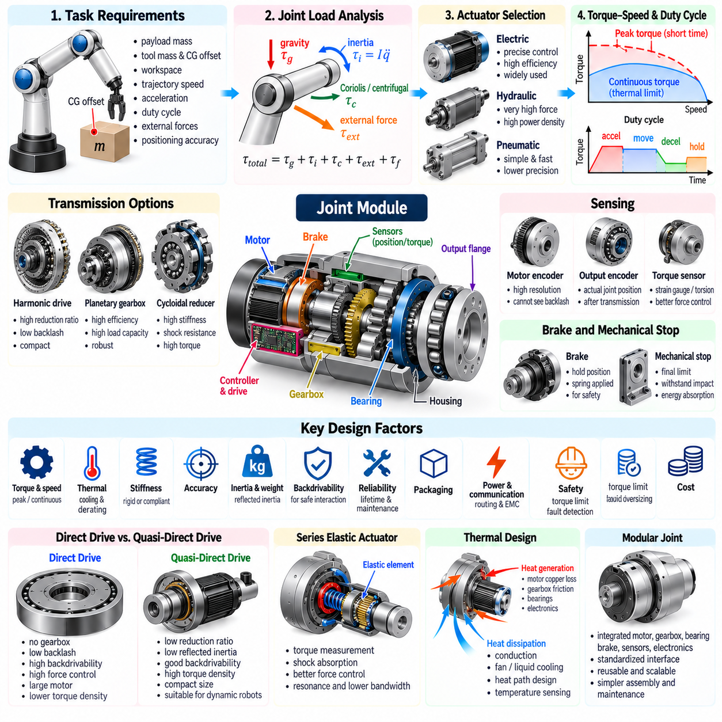
Actuator selection and joint module design determine how effectively a manipulator converts electrical, hydraulic, or pneumatic energy into controlled mechanical motion. The joint module must satisfy torque, speed, acceleration, precision, stiffness, thermal, safety, and packaging requirements simultaneously. Because actuator performance propagates through the entire robot, poor joint design can limit even sophisticated planning and control algorithms.
The design process should begin from task-level requirements rather than from a preferred motor. Payload mass, tool mass, center-of-gravity offset, workspace, trajectory speed, acceleration, duty cycle, external process forces, and required positioning accuracy define the mechanical demands. These requirements are propagated through manipulator kinematics and dynamics to estimate torque-speed profiles for every joint.
Joint loading contains several components that must be evaluated separately. Gravity creates configuration-dependent static torque, acceleration produces inertial torque, joint motion generates Coriolis and centrifugal effects, and contact operations introduce external forces and moments. Friction and transmission losses add further demand. The actuator must handle the combined load rather than a simplified payload value alone.
Peak torque and continuous torque represent different design constraints. Peak torque determines whether the joint can execute short periods of rapid acceleration, disturbance rejection, or high-force interaction. Continuous torque determines whether repeated or sustained operation can occur without excessive heating. Selecting a motor from peak torque alone can produce thermal failure even when instantaneous mechanical performance appears sufficient.
Speed requirements must be evaluated together with torque. Manipulator joints often experience strongly varying torque-speed operating points during a trajectory, so a single rated value cannot describe actuator suitability. A torque-speed envelope should contain expected continuous operation, transient peaks, and appropriate design margins while respecting motor voltage, current, inverter, gearbox, and thermal limitations.
Electric actuators dominate many manipulators because they combine precise controllability, high efficiency, compact power electronics, and mature sensing technology. Brushless DC and permanent-magnet synchronous motors are particularly common. Hydraulic actuators remain valuable when extremely high force density is required, while pneumatic actuators are suitable for simpler compliant or high-speed motions where precise servo behavior is less critical.
Motor torque density is important because actuator mass itself becomes part of the robot load. This effect is especially significant for distal joints, where additional motor and gearbox mass increases the torque required from every upstream joint. Manipulator design therefore often uses smaller actuators near the wrist and progressively larger actuators toward the shoulder and base, while minimizing distal inertia wherever possible.
A reduction gearbox allows a high-speed motor to drive a lower-speed, higher-torque joint. Ideally, output torque increases approximately with reduction ratio while output speed decreases correspondingly. Real transmissions introduce efficiency losses, friction, compliance, backlash, reflected inertia, and thermal effects. The selected gear ratio must therefore balance torque amplification against speed, responsiveness, precision, and backdrivability.
Harmonic drives are widely used in compact robotic joints because they provide large reduction ratios, low backlash, and coaxial packaging. However, torsional compliance, friction, efficiency variation, and fatigue life must be considered. Cycloidal reducers can provide high stiffness and shock capacity, while planetary gearboxes offer high efficiency and robust power transmission across a broad range of sizes.
Reflected inertia is a critical consideration when selecting a transmission. Motor rotor inertia viewed from the output side changes approximately with the square of the reduction ratio. A very high gear ratio can therefore make the joint dynamically stiff and difficult to backdrive even if static torque performance improves. Inertia matching between the motor, transmission, and mechanical load influences acceleration response and control bandwidth.
Backdrivability describes how easily external joint torque can drive the actuator backward through the transmission. High backdrivability is useful for physical human-robot interaction, force control, collision response, and compliant manipulation. Large reduction ratios and high-friction transmissions generally reduce backdrivability, creating a fundamental tradeoff between passive mechanical transparency and compact torque amplification.
Direct-drive joints eliminate or greatly reduce mechanical transmission between the motor and joint output. They can provide low friction, negligible backlash, high force-control fidelity, and excellent backdrivability. Their disadvantages include larger motors, higher current requirements, increased thermal load, and lower torque density at low speed unless large-diameter torque motors are used.
Quasi-direct-drive actuators use relatively low reduction ratios with high-torque-density motors. This architecture seeks a compromise between direct-drive transparency and geared-actuator torque density. It has become important in dynamic robots because low reflected inertia and good backdrivability support impact tolerance, force control, and rapid motion while retaining practical joint dimensions.
Series elastic actuators intentionally place an elastic element between the actuator and output load. Measuring elastic deformation provides an estimate of transmitted torque, while the compliance absorbs shocks and improves force controllability. The added elasticity, however, introduces resonant dynamics and can reduce positioning bandwidth, requiring careful spring selection, sensing, and controller design.
Joint stiffness must match the intended manipulation task. High stiffness is desirable for machining, precise positioning, and disturbance rejection, whereas controlled compliance is valuable for contact-rich manipulation and human interaction. Effective stiffness results from the motor controller, gearbox, bearings, shafts, housing, structural links, and any intentional elastic elements rather than from a single component.
Joint torque sensing can be implemented through motor-current estimation or dedicated mechanical sensors. Current-based estimation is inexpensive but is affected by friction, gearbox losses, motor constants, and temperature. Strain gauges, torsion sensors, or series elastic elements can measure output torque more directly. High-quality torque feedback significantly improves impedance control, collision detection, and contact-force regulation.
Position sensing can be located on the motor side, joint output side, or both. A motor encoder provides high-resolution rotor information but cannot directly observe gearbox backlash or elastic deformation. An output encoder measures the actual joint position after the transmission. Dual-encoder architectures enable estimation of transmission deformation and can improve precision, torque observation, and joint diagnostics.
Absolute encoders are advantageous when the robot must know joint position immediately after startup without performing a homing procedure. Incremental encoders can provide excellent resolution but normally require a reference procedure after power loss. Safety-critical systems may use redundant sensing channels or independent position monitoring to detect encoder faults and maintain safe operating limits.
Bearings determine how radial, axial, and moment loads are transferred through the joint. Robotic joints frequently require compact bearing arrangements capable of supporting multidirectional loads with minimal play. Cross-roller bearings are widely used in precision rotary joints because they can support radial, axial, and overturning loads while maintaining high rigidity and compact dimensions.
The joint housing performs structural, thermal, alignment, and protective functions simultaneously. It maintains precise relationships among motor, reducer, bearings, sensors, and output flange while transmitting loads into neighboring links. Housing deformation can directly reduce end-effector accuracy, so finite-element analysis may be used to evaluate stress, stiffness, resonance, and weight during detailed design.
Thermal design often determines the true continuous capability of a joint. Copper losses, iron losses, gearbox friction, bearings, brakes, and power electronics generate heat. If this heat cannot be transferred through the housing or cooling system, winding temperature rises and available torque must be derated. Compact sealed joints can therefore be thermally limited long before reaching their structural limits.
Passive cooling uses conduction through the joint structure and natural or forced convection to the environment. Higher-performance systems may employ fans, liquid cooling, heat pipes, or thermally conductive structural paths. Temperature sensors embedded near motor windings, bearings, reducers, and electronics support thermal protection and model-based derating during sustained operation.
Brakes are commonly integrated into joints that must hold position safely when power is removed. Spring-applied, electrically released brakes can prevent gravity-driven motion during emergency stops or shutdown. Brake holding torque must exceed expected static loading with suitable margin, but the brake should not normally be treated as a precision motion-control element or repeatedly used to stop high-energy motion.
Mechanical stops provide a final physical limit beyond software joint limits. They must tolerate credible impact energy without damaging critical structures, while normal control should prevent routine contact with them. Buffers, elastomeric elements, or energy-absorbing features may reduce impact loads. Cable routing must also accommodate the entire allowed joint range without excessive twisting or bending.
Power and communication routing becomes increasingly difficult as the number of joints increases. Motors require high-current conductors, sensors require low-noise signal paths, and distributed controllers require deterministic communication. Hollow-shaft actuators, internal cable passages, slip rings, flexible harnesses, and local electronics can simplify routing but introduce packaging, electromagnetic compatibility, reliability, and maintenance considerations.
Distributed joint electronics place motor drives, sensor interfaces, and local control close to each actuator. This reduces centralized wiring and enables modular robot construction. Networks such as EtherCAT or other real-time fieldbuses can synchronize multiple joints with deterministic timing. Local electronics must nevertheless withstand vibration, heat, electromagnetic interference, and constrained cooling conditions.
Joint control bandwidth depends on the combined electromechanical system. Motor electrical dynamics, inverter switching, gearbox compliance, structural resonance, sensor latency, communication delay, and control-loop frequency all influence achievable performance. Increasing feedback gains without understanding these dynamics can excite resonances rather than improve accuracy, making system identification and frequency-response analysis valuable.
Actuator sizing should include realistic design margins but avoid excessive oversizing. An oversized motor increases mass, inertia, cost, power consumption, and upstream joint loading, potentially creating a cascading increase in robot size. An undersized actuator overheats or saturates and cannot maintain trajectory performance. Iterative system-level optimization is therefore preferable to sizing each joint independently.
Duty cycle provides a more realistic sizing criterion than maximum load alone. A manipulator may accelerate rapidly for a short interval, move at moderate torque, decelerate regeneratively, and then remain stationary. Root-mean-square torque can estimate thermal loading over repeated cycles, while peak torque and speed constraints ensure that transient demands remain within actuator and drive capabilities.
Regenerative energy appears when motors decelerate moving links or lower gravitational loads. This energy can be returned to a shared DC bus, stored, dissipated through braking resistors, or potentially reused by other joints. Power-system design must account for regeneration because excessive bus voltage can occur if returned energy has no appropriate path.
Safety influences joint architecture from the beginning of design. Safe torque off, redundant encoders, brakes, mechanical limits, torque monitoring, current limits, temperature protection, and fault diagnostics may all be required depending on the application. Collaborative manipulators additionally benefit from low moving inertia, smooth external geometry, sensitive torque measurement, and predictable collision response.
Reliability depends on repeated mechanical and thermal loading over millions of cycles. Gear teeth, flexsplines, bearings, seals, cables, connectors, brakes, and solder joints can accumulate fatigue or wear. Joint design therefore considers rated life, lubrication, contamination, shock loads, vibration, service intervals, and replacement procedures rather than evaluating only initial performance.
A modular joint can reduce development and maintenance complexity by integrating the motor, transmission, bearing, brake, sensors, electronics, housing, and standardized interfaces into one reusable unit. Several joint sizes can form a scalable family for different robot axes. Standard mechanical, electrical, and software interfaces simplify assembly, spare-parts management, calibration, and future manipulator variants.
Validation should proceed from component tests to integrated joint and robot tests. Motor constants, gearbox efficiency, backlash, torque sensing, encoder accuracy, stiffness, thermal behavior, vibration, braking, and communication can first be characterized independently. Loaded trajectory tests then verify peak performance, continuous duty, control stability, positioning accuracy, safety functions, and long-term reliability.
Successful actuator and joint module design is ultimately a multidisciplinary optimization problem. Torque density, speed, inertia, stiffness, compliance, backdrivability, sensing, thermal performance, safety, reliability, cost, and packaging interact strongly. The best actuator is therefore not the component with the largest torque rating, but the joint system that satisfies the complete manipulation mission with adequate performance margins and minimum unnecessary mass and complexity.

01.08. Compliance and Impedance Properties of Joints
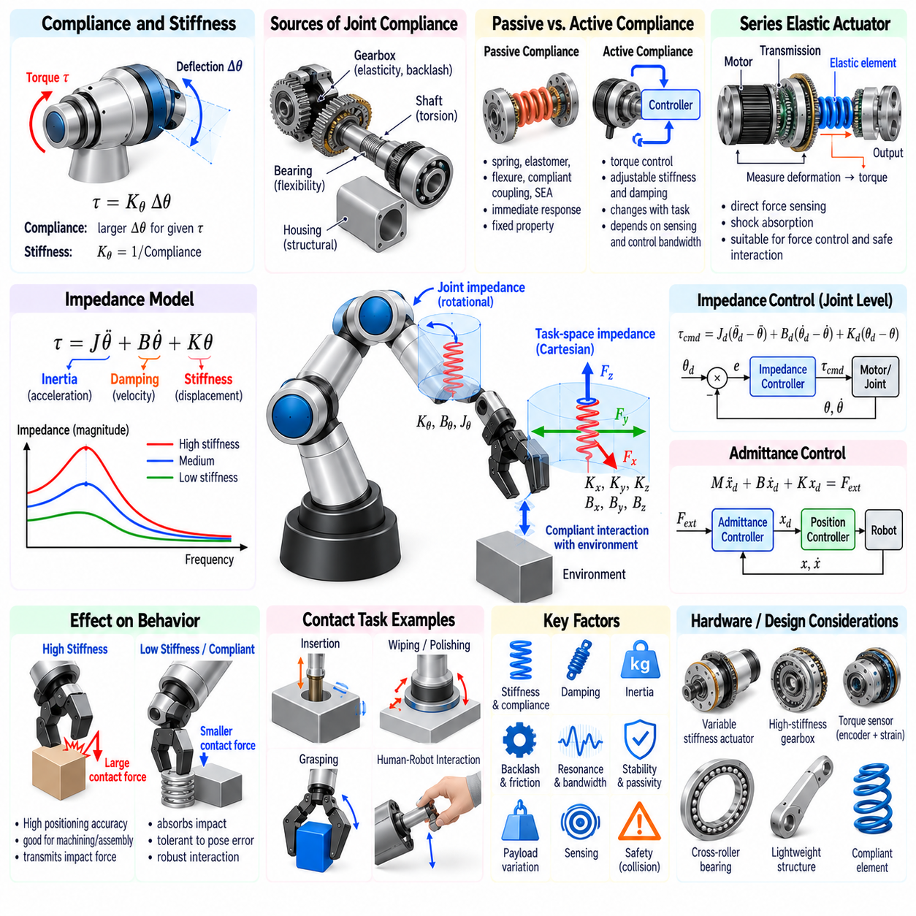
Joint compliance describes the ability of a manipulator joint to deform or yield when external torque is applied. Rather than behaving as an ideally rigid connection, a real joint contains elasticity in gears, shafts, bearings, housings, sensors, and structural interfaces. Compliance strongly influences positioning accuracy, contact behavior, vibration, impact response, force transmission, and the stability of manipulation control.
Stiffness is the inverse concept of compliance and expresses the resistance of a joint to deformation. For a simplified rotational joint, torque and angular deflection may be related by τ = KθΔθ, where Kθ is rotational stiffness. High stiffness produces small deformation under load, while low stiffness allows larger displacement. Real joints often exhibit nonlinear, direction-dependent, and configuration-dependent stiffness rather than a single constant value.
Compliance may be intentional or parasitic. Parasitic compliance arises from gearbox deformation, bearing flexibility, structural bending, backlash, and imperfect mechanical interfaces. Intentional compliance is deliberately introduced using springs, elastic transmissions, flexible elements, or controlled actuators. The engineering objective is therefore not always to maximize stiffness, but to establish the compliance characteristics appropriate for the manipulation task.
A highly rigid joint is advantageous when accurate geometric positioning must be maintained under external load. Machining, precision assembly, metrology, and high-speed trajectory tracking often benefit from high structural stiffness. However, extreme rigidity can transmit impact forces directly through the robot and environment, increasing contact instability, component stress, and potential danger during unexpected collisions.
Compliant joints can absorb mechanical energy during impacts and accommodate small geometric errors during contact. In insertion, grasping, surface following, or human-robot interaction, limited compliance prevents small pose errors from immediately producing large contact forces. This mechanical adaptability can make physical interaction more robust even when perception and geometric models contain uncertainty.
Passive compliance is created by mechanical properties that do not require active control. Springs, elastomers, flexures, compliant couplings, and series elastic elements can provide predictable deformation under load. Passive compliance responds immediately without sensing or computation, which is valuable for impact absorption and safety, but its behavior is constrained by the mechanical design and cannot be changed arbitrarily during operation.
Active compliance is generated through sensing and feedback control. A torque-controlled actuator can intentionally modify its response so that the joint behaves as if it possesses a desired virtual stiffness and damping. Unlike fixed passive elasticity, active control can change compliance according to task phase, contact state, payload, or safety condition. Its performance, however, depends on sensing quality, control bandwidth, latency, and actuator dynamics.
Series elastic actuators place a physical elastic element between the motor-transmission system and the output load. If the spring stiffness is known, measured spring deformation can be converted into transmitted torque. This provides direct force information while reducing shock transmission. The architecture is particularly attractive for robots requiring force control, safe interaction, impact tolerance, or dynamic locomotion and manipulation.
Adding elasticity introduces important dynamic consequences. The motor inertia and load inertia become connected through a spring, creating resonant modes that do not exist in an ideal rigid joint. Increasing compliance can improve impact absorption while reducing achievable position-control bandwidth. Joint design therefore requires a balance among spring stiffness, torque measurement resolution, resonance frequency, motion accuracy, and force-control performance.
Variable-stiffness actuators extend this concept by allowing mechanical stiffness to change during operation. Mechanisms may alter spring preload, geometry, lever arms, or antagonistic actuator forces. Low stiffness can support safe interaction and impact tolerance, while high stiffness can improve positioning and disturbance rejection. The added adaptability is obtained at the cost of greater mechanical complexity, mass, control requirements, and energy consumption.
Joint impedance provides a broader description than stiffness alone. Mechanical impedance relates applied force or torque to resulting motion as a function of frequency and generally includes inertia, damping, and stiffness. A simplified rotational impedance can be represented by τ = Jθ̈ + Bθ̇ + Kθ, where J represents effective inertia, B damping, and K stiffness. Each term dominates different aspects of transient and steady-state behavior.
Inertia determines resistance to acceleration, damping determines resistance related to velocity, and stiffness determines resistance related to displacement. Two joints with identical static stiffness can therefore respond very differently during dynamic contact if their inertia and damping differ. Manipulation performance must consequently be evaluated through dynamic impedance rather than through stiffness measurements alone when transient interaction is important.
Impedance control commands a desired dynamic relationship between motion error and interaction force. Instead of forcing the robot to follow a position trajectory regardless of contact, the controller allows controlled deviation according to specified virtual inertia, damping, and stiffness. The robot can therefore behave softly when encountering an uncertain environment while still maintaining a defined tendency toward the desired trajectory.
At the joint level, an impedance controller can generate actuator torque according to the difference between desired and measured joint position and velocity, together with dynamic compensation. A simple form resembles a virtual spring-damper system. More advanced controllers compensate gravity, inertia, friction, and coupling effects so that the apparent mechanical behavior observed at the joint approaches the commanded impedance.
Cartesian impedance extends the same concept to the end effector. Desired translational and rotational stiffness and damping are defined in task space, and the resulting Cartesian wrench is transformed into joint torques using the Jacobian transpose. This allows the tool to be stiff along directions requiring precision while remaining compliant along directions where contact accommodation or safe interaction is desired.
Directional impedance is particularly valuable for assembly. During peg insertion, for example, the robot may maintain stiffness along the insertion direction while allowing limited lateral and rotational compliance to correct alignment errors. Similar strategies apply to polishing, grinding, wiping, connector insertion, door manipulation, and surface inspection, where different motion directions require different interaction properties.
Joint compliance and Cartesian compliance are related through manipulator kinematics. The end-effector stiffness depends on joint stiffness and the Jacobian, meaning that the same joint settings can produce different Cartesian behavior at different robot configurations. Near singular configurations, this relationship can become poorly conditioned, and stiffness or force capability may vary strongly with direction.
The effective stiffness of a manipulator also includes structural deformation outside the actuated joints. Links bend, bearings deflect, gear teeth deform, tool interfaces move, and the end effector itself may be compliant. A controller that assumes all flexibility exists at the joints may therefore misestimate actual tool displacement. High-precision systems may require experimentally identified whole-arm stiffness models.
Backlash differs from elastic compliance because it creates a region of lost motion rather than a continuous restoring force. Gear clearance can allow motor-side movement without immediate output motion, degrading position accuracy and force estimation. Friction further complicates compliant behavior by introducing hysteresis and stick-slip effects. Joint impedance models should therefore distinguish elasticity, backlash, friction, and damping whenever high fidelity is required.
Hysteresis means that the torque-deflection relationship depends on the previous loading history. Harmonic drives, elastomers, cables, and complex transmissions can exhibit substantial hysteresis. Consequently, unloading may follow a different path from loading. Simple linear spring models cannot fully reproduce this behavior, and compensation may require nonlinear identification, empirical maps, or learned models.
Damping is essential for controlling oscillation in compliant systems. Mechanical damping dissipates energy physically, while active damping can be synthesized through velocity feedback. Insufficient damping allows oscillations after disturbances or contact transitions, whereas excessive damping can make motion sluggish and increase control effort. Appropriate damping is therefore selected together with stiffness rather than treated as an independent afterthought.
Force control and impedance control address related but different objectives. Direct force control attempts to regulate measured interaction force toward a desired value. Impedance control instead regulates the relationship between motion and force, allowing interaction forces to emerge from contact dynamics. Hybrid approaches can control force in constrained directions and position or impedance in unconstrained directions.
Admittance control represents the inverse conceptual relationship. Rather than commanding force from measured motion error, an admittance controller measures external force and generates a motion response according to a virtual mass-damper-spring model. This is often convenient for robots with stiff position-controlled inner loops because compliant behavior can be implemented by modifying the commanded trajectory based on measured forces.
Impedance and admittance implementations have different sensitivity to hardware properties. Torque-controlled, backdrivable robots are naturally suited to impedance control, whereas mechanically stiff industrial robots often use admittance control with a force-torque sensor. Controller selection should therefore reflect actuator transparency, transmission friction, sensor quality, inner-loop architecture, and expected environmental stiffness.
Contact stability depends on the combined impedance of the robot, controller, tool, object, and environment. A controller that behaves well in free space may become unstable against a very stiff surface if delay, sampling, filtering, and structural resonance are significant. Stable interaction therefore requires analysis of the complete coupled physical system rather than tuning the robot independently from its environment.
Control-loop delay can severely reduce the apparent stability of actively compliant joints. Sensor filtering, communication, computation, motor-drive latency, and discrete sampling introduce phase lag. High virtual stiffness combined with delay can generate oscillation or instability during contact. Increasing control frequency, reducing latency, applying appropriate damping, and respecting passivity constraints can improve robustness.
Passivity provides an important framework for safe physical interaction. A passive system cannot generate unlimited net mechanical energy from internal control behavior. Designing controllers to preserve or monitor passivity can improve stability when interacting with uncertain environments or humans. Energy tanks, passivity observers, and passivity controllers are examples of techniques used to manage energy exchange in advanced interaction control.
Collision behavior is strongly influenced by joint impedance. Lower reflected inertia, higher backdrivability, controlled compliance, and rapid torque sensing can reduce peak collision forces. However, making a robot extremely soft is not always safer because poor trajectory control or large deflections may create other hazards. Safety design must combine mechanical properties, sensing, control limits, speed restrictions, and collision detection.
Payload changes alter effective impedance because additional mass and inertia modify dynamic response. A controller tuned for an empty gripper may behave differently while carrying a heavy or extended object. Payload identification and gain adaptation can therefore be important for maintaining consistent interaction behavior. Tool stiffness and grasp stability must also be included because they form part of the mechanical chain.
Compliance can improve robustness to uncertainty but cannot replace accurate perception and planning. Excessive compliance may allow large pose errors, reduce task precision, or create ambiguous contact states. Effective manipulation uses compliance to tolerate bounded uncertainty while perception, estimation, and planning maintain the task within a region where compliant behavior can successfully accommodate residual errors.
Joint impedance should be characterized experimentally rather than inferred only from component specifications. Static torque-deflection tests estimate stiffness, dynamic excitation identifies resonance and damping, and impact tests reveal transient behavior. Frequency-response measurements can expose structural modes and control limitations. Testing across temperature, payload, joint position, and motion direction reveals nonlinearities hidden by nominal values.
Simulation of compliant manipulators requires models that represent the relevant elastic and dissipative effects. Rigid-body simulation may be sufficient for slow motion with high joint stiffness, but series elasticity or flexible transmissions may require additional states. Contact models must also be selected carefully because unrealistically stiff numerical contacts can produce behavior that differs significantly from physical hardware.
Design validation should connect component-level compliance to task-level performance. A joint may satisfy its specified stiffness while the complete arm still deflects excessively because several compliant elements accumulate. Conversely, some compliance may improve insertion success or reduce impact force. Evaluation should therefore include positioning under load, force tracking, contact transitions, disturbance recovery, and representative manipulation tasks.
The optimal joint is neither perfectly rigid nor universally soft. Its mechanical and controlled impedance should match the physical interaction requirements of the robot. By coordinating structural stiffness, transmission elasticity, sensing, backdrivability, damping, torque control, and task-space impedance, a manipulator can achieve both precise free-space motion and robust, safe, adaptable contact with the physical world.

01.09. Manipulation Safety Standards ISO 10218 TS 15066
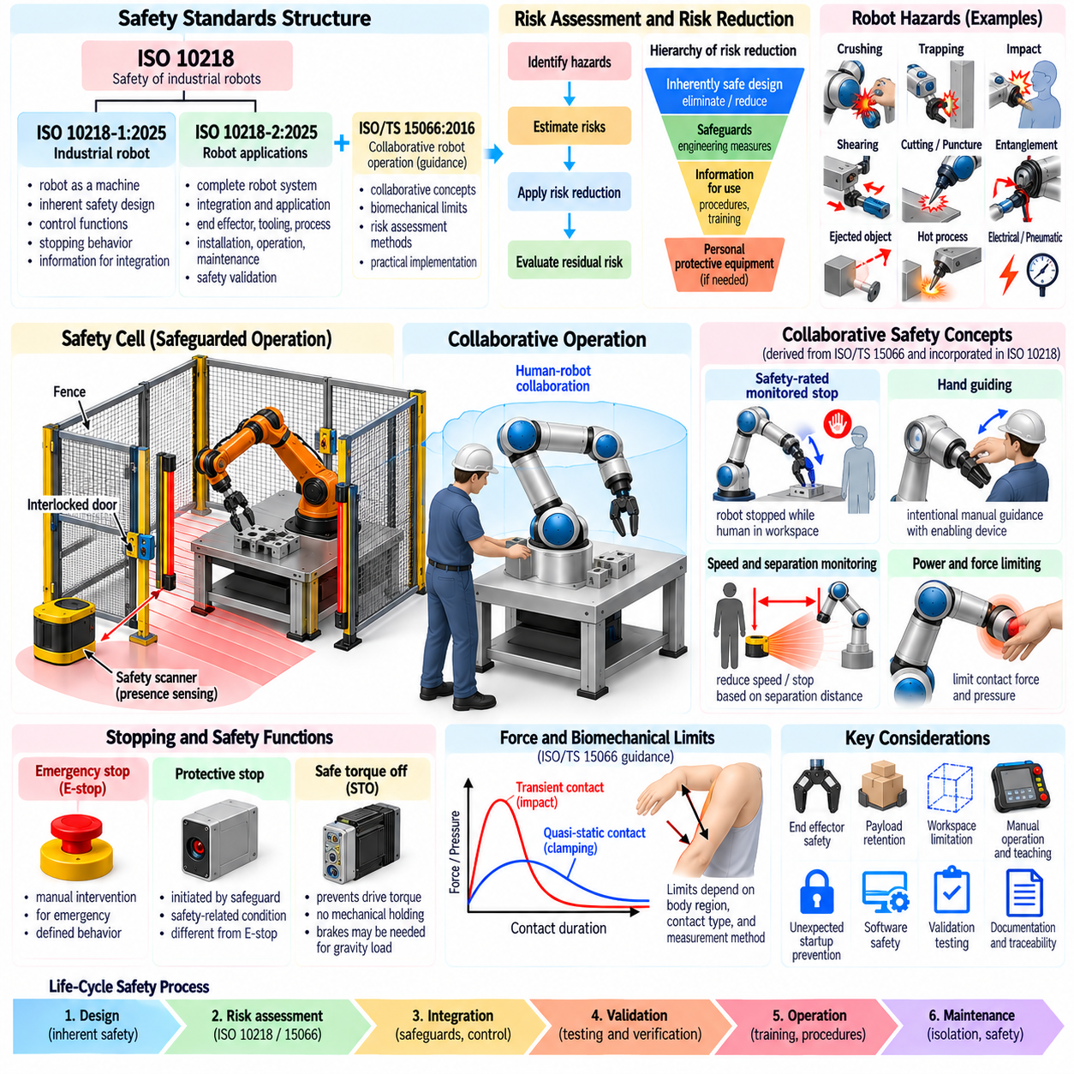
Manipulation safety begins with the principle that a robot system must be designed around foreseeable hazards rather than relying only on intelligent control. Industrial manipulators can generate large forces, high speeds, stored mechanical energy, and unexpected motion. Safety therefore requires coordinated mechanical design, electrical protection, functional safety, risk assessment, integration procedures, and operational controls throughout the system life cycle.
ISO 10218 provides the principal international framework for industrial robot and robot-system safety. The 2025 revision reorganized and updated the requirements into ISO 10218-1:2025 for industrial robots and ISO 10218-2:2025 for industrial robot applications and robot cells. The standards distinguish responsibilities associated with the robot product itself from those associated with integrating that robot into a complete application.
ISO 10218-1 addresses safety requirements associated with the industrial robot as a machine. It covers hazards created by robot motion, control functions, stopping behavior, interfaces, operating modes, protective functions, and information required for safe integration. Compliance at the robot level does not automatically make the completed workcell safe because tooling, fixtures, processes, layout, and human access introduce additional hazards.
ISO 10218-2 focuses on the integration and application of industrial robots. It considers the complete robot system, including end effectors, workpieces, peripheral equipment, safeguards, control interfaces, installation, commissioning, operation, maintenance, and decommissioning. The integrator must evaluate how these elements interact rather than treating the robot manufacturer's safety functions as a complete application-level solution.
Risk assessment is the foundation of manipulation safety. The process identifies hazards, estimates associated risks, applies risk-reduction measures, and evaluates the residual risk. Hazard analysis must consider normal production as well as setup, teaching, cleaning, troubleshooting, recovery, maintenance, tool changes, foreseeable misuse, and failure conditions because many human-robot interactions occur outside automatic production.
Risk reduction generally follows a hierarchy. Hazards should first be eliminated or reduced through inherently safe design wherever reasonably practicable. Remaining risks are addressed using engineering safeguards and protective measures, followed by information for use, procedures, training, and personal protective equipment where appropriate. Administrative instructions should not substitute for feasible engineering protection against significant mechanical hazards.
Robot hazards include crushing, trapping, impact, shearing, cutting, puncture, entanglement, and ejection of objects. Manipulation applications add hazards from grippers, sharp tools, hot processes, payloads, stored pneumatic or hydraulic energy, electrical systems, and unexpected release of workpieces. Safety analysis must therefore examine the complete application and not only the robot arm.
Safeguarded industrial robot cells traditionally separate people from hazardous automatic motion using physical guards, interlocked doors, presence-sensing devices, or other protective equipment. When a person enters a hazardous area, safety-related functions stop or prevent dangerous motion. Guard geometry and access control must also prevent reaching around, under, over, or through protection toward hazardous machinery.
Emergency stopping and protective stopping serve different purposes. An emergency stop is intended for emergency situations requiring deliberate intervention, while a protective stop is initiated by a safeguarding function or safety-related condition. Their required behavior must be defined within the machine's safety architecture. Neither should be treated as the normal production method for controlling routine robot motion.
Stopping performance is fundamental because protective distances depend on how far the robot and associated machinery move after a stop is initiated. Total stopping behavior includes sensing delay, safety logic response, communication delay, drive reaction, brake behavior, mechanical dynamics, payload, speed, and configuration. Stop time and stop distance should therefore be measured or validated under representative worst-case operating conditions.
Functional safety concerns the reliability of safety-related control functions. Examples include safe stopping, speed monitoring, position or workspace limitation, enabling devices, and prevention of unexpected startup. Safety functions must achieve a risk-appropriate performance level or integrity according to the applicable safety-control framework, commonly involving standards such as ISO 13849-1 or IEC 62061.
Safe Torque Off, commonly abbreviated STO, prevents a drive from generating torque capable of producing hazardous motion. STO is widely implemented in servo drives and can be an important element of a safety architecture, but it does not necessarily provide mechanical holding. A gravity-loaded robot axis may therefore require brakes or other measures to prevent movement after motor torque has been removed.
Collaborative robot operation changes how separation between humans and robot systems is managed, but it does not eliminate the need for risk assessment. A robot marketed as collaborative does not automatically create a safe collaborative application. The end effector, payload, workpiece, surrounding structures, process hazards, robot speed, contact geometry, and foreseeable human behavior all contribute to application-level risk.
ISO/TS 15066:2016 was developed to supplement the earlier collaborative-operation provisions of ISO 10218 by providing detailed guidance for collaborative industrial robot applications. It became widely known for practical information concerning collaborative methods, biomechanical contact considerations, and risk assessment. The collaborative concepts associated with it strongly influenced engineering practice and later standardization work.
The 2025 revision of ISO 10218 incorporates updated collaborative-application requirements into the main industrial robot safety framework. Consequently, engineers should verify which edition and regional adoption apply to a specific project rather than assuming that ISO/TS 15066 is always the sole or current governing document. Customer requirements, certification schemes, and national regulations may additionally influence compliance.
Collaborative operation has historically been organized around several safety concepts. These include safety-rated monitored stop, hand guiding, speed and separation monitoring, and power and force limiting. These concepts describe different ways of controlling hazardous interaction, and an application may combine more than one depending on the task, workspace, robot capability, and identified risks.
Safety-rated monitored stop allows a person to enter or remain in the collaborative workspace while hazardous robot motion is stopped and monitored by safety-related controls. Production motion does not simply continue as normal beside the person. The system must reliably detect the relevant state and prevent unsafe restart until the conditions defined by the safety design are satisfied.
Hand guiding allows an operator to intentionally command robot motion through an appropriate guiding device or interface. Safety depends on controlled speed, suitable enabling behavior, predictable motion, and protection from surrounding hazards. Hand guiding should not be confused with manually pushing any powered robot arm without a defined safety-related operating concept.
Speed and separation monitoring maintains sufficient separation between a person and hazardous robot motion. Human position may be detected using safety laser scanners, vision systems, or other protective sensing technologies. Robot speed or motion is reduced as separation decreases, and protective stopping occurs when the required protective separation can no longer be maintained.
Protective separation is not a fixed universal distance. It depends on human approach speed, robot motion, system reaction time, robot stopping time, positional uncertainty, sensor uncertainty, and additional margins. A system moving faster or stopping more slowly generally requires greater separation. Dynamic separation monitoring therefore requires reliable sensing and validated stopping-performance information.
Power and force limiting permits certain forms of physical contact when the resulting mechanical exposure is reduced to acceptable levels for the assessed application. Robot mass, reflected inertia, speed, joint torque limits, contact area, body region, tool geometry, and whether a person can become trapped all influence injury risk. Limiting motor torque alone is therefore insufficient to establish safe contact.
Transient contact and quasi-static contact represent different mechanical situations. Transient contact allows the body to move away after impact, whereas quasi-static contact can trap or clamp part of the body between the robot and another surface. Quasi-static situations can be particularly hazardous because force may persist. Cell layout should therefore minimize trapping and crushing geometries even when force-limited robots are used.
Biomechanical limits associated with collaborative safety should be applied carefully. Permissible values depend on contact type, body region, measurement method, and applicable standard or assessment procedure. They should not be reduced to one universal force threshold. Validation may require specialized force and pressure measurement equipment that reproduces relevant mechanical characteristics of human contact.
End-effectors are critical to manipulation safety because they directly interact with objects and frequently approach humans or fixtures. A low-force robot equipped with a sharp tool, pointed gripper, hot component, or heavy workpiece can remain hazardous. Tool shape, accessible edges, pinch points, gripping force, stored energy, object retention, and failure behavior must therefore be included in risk assessment.
Dropped or ejected payloads require explicit consideration. A gripper can lose power, suffer sensor failure, encounter unexpected geometry, or release an object during an emergency condition. Mechanical retention, redundant gripping, vacuum monitoring, check valves, payload detection, or safe trajectories may be needed depending on the consequence of release. Human access below suspended payloads deserves particular attention.
Safe workspace limitation can reduce risk by preventing the robot from entering defined regions. Safety-rated position or axis limiting may complement physical guards and workcell layout, provided the function is implemented and validated at the required safety level. Software limits used only for normal motion planning should not automatically be assumed equivalent to safety-rated workspace restriction.
Manual operation and teaching introduce different risks from automatic production. Operators may stand close to the robot while commanding motion, so reduced speed, enabling devices, mode selection, and prevention of unintended automatic startup become important. Teach pendants and other manual interfaces should provide predictable authority over motion and support safe recovery from abnormal situations.
Unexpected startup is a major maintenance hazard. Isolation procedures must address electrical, pneumatic, hydraulic, gravitational, spring, and other stored energy sources. Lockout or equivalent energy-isolation practices may be required before personnel enter locations where unexpected movement could cause injury. Control-commanded stopping alone is not necessarily sufficient for mechanical maintenance.
Safety-related software requires disciplined engineering because faults can arise from incorrect requirements, configuration, communication, parameter changes, or integration errors as well as hardware failure. Safety parameters such as maximum speed, workspace boundaries, payload assumptions, and stopping limits should be controlled, documented, verified, and protected against unauthorized or accidental modification.
Validation demonstrates that implemented protective measures actually achieve their intended safety functions. Testing may include interlocks, emergency stops, protective stops, enabling devices, safe speed limits, safe position limits, brakes, sensing coverage, restart prevention, and stopping performance. Fault conditions should also be considered where required rather than validating only normal operating behavior.
Documentation provides traceability between identified hazards and implemented safeguards. A robust safety file records system boundaries, risk assessments, safety requirements, safety-function architecture, calculations, device specifications, configuration parameters, validation results, residual risks, and operating instructions. Changes to tooling, payload, software, layout, or process conditions should trigger review when they can affect the original assessment.
Manipulation safety is therefore a system property rather than a feature of a single robot component. ISO 10218 establishes the industrial robot and application safety framework, while collaborative guidance developed through ISO/TS 15066 remains important context for contact-oriented engineering. Safe deployment requires risk-based integration of mechanics, controls, sensing, stopping performance, workspace design, validation, documentation, and disciplined operation.

01.10. Manipulation Platforms Industrial Cobot Mobile
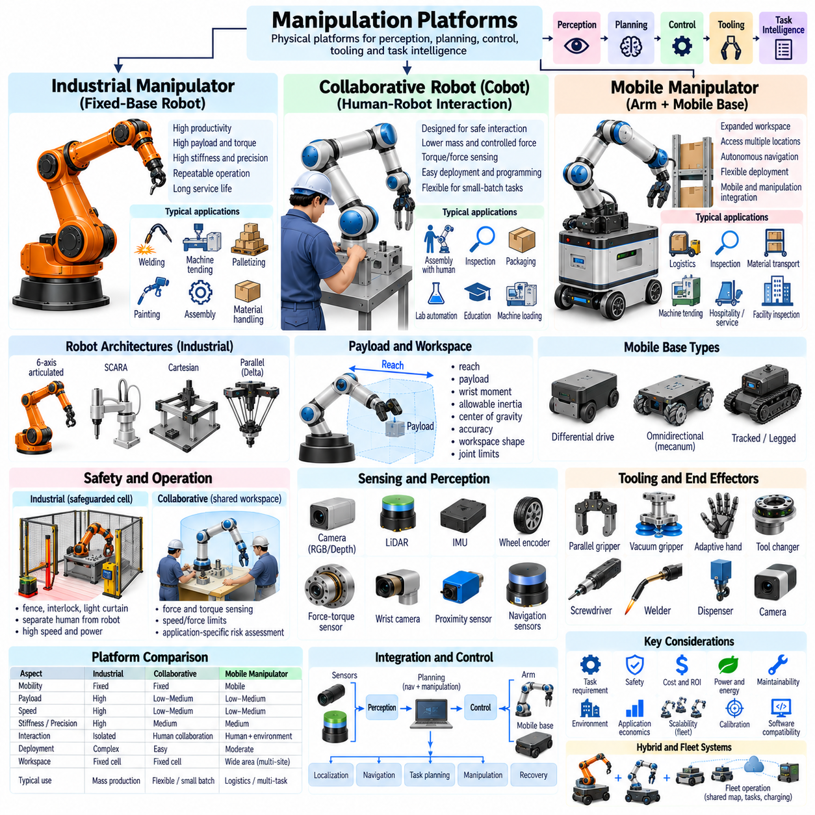
Manipulation platforms provide the physical foundation on which perception, planning, control, tooling, and task intelligence operate. Platform architecture determines workspace, payload, precision, mobility, interaction capability, cycle time, and deployment complexity. Industrial manipulators, collaborative robots, and mobile manipulators represent three major platform classes, each optimized for different relationships among productivity, flexibility, safety, and environmental reach.
An industrial manipulator is typically a fixed-base robotic arm designed for repeatable operation within a defined workcell. Six-axis articulated robots dominate many applications because they provide general three-dimensional position and orientation control. Other industrial architectures include SCARA, Cartesian, parallel, and Delta robots. Their mechanical structures are selected according to process geometry, payload, speed, stiffness, and precision requirements.
Traditional industrial robots emphasize high productivity, structural rigidity, repeatability, and long service life. Their actuators and transmissions can generate substantial joint torque, enabling handling of heavy payloads and execution of demanding processes. Welding, machine tending, palletizing, painting, assembly, material handling, dispensing, and inspection are representative applications where predictable workspaces and repetitive production justify fixed automation.
Fixed installation provides important mechanical advantages. The robot base can be rigidly attached to a floor, machine frame, pedestal, wall, or overhead structure, producing a stable reference for calibration and high-speed motion. Utilities, safety equipment, tooling, and material flow can be designed around a known workspace. This enables high process consistency but reduces the ability to relocate the manipulator dynamically between distant tasks.
Industrial robot payload classes range from small arms for electronics assembly to large manipulators capable of handling hundreds of kilograms. Payload rating alone does not define capability because reach, wrist moment, allowable inertia, center-of-gravity offset, acceleration, and process forces also constrain operation. A platform should therefore be selected using the complete tool-and-workpiece load case rather than nominal object mass.
Reach and workspace define where the manipulator can perform useful work. A long-reach robot can service larger machines or multiple stations but generally introduces greater structural mass and joint loading. Workspace shape is also configuration dependent, and internal singularities, joint limits, collision zones, and tool geometry can remove apparently reachable regions. Cell design should therefore use task-specific reachability analysis.
Industrial manipulators commonly operate inside safeguarded cells when their speed, force, process, or tooling presents unacceptable risk to nearby personnel. Fences, interlocked doors, light curtains, scanners, and safety-related controls regulate access. This separation enables the robot to exploit high speed and power while maintaining safety through controlled human exclusion from hazardous automatic operation.
Collaborative robots, commonly called cobots, are designed to support applications where closer human-robot interaction is required. Their hardware often emphasizes lower moving mass, torque sensing, smooth external surfaces, controlled joint forces, and safety-related monitoring. However, collaborative capability is an application property rather than a guarantee that every task performed by a cobot is safe without additional protective measures.
Cobots are particularly attractive for flexible manufacturing environments where operators and robots may share production activities. A human can perform perception-intensive, dexterous, or judgment-based steps while the robot performs repetitive positioning, handling, inspection, or machine interaction. This division of work can automate processes that are difficult to justify using a fully isolated high-volume robot cell.
Ease of deployment is an important characteristic of many collaborative platforms. Graphical programming, hand-guided teaching, integrated force sensing, modular grippers, and simplified peripheral interfaces can reduce commissioning effort. These features make cobots useful for small-batch production, laboratory automation, education, inspection, packaging, and applications where task configurations change more frequently than in traditional fixed automation.
Collaborative platforms usually trade some payload, speed, and structural stiffness for interaction capability and deployment flexibility. Lower joint torque or speed limits can reduce mechanical exposure, while lightweight structures improve backdrivability and collision response. Nevertheless, sharp tools, heavy workpieces, trapping geometries, hot processes, or high-speed end effectors can make a cobot application hazardous regardless of the robot's intrinsic features.
Force and torque sensing is especially valuable in collaborative and contact-rich manipulation. Joint torque sensors or end-effector force-torque sensors can detect unexpected contact, regulate interaction forces, support hand guiding, and implement impedance behavior. Accurate sensing also enables assembly tasks such as insertion, surface following, connector engagement, and compliant alignment where purely position-controlled motion may be unreliable.
A mobile manipulator combines a robotic arm with a mobile base, extending manipulation from a fixed workspace to a larger operational environment. The base may be an autonomous mobile robot, automated guided vehicle, omnidirectional platform, tracked vehicle, or legged system. Mobility allows one manipulation platform to access multiple machines, shelves, rooms, workstations, or inspection locations rather than remaining at one fixed cell.
The fundamental advantage of mobile manipulation is expanded workspace. A fixed arm is limited by its geometric reach, whereas a mobile manipulator can reposition its base and create a sequence of local manipulation workspaces. This transforms manipulation planning into a combined mobility and arm-placement problem in which navigation, base pose, arm configuration, visibility, collision avoidance, and task feasibility must be considered together.
Mobile bases introduce uncertainty that fixed manipulators largely avoid. Localization error, floor irregularity, wheel slip, suspension motion, docking tolerance, and structural compliance can change the relationship between the arm and target. High-precision tasks may therefore require accurate docking, visual servoing, fiducial localization, force-guided alignment, or local recalibration before manipulation begins.
Differential-drive mobile bases are mechanically simple and efficient but cannot translate laterally without reorientation. Omnidirectional platforms using mecanum or specialized wheel arrangements can move in multiple planar directions and simplify precise base placement in constrained spaces. Their greater maneuverability must be balanced against wheel complexity, floor sensitivity, vibration, load capacity, and localization behavior.
The manipulator and mobile base cannot always be treated as independent subsystems. Arm motion shifts the system center of mass and can generate reaction forces that affect the base. A long horizontal reach with a heavy payload may reduce stability or exceed wheel traction and structural limits. Platform design must therefore evaluate the combined dynamic system, particularly for high acceleration, heavy payloads, or narrow mobile bases.
Static stability can be evaluated by considering the projected center of mass relative to the support polygon. Dynamic motion adds inertial forces and moments that can reduce the stability margin further. Mobile manipulators may restrict arm configurations, payload, speed, or acceleration according to base orientation and extension. Active outriggers or stabilizers can be used when high manipulation forces are required.
Power architecture is another major distinction between fixed and mobile platforms. Fixed industrial robots can rely on continuous facility power, whereas mobile manipulators must usually share onboard battery energy among locomotion, arm actuators, sensors, computers, communication systems, and accessories. Energy-aware task planning becomes important because intensive manipulation and frequent base acceleration can significantly reduce mission duration.
Mobile manipulation also requires coordinated communication and computation. Navigation, localization, perception, arm planning, grasping, safety monitoring, and low-level control may operate at different frequencies and computational levels. Real-time joint control typically remains close to the actuators, while higher-level planning may run on onboard computers or connected infrastructure. Reliable synchronization and state estimation are essential for coherent behavior.
Perception requirements differ among platform types. A fixed industrial cell can use carefully calibrated cameras and known fixtures because the geometry changes little over time. Cobots often require perception that accommodates human activity and changing workpieces. Mobile manipulators require broader environmental perception for navigation as well as local high-resolution sensing for object localization, grasping, docking, and contact tasks.
Sensor placement must consider both navigation and manipulation. Mobile platforms may use LiDAR, depth cameras, RGB cameras, IMUs, wheel encoders, and localization sensors on the base, while wrist cameras and force-torque sensors provide detailed local information near the task. Combining global and local sensing allows the robot to approach a target approximately and then refine alignment before physical interaction.
Calibration becomes more complex as platform flexibility increases. A fixed robot may require base, tool, camera, and workpiece calibration. A mobile manipulator additionally requires accurate relationships among navigation frames, mobile-base frames, arm-base frames, onboard sensors, and temporary task frames. Calibration errors across this chain can accumulate and produce substantial end-effector error even when individual subsystems appear accurate.
Task planning for fixed industrial robots can often assume a known environment and predefined work sequence. Collaborative systems must additionally account for human presence and potentially changing task ownership. Mobile manipulators require hierarchical planning across navigation, base positioning, arm motion, grasp selection, manipulation, and recovery. The platform architecture therefore strongly influences software complexity.
Recovery behavior is especially important outside tightly controlled industrial cells. A mobile manipulator may encounter blocked paths, moved objects, localization uncertainty, failed grasps, inaccessible targets, or occupied workstations. Robust deployment requires the ability to detect failure, retreat safely, reposition, re-perceive, retry, request assistance, or select an alternative task rather than assuming every planned action succeeds.
Tooling remains central across all platform categories. Parallel-jaw grippers, vacuum grippers, adaptive hands, screwdrivers, welding tools, dispensers, cameras, and specialized process equipment transform a general arm into a task-specific machine. Automatic tool changers can increase flexibility, but they add mass, calibration requirements, utilities, locking mechanisms, storage infrastructure, and failure modes that must be managed.
End-effector interfaces should provide mechanical attachment, electrical power, communication, pneumatic or hydraulic services where required, and a repeatable tool coordinate frame. Standardized interfaces simplify tool replacement and platform reuse. For mobile manipulators, tool weight is especially important because it affects arm payload, base stability, energy consumption, and achievable reach simultaneously.
Industrial, collaborative, and mobile platforms can increasingly share common software components despite different mechanical architectures. Robot description models, kinematics libraries, trajectory planners, perception pipelines, device interfaces, and task planners can be reused when hardware abstraction is well designed. However, safety functions and real-time control constraints must remain consistent with the specific physical platform and certified architecture.
Hybrid systems blur the boundaries among platform categories. A high-performance industrial arm may be mounted on an autonomous mobile base, a collaborative arm may operate at a docked workstation, or a mobile manipulator may use stabilizers to temporarily behave like a fixed machine. Platform classification is therefore less important than understanding which capabilities and constraints apply during each operational mode.
Fleet deployment extends mobile manipulation from one robot to a coordinated infrastructure. Multiple robots can share maps, task queues, charging stations, elevators, tools, and work resources. Fleet orchestration must prevent traffic conflicts while assigning manipulation tasks according to robot capability, battery state, tool availability, location, and workload. This introduces system-level optimization beyond individual robot control.
Application economics also influence platform selection. A fixed industrial robot may require substantial cell engineering but provide excellent throughput over long production runs. A cobot can reduce integration effort for variable tasks, while a mobile manipulator may replace several fixed installations by traveling between stations. Total cost should include tooling, safety systems, integration, floor modifications, maintenance, programming, downtime, and utilization.
Performance evaluation should therefore use task-level metrics rather than comparing platforms only by payload or reach. Relevant measures include cycle time, successful grasp rate, positioning accuracy, contact-force quality, uptime, human intervention rate, navigation success, docking repeatability, energy per task, changeover time, and recovery success. The importance of each metric depends on the intended operational environment.
A platform should also be evaluated for maintainability and scalability. Modular joints, replaceable sensors, standardized tools, accessible batteries, diagnostic interfaces, and software configuration management reduce lifecycle cost. Mobile systems additionally require maintenance of wheels, suspension, charging contacts, navigation sensors, and wireless communication. Reliability becomes increasingly important as robots operate for longer periods without direct supervision.
Industrial manipulators, cobots, and mobile manipulators should ultimately be viewed as complementary rather than competing technologies. Fixed industrial platforms maximize performance in structured production, collaborative platforms emphasize adaptable human-centered automation, and mobile platforms extend manipulation across spatially distributed tasks. Selecting the appropriate platform requires matching mechanical architecture, sensing, safety, autonomy, and operational economics to the complete manipulation mission.

