Volume 17 Manipulation and Grasping AI

Chapter 04. Object Pose Estimation

04.01. 6DoF Object Pose Estimation Problem and Methods
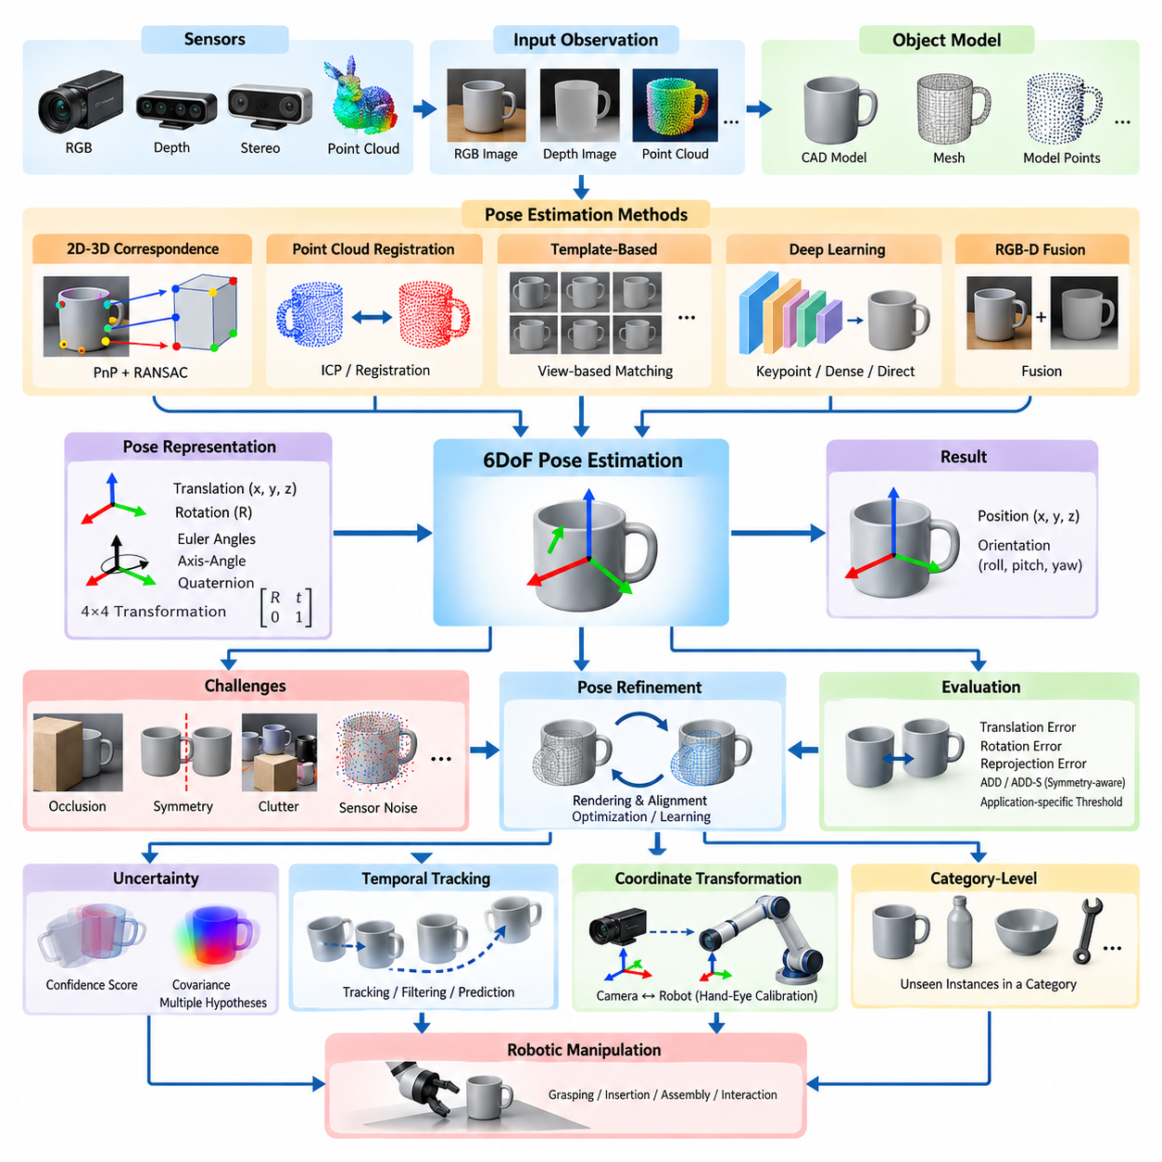
Six-degree-of-freedom object pose estimation determines the three-dimensional position and orientation of an object relative to a reference coordinate frame. The six degrees of freedom consist of three translational components along the x, y, and z axes and three rotational components describing orientation. This capability allows a robot to understand not only where an object is located but also how it is oriented in space.
In robotic manipulation, pose estimation forms a critical bridge between perception and physical action. Object detection may identify that a target object exists within an image, but manipulation requires substantially richer geometric information. A robot must determine the object's spatial transformation relative to the camera, robot base, or end-effector before it can calculate collision-free reaching, grasping, insertion, or assembly motions.
A 6DoF pose is commonly represented by a rigid-body transformation belonging to the special Euclidean group SE(3). The transformation combines a three-dimensional translation vector with a 3 × 3 rotation matrix belonging to SO(3). Alternative orientation representations include Euler angles, axis-angle coordinates, and unit quaternions, while homogeneous 4 × 4 transformation matrices provide a convenient representation for chaining coordinate transformations.
The fundamental estimation problem can be expressed as recovering the transformation between an object's coordinate system and the camera coordinate system from available sensor observations. Depending on the application, observations may include RGB images, depth measurements, point clouds, stereo images, or combinations of these modalities. Known camera calibration parameters are normally required to convert image observations into geometrically meaningful spatial relationships.
Model-based pose estimation assumes that geometric information about the target object is available beforehand. This information may be represented as a CAD model, polygon mesh, point cloud, or collection of characteristic three-dimensional features. The observed scene is compared with the known model, and the transformation producing the strongest geometric or visual correspondence is selected as the estimated object pose.
A classical approach establishes correspondences between known three-dimensional object points and their two-dimensional projections in an image. Once sufficient 2D–3D correspondences have been obtained, the Perspective-n-Point problem can be solved to estimate camera-relative object pose. Practical systems frequently combine PnP algorithms with RANSAC so that incorrect feature correspondences and image outliers do not dominate the estimated transformation.
Depth cameras and three-dimensional sensors enable pose estimation directly from geometric structure. Local or global features can establish correspondences between an observed point cloud and an object model, after which rigid registration estimates their relative transformation. Iterative Closest Point can further refine an initial estimate by repeatedly minimizing geometric distances between corresponding surfaces, although its performance depends strongly on initialization and visible geometry.
Template-based methods compare sensor observations against representations generated from known object poses. A database may contain RGB appearance, depth structure, surface normals, edges, or synthetic renderings corresponding to many viewpoints. During inference, the observation is matched against these templates to obtain candidate poses. Such methods can be effective for textureless industrial objects where conventional visual feature extraction is unreliable.
Deep learning changed pose estimation by learning object representations directly from training data rather than depending entirely on manually designed geometric features. Neural networks may predict keypoints, object coordinates, rotation and translation parameters, dense correspondences, or intermediate representations used by geometric solvers. Modern pipelines often combine learned perception with explicit geometry because the two approaches provide complementary strengths.
Keypoint-based neural approaches detect semantically or geometrically meaningful points associated with an object, such as corners, holes, joints, or predefined CAD landmarks. The predicted image coordinates are associated with their known three-dimensional locations, allowing a PnP solver to recover the final pose. Separating learned keypoint detection from geometric pose recovery can improve interpretability and enforce physically meaningful camera constraints.
Dense correspondence methods predict object-related information for many pixels instead of relying on a small set of sparse landmarks. Each visible pixel may be mapped to a coordinate on the object's three-dimensional model, creating numerous potential 2D–3D correspondences. Robust geometric estimation can then recover the pose even when some regions are occluded, corrupted, or incorrectly predicted, making dense approaches attractive for cluttered manipulation scenes.
Direct regression methods attempt to predict translation and rotation from image features in a single learned mapping. Their conceptual simplicity can support efficient inference, but rotation representation, generalization, and geometric accuracy require careful treatment. Hybrid architectures therefore frequently predict coarse pose hypotheses first and subsequently refine them using image evidence, depth geometry, rendered models, or differentiable alignment procedures.
RGB-D pose estimation combines complementary appearance and geometry. RGB information provides texture, color, boundaries, and semantic cues, while depth measurements reveal metric distance and three-dimensional surface structure. Fusion may occur at the input, feature, correspondence, or hypothesis level. For robotic manipulation, RGB-D sensing is especially valuable because accurate translation and surface geometry directly affect grasp approach and contact positioning.
Occlusion is one of the central difficulties in practical pose estimation. In cluttered environments, only a fraction of the target object's surface may be visible because other objects, robot components, containers, or fixtures block the sensor view. Robust methods must infer pose from partial observations while distinguishing true object evidence from background geometry. Multi-view sensing can reduce ambiguity by observing the object from different viewpoints.
Object symmetry introduces another fundamental challenge. Cylinders, boxes, gears, bottles, and many manufactured components can possess rotational or reflective symmetries that make multiple poses visually or geometrically indistinguishable. A predicted orientation that differs numerically from the annotated pose may therefore represent an equivalent physical configuration. Symmetry-aware training losses and evaluation metrics are necessary to avoid incorrectly penalizing valid pose estimates.
Pose refinement improves an initial estimate by aligning the hypothesized object configuration with sensor observations. A model can be rendered at the estimated pose and compared with the measured RGB or depth data, allowing residual errors to generate corrective updates. Refinement may use geometric optimization, neural networks, differentiable rendering, or combinations of these techniques and is particularly important when manipulation requires millimeter-scale positioning accuracy.
Pose-estimation accuracy must be evaluated in terms relevant to downstream robotic behavior. Common metrics measure translation error, rotation error, reprojection error, or distances between transformed model points. Metrics such as ADD compare the positions of model vertices under estimated and ground-truth transformations, while symmetry-aware variants consider equivalent configurations. Application-specific thresholds should reflect the tolerances of the manipulation task.
Real robotic systems must also address uncertainty rather than treating every pose estimate as exact. Sensor noise, calibration error, motion blur, reflective surfaces, limited resolution, occlusion, and ambiguous geometry all contribute to uncertainty. Confidence scores, covariance estimates, multiple pose hypotheses, or probabilistic distributions can communicate this uncertainty to grasp planning and motion planning modules, enabling safer decisions when perception is unreliable.
Coordinate-frame management is equally important because the estimated camera-relative pose must eventually be expressed in coordinates meaningful to the robot controller. Camera calibration determines intrinsic imaging parameters, while extrinsic calibration relates the camera to the robot base or end-effector. Hand-eye calibration is therefore a fundamental component of manipulation systems, and small calibration errors can propagate into significant positioning errors at the gripper.
Temporal information provides another opportunity for improving robustness. Instead of estimating every video frame independently, a robot can track object pose over time and exploit motion continuity. Filtering, optimization, learned tracking, and prediction models can combine successive observations to suppress noise and recover temporarily occluded objects. Dynamic manipulation additionally requires estimating object velocity and predicting future pose at the intended interaction time.
Category-level pose estimation extends the problem beyond objects with exact CAD models. Rather than recognizing one specific instance, the system must estimate the pose of previously unseen objects belonging to a semantic category such as mugs, bottles, tools, or containers. This requires representations capable of handling variations in shape and dimensions while maintaining meaningful geometric correspondences, often through canonical object coordinate spaces or learned shape priors.
For general-purpose manipulation, pose estimation is increasingly integrated with object segmentation, foundation vision models, three-dimensional reconstruction, grasp generation, and scene-level reasoning. The objective is not merely to produce an isolated transformation matrix but to construct an actionable spatial representation. Object identity, geometry, pose, uncertainty, affordances, and relationships with surrounding objects collectively determine how a robot should interact with the scene.
The appropriate pose-estimation method therefore depends on sensing modality, object knowledge, environmental complexity, accuracy requirements, and computational constraints. Classical geometric methods remain valuable when accurate models and reliable correspondences exist, while learning-based methods provide stronger robustness to appearance variation and complex scenes. Hybrid systems that combine learned perception, geometric constraints, uncertainty estimation, and pose refinement offer a practical foundation for reliable robotic manipulation.

04.02. Template Based Pose Estimation LINEMOD [w/Code]
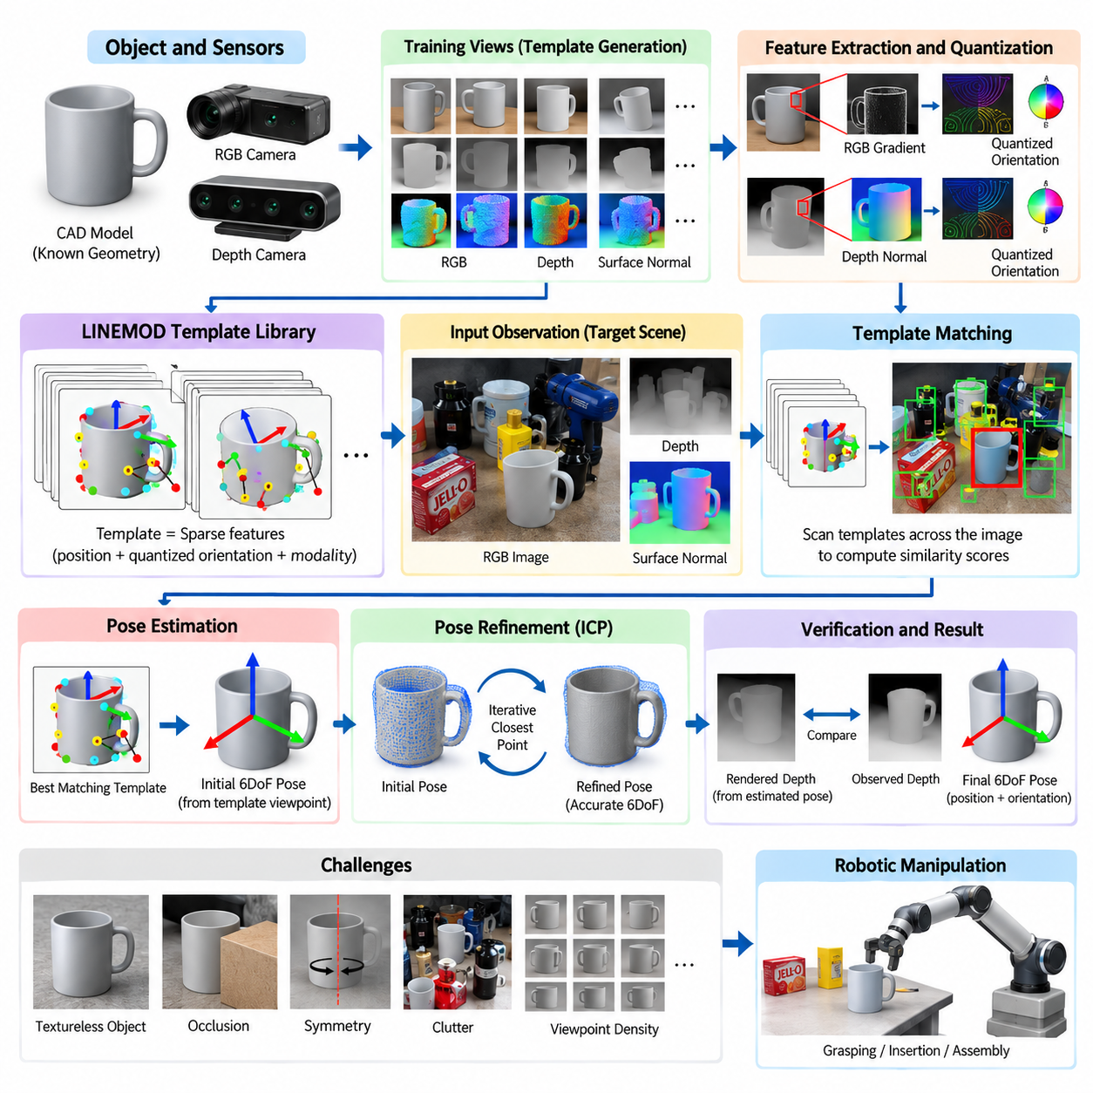
Template-based pose estimation determines an object's position and orientation by comparing current sensor observations with a collection of reference appearances generated from known poses. Instead of reconstructing pose entirely from sparse feature correspondences, the method searches for the reference template that best matches the observed object. This strategy is especially useful for rigid industrial objects whose geometry is known in advance.
LINEMOD is a representative template-based method designed for recognizing and localizing textureless objects using multiple sensor modalities. Conventional feature descriptors often depend on distinctive textures, corners, or repeatable local patterns, which may be scarce on manufactured components. LINEMOD instead emphasizes object shape and surface orientation, allowing recognition to rely on structural information that remains informative even when surface texture is weak.
The central idea of LINEMOD is to describe an object using discriminative features extracted from complementary modalities. In the RGB image, gradient orientations capture visible boundaries and internal intensity transitions. From depth information, surface normals represent the local three-dimensional orientation of the object's geometry. Combining these cues produces templates that encode both appearance-related edges and geometric surface structure without requiring rich texture.
During template generation, the target object's appearance is observed or rendered from predefined viewpoints. Features are extracted at selected locations and stored together with their modality information and relative spatial positions. A template therefore represents a sparse constellation of characteristic orientation measurements rather than a complete image. This sparse representation reduces computation while preserving features that strongly distinguish the object from its surroundings.
Image-gradient features are calculated from changes in intensity or color across neighboring pixels. Strong gradients commonly occur along object silhouettes, geometric edges, holes, handles, and other visible structures. Rather than depending heavily on exact gradient magnitude, LINEMOD primarily uses quantized orientation information. This makes matching less sensitive to moderate illumination changes while retaining the directional structure necessary for recognizing an object's projected shape.
Depth measurements provide an additional modality that is particularly valuable for textureless objects. A local surface normal can be estimated from neighboring three-dimensional points reconstructed from the depth image. Normal orientation describes how a surface faces the sensor and therefore captures shape information unavailable from RGB appearance alone. Planar faces, curved surfaces, recesses, and geometric transitions can consequently contribute to template discrimination.
Feature orientations are quantized into discrete directional categories to make template matching efficient and robust. Exact orientation values can fluctuate because of sensor noise, illumination variation, depth quantization, and small viewpoint changes. Quantization groups similar measurements into common orientation bins, reducing sensitivity to these variations. The resulting representation sacrifices some precision but significantly simplifies similarity computation across many candidate image positions.
A LINEMOD template contains selected feature locations together with their quantized orientations and modality labels. Feature selection is important because storing every possible gradient or surface normal would produce excessive redundancy and computational cost. Informative features are therefore chosen to represent distinctive object structures while maintaining spatial coverage. A relatively small set of carefully distributed features can characterize a viewpoint effectively.
At inference time, templates are scanned across the observed scene to search for locations producing high similarity scores. For each candidate location, the system compares stored template orientations with corresponding orientation information in the current RGB and depth observations. Contributions from individual features are accumulated into an overall matching score. Candidate detections exceeding a predefined threshold can then be considered possible object instances.
Efficient matching is essential because an object may have hundreds or thousands of templates representing different viewpoints, distances, and in-plane rotations. LINEMOD uses precomputed orientation representations and lookup mechanisms so that similarity calculations can be performed rapidly. This design made the method attractive for real-time object detection when computational resources were considerably more limited than those available in modern GPU-based perception systems.
Pose estimation requires more than determining that an object is present. Each stored template is associated with the viewpoint and transformation from which it was generated. Once a template matches the observed scene, its associated pose provides an initial estimate of the object's orientation and position. Depth information can further constrain translation by supplying metric distance, allowing the template detection to be converted into a three-dimensional pose hypothesis.
The density and distribution of template viewpoints directly influence pose coverage. If templates are generated only from widely separated orientations, the observed object may fall between represented viewpoints and produce a weak match or inaccurate pose. Increasing viewpoint density improves coverage but enlarges the template database and computational workload. Practical implementations therefore balance angular resolution, scale variation, expected operating poses, and available processing resources.
Synthetic template generation can reduce the burden of physically capturing objects from many viewpoints. Given a CAD model, a rendering system can generate RGB, depth, silhouette, and surface-normal information across systematically sampled camera poses. This allows large template libraries to be constructed automatically. However, differences between rendered and real sensor observations must be considered because unrealistic lighting, depth characteristics, or material appearance can reduce matching reliability.
One important advantage of LINEMOD is its ability to handle objects with limited texture. Industrial parts are frequently metallic, plastic, uniformly colored, or visually repetitive, making keypoint descriptors unreliable. Shape boundaries and surface normals may remain informative under these conditions. As a result, template-based multimodal matching has historically been useful for bin picking, assembly, component localization, quality inspection, and other structured robotic applications.
Occlusion nevertheless remains a significant challenge. A template assumes that a collection of characteristic features should appear in approximately expected spatial relationships, but some of those features may disappear when another object blocks the target. Partial matching can tolerate missing evidence to some degree, yet severe occlusion lowers similarity scores and may cause false negatives. Dense clutter also introduces unrelated edges and surfaces that can create competing matches.
Symmetric objects create another source of ambiguity. Multiple viewpoints of a cylindrical, rotationally symmetric, or repetitive object may generate nearly identical templates even though their numerical orientations differ. In such cases, the sensor observations may not contain enough information to uniquely determine orientation. Pose-estimation systems should explicitly represent equivalent poses or apply symmetry-aware reasoning rather than forcing an arbitrary single orientation.
Background clutter affects template matching because strong gradients and surface normals can originate from neighboring objects, containers, fixtures, or workspace structures. Combining RGB gradients with depth-based surface information helps suppress some false detections, but robust systems often incorporate segmentation, depth constraints, non-maximum suppression, geometric verification, or additional pose refinement. These stages separate plausible template responses from physically consistent object hypotheses.
The initial pose obtained from a matched template is limited by the discrete resolution of the template library. For precision manipulation, this coarse estimate is commonly followed by a refinement stage. The associated 3D model can be transformed according to the initial pose and aligned with the observed point cloud using Iterative Closest Point or related registration techniques. Refinement converts discrete viewpoint matching into a more continuous and accurate pose estimate.
Pose verification can further improve reliability by comparing the transformed object model with actual scene measurements. Rendered depth from the hypothesized pose can be compared against measured depth to evaluate surface agreement, visibility, and occlusion. Hypotheses that explain only a small portion of the observation or conflict strongly with measured geometry can be rejected. This geometric verification is particularly useful when several templates produce similar matching scores.
LINEMOD also illustrates an important engineering principle: object recognition does not always require a large learned model. When the object set is fixed, CAD data are available, and operating conditions are relatively controlled, explicit geometric templates can provide deterministic and interpretable behavior. Templates can be inspected, regenerated, or extended for particular viewpoints without retraining a neural network, which can simplify deployment and debugging in industrial environments.
However, template-based systems face scalability limitations when the number of objects and possible poses becomes very large. Every additional object, viewpoint, scale, or sensor configuration can increase storage and search requirements. Changes in object appearance or sensing conditions may also require template regeneration. Learning-based approaches can often share representations across objects and variations more effectively, motivating modern systems to combine learned features with template or geometric matching.
Modern descendants of the LINEMOD concept replace handcrafted orientation features with learned descriptors while retaining the idea of comparing observations against object representations associated with known poses. Neural networks can improve segmentation, feature extraction, correspondence estimation, and candidate ranking, while CAD geometry provides explicit spatial constraints. This hybrid strategy preserves geometric interpretability while gaining robustness from data-driven representation learning.
For robotic manipulation, the output of template matching should be interpreted as an initial object hypothesis rather than an isolated recognition result. The estimated pose must be transformed through calibrated camera and robot coordinate frames, checked for uncertainty, refined when necessary, and supplied to grasp or motion planning. Errors in camera calibration, depth sensing, template discretization, or registration can accumulate and ultimately appear as positioning errors at the robot end-effector.
A practical LINEMOD-based pipeline therefore connects offline template generation with online multimodal feature extraction, efficient similarity matching, candidate selection, pose recovery, geometric verification, and refinement. Its effectiveness comes from combining directional RGB information with three-dimensional surface orientation while exploiting known object geometry. Although newer learning-based techniques provide stronger generalization, LINEMOD remains an important reference architecture for understanding efficient model-based 6DoF pose estimation.

04.03. Keypoint Based Pose Estimation PVNet CDPN [w/Code]
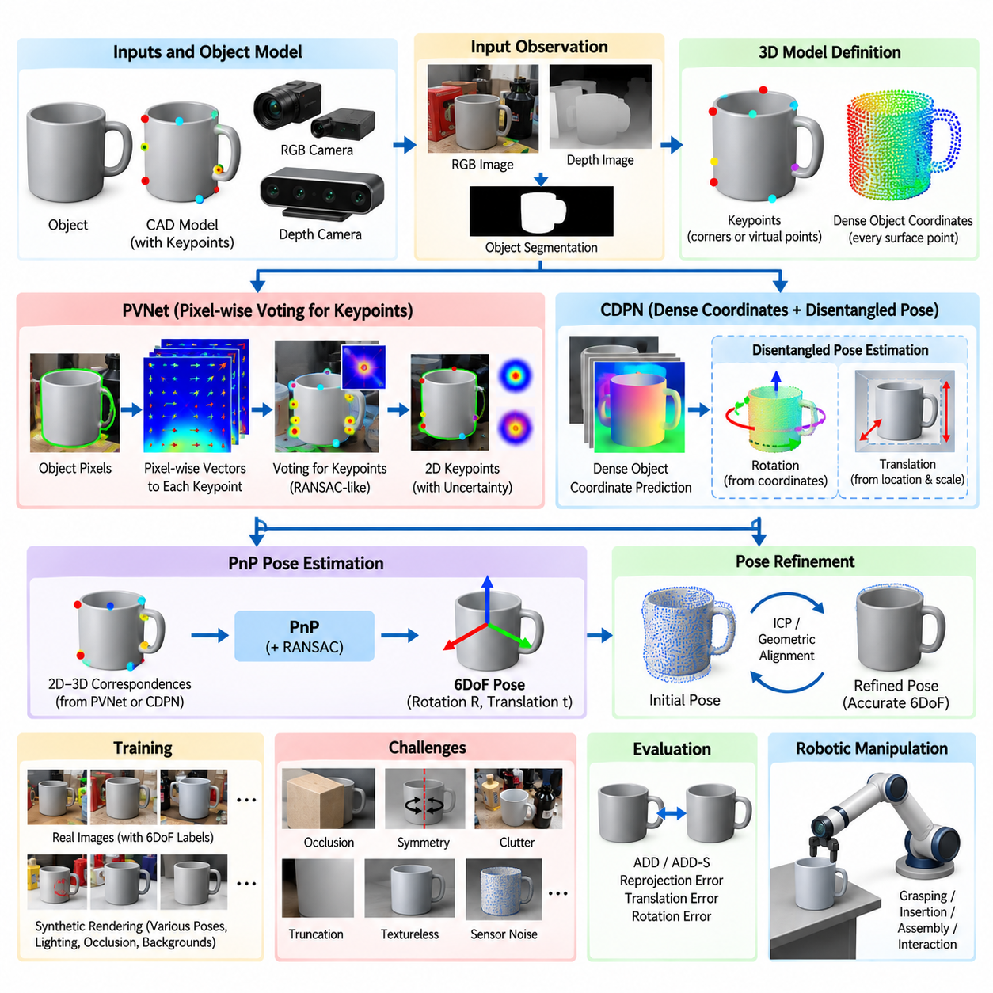
Keypoint-based object pose estimation recovers an object's 6DoF position and orientation by establishing correspondences between known three-dimensional points on an object model and their projected locations in an image. Rather than directly regressing a complete pose, the perception model predicts geometrically meaningful intermediate information. A geometric solver then converts these observations into a rigid transformation.
The keypoints are normally defined in the coordinate frame of a known CAD or 3D object model. They may correspond to physical corners or distinctive structures, but they can also be virtual points selected to provide good spatial coverage. Once their two-dimensional image positions are estimated, each predicted point can be associated with its known 3D coordinate, creating the 2D–3D correspondences required for pose recovery.
Perspective-n-Point, commonly abbreviated as PnP, forms the geometric bridge between keypoint prediction and 6DoF pose estimation. Given camera intrinsic parameters and several 2D–3D correspondences, PnP estimates the rotation and translation that project the known object points onto their observed image locations. Robust variants can be combined with RANSAC to suppress erroneous correspondences before the final transformation is calculated.
A major difficulty is that object keypoints are frequently invisible. They may lie on the rear surface, be blocked by another object, or disappear under severe self-occlusion. Predicting only directly visible keypoints therefore makes pose estimation fragile in cluttered scenes. Modern approaches instead learn contextual relationships between visible object regions and hidden keypoints, allowing the network to infer geometric locations that are not directly observable.
PVNet addresses this problem by replacing direct keypoint-coordinate regression with pixel-wise vector-field prediction. For each pixel belonging to an object, the network predicts a two-dimensional unit vector pointing toward a predefined keypoint. Many object pixels therefore contribute independent directional evidence about the same keypoint. This distributed representation makes pose estimation more tolerant of occlusion, truncation, local prediction errors, and ambiguous image regions.
The first stage of PVNet identifies pixels associated with the target object through semantic segmentation. For every foreground pixel, the network simultaneously estimates vectors toward multiple object keypoints. Instead of asking one network output to determine an exact keypoint position, the method gathers evidence across the visible object area. Even when part of the object is hidden, remaining pixels can continue voting for the expected keypoint locations.
PVNet converts the predicted vector field into keypoint hypotheses using a RANSAC-like voting procedure. Candidate intersections are generated from directional predictions, and support from many pixels determines which hypotheses are geometrically consistent. The resulting voting distribution provides not only a keypoint location but also information about uncertainty. This is important because different keypoints can have very different confidence under partial visibility.
Uncertainty-aware pose estimation is one of the important characteristics of the PVNet pipeline. A sharply concentrated voting distribution indicates that image evidence strongly constrains a keypoint, whereas a broad distribution suggests ambiguity. This uncertainty can be incorporated when solving the pose so that unreliable keypoints contribute less strongly. The resulting system is more robust than treating every predicted keypoint as equally accurate.
After keypoint voting, PVNet associates the estimated 2D keypoints with their predefined 3D model coordinates and applies a PnP solver. The output is a camera-relative rotation and translation describing the object's 6DoF pose. Because the neural network predicts intermediate geometric evidence rather than the final transformation directly, camera projection geometry remains explicitly embedded in the estimation process.
PVNet is particularly valuable under occlusion because its evidence is spatially distributed across object pixels. If a conventional keypoint detector depends strongly on a small image region and that region becomes hidden, the corresponding keypoint may fail completely. In PVNet, many remaining pixels can still point toward the hidden location. This converts keypoint localization from a localized detection problem into a collective geometric voting problem.
CDPN approaches pose estimation from a related but different perspective. The name refers to a Coordinate-based Disentangled Pose Network, and its central idea is to estimate dense object-coordinate information while separating pose components that have different geometric properties. Instead of relying only on sparse keypoints, CDPN predicts correspondences between image pixels and coordinates defined in the object's three-dimensional model space.
Dense object coordinates provide substantially more correspondence information than a small keypoint set. Each valid object pixel can potentially indicate where the observed surface lies in the object's canonical coordinate frame. This produces a dense 2D–3D correspondence field from which pose can be inferred. Redundancy across many pixels increases robustness when individual regions contain noise, weak texture, reflections, or partial occlusion.
CDPN also emphasizes disentangling rotation and translation because these quantities respond differently to image observations and camera geometry. Rotation is strongly related to object appearance and coordinate correspondences, while translation depends on image location, apparent scale, object dimensions, and camera intrinsics. Learning these components with appropriately designed representations can reduce undesirable coupling between errors and improve pose-estimation stability.
For rotation estimation, dense correspondence predictions encode how visible image regions map onto the known object coordinate system. The spatial arrangement of these correspondences provides strong information about object orientation. Compared with direct rotation regression from global image features, coordinate-based reasoning preserves local geometric structure. It also allows the network to exploit many surface observations instead of compressing all evidence immediately into a single orientation vector.
Translation estimation requires accurate recovery of the object's position relative to the camera. Image-plane center displacement constrains lateral translation, while apparent object size and geometric information help determine depth. CDPN-style architectures can parameterize these quantities separately rather than regressing raw XYZ translation without structure. Such disentanglement can improve learning because the network predicts variables more closely related to observable image characteristics.
Object segmentation is important for both PVNet and coordinate-based approaches because background pixels should not participate in object correspondence estimation. Incorrect segmentation can introduce vectors or coordinates unrelated to the target geometry. Robust systems therefore learn segmentation jointly with geometric predictions or use dedicated detection and instance-segmentation stages to define the region from which pose evidence is collected.
Symmetry remains challenging even with dense correspondence prediction. Two physically equivalent surface regions on a symmetric object may correspond to different canonical coordinates despite producing indistinguishable observations. A network trained with a single arbitrary correspondence can therefore receive contradictory supervision. Symmetry-aware coordinate definitions, equivalent-pose losses, or correspondence mappings are needed to represent the actual observability of symmetric objects correctly.
Training these methods requires accurate object models and pose annotations. Ground-truth 6DoF poses allow predefined 3D keypoints or dense model coordinates to be projected into training images. Synthetic rendering is particularly useful because unlimited pose configurations, backgrounds, lighting conditions, and occlusion patterns can be generated automatically. Domain randomization and realistic rendering help reduce the gap between synthetic supervision and real camera observations.
Data augmentation is essential for improving robustness beyond the conditions represented in a limited physical dataset. Random occluders can teach PVNet to infer hidden keypoints from remaining visible regions, while changes in illumination, blur, scale, background, and sensor noise improve appearance invariance. Coordinate-based networks similarly benefit from diverse viewpoints and truncation because correspondence prediction must remain reliable over a broad pose distribution.
Pose refinement can be applied after the initial PVNet or CDPN estimate. A transformed CAD model may be compared with RGB boundaries, predicted coordinates, measured depth, or a point cloud to minimize residual disagreement. RGB-D systems can additionally use ICP or depth-based alignment. Refinement is particularly valuable for manipulation because a visually plausible pose may still contain translation or orientation errors large enough to compromise grasping or insertion.
Evaluation commonly measures the geometric discrepancy between an estimated pose and ground truth. ADD evaluates the average distance between model points transformed by the two poses, while ADD-S or symmetry-aware alternatives accommodate indistinguishable configurations. Reprojection error measures disagreement in image space. For robotic applications, translation and angular errors should also be interpreted relative to gripper clearance, assembly tolerance, and contact requirements.
PVNet and CDPN illustrate two complementary strategies for introducing geometry into learned pose estimation. PVNet converts sparse keypoint localization into distributed pixel-wise directional voting, whereas CDPN uses dense object-coordinate correspondences and structured pose prediction. Both avoid relying exclusively on opaque end-to-end pose regression and instead construct intermediate representations that connect neural perception with explicit projective geometry.
Their computational characteristics also differ. PVNet must predict vector fields for multiple keypoints and perform voting before PnP, while dense coordinate methods generate per-pixel model correspondences and subsequently recover pose components. The preferred architecture depends on object complexity, image resolution, number of target objects, required accuracy, available GPU resources, and whether the application benefits more from sparse landmark reasoning or dense surface information.
In practical robotic manipulation, the estimated camera-relative pose is only one stage of the complete perception-to-action chain. Camera calibration and hand-eye calibration transform the object pose into the robot base or end-effector coordinate system. Pose confidence can influence grasp selection, while uncertainty may trigger another observation from a different viewpoint. The final objective is therefore reliable spatial information for physical interaction rather than pose estimation in isolation.
Keypoint- and correspondence-based methods remain conceptually important because they expose the relationship between learned visual evidence and rigid-body geometry. PVNet demonstrates how distributed voting can recover hidden landmarks under occlusion, while CDPN demonstrates how dense coordinates and disentangled pose components can improve geometric reasoning. Together they provide a strong foundation for accurate, interpretable, and robust 6DoF object pose estimation in robotic manipulation.

04.04. Dense Pose Estimation DenseFusion FFB6D [w/Code]
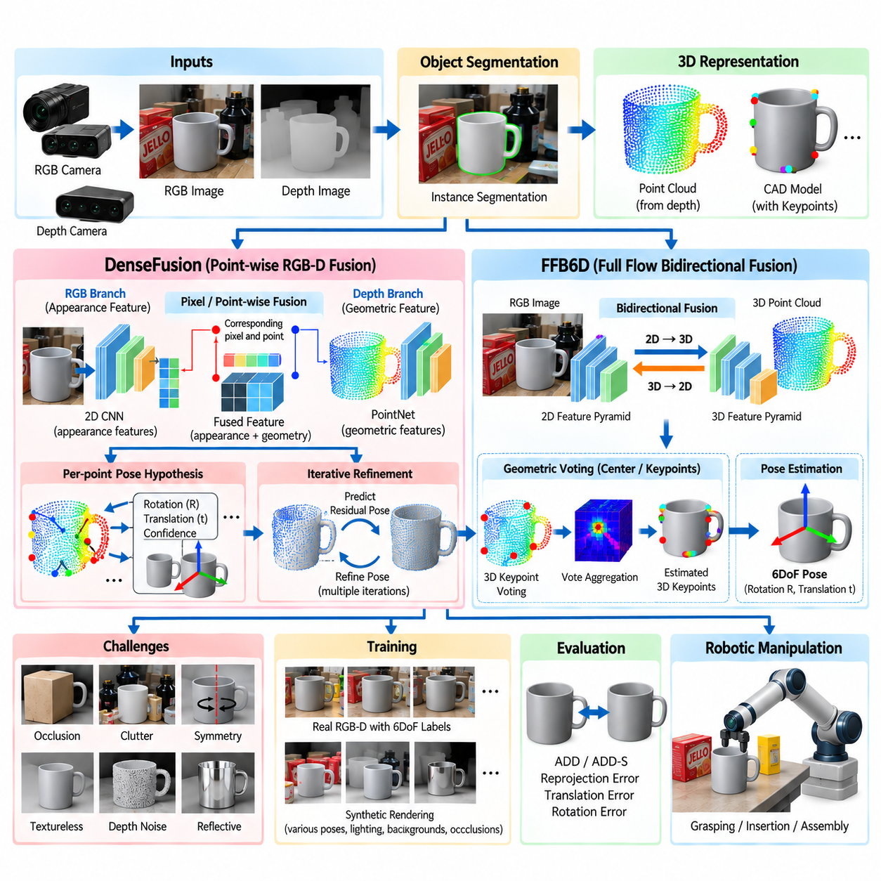
Dense pose estimation uses information distributed across many visible object pixels or 3D points to recover an object's six-degree-of-freedom position and orientation. Unlike approaches that depend on a small number of landmarks, dense methods exploit surface-wide appearance and geometry. This redundancy is valuable in robotic scenes because individual regions may be textureless, noisy, reflective, truncated, or partially hidden by surrounding objects.
RGB-D sensing is particularly suitable for dense 6DoF pose estimation because RGB and depth provide complementary information. Color images contain texture, boundaries, semantic appearance, and contextual cues, whereas depth measurements provide metric distance and three-dimensional surface structure. DenseFusion and FFB6D represent important architectures for combining these modalities while preserving spatial relationships required for accurate object pose reasoning.
DenseFusion was designed around the observation that global fusion of RGB and depth features can discard important local correspondences. Instead, it extracts appearance features from RGB observations and geometric features from a point-cloud representation of depth. Features corresponding to the same physical object locations are then combined at the pixel or point level, creating a dense fused representation that retains both visual and geometric information.
The RGB branch of DenseFusion uses a convolutional image network to extract feature vectors from pixels belonging to a detected object. An instance segmentation stage normally identifies the target region before pose estimation. Image features describe local appearance while also incorporating contextual information from surrounding pixels. Segmentation is therefore important because background features should not be mixed with measurements representing the target object's physical surface.
The depth branch converts depth pixels inside the segmented object region into three-dimensional points using camera intrinsic parameters. A point-based network then processes these coordinates to produce geometric features describing local and global object structure. Because the resulting representation exists directly in metric 3D space, it provides information about surface shape, distance, and spatial arrangement that cannot be recovered reliably from RGB appearance alone.
DenseFusion associates each sampled 3D point with the RGB feature originating from its corresponding image pixel. The two feature vectors are concatenated or otherwise fused to create a multimodal descriptor for that physical location. Repeating this operation across the visible object produces a dense set of fused features. The architecture therefore preserves explicit relationships between image appearance and three-dimensional geometry rather than merging modalities only at a global level.
Pose hypotheses are generated from the dense fused features. Individual points can contribute estimates of object rotation and translation together with confidence values indicating the reliability of each hypothesis. The system can select the most confident prediction or combine evidence across points. This distributed hypothesis mechanism allows reliable surface regions to dominate when other portions of the object are affected by occlusion, sensor artifacts, or ambiguous appearance.
Confidence prediction is important because not every visible point provides equally useful pose information. A point on a distinctive corner may strongly constrain orientation, while a point on a large uniform plane may be ambiguous. Depth discontinuities and reflective regions can also produce unreliable measurements. By learning confidence jointly with pose hypotheses, DenseFusion can emphasize informative regions rather than treating all observations as equally trustworthy.
DenseFusion includes an iterative refinement mechanism for improving the initial pose estimate. After predicting a pose, observed points can be transformed into a coordinate frame determined by the current estimate and processed again to predict a residual transformation. Repeating this process progressively reduces alignment error. This learned refinement concept performs a role analogous to iterative geometric registration while allowing the correction strategy to be learned from data.
DenseFusion demonstrated that pixel-wise RGB-D fusion can provide strong robustness in cluttered environments, but later methods extended the idea by allowing richer bidirectional communication between image and point-cloud feature spaces. FFB6D is an important example. Its name refers to Full Flow Bidirectional Fusion for 6D pose estimation, emphasizing repeated exchange of information between two-dimensional RGB features and three-dimensional geometric features throughout the network.
FFB6D employs separate feature extraction streams for RGB images and point clouds, but the streams are not isolated until a final fusion stage. Instead, features flow repeatedly from the image domain into the point domain and from the point domain back into the image domain. This bidirectional fusion allows semantic appearance to improve geometric representations while three-dimensional structure simultaneously strengthens image-based reasoning.
Mapping features between 2D and 3D requires known geometric correspondences established by the RGB-D camera. A depth pixel can be back-projected into a 3D point using camera intrinsics, while the point retains its original image location. These relationships allow image features to be gathered for corresponding points and point features to be projected or aggregated into image locations. Accurate sensor calibration is therefore fundamental to the fusion process.
Repeated fusion across multiple network resolutions allows information to interact at different spatial scales. Fine-resolution features can represent boundaries, small geometric structures, and local texture, whereas deeper features encode broader semantic and shape context. By exchanging information throughout the feature hierarchy, FFB6D avoids postponing multimodal interaction until the end of feature extraction and creates representations jointly informed by appearance and geometry.
FFB6D can formulate pose estimation through dense geometric voting rather than directly regressing a single transformation from a global feature. The network predicts information associated with object center points, keypoints, or geometric offsets from many observed 3D points. These predictions are aggregated to recover stable object landmarks in three-dimensional space. The resulting correspondences can then be used to calculate the rigid transformation describing object pose.
Three-dimensional keypoint voting provides useful robustness to partial visibility. Even when a predefined keypoint itself is not visible, multiple observed surface points can predict offsets toward its expected location. Their votes can be aggregated to estimate the hidden landmark. This principle resembles distributed keypoint voting in image-based methods but operates directly with multimodal RGB-D features and metric three-dimensional geometry.
Dense methods are especially effective under occlusion because they do not depend on a single image patch or a small number of directly observable landmarks. If part of an object disappears behind another object, remaining pixels and points can still provide pose evidence. However, robustness depends on how much informative geometry remains visible. Severe occlusion can leave multiple poses consistent with the observation, making uncertainty estimation or multi-view sensing necessary.
Instance segmentation remains an important front-end component. The pose network must know which RGB pixels and depth points belong to each object instance, particularly in bin-picking or tabletop scenes containing overlapping objects. Segmentation errors can introduce background or neighboring-object geometry into the dense representation. Such contamination may shift predicted centers, distort keypoint votes, and ultimately produce incorrect rotation or translation estimates.
Depth quality strongly influences RGB-D pose estimation. Commodity depth cameras may contain missing measurements, quantization artifacts, multipath interference, and errors around object boundaries. Transparent, glossy, black, or highly reflective surfaces are particularly difficult. Robust training therefore benefits from realistic depth noise, missing-point simulation, and augmentation so that the model does not assume ideal geometric observations during deployment.
Object symmetry remains challenging for DenseFusion, FFB6D, and related dense methods. A symmetric surface can produce nearly identical RGB-D observations under multiple orientations, meaning that the physical measurement itself may not uniquely determine pose. Training losses and evaluation metrics must account for equivalent transformations. For manipulation, the relevant pose may also depend on functional features such as handles or graspable regions that break otherwise geometric symmetry.
Training dense RGB-D networks requires synchronized color and depth data, accurate camera calibration, object masks, 3D models, and ground-truth poses. Synthetic data can supplement expensive real annotations by rendering objects under varied viewpoints, lighting, backgrounds, clutter, and occlusion. Domain randomization can increase variation, while physically realistic rendering and sensor simulation can reduce discrepancies between synthetic depth and real RGB-D measurements.
Pose accuracy is commonly evaluated with model-based metrics such as ADD and ADD-S, as well as rotation, translation, and reprojection errors. Dense predictions should ultimately be judged according to the requirements of the downstream robotic task. A pose that is acceptable for coarse object sorting may be insufficient for connector insertion, precision assembly, or tool engagement, where millimeter-scale translation and small angular errors can cause failure.
DenseFusion and FFB6D differ primarily in how deeply multimodal interaction is integrated into feature extraction. DenseFusion established an influential pixel-wise fusion strategy in which corresponding RGB and point-cloud features are combined before dense pose prediction. FFB6D extends multimodal reasoning through full-flow bidirectional fusion across network stages, allowing two-dimensional semantic features and three-dimensional geometric features to repeatedly strengthen one another.
These architectures also illustrate a broader progression in robotic perception from late sensor fusion toward tightly coupled multimodal representations. RGB and depth should not simply be regarded as independent measurements whose final decisions are averaged. Their spatial correspondence provides a powerful constraint. Appearance can disambiguate similar shapes, while metric geometry can resolve scale, depth, and surface orientation that may be ambiguous in monocular images.
For robotic manipulation, the estimated camera-relative pose must be transformed into the robot's operational coordinate system through calibrated extrinsic and hand-eye transformations. The resulting pose can drive grasp generation, collision checking, approach planning, insertion, or assembly. Confidence and geometric consistency should also be considered so that uncertain estimates can trigger re-observation, refinement, or an alternative manipulation strategy instead of unsafe execution.
Dense RGB-D pose estimation therefore provides a practical bridge between semantic visual perception and metric three-dimensional interaction. DenseFusion demonstrates the effectiveness of point-wise multimodal fusion and learned iterative refinement, while FFB6D demonstrates the advantages of repeated bidirectional exchange between image and point-cloud representations. Together, they form important reference architectures for robust 6DoF object pose estimation in cluttered robotic environments.

04.05. Foundation Model Based Pose Estimation FoundPose [w/Code]
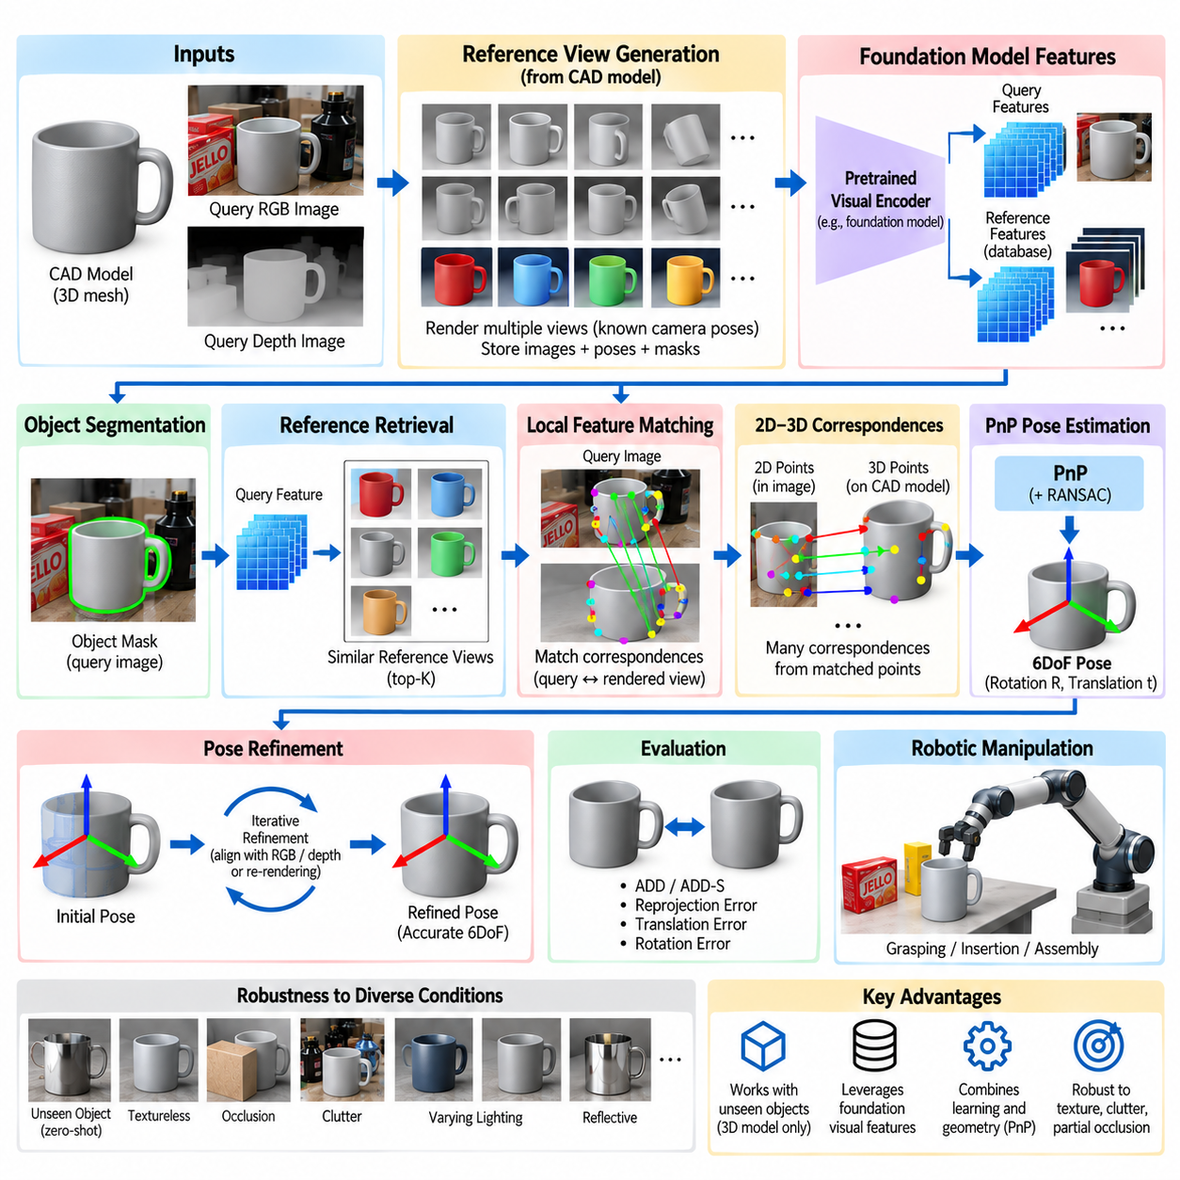
Foundation-model-based pose estimation extends classical 6DoF object pose estimation by using visual representations learned from very large and diverse datasets. Instead of training a perception backbone only for a fixed collection of pose-estimation objects, the system begins with features that already encode broad information about shape, appearance, parts, semantics, and visual correspondence. This improves the possibility of handling objects not encountered during task-specific training.
The motivation is closely related to the limitations of conventional instance-level pose estimators. Many earlier methods assume that every target object appears in the training set and that large numbers of annotated images are available for each instance. When a new industrial component, household object, or tool is introduced, retraining may be necessary. Foundation visual representations seek to reduce this dependency by transferring previously learned visual knowledge to unseen objects.
FoundPose represents this transition toward generalizable object pose estimation. Rather than learning a complete pose estimator from scratch for every object collection, the approach exploits pretrained visual foundation features to establish correspondences between an observed object and reference information derived from its three-dimensional model. The resulting pipeline combines broad learned visual representation with explicit geometric reasoning for estimating object position and orientation.
A typical model-based setting assumes that a CAD model or mesh of the target object is available at inference time. Unlike traditional supervised pose estimation, however, the target object does not necessarily need to have appeared during pose-network training. Reference views can be generated by rendering the provided 3D model from many known camera poses. These rendered observations create a bridge between the unseen model and the real query image.
The reference-generation stage samples viewpoints around the object and renders its appearance under known transformations. Each rendering has an associated camera pose, object mask, and geometric relationship to the CAD model. Foundation-model features can then be extracted from these reference images and stored. The resulting reference database represents how the object may appear from different directions without requiring real pose-annotated photographs of that particular instance.
When a real query image arrives, the target object must first be localized or segmented so that relevant image regions can be separated from the background. A pretrained visual encoder extracts feature maps from the query region. Because the encoder has learned from diverse visual data, its descriptors can provide meaningful similarity even when the object's texture, lighting, background, or exact instance was absent from the pose-estimation training distribution.
Reference retrieval provides an initial estimate of which rendered viewpoints resemble the query observation. Global or regional feature similarity can rank candidate reference images, reducing a large pose search space to a smaller set of plausible orientations. Retrieval alone does not normally provide sufficient accuracy for robotic manipulation, but it supplies strong initialization for subsequent local correspondence and geometric pose recovery.
After retrieving promising references, local feature matching establishes correspondences between locations in the real image and locations in the rendered model views. Foundation features are useful because corresponding semantic or geometric regions can remain similar despite changes in appearance. Instead of depending exclusively on handcrafted edges or object-specific learned keypoints, the system can exploit dense descriptors representing structures learned across many visual categories.
The known rendering geometry allows matched reference pixels to be connected with three-dimensional points on the object model. A correspondence between a query pixel and a rendered reference location can therefore be converted into a 2D–3D relationship. Once enough reliable correspondences are available, classical projective geometry becomes applicable. This is an important design principle because the foundation model supplies visual evidence while geometry enforces a physically meaningful pose.
A PnP solver can recover object rotation and translation from these 2D–3D correspondences using known camera intrinsic parameters. RANSAC or related robust estimators can reject incorrect matches before computing the final transformation. The resulting architecture is therefore hybrid rather than purely neural: large-scale representation learning addresses difficult visual correspondence, while established geometric algorithms transform those correspondences into an interpretable SE(3) pose.
The quality of reference viewpoints strongly affects the initial search. Sparse viewpoint sampling reduces storage and computation but may leave large appearance differences between the query image and its nearest rendered reference. Dense sampling improves coverage but increases retrieval cost. Hierarchical strategies can first identify a coarse viewpoint region and then perform more detailed matching among nearby candidates, balancing efficiency and pose resolution.
Foundation features provide an important advantage for objects with weak texture. A conventional local feature detector may find few stable interest points on smooth plastic, painted metal, or uniformly colored industrial components. Large pretrained visual encoders can represent broader shape, contour, part, and contextual information rather than relying only on high-frequency texture. This can improve correspondence quality for objects that challenge traditional feature pipelines.
Occlusion remains difficult because only a subset of the object may be visible in the query image while rendered references may show much more of its surface. Dense local matching can concentrate on regions that remain visible, while robust geometric estimation can discard inconsistent correspondences. Nevertheless, severe occlusion can produce insufficient evidence or ambiguous viewpoint retrieval, motivating multiple reference hypotheses, uncertainty estimation, or active re-observation by the robot.
Clutter creates another challenge because nearby objects may produce visually similar structures and foundation features. Accurate object segmentation helps prevent background regions from participating in correspondence estimation. Geometric consistency provides an additional defense: visually plausible matches that cannot be explained by one rigid 3D transformation can be rejected. This interaction between semantic representation and geometric verification is central to robust foundation-model-based pose estimation.
Symmetry must also be treated explicitly. A CAD model may possess rotational or reflective symmetries that generate nearly identical appearances from multiple poses. Foundation features cannot recover information that is physically absent from the observation. Reference retrieval may therefore return several equivalent viewpoints, and geometric solvers may produce multiple valid transformations. Symmetry-aware evaluation and representation are required to avoid incorrectly penalizing physically equivalent poses.
A major benefit of the FoundPose philosophy is zero-shot or training-free generalization at the object-instance level. A previously unseen object can be introduced by supplying its 3D model rather than collecting a new pose-labeled training dataset and retraining the network. This is highly relevant to flexible manufacturing, warehouse automation, service robotics, and inspection, where object inventories can change more rapidly than specialized perception models can be retrained.
Synthetic rendering becomes particularly powerful in this framework because it is performed for the object introduced at deployment time. The system can automatically create reference images from its CAD model without requiring manual annotation. However, the synthetic-to-real gap remains relevant. Differences in material, lighting, reflections, camera response, and background can affect correspondence quality, even when foundation features provide greater invariance than raw pixel comparison.
Pose refinement can improve the transformation recovered from feature correspondence and PnP. The estimated CAD model may be rendered back into the query view and compared with image boundaries, segmentation masks, dense features, or measured depth. If RGB-D information is available, geometric alignment can further reduce translation and orientation errors. Refinement is particularly important when the final pose is used for precise grasping, insertion, or assembly.
Confidence should be derived from more than a single feature-similarity score. Useful indicators include retrieval consistency, number and spatial distribution of local matches, RANSAC inlier ratio, reprojection error, segmentation quality, and agreement among multiple pose hypotheses. A robotic system can combine these signals to decide whether the estimate is sufficiently reliable for execution or whether another viewpoint should be acquired.
Foundation-model-based methods introduce computational considerations that differ from lightweight task-specific networks. Large visual encoders can require substantial GPU memory and inference time, while reference databases may contain many views for each object. Practical systems can precompute reference descriptors, reduce feature dimensionality, cache model representations, use approximate nearest-neighbor retrieval, and apply the expensive local matching stage only to a small number of retrieved candidates.
The approach also changes the role of training data. Instead of requiring pose annotations for every deployed object, the foundation encoder obtains transferable visual knowledge from broad pretraining, while task-specific pose recovery relies heavily on model geometry and inference-time references. This separates representation learning from object deployment and can substantially reduce the marginal data-engineering cost associated with adding a new target object.
Evaluation should measure both pose accuracy and generalization. Traditional metrics such as ADD, ADD-S, visible surface discrepancy, projection error, rotation error, and translation error remain relevant, but experiments should clearly distinguish objects seen during development from genuinely unseen instances. Zero-shot performance is meaningful only when information about evaluation objects has not leaked into task-specific training or model-selection procedures.
For robotic manipulation, the estimated camera-relative pose must still pass through the same physical calibration chain as any other pose estimate. Camera intrinsics, camera-to-robot extrinsics, and hand-eye calibration determine how accurately the pose can be expressed in robot coordinates. Generalizable visual perception cannot compensate for poor calibration, mechanical compliance, or inaccurate tool-center-point definition when the robot physically contacts the object.
FoundPose therefore illustrates a broader movement from closed-set pose recognition toward open and model-driven physical perception. The key change is not the removal of geometry but the use of foundation representations to make geometric correspondence transferable across objects. Large-scale visual learning provides reusable descriptors, CAD rendering supplies object-specific references, and PnP or related solvers preserve explicit physical constraints.
This combination is especially important for general-purpose manipulation systems that cannot assume a permanently fixed object catalog. A robot may receive a new CAD model, construct reference representations automatically, observe the corresponding physical object, establish foundation-feature correspondences, and estimate its 6DoF pose without conventional object-specific retraining. Such a workflow moves pose estimation closer to scalable, reusable perception for Physical AI.
Foundation-model-based pose estimation should therefore be viewed as an integration of pretrained visual intelligence, inference-time object knowledge, correspondence reasoning, and rigid-body geometry. FoundPose demonstrates how these components can support unseen-object pose estimation while retaining interpretable geometric structure. The resulting paradigm offers a promising foundation for robots that must perceive and manipulate continually changing sets of physical objects.

04.06. Category Level Pose Estimation NOCS [w/Code]
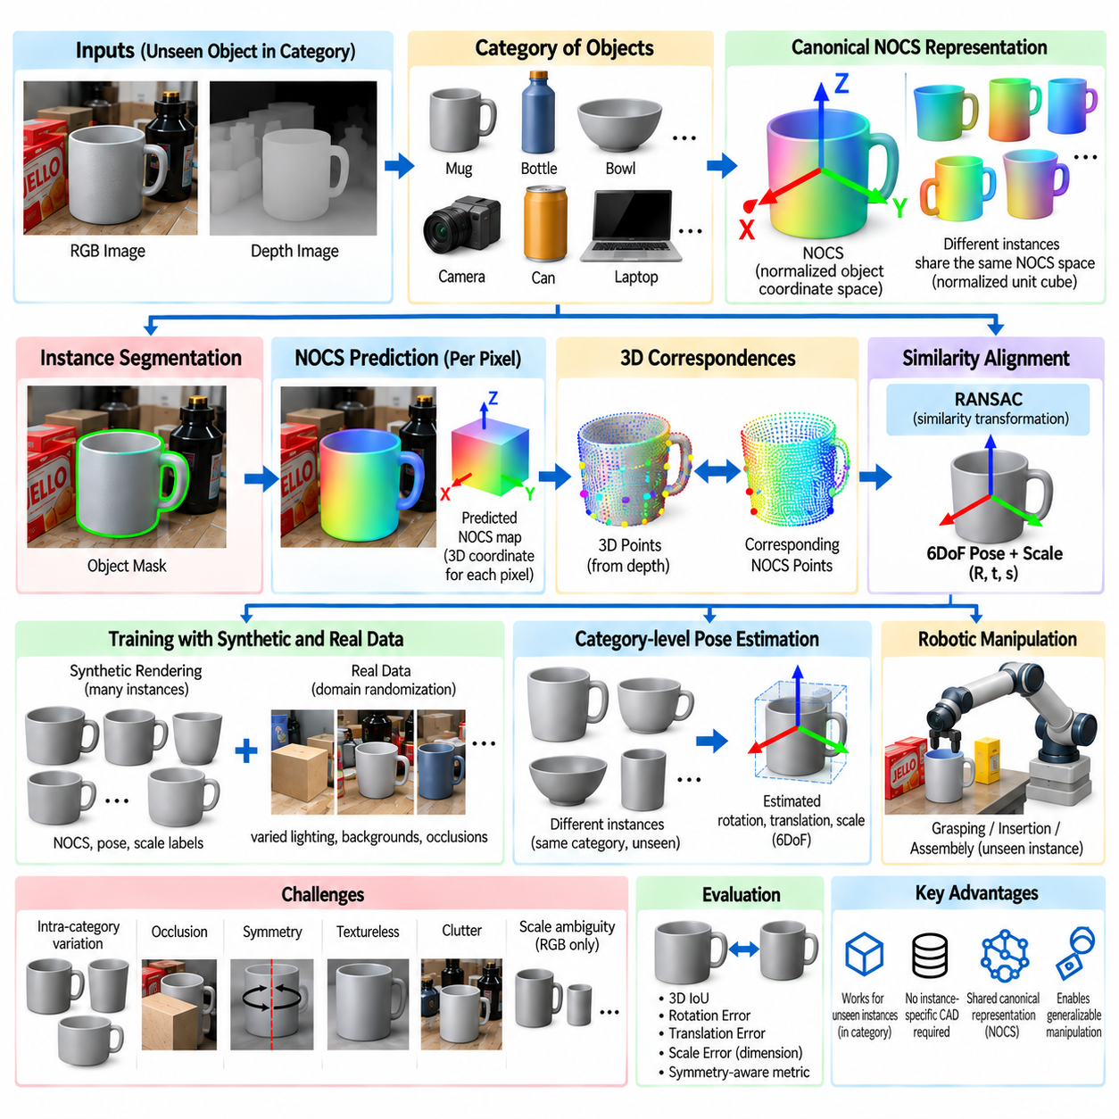
Category-level pose estimation extends 6DoF perception from recognizing known object instances to estimating the pose of previously unseen objects that belong to a familiar semantic category. Instead of assuming an exact CAD model for every target, the system learns geometric regularities shared by categories such as bottles, mugs, cameras, bowls, cans, and laptops. This capability is important for robots operating in environments where individual object instances cannot be predetermined.
Instance-level pose estimation usually establishes correspondence between an observed object and its exact three-dimensional model. This assumption provides strong geometric constraints but limits scalability because every new object requires a model, reference representation, or additional training information. Category-level estimation removes this dependency and asks a more difficult question: how can a common spatial representation describe objects whose shapes and dimensions vary significantly within the same category?
NOCS provides an influential solution through the Normalized Object Coordinate Space. The central idea is to map different object instances belonging to the same category into a shared canonical three-dimensional coordinate system. Rather than representing every mug, bottle, or camera using its original physical dimensions, each instance is normalized into a common coordinate space. Corresponding semantic regions can then occupy approximately consistent positions across different object instances.
A NOCS representation is commonly defined inside a normalized unit cube. An object's canonical geometry is scaled so that its coordinates occupy a standardized range, typically independent of the object's absolute metric dimensions. Each visible surface point can therefore be assigned a normalized three-dimensional coordinate. These coordinates encode where the observed surface belongs within the canonical object representation rather than where it currently lies in the camera frame.
This normalization separates category-level geometric correspondence from absolute object size. Two bottles may differ substantially in height and diameter, but their surfaces can still be represented within the same normalized coordinate convention. The pose-estimation problem then becomes one of finding a transformation that aligns the predicted canonical coordinates with the actual three-dimensional observations. Scale must additionally be recovered because normalization intentionally removes the original metric dimensions.
The complete category-level problem is therefore often described as estimating rotation, translation, and scale. Rotation determines the object's orientation relative to the camera, translation determines its spatial position, and scale connects normalized canonical geometry to its physical dimensions. Depending on the formulation, scale may be represented by one isotropic factor or by dimensions associated with different axes when intra-category shape variation requires more flexibility.
A NOCS-based perception network processes an RGB or RGB-D observation and identifies object instances through detection or instance segmentation. For pixels belonging to an object, the network predicts their corresponding coordinates in normalized object space. The output can be interpreted as a dense coordinate map in which each foreground pixel contains a three-dimensional canonical coordinate describing its predicted location on the category-level object representation.
Dense coordinate prediction is powerful because thousands of image pixels can contribute geometric evidence. The network does not need to identify a small set of manually selected landmarks that may vary across object instances. Instead, the visible surface itself provides correspondence information. Even if some predictions are inaccurate because of texture, illumination, occlusion, or unusual geometry, robust alignment can exploit the large number of remaining consistent correspondences.
When depth information is available, foreground depth pixels can be back-projected through the camera intrinsic parameters to produce a point cloud in camera coordinates. Each observed 3D point can then be associated with the NOCS coordinate predicted at the same image pixel. The system consequently obtains correspondences between normalized canonical points and measured metric points, providing the geometric information required to estimate pose and physical scale.
The transformation between NOCS coordinates and camera-space observations is generally a similarity transformation rather than only a rigid transformation. A rigid SE(3) transformation contains rotation and translation but preserves absolute dimensions. Because NOCS coordinates are normalized, scale must also be introduced. Robust similarity alignment methods can estimate rotation, translation, and scale from corresponding canonical and observed 3D points while rejecting inconsistent predictions.
RANSAC is useful in this alignment process because dense coordinate maps inevitably contain outliers. Pixels near object boundaries may contain mixed depth measurements, segmentation errors can introduce background points, and coordinate predictions may be incorrect on heavily occluded or unusual surfaces. By repeatedly sampling subsets of correspondences and evaluating geometric consistency, RANSAC can identify a transformation supported by a large inlier population.
The canonical coordinate system must maintain meaningful consistency across a category. For example, mugs should ideally share conventions for upright direction, handle orientation, and normalized center, while bottles should share a consistent vertical axis and body organization. Without such conventions, two geometrically similar instances could be mapped into incompatible canonical orientations, making category-level correspondence ambiguous and preventing stable pose estimation.
Intra-category variation remains one of the fundamental challenges. Objects grouped under the same semantic label may have significantly different geometry. Mugs can have cylindrical or tapered bodies and many handle shapes, while cameras can vary dramatically in body proportions and lens structure. A single canonical representation must therefore preserve useful shared geometry without assuming that every category member is simply a scaled copy of one prototype.
Shape priors can improve category-level reasoning by modeling typical geometric variation within a category. Instead of predicting coordinates without structural constraints, a network may infer a latent shape representation or deform a canonical category model toward the observed instance. Such approaches can provide more coherent geometry when large portions of the object are hidden and can support reconstruction together with pose and scale estimation.
Synthetic data has historically played an important role in NOCS-style training because dense canonical coordinates and exact object poses are expensive to annotate manually. Three-dimensional object repositories can provide many category instances that are rendered under randomized camera poses, lighting, backgrounds, and occlusions. Since rendering geometry is known, object masks, depth, NOCS coordinates, pose, and scale labels can be generated automatically.
Real data remains necessary because synthetic images cannot perfectly reproduce sensor characteristics and real-world appearance. Differences in material, illumination, clutter, depth noise, and camera response create a synthetic-to-real domain gap. Mixed training with synthetic and real observations, domain randomization, realistic rendering, augmentation, and feature-level adaptation can improve transfer while retaining the large geometric diversity available from synthetic object models.
Occlusion is particularly challenging for unseen instances because the system must simultaneously infer category-level shape correspondence and pose from incomplete evidence. Dense coordinate prediction provides redundancy, but severe occlusion can remove regions that define orientation or scale. Learned shape priors, contextual reasoning, uncertainty prediction, and multi-view observations can compensate by using information beyond the immediately visible surface.
Symmetry introduces another ambiguity. Bottles, bowls, and cans often possess rotational symmetry, meaning that several orientations correspond to indistinguishable observations. A category may also contain both symmetric and asymmetric instances. Pose losses and evaluation metrics must therefore distinguish between physically observable orientation and arbitrary canonical labeling. For manipulation, orientation around a symmetry axis may be irrelevant unless a functional feature breaks the symmetry.
Scale estimation is a distinctive requirement of category-level pose estimation. Monocular RGB observations contain inherent ambiguity between object size and distance, making metric scale difficult to recover without additional assumptions. RGB-D sensing substantially reduces this ambiguity because measured depth supplies metric geometry. Nevertheless, partial visibility and intra-category shape variation can still make dimensions uncertain, particularly when only a small portion of the object is observed.
Evaluation must account for both pose and size accuracy. Rotation and translation errors describe spatial alignment, while three-dimensional intersection-over-union can measure agreement between predicted and ground-truth object extents. Threshold-based combinations of rotation and translation error are also widely useful. Symmetry-aware criteria are essential so that equivalent orientations are not incorrectly counted as failures.
NOCS changes the correspondence problem from exact-model matching into canonical-space matching. Instance-level systems ask which point on a specific CAD model corresponds to an observation, whereas NOCS asks where an observed point belongs within a normalized representation shared by a category. This abstraction sacrifices some instance-specific precision but greatly expands the ability to reason about objects whose exact geometry is unavailable beforehand.
For robotic manipulation, category-level pose estimation is particularly valuable when the robot encounters everyday objects or changing inventories. A service robot may need to grasp a mug it has never seen, while a warehouse system may encounter new containers with familiar functional structure. Estimated pose, dimensions, and category information can guide generic grasp generation even when no exact object-specific grasp database exists.
However, category-level pose should not automatically be assumed sufficient for precision assembly or tight-tolerance insertion. When exact surface geometry determines contact, an approximate category representation may produce errors that are unacceptable for the task. A practical system can therefore use category-level estimation for initialization and subsequently reconstruct local geometry, acquire additional depth observations, or retrieve a more specific model before precision interaction.
Modern category-level methods increasingly combine canonical coordinates with learned shape models, transformers, large pretrained visual representations, implicit 3D representations, and foundation models. These components can improve generalization across object appearance and shape while preserving the geometric concept introduced by NOCS. The canonical space remains useful because it provides a common language connecting semantic category knowledge with metric three-dimensional observations.
Category-level pose estimation therefore occupies an important position between closed-set instance recognition and fully open-world physical perception. NOCS demonstrates that normalized canonical coordinates can transform diverse object instances into a shared geometric representation from which pose and scale can be recovered. This principle enables robots to move beyond memorizing individual objects toward reasoning about previously unseen members of meaningful physical categories.

04.07. RGB D Based Pose Refinement ICP Post Processing [w/Code]
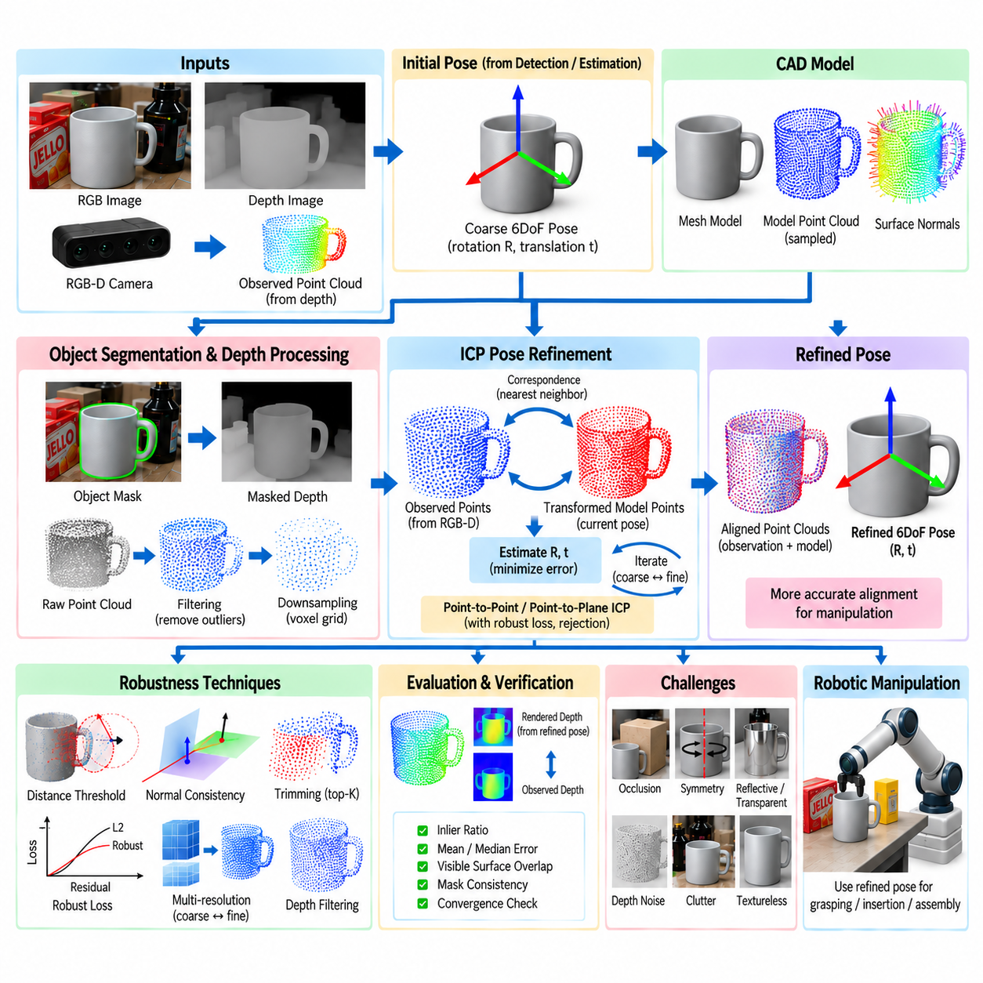
RGB-D-based pose refinement improves an initial 6DoF object pose by aligning predicted object geometry with depth measurements from the observed scene. A neural or geometric pose estimator may already provide an approximate rotation and translation, but small errors can remain because of image resolution, feature uncertainty, occlusion, or discrete pose hypotheses. Refinement converts this coarse estimate into a more accurate transformation suitable for physical interaction.
The basic principle is to compare a three-dimensional object model transformed by the initial pose with the point cloud reconstructed from the RGB-D observation. If the estimated pose is correct, corresponding model and observed surfaces should occupy approximately the same positions in camera coordinates. Misalignment generates geometric residuals that can be minimized by updating rotation and translation until the two representations agree more closely.
An RGB-D camera supplies registered color and depth observations. Using the camera intrinsic parameters, a depth pixel with image coordinates and measured depth can be back-projected into a three-dimensional point. Repeating this process over the segmented object region generates an observed point cloud. RGB information assists object detection and segmentation, while depth supplies the metric geometry required for direct spatial alignment.
Accurate segmentation is important before refinement because depth measurements from the background or neighboring objects can create false correspondences. The estimated object mask is normally used to extract only the relevant depth points. Additional filtering can reject measurements outside an expected depth interval, remove isolated points, or suppress pixels near uncertain object boundaries where foreground and background depth may become mixed.
The CAD model provides the geometric representation used as the refinement target. A polygon mesh can be sampled into a model point cloud, and surface normals can be computed from local mesh geometry. The initial 6DoF pose transforms these model points from object coordinates into the camera coordinate system. Refinement then searches for a small corrective transformation that improves agreement with the observed depth geometry.
Iterative Closest Point, commonly abbreviated as ICP, is one of the most widely used algorithms for this alignment problem. ICP alternates between establishing correspondences and estimating a transformation. Given the current pose, each transformed model point is associated with a nearby observed point, or vice versa. A new rigid transformation is then calculated to reduce the discrepancy between the matched point sets.
Point-to-point ICP minimizes Euclidean distances between corresponding three-dimensional points. If model point p corresponds to observed point q, the optimization seeks a rotation and translation that minimize the sum of squared distances between transformed p and q. This formulation is conceptually simple and broadly applicable, but convergence can become slow or unstable when surfaces contain insufficient geometric structure.
Point-to-plane ICP instead minimizes displacement along the surface normal of the corresponding point. Rather than penalizing the complete Euclidean separation equally in every direction, it measures how far a transformed model point lies from the local tangent plane of the observed surface. For smooth surfaces and sufficiently accurate initialization, point-to-plane optimization often converges faster and produces more precise local alignment.
Correspondence selection strongly influences ICP performance. A nearest-neighbor relationship does not necessarily represent the same physical surface, particularly in cluttered scenes or under partial occlusion. Distance thresholds can reject pairs that are too far apart, while normal-angle thresholds can reject surfaces with incompatible orientation. Trimming strategies can retain only a fraction of correspondences with the smallest residuals to reduce the influence of outliers.
Robust loss functions provide another mechanism for limiting incorrect correspondences. Standard least-squares optimization gives large residuals substantial influence, allowing a small number of erroneous matches to distort the solution. Robust estimators reduce the weight of residuals beyond an expected range. This is valuable when depth noise, segmentation leakage, occlusion, or imperfect CAD geometry prevents exact correspondence across all visible surfaces.
ICP is fundamentally a local optimization algorithm and therefore depends strongly on initialization. If the initial pose is too far from the correct solution, nearest-neighbor matching may associate unrelated surfaces and the optimization can converge to an incorrect local minimum. The preceding pose-estimation stage must consequently provide a pose within an appropriate convergence basin, or the system must evaluate multiple initial hypotheses.
Coarse-to-fine refinement increases the effective convergence range. At a coarse level, point clouds can be voxel-downsampled so that broad geometric structure dominates alignment. After obtaining a better pose, the system progressively reduces voxel size and correspondence thresholds to use finer surface detail. This multi-resolution strategy improves efficiency and can prevent small local structures or sensor noise from dominating early optimization.
Surface normals must be estimated reliably when point-to-plane objectives or normal consistency checks are used. Observed normals can be computed from local neighborhoods in the depth-derived point cloud, while model normals come directly from the CAD mesh. Neighborhood size creates a tradeoff: small regions preserve fine geometry but are sensitive to noise, whereas larger regions provide smoother estimates but can blur edges and small features.
Depth preprocessing can substantially improve refinement quality. Bilateral filtering or related edge-preserving methods can suppress random measurement noise without excessively smoothing object boundaries. Statistical or radius-based outlier removal can eliminate isolated points. Voxel downsampling reduces computational load and regularizes point density. However, aggressive filtering may remove precisely the small geometric structures needed to determine orientation accurately.
Occlusion requires special treatment because only part of the CAD model may be visible in the measured depth image. Aligning every model point against the observation would incorrectly force hidden surfaces toward unrelated visible geometry. Visibility reasoning can render the model from the current pose and select only surfaces expected to be visible from the camera. Refinement can then compare compatible visible model regions with measured object points.
Depth consistency can also be evaluated in image space. The CAD model is rendered at the current pose to generate a synthetic depth map, which is compared with the measured depth image. Pixels where rendered and observed depths agree provide evidence supporting the hypothesis, while large discrepancies indicate pose error, occlusion, segmentation problems, or incorrect object identity. This projective formulation can be efficient because image-space correspondence is naturally available.
RGB information can complement depth-based refinement. Object silhouettes provide strong constraints near boundaries, particularly when depth measurements are unreliable at edges. Image gradients, learned dense features, or photometric consistency can provide additional alignment signals. A combined objective can therefore minimize geometric depth residuals together with silhouette or appearance disagreement, improving robustness when either modality alone is ambiguous.
Pose refinement should preserve the mathematical structure of rigid transformations. Rotation updates cannot be treated as arbitrary unconstrained matrix corrections because the result must remain a valid member of SO(3). Incremental updates can be represented using axis-angle coordinates, Lie algebra se(3), or quaternions. The incremental transformation is composed with the current SE(3) estimate at each iteration until convergence criteria are satisfied.
Convergence can be determined from several conditions. Iteration may stop when the change in translation and rotation falls below predefined thresholds, when the reduction in residual error becomes negligible, or when a maximum number of iterations is reached. Monitoring the number of valid correspondences and final residual distribution is also important because numerical convergence does not guarantee that the recovered pose is physically correct.
Post-processing should include pose verification rather than automatically accepting the ICP result. Useful checks include inlier ratio, mean or median geometric residual, visible-surface overlap, rendered-depth consistency, and agreement with the object mask. A refined pose that has moved significantly away from a high-confidence initial estimate without improving geometric support may indicate ICP failure and should be rejected.
Symmetric objects require careful interpretation because ICP can converge to different but physically equivalent orientations. A cylindrical object may rotate around its symmetry axis without changing the measured geometry. Forcing one arbitrary orientation can create apparent numerical error even though physical alignment is correct. Symmetry-aware pose representations and validation metrics should therefore evaluate equivalence classes rather than a single annotated transformation.
RGB-D sensors also introduce systematic limitations. Reflective, transparent, dark, or highly absorptive surfaces may produce missing or biased depth measurements. Multipath interference and depth-edge artifacts can create geometry that does not correspond to the actual object. Confidence masks or sensor-specific filtering can exclude unreliable regions so that ICP does not attempt to explain measurement artifacts by incorrectly changing the object pose.
The refined pose can be accompanied by an uncertainty estimate derived from residual geometry and optimization curvature. Well-constrained alignment with many spatially distributed correspondences generally indicates higher confidence than alignment supported by a small planar region. Such uncertainty information can be propagated to grasp planning, allowing the robot to select larger-clearance grasps or request another observation when pose precision is insufficient.
In robotic manipulation, even small refinement improvements can have substantial practical value. A coarse pose may be sufficient to approach an object, but finger placement, connector insertion, peg alignment, tool engagement, and precision assembly can require millimeter-scale positioning. ICP-based post-processing converts metric depth information into a final geometric correction immediately before motion planning or contact execution.
A practical pipeline therefore begins with RGB-based detection or segmentation and an initial 6DoF estimate, reconstructs the corresponding object point cloud from depth, transforms the CAD model using the initial pose, and performs robust coarse-to-fine alignment. The refined transformation is then verified through residual, overlap, visibility, and confidence checks before being transferred through the calibrated camera-to-robot coordinate chain.
RGB-D pose refinement demonstrates how learned perception and classical geometry can cooperate rather than compete. A neural estimator provides semantic understanding and a sufficiently accurate initialization, while ICP and related geometric methods exploit metric depth to enforce surface-level consistency. This hybrid structure is especially effective in robotic manipulation, where the final requirement is not merely visual recognition but physically accurate alignment between the estimated object and the real world.

04.08. Pose Estimation Under Occlusion Clutter [w/Code]
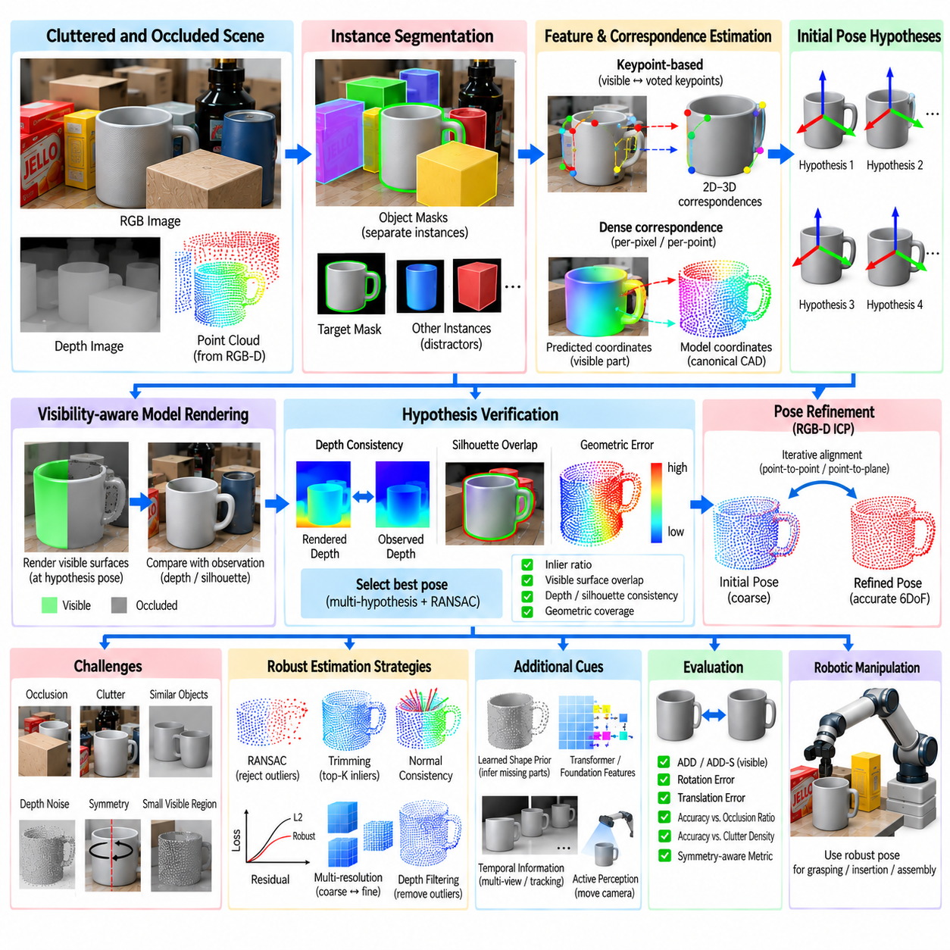
Occlusion and clutter are among the most difficult conditions for reliable 6DoF object pose estimation. Occlusion removes part of the visual and geometric evidence belonging to a target object, while clutter introduces competing evidence from neighboring objects and background structures. A robust estimator must therefore infer position and orientation from incomplete observations while rejecting measurements that do not belong to the target.
Occlusion can be caused by other objects, robot grippers, containers, shelves, or the target object's own geometry. Self-occlusion occurs naturally because only surfaces facing the sensor are visible from a given viewpoint. External occlusion further reduces the observable region. As visibility decreases, pose estimation becomes increasingly underconstrained because multiple object configurations may explain the remaining image or depth evidence.
Clutter creates a different but related problem. In a densely packed bin or workspace, boundaries, textures, depth discontinuities, and geometric surfaces from several objects may overlap in image space. Similar objects can also touch or partially overlap one another. The perception system must separate target evidence from distractors before estimating pose, otherwise incorrect correspondences can produce plausible but physically invalid transformations.
Instance segmentation is therefore an important front end for pose estimation in clutter. A segmentation network assigns pixels to individual object instances, allowing RGB and depth information associated with a target to be isolated. Accurate masks reduce contamination from neighboring geometry. However, segmentation itself becomes difficult under severe occlusion because the visible object region may be fragmented, extremely small, or visually similar to surrounding instances.
Detection confidence should not be interpreted as pose confidence. A network may correctly identify an object category or instance while remaining uncertain about its exact orientation. Conversely, a small visible region may strongly constrain pose if it contains a distinctive geometric feature. Robust systems therefore maintain separate confidence signals for detection, segmentation, correspondence quality, pose hypotheses, and final geometric verification.
Keypoint-based approaches can handle partial visibility by predicting hidden landmarks from visible context. Instead of requiring every keypoint to be directly observable, methods such as vector-field voting allow many visible pixels to vote toward expected landmark locations. If enough object structure remains visible, distributed evidence can recover keypoints behind occluders. The resulting 2D–3D correspondences can then support PnP-based pose recovery.
Dense correspondence methods provide another source of robustness. Rather than depending on a small set of landmarks, every visible object pixel or 3D point can contribute evidence about canonical coordinates, model correspondences, centers, or keypoint offsets. When part of the object disappears, the remaining surface still produces many measurements. Robust aggregation prevents a limited number of erroneous local predictions from dominating the final pose.
RGB-D sensing is especially valuable in clutter because depth helps distinguish surfaces that overlap in the RGB image. Two objects with similar color may occupy clearly different depths, while geometric discontinuities can reveal boundaries that are visually weak. Point clouds also provide metric structure for correspondence checking and pose refinement. Nevertheless, depth sensors introduce missing values and edge artifacts that can become severe around occlusion boundaries.
Occlusion boundaries require careful treatment because depth pixels near foreground-background transitions may contain mixed or unstable measurements. If these points are used directly, they can distort object geometry and corrupt registration. Eroding uncertain mask boundaries, rejecting depth discontinuities, or assigning lower confidence to boundary measurements can improve pose stability. Sensor-specific uncertainty models can further distinguish reliable surface points from likely artifacts.
Robust correspondence estimation is central to clutter-resistant pose recovery. Feature matches, predicted coordinates, or point associations should be tested for consistency with a common rigid transformation. RANSAC can repeatedly sample correspondence subsets and identify hypotheses supported by many inliers. Incorrect matches generated by neighboring objects or background texture are then rejected when they fail to satisfy the same geometric model.
The spatial distribution of inliers is as important as their number. Many correspondences concentrated on one small planar patch may provide weak constraints on some rotational or translational directions. Correspondences distributed across multiple object surfaces generally produce a better-conditioned pose estimate. Confidence measures should therefore consider geometric coverage, not simply the percentage of matching pixels or points.
Multi-hypothesis estimation is useful when incomplete observations support several plausible poses. Instead of immediately selecting the highest-scoring transformation, the system can retain multiple candidates and evaluate them using additional evidence. Rendered silhouettes, depth consistency, collision relationships, temporal observations, or a second camera view can eliminate hypotheses that initially appeared equally plausible.
Model rendering provides an effective mechanism for pose verification under occlusion. A CAD model transformed by a candidate pose can be rendered to predict visible surfaces, silhouette, and depth. These predictions are compared with the actual RGB-D observation. Visible model regions should agree with measured surfaces, while model parts predicted behind known occluders should not be incorrectly penalized for being absent.
Visibility reasoning is therefore essential. A simple comparison between the complete CAD model and the observed point cloud incorrectly treats hidden model surfaces as missing measurements. Z-buffer rendering or ray-based visibility analysis can determine which model surfaces should be observable from the camera. Only expected visible regions are then included in geometric consistency calculations, producing an occlusion-aware verification score.
Occlusion ratio can provide a useful measure of pose reliability. The system can estimate how much of the object's predicted visible area is actually observed and how much is hidden by foreground geometry. A low visibility ratio does not automatically invalidate a pose, but it should increase uncertainty. Different objects also require different minimum visibility because distinctive asymmetric structures may remain informative even when only a small region is exposed.
Symmetry compounds the ambiguity created by occlusion. If the visible region is itself symmetric, several orientations may be indistinguishable. A mug whose handle is hidden can resemble a rotationally symmetric cup, while a partially visible rectangular object may support multiple flipped orientations. Symmetry-aware representations should preserve equivalent hypotheses rather than forcing an arbitrary orientation unsupported by the sensor data.
Learned shape priors can infer missing geometry from partial observations. Networks trained across many instances learn statistical relationships between visible surfaces and likely hidden structures. Such priors are useful for category-level pose estimation and unseen objects, but inferred geometry should not be confused with direct measurement. Confidence must reflect whether pose constraints originate from observed evidence or from learned assumptions about typical shape.
Transformers and attention mechanisms can improve reasoning over fragmented object regions by integrating information across distant image or point-cloud locations. Visible patches separated by occluders may still belong to the same physical object. Attention-based representations can connect these regions through semantic and geometric context, helping the system form a coherent object hypothesis without requiring continuous visible boundaries.
Foundation visual features can also strengthen correspondence under clutter by providing descriptors learned from broad visual data. They may match semantically related object regions despite illumination changes, weak texture, or partial visibility. However, foundation features do not eliminate geometric ambiguity. Their matches should still be validated through rigid transformation constraints, depth consistency, and object-level segmentation before a pose is trusted.
Synthetic training data is particularly useful for generating controlled occlusion and clutter distributions. Objects can be randomly placed in bins, stacked, partially hidden, or intersected in image space while exact poses and visibility masks remain known. Training can systematically vary occlusion ratios and distractor density, allowing performance to be characterized as scene difficulty increases rather than relying only on naturally occurring examples.
Domain randomization should include more than visual appearance. Useful variations include object placement, overlap, depth ordering, camera viewpoint, lighting, sensor noise, missing depth, distractor similarity, and segmentation errors. Hard-example generation can deliberately create cases where only distinctive object fragments remain visible. Such training encourages the estimator to exploit robust geometric evidence rather than memorizing complete-object appearances.
Temporal information can reduce ambiguity when the robot or object moves. A single frame may contain severe occlusion, but successive viewpoints can reveal different surfaces. Pose hypotheses can be tracked across time using motion models and observation updates. Evidence accumulated over several frames can stabilize orientation and translation while rejecting transient false detections caused by clutter or temporary occluders.
Active perception extends this idea by allowing the robot to intentionally acquire a more informative viewpoint. If pose uncertainty is high because a critical surface is hidden, the camera or robot can move to expose that region. The best next view can be selected according to expected visibility, information gain, collision constraints, and motion cost. Pose estimation then becomes an interactive perception problem rather than a passive single-image calculation.
Multi-camera systems provide simultaneous observations from different viewpoints and can substantially reduce occlusion. A surface hidden from one camera may be visible from another. Pose hypotheses can be fused in a shared coordinate frame after accurate extrinsic calibration. The benefit is greatest when cameras provide complementary viewing directions, although synchronization, calibration, bandwidth, and computational requirements become more demanding.
Pose refinement under clutter must also be occlusion-aware. Standard ICP may align a model with points belonging to neighboring objects if the initial segmentation contains contamination. Robust ICP variants use distance thresholds, normal consistency, trimming, visibility filtering, and robust losses. Refinement should improve agreement with verified target surfaces without allowing unrelated clutter to pull the model toward an incorrect local minimum.
Evaluation should explicitly measure robustness as visibility decreases and clutter increases. Reporting only average pose accuracy can hide catastrophic failure in difficult scenes. Performance can be stratified by occlusion percentage, number of neighboring objects, object distance, visible surface fraction, or segmentation quality. ADD, ADD-S, visible-surface metrics, rotation error, translation error, and recall at defined pose thresholds can then be analyzed across these conditions.
For robotic manipulation, uncertainty caused by occlusion must influence action planning. A robot should not execute a tight-clearance grasp or insertion merely because one pose hypothesis has the highest score. High uncertainty may justify a wider grasp, a collision-tolerant approach, removal of an obstructing object, or acquisition of another viewpoint. Perception confidence therefore becomes part of physical decision making.
A robust cluttered-scene pipeline combines instance segmentation, partial-object feature extraction, distributed correspondence prediction, robust hypothesis generation, visibility-aware rendering, geometric verification, and optional RGB-D refinement. Multiple hypotheses can be preserved until sufficient evidence exists to select one. Temporal or active sensing can be invoked when the observation remains fundamentally ambiguous.
Pose estimation under occlusion and clutter ultimately requires distinguishing what is observed from what is inferred. Dense features, learned priors, and foundation models can reconstruct useful hypotheses from incomplete data, while projective geometry and depth enforce physical consistency. By combining uncertainty, visibility reasoning, robust estimation, and active perception, a robot can maintain reliable 6DoF object understanding even when the scene provides only fragmented evidence.

04.09. Pose Estimation ROS2 Node Integration [w/Code]
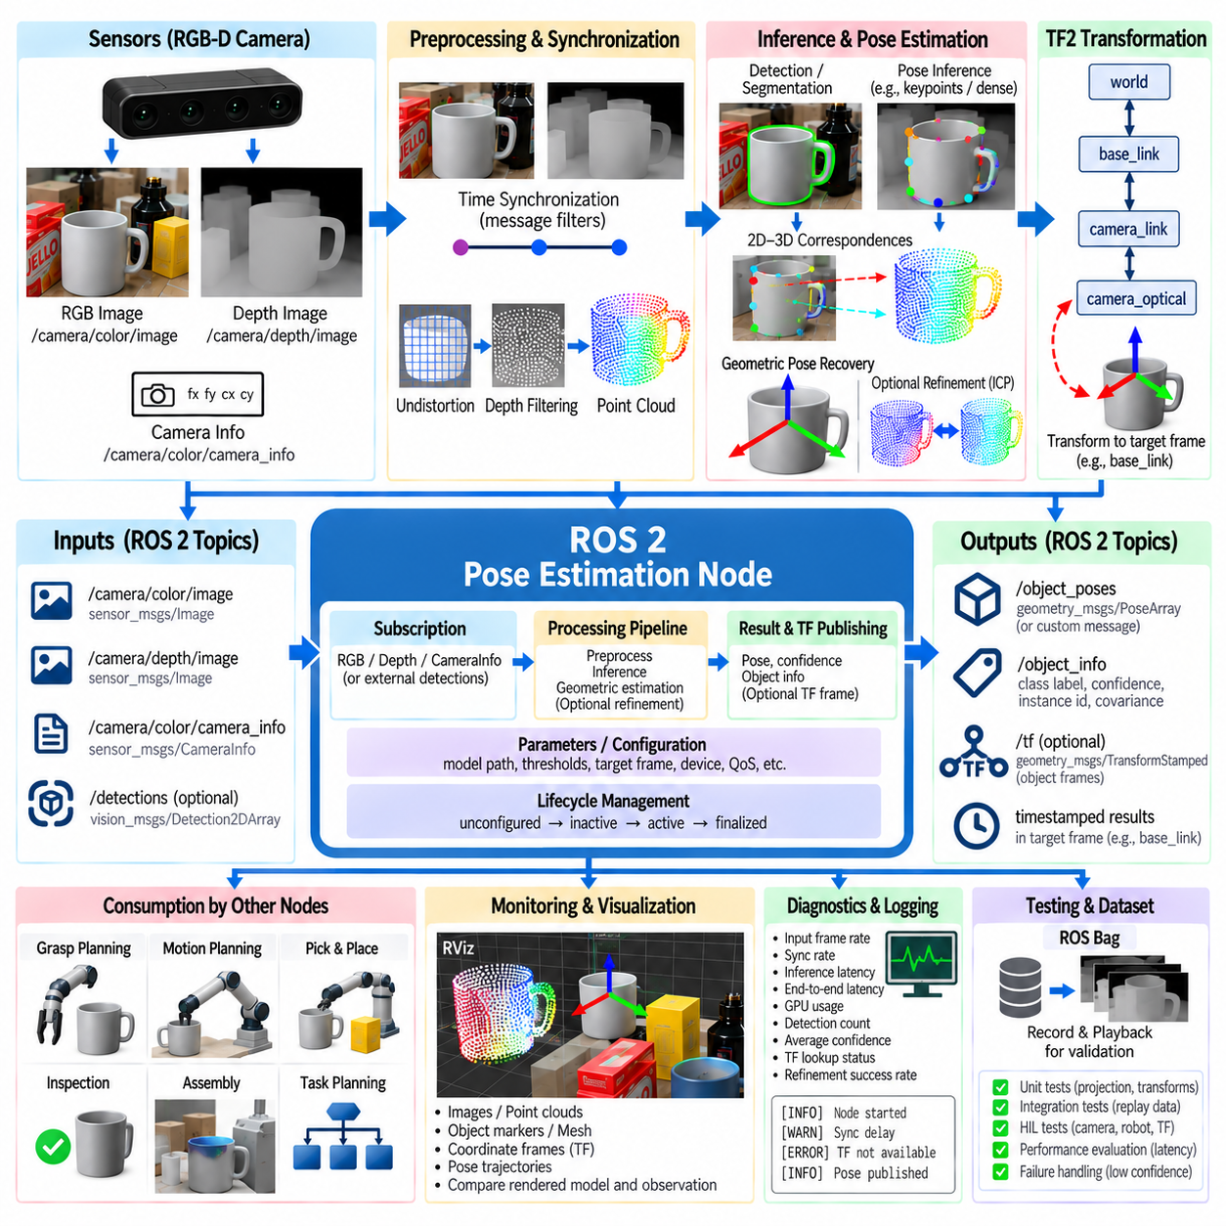
A ROS 2 pose-estimation node converts object perception from an isolated algorithm into a reusable component of a robotic software system. The node receives synchronized sensor observations, executes detection and 6DoF pose inference, transforms results into defined coordinate frames, and publishes poses with confidence and metadata. Other components can then consume the estimates without depending on the internal implementation of the perception model.
A practical integration begins by defining clear node responsibilities. The pose node should normally own sensor preprocessing, model inference, geometric pose recovery, confidence evaluation, and publication of results, while navigation, manipulation, and task planning remain separate components. This separation reduces coupling and allows the pose estimator to be replaced or upgraded without redesigning the complete robot application.
RGB-D pose estimation commonly requires color images, depth images, and camera calibration information. ROS 2 represents these inputs through image and camera-information messages published by camera drivers. The pose node subscribes to the required topics and converts incoming messages into the image arrays, depth measurements, and intrinsic matrices expected by the inference pipeline.
Temporal synchronization is essential because RGB and depth observations must describe approximately the same physical scene. If the robot, camera, or object moves between measurements, combining unsynchronized frames creates incorrect 2D–3D relationships. Message-filtering mechanisms can perform exact or approximate synchronization, while timestamps allow the system to detect excessive delays and reject observations that should not be fused.
Camera calibration provides the projection model needed to connect image coordinates with metric three-dimensional geometry. Focal lengths, principal point, distortion parameters, and image dimensions are obtained from camera-information messages or calibrated configuration. Depth pixels can then be back-projected into camera coordinates, while model points or predicted poses can be projected into the image for verification and visualization.
The ROS 2 transform system, TF2, provides the coordinate-frame infrastructure needed to connect perception with the rest of the robot. A pose estimator typically predicts an object's transformation relative to an optical camera frame. Manipulation may instead require the pose in a robot base, world, tool, or workcell frame. TF2 resolves the required transformation chain at the timestamp associated with the observation.
Frame conventions must be defined rigorously because a numerically valid transformation can still be physically wrong if coordinate axes are interpreted inconsistently. Camera optical frames, robot base frames, object model frames, and tool frames may use different axis conventions. The pose-estimation interface should explicitly define the parent and child frames and verify rotation conventions using known physical configurations before deployment.
Object detection or instance segmentation commonly precedes pose estimation. The node may execute these stages internally or subscribe to detections produced by another perception component. A modular architecture can separate detection and pose estimation when several downstream applications share detections, while an integrated node may reduce communication overhead when detection and pose inference use the same GPU and intermediate features.
The inference pipeline can support different pose algorithms behind a common ROS 2 interface. A keypoint model may predict 2D landmarks followed by PnP, an RGB-D network may directly fuse image and point-cloud features, and a foundation-model pipeline may retrieve references before geometric correspondence estimation. Standardized inputs and outputs allow these internal approaches to change without modifying downstream consumers.
Published pose results should contain more than rotation and translation. Object identity, class label, detection score, pose confidence, timestamp, source frame, instance identifier, and optional covariance are useful for downstream reasoning. Multiple objects can be published as an array of detections or tracked instances, while each pose remains associated with the sensor observation from which it was calculated.
Pose uncertainty is especially important for manipulation. A single deterministic transformation does not indicate whether the estimate is supported by a complete object view or a small occluded region. Covariance or application-specific confidence metrics can describe uncertainty in translation and orientation. A manipulation planner can use this information to reject risky estimates, choose tolerant grasps, or request another observation.
Quality of Service, or QoS, determines how ROS 2 communication behaves under different timing and reliability requirements. High-rate camera streams may favor sensor-data profiles that prioritize fresh observations over retransmission of old frames. Pose results may use different reliability and queue settings depending on whether every estimate must be delivered or only the most recent pose is relevant to the control system.
Queue depth must be selected carefully because excessive buffering can make perception operate on stale images. If neural inference is slower than the camera frame rate, continuously accumulating messages increases latency even though throughput appears stable. A real-time-oriented pose pipeline often prefers dropping obsolete observations and processing the newest available synchronized frame so that published poses remain temporally relevant.
Executors and callback groups influence concurrency inside the node. Image reception, synchronization, GPU inference, TF lookup, visualization, and service requests can compete for execution resources. Long inference operations should not unnecessarily block lightweight callbacks. Multi-threaded execution, separate callback groups, or dedicated worker threads can isolate expensive computation while preserving predictable communication behavior.
GPU inference introduces additional integration considerations. Model weights should normally be loaded once during node initialization rather than for every callback. Input buffers can be preallocated, inference contexts reused, and unnecessary CPU–GPU copies minimized. Where supported, optimized inference runtimes, mixed precision, or compiled execution graphs can reduce latency while maintaining pose accuracy within application requirements.
A useful node architecture separates message callbacks from the heavy inference pipeline. The callback validates and stores the newest synchronized observation, while a processing worker performs preprocessing, inference, geometric solving, and refinement. This prevents subscription queues from becoming blocked by long GPU execution. Care is required to protect shared data and ensure that timestamps remain associated with the correct inference result.
Lifecycle nodes can improve deployment reliability by providing explicit states such as unconfigured, inactive, active, and finalized. Model paths, camera topics, object databases, thresholds, and device selections can be validated during configuration before the node begins processing data. Activation can then start subscriptions and inference, while deactivation can release runtime resources or temporarily stop publication without terminating the entire process.
ROS 2 parameters provide a convenient mechanism for configuring the pose-estimation component without recompiling software. Useful parameters include model paths, confidence thresholds, object classes, synchronization tolerance, input resolution, depth range, ICP settings, target frames, inference device, and publication rate. Parameters that affect safety or coordinate conventions should be validated before accepting runtime changes.
Services can support operations that are event-driven rather than continuous. A manipulation system may request a pose estimate only when it is ready to grasp an object, or an operator may request model reload, calibration validation, or a snapshot estimate. Continuous topics remain appropriate for streaming perception, while services provide explicit request-response behavior for discrete operations.
Actions can be useful when pose acquisition requires a longer procedure such as moving a camera, collecting multiple views, refining a hypothesis, or waiting until confidence exceeds a threshold. Unlike a simple service, an action can provide progress feedback and support cancellation. This makes it suitable for active perception workflows in which pose estimation becomes a multi-step robotic behavior.
Pose refinement can be integrated as an optional stage after initial inference. If RGB-D data and a CAD model are available, the node can perform ICP or rendered-depth alignment before publishing the final transformation. The system should preserve both initial and refined confidence information because refinement can occasionally fail when segmentation is poor, visibility is low, or the initial pose lies outside the convergence region.
TF publication requires careful architectural decisions. Dynamic object frames may be broadcast for visualization and manipulation, but large numbers of short-lived object instances can make the TF tree difficult to manage. In many systems, object poses are primarily published as stamped pose messages, while TF frames are generated only for selected targets that must participate directly in transformation queries.
Visualization is valuable during integration and debugging. RViz can display RGB images, point clouds, object markers, coordinate axes, bounding boxes, meshes, and pose trajectories in a common frame. Comparing the rendered object model with measured point clouds provides an immediate way to identify calibration errors, incorrect frame conventions, timestamp mismatches, or systematic pose offsets.
Diagnostics should expose the health of the complete perception pipeline rather than only whether the node process is alive. Useful measurements include input frame rate, synchronized-frame rate, inference latency, end-to-end latency, dropped frames, GPU utilization, detection count, average confidence, TF lookup failures, and refinement success rate. These signals help distinguish model errors from software integration or sensor problems.
Logging should record enough context to reproduce failures without overwhelming the system. Important events include missing camera information, synchronization timeout, invalid depth data, model loading failure, unavailable transforms, inference exceptions, and rejected pose hypotheses. Throttled warnings prevent repeated sensor problems from flooding logs while still making persistent faults visible to operators.
Recording ROS bags is an effective validation strategy because the same sensor streams and transforms can be replayed through different versions of the pose node. Developers can compare algorithms, parameters, inference runtimes, and refinement strategies using identical observations. Deterministic replay also helps investigate rare failures that would be difficult to reproduce manually in a physical workcell.
Testing should cover individual mathematical functions as well as complete message-level behavior. Unit tests can verify projection, back-projection, quaternion conversion, pose composition, and coordinate-frame transformations. Integration tests can replay known sensor sequences and compare published poses against expected results. Hardware-in-the-loop testing then validates timing, camera drivers, GPU execution, TF availability, and robot-side consumption.
Performance evaluation should separate algorithmic inference time from complete system latency. A network may require only tens of milliseconds for inference while synchronization, image conversion, queueing, TF lookup, refinement, and message publication add substantial delay. For manipulation of moving objects, the age of the final pose at the moment of execution can be more important than the raw neural-network benchmark.
A production ROS 2 pose node should fail safely when confidence or required system information is insufficient. Missing transforms, invalid calibration, stale images, unavailable depth, or low-confidence hypotheses should produce explicit invalid states rather than plausible-looking poses. Downstream planners can then stop, reacquire perception, or select an alternative behavior instead of executing motion based on uncertain geometry.
The complete integration pipeline therefore connects sensor topics, synchronization, calibration, preprocessing, pose inference, optional geometric refinement, uncertainty estimation, TF2 transformation, and standardized pose publication. Parameters, lifecycle management, QoS, diagnostics, logging, visualization, and testing surround the core estimator so that it behaves as a maintainable robotic software component rather than an isolated machine-learning script.
ROS 2 integration ultimately makes object pose estimation actionable within Physical AI. The perception model determines where an object is, TF2 connects that estimate to the robot's physical coordinate system, and standardized interfaces deliver the result to grasp planning, motion planning, inspection, or assembly. Reliable deployment depends not only on pose accuracy but also on synchronization, calibration, latency, uncertainty, observability, and safe software behavior.

04.10. Real Time Pose Estimation TensorRT Deployment [w/Code]
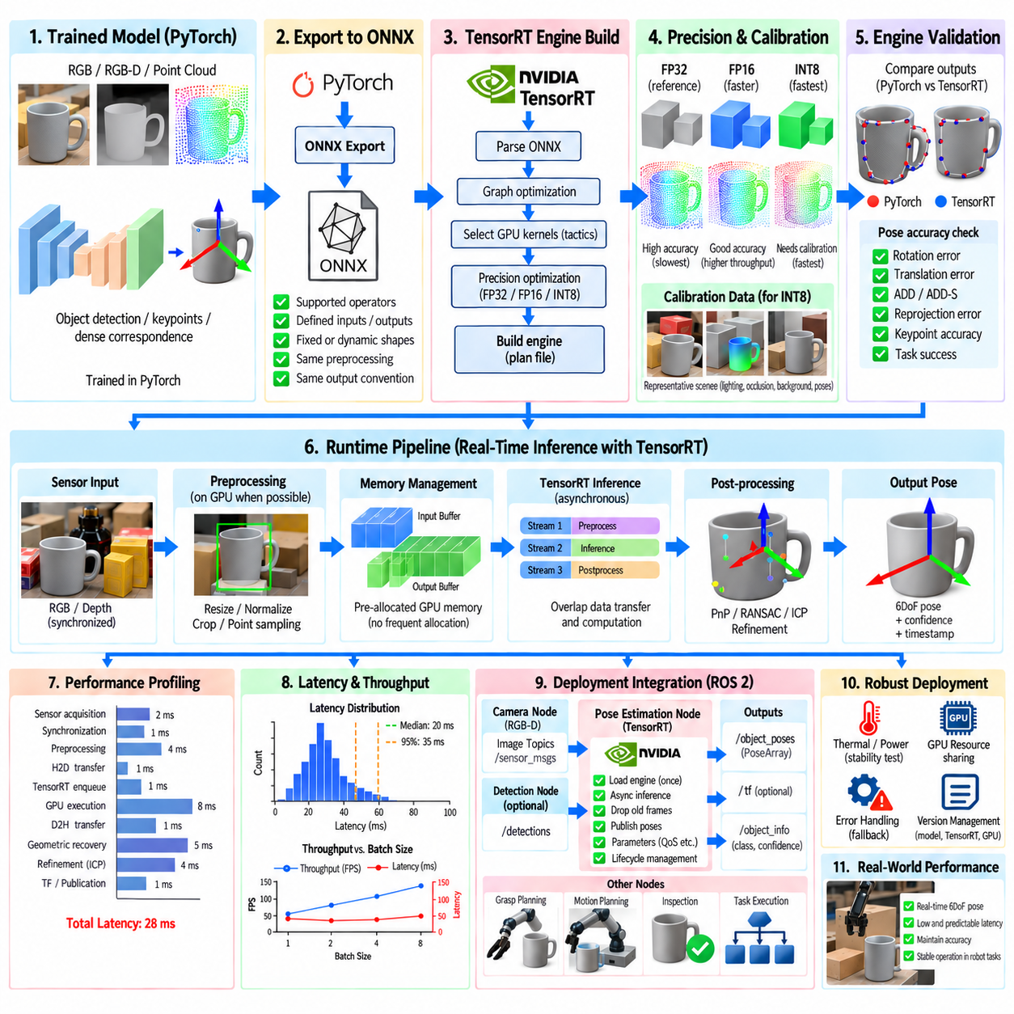
Real-time object pose estimation transforms perception from an offline inference problem into a continuously operating component of a robotic control system. The objective is not only to produce accurate 6DoF rotation and translation but to deliver them with sufficiently low and predictable latency. In manipulation, inspection, or moving-object tracking, a highly accurate pose can become useless if it represents a scene state that is already outdated when the robot acts.
TensorRT provides an optimized inference runtime for deploying trained deep neural networks on NVIDIA GPUs. A pose-estimation model is typically trained in a framework such as PyTorch and then exported into an interoperable representation such as ONNX. TensorRT analyzes the computational graph, selects optimized GPU kernels, applies precision and memory optimizations, and builds an inference engine specialized for the target hardware and deployment configuration.
The deployment process should begin with a validated reference model rather than optimization itself. Outputs from the original training framework must first be checked on representative RGB, RGB-D, or point-cloud inputs. Pose accuracy, preprocessing conventions, tensor layouts, normalization, coordinate definitions, and post-processing must be frozen as a reference. Without this baseline, numerical differences introduced during deployment can easily be confused with pre-existing model or data errors.
ONNX export converts the trained network into a framework-independent computational graph. The exported graph should use supported operators and clearly defined input and output tensors. Dynamic dimensions may be retained when variable image sizes, batch sizes, or point counts are required, but unnecessary dynamic shapes increase optimization complexity. Fixed deployment dimensions often enable stronger TensorRT optimization and more predictable execution latency.
Graph validation should occur before TensorRT engine generation. The ONNX model can be compared against the original network using identical input tensors and numerical tolerance criteria. Intermediate or final outputs should remain sufficiently close that the resulting pose prediction does not change materially. This validation isolates export problems such as unsupported operations, incorrect reshaping, axis ordering errors, or differences in interpolation and normalization behavior.
TensorRT engine building transforms the network graph into an optimized executable representation for a specific class of GPU environment. During this stage TensorRT evaluates candidate implementations for network layers and selects efficient tactics according to available hardware, workspace constraints, tensor dimensions, and precision modes. Engine generation can require significant time, but the resulting optimized plan is reused during normal inference.
FP32 inference provides a useful deployment reference because it generally remains closest to the original floating-point model. FP16 can substantially improve throughput and reduce memory consumption on GPUs with efficient half-precision execution while often preserving pose accuracy. The actual benefit depends on network architecture, GPU generation, memory bandwidth, preprocessing cost, and the fraction of operations that can execute efficiently at reduced precision.
INT8 inference can provide additional acceleration and memory reduction but requires greater attention to numerical behavior. Post-training quantization generally needs representative calibration data so that activation ranges can be estimated. Calibration samples should reflect realistic object appearances, lighting, occlusion, backgrounds, depths, and geometric configurations. Poor calibration can preserve classification confidence while degrading the continuous geometric quantities required for accurate pose estimation.
Quantization evaluation should therefore use pose-specific metrics rather than only tensor-level differences. Rotation error, translation error, ADD, ADD-S, reprojection error, keypoint accuracy, correspondence quality, and task success can reveal degradation that generic neural-network metrics overlook. If INT8 causes unacceptable errors in sensitive layers, mixed-precision strategies can retain selected operations at FP16 or FP32 while quantizing more tolerant portions of the network.
Optimization profiles define the tensor shape ranges that a TensorRT engine is expected to process. For dynamic inputs, minimum, optimum, and maximum shapes should reflect realistic deployment conditions. Excessively broad profiles can reduce optimization efficiency, while profiles that are too narrow may reject valid inputs. Real-time robotic systems benefit from constraining dimensions whenever possible so that memory allocation and execution behavior remain predictable.
Engine initialization should occur before the real-time processing loop. Model files should not be parsed and engines should not be rebuilt whenever a camera frame arrives. The application loads or deserializes the TensorRT engine, creates an execution context, allocates required device memory, initializes CUDA resources, and performs warm-up inference. Only then should the system begin reporting production latency and accepting time-critical sensor data.
Memory management can determine whether theoretical GPU acceleration produces actual end-to-end improvement. Repeated allocation and deallocation of CPU and GPU buffers introduces unnecessary overhead and latency variation. Persistent input, output, and workspace buffers should be allocated when possible. Reusing memory across frames reduces runtime overhead and helps stabilize execution time, which is important for deterministic robotic behavior.
Host-to-device and device-to-host transfers should also be minimized. A conventional pipeline may decode an image on the CPU, preprocess it, copy it to the GPU, execute inference, copy outputs back, and then perform post-processing on the CPU. Each transition introduces synchronization and transfer costs. Keeping preprocessing, inference, and suitable post-processing stages on the GPU can significantly reduce end-to-end latency.
CUDA streams allow data movement and GPU computation to be scheduled asynchronously. With an appropriate pipeline, preprocessing of one frame, inference of another, and transfer or post-processing of a previous result can overlap. However, asynchronous execution must preserve correct ownership of buffers and timestamps. Increased concurrency is useful only when the resulting pose remains associated with the exact sensor observation that produced it.
Pose-estimation pipelines frequently contain operations outside the neural network itself. Object detection, segmentation, crop generation, depth conversion, point-cloud sampling, keypoint decoding, PnP, RANSAC, ICP, and coordinate transformations may all contribute to runtime. Optimizing only the neural model can therefore produce disappointing system-level gains if preprocessing or geometric post-processing remains the dominant bottleneck.
Profiling should measure every major pipeline stage independently. Useful quantities include sensor acquisition delay, synchronization time, preprocessing latency, host-to-device transfer, TensorRT enqueue time, GPU execution, output transfer, geometric pose recovery, refinement, TF transformation, and publication. The sum of these stages determines how old the estimated pose is when it reaches the robot controller.
Latency distributions are more informative than average latency alone. A system averaging 20 ms but occasionally requiring 150 ms may be unsuitable for time-critical manipulation. Median, high-percentile, maximum, and jitter measurements reveal whether inference is predictable. GPU contention, memory allocation, thermal throttling, background processes, synchronization barriers, or variable post-processing workloads can create latency spikes that are hidden by mean values.
Throughput and latency must also be distinguished. Batch processing can increase frames per second by improving GPU utilization, but it may delay individual observations while waiting for a batch to fill. Real-time robotic perception commonly uses batch size one because immediate response is more important than maximum offline throughput. Larger batches are appropriate only when multiple cameras or independent objects can be processed without violating latency requirements.
Frame dropping is often preferable to unlimited queue growth. If the camera produces images faster than the complete pose pipeline can process them, processing every frame causes the estimator to fall progressively behind reality. A low-latency architecture can discard obsolete observations and process the newest synchronized frame. This sacrifices frame completeness while preserving temporal relevance for control and manipulation.
Input resolution creates a direct tradeoff between computational cost and pose accuracy. Reducing image dimensions accelerates convolutional processing but may remove small edges, keypoints, or object details needed for precise orientation. Region-of-interest processing can provide a better compromise by detecting the object at moderate resolution and applying the expensive pose network only to cropped target regions while maintaining useful local detail.
Point-cloud-based models have an analogous tradeoff in the number of sampled points. Large point sets preserve detailed geometry but increase feature extraction and neighborhood-processing costs. Voxel filtering, depth cropping, foreground segmentation, and adaptive sampling can reduce the number of points before inference. Sampling should retain geometrically informative regions rather than simply minimizing point count.
Model architecture strongly influences deployability. Networks designed without hardware constraints may contain operators that are inefficient or unsupported in TensorRT, requiring graph modifications or custom plugins. Deployment-oriented design favors operations with efficient GPU implementations, predictable tensor shapes, and limited dynamic control flow. Accuracy should therefore be optimized together with runtime characteristics rather than treating deployment as an afterthought.
Custom TensorRT plugins can implement unsupported or application-specific operations while keeping computation inside the optimized engine. Examples may include specialized sampling, geometric feature aggregation, decoding, or other pose-specific layers. Plugins require careful implementation and validation because errors can affect both numerical correctness and memory safety. Standard TensorRT operators should be preferred whenever they provide equivalent functionality.
CUDA Graphs can reduce CPU launch overhead when the same sequence of GPU operations is executed repeatedly with stable tensor shapes and memory addresses. Capturing a recurring inference workflow allows subsequent frames to replay the operation graph with less launch overhead. This can improve latency consistency for high-frequency pose estimation, particularly when individual GPU kernels are small and CPU scheduling overhead becomes significant.
Real-time deployment also requires careful interaction with ROS 2. The inference worker should avoid blocking sensor subscription callbacks, and queue policies should prevent stale observations from accumulating. A common architecture stores the newest synchronized RGB-D frame and lets a dedicated inference thread process it. The resulting pose retains the original sensor timestamp so that TF2 transformations and downstream prediction can account for measurement age.
GPU resource sharing becomes important when detection, segmentation, pose estimation, mapping, and other AI components execute on the same device. Independent nodes can unintentionally compete for compute and memory, producing unpredictable latency. Resource-aware scheduling, model consolidation, execution priorities, memory budgeting, or separate accelerators may be required when deterministic timing matters more than peak aggregate utilization.
Thermal and power conditions must be included in performance testing, especially on edge computers. A system can achieve the target frame rate during a short benchmark but slow after sustained operation because GPU clocks change under temperature or power constraints. Validation should therefore include long-duration inference under realistic concurrent workloads rather than relying only on brief isolated benchmarks.
Accuracy validation after optimization must use the same datasets and evaluation criteria as the reference model. FP16, INT8, graph transformations, altered preprocessing, and optimized post-processing can each change numerical results. Regression testing should compare pose accuracy and runtime together so that a faster engine is accepted only when its accuracy remains within the tolerance required by the robotic task.
End-to-end validation should additionally measure physical task performance. Millisecond-level inference improvements have little value if coordinate conversion, robot communication, or motion planning dominates response time. Conversely, a small reduction in pose error can matter greatly for grasping or insertion. Deployment targets should therefore be defined in terms of total perception latency, pose accuracy, update rate, and manipulation success rather than inference FPS alone.
A robust deployment pipeline preserves fallback behavior. If an optimized engine fails to load, receives an unsupported tensor shape, produces invalid outputs, or encounters GPU resource exhaustion, the system should report an explicit fault rather than publish arbitrary poses. Depending on the application, it may fall back to another precision engine, a slower reference implementation, or a safe perception-unavailable state.
Version management is important because a TensorRT engine is more hardware- and software-specific than a portable training checkpoint. The deployed package should record the source model version, ONNX version, TensorRT version, precision mode, optimization profile, calibration dataset identity, target GPU, and accuracy benchmark results. This metadata makes performance regressions and deployment differences reproducible across robots.
The practical workflow therefore proceeds from a validated trained model to ONNX export, graph verification, TensorRT engine generation, precision optimization, memory preparation, warm-up, asynchronous execution, and complete pipeline profiling. Pose-specific regression tests verify numerical accuracy, while ROS 2 and hardware tests verify latency, timestamp integrity, resource behavior, and failure handling under realistic operating conditions.
TensorRT deployment ultimately connects high-capacity pose-estimation models with the timing requirements of Physical AI. The neural network provides visual and geometric inference, TensorRT converts that computation into hardware-efficient GPU execution, and the surrounding real-time architecture ensures that the resulting 6DoF pose is fresh, calibrated, and reliable when consumed by the robot. Successful deployment is therefore an optimization of accuracy, latency, determinism, memory, and physical task performance as one integrated system.

