Volume 21. Quadruped Robot Software

Chapter 10. Quadruped AI and Physical AI

10.01. Physical AI Integration Points for Quadruped
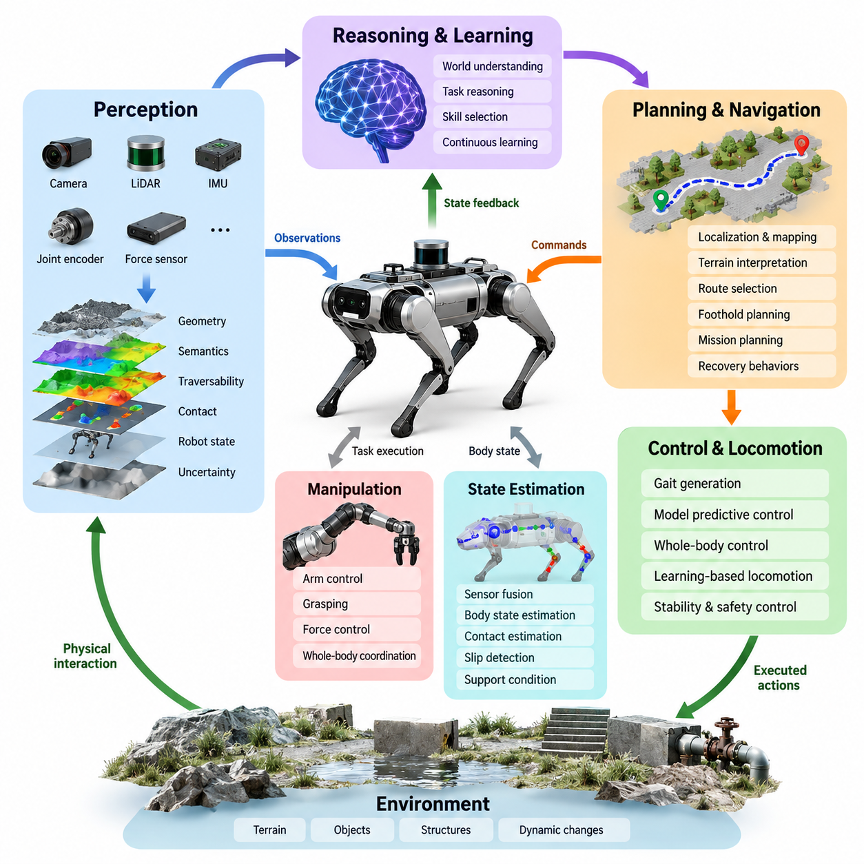
Physical AI in a quadruped robot emerges when perception, reasoning, learning, planning, and physical control are integrated into a continuous closed loop rather than implemented as isolated software modules. The quadruped must observe its surroundings and internal state, interpret their physical meaning, select actions that satisfy a mission, execute those actions through locomotion or manipulation, and evaluate the resulting state before making the next decision. This integration extends the conventional locomotion stack into an embodied intelligence system.
The first integration point is multimodal perception. Cameras, depth sensors, LiDAR, IMUs, joint encoders, force estimates, and other proprioceptive signals provide complementary observations of the robot and environment. Physical AI requires these measurements to be transformed from raw sensor streams into representations such as terrain geometry, semantic objects, traversability, contact conditions, robot state, and uncertainty. These representations establish the physical context within which higher-level AI models can reason and generate meaningful actions.
Terrain perception becomes especially important because a quadruped interacts with the environment through discrete foot contacts. An obstacle cannot be represented only as an object to avoid; the system must determine whether it can be stepped over, climbed, traversed, or used as a foothold. Elevation maps, semantic maps, geometric features, and learned terrain embeddings can therefore be connected to gait selection, foothold planning, and locomotion policies. This coupling converts environmental understanding directly into physically executable behavior. Volume_21_Quadruped_Robot_Softw…
A second integration point lies between AI perception and state estimation. Visual observations may describe external geometry while IMU, encoder, and contact information estimate body motion and support conditions. Combining exteroceptive and proprioceptive information allows the robot to distinguish apparent environmental changes from its own motion and to recognize events such as slipping, unexpected contact, unstable support, or terrain deformation. The resulting state representation becomes a shared interface between learned intelligence and deterministic control.
Physical AI must also connect high-level decisions to locomotion commands without bypassing the stability mechanisms required by a legged platform. An AI model may request a destination, velocity, posture, gait, foothold preference, or interaction behavior, but these commands should be converted into constrained references for gait generation, model predictive control, whole-body control, or learned locomotion policies. The existing architecture explicitly includes model-based, learning-based, and hybrid locomotion approaches, providing several interfaces through which intelligent policies can influence physical motion. Volume_21_Quadruped_Robot_Softw…
Whole-body control forms another critical boundary. High-level intelligence may specify tasks such as orienting a sensor, maintaining a viewing direction, carrying a payload, positioning an arm, or approaching an object while walking. Whole-body control translates these objectives into dynamically consistent forces and joint commands while respecting contact, torque, friction, posture, and stability constraints. Physical AI therefore does not replace low-level control; it supplies task intent while the control layer preserves physical feasibility and safe execution.
Learning-based locomotion creates a particularly direct integration pathway. Reinforcement learning policies can map observations and commands to joint targets or other control references, while simulation, terrain curricula, privileged learning, actuator modeling, and domain randomization improve robustness before deployment. Onboard inference then places the learned policy inside the real-time robotic loop. The chapter structure treats training, Sim2Real transfer, onboard inference, and production deployment as successive parts of the quadruped learning pipeline. Volume_21_Quadruped_Robot_Softw…
Navigation introduces a longer temporal horizon. Physical AI must combine localization, mapping, terrain interpretation, semantic understanding, route selection, and locomotion feasibility. A conventional planner may determine that a geometric route is collision-free, yet a quadruped must additionally decide whether surfaces along that route are physically traversable. Semantic goals such as finding equipment or reaching an inspection target can consequently be translated into navigation objectives and then refined into terrain-aware paths, footholds, gait commands, and recovery behaviors.
Manipulation adds another integration dimension because the robot can intentionally modify its environment. A quadruped equipped with an arm may need to walk toward a valve, stabilize its body, place the manipulator within its workspace, establish contact, apply force, and compensate for the reaction transmitted to the floating base. AI perception and task reasoning therefore interact with locomotion, grasping, force control, and whole-body coordination. The volume explicitly places locomotion-manipulation coordination, mobile grasping, tool use, and manipulation during dynamic locomotion before the Physical AI chapter. Volume_21_Quadruped_Robot_Softw…
Foundation models provide an interface for connecting semantic knowledge with embodied observations and actions. A multimodal model can interpret visual scenes, language instructions, mission context, and robot state, while an action-oriented model can transform those representations into goals, skills, or policy commands. For quadrupeds, the useful output is not unrestricted text but structured physical intent such as inspect, approach, traverse, observe, manipulate, retreat, or recover. These intentions must ultimately be grounded in executable robot capabilities.
Vision-Language-Action integration extends this concept by associating visual observations and language-level objectives with actions. A command such as inspecting a particular machine requires the system to identify the target, reason about accessibility, navigate toward an appropriate observation position, orient sensors, maintain balance, collect measurements, and determine whether the mission condition has been satisfied. The VLA layer can coordinate these semantic relationships while specialized locomotion and control modules execute actions under real-time physical constraints.
World models provide another important Physical AI integration point by representing how the environment and robot state may evolve after an action. Instead of responding only to the current observation, a quadruped can estimate consequences such as whether a foothold is likely to remain stable, whether a path leads into difficult terrain, or whether an interaction changes the scene. Predictive representations can support planning over future states, but their predictions must remain coupled to sensor feedback because physical environments contain uncertainty that cannot be eliminated by model inference alone.
Edge computing connects these AI capabilities to the timing requirements of the robot. Perception networks, learned locomotion policies, multimodal models, anomaly detectors, and planning modules may operate at different frequencies and computational costs. Fast balance and actuator control must remain deterministic, while slower semantic reasoning can execute asynchronously. The software architecture must therefore establish explicit interfaces, timestamps, validity periods, command priorities, and fallback behavior between AI inference and real-time control rather than assuming that every model operates at the same control frequency.
Safety is the final integration boundary surrounding all other Physical AI functions. Learned or foundation-model-generated commands must not directly override actuator, contact, torque, velocity, stability, or workspace constraints. Safety monitors can validate proposed actions, restrict command ranges, detect anomalous states, reject infeasible behavior, and transfer authority to deterministic recovery controllers when necessary. The chapter sequence accordingly places AI safety override mechanisms after foundation-model, language, VLA, adaptation, health-monitoring, mission-planning, and edge-inference topics. Volume_21_Quadruped_Robot_Softw…
The complete quadruped Physical AI system can therefore be understood as a hierarchy of tightly connected feedback loops. Sensors establish physical state, perception extracts geometry and semantics, AI models interpret context and mission intent, planning selects feasible behaviors, locomotion and whole-body controllers realize those behaviors, and new observations measure their consequences. Intelligence becomes physically meaningful only when every semantic decision can be grounded into safe executable actions and every physical outcome can return as evidence for the next decision.

10.02. Foundation Model Based Quadruped Control [w/Code]
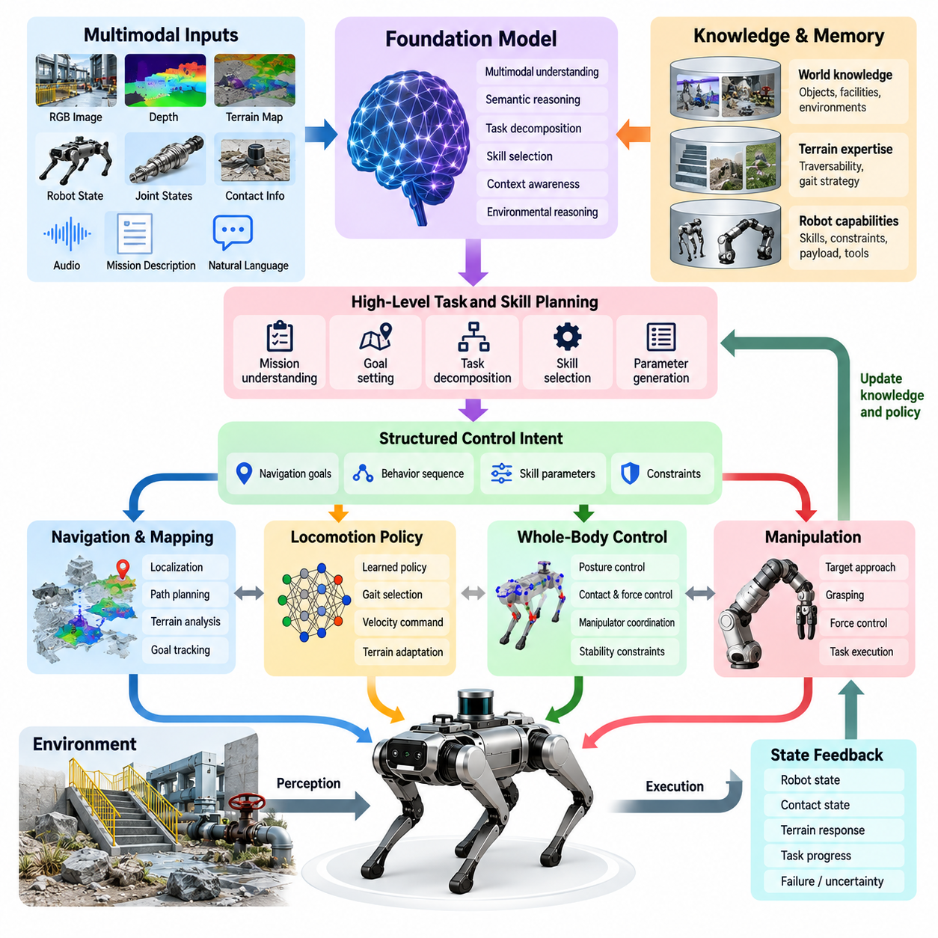
Foundation-model-based quadruped control introduces a hierarchical intelligence layer above conventional locomotion and whole-body control. Instead of replacing real-time controllers, a foundation model interprets multimodal observations, mission instructions, environmental context, and robot capabilities to generate structured control intentions. These intentions are converted into bounded commands that can be executed by gait generators, locomotion policies, trajectory planners, model predictive controllers, and whole-body controllers.
A foundation model for quadruped operation can receive heterogeneous inputs including RGB images, depth observations, terrain maps, robot poses, joint states, contact estimates, mission descriptions, and operator language. These modalities represent different aspects of the same physical situation and therefore require a common representation. Multimodal encoders can transform them into latent features that describe environmental semantics, geometric relationships, robot configuration, task context, and potential interaction opportunities.
The control architecture should distinguish semantic reasoning from dynamic stabilization. Foundation-model inference may operate at relatively low frequencies because understanding a scene or selecting a behavior does not require a kilohertz update rate. In contrast, actuator control, state estimation, balance regulation, and whole-body control require deterministic high-frequency execution. The foundation model should therefore produce goals, constraints, skill selections, or reference commands rather than directly generating unrestricted motor torques.
A useful abstraction is to organize quadruped behavior as reusable physical skills. Skills may include stand, walk, trot, turn, climb, approach, inspect, crouch, recover, manipulate, or retreat. The foundation model selects and parameterizes these capabilities according to the current task and environment. A command such as approaching an inspection target can consequently become a sequence of navigation, terrain traversal, body orientation, sensor positioning, and stabilization skills rather than a single opaque action.
Language provides an intuitive interface to this hierarchy. An operator may specify a mission such as moving to a machine, inspecting its front panel, and returning if the path becomes unsafe. The foundation model interprets the semantic intent and decomposes it into executable objectives. Each objective must then be grounded in measurable robot states, such as target pose, allowable terrain class, desired camera orientation, locomotion velocity, stopping distance, or termination condition.
Visual information enables the model to associate language-level concepts with objects and regions in the physical environment. A phrase such as “the valve beside the large pipe” is meaningful only when the robot can connect the linguistic description to visual observations and spatial coordinates. Once grounding is established, the selected target can be passed to navigation or manipulation modules. The foundation model thus connects semantic identification with conventional geometric estimation and control rather than eliminating those components.
Terrain understanding is particularly important for quadruped control because semantic interpretation must ultimately respect contact feasibility. A foundation model may recognize stairs, rocks, debris, vegetation, pipes, or narrow passages, but the locomotion system must determine whether these structures can actually be traversed. Semantic terrain information can therefore condition gait selection, speed limits, body height, foothold preferences, and local planning while dedicated controllers enforce balance, friction, reachability, and contact constraints.
Foundation models can also provide context for selecting among multiple locomotion strategies. A flat industrial corridor may permit an efficient trot, while loose gravel may require slower motion and more conservative footholds. Stairs may require a dedicated climbing behavior, and uncertain terrain may trigger exploratory sensing before movement. The model can reason about these situations at the task level while model-based or reinforcement-learning locomotion policies execute the resulting physical strategy.
Integration with reinforcement learning creates a practical division between general reasoning and specialized motor competence. A foundation model can select a learned locomotion policy and provide commands such as desired velocity, gait mode, body posture, or terrain objective. The reinforcement-learning policy then transforms observations and commands into high-frequency control references. This separation allows broad semantic intelligence to exploit motor policies that were trained specifically for dynamic quadruped locomotion.
Whole-body control provides another execution interface. When a quadruped carries a manipulator, sensor mast, payload, or inspection device, foundation-model decisions may involve several body objectives simultaneously. The model can specify priorities such as maintaining camera visibility while approaching a target or stabilizing the base while manipulating a valve. Whole-body control resolves these objectives subject to joint, contact, friction, torque, and stability constraints and produces dynamically consistent commands.
Temporal reasoning becomes important when missions extend beyond a single action. The robot may need to traverse several terrain regions, inspect multiple assets, react to unexpected obstacles, and return to a charging location. A foundation model can maintain task context and determine which skill should execute next based on observations and previous outcomes. However, the physical state must remain the authoritative source for determining whether an action actually succeeded rather than assuming success from the generated plan.
Memory can extend this architecture by retaining information about previously observed locations, obstacles, unsuccessful actions, terrain conditions, or mission progress. Such information allows the quadruped to adapt later decisions without treating every observation independently. Short-term memory can support immediate task execution, while longer-term semantic or episodic representations can help the system recognize recurring environments and reuse previously successful strategies.
Predictive models can further improve control by estimating the consequences of candidate actions before execution. The system may compare whether moving forward, changing gait, selecting another foothold region, or taking an alternate route is likely to produce a safer state. These predictions resemble a world-model interface between semantic reasoning and physical planning. Because prediction errors are inevitable, model-generated expectations must continuously be compared with measured states and corrected through feedback.
Foundation-model inference also introduces computational constraints. Large multimodal networks may require substantially more memory and processing than conventional robot controllers, while a mobile quadruped has limited power and thermal capacity. Practical systems can therefore combine compressed models, quantization, accelerated inference, asynchronous execution, and hierarchical scheduling. Time-critical control remains local and deterministic, while computationally expensive reasoning executes only when new semantic decisions are required.
Communication with remote edge or cloud resources can extend available intelligence, but locomotion safety must never depend exclusively on network connectivity. Remote computation may assist with large-model inference, map analysis, mission optimization, or fleet-level knowledge, while onboard systems retain state estimation, stabilization, obstacle response, and emergency behavior. Loss of communication should cause a defined degradation of capability rather than loss of physical control.
Safety requires every model-generated command to pass through an execution boundary. Proposed velocities, poses, footholds, manipulation targets, and skill transitions must be checked against robot limits and current environmental conditions. Confidence estimates, state validity, collision constraints, stability margins, actuator limits, and communication health can contribute to this validation. Commands that violate the permitted operating envelope should be rejected, modified, or replaced by a verified fallback behavior.
Uncertainty should therefore be represented explicitly rather than hidden inside model output. Ambiguous object recognition, incomplete terrain observations, uncertain localization, or unfamiliar situations can cause the robot to request additional sensing, reduce speed, stop, or transfer authority to a conservative controller. A foundation model becomes more useful for physical control when it can distinguish between situations in which semantic reasoning is sufficiently grounded and situations requiring further physical evidence.
Training such systems requires data that connects perception, language, state, action, and physical outcome. Demonstrations, teleoperation trajectories, simulation episodes, navigation records, manipulation sequences, failure cases, and synthetic environments can provide complementary supervision. The objective is not merely to predict plausible actions but to learn representations that preserve relationships between task intent, environmental conditions, robot capabilities, and successful physical execution.
Simulation provides a scalable environment for evaluating foundation-model decisions before deployment. Diverse terrain, sensor degradation, obstacles, disturbances, payloads, and mission instructions can expose the model to situations that would be expensive or dangerous to reproduce repeatedly with hardware. Simulation results must nevertheless be followed by hardware validation because contact dynamics, sensing artifacts, actuator behavior, communication latency, and environmental uncertainty create discrepancies that remain difficult to model perfectly.
The resulting architecture is best understood as a hierarchy rather than an end-to-end replacement of the quadruped software stack. Foundation models contribute semantic interpretation, task decomposition, contextual reasoning, skill selection, and adaptation. Navigation, learned locomotion, model predictive control, whole-body control, and actuator loops provide progressively faster and more physically constrained execution. Feedback from each layer continuously informs the layers above it.
Foundation-model-based quadruped control therefore connects general-purpose AI reasoning with specialized embodied competence. Its value comes from allowing a robot to understand broader instructions and unfamiliar contexts while preserving the deterministic mechanisms needed for stable locomotion. A successful implementation keeps semantic intelligence and physical authority clearly separated: the foundation model proposes meaningful behavior, while validated planning and control layers determine how that behavior can safely become motion.

10.03. Language Commanded Quadruped Locomotion [w/Code]
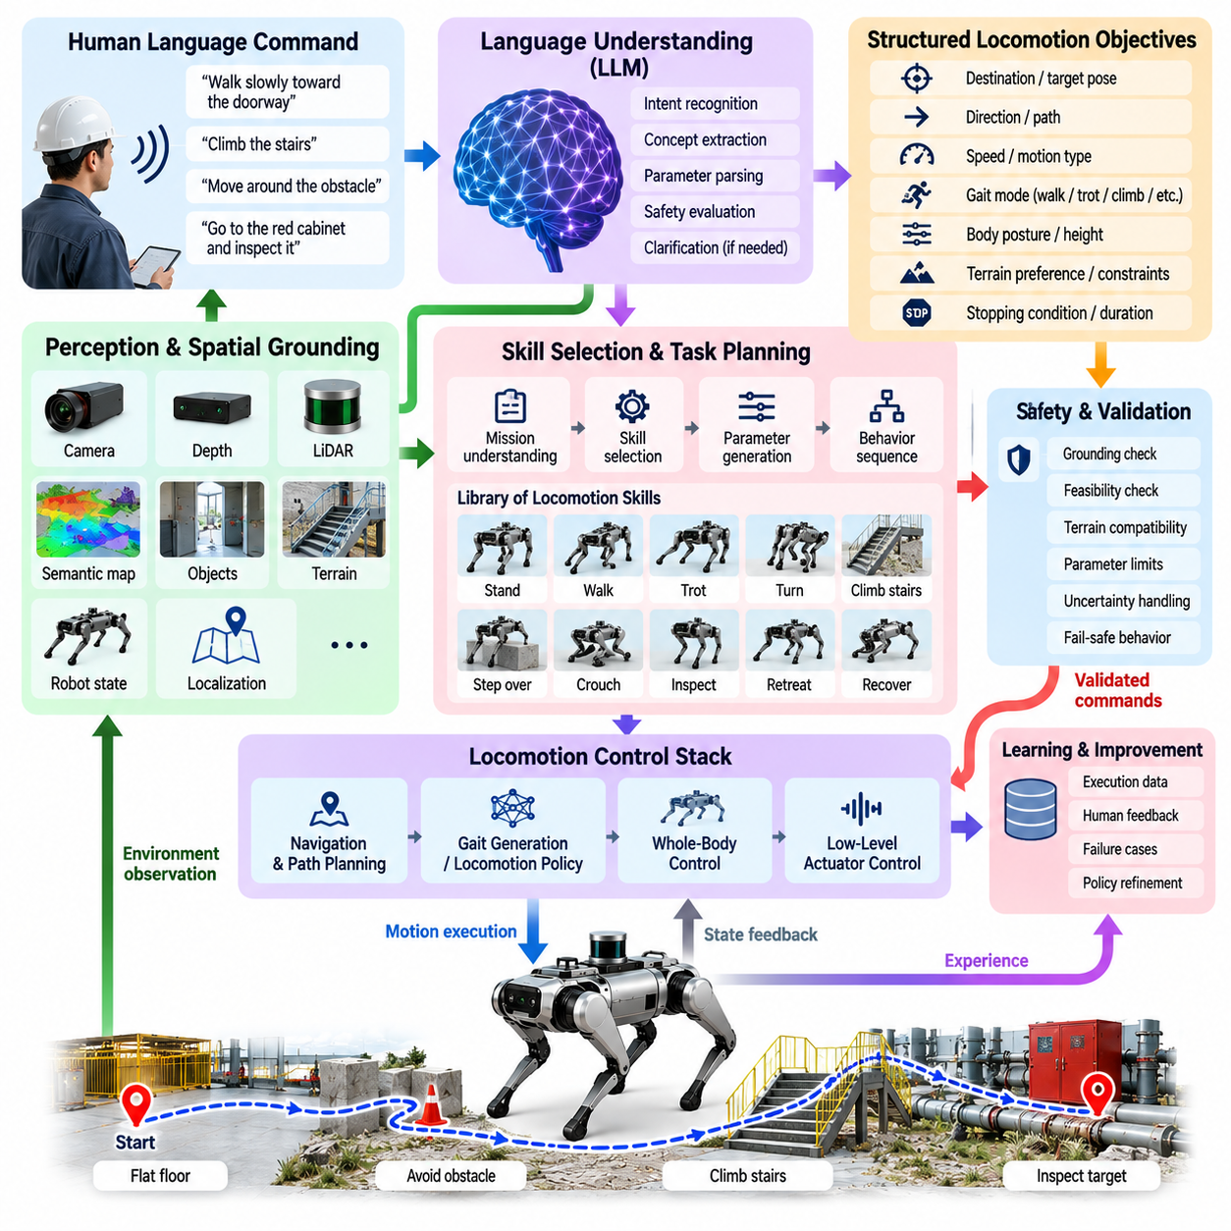
Language-commanded quadruped locomotion provides a semantic interface between human intent and the physical motion capabilities of a legged robot. Instead of requiring an operator to specify velocity vectors, gait parameters, footholds, or controller states directly, the system accepts commands such as “walk slowly toward the doorway,” “climb the stairs,” or “move around the obstacle.” Language is interpreted as task intent and converted into structured locomotion objectives that conventional or learned controllers can safely execute.
The language interface should remain separated from the real-time locomotion loop. A language model may interpret instructions and determine behavioral objectives at relatively low frequency, whereas state estimation, balance control, gait generation, and actuator control operate at much higher rates. The language layer therefore produces bounded parameters such as desired direction, velocity, destination, gait mode, body posture, terrain preference, or stopping condition rather than directly commanding joint torques or actuator currents.
Natural-language interpretation begins by identifying the locomotion-related concepts contained in an instruction. A command can describe motion type, direction, speed, destination, terrain, spatial relationship, duration, and safety constraints simultaneously. For example, “walk slowly along the left side of the corridor and stop before the stairs” contains a velocity preference, spatial constraint, route concept, and termination condition. These elements must be extracted and represented in a machine-executable form before locomotion begins.
Spatial grounding connects linguistic expressions to the robot’s perceived environment. Terms such as “left,” “behind,” “near,” “through,” or “toward” have meaning only relative to a reference frame and observed objects. Vision, depth sensing, LiDAR, localization, and semantic mapping can identify referenced structures and estimate their coordinates. The language system can then convert descriptions such as “go to the red cabinet” into a navigation target associated with a physically observable location.
Ambiguity must be resolved before potentially unsafe movement is initiated. A command such as “go over there” may not contain enough information to determine a unique target, while “walk faster” may be unsafe on the currently observed terrain. The system should evaluate whether linguistic references are sufficiently grounded and whether requested behavior is compatible with current conditions. When confidence is inadequate, the appropriate response is clarification, additional perception, reduced motion, or refusal to execute the uncertain portion of the command.
Language can also specify gait-level behavior. Expressions such as “move carefully,” “cross quickly,” “step over the object,” or “keep low” can be translated into locomotion parameters including speed, gait family, body height, step height, duty factor, foothold conservatism, and stability margin. The mapping should not be unrestricted: requested parameters must remain within validated operating ranges, while the gait generator or learned policy determines the detailed leg motion required to realize them.
Terrain-aware interpretation is essential because identical language commands may require different physical behavior in different environments. “Move forward” on a flat floor may permit a normal trot, whereas the same command on loose gravel, stairs, rocks, or a narrow elevated surface requires different gait and foothold strategies. Terrain perception therefore conditions the translation from semantic intent to locomotion parameters, allowing language to specify the goal while physical context determines how that goal is achieved.
A hierarchical skill representation provides a practical bridge between language and locomotion. The robot can expose validated skills such as stand, walk, trot, turn, climb stairs, step over, crouch, inspect, stop, retreat, and recover. The language model selects one or more skills and supplies their parameters instead of synthesizing arbitrary motor behavior. Complex instructions can consequently be decomposed into sequences of verified locomotion capabilities with explicit entry, execution, and termination conditions.
For example, an instruction to “walk to the stairs, climb them slowly, and stop at the top” can be represented as several connected behaviors. Navigation first approaches an appropriate stair-entry pose, terrain perception verifies stair geometry, the locomotion manager activates a stair-climbing mode, and a completion condition detects arrival at the upper surface. Language determines the behavioral sequence, while perception and control determine whether each transition is physically valid.
Language-commanded locomotion can also be integrated with reinforcement-learning policies. A learned locomotion policy may accept desired linear velocity, angular velocity, body height, or gait-related commands as inputs. The language layer converts semantic expressions into these command variables, while the policy generates high-frequency joint targets from robot observations. This architecture preserves the dynamic competence learned by reinforcement learning without requiring the language model to understand detailed actuator dynamics.
Navigation provides another execution pathway for commands containing destinations rather than immediate motion instructions. “Go to the inspection area” should normally become a semantic navigation goal rather than a continuous forward-velocity command. The navigation system determines a route, terrain-aware planning evaluates traversability, and the locomotion layer follows locally feasible motion commands. This separation prevents high-level language reasoning from unnecessarily controlling every short-timescale movement.
Conversational commands require maintenance of temporal context. After an operator says “walk toward the pump,” a subsequent instruction such as “slower,” “move to its right side,” or “stop there” depends on the preceding command and current physical situation. The language interface therefore requires short-term task state containing the active target, selected behavior, relevant objects, current constraints, and mission progress. Physical observations must continuously update this context as the robot moves.
Language can express conditional behavior as well as direct commands. An operator might request that the robot continue until it reaches rough terrain, stop if the passage becomes too narrow, or return if communication quality deteriorates. Such instructions should be converted into explicit conditions evaluated using measurable robot or environment states. Execution logic then monitors these predicates independently of language-model inference so that critical stopping conditions remain deterministic and continuously available.
Negative constraints are especially important for safe instruction following. Commands may include requirements such as “do not enter the wet area,” “avoid the stairs,” or “keep away from the edge.” These constraints should become persistent planning and control restrictions rather than temporary textual context. Semantic maps, traversability layers, exclusion regions, speed limits, and controller constraints provide mechanisms for maintaining the operator’s restrictions throughout the corresponding locomotion task.
The system must also distinguish commands from descriptive conversation. An operator discussing an obstacle should not accidentally trigger motion merely because the utterance contains locomotion-related words. A command classifier or dialogue-state mechanism can determine whether an utterance represents an executable request, clarification, cancellation, information query, or unrelated statement. Explicit execution states and confirmation policies can be introduced for operations whose consequences exceed predefined risk thresholds.
Safety supervision remains authoritative regardless of linguistic intent. Even a clearly understood command must be rejected or modified when it conflicts with stability limits, collision constraints, actuator capability, localization validity, terrain uncertainty, or defined operational boundaries. Emergency stop, fall prevention, posture recovery, and low-level protective mechanisms must operate independently of the language model so that semantic reasoning cannot disable the robot’s fundamental safety functions.
Latency and computational availability must also be considered. Language interpretation may require a relatively large model, but locomotion cannot wait for repeated model inference during every control cycle. Semantic interpretation should therefore occur when a new instruction, contextual change, or decision point requires it. Once a validated locomotion skill is active, deterministic controllers or onboard learned policies can continue execution without depending on continuous language-model responses.
Testing should evaluate more than whether the system correctly understands individual sentences. Validation must examine paraphrases, ambiguous references, contradictory commands, changing terrain, interrupted instructions, unavailable skills, sensor uncertainty, and unsafe requests. Simulation can generate large combinations of language and environment conditions, while hardware tests verify that interpreted commands produce predictable physical behavior under real sensing, communication, contact, and actuator limitations.
Language-commanded quadruped locomotion ultimately forms a layered translation process from human semantics to physical execution. Language models interpret intent and context, perception grounds referenced entities, task logic selects validated skills, navigation and terrain reasoning determine feasible motion, and locomotion controllers execute the resulting commands. Continuous feedback confirms whether the intended physical state has actually been reached, ensuring that linguistic understanding remains anchored to observable robot behavior.

10.04. Vision Language Action for Quadruped [w/Code]
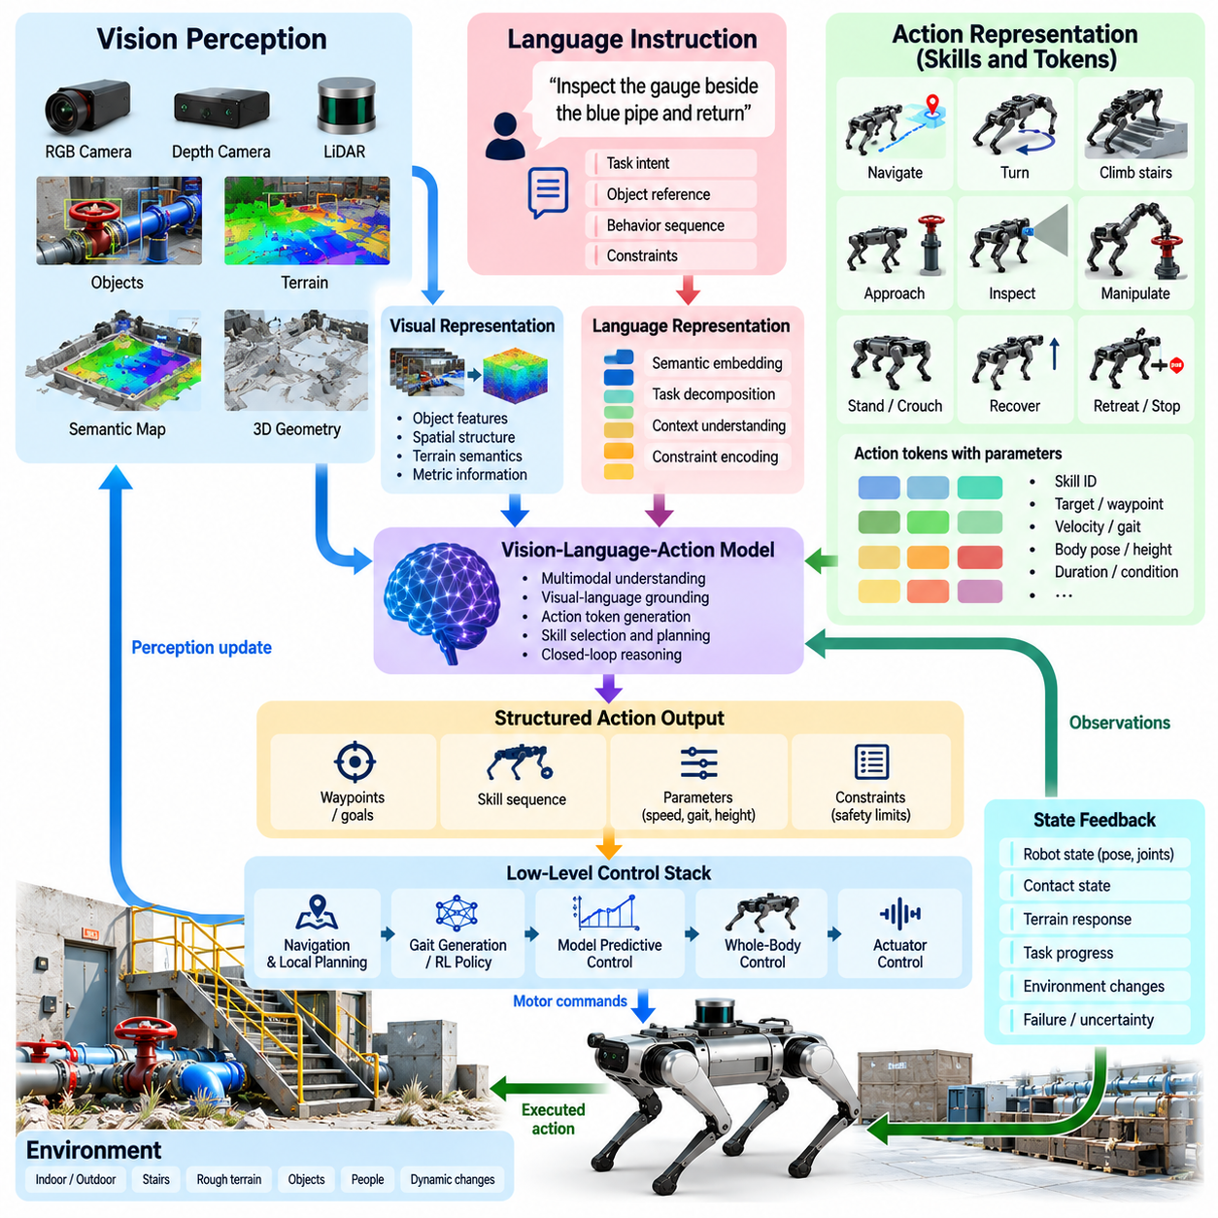
Vision-Language-Action integration for quadruped robots connects visual perception, semantic reasoning, language instructions, and physical behavior within a unified embodied intelligence pipeline. The objective is not simply to describe what the robot sees, but to transform observations and task instructions into actions that affect the physical environment. For a quadruped, these actions may involve locomotion, body positioning, terrain traversal, inspection, recovery, or coordinated manipulation.
The vision component provides information about objects, terrain, structures, people, obstacles, and spatial relationships surrounding the robot. RGB cameras may provide semantic appearance, while depth cameras, LiDAR, and geometric maps contribute metric structure. These observations can be encoded into visual representations containing both semantic and spatial information, allowing the VLA system to associate concepts such as stairs, doors, valves, corridors, debris, or inspection targets with physically observable regions.
Language supplies task intent and contextual constraints that cannot always be inferred from vision alone. An instruction such as “inspect the gauge beside the blue pipe and return” identifies an objective, a semantic reference, and an expected sequence of behavior. The language representation must be grounded in visual observations so that referenced entities correspond to actual objects or locations. This grounding transforms linguistic concepts into targets that navigation, locomotion, or manipulation modules can use.
The action component translates grounded semantic representations into executable robot behavior. Direct prediction of raw joint torques from a large multimodal model is generally inappropriate for safety-critical quadruped operation because dynamic stabilization requires deterministic, high-frequency feedback. A practical VLA architecture instead generates actions at the level of goals, skills, waypoints, velocity commands, body poses, gait selections, or manipulation objectives that validated lower-level controllers can execute.
Action tokenization provides one mechanism for connecting multimodal reasoning to robot behavior. Continuous robot actions can be represented by discrete or structured action tokens corresponding to motion primitives, skill identifiers, parameter ranges, or temporally extended behaviors. A token may represent actions such as approach, turn, climb, stop, inspect, crouch, recover, or manipulate. The resulting vocabulary provides an intermediate representation between general semantic reasoning and platform-specific motor control.
For quadrupeds, action representation must account for the distinction between task-space intention and leg-level execution. A VLA model may decide that the robot should move across a rocky region toward an inspection target, but it should not need to generate every individual swing trajectory. Terrain-aware locomotion controllers can determine contact schedules and footholds, while model predictive control, reinforcement-learning policies, or whole-body control produce dynamically feasible motion. This separation preserves specialized locomotion competence.
Spatial grounding is particularly important because quadruped actions occur within three-dimensional terrain rather than only in image coordinates. A visually detected object must be associated with depth, robot pose, map coordinates, and accessible approach regions. When the command references “the second valve on the left,” the system must identify the correct visual entity, estimate its physical location, and determine a reachable observation or interaction pose before generating movement.
Terrain semantics provide another connection between vision and action. Recognizing a region as grass, gravel, stairs, mud, rubble, or a narrow platform can influence how the robot moves through it. The VLA layer can associate semantic terrain categories with behavioral preferences, while traversability analysis determines whether the terrain is physically feasible. Gait selection, speed, body height, step height, and foothold strategy can then be adapted to the observed environment.
A hierarchical VLA architecture can represent long missions as sequences of shorter embodied skills. Consider an instruction to enter a room, locate a control panel, inspect its indicators, and return. The model can first select navigation toward the room, then visual search, target approach, sensor orientation, inspection, and return navigation. Each skill has measurable preconditions and completion criteria, allowing physical feedback to determine when the system should advance to the next stage.
Visual feedback must remain active throughout action execution because the environment may change after the initial decision. People may move, obstacles may appear, doors may close, or the robot may reach a different pose than expected. The system therefore requires repeated observation-action cycles rather than a single open-loop prediction. Updated visual and proprioceptive observations allow the VLA layer or underlying planners to revise actions when execution diverges from the expected state.
Proprioception complements vision by providing information that cannot reliably be inferred from images. Joint positions, IMU measurements, contact states, estimated forces, body orientation, and slip indicators describe the robot’s interaction with the environment. Combining these signals with visual and language representations allows the system to distinguish between seeing traversable terrain and actually maintaining stable contact while crossing it. Physical feedback therefore becomes part of embodied action understanding.
VLA models can also coordinate quadruped manipulation when an arm or other end effector is available. A task such as opening a door requires recognizing the handle, selecting an approach pose, positioning the quadruped base, reaching with the manipulator, establishing contact, applying force, and adapting locomotion as the door moves. Semantic action planning can coordinate this sequence, while whole-body control resolves the coupled dynamics between the legs, floating base, and arm.
Training data for quadruped VLA systems must preserve relationships among observation, instruction, action, and outcome. Teleoperation demonstrations, navigation trajectories, manipulation episodes, robot sensor logs, simulation rollouts, and annotated task sequences can provide complementary examples. Data should represent successful behavior as well as recovery and failure conditions because a robot operating in physical environments must learn when actions cannot be completed as originally planned.
Simulation can substantially expand the diversity of VLA training and evaluation. Virtual environments can vary terrain geometry, object placement, lighting, sensor noise, obstacles, mission instructions, and disturbances while recording synchronized observations and actions. Synthetic language descriptions can also be paired with generated scenarios. However, real-world validation remains necessary because contact dynamics, visual artifacts, actuator characteristics, and environmental uncertainty produce gaps that simulation cannot completely reproduce.
Generalization is a central motivation for using VLA models. A conventional behavior may be engineered for a specific target and environment, whereas a multimodal model can potentially associate unfamiliar instructions and visual configurations with previously learned concepts. Generalization must nevertheless remain bounded by the robot’s verified physical capabilities. Recognizing a new terrain or object does not imply that the platform has the mechanical or control capability required to traverse or manipulate it safely.
Uncertainty management is therefore essential. The VLA system may encounter ambiguous objects, occluded targets, unfamiliar terrain, contradictory instructions, or observations outside its training distribution. Confidence measures and consistency checks can trigger additional sensing, alternative viewpoints, reduced speed, operator clarification, or safe termination. A physically grounded system should prefer gathering additional evidence over confidently executing an action whose semantic or geometric interpretation remains uncertain.
Safety filtering must remain independent of VLA-generated intent. Every proposed action should pass through constraints covering collision risk, stability, joint limits, actuator limits, terrain feasibility, localization quality, and operational boundaries. High-level AI may suggest a behavior, but safety supervisors and deterministic controllers retain authority over whether and how it is executed. Emergency stop and recovery mechanisms must remain available even if the multimodal model becomes unavailable.
Edge deployment introduces another architectural constraint because VLA inference can be computationally expensive. Visual encoders and multimodal transformers may consume substantial GPU memory and power, while a mobile quadruped must maintain battery endurance and thermal limits. Practical systems can use compressed models, quantization, asynchronous inference, cached representations, and multiple inference rates so that semantic reasoning does not interfere with time-critical locomotion and balance computation.
Evaluation should measure both semantic correctness and physical success. A VLA system may identify the correct object but fail to reach it, or generate an appropriate skill while violating terrain constraints. Useful evaluation therefore includes instruction understanding, grounding accuracy, task completion, traversal success, intervention rate, recovery behavior, stability, latency, energy consumption, and safety violations. Testing should combine simulation, controlled hardware experiments, and progressively more realistic field environments.
Vision-Language-Action for quadrupeds ultimately provides a bridge from multimodal understanding to embodied execution. Vision establishes what and where, language specifies intent and constraints, and action representations determine what the robot should do next. Navigation, locomotion policies, whole-body control, and safety mechanisms then convert that semantic decision into physically valid motion, while continuous sensory feedback closes the loop between predicted behavior and the real world.

10.05. Adaptive AI Policy to New Terrain Online [w/Code]
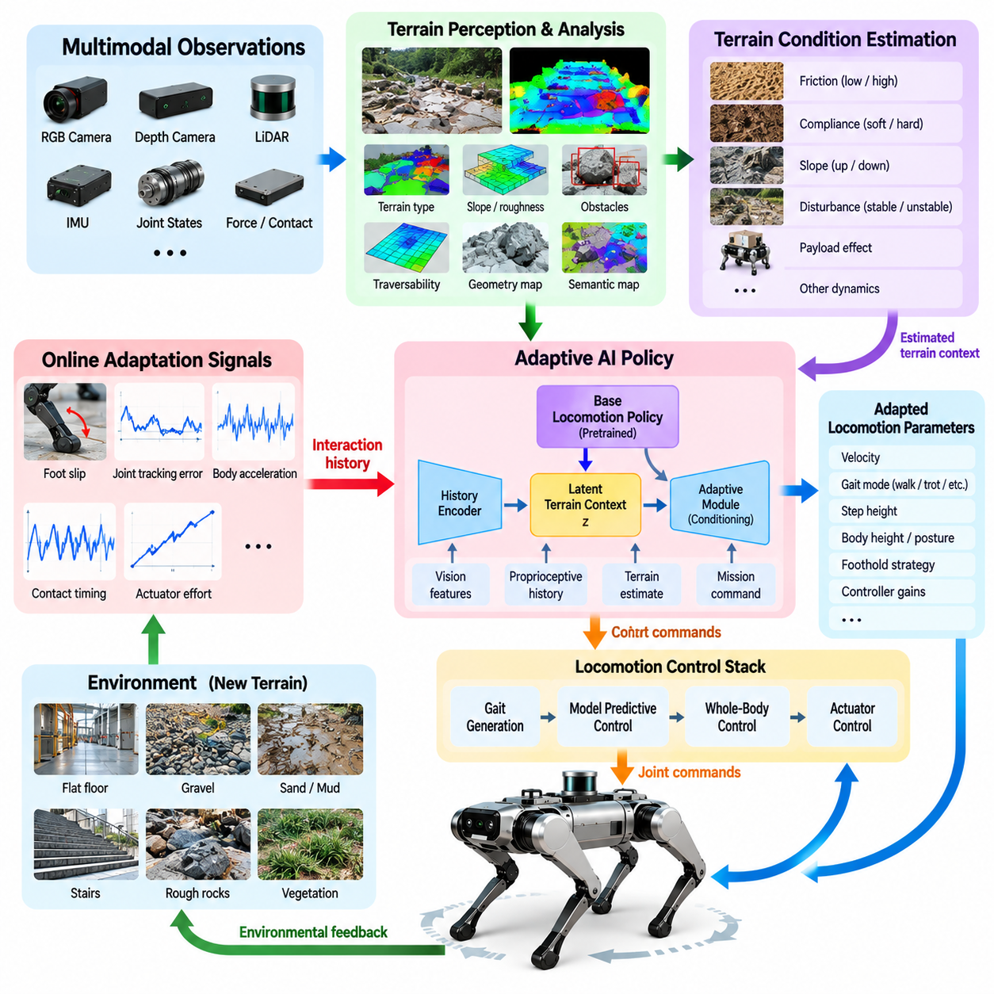
Online adaptation enables a quadruped robot to modify its locomotion behavior when it encounters terrain conditions that were not sufficiently represented during training. A policy trained in simulation or controlled environments may perform well on familiar surfaces yet experience reduced stability on loose soil, wet ground, vegetation, deformable material, or irregular rocks. Adaptive AI addresses this limitation by using observations collected during operation to adjust behavior without requiring complete offline retraining.
The adaptation problem begins with detecting that the current environment differs from previously experienced conditions. Visual and geometric perception can identify unusual terrain appearance or structure, while proprioceptive signals reveal unexpected physical interaction. Increased foot slip, abnormal joint tracking error, unexpected body acceleration, altered contact timing, or higher actuator effort may indicate that the assumed terrain dynamics are inaccurate even when the terrain appears visually familiar.
A useful adaptive locomotion architecture separates a base policy from an adaptation mechanism. The base policy contains locomotion capabilities learned from large-scale simulation or robot data, while the adaptation module estimates latent environmental properties from recent observations. These properties may represent friction, compliance, slope, disturbance, payload effects, actuator response, or other hidden dynamics. The estimated context conditions the policy so that locomotion can change as physical conditions evolve.
Temporal observation history is important because many terrain properties cannot be determined from a single sensor frame. A robot may recognize gravel visually, but its effective friction and stability become clearer only after several foot contacts. Short sequences of joint states, contact events, body motion, commanded actions, and resulting accelerations can therefore be encoded into a latent context. This history allows adaptation to depend on measured physical interaction rather than visual classification alone.
Online adaptation can occur at several levels without directly modifying every parameter of a locomotion network. The system may adjust commanded speed, gait frequency, duty factor, step height, body height, foothold margin, or controller gains while preserving the underlying policy. More advanced systems can update latent variables, residual policies, or selected network parameters. Restricting adaptation to validated dimensions can reduce the risk of unstable behavior during deployment.
Terrain perception provides predictive information before contact occurs. Depth cameras and LiDAR can estimate slope, roughness, discontinuities, and obstacle geometry, while vision models may classify surface types such as grass, gravel, sand, mud, or rock. These observations can initialize an expected terrain context before the robot steps onto the region. Proprioceptive feedback then confirms or corrects that estimate after physical contact, creating a combination of anticipatory and reactive adaptation.
Slip detection is a particularly valuable adaptation signal. Differences between expected and observed foot motion, inconsistencies between kinematic velocity and inertial motion, or unexpected contact displacement can indicate insufficient traction. When persistent slip is detected, the system may reduce velocity, increase stance duration, modify foot placement, lower the center of mass, or select a more conservative gait. Adaptation should occur progressively so that a temporary measurement error does not trigger an unnecessary large behavioral change.
Terrain compliance introduces a different challenge because the supporting surface may deform under load. Sand, soil, vegetation, snow, or soft industrial material can cause feet to sink or produce delayed reaction forces. The robot can infer such behavior from contact depth, joint motion, force estimates, and body response. An adaptive policy can then modify step timing, foot clearance, stance force distribution, or commanded acceleration to maintain stable progression across the deformable region.
Reinforcement-learning locomotion policies are well suited to adaptive control when their training distribution includes diverse dynamics. Domain randomization can expose the policy to variations in friction, mass, actuator strength, delay, terrain geometry, and disturbances. During deployment, an adaptation network can infer which portion of this dynamic distribution best explains recent observations. The resulting latent estimate conditions the locomotion policy, effectively selecting behavior appropriate to the encountered physical regime.
Rapid adaptation differs from conventional online learning because it does not necessarily require gradient-based weight updates on the robot. A pretrained adaptation encoder can infer environmental context from a short history and immediately alter policy behavior. This approach reduces computational cost and avoids potentially dangerous unrestricted parameter changes. Gradient-based fine-tuning may still be useful in carefully controlled circumstances, but it requires stronger validation, rollback, and stability mechanisms.
Memory can help the robot reuse terrain experience across a mission. If a particular corridor, slope, or outdoor region has already produced significant slip, the system can associate that location or semantic terrain category with the observed physical properties. When the robot encounters the region again, previously learned adaptation parameters can initialize the policy before contact. New measurements then update the estimate if environmental conditions have changed.
Adaptation must distinguish terrain changes from other causes of altered dynamics. A heavier payload, damaged foot, actuator degradation, battery voltage reduction, external force, or state-estimation error can produce observations similar to difficult terrain. Combining terrain perception with robot health information and proprioceptive history helps avoid incorrect adaptation. The system should represent uncertainty when several explanations remain plausible rather than forcing every unexpected response into a terrain category.
A confidence-aware adaptation mechanism can regulate how aggressively the policy changes. When observations strongly support a new terrain condition, adaptation can move toward a specialized behavior. When evidence is weak or contradictory, the robot can preserve conservative parameters, slow down, gather additional contacts, or stop. Confidence thresholds are especially important because adaptation based on incorrect environmental estimates can degrade a previously stable locomotion policy.
Online adaptation must operate within strict safety envelopes. Regardless of what the learning system proposes, joint limits, torque limits, collision constraints, allowable body orientation, contact feasibility, and stability criteria remain authoritative. A safety supervisor can monitor the adapted policy and reject commands that exceed validated bounds. If instability grows, the robot should transition to a conservative gait, stop safely, recover posture, or request operator assistance rather than continuing uncontrolled learning.
Catastrophic forgetting is another concern when adaptation includes persistent parameter updates. Learning aggressively from a short terrain episode can improve immediate performance while degrading capabilities that were previously reliable. Practical systems can limit trainable parameters, preserve a frozen base policy, use residual adaptation, maintain reference checkpoints, or store terrain-specific adaptation states. These mechanisms allow new experience to influence behavior without destroying general locomotion competence.
The adaptation loop must also respect computational timing. High-frequency torque and balance control may operate at hundreds of hertz or approximately one kilohertz, while terrain context estimation can execute at a lower rate. Visual terrain interpretation may operate more slowly still. A multirate architecture allows each component to update according to its temporal requirements while timestamped observations and bounded interfaces maintain consistency between perception, adaptation, and control.
Simulation is essential for preparing an adaptive policy because large variations of terrain and dynamics can be generated safely. Training environments can randomize friction, compliance, slope, step geometry, sensor noise, actuator delay, payload, and external disturbances. Curriculum strategies can gradually increase difficulty while exposing the adaptation mechanism to transitions between terrain types. The goal is not merely to master individual surfaces but to learn how physical changes can be inferred from interaction.
Evaluation should specifically include terrain conditions that were excluded or significantly altered from the training distribution. Tests can measure velocity tracking, slip rate, body stability, foot-placement error, energy consumption, recovery frequency, adaptation time, and fall rate before and after adaptation. Transition tests are particularly important because a robot may remain stable on grass and gravel independently yet fail when it must recognize and adapt during the transition between them.
Field deployment should initially constrain adaptation to reversible changes. Parameters and latent states should be logged together with observations, terrain estimates, safety interventions, and performance metrics. If an adapted configuration produces degraded behavior, the system should return immediately to a known stable policy. Logged episodes can later be reviewed and incorporated into offline training, converting difficult real-world encounters into improved future policy coverage.
Online terrain adaptation therefore transforms quadruped locomotion from a fixed mapping between observation and action into a context-sensitive control process. Perception predicts terrain characteristics, physical interaction reveals actual dynamics, an adaptation mechanism updates the estimated context, and the locomotion policy changes behavior within verified limits. Continuous feedback then determines whether the adaptation improved stability and task progress, allowing the robot to operate more robustly when the physical world differs from its training assumptions.

10.06. AI Based Anomaly Detection Health Monitor [w/Code]
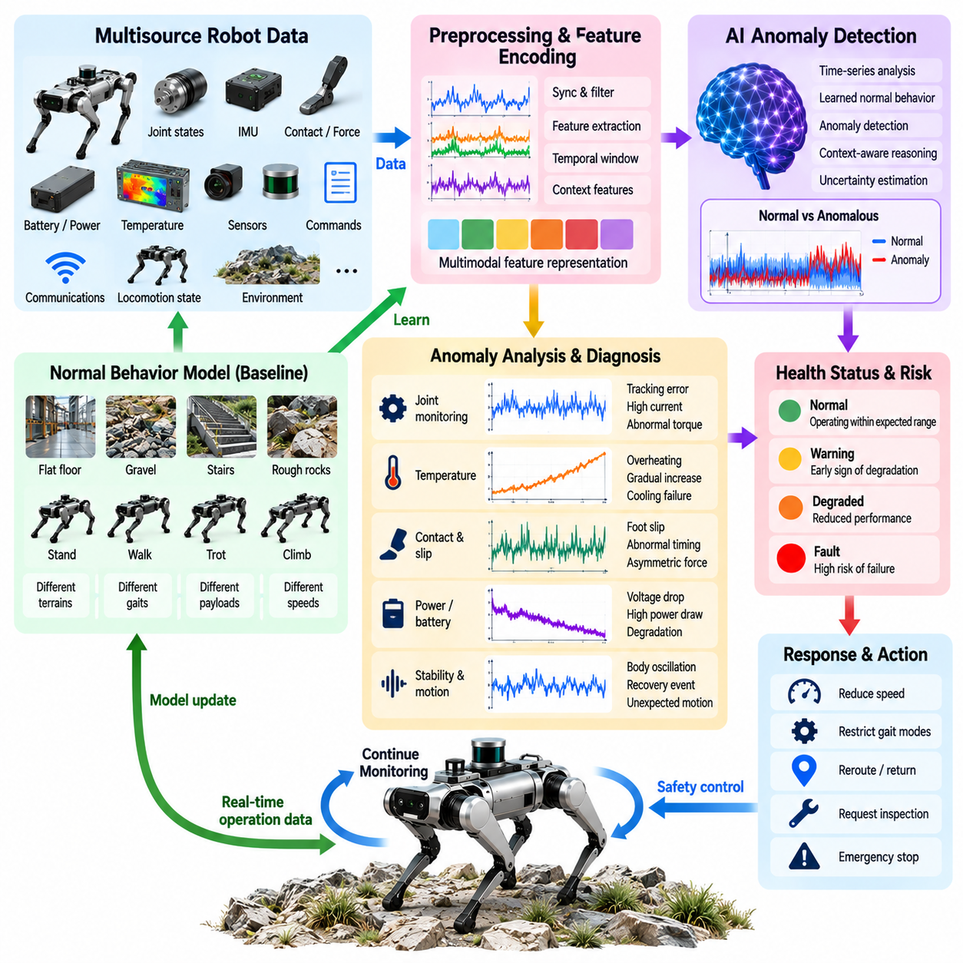
AI-based anomaly detection and health monitoring provide a continuous mechanism for determining whether a quadruped robot is operating within its expected physical and computational state. Rather than relying only on fixed threshold alarms, AI models can learn relationships among joint motion, actuator behavior, contact patterns, body dynamics, sensor outputs, power consumption, temperature, and locomotion performance. The purpose is not simply to identify abnormal signals, but to determine whether a combination of observations indicates degradation, unexpected interaction, or an emerging failure condition.
A quadruped generates large amounts of health-related information during operation. Joint position, velocity, torque, current, temperature, IMU measurements, contact estimates, battery voltage, communication status, and locomotion commands can all provide evidence about system condition. These signals should be interpreted together because an individual measurement may appear abnormal for legitimate reasons. For example, increased motor current may result from difficult terrain, payload changes, or actuator degradation. AI-based monitoring can examine correlations among multiple signals before determining whether the condition is anomalous.
The monitoring system should establish a representation of normal behavior before abnormal behavior can be detected reliably. Normal operating data can be collected from simulation, laboratory testing, controlled locomotion experiments, and field operation. The data should cover different gaits, speeds, terrains, payloads, body orientations, temperatures, and battery conditions. This creates a baseline describing the expected operating envelope rather than defining normality as a single fixed sensor value. Deviations can then be evaluated relative to the operating context in which they occur.
Time-series analysis is particularly important because many failures develop gradually rather than appearing as a single abnormal measurement. A slowly increasing actuator temperature, progressively larger tracking error, increasing slip frequency, or gradual deterioration in battery voltage can provide an early indication of degradation. Recurrent models, temporal encoders, statistical models, or other sequence-based methods can analyze recent observation histories and detect changes in temporal patterns that would be difficult to identify from individual samples.
Anomaly detection should also consider the relationship between commanded and observed behavior. If a locomotion controller requests a particular velocity but the measured body motion consistently differs from the expected response, the discrepancy may indicate terrain interaction, actuator limitations, mechanical wear, or state-estimation problems. Similar comparisons can be performed between commanded joint trajectories and measured joint motion. Residual signals generated from these comparisons provide useful evidence for distinguishing normal environmental variation from abnormal robot behavior.
Contact and locomotion information provide additional health indicators that are specific to quadruped systems. Unexpected contact timing, persistent foot slip, abnormal stance duration, asymmetric force distribution, or repeated recovery behavior can indicate either difficult terrain or deterioration in the robot itself. AI monitoring should therefore combine terrain perception with proprioceptive and locomotion information. This allows the system to avoid incorrectly classifying an expected response to rough terrain as a hardware fault while still detecting abnormal behavior that persists under comparable conditions.
Health monitoring can be organized into several levels ranging from signal-level anomaly detection to subsystem-level diagnosis. Individual sensor anomalies may indicate corrupted measurements or communication problems, while correlated abnormalities across several joints may indicate a mechanical or actuator issue. Higher-level patterns involving locomotion stability, power consumption, thermal behavior, and repeated recovery events can indicate broader system degradation. The monitoring architecture should preserve these relationships so that isolated observations are not interpreted without operational context.
AI models can support predictive health monitoring by estimating how the robot is likely to behave if a detected trend continues. Instead of waiting for a component to exceed a hard failure threshold, the system can identify increasing deviation from historical behavior and assign an estimated risk level. Such predictions should remain advisory unless validated against reliable evidence. The health monitor can recommend inspection, reduced operating speed, restricted gait modes, or maintenance while deterministic safety mechanisms continue to control immediate protective actions.
Uncertainty and confidence are essential when interpreting anomalies. An AI model may detect a pattern that resembles a known failure while the actual cause remains ambiguous. The system should therefore distinguish between anomaly detection, fault classification, and confirmed diagnosis. A low-confidence anomaly can trigger additional sensing or increased monitoring frequency, while a high-confidence and safety-critical condition can initiate a predefined protective response. This separation reduces the possibility that an incorrect AI interpretation will unnecessarily disrupt normal operation.
The health monitor should be integrated with the quadruped control architecture without becoming a single point of failure. AI inference can operate alongside state estimation, locomotion control, whole-body control, and system diagnostics. When an anomaly is detected, the monitor can communicate its severity and affected subsystem to the appropriate control layer. A mild condition may result in continued operation with restrictions, while a serious condition can cause a gait transition, controlled stop, posture stabilization, or recovery behavior. The actual protective response should remain bounded by validated system logic.
Edge deployment is important because health monitoring must continue even when remote connectivity is unavailable. Sensor streams and inference results can be processed onboard with compact models and efficient time-series pipelines. More computationally expensive analysis can be transferred to an edge server or cloud system for fleet-level diagnostics and long-term trend analysis, but immediate anomaly detection and safety-related responses should remain available locally. This architecture also allows operational data to be accumulated for subsequent model improvement without making real-time safety dependent on network availability.
The final objective of AI-based anomaly detection and health monitoring is to create a closed feedback relationship between robot operation, physical condition, and adaptive system management. Normal behavior establishes a continuously refined baseline, sensor and control residuals reveal deviations, AI models identify anomalous patterns, and health assessment determines the appropriate operational response. The resulting information can also be recorded for maintenance, failure analysis, simulation refinement, and future training. In this way, health monitoring becomes an integral part of Physical AI rather than a separate diagnostic function, allowing the quadruped to recognize changes in its own operating condition and respond within defined safety boundaries.

10.07. LLM Based Mission Planning for Quadruped [w/Code]
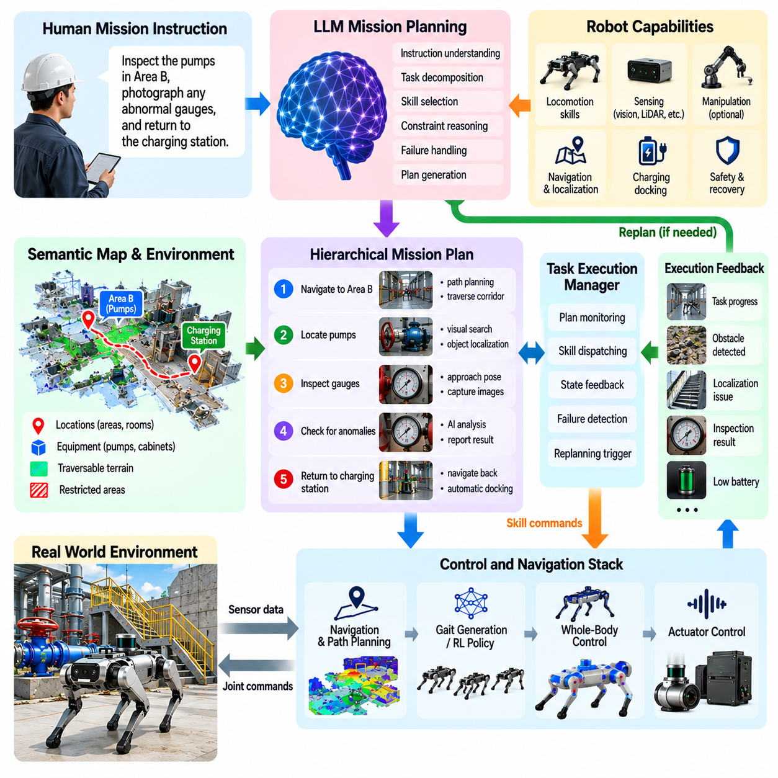
Large Language Model based mission planning enables a quadruped robot to translate high-level human objectives into structured sequences of executable robotic tasks. Instead of requiring an operator to manually define every waypoint, gait transition, inspection pose, or recovery action, an LLM can interpret mission descriptions and decompose them into semantic objectives. These objectives are then passed to validated navigation, locomotion, perception, manipulation, and safety modules for physical execution.
The LLM should operate as a mission-level reasoning component rather than a direct motion controller. Quadruped locomotion requires deterministic feedback loops for state estimation, balance, gait generation, whole-body control, and actuator regulation, while mission reasoning typically evolves at a much slower rate. The LLM therefore produces task plans, skill selections, constraints, priorities, and termination conditions instead of generating joint torques or other high-frequency commands.
Mission planning begins by transforming natural-language instructions into explicit task representations. A command such as “inspect the pumps in Area B, photograph any abnormal gauges, and return to the charging station” contains multiple objectives, ordering constraints, conditional actions, and a final destination. The planner must identify these elements and convert them into machine-readable mission states that can be evaluated during execution rather than retaining the instruction only as unstructured text.
A capability model is required to prevent the LLM from planning actions that the robot cannot perform. The planner should know which locomotion, sensing, navigation, manipulation, communication, and recovery skills are currently available. A quadruped without an arm cannot physically operate a valve, while a robot without an appropriate sensor cannot perform a requested measurement. Mission generation should therefore be grounded in an explicit registry of validated robot capabilities and their operating constraints.
Hierarchical task decomposition provides a practical planning structure. A complex inspection mission can be divided into navigation to the work area, localization of target equipment, approach to an observation pose, sensor alignment, data acquisition, anomaly assessment, and return navigation. Each high-level task can be further connected to existing robot skills. This hierarchy allows semantic planning to remain independent from the detailed control implementation while preserving clear interfaces between mission intent and physical execution.
Environmental context must influence the generated plan because quadruped missions are constrained by terrain and accessibility. A geometrically short route may contain stairs, loose ground, narrow structures, or obstacles that require specialized locomotion. Terrain perception and traversability analysis can provide the mission planner with feasibility information, while the LLM reasons about alternative task sequences or routes. Final path and foothold generation should remain the responsibility of dedicated navigation and locomotion modules.
Semantic maps can provide persistent grounding between language and the physical environment. Locations such as inspection zones, pumps, electrical cabinets, corridors, stairways, charging stations, and restricted areas can be represented as named entities associated with map coordinates and operational attributes. The LLM can reason using these semantic concepts, while conventional localization and navigation systems resolve them into geometric targets. This separation connects human-readable mission descriptions with metric robot motion.
Mission plans should include explicit preconditions and completion conditions for each task. An inspection action may require the robot to be within a specified distance of the target, maintain a stable posture, and obtain sufficient sensor visibility before data collection begins. Completion may require successful image capture or confirmation that the target was observed. These conditions prevent the LLM from assuming that an action succeeded merely because it was included in the generated plan.
Execution feedback is essential because the physical world rarely follows a mission plan exactly. A planned corridor may become blocked, localization quality may deteriorate, terrain may prove more difficult than expected, or a target object may not be found. The execution manager should report such events to the mission reasoning layer using structured state information. The LLM can then revise the remaining plan while preserving already completed tasks, active constraints, and the overall mission objective.
Replanning should be triggered by meaningful state changes rather than continuously invoking the LLM during normal locomotion. Local obstacle avoidance, gait adaptation, balance recovery, and short-term trajectory correction can be handled by specialized controllers without modifying the mission plan. LLM reasoning becomes useful when a failure changes the semantic structure of the task, such as when a destination becomes inaccessible, a required capability becomes unavailable, or an alternative sequence of objectives must be selected.
Memory supports missions that extend over long periods or involve multiple locations. The planner can maintain information about completed inspections, previously blocked routes, discovered equipment, unresolved targets, collected data, and remaining objectives. This mission state allows commands such as “continue the inspection from where you stopped” to be interpreted consistently. Memory should be linked to verified execution events rather than relying solely on conversational history generated by the language model.
Conditional planning allows the robot to respond to mission-dependent observations. An instruction may specify that the robot should inspect a gauge and capture additional images only if its reading appears abnormal, or return immediately if battery capacity falls below an operational threshold. The LLM can express these relationships as task-level branches, but safety-critical conditions should be evaluated by deterministic runtime logic using measurable sensor states rather than repeated language-model interpretation.
Multi-objective missions require explicit management of priorities. Inspection coverage, travel time, energy consumption, communication quality, terrain risk, and remaining battery capacity may compete with one another. The LLM can reason about mission-level tradeoffs and propose task ordering, while quantitative planners evaluate route costs and feasibility. Combining semantic reasoning with numerical optimization prevents natural-language planning from replacing algorithms that are better suited to precise geometric or resource calculations.
Uncertainty must be represented throughout mission planning. The robot may be uncertain about object identity, route accessibility, localization, or whether a requested task has been completed successfully. Instead of inventing missing information, the planner should generate information-gathering actions such as changing viewpoint, approaching more closely, rescanning an area, or requesting operator clarification. Mission planning becomes more reliable when uncertainty can create explicit tasks rather than being hidden inside confident textual output.
Safety constraints must remain external to the authority of the LLM. Restricted zones, maximum velocities, stability limits, communication requirements, battery reserves, collision constraints, and emergency procedures should be enforced by deterministic supervisors. The LLM may propose entering an area or continuing a mission, but the execution system must reject any action that violates the validated operating envelope. Emergency stop, safe posture, recovery, and controlled shutdown remain available independently of mission reasoning.
An LLM planner can also coordinate manipulation when a quadruped carries an arm. A mission such as locating a valve, approaching it, operating it, verifying its new state, and continuing inspection requires coordination among semantic perception, navigation, loco-manipulation, and verification. The LLM can organize these capabilities into a task sequence, while whole-body control and manipulation controllers determine whether each physical interaction is dynamically feasible and safely executable.
Edge and cloud computing can extend mission-level reasoning when larger models are required, but network connectivity should not be a prerequisite for maintaining physical safety. An onboard mission executor can retain the active task, fallback behaviors, return routes, and safety rules even if remote LLM access is interrupted. Remote inference can improve semantic planning and fleet-level coordination, while local autonomy preserves safe locomotion, stopping, recovery, and basic mission continuation.
Validation should evaluate complete mission behavior rather than only the linguistic quality of generated plans. Tests should include ambiguous instructions, inaccessible targets, changing terrain, blocked routes, missing objects, communication loss, low battery conditions, failed skills, and unexpected mission interruptions. Simulation can generate large combinations of these events, while hardware and field tests determine whether plans remain executable under real sensing, locomotion, timing, and environmental constraints.
LLM-based mission planning therefore acts as a semantic orchestration layer above the quadruped autonomy stack. Human objectives are converted into structured tasks, grounded against robot capabilities and environmental knowledge, executed through validated skills, and continuously checked against physical feedback. The LLM determines what should be attempted and how tasks relate, while navigation, locomotion, whole-body control, health monitoring, and safety systems determine what can actually be executed in the physical world.

10.08. Quadruped AI Edge Inference Optimization [w/Code]
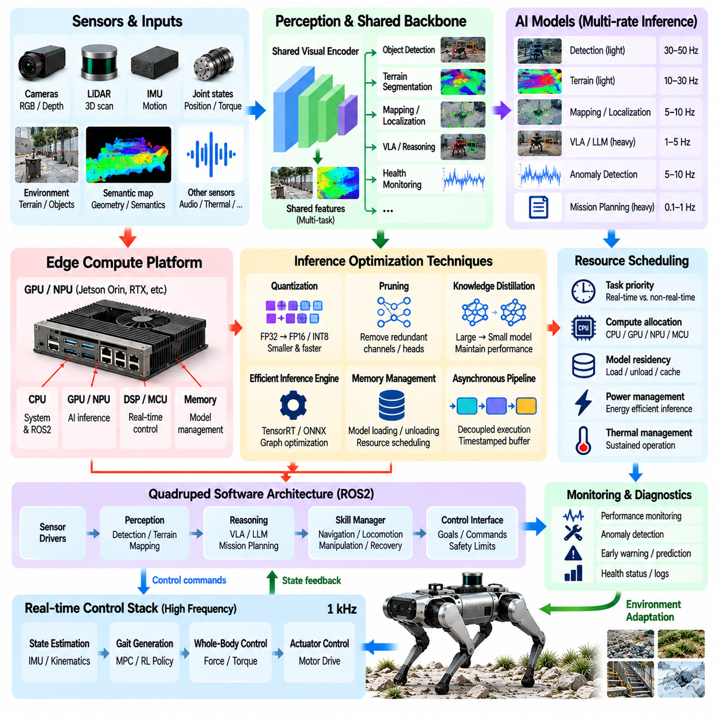
Edge inference optimization for quadruped AI focuses on executing perception, reasoning, locomotion intelligence, and health-monitoring models within the limited compute, power, memory, and thermal resources available onboard a mobile robot. Unlike cloud AI, quadruped inference must coexist with real-time control while the platform continuously moves through uncertain environments. Optimization therefore targets not only model throughput but also deterministic latency, resource isolation, energy efficiency, and sustained operation.
The onboard computing architecture normally contains workloads with very different timing requirements. State estimation, balance control, actuator communication, and safety functions may require deterministic high-frequency execution, while object detection, terrain segmentation, VLA reasoning, anomaly detection, and mission planning can operate at lower frequencies. Edge optimization should assign compute resources according to these temporal requirements so that expensive AI inference never blocks or destabilizes time-critical locomotion processes.
Model selection begins by matching inference complexity to the physical task rather than deploying the largest available network. Terrain classification may require a compact visual encoder, while semantic mission reasoning may justify a larger multimodal model that runs only at decision points. A heterogeneous architecture can therefore combine small continuously running models with larger event-driven models. This reduces average computational load while preserving advanced reasoning capabilities when environmental or mission conditions require them.
Quantization is one of the most effective methods for reducing inference cost. Converting model weights and activations from high-precision floating-point representations to FP16, INT8, or lower-precision formats can reduce memory traffic and increase accelerator utilization. However, quantization must be validated separately for each function because perception confidence, terrain classification, anomaly scores, or policy outputs may respond differently to reduced numerical precision. Performance improvement should never be accepted without task-level accuracy verification.
Structured pruning and model compression can further reduce computational demand by removing parameters, channels, attention heads, or other components that contribute little to task performance. Knowledge distillation can transfer behavior from a larger teacher model into a smaller student model suitable for onboard deployment. For quadruped applications, compression should be evaluated against physical task metrics such as traversal success, grounding accuracy, obstacle detection, or recovery behavior rather than only conventional neural-network accuracy.
Inference engines can optimize trained networks by fusing operations, selecting efficient kernels, minimizing memory copies, and exploiting hardware-specific accelerators. Graph compilation can convert a general training model into an execution graph optimized for the target GPU, NPU, or other AI accelerator. Static tensor dimensions and predefined input profiles can improve efficiency when practical, while dynamic shapes may be retained only where environmental observations or multimodal inputs genuinely require them.
Memory management is critical because several AI models may share the same onboard accelerator. Vision encoders, terrain models, locomotion policies, language components, and health-monitoring networks can collectively exceed available device memory if loaded without coordination. Model residency should therefore be planned according to execution frequency and mission state. Frequently used models can remain resident, while rarely used models may be loaded, unloaded, or activated only when their corresponding capabilities are required.
Shared feature extraction can reduce duplicated computation across perception tasks. Instead of processing the same camera frame independently for terrain recognition, object detection, semantic mapping, and VLA reasoning, a common visual backbone can generate reusable intermediate representations. Task-specific heads can then consume these features. This architecture can reduce latency and memory bandwidth, although shared representations must be validated to ensure that optimization for one task does not degrade another safety-relevant perception function.
Asynchronous execution allows perception and reasoning pipelines to progress without forcing the locomotion controller to wait for every AI result. Camera acquisition, preprocessing, inference, postprocessing, mapping, and mission reasoning can operate as independent stages connected through timestamped buffers. The control system can consume the newest valid result while rejecting information that has become too old. Such temporal decoupling is especially important when AI workloads experience variable execution time.
Multirate inference provides another major optimization opportunity. Terrain segmentation may need frequent updates while the robot moves quickly, whereas semantic scene interpretation can run more slowly when the environment is stable. Mission-level language reasoning may execute only after a new instruction, task completion, or significant environmental change. Dynamically adjusting inference frequency according to robot speed, scene change, uncertainty, and mission state reduces unnecessary computation while preserving responsiveness.
Region-of-interest processing can avoid applying expensive perception to irrelevant image regions. Navigation and terrain analysis may prioritize the ground and near-field workspace, while inspection tasks can focus high-resolution processing on a specific instrument or structure. Coarse models can first identify candidate regions and activate more expensive models only where additional semantic detail is required. This coarse-to-fine strategy reduces average inference cost while retaining high-resolution analysis for important targets.
Sensor preprocessing should also be optimized because image conversion, resizing, point-cloud transformation, synchronization, and data copying can consume significant resources before neural inference begins. Zero-copy transport, hardware-accelerated preprocessing, pinned memory, efficient message passing, and direct accelerator access can reduce pipeline overhead. Optimization must therefore consider the complete sensor-to-decision latency rather than reporting only the execution time of the neural network itself.
AI inference should be scheduled with explicit priority below hard real-time safety and control workloads. GPU or accelerator contention can create latency spikes even when average inference performance appears acceptable. Resource partitioning, CPU affinity, execution priorities, bounded queues, and workload admission policies can protect critical processes. When compute demand exceeds available capacity, the system should reduce nonessential inference frequency or disable optional models rather than allowing locomotion timing to degrade unpredictably.
Thermal management is directly connected to sustained AI performance. A model may achieve high throughput during a short benchmark but trigger thermal throttling after prolonged field operation. Temperature, power consumption, accelerator frequency, and inference latency should therefore be monitored together. Dynamic workload management can lower inference frequency, select smaller models, reduce sensor processing, or postpone noncritical reasoning when thermal margins become insufficient, preserving stable long-duration robot operation.
Energy efficiency is equally important because every watt used for computation reduces energy available for locomotion, sensing, communication, and mission endurance. Optimization should therefore consider inference energy per decision as well as frames per second. Event-driven execution, adaptive frame rates, model compression, accelerator utilization, and selective sensor activation can reduce computational energy. Mission planning can also account for remaining battery capacity when deciding whether expensive AI functions should continue at full performance.
Fallback behavior is required when an AI model misses its latency deadline, becomes unavailable, or produces invalid output. The quadruped should retain a safe locomotion mode that does not depend on continuous high-level inference. Cached terrain information, conservative velocity limits, conventional obstacle detection, local stopping behavior, and validated recovery controllers can preserve physical safety during temporary AI degradation. Edge optimization must therefore include graceful degradation rather than assuming that every inference request succeeds.
Profiling should measure the complete deployed system under representative workloads. Useful measurements include end-to-end latency, inference jitter, accelerator utilization, CPU utilization, memory occupancy, bandwidth, temperature, power, dropped sensor frames, and deadline misses. Tests should include simultaneous locomotion, perception, recording, communication, and reasoning because isolated model benchmarks can significantly overestimate the performance available during actual quadruped operation.
Optimization should be validated through progressive deployment from recorded data and simulation to hardware-in-the-loop and field testing. Each optimization step should confirm that numerical changes, scheduling decisions, or model compression do not alter critical physical behavior unexpectedly. Regression tests can compare perception outputs, policy commands, mission decisions, and safety events across model versions. This establishes a traceable relationship between computational optimization and robot-level performance.
Quadruped AI edge inference optimization ultimately creates a balanced computing hierarchy in which each intelligence function receives only the resources and update rate required by its physical role. Compression, quantization, asynchronous pipelines, shared representations, multirate execution, hardware acceleration, and resource scheduling reduce computational cost, while deterministic control and safety remain protected. The objective is not maximum AI throughput, but reliable embodied intelligence that can operate continuously within the robot’s real power, thermal, memory, and timing limits.

10.09. Quadruped AI Safety Override Mechanisms [w/Code]
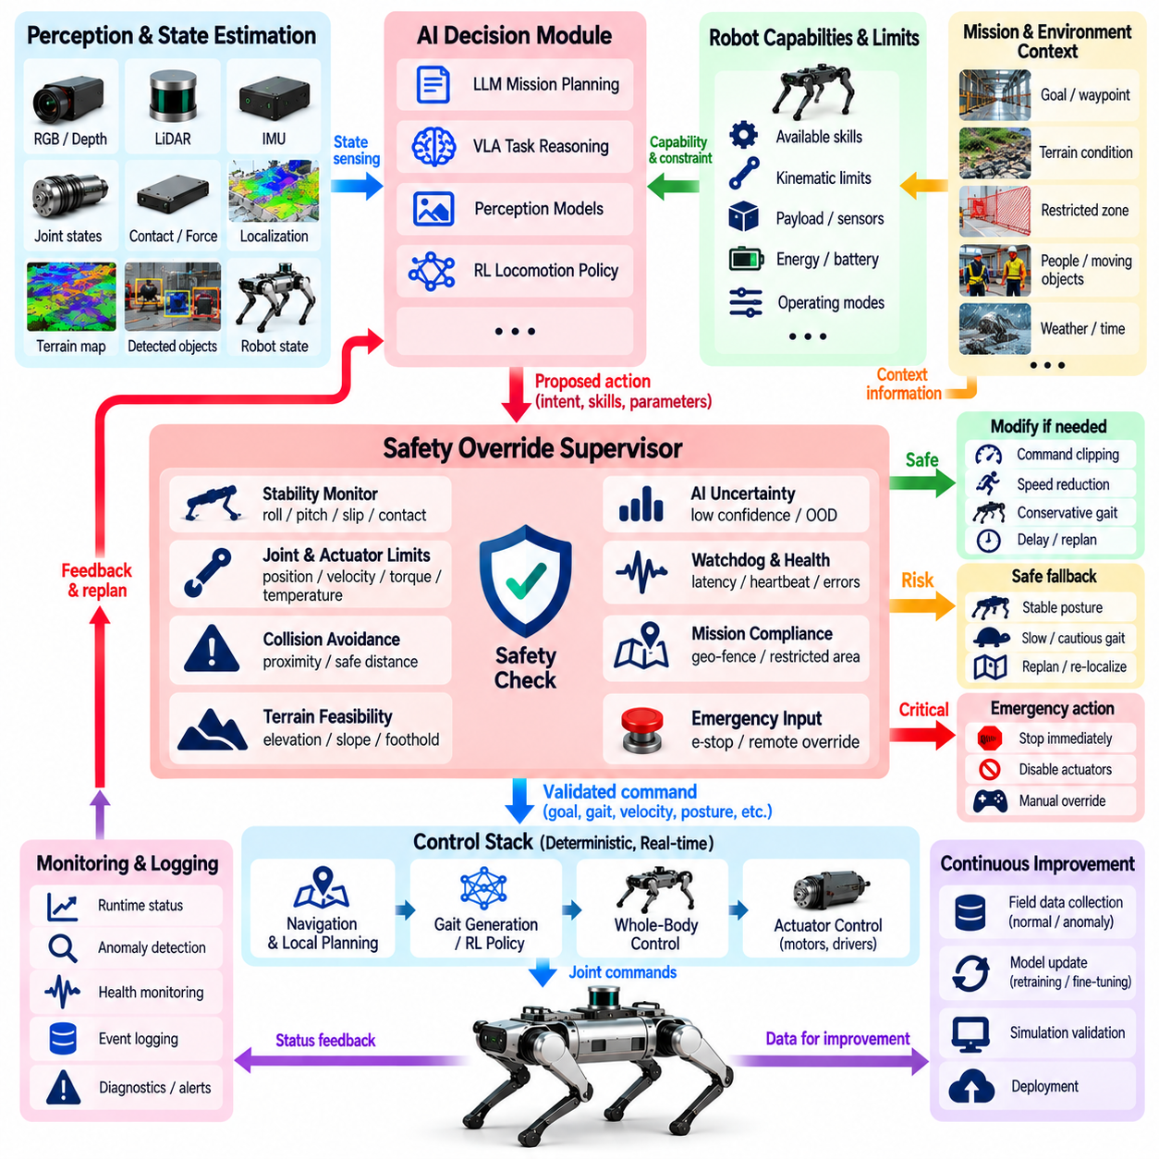
AI safety override mechanisms for quadruped robots establish an independent authority that can restrict, modify, or terminate actions proposed by learning-based and generative AI components. A quadruped may use reinforcement learning, vision-language-action models, adaptive policies, or LLM mission planners, but these systems cannot be assumed to remain correct under every physical condition. Safety overrides therefore separate intelligent decision making from final permission to execute motion.
The fundamental principle is that AI-generated intent must never have unrestricted access to actuators. Commands produced by a policy or reasoning model should pass through a validated execution boundary before reaching locomotion, whole-body control, or hardware interfaces. This boundary evaluates whether requested velocity, posture, gait, foothold, trajectory, manipulation target, or mission transition remains inside predefined operating limits. Unsafe commands can be clipped, replaced, delayed, or rejected entirely.
Safety supervision should operate independently from the AI model being supervised. If the same learned model both generates an action and determines whether that action is safe, correlated failures may defeat the protection mechanism. A separate safety supervisor can instead use deterministic rules, state-machine logic, analytical constraints, verified estimators, and hardware signals. This architecture creates an independent path capable of overriding AI behavior even when the primary inference system produces incorrect or unavailable outputs.
Override mechanisms can be organized according to severity. Minor violations may trigger command limiting, such as reducing velocity, acceleration, body height, or turning rate. More significant risk may force a transition from dynamic locomotion to a conservative gait or stable standing posture. Critical conditions can initiate controlled stopping, actuator disablement, or emergency stop. The response should match the available time and physical risk rather than treating every abnormal condition identically.
Robot stability provides one of the most important override criteria. Excessive roll or pitch, rapidly changing angular velocity, loss of expected contacts, insufficient support geometry, or repeated foot slip can indicate that continued execution of an AI command is unsafe. The safety layer can monitor these variables independently of the locomotion policy and reduce commanded motion before the robot reaches an unrecoverable state. Near-fall detection may additionally activate a dedicated balance-recovery behavior.
Joint and actuator constraints form another hard protection boundary. AI-generated motion must respect joint position, velocity, torque, current, and temperature limits as well as mechanical collision constraints. Whole-body control and low-level motor interfaces can enforce these restrictions even when a higher-level policy requests an infeasible posture. Rate limiters and torque saturation prevent abrupt changes, while thermal or electrical protection can progressively reduce available performance before hardware damage occurs.
Terrain-related overrides are required because perception or learned locomotion policies may incorrectly estimate traversability. Negative obstacles, unstable edges, excessive slopes, insufficient foothold area, or uncertain terrain can invalidate a planned motion. A safety monitor can compare intended movement against elevation maps, collision geometry, terrain confidence, and contact feasibility. If the required physical evidence is unavailable, the robot can stop, slow down, obtain another observation, or request an alternative route.
Collision avoidance should remain authoritative over semantic or mission-level objectives. An LLM may decide that reaching an inspection target is important, but the robot must not continue when a person, vehicle, structure, or unexpected obstacle enters its protected region. Independent proximity monitoring can use LiDAR, depth cameras, bump sensors, or other validated sensing channels. Protective zones can reduce speed progressively as clearance decreases and command an immediate stop when minimum separation is violated.
AI uncertainty provides an additional trigger for intervention. Low confidence in object grounding, terrain classification, localization, action prediction, or anomaly interpretation should reduce the authority granted to the AI component. Instead of forcing a decision from uncertain information, the safety architecture can request additional sensing, select a conservative policy, or suspend execution. Out-of-distribution detection can similarly indicate that the robot has entered conditions that were poorly represented during training.
Watchdog mechanisms protect against computational failures as well as incorrect decisions. Each critical AI process can periodically provide a heartbeat, timestamp, sequence number, or validity status. Missing updates, excessive inference latency, corrupted messages, stale perception results, or communication interruption can cause the safety supervisor to invalidate the associated commands. The robot then transitions to a predefined fallback behavior rather than continuing indefinitely with obsolete AI output.
Command freshness is particularly important in asynchronous AI architectures. A terrain estimate or navigation command may have been correct when generated but become unsafe after the robot has moved. Every safety-relevant message should therefore carry timing information and an explicit validity interval. The execution layer can reject stale commands and compare their reference state with the robot’s current state. This prevents delayed inference or communication from unintentionally controlling the robot using outdated environmental assumptions.
Fallback policies should be simpler and more extensively validated than the AI behaviors they replace. Depending on the situation, fallback operation may mean reducing speed, holding position, entering a stable stance, retracing a verified path, returning to a safe location, or performing posture recovery. The objective is not to preserve maximum mission performance during failure but to move the system toward a known and controllable state from which operation can safely resume or terminate.
Human override must remain available for operations in which remote or local supervision is required. An operator should be able to pause autonomous execution, cancel a mission, command a controlled stop, or activate emergency stop without negotiating with the AI planner. Authority arbitration must define which command source has priority when autonomous, supervisory, remote, and emergency commands conflict. Safety-critical human commands should bypass semantic interpretation and reach deterministic control logic through a protected channel.
Communication loss requires explicit handling because quadrupeds may operate beyond reliable network coverage. The robot should not assume that absence of new operator commands means permission to continue indefinitely. Mission-specific rules can define whether communication loss causes a stop, return, completion of a bounded local task, or transition to autonomous recovery. Regardless of the selected strategy, stabilization, obstacle response, and emergency protection must remain fully available onboard.
Battery and power conditions can also override AI objectives. A mission planner may attempt to continue inspection, but the safety manager should preserve sufficient energy for stopping, recovery, communication, or return when required. Low voltage, abnormal current draw, power-system temperature, or rapidly decreasing state of charge can progressively restrict locomotion performance. Critical power conditions should terminate nonessential AI workloads and move the robot toward a safe state before control capability is lost.
Health-monitoring information can provide predictive triggers before an immediate safety threshold is crossed. Increasing actuator temperature, repeated tracking errors, unusual vibration, asymmetric loading, or persistent recovery events may indicate developing degradation. Rather than waiting for complete failure, the safety supervisor can derate speed, disable demanding gait modes, restrict payload operation, or terminate the mission. Predictive information should influence safety conservatively while deterministic limits retain final authority.
Safety overrides should be represented as explicit system states rather than hidden modifications to AI output. Modes such as normal operation, constrained operation, degraded operation, controlled stop, recovery, and emergency stop provide traceable behavior. Each transition should have defined entry conditions, permitted actions, and exit conditions. This state-based architecture makes it possible to determine why AI authority was reduced and what conditions must be satisfied before autonomous execution can resume.
Recovery from an override requires validation rather than automatic restoration of full AI authority. After a slip event, communication failure, thermal warning, or perception fault disappears, the system should confirm that relevant states have returned to acceptable ranges. A stabilization period, sensor consistency check, operator acknowledgement, or successful self-test may be required. Hysteresis can prevent rapid switching between normal and restricted modes when measurements remain near a safety threshold.
Hardware emergency stop remains the final protection layer and should not depend on AI inference, operating-system scheduling, or network communication. Where platform architecture permits, the emergency path should directly force a verified safe actuator condition. Software emergency stop and controlled stopping provide additional layers, but they should not eliminate independent hardware protection. The exact safe state depends on robot mechanics, terrain, payload, and whether immediate torque removal would itself create a fall hazard.
Logging is essential for understanding safety interventions and improving future AI behavior. The system should record robot state, AI commands, supervisor decisions, sensor evidence, override reason, resulting action, and recovery outcome around each event. These records support incident analysis, regression testing, policy retraining, and safety validation. Repeated overrides can reveal operating regions in which the AI policy remains insufficiently trained even when no catastrophic failure occurs.
Validation must deliberately challenge every override path rather than waiting for failures to appear during field operation. Simulation, software-in-the-loop, hardware-in-the-loop, and controlled physical tests can inject stale commands, sensor faults, excessive velocities, invalid footholds, communication loss, thermal warnings, low battery conditions, unstable postures, and AI timeouts. Tests should verify not only that intervention occurs, but that response latency and resulting robot behavior remain within defined safety requirements.
Quadruped AI safety override mechanisms ultimately establish a hierarchy of authority between intelligent autonomy and physical safety. AI systems may propose sophisticated actions, adapt to terrain, interpret language, and plan missions, but independent supervisors determine whether those actions are permissible. Deterministic constraints, watchdogs, fallback states, human override, health monitoring, and emergency protection ensure that loss of AI correctness does not automatically become loss of robot control.

10.10. Future AI Native Quadruped Platform Vision
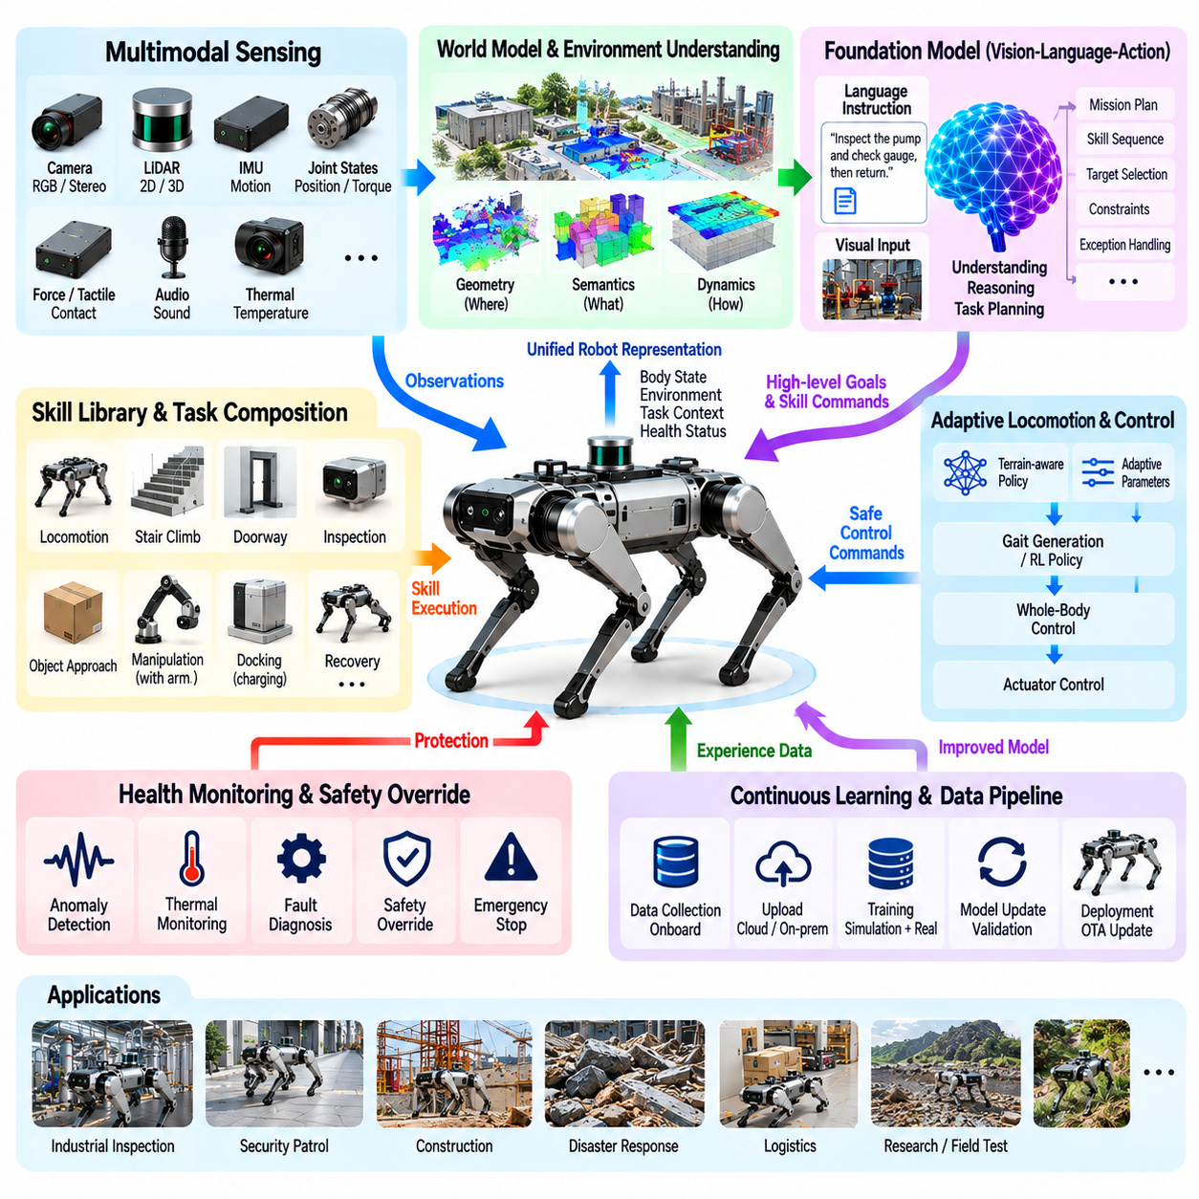
Future AI-native quadruped platforms will evolve from robots that merely host AI applications into machines whose mechanical design, sensing, computing, control, data architecture, and safety systems are created around embodied intelligence from the beginning. AI will no longer exist as an optional perception layer attached to a conventional locomotion stack. Instead, learning, reasoning, adaptation, and physical interaction will become fundamental architectural properties of the complete robotic platform.
An AI-native quadruped should maintain a unified representation of its body, environment, task, and operational condition. Cameras, LiDAR, proprioception, force estimation, audio, thermal sensing, and other modalities can contribute to a continuously updated multimodal world representation. Rather than operating as isolated perception pipelines, these sensors provide complementary evidence about geometry, semantics, dynamics, contacts, objects, people, terrain, and uncertainty that higher intelligence layers can use for decision making.
The future platform will increasingly combine world models with conventional state estimation and mapping. A world model can represent how the environment and robot state may evolve under candidate actions, allowing the system to reason beyond immediate observations. Geometric maps describe where structures exist, semantic representations describe what they mean, and learned dynamics estimate how physical interactions may change. Together, these representations support predictive embodied intelligence rather than purely reactive autonomy.
Foundation models can provide a reusable semantic and reasoning layer across many quadruped applications. Instead of developing completely independent AI systems for inspection, security, construction, logistics, disaster response, and industrial maintenance, a common multimodal foundation can interpret scenes, instructions, objects, and mission context. Application-specific capabilities can then be added through adapters, task policies, skill libraries, retrieval mechanisms, or specialized perception modules without rebuilding the entire intelligence stack.
Language will become an important interface between human intent and robot autonomy. Operators may describe objectives, constraints, priorities, and exceptions in natural language rather than programming detailed state machines for every mission. The AI-native platform can translate these instructions into structured mission graphs and executable skills. Language, however, remains a semantic interface rather than a substitute for geometric planning, real-time control, or deterministic safety enforcement.
Skill-based autonomy provides the bridge between general reasoning and reliable physical execution. Locomotion, stair climbing, doorway traversal, inspection, object approach, sensor positioning, manipulation, docking, recovery, and return behaviors can be represented as reusable skills with explicit preconditions and completion criteria. Higher-level AI can compose these skills dynamically according to mission context while validated controllers retain responsibility for the detailed physical motions required by each skill.
Future locomotion policies will become increasingly adaptive rather than fixed for a narrow set of terrain assumptions. Visual terrain understanding can predict upcoming conditions, while proprioceptive interaction reveals friction, compliance, slip, impact, and unexpected disturbances after contact. Adaptive policies can combine these observations to modify gait, velocity, footholds, body posture, or controller parameters. The platform therefore learns to interpret terrain as a physical interaction problem rather than only as geometric geometry.
Continuous learning will extend this adaptation beyond individual missions. Difficult terrain encounters, failed approaches, recovery events, unusual objects, operator interventions, and successful task executions can become training evidence for future system versions. Robot experience can be uploaded to an on-premise or cloud learning environment, curated, replayed in simulation, and incorporated into updated models. Validated improvements can then return to deployed robots through controlled model lifecycle management.
Simulation and synthetic data will become permanent components of the AI-native development loop. Digital environments can generate terrain variations, sensor conditions, rare failures, object arrangements, weather effects, and mission combinations that would be expensive or unsafe to reproduce physically. Real operational data can identify gaps in simulation coverage, while simulation can generate targeted cases around those gaps. The resulting closed loop continuously expands the conditions under which robot intelligence is tested.
An AI-native platform should treat data as an architectural resource rather than an incidental log. Sensor streams, actions, mission states, model outputs, uncertainty estimates, safety interventions, failures, and outcomes should be synchronized and associated with consistent metadata. This creates traceable episodes that can support debugging, model evaluation, imitation learning, reinforcement learning, anomaly detection, and fleet analytics. The robot therefore becomes both an operational machine and a structured data-generation platform.
Onboard computing will increasingly become heterogeneous. CPUs can manage orchestration and deterministic software, GPUs or NPUs can execute perception and foundation models, real-time processors can protect control loops, and dedicated safety hardware can remain independent from general AI computation. Workloads can move among these resources according to latency, power, thermal conditions, and mission priority. Such partitioning allows advanced intelligence to coexist with predictable physical control.
Edge, on-premise, and cloud intelligence can form a hierarchical computing system rather than competing deployment choices. The robot requires sufficient onboard intelligence for immediate perception, locomotion, safety, and degraded operation without connectivity. Nearby edge or on-premise infrastructure can support larger models, local fleet coordination, map fusion, and site-specific learning. Cloud systems can provide foundation-model development, large-scale training, global fleet analysis, and long-term knowledge consolidation.
Multiple quadrupeds can extend this architecture from individual embodied intelligence to collective physical intelligence. Robots operating at the same site can exchange semantic maps, terrain observations, detected hazards, mission progress, and learned experience. One robot discovering an inaccessible passage or slippery surface can provide information that changes the plans of others before they encounter it. Fleet intelligence therefore converts isolated robot experience into shared operational knowledge.
A common spatial and semantic graph can provide a foundation for this collective intelligence. Robots, objects, locations, tasks, hazards, capabilities, observations, and relationships can be represented as connected entities rather than independent database records. Temporal information can describe how these relationships change. Such graph-based representations allow mission reasoning to connect physical locations with semantic meaning, robot capability, operational history, and current fleet state.
Future AI-native quadrupeds may also become general mobile manipulation platforms. Adding an arm or other end effector transforms locomotion from transportation into active positioning for physical interaction. The robot must coordinate footholds, base posture, manipulator reach, contact force, and balance while reasoning about task objectives. Loco-manipulation therefore requires intelligence that understands the body as one coupled physical system rather than treating legs and manipulators as independent machines.
Self-awareness in this context does not imply consciousness, but operational knowledge of the robot's own capabilities and limitations. The platform should know which sensors are available, which skills are validated, how much energy remains, whether actuators are degraded, what payload is attached, and which terrain classes are uncertain. Mission reasoning can use this internal state to avoid proposing actions that exceed the robot's current physical or computational capability.
Safety must consequently become native to the AI architecture rather than being added after model development. Learning systems can propose actions, but independent safety supervisors must enforce stability, collision, actuator, thermal, power, and operational constraints. Confidence and uncertainty can modify the authority granted to AI decisions. Fallback controllers, watchdogs, hardware emergency mechanisms, and human override ensure that increasingly capable autonomy does not remove deterministic protection.
Cybersecurity and model integrity will become equally important as robots gain greater autonomy and connectivity. Models, mission commands, maps, software packages, and configuration updates should be authenticated before execution. Access control should separate operator, developer, fleet, and maintenance privileges. Runtime monitoring can detect corrupted or unexpected components, while signed deployment artifacts and rollback mechanisms protect the robot against unauthorized or defective AI updates.
The software architecture should support continuous evolution without requiring complete platform redesign. Standardized interfaces between sensing, world modeling, skills, planning, control, safety, and hardware allow individual components to improve independently. Models can be replaced as better architectures emerge, while capability descriptions and execution contracts remain stable. This modularity is essential because AI development cycles will often be much faster than mechanical platform replacement cycles.
Evaluation will therefore shift from isolated benchmark accuracy toward complete embodied capability. A future quadruped should be measured by whether it can understand a mission, perceive relevant conditions, select feasible skills, traverse unfamiliar terrain, recover from disturbances, manage uncertainty, complete useful physical work, and remain safe. Evaluation must combine simulation, synthetic scenarios, hardware testing, long-duration operation, adversarial conditions, and real field deployments.
The long-term vision is a quadruped platform that operates as a persistent physical intelligence node rather than a remotely operated machine with added autonomy. It perceives and models its surroundings, understands human objectives, predicts physical consequences, selects and executes skills, adapts to unfamiliar conditions, evaluates its own operational health, and contributes experience to a larger learning system. Intelligence becomes distributed across body, edge, fleet, and cloud while physical safety remains locally enforceable.
An AI-native quadruped platform therefore represents a transition from programming robots for predefined situations toward engineering systems that can continuously connect perception, knowledge, reasoning, learning, control, and physical experience. The central objective is not to eliminate conventional robotics, but to combine its deterministic foundations with scalable AI. The resulting platform can become progressively more capable through accumulated experience while remaining grounded in measurable physical state, verified execution, and explicit safety boundaries.

