Volume 21. Quadruped Robot Software

Chapter 11. Quadruped SW Testing and Validation

11.01. Quadruped SW Test Strategy Overview SIL HIL Field
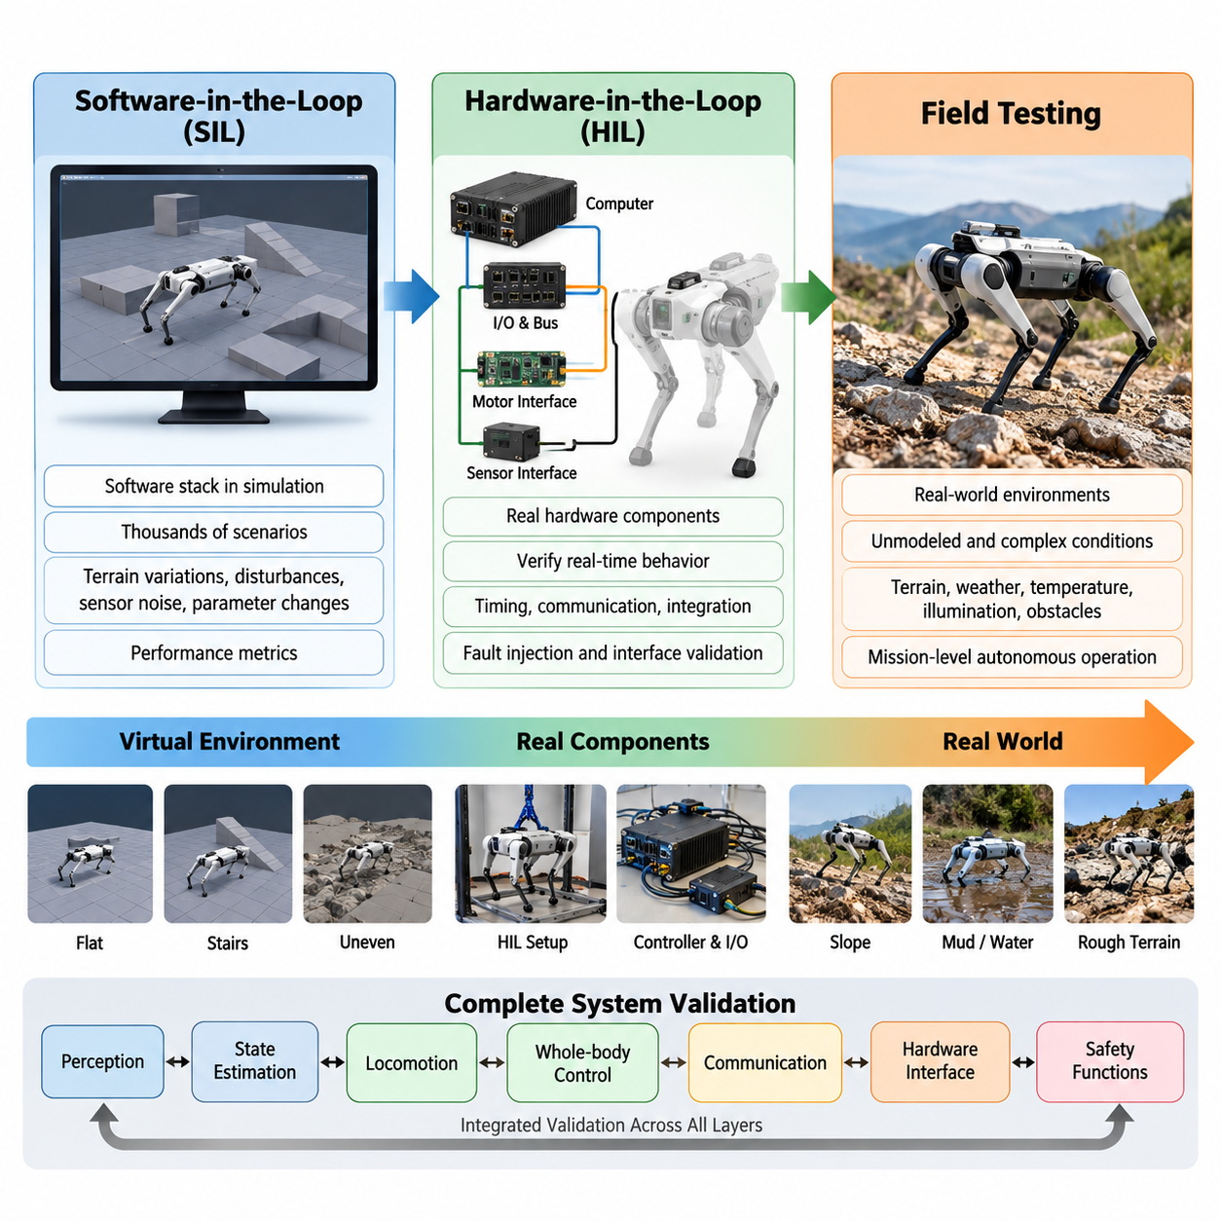
A comprehensive quadruped software test strategy must validate not only individual algorithms but the complete interaction among perception, state estimation, locomotion, whole-body control, communication, hardware interfaces, and safety functions. Because quadruped robots operate through repeated physical contacts with uncertain environments, failures that appear insignificant in software can rapidly develop into loss of balance, actuator overload, collision, or falls. Validation should therefore progress systematically from controlled virtual environments toward increasingly realistic hardware and field conditions. Volume_21_Quadruped_Robot_Softw…
Software-in-the-loop (SIL) testing provides the first scalable environment for evaluating quadruped behavior without exposing physical hardware to risk. The production software stack, controller, planner, state estimator, or learned locomotion policy is executed against a simulated robot and environment. SIL testing enables thousands of repeatable scenarios involving gait commands, terrain variations, disturbances, sensor noise, communication delay, contact uncertainty, and parameter changes while automatically collecting performance metrics.
A useful SIL environment must reproduce the dynamics that influence locomotion rather than merely generate visually realistic motion. Robot mass and inertia, joint friction, actuator limits, transmission behavior, contact stiffness, ground friction, sensor characteristics, and control latency should be represented with sufficient fidelity. These parameters can also be randomized within realistic ranges so that testing measures robustness across a distribution of operating conditions instead of demonstrating success for one ideal simulation configuration.
SIL validation should combine deterministic regression scenarios with randomized stress testing. Deterministic tests verify that identical software versions and initial conditions continue to produce expected behavior after modifications, while randomized tests expose controllers to combinations that developers may not anticipate manually. Important observations include velocity tracking error, orientation error, foot placement accuracy, slip frequency, body clearance, contact force, joint torque, energy consumption, solver failures, and fall probability.
Hardware-in-the-loop (HIL) testing introduces real computational and electrical components while retaining controlled portions of the simulated environment. The onboard computer, real-time controller, communication buses, motor interfaces, sensor interfaces, and safety logic can operate using simulated or emulated plant signals. This stage reveals timing and integration problems that conventional simulation can overlook, including scheduling jitter, packet loss, timestamp errors, computational overload, communication latency, driver faults, and incorrect hardware abstraction behavior.
Real-time behavior is particularly important because the quadruped architecture includes high-frequency control loops and tightly coupled locomotion components. The source structure explicitly places a 1 kHz real-time control-loop architecture and hardware abstraction within the locomotion stack, making timing validation a necessary bridge between algorithmic simulation and physical deployment. Volume_21_Quadruped_Robot_Softw… HIL measurements should therefore include loop execution time, deadline misses, jitter distributions, sensor-to-command latency, synchronization accuracy, CPU/GPU utilization, and communication timing.
The transition from SIL to HIL should preserve test identity whenever possible. A terrain event, disturbance profile, command sequence, or fault injection used in simulation should be representable in the HIL environment using equivalent inputs and acceptance criteria. This allows engineers to compare results across validation layers and identify where discrepancies originate. Differences between SIL and HIL behavior often reveal incomplete actuator models, timing assumptions, numerical differences, interface problems, or unmodeled hardware constraints.
Physical robot testing begins only after basic safety, communication, actuator, and controller behavior has passed preceding gates. Initial tests should use restrained or low-risk conditions such as suspended-leg operation, low body height, reduced torque and velocity limits, flat ground, controlled gait speeds, and accessible emergency stopping. Test complexity can then increase progressively through walking, turning, gait transitions, slopes, stairs, irregular terrain, payloads, external disturbances, and mission-level autonomous operation.
Field testing provides evidence that the software remains functional under conditions that cannot be completely represented in simulation or laboratory HIL systems. Surface compliance, loose gravel, vegetation, mud, dust, rain, temperature variation, illumination changes, unexpected obstacles, radio degradation, and repeated mechanical impacts create coupled disturbances. The chapter structure consequently extends validation beyond SIL and HIL into terrain crossing, push recovery, endurance, safety functions, and environmental testing. Volume_21_Quadruped_Robot_Softw…
Field tests should not be treated as informal demonstrations. Every run requires defined initial conditions, robot configuration, software version, terrain description, command profile, environmental conditions, expected behavior, failure criteria, and recorded telemetry. Quantitative metrics allow two controller versions to be compared objectively. Video can support diagnosis, but synchronized joint states, IMU measurements, estimated state, contact information, actuator commands, temperatures, power consumption, planner outputs, safety events, and system logs provide the evidence needed for engineering validation.
A critical principle is traceability from requirement to test result. Each locomotion, navigation, manipulation, AI, and safety requirement should map to one or more verification procedures and measurable acceptance thresholds. Test artifacts should identify the software commit, configuration parameters, robot hardware revision, calibration state, model or policy version, dataset or replay sequence, simulator configuration, and test environment. Without this information, successful experiments cannot reliably support regression testing or production release decisions.
Fault injection complements nominal testing by deliberately introducing abnormal conditions such as sensor dropout, corrupted measurements, delayed messages, actuator saturation, reduced friction, communication interruption, estimator divergence, excessive temperature, or unavailable planning outputs. The objective is not always to maintain normal locomotion. Depending on severity, correct behavior may instead involve degraded operation, controlled stopping, stable posture, safe sitting, or emergency shutdown. Validation must therefore examine recovery behavior as carefully as nominal performance.
Learned locomotion policies require additional distribution-oriented testing because conventional functional test cases cannot fully characterize neural policy behavior. Terrain geometry, friction, payload, actuator strength, latency, sensor noise, external disturbances, and command profiles should be swept across broad ranges. Simulation enables large-scale coverage, but representative boundary conditions must eventually be reproduced on hardware because simulator success alone cannot establish physical robustness, especially where contact dynamics and actuator behavior dominate.
Regression testing should connect the entire SIL-HIL-field pipeline to software development. Changes to controllers, estimators, planners, drivers, robot models, configuration files, or learned policies should automatically trigger an appropriate subset of previously validated scenarios. Lightweight tests can execute for every software change, larger simulation campaigns can run periodically, and HIL or physical tests can be reserved for release candidates. This hierarchy improves coverage while preventing expensive hardware testing from becoming the primary debugging mechanism.
The final validation decision should therefore be based on accumulated evidence rather than a single successful field demonstration. SIL establishes broad scenario coverage and algorithmic repeatability, HIL verifies timing and hardware-software integration, and field testing establishes performance under physical uncertainty. Together they form a progressive validation funnel in which inexpensive and reproducible tests eliminate defects early while increasingly realistic stages confirm that remaining assumptions continue to hold on the actual quadruped platform.
A mature quadruped release process closes this loop by feeding every field failure back into earlier test layers. Recorded sensor streams can become replay-based regression cases, unexpected terrain can become new simulation scenarios, hardware timing faults can become HIL injections, and safety incidents can become mandatory release tests. In this way, SIL, HIL, and field validation operate as a continuously expanding evidence system rather than isolated development phases, allowing the software baseline to become progressively more robust with operational experience.

11.02. Locomotion Policy SIL Isaac Lab Validation [w/Code]
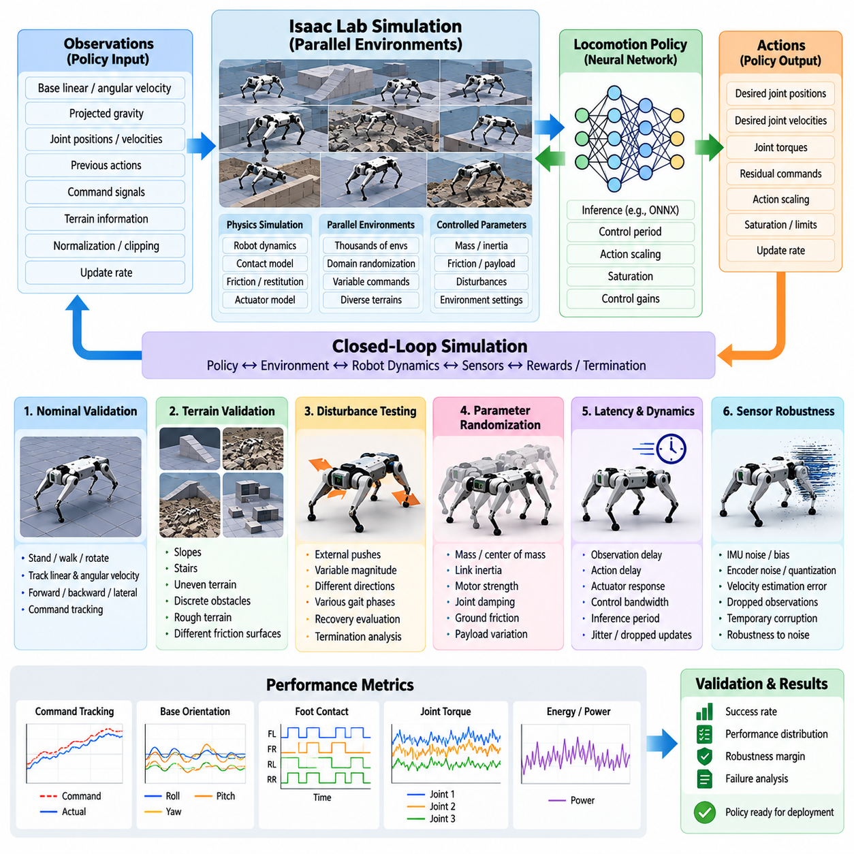
Software-in-the-loop validation of a quadruped locomotion policy evaluates the policy inside a controlled physics simulation before execution on physical hardware. For learning-based locomotion, this stage is especially important because policy behavior emerges from interactions among observations, neural-network inference, actuator commands, robot dynamics, and contact conditions. Isaac Lab provides a scalable environment in which these interactions can be exercised repeatedly while maintaining precise control over initial states and environmental parameters.
The validation environment should reproduce the same policy interface used during deployment. Observations may contain base linear and angular velocity, projected gravity, joint positions and velocities, previous actions, command signals, terrain information, or other policy-specific inputs. Their ordering, normalization, clipping, scaling, and update rates must match the training and deployment pipelines. A policy can appear unstable even when its learned behavior is correct if the SIL implementation changes observation semantics or coordinate conventions.
Policy outputs require equally strict verification. Neural-network actions are commonly transformed into desired joint positions, joint velocities, torques, or residual commands before reaching the low-level controller. Validation must therefore inspect the complete path from network output through action scaling, saturation, control gains, and actuator models. Incorrect action limits or mismatched control periods can produce unrealistic simulation performance and can conceal failures that would become dangerous when transferred to the physical quadruped.
Isaac Lab enables many robot environments to execute in parallel, allowing locomotion policies to be evaluated across substantially broader condition distributions than practical physical testing permits. Parallel environments can vary commanded velocity, heading, initial posture, terrain geometry, friction, payload, disturbance magnitude, and robot parameters. Instead of judging a policy from a few successful trajectories, engineers can estimate success rates and performance distributions over thousands of episodes and identify regions where behavior becomes unreliable.
A baseline validation campaign should first establish performance under nominal conditions. The quadruped can be commanded to stand, walk forward and backward, move laterally, rotate in place, and track combinations of linear and angular velocity. Measurements should include command tracking error, base orientation, body height, joint motion, foot contact timing, torque demand, power-related quantities, and termination events. Stable nominal performance becomes the reference against which increasingly difficult scenarios can be compared.
Terrain validation should then expand the operating envelope beyond flat ground. The policy can be evaluated on slopes, stairs, uneven surfaces, discrete obstacles, rough terrain, and surfaces with different friction characteristics. This is consistent with the broader software structure, where terrain curriculum, actuator modeling, domain randomization, and Sim2Real transfer are treated as core elements of reinforcement-learning locomotion. Volume_21_Quadruped_Robot_Softw… Terrain difficulty should increase systematically so that the boundary between reliable and unstable locomotion can be measured rather than described qualitatively.
Robustness testing requires controlled perturbation of physical parameters. Robot mass, center of mass, link inertia, motor strength, joint damping, ground friction, restitution, and payload can be varied around their nominal values. These variations reveal whether the learned policy depends excessively on one simulated robot model. A production candidate should maintain acceptable behavior across realistic parameter uncertainty because manufacturing tolerances, payload changes, wear, calibration error, and modeling inaccuracies inevitably separate the physical platform from its nominal simulation.
Latency and actuator dynamics deserve dedicated SIL tests because locomotion policies can become highly sensitive to temporal mismatch. Observation delay, action delay, actuator response, low-level control bandwidth, and policy inference period can be swept independently or jointly. Artificial jitter and occasional delayed updates can also be introduced. The resulting stability degradation helps define allowable timing budgets for onboard deployment and indicates whether additional delay randomization or actuator modeling is required before hardware testing.
Sensor robustness can be evaluated by perturbing observations rather than changing physical dynamics. IMU noise, joint encoder noise, velocity estimation error, bias, quantization, dropped observations, and temporary corruption can be injected with controlled severity. The purpose is to determine whether small perception or estimation errors lead to proportional performance degradation or abrupt policy failure. Such experiments also identify observations on which the policy has developed excessive dependence and therefore help prioritize hardware sensing and estimation requirements.
External disturbance tests evaluate recovery capability by applying impulses or sustained forces to the robot body while it is standing or moving. Disturbance direction, magnitude, duration, gait phase, and commanded velocity should be varied because the same force can have very different consequences depending on the current contact configuration. Useful metrics include maximum body deviation, recovery time, foot-placement response, command tracking after recovery, and fall probability. Repeated trials provide a statistical recovery envelope rather than a single successful push demonstration.
Episode termination must be defined carefully because termination conditions directly affect reported policy robustness. Conditions may include excessive roll or pitch, body-ground collision, forbidden contacts, joint-limit violation, unstable height, numerical failure, or inability to recover within a specified period. Validation reports should distinguish true falls from conservative safety termination. Otherwise, comparisons among policies can become misleading because different termination logic may produce different success rates even when their physical behavior is similar.
Deterministic reproducibility is essential for regression testing. Random seeds, simulator configuration, robot model version, policy checkpoint, observation configuration, terrain generator parameters, control frequency, physics timestep, and domain-randomization settings should be recorded for every validation campaign. When a new policy checkpoint or software revision is introduced, the same scenario collection can be replayed so that behavioral changes are attributable to the modification rather than uncontrolled differences in the test environment.
Large-scale evaluation should summarize distributions rather than only averages. Mean velocity error can hide rare catastrophic failures, while a high overall success rate can hide weakness on a particular terrain or command range. Percentiles, worst-case values, failure counts, fall probability, completion rate, energy-related metrics, and performance grouped by terrain difficulty provide a more informative picture. Failure scenarios should be preserved with their simulator states and parameters so they can become permanent regression cases.
Policy validation should also search deliberately for boundary conditions. Parameter sweeps can progressively increase slope, stair height, terrain roughness, commanded speed, payload, latency, or disturbance until predefined acceptance criteria are violated. The resulting operating envelope describes where the policy remains reliable and where degradation begins. This approach is more useful for engineering release decisions than simply reporting that a policy successfully traversed several representative environments.
SIL validation must also verify integration with the surrounding locomotion software rather than testing the neural policy as an isolated mathematical function. Command generation, locomotion state transitions, observation construction, inference scheduling, low-level control, safety limits, and termination logic should execute together. The volume structure explicitly treats learned policy deployment as part of a wider locomotion architecture and follows it with HIL, replay regression, terrain, disturbance, endurance, safety, and environmental validation. Volume_21_Quadruped_Robot_Softw…
A policy should advance from Isaac Lab SIL validation only when its acceptance criteria are defined and reproducibly satisfied across nominal, randomized, disturbed, and boundary-condition scenarios. Passing SIL does not prove that the physical robot will behave identically because contact dynamics, actuator behavior, sensing, timing, and structural effects remain imperfectly modeled. Instead, SIL provides a broad and repeatable evidence base that eliminates weak policies early and identifies the precise conditions that must receive attention during subsequent HIL and field validation.

11.03. Control Loop HIL Test Automation [w/Code]
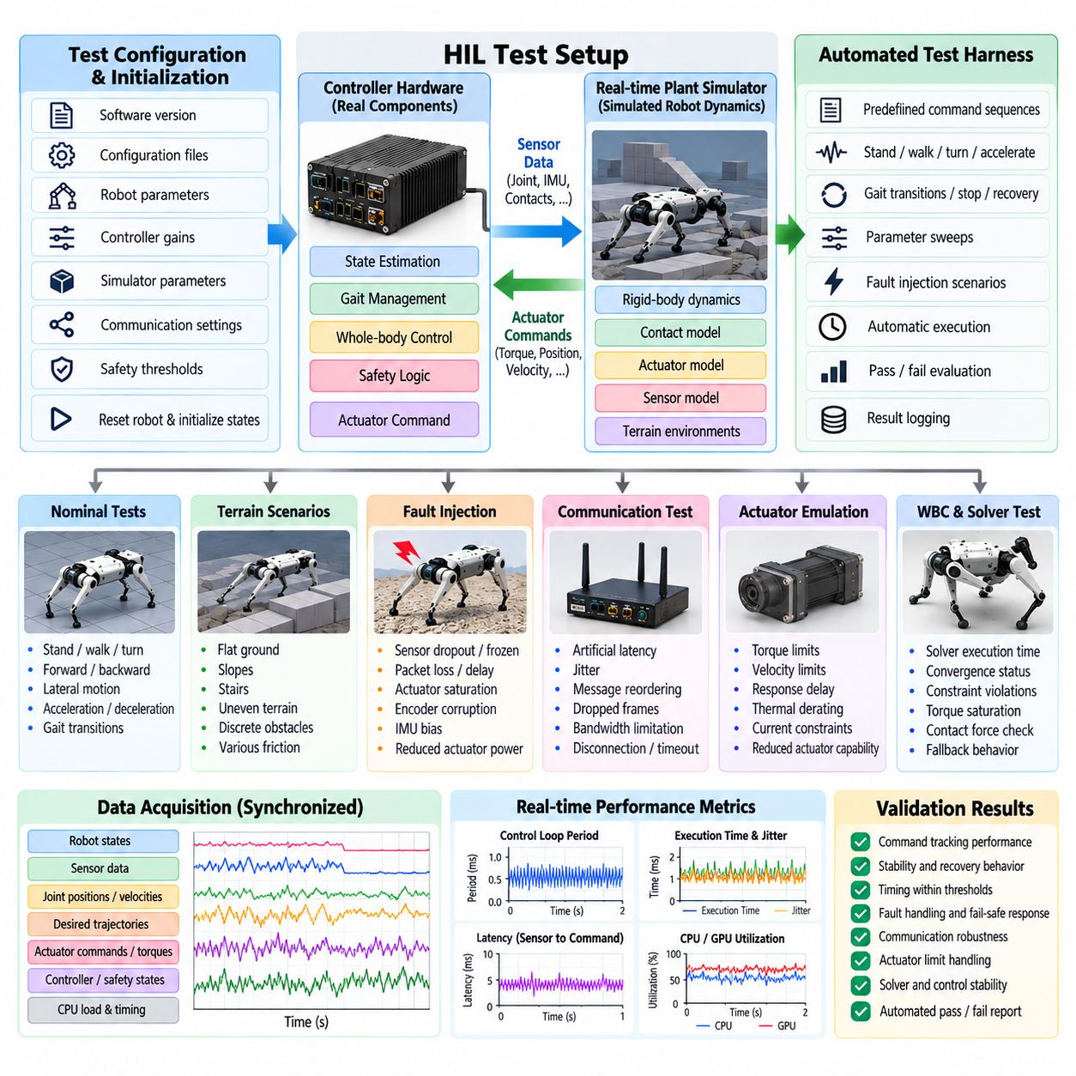
Hardware-in-the-loop testing of a quadruped control loop verifies whether production control software behaves correctly when executed on representative computing and communication hardware while the robot dynamics remain simulated or emulated. This stage bridges software-in-the-loop validation and physical robot testing by exposing the controller to realistic execution timing, interfaces, communication delays, and hardware constraints without requiring every abnormal condition to be reproduced on an actual quadruped.
A typical HIL configuration separates the controller hardware from a real-time plant simulator. The controller executes state estimation, gait management, whole-body control, safety logic, and actuator command generation using the same software configuration intended for deployment. The plant simulator computes joint and floating-base dynamics, contact interactions, actuator responses, and virtual sensor measurements, then exchanges these signals with the controller through representative communication interfaces at deterministic rates.
Control-loop timing is one of the primary HIL validation targets. Quadruped locomotion depends on synchronized execution of sensing, estimation, optimization, and actuator command generation, and the software structure includes a 1 kHz real-time control-loop architecture. HIL automation should therefore measure execution period, worst-case execution time, scheduling jitter, deadline misses, sensor-to-command latency, and command age while simultaneously determining whether timing degradation produces measurable instability in the simulated robot.
Automated HIL tests should begin with a precisely defined initialization sequence. Software versions, configuration files, robot parameters, controller gains, simulator parameters, communication settings, and safety thresholds must be loaded before each run. The simulated robot should then be reset to a known pose and internal controller states initialized consistently. Reproducible initialization prevents residual state from one experiment from affecting another and enables meaningful comparison among software revisions.
The automated test harness should generate command sequences rather than depend on manual operator input. Standing, forward and backward motion, lateral motion, turning, acceleration, deceleration, gait transitions, stopping, and recovery commands can be represented as timestamped test profiles. Expected responses and acceptance ranges are associated with each phase. This transforms HIL from an interactive engineering experiment into a repeatable verification process suitable for regression testing and release qualification.
Signal acquisition must capture both functional behavior and real-time system behavior. Robot states, joint positions and velocities, estimated base state, contact estimates, desired trajectories, joint torques, actuator commands, controller modes, safety states, communication statistics, processor load, and timing measurements should share a synchronized time base. Without consistent timestamps, it becomes difficult to determine whether an observed locomotion error originated from control logic, delayed measurements, communication, or scheduling behavior.
Fault injection is particularly valuable because HIL permits dangerous or difficult failures to be reproduced without damaging the physical robot. Automated scenarios can introduce sensor dropout, frozen measurements, timestamp offsets, packet loss, delayed communication, actuator saturation, reduced actuator authority, encoder corruption, IMU bias, or intermittent interfaces. The expected controller response may be continued degraded operation, gait modification, controlled stopping, safe posture transition, or emergency shutdown depending on fault severity.
Communication interfaces should be stressed independently from the plant dynamics. Artificial latency, jitter, message reordering, dropped frames, bandwidth limitation, and temporary disconnection can be inserted into sensor and actuator paths. These tests establish how much communication degradation the control architecture tolerates before stability or safety is compromised. They also verify timeout detection, stale-data rejection, reconnection logic, watchdog operation, and transitions into predefined fail-safe states.
Actuator emulation should represent more than ideal torque delivery. Motor torque limits, velocity limits, saturation, response delay, thermal derating, current constraints, transmission effects, and reduced actuator capability can influence whole-body behavior. HIL automation can sweep these parameters systematically while executing identical locomotion commands. Such experiments reveal whether the controller remains stable near hardware limits and whether torque safety limiting behaves correctly before comparable tests are attempted on physical actuators.
The whole-body controller requires special attention because optimization failures can immediately affect several legs. Automated tests should monitor solver execution time, convergence status, constraint violations, torque saturation, contact-force feasibility, and fallback behavior. Infeasible conditions can be deliberately generated through aggressive commands, unrealistic contact configurations, payload changes, or reduced friction. The software structure explicitly includes WBC constraint relaxation, infeasible recovery, torque-command safety limiting, and subsequent simulation and field validation, making these behaviors natural HIL verification targets.
Contact transitions should be exercised repeatedly because they combine dynamic discontinuities with strict timing requirements. Automated gait sequences can execute thousands of stance-to-swing and swing-to-stance transitions while recording contact estimates, desired foot trajectories, ground reaction forces, and torque commands. Statistical analysis can identify rare spikes, delayed contact responses, incorrect phase transitions, or accumulated timing errors that may remain invisible during short manual tests.
Stress testing should increase computational load while maintaining the same control task. Additional perception processing, logging, communication traffic, diagnostics, or artificial CPU/GPU workloads can reproduce realistic onboard resource contention. The objective is to verify that critical control tasks retain their scheduling guarantees when noncritical processes become expensive. Resource exhaustion should never silently degrade the control loop; monitoring and safety mechanisms should detect unacceptable timing conditions before locomotion becomes unstable.
Regression automation is one of the strongest benefits of HIL. Every validated scenario can be stored with its command profile, initial conditions, injected faults, configuration, and acceptance thresholds. When controller code, middleware, drivers, robot models, or safety logic changes, the test suite can automatically rerun the relevant cases. Results can be compared against a known baseline so that timing regressions, altered safety responses, and behavioral changes are detected before deployment.
Acceptance criteria should combine real-time metrics with physical-performance metrics. A controller that tracks motion accurately but repeatedly misses deadlines is not acceptable, just as a perfectly timed controller that produces unstable locomotion is not acceptable. Release thresholds can therefore cover maximum jitter, deadline-miss rate, latency, tracking error, orientation deviation, torque margin, contact consistency, recovery time, solver reliability, and correct activation of safety functions under injected faults.
Automated reporting should preserve enough information to reproduce every failure. Each result should identify the software commit, controller and middleware configuration, hardware revision, plant-model version, test-case version, timing configuration, random seed when applicable, and measured acceptance criteria. Failed runs should retain synchronized telemetry around the triggering event. These records allow an engineer to replay the condition, determine its cause, implement a correction, and convert the failure into a permanent regression test.
HIL automation ultimately acts as a controlled release gate between simulation and physical testing. It cannot reproduce every structural vibration, contact phenomenon, actuator imperfection, or environmental effect encountered by a real quadruped, but it can verify that production software executes correctly under representative hardware timing and interface conditions. Combined with subsequent replay, terrain, disturbance, endurance, safety, and environmental tests defined in the validation chapter, it substantially reduces the number of software and integration defects first discovered on the physical robot.

11.04. Sensor Data Replay Based Regression Test [w/Code]
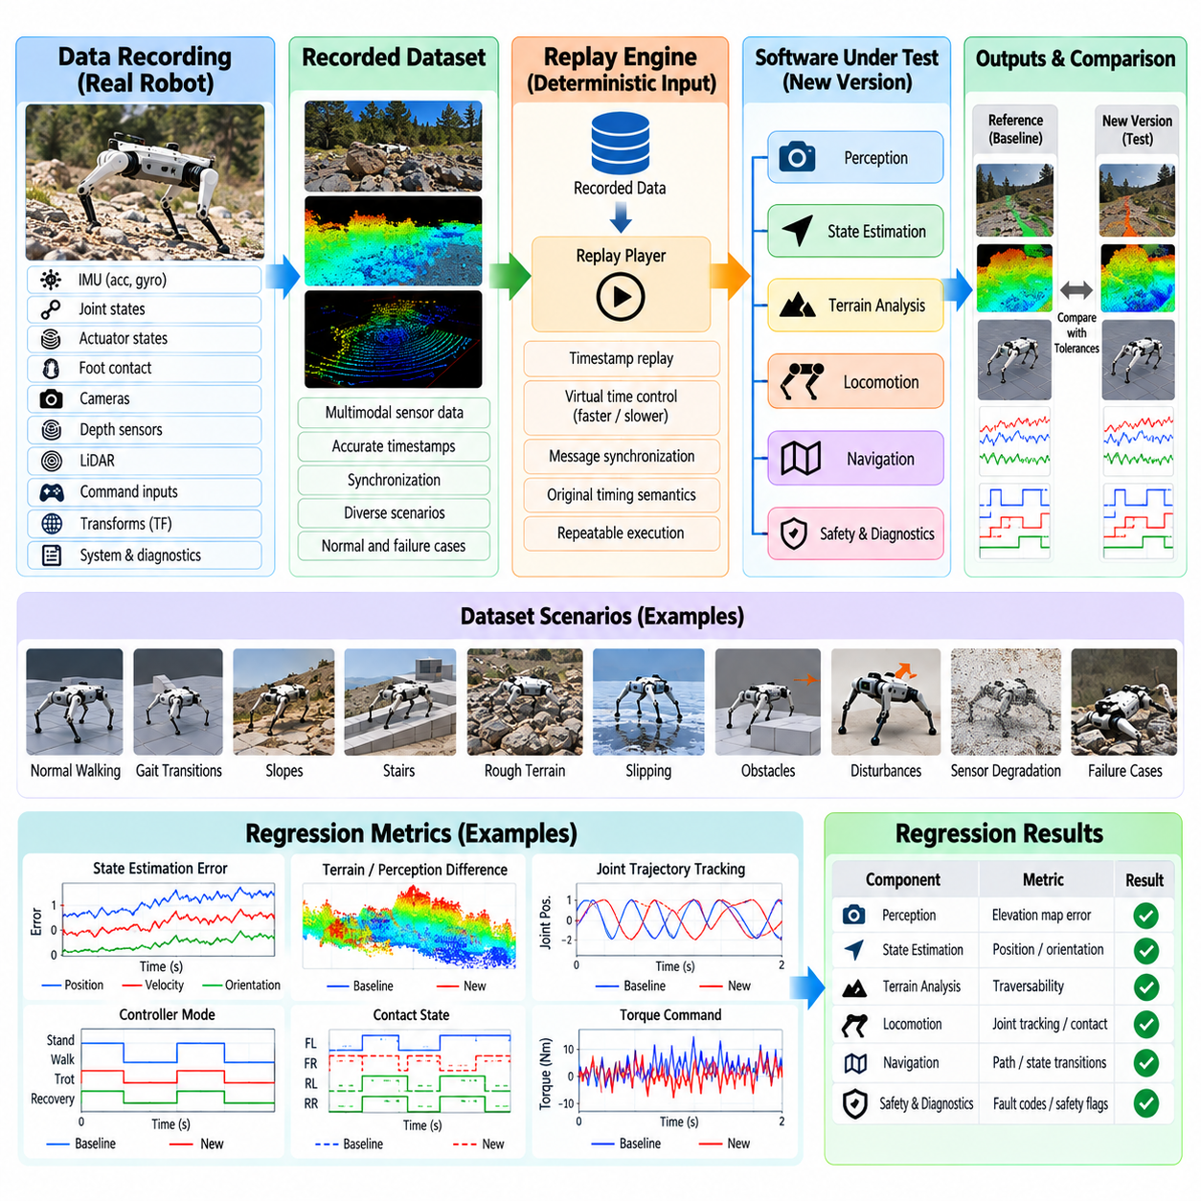
Sensor data replay-based regression testing verifies whether quadruped software continues to produce correct and consistent behavior when previously recorded sensor streams are processed by a new software version. Unlike live robot testing, replay provides deterministic input that can be executed repeatedly without recreating the original terrain, disturbance, or hardware condition. This makes recorded operational data a permanent verification asset for detecting behavioral changes introduced by updates to perception, estimation, locomotion, navigation, and safety software.
A replay dataset should preserve the sensor information required to reconstruct the relevant software inputs as faithfully as possible. Typical streams include IMU measurements, joint positions and velocities, actuator states, foot-contact signals, cameras, depth sensors, LiDAR, command inputs, transforms, system states, and diagnostic messages. Accurate timestamps and synchronization metadata are essential because quadruped control depends strongly on temporal relationships among proprioceptive, exteroceptive, and command signals.
Reference datasets should represent more than nominal walking. Recordings should include standing, gait transitions, acceleration, turning, slopes, stairs, rough terrain, slipping, obstacle negotiation, disturbances, recovery behaviors, sensor degradation, and representative failure events. Data collected during difficult field situations is especially valuable because reproducing exactly the same physical conditions may be expensive or impossible. Each discovered failure can therefore become a permanent regression scenario after its root cause has been identified.
Replay architecture should separate recorded inputs from outputs generated by the software under test. Recorded sensor messages are injected according to their original timestamps or a controlled virtual clock, while perception, state estimation, terrain analysis, diagnostics, and other selected modules execute normally. Their newly generated outputs are captured and compared with a validated baseline or explicit acceptance criteria. This preserves realistic inter-module behavior while maintaining repeatable external inputs.
Time handling requires careful design because replaying messages in the correct order is not sufficient. Software components may depend on timers, message age, interpolation, buffering, transform availability, or timeout logic. A virtual-time mechanism can reproduce the original temporal progression while allowing execution to run faster or slower than real time. Tests should verify that time-dependent algorithms receive equivalent timing semantics so differences in replay infrastructure are not mistaken for software regressions.
Regression comparison should use metrics appropriate to each software component rather than requiring every numerical output to be exactly identical. State-estimation outputs can be compared using position, velocity, orientation, and drift errors, while terrain processing can use elevation or traversability differences. Locomotion modules may be evaluated through gait phase, contact state, desired joint trajectories, torque commands, or safety transitions. Numerical tolerances must account for acceptable floating-point and solver variations.
Exact comparison is nevertheless useful for deterministic discrete outputs. Controller mode transitions, fault codes, safety flags, gait-state changes, planner decisions, watchdog events, and emergency-stop requests should often remain identical for an unchanged test condition. If a software modification intentionally changes one of these outputs, the regression result should be reviewed and the reference updated only after the new behavior has been verified. Automatically accepting changed baselines would remove the primary value of regression testing.
Replay testing is particularly effective for state-estimation software because recorded IMU, encoder, contact, and external sensing data can be processed repeatedly through modified filters or estimators. Engineers can determine whether a change reduces drift or improves robustness without repeating the original robot experiment. At the same time, replay can expose unintended changes in initialization, bias estimation, contact handling, coordinate transforms, or sensor synchronization that might otherwise appear only during later field testing.
Perception and terrain-processing regression can use recorded camera, depth, and LiDAR streams to verify mapping and terrain interpretation. Changes to preprocessing, calibration handling, filtering, neural inference, elevation-map construction, or traversability analysis can be compared against previous results. Because the volume treats terrain perception as tightly connected to foothold selection and locomotion, replay should also examine whether apparently small perception changes propagate into materially different downstream movement decisions.
Sensor fault cases should be deliberately retained in the regression library. Recordings containing dropped packets, temporary occlusion, noisy IMU measurements, contact uncertainty, corrupted frames, delayed streams, or intermittent sensors provide realistic robustness tests. Additional faults can also be injected during replay by dropping, delaying, duplicating, or modifying selected messages. This creates controlled variants of authentic data without repeatedly exposing the physical robot to potentially hazardous conditions.
A regression library should be organized by scenario and expected verification purpose. Short datasets are useful for fast continuous integration tests, while longer sequences can cover endurance behavior, environmental transitions, or rare events. The validation structure places sensor replay after SIL locomotion-policy validation and HIL control-loop testing, followed by terrain, disturbance, endurance, safety, and environmental tests. This positioning makes replay a practical mechanism for carrying evidence from physical testing back into repeatable software verification.
Every replay dataset requires provenance information. The robot hardware revision, sensor configuration, calibration files, software version used during recording, environment, test objective, command sequence, known anomalies, and recording time should be associated with the dataset. Dataset checksums or equivalent integrity mechanisms can prevent accidental modification. Versioning is important because changing calibration or message definitions without updating dataset metadata can invalidate comparisons while leaving the raw sensor files apparently unchanged.
Automation should execute replay cases whenever relevant software changes occur. A modification to an estimator may trigger estimation datasets, while terrain-processing changes can trigger camera, depth, and LiDAR cases. Broader release candidates can execute the complete regression library. Automated pipelines should report pass or fail status together with metric differences and the time intervals where deviations occur, allowing engineers to focus directly on the portions of a recording affected by the modification.
Large sensor datasets require practical data-management strategies. Not every field recording should become a permanent test case, because redundant data increases storage and execution cost without improving coverage. Representative sequences should be selected according to operating condition, terrain type, sensor configuration, failure mode, and software function. Particularly informative intervals can be extracted from long missions while retaining enough context for initialization and temporal algorithms to reach valid operating states.
Regression thresholds should distinguish harmless numerical variation from meaningful behavioral change. Thresholds that are too strict generate frequent false failures, while thresholds that are too loose allow genuine degradation to pass unnoticed. Baselines should therefore be established using repeated validated executions and engineering knowledge of each signal. Critical safety outputs should generally use stricter criteria than intermediate estimates whose small numerical variations do not affect downstream behavior.
When a field failure is discovered, the corresponding sensor history should be preserved before software changes are introduced. After the defect is reproduced using replay, engineers can implement a correction and confirm that the modified software resolves the failure while continuing to pass existing datasets. The new case is then added permanently to the regression suite. Through this process, operational experience progressively increases test coverage rather than disappearing after individual debugging sessions.
Replay-based regression does not replace SIL, HIL, or physical testing because recorded inputs cannot react dynamically to newly generated control outputs. It is fundamentally an open-loop reproduction of historical observations unless coupled with an interactive simulation model. Its strength is deterministic reproduction of authentic sensor conditions. Used together with SIL, HIL, and field validation, replay creates a continuous feedback path in which real-world experience becomes reusable evidence for every subsequent quadruped software release.

11.05. Terrain Crossing Test Protocol Field [w/Code]
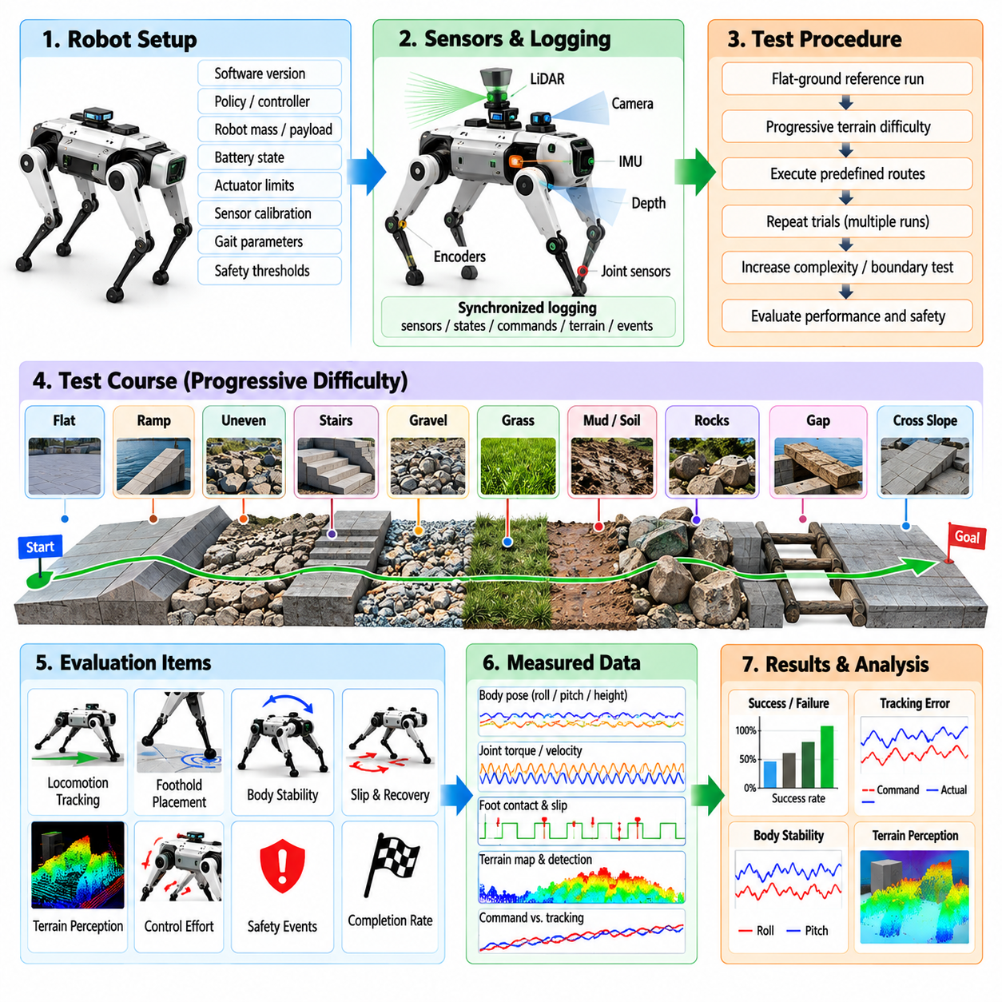
Field terrain-crossing validation determines whether a quadruped can preserve locomotion stability, command tracking, perception reliability, and safety while traversing physical surfaces that introduce geometric and contact uncertainty. Unlike laboratory walking tests, terrain trials expose the complete robot to coupled effects involving sensing, state estimation, foothold selection, gait generation, whole-body control, actuator dynamics, and mechanical interaction. The protocol should therefore evaluate system-level behavior rather than only whether the robot reaches the end of a course.
A terrain test course should be constructed from controlled and measurable terrain elements before progressing to unstructured environments. Representative sections can include flat reference surfaces, ramps, cross slopes, stairs, isolated steps, uneven blocks, gravel, grass, loose soil, rocks, gaps, and mixed terrain transitions. Geometry, surface material, dimensions, slope, step height, friction characteristics, and environmental conditions should be documented so that repeated trials can be compared and progressively more difficult configurations can be generated.
Every field trial should begin from a defined robot configuration. Software revision, locomotion policy or controller version, robot mass, payload, battery state, actuator limits, sensor calibration, gait parameters, safety thresholds, and environmental conditions should be recorded. Initial position and commanded route should also be repeatable where practical. These controls prevent changes in hardware or configuration from being incorrectly interpreted as differences in terrain-crossing performance.
A flat-ground reference run should precede difficult terrain testing. The robot executes representative standing, walking, turning, acceleration, and stopping commands while baseline tracking and stability metrics are recorded. This reference confirms that the platform is operating normally before terrain exposure and provides a comparison for evaluating performance degradation. Abnormal behavior on the reference surface should stop the test campaign until the underlying problem is understood.
Geometric terrain difficulty should increase progressively rather than jumping directly to extreme conditions. Ramp inclination, cross-slope angle, step height, obstacle size, gap width, surface roughness, or rock distribution can be increased between trials. The objective is not simply to demonstrate one successful traversal but to identify an operating envelope within which performance remains repeatable. Boundary testing should determine where tracking quality deteriorates, recovery behavior becomes frequent, or safety criteria are exceeded.
Terrain perception must be evaluated together with physical locomotion when exteroceptive sensing is used. Elevation maps, terrain classifications, traversability estimates, obstacle detections, and candidate footholds should be logged alongside the robot motion. The software structure explicitly connects elevation mapping, terrain classification, traversability analysis, discrete terrain detection, negative-obstacle detection, and terrain-aware foothold selection, making their downstream influence on locomotion an important field-validation target. Volume_21_Quadruped_Robot_Softw…
Foot placement provides a direct measure of how perception and locomotion planning interact with the physical environment. Tests should record desired and achieved footholds, touchdown timing, contact confidence, foot slip, swing clearance, and unexpected collisions. On discrete terrain such as blocks or stepping surfaces, the margin between the foot and support boundary is particularly informative. Repeated near-edge contacts can reveal weaknesses even when the robot technically completes the course without falling.
Body stability should be evaluated continuously rather than only through a binary pass or fall result. Roll, pitch, body height, angular velocity, acceleration, orientation error, and recovery events describe how strongly terrain disturbances affect the base. Joint torque, velocity, contact force, and actuator saturation provide complementary information about control effort. A traversal that succeeds only through repeated saturation or extreme body motion should not be considered equivalent to a stable traversal with adequate control margin.
Slip testing is important because terrain geometry alone does not define locomotion difficulty. Surfaces with different friction levels can produce significantly different behavior even when their shape is identical. Tests should record slip occurrence, slip distance, affected leg, gait phase, estimated friction response, and recovery time. Controlled reduction of available traction can establish whether the controller adapts gracefully or whether a relatively small friction change produces abrupt loss of stability.
Terrain transitions deserve dedicated evaluation because moving between two surface types can be more difficult than remaining on either surface. Examples include flat ground to gravel, rigid floor to grass, level terrain to a ramp, or a slope followed immediately by stairs. Such transitions simultaneously alter geometry, contact characteristics, and perception statistics. Entry speed, gait phase, foothold timing, and estimator behavior should therefore be examined around the transition boundary.
Commanded speed should be varied independently from terrain difficulty. A terrain that is traversable at low speed may become unstable as dynamic effects increase. Tests can progressively increase forward, lateral, or turning velocity while maintaining the same course configuration. Measurements should reveal how tracking error, foot slip, body motion, torque demand, and success probability change with speed. The resulting data define terrain-dependent velocity limits that can later support supervisory safety logic.
Payload should also be treated as an independent test variable when the quadruped is intended to carry equipment or manipulation hardware. Additional mass and changes in center of mass modify required contact forces, joint torques, body dynamics, and stability margins. Terrain trials should therefore be repeated at representative payload conditions. Comparing unloaded and loaded results reveals whether controller tuning and safety limits remain valid across the intended operational configuration.
A field protocol requires explicit failure and intervention criteria. Conditions such as excessive body attitude, repeated foot slip, joint-limit approach, actuator overload, thermal limits, loss of localization, perception failure, uncontrolled backward motion, imminent fall, or safety-system activation can terminate a trial. Human intervention should be recorded as a failed or assisted traversal rather than silently excluded. Clear criteria protect hardware while preventing subjective interpretation of borderline runs.
Statistical repetition is necessary because contact-rich locomotion can vary between nominally identical trials. Each terrain condition should be repeated sufficiently to estimate completion rate, fall or intervention probability, traversal time, tracking performance, slip frequency, recovery count, and energy consumption. Reporting only the best run hides variability. A production-oriented validation process should emphasize repeatability and lower-tail performance because rare failures can dominate operational risk.
Field telemetry should use synchronized logging across sensors, estimation, perception, planning, control, actuator, power, and safety systems. Video from external viewpoints can provide useful context, but it should complement rather than replace machine-readable data. When a failure occurs, synchronized logs should make it possible to reconstruct the sequence from terrain observation through foothold decision, contact event, state-estimation response, controller action, and final recovery or termination.
Unexpected field behavior should be converted into reusable validation assets. Sensor histories can become replay-based regression cases, measured terrain geometry can be reconstructed in simulation, and problematic friction or disturbance conditions can be introduced into SIL or HIL testing. This feedback process connects the terrain-crossing protocol with the chapter’s preceding SIL, HIL, and sensor-replay validation stages and allows field experience to expand future regression coverage. Volume_21_Quadruped_Robot_Softw…
A terrain condition should be considered validated only when predefined acceptance criteria are satisfied repeatedly without unsafe intervention. Completion alone is insufficient; stability, tracking accuracy, control margin, perception consistency, slip behavior, recovery frequency, and safety-system behavior must remain within acceptable limits. By progressing from measured terrain elements to mixed and less structured environments, the field protocol establishes an evidence-based operating envelope for deployment rather than relying on isolated demonstrations of quadruped mobility.

11.06. Push Recovery and Disturbance Test Protocol
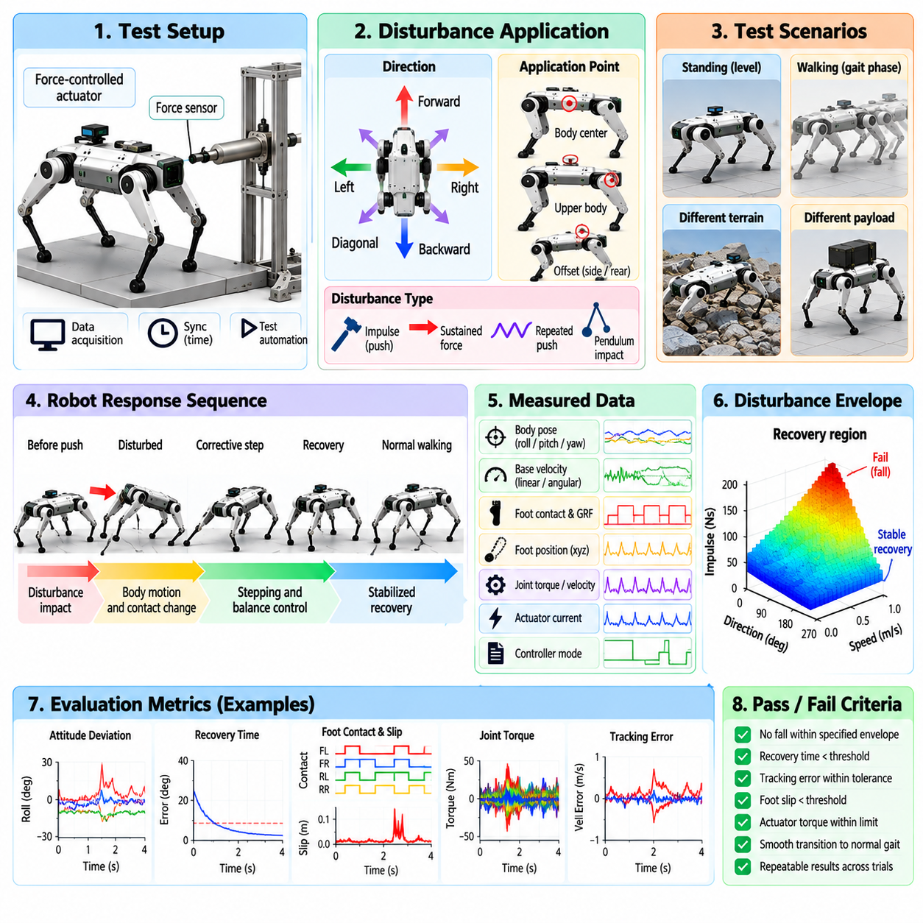
Push-recovery and disturbance testing evaluates whether a quadruped can preserve or restore stable locomotion after external forces disrupt its nominal motion. The objective is not simply to determine whether the robot falls, but to characterize how disturbance magnitude, direction, timing, contact configuration, and operating state affect stability. A rigorous protocol measures the complete response from initial perturbation through balance correction, stepping adaptation, recovery, or controlled safety termination.
A reproducible disturbance mechanism is essential because manually pushing the robot produces poorly controlled forces and makes quantitative comparison difficult. Tests can use instrumented pendulums, linear actuators, suspended masses, calibrated impact devices, or force-controlled mechanisms capable of delivering known impulses or sustained loads. Applied force, duration, direction, point of application, and resulting impulse should be measured so that controller versions and robot configurations can be evaluated under equivalent disturbances.
Disturbances should be applied along multiple directions because quadruped stability is strongly dependent on contact geometry. Forward, backward, lateral, diagonal, and rotational perturbations can produce different responses even when their magnitudes are identical. The application point should also vary between the body center and elevated or offset locations because the resulting moment can substantially change roll, pitch, and yaw responses. Each condition should therefore be defined as a repeatable disturbance vector rather than an informal push.
Initial testing should begin while the robot is standing on a high-friction level surface. Disturbance magnitude can then increase progressively from small perturbations that require only posture regulation to larger impulses that require substantial contact-force redistribution or corrective stepping. The objective is to identify the transition among passive rejection, active body correction, stepping recovery, near-fall recovery, and unrecoverable disturbance rather than testing only one severe impact condition.
Dynamic tests should apply disturbances while the robot is walking because recovery capability depends strongly on gait phase. A lateral push during a four-foot support configuration differs fundamentally from the same push during a reduced-support phase. Tests should therefore synchronize the disturbance with stance and swing phases of individual legs or selected gait phases. Repetition across phase offsets reveals vulnerable portions of the gait cycle that random field pushes may fail to identify.
The robot's balance-control architecture should be observed throughout the response. The volume structure includes stance-phase force distribution, push-recovery control, base height and orientation regulation, external-disturbance estimation, and near-fall recovery as dedicated balance functions. Volume_21_Quadruped_Robot_Softw… Testing should determine how these mechanisms interact as disturbance severity increases and whether transitions between normal control and recovery behavior occur smoothly without generating secondary instability.
Useful body-level measurements include roll, pitch, yaw, base position, body height, linear and angular velocity, and acceleration. Peak attitude deviation indicates the immediate disturbance response, while recovery time describes how quickly the robot returns to an acceptable state. Residual orientation or velocity error can reveal incomplete recovery even when no fall occurs. These quantities should be evaluated relative to the commanded trajectory rather than only against an absolute upright posture during moving tests.
Contact-level measurements provide insight into how the controller physically rejects the disturbance. Ground reaction forces, estimated contact state, center of pressure, foot position, slip distance, touchdown timing, and contact-force redistribution should be recorded for each leg. Sudden unloading, excessive tangential force, or repeated contact switching may indicate reduced stability margin. Corrective stepping should be distinguished from uncontrolled foot motion because both can appear as large changes in foothold position.
Joint and actuator responses should be monitored simultaneously. Joint position, velocity, commanded torque, estimated torque, current, saturation, and thermal state reveal the control effort required for recovery. A robot that remains upright only because multiple actuators operate continuously at their limits may have insufficient practical recovery margin. Acceptance criteria should therefore include actuator utilization and torque reserve in addition to successful stabilization.
The disturbance envelope should be determined systematically by increasing impulse or sustained force until predefined recovery criteria are no longer satisfied. Separate envelopes can be measured for disturbance direction, gait, commanded speed, terrain, and payload. Rather than reporting a single maximum push value, the resulting data describe a multidimensional recovery region. This representation is more useful because a quadruped may tolerate strong longitudinal disturbances while remaining significantly more vulnerable to lateral disturbances.
Terrain should be introduced after baseline recovery capability has been established on level ground. The same disturbance protocol can then be repeated on slopes, low-friction surfaces, gravel, uneven terrain, or discrete footholds. Reduced friction and irregular contact geometry may sharply decrease available corrective forces. Combining terrain and disturbance testing reveals whether a controller that performs well under ideal contact conditions retains sufficient recovery capability in representative operational environments.
Commanded motion also affects disturbance tolerance. Tests should compare standing, low-speed walking, faster locomotion, turning, acceleration, and gait transitions under comparable perturbations. Increasing velocity changes momentum and available contact time, while turning introduces asymmetric loading. Disturbance testing during transitions is particularly valuable because temporary changes in support configuration or controller state can create vulnerabilities not visible during steady-state locomotion.
Payload testing is necessary when the quadruped carries sensors, cargo, batteries, or manipulation hardware. Added mass increases momentum, while a shifted or elevated center of mass changes rotational response and required ground reaction forces. The same calibrated disturbance should therefore be repeated at representative payload configurations. This determines whether recovery thresholds and controller parameters remain valid across the intended operating range rather than only for an unloaded robot.
Near-fall behavior should be evaluated separately from ordinary disturbance rejection. Once body attitude, angular velocity, or support geometry exceeds the nominal recovery region, the controller may need aggressive stepping, body-height adjustment, gait modification, or a controlled protective posture. A successful test does not necessarily require returning immediately to the original gait. Entering a safe stable configuration without uncontrolled impact can be the correct outcome for disturbances beyond the normal recovery envelope.
Safety termination criteria must be established before high-energy tests begin. Excessive body angle, joint-limit proximity, actuator overload, uncontrolled slip, tether loading, collision risk, or loss of state estimation may require automatic or operator-initiated termination. Emergency stopping should not abruptly remove support torque if doing so increases impact severity. The test setup should protect personnel and hardware while allowing the safety software itself to remain part of the validation target.
Statistical repetition is required because contact timing and physical interaction introduce trial-to-trial variability. Each disturbance condition should be repeated sufficiently to estimate recovery probability, fall probability, corrective-step frequency, peak body deviation, recovery time, slip, and actuator demand. Reporting only the strongest successfully rejected push can conceal substantial inconsistency. Production validation should emphasize repeatable recovery performance and confidence near the operating boundary.
All disturbance tests should use synchronized telemetry and external observation. Force measurements, robot state, contact estimates, gait phase, controller mode, joint commands, actuator feedback, safety events, and power data should share a common time reference. High-speed or conventional video can provide complementary physical context. Together these records allow engineers to reconstruct the causal sequence from applied disturbance through controller response to successful recovery or failure.
Failures discovered during physical disturbance testing should feed directly into earlier validation layers. Measured force profiles can be reproduced in SIL, timing-sensitive responses can become HIL scenarios, and recorded sensor histories can become replay regression tests. In this way, push-recovery testing is not an isolated demonstration of robustness but a source of reusable verification cases that progressively strengthen the quadruped software release process and define an evidence-based disturbance operating envelope.

11.07. Endurance and Battery Life Test Protocol
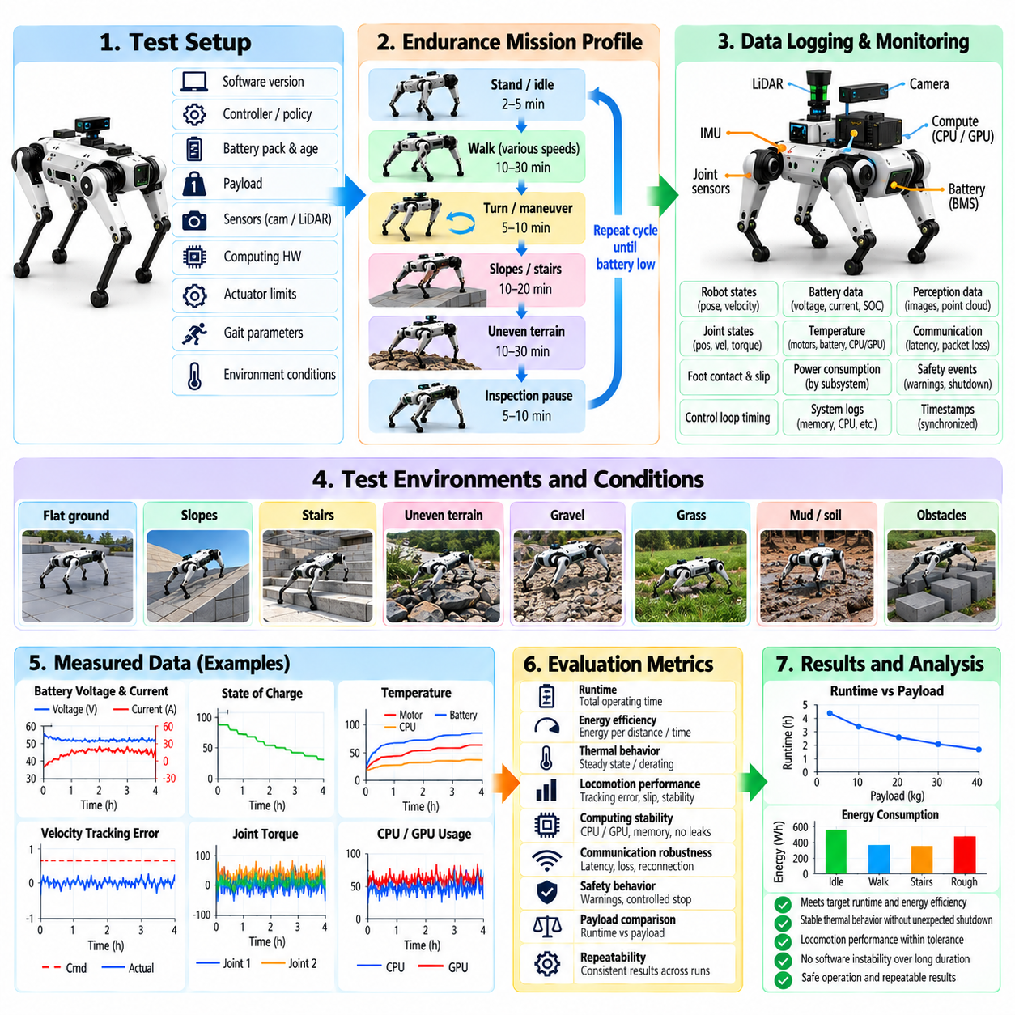
Endurance testing evaluates whether a quadruped robot can maintain reliable locomotion, computation, sensing, communication, and safety behavior over sustained operation rather than only during short demonstrations. Battery-life testing complements this objective by measuring how available energy changes across realistic mission profiles. The protocol should expose gradual degradation, thermal accumulation, energy limitations, and intermittent failures that may remain invisible during short functional tests.
A repeatable endurance mission profile should represent the intended operational duty cycle. The sequence can combine standing, walking, turning, stopping, slopes, stairs, uneven terrain, inspection pauses, communication activity, perception processing, and recovery periods. Instead of operating continuously at one speed, the profile should reproduce realistic changes in locomotion and computational demand so that measured endurance reflects practical deployment rather than an artificial steady-state condition.
Before each test, the robot configuration must be documented and stabilized. Software revision, locomotion controller or policy version, battery pack, battery age, initial state of charge, payload, sensor configuration, computing hardware, actuator limits, gait parameters, and environmental conditions should be recorded. Battery temperature and robot thermal state should also be allowed to reach defined initial conditions so repeated tests can be compared without hidden differences in starting state.
Battery measurements should capture more than total operating time. Pack voltage, current, state of charge, accumulated energy, instantaneous power, battery temperature, cell-level information when available, and power-system warnings should be recorded throughout the mission. Correlating these signals with locomotion states reveals which behaviors dominate energy consumption and whether voltage sag or current peaks approach electrical limits during acceleration, difficult terrain, recovery maneuvers, or high-torque operation.
Power consumption should be decomposed where instrumentation permits. Actuators generally represent a major dynamic load, while onboard computers, GPUs, cameras, LiDAR, communication devices, cooling systems, and auxiliary electronics create persistent electrical demand. Measuring subsystem power allows engineers to distinguish locomotion efficiency from computing overhead and identify whether improvements should target gait generation, actuator utilization, perception workloads, inference scheduling, or auxiliary power management.
Endurance should be evaluated under multiple locomotion conditions because energy consumption depends strongly on gait, velocity, terrain, and control effort. Flat-ground walking can establish a baseline, followed by representative slopes, rough terrain, repeated turning, stop-and-go operation, and obstacle traversal. Comparing energy per unit time and energy per unit distance helps distinguish missions dominated by stationary electronics from those dominated by mechanical locomotion and terrain interaction.
Payload is an important endurance variable when the quadruped carries inspection sensors, cargo, batteries, or manipulation hardware. Additional mass changes joint torque requirements, ground reaction forces, acceleration demand, and potentially gait efficiency. Tests should therefore compare representative payload configurations using equivalent mission profiles. The results can establish payload-dependent runtime estimates and reveal whether thermal or actuator limits are reached before battery capacity becomes the primary constraint.
Thermal behavior must be monitored throughout long-duration operation. Motor windings or housings, motor drivers, batteries, CPUs, GPUs, power electronics, and internal enclosure temperatures can rise gradually even when instantaneous measurements remain within limits. The test should determine whether temperatures converge to a sustainable equilibrium or continue increasing toward derating or shutdown thresholds. Thermal throttling can also reduce computing performance and indirectly affect control-loop timing or AI inference rates.
Control performance should be evaluated continuously during endurance testing rather than assumed constant until the battery is depleted. Velocity tracking error, base orientation, gait consistency, foot slip, joint torque, estimator health, control-loop timing, solver status, and recovery events should be compared across the beginning, middle, and end of the test. Gradual performance changes may reveal temperature-dependent actuator behavior, voltage-related torque limitations, sensor drift, or accumulated software problems.
Long-duration software stability is itself a major validation target. Memory growth, resource leakage, increasing CPU or GPU utilization, log-storage exhaustion, communication degradation, queue accumulation, timestamp drift, process restarts, and watchdog events should be monitored throughout the mission. A robot that locomotes correctly for several minutes but develops software instability after hours of operation cannot satisfy production endurance requirements even when sufficient battery energy remains.
Battery state-of-charge estimation should be validated against measured energy usage because inaccurate remaining-runtime estimates can compromise mission planning. The reported state of charge should decrease consistently with accumulated current or energy and should remain meaningful under changing loads. High-current locomotion can produce temporary voltage sag, so safety logic should distinguish transient electrical behavior from genuine depletion while maintaining sufficient reserve for controlled mission termination.
Low-battery behavior requires dedicated testing rather than simply allowing the robot to operate until uncontrolled shutdown. Defined thresholds should trigger warnings, mission restriction, return-to-base behavior, reduced performance, safe stopping, or other platform-specific responses. The robot should retain sufficient energy to reach a safe state after the first critical warning. Abrupt power loss during locomotion is not an acceptable method for determining usable battery capacity.
Repeated charge-and-discharge testing can reveal behavior that a single endurance run cannot identify. Battery capacity, internal resistance, voltage sag, temperature response, and usable mission duration may change with cycling and aging. The purpose of software validation is not to perform complete electrochemical qualification, but the control and energy-management software should remain correct as battery characteristics vary within the expected service range and should recognize conditions that require maintenance or replacement.
Environmental conditions should be considered because battery and thermal performance depend on ambient temperature and cooling effectiveness. Representative cold, nominal, and hot conditions can alter available energy, voltage behavior, actuator efficiency, and computing temperature. Environmental endurance tests should therefore use controlled conditions where possible and record ambient temperature, airflow, surface conditions, and other factors needed to interpret differences between otherwise equivalent mission runs.
Endurance testing should include controlled interruptions and abnormal events. Temporary communication loss, sensor restart, localization degradation, gait recovery, computation spikes, or mission replanning can be introduced during long runs to verify that accumulated operating time does not weaken fault handling. Recovery mechanisms that work immediately after startup should continue to function after prolonged operation without stale state, exhausted resources, or hidden timing degradation.
Acceptance criteria should combine mission duration with system health. Useful measures include completed operating time, traveled distance, energy consumed, energy per distance, minimum voltage, peak current, thermal margins, actuator saturation frequency, tracking performance, software fault count, safety events, and remaining energy reserve. A long runtime achieved through unacceptable temperatures, repeated faults, severe performance degradation, or exhausted safety margin should not be considered a successful endurance result.
All endurance tests require synchronized telemetry so that energy, thermal, locomotion, computation, and safety behavior can be analyzed on a common timeline. Important events should be traceable to the robot operating state that produced them. If a temperature rise begins during repeated slope climbing or a voltage warning coincides with recovery behavior, synchronized data allows the causal relationship to be examined rather than treating battery and locomotion performance as independent measurements.
Endurance and battery-life validation ultimately establishes whether the quadruped can complete its intended mission repeatedly while preserving adequate energy and safety reserve. Results should define realistic runtime and range envelopes for specific payload, terrain, speed, computation, and environmental conditions rather than advertise one maximum operating time. Failures discovered during long-duration testing should become replay, SIL, HIL, or physical regression cases so that endurance evidence contributes directly to subsequent software releases.

11.08. Safety Function Test E Stop Posture [w/Code]
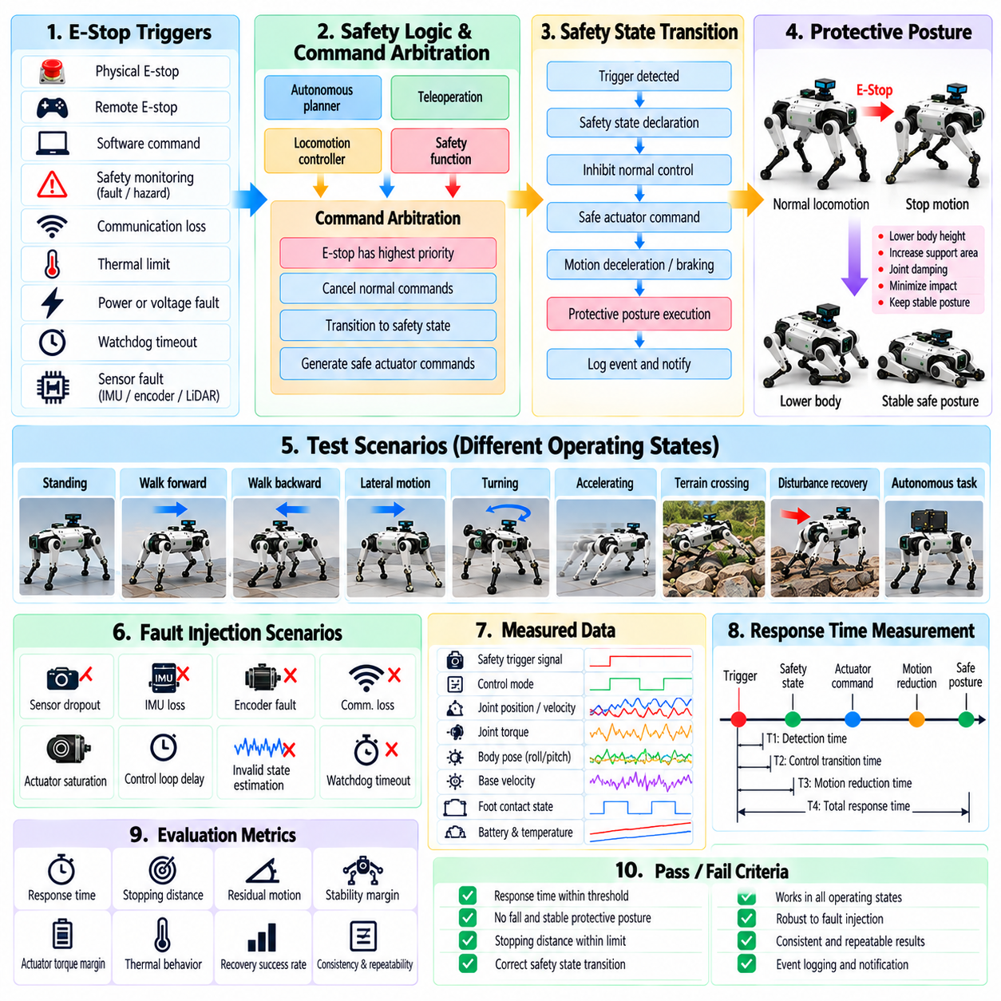
Safety-function validation verifies that a quadruped robot responds predictably when normal locomotion must be interrupted because of operator commands, detected faults, hazardous conditions, or loss of system integrity. Emergency stop and protective posture functions are especially important because an inappropriate shutdown can itself create danger. Testing must therefore evaluate not only whether motion stops, but how the robot transitions from active control to a mechanically and operationally safe state.
An emergency-stop architecture should be tested across the complete command path from the physical or remote trigger to the final actuator response. The validation should confirm trigger detection, safety-state transition, command inhibition, actuator behavior, software notification, and event logging. Where multiple emergency-stop sources exist, each source should be exercised independently and in combination so that no communication path, software state, or operating mode can unintentionally prevent the safety request from reaching the motion system.
Emergency stopping must be evaluated separately from ordinary commanded stopping. A normal stop may permit trajectory deceleration, gait completion, or controlled posture adjustment, while an emergency condition may require a faster transition with different priorities. However, immediately removing all actuator effort from a standing or dynamically moving quadruped can cause collapse. The expected response should therefore be explicitly defined for each platform, including whether support torque, damping, controlled lowering, braking, or another protective behavior remains available.
Test conditions should cover the major operating states of the robot. Emergency-stop activation should be evaluated while standing, walking forward or backward, moving laterally, turning, accelerating, traversing terrain, recovering from a disturbance, and executing higher-level autonomous behavior. The same stop command can produce very different physical consequences depending on gait phase, velocity, body momentum, support geometry, and terrain, so validation cannot be limited to a stationary laboratory condition.
Response time should be measured from safety-trigger activation to relevant control and physical events. Useful timing points include trigger detection, safety-state declaration, cancellation of normal commands, generation of safe actuator commands, measurable reduction of joint motion, and achievement of the final safe condition. The objective is to characterize the complete safety response latency rather than report only software callback time, which may represent a small fraction of the physical stopping process.
Protective posture behavior should provide a controlled configuration when continued locomotion is unsafe but immediate power removal would increase risk. Depending on robot design, this may involve lowering the body, increasing support area, adopting a stable stance, applying joint damping, or transitioning toward a defined resting posture. The posture should minimize uncontrolled motion and impact while respecting joint, actuator, payload, and environmental constraints. Its behavior must be reproducible rather than dependent on operator intervention.
Posture transitions should be tested from a range of initial body orientations and leg configurations. A protective routine that succeeds only from a nominal standing pose is insufficient for field operation. Tests should include moderate roll and pitch, uneven footholds, different gait phases, partial slip, and representative near-fall conditions. The software structure already treats emergency stopping, posture recovery, push recovery, and near-fall recovery as important quadruped safety and balance functions, so their interaction must remain consistent across abnormal states.
Safety logic should distinguish recoverable faults from conditions requiring immediate termination. Temporary sensor degradation, communication delay, localization loss, actuator warnings, excessive body attitude, thermal limits, or control-loop faults may require different responses. Tests should verify that each fault severity maps to the intended action, such as warning, degraded operation, controlled stop, protective posture, or emergency stop, and that escalation occurs correctly when the condition becomes more severe or persists beyond an allowed interval.
Fault injection provides a controlled method for exercising safety behavior that may be difficult or hazardous to reproduce naturally. Tests can introduce stale sensor data, IMU loss, encoder faults, communication interruption, controller timeout, actuator saturation, invalid state estimates, excessive computation delay, or watchdog expiration. The expected safety transition should occur without relying on the failed component itself, particularly where a single fault could otherwise prevent both normal control and fault detection.
Command arbitration requires dedicated validation because autonomous planners, teleoperation commands, locomotion controllers, and safety functions may simultaneously request different actions. Once an emergency or protective state is active, lower-priority motion commands must not restore movement unintentionally. Tests should continue injecting normal commands after safety activation and verify that they remain inhibited until the defined reset procedure is completed. Restart behavior should never occur merely because the original fault disappears.
Reset and recovery procedures are part of the safety function and should be tested as rigorously as activation. The system should verify required conditions before leaving the emergency state, such as operator acknowledgement, valid sensor state, healthy actuators, acceptable body posture, restored communication, and absence of active critical faults. A reset should not automatically resume the previous gait or autonomous mission unless that behavior is explicitly designed and independently verified to be safe.
Communication failures deserve special attention when emergency commands can originate remotely. Loss, delay, duplication, or reordering of messages should not create ambiguous safety states. The robot should have defined behavior for loss of supervisory communication and should not depend solely on a remote connection for maintaining local safety. Tests should verify timeout handling, local watchdogs, command freshness checks, and the relationship between onboard safety logic and external emergency-stop mechanisms.
Actuator behavior during safety transitions must remain within mechanical and electrical limits. Joint torque, velocity, position, current, and temperature should be monitored while emergency and posture functions execute. Sudden command discontinuities can create impact loads or destabilize the robot even when the final command is safe. Validation should therefore examine transient behavior, torque saturation, joint-limit approach, foot slip, body impact, and actuator faults throughout the complete transition.
Payload and manipulation configurations can significantly change protective behavior. Additional mass or an elevated center of mass can increase stopping distance and body momentum, while an attached manipulator may introduce collision hazards during lowering. Safety tests should therefore be repeated with representative payload and equipment configurations. A protective posture validated for the bare robot cannot automatically be assumed safe for every deployed configuration.
Terrain also influences emergency and posture performance. Tests should progress from high-friction level ground to slopes, low-friction surfaces, uneven terrain, stairs, and representative field conditions where safe execution is practical. A posture that is stable on a laboratory floor may cause sliding or tipping on a slope. Terrain-dependent limitations should be identified explicitly so higher-level safety logic can select appropriate responses when environmental information is available.
Repeated activation is necessary to establish reliability rather than demonstrating one successful event. Emergency-stop and protective-posture tests should be repeated across operating states, speeds, gait phases, payloads, and relevant fault conditions. Metrics should include activation success rate, response latency, stopping distance, peak body attitude, residual motion, actuator loading, posture completion rate, unintended restart events, and failures requiring human intervention.
Every safety event should generate synchronized and persistent diagnostic evidence. Trigger source, timestamps, robot state, active faults, controller mode, safety-state transitions, actuator commands, measured joint behavior, communication status, and reset sequence should be recorded. These logs support root-cause analysis and demonstrate whether the safety function behaved according to its defined requirements. Safety-related records should remain distinguishable from ordinary operational logs.
Safety-function validation is complete only when activation, physical response, stable protective behavior, fault containment, reset, and subsequent recovery have all been demonstrated under representative conditions. Failures discovered during testing should become permanent regression cases in SIL, HIL, replay, or physical test environments. In this way, emergency-stop and protective-posture testing becomes an enforceable release gate that prevents software changes from silently weakening the quadruped robot's established safety behavior.

11.09. Environmental Test Rain Dust Temperature
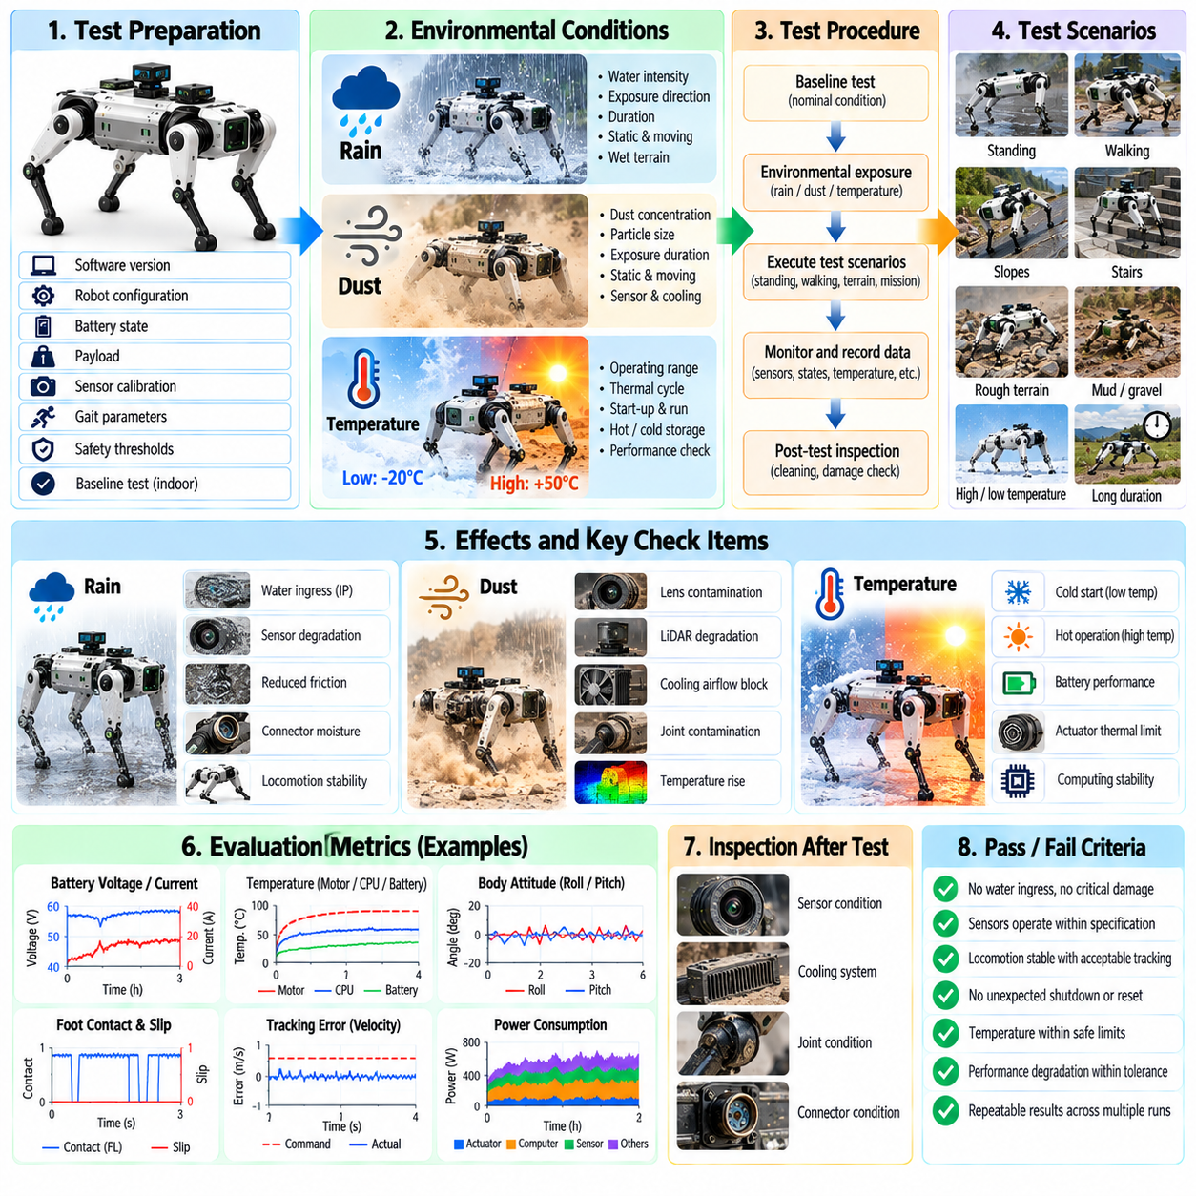
Environmental validation determines whether a quadruped robot can maintain safe and reliable operation when exposed to rain, dust, and temperature conditions representative of its intended deployment environment. Production robots may operate outdoors, inside industrial plants, construction sites, mines, energy facilities, or disaster areas where environmental conditions differ greatly from laboratory settings. The test objective is therefore to evaluate the integrated robot rather than environmental resistance of individual components alone.
Environmental requirements should first be derived from the robot's operational design domain. Expected rainfall, airborne dust concentration, ambient temperature range, exposure duration, terrain condition, wind, payload, mission duration, and required recovery behavior should be documented before testing. Production quadruped deployment may include rain, snow, dust, extreme temperatures, gravel, mud, and other changing field conditions, making environmental limits an important part of defining the practical operating envelope. Pasted text(75)
A baseline functional test should be completed under nominal laboratory conditions before environmental exposure. The robot should execute standing, walking, turning, stopping, state estimation, perception, communication, and safety functions while reference telemetry is recorded. Battery voltage, actuator current, temperatures, control-loop timing, sensor health, localization quality, and locomotion performance establish a baseline against which environmental degradation can later be measured.
Rain testing should reproduce controlled water exposure rather than relying only on naturally occurring weather. Water intensity, exposure direction, duration, robot posture, and operating state should be defined for each test. The robot should be evaluated while stationary and while performing representative locomotion because joint motion, body orientation, cooling airflow, and foot impacts can alter water ingress paths. Testing should remain consistent with the enclosure and ingress-protection requirements defined for the specific platform.
Water exposure can influence much more than enclosure integrity. Camera windows may accumulate droplets, LiDAR returns may become degraded, electrical connectors can become vulnerable to moisture, and wet surfaces can reduce foot-ground friction. Testing should therefore monitor sensor quality, communication, actuator behavior, insulation or electrical warnings where available, and locomotion stability simultaneously. The robot should not be considered environmentally validated merely because water does not visibly enter its enclosure.
Wet-terrain locomotion requires dedicated evaluation because rain changes both sensing and contact mechanics. Concrete, metal, stone, soil, grass, or painted surfaces may exhibit substantially different friction after becoming wet. The robot should traverse representative surfaces while foot slip, ground reaction behavior, body attitude, corrective stepping, and velocity tracking are measured. Rain validation therefore connects environmental testing directly with terrain-crossing and disturbance-recovery validation rather than treating weather as an isolated enclosure test.
Perception performance should also be examined during water exposure. Droplets or films on camera and depth-sensor windows can distort images, while rain can introduce transient measurements into active ranging sensors. Engineers should compare sensor availability, image quality, point-cloud characteristics, terrain estimates, and downstream locomotion decisions against dry-condition baselines. Cleaning, heating, hydrophobic surfaces, or sensor redundancy should be evaluated when such mechanisms are part of the production design.
Dust testing should represent airborne contamination expected in environments such as construction sites, mines, factories, agricultural areas, or unpaved outdoor locations. Dust concentration, particle characteristics, airflow, exposure duration, and robot operating state should be controlled where practical. The robot should perform representative motion during exposure because moving joints, cooling fans, pressure differences, and vibration can create contamination paths that may not appear during a static enclosure test.
Dust accumulation can progressively affect sensors and thermal management even when immediate functional failure does not occur. Camera lenses, depth sensors, LiDAR windows, ventilation paths, heat sinks, fans, joints, connectors, and exposed mechanical interfaces should therefore be inspected before and after testing. Sensor signal quality and internal temperatures should be monitored continuously to determine whether contamination produces gradual degradation rather than a sudden binary failure.
Cooling performance deserves particular attention during dust exposure. Restricted airflow or contaminated heat-transfer surfaces can increase CPU, GPU, motor-driver, battery, and actuator temperatures during sustained operation. Environmental tests should therefore combine contamination with realistic computational and locomotion workloads. A robot that remains functional during a short dust exposure but subsequently reaches thermal throttling or shutdown during a normal mission does not satisfy practical environmental endurance requirements.
Temperature testing should cover cold, nominal, and hot conditions derived from the intended operating range. The complete robot should be allowed to reach appropriate thermal conditions before functional evaluation because brief exposure may leave batteries, actuators, electronics, and mechanical structures near room temperature. Cold-start and hot-start behavior should be tested separately from operation after thermal stabilization, since startup can expose different weaknesses from continuous operation.
Low-temperature testing should examine battery output, voltage sag, actuator response, lubrication effects, sensor startup, computing initialization, and mechanical motion. Reduced battery capability may limit available torque or mission duration even when the control software remains functional. The robot should execute representative standing, walking, turning, terrain traversal, and safety transitions while energy consumption, joint tracking, actuator effort, sensor validity, and control stability are compared with nominal-temperature results.
High-temperature testing should evaluate thermal accumulation across batteries, actuators, motor drivers, CPUs, GPUs, power electronics, and internal enclosures. The robot should operate under realistic locomotion and computational loads long enough to determine whether temperatures stabilize or continue approaching warning, derating, or shutdown thresholds. Thermal throttling is particularly important because reduced computing performance can indirectly increase inference latency, control-loop jitter, or delayed perception even before hardware protection becomes active.
Temperature transitions can reveal problems that steady-state tests miss. Moving a robot between cold and warm environments may create condensation, while rapid heating or cooling can affect calibration, structural dimensions, seals, and sensor characteristics. Where relevant to the deployment domain, tests should examine startup and operation following environmental transitions rather than treating each temperature point independently. Sensor recalibration or stabilization requirements should be documented when they affect mission readiness.
Combined environmental conditions are important because real deployment rarely presents one stressor at a time. Rain may coincide with low temperature, dust with high temperature, or contamination with sustained high computational load. After individual environmental limits have been established safely, representative combined tests can determine whether interactions create new failure modes. Test severity should be increased progressively so that environmental boundaries are characterized without unnecessarily exposing hardware to uncontrolled damage.
Safety functions must remain operational throughout environmental exposure. Emergency stop, protective posture, watchdogs, communication-loss handling, thermal protection, actuator fault detection, and low-battery responses should be exercised under representative rain, dust, and temperature conditions. Safety supervision commonly depends on body orientation, joint limits, actuator status, temperature, communication health, estimator validity, and timing monitoring, so environmental degradation must not silently invalidate the information required for safe behavior. Quadruped Robot Software Stack …
Environmental telemetry should synchronize ambient conditions with robot behavior. Temperature, humidity, water exposure, dust conditions, battery state, internal temperatures, actuator data, sensor status, communication statistics, state-estimation quality, control timing, locomotion metrics, and safety events should share a common timeline. Post-test inspection should complement telemetry by identifying moisture, contamination, corrosion, seal damage, connector problems, mechanical wear, or deposits that may not immediately generate software faults.
Acceptance criteria should address both immediate operation and residual condition after exposure. The robot should complete required functions without unsafe behavior, unacceptable sensor degradation, thermal-limit violation, uncontrolled slipping, communication loss, or unexpected shutdown. After exposure, inspection and repeated baseline tests should determine whether performance returns to the expected range. Environmental survival without continued functional reliability is insufficient for production validation.
Failures discovered during rain, dust, or temperature testing should be converted into reusable regression cases wherever possible. Recorded sensor degradation can become replay data, temperature-related timing problems can become HIL stress cases, and altered friction or sensing conditions can be reconstructed in simulation. Environmental testing then becomes part of the continuous validation loop, defining evidence-based operating limits while ensuring that later hardware and software revisions do not reintroduce previously discovered environmental weaknesses.

11.10. Quadruped SW Certification Checklist and Release
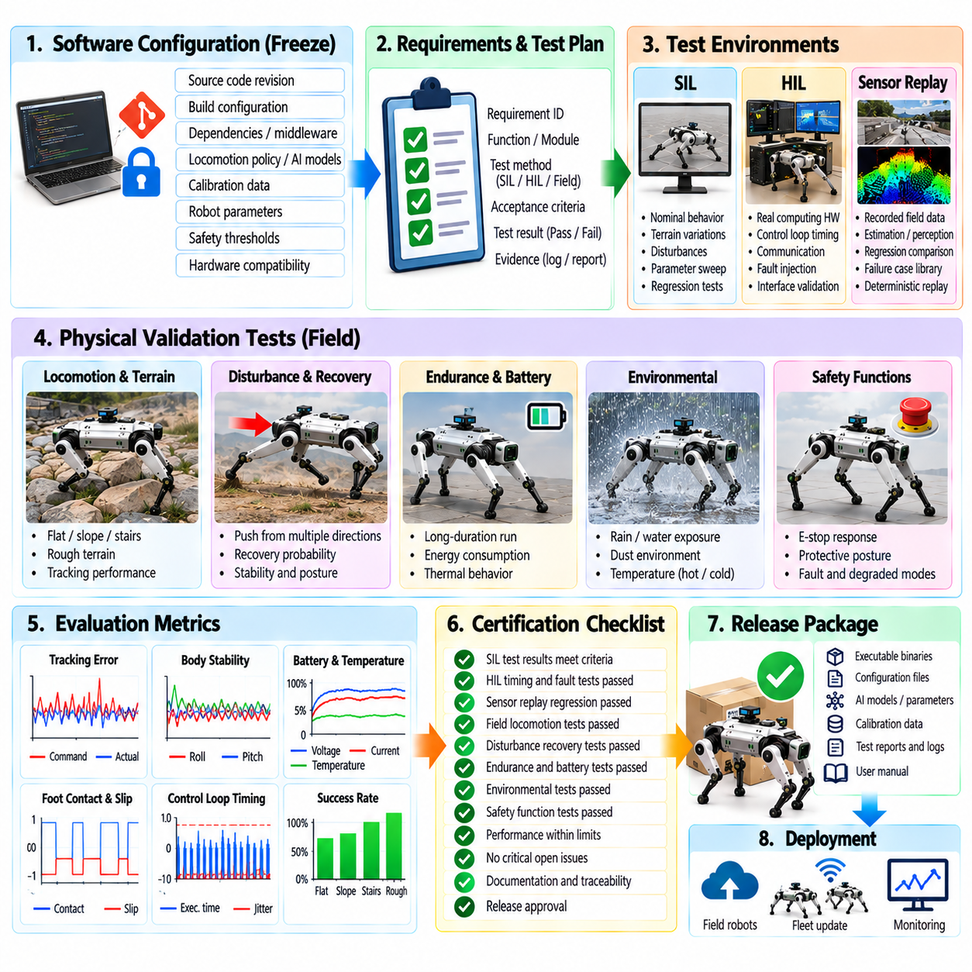
Quadruped software certification and release should convert accumulated validation evidence into a controlled decision that a specific software configuration is suitable for deployment. Certification in this context is not a single final test, but the completion of defined verification gates covering locomotion, perception, control, hardware integration, safety, endurance, and environmental behavior. Every released build should therefore be traceable to requirements, test evidence, configuration records, known limitations, and an explicit approval decision.
The release candidate must be uniquely identifiable before certification begins. Source-code revision, repository commit identifiers, build configuration, compiler and dependency versions, middleware, firmware, locomotion policy, AI model files, calibration data, robot parameters, safety thresholds, and hardware compatibility should be frozen. Testing a continuously changing software branch invalidates certification evidence because results can no longer be associated with the exact executable configuration intended for deployment.
A certification checklist should establish traceability between software requirements and verification evidence. Each safety-critical or mission-critical requirement should identify the responsible software function, applicable test method, acceptance criteria, test result, and supporting log or report. Requirements without objective verification evidence should remain open rather than being accepted through engineering judgment alone. This creates a measurable relationship between design intent, implemented behavior, and demonstrated system performance.
Software-in-the-Loop testing should confirm the fundamental behavior of locomotion policies, controllers, estimators, planners, and safety logic before hardware-dependent certification proceeds. Representative nominal cases, parameter variations, terrain conditions, disturbances, and failure scenarios should execute without unresolved critical regressions. Deterministic simulation cases should be retained as permanent regression assets so every subsequent release candidate can be evaluated against the same behavioral expectations.
Hardware-in-the-Loop testing should verify execution on representative deployment computing and communication hardware. Control-loop frequency, worst-case execution time, scheduling jitter, sensor-to-command latency, deadline misses, processor loading, communication timing, and watchdog behavior should remain within defined limits. Fault-injection cases should confirm that delayed, missing, corrupted, or stale signals produce the intended degraded mode, controlled stop, or safety transition rather than undefined behavior.
Sensor replay regression should demonstrate that validated field recordings continue to produce acceptable outputs after software changes. State estimation, terrain perception, contact estimation, localization, diagnostics, and safety decisions should be compared with approved baselines using function-specific tolerances. Previously discovered field failures should remain permanently represented in the replay library, ensuring that a defect corrected in one release cannot silently return in a later revision.
Physical locomotion certification should confirm operation across the terrain envelope defined for deployment. Flat surfaces, slopes, cross slopes, stairs, uneven terrain, low-friction regions, discrete footholds, and representative mixed environments should be tested where applicable. Completion rate alone is insufficient; body stability, tracking error, foot slip, actuator margin, contact consistency, perception performance, recovery behavior, and human intervention frequency should satisfy predefined acceptance limits.
Disturbance and recovery evidence should establish that the robot remains controllable when nominal locomotion is disrupted. Push-recovery tests should cover representative disturbance directions, magnitudes, gait phases, speeds, terrain conditions, and payloads. Recovery probability, peak body deviation, corrective stepping, actuator demand, and recovery time should remain acceptable. Disturbances outside the recoverable envelope should lead to predictable protective behavior rather than uncontrolled failure.
Endurance certification should demonstrate that acceptable performance is maintained over the required mission duration. Battery energy, voltage, current, actuator temperatures, CPU and GPU temperatures, memory consumption, computational loading, communication health, control timing, and locomotion performance should be monitored throughout long-duration operation. A release should not pass endurance qualification if resource leakage, thermal throttling, timing degradation, accumulated faults, or reduced control quality emerges after extended operation.
Battery behavior should be verified together with mission-management and safety functions. State-of-charge estimation, low-energy warnings, power limitations, return-to-base logic where implemented, and controlled low-battery stopping should operate at their defined thresholds. Sufficient reserve energy should remain after critical warnings to reach the intended safe state. Certification should therefore distinguish nominal battery capacity from practically usable mission energy under representative payload, terrain, temperature, and computational load.
Safety-function certification should verify emergency stop, protective posture, fault escalation, watchdogs, command arbitration, reset logic, and recovery procedures. Emergency commands must override lower-priority autonomous or teleoperation commands and remain latched where required until valid reset conditions are satisfied. Tests should measure complete physical response rather than software detection alone, including stopping behavior, residual motion, body stability, actuator loading, and final safe configuration.
Environmental qualification evidence should demonstrate that software-dependent functionality remains reliable under the approved rain, dust, and temperature conditions. Environmental exposure must not invalidate sensing, state estimation, communication, control timing, locomotion, or safety supervision without detection. Where environmental conditions exceed validated limits, the software should provide defined warnings, restrictions, degraded operation, or safe termination rather than continuing with unrecognized loss of capability.
Fault management should be reviewed as an integrated architecture rather than as independent error handlers. Sensor faults, actuator faults, communication loss, estimator invalidity, excessive temperature, low battery, control-loop overruns, localization failure, and other monitored conditions should map consistently to warning, degraded operation, controlled stop, protective posture, or emergency response. Conflicting faults must not produce contradictory commands or prevent escalation toward a safer system state.
Known limitations and unresolved defects must be explicitly classified before release. Critical defects affecting safety, uncontrolled motion, state integrity, or required mission functions should block deployment. Lower-severity issues may be accepted only when their operational impact, detection method, workaround, and permitted operating conditions are documented. Release approval should never depend on defects being informally understood by the development team, because deployed operators may not share that knowledge.
Configuration management should prevent certified software from being combined accidentally with unvalidated hardware or parameters. Robot model, actuator type, sensor configuration, payload range, calibration set, computing platform, firmware versions, AI models, and safety parameters should be checked during deployment or startup where practical. Configuration mismatch should generate a diagnostic response and, for safety-relevant incompatibilities, prevent normal operation until the approved configuration is restored.
Certification evidence should be archived as a reproducible release package. The package should include software identifiers, build artifacts, configuration manifests, requirement-to-test traceability, automated test summaries, field-test results, environmental and endurance evidence, known limitations, approved operating envelope, and relevant telemetry references. Test datasets and scripts should also be versioned so that an engineer can later reconstruct why a particular release was approved and reproduce important verification results.
Final release approval should require independent review of the evidence rather than relying only on the software developer who implemented the change. Open failures, waived requirements, changed baselines, modified safety thresholds, and deviations from previous releases should receive explicit attention. Approval responsibility should be recorded together with the release identifier and date, creating accountability for the decision that the software satisfies the defined deployment criteria.
Deployment should preserve the certified software state. Installation packages should use integrity checks, controlled versioning, and rollback capability so that unsuccessful deployment or newly discovered problems can return the robot to a previously validated release. Field robots should report their active software and configuration versions, allowing fleet operators to determine which units are affected when a defect or safety issue is discovered after deployment.
Post-release monitoring completes the certification lifecycle rather than existing outside it. Field faults, unexpected recovery events, operator interventions, sensor degradation, performance anomalies, and safety activations should be collected and reviewed. Significant events should be converted into replay, SIL, HIL, or physical regression cases. Certification therefore becomes a continuously strengthening evidence process in which each deployed generation contributes new validation knowledge to subsequent software releases.
A quadruped software release should ultimately be approved only when its exact configuration has passed the required SIL, HIL, replay, field, disturbance, endurance, safety, and environmental gates with no unresolved release-blocking defect. The resulting checklist is not merely administrative documentation; it is the final technical barrier between experimental software and operational deployment. By preserving traceability, reproducibility, operating limits, and regression evidence, the release process ensures that new capability does not silently reduce previously demonstrated reliability or safety.

