Volume 22. Humanoid Robot Software

Chapter 06. Humanoid Perception

06.01. Humanoid Perception Architecture Head Wrist Body
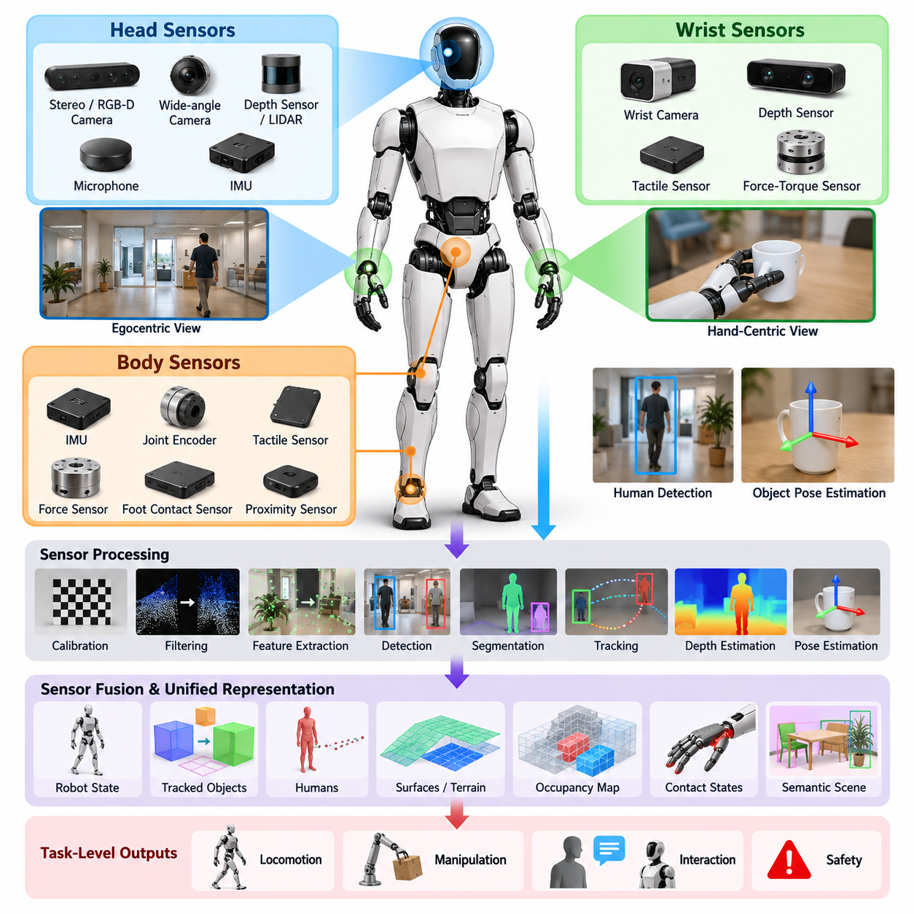
Humanoid perception is fundamentally different from perception in fixed manipulators or wheeled mobile robots because sensing is distributed across a moving articulated body. A practical architecture therefore treats perception as a coordinated system of head, wrist, and body sensors rather than as a single camera pipeline. This organization supports locomotion, manipulation, interaction, and safety while maintaining a consistent representation of the environment as the robot continuously changes posture. Volume_22_Humanoid_Robot_Softwa…
The head sensing system provides the primary egocentric view of the world. Stereo or RGB-D cameras, wide-angle cameras, depth sensors, microphones, and sometimes LiDAR can be mounted near the head to observe objects, humans, terrain, and workspace structure. Because the head can rotate independently of the torso, its perception pipeline must continuously transform measurements through the head, neck, floating-base, and world coordinate frames before observations can be used by planning or control.
Head perception is especially important for long-range and task-level understanding. It identifies potential manipulation targets, estimates human locations, recognizes traversable regions, and constructs semantic descriptions of the surrounding scene. Unlike a static surveillance camera, however, a humanoid head experiences rapid rotations, walking-induced oscillation, self-motion, and temporary occlusion. Visual processing must therefore combine image observations with accurate timestamps, joint states, inertial measurements, and robot kinematics.
Wrist-mounted cameras complement the head view by providing close-range observations around the hands. During reaching, grasping, insertion, tool operation, or object handover, an object that was clearly visible from the head may become partially hidden behind the robot's arm or hand. Wrist cameras preserve visual access to the local manipulation region and provide higher effective spatial resolution for estimating object pose, contact geometry, grasp alignment, and small relative motions near the end effector.
The relationship between head and wrist perception naturally creates a coarse-to-fine sensing strategy. Head sensors can locate a target within the larger environment and guide the arm toward the appropriate workspace, while wrist sensing progressively refines the target estimate as the hand approaches it. This allows manipulation to transition from global scene understanding to local visual servoing without requiring a single sensor to provide both wide-area coverage and millimeter-scale task information.
Body perception extends sensing beyond vision. Inertial measurement units, joint encoders, force-torque sensors, tactile sensors, foot contact sensors, and distributed proximity or contact sensors provide information about the robot's own physical state and its interaction with the environment. These measurements are essential because humanoid perception must estimate not only what exists around the robot but also how the robot's articulated body is positioned, moving, loaded, and contacting external surfaces.
A unified perception architecture therefore requires a common spatial reference system. Every camera, IMU, tactile region, force sensor, and articulated link should have a calibrated transformation relative to the robot model. Forward kinematics continuously updates these relationships as joints move. Sensor observations can then be transformed into base, pelvis, torso, hand, or world frames, allowing a detected object from the head camera and a refined observation from the wrist camera to refer to the same physical entity.
Temporal synchronization is equally important. During dynamic walking, even a small timestamp mismatch between an image and joint configuration can produce significant geometric error because the head, torso, arms, and floating base may all be moving simultaneously. Hardware timestamps, synchronized clocks, buffered transforms, and interpolation of joint and inertial states help reconstruct the robot configuration corresponding to each observation. Perception quality therefore depends as much on timing integrity as on individual sensor accuracy.
The architecture should separate low-level sensor processing from higher-level perceptual representations. Device interfaces first acquire images, depth, inertial data, force measurements, audio, and tactile signals. Processing modules then perform calibration correction, filtering, feature extraction, detection, segmentation, tracking, depth estimation, and pose estimation. Fusion layers transform these outputs into persistent representations such as tracked objects, humans, surfaces, occupancy structures, contact states, and semantic scene elements.
Different perception products operate at different rates and latency requirements. Balance and contact estimation may require very fast proprioceptive updates, while object detection can operate at a lower image-frame frequency. Semantic scene understanding or open-vocabulary recognition may tolerate still longer inference times. A well-designed humanoid architecture therefore avoids forcing every perception algorithm into one synchronous loop and instead publishes time-stamped results that consumers can access according to their own control or planning frequencies.
Perception must also account explicitly for the robot's own body. Head and wrist cameras frequently observe arms, hands, legs, or torso surfaces, especially during manipulation and crouched postures. Using the known robot geometry and current joint configuration, self-regions can be predicted and separated from external objects. The same body model supports self-occlusion reasoning, collision monitoring, visibility prediction, and selection of alternative viewpoints when important regions become hidden.
Sensor redundancy improves robustness because no single viewpoint remains reliable throughout humanoid operation. Head cameras may lose an object during close manipulation, wrist cameras may have a narrow field of view, depth sensors may fail on reflective surfaces, and vision may degrade under poor illumination or motion blur. Combining multiple viewpoints with proprioception, force, tactile, and contact sensing allows the system to maintain useful state estimates even when one modality becomes temporarily unreliable.
The fused output should form a robot-centered world representation rather than a collection of unrelated detections. Objects require identities, poses, confidence estimates, semantic attributes, and temporal histories. Humans require position, pose, motion, and interaction state. Surfaces require geometry and traversability information, while contacts require location, force, and persistence. Maintaining these entities across sensor updates provides a stable interface between perception and downstream intelligence.
This shared representation connects directly to locomotion, whole-body control, manipulation, VLA policies, and human-robot interaction. The surrounding chapter structure reflects this progression from head and wrist vision through 3D understanding, human tracking, object pose estimation, open-vocabulary perception, audio, tactile sensing, and latency optimization. The architecture is therefore the integration foundation on which the specialized perception capabilities of the subsequent sections operate. Volume_22_Humanoid_Robot_Softwa…
For locomotion, perception supplies terrain geometry, obstacles, humans, free space, and potentially safe contact regions. For manipulation, it supplies object identity, 3D position, orientation, grasp-relevant geometry, and hand-object relationships. For interaction, it provides human pose, voice, gesture, gaze-related cues, and proximity information. These consumers may use different subsets of the same world model, making standardized representations and confidence information important for avoiding duplicated perception pipelines.
A production architecture must additionally expose uncertainty and health information. Each perception result should carry confidence, age, source, and validity information so that planning and control components can distinguish reliable observations from stale or ambiguous estimates. Sensor diagnostics should detect dropped frames, calibration drift, synchronization errors, blocked cameras, abnormal latency, and unavailable devices. Failure of perception must become an observable system state rather than silently propagating incorrect information.
Computational placement also influences architecture. Fast preprocessing and safety-critical estimation should remain close to the sensors and real-time control system, while GPU-intensive detection, segmentation, multimodal reasoning, and foundation-model inference can execute on dedicated AI computing hardware. Data movement between these domains should be minimized through efficient image transport, shared memory, zero-copy mechanisms, compressed representations where appropriate, and carefully defined interfaces between real-time and AI processes.
Ultimately, humanoid perception should be understood as active embodied sensing. The robot can move its head to inspect a region, reposition its torso to reduce occlusion, move a wrist camera closer to an object, touch a surface to resolve uncertainty, or change stance to obtain a better viewpoint. Head, wrist, and body perception therefore form a closed perception-action loop in which sensing guides motion and motion deliberately improves sensing, providing the perceptual foundation required for autonomous humanoid behavior.

06.02. Egocentric Visual Perception Head Camera [w/Code]
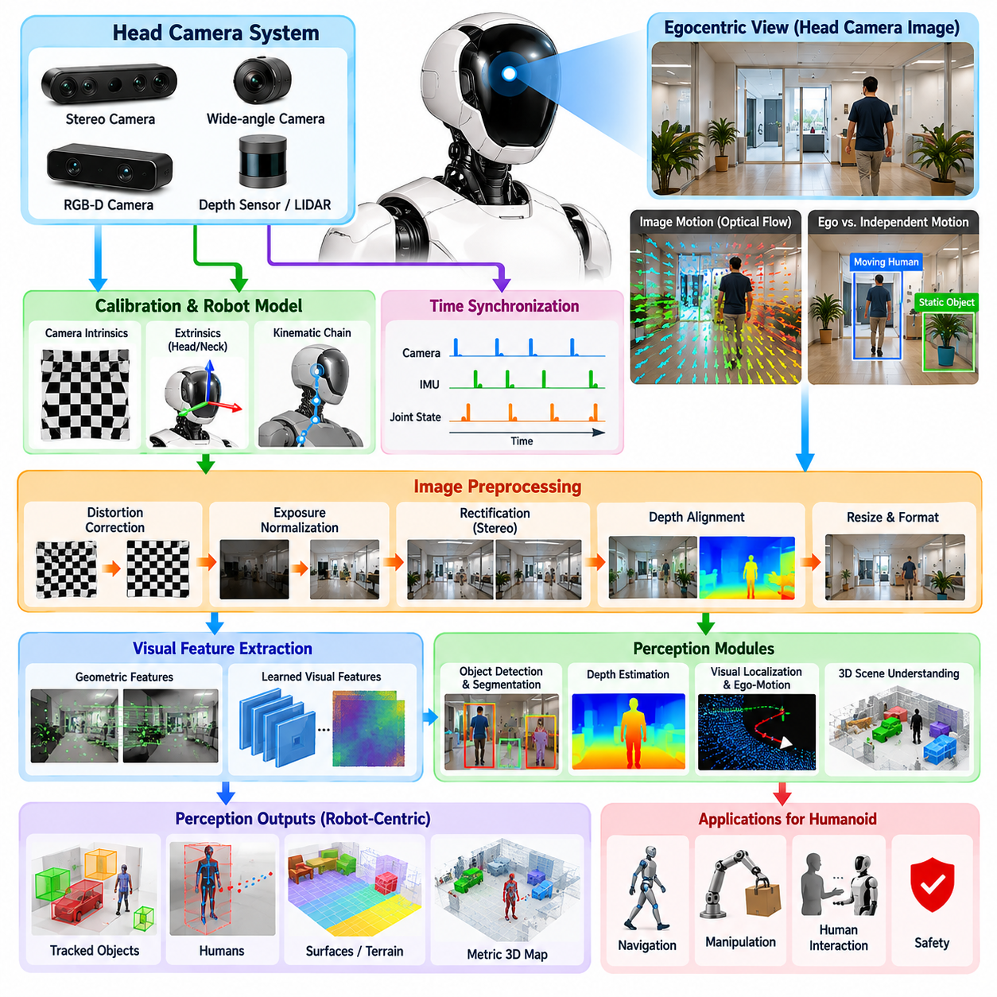
Egocentric visual perception allows a humanoid robot to interpret the environment from a viewpoint that moves with its head and body. Unlike fixed-camera perception, the visual coordinate system continuously changes as the robot walks, turns, bends, or directs its gaze. The head camera therefore acts as a primary perceptual interface between the humanoid and its surroundings, supporting scene understanding, navigation, manipulation, and human interaction.
A typical head vision system combines one or more RGB cameras with stereo, RGB-D, or other depth-sensing technologies. Wide-angle cameras provide broad situational awareness, while stereo or depth sensors recover three-dimensional structure around the robot. The sensor configuration must balance field of view, spatial resolution, depth range, frame rate, dynamic range, and computational bandwidth because the same visual stream may support several perception tasks simultaneously.
The defining characteristic of egocentric vision is that apparent image motion contains both environmental motion and motion generated by the robot itself. Head rotation, neck movement, torso oscillation, and locomotion can produce substantial optical flow even when surrounding objects remain stationary. Consequently, interpreting visual motion requires knowledge of the robot's own motion so that ego-motion can be separated from independently moving objects, humans, and other dynamic elements.
Accurate calibration connects head images to the physical humanoid model. Camera intrinsic parameters describe focal length, principal point, distortion, and projection characteristics, while extrinsic calibration defines the camera pose relative to the head or neck link. Because the head belongs to an articulated kinematic chain, the camera pose relative to the torso, floating base, and world changes continuously according to neck joints, body posture, and estimated base motion.
Time synchronization is critical when transforming visual observations through this moving kinematic chain. Each image should correspond to the joint positions, inertial measurements, and base state that existed when the frame was captured. If an image is associated with a delayed robot state, projected object locations can shift significantly during fast head rotation or walking. Timestamped sensor acquisition and interpolated state histories therefore form an essential part of reliable egocentric perception.
Image preprocessing prepares head-camera data for downstream algorithms. Typical operations include distortion correction, exposure normalization, image resizing, rectification for stereo cameras, depth alignment, and conversion into inference-compatible formats. These operations should preserve geometric consistency because later functions such as depth reconstruction, object localization, visual odometry, and 3D scene understanding depend on accurate relationships between pixels, camera rays, and physical coordinates.
Visual feature extraction converts raw images into representations useful for perception. Traditional geometric features can support tracking, localization, and motion estimation, while learned visual encoders provide semantic representations for object recognition, segmentation, open-vocabulary perception, and multimodal reasoning. Modern humanoid systems may therefore maintain both geometric and semantic pathways rather than forcing every visual task to depend on a single representation.
Object detection and segmentation transform the egocentric image into task-relevant entities. Detection identifies objects and humans within image regions, while semantic or instance segmentation provides more detailed spatial boundaries. For humanoid operation, these outputs become more useful when combined with depth information, allowing image detections to be projected into three-dimensional space and represented relative to the robot, local environment, or persistent world frame.
Depth perception is particularly important because humanoid behavior requires physical interaction with three-dimensional space. Stereo disparity, RGB-D sensing, monocular depth estimation, or combinations of these methods can provide distance information for obstacles, surfaces, humans, and manipulation targets. Depth uncertainty must be considered explicitly, especially for reflective, transparent, textureless, distant, or partially occluded objects where individual sensing technologies may become unreliable.
Head-camera perception also supports visual localization and ego-motion estimation. Consecutive observations can be used to estimate relative camera movement by tracking geometric or learned features across frames. When combined with IMU measurements and robot kinematics, visual information can contribute to a more stable estimate of head and body motion. This is especially valuable when the humanoid moves through environments where external localization infrastructure is unavailable or unreliable.
Dynamic scene understanding requires distinguishing ego-motion from independently moving entities. A person walking across the robot's field of view produces motion that differs from background motion caused by head rotation or forward walking. By combining optical flow, depth, camera motion, object tracking, and semantic information, the perception system can estimate which scene components are static and which are moving, enabling safer navigation and more reliable human-aware behavior.
Because the humanoid head is controllable, visual perception can be active rather than passive. The robot can rotate its neck to inspect an uncertain region, track a moving person, maintain visibility of a manipulation target, or search for an object outside the current field of view. Gaze direction can therefore be selected according to task relevance, uncertainty, safety, or expected information gain instead of simply pointing the camera in the direction of locomotion.
Active head motion introduces an important tradeoff between observation quality and motion-induced degradation. Rapid gaze changes increase coverage but may create motion blur and temporarily destabilize feature tracking. Slow movements preserve image quality but may respond too late to dynamic events. A practical gaze controller should therefore coordinate head velocity, camera exposure, tracking confidence, task priority, and body motion to obtain useful observations without unnecessarily disrupting perception.
Self-occlusion is another characteristic problem of egocentric humanoid vision. During reaching or manipulation, the robot's arms and hands can occupy large portions of the head-camera image and hide target objects. Current joint states and the robot's geometric model can predict where body links should appear in the image. These predicted regions can be masked, classified as self-body, or explicitly incorporated into visibility reasoning and viewpoint planning.
Persistent perception requires information to survive beyond individual frames. A detected object should not be treated as entirely new whenever the camera moves or the object temporarily disappears. Tracking and data association maintain object identities across time, while a local or global scene representation stores estimated poses, semantic labels, confidence, and observation history. This converts rapidly changing egocentric images into a more stable representation suitable for planning and reasoning.
Head vision has a direct relationship with manipulation perception. The head camera provides broad workspace awareness and identifies candidate objects before reaching begins. As the hand approaches a target, wrist-camera observations can provide higher-resolution local information and compensate for head-view occlusion. The two viewpoints can share object identities and coordinate frames, enabling perception to transition from global target acquisition to precise hand-object alignment.
Human perception is another major responsibility of the head camera. Detection, pose estimation, tracking, gesture recognition, and proximity analysis can transform visual observations into representations of nearby people. Because humans can move unpredictably and may interact directly with the robot, their states should be updated continuously with uncertainty estimates. These observations can then support collision avoidance, social interaction, handover, collaborative tasks, and safety monitoring.
Egocentric visual perception also provides an important input to higher-level semantic and language-conditioned intelligence. Visual encoders can associate observed regions with semantic concepts, while open-vocabulary models can identify objects beyond a fixed training taxonomy. Vision-language systems can connect linguistic instructions such as finding, approaching, picking, or pointing to objects with actual regions in the robot's current visual scene, grounding abstract commands in physical observations.
Real-time performance requires careful management of computation. Not every visual algorithm needs to process every camera frame at full resolution. Fast pathways can provide motion, obstacle, or human-safety information, while more expensive detection, segmentation, and semantic models operate asynchronously or only when requested. Region-of-interest processing, model optimization, reduced precision, GPU acceleration, and efficient memory transfer can reduce latency while preserving task-relevant visual quality.
Robustness requires continuous assessment of visual reliability. Excessive blur, poor illumination, saturation, blocked lenses, depth failure, dropped frames, or inference delays should be detectable conditions rather than hidden failures. Perception outputs should carry confidence and timing information so downstream components can determine whether an observation remains usable. When head vision becomes unreliable, the system can reduce motion, seek another viewpoint, or rely more heavily on other sensing modalities.
Ultimately, the head camera is not merely an image acquisition device but the central component of an embodied visual loop. The humanoid observes the environment, interprets relevant geometry and semantics, moves its eyes or head to improve visibility, and uses the resulting information to guide locomotion, manipulation, and interaction. Egocentric visual perception therefore links sensing, body motion, attention, spatial understanding, and task intelligence into a continuously operating perception-action process.

06.03. Wrist Camera for Manipulation Grasping [w/Code]
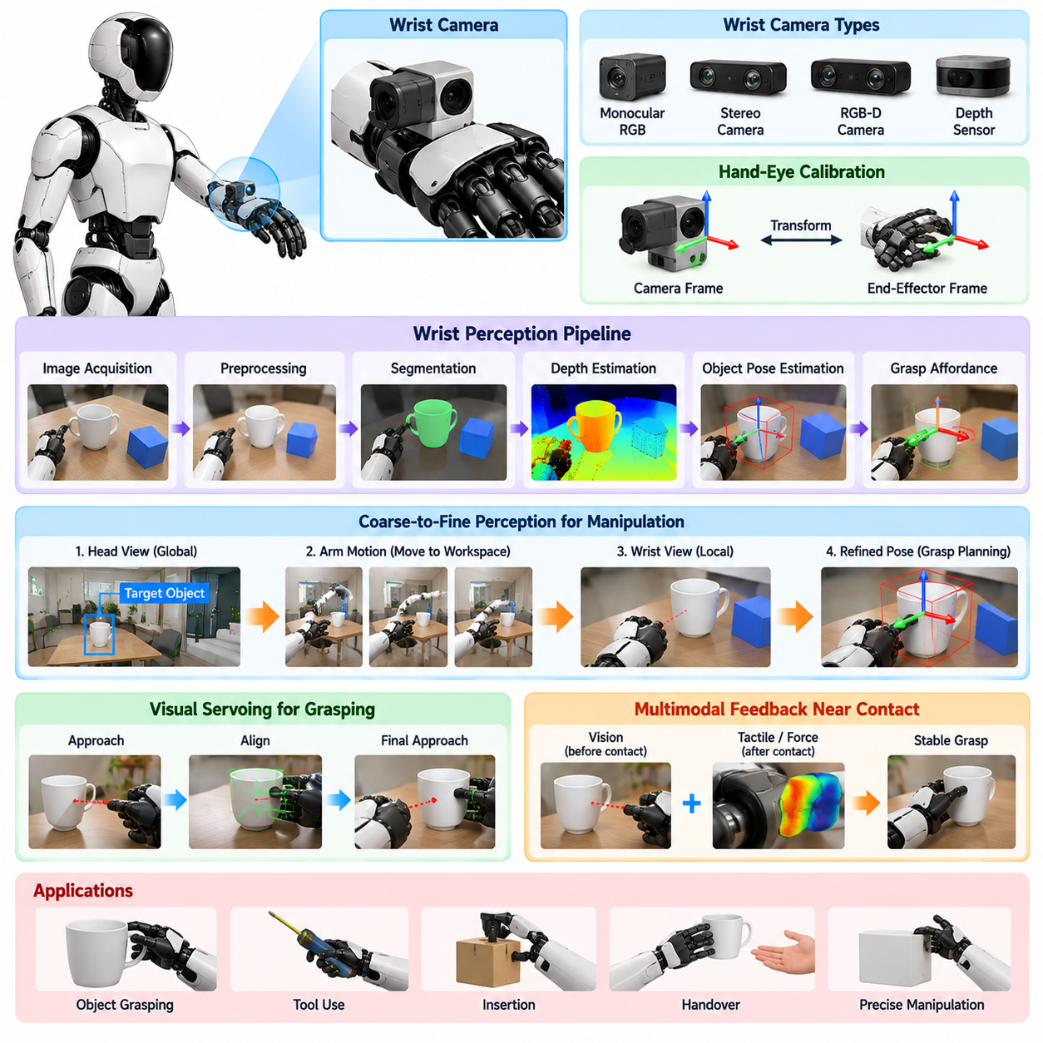
Wrist-mounted cameras provide a humanoid robot with a local visual perspective directly connected to manipulation and grasping. While head cameras offer broad scene awareness, their view becomes less effective as the hand approaches an object and the arm begins to occlude the target. A wrist camera moves with the manipulator, preserving visibility of the immediate workspace and enabling perception to remain tightly coupled with hand motion during physical interaction.
The wrist camera is typically mounted near the end effector, hand, or distal forearm so that its optical axis covers the region in which grasping and contact occur. Depending on the task, the system may use monocular RGB, stereo, RGB-D, or compact depth cameras. Camera placement must balance visibility, mechanical protection, field of view, minimum focusing distance, cable routing, and interference with the hand's reachable workspace.
Unlike a head camera, the wrist camera undergoes large translations and rotations generated directly by arm motion. Every joint movement changes the camera pose relative to the environment, making accurate hand-eye calibration essential. The transformation between the camera and end-effector coordinate frames must be known precisely so that visual observations can be converted into positions and orientations usable by inverse kinematics, motion planning, visual servoing, and grasp control.
Wrist perception usually operates as part of a coarse-to-fine perception architecture. The head camera first identifies a target and estimates its approximate location within the global workspace. The arm then moves toward the target, bringing the wrist camera into a favorable observation region. Local perception subsequently refines object position, orientation, surface geometry, and grasp features, reducing the uncertainty inherited from longer-range head-camera observations.
This transition requires consistent object identities and coordinate transformations between head and wrist perception. A target detected from the head should remain the same logical object when observed from the wrist, even though its appearance, scale, viewing angle, and illumination may change dramatically. Shared spatial representations and data association allow the manipulation system to combine global context with local observations instead of restarting perception whenever the viewpoint changes.
Depth estimation becomes particularly valuable near the hand. Grasp execution depends not only on recognizing an object but also on estimating the relative translation and orientation between the hand and target. Stereo disparity, active depth sensing, structured depth measurements, or learned monocular depth can provide local geometric information. At short range, calibration accuracy and depth noise can directly determine whether the fingers align correctly with intended contact regions.
Object pose estimation converts local visual observations into a manipulation-ready geometric state. For known rigid objects, model-based or learned methods can estimate six-degree-of-freedom pose, including three-dimensional position and orientation. For unfamiliar objects, segmentation, point-cloud geometry, surface normals, keypoints, or grasp-affordance representations can provide sufficient information to generate candidate grasps without requiring an exact object model.
Segmentation is important because wrist images often contain visually complex mixtures of the target, hand, fingers, nearby objects, support surfaces, and background regions. Instance segmentation can isolate the intended object, while self-body masking can remove image regions occupied by the robot's own hand or arm. Combining segmentation with depth allows the system to extract a local three-dimensional representation that is more suitable for grasp planning than a raw image alone.
As the hand approaches the target, closed-loop visual servoing can replace purely open-loop motion. Rather than executing an entire trajectory from an initial pose estimate, the robot repeatedly measures the target relative to the wrist camera and corrects the hand trajectory. Image-based visual servoing uses visual features directly, while position-based approaches reconstruct geometric error in three dimensions. Both methods can reduce errors caused by calibration uncertainty or object displacement.
The final centimeters before contact are particularly important because small pose errors can cause grasp failure. A wrist camera can monitor the relative alignment between fingers, object boundaries, handles, holes, edges, or other grasp features as the hand closes in. The controller can reduce approach velocity and increase perception frequency near contact, creating a precision phase in which visual feedback becomes more influential than the initial global motion plan.
Wrist vision and tactile sensing naturally complement each other. Vision provides information before physical contact, while tactile and force sensing become increasingly informative after contact begins. The manipulation system can therefore transition from visual guidance to multimodal contact control as the fingers touch the object. If visual alignment appears correct but tactile feedback indicates unexpected contact, the robot can stop, adjust the hand pose, or initiate a recovery action.
Occlusion remains challenging even with wrist-mounted sensing. Fingers may block the target during grasp closure, and the object itself may hide important contact regions depending on the approach direction. Multiple wrist cameras, wide-angle optics, head-camera observations, or active viewpoint changes can reduce this problem. The robot can also reposition the wrist before grasping to obtain an observation that maximizes visibility of critical geometric features.
Motion blur and rapid viewpoint changes can degrade wrist-camera perception during fast arm movement. A practical system may therefore coordinate manipulator velocity with visual confidence, slowing temporarily when precise observation is required. Short exposure, sufficient illumination, high frame rate, and motion-aware tracking can further improve image stability. Perception and manipulation should consequently be designed as coupled processes rather than independent software pipelines.
Bimanual humanoid manipulation introduces additional opportunities and complexity. Cameras mounted on both wrists provide complementary views of an object and allow each hand to observe the other's interaction region. During cooperative grasping, assembly, folding, or handover, the system can fuse observations from the left wrist, right wrist, and head. Accurate calibration across both kinematic chains is necessary to maintain a consistent shared representation of the task.
Wrist cameras are especially useful for tasks requiring precise alignment, such as inserting a connector, turning a handle, placing an object into a narrow slot, or operating a tool. In these cases, global object detection alone is insufficient because the relevant state is the small relative error between task features. Local vision can identify edges, holes, mating surfaces, markers, or functional components and provide continuous corrections throughout the operation.
Open-vocabulary and learned visual representations can extend wrist perception beyond predefined object categories. Instead of requiring every manipulated object to belong to a fixed detector class, a semantic model can associate local image regions with language descriptions or task concepts. This capability is important for general-purpose humanoids that may encounter previously unseen tools, containers, household objects, industrial parts, and other objects during deployment.
Manipulation policies can also consume wrist images directly. Imitation learning, reinforcement learning, and vision-language-action models may map local visual observations together with proprioception and task commands into end-effector or joint actions. In such architectures, the wrist camera becomes part of the policy observation space. Nevertheless, geometric calibration and explicit perception remain valuable for safety, diagnostics, interpretability, and integration with conventional planners.
Real-time execution requires careful control of the wrist vision pipeline. High-resolution images can improve fine-feature recognition but increase inference latency and memory bandwidth. The system may therefore crop regions of interest, reduce resolution during large arm motions, and switch to higher-detail processing near the target. GPU acceleration, efficient image transport, asynchronous inference, and optimized neural networks help maintain responsive perception without blocking the manipulation control loop.
Reliability monitoring should detect blurred images, blocked lenses, depth failure, calibration inconsistency, dropped frames, excessive latency, and unexpected disagreement between head and wrist observations. Each estimated object pose or grasp feature should include confidence and timing information. When local visual confidence falls below an acceptable level, the robot can pause the approach, move to another viewpoint, request a new global observation, or rely on contact sensing.
A robust grasping architecture therefore treats the wrist camera as an active sensor rather than a passive recorder. The manipulator can deliberately move the camera to reduce uncertainty before committing to contact, inspect multiple sides of an object, verify grasp success, and observe the object after lifting. Perception becomes part of the manipulation strategy itself, allowing actions to be selected not only to accomplish the task but also to obtain better information.
Ultimately, wrist-camera perception bridges the gap between global scene understanding and physical contact. Head vision identifies where interaction should occur, wrist vision resolves the local geometry required to approach accurately, and tactile or force perception confirms the interaction once contact begins. This progression creates a closed perception-action-contact loop that enables a humanoid to transform visual understanding into precise, adaptive, and robust grasping behavior.

06.04. 3D Scene Understanding for Humanoid [w/Code]
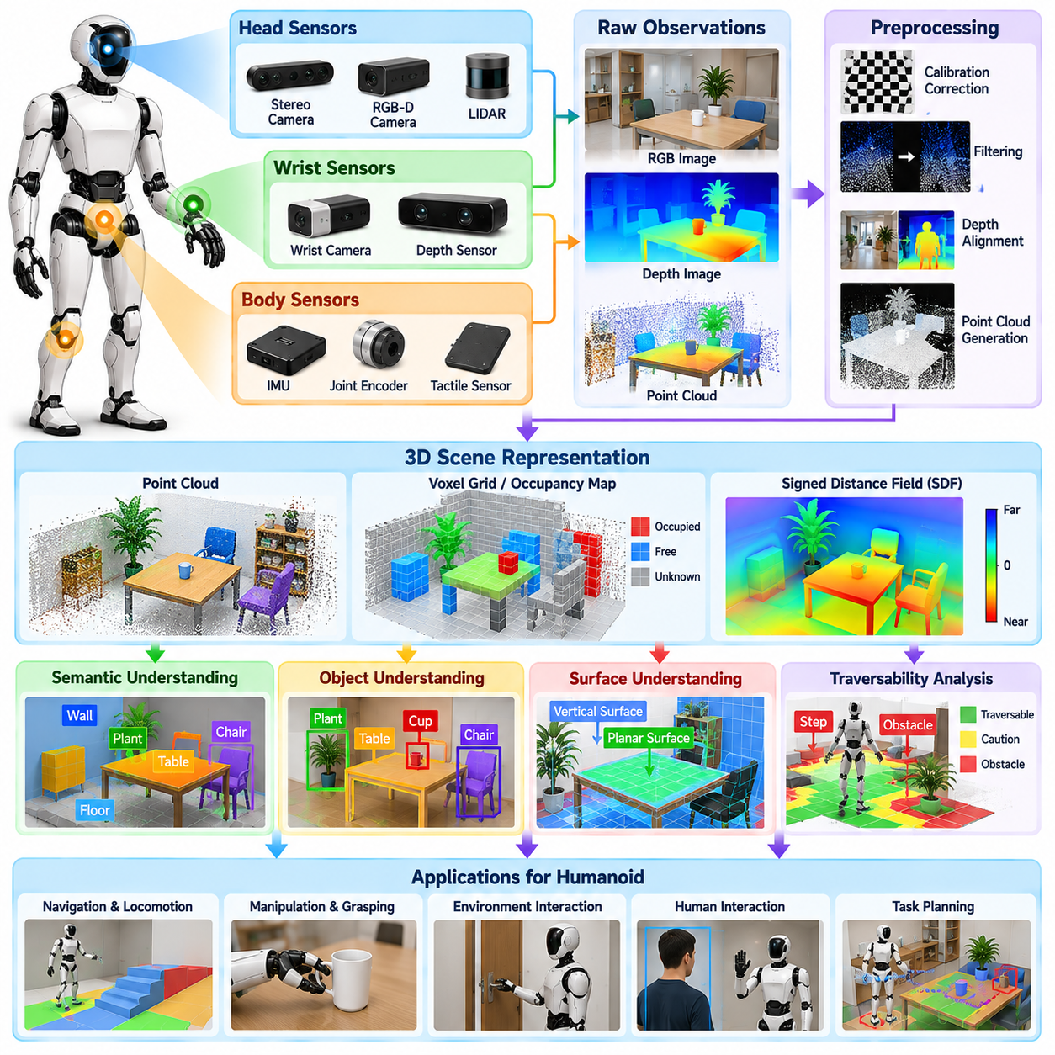
Three-dimensional scene understanding enables a humanoid robot to convert raw sensory observations into a spatial representation of the physical environment. Unlike image-level perception, which primarily describes what appears in individual camera frames, 3D understanding estimates where objects, surfaces, humans, obstacles, and interaction regions exist relative to the robot. This spatial representation supports locomotion, manipulation, whole-body planning, and safe physical interaction.
A humanoid can obtain 3D information from stereo cameras, RGB-D sensors, LiDAR, monocular depth models, or combinations of these sources. Each sensing method has different characteristics in range, resolution, field of view, noise, and failure conditions. A practical perception system therefore treats depth measurements as uncertain observations and integrates complementary sensors when necessary rather than assuming that every measured 3D point is equally reliable.
The moving humanoid body makes 3D reconstruction more complex than reconstruction from a fixed sensor platform. Head cameras rotate with the neck, wrist cameras move with the arms, and the floating base changes position during walking. Every depth observation must therefore be transformed through calibrated sensor extrinsics and the current robot kinematic state into a consistent coordinate frame before measurements acquired from different viewpoints can be combined.
Accurate temporal alignment is essential during this transformation process. A depth image captured at one instant must be associated with the joint configuration, IMU state, and estimated base pose corresponding to that same instant. Even small synchronization errors can distort reconstructed geometry when the head or body moves rapidly. Timestamped measurements, buffered transforms, and state interpolation help maintain geometric consistency across asynchronous sensing streams.
The first useful representation may be a depth image or organized point cloud in the camera coordinate frame. By applying camera calibration and depth measurements, image pixels can be projected into three-dimensional points containing position and potentially color or semantic information. These local point clouds provide immediate geometric evidence but usually require filtering to remove invalid depth, isolated noise, reflective artifacts, and measurements outside the robot's useful operating region.
Multiple observations can be accumulated into a larger spatial representation as the humanoid moves. Registration aligns successive point clouds or depth observations using estimated camera motion, robot kinematics, visual odometry, or SLAM information. Accumulation increases coverage beyond a single viewpoint and allows the robot to reason about regions that are temporarily outside the camera view, although stale information must be handled carefully in dynamic environments.
Dense scene representations can use point clouds, voxel grids, occupancy maps, signed distance fields, or related structures depending on the task. Point clouds preserve measured geometry efficiently, while voxel representations provide regular spatial indexing. Occupancy structures indicate whether regions are free, occupied, or unknown, and signed distance representations can support collision checking, surface reconstruction, trajectory optimization, and manipulation planning.
A humanoid requires more than geometric reconstruction because physical tasks depend on the meaning and function of scene elements. Semantic segmentation can associate 3D regions with categories such as floor, wall, table, container, tool, human, or obstacle. Instance-level representations separate individual objects within the same category. Combining geometry with semantics produces a structured scene in which the robot understands both spatial arrangement and task-relevant identity.
Object-level 3D understanding transforms dense sensor measurements into persistent entities. Each object can maintain an estimated position, orientation, dimensions, semantic label, confidence, and observation history. When an object is observed from several viewpoints, its state can be refined rather than recreated from each frame. Persistent object representations are particularly useful for task planning because actions are usually expressed in terms of objects rather than millions of individual points.
Surface understanding is equally important for humanoid behavior. Floors, stairs, ramps, shelves, tables, walls, handles, and support surfaces impose different constraints on locomotion and manipulation. Surface normals, planar regions, edges, curvature, height changes, and local roughness can be extracted from 3D geometry. These properties help determine whether a region can support a foot, receive an object, permit contact, or provide a useful manipulation feature.
For locomotion, the 3D scene representation must describe traversable and hazardous regions around the humanoid. Ground geometry can be analyzed to identify steps, gaps, slopes, obstacles, and changes in elevation. Because humanoid locomotion involves discrete foot contacts rather than only planar driving, perception may need to estimate candidate footholds and their orientation, dimensions, clearance, and local surface quality for use by footstep and whole-body planners.
Manipulation requires a different interpretation of the same scene. The perception system must identify reachable objects, estimate their geometry and pose, determine free approach directions, and understand surrounding obstacles. A target may be visually detectable but physically inaccessible because another object blocks the hand trajectory. Three-dimensional reasoning therefore connects object perception with reachability, collision constraints, grasp planning, and whole-body configuration.
Head and wrist cameras provide complementary contributions to 3D scene understanding. Head sensing captures broad environmental structure and establishes global context, while wrist sensing provides detailed geometry near the manipulation target. Observations from both viewpoints can be transformed into a shared reference frame and fused. This allows the robot to preserve global awareness while refining local geometry during reaching, grasping, insertion, or tool use.
Human-aware 3D perception is necessary when humanoids operate near people. Human detection and pose estimation can be projected into three-dimensional space to estimate body locations, limb configurations, motion, and proximity. Tracking these states over time allows the robot to distinguish occupied regions from potentially safe motion space and provides spatial information for collaborative manipulation, handover, social interaction, and collision avoidance.
Dynamic environments require the scene model to distinguish persistent structure from moving or temporary content. A table may remain static while people, tools, containers, or mobile equipment move through the workspace. If all observations are permanently fused into one static map, moving objects can leave incorrect geometry behind. Dynamic scene understanding therefore requires tracking, temporal decay, change detection, and object-aware map updates to maintain a current representation.
Occlusion must also be represented explicitly. A region that has not been observed is different from a region known to be empty. Three-dimensional occupancy models can preserve unknown space behind objects, walls, furniture, or the robot's own body. This distinction is important for safe motion planning because a humanoid should not assume that unobserved space is collision-free merely because no sensor measurement currently occupies it.
Scene graphs can provide a higher-level representation above dense geometry. Instead of describing only coordinates, a graph can encode objects and regions as entities connected by spatial or functional relations such as on, inside, next to, supported by, reachable from, or held by. Such relational representations allow task planners and language-conditioned systems to reason about physical scenes using structured concepts while retaining links to underlying metric geometry.
Open-vocabulary perception can further extend the semantic layer by allowing scene elements to be associated with language concepts beyond a fixed detector taxonomy. Visual and multimodal models can connect regions of the 3D environment with textual descriptions, enabling commands referring to previously unseen objects or functional concepts. Metric grounding remains necessary so that semantic recognition ultimately produces physical locations usable for robot action.
Uncertainty should propagate through the complete 3D perception pipeline. Depth measurements, camera poses, object detections, registration, and semantic predictions all contain error. A useful scene model therefore stores confidence, covariance, observation age, or related quality measures rather than representing every estimate as exact. Planning components can use this information to avoid uncertain regions or request additional observations before executing risky physical actions.
Active perception allows the humanoid to improve the scene model through deliberate movement. The robot can rotate its head to reveal an occluded region, move its torso to obtain depth from another viewpoint, approach an object for higher-resolution sensing, or reposition a wrist camera before manipulation. Viewpoint selection can be driven by uncertainty or task relevance, turning 3D reconstruction into an interactive perception-action process rather than passive mapping.
Real-time operation requires multiple spatial representations at different scales and update rates. A rapidly updated local map can support collision avoidance and immediate motion, while a broader semantic representation can evolve more slowly for task planning and memory. GPU acceleration, efficient voxel structures, region-of-interest updates, asynchronous processing, and selective map maintenance help control computation and memory consumption on onboard hardware.
Ultimately, 3D scene understanding provides the spatial foundation that connects humanoid perception with physical intelligence. Raw images and depth measurements become surfaces, objects, humans, free space, obstacles, relations, and actionable regions expressed in consistent coordinates. By maintaining these representations over time and updating them through active sensing, the humanoid gains a continuously evolving model of where it is, what surrounds it, and how its body can safely interact with the world.

06.05. Human Detection Pose Estimation and Tracking [w/Code]
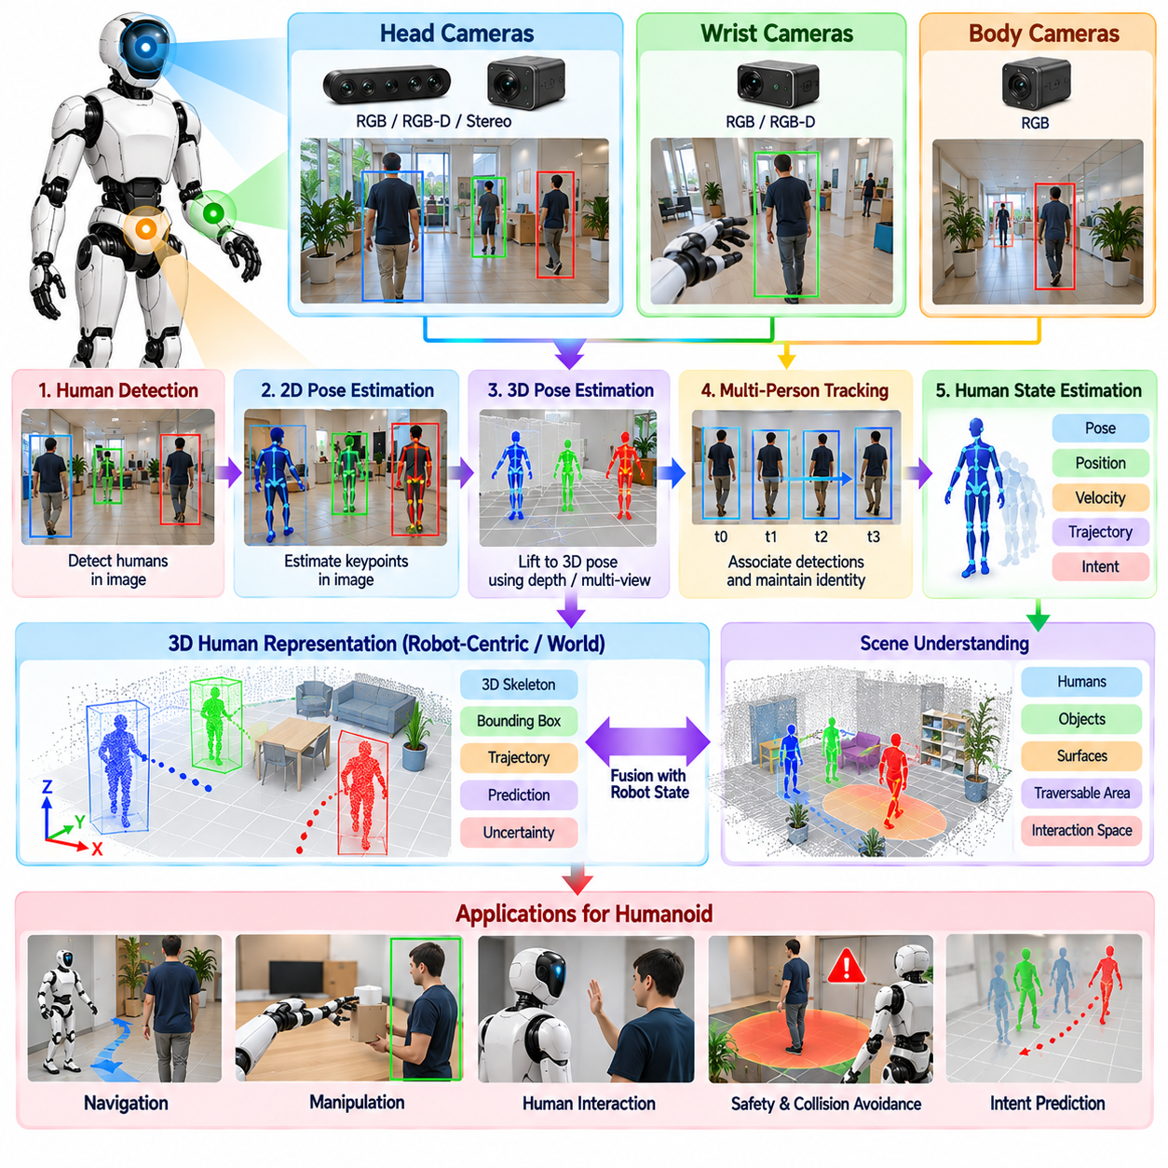
Human detection is a fundamental perception capability for humanoid robots operating in environments shared with people. The robot must determine whether humans are present, where they are located, how their bodies are configured, and how they are moving. Unlike simple image classification, humanoid perception must convert visual observations into continuously updated spatial states that can support navigation, manipulation, collaboration, interaction, and safety-critical motion decisions.
Human detection typically begins with RGB or RGB-D images acquired from the humanoid's head cameras, although wrist or body cameras may provide additional viewpoints. A detector identifies image regions likely to contain people and assigns confidence values to each observation. Modern learned detectors can operate under variations in clothing, body size, background, and orientation, but their reliability still depends on image resolution, illumination, occlusion, motion blur, and viewing distance.
Detection alone provides only a coarse representation because a bounding box does not describe the configuration of the human body. Human pose estimation extends perception by locating anatomical keypoints such as the head, shoulders, elbows, wrists, hips, knees, and ankles. These landmarks form an articulated representation that allows the robot to distinguish standing, walking, reaching, bending, sitting, and other body configurations relevant to physical and social interaction.
Two-dimensional pose estimation predicts keypoints in the image plane and can operate efficiently using a single RGB camera. For humanoid interaction, however, image coordinates often need to be converted into metric three-dimensional positions. Depth measurements, stereo reconstruction, multi-view geometry, or learned 3D pose estimation can associate keypoints with spatial coordinates, allowing the robot to reason about human limbs and body regions relative to its own physical workspace.
Three-dimensional human pose is particularly important when the humanoid and person occupy the same manipulation space. Knowing that a hand exists in an image is insufficient when the robot must determine whether that hand intersects an arm trajectory or is approaching an object. A 3D skeletal representation provides approximate body geometry that can be incorporated into collision checking, handover planning, collaborative manipulation, and dynamic safety-zone estimation.
The moving viewpoint of a humanoid introduces additional complexity. When the robot walks or turns its head, human image positions change even if people remain stationary. The perception system must therefore distinguish apparent motion caused by robot ego-motion from actual human movement. Camera pose estimates, robot kinematics, inertial measurements, depth, and visual tracking can be combined to express detected people in a stable robot-centered or world coordinate frame.
Temporal tracking connects detections across successive frames and maintains persistent identities. Without tracking, a person would appear as a new observation every time the detector runs. A tracker associates current measurements with previously observed individuals using position, motion, visual appearance, body pose, or combinations of these features. Persistent tracks allow the robot to estimate velocity, trajectory, observation history, and interaction context for each nearby person.
Tracking commonly combines a motion model with repeated perception updates. A person's previous position and velocity can predict where that person is expected to appear next, while new detections correct the prediction. Filtering methods can smooth noisy measurements and provide more stable states than individual frames. The resulting track should include uncertainty because human motion can change rapidly and visual observations can become unreliable without warning.
Occlusion is one of the most difficult problems in human tracking. A person may disappear behind furniture, another person, machinery, or even the humanoid's own arm. A robust tracker should preserve the identity for a limited period rather than immediately deleting it. Motion prediction and appearance information can support re-identification when the person becomes visible again, while uncertainty should increase as the duration without direct observation becomes longer.
Multi-person environments require data association between several simultaneous detections and existing tracks. People may cross paths, overlap in the image, or temporarily exchange relative positions. Incorrect association can cause identity switches that corrupt trajectory prediction and interaction state. Combining geometric proximity, appearance embeddings, pose consistency, depth, and motion history can improve identity preservation when multiple humans occupy the robot's operating region.
Human pose itself can also be tracked temporally rather than estimated independently in every frame. Joint trajectories can be filtered to reduce keypoint jitter and reject implausible changes. Temporal models can exploit relationships between consecutive body configurations to improve estimates when individual joints are briefly hidden. This is valuable for recognizing gestures, estimating reaching motion, and determining whether a person is entering or leaving the robot's workspace.
Human motion prediction extends tracking from estimating the present to anticipating the near future. Velocity and trajectory estimates can predict where a person may move over the next short interval, while body pose can reveal intent-related cues such as reaching or turning. Predictions should remain probabilistic because human behavior is inherently uncertain. Conservative uncertainty bounds allow planners to account for several plausible future positions rather than relying on one deterministic trajectory.
For navigation, tracked humans become dynamic obstacles with richer semantics than ordinary moving objects. The humanoid can maintain appropriate clearance, avoid crossing directly through a person's path, and adapt its velocity when approaching crowded regions. Human-aware navigation may also consider orientation and motion direction so that the robot behaves predictably around people rather than merely satisfying geometric collision constraints.
For manipulation, human detection and pose estimation provide spatial constraints around shared workspaces. During object handover, the robot can estimate the person's hand location and approach direction while monitoring the rest of the body. During collaborative carrying or assembly, pose tracking helps maintain awareness of partner motion. These observations can influence grasp timing, arm trajectory, impedance behavior, and whole-body configuration throughout physical cooperation.
Safety requires a conservative interpretation of human perception. Detection confidence, pose uncertainty, tracking age, and sensor visibility should accompany estimated human states. If a person becomes partially hidden or the perception pipeline loses confidence, the system should not simply assume that the space has become free. Instead, planners can enlarge safety margins, reduce robot velocity, restrict motion, or wait for reliable observations before continuing potentially hazardous movement.
The humanoid's own body can interfere with human perception. Arms, hands, tools, and carried objects may block the head camera during manipulation, while body rotation can move people outside the field of view. Robot geometry and joint states can predict self-occluded image regions, and additional cameras may provide complementary coverage. Active head motion can also restore visibility by directing the camera toward humans whose states are important for the current task.
Active perception is especially useful during interaction because the robot can deliberately orient its head toward a person, their hands, or another task-relevant body region. Gaze control can prioritize individuals based on proximity, interaction role, uncertainty, or expected risk. Rather than continuously processing every direction with equal priority, the perception system can allocate visual attention according to the current task and the importance of maintaining reliable human state estimates.
Pose information also provides a foundation for gesture and activity interpretation. A raised arm, pointing motion, extended hand, or reaching movement can be represented as temporal patterns of body keypoints. Higher-level interaction modules can combine these patterns with gaze, speech, object context, and task state to infer possible commands or intentions. Pose estimation therefore forms an important bridge between low-level visual detection and human-robot interaction.
Real-time performance is essential because stale human states can be dangerous. Detection, pose estimation, and tracking may operate at different frequencies, with fast tracking updating states between more expensive neural-network inference cycles. GPU acceleration, reduced-resolution processing, region-of-interest inference, asynchronous pipelines, and efficient data transfer can reduce latency while preserving sufficient accuracy for the robot's current operating speed and interaction distance.
A production system should continuously monitor perception quality. Missing detections, abnormal keypoint configurations, identity switches, excessive inference latency, camera obstruction, and disagreement between depth and visual estimates should be detectable conditions. Human tracks should carry timestamps and confidence values so downstream components can determine whether information is current enough for planning, control, or safety decisions.
Ultimately, human detection, pose estimation, and tracking form a unified temporal perception process rather than three isolated algorithms. Detection establishes human presence, pose estimation describes articulated body configuration, and tracking preserves identity and motion across time. Combined with 3D geometry, uncertainty, robot ego-motion, and active sensing, these capabilities allow a humanoid to maintain a continuously evolving model of nearby people and interact with them safely and intelligently.

06.06. Object Detection and 6DoF Pose for Grasping [w/Code]
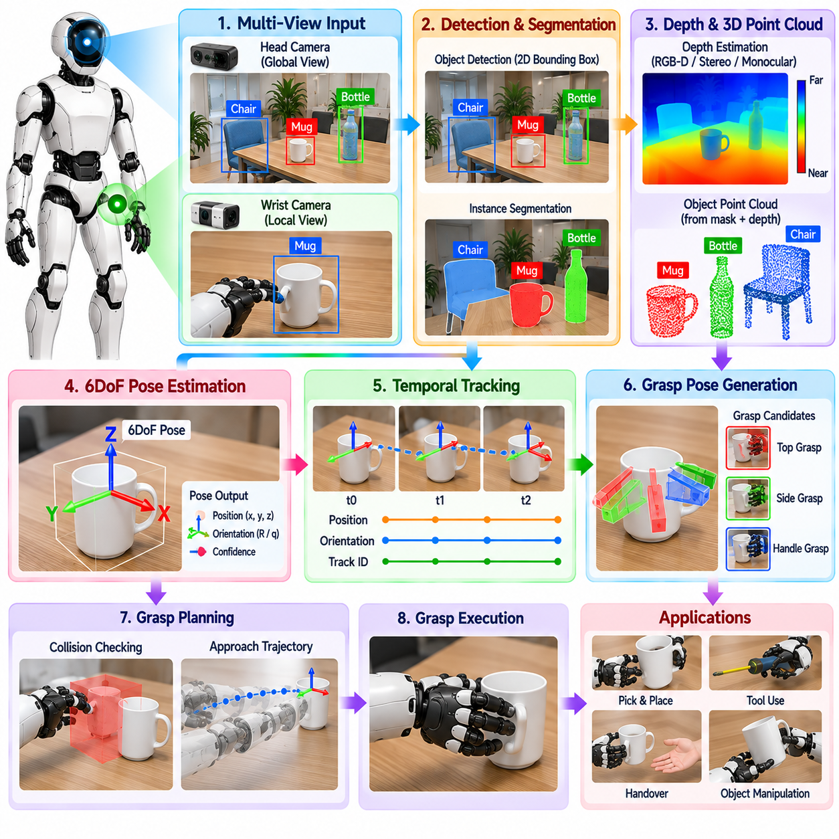
Object detection provides the first semantic link between visual observations and physical manipulation. A humanoid must identify which objects are present, distinguish the intended target from surrounding items, and determine where the target appears in the visual scene. For grasping, however, a two-dimensional bounding box is insufficient because the hand must approach an object at a physically meaningful position and orientation in three-dimensional space.
A typical grasping perception pipeline begins with RGB, stereo, or RGB-D observations from head and wrist cameras. Head vision provides broad workspace awareness and identifies candidate targets, while wrist sensing refines perception near the hand. Object detectors produce class labels, regions, masks, or semantic features that can be associated with depth measurements and transformed into metric coordinates for downstream manipulation.
Instance segmentation is often more useful than rectangular detection when objects are closely packed or partially overlapping. A segmentation mask isolates the visible target pixels from the background, support surface, neighboring objects, and robot body. When combined with depth, the mask can extract a target-specific point cloud, providing geometric information that supports pose estimation, grasp generation, collision reasoning, and local refinement.
Six-degree-of-freedom pose estimation represents an object's three-dimensional translation and three-dimensional orientation relative to a defined coordinate frame. The translation specifies where the object is located, while rotation specifies how it is oriented. This 6DoF representation provides the geometric connection between visual perception and robot motion because grasp poses, approach directions, and end-effector trajectories can be expressed relative to the estimated object frame.
For known objects, pose estimation can use geometric models, CAD data, learned object representations, or combinations of these sources. Visual features or predicted correspondences associate observed image regions with locations on the object model. Perspective geometry then estimates the camera-relative pose, which may be refined using depth measurements or point-cloud registration to improve alignment between the observed surface and expected object geometry.
Depth information can significantly improve pose estimation when reliable measurements are available. RGB-D cameras or stereo systems provide three-dimensional points associated with the detected object, enabling direct geometric comparison with a reference model. Depth is nevertheless imperfect around reflective, transparent, dark, thin, or distant surfaces. A robust estimator should therefore reject invalid measurements and represent uncertainty rather than treating all depth samples as equally accurate.
Objects without predefined geometric models require more general representations. The system may estimate object center, principal axes, visible surfaces, keypoints, oriented bounding volumes, or grasp-relevant affordances instead of an exact model pose. For general-purpose humanoids, this distinction is important because many deployment environments contain unfamiliar objects that cannot be represented by a complete CAD database prepared before operation.
Object symmetry introduces ambiguity into 6DoF pose estimation. Cylindrical containers, repeated geometric structures, and visually symmetric parts may have several orientations that produce nearly identical observations. A pose estimator should represent equivalent orientations or task-relevant symmetry rather than penalizing all deviations from one arbitrary reference pose. For grasping, the important question is often whether the estimated orientation supports a valid grasp rather than whether one canonical rotation is recovered exactly.
Occlusion creates another major challenge. Objects may be partially hidden behind containers, tools, furniture, the robot's own hand, or other items in a cluttered workspace. Pose estimation must operate using incomplete observations and avoid excessive confidence when only a small surface region is visible. Multi-view sensing, temporal accumulation, head motion, and wrist-camera repositioning can expose additional geometry and reduce ambiguity before the robot commits to a grasp.
The estimated pose must be transformed from the camera coordinate frame into a coordinate system usable by manipulation. Accurate camera intrinsics, hand-eye calibration, robot kinematics, and synchronized joint states are therefore essential. A small error in the camera-to-robot transformation can become a significant grasp error at the fingers, especially when the robot performs precise insertion, narrow-handle grasping, or manipulation of small objects.
Pose estimates should be maintained over time rather than generated independently for every frame. Temporal filtering and object tracking can stabilize translation and orientation, reject isolated outliers, and preserve object identity when the viewpoint changes. When the object itself moves, the tracker can estimate its motion and update the target state continuously. This enables manipulation planning to operate on a persistent object representation rather than unstable frame-level detections.
The relationship between object pose and grasp pose must be explicitly defined. Object pose describes the state of the target, whereas grasp pose describes a desired hand or end-effector configuration relative to that target. A grasp generator can transform predefined grasp templates through the estimated object pose, or it can infer candidate grasps directly from local geometry. Candidates may differ in approach direction, contact locations, hand orientation, and required finger configuration.
Grasp selection requires more than geometric reachability. Candidate poses should be evaluated for collision with surrounding objects, kinematic feasibility, joint limits, hand clearance, expected contact quality, and compatibility with the intended task. A grasp suitable for lifting an object may not be appropriate for pouring, handing it to a person, inserting it into another component, or using it as a tool. Perception should therefore expose geometry and semantics needed for task-conditioned grasp selection.
Head and wrist perception naturally support hierarchical pose refinement. The head camera can estimate an initial target pose that is sufficiently accurate for coarse reaching. As the arm approaches, the wrist camera obtains a closer view and updates the object pose with higher local precision. The manipulator can repeatedly correct its trajectory using these estimates, reducing dependence on a single perception result acquired before arm motion begins.
Visual servoing provides a direct mechanism for closing this perception-action loop. The system compares the current relative pose between the hand and object with the desired grasp relationship and generates corrective motion. As the hand approaches the target, motion can slow while perception updates become more influential. This iterative correction helps compensate for pose-estimation noise, calibration errors, mechanical deflection, or small object movements occurring after the original plan was generated.
Contact sensing becomes increasingly important during the final grasp phase. Vision can guide the hand toward the predicted contact configuration, but tactile and force sensors determine whether physical contact actually occurs as expected. Unexpected contact may indicate pose error, object displacement, or inaccurate geometry. The controller can then stop, reopen the hand, modify the approach, or perform a local search instead of continuing a potentially damaging grasp.
Bimanual manipulation increases the importance of consistent object pose representation. Both hands may need to approach different regions of the same object while maintaining coordinated geometry. Head and two wrist cameras can provide multiple observations that are transformed into a common frame. This shared representation supports coordinated lifting, assembly, hand-to-hand transfer, and manipulation of large objects whose geometry cannot be observed completely from one viewpoint.
Learned grasping systems may reduce reliance on explicit object models by predicting grasp quality directly from RGB images, depth maps, point clouds, or multimodal features. Such systems can generalize across object categories and generate grasps for previously unseen items. Explicit 6DoF pose estimation nevertheless remains valuable when manipulation requires object-relative reasoning, precise task geometry, explainable intermediate states, or integration with conventional motion planners.
Vision-language-action systems can connect object detection and pose estimation with language-conditioned manipulation. A command such as selecting a particular container or tool first requires semantic grounding to identify the intended object. The corresponding spatial estimate must then connect that semantic target to a physically executable grasp. Thus semantic recognition, metric 6DoF localization, and action generation form complementary layers rather than independent perception problems.
Real-time deployment requires balancing accuracy with latency. High-resolution segmentation and pose networks may provide precise estimates but can delay manipulation if inference is too slow. A practical system can use fast detection for target acquisition, selective high-resolution processing for the chosen object, and rapid tracking between expensive pose updates. GPU acceleration, reduced precision, region-of-interest processing, and asynchronous pipelines can further reduce response time.
Every pose estimate should include a measure of reliability. Detection confidence alone is insufficient because an object may be correctly classified while its orientation remains uncertain. Visibility, depth quality, geometric fit, temporal consistency, and pose covariance can provide additional evidence. When uncertainty exceeds task-specific limits, the robot can acquire another viewpoint, move closer, delay grasping, or select a grasp that is less sensitive to pose error.
Ultimately, object detection and 6DoF pose estimation transform visual recognition into actionable spatial knowledge. Detection determines what object should be manipulated, pose estimation determines where it is and how it is oriented, grasp generation defines how the hand should engage it, and closed-loop visual and contact feedback correct remaining errors. Together these processes provide the geometric foundation for precise, adaptive, and reliable humanoid grasping.

06.07. Open Vocabulary Perception for Novel Objects [w/Code]
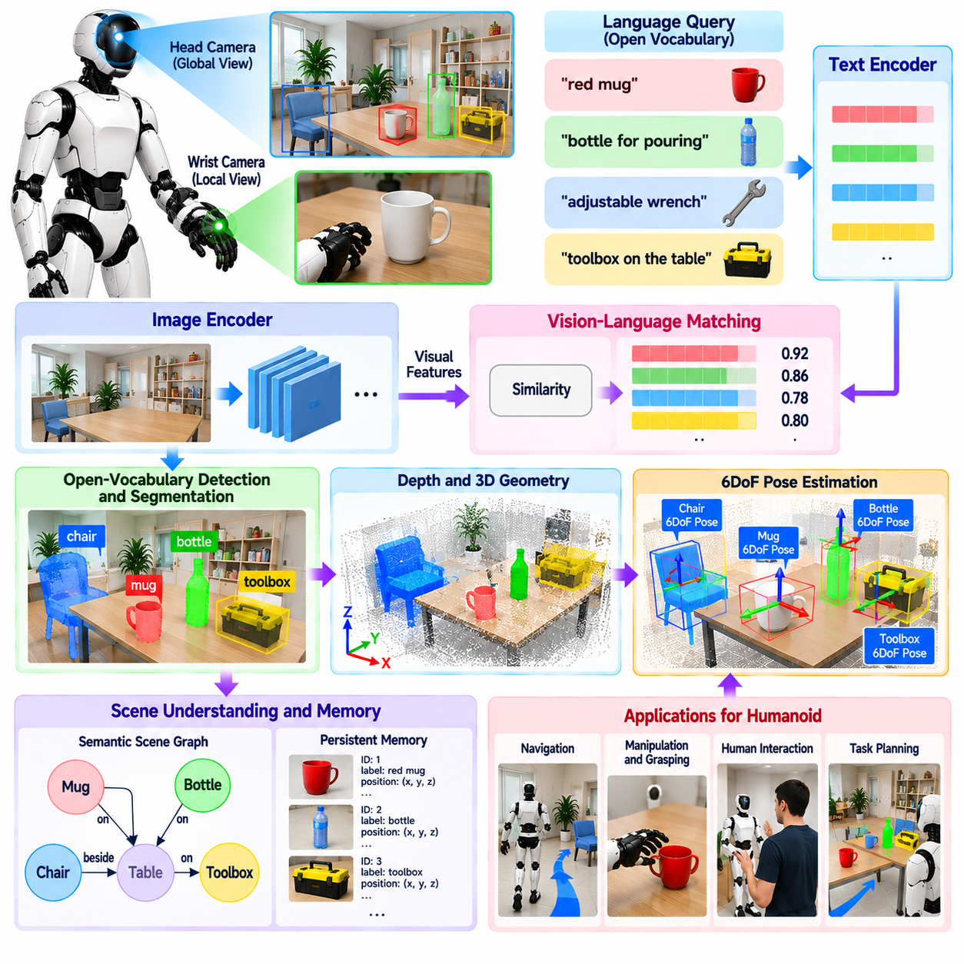
Open-vocabulary perception enables a humanoid robot to recognize and reason about objects beyond a fixed set of categories defined during detector training. Conventional closed-set perception assumes that every relevant object belongs to a predefined label space, but general-purpose humanoids operate in environments containing unfamiliar tools, containers, components, personal items, and task-specific objects. Open-vocabulary methods connect visual observations with flexible semantic concepts expressed through language.
The central idea is to represent images and language within compatible semantic spaces. A visual encoder extracts features from an observed scene, while a text encoder represents names, descriptions, attributes, or functional concepts. Similarity between these representations allows the system to associate image regions with textual queries even when the queried category was not explicitly included as a conventional detector class during training.
For humanoid operation, open-vocabulary perception should provide spatial grounding rather than only image-level classification. A language query such as “red container,” “adjustable wrench,” or “object used for pouring” must be associated with a specific region of the current scene. Detection, segmentation, or region-grounding models can localize candidate objects and produce masks or bounding regions that connect semantic descriptions to physical observations.
Language descriptions can express more than object names. Attributes such as color, shape, material, size, state, and relative location can help distinguish among visually similar candidates. Functional descriptions are particularly valuable for novel objects because a robot may not know an exact category label but can still reason about an object as something that can hold liquid, turn a fastener, provide support, or serve as a handle.
Open-vocabulary perception becomes physically useful when semantic grounding is connected to depth and three-dimensional geometry. A detected image region can be associated with RGB-D measurements, stereo depth, or reconstructed point clouds to estimate its spatial location and extent. The resulting representation links flexible language concepts to metric coordinates that can be consumed by navigation, reaching, grasp planning, and whole-body motion.
Head and wrist cameras provide complementary viewpoints for this process. The head camera can search a broad workspace using semantic queries and identify likely target regions from a distance. After the robot approaches, a wrist camera can inspect the candidate at higher effective resolution. Local observations can confirm object identity, refine segmentation, and estimate manipulation-relevant geometry before the hand commits to physical contact.
Novel-object perception should separate semantic recognition from geometric manipulation requirements. A model may correctly associate an unfamiliar object with a language description while still lacking an accurate estimate of its pose or graspable geometry. Consequently, semantic grounding should trigger additional geometric processing such as depth extraction, surface reconstruction, keypoint estimation, affordance prediction, or candidate grasp generation before manipulation begins.
Open-vocabulary segmentation is useful when the robot needs the actual spatial extent of an unfamiliar object rather than a coarse detection box. Pixel-level masks can separate the target from nearby objects and support extraction of object-specific depth points. These masks can then contribute to local point clouds, collision models, grasp regions, and scene representations without requiring the object to belong to a predefined segmentation taxonomy.
Ambiguous language introduces an additional reasoning problem. A command such as “pick up the bottle” may correspond to several visible objects, while a description such as “the tool near the box” depends on spatial relationships. The perception system can combine semantic similarity with color, geometry, depth, scene relations, interaction history, and task context to rank candidates instead of selecting an object from language similarity alone.
Scene memory can preserve open-vocabulary detections across time. Once an unfamiliar object has been grounded and assigned a temporary identity, the robot should not need to rediscover it from scratch whenever the camera moves. Object tracks can maintain semantic descriptors, position, appearance features, confidence, and observation history, allowing later commands to refer to previously observed objects even when they are temporarily outside the current field of view.
A semantic scene graph can organize these persistent observations into relational knowledge. Objects may be connected by relations such as on, inside, beside, behind, held by, or reachable from. Language-conditioned reasoning can then resolve expressions involving both object properties and spatial relationships. The graph provides a bridge between open-ended semantic concepts and the metric 3D scene representation required for physical robot action.
Open-vocabulary models can also support affordance-oriented perception. Instead of asking only what an object is, the robot can reason about what actions the object may support. Candidate regions may correspond to graspable handles, pushable surfaces, containers, buttons, support areas, or tool-like structures. Affordance predictions should remain grounded in observed geometry because semantic plausibility alone does not guarantee that a physical interaction is feasible.
Generalization to novel objects does not eliminate uncertainty. Semantic similarity scores can be misleading when objects have unusual appearances, labels are ambiguous, or the visual model lacks relevant experience. A robust system should retain multiple candidate hypotheses when appropriate and expose confidence to downstream modules. Low-confidence grounding can trigger additional observations, alternative queries, closer inspection, or confirmation through another sensing modality.
Active perception is particularly valuable for resolving semantic uncertainty. The humanoid can rotate its head, move closer, inspect an object from another angle, or reposition a wrist camera to reveal hidden features. Instead of immediately acting on the highest-scoring prediction, the robot can deliberately acquire observations that distinguish competing hypotheses. This turns novel-object recognition into an iterative perception-action process.
Occlusion and clutter remain difficult because open-vocabulary recognition still depends on observable evidence. A partially hidden object may expose too little appearance information for reliable semantic matching. Instance segmentation, depth ordering, multi-view accumulation, object tracking, and active viewpoint changes can progressively reveal the target. Persistent scene memory can preserve earlier evidence when the object becomes temporarily occluded during reaching or manipulation.
Language-conditioned perception must also account for changing object state. An open container, closed container, empty cup, filled cup, connected cable, or disconnected cable may require different actions despite belonging to the same semantic category. Combining appearance, geometry, temporal observations, and task context allows the robot to represent object state in addition to identity, improving the relevance of perception for sequential manipulation tasks.
Vision-language-action models can consume open-vocabulary visual representations directly when generating robot behavior. Language specifies a task or target, visual features ground the instruction in the current scene, and an action policy predicts movements appropriate to that grounding. However, explicit object representations remain useful for validating targets, enforcing safety constraints, supporting motion planning, and diagnosing failures when an end-to-end policy produces uncertain behavior.
Open-vocabulary perception also requires mechanisms for rejecting unsupported concepts. A robot should not assume that every textual query corresponds to an object actually present in the scene. Similarity thresholds, background hypotheses, cross-view consistency, geometric validation, and temporal evidence can help distinguish genuine detections from forced matches. The ability to represent “not observed” or “uncertain” is essential for reliable autonomous operation.
Real-time deployment requires selective use of computationally expensive semantic models. Broad visual-language inference can identify candidate regions, after which detailed segmentation or high-resolution processing can focus only on relevant objects. Cached visual features, region-of-interest inference, GPU acceleration, reduced-precision computation, and asynchronous processing can reduce latency while allowing semantic perception to coexist with faster safety and control pipelines.
Evaluation should measure more than recognition accuracy on predefined datasets. For humanoid applications, important outcomes include whether novel targets can be correctly grounded from language, whether the correct physical instance is selected in clutter, whether semantic observations remain stable across viewpoints, and whether the resulting representation enables successful reaching or grasping. Task success therefore provides an important complement to conventional detection metrics.
Ultimately, open-vocabulary perception expands humanoid intelligence from recognizing a catalog of known classes to grounding flexible concepts in the physical world. Language supplies adaptable semantic descriptions, vision identifies corresponding scene regions, 3D perception converts them into spatial entities, and manipulation determines how those entities can be physically used. This integration enables a humanoid to encounter novel objects, reason about their likely meaning and function, and transform that understanding into task-directed action.

06.08. Audio Processing Voice Command for HRI [w/Code]
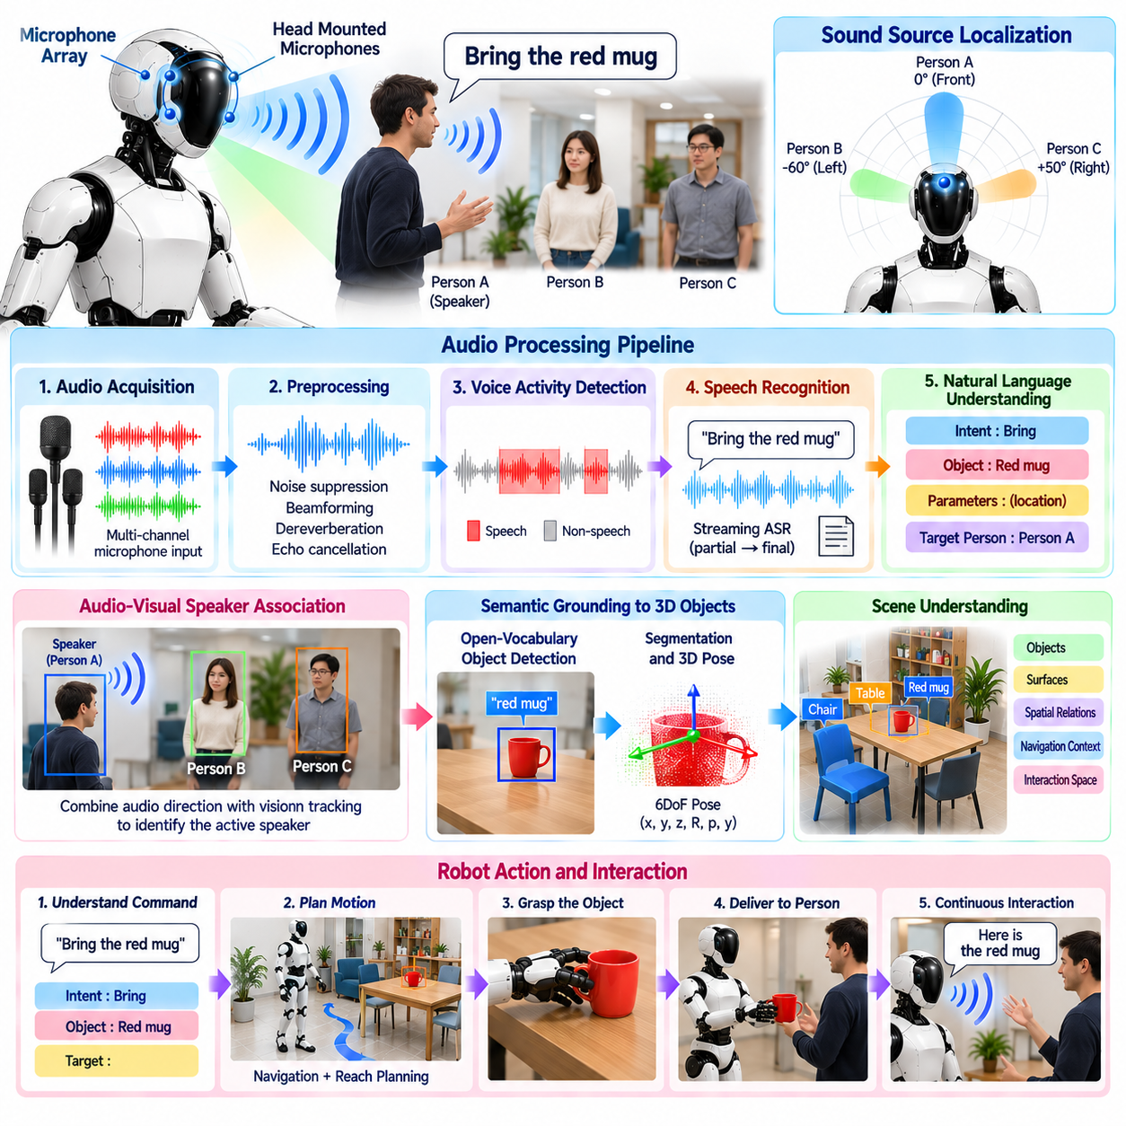
Audio processing provides a humanoid robot with an acoustic communication channel for human-robot interaction. Voice commands allow people to express goals without using a physical interface, while environmental audio can reveal speakers, events, and changes outside the robot's visual field. A practical humanoid audio system must therefore convert continuously captured microphone signals into reliable speech and interaction information despite motion, reverberation, machinery, and competing voices.
The sensing front end commonly uses a microphone array mounted in the head or upper body. Multiple microphones provide spatial information that a single microphone cannot capture, allowing the system to estimate sound direction and improve speech quality through spatial filtering. Array geometry, microphone spacing, sampling rate, synchronization, acoustic shielding, and placement relative to motors and cooling systems directly influence the quality of downstream voice processing.
Humanoid robots generate substantial self-noise while operating. Joint actuators, cooling fans, footsteps, gear mechanisms, manipulators, and structural vibration can contaminate recorded speech. Because some of this noise is correlated with robot motion, the audio pipeline can combine conventional noise suppression with knowledge of motor state or reference signals. Robust voice interaction therefore requires acoustic design and signal processing to be considered together with mechanical system behavior.
The raw microphone channels normally pass through preprocessing before speech recognition. Processing may include gain control, filtering, denoising, dereverberation, echo cancellation, and suppression of stationary or transient noise. The objective is not simply to produce pleasant audio but to preserve linguistic information needed by downstream models. Excessive filtering can distort speech features, so preprocessing should improve signal quality without removing information required for recognition.
Beamforming combines signals from multiple microphones to emphasize sound arriving from a selected direction while suppressing interference from other directions. When a speaker is localized, the array can steer an acoustic beam toward that person and improve the effective signal-to-noise ratio. Adaptive beamforming can update spatial filters as the speaker or robot moves, which is particularly important for humanoids whose head orientation and body configuration change during interaction.
Sound source localization estimates the direction from which speech or another acoustic event originates. Differences in arrival time, phase, and amplitude across microphones provide cues for estimating azimuth and potentially elevation. The estimated direction can be transformed into the robot coordinate system and combined with visual human detections. This enables the humanoid to associate a voice with a nearby person and orient its head toward the likely speaker.
Audio-visual fusion can significantly improve speaker identification in multi-person environments. Visual tracking provides candidate human positions, while acoustic localization indicates the probable direction of the active speaker. Combining these observations helps determine who is speaking when several people are visible. The robot can then maintain speaker identity across time and associate commands with the appropriate person instead of treating speech as an anonymous acoustic signal.
Voice activity detection determines when meaningful speech is present in the incoming audio stream. Continuous speech recognition on every audio sample wastes computation and increases false activations caused by environmental noise. A voice activity detector identifies likely speech intervals and forwards relevant segments to subsequent processing. In noisy environments, detection should use temporal and spectral evidence rather than relying only on simple energy thresholds.
Automatic speech recognition converts detected speech into textual or token-based representations. The recognition model must tolerate differences in accent, speaking rate, distance, background noise, reverberation, and vocabulary. For humanoid applications, command accuracy may be more important than perfect transcription of unrestricted conversation. Domain-specific vocabulary, contextual decoding, and task information can therefore help resolve acoustically ambiguous words that have different consequences for robot behavior.
Streaming speech recognition is useful because the robot often needs to respond before a long utterance has completely finished. Partial hypotheses can be generated while speech continues, allowing early interpretation of likely intent. However, preliminary transcriptions can change as additional words arrive. The interaction architecture should distinguish unstable partial results from finalized speech segments so that irreversible physical actions are not triggered by incomplete recognition.
Natural language understanding transforms recognized speech into representations that can guide robot behavior. A command such as asking the robot to bring an object contains information about an intended action, target object, destination, and possibly constraints. Language parsing or language models can extract these elements and connect them with task representations. The resulting intent must then be grounded in the robot's current perception and operational capabilities.
Semantic grounding connects spoken expressions to entities in the physical environment. A phrase such as “pick up that box” is incomplete without determining which visible box the speaker means. Visual perception, pointing gestures, gaze, spatial relations, dialogue history, and scene memory can help resolve the reference. Voice-command processing therefore becomes most useful when integrated with visual and spatial perception rather than operating as an isolated speech interface.
Open-vocabulary perception provides an important connection between language and unfamiliar objects. A user may refer to an item by name, appearance, location, or function even when the object is not part of a predefined detector taxonomy. The humanoid can use the spoken description as a semantic query, search the current visual scene, and associate candidate regions with the command. Geometric perception can then determine whether the selected object is physically reachable and manipulable.
Ambiguous commands should trigger clarification rather than arbitrary action. If several cups are present and the user says “bring me the cup,” the robot may need additional information before moving. A dialogue manager can identify unresolved references, missing parameters, or conflicting interpretations and request clarification. This behavior is especially important when an incorrect interpretation could cause unsafe motion, object damage, or interference with another person's activity.
Command interpretation must also distinguish conversational language from executable instructions. People near the robot may discuss actions without intending the robot to perform them. Wake words, explicit addressing, interaction state, speaker identity, gaze, or dialogue context can help determine whether an utterance is directed toward the humanoid. The system should avoid converting every recognized imperative phrase in ambient conversation into a robot command.
Safety-critical commands require a different treatment from ordinary task requests. Commands such as stop, freeze, cancel, or emergency-related instructions may need low-latency detection paths that do not depend on a complete high-level language pipeline. A dedicated command recognizer can operate alongside general speech understanding so that urgent instructions are detected rapidly. Final safety behavior should also remain integrated with physical emergency-stop and protective control mechanisms.
The robot must verify that a recognized command is executable before sending it to motion or manipulation systems. A linguistically valid instruction may request an unreachable object, prohibited region, unavailable capability, or unsafe action. Task-level validation should compare interpreted intent with scene state, robot capability, safety constraints, and current operational mode. Speech recognition therefore proposes user intent, while execution remains governed by the robot's planning and safety architecture.
Dialogue feedback helps users understand whether their command was received correctly. The humanoid can acknowledge an instruction, repeat an uncertain target, request missing information, or report that a requested action cannot currently be performed. Spoken feedback may be combined with head orientation, gestures, displays, or other interaction cues. Clear feedback reduces uncertainty for both the person and robot and supports recovery when recognition or grounding fails.
Text-to-speech provides the output side of the acoustic interaction loop. The system converts generated responses into intelligible speech while controlling timing, volume, and speaking style according to the environment. The robot should coordinate speech playback with microphone processing because its own loudspeaker output can re-enter the microphone array. Acoustic echo cancellation can use the known playback signal to reduce this interference and preserve the ability to hear users while speaking.
Turn-taking determines when the robot should listen, speak, interrupt, or yield. Human conversation contains pauses, overlaps, corrections, and incomplete sentences that cannot be handled reliably by a rigid request-response sequence. Voice activity, speech recognition state, dialogue context, speaker behavior, and task urgency can contribute to turn management. A humanoid should also support interruption when a user needs to correct or stop an ongoing action.
Audio processing can contribute information beyond explicit speech commands. Alarms, impacts, breaking sounds, machinery changes, calls for attention, or other acoustic events may provide useful environmental context. Event classification and anomaly detection can complement vision, particularly when the sound source lies outside the camera field of view. Such observations should be associated with confidence and location estimates before influencing autonomous physical behavior.
Real-time implementation requires different audio components to operate at appropriate rates and latency budgets. Low-level filtering, voice activity detection, localization, speech recognition, language understanding, and dialogue reasoning need not run within one synchronous loop. Streaming buffers and asynchronous processing allow fast acoustic functions to continue while computationally expensive language models operate at slower rates. Timestamps preserve relationships between audio, vision, and robot state.
Ultimately, voice-command processing for human-robot interaction is a multimodal perception and action problem rather than only a speech-recognition task. Microphone arrays capture sound, signal processing isolates relevant speech, localization identifies the speaker direction, speech recognition extracts language, semantic grounding connects words to the physical scene, and task reasoning determines safe execution. Together these functions allow a humanoid to transform spoken human intent into context-aware physical behavior.

06.09. Whole Body Contact and Tactile Perception [w/Code]
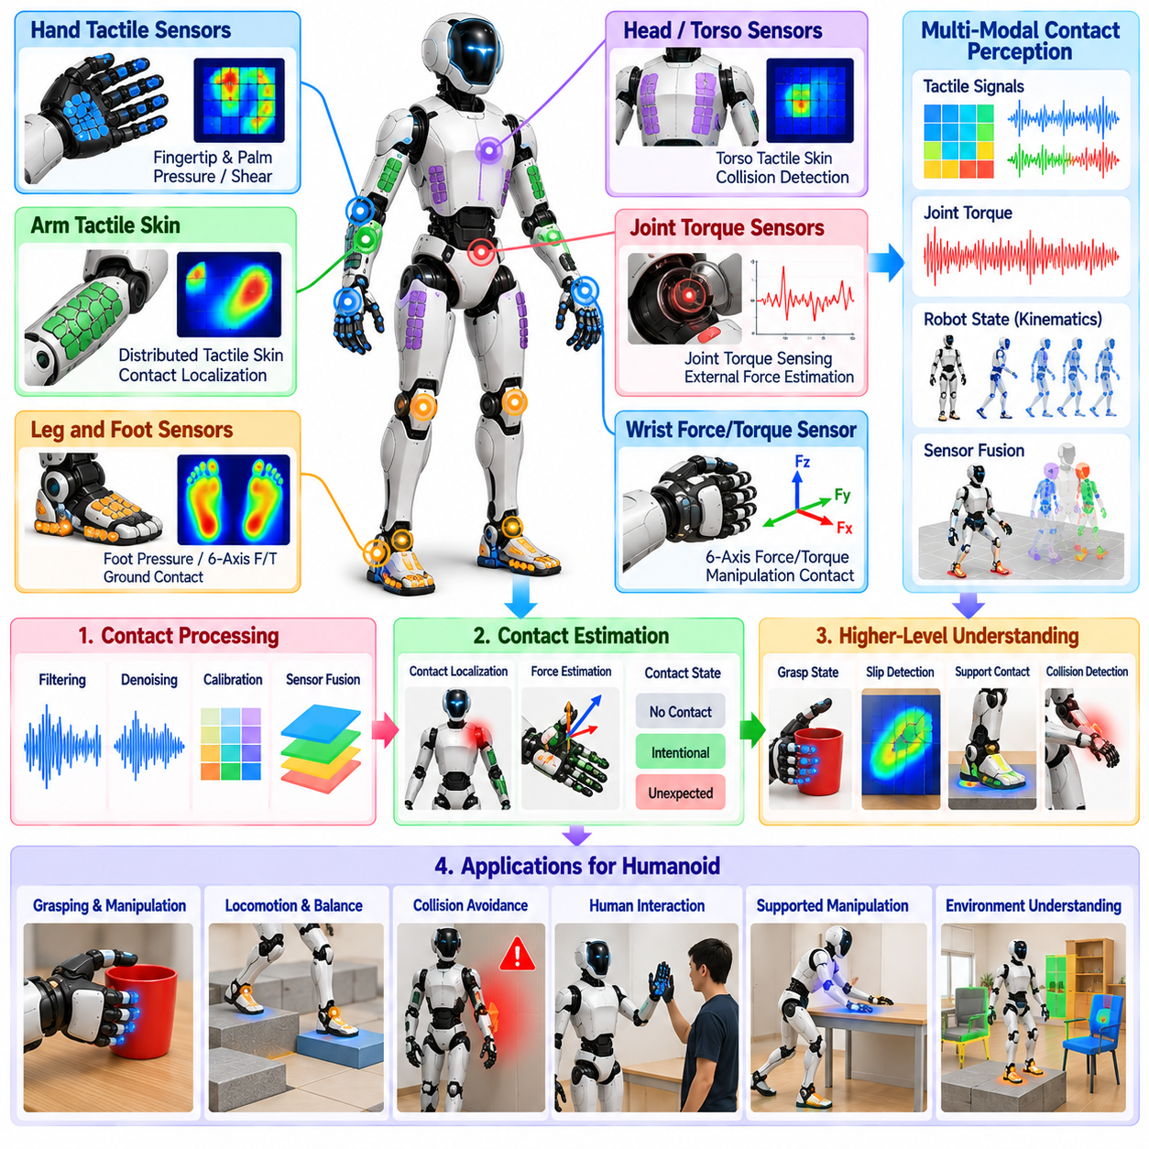
Whole-body contact and tactile perception enables a humanoid robot to sense physical interactions occurring across its hands, feet, arms, torso, and other body surfaces. Vision can predict contact before interaction, but tactile sensing provides direct evidence that physical contact has actually occurred. For humanoids operating in human environments, this capability supports grasping, balance, collision detection, compliant manipulation, physical collaboration, and safe interaction with people.
A whole-body tactile system may combine fingertip sensors, palm arrays, force-sensitive skin, joint torque sensing, six-axis force-torque sensors, pressure sensors, and foot contact measurements. These sensing modalities differ in spatial resolution, force range, bandwidth, and mechanical robustness. Their outputs must be integrated into a common contact representation so that the robot can reason consistently about interactions occurring at different body locations.
Tactile sensors mounted on the hands provide detailed information about grasp contacts. Fingertip and palm measurements can indicate whether an object has been touched, where contact occurs, how pressure is distributed, and whether the object is beginning to slip. This information complements wrist-camera perception because visual sensing becomes increasingly unreliable when fingers occlude the object during the final stages of grasping and manipulation.
Foot contact perception is essential for humanoid locomotion and balance. Pressure sensors, force-torque measurements, or distributed tactile arrays can estimate whether each foot is firmly supported and how the ground reaction force is distributed across the sole. These measurements help determine contact transitions, center of pressure, unexpected edge contact, and partial support conditions that may not be predicted accurately from kinematics alone.
Contact sensing on the arms and torso expands perception beyond planned hand and foot interactions. A humanoid may touch furniture, walls, equipment, or people with parts of its body during navigation or manipulation. Distributed tactile skin can localize these contacts and estimate their intensity. The controller can then distinguish expected support contacts from unexpected collisions and modify whole-body motion before excessive forces develop.
Joint torque sensing provides an indirect but broadly available source of contact information. External forces acting on the robot create deviations between expected and measured joint torques. By combining actuator models, dynamics, and state estimation, the system can infer that an unmodeled external interaction has occurred. Although torque-based contact localization may be less precise than tactile skin, it can provide coverage for body regions without dedicated surface sensors.
Contact localization determines where an external interaction occurs on the robot body. Distributed tactile arrays provide direct spatial measurements, while model-based approaches infer likely contact points from joint torques and robot dynamics. Accurate localization is important because the same measured force can require different responses depending on whether it acts on a fingertip, forearm, shoulder, torso, or leg.
Contact force estimation extends localization by determining the magnitude and direction of physical interaction. Normal force describes compression against a surface, while tangential components provide information about friction and potential slip. Force estimates can be expressed in local sensor frames and transformed into robot or world coordinates, allowing whole-body controllers to incorporate measured interactions directly into optimization and stability calculations.
Tactile perception should distinguish intentional contact from unexpected collision. During grasping, leaning, pushing, or supported manipulation, contact may be explicitly planned and necessary for task completion. In contrast, an unexpected impact on the torso or arm may indicate an obstacle, human interaction, or planning error. Task context, predicted contact regions, timing, force direction, and contact magnitude can help classify the interaction appropriately.
Contact state estimation converts noisy sensor measurements into stable discrete or continuous states. A controller may need to know whether a foot is in contact, a finger has established a stable grasp, or an arm is pressing against an external surface. Hysteresis, temporal filtering, confidence estimation, and sensor fusion help prevent rapid switching caused by noise near contact thresholds and provide more reliable information to downstream control systems.
Slip detection is particularly important during object manipulation. An object can begin moving relative to the fingers even when substantial normal force remains present. High-frequency tactile signals, changes in pressure distribution, shear measurements, or learned tactile features can indicate incipient slip. The hand controller can respond by adjusting grip force, finger posture, or object support before the grasp fails completely.
Tactile information also improves object property estimation. During contact, the robot can infer characteristics such as surface compliance, texture, friction, approximate stiffness, and contact geometry. These properties may be difficult to estimate reliably from vision alone. By combining visual predictions with tactile observations, the humanoid can adapt grasp force and manipulation strategy according to the actual physical behavior of the object.
Whole-body tactile perception becomes especially valuable during constrained manipulation. Tasks such as insertion, opening doors, pushing objects, operating tools, or sliding along surfaces involve sustained contact rather than isolated touch events. The robot must continuously estimate contact forces and constraints while moving. Tactile and force feedback can reveal misalignment or jamming earlier than vision and support compliant correction before large forces accumulate.
Physical human-robot interaction requires conservative interpretation of whole-body contact. A person may touch, guide, push, or accidentally collide with the humanoid. Distributed tactile sensing can identify where this interaction occurs and estimate its intensity. Combined with human tracking and task context, the robot can reduce stiffness, stop motion, yield, or interpret deliberate physical guidance while maintaining appropriate safety constraints.
Whole-body control can incorporate measured contacts as additional physical constraints or opportunities. A humanoid may deliberately place a hand against a wall for support, use a forearm to stabilize an object, or establish multiple contacts while performing a difficult task. Once these contacts are detected and validated, the controller can include their locations, force limits, friction constraints, and stability contributions within its optimization problem.
Unexpected contact should trigger rapid protective behavior before high-level perception completes complex reasoning. Fast tactile and torque monitoring can operate at control frequency and detect abnormal force changes with low latency. Depending on severity and location, the robot may reduce commanded torque, stop the affected limb, increase compliance, freeze whole-body motion, or transition to a safe posture while higher-level modules determine the cause.
Self-contact must be distinguished from external contact. During complex whole-body motion, one robot link may touch another, producing tactile or torque responses similar to environmental interaction. The robot's kinematic model and collision geometry can predict potential self-contact regions. Combining this prediction with tactile measurements helps prevent false environmental interpretations and provides useful information for detecting unintended body-body collisions.
Sensor calibration is essential because tactile measurements can drift with temperature, mechanical preload, aging, and repeated impacts. Zero offsets, sensitivity, cross-axis coupling, and spatial calibration should be characterized for each sensing element. Online bias estimation and health monitoring can compensate for gradual changes, while abnormal patterns may indicate damaged sensors, loose mounting, or degraded protective skin.
Temporal synchronization is also important when tactile perception is fused with vision, proprioception, and control state. A contact event should correspond to the robot configuration and commanded motion at the instant it occurred. Accurate timestamps allow the system to determine whether contact was expected along the planned trajectory and to associate tactile observations with visual objects or surfaces being manipulated.
Multimodal fusion combines tactile perception with cameras, depth sensors, joint states, force-torque measurements, and inertial sensing. Vision predicts where contact should occur, proprioception describes body configuration, and tactile sensing confirms the actual interaction. Disagreement between modalities can be informative: expected visual contact without tactile confirmation may indicate pose error, while unexpected tactile contact may reveal an unobserved obstacle.
Learned tactile representations can complement explicit force and contact models. Neural networks may classify slip, contact type, surface properties, or manipulation state from high-dimensional tactile arrays. Multimodal policies can combine tactile features with images and proprioception to produce actions directly. Explicit physical quantities nevertheless remain valuable for safety monitoring, whole-body optimization, diagnostics, and interpretable contact reasoning.
Real-time implementation requires tactile processing to operate across multiple time scales. Protective collision detection and force limiting require fast updates, while object property estimation or semantic interpretation can operate more slowly. Local preprocessing near sensors can reduce communication bandwidth, and asynchronous pipelines can separate high-frequency safety functions from computationally expensive learned perception without delaying critical control responses.
Reliability monitoring should detect saturated sensors, missing channels, abnormal bias, communication loss, inconsistent force estimates, and disagreement between redundant measurements. Contact estimates should carry confidence, timestamp, location, and force information so that controllers can determine how strongly to trust them. When tactile sensing becomes unreliable, the robot may reduce speed, restrict contact-rich behavior, or rely more heavily on alternative sensing.
Ultimately, whole-body contact and tactile perception transforms physical interaction into observable state information. Hands sense grasp quality, feet measure support, body surfaces detect external interaction, and force or torque sensors reveal contact dynamics. By integrating these signals with vision, proprioception, planning, and whole-body control, a humanoid can move beyond visually guided behavior toward contact-aware physical intelligence that is adaptive, compliant, and safe.

06.10. Humanoid Perception Latency Optimization [w/Code]
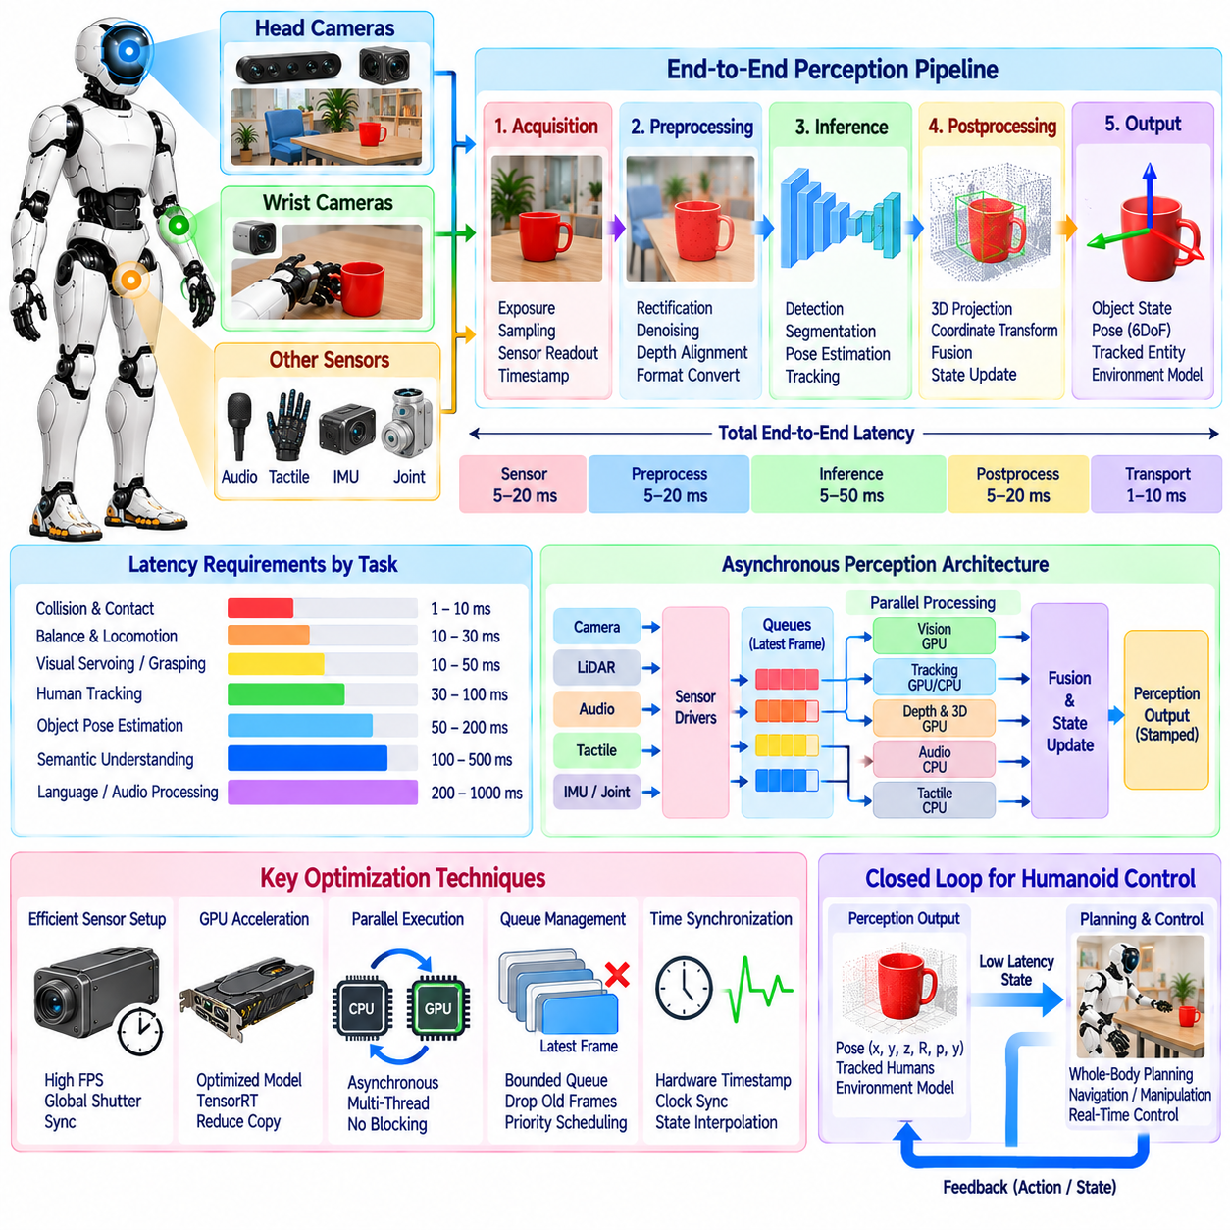
Perception latency is a fundamental systems constraint for humanoid robots because sensing is useful only when information reaches planning and control while it still represents the physical world accurately. A delayed object pose, human position, contact estimate, or terrain model can cause the robot to react to a state that no longer exists. Latency optimization therefore concerns the complete sensing-to-decision pipeline rather than only accelerating individual neural networks.
End-to-end perception latency begins when a physical event is sampled by a sensor and ends when the resulting state becomes available to a consuming module. This interval may include sensor exposure, data transfer, synchronization, preprocessing, inference, postprocessing, coordinate transformation, fusion, middleware transport, and scheduling delay. Measuring only model inference time can therefore hide substantial delays elsewhere in the perception architecture.
Humanoid systems contain perception functions with very different timing requirements. Collision detection and contact monitoring may require extremely fast responses, while semantic scene understanding or language-conditioned recognition can tolerate longer delays. Human tracking, object pose estimation, visual servoing, terrain perception, and audio processing occupy intermediate ranges. The architecture should therefore assign latency budgets according to the physical consequence of stale information.
Sensor acquisition itself contributes latency. Camera exposure time, rolling or global shutter behavior, depth reconstruction, LiDAR scanning, microphone buffering, and tactile sampling all determine when observations become available. Increasing image exposure may improve visual quality but also increase delay and motion blur sensitivity. Sensor configuration should therefore balance measurement quality, frame rate, synchronization accuracy, and response time according to the humanoid's operating speed.
Time synchronization is critical because low computational latency does not guarantee temporally correct perception. Images, depth measurements, IMU samples, joint states, tactile signals, and audio streams may arrive at different rates and with different transport delays. Each observation should carry a reliable timestamp representing its acquisition time so that fusion modules can reconstruct the robot and environment state corresponding to the actual measurement instant.
Motion makes temporal errors especially important for humanoids. A head camera may rotate rapidly, a wrist camera may move during reaching, and the floating base changes continuously during locomotion. If perception uses the latest joint state rather than the state corresponding to image exposure, spatial estimates can become systematically distorted. Buffered transforms and state interpolation allow observations to be projected using temporally aligned robot configurations.
Pipeline profiling should identify where time is actually spent before optimization begins. Instrumentation can record timestamps at sensor acquisition, host arrival, preprocessing completion, inference start and finish, postprocessing, fusion, and publication. These measurements reveal average latency, worst-case latency, jitter, queue waiting time, and dropped frames. A system optimized only for average throughput may still fail when occasional latency spikes occur during critical motion.
Throughput and latency should be treated as different quantities. A perception network capable of processing thirty frames per second does not necessarily provide a thirty-three-millisecond response if frames accumulate in a queue. When processing is slower than sensor production, queued observations become progressively older. For real-time humanoid behavior, processing the newest relevant observation is often more valuable than completing every historical frame.
Queue management is therefore an important optimization mechanism. Bounded queues, latest-frame policies, selective frame dropping, and task-dependent priorities can prevent outdated observations from consuming computational resources. Safety-critical streams may receive guaranteed processing priority, while expensive semantic modules can skip intermediate frames. The objective is to preserve temporal relevance rather than maximizing the number of processed samples.
Asynchronous execution allows independent perception components to operate without blocking one another. Camera capture, neural inference, tracking, mapping, audio processing, and tactile estimation can run in separate execution contexts connected by timestamped messages. Slow semantic reasoning should not prevent fast obstacle or contact updates. Properly designed asynchronous pipelines improve responsiveness, although they require explicit management of data age and cross-module consistency.
GPU acceleration is central to many humanoid perception workloads, but efficient utilization requires more than moving neural networks onto a GPU. Repeated host-device copies, synchronization barriers, inefficient memory allocation, small sequential kernels, and unnecessary format conversions can dominate execution time. Persistent buffers, pinned memory, device-resident preprocessing, kernel fusion, and reduced synchronization can shorten the path between sensor data and inference output.
Reduced-precision computation can further decrease inference latency and memory bandwidth requirements. Models may execute using lower-precision numerical formats when accuracy remains acceptable for the task. Quantization and optimized inference engines can improve performance on embedded accelerators, but conversion should be validated against perception quality. Small numerical errors can become significant when they affect depth, pose, keypoints, or confidence near decision thresholds.
Model architecture should be selected according to the required latency envelope rather than benchmark accuracy alone. Large perception networks may produce strong offline results but be unsuitable for high-rate onboard operation. Lightweight backbones, efficient attention mechanisms, reduced input resolution, model pruning, distillation, and task-specific networks can reduce computational cost. The appropriate model is the one that satisfies accuracy requirements within the robot's real execution constraints.
Region-of-interest processing can avoid repeatedly analyzing the entire sensor image at maximum resolution. A broad detector may first identify relevant people, objects, hands, or workspace regions, after which more expensive pose estimation or segmentation operates only on selected areas. During manipulation, wrist-camera processing can focus on the target and nearby obstacles instead of processing unrelated background content with equal computational priority.
Multi-rate perception is particularly suitable for humanoids. Fast tracking can update object or human states between slower neural detections, while local obstacle maps can refresh more frequently than global semantic maps. Tactile safety processing may operate at control-related rates, whereas open-vocabulary reasoning can execute only when requested. Separating these rates prevents the most computationally expensive perception functions from defining the timing of the entire system.
Tracking provides an effective bridge between expensive inference updates. Once an object, person, or feature has been detected, lightweight temporal estimation can propagate its state using motion models, optical flow, geometric tracking, or filtering. Periodic neural inference corrects accumulated drift. This combination can deliver high-rate state estimates without requiring the complete detection and recognition stack to execute at every sensor frame.
Prediction can compensate for unavoidable perception delay. If a human or object state was measured several milliseconds earlier, its current position can be estimated from velocity and motion history. Robot ego-motion can similarly propagate spatial observations into the present frame. Prediction does not eliminate latency and should not conceal excessive delays, but it can reduce temporal error when bounded processing and communication delays are known.
Spatial representations should also be designed for efficient updates. Rebuilding a complete three-dimensional map whenever a new depth frame arrives wastes computation. Local voxel updates, incremental point-cloud integration, rolling maps, sparse representations, and region-based invalidation allow the system to modify only affected areas. Manipulation can maintain a high-resolution local model while navigation uses a coarser representation over a larger region.
Memory bandwidth frequently becomes a hidden bottleneck in multimodal perception. High-resolution RGB images, depth maps, point clouds, feature tensors, and intermediate neural representations can generate substantial data movement. Zero-copy transport, shared-memory communication, compact representations, memory reuse, and avoiding unnecessary serialization can reduce both latency and processor load, particularly when multiple perception nodes consume the same sensor stream.
Middleware and interprocess communication should be included in latency analysis. Serialization, message copying, scheduling, network transport, and subscriber backlogs can add significant delay even when individual algorithms are fast. In a distributed humanoid architecture, timestamps and sequence identifiers should accompany messages so that downstream modules can detect stale or reordered data rather than assuming that arrival time equals acquisition time.
Scheduling must reflect perception criticality. Contact detection, human proximity estimation, collision monitoring, and state estimation should not compete equally with background mapping or semantic indexing. CPU affinity, thread priority, accelerator scheduling, and resource reservation can protect time-sensitive workloads from interference. Deterministic execution is often more valuable for control integration than achieving the highest possible average computational utilization.
Thermal and power constraints must be considered because humanoid perception operates continuously on onboard hardware. A configuration that achieves low latency briefly may throttle after sustained GPU or CPU loading. Model selection, accelerator utilization, cooling, power modes, and workload scheduling should therefore be evaluated over realistic mission durations. Stable sustained performance is more useful than peak benchmark throughput that cannot be maintained.
Latency monitoring should continue during deployment rather than remaining a development-time benchmark. Each perception output can carry acquisition time, processing completion time, confidence, and data age. Planning and control modules can reject states that exceed freshness limits or switch to conservative behavior when perception becomes delayed. Runtime diagnostics can also detect queue growth, inference slowdown, dropped sensors, or communication congestion before they cause unsafe behavior.
Validation should reproduce the timing conditions of real humanoid operation. Benchmarks should include head motion, walking vibration, simultaneous camera streams, manipulation, audio processing, mapping, and other concurrent workloads rather than testing each model in isolation. Important metrics include end-to-end latency distributions, worst-case delay, jitter, frame age, deadline misses, resource utilization, and the effect of timing on actual task success.
Ultimately, humanoid perception latency optimization is a co-design problem spanning sensors, synchronization, algorithms, compute hardware, middleware, scheduling, and control. Fast inference alone cannot guarantee responsive physical intelligence. By measuring complete data paths, prioritizing freshness, separating workloads by timing requirements, reducing unnecessary computation and data movement, and continuously monitoring runtime delay, the humanoid can maintain perception that remains synchronized with a rapidly changing physical world.

