Volume 22. Humanoid Robot Software

Chapter 02. Humanoid System Architecture

02.01. Humanoid SW Stack Overview Perception Plan Control
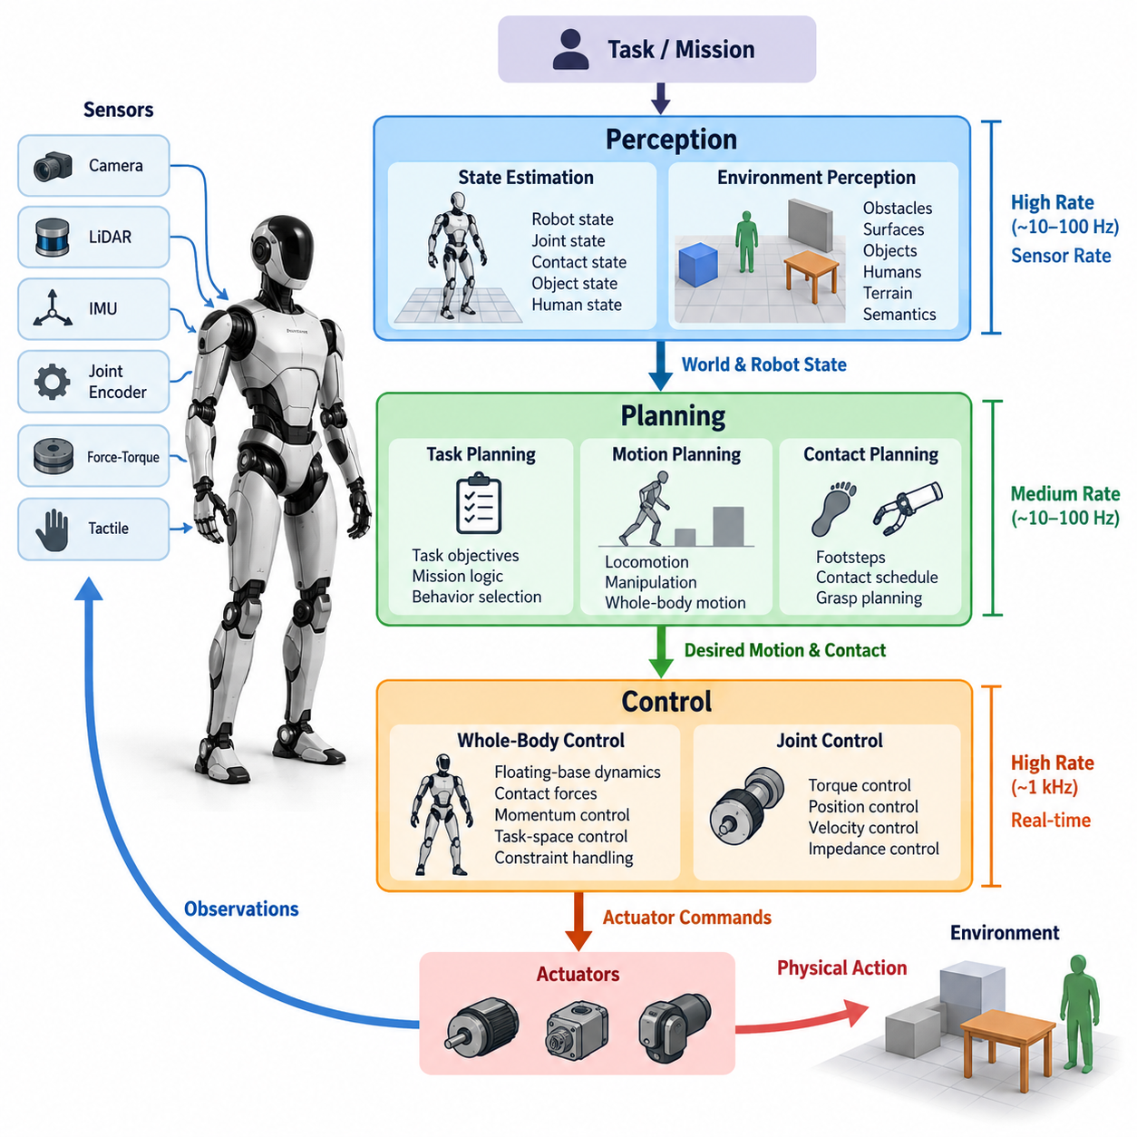
A humanoid software stack must coordinate perception, planning, and control as a continuous closed-loop system rather than as three isolated functional blocks. Perception converts heterogeneous sensor observations into estimates of the robot, objects, humans, contacts, and surrounding geometry. Planning transforms these estimates and task objectives into feasible behaviors, while control converts planned motion into stable actuator commands under strict physical constraints. Volume_22_Humanoid_Robot_Softwa…
The stack is inherently hierarchical because different functions operate at radically different temporal scales. High-level task reasoning may update only when the environment or mission changes, motion planning may operate at tens of hertz, perception pipelines may process sensor streams at camera or LiDAR frame rates, and low-level whole-body control can require deterministic execution near 1 kHz. The architecture must therefore preserve coherent state information while allowing each layer to run at an appropriate frequency.
Perception begins with synchronized observations from cameras, IMUs, joint encoders, force-torque sensors, tactile devices, and other proprioceptive or exteroceptive sensors. Raw measurements are transformed into representations such as floating-base state, joint configuration, contact state, object pose, human pose, free space, terrain geometry, and semantic scene information. Humanoid perception is particularly demanding because sensing occurs from a continuously moving articulated body rather than a mechanically stable sensor platform.
State estimation forms the critical bridge between sensing and physical control. The controller cannot directly rely on noisy individual sensor measurements, especially during walking, impacts, manipulation, or temporary visual degradation. Instead, inertial measurements, kinematics, contact information, and environmental observations are fused into a dynamically consistent estimate of the robot state. This estimated state becomes the common physical reference used by locomotion, balance, manipulation, and safety functions.
Environmental perception provides a second representation describing what exists around the robot and how it relates to possible actions. Visual and geometric pipelines identify obstacles, surfaces, humans, manipulable objects, stairs, support regions, and interaction targets. Semantic perception can further classify functional properties such as whether an object can be grasped or a surface can support a foot, allowing planning to operate on actionable representations rather than only raw geometry.
Planning occupies the intermediate layer between interpreted world state and executable physical motion. A task planner determines what the humanoid should accomplish, while behavior and motion planners determine how the objective can be achieved through navigation, locomotion, reaching, grasping, manipulation, or coordinated whole-body actions. This hierarchy prevents symbolic task reasoning from being directly coupled to individual joints and allows the same task representation to be executed through different physical strategies.
For humanoids, motion planning must consider the entire articulated body. A seemingly simple command such as reaching for an object can require repositioning the feet, shifting the center of mass, rotating the torso, moving both arms, preserving visibility, and maintaining collision-free configurations. Planning therefore operates under kinematic reachability, joint limits, self-collision constraints, environmental obstacles, contact feasibility, balance requirements, and actuator capability simultaneously.
Locomotion planning introduces additional contact decisions. The software must determine where and when feet should contact the environment and generate dynamically feasible body motion between those contacts. Footstep plans, center-of-mass references, swing trajectories, contact schedules, and balance objectives become interconnected components of the motion representation. These outputs provide structured references that downstream controllers can track while responding to disturbances and estimation errors.
Manipulation adds another planning pathway in which object pose, grasp configuration, arm trajectory, hand state, and expected contact forces must be coordinated. In humanoids, manipulation cannot always be separated from locomotion because the body may need to move to extend workspace or compensate for reaction forces. Consequently, advanced systems increasingly represent locomotion and manipulation as coupled whole-body behaviors rather than independent arm and leg subsystems.
The control layer converts these desired behaviors into physically realizable commands. Whole-body control coordinates floating-base dynamics, joint motion, contact forces, momentum, and task-space objectives while respecting torque, friction, contact, and joint constraints. Lower-level joint controllers then regulate torque, position, velocity, or impedance depending on actuator architecture. This layered arrangement allows high-level software to express physical objectives without directly managing motor-level dynamics.
Real-time execution creates an important architectural boundary. Computationally expensive perception and AI inference may execute asynchronously on GPU or NPU resources, whereas balance and actuator control cannot wait for variable-latency inference. The system therefore needs explicit interfaces between best-effort AI computation and deterministic control computation. Timestamping, buffering, shared state representations, bounded communication latency, and graceful handling of stale information are fundamental architectural requirements.
Communication between perception, planning, and control should preserve semantic meaning as well as timing. Instead of exposing every internal variable globally, modules exchange well-defined representations such as estimated robot state, tracked objects, contact plans, trajectories, task commands, and controller status. Middleware such as ROS 2 can support modular communication, while latency-sensitive control paths may require optimized inter-process communication or shared memory mechanisms. The broader volume explicitly separates ROS 2 node architecture and shared-memory IPC as subsequent architectural topics. Volume_22_Humanoid_Robot_Softwa…
Feedback closes the architecture. Control actions alter robot posture and environmental contact, producing new sensor observations that modify the estimated state and potentially invalidate previous plans. Perception therefore continuously updates planning, while controllers report tracking quality, contact changes, saturation, instability, and faults upstream. Planning must respond by adjusting trajectories, selecting another behavior, or requesting recovery instead of assuming that previously generated motion will remain valid.
Safety must cross all three layers rather than exist as a final software wrapper. Perception contributes obstacle, human, contact, and anomaly information; planning rejects unsafe or infeasible behaviors; control enforces physical limits and stability constraints. Independent monitoring can override nominal commands when necessary. Such separation is especially important for learned policies and AI-generated actions because semantic plausibility does not guarantee dynamic feasibility or safe physical execution.
A production humanoid therefore benefits from separating intelligence according to responsibility while maintaining a shared representation of robot and world state. Perception answers what the robot currently observes and estimates, planning determines what physical behavior should occur next, and control determines how that behavior can be executed within dynamics and contact constraints. Diagnostics and health monitoring surround these functional paths so degraded sensors, computation, networks, or actuators can be detected before they propagate into unsafe motion.
This architecture also provides a natural integration point for learning-based components. Neural perception models can replace or augment conventional detectors, learned locomotion policies can propose actions, and vision-language-action systems can generate task-conditioned behaviors. However, learned modules should still interact through explicit state, command, constraint, and safety interfaces. This permits AI capability to evolve without requiring the deterministic control and hardware layers to be redesigned whenever a model changes.
The resulting humanoid software stack is best understood as a multi-rate closed-loop hierarchy: sensors feed perception and state estimation; interpreted state feeds task and motion planning; plans become whole-body references; controllers generate actuator commands; and physical execution returns new observations. Around this loop, synchronization, communication, diagnostics, safety, and computation management provide the infrastructure required for reliable operation. This framing also prepares the chapter progression toward real-time control computers, AI inference hardware, sensor integration, actuator networks, ROS 2, IPC, OTA, diagnostics, and system-level integration testing. Volume_22_Humanoid_Robot_Softwa…

02.02. Real Time Control Computer Architecture 1kHz [w/Code]
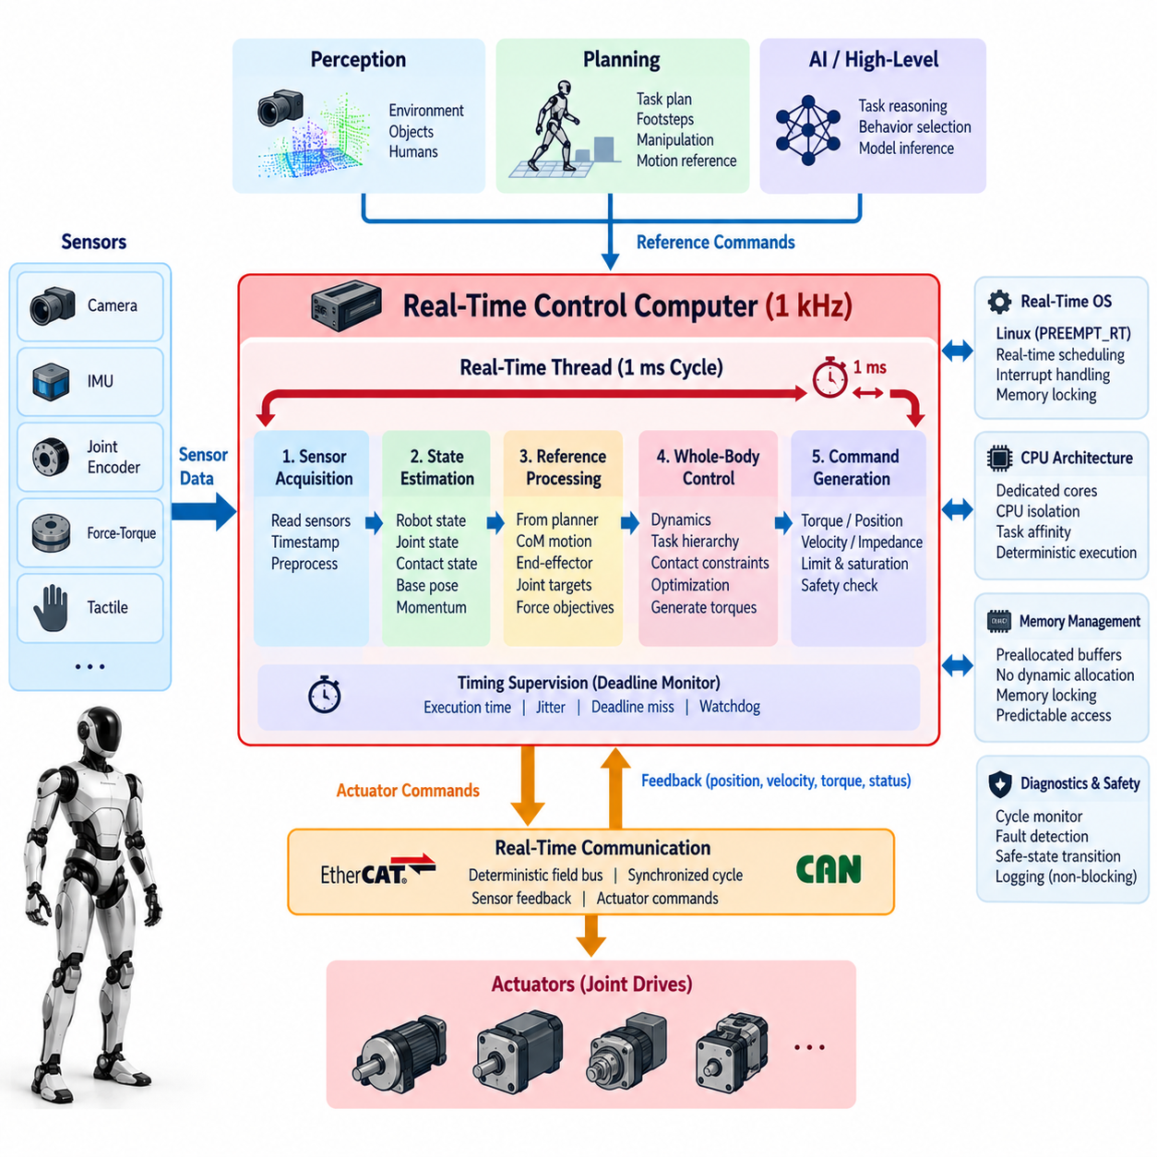
A real-time control computer is the deterministic computational core of a humanoid robot, responsible for executing balance, whole-body control, joint coordination, and actuator commands within strictly bounded timing constraints. A nominal 1 kHz control frequency provides a 1 ms cycle in which sensor acquisition, state updates, control computation, command transmission, and timing supervision must be completed. This requirement distinguishes the control computer from higher-level AI and perception computers.
The 1 kHz cycle should be understood as a real-time deadline rather than merely an average execution frequency. Completing one thousand iterations per second is insufficient if individual cycles occasionally exceed the 1 ms budget. Excessive jitter or deadline misses can introduce delayed feedback, inconsistent actuator commands, and degraded stability. The architecture must therefore optimize worst-case execution time, scheduling predictability, interrupt behavior, memory access, and communication latency rather than only maximizing computational throughput.
A typical control cycle begins by acquiring the newest joint encoder, motor, IMU, force-torque, and contact measurements. These observations are timestamped and converted into a consistent robot state before control calculations begin. State estimation then updates quantities such as floating-base pose, velocity, joint states, contact conditions, and body momentum. The controller uses this synchronized state snapshot rather than independently reading sensors at arbitrary points during its computation.
After state acquisition, the control pipeline evaluates reference commands supplied by locomotion, manipulation, or motion-planning components. Desired center-of-mass motion, body orientation, foot contacts, end-effector poses, joint references, and force objectives can enter the real-time domain through controlled interfaces. References produced asynchronously should be buffered so the 1 kHz thread never blocks while waiting for a planner, perception model, network service, or AI inference process.
Whole-body control is commonly one of the most computationally demanding operations inside the real-time loop. It may evaluate rigid-body dynamics, Jacobians, contact constraints, momentum objectives, task hierarchies, and optimization problems before generating desired joint torques or accelerations. The computation must remain bounded even when the robot changes contact configurations, performs bimanual manipulation, or transitions between standing and locomotion, because control complexity cannot be allowed to produce unpredictable cycle overruns.
The actuator command stage transforms controller outputs into representations accepted by the joint drives. Depending on the humanoid platform, these can include desired torque, position, velocity, impedance parameters, or combinations of them. Commands must be checked against joint position, velocity, torque, thermal, and power constraints before transmission. Saturation should be explicitly managed because uncontrolled clipping can invalidate assumptions made by the whole-body controller and create unexpected dynamic responses.
Real-time communication is therefore part of the control architecture rather than an external networking problem. Deterministic field buses such as EtherCAT can connect the control computer to distributed servo drives, while CAN-based networks may serve lower-bandwidth devices or auxiliary subsystems. Communication scheduling must ensure that sensor feedback arrives early enough for computation and that actuator commands reach drives before the next servo update, making network cycle design inseparable from the 1 kHz computational schedule.
The operating system must provide predictable scheduling behavior for the critical control thread. A real-time Linux configuration, commonly using PREEMPT_RT or equivalent mechanisms, can reduce scheduling and interrupt latency while preserving the flexibility of a general-purpose operating environment. Critical threads should use appropriate real-time priorities, and noncritical processes such as logging, visualization, model loading, file operations, or network services must not preempt time-sensitive control execution.
CPU architecture and task allocation also influence determinism. Dedicated processor cores can be reserved for control, communication, and selected real-time support functions, reducing interference from unrelated workloads. CPU affinity, interrupt affinity, and isolation mechanisms can prevent scheduler migration and excessive interrupt handling on critical cores. The objective is not necessarily to maximize processor utilization but to maintain sufficient timing margin under the worst operating conditions expected on the robot.
Dynamic memory allocation should be minimized or eliminated inside hard real-time paths because allocation, deallocation, paging, and unpredictable memory-management behavior can introduce latency variation. Control data structures can instead be preallocated during initialization, while memory locking prevents critical pages from being swapped. Fixed-size buffers, bounded queues, and predictable data structures make execution behavior easier to analyze and reduce hidden sources of jitter during long-duration operation.
Synchronization between threads requires similar discipline. Conventional mutex usage can create priority inversion or unbounded waiting when poorly designed. Real-time architectures therefore favor short bounded critical sections, lock-free or wait-free data exchange where appropriate, double buffering, and single-producer/single-consumer queues. The control thread should normally consume the newest valid data without waiting for slower producers, preserving deterministic execution even when another subsystem temporarily becomes overloaded.
The boundary between the real-time computer and the AI inference computer is particularly important in modern humanoids. GPU- or NPU-based perception, VLA models, learned policies, and semantic reasoning can provide valuable commands, but their execution time may vary substantially. Such outputs should therefore be treated as asynchronous references or policy updates. A delayed AI result must never stall the balance controller; the real-time layer should continue using the last valid reference, a safe fallback behavior, or a controlled transition.
Multi-rate execution further improves computational organization. Not every algorithm needs to run at 1 kHz simply because the actuator controller does. Joint servo and whole-body stabilization may execute at the highest rate, while state-estimation components, trajectory updates, diagnostics, thermal management, and supervisory functions can operate at lower frequencies. Explicit rate separation prevents unnecessary computation from consuming the critical 1 ms budget while preserving coherent data exchange between fast and slow loops.
Timing instrumentation must be integrated into the software rather than added only during debugging. Each control cycle can record wake-up latency, sensor acquisition time, estimator duration, controller computation time, communication duration, total cycle time, and deadline status. Statistical averages are useful, but maximum latency, high-percentile execution time, jitter distribution, and consecutive deadline misses are more important when evaluating whether the system can safely sustain real-time operation.
Watchdog mechanisms provide another layer of protection. A hardware or independent software watchdog can detect stalled control execution, missed communication cycles, corrupted state updates, or repeated deadline violations. Depending on severity, the response may hold the previous command briefly, transition toward a stable posture, reduce actuator authority, disable selected joints, or initiate an emergency stop. The response strategy must itself be deterministic because failure handling occurs when normal computational assumptions may already be compromised.
Startup and shutdown also require explicit real-time state management. The system should not immediately enable full actuator torque when software processes begin running. Initialization normally verifies communication, sensor validity, time synchronization, robot configuration, actuator state, and controller readiness before entering active control. Shutdown follows a controlled sequence that reduces commands and places the robot into a defined safe state rather than abruptly terminating the process while actuators remain energized.
A practical humanoid architecture consequently separates computational domains according to criticality. The real-time control computer owns the deterministic path from synchronized robot state to actuator commands, while higher-level computers handle perception, planning, learning, visualization, and semantic reasoning. Communication between these domains occurs through bounded and explicitly defined interfaces. This separation limits the ability of computationally variable workloads to disturb physical stabilization while allowing sophisticated AI functionality to evolve independently.
Validation of the 1 kHz architecture must ultimately measure behavior under realistic worst-case loading rather than demonstrating an unloaded loop on a development computer. Tests should combine actuator communication, state estimation, whole-body computation, logging, network traffic, sensor interrupts, and background processes while recording deadline performance. Long-duration stress testing is especially valuable because thermal throttling, resource contention, memory behavior, and rare scheduling events may reveal timing failures that short laboratory demonstrations do not expose.
The resulting real-time architecture is therefore defined less by raw processor performance than by bounded latency, deterministic communication, controlled resource ownership, and predictable failure behavior. A successful 1 kHz humanoid control computer repeatedly completes sensing, estimation, whole-body computation, safety checking, and actuator output within its 1 ms deadline while maintaining sufficient timing margin. This deterministic foundation allows slower perception, planning, and AI layers to command an agile humanoid without directly compromising its physical stability.

02.03. AI Inference Computer Architecture GPU NPU [w/Code]
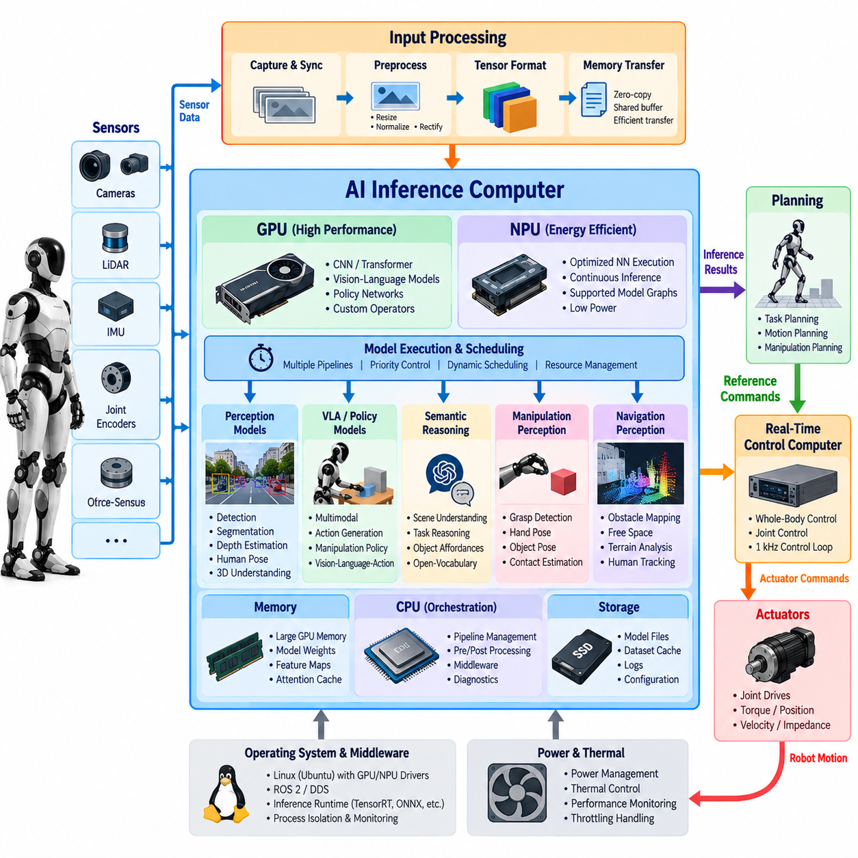
An AI inference computer provides the high-throughput computational domain required for perception, learned policies, vision-language-action models, semantic reasoning, and other neural workloads in a humanoid robot. Unlike the real-time control computer, its primary objective is not deterministic 1 kHz execution but efficient processing of large tensor operations under bounded application-level latency. GPU and NPU accelerators therefore complement, rather than replace, the deterministic control processor.
The architecture should separate AI computation according to workload characteristics. GPUs provide highly programmable parallel computation and are well suited to convolutional networks, transformers, vision encoders, multimodal models, policy networks, and custom CUDA-style operators. NPUs emphasize energy-efficient execution of supported neural-network operations and can handle continuously running inference workloads when model graphs, numerical precision, and operator sets are compatible with the accelerator.
Humanoid perception generates particularly demanding AI workloads because multiple cameras and other sensors continuously observe a dynamic environment while the robot itself moves. Object detection, segmentation, depth estimation, human pose estimation, visual tracking, open-vocabulary recognition, and 3D scene understanding may operate simultaneously. The inference computer must therefore support concurrent pipelines rather than being sized according to the peak performance requirement of only one neural network.
Input processing begins before the neural network itself executes. Camera frames may require capture, synchronization, color conversion, resizing, normalization, rectification, cropping, or tensor formatting. Efficient architectures minimize unnecessary copies while moving data from sensor interfaces into accelerator-accessible memory. Hardware-assisted image processing and zero-copy or shared-buffer mechanisms can reduce CPU utilization and memory bandwidth consumption, which becomes increasingly important as the number and resolution of cameras increase.
GPU memory capacity is as important as raw compute throughput. Model weights, intermediate activations, image tensors, attention caches, feature maps, and temporary execution workspaces compete for accelerator memory. Large multimodal or VLA models can consume substantially more memory than conventional perception networks. The system must therefore estimate simultaneous memory demand rather than assuming that every model can independently use the full GPU capacity available during isolated benchmarking.
Model execution can be organized as multiple services or inference pipelines with different priorities and update rates. A fast obstacle or human detector may require frequent execution, while semantic scene interpretation can tolerate slower updates. Manipulation perception may become high priority when the hands approach an object, whereas navigation-related processing may dominate during locomotion. Dynamic scheduling allows limited accelerator resources to follow the robot's current operational context instead of executing every model continuously at maximum frequency.
Latency must be considered end to end. A neural network that reports a 10 ms inference time may still produce much older information if sensor capture, preprocessing, queuing, memory transfer, postprocessing, and inter-process communication add substantial delay. Each inference result should therefore retain the timestamp associated with its source observation. Downstream planning and control components can then determine whether an AI result is sufficiently recent for the physical decision being made.
Asynchronous execution is fundamental because AI latency is normally variable. GPU kernels, memory transfers, concurrent models, thermal conditions, and input-dependent processing can change completion time from one cycle to another. The real-time control domain should never block while waiting for an inference result. Instead, the AI computer publishes the newest valid state, detection, trajectory proposal, or policy output through a bounded interface, and the control system independently decides whether that information remains usable.
A humanoid can employ GPU and NPU resources together rather than treating them as mutually exclusive alternatives. Stable, frequently executed networks can be deployed to an NPU when supported efficiently, while a GPU handles larger transformers, rapidly changing research models, or operations requiring greater programmability. CPU cores remain important for orchestration, preprocessing, postprocessing, middleware, diagnostics, and algorithms that do not map efficiently onto neural accelerators.
Numerical precision strongly affects deployment efficiency. Training commonly uses floating-point representations with relatively high precision, whereas inference can employ FP16, BF16, INT8, or other reduced-precision formats when model accuracy permits. Quantization can reduce memory footprint, memory bandwidth, power consumption, and inference latency, but it should be validated against task-level performance. Small numerical changes can become physically significant when predictions influence grasping, contact, or locomotion decisions.
Optimization engines can transform trained models into accelerator-specific execution graphs by fusing operators, selecting efficient kernels, managing memory, and exploiting reduced precision. However, optimization should preserve a reproducible relationship between the original model and the deployed artifact. Model version, runtime version, accelerator target, precision configuration, calibration data, and performance results should be tracked so that inference behavior can be reproduced during debugging and regression testing.
Vision-language-action models introduce a different computational profile from conventional perception networks. They may combine visual encoders, language processing, multimodal attention, and action generation within one inference pipeline. Their execution frequency can be much lower than the servo frequency while still influencing complex robot behavior. The architectural challenge is therefore to transform relatively slow semantic or action-level predictions into references that can be safely consumed by faster motion and control layers.
Learned locomotion and manipulation policies can require tighter latency than high-level semantic models. A policy may consume proprioceptive state, visual features, commands, or histories and generate joint-level or task-space actions. When such policies operate near the physical control boundary, the architecture must establish explicit maximum age, timeout, and fallback conditions. A policy output that arrives too late should be rejected rather than blindly executed after the physical state has changed.
Data exchange between the AI and real-time computers should use clearly defined representations. Perception may publish object poses, human tracks, terrain features, semantic maps, or latent features, while learned policies may publish desired velocities, poses, trajectories, or action references. Large raw tensors should cross computer boundaries only when necessary because repeated copying consumes bandwidth and increases latency. Interfaces should expose the minimum information required by downstream functions.
The inference computer must also manage failure independently of the control computer. A GPU process can crash, an NPU runtime can reject a model, memory can become exhausted, or inference latency can exceed acceptable limits. Such events should degrade AI capability without immediately destroying physical stability. Health monitoring should report accelerator availability, model status, memory utilization, inference latency, dropped frames, and stale outputs so supervisory software can select fallback functionality.
Thermal and electrical constraints are particularly important for onboard humanoid computing. Accelerators capable of high AI throughput can consume substantial power and generate concentrated heat inside a compact moving platform. Sustained inference performance may therefore differ from short benchmark results if thermal limits cause frequency throttling. Compute selection must consider performance per watt, cooling capacity, battery endurance, enclosure airflow, ambient temperature, and simultaneous loading from other electrical subsystems.
Power modes can be adapted to robot activity. Maximum accelerator performance may be justified during visually demanding manipulation or complex autonomous operation, while reduced-power modes can be used during standby, teleoperation, or simple repetitive tasks. Models can also be selectively activated according to context. Such strategies treat AI computation as a managed robotic resource rather than an accelerator that permanently operates at maximum utilization.
Software isolation improves maintainability because perception, VLA, and learned-policy components evolve much faster than low-level control software. Containerized or otherwise isolated inference services can maintain separate runtime dependencies while communicating through stable interfaces. Model updates can then be validated and deployed without rebuilding the deterministic controller. This separation also simplifies rollback when a new model produces unacceptable latency, memory usage, or behavioral regression.
The architecture should support observability at both model and system levels. Useful measurements include preprocessing time, queue delay, accelerator execution time, postprocessing time, end-to-end latency, memory consumption, accelerator utilization, temperature, power state, and output age. These measurements reveal whether poor robot behavior originates from model accuracy, scheduling contention, data movement, thermal throttling, or communication rather than from the neural network alone.
A production humanoid therefore benefits from a heterogeneous computing architecture in which CPU, GPU, and NPU resources have distinct responsibilities. The CPU coordinates software and data flow, the GPU provides flexible high-performance parallel inference, and the NPU provides efficient execution for suitable neural workloads. The deterministic real-time computer remains responsible for physical stabilization and actuator control, preserving a clear safety and timing boundary between probabilistic AI computation and robot dynamics.
The resulting AI inference architecture is not defined solely by tera-operations per second or benchmark throughput. Its effectiveness depends on whether multiple models can execute concurrently within memory, latency, power, and thermal budgets while delivering timestamped outputs to downstream systems. A well-designed GPU/NPU architecture allows perception and learned intelligence to scale in capability without allowing variable AI workloads to compromise the deterministic control foundation of the humanoid platform.

02.04. Sensor Integration Architecture Camera IMU F T [w/Code]
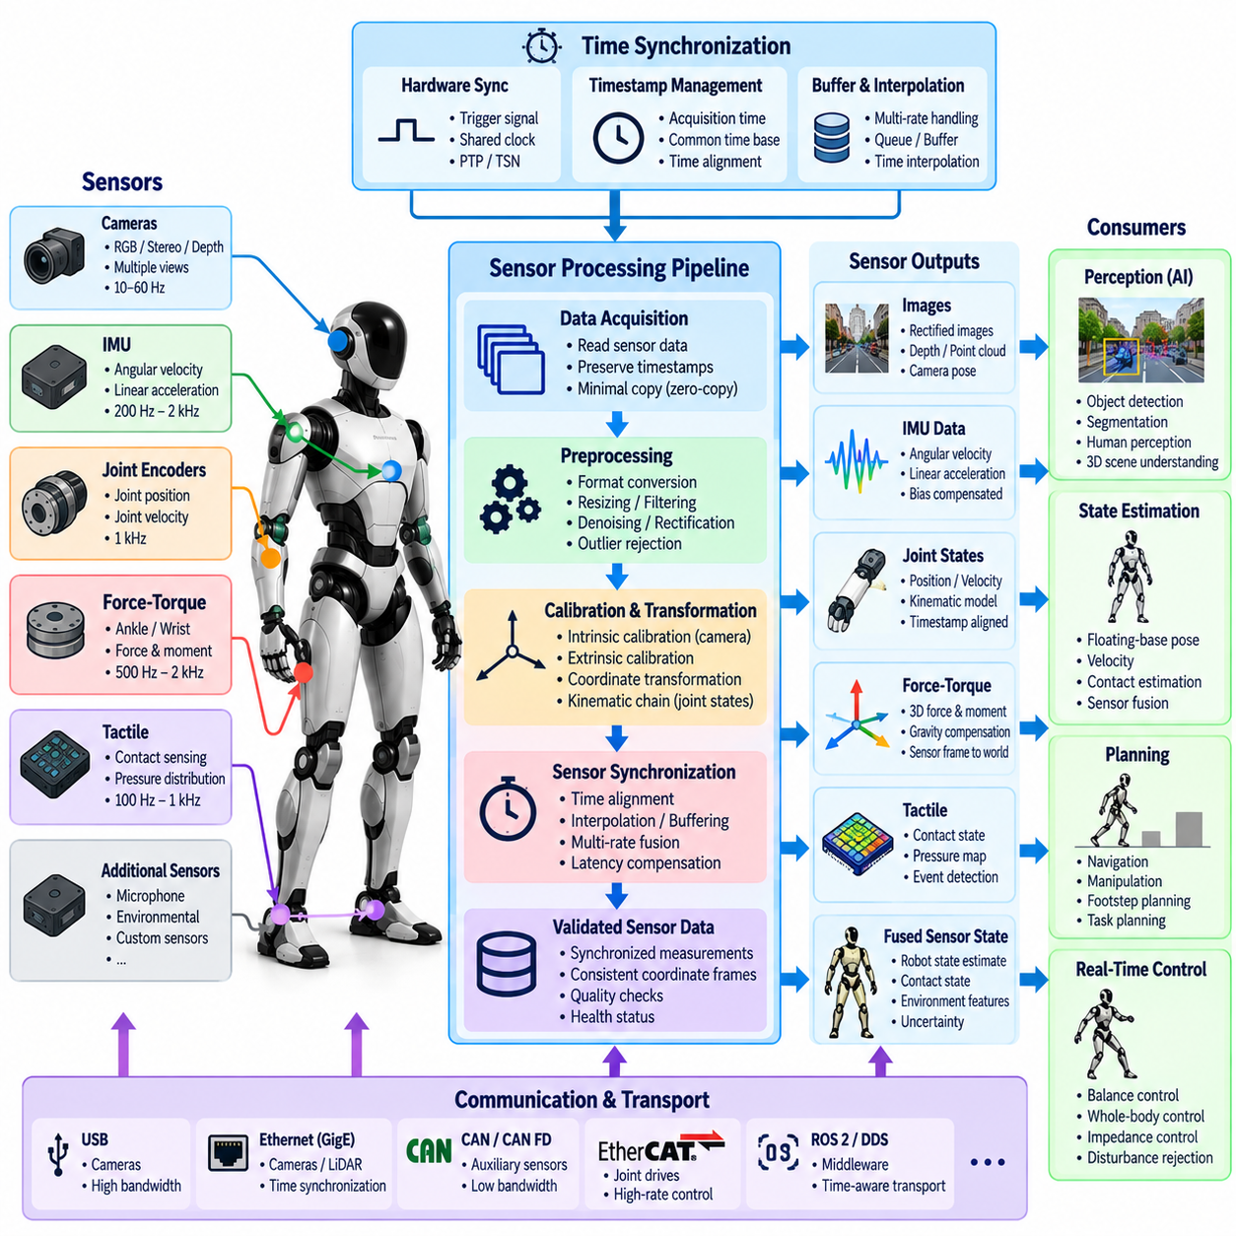
Sensor integration in a humanoid robot must transform heterogeneous measurements from cameras, inertial measurement units, force-torque sensors, joint encoders, and contact devices into a temporally and spatially coherent representation of the robot and its environment. The challenge is not simply connecting sensors to a computer. Each sensing modality has different sampling rates, latency, noise characteristics, coordinate frames, bandwidth requirements, and failure modes that must be managed systematically.
Cameras provide rich exteroceptive information for object recognition, human perception, navigation, manipulation, and scene understanding. A humanoid may distribute cameras across the head, wrists, torso, or other body locations, creating multiple viewpoints that continuously move with the articulated body. Integration therefore requires accurate intrinsic calibration, lens distortion correction, extrinsic calibration, timestamp management, and knowledge of the kinematic relationship between each camera and the robot body.
Camera interfaces must also accommodate substantial data bandwidth. Multiple high-resolution RGB, stereo, depth, or global-shutter cameras can generate large continuous streams that compete for USB, Ethernet, PCIe, and memory resources. The architecture should minimize unnecessary frame copies and preserve acquisition timestamps through preprocessing and inference. Dropping or delaying frames without explicit accounting can cause perception algorithms to associate visual observations with an incorrect robot configuration.
The inertial measurement unit provides high-rate measurements of angular velocity and linear acceleration and is fundamental to estimating floating-base motion. Because a humanoid has no fixed base while walking, its controller requires continuous information about body orientation and motion. IMU measurements are commonly fused with joint kinematics, contact information, and other observations to estimate base pose and velocity even when visual information is temporarily unavailable or delayed.
IMU integration requires careful treatment of bias, noise, scale factors, mounting orientation, vibration, and temperature-dependent behavior. The physical mounting location should be rigidly related to the robot frame, and its transformation must be represented accurately in the kinematic model. High-frequency vibration from actuators, foot impacts, or structural resonance can contaminate inertial measurements, making mechanical mounting and filtering decisions part of the sensing architecture rather than merely software concerns.
Force-torque sensors provide direct information about physical interaction. Sensors mounted at the ankles can measure ground reaction forces and moments, while wrist sensors can measure forces generated during grasping, pushing, carrying, assembly, or tool use. These measurements are essential for contact detection, balance control, impedance control, manipulation, and estimation of external disturbances because they reveal interaction quantities that cannot be reliably inferred from vision alone.
Force-torque integration requires calibration of sensor offsets, coordinate orientation, payload effects, and temperature drift. A wrist sensor, for example, measures not only external contact but also forces caused by the mass and acceleration of the hand, gripper, or carried object. Software may therefore compensate for gravity and known inertial effects before interpreting the remaining wrench as environmental interaction. Similar care is required when ankle sensors are used to estimate center of pressure or contact stability.
Joint encoders complement these sensors by providing the articulated configuration needed to transform measurements between coordinate frames. Camera poses depend on head, torso, arm, and wrist joint states, while force measurements must often be transformed from local sensor frames into foot, hand, body, or world frames. Accurate joint timestamps are therefore important because even a precisely calibrated transformation becomes incorrect when evaluated using a joint configuration from the wrong instant.
Time synchronization is one of the central requirements of sensor integration. A camera operating at tens of frames per second, an IMU at hundreds or thousands of samples per second, and force-torque sensors at high control rates do not naturally produce measurements at identical times. The system must preserve precise acquisition timestamps and establish a common time base so estimation algorithms can interpolate, buffer, or associate measurements according to when physical events actually occurred.
Hardware synchronization is preferable when tight temporal alignment is required. Trigger signals can coordinate camera exposures, while shared clocks, precision time synchronization, or hardware timestamping can align distributed sensor interfaces. Software timestamps applied after data has passed through operating-system queues or communication stacks may represent arrival time rather than acquisition time. This distinction becomes significant during rapid head motion, foot impact, or fast manipulation.
Spatial synchronization is equally important. Every sensor measurement exists in a coordinate frame, and the architecture must maintain explicit transformations among camera, IMU, wrist, foot, torso, base, and world frames. Static transformations describe rigidly mounted sensors, whereas articulated transformations depend on current joint states. A consistent transformation tree allows perception and control algorithms to interpret measurements without embedding duplicated frame assumptions throughout the software.
Calibration should therefore be treated as managed system data. Camera intrinsics, camera-to-body extrinsics, IMU orientation, force-torque sensor transforms, encoder offsets, and related parameters should be versioned with the robot configuration. Replacing a camera, changing a mounting bracket, servicing a joint, or modifying a wrist assembly can invalidate previous calibration. The software should associate calibration parameters with the physical hardware configuration rather than treating them as permanent constants.
Sensor data should enter the software stack through well-defined acquisition components that separate hardware-specific drivers from higher-level estimation and perception. Drivers manage device communication, timestamps, configuration, and basic health information, while downstream modules consume standardized messages or shared-memory representations. This separation allows a sensor model or interface to change without requiring every perception and control algorithm to be rewritten.
Different data paths require different communication strategies. Large camera images benefit from shared memory, zero-copy transport, or accelerator-accessible buffers because repeated serialization and copying can consume substantial bandwidth. Compact IMU, encoder, and force-torque messages can be transmitted at high frequency with relatively small payloads, but their timing requirements may be stricter. Communication architecture should therefore be selected according to both data size and temporal criticality.
The real-time control domain should receive only the sensor information necessary for deterministic physical control. Joint states, inertial measurements, contact estimates, and force-torque data may participate directly in fast state estimation and stabilization. Large images and computationally intensive visual processing are better handled by the perception or AI computer. Derived visual information can then cross into planning or control through bounded interfaces without placing camera processing inside the 1 kHz servo loop.
Sensor fusion combines complementary strengths rather than merely averaging measurements. IMU data provides fast motion information but accumulates drift, kinematic estimates depend on model and contact assumptions, cameras provide environmental references but have higher latency, and force sensors reveal physical contact but only at specific locations. Fusion algorithms exploit these differences to construct a state estimate that remains useful when any individual modality becomes noisy, delayed, occluded, or temporarily unavailable.
Contact events deserve special treatment because they couple sensing directly to humanoid dynamics. Foot touchdown can be inferred from force measurements, kinematics, IMU response, or combinations of these signals. Incorrect contact classification can corrupt floating-base estimation and destabilize balance control. The architecture should therefore represent contact state together with confidence, timing, and sensor validity rather than exposing a single unqualified binary signal.
Health monitoring must accompany every sensor stream. The system should detect missing frames, stale timestamps, excessive latency, communication errors, saturation, implausible values, calibration inconsistencies, and abnormal noise. A sensor that continues transmitting data is not necessarily healthy. Explicit validity and quality information allows estimation and control components to reduce reliance on degraded measurements instead of silently treating them as trustworthy.
Failure handling should be designed according to sensor criticality. Loss of one redundant camera may reduce perception coverage while permitting continued operation, whereas loss of the primary IMU or critical joint feedback can directly threaten stabilization. The supervisory system should distinguish recoverable degradation from conditions requiring restricted motion, transition to a safe posture, or emergency stopping. Redundancy is valuable only when failures can be detected and isolated reliably.
Diagnostics and recording are also integral to integration architecture. Raw measurements, timestamps, synchronization status, calibration identifiers, transformed data, and selected fused states should be recordable for offline analysis. When a humanoid loses balance or fails a manipulation task, reconstructing the temporal relationship among camera frames, inertial motion, contact forces, and controller states is essential for determining whether the root cause originated in sensing, estimation, communication, or control.
A robust sensor architecture therefore establishes a disciplined path from physical measurement to synchronized robot state. Cameras describe the external world, the IMU captures rapid body motion, force-torque sensors reveal interaction, and joint encoders define the articulated geometry connecting these measurements. Accurate calibration, common timing, explicit coordinate frames, efficient data transport, health monitoring, and controlled failure behavior allow these heterogeneous signals to function as one coherent sensing system.
The resulting architecture provides the foundation required by every higher humanoid capability. Stable locomotion depends on synchronized inertial, kinematic, and contact sensing; manipulation depends on calibrated vision and interaction forces; perception depends on accurate camera poses; and whole-body control depends on trustworthy state estimates. Sensor integration is therefore not a peripheral hardware task but a central system architecture that connects the physical humanoid body to perception, planning, AI inference, and deterministic control.

02.05. Actuator Network EtherCAT CAN Topology [w/Code]
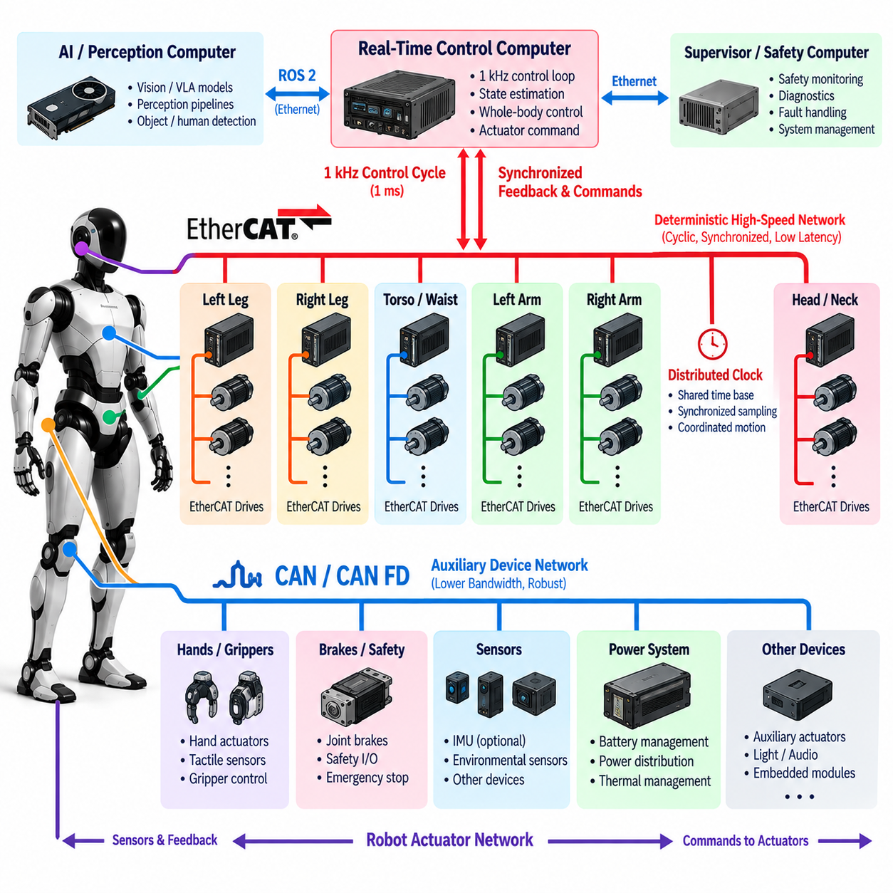
An actuator network is the communication backbone that connects the humanoid real-time control computer to distributed joint drives, motor controllers, encoders, brakes, and auxiliary devices. Because a humanoid may contain dozens of actively controlled joints, the network must transport synchronized feedback and commands with predictable latency. Its architecture directly influences control bandwidth, coordination accuracy, fault containment, wiring complexity, and ultimately whole-body stability.
The actuator network differs fundamentally from ordinary data networking because communication timing is part of the physical control loop. Joint position, velocity, torque, temperature, and drive status must reach the controller before computation begins, while new torque or motion commands must return to the actuators within the same bounded cycle. At a 1 kHz control rate, communication therefore consumes a measurable portion of the available 1 ms real-time budget.
EtherCAT is particularly suitable for high-performance humanoid joint networks because it supports deterministic cyclic communication across many distributed devices. Instead of processing conventional network packets independently at every node, EtherCAT devices can exchange process data while frames traverse the network. This mechanism enables efficient collection of actuator feedback and distribution of commands while maintaining predictable timing across a relatively large number of servo drives.
A typical EtherCAT topology places the real-time control computer in the master role and distributed joint drives in slave roles. The master initiates cyclic communication according to the control schedule, and each drive exchanges predefined process data such as joint position, velocity, torque, status words, and command values. The process image should remain compact and deterministic so that every control cycle transfers only information required by time-critical actuator operation.
Distributed clock synchronization is important when multiple joints must behave as one coordinated mechanical system. Small differences in sampling or command application time can become significant during dynamic walking, impact recovery, or whole-body manipulation. EtherCAT distributed clocks can provide a shared timing reference so geographically separated drives sample feedback and apply outputs with tightly controlled temporal alignment, improving consistency between network communication and physical motion.
The physical topology must reflect humanoid morphology as well as communication requirements. A simple line can connect drives sequentially through a leg, torso, or arm, reducing cable count and simplifying routing. Branching through suitable junction devices can separate left and right limbs or upper and lower body segments. The chosen topology should minimize cable length and connector complexity while ensuring that a single mechanical or electrical failure does not unnecessarily disable unrelated subsystems.
CAN and CAN FD provide complementary communication capabilities for devices that do not require the same bandwidth or synchronization performance as the primary servo network. They can connect auxiliary actuators, grippers, hands, brakes, battery controllers, thermal devices, or embedded sensor modules. Their widespread embedded support and relatively simple physical layer make them useful where robustness and implementation simplicity are more important than extremely high cyclic data throughput.
CAN communication requires careful bus-load analysis because nodes share a common communication medium and messages compete for transmission according to identifier priority. High-priority safety or control frames can obtain preferential access, but excessive traffic can increase latency for lower-priority messages. The architecture should therefore define message rates, payload sizes, priorities, timeout behavior, and maximum expected utilization rather than simply attaching additional devices until the bus becomes saturated.
CAN FD extends conventional CAN by supporting larger payloads and higher data rates during the data phase, making it attractive for modern distributed robotic electronics. Nevertheless, it remains important to distinguish its intended role from that of a tightly synchronized high-performance servo fieldbus. A heterogeneous humanoid network can use EtherCAT for deterministic multi-axis motion while using CAN or CAN FD for slower actuators and supervisory embedded devices.
Network segmentation helps contain faults and organize the robot according to physical function. Legs may occupy one actuator segment, arms another, while hands or auxiliary mechanisms use separate buses or gateways. Such segmentation can reduce traffic concentration and simplify diagnosis. It can also allow a failed peripheral network to be isolated while maintaining communication with joints required for balance or controlled transition into a safe posture.
Gateway design requires particular attention because bridging EtherCAT, CAN, or other embedded networks introduces additional buffering and timing behavior. A gateway should not obscure the age or validity of information arriving from a slower network. Data transferred between domains should preserve timestamps, status information, and timeout semantics so the real-time controller can distinguish fresh actuator feedback from delayed or repeated values.
Command and feedback interfaces should use explicit engineering semantics. Position, velocity, torque, current, temperature, and impedance parameters need clearly defined units, scaling, ranges, sign conventions, and coordinate directions. Ambiguous conventions can produce dangerous integration errors even when network communication itself operates correctly. Interface definitions should therefore be versioned together with actuator firmware and robot configuration.
The control computer should monitor network timing during every operating cycle. Useful information includes frame completion time, communication jitter, working-counter or node-status information, missing responses, bus errors, and command age. A network that remains logically connected can still be unsuitable for control if latency becomes excessive or synchronization quality deteriorates. Timing health is therefore as important as basic connectivity.
Startup should follow a controlled actuator-network state sequence. After power is applied, the system identifies expected devices, verifies topology and configuration, checks firmware compatibility, establishes synchronization, and confirms valid feedback before enabling torque. Individual drives should remain in a safe disabled state until the supervisory and real-time controllers agree that communication and robot state are valid. This prevents uncontrolled activation during partial system initialization.
Operational state transitions should also distinguish communication readiness from motion readiness. A drive can be reachable on the network while reporting encoder faults, overtemperature, undervoltage, brake problems, or internal controller errors. The system must evaluate both network status and actuator health before accepting the joint as controllable. Whole-body control should never assume that successful packet exchange implies mechanical availability.
Failure detection requires explicit timeout and plausibility rules. Missing cyclic feedback, repeated values, synchronization loss, corrupted state, or unexpected topology changes should be detected within bounded time. The response depends on the affected joint and current behavior. A hand actuator failure during stationary manipulation may permit graceful degradation, while loss of a hip, knee, or ankle drive during walking may require immediate stabilization or protective stopping.
Emergency-stop architecture should not depend solely on ordinary software messages traveling through the actuator network. Safety-critical torque removal can require independent hardware paths, drive-level safety functions, or dedicated safety communication mechanisms. The normal fieldbus can coordinate controlled stopping and report diagnostic information, but the system should retain a method of removing hazardous actuator energy even if the main computer or communication stack fails.
Electrical design is inseparable from network reliability. Motor drives generate switching noise and large transient currents that can interfere with communication signals. Cable shielding, grounding strategy, connector quality, differential signaling, termination, physical separation from high-current conductors, and strain relief all influence field performance. A topology that functions on a laboratory bench may fail on a moving humanoid if electromagnetic and mechanical conditions are ignored.
Cable routing is especially challenging because communication links pass through moving joints and compact limbs. Repeated bending, torsion, connector vibration, and limited bend radius can gradually damage cables or create intermittent faults. Network design should therefore consider service loops, flex-rated cables, connector retention, replaceable harness sections, and diagnostic methods capable of identifying sporadic link degradation before complete communication loss occurs.
Bandwidth planning should be performed using the complete robot configuration rather than individual device specifications. The designer must consider the number of joints, feedback variables per joint, command payload, cyclic frequency, protocol overhead, diagnostic traffic, synchronization requirements, and future expansion. Sufficient margin should remain for abnormal conditions and engineering diagnostics instead of operating the network continuously near its theoretical maximum capacity.
The software architecture should isolate hardware-specific network drivers from whole-body control logic. A real-time hardware abstraction layer can present normalized joint states and accept normalized actuator commands while EtherCAT or CAN components handle protocol details. This approach allows drive models, firmware, or network topology to evolve without forcing major changes in locomotion, balance, manipulation, and higher-level control algorithms.
Diagnostics should preserve both system-level and node-level evidence. Recording joint feedback, commands, drive states, bus errors, synchronization status, and timestamps allows engineers to reconstruct failures involving multiple joints. This is particularly important for humanoids because a network disturbance lasting only a few milliseconds can propagate through balance dynamics and appear later as a mechanical instability whose original communication cause is otherwise difficult to identify.
A robust humanoid actuator topology therefore combines deterministic high-rate communication with appropriately segmented lower-bandwidth networks. EtherCAT can form the primary synchronized backbone for dynamically critical joints, while CAN or CAN FD can support auxiliary actuators and embedded subsystems where their characteristics are appropriate. Gateways, timing rules, health monitoring, and safety mechanisms integrate these networks without allowing slower communication domains to compromise the primary control loop.
The resulting actuator network should be treated as part of the robot's distributed real-time control system rather than merely as wiring between computers and motors. When topology, synchronization, bandwidth, electrical integrity, fault handling, and software interfaces are designed together, dozens of physically separated actuators can behave as one coordinated mechanism. This deterministic communication foundation enables the humanoid to execute stable locomotion, balance recovery, manipulation, and whole-body motion under demanding dynamic conditions.

02.06. ROS2 Based Humanoid Node Architecture [w/Code]
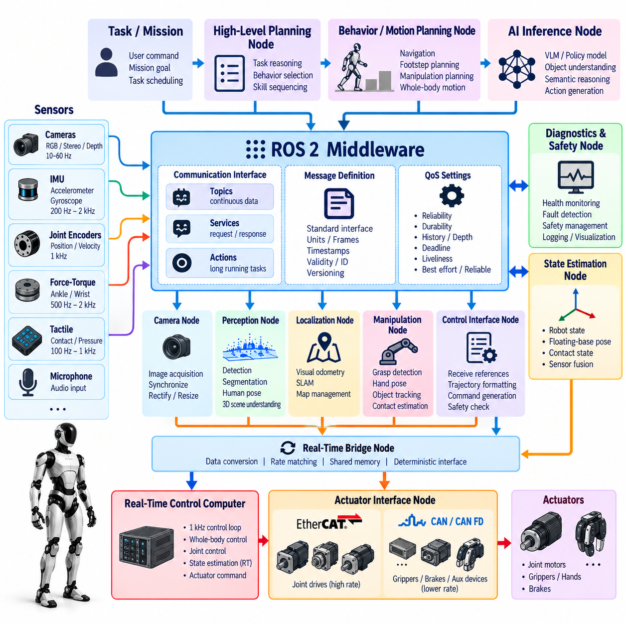
ROS 2 provides a distributed middleware framework for organizing the many software functions required by a humanoid robot. Instead of implementing perception, state estimation, planning, locomotion, manipulation, diagnostics, and hardware interfaces inside one monolithic process, the system can divide them into nodes with explicit communication interfaces. This decomposition improves modularity while allowing components with different computational rates and hardware dependencies to cooperate within one robot.
A node should represent a coherent functional responsibility rather than an arbitrarily small piece of computation. Typical humanoid nodes may manage camera acquisition, IMU processing, state estimation, object perception, footstep planning, whole-body control, actuator interfaces, or system diagnostics. Excessive fragmentation increases communication and scheduling overhead, while overly large nodes create tight coupling. Node boundaries should therefore follow ownership of state, timing requirements, and failure containment.
ROS 2 communication is built primarily around publishers and subscribers for continuous data exchange. Sensor nodes can publish images, inertial measurements, joint states, and force information, while estimation and perception nodes subscribe to the required streams and publish higher-level representations. Planning and control components consume these representations without requiring direct knowledge of the hardware-specific implementation that produced them, reducing dependencies between software layers.
Topics are appropriate for continuously changing information such as robot state, sensor observations, trajectories, diagnostics, and perception outputs. Services are better suited to bounded request-response operations such as querying configuration or requesting a specific state transition. Actions support longer-running operations that require progress feedback, cancellation, and completion status. Selecting the correct interaction pattern prevents command semantics from being hidden inside generic topic traffic.
Message definitions form contracts between humanoid subsystems. Joint state, contact state, object pose, planned trajectory, controller command, and diagnostic information should use clearly specified units, coordinate frames, timestamps, validity indicators, and identifiers. Stable interface definitions allow perception, planning, and control implementations to evolve independently. Version management becomes especially important when multiple robot software releases or hardware variants must coexist.
Quality of Service settings must be selected according to the physical meaning of each data stream. A camera feed may prefer recent frames over guaranteed delivery of old images, whereas configuration or critical state-transition information may require reliable delivery. Queue depth, reliability, durability, deadline, history, and liveliness policies influence both latency and failure behavior. Using identical QoS settings for every topic ignores the very different requirements of robotic data.
Humanoid sensor streams make timestamp discipline essential. Messages should preserve acquisition time rather than simply recording when a ROS 2 callback receives the data. Camera, IMU, force-torque, and joint measurements can arrive through different drivers and at different rates, yet estimation algorithms must associate them with the physical instant at which they were measured. ROS 2 transport should therefore preserve timing semantics established by the underlying sensor architecture.
Coordinate-frame management provides another shared architectural service. Sensors mounted on the head, torso, wrists, feet, and other links continuously move as the humanoid changes configuration. Static transforms describe rigid sensor mounting, while dynamic transforms depend on joint motion and estimated floating-base pose. A consistent frame tree enables perception and planning nodes to interpret data in sensor, link, base, odometry, or world frames without duplicating transformation logic.
Executors determine when ROS 2 callbacks actually run, making executor design important for latency-sensitive systems. If high-rate state callbacks share an executor with slow image processing, logging, or blocking service callbacks, critical work can experience unpredictable delay. Nodes and callback groups should therefore be arranged so computationally expensive or potentially blocking operations cannot starve functions that require predictable update rates.
Multi-threaded execution can improve throughput but introduces concurrency concerns. Shared state accessed by callbacks must be protected without creating excessive locking or priority inversion. Callback groups can separate mutually exclusive operations from callbacks that may execute concurrently. The architecture should use parallelism intentionally rather than assuming that additional executor threads automatically improve performance, because uncontrolled concurrency can increase jitter and complicate debugging.
ROS 2 should not be assumed to provide hard real-time behavior merely because it supports fast communication. A humanoid's deterministic 1 kHz servo loop may require dedicated real-time threads, carefully controlled memory behavior, specialized hardware interfaces, or shared-memory communication outside ordinary ROS callback execution. ROS 2 can expose references, state, diagnostics, and supervisory commands while the most timing-critical control path remains protected from variable middleware workloads.
This separation creates a useful boundary between real-time and non-real-time nodes. Perception, semantic reasoning, task planning, visualization, logging, and AI inference can operate asynchronously, while the hardware interface and stabilization controller execute under stricter timing rules. Data crossing this boundary should be buffered and timestamped. The real-time controller consumes the newest valid command without blocking while waiting for a ROS 2 publisher to produce another message.
Composition can reduce communication overhead when multiple nodes operate on the same computer. Components loaded into a shared process can exchange data more efficiently than independent processes in some configurations, reducing serialization and memory-copy costs. However, process isolation provides stronger fault containment. A production architecture must therefore balance performance against reliability, deciding which functions benefit from composition and which should remain isolated processes.
Large image and point-cloud streams require particular attention because copying them repeatedly through middleware can consume CPU time and memory bandwidth. Intra-process communication, loaned messages, shared-memory transport, or hardware-specific zero-copy paths can reduce these costs when supported. The objective is to avoid moving the same high-bandwidth sensor data through multiple memory buffers before it reaches perception or AI acceleration hardware.
Lifecycle management helps coordinate complex humanoid startup and shutdown. A node can move through controlled states such as unconfigured, inactive, active, and finalized rather than beginning full operation immediately when its process starts. Sensor drivers can be configured before activation, controllers can wait for valid state estimates, and actuator interfaces can remain disabled until dependencies are ready. This creates a more deterministic system-level initialization sequence.
Dependencies between nodes should be expressed through readiness conditions rather than arbitrary startup delays. Waiting several seconds before activating a controller does not prove that sensors, transforms, state estimation, and actuator communication are valid. Supervisory logic should verify required topics, valid timestamps, calibration state, hardware health, and controller readiness before enabling physical motion. The same principle applies when restarting components after a failure.
Namespaces and parameter management become important when software must support multiple humanoid platforms or repeated subsystem instances. Left and right arms, hands, cameras, or robots can use structured namespaces while sharing common node implementations. Parameters can describe device identifiers, frame names, controller gains, model paths, and operating modes. Configuration should remain separate from source code so deployment variants do not require unnecessary software modifications.
Diagnostics should be integrated into the node architecture rather than implemented as an independent afterthought. Nodes can report update rate, latency, dropped data, internal state, resource utilization, and hardware errors. A supervisory health node can aggregate these reports and determine whether the robot remains fully operational, should enter a degraded mode, or must transition to a safe state. Communication health itself should also be monitored.
Fault containment is one reason to avoid a completely monolithic ROS 2 process. A perception model that exhausts memory or crashes should not necessarily terminate actuator communication or balance control. Conversely, excessive process isolation can increase transport overhead and operational complexity. Critical control, hardware access, perception, AI inference, and user-facing functions should therefore be grouped according to both performance needs and acceptable failure propagation.
Security and network boundaries become relevant when ROS 2 communication extends beyond the onboard computer. Development workstations, remote operators, edge servers, and fleet infrastructure should not automatically participate in every internal robot data exchange. Discovery scope, network interfaces, permissions, authentication, and access policies should reflect operational requirements. Safety-critical actuator commands require especially controlled communication paths.
Logging and data recording should preserve enough context to reconstruct distributed behavior. Recording sensor messages alone is insufficient when debugging a complex humanoid. Relevant trajectories, controller states, transforms, timestamps, diagnostics, node transitions, and command messages should also be captured. Consistent time references allow engineers to determine whether failures originated in perception, planning, middleware latency, control, or hardware.
A scalable ROS 2 humanoid architecture therefore combines modular nodes with deliberate communication and execution policies. Nodes encapsulate responsibilities, topics carry continuous state, services handle bounded requests, actions represent longer operations, and lifecycle mechanisms coordinate system state. QoS, timestamps, transforms, executors, composition, and diagnostics determine whether this conceptual modularity becomes a reliable physical robot implementation.
The resulting architecture positions ROS 2 as the integration fabric connecting humanoid software domains rather than as the sole mechanism for every computation. It can coordinate sensors, perception, planning, AI, control supervision, diagnostics, and hardware abstraction while deterministic control paths retain specialized real-time mechanisms where necessary. This layered approach provides the modularity needed for rapid software evolution without sacrificing the timing discipline required for stable physical behavior.

02.07. Inter Process Communication Design Shared Memory [w/Code]
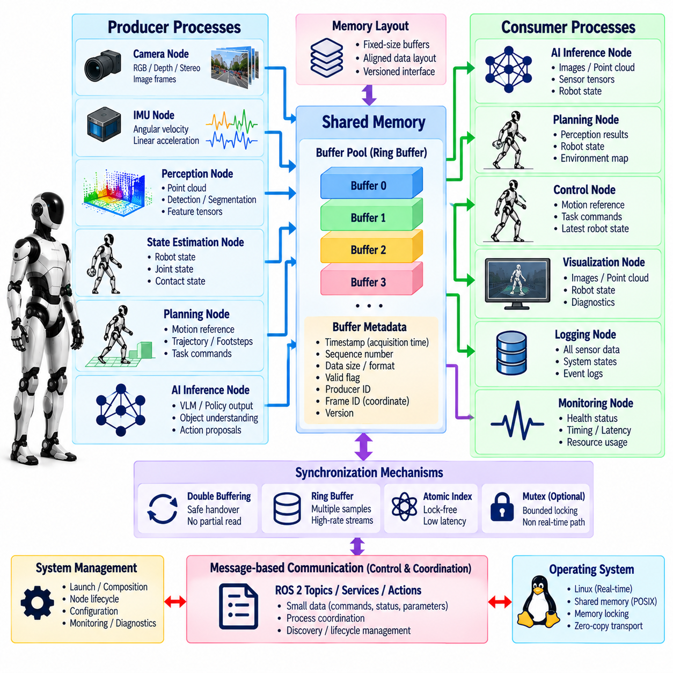
Inter-process communication is a critical architectural layer in a humanoid robot because perception, state estimation, planning, AI inference, control, diagnostics, and hardware interfaces frequently execute as separate processes. These processes must exchange information without introducing excessive latency, memory copies, blocking behavior, or unpredictable scheduling interference. The communication design must therefore consider data size, update frequency, timing criticality, ownership, and failure isolation together.
Conventional message-based communication provides strong modularity because producers and consumers interact through explicit interfaces rather than directly accessing each other's internal memory. This approach is suitable for compact information such as commands, robot states, diagnostics, and configuration data. However, repeatedly serializing and copying high-bandwidth camera images, point clouds, or neural-network tensors between processes can consume substantial CPU time and memory bandwidth, making alternative mechanisms necessary.
Shared memory allows multiple processes on the same computer to access a common physical memory region without repeatedly copying the payload through intermediate buffers. A producer can write sensor data or computational results into a shared region and publish a lightweight descriptor identifying the valid buffer, timestamp, size, and format. Consumers then access the same underlying data directly, significantly reducing transport overhead for large objects such as images, depth maps, point clouds, and feature tensors.
The performance advantage of shared memory does not eliminate the need for explicit interface design. Processes must agree on data layout, alignment, dimensions, numerical representation, version, and validity semantics. A raw memory pointer cannot safely serve as a system-level interface because virtual addresses differ between processes and object lifetimes must be controlled. Shared-memory communication should therefore expose stable handles or buffer identifiers rather than implementation-specific memory addresses.
Buffer ownership is one of the central design problems. If a producer overwrites a buffer while another process is still reading it, the consumer can observe partially updated or inconsistent data. Double buffering can separate a buffer being written from one currently available for reading, while ring buffers support streams containing multiple recent samples. More advanced buffer pools can provide several reusable blocks when multiple consumers operate at different rates.
Synchronization should be designed to avoid turning shared memory into a source of unpredictable blocking. A conventional mutex around a large shared structure may force a real-time process to wait for a slower perception or logging process. Lock-free or carefully bounded synchronization mechanisms are therefore preferable for timing-sensitive paths. Atomic sequence counters, ownership flags, producer-consumer indices, and version markers can coordinate access while keeping critical sections extremely short.
Single-producer and single-consumer communication is particularly straightforward to implement efficiently. The producer advances a write index after completing a data item, while the consumer independently advances a read index after processing it. Memory-ordering rules ensure that payload writes become visible before publication of the corresponding index. This pattern is useful for high-rate state, command, and telemetry channels where predictable execution is more important than retaining every historical sample.
Many humanoid data paths favor a latest-value semantic rather than guaranteed processing of every message. A controller receiving motion references usually needs the newest valid command, not a backlog of outdated commands. Similarly, perception consumers may prefer the newest camera frame when processing falls behind. Shared-memory interfaces should explicitly distinguish latest-value channels from queues that require ordered delivery so overload behavior remains predictable.
Timestamps must travel with shared data because zero-copy transport does not guarantee that the information itself is current. Each buffer should preserve the acquisition or generation time of its payload, together with sequence numbers and validity information where appropriate. Consumers can then detect stale data, skipped updates, repeated samples, or excessive transport delay. This is especially important when asynchronous AI and perception processes provide information to faster planning or control components.
Memory allocation should normally occur during initialization rather than inside timing-critical communication paths. Dynamically creating shared buffers during operation can introduce allocation latency, fragmentation, page faults, and failure conditions that are difficult to bound. Fixed-size pools or preallocated regions provide more predictable behavior. Memory locking and page prefaulting may also be used when the communication path participates in a real-time execution environment.
Data alignment and cache behavior influence shared-memory performance. Frequently updated control variables should not unintentionally share cache lines with unrelated variables written by another processor core, because false sharing can generate unnecessary cache-coherency traffic. Large sequential sensor buffers have different access characteristics from small high-frequency state structures. Memory layout should therefore reflect both the logical interface and the behavior of the underlying CPU cache hierarchy.
NUMA effects can become relevant on high-performance humanoid computers containing multiple processor sockets or complex accelerator interconnects. A shared buffer physically allocated near one processing domain may be expensive for another domain to access repeatedly. Although many onboard computers are simpler, future systems combining CPUs, discrete GPUs, and multiple accelerators should consider memory locality. Zero-copy is beneficial only when direct access is actually cheaper than an intentional transfer.
Shared memory is especially useful between sensor acquisition and perception processes. A camera driver can place a captured frame into a reusable buffer and provide its descriptor to one or more consumers without serializing the full image repeatedly. A vision pipeline can then perform preprocessing or inference directly from the shared representation when hardware and software support it. Similar patterns apply to depth images, point clouds, and high-dimensional feature maps.
Communication with GPUs and NPUs requires additional consideration because accelerator memory may not be directly accessible through ordinary CPU shared memory. Data paths may use pinned host memory, unified memory, DMA-capable buffers, or platform-specific zero-copy mechanisms to reduce transfers. The architecture should measure the complete sensor-to-accelerator path rather than assuming that eliminating one CPU copy automatically produces end-to-end zero-copy behavior.
Small control data often does not benefit from complex shared-memory optimization. Joint references, mode commands, health states, and diagnostic events can be efficiently exchanged through conventional middleware while preserving clear semantics and process isolation. A hybrid architecture is therefore practical: large high-bandwidth payloads use shared or zero-copy buffers, while lightweight control and supervisory information uses message-oriented communication.
The boundary between ROS 2 and specialized shared-memory transport should remain explicit. ROS 2 can provide discovery, lifecycle coordination, metadata, commands, and distributed communication, while optimized local transport handles data whose size or latency makes repeated serialization undesirable. The system should avoid exposing transport-specific assumptions to application algorithms so that communication mechanisms can evolve without rewriting perception, planning, or control logic.
Real-time control communication requires particularly strict rules. A 1 kHz controller should never block indefinitely while waiting for another process to release memory or produce new data. Inputs should be available through bounded-time reads, often by accessing the most recent completed sample. Outputs should similarly be published without waiting for slow consumers. When data is unavailable, the controller must follow defined timeout and fallback behavior rather than violating its execution deadline.
Process crashes create lifecycle problems for shared resources. If a producer terminates while holding ownership of a buffer, consumers must detect that the data is no longer being updated. Sequence counters, heartbeat information, process-generation identifiers, and timeout rules can prevent stale memory from appearing valid indefinitely. Restarted processes should reconnect to shared resources through controlled initialization rather than assuming the previous memory state remains trustworthy.
Access permissions are also important because shared memory bypasses some isolation normally provided by message serialization. Only authorized processes should be able to modify control-critical regions. Read-only mappings can protect data consumed by processes that do not need write access, while separate channels can isolate commands from telemetry. The communication architecture should preserve process isolation as far as practical even when processes share physical memory.
Observability must be designed into the IPC layer. Useful metrics include publication rate, consumption rate, buffer occupancy, dropped samples, overwritten samples, maximum data age, lock contention, copy count, and communication latency. Without these measurements, performance problems can be incorrectly attributed to perception or control algorithms when the actual cause is queue buildup, memory contention, or inefficient transport.
Stress testing should intentionally create mismatched producer and consumer rates. Camera processing can be slowed, logging can be overloaded, and AI inference can be made computationally expensive while communication behavior is monitored. The system should demonstrate that high-priority processes continue operating within their timing limits and that low-priority consumers lose or skip data according to defined policies rather than causing global blocking or uncontrolled memory growth.
A robust humanoid IPC architecture therefore uses different communication mechanisms according to data characteristics rather than forcing every interaction through one transport. Message-based middleware provides modularity and distributed communication, shared memory reduces copying for large local payloads, and bounded lock-free structures support timing-sensitive exchanges. Explicit timestamps, ownership, buffer lifetimes, and overload policies preserve correctness across these mechanisms.
The resulting shared-memory architecture is successful when optimization remains invisible to higher-level robot behavior. Perception receives timely sensor data, planners obtain coherent state, AI accelerators access large inputs efficiently, and real-time controllers exchange compact references without blocking. By treating memory ownership, synchronization, timing, failure recovery, and observability as first-class architectural concerns, inter-process communication can support high-performance humanoid software without compromising determinism or modularity.

02.08. Humanoid OTA Update Architecture [w/Code]
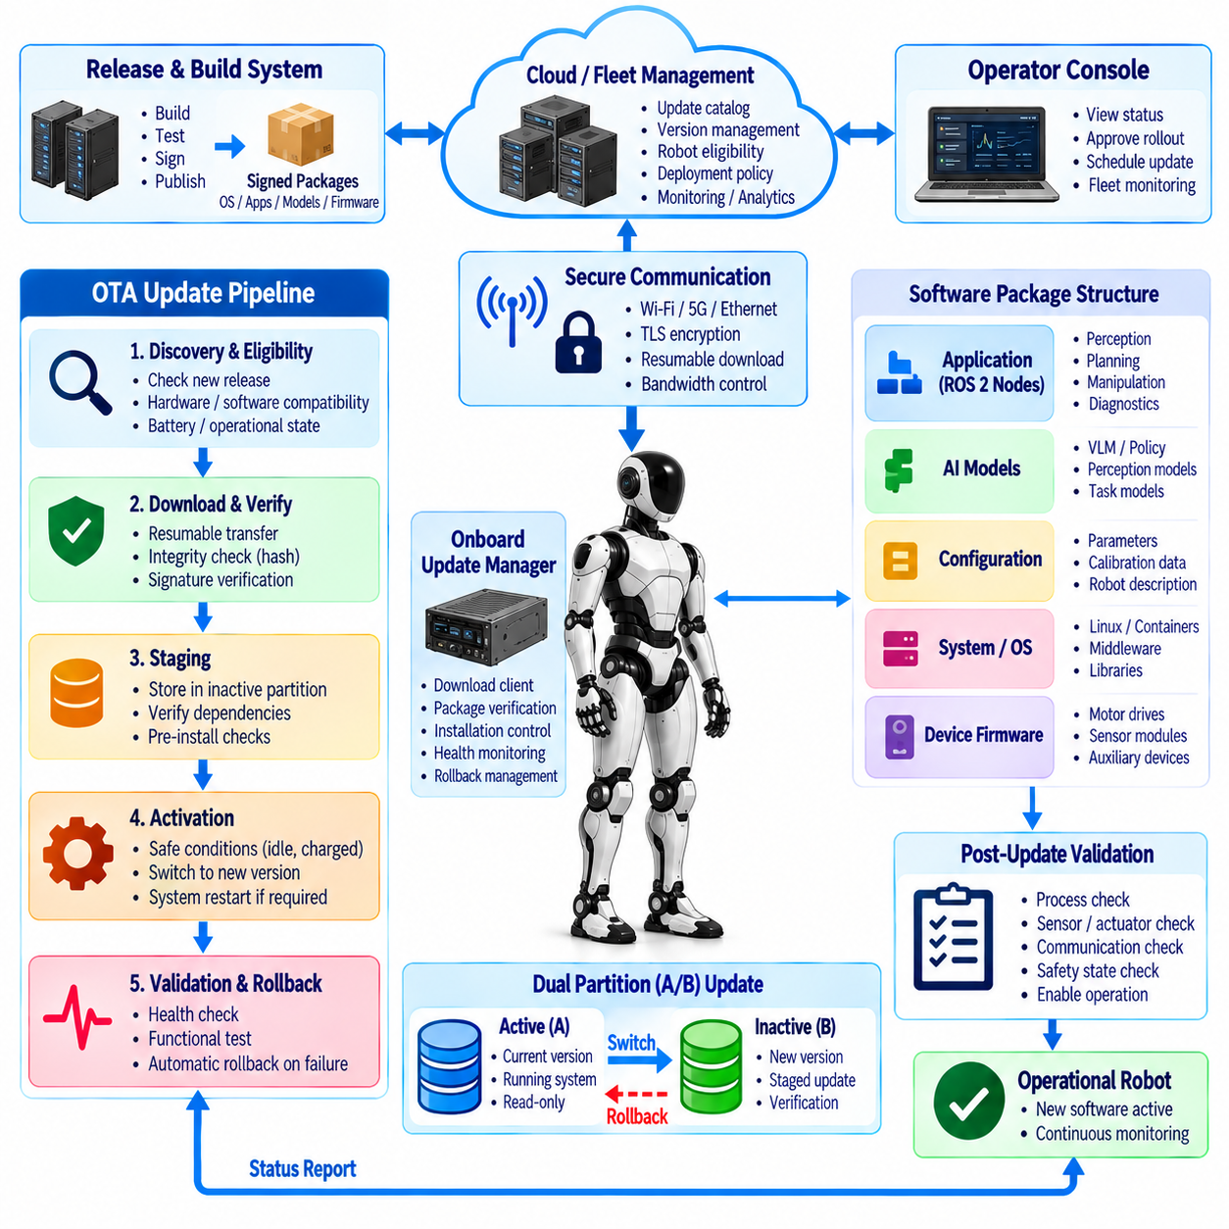
An over-the-air update architecture enables a humanoid robot to receive, validate, install, activate, and recover software without requiring direct physical access to its onboard computers. Unlike conventional consumer devices, a humanoid contains safety-critical control software, AI models, sensor drivers, actuator interfaces, middleware, firmware, and configuration data that interact with a moving physical system. OTA design must therefore treat software deployment as a controlled system transition rather than a simple file replacement.
The update architecture should separate software into domains according to criticality and operational responsibility. Real-time control software, hardware drivers, ROS 2 components, perception services, AI models, configuration packages, and embedded-device firmware may follow different validation and activation procedures. A perception model can often be replaced independently, while modifications to actuator firmware or the real-time controller require substantially stronger compatibility checks because failures can directly affect physical stability.
Every deployable artifact should have an explicit identity. Version information should describe the software release, target hardware, operating-system dependency, interface version, configuration schema, model revision, and required firmware where applicable. A manifest can define the complete compatible set of components expected on a robot. This prevents a successful download from creating an invalid combination of individually functional but mutually incompatible software packages.
The OTA process begins with update discovery and policy evaluation rather than immediate installation. A robot or fleet-management service can determine whether a newer approved release exists and whether the specific robot is eligible for it. Eligibility may depend on hardware revision, current software baseline, battery level, network connectivity, maintenance state, operational schedule, and unresolved faults. Updates should not begin merely because a package is available.
Package authenticity and integrity must be verified before software is trusted. Digitally signed manifests and artifacts allow the robot to confirm that an update originates from an authorized release process and has not been modified during distribution. Cryptographic hashes can verify package integrity after download. Signature verification should occur before activation, and security-critical trust material should be protected separately from ordinary application data.
Transport should tolerate unreliable wireless connectivity. Large operating-system images, containers, neural-network weights, or map packages may require substantial download time, especially when robots operate through variable Wi-Fi or cellular links. Resumable transfer, chunk verification, bandwidth limiting, and retry mechanisms prevent temporary network interruptions from invalidating the complete download. Update traffic should also avoid interfering with operational communication required by the robot.
Downloading and activating an update should be separate phases. A robot may safely retrieve packages while operating, but activation should occur only when defined safety conditions are satisfied. The robot can verify that it is stationary, mechanically supported if required, not carrying a hazardous payload, sufficiently charged, and outside an active mission. Separating staging from activation allows fleet operators to distribute large packages in advance and choose a controlled maintenance window later.
Atomic update mechanisms reduce the risk of leaving the computer in a partially updated state. An A/B system partition architecture can maintain an active software image while writing the new release to an inactive partition. After verification, the system boots into the candidate image without destroying the previous known-good environment. If startup validation fails, the boot mechanism can return to the previous partition rather than requiring manual recovery.
Application-level software can use similar transactional principles even when complete system partitions are unnecessary. Container images, packages, or versioned deployment directories can be staged beside the currently active release. Activation then changes a controlled reference from the old version to the new one. The previous release remains available until the new software passes health checks, allowing rollback without reconstructing the earlier environment from individual files.
Boot validation is particularly important because successful installation does not prove that a humanoid is operational. After restart, the system should verify required processes, storage, network interfaces, sensor drivers, actuator communication, calibration data, time synchronization, and internal dependencies. Higher-level software should not enable physical motion until these checks demonstrate that the updated platform has reached a known and internally consistent state.
Hardware compatibility must be evaluated explicitly. A humanoid fleet may contain different motor revisions, cameras, compute modules, sensor boards, or wiring configurations even when robots share the same product name. An update intended for one hardware revision may fail on another. Device identifiers, board revisions, firmware versions, and feature capabilities should therefore participate in update eligibility and post-installation validation.
Firmware updates require additional protection because interruption can make embedded devices unavailable. Motor controllers, sensor modules, battery systems, or communication gateways may require bootloaders capable of validating new firmware and recovering from failed programming. Critical devices can maintain dual firmware banks or protected recovery images where practical. Power loss during programming should result in a recoverable state rather than permanently disabling the component.
Configuration and calibration data should be managed separately from generic software binaries. Joint offsets, camera extrinsics, force-torque calibration, robot serial configuration, network addresses, and actuator parameters may be unique to an individual robot. A system update must not silently overwrite these values with generic defaults. Migration tools should transform configuration schemas while preserving robot-specific parameters and maintaining a traceable record of any changes.
AI models introduce another update category because model behavior can change even when interfaces remain identical. A new perception or VLA model may use the same input and output messages yet produce different decisions, latency, memory consumption, or accelerator load. Model deployment should therefore record model identity, runtime requirements, precision mode, expected resource consumption, validation results, and compatibility with the surrounding planning and safety architecture.
Progressive deployment reduces fleet-wide risk. A release can first be installed on development robots, then a small controlled group, followed by increasingly larger deployment cohorts after health metrics remain acceptable. This staged rollout limits the impact of defects that escaped laboratory testing. Different update channels can distinguish experimental, internal validation, pilot, and production releases without changing the fundamental package architecture.
Health monitoring should continue after activation because some regressions appear only during sustained operation. The system can compare boot success, process crashes, control-loop timing, sensor availability, inference latency, memory use, temperature, communication errors, and mission failures against expected limits. An update that technically boots but degrades real-time timing or repeatedly destabilizes a subsystem should not be considered successfully deployed.
Rollback policy should be defined before an update is released. Automatic rollback may be appropriate when the robot cannot boot, required services repeatedly fail, or critical hardware communication cannot be established. Other failures may require a controlled maintenance decision because reverting software can also involve configuration or firmware compatibility. The architecture should know which components can be independently reverted and which must move together as a compatible release set.
Database and configuration migrations complicate rollback because newer software may transform persistent data into formats older software cannot understand. Reversible migrations, versioned schemas, backups, or compatibility layers can reduce this risk. Update testing should therefore evaluate both forward installation and rollback paths. A recovery strategy that has never been exercised should not be assumed to work reliably during a field failure.
Safety state must dominate update state. OTA software should never independently enable actuators merely because installation has completed. After an update, the normal startup supervisor should verify sensors, estimation, actuator networks, emergency-stop state, and controller readiness before motion authority is granted. If validation remains incomplete, the robot should stay in a non-moving or otherwise defined safe condition while reporting the reason to operators.
Update orchestration across multiple onboard computers requires dependency management. A humanoid may contain separate real-time, AI, sensor, and supervisory computers, each running different software images. Updating only one computer can temporarily create incompatible interfaces. The orchestrator should understand dependency order, coordinate reboots, verify communication after each transition, and activate mutually dependent components as a tested system release rather than unrelated packages.
Fleet management adds identity and auditability requirements. Operators should be able to determine which release is installed on each robot, when it was downloaded, who or what policy authorized activation, whether validation succeeded, and whether rollback occurred. Update events should generate durable records so field behavior can later be correlated with exact software, firmware, model, and configuration versions.
Security must extend beyond package signatures to the update service itself. Robot authentication, encrypted transport, authorization policies, credential rotation, and restricted update privileges reduce the risk of unauthorized deployment. Compromise of an OTA service could affect many physical robots simultaneously, so release signing and deployment authorization should ideally use separated trust boundaries rather than relying on a single unrestricted administrative credential.
Recovery mechanisms should remain available even when normal OTA infrastructure is unavailable. A robot that cannot reach the fleet service or boot its primary software may require a protected local recovery environment, service interface, or known-good image. Recovery procedures should be deliberately simpler than the normal software stack so they remain usable when application services, middleware, networking configuration, or recent updates are damaged.
Testing should reproduce realistic update failures rather than validating only successful installations. Engineers should interrupt network transfers, remove power during allowed stages, corrupt packages, introduce incompatible versions, exhaust storage, fail health checks, and simulate unsuccessful reboots. The architecture is robust only when each failure produces a defined and recoverable state instead of an ambiguous mixture of old and new software.
A production humanoid OTA architecture therefore combines secure distribution, versioned artifacts, staged installation, atomic activation, hardware-aware compatibility checking, post-update health validation, and tested rollback. Software, firmware, AI models, configuration, and calibration must be managed as related but distinct assets. Their dependencies are captured in release metadata so the robot can determine whether an update represents a coherent deployable system.
The resulting architecture makes OTA part of the humanoid lifecycle rather than merely a maintenance convenience. A reliable update system allows perception and AI capabilities to evolve rapidly while protecting deterministic control, robot-specific calibration, and actuator safety. By treating every update as a reversible, authenticated, observable system transition, a humanoid fleet can continuously improve without making remote software deployment an uncontrolled source of physical risk.

02.09. System Diagnostics and Health Monitor [w/Code]
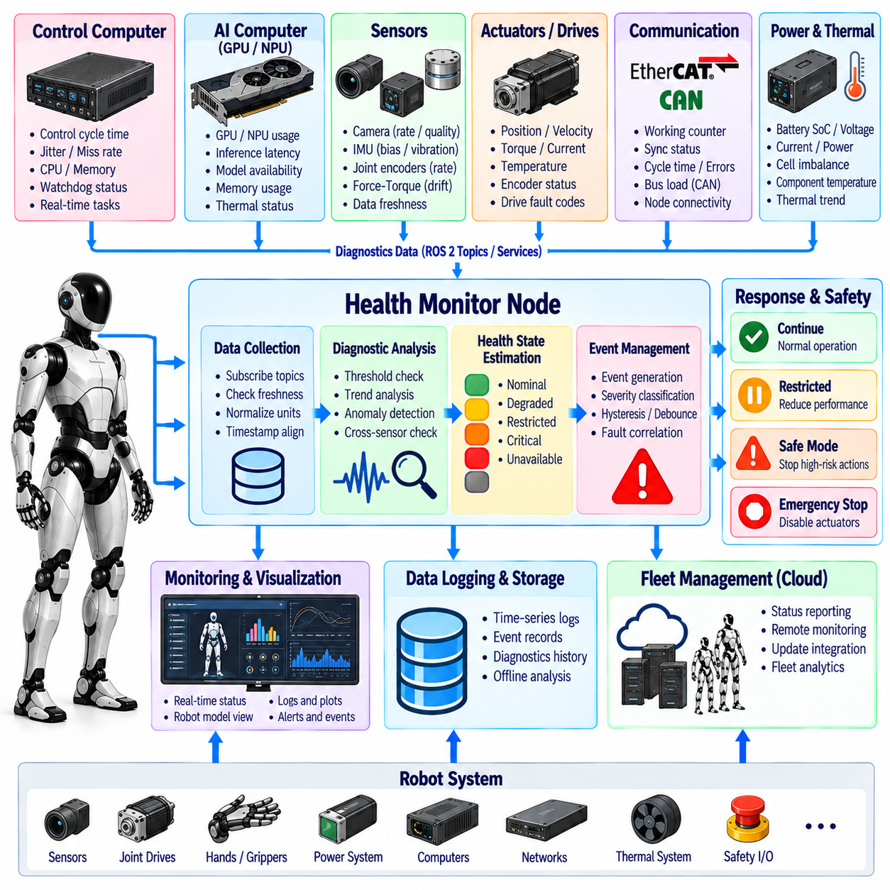
System diagnostics and health monitoring provide the supervisory awareness required to determine whether a humanoid robot is operating within acceptable computational, electrical, thermal, communication, sensing, and mechanical conditions. Because dozens of distributed subsystems cooperate to maintain physical stability, a failure may begin locally but propagate rapidly through the robot. The health architecture must therefore detect degradation early, preserve context, classify severity, and initiate an appropriate system response.
Health monitoring should distinguish between raw measurements, diagnostic indicators, and interpreted health states. Temperature, voltage, current, packet loss, control-loop latency, sensor update rate, and memory utilization are measurements. Threshold violations or timing anomalies become diagnostic events, while supervisory logic combines these events into states such as nominal, degraded, restricted, critical, or unavailable. This separation prevents isolated measurements from directly causing poorly coordinated robot behavior.
The diagnostic architecture should cover every major computational domain. The real-time control computer can report control-cycle duration, jitter, deadline misses, CPU load, memory status, and watchdog state. AI computers can report accelerator utilization, inference latency, model availability, memory consumption, and thermal throttling. Storage, operating-system services, middleware processes, and communication interfaces should expose equivalent health information so failures can be correlated across software layers.
Sensor health requires more than checking whether a device remains connected. Cameras can continue transmitting while producing frozen, corrupted, overexposed, or delayed images. An IMU may remain online while developing excessive bias or vibration, and a force-torque sensor can drift while still publishing plausible numerical values. Health monitoring should therefore evaluate update rate, timestamp freshness, signal range, noise characteristics, calibration status, saturation, and cross-sensor consistency where appropriate.
Actuator diagnostics are directly related to physical safety. Each joint drive can report position, velocity, torque, motor current, temperature, bus voltage, encoder status, communication state, brake condition, and internal fault codes. Supervisory logic should identify persistent overload, tracking error, thermal stress, unexpected current, encoder inconsistency, or repeated drive resets before these conditions become complete actuator failures during locomotion or manipulation.
The actuator network itself requires continuous health supervision. EtherCAT working counters, synchronization status, communication-cycle time, missing nodes, frame errors, and distributed-clock quality can reveal degradation before communication is completely lost. CAN or CAN FD networks can similarly expose bus errors, error counters, message timeouts, and excessive utilization. Network connectivity alone is insufficient because timing degradation can destabilize control even while packets continue to arrive.
Power-system monitoring provides another essential diagnostic domain. Battery state of charge, pack voltage, cell imbalance, current, temperature, power-distribution status, converter health, and transient voltage drops influence the availability of every other subsystem. A humanoid performing dynamic motion can experience rapidly changing power demand, so the health monitor should distinguish ordinary load transients from conditions indicating insufficient battery capability, wiring faults, or power-electronics degradation.
Thermal monitoring must consider both absolute temperature and thermal trend. CPUs, GPUs, NPUs, motor drives, batteries, and actuators may remain below shutdown thresholds while approaching conditions that will soon cause throttling or protection events. Rate-of-rise information allows the supervisory system to reduce computational load or motion intensity before hard limits are reached. Thermal management therefore becomes predictive rather than purely reactive.
Software process health should be monitored through more than process existence. A node can remain alive while deadlocked, producing stale data, consuming excessive resources, or repeatedly failing internal operations. Heartbeats, output freshness, callback rate, queue depth, error counters, and progress indicators can reveal functional failure. The monitor should distinguish a process that has terminated from one that is running but no longer performing useful work.
Time synchronization deserves explicit diagnostic treatment because many humanoid algorithms depend on coherent timestamps. Clock offset, synchronization quality, hardware timestamp availability, and drift between computers should be monitored continuously. A system may appear operational while sensor fusion silently deteriorates because distributed clocks have diverged. Excessive time error should therefore be reported as a system-level condition rather than only as a networking statistic.
Data freshness is one of the most useful cross-domain health concepts. Every important state estimate, perception result, planner command, AI output, and actuator feedback sample has an age relative to the current control decision. Monitoring this age detects stalled producers, communication delays, overloaded consumers, and repeated messages using a common abstraction. Maximum acceptable age should depend on the physical role of the data rather than one global threshold.
Diagnostic thresholds should support multiple severity levels instead of a single pass-or-fail boundary. A rising actuator temperature may first generate an advisory condition, then a degraded state requiring reduced performance, and finally a critical state requiring shutdown. Hysteresis and persistence rules prevent noisy measurements near a threshold from repeatedly switching system states. Severity should reflect both the magnitude and duration of an abnormal condition.
Fault correlation helps distinguish root causes from secondary symptoms. A power-voltage drop may simultaneously trigger actuator communication errors, computer resets, and sensor interruptions. Treating each event as an independent failure can obscure the actual problem. The health architecture should preserve timing relationships and subsystem dependencies so supervisory logic or offline analysis can determine whether multiple alarms originate from one shared infrastructure failure.
A centralized health supervisor can aggregate diagnostic information while individual subsystems retain responsibility for local protection. Motor drives should enforce their own electrical and thermal limits even if the central supervisor fails, while the supervisor coordinates robot-level responses such as reducing speed, disabling a manipulation task, transitioning to a stable posture, or stopping operation. This layered approach avoids relying on one software component for every safety decision.
Degraded operation can preserve useful functionality when complete shutdown is unnecessary. Loss of one noncritical camera may reduce perception coverage, a failed hand sensor may disable dexterous manipulation, and elevated GPU temperature may require a lower AI workload. The robot can continue restricted operation if balance, localization, obstacle awareness, and other required capabilities remain trustworthy. Degradation policies should explicitly define which capabilities depend on each subsystem.
Critical failures require deterministic transition behavior. Loss of essential joint feedback, severe actuator-network faults, unstable power, repeated real-time deadline violations, or invalid state estimation may require immediate motion restriction or protective stopping. The health system should not attempt complex recovery indefinitely while physical stability deteriorates. Each critical condition needs a bounded response path that leads toward a known safe state.
Watchdogs complement semantic health monitoring by detecting failures that prevent normal diagnostics from being produced. A hardware watchdog can reset or isolate a computer that stops responding, while software watchdogs can supervise control threads, middleware processes, and communication channels. Watchdog timeouts should be selected according to subsystem dynamics because an acceptable delay for a logging service may be unacceptable for an actuator interface or balance controller.
Automatic recovery is useful when failure modes are well understood and physically safe. A crashed perception process may be restarted, a disconnected peripheral can be reinitialized, or a temporary network service can reconnect. Recovery attempts should be bounded and recorded because repeated restarting can conceal persistent defects. Components that influence physical control should generally require stronger validation before being returned to active service after a fault.
Diagnostics should maintain a structured event history rather than only displaying current alarms. Each event should preserve timestamp, source, severity, relevant measurements, software or firmware version, and state transitions where possible. When a robot falls or unexpectedly stops, engineers need to reconstruct what happened before the visible failure. Pre-event buffering can retain several seconds of high-value telemetry that might otherwise be overwritten.
Logging rates should reflect diagnostic value and storage constraints. High-frequency control variables may require temporary ring buffers, while long-term fleet monitoring can store lower-rate summaries and exceptional events. Triggered recording can preserve detailed data around faults without continuously storing every signal at full frequency. This approach supports both onboard troubleshooting and large-scale operational analysis while controlling storage and network requirements.
A health-monitoring interface should present information according to operational responsibility. Developers may require detailed node, sensor, bus, and timing metrics, while operators need clear robot-level status, affected capability, severity, and recommended action. Fleet systems require standardized health summaries that allow many robots to be compared. The underlying diagnostic model should support these views without creating separate and inconsistent definitions of robot health.
Health information should also participate in planning and control decisions. A planner can avoid high-dynamic motions when actuator thermal margin is low, an AI scheduler can reduce inference workloads during thermal throttling, and a manipulation system can reject tasks when wrist sensing is unavailable. Diagnostics therefore become an input to adaptive behavior rather than merely a mechanism for reporting failures after they occur.
Testing the health architecture requires deliberate fault injection. Engineers should disconnect sensors, delay messages, overload CPUs, introduce network loss, simulate actuator faults, increase thermal load, corrupt timestamps, and terminate processes while observing detection and response. The objective is not simply to generate alarms but to verify detection latency, severity classification, fault containment, degraded operation, recovery behavior, and transition to safe states.
A production humanoid health architecture consequently combines distributed local diagnostics with centralized supervisory interpretation. Sensors, actuators, networks, computers, power systems, software processes, and AI services continuously expose measurable health information. Timestamped events and dependency-aware correlation transform these signals into an integrated understanding of which robot capabilities remain trustworthy and which must be restricted.
The resulting system health monitor acts as a continuous observer of the complete humanoid platform. It does not merely report whether components are online, but evaluates whether they are timely, accurate, thermally sustainable, electrically stable, computationally responsive, and safe to use. By connecting diagnostics to degradation policies, recovery mechanisms, control authority, and historical evidence, the architecture enables complex humanoid systems to fail predictably rather than unexpectedly.

02.10. Humanoid System Integration Test Framework
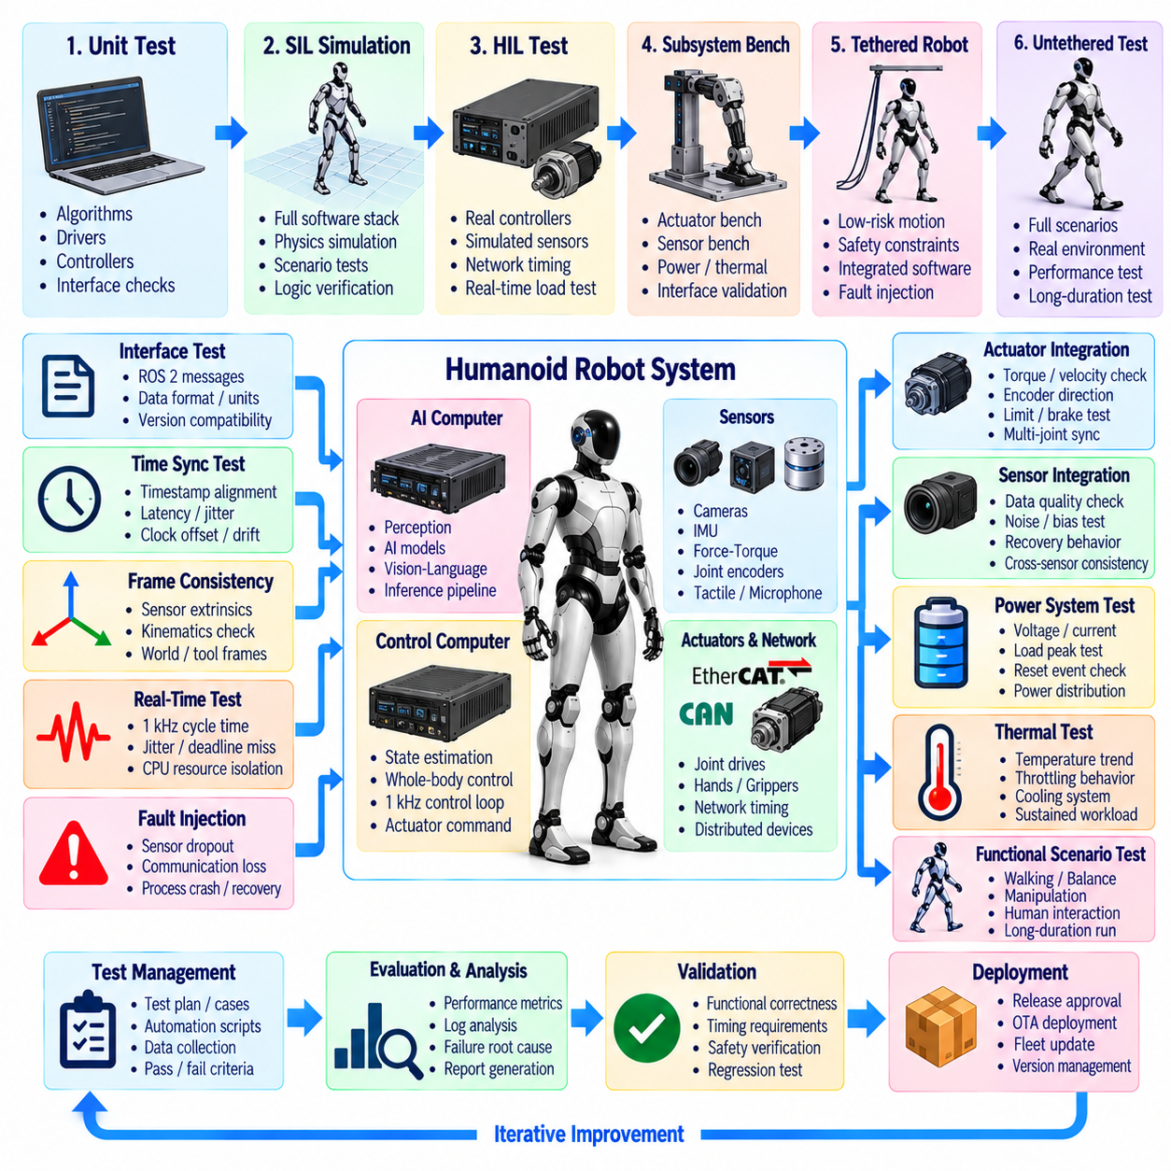
System integration testing verifies that independently developed humanoid subsystems operate correctly when combined into a complete physical robot. Unit tests can confirm individual algorithms, drivers, and controllers, but they cannot reveal many failures caused by timing, interfaces, coordinate frames, resource contention, power interactions, or unexpected subsystem dependencies. The integration framework must therefore validate not only functional correctness but also the coordinated behavior of the complete system.
A structured integration strategy should progress from low-risk software environments toward increasingly realistic physical operation. Individual components can first be validated with recorded data and mocked interfaces, followed by software-in-the-loop simulation, hardware-in-the-loop testing, subsystem benches, tethered robot operation, and finally untethered system trials. Each stage should introduce additional physical complexity only after the preceding level satisfies defined entry and exit criteria.
Interface verification is one of the earliest integration activities. ROS 2 messages, shared-memory layouts, actuator commands, sensor outputs, coordinate frames, units, sign conventions, timestamps, and configuration schemas must match their documented contracts. Many integration failures originate from individually correct modules interpreting the same data differently. Automated interface checks can detect incompatible versions, missing fields, invalid ranges, or unexpected message rates before physical motion begins.
Time synchronization should be tested as a system property rather than assumed from individual device configuration. Camera frames, IMU samples, joint states, force-torque measurements, actuator feedback, and controller outputs must maintain coherent timing across distributed computers. Tests should measure clock offset, timestamp age, transport latency, jitter, and synchronization loss under realistic computational load because timing errors can corrupt state estimation without producing obvious communication failures.
Coordinate-frame consistency requires similarly explicit validation. Sensor extrinsics, robot kinematics, floating-base pose, world frames, and tool frames should be checked through known poses and controlled motions. A sign error or incorrect transformation can remain hidden during static testing but become dangerous during dynamic control. Integration tests should verify that measured and commanded motion corresponds consistently across perception, estimation, planning, and control coordinate systems.
The real-time control path must be evaluated under worst-case system load. A nominal 1 kHz controller may satisfy its deadline when running alone but miss cycles when perception, logging, AI inference, networking, or visualization becomes active. Tests should record execution time, scheduling jitter, deadline misses, communication completion, and CPU interference while stressing non-real-time workloads. The objective is to prove timing isolation rather than merely demonstrate average performance.
Actuator integration should begin with restricted-energy tests. Individual joints can first operate at reduced torque and velocity while direction, encoder polarity, limits, brake behavior, current sensing, and command scaling are verified. Multi-joint tests can then evaluate synchronized motion and network timing before whole-body behaviors are enabled. This staged approach prevents a simple configuration error from immediately becoming a high-energy mechanical event.
Sensor integration tests should evaluate both nominal data and abnormal behavior. Cameras can be occluded or delayed, IMU signals can be disturbed, force-torque sensors can be biased, and selected streams can be intentionally interrupted. State estimation should respond according to defined validity and degradation rules rather than silently accepting corrupted information. Sensor recovery should also be tested to ensure reconnection does not introduce stale timestamps or invalid calibration state.
Power integration becomes increasingly important as more actuators and computers operate simultaneously. Dynamic motion can produce current peaks, bus-voltage variation, converter loading, and thermal effects that are absent during isolated component tests. The framework should observe battery voltage, current, distribution rails, compute power, actuator demand, and reset events while executing representative motions. Power-related failures can otherwise appear incorrectly as communication or software instability.
Thermal integration testing should reproduce sustained workloads rather than only short demonstrations. Walking, repeated manipulation, continuous perception, and AI inference can heat actuators, drives, processors, batteries, and enclosed electronics over different time scales. Tests should measure temperature trends, throttling, fan or cooling behavior, performance degradation, and protective limits so the system's sustainable operating envelope can be distinguished from short-duration peak capability.
Functional integration scenarios should combine perception, planning, control, and physical interaction. A humanoid may detect a target, estimate its own state, plan footsteps, approach the workspace, manipulate an object, and return to a stable posture. Such end-to-end scenarios expose interface assumptions that subsystem tests cannot reveal. Success criteria should include not only task completion but timing, stability, safety margin, and absence of hidden diagnostic faults.
Balance and locomotion integration requires controlled progression in dynamic difficulty. Initial tests can use external support, reduced speed, conservative trajectories, and level terrain before introducing turns, disturbances, uneven surfaces, stairs, or faster gait transitions. State estimation, contact detection, whole-body control, actuator limits, and safety responses must operate together. Each increase in difficulty should occur only after objective stability metrics satisfy predefined thresholds.
Manipulation integration similarly combines multiple subsystems. Vision estimates object and hand relationships, planning generates arm or whole-body motion, force sensing detects interaction, and controllers regulate contact. Tests should include free-space reaching, grasping, payload handling, pushing, bimanual tasks, and controlled contact. Errors in calibration or latency that appear insignificant in isolation can become obvious when visual and force feedback must agree during physical interaction.
Regression testing is essential because humanoid software changes frequently. A modification to perception, middleware, control, firmware, or configuration can unintentionally alter previously validated behavior. Stable integration scenarios should therefore be automated where practical and executed against every significant release. Test results should retain software, firmware, AI-model, calibration, and hardware configuration identifiers so performance changes can be associated with exact system versions.
Fault injection transforms integration testing from nominal demonstration into robustness validation. Engineers can disconnect sensors, delay messages, terminate ROS 2 nodes, introduce network errors, simulate actuator faults, overload CPUs, reduce available power, or corrupt selected state information. The framework should verify detection latency, fault classification, degraded operation, recovery, and safe-state transition rather than simply confirming that an alarm appears.
Communication failures deserve targeted scenarios because distributed humanoid software depends heavily on timely data exchange. Tests should introduce packet loss, increased latency, stale shared-memory buffers, EtherCAT disturbances, CAN message loss, and temporary disconnection between onboard computers. Critical control functions should remain bounded and predictable, while noncritical services should recover without creating uncontrolled command backlogs or invalid state transitions.
Recovery testing should verify what happens after the original fault disappears. A restarted sensor driver, recovered network link, rebooted AI computer, or reinitialized actuator should not automatically regain full authority without validation. The system should confirm timestamps, calibration, synchronization, health, and interface compatibility before returning the component to active use. Recovery is therefore a controlled state transition rather than simple reconnection.
Emergency and protective-stop behavior must be tested throughout integration. Hardware emergency stops, software protective stops, actuator torque removal, braking, safe posture transitions, and restart interlocks should be exercised under representative robot states. Tests should include standing, walking, manipulation, and fault conditions because stopping dynamics differ significantly. A safe response demonstrated only while the robot is stationary is insufficient evidence for dynamic operation.
Test instrumentation should capture enough synchronized information to reconstruct every significant failure. Joint states, commands, control timing, sensor streams, transforms, actuator status, power measurements, diagnostics, process events, and safety transitions should share a consistent time reference. Pre-event and post-event recording is especially valuable because the root cause may occur seconds before a visible fall, stop, or task failure.
Automated test orchestration improves repeatability. A test runner can configure the robot, verify prerequisites, start required processes, execute a scenario, collect measurements, evaluate acceptance criteria, and archive results. Automation reduces dependence on operator judgment and allows identical tests to be repeated after software or hardware changes. Physical tests should still include explicit safety authorization before any motion-producing stage begins.
Acceptance criteria should be quantitative wherever possible. Instead of stating that walking appears stable, the test can specify allowable tracking error, control-loop jitter, state-estimation uncertainty, contact consistency, actuator temperature, communication latency, or recovery time. Quantitative thresholds make regression analysis meaningful and prevent subjective demonstrations from being mistaken for engineering validation.
The framework should maintain traceability between requirements, tests, configurations, and results. Each safety, performance, timing, interface, and reliability requirement should map to one or more verification activities. Failed tests should generate reproducible evidence linked to logs and system versions. This traceability supports engineering reviews and makes it possible to determine which capabilities have actually been validated for a particular robot configuration.
Long-duration testing is necessary to expose failures that short laboratory trials miss. Memory leaks, thermal accumulation, intermittent connectors, clock drift, storage exhaustion, actuator heating, and repeated recovery behavior may emerge only after hours of operation. Endurance scenarios should combine representative idle, walking, manipulation, charging, and computational workloads while continuously monitoring system health and resource trends.
A production integration framework therefore combines simulation, hardware-in-the-loop testing, subsystem validation, controlled physical trials, regression testing, fault injection, endurance testing, and quantitative acceptance criteria. Every stage should preserve configuration and diagnostic evidence so a successful test identifies exactly which hardware and software combination was validated rather than merely recording that one demonstration worked.
The resulting framework turns humanoid integration from an informal sequence of demonstrations into a repeatable verification process. By progressively increasing physical risk while testing interfaces, timing, power, sensing, actuation, recovery, and safety as interacting system properties, engineers can identify failures before they become uncontrolled robot behavior. System integration testing ultimately provides the evidence that the complete humanoid operates as one coordinated, observable, and recoverable physical system.

