Volume 22. Humanoid Robot Software

Chapter 12. Humanoid Case Studies

12.01. Manufacturing Assembly Line Humanoid Pilot Case
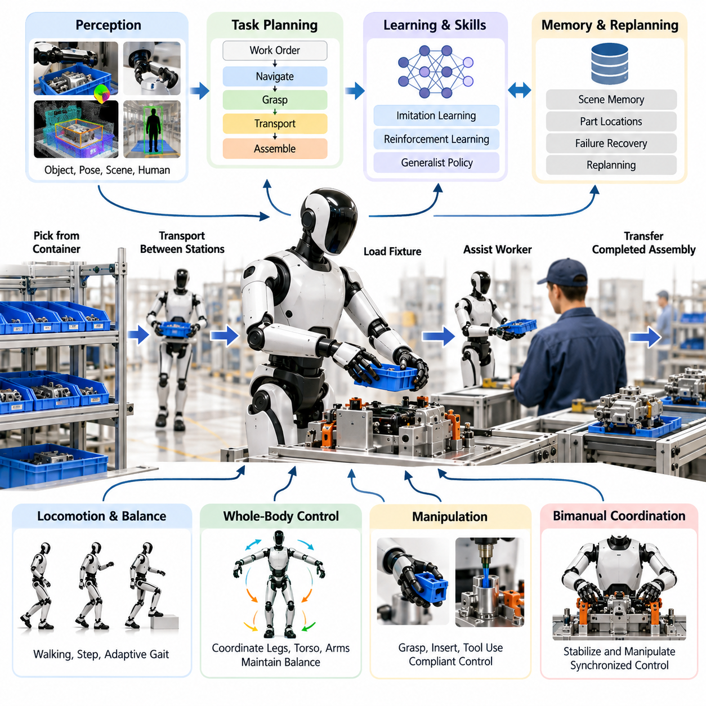
A manufacturing assembly-line humanoid pilot should be designed as a controlled production experiment rather than as a demonstration of general humanoid capability. Within the humanoid software structure, the pilot integrates locomotion, balance, whole-body control, perception, manipulation, generalist policies, interaction, agent planning, and validation into one operational workflow. Volume_22_Humanoid_Robot_Softwa… The objective is to determine whether a humanoid can execute useful production tasks safely and repeatedly inside an environment originally designed around human workers.
The first deployment phase should select operations that exploit human-compatible morphology without immediately requiring exceptional dexterity. Typical candidates include retrieving components from standardized containers, transporting lightweight parts between nearby stations, loading fixtures, presenting components to a worker, operating simple handles, and transferring completed assemblies. These activities exercise walking, reaching, grasping, carrying, and placement while keeping task complexity sufficiently bounded for systematic engineering evaluation.
A practical pilot begins with detailed decomposition of the production cycle into observable robot skills. A single assembly operation may contain navigation to a rack, object identification, grasp pose estimation, reaching, grasp verification, transportation, fixture localization, compliant insertion, release, and return. Each skill should expose measurable entry and exit conditions so that failures can be isolated instead of treating the entire operation as one opaque AI behavior. This also enables conventional automation logic to coexist with learned policies.
The perception subsystem must maintain a task-centered representation of the workstation rather than merely detect objects. Head and body cameras provide wider environmental context, while wrist cameras support close-range grasping and alignment. The software must estimate object identity, six-degree-of-freedom pose, fixture state, free workspace, human location, and relevant contact conditions. These capabilities are consistent with the volume's humanoid perception architecture, including egocentric vision, wrist sensing, 3D scene understanding, human tracking, and grasp-oriented object pose estimation. Volume_22_Humanoid_Robot_Softwa…
Manipulation introduces a different challenge from fixed industrial robots because the humanoid's arms operate on a floating, dynamically constrained body. Reaching for a component changes the center of mass and may reduce stability margins, particularly when the object is distant or asymmetric. Whole-body control therefore coordinates legs, torso, arms, and contact forces while maintaining balance constraints. The software can reposition the feet or torso when an otherwise reachable target would create an undesirable configuration instead of forcing the arm to complete the motion independently.
Contact-rich assembly requires control modes beyond geometric trajectory tracking. When inserting a connector, positioning a component against a fixture, opening a guarded mechanism, or manipulating a tool, small pose errors can produce large contact forces. Arm impedance control and compliant joint torque control allow the humanoid to accommodate these uncertainties, while force and tactile feedback provide evidence of contact state. The architecture therefore combines motion objectives with force limits, collision constraints, and task-specific contact conditions rather than relying exclusively on visual alignment.
Bimanual tasks can provide an important justification for humanoid morphology. One hand may stabilize a component while the other performs insertion, fastening, inspection, or tool manipulation. The two arms cannot be planned as independent manipulators because their motions interact through the torso and floating base. Coordinated bimanual control must account for shared workspace, self-collision, load distribution, synchronization, and balance. The underlying software structure explicitly includes bimanual coordination and unified locomotion-manipulation functions for these requirements. Volume_22_Humanoid_Robot_Softwa…
The pilot should use a hierarchical task architecture in which production objectives are separated from real-time execution. A task planner may interpret a work order such as supplying a component to an assembly station and decompose it into navigation, perception, grasping, transport, and placement actions. Lower-level controllers execute those actions under deterministic safety constraints. Semantic scene memory can retain the locations and states of parts, tools, fixtures, and workstations, while failure-aware replanning determines what action should follow an unsuccessful grasp or blocked destination.
Learned policies can be introduced selectively where explicit programming becomes expensive. Teleoperation demonstrations may provide imitation-learning data for manipulation sequences, while reinforcement learning or hybrid IL-RL methods can improve behaviors that require adaptation to contact or configuration variation. A generalist or VLA policy can connect visual observations and task instructions to higher-level actions, but production deployment should retain safety overrides and fallback behaviors. The volume specifically treats teleoperation, multi-task policies, language-conditioned execution, onboard inference, and VLA safety fallback as connected humanoid capabilities. Volume_22_Humanoid_Robot_Softwa…
Integration with the assembly line is equally important because the humanoid is only one component of the manufacturing system. The robot may need interfaces to manufacturing execution systems, workstation controllers, machine status signals, safety equipment, and production scheduling services. Instead of autonomously guessing whether a machine is ready, the robot should consume explicit state information whenever reliable digital interfaces exist. Perception can then provide complementary verification, allowing discrepancies between commanded production state and physically observed state to be detected.
Human-robot coexistence changes both motion planning and production scheduling. The humanoid must recognize workers, maintain appropriate separation, limit speed and force where necessary, and yield when shared workspaces become occupied. Collaborative actions such as component handover require explicit estimation of human readiness rather than simple object release. Voice or gesture interaction may provide secondary interfaces, but safety-critical commands should be associated with deterministic supervisory mechanisms instead of depending solely on probabilistic language interpretation.
A production pilot should also define recovery behavior before deployment. A failed grasp may trigger perception refresh and another grasp candidate; an unexpected obstacle may invoke local replanning; uncertain object identity may request human confirmation; excessive contact force should terminate the manipulation action; and localization or controller faults may transition the robot to a safe state. Recovery coverage is often more significant than nominal task performance because real manufacturing environments continuously expose the robot to small variations that scripted demonstrations avoid.
Validation should progress from simulation and software-in-the-loop testing to hardware-in-the-loop evaluation and finally restricted field operation. The software structure for humanoids explicitly includes locomotion SIL, WBC HIL, manipulation simulation, VLA regression testing, HRI function testing, field protocols, safety-function testing, and environmental stress testing. Volume_22_Humanoid_Robot_Softwa… Digital models can first exercise thousands of variations in object pose, worker position, disturbances, and task sequences before equivalent scenarios are admitted to the physical production cell.
The pilot evaluation must measure more than whether the robot eventually completes a task. Useful metrics include task success rate, cycle time, intervention frequency, grasp and insertion success, localization reliability, balance recovery, safety-stop frequency, energy consumption, and mean time between operational failures. Human intervention should be recorded as a first-class metric because a system that reports high task success while requiring frequent remote recovery may have little production value. Performance distributions are more informative than a single successful demonstration.
Production economics provide the final deployment gate. A humanoid does not need to outperform specialized automation at every individual operation; its potential advantage lies in sharing human-oriented infrastructure and being reassigned across tasks without extensive mechanical redesign. The pilot should therefore compare integration cost, changeover effort, utilization, labor assistance, downtime, maintenance, and software adaptation against conventional alternatives. Tasks with high variability but moderate throughput may provide stronger early opportunities than extremely repetitive, high-speed operations already served efficiently by fixed automation.
A successful assembly-line pilot ultimately demonstrates an integrated operational capability rather than a collection of isolated humanoid features. Reliable locomotion delivers the robot to the station, perception establishes physical context, whole-body control maintains feasible motion, compliant manipulation performs the work, AI policies handle bounded variability, agent logic manages task progression, and deterministic safety mechanisms constrain every action. This layered integration is consistent with the broader software organization of the humanoid volume, which develops these capabilities individually before bringing them together in industrial case studies. 08_Robotics_Software_Tree

12.02. Warehouse Picking and Sorting Humanoid Case
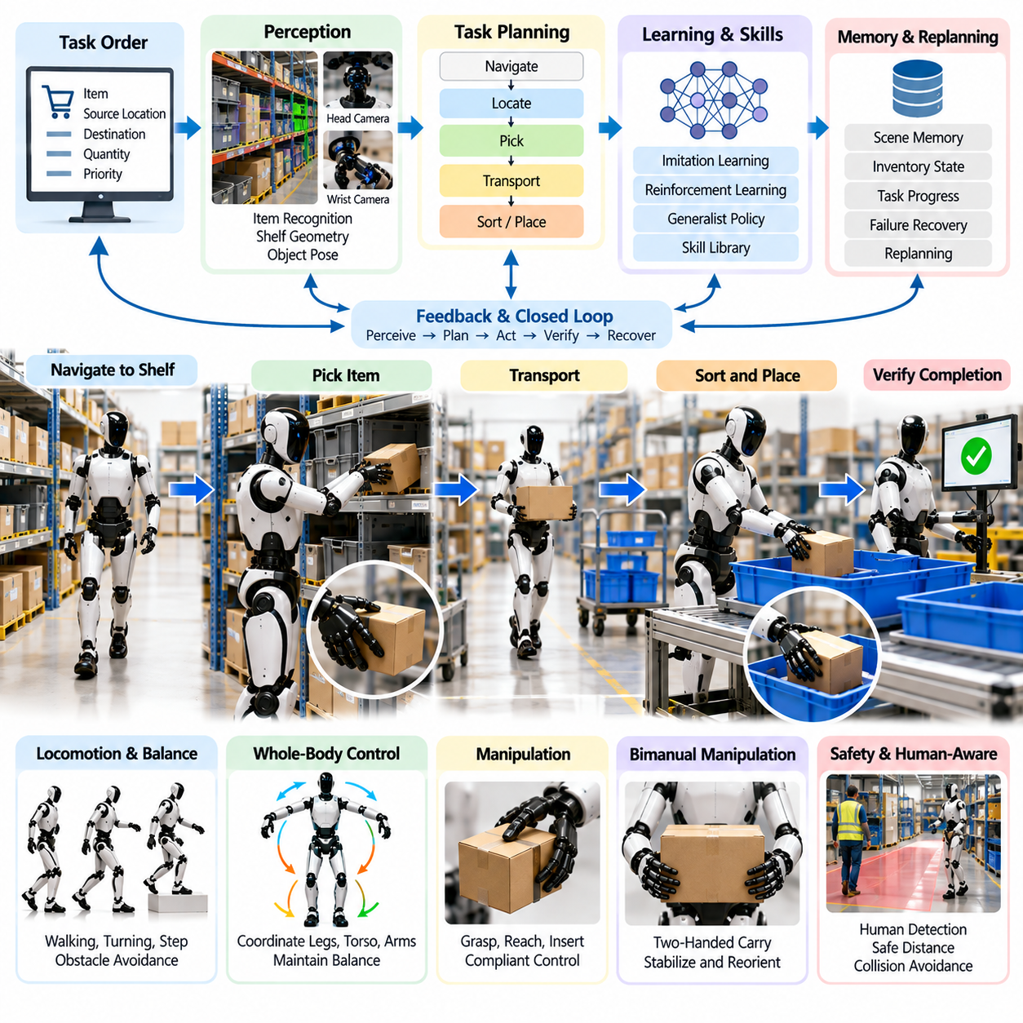
Warehouse picking and sorting provides a strong humanoid deployment case because conventional warehouses contain shelves, totes, carts, worktables, handles, and passages largely dimensioned for human workers. A humanoid can potentially operate within this infrastructure without requiring every storage location to be redesigned for fixed automation. The case combines navigation, perception, grasping, carrying, placement, balance, task planning, and recovery, making it a representative test of integrated humanoid software capability.
The operational workflow begins when the warehouse management layer assigns a picking or sorting task containing item identity, source location, destination, quantity, and priority. The humanoid task planner converts this information into executable actions such as navigating to a shelf, locating the target container, identifying the requested object, selecting a grasp, retrieving the item, verifying acquisition, transporting it, and placing it into the designated tote or sorting destination. Each stage should expose explicit success and failure conditions.
Navigation must account for the distinctive characteristics of a biped robot. Unlike a wheeled AMR, a humanoid continuously manages dynamic stability while moving through aisles, turning near racks, stepping around temporary obstacles, and approaching work surfaces. Footstep planning, balance control, state estimation, and local obstacle avoidance must operate together. The robot should select stable approach poses that provide sufficient manipulation reach while avoiding configurations that force excessive leaning or create narrow balance margins during subsequent picking motions.
Warehouse perception must connect semantic item recognition with geometric manipulation information. Head-mounted cameras can provide wide-area shelf and aisle observations, while wrist cameras offer detailed views during final reaching and grasping. The system must estimate shelf geometry, container boundaries, object identity, object pose, free space, human location, and possible grasp regions. Open-vocabulary perception can further support warehouses where product inventories change more rapidly than a conventional closed-set detector can be retrained.
Picking becomes difficult when objects are partially occluded, densely packed, reflective, deformable, or visually similar. A reliable system should therefore treat perception as an active process rather than a single detection operation. The humanoid may move its head, torso, or hand camera to obtain another viewpoint, reposition neighboring objects when permitted, or compare visual observations with inventory information. Low-confidence identification should trigger additional inspection or human confirmation instead of allowing an uncertain prediction to propagate directly into physical manipulation.
Grasp generation must consider not only whether the hand can acquire an object but whether the resulting configuration supports the remainder of the task. A grasp suitable for removing an item from a shelf may obstruct barcode inspection or make placement into a tote difficult. The planner should therefore evaluate accessibility, hand orientation, collision clearance, expected load, object geometry, and downstream manipulation requirements. Tactile and force feedback can verify contact, detect slip, and determine whether the object has actually been secured before transport begins.
Shelf height variation highlights an important advantage and challenge of humanoid morphology. Low locations may require crouching, while high shelves require coordinated extension of the legs, torso, shoulder, and arm. These motions modify the center of mass and available stability margin, particularly when the robot retrieves a heavy object. Whole-body control must coordinate posture and manipulation so that reaching objectives remain subordinate to balance, joint limits, self-collision avoidance, contact constraints, and actuator torque limits.
Bimanual manipulation becomes useful for large packages, unstable containers, or objects requiring reorientation. The humanoid may use one hand to stabilize a tote while the other retrieves an item, hold a package with both hands during transport, or transfer an object between hands to obtain a better placement orientation. Such behaviors require coordinated arm motion through the shared torso and floating base. Load distribution must also be incorporated into balance control because the carried object's mass changes the dynamics of the complete robot-object system.
Sorting extends the task beyond successful picking. After acquisition, the robot must determine the correct destination from the work order, observed item identity, or warehouse routing information and then execute reliable placement. Destination containers may already contain objects, so the available placement region can change continuously. Perception should update the container state before release, while manipulation planning should avoid collisions and excessive drop height. Successful placement should be verified visually or through other available sensing before the task record is completed.
A generalist or vision-language-action policy can provide flexibility when warehouse tasks are expressed through semantic instructions such as finding a specified product and placing it into a destination bin. However, language-conditioned policies should not independently control safety-critical motion boundaries. High-level semantic reasoning can select goals and skills, while validated locomotion, whole-body control, collision checking, grasp execution, and safety supervision constrain physical actions. This separation allows learned intelligence to increase adaptability without making production safety dependent on unconstrained model output.
Warehouse environments are inherently shared spaces, so human detection and interaction must remain active throughout execution. Workers may enter aisles, reach into neighboring shelves, move carts, or temporarily block the robot's planned path. The humanoid should reduce speed or stop when separation becomes insufficient and replan when necessary. During shared picking operations, intent estimation can help distinguish a passing worker from someone actively interacting with the same shelf, while deterministic safety logic retains authority over motion permission.
Failure recovery is essential because picking errors accumulate rapidly over thousands of warehouse transactions. A failed grasp may trigger another viewpoint and grasp candidate, while a slipped object should initiate a controlled recovery response. If the requested item is absent, the robot should distinguish between perception uncertainty and inventory inconsistency. Blocked shelves, unreachable objects, navigation failures, unexpected package weights, and occupied destinations should generate explicit exception states that can be resolved through replanning, reassignment, or human assistance.
The software architecture should maintain semantic task memory across these recovery cycles. The robot needs to know which order it is executing, which locations have already been inspected, which object was grasped, what failures occurred, and what destination remains valid. Without persistent task state, a recovery action can cause repeated searches or duplicate handling. An agent architecture combining perception, memory, action, multi-step planning, and failure-aware replanning is therefore particularly valuable for long warehouse workflows involving many sequential decisions.
Evaluation should progress from isolated shelf-picking experiments to integrated warehouse missions. Simulation can vary shelf geometry, object pose, lighting, occlusion, aisle traffic, package mass, and destination occupancy before physical deployment. Hardware tests should then validate balance, manipulation forces, perception latency, safety stops, and recovery behavior. Restricted field trials can gradually introduce real inventory and human traffic after the robot demonstrates stable behavior under controlled conditions, preserving a clear progression from software validation to operational exposure.
Performance measurement should include item recognition accuracy, grasp success rate, first-attempt pick rate, placement accuracy, order completion rate, cycle time, walking time, intervention frequency, recovery success, damaged-item rate, and safety-stop frequency. Throughput alone is insufficient because a fast system that frequently requires human recovery can increase warehouse workload. Metrics should therefore distinguish autonomous completion from assisted completion and record the causes of failures so that software improvements can target the dominant operational bottlenecks.
The economic value of a warehouse humanoid depends on flexibility rather than simply matching the speed of specialized automation. Fixed conveyors, sorters, robotic cells, and AMRs remain superior for many highly structured flows. Humanoids become attractive where facilities contain human-oriented shelves, variable handling tasks, frequent layout changes, or workflows requiring both mobility and manipulation. The strongest deployment model may therefore combine humanoids with existing automation, assigning each platform the tasks that best match its physical and software capabilities.
A successful warehouse pilot ultimately demonstrates closed-loop autonomy across perception, locomotion, manipulation, reasoning, and recovery. The humanoid must move to the correct location, understand the local scene, acquire the correct object, maintain balance under changing loads, deliver it to the correct destination, verify completion, and recover from predictable failures without continuous supervision. Repeated execution of this complete cycle transforms warehouse picking and sorting from an isolated manipulation benchmark into a practical test of production-grade humanoid intelligence.

12.03. Retail Store Shelf Stocking Humanoid Case
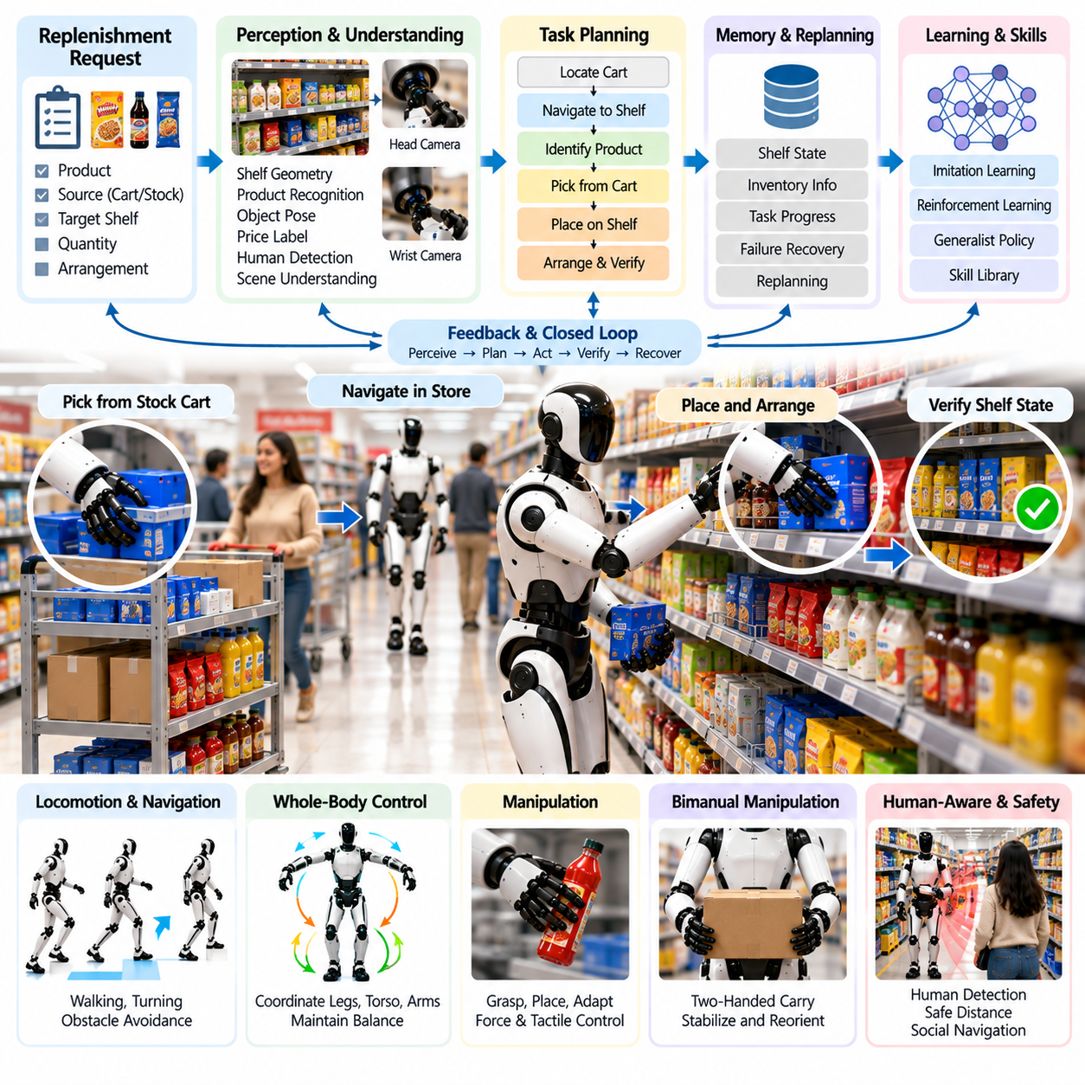
Retail shelf stocking is a demanding humanoid case because it combines mobile manipulation with continuous operation in a human-centered environment. Unlike a warehouse with relatively controlled aisles and inventory processes, a retail store contains customers, employees, shopping carts, changing displays, narrow passages, and products that are frequently moved from their expected positions. The humanoid must therefore combine perception, locomotion, manipulation, task reasoning, and human-aware behavior while preserving safe operation around the public.
The workflow can begin with a replenishment request generated from inventory records, shelf monitoring, or an employee instruction. The task may specify a product, source container, target shelf, quantity, and desired arrangement. A humanoid task planner converts this request into actions for locating the replenishment cart, identifying the correct products, navigating to the display area, finding the shelf position, removing misplaced items when permitted, placing new products, arranging their orientation, and verifying the final shelf state.
Retail perception requires understanding both individual products and the structural organization of the shelf. Head-mounted cameras can observe aisles, customers, signs, shelves, and obstacles, while wrist cameras provide close-range information during grasping and placement. The perception system should estimate product identity, object pose, shelf boundaries, available placement regions, neighboring products, price-label locations, and human positions. Open-vocabulary perception is particularly useful because retail inventories may contain thousands of products and change more frequently than fixed detection classes.
Product identification can be difficult because packages may share similar colors, shapes, logos, or dimensions. Products can also be partially occluded, rotated, stacked, or positioned behind other items. The humanoid should combine visual recognition with barcode, text, inventory, or shelf-location information whenever available. Low-confidence recognition should initiate another observation or request confirmation rather than allowing an uncertain classification to produce an incorrect shelf placement that later creates inventory and customer-service errors.
Shelf stocking requires more than placing an object inside an available space. Products are normally expected to follow merchandising constraints such as facing forward, maintaining category grouping, aligning package fronts, preserving price-label correspondence, and keeping sufficient spacing. The robot therefore needs a representation of the desired shelf state and must compare it with the observed state. Placement planning can then determine not only where an item fits geometrically but where it belongs according to the merchandising objective.
Manipulation difficulty varies substantially across retail products. A rigid box may support simple parallel gripping, whereas bottles, bags, flexible packages, fragile containers, and cylindrical objects require different grasp strategies. Force and tactile sensing can help detect secure contact, excessive squeezing, or object slip. The manipulation system should adapt grasp force and hand configuration to product properties while maintaining conservative limits, particularly when handling fragile goods or products whose packaging can deform under concentrated contact.
Shelf height introduces a whole-body control problem similar to other humanoid manipulation tasks but with greater variation across a store. Low shelves may require crouching or kneeling-like postures, while upper shelves require coordinated extension of the legs, torso, shoulder, and arm. The controller must maintain center-of-mass stability while respecting joint limits, self-collision constraints, actuator limits, and environmental clearance. Repositioning the feet should be preferred when excessive reaching would reduce stability or manipulation accuracy.
Restocking multiple units introduces repetitive manipulation combined with changing scene geometry. After every placement, the available shelf space changes and the next target pose may need to be recomputed. Rather than executing a fixed sequence of identical coordinates, the robot should observe the shelf state repeatedly and close the loop between perception and action. This approach allows the system to compensate for small placement errors and for unexpected changes caused by customers or employees during the stocking operation.
Bimanual manipulation can improve performance when handling trays, cartons, multipacks, or unstable objects. The humanoid may hold a supply carton with one hand while retrieving products with the other, use both hands to carry a larger package, or stabilize neighboring merchandise during insertion. These actions require coordination between both arms, torso posture, and balance control. The controller must account for the changing load distribution because asymmetric carrying can significantly alter the robot's center of mass and feasible motion.
Navigation in a retail store cannot assume that previously planned paths remain clear. Customers can stop unexpectedly, carts may block aisles, children may move unpredictably, and employees may temporarily occupy stocking areas. The humanoid should continuously update local free space and maintain human-aware separation while moving. When an aisle becomes blocked, waiting or replanning is preferable to attempting aggressive passage. Locomotion speed should reflect visibility, pedestrian density, carried load, and the robot's current ability to stop safely.
Human-robot interaction becomes more important in retail than in isolated industrial environments. Customers may approach the robot, ask questions, interrupt its path, or reach toward products near its hands. Employees may provide verbal instructions or request temporary suspension of a stocking task. Voice and language interfaces can support these interactions, but physical safety must remain governed by deterministic mechanisms. Conversational behavior should never override collision avoidance, force limits, emergency stops, or protected motion boundaries.
A language-conditioned or VLA system can improve flexibility by interpreting instructions such as placing a group of products on a specified shelf or correcting a display. Semantic reasoning can connect product descriptions, visual observations, and task objectives without requiring every operation to be manually scripted. However, high-level model outputs should be translated into validated robot skills. Navigation, grasping, whole-body control, collision checking, and release actions should remain constrained by tested execution layers and independent safety supervision.
Failure recovery should be considered part of normal retail operation rather than an exceptional function. A failed grasp can trigger another grasp candidate, while an occupied shelf position can initiate a search for the correct neighboring location or request assistance. If a product falls, the robot should stop the current sequence and evaluate whether safe recovery is possible. Missing products, incorrect labels, blocked displays, uncertain identification, damaged packaging, and unexpected shelf configurations should generate explicit exception states instead of uncontrolled improvisation.
Persistent task memory is necessary when a stocking mission contains many products and locations. The robot should retain which products have been retrieved, which shelf positions have been completed, which placements failed, and which tasks require later inspection. Semantic scene memory can also help detect whether a customer moved an item after placement. By combining memory with failure-aware replanning, the humanoid can resume interrupted work without restarting the entire stocking sequence or duplicating already completed actions.
Testing should begin with controlled shelf layouts before introducing realistic store complexity. Simulation can vary product geometry, shelf height, lighting, occlusion, pedestrian traffic, package mass, and object arrangement. Physical tests can then introduce representative shelves and products while measuring perception, grasping, whole-body stability, placement accuracy, and recovery. Human traffic should be added progressively so that public-space interaction is evaluated only after the underlying manipulation and safety behaviors have reached stable performance.
Useful pilot metrics include product recognition accuracy, first-attempt grasp success, placement success, facing accuracy, shelf-state verification accuracy, task completion time, intervention frequency, recovery success, product damage, navigation delays, and safety-stop frequency. The evaluation should distinguish fully autonomous completion from employee-assisted completion. A robot that stocks many products but repeatedly requires workers to correct orientation, identification, or recovery failures may provide less operational value than its raw throughput suggests.
The economic case depends on whether humanoid flexibility compensates for lower speed relative to specialized retail automation. A humanoid can potentially move between aisles, manipulate existing shelves, use carts and containers designed for people, and perform several related tasks without major infrastructure changes. The strongest applications may therefore involve stores with variable product layouts, frequent replenishment, labor-intensive shelf maintenance, or periods when employees must divide their attention between stocking and customer-facing activities.
A successful retail pilot demonstrates more than autonomous product placement. The humanoid must interpret replenishment goals, navigate safely through a changing public environment, recognize the correct merchandise, manipulate products without damage, maintain whole-body stability across different shelf heights, satisfy merchandising constraints, verify the resulting display, and recover from routine failures. When these capabilities operate repeatedly as one closed-loop system, shelf stocking becomes a meaningful test of general-purpose humanoid deployment in human-designed commercial environments.

12.04. Hospital Logistics and Patient Assist Case
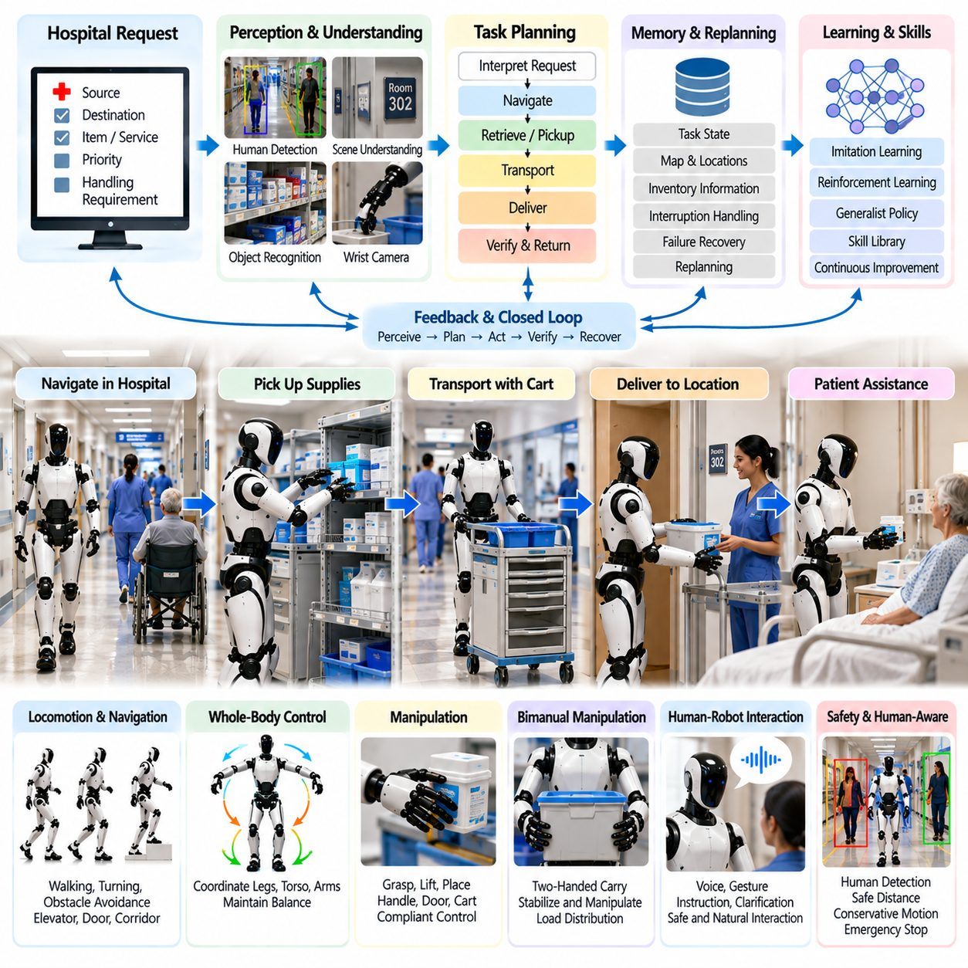
Hospital logistics and patient assistance represent a demanding humanoid application because hospitals combine structured operational workflows with highly dynamic human environments. A humanoid may move supplies, deliver materials, manipulate doors and carts, retrieve objects, and provide bounded assistance to patients or staff. Unlike conventional industrial deployment, however, every action must account for vulnerable people, clinical priorities, privacy, infection-control procedures, and strict limitations on physical interaction.
A practical hospital pilot should begin with low-risk logistics tasks before progressing toward direct patient assistance. Initial missions can include transporting sealed supplies, collecting lightweight materials, delivering linens, moving approved carts, carrying laboratory containers within defined procedures, or retrieving commonly used items for staff. These activities exploit human-compatible mobility and manipulation while allowing the system to establish reliability without immediately introducing high-risk physical contact with patients.
The workflow can begin when a hospital information or logistics system assigns a request containing source, destination, item identity, priority, and handling requirements. The humanoid task planner translates this request into navigation, access, retrieval, transport, delivery, verification, and return actions. Emergency or time-critical clinical activities must remain dominant over robot objectives, so the task architecture should support interruption, priority changes, cancellation, and safe suspension whenever staff or operational conditions require it.
Hospital navigation differs from ordinary indoor navigation because corridors are continuously shared with patients, visitors, nurses, physicians, beds, wheelchairs, carts, and mobile medical equipment. The humanoid must maintain stable biped locomotion while predicting nearby motion conservatively. Local planning should favor wide clearance and low-risk trajectories rather than shortest-path optimization. Elevators, automatic doors, narrow passages, temporary equipment, and changing access restrictions also require continuous environmental interpretation and replanning.
Perception must provide both geometric awareness and semantic understanding of the clinical environment. Head cameras can observe corridors, rooms, signs, people, carts, doors, and obstacles, while wrist cameras support close manipulation of handles, containers, and delivered items. Human detection, pose estimation, object recognition, and 3D scene understanding should operate together so that the robot can distinguish navigable space from areas occupied by people or equipment and identify objects relevant to the assigned task.
Human perception requires particularly conservative treatment because a patient may move slowly, unpredictably, or with limited awareness of the robot. The system should estimate position and motion without assuming that detected people will actively avoid it. Children, elderly patients, people using mobility aids, and individuals lying or sitting outside typical standing-body configurations can challenge conventional perception models. Uncertain human detection should therefore bias the robot toward slower motion, greater separation, or stopping rather than aggressive continuation.
Manipulation tasks should initially focus on objects with controlled interfaces and known handling constraints. The humanoid may grasp supply bins, operate approved door handles, place packaged materials on a table, retrieve lightweight objects, or manipulate carts designed for robotic interaction. Force and tactile sensing can verify contact and detect slip, while compliant arm control limits interaction forces. Fragile, sterile, hazardous, or medically critical objects should require additional handling rules and may remain outside the pilot scope.
Whole-body control becomes important when the humanoid reaches toward shelves, opens doors, pushes a cart, or carries objects through corridors. Manipulation forces propagate through the arms and torso into the floating-base dynamics, so balance cannot be treated independently from the task. The controller should coordinate feet, legs, torso, and arms while respecting joint, torque, contact, and self-collision constraints. When necessary, repositioning the feet should precede manipulation rather than allowing unstable extended reaches.
Patient assistance introduces a substantially higher safety threshold than material logistics. Early assistance should therefore emphasize non-contact or lightly interactive functions such as bringing requested items, providing directions, calling staff, presenting objects within reach, or supporting simple communication. Tasks involving lifting, transferring, physically supporting, restraining, or medically positioning a patient require specialized safety engineering and clinical validation and should not be treated as ordinary extensions of warehouse-style manipulation.
Human-robot interaction is central to hospital operation because the robot must communicate with both trained staff and members of the public. Voice interfaces can receive bounded requests, announce intentions, confirm destinations, or ask for clarification. Gesture and gaze cues may help determine whether a person intends to interact with the robot. However, language interpretation should remain separated from safety-critical execution, with validated control layers determining whether requested physical actions are permitted.
An AI agent can coordinate longer hospital missions by maintaining task context across multiple locations and interactions. Semantic memory may store the current delivery objective, collected item, destination, access state, completed steps, and unresolved exceptions. If a corridor becomes blocked or the destination is temporarily unavailable, failure-aware replanning can select another route, wait at an approved location, or request staff assistance. Persistent state prevents interrupted missions from restarting incorrectly or delivering an item twice.
Language-conditioned and VLA policies may improve flexibility when instructions vary across departments or objects are not represented by fixed identifiers. A staff member could request that a known supply be brought from a nearby storage area, and semantic reasoning could connect the instruction with perceived objects and available robot skills. Nevertheless, model-generated plans should be converted into validated actions, while locomotion, manipulation, collision avoidance, force limits, and access permissions remain under deterministic supervision.
Hospital operations require explicit failure handling because an apparently minor robot fault can obstruct clinical work. Navigation failure should move the robot toward a safe waiting state when possible, while uncertain object identity should prevent delivery until verification occurs. A dropped item, unexpected contact, blocked doorway, localization loss, actuator fault, or emergency stop must generate a defined recovery path. The robot should never improvise around a safety or clinical restriction merely to complete its assigned task.
Operational safety should include behavior for emergency conditions in which the robot itself is not the priority. If staff rapidly move a bed or emergency equipment through a corridor, the humanoid should yield and avoid obstructing access. Safe-stop locations should be selected so that a disabled robot does not become a hazard. Supervisory systems should provide staff with clear robot status, mission state, and mechanisms for immediate stop, task cancellation, manual recovery, or removal from the operational area.
Privacy and data governance are also important because humanoid perception may continuously observe patients, visitors, staff, room identifiers, screens, and documents. The perception architecture should minimize collection and retention of information not required for robot operation. Access to stored sensor data, task logs, and semantic memory should follow defined authorization and auditing policies. Development datasets and operational recordings should also be managed separately from routine clinical information wherever the deployment architecture permits.
Validation should progress from simulation and controlled laboratory environments to mock hospital spaces and then restricted clinical pilots. Tests should vary pedestrian density, corridor obstruction, lighting, object placement, door states, communication noise, and task interruptions. Software-in-the-loop and hardware-in-the-loop testing can expose failures before human interaction is introduced. Direct patient-facing functions should only be added after navigation, manipulation, safety supervision, and recovery behavior demonstrate stable performance.
Useful logistics metrics include delivery success, task completion time, autonomous completion rate, navigation intervention, object-handling success, localization reliability, recovery success, and safety-stop frequency. Patient-facing evaluation additionally requires measures of interaction clarity, response appropriateness, minimum separation, unintended contact, and staff intervention. Metrics should distinguish technical task completion from clinically acceptable execution because a robot can successfully reach a destination while still creating unacceptable disruption or risk.
The economic and operational value of a hospital humanoid is likely to come from versatility across human-designed infrastructure rather than maximum throughput. Hospitals contain many low-volume, variable tasks that are difficult to automate with dedicated machinery. A humanoid capable of navigating existing corridors and manipulating familiar objects could assist staff across several workflows. Deployment value should therefore be measured against staff time saved, workflow disruption, supervision demand, reliability, maintenance burden, and integration cost.
A successful hospital pilot ultimately requires a layered system in which perception establishes situational awareness, locomotion provides safe mobility, whole-body control maintains physical feasibility, manipulation executes bounded tasks, human-robot interaction supports communication, and agent logic coordinates longer missions. Safety supervision must remain authoritative across all layers. Only when these capabilities operate reliably together can humanoid robots progress from controlled hospital logistics toward carefully defined forms of patient assistance.

12.05. Construction Material Handling Humanoid Case
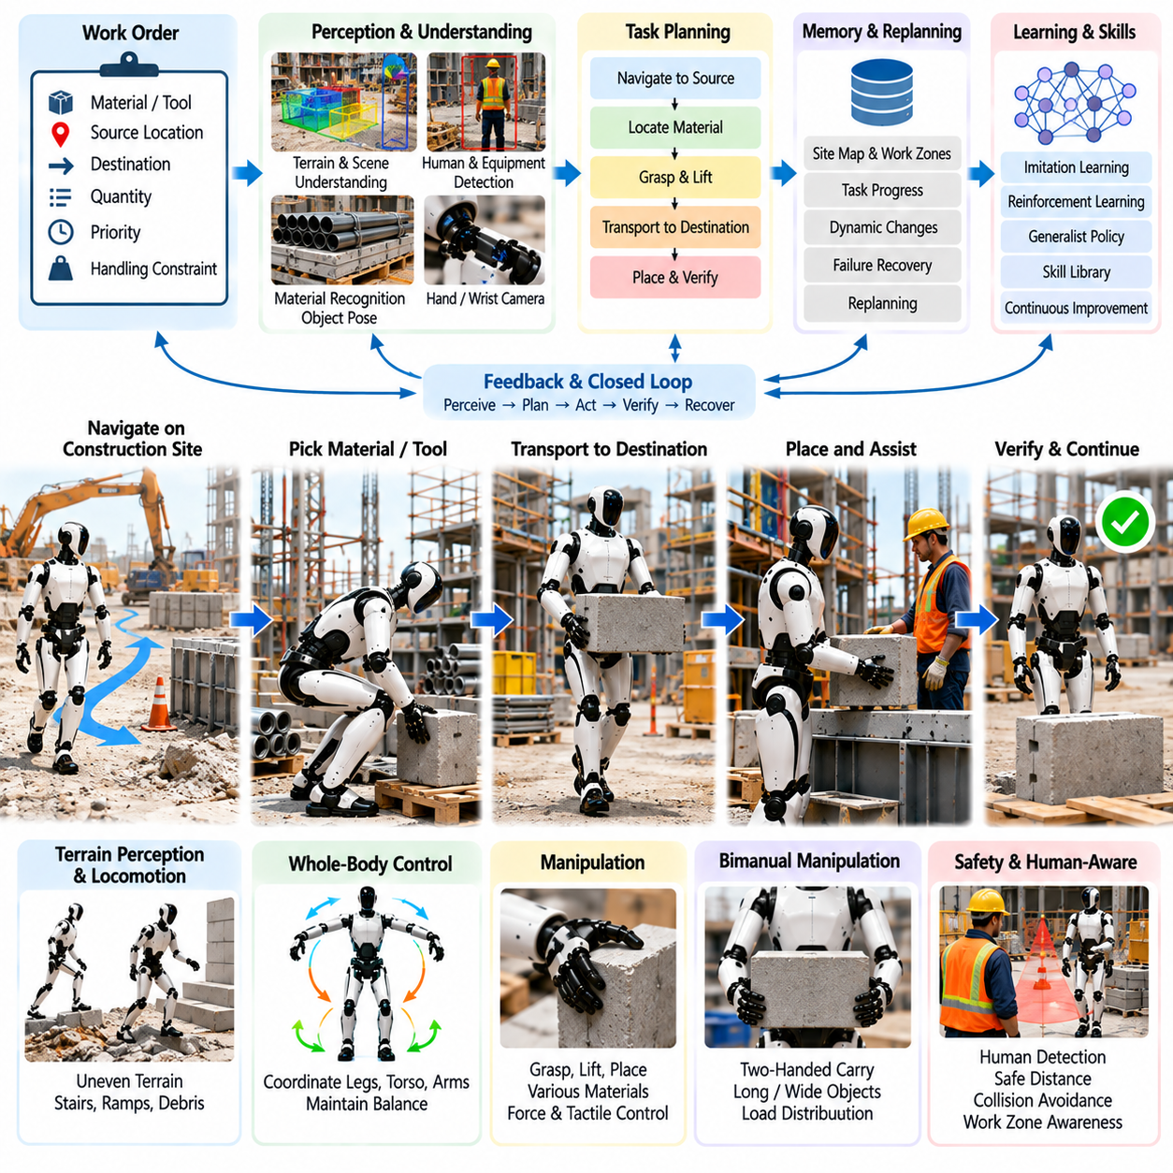
Construction material handling is a challenging humanoid deployment case because construction sites combine unstructured terrain, changing layouts, heavy or awkward objects, temporary obstacles, and continuous interaction with human workers. Unlike factories or warehouses, the environment may change significantly within hours. A useful humanoid must therefore integrate terrain perception, biped locomotion, whole-body balance, manipulation, task planning, and safety supervision while adapting to incomplete and frequently changing site information.
A practical pilot should begin with bounded material-handling tasks rather than unrestricted construction work. Suitable operations include carrying lightweight components between staging areas, retrieving tools, moving packaged materials, supplying parts to workers, sorting reusable components, and transferring objects between carts and work surfaces. These tasks exercise mobility and manipulation while avoiding initial dependence on high-force operations or complex construction processes that require specialized certification, tooling, or expert craftsmanship.
The workflow can begin from a digital work order specifying the material, source, destination, quantity, priority, and handling constraints. The humanoid task planner converts this request into navigation, object search, grasp preparation, lifting, transportation, placement, and verification actions. Because construction schedules and work zones change continuously, the plan must remain interruptible. Temporary access restrictions, moving equipment, worker instructions, or newly identified hazards should trigger task suspension or replanning instead of forcing completion of an obsolete plan.
Terrain perception is fundamental because the robot cannot assume a flat and unobstructed floor. Construction environments may contain ramps, temporary plates, cables, debris, uneven surfaces, thresholds, partially completed stairs, and differences in floor elevation. The perception system should estimate traversable regions, surface geometry, obstacle height, foothold quality, and clearance while maintaining awareness of nearby workers and machinery. Uncertain terrain should cause conservative locomotion or route selection rather than aggressive traversal.
Biped locomotion provides potential access to spaces designed for workers, but it also creates significant stability requirements. The humanoid must coordinate footstep planning, state estimation, balance control, and local navigation while carrying materials across changing surfaces. Step length, foot orientation, walking speed, and body posture should adapt to terrain and load. When the available foothold becomes uncertain, the robot should shorten steps, reduce velocity, increase stability margins, or select an alternative route before continuing.
Material handling changes the dynamics of the complete robot system. A package carried in front of the torso shifts the combined center of mass, while an object held in one hand creates asymmetric loading. The whole-body controller must account for estimated object mass and grasp location while coordinating the legs, torso, and arms. Balance constraints should remain dominant over task speed, and the robot should reject or request assistance for objects whose mass, dimensions, or inertia exceed validated handling limits.
Grasp planning must accommodate construction materials that differ substantially from standardized warehouse products. Boxes, pipes, panels, containers, tools, fittings, cables, and irregular components present different grasp surfaces and load characteristics. Visual geometry can generate candidate grasps, while force and tactile sensing can verify contact and detect slip. The system should also consider sharp edges, unstable contents, deformable packaging, and surfaces contaminated by dust or moisture when determining whether autonomous handling is permitted.
Bimanual manipulation is particularly valuable for long, wide, or unstable materials. The humanoid may use both hands to carry a panel, stabilize a container, reposition a pipe, or transfer a component onto a workbench. Coordinated arm motion must be integrated with torso posture and foot placement because the object can constrain the robot's reachable workspace. The controller should maintain appropriate internal forces between the hands without applying unnecessary stress to the object or destabilizing the robot.
Lifting should be planned as a whole-body motion rather than an isolated arm trajectory. When retrieving an object from the floor, the humanoid may need to lower its center of mass, bend the knees, position the torso, establish a stable grasp, and then extend the legs while maintaining balance. High shelves or elevated platforms create the opposite challenge. Joint limits, actuator torque, contact forces, self-collision, and load-dependent stability must therefore be considered throughout the complete lifting and placement trajectory.
Navigation while carrying a load requires different constraints from unloaded walking. The object may block the robot's lower field of view, extend beyond its body envelope, or reduce the ability to recover from disturbances. Collision checking must include the carried object rather than only the robot model. The planner should also account for reduced stopping capability, narrower clearance, and limited arm motion. If visibility becomes inadequate, additional cameras or deliberate head and torso movements can provide alternative observations.
Construction sites contain workers, forklifts, mobile platforms, cranes, carts, and power tools, creating complex human-machine interactions. The humanoid should continuously detect people and moving equipment and maintain conservative separation. It must not assume that workers will yield simply because the robot has planned a path. Audible or visual intention signaling may improve awareness, but deterministic safety mechanisms should retain authority to slow, stop, or cancel motion whenever safe separation cannot be maintained.
A language-conditioned AI agent can improve flexibility because construction instructions are often expressed in task-oriented terms rather than precise robot coordinates. A supervisor might request delivery of a specified component to a particular work area, and semantic reasoning can connect the instruction with perceived materials, site locations, and available robot skills. However, language interpretation should determine task intent rather than bypass physical constraints. Validated navigation, grasping, lifting, and whole-body controllers must govern actual execution.
Semantic scene memory is useful because construction environments evolve during the workday. The robot may need to remember material staging locations, previously blocked routes, completed deliveries, temporary hazards, tool locations, and unfinished tasks. This information should be refreshed when new observations contradict stored state. Failure-aware replanning can then use both current perception and task history to avoid repeatedly attempting inaccessible routes or searching locations already determined to be empty.
Failure recovery should cover dropped objects, grasp loss, unexpected weight, blocked paths, unstable footholds, localization degradation, and worker interruption. If the measured load differs substantially from expectation, the robot should return the object to a safe support surface rather than continue. Loss of terrain confidence should stop locomotion before the next unsafe step. Recovery policies should favor stable intermediate states from which a human can intervene without requiring emergency physical support of the humanoid.
Testing should progress from simulated construction scenes to controlled mock sites and then restricted field trials. Simulation can vary terrain roughness, obstacle placement, material geometry, object mass, lighting, dust-like visual degradation, and worker motion. Hardware testing should validate load-dependent balance, grasp reliability, foot placement, collision avoidance, and protective stops. Field exposure should expand only after the system demonstrates repeatable recovery from representative disturbances and handling failures.
Evaluation should include task completion rate, first-attempt grasp success, load-handling success, walking stability, placement accuracy, intervention frequency, recovery success, route replanning, safety stops, and material damage. Load-dependent performance should be reported separately because success with an empty container does not demonstrate equivalent capability with a heavy object. Autonomous completion should also be distinguished from remotely assisted execution so that the true operational maturity of the system remains visible.
The economic value of a construction humanoid is unlikely to come from replacing specialized heavy equipment. Forklifts, cranes, hoists, and dedicated machines remain better suited to high-load transportation. The humanoid's advantage is potential flexibility in worker-scale spaces and tasks where materials must be retrieved, carried, positioned, and transferred through infrastructure designed for people. It can therefore complement specialized machinery by addressing variable material flows that remain difficult to automate economically.
A successful construction pilot demonstrates that the humanoid can perceive changing terrain, select safe footholds, manipulate diverse materials, maintain balance under load, navigate around workers and equipment, verify delivery, and recover from routine failures as one integrated system. The critical achievement is not maximum lifting capacity but dependable physical intelligence under environmental variation. Such capability provides a foundation for progressively expanding humanoid roles from controlled material transport toward more complex construction assistance.

12.06. Domestic Home Service Humanoid Pilot Case
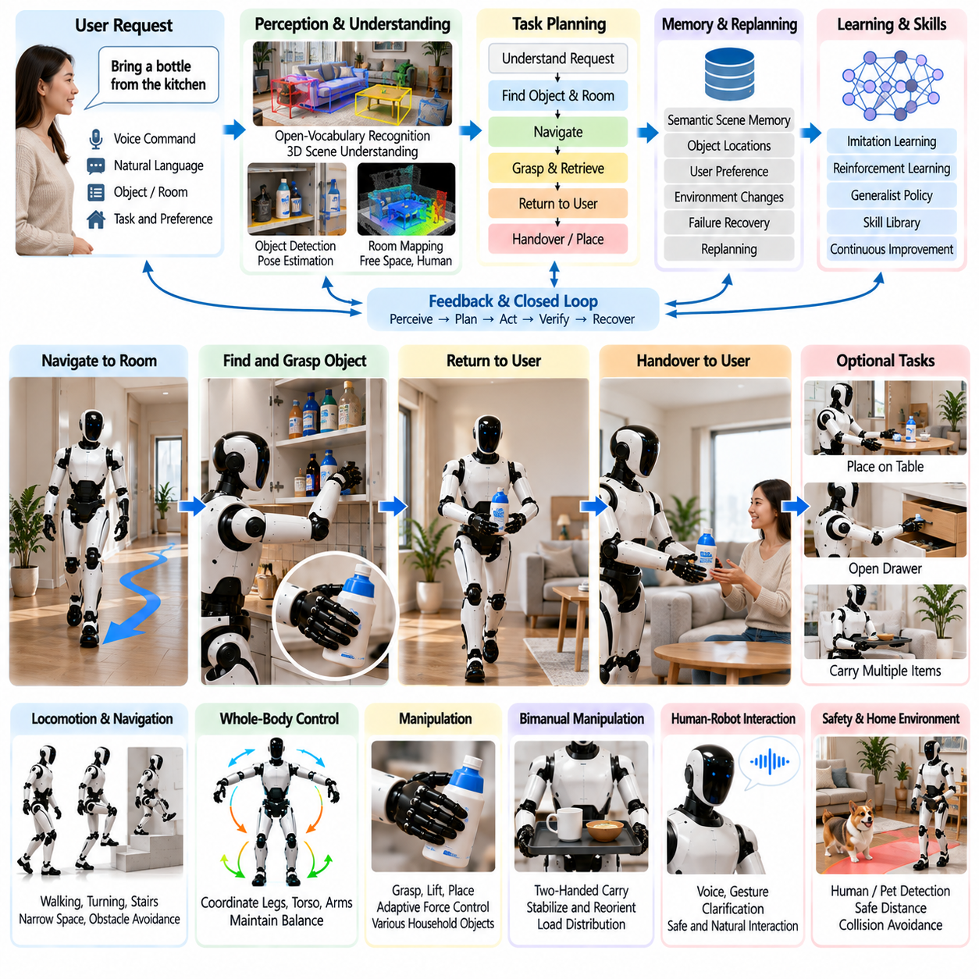
A domestic home-service humanoid pilot is one of the most comprehensive tests of general-purpose robotics because homes are highly variable, weakly structured, and designed around human morphology rather than automation. Furniture, objects, lighting, floor conditions, and available space differ between households and can change continuously. A useful humanoid must therefore combine perception, locomotion, manipulation, language understanding, memory, whole-body control, and safety within a single adaptive system.
The pilot should begin with bounded household tasks that provide practical value without requiring unrestricted autonomy. Suitable examples include retrieving objects, carrying lightweight items between rooms, organizing selected household goods, placing dishes or containers on designated surfaces, opening approved doors or drawers, and performing simple table-clearing activities. These tasks exercise multiple capabilities while allowing the operating environment, object set, and permitted interactions to remain clearly defined during early deployment.
A household mission may begin from a spoken or digital instruction such as bringing a specified object from another room. The AI task planner must translate this semantic request into a sequence of executable skills: interpreting the requested object, locating the relevant room, navigating to it, searching for the object, selecting a grasp, retrieving it, returning to the user, and performing a safe handover. Each stage requires explicit completion criteria so that failures can trigger recovery rather than silently propagating through the task.
Home perception must support open-ended scene understanding because household objects cannot be represented effectively by a small fixed set of classes. Head-mounted vision can provide room-scale observations, while wrist cameras support close-range manipulation. Open-vocabulary perception can connect natural-language object descriptions with visible objects, and 3D scene understanding can estimate surfaces, free space, furniture geometry, and object poses. The robot should maintain confidence estimates because visual ambiguity is unavoidable in cluttered domestic environments.
Semantic scene memory becomes especially important because objects in a home move frequently. The robot may remember that cups are usually stored in a cabinet or that cleaning supplies are normally located in a particular area, but stored information cannot be treated as permanent truth. Current perception should update memory whenever the environment changes. Combining semantic memory with object tracking allows the humanoid to search likely locations first while remaining capable of detecting and adapting to unexpected arrangements.
Domestic navigation requires more than moving between predefined waypoints. Homes contain narrow corridors, furniture, rugs, thresholds, stairs, pets, people, and objects temporarily left on the floor. The humanoid must continuously estimate traversable space while maintaining stable biped locomotion. Footstep planning and balance control should adapt to restricted clearance and surface changes, while uncertain terrain or insufficient space should cause the robot to stop, reposition, or select another route rather than forcing passage.
Manipulation presents extreme diversity because household objects vary in geometry, stiffness, fragility, weight, and function. A rigid bottle, ceramic cup, towel, book, remote control, food container, and drawer handle require different grasp and interaction strategies. Vision can propose grasp configurations, while force and tactile sensing verify contact and detect slip. The controller should adjust grasp force conservatively and reject manipulation when object properties or required forces fall outside validated operating limits.
Whole-body control is necessary whenever manipulation changes the robot's posture or balance. Reaching into a low cabinet may require crouching, retrieving an object from a high shelf may require coordinated torso and arm extension, and carrying an object shifts the combined center of mass. The controller must coordinate the legs, torso, and arms while respecting balance, joint limits, self-collision, environmental collision, and torque constraints. Repositioning the feet should be preferred over unstable extended reaching.
Bimanual manipulation expands the range of household activities. The humanoid may hold a container with one hand while placing an item inside with the other, carry a tray using both hands, stabilize a drawer while retrieving an object, or reorient a large package before placement. Such operations require synchronization of both arms with torso and balance control. The system must also recognize when a task that appears simple visually requires two-handed support because of size, mass distribution, or object instability.
Language interaction provides a natural interface because household users should not need to program robot coordinates or motion sequences. A language-conditioned agent can interpret requests expressed in terms of objects, rooms, and desired outcomes. However, semantic interpretation and physical execution should remain separated. A language model may determine what the user intends, while validated robot skills determine how navigation, grasping, carrying, placement, and handover are physically executed under independent safety constraints.
Ambiguous instructions require dialogue rather than arbitrary action. If a user requests a cup when several cups are visible, the robot can ask which one is intended or use contextual information when confidence is sufficient. Similarly, instructions such as cleaning a table contain multiple possible interpretations and should be decomposed into explicitly permitted subtasks. This clarification process is important because domestic environments contain personal belongings and actions that may have consequences beyond the immediate physical manipulation.
Human-robot interaction must account for close proximity because family members may approach the robot unexpectedly, cross its path, or reach toward an object it is carrying. Human detection, pose estimation, gesture recognition, and intent estimation can help the robot adapt its behavior, but deterministic safety supervision should remain authoritative. Motion speed, separation distance, contact force, and emergency-stop behavior must be constrained independently from conversational or learned decision-making systems.
Homes may also contain children, older adults, pets, and visitors who behave differently from trained industrial personnel. The robot should not assume that nearby people understand its planned motion or will respect a designated operating zone. Uncertain human or animal motion should increase caution, reduce speed, or suspend manipulation. Tasks involving direct physical support of a person require a substantially higher safety threshold and should remain outside an initial general home-service pilot unless specifically engineered and validated.
Failure recovery is a core requirement because domestic tasks contain many sources of uncertainty. An unsuccessful grasp can trigger another observation and grasp candidate, while a missing object can initiate search across likely locations. A blocked route may require replanning, and a dropped object should interrupt the current task so that the robot can assess safe recovery. If confidence becomes too low, requesting human assistance is preferable to improvising a potentially unsafe action.
Persistent task memory enables the humanoid to manage long multi-step activities. The robot should retain the user's request, objects already handled, locations searched, completed subtasks, failures, and current goal. Failure-aware replanning can then continue from a valid intermediate state instead of restarting the complete mission. This combination of perception, memory, action, and replanning is particularly important when household activities are interrupted by people or unexpected environmental changes.
A VLA or generalist policy can provide useful adaptability across the diverse visual and manipulation situations found in homes. Teleoperation demonstrations may supply imitation-learning data for common household skills, while learned policies can generalize across variations in object appearance and placement. Production deployment should nevertheless include safety overrides and fallback behaviors. Learned action generation should operate inside validated boundaries rather than directly commanding unrestricted full-body motion.
Testing should progress from simulation to controlled apartment-like environments before deployment in occupied homes. Evaluation scenarios can vary furniture layouts, object positions, lighting, clutter, floor conditions, human movement, and instruction phrasing. Software-in-the-loop and hardware-in-the-loop testing can expose failures before unrestricted physical trials. Real-home pilots should initially constrain accessible rooms, object categories, manipulation forces, and task types while collecting structured evidence about reliability and recovery.
Useful metrics include task success rate, autonomous completion rate, object recognition accuracy, grasp success, placement accuracy, navigation success, intervention frequency, recovery success, unintended contact, safety stops, and task completion time. Generalization should also be measured by changing room layouts and object instances rather than repeatedly testing an identical environment. User satisfaction is relevant, but it should complement rather than replace objective measures of physical reliability and safety.
The value of a home-service humanoid ultimately depends on versatility. Dedicated appliances will remain more efficient for many individual household functions, but a humanoid can potentially use the same body and software platform for many low-frequency tasks performed through human-designed infrastructure. A successful pilot therefore demonstrates not one impressive behavior but reliable composition of perception, locomotion, manipulation, language reasoning, memory, recovery, and safety across changing domestic situations.
The long-term objective is a humanoid that can receive a goal expressed in ordinary human terms, understand the surrounding physical context, construct an executable plan, safely interact with household objects, recognize when assumptions become invalid, and recover or request assistance when necessary. Achieving this closed-loop capability would transform the home-service robot from a collection of scripted demonstrations into an adaptive Physical AI system capable of useful operation within everyday human environments.

12.07. Humanoid WBC Stair Climbing Field Test Case
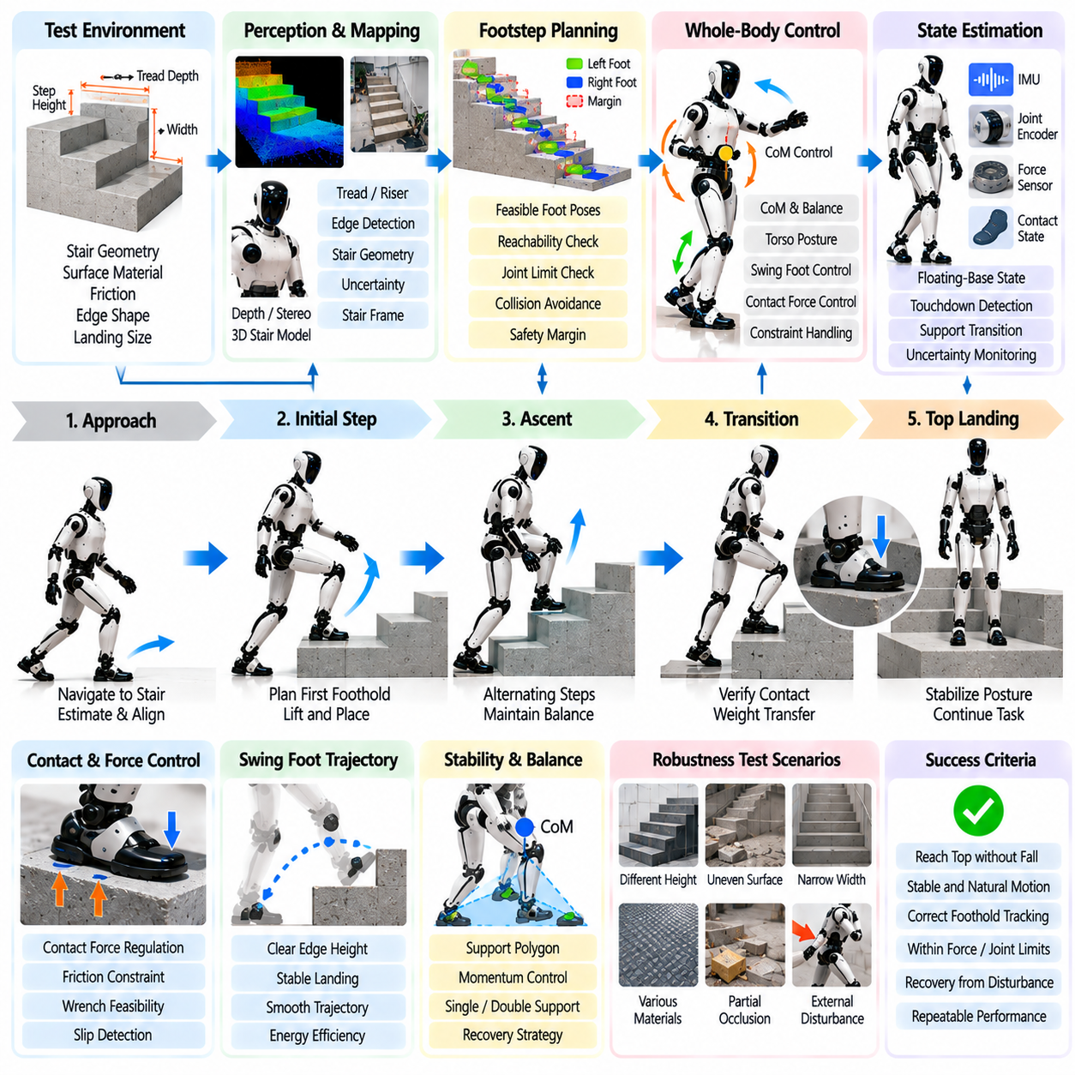
Stair climbing is a demanding field test for humanoid whole-body control because it combines discontinuous terrain, large center-of-mass motion, alternating contacts, limited foothold area, and substantial joint loading. Unlike level walking, each step requires coordinated vertical and forward motion while the support configuration changes. A successful test therefore evaluates perception, footstep planning, state estimation, balance, contact management, and whole-body control as one tightly coupled locomotion system.
The field test should begin with a precisely characterized staircase before introducing unknown structures. Step height, tread depth, stair width, inclination, surface friction, edge geometry, and landing dimensions should be measured and represented in the test environment. Initial trials can use uniform stairs with generous width and predictable surfaces. Later stages can introduce dimensional variation, imperfect perception, different surface materials, and environmental disturbances to evaluate robustness beyond nominal conditions.
Before ascent begins, the perception system must estimate the staircase geometry and establish a stair-relative coordinate frame. Depth cameras, stereo vision, or other 3D sensing can identify tread planes, riser boundaries, stair edges, and the upper landing. The resulting geometric representation should include uncertainty because small errors in estimated step height or edge position can significantly affect foot clearance and landing quality. Perception confidence should therefore influence the aggressiveness of the locomotion plan.
The footstep planner converts perceived stair geometry into a sequence of feasible support locations. Each target foot pose must provide sufficient contact area while respecting leg reachability, joint limits, collision clearance, and the expected transition to the next step. The planner should avoid placing the foot too close to an edge even when such a pose is kinematically reachable. Conservative foothold margins provide tolerance for perception error, state-estimation drift, and small execution deviations during field operation.
Stair ascent produces larger vertical center-of-mass motion than ordinary walking. The controller must raise the body while transferring support from one leg to the other without allowing the projected dynamics to exceed the feasible support region. Center-of-mass references, torso orientation, momentum, and contact forces therefore need coordinated regulation. Excessive forward leaning may improve reach but reduce recovery margin, while insufficient forward progression can create an inefficient or dynamically infeasible lifting motion.
Swing-foot trajectory generation is critical because the moving foot must clear the stair edge before reaching the next tread. A trajectory that is adequate on flat ground can collide with the riser during ascent. The planner should therefore include vertical clearance above the detected edge and shape the approach to produce a stable landing. Excessive clearance is also undesirable because it increases joint motion, energy consumption, and disturbance to the upper body, so clearance should reflect geometric uncertainty.
Whole-body control translates these locomotion objectives into dynamically consistent joint torques or commands. The controller can simultaneously track center-of-mass motion, torso posture, swing-foot pose, support-foot contact, and selected joint regularization objectives while satisfying physical constraints. A hierarchical quadratic-programming or comparable constrained-control formulation is useful because balance and contact feasibility can be given higher priority than posture preferences or nominal joint configurations.
Contact modeling becomes especially important during stair transitions. The support foot may have less usable contact area than during level walking, and partial contact near a tread edge can reduce the feasible wrench region. The controller should regulate contact forces while respecting friction and center-of-pressure constraints. Force or torque sensing can detect unexpected loading patterns, premature contact, incomplete landing, or foot slip and provide information for immediate modification of the control response.
State estimation must remain reliable despite impacts and rapid changes in support configuration. IMU measurements, joint encoders, kinematic contact information, and available force sensing can be fused to estimate the floating-base state and body motion. Incorrect contact classification can corrupt the state estimate and destabilize the controller, so touchdown detection and support-state transitions require robust logic. Estimation uncertainty should be monitored rather than assuming every planned contact occurred exactly as expected.
The transition from double support to single support is one of the critical phases of each stair step. Before unloading the trailing foot, the controller should confirm that the leading foot has established adequate contact and that the estimated body state lies within an acceptable region. Weight transfer can then proceed gradually while monitoring contact forces and balance indicators. If the new support is unreliable, the system should retain or restore double support instead of committing to the next swing motion.
Arm and torso motion can contribute to balance through momentum regulation even when the hands are not used for support. Whole-body control may adjust upper-body posture to compensate for leg motion or external disturbances, but such behavior should remain within collision and joint constraints. Field tests can compare fixed-arm and coordinated-arm strategies to determine whether upper-body momentum improves stability, energy use, or disturbance recovery during ascent without introducing unnecessary motion.
Disturbance testing should be introduced only after nominal stair climbing is stable. Controlled perturbations can include moderate variations in step dimensions, small changes in friction, payload differences, state-estimation offsets, or carefully bounded external forces. The objective is not to force failure but to determine how stability margins degrade and whether the controller detects approaching limits. Recovery may involve pausing, lowering the center of mass, returning to double support, or stepping back to a verified foothold.
Descending stairs requires separate validation because it is not simply the reverse of ascent. The robot must lower its center of mass while placing the swing foot onto a surface that may be partly occluded by the stair geometry. Impact management, visual observability, knee loading, and forward stability become different concerns. A complete field-test program should therefore evaluate ascent and descent independently, with separate limits and recovery criteria before combining them into continuous multi-floor missions.
Safety supervision should operate independently from the nominal whole-body controller. Joint position and velocity limits, torque limits, contact-force thresholds, body orientation, foot-slip indicators, state-estimation confidence, and communication health can be monitored continuously. When predefined boundaries are exceeded, the supervisor should transition the robot toward the safest available state. Depending on the support configuration, this may mean freezing progression, restoring double support, lowering posture, or executing a validated protective response.
Field-test instrumentation should record synchronized controller references, estimated states, joint positions, velocities, torques, contact forces, foot poses, center-of-mass motion, perception outputs, and safety events. Video from external viewpoints can provide complementary evidence for diagnosing edge contacts, body oscillation, or clearance problems. Accurate time synchronization is essential because stair-climbing failures often emerge from interactions among perception, estimation, planning, and control rather than from a single isolated component.
Performance evaluation should include successful steps, complete staircase success rate, foot-placement error, minimum edge clearance, center-of-mass tracking, torso deviation, contact-force distribution, slip events, intervention frequency, and recovery success. Controller computation time and deadline misses should also be measured because whole-body control must maintain its required real-time update rate. Results should be reported across repeated trials rather than relying on a single visually successful staircase traversal.
A useful robustness evaluation progressively changes one condition while holding others controlled. Stair dimensions, payload, speed, perception noise, or surface properties can be varied to identify the operational envelope. This reveals not only whether the humanoid can climb stairs but where performance begins to degrade. Such boundary characterization is essential for deployment because the controller needs explicit conditions under which stair traversal is permitted, restricted, or rejected.
A successful stair-climbing field test demonstrates more than the ability to place one foot above another. It shows that perception can construct usable terrain geometry, planning can generate feasible contacts, state estimation can track a changing floating-base system, and whole-body control can coordinate forces and motion while preserving balance. When these functions remain stable across repeated trials and controlled disturbances, stair climbing becomes strong evidence of integrated humanoid locomotion maturity.

12.08. VLA Language Command Task Execution Case
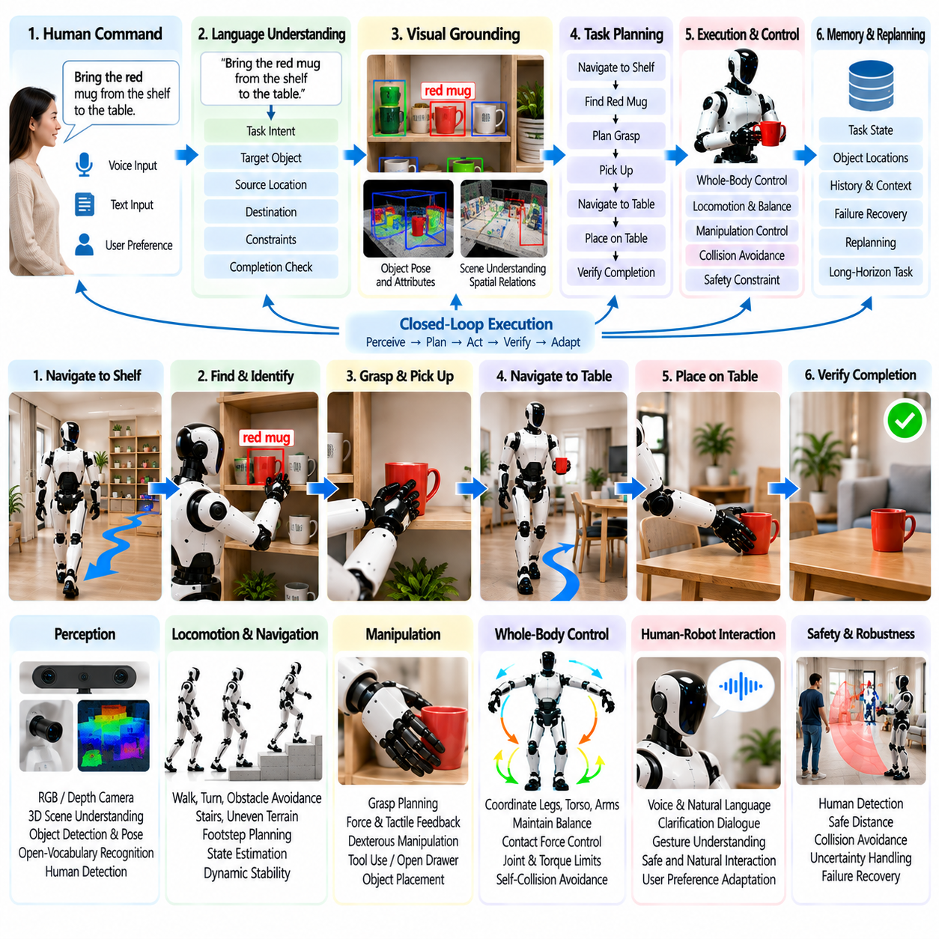
Vision-Language-Action execution provides a representative test of whether a humanoid can convert human intent into grounded physical behavior. Instead of receiving predefined coordinates or fixed motion scripts, the robot may receive commands such as bringing an object, organizing a workspace, or placing an item at a specified location. The challenge is to connect language meaning with visual observations, robot capabilities, environmental constraints, and safe executable actions.
The execution pipeline begins when a spoken or textual instruction is converted into a structured task representation. The system should identify the requested object, desired action, destination, relevant constraints, and expected completion condition. Language understanding alone is insufficient because terms such as “the box on the left” or “put it beside the bottle” depend on the current scene. The VLA system must therefore ground linguistic references in visual and spatial observations before planning physical behavior.
Visual grounding connects words with objects, regions, attributes, and relationships in the robot's environment. Camera observations may be processed to identify candidate objects, estimate their poses, recognize relevant properties, and determine spatial relations such as left, right, inside, above, or near. When several objects satisfy a description, the system should maintain multiple hypotheses or request clarification rather than selecting an arbitrary target and allowing an early semantic error to propagate into manipulation.
Task decomposition converts a grounded instruction into a sequence of robot skills. A command to move a container from a shelf to a table may require navigating to the shelf, locating the object, selecting an approach pose, generating a grasp, lifting the container, navigating to the table, selecting a placement region, releasing the object, and verifying completion. This hierarchical decomposition allows semantic reasoning to operate at the task level while lower layers execute validated locomotion and manipulation primitives.
The VLA policy should operate with explicit awareness of robot embodiment. A physically meaningful action depends on arm reach, hand configuration, payload limits, joint range, balance state, collision geometry, and available footholds. A visually obvious object may still be unreachable from the current posture. The execution architecture should therefore connect semantic action proposals with feasibility checks so that the robot can reposition its body, choose another grasp, or reject an action that exceeds validated physical limits.
Whole-body control becomes essential when language-generated tasks require reaching, bending, carrying, or interacting with objects while standing. The controller must coordinate the floating base, legs, torso, and arms while maintaining balance and respecting contact, joint, torque, and collision constraints. High-level VLA outputs should specify task objectives rather than unrestricted joint commands. This separation preserves the flexibility of learned semantic behavior while retaining deterministic control over dynamically critical motion.
Closed-loop execution is necessary because a VLA command cannot be treated as a one-time prediction followed by blind action. After each meaningful action, the robot should observe the environment again and compare the resulting state with the expected state. If an object moved differently than predicted, a grasp failed, or a person changed the scene, the plan should be updated. Repeated perception-action feedback converts language-conditioned behavior from an open-loop demonstration into adaptive physical task execution.
Semantic memory supports commands that depend on information accumulated across time. The robot may need to remember which objects have already been moved, which locations were searched, what the user requested, or why an earlier action failed. Persistent task state prevents repeated execution and allows interrupted missions to resume from a valid intermediate point. Memory should remain revisable because the physical environment can change after information has been stored.
Ambiguity management is a central capability of language-driven robotics. Commands such as “bring me the red one” may be underspecified when several red objects exist, while instructions such as “clean this area” may imply many possible actions. The robot should estimate semantic confidence and distinguish between uncertainty that can be resolved through additional perception and uncertainty requiring user clarification. Asking a concise question is preferable to performing a confident but incorrectly grounded physical action.
Long-horizon commands require failure-aware replanning because errors can occur at multiple stages. A target object may be absent, a route may become blocked, a grasp may fail, or the intended destination may no longer be available. The agent should identify the failed precondition or skill, update the task state, and select an appropriate recovery action. Replanning from the current verified state is more efficient and reliable than restarting the entire language instruction after every local failure.
Generalist VLA policies can be trained from combinations of robot demonstrations, teleoperation trajectories, images, language annotations, and action sequences. Diverse training data can help connect visual variation and linguistic variation with common physical skills. However, generalization should not be interpreted as unrestricted competence. The deployment system should estimate whether the current scene and requested action fall within a validated operating envelope and invoke fallback behavior when confidence or feasibility becomes insufficient.
Skill libraries provide an effective bridge between general semantic reasoning and production robot control. The VLA or agent layer can select parameterized skills such as navigate, inspect, reach, grasp, lift, carry, place, open, or hand over. Each skill can expose preconditions, execution constraints, success criteria, and failure codes. This structure makes learned reasoning more interpretable and enables the task planner to recover from failures without requiring the language model to generate every low-level control detail.
Safety supervision must remain independent from semantic task generation. A language instruction should never override collision avoidance, joint limits, torque limits, protected zones, human separation requirements, or emergency-stop logic. Even a correctly interpreted command may be unsafe under the current physical conditions. The safety layer should therefore evaluate ongoing execution continuously and be capable of slowing, stopping, or rejecting actions regardless of the confidence reported by the VLA model.
Human interaction can continue during execution rather than occurring only at the beginning of the task. A user may correct the target, change the destination, cancel the task, or provide additional constraints while the robot is operating. The agent should incorporate these updates into the current task state without losing completed progress. Explicit confirmation may be appropriate before actions that are difficult to reverse, affect valuable objects, or involve close interaction with people.
Verification is necessary because completion cannot be inferred solely from the issuance of a motor command. After placement, the robot should confirm that the intended object is at the requested destination and remains stable. After opening a drawer, it should verify the resulting state before proceeding. Visual observations, proprioception, tactile sensing, and task-specific checks can contribute to verification. Only verified state transitions should be committed to semantic task memory as successfully completed actions.
Testing should separate semantic understanding from physical execution before evaluating the complete system. Language grounding can first be tested against controlled scenes, while manipulation and locomotion skills are validated independently. Integrated simulation can then introduce object variation, ambiguous commands, scene changes, and skill failures. Hardware trials should progressively expand task length and environmental diversity while preserving detailed logs of model decisions, controller states, recovery actions, and safety interventions.
Evaluation should include language grounding accuracy, object-selection accuracy, task decomposition correctness, skill success, autonomous completion rate, clarification frequency, replanning success, execution time, intervention rate, and safety events. Long-horizon evaluation should additionally measure whether local errors accumulate into mission failure. Testing paraphrased instructions and unseen object arrangements helps determine whether the system learned transferable semantic relationships rather than memorizing a small set of command templates.
A successful VLA case demonstrates that the humanoid can connect semantic intelligence with embodied control through a reliable closed loop. Language provides goals, vision grounds those goals in the physical scene, planning organizes actions, validated skills execute them, perception verifies the results, and memory preserves task continuity. Failure-aware replanning and independent safety supervision complete the loop, allowing learned intelligence to remain flexible without becoming the sole authority over physical motion.
The broader significance of language-command execution is that it changes how humanoids can be programmed and deployed. Instead of manually specifying every sequence for every environment, users can describe desired outcomes in ordinary language while the robot determines how those goals map onto its available capabilities. When semantic reasoning, visual grounding, embodiment awareness, control, verification, and safety operate together, VLA becomes an interface between human intent and practical Physical AI execution.

12.09. Humanoid HRI User Acceptance Study Case
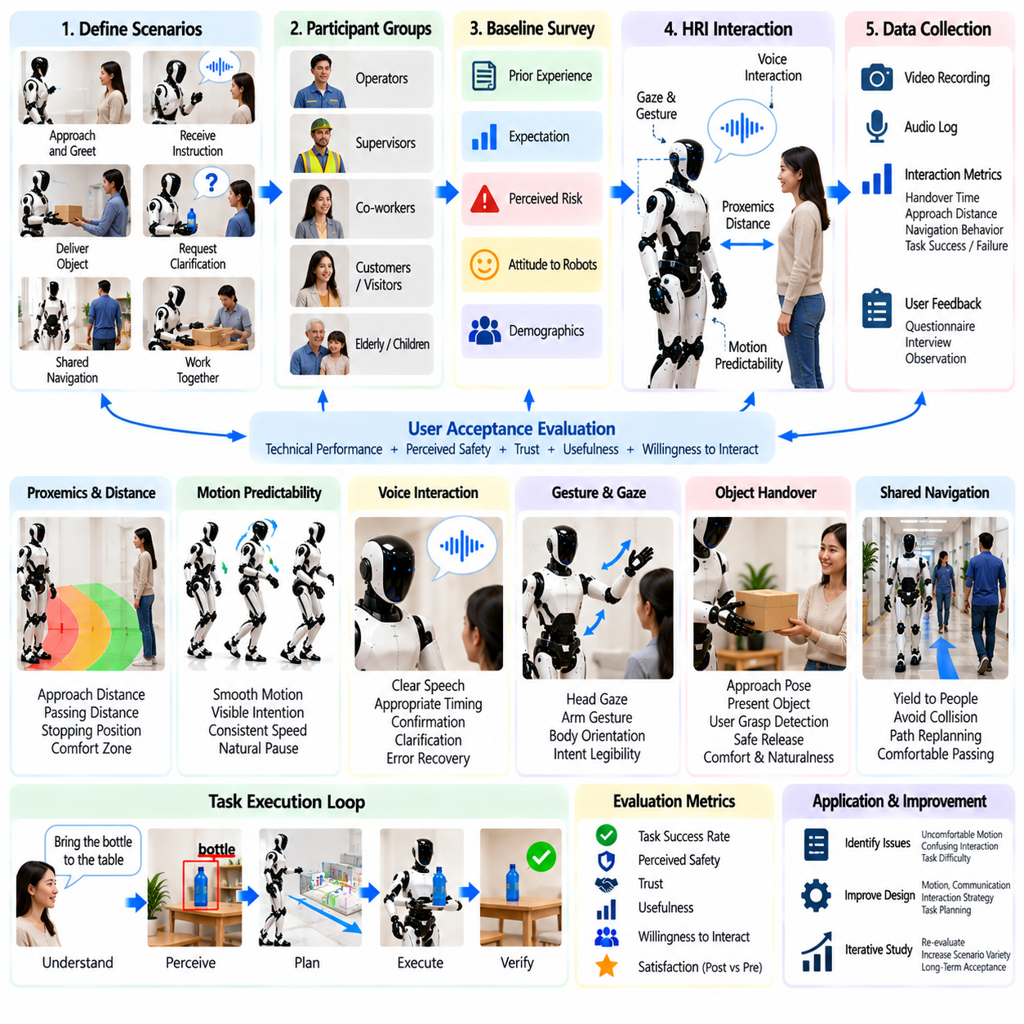
User acceptance is a critical dimension of humanoid deployment because technical task success does not guarantee that people will trust, understand, or willingly work with a robot. A humanoid may navigate safely and complete assigned tasks while still creating discomfort through unpredictable motion, inappropriate proximity, confusing communication, or excessive waiting. An HRI acceptance study therefore evaluates how technical behavior is perceived by users and whether repeated interaction produces practical confidence.
The study should begin with clearly defined interaction scenarios rather than unrestricted social encounters. Representative cases can include approaching a user, receiving a spoken instruction, delivering an object, requesting clarification, yielding during shared navigation, working beside a person, and recovering from a minor task failure. These scenarios allow perception, communication, motion, and safety behavior to be evaluated consistently while exposing participants to interactions representative of realistic humanoid operation.
Participant groups should reflect the intended deployment environment because acceptance can vary with role, experience, expectations, and exposure to automation. A workplace study may distinguish operators, supervisors, maintenance personnel, and nearby workers, while a service study may include customers or visitors. Demographic information can provide useful context, but the primary objective is to understand how interaction experience and operational role influence perceived safety, usefulness, predictability, and willingness to interact.
Before interaction begins, baseline measurements can capture participants' prior experience with robots, expectations, perceived risk, and general attitude toward automation. These measurements provide a reference for interpreting post-interaction responses. Acceptance should not be inferred only from first impressions because humanoid appearance can create expectations that differ from actual capability. Comparing expectations before use with evaluations after direct experience helps reveal whether interaction improves confidence or exposes previously unrecognized concerns.
Proxemics is an important experimental variable because humanoids operate within spaces normally occupied by people. The study can examine how users respond to different approach distances, passing distances, orientations, and stopping positions. A technically collision-free trajectory may still feel uncomfortable if the robot approaches too closely or from an unexpected direction. Preferred interpersonal distance should therefore be considered alongside geometric collision margins when designing socially acceptable navigation behavior.
Motion predictability strongly influences perceived safety. Participants should be able to understand whether the humanoid intends to approach, stop, turn, reach, or hand over an object. Smooth trajectories, visible preparation movements, consistent speed changes, and appropriate pauses can make robot behavior easier to interpret. Sudden upper-body motion or unexplained changes in direction may reduce confidence even when the controller remains dynamically stable, showing that physical stability and perceived stability are related but distinct properties.
Voice interaction should be evaluated for intelligibility, timing, confirmation behavior, and error recovery. The humanoid should communicate enough information to make its intentions understandable without producing excessive dialogue that interrupts work. When a command is ambiguous, requesting clarification can improve trust because it exposes uncertainty rather than hiding it. However, repeated unnecessary questions can reduce usability. The study should therefore evaluate whether the robot chooses appropriate moments to confirm, clarify, or proceed autonomously.
Gesture, gaze, and body orientation can complement spoken communication. Head direction may indicate attention, arm motion may communicate an intended handover, and torso orientation can make navigation intent more legible. These signals should remain consistent with the robot's actual task state. If gaze suggests attention to one person while the robot responds to another, or if an arm begins moving before the user understands the intended interaction, the mismatch can create confusion and reduce perceived competence.
Object handover provides a useful HRI test because it combines perception, communication, manipulation, force control, and mutual timing. The humanoid must approach an appropriate transfer pose, present the object within comfortable reach, detect when the user has established a secure grasp, and release without excessive force or delay. Participants can evaluate comfort, predictability, and naturalness, while technical logs record handover time, grip forces, failed transfers, and corrective actions.
Shared-space navigation should examine how the robot behaves when people cross its path, walk beside it, or temporarily block access. Conservative stopping can improve safety but may become frustrating if the robot freezes unnecessarily during normal human movement. Conversely, aggressive path execution can reduce perceived safety. Acceptance testing should therefore explore the balance between efficiency and deference, measuring both objective separation distances and subjective judgments of whether the robot behaved appropriately.
Failure behavior can influence trust more strongly than nominal success. A robot that fails occasionally but clearly communicates the problem and recovers predictably may be preferred over one that appears confident while performing incorrect actions. Experimental scenarios can include a deliberately unavailable object, ambiguous instruction, blocked path, or failed grasp. The study should evaluate whether users understand what happened, whether the recovery seems reasonable, and whether confidence is restored after the failure.
Transparency should be calibrated to the needs of the user. The humanoid does not need to expose every internal computation, but it should communicate information relevant to collaboration, such as inability to identify an object, need for additional space, or requirement for assistance. Short explanations can improve mental-model alignment by helping users understand what the robot can and cannot do. Excessive technical explanation, however, can increase cognitive load and make routine interaction inefficient.
Trust should be treated as calibrated reliance rather than a goal of maximizing positive perception. Excessive trust can cause users to assume capabilities the humanoid does not possess, while insufficient trust can prevent useful adoption. The interface should therefore expose limitations consistently and avoid presenting uncertain behavior as guaranteed competence. A successful acceptance study examines whether participants develop expectations that correspond reasonably well to the robot's demonstrated operational capabilities.
Safety perception should be compared with objective safety measurements. Participants may report discomfort even when minimum separation and force limits remain within validated boundaries, or they may feel safe during behavior that leaves insufficient technical margin. Combining questionnaires with robot telemetry allows these differences to be identified. Motion speed, proximity, contact force, stop events, and intervention records can then be correlated with subjective comfort and perceived risk.
Repeated exposure is important because novelty can distort initial reactions. A humanoid may initially receive unusually positive attention or excessive caution simply because participants have little experience with it. Multi-session studies can examine whether perceived usefulness, trust, workload, and comfort stabilize after repeated interaction. They can also reveal whether small annoyances become more important over time or whether users learn interaction patterns that make collaboration more efficient.
Quantitative evaluation can include task success, interaction time, clarification frequency, intervention rate, minimum human-robot distance, handover success, response latency, and safety-stop frequency. Subjective measures can examine perceived safety, usefulness, ease of use, trust, predictability, comfort, workload, and willingness for future use. Behavioral observations such as hesitation, avoidance, repeated checking, or unnecessary intervention can provide additional evidence that may not appear in questionnaire responses.
Experimental logging should synchronize robot state, perception output, task events, dialogue, motion trajectories, safety interventions, and participant responses. Video can support later analysis of body orientation, hesitation, and interaction timing, provided that the study follows appropriate consent and privacy procedures. Accurate synchronization allows researchers to identify which specific robot behavior preceded a positive or negative user reaction rather than relying only on general impressions after the session.
The study should also examine adaptation without allowing personalization to undermine predictable safety behavior. The humanoid may adjust speaking pace, interaction distance, or confirmation frequency based on user preference, but safety limits and protected behaviors should remain consistent. Adaptation is valuable when it reduces unnecessary friction while preserving understandable robot behavior. Users should not need to relearn fundamental safety expectations whenever the robot adapts its social interaction style.
A successful HRI acceptance study ultimately connects engineering performance with human experience. The objective is not simply to demonstrate that participants like a humanoid, but to determine whether they understand its intentions, maintain appropriately calibrated trust, feel comfortable sharing space, and can recover collaboration after errors. These findings can then guide changes to motion planning, dialogue, proxemics, handover behavior, failure communication, and interface design before larger-scale deployment.
Humanoid acceptance should therefore be treated as part of system validation rather than a final usability check performed after technical development. Perception, locomotion, manipulation, language interaction, and safety all influence how the robot is interpreted by people. When objective performance and human-centered evaluation are developed together, HRI studies provide a practical bridge between a technically functional humanoid prototype and a robot that can operate reliably within everyday human environments.

12.10. Future Humanoid Platform Roadmap
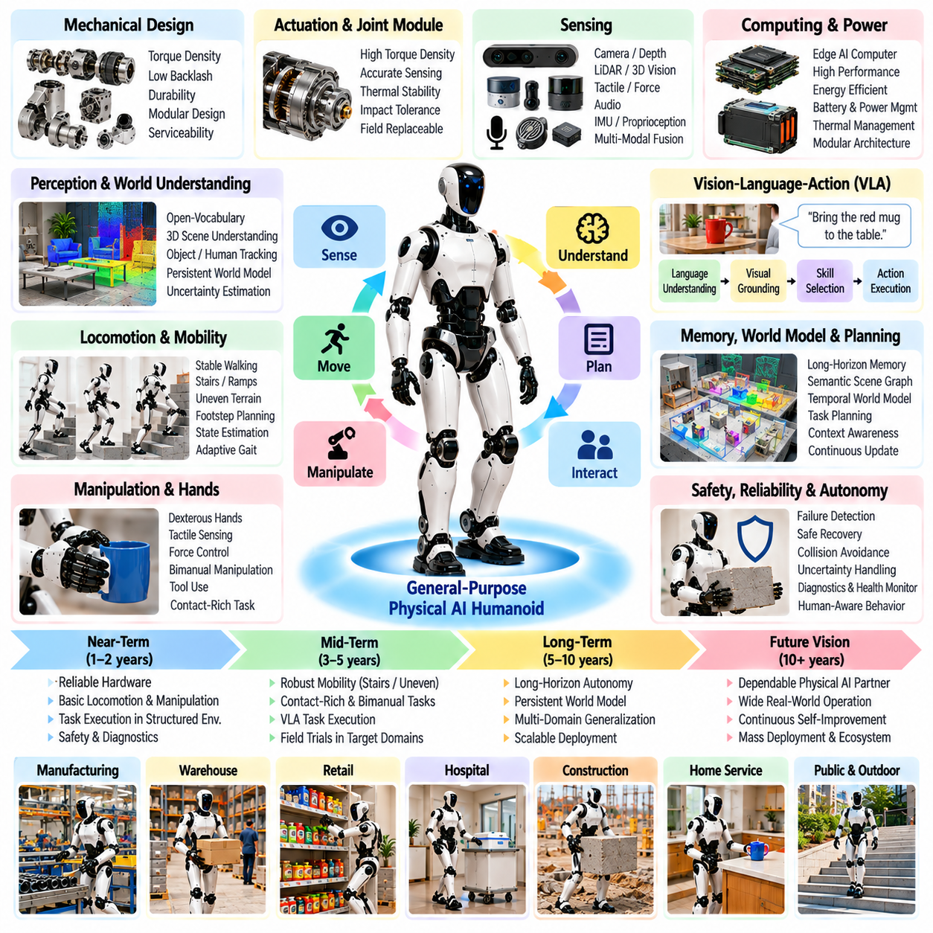
The future humanoid platform should evolve from a collection of specialized demonstrations into a dependable general-purpose Physical AI system. Progress will require simultaneous improvement in mechanical design, actuation, sensing, computation, locomotion, manipulation, intelligence, safety, and software integration. The central roadmap objective is not simply greater model capability, but reliable closed-loop operation in which perception, reasoning, action, verification, and recovery remain connected during long real-world missions.
Near-term platform development should prioritize hardware reliability and maintainability. Joint modules need sufficient torque density, low backlash, thermal stability, impact tolerance, and accurate sensing while remaining serviceable in field conditions. Electrical architecture should support modular replacement of actuators, sensors, batteries, and computing units. A humanoid intended for continuous operation must be designed around diagnostic visibility and predictable degradation rather than assuming that every mechanical component remains nominal throughout deployment.
Energy capacity remains a fundamental limitation because humanoids continuously expend power on balance, locomotion, computation, sensing, and manipulation. Future platforms require improvements in battery energy density, actuator efficiency, regenerative operation, thermal management, and power-aware planning. The software stack should understand remaining energy as an operational constraint, adapting walking speed, task sequence, payload, and charging decisions. Autonomous docking or battery exchange can become part of normal mission planning rather than a separate maintenance activity.
Perception should progress from isolated object detection toward persistent multimodal world understanding. Cameras, depth sensors, proprioception, force sensing, tactile arrays, audio, and potentially other modalities can contribute complementary observations. The platform should maintain a continuously updated representation of objects, people, surfaces, free space, contacts, and uncertainty. Temporal consistency is essential because useful Physical AI requires understanding not only what is visible now but how the environment has changed and what previous actions caused those changes.
Locomotion development should expand from stable walking on prepared surfaces toward robust mobility across stairs, ramps, uneven terrain, narrow passages, and changing footholds. State estimation, terrain perception, footstep planning, model-based control, learned policies, and whole-body control should increasingly operate as a coordinated stack. The objective is not maximum walking speed but a wide operational envelope in which the humanoid recognizes when terrain is safe, modifies its gait appropriately, and refuses traversal when stability cannot be maintained.
Whole-body control will become a central integration layer between mobility and manipulation. Future humanoids must coordinate feet, legs, torso, arms, and contact forces while carrying objects, opening doors, pushing carts, using tools, or interacting with work surfaces. Controllers should incorporate balance, friction, torque, collision, joint, and contact constraints in real time. Model-based optimization can provide physical structure, while learned components may improve adaptation where accurate analytical models are difficult to maintain.
Manipulation should progress from isolated pick-and-place toward contact-rich and bimanual behavior. Future hands require improved tactile sensing, force control, durability, and practical grasp diversity without excessive mechanical complexity. Manipulation policies must reason about object geometry, material properties, expected load, contact state, and downstream task requirements. Regrasping, hand-to-hand transfer, tool use, compliant insertion, and coordinated carrying will be important milestones toward useful operation in human-designed environments.
Generalist Vision-Language-Action models can provide the semantic layer that connects human instructions with visual observations and robot skills. Instead of programming every task sequence manually, future platforms should interpret goals, identify relevant objects and locations, decompose tasks, and select appropriate behaviors. VLA capability should remain embodiment-aware, incorporating reachability, payload, balance, collision, and manipulation feasibility rather than treating physical action as an unconstrained extension of language generation.
Long-horizon autonomy requires memory and world models that persist beyond individual control cycles. A humanoid should remember task goals, completed actions, object locations, interaction history, failures, and unresolved conditions while continuously revising that information from new observations. Temporal intelligence can help predict how the environment may evolve and how actions influence future states. This enables planning to shift from reactive skill execution toward purposeful multi-step behavior grounded in accumulated physical experience.
Failure-aware intelligence should become a first-class architectural capability. Real environments guarantee perception errors, blocked paths, failed grasps, unexpected contacts, unavailable objects, and changing instructions. The platform must detect when predicted and observed states diverge, identify likely causes, and select recovery actions from the current verified state. Reliable autonomy will depend less on eliminating every failure than on preventing local failures from escalating into unsafe or unrecoverable mission-level breakdowns.
Learning architecture should combine foundation models with task-specific adaptation rather than assuming that one monolithic policy will solve every physical problem. Large pretrained models can provide semantic knowledge and broad representations, while imitation learning, reinforcement learning, teleoperation data, simulation, and real-world experience can specialize behavior. Skill-level policies can then operate beneath an agent layer that performs reasoning and planning, while validated control and safety layers constrain physical execution.
Simulation and synthetic data will remain essential for scaling humanoid development. Digital environments can generate variations in object pose, lighting, terrain, contact conditions, disturbances, human motion, and task structure that would be expensive or unsafe to collect physically. Domain randomization and physics-based simulation can broaden the training distribution, while hardware data identifies simulation gaps. The development loop should continuously connect simulation, real-world evaluation, failure collection, model adaptation, and regression testing.
Robot data infrastructure should evolve into an experience pipeline rather than a collection of isolated logs. Synchronized perception, language, action, force, proprioception, controller state, task outcome, and failure information should be stored with consistent semantics. Fleet operation can then produce reusable experience for training and validation. Data quality, timestamp integrity, provenance, scenario coverage, and failure labeling will become as important as raw dataset size when improving general-purpose humanoid intelligence.
Compute architecture must support multiple time scales. High-frequency stabilization and actuator control require deterministic low-latency execution, while perception, planning, VLA inference, memory, and world-model processing operate at slower rates. Edge computation should preserve safety and essential autonomy even when external connectivity is unavailable. On-premise or cloud resources can support large-scale training, fleet analytics, model improvement, and knowledge aggregation without placing time-critical physical control in a remote dependency loop.
Safety architecture should remain layered and independent from general-purpose AI reasoning. Hardware limits, emergency stops, joint and torque boundaries, collision monitoring, human separation, contact-force limits, and protective behaviors should retain authority over learned policies. Higher-level intelligence may propose goals and actions, but execution must remain within validated operating envelopes. Future certification will increasingly require evidence that safety behavior remains predictable even when AI components encounter unfamiliar situations.
Human-robot interaction should evolve from simple command reception toward collaborative communication. The humanoid should understand spoken goals, request clarification, signal motion intent, explain relevant failures, and adapt interaction timing without creating excessive cognitive load. Trust should remain calibrated to demonstrated capability. A platform that communicates uncertainty and requests assistance appropriately can be more useful than one that attempts autonomous completion of every task regardless of confidence.
Testing methodology must scale with increasing autonomy. Component tests for perception, joints, hands, locomotion, and control should connect to integrated scenario tests, software-in-the-loop evaluation, hardware-in-the-loop validation, and controlled field trials. Long-duration testing is particularly important because thermal behavior, calibration drift, communication faults, accumulated localization error, and repeated manipulation failures may not appear in short demonstrations. Regression testing should accompany every major software and model update.
Deployment should progress through clearly bounded operational domains. Early systems can perform repetitive material handling or structured logistics, followed by more variable industrial and service tasks as reliability improves. Expansion should be based on measured operational envelopes rather than visual demonstration quality. Each new environment should define supported terrain, objects, payloads, interaction modes, environmental conditions, recovery capabilities, and human supervision requirements before autonomous operation is extended.
Fleet learning represents a major transition from individual robots toward collective improvement. Multiple humanoids can contribute experience from different tasks, sites, objects, and failure conditions to a shared learning infrastructure. Models and skills can then be evaluated centrally before controlled redistribution to robots. This creates a feedback loop in which deployed systems generate experience, experience improves models, and improved models expand the operational envelope while preserving version control and validation.
The longer-term platform will increasingly resemble an embodied agent ecosystem rather than a standalone robot. Edge intelligence can provide immediate perception and action, local infrastructure can coordinate multiple robots and shared environmental information, and larger foundation systems can aggregate knowledge across fleets. The humanoid becomes one physical embodiment within this hierarchy, capable of autonomous local action while benefiting from collective experience, shared models, and higher-level reasoning resources.
The ultimate roadmap objective is dependable general-purpose humanoid intelligence that can perceive an unfamiliar situation, understand a human goal, construct a feasible plan, execute it through whole-body action, verify physical outcomes, recover from failure, and learn from accumulated experience. Progress toward this objective should be measured by reliability, adaptability, safety, autonomy duration, recovery capability, and transferable task competence rather than isolated demonstrations. This transition defines the path from humanoid prototypes toward scalable Physical AI platforms.

