Volume 23. Cargo UAV Autonomy and Flight AI

Chapter 06. Route Planning and Airspace Integration

06.01. 4D Trajectory Planning Lat Lon Alt Time
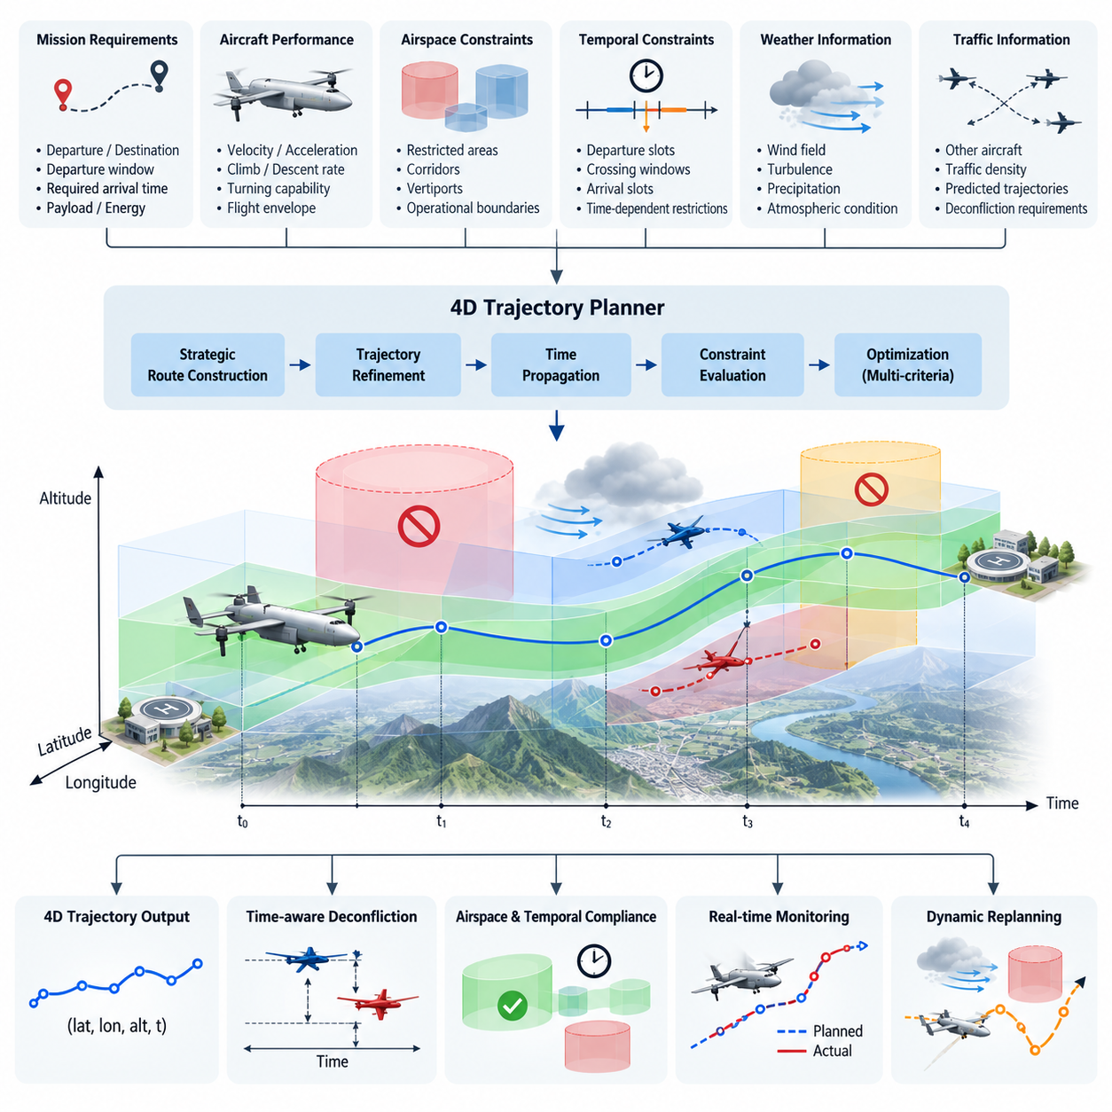
Four-dimensional trajectory planning extends conventional spatial route planning by treating time as an explicit dimension of the aircraft trajectory. Instead of defining a mission only as a sequence of latitude, longitude, and altitude waypoints, the planner associates each spatial state with a target time or allowable time interval. The resulting trajectory can therefore be represented as a sequence of states such as \(P_i=(lat_i, lon_i, alt_i, t_i)\), providing a deterministic description of where the cargo UAV is expected to be and when it should occupy that position.
This time-dependent representation is particularly important for cargo UAV operations in shared or managed airspace. Two aircraft may safely use the same geographic corridor and altitude when their occupancy times are sufficiently separated, while trajectories that appear spatially independent can become conflicting when timing uncertainty is considered. Four-dimensional planning therefore transforms route generation into a spatiotemporal coordination problem that connects autonomous navigation with airspace management, traffic deconfliction, mission scheduling, and operational approval.
A practical 4D trajectory begins with mission constraints describing departure and destination locations, departure windows, required arrival times, aircraft performance, payload state, available energy, and permitted airspace. Geographic constraints may include restricted regions, terrain clearance, vertiports, predefined corridors, and operational boundaries. Temporal constraints add departure slots, corridor reservation periods, crossing windows, arrival slots, and time-dependent restrictions, allowing the planner to reason about airspace availability as a function of both position and time.
Trajectory generation typically separates strategic route construction from continuous trajectory refinement. A strategic planner first identifies feasible spatial corridors connecting the origin and destination while excluding prohibited or operationally unsuitable regions. The selected corridor is then converted into a dynamically achievable trajectory by considering velocity, acceleration, climb rate, descent rate, turning capability, and propulsion limits. Time is propagated along the trajectory so that every significant point receives an estimated time of arrival and can be evaluated against temporal constraints.
For heavy cargo UAVs, the relationship between trajectory geometry and vehicle dynamics becomes especially important. A 2.5-ton, 5-ton, or 10-ton aircraft cannot instantaneously change velocity, altitude, or heading when a new waypoint is introduced. Payload mass and center-of-gravity conditions can further modify acceleration, climb, and maneuvering capability. Consequently, a valid 4D planner must produce trajectories that remain inside the actual flight envelope rather than merely constructing mathematically short paths between geographic coordinates.
The temporal dimension can be represented using exact target times, bounded time windows, or probabilistic arrival estimates. Exact timing is useful at controlled crossing points or scheduled arrival interfaces, whereas time windows provide operational flexibility when atmospheric disturbances or traffic conditions create uncertainty. Probabilistic models can additionally represent expected arrival time and variance, enabling the system to maintain larger separation margins when uncertainty grows instead of assuming that every predicted trajectory will be executed perfectly.
Wind is one of the major causes of deviation between planned and executed 4D trajectories. Headwind, tailwind, crosswind, vertical air motion, and localized turbulence change ground speed and therefore modify waypoint arrival times even when commanded airspeed remains unchanged. The planner should incorporate forecast wind fields during initial optimization and continuously compare predicted versus measured progress during flight. Significant deviations can trigger speed adjustment, trajectory retiming, or complete replanning when the original temporal constraints can no longer be satisfied.
The optimization objective is normally multi-criteria rather than purely distance based. A useful cost function may combine flight time, energy consumption, airspace risk, weather exposure, maneuvering effort, traffic density, and deviation from scheduled arrival times. Weighting these terms allows different cargo missions to express different priorities. Time-critical medical logistics may emphasize arrival performance, while long-range industrial cargo transport may assign greater importance to energy efficiency, weather margin, and conservative airspace separation.
Airspace constraints can be modeled as four-dimensional volumes whose validity changes over time. A region may be available during one interval and prohibited during another because of temporary flight restrictions, scheduled operations, emergency activity, or traffic-management decisions. The trajectory planner must therefore evaluate not only whether the geometric path intersects a constrained volume, but also whether the aircraft is predicted to occupy that volume while the restriction is active. This principle provides the foundation for later airspace constraint modeling and dynamic rerouting functions.
Conflict detection similarly becomes a comparison between predicted 4D occupancy volumes. Each aircraft trajectory can be surrounded by horizontal, vertical, and temporal protection margins that account for navigation error, control tracking error, communication latency, and prediction uncertainty. When protection volumes overlap beyond acceptable thresholds, the system identifies a potential conflict. Resolution may then alter altitude, lateral route, speed, departure time, or waypoint timing while preserving aircraft performance and mission constraints.
Trajectory execution requires close integration between the strategic planner, flight management system, navigation subsystem, and flight control software. The planner generates the desired 4D reference, while the navigation system continuously estimates the aircraft state and determines progress relative to that reference. The flight management layer calculates timing errors and decides whether minor deviations can be corrected through speed or path adjustments. Low-level controllers then convert the updated reference into attitude, thrust, velocity, and position commands.
The trajectory should not be treated as a rigid sequence that becomes invalid after the first disturbance. Operational systems benefit from a rolling-horizon approach in which the near-term portion of the trajectory is executed with high commitment while later segments remain adjustable. As new weather, traffic, vehicle-state, and airspace information becomes available, the planner periodically recomputes future segments. This preserves continuity with the currently flown path while allowing the aircraft to respond intelligently to changing conditions.
A useful trajectory data structure contains more information than latitude, longitude, altitude, and timestamp alone. Each trajectory point may carry desired ground speed, airspeed, heading, vertical speed, allowable timing error, navigation tolerance, corridor identifier, constraint status, and contingency information. Metadata describing the trajectory version and planning assumptions is also valuable because ground systems and onboard computers must determine whether they are operating from the same approved trajectory after updates or communication interruptions.
Time synchronization is therefore a fundamental infrastructure requirement. GNSS time or another trusted synchronized clock can provide a common temporal reference for the aircraft, ground control station, fleet services, and airspace-management interfaces. Timestamp errors directly translate into uncertainty in 4D position prediction, especially for high-speed aircraft. Systems should consequently monitor clock quality and synchronization status and expand temporal safety margins or degrade gracefully when trusted timing becomes unavailable.
For autonomous cargo operations, the planner must also consider contingency states before departure. Candidate diversion locations, holding regions, emergency landing zones, and alternate corridors can be associated with reachable points along the nominal trajectory. If propulsion degradation, battery limitations, communication loss, severe weather, or airspace closure occurs, the vehicle can transition from the nominal 4D plan to a predefined or dynamically generated contingency trajectory rather than improvising an unrestricted route during an emergency.
Verification of 4D trajectory planning requires more than checking whether the destination is reached. Testing should measure spatial tracking error, temporal tracking error, constraint violations, minimum traffic separation, energy prediction accuracy, replanning latency, and robustness against disturbances. Simulation can systematically inject wind changes, navigation errors, delayed traffic updates, temporary restrictions, and vehicle-performance degradation. SIL and HIL environments can then verify that trajectory generation and execution remain consistent with the actual avionics interfaces.
Ultimately, 4D trajectory planning provides the coordination layer between autonomous flight and integrated airspace operation. Latitude, longitude, and altitude describe where the cargo UAV intends to fly, while time determines how that route interacts with other aircraft, scheduled corridors, restrictions, and mission commitments. By maintaining a continuously validated spatiotemporal trajectory, the cargo UAV can progress from isolated waypoint navigation toward predictable, scalable, and coordinated autonomous operation within increasingly complex airspace.

06.02. 3D Route Optimization Energy Time Safety [w/Code]
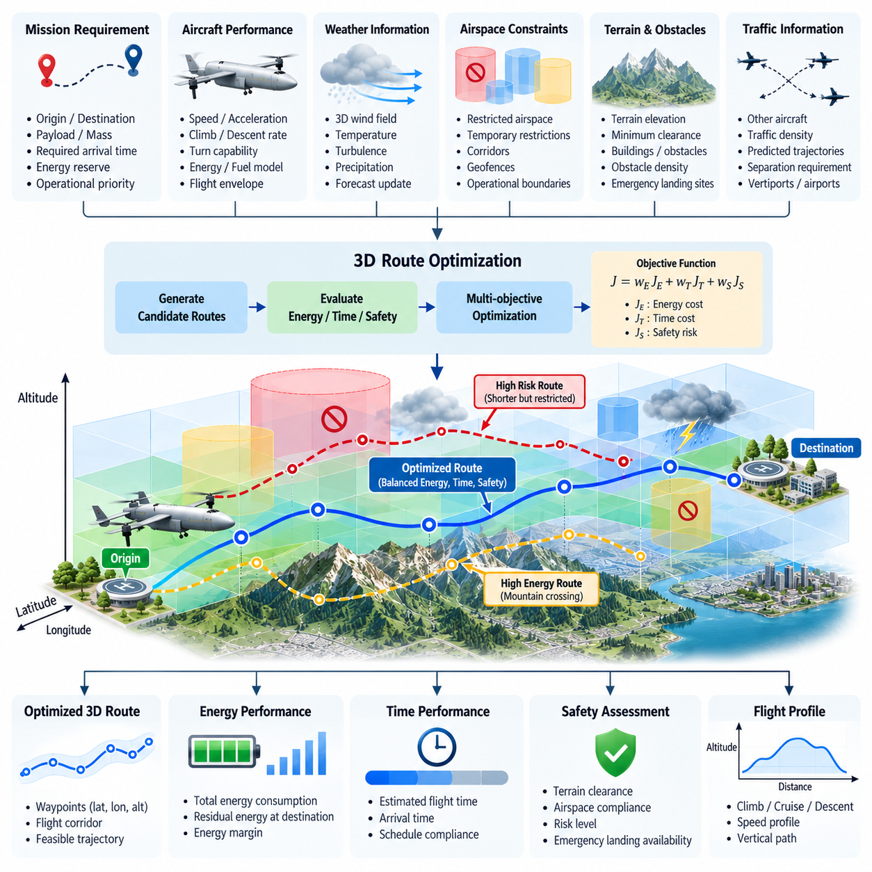
Three-dimensional route optimization determines how a cargo UAV should move through latitude, longitude, and altitude while balancing competing operational objectives. Unlike shortest-path planning, which primarily minimizes geometric distance, a practical cargo route must account for energy consumption, flight time, safety margins, terrain, weather, airspace restrictions, and vehicle performance. The resulting route is therefore an optimized flight corridor rather than simply the shortest connection between origin and destination.
The route can be represented as a sequence of three-dimensional states \(P_i=(lat_i, lon_i, alt_i)\) connected by feasible flight segments. Each segment has associated distance, heading, altitude change, predicted airspeed, ground speed, energy requirement, and risk. Optimization evaluates alternative combinations of these segments and selects a route that satisfies mandatory constraints while minimizing a composite cost representing the operational priorities of the cargo mission.
Energy is a critical optimization variable because cargo UAV range and reserve capability are directly limited by propulsion efficiency and available onboard energy. For electric aircraft, route evaluation considers battery state of charge, power demand, motor and inverter efficiency, and expected reserve at destination. Hybrid or turbine-powered aircraft require corresponding fuel-consumption models. In all cases, energy prediction should reflect the actual vehicle configuration and payload rather than relying only on geographic distance.
Altitude strongly influences route energy consumption. Climbing requires additional potential energy and usually increases propulsion demand, while descent may reduce power requirements but introduces limits associated with speed, controllability, and energy recovery capability. A route that crosses mountainous terrain using repeated climbs and descents can therefore consume substantially more energy than a slightly longer route around the terrain. Three-dimensional optimization explicitly evaluates these vertical costs when comparing candidate paths.
Payload mass further changes the optimal solution. A heavily loaded cargo UAV requires greater lift and propulsion power and may have reduced climb performance, acceleration capability, and maneuvering margins. The same geographic route may therefore be efficient for an unloaded return flight but unsuitable for the outbound loaded mission. Route optimization should use current mass, center-of-gravity condition, propulsion availability, and aircraft performance data so that the generated route remains achievable throughout the mission.
Flight time represents another major objective. The minimum-distance route is not necessarily the minimum-time route because wind, speed restrictions, climb rates, traffic constraints, and airspace geometry affect actual travel duration. A longer path with favorable winds can produce an earlier arrival than a direct route exposed to strong headwinds. Time optimization therefore evaluates predicted ground speed along each segment and estimates the total mission duration under expected atmospheric conditions.
Wind-aware optimization can use three-dimensional wind fields containing direction and magnitude as functions of position and altitude. The planner evaluates whether changing altitude or lateral route produces more favorable wind conditions while remaining inside the aircraft flight envelope. For long-range cargo missions, even modest differences in sustained headwind or tailwind can significantly affect energy use and arrival time. Updated weather forecasts can consequently change the preferred route before or during flight.
Safety introduces objectives that cannot always be expressed through distance, energy, or time alone. Route risk may incorporate terrain clearance, population exposure, obstacle density, emergency landing accessibility, weather severity, communication coverage, navigation quality, traffic density, and distance from hazardous areas. Instead of treating every feasible region as equally desirable, the planner can assign spatially varying risk costs so that routes naturally favor areas offering greater operational margins.
Some safety requirements must be implemented as hard constraints rather than optimization penalties. A prohibited airspace volume, minimum terrain clearance, aircraft performance boundary, severe weather cell, or mandatory geofence cannot be violated simply because doing so would save energy or time. The optimization problem therefore distinguishes hard constraints from soft objectives. Hard constraints define the feasible route space, while soft costs determine which of the remaining feasible alternatives provides the best operational trade-off.
A multi-objective cost function can combine energy, time, and safety as \(J=w_EJ_E+w_TJ_T+w_SJ_S\), where the weighting parameters represent mission priorities. The weights do not need to remain constant for every operation. Urgent medical cargo may justify a stronger time objective, while routine industrial transport may prioritize energy efficiency. Missions over populated or environmentally challenging regions may assign greater weight to safety and contingency accessibility even when the resulting route is longer.
Care is required when combining objectives with different physical units and numerical ranges. Energy may be expressed in kilowatt-hours or fuel mass, time in seconds, and safety through normalized risk scores. These quantities should be normalized before weighting so that one objective does not dominate simply because its numerical magnitude is larger. Constraint violations can additionally receive very large penalties or be removed entirely from the candidate set when they represent unacceptable operating conditions.
The search environment can be represented using a three-dimensional grid, graph, navigation mesh, corridor network, or continuous state space. Graph-based approaches are useful when airspace contains structured corridors and predefined transition points, while sampling-based and optimization-based methods can explore less structured environments. For large operational areas, hierarchical planning can first determine a coarse strategic corridor and then optimize a higher-resolution trajectory within that corridor, reducing computational cost while preserving useful route detail.
Terrain and obstacle information must be incorporated into the three-dimensional representation with appropriate safety buffers. Digital elevation models can define minimum safe altitude, while buildings, towers, cranes, infrastructure, and other obstacles can be represented as occupied or restricted volumes. The planner should consider uncertainty in map accuracy, localization, and obstacle dimensions by expanding these volumes rather than planning directly along their nominal boundaries. This produces routes with realistic navigation margins.
Airspace constraints add another layer to the optimization environment. Controlled zones, temporary restrictions, no-fly regions, altitude limits, designated corridors, and operational boundaries can be represented as permitted or prohibited volumes with associated costs and rules. The route optimizer can then evaluate alternatives that remain compatible with the broader airspace integration architecture. This provides the spatial optimization foundation required for subsequent dynamic rerouting, conflict resolution, and UTM service integration.
Contingency capability can also influence route selection. A nominally efficient route may become operationally undesirable if large portions of it provide no reachable emergency landing location or diversion path. The planner can calculate contingency accessibility along candidate routes and penalize segments with insufficient alternatives. For heavy cargo UAVs, where emergency landing requirements and kinetic consequences are more significant, this consideration can materially alter the preferred route even under normal operating conditions.
Route optimization should account for reserve energy rather than planning to consume the entire predicted energy budget. The required reserve can include uncertainty in wind prediction, navigation deviations, holding time, diversion distance, and unexpected maneuvering. As uncertainty increases, the usable planning budget decreases accordingly. A route is therefore feasible only when predicted destination energy remains above the required reserve threshold under the defined operational assumptions and safety policy.
During flight, actual energy consumption and progress should be compared continuously with planning predictions. If measured power demand is higher than expected, wind conditions deteriorate, or the aircraft is delayed, the remaining route can be re-evaluated using the latest state estimate. Incremental replanning allows the system to select a new altitude, corridor, or diversion destination before reserve margins become critical. This connects strategic route optimization with real-time autonomous mission management.
Validation requires testing the optimizer across normal and adverse operating scenarios. Representative cases should include varying payloads, strong winds, terrain constraints, blocked corridors, degraded propulsion, changing energy reserves, and competing safety requirements. Important metrics include route feasibility, total energy, flight time, minimum safety margin, computation time, reserve at destination, and sensitivity to uncertain inputs. Simulation can compare candidate algorithms consistently before their behavior is evaluated in SIL, HIL, and flight testing.
Ultimately, three-dimensional route optimization provides the decision layer that converts mission intent into a physically achievable and operationally acceptable flight path. Energy determines whether the aircraft can complete the mission, time determines whether operational commitments can be satisfied, and safety determines whether the route maintains acceptable risk. Balancing these objectives enables cargo UAVs to move beyond simple waypoint routing toward mission-aware autonomous flight optimized for real-world airspace operations.

06.03. Airspace Constraint Modeling TFR No Fly Zone [w/Code]
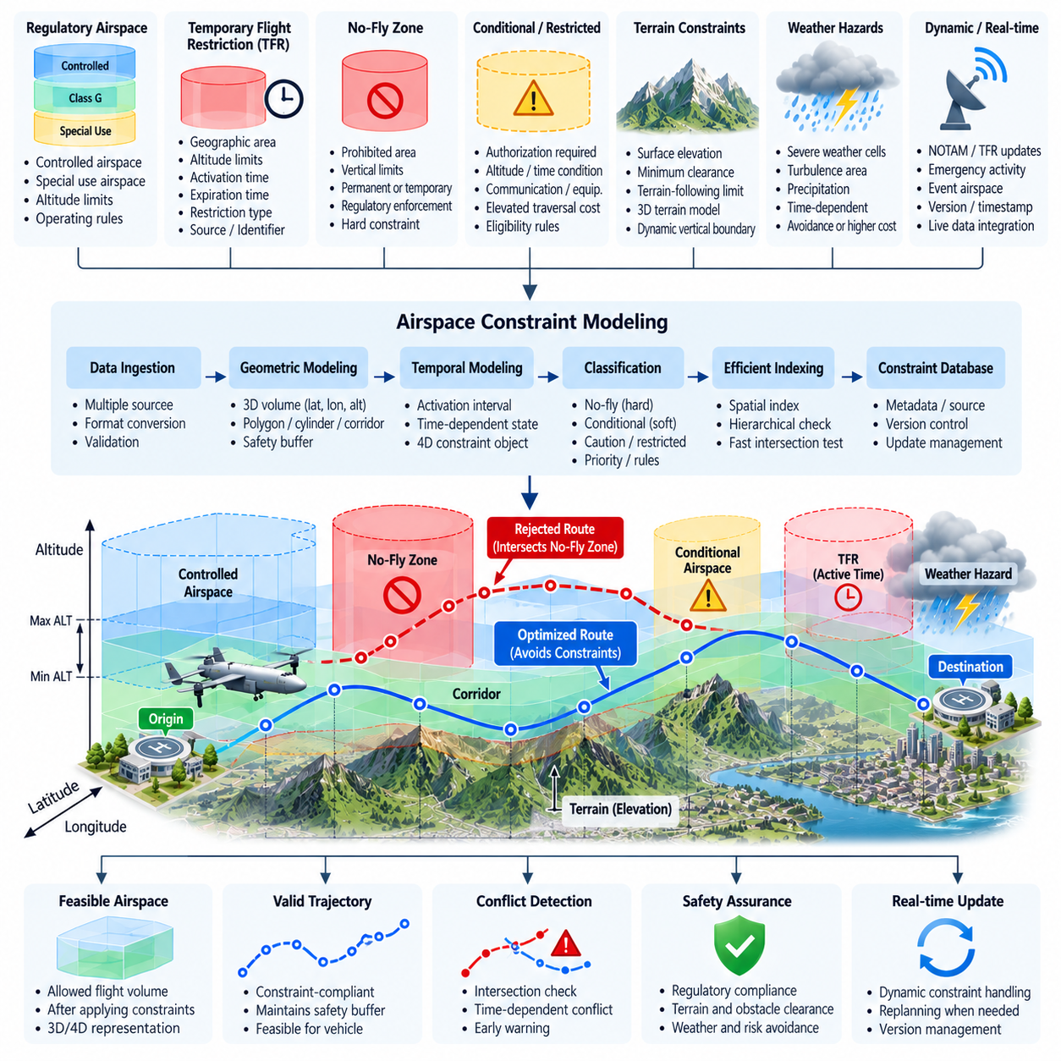
Airspace constraint modeling converts regulatory, operational, geographic, and safety restrictions into machine-readable spatial and temporal objects that an autonomous cargo UAV can evaluate during route planning and flight execution. Instead of treating airspace as an unrestricted three-dimensional environment, the autonomy system represents where flight is permitted, prohibited, conditionally allowed, or subject to additional requirements. This capability forms a core part of route planning and airspace integration for cargo UAV operations.
A basic airspace constraint can be represented as a three-dimensional volume defined by horizontal geometry and vertical limits. The horizontal boundary may use polygons, circles, corridor segments, or combinations of geometric primitives expressed in geographic coordinates. Vertical boundaries define minimum and maximum permitted altitudes. Together, these elements allow the planner to determine whether a waypoint, trajectory segment, or predicted aircraft volume intersects restricted airspace.
Many airspace restrictions are not permanently active, making time an essential component of the constraint model. A restricted region can therefore be represented as a four-dimensional object containing latitude, longitude, altitude, and an activation interval. The same geographic volume may be available during normal operations and unavailable during a specified period. Route validation must consequently evaluate both spatial intersection and whether the aircraft is expected to occupy the affected region while the restriction is active.
Temporary Flight Restrictions, or TFRs, illustrate the importance of dynamic constraint management. A TFR may be established because of emergency response, disaster activity, major public events, security operations, hazardous conditions, or other temporary requirements. From the autonomous planner's perspective, a TFR should be converted into a structured constraint containing geographic boundaries, altitude limits, activation and expiration times, restriction type, source, identifier, and applicable operating rules.
No-fly zones represent airspace volumes that the autonomous system must normally treat as hard constraints. Candidate routes intersecting an active no-fly volume should be rejected rather than merely assigned a higher optimization cost. This distinction is important because an optimization algorithm could otherwise select a prohibited route when the reduction in distance, energy, or time outweighs an ordinary numerical penalty. Regulatory prohibitions therefore require explicit constraint enforcement independent of route efficiency.
Not every constrained region must be completely prohibited. Some areas can be modeled as conditional or soft constraints when flight is permitted only under specific authorization, altitude, equipment, communication, or operational conditions. The route planner can represent such regions with eligibility rules and elevated traversal costs. This allows the same airspace model to distinguish absolute exclusion zones from controlled areas, preferred corridors, caution regions, and authorization-dependent operating volumes.
Constraint data should include provenance and lifecycle information in addition to geometry. Useful metadata includes the issuing authority, source system, publication time, effective time, expiration time, revision number, confidence, and last update timestamp. Maintaining provenance allows the autonomy system and ground control infrastructure to determine whether a constraint is current and authoritative. Version information is particularly important when restrictions change while an aircraft is already executing a previously approved route.
Geometric representation must also account for uncertainty. Regulatory boundaries may be exact, but aircraft localization, map transformation, communication latency, and trajectory tracking all introduce errors. The system should therefore apply configurable safety buffers around restricted volumes. Horizontal and vertical margins can be selected according to navigation performance, vehicle dynamics, operational policy, and restriction criticality, preventing the planner from generating trajectories that pass unrealistically close to a prohibited boundary.
Terrain-related constraints can coexist with regulatory airspace restrictions in the same planning framework. Minimum terrain clearance defines a lower boundary that changes according to surface elevation, while controlled airspace or vehicle performance may impose an upper boundary. The resulting feasible region can become a complex three-dimensional corridor. For heavy cargo UAVs, sufficient vertical margin must also account for climb performance, descent capability, payload mass, and the ability to respond safely to unexpected disturbances.
The constraint model should support efficient intersection testing because route optimizers may evaluate thousands of candidate segments. Spatial indexing, hierarchical partitioning, voxel structures, bounding volumes, or geospatial databases can reduce the number of detailed geometric checks. A coarse stage can quickly eliminate routes that clearly do not interact with restricted areas, while a precise stage evaluates candidate segments near constraint boundaries using higher-resolution geometry and appropriate safety margins.
Dynamic updates require special attention during flight. A route that was valid at departure may become invalid when a new TFR, emergency restriction, weather exclusion volume, or operational closure is issued. The onboard or ground-based airspace service should detect relevant changes and determine whether the current trajectory is affected. If an active or future trajectory segment intersects a newly introduced constraint, the system must initiate route reassessment rather than continuing solely on the original flight plan.
The response to a new restriction depends on urgency and geometry. If the affected region lies far ahead, the planner may perform a normal reroute while preserving energy and arrival objectives. If a restriction appears close to the aircraft, immediate actions may include slowing, holding, changing altitude, or diverting toward a safe region while a new route is computed. Heavy cargo UAVs require particularly conservative logic because their inertia and maneuvering limits can make late avoidance substantially more difficult.
Airspace constraints should be integrated directly with three-dimensional route optimization rather than checked only after route generation. When restrictions are included in the feasible search space, the optimizer avoids spending computational effort on paths that cannot legally or safely be flown. Hard constraints remove prohibited regions, while conditional regions can contribute cost or authorization requirements. This structure naturally extends the preceding energy, time, and safety optimization framework into regulated operational airspace.
Constraint validation should occur at several stages of the mission lifecycle. Preflight validation verifies the planned route against the latest available airspace model. Approval-time validation checks that the submitted trajectory remains consistent with applicable restrictions. Execution-time monitoring continuously compares the active trajectory with updated constraints, while postflight records preserve the constraint versions used during planning and operation. This history supports traceability, incident analysis, and certification evidence.
Communication failures must also be considered because dynamic restrictions may normally arrive through external services. If the aircraft loses access to updated airspace information, the system needs a defined degraded mode based on cached constraints, validity periods, mission criticality, and communication-loss procedures. It should not assume indefinitely that previously downloaded airspace data remains valid. Conservative behavior may include restricting route changes, maintaining an approved corridor, holding, returning, or diverting according to operational policy.
The airspace database must maintain consistency between onboard and ground systems. Constraint identifiers, coordinate reference systems, altitude references, timestamps, units, and version semantics should be standardized so that identical data produces identical interpretations. Confusion between altitude above mean sea level and altitude above ground level, for example, can create serious errors. Explicit schemas and validation rules are therefore essential components of reliable airspace integration software.
Testing should include both geometric and operational edge cases. Examples include routes tangent to a restricted boundary, overlapping restrictions, nested altitude bands, restrictions activated while the UAV is inside or approaching the area, expired constraints, conflicting updates, delayed messages, and inaccurate aircraft position estimates. The objective is not only to verify intersection mathematics but also to confirm that the complete autonomy system responds safely and predictably to changing constraint states.
Simulation, software-in-the-loop, and hardware-in-the-loop environments can inject synthetic TFRs and no-fly zones while the vehicle executes representative cargo missions. Evaluation metrics can include detection latency, route validation accuracy, minimum boundary separation, replanning time, incorrect acceptance or rejection rates, and behavior during data loss. Flight testing can then verify that the same constraint semantics and response logic remain consistent when connected to actual navigation, communication, and flight-control systems.
Ultimately, airspace constraint modeling provides the machine-readable boundary between autonomous route freedom and regulated airspace operation. TFRs, no-fly zones, altitude restrictions, conditional regions, and operational corridors become explicit objects that can be evaluated by planning and monitoring software. By combining geometry, altitude, time, authority, validity, uncertainty, and update state, a cargo UAV can continuously determine not only where it can physically fly, but where it is operationally permitted and safe to fly.

06.04. UTM Service Integration FIMS USS Interface [w/Code]
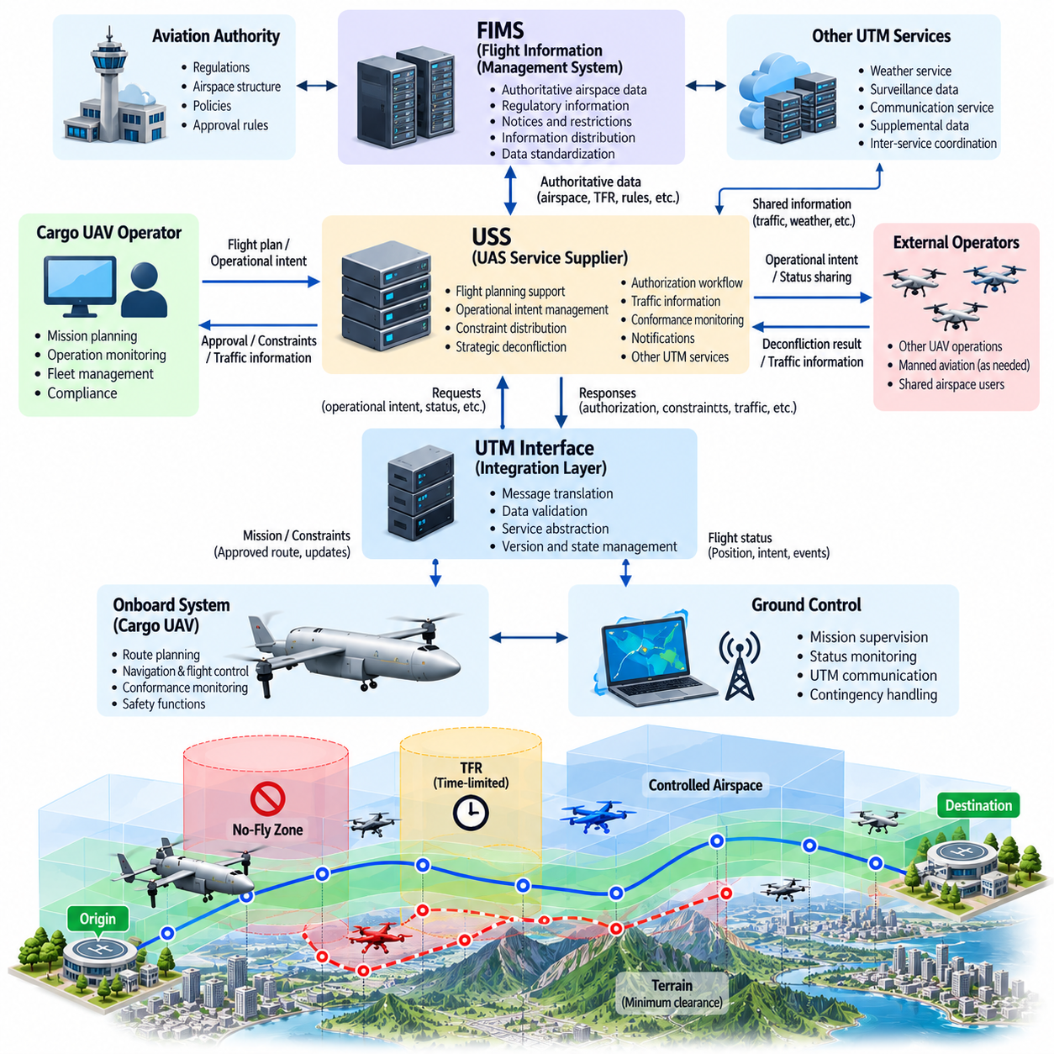
Unmanned Aircraft System Traffic Management, or UTM, provides a digital coordination framework for integrating large numbers of unmanned aircraft into shared airspace. For autonomous cargo UAVs, UTM integration connects onboard mission and route planning with external services responsible for operational intent, airspace constraints, traffic coordination, authorization, and flight status. This interface becomes increasingly important as cargo UAV operations expand beyond isolated missions toward routine networked transportation.
A typical UTM architecture separates vehicle-level autonomy from traffic-management services. The cargo UAV and its ground control infrastructure manage navigation, flight control, vehicle health, and mission execution, while external UTM components coordinate information across multiple operators. The interface between these domains allows the aircraft to submit intended operations, receive constraints and strategic information, report relevant status, and respond to changes affecting the approved mission.
The Flight Information Management System, or FIMS, can be understood as an information exchange and coordination gateway between aviation authority functions and the broader UTM service environment. It enables regulatory or authoritative airspace information to be distributed without requiring every aircraft operator to implement separate direct interfaces to every source. This architecture supports scalable information sharing while maintaining a separation between authority-level functions and operator-facing service providers.
A UAS Service Supplier, or USS, provides UTM-related services to operators and unmanned aircraft systems. Depending on the operational architecture, these services may include flight planning support, operational intent exchange, constraint distribution, strategic deconfliction, authorization workflows, traffic information, conformance monitoring, and notifications. The cargo UAV operator can therefore interact primarily with a USS while the broader UTM ecosystem coordinates information among participating services and relevant aviation infrastructure.
From the cargo UAV software perspective, the UTM interface should be implemented as a well-defined service boundary rather than tightly coupling the flight-control system to an external network service. A dedicated UTM integration component can translate between external messages and internal mission objects. This separation prevents communication protocols, service-provider changes, or network failures from directly affecting deterministic flight-control functions and supports cleaner verification of safety-critical software boundaries.
Operational intent is one of the central information objects exchanged through UTM services. It describes where and when an aircraft intends to operate, normally using spatial volumes and associated time intervals rather than only a sequence of individual waypoints. The onboard route planner can convert its planned 4D trajectory into an operational representation suitable for external coordination, while received constraints can be transformed back into internal planning objects for validation and optimization.
Before departure, the mission-management system can submit the proposed operation through the UTM service interface. The submitted information may include operating volumes, planned time intervals, vehicle and operator references, departure and destination information, and other data required by the applicable service environment. The response can indicate acceptance, required modification, conflict, or additional conditions. The autonomous system must therefore treat approval status as part of mission readiness rather than assuming that a physically feasible route is automatically operationally available.
Strategic deconfliction attempts to identify incompatible operational intentions before aircraft encounter one another in flight. When the USS receives or exchanges planned operating volumes, it can determine whether proposed missions create unacceptable spatial and temporal overlap. The cargo UAV route planner can then modify departure time, altitude, corridor, speed profile, or route geometry. This approach reduces the probability that tactical collision-avoidance systems will need to resolve conflicts during actual flight.
Airspace constraint information is another essential input. Temporary restrictions, no-fly zones, controlled volumes, corridor availability, emergency areas, and other operational constraints can be received through the service layer and inserted into the local airspace model. Each update should preserve identifiers, effective times, altitude limits, geometry, source information, and version state so that the route planner can determine whether the active or proposed trajectory remains compliant with the latest available constraints.
UTM integration must also support changes after departure. Airspace availability, traffic conditions, emergency activity, weather-related restrictions, or other operational information may change while the cargo UAV is airborne. The integration layer should process incoming updates, determine their relevance to the active mission, and notify the mission-management and route-planning components. Changes that affect future trajectory segments can trigger validation, negotiation, or dynamic replanning without unnecessarily disturbing unaffected flight segments.
Conformance monitoring determines whether the aircraft remains consistent with its declared or authorized operation. The system can compare actual aircraft position, altitude, time, and predicted trajectory against the approved operating volume. Small deviations may remain inside defined tolerance boundaries, while larger deviations can generate alerts or require corrective action. This function links onboard navigation performance with external traffic coordination and helps prevent an individual vehicle from creating unexpected conflicts in shared airspace.
The interface should distinguish strategic UTM coordination from tactical onboard safety functions. External services can support planning, authorization, traffic awareness, and strategic conflict management, but the aircraft must retain local capabilities needed to respond to immediate hazards. Sense-and-avoid, obstacle avoidance, flight-envelope protection, and emergency control should not depend on continuous connectivity to a USS. This separation is particularly important for heavy cargo UAVs whose safety cannot rely on cloud communication latency or availability.
Communication architecture therefore requires explicit degraded-mode behavior. If the USS connection is interrupted, the system should determine whether the mission may continue using cached authorization and constraint data, whether it must remain inside the current approved corridor, or whether holding, return, or diversion is required. The appropriate response depends on operational rules and mission conditions, but the software must implement a deterministic policy rather than treating network loss as an undefined exception.
Reliable message exchange requires consistent schemas, identifiers, timestamps, coordinate references, units, and version semantics. Messages should support validation so that malformed, stale, duplicated, or inconsistent information cannot silently alter the mission plan. Sequence information and timestamps can help detect delayed updates, while unique identifiers allow the system to associate constraints and operational changes with the correct mission. Secure transport and authenticated service endpoints are also necessary for trusted traffic-management communication.
Because UTM data influences autonomous routing, cybersecurity becomes directly related to flight safety. False airspace restrictions could unnecessarily block routes, while missing or manipulated constraints could direct an aircraft into unsafe or unauthorized areas. The integration architecture should therefore protect message integrity, authenticate participating services, manage credentials securely, and record relevant exchanges for audit. Security failures should produce controlled degraded behavior rather than uncontrolled modification of the active trajectory.
The UTM integration layer should maintain a clear state model for each mission. Typical states can represent preparation, submission, authorization, activation, execution, modification, contingency, completion, or cancellation. State transitions should be synchronized with the mission manager so that the aircraft does not depart under an invalid authorization state or continue operating after a critical change. Persistent records allow recovery after software restart or temporary communication interruption without losing the authoritative mission context.
Heavy cargo UAV operations place additional demands on UTM coordination because vehicle size, kinetic energy, maneuvering limits, and operational consequences are greater than those of small drones. Route modifications cannot assume instantaneous turns, climbs, or stops. When a USS-related update requires a trajectory change, the route planner must evaluate whether sufficient distance, time, energy, and flight-envelope margin remain to execute the modification safely. External coordination and vehicle dynamics must therefore be tightly aligned.
Testing should reproduce both normal service exchanges and failure conditions. Simulation can emulate operational submissions, approvals, conflicts, restriction updates, network latency, duplicated messages, service outages, expired authorization, and unexpected mission modifications. Software-in-the-loop and hardware-in-the-loop testing can then verify that external events propagate correctly through the UTM integration layer without violating flight-control boundaries or producing inconsistent mission states.
Important evaluation metrics include message latency, update-processing time, operational intent consistency, constraint synchronization accuracy, conflict-response time, conformance-monitoring accuracy, reconnection behavior, and successful recovery from malformed or missing data. Flight trials can subsequently validate end-to-end interaction among the cargo UAV, ground infrastructure, mission-management software, and representative traffic-management services under realistic communication and operational conditions.
Within the cargo UAV software structure, UTM service integration forms the bridge between route planning and broader airspace coordination, preceding dynamic rerouting, conflict resolution, contingency routing, corridor navigation, and automated flight-plan processing. A robust FIMS and USS interface therefore enables autonomous cargo aircraft to evolve from independently planned vehicles into cooperative participants in digitally managed airspace while preserving onboard authority for immediate flight safety.

06.05. Dynamic Re Routing and Weather Avoidance [w/Code]
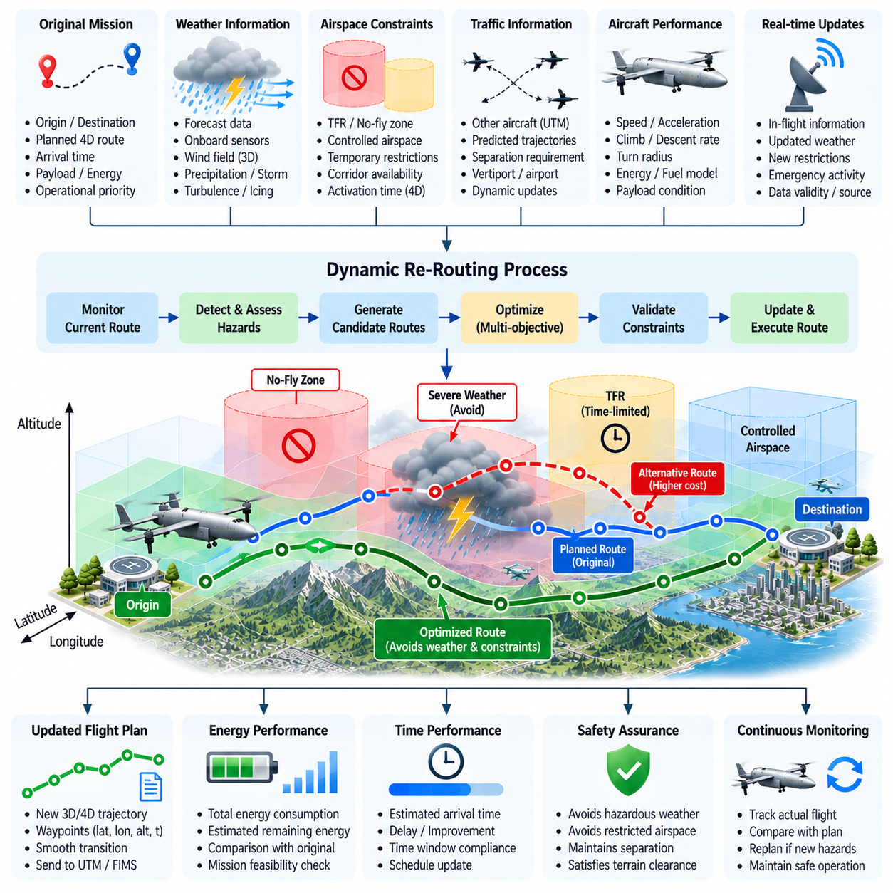
Dynamic re-routing enables a cargo UAV to modify its planned trajectory when the operating environment changes after mission planning or departure. A route that was feasible and efficient during preflight preparation may become undesirable because of weather, airspace restrictions, traffic, vehicle performance, or emergency activity. The re-routing system therefore continuously evaluates whether the active trajectory remains safe, compliant, and achievable rather than treating the original flight plan as immutable.
Weather avoidance is one of the most important triggers for dynamic route modification. Cargo UAVs may encounter thunderstorms, strong winds, turbulence, icing conditions, heavy precipitation, reduced visibility, or rapidly changing local weather. These hazards can affect controllability, structural loading, propulsion demand, sensor performance, navigation quality, and energy consumption. The planner must convert weather information into constraints or costs that can be evaluated together with terrain, airspace, and vehicle limitations.
Weather information can originate from forecast services, ground infrastructure, onboard sensors, and updated operational data received during flight. Forecast products provide strategic information over larger areas and longer horizons, while onboard observations can reveal local conditions that were not predicted accurately. The autonomy system benefits from combining these sources while retaining timestamps, validity periods, spatial resolution, confidence, and source information so that outdated weather data does not silently influence critical routing decisions.
A useful weather model represents hazardous conditions as three-dimensional or four-dimensional volumes. A thunderstorm cell, for example, can be described by horizontal extent, altitude range, intensity, motion, and expected validity time. Because weather systems move and evolve, a static exclusion polygon is often insufficient. The route planner should predict where the hazardous volume is expected to be when the aircraft reaches that region, creating a time-dependent avoidance problem similar to dynamic airspace constraint modeling.
Weather constraints can be classified according to severity. Conditions exceeding aircraft operating limits should be treated as hard constraints that the planned trajectory cannot enter. Less severe regions can be represented as elevated costs, allowing the optimizer to decide whether limited exposure is acceptable when alternatives impose substantial energy or time penalties. This approach preserves strict protection against unacceptable hazards while providing flexibility for conditions that remain inside certified operating limits.
Wind requires more detailed treatment because it can be both a hazard and an optimization opportunity. Strong crosswinds or turbulence may make a corridor unsafe, while moderate tailwinds can reduce energy consumption and flight time. The planner should therefore evaluate wind direction and magnitude relative to aircraft heading, airspeed, payload, and control authority. Vertical wind structure can also make altitude changes beneficial even when the horizontal route remains unchanged.
The dynamic re-routing process begins with continuous monitoring of the active route and its surrounding operational environment. When new information arrives, the system first determines whether it materially affects the current or future trajectory. Updates far from the planned route may require no action, whereas a developing weather cell intersecting a future segment can trigger detailed reassessment. This relevance filtering prevents unnecessary route changes and reduces computational and communication load.
Once a significant hazard is identified, the planner estimates the remaining time and distance before interaction. This determines how much freedom exists for corrective action. A distant weather system may allow a gradual lateral diversion or altitude change, while a rapidly developing hazard near the aircraft may require immediate avoidance, holding, diversion, or contingency behavior. Heavy cargo UAVs require greater anticipation because their mass and maneuvering limits reduce the feasibility of aggressive late trajectory changes.
Candidate routes should be generated from the aircraft's current predicted state rather than simply from the original mission origin. The new route must connect smoothly with the trajectory already being flown and respect heading, velocity, climb rate, turn radius, acceleration, and energy limitations. A geometrically valid path that requires an instantaneous heading change or excessive climb is not operationally feasible. Dynamic re-routing must therefore remain tightly coupled with the aircraft performance model.
The re-routing objective normally balances several competing costs. A candidate route may avoid hazardous weather but increase flight distance, energy consumption, arrival delay, traffic exposure, or proximity to restricted airspace. The optimizer can combine these factors using a multi-objective cost function while enforcing hard safety and regulatory constraints. Safety takes precedence when conditions exceed allowable limits, while energy and schedule objectives determine the preferred solution among remaining safe alternatives.
Energy reserve is particularly important during weather avoidance. Detouring around a large storm may significantly increase distance, and strong headwinds can further increase propulsion demand. The system should estimate energy at destination and at potential diversion points for every serious candidate route. If the nominal destination can no longer be reached with the required reserve, the mission manager should consider an alternate landing location instead of repeatedly extending the route until the energy margin becomes unsafe.
Dynamic re-routing must also remain consistent with airspace restrictions and UTM coordination. A weather-avoidance path cannot simply enter a no-fly zone, unauthorized corridor, or conflicting operational volume because it is meteorologically preferable. The planner should combine weather hazards with the existing airspace constraint model and, where required, communicate proposed operational changes through the relevant traffic-management service. This places weather avoidance directly after UTM integration in the route-planning architecture.
When a modified route changes the externally coordinated operational intent, the UTM integration layer may need to submit or communicate the updated trajectory. The onboard mission manager should distinguish between small adjustments that remain within an authorized operating volume and larger changes requiring external coordination. This prevents every minor control correction from becoming a traffic-management transaction while ensuring that strategically significant route changes are visible to other participants.
Weather avoidance should operate at multiple planning horizons. Strategic planning may reroute tens or hundreds of kilometers ahead using forecast information, while tactical planning reacts to more immediate observations. The two layers should remain coordinated so that a tactical maneuver does not place the aircraft in a poor strategic position. After immediate avoidance is completed, the strategic planner can determine whether to rejoin the original route, continue on a modified route, divert, or terminate the mission.
Route stability is an important design consideration. Frequent changes in weather estimates can cause an optimizer to alternate repeatedly between similar routes, producing undesirable oscillation. Hysteresis, minimum route-hold times, confidence thresholds, and switching penalties can reduce unnecessary replanning. The system should change the active route when the expected operational benefit is meaningful or when safety requires it, rather than reacting aggressively to every small variation in forecast data.
Uncertainty should be represented explicitly when defining weather avoidance margins. Forecast location, intensity, and movement are never perfectly known, and sensor observations also contain errors. Safety buffers can therefore expand according to forecast uncertainty, hazard severity, vehicle speed, and update latency. A fast heavy cargo UAV approaching a rapidly developing storm may require a substantially larger avoidance margin than a slower aircraft operating near a stable and accurately observed weather region.
Communication loss creates an additional challenge when weather information normally depends on external services. The aircraft should retain the latest valid weather model and determine how long it can safely rely on cached information. Onboard sensing and conservative operating rules can support temporary degraded operation. If uncertainty grows beyond acceptable limits, the system may need to avoid known hazardous regions more broadly, remain within a protected corridor, divert, or terminate the mission according to predefined contingency policy.
The mission manager should maintain traceability of major re-routing decisions. Relevant records include the triggering event, weather data version, aircraft state, candidate routes, selected trajectory, rejected alternatives, predicted energy, constraint status, and decision time. Such information supports postflight analysis and helps engineers determine whether the planner responded appropriately. For safety-critical autonomous cargo operations, decision traceability also contributes to verification and operational assurance.
Validation requires scenarios in which weather evolves while the aircraft is already committed to a mission. Simulation can introduce moving thunderstorms, changing wind fields, turbulence zones, forecast errors, delayed updates, blocked alternatives, and reduced energy reserves. The planner should demonstrate that it detects relevant hazards, generates feasible alternatives, preserves required separation margins, and selects contingency actions when no acceptable route to the original destination remains.
Software-in-the-loop and hardware-in-the-loop testing can measure detection-to-replan latency, computation time, trajectory continuity, weather clearance, energy impact, arrival delay, route stability, and response to communication failures. Flight testing can then evaluate the complete loop using real navigation, weather inputs, mission-management logic, and flight-control execution. Particular attention should be given to transitions between the original and modified trajectories because unsafe discontinuities can negate an otherwise valid re-routing decision.
Ultimately, dynamic re-routing and weather avoidance transform route planning from a preflight calculation into a continuous autonomous decision process. The cargo UAV repeatedly evaluates its trajectory against changing weather, airspace, traffic, energy, and vehicle conditions and modifies future flight only when necessary. By combining predictive weather modeling, constraint-aware optimization, UTM coordination, energy management, and contingency logic, the aircraft can preserve safety while maintaining the greatest practical degree of mission efficiency and operational continuity.

06.06. Conflict Detection and Resolution CDR [w/Code]
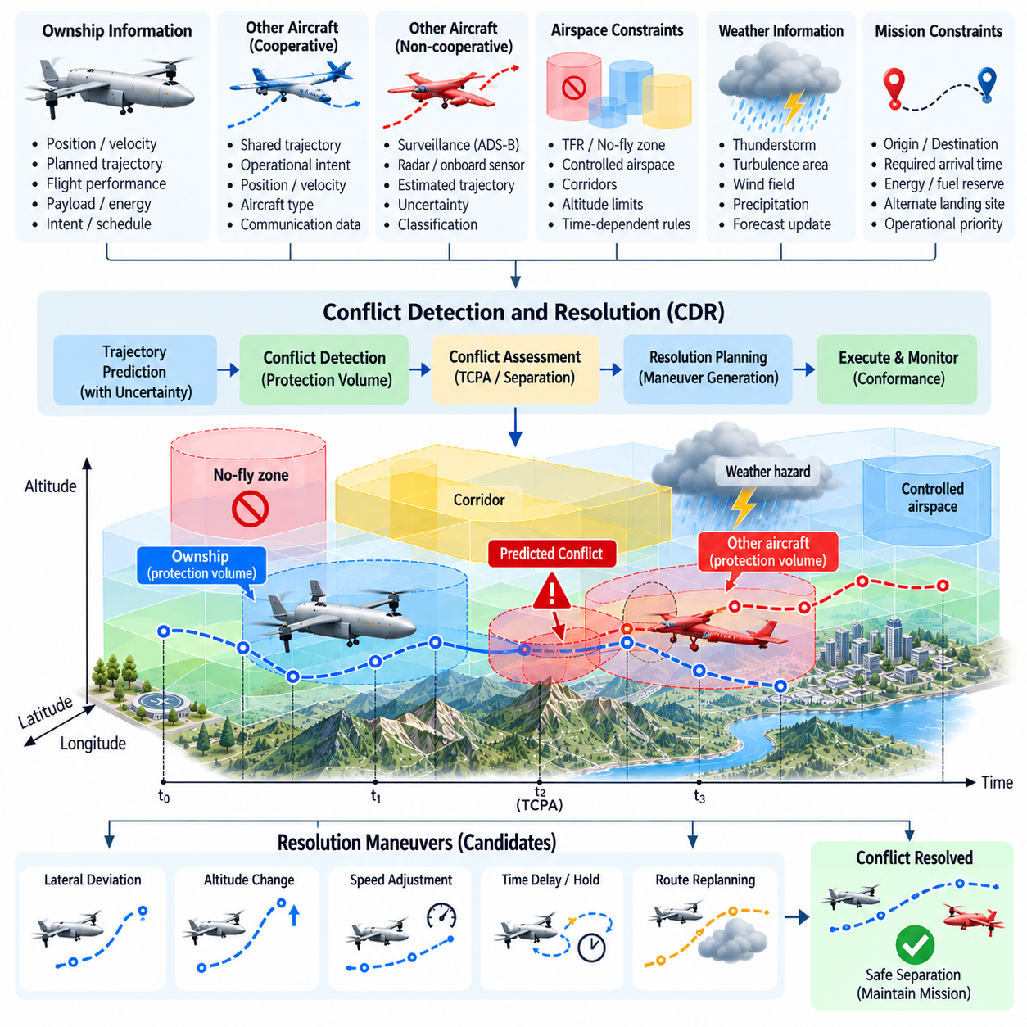
Conflict Detection and Resolution, or CDR, enables autonomous cargo UAVs to identify predicted losses of safe separation and modify their trajectories before a hazardous encounter occurs. Unlike reactive collision avoidance, CDR primarily operates on predicted aircraft motion over a future time horizon. It compares planned or estimated trajectories of multiple airspace participants and determines whether their protected operating volumes are expected to overlap in space and time.
A conflict is not necessarily a physical collision. It normally represents a predicted violation of defined horizontal, vertical, or temporal separation criteria. Each aircraft can be surrounded by a protection volume that reflects required separation, navigation uncertainty, trajectory tracking error, communication latency, and vehicle performance. When predicted protection volumes overlap within the monitoring horizon, the system classifies the situation as a potential conflict requiring further assessment.
Trajectory prediction is therefore fundamental to CDR performance. The system estimates future latitude, longitude, altitude, velocity, heading, and time using current aircraft state, intended route, flight dynamics, and available operational intent. For cooperative traffic, externally shared trajectories can improve prediction quality. For traffic with limited information, the system may extrapolate current motion or use observations from onboard surveillance and perception systems, producing correspondingly larger uncertainty bounds.
The detection horizon should reflect vehicle speed, maneuverability, traffic density, and system latency. A short horizon may detect conflicts too late for a heavy cargo UAV to maneuver safely, while an excessively long horizon can generate unnecessary alerts because distant trajectory predictions contain greater uncertainty. Multi-horizon processing can address this problem by combining strategic conflict detection over longer periods with more precise tactical monitoring as aircraft approach one another.
Closest point of approach provides a useful geometric basis for conflict assessment. Given predicted trajectories for two aircraft, the CDR system can estimate the time to closest approach and the corresponding horizontal and vertical separation. These values are compared with required thresholds while considering uncertainty. A conflict exists when predicted separation falls below acceptable limits during a relevant time interval, rather than simply when two geometric route lines cross on a map.
Uncertainty must be explicitly incorporated because predicted trajectories are never exact. Position estimation error, wind, control response, route changes, delayed traffic information, and communication latency all affect future aircraft location. Instead of representing another aircraft as a single point, the system can propagate an uncertainty region around its predicted state. The protection volume can expand with prediction time so that longer-range decisions remain conservative without assuming unrealistic precision.
Conflict severity can be evaluated using several related factors, including time to loss of separation, predicted minimum distance, uncertainty, relative velocity, maneuvering capability, and available escape options. A distant low-probability conflict may require continued monitoring, whereas a rapidly converging encounter with limited maneuvering space demands immediate resolution. Severity classification helps prevent every predicted interaction from triggering the same response and supports proportional autonomous decision making.
Resolution begins by generating candidate maneuvers that restore acceptable separation while preserving mission feasibility. Possible actions include lateral path changes, altitude changes, speed adjustments, delayed entry into a corridor, holding, or combinations of these actions. The preferred maneuver depends on available airspace, vehicle dynamics, energy reserve, weather, regulatory constraints, and the behavior expected from other aircraft. Resolution is therefore a constrained trajectory optimization problem rather than a simple avoidance turn.
Strategic resolution can often preserve mission efficiency because it acts before the conflict becomes urgent. If two cargo UAVs are predicted to occupy the same corridor several minutes in the future, one aircraft may reduce speed, shift its crossing time, use another altitude band, or select an alternate corridor. Small early adjustments can create sufficient temporal or spatial separation with much lower energy and schedule impact than an aggressive maneuver performed shortly before the encounter.
Heavy cargo UAV dynamics strongly influence resolution feasibility. A multi-ton aircraft has limited acceleration, climb performance, turn rate, and stopping capability compared with a small drone. The CDR system must therefore reject candidate maneuvers that are geometrically attractive but dynamically impossible. Required maneuver initiation distance should include control response, vehicle inertia, payload condition, wind, and flight-envelope limits so that the selected resolution remains executable by the actual aircraft.
Resolution maneuvers must also respect airspace constraints. An altitude change cannot enter a prohibited altitude band, and a lateral diversion cannot cross a no-fly zone merely to avoid another aircraft. Weather hazards, terrain clearance, corridor boundaries, and authorization conditions remain active during conflict resolution. The CDR optimizer must consequently search only within the feasible airspace defined by the route-planning and constraint-management layers.
UTM information can extend CDR from local aircraft sensing to cooperative traffic coordination. Operational intent received through traffic-management services provides knowledge of planned aircraft occupancy before vehicles become locally observable. Strategic deconfliction can therefore resolve many interactions during mission planning, while onboard CDR continues monitoring actual execution. This layered structure links UTM integration, dynamic rerouting, and conflict resolution within the chapter's airspace-integration sequence.
Cooperative resolution requires consistent responsibility rules so that two autonomous aircraft do not repeatedly react to each other's maneuvers. Priority, right-of-way, assigned altitude, corridor rules, or traffic-management instructions can determine which aircraft should modify its trajectory. When coordination information is unavailable, onboard logic should follow predefined conservative rules. Deterministic behavior reduces the possibility of oscillatory responses in which both vehicles continuously select conflicting avoidance actions.
Route stability is important after a resolution is selected. The CDR system should avoid changing maneuvers every time a small prediction update occurs. Hysteresis, maneuver commitment intervals, confidence thresholds, and switching penalties can stabilize the decision. However, commitment must not prevent reassessment when the other aircraft behaves unexpectedly or when a new hazard appears. The system therefore balances trajectory stability with continuous monitoring and the ability to escalate when necessary.
CDR must distinguish strategic conflict resolution from immediate collision avoidance. Strategic CDR operates with sufficient time to optimize energy, schedule, and route efficiency, while tactical collision avoidance prioritizes rapid restoration of separation. If the available time falls below a defined threshold, authority may transition from the strategic planner to a higher-priority tactical safety function. This prevents computationally expensive route optimization from delaying an urgent avoidance maneuver.
Communication loss and incomplete traffic information require degraded operating modes. If cooperative trajectory data becomes unavailable, the system can increase uncertainty margins and rely more heavily on onboard surveillance, radar, vision, ADS-B where applicable, or other available sensing. Reduced confidence may require lower speed, increased separation, restricted corridor entry, holding, or diversion. The system should explicitly represent the loss of traffic information rather than continuing to trust stale predictions.
After a resolution maneuver is executed, the system must verify that the conflict is actually clearing. Updated state estimates are used to recompute predicted minimum separation and determine whether the selected maneuver remains effective. Once safe separation is established, the route planner can evaluate whether the aircraft should rejoin its original trajectory or continue along a modified route. Rejoining must itself be checked for new conflicts, airspace restrictions, weather, and energy feasibility.
Multiple-aircraft encounters make the problem substantially more complex because resolving one pairwise conflict can create another. Dense cargo corridors may therefore require multi-agent reasoning that evaluates several interacting trajectories simultaneously. Priority rules, corridor scheduling, graph-based traffic models, or optimization methods can coordinate these encounters. The objective is not merely to separate one aircraft pair but to preserve stable traffic flow while avoiding cascades of repeated local resolutions.
CDR decisions should be recorded for operational traceability. Relevant information includes detected aircraft, predicted trajectories, protection volumes, conflict time, expected minimum separation, candidate maneuvers, selected resolution, applicable constraints, and final outcome. These records support postflight investigation and algorithm validation. They also allow developers to determine whether missed detections, excessive alerts, or inefficient resolutions resulted from prediction, sensing, communication, or decision logic.
Validation should include crossing, converging, overtaking, head-on, vertical, and corridor-merging encounters under different speeds and payload conditions. Additional scenarios should inject wind errors, delayed trajectory updates, navigation uncertainty, communication loss, unexpected maneuvers, blocked escape routes, and simultaneous conflicts. Performance metrics can include detection probability, false-alert rate, detection lead time, minimum achieved separation, resolution computation time, and additional energy or delay caused by avoidance.
Simulation provides the scale required to evaluate thousands of encounter geometries before flight testing. Software-in-the-loop and hardware-in-the-loop environments can then verify timing, message handling, planner interaction, and flight-control execution. Representative flight trials should confirm that predicted resolution maneuvers remain dynamically achievable and that transitions between strategic CDR, tactical avoidance, and normal route following occur without unsafe discontinuities.
Ultimately, Conflict Detection and Resolution provides the predictive safety layer required for scalable autonomous cargo traffic. By combining trajectory prediction, uncertainty modeling, protection volumes, vehicle dynamics, airspace constraints, UTM information, and multi-objective resolution planning, CDR allows potential encounters to be addressed before they become emergencies. This capability enables cargo UAVs to share increasingly complex airspace while maintaining safe separation, predictable behavior, and efficient mission execution.

06.07. Contingency Routing Engine Off Nominal [w/Code]
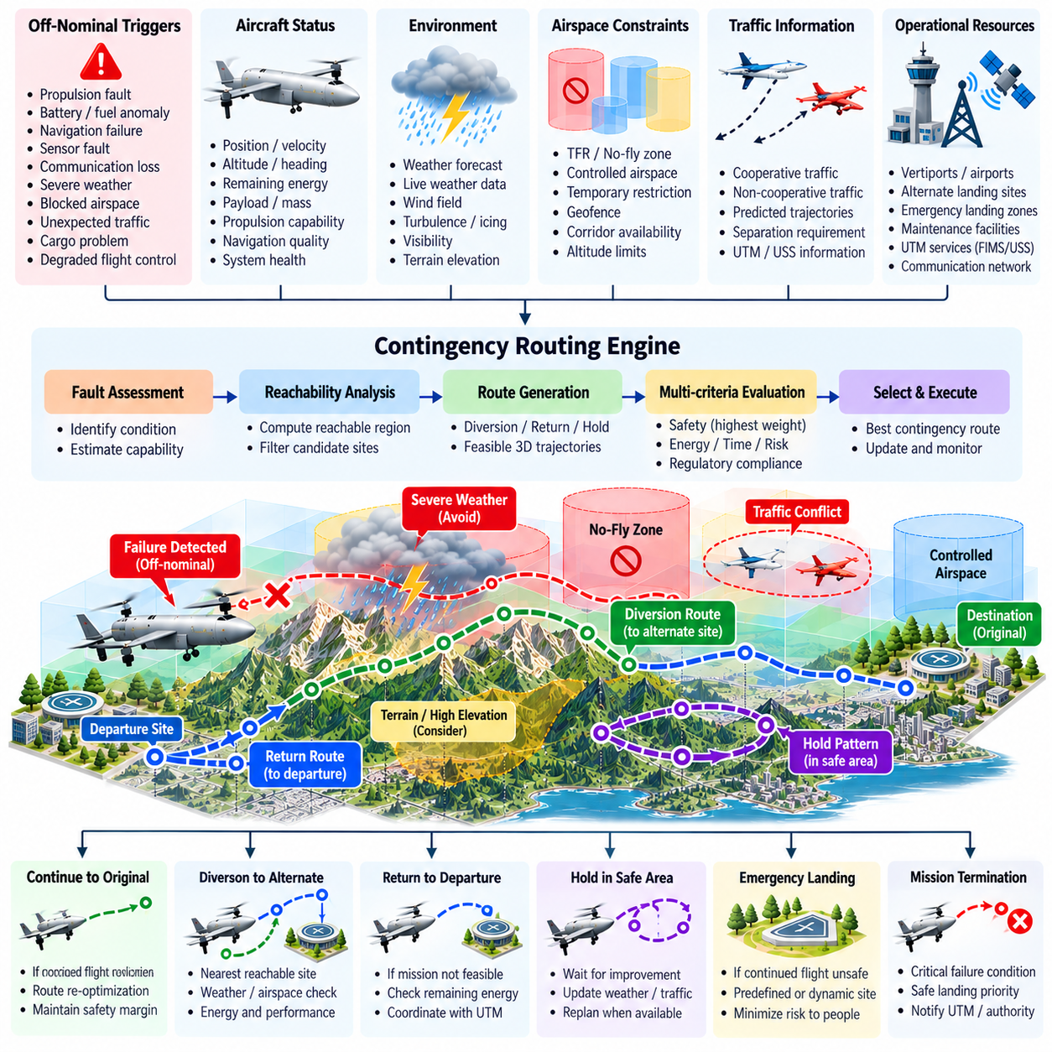
A contingency routing engine provides the autonomous cargo UAV with alternative flight paths when the nominal mission can no longer be executed safely or reliably. Unlike routine dynamic re-routing, which primarily optimizes around changing weather or traffic while preserving the original mission, contingency routing responds to off-nominal conditions that may require diversion, holding, return, emergency landing, or mission termination. Its primary objective is safe recovery rather than schedule or route efficiency.
Off-nominal conditions can originate from the aircraft, environment, communication infrastructure, or external airspace system. Representative triggers include propulsion degradation, battery or fuel anomalies, navigation failures, sensor faults, communication loss, severe weather, blocked airspace, unexpected traffic, cargo problems, and degraded flight-control capability. The routing engine must translate each detected condition into constraints describing what flight capabilities remain available.
A contingency state should therefore include more than a simple fault identifier. The engine needs the current aircraft position, velocity, altitude, heading, mass, payload condition, remaining energy, propulsion capability, navigation quality, communication status, weather exposure, and applicable airspace constraints. These variables define the aircraft's remaining operational envelope and determine which destinations and trajectories are realistically reachable after the failure or abnormal event.
Contingency routing begins with fault assessment and capability estimation. A propulsion fault, for example, may reduce available thrust and climb performance without immediately requiring landing, while a severe energy-system failure may make continued flight impossible. Navigation degradation can restrict operations to regions supported by alternative positioning sources. The routing system should therefore reason from remaining capability rather than applying an identical emergency route to every abnormal condition.
Candidate destinations can include the original destination, departure site, alternate vertiports, predefined emergency landing zones, holding regions, maintenance facilities, or dynamically assessed safe landing areas. Each candidate is evaluated for reachability and operational suitability. The geographically closest site is not necessarily the safest because terrain, wind, approach geometry, population exposure, airspace restrictions, landing capability, and remaining vehicle performance can make a more distant location preferable.
Reachability analysis is especially important for heavy cargo UAVs. A 2.5-ton, 5-ton, or 10-ton aircraft may require substantial distance for descent, turning, deceleration, and landing preparation. The routing engine must estimate whether a candidate site lies inside the remaining reachable set under current propulsion and energy conditions. A destination outside this dynamic envelope should be eliminated even when a conventional route planner identifies a geometrically valid path.
Energy reserve becomes a direct safety variable during contingency planning. The engine should estimate energy consumption along each candidate trajectory and include uncertainty caused by wind, degraded propulsion efficiency, holding, approach, and possible go-around requirements. Under severe conditions, the objective may shift from maintaining normal reserve policy to maximizing probability of safe landing. Nevertheless, the system should avoid routes that consume critical energy merely to preserve the original destination.
Contingency routes must remain compatible with terrain and obstacle clearance. A degraded aircraft may no longer possess the climb capability assumed by the nominal route planner, making mountainous regions or tall obstacles newly inaccessible. The engine should recompute feasible altitude profiles using the reduced flight envelope. In some situations, descending early toward a safe low-risk region may be preferable to attempting to maintain the altitude profile of the original mission.
Airspace restrictions remain relevant during off-nominal operation, but contingency policy may assign them different priorities depending on safety and applicable operational rules. The planner should first search for routes that remain within normal constraints and approved volumes. If aircraft safety cannot be preserved using those routes, the contingency state must be escalated according to predefined procedures rather than allowing an ordinary optimization function to silently violate restrictions.
Weather can significantly change the preferred contingency destination. An alternate landing site may be geographically close but located behind a thunderstorm, strong crosswind region, icing area, or other hazardous weather. The engine should therefore evaluate current and forecast conditions along the entire diversion trajectory and at the landing site. Weather uncertainty should increase route margins because an off-nominal aircraft typically has less maneuvering capability available to absorb additional disturbances.
Traffic conflicts must also be considered when generating emergency routes. A direct diversion path can intersect active corridors or other aircraft trajectories, particularly near vertiports and logistics hubs. Integration with Conflict Detection and Resolution allows the contingency route to be evaluated against surrounding traffic. When urgency is high, the aircraft's contingency status can be communicated through the traffic-management architecture so that other participants can respond appropriately.
The routing engine should coordinate with UTM services when communication remains available. A major diversion, emergency landing, corridor departure, or mission termination may change the aircraft's previously declared operational intent. The system can provide updated operating volumes, trajectory information, or contingency status through the appropriate service interface. However, safe execution must not depend on continuous UTM connectivity because the initiating failure may itself include loss of communication.
Communication-loss scenarios require deterministic behavior established before flight. Depending on mission rules and aircraft state, the vehicle may continue within an approved corridor, proceed toward a predefined recovery point, hold, return to base, or divert to an alternate site. Cached airspace and weather information can support temporary autonomous operation, but confidence in external information decreases over time. The routing engine should account for this increasing uncertainty when selecting a recovery strategy.
Precomputed contingency routes can reduce response latency for predictable failures. Critical points along the nominal mission may be associated with preferred alternates and validated recovery corridors before departure. During flight, the system can continuously update which alternate is preferred as position, weather, traffic, and energy change. This approach combines deterministic safety preparation with online optimization, avoiding the need to solve every emergency routing problem completely from scratch.
Dynamic contingency planning remains necessary because not every abnormal event can be anticipated precisely. A newly blocked alternate, unexpected wind, propulsion degradation, or traffic conflict can invalidate a precomputed recovery route. The engine should therefore maintain the ability to generate new trajectories from the current aircraft state. Online solutions must still satisfy computational deadlines because an optimal route that arrives after the safe decision window has expired has little operational value.
The contingency manager benefits from a hierarchy of response severity. Minor degradation may permit continuation with modified limits, while a more significant condition can trigger diversion or return. Severe failures may require immediate landing at the safest reachable location. This graduated approach prevents unnecessary mission termination for manageable faults while ensuring that critical conditions rapidly receive higher-priority safety responses. Escalation criteria should be explicit and testable.
Once a contingency route is selected, trajectory continuity is essential. The new path should connect to the current aircraft state without demanding impossible changes in heading, velocity, altitude, or acceleration. The flight management system can convert the selected route into an executable reference trajectory, while the flight-control system tracks it within the degraded vehicle envelope. The contingency planner must continue monitoring execution because remaining capability may deteriorate further.
The routing engine should continuously reassess whether the selected recovery strategy remains feasible. Remaining energy, fault progression, weather, traffic, navigation quality, and destination availability can change during diversion. If the original alternate becomes unsuitable, the system may need to select a second recovery option. Such replanning should avoid unnecessary oscillation while allowing rapid escalation when the safety margin decreases or the aircraft state changes materially.
Contingency decisions require strong traceability. The system should record the initiating fault, aircraft state, available capabilities, candidate destinations, rejected alternatives, selected route, predicted energy, active constraints, decision time, and subsequent changes. These records support engineering analysis and operational assurance by showing why the autonomous system selected a particular recovery strategy instead of another during an off-nominal event.
Validation must include combinations of failures rather than only isolated faults. Scenarios can include propulsion degradation with strong headwind, navigation failure near restricted airspace, communication loss during weather diversion, reduced energy combined with a blocked alternate, or traffic conflicts near an emergency landing site. These combinations reveal interactions that may not appear when each subsystem is tested independently and are particularly important for highly autonomous cargo aircraft.
Simulation can evaluate thousands of off-nominal missions with varying failure locations, payloads, weather conditions, energy states, and available landing sites. Software-in-the-loop and hardware-in-the-loop testing can then verify detection-to-decision latency, route feasibility, interface behavior, and transition into contingency flight modes. Flight testing should progressively validate representative recoverable failures while maintaining appropriate safety supervision and predefined test boundaries.
Within the route-planning architecture, contingency routing follows dynamic re-routing and conflict resolution by providing a dedicated mechanism for conditions in which normal mission assumptions no longer hold. It also prepares the foundation for corridor navigation, automated flight-plan management, and broader UTM field operation within the cargo UAV software structure.
Ultimately, the contingency routing engine transforms off-nominal response from a small collection of fixed emergency commands into a capability-aware autonomous recovery process. By combining fault assessment, reachable-set estimation, energy management, terrain and weather constraints, traffic coordination, alternate-site evaluation, and continuous replanning, the cargo UAV can select the safest achievable outcome when the original mission can no longer be completed as planned.

06.08. Corridor Based Navigation and Deconfliction [w/Code]
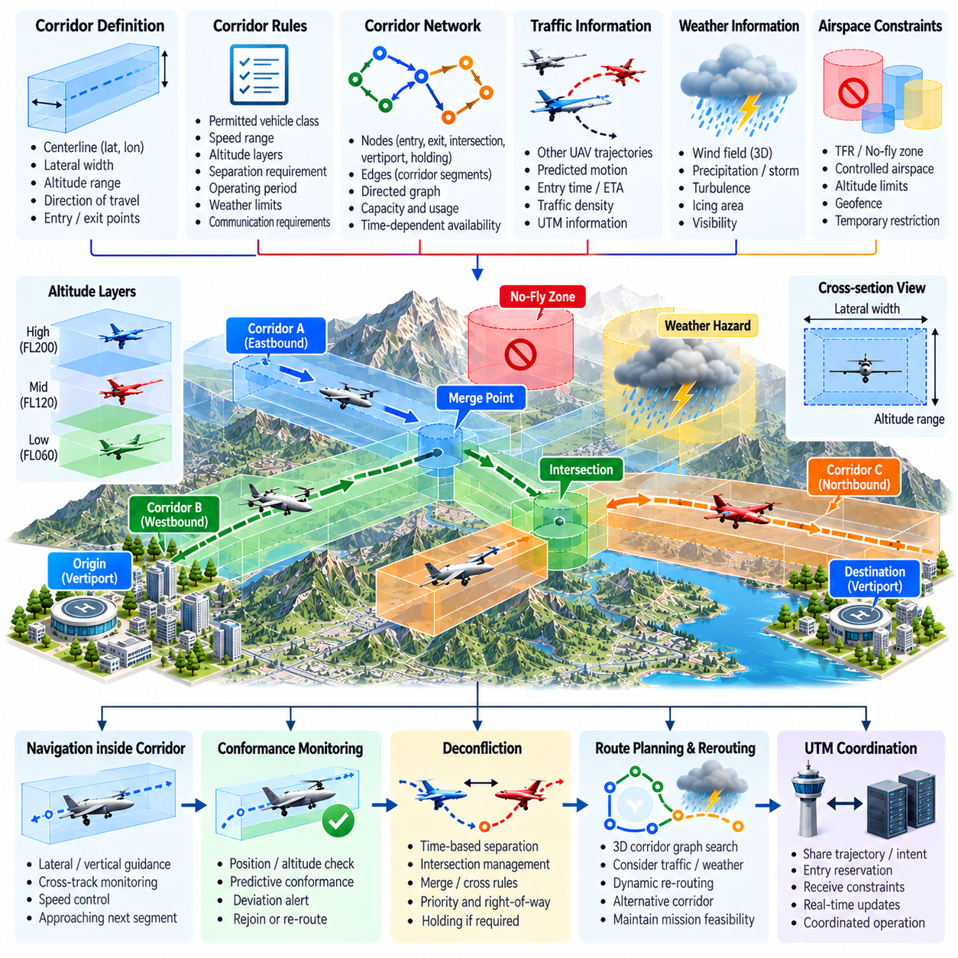
Corridor-based navigation organizes cargo UAV traffic around predefined three-dimensional airspace structures rather than allowing every aircraft to select unrestricted point-to-point paths. A corridor can define a permitted geographic centerline, lateral width, altitude range, direction of travel, entry and exit locations, and operational rules. This structure reduces route uncertainty and creates a predictable framework for coordinating large numbers of autonomous cargo aircraft.
A flight corridor should be modeled as more than a geometric tube. Its digital representation can include capacity, permitted vehicle classes, speed ranges, altitude layers, directional rules, separation requirements, operating periods, weather limitations, communication requirements, and contingency procedures. Time-dependent availability can further convert the corridor into a four-dimensional resource whose occupancy is coordinated according to both position and expected traversal time.
Corridor networks can be represented as directed graphs in which nodes correspond to entry points, exits, intersections, vertiports, holding regions, or transition locations, while edges represent flyable corridor segments. Route planning then becomes a constrained graph-search problem combined with aircraft performance optimization. Edge costs can include distance, expected energy consumption, traversal time, congestion, weather exposure, operational risk, and predicted traffic demand.
For heavy cargo UAVs, corridor geometry must reflect actual vehicle dynamics. Corridor turns require sufficient radius, altitude transitions must respect climb and descent performance, and entry procedures must allow enough distance for speed and heading alignment. A corridor that is suitable for a small multirotor may be dynamically infeasible for a multi-ton cargo aircraft. Vehicle class and performance limits should therefore be explicit inputs to corridor eligibility and route selection.
Navigation inside a corridor requires continuous estimation of the aircraft's relationship to the permitted operating volume. The guidance system can monitor lateral cross-track error, vertical deviation, along-track progress, heading, speed, and distance to upcoming transitions. Rather than following isolated waypoints, the aircraft follows a bounded spatial path with known operational limits. Navigation tolerances should include localization uncertainty and control tracking performance.
Corridor conformance monitoring determines whether the aircraft remains inside its assigned operating region and whether future motion is expected to remain compliant. A small deviation may be corrected through normal guidance, while a larger deviation can trigger warnings, speed reduction, route reassessment, or contingency behavior. Predictive conformance is particularly valuable because a heavy aircraft should begin corrective action before its physical position reaches the corridor boundary.
Deconfliction within corridors requires both spatial and temporal coordination. Two aircraft may safely use the same corridor if their occupancy intervals maintain sufficient separation, while aircraft entering from different branches can create conflicts at intersections or merge points. Shared trajectory information enables planners to treat other vehicles as time-dependent constraints rather than reacting only after they become locally observable. This principle is consistent with coordinated navigation systems that reserve space or time to prevent route conflicts.
Corridor reservations can assign aircraft specific entry windows, altitude layers, or traversal intervals. When capacity is limited, an aircraft may delay departure, reduce speed, hold at a designated location, or select another corridor. Reservation logic should account for vehicle speed and uncertainty rather than assuming perfectly synchronized motion. Buffers between occupancy intervals provide tolerance for wind, control deviations, communication latency, and minor schedule variation.
Intersections and merge points require special coordination because several traffic streams compete for the same airspace resource. Priority can be determined according to operational rules, arrival sequence, mission urgency, vehicle capability, or traffic-management instructions. The objective is to establish predictable right-of-way behavior and avoid situations in which multiple autonomous aircraft repeatedly adjust to one another without reaching a stable solution.
Bidirectional operation introduces additional complexity. If a corridor does not provide physically separated directional lanes, simultaneous opposing traffic may be prohibited or tightly scheduled. One direction can receive temporary corridor ownership while opposing aircraft wait at designated holding locations. Similar coordination principles are used in constrained robotic passages where intended occupancy intervals and waiting locations prevent head-on conflicts.
Altitude layering can increase corridor capacity by separating traffic vertically. Different layers may support opposite directions, vehicle classes, speed ranges, or mission priorities. However, vertical separation is useful only when aircraft can safely transition between layers. Climb and descent zones should therefore be explicitly defined, and transition maneuvers must be checked against surrounding traffic, energy state, weather, and vehicle performance.
Speed management provides another mechanism for maintaining separation without changing the geometric route. If an aircraft is approaching slower traffic or a congested merge point, the planner can modify its speed profile to preserve the required spacing. Early speed adjustments generally consume less energy and create less disruption than late lateral avoidance. For cargo UAVs, this makes time-based deconfliction an important complement to conventional spatial separation.
Operational intent exchange improves corridor coordination by allowing participating aircraft and traffic-management services to know expected occupancy before vehicles physically approach one another. Shared trajectory information should include timing, validity, and uncertainty because plans may change after disturbances or replanning. Information that is no longer refreshed should eventually expire rather than remaining indefinitely trusted, particularly when coordination depends on predicted occupancy.
UTM services can coordinate corridor demand across multiple operators by distributing availability, operational constraints, reservations, and relevant traffic information. A route planner can request or evaluate corridor access before departure and update operational intent when significant changes occur. This allows strategic deconfliction to occur before aircraft enter constrained regions, while onboard navigation and CDR continue to provide local monitoring during actual flight.
Dynamic events can reduce corridor capacity or close a segment entirely. Severe weather, temporary flight restrictions, emergency activity, communication outages, infrastructure failures, or unexpected congestion may invalidate the planned corridor. The route planner should determine whether the aircraft can transition to another corridor, change altitude, hold, divert, or invoke contingency routing. Corridor navigation must therefore remain connected to dynamic re-routing rather than becoming a rigid path-following mechanism.
Local sensing remains essential even when corridor traffic is cooperatively coordinated. An aircraft cannot assume that every participant will remain exactly on its declared trajectory or that all obstacles are represented by the traffic-management system. Navigation errors, communication delay, unexpected aircraft behavior, birds, helicopters, or other hazards may still require onboard detection and tactical avoidance. Cooperative planning reduces conflict probability but does not replace immediate onboard safety functions.
Time synchronization is important when corridor deconfliction relies on scheduled occupancy. Trajectory, reservation, position, and corridor-state messages should contain reliable timestamps so that receiving systems can determine whether information remains current. Timing uncertainty should be incorporated into separation margins, and stale information should receive reduced confidence or be rejected. Coordinated navigation systems similarly depend on bounded timing uncertainty when predicted occupancy is exchanged.
Congestion management becomes necessary as corridor utilization increases. If too many aircraft attempt to enter a segment, unrestricted acceptance can create queues, unstable speed changes, and downstream conflicts. Capacity management can meter corridor entry, allocate time slots, reroute lower-priority traffic, or temporarily use alternative altitude layers. The objective is to preserve stable traffic flow rather than maximizing instantaneous corridor occupancy.
Communication loss requires a predefined corridor behavior. Depending on operational policy, an aircraft may continue through its currently assigned segment, maintain its altitude and speed profile, proceed to a defined exit, hold, or transition into contingency routing. Other participants should not indefinitely assume that the disconnected aircraft will follow previously transmitted intentions. Its predicted occupancy can instead be assigned increasing uncertainty until reliable communication or local surveillance restores confidence.
Corridor deconfliction must also address deadlock and oscillation. Multiple aircraft can individually make reasonable decisions yet collectively prevent progress by repeatedly yielding, changing routes, or waiting for one another. Stable priority rules, reservation ownership, minimum commitment intervals, and controlled release of corridor resources can resolve these conditions. Related coordinated navigation systems likewise require explicit deadlock detection when independent decisions block collective movement.
Validation should cover normal traversal, corridor entry and exit, merges, crossings, opposing traffic, altitude transitions, overtaking, congestion, communication delay, blocked segments, and emergency diversion. Useful metrics include conformance error, minimum separation, corridor throughput, waiting time, conflict frequency, rerouting latency, communication load, energy impact, and recovery success. Coordinated-navigation testing similarly benefits from measuring waiting, collision events, communication effects, and deadlock behavior.
Simulation can evaluate dense corridor networks containing hundreds or thousands of interacting flights before physical deployment. Software-in-the-loop and hardware-in-the-loop testing can then verify reservation messages, timing behavior, route transitions, CDR interaction, and flight-control execution. Flight trials should progressively introduce multiple vehicles and increasingly complex corridor interactions while confirming that strategic coordination and tactical onboard safety remain correctly separated.
Ultimately, corridor-based navigation transforms shared airspace into a structured transportation network in which spatial boundaries, altitude layers, time windows, vehicle capabilities, and traffic priorities can be coordinated systematically. By combining route optimization, conformance monitoring, reservations, trajectory sharing, UTM coordination, conflict resolution, and contingency handling, autonomous cargo UAVs can achieve predictable and scalable traffic flow while retaining local responsibility for immediate flight safety.

06.09. Flight Plan Filing and Approval Automation [w/Code]
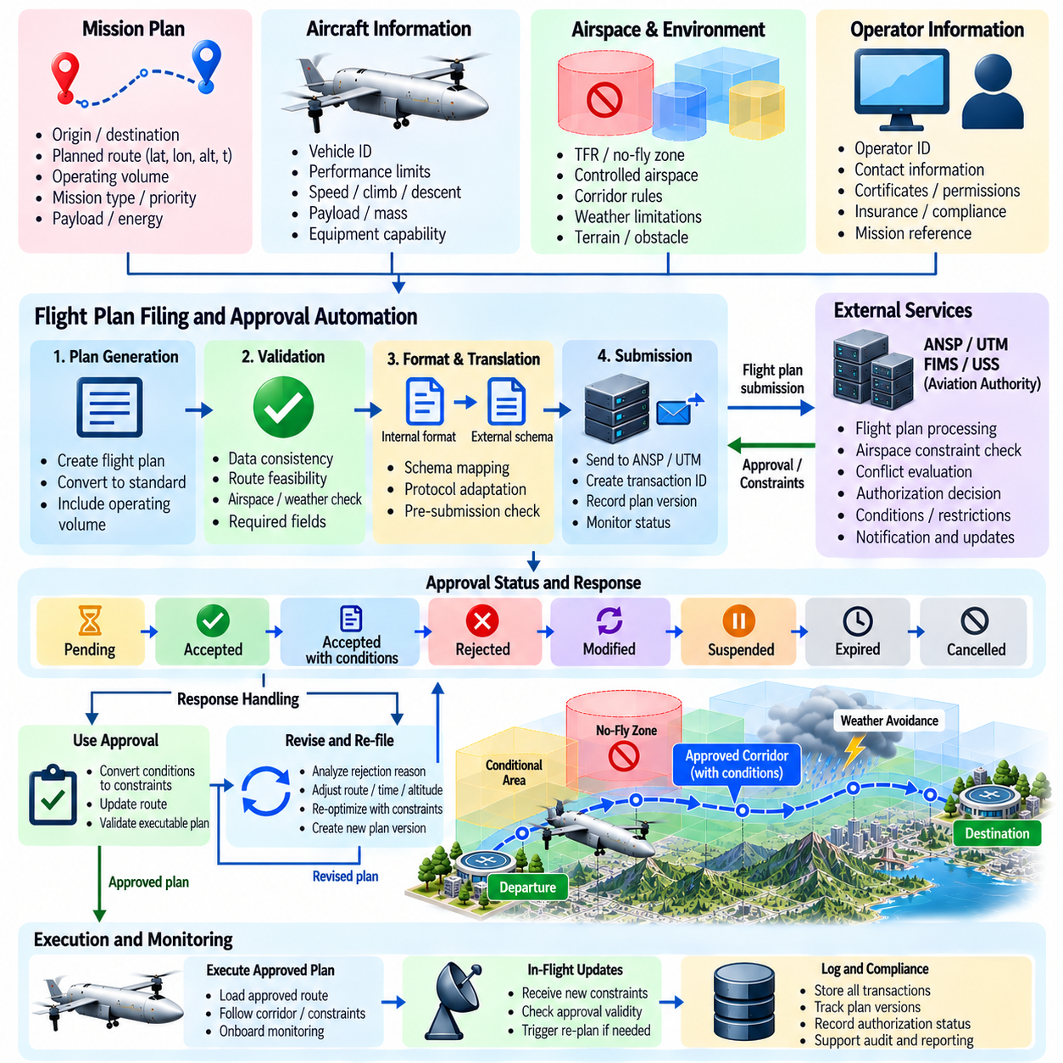
Flight plan filing and approval automation connects autonomous cargo UAV mission planning with the regulatory and traffic-management processes required before flight execution. Instead of relying on an operator to manually translate a generated route into multiple external forms, the software can transform mission intent into structured operational data, validate it, submit it through appropriate interfaces, monitor approval status, and return accepted constraints to the mission-management system.
The automation process begins after route planning has produced a feasible trajectory. The proposed flight plan should contain departure and destination information, geographic route geometry, altitude profile, expected timing, vehicle identification, operating characteristics, and relevant mission references. For autonomous cargo operations, the plan may also include operating volumes or trajectory envelopes that describe where the aircraft is expected to be throughout the mission rather than relying only on conventional waypoint sequences.
Before submission, the filing system should perform internal validation. Geographic coordinates, altitude references, timestamps, units, vehicle identifiers, route continuity, and required data fields must be checked for consistency. The route should also be compared against known airspace restrictions, corridor rules, weather limitations, vehicle performance, and energy requirements. Detecting errors locally prevents avoidable rejection and reduces unnecessary transactions with external approval services.
A flight plan should be generated from authoritative mission data rather than manually duplicated information. The mission manager, route planner, vehicle configuration database, and operator information service can supply standardized fields through defined interfaces. This reduces transcription errors and ensures that the plan submitted externally corresponds to the trajectory actually loaded for execution. A common internal data model also simplifies integration with different approval systems and regional service providers.
The filing interface can translate the internal flight representation into the schema required by an external aviation or UTM service. This translation layer separates mission software from provider-specific protocols and allows the underlying flight-planning logic to remain stable when an external interface changes. Schema validation should occur before transmission so that missing fields, invalid formats, unsupported values, or inconsistent time intervals are detected before the request leaves the operator system.
Submission should create a persistent transaction associated with a unique mission and plan version. The system records when the request was generated, what trajectory was submitted, which external service received it, and what authorization state applies. This is important because route optimization may continue after an initial filing, and the aircraft must not accidentally execute a newer internal route while relying on approval granted for an older trajectory.
Approval should be modeled as a stateful workflow rather than a single Boolean response. A submission may be pending, accepted, accepted with conditions, rejected, expired, modified, suspended, or cancelled depending on the operational environment. The mission-management system should interpret each state according to predefined rules. Departure authorization should require the combination of valid route data, applicable approvals, vehicle readiness, and any additional mission-specific conditions.
Conditional approval requires particular attention because the returned authorization may differ from the originally requested operation. An external service can impose an altitude limit, modified time window, corridor requirement, geographic restriction, or other operating condition. These conditions must be converted into machine-readable constraints and passed back to the route planner. The resulting trajectory should then be revalidated before it is treated as the executable mission plan.
A rejected flight plan should trigger structured analysis rather than simple manual failure handling. If the rejection contains a reason or conflicting constraint, the automation layer can determine whether a feasible modification exists. The route planner may change departure time, altitude, corridor selection, speed profile, or route geometry and generate a revised plan. This creates an iterative planning and approval loop in which machine-readable feedback directly supports automated correction.
Version control is essential when plans are revised. Every submitted trajectory should have a unique version linked to its approval response, applicable constraints, and activation status. When a new plan supersedes an older one, the system should explicitly mark which version is authoritative. The aircraft, ground station, mission manager, and external traffic-management service must share the same operational reference to prevent inconsistent execution.
Time validity must also be managed automatically. Approvals can apply only to specific departure windows or operating intervals, and delays may invalidate an otherwise accepted plan. The system should monitor current mission timing against authorization validity and determine whether a delay remains within tolerance. If the permitted interval is exceeded, the software can request an update, generate a revised filing, or prevent departure until a valid authorization is restored.
Flight plan automation should integrate closely with UTM and USS interfaces because operational intent, airspace constraints, strategic deconfliction, and authorization may be exchanged through related services. The filing component can use the same internal trajectory representation employed for UTM coordination, reducing inconsistencies between the approved plan and externally shared intent. Nevertheless, approval semantics should remain explicit rather than assuming that information exchange itself constitutes authorization.
Strategic conflict information received during approval can feed directly back into route planning. If the requested operating volume conflicts with another scheduled operation, the system can evaluate alternative time slots, altitude layers, or corridors. Early automated negotiation is especially valuable for cargo networks with repetitive flights because small scheduling changes can resolve conflicts before aircraft are dispatched, avoiding costly airborne rerouting or holding.
Corridor-based operations can simplify filing by representing portions of a route through recognized corridor identifiers and associated entry and exit conditions. The plan can specify expected corridor occupancy, altitude layer, direction, and timing. If corridor capacity is unavailable, the automation system can search for another slot or route. This links flight-plan approval with the corridor reservation and deconfliction mechanisms used elsewhere in the route-planning architecture.
Changes after approval require controlled amendment procedures. Weather, traffic, aircraft condition, cargo handling delays, or temporary restrictions may force the planned trajectory to change before departure. The system should determine whether the modification remains inside the scope of the existing authorization or requires a new filing. Significant changes should generate a revised plan and prevent execution until the required approval state has been obtained.
In-flight modifications create a related but more time-sensitive workflow. Dynamic rerouting or contingency actions may cause the aircraft to deviate from the originally coordinated trajectory. When connectivity and operational rules permit, the updated intent can be transmitted to relevant services and associated with the active mission. Immediate safety actions, however, must not be delayed while waiting for an external approval transaction when urgent onboard intervention is required.
Communication failures should be handled through deterministic transaction logic. If a filing request is transmitted but no response is received, the system must not infer approval merely from the absence of rejection. It should distinguish between unsent, transmitted, acknowledged, pending, and confirmed states. Retry behavior should use transaction identifiers and idempotent processing where possible so that communication recovery does not create duplicate or contradictory flight-plan records.
Cybersecurity is fundamental because automated filing can influence whether and where an autonomous aircraft is permitted to operate. Communications should protect authentication, confidentiality where required, and message integrity. Credentials and authorization tokens must be managed securely, while responses should be verified as originating from trusted services. A compromised approval interface could otherwise inject false constraints, create unauthorized missions, or alter legitimate operational plans.
Auditability is equally important. The system should preserve the submitted plan, plan version, validation results, timestamps, external responses, conditions, amendments, cancellations, and final authorization state. These records provide traceability between the route generated by the autonomy software and the operation that was actually approved and flown. They also support postflight investigation, regulatory review, software verification, and fleet-level operational analysis.
Fleet operations benefit substantially from automation because many cargo flights may share recurring origins, destinations, corridors, and vehicle configurations. Templates can provide reusable mission structures while each individual flight receives current timing, weather, traffic, energy, payload, and airspace validation. Automation reduces repetitive operator workload without eliminating supervision, allowing human personnel to focus on exceptions and conditions requiring operational judgment.
The human-machine interface should clearly present approval status without requiring operators to interpret low-level service messages. The operator should be able to identify which plan version is active, whether authorization is valid, what conditions apply, when the approval expires, and whether any action is required. Automation should reduce administrative workload while preserving the operator's ability to understand, review, suspend, or escalate the mission when appropriate.
Testing should include successful submissions, missing fields, invalid route geometry, rejected requests, conditional approvals, delayed responses, duplicate messages, expired authorizations, plan amendments, network interruptions, and inconsistent plan versions. Integration tests should verify that approval conditions propagate correctly into route planning and that an aircraft cannot transition into an authorized departure state when required approval data is absent or stale.
Simulation and software-in-the-loop testing can reproduce external approval services and inject different transaction responses without requiring real operational filings. Hardware-in-the-loop testing can verify timing, communication interfaces, mission-computer state transitions, and persistence across restarts. Field trials can then evaluate end-to-end operation from route generation and filing through authorization, aircraft activation, flight execution, amendment handling, and final mission closure.
Ultimately, flight plan filing and approval automation transforms regulatory coordination from a separate manual administrative process into an integrated part of autonomous mission management. By combining structured plan generation, validation, external submission, state tracking, version control, constraint feedback, amendment handling, security, and traceability, cargo UAV operations can scale while ensuring that the trajectory executed by the aircraft remains synchronized with the operation that has been reviewed and authorized.

06.10. UTM Integration Field Trial Case
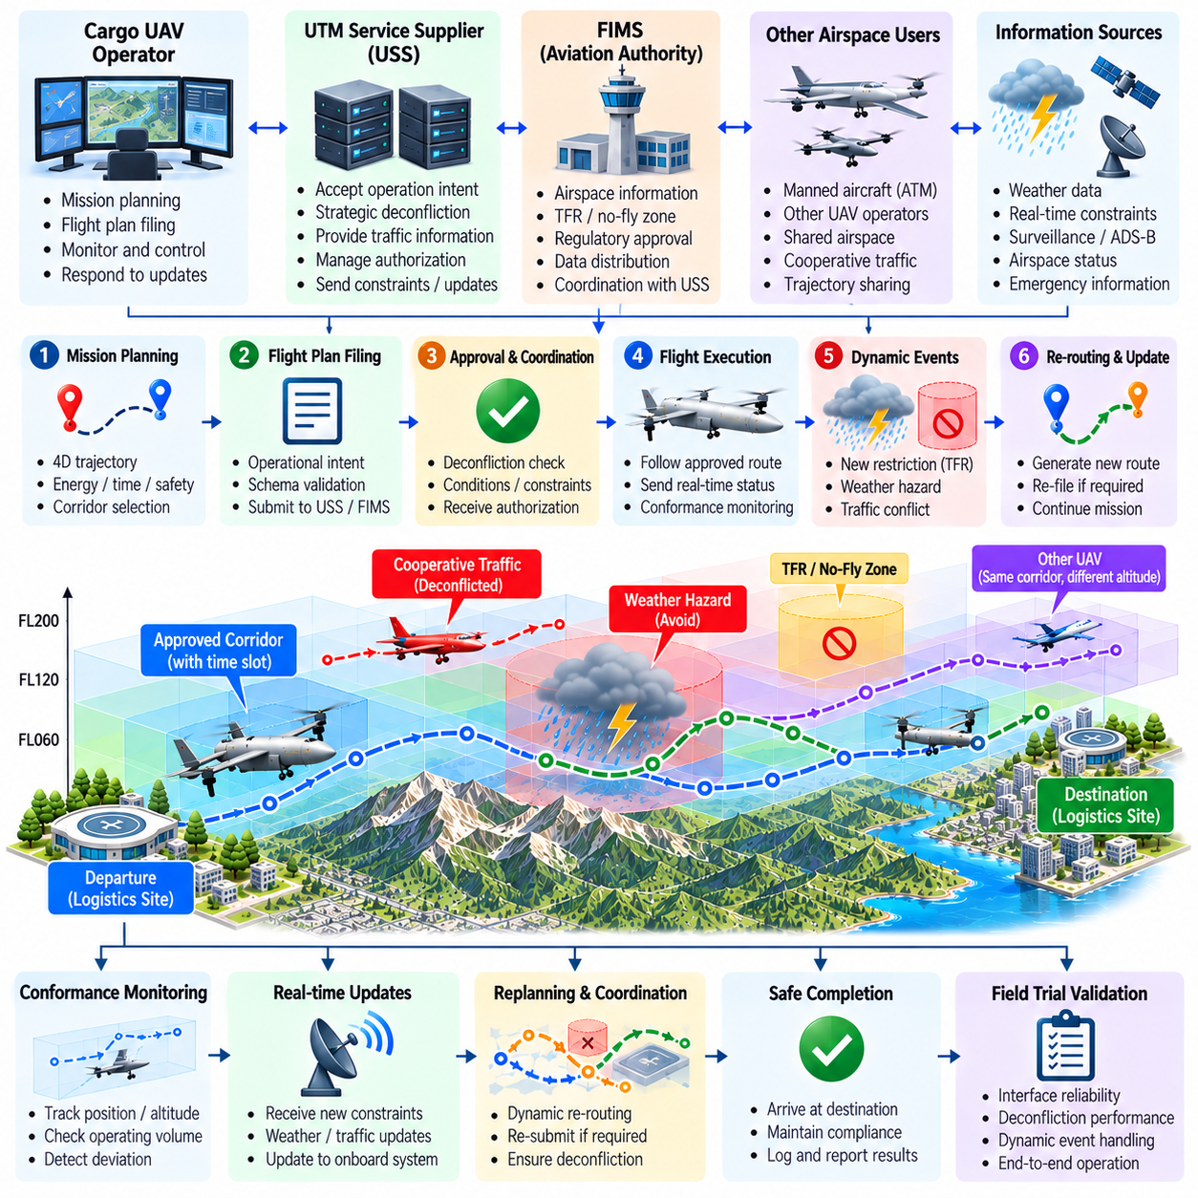
A UTM integration field trial validates whether an autonomous cargo UAV can operate as a coordinated participant in digitally managed airspace rather than as an isolated aircraft. The trial combines route planning, operational intent exchange, airspace constraints, authorization, traffic information, conformance monitoring, dynamic rerouting, and contingency handling in one end-to-end mission. Its purpose is to demonstrate that interfaces proven in simulation remain reliable under real communication, navigation, weather, and operational conditions.
A representative trial begins with a cargo mission between two logistics sites connected through controlled or designated operating areas. Before departure, the mission-management system generates a four-dimensional trajectory containing latitude, longitude, altitude, and time. The route is optimized for energy, flight duration, safety, terrain clearance, weather, and available airspace while respecting the performance limits of the cargo aircraft and the requirements associated with the planned operating corridor.
The planned trajectory is converted into an operational intent suitable for exchange with UTM services. This representation can contain operating volumes, altitude ranges, entry and exit times, route identifiers, and mission references. The UTM integration layer separates the internal autonomy representation from external service protocols so that the mission planner does not depend directly on a particular network interface. Schema validation is performed before any operational data is submitted.
The flight plan is then filed through the appropriate service interface and associated with a unique mission and trajectory version. The system records submission time, authorization state, applicable constraints, and returned conditions. If the requested operation conflicts with an active restriction or another scheduled operation, the mission manager does not immediately proceed. Instead, the route planner evaluates alternatives such as a modified departure time, altitude layer, corridor, or route geometry.
A useful field trial includes another cooperative aircraft or simulated traffic operation whose planned trajectory interacts with the cargo UAV route. Strategic deconfliction should identify the predicted overlap before departure and determine a coordinated solution. The cargo UAV may receive a revised entry time or altitude assignment, after which its operational intent is updated. This demonstrates that UTM integration is connected to actual mission planning rather than functioning only as a passive information display.
Once authorization and vehicle readiness conditions are satisfied, the mission transitions into the active state. The aircraft follows the approved trajectory while transmitting or otherwise making available the operational status required by the trial architecture. Ground infrastructure monitors aircraft position, mission progress, communication health, and conformance with the declared operating volume. The onboard system simultaneously maintains responsibility for navigation, flight-envelope protection, and immediate safety functions.
Conformance monitoring compares the actual aircraft state with the coordinated trajectory and operating volume. Position, altitude, timing, and predicted future motion can be evaluated against defined tolerances. Minor deviations caused by wind or tracking error can be corrected by normal guidance, while larger deviations generate alerts or mission-management actions. The field trial should verify that conformance information remains consistent between onboard, ground, and UTM-facing components.
The trial should introduce a dynamic airspace event after departure to evaluate real-time constraint processing. A temporary restriction can be activated ahead of the aircraft or a previously available corridor segment can be closed. The UTM integration layer receives the update, validates its identifier, geometry, altitude range, effective time, and version, and determines whether the active trajectory is affected. Irrelevant updates should not unnecessarily disturb the mission.
If the new restriction intersects a future trajectory segment, the route planner initiates dynamic rerouting. Candidate alternatives are evaluated for airspace compliance, terrain clearance, energy consumption, arrival delay, weather exposure, and vehicle performance. The selected route must connect smoothly to the current aircraft state without requiring infeasible turns or altitude changes. The resulting trajectory is then propagated to the mission-management and coordination layers.
A weather-related event can provide a second dynamic scenario. Updated weather information may indicate that a portion of the preferred corridor is affected by strong wind, turbulence, precipitation, or another hazard. The planner converts the affected region into an avoidance constraint or elevated route cost. If the weather exceeds allowable operating limits, the affected volume becomes unavailable and the aircraft must select a safe alternative rather than optimizing through the hazardous region.
When rerouting changes the coordinated operational intent, the UTM interface communicates the significant trajectory modification according to the applicable trial workflow. The system must maintain clear version control so that the aircraft, ground station, mission manager, and traffic-management service refer to the same active trajectory. This prevents an old authorization or obsolete operational intent from remaining associated with a newly generated route.
Conflict Detection and Resolution can also be exercised during the field trial. A cooperative aircraft can be scheduled to converge toward the cargo UAV's updated route, allowing the system to predict time to closest approach and minimum separation. If separation criteria are expected to be violated, the CDR function generates feasible alternatives such as speed adjustment, altitude change, or lateral rerouting while continuing to respect airspace and weather constraints.
The trial should demonstrate the separation between strategic coordination and tactical onboard safety. UTM information can support operational intent exchange and strategic deconfliction, but immediate collision avoidance, obstacle avoidance, flight-envelope protection, and emergency control remain onboard responsibilities. Network latency or temporary loss of an external service must therefore not remove the aircraft's ability to maintain safe flight during a rapidly developing local hazard.
Corridor-based navigation can be evaluated by assigning the cargo UAV a defined entry window, altitude layer, and traversal segment. The aircraft should enter the corridor within permitted tolerances and maintain lateral, vertical, and temporal conformance. At merge points or intersections, traffic coordination can adjust speed or timing to preserve separation. This demonstrates that the route is treated as a managed airspace resource rather than merely a geometric line between waypoints.
Communication degradation provides an important field-trial scenario. The test can intentionally interrupt or delay the UTM data connection while preserving safe flight-control communication and supervision. The autonomy system should recognize the loss, maintain a defined degraded state, use valid cached information where permitted, and avoid assuming that stale traffic or constraint data remains indefinitely reliable. Reconnection should restore synchronization without generating contradictory mission states.
A more demanding scenario can activate contingency routing during the same mission. A simulated propulsion limitation, reduced energy margin, blocked corridor, or unavailable destination can force the mission manager to evaluate alternate landing sites. The contingency engine considers remaining vehicle capability, weather, terrain, airspace, traffic, and reachable distance. If the original destination is no longer safely achievable, the system selects an appropriate recovery route and communicates the changed operational status when connectivity permits.
The field trial must capture precise timing across all major events. Relevant timestamps include constraint publication, message reception, hazard recognition, replanning initiation, route generation, operational intent update, acknowledgment, maneuver initiation, and restored conformance. These measurements reveal whether the complete system responds within operationally useful time limits. A logically correct solution can still be unacceptable if communication or computation delays cause the aircraft to act too late.
Data provenance and version tracking are equally important. The trial should record which airspace constraint, weather product, traffic trajectory, flight-plan version, and vehicle state were used for every major routing decision. This creates a traceable chain between external information and autonomous action. When results are analyzed after flight, engineers can determine whether unexpected behavior originated in the data source, communication layer, planner, mission manager, or vehicle execution.
Evaluation metrics should cover both safety and operational performance. Important measures include authorization success, message latency, constraint synchronization accuracy, operational intent consistency, conformance error, minimum traffic separation, rerouting latency, trajectory continuity, energy deviation from plan, arrival delay, communication availability, and contingency recovery success. These metrics allow the field trial to evaluate the integrated system rather than judging individual software components independently.
The test sequence should progress from nominal missions to increasingly difficult disturbances. Initial flights can verify filing, authorization, trajectory exchange, and normal corridor conformance. Later flights can introduce dynamic restrictions, weather changes, cooperative conflicts, delayed messages, communication loss, and contingency events. Progressive complexity makes it easier to isolate defects while building evidence that the integrated architecture remains stable as operational uncertainty increases.
Safety supervision remains essential during field testing even when the objective is high autonomy. Test boundaries, termination criteria, recovery locations, manual intervention capability, communication procedures, and responsibilities should be defined before flight. Injected failures should remain controlled and recoverable. The field trial is intended to validate autonomous behavior without converting software verification into an uncontrolled operational hazard.
Postflight analysis reconstructs the complete mission from synchronized aircraft, ground, planner, and UTM-interface logs. Engineers compare the planned trajectory, approved operational intent, actual flight path, constraint updates, conflict predictions, rerouting decisions, and contingency responses. Any mismatch between internal and externally coordinated states should be investigated because synchronization errors can become significant hazards when the system scales to multiple aircraft and operators.
Successful completion of the trial demonstrates more than basic network connectivity. It shows that route planning, airspace constraint modeling, UTM service integration, dynamic rerouting, conflict resolution, contingency routing, corridor navigation, and automated flight-plan handling operate as a coherent mission-management chain. The aircraft can receive external information, convert it into actionable constraints, modify its future trajectory, and preserve safe local control throughout the process.
Ultimately, a UTM integration field trial provides the transition from component-level verification to operational evidence for networked autonomous cargo flight. By exercising nominal operation, changing constraints, traffic interactions, weather, communication degradation, and off-nominal recovery in an integrated environment, the trial demonstrates whether the cargo UAV can safely participate in scalable managed airspace while maintaining synchronization between onboard autonomy, ground infrastructure, and external traffic-management services.

