Volume 23. Cargo UAV Autonomy and Flight AI

Chapter 09. AI Based Flight Optimization

09.01. AI Flight Optimization Opportunities Energy Route
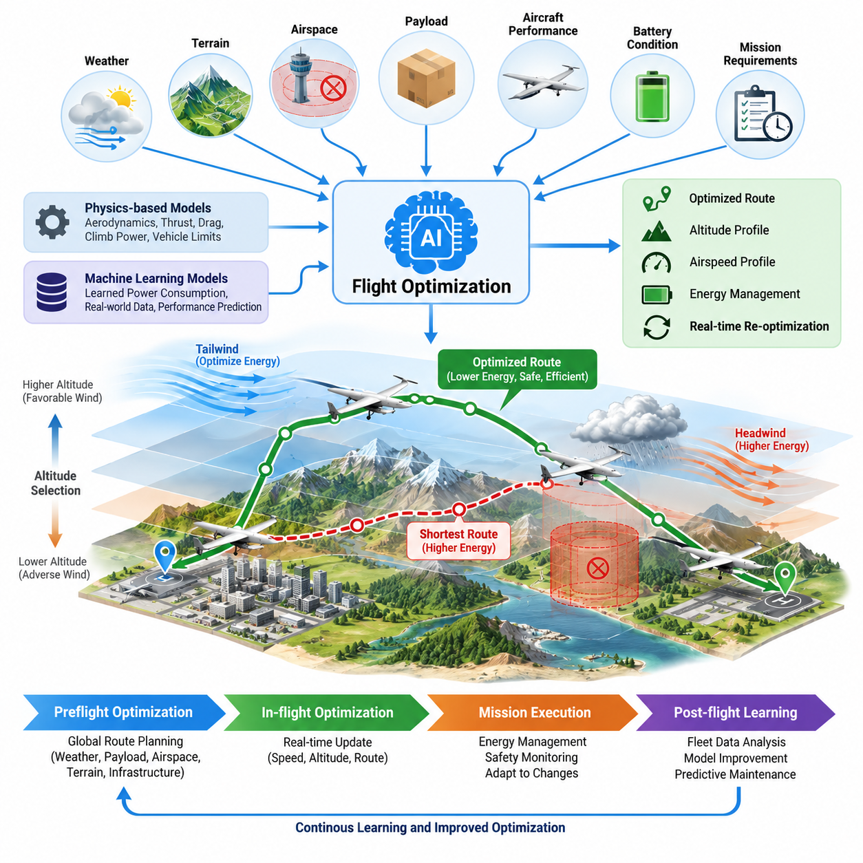
AI-based flight optimization provides a systematic way to improve how unmanned aerial vehicles execute missions under changing aerodynamic, environmental, payload, and operational conditions. Instead of following fixed trajectories or conservative lookup tables, an intelligent optimizer can continuously evaluate energy consumption, flight time, safety margins, and mission objectives to identify more efficient operating decisions.
For cargo UAVs, energy efficiency is particularly important because propulsion power increases significantly with vehicle mass, aerodynamic drag, maneuver intensity, and adverse atmospheric conditions. AI models can learn relationships among payload weight, airspeed, altitude, rotor or propeller efficiency, battery state, and environmental variables. These relationships allow the flight system to estimate the energetic consequence of alternative actions before commands are executed.
Conventional route planning often minimizes geometric distance, but the shortest path is not necessarily the most energy-efficient path. Wind direction, wind speed, terrain, restricted airspace, altitude changes, and required maneuvering can make a longer route consume less energy. AI-assisted optimization therefore treats the route as a dynamic energy-management problem rather than simply a shortest-path calculation between departure and destination.
An energy-aware optimizer can combine vehicle dynamics with learned power-consumption models. Physics-based models describe fundamental relationships such as thrust requirements, drag, climb power, and vehicle limits, while machine-learning models compensate for effects that are difficult to represent accurately. This hybrid approach can improve predictions as operational data accumulates without abandoning physically meaningful constraints required for safe flight.
Wind represents one of the strongest opportunities for intelligent optimization. Forecast data provide an initial atmospheric estimate, while onboard sensors can measure actual wind conditions during flight. AI algorithms can fuse these sources to estimate local wind fields and determine whether changes in heading, altitude, or airspeed could reduce propulsion demand. The resulting trajectory can exploit favorable winds while avoiding regions that impose excessive energy penalties.
Altitude selection is closely coupled with route optimization. Different altitude layers may experience substantially different wind velocity, turbulence, temperature, and air density. An intelligent flight optimizer can evaluate the energy required to climb against the potential benefit obtained after reaching another altitude. The decision therefore considers the complete energy balance instead of assuming that maintaining a constant altitude is always optimal.
Airspeed optimization offers another major source of efficiency. Flying faster can reduce mission duration but generally changes aerodynamic and propulsion losses, while flying too slowly may increase exposure to unfavorable winds or reduce operational productivity. AI can estimate an appropriate speed profile for each flight segment by balancing energy consumption, arrival-time requirements, battery reserves, vehicle limitations, and mission priorities.
Payload variation makes static optimization particularly inadequate for cargo aircraft. A UAV carrying a heavy outbound load can have substantially different optimal speeds, climb profiles, and route choices from the same aircraft returning with little or no cargo. The optimization system should therefore incorporate payload mass, center-of-gravity information, and configuration state when predicting power demand and generating the flight profile.
Battery condition must also influence optimization decisions. Available energy depends not only on nominal state of charge but also on temperature, cell aging, discharge rate, voltage behavior, and previous load history. AI-based battery models can estimate usable energy and remaining flight capability more accurately than a simple percentage indicator, enabling route optimization to preserve realistic reserves throughout the mission.
Mission optimization is naturally a multi-objective problem. Minimum energy consumption may conflict with minimum flight time, delivery deadlines, noise restrictions, passenger or cargo handling requirements, airspace constraints, and safety margins. AI methods can represent these competing objectives through weighted costs or constrained optimization, allowing the system to select a trajectory that reflects operational priorities rather than optimizing a single isolated metric.
The optimization process should operate across several time horizons. Before departure, the system can calculate a global route using weather forecasts, payload information, airspace data, terrain, infrastructure, and expected vehicle performance. During flight, a faster local optimizer can update speed, altitude, and trajectory decisions as measured conditions diverge from the original assumptions or unexpected constraints appear.
Machine learning can enhance this process by extracting performance characteristics from fleet history. Repeated missions reveal how particular aircraft consume energy under specific payloads, temperatures, winds, routes, and battery conditions. Models trained from these observations can progressively improve energy prediction and identify operating regions where theoretical performance models systematically underestimate or overestimate actual consumption.
Reinforcement learning can extend optimization toward sequential decision making, where each flight action affects future energy state and mission feasibility. A policy can learn when to climb, descend, change speed, or modify the route while considering long-term consequences. For production deployment, however, learned policies should operate inside explicit flight envelopes and constraint layers rather than being permitted unrestricted control authority.
Uncertainty must remain visible to the optimizer. Weather forecasts, wind estimates, battery models, payload measurements, and learned energy predictions all contain errors. A robust system should therefore optimize not only expected performance but also confidence margins and worst-case behavior. When uncertainty becomes large, the optimizer can deliberately choose a more conservative trajectory that protects reserve energy and recovery options.
Safety constraints always dominate efficiency objectives. Geofences, minimum separation, obstacle clearance, structural limits, propulsion limits, battery reserve thresholds, communication requirements, and emergency landing accessibility define boundaries that optimization cannot violate. AI is consequently most valuable as a decision mechanism operating within a certified or independently monitored safety envelope rather than as an unconstrained efficiency engine.
Route optimization can also incorporate contingency accessibility. Two routes with similar predicted energy consumption may have very different emergency characteristics if one provides frequent diversion or landing opportunities while the other crosses areas with few recovery options. Assigning costs to contingency exposure enables the planner to select routes that combine energy efficiency with practical operational resilience.
For large cargo UAVs, optimization becomes increasingly valuable because small percentage improvements can translate into substantial absolute energy savings. Efficient speed scheduling, reduced unnecessary climb, favorable wind utilization, and smoother trajectory generation can collectively increase effective range or payload capability. Optimization can therefore contribute directly to aircraft economics without requiring immediate changes to batteries or propulsion hardware.
Fleet-level intelligence creates another optimization layer. When several cargo UAVs share routes, charging stations, vertiports, or controlled airspace, independently optimal trajectories may create congestion or inefficient resource use. A supervisory AI system can coordinate departure times, routes, charging schedules, and energy reserves so that optimization occurs at both individual-aircraft and fleet levels.
Digital twins and simulation environments provide an important development mechanism for these capabilities. Thousands of combinations of payload, wind, temperature, battery condition, route geometry, component degradation, and abnormal events can be evaluated before algorithms are deployed. Simulation results can expose unsafe optimization behavior and provide training data for conditions that would be expensive or hazardous to reproduce repeatedly in physical flight tests.
Operational validation should compare optimized flights against well-defined baselines using metrics such as energy per kilometer, energy per payload-distance, mission completion time, reserve energy at landing, route deviation, and constraint violations. Improvements must remain statistically meaningful across representative conditions. A solution that performs exceptionally under nominal weather but becomes unstable under uncertainty is unsuitable for operational deployment.
The mature architecture therefore combines prediction, optimization, adaptation, and safety supervision. AI estimates future energy demand and environmental conditions, optimization algorithms evaluate feasible trajectories, onboard systems adapt decisions using current measurements, and independent safety logic verifies every command against operational constraints. This layered structure allows intelligence to improve efficiency without replacing deterministic protections.
Ultimately, AI-based flight optimization transforms energy and route management from static mission preparation into continuous predictive decision making. The aircraft can reason about how current actions affect future energy availability, route feasibility, arrival performance, and contingency capability. For cargo UAV operations, this capability provides a foundation for longer range, higher utilization, improved energy economics, and safer autonomous missions under variable real-world conditions.

09.02. RL Based Energy Optimal Trajectory Planning [w/Code]
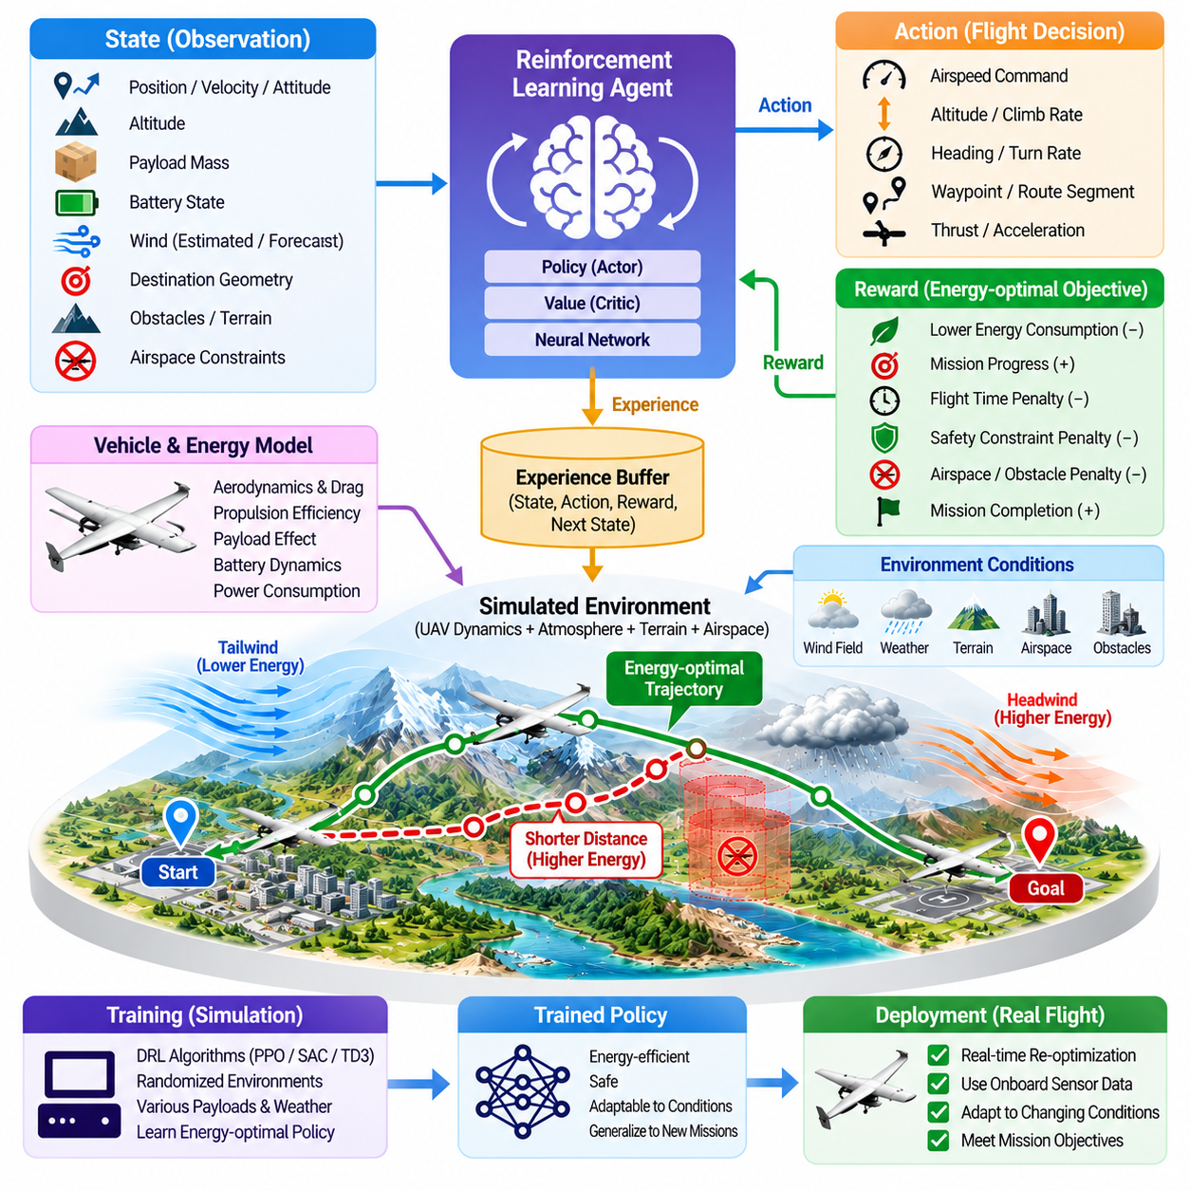
Reinforcement learning provides a framework for energy-optimal trajectory planning in which a UAV learns how sequences of flight decisions influence total mission energy rather than optimizing each maneuver independently. The aircraft interacts with a simulated or modeled environment, observes its current state, selects actions, and receives rewards that represent energy efficiency, mission progress, safety, and constraint satisfaction.
The state representation determines what information the reinforcement learning policy can use when making trajectory decisions. For a cargo UAV, useful states include position, velocity, attitude, altitude, payload mass, battery state, propulsion demand, estimated wind, destination geometry, obstacle locations, and airspace constraints. Historical or predicted environmental information may also be included when future conditions significantly affect energy consumption.
Actions can be defined at different levels of control abstraction. A high-level policy may select waypoints, altitude bands, desired airspeed, or route segments, while a lower-level policy can generate acceleration, climb-rate, heading, or thrust references. Separating strategic trajectory optimization from safety-critical flight stabilization allows reinforcement learning to improve mission efficiency without unnecessarily replacing mature deterministic flight-control functions.
The reward function translates energy-optimal flight objectives into a numerical learning signal. Energy consumption can receive a continuous penalty, while progress toward the destination provides a positive reward. Additional penalties can represent excessive flight time, aggressive maneuvering, battery depletion, restricted-airspace entry, obstacle proximity, or violation of vehicle limits. Mission completion and safe landing can provide strong terminal rewards.
Reward design must avoid unintended behavior. A policy rewarded only for low instantaneous power might learn to fly excessively slowly, accept unacceptable delays, or exploit unrealistic properties of the simulator. Conversely, a policy dominated by mission-time rewards may choose high-power trajectories that reduce useful range. Effective reward engineering therefore balances energy, time, progress, safety margins, and operational requirements while preventing undesirable shortcuts.
Energy optimization requires an environment model capable of representing realistic propulsion demand. Rotor or propeller efficiency, aerodynamic drag, vehicle mass, payload, airspeed, climb rate, acceleration, temperature, and battery characteristics can all affect the energy cost of a trajectory. High-fidelity models improve learning realism, although computationally efficient approximations are often required when millions of simulation steps are needed during policy training.
Wind must be incorporated as a dynamic part of the reinforcement learning environment rather than treated as a constant disturbance. Training scenarios can include headwinds, tailwinds, crosswinds, vertical flows, turbulence, and spatially varying wind fields. Through repeated exposure, a policy can learn when to modify heading, altitude, and speed to exploit favorable conditions or avoid regions where environmental disturbances create excessive propulsion demand.
Altitude decisions illustrate the sequential nature of the problem. Climbing to a favorable wind layer requires an immediate energy investment but may reduce propulsion power over the remaining route. A conventional greedy optimizer can reject the climb because of its short-term cost, whereas reinforcement learning can learn the delayed benefit through cumulative return. This ability is valuable when locally inefficient actions produce globally efficient missions.
Payload-dependent dynamics should be randomized during training because cargo UAV behavior can change substantially as payload mass varies. A policy trained only at one nominal weight may produce poor trajectories near maximum payload or during an empty return flight. Training across representative mass distributions encourages the policy to learn energy-management strategies that adapt speed, altitude, and maneuver intensity according to the current vehicle configuration.
Battery dynamics introduce another long-term dependency. High-power maneuvers can increase voltage drop, thermal stress, and effective energy loss even when their duration is short. A reinforcement learning environment can include state-of-charge, temperature, internal resistance, and power limits so that the policy learns to preserve usable energy. This makes trajectory optimization more realistic than simply minimizing geometric distance or accumulated mechanical work.
Several reinforcement learning methods can support trajectory optimization. Value-based methods are useful when actions are discrete, while actor-critic and policy-gradient methods are better suited to continuous flight commands. Algorithms such as PPO, SAC, or TD3 can learn continuous control policies, although algorithm selection should depend on stability, sample efficiency, computational resources, action representation, and the required level of operational assurance.
Model-based reinforcement learning can improve sample efficiency by learning or using a predictive model of vehicle and environmental behavior. The policy can evaluate potential future trajectories before committing to an action, combining aspects of optimal control with learned decision making. For cargo UAVs, this approach is attractive when physical flight data are expensive and a sufficiently accurate dynamics model or digital twin is available.
Offline reinforcement learning offers another useful development path because large volumes of flight logs may already exist before autonomous optimization is introduced. Instead of exploring directly on an aircraft, the learning system can derive policies from historical trajectories containing energy usage, weather, payload, and control information. Care is required because the learned policy should not make decisions far outside the distribution represented in the recorded dataset.
Simulation is therefore central to safe training. A digital environment can expose the policy to thousands of routes and millions of state transitions without risking an aircraft. Normal missions can be mixed with strong winds, navigation uncertainty, degraded propulsion, communication loss, battery anomalies, and unexpected obstacles. Rare but important conditions can be deliberately oversampled so that the policy encounters them sufficiently during development.
Domain randomization helps prevent excessive dependence on a specific simulator configuration. Vehicle mass, aerodynamic coefficients, motor efficiency, sensor noise, wind, temperature, latency, and battery parameters can be varied across training episodes. A policy that succeeds across these variations is more likely to tolerate differences between simulation and physical aircraft, reducing the simulation-to-reality gap during deployment.
Curriculum learning can further stabilize training by increasing mission difficulty progressively. Early episodes may use short routes, mild winds, generous energy reserves, and few constraints. Later stages can introduce heavier payloads, complex terrain, uncertain weather, restricted airspace, tighter reserves, and multiple objectives. This progression allows the policy to learn basic energy-efficient behavior before confronting highly constrained operational scenarios.
Safety should not depend exclusively on the learned reward function. Hard constraints can be implemented through safety filters, control barrier functions, reachability checks, geofencing, or constrained optimization layers that inspect proposed actions before execution. If the reinforcement learning policy requests an unsafe trajectory modification, an independent mechanism can reject or modify the command while preserving stable aircraft behavior.
A hierarchical architecture is particularly suitable for production cargo UAVs. The reinforcement learning policy can optimize route segments, altitude, and speed at a relatively slow update rate, while conventional guidance and flight-control systems execute the requested trajectory at higher frequencies. This division reduces certification complexity and isolates learned optimization from attitude stabilization, actuator control, and other safety-critical functions.
Real-time inference must satisfy strict computational and timing requirements. The onboard policy should generate decisions within a predictable latency while sharing processors with perception, navigation, communication, and flight-control workloads. Model compression, quantization, reduced observation dimensions, and hardware acceleration can reduce inference cost. Timing overruns should trigger deterministic fallback behavior rather than delayed or stale trajectory commands.
The policy should also express or support awareness of uncertainty. Wind estimates, battery predictions, localization, and future traffic conditions may become unreliable during flight. An uncertainty-aware architecture can reduce the authority of the learned optimizer when confidence deteriorates. Conservative speed profiles, larger energy reserves, predefined diversion routes, or conventional optimization methods can then replace aggressive energy-saving decisions.
Evaluation should measure more than cumulative reinforcement learning reward. Important operational metrics include total electrical energy consumed, energy per payload-distance, flight time, minimum battery reserve, peak power, trajectory smoothness, route length, constraint violations, and successful mission completion. Performance should be compared against shortest-path planners, conventional optimal-control methods, and manually tuned energy-efficient baselines.
Robustness testing must examine conditions outside the nominal training distribution. Policies should be evaluated under stronger-than-expected winds, inaccurate payload estimates, degraded batteries, sensor bias, unexpected airspace changes, and propulsion efficiency losses. A small average energy improvement is not valuable if the policy occasionally produces trajectories that exhaust reserve energy or approach unsafe operating boundaries.
Flight testing should proceed incrementally from simulation to software-in-the-loop, hardware-in-the-loop, controlled physical tests, and finally representative operational missions. Early flights can limit the reinforcement learning policy to advisory recommendations or narrow trajectory adjustments. Authority can increase only after recorded evidence demonstrates predictable behavior, energy benefits, constraint compliance, and reliable interaction with existing flight systems.
Continuous operational data can later support policy improvement, but production learning should be carefully governed. Flight logs can be transferred to an offline training environment where new policies are trained, tested, compared, and version controlled. Updates should pass regression tests and safety validation before deployment. Allowing unrestricted online learning during safety-critical cargo operations would make behavior difficult to reproduce and verify.
At fleet scale, reinforcement learning can learn patterns that are difficult to capture from a single aircraft. Experience collected across different routes, payloads, weather conditions, battery ages, and vehicle configurations can improve generalized energy models and trajectory policies. Fleet learning can therefore transform individual mission experience into reusable operational intelligence while still allowing aircraft-specific adaptation where performance differences are significant.
RL-based energy-optimal trajectory planning ultimately combines long-horizon decision making with adaptive knowledge of aircraft performance and environmental conditions. Its primary advantage is not merely finding a shorter path, but learning how present choices influence future energy, safety margins, and mission feasibility. When bounded by deterministic safety mechanisms and validated systematically, it can become a powerful optimization layer for autonomous cargo UAV operations.

09.03. Wind Prediction ML Model for Route Opt [w/Code]
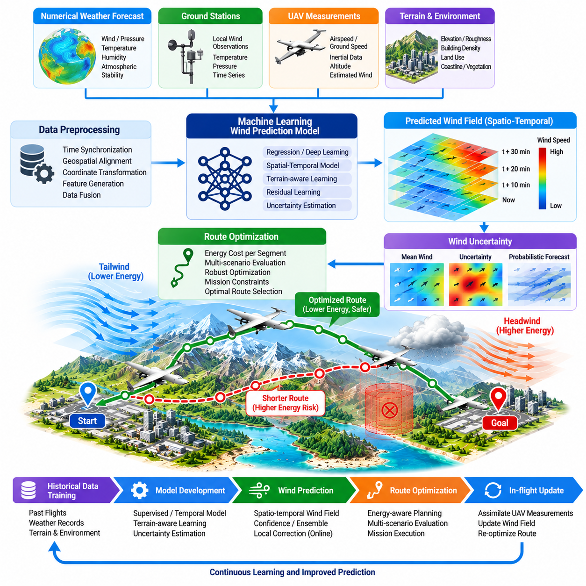
Wind prediction is a critical component of AI-based route optimization because atmospheric motion directly affects ground speed, propulsion power, flight time, and energy reserve. For cargo UAVs, even moderate prediction errors can accumulate into substantial energy deviations over long missions. A machine-learning wind model can provide localized forecasts that complement conventional numerical weather information and onboard measurements.
Traditional weather forecasts are often produced at spatial and temporal resolutions that are insufficient for low-altitude autonomous flight. Buildings, terrain, vegetation, coastlines, and thermal effects can create local wind patterns that differ considerably from regional forecasts. Machine learning can learn these localized relationships from historical weather data, terrain characteristics, sensor observations, and previous UAV flights to generate route-relevant wind estimates.
The input representation of a wind prediction model can combine multiple information sources. Numerical weather prediction data may provide regional wind vectors, pressure, temperature, humidity, and atmospheric stability, while ground stations contribute local observations. UAV measurements can add airspeed, ground velocity, inertial data, altitude, and estimated wind. Terrain elevation and land-use information can further explain spatial variations near the operating area.
Accurate time synchronization and geospatial alignment are essential when combining these heterogeneous data sources. Weather observations collected at different times or positions cannot simply be treated as simultaneous measurements. The preprocessing pipeline should transform data into consistent coordinate frames, timestamps, altitude references, and spatial grids. Poor alignment can cause the learning algorithm to model synchronization errors rather than genuine atmospheric behavior.
Supervised learning can be used when historical observations provide target wind vectors for training. Regression models can estimate wind speed and direction at future locations and times from meteorological and geographic features. Tree-based models may provide efficient baselines, while neural networks can capture nonlinear interactions among atmospheric variables. Model complexity should be selected according to prediction accuracy, available data, and onboard computational constraints.
Temporal models are particularly useful because wind evolves continuously rather than as independent observations. Recurrent neural networks, gated architectures, temporal convolutional networks, or transformer-based models can learn patterns across sequences of measurements. These models may predict how local wind conditions will change during the next several minutes, providing information that can be directly incorporated into receding-horizon route optimization.
Spatial relationships are equally important. Wind measured at one location can provide information about nearby regions, especially when combined with terrain geometry and prevailing atmospheric flow. Grid-based neural models can estimate wind fields over a geographic area, while graph-based representations can model relationships among irregularly distributed weather stations, UAV observations, terrain points, and route waypoints without requiring a uniform spatial grid.
For low-altitude cargo UAV operations, terrain-aware prediction can significantly improve route planning. Hills, valleys, urban structures, and large industrial facilities can accelerate, redirect, or disturb airflow. A machine-learning model can include terrain elevation, surface roughness, building density, or computational fluid dynamics information as contextual features. This allows the predicted wind field to reflect local effects that coarse regional forecasts may not resolve.
UAVs themselves can act as mobile atmospheric sensors. Differences between measured airspeed and ground velocity, combined with attitude and inertial estimates, can provide observations of the local wind vector. As aircraft move through the operational area, these measurements can update the wind model. A fleet of cargo UAVs can therefore create a distributed sensing network that progressively improves short-term knowledge of the environment.
Online data assimilation can combine prior forecasts with recent measurements. Instead of replacing the original weather prediction completely, the system can estimate corrections to the regional forecast based on local observations. This residual-learning approach is often practical because large-scale atmospheric behavior remains available from established forecasting systems while machine learning focuses on local biases and unresolved variations relevant to UAV flight.
The prediction output should include more than a single deterministic wind vector. Route optimization benefits from estimates of uncertainty because the consequences of prediction errors can be significant. The model can produce confidence intervals, probability distributions, ensembles, or variance estimates for wind speed and direction. Areas with highly uncertain winds can then receive additional risk cost during trajectory planning.
Wind uncertainty should propagate into energy prediction. A route that appears highly efficient under the mean forecast may become unfavorable if a small wind error produces a strong headwind along a critical segment. Robust optimization can evaluate multiple wind scenarios and select a route with acceptable energy performance across them. This approach may deliberately sacrifice a small amount of expected efficiency to improve mission reliability.
The route planner can convert predicted wind fields into segment-specific energy costs. For each candidate trajectory, the system estimates the airspeed required to achieve the desired ground velocity and calculates the associated propulsion demand. Headwinds, crosswinds, altitude transitions, and maneuvering requirements are therefore translated into energy consequences. Route search then minimizes expected mission cost rather than geometric distance alone.
Altitude optimization becomes particularly valuable when the wind model provides three-dimensional predictions. Different altitude layers may contain substantially different wind vectors, and a cargo UAV can sometimes reduce total energy by climbing into a favorable layer. The planner must compare the immediate energy required for the altitude transition with the cumulative propulsion savings expected during the remaining route.
Prediction horizon should correspond to mission and planning requirements. Very short-term forecasts may support local trajectory adjustments, while longer forecasts are required for preflight route selection and diversion planning. Accuracy generally decreases as the prediction horizon increases, so the route optimizer should treat distant forecasts with greater uncertainty and update decisions as newer measurements become available during flight.
Model training requires representative datasets covering seasonal, geographic, and operational variability. Data should include calm conditions, strong winds, changing fronts, thermal effects, turbulence, and different times of day whenever relevant to the intended operating region. A model trained primarily on benign conditions may perform poorly during precisely the adverse weather situations in which accurate energy prediction is most important.
Data quality management is therefore fundamental. Faulty anemometers, inaccurate aircraft state estimates, GPS errors, sensor latency, and communication problems can contaminate training labels. Automated quality checks can detect unrealistic wind magnitudes, abrupt discontinuities, inconsistent timestamps, and sensor disagreement. Maintaining provenance for each observation also allows questionable data sources to be excluded or assigned lower confidence during training.
Simulation can supplement limited real-world datasets. Numerical weather models, computational fluid dynamics, and synthetic terrain scenarios can generate diverse wind fields for initial training and stress testing. Domain randomization can vary wind intensity, direction, turbulence, terrain effects, and sensor noise. Real flight measurements are still necessary for calibration because simulated atmospheric behavior cannot perfectly reproduce operational conditions.
Model evaluation should consider errors that matter directly to flight optimization. Mean absolute error in wind speed is useful but insufficient by itself. Direction error, vector error, altitude-dependent accuracy, forecast-horizon degradation, and extreme-condition performance should also be measured. More importantly, the predicted wind should be evaluated according to its effect on route choice, estimated energy consumption, and battery reserve at arrival.
A model with slightly lower statistical wind accuracy can sometimes produce better mission decisions if its errors occur in less operationally important regions. End-to-end evaluation should therefore compare routes generated using predicted winds against routes based on actual measured conditions. Metrics can include excess energy consumption, additional flight time, unnecessary altitude changes, route instability, and frequency of reserve-energy violations.
Real-time deployment requires predictable computational performance. Wind models may run onboard the UAV, at an edge station, or through a distributed architecture depending on connectivity and mission requirements. Onboard inference provides low latency and independence from communication links, while edge or ground computation can support larger models. Critical route adaptation should remain possible if external connectivity is temporarily unavailable.
The system should define fallback behavior when wind predictions become unreliable. Missing observations, model confidence degradation, unexpected turbulence, or disagreement between predicted and measured winds can trigger conservative planning. The UAV may increase energy reserves, reduce route aggressiveness, use direct onboard wind estimation, or revert to conventional weather data until prediction quality returns to an acceptable level.
Continuous fleet operation creates an opportunity for systematic model improvement. Wind observations and mission outcomes can be uploaded after flight, validated, and incorporated into an offline training pipeline. Updated models can then be tested against historical missions and challenging scenarios before controlled deployment. Versioning ensures that prediction changes can be traced to specific datasets, algorithms, and validation results.
At fleet scale, shared wind intelligence can become a significant operational advantage. An aircraft encountering an unexpected headwind, shear layer, or favorable altitude band can provide information to vehicles that will enter the same region later. This converts individual aircraft observations into collective environmental knowledge and allows route optimization to respond faster than systems relying only on periodically updated regional forecasts.
A mature wind-prediction architecture therefore connects meteorological forecasting, onboard sensing, machine learning, uncertainty estimation, and energy-aware route planning. The objective is not simply to predict atmospheric conditions with minimum statistical error, but to produce actionable information that improves flight decisions. Prediction quality must ultimately be judged by safer routes, lower energy consumption, and more reliable mission completion.
Machine-learning wind prediction can consequently transform wind from an external disturbance into a partially predictable resource for autonomous flight optimization. By anticipating spatial and temporal variations, a cargo UAV can choose routes, altitudes, and speeds that exploit favorable conditions while maintaining reserves against uncertainty. Integrated with continuous measurement and robust planning, this capability can materially increase range, efficiency, and operational resilience.

09.04. AI Based Predictive Maintenance for UAV [w/Code]
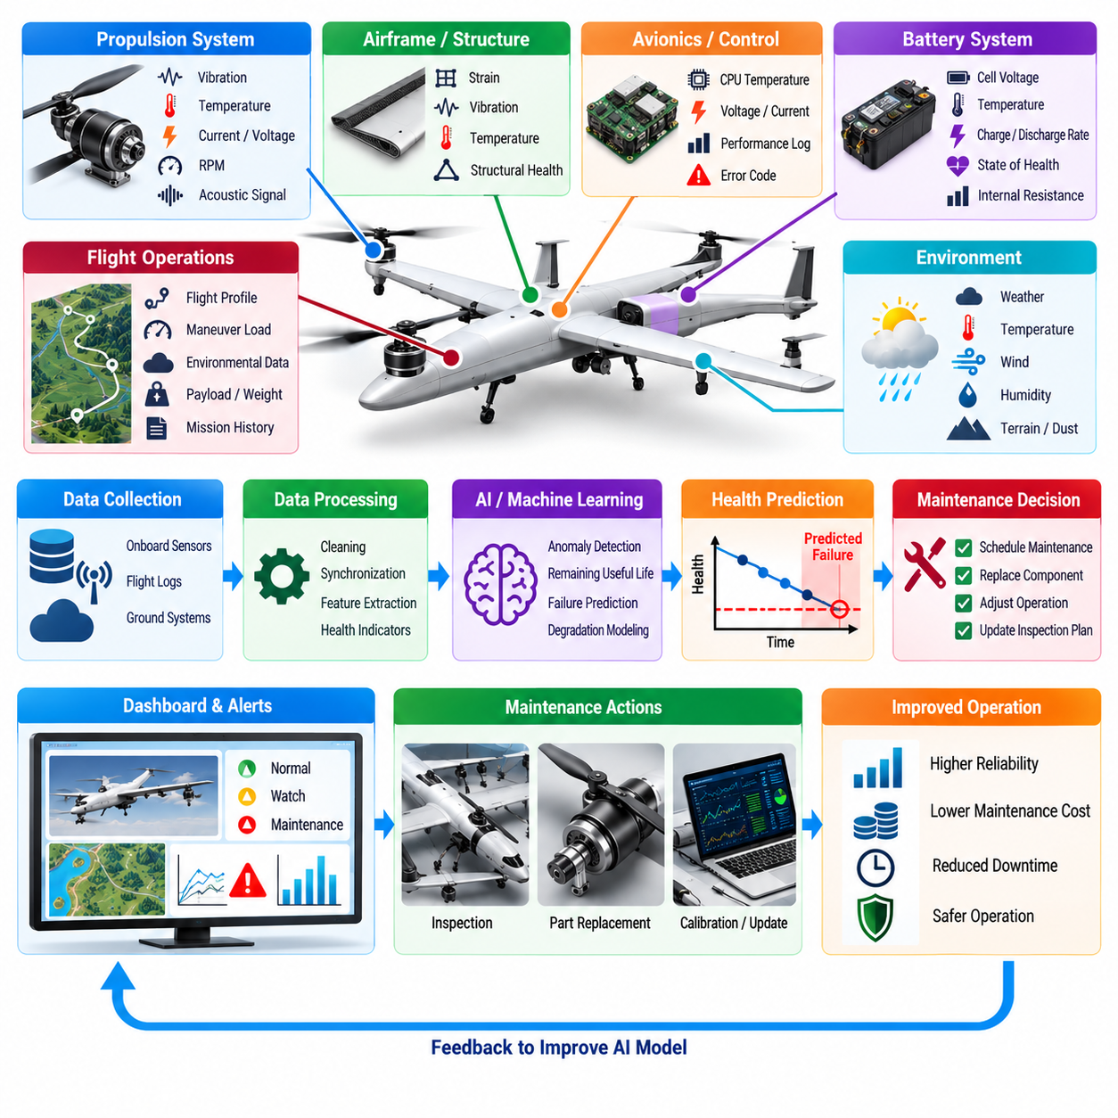
AI-based predictive maintenance enables a UAV operator to move from fixed inspection intervals and reactive repairs toward maintenance based on the measured and predicted condition of aircraft components. By analyzing flight telemetry, sensor signals, maintenance records, environmental exposure, and operating history, machine-learning models can identify degradation patterns before they develop into mission failures or safety-critical faults.
Cargo UAVs are strong candidates for predictive maintenance because propulsion, batteries, actuators, structures, landing systems, and avionics experience highly variable loads. Aircraft carrying maximum payload in strong winds may accumulate degradation differently from aircraft performing light-duty missions. An intelligent maintenance system can therefore estimate component health from actual operational stress rather than treating every flight hour as equivalent.
The predictive-maintenance architecture begins with reliable condition-monitoring data. Motor current, voltage, rotational speed, winding temperature, vibration, bearing signatures, electronic speed controller telemetry, battery parameters, actuator position, structural strain, and environmental measurements can provide evidence of component condition. Flight-control and navigation logs add contextual information explaining the operating conditions under which these signals were generated.
Raw sensor values rarely indicate degradation directly. Preprocessing can remove invalid samples, synchronize measurements, compensate for sensor bias, normalize operating conditions, and divide long flight logs into meaningful phases such as takeoff, climb, cruise, descent, and landing. Comparing components under similar operating regimes prevents normal changes caused by payload or flight mode from being incorrectly interpreted as mechanical deterioration.
Feature engineering can extract health indicators from time-series signals. Vibration spectra may reveal bearing wear or rotor imbalance, while current harmonics can indicate motor or electronic abnormalities. Temperature rise relative to load can expose increasing friction or cooling degradation. Statistical trends, frequency-domain features, transient responses, and relationships among multiple sensors can provide stronger evidence than any single measurement.
Supervised machine learning is useful when historical maintenance records contain labeled examples of known faults. Classification models can distinguish normal operation from specific fault categories, while regression models can estimate degradation severity or remaining useful life. The quality of these models depends heavily on accurate maintenance labels because incorrect fault attribution can teach the algorithm misleading relationships between telemetry and component condition.
In many UAV fleets, actual failures are rare, making labeled fault datasets limited and imbalanced. Anomaly detection can address this problem by learning the characteristics of normal aircraft behavior and identifying deviations without requiring examples of every possible failure. Autoencoders, one-class models, clustering techniques, and probabilistic approaches can detect unusual combinations of vibration, temperature, current, or actuator behavior that deserve further inspection.
Remaining useful life estimation extends fault detection into maintenance planning. Instead of merely reporting that a component is abnormal, the system estimates how much safe operational life may remain before inspection, replacement, or overhaul becomes necessary. Sequence models and degradation models can use historical trends to predict future health trajectories, although uncertainty should accompany every estimate because future mission loads cannot be known perfectly.
Battery predictive maintenance is particularly important for electric cargo UAVs. Capacity fade, internal resistance growth, cell imbalance, abnormal heating, and voltage sag can gradually reduce usable energy and peak-power capability. Machine-learning models can combine charge-discharge history, temperature exposure, mission power profiles, cell voltage behavior, and age to estimate state of health and detect batteries whose degradation differs from the expected fleet pattern.
Propulsion systems provide another high-value application. Motors, bearings, propellers, gearboxes where applicable, and electronic speed controllers can generate characteristic signatures as wear develops. Changes in vibration, acoustic response, current consumption, temperature, or commanded-versus-achieved rotational speed may reveal emerging faults. Multisensor fusion can improve detection when individual indicators are weak or affected by changing flight conditions.
Actuator and flight-control surface health can be monitored through command-response relationships. Increasing position error, slower response, abnormal current demand, hysteresis, or repeated control corrections may indicate mechanical friction, linkage problems, servo degradation, or aerodynamic damage. AI models can compare expected and measured actuator behavior while accounting for airspeed and load, enabling early detection without requiring dedicated inspection flights.
Structural health monitoring can use strain, vibration, inertial response, and accumulated load history to estimate fatigue exposure. Heavy cargo operations may produce repeated stress cycles during takeoff, turbulence, maneuvering, and landing. Rather than relying solely on calendar time or total flight hours, a digital fatigue model can estimate damage accumulation from the actual load spectrum experienced by each individual airframe.
Landing gear and ground-contact systems can also benefit from condition-based analysis. Hard landings, uneven terrain, repeated high-load operations, or abnormal touchdown dynamics can accelerate wear. Inertial sensors, load sensors, and flight logs can quantify landing severity and identify aircraft requiring inspection. This allows maintenance resources to focus on vehicles that experienced significant stress rather than inspecting the entire fleet identically.
Environmental exposure should be included because component degradation depends on more than mechanical loading. High temperature, humidity, dust, rain, salt exposure, and repeated thermal cycling can influence electronics, connectors, batteries, motors, and structural materials. Combining environmental history with component telemetry allows predictive models to distinguish aircraft operating under benign conditions from those accumulating accelerated degradation.
Digital twins can provide a physics-informed foundation for predictive maintenance. A digital representation of the UAV can maintain component-specific health states and update them after each mission using measured loads and sensor data. Machine learning can estimate residual behavior that physical models cannot represent accurately, creating a hybrid approach that combines engineering knowledge with patterns learned from operational experience.
Fleet-level learning is valuable because individual aircraft may not accumulate enough failures to train reliable models. Data from many vehicles can reveal common degradation signatures and relationships between mission profiles and maintenance outcomes. At the same time, aircraft-specific baselines should be preserved because manufacturing tolerances, repair history, component age, and operating environment can cause normal behavior to differ among nominally identical vehicles.
Maintenance models should distinguish gradual degradation from sudden faults. Slowly increasing vibration or resistance may support trend-based remaining-life prediction, whereas abrupt sensor changes can indicate immediate damage requiring rapid response. The monitoring architecture therefore needs both long-term health analytics and real-time fault detection, with different thresholds and escalation procedures for each type of abnormal behavior.
Uncertainty management is essential because predictive maintenance decisions have operational and safety consequences. A remaining-life prediction should not be treated as an exact countdown. Models should provide confidence bounds or risk estimates that reflect sensor quality, data coverage, model uncertainty, and expected future loading. Maintenance thresholds can then incorporate conservative margins when confidence is low or component criticality is high.
False alarms must also be controlled. Excessive maintenance alerts can reduce fleet availability, increase labor costs, and cause operators to lose confidence in the monitoring system. Conversely, missed detections can allow degradation to progress toward failure. Thresholds should therefore be selected using the operational cost of false positives and false negatives, with stricter detection criteria applied to components whose failure could directly threaten flight safety.
Predictive maintenance should integrate with mission planning rather than operate as an isolated maintenance database. If a propulsion unit shows moderate degradation, the fleet manager may assign the aircraft to shorter or lighter missions until maintenance is performed. Battery health estimates can influence required energy reserves, while actuator or structural health information can restrict allowable payload, speed, or maneuver intensity.
A health-aware mission planner can therefore treat component condition as an operational constraint. Two aircraft with identical nominal specifications may receive different missions because their remaining useful life, battery capability, or accumulated fatigue differs. This approach can improve fleet utilization by avoiding unnecessary grounding while preventing degraded aircraft from being assigned missions that impose excessive stress or insufficient safety margins.
Edge inference can support immediate health monitoring during flight. Lightweight models running onboard can detect abnormal vibration, temperature, current, or control response and communicate health events to the flight-management system. More computationally intensive analysis can occur after landing on ground or cloud infrastructure. This layered architecture combines rapid safety response with deeper fleet-level diagnostic analysis.
Data integrity and traceability are critical for trustworthy maintenance decisions. Sensor calibration history, firmware versions, component serial numbers, installation dates, repairs, replacements, and mission records should remain associated with health data. When a component is replaced, the maintenance system must distinguish the new component history from the previous one so that accumulated degradation estimates are not incorrectly transferred.
Validation requires historical replay, seeded-fault testing, simulation, bench testing, and controlled flight evaluation. Models should demonstrate that they detect relevant degradation early enough to support maintenance action without generating unacceptable false-alarm rates. Validation should also test sensor failures, missing data, unusual missions, environmental extremes, and aircraft configurations that differ from the primary training dataset.
Operational deployment should use controlled model lifecycle management. New predictive models can be trained offline using accumulated fleet data, evaluated against established baselines, subjected to regression testing, and released under version control. Maintenance recommendations should remain reproducible so that operators can determine which model version, data, thresholds, and component history produced a particular health assessment.
Human maintenance personnel remain an important part of the system. AI should prioritize inspections, identify likely fault sources, summarize supporting evidence, and estimate urgency rather than presenting unexplained predictions as unquestionable conclusions. Technicians can confirm physical conditions and feed inspection outcomes back into the dataset, creating a closed learning loop that progressively improves diagnostic accuracy.
At fleet scale, predictive maintenance connects aircraft health with spare-parts planning, workshop capacity, mission scheduling, and fleet availability. Forecasting likely component replacements allows operators to prepare parts and labor before failures disrupt operations. Maintenance can be scheduled during naturally low-demand periods, reducing unscheduled downtime while maintaining conservative safety requirements for critical systems.
AI-based predictive maintenance ultimately transforms UAV maintenance from a calendar-driven activity into a continuously updated assessment of operational health. By combining multisensor telemetry, degradation modeling, machine learning, uncertainty estimation, and fleet experience, the system can detect emerging faults earlier and allocate maintenance more intelligently. For autonomous cargo UAV fleets, this capability supports higher availability, lower lifecycle cost, and safer long-duration operations.

09.05. Anomaly Detection In Flight Parameter Monitor [w/Code]
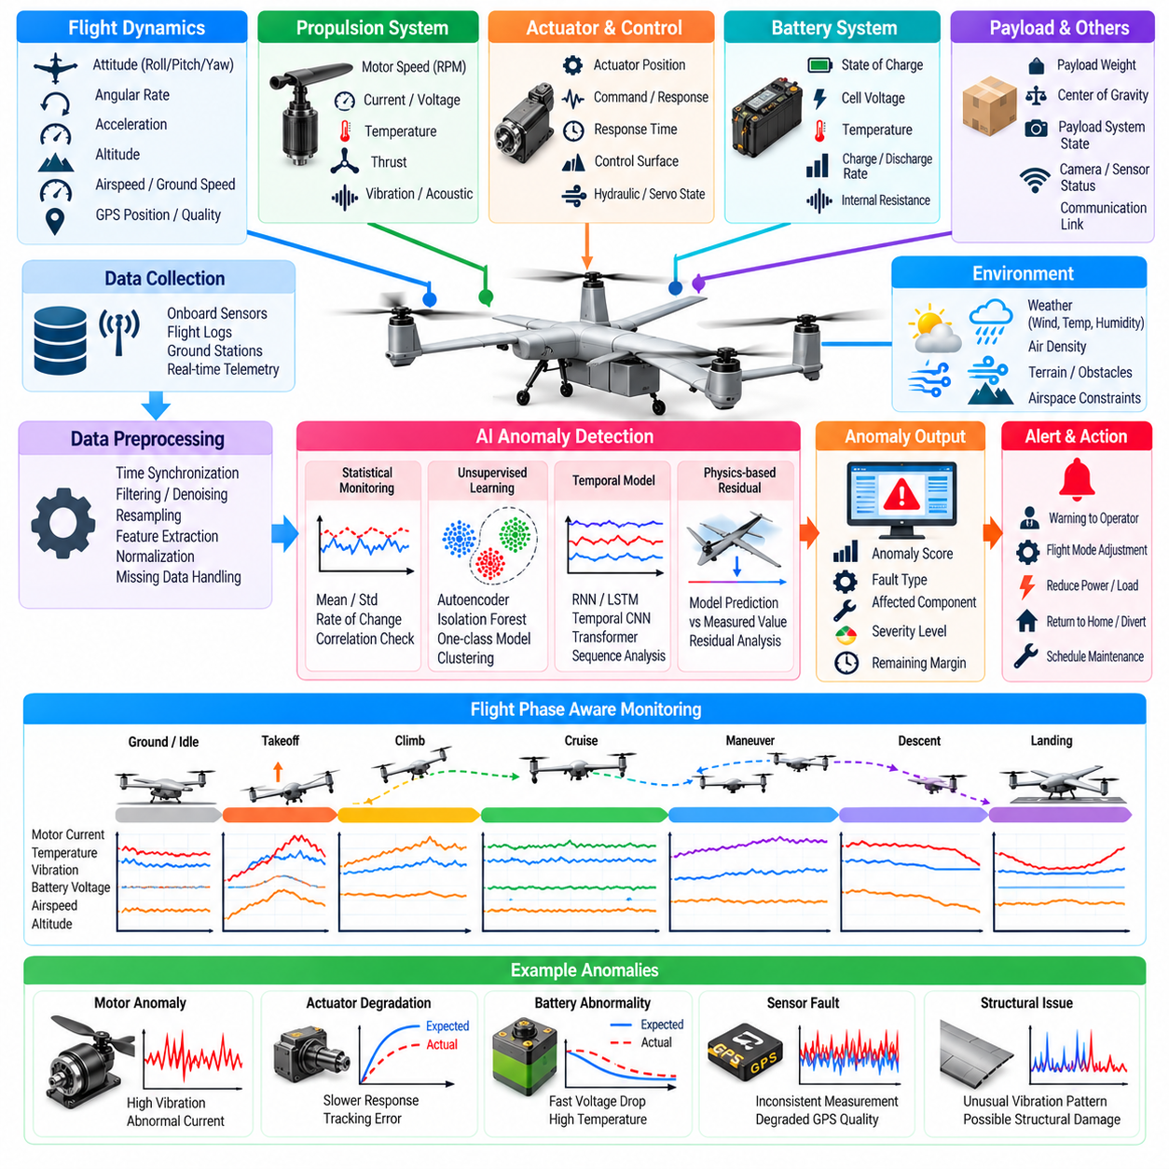
Flight-parameter anomaly detection provides an intelligent monitoring layer that identifies abnormal UAV behavior before conventional limit checks necessarily indicate a failure. Instead of evaluating each signal only against fixed thresholds, an AI-based monitor can learn relationships among flight variables and detect combinations, trends, or temporal patterns that differ from expected aircraft behavior during a particular mission phase.
A cargo UAV generates large volumes of telemetry from flight-control computers, navigation systems, propulsion units, batteries, actuators, payload systems, and environmental sensors. Relevant parameters include attitude, angular rate, acceleration, altitude, airspeed, ground speed, motor speed, current, voltage, temperature, vibration, actuator position, GPS quality, and communication status. Together these measurements provide a multidimensional description of aircraft condition.
Traditional threshold monitoring remains essential because known safety limits must trigger deterministic responses. However, many emerging faults remain within individual parameter limits during their early stages. A motor may consume slightly more current while producing slightly less thrust, or an actuator may respond progressively more slowly without exceeding a fixed threshold. Multivariate anomaly detection can identify these relationships before any single variable becomes obviously abnormal.
The monitoring system should account for flight phase because normal parameter distributions change substantially between ground operation, takeoff, climb, cruise, maneuvering, descent, and landing. High motor current may be normal during takeoff but suspicious during steady cruise. Flight-phase-aware models compare measurements with appropriate operational baselines, reducing false alarms caused by legitimate changes in aircraft operating state.
Payload also influences expected behavior. A heavily loaded cargo UAV naturally requires greater thrust and energy than the same vehicle during an empty return flight. An anomaly detector that ignores payload could incorrectly classify normal high-power operation as abnormal. Payload mass, center-of-gravity information, mission configuration, and commanded maneuver intensity should therefore be included as contextual variables when establishing expected parameter behavior.
Data preprocessing is fundamental to reliable detection. Telemetry streams must be time synchronized, resampled when necessary, filtered for corrupted measurements, and transformed into consistent units and coordinate systems. Sensor latency should be considered because comparing signals with different delays can create artificial anomalies. Missing values must also be identified explicitly rather than silently interpreted as valid measurements.
Simple statistical monitoring can provide a useful first layer. Moving averages, standard deviations, rate-of-change limits, residuals, and correlation checks can detect abrupt shifts or gradual drift. More advanced machine-learning methods can then analyze higher-dimensional relationships. Combining interpretable statistical rules with learned models creates a layered architecture that preserves deterministic monitoring while adding sensitivity to complex abnormal behavior.
Unsupervised learning is particularly valuable because comprehensive examples of every possible UAV failure rarely exist. Algorithms can learn the distribution of normal telemetry and assign anomaly scores to observations that differ from that distribution. Autoencoders, isolation-based methods, one-class classifiers, clustering, and probabilistic density models can identify unusual patterns without requiring explicit labels for every fault type.
Autoencoder-based detection learns to reconstruct normal combinations of flight parameters through a compressed latent representation. When telemetry differs significantly from learned normal behavior, reconstruction error increases and can serve as an anomaly score. Sequence autoencoders can extend this concept across time, allowing the monitor to recognize abnormal temporal behavior rather than evaluating isolated telemetry samples independently.
Temporal models are important because many anomalies develop as sequences. Oscillating attitude, gradually increasing motor temperature, repeated actuator corrections, deteriorating GPS accuracy, or slowly decreasing battery voltage may not appear abnormal in a single sample. Recurrent networks, temporal convolutional models, transformers, or state-space approaches can capture these patterns and estimate whether recent behavior is consistent with expected dynamics.
Physics-based residual monitoring can complement machine learning. A vehicle model can predict acceleration, angular motion, energy use, or actuator response from commands and current state. Differences between predicted and measured behavior create residual signals. Machine learning can then analyze residual patterns to distinguish normal modeling errors from developing faults, producing a hybrid diagnostic system grounded in known aircraft dynamics.
Sensor consistency checking provides another important detection mechanism. Position, velocity, acceleration, attitude, and altitude are often observed through multiple sensors or estimation processes. Disagreement between GPS, inertial sensors, barometric altitude, radar or laser altimeters, and visual navigation may indicate sensor degradation. Cross-validation among independent measurements can detect failures even when an individual sensor continues producing plausible values.
Propulsion anomalies can be detected by comparing motors operating under similar commanded conditions. On a multirotor platform, one motor requiring significantly more current or exhibiting abnormal vibration relative to neighboring units may indicate bearing wear, propeller damage, motor degradation, or aerodynamic disturbance. Context-aware comparison prevents normal differences caused by maneuvering from being incorrectly interpreted as component faults.
Battery anomalies require analysis of voltage, current, temperature, state of charge, cell balance, and power demand. Sudden voltage sag, abnormal heating, unexpected capacity loss, or divergence among cells can indicate degradation or an emerging electrical problem. The detector should consider current load because voltage behavior that is normal under high power may be suspicious during low-demand operation.
Flight-control anomalies can appear as persistent tracking errors, excessive control activity, unexpected oscillation, or disagreement between commanded and achieved states. These patterns may originate from actuator degradation, aerodynamic damage, incorrect payload distribution, sensor problems, or controller instability. Anomaly detection can flag the behavior even when the underlying cause cannot yet be uniquely identified.
Navigation monitoring should detect both obvious failures and subtle degradation. Increasing position uncertainty, inconsistent velocity estimates, satellite loss, multipath effects, magnetic interference, or disagreement between navigation sources can reduce autonomous-flight reliability. An AI monitor can combine quality indicators and vehicle dynamics to determine whether the navigation solution remains credible for the current mission environment.
Communication and computing parameters should also be monitored. Packet loss, increasing latency, processor overload, memory pressure, timing jitter, dropped control messages, or abnormal software restart patterns can precede functional failures. For highly autonomous UAVs, computational health is as important as mechanical health because perception, planning, navigation, and control depend on predictable execution of onboard software.
Anomaly detection should generate graded severity rather than a single binary alarm whenever possible. A low anomaly score may only require logging, while persistent moderate anomalies can trigger enhanced monitoring or maintenance notification. High-confidence anomalies affecting safety-critical systems may require immediate mission replanning, return-to-base behavior, diversion, degraded control mode, or emergency landing according to predefined safety logic.
Persistence logic is important because short-lived disturbances do not always represent faults. Turbulence, communication interference, temporary GPS degradation, or aggressive maneuvers can produce transient abnormal measurements. Requiring anomalies to persist for an appropriate duration, or combining multiple supporting indicators, can reduce nuisance alarms while retaining sensitivity to rapidly developing safety-critical conditions.
The detector should estimate confidence in its own output. An anomaly score produced from high-quality, synchronized sensor data has different significance from one generated when several inputs are missing or unreliable. Confidence estimates can incorporate sensor validity, model uncertainty, distance from the training distribution, and agreement among independent detectors. Low-confidence situations can invoke conservative monitoring policies.
Explainability is valuable for operational use. Instead of reporting only that an anomaly occurred, the system should identify which parameters, residuals, or temporal patterns contributed most strongly to the decision. A maintenance technician may need to know that motor current increased while rotational speed and thrust response declined, whereas a flight supervisor needs to understand which subsystem may affect immediate mission safety.
False-positive management is a major design requirement. If the system repeatedly raises alarms during normal turbulence, high-payload takeoff, or expected aggressive maneuvering, operators may begin to disregard warnings. Thresholds and anomaly scores should therefore be calibrated using representative operational data, with separate sensitivity levels for advisory monitoring and safety-critical intervention.
False negatives are equally important because an undetected anomaly may progress toward a hazardous failure. Evaluation should measure detection probability, time to detection, false-alarm rate, missed-event rate, and performance across different operating conditions. Early detection is especially valuable when it provides enough time for mission replanning or controlled recovery before the affected subsystem loses functionality.
Training datasets should represent the full operational envelope rather than only nominal cruise flight. Different payloads, speeds, altitudes, temperatures, winds, maneuvers, battery states, and mission phases should be included. Simulated faults and controlled fault-injection experiments can supplement limited real failure data, although synthetic anomalies must be validated to ensure that they resemble physically realistic failure behavior.
Software-in-the-loop and hardware-in-the-loop testing provide safe environments for evaluating detection algorithms. Faults can be introduced into sensor streams, propulsion models, navigation signals, communication links, and actuator responses while the complete flight software executes normally. These tests can determine whether anomalies are detected early enough and whether downstream safety logic responds correctly to the generated alerts.
Real-time deployment requires bounded computational latency. The monitoring algorithm must process telemetry quickly enough that alerts remain relevant to the current aircraft state. Lightweight detection models can operate directly on the flight computer or a dedicated edge processor, while more complex diagnostic analysis can run at lower rates. Monitoring functions should not consume resources needed by primary flight-control tasks.
A robust architecture also requires deterministic fallback monitoring. If the AI model becomes unavailable, encounters invalid inputs, exceeds execution deadlines, or detects conditions far outside its training distribution, conventional threshold checks and model-based safety monitors must continue operating. AI anomaly detection should enhance existing protections rather than become a single point of failure.
Fleet-level analysis can improve anomaly detection by comparing behavior across nominally similar aircraft. If one vehicle consistently shows higher motor temperature, greater control effort, or unusual battery voltage behavior under comparable missions, fleet statistics can reveal the deviation. Aircraft-specific baselines remain necessary because manufacturing variation and component age can produce legitimate differences between vehicles.
Flight anomalies should be connected to post-flight maintenance and learning processes. Detected events can be stored with surrounding telemetry, mission context, operator actions, and inspection results. Confirmed faults provide valuable labeled examples, while false alarms reveal where models require refinement. This feedback loop allows the monitoring system to improve as operational experience accumulates.
Anomaly detection ultimately serves as a bridge between real-time flight safety and long-term aircraft health management. By combining deterministic limits, statistical monitoring, machine learning, temporal analysis, physical models, and multisensor consistency checks, the system can recognize abnormal behavior earlier and with greater context. For autonomous cargo UAVs, this capability supports safer missions, faster fault response, and more effective predictive maintenance.

09.06. Vision Based Precision Landing CNN Policy [w/Code]
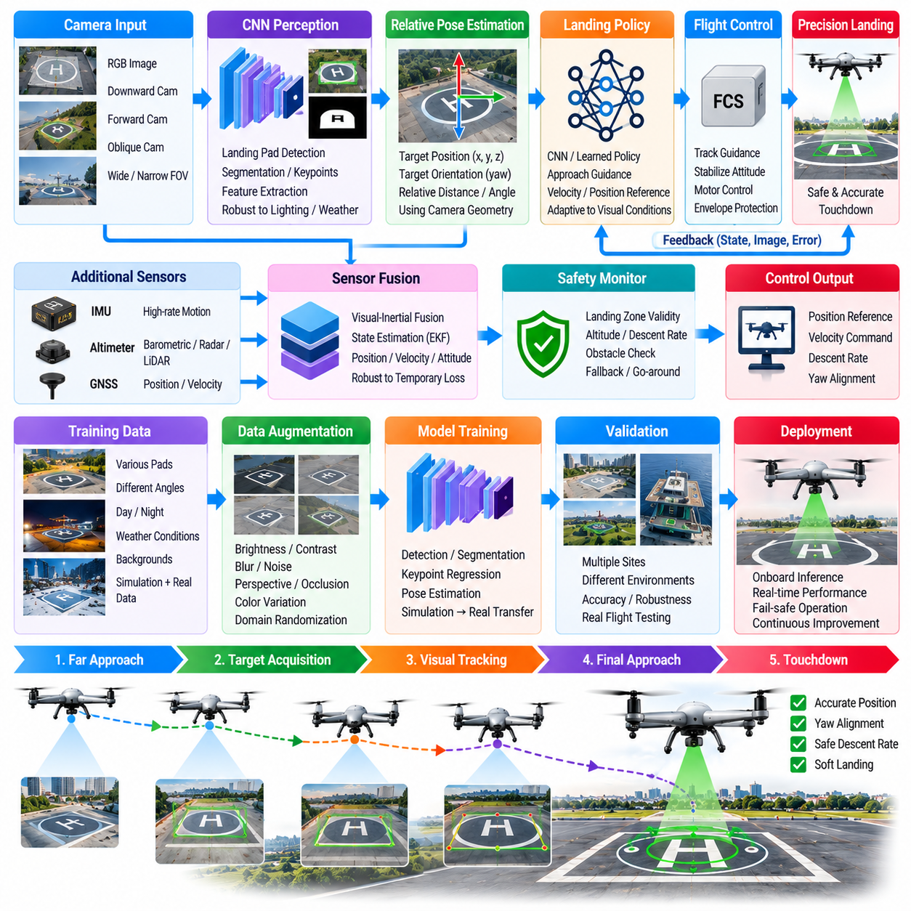
Vision-based precision landing enables a UAV to estimate the location and orientation of a landing zone from onboard imagery and use that information to guide the final approach. A convolutional neural network can extract landing-relevant visual features from camera frames even when GNSS accuracy is insufficient. For cargo UAVs, this capability supports repeatable delivery to compact pads, remote sites, and infrastructure with limited navigation aids.
The landing system typically combines perception, relative localization, guidance, control, and safety supervision. The CNN processes camera images to detect a landing target or suitable landing region, while geometric estimation converts visual observations into relative position and orientation. A guidance module then generates approach commands, and the existing flight-control system tracks them while independent safety logic verifies altitude, descent rate, and landing-zone validity.
Camera configuration strongly influences achievable precision. A downward-facing camera provides direct observations during vertical descent, while a forward or oblique camera can detect the landing zone earlier during approach. Wide-angle optics increase coverage but introduce distortion, whereas narrow fields of view provide greater target detail at the cost of visibility. Multi-camera arrangements can support transitions from long-range acquisition to close-range touchdown guidance.
CNN-based detection can identify artificial landing markers, pad boundaries, structural features, or naturally occurring visual landmarks. The network may produce bounding boxes, segmentation masks, keypoints, or heatmaps depending on the required localization method. Keypoint-based approaches are particularly useful when known geometric features allow pose estimation, while segmentation can support landing-zone evaluation when a precisely marked pad is unavailable.
Relative pose estimation converts visual detections into metric guidance information. If the dimensions and geometry of a landing marker are known, perspective relationships can estimate camera position and orientation relative to the target. Camera calibration parameters must be accurate because errors in focal length, optical center, or distortion correction can translate directly into landing-position error, especially during the final descent.
A learned policy can operate above the conventional controller by converting visual state estimates into velocity, heading, or position references. This architecture limits the CNN policy to guidance-level decisions rather than direct actuator commands. Such separation is advantageous for safety-critical UAVs because deterministic attitude stabilization, motor control, envelope protection, and emergency functions remain within established flight-control software.
End-to-end visual policies provide an alternative in which neural networks map images or learned visual features directly to landing guidance commands. This can reduce dependence on explicit geometric pipelines and may learn robust behavior under complex visual conditions. However, end-to-end policies are harder to interpret and verify, so practical systems often retain explicit state estimation and constraint checking around the learned component.
Training data must represent the diversity expected during actual landing operations. Images should cover different approach angles, altitudes, offsets, pad sizes, backgrounds, seasons, lighting conditions, shadows, weather, and camera exposure settings. A network trained mainly on centered daytime approaches may perform poorly when the target appears near the image boundary, under strong shadows, or during low-contrast environmental conditions.
Data augmentation can expand visual variability without requiring every condition to be physically recorded. Brightness, contrast, blur, noise, perspective, partial occlusion, image compression, and color changes can be applied during training. Augmentation should remain physically plausible because unrealistic transformations may encourage the network to learn features that do not correspond to actual camera behavior or operational environments.
Synthetic data can further increase training coverage. Simulation engines can generate landing approaches with randomized pad appearance, terrain, buildings, lighting, weather, and camera pose. Accurate labels for target position, segmentation, and relative pose are automatically available in simulation. Domain randomization can deliberately vary visual characteristics so that the network learns robust geometric and semantic features rather than memorizing a particular landing site.
The simulation-to-reality gap remains an important challenge. Real cameras contain lens artifacts, motion blur, rolling or global shutter effects, exposure transitions, vibration, dirt, and sensor noise that may not be perfectly represented in simulation. Fine-tuning with real flight imagery and validating across multiple physical sites can reduce this gap. Real data should include difficult cases rather than only successful nominal landings.
Temporal information can improve stability because landing is a continuous process rather than a sequence of independent images. Filtering detections across frames reduces jitter, while recurrent or temporal neural models can exploit target motion patterns. Combining vision with inertial measurements allows the system to distinguish genuine target movement from camera motion and maintain relative estimates during brief visual degradation.
Visual-inertial fusion is particularly valuable during final approach. The camera provides information about the landing zone, while the inertial measurement unit provides high-rate motion estimates between image updates. Barometric, radar, or lidar altitude measurements can contribute vertical information. An estimator can fuse these sources to produce smooth relative position and velocity estimates suitable for closed-loop landing guidance.
GNSS information can still assist the approach even when it lacks touchdown-level precision. The aircraft can use GNSS to navigate to the general landing area and activate vision when the target should become observable. The system then transitions from global navigation to relative visual guidance. This staged approach reduces the search region and prevents the vision network from being responsible for the entire mission-navigation problem.
Landing-zone acquisition should include confidence estimation. The system must distinguish a genuine target from visually similar patterns such as road markings, rooftops, containers, or shadows. Detection probability, temporal consistency, geometric validity, and agreement with expected location can contribute to a target-confidence score. Descent should not continue into critical altitude regions unless target confidence remains above an appropriate threshold.
Precision landing also requires assessment of touchdown-zone safety. Detecting the pad center alone is insufficient if people, vehicles, cargo, debris, or other aircraft occupy the area. A secondary perception function can identify obstacles and evaluate whether the landing surface remains clear. For unprepared sites, semantic segmentation and terrain analysis can estimate surface suitability, slope, available area, and potential hazards.
Cargo UAVs require special consideration because vehicle mass and payload influence approach dynamics. Heavy aircraft may require lower lateral acceleration, longer stabilization time, and stricter descent-rate limits than small drones. Guidance policies should therefore include vehicle configuration and payload information or operate through controllers that enforce mass-dependent constraints. A visually accurate target estimate does not guarantee a dynamically safe landing trajectory.
Wind disturbance becomes increasingly important near touchdown because lateral errors must be corrected within a shrinking maneuvering region. The controller can combine visual target displacement with wind estimates and inertial velocity to compensate for drift. The landing policy should avoid aggressive last-second corrections that exceed attitude, thrust, structural, or payload-stability limits, even when doing so would reduce instantaneous position error.
Ground effect and aerodynamic interactions near the surface can also alter control response. Large rotors or distributed propulsion systems may experience changes in thrust efficiency as altitude decreases. A precision-landing controller should account for these effects through calibrated models, adaptive control, or robust margins. Vision provides target geometry, but safe touchdown still depends on accurate understanding of vehicle dynamics near the ground.
Occlusion is another important operational challenge. Dust, rain, fog, snow, vegetation, structures, exhaust, or objects moving across the camera view can partially hide the landing target. The system should detect loss of visual confidence and maintain a safe hover, climb, or go-around behavior rather than extrapolating indefinitely from stale observations. Multiple sensors or cameras can provide additional resilience.
Lighting variation can significantly affect CNN performance. Strong sunlight, deep shadows, reflections, dusk, and artificial lighting may change the appearance of the same landing marker. High-dynamic-range cameras, exposure control, infrared sensing where appropriate, and training across diverse illumination conditions can improve robustness. The perception system should monitor image quality and recognize when visual information becomes unreliable.
Landing guidance should be organized into operational phases. Initial acquisition establishes the target, approach reduces horizontal and heading error, stabilized descent maintains alignment, and terminal descent transitions toward touchdown. Different gains, confidence thresholds, and speed limits can be applied in each phase. Phase-specific logic prevents a policy optimized for high-altitude correction from commanding inappropriate maneuvers close to the ground.
Safety supervision must remain independent of the CNN output. Geofences, minimum and maximum descent rates, attitude limits, thrust margins, obstacle constraints, target-confidence thresholds, and abort criteria can be checked by deterministic software. If the visual policy proposes an unsafe command, the supervisor can modify or reject it and initiate hover, climb, alternate-site diversion, or go-around procedures.
Failure detection should include camera malfunction, frozen frames, excessive blur, calibration errors, neural-network execution failure, inconsistent pose estimates, and loss of target tracking. A watchdog can monitor image timestamps, inference latency, confidence, and estimator residuals. Precision landing should degrade gracefully to an alternate navigation method or abort rather than continuing with uncertain or stale visual information.
Real-time inference requires predictable latency because delayed visual guidance can produce oscillation or excessive correction. CNN architecture, image resolution, frame rate, and processor selection must therefore be considered jointly. Quantization, pruning, optimized inference engines, and hardware accelerators can reduce computational load while maintaining sufficient accuracy. Worst-case execution time is more important than average inference speed for safety-critical control.
Validation should progress from recorded-image testing to simulation, software-in-the-loop, hardware-in-the-loop, controlled flight tests, and representative operational sites. Tests should vary target offset, approach angle, wind, illumination, payload, camera vibration, obstacle presence, and partial occlusion. Failure cases and aborted approaches are as important as successful landings because they demonstrate whether the safety architecture responds correctly.
Performance metrics should include target-detection probability, relative-position error, touchdown horizontal error, heading error, descent stability, inference latency, go-around rate, false-target rate, and successful landing percentage. Results should be separated by environmental and operational conditions. Average touchdown accuracy alone can hide rare but unacceptable failures that occur under difficult lighting or visual ambiguity.
Operational data can support controlled improvement of the perception model. Images, detections, confidence values, estimated poses, guidance commands, and touchdown outcomes can be logged for post-flight analysis. Difficult examples can be reviewed, labeled, and incorporated into offline retraining. Updated networks should pass regression and safety tests before deployment rather than learning unrestricted behavior during active missions.
Vision-based precision landing ultimately combines learned perception with geometric estimation, multisensor fusion, deterministic flight control, and independent safety supervision. The CNN provides robust interpretation of complex visual scenes, while conventional control mechanisms preserve predictable vehicle behavior. For autonomous cargo UAVs, this architecture enables accurate landing at locations where global navigation alone cannot provide the precision, reliability, or environmental awareness required.

09.07. AI Based Obstacle Avoidance in Complex Airspace [w/Code]
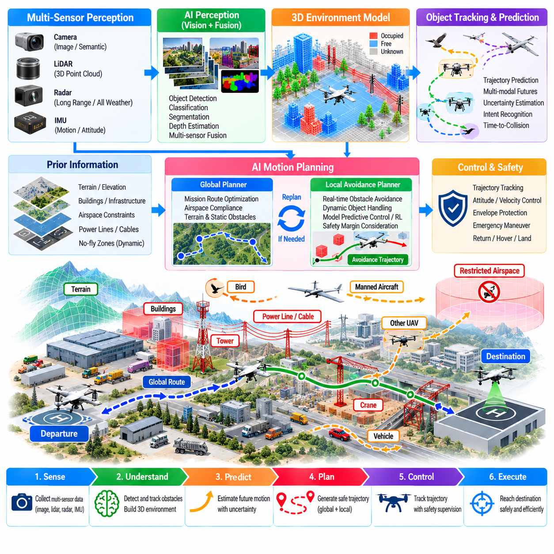
AI-based obstacle avoidance enables an autonomous UAV to perceive hazards, predict their evolution, and generate safe trajectories in environments where fixed routes alone are insufficient. Complex airspace may contain buildings, terrain, towers, cables, cranes, birds, vehicles, other UAVs, and temporary restrictions. The avoidance system must therefore reason continuously about both static geometry and moving objects while preserving mission objectives.
Cargo UAVs make this problem especially demanding because their size, mass, momentum, and limited maneuverability can require significantly larger safety distances than small drones. An obstacle detected at short range may leave insufficient time for a heavily loaded aircraft to stop or turn. AI-based avoidance must consequently consider vehicle dynamics, payload, speed, wind, actuator capability, and required safety margins when evaluating feasible escape trajectories.
The perception architecture can combine cameras, lidar, radar, ultrasonic sensors where appropriate, and cooperative traffic information. Cameras provide rich semantic information, lidar supplies accurate three-dimensional geometry, and radar can retain useful detection capability under difficult visibility. No single sensor is reliable in every condition, so multisensor fusion can improve coverage and reduce dependence on one sensing modality.
Visual perception models can detect and classify obstacles from onboard imagery. Convolutional neural networks and transformer-based vision models can identify structures, aircraft, vehicles, people, vegetation, and other relevant objects. Semantic or instance segmentation provides spatial information about occupied regions, while depth estimation can help infer obstacle distance when direct ranging sensors are unavailable or temporarily degraded.
Three-dimensional environmental representation is essential for aerial avoidance. Point clouds, occupancy grids, voxel maps, signed-distance fields, or learned spatial representations can describe free and occupied space around the UAV. The map should distinguish confirmed obstacles from unknown regions because unexplored space cannot automatically be assumed safe. Confidence information can represent uncertainty caused by limited sensing range, occlusion, or noisy measurements.
Static obstacles require accurate geometric reasoning. Buildings, towers, bridges, terrain, and power infrastructure can often be represented in preloaded maps, but onboard sensing is still necessary because maps may be outdated or incomplete. Construction equipment, temporary structures, vegetation growth, and unrecorded cables can alter the environment. The system should therefore treat prior maps as useful information rather than unquestionable ground truth.
Thin obstacles such as wires and cables are particularly challenging because they may occupy only a few image pixels and produce weak lidar or radar returns. Detection can combine specialized vision models, geometric line features, temporal observations, and prior infrastructure maps. When confidence is insufficient in an area where cables are plausible, the planner should increase clearance or select a route that avoids relying on uncertain detection.
Dynamic obstacles introduce the additional requirement of motion prediction. Detecting another aircraft is not enough; the system must estimate its velocity, trajectory, and possible future positions. Tracking filters and learned motion-prediction models can maintain object states across time. Probabilistic prediction is valuable because human-controlled aircraft, birds, vehicles, or other autonomous systems may change direction unexpectedly.
Trajectory prediction should represent multiple plausible futures rather than only one deterministic path. Another UAV approaching an intersection of flight corridors may continue straight, climb, descend, or turn. A multimodal prediction model can assign probabilities to these possibilities, allowing the avoidance planner to evaluate collision risk across a range of future behaviors instead of relying on a single potentially incorrect forecast.
Time-to-collision and closest-approach metrics provide useful indicators but should not be the only basis for avoidance. Two objects may currently appear separated yet be converging rapidly, while another nearby object may be moving away safely. AI-based risk assessment can combine relative position, velocity, predicted trajectory, uncertainty, maneuverability, and environmental constraints to estimate the urgency and severity of a potential conflict.
Obstacle avoidance operates most effectively when divided into global and local planning layers. A global planner generates an efficient mission route using known terrain, airspace, and infrastructure information. A local planner continuously responds to newly observed obstacles and traffic. If local avoidance creates a substantial deviation, the global route can be recalculated so that short-term collision avoidance remains consistent with long-term mission feasibility.
Classical planning algorithms remain useful within an AI-enabled architecture. Graph search, sampling-based planning, optimization, model predictive control, and velocity-obstacle methods provide interpretable mechanisms for generating collision-free motion. Machine learning can improve perception, prediction, cost estimation, or policy selection while deterministic planners enforce geometric and dynamic constraints. This hybrid approach can improve both capability and verifiability.
Reinforcement learning can learn avoidance strategies through repeated interaction with simulated environments. A policy can observe local geometry, dynamic objects, vehicle state, and mission direction and then select motion commands that balance progress with collision risk. Reward functions can penalize proximity, excessive maneuvering, energy consumption, and mission delay while strongly penalizing collisions and safety-envelope violations.
Pure reinforcement-learning control, however, can produce unpredictable behavior outside its training distribution. For safety-critical cargo UAVs, learned policies should therefore operate within constrained action spaces or propose trajectories that are independently checked before execution. A safety filter can reject commands that violate minimum separation, flight-envelope, terrain-clearance, or reachable-safe-state requirements.
Model predictive control can provide a strong connection between prediction and avoidance. At each planning cycle, the system predicts UAV motion over a finite horizon, evaluates candidate control sequences, and selects one satisfying obstacle and vehicle constraints. The calculation repeats as new measurements arrive. Learned models can improve obstacle-motion prediction or aerodynamic estimates while the optimization layer retains explicit safety constraints.
Vehicle dynamics must remain central to planning. A geometrically open corridor may still be infeasible if the UAV cannot turn tightly enough, climb rapidly enough, or decelerate within the available distance. The planner should include velocity, acceleration, jerk, attitude, thrust, structural, and payload constraints. Large cargo UAVs may require trajectory decisions several seconds earlier than small multirotor platforms operating at similar speeds.
Wind further modifies reachable trajectories. Strong crosswinds can reduce lateral avoidance capability, while tailwinds can increase stopping distance relative to the ground. Wind uncertainty should therefore influence collision margins and predicted vehicle motion. An avoidance trajectory that is feasible in still air may become unsafe under gusts, making robust planning necessary for operation near buildings, terrain, or other aircraft.
Complex airspace also contains regulatory and operational constraints that behave like virtual obstacles. Geofences, altitude restrictions, temporary flight restrictions, controlled corridors, noise-sensitive areas, and reserved traffic volumes may prohibit otherwise collision-free maneuvers. The planner must avoid solving a physical conflict by entering prohibited airspace unless predefined emergency authority explicitly permits such action.
Cooperative traffic information can significantly extend situational awareness beyond onboard sensor range. Networked UAVs or airspace-management systems may share position, velocity, intent, route, and priority information. This allows conflicts to be predicted before vehicles become locally visible. Cooperative data should still be validated because communication delay, stale messages, localization errors, or noncooperative aircraft can make network information incomplete.
Priority and right-of-way logic are necessary when multiple vehicles interact. If every UAV independently chooses an aggressive avoidance direction, reciprocal maneuvers can create oscillation or new conflicts. Shared rules, coordinated trajectory negotiation, or standardized conflict-resolution policies can produce predictable behavior. When communication is unavailable, conservative noncooperative avoidance rules should provide a deterministic fallback.
Uncertainty should be represented throughout the perception and planning pipeline. Obstacle location, classification, velocity, predicted intent, vehicle state, and wind estimates all contain errors. Probabilistic occupancy and uncertainty-aware trajectory prediction allow the planner to enlarge safety margins when confidence decreases. Treating uncertain observations as exact values can produce apparently efficient but fragile avoidance decisions.
Occlusion creates an additional risk because objects may emerge suddenly from behind buildings, terrain, or other structures. The planner can identify regions that sensors cannot currently observe and reduce speed or increase clearance near potential emergence zones. This form of occlusion-aware planning treats limited visibility itself as a risk factor rather than waiting until an obstacle becomes directly detectable.
Sensor degradation should trigger graceful changes in behavior. If lidar becomes unavailable, cameras and radar may continue supporting reduced-capability navigation. If visibility deteriorates severely, the UAV may slow, climb to a safer altitude, hold position, return, or divert according to mission rules. AI perception should not encourage continued aggressive flight when the information required for safe avoidance has become unreliable.
Real-time performance is critical because obstacle information becomes stale quickly. Perception, tracking, prediction, planning, and command generation must complete within bounded latency. Computational scheduling should protect flight-control tasks while providing sufficient resources for AI inference. If planning deadlines are missed, the system should use a validated fallback trajectory or emergency maneuver rather than executing delayed avoidance commands.
Testing requires environments that contain both common and rare conflict scenarios. Simulation can generate dense traffic, moving cranes, unexpected vehicles, birds, sensor failures, wind gusts, narrow corridors, map errors, and communication loss. Large numbers of randomized encounters can reveal unsafe policy behavior that would be difficult or dangerous to reproduce repeatedly in real-world flight testing.
Software-in-the-loop and hardware-in-the-loop evaluation can verify timing, interfaces, sensor processing, and safety responses before physical flight. Controlled flight tests should then increase complexity progressively, beginning with static obstacles and cooperative targets before introducing more realistic dynamic encounters. Minimum separation, intervention frequency, trajectory smoothness, energy cost, and mission delay should be measured across scenarios.
Safety validation must emphasize rare failures rather than average performance alone. A system that successfully avoids 99 percent of obstacles may still be unacceptable if the remaining failures occur unpredictably at high closing speeds. Scenario-based testing, adversarial cases, out-of-distribution conditions, and worst-case analysis are needed to characterize the boundaries within which the AI-enabled avoidance system can be trusted.
Operational logs should capture sensor observations, detected objects, predicted trajectories, planner decisions, safety-filter interventions, and actual vehicle responses. Near-miss events and unnecessary avoidance maneuvers provide valuable data for model improvement. Updated perception or prediction models should be trained offline and subjected to regression testing before deployment so that operational behavior remains reproducible.
AI-based obstacle avoidance ultimately requires more than a neural network that recognizes objects. It is a coordinated architecture connecting perception, three-dimensional mapping, motion prediction, uncertainty estimation, dynamically feasible planning, flight control, and independent safety supervision. Each layer contributes different evidence and constraints, allowing the UAV to respond intelligently without abandoning deterministic protections.
For autonomous cargo UAVs operating in complex airspace, the primary objective is not merely to avoid immediate collisions but to preserve safe mission continuity under uncertainty. By anticipating conflicts, respecting vehicle dynamics, integrating cooperative and onboard information, and maintaining robust fallback behavior, AI-enabled avoidance can support scalable operations in increasingly dense and challenging aerial environments.

09.08. Fleet Level AI Dispatch Optimization [w/Code]
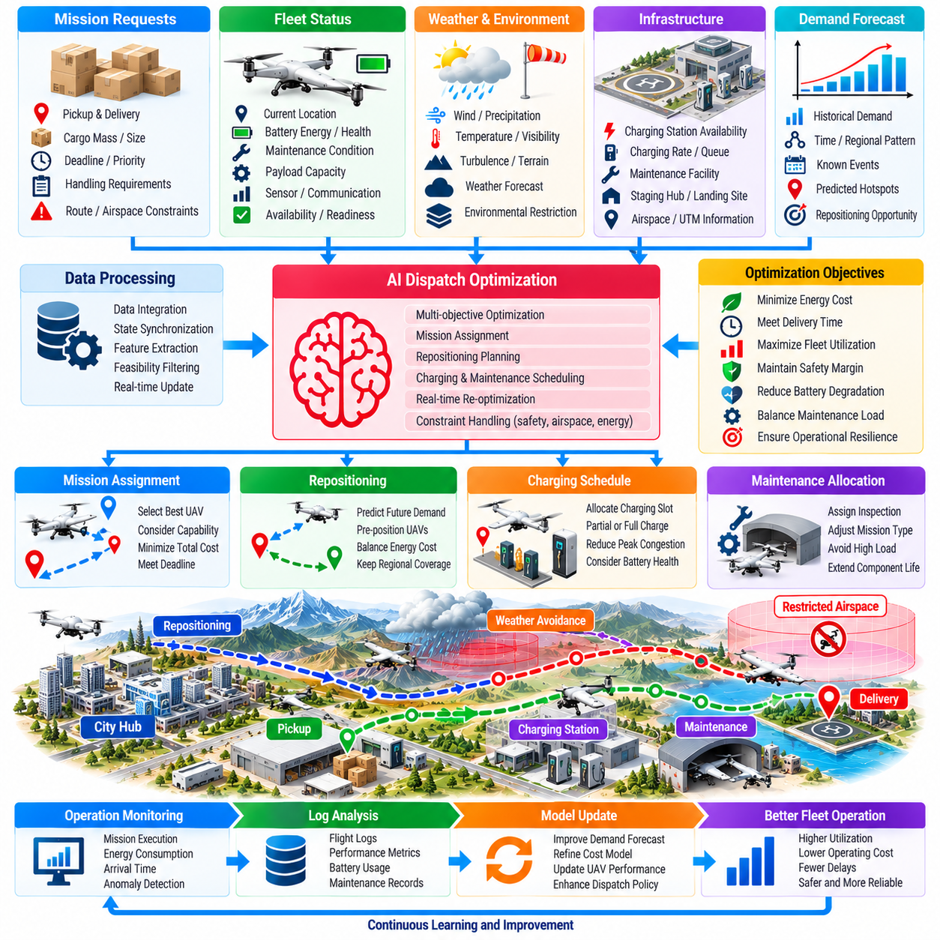
Fleet-level AI dispatch optimization coordinates multiple cargo UAVs so that missions are assigned according to vehicle capability, location, energy state, maintenance condition, airspace constraints, and operational priority. Instead of dispatching the nearest available aircraft, the system evaluates how each assignment affects the entire fleet over time, seeking higher utilization, lower energy consumption, reliable delivery, and sufficient operational resilience.
The dispatch problem is inherently dynamic because mission requests, aircraft availability, weather, charging capacity, maintenance status, and airspace conditions change continuously. A decision that is optimal when a request arrives may become inefficient minutes later. AI-assisted dispatch therefore combines current fleet state with predictions of future demand and resource availability, allowing assignments to reflect both immediate mission requirements and expected downstream consequences.
Each aircraft can be represented by a continuously updated operational state. Relevant information includes current location, payload capacity, remaining battery energy, battery health, estimated range, maintenance restrictions, propulsion condition, available sensors, communication capability, and expected time until mission readiness. Vehicle-specific performance models allow nominally similar aircraft to be treated differently when their actual health or energy capability differs.
Mission requests also require structured representation. Cargo mass, dimensions, pickup location, destination, delivery deadline, handling requirements, route constraints, environmental restrictions, and service priority determine which aircraft are feasible candidates. Some missions may require particular payload interfaces, redundant systems, weather capability, or landing precision. The optimizer should eliminate infeasible assignments before comparing the efficiency of remaining alternatives.
A basic dispatch objective may minimize total operating cost, but practical fleet management requires multiple objectives. Energy use, flight time, lateness, aircraft utilization, battery degradation, maintenance exposure, repositioning distance, charging congestion, and reserve capacity may all matter simultaneously. Weighted optimization or hierarchical objectives can express operational priorities while preserving hard safety and regulatory constraints.
The nearest aircraft is not always the best choice. A vehicle located close to a pickup point may have a partially depleted battery or may be needed soon for a high-priority mission in the same region. Another aircraft slightly farther away may complete the current mission efficiently without reducing future fleet flexibility. Fleet-level optimization evaluates opportunity cost rather than making isolated aircraft-by-aircraft decisions.
Demand forecasting can significantly improve dispatch quality. Historical delivery patterns, time of day, day of week, customer schedules, seasonal effects, and known events can be used to predict where future missions are likely to originate. Machine-learning models can estimate spatial and temporal demand distributions, allowing aircraft to be positioned before requests arrive rather than repeatedly reacting after demand has already appeared.
Predictive repositioning must balance readiness against unnecessary energy consumption. Moving aircraft toward predicted demand centers can reduce response time, but incorrect forecasts may waste energy and increase battery cycling. The optimizer can therefore compare the expected benefit of repositioning with its energy cost and forecast uncertainty. When confidence is low, maintaining strategically distributed reserve aircraft may be preferable to aggressive repositioning.
Charging introduces a major scheduling dependency for electric UAV fleets. Aircraft cannot be dispatched independently of charger availability, charging rate, battery temperature, required turnaround time, and future mission demand. AI optimization can coordinate mission assignment with charging schedules so that several vehicles do not return simultaneously and compete for limited charging infrastructure during a peak operating period.
Partial charging can sometimes be more efficient than always charging to maximum capacity. If an aircraft needs only enough energy for a short mission plus required reserves, dispatching it after a shorter charge may improve fleet throughput. The optimizer must nevertheless consider battery health, charging characteristics, contingency energy, and subsequent missions. Energy scheduling therefore becomes part of the fleet dispatch problem rather than a separate support activity.
Battery degradation can be incorporated as a long-term cost. Repeated high-power missions, deep discharge, extreme temperatures, and aggressive charging can accelerate aging. If dispatch optimization considers only immediate energy consumption, it may repeatedly assign demanding missions to the same high-performing aircraft. Including estimated degradation cost encourages workload distribution that preserves battery life and reduces long-term replacement expense.
Maintenance condition creates another important constraint. Predictive-maintenance models may indicate that an aircraft remains airworthy but should avoid high-load or long-range missions until inspection. The dispatcher can assign it shorter missions while reserving healthier aircraft for demanding operations. This health-aware allocation increases useful fleet availability without ignoring emerging component degradation or conservative safety margins.
Weather should influence both feasibility and cost. Wind, precipitation, temperature, visibility, and convective conditions can affect different aircraft unequally depending on payload, configuration, battery state, and sensor capability. A mission that is feasible for one vehicle may violate energy reserves for another. The dispatch optimizer should therefore use route-specific weather estimates rather than applying a single fleet-wide weather status.
Airspace capacity can also constrain dispatch decisions. Multiple UAVs assigned simultaneously through the same corridor may create congestion, separation conflicts, or delays. The optimizer can distribute departures across routes, altitudes, or time windows while coordinating with traffic-management systems. This prevents locally efficient aircraft assignments from creating globally inefficient or unsafe traffic concentrations.
Landing-site and ground-resource availability should be modeled alongside airspace. Vertiports, loading areas, remote pads, maintenance stations, and charging facilities have finite capacity. An aircraft arriving at a destination may need to wait if the landing zone is occupied, consuming additional energy or forcing diversion. Dispatch decisions should therefore account for predicted resource occupancy at both departure and destination locations.
Mixed fleets increase optimization complexity but also create opportunities. Different UAV types may offer different payload capacities, ranges, speeds, weather tolerances, landing capabilities, and operating costs. AI dispatch can match each mission to the most appropriate platform instead of treating every aircraft as interchangeable. Smaller vehicles can handle light local deliveries while larger aircraft remain available for missions that genuinely require their capability.
Optimization methods can range from mixed-integer programming and constraint programming to heuristics, graph methods, reinforcement learning, and multi-agent approaches. Mathematical optimization is attractive when constraints and costs can be expressed explicitly. Machine learning can predict demand, travel time, energy consumption, or mission risk, while an optimization layer converts these predictions into feasible dispatch decisions.
Reinforcement learning can address sequential fleet decisions where each assignment changes future system state. The policy can learn when to dispatch, charge, reposition, or hold aircraft in reserve by optimizing long-term cumulative performance. Simulation is particularly important because exploration on an operational fleet could produce costly or unsafe decisions. Learned policies should also remain bounded by explicit operational constraints.
Multi-agent formulations can represent each UAV as an autonomous decision-making entity while a supervisory layer coordinates shared resources and fleet objectives. Decentralized decisions can improve scalability and resilience when communication is limited. However, purely independent agents may compete for chargers, routes, or missions, so coordination mechanisms are necessary to prevent local optimization from degrading fleet-wide performance.
Mission priority must be represented explicitly. Medical supplies, disaster-response cargo, critical spare parts, and routine commercial deliveries may require different service levels. High-priority missions can receive stronger lateness penalties or reserved aircraft capacity. The system should avoid consuming all available vehicles on low-priority tasks if doing so would eliminate the ability to respond to urgent requests expected during the same operating period.
Reserve management is therefore an important optimization objective. Maximum utilization is not necessarily optimal if every aircraft is continuously committed. Maintaining some vehicles in suitable locations with sufficient energy provides resilience against urgent missions, weather changes, aircraft failures, or unexpected demand. AI can estimate the appropriate reserve level dynamically instead of relying on a fixed percentage of idle aircraft.
Disruptions require rapid replanning. An aircraft may report a fault, a landing site may become unavailable, weather may deteriorate, or a high-priority request may arrive after dispatch decisions have already been made. The optimizer should update assignments without unnecessarily destabilizing the entire schedule. Receding-horizon optimization can periodically reconsider future missions while preserving commitments that are already difficult or costly to change.
Mission handoff can provide additional flexibility in some logistics networks. A long delivery may be divided between aircraft operating from different hubs, allowing each vehicle to remain within efficient range and charging patterns. However, transfers introduce handling time, synchronization requirements, and additional failure points. The optimizer should use handoffs only when their network-level benefits exceed these operational costs.
Uncertainty must be incorporated into dispatch decisions. Flight time, energy consumption, weather, demand, charging duration, and maintenance availability cannot be predicted perfectly. Robust or stochastic optimization can evaluate multiple scenarios rather than assuming a single future. Assignments with slightly higher expected cost may be preferable if they remain feasible across a wider range of uncertain conditions.
Digital twins can provide a simulation environment for evaluating fleet policies before operational deployment. Thousands of aircraft, missions, weather scenarios, charger configurations, and failure events can be simulated faster than real time. Dispatch algorithms can be compared using identical scenarios, allowing operators to quantify energy consumption, delivery performance, congestion, resilience, and fleet utilization under controlled conditions.
Operational metrics should extend beyond the percentage of aircraft in use. Important measures include mission completion rate, on-time delivery, energy per payload-distance, empty repositioning distance, charger utilization, aircraft idle time, battery degradation, maintenance downtime, rejected missions, and reserve availability. Evaluating multiple metrics prevents optimization from improving one measure while silently degrading another important operational objective.
Real-time fleet dispatch requires scalable computation and reliable data exchange. Aircraft status, mission requests, weather updates, charging information, and airspace constraints may change every few seconds. The architecture can distribute computation between fleet servers, edge infrastructure, and aircraft, while maintaining consistent operational state. Communication failure should not leave airborne vehicles dependent on continuously updated centralized commands.
Fallback dispatch rules remain necessary when AI services or optimization infrastructure are unavailable. Conservative priority queues, predefined vehicle eligibility rules, minimum battery thresholds, and static reserve policies can maintain limited operations. AI optimization should enhance efficiency and responsiveness, but the fleet should retain a deterministic operating mode capable of preserving safety and essential service during degraded conditions.
Human supervisors also require visibility into dispatch decisions. The system should explain why a particular aircraft was assigned, why another was held in reserve, or why a mission was delayed or rejected. Presenting factors such as energy margin, maintenance status, weather exposure, charger availability, and mission priority supports operational trust and allows authorized personnel to intervene when exceptional circumstances require judgment.
Fleet-level AI dispatch optimization ultimately transforms autonomous UAV logistics from independent vehicle scheduling into coordinated management of a shared physical system. Aircraft, batteries, chargers, routes, landing sites, maintenance resources, and missions become interconnected optimization variables. Decisions are evaluated according to their consequences for the entire operating network rather than the immediate efficiency of a single flight.
For large autonomous cargo UAV fleets, this capability can improve delivery reliability while reducing energy use, unnecessary repositioning, charging congestion, and maintenance disruption. By combining forecasting, health-aware allocation, energy scheduling, airspace coordination, uncertainty management, and continuous replanning, AI dispatch provides the supervisory intelligence required to operate many autonomous aircraft as one efficient and resilient logistics network.

09.09. AI Model Certification Challenges for UAV
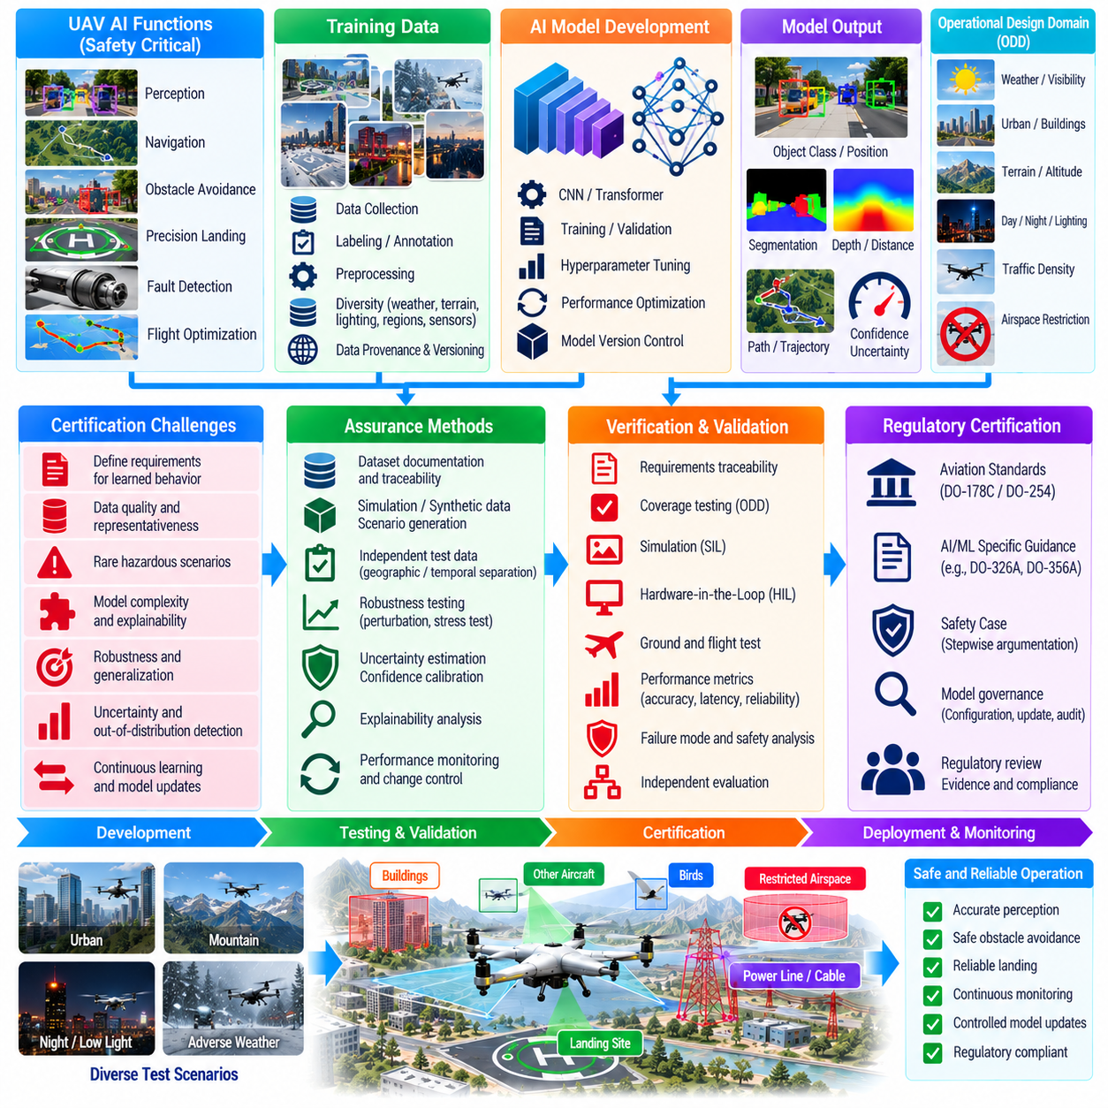
Certification of AI models for UAV applications is difficult because conventional aviation assurance assumes that software behavior can be specified, traced, reviewed, and verified against deterministic requirements. Machine-learning models derive behavior from training data and optimization rather than explicit rules, creating new assurance questions about completeness, predictability, robustness, explainability, and acceptable operational boundaries.
The certification challenge becomes more significant when AI contributes to safety-critical functions such as perception, navigation, obstacle avoidance, landing, flight optimization, or fault detection. A classification error in a noncritical advisory function may have limited consequences, while an incorrect obstacle estimate used directly by guidance could create a hazardous trajectory. Assurance rigor must therefore reflect the safety impact of each AI function.
A fundamental difficulty is defining requirements for learned behavior. Traditional software requirements can specify precise input-output relationships, timing constraints, and failure responses. For a vision model, however, it may be impossible to enumerate every appearance of an aircraft, landing zone, cable, building, or terrain feature. Requirements must instead describe intended capabilities, operating conditions, performance limits, and prohibited behaviors.
The operational design domain provides an important boundary for AI assurance. It defines conditions under which the model is expected to operate, including weather, visibility, illumination, altitude, terrain, sensor configuration, traffic density, payload, and vehicle state. Certification evidence should demonstrate acceptable performance throughout this domain while also showing that the system can detect or safely respond when conditions move outside validated boundaries.
Training data becomes part of the assurance argument because model behavior depends directly on the examples used during development. Data provenance, collection methods, labeling procedures, sensor configuration, environmental coverage, and preprocessing transformations must be documented. Without traceable data, it becomes difficult to determine whether model performance reflects representative operational experience or accidental bias in the development dataset.
Dataset representativeness is particularly challenging for UAVs because the physical world contains enormous variability. Weather, seasons, geographic regions, building styles, terrain, lighting, traffic, vegetation, and sensor artifacts can produce conditions absent from training. A model may achieve excellent aggregate accuracy while failing systematically in a narrow but safety-relevant condition that was poorly represented during development.
Rare hazardous scenarios create another certification problem. Collisions, severe sensor failures, unusual atmospheric conditions, and complex emergency combinations may occur too infrequently to provide sufficient real-world training data. Simulation, synthetic data, controlled fault injection, and scenario generation can expand coverage, but evidence is required that simulated conditions adequately represent the physical phenomena relevant to the safety claim.
Data independence must also be considered. If training, validation, and test datasets contain highly similar samples from the same flights or locations, measured performance can appear unrealistically high. Certification-oriented evaluation should maintain strict separation between development and independent test data. Geographic, temporal, environmental, and vehicle-level separation can provide stronger evidence of generalization than random image-level splitting alone.
Model architecture introduces additional assurance concerns. Deep neural networks may contain millions or billions of parameters whose individual contribution to system behavior cannot be reviewed like conventional source code. Certification cannot realistically depend on inspecting every learned weight. Assurance must instead combine controlled development processes, architectural constraints, systematic testing, robustness analysis, and independent safety mechanisms.
Explainability can support assurance but should not be treated as proof of correctness. Attention maps, feature attribution, confidence scores, or interpretable intermediate outputs may help engineers understand why a model produced a result. However, a plausible explanation does not guarantee that the decision is safe. Explainability is most valuable when combined with measurable requirements, failure analysis, and traceable verification evidence.
Robustness to input variation is a major concern. Small changes in illumination, viewpoint, sensor noise, blur, weather, or object appearance can alter neural-network outputs. Testing should therefore evaluate controlled perturbations across relevant operational dimensions. The objective is not merely to measure average accuracy but to determine whether performance degrades gradually and predictably as conditions approach the limits of the validated domain.
Out-of-distribution detection is important because UAVs may encounter situations that differ substantially from training data. A model should not remain highly confident when presented with unfamiliar terrain, damaged sensors, unusual objects, or environmental conditions outside its experience. Confidence calibration and distribution-shift detection can help trigger conservative behavior, although these mechanisms themselves require validation and cannot guarantee detection of every unknown condition.
Uncertainty estimation provides another layer of protection. AI outputs can include confidence intervals, probability distributions, or quality indicators rather than only point estimates. Guidance and planning software can use these values to increase separation margins or reject uncertain observations. For certification, the relationship between reported confidence and actual error probability must be measured so that confidence has operational meaning.
Timing behavior must be assured in addition to functional accuracy. An AI model that produces correct results but occasionally exceeds its computational deadline can still create unsafe behavior. Worst-case inference latency, memory consumption, accelerator availability, thermal throttling, processor contention, and startup behavior should therefore be evaluated under representative hardware conditions rather than relying only on average benchmark performance.
Hardware dependence can complicate certification because neural-network execution may vary with processors, accelerators, libraries, compiler versions, numerical precision, and optimization settings. Quantization or hardware-specific acceleration may change model outputs from the original development environment. The deployed model, runtime, hardware configuration, preprocessing pipeline, and numerical behavior must consequently be configuration-controlled as an integrated implementation.
Tool qualification presents another challenge. AI development depends on training frameworks, labeling tools, data pipelines, simulation systems, model converters, compilers, and inference engines. Errors in these tools can influence the final model or its verification evidence. Assurance planning must determine which tools can introduce undetected errors and what validation, qualification, independent checking, or output verification is necessary.
Traceability must extend beyond source code. An AI assurance chain may need to connect system hazards to functional requirements, dataset requirements, training configurations, model versions, test scenarios, performance metrics, and deployed binaries. Reproducing a model should include not only its architecture but also dataset versions, random seeds where relevant, preprocessing, hyperparameters, optimization procedures, and conversion steps.
Model updates create significant lifecycle challenges. Conventional certified software generally undergoes controlled modification and regression verification before release. An AI model retrained with additional data may change behavior in thousands of scenarios even when its architecture remains unchanged. Every update therefore requires controlled impact analysis and regression testing rather than assuming that more training data automatically produces a safer model.
Online learning is especially difficult to reconcile with conventional certification because the deployed model can change after approval. Unrestricted adaptation may invalidate previously collected verification evidence. Safety-critical UAV applications are therefore more likely to use controlled offline learning, followed by verification and approved deployment. If online adaptation is permitted, its modification space and safety constraints must be tightly bounded.
Runtime assurance can reduce dependence on proving that an AI component is correct under every possible condition. A runtime-assurance architecture monitors AI outputs and prevents unsafe actions using independently developed safety logic. For example, an AI planner may propose a trajectory while a deterministic monitor verifies terrain clearance, geofences, vehicle limits, and minimum obstacle separation before commands reach flight control.
Architectural partitioning can further contain AI-related risk. Learned perception may provide object detections to conventional tracking and planning software instead of commanding actuators directly. A neural policy may generate guidance references while certified control laws maintain attitude stabilization and envelope protection. Restricting the authority of AI components reduces the consequences of individual model errors and simplifies the safety argument.
Redundancy can provide independent evidence when AI outputs are uncertain. A vision-based obstacle detector may be cross-checked against radar or lidar, while a learned navigation estimate may be compared with inertial and GNSS information. Redundancy is most valuable when failure modes are sufficiently independent. Multiple neural networks trained from similar data may share weaknesses and should not automatically be treated as independent safety channels.
Formal methods can verify selected properties around AI components even when the complete neural network cannot be fully proven. Input bounds, output limits, safety envelopes, monitor logic, state transitions, and command arbitration can often be specified mathematically. Neural-network verification techniques may also demonstrate robustness within constrained input regions, although scalability remains challenging for large perception systems.
Scenario-based verification is therefore essential. Test campaigns should systematically vary environmental conditions, vehicle states, sensor quality, object configurations, traffic behavior, and failure combinations. Coverage should be defined according to meaningful operational dimensions rather than simply counting test samples. Boundary conditions deserve particular attention because failures frequently emerge near the edge of the validated operating domain.
Simulation can generate millions of scenarios that would be impractical to reproduce physically. Monte Carlo testing, domain randomization, adversarial scenario generation, and search-based testing can expose weaknesses in perception and decision models. Simulation evidence becomes stronger when models of sensors, vehicle dynamics, weather, and environments are validated against measurements from representative real-world operations.
Hardware-in-the-loop testing provides evidence that the deployed implementation behaves correctly with actual computing hardware and flight interfaces. Recorded or simulated sensor streams can be supplied to the operational processor while timing, outputs, resource use, and failure responses are measured. Fault injection can evaluate corrupted images, delayed messages, sensor dropouts, accelerator failures, and communication interruptions without risking an aircraft.
Flight testing remains necessary because some interactions cannot be reproduced perfectly in simulation. Real vibration, lighting, weather, electromagnetic interference, sensor contamination, aerodynamic effects, and unexpected environmental complexity can reveal model weaknesses. Flight tests should be selected to validate assumptions established earlier rather than attempting to discover the entire AI operating envelope through physical testing alone.
Performance metrics must be connected to system-level safety consequences. Classification accuracy, precision, recall, or intersection-over-union may be useful engineering measures but do not directly express flight risk. Certification evidence should show how perception errors propagate through tracking, planning, control, and safety monitoring, establishing acceptable error rates according to their effect on hazardous system outcomes.
Human oversight may remain part of the safety architecture for some operations. Ground supervisors can review uncertain situations, authorize specific actions, or intervene when automated systems report degraded confidence. However, certification cannot assume that a human can instantly correct every AI error. Communication latency, workload, situational awareness, and available reaction time must be considered when assigning safety responsibility to human operators.
Cybersecurity also intersects with AI assurance. Manipulated sensor inputs, corrupted model files, unauthorized updates, or compromised training data can alter learned behavior. Model integrity, secure boot, authenticated updates, protected datasets, and configuration management should therefore support the certification framework. Safety evidence can be undermined if the deployed model cannot be guaranteed to match the approved configuration.
Operational monitoring continues after deployment. Fleets can record AI confidence, unusual inputs, safety-monitor interventions, false detections, missed events, and operational conditions. These records can reveal emerging performance issues or previously unrepresented environments. Post-deployment monitoring should feed a controlled engineering process rather than allowing unverified operational data to modify safety-critical models automatically.
Certification of AI-enabled UAVs ultimately requires a system-level assurance strategy rather than a single test proving that a neural network is safe. Data governance, model development controls, independent verification, uncertainty management, runtime monitoring, architectural containment, simulation, hardware testing, flight testing, configuration control, and operational feedback must collectively support the safety case.
The practical objective is not to demonstrate that an AI model can never make an error, which is generally unrealistic for perception and learned decision systems. The objective is to establish where the model can be trusted, quantify its limitations, detect conditions in which confidence is insufficient, and ensure that individual AI errors cannot directly produce catastrophic aircraft behavior.
For autonomous cargo UAVs, successful certification will depend on treating AI as one component within a layered safety architecture. Learned functions can provide powerful perception, prediction, optimization, and autonomy, while deterministic monitors, constrained authority, redundant sensing, controlled updates, and validated fallback behavior preserve predictable safety. This combination offers a practical path toward deploying increasingly capable AI without abandoning rigorous aviation assurance principles.

09.10. AI Flight Optimization Operational Case
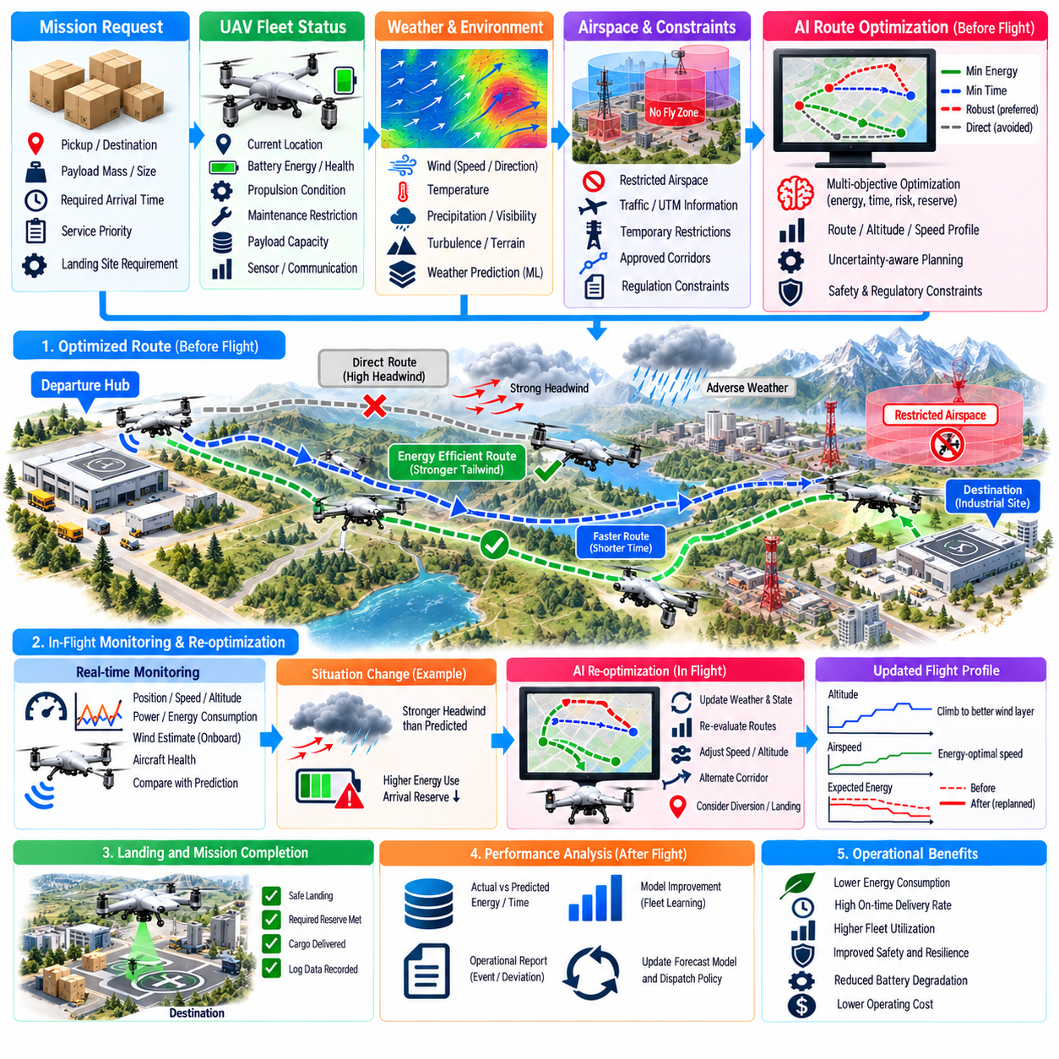
An operational case for AI-based flight optimization can be considered through an autonomous cargo UAV network connecting regional logistics hubs with remote delivery sites. The aircraft must transport variable payloads while minimizing energy use, meeting delivery deadlines, maintaining reserve margins, and responding to changing weather and airspace conditions. AI optimization operates as a continuous decision layer rather than a one-time route calculation.
Before dispatch, the system combines mission requirements with aircraft-specific information. Payload mass, destination, required arrival time, landing-site characteristics, and service priority are evaluated against battery state, battery health, propulsion condition, expected aircraft performance, and maintenance restrictions. This prevents a nominally available UAV from being assigned to a mission for which its actual operational condition provides insufficient margin.
Weather information is incorporated at route level rather than represented by a single regional forecast. Wind speed and direction, temperature, precipitation, visibility, and expected turbulence can vary substantially along a long cargo route. Machine-learning models can combine forecasts with historical flight observations to estimate route-specific energy consumption and travel time, including systematic differences between predicted atmospheric conditions and actual UAV performance.
The initial route optimizer evaluates multiple candidate trajectories instead of simply selecting the shortest geometric path. A longer route may consume less energy if it benefits from favorable winds, avoids repeated altitude changes, or reduces exposure to turbulence. The optimization objective can therefore combine energy, flight time, battery stress, weather risk, airspace cost, and required reserve energy while enforcing hard safety and regulatory constraints.
Consider a mission carrying a heavy payload from a distribution hub to a remote industrial facility. The direct route crosses an area where strong headwinds are predicted during the planned departure period. Historical data indicate that similar aircraft experience significantly increased power demand under these conditions. The optimizer may select a slightly longer lateral route where winds are weaker, reducing expected battery depletion despite the additional distance.
The energy model continuously estimates the relationship between vehicle state and required propulsion power. Payload, airspeed, altitude, wind, temperature, maneuver intensity, and battery condition influence consumption. Rather than relying only on a fixed nominal range, the AI system predicts energy use for the specific aircraft and mission. This produces a more realistic estimate of arrival energy and contingency reserve.
Uncertainty is included because weather forecasts and energy predictions are never exact. The system can evaluate optimistic, nominal, and adverse scenarios or use probabilistic distributions for expected consumption. A route with the lowest average energy requirement may be rejected if small forecast errors could reduce the landing reserve below its required threshold. Robust optimization favors plans that remain feasible across credible variations.
After dispatch, the aircraft begins executing the optimized trajectory while onboard systems monitor actual performance. Measured ground speed, airspeed, propulsion power, battery voltage, state of charge, temperature, and wind estimates are compared with predicted values. These observations allow the system to determine whether the original energy and arrival-time assumptions remain valid as the mission progresses.
Suppose the UAV encounters stronger headwinds than predicted during the first segment. The monitoring system detects that energy consumption per kilometer is increasing and that projected arrival reserve is declining. Instead of waiting until the battery reaches a low threshold, the optimizer updates the remaining trajectory using the latest atmospheric and vehicle-state information. This provides time to make efficient corrections before the situation becomes critical.
The replanning process can evaluate altitude changes, speed adjustments, route deviations, alternate corridors, intermediate landing sites, or mission diversion. Climbing may reach a layer with more favorable wind, but the energy required for the climb must be included. Reducing airspeed may save power in some conditions but increase exposure time. AI optimization evaluates these coupled effects rather than applying a single fixed response.
Speed optimization is particularly valuable for electric cargo UAVs because propulsion efficiency and mission duration are nonlinear functions of velocity. Flying faster can reduce travel time but increase aerodynamic power demand, while flying too slowly may increase total energy because hotel loads and avionics remain active longer. The optimal speed therefore depends on aircraft configuration, payload, wind, battery condition, and remaining route.
During flight, the optimization layer must remain subordinate to safety-critical control functions. It can recommend speed, altitude, route, or timing changes, but attitude stabilization, actuator control, envelope protection, collision avoidance, and emergency responses remain governed by dedicated systems. This separation prevents an optimization objective such as energy reduction from overriding immediate flight-safety requirements.
Dynamic airspace information can force additional replanning. A temporary restriction, emergency operation, traffic congestion, or unavailable corridor may invalidate the original route. The optimizer receives the updated constraint and searches for a feasible alternative while considering energy remaining, destination priority, weather, and nearby landing options. A safe diversion may become preferable if continuing the mission would consume excessive reserve energy.
Traffic information also affects trajectory efficiency. Avoiding another aircraft with a large last-minute maneuver can waste energy and create schedule uncertainty. If cooperative traffic information provides future intent, the optimizer can modify speed or altitude earlier and achieve separation with a smaller deviation. Early conflict prediction therefore improves both safety and energy efficiency when integrated with route planning.
The destination introduces another operational uncertainty. A remote landing site may become temporarily occupied, experience deteriorating visibility, or report a sensor or communication problem. The aircraft should not arrive with only the energy required for immediate touchdown. The optimization model preserves contingency energy for holding, go-around, diversion, or return according to the mission and aircraft safety policy.
AI-based precision landing can contribute during the terminal phase without replacing the broader optimization architecture. Vision-based perception identifies the landing zone and estimates relative position, while the trajectory manager selects an approach consistent with wind, obstacle clearance, energy state, and vehicle dynamics. If landing confidence becomes insufficient, the system can execute a predefined go-around while recalculating available alternatives.
After touchdown, the operational case continues because flight optimization is connected to fleet management. Actual energy consumption, route duration, wind observations, control effort, battery temperature, and landing reserve are uploaded to the fleet system. Predicted values are compared with measured outcomes, creating structured feedback that can reveal systematic prediction errors or changes in aircraft performance.
If the aircraft repeatedly consumes more energy than comparable vehicles on similar missions, the system may identify an emerging efficiency anomaly. Increased motor losses, propeller damage, battery degradation, aerodynamic contamination, or sensor bias could be responsible. The flight-optimization data therefore also supports predictive maintenance by distinguishing environmental causes from persistent vehicle-specific performance changes.
Battery information from the completed mission influences the next dispatch decision. A vehicle may return with sufficient state of charge for another short mission but elevated battery temperature may require cooling before rapid charging or immediate redeployment. Fleet optimization combines remaining energy, thermal state, expected charging time, future demand, and battery-health objectives when deciding whether to recharge, hold, or redispatch the aircraft.
Operational learning improves prediction models over time. Forecast wind can be compared with wind inferred from aircraft motion, while predicted propulsion power can be compared with measured electrical consumption. Machine-learning models can use these residuals to correct systematic biases for particular routes, seasons, payload classes, or aircraft configurations. The objective is controlled model improvement rather than unrestricted online adaptation.
A digital twin can reproduce each mission using recorded conditions and evaluate alternative decisions after the flight. Engineers can determine whether another altitude, speed profile, departure time, or route would have reduced energy while preserving safety margins. Repeated analysis across many flights provides evidence for adjusting dispatch rules, energy models, route costs, and operational policies before changes are introduced into the active fleet.
Performance evaluation should examine more than minimum energy consumption. Relevant measures include delivery completion, arrival-time accuracy, reserve energy, energy per payload-distance, route deviation, battery stress, number of replanning events, safety interventions, and diversion frequency. A strategy that saves a small amount of energy but produces frequent low-reserve arrivals would not represent successful operational optimization.
The operational system must also distinguish optimization failure from safety failure. If the AI service becomes unavailable, the UAV should continue using a validated baseline route, conservative energy rules, and predefined diversion logic. Loss of optimization may reduce efficiency but should not eliminate essential navigation or flight-control capability. This architectural principle prevents the AI optimizer from becoming a single point of failure.
Human fleet supervisors require visibility into significant optimization decisions. When the system changes a route, delays departure, diverts an aircraft, or rejects a mission, it should provide operational reasons such as unfavorable wind, insufficient energy margin, airspace restrictions, maintenance limitations, or destination availability. This enables oversight without requiring operators to manually reproduce the optimization calculation.
For high-priority cargo, the objective function can change according to mission importance. A routine delivery may emphasize energy efficiency and battery preservation, whereas emergency medical or critical industrial cargo may prioritize arrival time while still respecting mandatory safety reserves. AI optimization allows these priorities to be expressed systematically without modifying the underlying flight-safety constraints.
Fleet-scale operation amplifies the value of individual flight optimization. A small reduction in energy or turnaround time on one mission may appear insignificant, but repeated across hundreds or thousands of flights it can reduce charger demand, battery cycling, fleet size requirements, and operating cost. The benefit therefore emerges from coordinated improvements across the entire logistics network rather than from a single optimized trajectory.
The same operational framework can support mixed fleets with different UAV sizes and capabilities. A mission initially planned for a large aircraft may be reassigned to a smaller vehicle if payload and weather conditions permit, preserving the larger platform for demanding missions. Conversely, deteriorating wind may justify assigning a more capable aircraft even if its nominal operating cost is higher.
Validation of the operational concept requires simulation, historical replay, controlled flight trials, and progressive fleet deployment. Identical missions can be evaluated with baseline and AI-optimized planning to quantify energy savings and operational effects. Testing should include forecast errors, communication loss, traffic conflicts, battery degradation, route closures, and destination unavailability rather than only favorable nominal missions.
Safety evidence should demonstrate that optimization remains bounded by independently enforced constraints. Minimum battery reserve, terrain clearance, airspace restrictions, vehicle limits, obstacle separation, and emergency procedures must remain valid regardless of the AI recommendation. Optimization is therefore allowed to search for better performance only within a verified region of acceptable aircraft operation.
An AI flight-optimization operational case ultimately forms a closed loop connecting preflight planning, real-time monitoring, adaptive replanning, landing, post-flight analysis, maintenance, charging, and future dispatch. Information collected during one mission improves estimates used by subsequent missions, while configuration control and verification prevent uncontrolled changes from entering safety-critical operation.
For autonomous cargo UAVs, the primary operational benefit is the ability to make context-aware decisions continuously rather than relying on fixed routes and nominal performance assumptions. By integrating weather prediction, vehicle health, battery state, airspace conditions, traffic, mission priority, and learned performance models, AI optimization can improve energy efficiency and fleet productivity while preserving explicit safety margins and predictable fallback behavior.

