Volume 23. Cargo UAV Autonomy and Flight AI

Chapter 04. Autonomous Navigation for UAV

04.01. UAV Autonomous Navigation Architecture
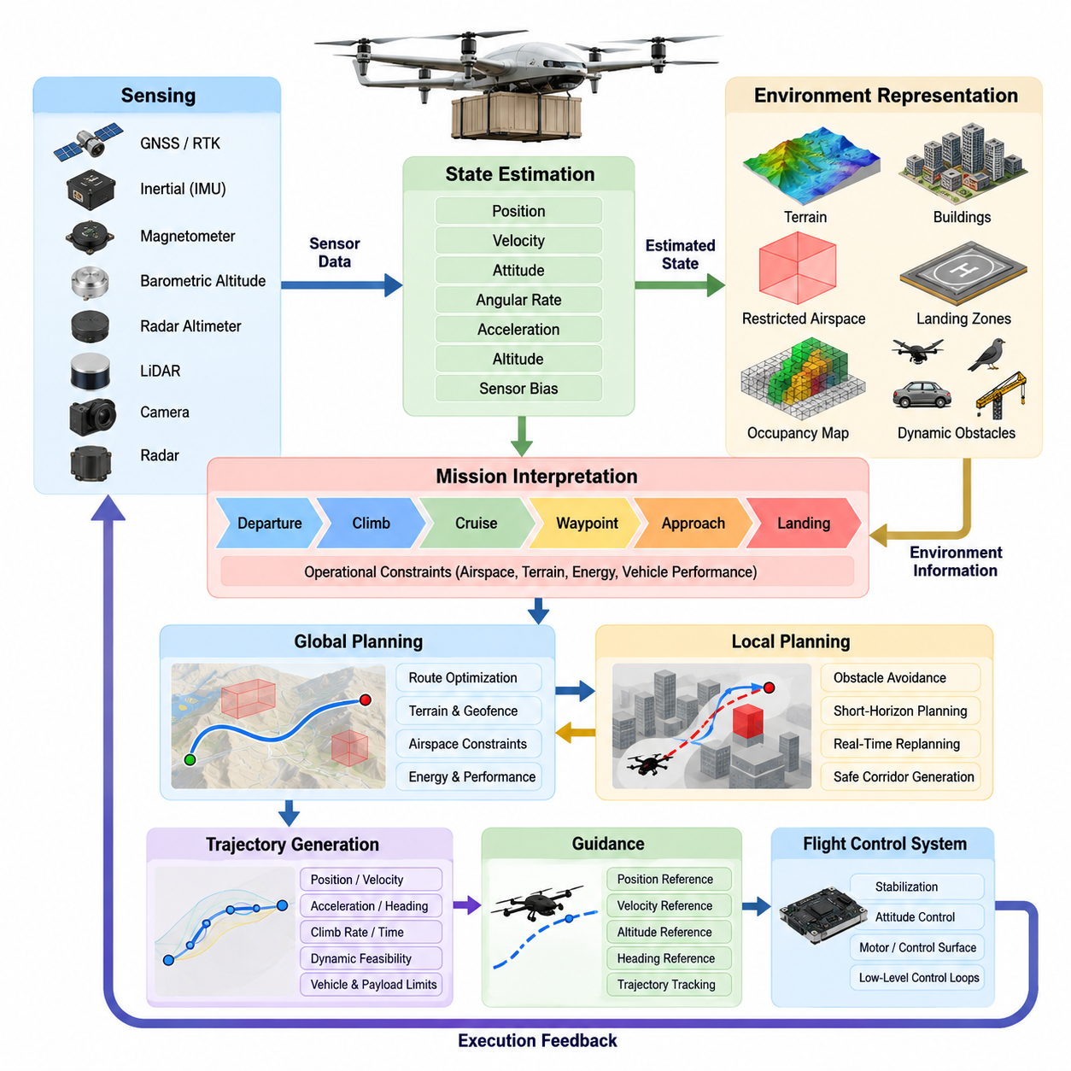
An autonomous navigation architecture for a cargo UAV provides the functional bridge between mission-level intent and the real-time flight-control system. It continuously converts destination, waypoint, airspace, terrain, and operational constraints into navigation states and trajectory commands that the aircraft can safely execute. The architecture must remain dependable across long-range missions, changing payload conditions, uncertain weather, communication interruptions, and degraded sensor environments.
At the highest level, the navigation system is organized around sensing, state estimation, environment representation, mission interpretation, path planning, trajectory generation, guidance, and safety supervision. These functions form a closed perception–planning–execution loop rather than a simple sequential pipeline. Sensor observations continuously update the estimated aircraft state and surrounding environment, while execution feedback determines whether the planned trajectory remains feasible or must be modified.
Navigation begins with a multi-source sensing layer that may combine GNSS, RTK-GNSS, inertial measurement units, magnetometers, barometric altitude sensors, radar altimeters, LiDAR, cameras, and radar. The exact sensor configuration depends on vehicle class and operating environment. Cargo UAVs require complementary sensing because no individual sensor can provide sufficiently reliable position, velocity, attitude, altitude, and environmental awareness under every operational condition.
The state-estimation layer transforms these asynchronous measurements into a coherent estimate of vehicle motion. Position, velocity, attitude, angular rate, acceleration, altitude, and sensor-bias states may be estimated through filtering or optimization techniques. GNSS and RTK provide globally referenced positioning, while inertial sensing maintains high-rate motion information. Visual, LiDAR, radar, or terrain-relative measurements can provide alternative references when satellite navigation becomes unreliable or unavailable.
A robust architecture therefore treats navigation sources according to confidence rather than assuming that GNSS is permanently available. Measurement quality, consistency, timestamp validity, innovation statistics, and sensor health can be monitored continuously. When GNSS accuracy deteriorates or interference is detected, the estimator can reduce its weighting and transition toward inertial, visual, LiDAR, radar, or other relative-navigation sources without forcing an immediate loss of autonomous flight capability.
Environment representation provides the spatial context required for autonomous decisions. Static terrain, buildings, restricted volumes, known infrastructure, landing zones, and planned corridors can be combined with dynamically detected aircraft, drones, birds, vehicles, cranes, or temporary obstacles. Different representations may coexist, including georeferenced maps, occupancy grids, voxel maps, elevation models, obstacle tracks, and semantic regions, depending on the planning horizon and computational requirements.
Mission interpretation sits above the navigation estimation functions and converts the approved mission into executable navigation objectives. A cargo mission may contain departure, climb, cruise, corridor entry, waypoint traversal, approach, landing, unloading, return, diversion, and emergency phases. Each phase activates different constraints and navigation behaviors, allowing the autonomy stack to adapt its planning horizon, altitude limits, obstacle margins, speed envelope, and landing requirements to the current operational context.
Global planning determines the broad spatial route between mission objectives while respecting terrain, geofences, prohibited airspace, vehicle performance, energy reserves, and mission constraints. Local planning operates at a shorter horizon and reacts to newly detected obstacles or environmental changes. Separating these responsibilities prevents every local disturbance from causing complete route reconstruction while still allowing rapid maneuver generation when the immediate flight path becomes unsafe.
Trajectory generation converts geometric routes into dynamically feasible motion references containing position, velocity, acceleration, heading, climb rate, and potentially time constraints. For heavy cargo UAVs, this stage must account for mass, center-of-gravity variation, propulsion capability, aerodynamic limits, turning radius, vertical-rate limits, and energy consumption. A path that is geometrically collision-free may still be unacceptable if the loaded aircraft cannot follow it within its certified flight envelope.
The guidance layer transforms the selected trajectory into references suitable for the flight-control system. Rather than directly commanding individual motors or control surfaces, navigation normally supplies desired position, velocity, altitude, heading, or trajectory states to lower-level control loops. This separation preserves a clear boundary between autonomous decision making and deterministic stabilization, while allowing the flight controller to maintain high-rate attitude and vehicle dynamics control independently. Volume_23_Cargo_UAV_Autonomy_an…
Obstacle avoidance and sense-and-avoid functions provide an additional reactive safety capability. Detected objects are evaluated according to relative position, velocity, predicted closest approach, uncertainty, and required separation. The navigation system can then modify speed, altitude, heading, or local trajectory while maintaining mission intent whenever possible. For cargo-class aircraft, avoidance decisions must be initiated early enough to respect the larger vehicle's inertia and limited maneuver authority.
Navigation architecture must also support autonomous takeoff and landing as specialized modes rather than treating them as ordinary waypoint transitions. Takeoff requires verification of navigation validity, flight-area clearance, vehicle readiness, and departure trajectory feasibility. Landing progressively increases the importance of accurate relative positioning, terrain assessment, obstacle clearance, and vertical guidance. Precision landing may additionally use visual markers, LiDAR, radar, or platform-relative estimation for fixed or moving destinations. Volume_23_Cargo_UAV_Autonomy_an…
Safety supervision operates across the entire navigation stack. Independent monitors can verify geofence compliance, navigation integrity, estimator health, trajectory feasibility, obstacle separation, communication status, remaining energy, and destination accessibility. If nominal navigation becomes unsafe, the supervisor may command route replanning, holding, return-to-home, diversion, emergency landing, or another predefined contingency behavior. These mechanisms ensure that autonomy includes explicit responses to off-nominal conditions rather than only nominal mission execution.
Return-to-home functionality illustrates the integration required across the architecture. A return decision cannot simply reverse the original route because weather, energy state, airspace restrictions, obstacles, or vehicle health may have changed. The navigation system must select an appropriate recovery destination, determine whether it remains reachable, construct a safe trajectory, and continuously reassess the route. If the home location becomes infeasible, an alternate landing site may provide the safer contingency. Volume_23_Cargo_UAV_Autonomy_an…
Timing and coordinate management are fundamental architectural concerns. Measurements arriving from multiple avionics devices must share consistent timestamps and well-defined reference frames so that sensor fusion and obstacle prediction represent the same physical state. Transformations between body, local navigation, Earth-referenced, map, sensor, and landing-site frames must therefore be explicitly controlled. Errors in synchronization or frame conventions can propagate through estimation and planning even when individual algorithms appear correct.
The architecture should also distinguish high-rate and low-rate computation. Inertial propagation, state estimation, collision monitoring, and guidance may require rapid deterministic execution, whereas global route optimization, semantic interpretation, weather assessment, and mission replanning can operate at slower rates. This multi-rate organization reduces computational load while ensuring that safety-critical reactions are not delayed by expensive planning or perception workloads running elsewhere in the autonomy computer.
Redundancy becomes increasingly important as cargo UAV size and consequence of failure increase. Navigation computers, communication paths, power supplies, and critical sensors can be partitioned so that a single fault does not immediately eliminate autonomous navigation. Redundant estimates may be cross-checked through health monitoring and voting logic, while degraded operating modes preserve essential navigation functions after selected failures. This architecture complements the broader redundant avionics design used by the UAV platform. Volume_23_Cargo_UAV_Autonomy_an…
The interfaces between navigation, perception, flight management, flight control, and mission management should be explicit and deterministic. Navigation consumes vehicle state, sensor health, obstacle information, mission objectives, airspace constraints, and system status, then publishes trajectories, guidance references, navigation integrity, and contingency recommendations. Clearly defined interfaces make individual components replaceable and support independent software verification, simulation, hardware-in-the-loop testing, and incremental certification.
For cargo operations, energy awareness must be incorporated throughout navigation rather than added only during mission planning. Remaining battery energy or fuel, payload mass, wind, altitude, propulsion efficiency, diversion distance, and reserve requirements influence whether a trajectory remains operationally feasible. The navigation system should continuously compare mission demand against reachable safe destinations so that an aircraft does not continue along a nominal route until insufficient reserve remains for recovery.
The resulting architecture is hierarchical but continuously interconnected. Mission management defines what the aircraft must accomplish, navigation determines where and how it should move, perception establishes what exists around it, state estimation determines where the aircraft actually is, and flight control executes the requested motion. Safety supervision constrains every layer. This organization provides the foundation for the subsequent precision GNSS, GPS-denied navigation, waypoint execution, obstacle avoidance, sense-and-avoid, autonomous landing, recovery, and simulation-validation functions defined for the UAV navigation chapter.

04.02. GNSS RTK Based Precision Navigation [w/Code]
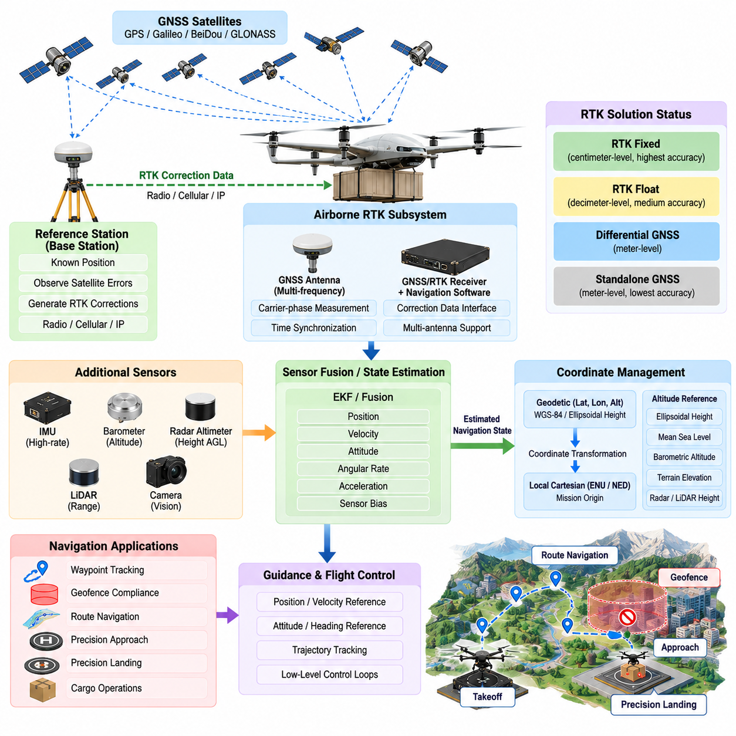
Global Navigation Satellite System (GNSS) and Real-Time Kinematic (RTK) positioning provide the primary foundation for high-accuracy outdoor navigation in autonomous cargo UAV operations. Standard GNSS can support global position estimation over long flight distances, while RTK improves relative positioning accuracy by applying correction information from a reference station or correction network. Together, they enable precise waypoint tracking, controlled approach, geofence compliance, and accurate terminal navigation.
A GNSS receiver estimates the UAV position by measuring signals transmitted from multiple navigation satellites. These measurements provide latitude, longitude, altitude, velocity, and timing information that can be transformed into the navigation coordinate frame used by the flight system. Because raw satellite measurements contain atmospheric, orbital, clock, multipath, and receiver errors, conventional standalone GNSS accuracy may not be sufficient for operations requiring highly repeatable trajectories or precision landing.
RTK navigation improves positioning by using carrier-phase measurements together with correction data derived from a known reference location. A base station observes many of the same satellite errors as the UAV receiver and distributes correction information to the airborne rover. When carrier-phase ambiguities are successfully resolved, the RTK solution can provide centimeter-class positioning under favorable satellite visibility, signal quality, correction availability, and geometric conditions.
The airborne RTK subsystem normally consists of a multi-frequency GNSS receiver, one or more antennas, correction-data communication interfaces, time synchronization functions, and navigation software. The reference information may originate from a dedicated local base station or a network-based correction service. Correction messages are delivered through radio, cellular, IP, or another supported communication channel and must be associated with the appropriate measurement epoch before the navigation solution is calculated.
RTK solution status is particularly important because precision varies substantially between operating modes. A receiver may report standalone GNSS, differential, RTK float, or RTK fixed solutions depending on correction availability and ambiguity resolution. The navigation software should therefore avoid treating every reported position as equally accurate. Position covariance, solution type, satellite count, correction age, dilution of precision, signal quality, and integrity indicators should accompany the estimated position.
A fixed RTK solution generally represents the preferred state for precision navigation because integer carrier-phase ambiguities have been resolved. An RTK float solution retains greater uncertainty and may still support less demanding phases of flight, but it should not automatically be accepted for operations requiring centimeter-level accuracy. Mission logic can define different navigation-quality thresholds for cruise, corridor traversal, approach, hover, cargo positioning, and precision landing.
GNSS and RTK measurements are most effective when integrated with the Inertial Measurement Unit (IMU). GNSS supplies globally referenced position and velocity information at a moderate update rate, while the IMU provides high-frequency angular-rate and acceleration measurements. A state estimator, commonly based on an Extended Kalman Filter (EKF) or related fusion method, combines these complementary sources to produce smooth estimates of position, velocity, attitude, and sensor biases for guidance and flight control.
During short GNSS interruptions, inertial propagation allows the navigation state to continue evolving without an immediate discontinuity. However, inertial errors accumulate with time, so satellite measurements are required to constrain long-term drift. When valid GNSS or RTK observations return, the estimator should incorporate them progressively according to measurement uncertainty rather than abruptly replacing the predicted state. This prevents large navigation corrections from generating undesirable trajectory or flight-control transients.
Coordinate management is essential because GNSS measurements are normally expressed in geodetic or Earth-referenced coordinates, while flight-control algorithms often operate in a local Cartesian frame. Latitude, longitude, and altitude can therefore be transformed into a local East-North-Up or North-East-Down representation referenced to a mission origin. Consistent datum, altitude reference, axis convention, and transformation definitions are necessary to prevent systematic position errors across planning and control modules.
Altitude requires particular attention because satellite-derived height and operational altitude may use different references. GNSS commonly produces ellipsoidal height, while mission planning, terrain databases, aviation procedures, or ground-control displays may use mean sea level or another vertical datum. Barometric altitude, radar altitude, LiDAR range, and terrain elevation can provide additional vertical information. The navigation architecture must explicitly manage these references rather than assuming that all altitude values are interchangeable.
For cargo UAVs, antenna installation can materially affect precision performance. GNSS antennas should maintain adequate sky visibility while minimizing electromagnetic interference, structural blockage, multipath, and interference from propulsion or communication equipment. Large airframes may also introduce significant lever arms between the GNSS antenna, IMU, and vehicle reference point. These geometric offsets should be calibrated and compensated so that estimated motion corresponds to the intended aircraft navigation origin.
Dual-antenna or multi-antenna GNSS configurations can additionally provide heading information from the relative carrier-phase solution between antennas. This can be useful when the UAV is stationary or moving slowly, conditions under which velocity-derived course information becomes weak. GNSS-based heading can complement magnetometers and inertial attitude estimation, particularly around large electrical propulsion systems where magnetic disturbances may degrade conventional compass measurements.
Precision waypoint navigation uses the fused state estimate to calculate position and velocity errors relative to the desired trajectory. The guidance system converts these errors into horizontal and vertical motion references that are passed to the flight-control loops. RTK does not replace the flight controller; instead, it improves the accuracy of the navigation reference used by guidance. Stable trajectory tracking still depends on vehicle dynamics, control authority, wind rejection, and correctly tuned control laws.
Communication reliability is another critical consideration because RTK performance depends on timely correction information. The navigation software should monitor correction age, message continuity, link status, and base-station validity. Temporary loss of corrections does not necessarily imply immediate loss of GNSS navigation, but the solution may degrade from RTK fixed to float or standalone operation. The autonomy system should recognize this degradation and adjust the permitted operational mode accordingly.
Satellite visibility can deteriorate near buildings, mountains, infrastructure, or other obstructions, while reflected signals may produce multipath errors. Signal blockage can reduce the number of usable satellites and weaken satellite geometry. Navigation software should monitor measurement residuals and receiver quality indicators to identify abnormal observations. Measurements inconsistent with inertial motion or other sensors can be rejected or assigned lower confidence before they corrupt the fused navigation solution.
GNSS interference presents a more serious operational risk. Jamming can reduce or eliminate satellite reception, while spoofing can introduce plausible but false navigation information. A precision-navigation architecture should therefore compare GNSS-derived motion against IMU, visual, LiDAR, radar, barometric, or other independent observations where available. Sudden position jumps, inconsistent velocity, abnormal clock behavior, unusual signal characteristics, or disagreement between redundant receivers can indicate degraded or potentially compromised GNSS.
The response to RTK degradation should be determined by mission phase and required navigation performance. Loss of a fixed solution during cruise may permit continued flight using standard GNSS and inertial fusion, whereas the same event during precision landing may require an aborted approach, hover, go-around, or transition to another landing sensor. This performance-based strategy allows the UAV to preserve useful autonomy without assuming that every navigation degradation requires identical contingency behavior.
Precision navigation must also maintain accurate timing. GNSS provides a highly stable time reference that can support timestamp alignment across the IMU, cameras, LiDAR, radar, flight computers, and logging systems. Sensor measurements used in state estimation should correspond to the correct physical instant, especially during high-speed motion. Even accurate position measurements can produce estimation errors when latency, timestamp offsets, or correction-message delays are incorrectly handled.
For long-range cargo operations, GNSS/RTK navigation should be continuously supervised rather than validated only before takeoff. The system can monitor horizontal and vertical uncertainty, correction age, satellite geometry, receiver status, estimator innovation, inertial consistency, and communication quality throughout the mission. These parameters provide a navigation-integrity assessment that can be consumed by mission management and safety functions when deciding whether normal autonomous operation remains acceptable.
Validation should cover nominal accuracy as well as transitions between navigation states. Simulation, recorded-data replay, software-in-the-loop testing, hardware-in-the-loop testing, ground trials, and flight tests can evaluate RTK acquisition, fixed-to-float transitions, correction outages, satellite blockage, multipath, receiver resets, and recovery behavior. Particular attention should be given to whether navigation degradation causes discontinuities that propagate into guidance or flight-control commands.
GNSS/RTK precision navigation ultimately forms one component of the broader autonomous navigation architecture defined for the cargo UAV. Its purpose is not merely to produce an accurate coordinate but to provide a continuously qualified, time-consistent, and operationally usable navigation state. By combining RTK positioning with inertial fusion, integrity monitoring, coordinate management, degradation handling, and flight-phase-dependent logic, the UAV can exploit centimeter-level positioning when available while retaining controlled behavior when precision satellite navigation becomes degraded or unavailable.

04.03. GPS Denied Navigation LiDAR Visual Inertial [w/Code]
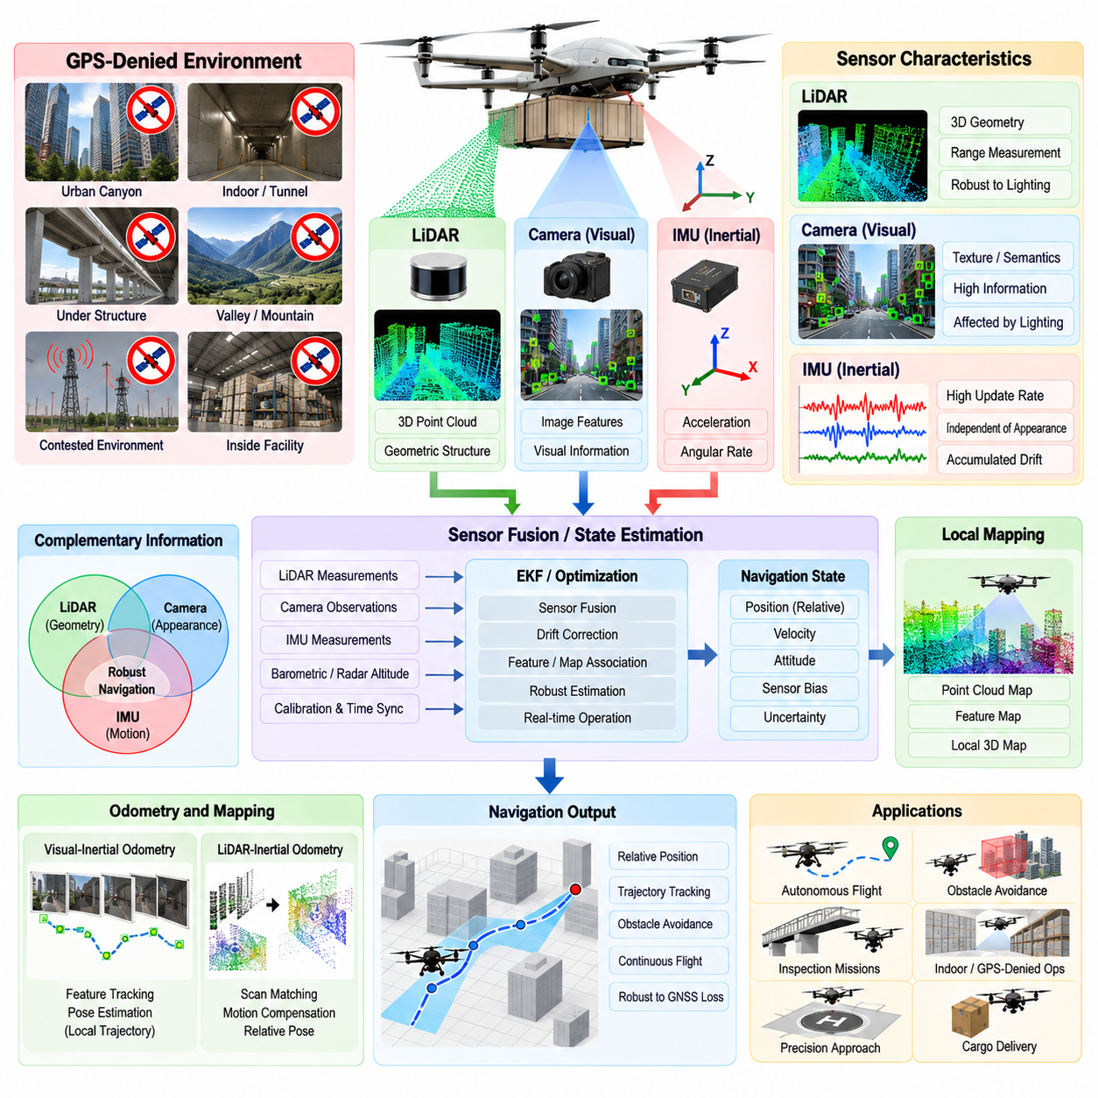
GPS-denied navigation enables a cargo UAV to maintain autonomous flight when Global Navigation Satellite System signals become unavailable, unreliable, jammed, spoofed, or obstructed. Instead of depending on a single absolute positioning source, the navigation system combines LiDAR, cameras, and inertial sensing to estimate vehicle motion relative to the surrounding environment. This capability is essential for operations near infrastructure, inside valleys, around buildings, beneath structures, or in contested environments.
The fundamental challenge of GPS-denied navigation is that the aircraft loses its continuously available global position reference. An Inertial Measurement Unit provides high-rate acceleration and angular-rate measurements, but small sensor biases accumulate through integration and gradually produce position and attitude drift. LiDAR and visual sensors provide environmental observations that constrain this drift by identifying geometric or visual relationships between measurements collected at different positions.
Visual-Inertial Odometry combines camera observations with IMU measurements to estimate the UAV trajectory. Cameras detect and track image features or directly compare image intensity patterns across consecutive frames, while inertial measurements predict rapid vehicle motion between visual observations. The estimator jointly uses these sources to recover position, velocity, orientation, and sensor biases, providing a locally consistent navigation solution even without satellite positioning.
A Visual-Inertial Navigation System must account for the complementary characteristics of cameras and inertial sensors. Cameras provide rich environmental information but can suffer from darkness, glare, motion blur, low texture, repetitive patterns, fog, or rapid attitude changes. IMUs operate independently of external appearance and at much higher rates, but accumulate drift. Their fusion allows inertial propagation to bridge short visual failures while visual observations continuously constrain accumulated inertial errors.
LiDAR-Inertial Odometry provides another important GPS-denied navigation mechanism. A LiDAR sensor generates three-dimensional geometric measurements of surrounding surfaces, while the IMU provides high-frequency motion information between scans. Successive point clouds can be aligned against previous scans or a local map to estimate the UAV's relative displacement and orientation. This approach can remain effective where visual texture is poor, provided sufficient geometric structure is observable.
LiDAR and cameras offer complementary environmental information. LiDAR directly measures three-dimensional range and is relatively insensitive to illumination changes, whereas cameras provide dense appearance, texture, and semantic information. A combined LiDAR-Visual-Inertial navigation architecture can therefore use geometric constraints, visual feature constraints, and inertial motion simultaneously. The resulting redundancy improves robustness when one sensing modality temporarily becomes unreliable.
The state estimator forms the computational center of this navigation architecture. It receives timestamped IMU samples, camera observations, LiDAR measurements, and potentially barometric or radar-altimeter information. Filtering approaches such as an Extended Kalman Filter can propagate and correct the navigation state, while optimization-based estimators can jointly refine a window of previous poses, velocities, biases, and environmental features. The selected method must balance accuracy, latency, computational load, and deterministic behavior.
Accurate sensor calibration is critical because each sensor observes the environment from a different physical location and orientation on the aircraft. The rigid transformations between the IMU, cameras, LiDAR, and vehicle reference frame must be known accurately. Timing offsets are equally important because measurements taken at different physical instants cannot be fused correctly during rapid UAV motion. Extrinsic calibration and temporal synchronization should therefore be treated as core navigation parameters rather than installation details.
Visual navigation commonly relies on feature tracking across multiple camera frames. Distinctive points, edges, or other visual structures are detected and associated over time, allowing the estimator to infer camera motion from changes in their image locations. Stereo or depth-capable cameras can provide additional scale information, while monocular systems depend more heavily on inertial measurements and motion constraints. Poor feature distribution should be detected because it can significantly reduce pose observability.
LiDAR navigation estimates motion by matching geometric structures between scans or between a current scan and an accumulated map. Planes, edges, surfaces, or raw point distributions may provide constraints on translation and rotation. During high-speed flight, scan distortion caused by vehicle motion must be compensated using inertial information. Without motion compensation, points collected at different times within a scan may incorrectly represent the environment and reduce registration accuracy.
Local mapping extends odometry by maintaining a spatial representation of the environment around the UAV. Newly observed LiDAR points or visual landmarks are registered into this map using the estimated vehicle pose. The map then provides a stable reference for subsequent localization and obstacle perception. For cargo UAV navigation, map management must balance sufficient spatial coverage against onboard memory and processing constraints, particularly during long missions through large operational areas.
Simultaneous Localization and Mapping becomes important when the UAV must navigate through an initially unknown environment. The aircraft estimates its trajectory while constructing a map from its observations, creating mutual constraints between vehicle motion and environmental structure. Loop closure can recognize previously visited regions and reduce accumulated drift by correcting inconsistencies in the estimated trajectory. Such corrections must be applied carefully so that map optimization does not create abrupt commands in the real-time flight-control path.
The navigation architecture should distinguish between locally accurate motion estimation and globally referenced position. LiDAR-Visual-Inertial odometry can maintain excellent local consistency while its global position gradually drifts over long distances. When prior maps, surveyed landmarks, terrain references, or other absolute observations are available, they can constrain this drift. The system should therefore expose both pose estimates and associated uncertainty rather than presenting locally derived navigation as perfectly absolute.
Transition from GNSS-based navigation to GPS-denied operation must be managed without discontinuities. When GNSS quality decreases, the estimator can progressively reduce the confidence assigned to satellite measurements while continuing inertial, visual, and LiDAR estimation. The local navigation frame should already be initialized and aligned before complete GNSS loss whenever possible. This allows the aircraft to continue following its trajectory without a sudden coordinate jump when satellite measurements are rejected.
Recovery of GNSS requires similarly careful handling. A newly available satellite position should not immediately overwrite the locally estimated state because the two solutions may have accumulated an offset. The navigation system should validate GNSS integrity, compare the solutions, estimate their relative transformation, and gradually reintroduce the global measurement. Smooth re-alignment prevents large position corrections from propagating into guidance commands and producing unnecessary aircraft maneuvers.
Environmental conditions strongly influence sensor selection. Cameras may dominate in visually textured environments with adequate illumination, while LiDAR may provide stronger localization around buildings, terrain, industrial structures, or low-light areas. In open regions with few geometric features, LiDAR registration can become weak, and repetitive environments may create ambiguous associations. Navigation health monitoring should therefore evaluate the actual observability provided by the current environment.
Cargo UAV dynamics add further difficulty because large aircraft may travel rapidly and possess substantial vibration, structural flex, and propulsion-induced disturbances. Sensor mounting must minimize vibration while preserving rigid calibration, and algorithms must tolerate rapid translations and rotations without losing tracking. Processing latency is also critical because an accurate pose estimate delivered too late can degrade guidance performance. Estimation pipelines should therefore maintain bounded latency under worst-case computational load.
GPS-denied navigation must integrate directly with obstacle avoidance and sense-and-avoid functions defined elsewhere in the autonomous navigation stack. The same LiDAR and camera measurements used for localization can contribute to three-dimensional obstacle detection and environmental mapping. However, localization and collision avoidance have different failure consequences, so shared sensor data should not imply identical processing or health criteria. Safety supervision must independently evaluate whether navigation and obstacle perception remain trustworthy.
Failure detection should monitor visual tracking quality, LiDAR registration residuals, IMU saturation, estimator covariance, innovation consistency, map quality, timing errors, and computational health. If localization uncertainty exceeds the permitted threshold, the UAV may reduce speed, hold position where feasible, climb to recover GNSS visibility, retrace a known route, return using alternative navigation sources, or initiate contingency landing. The selected behavior depends on vehicle capability, mission phase, surrounding obstacles, and remaining energy.
Validation must reproduce realistic GPS-denied failure conditions rather than simply disabling GNSS in ideal simulation. Testing should include poor lighting, motion blur, low-texture surfaces, repetitive structures, LiDAR feature scarcity, vibration, sensor dropout, timestamp errors, calibration offsets, high-speed motion, and processor overload. Software-in-the-loop, hardware-in-the-loop, recorded sensor replay, controlled flight tests, and progressively more complex field trials can expose weaknesses before operational deployment.
LiDAR-Visual-Inertial navigation ultimately provides the cargo UAV with an independent local navigation capability that complements GNSS/RTK precision positioning. The objective is not to permanently replace satellite navigation, but to maintain safe and continuous autonomous motion when global positioning cannot be trusted. By combining inertial propagation, visual motion estimation, LiDAR geometry, local mapping, uncertainty monitoring, and controlled transitions between navigation sources, the UAV can preserve navigation continuity across both GNSS-available and GPS-denied environments.

04.04. Waypoint Based Mission Flight Execution [w/Code]
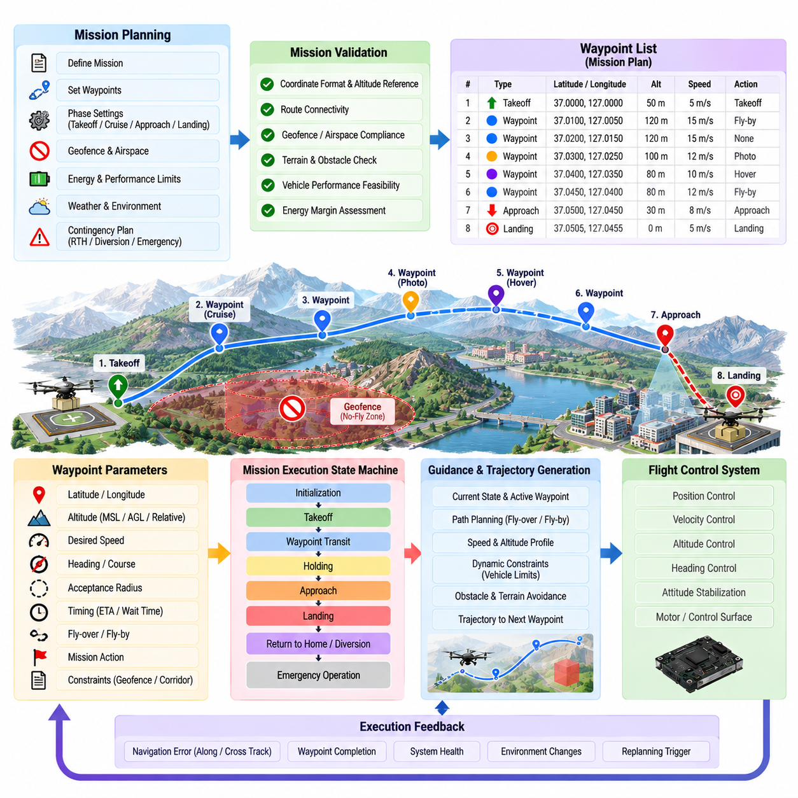
Waypoint-based mission flight execution converts a planned cargo UAV mission into an ordered sequence of spatial objectives that the autonomous navigation system can execute. Each waypoint represents more than a geographic coordinate; it may define altitude, desired speed, heading, acceptance radius, arrival behavior, timing constraints, or mission actions. The execution system manages progression through these objectives while maintaining safe and dynamically feasible flight.
A mission is normally prepared as a structured flight plan containing departure conditions, intermediate waypoints, destination approach points, landing objectives, and contingency information. Before execution, the mission manager validates coordinates, altitude references, route connectivity, vehicle performance limits, geofence constraints, and available energy. This prevents malformed or physically infeasible waypoint sequences from being transferred directly into the active navigation system.
Waypoint coordinates may be expressed using latitude, longitude, and altitude or transformed into a local navigation frame such as North-East-Down or East-North-Up. The execution system must preserve consistent coordinate and altitude references throughout the mission. Incorrect interpretation of ellipsoidal height, mean-sea-level altitude, terrain-relative altitude, or local coordinates can generate significant vertical or horizontal errors even when the individual waypoint values appear valid.
The mission executor operates as a state-driven supervisory function between mission planning and trajectory guidance. It determines which waypoint is active, evaluates completion conditions, selects the next objective, and coordinates special flight phases. Typical execution states include mission initialization, takeoff, waypoint transit, holding, approach, landing, return-to-home, diversion, and emergency operation. State transitions are triggered by navigation progress, system health, mission events, or safety logic.
Activating a waypoint does not normally mean commanding the aircraft to fly directly toward that coordinate. The navigation system first considers the current position, velocity, heading, vehicle dynamics, surrounding constraints, and subsequent route geometry. A feasible trajectory is then generated toward or through the waypoint. This distinction is especially important for heavy cargo UAVs because abrupt direction changes may exceed available acceleration, bank-angle, climb-rate, or propulsion limits.
Waypoint acceptance logic determines when an objective has been successfully reached. A simple implementation can use horizontal distance from the waypoint, but practical systems may also consider altitude error, cross-track error, heading, velocity, elapsed time, and whether the aircraft has crossed an associated waypoint plane. The acceptance criteria should prevent both premature waypoint completion and unnecessary circling around a point that the vehicle has effectively passed.
Fly-over and fly-by waypoint behaviors support different mission geometries. A fly-over waypoint requires the UAV to reach the vicinity of the specified point before transitioning toward the next segment. A fly-by waypoint permits the trajectory to begin turning before reaching the coordinate so that the aircraft can follow a smooth continuous path. Fly-by behavior is generally advantageous when vehicle inertia and mission efficiency make sharp turns undesirable.
The waypoint executor continuously calculates navigation errors relative to the active route segment. Along-track progress indicates advancement toward the objective, while cross-track error measures lateral displacement from the desired route. Vertical error represents deviation from the planned altitude or vertical profile. These quantities allow the guidance system to generate correction commands while also providing mission monitoring functions with clear measures of route-following performance.
Speed management should be associated with route geometry and mission phase rather than treated as a constant mission parameter. Long unobstructed segments may permit efficient cruise speed, while turns, confined corridors, approach zones, obstacle-rich regions, or terminal operations may require reduced velocity. Waypoints can carry speed constraints, but trajectory generation should transition between them smoothly so that acceleration and deceleration remain within the aircraft's operational envelope.
Altitude profiles require similar treatment. A waypoint sequence can specify target altitudes, but the UAV must respect climb rate, descent rate, terrain clearance, obstacle clearance, airspace limits, and energy constraints while transitioning between them. The mission executor therefore works with trajectory planning to create continuous vertical profiles instead of commanding instantaneous altitude changes. Terrain-aware constraints may additionally modify the effective altitude reference along a route.
Mission waypoints can also contain actions that must occur at specific locations or flight phases. Examples include entering a hover, waiting for authorization, changing navigation mode, initiating an approach, activating landing sensors, transmitting status, or coordinating cargo operations. These actions should be executed only after their spatial and system prerequisites have been verified, preventing mission sequencing errors from initiating operations at an incorrect location or vehicle state.
Holding behavior provides a controlled response when the UAV reaches a waypoint but cannot immediately continue. The vehicle may maintain a hover, orbit a defined point, or follow another bounded holding trajectory depending on aircraft configuration and energy constraints. Holding can be required while waiting for airspace clearance, destination availability, weather improvement, ground coordination, or mission authorization. Energy consumption during holding must remain part of mission feasibility assessment.
Dynamic mission updates allow the waypoint sequence to change after takeoff. A ground control station, mission manager, airspace service, or onboard autonomy function may request insertion, deletion, or modification of future objectives. The executor should validate any updated route before activation and preserve a safe transition from the current trajectory. Changes affecting the active waypoint require particular care because abrupt replacement can generate discontinuous guidance commands.
Obstacle avoidance operates as a tactical layer around waypoint execution. The waypoint mission defines where the UAV intends to travel, while local avoidance may temporarily modify the immediate trajectory around detected hazards. After the conflict is cleared, the navigation system can return toward the active route or rejoin at a suitable downstream waypoint. The mission executor should distinguish such temporary deviations from actual waypoint completion or mission abandonment.
Airspace constraints can similarly override the nominal waypoint route. Geofences, temporary restrictions, altitude limits, traffic conflicts, or corridor requirements may invalidate a previously accepted segment. The executor must not continue blindly toward a waypoint when its connecting trajectory becomes prohibited. Instead, it can request route replanning, hold at a safe location, select an approved alternative, or transition to contingency logic according to mission and safety policies.
Navigation uncertainty must influence waypoint progression. When GNSS/RTK provides high-confidence positioning, relatively tight waypoint tolerances may be practical. During GPS-denied operation using LiDAR-Visual-Inertial navigation, uncertainty may increase or become locally referenced. The executor should use navigation integrity and covariance information when evaluating waypoint completion so that an uncertain position estimate is not mistaken for precise arrival at a mission-critical objective.
Communication loss should not automatically invalidate an onboard waypoint mission. For appropriately authorized autonomous operation, the aircraft can retain the validated mission and continue according to predefined command-and-control loss procedures. Mission policy may instead require holding, return-to-home, diversion, or landing depending on operational conditions. The waypoint executor therefore receives communication status as a supervisory input without making basic trajectory execution dependent on continuous ground commands.
Off-nominal conditions require explicit branching from the nominal waypoint sequence. Low energy, propulsion degradation, sensor failure, navigation uncertainty, severe weather, destination unavailability, or safety-system activation can cause the current mission to be suspended. A contingency manager may replace the nominal objective with a return point, alternate landing site, emergency landing area, or safe holding location. Safety objectives must always take precedence over completion of the original waypoint list.
For cargo missions, waypoint execution must remain coordinated with payload and ground-operation states. Arrival at a destination does not necessarily mean that cargo handling can immediately begin. The UAV may need to confirm landing-zone availability, achieve stable landing or hover conditions, verify vehicle configuration, and establish a ground-system handshake before loading or unloading. Mission progression should therefore depend on both navigation completion and required operational acknowledgments.
Mission progress is continuously recorded through telemetry and onboard logs. Active waypoint identification, position error, estimated arrival time, route deviation, navigation quality, flight mode, energy state, and transition events provide operators with visibility into execution. The same information supports post-flight analysis and verification, allowing engineers to determine whether unexpected behavior originated from mission logic, navigation estimation, trajectory generation, guidance, or lower-level flight control.
Validation of waypoint execution should include more than successful nominal flights. Simulation and software-in-the-loop testing can exercise route geometry, state transitions, waypoint tolerances, mission updates, and contingency branches. Hardware-in-the-loop and flight testing can then evaluate timing, navigation interfaces, vehicle dynamics, communication interruptions, waypoint overshoot, route replanning, and recovery behavior under realistic conditions before operational deployment.
Waypoint-based mission execution ultimately provides the deterministic mission progression mechanism connecting high-level cargo objectives with autonomous navigation and flight control. Reliable implementation requires coordinate consistency, state-based sequencing, trajectory-aware waypoint transitions, navigation-integrity monitoring, dynamic replanning, and explicit contingency handling. When these functions operate together, a cargo UAV can execute complex multi-phase routes while preserving safety, continuity, and predictable autonomous behavior.

04.05. 3D Obstacle Detection and Avoidance OA [w/Code]
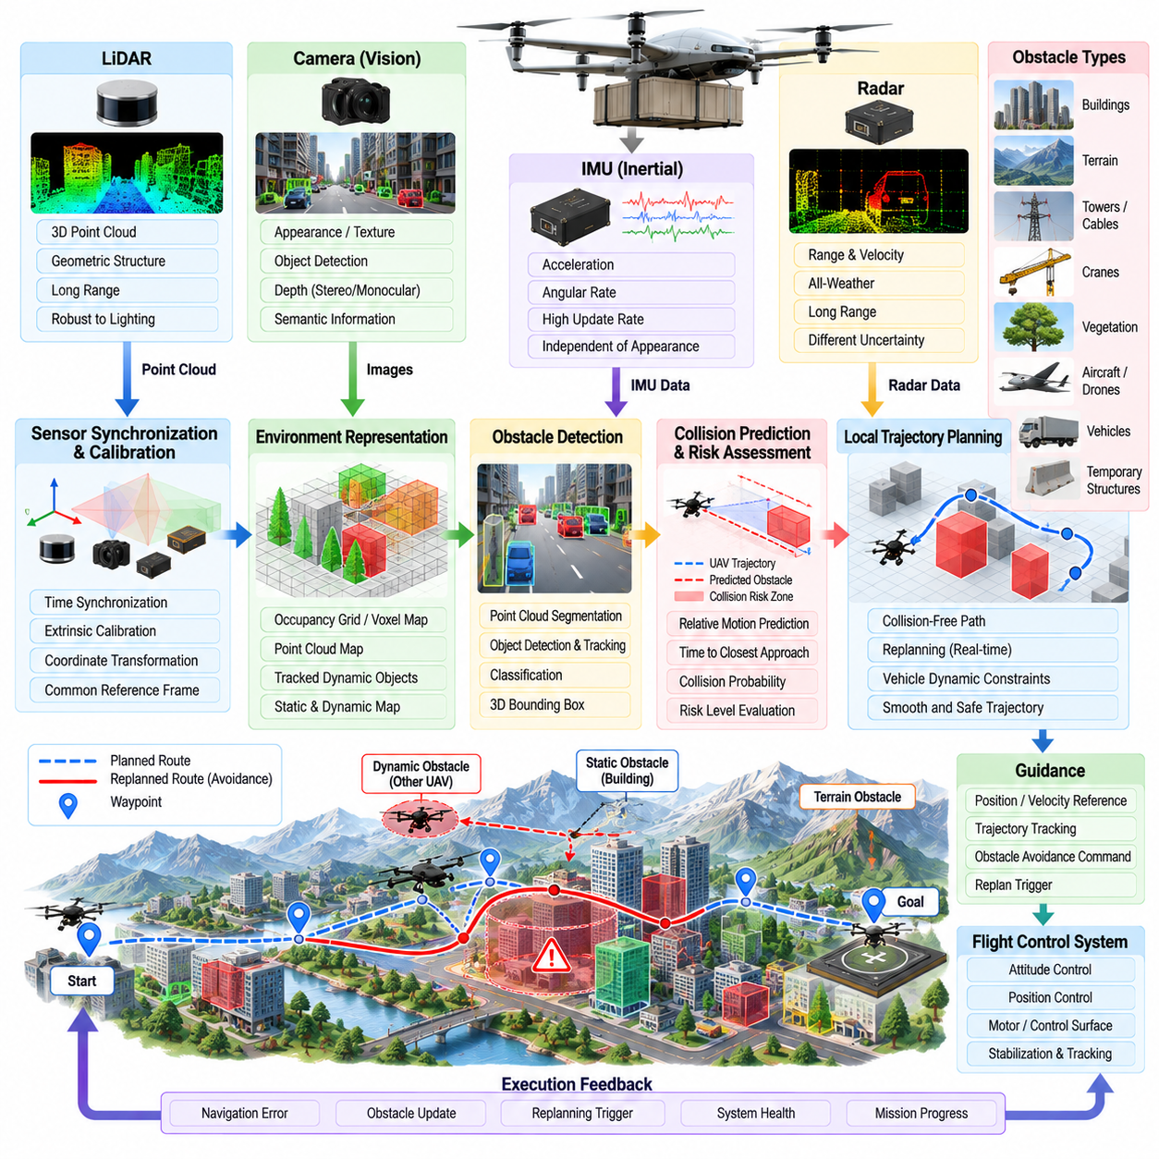
Three-dimensional obstacle detection and avoidance enables a cargo UAV to identify hazardous objects within its surrounding flight volume and modify its trajectory before separation becomes unsafe. Unlike ground navigation, aerial avoidance must reason simultaneously about horizontal and vertical motion. Buildings, terrain, towers, cables, cranes, vegetation, aircraft, drones, and temporary structures can therefore become relevant obstacles depending on altitude, velocity, vehicle dimensions, and mission geometry.
The obstacle-avoidance architecture normally combines perception, state estimation, spatial mapping, collision prediction, local trajectory planning, guidance, and safety supervision. Sensor observations are transformed into a common reference frame and associated with the estimated UAV state. Detected objects are represented within a three-dimensional environmental model, after which the planner evaluates whether the active trajectory intersects occupied or potentially hazardous space.
LiDAR provides direct three-dimensional range measurements and can generate dense geometric information around the aircraft. Point clouds can be filtered, motion-compensated, segmented, and transformed into the navigation frame before obstacle extraction. LiDAR is particularly useful for detecting terrain, buildings, vegetation, and structural surfaces, although range, field of view, weather, reflectivity, scan pattern, and vehicle motion influence the quality of the resulting obstacle representation.
Camera-based perception complements LiDAR by providing appearance, texture, and semantic information. Stereo cameras can estimate depth directly, while monocular cameras may infer depth through motion, learned models, or geometric constraints. Visual processing can identify objects that are difficult to characterize from geometry alone, but performance may degrade under darkness, glare, fog, rain, low contrast, or motion blur. Camera confidence should therefore be considered during sensor fusion.
Radar provides another complementary sensing modality for obstacle detection, particularly when visibility is degraded. It can estimate range and relative velocity and may maintain useful detection capability in conditions that reduce camera or LiDAR performance. Radar measurements generally have different spatial resolution and uncertainty characteristics, so they should not simply be merged as equivalent observations. Fusion logic should preserve the confidence and error properties associated with each sensor.
Sensor measurements must be synchronized and transformed into a consistent coordinate system before reliable three-dimensional fusion is possible. The physical offsets and orientations between LiDAR, cameras, radar, IMU, and the vehicle reference point require accurate extrinsic calibration. Timing errors can create apparent obstacle displacement during fast flight, while incorrect transformations can shift obstacles into false locations. Calibration and timestamp integrity are therefore safety-relevant properties of the avoidance pipeline.
Raw sensor observations are converted into a representation suitable for planning. A three-dimensional occupancy grid, voxel map, point-cloud map, signed-distance representation, or tracked-object list may be used depending on computational resources and operational requirements. Static structures can be maintained within a local map, while dynamic objects require state estimates containing position, velocity, uncertainty, and potentially predicted motion over the planning horizon.
Obstacle detection must account for the physical dimensions of the UAV rather than treating the aircraft as a mathematical point. The occupied region can be expanded by the vehicle footprint, rotor or wing clearance, navigation uncertainty, control-tracking error, and an additional safety margin. This configuration-space treatment allows the planner to evaluate whether the complete aircraft can safely pass through a corridor rather than determining only whether its center position is collision-free.
Collision prediction evaluates how the UAV and detected obstacles may move relative to one another. For static obstacles, the planned trajectory can be tested directly against occupied space. Dynamic objects require prediction of future relative position, time to closest approach, minimum separation, and uncertainty. The avoidance system should consider the entire near-term trajectory because a currently distant obstacle may become critical rapidly when closing velocity is high.
Risk assessment converts geometric conflict information into an operational decision. A detected object should not necessarily trigger an immediate maneuver simply because it appears within sensor range. Distance, relative velocity, predicted collision probability, available maneuver space, navigation confidence, sensor confidence, vehicle dynamics, and mission constraints should influence the response. This reduces unnecessary avoidance while ensuring that high-consequence conflicts are addressed sufficiently early.
Local trajectory planning generates a collision-free modification around obstacles while preserving the mission objective whenever possible. Candidate trajectories can vary horizontally, vertically, or simultaneously in three dimensions. The planner evaluates clearance, smoothness, energy consumption, flight-envelope limits, route deviation, and progress toward the active waypoint. For large cargo UAVs, feasible avoidance must explicitly respect acceleration, climb rate, descent rate, bank angle, and propulsion limitations.
Vertical avoidance can provide an important degree of freedom unavailable to ground vehicles, but it is not always the preferred response. Climbing may violate airspace ceilings or consume significant energy, while descending can reduce terrain clearance or enter populated and obstructed regions. Horizontal deviation may increase route distance or create another conflict. The planner therefore evaluates alternative maneuver directions against the complete set of environmental, vehicle, and regulatory constraints.
Reactive avoidance provides rapid responses to immediate hazards, whereas predictive planning considers a longer trajectory horizon. A practical system may combine both mechanisms. Predictive planning attempts to generate smooth, efficient deviations before a conflict becomes urgent, while a faster reactive layer protects against unexpected objects or perception updates. Safety supervision can override both when the available maneuvering volume becomes insufficient for nominal planning.
Obstacle avoidance must remain coordinated with waypoint-based mission execution. The active waypoint defines the intended mission direction, but the local planner may temporarily depart from the nominal route to maintain separation. Once the obstacle has been cleared, the system determines whether to return to the original route segment, proceed directly toward the active waypoint, or rejoin at a downstream location. Temporary avoidance should not accidentally advance or corrupt the mission sequence.
Geofences and airspace restrictions form virtual obstacles that must be considered together with physically detected objects. An avoidance maneuver that prevents collision but enters prohibited airspace is not acceptable. Likewise, terrain, minimum altitude, maximum altitude, corridor boundaries, and reserved flight volumes constrain the available escape space. The planner should therefore operate on a unified representation of physical obstacles and navigation constraints rather than treating them independently.
Navigation uncertainty directly affects obstacle clearance. If the UAV position is uncertain, an obstacle location expressed in the navigation frame inherits additional uncertainty. Similarly, imperfect perception creates uncertainty in obstacle boundaries and motion. Safety margins can be enlarged according to covariance or integrity estimates so that apparent free space is not treated as precisely known. Degraded navigation may therefore require slower flight or more conservative avoidance behavior.
Sensor degradation must be recognized before it creates unsafe free-space estimates. LiDAR returns may weaken in adverse weather, cameras may lose contrast, radar may generate clutter, and individual sensors may become blocked or fail. Health monitoring should evaluate detection consistency, measurement rate, field-of-view coverage, sensor status, and agreement between modalities. When perception confidence decreases, the system can reduce speed, enlarge safety margins, or transition to a contingency mode.
The relationship between obstacle avoidance and sense-and-avoid is important. Obstacle avoidance primarily protects the UAV from nearby terrain, structures, and detected hazards, while sense-and-avoid also addresses cooperative and non-cooperative airborne traffic and required separation behavior. Some sensors and prediction functions can be shared, but the operational rules and required detection ranges may differ. The architecture should therefore support common perception resources without collapsing the two safety functions into a single undifferentiated process.
Processing latency strongly influences avoidance performance. Sensor acquisition, perception, fusion, prediction, planning, and command generation all consume time while the UAV continues moving. At higher speed, even modest latency can substantially reduce remaining maneuver distance. The system must therefore account for end-to-end delay when determining detection range and safety margins, and computationally expensive algorithms must remain bounded under worst-case environmental complexity.
Fail-safe behavior is required when no collision-free trajectory can be identified. Depending on aircraft configuration and surrounding conditions, the UAV may decelerate, hover, climb, descend, execute an emergency turn, retreat along a known safe path, or transition toward a contingency landing location. The selected response should minimize overall risk rather than merely minimize distance to the original route. Mission completion becomes secondary when safe separation cannot be maintained.
Validation should expose the avoidance system to diverse static and dynamic scenarios. Simulation can systematically vary obstacle geometry, closing speed, sensor noise, navigation uncertainty, weather effects, route constraints, and vehicle dynamics. Software-in-the-loop and hardware-in-the-loop testing can evaluate timing and interfaces, while controlled flight tests verify real sensor behavior. Testing should include missed detections, false detections, delayed measurements, sensor failures, and situations with limited escape space.
Three-dimensional obstacle detection and avoidance ultimately provides the tactical safety layer that allows waypoint-based cargo UAV navigation to operate in realistic environments. Reliable performance requires more than detecting nearby objects; the system must understand free space, predict conflicts, respect aircraft dynamics and airspace constraints, manage uncertainty, and generate timely feasible maneuvers. Integrated with navigation, perception, guidance, and safety supervision, it enables autonomous flight to continue while preserving safe separation from surrounding hazards.

04.06. Sense and Avoid SAA System Design [w/Code]
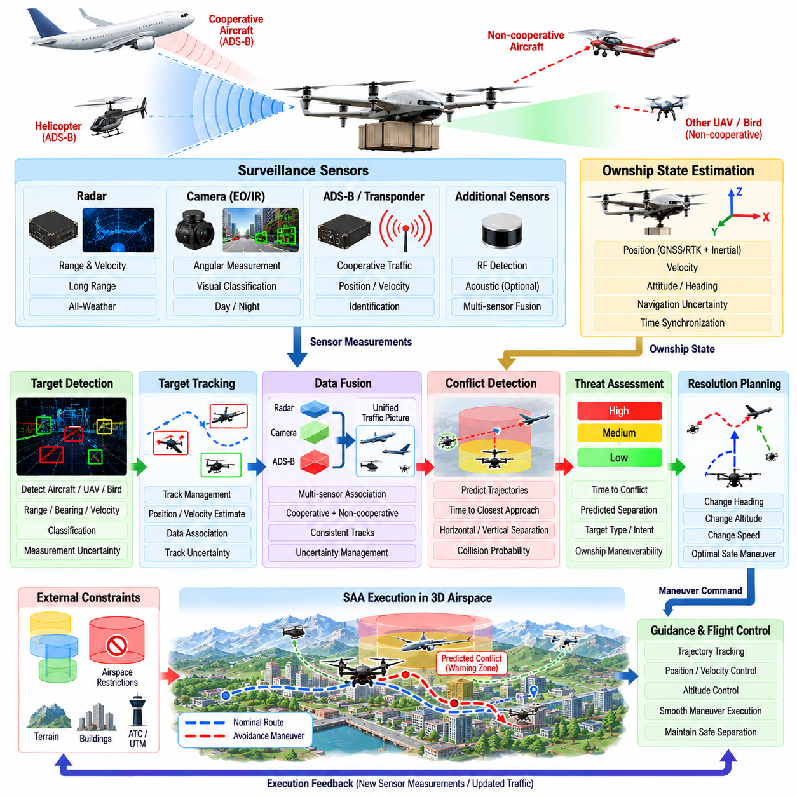
Sense-and-Avoid (SAA) provides an autonomous UAV with the capability to detect potential airborne conflicts, evaluate collision risk, and execute an appropriate maneuver before required separation is lost. For cargo UAVs operating beyond visual line of sight or through shared airspace, SAA extends conventional obstacle avoidance from nearby physical hazards toward systematic management of cooperative and non-cooperative air traffic.
An SAA architecture is normally organized around surveillance sensing, target detection, tracking, data fusion, conflict detection, threat assessment, resolution planning, guidance, and safety supervision. These functions operate continuously while the UAV follows its mission trajectory. The objective is not simply to detect another aircraft, but to determine whether its predicted motion creates a future conflict and whether a safe resolution remains available.
Cooperative surveillance obtains information from aircraft that actively broadcast their identity or flight state through compatible systems. Depending on the operational environment, these reports may provide position, altitude, velocity, heading, identification, and other traffic information. Cooperative data can support relatively long-range awareness, but SAA cannot rely exclusively on it because some aircraft, drones, birds, or other airborne hazards may not transmit usable information.
Non-cooperative detection therefore uses onboard sensors to observe targets independently of external transmissions. Radar is particularly valuable because it can measure range and relative velocity over significant distances and may operate under visibility conditions that degrade optical sensors. Cameras can provide angular measurements, visual classification, and target confirmation, while other sensing modalities may supplement the system according to vehicle configuration and operational requirements.
The surveillance system must provide sufficient field of regard, detection range, update rate, and measurement accuracy for the UAV's operating speed and maneuverability. A target detected too late may leave insufficient distance for a large cargo aircraft to perform a safe avoidance maneuver. Sensor requirements should therefore be derived from closing speed, processing latency, tracking uncertainty, aircraft response time, required separation, and achievable maneuver performance.
Target tracking converts intermittent sensor detections into persistent estimates of surrounding traffic. A tracker estimates target position, velocity, acceleration where appropriate, and associated uncertainty over time. Data association determines whether new measurements correspond to existing tracks or represent new objects. Reliable association becomes especially important when several aircraft or other targets occupy the surveillance volume simultaneously.
Multi-sensor fusion combines cooperative reports and non-cooperative observations into a consistent traffic picture. Radar range and velocity, camera bearing information, broadcast traffic states, and the UAV's own navigation estimate may contribute different constraints. Fusion logic must preserve measurement uncertainty and timing rather than assuming all sources have equivalent accuracy. Duplicate reports describing the same aircraft should also be recognized to prevent creation of false independent threats.
Accurate ownship state estimation is fundamental to SAA because collision risk is determined from relative motion. Errors in the UAV's position, velocity, heading, or timing directly affect predicted separation from traffic. GNSS/RTK may provide the primary global reference, while inertial and alternative navigation sources maintain continuity during degradation. SAA should consume navigation-integrity information so that uncertainty in ownship position is reflected in conflict assessment.
Conflict detection predicts whether the current trajectories of ownship and traffic will violate defined separation criteria. Relative position and velocity can be propagated forward to estimate time to closest approach, horizontal separation, vertical separation, and collision probability. More advanced prediction can incorporate maneuver uncertainty and trajectory intent. Conflict detection should operate over a sufficiently long horizon to support smooth strategic resolution before emergency maneuvering becomes necessary.
Threat assessment determines the urgency and severity of a detected conflict. A nearby aircraft is not necessarily dangerous if relative motion increases separation, while a distant aircraft can become critical when closing speed is high. Time to conflict, predicted minimum separation, uncertainty, target classification, maneuverability, airspace constraints, and ownship performance can therefore contribute to a graded threat level used by the resolution system.
Resolution planning determines how the cargo UAV should alter its trajectory to restore safe separation. Candidate responses may include changes in heading, altitude, vertical rate, speed, or combinations of these variables. The selected maneuver should provide adequate separation while respecting the UAV's flight envelope, energy state, payload condition, terrain clearance, geofences, surrounding traffic, and mission constraints. Avoiding one conflict must not create another.
Strategic and tactical resolution can operate at different time horizons. Strategic conflict management modifies the planned trajectory early when sufficient information and maneuvering space are available. Tactical SAA responds to more immediate threats requiring faster decisions. An emergency collision-avoidance layer may provide a final protective response when nominal resolution is no longer adequate. Clear priority rules are required so that simultaneous planning layers do not issue contradictory commands.
SAA resolution should interface with guidance rather than directly controlling motors, actuators, or control surfaces. The resolution function generates an approved avoidance trajectory or modified navigation reference, which the guidance and flight-control systems execute within the aircraft's dynamic limits. This separation preserves the architecture boundary between traffic reasoning and vehicle stabilization while allowing the flight controller to maintain deterministic high-rate control.
Cargo UAV dynamics strongly influence SAA design. A heavy aircraft may require substantially more distance to turn, climb, descend, or decelerate than a small multirotor. Payload mass and center-of-gravity variation can further change achievable maneuver performance. Conflict detection and resolution logic should therefore use realistic vehicle-specific dynamic envelopes instead of assuming that any geometrically available escape direction can be executed safely.
SAA must remain coordinated with waypoint mission execution and route planning. An avoidance maneuver temporarily has higher priority than the nominal waypoint trajectory, but the mission should remain recoverable after the conflict is cleared. The navigation system can determine whether to rejoin the original route, proceed toward a later waypoint, or request route replanning. The mission executor should not interpret temporary SAA deviations as unintended waypoint completion.
Airspace constraints remain active during collision avoidance. A maneuver that increases aircraft separation but violates a prohibited volume, terrain-clearance requirement, or altitude restriction may create a different hazard. Resolution planning must therefore evaluate traffic conflicts together with geofences, terrain, weather, corridor boundaries, and other operational restrictions. Available maneuver space can become substantially smaller than the apparent geometric free space surrounding the UAV.
Uncertainty management is central to reliable SAA operation. Traffic tracks contain errors in position, velocity, classification, and future-motion prediction, while ownship navigation also has finite uncertainty. Safety volumes and predicted separation should therefore account for covariance or equivalent integrity information. As uncertainty increases, the system may require larger separation margins, earlier resolution, reduced speed, or more conservative assumptions about target behavior.
False alarms and missed detections create competing design risks. Excessive false alerts can produce unnecessary deviations, increase energy consumption, disrupt traffic flow, and reduce operator confidence. Missed or delayed detections can eliminate the time needed for safe avoidance. Detection thresholds, track confirmation logic, sensor diversity, and threat filtering must therefore balance sensitivity against operational stability without suppressing legitimate high-consequence threats.
Sensor or communication degradation should lead to explicitly defined SAA behavior. Loss of cooperative traffic information may increase reliance on onboard radar and vision, while degradation of non-cooperative sensors can reduce confidence in surrounding free airspace. Depending on mission rules and remaining capability, the UAV may reduce speed, increase separation margins, leave complex airspace, hold, return, divert, or land rather than continue with inadequate surveillance performance.
The relationship between SAA and three-dimensional obstacle avoidance should remain clearly defined. Obstacle avoidance primarily handles terrain, buildings, infrastructure, and nearby hazards, whereas SAA emphasizes airborne traffic and separation assurance. Both functions can share sensors, tracking components, spatial representations, and trajectory-planning resources, but their detection horizons, operational rules, threat models, and validation criteria may differ significantly.
End-to-end latency is a critical SAA design parameter. Sensor acquisition, communication, detection, tracking, fusion, conflict prediction, resolution planning, guidance, and aircraft response all consume part of the available avoidance time. The safety analysis must therefore consider the complete processing and actuation chain rather than only sensor detection range. Worst-case computational delay is particularly important when several simultaneous targets increase tracking and planning workload.
Validation should include cooperative traffic, non-cooperative aircraft, crossing encounters, head-on approaches, overtaking situations, climbing and descending traffic, multiple simultaneous targets, sensor degradation, navigation uncertainty, communication loss, and constrained maneuver space. Simulation can explore large encounter sets, while software-in-the-loop, hardware-in-the-loop, sensor replay, and controlled flight testing progressively verify timing, interfaces, tracking, resolution logic, and aircraft response.
Sense-and-Avoid ultimately provides the traffic-separation safety layer required for increasingly autonomous cargo UAV operations in shared airspace. A dependable system must integrate surveillance, tracking, sensor fusion, navigation integrity, conflict prediction, threat assessment, dynamically feasible resolution, and contingency behavior. Combined with obstacle avoidance, waypoint execution, and flight-control supervision, SAA allows the UAV to pursue its mission while continuously protecting separation from surrounding airborne traffic.

04.07. Auto Takeoff and Landing AT AL Controller [w/Code]
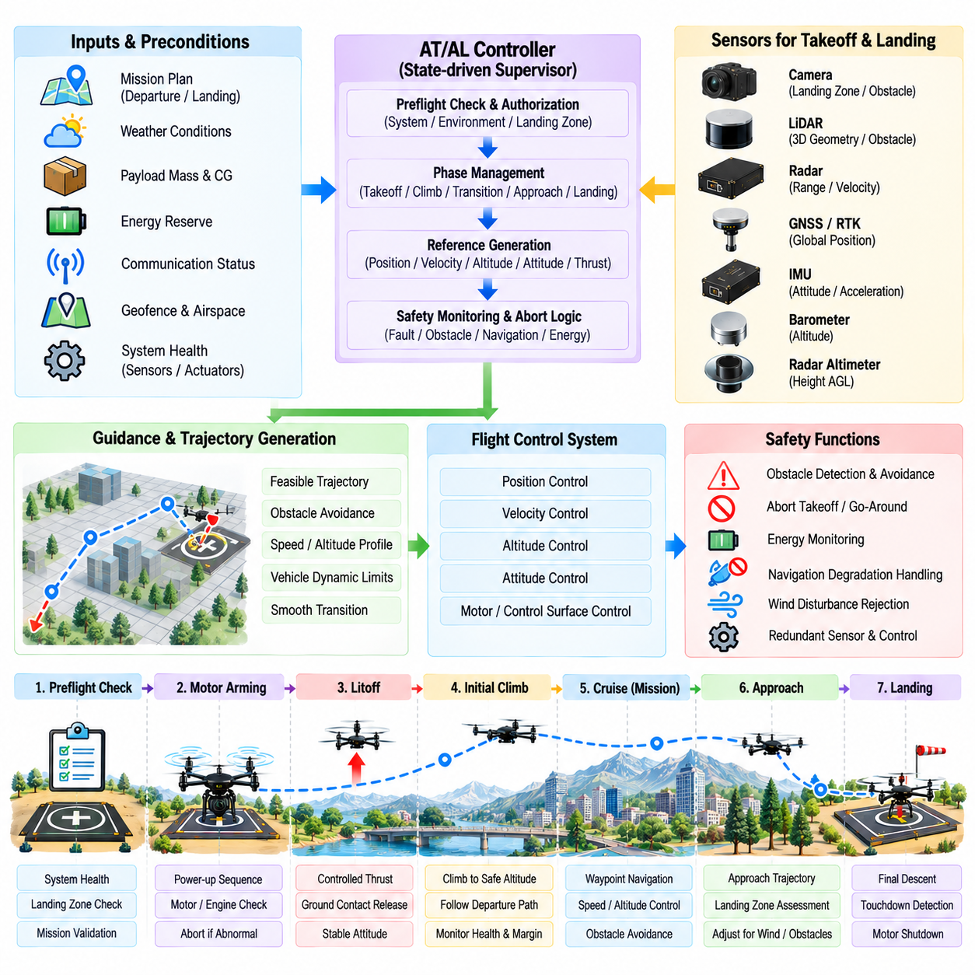
Automatic Takeoff and Landing (AT/AL) control provides the autonomous transition between ground operation and stable airborne flight without requiring continuous pilot input. For cargo UAVs, these phases are especially safety-critical because propulsion demand, ground proximity, aerodynamic effects, payload mass, and limited maneuvering space interact simultaneously. The controller must coordinate navigation, guidance, flight control, sensing, and safety supervision throughout both operations.
The AT/AL controller is normally implemented as a state-driven supervisory function rather than a single control loop. It manages a sequence of operational phases and supplies appropriate references to lower-level position, velocity, altitude, attitude, and propulsion controllers. This architecture preserves separation between mission logic and stabilization while allowing takeoff and landing procedures to enforce phase-specific limits, sensor requirements, and abort conditions.
Automatic takeoff begins with a preflight readiness assessment. The system verifies navigation validity, IMU and altitude-sensor health, propulsion availability, actuator status, energy reserve, communication state, payload configuration, and flight-control readiness. Geofence status and the planned departure trajectory are also checked. Takeoff authorization should be withheld whenever a required subsystem cannot demonstrate sufficient integrity for the intended autonomous operation.
The takeoff area must be evaluated before propulsion is committed to flight. Depending on the vehicle and sensor configuration, the system can confirm local obstacle clearance, terrain geometry, departure direction, and available vertical or forward escape space. For heavy cargo UAVs, the controller should also consider rotor or wing clearance and nearby structures because downwash, ground personnel, equipment, and confined infrastructure can influence safe departure conditions.
After authorization, propulsion is initialized through a controlled arming and power-up sequence. Motor or engine states are monitored to confirm that commanded thrust can be generated consistently before liftoff. Abnormal rotational speed, temperature, current, vibration, actuator response, or propulsion asymmetry can cause the sequence to stop before the aircraft leaves the ground. Detecting such faults before liftoff is generally safer than attempting recovery after becoming airborne.
The liftoff phase transitions the aircraft from ground contact to free flight. Thrust should increase smoothly to avoid abrupt vertical acceleration, payload movement, structural loading, or attitude disturbance. Ground-contact logic may use altitude, vertical acceleration, landing-gear state, weight-on-support information, or combinations of these observations. Once liftoff is confirmed, the controller transitions from ground constraints toward normal airborne position and attitude stabilization.
Initial climb establishes a safe separation from the takeoff surface before the mission trajectory begins. The UAV can follow a predefined vertical or combined vertical-horizontal profile while maintaining limits on climb rate, acceleration, attitude, and lateral deviation. During this phase, the controller monitors propulsion margin and navigation quality closely because a failure near the ground leaves limited recovery time and maneuvering space.
Cargo mass and center-of-gravity variation directly affect automatic takeoff performance. A heavier payload increases required thrust and can reduce climb margin, while an offset center of gravity changes actuator or rotor loading. The controller should therefore use validated mass and balance information when selecting takeoff acceleration, climb rate, attitude limits, and propulsion reserve. A profile suitable for an unloaded aircraft may not be appropriate at maximum cargo weight.
Once the UAV reaches the defined takeoff completion conditions, the AT controller hands mission authority to the normal navigation and waypoint-execution functions. Completion may require minimum altitude, stable vertical speed, acceptable position error, valid navigation, and confirmation that the aircraft has entered the departure corridor. The transition should be smooth so that changing supervisory modes does not create discontinuities in position, velocity, attitude, or thrust commands.
Automatic landing begins before the aircraft reaches the touchdown point. The mission system transitions from cruise or waypoint navigation into an approach state after validating the landing destination, navigation quality, remaining energy, weather constraints, and landing-system availability. The approach trajectory must respect vehicle dynamics, terrain clearance, surrounding obstacles, airspace restrictions, and the geometry of the selected landing area.
Landing-zone assessment determines whether the intended touchdown region remains usable. Cameras, LiDAR, radar, maps, or externally supplied information may contribute to detecting obstacles, surface geometry, unexpected vehicles, personnel, or other hazards. The landing controller should not assume that a previously approved location remains clear. If landing-zone confidence falls below the required threshold, the approach can be suspended or redirected toward an alternative site.
The approach phase guides the UAV from mission altitude toward a stabilized terminal condition. Position, velocity, heading, altitude, and descent rate are progressively constrained as the aircraft approaches the landing point. Large corrections should be completed early because aggressive maneuvering near the ground increases risk. The controller therefore attempts to establish a stable approach before entering the final descent region.
Altitude estimation during landing should use complementary sensing because different sensors provide different references and failure characteristics. GNSS or RTK may provide global altitude and horizontal position, while barometric sensing supports smooth vertical estimation. Radar altimeters or LiDAR can provide direct height above the local surface. Combining these measurements helps distinguish absolute altitude from actual ground clearance during terminal descent.
Precision positioning becomes increasingly important near touchdown. RTK-GNSS may support highly repeatable landings in open environments, while visual markers, LiDAR geometry, or other relative-navigation methods can refine the position of the landing target. The controller should monitor both the estimated landing error and its uncertainty. High apparent accuracy is insufficient if navigation integrity or sensor confidence has degraded.
Final descent reduces altitude while maintaining tight control of horizontal position, vertical velocity, attitude, and heading. Descent speed is normally reduced as ground distance decreases so that the aircraft can arrest motion without excessive touchdown energy. Disturbance rejection remains important because gusts, ground effect, downwash interaction, or payload dynamics can displace the UAV during the final seconds of flight.
Ground effect and near-surface aerodynamic behavior can change the relationship between commanded propulsion and vertical motion. Large rotorcraft may experience significant variations in lift as they approach the surface, while uneven terrain or nearby structures can produce complex airflow. The controller should therefore rely on measured vertical motion and altitude feedback rather than assuming that a fixed thrust command will produce the same descent behavior throughout landing.
Touchdown detection determines when the vehicle has transitioned from flight to ground support. The logic may combine low altitude, low vertical velocity, acceleration response, landing-gear sensors, propulsion behavior, or weight-on-support measurements. False touchdown detection can reduce thrust while the aircraft is still airborne, whereas delayed detection can cause unnecessary propulsion after contact. Multiple consistent indicators can improve robustness.
After touchdown, the controller transitions through stabilization, propulsion reduction, disarming, and post-landing verification. The aircraft should confirm that it is securely supported and not drifting, tipping, or bouncing before propulsion is fully disabled. Cargo handling should remain inhibited until the landing state, propulsion state, vehicle attitude, and relevant ground-system conditions indicate that loading or unloading operations can safely begin.
Abort and go-around capability is fundamental to autonomous landing. Navigation degradation, obstacle detection, excessive position error, unstable descent, propulsion anomalies, strong disturbances, or loss of landing-zone confidence can trigger termination of the approach. If sufficient flight capability remains, the UAV climbs or transitions to a predefined escape trajectory before holding, attempting another approach, selecting an alternate site, or executing contingency logic.
Automatic takeoff requires equivalent abort logic. Before liftoff, an abnormal condition can normally result in propulsion shutdown and mission cancellation. Immediately after liftoff, however, the safest response may depend on altitude, vehicle state, available thrust, and surrounding obstacles. The controller must distinguish between conditions that justify immediate landing, controlled climb, return to the departure point, or transition to an emergency landing procedure.
AT/AL operation must remain integrated with obstacle avoidance and Sense-and-Avoid (SAA). A clear landing pad does not guarantee a clear approach volume, and a valid takeoff point does not guarantee that the departure corridor is free of hazards or traffic. Local obstacle perception and airborne traffic monitoring therefore remain active during terminal operations, with safety functions able to interrupt the nominal takeoff or landing sequence.
Wind and weather can significantly affect terminal flight. Crosswind, gusts, precipitation, reduced visibility, and rapidly changing local airflow may exceed the validated limits of the automatic landing system. The controller should use available environmental estimates together with measured tracking performance rather than relying only on preflight weather information. Persistent inability to maintain approach tolerances should trigger a go-around or alternate landing strategy.
Validation of AT/AL control must exercise complete sequences and phase transitions rather than testing only individual altitude or position loops. Simulation, software-in-the-loop, hardware-in-the-loop, ground testing, tethered testing where appropriate, and progressive flight trials can evaluate sensor failures, propulsion anomalies, navigation degradation, wind disturbances, overweight conditions, landing-zone obstruction, aborted takeoffs, and go-around behavior.
Automatic Takeoff and Landing ultimately forms the terminal-flight execution layer connecting cargo mission management with navigation and flight control. Reliable AT/AL requires state-based sequencing, precise navigation, smooth trajectory generation, payload-aware control limits, landing-zone assessment, robust touchdown detection, and explicit abort logic. When these functions are integrated with safety supervision, the cargo UAV can transition between ground and airborne operation while maintaining predictable autonomous behavior.

04.08. Precision Landing on Moving Platform [w/Code]
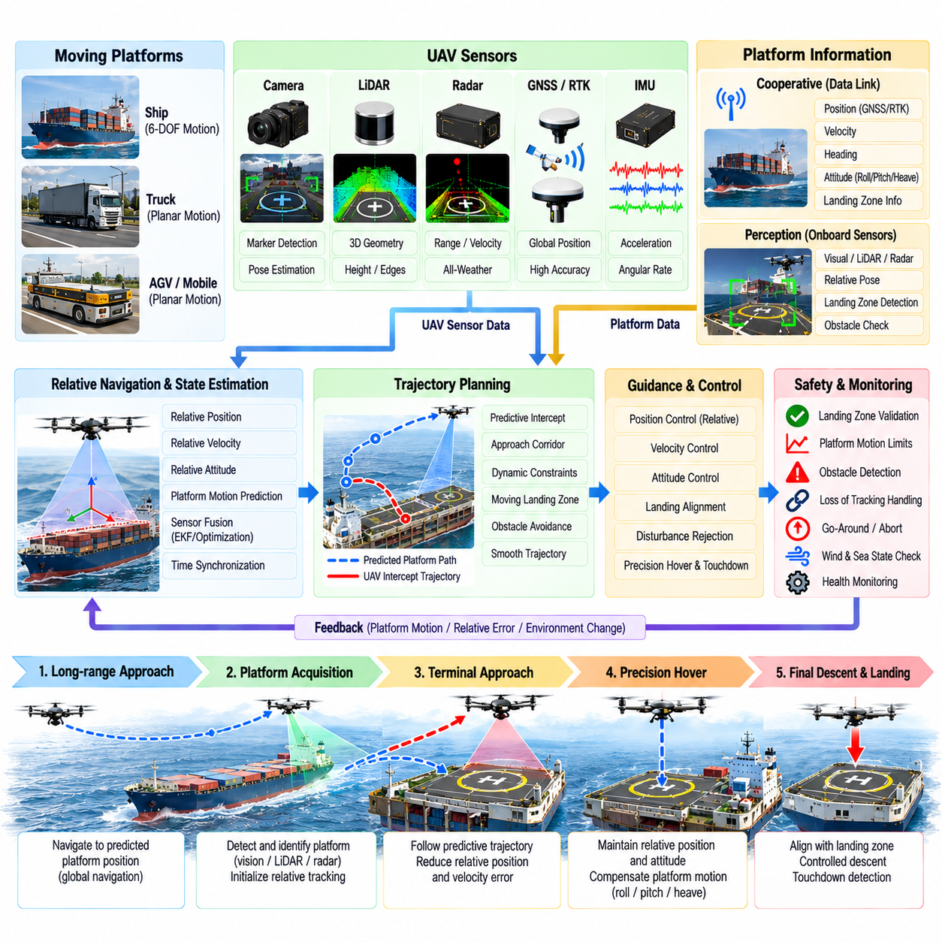
Precision landing on a moving platform requires a cargo UAV to estimate, predict, and continuously follow a landing surface whose position, velocity, heading, and attitude may change throughout the approach. Unlike landing on a fixed pad, the target cannot be represented as a stationary coordinate. The guidance system must control the aircraft relative to the platform while both vehicles continue moving within a shared dynamic reference frame.
Typical moving platforms include ships, trucks, autonomous ground vehicles, mobile logistics systems, and other transport assets. Each platform produces different motion characteristics. A road vehicle may generate rapid changes in speed and heading, while a ship introduces translation together with roll, pitch, and heave. The landing architecture must therefore represent platform motion with sufficient degrees of freedom for the intended operational environment.
The landing process begins with platform acquisition and identification. Cooperative platforms can transmit GNSS position, velocity, heading, motion state, and landing-zone information through a communication link. Onboard cameras, LiDAR, radar, or other sensors can then detect the platform independently or refine its relative location. Combining cooperative information with onboard perception reduces dependence on either communications or a single sensing modality.
Relative navigation is the central requirement for moving-platform landing. Instead of controlling only toward an Earth-fixed destination, the UAV estimates the relative position, velocity, and orientation between itself and the landing surface. The navigation solution may combine UAV GNSS/RTK, platform GNSS/RTK, inertial measurements, visual markers, LiDAR geometry, radar observations, and platform telemetry to maintain a continuously updated relative state.
Differential GNSS or RTK can provide an accurate global relationship when both the UAV and platform have high-quality satellite visibility. However, independent GNSS errors, communication delays, multipath, and platform motion can still influence terminal accuracy. Relative visual or ranging sensors therefore become increasingly important during the final approach, where the controller requires precise knowledge of the landing pad rather than only the global coordinates of the platform.
Vision-based landing can use fiducial markers, geometric patterns, natural features, or learned object detection to identify the landing region. Image observations provide bearing, orientation, and potentially relative pose information as the UAV approaches. Marker size and camera resolution should support detection across the required altitude range. Illumination, glare, sea reflections, shadows, motion blur, precipitation, and partial occlusion must be considered when determining visual confidence.
LiDAR and radar can complement vision by directly measuring geometric range. LiDAR may estimate the landing-surface plane, relative height, platform edges, and nearby obstacles, while radar can provide useful range and relative-motion information under degraded visibility. The fusion architecture should preserve the different uncertainty characteristics of each sensor so that temporary degradation of one modality does not cause unstable relative-state estimation.
Time synchronization is particularly important because both the UAV and landing platform are moving. A delayed platform position or an incorrectly timestamped camera observation represents the target at a previous location. At significant relative velocity, even modest latency can create substantial apparent landing error. Sensor timestamps, platform telemetry, communication delay, estimator processing time, and actuator response should therefore be included in the end-to-end timing model.
Platform-state prediction compensates for unavoidable measurement and control latency. The estimator can propagate the measured platform position, velocity, heading, and attitude forward to the expected command-execution time. For vehicles with predictable motion, short-horizon models can provide effective compensation. Highly irregular motion requires greater uncertainty margins because aggressive prediction may become less reliable than the original measurement.
The approach should be organized into progressively tighter relative-navigation phases. At long range, the UAV can navigate toward the predicted platform location using global navigation information. During acquisition, onboard sensors confirm the platform and establish relative tracking. The terminal approach then reduces relative position and velocity error, while final descent begins only after the aircraft has achieved a sufficiently stable relationship with the landing zone.
Trajectory planning must account for where the platform will be rather than where it is currently located. The intercept point depends on platform velocity, UAV velocity, approach geometry, wind, vehicle dynamics, and expected time of arrival. A planner that continuously chases the instantaneous platform coordinate can produce inefficient or oscillatory motion. Predictive interception instead creates a trajectory toward a future platform state that remains dynamically achievable.
Velocity matching is a defining element of moving-platform landing. Before final descent, the UAV should reduce relative horizontal velocity with respect to the landing surface even though both may still be moving rapidly relative to Earth. The controller therefore distinguishes ground-referenced velocity from platform-relative velocity. Touchdown becomes practical when relative motion is sufficiently small to remain within landing-gear, structural, and control limits.
For a translating platform, matching position and velocity may be sufficient for initial alignment, but a rotating or marine platform requires additional attitude awareness. Ship decks can experience roll, pitch, yaw, and vertical heave, causing the landing surface normal and height to change continuously. The UAV must determine whether the instantaneous deck state lies within validated touchdown limits and may delay descent while waiting for a more favorable motion phase.
A landing reference frame attached to the platform simplifies terminal guidance. The origin can be defined at the desired touchdown point, with axes aligned to the platform heading and landing surface. UAV position and velocity are transformed into this moving frame, allowing the guidance system to regulate longitudinal, lateral, vertical, and heading errors directly relative to the target. This representation also separates platform motion from true landing error.
Final descent should begin only when relative tracking quality, position error, velocity error, heading alignment, platform motion, and available control authority satisfy predefined conditions. The descent profile becomes progressively more conservative near the surface. If lateral or velocity errors increase beyond limits, the controller can stop descending, climb slightly, or transition to a go-around rather than attempting to force touchdown from an unstable state.
Wind creates additional complexity because the UAV may need to maintain aerodynamic compensation while simultaneously matching the platform's ground motion. A moving ship or vehicle can also generate local airflow and turbulence that differ from ambient wind. Guidance and control should therefore use measured tracking performance and available disturbance estimates rather than assuming that matching platform velocity automatically produces a stable aerodynamic condition.
Obstacle clearance must remain active throughout the approach. A moving platform may contain antennas, cranes, containers, vehicle structures, personnel, or other temporary obstacles near the landing zone. The approach corridor itself may also change as the platform turns or moves through the environment. Three-dimensional obstacle perception should therefore be evaluated relative to both the UAV trajectory and the predicted future pose of the platform.
Communication between the platform and UAV can improve coordination but should be treated as a monitored resource. The platform may transmit intended speed changes, heading commands, landing authorization, deck availability, or motion estimates. Loss or excessive delay of this information should be detected explicitly. Depending on onboard sensing capability, the UAV may continue relative tracking, hold nearby, abort the approach, or transition to another landing strategy.
Touchdown timing is critical when the landing surface has significant vertical or angular motion. The controller should avoid contact when relative vertical velocity, deck inclination, or rotational rate exceeds validated limits. Prediction can identify a short future interval in which the platform motion is favorable for touchdown. The UAV can regulate height above the deck while waiting for this landing window instead of descending according to a fixed Earth-referenced altitude profile.
Touchdown detection must distinguish true mechanical support from temporary proximity to a moving surface. Relative altitude, vertical velocity, acceleration response, landing-gear sensors, propulsion behavior, and weight-on-support measurements can provide complementary evidence. After contact, the controller should prevent premature propulsion reduction if platform motion causes bouncing or incomplete support and should verify that the aircraft remains stable relative to the deck.
Post-touchdown stabilization may require additional functions that are unnecessary on a fixed landing pad. The aircraft can remain exposed to platform acceleration, ship motion, wind, or vibration after landing. Propulsion reduction and disarming should therefore occur only after secure support has been confirmed. Depending on vehicle design, mechanical retention, wheel braking, deck locking, or other securing mechanisms may be coordinated before cargo operations begin.
Abort and go-around logic is essential because the target itself can leave the valid landing envelope. Excessive platform acceleration, loss of tracking, communication failure, unstable deck motion, obstacle intrusion, insufficient control margin, or excessive relative velocity can terminate the approach. The UAV should transition to a predefined escape trajectory that avoids both the platform and surrounding structures before deciding whether to hold, retry, divert, or land elsewhere.
Validation must reproduce realistic coupled motion between the UAV and platform. Simulation can vary platform speed, acceleration, turning rate, ship motion, wind, sensor noise, communication delay, navigation uncertainty, and landing-zone obstruction. Software-in-the-loop, hardware-in-the-loop, moving-target ground tests, and progressively controlled flight trials can verify acquisition, prediction, relative guidance, touchdown timing, abort behavior, and post-contact stability.
Precision landing on a moving platform ultimately extends automatic landing from fixed-position control into dynamic relative-motion coordination. Reliable performance requires accurate platform tracking, multi-sensor relative navigation, latency compensation, future-state prediction, velocity matching, moving-frame guidance, obstacle awareness, and robust abort logic. By integrating these functions with the AT/AL controller and flight-safety architecture, a cargo UAV can autonomously recover onto mobile logistics platforms while maintaining controlled terminal-flight behavior.

04.09. Return to Home and Emergency Landing [w/Code]
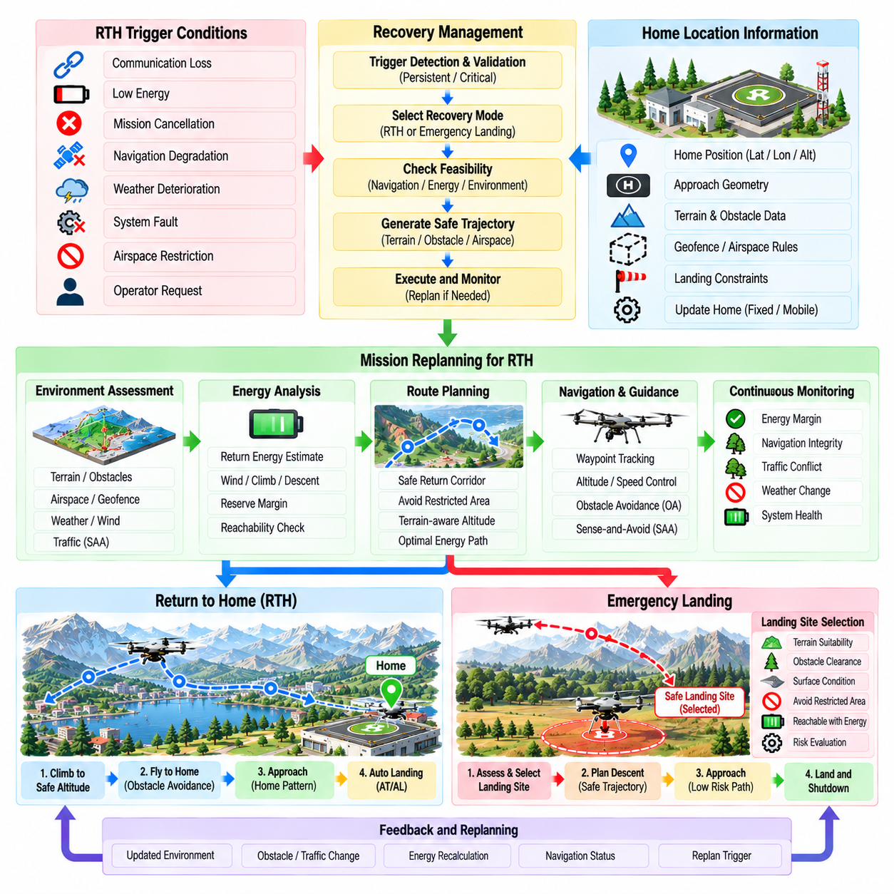
Return-to-Home (RTH) and emergency landing functions provide autonomous recovery mechanisms when a cargo UAV can no longer continue its nominal mission safely. RTH attempts to return the aircraft to a predefined recovery location, while emergency landing selects or executes a safer landing option when continued flight or return is impractical. Both functions belong to the safety-supervision layer and must override normal mission objectives when predefined risk thresholds are exceeded.
RTH can be triggered by command-and-control link loss, low remaining energy, mission cancellation, navigation degradation, weather deterioration, system faults, airspace restrictions, or an explicit operator request. Trigger logic should distinguish transient disturbances from persistent failures so that short communication interruptions or temporary sensor anomalies do not cause unnecessary mission termination. Critical failures, however, must initiate recovery without depending on ground confirmation.
The home location must be established and validated before departure. It can represent the original takeoff point, a designated recovery pad, a logistics hub, or another approved landing site. The system should store position, altitude reference, approach geometry, landing constraints, and relevant geofence information. For mobile operations, the recovery destination may also be updated during flight if the authorized home platform changes location.
Activating RTH should not simply command a straight-line flight toward the home coordinate. The recovery planner must consider terrain, obstacles, geofences, airspace restrictions, weather, traffic, vehicle performance, and remaining energy. A direct route may cross unsafe or prohibited regions. The system therefore generates or selects a validated return trajectory that maintains required clearance while minimizing recovery risk and unnecessary energy consumption.
RTH altitude management is particularly important because the UAV may need to clear terrain and structures before beginning the return segment. A fixed return altitude can be useful in simple environments but may be inefficient or unsafe across varied terrain. Terrain-aware planning can select a vertical profile that satisfies minimum clearance, maximum altitude, airspace constraints, climb capability, and available energy while avoiding unnecessary altitude changes.
Energy feasibility must be evaluated before committing to the home destination. The system estimates energy required for the return route, expected wind, climb and descent, reserve requirements, payload mass, and terminal landing operation. If the predicted energy margin is insufficient, continuing toward home may create greater risk than selecting a closer alternate site. RTH therefore requires continuous reachability assessment rather than assuming that the original departure point remains recoverable.
Communication loss is a common reason for autonomous RTH. When the command-and-control link becomes unavailable, the UAV can continue monitoring navigation, propulsion, energy, obstacle perception, and flight safety independently. A configurable delay may allow short link interruptions to recover before RTH begins. Once recovery is initiated, restoration of communications should not automatically cancel the procedure unless mission policy and system state permit a safe transition.
Navigation integrity determines whether conventional RTH remains possible. With valid GNSS/RTK, the UAV can navigate toward a globally referenced home position. During GNSS degradation, inertial, visual, LiDAR, terrain-relative, or previously mapped navigation may provide limited recovery capability. If global position uncertainty becomes too large to guarantee a safe return corridor, the system should avoid blindly flying toward an uncertain home coordinate and instead transition to an appropriate contingency strategy.
Obstacle detection and avoidance remain active throughout RTH. The return route may encounter temporary cranes, vehicles, vegetation, infrastructure, terrain, or other obstacles that were not present during departure. Local avoidance can modify the immediate trajectory while preserving the recovery objective. If an obstacle blocks the return corridor completely, the planner may select another route, hold temporarily, or determine that an alternate landing site provides a safer outcome.
Sense-and-Avoid (SAA) must also remain available during autonomous recovery through shared airspace. RTH does not grant priority over surrounding aircraft and should not cause the UAV to ignore separation requirements. Traffic conflicts can temporarily modify the recovery trajectory, altitude, or speed. Once separation is restored, the UAV can resume the return path provided that the resulting energy and navigation margins remain acceptable.
As the aircraft approaches home, the recovery function transitions from route navigation into the normal automatic landing sequence. The system verifies landing-zone availability, navigation quality, obstacle clearance, environmental conditions, and terminal guidance capability before committing to final descent. If the home landing area is obstructed or unavailable, the UAV should retain sufficient reserve to hold, execute a go-around, or transition to an approved alternate site.
Emergency landing becomes necessary when the aircraft cannot safely complete normal RTH or when continued flight increases risk. Potential triggers include critical energy depletion, severe propulsion degradation, loss of essential sensors, uncontrollable navigation uncertainty, structural anomalies, extreme weather, or multiple simultaneous subsystem failures. The objective changes from mission recovery to minimizing the consequences of an unavoidable or strongly preferred landing.
Emergency landing-site selection evaluates candidate areas according to reachability and landing risk. Relevant factors can include distance, terrain slope, surface condition, obstacle density, available area, population exposure, approach geometry, wind, vehicle capability, and remaining energy. Predefined emergency sites can simplify this process, while onboard perception and mapping may be required when the UAV must identify a suitable location dynamically.
A candidate landing site must be reachable within the degraded aircraft's actual performance envelope. A propulsion fault may reduce climb capability or maximum controllable speed, while low energy may sharply limit remaining flight time. The planner should therefore use current degraded performance rather than nominal vehicle specifications. The safest site is not necessarily the geometrically closest one, but the location offering the lowest achievable overall landing risk.
When sufficient sensing is available, onboard cameras, LiDAR, radar, or terrain maps can support emergency landing-zone assessment. The system can estimate surface slope, roughness, obstacles, available dimensions, and approach clearance. Perception uncertainty should remain part of the decision because an apparently open region may contain poorly detected hazards. Conservative margins become increasingly important when sensor performance or environmental visibility is degraded.
Emergency descent planning must balance urgency against controllability. A critically low-energy vehicle may need to descend quickly, whereas an aircraft with partial propulsion capability may benefit from a controlled approach that preserves maneuvering margin. The trajectory should avoid excessive bank, descent rate, or acceleration that could exceed the degraded flight envelope. Where possible, the UAV should establish a stabilized final approach before touchdown.
Different propulsion failures can require different recovery strategies. A multirotor with partial rotor degradation may retain limited controlled flight, while other configurations may transition to gliding, autorotation, or another aircraft-specific emergency mode where supported. The emergency manager should therefore select procedures according to verified remaining capability rather than applying a single generic landing sequence to every failure.
Loss of reliable navigation creates a particularly difficult emergency condition. If global position is unavailable but local relative navigation remains valid, the UAV may use nearby terrain, visual features, LiDAR mapping, or a locally detected landing area. When both global and local navigation confidence deteriorate, continued translational flight can become hazardous. Reducing speed, maintaining attitude stability, and selecting the safest observable nearby area may become preferable to attempting a long recovery route.
Emergency behavior should maintain clear priority over payload delivery and normal mission completion. Cargo objectives, schedule requirements, and route efficiency become secondary once the safety supervisor determines that recovery is required. Depending on payload characteristics, additional procedures may be needed to prevent cargo movement or unsafe ground interaction. The emergency system should preserve aircraft controllability and minimize risk to people and surrounding infrastructure.
RTH and emergency landing logic should use explicit state transitions and hysteresis to prevent repeated switching between nominal and contingency modes. Once a serious recovery state has been entered, returning to normal mission execution should require clearly defined conditions. This prevents unstable behavior in which intermittent communication, energy estimates, or navigation quality repeatedly cause the UAV to alternate between mission continuation and recovery.
Telemetry and event logging are essential during autonomous recovery. Trigger reason, subsystem health, navigation quality, selected recovery destination, estimated energy margin, route changes, avoidance events, landing-site evaluation, and state transitions should be recorded. When communication remains available, these states should also be transmitted to operators so that they can understand whether the UAV is returning, diverting, holding, or performing an emergency landing.
Validation must examine failures individually and in combination. Simulation can evaluate communication loss, low energy, navigation degradation, blocked return routes, adverse wind, propulsion faults, unavailable home sites, and emergency landing-site selection. Software-in-the-loop and hardware-in-the-loop testing can verify supervisory logic and interfaces, while controlled flight testing confirms vehicle response, RTH transitions, go-around behavior, and degraded-mode landing performance.
Return-to-Home and emergency landing ultimately provide the final autonomous recovery layer between normal cargo mission execution and uncontrolled vehicle loss. Reliable implementation requires trigger management, route and energy feasibility assessment, navigation-integrity monitoring, obstacle and traffic avoidance, alternate-site selection, degraded-performance planning, and robust landing control. Integrated with the broader safety architecture, these functions allow the cargo UAV to abandon its original mission when necessary and pursue the safest achievable recovery outcome.

04.10. UAV Navigation Simulation Validation AirSim [w/Code]
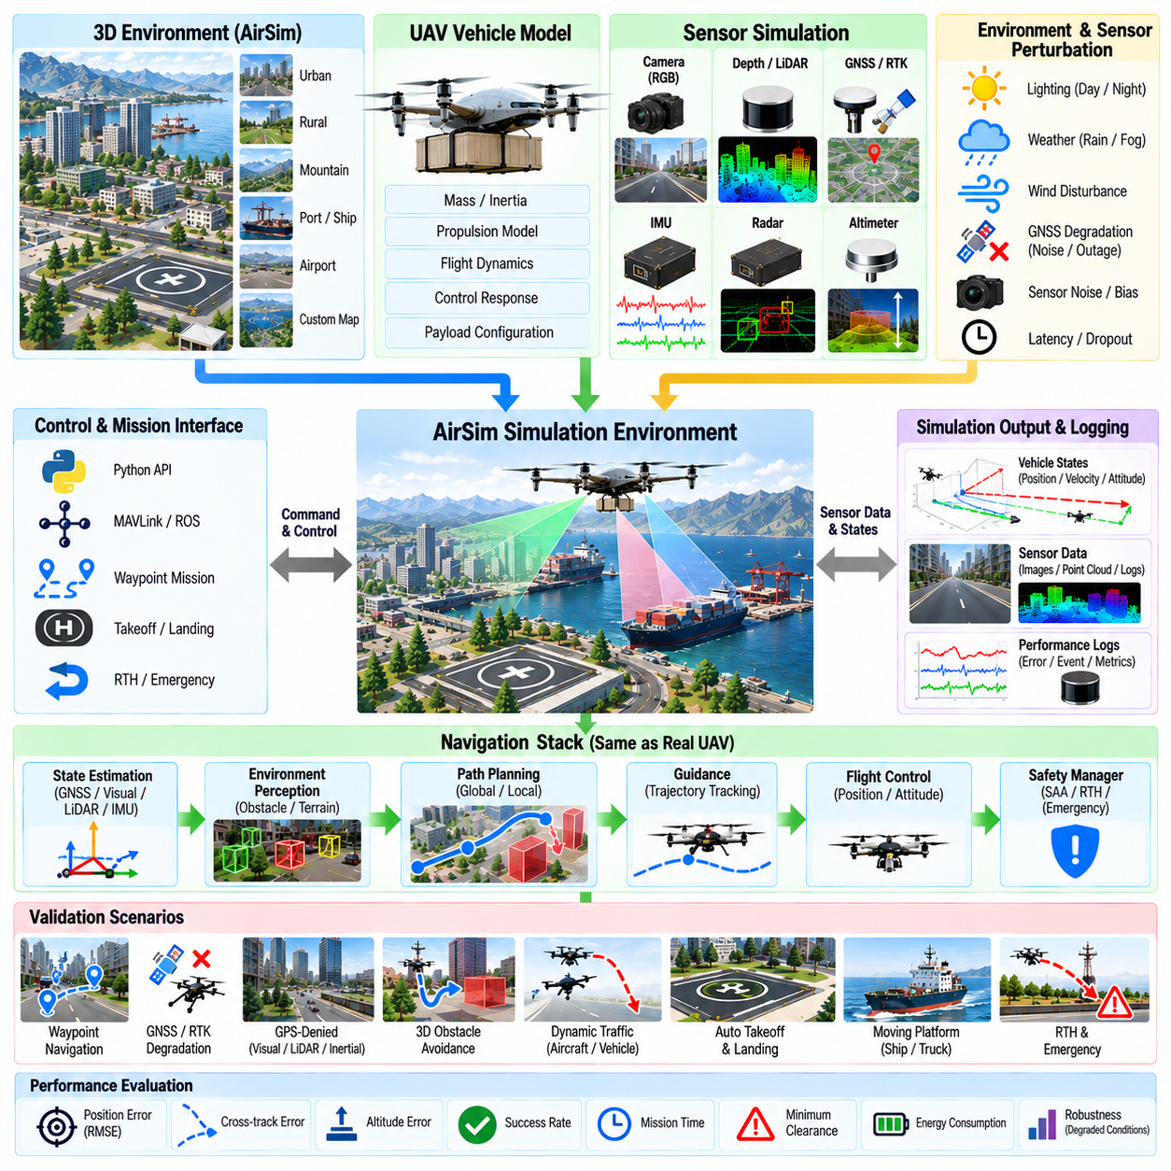
Simulation-based validation provides a controlled environment for evaluating UAV autonomous navigation before algorithms are exposed to expensive or safety-critical flight testing. AirSim can represent the aircraft, sensors, environment, and software interfaces required to exercise navigation functions under repeatable conditions. For cargo UAV development, simulation is especially valuable because large vehicles, heavy payloads, and complex missions make unrestricted experimental testing difficult.
The simulation environment should reproduce the navigation architecture rather than only visualize aircraft motion. State estimation, waypoint execution, trajectory generation, obstacle avoidance, automatic takeoff and landing, Return-to-Home, and contingency functions can operate through interfaces comparable to those used on the real vehicle. This allows validation to examine interactions among software modules instead of testing isolated algorithms with idealized inputs.
AirSim provides a virtual three-dimensional environment in which UAV motion can be combined with simulated cameras, depth sensing, inertial measurements, GNSS-like information, and other state data. Environmental geometry can represent buildings, terrain, roads, landing areas, and obstacles. These capabilities allow developers to create repeatable navigation scenarios while collecting synchronized vehicle states and sensor observations for performance analysis.
A useful validation environment begins with a representative vehicle model. Mass, inertia, propulsion response, acceleration limits, maximum velocity, climb and descent capability, and attitude constraints should approximate the intended cargo UAV. If the simulated aircraft is unrealistically agile, navigation algorithms may appear successful even when their trajectories cannot be executed by the real platform. Vehicle dynamics therefore form part of the validation assumptions.
Sensor simulation should represent more than nominal measurement values. Navigation algorithms need to be evaluated under noise, bias, latency, limited field of view, measurement dropout, and degraded visibility. Camera observations can be affected by lighting and environmental geometry, while range or depth measurements can include uncertainty. GNSS-like position information can also be perturbed to evaluate estimator robustness rather than providing continuously perfect global position.
Time synchronization and simulation timing are important when multiple sensor streams are fused. Camera frames, inertial measurements, navigation states, and control commands should carry consistent timestamps so that estimator behavior can be analyzed correctly. Validation should also distinguish simulation time from wall-clock execution time. An algorithm that succeeds only when the simulator runs slowly may fail when deployed under real-time computational constraints.
Waypoint navigation provides a basic validation scenario for the autonomous navigation stack. The UAV can be commanded through routes containing straight segments, turns, altitude changes, narrow corridors, and terminal approach points. Position error, cross-track error, altitude error, waypoint completion behavior, trajectory smoothness, and mission completion time can then be measured. Routes should include geometries that expose both normal performance and boundary conditions.
GNSS/RTK-based navigation can be evaluated by varying global positioning accuracy and availability. Nominal scenarios verify precise waypoint tracking, while degraded scenarios introduce noise, bias, intermittent measurements, or complete GNSS loss. The navigation stack should demonstrate appropriate changes in confidence and behavior rather than continuing to treat corrupted measurements as valid. Recovery after signal restoration should also occur without creating abrupt trajectory discontinuities.
GPS-denied navigation scenarios can exercise visual, inertial, LiDAR-based, or locally referenced estimation. The simulator can place the UAV near structures, within urban corridors, or in environments where global positioning is intentionally removed. Drift, localization consistency, map alignment, and recovery behavior can then be measured. Such scenarios are useful for determining how navigation uncertainty propagates into trajectory planning and safety margins.
Three-dimensional obstacle avoidance can be tested by placing static obstacles along or near the nominal route. Buildings, towers, vegetation-like structures, walls, narrow openings, and temporary obstructions can force the local planner to generate alternative trajectories. Validation should measure minimum obstacle clearance, avoidance initiation distance, route deviation, control smoothness, and successful return to the mission path after the hazard has been cleared.
Dynamic obstacle scenarios extend testing beyond static geometry. Moving vehicles, simulated UAVs, or other moving objects can cross the flight path with different relative velocities and encounter angles. The system should detect developing conflicts early enough to generate feasible avoidance maneuvers. Repeated trials with varying initial conditions help determine whether collision avoidance remains stable near the boundary between safe and unsafe encounter geometries.
Sense-and-Avoid validation requires systematic airborne encounter scenarios. Head-on approaches, crossing traffic, overtaking, climbing or descending traffic, and multiple simultaneous targets can be generated with controlled timing. Cooperative traffic information can be combined with simulated non-cooperative detections where supported by the test architecture. Conflict detection time, predicted separation, resolution timing, and achieved minimum separation provide useful evaluation metrics.
Automatic takeoff can be validated from initial system readiness through liftoff and transition to mission navigation. Scenarios can vary vehicle mass, propulsion response, wind disturbance, sensor quality, and nearby obstacles. The test should verify that invalid preflight conditions prevent departure and that faults detected during the takeoff sequence produce the intended abort behavior. Successful takeoff should transition smoothly into the departure trajectory.
Automatic landing scenarios should evaluate approach acquisition, descent, position stabilization, touchdown, and post-landing state transitions. Landing targets can be placed in open areas or constrained environments with nearby obstacles. Position and velocity errors near touchdown, descent-rate stability, final heading, and touchdown detection can be recorded. Additional cases should introduce navigation degradation or landing-zone obstruction to verify go-around behavior.
Moving-platform landing can be represented by commanding a ground or marine-like target to follow a defined trajectory while the UAV attempts relative acquisition and landing. Platform speed, heading change, acceleration, and target motion can be varied between trials. The validation system should measure relative position error, relative velocity error, tracking stability, interception performance, and whether final descent begins only when landing conditions satisfy the required limits.
Return-to-Home validation should begin from different mission positions, altitudes, energy states, and environmental conditions. Communication loss or explicit recovery events can trigger the procedure while obstacles or restricted regions modify the direct path home. The test verifies that the UAV selects a feasible return trajectory, maintains obstacle clearance, preserves sufficient energy for terminal operations, and transitions correctly from return navigation into automatic landing.
Emergency landing scenarios can evaluate behavior when normal return is no longer feasible. Simulated low-energy conditions, navigation degradation, propulsion limitations, or blocked recovery locations can force selection of an alternate landing area. Candidate-site assessment should be evaluated against reachability and environmental risk. The simulation should verify that the emergency trajectory respects degraded vehicle capability rather than relying on nominal maneuver performance.
Fault injection is essential for meaningful navigation validation. Sensor dropout, delayed measurements, frozen values, communication interruption, actuator degradation, corrupted navigation data, or unexpected obstacle appearance can be introduced at controlled times. The objective is not only to determine whether the nominal mission succeeds, but also whether the system detects abnormal conditions, transitions to the correct safety state, and avoids uncontrolled behavior.
Environmental variation should be incorporated into repeated tests. Wind magnitude and direction, visibility, lighting, obstacle configuration, route geometry, and sensor quality can be changed systematically. Randomized trials expose navigation software to combinations that may not be anticipated by manually designed scenarios. Monte Carlo testing can then estimate distributions of tracking error, minimum clearance, mission success, recovery success, and other safety-related performance indicators.
Validation metrics should be defined before large simulation campaigns begin. Useful measures include position error, velocity error, cross-track deviation, altitude error, navigation drift, minimum obstacle separation, conflict-detection time, trajectory smoothness, control saturation, energy estimate, mission completion rate, and recovery success rate. Pass and fail thresholds should correspond to system requirements so that simulation results support engineering decisions rather than subjective visual assessment.
Simulation logs should preserve enough information to reconstruct each test. Vehicle states, sensor measurements, estimator outputs, active waypoints, planned trajectories, avoidance commands, controller references, safety events, and mode transitions should be recorded with synchronized timestamps. When a test fails, engineers should be able to determine whether the cause originated in perception, estimation, planning, guidance, control, timing, or supervisory logic.
Automated scenario execution improves repeatability and regression testing. A defined scenario can initialize the environment, configure the UAV, apply faults or disturbances, execute the mission, collect metrics, and determine pass or fail status. The same scenario suite can then be rerun whenever navigation software changes. Regression testing is particularly important because improvements to one function, such as obstacle avoidance, can unintentionally affect waypoint tracking or landing behavior.
Simulation results should not be interpreted as complete evidence of real-world readiness. Sensor models, aerodynamic effects, communication behavior, environmental complexity, and vehicle dynamics inevitably differ from physical operation. The purpose of AirSim validation is to discover software defects, verify architecture behavior, exercise hazardous conditions, and reduce the number of unknowns before field testing. Critical assumptions identified in simulation must subsequently be verified with real hardware.
A progressive validation process can move from model-in-the-loop concepts to software-in-the-loop execution, hardware-in-the-loop integration, controlled flight testing, and increasingly representative operational trials. Scenarios that fail in simulation should normally be corrected before advancing to more expensive stages. Scenarios that pass provide structured test cases that can be reused later to compare simulated behavior with actual aircraft measurements.
UAV navigation simulation validation with AirSim ultimately provides a repeatable framework for evaluating the complete autonomous navigation stack across nominal, degraded, and emergency conditions. Its value comes from combining realistic mission logic, representative sensing, vehicle constraints, fault injection, measurable acceptance criteria, and automated regression. Used as part of a progressive verification strategy, simulation reduces development risk while preparing cargo UAV navigation functions for systematic real-world validation.

