Volume 23. Cargo UAV Autonomy and Flight AI

Chapter 01. Cargo UAV Autonomy Fundamentals

01.01. Cargo UAV Autonomy Levels and Operational Concept
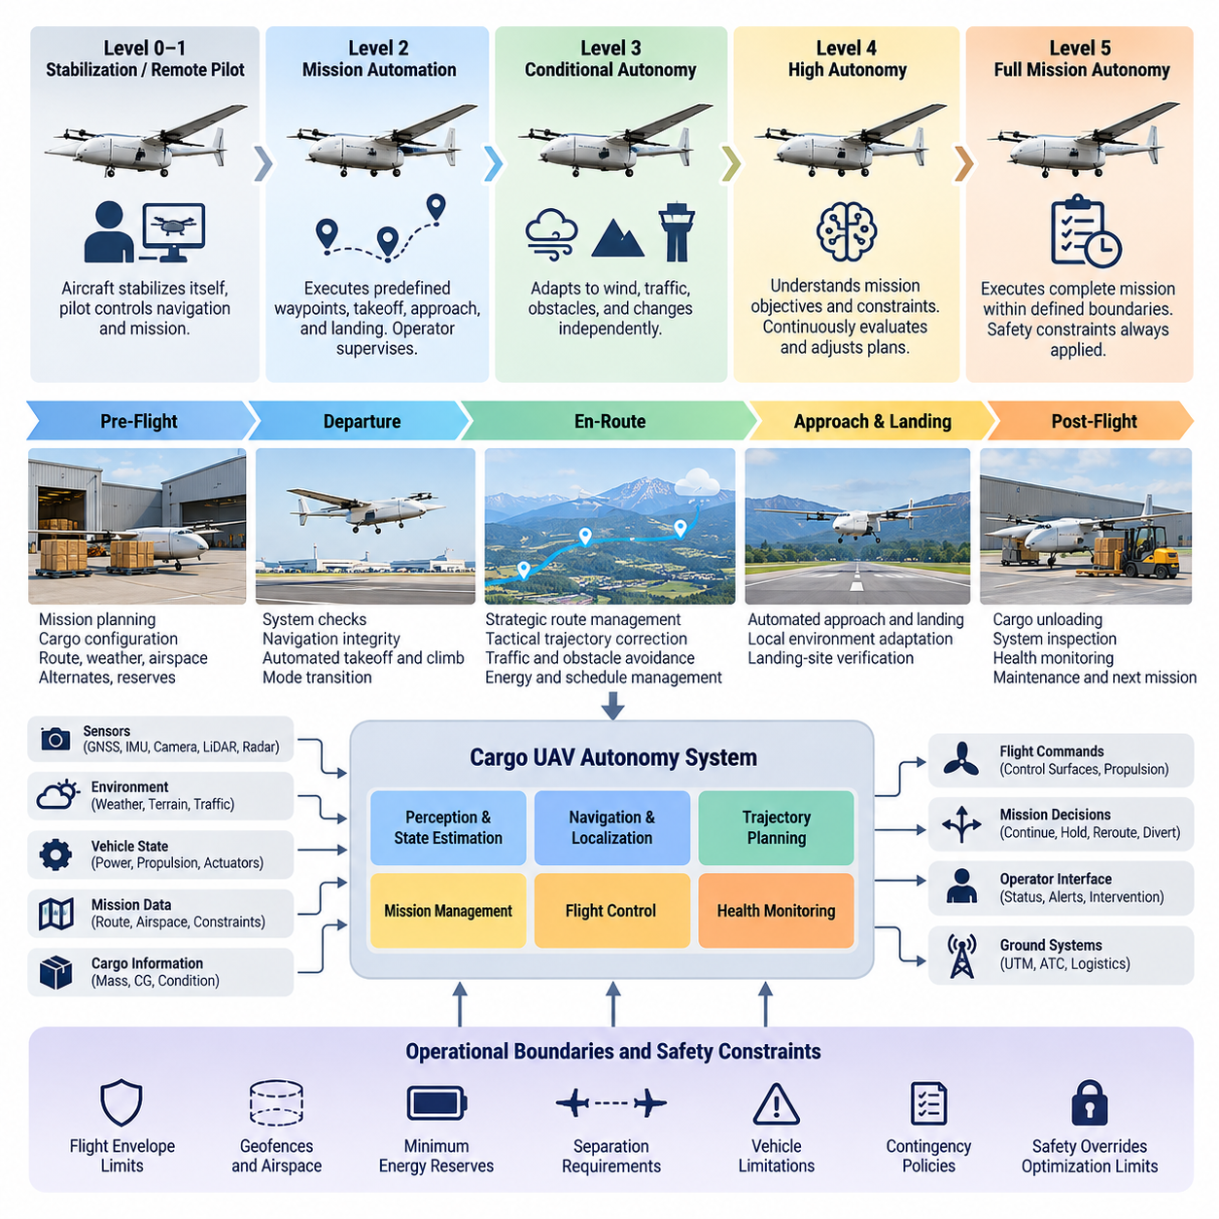
Cargo UAV autonomy defines how authority for perception, decision making, trajectory generation, flight control, mission execution, and contingency response is distributed between onboard software and human operators. Unlike small remotely piloted drones, heavy cargo UAVs must sustain safe operation while transporting valuable payloads across long routes, complex airspace, and changing environmental conditions. Volume_23_Cargo_UAV_Autonomy_an…
At the lowest autonomy level, the aircraft primarily stabilizes itself while a remote pilot remains responsible for navigation and mission decisions. Automated functions may maintain attitude, altitude, heading, or airspeed, but the operator continuously supervises the flight. This architecture reduces pilot workload compared with direct manual control while retaining human authority over route changes, abnormal situations, and landing decisions.
A higher level introduces mission automation, allowing the UAV to execute predefined waypoints, altitude profiles, takeoff procedures, approaches, and landing sequences. The operator becomes a supervisory controller rather than a continuous flight controller. The aircraft monitors navigation states and flight constraints while the ground station provides mission authorization, status monitoring, intervention capability, and command interfaces for exceptional conditions.
Conditional autonomy extends this concept by enabling the aircraft to respond independently to predictable operational changes. The autonomy system may modify velocity, altitude, or local trajectory when encountering wind, traffic, obstacles, restricted volumes, or degraded navigation. Such behavior requires tightly integrated navigation, perception, sensor fusion, route planning, and flight control functions rather than a simple sequence of preprogrammed waypoint commands.
Highly autonomous cargo operations require the vehicle to understand both mission objectives and operational constraints. The aircraft must continuously determine whether the planned trajectory remains feasible given energy reserves, payload condition, propulsion performance, weather, communication quality, airspace restrictions, and landing-site availability. Mission execution therefore becomes a closed-loop process in which plans are repeatedly evaluated and adjusted during flight.
Full mission autonomy does not imply unrestricted machine authority. Safety-critical cargo UAVs require explicit operational boundaries defining which decisions the autonomous system may make and which require external authorization. Flight envelopes, geofences, vehicle limitations, minimum energy reserves, separation requirements, and contingency policies constrain autonomous decisions so that optimization functions cannot override fundamental safety requirements.
The operational concept begins before takeoff. Mission data define the origin, destination, payload, route, expected weather, airspace constraints, reserve requirements, and alternate landing locations. Cargo properties influence aircraft mass, center of gravity, aerodynamic behavior, propulsion demand, and achievable range. The autonomy system must therefore treat cargo configuration as part of the vehicle state rather than as independent logistics information.
During departure, autonomous functions verify vehicle readiness, navigation integrity, propulsion availability, communication links, payload status, and environmental conditions. Once authorization is established, automated takeoff and climb procedures transition the aircraft into en-route navigation. Mode transitions must be deterministic and observable because ambiguity regarding whether the pilot, mission manager, or onboard controller currently holds authority can create significant operational risk.
En-route autonomy combines strategic and tactical decision layers. Strategic logic manages the mission route, destination, energy budget, airspace commitments, and arrival schedule, while tactical logic handles immediate trajectory corrections, obstacle avoidance, traffic conflicts, wind disturbances, and local constraints. Separating these timescales prevents short-term avoidance actions from unintentionally violating higher-level mission requirements or exhausting critical energy reserves.
Perception and state estimation provide the autonomy stack with an operational representation of the aircraft and its surroundings. GNSS, inertial sensors, cameras, LiDAR, radar, air-data sensors, and vehicle health measurements can contribute complementary information. Sensor fusion must estimate not only position and motion but also uncertainty, because autonomous decisions should depend on the confidence associated with navigation, obstacle detection, and environmental interpretation.
Cargo UAV autonomy also requires continuous health awareness. The system monitors propulsion, electrical power, flight-control computers, actuators, sensors, communication links, navigation sources, and cargo interfaces. A detected fault should initiate a defined transition from nominal operation to degraded or contingency behavior. Depending on severity, the aircraft may continue its mission, reroute, return to origin, divert, hold, or perform an emergency landing.
Communication architecture strongly influences the operational concept. A command-and-control link enables supervision and intervention, but safe autonomy cannot assume uninterrupted connectivity throughout every mission. Loss or degradation of the link must therefore correspond to predetermined behaviors based on aircraft state and mission context. The UAV should maintain stable flight and execute authorized contingency logic without requiring immediate human commands.
The human operator remains an important element even as onboard autonomy increases. The role evolves from manually controlling aircraft motion toward supervising mission intent, approving significant changes, assessing unusual conditions, and coordinating with external operational systems. Effective human-autonomy interaction requires concise state presentation, clear alerts, predictable automation behavior, and explicit indication of the reason behind important autonomous transitions.
Autonomy must also interact with external airspace services. Route constraints, traffic information, temporary restrictions, weather updates, and operational approvals can modify the mission after departure. The broader volume structure explicitly connects cargo UAV fundamentals with UTM integration, route planning, conflict resolution, contingency routing, and automated flight-plan processes, making airspace interaction part of the autonomy architecture rather than a separate administrative function. Volume_23_Cargo_UAV_Autonomy_an…
For heavy cargo platforms, autonomy requirements become more demanding as aircraft mass and kinetic energy increase. Decisions that may be acceptable for a small UAV can have substantially greater consequences for multi-ton vehicles. Larger platforms therefore require stronger redundancy, more rigorous fault containment, carefully controlled mode transitions, deterministic safety monitors, and independently protected functions capable of preventing unsafe commands from propagating to flight-critical actuators.
A practical architecture distinguishes mission autonomy from flight-critical control. High-level autonomy can select routes, trajectories, landing alternatives, and mission actions, while deterministic flight-control functions stabilize the vehicle and enforce validated limits. Independent safety mechanisms supervise both layers and can reject commands that violate protected constraints. This separation allows advanced planning and AI functions to evolve without transferring unrestricted authority into the innermost control loops.
The autonomy level should consequently be defined by operational responsibility rather than by the number of automated features installed on the aircraft. Two UAVs may contain similar sensors and algorithms yet operate at different autonomy levels because their authority allocation, supervision requirements, contingency permissions, and certification assumptions differ. Autonomy is therefore a system property involving software, hardware, operators, procedures, communications, infrastructure, and airspace integration.
The target operational concept for cargo UAVs is ultimately supervised, resilient mission autonomy: the aircraft performs routine flight and responds safely to anticipated disturbances while humans retain appropriate strategic authority. Progress toward greater autonomy should reduce dependence on continuous intervention without eliminating accountability or deterministic safety protection. This foundation supports the later treatment of fail-safe design, software architecture, certification, and the transition from small UAVs to multi-ton cargo aircraft

01.02. UAV Classifications 2.5t 5t 10t Design Drivers
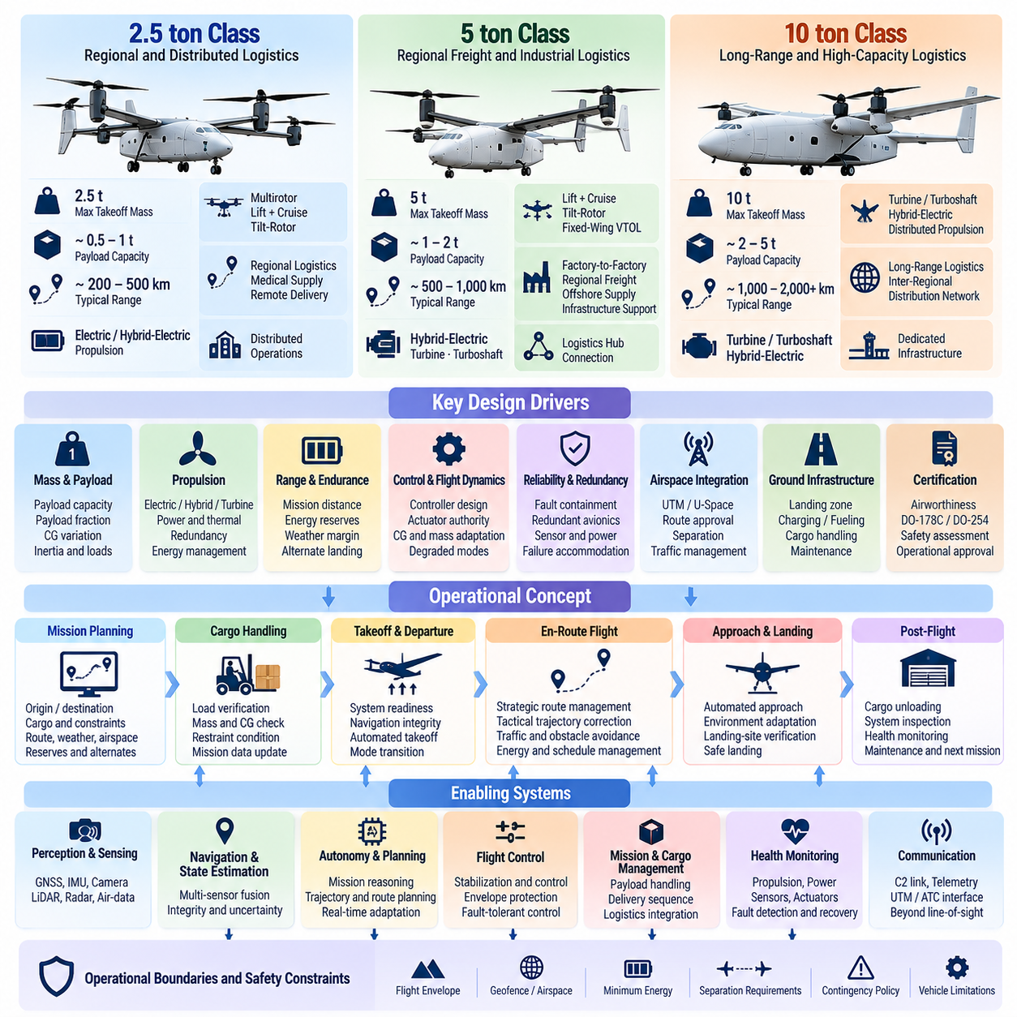
Cargo UAV classification is strongly influenced by maximum takeoff mass, payload capacity, propulsion architecture, operating range, airspace integration, and the consequences of system failure. A 2.5-ton, 5-ton, and 10-ton aircraft cannot be treated simply as scaled versions of the same UAV because increasing mass changes structural loads, propulsion requirements, control authority, redundancy needs, ground infrastructure, and certification expectations.
The 2.5-ton class represents an important transition between conventional small unmanned aircraft and heavy autonomous cargo platforms. It can support regional logistics, industrial supply, medical transportation, offshore operations, and remote-area delivery while remaining sufficiently compact for distributed operations. Its design emphasizes efficient electric or hybrid-electric propulsion, automated cargo handling, precision navigation, and relatively flexible ground infrastructure.
A representative 2.5-ton platform may use a multirotor, lift-plus-cruise, tilt-rotor, or other vertical takeoff and landing configuration depending on range and mission requirements. Pure multirotor architectures simplify hover and vertical flight but impose significant energy demands during long-range transportation. Wing-assisted configurations improve cruise efficiency but introduce additional transition-control, actuator, aerodynamic-modeling, and flight-envelope-management requirements.
At approximately the 5-ton class, cargo UAV design becomes increasingly comparable to conventional aviation engineering rather than scaled drone engineering. Higher gross mass increases kinetic energy, rotor or propeller loads, structural stresses, thermal loads, and the consequences of propulsion or control failures. The aircraft therefore requires stronger fault containment, redundant avionics, more sophisticated flight-control laws, and carefully engineered degraded operating modes.
Five-ton cargo UAVs are well suited to factory-to-factory logistics, regional freight transportation, offshore supply, infrastructure support, and operations connecting distribution centers. Payload and range must be balanced against fuel or battery mass, reserve requirements, weather margins, and alternate landing capability. Mission planning therefore becomes tightly coupled with aircraft performance prediction rather than functioning as an independent waypoint-generation process.
The 10-ton class introduces another major architectural transition. At this scale, turbine, turboshaft, hybrid-electric, or distributed propulsion configurations may become preferable depending on endurance and payload requirements. Propulsion management must coordinate engines, generators, batteries, electric motors, power electronics, and thermal systems where applicable, transforming energy management into a flight-critical system rather than a secondary vehicle function.
A 10-ton autonomous cargo aircraft also requires highly dependable flight-control and actuation architectures. Fly-by-wire control, redundant flight-control computers, multiple sensor channels, independent electrical buses, and fault-tolerant actuators become central design considerations. A single failure must not automatically result in loss of control, and critical faults must be detected, isolated, and accommodated within time limits appropriate to aircraft dynamics.
Payload fraction is a fundamental design driver across all three classes. Increasing payload improves transportation productivity but also shifts the center of gravity, modifies inertia, increases propulsion demand, and reduces available energy margin. Cargo loading information must therefore be integrated into mission planning and flight-control configuration. The system should verify cargo mass, location, restraint status, and center-of-gravity limits before authorizing departure.
Center-of-gravity variation is especially important for cargo aircraft because payload configurations can change between missions. Flight-control laws designed around a single nominal mass model may perform poorly when cargo distribution changes substantially. Larger platforms consequently benefit from mass-property estimation and adaptive control mechanisms that modify controller parameters, actuator allocation, or performance limits according to the actual loading condition.
Range and endurance requirements create another major distinction between vehicle classes. A 2.5-ton aircraft may prioritize shorter regional routes and frequent charging or refueling, whereas 5-ton and 10-ton systems may be expected to connect more distant logistics hubs. Greater range increases dependence on weather forecasting, reserve management, alternate landing sites, communication coverage, navigation continuity, and dynamic route optimization during flight.
Propulsion redundancy must be evaluated according to vehicle configuration rather than merely counting motors or engines. Distributed electric propulsion can provide multiple thrust sources, but safe operation depends on electrical isolation, power-bus architecture, control allocation, thermal management, and the remaining thrust available after failures. Larger aircraft require quantitative assessment of whether degraded propulsion can maintain controlled flight, diversion, or safe landing.
Energy architecture scales differently from aircraft mass. Battery capacity cannot simply be increased proportionally because additional batteries themselves add structural mass and require cooling, protection, monitoring, and containment. Hybrid systems introduce generators and fuel but add mechanical and software complexity. Consequently, energy-system selection is an aircraft-level optimization involving payload, range, redundancy, thermal performance, maintenance, and operational economics.
Aerodynamic configuration also reflects mission class. Aircraft optimized for vertical logistics require strong low-speed and hover capability, while long-distance cargo vehicles benefit from efficient wing-borne cruise. Transition between these regimes can become one of the most demanding portions of the flight envelope. Control software must manage rapidly changing aerodynamic forces, propulsion allocation, actuator authority, and stability margins without exposing unsafe intermediate states.
Environmental design requirements become more significant as cargo UAV missions expand geographically. Wind, precipitation, temperature, icing, turbulence, density altitude, and visibility affect performance differently across vehicle sizes and propulsion configurations. Heavy aircraft possess greater inertia but also require larger safety margins because an unsuccessful recovery carries greater consequences. Environmental limitations must therefore be explicitly represented within mission authorization and flight-envelope protection.
Avionics architecture is another major scaling driver. A 2.5-ton vehicle may employ compact redundant computing modules, while 5-ton and 10-ton systems increasingly require physically separated computing channels, independent power supplies, redundant communication buses, and dissimilar monitoring functions. The objective is not redundancy for its own sake but prevention of a common failure from disabling navigation, control, propulsion management, and safety supervision simultaneously.
Communication requirements also change with operational scale. Short-range cargo missions may rely primarily on terrestrial command-and-control networks, whereas longer routes may require combinations of cellular, private wireless, satellite, or aviation communication services. The aircraft must manage link transitions and degraded connectivity while preserving command integrity. Safe flight cannot depend on continuous high-bandwidth communication with a remote operator or cloud service.
Ground infrastructure becomes progressively more important from the 2.5-ton to the 10-ton class. Landing-area dimensions, surface strength, charging or fueling equipment, cargo loaders, maintenance access, fire protection, and emergency response requirements all increase with vehicle size. Autonomous operation therefore includes coordination between airborne software and ground systems rather than treating the aircraft as an isolated robotic platform.
Operational economics influence architecture as strongly as technical performance. A larger aircraft can transport more cargo per flight, but it also requires more expensive propulsion, maintenance, infrastructure, redundancy, and certification activities. The economically optimal vehicle is therefore not necessarily the largest one. Fleet designers must match aircraft class to route density, payload distribution, turnaround time, utilization rate, energy cost, and required service reliability.
Safety assurance scales with potential consequence. As aircraft become heavier, acceptable assumptions about component reliability, software behavior, emergency landing, and separation from populated areas become increasingly restrictive. Safety analysis must examine propulsion loss, flight-control failures, navigation degradation, communication loss, power-system faults, structural limitations, and combinations of failures that could prevent continued controlled flight.
Software complexity similarly increases across the three classes. The broader cargo UAV architecture separates flight control, autonomous navigation, perception and sensor fusion, route and airspace integration, cargo mission management, safety, and AI-based optimization into coordinated functional domains. The planned volume further treats the 2.5-ton platform separately from the 5-ton and 10-ton architectures, reflecting the different engineering concerns introduced by scale.
The resulting classification should therefore be understood as an architectural framework rather than a simple weight table. The 2.5-ton class emphasizes practical autonomous logistics and efficient distributed operation, the 5-ton class introduces stronger aviation-grade redundancy and heavy-lift control requirements, and the 10-ton class demands highly integrated propulsion, fly-by-wire control, fault tolerance, and certification-oriented engineering. Mass becomes a driver of the entire autonomous aircraft system.

01.03. Flight Envelope and Performance Requirements
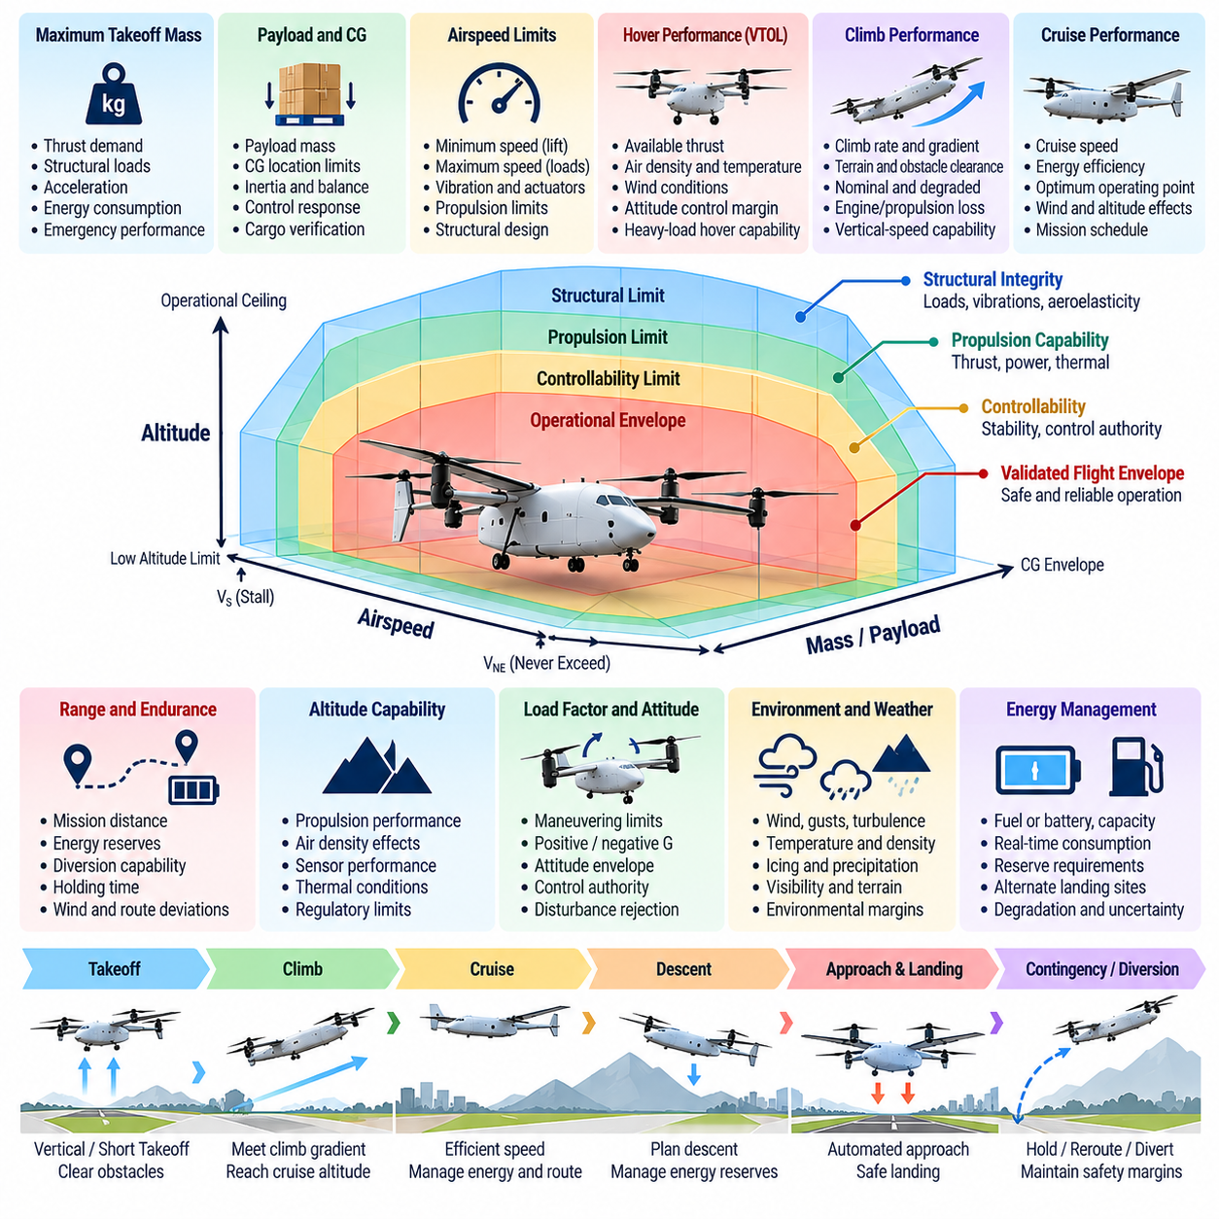
The flight envelope of a cargo UAV defines the validated region in which the aircraft can operate while maintaining controllability, structural integrity, propulsion capability, navigation performance, and required safety margins. For heavy cargo platforms, the envelope is multidimensional and depends on airspeed, altitude, attitude, load factor, aircraft mass, center of gravity, weather, propulsion state, and configuration.
Performance requirements translate the intended cargo mission into measurable aircraft capabilities. Payload, range, cruise speed, hover duration, climb rate, ceiling, takeoff and landing capability, energy reserve, and diversion capability must be defined together rather than independently. Increasing one performance objective often reduces margin elsewhere, making aircraft design a continuous tradeoff among useful load, energy, safety, and operational productivity.
Maximum takeoff mass is a primary boundary condition because it influences thrust demand, structural loading, acceleration capability, energy consumption, and emergency performance. A cargo UAV must demonstrate adequate control authority not only at nominal loading but across the approved mass range. The most demanding condition may occur at maximum payload, while other stability challenges can appear during lightly loaded or asymmetrically loaded operation.
Center-of-gravity limits form another essential dimension of the envelope. Cargo position changes longitudinal and lateral balance, rotational inertia, control response, and actuator demand. The approved loading envelope must therefore specify combinations of payload mass and location that preserve controllability. Automated cargo verification should prevent flight authorization when estimated mass properties exceed validated limits or cannot be determined with sufficient confidence.
Airspeed limits protect the aircraft from both insufficient aerodynamic control and excessive structural or propulsion loads. Wing-borne configurations require minimum speeds that maintain adequate lift and control margin, while maximum speeds are constrained by aerodynamic loads, vibration, actuator capability, propulsion limits, and structural design. Autonomous guidance must command trajectories that remain inside these limits even during disturbances or route changes.
Vertical takeoff and landing cargo UAVs introduce additional low-speed and hover requirements. Hover performance depends on available thrust, aircraft mass, air density, temperature, wind, and propulsion efficiency. Sufficient thrust margin must remain for attitude control and disturbance rejection rather than allocating all available propulsion capability to supporting weight. Heavy-load hover conditions can consequently become critical sizing points for motors, rotors, engines, and power systems.
Climb performance determines whether the aircraft can safely clear terrain, obstacles, departure corridors, and airspace constraints while carrying the required payload. Minimum climb gradients and vertical-speed capability should be evaluated under nominal and degraded propulsion conditions. For multi-propulsor aircraft, the ability to continue climbing, maintain altitude, or execute a controlled landing after propulsion loss becomes an important safety requirement.
Cruise performance determines much of the economic effectiveness of cargo UAV operations. Efficient cruise reduces energy consumption and extends range, but the optimum operating point varies with mass, wind, altitude, aerodynamic configuration, and mission schedule. Autonomous flight management should therefore distinguish maximum speed from economically efficient cruise speed and select operating conditions consistent with energy reserves and arrival constraints.
Range requirements cannot be defined only as the distance between origin and destination. A practical mission energy budget includes takeoff, climb, cruise, descent, landing, expected holding, route deviations, wind effects, thermal loads, and mandatory reserves. The aircraft must retain sufficient energy for foreseeable contingencies, including diversion to an alternate landing location when the intended destination becomes unavailable.
Endurance becomes particularly important for missions involving holding, offshore logistics, remote destinations, or uncertain landing availability. Remaining flight time must be estimated continuously rather than calculated only before departure. Energy prediction should incorporate actual consumption, payload, wind, propulsion efficiency, route changes, and system degradation so that mission management can initiate diversion before reserve margins become critically small.
Altitude capability is constrained by propulsion performance, aerodynamic behavior, air density, thermal conditions, sensor performance, and regulatory operating limits. Reduced air density can decrease rotor thrust and cooling effectiveness while changing aerodynamic characteristics. The operational ceiling should therefore represent a validated combination of controllability and performance rather than merely the maximum altitude that the aircraft can physically reach.
Wind limits are central to cargo UAV envelope definition because wind affects ground speed, route feasibility, hover stability, landing precision, and energy consumption. Headwinds may make a nominally valid route energetically infeasible, while crosswinds can challenge approach and landing control. Gusts and turbulence additionally require sufficient control bandwidth and actuator margin to prevent temporary disturbances from driving the aircraft outside protected states.
Temperature influences batteries, engines, motors, electronics, sensors, actuators, and structural materials. High temperatures may reduce available electrical power or cooling margin, while low temperatures can reduce battery performance and alter mechanical behavior. The flight envelope must therefore incorporate environmental operating limits, and mission authorization should evaluate predicted conditions across the entire route rather than only at the departure location.
For configurations that transition between vertical and wing-borne flight, the transition envelope requires special attention. Lift distribution, propulsion direction, aerodynamic control effectiveness, and stability can change rapidly during conversion. Transition trajectories must remain inside validated combinations of airspeed, attitude, thrust, and configuration state, with software preventing transitions when environmental or vehicle conditions do not provide adequate margin.
Structural limits constrain load factor, maneuver rate, speed, payload distribution, and allowable turbulence exposure. Autonomous trajectory generation must respect these limits explicitly because mathematically feasible paths may still impose unacceptable loads on the airframe or cargo. Heavy cargo vehicles generally favor smooth commands with bounded acceleration, jerk, roll rate, and vertical load to protect structures while maintaining payload stability.
Propulsion and power limits constitute another protected envelope. Motors, engines, generators, batteries, inverters, and transmission components have maximum continuous and transient operating regions. Short-duration peak power may support takeoff or emergency maneuvering but cannot be treated as continuously available. Flight-control and mission software must distinguish sustained capability from temporary overload capability when evaluating trajectory feasibility.
Performance requirements must also address degraded operation. Failure of a motor, engine, actuator, sensor, battery segment, or computing channel can reduce the available envelope even when continued flight remains possible. The autonomy system should therefore maintain a dynamic degraded envelope describing the safe combinations of speed, maneuver, altitude, and mission action available after a detected fault.
Landing performance establishes limits for descent rate, approach speed, touchdown velocity, lateral error, slope, surface condition, and available landing area. Vertical landing aircraft additionally require sufficient power margin during the final descent and possible rejected landing. Autonomous landing logic must determine whether the destination remains suitable and transition to holding, diversion, or an alternate site when landing requirements cannot be satisfied.
Performance margins should be represented directly within mission planning rather than evaluated only by low-level flight control. A route may satisfy geometric airspace constraints yet remain unacceptable because predicted energy, wind, climb, thermal, or degraded-performance margins are insufficient. This relationship connects flight-envelope management with the later navigation, route-planning, mission-management, and safety functions defined throughout the cargo UAV architecture.
Flight-envelope protection provides the final operational barrier between mission commands and unsafe aircraft states. Guidance or AI-based optimization may request aggressive trajectories, but protected control layers must constrain commands according to validated limits. Safety monitors should remain capable of detecting boundary violations independently and initiating corrective actions when normal planning or control functions fail to preserve required margins.
For 2.5-ton, 5-ton, and 10-ton cargo UAVs, the numerical limits will differ substantially, but the engineering principle remains consistent: every mission must remain inside a validated combination of vehicle, payload, environment, and system-health conditions. The flight envelope is therefore not a static chart but an operational contract connecting aircraft physics, autonomy, flight control, mission planning, fault management, and safety assurance.

01.04. Regulatory Framework FAA EASA ICAO for Cargo UAV
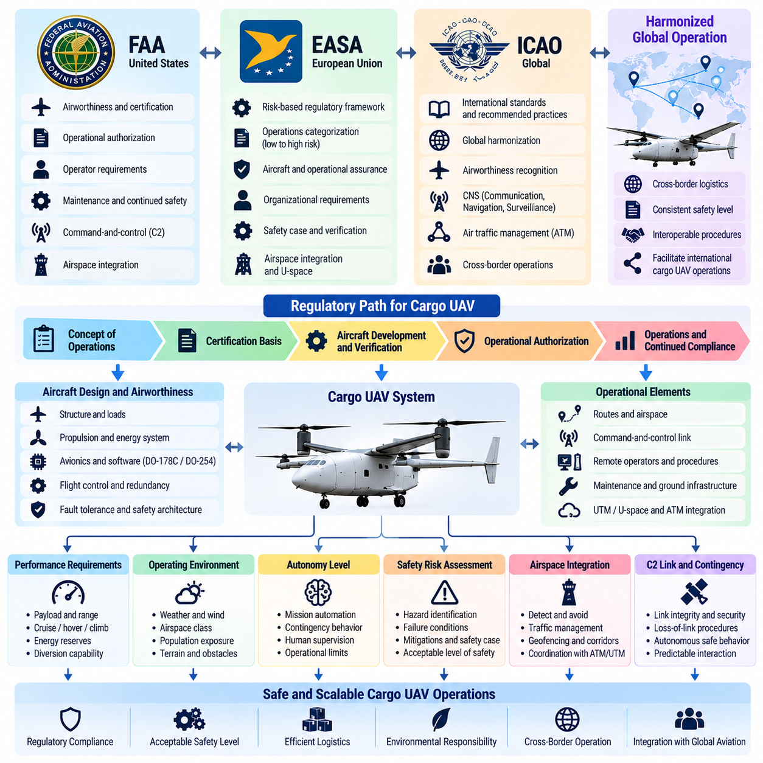
The regulatory framework for cargo UAVs determines how an unmanned aircraft may be designed, certified, operated, maintained, and integrated into shared airspace. For multi-ton cargo platforms, regulation extends far beyond rules developed for small drones because aircraft mass, operational range, kinetic energy, payload value, and potential consequences of failure increasingly resemble those of conventional aviation.
Three regulatory perspectives are particularly important for international cargo UAV development: national oversight represented by the U.S. Federal Aviation Administration (FAA), the European regulatory framework administered by the European Union Aviation Safety Agency (EASA), and international standards and recommended practices coordinated through the International Civil Aviation Organization (ICAO). Their roles differ, but together they shape certification and cross-border operation.
The FAA framework distinguishes small unmanned aircraft operations from larger or higher-risk aircraft requiring more extensive authorization and certification. A multi-ton cargo UAV generally cannot rely on the simplified assumptions associated with routine small-UAS operations. Its certification strategy must instead address aircraft airworthiness, operating limitations, command-and-control capability, continued safe flight, maintenance, operator responsibilities, and integration with existing air traffic procedures.
For cargo UAV developers, FAA engagement therefore begins with defining the intended concept of operations rather than selecting isolated technical requirements. Aircraft size, propulsion type, operating altitude, population exposure, beyond-visual-line-of-sight operation, cargo characteristics, airspace class, and degree of autonomy influence the certification basis. The regulatory path becomes a system-level argument demonstrating that the proposed aircraft and operation achieve an acceptable level of safety.
Airworthiness is particularly significant for 2.5-ton, 5-ton, and 10-ton cargo UAVs. The applicant must establish that the aircraft structure, propulsion, flight controls, electrical systems, avionics, software, and safety architecture are suitable for the intended operation. Increasing aircraft size generally increases the importance of redundancy, fault tolerance, development assurance, configuration control, verification evidence, and traceability between hazards and implemented mitigations.
EASA applies a risk-based regulatory philosophy to unmanned aircraft operations. Lower-risk operations can be handled with relatively standardized requirements, while higher-risk operations demand progressively stronger operational authorization and aircraft assurance. Large cargo UAVs operating beyond visual line of sight, over significant distances, or in integrated airspace naturally move toward the higher-assurance end of this framework because the consequences of failure are substantially greater.
For the largest and most operationally capable cargo UAVs, certification concepts increasingly converge with principles used for conventional aircraft. The aircraft must demonstrate controlled behavior under normal, abnormal, and selected failure conditions. The safety case must connect operational hazards to system requirements and verification evidence, while the organization operating the aircraft must maintain procedures for dispatch, maintenance, crew responsibilities, emergency response, and continued operational safety.
The European framework also emphasizes the relationship between aircraft risk and operational risk. An aircraft may possess sophisticated technical redundancy yet still create unacceptable risk if operated over unsuitable areas or without adequate airspace coordination. Conversely, operational restrictions can sometimes reduce exposure. Cargo UAV certification must therefore consider the combined system consisting of aircraft, route, ground infrastructure, operators, communication services, and surrounding airspace.
ICAO has a different role because it establishes international aviation principles, standards, recommended practices, and coordination mechanisms rather than directly certifying an individual cargo UAV. Its importance grows when remotely piloted or increasingly autonomous cargo aircraft operate across national boundaries or interact with conventional international aviation. Common expectations are necessary for airworthiness recognition, operational procedures, communication, navigation, surveillance, and air traffic management.
A central regulatory issue is the command-and-control link between the aircraft and its remote operating environment. The link must provide sufficient integrity, availability, continuity, and security for the assigned operational role. Regulation must also address what happens when communication degrades or disappears. A cargo UAV cannot become uncontrolled simply because its remote connection fails; predefined contingency behavior must preserve safe flight and predictable interaction with airspace users.
Beyond-visual-line-of-sight operation is fundamental to economically useful cargo transportation because long-distance logistics cannot depend on direct visual observation by a pilot. BVLOS operation increases regulatory attention to navigation integrity, surveillance, detect-and-avoid capability, communication coverage, traffic awareness, contingency procedures, and remote supervision. The aircraft must demonstrate that loss of direct human observation does not create an unacceptable reduction in safety.
Detect-and-avoid capability becomes especially important when unmanned cargo aircraft share airspace with crewed aviation. The system must obtain sufficient information about surrounding traffic, evaluate collision risk, and support or execute appropriate avoidance actions. Sensors, cooperative surveillance, airspace services, onboard algorithms, and operational procedures may contribute to this capability, but their combined performance must satisfy the safety objectives associated with the intended airspace.
Remote-pilot and operator responsibilities must remain clearly defined even when the aircraft performs most routine tasks autonomously. Regulations require accountability for mission authorization, aircraft condition, operational limitations, abnormal situations, and coordination with external authorities. Increasing autonomy therefore changes the nature of human responsibility rather than eliminating it. Authority transitions between automation and human supervision must be explicit, predictable, and auditable.
Software assurance is a major concern because cargo UAV behavior depends heavily on digital flight-control, navigation, mission-management, and safety functions. The volume structure consequently introduces certification foundations such as DO-178C for airborne software and DO-254 for airborne electronic hardware immediately after the regulatory and fail-safe fundamentals, reflecting the close relationship between regulation, safety architecture, and development assurance.
Artificial intelligence introduces additional certification challenges when machine-learning components influence perception, trajectory optimization, anomaly detection, landing, or other operational decisions. Traditional assurance methods assume behavior that can be specified and verified systematically. Learning-based functions may require additional evidence concerning training data, operational boundaries, robustness, uncertainty, monitoring, fallback behavior, and protection against outputs outside validated conditions.
Regulators are therefore likely to distinguish between AI that advises or optimizes within protected limits and AI that directly controls safety-critical functions. A practical cargo UAV architecture can place learning-based functions behind deterministic safety constraints, allowing advanced optimization while maintaining independently verified envelope protection and contingency logic. The broader volume explicitly treats AI model certification as a separate challenge within flight optimization.
Operational approval also depends on ground infrastructure and organizational processes. Vertiports, cargo loading systems, charging or fueling equipment, maintenance facilities, ground communication networks, and emergency procedures can influence overall safety. Large cargo UAV operations therefore require coordinated assurance of both airborne and ground elements, particularly when automated turnaround and high-frequency logistics reduce direct human inspection between flights.
Cybersecurity is increasingly inseparable from regulatory safety. Navigation signals, command links, software updates, ground stations, maintenance interfaces, and fleet services can become attack surfaces. Security failures may produce effects equivalent to equipment failures, including corrupted navigation, unauthorized commands, or unavailable communication. Certification-oriented architecture must consequently protect critical interfaces while preserving recoverability and operational continuity.
The regulatory framework also affects fleet scalability. A demonstration aircraft operating under restricted conditions may prove technical feasibility without establishing a path to routine commercial service. Scalable cargo operations require repeatable aircraft conformity, standardized maintenance, trained operators, predictable airspace access, approved operating procedures, and evidence that safety performance remains acceptable as the number of aircraft and missions increases.
For 2.5-ton platforms, regulatory strategy may initially emphasize constrained routes and controlled operating environments, while 5-ton and 10-ton systems increasingly require aviation-grade certification and integration practices. The exact regulatory basis depends on jurisdiction and concept of operations rather than weight alone. Nevertheless, increasing mass and operational complexity generally raise the assurance expected for flight controls, propulsion, autonomy, redundancy, and continued safe operation.
FAA, EASA, and ICAO perspectives should therefore be considered from the beginning of cargo UAV system design rather than addressed after the aircraft is complete. Regulatory requirements influence avionics architecture, software development, redundancy, communication, detect-and-avoid functions, operational procedures, maintenance, and verification. Certification is consequently not a final administrative milestone but a design constraint that shapes the complete autonomous cargo aircraft lifecycle.

01.05. UTM Integration Concept and U Space Services
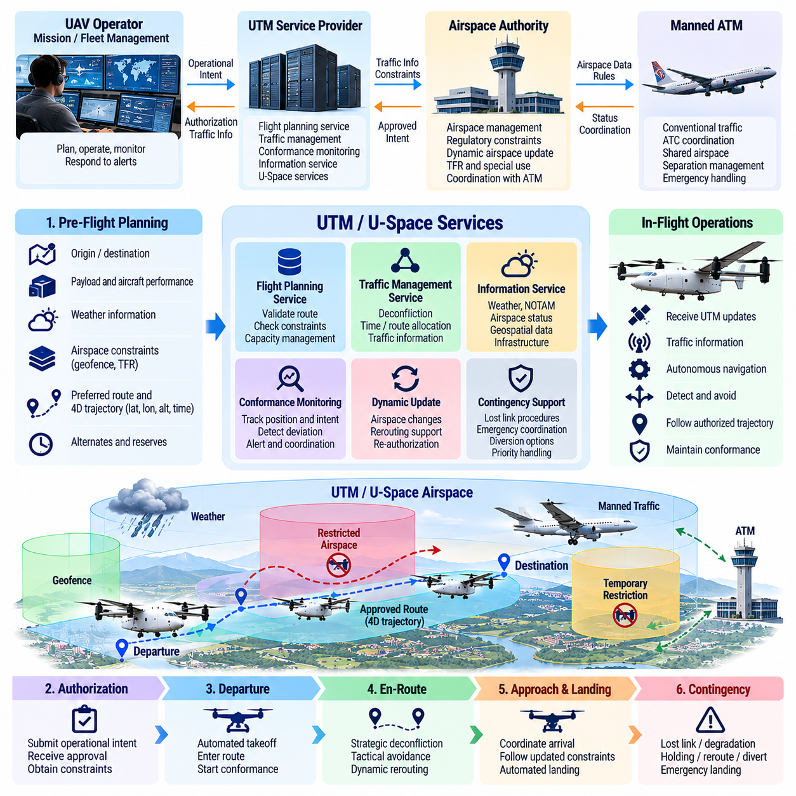
Unmanned Aircraft System Traffic Management, or UTM, provides the digital coordination framework required to operate large numbers of unmanned aircraft beyond the capabilities of traditional pilot-centered air traffic procedures. For cargo UAVs, UTM integration connects mission planning, airspace constraints, traffic information, authorization, monitoring, and contingency management so that autonomous flights can coexist predictably with other airspace users.
Cargo UAV operations place demanding requirements on UTM because missions may extend beyond visual line of sight, cross multiple operating regions, and involve aircraft with substantial mass and kinetic energy. A 2.5-ton, 5-ton, or 10-ton cargo aircraft cannot treat UTM as a simple flight-permission interface. Airspace information must become an active input to onboard and ground-based mission management throughout the complete flight lifecycle.
The integration concept begins during preflight planning. The operator defines origin, destination, departure time, aircraft performance, payload, preferred route, altitude profile, and contingency options. These mission parameters are evaluated against airspace availability, geographic restrictions, temporary constraints, weather, traffic expectations, infrastructure availability, and applicable operating rules before a flight plan or operational intent is submitted for coordination.
Operational intent represents more than a sequence of geographic waypoints. For autonomous cargo operations it can include the planned four-dimensional trajectory defined by latitude, longitude, altitude, and time, together with operational volumes and timing tolerances. This representation enables traffic-management services to determine where and when the aircraft intends to operate and whether its planned volume conflicts with other authorized operations.
UTM integration requires a clear interface between the aircraft operator, fleet or mission-management system, UTM service providers, and relevant airspace authorities. The aircraft itself may not communicate directly with every external service. A ground-based mission system can aggregate regulatory and traffic information, translate it into validated mission constraints, and distribute the resulting operational data to the onboard autonomy system through controlled interfaces.
Authorization is a dynamic part of the mission rather than a one-time administrative event. Airspace availability may change because of temporary flight restrictions, emergency activity, priority operations, weather, infrastructure failures, or other traffic. Cargo UAV mission software must therefore maintain awareness of whether the current operational intent remains valid and initiate replanning or coordination when previously approved assumptions no longer hold.
Strategic deconfliction attempts to identify conflicts before aircraft reach the same airspace. Planned trajectories or operational volumes are compared in space and time, allowing departure times, routes, altitudes, or reserved volumes to be modified before flight. This approach is especially valuable for cargo networks because predictable scheduled missions can be coordinated efficiently without relying exclusively on last-second airborne collision avoidance.
Tactical conflict management addresses situations that cannot be resolved completely during strategic planning. Unexpected traffic, delayed departures, wind-driven timing changes, emergency aircraft, or deviations from planned trajectories can create new conflicts during flight. Traffic information and onboard detect-and-avoid functions therefore complement UTM services, creating multiple layers of protection rather than assuming that preflight deconfliction eliminates every collision risk.
Conformance monitoring determines whether the cargo UAV remains within its authorized trajectory or operational volume. The mission-management system compares actual position, altitude, timing, and flight status with the accepted operational intent. Significant deviation can trigger alerts, updated coordination, or contingency procedures. For heavy UAVs, conformance information must be sufficiently reliable to support timely decisions by both automation and human supervisors.
Dynamic rerouting is necessary when the original route becomes unavailable or inefficient. Weather cells, airspace closures, traffic congestion, navigation degradation, energy limitations, or destination problems may require a new trajectory. The route planner must evaluate candidate alternatives against aircraft performance and safety constraints before the revised operational intent is coordinated with external traffic-management services.
Contingency management is particularly important for cargo UAV integration because abnormal conditions may force the aircraft to leave its nominal trajectory. Lost communication, propulsion degradation, navigation failure, low energy, severe weather, or an unavailable landing site can require holding, diversion, return-to-origin, or emergency landing. UTM interfaces should communicate relevant status while onboard safety logic retains authority for time-critical protective actions.
Geofencing provides a local enforcement mechanism for airspace constraints received through planning or traffic-management services. Restricted areas, altitude limits, protected infrastructure, temporary exclusion zones, and mission boundaries can be represented as spatial or spatiotemporal constraints. Onboard guidance should prevent commanded trajectories from violating validated restrictions even when higher-level planning or external communication becomes unavailable.
U-Space provides the European service framework intended to support safe, efficient, and scalable unmanned aircraft operations through digital and automated services. Its underlying concept complements UTM by connecting operators, service providers, authorities, and airspace information. Cargo UAVs can use such services to obtain operationally relevant information and coordinate flights without requiring every interaction to follow conventional voice-based air traffic procedures.
Core U-Space concepts include digital identification, geo-awareness, flight authorization, and traffic information services. Together they establish who is operating an aircraft, where restrictions apply, whether the intended operation is authorized, and what relevant traffic exists nearby. More advanced services can support additional information exchange, coordination, monitoring, and operational decision making as unmanned traffic density and complexity increase.
Network identification and tracking improve shared situational awareness by associating an unmanned aircraft with operational information. For heavy cargo UAVs, identity and flight status must be managed securely because inaccurate or unauthorized information could affect airspace decisions. Identification mechanisms therefore interact with cybersecurity, operator authentication, communication integrity, and the broader safety architecture of the aircraft and fleet-management system.
Geo-awareness provides current information about geographic and airspace constraints relevant to the operation. The autonomy stack must distinguish externally supplied restrictions from locally sensed obstacles and vehicle-specific performance limits. All three may constrain the trajectory, but they originate from different authorities and have different update rates. Mission planning should combine them without allowing one information source to silently invalidate another safety constraint.
Traffic information allows the cargo UAV system to anticipate interactions with cooperative aircraft and other known operations. However, UTM or U-Space information should not be treated as the only source of collision protection. Non-cooperative traffic, delayed information, communication outages, and sensor uncertainty remain possible. Onboard surveillance and detect-and-avoid capabilities therefore provide an independent tactical layer when required by the operational environment.
The communication architecture must tolerate temporary service degradation. A cargo UAV should not immediately become unsafe because connectivity to a UTM or U-Space service is interrupted. The mission system requires defined data-validity periods, cached restrictions, communication-loss procedures, and conservative fallback behavior. Safety-critical flight stabilization and immediate collision avoidance should remain independent of continuous cloud connectivity.
UTM integration also changes fleet operations. A logistics operator may coordinate dozens or hundreds of aircraft, making manual submission and monitoring of individual missions impractical. Fleet software must automate operational-intent generation, authorization requests, status reporting, route updates, and exception handling while maintaining traceability. Human operators then supervise network-level behavior and intervene primarily when automated coordination cannot resolve an issue.
The cargo UAV volume treats UTM as both a fundamental operational concept and a later implementation problem. Subsequent sections extend this foundation into four-dimensional trajectory planning, airspace constraint modeling, UTM service interfaces, dynamic rerouting, conflict detection and resolution, contingency routing, corridor navigation, automated flight-plan processing, and field-trial integration.
For heavy cargo UAVs, successful UTM and U-Space integration ultimately requires coordination among autonomy, airspace services, flight control, communication, fleet management, and human supervision. External services provide shared operational information and coordination, while the aircraft preserves independent safety protections. This separation enables scalable autonomous logistics without making continued safe flight dependent on a single network, service provider, or communication path.

01.06. Fail Safe and Fail Operational Design for UAV
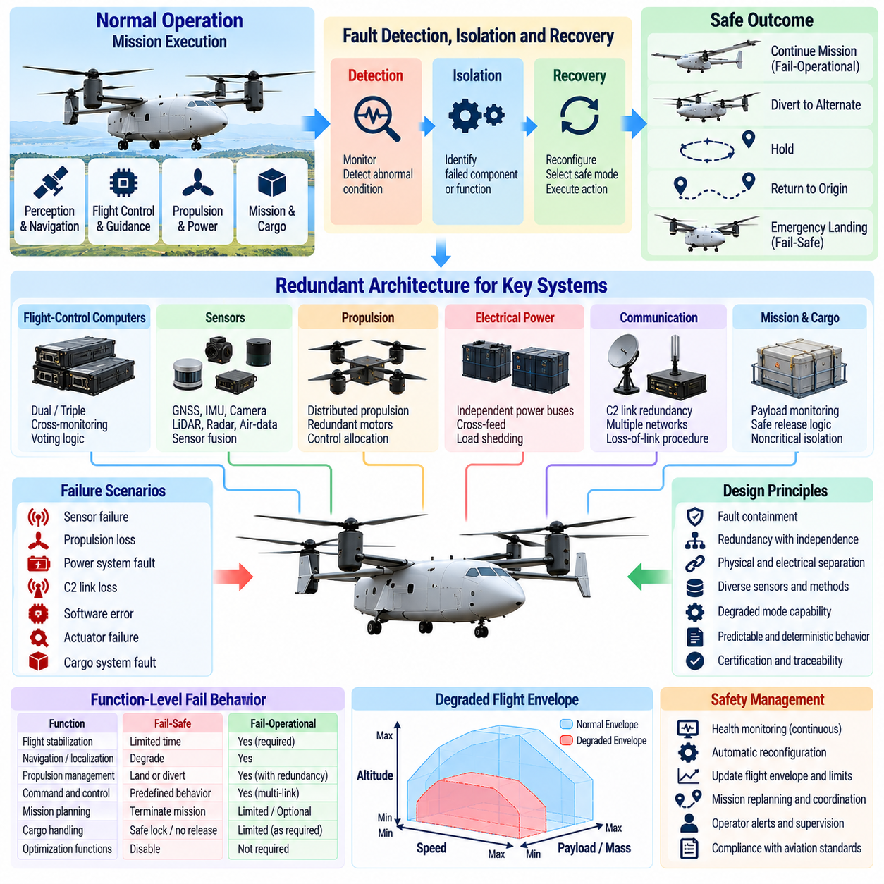
Fail-safe and fail-operational design defines how a cargo UAV responds when components, subsystems, communication links, or software functions no longer behave as intended. For multi-ton autonomous aircraft, fault management cannot be limited to shutting down a failed function. The architecture must preserve control, prevent hazardous propagation, and determine whether continued flight, diversion, or immediate landing provides the safest outcome.
A fail-safe system transitions toward a condition in which the consequences of a failure are minimized, even when the original mission cannot continue. Depending on aircraft state and failure severity, this condition may involve stabilized flight, reduced performance, holding, return to origin, diversion, or controlled emergency landing. The objective is not necessarily continued mission completion but preservation of aircraft control and protection of people and infrastructure.
Fail-operational design provides a stronger capability by allowing required functions to continue after one or more defined failures. This approach is particularly important when immediate landing is impossible or itself hazardous. A cargo UAV operating over water, mountainous terrain, populated areas, or constrained airspace may need sufficient redundant capability to continue controlled flight until it reaches an appropriate diversion or landing location.
The distinction between fail-safe and fail-operational behavior must be defined at the function level rather than assigned to the aircraft as a single label. Flight stabilization may require fail-operational behavior, while a noncritical optimization function can fail silently or be disabled. Navigation, propulsion management, command and control, cargo functions, and perception can each have different failure responses according to their contribution to continued safe flight.
Redundancy is a primary mechanism for achieving fault tolerance, but redundancy alone does not guarantee safety. Multiple computers, sensors, power supplies, communication links, or actuators can still fail together when they share a common dependency. Architecture design must therefore consider physical separation, electrical isolation, independent data paths, environmental exposure, software diversity, and common-mode failures when determining whether redundant channels are genuinely independent.
Flight-control computing is a central example. Dual or triple flight-control computers can execute equivalent control functions and monitor one another. Voting or comparison logic identifies disagreement and determines which outputs remain trustworthy. Triple-channel architectures can support majority voting, while dual-channel systems require additional monitoring or dissimilar evidence because disagreement between two channels alone does not identify which channel is correct.
Sensor redundancy follows similar principles but must account for measurement diversity. Multiple identical inertial sensors improve tolerance to individual device failure, yet common environmental effects or systematic errors can affect all channels. Combining inertial measurement units, GNSS, air-data sensors, radar, cameras, LiDAR, or other independent observations can improve fault detection by allowing physically different measurement sources to cross-check the estimated aircraft state.
Fault detection, isolation, and recovery form the operational core of the safety architecture. Detection determines that observed behavior is abnormal, isolation identifies the affected component or function, and recovery selects a safe response. These activities must occur within timing constraints derived from aircraft dynamics. A rapidly diverging attitude-control fault requires much faster response than degradation of a noncritical mission-planning service.
Health monitoring continuously evaluates computing nodes, sensors, actuators, propulsion units, batteries, communication channels, and software processes. Heartbeats, watchdogs, reasonableness checks, range checks, timing monitors, cross-channel comparisons, and model-based residuals can reveal different classes of faults. Monitoring should also distinguish a failed component from corrupted data so that erroneous information is not propagated into otherwise healthy control functions.
Propulsion failures are particularly critical for heavy cargo UAVs. In a distributed propulsion configuration, loss of one motor or rotor changes available thrust and may introduce substantial asymmetric moments. Control allocation must rapidly redistribute commands among remaining propulsion units while respecting their limits. The resulting degraded flight envelope may restrict climb, speed, maneuvering, hover duration, or landing options even when controlled flight remains possible.
Electrical power architecture must prevent a single bus, converter, battery, generator, or protection-device failure from disabling all flight-critical functions. Independent power domains and carefully designed cross-feed mechanisms can preserve essential loads after failures. Load shedding may disconnect nonessential computing, payload equipment, heaters, or auxiliary systems so that remaining energy and generation capacity are reserved for navigation, control, communication, and landing.
Communication loss requires predefined behavior because a remotely supervised cargo UAV cannot assume continuous connectivity. When the command-and-control link becomes unavailable, the aircraft should maintain stable flight while evaluating link-loss duration, navigation integrity, energy state, airspace constraints, and mission phase. Depending on approved policy, it may continue temporarily, hold, return, divert, or land without waiting indefinitely for remote commands.
Navigation degradation also requires layered fallback mechanisms. Loss or corruption of GNSS should not automatically cause loss of aircraft control if inertial, visual, LiDAR, radar, or other navigation sources remain available. The autonomy system should estimate the quality of each source and transition to a degraded navigation mode when necessary. If uncertainty exceeds validated limits, mission continuation should be replaced by a conservative contingency response.
Software failures must be contained as deliberately as hardware failures. Memory corruption, task overruns, deadlocks, invalid messages, stale data, and uncontrolled resource consumption can affect safety even when the physical computer remains functional. Process isolation, memory protection, deterministic scheduling, watchdog supervision, interface validation, and controlled restart mechanisms help prevent a local software fault from cascading across the avionics architecture.
Mode management is essential during degraded operation. The aircraft must know which capabilities remain available after a fault and must not command maneuvers requiring unavailable functions. Transitions from nominal mode to degraded, contingency, or emergency modes should be explicit and deterministic. Human operators also need clear information about the active mode, detected failure, remaining capability, and autonomous action currently being executed.
A fail-operational architecture requires continued control after the first relevant failure, but it must also define what happens after subsequent failures. The system may transition from fully operational to fail-operational, then to fail-safe as redundancy is consumed. This degradation sequence should be designed in advance so that each state has known capabilities, protected limits, permitted mission actions, and criteria for further transition.
Emergency landing logic represents one of the final layers of failure response. The aircraft must determine whether continued flight presents greater risk than landing at an alternate location. Landing-site suitability may depend on terrain, obstacle clearance, population exposure, available area, surface condition, wind, remaining propulsion capability, and energy. For heavy cargo UAVs, selecting a controlled landing location can be a complex autonomous safety decision.
Cargo state can also influence failure management. A heavy or shifted payload changes aircraft inertia, center of gravity, landing performance, and remaining control margin. Cargo-related faults may therefore interact with propulsion or flight-control failures rather than remaining isolated logistics problems. Mission and safety software must account for actual loading conditions when determining whether diversion, continued flight, or emergency landing remains feasible.
Independent safety monitoring provides protection when the primary autonomy or mission-management system produces unsafe commands. A safety monitor can supervise flight-envelope limits, geofences, energy reserves, actuator commands, navigation validity, and critical system health. When protected constraints are violated, it can inhibit commands or request a transition to a safer mode without depending entirely on the component that created the hazardous condition.
Verification must demonstrate not only correct nominal behavior but also correct transitions under failures. Fault injection in simulation, software-in-the-loop, hardware-in-the-loop, and aircraft testing can evaluate sensor loss, processor faults, communication interruption, propulsion degradation, power failures, and combinations of faults. The broader cargo UAV structure later expands these principles into redundant FCC design, propulsion failure control, GNSS fallback, link-loss behavior, watchdogs, and safety validation.
The required degree of fail-operational capability generally increases with aircraft mass, mission exposure, and the difficulty of reaching a safe state immediately. The volume accordingly separates 2.5-ton architecture from the heavier 5-ton and 10-ton platforms, where redundant avionics, fly-by-wire control, propulsion integration, and higher development assurance become increasingly prominent engineering concerns.
Fail-safe and fail-operational design should therefore be understood as a coordinated degradation strategy rather than a collection of backup components. The objective is to know what capability remains after each relevant failure, constrain the aircraft to a safe degraded envelope, and select an appropriate response before control margins are exhausted. This philosophy connects redundancy, diagnostics, autonomy, flight control, contingency planning, and safety assurance into one resilient cargo UAV architecture.

01.07. Cargo UAV SW Stack Architecture Overview
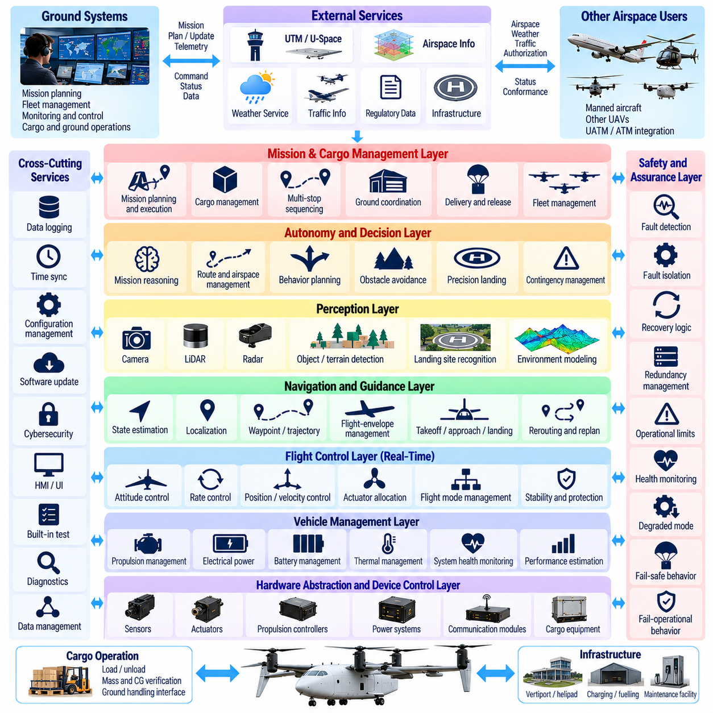
A cargo UAV software stack organizes flight-critical control, navigation, autonomy, perception, mission management, safety, communication, and vehicle services into coordinated architectural layers. Unlike a small drone autopilot, a multi-ton cargo aircraft requires strict separation of responsibilities because control loops, AI functions, payload operations, external airspace services, and safety mechanisms operate at different timing, assurance, and reliability levels.
At the lowest level, hardware abstraction and device-control software provide deterministic access to sensors, actuators, propulsion controllers, power systems, communication interfaces, and cargo equipment. Drivers convert hardware-specific signals into standardized software interfaces while monitoring device status and timing. This layer isolates higher-level functions from implementation details and supports controlled replacement or redundancy of physical components.
The real-time flight-control layer closes the fastest control loops. It receives estimated aircraft states and generates commands for motors, engines, control surfaces, or other actuators to regulate attitude, angular rate, altitude, velocity, and position. These functions require deterministic execution and bounded latency because missed deadlines or unpredictable scheduling can directly affect aircraft stability and controllability.
State estimation provides the common representation of aircraft motion required by flight control and autonomy. Measurements from inertial sensors, GNSS, air-data systems, radar, cameras, LiDAR, and other sources can be synchronized and fused to estimate position, velocity, attitude, acceleration, and associated uncertainty. Sensor-health information must accompany estimates so downstream software can distinguish accurate navigation from degraded or unreliable states.
Above stabilization and state estimation, guidance and navigation software convert mission objectives into dynamically feasible flight commands. This layer manages waypoint tracking, trajectory following, altitude profiles, takeoff, approach, landing, return-to-home, and local path corrections. It must respect the validated flight envelope while translating high-level route objectives into references that the flight-control system can safely execute.
Perception extends the software stack from vehicle-state awareness to environmental understanding. Camera, LiDAR, radar, and other sensing pipelines identify terrain, obstacles, aircraft, landing areas, and relevant environmental conditions. Perception outputs should include confidence or uncertainty because autonomous planning cannot safely treat every detection as equally reliable, particularly during poor visibility, sensor degradation, or unfamiliar operating conditions.
The autonomous navigation layer combines localization, environmental perception, obstacle avoidance, and trajectory generation. It determines how the UAV should move through three-dimensional space while satisfying mission and safety constraints. GPS-denied navigation, sense-and-avoid, precision landing, and emergency routing become integrated capabilities rather than isolated algorithms because each may alter the trajectory that is ultimately sent to flight control.
Route and airspace management operates on a broader spatial and temporal scale. It handles four-dimensional trajectory planning, restricted volumes, weather avoidance, traffic conflicts, corridors, UTM interactions, and dynamic rerouting. The source structure assigns these functions to dedicated navigation and airspace chapters, reflecting the architectural separation between immediate vehicle control and strategic management of where and when the aircraft should fly.
Mission management coordinates the complete cargo operation rather than only aircraft motion. It maintains mission state from planning and loading through takeoff, transportation, delivery, unloading, and mission completion. The mission manager can sequence destinations, supervise cargo interfaces, monitor mission constraints, initiate approved replanning, and coordinate airborne actions with ground systems while remaining separated from the inner flight-control loops.
Cargo-management software introduces functions that are unusual in conventional UAV autopilots. Cargo mass, center of gravity, restraint condition, loading confirmation, release mechanisms, and chain-of-custody information can influence mission authorization and aircraft behavior. The volume consequently treats cargo management as a dedicated architectural domain covering load verification, release control, multi-stop sequencing, ground handling, telemetry, anomaly detection, and emergency cargo logic.
Vehicle-management services supervise propulsion, electrical power, batteries, thermal systems, actuators, avionics, and other aircraft resources. They provide health status and capability information to flight control, mission management, and safety functions. A propulsion or battery fault may therefore propagate upward as a reduced performance capability rather than simply as a component alarm, allowing higher layers to select an appropriate degraded mission response.
Safety management should remain architecturally distinct from normal mission optimization. Independent monitors supervise flight-envelope limits, geofences, navigation validity, energy reserves, communication status, computing health, and critical actuator behavior. When protected constraints are violated, safety logic can inhibit unsafe commands or initiate degraded, contingency, return, diversion, or emergency modes without depending exclusively on the function that created the hazardous condition.
Redundancy management coordinates duplicated or triplicated flight-control computers, sensors, communication links, power domains, and actuators. Cross-channel comparison, voting, health monitoring, fault isolation, and reconfiguration determine which resources remain trustworthy after failures. The later safety architecture explicitly expands these mechanisms into redundant FCC design, propulsion-failure control, GNSS fallback, communication-loss response, watchdogs, and validation.
Communication middleware connects distributed onboard computers and external systems while controlling data ownership, timing, quality, and interface behavior. Flight-critical messages require bounded latency and predictable delivery, whereas maintenance logs or bulk perception data can tolerate different communication characteristics. Architectural separation of these traffic classes prevents high-bandwidth noncritical processing from interfering with deterministic control and safety communication.
The ground-control station provides mission supervision, aircraft status, operator commands, alerts, configuration management, and contingency interaction. For autonomous cargo operations, it should not continuously generate low-level control commands under nominal conditions. Instead, it communicates mission-level intent and supervisory decisions while onboard systems retain the real-time capability required to stabilize the aircraft and respond safely during temporary communication loss.
External service interfaces connect the software stack with UTM or U-Space services, weather information, fleet systems, maintenance platforms, logistics infrastructure, and other operational resources. External information should pass through validation and policy layers before affecting flight-critical behavior. Cloud or network services can enhance planning and coordination, but immediate stabilization, envelope protection, and essential contingency behavior must remain available without continuous external connectivity.
AI-based functions can be introduced where learning or optimization provides operational value, including wind prediction, energy-optimal routing, anomaly detection, perception, precision landing, predictive maintenance, and fleet dispatch. The source structure assigns these functions to a dedicated AI-based flight-optimization domain, emphasizing that advanced AI complements rather than replaces the deterministic flight-control and safety foundations.
The stack also requires persistent data and observability services. Flight states, sensor measurements, control commands, faults, mode transitions, cargo events, communication status, and software health should be recorded with synchronized timestamps. These records support post-flight analysis, maintenance, incident investigation, certification evidence, and continuous reliability improvement while enabling operators to reconstruct why important autonomous decisions occurred.
Configuration and software lifecycle management ensure that every aircraft operates with approved combinations of software, parameters, maps, models, and calibration data. Version compatibility becomes particularly important when flight-control software, AI models, sensor configurations, and ground systems evolve at different rates. Updates must preserve traceability and prevent an unverified component combination from silently entering operational service.
The architecture must also support simulation and verification. Individual modules should be testable independently before being integrated into software-in-the-loop, hardware-in-the-loop, and full aircraft environments. Deterministic interfaces between layers allow sensor faults, communication loss, actuator failures, navigation degradation, and abnormal mission states to be injected systematically without requiring every validation activity to begin with a physical flight test.
Scaling from 2.5-ton to 5-ton and 10-ton cargo UAVs preserves these functional domains while increasing redundancy, computational separation, propulsion integration, and development assurance. The source structure therefore assigns dedicated architecture chapters to the 2.5-ton platform and to the heavier 5-ton and 10-ton systems, including their FCC, propulsion, navigation, cargo, telemetry, safety, and certification concerns.
The resulting software stack is best understood as a hierarchy of authority and timing rather than a collection of algorithms. Fast deterministic control protects immediate aircraft stability, autonomy converts mission intent into feasible motion, mission software coordinates cargo operations, external services provide broader information, and independent safety mechanisms constrain every layer. This separation allows sophisticated autonomous behavior while preserving predictable, verifiable flight-critical operation.

01.08. Certification Basis DO 178C DO 254 Overview
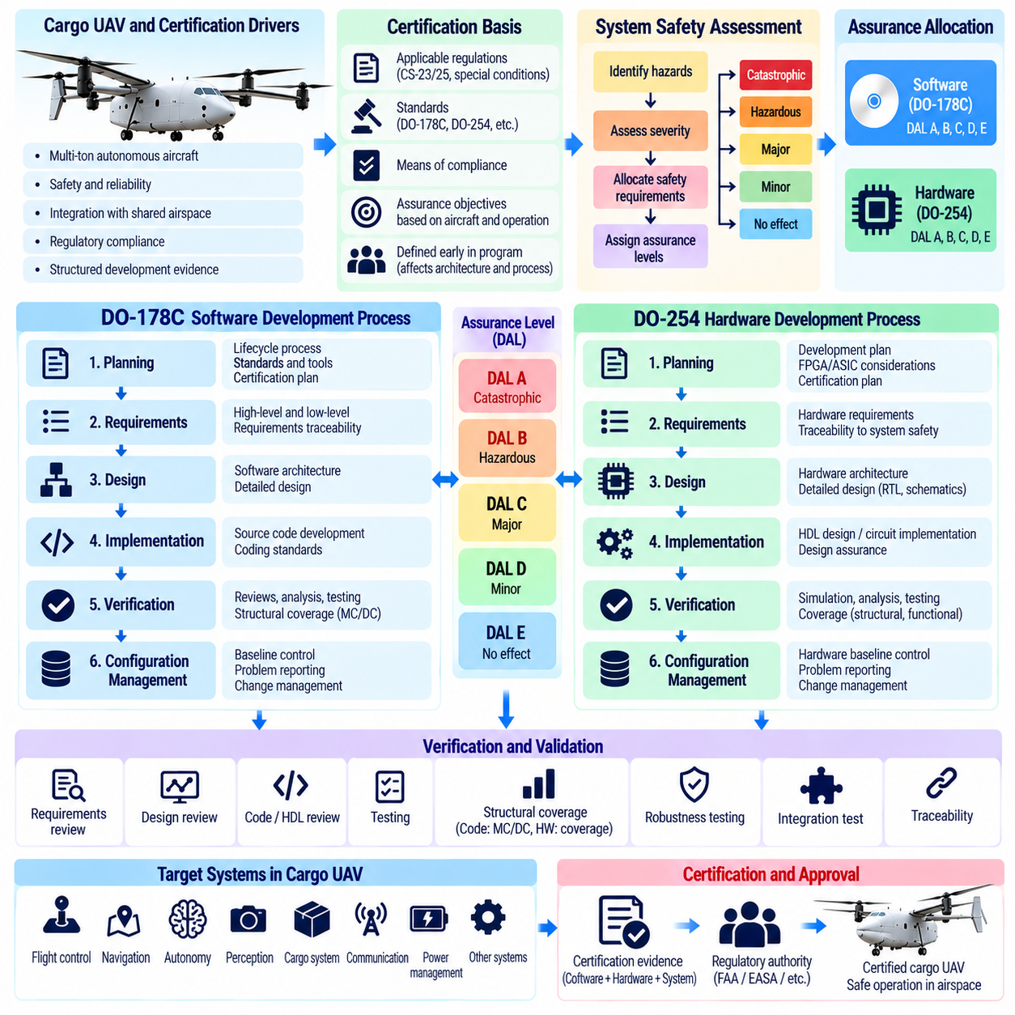
Certification of a cargo UAV requires evidence that flight-critical systems have been developed with rigor proportional to the consequences of failure. For multi-ton autonomous aircraft, certification is therefore not limited to demonstrating successful flight tests. Authorities need structured evidence showing that system requirements, software, airborne electronic hardware, verification activities, configuration management, and safety assessments form a controlled development process.
A certification basis establishes the regulations, standards, special conditions, means of compliance, and assurance objectives applicable to a particular aircraft and concept of operations. The exact basis depends on aircraft configuration, operational environment, autonomy level, and jurisdiction. For cargo UAV development, the certification strategy should be defined early because assurance requirements directly influence architecture, redundancy, interfaces, development processes, and verification planning.
System safety assessment provides the foundation for assigning assurance rigor. Aircraft-level hazards are identified and evaluated according to the severity of their potential effects. These hazards are decomposed into system and item requirements, allowing development assurance levels to reflect how strongly a software or hardware failure could contribute to an unsafe aircraft condition. Certification evidence should preserve traceability through this complete chain.
DO-178C provides widely used guidance for developing software in airborne systems and equipment. Its central purpose is not to prescribe a particular programming language, operating system, processor, or software architecture. Instead, it establishes lifecycle objectives and evidence demonstrating that airborne software has been planned, developed, verified, controlled, and documented with rigor appropriate to its contribution to aircraft safety.
Software levels are associated with the consequences of software failure conditions. The highest assurance is required when erroneous software behavior could contribute to catastrophic aircraft effects, while progressively lower levels correspond to less severe consequences. This classification influences the number and rigor of lifecycle objectives, verification independence, structural coverage expectations, traceability, configuration control, and certification evidence required for the software.
Planning is a fundamental DO-178C activity because certification requires an agreed development and verification framework rather than retrospective documentation. Software planning defines lifecycle processes, standards, verification methods, configuration management, quality assurance, tool usage, and certification interaction. For a cargo UAV, these plans should align with the broader system architecture and identify which flight-control, navigation, safety, and support functions require different assurance levels.
Requirements-based development is central to airborne software assurance. High-level software requirements are derived from system requirements and refined into lower-level requirements that define implementable behavior. Source code is then produced from those requirements rather than treated as the primary specification. Bidirectional traceability allows certification reviewers to determine why software exists and whether every required behavior has been implemented and verified.
Verification under DO-178C evaluates requirements, design where applicable, source code, executable behavior, and lifecycle data. Reviews and analyses complement testing because successful execution of test cases alone cannot demonstrate that unnecessary, unintended, or incorrectly implemented functionality is absent. Verification should confirm both that requirements are correctly implemented and that the resulting software does not contain behavior unsupported by approved requirements.
Structural coverage analysis provides evidence about how thoroughly requirements-based tests exercise the implemented software structure. The required coverage rigor depends on the assigned software level and can include statement, decision, and Modified Condition/Decision Coverage, or MC/DC. Coverage analysis is not a substitute for requirements-based testing; instead, it helps reveal code that was not exercised and may indicate missing tests, unintended functionality, or incomplete requirements.
Robustness testing examines software behavior outside ordinary nominal inputs. Flight software must handle invalid messages, sensor limits, timing anomalies, communication interruptions, numerical boundaries, unavailable resources, and abnormal mode transitions without producing uncontrolled behavior. This is particularly important in autonomous cargo UAVs because multiple distributed functions exchange data continuously and failures may propagate through software interfaces if not properly contained.
Configuration management ensures that certification evidence corresponds to a known software baseline. Requirements, source code, test procedures, test results, build information, tools, parameters, and problem reports must be controlled so that an approved software version can be reproduced. For cargo fleets, this discipline also supports aircraft-to-aircraft consistency and prevents unapproved software combinations from entering operational service.
Software quality assurance provides independent confidence that the defined lifecycle processes are followed and that deviations are identified and resolved. Certification credit depends not only on the technical quality of the final executable software but also on evidence that the development organization consistently applied its approved processes. Process assurance becomes increasingly important as software complexity, team size, supplier involvement, and aircraft criticality increase.
DO-254 addresses design assurance for airborne electronic hardware. It applies to complex electronic hardware whose behavior cannot be fully verified only by simple inspection or testing at the completed equipment level. Examples relevant to cargo UAV avionics can include programmable logic devices, field-programmable gate arrays, application-specific integrated circuits, and other complex hardware implementing flight-critical processing or interface functions.
The DO-254 lifecycle shares important principles with airborne software assurance, including planning, requirements capture, detailed design, implementation, verification, configuration management, process assurance, and certification liaison. Hardware requirements must be traceable to higher-level system requirements, and verification evidence must demonstrate that the implemented device satisfies those requirements without introducing unacceptable unintended behavior.
Hardware design assurance levels are similarly related to failure-condition severity and determine the rigor expected from development and verification. High-criticality hardware requires stronger independence, traceability, reviews, analyses, testing, and configuration control. For redundant flight-control computers, sensor interfaces, propulsion-control electronics, or safety monitors, the assigned hardware assurance level can significantly affect architecture and component selection.
Verification of complex airborne electronic hardware can combine simulation, analysis, reviews, laboratory testing, hardware testing, and target-device verification. Verification must address not only nominal functional behavior but also timing, interfaces, reset behavior, initialization, boundary conditions, and failure responses. Coverage of hardware requirements and implementation details must be sufficient to justify confidence that critical functions behave as intended.
DO-178C and DO-254 should not be interpreted as isolated software and hardware checklists. A flight-control computer, for example, contains hardware and software whose safety properties depend on their interaction. System-level requirements must allocate functions correctly between the two domains, define interfaces precisely, and ensure that assumptions made by software about hardware behavior are consistent with the verified characteristics of the electronic platform.
Tool qualification can become important when development or verification tools eliminate, reduce, or automate activities that would otherwise require independent confirmation. Compilers, code generators, model-based development environments, verification tools, and hardware design tools may require additional assurance depending on how their outputs are used. Tool strategy should therefore be established early rather than addressed only near certification completion.
Model-based development and advanced software technologies can be accommodated within a certification-oriented lifecycle, but their generated artifacts, verification strategy, traceability, and tool dependencies must remain controlled. The same principle applies to reusable software components and commercial hardware. Reuse can reduce engineering effort only when previous assurance evidence is applicable to the new operational environment and configuration.
Artificial intelligence and machine-learning functions introduce additional challenges because DO-178C and DO-254 were fundamentally developed around deterministic lifecycle artifacts and traceable requirements. Learning-based perception or optimization may therefore require complementary assurance arguments concerning training data, model boundaries, robustness, uncertainty, runtime monitoring, and fallback behavior rather than assuming conventional software evidence alone is sufficient.
For cargo UAVs, architectural partitioning can reduce certification complexity by separating highly critical deterministic functions from lower-criticality mission, optimization, or AI services. Flight stabilization, envelope protection, and essential fault management can operate within tightly controlled partitions, while less critical functions execute with different assurance requirements. Partitioning is useful only when spatial, temporal, communication, and failure isolation are convincingly demonstrated.
Certification evidence must also remain consistent with fail-safe and fail-operational architecture. Redundant computers or hardware channels do not automatically reduce assurance requirements if common software, shared power, identical interfaces, or common design errors can defeat the redundancy. Safety analysis, DO-178C software assurance, and DO-254 hardware assurance must therefore support a coherent argument explaining how failures are detected, isolated, tolerated, and recovered.
The cargo UAV structure places DO-178C and DO-254 immediately after regulatory, UTM, fail-safe, and software-stack fundamentals, establishing certification assurance as part of the architectural foundation rather than a final documentation activity. Later chapters then extend this basis into flight-control redundancy, navigation, cargo management, safety validation, AI certification, and dedicated 2.5-ton, 5-ton, and 10-ton software architectures.
A practical certification program therefore begins by connecting aircraft hazards to system requirements, system requirements to software and hardware assurance levels, and those levels to lifecycle evidence. DO-178C provides the principal framework for airborne software assurance, while DO-254 provides the corresponding framework for complex airborne electronic hardware. Together they support a traceable engineering argument that critical cargo UAV functions are suitable for their intended operational role.

01.09. Key Differences from Small UAV to Cargo UAV
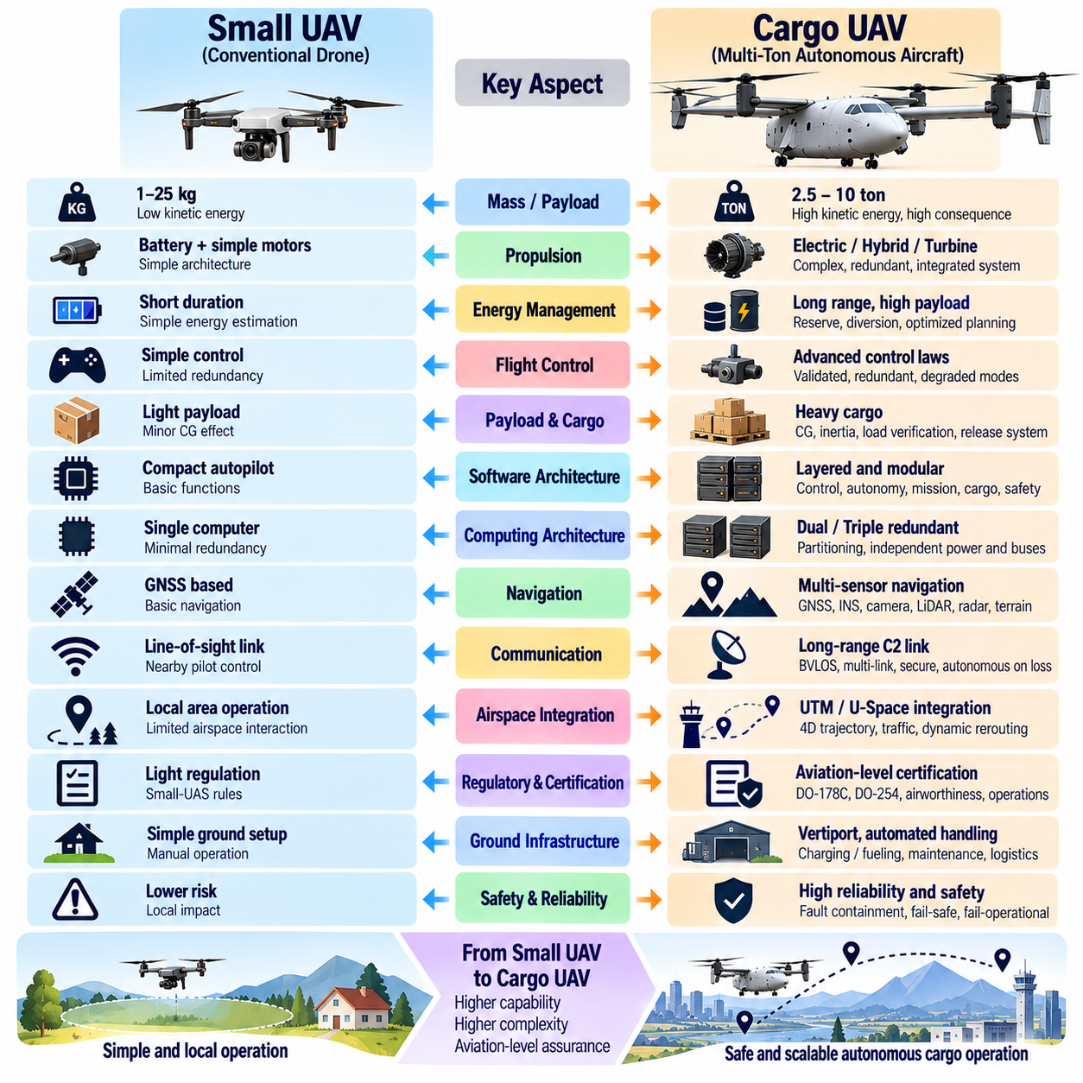
The transition from a small UAV to a multi-ton cargo UAV is not simply a matter of increasing dimensions, propulsion power, and payload capacity. Aircraft mass changes the consequences of failure, structural loads, energy demand, control dynamics, infrastructure requirements, and regulatory expectations. As a result, cargo UAV engineering increasingly resembles safety-critical aviation system development rather than conventional small-drone integration.
Small UAVs commonly operate with payloads measured in kilograms and relatively limited kinetic energy, whereas cargo UAVs may transport hundreds or thousands of kilograms. A failure that causes a small aircraft to descend may remain geographically limited, while loss of control of a multi-ton aircraft can create substantially greater risk. Increasing mass therefore drives stronger requirements for reliability, fault containment, redundancy, and controlled emergency behavior.
Propulsion architecture changes fundamentally as vehicle size increases. Small multirotors can often use relatively simple combinations of batteries, electronic speed controllers, and electric motors. Cargo UAVs may require high-voltage electrical distribution, multiple propulsion buses, generators, turbines, hybrid-electric systems, thermal management, and sophisticated propulsion control. Propulsion becomes a tightly integrated flight-critical system rather than a collection of interchangeable motors.
Energy management similarly becomes a mission-level concern. A small UAV can often estimate remaining flight time primarily from battery state and recent consumption. A heavy cargo aircraft must consider payload, wind, climb requirements, thermal conditions, propulsion efficiency, reserves, diversion capability, and degradation of individual energy sources. Energy prediction therefore becomes tightly coupled with route planning, flight-envelope management, and contingency decisions.
Flight-control requirements also become more demanding. Small UAV control systems can often tolerate relatively simple actuator allocation and limited redundancy, depending on their operational environment. Cargo UAVs require control laws validated across substantial variations in mass, center of gravity, inertia, propulsion state, and aerodynamic configuration. The controller must remain predictable during both nominal operation and defined degraded conditions.
Payload is no longer an independent accessory attached to the vehicle. Heavy cargo directly affects center of gravity, structural loading, inertia, propulsion demand, landing performance, and control authority. Cargo UAV software must therefore know what has been loaded, where it is positioned, whether it is properly restrained, and whether the resulting mass properties remain within approved limits before the aircraft is authorized to depart.
The software architecture expands accordingly. A small UAV may combine stabilization, navigation, telemetry, and mission logic within a compact autopilot environment. A cargo UAV requires clearer separation among real-time flight control, state estimation, autonomous navigation, perception, route and airspace management, cargo mission management, vehicle management, safety monitoring, communication, ground supervision, and potentially AI-based optimization.
Computing architecture also moves toward stronger partitioning and redundancy. Multi-ton platforms may require duplicated or triplicated flight-control computers, independent power domains, redundant communication buses, cross-channel monitoring, voting, and physically separated sensors. The objective is not merely greater computing performance but continued availability of essential functions when individual hardware, software, or communication components fail.
Navigation requirements expand from basic waypoint following toward assured navigation. Small UAVs often depend heavily on GNSS under relatively constrained operations. Cargo aircraft may require multi-sensor navigation using inertial systems, GNSS, cameras, LiDAR, radar, terrain information, or other sources. Navigation integrity and uncertainty become explicit system variables because route continuation must depend on whether the estimated aircraft state remains sufficiently trustworthy.
Communication changes from a convenient control link into part of the operational safety architecture. Small UAVs may frequently assume a nearby pilot and relatively direct radio connection. Long-range cargo operations require command-and-control links capable of supporting beyond-visual-line-of-sight missions, while the aircraft must also remain safe when those links degrade. Link loss therefore requires predefined autonomous contingency behavior rather than immediate dependence on manual recovery.
Airspace integration becomes substantially more complex. Small UAVs may operate inside localized areas, restricted sites, or low-altitude zones with limited interaction with conventional traffic. Cargo UAVs can traverse long routes and multiple airspace environments. Four-dimensional trajectory planning, UTM or U-Space coordination, traffic information, geofencing, dynamic rerouting, conflict resolution, and detect-and-avoid functions consequently become central operational capabilities.
Autonomy also changes in purpose. For a small drone, autonomy may primarily reduce pilot workload by automating waypoint navigation or landing. For cargo UAVs, autonomy must support scalable logistics while preserving aviation-grade safety. The aircraft may need to evaluate route feasibility, weather, energy reserves, traffic, landing availability, system health, and contingency options continuously rather than simply execute a preloaded mission.
Safety architecture represents one of the largest differences. A small UAV may respond to many faults by stopping the mission and landing quickly. A multi-ton cargo UAV may be unable to reach a safe state immediately because it is operating over unsuitable terrain, water, infrastructure, or populated areas. Fail-operational capability can therefore be required so that essential control and navigation remain available until a suitable diversion or landing location is reached.
Failure management becomes correspondingly more structured. Cargo UAVs require systematic fault detection, isolation, and recovery across sensors, actuators, propulsion, electrical power, computing, navigation, and communication. A detected failure may reduce the available flight envelope without making the aircraft uncontrollable. Software must understand the remaining capability and prevent mission functions from commanding maneuvers that the degraded vehicle can no longer safely perform.
Verification changes from predominantly functional testing toward structured development assurance. Flight demonstrations remain important, but successful flights alone cannot establish that rare software, hardware, timing, and failure conditions have been adequately addressed. Cargo UAV development therefore requires requirements traceability, configuration control, independent verification, fault injection, software-in-the-loop testing, hardware-in-the-loop testing, and carefully controlled aircraft-level validation.
Certification becomes a major architectural driver. The chapter structure introduces regulatory frameworks, fail-safe and fail-operational design, the software stack, and DO-178C and DO-254 foundations before moving into detailed flight-control and autonomy functions. This ordering reflects the need to treat assurance and certification as fundamental engineering constraints rather than documentation activities performed after implementation.
Ground infrastructure changes as dramatically as the aircraft. A small UAV may operate from a compact launch area with portable charging equipment, whereas cargo UAVs require appropriately sized landing zones, load-bearing surfaces, cargo handling, charging or fueling systems, maintenance access, fire protection, communication infrastructure, and emergency procedures. Autonomous logistics therefore extends beyond the airborne vehicle into an integrated ground-air system.
Maintenance and fleet management also become more formal. High-utilization cargo aircraft must track component condition, software configuration, propulsion health, battery or energy-system status, fault history, maintenance actions, and aircraft availability. Predictive maintenance and centralized fleet supervision become economically important because unscheduled failures can disrupt logistics networks and because each aircraft represents a substantially larger operational asset.
Artificial intelligence must operate within stronger safety boundaries. A small experimental UAV may allow learning-based algorithms to exercise broad authority during research flights. A certified cargo aircraft requires clear limits on AI behavior, particularly when perception, trajectory optimization, landing, or anomaly detection affects safety. Deterministic protection, runtime monitoring, uncertainty management, and fallback behavior become important mechanisms for containing AI-related risk.
The differences continue to increase across cargo aircraft classes themselves. The broader architecture separates 2.5-ton software architecture from 5-ton and 10-ton architectures because increasing scale drives stronger requirements for redundant avionics, fly-by-wire control, propulsion integration, telemetry, cargo interfaces, safety management, and certification evidence. A cargo UAV family therefore cannot be designed effectively by applying a single small-UAV architecture at progressively larger scale.
The key engineering transition is ultimately one of system assurance. Small UAV design can often focus primarily on achieving the desired flight capability, while cargo UAV design must demonstrate that capability remains controlled across normal conditions, environmental variation, equipment failures, communication loss, navigation degradation, and operational contingencies. Performance and safety can no longer be treated as separate objectives because every major function contributes to both.
A cargo UAV should therefore be viewed as an autonomous aviation system rather than a large drone. Its software, hardware, propulsion, payload, ground infrastructure, airspace interfaces, operators, and certification evidence form one operational architecture. Moving from small UAVs to multi-ton cargo platforms means transitioning from feature-oriented autonomy toward deterministic control, managed degradation, verifiable safety, and scalable aviation-grade autonomous logistics.

01.10. Robotics Cargo UAV Autonomy Vision
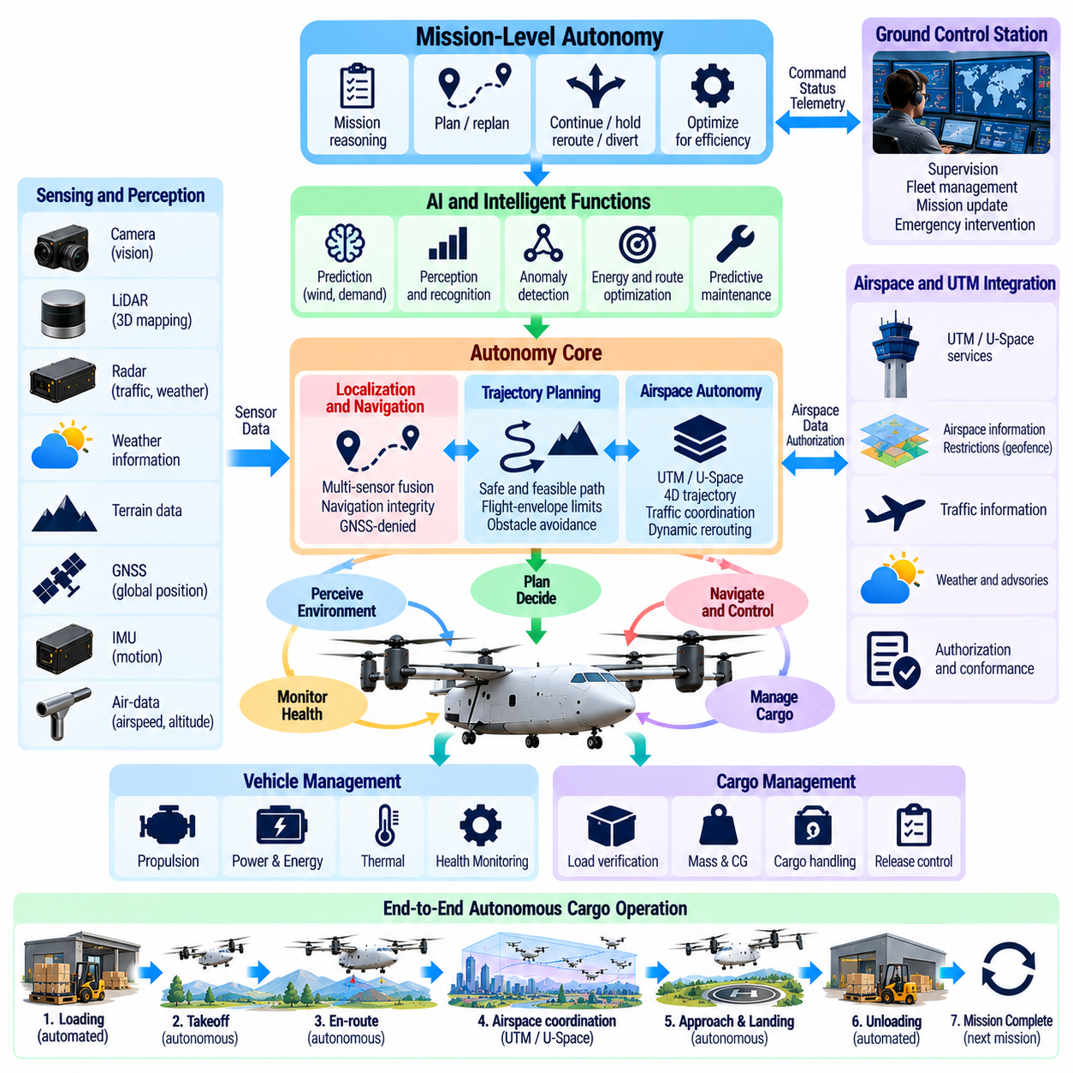
The autonomy vision for robotics cargo UAVs extends beyond automating conventional flight procedures. The objective is to create an aerial robotic logistics system capable of understanding mission intent, perceiving its environment, planning safe actions, controlling a multi-ton aircraft, managing cargo, and responding to changing operational conditions with limited human intervention while preserving aviation-grade safety.
A cargo UAV should therefore be viewed as a physical robotic agent operating simultaneously within aerodynamic, geographic, logistical, and regulatory environments. Its autonomy system must connect perception, localization, prediction, planning, control, communication, and mission reasoning. Successful autonomy is achieved when these functions operate as a coordinated closed loop rather than as independent software features added to an autopilot.
The first foundation of this vision is dependable vehicle autonomy. The aircraft must autonomously execute takeoff, climb, cruise, approach, landing, holding, diversion, and emergency procedures within its validated flight envelope. These capabilities must remain predictable across payload variations, wind, temperature, sensor uncertainty, propulsion degradation, and communication loss so that autonomy improves operational capability without weakening deterministic flight safety.
Environmental perception expands the aircraft's awareness beyond its internal state. Cameras, radar, LiDAR, cooperative traffic information, terrain databases, weather information, and other sensing sources can provide complementary observations of obstacles, aircraft, landing areas, terrain, and environmental hazards. Sensor fusion must convert these observations into an operational representation containing both estimated conditions and the uncertainty associated with them.
Localization and navigation must support operation when a single positioning source cannot be trusted continuously. GNSS can provide global positioning, but inertial navigation, vision, LiDAR, radar, terrain references, and other sources may be required for redundancy or degraded environments. The autonomous system should reason about navigation integrity and modify its mission when uncertainty becomes too large for the current route, airspace, approach, or landing requirement.
Trajectory planning transforms environmental understanding into safe aircraft motion. The planner must consider vehicle dynamics, flight-envelope limits, terrain, obstacles, airspace restrictions, weather, traffic, energy reserves, and destination constraints simultaneously. For heavy cargo UAVs, the shortest geometric path is rarely sufficient; a valid trajectory must also be dynamically achievable, energetically feasible, operationally authorized, and recoverable after foreseeable disturbances.
Airspace autonomy adds another reasoning layer above local trajectory generation. Long-range cargo aircraft must coordinate four-dimensional trajectories, restricted regions, corridors, UTM or U-Space services, traffic information, and dynamic rerouting. Strategic coordination can reduce conflicts before departure, while onboard surveillance and detect-and-avoid functions provide tactical protection when unexpected traffic or deviations occur during flight.
Cargo autonomy extends robotic intelligence into the logistics process itself. The aircraft should understand payload mass, center of gravity, loading status, restraint condition, destination sequence, release authorization, and delivery completion. Mission decisions can then reflect the actual cargo state rather than assuming a fixed payload. This integration connects autonomous flight with loading, transportation, unloading, and ground logistics as one continuous robotic workflow.
Ground operations represent an important part of the autonomy vision. Cargo UAVs can coordinate with automated loading equipment, charging or fueling infrastructure, maintenance systems, landing facilities, and fleet-management services. Reducing manual turnaround operations can improve utilization, but every automated ground interaction must include state verification, interlocks, authorization, and safe recovery when equipment or communication does not behave as expected.
Mission-level autonomy coordinates these airborne and ground functions around operational objectives. Rather than executing a static waypoint list, the mission manager can evaluate whether the aircraft should continue, hold, reroute, divert, return, or land. Decisions should consider aircraft health, cargo priority, energy, weather, traffic, destination availability, regulatory constraints, and the feasibility of alternative actions before committing the vehicle to a new mission state.
Artificial intelligence can enhance this architecture where prediction, perception, or optimization benefits from data-driven methods. AI can support wind-field prediction, energy optimization, anomaly detection, landing-site assessment, perception, predictive maintenance, and fleet scheduling. The broader cargo UAV structure dedicates a separate domain to these functions, emphasizing their role in improving flight efficiency and operational intelligence rather than replacing foundational flight control.
Learning-based autonomy must remain bounded by verified safety mechanisms. An AI planner may propose an energy-efficient route, but deterministic constraints should reject trajectories that violate structural, airspace, energy, or flight-envelope limits. Similarly, perception models should communicate confidence and uncertainty so that downstream decision making can transition to conservative behavior when environmental understanding becomes insufficient for safe autonomous operation.
Runtime assurance provides a practical bridge between advanced autonomy and aviation safety. A high-capability planner or AI component can operate within a monitored region while an independent safety function observes critical states and commands. If protected limits are approached or confidence falls below an acceptable threshold, authority can transition to a simpler verified controller, contingency route, holding pattern, diversion procedure, or emergency landing strategy.
Fault-aware autonomy is essential because a robotic cargo aircraft must reason about what it can still accomplish after failures. Loss of a sensor, motor, communication link, computing channel, or energy source may reduce capability without immediately ending controlled flight. The autonomy system should update its available flight envelope and mission options so that planning reflects the actual degraded aircraft rather than the capabilities of a fully healthy vehicle.
Human supervision remains part of the architecture even as onboard autonomy becomes more capable. The long-term objective is not necessarily to remove humans from every operational decision, but to move them from continuous low-level control toward supervisory management of missions and fleets. Operators should receive concise information about aircraft intent, health, exceptions, and autonomous responses while retaining clearly defined authority for appropriate interventions.
This supervisory model enables one operator organization to manage increasing numbers of aircraft without requiring continuous manual piloting of every vehicle. Fleet-level software can coordinate departures, route allocation, charging, maintenance, payload priorities, and contingency resources. Autonomy therefore scales from individual aircraft intelligence toward coordinated logistics intelligence in which multiple vehicles share infrastructure and operational information.
Communication architecture must support this distributed autonomy without making safety dependent on uninterrupted connectivity. Cloud and ground services can provide fleet optimization, weather updates, airspace coordination, maintenance analytics, and logistics information. However, stabilization, essential navigation, flight-envelope protection, immediate collision avoidance, and critical contingency behavior must remain available onboard when external services are delayed or unavailable.
The autonomy vision must also include explainability and operational traceability. Important decisions such as rerouting, rejecting a landing site, entering a degraded mode, or initiating diversion should be associated with recorded aircraft states, constraints, health information, and decision causes. Such records support operator understanding, maintenance, safety investigation, verification, certification evidence, and systematic improvement of autonomous behavior.
Simulation becomes a fundamental development environment for this level of autonomy. Large numbers of nominal, abnormal, environmental, and failure scenarios can be exercised before aircraft testing. Software-in-the-loop and hardware-in-the-loop environments can evaluate interactions among perception, planning, control, propulsion, communication, and safety functions while exposing rare conditions that would be expensive or dangerous to create repeatedly in flight.
The architectural vision must scale across the 2.5-ton, 5-ton, and 10-ton classes without assuming identical implementations. A 2.5-ton platform can emphasize distributed regional logistics, while heavier aircraft demand stronger redundancy, propulsion integration, fly-by-wire control, fault tolerance, and certification assurance. Common autonomy principles can be retained while computing, actuation, energy, and safety architectures evolve according to aircraft scale.
The broader cargo UAV structure develops this vision progressively through system architecture, flight control, autonomous navigation, perception and sensor fusion, cargo mission management, flight safety, AI-based optimization, and dedicated software architectures for different weight classes. These domains collectively establish autonomy as an aircraft-wide capability rather than a single navigation or artificial-intelligence module.
The long-term robotics cargo UAV vision is therefore an autonomous logistics aircraft that can perceive, reason, act, monitor itself, and cooperate with surrounding infrastructure while remaining inside verified safety boundaries. Its intelligence must combine robotic adaptability with aviation discipline. The resulting system is not simply a drone carrying heavier cargo, but a resilient physical autonomous platform capable of scalable, dependable, and increasingly intelligent aerial logistics.

