Volume 24. Robot Cybersecurity

Chapter 07. OTA and Firmware Security

07.01. OTA Security Threat Model Rollback Injection
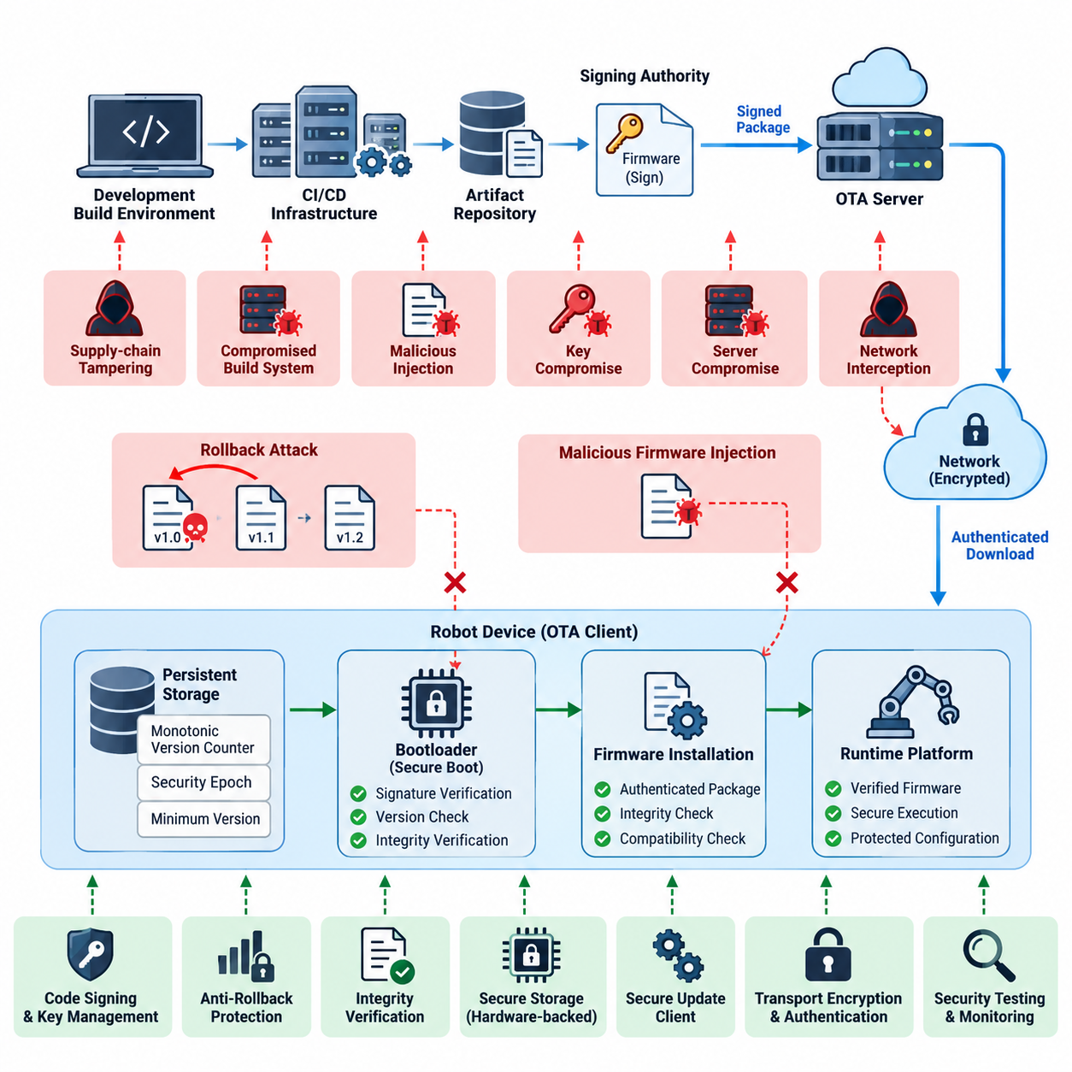
Over-the-air update mechanisms create a security boundary that extends from the firmware build environment and release infrastructure to communication networks, bootloaders, persistent storage, and the robot’s runtime platform. A threat model must therefore treat OTA as an end-to-end trust chain rather than a simple file-transfer function. The referenced structure places rollback prevention, firmware signing, secure boot, integrity verification, key storage, supply-chain security, and security testing within the same OTA security domain. Volume_24_Robot_Cybersecurity
A useful OTA threat model begins by identifying protected assets and trust boundaries. Critical assets include firmware images, bootloader code, signing keys, update manifests, version metadata, device identities, configuration data, recovery partitions, and update authorization policies. Trust boundaries appear between development systems, CI/CD infrastructure, artifact repositories, OTA servers, fleet networks, robot gateways, bootloaders, and execution environments.
Rollback attacks attempt to replace currently trusted firmware with an older but legitimately signed version containing known vulnerabilities. Because the historical image may possess a valid cryptographic signature, signature verification alone cannot prevent this attack. An adversary who obtains an archived package or intercepts an update workflow may attempt to force installation of a vulnerable release and subsequently exploit weaknesses that were corrected in later firmware.
Rollback resistance therefore requires firmware authenticity to be evaluated together with version freshness. A robot can maintain a trusted monotonic version counter, security epoch, or minimum acceptable firmware version in protected storage. During installation and boot, the platform compares package metadata with this trusted state. Firmware whose security version is below the accepted threshold is rejected even when its signature and cryptographic hash remain valid.
The anti-rollback state itself becomes a high-value security asset. If an attacker can rewrite the trusted version counter, reset secure storage, substitute metadata, or manipulate bootloader comparison logic, rollback protection can be bypassed. The counter should consequently reside within hardware-backed or otherwise strongly protected storage, with modification restricted to authenticated update procedures and carefully controlled recovery mechanisms.
Firmware injection represents a different but related threat. Instead of selecting an older authentic image, the adversary attempts to introduce unauthorized code into the update path. Injection may occur through a compromised build system, malicious artifact repository, manipulated OTA server, man-in-the-middle position, exposed maintenance interface, removable media, or vulnerable update parser. The injected payload may contain persistent malware or altered robot-control logic.
Cryptographic signing provides the primary authenticity control against unauthorized firmware injection. Firmware packages should be signed by an approved release authority, while the robot verifies the signature against a trusted public key anchored within its root of trust. Verification should cover not merely executable binaries but also security-sensitive metadata such as device compatibility, firmware version, component identifiers, dependencies, and update policy attributes.
Integrity verification complements authenticity verification by detecting corruption or modification of OTA artifacts. Cryptographic hashes can identify unexpected package changes, while authenticated structures protect manifests and individual components. Verification should occur before installation and, where architecture permits, again before execution. The chapter structure explicitly separates signing-chain design, package integrity verification, and anti-rollback mechanisms, reflecting these distinct security responsibilities. Volume_24_Robot_Cybersecurity
The OTA client itself must be included in the attack surface. Package parsers, decompression libraries, delta-update engines, filesystem operations, manifest processors, and bootloader update routines process externally delivered data and can contain exploitable defects. A correctly signed package can still trigger unsafe behavior if parsing logic is vulnerable. Strict bounds checking, constrained privileges, authenticated metadata, defensive parsing, and security testing are therefore essential.
Network compromise should not automatically translate into firmware compromise. Transport encryption and authenticated sessions protect confidentiality and reduce interception risks, but firmware trust should remain independently verifiable at the device. Even when DNS, a proxy, wireless infrastructure, or an OTA distribution server is compromised, the robot should reject packages that cannot establish the required cryptographic authorization and acceptable security version.
Threat modeling must also consider signing-key compromise because possession of an authorized private key can transform malicious firmware into apparently legitimate firmware. Signing keys should therefore be isolated from ordinary development environments, protected through hardware security controls where appropriate, and governed by restricted release procedures. Key rotation, revocation, audit trails, and emergency replacement procedures must be designed before deployment rather than after compromise occurs.
Supply-chain threats extend the model upstream from the OTA service. A legitimate release may contain malicious or vulnerable components introduced through compromised source repositories, dependencies, build tools, developer credentials, or third-party firmware. Consequently, package signing proves who authorized an artifact but does not prove that its contents are safe. The chapter structure accordingly treats firmware supply-chain security and SBOM-based vulnerability tracking as dedicated OTA concerns. Volume_24_Robot_Cybersecurity
Recovery mechanisms require equal scrutiny because emergency installation modes can become alternate paths around normal OTA controls. Maintenance ports, factory recovery images, rescue bootloaders, and service procedures should preserve authenticity and rollback policies unless a deliberately stronger administrative authorization is supplied. Otherwise, an attacker may ignore the protected OTA channel entirely and exploit a weaker recovery interface to install unauthorized firmware.
Robot systems add physical consequences to conventional firmware compromise. Modified firmware can affect motor controllers, safety processors, perception devices, battery management, communication modules, or actuator interfaces. A successful update attack may therefore produce unsafe motion or disable protective functions rather than merely expose information. Threat severity should incorporate possible effects on physical safety, operational availability, fleet behavior, and surrounding equipment.
Fleet deployment creates another dimension because a compromised OTA service can potentially affect thousands of robots simultaneously. Security architecture should limit blast radius through staged deployment, device-group authorization, controlled release channels, health monitoring, and rapid suspension of suspicious campaigns. Update telemetry should record package identity, version transitions, verification outcomes, installation status, boot results, and rejected rollback or injection attempts.
The completed threat model should connect each attack path to preventive, detective, and recovery controls. Rollback threats map to protected version state and anti-rollback enforcement; injection threats map to signing and integrity verification; key compromise maps to hardware-backed key protection and revocation; supply-chain compromise maps to provenance and SBOM controls; parser attacks map to hardened update software and fuzz testing. This establishes OTA security as a continuous trust lifecycle rather than a single cryptographic check.

07.02. Firmware Signing Chain Root of Trust Design [w/Code]
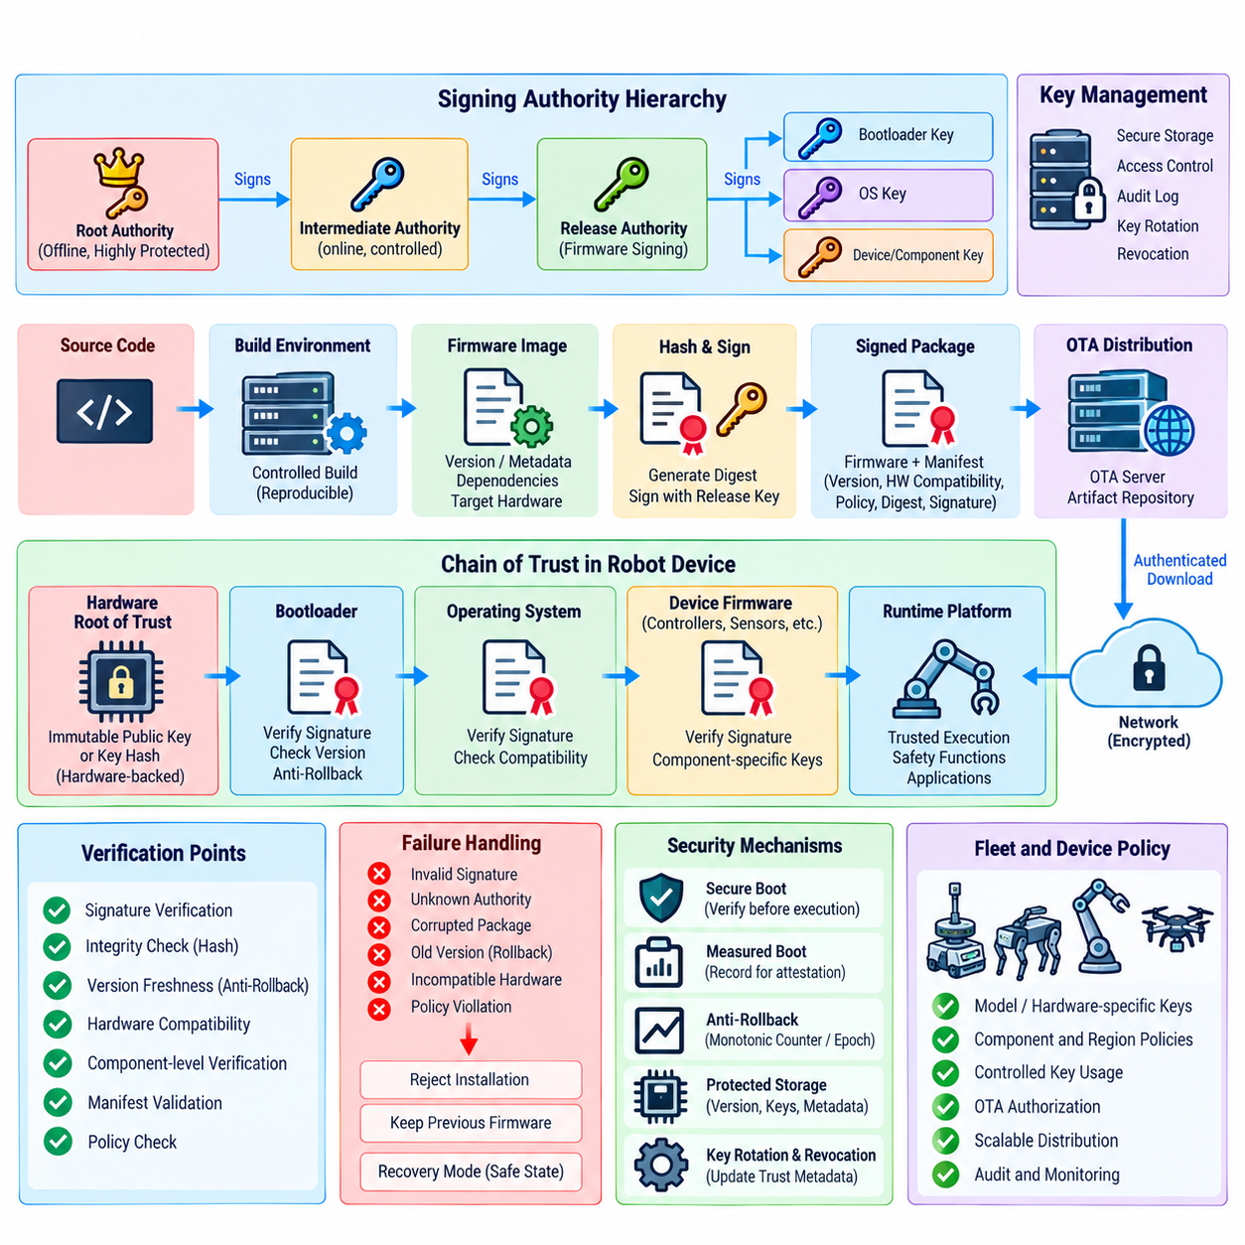
A firmware signing chain establishes the cryptographic trust relationship that allows a robot to determine whether firmware is authorized before it is installed or executed. In a secure robot architecture, firmware signing should not be treated as an isolated release activity but as part of a complete root-of-trust design. The chain connects the hardware trust anchor, bootloader, operating system, device firmware, OTA package, and release authority so that each stage can verify the legitimacy of the next stage before transferring control.
The root of trust is the foundation of this chain. It should begin with a trust anchor that is difficult to modify or replace, preferably through hardware-backed security capabilities embedded in the robot platform. The trust anchor may contain an immutable public key, a protected key hash, or another cryptographic reference used to validate the first trusted software component. The security objective is that an attacker who gains control of ordinary software cannot simply replace the initial verification authority and establish a new unauthorized chain of trust.
A typical signing hierarchy separates different responsibilities rather than relying on one universal signing key. A highly protected root authority can establish intermediate signing authorities, while release keys can sign approved firmware packages. Component-specific keys may also be used for bootloader, operating system, peripheral firmware, or safety-critical controller updates. This separation limits the consequences of a single key compromise and makes key rotation, revocation, and operational access control more manageable across the robot firmware lifecycle.
The signing process should begin before an artifact reaches the OTA distribution system. A firmware build must be associated with a controlled source revision, reproducible or auditable build environment, version identifier, target hardware definition, dependency information, and release metadata. After validation, the resulting artifact is hashed and signed by an authorized release key. The signed manifest should bind the firmware identity, version, compatibility constraints, cryptographic digest, and applicable security policy so that an attacker cannot substitute one component while preserving an apparently valid package structure.
Signature verification must occur at every security boundary that matters. The bootloader should verify the firmware before execution, while an OTA client should verify the package before installation. If firmware contains independently updateable components, each component should have an appropriate verification mechanism rather than assuming that validation of one top-level container proves the integrity of every internal element. This layered verification prevents a trusted outer package from becoming a mechanism for silently introducing an unauthorized inner component.
The chain of trust must also define what happens when verification fails. An invalid signature, unknown signing authority, corrupted manifest, incompatible hardware identifier, or unacceptable security version should result in a controlled rejection rather than an attempted installation. Failure handling should preserve the previously trusted firmware when possible and transition to a defined recovery state when necessary. For safety-critical robots, this behavior must be coordinated with the boot process, actuator state, watchdog mechanisms, and operational safety controls so that a cybersecurity failure does not create a physical hazard.
Key protection is one of the most important elements of the signing architecture because compromise of an authorized signing key can undermine the entire trust chain. Private keys should be isolated from ordinary development workstations and protected using appropriate hardware security mechanisms or restricted signing services. Access should require strong authentication and authorization, while signing operations should generate auditable records. The architecture should also provide procedures for key rotation, emergency revocation, replacement, and recovery without requiring uncontrolled modification of the robot's fundamental trust anchor.
Root-of-trust design must account for key compromise and certificate or key revocation throughout the firmware lifecycle. A robot that permanently trusts a signing key without an update mechanism for trust metadata may remain vulnerable after that key is exposed. Revocation information, replacement keys, security epochs, or equivalent mechanisms should therefore be incorporated into the platform's trust model. However, the update mechanism for trust anchors must itself be protected, because an attacker who can arbitrarily modify trusted-key information can bypass the firmware authentication mechanism.
The signing chain should be closely integrated with secure boot and measured boot. Secure boot establishes whether the software about to execute is authorized, while measured boot can record cryptographic measurements of firmware and other boot components for later verification or remote attestation. The resulting architecture creates a sequence in which hardware establishes the initial trust state, the bootloader verifies the next software layer, and subsequent components inherit only the trust that has been cryptographically established. This relationship is particularly important for robots whose firmware controls safety, sensing, communications, and actuation.
Fleet-scale robotics introduces additional requirements for firmware signing. The same signing infrastructure may distribute firmware to many robot models, hardware revisions, geographic deployments, and security domains. Signing policies should therefore restrict which keys may authorize which device classes and firmware components. A package intended for one controller or robot generation should not automatically become valid for another merely because the cryptographic signature is correct. Device identity, hardware compatibility, security level, firmware version, and deployment policy should participate in authorization decisions.
A mature firmware signing architecture finally treats trust as a lifecycle rather than a one-time configuration. Source code, build systems, signing infrastructure, artifact repositories, OTA services, bootloaders, and robot hardware all participate in maintaining the chain. Audit evidence should demonstrate which source and build produced an artifact, which authority signed it, which devices accepted it, and which verification controls were applied. Within the OTA security structure, this signing-chain design provides the foundation for secure boot, package integrity verification, anti-rollback enforcement, supply-chain protection, secure key storage, and subsequent OTA security testing.

07.03. Secure Boot and Measured Boot for Robots [w/Code]
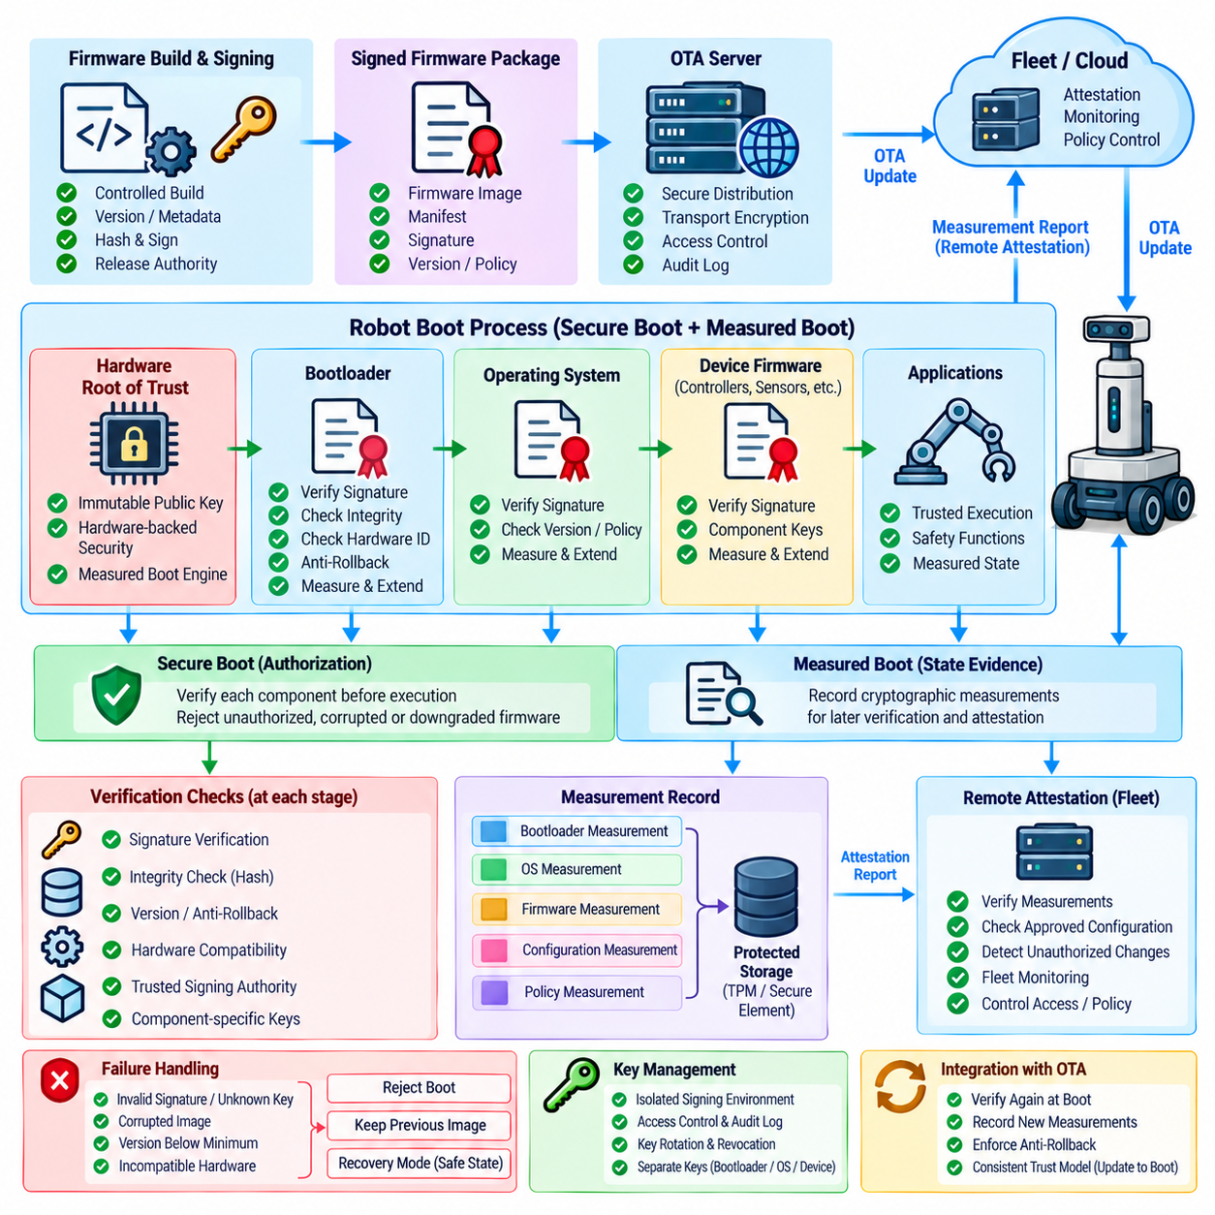
Secure Boot and Measured Boot provide complementary mechanisms for establishing and maintaining trust during the robot startup process. Secure Boot determines whether software is authorized to execute, while Measured Boot records cryptographic measurements of boot components so that their actual state can be evaluated later. In a robot platform, these mechanisms extend the firmware signing chain into the boot process and help prevent unauthorized firmware, modified bootloaders, and compromised operating-system components from becoming trusted execution elements. Volume_24_Robot_Cybersecurity
Secure Boot begins with a hardware-rooted trust anchor that cannot be freely modified by ordinary software. The initial verification stage establishes whether the next boot component is authentic and authorized, after which that component verifies the following stage. This creates a chain of trust extending from hardware or immutable boot code through the bootloader, operating system, device firmware, and other security-sensitive components. Each stage inherits trust only after the previous stage has successfully validated its cryptographic identity and authorization.
The bootloader is therefore a critical security boundary in a robot. Before transferring control to an operating system or firmware image, it should verify the digital signature, trusted signing authority, image integrity, hardware compatibility, and applicable security version. A package that has been corrupted, signed by an unauthorized key, targeted at another hardware platform, or rejected by anti-rollback policy must not be executed. The failure path should preserve a known-good image or enter a controlled recovery state rather than blindly continuing the boot process.
Secure Boot must protect more than the primary application firmware when multiple programmable components participate in robot operation. Motor controllers, safety processors, communication processors, sensor subsystems, and specialized accelerators may each contain executable firmware. Where these components can influence security or physical behavior, their firmware should participate in an appropriate verification process. Otherwise, an attacker could bypass a protected main processor by compromising a secondary controller that operates outside the primary trust chain.
Measured Boot addresses a different requirement. Instead of simply deciding whether a component is authorized, it calculates and records a cryptographic measurement of the component that actually participates in the boot process. Measurements can include the bootloader, firmware image, operating-system components, configuration data, security policies, and other relevant artifacts. The resulting measurement record provides evidence of the software state and can later support integrity assessment, forensic analysis, fleet monitoring, or remote attestation.
The distinction between Secure Boot and Measured Boot is important because authorization and state visibility are different security objectives. Secure Boot can prevent an unauthorized image from executing, but it does not by itself provide a detailed historical record of everything that was loaded. Measured Boot can provide such evidence, but measurement alone does not necessarily prevent execution of malicious software. A robust robot platform therefore uses both mechanisms together: Secure Boot establishes an execution boundary, while Measured Boot establishes verifiable evidence about the platform state.
Measured Boot becomes particularly valuable when robots are connected to fleet infrastructure or cloud security services. A robot can report selected measurement information to a trusted verifier, which can compare the observed state against an approved reference configuration. This enables remote attestation and allows fleet operators to identify devices that booted unexpected firmware, modified configuration, or an unapproved software combination. Attestation results can then influence whether a robot receives sensitive commands, joins a secure operational group, or becomes eligible for additional OTA updates.
The measurement process itself must be protected against manipulation. If an attacker can alter or delete measurement records after boot, the resulting evidence cannot be trusted. Measurement values should therefore be extended into protected hardware-backed structures or otherwise stored in a manner that prevents ordinary software from rewriting historical measurements. The design should also define which components are measured, the order in which measurements are performed, how values are extended, and how measurement records are securely transmitted to an external verifier.
Secure Boot and Measured Boot must also interact with firmware updates. When a new firmware image is installed through OTA, its signature must first establish authorization, while the subsequent boot process should verify the image again before execution and record its measurement where applicable. The new measurement should correspond to the approved release and security policy. This prevents an attacker from exploiting a gap between OTA installation and boot-time verification and ensures that the firmware accepted during deployment remains subject to the same trust model during execution.
Anti-rollback protection should be incorporated into the boot decision. A previously valid firmware image may possess a legitimate signature while containing vulnerabilities that have already been corrected. The bootloader should therefore evaluate security version information or a protected monotonic counter in addition to signature validity and integrity. If the firmware falls below the minimum permitted security level, the bootloader must reject it. This makes Secure Boot part of the broader OTA security lifecycle rather than an isolated signature check.
Recovery architecture requires particular attention because recovery paths can otherwise become an unintended bypass around Secure Boot. Factory images, rescue bootloaders, maintenance interfaces, and emergency update procedures should retain appropriate signature and version checks. If a recovery mode permits arbitrary unsigned firmware to execute, an attacker who obtains physical or privileged access could circumvent the normal chain of trust. Recovery therefore needs its own authenticated authorization model, protected credentials, controlled access conditions, and auditable procedures.
For robots with safety-critical functions, boot security must be coordinated with the physical safety architecture. A failed firmware verification should not cause uncontrolled actuator activation, unsafe motor commands, or loss of required protective functions. The system should establish a safe hardware state before attempting recovery or retrying boot, while watchdogs and independent safety mechanisms remain available. Cybersecurity controls must therefore be designed together with functional safety and fault-handling requirements rather than treating boot security as a purely software-level concern.
A mature Secure Boot and Measured Boot architecture also requires lifecycle management. Trusted keys may need replacement, firmware security policies may evolve, hardware platforms may be revised, and previously trusted software may eventually become unacceptable. The platform must therefore support controlled trust-anchor updates, key rotation, revocation, security-version advancement, and recovery from compromised credentials. These operations require stronger authorization than ordinary firmware updates because modification of the trust foundation can affect every subsequent verification decision.
Within a robot fleet, boot measurements and verification results can also become valuable security telemetry. Fleet infrastructure can identify repeated boot failures, unexpected measurements, rejected rollback attempts, or deviations from approved firmware configurations. Correlating these events with OTA deployment records helps distinguish normal update transitions from possible compromise. The resulting evidence can support incident response, device quarantine, forensic investigation, and controlled redeployment without requiring every robot to be physically inspected.
The overall objective is to establish a continuous hardware-to-software trust relationship in which every security-sensitive stage is authenticated, measured where appropriate, and subject to explicit policy. Secure Boot prevents unauthorized components from becoming trusted execution elements, while Measured Boot provides evidence of the software state that actually executed. Together with firmware signing, OTA integrity verification, anti-rollback controls, protected key storage, and recovery procedures, they form a foundational security layer for maintaining trustworthy robot firmware throughout its operational lifecycle.

07.04. OTA Package Integrity SHA HMAC Verification [w/Code]
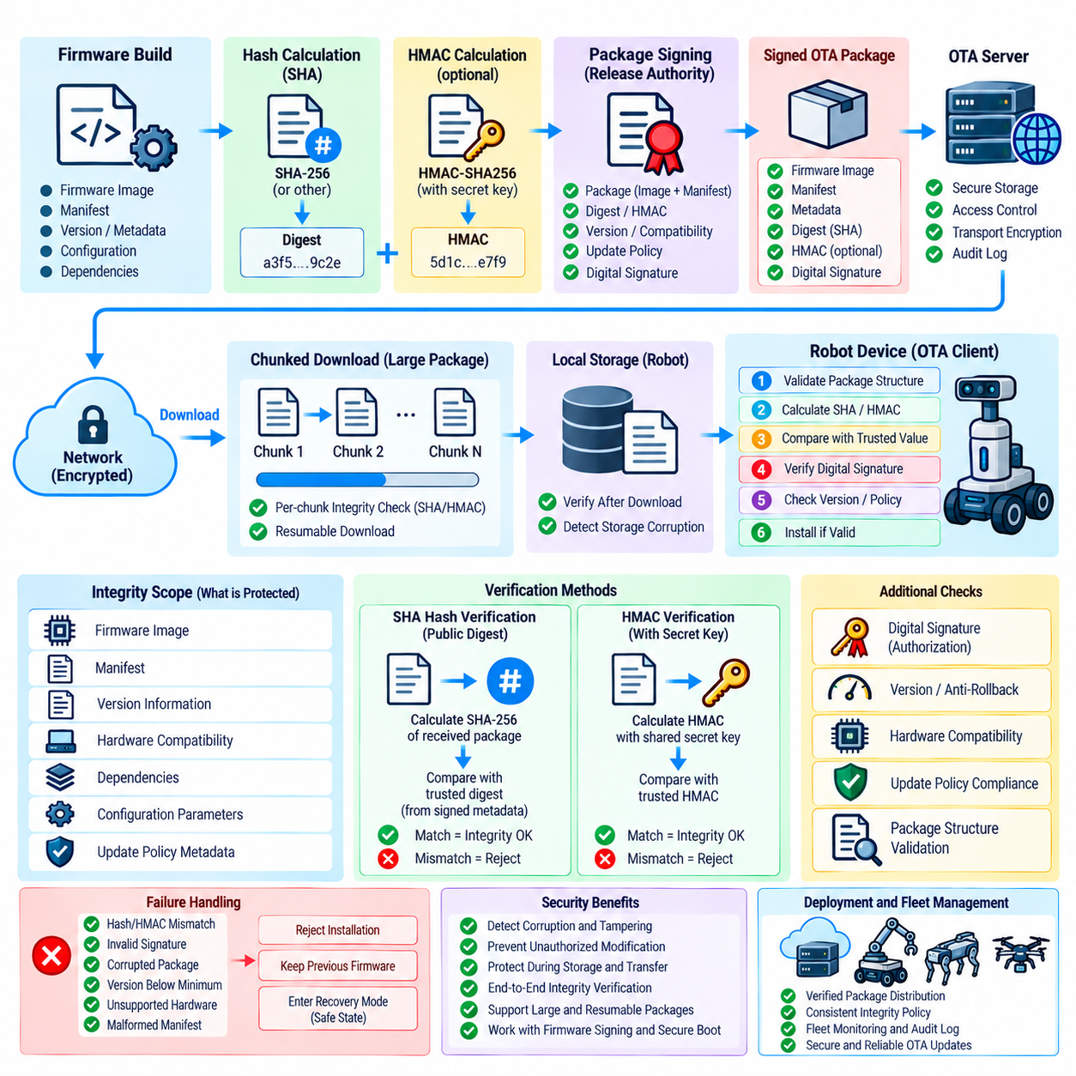
An OTA package integrity architecture ensures that a firmware package received by a robot is identical to the package that was approved and released for deployment. Integrity verification is distinct from authorization: a cryptographic signature establishes who approved an artifact, while a hash or message authentication code can determine whether protected data has changed. In a robot OTA pipeline, these mechanisms should operate together with firmware signing, secure boot, version control, and deployment policy so that corrupted or modified packages cannot enter the firmware installation path. Volume_24_Robot_Cybersecurity
A cryptographic hash generates a fixed-length digest from the OTA package contents. When the package is produced, the release system calculates its digest and records it in authenticated release metadata. After transmission, the robot calculates the digest again from the received package and compares the result with the trusted value. If even a small portion of the package has changed, the resulting digest should differ. This provides an efficient mechanism for detecting accidental corruption and unauthorized modification during storage, transmission, or staging.
SHA-family algorithms can be used to generate these package digests, with the specific algorithm selected according to the platform security policy and current cryptographic requirements. The important architectural principle is that the expected digest itself must come from a trusted source. A robot should not simply compare a downloaded package against a digest delivered through the same untrusted channel because an attacker who can replace the package may also replace its digest. Integrity metadata therefore needs to be authenticated or obtained through an independently trusted mechanism.
HMAC provides a different integrity mechanism because it combines the message with a secret cryptographic key. The sender calculates the HMAC over the protected OTA data, and the receiving robot recalculates it using its trusted secret key. Matching values demonstrate that the data has not been modified by an entity that lacks the key. HMAC can therefore provide both integrity protection and origin authentication within an environment where the participating endpoints can securely share and protect the required secret.
The choice between an ordinary hash and HMAC depends on the trust architecture. A public hash is useful when the expected digest is protected by a separate digital signature or another trusted authentication mechanism. HMAC is appropriate when the endpoints share a protected secret and the architecture requires symmetric authentication. Neither mechanism should be treated as a replacement for firmware signing when the system requires proof that a particular release authority approved the firmware.
The OTA package should be treated as a structured security object rather than an opaque binary file. Its integrity scope may include the firmware image, manifest, version information, hardware compatibility data, dependency information, configuration parameters, and update policy metadata. If only the main binary is protected while security-sensitive metadata remains outside the integrity boundary, an attacker may attempt to manipulate the unprotected fields and alter how the robot interprets an otherwise valid package.
Verification should occur before installation and before any security-sensitive processing that could allow package contents to influence the robot. The OTA client should validate package structure, calculate the required digest or HMAC, compare it with the trusted reference, and reject the package if verification fails. Verification results should be recorded so that operators can distinguish network corruption, storage failure, invalid packages, and possible deliberate manipulation during later security analysis.
Transport protection remains important even when package integrity is cryptographically verified. Encrypted and authenticated communication reduces interception, tampering opportunities, and information exposure during delivery. However, transport security should not be the final trust boundary because the package may pass through proxies, caches, gateways, storage systems, or intermediate distribution services. End-to-end package verification ensures that the robot can independently determine whether the artifact it is about to install remains trustworthy.
Large firmware packages require careful handling of memory, storage, and processing resources during verification. A robot should not need to load an entire multi-gigabyte artifact into memory merely to calculate a cryptographic digest. Streaming or chunk-based hashing allows the OTA client to process the package incrementally while maintaining a predictable resource footprint. Where resumable downloads are supported, each chunk can also be validated before the complete package is assembled and subjected to final verification.
Partial verification must not be confused with complete package verification. Chunk-level checks can detect corruption during transfer and make interrupted downloads easier to resume, but the final assembled artifact must still be validated against the authoritative package identity. Otherwise, an attacker might manipulate the ordering, selection, or composition of individually valid chunks. The final verification stage therefore remains the decisive integrity boundary before installation.
OTA integrity controls should also account for storage corruption after successful download. A package may be correctly received but later damaged in temporary storage because of filesystem failure, unexpected power loss, defective media, or malicious local modification. The installation process should therefore verify the artifact at the appropriate point immediately before use rather than assuming that an earlier successful download check remains permanently valid.
When HMAC is deployed across a robot fleet, secret-key management becomes a major architectural concern. A shared fleet-wide HMAC key can create a large blast radius if compromised because possession of the key may allow an attacker to generate apparently valid integrity codes for many devices. More isolated key scopes, device-specific keys, protected key storage, controlled provisioning, rotation, and revocation can reduce this risk. The key-management architecture must therefore be considered together with OTA integrity rather than treated as an independent operational detail.
Hash and HMAC verification should be integrated with the broader firmware trust chain. A package that passes integrity verification must still satisfy signing authorization, hardware compatibility, security-version requirements, and secure-boot policy. Conversely, a correctly signed package that fails its integrity check must be rejected. This layered approach prevents one security mechanism from being incorrectly interpreted as proof of all other security properties.
For fleet operations, verification results provide useful security telemetry. The OTA service can track successful verification, repeated hash mismatches, HMAC failures, incomplete packages, unexpected package identities, and device-specific failure patterns. A sudden increase in integrity failures across a deployment group may indicate a distribution problem, storage fault, network issue, or deliberate interference. Correlating these events with release and deployment records supports faster diagnosis and helps distinguish operational failures from security incidents.
A mature OTA package integrity design therefore establishes a deterministic and independently verifiable boundary between artifact distribution and firmware installation. SHA-based hashing provides efficient content-integrity detection, while HMAC provides keyed integrity and authentication where shared-secret trust is appropriate. Combined with authenticated manifests, firmware signatures, secure boot, protected storage, anti-rollback controls, and controlled deployment, these mechanisms ensure that a robot installs only the exact package that its security architecture permits.

07.05. Anti Rollback Counter Mechanism [w/Code]
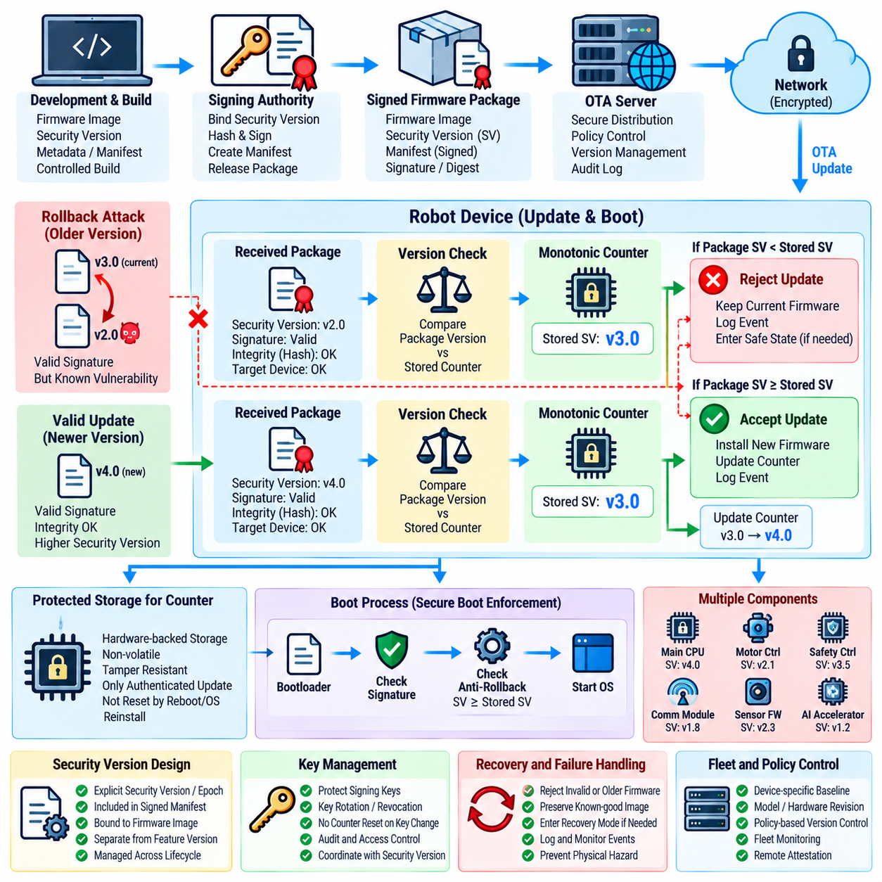
An anti-rollback counter mechanism prevents a robot from installing or executing firmware that is older than the minimum security version permitted by the platform. This protection is necessary because an older firmware image may still carry a valid digital signature even though it contains vulnerabilities that were corrected in later releases. Within the OTA and firmware security architecture, anti-rollback therefore complements firmware signing, secure boot, package integrity verification, and update authorization rather than replacing them. Volume_24_Robot_Cybersecurity
The central concept is a trusted monotonic value that represents the security progression of installed firmware. When a firmware release with a higher security version is accepted, the protected counter or equivalent security state advances. A later installation request is then evaluated against this state. If the requested firmware carries a security version below the stored minimum, the update is rejected even when its cryptographic signature and package integrity are completely valid. This prevents legitimate but obsolete firmware from being deliberately reintroduced.
The counter must be protected from unauthorized modification because it represents a critical security decision. If an attacker can reset, decrease, replace, or otherwise manipulate the counter, previously rejected firmware may become installable again. The mechanism should therefore use hardware-backed secure storage or another strongly protected persistence mechanism where available. Access to the counter should be restricted to authenticated boot, update, or security-management operations, and ordinary application software should not have the authority to modify its security state.
Anti-rollback state must survive events that might otherwise reset ordinary software configuration. Rebooting the robot, replacing an operating-system image, reinstalling application software, or recovering from a normal system failure should not automatically return the security version to an earlier value. The persistent state therefore belongs to the platform security domain rather than to an ordinary filesystem or application database. Recovery procedures must explicitly define how this state is preserved during maintenance and device restoration.
The firmware package should contain an explicit security version, security epoch, or equivalent monotonic release identifier. This value should be covered by the authenticated manifest or firmware signing structure so that an attacker cannot modify the version field independently of the signed artifact. During an update, the robot evaluates the package identity, signature, integrity, hardware compatibility, and security version together. Anti-rollback becomes effective only when the version information itself is cryptographically bound to the firmware being authorized.
The update decision should distinguish between a firmware version that is merely newer and one that represents a higher security state. Conventional semantic versions may increase because of features or functional changes without necessarily establishing a new security baseline. An anti-rollback mechanism should therefore rely on an explicitly defined security counter or security version rather than assuming that a larger software version number always represents stronger security. Release engineering must maintain this relationship consistently throughout the firmware lifecycle.
Secure Boot should enforce the anti-rollback decision at the point where firmware becomes executable. OTA software can reject an obsolete package during installation, but an additional boot-time check prevents an older image from being activated through recovery procedures, local storage manipulation, or other alternative paths. The bootloader compares the firmware security value with the protected platform state before transferring execution. If the firmware is below the permitted threshold, the boot process must refuse to launch it and enter an appropriate recovery or safe state.
Anti-rollback protection must also cover multiple firmware components when the robot contains several independently updateable processors. A robot may include application processors, motor controllers, safety controllers, communication modules, sensor processors, and other embedded components. If only the primary application image is protected, an attacker may attempt to downgrade a secondary component that retains a known vulnerability. The security architecture should therefore define component-specific version state or an equivalent coordinated policy for every security-relevant firmware domain.
A fleet environment introduces additional complexity because different robot models and hardware revisions may legitimately operate on different firmware baselines. The anti-rollback policy must distinguish an authorized compatibility transition from an actual security downgrade. Device identity, hardware revision, firmware family, security epoch, and deployment policy may all be required to make this determination. A version that is invalid for one device may be legitimate for another, so the counter policy must be bound to the appropriate platform identity and firmware scope.
Key management and anti-rollback management are closely related. If an attacker compromises a signing key, the attacker may be able to create a malicious firmware package that appears authentic. Anti-rollback provides an additional defense by preventing that package from using an obsolete security state, but it cannot compensate for every form of signing-key compromise. Conversely, replacing a signing key must not unintentionally reset the security counter. Key rotation, trust-anchor replacement, firmware updates, and security-version advancement should therefore be coordinated as separate but related lifecycle operations.
Exceptional recovery scenarios require carefully controlled rollback semantics. Engineering teams may occasionally need to return a robot to an earlier image for diagnosis or controlled recovery, but unrestricted rollback creates a permanent security bypass. If an exception is necessary, it should require a stronger authorization mechanism and should be explicitly bounded by device state, maintenance mode, authorization credentials, audit records, and safety conditions. Any temporary exception should not silently modify the normal security policy for future boots or OTA operations.
The counter mechanism should be observable through appropriate security telemetry without exposing sensitive implementation details. Update services can record accepted security-version transitions, rejected rollback attempts, recovery events, and devices that repeatedly request obsolete firmware. These records help identify accidental deployment errors as well as deliberate attacks. A sudden increase in rollback rejections across a fleet may indicate an incorrectly configured release campaign, a distribution problem, or an attempt to exploit known vulnerable firmware.
Anti-rollback state should also be incorporated into incident response and device recovery procedures. If a vulnerability is discovered in a deployed firmware release, the security baseline can be advanced so that the affected version becomes permanently unacceptable for normal operation. After this transition, an attacker who possesses an old signed image cannot simply reinstall it to regain the vulnerable state. The resulting security floor becomes a persistent property of the device rather than a temporary rule enforced only by the OTA server.
A mature anti-rollback mechanism therefore establishes a persistent security floor that remains effective across updates, reboots, recovery operations, and fleet deployment changes. The mechanism should cryptographically bind security-version information to firmware identity, protect the monotonic state against unauthorized modification, enforce the decision during both installation and boot, and provide controlled procedures for legitimate exceptional recovery. Combined with firmware signing, Secure Boot, package integrity verification, protected key storage, and supply-chain controls, anti-rollback converts firmware version management into an enforceable security policy rather than a simple software release preference.

07.06. SBOM and Vulnerability Tracking for OTA [w/Code]
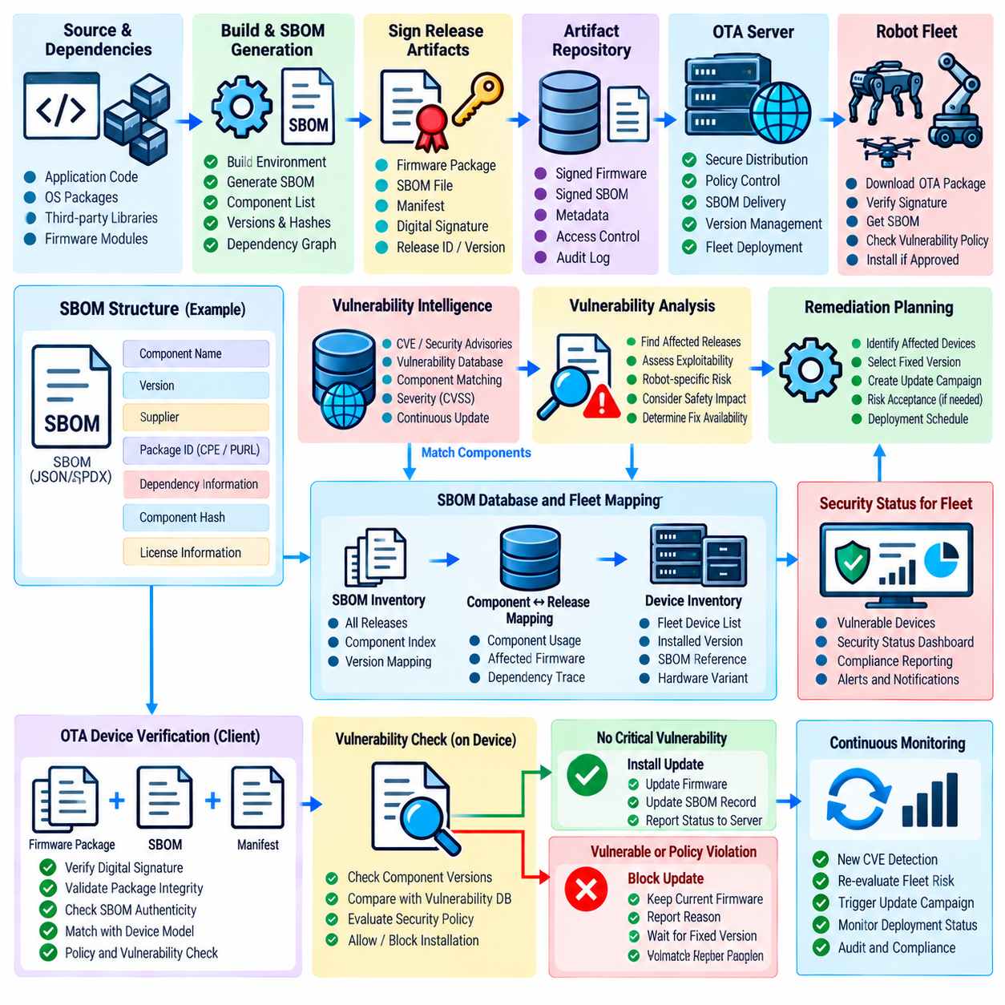
Software Bill of Materials (SBOM) provides a structured inventory of the software components contained within a robot firmware release, allowing the OTA security process to identify what is actually being deployed to each device. An SBOM can describe operating-system packages, open-source libraries, third-party components, firmware modules, dependencies, and their corresponding versions. Within an OTA architecture, this information creates traceability between a released firmware artifact and the software components that may introduce vulnerabilities or licensing and supply-chain risks.
SBOM generation should be integrated into the firmware build and release pipeline rather than performed only after an incident occurs. Each firmware build should produce an SBOM associated with a unique release identifier, source revision, build environment, target hardware, and artifact digest. The SBOM should remain linked to the exact firmware package distributed through the OTA system so that security teams can determine precisely which software composition is installed on a particular robot. This relationship becomes especially important when the same firmware family is deployed across multiple hardware revisions.
An effective SBOM should provide sufficient component identity to support vulnerability correlation. Component names, versions, suppliers, package identifiers, dependency relationships, and cryptographic hashes can help distinguish similar components and prevent ambiguous matching. Where appropriate, standardized identifiers such as Common Platform Enumeration or Package URLs can improve automated correlation with vulnerability databases. The objective is not simply to produce a document but to create machine-readable security metadata that can participate directly in OTA decision-making.
Vulnerability tracking connects SBOM information with newly discovered security weaknesses. When a vulnerability is disclosed in an operating-system package, library, middleware component, bootloader dependency, or other firmware element, the security system can search the SBOM inventory to determine which robot releases contain the affected component. This is substantially more efficient than manually inspecting firmware images after every vulnerability announcement. The result is a continuous relationship between vulnerability intelligence, firmware composition, release management, and OTA deployment decisions.
The vulnerability-management process should distinguish between the presence of a vulnerable component and the actual exploitability of that vulnerability in a robot. A component may contain a known weakness but be compiled without the affected feature, isolated from the vulnerable interface, or protected by another security control. Conversely, a vulnerability with a lower conventional severity may become highly significant when it affects a robot component connected directly to motion control, safety functions, network access, or sensitive fleet infrastructure. Risk assessment should therefore combine vulnerability information with robot-specific architecture and operational context.
OTA systems should maintain vulnerability status across firmware versions rather than treating every release independently. When a vulnerability is discovered, the system should identify affected releases, determine whether a fixed version is available, establish the minimum secure firmware baseline, and identify devices requiring remediation. The resulting information can be associated with deployment groups and hardware variants so that remediation campaigns target only relevant devices. This reduces unnecessary updates while ensuring that known security weaknesses are not left indefinitely in operational systems.
SBOM data should also support dependency analysis because vulnerabilities can originate several levels below the primary application. A robot firmware image may contain an operating system, middleware, communication libraries, cryptographic libraries, device drivers, and third-party utilities, each with its own dependencies. A vulnerability in a deeply nested dependency may therefore affect the final firmware even when the top-level application was not directly modified. Dependency relationships in the SBOM allow security teams to trace these relationships and determine whether a vulnerable component is actually included in a deployed artifact.
The integrity and authenticity of the SBOM itself must be protected. An attacker who can modify vulnerability metadata or substitute an SBOM could cause a dangerous firmware package to appear compliant or cause legitimate firmware to be incorrectly classified. SBOM artifacts should therefore be associated with the same trusted build and release process as firmware packages, with appropriate authentication, signing, version control, and audit records. The OTA system should be able to establish that the SBOM corresponds to the exact firmware artifact under evaluation.
SBOM-based vulnerability tracking should integrate with the firmware signing chain and OTA approval process. A firmware package may be cryptographically authentic and pass integrity verification while still containing a newly identified vulnerable dependency. The OTA release decision should therefore consider both artifact authenticity and current security intelligence. Depending on organizational policy, a release containing a critical vulnerability may be blocked, restricted to controlled deployment, or permitted temporarily under a documented risk acceptance process. This creates a security-aware release gate rather than a purely cryptographic deployment gate.
Robot fleets require continuous monitoring because firmware security status changes after deployment. A release that was considered acceptable at deployment time may later become vulnerable when a new CVE or equivalent security advisory is published. The fleet security system should therefore maintain a relationship between device identity, installed firmware version, SBOM, vulnerability status, and remediation state. This enables operators to determine which robots require immediate attention and which devices remain outside the affected component scope.
Vulnerability tracking should also support prioritization according to operational consequences. Robots performing safety-critical industrial tasks, operating in exposed environments, or connected to sensitive infrastructure may require faster remediation than isolated development platforms. Factors such as exploit availability, attack complexity, network exposure, privilege requirements, physical consequences, fleet population, and availability of a tested firmware fix can influence remediation priority. The goal is to transform generic vulnerability information into an actionable robot-specific risk assessment.
OTA remediation should be coordinated with testing and validation because replacing a vulnerable component can introduce new functional or compatibility risks. A patched library or operating-system package may affect real-time behavior, driver interfaces, memory usage, communication timing, or AI inference performance. The updated firmware should therefore pass appropriate cybersecurity, functional, regression, and hardware-in-the-loop validation before broad fleet deployment. The SBOM should then be regenerated so that the deployed package has an updated and verifiable software composition record.
SBOM history provides valuable evidence for incident response and forensic investigation. When a security event occurs, investigators can determine which firmware versions contained a vulnerable component, when those versions were deployed, which robots received them, and whether a subsequent update removed the affected component. Historical SBOM records also support vulnerability disclosure analysis and help establish whether a vulnerable dependency entered the product through an upstream supplier, build process, or direct software change.
The architecture should also address SBOM coverage limitations. An SBOM is only useful when it accurately represents the deployed software. Dynamically loaded components, generated binaries, proprietary firmware, containers, plugins, and externally sourced runtime modules may require additional inventory mechanisms. Build pipelines should therefore define what constitutes an SBOM-complete release and identify components that cannot be represented with conventional package metadata. Missing inventory information should be treated as a security visibility gap rather than silently interpreted as absence of vulnerabilities.
A mature OTA security architecture treats SBOM as a continuously maintained security control rather than a compliance document produced once per release. The SBOM connects firmware composition with vulnerability intelligence, signing authorization, deployment policy, remediation planning, fleet monitoring, and incident response. When combined with controlled firmware release, cryptographic integrity, anti-rollback protection, secure boot, and systematic vulnerability tracking, SBOM enables the OTA system to answer a critical operational question: which robots are running which software components, which of those components are vulnerable, and which verified firmware update should be deployed to reduce the resulting risk?

07.07. Supply Chain Security for Robot Firmware [w/Code]
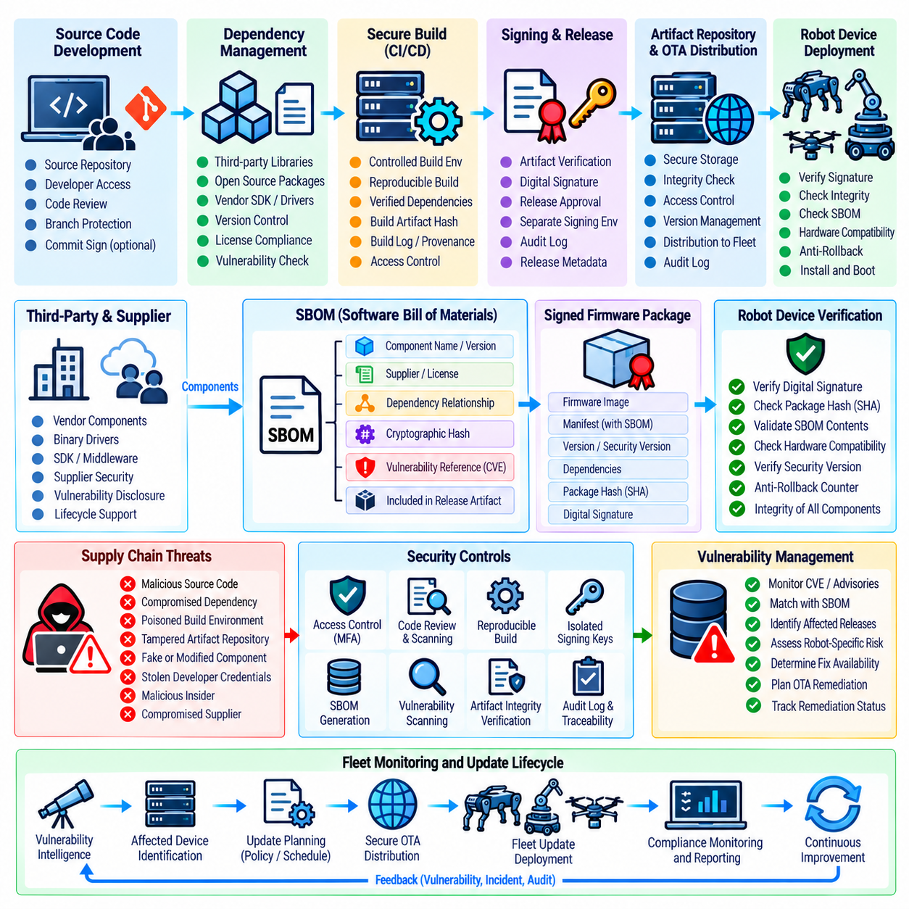
Supply-chain security for robot firmware addresses the risk that malicious, counterfeit, compromised, or vulnerable components may enter a robot through legitimate development and update processes. Firmware is rarely created from completely isolated source code; it may incorporate operating-system components, device drivers, open-source libraries, middleware, cryptographic modules, third-party binaries, development tools, and vendor-provided firmware. The OTA security architecture therefore has to extend its trust boundary beyond the robot manufacturer and include the organizations, software, tools, and artifacts involved in producing the final firmware package.
A secure firmware supply chain begins with controlled source-code provenance. Each release should be traceable to an approved source revision, authorized development environment, defined dependencies, and a controlled build process. Source repositories, developer credentials, build servers, package registries, and release systems should be treated as security-sensitive assets because compromise at any of these points can result in malicious code being incorporated before conventional firmware signing occurs. The objective is to establish evidence showing how the final firmware was produced and which trusted inputs contributed to it.
Third-party software introduces an additional trust dependency because the robot manufacturer may not directly control its development or maintenance. External libraries, middleware, operating-system packages, vendor SDKs, binary drivers, and firmware components should therefore be identified and tracked throughout the product lifecycle. Their versions, suppliers, provenance, licensing conditions, known vulnerabilities, and update history should be associated with the firmware release. This information enables security teams to determine whether an upstream compromise or newly discovered weakness affects deployed robot firmware.
The build environment itself must be protected because a trusted source repository does not guarantee a trustworthy output if the compilation infrastructure has been compromised. Build servers, compilers, dependency managers, signing interfaces, environment variables, and artifact-generation tools can all influence the resulting firmware. Access should be restricted according to least-privilege principles, build activities should be auditable, and unexpected changes to build configurations should be detectable. Reproducible or independently verifiable builds can provide additional evidence that the produced firmware corresponds to the intended source and dependencies.
Dependency management is particularly important because vulnerabilities can enter through deeply nested software relationships. A robot application may depend on middleware, which depends on communication libraries, which in turn depends on cryptographic or system libraries. A vulnerability introduced several layers below the primary application can therefore become part of the final firmware without an obvious change to the robot-specific source code. Maintaining an accurate dependency inventory and SBOM allows the organization to identify these relationships and determine which firmware releases contain affected components.
Supply-chain security must also address artifact repositories and package distribution infrastructure. Firmware binaries, update manifests, intermediate packages, and dependency artifacts should be stored in controlled repositories with authentication, authorization, integrity protection, and audit logging. Unauthorized replacement of a build artifact before signing can be particularly dangerous because the resulting malicious binary may subsequently receive an apparently legitimate release signature. Release systems should therefore verify artifact identity and provenance before the final signing operation takes place.
Firmware signing provides an important downstream control but should not be considered proof that the entire supply chain was trustworthy. A compromised build environment may generate malicious firmware and submit it to an authorized signing process. If release controls verify only the binary's cryptographic signature, the malicious artifact may appear fully legitimate. Supply-chain security therefore requires provenance validation, controlled build inputs, dependency verification, release approval, and separation of duties before signing authority is exercised.
Vendor and supplier relationships should be incorporated into the threat model. A supplier may provide a hardware abstraction layer, bootloader, communication stack, device firmware, SDK, or security component that becomes essential to robot operation. Security requirements should define expectations for vulnerability disclosure, software provenance, update support, incident notification, component integrity, and lifecycle management. Supplier changes should also be assessed because ownership transfers, discontinued products, unsupported dependencies, or changes in development infrastructure can create new security risks.
Compromise of development credentials represents another important supply-chain threat. An attacker who obtains a developer, repository, CI/CD, package-registry, or release-management credential may introduce malicious code without directly attacking the robot. Strong authentication, narrowly scoped permissions, protected credentials, access monitoring, and separation between development and production signing environments reduce this risk. High-impact actions such as modifying release configuration or submitting production firmware for signing should require stronger authorization and generate auditable evidence.
The firmware release process should maintain provenance from source to deployed device. The final package should be associated with its source revision, build identifier, dependency set, SBOM, build environment, signing authority, security version, and target hardware. This information allows investigators and security operators to reconstruct the software lineage of a deployed robot. It also makes it possible to identify every device that received a release when an upstream component is later determined to be compromised.
Supply-chain controls should extend to firmware received directly from hardware vendors. A robot may contain controllers, sensors, communication modules, storage devices, and safety processors that execute vendor-supplied firmware independently of the primary application processor. Each component can therefore represent a separate software supply-chain boundary. Vendor firmware should be authenticated where supported, tracked by version and provenance, evaluated for known vulnerabilities, and incorporated into the robot's overall security inventory rather than being treated as inherently trustworthy.
OTA deployment should consume only artifacts that have passed the defined supply-chain controls. Before a release enters the deployment pipeline, the system should confirm artifact provenance, SBOM consistency, vulnerability status, signature authorization, target compatibility, and security-version requirements. If a critical component has an unresolved supply-chain concern, deployment should be blocked or restricted according to the organization's risk policy. This creates a security gate between software production and operational deployment.
Incident response procedures must include supply-chain compromise scenarios. If a supplier, dependency, build system, or signing environment is compromised, the organization needs to identify affected artifacts, determine which robots received them, revoke or replace compromised trust material where necessary, and prepare a verified remediation release. Historical build records, SBOMs, signing logs, artifact hashes, and deployment telemetry provide the evidence required to determine the scope of exposure. Without this traceability, fleet-wide remediation becomes significantly more difficult.
A mature robot firmware supply-chain architecture therefore establishes trust through verifiable provenance rather than relying solely on the reputation of individual suppliers or the presence of a valid firmware signature. Source control, dependency management, protected build infrastructure, SBOM generation, artifact integrity, supplier governance, signing authorization, vulnerability tracking, and OTA deployment controls must operate as one continuous security process. This approach reduces the probability that compromised software or vulnerable components will enter the robot platform and provides the evidence necessary to detect, contain, and remediate supply-chain security failures throughout the firmware lifecycle.

07.08. Secure Key Storage HSM TPM for OTA [w/Code]
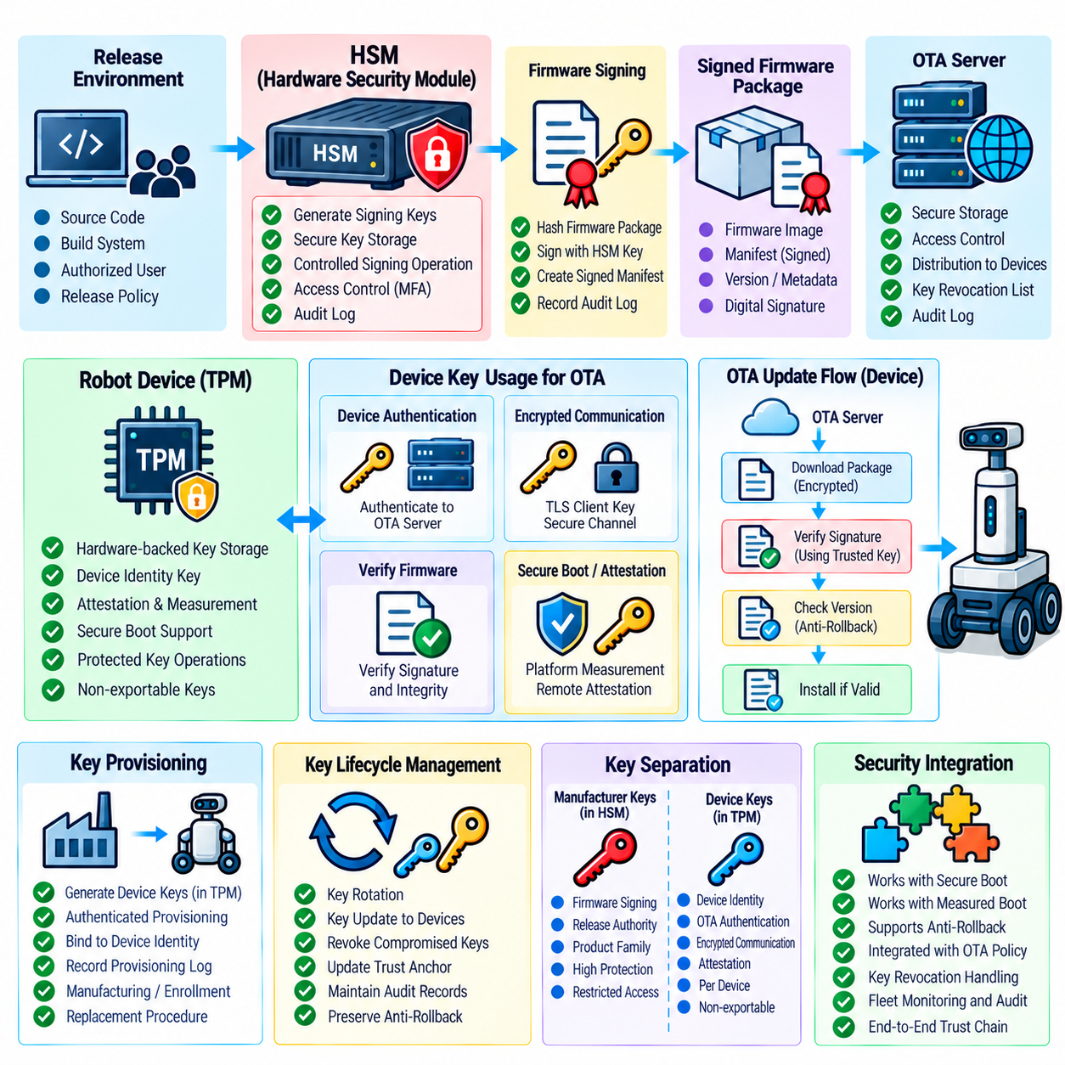
Secure key storage is a foundational element of OTA security because firmware authenticity depends on cryptographic keys that must remain protected throughout the robot lifecycle. Private signing keys, device authentication keys, encryption keys, trust-anchor information, and recovery credentials should not be stored as ordinary files that can be freely accessed by operating-system processes. The OTA security structure places secure key storage using Hardware Security Modules (HSM) and Trusted Platform Modules (TPM) alongside firmware signing, secure boot, anti-rollback, and supply-chain controls. Volume_24_Robot_Cybersecurity
An HSM provides a dedicated security boundary for generating, storing, and using sensitive cryptographic keys. In an OTA environment, the most important application is usually protection of high-value signing keys used by release infrastructure. The private key can remain inside the HSM while signing operations are performed through controlled interfaces. This prevents ordinary users, build servers, applications, or filesystem access from directly extracting the private key, reducing the consequences of compromise within the surrounding development environment.
The security value of an HSM depends not only on protected key storage but also on controlled authorization for cryptographic operations. Production firmware signing should require authenticated access, appropriate privileges, and release-policy validation before an operation is permitted. Signing activities should generate audit records that identify the requesting system, artifact, time, authorization context, and resulting operation. This creates accountability around the most sensitive stage of the firmware release process and helps detect unauthorized signing activity.
A TPM provides a different but complementary security capability at the robot endpoint. It can provide hardware-backed key protection, platform measurements, device identity functions, and protected storage for security-sensitive information. Within an OTA architecture, a TPM can help protect device-specific credentials and support Secure Boot or Measured Boot workflows. The objective is to ensure that important cryptographic material remains associated with the trusted hardware platform rather than being exposed as ordinary software-managed data.
Device-specific OTA credentials should be isolated from general application credentials whenever possible. A robot may require separate keys for device authentication, encrypted communication, attestation, update authorization, and other security functions. Separating these purposes limits the impact of a single credential compromise. If an application credential is exposed, the attacker should not automatically obtain the authority required to authenticate firmware, modify trust anchors, or authorize privileged update operations.
Key generation should preferably occur within a protected security boundary when the platform permits it. Generating sensitive private keys directly on general-purpose operating-system storage increases the possibility of exposure through memory inspection, filesystem access, backup systems, malware, or accidental disclosure. Hardware-backed generation can establish stronger control over the complete key lifecycle. The resulting keys should be marked for their intended purpose and should not be exportable unless a formally controlled recovery requirement makes export unavoidable.
Key provisioning is another critical stage because a secure storage device cannot protect a key that was introduced through an insecure process. Device identity credentials and other secrets should be provisioned through authenticated and controlled procedures. Manufacturing, enrollment, field replacement, and recovery workflows should establish which authority is permitted to provision or replace keys. Provisioning records should connect the device identity, hardware platform, credential generation process, and applicable security policy so that later investigations can reconstruct the origin of trusted credentials.
The OTA system should distinguish between keys used by the manufacturer and keys used by individual robots. A manufacturer-controlled signing key may authorize firmware for an entire product family, while a robot-specific key may authenticate an individual device to the OTA service. These roles should not be unnecessarily combined. Separating release authority from device identity reduces the possibility that compromise of one credential class can be used to impersonate devices, sign firmware, or alter the broader OTA trust model.
Key rotation and replacement must be designed before deployment because cryptographic credentials have finite operational lifetimes and may eventually require replacement. A robot should be able to receive an authorized replacement trust credential without creating a path for an attacker to install an arbitrary key. Rotation procedures should authenticate the new key, protect the transition from the old trust state, maintain auditability, and preserve anti-rollback policies. Emergency replacement is particularly important when a signing authority or device credential is suspected of compromise.
Revocation is closely connected to key rotation. When a key is compromised, the system needs a mechanism to prevent continued acceptance of artifacts or authentication attempts associated with that key. Revocation information itself must be protected because an attacker who can modify revocation state may restore trust in a compromised credential. The OTA architecture should therefore define how trust changes are authenticated, how devices receive updated trust information, and how the bootloader and OTA client respond when a previously trusted key becomes unacceptable.
HSM and TPM protection should also be integrated with Secure Boot and Measured Boot. The endpoint can establish that the boot environment is in an expected security state before allowing sensitive cryptographic operations to proceed. Conversely, protected keys and measurements can help demonstrate that critical firmware components have not been replaced or modified. This creates a relationship between hardware identity, platform state, cryptographic authorization, and OTA access rather than treating key storage as an isolated hardware feature.
Recovery procedures require particular care because emergency access can become a mechanism for bypassing protected key storage. Factory reset, motherboard replacement, service operations, and hardware recovery may require restoration or reprovisioning of security credentials. These procedures should use authenticated administrative authorization and should preserve security-version and trust-anchor policies. A recovery process that simply clears protected storage and installs new credentials without verification can undermine the entire OTA security architecture.
For robot fleets, secure key storage also supports scalable device identity and controlled authorization. Each robot can maintain protected credentials that identify it to fleet services without exposing private material to ordinary applications. Fleet infrastructure can use these identities to restrict which devices are eligible for specific firmware releases, security domains, or update campaigns. Device-specific protection also limits the blast radius of credential compromise because exposure of one robot's key does not automatically expose the corresponding credentials of the entire fleet.
A mature OTA key-management architecture therefore treats HSM and TPM capabilities as components of a complete cryptographic trust lifecycle. Secure generation, protected storage, controlled use, provisioning, rotation, revocation, recovery, and auditing must work together. HSMs primarily protect high-value signing operations and centralized release authority, while TPM-class hardware can protect device-side credentials and establish hardware-backed platform trust. Integrated with firmware signing, Secure Boot, anti-rollback, package integrity, and supply-chain security, these mechanisms provide the protected cryptographic foundation required for trustworthy OTA firmware deployment.

07.09. OTA Security Testing Fuzzing Injection [w/Code]
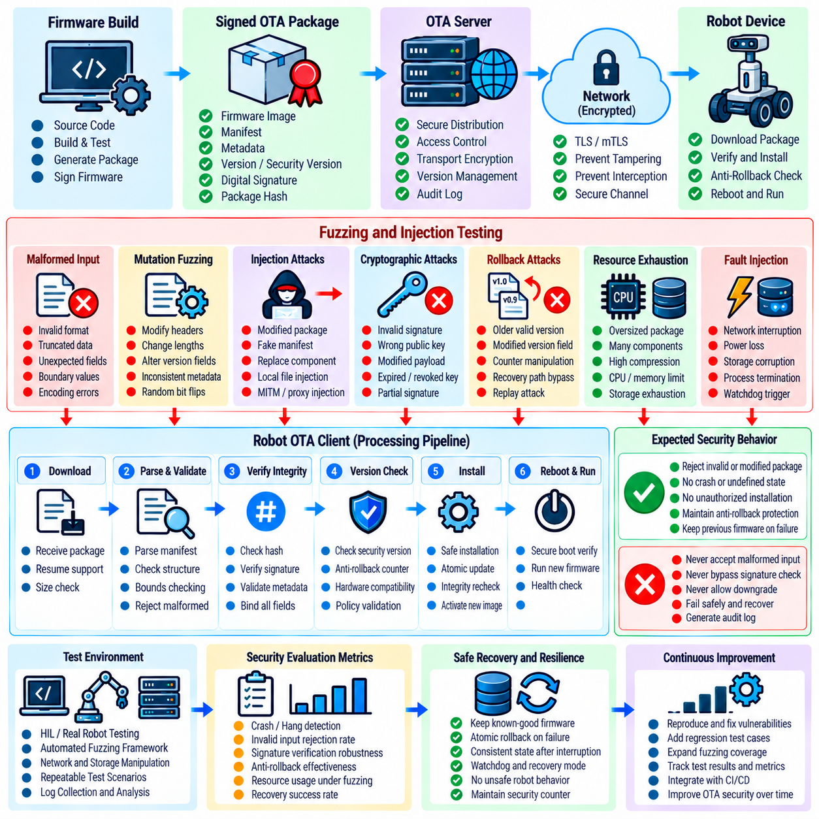
OTA security testing validates whether the update mechanism can preserve firmware authenticity, integrity, authorization, and safe recovery when exposed to malformed input or deliberate attack. The test scope should cover the complete path from update-server interaction and package retrieval to local storage, package parsing, signature verification, installation, reboot, and recovery. Within the OTA security structure, fuzzing and injection testing should complement firmware signing, secure boot, package integrity verification, anti-rollback protection, key protection, and supply-chain controls rather than being treated as isolated software tests. Volume_24_Robot_Cybersecurity
The OTA client should be treated as a security-sensitive parser because it processes data that may originate outside the robot's trusted execution environment. Update manifests, package headers, version fields, metadata, compressed archives, dependency information, and firmware containers can all contain malformed or intentionally manipulated values. Testing should therefore exercise unexpected lengths, invalid encodings, truncated structures, duplicated fields, inconsistent metadata, boundary values, and unexpected component combinations to determine whether the client rejects unsafe input without crashing or entering an undefined state.
Fuzzing is particularly valuable for components that process complex OTA package structures. A fuzzing campaign can generate large numbers of malformed or mutated inputs and observe crashes, hangs, memory corruption, excessive resource consumption, parser inconsistencies, and unexpected acceptance. The objective is not simply to demonstrate that a parser can fail, but to establish that untrusted update data cannot cause security-sensitive behavior. Failures should be reproducible, classified by affected component, and connected to corrective actions and regression tests.
Mutation-based fuzzing can begin with valid OTA packages and systematically modify selected fields while preserving enough structure to reach deeper processing paths. Fields such as package length, component count, firmware version, security version, digest values, manifest references, compression parameters, and hardware identifiers can be varied independently or in combination. This approach helps reveal inconsistencies between validation stages, especially when one component accepts a value that another component interprets differently.
Structured fuzzing should also target the relationship between package metadata and cryptographic verification. An attacker may attempt to create a package whose manifest describes one firmware image while the payload contains another, or whose declared digest, signature scope, and actual binary contents are inconsistent. Testing should verify that the OTA client binds all security-relevant fields to the authenticated artifact and rejects mismatched combinations rather than processing them according to whichever field is checked first.
Injection testing examines whether unauthorized content can enter the update path and influence firmware installation or execution. Injection attempts may target downloaded packages, local staging areas, update manifests, maintenance interfaces, removable media, recovery mechanisms, or intermediary distribution services. The test objective is to confirm that only artifacts satisfying the complete authorization and integrity policy can reach installation. A package that is modified after download, substituted before installation, or introduced through an alternate interface should fail the same security checks.
Cryptographic verification must be tested under adversarial conditions rather than only with correctly signed packages. Test cases should include invalid signatures, incorrect public keys, altered payloads, modified manifests, expired or revoked signing authorities where applicable, corrupted certificate or trust metadata, and signatures covering an incomplete or incorrect portion of the package. The expected behavior is deterministic rejection without silently falling back to an insecure verification mode or accepting a partially authenticated artifact.
Anti-rollback controls require dedicated testing because an older firmware image may remain cryptographically authentic. Test campaigns should attempt to install valid but prohibited firmware versions, manipulate security-version metadata, alter persistent version state, interrupt updates during counter advancement, and exercise recovery paths that might bypass the normal version check. The system should maintain the established security floor across reboot, failed installation, recovery, and power interruption conditions.
Fuzzing should also examine resource-exhaustion conditions because OTA processing can consume significant storage, memory, CPU time, and temporary filesystem space. Oversized manifests, highly compressed payloads, excessive component counts, repeated metadata structures, and deliberately inefficient archives can expose denial-of-service weaknesses. The update client should enforce explicit resource limits and transition to a controlled failure state when those limits are exceeded. Resource exhaustion during an update must not leave the robot in an unsafe or unrecoverable firmware state.
The installation and recovery sequence should be tested for interruption and fault injection. Power loss, network interruption, storage errors, process termination, watchdog activation, corrupted temporary files, and unexpected reboot events can occur during real deployments and may also be deliberately induced by an attacker. Testing should verify that incomplete updates cannot be mistaken for valid firmware and that the robot can return to a trusted image or defined recovery state. The security outcome must remain consistent regardless of where the interruption occurs.
Test environments should provide sufficient observability to determine what happened after each malicious or malformed input. Logs and telemetry can record package identity, verification stage, rejection reason, firmware version, security version, recovery state, and relevant error classification without exposing sensitive cryptographic material. Where hardware-backed security functions are involved, the test process should also verify that protected keys, trust anchors, and anti-rollback state remain unchanged when untrusted update data is rejected.
OTA security testing should include negative tests across different trust boundaries. A package that fails at the distribution server may still be tested against the robot-side client, while a package rejected by the OTA client should also be evaluated against recovery and local installation paths. This layered approach helps identify alternate routes around the intended security architecture. Testing should confirm that every path leading toward firmware execution applies the appropriate authentication, integrity, compatibility, and security-version controls.
Regression testing is essential after vulnerabilities are discovered through fuzzing or injection testing. Each confirmed defect should produce a deterministic reproduction case that remains in the security test corpus after remediation. Future firmware, bootloader, OTA client, and recovery changes should execute these cases automatically where practical. This prevents previously corrected parser, validation, or authorization weaknesses from returning during later development cycles.
Fleet-scale OTA testing should also evaluate how the security system behaves when malicious inputs are distributed across many devices. Controlled campaigns can test repeated invalid packages, unauthorized versions, invalid signatures, corrupted downloads, and abnormal update requests while monitoring device availability and security telemetry. The objective is to ensure that a compromised distribution source or aggressive attack cannot cause uncontrolled fleet-wide failure. Deployment controls should provide mechanisms for suspending campaigns and isolating affected devices when abnormal behavior is detected.
A mature OTA security testing program therefore treats fuzzing, injection, fault injection, cryptographic negative testing, and recovery testing as continuous validation of the firmware trust lifecycle. Testing must demonstrate not only that valid firmware can be deployed successfully, but also that malformed, modified, unauthorized, outdated, or interrupted update operations consistently fail within defined security boundaries. When integrated with secure boot, firmware signing, package integrity, anti-rollback controls, protected key storage, SBOM-based vulnerability management, and supply-chain security, OTA testing provides evidence that the robot's update mechanism remains trustworthy under both operational faults and deliberate adversarial pressure.

07.10. OTA Security Compliance IEC 62443 Checklist
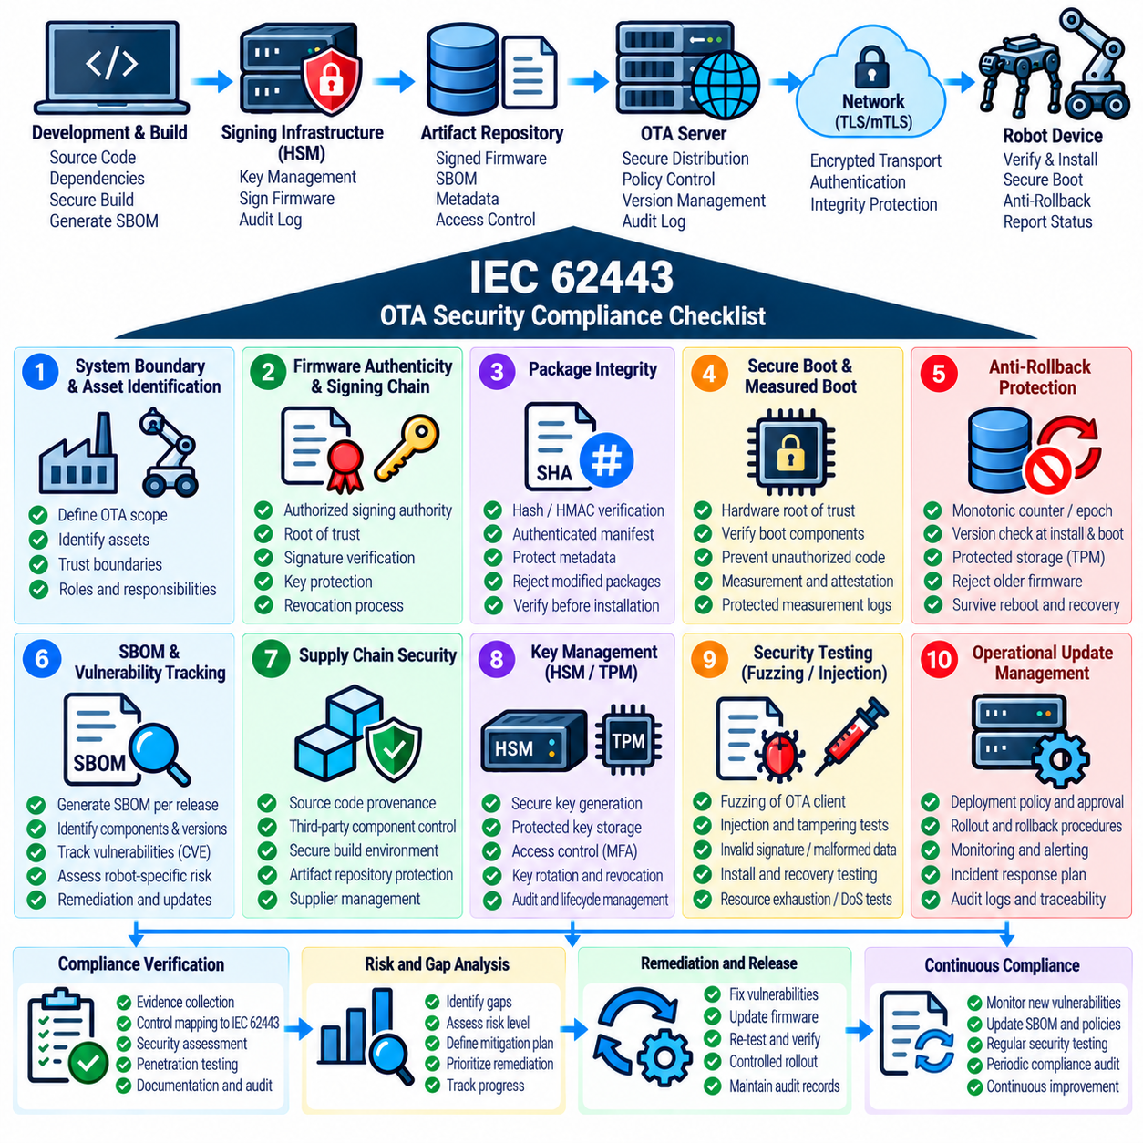
OTA security compliance should be treated as a structured verification of the controls that protect firmware throughout its complete update lifecycle. The compliance scope should cover firmware signing, secure boot, package integrity, anti-rollback, SBOM and vulnerability tracking, supply-chain security, protected key storage, security testing, and operational update management. In the robot cybersecurity structure, IEC 62443 is positioned as a major compliance framework, while the OTA chapter provides the technical controls that must be evaluated as part of the broader industrial cybersecurity architecture. Volume_24_Robot_Cybersecurity
An OTA compliance assessment should begin by defining the system boundary and identifying the assets involved in firmware deployment. The assessment should include the robot, bootloader, OTA client, update server, artifact repository, signing infrastructure, key-management environment, recovery mechanism, communication paths, and relevant fleet-management services. Each component should have clearly defined security responsibilities and trust relationships. This prevents compliance from being reduced to a checklist applied only to the robot itself while ignoring infrastructure that can modify or authorize the firmware delivered to it.
Firmware authenticity should be a primary compliance concern. The organization should be able to demonstrate that production firmware is signed by an authorized release authority and that the robot verifies the signature before installation and execution. The signing chain should identify the root of trust, intermediate authorities where applicable, key-protection mechanisms, signing procedures, and revocation processes. Evidence should establish that unauthorized or incorrectly signed firmware cannot become an accepted execution image through either the normal OTA path or an alternate recovery path.
Package integrity should also be verified throughout the update process. OTA packages should have authenticated integrity information, and the robot should verify the received artifact before installation. SHA-based hashing, HMAC where appropriate, digital signatures, authenticated manifests, and protected metadata can contribute to this control. Compliance evidence should demonstrate that corrupted, incomplete, modified, or mismatched packages are rejected deterministically and that the verification process cannot be bypassed by manipulating metadata, transport conditions, temporary storage, or alternate installation interfaces.
Secure Boot and Measured Boot should be evaluated as part of the firmware trust chain. Secure Boot should prevent unauthorized firmware or boot components from executing, while Measured Boot can provide evidence of the software state that actually participated in startup. The assessment should verify that trust begins from an appropriate hardware or immutable root and continues through the bootloader and security-relevant firmware components. Measurement records, when used, should be protected against unauthorized modification and should support appropriate integrity assessment or remote attestation functions.
Anti-rollback protection should be included explicitly in the compliance review because a correctly signed firmware image may still contain known vulnerabilities. The platform should maintain a protected minimum security version, security epoch, or equivalent monotonic state and enforce that state during both OTA installation and boot. Compliance evidence should demonstrate that reboot, power interruption, recovery, operating-system replacement, or ordinary application changes cannot silently reduce the established security floor. Any exceptional rollback process should require stronger authorization and produce appropriate audit evidence.
SBOM and vulnerability tracking should demonstrate that the organization knows what software components are present in each deployable firmware release. The SBOM should be linked to the exact firmware artifact and should provide sufficient component identity and dependency information for vulnerability correlation. When a new vulnerability is discovered, the organization should be able to identify affected firmware versions and deployed devices, determine the risk, establish a remediation baseline, and deploy an appropriately tested update. This connects compliance evidence to an operational vulnerability-management process rather than treating the SBOM as a static documentation requirement.
Supply-chain security should be assessed across the complete firmware production path. Source repositories, third-party dependencies, development tools, build infrastructure, artifact repositories, supplier-provided firmware, and release systems can all influence the final firmware. Compliance evidence should demonstrate appropriate provenance tracking, access control, dependency management, build protection, supplier governance, and artifact verification. A valid production signature alone should not be considered sufficient evidence because a compromised build environment could potentially produce malicious firmware that is later submitted to an authorized signing process.
Cryptographic key management should provide evidence that sensitive keys are appropriately protected throughout their lifecycle. HSMs can protect high-value signing keys within release infrastructure, while TPM-class hardware can protect device-side credentials and support hardware-backed platform trust. Compliance should consider key generation, provisioning, storage, access authorization, usage restrictions, rotation, revocation, backup or recovery where applicable, and destruction. The assessment should also verify that key compromise does not automatically provide unrestricted authority to modify firmware, replace trust anchors, or bypass anti-rollback controls.
OTA security testing should provide evidence that the update mechanism remains secure under malformed, modified, unauthorized, outdated, and interrupted conditions. Fuzzing should exercise package parsers and metadata processing, while injection testing should attempt to introduce unauthorized firmware or manipulate update paths. Negative cryptographic tests should include invalid signatures and altered artifacts, while fault-injection testing should examine power loss, network interruption, storage errors, and recovery behavior. The objective is to demonstrate that security failures produce controlled rejection or recovery rather than unsafe execution.
Access control and auditability should be included in the compliance checklist because OTA infrastructure can become a privileged control plane for the entire robot fleet. Only authorized personnel and services should be able to approve releases, operate signing infrastructure, modify deployment policies, or initiate sensitive update campaigns. Security-relevant actions should generate audit records that allow investigators to determine who or what initiated an operation, which firmware artifact was involved, which devices were targeted, and what verification result followed. Audit information should be protected against unauthorized modification.
Recovery and failure handling should be assessed with the same rigor as normal update operation. A compliant OTA architecture should define how the robot behaves when signature verification fails, package integrity is invalid, firmware is incompatible, the security version is too old, storage becomes unavailable, or an update is interrupted. The system should preserve a trusted firmware state or enter a defined recovery state without creating an insecure fallback. Recovery interfaces should retain appropriate authentication and trust controls rather than becoming unrestricted installation paths.
Fleet-level compliance should verify that the controls operate consistently across different robot models, hardware revisions, firmware families, and deployment environments. Device identity, hardware compatibility, security baseline, update authorization, and deployment policy should be evaluated together so that a valid update for one platform cannot automatically become valid for another. Compliance records should also demonstrate the ability to suspend a deployment campaign, isolate affected devices, and trace firmware versions across the fleet when a security issue is discovered.
A mature IEC 62443-oriented OTA compliance program should therefore treat the checklist as evidence of an implemented security process rather than a collection of isolated technical claims. The organization should be able to demonstrate controlled firmware provenance, authenticated release, protected keys, secure boot, package integrity, anti-rollback enforcement, SBOM visibility, vulnerability remediation, supply-chain controls, adversarial testing, access control, auditability, and secure recovery. The resulting evidence connects OTA implementation with the broader robot cybersecurity and compliance lifecycle and provides a defensible basis for demonstrating that firmware updates are controlled, traceable, and resistant to unauthorized modification. Volume_24_Robot_Cybersecurity

