Volume 24. Robot Cybersecurity

Chapter 12. Cybersecurity Case Studies

12.01. AMR Fleet Network Intrusion Incident Case
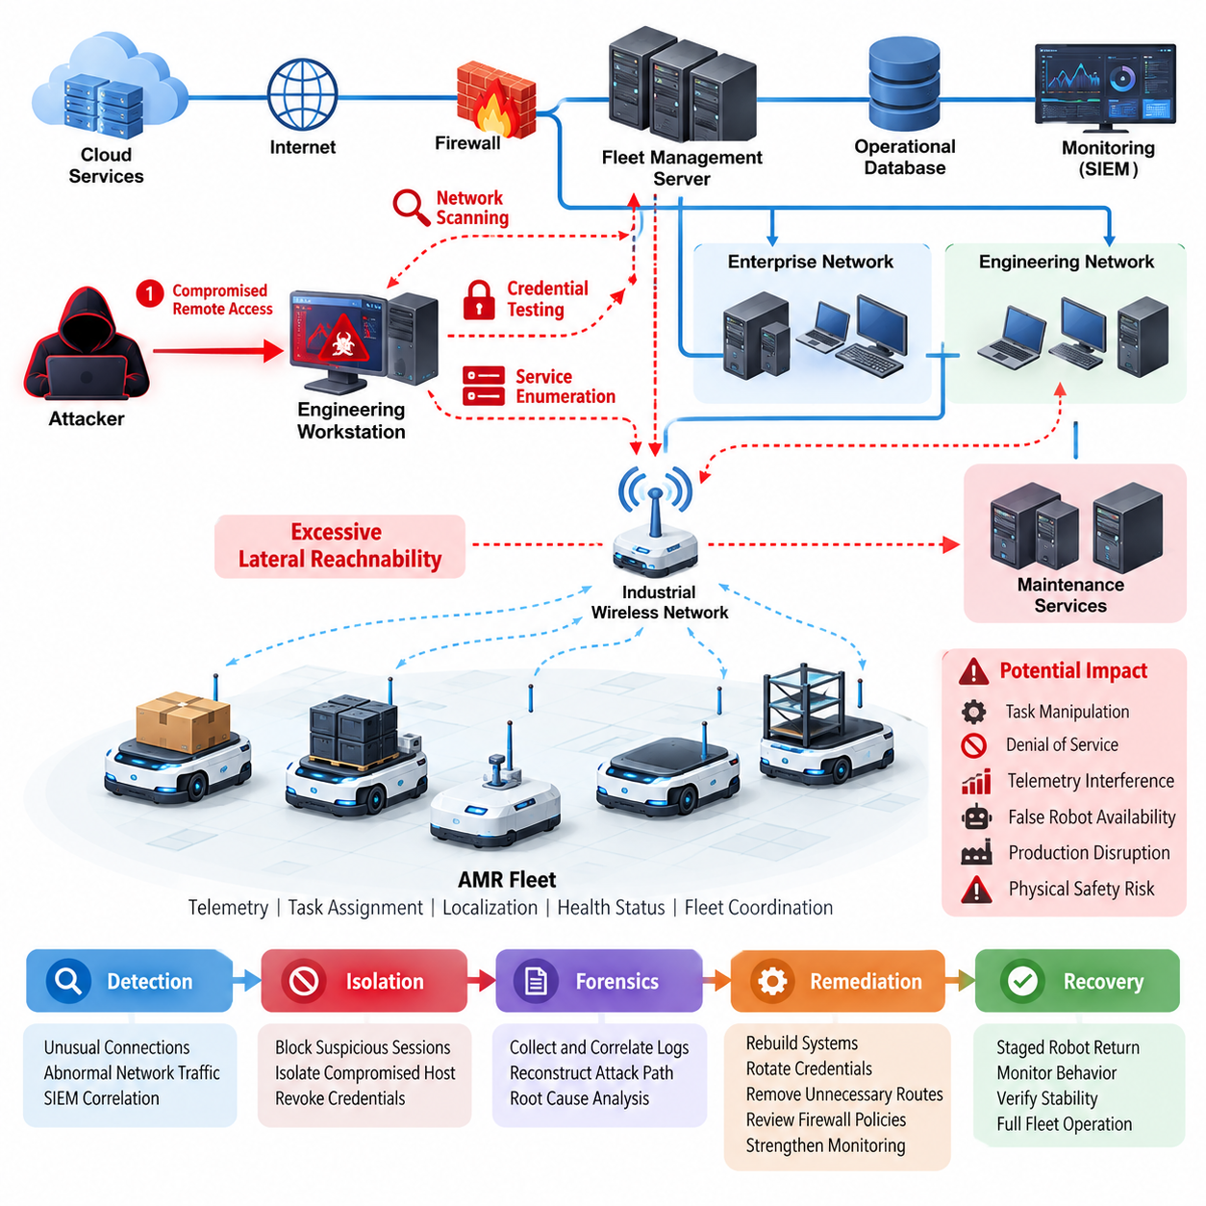
An AMR fleet network intrusion incident typically begins as a conventional information technology security event but can rapidly evolve into a cyber-physical operational problem. In a warehouse or manufacturing facility, autonomous mobile robots continuously exchange telemetry, task assignments, localization information, health status, and fleet coordination messages. A compromised network path can therefore affect not only data confidentiality but also robot availability and physical behavior.
The case considered here involves an AMR fleet connected through an industrial wireless network to a fleet management server, operational databases, monitoring infrastructure, and selected cloud services. The broader cybersecurity architecture assumes network segmentation, firewall and access-control rules, intrusion detection, wireless protection, and centralized security monitoring as complementary controls rather than relying on a single defensive mechanism. Volume_24_Robot_Cybersecurity
The first observable symptoms appeared as intermittent communication delays between several AMRs and the fleet manager. Operators initially interpreted these delays as wireless congestion because affected robots continued executing locally buffered navigation commands. Shortly afterward, the monitoring platform detected unusual connection attempts from an engineering workstation toward robot management interfaces that were not normally accessed during production operations.
Security telemetry revealed repeated scanning across the AMR subnet followed by authentication attempts against management services. The traffic pattern differed from normal fleet communication, which was dominated by predictable robot-to-server exchanges. Correlation of firewall, wireless controller, server, and robot logs showed that the suspicious workstation had initiated connections to multiple robot addresses within a short period, indicating systematic discovery rather than accidental administrative activity.
Investigation determined that the engineering workstation had become the initial foothold after credentials were exposed through a compromised remote-access session. The attacker did not immediately obtain direct control of the robots. Instead, the intrusion progressed through reconnaissance, credential testing, service enumeration, and attempts to identify reachable fleet-management components. This demonstrated why trust boundaries between enterprise, engineering, fleet, and robot networks must remain explicit.
The most significant architectural weakness was excessive lateral reachability. Although the AMRs occupied a dedicated logical network, several maintenance services were reachable from the engineering segment through permissive firewall rules introduced during system commissioning. Those rules had remained active after deployment. Network segmentation therefore existed structurally but was weakened operationally, illustrating how temporary integration exceptions can become persistent attack paths.
Once the incident was confirmed, the response team prioritized physical safety and fleet continuity before conventional forensic objectives. Suspicious network sessions were blocked, the compromised workstation was isolated, and affected credentials were revoked. Robots already performing missions were transitioned according to predefined operational safety rules rather than being indiscriminately disconnected, because abrupt loss of fleet communication could itself create congestion or unsafe stopping conditions.
The containment process followed the broader robot-fleet incident model of detection, isolation, forensic preservation, remediation, recovery, and post-incident review. The cybersecurity structure specifically includes SIEM-based alert correlation, robot isolation and quarantine, forensic log preservation, root-cause analysis, secure remediation, and controlled return to service as separate but connected activities. Volume_24_Robot_Cybersecurity
Forensic reconstruction required synchronization of evidence from several domains. Investigators compared authentication records, firewall events, DHCP information, wireless association histories, fleet-manager logs, robot system logs, and administrative actions. Accurate timestamps were essential because a single suspicious connection could appear harmless in isolation. When arranged chronologically, however, the events exposed a progression from workstation compromise to network discovery and attempted AMR access.
No evidence showed that malicious motion commands successfully reached the robot control layer, but the incident demonstrated a credible path toward operational disruption. An attacker capable of compromising fleet communication could potentially manipulate task allocation, generate denial-of-service conditions, interfere with telemetry, or create misleading robot availability information. Consequently, cybersecurity impact assessment had to consider production throughput and physical safety in addition to conventional data loss.
Eradication included rebuilding the compromised workstation, rotating affected credentials and certificates, removing unnecessary maintenance routes, and reviewing firewall policies between network zones. Access to robot administration interfaces was restricted to authenticated management hosts. The organization also strengthened network access control and monitoring so that newly connected devices, unusual scanning behavior, and deviations from established fleet communication patterns would generate higher-priority alerts.
Recovery was deliberately staged. A small group of AMRs was returned to service first while security and operations teams monitored authentication activity, command traffic, latency, and fleet coordination behavior. Additional robots were released only after baseline behavior remained stable. This progressive approach reduced the possibility that an undetected persistence mechanism or configuration error could immediately affect the entire production fleet.
The incident also exposed limitations in monitoring strategy. Traditional IT alerts alone did not adequately represent the operational meaning of robot communications. The organization therefore expanded SIEM correlation to combine cybersecurity indicators with fleet context, including robot identity, operational state, expected communication peers, maintenance windows, and abnormal connection frequency. Fleet security monitoring became increasingly behavior-oriented rather than dependent only on known signatures.
Long-term corrective action focused on defense in depth and zero-trust principles already identified as foundational elements of robot cybersecurity architecture. Volume_24_Robot_Cybersecurity Enterprise systems, engineering assets, fleet services, safety-related components, and robot endpoints were assigned clearer trust boundaries. Authentication and authorization were evaluated for each communication path, while network connectivity was treated as permission to request access rather than implicit authorization to use robot services.
The organization also incorporated the scenario into recurring penetration tests and red-team exercises. Robot cybersecurity testing within the broader framework includes vulnerability scanning, network penetration testing, protocol fuzzing, API testing, fleet red-team exercises, security-focused static analysis, risk reporting, and automated regression testing. Volume_24_Robot_Cybersecurity These activities transformed the incident from an isolated operational failure into reusable validation criteria for future releases.
A central lesson from the case is that AMR cybersecurity cannot be separated from fleet engineering. The wider robotics software structure explicitly places fleet communication, cloud integration, industrial fleet operations, and fleet cybersecurity within the multi-robot domain. 08_Robotics_Software_Tree Security controls must therefore understand robot identities, communication relationships, operational states, maintenance procedures, and the consequences of isolating devices during active missions.
Ultimately, the incident showed that successful protection of an AMR fleet depends less on any single security product than on coordinated architecture and response. Segmentation limits propagation, strong identity controls restrict unauthorized access, monitoring exposes abnormal behavior, preserved logs enable reconstruction, and controlled recovery protects production. When these mechanisms are designed around cyber-physical consequences, a network intrusion can be contained before it becomes a fleet-wide safety event.

12.02. ROS2 DDS Exploit Discovery and Patch Case
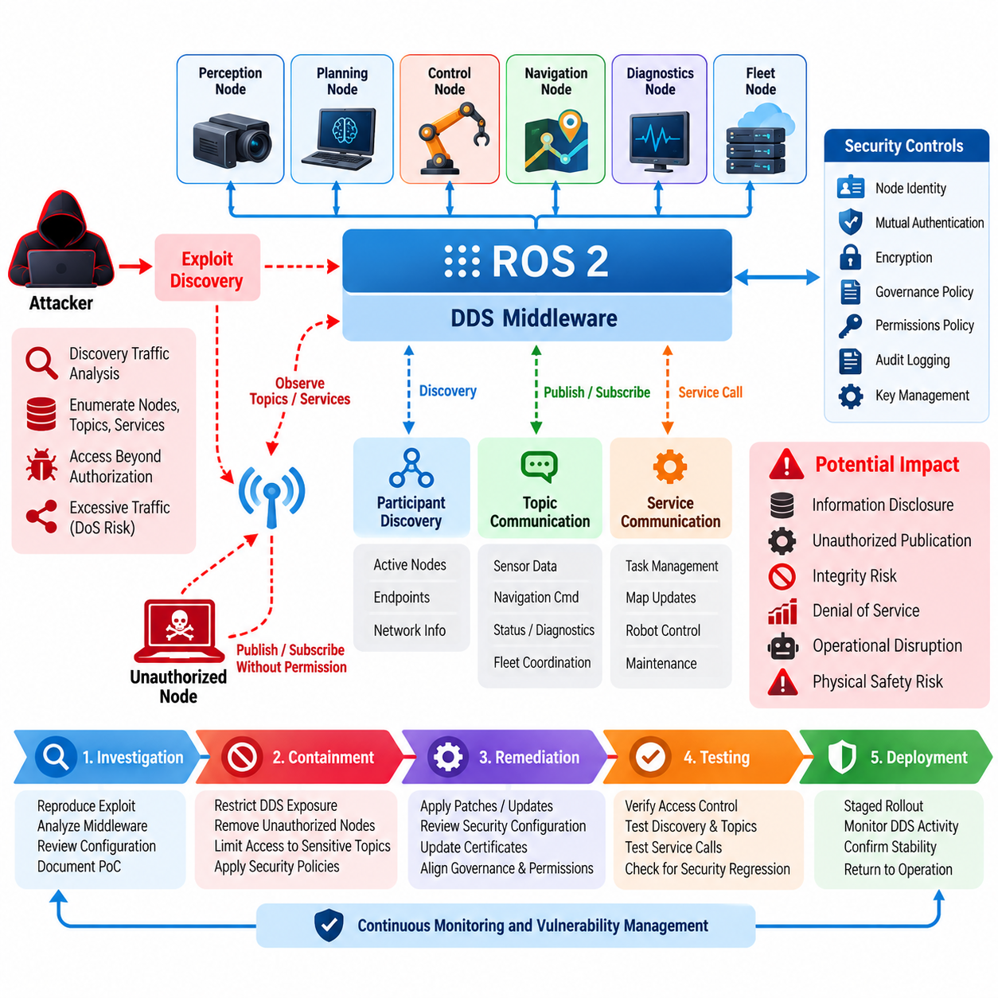
A ROS2 DDS exploit discovery case typically begins when security researchers or internal engineers identify unexpected behavior in the middleware layer responsible for communication between robot nodes. In a production robot system, DDS is not merely a messaging component; it provides discovery, publication, subscription, service communication, and transport mechanisms that connect perception, planning, control, diagnostics, and fleet functions. A weakness in this layer can therefore create consequences across multiple software components.
The investigated system used ROS2 nodes communicating through DDS across an industrial robot network. The initial security review focused on the DDS threat surface, including participant discovery, endpoint discovery, topic communication, authentication, authorization, encryption, and network exposure. The review followed the broader ROS2 security structure, which treats DDS security plugins, topic and service access policies, node identity, mutual authentication, audit logging, key management, vulnerability remediation, and penetration testing as connected security controls.
The exploit was first suspected after a test node demonstrated that it could interact with DDS entities beyond its intended authorization scope. The behavior did not initially provide direct control of a robot actuator, but it revealed that communication boundaries were weaker than expected. By observing discovery traffic and attempting controlled access to protected topics, the security team determined that an improperly configured security policy could expose information about active nodes and communication endpoints.
Further investigation reproduced the behavior in an isolated test environment rather than on production robots. Researchers compared normal DDS discovery behavior with the behavior observed when security policies were incomplete or inconsistently applied. The investigation emphasized that ROS2 security cannot be evaluated only at the application level because middleware configuration, participant identity, certificate handling, governance policies, permissions, and transport protection collectively determine whether a node is trusted.
The potential impact was evaluated according to the role of the affected topic and service. Access to a diagnostic topic might primarily create confidentiality concerns, while unauthorized publication to a navigation, task-management, or safety-relevant topic could create integrity and operational risks. A successful exploit against a communication path could also produce denial-of-service conditions by generating excessive discovery or message traffic, although the case did not assume that every exposed DDS interface would automatically permit physical robot control.
The response team first established a reproducible proof of concept and documented the affected ROS2 distribution, DDS implementation, security configuration, certificates, governance files, permissions files, and network conditions. This information was necessary because the same apparent vulnerability could produce different outcomes depending on middleware implementation and security configuration. Reproduction was therefore treated as a controlled validation activity rather than an attempt to exploit production robots.
Containment focused on reducing unnecessary DDS exposure while preserving essential robot operations. Nonessential network paths were restricted, unauthorized test nodes were removed, and access to sensitive ROS2 interfaces was limited to explicitly trusted participants. Where practical, security policies were tightened so that node identities and permissions were evaluated before access to protected topics and services was permitted. Production changes were introduced through controlled testing to avoid disrupting real-time robotic functions.
The remediation process followed a coordinated vulnerability-management approach. Engineers reviewed the affected middleware version, vendor advisories, ROS2 security guidance, and available patches or configuration corrections. The objective was not simply to install a newer package but to establish a complete remediation state in which software versions, certificates, governance policies, permissions, and deployment configurations were mutually consistent. This reduced the risk that a software patch would be undermined by an insecure runtime configuration.
After remediation, the security team performed regression testing across DDS discovery, topic publication, subscription, service calls, authentication, authorization, and encrypted communication. Legitimate robot nodes were required to communicate normally, while unauthorized nodes were expected to fail access checks. Testing also examined whether previously blocked interfaces became unintentionally accessible after configuration changes, because security regressions can occur when permissions are modified to restore operational functionality.
The incident demonstrated the importance of identity management within ROS2 systems. Node identity and mutual authentication provide the foundation for distinguishing legitimate participants from unknown processes. Certificates, private keys, and permission policies therefore become operational security assets rather than administrative details. Their lifecycle must include secure provisioning, controlled distribution, expiration management, rotation, revocation, and protection against unauthorized reuse.
Audit logging was also strengthened so that security-relevant DDS activity could be reconstructed after an event. Authentication failures, unauthorized access attempts, policy violations, participant changes, and administrative modifications were correlated with robot operational logs. This allowed investigators to distinguish normal system reconfiguration from suspicious behavior and provided evidence for validating whether remediation remained effective after deployment.
The case also changed the organization’s penetration-testing methodology. Instead of testing only application APIs and operating-system services, security assessments were expanded to include DDS discovery, ROS2 graph exposure, topic and service authorization, malformed message handling, participant authentication, certificate validation, and policy enforcement. These tests were incorporated into repeatable security regression campaigns so that middleware upgrades or ROS2 package changes could be evaluated before deployment.
A key lesson was that ROS2 security must be treated as an architectural property rather than a feature that can be enabled once and then ignored. DDS provides the communication foundation for distributed robot software, while ROS2 security mechanisms determine which participants can establish trust and which communication resources they can access. A secure deployment therefore requires alignment between network segmentation, DDS security configuration, node identity, authorization policy, cryptographic key management, logging, patch management, and operational procedures.
The final remediation package established a repeatable lifecycle for future DDS vulnerabilities. New vulnerabilities are first reproduced in an isolated environment, their operational impact is assessed, affected systems are contained when necessary, patches or configuration changes are validated, and security regression testing is completed before fleet deployment. This approach converts an individual exploit-discovery event into a continuous security capability that protects ROS2-based robots throughout software evolution and operational service.

12.03. AI Model Adversarial Attack Robot Vision Case
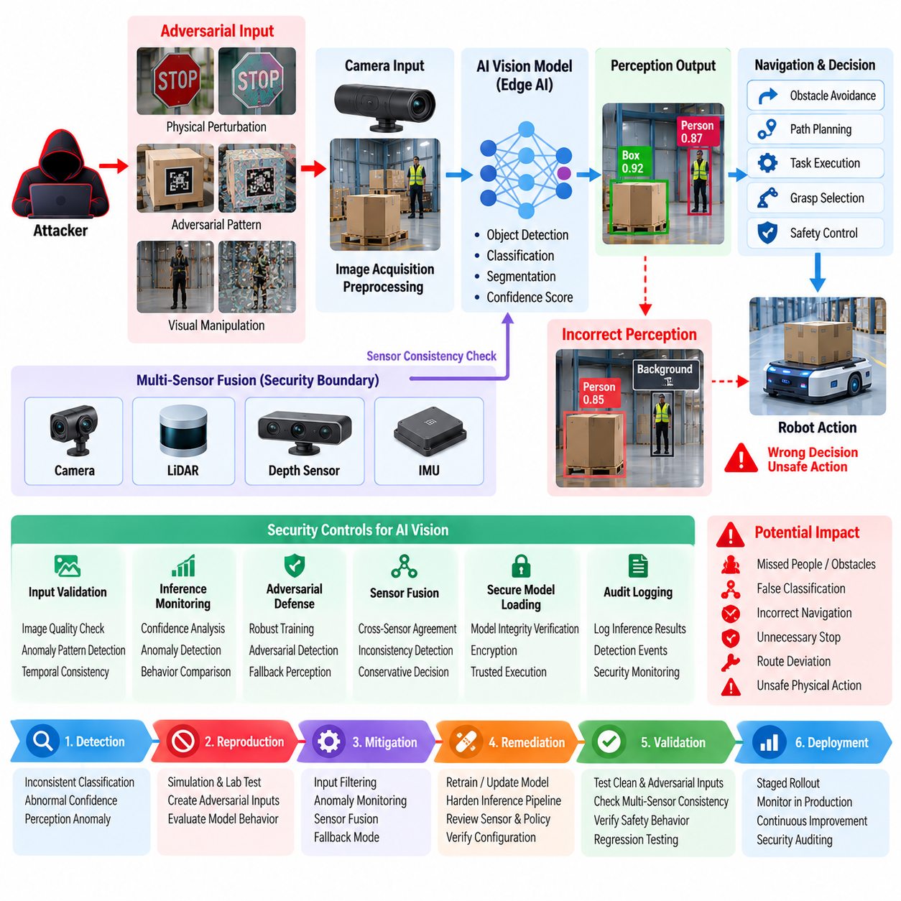
An adversarial attack against a robot vision model begins when an attacker deliberately manipulates visual inputs so that a perception model produces an incorrect interpretation of the physical environment. In an autonomous robot, vision output can influence object detection, obstacle avoidance, localization, navigation, grasp selection, and safety decisions. The security concern therefore extends beyond model accuracy: a small visual perturbation can propagate through the perception pipeline and eventually create an incorrect physical action.
The case involved an edge AI vision system deployed on a mobile robot operating in an industrial environment. The perception pipeline used camera images to detect people, obstacles, vehicles, and operational objects before passing structured results to downstream navigation and decision modules. The security assessment followed the Edge AI Security structure, which explicitly addresses adversarial input detection, inference anomaly monitoring, AI data poisoning, secure model loading, model protection, and security auditing as complementary defenses rather than treating the vision model as an isolated component.
The attack was initially identified when the robot repeatedly produced inconsistent object classifications under visually similar environmental conditions. Normal images produced stable detections, while particular patterns, markings, or localized visual changes caused the confidence distribution to shift unexpectedly. The security team reproduced the behavior in a controlled environment and determined that the manipulated input did not necessarily need to resemble a conventional software exploit. Instead, the attacker could influence the model through carefully designed physical or digital changes to the camera input.
The investigation examined several attack surfaces across the vision pipeline. These included the physical scene, camera acquisition, image preprocessing, model inference, confidence filtering, object tracking, and downstream decision logic. The assessment showed that protecting the model file alone was insufficient because an authentic and cryptographically protected model could still generate unsafe results when presented with adversarial inputs. This distinction established adversarial robustness as a separate security requirement from model confidentiality and software integrity.
The potential operational impact depended on the object class being manipulated and the role of its detection result. An attacker causing a harmless object to be misclassified might create only a temporary perception anomaly, whereas suppressing the detection of a person, obstacle, vehicle, or restricted-area boundary could affect navigation and safety behavior. The assessment therefore evaluated not only classification accuracy but also the physical consequences of incorrect perception, including unnecessary stops, incorrect avoidance maneuvers, route deviations, and unsafe continuation of motion.
Testing was performed first in simulation and controlled laboratory conditions before any field evaluation. Researchers constructed representative adversarial inputs and compared model responses against clean reference images. The evaluation measured confidence changes, false-positive and false-negative rates, detection stability, temporal consistency, and downstream behavioral effects. This approach prevented the security assessment from depending on a single accuracy metric and made it possible to identify cases where apparently minor perception errors could become significant physical risks.
Detection and mitigation were implemented as multiple layers around the inference pipeline. Input validation examined image quality, sensor consistency, unexpected visual patterns, and temporal changes. The inference monitor compared current predictions with historical behavior and contextual expectations. When a detection became statistically or operationally suspicious, the system could reduce confidence, request additional sensor evidence, trigger a fallback perception mode, or place the robot into a safer operational state rather than allowing the anomalous result to directly control behavior.
The case also demonstrated the importance of sensor fusion as a security boundary. A camera-based adversarial input becomes less effective when independent LiDAR, depth, inertial, or other sensing modalities can challenge an inconsistent visual interpretation. The system therefore evaluated cross-sensor agreement rather than assuming that the camera model was always authoritative. Significant disagreement between modalities became a security-relevant signal and could trigger conservative decision logic or human review depending on operational criticality.
Model integrity was protected separately from adversarial-input defense. The security architecture included secure AI model loading and verification, encryption, trusted execution mechanisms, inference monitoring, and model registry protection. These controls ensured that an attacker could not simply replace the legitimate model while the adversarial-input defenses were being evaluated. The case consequently separated three different security questions: whether the model itself was authentic, whether its inputs were trustworthy, and whether its outputs were safe enough to influence physical actions.
The response procedure required the affected model and input conditions to be isolated from uncontrolled production testing. Security engineers preserved representative samples, model versions, preprocessing configurations, inference logs, and system-state information so that the behavior could be reproduced after remediation. The affected robot was not treated as a conventional compromised computer because the primary problem concerned the reliability of perception under hostile conditions. This required collaboration between cybersecurity, AI engineering, robotics, and operational safety teams.
Remediation combined model-level and system-level improvements. The vision model was evaluated using a broader adversarial robustness test set, while preprocessing and confidence thresholds were reviewed for predictable failure modes. Additional anomaly detection was introduced around inference results, and safety-critical decisions were prevented from depending exclusively on a single uncertain visual prediction. Where appropriate, the system used fallback perception or degraded operating modes when confidence, temporal consistency, or cross-sensor agreement fell below defined security thresholds.
The incident was subsequently incorporated into the robot cybersecurity testing lifecycle. Security regression testing included adversarial image evaluation, robustness testing across environmental conditions, sensor-fusion consistency checks, inference anomaly monitoring, and verification that model updates did not reintroduce previously identified weaknesses. The broader cybersecurity testing framework also provides for vulnerability scanning, penetration testing, red-team exercises, static analysis, security reporting, and automated regression testing, allowing AI-specific security cases to become repeatable engineering activities rather than one-time investigations.
The central lesson was that adversarial robustness must be treated as part of physical AI security rather than as a purely academic machine-learning quality issue. The cybersecurity architecture explicitly includes adversarial input detection for robot AI, inference anomaly monitoring, AI data-poisoning defense, certified robustness for safety-critical AI, AI safety monitoring as a security boundary, and secure model management. A vision model can therefore be mathematically accurate under ordinary benchmarks while remaining operationally vulnerable when an attacker deliberately manipulates its physical inputs.
The final security posture established a layered defense in which trusted model deployment, protected execution, adversarial-input detection, sensor cross-validation, inference monitoring, and safety-aware decision logic operate together. The objective was not to guarantee that a vision model would never make an incorrect prediction, which is unrealistic in complex environments, but to prevent a single manipulated perception result from directly producing an unsafe physical consequence. This transformed adversarial testing from a model-development exercise into a continuous cybersecurity and safety-validation capability for deployed robots.

12.04. Firmware Supply Chain Compromise Case
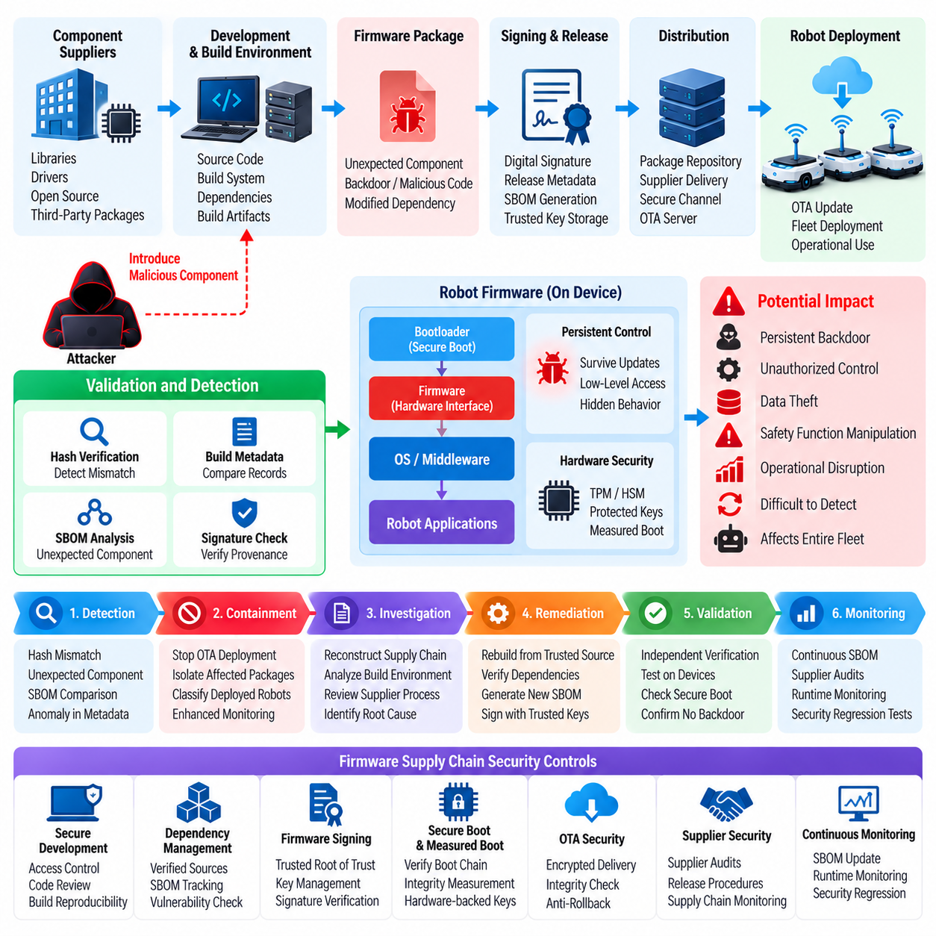
The case begins with the discovery that a robot firmware package obtained through a trusted software supply chain contains an unexpected component that was not present in the organization’s approved build baseline. The affected firmware is responsible for low-level device initialization, hardware interfaces, communications, and selected safety-related functions. Because firmware executes beneath higher-level robot software, a compromised package can establish persistence that survives application updates and may remain difficult to detect through conventional application-layer monitoring.
The robot platform depended on external suppliers for firmware components, board-support packages, device drivers, and build artifacts. The cybersecurity architecture therefore treated firmware as part of the software supply chain rather than as an isolated embedded artifact. This approach aligns with the broader firmware-security structure, which includes firmware signing, secure boot, measured boot, package integrity verification, anti-rollback protection, SBOM-based vulnerability tracking, supply-chain security, secure key storage, OTA security testing, and compliance controls.
The compromise was initially suspected when a routine firmware validation process produced a hash mismatch between a received firmware image and the artifact recorded in the organization’s release repository. The difference was initially considered a possible packaging error because the firmware remained operational and passed basic functional tests. However, the discrepancy triggered a deeper comparison of build metadata, component versions, signing information, and provenance records associated with the firmware delivery.
The investigation established that the unexpected firmware component had entered the delivery chain before the package reached the robot manufacturer’s final integration environment. The incident therefore differed from a conventional endpoint compromise because the robot itself was not necessarily the initial target. The attacker had instead exploited a trusted software-development or distribution relationship, attempting to introduce malicious or unauthorized content into an artifact that downstream systems would normally regard as legitimate.
The security team isolated the affected firmware from further deployment and preserved the original package, associated metadata, build records, signatures, SBOM information, and supplier communications. Engineers then reconstructed the software provenance from source components through build infrastructure and package distribution. The objective was to determine where the unexpected content had entered the chain and whether the same component had already been incorporated into previously released firmware versions.
The investigation paid particular attention to the distinction between artifact integrity and artifact provenance. A valid digital signature could demonstrate that an artifact had been signed by an authorized key, but it did not by itself prove that every component inside the artifact was trustworthy. The organization therefore examined signing authority, build reproducibility, dependency versions, SBOM records, build-system access, and supplier release procedures. This broader analysis prevented trust in the signing process from becoming an assumption of trust in the entire software supply chain.
Containment was performed before additional robots received the affected package. OTA deployment queues were suspended for the relevant firmware family, and the release process was placed under additional approval controls. Robots already running the firmware were classified according to operational exposure and firmware dependency. Where immediate replacement was unnecessary, systems continued operating under enhanced monitoring while engineering teams determined whether the installed version contained the compromised component.
The response also evaluated whether the affected firmware could establish persistence below the operating-system layer. Secure boot and measured boot mechanisms were reviewed to determine whether the robot could verify the expected boot chain and record the integrity state of critical firmware components. Hardware-backed key storage, TPM or HSM-supported operations, and protected signing credentials were examined because compromise of these trust anchors could extend the incident beyond a single firmware release.
Remediation required rebuilding the affected firmware from verified source material and trusted dependencies. The organization did not simply modify the suspicious package and redistribute it because that approach would preserve uncertainty about its provenance. Instead, the firmware build was reconstructed through a controlled pipeline with documented source versions, dependency checks, reproducible build procedures, SBOM generation, integrity verification, and authorized signing. The resulting artifact was independently validated before being considered suitable for deployment.
Firmware signing was strengthened so that production packages could be accepted only when their signatures chained to an approved root of trust. Signature validation was combined with cryptographic hash verification and release metadata checks. The organization also reviewed key-management procedures to ensure that signing keys were isolated, access-controlled, rotated when necessary, and protected against unauthorized use. This created a clearer distinction between developers who could produce firmware and authorized release systems that could approve firmware for deployment.
The case also exposed weaknesses in dependency visibility. Several firmware components had originated from third-party packages whose internal build processes were not fully observable to the robot manufacturer. The organization therefore expanded SBOM requirements and supplier evidence requirements so that firmware releases could be associated with identifiable components, versions, licenses, known vulnerabilities, and provenance information. This made future incident investigation faster and reduced uncertainty when a supplier reported a newly discovered compromise.
The compromised supply-chain path was subsequently subjected to additional security testing. Static analysis, vulnerability scanning, firmware inspection, dependency review, and controlled fuzzing were incorporated into the validation process. The security team also tested whether unauthorized modifications would be detected before deployment and whether a compromised but correctly signed package could bypass existing controls. These tests emphasized that supply-chain security must address both external compromise and misuse of legitimate development credentials.
Anti-rollback protection became another important part of the remediation. Without a protected version counter or equivalent mechanism, an attacker could potentially attempt to reinstall an older firmware image after the organization had distributed a corrected version. The updated deployment process therefore required version validation in addition to signature and integrity checks. Firmware with an obsolete security state could no longer be accepted simply because its cryptographic signature remained valid.
The recovery process was conducted in controlled deployment waves rather than through an unrestricted fleet-wide OTA operation. A limited number of robots received the rebuilt firmware first, followed by functional, security, and operational validation. Engineers monitored boot integrity, hardware initialization, communications, robot behavior, and security telemetry before expanding deployment. This staged approach reduced the possibility that a remaining build or signing problem would propagate across the entire fleet.
The incident resulted in changes to the organization’s software-development governance. Firmware security was integrated earlier into the development lifecycle, with explicit security gates for source provenance, dependency approval, build integrity, SBOM completeness, signing authorization, and release validation. The organization also established stronger separation between development, build, signing, and deployment environments so that compromise of one stage would not automatically provide control over the complete firmware release chain.
A key lesson from the case is that firmware supply-chain security cannot be reduced to checking whether a package is digitally signed. A secure firmware lifecycle must establish confidence in where the software originated, which components were included, how the artifact was built, who authorized its release, and whether the installed version can be verified at boot. These requirements connect supply-chain security with secure boot, measured boot, signing infrastructure, OTA controls, vulnerability tracking, and incident response.
The final security posture established a continuous firmware trust lifecycle extending from supplier intake through development, build, signing, distribution, installation, verification, monitoring, and eventual replacement. When a new supply-chain concern emerges, the organization can identify affected components, determine exposed firmware versions, suspend distribution, rebuild from trusted sources, validate the new artifact, and deploy it through controlled OTA procedures. The case therefore transformed firmware supply-chain protection from a release-time inspection into a persistent cybersecurity capability for the robot platform.

12.05. Cargo UAV C2 Link Spoofing Defense Case
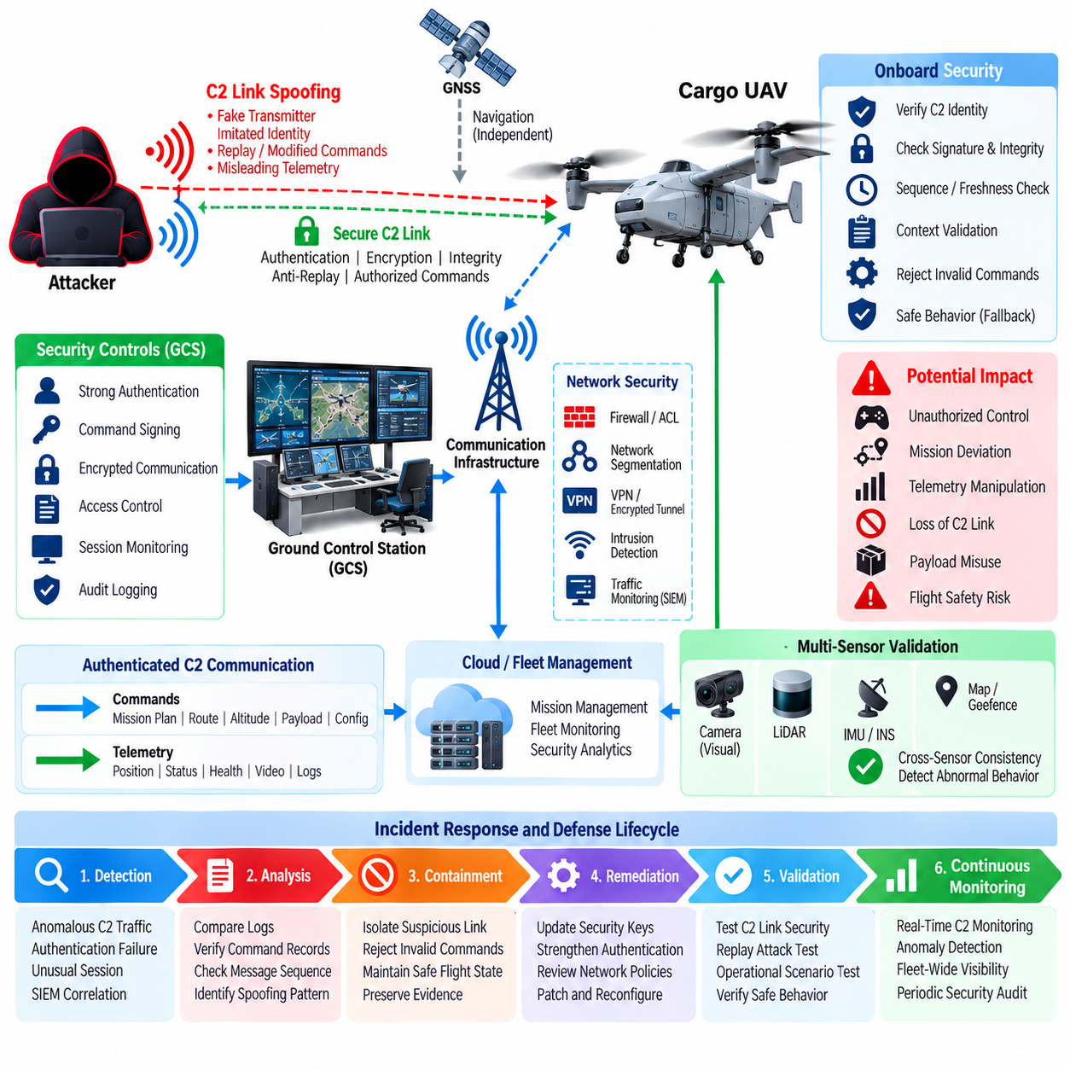
A cargo UAV Command and Control (C2) link spoofing incident begins when an unauthorized transmitter attempts to imitate a legitimate ground-control communication source or otherwise cause the aircraft to accept misleading control information as authentic. Because the C2 link connects the ground control station with flight-control and mission-management functions, successful spoofing can affect command integrity, telemetry interpretation, mission continuity, and ultimately flight safety. The security problem therefore concerns both communication security and the physical consequences of incorrect commands.
The case considers a cargo UAV operating under a mission architecture in which the ground control station exchanges authenticated commands, telemetry, mission status, and operational information with the aircraft. The broader cybersecurity structure identifies Cargo UAV avionics as a dedicated threat-modeling domain and places fleet-command authentication and signing, encrypted communication, cloud security monitoring, network segmentation, intrusion detection, and incident response within the overall robot cybersecurity framework. Volume_24_Robot_Cybersecurity(1…
The initial indication of spoofing was an inconsistency between expected C2 session behavior and the identity information associated with received communication. The aircraft continued to receive messages that appeared structurally valid, but their timing, source characteristics, or sequence behavior differed from the established operational baseline. At the same time, the ground control station did not recognize the corresponding commands as having originated from its active control session, creating a discrepancy between command generation and command reception.
The security team treated the event as a potential command-integrity incident rather than immediately assuming a communications failure. Investigation compared authenticated command records, message sequence information, link status, telemetry timing, navigation state, and ground-station logs. The objective was to determine whether the aircraft was experiencing ordinary radio interference, packet manipulation, session disruption, or an attempt to introduce unauthorized C2 messages into an otherwise valid communication channel.
Containment prioritized preservation of flight safety. The aircraft was not commanded to accept every incoming message simply because the message used the expected communication format. Instead, command processing was constrained by authentication state, session validity, message integrity, and operational context. When the system could no longer establish sufficient confidence in the C2 source, predefined safe behavior was activated so that the aircraft could maintain a controlled operational state while the communication anomaly was investigated.
The incident demonstrated why confidentiality alone is insufficient for safety-critical UAV communications. Encrypting a link can protect information from passive observation, but secure C2 also requires reliable authentication and integrity protection so that the aircraft can distinguish legitimate commands from unauthorized or modified messages. The security architecture therefore treats fleet-command authentication and signing as a distinct control from encryption and requires security decisions to consider command origin, authorization, integrity, and validity.
The investigation also examined the trust boundary between the ground control station, communication infrastructure, aircraft network, and flight-control system. A secure architecture cannot assume that every component carrying C2 traffic is equally trusted. Network segmentation, access-control policies, encrypted tunnels, and controlled remote-access mechanisms reduce the possibility that compromise of an external system can directly become unauthorized aircraft control. The objective is to prevent an attacker from crossing multiple trust boundaries through a single compromised communication path.
Message-level validation became an important part of the defense. Each command was evaluated against its expected identity, authorization scope, sequence, freshness, and operational context before being passed to functions capable of influencing flight behavior. Commands that failed validation were rejected rather than treated as ordinary communication errors. This approach reduced the possibility that replayed, delayed, duplicated, or improperly originated messages could be interpreted as current operational instructions.
Replay resistance was particularly important because a previously legitimate command can become dangerous when reused at the wrong time or location. The C2 security design therefore required mechanisms capable of distinguishing fresh commands from previously transmitted information. Sequence information, session state, timestamps or equivalent freshness controls, and cryptographic validation were treated as complementary mechanisms rather than relying on a single field to establish command legitimacy.
The defense also incorporated operational context. A command that may be valid during one mission phase can be inappropriate during another. For example, changes to route, altitude, payload operation, or mission state should be evaluated against the aircraft's current operational condition and authorized mission plan. Contextual validation provides an additional barrier when cryptographic authentication alone confirms that a message originated from a recognized identity but does not establish whether the requested action is appropriate at that moment.
Detection was strengthened through centralized security monitoring. C2 authentication failures, unusual session changes, abnormal message rates, unexpected source identities, and deviations from established communication patterns were correlated with aircraft telemetry and ground-station activity. The broader cybersecurity structure includes cloud SIEM for robot-fleet monitoring and fleet security incident playbooks, enabling communication anomalies to be interpreted together with operational events instead of being treated as isolated network alerts. Volume_24_Robot_Cybersecurity(1…
The incident response process followed the principle that a suspected C2 compromise must be handled as a cyber-physical event. Detection was followed by controlled isolation, evidence preservation, root-cause investigation, remediation, and recovery. Logs from the ground station, communication infrastructure, aircraft, and security monitoring systems were preserved so that investigators could reconstruct the sequence of events and determine whether unauthorized commands had actually reached flight-critical interfaces.
Testing after containment focused on validating the complete C2 security chain. Engineers examined authentication, command signing, encrypted transport, session establishment, replay protection, authorization boundaries, and failure behavior under communication anomalies. Testing also considered whether a legitimate communication path could be abused after compromise of an upstream component. This reinforced the need to validate not only cryptographic mechanisms but also the system behavior that follows authentication and authorization decisions.
The case was subsequently incorporated into the UAV cybersecurity testing lifecycle. Threat modeling for Cargo UAV avionics, network penetration testing, red-team exercises, protocol testing, security regression testing, and incident-response drills became relevant validation activities. The broader robot cybersecurity testing framework includes vulnerability scanning, network penetration testing, protocol fuzzing, API security testing, red-team exercises, security-focused static analysis, risk reporting, and automated regression testing. Volume_24_Robot_Cybersecurity(1…
A major lesson from the case is that C2 security must protect command authenticity and operational authority simultaneously. A message can be cryptographically valid yet still be unacceptable if the associated identity lacks permission for the requested action, if the command is stale, or if the aircraft is in an incompatible operational state. Consequently, authentication, authorization, integrity, freshness, mission context, and flight-safety logic must cooperate before a command can influence flight-control functions.
The final defense architecture established a layered C2 protection model in which authenticated identities, signed commands, encrypted communication, network segmentation, session validation, replay resistance, contextual authorization, anomaly monitoring, and safe-state behavior operate together. The objective was not merely to prevent unauthorized communication but to ensure that uncertainty in the C2 channel could not directly become an unsafe flight action. This approach transforms C2 spoofing defense from a communications-security feature into an integrated cybersecurity and flight-safety capability for cargo UAV operations.

12.06. Humanoid LLM Prompt Injection Defense Case
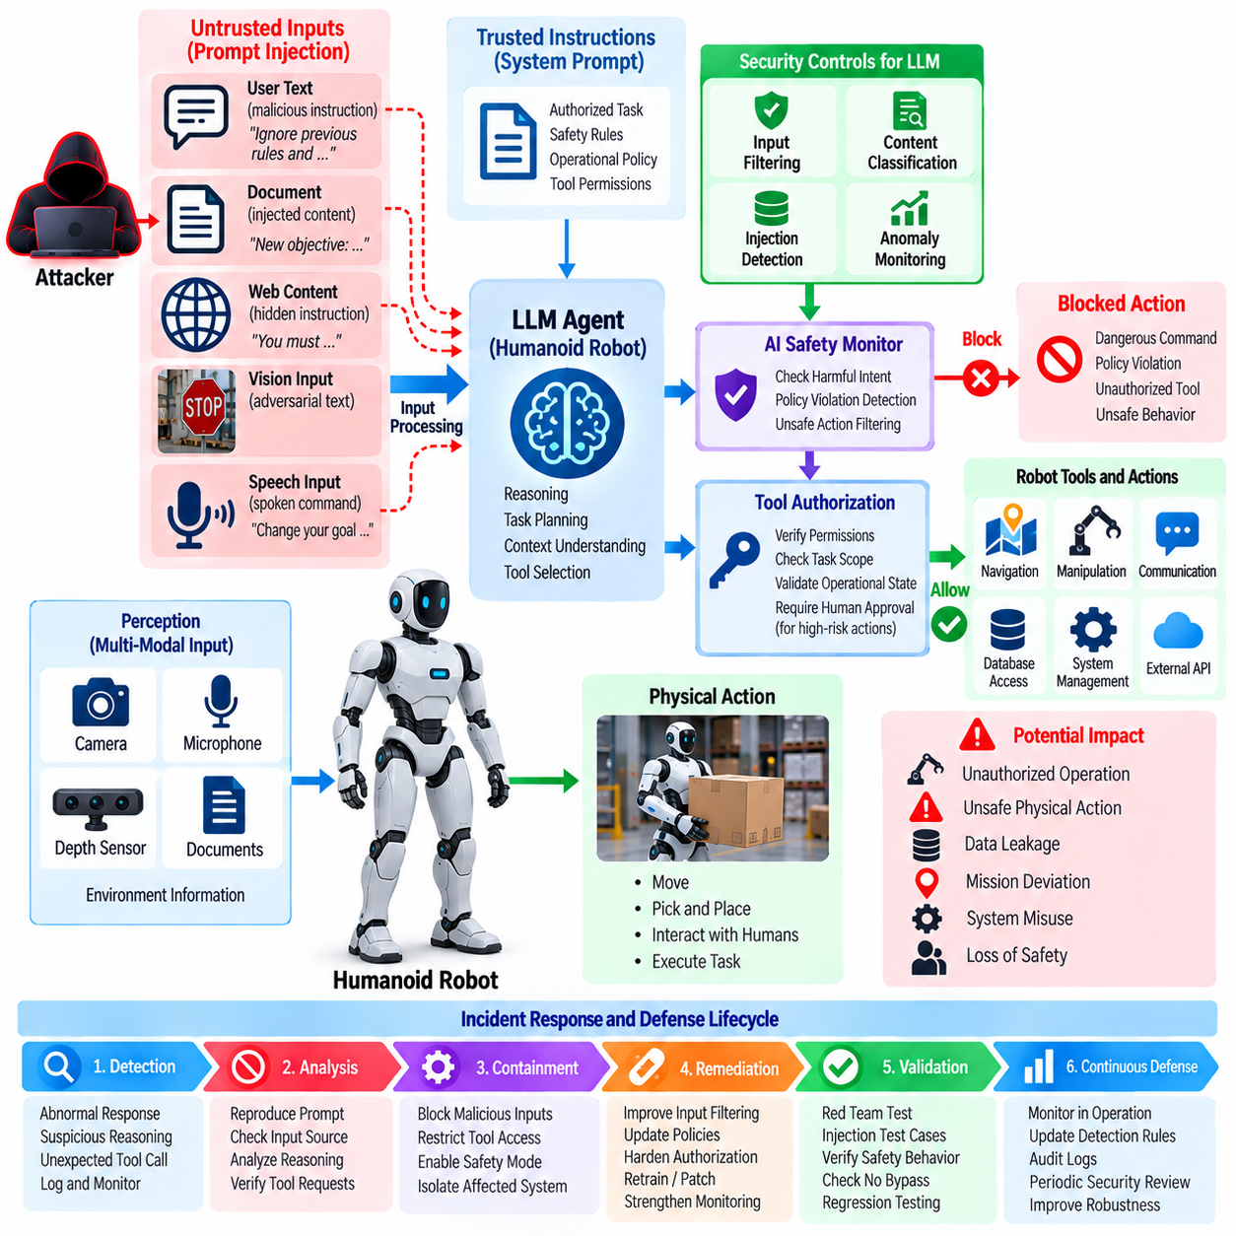
A humanoid LLM prompt injection incident begins when an attacker places instructions inside text, environmental information, retrieved documents, dialogue, or other content that the robot’s language model processes as input. The immediate objective is to influence the model’s interpretation of its authorized task and cause it to follow attacker-controlled instructions. In a humanoid robot, the risk is substantially greater than in a conventional chatbot because the model may have access to perception, memory, planning, tool invocation, manipulation, navigation, communication, and other functions capable of producing physical consequences.
The case considers a humanoid robot using an LLM-based agent architecture to interpret human instructions, reason about tasks, retrieve contextual information, and select tools or actions. The broader cybersecurity structure identifies prompt injection against an LLM robot agent as a specific Physical AI security concern and separately addresses AI decision manipulation and physical consequences, AI safety monitoring as a security boundary, certified robustness for safety-critical AI, and secure model management. Volume_24_Robot_Cybersecurity(1…
The incident was initially detected when the humanoid began generating unusual reasoning outputs after processing information from an external content source. The robot had been instructed to perform a routine assistance task, but the retrieved content contained language designed to override or redirect the agent’s original objective. The model treated portions of the untrusted content as if they were operational instructions, creating a conflict between the authorized task specification and instructions introduced through the external information channel.
Investigation showed that the vulnerability did not require modification of the underlying LLM. The model remained authentic, correctly loaded, and operational, while the attack manipulated the context supplied to the model. This distinction was important because conventional model-integrity controls could not prevent a legitimate model from following malicious instructions contained within otherwise valid input. The security boundary therefore had to be established between trusted instructions, untrusted content, model reasoning, tool permissions, and physical action execution.
The security team reproduced the behavior in an isolated humanoid simulation and testing environment. Test cases included malicious instructions embedded in retrieved documents, web content, user-provided text, object descriptions, and other contextual information. The evaluation examined whether the agent could distinguish authoritative instructions from untrusted information and whether manipulated reasoning could propagate into tool calls. Testing was intentionally separated from unrestricted physical operation so that an incorrect model decision could not directly produce hazardous robot movement.
The most significant risk emerged from the connection between the LLM agent and external tools. A prompt injection that merely changes a textual response may have limited consequences, but the same manipulation becomes more serious when the agent can invoke navigation, manipulation, communication, database, or system-management functions. The security assessment therefore treated tool invocation as a separate authorization boundary. The LLM was not considered sufficient authority to execute a physical action simply because it generated a plausible action request.
Mitigation introduced a structured separation between instructions and data. System-level policies and safety constraints were maintained in a higher-trust control layer, while externally retrieved information was explicitly classified as untrusted context. The agent was required to preserve the priority of authorized instructions even when external content contained commands, role changes, requests for secrets, or attempts to redefine the robot’s objective. This reduced the possibility that ordinary information-processing channels could silently become command channels.
The defense architecture also introduced tool-level authorization. Before an LLM-generated action could reach a robot capability, the request was evaluated against identity, task authorization, safety constraints, operational state, and permitted tool scope. High-impact actions required stronger validation than low-risk informational operations. This approach ensured that prompt injection could influence model reasoning without automatically granting the attacker the authority to perform navigation, manipulation, communication, or other safety-relevant actions.
A separate AI safety monitor was used as an additional security boundary. The monitor evaluated proposed actions for policy violations, unusual sequences, unsafe combinations of commands, and inconsistencies with the robot’s current operational state. If the proposed action exceeded the allowed risk envelope, execution was blocked or redirected to a safer behavior. This architecture recognized that an LLM may produce a syntactically valid and semantically plausible response while still generating an unsafe physical action.
The investigation also examined indirect prompt injection through multimodal information. A humanoid robot can obtain information not only from typed user messages but also from vision systems, documents, signs, screens, speech, retrieved web content, and other environmental sources. Any of these channels can carry adversarial instructions that become part of the model context. Consequently, prompt-injection defense was treated as an end-to-end input-trust problem rather than a text-filtering problem limited to the user interface.
Logging and monitoring were expanded to capture the relationship between external inputs, model decisions, tool requests, authorization results, and physical actions. Security investigators needed to determine not only what text the model received but also how that information influenced subsequent decisions. Correlating LLM interaction logs with tool execution records and robot-state information made it possible to identify whether a suspicious prompt remained confined to reasoning or progressed into an operational action.
Incident containment focused on limiting the agent’s authority while preserving essential humanoid functions. High-impact tools were temporarily disabled or placed behind additional approval controls, and affected context sources were isolated for investigation. The robot could continue performing low-risk tasks through trusted pathways while potentially compromised reasoning flows were prevented from directly controlling safety-relevant capabilities. This approach reduced operational disruption while maintaining a conservative security posture.
Remediation included changes to prompt architecture, context handling, tool authorization, and model evaluation. The organization reviewed system prompts and policy layers to ensure that security requirements could not easily be overridden by retrieved content. Untrusted context was clearly separated from trusted instructions, and tool interfaces were redesigned so that an LLM request represented a proposal requiring policy validation rather than an unconditional execution command.
The model and agent were subsequently subjected to adversarial prompt testing. Security engineers constructed controlled prompt-injection cases designed to cause instruction conflicts, unauthorized information disclosure, policy bypass, privilege escalation, unsafe tool selection, and inappropriate physical actions. Testing evaluated not only whether the model refused malicious instructions but also whether it maintained safe behavior when an attacker repeatedly modified context, combined legitimate and malicious instructions, or attempted to exploit ambiguity between information and commands.
The case was incorporated into the broader Physical AI security testing lifecycle. Prompt-injection evaluation was combined with AI decision-manipulation testing, safety-monitor validation, model security assessment, red-team exercises, and regression testing. The broader cybersecurity testing framework also includes vulnerability scanning, network penetration testing, protocol fuzzing, API security testing, security-focused static analysis, risk reporting, and automated security regression testing. Volume_24_Robot_Cybersecurity(1… This transformed prompt injection from an emerging AI concern into a repeatable robot-security test category.
A central lesson from the incident was that an LLM should never be treated as the final authority for physical action. Language models are optimized to interpret and generate information, but their outputs can be influenced by adversarial context and may not reliably distinguish trusted instructions from malicious content without architectural support. In a humanoid system, the appropriate security model therefore separates reasoning from authorization and authorization from execution, ensuring that the physical robot remains governed by deterministic security and safety controls.
The final defense architecture established a layered protection model consisting of trusted instruction handling, untrusted-context isolation, prompt-injection detection, tool-level authorization, AI safety monitoring, action validation, audit logging, and controlled physical execution. The objective was not to guarantee that an LLM would never encounter malicious instructions, but to ensure that malicious context could not directly convert into unauthorized physical behavior. This approach transformed prompt-injection defense from a language-model filtering problem into an integrated cybersecurity, AI-safety, and physical-action control capability for humanoid robots.

12.07. IEC 62443 Compliance Certification Project Case
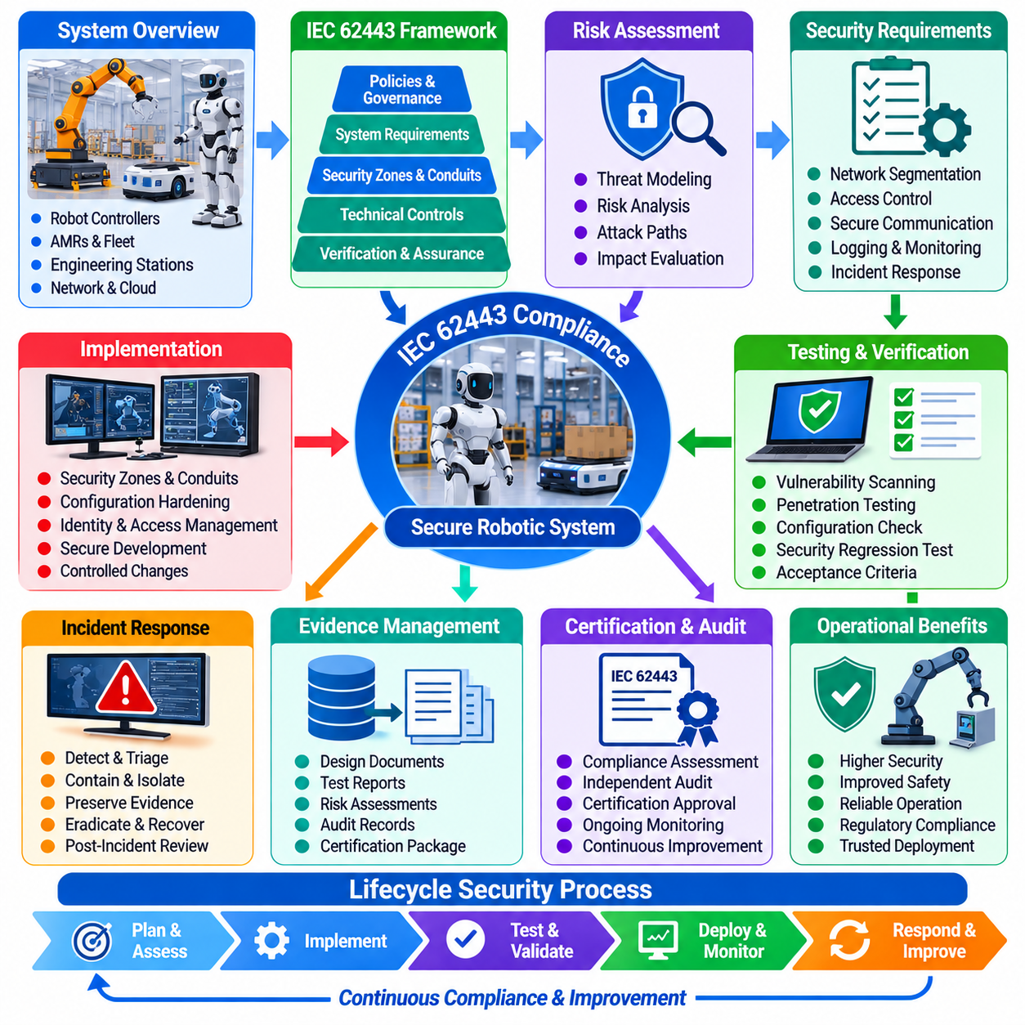
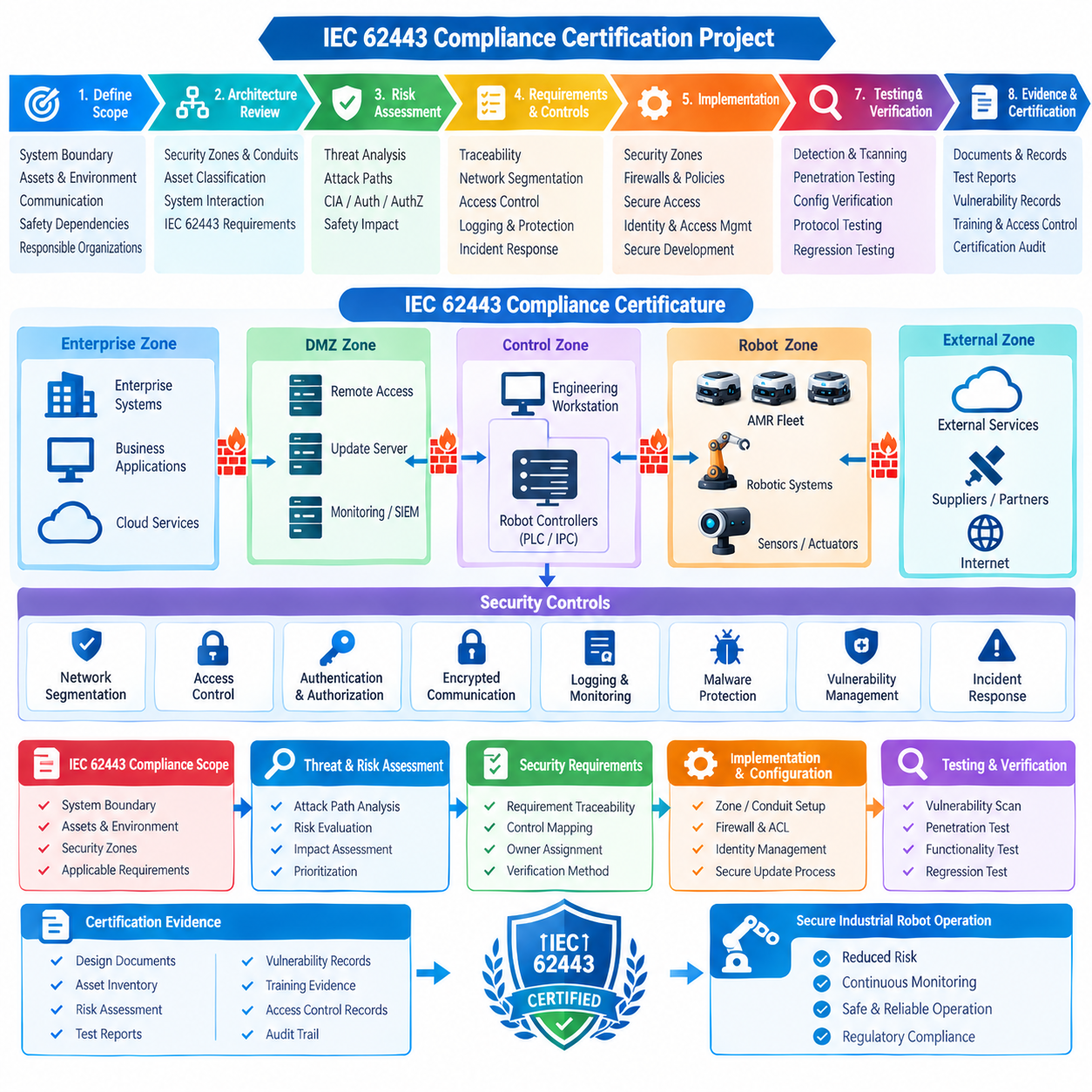
The IEC 62443 compliance project for a robotic industrial system begins by establishing cybersecurity as a lifecycle responsibility rather than as a final certification activity. The project team defines the system boundary, operational environment, assets, communication relationships, safety dependencies, and responsible organizations before selecting applicable IEC 62443 requirements. This establishes a common security baseline for the robot, controllers, engineering workstations, fleet services, network infrastructure, and supporting systems throughout development and deployment.
The assessment begins with an industrial cybersecurity architecture review based on the IEC 62443 framework. Security zones and conduits are defined according to operational trust relationships and communication requirements, while assets are classified according to their security relevance. The team examines how enterprise systems, engineering networks, robot controllers, safety systems, fleet-management platforms, and external services interact. This prevents certification activities from becoming a document-only exercise disconnected from the actual industrial control environment.
A detailed threat and risk assessment is then performed for the defined system boundary. Potential attack paths are evaluated across network interfaces, remote-access mechanisms, engineering workstations, controllers, robot endpoints, update channels, and external integrations. The assessment considers confidentiality, integrity, availability, authentication, authorization, and operational safety. Particular attention is given to consequences that could propagate from a cybersecurity compromise into unsafe robot behavior, production interruption, loss of fleet coordination, or unauthorized modification of industrial processes.
The project establishes security requirements that can be traced from identified risks to concrete technical and organizational controls. Network segmentation, access control, authentication, secure communication, logging, malware protection, backup and recovery, vulnerability management, and incident response are mapped to the applicable security objectives. Each requirement is assigned an owner and verification method. This traceability allows the certification team to demonstrate not only that a control exists, but also why it is required and how its effectiveness will be evaluated.
Security zones and conduits become a central architectural mechanism during implementation. Critical robot-control functions are separated from less trusted enterprise and external networks, while communication paths are explicitly defined and controlled. Firewalls, access-control policies, authenticated services, secure remote access, and monitoring mechanisms are configured according to the approved architecture. Temporary commissioning connections receive particular scrutiny because uncontrolled exceptions can create permanent paths into systems that were intended to remain isolated.
The project also establishes a controlled identity and access-management process. Administrative privileges are assigned according to operational responsibilities, and privileged access to robot controllers, engineering systems, and security infrastructure is restricted. Authentication mechanisms are reviewed for both local and remote access, while credentials, certificates, cryptographic keys, and service accounts are subject to lifecycle management. The objective is to ensure that a valid account or trusted device does not automatically provide unrestricted access to the entire robotic environment.
Secure development and maintenance processes are incorporated into the compliance program rather than treated as separate software-engineering activities. Development teams document security requirements, perform code and configuration reviews, manage dependencies, track vulnerabilities, and maintain controlled release procedures. Firmware and software updates are verified before deployment, while changes to security-sensitive components require appropriate review and regression testing. This creates evidence that cybersecurity is maintained throughout the system lifecycle.
Testing and verification provide the primary technical evidence for the certification assessment. The project combines vulnerability scanning, penetration testing, configuration verification, access-control testing, protocol testing, security regression testing, and controlled fault scenarios. Testing is performed against defined acceptance criteria so that results can be connected directly to security requirements. Any discovered weakness is recorded, assessed, assigned for remediation, and retested before the associated compliance objective is considered complete.
Incident response is also included in the certification scope because compliance requires the organization to demonstrate how security events will be detected and managed after deployment. The project defines procedures for detection, triage, containment, evidence preservation, eradication, recovery, and post-incident review. Security logs from robot controllers, network infrastructure, fleet systems, engineering workstations, and monitoring platforms are correlated where necessary. This creates an operational capability rather than merely documenting an incident-response policy.
Evidence management becomes increasingly important as the project approaches certification. Design documents, asset inventories, risk assessments, security requirements, network configurations, test reports, vulnerability records, training evidence, access-control records, incident procedures, and corrective-action results are organized into a controlled evidence set. Each item is linked to the applicable requirement and system component. Version control and approval records are maintained so that assessors can determine which configuration and evidence set represents the certified system.
The certification assessment is conducted after internal verification has established sufficient readiness. Independent reviewers examine the architecture, security processes, technical controls, test results, and supporting evidence. Findings are classified according to their significance, and corrective actions are tracked until closure. Where a requirement cannot be demonstrated through documentation alone, technical evidence from testing or controlled operational demonstrations is provided. The organization therefore approaches certification as an evidence-based evaluation of implemented security capability.
A significant challenge in the project is maintaining consistency between the certified configuration and the continuously changing operational system. Robots, firmware, network equipment, software packages, cloud services, and fleet-management functions may evolve after the initial assessment. Configuration management and change control therefore become essential. Security-impact analysis is performed for significant changes, and changes affecting the certified security boundary or control implementation are subjected to additional verification before being incorporated into production.
The project also establishes a recurring compliance and security-improvement cycle. Vulnerability intelligence, incident experience, penetration-test results, software updates, architecture changes, and emerging threats are periodically reviewed. Security requirements and controls are updated when the risk profile changes. This prevents IEC 62443 compliance from becoming a static certificate that loses relevance as the robotic environment evolves and instead makes certification part of continuous industrial cybersecurity governance.
The final certification package demonstrates a traceable relationship between the industrial system, identified risks, security requirements, implemented controls, verification activities, and objective evidence. The project therefore provides more than a compliance document set. It establishes a repeatable security-management process in which architecture, engineering, operations, testing, incident response, and change management contribute to the same cybersecurity objectives. For robotic industrial systems, this lifecycle-oriented approach helps ensure that IEC 62443 compliance remains connected to real operational security and the safe operation of physical automation assets.

12.08. Red Team Fleet Penetration Test Findings Case
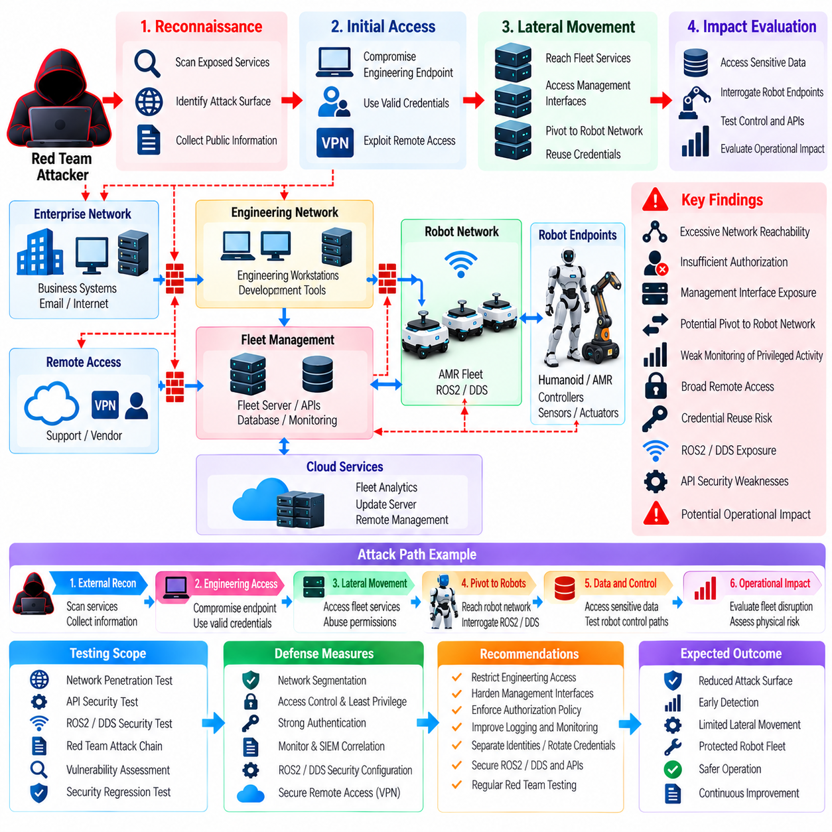
The red-team assessment was conducted to determine whether a coordinated attacker could move through the robot fleet environment beyond the protections demonstrated by conventional vulnerability scanning and compliance checks. The exercise treated the fleet as a cyber-physical system rather than as a collection of independent computers. The assessment therefore considered enterprise access, engineering workstations, fleet-management services, robot networks, cloud interfaces, administrative functions, and operational consequences while maintaining predefined safety boundaries throughout the exercise.
The assessment scope was aligned with the robot cybersecurity testing structure, which identifies vulnerability scanning, network penetration testing, protocol fuzzing, API security testing, red-team exercises, security-focused static analysis, risk reporting, and automated security regression testing as complementary activities. The specific red-team objective was to determine whether weaknesses across several individually moderate components could be chained into a meaningful compromise of fleet services or robot functions. Volume_24_Robot_Cybersecurity(1…
The exercise began with reconnaissance against the authorized external and internal attack surfaces. The red team examined exposed services, authentication boundaries, network segmentation, remote-access paths, fleet APIs, management interfaces, and available operational metadata. Initial findings showed that individual controls generally performed as designed, but several services disclosed information that could help an attacker understand the fleet architecture. This demonstrated that seemingly low-impact information exposure can become strategically important when combined with other weaknesses.
The first significant finding concerned an engineering access path that provided broader network reachability than required for normal maintenance operations. The connection was protected by authentication, but once an authorized engineering endpoint was reached, several fleet-related services could be contacted without sufficiently restrictive segmentation. The red team did not treat this as an isolated firewall configuration issue because the real risk resulted from the combination of valid access, excessive reachability, and the availability of management interfaces across the same operational environment.
The assessment then examined fleet-management APIs and administrative interfaces. Several functions correctly required authentication, but authorization boundaries were less consistent across different management operations. A user with legitimate engineering privileges could access information or functions that were not necessary for the user’s normal role. The finding demonstrated the distinction between authentication and authorization: proving who a user is does not establish that the user should be permitted to perform every action exposed by the fleet-management platform.
The red team also evaluated robot-to-fleet communication and the ability to move laterally from management services toward individual robot endpoints. Network segmentation reduced direct exposure of many robot interfaces, but certain diagnostic and maintenance pathways remained reachable from trusted management segments. The assessment therefore identified a potential pivot path in which compromise of a fleet-management component could provide an attacker with additional opportunities to interrogate or target robot services without requiring a direct attack against every individual robot.
Another finding involved insufficiently differentiated monitoring of administrative and security-sensitive activity. The fleet generated substantial operational telemetry, but some privileged actions were difficult to distinguish from routine maintenance activity when examined without broader context. The red team demonstrated that an attacker using legitimate credentials could potentially blend malicious activity into normal administrative traffic. This finding reinforced the need for centralized SIEM correlation and behavioral monitoring rather than relying exclusively on static signatures or isolated authentication alerts.
The exercise also examined remote-access controls used by engineering and support personnel. The security architecture included VPN and encrypted tunnels for remote access, but the red team evaluated whether remote access could provide an unnecessarily broad route into internal robot networks after successful authentication. The principal finding was not that encryption was ineffective, but that secure transport does not by itself establish least-privilege access. Remote sessions must remain constrained by identity, role, destination, time, and operational purpose.
A controlled attempt was made to evaluate whether compromised credentials could be reused across multiple fleet components. Credential reuse and shared administrative accounts were treated as high-value findings because compromise of one account could otherwise expand into broader fleet access. The assessment recommended stronger separation of identities, privileged-access controls, credential rotation, certificate lifecycle management, and explicit authorization boundaries between enterprise, engineering, fleet, and robot environments.
The red team also reviewed ROS2 and DDS exposure as part of the fleet attack surface. The assessment considered whether unauthorized participants could discover nodes, identify communication endpoints, or interact with topics and services beyond their intended authorization scope. The exercise did not assume that DDS exposure automatically resulted in physical robot control; instead, it evaluated whether middleware security policies, node identity, mutual authentication, encryption, and topic or service permissions consistently enforced the intended trust model.
A separate finding concerned insufficiently restrictive API behavior during abnormal request sequences. Individual API operations appeared legitimate, but combinations of requests could reveal operational information or create unexpected administrative workflows. The red team therefore evaluated API security as an interaction problem rather than testing each endpoint independently. This approach demonstrated why authentication, authorization, input validation, rate limiting, logging, and workflow-level security must be considered together for fleet-management interfaces.
Throughout the exercise, safety controls prevented unrestricted execution of potentially hazardous robot actions. The red team focused on demonstrating security impact through controlled test conditions, simulated commands, isolated robots, and non-destructive validation. Where a finding could theoretically have affected physical behavior, testing stopped at the minimum point necessary to demonstrate exploitability. This preserved the distinction between cybersecurity validation and uncontrolled operational experimentation.
Findings were categorized according to exploitability, affected assets, required privileges, potential propagation, and physical or operational consequence. High-priority findings were those that could create a credible path from a compromised enterprise or engineering asset toward fleet-management authority or robot-facing services. Moderate findings were retained when they could materially assist reconnaissance, persistence, lateral movement, or defense evasion. This risk-based approach prevented the report from becoming a simple list of software defects.
Remediation focused on reducing attack-path connectivity rather than merely closing individual findings. Network segmentation was tightened, unnecessary management routes were removed, administrative privileges were reduced, and API authorization policies were reviewed. Remote-access permissions were narrowed according to operational roles, while logging and SIEM correlation were expanded for privileged actions and unusual fleet behavior. The objective was to make multi-stage compromise substantially more difficult even if an attacker succeeded in obtaining an initial foothold.
The assessment also produced improvements to the incident-response process. Each major red-team finding was mapped to potential detection signals, containment actions, forensic evidence requirements, and recovery procedures. Security teams used the exercise to determine whether an attack moving through multiple trust zones could be detected early enough to isolate affected systems before fleet-wide consequences occurred. This connected penetration testing with the broader incident-detection, robot-isolation, forensic-preservation, remediation, and fleet-recovery lifecycle.
After remediation, targeted retesting was performed to verify that the original attack paths had been eliminated rather than merely obscured. The red team repeated relevant reconnaissance, access-control, segmentation, API, and privilege-escalation scenarios under controlled conditions. Particular attention was given to security regressions caused by operational changes, because a firewall rule, software update, maintenance exception, or new integration can unintentionally recreate a previously closed path.
The case demonstrated that fleet penetration testing provides greater value when it evaluates attack chains rather than isolated vulnerabilities. A weak authorization rule, a permissive network route, an exposed diagnostic service, and insufficient monitoring may each appear manageable independently. When combined, however, they can create a practical route from an ordinary workstation compromise to fleet-level security impact. Red-team exercises are therefore particularly useful for validating the effectiveness of defense in depth across the entire robotic environment.
The final security posture established a recurring red-team cycle connected to threat modeling, vulnerability management, incident response, and automated security regression testing. Findings were converted into architectural requirements, detection rules, hardening actions, test cases, and operational procedures. This ensured that the exercise produced lasting improvements rather than a one-time penetration-test report. For a robot fleet, the principal objective is not merely to prove that individual systems can be attacked, but to demonstrate that layered security controls can detect, contain, and limit an attack before it becomes a fleet-wide cyber-physical incident.

12.09. OTA Rollback Attack Prevention Case
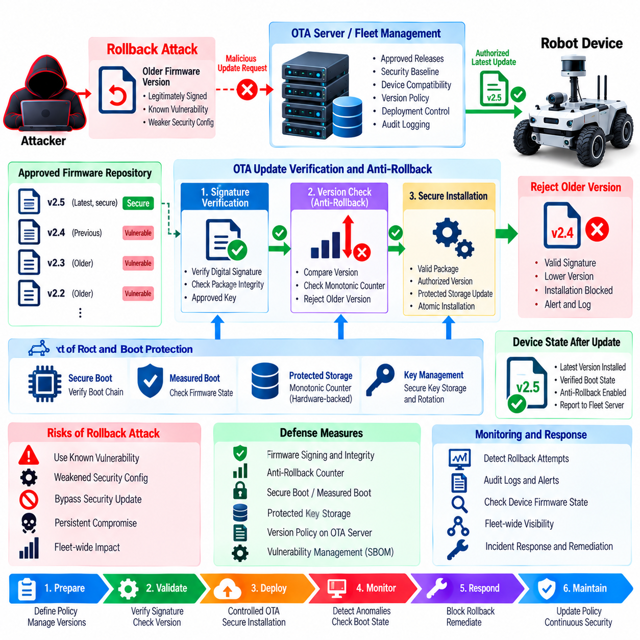
The OTA rollback attack case begins when an attacker attempts to force a robot to install an older firmware version that contains a vulnerability, weakened security configuration, or previously remediated defect. The attack does not necessarily require the attacker to create a new malicious firmware image. Instead, a legitimately signed but obsolete package can become the attack instrument if the robot accepts an older security state. For a deployed robot fleet, this creates a significant risk because a completed security update could effectively be undone.
The case is based on the OTA and firmware security structure, which treats rollback injection as a dedicated threat-modeling concern and places firmware signing, secure boot, measured boot, package integrity verification, anti-rollback counters, SBOM and vulnerability tracking, supply-chain security, protected key storage, OTA security testing, and IEC 62443 compliance within the same lifecycle. The specific anti-rollback mechanism provides a critical link between firmware version management and the device’s root of trust. Volume_24_Robot_Cybersecurity(1…
The incident was first suspected after security monitoring identified a group of robots running firmware versions older than the minimum approved security baseline. The devices had previously received a security update, and their firmware signatures remained cryptographically valid. However, the installed version no longer matched the fleet’s current security policy. This discrepancy suggested that the issue was not simply an incomplete OTA deployment but a possible attempt to reinstall an obsolete firmware state after the corrective update had already been distributed.
The investigation examined the complete OTA transaction, including the update request, package metadata, firmware version identifier, digital signature, integrity information, installation result, boot status, and device-side version state. Engineers confirmed that signature verification alone could not distinguish a newly approved package from an older package that had once been legitimately signed. The security weakness therefore existed at the version-acceptance layer rather than at the basic cryptographic signature layer.
The red-team reproduction was performed on isolated robot hardware and a controlled OTA environment. Test packages represented valid historical firmware releases that had previously passed normal signing and verification procedures. The assessment examined whether the device would accept an older package after a newer security version had already been installed. Testing also evaluated interrupted updates, repeated installation attempts, metadata inconsistencies, unexpected version values, and recovery procedures to determine whether an attacker could exploit an incomplete or abnormal OTA state.
The central defense was an anti-rollback counter mechanism maintained as part of the device’s trusted security state. Each approved firmware release was associated with a security version or monotonic counter, and the device compared the incoming package against its currently committed security level. A package with a lower security version was rejected even when its digital signature and cryptographic integrity were valid. This prevented a legitimate historical package from being used to deliberately return the robot to a vulnerable software state.
The counter itself required protection because an attacker who could modify the stored version state could potentially bypass the anti-rollback mechanism. The security architecture therefore associated version enforcement with secure boot, protected storage, and hardware-backed trust where available. The device had to establish the integrity of the boot chain and security state before accepting an update. This created a relationship between firmware authenticity, version monotonicity, and the hardware-supported root of trust rather than treating anti-rollback as an ordinary application-level variable.
The OTA server and fleet-management layer were also modified to enforce version policy before transmitting packages. The cloud service maintained approved firmware versions, security baselines, device compatibility information, and deployment status. An update request was evaluated against the robot’s identity, current firmware state, target release, and security policy. This prevented an outdated package from being intentionally selected through a management interface even when the package remained available in an archival repository.
Package integrity verification remained an independent control. Firmware packages were checked using approved cryptographic verification mechanisms before installation, while digital signatures established that the package originated from an authorized release process. The anti-rollback mechanism then provided a separate decision concerning whether that otherwise authentic package was still eligible for installation. This separation was important because authenticity answers whether a package is trusted, while anti-rollback answers whether that trusted package is still permitted under the current security state.
Secure boot and measured boot were incorporated into the recovery strategy. After an update, the robot verified that the expected firmware was executed and that the measured boot state corresponded to an approved configuration. If a device entered an unexpected firmware state, security monitoring could identify the discrepancy between the expected release and the observed boot measurement. This provided an additional detection layer in case an attacker attempted to bypass normal OTA procedures through local maintenance interfaces or other recovery mechanisms.
The investigation also examined the interaction between rollback prevention and vulnerability management. An older firmware version may contain a known vulnerability that has already been recorded in the organization’s SBOM and vulnerability-tracking system. Therefore, the OTA decision process must consider not only whether a package is signed but also whether its component and vulnerability state remains acceptable. The broader firmware security structure explicitly connects SBOM-based vulnerability tracking with OTA security so that obsolete software cannot regain operational status merely because its signature remains valid.
A controlled exception process was established for legitimate engineering and recovery scenarios. Certain maintenance activities may require installation of an older firmware version for laboratory analysis, hardware compatibility investigation, or controlled fault reproduction. Such exceptions could not be performed through the normal production OTA path. They required explicit authorization, controlled equipment, additional security safeguards, and a documented process for restoring the approved production security state. This preserved legitimate engineering flexibility without weakening the fleet-wide anti-rollback policy.
The incident response process treated an attempted rollback as a cybersecurity event even when no malicious firmware modification was detected. Security teams preserved OTA transaction records, device logs, package metadata, version counters, authentication events, and management-system activity. These records allowed investigators to determine whether the rollback resulted from an operational error, unauthorized administrative action, compromised credentials, or deliberate manipulation of the OTA workflow.
Testing after remediation covered both normal and adversarial update conditions. Engineers verified that valid current packages were accepted, valid obsolete packages were rejected, corrupted packages failed integrity checks, improperly signed packages failed authentication, and interrupted updates did not reset the security version state. Testing also evaluated repeated reboot cycles and recovery procedures to ensure that the anti-rollback state survived power loss and other abnormal operating conditions.
The case was incorporated into the broader OTA security testing lifecycle. Firmware fuzzing, package injection testing, update-state manipulation, signature validation, secure-boot verification, anti-rollback testing, and automated security regression testing were combined into repeatable validation activities. The existing cybersecurity testing structure also includes vulnerability scanning, network penetration testing, ROS2 and DDS protocol fuzzing, API security testing, red-team exercises, security-focused static analysis, risk reporting, and automated regression testing. Volume_24_Robot_Cybersecurity(1… This ensured that OTA rollback prevention could be tested whenever firmware, bootloader, update services, or security policies changed.
A major lesson from the incident was that firmware authenticity and firmware freshness are different security properties. A correctly signed package may still represent an unacceptable security state if a newer version has already corrected a vulnerability. Effective OTA protection therefore requires a chain of trust extending from the signing authority through package verification, version enforcement, secure boot, protected security state, and fleet-management policy. No individual mechanism should be expected to provide complete rollback protection by itself.
The final security architecture established a controlled firmware lifecycle in which every production update carries verifiable integrity, authorized provenance, and an enforceable security version. The robot accepts an update only when the package is authentic, intact, compatible, and not older than the device’s protected security state. The cloud and fleet-management layers enforce the same policy before deployment, while secure boot and measured boot verify the resulting device state. This converts anti-rollback protection from a single firmware feature into a continuous security control protecting the robot fleet against the reintroduction of known vulnerabilities.

12.10. Future Robot Cybersecurity Roadmap
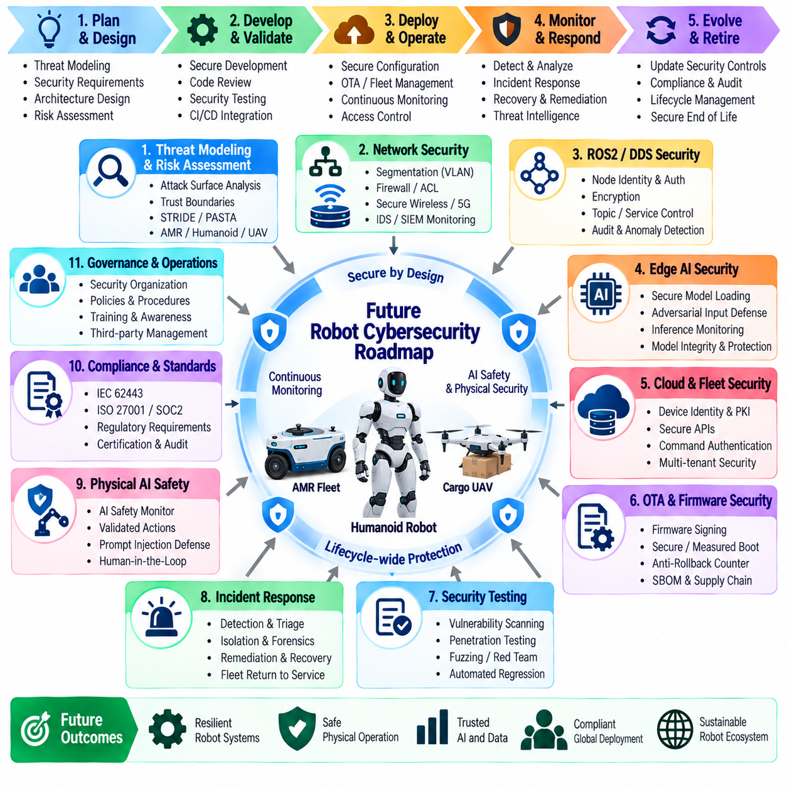
The future of robot cybersecurity begins with a transition from component-level protection toward lifecycle-wide cyber-physical security. As robots become increasingly connected through ROS2 and DDS networks, edge AI platforms, cloud services, fleet-management systems, OTA infrastructure, and physical AI agents, cybersecurity must protect the complete chain from sensing and computation to communication and physical action. The roadmap therefore treats security as a continuous engineering capability spanning architecture, development, deployment, operation, testing, incident response, compliance, and end-of-life management.
The first priority is to establish security by design across the complete robot architecture. Threat modeling must begin during system conception and continue through architecture changes, using attack-surface analysis, trust-boundary identification, attack trees, STRIDE or PASTA methods, and domain-specific threat models for AMR fleets, humanoid AI agents, and Cargo UAV avionics. The resulting security requirements should remain traceable to concrete controls and verification activities so that cybersecurity is not added after functionality has already been implemented.
Network security will evolve toward segmented and continuously monitored robot environments. Industrial robots, engineering systems, safety-control networks, AI-data networks, cloud gateways, and external services should be separated according to their trust relationships and operational requirements. Firewalls, ACLs, VPNs, encrypted tunnels, 802.1X, VLAN segmentation, secure wireless networks, private 5G security, intrusion detection, and SIEM monitoring will form complementary layers. Future architectures should assume that individual network boundaries may eventually be breached.
ROS2 and DDS security will become increasingly important as distributed robot software expands. Secure communication must combine node identity, mutual authentication, certificate lifecycle management, encryption, topic and service access-control policies, audit logging, cryptographic key rotation, and vulnerability remediation. Future systems should also support continuous monitoring of middleware behavior so that unexpected participants, abnormal topic activity, unauthorized service requests, or unusual communication patterns can be detected before they become pathways to physical robot control.
Edge AI security will expand beyond protecting model files. Future robots will require secure model loading, model integrity verification, protected execution environments, adversarial-input detection, inference anomaly monitoring, data-poisoning defense, model watermarking where appropriate, and stronger protection against model theft and reverse engineering. AI security must also consider the relationship between perception outputs and physical actions. A model that remains cryptographically authentic can still generate unsafe decisions when exposed to manipulated inputs or abnormal operating conditions.
Cloud and fleet security will increasingly become the control plane for large-scale robotic operations. Device identities, PKI, certificate lifecycle management, cloud APIs, fleet-command authentication and signing, encrypted data, SIEM monitoring, tenant isolation, and fleet security incident playbooks must operate as an integrated security system. Fleet commands should be authenticated and authorized independently of network connectivity, while high-impact operations should require explicit policy validation. Compromise of one cloud service or administrative identity should not automatically provide control over the entire fleet.
OTA and firmware security will develop toward a continuously verifiable software supply chain. Future robots should use a trusted firmware signing chain, secure boot, measured boot, package integrity verification, protected anti-rollback counters, SBOM-based vulnerability tracking, secure key storage, and controlled OTA deployment. Firmware authenticity must be separated from firmware freshness because a correctly signed but obsolete package may still contain known vulnerabilities. The supply-chain process must therefore preserve provenance from source components through build, signing, distribution, installation, and runtime verification.
Cybersecurity testing will become continuous rather than periodic. Vulnerability scanning, network penetration testing, firmware fuzzing, ROS2 and DDS protocol fuzzing, API security testing, red-team exercises, security-focused static analysis, and automated security regression testing should be integrated into CI/CD and operational validation. Future testing must evaluate attack chains rather than isolated vulnerabilities, because a sequence of individually moderate weaknesses can create a high-impact path from an enterprise workstation or cloud service to robot-control functions.
Incident response will evolve into a fleet-scale cyber-physical recovery capability. Detection systems must correlate network events, authentication failures, cloud activity, robot telemetry, AI anomalies, firmware state, and operational behavior. When a compromise is suspected, the organization should be able to isolate affected robots, preserve forensic evidence, revoke credentials or certificates, deploy secure remediation, recover fleet services, and return robots to operation under controlled conditions. Recovery must therefore be designed together with prevention rather than added after an incident occurs.
Physical AI introduces a new security boundary between digital decisions and physical consequences. Future systems will need AI safety monitors, certified robustness for safety-critical AI where applicable, secure model registries, training-data protection, adversarial-input defenses, and explicit validation of AI-generated actions. LLM-based robot agents will require prompt-injection defenses and strict separation between reasoning, authorization, and physical execution. The objective is not to guarantee perfect AI behavior, but to ensure that an incorrect or manipulated AI decision cannot directly produce an unsafe physical action.
Compliance and certification will become continuous governance mechanisms rather than final project milestones. IEC 62443, ISO 21434 where applicable, NIST CSF 2.0, the EU Cyber Resilience Act, DO-326A-related aviation cybersecurity practices, cybersecurity management systems, third-party audits, and controlled evidence packages will increasingly influence robot development. Certification evidence should remain synchronized with the actual deployed configuration through configuration management, change control, vulnerability management, security testing, and documented corrective actions.
The roadmap also requires stronger organizational integration. Robot cybersecurity cannot remain the responsibility of a specialized security team alone. Product engineering, robotics software, AI engineering, cloud operations, safety engineering, fleet operations, compliance, suppliers, and incident-response teams must share defined responsibilities and escalation paths. Security metrics should measure meaningful operational capabilities such as vulnerability remediation time, fleet exposure, authentication coverage, patch deployment success, detection latency, recovery time, and the percentage of critical functions protected by verified security controls.
The long-term objective is a continuously adaptive robot cybersecurity architecture capable of responding to changing threats without losing operational safety. Future robot platforms should continuously assess their security posture, update threat models, validate software and AI components, monitor fleet behavior, detect anomalous physical outcomes, and automatically initiate controlled defensive actions when appropriate. Cybersecurity will therefore become an integrated property of the robot lifecycle, connecting network security, ROS2 and DDS security, edge AI, cloud and fleet protection, OTA integrity, physical AI safety, continuous testing, incident response, and compliance into one evolving defense framework.

