Volume 24. Robot Cybersecurity

Chapter 09. Incident Response and Recovery

09.01. Cyber Incident Response Plan for Robot Fleets
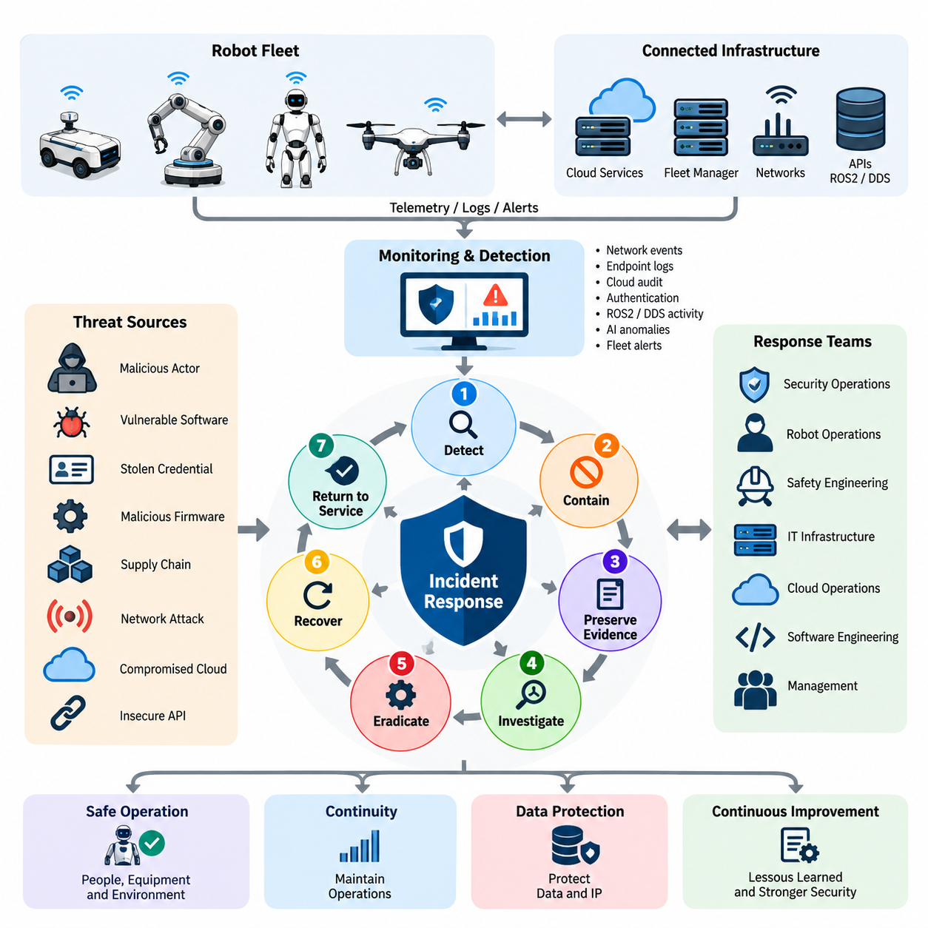
A cyber incident response plan for robot fleets establishes the organizational and technical procedures required to detect, contain, investigate, eradicate, and recover from security events affecting distributed robotic systems. Unlike conventional IT incidents, a compromised robot can create immediate physical consequences, so response decisions must simultaneously protect people, equipment, operational continuity, data, and digital infrastructure. Volume_24_Robot_Cybersecurity
Fleet environments expand the scope of incident response because individual robots are connected through wireless networks, fleet managers, cloud services, edge computers, APIs, ROS2 or DDS middleware, and centralized identity systems. A single compromised credential or communication channel may therefore expose many robots. The response plan must define how incidents are classified and how fleet-wide propagation risks are evaluated before containment actions are selected.
Preparation begins with establishing clear ownership across the security operations team, robot operations team, safety engineering, IT infrastructure, cloud operations, software engineering, and management. Each group requires predefined authority during an emergency. A security team may identify malicious activity, while robot operators determine whether a machine can safely stop, return to a designated area, or continue a limited mission without creating additional physical hazards.
Incident severity should reflect both cybersecurity impact and physical operational consequences. An unauthorized login to a diagnostic interface may initially represent a limited security event, while manipulation of navigation commands, safety parameters, actuator controls, firmware, or fleet dispatch instructions can require immediate escalation. Classification criteria should consider affected robots, privilege level, persistence, data exposure, safety impact, mission criticality, and evidence of lateral movement.
Detection mechanisms should combine network telemetry, endpoint events, robot application logs, cloud audit records, authentication events, ROS2 or DDS activity, AI inference anomalies, firmware integrity information, and fleet management alerts. Central correlation allows responders to distinguish isolated equipment failures from coordinated attacks. The broader architecture explicitly connects robot cybersecurity with network monitoring, cloud SIEM, fleet security, ROS2 security, and OTA protection. Volume_24_Robot_Cybersecurity Volume_24_Robot_Cybersecurity
Once suspicious activity is confirmed, containment must prioritize safe physical behavior rather than simply disconnecting the affected computer. Abrupt network isolation could leave a mobile robot, manipulator, humanoid, or UAV in an unsafe operating state. The response procedure should therefore coordinate cyber containment with controlled stopping, mission cancellation, safe-state transitions, restricted autonomy, geofencing, or transfer to an independently protected safety controller.
Fleet containment should prevent compromise from propagating to other robots. Responders may revoke device credentials, block suspicious network sessions, isolate affected VLANs, disable compromised APIs, suspend fleet commands, restrict cloud identities, or quarantine selected robots. These actions should be granular whenever possible so that unaffected fleet segments can continue operating while investigators establish the true scope of the incident.
Evidence preservation must begin before destructive remediation whenever safety conditions permit. Relevant artifacts include system and application logs, network captures, authentication histories, ROS2 or DDS records, firmware measurements, process information, configuration snapshots, cloud audit trails, command histories, and security alerts. Time synchronization and reliable timestamps are essential for reconstructing how an attacker moved between fleet components and determining the sequence of unauthorized actions.
The investigation phase reconstructs the initial access vector, exploited vulnerability, compromised identities, affected assets, attacker persistence, and lateral movement. Responders should establish whether the event originated from exposed network services, stolen credentials, vulnerable software, malicious firmware, insecure APIs, compromised OTA infrastructure, or supply-chain components. The chapter structure deliberately follows detection with quarantine, forensic preservation, and root-cause analysis. Volume_24_Robot_Cybersecurity
Eradication removes the attacker's access and eliminates the underlying weakness rather than merely restoring robot connectivity. Actions can include credential rotation, certificate revocation, removal of unauthorized software, configuration correction, firmware replacement, vulnerability remediation, and secure OTA deployment. Any restored software or firmware should originate from trusted repositories and pass integrity, signature, version, and compatibility checks before deployment to operational robots.
Recovery should proceed through controlled stages instead of returning the entire fleet to service simultaneously. A recovered robot can first enter an isolated validation environment where boot integrity, communications, sensors, actuators, safety functions, software versions, credentials, and mission behavior are verified. Limited operational deployment can follow, with enhanced monitoring maintained until responders have sufficient evidence that the compromise has been eliminated.
Fleet-scale restoration requires explicit criteria for return to service. Security validation alone is insufficient because remediation can change software, firmware, network policies, certificates, AI components, or control parameters that influence robot behavior. Cybersecurity engineers and operational or safety personnel should therefore jointly authorize release. The planned chapter sequence accordingly separates secure remediation from fleet recovery and formal return-to-service activities. Volume_24_Robot_Cybersecurity
Communication procedures are another critical component of the response plan. Internal stakeholders require timely information about affected assets, containment decisions, operational restrictions, and recovery status without distributing unverified conclusions. External communication may involve customers, suppliers, service providers, insurers, regulators, or legal authorities depending on contractual obligations, data exposure, safety consequences, and applicable notification requirements.
A fleet incident should remain traceable through a formal incident record containing detection time, severity changes, affected assets, evidence references, containment actions, approvals, remediation packages, validation results, and recovery decisions. Maintaining this record supports forensic integrity, regulatory evidence, insurance claims, engineering analysis, and future security improvements. It also provides a common operational picture when multiple technical and management teams participate in a prolonged response.
Post-incident review converts operational experience into preventive controls. The organization should determine which safeguards failed, which alerts were useful, where responders lacked visibility, whether containment was sufficiently rapid, and whether recovery procedures introduced unnecessary downtime. Findings should update threat models, monitoring rules, access policies, software baselines, OTA controls, training material, incident playbooks, and future cybersecurity tests.
The response plan itself must be exercised rather than treated as static documentation. Tabletop scenarios and controlled drills can simulate credential theft, ROS2 compromise, malicious fleet commands, firmware manipulation, cloud account intrusion, or coordinated attacks against multiple robots. Exercises reveal unclear authority, missing telemetry, unsafe containment assumptions, communication delays, and recovery dependencies before those weaknesses appear during a real emergency.
Effective robot fleet incident response ultimately integrates cybersecurity resilience with physical safety and operational resilience. Detection, quarantine, forensic preservation, root-cause analysis, secure OTA remediation, fleet recovery, lessons learned, notification policy, and response exercises form a continuous lifecycle rather than isolated activities. This lifecycle matches the intended progression of the Incident Response and Recovery chapter within the broader Robot Cybersecurity volume. 08_Robotics_Software_Tree

09.02. Incident Detection SIEM Alert Correlation [w/Code]
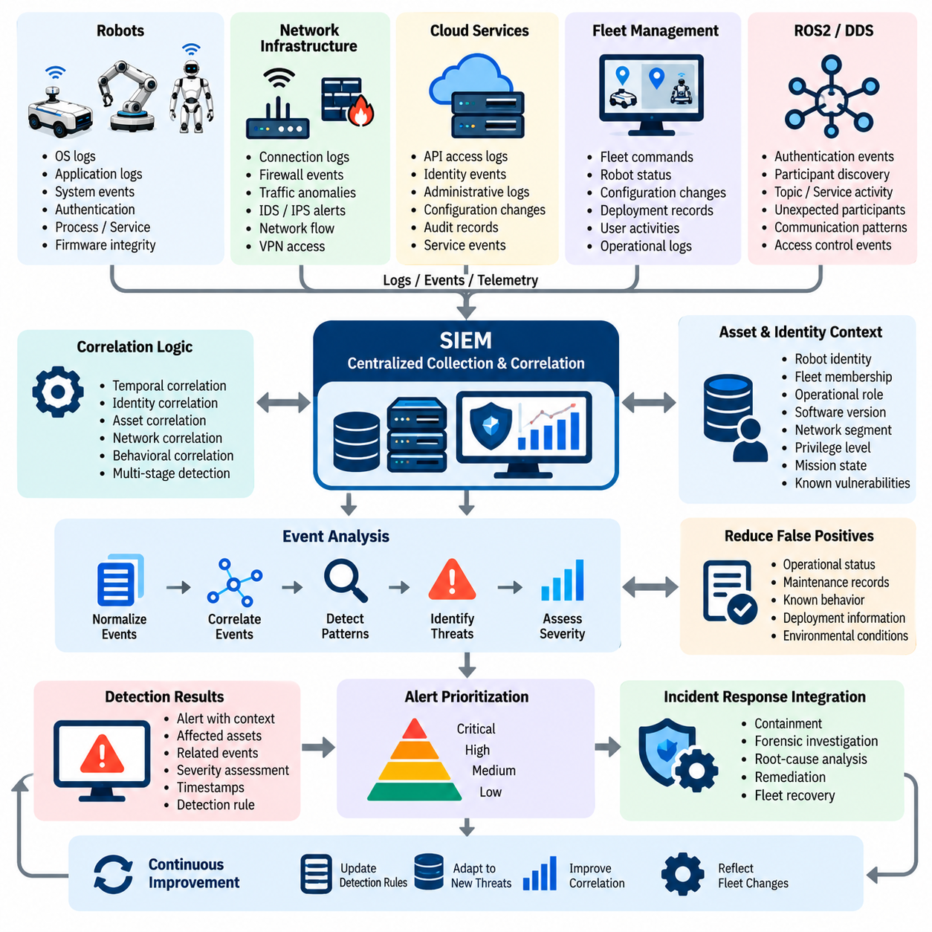
Security incident detection in a robot fleet requires continuous collection and correlation of security-relevant events across robots, networks, cloud services, fleet management platforms, and robotic middleware. A Security Information and Event Management (SIEM) platform provides a centralized capability for aggregating these events and identifying patterns that may indicate an ongoing cyber incident. In a distributed fleet, effective detection must connect individual alerts with the wider operational and security context.
Robot fleets generate diverse telemetry from operating systems, applications, network interfaces, authentication services, ROS2 or DDS communications, cloud platforms, firmware integrity mechanisms, and fleet management systems. Individual events may appear harmless when viewed separately, but their combination can reveal coordinated malicious activity. SIEM-based correlation therefore becomes important for distinguishing normal robot behavior, isolated faults, and multi-stage attacks affecting several components.
Detection begins with establishing reliable event sources and ensuring that security-relevant records are collected consistently. Robot operating systems can provide authentication, process, service, and system events, while network infrastructure can provide connection attempts, firewall decisions, traffic anomalies, and intrusion detection alerts. Cloud and fleet platforms can contribute API access, identity, command, configuration, and administrative events that extend visibility beyond the individual robot.
ROS2 and DDS environments require particular attention because communication activity is closely related to robot operation. Authentication failures, unexpected participants, unusual topic activity, unauthorized service access, or abnormal communication relationships can provide indicators of compromise. These events should be interpreted together with network and application telemetry rather than treated as isolated warnings, allowing the detection system to distinguish legitimate distributed robotic communication from suspicious behavior.
SIEM alert correlation combines multiple events according to temporal, identity, asset, network, and behavioral relationships. For example, an unusual administrator authentication event followed by configuration changes and unexpected fleet commands may represent a substantially higher risk than any single event alone. Correlation rules should therefore connect related observations across multiple systems and preserve the sequence of activity needed for incident investigation.
Asset and identity context is essential for meaningful correlation. A security event involving a safety-critical robot, fleet controller, cloud administrator account, or firmware service should not necessarily receive the same priority as an equivalent event involving a low-impact development device. Correlation should consider robot identity, fleet membership, operational role, software version, network segment, privilege level, mission state, and known vulnerabilities when evaluating the significance of an alert.
Effective detection also requires distinguishing operational faults from cybersecurity incidents. Robots can generate abnormal telemetry because of sensor failures, communication loss, software defects, hardware degradation, or environmental conditions. A SIEM should therefore avoid treating every anomaly as malicious. Correlation with operational status, maintenance records, deployment information, and known system behavior can reduce false positives while preserving sensitivity to coordinated or persistent attacks.
Alert prioritization should reflect both cybersecurity severity and physical consequences. An authentication anomaly on an administrative interface may require investigation, while evidence of unauthorized commands affecting navigation, motion, safety parameters, or coordinated fleet behavior may require immediate escalation. Detection logic should therefore connect technical indicators with operational impact so that the most consequential incidents receive rapid attention.
A reliable detection architecture must preserve sufficient evidence for subsequent response activities. Alerts should retain event timestamps, source identifiers, affected assets, identities, relevant network information, detection rules, severity assessments, and relationships to other events. Consistent time synchronization is particularly important because incident responders may need to reconstruct the order of authentication, network access, command execution, configuration modification, and subsequent robot behavior.
SIEM detection should also support fleet-level analysis. When several robots exhibit similar authentication failures, unexpected communications, configuration changes, or abnormal command patterns within a related period, the system should identify the relationship rather than generate unrelated individual alerts. This approach helps reveal lateral movement, credential compromise, coordinated exploitation, and attempts to propagate malicious activity across the fleet.
Alert correlation should integrate with the broader incident response process rather than operate as an independent monitoring function. Confirmed alerts should provide sufficient context for containment, forensic investigation, root-cause analysis, remediation, and fleet recovery. The chapter structure places incident detection and SIEM alert correlation immediately before robot isolation, forensic log collection, root-cause analysis, secure OTA remediation, and fleet recovery, establishing detection as the operational entry point for the response lifecycle.
Continuous improvement is necessary because robot fleets, software configurations, network architectures, and attack techniques evolve over time. Detection rules should be reviewed after incidents, security testing, operational changes, and newly identified vulnerabilities. Lessons from false positives and missed detections should be incorporated into correlation logic, telemetry requirements, alert severity, and response procedures so that SIEM capabilities progressively become more accurate and more closely aligned with the actual cybersecurity risks of the robot fleet.

09.03. Robot Isolation and Quarantine Procedure [w/Code]
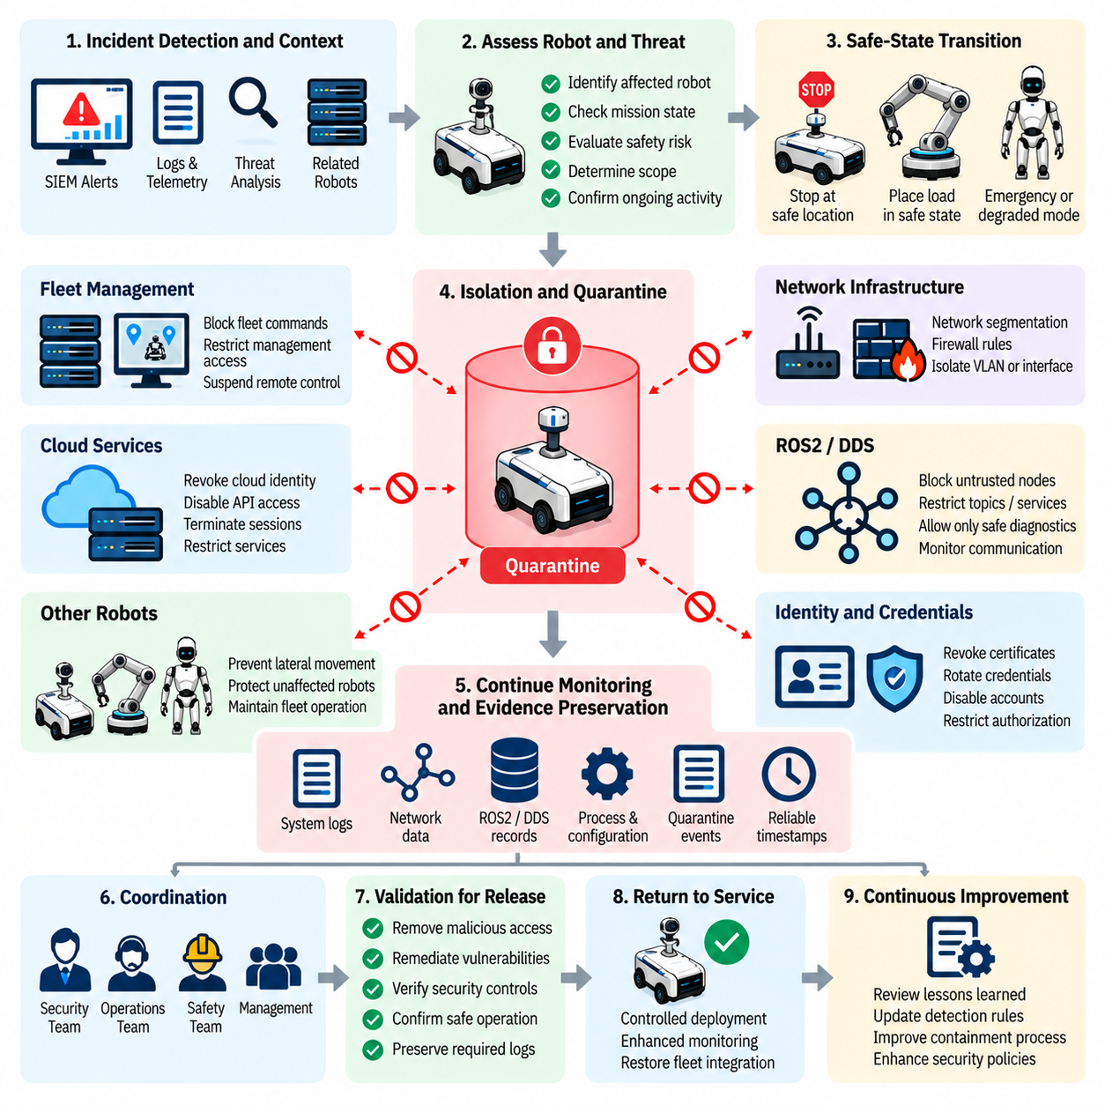
Robot isolation and quarantine procedures provide the operational controls required to prevent a compromised robot from affecting other robots, fleet infrastructure, or physical operations. In a robot fleet, isolation cannot be treated as a simple network disconnection because a robot may be moving, manipulating objects, transporting cargo, or executing an autonomous mission when an incident is detected. The procedure must therefore combine cybersecurity containment with controlled and physically safe robot behavior.
The isolation decision should begin with reliable incident context obtained from security monitoring, SIEM correlation, robot telemetry, authentication records, network events, and fleet management systems. Responders should determine which robot or subsystem is affected, what privileges may have been compromised, whether malicious activity is continuing, and whether other fleet members show related indicators. The scope of isolation should be based on evidence rather than automatically disabling the entire fleet.
Before network isolation is executed, the robot's operational state should be evaluated. A mobile robot may need to stop at a safe location, a manipulator may need to place its payload into a controlled state, and an autonomous vehicle may require a predefined emergency or degraded operating mode. If immediate isolation is necessary because the robot presents an active safety or security threat, the response mechanism should prioritize a safe-state transition that limits hazardous physical behavior while preventing further unauthorized control.
Quarantine should provide a stronger restriction than ordinary operational isolation. A quarantined robot may remain powered and locally observable while being prevented from communicating with production fleet services, issuing commands to other robots, receiving ordinary mission instructions, or accessing sensitive resources. Network segmentation, firewall rules, identity revocation, access-control policies, and fleet-management restrictions can be combined to establish a controlled quarantine environment without unnecessarily destroying forensic evidence.
Isolation should be sufficiently granular to contain the incident while preserving unaffected fleet operations. Depending on the architecture, responders may isolate an individual robot, a robot subnet, a communication interface, a software service, a cloud identity, or a fleet-management function. If evidence indicates lateral movement or coordinated compromise, the containment boundary should be expanded progressively. Conversely, broad fleet shutdown should be avoided when a smaller containment boundary can adequately control the threat.
Identity and credential controls are an important part of quarantine. If a robot certificate, API credential, administrator account, or service identity is suspected of compromise, simply disconnecting one device may not prevent continued access through another path. Responders may need to revoke certificates, rotate credentials, terminate active sessions, disable compromised accounts, or restrict command authorization. These changes should be recorded so that subsequent investigation can determine exactly which identities and access paths were affected.
ROS2 and DDS communications require particular attention during isolation because communication relationships are integral to robot operation. Unauthorized nodes, unexpected participants, abnormal topic activity, or suspicious service interactions may indicate compromise. Containment policies should restrict untrusted communication while preserving only the minimum communication required for safe operation, diagnostics, and controlled recovery. Security policies should be applied carefully so that isolation itself does not create an unsafe robot state.
Cloud and fleet-management connections should also be considered part of the quarantine boundary. A compromised robot may continue receiving malicious commands if its cloud identity or fleet-management session remains active after local network isolation. Responders should therefore evaluate command channels, API sessions, device certificates, management permissions, and remote-access paths. Where necessary, remote control capabilities can be suspended while maintaining a restricted management channel for authorized investigation and recovery.
The quarantine environment should preserve visibility for forensic investigation. Security personnel may need access to system logs, network telemetry, process information, configuration state, firmware measurements, ROS2 or DDS records, and other evidence while preventing the affected robot from communicating with production assets. Monitoring should therefore continue after isolation, with quarantine events and subsequent activity recorded using reliable timestamps. The objective is to contain malicious behavior without unnecessarily destroying evidence needed to understand the incident.
Communication between cybersecurity, robot operations, and safety personnel is essential during isolation. Cybersecurity personnel may determine that a robot is compromised, while operators understand its physical mission and safe stopping conditions. Safety personnel may define acceptable degraded states or emergency procedures. The isolation workflow should establish clear authority for initiating, modifying, and releasing quarantine so that technical actions do not conflict with physical safety requirements.
Release from quarantine should require explicit validation rather than a simple timeout or manual reconnection. Before a robot returns to production, responders should confirm that malicious access has been removed, compromised credentials have been addressed, vulnerable software or firmware has been remediated, security controls are functioning, and relevant logs have been preserved. Software and firmware restoration should use trusted sources and appropriate integrity and authenticity verification before the robot is permitted to reconnect to production services.
A controlled return-to-service process should normally begin with a restricted validation state. The robot can be monitored while basic communications, authentication, sensors, actuators, software components, safety functions, and mission behavior are verified. Enhanced monitoring should remain active during the initial operational period so that previously hidden persistence mechanisms or recurring malicious activity can be detected quickly. If suspicious behavior reappears, the robot should be returned to quarantine immediately.
The isolation and quarantine procedure should be exercised regularly through tabletop scenarios and controlled technical drills. Exercises can evaluate responses to compromised credentials, malicious fleet commands, unauthorized ROS2 or DDS communication, firmware compromise, cloud account intrusion, and coordinated attacks affecting multiple robots. The results should be used to improve containment boundaries, safe-state behavior, network policies, identity controls, communication procedures, and return-to-service criteria.
Effective robot isolation and quarantine therefore represent a coordinated cyber-physical containment process rather than a conventional IT network action. The procedure must control unauthorized access, prevent lateral movement, preserve investigative evidence, maintain safe physical behavior, and provide a controlled path toward recovery. This role directly follows the incident-detection stage in the chapter structure and precedes forensic collection, root-cause analysis, secure OTA remediation, and fleet recovery, making isolation the critical transition between detecting a threat and safely controlling its consequences.

09.04. Forensic Log Collection and Preservation [w/Code]
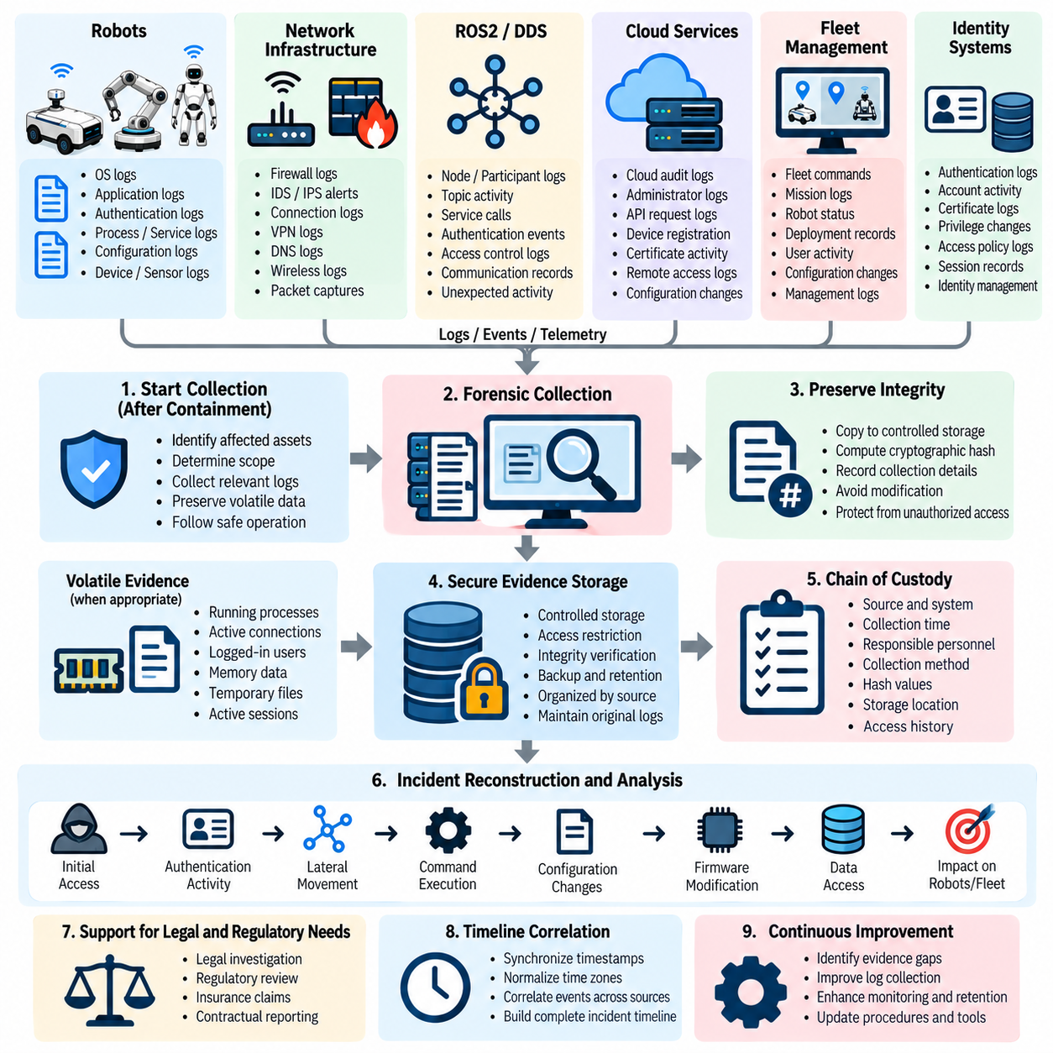
Forensic log collection and preservation provides the evidentiary foundation required to understand what occurred during a cybersecurity incident affecting a robot or robot fleet. In robotic environments, evidence may be distributed across robot operating systems, applications, network infrastructure, ROS2 or DDS middleware, cloud services, fleet management platforms, authentication systems, and security monitoring tools. The objective is to preserve these records accurately so that investigators can reconstruct the incident without unintentionally altering or destroying critical evidence.
Collection should begin as soon as an incident has been identified and the affected robot or system has been safely contained. Responders should first determine which assets may contain relevant evidence and establish a controlled collection process. Logs should be gathered from the affected robot, associated network devices, cloud services, fleet management systems, identity services, and security monitoring infrastructure. The collection scope should reflect the incident timeline and suspected attack path rather than being limited to the initially identified device.
Robot operating-system logs can provide evidence about authentication attempts, process execution, service activity, privilege changes, system configuration, device connections, and unexpected software behavior. Application logs can reveal abnormal commands, mission changes, errors, API activity, or unauthorized interactions. These records become particularly valuable when correlated with network telemetry and fleet-management events because they can establish relationships between an external access attempt and subsequent changes in robot behavior.
Network evidence is equally important because attackers may move between robots, edge computers, management servers, and cloud infrastructure through established communication channels. Firewall records, intrusion-detection alerts, connection histories, VPN activity, DNS information, wireless events, and relevant packet captures can help identify unauthorized communication and lateral movement. Collection should preserve sufficient contextual information to determine source and destination, timing, protocol, session characteristics, and the relationship between network activity and robot operations.
ROS2 and DDS environments require specialized attention because communication events can directly correspond to robot functions. Investigators may need to preserve information concerning nodes, participants, topics, services, authentication events, access-control decisions, and unusual communication relationships. Unexpected participants or unauthorized topic and service activity may provide important evidence of compromise. Such records should be correlated with system and network logs to distinguish legitimate distributed robotics behavior from malicious communication.
Cloud and fleet-management evidence should be collected whenever a robot is connected to centralized services. Relevant records can include administrator authentication, API requests, device registration, certificate activity, fleet commands, configuration changes, remote sessions, access-policy modifications, and cloud audit trails. These records can establish whether the incident originated from a cloud account, whether a compromised identity was used to control multiple robots, and whether commands were issued remotely after local containment.
Evidence preservation requires maintaining integrity and provenance throughout the collection process. Original logs should not be casually modified, overwritten, or deleted during investigation. Collected records should be copied into controlled storage and protected against unauthorized alteration. Cryptographic hashes or equivalent integrity mechanisms can be used to demonstrate that evidence has not changed after collection. The collection process should also record when the evidence was obtained, from which system, by whom, and through which method.
Reliable timestamps are essential for reconstructing an incident across distributed robotic components. Robot clocks, edge systems, network devices, cloud platforms, and security tools may otherwise produce inconsistent timelines. Investigators should therefore preserve the original timestamp information while also documenting time zones, clock offsets, synchronization status, and collection times. A normalized incident timeline can then connect authentication attempts, network connections, command execution, configuration changes, and abnormal robot behavior in their probable sequence.
Forensic collection should preserve volatile information when technically and operationally appropriate. Running processes, active network connections, logged-in identities, memory-resident activity, temporary configuration state, and active sessions may disappear after reboot or shutdown. However, collection of volatile evidence must be balanced against physical safety and containment requirements. A robot performing a hazardous operation should not remain active solely for forensic purposes when immediate transition to a safe state is required.
Chain of custody should be maintained for evidence that may support formal investigation, legal action, regulatory review, insurance claims, or contractual reporting. Each evidence item should have a traceable record describing its origin, collection time, responsible personnel, storage location, integrity verification, and subsequent handling. Access to preserved evidence should be restricted and auditable. This ensures that forensic conclusions can be supported by evidence whose authenticity and handling history can be demonstrated.
The preserved evidence should support reconstruction of the complete attack lifecycle. Investigators should be able to examine initial access, authentication, privilege escalation, persistence, lateral movement, command execution, configuration modification, data access, and attempted propagation across the fleet. Correlating these stages with physical robot behavior is especially important because cybersecurity events may have direct operational consequences. The evidence should therefore help establish not only what systems were compromised but also what actions the affected robots actually performed.
Forensic preservation must continue through remediation and recovery because later actions can destroy or obscure evidence of the original compromise. Firmware replacement, credential rotation, software reinstallation, configuration restoration, and secure OTA deployment should therefore occur only after the required evidence has been preserved, unless immediate safety or containment requirements demand otherwise. The preserved records can then support root-cause analysis and determine whether remediation successfully removed the attacker's access.
Forensic log collection is therefore a controlled process connecting incident detection, robot isolation, investigation, root-cause analysis, remediation, and recovery. Within the Incident Response and Recovery chapter, forensic collection follows robot isolation and quarantine and precedes attack root-cause analysis, secure OTA remediation, and fleet recovery. This sequence establishes evidence preservation as the critical bridge between containing an active incident and understanding, eliminating, and recovering from its underlying cause.

09.05. Attack Root Cause Analysis and Attribution
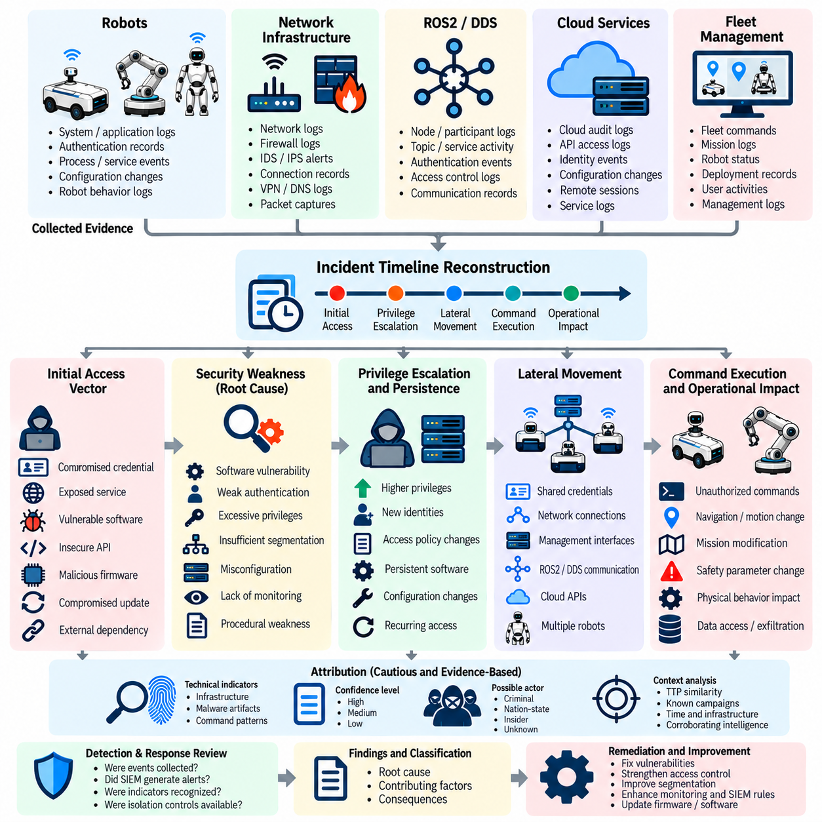
Attack root-cause analysis and attribution determines how a cybersecurity incident entered the robot environment, which weaknesses enabled the compromise, how the attacker progressed through affected systems, and what conditions allowed the incident to occur. In a robot fleet, this analysis must consider both digital and physical consequences because compromised identities, software, communication channels, or control interfaces can influence real robot behavior. The objective is not simply to identify an attacker but to establish a defensible technical explanation of the incident.
Root-cause analysis begins after sufficient evidence has been collected and preserved during isolation and forensic investigation. Investigators should reconstruct the incident timeline using authentication records, system and application logs, network telemetry, ROS2 or DDS activity, cloud audit records, fleet commands, configuration changes, and firmware information. The timeline should connect initial suspicious activity with subsequent compromise, persistence, lateral movement, command execution, and operational effects while maintaining clear separation between confirmed facts and investigative assumptions.
The initial access vector should be identified as precisely as the available evidence permits. Possible causes may include compromised credentials, exposed services, vulnerable software, insecure APIs, unauthorized remote access, malicious firmware, compromised update infrastructure, or weaknesses in external dependencies. The analysis should determine which access path was actually used rather than assuming that every discovered vulnerability contributed to the incident. This distinction is important because remediation must address the mechanism that enabled the compromise.
Investigators should then identify the security weakness that allowed the initial compromise to become operationally significant. A vulnerability may have existed for a long period without being exploited, while inadequate authentication, excessive privileges, weak segmentation, or insufficient monitoring may have allowed the attacker to expand access. Root-cause analysis should therefore examine the interaction between technical vulnerabilities and architectural or procedural weaknesses rather than assigning responsibility to a single software defect.
Privilege escalation and persistence should be analyzed as separate stages of the attack. Investigators should determine whether the attacker obtained higher privileges, created new identities, modified access policies, installed persistent software, altered configurations, or established recurring remote access. In robot fleets, persistence may occur on individual robots, edge computers, fleet-management servers, cloud accounts, or update infrastructure. Identifying every persistence mechanism is necessary before remediation can be considered complete.
Lateral movement is particularly important in fleet environments because one compromised robot or identity may provide a pathway toward additional assets. Investigators should examine authentication relationships, network connections, shared credentials, management interfaces, ROS2 or DDS communication, cloud APIs, and fleet-control channels. Similar anomalies appearing across multiple robots may indicate coordinated propagation rather than independent incidents. The analysis should establish which systems were actually accessed and which were merely exposed to the same threat.
Command execution and operational impact must be correlated with the cyber intrusion. A compromised account or system does not necessarily mean that an attacker successfully controlled physical behavior. Investigators should determine whether unauthorized commands were issued, whether navigation or motion parameters were changed, whether missions were modified, whether safety functions were affected, and whether the robot executed those instructions. This distinction helps separate confirmed physical consequences from attempted actions that were blocked by security controls.
Attribution should be approached cautiously and based on evidence rather than speculation. Technical indicators such as infrastructure characteristics, account behavior, malware artifacts, command patterns, timing, and reuse of known techniques may support an assessment of who or what was responsible. However, these indicators can be manipulated, reused, or deliberately misleading. The primary operational objective should therefore remain accurate reconstruction of the attack and effective remediation, while attribution confidence is explicitly recorded.
Root-cause analysis should also examine why existing detection and containment mechanisms did or did not stop the incident earlier. Investigators should review whether relevant events were collected, whether SIEM correlation generated useful alerts, whether security personnel recognized the indicators, and whether isolation controls were available and safely executable. A technically sophisticated attack may become a major incident because of weaknesses in monitoring, response authority, asset visibility, or operational procedures rather than because of a single exploitable vulnerability.
The analysis should produce a clear distinction between root causes, contributing factors, and consequences. The root cause identifies the fundamental condition that enabled the incident, contributing factors describe additional weaknesses that increased likelihood or impact, and consequences describe what happened after compromise. This separation prevents organizations from treating symptoms as causes and supports targeted improvements to architecture, access control, network segmentation, software security, monitoring, firmware protection, and incident-response procedures.
Findings from root-cause analysis should directly guide remediation and recovery decisions. If compromised credentials were responsible, identity controls and credential lifecycle management may require correction. If a software vulnerability enabled access, secure patching and vulnerability management should address it. If weak fleet segmentation allowed propagation, network architecture and access-control policies should be strengthened. If an OTA or firmware mechanism was involved, trusted signing, integrity verification, secure deployment, and rollback controls should be reassessed before affected robots return to service.
The final analysis should document the confidence level of each major conclusion and identify remaining uncertainties. Evidence should support claims about initial access, affected assets, attacker actions, persistence, lateral movement, and operational consequences. Where evidence is insufficient, investigators should explicitly record the uncertainty rather than presenting an assumption as fact. This discipline strengthens subsequent legal, regulatory, insurance, engineering, and security reviews while providing a reliable foundation for lessons learned and future incident-response improvements.
Within the Incident Response and Recovery chapter, attack root-cause analysis and attribution follows forensic log collection and preservation and precedes secure OTA remediation and fleet recovery. This sequence reflects the operational requirement to understand the mechanism and scope of compromise before permanently modifying affected systems. Root-cause analysis therefore serves as the decision bridge between evidence preservation and corrective action, ensuring that recovery addresses the underlying attack path rather than merely restoring the robot fleet to its previous operational state.

09.06. Secure OTA Remediation and Patch Deployment [w/Code]
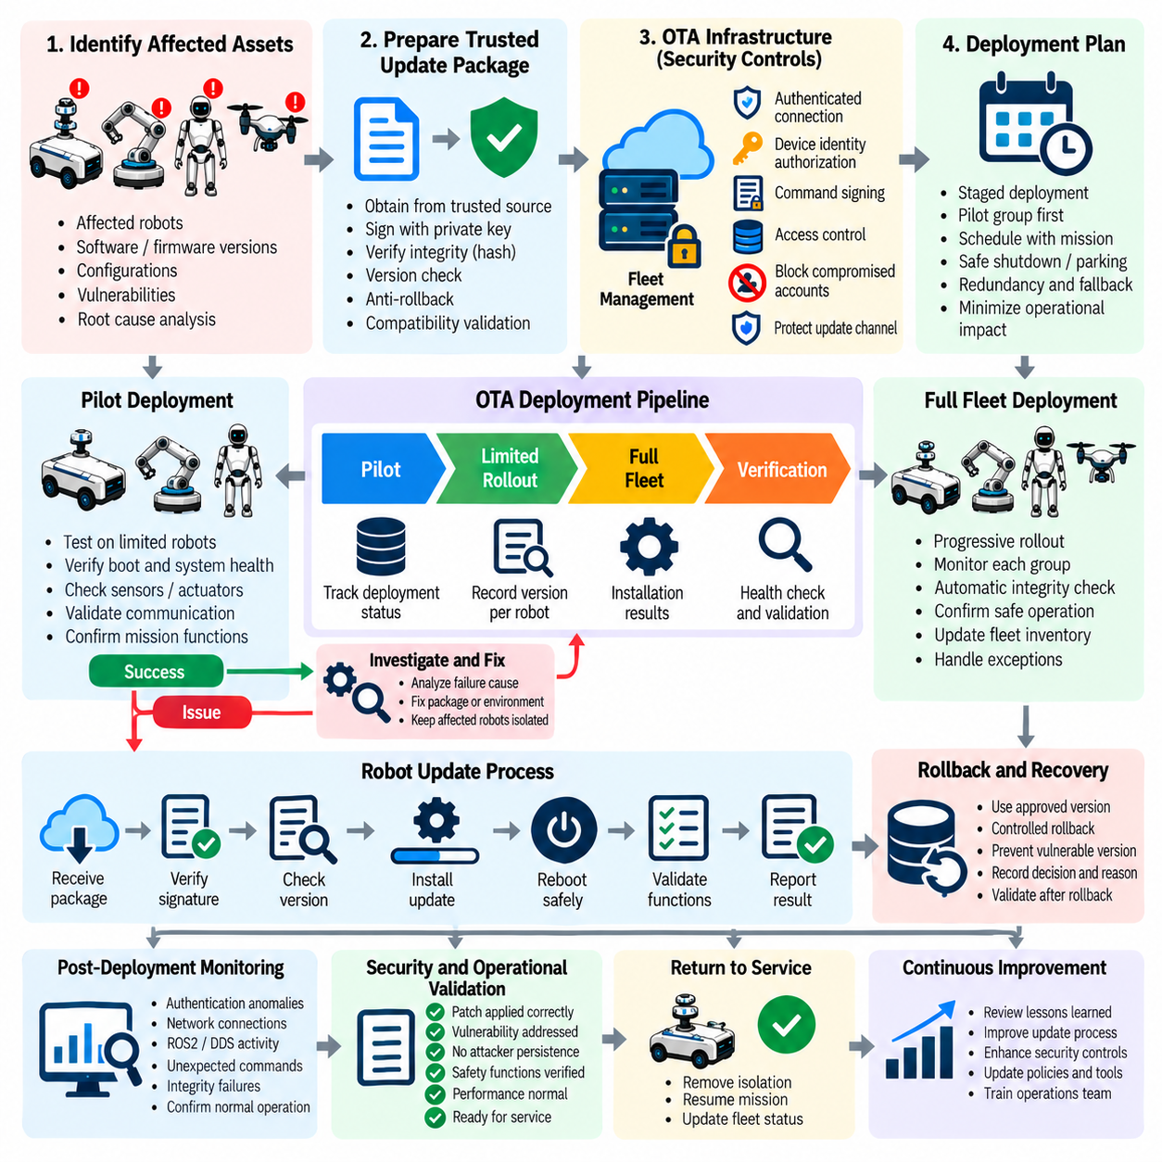
Secure OTA remediation and patch deployment provide the controlled mechanism for correcting vulnerabilities, removing compromised software, and restoring trusted software states across affected robots after the root cause of an incident has been understood. In a robot fleet, remediation must address both cybersecurity and operational safety because an incorrectly deployed update can interrupt communication, navigation, control, perception, or other mission-critical functions. The process therefore requires authenticated software, integrity verification, controlled deployment, and explicit recovery criteria.
The remediation process should begin by identifying exactly which robots, software components, firmware versions, configurations, and vulnerabilities are affected. Root-cause analysis should determine whether the incident resulted from vulnerable software, compromised firmware, unauthorized configuration changes, or another weakness. The deployment scope should then be based on verified evidence rather than applying an indiscriminate fleet-wide update. This approach reduces unnecessary operational disruption while ensuring that every confirmed affected asset receives the required corrective treatment.
Before deployment, the remediation package must be obtained from a trusted source and verified for authenticity and integrity. Firmware and software packages should use an established signing chain and appropriate cryptographic verification so that an attacker cannot substitute malicious content during the recovery process. Version information should also be validated to prevent unintended rollback to vulnerable software. The OTA security architecture should therefore connect package integrity, signing, trusted sources, version control, and anti-rollback mechanisms as mutually reinforcing controls.
Patch deployment should be staged rather than immediately applied to every robot in the fleet. A controlled pilot group can first receive the remediation package while operators verify boot behavior, system health, communications, sensors, actuators, software services, and mission functions. If the pilot deployment is successful, the update can progress to additional fleet segments. If unexpected behavior or security anomalies appear, deployment should be stopped and the affected robots should remain isolated until the problem is understood.
The deployment process should maintain a clear relationship between robot identity and the exact software or firmware version installed. Fleet management systems should record which package was assigned, when deployment began, whether authentication and integrity checks succeeded, whether installation completed successfully, and whether the robot returned to an expected operational state. These records provide evidence for incident recovery and make it possible to identify robots that remain vulnerable, failed during installation, or require additional remediation.
Secure OTA remediation must also protect the update channel itself. Communication between the fleet-management infrastructure and the robot should use authenticated and protected connections, while device identity and authorization determine whether a particular robot is permitted to receive the package. Compromised accounts, certificates, or management interfaces must not be allowed to initiate unauthorized deployments. Strong command authentication and signing are therefore important because an attacker who gains fleet-management access could otherwise transform the remediation mechanism into a new attack path.
Patch deployment should account for robot operational state and mission constraints. A robot performing a safety-critical task should not be unexpectedly rebooted or left without required control software. The deployment scheduler should coordinate updates with mission completion, safe parking, controlled shutdown, redundancy, or maintenance windows where appropriate. For robots that cannot immediately accept the patch, temporary containment and compensating controls may be required until a safe deployment opportunity becomes available.
Recovery packages should be validated for compatibility with the robot's hardware, operating system, middleware, drivers, applications, AI components, and configuration. A security patch that corrects one vulnerability but introduces incompatibility with another component can create a new operational failure. Validation should therefore include relevant integration and functional checks before production deployment. When a patch changes safety-relevant behavior, additional verification should be performed before the robot is permitted to resume normal autonomous operation.
Rollback capability should be controlled carefully because unrestricted rollback can recreate the original vulnerability. If a deployment fails, recovery should use an approved and trusted version rather than allowing arbitrary software selection. Anti-rollback controls should prevent installation of versions known to be insecure unless a formally authorized recovery procedure requires it. The rollback decision, selected version, reason, and validation result should be recorded as part of the incident recovery evidence.
After deployment, enhanced monitoring should remain active across remediated robots. Security teams should watch for repeated authentication anomalies, unexpected network connections, abnormal ROS2 or DDS activity, unusual fleet commands, integrity failures, or signs that the original attack path remains accessible. Operational monitoring should simultaneously verify that the robot performs normally. Successful installation alone does not demonstrate complete remediation; the organization must establish that the vulnerability was addressed and that the attacker no longer has the relevant access or persistence mechanism.
Fleet-scale deployment should include clear completion criteria. All affected robots should be accounted for, successful package installation should be confirmed, failed or unreachable devices should be identified, security verification should be completed, and operational behavior should meet defined acceptance requirements. Robots that cannot satisfy these conditions should remain quarantined or in a controlled recovery state rather than being automatically returned to production. This prevents incomplete remediation from becoming a hidden source of continued fleet exposure.
The secure OTA remediation process should preserve evidence throughout deployment. Package hashes, signatures, version identifiers, deployment logs, authentication records, installation results, failures, rollback events, and validation outcomes should be retained. These records allow investigators to demonstrate which corrective actions were performed and provide traceability if additional analysis is required. They also support post-incident review and help determine whether the remediation actually eliminated the technical condition identified during root-cause analysis.
Within the Incident Response and Recovery chapter, secure OTA remediation and patch deployment follows forensic preservation and attack root-cause analysis and precedes fleet recovery and return to service. This sequence is important because software modification should occur only after sufficient evidence has been preserved and the underlying attack mechanism has been understood. Secure OTA remediation therefore functions as the controlled transition from investigation to technical correction, ensuring that recovered robots return to operation with trusted software rather than merely restoring the pre-incident state.

09.07. Fleet Recovery and Return to Service Process
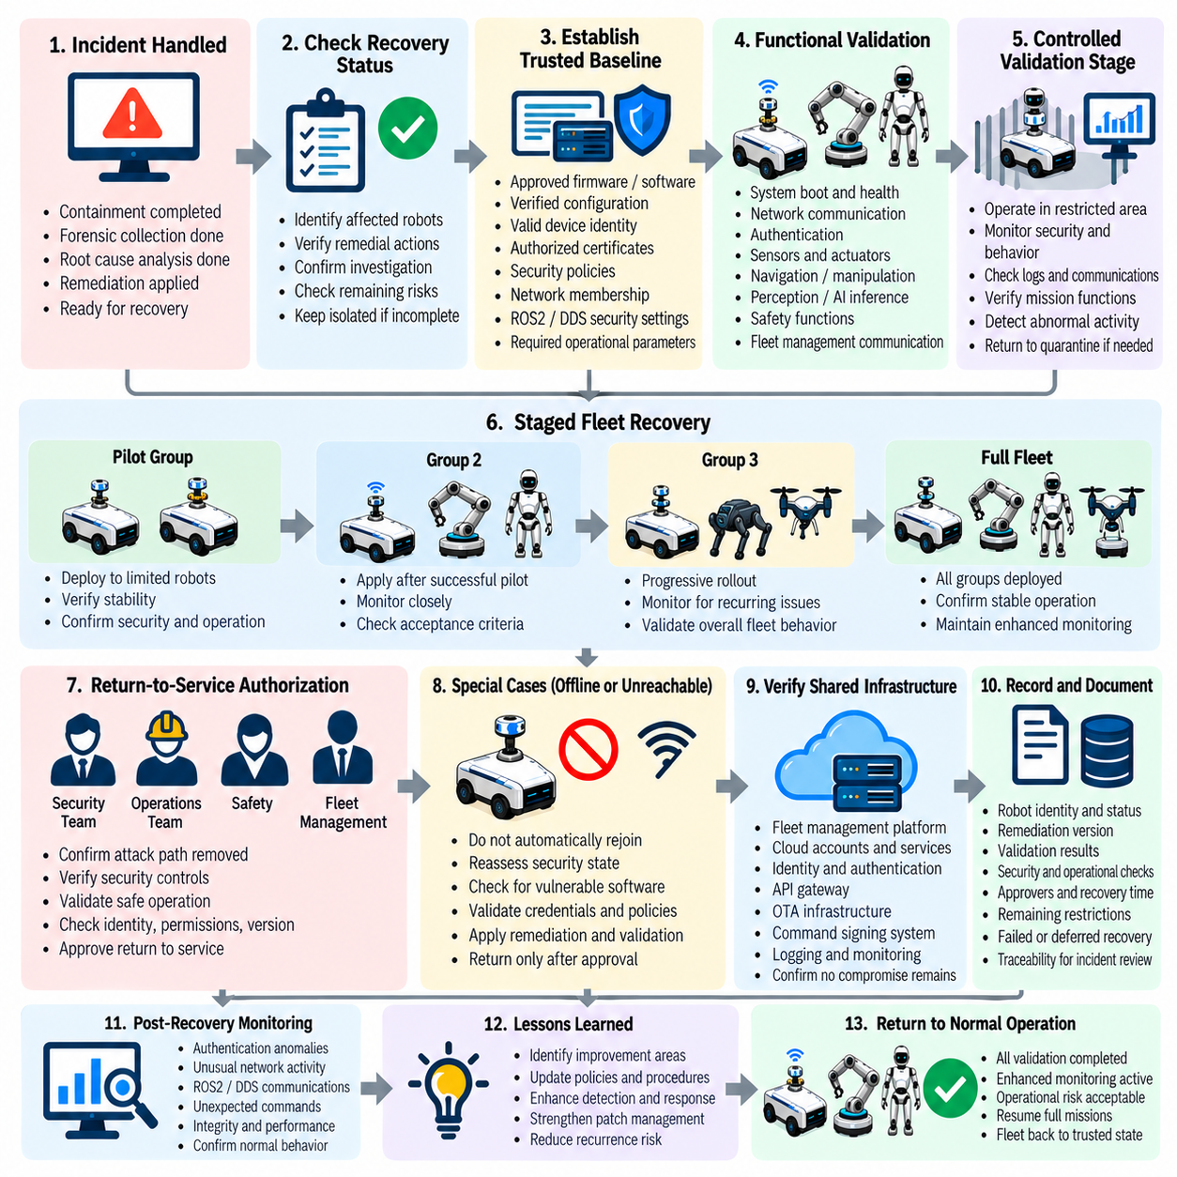
Fleet recovery and return to service establish the controlled process for restoring robots to normal operation after a cybersecurity incident has been contained, investigated, and remediated. Recovery must demonstrate that the affected robots are no longer exposed to the original attack path and that their software, configuration, communication, and security controls are trustworthy. In a robotic fleet, return to service must also confirm that restored systems can perform physical operations safely and reliably.
Recovery should begin only after the incident response team has completed the required containment, forensic preservation, root-cause analysis, and remediation activities. Each affected robot should have a clearly documented recovery status showing whether its credentials, software, firmware, configuration, and communication paths have been corrected. Robots for which the investigation remains incomplete or remediation cannot be verified should remain isolated or in a controlled recovery state rather than being automatically returned to production.
The recovery process should first establish a trusted baseline for each robot. This baseline can include approved firmware and software versions, verified configuration, valid device identity, authorized certificates, security policies, network membership, ROS2 or DDS security settings, and required operational parameters. Integrity and authenticity checks should confirm that the restored system corresponds to an approved state. Any unexplained deviation should be investigated before the robot proceeds to operational validation.
Functional validation should then confirm that the robot remains capable of performing its intended mission after security remediation. Relevant functions may include system boot, network communication, authentication, sensor operation, actuator control, navigation, manipulation, perception, AI inference, safety mechanisms, and fleet-management communication. The validation depth should reflect the robot's operational role and the changes introduced during remediation. Security restoration must not be considered complete if essential operational capabilities have been degraded.
A recovered robot should normally pass through a restricted validation stage before full production deployment. During this stage, the robot can operate within controlled conditions while cybersecurity and operational teams observe its behavior. Authentication events, network connections, ROS2 or DDS communications, system integrity, fleet commands, and application behavior should be monitored closely. Any unexpected behavior should trigger investigation and, when appropriate, a return to quarantine rather than immediate expansion of operational privileges.
Fleet recovery should proceed in controlled groups instead of restoring every affected robot simultaneously. A pilot group can demonstrate that the remediation package, configuration, network policy, and operational procedures function correctly under real conditions. Subsequent groups can be restored after the previous group meets defined acceptance criteria. This staged approach limits the consequences of an unnoticed remediation problem and provides an opportunity to detect recurring compromise before it reaches the entire fleet.
Return-to-service authorization should require agreement between the responsible cybersecurity and operational or safety functions. Cybersecurity personnel must confirm that the relevant attack path, unauthorized access, persistence mechanism, and vulnerability have been addressed. Operations and safety personnel must confirm that the robot can safely perform its intended mission. Where appropriate, fleet management should also verify that the device has the correct identity, permissions, software version, configuration, and service assignment.
Special attention should be given to robots that were offline, unreachable, or unable to complete remediation during the main recovery campaign. These robots should not automatically rejoin the production fleet when connectivity is restored. Their security state must be reassessed because they may still contain vulnerable software, expired credentials, outdated security policies, or evidence of compromise. Such devices should undergo the same controlled remediation and validation process before receiving normal fleet privileges.
Fleet-level recovery should also verify that shared infrastructure is trustworthy. Restoring individual robots is insufficient if the fleet-management platform, cloud account, identity service, API gateway, OTA infrastructure, or command-signing system remains compromised. Recovery should therefore confirm that centralized services have been secured and that their authentication, authorization, logging, certificate, and command-control mechanisms are functioning as intended before unrestricted fleet communication is restored.
The recovery process should maintain detailed records of every return-to-service decision. These records should identify the robot, remediation version, validation results, security checks, operational checks, responsible approvers, recovery time, and any remaining restrictions. Failed validation, deferred recovery, temporary compensating controls, and subsequent corrective actions should also be recorded. This evidence provides traceability for incident review and demonstrates that service restoration was based on defined criteria rather than operational pressure alone.
Enhanced monitoring should continue after robots return to production. A robot that successfully passes recovery validation may still require closer observation during its initial operational period because persistence mechanisms or secondary attack paths may not be immediately visible. Security teams should monitor authentication anomalies, unexpected network activity, unusual commands, integrity failures, ROS2 or DDS communication changes, and repeated indicators associated with the original incident. Operational teams should simultaneously monitor mission performance and safety behavior.
Recovery completion should therefore be based on evidence rather than the simple restoration of connectivity. The fleet should be considered recovered only when affected assets have been accounted for, remediation has been verified, security controls are functioning, operational functions have passed validation, and authorized personnel have approved service restoration. Any unresolved uncertainty should be explicitly recorded, with affected robots remaining under appropriate restrictions until the uncertainty is resolved.
The return-to-service process should also feed information into the post-incident improvement cycle. Difficulties encountered during recovery can reveal weaknesses in asset inventories, software baselines, OTA deployment, fleet segmentation, credential management, monitoring, validation procedures, or recovery authority. These findings should be incorporated into future incident-response plans, security architecture, testing programs, and operational procedures so that subsequent incidents can be contained and recovered from more efficiently.
Within the Incident Response and Recovery chapter, fleet recovery and return to service follows forensic preservation, root-cause analysis, and secure OTA remediation, and it precedes post-incident lessons learned, CSIRT activities, notification policy, and incident-response exercises. This position establishes recovery as the controlled transition from technical remediation back to operational service. The objective is not merely to reconnect robots, but to demonstrate that the fleet has returned to a verified, secure, safe, and operationally acceptable state. Volume_24_Robot_Cybersecurity

09.08. Post Incident Lessons Learned and CSIRT
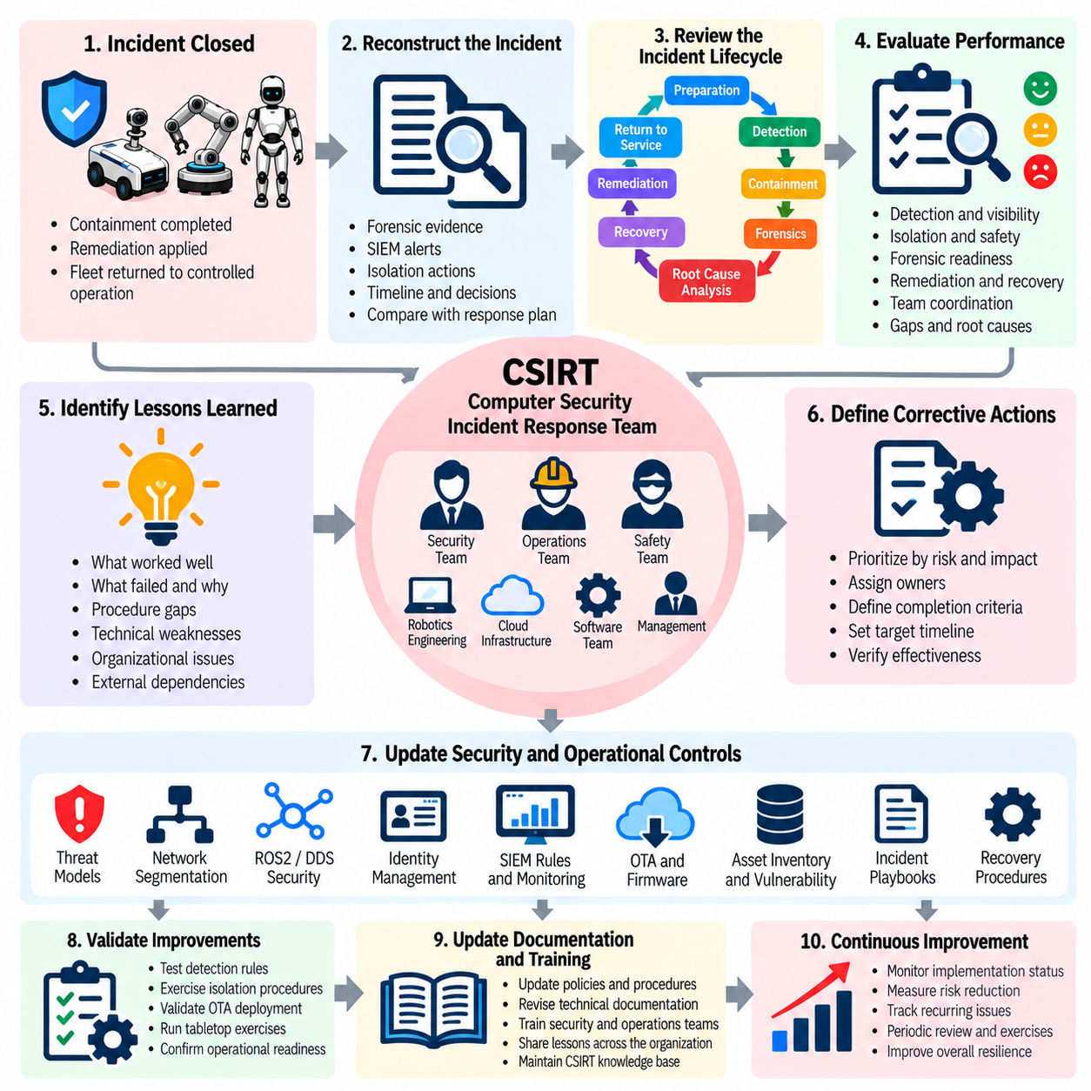
Post-incident lessons learned and Computer Security Incident Response Team (CSIRT) activities provide the organizational mechanism for converting the experience of a cybersecurity incident into measurable improvements. In a robot fleet, the review must consider not only whether the technical attack was contained, but also whether people, procedures, safety controls, fleet operations, and recovery mechanisms functioned as intended. The objective is to strengthen future prevention, detection, response, and recovery capabilities.
The post-incident review should begin after affected robots and supporting infrastructure have returned to an appropriately controlled operational state. Participants should reconstruct the incident using preserved forensic evidence, response records, SIEM alerts, isolation actions, remediation results, and return-to-service decisions. The review should distinguish confirmed facts from assumptions and identify where the actual response differed from the planned procedure. This creates a reliable basis for determining what worked, what failed, and why.
A useful lessons-learned process should examine the complete incident lifecycle rather than focusing only on the initial vulnerability. The organization should review preparation, detection, alert correlation, containment, quarantine, forensic collection, root-cause analysis, OTA remediation, fleet recovery, and service restoration. Attention should also be given to communication between cybersecurity, robotics, operations, safety, cloud, and management teams. Weaknesses at organizational boundaries can significantly delay response even when individual technical controls are effective.
The review should evaluate whether detection capabilities provided sufficient visibility into the affected environment. Investigators should determine whether relevant logs were available, whether timestamps supported reliable reconstruction, whether SIEM correlation generated actionable alerts, and whether responders received sufficient context to make timely decisions. Missed detections and excessive false positives should both be examined because they can reduce confidence in monitoring and delay recognition of coordinated activity across multiple robots or fleet services.
Containment and isolation performance should also be assessed from both cybersecurity and physical-safety perspectives. The organization should determine whether responders could safely isolate affected robots without creating hazardous states, whether quarantine boundaries were appropriate, and whether unaffected fleet operations could continue. Difficulties encountered during emergency stopping, network isolation, identity revocation, or cloud command restriction should be documented as engineering and procedural improvement opportunities.
Forensic readiness should be reviewed to determine whether evidence could be collected quickly and reliably. The organization should examine whether required logs existed, whether storage capacity was sufficient, whether time synchronization was reliable, and whether chain-of-custody procedures were practical. Missing evidence can prevent investigators from determining the complete attack path and may weaken subsequent legal, regulatory, insurance, or engineering analysis. Lessons learned should therefore strengthen evidence collection and preservation capabilities before the next incident.
The remediation and recovery process should be evaluated against its defined acceptance criteria. Reviewers should determine whether secure OTA deployment worked as intended, whether affected robots received the correct software or firmware, whether failed deployments were identified, and whether restored robots passed security and operational validation. Any unexpected behavior during recovery should be analyzed to determine whether it resulted from the original compromise, the remediation itself, incomplete configuration restoration, or another underlying weakness.
CSIRT coordination provides the organizational structure for turning these findings into accountable actions. The Computer Security Incident Response Team should consolidate technical findings, coordinate affected stakeholders, maintain incident documentation, track corrective actions, and communicate the security status of the incident. For robot fleets, effective CSIRT operation requires close cooperation with robotics engineering, fleet operations, safety engineering, cloud infrastructure, software teams, and management because cybersecurity decisions can directly influence physical operations.
Corrective actions should be prioritized according to risk and operational impact rather than simply accumulating a list of recommendations. Critical findings may require immediate architectural or security-control changes, while lower-risk findings can be incorporated into planned engineering work. Each action should have an accountable owner, defined completion criteria, an appropriate target timeframe, and a method for verifying that the corrective measure actually reduces the identified risk.
Lessons learned should feed back into the robot cybersecurity lifecycle. Findings may require updates to threat models, network segmentation, ROS2 and DDS security policies, identity management, SIEM correlation rules, OTA controls, firmware protection, asset inventories, vulnerability management, incident playbooks, and recovery procedures. Changes should be reflected in engineering standards and operational documentation so that improvements become repeatable organizational capabilities rather than remaining isolated knowledge from a single incident.
The organization should also determine whether additional testing is required to validate the improvements. A corrected detection rule can be tested with controlled security events, while a revised isolation procedure can be evaluated through a tabletop exercise or technical drill. Updated OTA controls can be validated through staged deployment testing, and fleet recovery procedures can be exercised using representative failure scenarios. Verification ensures that lessons learned have produced functioning controls rather than merely revised documentation.
CSIRT activities should continue after the formal incident has been closed when significant corrective actions remain outstanding. The team should monitor remediation progress, review newly identified indicators, coordinate additional investigation when necessary, and confirm that residual risk is understood by responsible stakeholders. Closure should therefore represent a controlled transition from active incident response to managed improvement rather than the simple disappearance of alerts from a monitoring system.
Within the Incident Response and Recovery chapter, post-incident lessons learned and CSIRT activities follow fleet recovery and return to service and precede cyber insurance and legal notification policy and incident-response drills. This position emphasizes that recovery is not the end of the security lifecycle. The incident must be transformed into organizational knowledge, accountable corrective actions, improved technical controls, and validated response capabilities so that the robot fleet becomes more resilient against future cyber incidents. Volume_24_Robot_Cybersecurity

09.09. Cyber Insurance and Legal Notification Policy
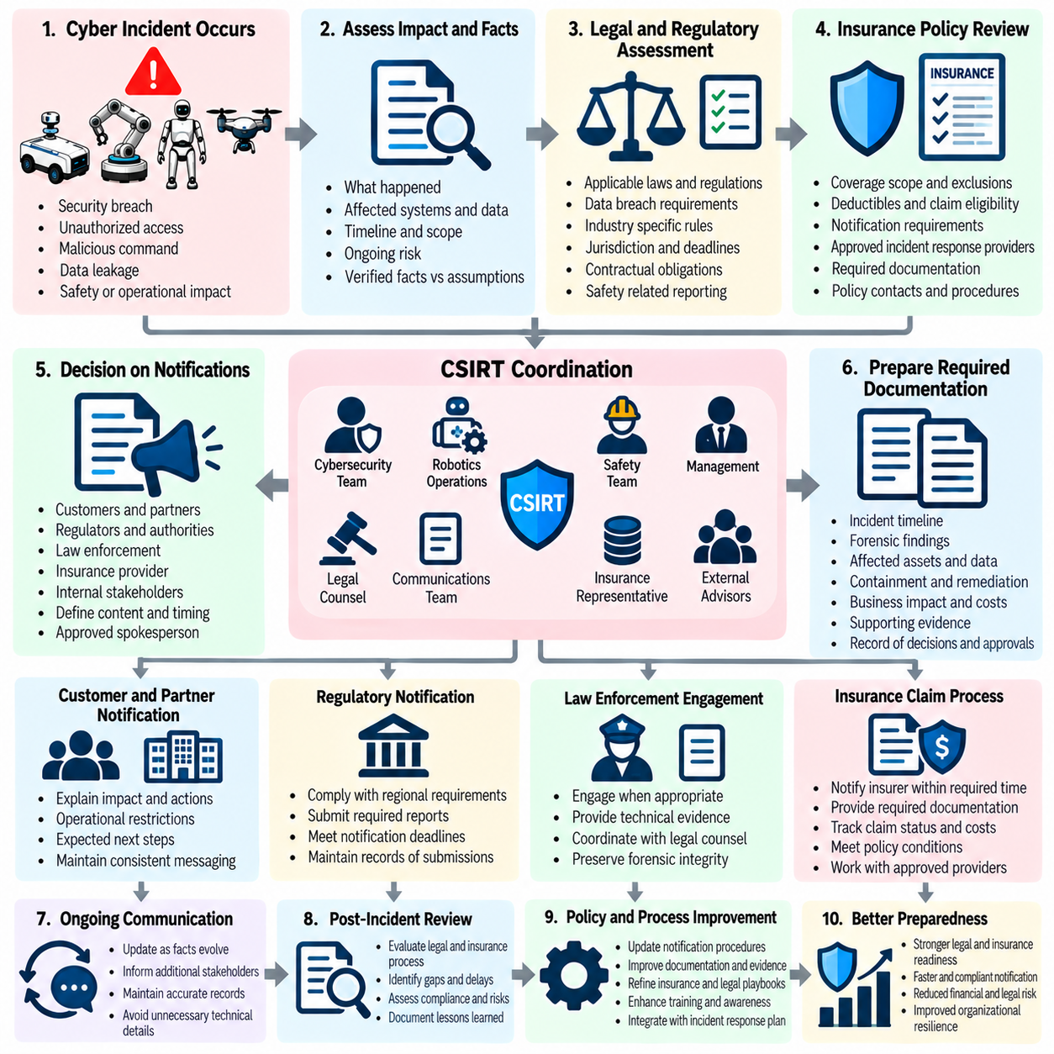
Cyber insurance and legal notification policy establishes the organizational framework for managing the financial, contractual, regulatory, and legal consequences of a cybersecurity incident affecting a robot or robot fleet. Unlike conventional IT incidents, a robotic compromise may involve physical safety, operational disruption, customer facilities, autonomous decisions, sensitive telemetry, or damage to equipment. The policy should therefore connect cybersecurity response with insurance requirements, legal review, contractual obligations, regulatory duties, and executive decision-making.
Insurance considerations should be integrated into incident preparation rather than addressed only after a major event occurs. The organization should understand the scope of applicable cyber insurance coverage, exclusions, deductibles, notification requirements, approved incident-response providers, forensic requirements, and conditions that could affect claim eligibility. Relevant policies and contact information should be accessible to authorized responders so that an emergency does not create unnecessary delays in initiating required insurance procedures.
A robot fleet may generate multiple categories of information that require careful legal assessment after an incident. These can include customer information, employee information, operational telemetry, location-related data, video or sensor records, authentication information, proprietary software, AI models, fleet commands, and security logs. The organization should determine whether the incident created a reportable data breach, contractual violation, intellectual-property concern, safety issue, or other legally significant consequence before making external statements.
Notification decisions should be based on verified facts and applicable obligations rather than speculation. Incident responders should establish what occurred, which systems and data were affected, when the incident was discovered, whether unauthorized access was confirmed, and whether the impact remains ongoing. Legal counsel should evaluate the relevant jurisdiction, contractual terms, regulatory requirements, and notification deadlines. Technical teams should provide evidence and factual assessments without independently making legal conclusions.
Customer and partner notification may be required when a cybersecurity incident affects contracted services, shared infrastructure, customer data, robot availability, or operational safety. Notification procedures should identify who has authority to communicate externally and ensure that messages are consistent with verified incident information. Communications should explain the known impact, relevant protective actions, operational restrictions, and expected next steps without disclosing unnecessary technical details that could increase security risk.
Regulatory notification should be coordinated carefully because requirements may differ according to jurisdiction, industry, data type, and incident impact. A robot fleet operating across multiple regions may therefore require parallel legal assessments rather than relying on a single notification rule. The organization should maintain records supporting the decision to notify or not notify, including the factual basis, legal assessment, responsible approver, notification time, recipient, and information provided.
Law-enforcement engagement should also be governed by a predefined policy. Some incidents may justify contacting appropriate authorities because of significant physical consequences, deliberate sabotage, theft, extortion, large-scale compromise, or other criminal activity. Decisions should be coordinated with legal counsel and incident leadership, while preserving forensic evidence and avoiding actions that could unnecessarily interfere with the technical investigation or recovery process.
Insurance claims require disciplined evidence and documentation. Incident timelines, forensic findings, affected assets, containment actions, remediation activities, business interruption records, recovery costs, external service expenses, and other relevant documentation may support a claim. The organization should preserve original evidence and maintain consistent records of decisions and expenditures. Insurance-related activities should not compromise forensic integrity or prevent technical teams from taking urgent safety and containment measures.
Legal and insurance communications should follow controlled information-handling procedures. Incident information may contain sensitive security architecture, vulnerabilities, customer information, proprietary technology, or details about defensive capabilities. Access should therefore be limited according to role and need. Draft notifications, legal assessments, forensic reports, and insurance correspondence should be handled through approved channels, with appropriate retention and access controls.
The organization should establish clear responsibility among the CSIRT, cybersecurity leadership, legal counsel, insurance representatives, communications personnel, executive management, and operational teams. CSIRT personnel should provide accurate technical facts, while legal specialists assess obligations and communications personnel manage approved external messaging. Executives may authorize major business decisions, but technical and legal conclusions should remain grounded in documented evidence and qualified analysis.
Notification policy should also address situations in which facts evolve after an initial communication. Early information may be incomplete, and subsequent forensic analysis may identify additional affected systems, data, or operational consequences. The organization should therefore maintain a process for updating customers, regulators, insurers, partners, or authorities when material information changes. Corrections and supplemental notifications should remain consistent with the verified incident record.
Within the Incident Response and Recovery chapter, cyber insurance and legal notification policy follows fleet recovery, return to service, and post-incident lessons learned and CSIRT activities, while preceding incident-response drills and tabletop exercises. This position emphasizes that legal and financial obligations continue beyond technical recovery. A mature robot cybersecurity program must therefore connect technical evidence, operational impact, insurance requirements, contractual duties, regulatory responsibilities, and controlled external communication within one accountable incident-management process. Volume_24_Robot_Cybersecurity

09.10. Incident Response Drill and Tabletop Exercise
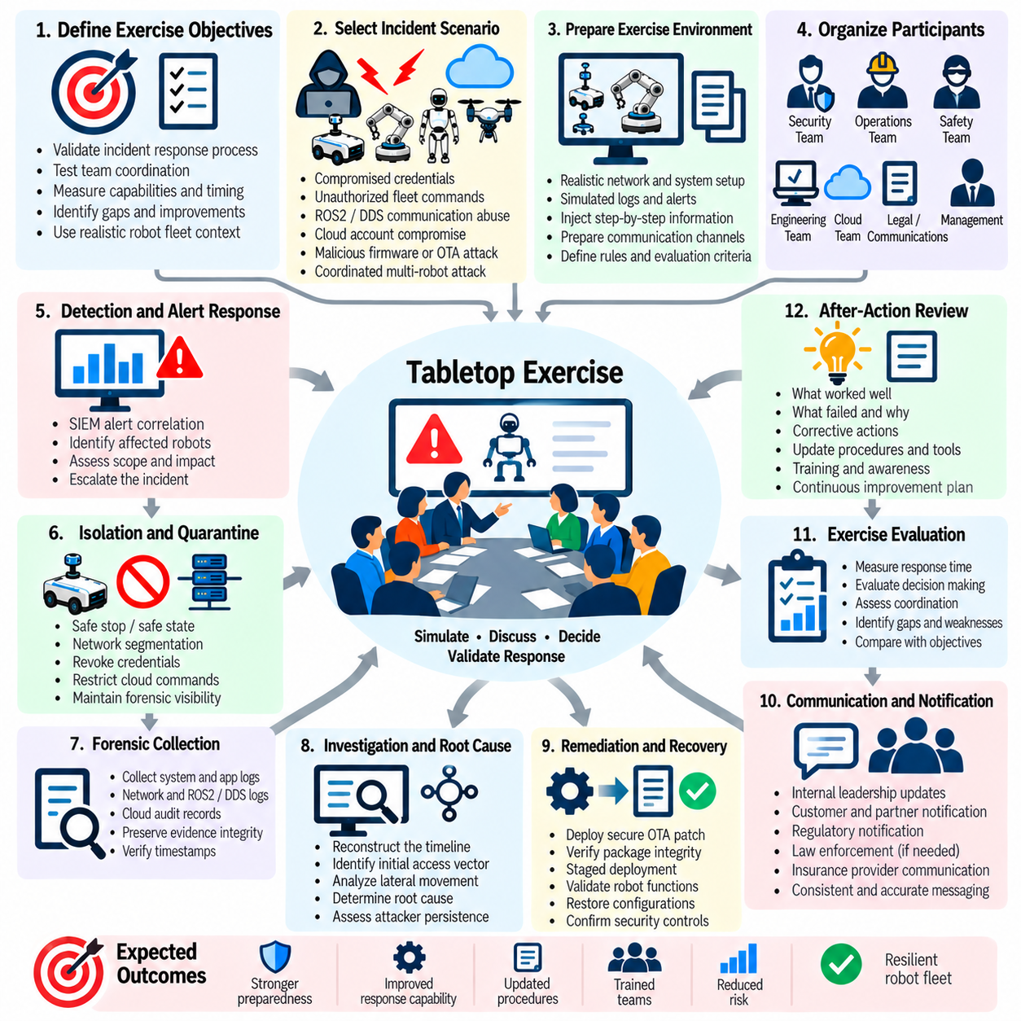
Incident response drills and tabletop exercises provide a controlled method for validating whether a robot fleet can detect, contain, investigate, remediate, and recover from a cybersecurity incident under realistic operational conditions. Because robotic systems combine digital infrastructure with physical behavior, exercises must evaluate more than conventional IT response. They should determine whether cybersecurity, robotics, operations, safety, cloud, and management teams can coordinate decisions while protecting personnel, equipment, mission continuity, and evidence.
A tabletop exercise should begin with a clearly defined incident scenario that reflects the architecture and threat model of the robot fleet. Scenarios may involve compromised credentials, unauthorized fleet commands, ROS2 or DDS communication abuse, cloud account compromise, malicious firmware, OTA infrastructure compromise, or coordinated attacks affecting multiple robots. The exercise should provide participants with progressive information rather than revealing the complete incident at the beginning, allowing the organization to evaluate how decisions are made under uncertainty.
The exercise should establish explicit objectives before execution. These objectives may include evaluating detection and SIEM alert correlation, validating escalation procedures, confirming authority for robot isolation and quarantine, testing forensic evidence preservation, assessing root-cause analysis, and verifying secure OTA remediation and fleet recovery. Objectives should be measurable so that the exercise can determine whether required capabilities actually functioned as intended rather than simply confirming that participants attended the exercise.
Incident command and organizational responsibilities should be tested throughout the exercise. Participants should understand who can declare an incident, who can authorize containment, who controls physical robot operations, who approves return to service, and who coordinates legal or external communication. Ambiguous authority can delay critical decisions, particularly when cybersecurity actions may affect physical safety or operational continuity. The exercise should therefore expose unclear roles, approval dependencies, communication gaps, and conflicts between security and operational priorities.
Robot isolation and quarantine should receive particular attention because cyber containment can create physical consequences. The exercise should examine whether responders can safely stop, restrict, or isolate an affected robot without creating an unsafe condition. Participants should evaluate network segmentation, credential revocation, cloud command restrictions, ROS2 or DDS access controls, and safe-state transitions. The objective is to confirm that containment procedures prevent further compromise while maintaining appropriate safety and preserving required forensic visibility.
Forensic readiness should also be evaluated during drills. Participants should identify which logs, telemetry, authentication records, network information, ROS2 or DDS records, cloud audit trails, firmware information, and fleet commands must be preserved. The exercise should determine whether these sources are actually available, whether timestamps can be correlated, and whether evidence can be collected without compromising integrity. Missing evidence, unclear collection authority, or inadequate storage should be documented as concrete improvement requirements.
The remediation and recovery portion of the exercise should test whether the organization can move from investigation to controlled technical correction. Participants should determine when secure OTA remediation is appropriate, how trusted packages are verified, how deployment is staged, how failed updates are handled, and which criteria must be satisfied before affected robots return to service. The exercise should also test whether compromised credentials, certificates, software, firmware, configurations, and management interfaces have been fully addressed before production access is restored.
Communication and notification should form part of the exercise rather than being treated as a separate administrative activity. Participants should practice communicating with internal leadership, customers, partners, legal counsel, insurers, regulators, and other relevant parties when required. The exercise should evaluate whether technical facts are communicated accurately, whether legal conclusions are appropriately handled by qualified personnel, and whether changing incident information can be incorporated into updated notifications without creating contradictory statements.
Exercise observers should record decisions, response times, information gaps, procedural deviations, technical failures, and coordination problems throughout the event. Performance should be evaluated against predefined objectives and acceptance criteria rather than subjective impressions. Particular attention should be given to delayed escalation, unavailable telemetry, ineffective isolation, unclear decision authority, unsuccessful OTA deployment, incomplete evidence preservation, and premature return-to-service decisions because these weaknesses may create significant consequences during a real incident.
After the exercise, the organization should conduct a structured after-action review. Participants should identify what worked well, what failed, what assumptions proved incorrect, and which capabilities require improvement. Findings should be separated into immediate corrective actions, engineering improvements, procedural changes, training requirements, and longer-term architectural initiatives. Each significant action should have an accountable owner, completion criteria, and a method for verifying that the improvement has actually been implemented.
Exercises should be repeated periodically and updated as the robot fleet evolves. Changes in robot models, ROS2 or DDS configurations, cloud infrastructure, network architecture, AI systems, OTA mechanisms, fleet-management platforms, and operational procedures can invalidate assumptions from previous exercises. Scenarios should therefore become progressively more realistic and challenging, including multi-robot incidents, simultaneous safety and cybersecurity events, loss of cloud connectivity, compromised identities, and incomplete forensic evidence. Repeated exercises build organizational readiness and reduce dependence on individual responders.
Within the Incident Response and Recovery chapter, incident-response drills and tabletop exercises conclude the sequence that begins with detection and continues through isolation, forensic preservation, root-cause analysis, secure OTA remediation, fleet recovery, lessons learned, CSIRT coordination, and legal or insurance considerations. This final stage validates the complete response lifecycle as an operational capability. The purpose is not merely to rehearse a written plan, but to demonstrate that the robot organization can make safe, coordinated, evidence-based decisions when a real cyber incident affects both digital systems and physical operations.

