Volume 24. Robot Cybersecurity

Chapter 11. Compliance and Certification

11.01. IEC 62443 Industrial Automation Security Framework
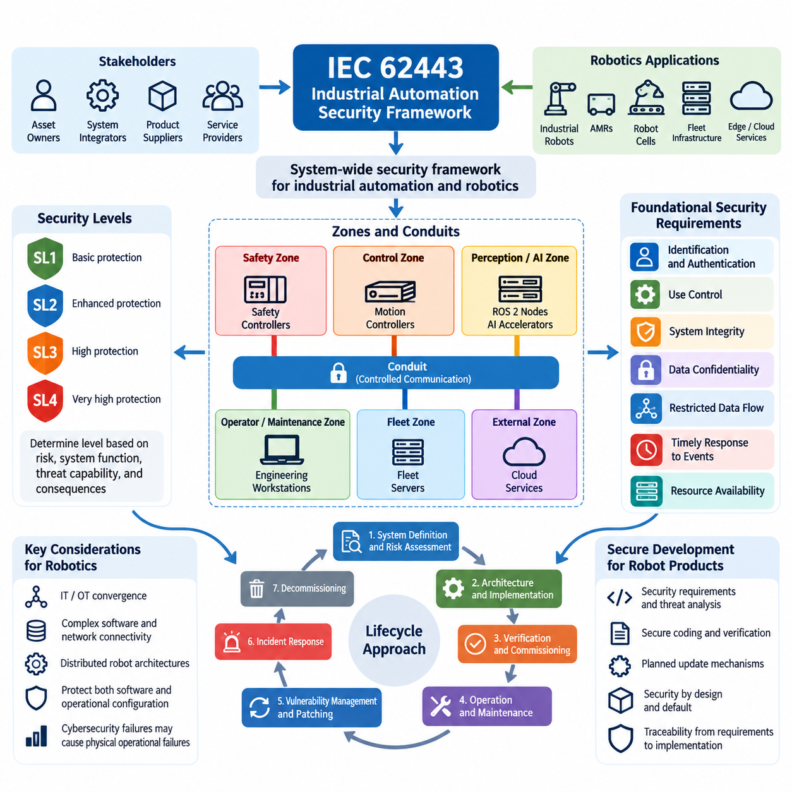
IEC 62443 provides a cybersecurity framework for industrial automation and control systems by treating security as a system-wide engineering responsibility rather than a collection of isolated technical controls. This approach is highly relevant to industrial robots, autonomous mobile robots, robot cells, fleet infrastructure, and supporting edge or cloud services because these environments combine operational technology with increasingly complex software and network connectivity. Volume_24_Robot_Cybersecurity
The IEC 62443 series organizes cybersecurity responsibilities across asset owners, system integrators, product suppliers, and service providers. Instead of assuming that a secure component automatically produces a secure robot system, the framework considers how products are developed, integrated, configured, operated, maintained, and eventually decommissioned. For robotics organizations, this lifecycle perspective connects engineering processes with deployment and operational security.
A central architectural concept is the division of an industrial system into zones and conduits. A zone groups assets that share similar security requirements, while a conduit represents controlled communication between zones. A robot deployment can therefore separate safety controllers, motion controllers, ROS 2 computing nodes, AI accelerators, engineering workstations, fleet servers, wireless infrastructure, and external cloud services according to their functions and risk exposure.
Zone and conduit modeling is particularly useful because modern robots cross conventional information technology and operational technology boundaries. A perception computer may exchange high-volume sensor data with an AI processor while a motion controller simultaneously handles deterministic control traffic. Fleet management systems may communicate with dozens or hundreds of robots. IEC 62443 encourages these interfaces to become explicit security boundaries rather than implicitly trusted connections.
IEC 62443 also introduces Security Levels as a structured means of expressing the degree of protection required against different classes of threats. Security requirements should therefore be determined from risk, system function, threat capability, and potential consequences instead of applying identical controls everywhere. A safety-critical motion-control zone may require stronger protection than a noncritical monitoring interface, even when both belong to the same physical robot.
The framework groups technical requirements around foundational security capabilities. These include identification and authentication control, use control, system integrity, data confidentiality, restricted data flow, timely response to events, and resource availability. Together, these capabilities provide a systematic basis for translating cybersecurity objectives into concrete requirements for robot controllers, operating systems, middleware, networks, applications, and supporting infrastructure.
Identification and authentication are especially important in distributed robot architectures. Human operators, maintenance engineers, robots, controllers, software services, and automated deployment systems should possess verifiable identities appropriate to their roles. Authentication mechanisms can then support authorization decisions so that a compromised engineering workstation, robot node, or external service cannot automatically inherit unrestricted access to the entire operational environment.
System integrity extends beyond conventional malware protection. Robot firmware, boot chains, configuration files, control applications, AI models, middleware policies, and OTA packages may all influence physical behavior. Integrity controls therefore need to protect both executable software and operational configuration. Secure boot, signed software, controlled updates, protected credentials, change monitoring, and verified configuration baselines can collectively reduce unauthorized modification.
Restricted data flow complements integrity protection by limiting unnecessary communication paths. Industrial robot networks can be segmented according to safety, control, perception, AI processing, fleet coordination, maintenance, and enterprise connectivity. Firewalls, access-control rules, authenticated middleware, VLANs, gateways, and application-level authorization can enforce these boundaries while allowing explicitly required traffic to cross designated conduits.
Availability has unusual significance in robotics because cybersecurity failures may become physical operational failures. Excessive traffic, resource exhaustion, malformed messages, compromised services, or unavailable authentication infrastructure can interfere with navigation, manipulation, fleet coordination, or production. Security architecture must therefore protect computational, communication, and control resources without introducing dependencies that undermine deterministic or safety-related operation.
IEC 62443 should also be understood as a lifecycle framework rather than only a deployment checklist. Cybersecurity activities begin with system definition and risk assessment, continue through architecture and implementation, and remain active during verification, commissioning, operation, maintenance, vulnerability management, patching, incident response, and retirement. This aligns naturally with robot platforms whose software, firmware, AI models, and fleet services evolve continuously after deployment.
For product development, secure development practices become part of the engineering process itself. Security requirements should be traceable into architecture and implementation, while threat analysis, secure coding, vulnerability handling, verification, and update mechanisms should be planned rather than added near release. Robotics software organizations can integrate these practices with existing CI/CD, firmware development, ROS 2 testing, simulation, and hardware-in-the-loop validation pipelines.
Component-level security and system-level security must remain distinct. A controller, gateway, operating system, or robot computer may provide strong security capabilities, yet integration choices can still create exploitable trust relationships. Conversely, system integrators cannot reliably compensate for products that lack fundamental security mechanisms. IEC 62443 therefore encourages complementary responsibilities between secure product development and secure system integration.
For ROS 2 and DDS-based robots, this perspective provides a useful compliance structure. Authentication, access-control policies, encryption, certificate management, logging, vulnerability remediation, and penetration testing can be treated as implementation mechanisms supporting broader industrial cybersecurity objectives. The source structure explicitly places ROS 2 security compliance mapping within the robotics cybersecurity program rather than treating middleware security as an isolated discipline. Volume_24_Robot_Cybersecurity
The same principle applies to firmware and OTA infrastructure. Signed firmware, secure boot, package-integrity verification, anti-rollback mechanisms, SBOM management, hardware-backed key storage, and supply-chain controls collectively support lifecycle assurance. The robotics cybersecurity structure consequently connects OTA security with an IEC 62443 compliance checklist, reinforcing the relationship between technical implementation and auditable security requirements. Volume_24_Robot_Cybersecurity
Evidence is essential when IEC 62443 is used for assessment or certification preparation. Architecture descriptions, asset inventories, zone-and-conduit models, risk assessments, security requirements, configuration baselines, test results, vulnerability records, patch histories, incident procedures, and development records can demonstrate that controls exist and are maintained. Evidence should be generated throughout engineering rather than reconstructed immediately before an audit.
An effective robotics implementation therefore converts IEC 62443 from a compliance document into an engineering framework. Risk analysis determines required protection, architecture establishes security boundaries, product and software processes implement controls, testing verifies their effectiveness, and operational monitoring maintains assurance after deployment. Certification then becomes evidence of a sustained cybersecurity process rather than a one-time technical inspection.
Within the broader robot cybersecurity curriculum, IEC 62443 serves as a foundation that can later be complemented by Security Level assessment, automotive cybersecurity approaches, NIST CSF practices, regulatory requirements, UAV airworthiness cybersecurity, cybersecurity management systems, penetration testing, and formal evidence packages. This progression is explicitly reflected in the compliance and certification chapter structure. Volume_24_Robot_Cybersecurity

11.02. IEC 62443 SL Assessment for Robot Systems [w/Code]
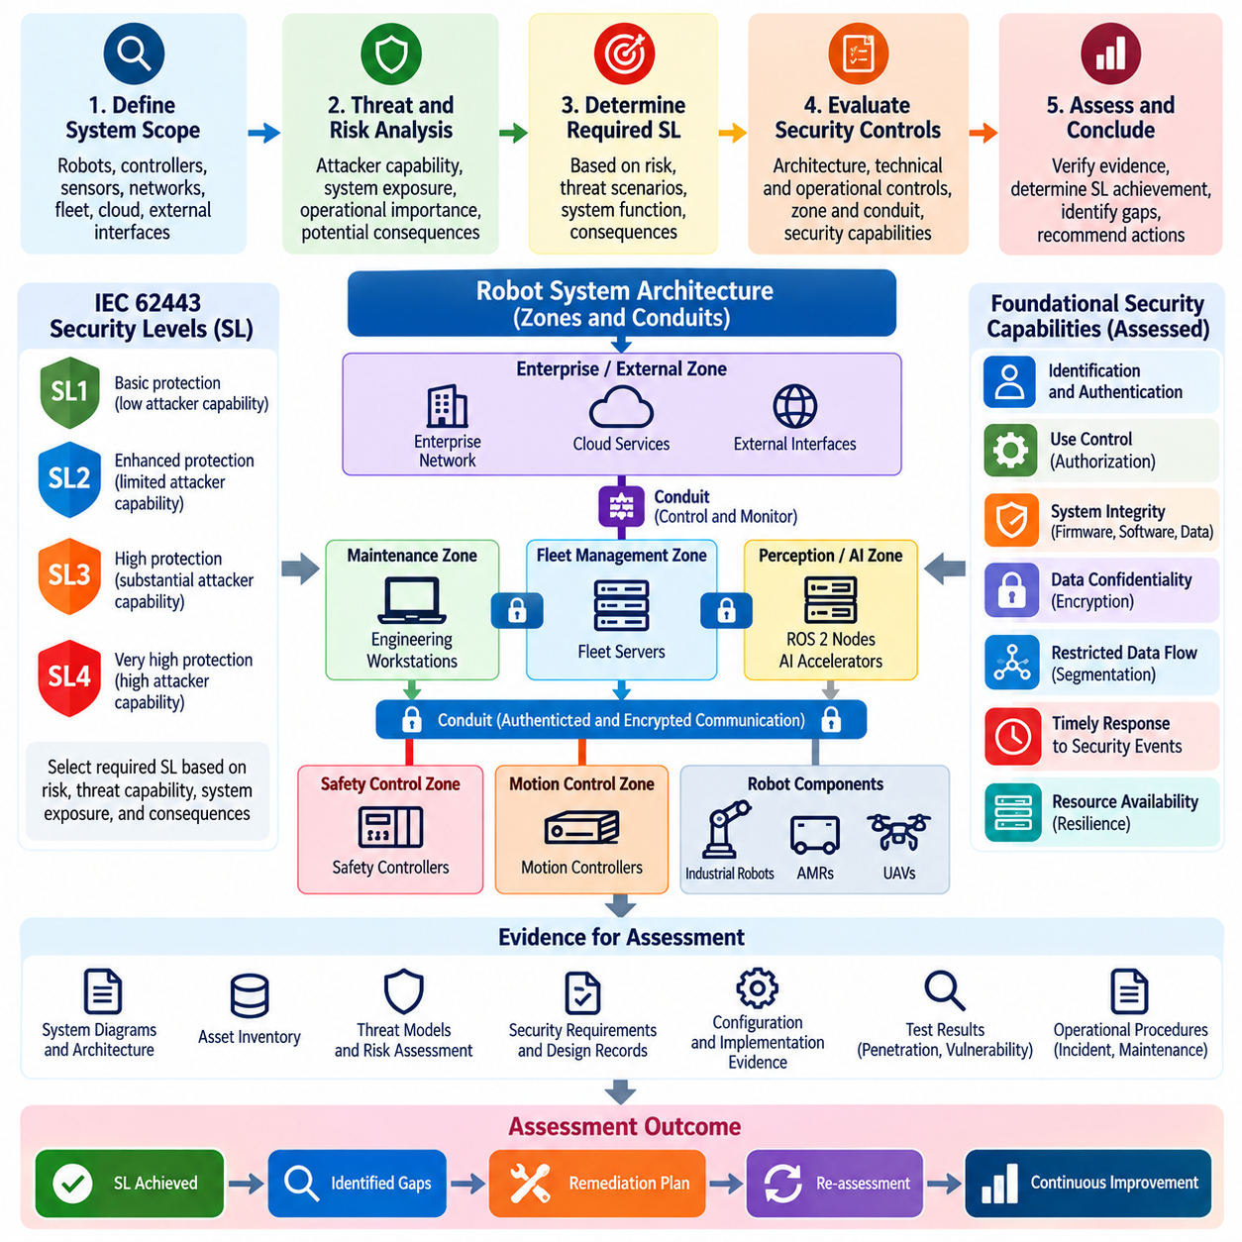
IEC 62443 Security Level assessment provides a structured method for determining whether a robot system has sufficient cybersecurity protection against defined levels of attacker capability. For robot systems, the assessment should consider the complete operational environment rather than evaluating a single controller or computer in isolation. The evaluation therefore connects system architecture, threat assumptions, security requirements, implemented controls, and operational procedures into a consistent assessment process.
Security Level assessment begins with a clear definition of the system under evaluation. The assessment boundary should identify robots, controllers, sensors, edge computers, networks, gateways, engineering stations, fleet-management infrastructure, and relevant external interfaces. Components that exchange information or commands across trust boundaries should be explicitly identified. This system definition prevents important dependencies from being excluded and establishes the scope against which cybersecurity requirements and evidence will be evaluated.
The concept of Security Level should be connected to the capabilities of potential attackers and the consequences of successful compromise. A robot operating in a controlled industrial environment may have different protection requirements from a fleet connected to public networks or cloud services. The assessment should therefore begin with threat and risk analysis rather than selecting a Security Level arbitrarily. Required protection should reflect realistic attack scenarios, system exposure, operational importance, and potential physical or business consequences.
For robotic systems, zones and conduits provide an important architectural basis for assessment. A safety-control zone, motion-control zone, perception and AI zone, fleet-management zone, maintenance zone, and enterprise or cloud connection may have different security requirements. Communication paths between these zones should be controlled and justified. The assessment can then determine whether authentication, authorization, encryption, segmentation, monitoring, and other controls provide protection appropriate to each security boundary.
The assessment also examines foundational security capabilities such as identification and authentication control, use control, system integrity, data confidentiality, restricted data flow, timely response to security events, and resource availability. These capabilities should not be treated as independent checklist items. Their effectiveness depends on how they are implemented across the robot architecture. For example, strong authentication may provide limited protection if authenticated users or services receive excessive privileges or unrestricted access to safety-critical functions.
Identification and authentication assessment should cover both human and machine identities. Operators, maintenance personnel, robot nodes, controllers, software services, gateways, and automated deployment systems may all require distinct identities and credentials. The assessor should examine how identities are issued, protected, validated, revoked, and periodically reviewed. In distributed robot environments, authentication should also prevent a compromised node from impersonating another trusted component or obtaining unauthorized control privileges.
Use control evaluates whether authenticated identities can perform only the operations appropriate to their assigned privileges. This is particularly important for robots because software commands can produce direct physical consequences. Administrative functions, configuration changes, firmware updates, motion commands, safety functions, and fleet-level operations should therefore be protected according to their risk. Role separation and least privilege can reduce the impact of compromised credentials and limit unauthorized operational actions.
System integrity assessment extends across firmware, operating systems, applications, robot middleware, configuration data, AI models, and update packages. Evidence may include secure-boot mechanisms, software signatures, integrity verification, controlled configuration management, vulnerability remediation procedures, and protected update processes. For AI-enabled robots, model files and inference configurations should also be considered because unauthorized modification can alter perception, planning, or decision-making without requiring conventional control software to be replaced.
Restricted data flow is evaluated by examining whether communication is limited to necessary and authorized paths. Robot networks should not rely on unrestricted internal connectivity simply because devices are located within the same facility. Firewalls, access-control lists, VLANs, gateways, authenticated DDS communication, API authorization, and network monitoring can provide layered restrictions. The assessment should determine whether these mechanisms actually enforce the intended zone-and-conduit architecture under normal and abnormal operating conditions.
Availability requires particular attention in robot systems because cybersecurity attacks can interfere with physical operation. Denial-of-service conditions, resource exhaustion, malicious traffic, compromised services, or unavailable authentication infrastructure may disrupt navigation, manipulation, fleet coordination, or safety-related functions. The assessment should therefore consider whether security mechanisms themselves introduce unacceptable dependencies or latency. Protection must preserve the availability and determinism required by critical robotic functions.
An IEC 62443 Security Level assessment should be supported by objective evidence rather than architectural claims alone. Relevant evidence may include system diagrams, asset inventories, threat models, security requirements, configuration baselines, access-control policies, certificate records, firewall rules, software-integrity records, vulnerability reports, penetration-test results, monitoring records, incident procedures, and maintenance documentation. Evidence should demonstrate not only that controls exist, but that they are correctly configured and consistently maintained.
Assessment should also consider the difference between intended security capability and demonstrated security performance. A robot may technically support encrypted communication, for example, while operating with encryption disabled or using improperly managed credentials. Similarly, a secure update mechanism may exist but lack reliable key management or rollback protection. The assessment therefore needs to verify implementation, configuration, operation, and maintenance rather than accepting product capabilities as proof of system-level security.
For a robot fleet, Security Level assessment becomes more complex because individual robots interact with shared infrastructure and with one another. A weakness in fleet management, certificate services, OTA infrastructure, cloud APIs, or centralized authentication can potentially affect many robots simultaneously. Assessment should therefore examine common services and trust relationships as potential concentration points. Fleet-level security must demonstrate that compromise of one robot does not automatically provide unrestricted access to other robots or central infrastructure.
The assessment should ultimately produce traceability between identified risks, required Security Levels, implemented controls, verification activities, and remaining gaps. Any unmet requirement should be documented with its cause, risk significance, compensating measure where applicable, and planned remediation. This creates a defensible basis for deciding whether the system is ready for deployment or requires additional engineering work. It also makes reassessment easier when software, firmware, network architecture, or operational conditions change.
For robotics organizations, IEC 62443 Security Level assessment should therefore be treated as a continuous engineering activity rather than a one-time certification exercise. Threats, software dependencies, AI models, network connections, fleet services, and operational procedures evolve throughout the robot lifecycle. Periodic reassessment, vulnerability management, security testing, incident learning, and controlled change management help preserve the required security posture after deployment and provide the evidence needed for ongoing compliance and certification activities.

11.03. ISO 21434 Automotive Cybersecurity for AMR [w/Code]
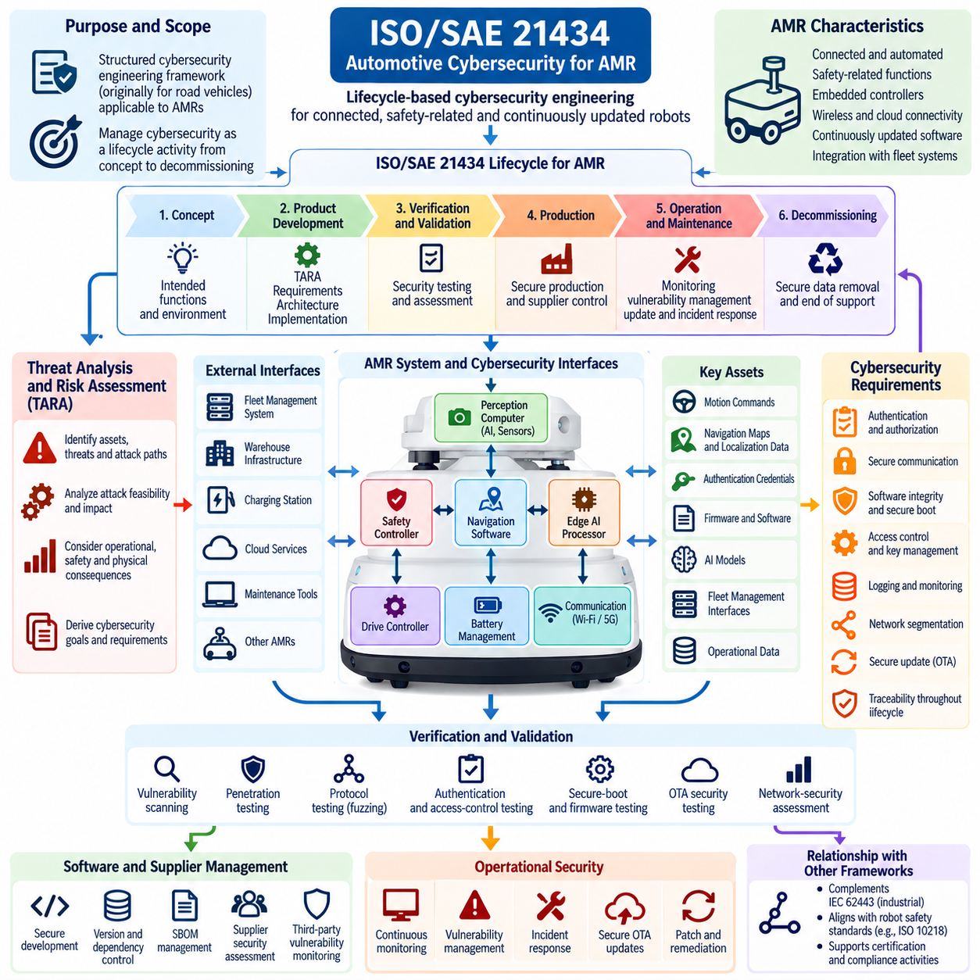
ISO/SAE 21434 provides a structured cybersecurity engineering framework originally developed for road-vehicle systems, but many of its lifecycle principles can be meaningfully applied to Autonomous Mobile Robots (AMRs) when they incorporate automotive-derived electronic architectures, embedded controllers, wireless connectivity, safety-related functions, and continuously updated software. For AMRs, the framework can help establish cybersecurity activities from concept development through production, operation, maintenance, and decommissioning.
The most important adaptation is to treat the AMR as a connected cyber-physical product rather than simply as a mobile machine. An AMR may contain drive controllers, battery-management systems, perception computers, safety controllers, navigation software, wireless interfaces, edge AI processors, fleet-management clients, and OTA update mechanisms. Cybersecurity analysis therefore needs to consider how compromise of one component could propagate into navigation, motion, fleet coordination, or other physically consequential functions.
ISO/SAE 21434 emphasizes cybersecurity throughout the product lifecycle. For an AMR program, cybersecurity should therefore begin during concept development rather than after hardware and software architectures have already been finalized. Early activities should identify intended functions, operational environments, external interfaces, assets, potential attack paths, and cybersecurity goals. These activities provide the foundation for later architectural decisions and help prevent security requirements from becoming isolated additions to an established robot design.
A central activity is the Threat Analysis and Risk Assessment (TARA). For an AMR, TARA should identify valuable assets such as motion commands, navigation maps, localization data, authentication credentials, firmware, AI models, fleet-management interfaces, and operational data. Potential attack paths can include wireless networks, maintenance ports, cloud APIs, debugging interfaces, removable media, compromised software components, and communication between robots. The resulting risk analysis should connect attack feasibility and potential impact to concrete cybersecurity requirements.
The consequences of an AMR cybersecurity compromise can differ significantly from those of a conventional information system. Unauthorized manipulation of navigation data could cause route deviation, while manipulation of motion commands could create collision or equipment-damage risks. Compromise of fleet-management credentials could affect many robots simultaneously. The cybersecurity assessment should therefore consider not only confidentiality and data loss but also integrity, availability, operational disruption, safety interaction, and potential physical consequences.
Cybersecurity goals derived from TARA should be translated into technical requirements that can be allocated to the AMR architecture. These requirements may concern authentication, authorization, secure communication, software integrity, secure boot, protected diagnostics, access control, key management, logging, intrusion detection, update security, and network segmentation. Requirements should remain traceable from the original cybersecurity concern through system architecture, hardware and software implementation, verification, and final operational evidence.
The concept of cybersecurity interfaces is particularly important for AMRs because they interact with many external systems. An AMR may communicate with fleet-management software, warehouse infrastructure, charging stations, wireless networks, cloud services, maintenance tools, and other robots. Each interface represents a potential trust boundary. The architecture should therefore define which entities are trusted, how they authenticate one another, which commands are permitted, and how communication is protected against interception, modification, replay, or unauthorized injection.
Cybersecurity should also be considered at the component and software level. Embedded controllers, operating systems, middleware, device drivers, communication stacks, AI applications, and third-party libraries can introduce vulnerabilities into the final AMR. Software composition should therefore be controlled through version management, dependency tracking, vulnerability monitoring, secure development practices, and Software Bill of Materials (SBOM) processes. The goal is to ensure that cybersecurity responsibility extends beyond proprietary robot software to the complete technology supply chain.
Verification and validation must demonstrate that cybersecurity requirements are actually implemented and effective. AMR cybersecurity testing can include vulnerability scanning, penetration testing, protocol testing, fuzzing, authentication testing, access-control verification, secure-boot validation, firmware-integrity testing, OTA security testing, and network-security assessment. Testing should reflect realistic operational conditions because a security mechanism that works in a laboratory environment may behave differently when the robot is connected to production infrastructure and fleet services.
Cybersecurity management continues after the AMR enters operation. Vulnerabilities may be discovered in operating systems, communication libraries, middleware, embedded components, cloud services, or third-party packages long after product release. A cybersecurity monitoring and incident-response process should therefore identify new threats, evaluate their relevance, prioritize remediation, and deploy validated patches. OTA mechanisms must preserve software authenticity and integrity while also preventing unauthorized downgrade or installation of untrusted software.
The relationship between ISO/SAE 21434 and other robotics cybersecurity frameworks should be handled as complementary rather than interchangeable. IEC 62443 can provide an industrial automation security perspective, while ISO/SAE 21434 contributes a structured automotive cybersecurity lifecycle and risk-management approach. For an AMR deployed in an industrial environment, combining these perspectives can help address both product-level cybersecurity engineering and system-level operational security. The robotics software structure already places ROS 2 security, edge AI security, cloud and fleet security, OTA security, testing, and compliance within connected lifecycle areas. Volume_24_Robot_Cybersecurity
For certification and audit preparation, cybersecurity evidence should be generated continuously throughout the AMR development lifecycle. Useful evidence includes TARA results, cybersecurity goals, requirements specifications, architecture decisions, interface definitions, implementation records, test results, vulnerability assessments, software and firmware versions, SBOM records, incident procedures, and update histories. Traceability is particularly important because it demonstrates that identified cybersecurity risks were translated into requirements and that those requirements were subsequently implemented and verified.
For AMR fleet operators, the lifecycle perspective becomes even more important because a deployed fleet represents a continuously changing cyber-physical environment. New robots, software releases, network configurations, cloud services, AI models, and operational integrations can alter the original threat landscape. Cybersecurity processes should therefore support controlled change, periodic risk reassessment, vulnerability management, incident learning, and secure retirement. Applied appropriately, ISO/SAE 21434 principles can provide AMR developers with a disciplined cybersecurity lifecycle that connects threat analysis, architecture, implementation, verification, deployment, and long-term operational assurance.

11.04. NIST CSF 2.0 Application to Robot Fleet [w/Code]
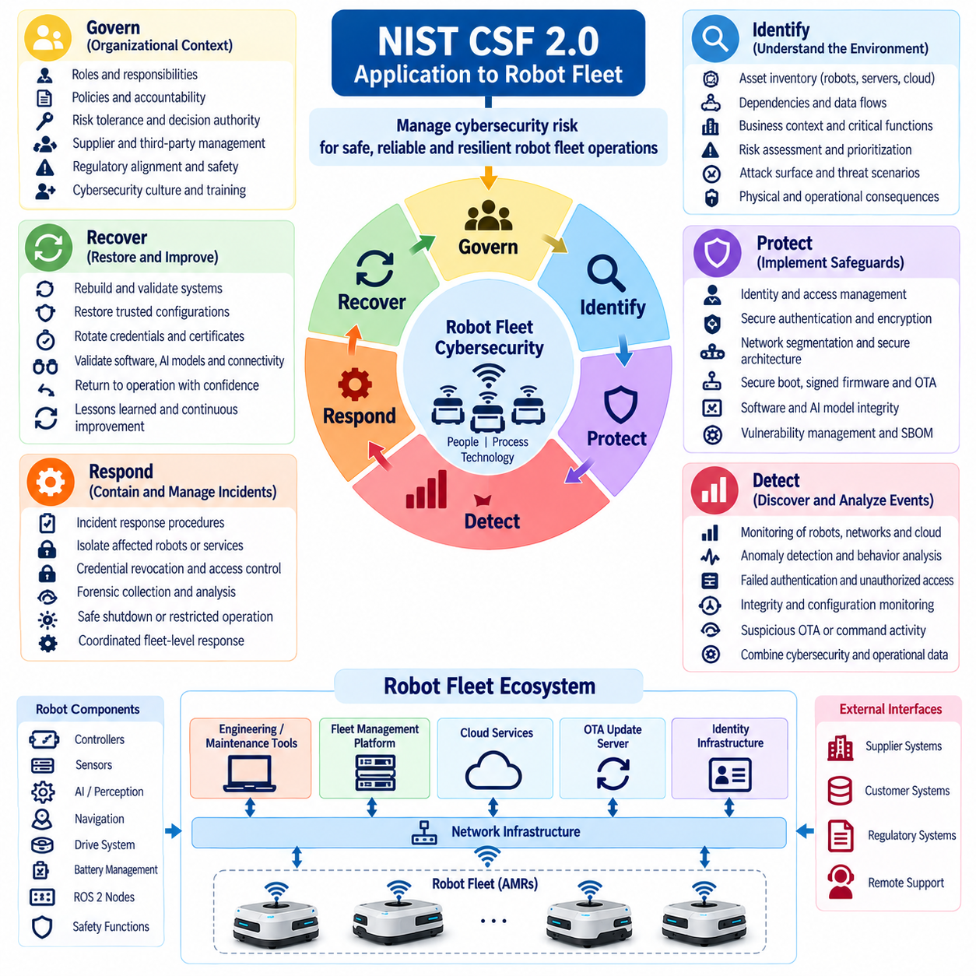
NIST Cybersecurity Framework 2.0 provides a flexible structure for managing cybersecurity risk across organizations, and its principles can be adapted effectively to robot fleets. For an autonomous fleet, cybersecurity cannot be limited to individual robot protection because robots depend on shared networks, fleet-management platforms, cloud services, maintenance systems, identity infrastructure, and software-update mechanisms. CSF 2.0 therefore provides a useful organizational framework for connecting technical controls with governance, risk management, operational processes, and continuous improvement.
The Govern function establishes the organizational context in which cybersecurity decisions are made. For a robot fleet, governance should define cybersecurity responsibilities, risk tolerance, policies, accountability, supplier expectations, and decision authority. Fleet operators need to establish who is responsible for robot identity, network security, software updates, AI model protection, incident response, and third-party services. Governance should also connect cybersecurity objectives with operational safety, business continuity, regulatory obligations, and the physical consequences of compromised robot behavior.
The Identify function focuses on understanding the assets, dependencies, risks, and business context that must be protected. In a robot fleet, this includes robot controllers, sensors, edge computers, batteries, navigation systems, ROS 2 nodes, AI models, fleet servers, cloud APIs, wireless infrastructure, charging stations, credentials, firmware, maps, telemetry, and operational data. Asset inventories should also capture relationships between robots and shared infrastructure because a weakness in a centralized service may create risks across the entire fleet.
The Identify function should also support risk assessment and prioritization. Not every robot component has the same cybersecurity importance, and not every vulnerability creates the same operational consequence. A fleet-management credential compromise may affect hundreds of robots, while a localized sensor vulnerability may affect only one platform. Risk analysis should therefore consider attack likelihood, exposure, operational dependency, physical consequences, recovery difficulty, and the scale of potential fleet impact when establishing cybersecurity priorities.
The Protect function converts identified risks into safeguards that reduce the likelihood or impact of cybersecurity incidents. For robot fleets, protection mechanisms can include strong identity management, least-privilege access, secure authentication, encryption, network segmentation, secure boot, signed firmware, protected AI models, secure configuration, credential management, and controlled OTA updates. These safeguards should be implemented as layers rather than relying on a single security mechanism, because robots operate across physical, embedded, network, edge, and cloud environments.
Protection must also extend to the software and AI lifecycle. Robot applications, ROS 2 packages, middleware, operating systems, firmware, AI models, configuration files, and third-party dependencies can all influence physical behavior. Secure development practices, vulnerability management, SBOM processes, code review, artifact signing, model integrity verification, and controlled deployment help maintain trustworthy software. The robotics cybersecurity structure connects these concerns across ROS 2 security, Edge AI security, cloud and fleet security, and OTA and firmware security. Volume_24_Robot_Cybersecurity
The Detect function establishes the capability to discover cybersecurity events and recognize abnormal behavior before incidents cause extensive damage. Fleet environments require monitoring at both individual-robot and centralized levels. Useful signals can include failed authentication attempts, unexpected network connections, abnormal command patterns, unauthorized configuration changes, unusual resource consumption, firmware-integrity violations, suspicious OTA activity, and deviations in communication between robots and fleet-management services.
Detection should account for the physical nature of robotic systems. A cybersecurity anomaly may appear not only as a conventional network event but also as unexpected robot behavior. Unusual motion commands, repeated navigation failures, abnormal task assignments, inconsistent telemetry, or unexpected actuator activity may provide additional indicators of compromise. Combining cybersecurity telemetry with operational and fleet data can therefore improve detection while helping distinguish ordinary robot faults from potentially malicious activity.
The Respond function defines how the organization contains and manages cybersecurity incidents after detection. A robot fleet requires response procedures that can isolate individual robots without unnecessarily disabling the entire operation. Response mechanisms may include network quarantine, credential revocation, certificate replacement, command restrictions, fleet-level access blocking, secure shutdown, forensic collection, and controlled deployment of remediation packages. Response decisions should account for safety, operational continuity, physical location, mission status, and the possibility that multiple robots are affected.
The Recover function focuses on restoring trustworthy operations after a cybersecurity incident. Recovery should not simply return a compromised robot to service; it should establish confidence that the robot, its software, credentials, configuration, and communication relationships are trustworthy again. Recovery may involve rebuilding software, restoring validated configurations, rotating credentials, reinstalling signed firmware, validating AI models, checking fleet connectivity, and conducting controlled functional tests before returning the robot to production.
NIST CSF 2.0 also supports the creation of organizational Profiles and Tiers that can help fleet operators express their current cybersecurity posture and desired future state. A robot fleet may establish a Current Profile representing existing capabilities and a Target Profile describing the security posture required for future deployment. The resulting gap analysis can prioritize improvements such as stronger authentication, improved monitoring, better asset visibility, more mature incident response, or stronger supply-chain controls.
For large fleets, CSF 2.0 should be applied at multiple levels rather than only at the individual robot level. A robot can have its own cybersecurity controls, while the fleet platform, cloud environment, network infrastructure, development pipeline, and supplier ecosystem require separate but connected risk management. Centralized services should receive particular attention because compromise of identity management, fleet APIs, OTA infrastructure, or command systems could create systemic consequences across many robots simultaneously.
NIST CSF 2.0 is therefore best used as an organizing framework that connects governance, asset understanding, protection, detection, response, and recovery across the complete robot fleet lifecycle. It does not replace detailed technical standards or robot-specific security mechanisms; instead, it provides a common structure for coordinating them. When combined with IEC 62443, ISO/SAE 21434, ROS 2 security practices, OTA controls, AI security, testing, and incident-response processes, the framework can provide a practical foundation for continuous cybersecurity management of autonomous robot fleets.

11.05. EU Cyber Resilience Act CRA for Robots
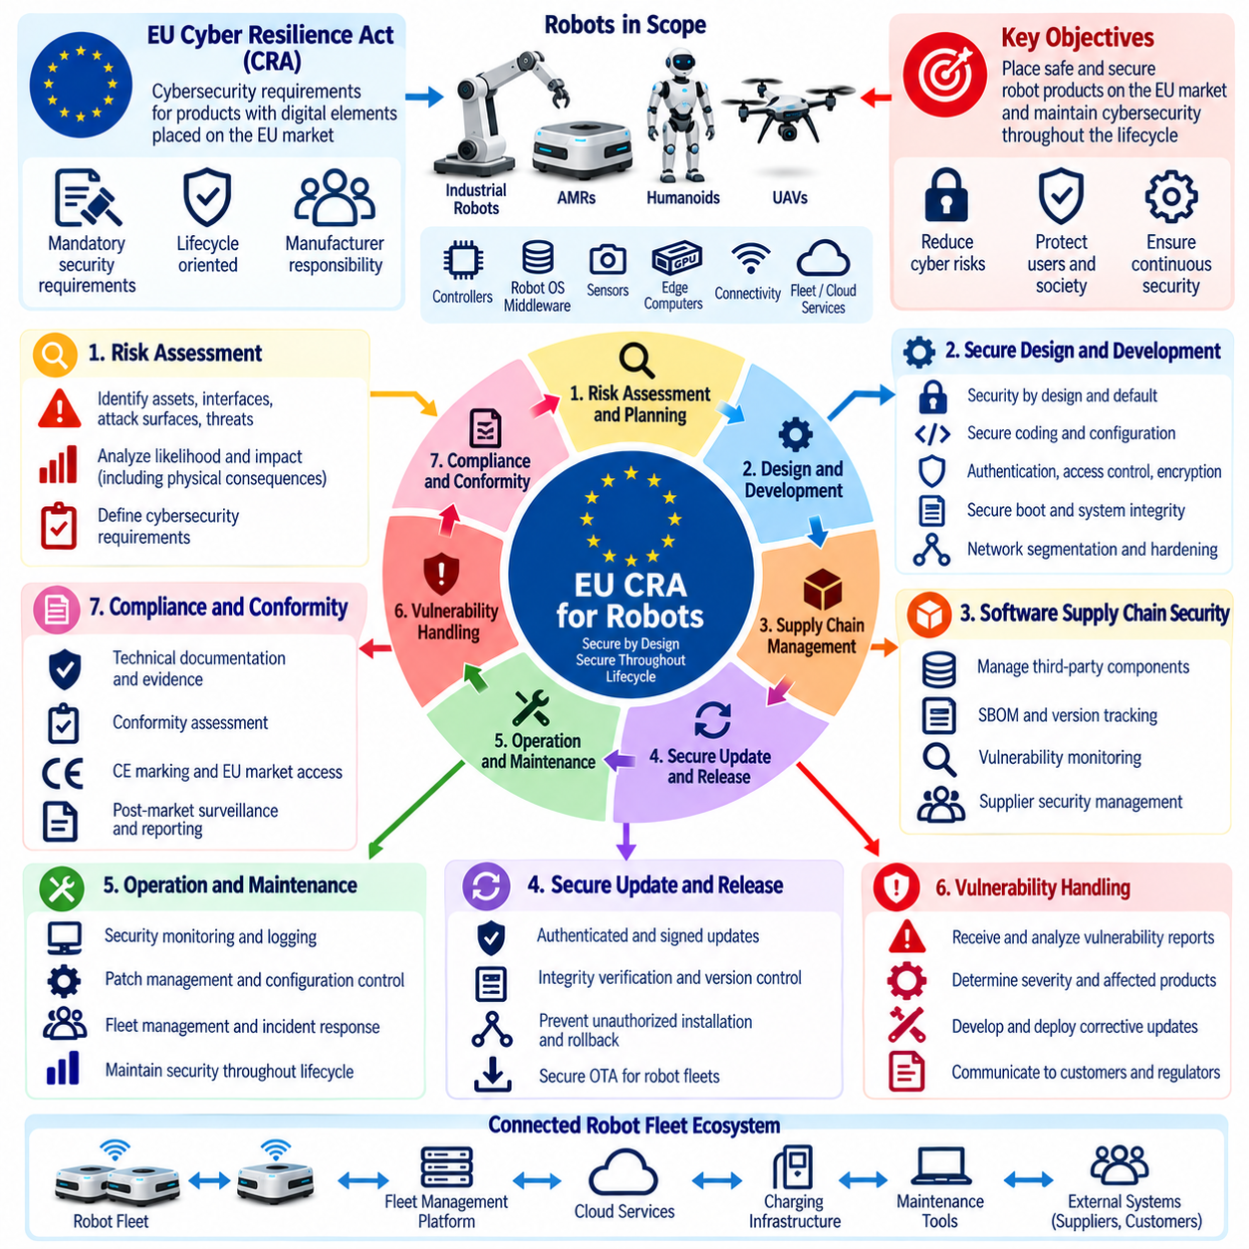
The European Union Cyber Resilience Act (CRA) establishes cybersecurity requirements for products with digital elements placed on the EU market, creating a lifecycle-oriented regulatory framework that is highly relevant to modern robot systems. For robots, this scope can include embedded controllers, robot operating software, communication interfaces, edge computers, fleet-management components, and connected services that form part of the product’s cybersecurity exposure. The CRA therefore shifts cybersecurity from an optional engineering feature toward a product-level responsibility.
For robotic manufacturers, the CRA is particularly important because modern robots are increasingly connected, software-defined, and continuously updated. An industrial robot, AMR, humanoid platform, or other autonomous machine may combine hardware, operating systems, middleware, AI software, wireless connectivity, cloud interfaces, and OTA mechanisms. A vulnerability in any of these elements can potentially affect physical operation. CRA-oriented engineering should therefore consider cybersecurity throughout the complete product lifecycle rather than concentrating only on pre-release testing.
A fundamental requirement is to identify and manage cybersecurity risks during product development. Robot manufacturers should analyze assets, interfaces, attack surfaces, vulnerabilities, foreseeable threats, and potential consequences before finalizing the system architecture. This process should consider both conventional cybersecurity consequences and physical consequences arising from compromised robot behavior. Unauthorized manipulation of navigation, motion, perception, configuration, or fleet commands may create safety, operational, financial, or privacy impacts that need to be incorporated into the cybersecurity risk assessment.
Security should be integrated into the design and development process through appropriate technical and organizational measures. For robots, these measures may include secure authentication, access control, encryption, secure boot, software integrity verification, protected credentials, network segmentation, vulnerability management, secure logging, hardened interfaces, and controlled update mechanisms. The appropriate combination depends on the product architecture and risk profile. Security controls should be designed into the system rather than added after functional development has been completed.
The CRA also places strong emphasis on vulnerability handling throughout the product lifecycle. Robot manufacturers need processes for receiving vulnerability information, analyzing affected components, determining severity, developing corrective measures, and distributing security updates. This is especially significant for robots that remain deployed for many years. A product that was secure when delivered may become vulnerable because of newly discovered weaknesses in operating systems, libraries, middleware, communication protocols, firmware, or third-party components.
Software supply-chain security is therefore an important part of CRA-oriented robot engineering. Modern robots frequently depend on open-source software, commercial middleware, hardware vendor packages, cloud services, AI frameworks, and external libraries. Manufacturers should maintain appropriate visibility into these dependencies and understand how vulnerabilities can propagate into the final product. Software Bill of Materials (SBOM), version tracking, vulnerability monitoring, dependency assessment, and controlled software release processes can support this responsibility.
The CRA approach also requires attention to secure update mechanisms. Robot software and firmware updates should be delivered through authenticated and integrity-protected channels so that attackers cannot substitute malicious packages. Update systems should verify package authenticity, protect signing keys, prevent unauthorized installation, and maintain reliable version control. Anti-rollback mechanisms can also be important where reverting to an older vulnerable version would reintroduce a known security weakness. These requirements are particularly relevant to autonomous robots because software updates can directly change physical behavior.
For connected robots, security boundaries between the robot, local infrastructure, fleet-management platform, and cloud services should be explicitly defined. Interfaces should use appropriate authentication and authorization rather than assuming that internal networks are inherently trustworthy. Fleet APIs, maintenance interfaces, wireless connections, charging infrastructure, and remote-management services can all become attack surfaces. A CRA-oriented architecture should therefore minimize unnecessary exposure and restrict communication and privileges according to operational necessity.
Manufacturers must also consider cybersecurity throughout the operational life of the robot. Security monitoring, vulnerability response, patch management, incident handling, and controlled configuration changes should remain active after deployment. For fleet environments, the organization should be capable of determining which robots are affected by a newly discovered vulnerability and deploying appropriate remediation without creating uncontrolled operational risk. Centralized fleet-management capabilities can improve response efficiency but must themselves be protected because their compromise could affect many robots simultaneously.
Conformity assessment and technical documentation are important elements of regulatory compliance. A manufacturer should be able to demonstrate how cybersecurity risks were identified, how security requirements were established, which controls were implemented, how the product was tested, and how vulnerabilities will be handled after release. Engineering records, architecture specifications, risk assessments, software versions, SBOM information, test results, update procedures, and vulnerability-management records can form part of the evidence supporting compliance.
The CRA should be considered together with the other cybersecurity frameworks used for robotics rather than treated as an isolated technical standard. IEC 62443 can provide industrial automation security concepts, ISO/SAE 21434 can contribute a structured cybersecurity lifecycle perspective for automotive-derived AMR architectures, and NIST CSF 2.0 can provide an organizational framework for cybersecurity risk management. The robotics cybersecurity structure places these subjects together within the compliance and certification chapter, alongside UAV cybersecurity, cybersecurity management systems, penetration testing, evidence packages, and certification planning. Volume_24_Robot_Cybersecurity
For AI-enabled robots, CRA-oriented cybersecurity should also consider the security implications of models, training data, inference software, model registries, and AI-dependent decision processes. Unauthorized modification of an AI model can change perception or decision behavior even when conventional application binaries remain intact. Model signing, protected model storage, controlled deployment, integrity verification, access control, and monitoring can therefore complement traditional software-security mechanisms and help maintain trustworthy robot behavior.
The practical objective is to make cybersecurity an accountable part of robot product engineering from concept through end of life. Risk assessment establishes the threats and required protections, secure architecture allocates controls, development processes implement them, testing verifies their effectiveness, and operational processes maintain security after deployment. For manufacturers targeting the EU market, the Cyber Resilience Act therefore provides a regulatory driver for establishing a disciplined cybersecurity lifecycle that connects product design, vulnerability management, software supply-chain security, secure updates, technical evidence, and long-term robot security.

11.06. DO 326A Airworthiness Cybersecurity for UAV [w/Code]
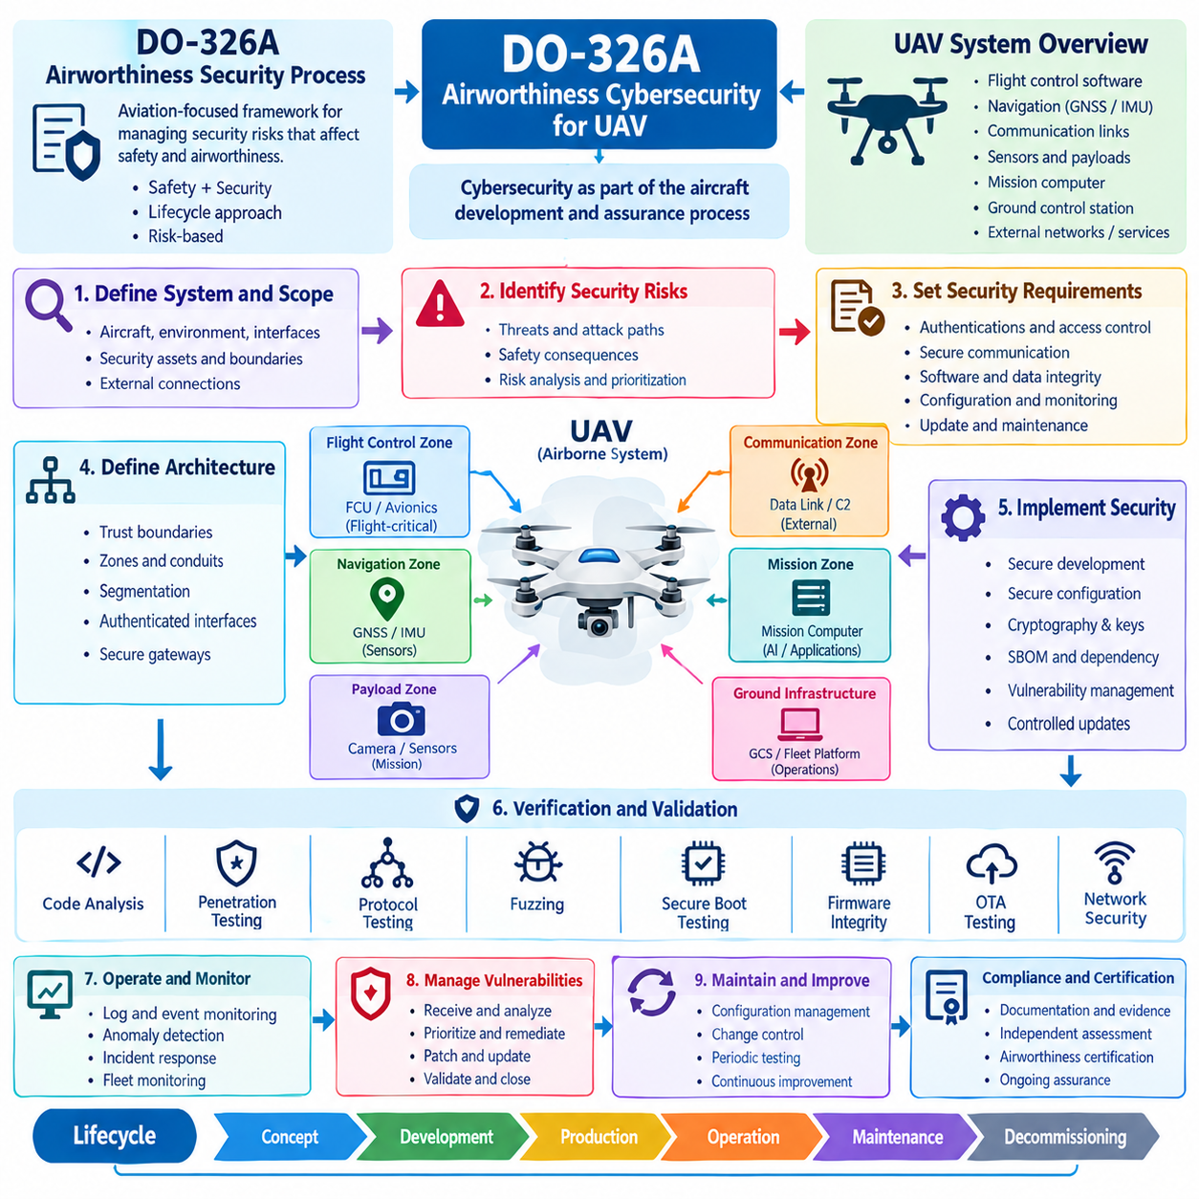
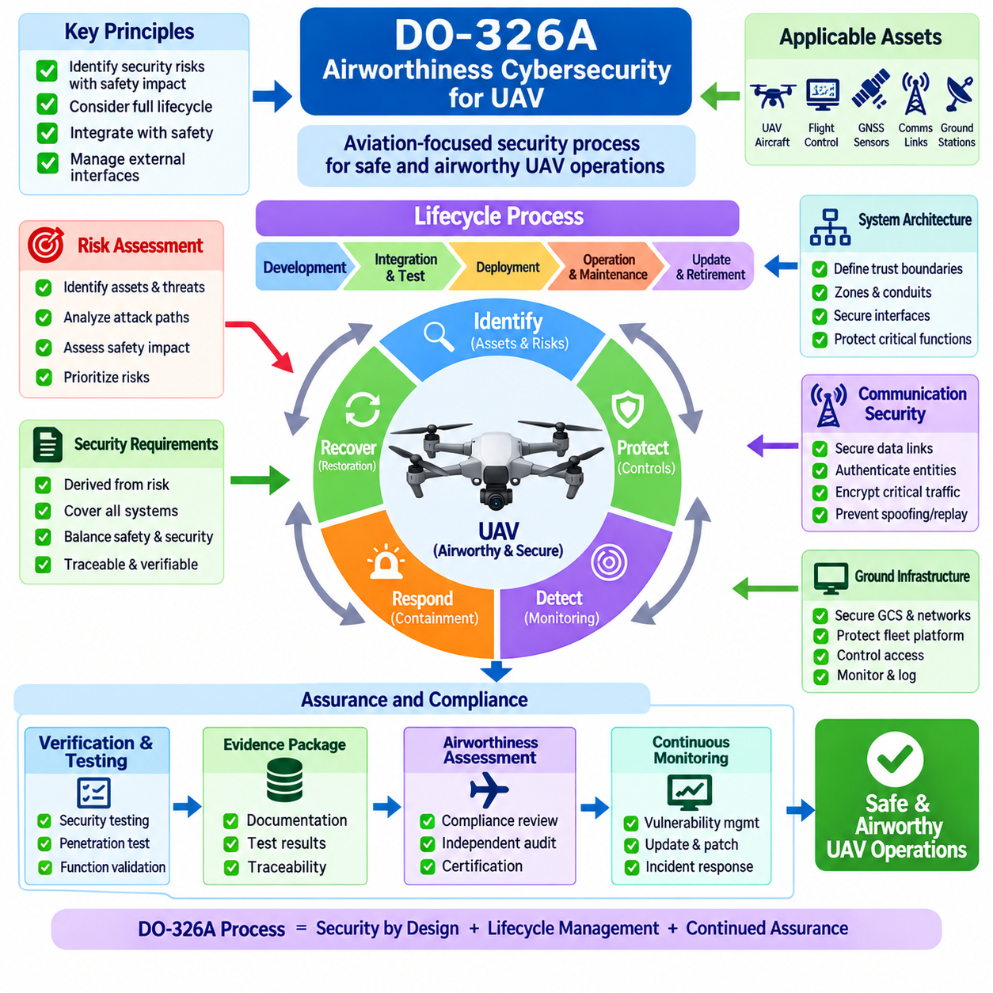
DO-326A, Airworthiness Security Process Specification, provides an aviation-focused framework for managing security risks that could affect the safety and airworthiness of airborne systems. For Unmanned Aerial Vehicles (UAVs), its principles are particularly relevant because modern aircraft depend on flight-control computers, navigation systems, communication links, sensors, software, data networks, and ground infrastructure. Cybersecurity must therefore be treated as part of the aircraft development and assurance process rather than as an independent information-technology activity.
A UAV cybersecurity program should begin by defining the aircraft system, operational environment, interfaces, and security-relevant assets. These may include flight-control software, navigation data, GNSS receivers, inertial sensors, telemetry links, command-and-control interfaces, mission computers, payload systems, maintenance ports, ground-control stations, and communication gateways. The analysis should also consider connections to external networks and services because an attack path may originate outside the aircraft and ultimately influence flight-related functions.
A key principle is to identify security risks that could have safety consequences. Conventional cybersecurity analysis may focus on confidentiality, integrity, and availability, but aviation security engineering must also consider how malicious manipulation could affect continued safe flight. Spoofed navigation information, unauthorized flight commands, corrupted configuration data, compromised flight software, or disruption of critical communication channels may create conditions that affect aircraft behavior. UAV security analysis should therefore establish explicit relationships between cybersecurity events and potential safety effects.
The security risk assessment should consider the UAV throughout its operational lifecycle. Threats may arise during development, manufacturing, integration, testing, deployment, maintenance, operation, software updates, and retirement. A UAV that is secure during certification may later acquire new vulnerabilities through software changes, communication-system modifications, new ground infrastructure, or newly discovered weaknesses in third-party components. Lifecycle security processes should therefore provide mechanisms for continuous assessment, controlled change, vulnerability management, and security assurance.
Security requirements should be derived from identified risks and allocated to the appropriate aircraft systems and interfaces. Requirements may address authentication, access control, communication protection, software integrity, configuration management, security monitoring, maintenance access, update mechanisms, and protection of critical data. For UAVs, these requirements should be carefully coordinated with existing flight-safety requirements because security mechanisms must not introduce unacceptable latency, resource consumption, failure modes, or dependencies into safety-critical functions.
The aircraft architecture should establish clear trust boundaries between flight-critical systems, mission systems, payloads, communication interfaces, and external infrastructure. A UAV may simultaneously support autonomous navigation, command-and-control communication, payload processing, telemetry, remote maintenance, and cloud-based mission services. These functions should not automatically share unrestricted trust. Segmentation, controlled gateways, authenticated interfaces, and appropriately restricted data flows can limit the ability of a compromised subsystem to propagate into safety-critical aircraft functions.
Software security is particularly important because modern UAVs increasingly depend on complex software and AI-enabled functions. Flight-control applications, operating systems, middleware, navigation software, perception algorithms, mission applications, and third-party libraries can introduce vulnerabilities. Secure development practices, configuration control, software integrity verification, dependency management, vulnerability tracking, and controlled release processes should therefore be integrated with the aircraft development lifecycle.
Secure software and firmware updates require special attention because UAVs may operate remotely and remain deployed for extended periods. Update packages should be authenticated and integrity-protected before installation, while signing credentials and trusted verification mechanisms must be protected. The update process should also provide reliable version control and appropriate recovery mechanisms. Where safety or security requires it, unauthorized downgrade to an earlier vulnerable software version should be prevented.
Communication security is another major concern for UAV airworthiness. Command-and-control links, telemetry channels, navigation-related interfaces, maintenance connections, and data links can expose the aircraft to interception, manipulation, replay, denial-of-service, or unauthorized command injection. Security controls should protect the authenticity and integrity of critical messages while preserving the timing and availability characteristics required for flight operations. Security architecture should therefore be evaluated together with communication and flight-control performance.
Ground infrastructure must also be included in the cybersecurity boundary. A UAV can be exposed through its ground-control station, operator workstation, mission-planning system, maintenance equipment, network gateway, or fleet-management platform. Compromise of ground infrastructure may provide an attacker with a path toward aircraft systems even when the airborne platform itself is strongly protected. Consequently, airworthiness cybersecurity should consider the complete operational ecosystem rather than evaluating the aircraft in isolation.
Verification and assurance activities should provide objective evidence that cybersecurity requirements have been correctly implemented and that identified risks have been adequately controlled. Relevant activities may include architecture reviews, security analyses, vulnerability assessment, penetration testing, interface testing, communication-security testing, software-integrity verification, configuration audits, and controlled security testing of ground and airborne systems. Test evidence should remain traceable to the corresponding security requirements and risk assessments.
Security assurance should also address interactions between cybersecurity and functional safety. A cybersecurity control cannot be considered successful merely because it blocks an attack if the control itself creates an unsafe aircraft condition. For example, aggressive network filtering, authentication failure, loss of connectivity, certificate expiration, or security-triggered system isolation may affect flight behavior. UAV cybersecurity engineering should therefore analyze degraded modes, fail-safe behavior, recovery mechanisms, and operational procedures for security-related failures.
For UAV fleets, the scope expands from a single aircraft to shared services and common dependencies. Fleet-management servers, identity systems, certificate authorities, OTA infrastructure, mission databases, and centralized command services can become high-value targets. A compromise of common infrastructure may affect multiple aircraft simultaneously. Fleet cybersecurity should therefore incorporate isolation, credential separation, controlled command authorization, monitoring, incident response, and recovery mechanisms that limit the propagation of a single compromise.
DO-326A-oriented security engineering should ultimately produce a traceable body of assurance evidence connecting threats, security objectives, requirements, architecture, implementation, verification, and operational controls. This evidence supports airworthiness-related decision making and provides a structured basis for demonstrating that cybersecurity risks have been systematically addressed. For UAV programs, the objective is not simply to add cybersecurity controls, but to establish security as an integrated part of the aircraft development and continued-airworthiness process.
Within the broader robotics cybersecurity structure, DO-326A provides an aviation-specific perspective that complements industrial and general cybersecurity frameworks. The compliance chapter places UAV airworthiness cybersecurity alongside IEC 62443, ISO/SAE 21434, NIST CSF 2.0, the EU Cyber Resilience Act, cybersecurity management systems, penetration testing, evidence packages, and certification planning. Volume_24_Robot_Cybersecurity This positioning allows UAV cybersecurity to be treated as part of a broader lifecycle in which technical security, safety assurance, operational security, and certification evidence are developed together.

11.07. Cybersecurity Management System CSMS Build
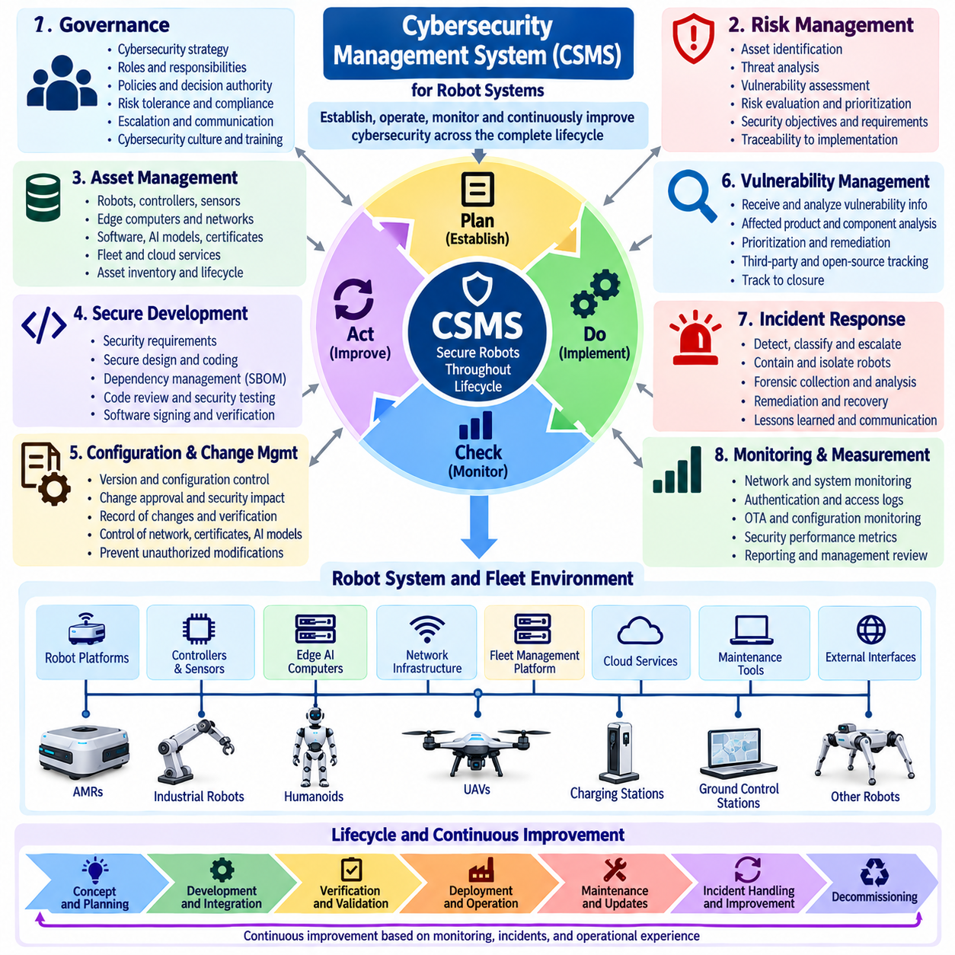
A Cybersecurity Management System (CSMS) provides an organizational framework for establishing, operating, monitoring, and continuously improving cybersecurity across the complete lifecycle of a robot system. For robotics, a CSMS should connect cybersecurity governance with engineering, software development, fleet operations, maintenance, incident response, and certification activities. Rather than treating cybersecurity as an isolated technical function, the CSMS establishes repeatable processes that define responsibilities, manage risk, control changes, preserve evidence, and maintain an appropriate security posture throughout the operational life of the robot.
The foundation of a CSMS is organizational governance. The organization should define cybersecurity objectives, responsibilities, decision authority, risk tolerance, policies, and escalation procedures before technical controls are evaluated. Responsibilities should extend across product engineering, embedded software, AI development, network operations, cloud and fleet management, quality assurance, maintenance, and incident response. For robot systems, governance should also recognize that cybersecurity failures may produce physical consequences, operational disruption, safety impacts, or fleet-wide effects, making cybersecurity decisions part of broader engineering and operational management.
A CSMS should establish a consistent cybersecurity risk-management process. Risk identification should consider the robot, its software, hardware, communications, supporting infrastructure, users, suppliers, and external services. Threat analysis should identify valuable assets, trust boundaries, attack surfaces, vulnerabilities, potential attack paths, and consequences of compromise. Risk decisions should then be translated into security objectives and requirements that can be assigned to appropriate systems and teams. This creates traceability between business or operational concerns and technical cybersecurity implementation.
Asset management is an essential CSMS capability because effective cybersecurity requires accurate knowledge of what must be protected. A robotics organization should maintain information about robot platforms, controllers, sensors, edge computers, firmware, operating systems, ROS 2 nodes, AI models, network devices, fleet services, cloud APIs, credentials, certificates, and third-party software. Asset information should remain current as robots are added, upgraded, relocated, repurposed, or retired. For large fleets, centralized visibility is especially important because shared infrastructure can create common points of failure across many robots.
The CSMS should integrate secure development practices into the product engineering lifecycle. Security requirements should be established during architecture and design, implemented through controlled development processes, and verified before release. Code review, dependency management, vulnerability analysis, secure configuration, software signing, SBOM management, and security testing should become repeatable engineering activities. The robotics cybersecurity structure places software security, ROS 2 security, edge AI security, cloud and fleet security, OTA security, and cybersecurity testing in connected lifecycle areas, providing a practical basis for integrating these activities into a broader management system. Volume_24_Robot_Cybersecurity
Configuration and change management are equally important because robot systems continuously evolve after deployment. Software versions, firmware, network policies, certificates, AI models, maps, security configurations, and fleet services may all change during normal operation. The CSMS should require security-impact analysis before significant changes are introduced and should maintain records showing what changed, why it changed, who authorized it, and how the resulting configuration was verified. This prevents uncontrolled modifications from silently weakening the security posture of deployed robots.
Vulnerability management should operate as a continuous process rather than an occasional scanning exercise. The organization should receive vulnerability information, determine which products and components are affected, assess exploitability and operational consequences, prioritize remediation, and track corrective actions through closure. Third-party software and open-source dependencies require particular attention because vulnerabilities may emerge after the robot has already entered service. The CSMS should provide a mechanism for connecting external vulnerability information with internal asset inventories, software versions, risk assessments, and remediation plans.
Incident response should be integrated directly into the CSMS rather than treated as a separate emergency activity. The organization should define how cybersecurity events are detected, classified, escalated, investigated, contained, eradicated, and recovered. Robot-specific procedures may include isolating a robot from the network, revoking credentials, replacing certificates, restricting fleet commands, preserving forensic evidence, deploying trusted software, or temporarily removing a robot from operation. Response procedures should account for physical location, mission status, safety conditions, fleet dependencies, and the possibility that a common service has compromised multiple robots.
A mature CSMS should also establish security monitoring and performance measurement. Monitoring should cover relevant network events, authentication activity, configuration changes, software integrity, OTA operations, fleet commands, resource anomalies, and other indicators appropriate to the system risk profile. Performance measures can evaluate vulnerability remediation time, patch coverage, unresolved high-risk findings, authentication failures, incident response performance, security-test results, and compliance evidence completeness. Metrics should support decision making rather than simply demonstrate that monitoring exists.
Supplier and supply-chain management should be included because robot manufacturers and operators frequently depend on external hardware, firmware, software, AI frameworks, cloud services, communication components, and maintenance providers. The CSMS should establish appropriate cybersecurity expectations for suppliers and define how security information is exchanged. Supplier assessments can consider secure development practices, vulnerability disclosure, update support, component provenance, SBOM availability, authentication mechanisms, and end-of-life policies. Supply-chain assurance becomes particularly important when a common component is deployed across a large fleet.
Training and cybersecurity awareness are another essential CSMS element. Engineers, operators, maintenance personnel, administrators, and security teams interact with different parts of the robot environment and therefore require role-appropriate knowledge. Training should address secure credential handling, maintenance access, incident reporting, phishing and social engineering, software-update procedures, remote access, configuration control, and recognition of abnormal robot behavior. Technical teams may additionally require specialized training in ROS 2 and DDS security, embedded security, AI security, network defense, and secure OTA operations.
The CSMS should maintain an auditable body of cybersecurity evidence throughout the lifecycle. Evidence may include policies, risk assessments, threat models, security requirements, architecture reviews, configuration records, test reports, vulnerability records, incident reports, training records, supplier assessments, software versions, SBOMs, update histories, and corrective-action records. Evidence should be generated as part of normal engineering and operational activities rather than reconstructed immediately before an audit. This approach improves both operational discipline and readiness for third-party assessment or certification.
Continuous improvement is the final characteristic of an effective CSMS. Security requirements and controls should be periodically reviewed using information from incidents, vulnerability disclosures, penetration tests, operational monitoring, technology changes, supplier findings, and lessons learned. Significant changes in robot architecture, AI capabilities, connectivity, fleet scale, or deployment environment should trigger appropriate reassessment. The CSMS should therefore function as a feedback system in which operational experience continuously improves risk analysis, controls, testing, response procedures, and organizational practices.
Within the broader compliance and certification structure, the CSMS connects individual cybersecurity standards and technical controls into a coherent management process. IEC 62443 can provide industrial security requirements, ISO/SAE 21434 can support lifecycle-oriented cybersecurity engineering for applicable AMR architectures, NIST CSF 2.0 can organize cybersecurity risk-management activities, and regulatory or aviation frameworks can introduce additional obligations. The chapter structure places CSMS development alongside security-level assessment, regulatory compliance, penetration testing, evidence management, and certification planning, reflecting the need to manage cybersecurity as an integrated organizational capability. Volume_24_Robot_Cybersecurity
For a robotics organization, the practical objective of a CSMS is to create a repeatable system in which cybersecurity responsibilities, risks, requirements, implementation, verification, operation, incident response, and improvement remain connected. A successful CSMS does not depend on a single security product or one-time certification event. It establishes an enduring management discipline that follows the robot from concept and development through deployment, fleet operation, maintenance, software and AI updates, incident recovery, and eventual retirement. This lifecycle discipline provides the foundation for demonstrating that cybersecurity is continuously governed, measured, improved, and supported by objective evidence.

11.08. Penetration Test and Third Party Audit Process
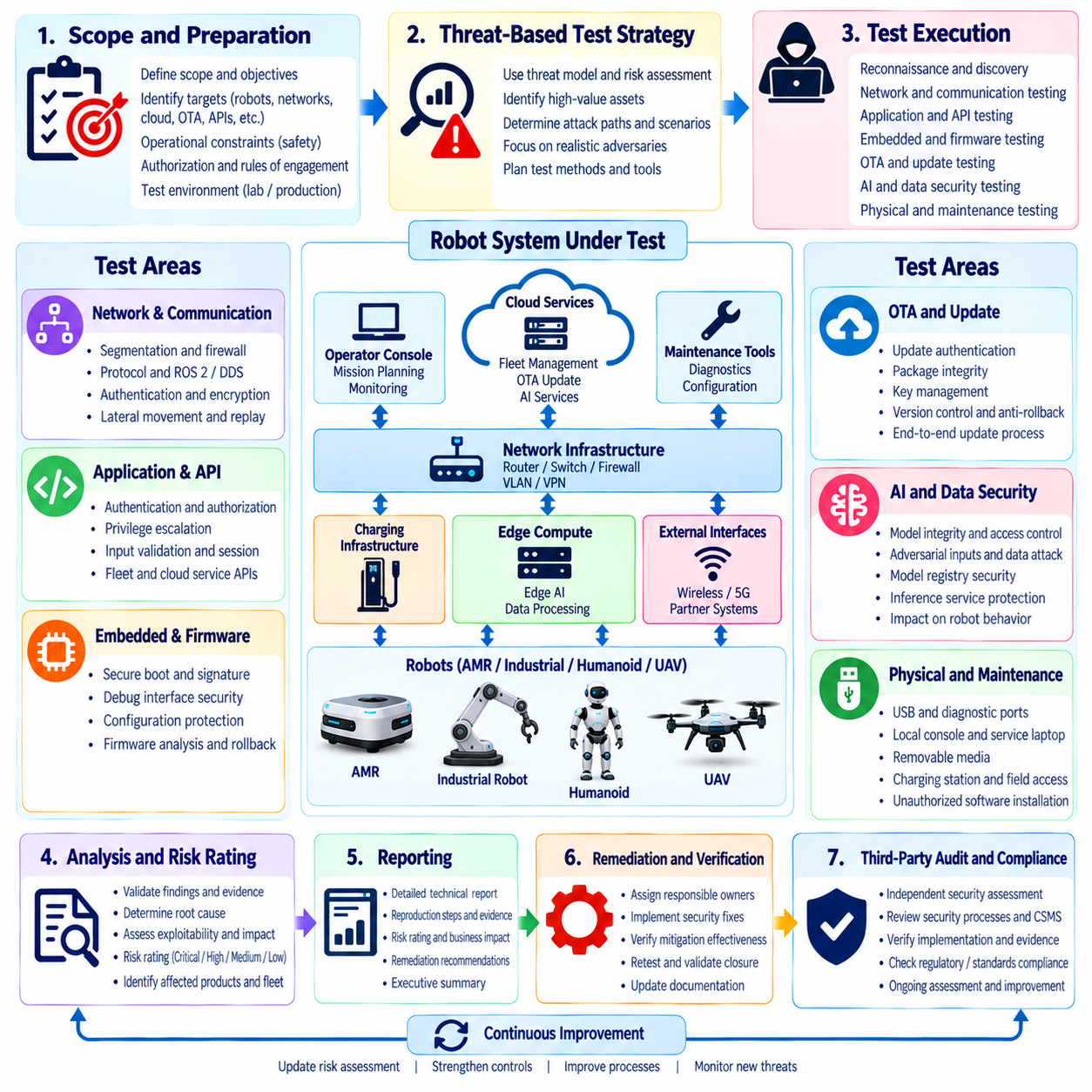
Penetration testing and third-party auditing provide independent assurance that a robot system’s cybersecurity controls are not only documented but also implemented and effective under realistic conditions. For robotics, these activities should cover the complete cyber-physical environment, including robot hardware, embedded software, ROS 2 and DDS communication, networks, edge computing, cloud and fleet services, OTA infrastructure, AI components, and maintenance interfaces. The objective is to identify weaknesses that internal development and verification activities may not detect.
A penetration test should begin with clearly defined scope, authorization, objectives, and operational constraints. Robot systems can contain safety-critical functions, so testing must distinguish between systems that may be actively exercised and those that require simulation, laboratory replicas, or controlled test environments. The scope should identify target robots, network segments, APIs, wireless interfaces, fleet services, update systems, and external dependencies while explicitly defining prohibited actions that could create unsafe physical behavior.
The test strategy should be based on the robot’s threat model and risk assessment rather than on generic vulnerability scanning alone. High-value assets, trust boundaries, exposed interfaces, authentication mechanisms, command channels, update paths, and centralized fleet services should receive appropriate attention. The testing team should consider realistic attack paths that could move from an externally accessible interface toward internal robot functions. This approach helps evaluate whether layered defenses actually prevent meaningful attack progression.
Reconnaissance and attack-surface discovery establish the technical environment before deeper testing begins. Testers should identify active services, communication protocols, exposed ports, APIs, wireless interfaces, authentication endpoints, software versions, and relationships between robot and infrastructure components. For a fleet, the assessment should also identify shared services whose compromise could affect multiple robots. Findings should be correlated with the authorized asset inventory so that unknown or unexpected exposure can be investigated rather than ignored.
Network and communication testing should examine whether segmentation, firewalls, access-control policies, VPNs, authenticated middleware, and encrypted communication actually enforce intended security boundaries. Testing may evaluate unauthorized lateral movement, protocol manipulation, weak authentication, replay conditions, malformed messages, and improper access between operational zones. ROS 2 and DDS environments require particular attention to node identity, topic and service authorization, certificate handling, and communication protection because middleware access can directly influence distributed robot behavior.
Application and API testing should examine interfaces used by robot applications, fleet-management systems, cloud services, maintenance tools, and operator consoles. Authentication and authorization controls should be tested for privilege escalation, session weaknesses, insecure direct access, inadequate input validation, and unauthorized command execution. Fleet APIs deserve special attention because a weakness in centralized command or management services may allow an attacker to influence many robots simultaneously rather than only one device.
Embedded and firmware testing should examine mechanisms that protect the integrity of software running on robot controllers and edge computers. Relevant areas include secure boot, firmware authentication, debug interfaces, configuration protection, update verification, key storage, rollback controls, and recovery mechanisms. Where appropriate, firmware analysis and controlled testing can determine whether an attacker could replace, modify, downgrade, or otherwise manipulate software in ways that alter robot behavior or bypass established security controls.
OTA security should be tested as an end-to-end process rather than only as a package-validation function. The assessment should examine update authentication, package integrity, signing-key protection, authorization of update requests, transport security, version enforcement, rollback prevention, failure recovery, and audit logging. A secure package format is insufficient if an attacker can obtain update authority, compromise the distribution mechanism, or force a robot to install an unauthorized version.
AI-enabled robots introduce additional testing requirements because security failures may originate in perception, models, data, or decision-making processes. Testing can examine unauthorized model replacement, insecure model loading, model-registry access, adversarial inputs, data-integrity weaknesses, and insufficient controls around AI inference services. The objective is not to treat AI testing as a separate discipline, but to determine whether compromise of AI components could cross established security boundaries and produce unauthorized physical actions.
Physical and maintenance interfaces should also be included when they are within the authorized scope. USB ports, diagnostic connectors, service laptops, local consoles, removable media, charging infrastructure, and maintenance networks can provide alternative paths around network-based security controls. Testing should determine whether physical access provides excessive privileges or enables unauthorized software installation, configuration changes, credential extraction, or disabling of security mechanisms. Such testing must be carefully controlled because the same interfaces may directly affect operational robot functions.
Third-party auditing provides an independent perspective that complements internal penetration testing. An external assessor can review cybersecurity governance, risk assessments, architecture decisions, technical controls, testing evidence, vulnerability management, incident procedures, configuration management, and lifecycle processes without being constrained by the assumptions of the development organization. Independence is particularly valuable when preparing for certification, customer security assessments, regulatory obligations, or high-assurance industrial and aviation deployments.
The audit process should connect documentary evidence with technical verification. Policies and procedures should be checked against actual implementation, while selected technical controls should be sampled or tested to confirm that documented requirements are reflected in deployed systems. Evidence may include threat models, security requirements, architecture records, access-control policies, configuration baselines, vulnerability reports, penetration-test results, software versions, SBOMs, OTA records, incident reports, and corrective-action histories. The audit should identify gaps between stated capability and demonstrated practice.
Findings should be classified according to severity, exploitability, affected assets, operational consequences, and potential physical impact. A vulnerability affecting a public-facing fleet API may require a different response from a weakness isolated to a laboratory interface. Findings should therefore be connected to the organization’s risk-management process rather than evaluated solely by technical severity. Each significant finding should have an assigned owner, remediation plan, target date, verification method, and documented closure decision.
Remediation should be followed by validation testing to determine whether the corrective action actually eliminates or sufficiently reduces the identified risk. Simply applying a patch or changing a configuration should not automatically close a finding. Retesting should confirm that the original attack path is blocked and that the remediation has not introduced new vulnerabilities, degraded required functionality, or created unexpected interactions with safety-critical systems. Evidence from retesting should remain linked to the original finding and corrective action.
Within the broader compliance and certification process, penetration testing and third-party auditing provide an important bridge between cybersecurity requirements and objective assurance. The robotics cybersecurity structure places this activity alongside IEC 62443, ISO/SAE 21434, NIST CSF 2.0, the EU Cyber Resilience Act, DO-326A, cybersecurity management systems, evidence packages, and certification planning. Volume_24_Robot_Cybersecurity This positioning emphasizes that testing is not an isolated security exercise, but part of a lifecycle process for demonstrating that robot cybersecurity controls are implemented, independently examined, corrected when necessary, and supported by auditable evidence.

11.09. Cybersecurity Documentation and Evidence Package
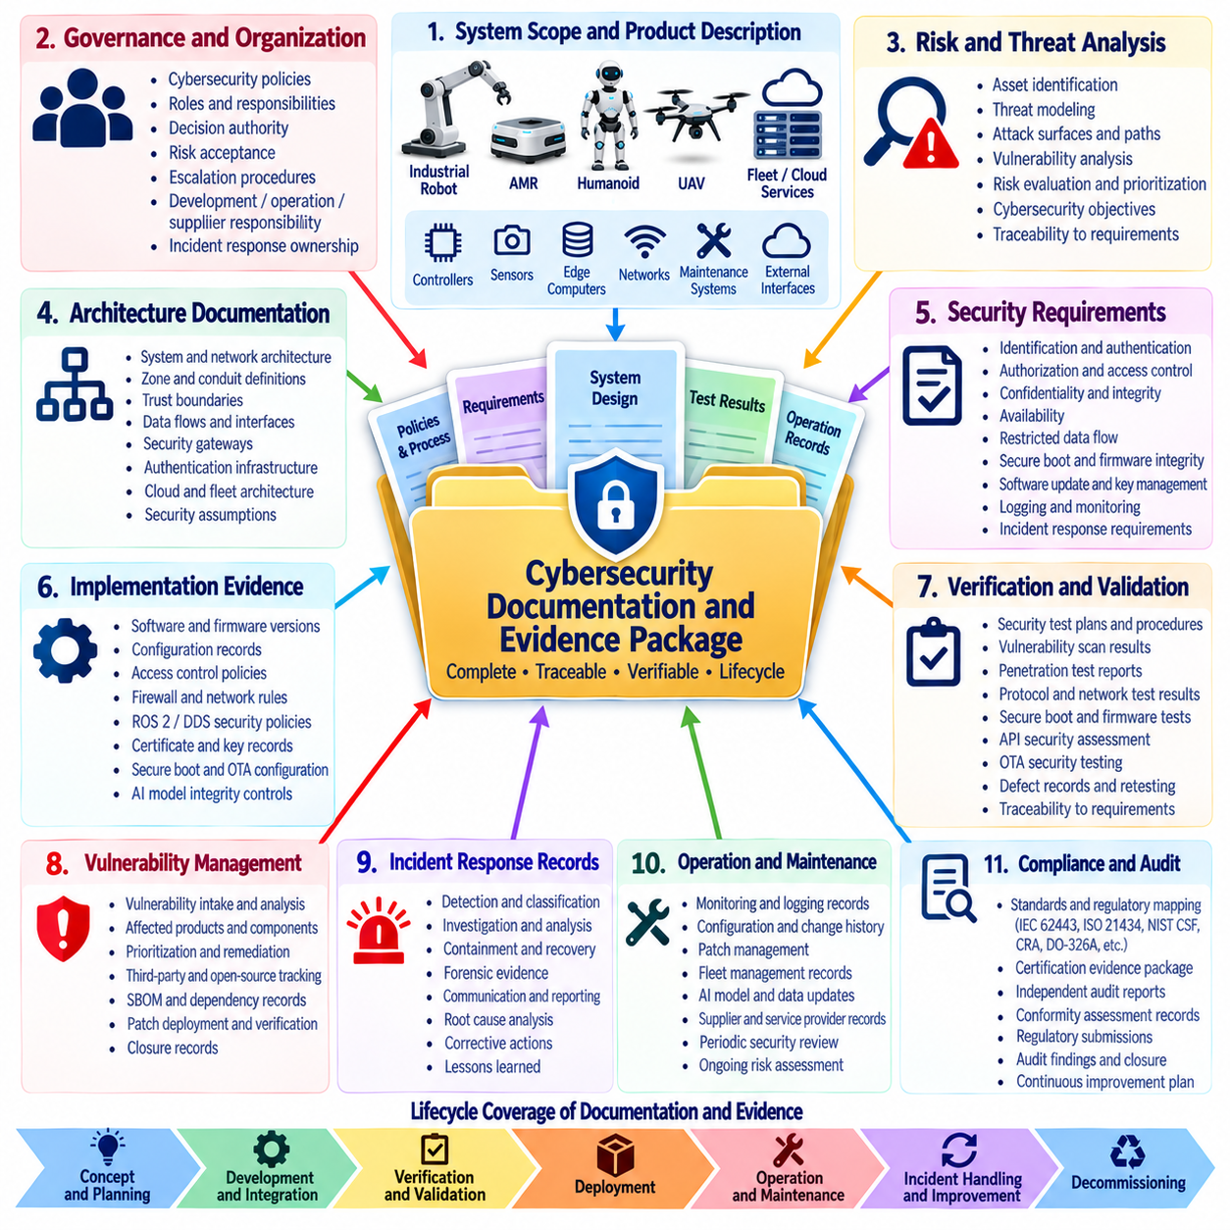
A cybersecurity documentation and evidence package provides the structured body of records needed to demonstrate that a robot system’s cybersecurity requirements have been identified, implemented, verified, maintained, and governed throughout its lifecycle. For robotics, documentation should cover the complete cyber-physical system rather than only software security. The package should connect cybersecurity governance, risk analysis, system architecture, security requirements, implementation records, testing, operational monitoring, vulnerability management, incident response, maintenance, and certification activities into a coherent and traceable body of evidence.
The evidence package should begin with a clearly defined system scope and product description. The documentation should identify the robot platform, major hardware and software components, communication interfaces, edge computers, controllers, sensors, AI components, network infrastructure, fleet services, cloud connections, maintenance systems, and external dependencies that fall within the cybersecurity boundary. For fleet deployments, shared services and common infrastructure should also be documented because a single compromised service may affect many robots. The scope establishes the foundation for determining which cybersecurity evidence must be collected and maintained.
Cybersecurity governance documentation should explain how responsibilities and decision authority are assigned within the organization. Relevant records may describe cybersecurity policies, organizational roles, risk acceptance authority, security objectives, escalation procedures, development responsibilities, operational responsibilities, supplier responsibilities, and incident-response ownership. The documentation should demonstrate that cybersecurity is managed as an organizational engineering responsibility rather than as an isolated technical activity. Clear ownership is particularly important when multiple teams control robot software, AI systems, networks, cloud infrastructure, fleet operations, and maintenance.
Risk and threat documentation provides the rationale for the security measures implemented in the robot system. Threat models should identify important assets, trust boundaries, attack surfaces, potential attack paths, threat scenarios, vulnerabilities, and potential consequences. Risk assessments should explain how identified risks were evaluated and prioritized. Where applicable, the package should preserve the relationship between threat analysis, cybersecurity objectives, security requirements, architectural decisions, implemented controls, and verification results. This traceability allows an assessor to determine why a control exists and whether it addresses the original cybersecurity concern.
Architecture documentation should describe how security is established across the robot system and its surrounding infrastructure. Relevant records may include system architecture descriptions, network architecture, zone and conduit definitions, trust boundaries, data flows, communication interfaces, security gateways, authentication infrastructure, cloud connections, fleet-management services, and external interfaces. The architecture evidence should make security assumptions visible and demonstrate how sensitive functions are separated or protected. For distributed robot systems, the documentation should also describe how trust is established between nodes, services, robots, operators, and centralized infrastructure.
Security requirements documentation should provide a controlled and traceable representation of the cybersecurity requirements allocated to the system. Requirements may address identification and authentication, authorization, confidentiality, integrity, availability, restricted data flow, secure boot, firmware integrity, software updates, logging, monitoring, key management, vulnerability handling, and incident response. Each significant requirement should have a defined implementation or verification relationship. Requirements should remain under configuration control so that changes can be identified, reviewed, approved, and evaluated for their cybersecurity impact.
Implementation evidence should demonstrate that the documented security requirements have actually been incorporated into the product. Depending on the robot architecture, this evidence may include software configuration records, firmware versions, cryptographic configuration, certificate records, access-control policies, firewall rules, ROS 2 and DDS security policies, secure-boot settings, OTA configuration, AI model integrity controls, and cloud security settings. Screenshots or configuration exports may be useful when they provide objective evidence of actual deployment, but they should be maintained with sufficient context to identify the system version, configuration state, and applicable requirement.
Verification and validation evidence demonstrates that cybersecurity controls operate as intended. The evidence package may contain security test plans, test procedures, test results, vulnerability scans, penetration-test reports, protocol tests, fuzzing results, secure-boot verification, firmware-integrity tests, API security assessments, network-security tests, and OTA security tests. Each result should identify the tested configuration and relevant software or firmware version. Failed tests should not simply disappear from the evidence package; they should be connected to defect records, corrective actions, retesting, and documented closure decisions.
Vulnerability-management records provide evidence that cybersecurity remains active after initial development and release. The documentation should show how vulnerabilities are received, analyzed, prioritized, assigned, remediated, verified, and closed. Software dependencies and third-party components should be traceable through appropriate version information and SBOM records where applicable. For fleet environments, vulnerability records should also demonstrate how affected robot populations are identified and how remediation decisions are applied consistently across different configurations, software versions, and deployment environments.
Change and configuration-management evidence is necessary because robot systems continuously evolve. Software, firmware, AI models, network policies, certificates, configuration parameters, maps, fleet services, and security controls may change throughout operational life. Records should show what changed, why the change was required, who approved it, which systems were affected, and how cybersecurity impact was evaluated. Where security-relevant changes require additional testing or risk assessment, the resulting evidence should remain linked to the change record. This creates a historical record of the security state of the deployed system.
Incident-response and operational evidence demonstrates that the organization can manage cybersecurity events after deployment. Relevant records may include incident reports, detection alerts, investigation records, containment actions, forensic evidence, credential revocation records, software remediation records, recovery tests, and lessons learned. The documentation should demonstrate that incident handling is connected to established procedures and that significant incidents can trigger changes to threat models, security requirements, monitoring rules, or operational controls. This converts operational experience into measurable cybersecurity improvement.
Supplier and supply-chain evidence should document the security characteristics of externally provided components and services. Robot systems may depend on processors, operating systems, middleware, communication modules, cloud services, AI frameworks, open-source libraries, firmware, and maintenance providers. Evidence may include supplier security assessments, contractual requirements, vulnerability-disclosure arrangements, component versions, SBOM information, update commitments, end-of-life notifications, and security advisories. The objective is to establish sufficient visibility into external dependencies to determine how supplier vulnerabilities could affect the robot system.
The evidence package should be managed under formal document and configuration control. Each significant artifact should have an identifiable owner, version, approval status, applicable system or product release, and appropriate retention information. Obsolete records should remain distinguishable from current evidence rather than being silently overwritten. Security evidence should also be protected against unauthorized modification because the integrity of the evidence itself may become relevant during an audit, certification activity, incident investigation, or dispute concerning the security state of a deployed robot.
For third-party assessment and certification, the evidence package should allow an independent reviewer to move from a cybersecurity objective to its supporting requirement, architecture decision, implementation record, verification result, and operational evidence. This traceability is particularly important because compliance cannot be demonstrated effectively through isolated documents. The package should instead show a consistent chain of reasoning and evidence across the lifecycle. The compliance and certification structure explicitly places cybersecurity documentation and evidence alongside Security Level assessment, regulatory frameworks, penetration testing, CSMS development, and certification planning. Volume_24_Robot_Cybersecurity
The final objective is to make cybersecurity evidence a normal output of robot engineering and operations rather than a collection assembled immediately before an audit. Documentation should be generated as risks are analyzed, requirements are defined, architecture is developed, software and firmware are implemented, tests are executed, vulnerabilities are resolved, incidents are handled, and changes are approved. When maintained continuously, the evidence package becomes a living representation of the robot’s cybersecurity posture and provides the foundation for demonstrating compliance, supporting certification decisions, accelerating audits, and maintaining trustworthy operation throughout the complete robot lifecycle.

11.10. Cybersecurity Certification Roadmap Hills Robotics
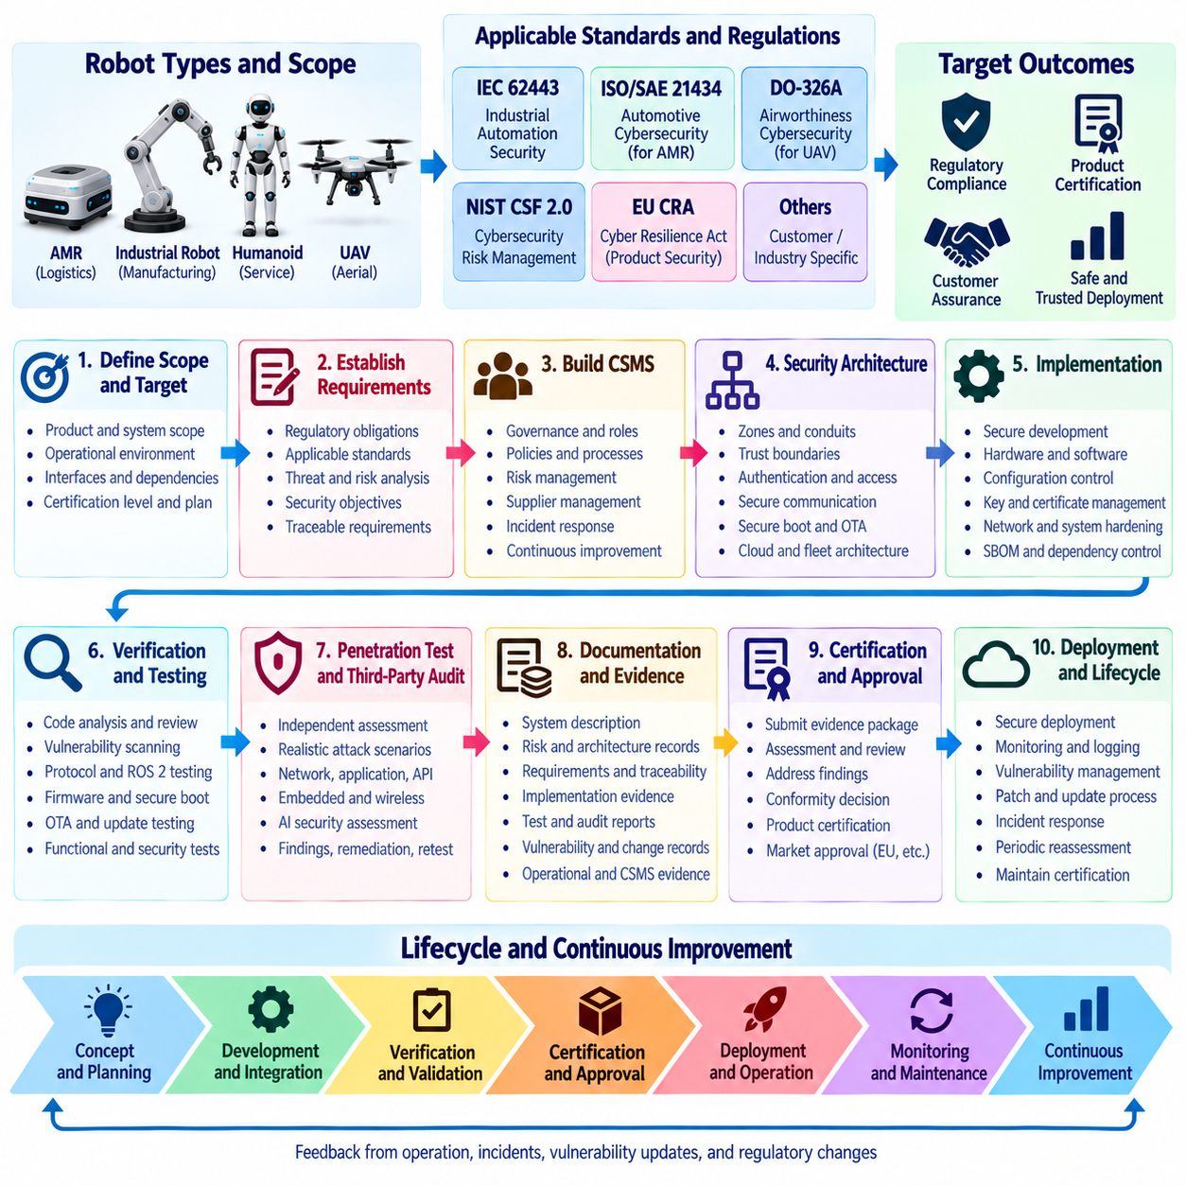
A cybersecurity certification roadmap for robotics should establish a controlled path from initial security planning to formal assessment, certification, deployment, and continued assurance. The roadmap should recognize that different robot categories may be subject to different standards and regulatory expectations. Industrial robots and AMRs may emphasize IEC 62443, ISO/SAE 21434 principles, NIST CSF 2.0, or the EU Cyber Resilience Act, while UAV programs may additionally require aviation-oriented security assurance such as DO-326A. The certification strategy should therefore begin by identifying the applicable regulatory and assurance framework.
The first stage is to define the certification scope and intended target state. The organization should identify the robot product, software and hardware boundaries, operational environment, deployment model, connected services, fleet infrastructure, suppliers, and external interfaces that will be included in the assessment. The scope should also identify whether certification applies to an individual robot, a product family, a fleet-management platform, or the complete cyber-physical ecosystem. This definition prevents important dependencies from being excluded and provides a stable foundation for subsequent assessment activities.
The certification roadmap should then establish the applicable cybersecurity objectives and requirements. These requirements should be derived from threat analysis, risk assessment, applicable standards, customer requirements, and regulatory obligations. IEC 62443 can provide industrial security requirements and Security Level concepts, ISO/SAE 21434 can provide lifecycle-oriented cybersecurity engineering principles for applicable AMR architectures, and NIST CSF 2.0 can organize organizational risk-management activities. For EU-market products, the Cyber Resilience Act may establish additional product-level obligations, while UAV programs may require airworthiness-oriented cybersecurity processes.
A formal Cybersecurity Management System (CSMS) should provide the organizational foundation for certification readiness. The CSMS should define governance, responsibilities, risk management, secure development, vulnerability management, configuration control, incident response, supplier management, training, monitoring, and continuous improvement. Certification should not depend on isolated technical controls because assessors need evidence that cybersecurity is consistently managed across the organization. The CSMS also provides the mechanism for maintaining security after the initial certification assessment and throughout the product lifecycle.
Technical architecture should be evaluated against the established cybersecurity objectives before final implementation is completed. The certification program should examine trust boundaries, zones and conduits, authentication infrastructure, authorization models, communication security, secure boot, software integrity, OTA mechanisms, logging, monitoring, fleet-management interfaces, cloud connections, and external access paths. For robotics, architecture assessment should also consider how cybersecurity controls interact with safety-critical and physically consequential functions, ensuring that security mechanisms do not introduce unacceptable operational or safety behavior.
Threat analysis and risk assessment should provide the technical rationale for the certification scope and security controls. The assessment should identify assets, attack surfaces, threat actors, attack paths, vulnerabilities, and potential consequences. Robot-specific consequences may include unauthorized motion, navigation manipulation, loss of fleet coordination, unsafe actuator commands, compromised AI decisions, denial of service, or unauthorized access to sensitive operational data. The resulting risk treatment should be traceable to security requirements, architecture decisions, implementation measures, and verification activities.
Implementation and verification should proceed under controlled engineering processes. Software, firmware, AI models, configurations, cryptographic keys, certificates, network policies, and security services should be maintained under appropriate configuration control. Verification activities can include code analysis, vulnerability scanning, protocol testing, ROS 2 and DDS security testing, API assessment, firmware analysis, secure-boot verification, OTA testing, penetration testing, and security regression testing. The objective is to demonstrate that cybersecurity requirements are implemented consistently and remain effective under realistic operating conditions.
Independent penetration testing and third-party assessment should form a major milestone before certification submission or final conformity decisions. External assessors should evaluate the system from an independent perspective and examine whether documented controls correspond to actual implementation. Testing should cover realistic attack paths across robot networks, maintenance interfaces, cloud and fleet services, APIs, wireless communication, update infrastructure, and other authorized attack surfaces. Findings should be risk-rated, assigned to responsible owners, remediated, and subjected to validation testing before closure.
Documentation and evidence should be developed continuously rather than assembled at the end of the program. The certification evidence package should contain system scope, cybersecurity policies, threat models, risk assessments, security objectives, requirements, architecture records, configuration baselines, implementation evidence, test results, vulnerability records, SBOM information, incident procedures, supplier assessments, change histories, and corrective-action records. Each important claim should be supported by objective evidence and remain traceable to the applicable requirement or risk.
A formal gap assessment should compare the current cybersecurity posture with the target certification state. Gaps may involve missing requirements, incomplete architecture controls, insufficient test coverage, weak evidence, unresolved vulnerabilities, immature incident procedures, supplier deficiencies, or inadequate configuration management. The roadmap should prioritize gaps according to cybersecurity risk, certification impact, operational consequences, and remediation complexity. This prevents certification preparation from becoming a documentation-only exercise and focuses resources on the areas that materially affect assurance.
Certification readiness should be demonstrated through an internal review before the formal external assessment. The review should verify that required documentation is complete, evidence is consistent, security tests have been successfully completed, significant findings have been closed or formally accepted, and the CSMS is operating as intended. Traceability should be sampled from high-level cybersecurity objectives through requirements, architecture, implementation, verification, and operational evidence. Any unresolved discrepancy should be addressed before the organization commits to the external assessment.
After certification or formal conformity assessment, cybersecurity assurance must continue throughout the operational lifecycle. New vulnerabilities, software updates, AI model changes, new network connections, fleet expansion, supplier changes, and changes in operational environments can invalidate assumptions made during the original assessment. The organization should therefore maintain vulnerability monitoring, controlled change management, periodic security testing, incident response, risk reassessment, and evidence updates. Certification should be treated as a baseline for continued assurance rather than the end of cybersecurity engineering.
For fleet-based robotics, the roadmap should additionally establish mechanisms for maintaining consistency across robot populations. A security update, certificate change, configuration modification, or newly discovered vulnerability may affect thousands of deployed units. Fleet management should therefore provide asset visibility, version tracking, credential and certificate lifecycle management, controlled command authorization, secure OTA deployment, monitoring, and recovery capabilities. The certification approach should demonstrate that centralized services are themselves protected because compromise of common infrastructure can create systemic fleet-wide consequences.
The final certification package should demonstrate a coherent relationship between governance, risk, requirements, architecture, implementation, testing, independent assessment, and operational assurance. The Chapter 11 structure places the certification roadmap after IEC 62443 assessment, ISO/SAE 21434, NIST CSF 2.0, the EU Cyber Resilience Act, DO-326A, CSMS development, penetration testing, and cybersecurity documentation and evidence. This structure establishes the roadmap as the culminating activity that integrates the preceding compliance and assurance processes into a practical certification pathway for robotics.
For a robotics organization, the ultimate objective is not simply to obtain a certificate but to establish a repeatable lifecycle capable of maintaining trustworthy cybersecurity as the product evolves. A successful roadmap connects early regulatory analysis with threat assessment, secure architecture, implementation, testing, independent review, evidence generation, remediation, certification, and continued monitoring. This approach allows industrial robots, AMRs, UAVs, and other autonomous systems to maintain a defensible cybersecurity posture while adapting to new technologies, new threats, expanding fleet operations, and changing regulatory expectations.

