Volume 24. Robot Cybersecurity

Chapter 06. Cloud and Fleet Security

06.01. Cloud Robot Security Architecture IAM PKI [w/Code]
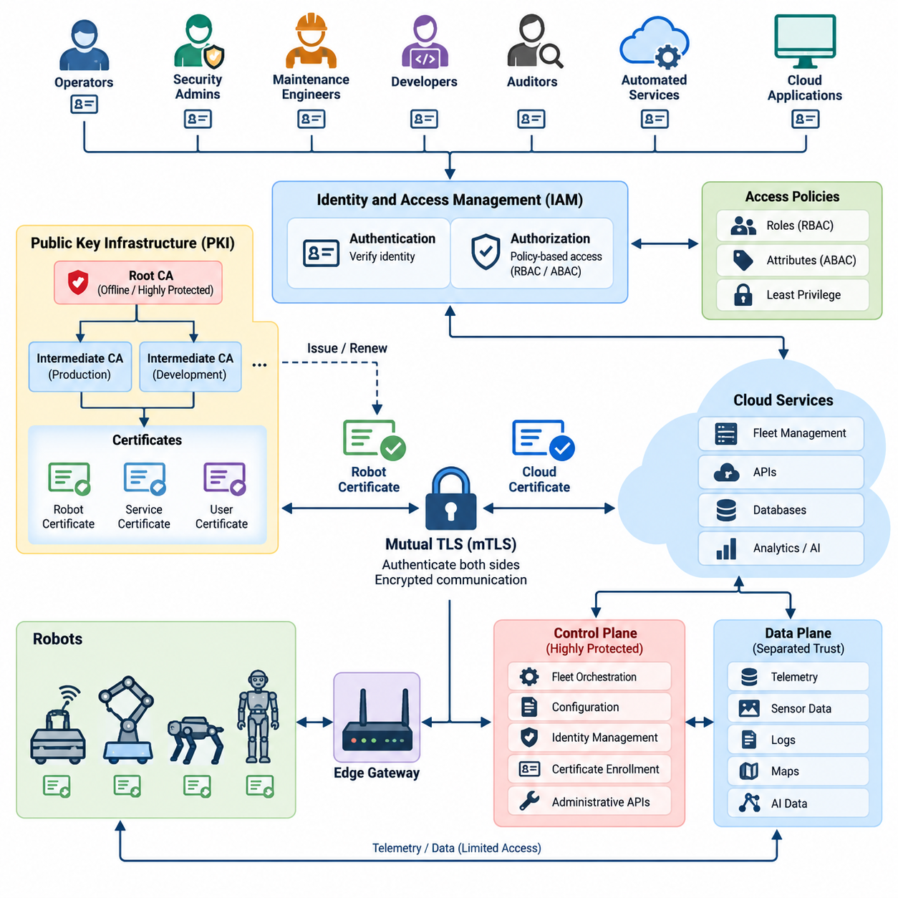
Cloud-connected robots extend the cybersecurity boundary far beyond the physical machine. A production fleet may include robots, edge gateways, wireless networks, cloud APIs, databases, operator consoles, telemetry pipelines, and fleet-management services. The architecture must therefore establish trusted identities and controlled communication across every component rather than treating the cloud as a single trusted domain. Volume_24_Robot_Cybersecurity
Identity and Access Management, or IAM, provides the policy foundation for determining who or what may interact with fleet resources. Human operators, robots, cloud services, maintenance applications, and automated workloads should receive distinct identities. Authentication proves the identity, while authorization determines which commands, APIs, data objects, robot groups, and administrative functions that identity is permitted to access.
Robot identity requires stronger treatment than ordinary application identity because a compromised credential can produce physical consequences. Each robot should possess a unique device identity bound to cryptographic credentials rather than relying on fleet-wide passwords or shared API keys. The identity can be associated with attributes such as robot serial number, fleet membership, deployment site, hardware class, software baseline, and operational role.
Public Key Infrastructure, or PKI, provides a scalable mechanism for establishing cryptographic trust between robots and cloud services. A certification authority issues digitally signed certificates that bind public keys to verified identities. Robots can then authenticate cloud endpoints, while cloud services authenticate individual robots, creating mutual trust without transmitting reusable passwords across potentially hostile networks.
A hierarchical PKI is particularly appropriate for large robot fleets. An offline or tightly protected root certification authority can establish the highest trust anchor, while subordinate issuing authorities perform operational certificate issuance. Separate intermediate authorities may serve production robots, development systems, cloud workloads, manufacturing environments, or different customers, limiting the impact of compromise within one trust domain.
Mutual Transport Layer Security, or mTLS, can apply PKI identities directly to robot-to-cloud communication. During connection establishment, the cloud validates the robot certificate and the robot validates the server certificate. Successful cryptographic authentication therefore occurs in both directions before telemetry, configuration information, mission requests, or operational commands are exchanged through the protected channel.
IAM authorization should operate after certificate authentication rather than assuming that every authenticated robot deserves unrestricted access. A valid certificate proves an identity, but policy determines permitted actions. A warehouse AMR, for example, may upload its own telemetry and receive missions assigned to its fleet while being prohibited from accessing another robot's credentials, administrative APIs, or unrelated customer data.
Role-Based Access Control, or RBAC, is useful for organizing human and service permissions. Fleet operators, security administrators, maintenance engineers, developers, auditors, and automated services can receive different roles with narrowly defined privileges. Attribute-Based Access Control, or ABAC, can further evaluate contextual properties such as fleet identifier, site, device state, certificate attributes, requested operation, or environment.
The principle of least privilege should govern both human and machine identities. A telemetry collector does not require permission to issue motion commands, and a diagnostic application should not automatically receive fleet-administration privileges. Separating permissions reduces lateral movement after credential compromise and creates clearer security boundaries among control, monitoring, maintenance, analytics, and administrative functions.
Cloud robot architecture should also separate control-plane and data-plane trust relationships. Fleet orchestration, configuration, identity management, certificate enrollment, and administrative APIs belong to highly protected control functions. Telemetry streams, sensor information, logs, maps, and AI-related data may follow different paths and retention policies. Independent authorization rules prevent data access from implicitly granting control authority.
Short-lived credentials reduce the period during which stolen authentication material remains useful. Human sessions, service tokens, and workload credentials should expire automatically, while robot certificates require defined validity periods and renewal procedures. Long-lived static API keys embedded in robot software are particularly dangerous because extracting one credential may provide persistent access unless it can be individually revoked and replaced.
Certificate lifecycle management begins before a robot enters service. A device may receive an initial identity during trusted manufacturing, commissioning, or secure enrollment. The cloud verifies enrollment evidence before issuing an operational certificate. The resulting identity should remain traceable to the physical device while allowing operational credentials to be renewed without replacing the robot's fundamental hardware identity.
Private keys must be protected because possession of a robot's private key may enable impersonation. Whenever practical, keys should be generated and retained inside a Trusted Platform Module, Hardware Security Module, secure element, or equivalent protected cryptographic boundary. Applications request signing or authentication operations through controlled interfaces so that private key material does not need to appear directly in ordinary filesystem storage.
Certificate rotation must be designed as a normal fleet operation rather than an emergency-only procedure. Robots should renew credentials before expiration, validate newly issued certificate chains, and transition without disrupting essential services. Fleet systems should monitor certificate age, expiration windows, enrollment failures, and abnormal renewal behavior so identity problems can be detected before they become availability incidents.
Revocation becomes essential when a robot is stolen, decommissioned, compromised, or transferred between operational domains. The security platform must be able to invalidate its credentials and prevent subsequent authentication. Certificate status mechanisms, cloud-side deny lists, identity-state databases, or short certificate lifetimes can support this objective, depending on connectivity and availability requirements of the deployed fleet.
IAM and PKI must also protect service-to-service communication inside the cloud. Fleet managers, message brokers, databases, telemetry processors, OTA services, AI inference services, and monitoring systems should not implicitly trust one another because they share a network. Workload identities and authenticated encrypted connections transform the cloud environment into explicit trust relationships rather than a broad trusted perimeter.
Zero Trust principles strengthen this architecture by requiring continuous verification across robot, edge, and cloud boundaries. Network location alone should never establish authority. Requests should be evaluated according to authenticated identity, authorization policy, device status, requested resource, and relevant security context. This approach complements the volume's broader treatment of Zero Trust and defense-in-depth for robot systems. Volume_24_Robot_Cybersecurity
Fleet-scale security additionally requires tenant and organizational boundaries. A cloud platform serving multiple customers must ensure that one tenant cannot authenticate into another tenant's robot namespace or retrieve its telemetry, commands, maps, certificates, or administrative information. Identity claims therefore need to propagate consistently through APIs, message brokers, databases, object storage, and analytics services.
Auditability is another fundamental IAM requirement. Authentication attempts, certificate issuance, policy changes, privilege elevation, token creation, failed authorization, credential revocation, and sensitive fleet commands should produce security records containing trustworthy identities and timestamps. Centralized monitoring can correlate these events with robot telemetry and network activity to reveal compromised credentials or abnormal administrative behavior.
Privileged human access requires stronger safeguards than ordinary operator access. Multi-Factor Authentication, or MFA, should protect administrative accounts, while privileged operations can require temporary elevation rather than permanent administrator rights. Emergency access mechanisms should be tightly controlled and extensively audited because cloud administrators may possess authority affecting hundreds or thousands of physical robots simultaneously.
The architecture should assume that connectivity can become intermittent. A robot may temporarily lose access to cloud identity services while continuing safety-critical local operation. Cached credentials and authorization decisions therefore require carefully bounded validity, while essential local safety functions must not depend on continuous cloud authentication. Reconnection should trigger certificate validation, policy synchronization, and reconciliation of security state.
Security boundaries must also preserve separation between cloud authority and local robot safety. Even a correctly authenticated cloud identity should not automatically override collision avoidance, emergency stopping, actuator limits, or independent safety controllers. IAM determines whether a command is authorized to reach the robot, while local safety mechanisms determine whether execution is physically permissible under the current operational state.
A mature implementation combines IAM, PKI, mTLS, protected key storage, least privilege, certificate lifecycle management, workload identity, audit logging, and network segmentation into one coherent trust architecture. This fits the broader robotics software structure in which cloud computing, fleet cloud, robot APIs, fleet APIs, API security, and fleet cybersecurity are treated as interconnected architectural concerns rather than isolated technologies. 08_Robotics_Software_Tree 08_Robotics_Software_Tree
The ultimate objective is cryptographic accountability from individual robot to fleet-scale cloud infrastructure. Every robot, user, workload, and service should have a verifiable identity; every sensitive interaction should be authenticated and authorized; every credential should have a controlled lifecycle; and every significant security action should be traceable. IAM defines who may act, while PKI establishes the cryptographic trust that makes those identities dependable.

06.02. Robot Device Certificate Lifecycle Management [w/Code]
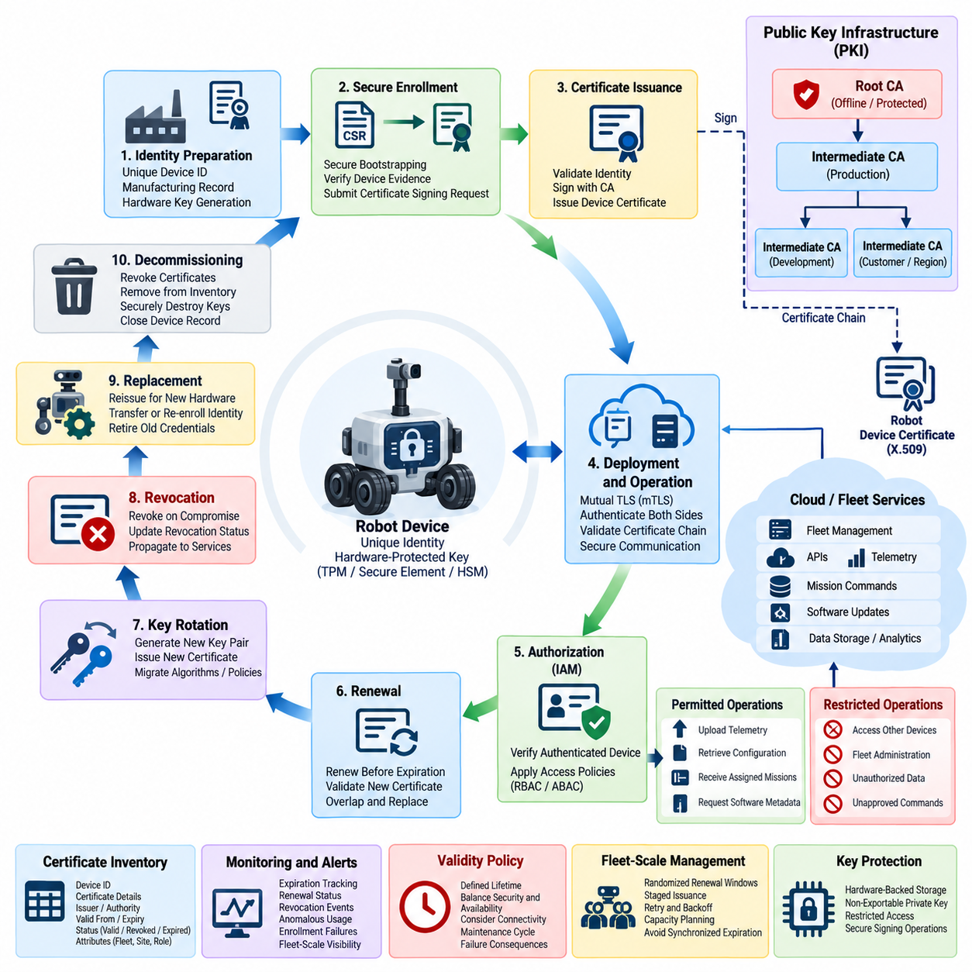
A robot device certificate is the cryptographic identity credential that allows a fleet platform to determine whether a connecting machine is an authorized device. Unlike a shared password or fleet-wide API key, a certificate binds a specific robot identity to a public key. Effective lifecycle management must protect this relationship from manufacturing and enrollment through operation, renewal, revocation, replacement, and final decommissioning.
The lifecycle begins with establishing a trustworthy device identity. Each robot should receive a unique identifier associated with its hardware, manufacturing record, deployment domain, and security configuration. The corresponding cryptographic key pair should preferably be generated inside protected hardware such as a Trusted Platform Module, secure element, or Hardware Security Module so that the private key does not need to leave its protected execution boundary.
Initial provisioning requires a secure method for connecting the physical robot to the fleet's Public Key Infrastructure. A manufacturer-installed credential, hardware-rooted identity, one-time enrollment secret, or controlled commissioning process can provide bootstrap trust. The enrollment service must verify this evidence before accepting a certificate signing request, because automatically issuing certificates to unverified devices would undermine the entire device identity architecture.
A certificate signing request normally contains the robot's public key and identity information required by the certification policy. The Certificate Authority validates the request and issues an operational certificate whose attributes identify the device within the permitted trust domain. Certificate contents should remain sufficiently stable and standardized that fleet services can reliably map authenticated certificates to robot records, policies, tenants, sites, and operational roles.
The certificate chain establishes how cloud services determine whether a robot certificate can be trusted. A protected root Certificate Authority forms the trust anchor, while intermediate issuing authorities can handle routine device certificate operations. Separating root and operational issuance reduces exposure of the highest-value signing key and allows different certificate authorities to be assigned to production, development, manufacturing, customer, or regional environments.
After provisioning, certificates become part of normal robot communication. Mutual Transport Layer Security can require the robot to authenticate the cloud service while the cloud simultaneously authenticates the robot certificate. Successful validation should include the certificate signature, chain of trust, validity period, intended key usage, expected identity attributes, and relevant certificate status before the connection is treated as authenticated.
Authentication alone does not determine what the robot may do. After certificate validation, the authenticated device identity should be passed to Identity and Access Management policies that authorize specific operations. A robot may be permitted to publish its telemetry, retrieve configuration, receive assigned missions, or request approved software metadata while remaining prohibited from accessing another device's information or fleet administration functions.
Certificate validity periods create a deliberate limit on credential lifetime. Extremely long-lived certificates increase exposure if a credential is compromised, whereas excessively short lifetimes can create operational availability problems when robots have intermittent connectivity. Fleet architects therefore need a validity policy that balances security, renewal reliability, connectivity characteristics, maintenance cycles, and the consequences of authentication failure.
Renewal should occur well before certificate expiration. A robot can authenticate with its existing valid credential, generate or select the appropriate key material, submit a renewal request, validate the returned certificate chain, and activate the replacement credential. Sufficient overlap between old and new certificates can prevent service interruption while still ensuring that obsolete credentials are retired according to defined policy.
Key rotation and certificate renewal are related but distinct operations. Renewal can issue a new certificate for an existing key, whereas key rotation creates a new cryptographic key pair and replaces the associated certificate. Periodic key rotation reduces dependence on long-lived private keys and provides an opportunity to migrate algorithms, key sizes, hardware security mechanisms, or certificate policies as security requirements evolve.
Fleet-scale renewal should avoid synchronized expiration events. If thousands of robots receive certificates at the same time and use identical validity periods, they may attempt renewal simultaneously, creating a load spike against enrollment and Certificate Authority services. Randomized renewal windows, staged issuance, retry backoff, capacity planning, and monitoring help distribute certificate operations across manageable intervals.
Private key protection remains critical throughout the lifecycle. Keys stored as ordinary files may be copied through malware, diagnostic access, backup processes, or filesystem compromise. Hardware-backed storage can make private keys non-exportable and require cryptographic operations to occur inside the protected component. Access to those operations should also be restricted so unauthorized software cannot freely use a legitimate device key.
Certificate inventory provides the fleet operator with visibility into the identity state of deployed robots. The platform should know which certificate belongs to each device, which authority issued it, when it became valid, when it expires, its current lifecycle status, and whether replacement or revocation has occurred. Inventory information should remain synchronized with fleet asset records so cybersecurity teams can trace credentials to physical devices.
Monitoring converts certificate management from a provisioning function into an operational security capability. Fleet services should detect certificates approaching expiration, repeated enrollment failures, unexpected issuers, invalid chains, abnormal renewal frequency, authentication from unexpected environments, or attempts to use revoked credentials. These events can be forwarded to centralized security monitoring and correlated with robot, network, and cloud activity.
Revocation is required when continued trust can no longer be justified. A robot certificate may need to be revoked because the device was compromised, stolen, retired, transferred, incorrectly provisioned, or suspected of private-key exposure. Revocation should disable the affected identity without forcing unrelated robots to replace their credentials, which is an important advantage of assigning unique certificates to individual devices.
Certificate Revocation Lists and online certificate status mechanisms can communicate invalid credential status, although fleet environments must account for intermittent connectivity. Short-lived certificates, cloud-side identity state, deny lists, and locally cached revocation information can supplement conventional PKI mechanisms. The architecture must define how long a disconnected robot may rely on cached trust information before additional restrictions become necessary.
Recovery from credential compromise requires more than simply issuing another certificate. The system must determine whether the existing private key can still be trusted, revoke the compromised credential, establish a trustworthy path for re-enrollment, and verify the robot's security state before restoring access. If the original device identity itself is questionable, recovery may require hardware-rooted attestation or controlled physical maintenance.
Certificate management must also handle device replacement and hardware repair. Replacing a controller, Trusted Platform Module, secure element, or motherboard may invalidate the cryptographic relationship between the physical robot and its previous credential. The fleet database should preserve historical traceability while creating a new trusted identity binding, rather than silently copying private keys from the replaced hardware into a new security environment.
Offline and intermittently connected robots require special lifecycle policies. A robot may be unable to contact enrollment or status services for extended periods, yet immediate certificate expiration could unnecessarily stop legitimate operations. Local safety functions should remain independent of cloud certificate availability, while cloud access can use bounded offline validity, cached trust anchors, and controlled reconnection procedures appropriate to operational risk.
Decommissioning closes the certificate lifecycle. When a robot permanently leaves service, its active certificates should be revoked or otherwise made unusable, cloud permissions removed, fleet records updated, and protected credentials securely destroyed where supported. Backup credentials, enrollment secrets, maintenance certificates, and associated service identities should also be addressed so retired hardware cannot later reappear as an apparently legitimate fleet device.
Audit records should capture important lifecycle events such as enrollment, certificate issuance, renewal, rotation, failed validation, revocation, administrative override, recovery, and decommissioning. These records create accountability and support incident investigation by showing which identity was valid at a particular time, which authority issued it, what administrative action occurred, and how the credential state changed.
Automation becomes essential as the fleet grows from tens of robots to hundreds or thousands. Certificate discovery, enrollment, renewal, expiration monitoring, rotation, revocation, policy validation, and inventory reconciliation should be orchestrated through controlled services rather than manual administrator actions. Automation reduces configuration drift while allowing security policy to be applied consistently across heterogeneous robot platforms.
A mature robot certificate lifecycle therefore forms a continuous trust-management process rather than a one-time provisioning task. Secure identity establishment, protected key generation, controlled enrollment, certificate validation, automated renewal, key rotation, revocation, recovery, auditing, and decommissioning collectively preserve device trust throughout operational life. The result is a fleet in which every robot's cryptographic identity can be individually established, monitored, changed, and withdrawn.

06.03. Cloud API Security for Fleet Management [w/Code]
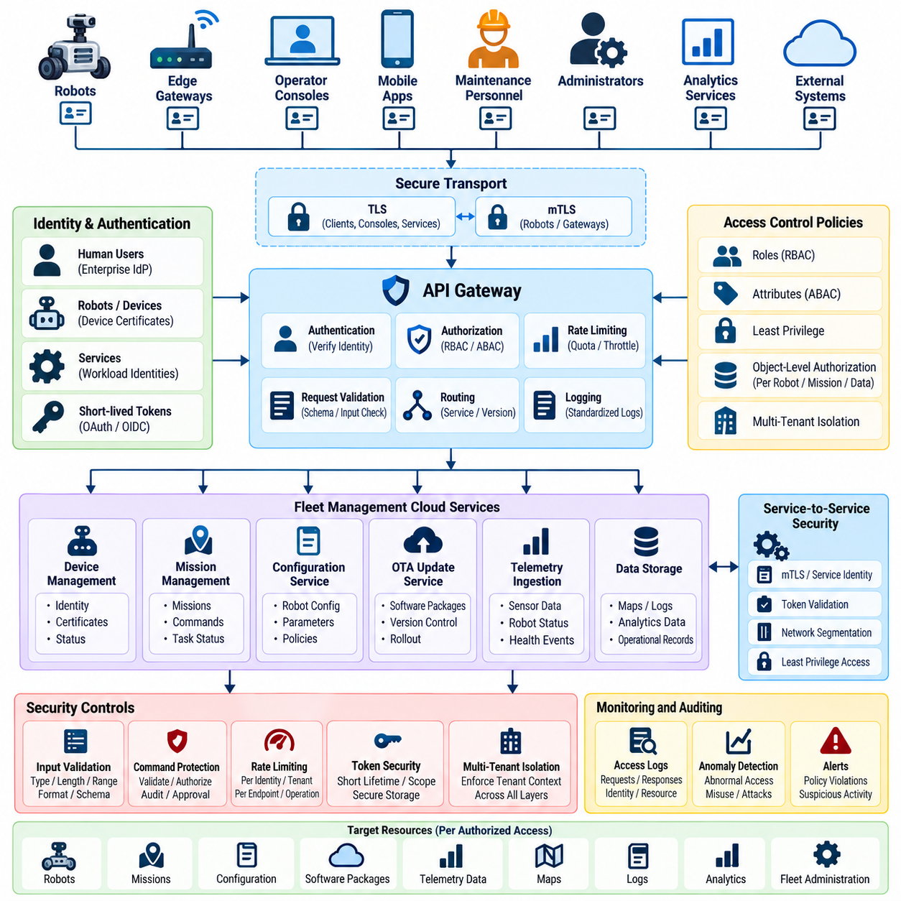
Cloud Application Programming Interfaces are central security boundaries in modern fleet-management platforms because they connect robots, operator consoles, mobile applications, edge gateways, analytics services, and administrative systems. An API request may retrieve telemetry or configuration, but it may also dispatch missions or change operational parameters. API security must therefore protect both digital information and actions that can produce physical consequences.
Every API request should originate from an authenticated identity. Human users can authenticate through enterprise identity systems and short-lived access tokens, while robots and machine services should use dedicated workload or device identities. Shared fleet credentials should be avoided because they make individual devices difficult to identify, revoke, and audit after compromise. Authentication must establish exactly which principal initiated each request.
Transport protection provides the first communication boundary. Fleet APIs should use Transport Layer Security for all external and internal network communication, with strong certificate validation and current cryptographic configurations. Robot-facing interfaces can additionally use mutual Transport Layer Security so that the cloud verifies the robot certificate while the robot verifies the fleet service, reducing exposure to impersonation and man-in-the-middle attacks.
Authentication must be followed by explicit authorization. A valid identity does not imply unrestricted access to every robot or fleet operation. Role-Based Access Control can assign permissions to operators, maintenance personnel, administrators, auditors, and services, while Attribute-Based Access Control can incorporate fleet identifier, tenant, site, robot class, requested action, device status, or operational context into authorization decisions.
Object-level authorization is particularly important for fleet APIs. An authenticated user who is permitted to access robot A must not automatically gain access to robot B simply by changing a robot identifier in a URL or request body. Authorization should be evaluated against the specific resource on every request, including robots, missions, maps, logs, certificates, configuration objects, software packages, and customer-specific fleet records.
API endpoints should follow the principle of least privilege. Telemetry ingestion services need permission to accept authorized data but generally should not issue motion commands. Analytics services may require historical fleet data without requiring access to certificate administration or robot control. Separating read, write, command, configuration, maintenance, and administrative privileges limits lateral movement if one account, token, or service becomes compromised.
Fleet command APIs require stronger controls because their outputs may affect physical motion. Commands should be associated with authenticated principals, authorized against the targeted robot and mission context, validated against allowed command schemas, and recorded for audit. High-impact operations such as disabling safety-related services, changing security configuration, or controlling large groups of robots may require elevated privileges or additional approval.
Input validation must occur before untrusted API data reaches fleet services. Parameters should be checked for expected type, length, range, format, enumeration, and structure. Unknown or malformed fields should not silently influence backend behavior. Strict schemas reduce injection opportunities, parser inconsistencies, unsafe parameter manipulation, and unexpected command interpretation across heterogeneous robot and cloud software.
API gateways can provide a centralized enforcement point for externally exposed fleet services. They can terminate secure connections, validate authentication tokens, enforce routing rules, apply rate limits, inspect request metadata, and generate standardized access logs. However, backend services should not assume that requests are trustworthy merely because they passed through a gateway; critical authorization should remain enforceable at the service or resource boundary.
Rate limiting protects fleet infrastructure from both deliberate abuse and malfunctioning clients. Limits can be applied by identity, robot, tenant, endpoint, source, or operation type. A telemetry endpoint may permit high sustained throughput, while administrative or command APIs may require much tighter thresholds. Burst controls and quotas help prevent compromised credentials from being used to overwhelm control-plane services.
Token security is another essential concern. Access tokens should have limited lifetime, constrained scope, protected storage, and secure transmission. Sensitive tokens should not appear in URLs, diagnostic dumps, source repositories, or ordinary application logs. Refresh mechanisms must also be protected because a long-lived refresh credential can undermine the security benefit of short-lived access tokens if it is stolen.
Fleet platforms commonly use service-to-service APIs internally, and these interfaces require protection equivalent to public endpoints. Microservices should authenticate one another through workload identities, mutual TLS, signed tokens, or equivalent mechanisms rather than trusting network location. Compromise of one internal service should not automatically provide unrestricted access to mission management, device identity, OTA, telemetry, or fleet administration services.
Multi-tenant platforms require authorization boundaries at every layer. Tenant identity should be propagated through authenticated requests and consistently enforced by API services, databases, message brokers, caches, and object storage. A request from one customer must never retrieve another customer's robots, missions, telemetry, maps, credentials, or administrative metadata even when resource identifiers are guessed or manipulated.
API versioning and lifecycle management also influence security. Obsolete endpoints can preserve weak authentication mechanisms, deprecated parameters, or unpatched implementation defects long after newer APIs are deployed. Fleet operators should maintain an inventory of active API versions, define deprecation schedules, monitor legacy usage, and eventually disable unsupported endpoints rather than leaving them indefinitely accessible for compatibility.
Error handling should provide useful diagnostics without exposing sensitive internal information. Responses should not reveal database queries, stack traces, secret values, internal network addresses, cryptographic material, or detailed authorization logic. Externally returned errors can remain concise while internal observability systems retain richer diagnostic context for authorized engineering and security personnel.
Logging should create an accountable history of fleet API activity. Important records include authenticated identity, requested resource, operation, timestamp, authorization result, response status, and relevant correlation identifiers. Security-sensitive operations such as fleet-wide commands, credential changes, permission modifications, configuration updates, or repeated authentication failures should receive additional monitoring and retention appropriate to their risk.
Centralized security monitoring can correlate API activity with robot telemetry, cloud logs, and network events. A valid account suddenly controlling unusual robots, downloading abnormal volumes of data, generating repeated authorization failures, or calling administrative endpoints from an unexpected environment may indicate credential compromise. Behavioral context can therefore reveal attacks that basic authentication alone would consider legitimate.
API secrets and signing keys must be managed through dedicated secret-management mechanisms rather than embedded in source code, container images, configuration repositories, or deployment scripts. Access should be limited to the workloads that require each secret, and rotation should be supported without extensive service interruption. Secret access itself should be logged because unusual retrieval can indicate preparation for further compromise.
Replay resistance is important for sensitive robot operations. An attacker who captures a legitimate command should not be able to resend it indefinitely. Short-lived authorization tokens, timestamps, nonces, request identifiers, signed command envelopes, and server-side state can help determine whether a request is fresh. The exact mechanism should reflect command criticality and the connectivity characteristics of the robot fleet.
Cloud API security must also preserve the boundary between fleet authorization and local safety. A correctly authenticated and authorized cloud command should still pass through robot-side operational and safety validation. Collision avoidance, emergency stopping, actuator limits, geofencing, and independent safety controllers should not become bypassable merely because an API request carries valid cloud credentials.
Availability is a security property for fleet APIs because robots may depend on cloud services for missions, configuration, maps, or coordination. Redundant services, bounded retries, request timeouts, graceful degradation, queueing, and circuit-breaking mechanisms can prevent failures from cascading through the fleet. Robots should also define safe behavior for temporary cloud loss rather than assuming continuous API availability.
Security testing should examine APIs as complete attack surfaces rather than only checking authentication. Testing should cover broken authorization, malformed requests, injection, excessive data exposure, weak rate limits, token misuse, replay, tenant isolation, insecure legacy endpoints, and unexpected state transitions. Automated regression tests can ensure that previously corrected vulnerabilities do not return during rapid cloud software releases.
A mature fleet API architecture combines strong identity, encrypted transport, resource-level authorization, strict input validation, rate limiting, protected tokens and secrets, comprehensive auditing, tenant isolation, continuous monitoring, and robot-side safety enforcement. The result is not simply a secure web interface but a controlled trust boundary between cloud software and a distributed population of physical machines whose actions must remain attributable, authorized, and constrained.

06.04. Fleet Command Authentication and Signing [w/Code]
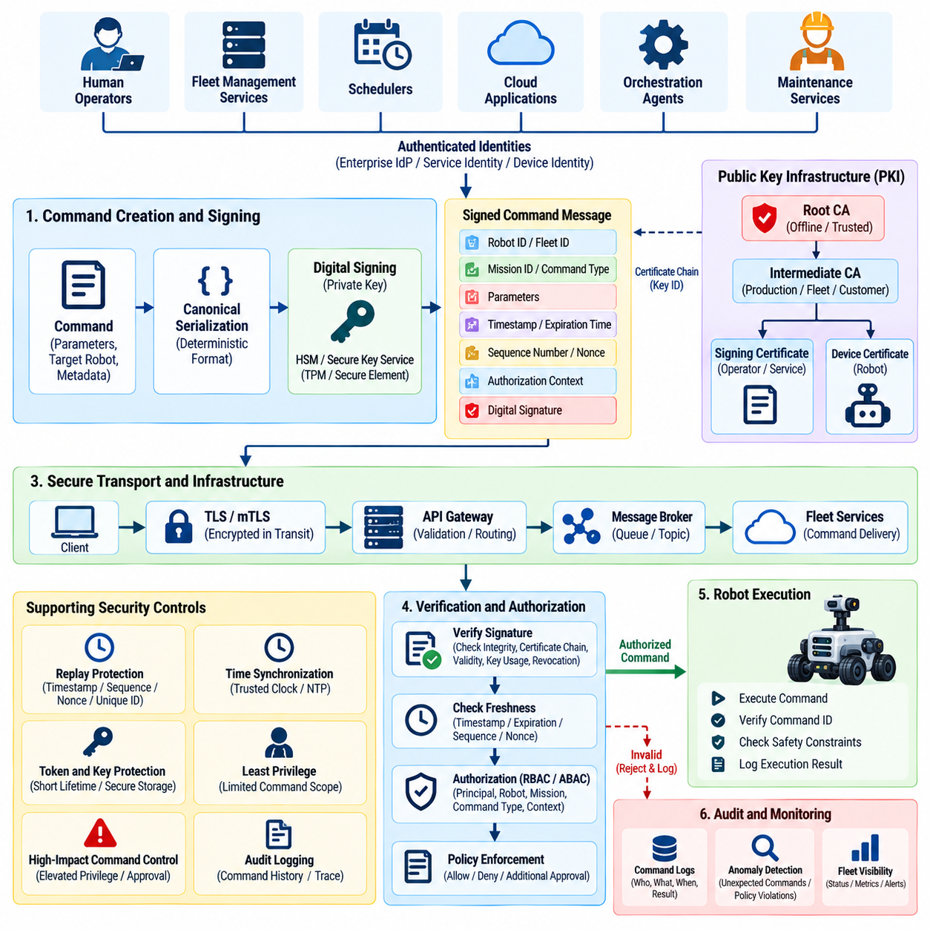
Fleet commands represent one of the most security-sensitive communication paths in a robotic system because they can directly influence physical behavior. Commands may assign missions, change operating modes, modify navigation parameters, initiate docking, pause operations, or coordinate multiple robots. Authentication and digital signing must therefore establish who issued each command, whether it was altered, and whether it remains valid for execution.
Command authentication begins with a trustworthy identity for every entity capable of issuing instructions. Human operators, fleet-management services, schedulers, cloud applications, and autonomous orchestration agents should use distinct identities rather than shared accounts or common API keys. The receiving system must associate each command with an authenticated principal before evaluating whether that principal has authority over the targeted robot or fleet.
Transport Layer Security protects commands while they move across the network, but transport encryption alone does not provide persistent command integrity. Once a message passes through gateways, brokers, queues, or intermediate services, transport-level protection may terminate. Digitally signing the command itself creates message-level evidence that can remain verifiable as the command travels through distributed fleet infrastructure.
A digital signature is created by applying a cryptographic signing operation to a defined representation of the command. The signer uses a protected private key, while the robot or trusted verification service uses the corresponding public key to validate the signature. Successful verification provides evidence that the command originated from an authorized signing identity and that protected command contents were not modified after signing.
The signed representation must include all security-relevant fields rather than only the primary command payload. Robot identifier, fleet identifier, mission identifier, command type, parameters, timestamp, sequence information, expiration time, and authorization context may all affect execution. If important metadata remains outside the signed envelope, an attacker could potentially modify routing or execution semantics without invalidating the signature.
Canonical serialization is necessary because the sender and receiver must calculate the signature over exactly the same byte representation. Differences in field ordering, whitespace, numeric encoding, character normalization, or optional values can cause legitimate verification failures. A fleet protocol should therefore define deterministic serialization rules so identical logical commands produce identical cryptographic input across different software implementations.
Replay protection prevents a captured legitimate command from being executed repeatedly. A signed message can remain cryptographically valid even when resent by an attacker, so freshness must be independently verified. Timestamps, expiration times, monotonic sequence numbers, nonces, unique command identifiers, or combinations of these mechanisms can allow the receiver to distinguish a new instruction from a previously accepted message.
Time-based validation requires trustworthy clocks. If a robot evaluates command creation and expiration timestamps, excessive clock drift can cause valid commands to be rejected or stale commands to remain acceptable. Fleet systems should therefore maintain controlled time synchronization and define tolerances appropriate to network latency and operating conditions while ensuring that clock manipulation cannot silently expand command validity windows.
Authorization must remain separate from signature verification. A valid digital signature proves that a recognized identity signed the command, but it does not automatically mean that the signer is permitted to perform the requested operation. The fleet security layer should evaluate the authenticated identity against policies governing the target robot, fleet, mission, operating mode, command category, and current security context.
Least-privilege authorization reduces the impact of credential compromise. A mission scheduler may be authorized to assign tasks without being allowed to change cybersecurity settings, while a maintenance service may request diagnostics without controlling robot motion. Separating mission, motion, configuration, maintenance, safety-related, and administrative command privileges prevents one compromised identity from obtaining universal fleet authority.
High-impact fleet commands deserve stronger controls than routine operations. Commands affecting many robots simultaneously, disabling services, changing trust configuration, modifying geofences, or initiating security-sensitive maintenance may require privileged authorization, secondary approval, or policy-based restrictions. The level of protection should reflect the potential physical and operational consequences rather than treating every command as equally sensitive.
Signing keys must receive stronger protection than ordinary application secrets because possession of a command-signing private key may allow an attacker to generate apparently legitimate instructions. Keys should preferably reside in a Hardware Security Module, secure key service, Trusted Platform Module, or equivalent protected environment. Applications should request signing operations without directly retrieving exportable private-key material.
Key identifiers and certificate chains can accompany signed commands so receivers can determine which trusted key should verify the signature. The verification process should confirm that the signing credential chains to an approved trust anchor, is within its validity period, has appropriate key usage, belongs to the expected identity domain, and has not been revoked or administratively disabled before accepting its authority.
Key rotation must be supported without interrupting fleet operation. Verification systems may temporarily trust both an existing key and its approved replacement while commands transition to the new credential. Rotation procedures should define activation times, overlap periods, retirement rules, and emergency replacement mechanisms so cryptographic keys can be changed predictably across large numbers of robots and distributed cloud services.
Compromise response requires rapid removal of signing authority. When a signing key, operator account, or command service is suspected of compromise, security administrators must be able to revoke the associated credential and prevent newly generated commands from being accepted. Previously issued commands may also require cancellation when their validity period extends beyond the time at which trust was withdrawn.
Message brokers and asynchronous queues require particular attention because commands may remain stored before delivery. The robot should verify the end-to-end signature rather than assuming that a command is trustworthy because it arrived through an approved broker. Broker authentication, access control, and encryption remain important, but message-level signatures preserve integrity even when commands traverse multiple infrastructure components.
Acknowledgment should be distinguished from command execution. A robot may first report that a signed command was received and authenticated, then separately indicate whether authorization, safety checks, operational preconditions, and execution succeeded. This distinction improves observability and prevents cloud systems from interpreting successful message delivery as evidence that a physical action was actually completed.
Local robot safety must remain authoritative after cryptographic verification. A perfectly signed and authorized command should not bypass collision avoidance, emergency stopping, actuator limits, geofencing, or independent safety controllers. Cryptographic security determines whether a command is trustworthy from a cybersecurity perspective, while the robot's safety architecture determines whether the requested action is physically permissible at that moment.
Fleet-wide command distribution should also consider partial connectivity and inconsistent robot state. Some robots may receive a command immediately while others remain offline. Commands therefore need explicit validity periods and execution conditions so a delayed robot does not perform an obsolete action after reconnecting. Mission state and command identifiers can help determine whether delayed instructions should execute, be superseded, or be discarded.
Audit logging should preserve the complete security history of important commands. Records can include the authenticated issuer, signing key identifier, target robot or fleet, command identifier, timestamp, verification result, authorization decision, delivery status, execution result, and rejection reason. These records support incident investigation and make sensitive physical actions attributable to specific authenticated identities.
Monitoring systems can use command history to identify suspicious behavior even when signatures are valid. Unusual command frequency, unexpected fleet-wide actions, commands issued outside normal operational periods, repeated rejected signatures, abnormal target selection, or sudden privilege changes may indicate compromised credentials or malicious use of legitimate authority. Cryptographic verification should therefore be combined with behavioral monitoring.
Emergency command paths require careful design because urgency must not eliminate trust controls. Emergency stop or containment commands may need highly available distribution and simplified operational workflows, but unauthorized parties must not gain equivalent authority. Pre-established emergency identities, protected signing keys, redundant communication paths, and tightly defined command semantics can preserve both rapid response and authentication.
A mature fleet command security architecture combines authenticated identities, explicit authorization, deterministic command formats, end-to-end digital signatures, replay resistance, protected signing keys, credential rotation, revocation, audit logging, behavioral monitoring, and independent robot-side safety validation. Together these mechanisms ensure that physical commands remain attributable, tamper-evident, timely, authorized, and constrained throughout distributed cloud and fleet operations.

06.05. Cloud Data Encryption at Rest and Transit [w/Code]
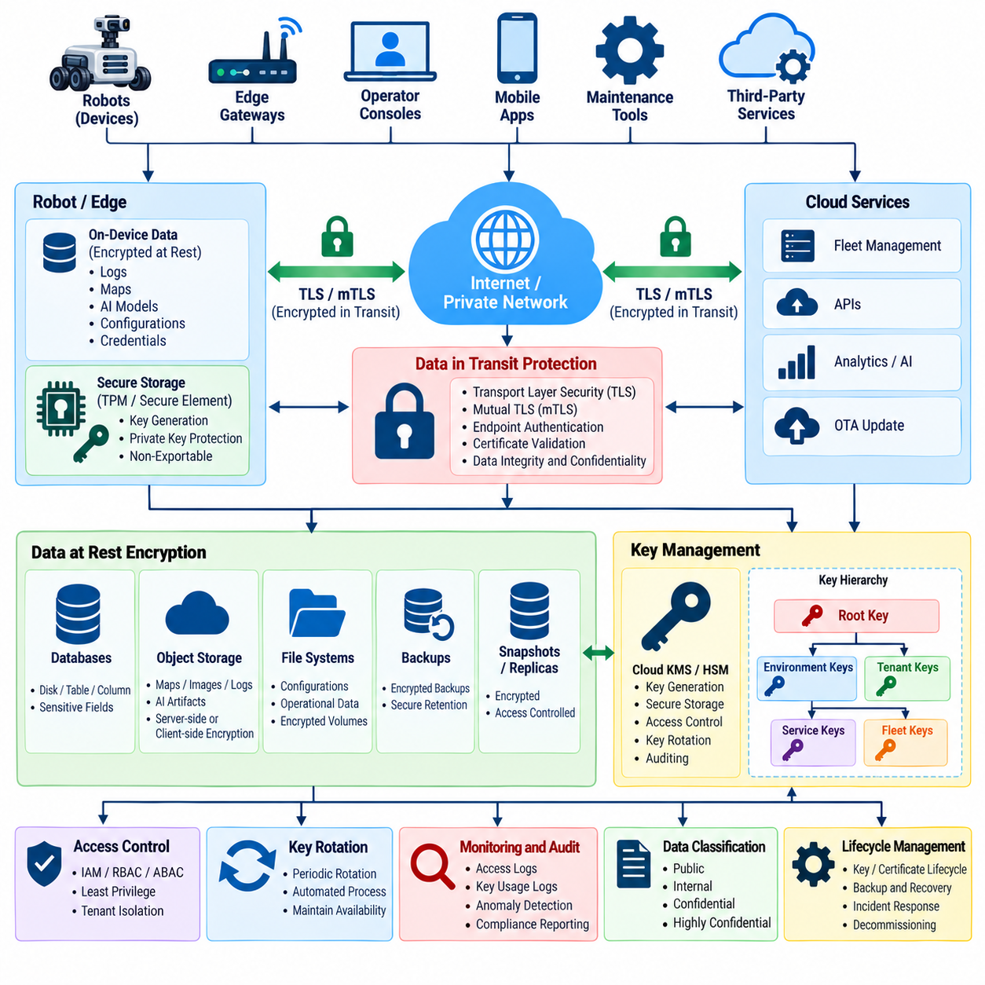
Cloud robotics platforms continuously generate and exchange sensitive information, including telemetry, maps, mission histories, diagnostic logs, robot configurations, credentials, AI model artifacts, sensor-derived data, and operational records. Protecting this information requires encryption both while data is stored and while it moves between robots, edge systems, cloud services, databases, and fleet-management applications.
Encryption at rest protects information stored on persistent media against unauthorized disclosure when storage devices, backups, snapshots, databases, or cloud resources are accessed outside their intended security controls. Fleet platforms should apply encryption to databases, object storage, block volumes, file systems, backup repositories, log archives, data lakes, and other persistent services containing operational or security-sensitive robot information.
Storage encryption should be implemented as part of a layered security architecture rather than treated as a substitute for access control. Encryption can prevent an attacker who obtains raw storage media from immediately reading its contents, but an authorized application may still decrypt information through normal interfaces. Identity management, least-privilege authorization, network isolation, monitoring, and encryption must therefore operate together.
Database encryption can protect structured fleet information such as robot identities, mission assignments, maintenance records, configuration states, and operational history. Depending on sensitivity, protection may be applied at the disk, database, table, column, or application level. Highly sensitive fields such as credentials, security tokens, or private operational metadata may require stronger controls than ordinary telemetry records.
Object storage frequently contains large robot datasets, maps, images, logs, AI artifacts, and exported fleet information. Server-side encryption can protect stored objects transparently, while client-side or application-level encryption can provide additional separation from the storage provider. Access policies should ensure that possession of storage credentials does not automatically provide unrestricted ability to decrypt every object.
Encryption in transit protects information against interception and modification while it crosses networks. Transport Layer Security should protect cloud APIs, web interfaces, service-to-service communication, telemetry ingestion, configuration retrieval, and other IP-based exchanges. Strong endpoint authentication is essential because encrypted communication with an impersonated endpoint does not provide meaningful confidentiality.
Robot-to-cloud communication benefits from mutual Transport Layer Security when both endpoints require cryptographic authentication. The robot validates the cloud service certificate, while the cloud validates the robot's device certificate. This creates an encrypted channel tied to explicit machine identities and reduces reliance on shared secrets that become difficult to manage securely across large fleets.
Encryption should also cover internal cloud traffic. A traditional architecture may assume that communication inside a private network is trusted, but compromised workloads or configuration errors can invalidate this assumption. Service-to-service encryption, workload identities, and authenticated connections provide stronger protection between fleet managers, message brokers, databases, analytics services, OTA systems, and AI services.
Key management determines the practical strength of encryption. Strong algorithms provide little protection when encryption keys are exposed, reused excessively, or stored beside the protected data. Cloud Key Management Services or Hardware Security Modules can centralize generation, storage, access control, rotation, and auditing of cryptographic keys while reducing direct exposure of raw key material to applications.
Envelope encryption is useful for large-scale cloud data protection. Data can be encrypted with a data encryption key, while that key is protected by a separate key-encryption key managed through a centralized security service. This approach allows large datasets to be encrypted efficiently while enabling administrators to rotate or restrict higher-level keys without repeatedly encrypting every stored data object.
Key hierarchy design should reflect organizational and security boundaries. Separate keys may be assigned by environment, customer, tenant, region, fleet, application, or data classification. Such separation limits the scope of compromise and supports independent rotation or revocation. A single universal encryption key for an entire robotics platform creates an unnecessarily large blast radius if that key is exposed.
Key rotation reduces long-term dependence on individual cryptographic keys. Rotation policies should define when new keys are generated, how applications begin using them, how previously encrypted information remains decryptable, and when old keys can be retired. Automated rotation is preferable at fleet scale, but it must preserve availability and maintain clear relationships between ciphertext, key versions, and access policies.
Backup encryption deserves the same attention as production storage. Backups often contain historical credentials, configuration data, operational records, logs, and customer information that remain valuable to attackers long after creation. Backup repositories should use controlled encryption keys, restricted access, integrity protection, defined retention periods, and tested restoration procedures that preserve security during recovery.
Snapshots and replicas can silently expand the number of locations containing sensitive fleet data. A protected production database may still expose information if an unencrypted snapshot is copied into a development account or an inadequately controlled region. Encryption policy should therefore follow data across replication, export, migration, disaster recovery, analytics, and temporary processing environments.
Data classification helps determine appropriate encryption controls. Public software metadata does not necessarily require the same protection as robot credentials, customer maps, security logs, video streams, proprietary AI models, or detailed operational histories. Classification allows encryption strength, key separation, retention, access control, and monitoring requirements to correspond to the consequences of disclosure or manipulation.
Multi-tenant fleet platforms require strong cryptographic and authorization separation between customers. Tenant-specific keys can provide an additional boundary beyond logical access controls, particularly for highly sensitive deployments. Even when shared infrastructure is used, one tenant's application identity should not be capable of requesting decryption operations with another tenant's protected key material.
Sensitive AI assets require particular consideration in Physical AI environments. Foundation models, adapted policies, perception models, embeddings, training datasets, and operational experience may contain valuable intellectual property or confidential information. Encryption should protect these assets in model registries, object storage, training pipelines, deployment packages, backups, and transfers between cloud and edge infrastructure.
Logs create another important encryption domain because security and operational logs may contain robot identifiers, network addresses, API metadata, command history, error information, or fragments of application data. Centralized log stores should therefore use encrypted transport and encrypted storage while preserving controlled access for security monitoring, incident response, engineering, and compliance activities.
Encryption must preserve operational availability. If a fleet service loses access to its encryption keys, protected information can become unavailable even though the underlying storage remains healthy. Key services therefore require resilient architecture, backup and recovery procedures, controlled caching where appropriate, and carefully designed failure behavior so cryptographic protection does not create an uncontrolled single point of failure.
Cryptographic access should be observable and auditable. Key creation, use, rotation, disabling, deletion, permission changes, and failed decryption attempts should generate security records. Monitoring unusual key usage can reveal compromised services or credentials, such as an application suddenly requesting decryption for large volumes of data outside its normal fleet, tenant, or operational scope.
Encryption also interacts with data deletion and lifecycle management. Cryptographic erasure can make encrypted information inaccessible by securely destroying the required keys, although storage retention and regulatory requirements must still be considered. Key deletion should be treated as a high-impact operation because accidental destruction of the only valid decryption key can permanently eliminate access to legitimate operational data.
Legacy protocols and devices require careful migration because older robots may not support current encryption mechanisms or certificate-based authentication. Compatibility gateways can provide transitional protection, but they should not silently weaken the security posture of the entire fleet. Unsupported cryptography should be inventoried, isolated, monitored, and replaced according to a defined modernization plan.
Testing should verify more than the presence of encryption settings. Security validation should confirm certificate verification, protocol configuration, key permissions, storage encryption status, tenant separation, backup protection, rotation behavior, and failure handling. Automated configuration checks can detect accidental exposure such as unencrypted storage resources, weak transport settings, public objects, or excessive key-management permissions.
A mature cloud data protection architecture combines encryption at rest, encryption in transit, authenticated endpoints, protected key management, key hierarchy, rotation, encrypted backups, tenant isolation, auditing, and resilient recovery. Together these controls preserve confidentiality and integrity across the complete robot data lifecycle while ensuring that authorized fleet operations can continue reliably across cloud, edge, and physical robot environments.

06.06. Cloud SIEM for Robot Fleet Monitoring [w/Code]
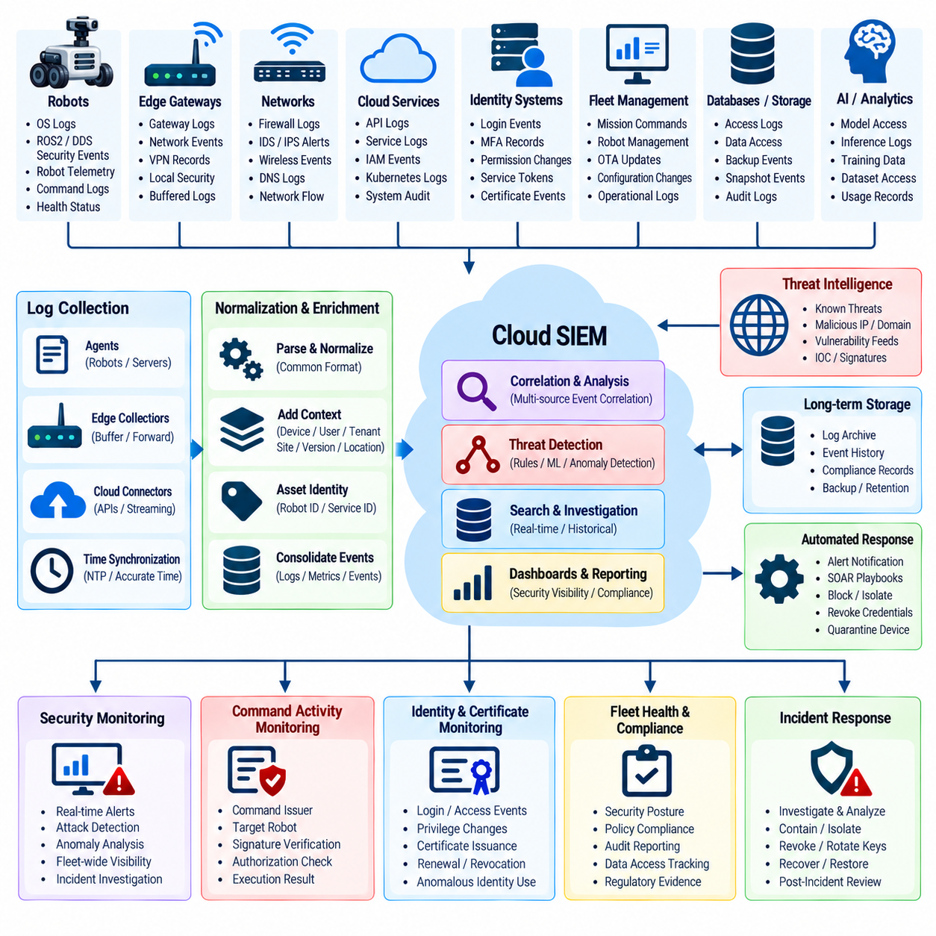
Security Information and Event Management provides a centralized monitoring layer for robot fleets whose security events are distributed across physical robots, edge gateways, networks, cloud services, APIs, databases, identity systems, and fleet-management applications. A cloud SIEM collects and correlates these signals so isolated technical events can be interpreted as coordinated security activity affecting both digital infrastructure and physical operations.
Robot fleet monitoring requires broader telemetry than conventional enterprise IT monitoring. Relevant sources include operating-system logs, ROS2 and DDS security events, authentication records, firewall alerts, VPN activity, wireless network events, cloud API logs, device certificate events, fleet commands, OTA operations, AI service activity, and robot health telemetry. Combining these sources provides context that no individual log stream can provide alone.
Log collection should preserve the identity of the device, service, user, and tenant associated with each event. Robot identifier, fleet identifier, site, software version, network address, certificate identity, timestamp, and operational state can provide essential context during analysis. Without reliable asset identity, a SIEM may detect suspicious activity but remain unable to determine which physical machine or operational process is affected.
Time synchronization is fundamental to fleet-wide event correlation. Security analysts may need to reconstruct a sequence involving cloud authentication, an API request, a signed fleet command, network activity, and a physical robot response occurring within seconds of one another. Consistent timestamps allow the SIEM to order events accurately, while clock drift can obscure causality and make distributed incident investigation significantly more difficult.
Event ingestion architecture must support different data rates and connectivity conditions. Cloud services may stream logs continuously, while mobile robots can temporarily lose network connectivity and upload buffered events after reconnection. Collection agents and gateways should preserve event timestamps, sequence information, source identity, and integrity so delayed transmission does not cause historical robot events to be interpreted incorrectly as newly occurring activity.
Normalization converts heterogeneous security records into a common analytical representation. Different robot platforms, cloud providers, middleware components, and network devices may describe authentication failures or connection events using incompatible fields. Mapping these records to consistent concepts such as source identity, destination, action, result, severity, resource, and timestamp allows correlation rules to operate across the complete fleet architecture.
Correlation is the central value of SIEM for robot cybersecurity. A single failed login may be insignificant, but repeated authentication failures followed by a successful login, unusual API access, a certificate change, and unexpected fleet commands can indicate credential compromise. Correlation combines weak signals from identity, network, cloud, and robot domains into a stronger security finding that reflects the complete attack sequence.
Fleet-specific detection rules should account for expected robot behavior rather than relying exclusively on generic enterprise signatures. A robot communicating with an unknown cloud endpoint, using an unexpected certificate, requesting unusual APIs, changing network behavior, or receiving commands outside its normal operational pattern may deserve investigation even when no traditional malware signature is present.
Command monitoring is especially important because cloud activity can result in physical movement. The SIEM should correlate command issuer identity, target robot, command type, authorization decision, digital-signature verification, delivery status, and execution result where available. Unexpected fleet-wide commands, repeated rejected commands, unusual command frequency, or privileged operations outside normal workflows can indicate misuse of legitimate authority.
Identity monitoring should cover both human and machine identities. Repeated login failures, unusual privilege elevation, authentication from unexpected environments, disabled accounts becoming active, abnormal service-token use, certificate enrollment anomalies, and attempts to use revoked robot credentials can reveal compromise. Machine identity behavior is particularly important because automated fleet services may perform large numbers of legitimate actions without direct human interaction.
Certificate lifecycle events provide another valuable SIEM signal. Certificate issuance, renewal, expiration, rotation, revocation, chain-validation failure, and unexpected issuer changes should be monitored across the fleet. A robot suddenly presenting a different certificate or repeatedly failing mutual TLS authentication may indicate provisioning errors, device replacement, credential theft, or an attempted impersonation attack.
Network security telemetry can reveal lateral movement and unauthorized communication. Firewall logs, intrusion-detection alerts, DNS activity, VPN records, wireless events, and network-flow information can identify robots communicating with unexpected destinations or services. Correlating these observations with device identity and operational state helps distinguish legitimate maintenance activity from suspicious network behavior.
Cloud API monitoring should identify abnormal access patterns such as excessive requests, repeated authorization failures, unexpected administrative calls, unusual data downloads, or access across tenant boundaries. When API activity is correlated with IAM events and robot telemetry, analysts can determine whether a suspicious cloud session merely accessed information or actually changed configurations, missions, credentials, or physical robot behavior.
OTA and software-update monitoring should record package requests, signature verification results, deployment approvals, installation status, rollback attempts, and software version changes. A SIEM can detect situations in which a robot unexpectedly installs an unapproved package, repeatedly fails verification, or diverges from the approved fleet baseline. Such visibility is essential for identifying both malicious updates and operational configuration drift.
Edge AI and Physical AI monitoring introduces additional security signals. Model loading failures, model hash mismatches, unexpected model versions, abnormal inference behavior, adversarial-input alerts, or unauthorized model-registry access can be correlated with robot operational events. This connects AI security monitoring with conventional cybersecurity rather than treating the model execution environment as an isolated subsystem.
Behavioral analytics can establish baselines for robots, users, and services. A warehouse robot may normally communicate with a predictable set of endpoints and receive missions during defined operating periods. Significant deviation from this pattern can generate a risk signal. Behavioral detection is valuable when an attacker uses valid credentials and therefore bypasses simple rules based only on authentication success or failure.
Alert severity should reflect physical as well as information-security consequences. Unauthorized access to archived telemetry may primarily threaten confidentiality, while suspicious modification of navigation configuration or fleet commands can create immediate operational or safety risk. SIEM prioritization should therefore consider affected asset, command capability, robot state, fleet scale, data sensitivity, and potential physical impact.
Multi-tenant fleet platforms require strict separation of monitoring data. Security logs can contain customer identifiers, robot locations, mission details, network information, and operational metadata. Tenant-aware access control should ensure that customer-specific monitoring views remain isolated while authorized central security teams retain the visibility required to detect attacks spanning shared infrastructure.
Alert enrichment improves investigation speed by attaching contextual information to raw events. A certificate failure becomes more useful when analysts can immediately see the associated robot, fleet, site, software version, owner, recent commands, and previous security alerts. Asset inventories, IAM directories, certificate databases, vulnerability records, and fleet-management systems can provide enrichment data automatically.
Automated response can reduce the time between detection and containment, but physical systems require careful safeguards. A high-confidence incident might trigger token revocation, API blocking, certificate suspension, or network quarantine. Actions that could stop moving robots or alter physical behavior should consider operational state and safety policy so cybersecurity automation does not introduce a new physical hazard.
Incident investigation depends on trustworthy log retention. Security events should be protected against unauthorized modification or deletion, retained according to operational and compliance requirements, and searchable across appropriate time periods. High-value audit records involving identity changes, privileged commands, certificate operations, security configuration, and incident response may require stronger integrity controls and longer retention than routine telemetry.
SIEM effectiveness should be continuously evaluated. Detection rules need testing against simulated attacks, known incident patterns, red-team exercises, and changing fleet architectures. False positives should be reduced without suppressing meaningful anomalies, while missed detections should lead to updated correlation logic. Automated regression testing can verify that critical detection rules continue to function after cloud, robot, or logging changes.
A mature cloud SIEM transforms distributed fleet telemetry into security awareness across the cyber-physical system. By combining identity, certificate, network, API, command, OTA, AI, cloud, and robot events, the platform can detect attack sequences that remain invisible within isolated components. The objective is continuous, attributable, and context-aware monitoring that connects cybersecurity evidence to the operational state of the physical robot fleet.

06.07. Multi Tenant Fleet Data Isolation [w/Code]
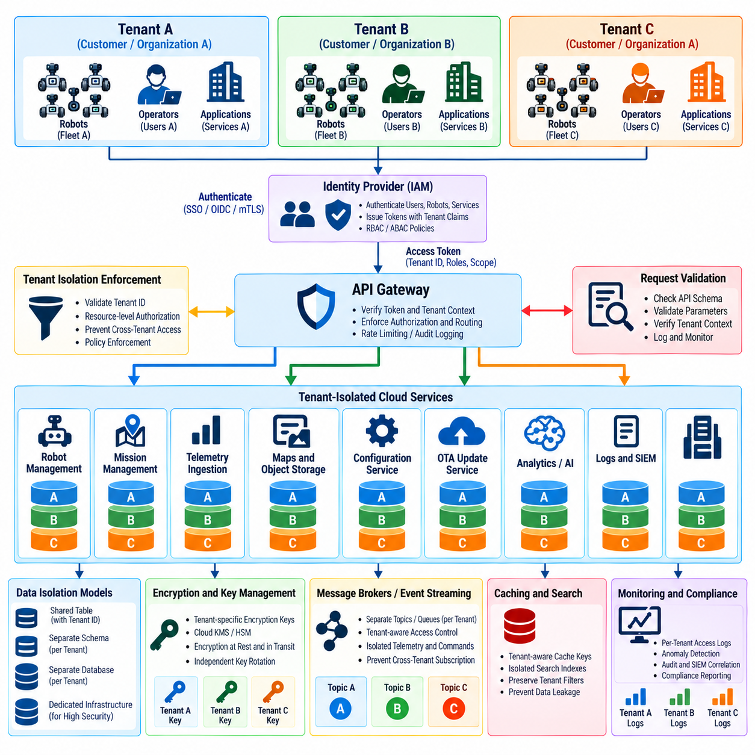
Multi-tenant fleet platforms allow a shared cloud infrastructure to serve multiple customers, organizations, sites, or business units while keeping their robot resources logically separated. This architecture improves operational efficiency and scalability, but it creates a critical security requirement: one tenant must never be able to view, modify, control, or infer another tenant’s robots, missions, telemetry, maps, credentials, or operational data.
Tenant isolation begins with an explicit tenant identity that is consistently associated with users, robots, services, and resources. Authentication should establish the requesting principal, while authorization determines the tenant context in which that principal may operate. Tenant identifiers should originate from trusted identity claims or server-side mappings rather than from unverified client parameters that an attacker could manipulate.
Every robot should belong to a clearly defined security domain. Its device certificate, fleet registration, cloud identity, and asset record can associate the machine with a specific tenant and fleet. When the robot authenticates, backend services should derive its permitted tenant context from trusted identity information. A robot must not gain access to another tenant simply by submitting a different customer, fleet, or robot identifier.
Authorization must be enforced at the resource level for every sensitive operation. A user who can retrieve telemetry from one fleet should not automatically be able to retrieve data from another fleet by changing an API path or object identifier. Robots, missions, maps, configuration objects, certificates, software packages, logs, commands, and maintenance records should all be evaluated against the authenticated tenant context.
Database isolation can be implemented using several architectural models. Tenants may share tables with mandatory tenant identifiers, use separate schemas, use separate databases, or receive dedicated infrastructure for highly sensitive deployments. The appropriate model depends on scale, performance, regulatory requirements, and risk, but every approach must prevent queries from accidentally crossing tenant boundaries.
Shared-table designs require particularly strict query controls because data from many customers exists in the same logical structure. Tenant predicates should be applied automatically and consistently rather than relying on individual developers to remember them in every query. Database-level row security, repository abstractions, policy enforcement layers, and automated tests can reduce the possibility of cross-tenant data exposure.
Object storage requires equivalent isolation. Maps, images, logs, AI artifacts, exported reports, backups, and sensor datasets should be organized so access policies restrict each tenant to its authorized objects. Predictable object names or paths must not become an authorization mechanism. Even if an attacker discovers another tenant’s object identifier, the storage service should independently reject unauthorized access.
Encryption can provide an additional tenant boundary beyond logical authorization. Tenant-specific encryption keys or separated key hierarchies limit the consequences of failures in storage permissions and allow independent key rotation or revocation. Key Management Service policies must ensure that an application operating in one tenant context cannot request decryption with keys assigned to another tenant.
API gateways and backend services should propagate tenant context in a controlled manner. A gateway may authenticate a request and attach verified identity claims, but downstream services must protect those claims from client modification. Critical services should still enforce their own authorization because trusting every upstream component without verification can turn one compromised service into a path across tenant boundaries.
Message brokers and event-streaming systems also require tenant-aware controls. Robot telemetry, commands, mission events, and status updates may share messaging infrastructure while using separate topics, queues, namespaces, or authorization policies. Producers and consumers should only publish or subscribe within their approved tenant scope, preventing one customer from observing or injecting another customer’s fleet messages.
Fleet command isolation is especially important because cross-tenant failure can produce physical consequences. An operator authorized for one organization must never be able to dispatch missions, change configurations, or issue movement-related commands to another organization’s robots. Command authorization should validate issuer identity, tenant, target fleet, target robot, requested action, and relevant operational policy before delivery.
Caching layers can unintentionally bypass otherwise correct tenant isolation. If a cache key includes only a robot identifier or API path without tenant context, data returned for one customer might later be served to another. Tenant identity should therefore participate in cache partitioning and key construction, and sensitive cached data should retain the same authorization assumptions as its authoritative backend source.
Search indexes and analytics platforms create similar risks because they often aggregate information from many fleets for efficient processing. Queries must preserve tenant filters through indexing, aggregation, reporting, and export operations. Derived information can also be sensitive; statistics, embeddings, operational trends, or aggregated maps may reveal another tenant’s activities even when raw records are not directly exposed.
Security logs and SIEM data require isolation because they can contain robot identifiers, network addresses, mission information, API activity, certificate events, and command histories. Customer-facing monitoring views should expose only the authorized tenant’s events, while central security teams may require broader privileged visibility. Such elevated access should be explicitly authorized, monitored, and audited.
Administrative functions create one of the most significant multi-tenant risks. Platform administrators may legitimately require access across customer environments for support, incident response, or maintenance. These privileges should use dedicated administrative identities, strong authentication, temporary privilege elevation, explicit approval where appropriate, and comprehensive auditing rather than ordinary operator accounts with permanently broad permissions.
Background jobs and automated services must preserve tenant context even when no interactive user is present. Scheduled analytics, report generation, data retention, backups, model processing, OTA deployment, and fleet optimization tasks should execute with identities and permissions appropriate to the affected tenant. A generic background worker should not implicitly receive unrestricted access to every customer's data merely for implementation convenience.
Backup and disaster-recovery systems must maintain isolation after data leaves the production environment. Shared backup repositories can contain information from many tenants, making them high-value targets. Encryption, access control, restore authorization, and audit logging should prevent operators or applications from restoring one tenant’s information into another tenant’s environment or exposing it during recovery testing.
Tenant onboarding and offboarding are part of the isolation lifecycle. Onboarding should create the required identity domains, fleet namespaces, storage policies, encryption keys, monitoring scopes, and administrative boundaries. Offboarding should revoke identities, remove permissions, address retained data according to policy, disable robot access, and ensure that obsolete tenant resources cannot later be reassigned in a way that exposes historical information.
Data export deserves additional control because authorized users may legitimately extract large quantities of fleet information. Export operations should verify tenant scope, apply appropriate authorization, generate audit records, and protect generated files. Temporary download links should expire, exported objects should remain encrypted where appropriate, and one tenant’s export process must never include records belonging to another tenant.
Isolation testing should deliberately attempt to cross tenant boundaries. Security tests can authenticate as one tenant and manipulate robot identifiers, fleet identifiers, API paths, database queries, object references, message topics, cache keys, and export parameters. Negative tests are particularly valuable because successful isolation is demonstrated when unauthorized cross-tenant requests consistently fail across every service boundary.
Automated regression testing is essential because multi-tenant authorization can be weakened by seemingly unrelated software changes. New APIs, database migrations, caching optimizations, analytics features, or background services may accidentally omit tenant enforcement. Continuous tests should verify that representative identities cannot read, modify, command, subscribe to, decrypt, or export resources outside their assigned security domain.
Monitoring should detect attempted boundary violations even when access controls successfully block them. Repeated requests for another tenant’s robot identifiers, unusual authorization failures, cross-namespace message access, unexpected decryption requests, or administrative access across many customers may indicate probing or credential compromise. SIEM correlation can distinguish isolated mistakes from systematic attempts to escape tenant boundaries.
A mature multi-tenant fleet architecture applies tenant isolation consistently across identity, APIs, databases, storage, messaging, caching, analytics, encryption, commands, logs, backups, and administrative operations. Isolation is therefore not a single database feature but an end-to-end security property. Every request and data flow must preserve trusted tenant context so shared cloud infrastructure never becomes shared authority over another customer’s physical robot fleet.

06.08. Cloud Security Compliance SOC2 ISO 27001
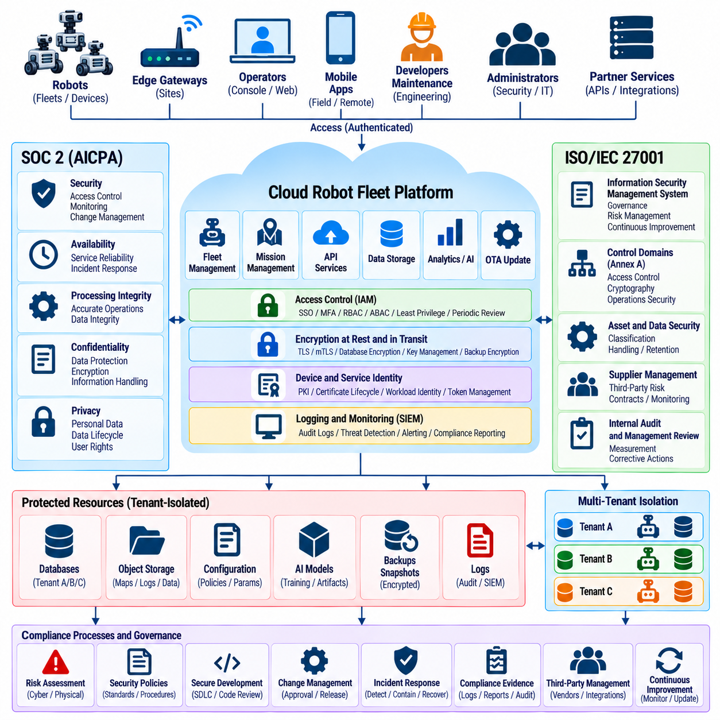
Cloud security compliance provides a structured method for demonstrating that robot fleet services protect information and operate according to defined security controls. SOC 2 and ISO/IEC 27001 are widely used assurance frameworks for cloud environments, but compliance should not be treated as a certificate-driven exercise. For robotics, governance must connect cloud controls with devices, operational data, fleet commands, and physical consequences.
SOC 2 evaluates controls relevant to the Trust Services Criteria, with security forming the foundation and additional criteria addressing availability, processing integrity, confidentiality, and privacy when included in scope. A robot fleet provider can use these criteria to demonstrate how access control, monitoring, change management, incident response, data protection, and service availability are systematically managed within its cloud platform.
A SOC 2 Type I examination evaluates whether relevant controls are suitably designed at a specified point in time, while a Type II examination additionally evaluates their operating effectiveness over a defined period. For an operational robot platform, Type II evidence is particularly valuable because security depends on controls functioning continuously across identity management, software deployment, monitoring, fleet operations, and administrative processes.
ISO/IEC 27001 establishes an Information Security Management System that organizes security around governance, risk management, documented policies, control implementation, measurement, internal review, and continual improvement. Rather than focusing only on technical mechanisms, it requires an organization to define the scope of its information-security responsibilities and systematically manage risks affecting information confidentiality, integrity, and availability. Pasted text(71)
The compliance scope should clearly identify the cloud services, robot fleets, operational sites, development systems, administrative interfaces, databases, APIs, identity providers, monitoring platforms, and supporting infrastructure covered by the program. Ambiguous scope can create unmanaged boundaries where important systems are excluded from control assessment even though they process fleet data or influence robot operations.
Risk assessment connects compliance requirements to actual robotic threats. Organizations should identify assets, threat scenarios, vulnerabilities, existing controls, likelihood, and potential impact. A compromised analytics dashboard may primarily expose information, whereas unauthorized access to mission-management or fleet-command services could influence physical operations. Risk treatment should therefore reflect both cybersecurity and cyber-physical consequences.
Identity and access management represents a major compliance control domain. Human administrators, operators, developers, automated services, and robots should use attributable identities with permissions based on business and operational requirements. Multi-factor authentication, role separation, least privilege, privileged-access controls, periodic access reviews, and timely account removal provide evidence that access is governed throughout the identity lifecycle.
Machine identities require equivalent governance. Robot certificates, workload identities, service accounts, API credentials, and signing keys should be inventoried, protected, rotated, monitored, and revoked when no longer required. Compliance evidence should demonstrate not merely that authentication exists, but that credentials are issued through controlled processes and remain traceable to approved devices, services, environments, and responsible owners.
Cryptographic controls protect sensitive fleet information across storage and communication paths. Encryption at rest should cover databases, object storage, backups, logs, and other persistent repositories, while encryption in transit protects robot-to-cloud and service-to-service communication. Key-management procedures should address generation, access, storage, rotation, revocation, recovery, and destruction according to defined security policy.
Cloud configuration management is important because security failures frequently arise from incorrect permissions or exposed resources rather than missing security technologies. Infrastructure-as-Code, approved configuration baselines, peer review, automated policy checks, drift detection, and controlled deployment pipelines can provide repeatable evidence that cloud environments remain aligned with established security requirements.
Change management should connect software development with production security. Source changes, infrastructure modifications, API revisions, model deployments, and security-policy updates should follow defined review, testing, approval, deployment, and rollback procedures. Traceability from requested change through implementation and production release allows auditors and security teams to determine who changed critical fleet functionality and why.
Secure development practices should be incorporated into the compliance program. Code review, dependency management, vulnerability scanning, secret detection, security testing, software composition analysis, and controlled build pipelines reduce software supply-chain risk. Robotics organizations should extend these practices to edge software, fleet services, OTA packages, AI models, containers, and middleware rather than limiting them to conventional cloud applications.
Logging and monitoring provide evidence that controls remain effective during operation. Cloud API calls, authentication events, administrative actions, certificate operations, fleet commands, configuration changes, software updates, security alerts, and privileged activities should generate appropriate records. Centralized monitoring can correlate these signals and identify suspicious behavior across cloud, network, identity, and robot domains.
Incident response procedures should define detection, classification, escalation, containment, investigation, recovery, communication, and post-incident improvement. Robotics introduces additional considerations because containment actions can influence physical systems. Disabling credentials or isolating a service may be appropriate, but response procedures should consider whether robots must transition to safe local operation when cloud connectivity or authority is removed.
Availability controls are particularly relevant when cloud services support mission scheduling, maps, coordination, software distribution, or operational monitoring. Redundancy, backup, disaster recovery, capacity management, health monitoring, and tested restoration procedures should correspond to business requirements. Compliance evidence should show that recovery objectives are defined and that recovery mechanisms are periodically exercised rather than merely documented.
Backup governance should address confidentiality, integrity, retention, restoration, and access control. Robot configuration, customer data, security logs, credentials, operational histories, and AI assets may persist in backup systems long after production data changes. Restoration tests should verify that backups are usable while ensuring that recovery processes do not bypass tenant isolation, authorization, encryption, or current security policies.
Multi-tenant fleet services require evidence that customer data and authority remain isolated. APIs, databases, storage, messaging, analytics, caching, encryption keys, logs, and administrative tools should preserve tenant boundaries. Compliance testing should include negative scenarios demonstrating that one tenant cannot retrieve another tenant's data or issue commands to another customer's robots by manipulating identifiers or application requests.
Vendor and supply-chain risk management extends compliance beyond the organization itself. Cloud providers, identity services, software vendors, monitoring platforms, communications providers, and other third parties may support critical fleet functions. Organizations should evaluate relevant supplier risks, contractual responsibilities, security assurances, dependency changes, and incident-notification processes throughout the supplier lifecycle.
Asset management establishes what must be protected. Inventories should cover cloud resources, robot devices, software components, certificates, service accounts, data repositories, models, external dependencies, and critical interfaces. Ownership and classification help determine which security requirements apply to each asset and provide the foundation for vulnerability management, access review, incident response, and lifecycle control.
Vulnerability management should define how weaknesses are discovered, prioritized, remediated, verified, and documented. Cloud workloads, containers, operating systems, libraries, APIs, edge computers, and robot software may require different remediation processes. Risk-based prioritization should consider exploitability and exposure together with whether a vulnerable component can influence fleet control, sensitive data, or safety-relevant behavior.
Evidence collection should be designed into normal operations rather than assembled manually before an audit. Access reviews, deployment approvals, security scan results, incident records, backup tests, training records, policy acknowledgments, vulnerability remediation, configuration checks, and monitoring results can be retained automatically. Reliable evidence reduces audit effort and demonstrates that security processes operate continuously rather than only during assessment periods.
Policies and procedures must correspond to actual engineering practice. A written requirement for key rotation or access review has limited assurance value when production systems cannot demonstrate that the activity occurs. Control owners should understand their responsibilities, evidence sources, review frequency, exceptions, and remediation procedures so documented governance remains connected to operational reality.
Internal audits, management reviews, control testing, and corrective actions create a continuous assurance cycle. Findings should be tracked to accountable owners, analyzed for underlying causes, remediated within defined periods, and retested. This continual-improvement model is especially important for robot fleets because software, cloud architecture, AI components, operational environments, and cybersecurity threats evolve throughout deployment. Pasted text(71)
SOC 2 and ISO/IEC 27001 can therefore support complementary assurance objectives. SOC 2 provides an attestation-oriented view of whether defined controls are suitably designed and, for Type II, operating effectively, while ISO/IEC 27001 establishes a certifiable management system for systematically governing information-security risks. Neither framework by itself replaces robotics safety, industrial cybersecurity, privacy, or sector-specific regulatory obligations.
A mature compliance program integrates governance with engineering instead of maintaining a separate audit layer. Identity, encryption, secure APIs, tenant isolation, monitoring, incident response, vulnerability management, change control, backup, recovery, supplier management, and evidence collection become normal operational processes. Compliance then becomes continuous assurance that cloud security controls remain effective as the robot fleet, software stack, and threat environment evolve.

06.09. Fleet Security Incident Playbook Design
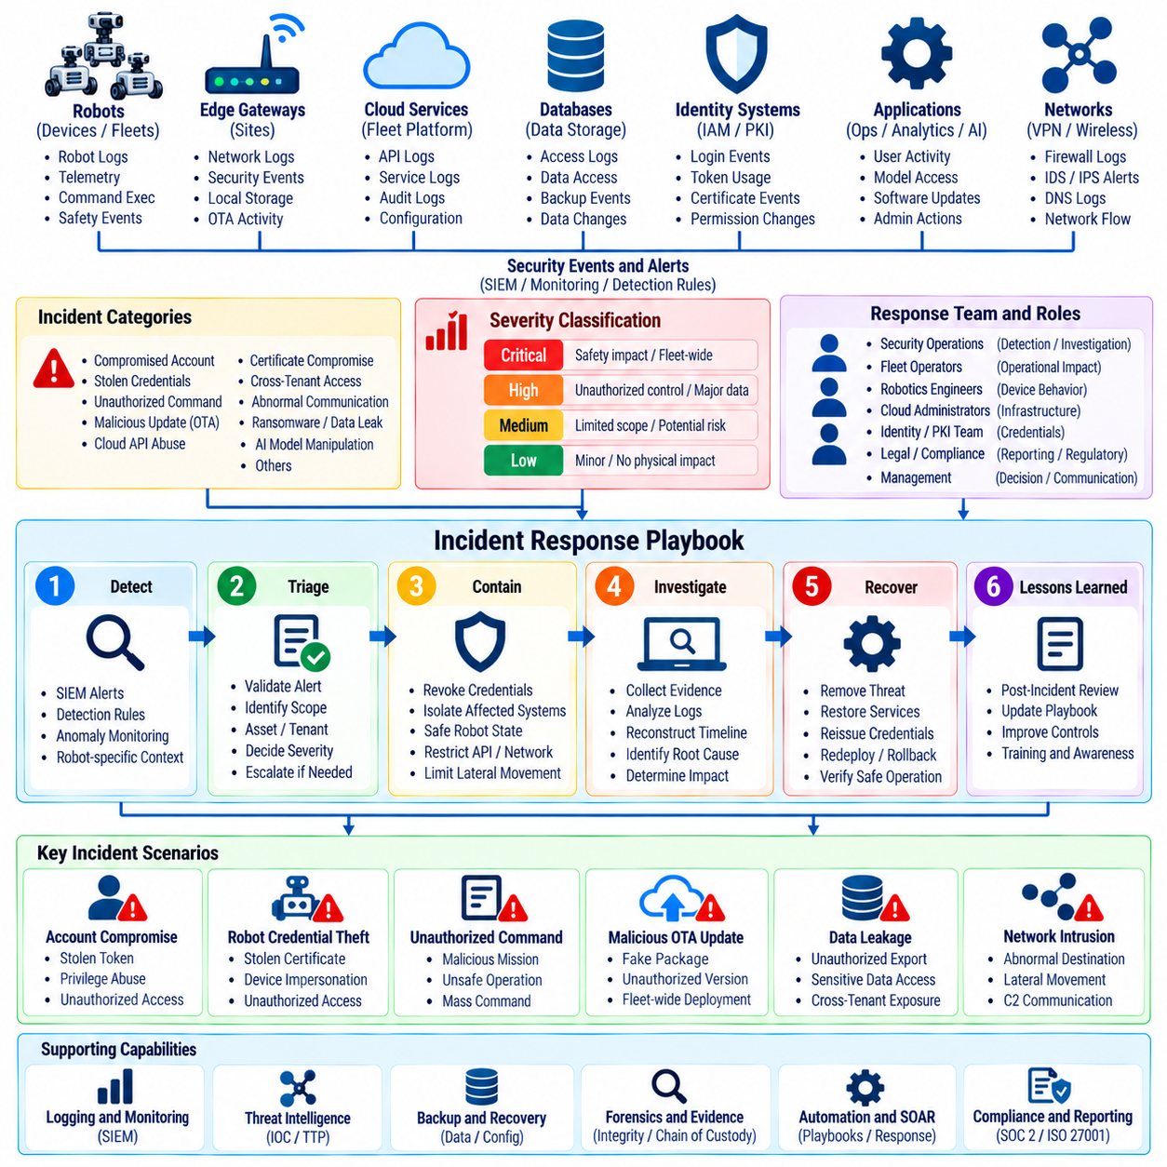
A fleet security incident playbook defines repeatable actions for detecting, assessing, containing, investigating, recovering from, and learning from cybersecurity incidents affecting connected robots. Unlike conventional IT response, fleet incidents can influence physical motion, mission execution, safety systems, and distributed devices. The playbook must therefore coordinate cybersecurity decisions with operational safety and fleet availability.
Playbook design begins by defining incident categories that reflect the fleet threat model. Relevant scenarios include compromised operator accounts, stolen robot credentials, unauthorized fleet commands, malicious software updates, cloud API abuse, certificate compromise, cross-tenant access, abnormal robot communication, ransomware, data leakage, and suspected manipulation of AI models. Each category requires predefined investigation and containment paths.
Severity classification should consider both cyber impact and physical consequences. A failed authentication attempt may be low severity, while unauthorized access to a fleet-command service can require immediate escalation even before physical movement occurs. Classification criteria should evaluate affected robots, privilege level, data sensitivity, operational state, fleet scale, safety implications, attacker persistence, and potential propagation across connected systems.
Clear roles prevent confusion during high-pressure response. Security operations personnel may lead detection and investigation, while fleet operators assess operational effects and robotics engineers evaluate device behavior. Cloud administrators, identity teams, safety personnel, legal or compliance functions, and management may participate according to severity. The playbook should define decision authority, escalation paths, communication channels, and ownership of recovery actions.
Detection criteria should connect Security Information and Event Management alerts with robot-specific context. Repeated authentication failures, unusual API activity, unexpected certificate changes, rejected command signatures, abnormal network destinations, unauthorized software versions, unusual model hashes, or commands outside expected operating patterns can initiate a playbook. Trigger conditions should be specific enough to support consistent activation without depending entirely on individual judgment.
Initial triage determines whether an alert represents a genuine incident and establishes its immediate scope. Analysts should identify the affected tenant, fleet, robot, account, service, credential, software version, and operational site where possible. Recent authentication events, commands, configuration changes, OTA activity, network connections, and robot state provide context for deciding whether escalation or immediate containment is required.
Evidence preservation should begin early because fleet systems generate distributed and sometimes short-lived data. Relevant evidence may include cloud audit logs, SIEM events, robot logs, command histories, API records, certificate events, network telemetry, software hashes, configuration snapshots, and device timestamps. Collection procedures should preserve integrity, provenance, and time relationships so investigators can reconstruct the sequence of events.
Containment must distinguish between digital isolation and safe physical behavior. Disconnecting a conventional server may be straightforward, but abruptly isolating an operating robot can interrupt navigation, charging, material handling, or coordinated missions. Playbooks should define how robots transition to safe local operation, controlled stop, restricted mode, or supervised recovery when cloud authority, network connectivity, or credentials are removed.
Credential compromise requires rapid but scoped containment. A compromised operator token may be revoked without disabling the entire fleet, while a stolen robot certificate may require isolating a specific device identity. If a fleet-wide signing key is compromised, the response may involve emergency key revocation, command rejection, replacement credentials, and controlled restoration of trust across many robots and cloud services.
Unauthorized command incidents require correlation between cyber evidence and physical execution. Investigators should determine who issued the command, which credential or signing key was used, which robots received it, whether signature and authorization checks succeeded, and whether the command was executed. Acknowledgment, acceptance, and physical completion should be treated as separate states when determining actual operational impact.
OTA incidents require verification of software provenance and deployment scope. The response should identify the package, signature, source repository, approval history, affected versions, targeted robots, installation status, and rollback capability. If malicious or corrupted software is suspected, further deployment should be blocked while affected robots are identified and moved to an operational state from which trusted software can be restored safely.
Cloud API incidents may involve stolen credentials, authorization failures, excessive requests, data extraction, or manipulation of fleet resources. The playbook should correlate API gateway records, IAM events, service logs, tenant context, and robot activity. Containment can include token revocation, endpoint restrictions, service isolation, permission reduction, or temporary blocking while preserving essential fleet functions whenever possible.
Multi-tenant incidents require immediate determination of whether a tenant boundary was crossed. Investigators should identify the source tenant, exposed resources, affected customers, accessed data, commands issued, and underlying authorization failure. Containment must close the cross-tenant path without unnecessarily disrupting unaffected customers, while evidence must support later assessment of confidentiality, integrity, and operational impact.
Robot network compromise requires visibility across both device and infrastructure layers. Unexpected outbound connections, lateral movement, abnormal DNS activity, scanning, or communication with unauthorized endpoints may indicate compromise. Network quarantine can restrict the affected robot, but the playbook should define whether local safety functions, diagnostic access, trusted maintenance channels, and emergency control must remain available during isolation.
AI-related incidents may involve unauthorized model replacement, model hash mismatch, malicious model artifacts, abnormal inference behavior, or suspected adversarial manipulation. Response procedures should identify the active model version, provenance, deployment history, input context, affected robots, and trusted fallback model. Restoring a known-good model should occur through the same authenticated and integrity-verified deployment controls used for normal production releases.
Communication procedures should prevent conflicting actions during an incident. Internal updates should identify incident severity, affected fleet scope, containment status, operational consequences, and assigned responsibilities. Customer, regulatory, partner, or public communication may be required depending on contractual and legal obligations. Sensitive investigative details should remain restricted while decision makers receive enough information to manage operational risk.
Recovery should restore trust rather than merely restore connectivity. Credentials may need replacement, certificates reissued, keys rotated, software reinstalled, configurations validated, permissions reviewed, and compromised accounts reset. Robots should rejoin the fleet only after identity, software integrity, configuration state, communication security, and required safety conditions have been verified against an approved baseline.
Recovery sequencing is important for large fleets. Restoring every robot simultaneously can reproduce an unresolved compromise or overload supporting services. A staged process can validate cloud services first, then selected test robots, followed by controlled groups and finally the broader fleet. Monitoring should remain elevated during restoration so recurring indicators are detected before full operational authority is returned.
Post-incident analysis should reconstruct the attack path and determine why existing controls failed or were insufficient. The review should examine initial access, privilege escalation, lateral movement, credential use, command activity, affected data, physical consequences, containment effectiveness, and recovery performance. Root causes should be translated into specific engineering, operational, monitoring, or governance improvements.
Playbooks should include measurable response objectives. Time to detection, triage, containment, credential revocation, fleet isolation, trusted recovery, and service restoration can reveal weaknesses in operational readiness. Metrics should be interpreted with safety context because the fastest technical containment is not always the safest action for robots that are moving, carrying loads, or operating near people.
Tabletop exercises allow teams to rehearse incidents without affecting production robots. Scenarios can simulate a compromised administrator, stolen signing key, malicious OTA package, tenant-isolation failure, or coordinated fleet-command attack. Participants can evaluate decision authority, communication, evidence availability, safety coordination, and recovery dependencies while identifying gaps before a real emergency occurs.
Technical exercises should complement tabletop reviews by validating that required response actions actually work. Teams should test certificate revocation, token invalidation, robot quarantine, command blocking, log retrieval, key rotation, software rollback, backup restoration, and controlled fleet re-entry. A documented procedure has limited value if production architecture cannot execute it reliably under realistic conditions.
Playbooks require continuous maintenance as fleet architecture evolves. New robot models, cloud services, APIs, identity mechanisms, AI components, communication networks, and operational sites can introduce new dependencies and response requirements. Incident findings, exercises, security tests, and architecture changes should therefore trigger playbook review, version control, approval, and redistribution to responsible teams.
A mature fleet security incident playbook connects cybersecurity response with physical safety, cloud operations, robot autonomy, identity management, and business continuity. Its purpose is not simply to document emergency steps, but to create rehearsed decision paths that preserve evidence, contain compromised authority, maintain safe robot behavior, restore trusted operation, and convert every incident into measurable improvement of fleet resilience.

06.10. Cloud Fleet Security Audit and Pen Test
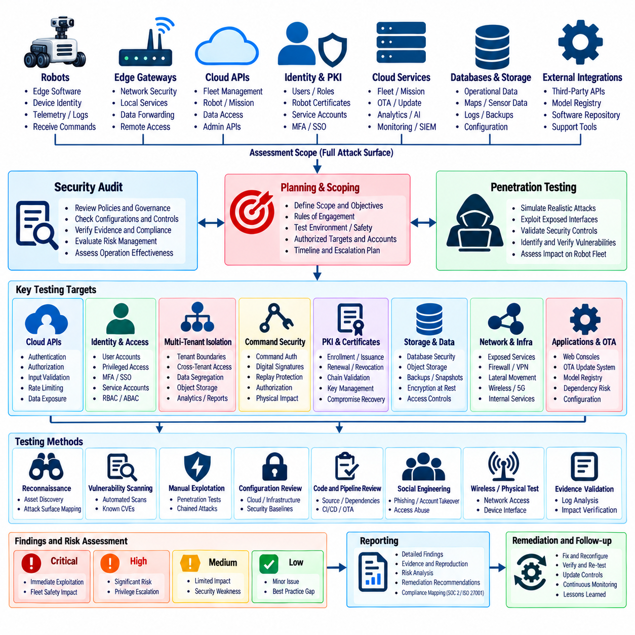
Cloud fleet security auditing and penetration testing provide complementary methods for determining whether security controls are correctly designed, implemented, and resistant to realistic attack paths. Audits evaluate architecture, policies, configurations, evidence, and control operation, while penetration testing actively challenges exposed interfaces and trust boundaries. Robot fleets require both because cloud weaknesses can ultimately influence distributed physical machines.
The assessment scope should include every component capable of storing fleet information, establishing trust, issuing commands, or influencing robot operation. Cloud APIs, identity services, databases, object storage, message brokers, fleet-management applications, OTA infrastructure, model registries, monitoring systems, administrative interfaces, edge gateways, and robot-facing communication paths should be considered according to the architecture under evaluation.
Before testing begins, rules of engagement must define authorized targets, techniques, accounts, time windows, escalation contacts, prohibited actions, and emergency stop conditions. Production robot environments require particular care because aggressive testing can disrupt missions or physical behavior. Potentially destructive techniques should be isolated in representative test environments unless explicit safety controls and operational approval make production validation acceptable.
Asset discovery establishes the actual attack surface rather than relying exclusively on architectural documentation. Assessors should identify internet-facing endpoints, internal services, APIs, storage resources, administrative consoles, certificates, service accounts, messaging infrastructure, software repositories, and externally reachable robot interfaces. Differences between documented and discovered assets often reveal unmanaged services or configuration drift requiring further investigation.
Architecture review should examine trust boundaries and data flows across robot, edge, and cloud layers. Assessors should determine where identities are established, where authorization occurs, how tenant context is propagated, where commands are signed and verified, and where sensitive data is encrypted or decrypted. Particular attention should be given to transitions between independently administered services because trust assumptions frequently fail at these boundaries.
Identity and Access Management should be audited for both human and machine identities. Testing should examine authentication strength, multi-factor authentication, role assignments, dormant accounts, privileged identities, service accounts, robot certificates, API credentials, and workload identities. Excessive permissions or shared credentials can transform compromise of one account or service into broader authority across cloud resources or robot fleets.
Authorization testing should verify that authenticated identities cannot exceed their assigned scope. Assessors can attempt to access different robots, fleets, missions, configuration objects, logs, software packages, or administrative operations by manipulating resource identifiers and API parameters. Negative testing is particularly important because successful authorization is demonstrated not only by permitted requests succeeding but by unauthorized requests consistently failing.
Multi-tenant isolation should be tested across every shared service. A tester operating as one tenant can attempt to access another tenant's API resources, database records, objects, message topics, cached responses, analytics results, exports, or fleet commands. Cross-tenant testing should also examine background services and administrative workflows because isolation failures can occur outside normal customer-facing application paths.
Cloud API penetration testing should examine authentication bypass, broken object-level authorization, excessive data exposure, insecure parameter handling, injection, weak rate limiting, token misuse, replay conditions, and unintended administrative functions. Testing should consider the complete API workflow rather than isolated endpoints because chained requests can expose privilege escalation paths that are not visible when individual functions are evaluated separately.
Fleet command interfaces require additional scrutiny because successful exploitation may create physical consequences. Tests should verify issuer authentication, authorization, digital signatures, command freshness, sequence handling, expiration, target validation, and replay protection. A modified robot identifier, stale signed command, duplicated message, or unauthorized command type should be rejected before it can influence robot execution.
Cryptographic review should verify encryption in transit and at rest rather than merely confirming that encryption features are enabled. Assessors should examine protocol versions, certificate validation, mutual TLS configuration, key permissions, signing algorithms, key rotation, storage encryption, backup encryption, and secret handling. Private keys, tokens, or credentials should not appear in source repositories, deployment packages, logs, container images, or ordinary configuration files.
Certificate and Public Key Infrastructure testing should examine enrollment, issuance, renewal, revocation, expiration, chain validation, and replacement procedures. Assessors should determine whether a revoked robot certificate is actually rejected and whether unauthorized devices can enroll themselves. Key-compromise scenarios can reveal whether fleet services can rapidly remove trust without unnecessarily disabling unaffected robots.
Storage testing should cover databases, object stores, snapshots, backups, logs, and temporary exports. Misconfigured permissions can expose telemetry, maps, operational histories, credentials, AI artifacts, or customer information even when application APIs are secure. Assessors should verify that sensitive storage is encrypted, non-public, correctly scoped, and inaccessible from identities that do not require it.
Messaging infrastructure should be evaluated because telemetry and commands frequently pass through brokers, queues, or event streams. Tests should determine whether unauthorized publishers can inject messages, whether subscribers can observe other fleets, and whether topic or namespace restrictions are correctly enforced. Message-level integrity controls should remain effective even when broker credentials or intermediate infrastructure are challenged.
OTA security testing should verify package provenance, signature validation, approval workflows, version controls, rollback behavior, and deployment authorization. Testers should determine whether modified, unsigned, outdated, or incorrectly targeted software can reach robots. The update system should fail securely when signature verification or trust validation fails and should preserve a controlled recovery path to a known-good software state.
AI and model infrastructure should be included when models influence robot perception, planning, or control. Assessors can review model registry permissions, artifact integrity, model hashes, deployment authorization, and access to training or adaptation data. Unauthorized model replacement or tampering should be detectable, while production robots should only load model artifacts whose identity, integrity, and deployment status satisfy approved policy.
Network testing should evaluate segmentation between cloud services, management networks, robot connectivity, development environments, and external interfaces. Firewall rules, VPN controls, security groups, routing policies, and service exposure should limit lateral movement. A compromised workload should not automatically gain unrestricted connectivity to certificate services, OTA infrastructure, administrative systems, or fleet-command components.
Logging and monitoring controls should be tested as part of the attack exercise. Penetration-test activity should generate expected authentication, API, network, command, certificate, and privilege-related events in the Security Information and Event Management system. This allows the assessment to evaluate not only whether an attack can succeed but whether defenders can detect, correlate, investigate, and respond to the attempted behavior.
Privilege escalation testing should explore whether a low-authority identity can obtain administrative or fleet-control capabilities. Misconfigured cloud roles, exposed service tokens, overly permissive workload identities, vulnerable internal APIs, or insecure automation pipelines can create escalation paths. Tests should trace the practical consequences of elevated access while remaining within agreed safety boundaries and avoiding unnecessary disruption.
Incident-response integration increases the value of penetration testing. Selected exercises can operate as controlled purple-team scenarios in which attackers execute agreed techniques while defenders investigate alerts and apply containment procedures. This validates communication, evidence collection, credential revocation, certificate suspension, network quarantine, and fleet incident playbooks under realistic conditions without requiring an uncontrolled security event.
Audit evidence should establish whether controls operate continuously rather than only during the assessment. Configuration records, access reviews, key-rotation history, vulnerability scans, deployment approvals, backup tests, incident records, monitoring alerts, and remediation evidence can demonstrate operational consistency. Sampling should cover representative fleets, tenants, environments, and privileged workflows rather than focusing only on a single ideal configuration.
Findings should be prioritized according to realistic fleet risk. A conventional severity score can provide useful technical context, but remediation priority should also consider exploitability, privilege gained, number of affected robots, tenant exposure, data sensitivity, command authority, persistence, and potential physical consequences. A vulnerability enabling unauthorized fleet commands may require urgent treatment even when its traditional IT impact appears limited.
Remediation should assign accountable owners, target dates, technical actions, and verification requirements. Fixes may involve policy changes, permission reduction, code modification, key rotation, architecture changes, network segmentation, improved monitoring, or operational procedures. High-risk findings should be retested after remediation to confirm that the original attack path is closed without introducing an alternative bypass.
Security audits and penetration tests should be repeated as the platform evolves. New cloud services, APIs, robot models, AI components, identity mechanisms, customer environments, and software releases can introduce new attack paths. Continuous automated security testing can cover common regressions, while periodic independent assessments provide deeper validation of architecture, trust assumptions, and chained vulnerabilities.
A mature cloud fleet security assessment program combines governance audits, configuration review, attack-surface discovery, penetration testing, tenant-isolation validation, command-security testing, cryptographic review, detection verification, and remediation tracking. Its objective is not simply to produce an audit report, but to demonstrate that cloud and fleet controls resist realistic attacks while preserving safe, attributable, and recoverable operation of physical robots.

