Volume 24. Robot Cybersecurity

Chapter 03. Robot Network Security

03.01. Robot Network Architecture Segmentation DMZ [w/Code]
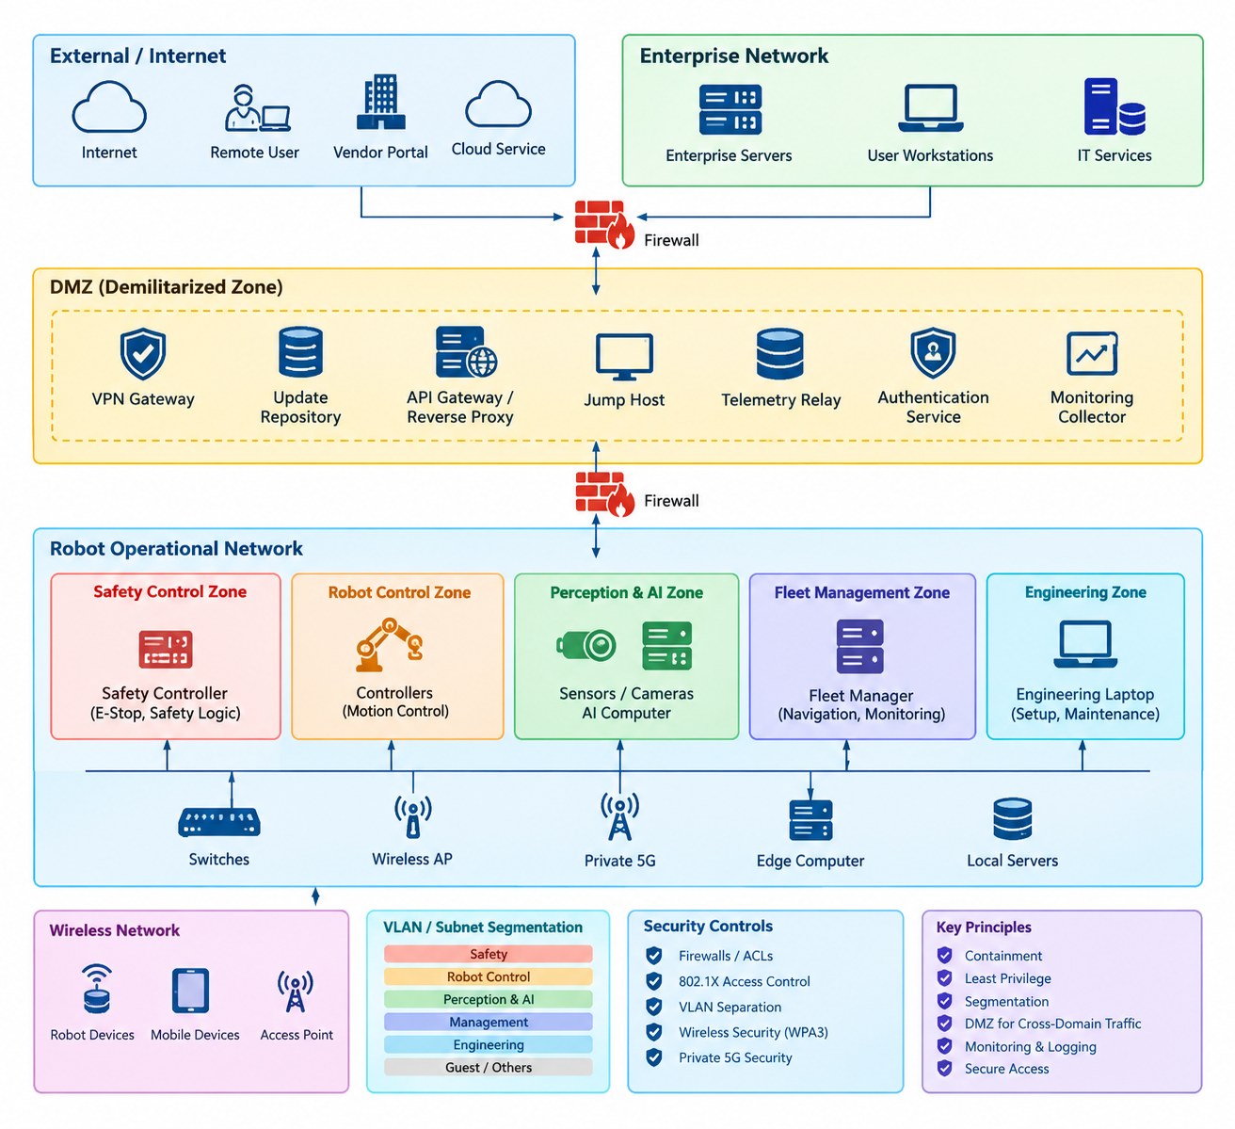
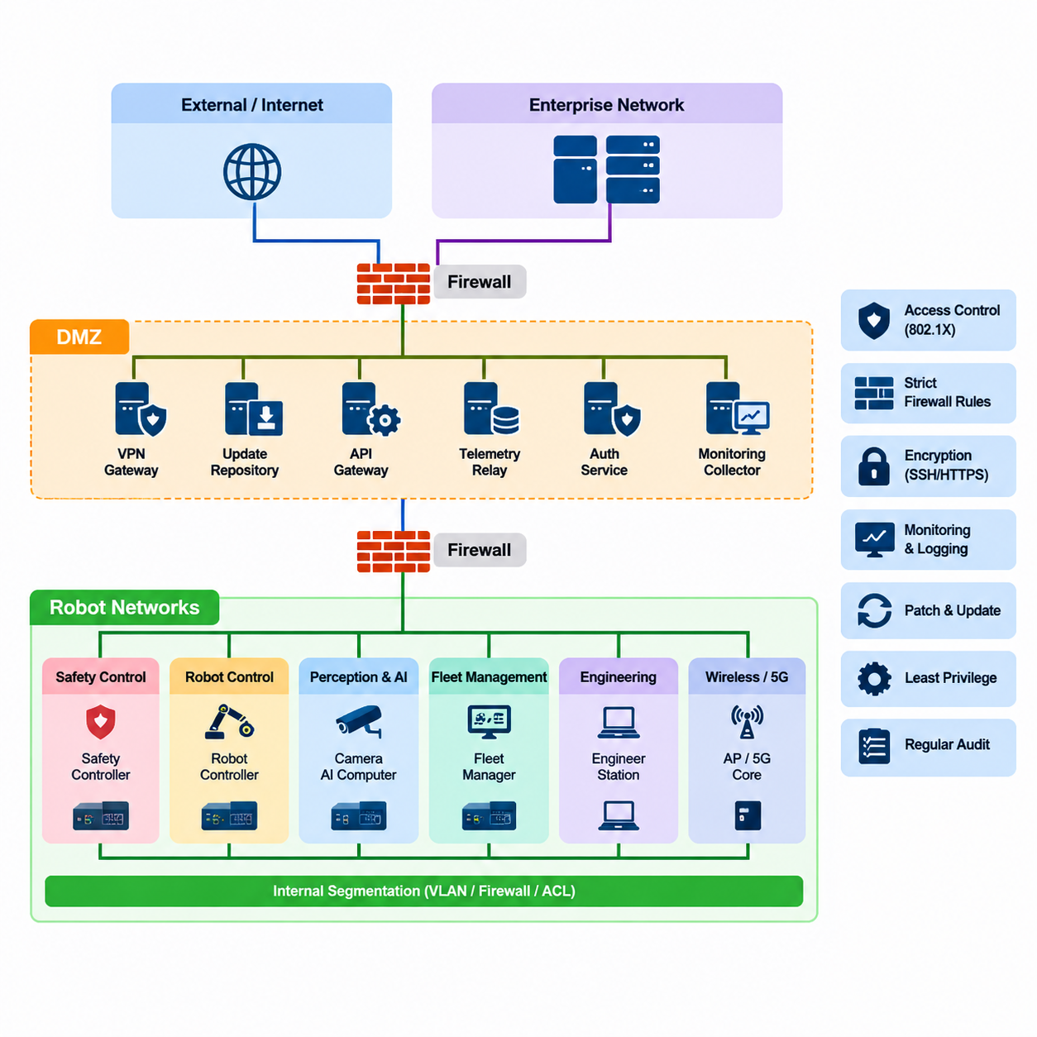
Robot networks form the communication foundation that connects controllers, sensors, actuators, edge computers, operator stations, fleet managers, and external services. In the cybersecurity structure of this volume, network security is treated as a dedicated layer between threat modeling and ROS2/DDS security, emphasizing that communication infrastructure requires protection independently from application-level mechanisms. Volume_24_Robot_Cybersecurity
A secure robot network should therefore not be designed as one large trusted subnet. Network segmentation divides the system into security zones according to operational function, criticality, trust level, and communication requirements. Typical zones may include safety control, robot control, perception and AI processing, fleet management, engineering, enterprise IT, wireless infrastructure, and externally accessible services.
The central security principle is containment. If an attacker compromises a maintenance laptop, wireless access point, camera, or AI computer, segmentation should prevent that compromise from automatically providing access to motor controllers or safety-critical control systems. Each boundary becomes an enforcement point where traffic can be authenticated, filtered, monitored, rate-limited, or completely rejected according to policy.
Segmentation should follow communication dependencies rather than physical location alone. Devices installed inside the same robot may belong to different trust zones because their consequences of compromise differ significantly. A safety controller handling emergency-stop functions requires stronger isolation than an infotainment interface, while an edge AI computer processing camera streams may require high bandwidth without requiring unrestricted access to actuator networks.
A practical architecture commonly separates safety-critical and deterministic control traffic from high-volume perception and AI traffic. The broader robotics software structure also distinguishes real-time networking, robot communication APIs, telemetry, edge computing, fleet communication, and cloud integration as separate architectural concerns. These distinctions provide natural boundaries that cybersecurity segmentation can reinforce. 08_Robotics_Software_Tree 08_Robotics_Software_Tree
At the lowest trust level, externally reachable networks should never communicate directly with critical robot controllers. Internet services, vendor portals, remote maintenance systems, cloud gateways, and enterprise applications should terminate at controlled intermediary systems. Connections crossing toward operational robot networks can then be explicitly authorized according to source identity, destination, protocol, port, service, and operational purpose.
A demilitarized zone, or DMZ, provides this intermediary security layer. Instead of exposing robot networks directly to enterprise or external networks, services requiring communication across trust domains are placed inside the DMZ. Typical examples include VPN gateways, update repositories, API gateways, reverse proxies, jump hosts, telemetry relays, authentication services, and security monitoring collectors.
The DMZ should be treated as a controlled exchange zone rather than a trusted extension of either side. Firewalls normally separate external or enterprise networks from the DMZ and separately isolate the DMZ from robot operational networks. A compromise of a DMZ service therefore does not automatically provide direct connectivity to robot controllers, because another independently enforced security boundary must still be crossed.
Communication policies should implement least privilege. A telemetry gateway may be permitted to receive selected robot status messages but should not automatically receive permission to issue motion commands. An OTA repository may provide signed software packages to authorized devices while being prohibited from initiating arbitrary sessions toward control nodes. Administrative access should similarly use dedicated management paths instead of general production traffic.
VLANs and subnet separation provide useful logical segmentation, but segmentation becomes a security control only when boundaries are enforced. Layer-3 firewalls, access-control lists, secure gateways, network access control, host firewalls, and application-aware proxies can restrict communication between zones. The chapter structure consequently treats firewall rules, 802.1X access control, VLAN separation, wireless security, and private 5G security as complementary network defenses. Volume_24_Robot_Cybersecurity
Robot architectures must also consider the difference between north-south and east-west traffic. North-south traffic connects robots or fleet infrastructure with enterprise, cloud, or remote systems. East-west traffic moves between robots, controllers, edge computers, servers, and services within the operational environment. Attackers who obtain an initial foothold frequently exploit permissive east-west connectivity to perform lateral movement.
Microsegmentation can reduce this risk by defining communication permissions at finer granularity than conventional network zones. Instead of allowing every device within a robot VLAN to communicate freely, policies can restrict communication to required service relationships. A localization computer may communicate with designated sensors and navigation services, while actuator interfaces accept commands only from authenticated control components.
Fleet environments require additional separation because hundreds or thousands of robots may share common infrastructure. A compromised robot should not become a bridge for attacking neighboring robots or the fleet-management system. Per-robot identities, restricted peer communication, isolated management channels, authenticated gateways, and carefully designed fleet service zones help constrain the blast radius of individual device compromise.
Wireless robots introduce dynamic network membership into this architecture. AMRs, humanoids, inspection robots, and UAV support systems may roam between access points or network domains while maintaining operational sessions. Network admission must therefore verify device identity before granting access, and authorization should determine which zone and services become reachable after authentication rather than assuming that wireless connectivity itself establishes trust.
Remote maintenance deserves especially strict treatment because it intentionally creates a path from outside the operational environment toward sensitive assets. Secure designs terminate remote connections at a VPN gateway or controlled access service in the DMZ, authenticate users and devices, and then require access through hardened jump systems. Direct inbound remote desktop, SSH, or engineering access to robot controllers should generally be prohibited.
Segmentation must preserve robot safety and real-time behavior as well as confidentiality. Security devices inserted into deterministic control paths can introduce latency, jitter, packet loss, or failure modes. Architects should therefore classify communication flows according to timing requirements and place enforcement mechanisms where they provide meaningful isolation without violating control-loop deadlines or interfering with emergency and fail-safe communication.
Availability also influences zone design. A single central firewall that handles every internal flow may become both a performance bottleneck and a common failure point. Industrial robot deployments can instead combine hierarchical segmentation, redundant gateways, local enforcement, deterministic network paths, and fail-safe policies. Security architecture must ensure that defensive controls do not transform ordinary network faults into unsafe robot behavior.
Monitoring should be integrated at major trust boundaries. Firewalls, gateways, switches, wireless controllers, VPN systems, and robot endpoints can generate security telemetry describing authentication failures, rejected connections, unexpected protocols, configuration changes, and abnormal traffic patterns. The volume subsequently extends this concept into dedicated network intrusion detection and SIEM-oriented network security monitoring. Volume_24_Robot_Cybersecurity
Segmentation policies should finally be represented as explicit architecture artifacts rather than undocumented switch configurations. Each zone should have a defined purpose, asset inventory, trust level, permitted communication flows, administrative path, logging requirement, and responsible owner. Changes to robot software or fleet infrastructure can then be evaluated against these boundaries before deployment rather than gradually creating uncontrolled connectivity.
A mature robot network architecture combines segmentation, DMZs, identity, least-privilege communication, encrypted remote access, monitoring, and controlled inter-zone gateways into defense in depth. The objective is not merely to block external attackers, but to ensure that compromise of any single robot, service, network interface, or administrative endpoint remains contained and cannot easily propagate into safety-critical or fleet-wide functions.

03.02. Firewall and ACL Rules for Robot Networks [w/Code]
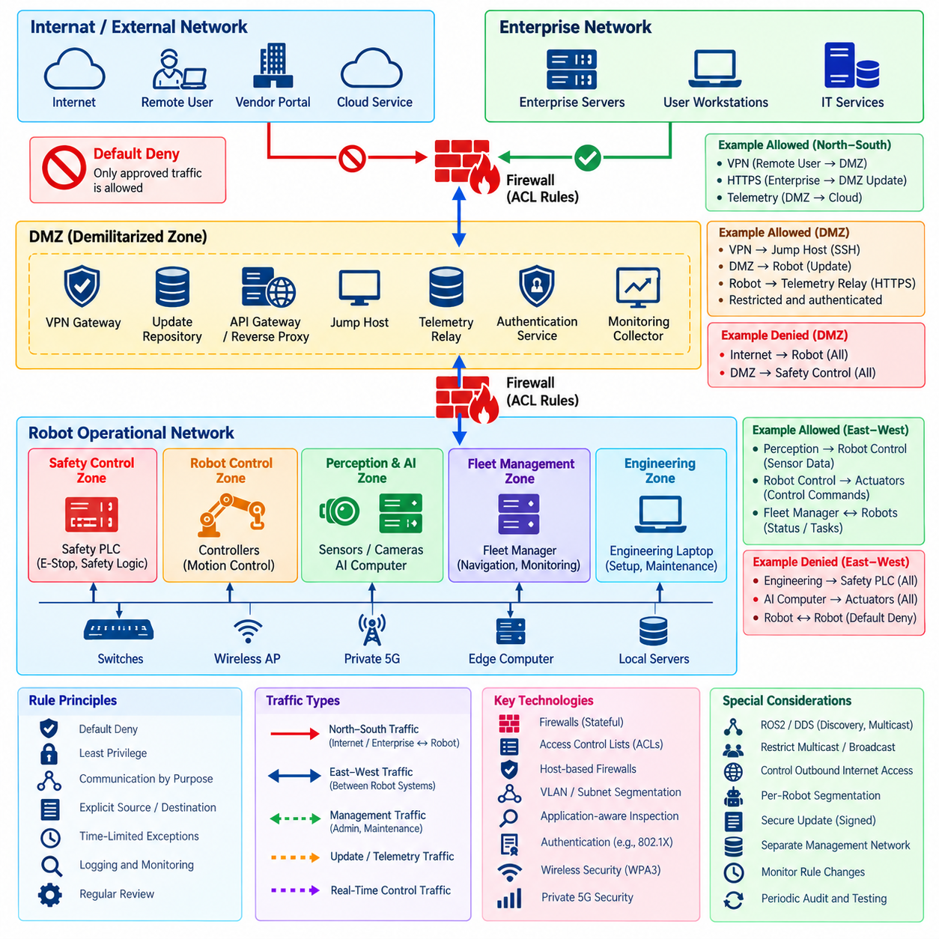
Firewalls and access control lists provide the enforcement layer that turns robot network segmentation into an operational security boundary. After zones such as safety control, robot control, perception, AI computing, fleet management, engineering, DMZ, and enterprise networks have been defined, firewall and ACL policies determine exactly which systems may communicate across those boundaries and under what conditions.
A secure rule set begins with a default-deny philosophy. Traffic should not be permitted merely because two devices share an operational environment or because a protocol is commonly used by robotics software. Each allowed flow should correspond to a documented communication requirement specifying the source, destination, protocol, port or service, direction, and operational purpose. Everything outside the approved communication model is rejected.
Firewalls and ACLs operate at different enforcement points and can complement one another. Router and switch ACLs provide efficient filtering based primarily on network and transport information, while stateful firewalls can track connection state and apply more detailed security policies. Host-based firewalls add another boundary directly on robot computers, edge nodes, engineering workstations, and servers, reducing dependence on perimeter controls alone.
Safety-critical robot networks require particularly restrictive policies. Motor controllers, safety PLCs, emergency-stop systems, and deterministic control components should accept traffic only from explicitly authorized control sources. General enterprise hosts, user laptops, cloud services, and unrelated robot subsystems should have no direct route or firewall permission to these components, even when physical network connectivity technically exists.
Robot control networks often require predictable communication among navigation, localization, motion planning, control, and hardware-interface components. Firewall policies should preserve these required flows while preventing unrelated services from entering the control domain. Administrative protocols such as SSH or remote management should normally use dedicated management paths rather than sharing unrestricted access with real-time production communication.
Perception and AI networks have different traffic characteristics. Cameras, LiDARs, radar systems, GPU computers, and inference servers may exchange large data streams at high rates, making indiscriminate inspection expensive. Security architecture should therefore identify necessary high-bandwidth flows precisely and prevent their network requirements from becoming justification for broad any-to-any rules that undermine segmentation.
Fleet management systems require controlled bidirectional communication with many robots. A robot may need to report health, position, mission status, battery state, and diagnostic information while receiving authorized tasks or configuration data. Firewall policies should distinguish these functions from direct low-level motion control so that compromise of a fleet service does not automatically provide unrestricted access to actuator interfaces.
The DMZ provides a natural location for services that mediate communication between robot operational technology and less trusted networks. VPN concentrators, API gateways, update servers, telemetry relays, jump hosts, and authentication services can terminate external sessions before selected traffic is forwarded inward. Firewall rules on both sides of the DMZ should remain independent so that compromise of one intermediary does not remove the inner security boundary.
Access control lists are particularly useful for implementing simple, deterministic restrictions close to network devices. An ACL may permit traffic from an authorized controller subnet toward a specific robot service while rejecting attempts from engineering or guest networks. However, ACL design must consider rule order carefully because broad permit statements placed before restrictive entries can unintentionally bypass the intended policy.
Source and destination definitions should be as specific as operationally practical. Rules based on entire large subnets are easier to administer but create larger trust domains. Where infrastructure supports it, policies can reference individual hosts, security groups, device identities, or narrowly scoped service networks. The objective is to minimize the number of systems that inherit access simply because they share an address range.
Port-based filtering also requires caution. Allowing TCP or UDP ports does not prove that the traffic using them is legitimate, particularly when applications can tunnel unexpected data through permitted services. Stateful inspection, application-aware gateways, mutual authentication, and encrypted protocol validation can supplement basic Layer-3 and Layer-4 controls where higher assurance is required.
ROS2 and DDS environments require special consideration because discovery and data exchange can involve dynamic ports, multicast communication, and multiple participants. A firewall policy copied from conventional client-server IT systems may either break required robot communication or become excessively permissive. Network rules should therefore be derived from the actual middleware topology, DDS configuration, discovery method, and security architecture used by the deployed system.
Multicast and broadcast traffic should not be allowed to cross security boundaries without a defined reason. Discovery mechanisms can expose information about robot nodes and services, while uncontrolled multicast propagation can enlarge both the attack surface and failure domain. Routers, VLAN boundaries, multicast controls, and middleware configuration can constrain discovery to the zones in which it is operationally required.
Outbound filtering is as important as inbound filtering. A compromised robot computer may attempt to contact an external command-and-control server, exfiltrate maps or sensor data, or download unauthorized software. Egress rules can restrict robot devices to approved DNS, NTP, update, telemetry, cloud, and management destinations, making unexpected external communication more difficult and more visible to monitoring systems.
Remote maintenance rules should be temporary, attributable, and narrowly scoped whenever possible. Instead of permanently exposing administrative services, remote users can authenticate through a VPN and hardened jump host before reaching designated management interfaces. Access can be limited by user role, device identity, destination, maintenance window, and session duration, with logs retained for subsequent security review.
Wireless robot networks should apply the same policy discipline as wired infrastructure. Successful Wi-Fi or private cellular authentication should provide network admission, not unrestricted trust. Once a robot joins the network, firewall and ACL policies should constrain its reachable services according to its assigned role, security zone, and identity, preventing wireless compromise from becoming unrestricted lateral access.
Rule logging provides evidence for both security monitoring and policy improvement. Denied connections can reveal scanning, configuration errors, unauthorized software, compromised devices, or legitimate communication flows that were omitted during architecture design. Permitted high-risk administrative traffic should also be logged so that security teams can reconstruct who accessed sensitive robot infrastructure and when.
Logging must nevertheless be engineered carefully in real-time environments. Recording every packet or repetitive denied flow can overload firewalls, consume storage, and hide important events within excessive noise. Rate limiting, aggregation, severity classification, and centralized SIEM collection can preserve useful security visibility without allowing monitoring functions to interfere with robot network availability.
Firewall high availability is important where a security gateway lies on an operationally critical path. Redundant appliances, synchronized state, redundant network links, health monitoring, and tested failover behavior can prevent a firewall failure from disabling an entire robot fleet. Fail-open behavior may preserve connectivity but weaken security, whereas fail-closed behavior may stop operations, so the correct strategy must follow safety and operational risk analysis.
Configuration management should treat firewall and ACL policies as controlled security artifacts rather than informal administrator settings. Rules should have identifiers, owners, business or operational justification, affected zones, approval records, and review dates. Infrastructure-as-code techniques can additionally place configurations under version control, enabling peer review, automated validation, rollback, and consistent deployment across multiple sites.
Rule sets tend to accumulate obsolete permissions as robot systems evolve. Temporary commissioning rules, retired engineering workstations, old vendor services, and previous software architectures may remain reachable long after their original purpose disappears. Periodic recertification should compare configured rules with current communication requirements and remove entries that no longer have a verified operational dependency.
Changes should be validated before production deployment. Testing can verify that required robot functions remain available while prohibited paths remain blocked, including attempts to move from enterprise networks toward control zones or from one robot toward another. Simulation, staging networks, hardware-in-the-loop environments, and automated connectivity tests can reduce the risk that security changes unexpectedly disrupt robot operations.
A mature firewall and ACL architecture ultimately implements least privilege as executable network policy. Segmentation defines where trust boundaries exist, while filtering rules determine what may cross them. When combined with authentication, encrypted communication, intrusion detection, network access control, logging, and continuous policy review, these controls constrain lateral movement and reduce the impact of a compromised robot, computer, service, or user account.

03.03. VPN and Encrypted Tunnel for Remote Access [w/Code]
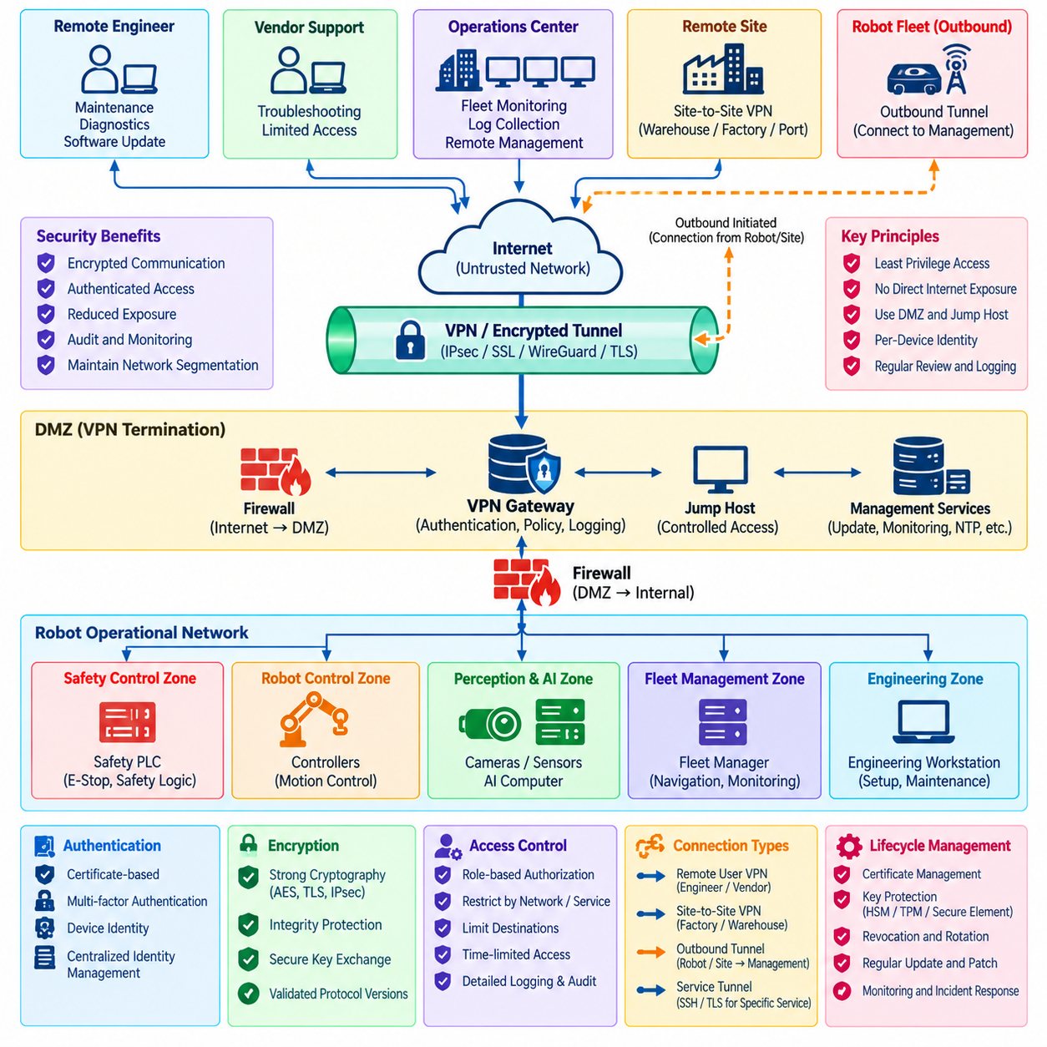
Remote access is essential for maintaining distributed robot fleets, diagnosing failures, deploying software, collecting logs, and supporting systems installed at customer or industrial sites. However, every remote connection creates a potential path from an external network toward operational robot infrastructure. VPNs and encrypted tunnels provide protected communication channels that reduce exposure when remote connectivity cannot be avoided.
A virtual private network establishes an authenticated and encrypted communication path across an untrusted network such as the public Internet. Instead of exposing SSH, remote desktop, web administration, ROS2 services, or device-management interfaces directly to external hosts, organizations can require remote users and systems to establish a VPN session before any protected robot resources become reachable.
Encryption protects the confidentiality of information moving through the tunnel. Robot networks may transmit configuration files, diagnostic logs, telemetry, software packages, maps, credentials, operational commands, and potentially sensitive sensor data. Strong cryptographic protocols prevent passive observers from reading this traffic, while integrity mechanisms help detect modification of packets while they traverse untrusted communication infrastructure.
Authentication is equally important because encryption alone does not establish whether a remote endpoint should be trusted. VPN gateways should verify users, devices, or services before granting access. Certificate-based device authentication, multifactor authentication, hardware-backed credentials, and centrally managed identities can provide stronger assurance than passwords alone, particularly for administrators with access to operational robot systems.
VPN termination should normally occur at a controlled network boundary rather than directly on safety-critical controllers. A gateway positioned in a DMZ can terminate encrypted sessions, validate identities, enforce security policy, generate audit records, and forward only authorized traffic toward internal networks. This preserves network segmentation while preventing external tunnels from bypassing established firewall boundaries.
Remote access authorization should follow least privilege. Establishing a VPN connection should not provide unrestricted access to every robot, server, controller, and engineering workstation. Policies can restrict users according to role, device, destination network, service, protocol, customer site, robot group, or maintenance responsibility, ensuring that authenticated access remains limited to resources required for the specific task.
A common administrative model combines VPN access with a hardened jump host. The remote engineer first establishes an authenticated VPN session and then connects to a controlled management system inside the DMZ or management zone. From that point, access to robot resources is mediated through approved tools and destinations, creating an additional security boundary and a centralized location for monitoring administrative activity.
Site-to-site VPNs address a different requirement by securely connecting entire networks. A robot deployment at a warehouse, factory, port, laboratory, or remote field site may establish an encrypted tunnel to a central operations center or fleet infrastructure. Routing policies should expose only the required subnets and services rather than merging both locations into one unrestricted trusted network.
Encrypted tunnels can also protect individual service connections without providing full network-level VPN access. SSH tunneling, TLS-protected APIs, mutually authenticated TLS sessions, and application-specific encrypted channels can be appropriate when only a narrowly defined service requires remote communication. Narrow service tunnels can reduce attack surface compared with granting broad network connectivity to an external endpoint.
Tunnel architecture must consider directionality. Many deployments are safer when robots or site gateways initiate outbound connections toward a known management service instead of accepting unsolicited inbound connections from the Internet. Outbound-initiated sessions can operate behind firewalls and address translation while reducing the number of publicly reachable services that attackers can scan or probe.
Split tunneling requires careful evaluation. When enabled, a remote maintenance computer may communicate simultaneously with the protected robot network and the public Internet or another local network. If that endpoint becomes compromised, it can potentially act as a bridge between trust domains. High-assurance maintenance environments may therefore route relevant traffic through controlled security infrastructure or prohibit unsafe simultaneous connectivity.
Cryptographic configuration must be managed throughout the system lifecycle. VPN security depends not only on selecting an encrypted protocol but also on appropriate algorithms, key lengths, certificate validation, key storage, session establishment, and protocol versions. Deprecated cryptographic mechanisms should be removed, and configurations should follow the security baseline established for the robot deployment rather than relying indefinitely on vendor defaults.
Key and certificate management becomes particularly important for large fleets. Shared credentials across hundreds of robots make revocation and attribution difficult because compromise of one credential may affect many devices. Per-device certificates or cryptographic identities allow administrators to revoke an individual robot, gateway, or engineering endpoint without invalidating credentials for the entire fleet.
Private keys should be protected against extraction wherever practical. Hardware security modules, trusted platform modules, secure elements, or operating-system protected credential stores can reduce the risk that malware or physical access exposes VPN credentials. The security architecture should also define certificate enrollment, renewal, expiration, revocation, replacement, and recovery processes before fleet scale makes manual management impractical.
VPN gateways themselves are high-value security assets because they sit at the boundary between external and operational networks. They should be hardened, patched, monitored, and configured with minimal exposed services. Administrative interfaces should be isolated from ordinary remote-user traffic, and gateway software should be included in vulnerability management and security update processes.
Logging should capture successful and failed authentication attempts, connection establishment and termination, source information, assigned identities, accessed destinations, policy violations, and important configuration changes. These records provide evidence for incident investigation and can be forwarded to centralized monitoring or SIEM systems where suspicious remote-access behavior can be correlated with robot and network events.
Monitoring can identify patterns such as repeated authentication failures, connections from unexpected locations, unusual access times, abnormal session duration, attempts to reach unauthorized robot zones, or sudden increases in transferred data. Such observations do not automatically prove compromise, but they provide useful signals for detecting credential abuse, compromised maintenance endpoints, or policy violations.
Remote sessions should be time-bounded where operationally feasible. Temporary vendor or maintenance access can be enabled only during an approved service window and automatically revoked afterward. Just-in-time access reduces the number of permanently valid paths into robot infrastructure and prevents forgotten accounts or old support arrangements from remaining available long after their operational need disappears.
Availability must also be considered because remote management may become critical during failures. Redundant VPN gateways, alternate management paths, configuration backups, monitored certificate expiration, and tested recovery procedures can prevent a single gateway failure from eliminating access to an entire fleet. Nevertheless, loss of remote connectivity should not compromise autonomous safety functions that must remain operational locally.
Real-time robot control should generally not depend on unpredictable Internet VPN latency when local control can be performed safely. Encryption, tunneling, routing changes, congestion, and wide-area network variation can introduce delay and jitter. Remote connectivity is therefore better suited to supervisory commands, fleet operations, diagnostics, software management, and telemetry unless the system has been specifically engineered and validated for remote real-time control.
Emergency access mechanisms require particular discipline. A bypass account or unrestricted maintenance tunnel created for recovery can become a permanent backdoor if poorly governed. Break-glass procedures should use strongly protected credentials, explicit authorization, extensive logging, limited duration, and post-use review so that exceptional access remains exceptional rather than becoming a routine administrative shortcut.
VPN policy should integrate with the broader robot network security architecture. Firewall rules determine which destinations remain reachable after tunnel establishment, network segmentation limits lateral movement, intrusion detection observes suspicious traffic, and identity systems determine who or what is connecting. Encryption protects the transport path, but these additional controls determine whether the resulting access is actually safe.
A mature remote-access design therefore treats VPNs and encrypted tunnels as components of defense in depth rather than universal trust mechanisms. Strong authentication, protected cryptographic identities, DMZ termination, least-privilege authorization, controlled routing, hardened gateways, centralized logging, certificate lifecycle management, and continuous monitoring together provide remote maintainability without unnecessarily exposing safety-critical robot infrastructure.

03.04. Network Intrusion Detection SNORT Suricata [w/Code]
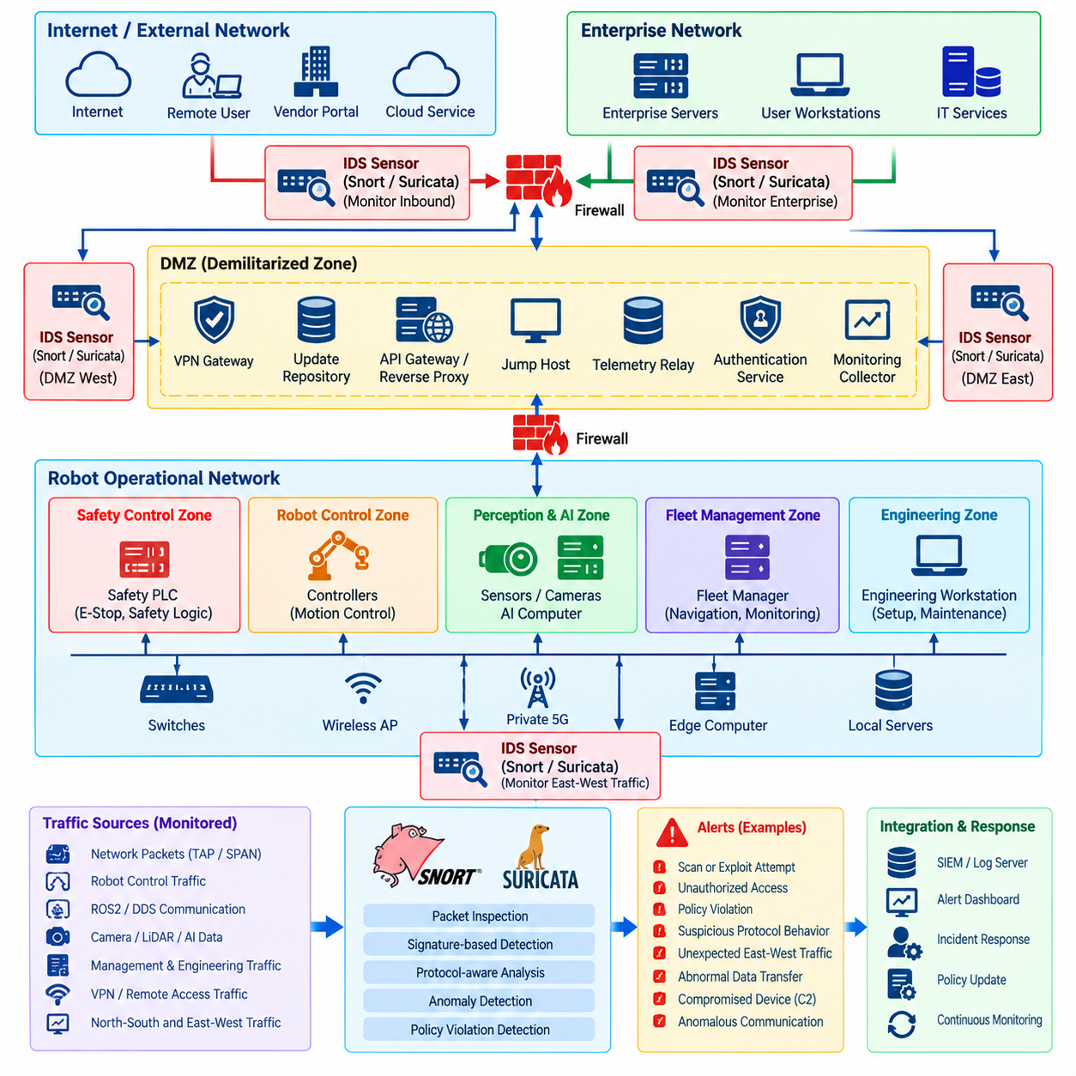
Network intrusion detection provides continuous visibility into communication activity that preventive controls alone cannot guarantee. Firewalls, ACLs, VPNs, and network segmentation reduce exposure, but compromised credentials, vulnerable services, configuration mistakes, or malicious insiders may still generate dangerous traffic. A network intrusion detection system observes these communications and identifies patterns that may indicate attacks or policy violations.
A network intrusion detection system, or NIDS, typically receives copies of packets from network taps, switch mirror ports, virtual switches, or monitoring interfaces. Unlike an inline firewall, a passive sensor can inspect traffic without becoming part of the robot control path. This is valuable in robotics because monitoring should not introduce latency, jitter, packet loss, or another failure point into safety-critical communication.
Sensor placement determines what the detection system can observe. Useful monitoring locations include the boundary between enterprise IT and the robot network, both sides of a DMZ, remote-access gateways, fleet-management networks, wireless infrastructure, and transitions between robot control and higher-level computing zones. Multiple sensors may be necessary because segmentation intentionally prevents one monitoring point from seeing every communication flow.
Snort and Suricata are widely used open-source technologies for network intrusion detection and prevention. Both can analyze packet headers and payloads, evaluate traffic against detection rules, identify suspicious protocol behavior, and generate structured alerts. They can therefore provide a programmable monitoring layer for robot networks instead of relying exclusively on generic network statistics or manually reviewed packet captures.
Signature-based detection compares observed traffic with patterns representing known malicious or prohibited activity. A rule can examine source and destination addresses, ports, protocols, connection state, payload content, or combinations of these attributes. This approach is effective for recognizable scans, exploit attempts, suspicious command sequences, malware communication, and violations of explicitly defined robot network policies.
Robot environments benefit from rules describing expected architecture as well as conventional attack signatures. For example, communication from an enterprise workstation directly toward a motor-control subnet may be suspicious even if the packets contain no known exploit. Similarly, a perception computer initiating administrative connections toward a safety controller may violate the intended trust model and should generate an alert.
Rules should therefore reflect network zones and permitted communication relationships. Sensors can identify attempts to cross prohibited boundaries, unexpected protocols within deterministic control networks, unauthorized access to engineering services, or robot-to-robot communication where peer connectivity is not expected. This converts architecture assumptions into observable security conditions rather than leaving them only in design documentation.
Protocol-aware inspection provides additional context beyond addresses and ports. Many attacks use legitimate ports to carry abnormal or malicious application traffic, so port-based detection alone may miss important behavior. Where protocol parsers are available, Snort or Suricata can inspect session characteristics and application-layer information to distinguish ordinary communication from suspicious deviations.
ROS2 and DDS traffic presents particular monitoring challenges because discovery, multicast, dynamic endpoints, and high-rate data exchange can produce complex traffic patterns. A generic enterprise intrusion-detection policy may generate excessive alerts or fail to recognize robot-specific misuse. Detection engineering should therefore begin by understanding the deployed DDS implementation, discovery configuration, participant relationships, and expected communication topology.
Encrypted communication changes what a passive sensor can inspect. VPN, TLS, and other protected channels may hide application payloads while still exposing metadata such as endpoints, timing, session frequency, connection duration, and traffic volume. Where deeper inspection is necessary, sensors can be positioned after authorized decryption points, but this should be designed carefully to avoid weakening end-to-end security or exposing sensitive data unnecessarily.
Suricata is particularly suitable for environments requiring high-throughput inspection and structured event output. Its multithreaded processing architecture can support substantial traffic volumes when properly sized, while event records can be forwarded to logging and SIEM platforms. Snort likewise provides mature rule-driven detection capabilities and can be integrated into monitoring architectures where signature management and packet-level analysis are required.
Performance engineering is essential in robot networks carrying camera, LiDAR, telemetry, map, and AI data. Sending every high-bandwidth stream through deep inspection may overwhelm monitoring infrastructure without providing proportional security value. Architects should prioritize security boundaries, management traffic, externally reachable services, and critical control relationships while sizing sensors according to actual throughput and packet rates.
Baseline analysis complements signature detection. A robot deployment often has more predictable communication patterns than a general office network because devices perform defined operational roles. Security monitoring can learn or document normal peers, protocols, traffic rates, operating periods, and service relationships. Significant deviations from this baseline can then be investigated even when no known malicious signature is triggered.
Examples of useful anomalies include a robot suddenly scanning many internal addresses, an edge computer contacting previously unseen Internet destinations, repeated connection attempts toward blocked control services, unusual DNS activity, or unexpected data transfers outside normal operating periods. Such behavior may indicate compromise, configuration errors, unauthorized software, or maintenance activity that has not followed established procedures.
Alert severity should reflect physical and operational consequences rather than conventional IT impact alone. An unsuccessful scan against a test server may have limited importance, while an attempt to access a safety PLC or manipulate a robot command channel can require immediate investigation. Detection policies should therefore incorporate asset criticality, network zone, protocol function, and potential effect on physical operation.
False positives are particularly damaging when operators receive large numbers of repetitive alerts. Excessive noise encourages alerts to be ignored and makes genuine incidents difficult to identify. Rules should be tuned using representative production traffic, known maintenance activities, software updates, fleet behavior, and expected discovery mechanisms while preserving visibility into genuinely abnormal communication.
Rule management should be treated as a controlled security engineering process. Community or vendor rule sets can provide useful coverage for known threats, but robot deployments also require site-specific rules reflecting their architecture. New rules should be reviewed, tested, version-controlled, documented, and validated before production deployment so that detection changes do not unexpectedly overload sensors or generate uncontrolled alert volumes.
Packet capture can provide valuable forensic evidence when an alert requires deeper investigation. Short rolling capture buffers around critical boundaries can preserve network context before and after suspicious events. Because full packet capture may consume substantial storage and can contain sensitive operational data, retention periods, access permissions, encryption, and privacy requirements should be explicitly defined.
NIDS events become more useful when correlated with other security telemetry. Firewall denies, VPN authentication records, operating-system logs, ROS2 events, endpoint alerts, fleet-management activity, and device identity information can provide context for a network alert. A SIEM platform can correlate these sources to distinguish isolated anomalies from coordinated behavior occurring across several components.
Intrusion prevention mode introduces additional considerations. Snort or Suricata can be deployed inline in architectures where suspicious traffic should be blocked automatically, but incorrect detection may interrupt legitimate robot communication. Automated blocking should therefore be applied cautiously around safety-critical or real-time paths, with validated rules, deterministic failure behavior, and clear understanding of operational consequences.
Passive detection is often safer for initial deployment. Security teams can first observe traffic, establish baselines, tune signatures, and measure false-positive rates before enabling prevention for selected threats. High-confidence controls may later block clearly unauthorized external access or known malicious patterns, while uncertain events can remain alert-only and be handled through investigation or incident-response procedures.
The monitoring infrastructure itself must be secured. Sensors, management consoles, rule repositories, capture storage, and alert pipelines can contain sensitive information about robot architecture and communication behavior. Administrative access should be restricted, software patched, configurations backed up, logs protected against tampering, and monitoring interfaces isolated from ordinary production access.
A mature robot NIDS architecture combines strategic sensor placement, Snort or Suricata rule-based inspection, robot-specific policy detection, behavioral baselines, protected packet evidence, centralized alert correlation, and carefully governed prevention. Its purpose is not simply to identify malware, but to reveal abnormal communication early enough that compromised devices can be investigated and isolated before cyber activity develops into fleet-wide or physical consequences.

03.05. 802.1X Network Access Control for Robots [w/Code]
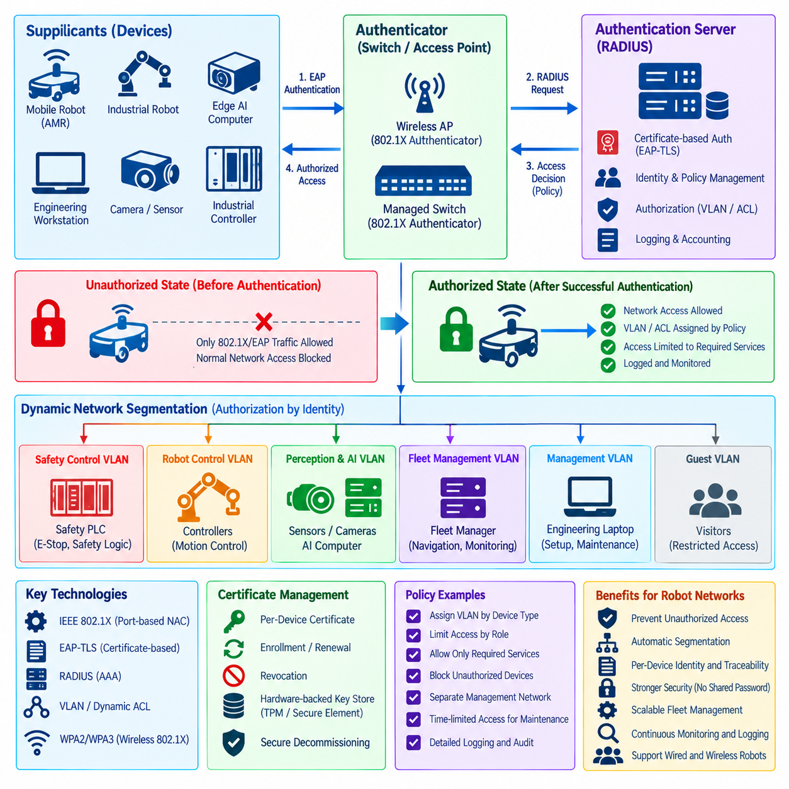
IEEE 802.1X provides port-based network access control that verifies a device or user before allowing normal communication through a wired or wireless network. In robot environments, this mechanism prevents physical connection to an Ethernet port or association with a wireless access point from automatically creating trusted network access. It establishes identity verification as an explicit prerequisite for connectivity.
An 802.1X architecture typically consists of three logical roles: the supplicant, authenticator, and authentication server. The robot, edge computer, engineering workstation, or other endpoint acts as the supplicant. A managed Ethernet switch or wireless access point operates as the authenticator, while a centralized authentication service, commonly using RADIUS, evaluates credentials and returns an access decision.
When a robot initially connects, the authenticator keeps the network port in an unauthorized state for ordinary data traffic. Only the communication required for authentication is permitted. The supplicant and authentication infrastructure then exchange Extensible Authentication Protocol information, and successful verification causes the port to transition into an authorized state according to the security policy assigned to that identity.
This model is particularly valuable in industrial robot networks because physical access cannot always be treated as trusted. Ethernet connectors may exist on robots, charging stations, cabinets, maintenance panels, factory switches, or field equipment. Without network access control, an unauthorized computer connected to an available port may immediately obtain connectivity to operational infrastructure even when higher-level services remain protected.
Certificate-based authentication can provide strong assurance for robot devices. EAP-TLS uses certificates and cryptographic authentication rather than relying only on shared passwords. Each robot or managed endpoint can receive a unique device identity, allowing the authentication system to distinguish individual assets and make authorization decisions according to their registered role, ownership, deployment site, or security posture.
Unique identities are preferable to fleet-wide shared credentials. If hundreds of robots use the same password or certificate, compromise of one device may expose credentials that provide access for many others. Per-device certificates allow administrators to revoke a compromised robot independently, trace authentication events to a specific endpoint, and maintain more precise lifecycle records for credentials across a large fleet.
Authentication should be followed by authorization rather than interpreted as unrestricted trust. A successfully authenticated safety controller, perception computer, maintenance laptop, and mobile robot may require very different network privileges. The authentication server and network infrastructure can assign VLANs, downloadable ACLs, security roles, or other policy attributes according to the identity and function of the connecting endpoint.
Dynamic segmentation can therefore connect 802.1X directly with the broader robot network architecture. A validated engineering workstation may enter a management VLAN, while an AMR receives access to a fleet communication zone and an edge AI computer enters a perception network. Devices can be placed into appropriate security domains automatically instead of relying entirely on the physical switch port to determine their privileges.
This capability is useful for mobile robots that move between network attachment points. AMRs, humanoids, inspection platforms, and other mobile systems may roam through facilities while maintaining communication with fleet infrastructure. Identity-based network access allows policy to follow the device rather than assuming that every endpoint connected through a particular access switch should receive identical permissions.
Wireless access control can apply the same principles through enterprise Wi-Fi infrastructure. A robot associating with a wireless network authenticates before receiving normal network access, and its resulting authorization can be based on device identity. This reduces dependence on shared Wi-Fi passwords and provides better attribution when many robots, engineering devices, and operational endpoints use common wireless infrastructure.
The authentication server becomes a critical security service because it participates in access decisions for many devices. RADIUS infrastructure should therefore be hardened, monitored, redundantly deployed where availability requirements justify it, and protected through network segmentation. Administrative interfaces, authentication databases, certificates, shared secrets, and policy configurations require controls appropriate to their importance.
Certificate lifecycle management must be integrated with 802.1X deployment from the beginning. Robots may operate for years, while certificates expire, cryptographic policies evolve, hardware is replaced, and devices change ownership or operational roles. Enrollment, renewal, rotation, revocation, recovery, and secure decommissioning processes should therefore be automated where fleet scale makes manual certificate administration impractical.
Private keys used for device authentication should be protected against extraction. Where supported, trusted platform modules, secure elements, hardware-backed key stores, or protected operating-system facilities can prevent credentials from being easily copied from one robot to another. Strong key protection helps ensure that successful authentication represents possession of the legitimate device identity rather than merely a duplicated certificate file.
Not every robot component can support a full 802.1X supplicant. Legacy controllers, industrial sensors, embedded devices, cameras, and specialized hardware may lack compatible software or certificate storage. Such devices require carefully controlled alternatives, potentially including dedicated network segments, restricted switch ports, gateway mediation, or other exception mechanisms that preserve isolation without pretending that unsupported equipment has strong identity.
Fallback mechanisms must be treated cautiously because they can weaken the architecture. Policies based only on MAC addresses, for example, provide limited identity assurance because addresses can often be observed and spoofed. When weaker authentication methods are unavoidable, the resulting endpoint should receive narrower privileges, stronger monitoring, and additional segmentation rather than access equivalent to a strongly authenticated device.
Availability is especially important in robotics because authentication infrastructure failures can prevent devices from joining the network. Designers should define behavior for loss of the authentication server, switch reboot, certificate validation failure, network interruption, and robot reconnection. Fail-open policies may preserve operation while weakening security, whereas fail-closed policies may protect the network but prevent robots from returning to service.
Safety-critical systems require explicit analysis of these failure modes. A temporary authentication problem should not create unsafe physical behavior, yet cybersecurity controls should not be bypassed indefinitely merely to maintain connectivity. Local safety functions should remain independent where appropriate, while operational network access can follow predetermined degraded-mode policies until authentication services are restored.
Reauthentication provides an opportunity to verify continued authorization during operation. Network infrastructure can require endpoints to authenticate again after defined intervals or events, preventing one successful connection from establishing permanent trust. Reauthentication intervals should balance security requirements against network stability and avoid unnecessary disruption to time-sensitive robot communications.
802.1X events also provide valuable security telemetry. Successful and failed authentications, certificate errors, repeated connection attempts, unexpected switch ports, identity changes, and policy assignments can be forwarded to centralized logging or SIEM systems. Correlation with firewall, VPN, intrusion-detection, endpoint, and fleet-management events can reveal suspicious behavior that would be difficult to identify from network traffic alone.
Deployment should be introduced carefully rather than enabling strict enforcement across an entire operational facility at once. An initial monitoring or low-impact phase can identify unsupported devices, certificate problems, unexpected dependencies, and authentication timing issues. Policies can then be progressively enforced across test networks, selected robot groups, production zones, and finally higher-criticality infrastructure after validation.
Operational procedures should also account for commissioning, maintenance, replacement, and emergency access. New robots need secure enrollment before receiving production privileges, replacement computers require new identities, and retired devices should have credentials revoked. Temporary maintenance equipment should receive explicitly limited authorization rather than inheriting broad access simply because technicians require short-term connectivity.
A mature 802.1X deployment turns network attachment from a physical event into an identity-driven security decision. Combined with per-device certificates, RADIUS policy, dynamic VLAN or ACL assignment, network segmentation, firewall enforcement, monitoring, and disciplined credential lifecycle management, it helps ensure that only recognized and appropriately authorized robots and supporting systems can participate in protected operational networks.

03.06. VLAN Segmentation Safety Control vs AI Data [w/Code]
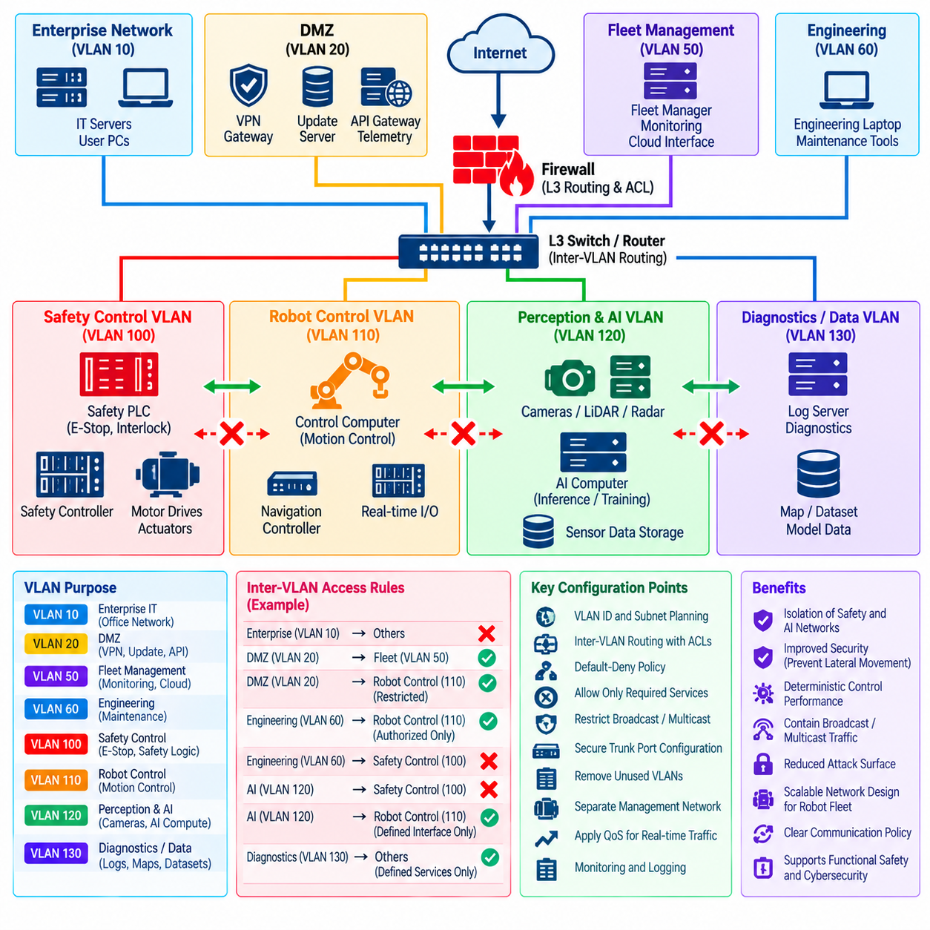
Virtual LAN segmentation separates robot communication into logical broadcast and security domains even when devices share the same physical switching infrastructure. In a modern robot, safety control, motion control, perception, AI inference, diagnostics, and fleet communication can have very different timing and security requirements. VLANs provide a practical mechanism for preventing these traffic classes from operating as one unrestricted network.
The distinction between safety-control traffic and AI-data traffic is especially important. Safety and low-level control communication may carry emergency states, actuator commands, interlocks, velocity limits, or deterministic feedback, while AI networks may transport camera images, LiDAR point clouds, feature tensors, maps, model outputs, and training or diagnostic data. Combining both classes in one Layer-2 domain creates unnecessary operational and cybersecurity coupling.
Safety-control networks should therefore be placed in dedicated VLANs with tightly constrained membership. Safety PLCs, certified controllers, motor interfaces, emergency-stop components, and explicitly authorized control computers should be the primary participants. General-purpose AI computers, engineering laptops, user devices, cloud gateways, and unrelated sensors should not receive direct Layer-2 access simply because they are connected to the same physical switch.
AI and perception VLANs can be designed for substantially higher bandwidth. Multiple cameras, LiDARs, radar sensors, GPU computers, and edge inference nodes may continuously exchange large streams that would be inappropriate on a safety-control broadcast domain. Separating this traffic reduces contention and limits the possibility that abnormal AI-data volume, multicast behavior, or a compromised perception device affects critical control communication.
VLAN segmentation alone does not constitute a complete security boundary. IEEE 802.1Q tagging identifies logical network membership, but an attacker that gains control of switching infrastructure or reaches an incorrectly configured trunk may bypass assumptions based solely on VLAN separation. Communication between security zones should therefore be controlled through Layer-3 routing, firewalls, ACLs, authenticated gateways, or other policy-enforcement mechanisms.
Inter-VLAN routing should follow a default-deny model. Safety and AI domains should not communicate merely because a router can connect them. Required flows must be identified explicitly, such as a validated perception result moving toward a planning system or selected status information leaving a controller. The gateway should permit only the necessary sources, destinations, protocols, ports, and directions while rejecting unrelated cross-zone communication.
This design also supports one-way or strongly asymmetric information relationships. A safety-monitoring service may need to export health information to fleet management without accepting commands from the same destination. An AI subsystem may provide object detections or trajectory proposals while lacking authority to write directly to actuator interfaces. Network policy should reflect these functional differences instead of granting symmetric connectivity by default.
The boundary between AI decisions and physical control deserves particular attention. An AI model may generate semantic interpretations, target selections, navigation proposals, or planned actions, but those outputs should pass through defined interfaces before influencing safety-critical actuators. VLAN separation can reinforce this architectural boundary by ensuring that AI computers cannot directly address low-level control devices unless a deliberately designed and validated communication path exists.
Broadcast and multicast containment is another important advantage. Robot middleware, discovery protocols, sensor systems, and diagnostic tools may generate broadcast or multicast traffic. Keeping AI discovery and high-volume data distribution within their intended VLAN prevents unnecessary propagation into control domains. This reduces both network load and the amount of topology information exposed across security boundaries.
Quality of service and VLAN segmentation can work together but solve different problems. VLANs establish logical separation, whereas QoS prioritizes traffic according to latency, jitter, or bandwidth requirements. Safety and deterministic control flows may receive strict priority or reserved resources, while AI data transfers can tolerate different scheduling behavior. Priority mechanisms should never be treated as substitutes for actual security isolation.
Physical switch architecture still matters even when VLANs provide logical separation. Highly critical deployments may use separate physical interfaces, switches, or redundant network paths for safety traffic rather than relying exclusively on logical VLAN boundaries. The appropriate design depends on safety integrity requirements, threat analysis, failure tolerance, performance constraints, and the consequences of a common switching infrastructure failure.
Trunk ports require careful configuration because they transport traffic for multiple VLANs. Only required VLANs should be permitted on each trunk, and unused VLAN membership should be removed. Access ports should normally belong to a single expected VLAN, while unused switch ports should be disabled or otherwise restricted. Broad trunk configurations can unintentionally extend sensitive robot networks into locations where they were never intended to exist.
Native VLAN and tagging behavior must also be standardized across switches. Inconsistent configurations can cause traffic to enter an unintended broadcast domain or create opportunities for VLAN-hopping techniques. Production robot networks should avoid relying on ambiguous default configurations, and switch templates should explicitly define allowed VLANs, tagging requirements, management interfaces, and port roles.
Management traffic deserves its own protected domain. Switch administration, firewall management, robot configuration, hypervisor access, and infrastructure monitoring should not share unrestricted connectivity with either AI data or ordinary production control traffic. A dedicated management VLAN with tightly controlled administrative access reduces the possibility that compromise of a robot workload immediately exposes the network infrastructure used to enforce segmentation.
Engineering and commissioning activities also require separation. Technicians may need temporary access to controllers, sensors, and AI computers during deployment or troubleshooting, but placing engineering laptops directly into critical production VLANs creates significant risk. A dedicated engineering or maintenance VLAN can provide mediated access through firewalls, jump hosts, and temporary authorization policies without eliminating production boundaries.
Dynamic VLAN assignment can strengthen segmentation when combined with 802.1X network access control. After a robot or endpoint successfully authenticates, infrastructure can assign it to a VLAN according to device identity and role rather than relying only on the physical switch port. This is particularly useful for mobile robots, replacement computers, and shared facilities where network attachment locations change over time.
Wireless infrastructure should map authenticated robot traffic into appropriate security domains rather than placing every wireless device in one common VLAN. AMRs and other mobile platforms may require separate operational, management, and telemetry access. Enterprise Wi-Fi or private wireless systems can combine identity-based admission with VLAN or policy assignment so that roaming does not eliminate the intended network segmentation.
VLAN design should also limit robot-to-robot lateral movement. If every robot in a large fleet belongs to one unrestricted Layer-2 domain, compromise of one endpoint can provide direct reachability to many peers. Smaller fleet segments, private VLAN concepts, host isolation, routed boundaries, or microsegmentation can restrict peer communication when robots primarily need to communicate with centralized fleet services rather than with each other.
Monitoring should observe important VLAN boundaries and inter-VLAN gateways. Firewall logs, switch telemetry, flow records, intrusion-detection sensors, and SIEM correlation can reveal unexpected communication between safety, AI, management, and enterprise domains. Attempts by an AI computer to reach a safety controller or by a user workstation to enter a robot-control subnet should be treated as meaningful security events.
Network capacity planning must account for the asymmetric bandwidth requirements of robot workloads. AI data may consume multiple gigabits per second, while critical control messages can be small but highly sensitive to latency and jitter. Segmentation allows these workloads to be engineered separately, reducing the likelihood that sensor bursts, model transfers, logging activity, or dataset collection interfere with deterministic operational traffic.
Failure behavior should be considered during architecture design. A routing gateway, trunk, switch, or firewall failure may affect several VLANs simultaneously even though they appear logically independent. Redundant switching, separate failure domains, tested failover behavior, and local safety mechanisms can reduce the risk that a shared network component causes both communication loss and unsafe robot behavior.
Configuration management is essential because VLAN security depends heavily on correct switch and gateway settings. VLAN identifiers, subnet assignments, trunk permissions, port roles, ACLs, routing policies, and management interfaces should be documented and placed under controlled change management. Automated configuration validation can detect accidental bridging, unauthorized trunks, missing restrictions, or differences between intended and deployed architecture.
Periodic review should confirm that segmentation still matches the evolving robot architecture. New sensors, AI accelerators, fleet services, diagnostic tools, and software components can introduce communication requirements that encourage temporary exceptions. These exceptions should not silently become permanent connectivity. Each cross-VLAN path should retain an identifiable operational purpose and be removed when that dependency disappears.
A mature VLAN architecture separates safety control from high-volume AI data while preserving only the communication paths required for robot operation. Combined with routing controls, firewalls, ACLs, 802.1X identity, QoS, intrusion detection, management isolation, and disciplined configuration control, VLAN segmentation reduces lateral movement, protects deterministic control traffic, and prevents AI infrastructure from becoming an unrestricted bridge into safety-critical robot functions.

03.07. Wireless Security WPA3 Wi Fi 6 for Robots [w/Code]
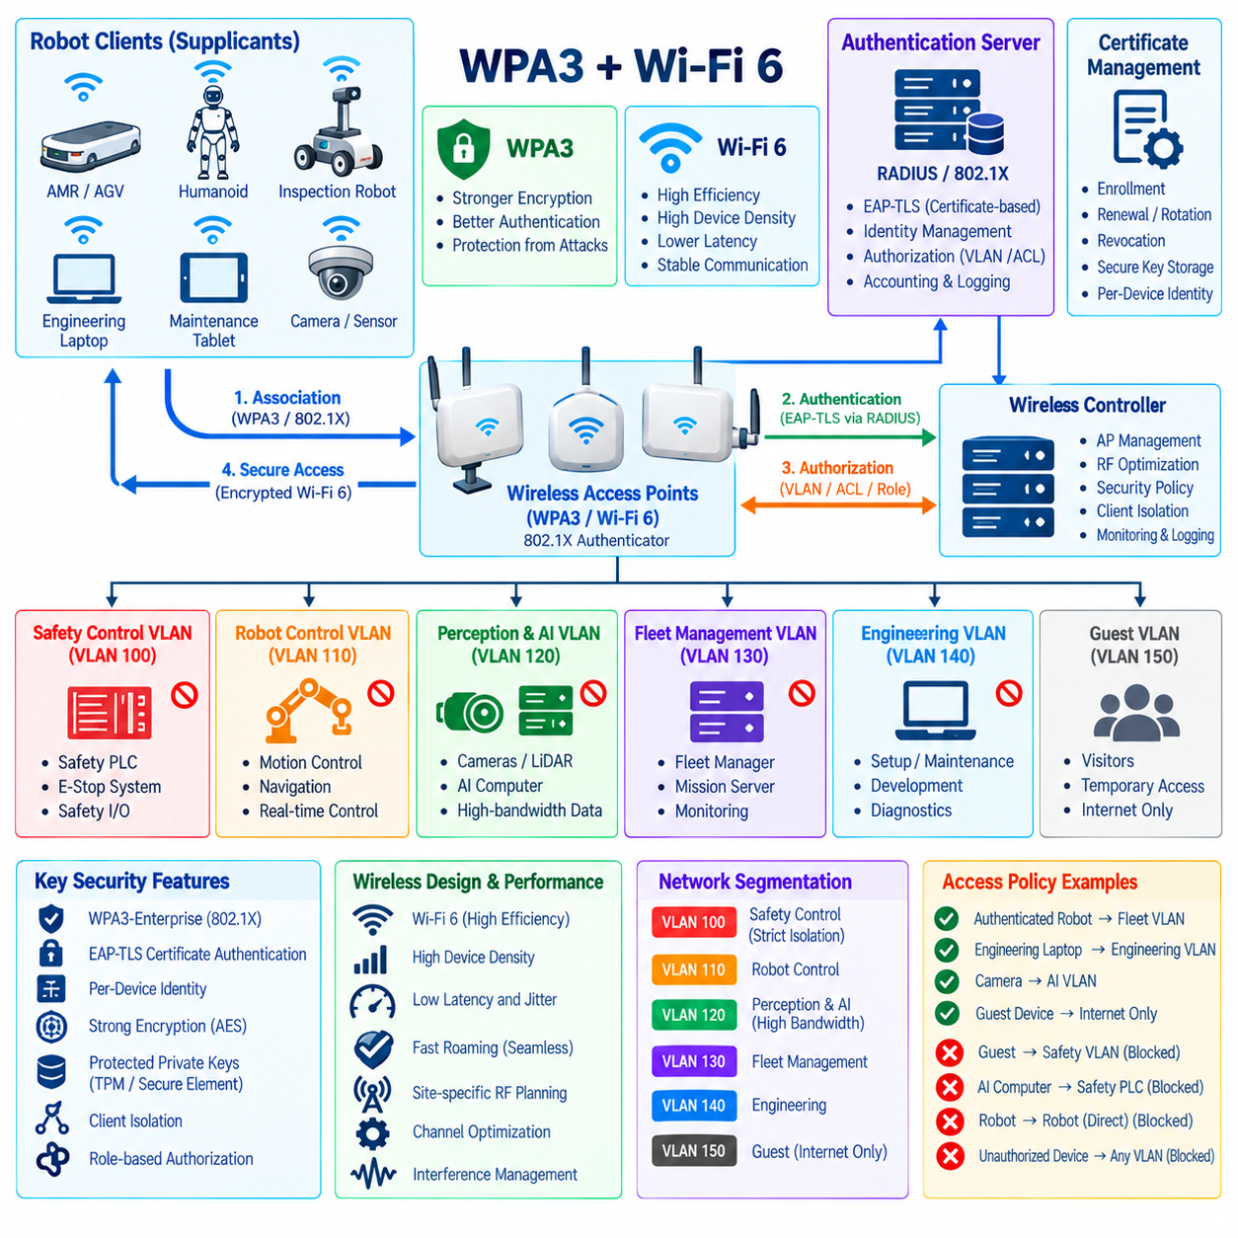
Wireless connectivity is fundamental to mobile robots because AMRs, humanoids, inspection platforms, and service robots must communicate while moving through dynamic environments. Unlike wired networks, however, radio signals extend beyond controlled physical boundaries and can be observed or attacked without direct cable access. Wireless security must therefore combine strong authentication, encryption, segmentation, monitoring, and resilient radio-network design.
WPA3 strengthens Wi-Fi security by improving authentication and cryptographic protection compared with earlier wireless security generations. In robot deployments, WPA3 should be considered part of a broader access-control architecture rather than simply a stronger wireless password mechanism. The objective is to ensure that only authenticated robots and authorized supporting devices can enter protected operational networks.
Enterprise deployments should prefer identity-based authentication where infrastructure and robot platforms support it. WPA3-Enterprise combined with IEEE 802.1X can authenticate robots through centrally managed credentials or certificates instead of relying on one shared password for an entire fleet. Individual device identities improve attribution and allow compromised or retired robots to be revoked without changing credentials across every deployed system.
Certificate-based authentication such as EAP-TLS provides particularly strong device identity when implemented correctly. Each robot can possess a unique certificate and private key that represent its network identity. Authentication servers can then associate that identity with a device type, fleet, site, security role, or authorization policy, allowing wireless admission decisions to become part of the overall robot identity-management architecture.
Private keys require protection because copying a robot certificate and its key could allow another device to impersonate that robot. Trusted platform modules, secure elements, hardware-backed credential stores, or protected operating-system facilities can reduce this risk. Certificate enrollment, renewal, rotation, revocation, expiration, and replacement should also be automated where large robot fleets make manual credential management impractical.
Wi-Fi 6 introduces capabilities that are valuable in dense robotic environments, including more efficient sharing of radio resources among many connected devices. Warehouses and factories may contain robots, handheld terminals, cameras, sensors, engineering computers, and conventional IT clients operating simultaneously. Efficient channel utilization can improve communication stability, but performance improvements do not replace authentication, encryption, or network isolation.
Robot wireless design must consider latency, jitter, packet loss, roaming delay, interference, and congestion in addition to confidentiality. A connection can be cryptographically secure while still being unsuitable for time-sensitive robot operation. Navigation updates, fleet commands, safety-related supervisory information, and telemetry may have different performance requirements, so wireless architecture should classify traffic according to operational criticality.
Roaming is especially important for AMRs and other continuously moving platforms. Robots may cross coverage areas and transition between access points while maintaining sessions with fleet-management or supervisory systems. Authentication and handoff mechanisms should be engineered so that mobility does not create excessive interruption, while security must ensure that faster roaming does not weaken identity verification or expose reusable credentials.
Wireless coverage should be designed through site-specific radio planning rather than assuming that additional access points automatically improve reliability. Metal racks, machinery, walls, vehicles, people, electromagnetic interference, and changing inventory can alter propagation conditions. Excessive access-point density can also create interference. Security and availability therefore depend partly on disciplined RF design, channel planning, coverage validation, and continuous operational measurement.
Segmentation remains necessary after successful wireless authentication. A robot that joins Wi-Fi should not automatically gain access to enterprise servers, engineering systems, safety controllers, and every other robot. Identity information obtained during authentication can be combined with VLAN assignment, ACLs, firewall policies, or role-based controls to place the endpoint into an appropriate operational security zone.
Different wireless device classes may require separate logical domains. Production robots, engineering laptops, maintenance devices, guest clients, infrastructure management systems, and ordinary enterprise endpoints should not share unrestricted connectivity merely because they use the same access-point infrastructure. Logical separation limits lateral movement and makes abnormal communication between device classes easier to identify and block.
Robot-to-robot communication also requires explicit policy. Many fleets primarily communicate with centralized fleet services and do not require unrestricted peer connectivity. Client isolation, routed boundaries, private VLAN mechanisms, firewall policies, or microsegmentation can prevent a compromised robot from directly scanning or attacking neighboring robots while still permitting required communication with authorized infrastructure.
Management interfaces for access points and wireless controllers should reside in protected management networks. Compromise of wireless infrastructure can undermine authentication, segmentation, and availability for an entire robot fleet. Administrative access should therefore be limited to authorized management systems, protected with strong authentication, logged centrally, and separated from ordinary robot and user traffic.
Wireless threats include unauthorized access points, rogue clients, credential theft, impersonation, deauthentication attempts, evil-twin networks, traffic interception, and denial-of-service activity. WPA3 can mitigate important authentication and confidentiality risks, but radio-frequency disruption cannot be eliminated through encryption. Wireless security architecture must consequently address both cyber compromise and availability attacks affecting the physical communication medium.
Rogue access-point detection is important in facilities where unauthorized equipment can be installed easily. Monitoring systems can compare observed wireless infrastructure against an approved inventory and investigate unknown access points using corporate or robot-related network identifiers. Detection should distinguish genuine threats from neighboring networks, temporary maintenance equipment, and legitimate infrastructure changes to avoid excessive false alarms.
Wireless intrusion detection can complement conventional network intrusion detection by observing radio and association behavior that wired sensors cannot see. Authentication failures, repeated association attempts, unusual roaming behavior, unexpected device identities, suspicious access points, and abnormal wireless events can be correlated with firewall, RADIUS, endpoint, and fleet-management logs to provide broader security context.
Availability planning should assume that wireless connectivity can degrade or disappear temporarily. Robots should define safe behavior for loss of communication, including local stopping, controlled continuation, mission suspension, or autonomous recovery according to system requirements. Critical local safety functions should not depend exclusively on continuous Wi-Fi availability when a radio outage could otherwise create hazardous physical behavior.
Redundant wireless coverage can improve resilience but should be validated under realistic operating conditions. Site testing should evaluate busy production periods, robot density, moving obstacles, handoff behavior, interference sources, and failure of individual access points. A design that performs well in an empty facility during commissioning may behave very differently when shelves, machines, workers, and dozens of robots occupy the environment.
Quality of service can help prioritize latency-sensitive robot communication over lower-priority transfers such as bulk logs, software packages, model files, or dataset uploads. However, QoS manages resource contention rather than providing a security boundary. High-priority classification should be assigned carefully so that compromised or misconfigured devices cannot consume excessive wireless resources simply by generating traffic marked as critical.
Software and firmware maintenance is essential for wireless infrastructure and robot Wi-Fi clients. Access points, controllers, wireless drivers, authentication services, and embedded supplicants can contain vulnerabilities requiring security updates. Patch processes should consider compatibility and operational availability, using staged validation before fleet-wide deployment when wireless changes could affect roaming, authentication, or communication stability.
Configuration management should standardize wireless security settings across sites. Approved authentication modes, certificate requirements, SSIDs, VLAN mappings, cipher policies, management access, logging, radio parameters, and fallback behavior should be documented and version-controlled where possible. Legacy compatibility options should not remain enabled without a verified requirement because they can silently weaken the intended security baseline.
Monitoring should combine cybersecurity and operational wireless metrics. Authentication failures and suspicious associations are security indicators, while signal strength, retransmissions, channel utilization, roaming time, packet loss, and connection instability reveal conditions that may affect robot availability. Correlating both perspectives helps distinguish malicious activity from RF interference, infrastructure failure, configuration errors, or normal mobility.
A mature robot wireless architecture therefore treats WPA3 and Wi-Fi 6 as components of a layered system rather than complete solutions by themselves. Strong device identity, 802.1X authentication, protected credentials, segmentation, firewall enforcement, secure roaming, RF engineering, intrusion monitoring, controlled infrastructure management, resilient failure behavior, and disciplined lifecycle management together provide secure and dependable mobility for robot fleets.

03.08. 5G Private Network Security Slicing [w/Code]
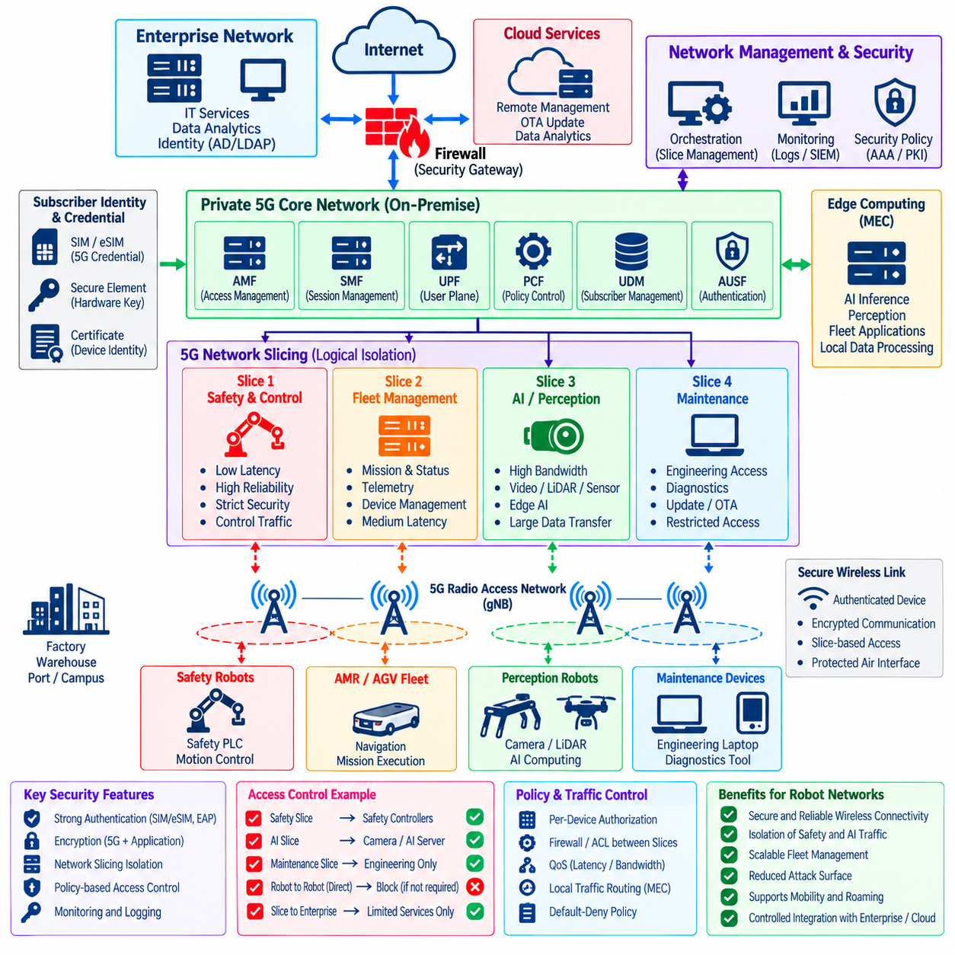
Private 5G networks provide dedicated cellular connectivity for robots operating across factories, warehouses, ports, campuses, mines, and other large industrial environments. Unlike public mobile services, a private deployment allows an organization to control radio coverage, device admission, traffic routing, security policy, and integration with operational systems. This control makes private 5G attractive for mobile robots requiring secure and predictable connectivity.
Security begins with strong subscriber and device authentication. Robots typically access the 5G network through provisioned subscriber identities and cryptographic credentials associated with SIM, eSIM, or equivalent secure identity mechanisms. The network validates these credentials before granting connectivity, reducing dependence on shared wireless passwords and allowing individual robots or communication modules to be identified, authorized, suspended, or revoked.
Credential protection is essential because compromise of a subscriber identity can allow an unauthorized device to impersonate legitimate equipment. Secure elements, protected SIM technologies, hardware-backed key storage, and controlled provisioning processes can reduce this risk. Fleet operators should also define lifecycle procedures for activation, replacement, revocation, ownership changes, lost devices, and secure decommissioning of robot communication modules.
A private 5G architecture includes radio access infrastructure, core network functions, subscriber management, policy control, and connections to enterprise or operational networks. Each component introduces a security boundary that must be managed deliberately. Administrative interfaces, management APIs, orchestration systems, and configuration databases require particularly strong protection because compromise of the infrastructure could affect connectivity for many robots simultaneously.
Network slicing provides a mechanism for creating logically differentiated communication environments over shared 5G infrastructure. Different robot workloads can be associated with slices designed for distinct performance, policy, and service requirements. A safety-related supervisory service, fleet-control application, high-bandwidth perception stream, and maintenance channel may therefore receive different network treatment instead of competing within one undifferentiated communication domain.
Slicing should not be interpreted as automatic end-to-end security isolation. The strength of separation depends on how radio resources, transport infrastructure, 5G core functions, edge computing, routing, and external networks are configured. Shared components may remain common failure or attack domains. Security architects should therefore determine exactly where isolation exists and where additional firewalls, ACLs, gateways, or application-level controls remain necessary.
Robot control traffic may require low latency and predictable communication behavior, while AI and perception workloads can demand much greater bandwidth. Camera streams, LiDAR data, maps, model outputs, and telemetry can consume substantial resources. Separating these workloads through appropriate policies or slices can prevent bulk AI traffic from unnecessarily competing with operational communication that has tighter latency and availability requirements.
A slice intended for robot operations should still enforce least privilege. Membership in a particular slice should not provide unrestricted reachability to every system associated with that service. Firewalls, routing policies, service authorization, identity controls, and application authentication can further restrict communication between robots, edge servers, fleet managers, maintenance systems, and safety-related components.
Edge computing is closely related to private 5G robot deployments because processing can be positioned near the radio network instead of in a distant cloud. Local edge platforms can host perception services, fleet applications, map processing, or AI inference while reducing wide-area latency. However, edge nodes become high-value assets and should be segmented, hardened, monitored, and authenticated like other critical robot infrastructure.
Local traffic routing can improve both performance and security by keeping operational robot data within the facility. Sensitive sensor streams or control information may not need to traverse a public network or remote cloud before reaching local applications. Policies should explicitly determine which traffic remains local, which services can communicate externally, and where inspection or security enforcement occurs before information leaves the private domain.
Integration with enterprise IT requires a controlled boundary. A private 5G network should not become a transparent bridge between mobile robots and corporate systems. Gateways and firewalls can mediate communication toward identity services, update infrastructure, analytics platforms, remote support systems, or cloud applications. Default-deny policies should permit only documented flows required for operational or administrative purposes.
Robot-to-robot connectivity should also be constrained according to actual operational requirements. Some cooperative systems require direct peer communication, but many fleets primarily communicate with centralized or edge-based fleet services. When direct communication is unnecessary, policy controls should limit lateral reachability so that compromise of one robot does not automatically provide a path to scan or attack every other robot using the private network.
Quality-of-service mechanisms and network slicing can support service differentiation, but they should not be confused with functional safety guarantees. Low latency or reserved resources do not prove that a communication path satisfies safety requirements. Safety-critical robot behavior requires independent hazard analysis, validated failure responses, appropriate redundancy, and local protective functions when loss or degradation of the 5G connection could affect physical operation.
Availability threats remain important because encryption and authentication cannot prevent all forms of radio interference or denial of service. Jamming, excessive signaling, infrastructure failures, software defects, configuration errors, backhaul outages, or overloaded network functions can disrupt robot connectivity. Robots should therefore define safe behavior for degraded or lost communication rather than assuming continuous private 5G availability.
Resilience can be improved through redundant core functions, diverse transport paths, overlapping radio coverage, monitored edge infrastructure, configuration backups, and tested recovery procedures. The appropriate level of redundancy depends on operational criticality. A failure affecting telemetry may be tolerable for a limited period, while interruption of fleet coordination in a dense autonomous environment may require immediate controlled degradation.
Mobility management must preserve both connectivity and security as robots move between radio cells. Handover procedures should maintain authorized sessions without creating unacceptable delays or bypassing identity controls. Site testing should evaluate realistic robot speeds, cell boundaries, congestion, radio obstacles, and simultaneous mobility because laboratory performance may not represent conditions inside an active industrial facility.
Private 5G management systems require strict administrative access control. Network operators may be able to create subscriber identities, modify policies, assign services, configure slices, or alter routing behavior. Privileged accounts should therefore use strong authentication, role-based authorization, controlled management networks, and detailed audit logging. Administrative changes should be attributable to specific users and reviewed through formal change processes.
Monitoring should combine cellular-network telemetry with robot and cybersecurity information. Authentication failures, unexpected subscriber identities, abnormal session creation, unusual traffic volume, slice-policy violations, repeated reconnects, and unauthorized destination attempts can provide useful security indicators. Correlation with firewall, endpoint, fleet-management, and application logs can reveal activity that individual network components cannot explain alone.
Network slicing also requires continuous policy validation. A configuration error can unintentionally allow traffic between slices, expose shared services, or route sensitive robot data through an unintended network path. Automated configuration checks and periodic segmentation tests can verify that intended boundaries remain effective as new robots, applications, edge nodes, and network functions are introduced.
Software supply-chain security is relevant because private 5G infrastructure relies on complex software components, virtualized network functions, containers, orchestration platforms, firmware, and management applications. Organizations should maintain component inventories, control update sources, validate software integrity, monitor vulnerabilities, and test patches before production deployment when changes could affect large numbers of connected robots.
Incident response procedures should include the ability to isolate individual robot identities, communication modules, services, or network segments without unnecessarily disabling the entire fleet. A compromised subscriber may need to be revoked rapidly, while suspicious traffic may require temporary routing restrictions. Predefined containment actions reduce the need to improvise network changes during a security event.
Logging and forensic readiness are equally important. Authentication records, subscriber assignments, session metadata, policy decisions, administrative changes, routing events, and security alerts can help reconstruct an incident. Time synchronization across 5G infrastructure, edge systems, robots, and monitoring platforms improves correlation and allows investigators to determine how network events relate to physical robot behavior.
Private 5G should coexist with Wi-Fi, wired Ethernet, and other robot communication technologies according to defined architectural roles. A robot may use 5G for wide-area mobility, Wi-Fi for local high-bandwidth access, and wired links for commissioning or fixed infrastructure. Security policies should prevent these multiple interfaces from creating unintended bridges between otherwise separated trust domains.
A mature private 5G architecture therefore treats network slicing as one layer of a broader robot security strategy. Strong device identity, protected credentials, controlled slice membership, segmentation, firewall enforcement, secure edge computing, resilient infrastructure, continuous monitoring, disciplined administration, and safe communication-loss behavior together allow private 5G to support scalable robot mobility without turning shared cellular infrastructure into unrestricted operational trust.

03.09. Network Security Monitoring and SIEM [w/Code]
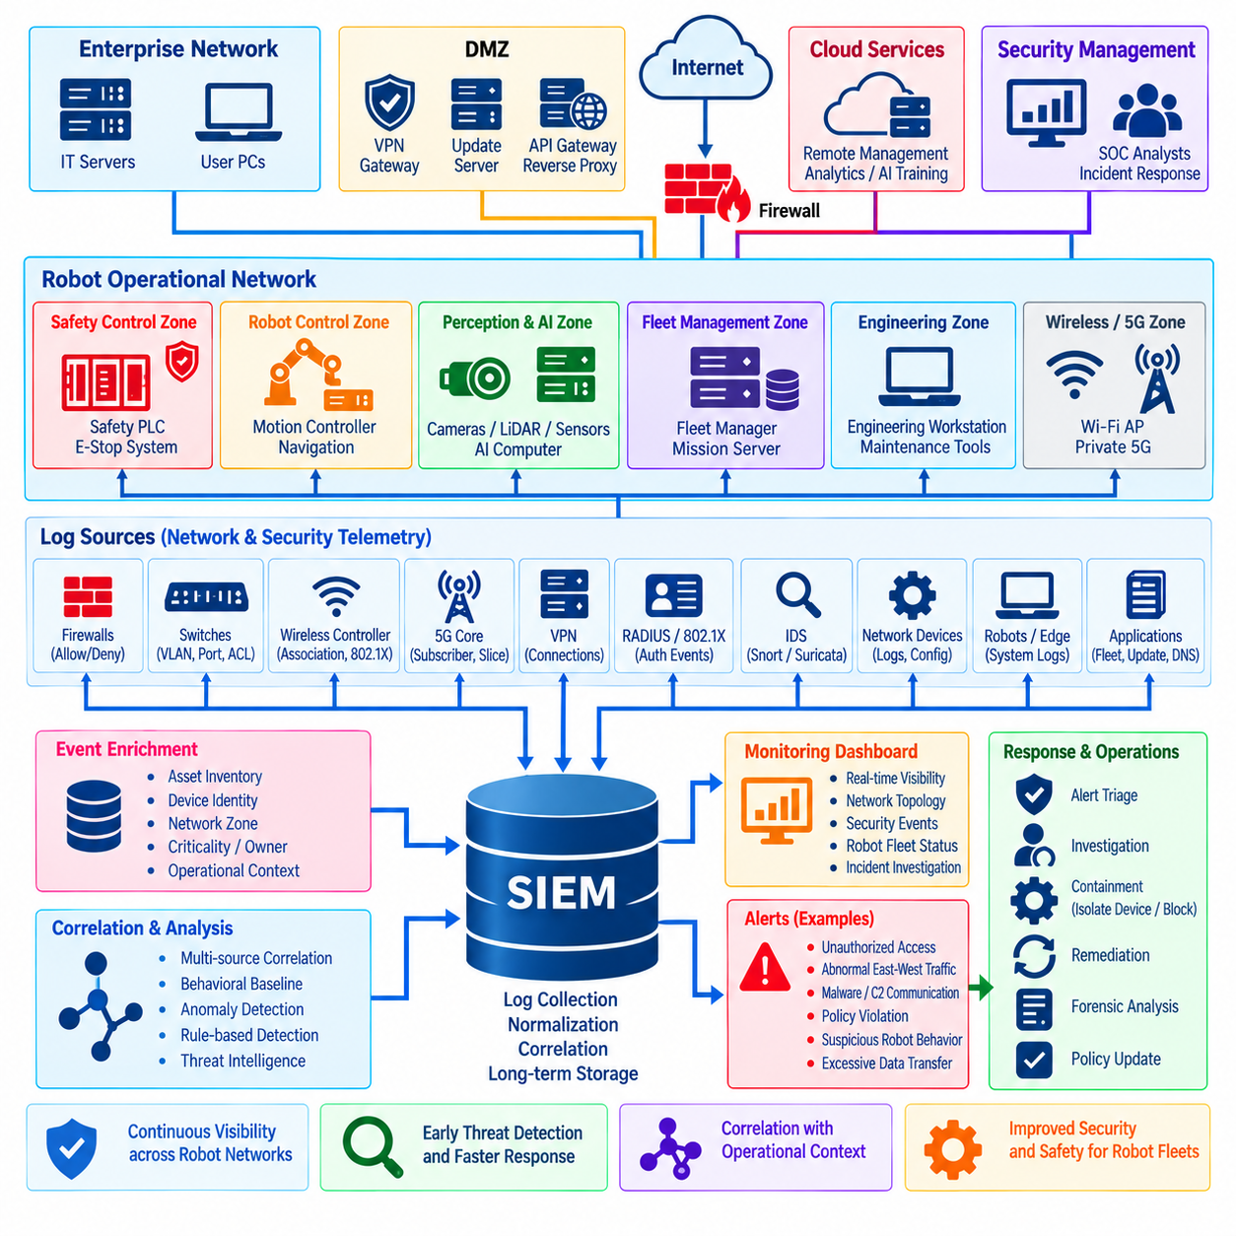
Network security monitoring provides continuous visibility into events occurring across robot communication infrastructure, while Security Information and Event Management, or SIEM, combines information from many systems to identify relationships that isolated logs cannot reveal. In robot environments, this capability is important because a cyber incident may begin as a minor network anomaly and later influence navigation, fleet coordination, control, or physical operation.
A monitoring architecture should collect telemetry from the major security boundaries and infrastructure components supporting robot operations. Useful sources include firewalls, routers, switches, wireless controllers, VPN gateways, 802.1X and RADIUS services, private 5G systems, DNS servers, intrusion-detection sensors, edge computers, robot operating systems, fleet-management platforms, and identity services. Together, these sources create a broader view of network activity.
SIEM platforms normalize and correlate events generated by systems that use different log formats and naming conventions. A firewall may report a denied connection using IP addresses, while an authentication server identifies the same endpoint through a certificate or device identity. Correlation allows analysts to connect these records and understand that several apparently separate events may describe one robot, user, session, or security incident.
Asset context is particularly important in robotics because identical network events can have very different consequences. A failed connection toward a development server may be low priority, while the same behavior directed toward a safety PLC, motion controller, or fleet-management server can require immediate investigation. SIEM enrichment should therefore associate events with asset role, criticality, network zone, owner, and operational function.
Network flow information provides useful visibility even when packet payloads cannot be inspected. Source and destination addresses, ports, protocols, connection duration, byte counts, and communication frequency can reveal unexpected relationships. A perception computer that suddenly communicates with an external host or a robot that begins scanning multiple internal subnets may indicate compromise even when application traffic is encrypted.
Intrusion-detection alerts from Snort, Suricata, or similar sensors can be integrated with SIEM data to improve interpretation. A single signature alert may be uncertain, but confidence increases when it occurs together with firewall denies, failed authentication attempts, abnormal DNS requests, or unusual endpoint activity. Correlation helps security teams distinguish isolated noise from behavior that spans multiple layers of the robot infrastructure.
Authentication telemetry is another major source of security evidence. VPN connections, 802.1X authentication, RADIUS decisions, wireless associations, certificate validation, and private 5G subscriber events can reveal who or what entered the network. Repeated failures, unexpected device identities, unusual access locations, expired certificates, or abnormal reconnection patterns may indicate credential misuse, configuration problems, or unauthorized equipment.
Robot-specific context should be incorporated wherever possible. Fleet systems may provide robot identifiers, mission states, charging status, maintenance periods, or expected operating locations. Network events can then be interpreted relative to operational behavior. For example, communication that is normal during scheduled maintenance may be suspicious when generated by an unattended robot during routine autonomous operation.
Baseline monitoring is effective because many robot networks exhibit relatively stable communication relationships. Robots often communicate with predictable fleet servers, time services, update systems, gateways, and edge applications. Monitoring can establish normal peers, protocols, traffic volumes, and operating periods, allowing deviations to generate investigation signals even when no known attack signature is available.
Anomaly detection should nevertheless be applied carefully. Software updates, new sensors, temporary engineering work, fleet expansion, and changing workloads can alter normal traffic without representing an attack. Baselines must therefore evolve through controlled processes, and anomalous behavior should be evaluated with operational context rather than automatically classified as malicious solely because it differs from historical activity.
Time synchronization is fundamental to reliable event correlation. Firewalls, robots, edge nodes, wireless infrastructure, 5G systems, authentication servers, and SIEM platforms should maintain sufficiently accurate timestamps. Without consistent time, investigators may be unable to determine whether authentication preceded a suspicious connection, whether a command occurred before a physical event, or which system initiated an incident sequence.
Timestamp provenance becomes especially important when robot incidents involve physical actions. Security records may need to be correlated with sensor measurements, control commands, mission transitions, software events, and operator actions. Preserving trustworthy timing information across these sources helps reconstruct the sequence from network access through digital activity to physical consequence and supports more reliable forensic analysis.
Centralized logging should protect records from modification or deletion by compromised endpoints. If logs remain only on a robot that has been attacked, an adversary may erase evidence before investigation begins. Forwarding important events to protected collectors or SIEM infrastructure improves evidence preservation. Transport encryption, access controls, integrity protection, retention policies, and backup mechanisms should protect the logging pipeline itself.
Log collection must be engineered to avoid interfering with robot operation. High-frequency control messages, sensor streams, and repetitive network events can generate enormous data volumes if recorded without filtering. Logging policies should prioritize security-relevant events, aggregate repetitive information, apply rate controls where appropriate, and preserve sufficient context without consuming resources needed for deterministic control or AI processing.
Alert severity should combine cybersecurity indicators with operational and physical consequences. Attempts to access a management interface, safety controller, actuator network, or fleet orchestration service may deserve higher priority than comparable activity against a low-value system. Severity models can incorporate asset criticality, network zone, attack confidence, user privilege, robot state, and potential effect on safety or availability.
Detection rules should identify both known threats and violations of intended architecture. Examples include enterprise hosts attempting to reach control VLANs, AI computers initiating connections toward safety devices, robots contacting unauthorized Internet destinations, unexpected robot-to-robot traffic, or maintenance systems operating outside approved windows. These conditions convert documented network policy into continuously monitored security expectations.
Dashboards should present information in a form useful to both cybersecurity and robot operations teams. Security analysts need attack indicators and identity context, while operations personnel need to understand affected robots, sites, missions, network segments, and service impact. Shared situational awareness reduces the risk that technical alerts remain disconnected from the physical systems whose behavior may ultimately be affected.
Automated response can reduce containment time but requires caution in operational robotics. A SIEM or security orchestration platform may trigger account suspension, firewall blocking, network quarantine, or certificate revocation after a high-confidence detection. However, automatically disconnecting a robot during motion could create operational or safety consequences, so response logic should account for robot state and validated safe-transition procedures.
For lower-confidence events, automation can gather evidence rather than immediately isolate equipment. A workflow might preserve relevant logs, capture network context, query device status, increase monitoring, notify responsible personnel, and create an incident record. Human review can then determine whether containment is appropriate, providing a balance between rapid response and the need to avoid unnecessary disruption of physical operations.
Retention policies should reflect forensic, operational, regulatory, and storage requirements. Authentication and administrative records may require longer retention than high-volume flow telemetry, while packet captures may be stored only briefly because of their size and sensitivity. Organizations should define what data is retained, for how long, who can access it, and how it is securely deleted when the retention period ends.
Monitoring infrastructure is itself a critical security asset. SIEM servers, collectors, sensors, dashboards, rule repositories, and automation credentials may reveal detailed information about robot architecture and security controls. These systems should be segmented, hardened, patched, backed up, and protected by strong administrative authentication. Access to modify detection rules or delete evidence should be especially restricted and audited.
Detection content requires continuous maintenance as robot systems evolve. New software versions, network zones, wireless technologies, AI services, and fleet workflows can invalidate old assumptions or create new attack paths. Rules, correlation logic, dashboards, asset inventories, and response procedures should therefore be reviewed whenever architecture changes occur and periodically tested against realistic security scenarios.
A mature monitoring program measures its own effectiveness. Teams can track alert quality, false-positive rates, detection coverage, investigation time, containment time, logging gaps, sensor health, and unresolved visibility limitations. Tabletop exercises, controlled attack simulations, and incident-response drills can verify whether monitoring actually provides the evidence and notifications required during a real robot cybersecurity event.
Network security monitoring and SIEM ultimately provide the observational layer that connects preventive security controls with incident response. By combining network telemetry, identity events, intrusion detection, robot operational context, trustworthy timestamps, centralized logging, correlation, and carefully governed automation, organizations can identify abnormal behavior early and respond before a local cyber event develops into fleet-wide disruption or unsafe physical consequences.

03.10. Network Security Hardening Baseline Checklist
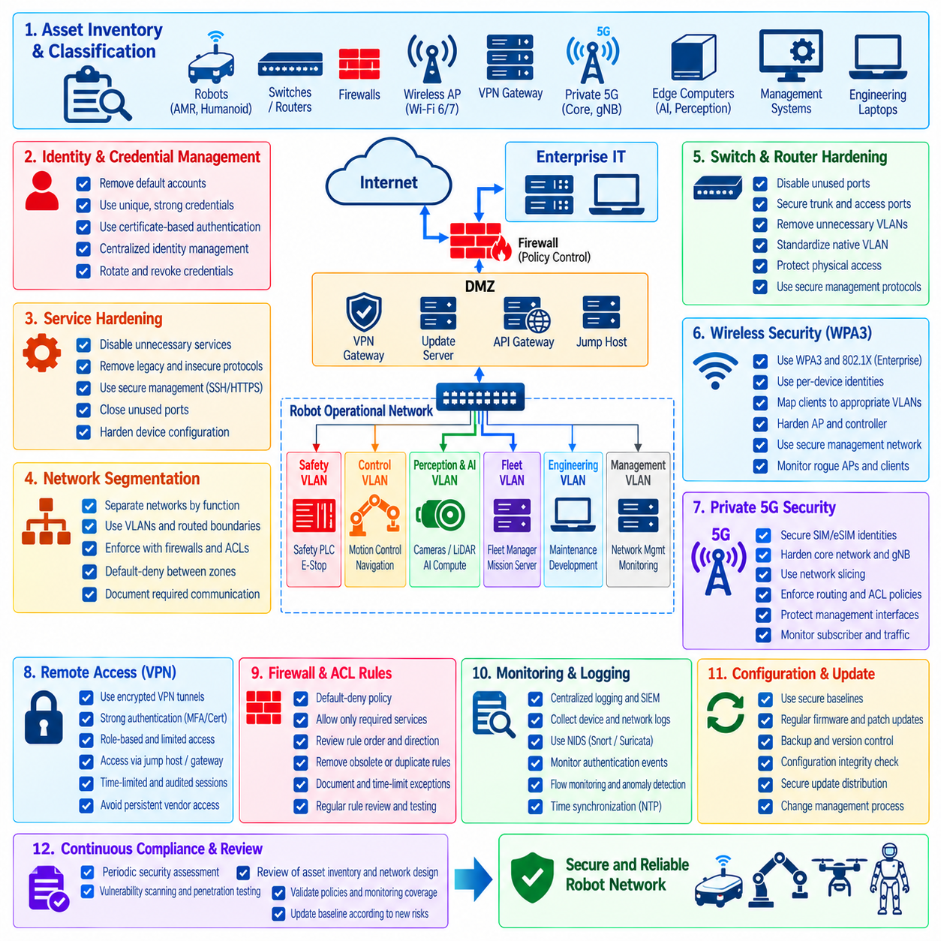
Network security hardening establishes a repeatable minimum configuration that every robot network component should satisfy before entering production. The baseline should cover robots, switches, routers, firewalls, wireless infrastructure, VPN gateways, edge computers, private 5G components, and management systems. Its purpose is to reduce unnecessary exposure and ensure that fundamental protections do not depend on individual engineering decisions.
The hardening process should begin with an accurate inventory of network-connected assets and their intended roles. Each device should have an identifiable owner, hardware and software version, network location, management method, trust classification, and operational purpose. Unknown or unmanaged equipment creates security gaps because administrators cannot reliably determine whether its services, credentials, firmware, or communication behavior satisfy the required baseline.
Default accounts, passwords, certificates, community strings, and vendor credentials should be removed, disabled, or replaced before deployment. Administrative identities should be unique and attributable wherever technically possible. Shared privileged accounts make investigation difficult and increase the impact of credential compromise. Strong authentication and centralized identity management should therefore be applied to network administration according to device capabilities.
Network devices should expose only services required for their operational role. Unused web interfaces, remote shells, discovery protocols, legacy management services, file-sharing functions, and unnecessary listening ports should be disabled. Reducing the number of active services decreases the attack surface and simplifies monitoring because unexpected communication becomes easier to distinguish from the limited set of intentionally permitted functions.
Secure management protocols should replace insecure alternatives. Encrypted administrative access such as SSH and HTTPS should be preferred over plaintext mechanisms, while management APIs should require authenticated and protected sessions. Legacy protocols that transmit credentials or configuration information without adequate protection should be removed whenever possible. Management traffic should also be separated from ordinary robot and user communication.
Network segmentation should be treated as a baseline requirement rather than an optional optimization. Safety control, motion control, AI and perception data, fleet services, engineering access, management traffic, enterprise IT, guest devices, and external connectivity should be separated according to risk and operational requirements. VLANs can provide logical separation, while routed boundaries, firewalls, and ACLs enforce communication policy between zones.
Inter-zone communication should follow a default-deny principle. Every permitted path should have a documented operational purpose and define the necessary source, destination, protocol, port, and direction. Broad rules such as unrestricted subnet-to-subnet access should be avoided. When temporary connectivity is required for commissioning or troubleshooting, the exception should be time limited, recorded, reviewed, and removed after the activity ends.
Switch hardening should include explicit access and trunk port configuration. Unused ports should be disabled or restricted, unnecessary VLANs should be removed from trunks, and native VLAN behavior should be standardized. Features that can alter Layer-2 topology or create unauthorized connectivity should be controlled according to the architecture. Physical switch access should also be protected because local configuration changes can bypass logical segmentation.
Network access control can strengthen the baseline by requiring device authentication before ordinary connectivity is granted. IEEE 802.1X with certificate-based authentication is suitable for capable robot endpoints, engineering systems, and infrastructure devices. Where legacy equipment cannot support strong authentication, exception mechanisms should provide narrower access, additional segmentation, and monitoring rather than equivalent trust based solely on physical connection.
Wireless networks require their own hardened configuration. WPA3 and enterprise authentication should be used where supported, shared credentials should be minimized, and robot identities should be managed individually when practical. Wireless clients should be mapped into appropriate security zones rather than placed into one unrestricted network. Access-point and wireless-controller administration should remain isolated from normal production traffic.
Private 5G environments should apply equivalent principles to subscriber identities, SIM or eSIM provisioning, core-network administration, edge connectivity, and network slicing. Slice membership should not be interpreted as unrestricted authorization. Routing controls, firewalls, application authentication, and monitoring should continue to enforce least privilege between robots, edge services, management systems, and external networks.
Remote access should terminate through controlled gateways rather than directly exposing robot services to external networks. VPNs or equivalent encrypted tunnels should use strong authentication, restricted authorization, and centralized logging. Remote users should receive only the access required for their assigned maintenance or support function. Persistent vendor access should be avoided when temporary, approved, and auditable sessions can satisfy the operational requirement.
Firewall and ACL policies should be reviewed for excessive permissions, obsolete rules, duplicate entries, temporary exceptions, and undocumented dependencies. Rule order and direction should be verified because technically valid configurations can still produce unintended access. Periodic policy review should compare deployed rules with the current robot architecture so that connectivity created for retired systems or previous projects does not remain indefinitely.
Software and firmware versions should be maintained within an approved security baseline. Network devices, wireless infrastructure, robot communication modules, operating systems, VPN components, and management platforms should be monitored for vulnerabilities and security updates. Patches should be validated before production deployment when changes could affect real-time communication, roaming, protocol compatibility, or operational availability.
Configuration files and firmware images should originate from trusted sources and be protected against unauthorized modification. Where supported, signed firmware, secure boot, integrity verification, and controlled update mechanisms can reduce the risk of malicious or corrupted software entering network infrastructure. Configuration backups should also be protected because they may contain addresses, topology information, credentials, certificates, and security policies.
Logging should be enabled for security-relevant activity without overwhelming devices or monitoring infrastructure. Authentication events, administrative changes, firewall decisions, VPN sessions, network-access-control results, wireless associations, configuration modifications, and critical system errors should be forwarded to protected centralized logging or SIEM systems. Logs should contain reliable timestamps so that events across robots and infrastructure can be correlated.
Time synchronization should therefore form part of the hardening baseline. Robots, switches, firewalls, edge systems, authentication servers, wireless infrastructure, private 5G components, and monitoring platforms should use approved time sources. Consistent timestamps improve incident reconstruction and allow network events to be compared with control commands, software activity, operator actions, and physical robot behavior.
Intrusion detection and network monitoring should cover critical boundaries between enterprise, management, AI, robot-control, wireless, and external domains. Sensors can identify known attack patterns as well as violations of intended communication relationships. Flow telemetry and behavioral baselines provide additional visibility when encrypted traffic prevents payload inspection. Monitoring should emphasize meaningful deviations rather than simply maximizing alert volume.
Administrative access should follow least privilege and separation of duties. Engineers who operate robots do not necessarily require unrestricted control of firewalls, switches, wireless controllers, or authentication systems. Privileged actions should be limited to authorized roles, strongly authenticated, logged, and periodically reviewed. Dormant accounts and unnecessary privileges should be removed as personnel and operational responsibilities change.
Backup and recovery procedures should include network-security configurations as well as application data. Firewall policies, switch configurations, wireless settings, authentication databases, certificates, routing rules, and SIEM content may be essential for restoring secure operation after equipment failure or compromise. Recovery procedures should be tested so that restoration does not unintentionally reintroduce obsolete credentials or insecure configurations.
Hardening must also define secure failure behavior. Loss of an authentication server, firewall, wireless controller, 5G component, VPN gateway, or routing service can affect robot availability. Fail-open behavior may preserve communication while weakening security, whereas fail-closed behavior may interrupt operations. The selected behavior should reflect threat analysis, operational criticality, safety requirements, redundancy, and local robot protection mechanisms.
Baseline verification should be automated where practical. Configuration scanning, policy comparison, vulnerability assessment, certificate-expiration checks, unauthorized-service detection, and segmentation testing can identify drift from approved settings. Automation is especially valuable for large fleets because manually reviewing hundreds of robots and network devices can leave inconsistencies undetected for long periods.
Exceptions to the baseline should be explicit rather than informal. Legacy controllers, specialized sensors, vendor appliances, or safety-certified equipment may not support current security mechanisms. Each exception should document the technical limitation, associated risk, compensating controls, responsible owner, approval, and review period. This prevents temporary weaknesses from becoming permanent and invisible elements of the architecture.
The baseline should be verified during commissioning and reviewed throughout the operational lifecycle. New robot models, AI computers, sensors, software releases, network technologies, and remote services can change the attack surface. Periodic audits, penetration testing, configuration reviews, incident lessons, and architecture changes should feed back into the hardening standard so that it evolves with both threats and system capabilities.
A mature network security hardening baseline combines asset inventory, secure identity, minimal services, segmentation, default-deny policy, protected administration, encrypted remote access, controlled wireless and 5G connectivity, patching, logging, monitoring, backup, resilience, and continuous verification. Applied consistently, this checklist-oriented approach creates a measurable security foundation for robot networks and reduces the probability that a simple configuration weakness develops into fleet-wide or safety-relevant compromise.

