Volume 25. Testing Validation and Benchmarking

Chapter 08. Validation and Benchmarking

08.01. Validation vs Verification Conceptual Distinction
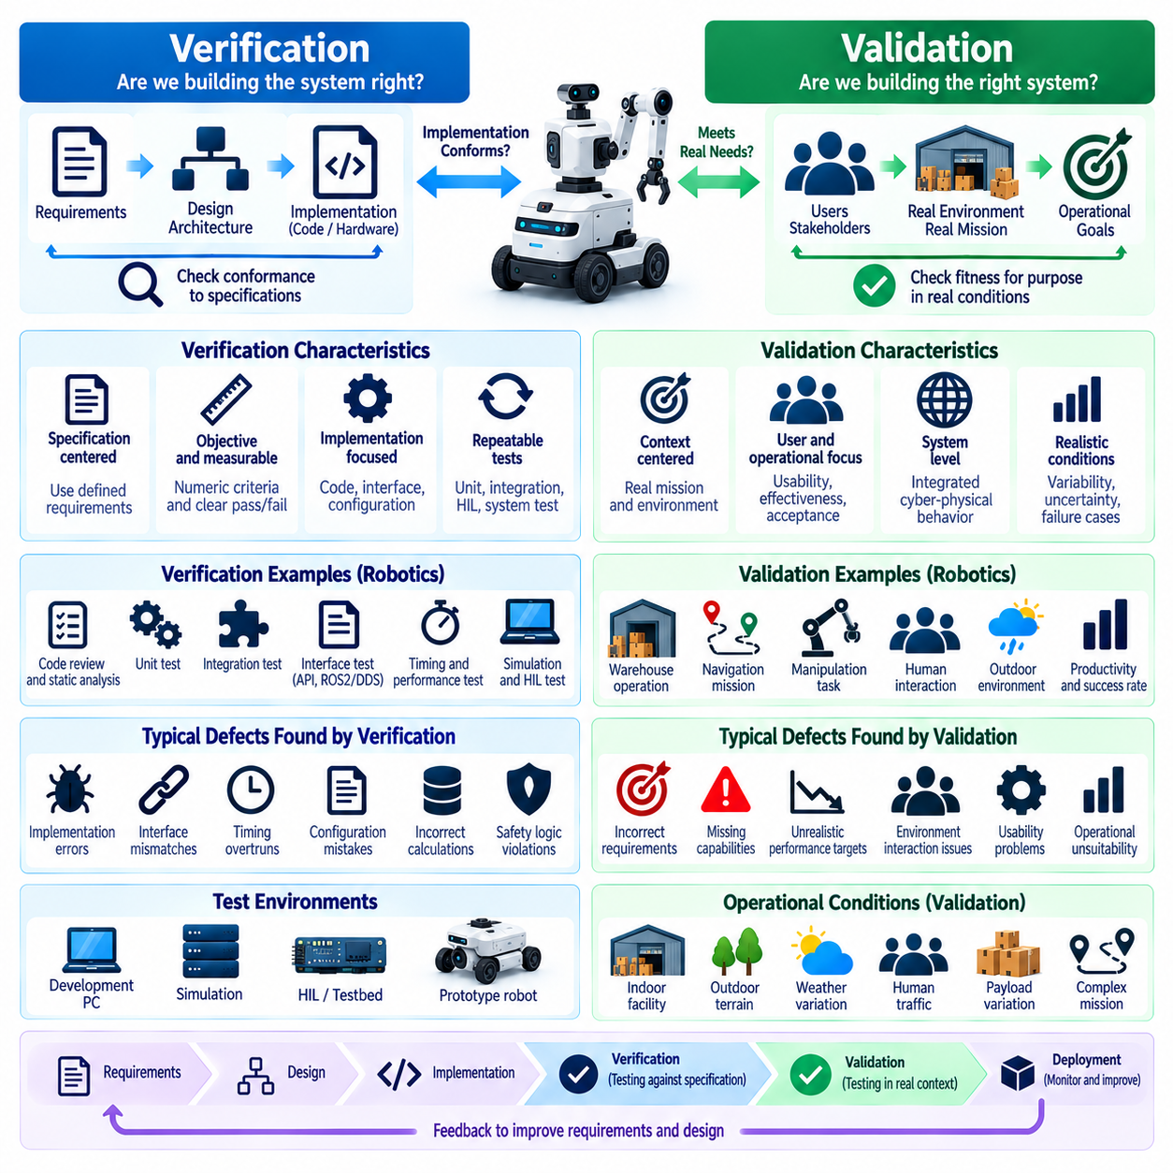
Verification and validation are closely related quality assurance activities, but they answer fundamentally different questions about a robotic system. Verification determines whether the system has been implemented according to its specified requirements, architecture, interfaces, and design constraints. Validation determines whether the resulting system actually satisfies the intended operational need when used in representative conditions. This distinction is especially important in robotics because correct software implementation does not automatically imply correct physical behavior.
A common conceptual formulation describes verification as asking, “Are we building the system right?” while validation asks, “Are we building the right system?” Verification therefore focuses primarily on conformance between implementation artifacts and defined specifications. Validation focuses on fitness for purpose and the relationship between the completed system and its real mission, users, environment, and operational expectations. Both activities are necessary because a robot may pass every implementation-level test yet remain unsuitable for deployment.
Verification begins with explicit requirements that can be traced into architecture, software components, hardware interfaces, algorithms, and test cases. A requirement specifying a maximum emergency-stop response time, for example, can be verified by instrumenting the control chain and measuring the actual response. Software interfaces can similarly be checked against API definitions, message schemas, timing constraints, state-machine specifications, or safety logic. The objective is to produce repeatable evidence showing that implemented behavior conforms to what was formally specified.
Verification can occur at many levels of the robotics development hierarchy. Static analysis, code review, unit testing, integration testing, interface testing, simulation, Hardware-in-the-Loop testing, and system testing can all provide verification evidence. The important property is not the particular test environment but the reference against which results are judged. When observed behavior is compared directly with an engineering requirement or design specification, the activity is primarily verification, even when physical robot hardware participates in the test.
Validation instead evaluates the relationship between the engineered robot and its intended application. An autonomous mobile robot may correctly implement localization, planning, obstacle avoidance, and motion-control requirements while still failing to deliver acceptable warehouse productivity. Validation therefore examines realistic missions, workflows, environmental variability, human interaction, operational constraints, and failure conditions. Evidence must demonstrate that the integrated system performs useful work safely and effectively within its intended operational domain.
The distinction becomes clearer when considering navigation performance. Verification may establish that localization error remains below a specified threshold, commanded velocity is tracked within tolerance, planner interfaces operate correctly, and obstacle detection meets required latency. Validation asks whether these capabilities collectively allow the robot to transport material through actual facilities without unacceptable delays, unsafe interactions, frequent interventions, or mission failures. Component correctness is therefore necessary evidence, but system usefulness must be established separately.
Verification is typically specification-centered, whereas validation is context-centered. Verification requires precise acceptance criteria such as numerical tolerances, interface definitions, timing budgets, state transitions, and expected outputs. Validation requires a sufficiently representative description of the operational domain, including surfaces, lighting, traffic, obstacles, payloads, weather, human behavior, communication conditions, and mission complexity. Poorly defined requirements weaken verification, while an unrealistic operational environment weakens validation regardless of the amount of collected test data.
The two activities also differ in the types of defects they expose. Verification frequently identifies implementation defects such as incorrect calculations, violated interfaces, timing overruns, integration errors, configuration mistakes, or deviations from safety requirements. Validation more often reveals requirement defects, incorrect assumptions, missing capabilities, inappropriate performance targets, and unexpected interactions with the operating environment. A successfully verified system can therefore fail validation when the original requirements did not adequately represent the real problem.
Robotics makes validation unusually difficult because software outputs are converted into physical actions through sensors, actuators, mechanisms, communication networks, and control loops. Environmental uncertainty can affect every stage of this chain. Sensor noise, wheel slip, changing friction, actuator saturation, occlusion, illumination, terrain geometry, payload variation, and human movement may create behavior that was not apparent during software-level verification. Validation must consequently consider the complete cyber-physical system rather than evaluating isolated computational outputs alone.
For AI-enabled robots, the boundary becomes even more significant. Verification can confirm model packaging, tensor interfaces, preprocessing, inference execution, latency limits, memory usage, deployment configuration, and deterministic software surrounding an AI component. However, learned models cannot generally be characterized only through conventional functional requirements. Validation must evaluate whether perception or policy behavior remains acceptable across representative distributions, difficult scenarios, novel conditions, and operationally meaningful variations.
Validation should therefore use scenario coverage in addition to individual pass-or-fail requirements. Scenarios can represent nominal operation, boundary conditions, degraded sensing, unusual object configurations, dynamic obstacles, communication loss, environmental changes, or combinations of disturbances. Simulation enables large numbers of scenarios to be explored efficiently, while field testing provides evidence under physical conditions that simulation cannot perfectly reproduce. The broader volume structure accordingly places simulation-based validation and field testing before system benchmarking and validation. Volume_25_Testing_Validation_an…
Verification and validation should not be treated as sequential activities performed only at the end of development. Verification can begin with requirements and architecture reviews and continue through unit, integration, HIL, and system testing. Validation can also begin early through prototypes, simulation, user scenarios, operational demonstrations, and iterative field experiments. Early validation is particularly valuable because discovering that a technically correct system solves the wrong operational problem late in development can require expensive redesign.
Traceability provides the connection between these activities. Requirements should be associated with verification methods and objective evidence, while higher-level stakeholder needs and operational objectives should be associated with validation scenarios and measurable outcomes. A requirements matrix may show that every engineering requirement has been verified, but validation evidence must additionally demonstrate that those requirements collectively produce acceptable mission behavior. The chapter structure explicitly follows this conceptual distinction with system validation against a requirements matrix. Volume_25_Testing_Validation_an…
Benchmarking complements validation but should not be confused with it. A benchmark provides a standardized procedure, dataset, scenario set, metric definition, or test environment that allows performance to be measured consistently. Validation asks whether measured performance is sufficient for a particular intended use. A robot may achieve a strong benchmark score yet fail application-specific validation because the benchmark does not represent its deployment environment, payload, safety constraints, mission duration, or interaction patterns.
Conversely, successful validation within one operational domain does not automatically establish broad superiority. A warehouse AMR validated in structured indoor aisles may not be suitable for outdoor navigation, and a manipulation policy validated for a defined object set may not generalize to unfamiliar objects. Benchmarking helps expose these boundaries by providing common reference conditions across systems. The surrounding framework therefore separates navigation, manipulation, locomotion, humanoid, UAV, and cross-platform benchmark methodologies rather than assuming a universal metric. Volume_25_Testing_Validation_an…
A mature robotics quality process ultimately treats verification and validation as complementary evidence chains. Verification builds confidence that requirements have been implemented correctly and that subsystems behave according to specification. Validation builds confidence that those verified capabilities form a robot that performs its intended mission under representative real-world conditions. Benchmarking then supplies standardized measurements that support comparison, regression analysis, and engineering decisions across versions or platforms.
The practical goal is not merely to label individual tests as verification or validation, but to ensure that neither form of evidence is missing. Verification without validation can produce a precisely implemented system that is operationally inadequate. Validation without disciplined verification can produce encouraging demonstrations without sufficient evidence of correctness, repeatability, or safety. Effective robot engineering integrates both perspectives into a traceable process extending from requirements and software tests through simulation, HIL, field operation, benchmarking, and eventual certification evidence.

08.02. System Validation Against Requirements Matrix [w/Code]
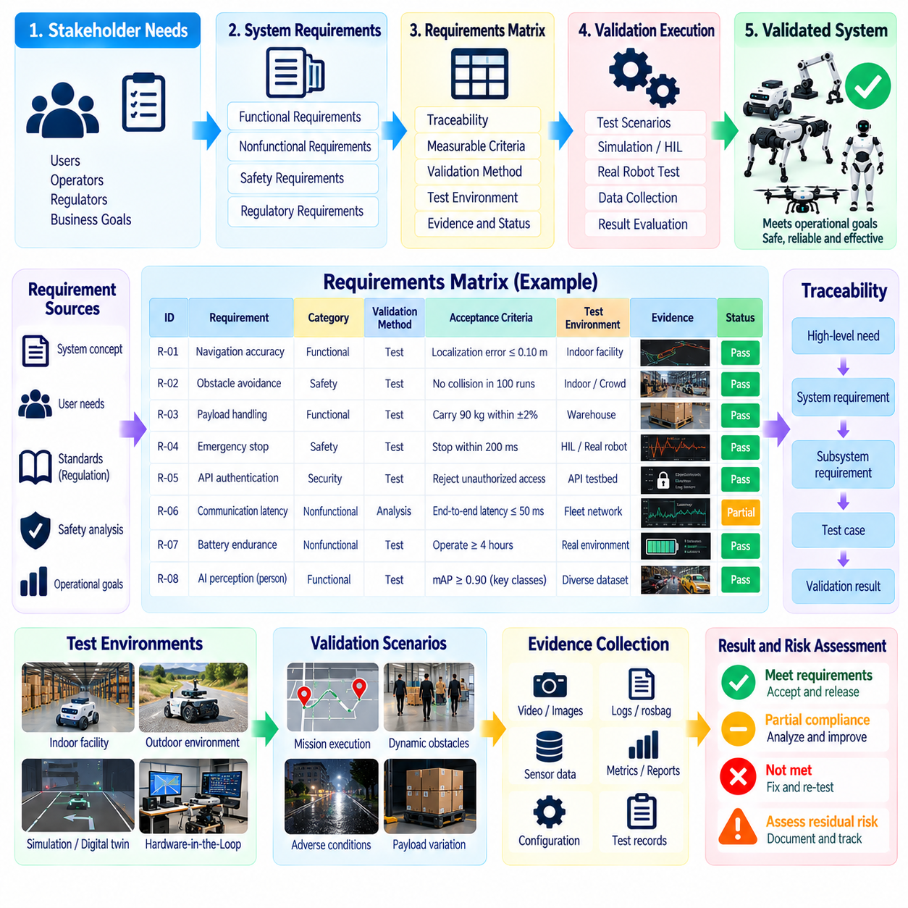
System validation against a requirements matrix provides a disciplined method for determining whether an integrated robot satisfies the capabilities, performance expectations, safety constraints, and operational objectives defined for its intended use. The matrix converts requirements into traceable validation obligations by connecting each requirement with its source, validation method, measurable acceptance criteria, test environment, evidence, and final status.
A requirements matrix should represent more than a checklist of completed tests. Each entry should describe a requirement in a form that can be objectively evaluated and connected to observable robot behavior. Functional requirements may address navigation, perception, manipulation, communication, charging, mission execution, or human interaction, while nonfunctional requirements may define latency, accuracy, reliability, availability, energy consumption, environmental tolerance, maintainability, or safety performance.
Requirement quality directly determines the quality of validation. Statements such as “the robot shall navigate accurately” are difficult to validate because they provide no measurable boundary. A stronger requirement specifies the operational conditions, performance metric, threshold, and relevant constraints. For example, localization accuracy may be defined for particular environments and operating speeds, allowing validation engineers to construct representative scenarios and determine objectively whether observed performance satisfies the intended requirement.
Traceability connects stakeholder needs to system requirements and then to validation evidence. A high-level requirement for safe autonomous material transport may decompose into requirements for obstacle detection, localization, path planning, braking, emergency stopping, payload handling, and fault response. The matrix preserves these relationships so that engineers can determine whether all necessary capabilities have been evaluated and whether failures at subsystem level affect satisfaction of higher-level operational objectives.
Every requirement should be assigned an appropriate validation method. Inspection can establish configuration or physical characteristics, analysis can evaluate calculated performance or accumulated statistical evidence, demonstration can confirm observable functionality, and testing can measure behavior under controlled conditions. Complex robotic requirements frequently require combinations of these methods because system behavior emerges from interactions among software, sensors, actuators, mechanical structures, networks, AI models, and environmental conditions.
Acceptance criteria translate requirements into explicit pass, fail, or conditional evaluation rules. Numerical thresholds should identify units, tolerances, sampling conditions, observation intervals, and statistical treatment when relevant. A navigation success requirement, for example, may require a defined percentage of missions to complete without collision or operator intervention while maintaining localization and timing limits. Such criteria prevent subjective judgments from being introduced after test results are already known.
The validation environment must also be represented in the matrix because performance without environmental context can be misleading. Indoor AMR validation may specify aisle width, floor condition, pedestrian density, obstacle types, lighting, payload, wireless coverage, and traffic patterns. Outdoor robots may additionally require slope, surface irregularity, weather, GNSS availability, and illumination ranges. UAV, quadruped, humanoid, and manipulation systems require similarly platform-specific descriptions of their operational conditions.
Validation scenarios transform matrix entries into executable system-level evaluations. A single scenario may validate several requirements simultaneously when the robot performs an integrated mission involving perception, planning, control, communication, and safety behavior. However, scenario reuse should not obscure traceability. The matrix should explicitly identify which observations and measurements provide evidence for each requirement so that one successful mission is not incorrectly interpreted as proof that every associated requirement has been satisfied.
System validation should include nominal conditions, boundary conditions, and reasonably foreseeable degraded conditions. Nominal tests demonstrate expected operation, while boundary tests examine behavior near specified performance limits. Degraded scenarios may introduce sensor deterioration, communication interruptions, localization uncertainty, dynamic obstacles, reduced battery state, or actuator limitations. The requirements matrix provides a systematic way to determine which conditions have been covered and where important validation gaps remain.
For AI-enabled robotic functions, matrix-based validation requires additional care because behavior may vary across data distributions and environmental conditions. A perception requirement cannot be validated adequately from a single aggregate accuracy value if critical object classes or difficult operating conditions are hidden within that average. Matrix entries can therefore associate AI requirements with datasets, scenario categories, operating domains, confidence measures, robustness criteria, and representative real-world trials.
Evidence management is an essential function of the requirements matrix. Validation results should reference test reports, logs, rosbag recordings, sensor streams, videos, measurement files, simulation records, software versions, calibration data, configuration files, and analysis outputs where appropriate. Evidence should be sufficiently complete to reconstruct the conditions under which a requirement was evaluated and to explain why the resulting status was classified as passed, failed, blocked, or requiring further investigation.
Configuration traceability is particularly important because robot behavior can change when software, firmware, AI models, parameters, hardware revisions, maps, or calibration values change. Validation evidence should therefore be associated with an identifiable system configuration. A requirement validated using one navigation-stack version or perception model cannot automatically be considered validated after a significant change unless impact analysis demonstrates that the previous evidence remains applicable or appropriate regression validation is performed.
The matrix also supports coverage analysis. Requirement coverage measures whether every applicable requirement has an assigned validation method and corresponding evidence, while scenario coverage evaluates whether representative operating conditions have been exercised. These perspectives should be considered together. Complete requirement coverage with narrow scenarios may overlook environmental weaknesses, whereas extensive scenario testing without traceability may generate large quantities of data without proving that contractual or engineering requirements were actually satisfied.
Failed requirements should remain visible rather than being hidden by aggregate success metrics. Each failure should be linked to observed evidence, probable cause, corrective action, responsible component, and planned revalidation activity. When a defect is corrected, the affected requirement should be evaluated again together with related requirements that could experience regression. This transforms the matrix from a static documentation artifact into an active control mechanism for validation and engineering change management.
The requirements matrix can also coordinate validation across simulation, Hardware-in-the-Loop testing, laboratory testing, and field testing. Some requirements can be evaluated efficiently through repeatable simulation, while timing and hardware interaction may require HIL. Physical safety behavior, environmental robustness, and mission-level suitability often require representative field conditions. Evidence from these environments should be complementary rather than treated as interchangeable when their realism and coverage differ.
Automation improves matrix maintenance when requirements, test cases, execution results, and evidence repositories are digitally connected. Continuous integration pipelines can automatically update execution status, attach logs, detect regression failures, and identify requirements affected by software changes. Nevertheless, automated test success should not automatically imply system validation success. Engineers must still determine whether the test configuration and scenarios adequately represent the intended operational conditions and acceptance rationale.
A validation review uses the completed matrix to assess readiness at system level. Reviewers should be able to move from an operational objective to its derived requirements, associated validation scenarios, acceptance criteria, execution records, and objective evidence without losing traceability. Open failures, waived requirements, assumptions, environmental limitations, and residual risks should remain explicit so that deployment decisions are based on known evidence rather than a simplified overall pass percentage.
Ultimately, system validation against a requirements matrix establishes an evidence-based argument that the integrated robot is suitable for its defined purpose. The matrix connects requirements engineering with simulation, HIL, field testing, AI evaluation, safety testing, and benchmarking, creating continuity across the broader validation process. When maintained throughout development, it becomes a living representation of what the robot must achieve, how achievement is demonstrated, what evidence exists, and which uncertainties remain before deployment.

08.03. AMR Navigation Benchmark Suite Design [w/Code]
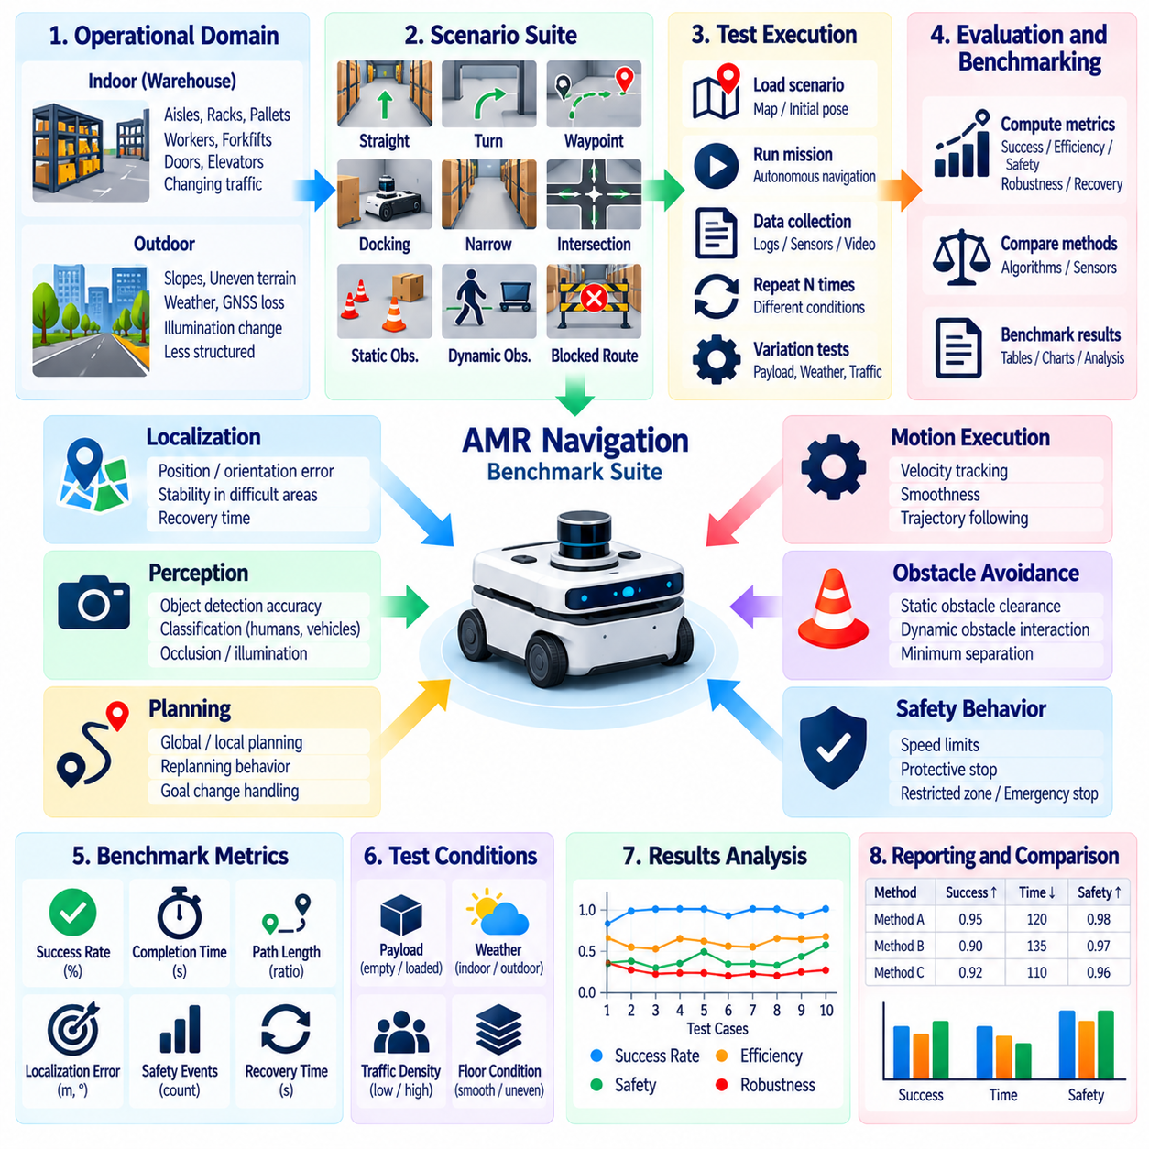
An AMR navigation benchmark suite should provide a repeatable framework for measuring how reliably and efficiently an autonomous mobile robot moves through representative operating environments. Rather than reducing navigation quality to a single success metric, the suite should evaluate localization, planning, obstacle avoidance, motion execution, safety behavior, efficiency, robustness, and recovery as interacting capabilities that collectively determine mission-level navigation performance.
Benchmark design begins by defining the operational domain that the results are intended to represent. Indoor warehouse AMRs may encounter narrow aisles, intersections, racks, pallets, workers, forklifts, doors, elevators, reflective surfaces, and changing traffic density. Outdoor platforms introduce slopes, uneven terrain, weather, GNSS degradation, illumination changes, and less structured boundaries. Benchmark conclusions should therefore remain explicitly bounded by the environments and conditions actually evaluated.
A useful suite organizes navigation tests into scenario families rather than relying on a single route. Basic scenarios can evaluate straight travel, turns, waypoint following, docking, and static obstacle avoidance. More demanding scenarios introduce narrow passages, intersections, dead ends, dense clutter, dynamic pedestrians, crossing traffic, blocked routes, temporary obstacles, and goal changes. This progression makes it possible to distinguish fundamental navigation limitations from failures that emerge only under complex interactions.
Mission success rate is a primary benchmark metric, but its definition must be precise. A successful trial may require reaching the assigned goal within a specified time without collision, safety violation, prohibited-area entry, or human intervention. Partial completion should not automatically be counted as success. Recording the cause of unsuccessful trials, such as localization loss, planning failure, collision risk, timeout, deadlock, or recovery failure, provides substantially more engineering value than a binary score alone.
Navigation efficiency should be evaluated together with success. Path length can be compared with a reference or feasible shortest path, while completion time measures operational efficiency under realistic motion constraints. Excessive replanning, oscillation, unnecessary stopping, and repeated recovery actions may indicate poor navigation quality even when the robot eventually reaches its goal. Benchmark metrics should therefore distinguish successful but inefficient behavior from consistently smooth and direct navigation.
Localization performance is another essential dimension because planning and control depend on an accurate estimate of robot state. Position and orientation error can be evaluated against suitable reference measurements, while benchmark scenarios should examine localization stability during turns, repetitive geometry, partial occlusion, feature-poor corridors, and environmental changes. Recovery time after temporary localization degradation is also important because practical AMRs must tolerate disturbances without immediately requiring operator assistance.
Obstacle avoidance benchmarks should include both static and dynamic objects. Static scenarios can measure clearance, path feasibility, stopping distance, and successful traversal around fixed obstacles. Dynamic scenarios should evaluate interactions with pedestrians, moving carts, other robots, or crossing vehicles at controlled speeds and trajectories. The benchmark should capture minimum separation distance, unnecessary stops, collision events, evasive behavior, and successful continuation after the interaction has ended.
Safety-related navigation measurements should remain distinct from pure productivity metrics. A fast robot that reaches goals efficiently but repeatedly violates required separation distances is not a high-performing navigation system. Tests should therefore monitor speed limits, protective stopping behavior, restricted zones, emergency responses, and interactions near humans where applicable. Safety events should be retained as explicit benchmark outcomes rather than being hidden inside an averaged navigation score.
Robustness testing examines whether navigation performance remains stable when operating conditions change. Scenario variations can modify payload, velocity, obstacle density, map accuracy, sensor visibility, floor characteristics, network quality, lighting, or localization conditions. Repeating equivalent missions under controlled perturbations reveals performance degradation that nominal tests may conceal. Robustness should be characterized by both absolute performance and the change relative to a defined baseline condition.
Recovery behavior deserves dedicated evaluation because real AMRs inevitably encounter situations that cannot be solved by nominal planning alone. Benchmark scenarios may deliberately create blocked paths, temporary localization uncertainty, planner infeasibility, controller oscillation, or communication interruptions. Measurements can include recovery success rate, recovery duration, number of attempts, distance traveled during recovery, and whether human intervention was ultimately required before mission execution could continue.
Repeatability is necessary for statistically meaningful comparison. Each benchmark scenario should be executed multiple times using controlled initial conditions and documented environmental configurations. Randomized scenarios may also be valuable, but random seeds and generation parameters should be preserved so that equivalent experiments can be reproduced. Reporting distributions, percentiles, variance, and failure frequencies provides a more reliable picture than reporting only the best run or arithmetic mean.
Benchmark infrastructure should capture synchronized evidence from the complete navigation stack. Robot pose, localization confidence, global and local plans, commanded and measured velocity, obstacle representations, safety states, controller outputs, CPU and GPU utilization, network conditions, battery state, and relevant sensor streams can be logged with consistent timestamps. These records allow benchmark scores to be connected to internal system behavior when regression analysis or root-cause investigation is required.
Simulation can provide large-scale scenario execution before physical testing. Identical navigation software can be exercised across many maps, obstacle configurations, pedestrian trajectories, sensor disturbances, and randomized initial states at relatively low cost. Simulation is particularly useful for regression benchmarking and rare situations, but simulated scores should not automatically be treated as equivalent to real-world performance because sensing, dynamics, friction, timing, and human behavior may differ from physical deployment.
Physical benchmark environments should complement simulation by measuring the integrated AMR under realistic sensing and motion conditions. Courses can reproduce corridors, intersections, narrow passages, loading areas, docking stations, dynamic traffic, and representative obstacles. Instrumentation should provide independent reference measurements where practical. Maintaining consistent layouts, route definitions, payloads, software versions, calibration states, and environmental conditions improves comparability across repeated benchmark campaigns.
A benchmark suite should support comparison across software releases without allowing configuration differences to invalidate conclusions. Every result should identify the robot platform, sensor configuration, navigation stack version, map, parameter set, firmware, payload, speed limits, and relevant compute configuration. When an algorithm or AI component changes, equivalent benchmark scenarios should be rerun so that improvements in one metric can be checked against regressions in safety, robustness, energy use, or mission completion.
Cross-platform comparison requires additional normalization because AMRs may differ substantially in dimensions, mass, maximum velocity, sensor coverage, drive configuration, and intended application. Raw completion time alone may unfairly favor faster platforms, while clearance or turning performance may depend strongly on robot geometry. Comparisons should therefore combine absolute operational measurements with normalized metrics and clearly state platform constraints rather than compressing fundamentally different robots into one universal ranking.
The final benchmark report should preserve individual metrics alongside any composite score. Aggregated scores are convenient for tracking releases or comparing configurations, but they can conceal critical weaknesses. Mission success, navigation efficiency, localization stability, dynamic obstacle handling, safety events, recovery performance, robustness, computational load, and energy consumption should remain independently visible so engineers can understand why one system performs differently from another.
An effective AMR navigation benchmark suite ultimately functions as both an evaluation framework and a regression control mechanism. By combining representative scenarios, measurable acceptance rules, synchronized evidence, repeated trials, simulation, and physical testing, it establishes a stable reference for navigation quality. Its greatest value comes not from producing a single ranking, but from revealing where navigation succeeds, where it degrades, how reliably results repeat, and whether each software or hardware change improves the robot as an operational system.

08.04. Manipulation Benchmark YCB RLBench DROID [w/Code]
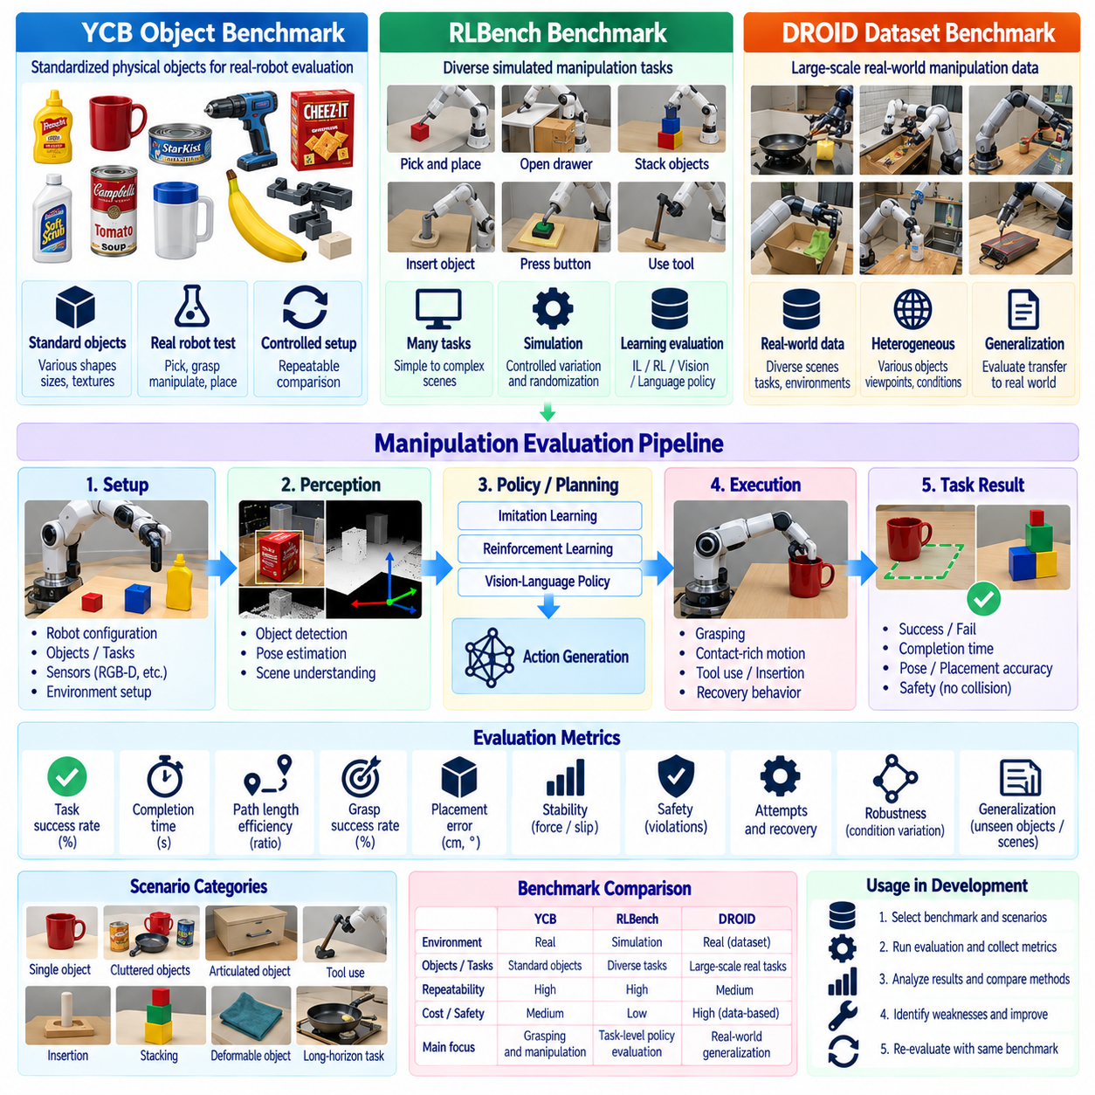
Manipulation benchmarking evaluates whether a robot can perceive objects, generate suitable actions, execute contact-rich motion, and complete tasks reliably across variations in objects, scenes, and initial conditions. Unlike isolated perception or controller evaluation, manipulation benchmarks measure the integrated behavior of sensing, pose estimation, planning, grasping, force interaction, policy execution, and recovery. YCB, RLBench, and DROID provide complementary foundations for evaluating these different dimensions.
The YCB object set provides standardized physical objects that support repeatable manipulation experiments across laboratories and robot platforms. Objects span different shapes, dimensions, textures, masses, materials, and grasping characteristics, allowing researchers to evaluate grasping and manipulation under controlled diversity. Because identical or comparable objects can be used repeatedly, YCB-based tests are useful for establishing reproducible physical benchmarks rather than relying on arbitrary laboratory objects.
A YCB-based benchmark should define the object subset, initial pose distribution, workspace geometry, robot configuration, sensing arrangement, gripper type, and task objective. Pick-and-place experiments can measure whether the robot detects an object, approaches it safely, establishes a stable grasp, transports it, and releases it at the intended destination. More demanding tests can introduce clutter, occlusion, pose variation, restricted approach directions, or objects with difficult grasp geometry.
Task success rate is a fundamental manipulation metric, but success must be defined at the complete task level. A grasp should not automatically count as successful if the object is subsequently dropped, incorrectly oriented, or placed outside the target region. Benchmark definitions should specify terminal conditions such as stable acquisition, transport completion, placement accuracy, object integrity, and absence of prohibited collisions. Failure categories should remain available for diagnostic analysis.
Grasp performance can additionally be characterized through grasp success rate, number of attempts, grasp stability, object displacement before acquisition, and recovery after an unsuccessful attempt. For precision manipulation, pose error and placement error may be required. Contact-sensitive tasks can include peak force, force stability, slip events, and unintended contacts. Execution time and trajectory length provide efficiency measures, while repeated trials reveal whether apparently successful behavior is consistently reproducible.
RLBench extends manipulation evaluation from individual objects toward diverse task-level behavior in simulation. It provides structured robotic manipulation tasks in which policies can be evaluated across demonstrations, initial conditions, object arrangements, and task variations. This makes it suitable for benchmarking imitation learning, reinforcement learning, vision-based policies, and language-conditioned manipulation while reducing the cost and risk associated with executing every experimental variation on physical hardware.
An RLBench benchmark should control task definitions, observation modalities, camera configuration, action representation, training and evaluation splits, randomization ranges, and success conditions. Comparisons become unreliable when one policy receives privileged state information while another operates only from visual observations. The benchmark protocol must therefore document what information is available to each policy and preserve equivalent evaluation conditions when comparing algorithms or model versions.
Task diversity is central to RLBench evaluation. Simple reaching or pick-and-place behavior may expose basic policy competence, while opening containers, manipulating tools, inserting objects, pressing controls, stacking items, or executing multi-stage tasks evaluates more complex reasoning and control. Performance should be reported across individual task categories because a single averaged success rate can conceal severe weaknesses in particular manipulation skills or interaction patterns.
Generalization can be measured by separating training conditions from evaluation conditions. Object positions, orientations, visual appearances, scene arrangements, or task parameters can be varied beyond combinations encountered during training. The resulting performance difference provides evidence about whether a policy has learned transferable manipulation behavior or primarily memorized familiar configurations. Generalization results should therefore identify precisely which dimensions were held out or changed.
DROID contributes a different perspective by providing large-scale real-world robot manipulation data collected across diverse scenes, tasks, and physical conditions. Its value for benchmarking lies in exposing learning systems to the variability and imperfections that characterize real robot operation. Compared with tightly controlled simulation, real-world datasets capture changes in viewpoints, backgrounds, object arrangements, demonstrations, execution styles, and environmental conditions that are difficult to model completely.
A DROID-based evaluation can examine how manipulation models learn from heterogeneous demonstrations and how effectively they transfer across tasks or environments. Dataset partitions should prevent unintended leakage between training and evaluation conditions, particularly when assessing generalization. Evaluation protocols should document the demonstrations, observation streams, action representations, preprocessing, model checkpoints, and selection criteria used so that performance differences can be attributed to the method rather than hidden data differences.
YCB, RLBench, and DROID should not be interpreted as interchangeable benchmarks. YCB emphasizes standardized physical objects and supports controlled real-world manipulation experiments. RLBench provides repeatable simulated tasks with configurable variations suitable for large-scale policy evaluation. DROID provides diverse real-world manipulation experience for data-driven robot learning. Their combination can therefore cover standardized objects, scalable task variation, and realistic data diversity within a broader manipulation evaluation strategy.
A layered benchmark can use simulation for rapid policy screening, standardized physical objects for controlled hardware validation, and diverse real-world data or environments for broader generalization assessment. A policy that performs strongly in RLBench can first be examined for task competence and robustness, then evaluated with YCB objects on physical hardware, and finally challenged under less controlled real-world conditions. This progression helps expose the gap between simulated competence and operational manipulation capability.
Sim-to-real differences should be measured rather than treated as incidental implementation problems. Policies may degrade because of camera calibration errors, depth noise, lighting, actuator dynamics, gripper compliance, friction, latency, object mass, or contact uncertainty. Equivalent task definitions across simulated and physical tests allow engineers to quantify performance loss and identify which assumptions fail during transfer. Such evidence is essential when simulation is used as a major development environment.
Benchmark reproducibility requires configuration traceability. Results should identify the robot arm, end effector, sensors, camera placement, control frequency, compute platform, software revision, model checkpoint, dataset version, random seeds, and task configuration. Physical experiments should additionally record calibration state and relevant environmental conditions. Without this information, apparently small configuration changes may produce performance differences that are incorrectly attributed to the manipulation algorithm.
Statistical reporting should reflect the stochastic nature of manipulation. Each task should be repeated across sufficient initial conditions and trials, and results should include success distributions rather than only selected demonstrations. Confidence intervals, failure frequencies, completion-time distributions, and performance across task categories can reveal instability hidden by a single average. For learned policies, evaluation across multiple seeds or checkpoints can further distinguish systematic capability from favorable training outcomes.
Failure taxonomy is particularly valuable for manipulation benchmarking. Failures may originate from perception, target selection, grasp planning, approach motion, collision avoidance, contact establishment, grasp stability, transport, placement, policy sequencing, or recovery. Assigning failures to consistent categories allows benchmark results to guide engineering improvement. It also prevents two systems with identical success rates but fundamentally different failure mechanisms from being treated as equivalent.
The benchmark should preserve separate measures for capability, robustness, efficiency, and safety rather than collapsing all behavior into one score. A policy may achieve high task success while requiring excessive retries, producing large contact forces, or depending on narrowly controlled scenes. Another may operate more slowly but generalize reliably across objects and environments. Maintaining multiple metrics makes these engineering tradeoffs visible and supports deployment decisions based on the intended manipulation application.
An effective manipulation benchmark combining YCB, RLBench, and DROID ultimately creates a progression from standardized physical interaction through scalable simulated tasks to diverse real-world learning conditions. The objective is not to declare one universal manipulation score, but to establish repeatable evidence about task success, grasp quality, generalization, robustness, efficiency, and transfer. Together, these benchmarks help determine whether manipulation intelligence remains reliable beyond demonstrations and can support practical robotic operation.

08.05. Locomotion Benchmark Speed Terrain Energy [w/Code]
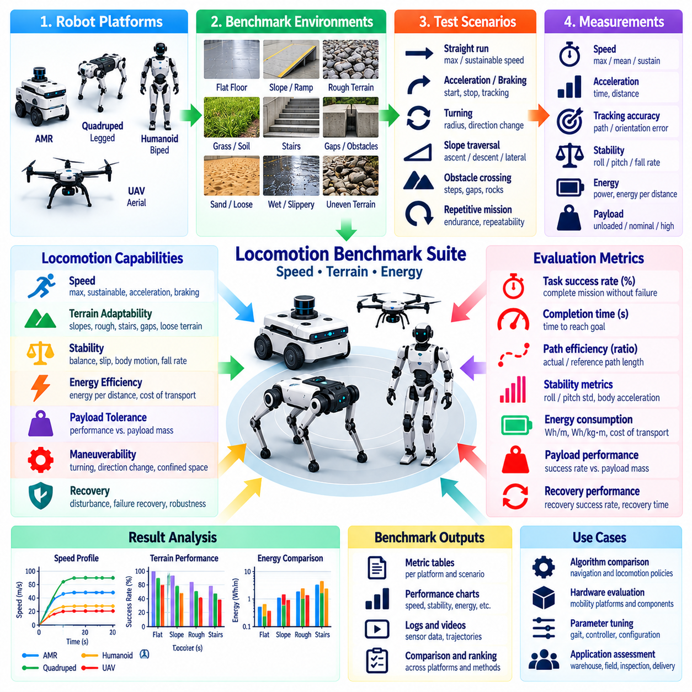
Locomotion benchmarking evaluates how effectively a mobile or legged robot converts mechanical and computational capability into stable movement across representative operating conditions. A complete benchmark should measure more than maximum velocity because useful locomotion depends on speed, stability, terrain adaptability, energy efficiency, payload tolerance, maneuverability, and recovery. These dimensions must be evaluated together to characterize practical mobility rather than isolated peak performance.
Speed benchmarking should distinguish commanded speed, achieved speed, sustainable speed, and short-duration maximum speed. A robot may briefly reach a high velocity but be unable to maintain it because of actuator heating, instability, power limits, or perception constraints. Tests should therefore define course length, acceleration and deceleration regions, payload, surface condition, controller configuration, and measurement interval so that reported velocities represent comparable operating conditions.
Straight-line velocity provides a useful baseline, but locomotion performance also depends on acceleration, braking, turning, and transitions between motion states. Benchmark courses can include starts, stops, constant-radius turns, direction changes, and repeated speed transitions. Measurements such as acceleration time, stopping distance, path deviation, yaw error, and velocity tracking error reveal whether higher speed is achieved without sacrificing controllability or trajectory accuracy.
For legged robots, gait behavior should be considered explicitly because walking, trotting, running, crawling, and other locomotion modes may exhibit different speed, stability, and energy characteristics. Benchmark protocols should identify the gait or controller mode used during each trial and document transitions between modes. A high maximum speed obtained through a specialized gait should not be interpreted as representative of the robot's performance across all mission conditions.
Terrain benchmarking examines whether locomotion remains stable as surface geometry and physical properties change. Representative courses may include flat floors, slopes, ramps, rough surfaces, gravel, grass, soil, steps, gaps, curbs, or irregular obstacles depending on the intended platform. Terrain parameters should be measurable wherever possible so that difficulty can be reproduced and performance degradation can be compared systematically rather than described only through subjective labels.
Slope capability should distinguish ascent, descent, and lateral traversal because each imposes different stability and traction constraints. Tests can progressively increase inclination until the robot reaches a defined failure or safety boundary. Measurements should include traversal success, velocity reduction, slip, body orientation, actuator effort, and energy consumption. Reporting only the maximum climbable slope can conceal severe performance degradation that occurs before the absolute limit is reached.
Rough-terrain evaluation should characterize both successful traversal and the quality of motion during traversal. A robot may technically complete a course while experiencing excessive body oscillation, repeated foot slip, wheel spin, impacts, or controller saturation. Body acceleration, attitude variation, contact events, tracking error, and traversal time can therefore supplement success rate. These measurements help distinguish controlled terrain adaptation from marginal completion.
Stability metrics are especially important for legged and high-center-of-mass platforms. Benchmark instrumentation can monitor roll, pitch, angular velocity, body acceleration, contact consistency, and deviations from desired body posture. Fall rate or loss-of-balance events should remain explicit outcomes rather than being absorbed into an average performance score. For wheeled robots, analogous measures can include wheel slip, rollover margin, suspension behavior, and loss of traction.
Payload should be treated as a benchmark variable because additional mass changes acceleration, braking, energy consumption, actuator loading, and stability. Trials can be repeated at unloaded, nominal, and high-payload conditions while preserving the same route and speed targets. The relationship between payload and locomotion performance is often more useful than a single maximum-payload claim because it shows how mobility degrades as the robot approaches its operational capacity.
Energy benchmarking connects mobility performance with mission endurance. Electrical energy consumed during a defined route can be measured from battery or power-distribution telemetry and normalized by distance, time, payload, or completed task. Average power alone is insufficient because a fast robot may consume high instantaneous power yet complete a route efficiently. Energy per unit distance and energy per payload-distance can provide more meaningful measures for transport-oriented platforms.
For legged locomotion, cost of transport provides a useful normalized measure relating energy expenditure to robot weight and traveled distance. However, the benchmark should clearly specify whether electrical, mechanical, or estimated actuator energy is being used because these values are not interchangeable. Compute, sensing, cooling, and communication loads may also represent a meaningful fraction of total platform power and should be included when system-level energy efficiency is the evaluation objective.
Terrain and energy measurements should be combined because locomotion efficiency changes significantly with surface conditions. The same robot may exhibit low energy consumption on a smooth floor but require substantially more power on slopes, loose terrain, or repeated obstacles. Running identical distance-based trials across terrain categories allows an energy-terrain profile to be constructed, revealing where mobility remains efficient and where environmental difficulty produces disproportionate energy cost.
Endurance testing extends short locomotion benchmarks by examining whether performance remains stable over time. Repeated laps or long-duration missions can expose battery voltage effects, thermal limitations, actuator heating, mechanical wear, controller drift, or progressive energy inefficiency. Speed, tracking error, power consumption, temperature, and stability should be monitored throughout the test so that degradation can be associated with operating duration rather than hidden in final completion statistics.
Recovery capability should also be incorporated into locomotion benchmarking. Legged robots may encounter slips, unexpected contacts, or temporary loss of balance, while wheeled platforms may experience wheel spin, local entrapment, or insufficient traction. Controlled disturbances can measure whether the robot restores stable locomotion without external assistance. Recovery success rate, recovery time, distance lost, energy cost, and number of corrective actions provide useful measures of resilience.
Benchmark scenarios should use repeated trials because terrain interaction is inherently variable. Foot placement, wheel contact, soil deformation, friction, and controller state can produce different outcomes even under apparently identical conditions. Reporting mean values together with variance, percentiles, confidence intervals, and failure frequencies provides a more representative characterization than selecting the fastest or most successful run from a small number of attempts.
Instrumentation and synchronization are critical for explaining benchmark results. Robot pose, velocity, joint state, wheel speed, actuator torque, current, voltage, battery state, body orientation, contact state, controller mode, compute utilization, and environmental measurements should share a consistent time reference. Synchronized records allow engineers to determine whether performance limitations originate from mechanics, control, perception, power delivery, thermal constraints, or interactions among these subsystems.
Simulation can support large-scale locomotion evaluation by varying friction, terrain geometry, payload, disturbance forces, actuator properties, and controller parameters. It is useful for regression testing and exploring conditions that would be expensive or unsafe to reproduce physically. However, simulated contact and terrain behavior may differ substantially from reality, so physical tests remain necessary for confirming traction, impact, compliance, energy consumption, and hardware durability.
Cross-platform comparison requires careful normalization because wheeled AMRs, quadrupeds, humanoids, and other mobile robots have fundamentally different locomotion mechanisms and mission objectives. Maximum speed alone cannot represent overall mobility. Benchmark reports should preserve absolute measures while also using normalized quantities where appropriate and clearly describing robot mass, payload, dimensions, locomotion mode, terrain class, and power boundary used for each comparison.
An effective locomotion benchmark ultimately produces a multidimensional performance profile rather than a single mobility score. Speed describes how rapidly the robot can move, terrain tests reveal where it can operate, stability indicates how reliably it maintains controlled motion, and energy metrics show the cost of that capability. Evaluated together across repeated and traceable conditions, these measures provide defensible evidence of whether locomotion performance is suitable for the robot's intended operational domain.

08.06. Humanoid Task Benchmark BEHAVIOR 1K [w/Code]
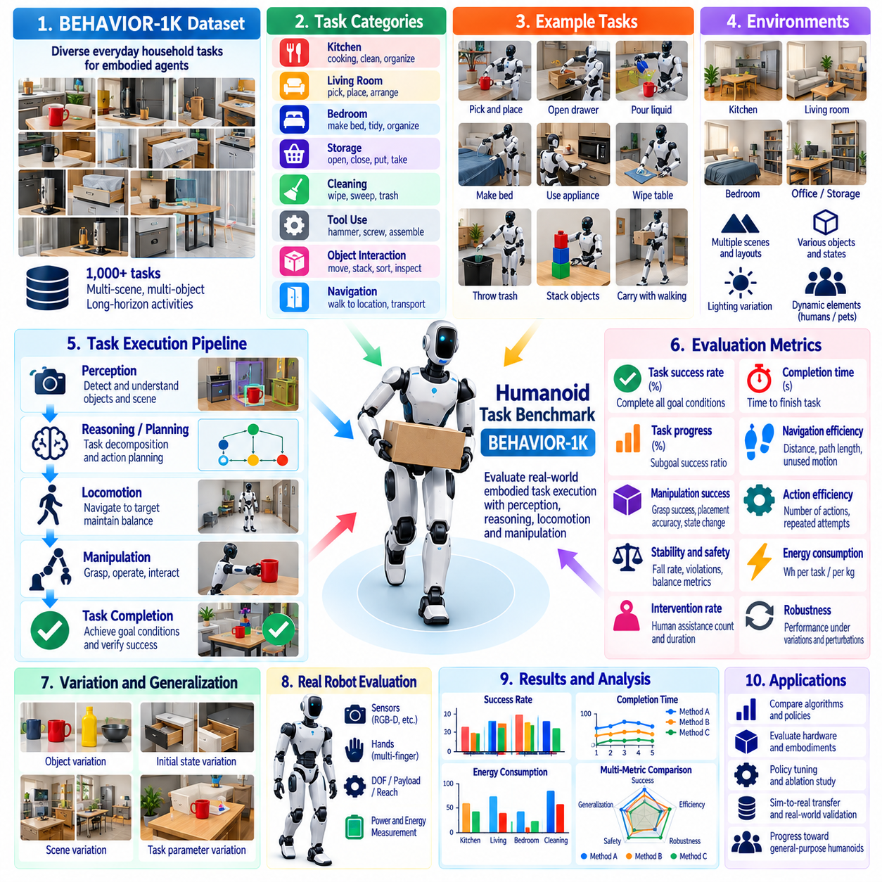
Humanoid task benchmarking evaluates whether a robot can combine perception, reasoning, locomotion, manipulation, and interaction into reliable completion of meaningful activities. Unlike isolated benchmarks for walking or grasping, task-level evaluation measures the complete embodied execution chain. BEHAVIOR-1K is particularly relevant because it emphasizes diverse household activities involving objects, spatial relationships, state changes, and extended sequences of actions.
A humanoid benchmark should begin by defining the task domain and embodiment assumptions. Human environments contain furniture, containers, appliances, tools, deformable objects, narrow spaces, and objects positioned at different heights. A humanoid may need to walk toward a workspace, reach across surfaces, manipulate objects with one or both hands, change posture, and maintain balance while performing the task. Evaluation should therefore preserve the coupling between mobility and manipulation.
BEHAVIOR-1K provides a broad task-oriented foundation for studying embodied agents across many everyday activities rather than optimizing performance for a small set of repetitive skills. This breadth is useful for humanoid evaluation because general-purpose robots are expected to operate across heterogeneous tasks. Benchmark design should nevertheless select and document task subsets explicitly, since computational resources, robot capabilities, available objects, and physical test infrastructure may prevent evaluation of every task.
Task success should be defined through observable goal conditions rather than subjective judgments about whether the robot appeared to perform the activity correctly. A benchmark may require specified objects to reach target locations, containers to become open or closed, surfaces to reach a required state, or combinations of predicates to become satisfied. Explicit terminal conditions allow automated or independently reviewed scoring and reduce ambiguity when comparing policies, software versions, or robot platforms.
Long-horizon activities are especially valuable because they reveal failures that short manipulation tests cannot expose. A task may require navigation to several locations, locating relevant objects, opening storage, grasping and transporting items, using an appliance or tool, and restoring the environment. Errors can accumulate across these stages, so high performance on individual subtasks does not guarantee successful completion of the complete activity. Task-level success should therefore remain a primary metric.
Progress metrics can complement binary success for complex activities. When a robot completes most required state transitions but fails near the final stage, a simple failure label discards useful information about its capability. Benchmarking can track satisfied goal conditions, completed subgoals, action-stage completion, or normalized task progress. These measures should supplement rather than replace full success because partial execution may still be operationally unacceptable for autonomous deployment.
Efficiency should be evaluated after capability has been established. Completion time, distance traveled, manipulation trajectory length, number of actions, unnecessary interactions, and repeated attempts can reveal inefficient behavior. A humanoid that eventually completes a task after extensive searching or repeated grasp failures differs substantially from one that performs the same task directly. Efficiency metrics should therefore be reported alongside success rather than incorporated invisibly into a single composite score.
Humanoid benchmarks should explicitly measure intervention dependence. Human assistance may be required after localization loss, failed grasping, falls, planning deadlocks, object drops, or unexpected scene changes. Intervention count, intervention duration, reset frequency, and the stage at which assistance occurs provide important evidence about autonomy. A system that achieves high success only through frequent resets should not be considered equivalent to one that completes tasks continuously without external assistance.
Generalization is a central objective for task-oriented humanoid intelligence. Evaluation conditions can vary object instances, object locations, room layouts, initial states, visual appearances, task parameters, and combinations of previously learned skills. Performance on held-out configurations provides evidence about whether a policy understands transferable task structure or depends on memorized scenes. Benchmark reports should state which variations were present during training and which were reserved for evaluation.
Scene diversity should also be separated from task diversity. A robot may perform many nominal tasks in one familiar environment while failing when the same tasks are moved to another layout. Conversely, it may navigate diverse scenes while possessing only a narrow manipulation repertoire. Evaluating both axes helps determine whether performance reflects genuine embodied generalization. Repeated tasks across different scenes are therefore valuable even when the semantic objective remains unchanged.
Physical feasibility must be considered when transferring benchmark activities to real humanoids. Tasks designed for simulated agents may assume reachability, grasp configurations, object properties, or interaction capabilities that differ from a specific robot. Before comparing results, the benchmark should document robot height, reach envelope, degrees of freedom, hand or gripper capability, payload, sensing coverage, and locomotion constraints. Infeasible tasks should be distinguished from policy failures rather than scored identically.
Safety must remain independent of task completion. A humanoid should not receive a high evaluation simply because it completes an activity while colliding with furniture, applying excessive forces, losing balance, entering unsafe configurations, or creating hazards for nearby humans. Benchmark instrumentation should therefore capture collisions, falls, contact forces where available, unstable postures, restricted interactions, and safety-system activations. Successful completion with a serious safety violation should remain explicitly identifiable.
Failure taxonomy is essential for understanding task-level performance. Failures may originate from perception, semantic interpretation, navigation, object localization, reach planning, grasping, bimanual coordination, force control, locomotion, balance, action sequencing, or recovery. Long-horizon tasks may also fail because an early action leaves the environment in an unrecoverable state. Consistent failure categories allow benchmark results to guide subsystem improvement rather than merely ranking complete systems.
Recovery capability should be evaluated because household-style environments rarely remain perfectly controlled. Objects can move unexpectedly, grasps can fail, doors may not open as predicted, and navigation routes may become blocked. A capable humanoid should detect unsuccessful actions, reassess state, and attempt an appropriate alternative when safe. Recovery success rate, additional actions, recovery time, and eventual need for intervention provide useful measures of autonomous resilience.
Simulation enables BEHAVIOR-1K-style activities to be executed repeatedly across many initial conditions and task variations. It supports policy development, regression testing, ablation studies, and large-scale evaluation without the cost of physically resetting complex scenes. However, simulation may simplify contact, deformable objects, friction, perception noise, and human environments. Simulated task success should therefore be treated as one layer of evidence rather than a direct substitute for physical humanoid performance.
Real-world validation should reproduce representative benchmark semantics while acknowledging physical constraints. Equivalent tasks can be constructed using available furniture, containers, tools, and household objects, with initial conditions documented for repeated trials. Differences between simulated and physical task success can then reveal sim-to-real limitations in perception, dynamics, grasping, balance, or execution timing. Such comparison is more informative than reporting simulation and real-world results as unrelated experiments.
Reproducibility requires precise configuration records. Benchmark results should identify the task subset, environment version, object configuration, observation modalities, policy checkpoint, robot model, controller version, random seeds, success predicates, and evaluation protocol. Physical trials should additionally record calibration and hardware configuration. Without this traceability, changes in benchmark setup can be mistaken for improvements or regressions in humanoid intelligence.
Statistical evaluation should reflect the variability of long-horizon embodied tasks. Each activity should be repeated across multiple initial states and relevant environmental variations rather than demonstrated through a single successful episode. Success rate, progress distribution, completion time, intervention frequency, recovery rate, and failure categories can be aggregated across tasks while remaining available individually. This prevents high performance on easy activities from masking systematic failures on difficult ones.
An effective BEHAVIOR-1K-oriented humanoid benchmark ultimately evaluates integrated embodied competence rather than isolated algorithm quality. Its value lies in testing whether perception, mobility, manipulation, reasoning, and recovery remain coordinated over meaningful activities and changing environments. By combining task success, progress, efficiency, generalization, safety, intervention, and failure analysis, the benchmark provides evidence of how close a humanoid system is to reliable general-purpose operation.

08.07. UAV Flight Performance Benchmark Suite [w/Code]
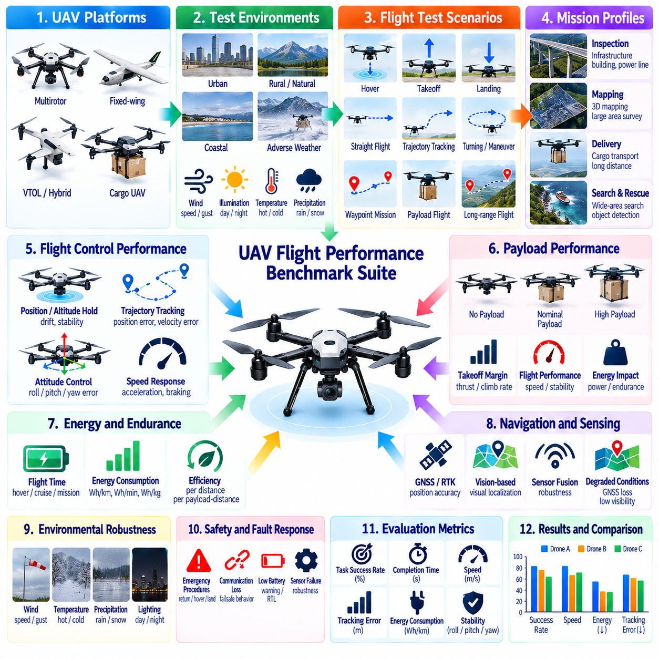
A UAV flight performance benchmark suite should provide a repeatable framework for evaluating whether an unmanned aerial vehicle can execute its intended missions with sufficient control accuracy, stability, efficiency, autonomy, and safety. Flight performance cannot be represented by maximum speed or endurance alone. The benchmark should combine trajectory tracking, maneuverability, payload capability, energy use, environmental robustness, navigation accuracy, fault response, and mission completion.
Benchmark design begins by defining the UAV configuration and intended operational domain. Multirotor, fixed-wing, hybrid VTOL, and cargo UAV platforms exhibit fundamentally different flight characteristics and constraints. Test conditions should therefore document vehicle mass, dimensions, propulsion architecture, battery or energy system, payload, flight-control configuration, sensor suite, navigation method, altitude range, speed envelope, and environmental boundaries relevant to the evaluated mission.
Basic flight-control performance should be established before complex autonomous missions are evaluated. Hover, takeoff, landing, altitude holding, heading control, straight flight, turns, acceleration, and deceleration provide fundamental reference cases. Position error, altitude error, attitude deviation, velocity tracking error, overshoot, settling time, and control oscillation can reveal whether the flight-control system maintains commanded states with sufficient accuracy and stability.
Hover performance is particularly important for multirotor and VTOL platforms because many inspection, cargo handling, sensing, and precision landing operations depend on stable stationary flight. Tests should measure horizontal position drift, altitude variation, roll and pitch stability, yaw error, and power consumption over a defined interval. Hover results should be reported under controlled environmental conditions and repeated with representative payloads and disturbances.
Trajectory tracking benchmarks evaluate how accurately the UAV follows planned three-dimensional paths. Courses may include straight segments, curves, altitude changes, waypoint sequences, and combinations of horizontal and vertical maneuvers. Cross-track error, along-track error, altitude error, waypoint accuracy, completion time, and velocity consistency provide quantitative measures. More demanding courses can progressively increase curvature, speed, or maneuver frequency to expose control limits.
Takeoff and landing require dedicated evaluation because they combine control precision with strong safety requirements. Benchmarks can measure takeoff stabilization time, landing position error, descent-rate control, touchdown velocity, attitude at contact, and aborted-landing behavior. Precision landing scenarios may incorporate visual markers, GNSS, RTK, or other localization sources. Repeated trials are necessary because landing reliability is often more operationally significant than a single highly accurate demonstration.
Speed benchmarks should distinguish maximum speed from sustainable mission speed. High velocity may increase aerodynamic load, power consumption, control error, sensing difficulty, and stopping or diversion distance. Tests should therefore evaluate performance across multiple commanded speeds rather than reporting only the highest achieved value. The resulting speed-performance profile can show where tracking accuracy, stability, energy efficiency, or perception capability begins to degrade.
Payload benchmarking is essential for cargo UAVs because added mass directly affects thrust margin, endurance, maneuverability, thermal load, and emergency capability. Equivalent routes should be repeated across unloaded, nominal, and high-payload configurations. Measurements can include takeoff margin, climb rate, cruise speed, energy consumption, trajectory error, motor or propulsion loading, and remaining reserve capability. Payload should always be reported with the associated flight conditions.
Endurance and range should be measured using clearly defined mission profiles. Hover endurance, cruise endurance, and route-based endurance are not interchangeable because they impose different power requirements. Benchmark protocols should identify payload, velocity, altitude, wind conditions, battery state, reserve policy, and termination criteria. Energy consumed per distance or payload-distance can complement total flight time when evaluating transport-oriented UAV efficiency.
Energy benchmarking should capture the complete vehicle rather than propulsion power alone when system-level efficiency is important. Flight computers, perception accelerators, communication equipment, navigation sensors, cooling systems, and payload electronics may contribute materially to total energy consumption. Synchronized voltage, current, battery state, propulsion demand, and compute utilization enable engineers to determine how autonomy and sensing workloads affect achievable endurance.
Environmental robustness should be evaluated under representative disturbances. Wind is particularly important because gusts and sustained crosswinds can degrade position holding, trajectory tracking, energy efficiency, and landing accuracy. Where safe and practical, benchmark conditions should characterize wind speed, direction, gust intensity, temperature, precipitation, visibility, and illumination. Performance degradation relative to calm baseline conditions provides a useful measure of environmental resilience.
Navigation performance should be evaluated independently from low-level flight control. Tests can compare estimated position and orientation against suitable reference measurements while varying GNSS quality, visual conditions, altitude, or environmental structure. Scenarios involving partial GNSS degradation or transitions between navigation sources can reveal whether localization remains sufficiently stable for autonomous flight. Recovery after temporary navigation uncertainty should also be measured.
Obstacle avoidance and autonomous replanning can be included when the UAV mission requires operation near structures, terrain, or other obstacles. Benchmark scenarios may introduce static obstacles, restricted regions, moving objects, or blocked planned routes. Measurements should include minimum separation distance, replanning latency, path efficiency, mission delay, intervention requirement, and successful continuation. Safety constraints should take precedence over shortest-path performance when evaluating avoidance behavior.
Mission-level benchmarking combines individual flight capabilities into representative operational scenarios. A cargo mission, for example, may include autonomous takeoff, route following, altitude transitions, waypoint arrival, precision approach, payload delivery, return flight, and landing. Mission success should require completion of all required phases without unacceptable safety events or external intervention. This prevents strong isolated flight metrics from masking weaknesses in integrated autonomous operation.
Fault and degraded-mode behavior should form part of the suite because practical UAVs must respond safely when nominal assumptions fail. Controlled tests or simulation can introduce sensor loss, communication degradation, navigation uncertainty, propulsion anomalies, battery warnings, or mission-planning failures. The benchmark should measure detection latency, transition to the appropriate contingency mode, stability during response, mission outcome, and whether the vehicle reaches a defined safe state.
Simulation and Software-in-the-Loop or Hardware-in-the-Loop environments can provide extensive regression coverage before physical flight. Wind fields, sensor faults, navigation disturbances, payload changes, and rare emergency conditions can be reproduced repeatedly without exposing hardware or personnel to unnecessary risk. Nevertheless, simulated aerodynamic behavior, propulsion dynamics, communication, and weather cannot fully replace physical flight evidence, so simulation and field results should remain distinguishable.
Physical flight benchmarking requires disciplined configuration and evidence management. Each result should identify aircraft hardware revision, propulsion configuration, firmware, flight-control software, autonomy stack, parameter set, payload, battery condition, sensor calibration, navigation configuration, and environmental conditions. Flight logs, telemetry, reference measurements, and event records should share synchronized timing so that unexpected behavior can be reconstructed during analysis.
Statistical reporting is necessary because flight performance varies with battery state, wind, temperature, control state, and environmental uncertainty. Benchmark scenarios should be repeated sufficiently to report distributions rather than isolated best cases. Mean values, percentiles, variance, confidence intervals, failure frequencies, and safety events provide a more defensible characterization of performance. Outliers should be investigated rather than automatically removed from the reported results.
Cross-platform comparison should respect differences among UAV architectures and mission classes. Maximum speed, endurance, payload, and energy efficiency cannot be compared meaningfully without considering aircraft mass, propulsion type, operating altitude, payload fraction, and mission profile. Benchmark reports should preserve absolute values while introducing normalized metrics where appropriate, avoiding a universal ranking that obscures the engineering tradeoffs among different UAV designs.
An effective UAV flight performance benchmark suite ultimately creates a multidimensional evidence base for operational readiness. Control accuracy establishes basic flight quality, trajectory and navigation tests evaluate autonomous precision, payload and energy metrics characterize useful mission capacity, and environmental and fault scenarios reveal robustness. When these measurements are repeated under traceable conditions, they provide a defensible basis for comparing configurations, detecting regressions, and validating UAV mission performance.

08.08. Cross Platform Benchmark Comparison Method
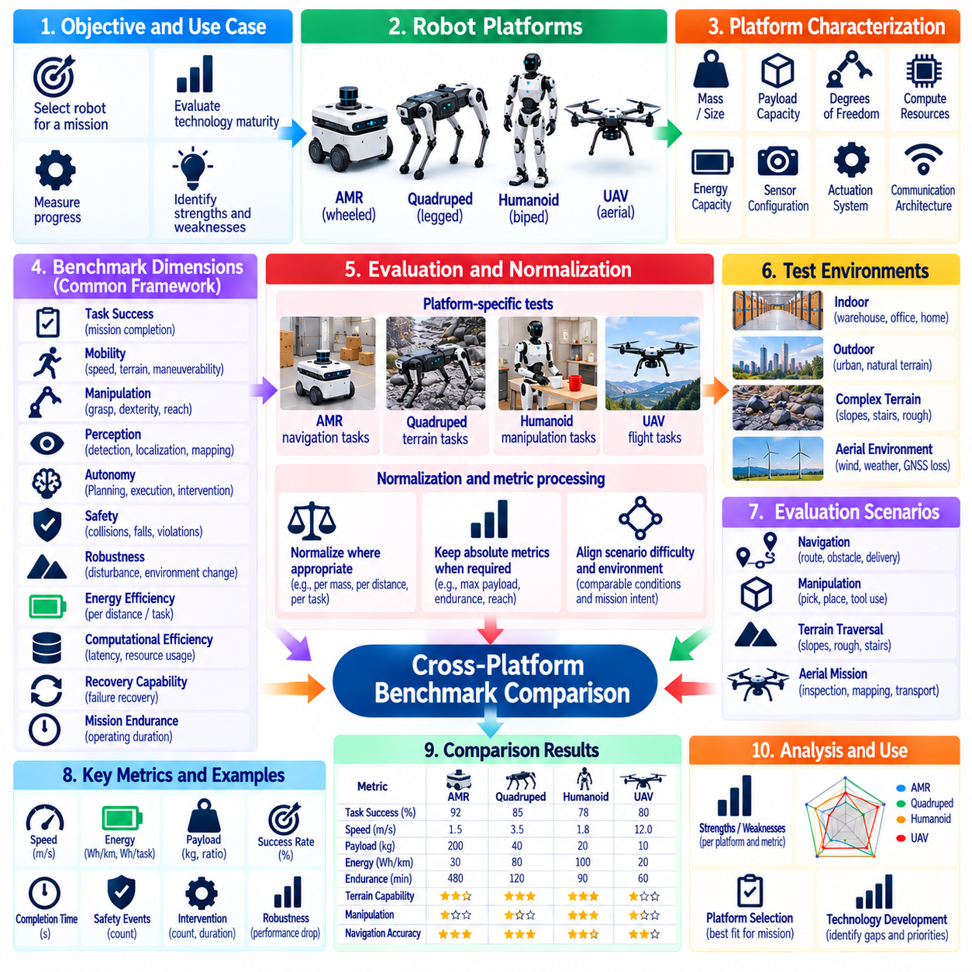
Cross-platform benchmark comparison provides a systematic method for evaluating robotic systems that differ in embodiment, mobility, manipulation capability, sensing, compute architecture, and intended mission. Direct comparison of raw performance values can be misleading because an AMR, quadruped, humanoid, and UAV operate under fundamentally different physical constraints. A meaningful method must preserve platform-specific performance while establishing common dimensions for higher-level comparison.
The comparison framework should begin by defining the purpose of the benchmark. Engineering teams may compare platforms to select a robot for a mission, evaluate technology maturity, measure progress between generations, or identify architectural strengths and weaknesses. The benchmark objective determines which metrics should be normalized and which should remain platform-specific. Without a defined comparison purpose, composite rankings can combine unrelated capabilities and produce conclusions with little operational meaning.
Platform characterization establishes the context required to interpret benchmark results. Each robot should be described by mass, dimensions, payload capacity, locomotion mechanism, degrees of freedom, actuator capability, sensing configuration, compute resources, energy capacity, communication architecture, and operational constraints. Mission characteristics such as indoor or outdoor use, terrain class, required autonomy, interaction type, and expected operating duration should also be recorded before performance values are compared.
Common comparison dimensions can provide a shared structure without forcing identical tests across fundamentally different robots. Useful dimensions include task success, mobility, manipulation capability, perception quality, autonomy, safety, robustness, energy efficiency, computational efficiency, recovery capability, and mission endurance. Each platform can be evaluated using appropriate platform-specific tests while results are mapped to these common dimensions at the comparison layer.
Task success should remain the primary mission-oriented metric whenever equivalent operational objectives can be defined. An AMR may deliver material between stations, a humanoid may retrieve and place objects, a quadruped may inspect a difficult terrain route, and a UAV may transport or observe from the air. Although their physical actions differ, comparison can examine whether each system completes its intended mission reliably under specified conditions and without unacceptable intervention or safety events.
Normalization is required when raw metrics depend strongly on platform scale or physical architecture. Energy consumption can be expressed per distance, payload-distance, task, or mission duration. Payload capability can be considered relative to robot mass, while speed may be interpreted relative to mission requirements rather than simply ranked by maximum velocity. Normalization should make physical differences interpretable without removing important absolute values that determine whether a platform is operationally useful.
Not every metric should be normalized. Absolute stopping distance, maximum payload, flight endurance, reachable height, minimum passage width, or maximum slope may represent hard operational constraints. A normalized score can appear favorable even when the robot fails a required absolute threshold. Benchmark reports should therefore preserve original measurements alongside normalized indicators so that relative efficiency and practical feasibility remain visible simultaneously.
Scenario equivalence is more important than test identity. Requiring every platform to perform exactly the same physical course may unfairly favor one embodiment. Instead, scenarios should represent comparable operational difficulty or mission intent. For example, obstacle negotiation can be evaluated using platform-appropriate challenges while preserving common concepts such as successful traversal, completion time, energy cost, safety margin, and need for recovery.
Environmental conditions should be categorized consistently across platforms. Surface quality, slope, obstacle density, illumination, weather, communication quality, localization availability, human activity, and spatial constraints can influence different robots in different ways. Recording these variables enables results to be grouped into comparable environmental classes. A platform should not be considered universally superior because it performs strongly in conditions that are substantially easier than those used to evaluate another system.
Autonomy should be measured independently from mechanical capability. A robot may possess excellent mobility or manipulation hardware while depending heavily on teleoperation, manual resets, or human planning. Metrics such as autonomous mission completion, intervention frequency, intervention duration, recovery success, replanning capability, and percentage of mission time under autonomous control provide a more accurate representation of operational autonomy than simply labeling a platform autonomous.
Safety comparison requires explicit event-based measures rather than subjective impressions. Depending on platform type, relevant events can include collisions, falls, unsafe separation, excessive contact forces, restricted-area entry, unstable flight, emergency stops, or safety-system activations. Because the physical consequences differ among platforms, safety events should be classified by type and severity. Successful mission completion should never erase a significant safety violation from benchmark results.
Robustness measures how performance changes when nominal operating assumptions are disturbed. Equivalent perturbation classes can include sensor degradation, communication loss, localization uncertainty, payload variation, environmental disturbance, blocked routes, or compute limitations. The absolute disturbance may differ by platform, but the benchmark can compare relative performance degradation, recovery behavior, and mission completion under defined levels of difficulty.
Energy efficiency should be interpreted in relation to useful work. Comparing total electrical power directly may be meaningless when one robot flies, another walks, and another moves on wheels. Energy per completed mission, energy per transported payload-distance, or energy relative to operational output can provide more useful comparisons. Nevertheless, absolute battery capacity, peak power, charging requirements, and achievable mission duration should remain visible because they affect deployment infrastructure.
Computational performance can also be normalized around workload rather than hardware specifications alone. GPU count, processor frequency, or memory capacity does not directly indicate robotic intelligence. Benchmarking should examine perception latency, planning latency, control-cycle stability, inference throughput, compute utilization, thermal behavior, and energy consumed while executing representative workloads. This connects compute architecture to observable robotic performance instead of treating hardware capability as an isolated score.
Reliability should be evaluated over repeated missions rather than inferred from successful demonstrations. Metrics can include mission success distribution, mean time between mission-affecting failures, reset frequency, fault occurrence, intervention frequency, and recovery success. Long-duration testing is particularly important because thermal effects, battery degradation, localization drift, mechanical wear, and accumulated software faults may not appear during short benchmark episodes.
Statistical comparison requires equivalent experimental rigor across platforms. Trial counts, initial-condition variation, environmental distributions, failure treatment, confidence intervals, and exclusion rules should be documented consistently. Reporting only the best result from one platform while using an average from another creates an invalid comparison. Where exact experimental equivalence is impossible, the uncertainty and limitations of the comparison should be stated explicitly rather than hidden by numerical precision.
Composite scores may be useful for dashboards or high-level decision making, but their construction must remain transparent. Weighting factors should reflect mission priorities rather than arbitrary mathematical convenience. A warehouse application may prioritize reliability, safety, payload transport, and energy efficiency, while disaster response may place greater weight on terrain access and robustness. The same benchmark evidence can therefore produce different decision scores for different operational objectives.
Pareto analysis can complement composite scoring by preserving tradeoffs between competing capabilities. One platform may provide high speed and payload capacity at greater energy cost, while another offers lower productivity but better endurance or environmental adaptability. Rather than forcing these systems into a single ranking, a Pareto-oriented comparison identifies configurations that provide advantageous combinations of performance and reveals where improvements require sacrifices in another dimension.
Configuration traceability is essential for credible cross-platform comparison. Every benchmark result should identify hardware revision, software version, controller configuration, AI model, sensor setup, payload, energy state, calibration, environmental conditions, and relevant benchmark parameters. When one platform receives a major software or hardware update, previous comparisons should be reconsidered because the benchmark represents a specific system configuration rather than an immutable property of the robot family.
The final comparison should present a multidimensional capability profile rather than declaring a universally best robot. Platform suitability depends on mission requirements, environmental constraints, safety expectations, infrastructure, cost, endurance, and required autonomy. A well-designed cross-platform benchmark method preserves these differences while establishing enough common structure for defensible comparison, enabling engineers to select the platform whose measured capabilities best match the intended operational domain.

08.09. Benchmark Reproducibility and Publication
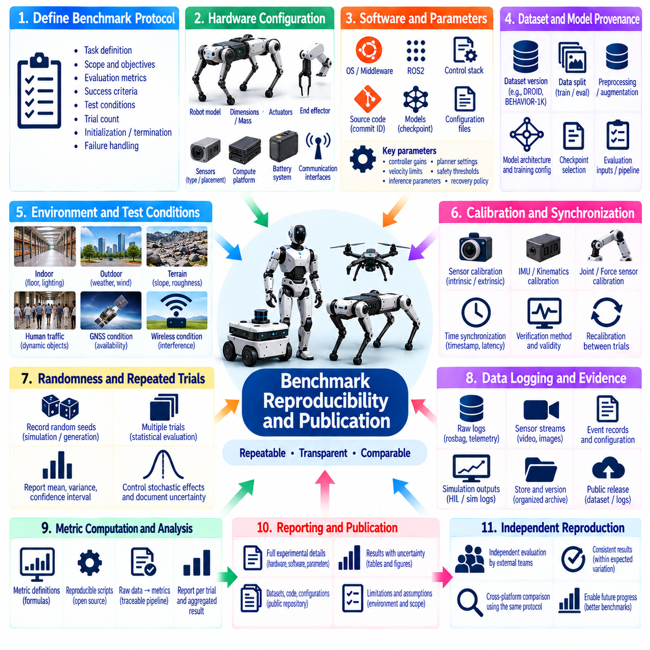
Benchmark reproducibility is the ability of independent teams to repeat an evaluation under sufficiently equivalent conditions and obtain results consistent with the original conclusions. In robotics, this requires more than publishing a final score because performance depends on hardware, software, calibration, environment, datasets, randomization, and experimental procedures. A reproducible benchmark therefore treats configuration, execution, evidence, and reporting as integral parts of the evaluation itself.
Reproducibility should be designed into the benchmark before experiments begin rather than reconstructed after results are collected. The protocol should define the evaluated capability, system boundaries, task conditions, metrics, success criteria, trial count, initialization procedure, termination rules, and treatment of failures. These definitions establish a stable experimental contract that prevents evaluation procedures from changing implicitly when unexpected results or implementation difficulties appear.
Hardware configuration must be documented at a level sufficient to explain performance differences. Relevant information can include robot model, hardware revision, dimensions, mass, actuator configuration, end effector, sensor types, sensor placement, compute platform, communication interfaces, battery system, and supporting infrastructure. Physical modifications introduced during development should be versioned because even small changes in sensing geometry, mass distribution, or actuation can alter benchmark outcomes.
Software traceability is equally important. Benchmark publications should identify operating system, middleware, drivers, firmware, control software, navigation or manipulation stack, simulation version, AI framework, model checkpoint, configuration files, and relevant dependencies. Source-code commit identifiers or immutable release tags are preferable to descriptive labels such as “latest version,” because later software changes can otherwise make the original experimental configuration impossible to reconstruct.
Parameter disclosure should include values that materially affect benchmark behavior. Controller gains, velocity limits, planner parameters, perception thresholds, safety margins, inference settings, and recovery policies can significantly change performance without modifying source code. Configuration files should therefore be preserved together with results whenever possible. If parameters cannot be released because of proprietary restrictions, the publication should identify the unavailable elements and explain their potential influence on reproducibility.
Dataset and model provenance are essential for AI-based robotics benchmarks. Reports should identify dataset versions, training and evaluation splits, preprocessing procedures, augmentation, model architecture, initialization, training configuration, checkpoint selection, and evaluation inputs. When datasets such as DROID, BEHAVIOR-1K, or other public resources are used, the exact subset and transformation pipeline should be recorded so that another team can reconstruct the evaluated data conditions.
Randomness must be controlled and reported because learned policies, simulation environments, scenario generation, and optimization procedures may produce different outcomes across runs. Random seeds should be recorded where deterministic control is possible, while inherently stochastic physical effects should be addressed through repeated trials. Reproducibility does not require every physical trajectory to be identical, but statistically equivalent experiments should support conclusions that remain consistent within documented uncertainty.
Environmental conditions require particular attention in physical robotics. Floor properties, lighting, temperature, weather, wind, obstacle placement, wireless conditions, GNSS availability, human traffic, and workspace geometry can materially affect results. Benchmark publications should document the environmental variables relevant to the evaluated capability and distinguish controlled variables from uncontrolled ones. Photographs or diagrams may support this documentation elsewhere, but the textual protocol should remain independently understandable.
Calibration state should be treated as part of the benchmark configuration. Camera intrinsics and extrinsics, LiDAR alignment, robot kinematics, joint offsets, force sensors, IMU calibration, localization references, and timing synchronization can strongly influence measured performance. Reports should describe the calibration procedure, verification method, and calibration validity at the time of testing. Recalibration between trials should also be recorded when it can influence comparability.
Time synchronization is especially important when benchmark evidence combines multiple sensors, controllers, computers, and external measurement systems. Logs should use a defined time reference and document synchronization mechanisms, timestamp sources, and known timing uncertainty. Without reliable temporal alignment, latency measurements, trajectory comparisons, perception-to-action analysis, and fault reconstruction may become ambiguous even when individual data streams appear accurate.
Raw evidence should be preserved whenever practical rather than publishing only processed metrics. Relevant evidence may include robot logs, rosbag files, telemetry, sensor streams, event records, videos, simulation outputs, test configurations, and analysis results. Processed benchmark scores should remain traceable to these underlying records. This enables independent verification, alternative analysis, regression investigation, and correction of processing errors without repeating every physical experiment.
The metric computation pipeline should itself be reproducible. Publications should define formulas, units, coordinate frames, filtering, interpolation, synchronization, exclusion criteria, and statistical procedures used to transform raw observations into reported metrics. When scripts are used, versioned analysis code is preferable to manual spreadsheet processing. A benchmark score has limited scientific value if another evaluator cannot determine exactly how the published number was calculated.
Failure handling must be defined before results are summarized. Collisions, falls, timeouts, emergency stops, human interventions, communication failures, corrupted logs, and invalid initialization should not be selectively removed after observing their effect on performance. The protocol should state which events count as benchmark failures, which justify trial invalidation, and when a trial may be repeated. Excluded trials should remain auditable and accompanied by documented reasons.
Statistical reporting should communicate both central performance and uncertainty. Mean values alone can hide unstable behavior, particularly in long-horizon robotic tasks. Publications should report appropriate distributions, variance, percentiles, confidence intervals, trial counts, and failure frequencies where relevant. Comparisons between systems should use equivalent statistical treatment, and small numerical differences should not be presented as meaningful improvements when experimental uncertainty is larger than the observed difference.
Benchmark publication should clearly separate measured results from interpretation. Tables and reported metrics should state what was directly observed, while discussion can explain likely causes, limitations, and engineering implications. Claims of superiority should remain bounded by the evaluated tasks and conditions. A robot that outperforms another platform in one benchmark configuration should not automatically be described as generally superior outside the tested operational domain.
Public benchmark releases should use stable identifiers and versioning. Task definitions, datasets, simulation environments, scoring scripts, configuration files, and reference results may evolve over time, so benchmark versions must remain distinguishable. A result obtained with one version should not be silently compared with a later version containing changed tasks or scoring rules. Changelogs and compatibility notes help preserve longitudinal comparisons as the benchmark matures.
Accessibility also affects reproducibility. Where licensing and intellectual-property constraints permit, publications should provide sufficient code, configuration, data references, and execution instructions for independent reproduction. Containers or environment specifications can reduce dependency ambiguity. When complete release is impossible, the benchmark should distinguish publicly reproducible components from restricted components rather than presenting partial disclosure as full reproducibility.
Independent replication provides stronger evidence than repetition by the original development team. External evaluators may uncover undocumented assumptions, hidden dependencies, ambiguous instructions, or environmental sensitivities that internal teams overlook. Replication results should therefore be treated as valuable benchmark evidence, including cases where performance differs from the original report. Disagreement can reveal weaknesses in protocol definition rather than simply indicating that one implementation is incorrect.
Reproducibility also supports continuous engineering rather than only academic publication. A benchmark package containing fixed scenarios, configuration records, automated execution, evidence capture, and analysis scripts can become part of a regression pipeline. New software, AI models, firmware, or hardware revisions can then be compared against established reference results. This converts publication-quality benchmarking into a practical mechanism for detecting performance degradation throughout the robot lifecycle.
A credible benchmark publication ultimately enables readers to understand what was tested, under which conditions, using which system configuration, how measurements were calculated, and how confidently the conclusions can be generalized. Reproducibility does not require eliminating all variability from physical robotics. Instead, it requires making relevant variability visible, controlled where possible, statistically characterized where necessary, and traceable through evidence so that benchmark claims can be independently examined and responsibly reused.

08.10. Hills Robotics Internal Benchmark Suite Design
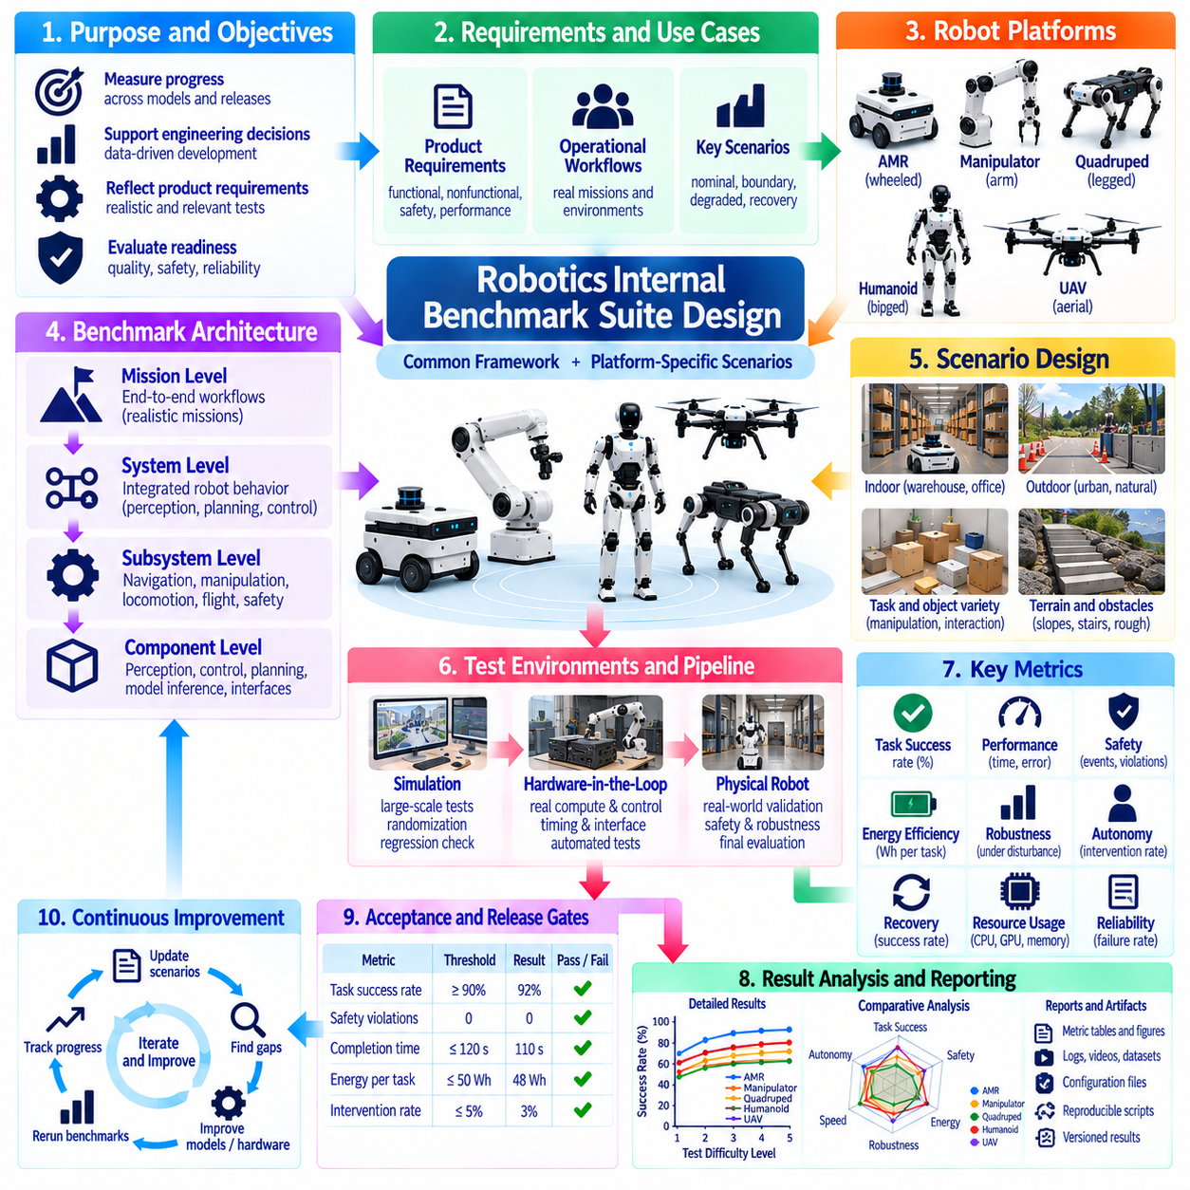
An internal robotics benchmark suite provides a controlled and repeatable framework for measuring engineering progress across robot platforms, software releases, AI models, and system configurations. Unlike public benchmarks designed primarily for external comparison, an internal suite should directly reflect product requirements, operational environments, known failure modes, and development priorities. Its primary purpose is to convert system performance into measurable evidence that supports engineering decisions and release readiness.
The benchmark architecture should begin with a common evaluation layer shared across platforms while preserving platform-specific test modules. Common dimensions may include task success, safety, autonomy, reliability, robustness, latency, energy efficiency, recovery, and resource utilization. AMRs, manipulators, quadrupeds, humanoids, and UAVs can then use specialized scenarios for their physical capabilities while reporting results through a consistent internal performance framework.
Benchmark scenarios should originate from system requirements and representative operational workflows. Tests should reproduce important mission phases, environmental constraints, expected disturbances, and interactions that the deployed robot is likely to encounter. Requirements traceability should connect each scenario to one or more measurable system objectives. This prevents the benchmark suite from becoming a collection of convenient demonstrations that produce impressive scores without representing actual product performance.
A layered structure can separate component, subsystem, integrated-system, and mission-level benchmarks. Component tests may evaluate perception accuracy or controller latency, while subsystem tests examine navigation, manipulation, locomotion, or flight behavior. Integrated tests combine sensing, planning, control, and safety, and mission benchmarks evaluate complete operational workflows. This hierarchy allows failures discovered at mission level to be traced toward lower-level causes without replacing end-to-end validation.
Each benchmark should define its initial conditions, execution procedure, termination conditions, success criteria, metrics, and evidence requirements before routine use. Ambiguous instructions create inconsistent results between teams and releases. Where practical, machine-readable scenario definitions and configuration files should accompany human-readable procedures. The benchmark should also specify which variables are controlled, randomized, measured, or intentionally left representative of natural operational variability.
Metric design should preserve individual engineering signals rather than collapsing performance immediately into a single score. Mission success, completion time, trajectory error, perception quality, intervention count, collision events, recovery time, energy consumption, compute utilization, and safety-system activation may all provide independent information. Composite indicators can support dashboards, but engineers should always be able to inspect the underlying measurements that produced the aggregate result.
Acceptance thresholds should be connected to product requirements and release gates. A benchmark can define minimum acceptable performance, target performance, and regression tolerance for critical metrics. Safety-related thresholds should remain hard constraints rather than being compensated by strong performance elsewhere. A release that improves task speed but increases collision frequency, intervention dependence, or uncontrolled failures should not receive a favorable overall assessment simply because its average score increased.
The suite should include nominal, boundary, degraded, and recovery scenarios. Nominal cases confirm expected operation, while boundary tests approach limits in speed, payload, terrain, visibility, workspace geometry, or environmental conditions. Degraded tests can introduce sensor uncertainty, communication impairment, localization degradation, compute load, or partial subsystem failure. Recovery scenarios determine whether the robot can recognize disruption and return to a safe or productive state without unnecessary human intervention.
Scenario difficulty should be controlled through explicit levels rather than informal descriptions such as easy or difficult. Difficulty can be adjusted using obstacle density, task horizon, object diversity, terrain complexity, dynamic-agent frequency, sensing degradation, environmental disturbance, or required precision. Defined levels enable teams to observe where performance begins to deteriorate and prevent comparisons in which different releases are unintentionally evaluated under substantially different conditions.
Simulation should provide the high-volume foundation of the internal benchmark suite. Large numbers of scenarios can be executed continuously across software commits, AI model checkpoints, parameter changes, and randomized conditions. Simulation is particularly useful for regression detection, rare-event exploration, and controlled fault injection. However, simulation results should retain clear separation from physical evidence because contact, sensing, timing, dynamics, and environmental complexity may differ from real hardware.
Hardware-in-the-Loop testing can bridge the gap between simulation and complete robot testing by introducing real compute, controllers, communication interfaces, and selected hardware into controlled scenarios. HIL benchmarks are valuable for timing, interface behavior, fault handling, deterministic execution, and integration regressions. The same scenario identifiers and metrics should be reused across simulation, HIL, and physical testing where possible so that performance changes between validation layers can be analyzed systematically.
Physical benchmark execution should focus on behaviors that require real sensing, dynamics, contact, traction, energy consumption, thermal effects, or human interaction. Standardized courses, objects, terrain elements, payloads, and environmental conditions improve repeatability. Field benchmarks should extend this evaluation into representative operational environments where uncontrolled variability is unavoidable. The internal suite should preserve the relationship between controlled laboratory evidence and realistic field evidence rather than treating them as interchangeable.
Automation is essential when the suite becomes part of continuous engineering. Benchmark orchestration can select scenarios, deploy software, configure the robot, execute trials, collect evidence, calculate metrics, compare results with baselines, and generate reports. Automated execution reduces manual inconsistency and enables frequent regression testing. Nevertheless, automation should detect invalid runs and infrastructure failures so that corrupted tests are not automatically interpreted as robot performance failures.
Every benchmark result should be tied to an immutable system configuration. Relevant information includes hardware revision, software commit, firmware, AI model checkpoint, parameters, sensor configuration, calibration state, dataset version, simulation version, payload, and environment configuration. This configuration fingerprint allows engineers to reproduce unexpected results and prevents performance changes caused by hidden configuration differences from being attributed incorrectly to a new algorithm or release.
Evidence management should support root-cause analysis as well as score reporting. Logs, telemetry, sensor data, videos, event traces, safety states, resource measurements, and benchmark metadata should be synchronized and linked to the corresponding trial. When a regression appears, engineers should be able to move from a dashboard metric to the individual failed trials and then to the underlying evidence without manually reconstructing which files belong to which experiment.
Regression analysis should compare new results against approved reference baselines rather than only against fixed absolute thresholds. Small degradations may be important even when a requirement is still technically satisfied, especially when they accumulate across releases. Statistical comparison can identify changes in distributions, tail latency, failure frequency, or recovery behavior. Baselines should be versioned so that improvements in requirements or hardware do not erase historical performance context.
Failure taxonomy should be standardized across the organization. Categories can distinguish perception, localization, planning, control, manipulation, locomotion, communication, compute, safety, hardware, and recovery failures while allowing platform-specific subcategories. Consistent classification enables trend analysis across releases and platforms. Repeated failures can then become candidates for dedicated regression scenarios, allowing operational incidents and engineering discoveries to continuously strengthen the benchmark suite.
Internal benchmark governance should define ownership, review authority, change control, and release criteria. Scenario definitions and scoring rules should not change casually when results become inconvenient. Proposed modifications should document their rationale, expected impact, compatibility with historical results, and required baseline updates. Critical benchmark versions should be frozen for release qualification while experimental scenarios can evolve separately until they are sufficiently mature for formal adoption.
Dashboards should present benchmark status at several levels of abstraction. Executives or program leads may require release readiness and major risk indicators, while engineering teams need scenario-level metrics, distributions, failures, and configuration details. A useful dashboard should therefore support movement from a high-level capability profile to the evidence behind an individual result. Visualization should summarize evidence rather than replace traceability or hide unfavorable outcomes.
The internal benchmark suite should evolve with the robot lifecycle. New customer environments, field incidents, newly discovered failure modes, hardware revisions, AI capabilities, and operational requirements should generate new scenarios or modify existing coverage. Retired tests should remain traceable when they contributed to historical release decisions. This creates a living benchmark system that captures accumulated engineering knowledge instead of rebuilding evaluation procedures independently for every project.
A mature robotics internal benchmark suite ultimately becomes an engineering control system for measurable product quality. It connects requirements, simulation, HIL, physical testing, field evidence, regression analysis, and release governance through common scenarios and traceable metrics. Its value is not simply producing scores, but establishing whether each system revision is safer, more capable, more robust, and more operationally reliable than its baseline before deployment.

