Volume 25. Testing Validation and Benchmarking

Chapter 04. Simulation Based Validation

04.01. Simulation Based Validation Architecture SiL MiL
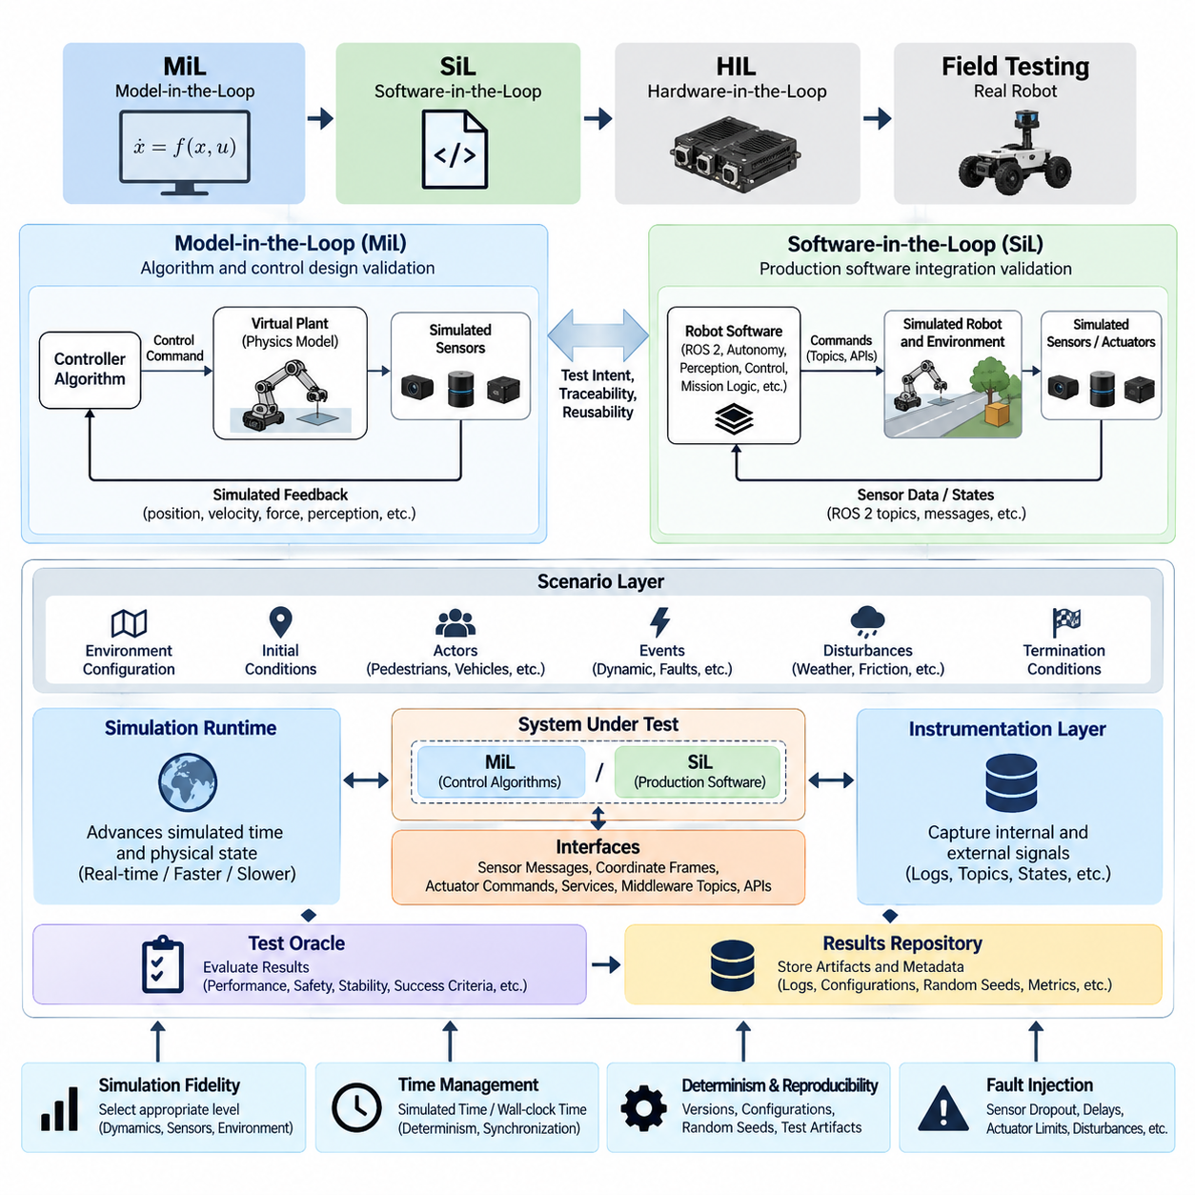
Simulation-based validation provides a controlled engineering environment in which robot software, control logic, autonomy functions, and AI components can be evaluated before they interact with physical hardware. Within the broader testing architecture, Model-in-the-Loop (MiL) and Software-in-the-Loop (SiL) form early validation layers that complement later HIL and field testing. Volume_25_Testing_Validation_an…
MiL validation places mathematical or behavioral models of the robot and its environment at the center of the test process. Controllers, plant dynamics, actuator behavior, sensor responses, and environmental interactions can be represented at different levels of fidelity. The objective is to verify algorithms and system behavior rapidly while design parameters remain inexpensive to modify and physical implementation constraints have not yet dominated development.
A typical MiL architecture separates the system under development from models representing the physical world. A controller may receive simulated position, velocity, force, or perception signals and generate commands that are applied to a virtual plant. The resulting state is fed back through simulated sensors. This closed-loop structure allows engineers to examine stability, tracking accuracy, state transitions, safety limits, and responses to disturbances without operating a real robot.
MiL is particularly valuable during controller and algorithm development because simulation time does not necessarily need to match wall-clock time. Tests can execute faster than real time, slower for detailed inspection, or repeatedly with systematically varied parameters. Large parameter sweeps can expose regions in which control gains, estimation assumptions, trajectory constraints, or decision thresholds produce unstable or unacceptable behavior before software integration begins.
SiL moves validation closer to the implementation by executing production-oriented software against simulated robots, sensors, actuators, networks, or environments. Instead of validating only abstract algorithms, SiL can exercise actual control modules, ROS 2 nodes, navigation components, perception pipelines, state machines, mission logic, and autonomy software. This makes it possible to detect integration defects that may remain invisible in purely mathematical models.
The transition from MiL to SiL should preserve test intent and traceability. A requirement validated against a model should be mapped to corresponding software-level tests wherever practical. Inputs, expected behavior, tolerances, scenarios, and pass/fail criteria should therefore be represented in reusable test specifications. This enables engineers to determine whether discrepancies originate from algorithm design, numerical implementation, middleware behavior, configuration, or software integration.
A robust simulation validation architecture normally contains a scenario layer, simulation runtime, system under test, instrumentation layer, test oracle, and results repository. The scenario layer defines initial conditions, environment configuration, actors, events, disturbances, and termination conditions. The runtime advances simulated time and physical state, while instrumentation captures internal and external signals needed to reconstruct the execution and determine why a test passed or failed.
Simulation fidelity should be selected according to the validation objective rather than maximized indiscriminately. Controller validation may require accurate dynamics, contact, latency, and actuator characteristics, whereas mission-management testing may benefit more from large numbers of simplified scenarios. Perception validation may emphasize sensor geometry, noise, visibility, and environmental variation. Excessive fidelity can increase computational cost without improving confidence in the requirement being tested.
Time is a critical architectural consideration in SiL. Robot software often depends on timestamps, timers, message ordering, control periods, communication latency, and synchronization between sensors. A simulation environment should therefore define whether components use simulated time or host wall-clock time and ensure that time-dependent behavior remains deterministic where required. Otherwise, identical scenarios may produce inconsistent results that are difficult to reproduce or diagnose.
Interfaces between the simulator and software under test should approximate operational interfaces sufficiently to preserve behavioral validity. Sensor messages, coordinate frames, actuator commands, service calls, middleware topics, and API contracts should maintain expected semantics. This allows production software to execute with minimal simulation-specific modification and reduces the possibility that a separate testing implementation behaves differently from the deployed robot software.
Determinism and reproducibility are essential characteristics of the architecture. Simulator versions, robot models, maps, software commits, configuration files, random seeds, scenario definitions, and dependency versions should be captured as test artifacts. When a failure occurs, engineers must be able to reconstruct the same execution environment. Reproducibility also enables meaningful comparison between software revisions and supports automated regression analysis.
Fault injection expands simulation beyond nominal functional testing. Sensor dropout, delayed messages, corrupted measurements, actuator saturation, localization errors, communication interruption, dynamic obstacles, degraded traction, or unexpected environmental changes can be introduced in controlled conditions. Such experiments reveal how the system detects abnormalities, enters degraded modes, invokes fallback behavior, and recovers without exposing physical equipment or personnel to unnecessary risk.
The simulation architecture should also distinguish functional correctness from model validity. A software component can behave correctly relative to an inaccurate simulator while still failing in the physical world. Validation therefore requires explicit assumptions about dynamics, sensors, environmental models, timing, and uncertainty. These assumptions should be compared with measurements from hardware and field tests so that simulation models can be calibrated and their applicable operating domains understood.
MiL and SiL become especially powerful when integrated with automated scenario execution. A single baseline scenario can be transformed into many variants by changing robot velocity, payload, obstacle position, illumination, friction, sensor noise, communication delay, or environmental conditions. This prepares the foundation for the later chapter topics of scenario-based validation, corner-case generation, Monte Carlo testing, SOTIF coverage, and regression pipelines. Volume_25_Testing_Validation_an…
Pass/fail evaluation should rely on explicit test oracles rather than visual inspection alone. Oracles may evaluate trajectory error, collision occurrence, minimum clearance, control saturation, task completion, timing deadlines, safety-state transitions, localization accuracy, or constraint violations. Multiple metrics can be combined when a scenario has interacting objectives, enabling automated execution to generate objective evidence rather than subjective observations.
For AI-enabled robots, SiL can connect learned perception, planning, navigation, manipulation, or policy models to synthetic observations and simulated physical consequences. The architecture should record not only final task success but also confidence values, intermediate decisions, state estimates, actions, constraint violations, and failure modes. This supports diagnosis of whether a failure originated in perception, reasoning, planning, control, or interaction with the simulated environment.
Simulation results should flow into a structured evidence pipeline. Each execution can produce metadata, logs, traces, metrics, events, and verdicts associated with a specific requirement, scenario, software version, and simulator configuration. Aggregating these artifacts makes it possible to identify regressions, compare builds, measure coverage, and determine which operating conditions remain insufficiently tested before progressing toward HIL or physical testing.
MiL and SiL should therefore be treated as connected validation stages rather than isolated simulation activities. MiL provides rapid exploration of models and algorithms, while SiL determines whether implemented software preserves the intended behavior within representative system interfaces. HIL can subsequently introduce real controllers, processors, communication hardware, sensors, or actuators, progressively reducing the abstraction between the test environment and the deployed robot.
An effective validation strategy uses simulation to reduce—not eliminate—the amount of physical testing required. Simulation offers scalability, repeatability, controlled fault injection, and access to hazardous or statistically rare conditions, while hardware and field testing reveal modeling errors and real-world effects that simulation cannot completely represent. Confidence grows by combining evidence across these layers rather than assuming that success in any single environment proves system readiness.
Ultimately, simulation-based validation architecture provides the scalable foundation for continuous robot verification. When MiL models, SiL software, scenarios, metrics, configurations, and evidence are version controlled and automated, validation can accompany every significant software change. This supports a progression from rapid virtual experimentation toward HIL, field validation, safety assessment, benchmarking, and production testing within the broader testing lifecycle. 08_Robotics_Software_Tree

04.02. Scenario Based Validation in Simulation [w/Code]
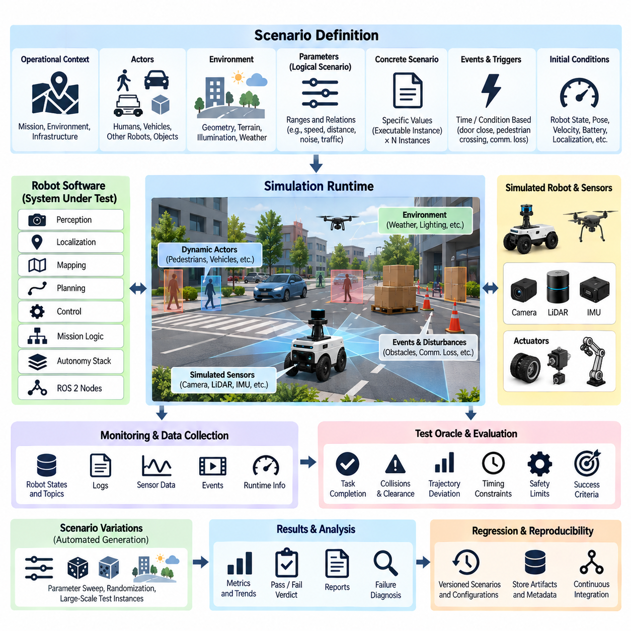
Scenario-based validation in simulation evaluates robot behavior through explicitly defined operational situations rather than isolated software functions. Each scenario represents a meaningful interaction among the robot, environment, infrastructure, objects, humans, and disturbances. This approach allows validation to focus on observable system behavior under conditions that approximate real missions while remaining repeatable and controllable.
A scenario should describe more than a map and an initial robot pose. It defines the operational context, participating actors, their states and behaviors, environmental conditions, mission objectives, triggering events, expected responses, and termination criteria. For an autonomous mobile robot, for example, a scenario may combine a delivery mission with pedestrians, blocked passages, localization uncertainty, and changing obstacle configurations.
Scenario descriptions are commonly separated into logical and concrete representations. A logical scenario defines parameter ranges and relationships, such as pedestrian speed, obstacle distance, sensor noise, or robot velocity. A concrete scenario assigns specific values to those parameters and becomes directly executable. This separation allows a small number of scenario concepts to generate thousands of reproducible test instances without manually authoring every case.
The scenario validation architecture normally connects a scenario definition layer to a simulation runtime, robot software, monitoring functions, and automated test oracles. The simulator creates the specified world and advances its state, while the robot software perceives and reacts to simulated conditions. Monitors continuously observe relevant signals and events, and test oracles determine whether requirements and behavioral constraints were satisfied during execution.
Scenario parameters should be selected from the robot's intended operating domain. Relevant dimensions may include geometry, terrain, illumination, weather, object placement, traffic density, human behavior, payload, friction, communication quality, sensor degradation, and robot speed. Systematically varying these dimensions exposes interactions that conventional nominal testing can overlook and provides a structured basis for measuring validation coverage.
Initial conditions are particularly important because autonomous systems can be highly sensitive to small differences in state. Robot pose, velocity, localization covariance, battery condition, actuator state, object configuration, and internal mission state may all influence the resulting behavior. A reproducible validation framework therefore records these conditions explicitly instead of depending on unspecified simulator defaults that can change between executions.
Dynamic actors make scenario validation more representative of real robot operation. Pedestrians, vehicles, other robots, moving machinery, manipulated objects, or simulated agents can follow scripted trajectories or reactive behavior models. Their interactions with the system under test can create merging paths, occlusions, sudden crossings, congestion, or conflicting objectives that exercise perception, prediction, planning, and control simultaneously.
Events and triggers provide temporal structure to scenarios. A door may close after the robot enters a corridor, a pedestrian may cross when the robot reaches a defined region, or communication may degrade during a mission phase. Event-driven definitions make complex situations reproducible because disturbances occur according to observable conditions rather than arbitrary manual intervention, improving consistency across software versions.
A scenario should contain measurable acceptance criteria linked to its validation objective. Successful task completion alone is often insufficient. The robot may reach its goal while violating minimum clearance, exceeding velocity limits, producing excessive control oscillation, entering prohibited areas, or responding too slowly to hazards. Multiple behavioral metrics are therefore needed to distinguish safe and correct execution from superficial mission success.
Automated test oracles convert simulation traces into validation verdicts. They can monitor collisions, distances, trajectory deviation, timing constraints, state transitions, control limits, localization error, task completion, and safety responses. An oracle should specify tolerances explicitly because simulated signals contain numerical approximations and because many robot requirements define acceptable ranges rather than exact values.
Scenario-based testing is especially effective for navigation systems because complete autonomy stacks can be exercised under repeatable traffic and environmental conditions. Localization, mapping, obstacle detection, path planning, local planning, and motion control can be evaluated as an integrated behavior chain. Failures can then be associated with recorded observations and internal states instead of being treated simply as unsuccessful navigation runs.
Manipulation validation can use scenarios describing object pose, clutter, grasp approach, contact conditions, target placement, and disturbances. The same task can be repeated across object positions, orientations, physical properties, or workspace configurations. Scenario variation therefore tests whether a manipulation policy succeeds only under a narrow nominal configuration or maintains acceptable behavior across a meaningful operational envelope.
For UAV software, scenarios can represent mission routes, wind conditions, obstacles, sensor uncertainty, communication degradation, and flight-mode transitions. Because potentially hazardous situations can be exercised without risking an aircraft, simulation is valuable for validating abnormal and boundary conditions. Nevertheless, conclusions remain dependent on the fidelity and validity of the aerodynamic, sensor, environmental, and timing models used by the simulator.
Scenario generation should balance manually designed cases with systematic parameterization. Expert-designed scenarios capture known hazards, requirements, operational experience, and previously observed failures. Parameterized generation expands these cases across ranges that humans may not test individually. Together, they create a progression from deterministic requirement-based validation toward large-scale corner-case exploration and statistical simulation.
Coverage must be measured against scenario space rather than merely counting executed simulations. Running ten thousand nearly identical cases provides less evidence than systematically covering important combinations of operating conditions. Coverage models can classify scenarios by environment, actor behavior, mission phase, system state, hazard type, and parameter ranges, revealing which regions of the intended operating domain remain insufficiently exercised.
Combinatorial growth is one of the central challenges of scenario-based validation. Even a modest number of variables can produce an impractically large test space. Validation frameworks therefore prioritize combinations according to requirements, risk, boundary conditions, operational frequency, previous failures, and expected behavioral sensitivity. This makes computational resources concentrate on scenarios that provide meaningful additional evidence instead of redundant executions.
Randomization can increase diversity, but random scenarios must remain reproducible. Each execution should preserve its random seed together with scenario parameters, simulator version, robot software revision, model versions, and configuration. When a rare failure appears during a large simulation campaign, these artifacts allow the exact case to be replayed for debugging, root-cause analysis, and subsequent regression testing.
Failure scenarios should become persistent regression assets. When simulation reveals a collision, planning deadlock, unstable controller response, missed detection, incorrect state transition, or other defect, the corresponding scenario can be stored in the validation repository. After the defect is corrected, the same scenario is repeatedly executed against future builds to prevent previously solved problems from silently returning.
Simulation execution can be scaled horizontally because many scenarios are independent. Containerized or isolated workers can run different parameter combinations in parallel across CPUs, GPUs, workstations, or compute clusters. Results can then be aggregated into a common database containing scenario identifiers, software versions, metrics, verdicts, logs, and failure artifacts. This architecture turns simulation into a scalable validation service rather than an interactive engineering tool.
Scenario-based validation also provides a foundation for continuous integration. Selected smoke scenarios can execute for every software change, broader regression suites can run periodically, and computationally expensive campaigns can execute before major releases. Test selection can be adjusted according to the components that changed, allowing simulation resources to focus on scenarios most likely to expose regressions associated with a particular modification.
The credibility of scenario results ultimately depends on correlation with physical testing. Important scenarios should be replayed on real robots where practical, and discrepancies in trajectories, sensor behavior, timing, contacts, or failure responses should be analyzed. These observations can refine simulator parameters and uncertainty models, progressively improving the relationship between virtual validation evidence and expected real-world behavior.
Scenario-based simulation therefore transforms validation from ad hoc virtual experimentation into a structured evidence-generation process. Explicit scenario definitions, controlled variation, measurable criteria, reproducible execution, coverage tracking, and regression management provide the foundation for subsequent corner-case generation, Monte Carlo analysis, SOTIF evaluation, Sim-to-Real gap analysis, and automated simulation validation pipelines within the chapter structure.

04.03. Edge Case and Corner Case Sim Test Generation [w/Code]
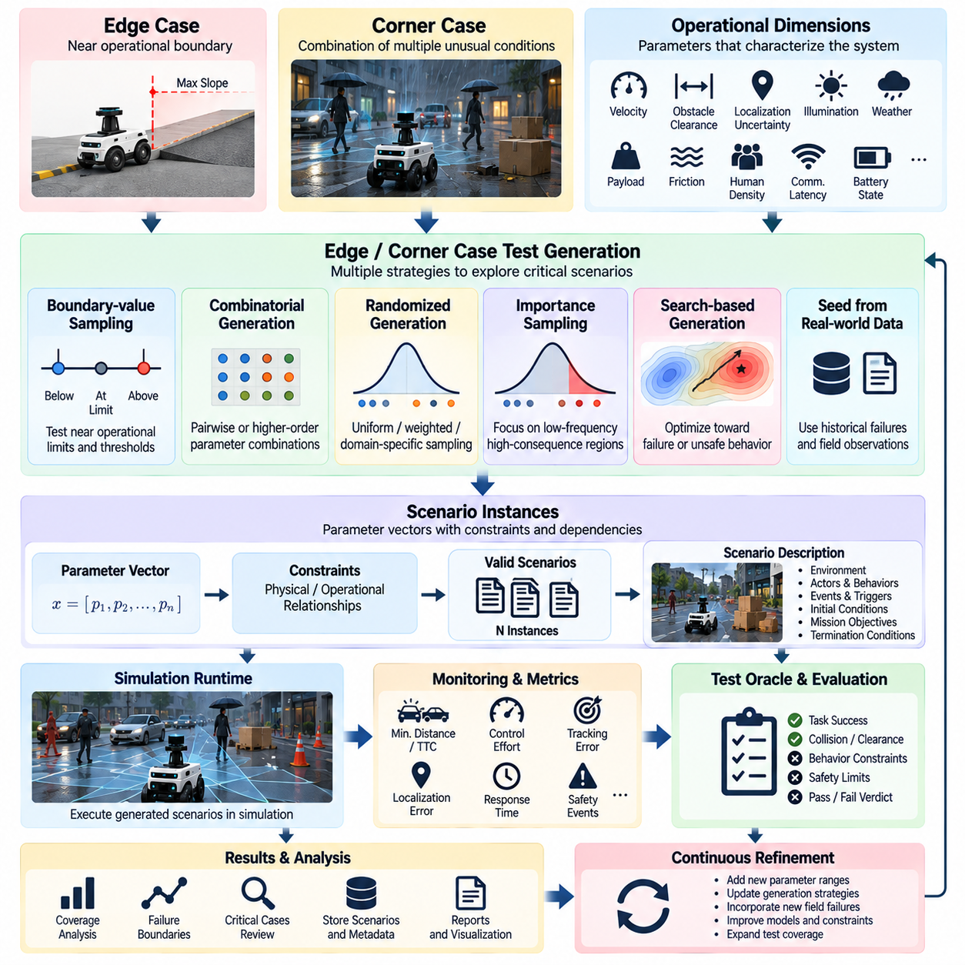
Edge-case and corner-case simulation test generation extends scenario-based validation toward conditions that are uncommon, extreme, or located near important operational boundaries. An edge case typically occurs near the limit of a valid operating range, while a corner case combines several unusual conditions whose interaction creates behavior that conventional tests may not expose. These cases are particularly important for autonomous robots because failures often emerge from combinations rather than isolated variables.
The generation process begins by defining the operational and behavioral dimensions that characterize the system. For a mobile robot, these dimensions may include velocity, obstacle clearance, localization uncertainty, sensor range, illumination, floor friction, payload, communication latency, pedestrian density, and battery state. For manipulators or UAVs, corresponding dimensions can represent object pose, contact properties, wind, flight state, actuator limits, or environmental disturbances.
Operational boundaries provide natural sources of edge cases. If a robot is designed to operate within specified velocity, slope, temperature, payload, visibility, or communication limits, tests should exercise values close to those limits rather than concentrating only on nominal conditions. Boundary-oriented generation can evaluate values immediately below, at, and above important thresholds to reveal discontinuities, unstable transitions, saturation, or incorrect fallback behavior.
Corner cases arise when individually acceptable conditions interact in unexpected ways. Moderate sensor noise may be harmless under normal motion, and high velocity may be acceptable with accurate localization, yet their combination can cause unsafe planning behavior. Simulation makes such interactions practical to explore because multiple parameters can be varied systematically without exposing equipment or personnel to the risks associated with physical reproduction of unusual conditions.
A test generator can represent each scenario as a parameter vector constrained by valid relationships. Parameter ranges should not be sampled independently when physical or operational dependencies exist. Vehicle speed may constrain feasible curvature, payload may affect acceleration, object dimensions may restrict grasp configurations, and weather may influence sensor performance. Constraint-aware generation prevents computational resources from being consumed by impossible or meaningless scenarios.
Several generation strategies can coexist within the same framework. Boundary-value sampling targets known limits, combinatorial methods explore interactions among selected variables, random sampling increases diversity, and search-based methods actively seek scenarios associated with undesirable behavior. Historical failures and field observations can also seed new cases, allowing real operational experience to continuously enrich the simulated test space.
Systematic parameter sweeping is useful when the number of dimensions remains manageable. A simulator can vary obstacle distance, robot speed, reaction time, or sensor uncertainty across predefined intervals and record where behavior changes from acceptable to unacceptable. The resulting failure boundary is often more informative than a single failing example because it reveals the sensitivity of the system and the margin separating normal operation from failure.
Combinatorial generation addresses situations where exhaustive enumeration is impractical. Instead of testing every possible combination, selected combinations of parameter values can be constructed to provide meaningful interaction coverage. Pairwise or higher-order combinations can expose defects triggered by relationships among multiple conditions while keeping the number of simulations substantially smaller than the complete Cartesian product of all parameters.
Randomized generation provides broader exploration when the scenario space is too large for deterministic enumeration. Parameters can be sampled from uniform, weighted, or domain-specific distributions depending on the validation objective. Randomization should not imply irreproducibility: every generated scenario should preserve its random seed, parameter values, environment configuration, software version, simulator version, and model versions so that any discovered failure can be executed again exactly.
Importance sampling can focus simulation effort on low-frequency but high-consequence regions. Instead of reproducing the statistical frequency of ordinary operation, the test campaign intentionally increases the occurrence of hazardous interactions, narrow clearances, sensor degradation, difficult terrain, unusual object configurations, or adverse environmental conditions. Results must then be interpreted according to the sampling strategy rather than treating the generated population as ordinary operational statistics.
Search-based test generation treats scenario discovery as an optimization problem. A fitness or objective function can reward behaviors approaching collision, violating clearance margins, increasing tracking error, delaying hazard responses, producing unstable control, or reducing task success probability. Optimization algorithms then modify scenario parameters to move progressively toward stressful conditions, enabling automated discovery of failures that manual scenario authors may not anticipate.
Failure proximity is a useful search signal even when no explicit failure occurs. Minimum time-to-collision, smallest obstacle clearance, maximum control effort, localization divergence, near-limit actuator commands, or safety intervention frequency can indicate that a scenario lies close to a hazardous boundary. These continuous metrics provide richer optimization signals than binary pass/fail results and help identify vulnerable regions before actual violations occur.
For perception systems, corner-case generation may vary illumination, occlusion, viewing angle, object scale, texture, clutter, motion, sensor noise, or environmental effects. Multiple factors can be combined to determine when detection, segmentation, tracking, depth estimation, or localization begins to degrade. Synthetic simulation is particularly useful because conditions can be manipulated independently and ground-truth information remains available for quantitative comparison.
Navigation corner cases can include narrow passages, dynamic obstacles, crossing pedestrians, localization uncertainty, blocked routes, ambiguous free space, planner oscillation, and communication delays. Generated scenarios should evaluate the complete behavior chain rather than only planner output. A safe trajectory computed by the planner is insufficient if perception latency, controller dynamics, or localization error causes the physical trajectory to violate the intended safety margin.
Manipulation testing can generate difficult combinations of object orientation, clutter, grasp accessibility, friction, mass, compliance, contact uncertainty, and placement tolerance. These variations can expose policies that perform well on nominal benchmark configurations but fail when several small deviations occur simultaneously. Recording intermediate observations, grasp decisions, contact states, forces, and recovery attempts helps distinguish perception failures from planning or control failures.
UAV simulation can generate edge conditions involving wind, turbulence, payload, navigation uncertainty, actuator degradation, communication loss, obstacle proximity, or mode transitions. Extreme combinations can test whether flight software maintains stability and appropriate safety behavior when nominal assumptions deteriorate. Because simulator fidelity limits the conclusions that can be drawn, discovered cases should later be prioritized for suitable HIL or controlled physical validation.
Generated tests require filtering and validity checking. Automated exploration may create scenarios that violate geometry, physics, mission rules, or assumptions of the intended operating domain. A validity layer should reject impossible initial states, contradictory actor configurations, unreachable missions, or parameter combinations outside the test objective. Maintaining this distinction prevents invalid simulations from artificially inflating scenario coverage or failure counts.
Duplicate and near-duplicate scenarios should also be managed. Large generators may repeatedly discover essentially the same failure through slightly different parameter values. Clustering scenarios by configuration, behavioral trace, failure signature, or root-cause indicators can reduce redundant execution. Representative cases can then be retained while preserving information about the size and structure of the surrounding failure region.
When an important corner case is discovered, it should be converted into a deterministic regression scenario. The triggering parameter set, random seed, simulator configuration, software revision, logs, metrics, and expected verdict should be stored together. After the underlying defect is corrected, this scenario becomes part of the permanent regression suite so that subsequent software changes cannot easily reintroduce the same behavior.
Coverage analysis should identify not only how many generated scenarios were executed but which regions and interactions of the scenario space were exercised. Coverage can be organized around parameter ranges, boundary conditions, actor interactions, hazard categories, mission phases, system states, and known failure modes. Sparse regions can then guide the next generation cycle, creating feedback between test execution, coverage measurement, and scenario selection.
Large-scale corner-case discovery benefits from parallel simulation infrastructure. Thousands of generated cases can execute across isolated workers, with each worker returning metrics, verdicts, traces, and failure artifacts to a centralized validation repository. Lightweight cases can be screened rapidly, while suspicious or failing scenarios can be replayed with higher simulation fidelity and more extensive instrumentation for detailed diagnosis.
The resulting workflow forms an iterative validation loop: define the scenario space, generate candidates, execute simulations, evaluate behavior, identify boundaries or failures, preserve significant cases, and use coverage gaps to guide subsequent generation. This approach transforms rare-event testing from manual speculation into a systematic engineering process and prepares the validation framework for Monte Carlo simulation, statistical coverage analysis, SOTIF evaluation, Sim-to-Real gap analysis, and continuous simulation regression.

04.04. Monte Carlo Simulation for Statistical Coverage [w/Code]
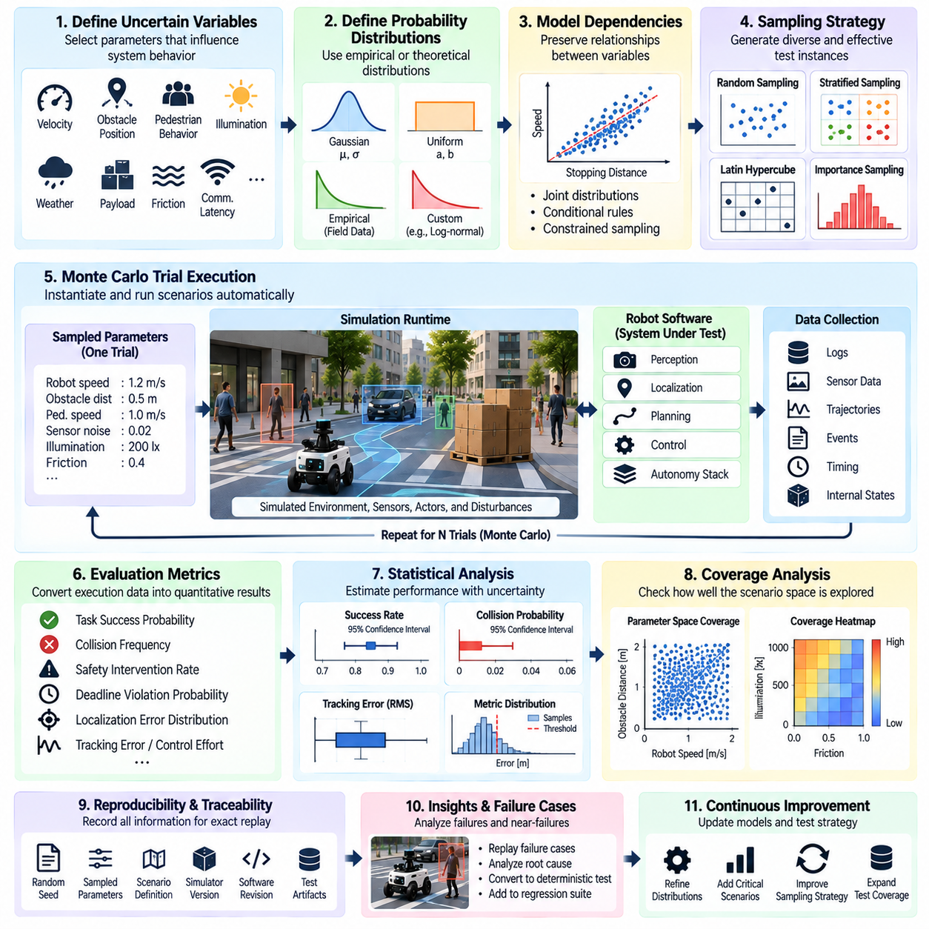
Monte Carlo simulation provides a statistical approach to robot validation by executing large numbers of scenarios whose parameters are sampled from defined probability distributions. Instead of demonstrating performance only at selected deterministic points, the method estimates how frequently acceptable, degraded, or unsafe behaviors occur across a broader operating space. It therefore complements scenario-based and corner-case testing with quantitative coverage evidence.
The first step is to define the uncertain variables that influence system behavior. These may include sensor noise, localization error, obstacle position, pedestrian speed, payload, friction, communication latency, actuator variation, illumination, weather, wind, or initial robot state. Each variable is represented by a probability distribution or bounded sampling model that reflects the intended validation objective and available operational knowledge.
Probability distributions should not be chosen merely for mathematical convenience. When field measurements are available, empirical distributions can represent realistic variability. Uniform distributions may be appropriate when all values within a bounded interval should receive equal exploration, while Gaussian or other distributions may model measurement uncertainty. The selected distributions become explicit assumptions of the validation campaign and should therefore be recorded with the results.
Dependencies between variables must also be represented. Sampling every parameter independently can generate unrealistic combinations and distort statistical conclusions. Robot velocity may correlate with stopping distance, weather may influence sensor noise, payload may affect acceleration, and terrain properties may affect wheel slip. Joint distributions, conditional rules, or constrained sampling mechanisms can preserve these relationships while maintaining controlled random variation.
Each Monte Carlo trial instantiates one concrete scenario from the statistical model. The simulator initializes the robot, environment, actors, disturbances, and software configuration according to the sampled parameters and then executes the scenario automatically. During execution, instrumentation records task outcomes, safety events, trajectories, timing, perception results, control signals, state transitions, and other metrics required by the validation objectives.
A fundamental requirement is reproducibility. Every trial should have a unique identifier and preserve its random seed, sampled parameters, scenario definition, simulator version, robot software revision, configuration, and model versions. A statistically generated failure must be replayable as a deterministic test case so engineers can inspect its behavior, identify the root cause, verify a correction, and retain the case for future regression testing.
Monte Carlo validation can estimate quantities such as task success probability, collision frequency, safety intervention rate, deadline violation probability, localization failure frequency, or distribution of tracking error. Results should normally include uncertainty around these estimates rather than reporting only a single percentage. Confidence intervals help distinguish genuine performance differences from variation caused by a limited number of simulation trials.
Sample size strongly affects the strength of statistical conclusions. Common behaviors can often be estimated with moderate numbers of trials, whereas very rare failures require substantially more execution. Observing zero failures does not prove that the true failure probability is zero. The campaign should therefore define the number of trials according to the probability level of interest, desired confidence, computational budget, and consequence of the event being evaluated.
Statistical coverage differs from simple execution count. Ten thousand simulations concentrated in a narrow nominal region may provide poor evidence about the complete operating domain. Coverage analysis should examine how sampled trials populate relevant parameter ranges, environmental conditions, mission phases, actor interactions, and system states. Sparse regions indicate where additional sampling or targeted scenario generation is necessary.
Stratified sampling can improve coverage by dividing the scenario space into meaningful regions and ensuring that each region receives sufficient trials. For example, obstacle density, visibility, robot speed, or localization uncertainty can be separated into operating bands. This prevents common nominal conditions from dominating the campaign and provides more balanced evidence about system behavior across important portions of the intended operating domain.
Latin hypercube and related space-filling methods can provide efficient exploration when many continuous variables must be varied. These methods distribute samples more evenly across parameter ranges than unconstrained random sampling. They are particularly useful during exploratory validation, where the objective is to characterize system sensitivity and discover vulnerable regions before concentrating computational resources on detailed statistical estimation.
Importance sampling is valuable when the events of greatest interest are too rare to observe efficiently under ordinary operational distributions. The sampling process deliberately increases the frequency of conditions associated with hazards or failures, such as short obstacle distances, severe sensor degradation, strong wind, or high localization uncertainty. Statistical weighting is then required if results are used to estimate probabilities under the original operating distribution.
Monte Carlo methods are especially useful for autonomous navigation because small variations can propagate through perception, localization, planning, and control. Repeated trials can vary obstacle geometry, pedestrian motion, sensor uncertainty, initial pose, and timing while measuring collision rate, minimum clearance, mission completion, path efficiency, or intervention frequency. This reveals performance distributions that a small set of deterministic scenarios cannot characterize.
Manipulation systems can similarly be evaluated by sampling object position, orientation, friction, mass, grasp uncertainty, perception error, and contact properties. The resulting distribution of grasp success, placement accuracy, task duration, contact force, or recovery behavior provides a more realistic picture of robustness than a single benchmark configuration. Failed trials can also reveal clusters of object states that systematically challenge the manipulation policy.
For UAV validation, Monte Carlo campaigns can vary wind, turbulence, payload, navigation error, actuator characteristics, communication conditions, and mission geometry. Repeated execution can estimate distributions of tracking error, energy consumption, stability margins, mission success, or safety-mode activation. High-consequence cases identified statistically can then be transferred to higher-fidelity simulation, HIL, or carefully controlled flight testing.
Sequential analysis can reduce unnecessary computation by evaluating results while a campaign is still running. If statistical confidence becomes sufficient, execution may stop without reaching a predetermined maximum number of trials. Conversely, if uncertainty remains large or failures appear near an important threshold, additional simulations can be scheduled. This makes validation resources responsive to the evidence being collected.
Adaptive sampling extends this idea by using previous simulation results to determine where new trials should be placed. Regions containing steep performance changes, high uncertainty, near-failures, or sparse coverage can receive more samples than stable nominal regions. Monte Carlo simulation can therefore operate together with edge-case search rather than functioning as a purely passive random experiment.
Large campaigns require scalable execution infrastructure. Independent trials can be distributed across CPU or GPU workers, containers, workstations, or simulation clusters. A central scheduler can assign scenario instances, monitor execution, retry infrastructure failures, and collect standardized artifacts. Parallelism allows thousands or millions of virtual operating episodes to be evaluated without changing the statistical definition of individual trials.
Results should be stored in a structured validation repository rather than reduced immediately to summary statistics. The repository can associate every trial with sampled parameters, metrics, verdicts, traces, logs, and software versions. Engineers can then query relationships between failures and scenario variables, compare software releases, identify sensitivity patterns, and reconstruct individual executions when aggregate statistics indicate unexpected behavior.
Statistical analysis should distinguish simulation failure from infrastructure failure. A robot collision, missed detection, unstable controller, or mission timeout may represent a valid system outcome, whereas a simulator crash, corrupted asset, worker timeout, or missing dependency represents invalid test execution. Mixing these categories can bias estimated probabilities and conceal problems in the simulation platform itself.
Monte Carlo evidence must also be interpreted within the validity limits of the simulator. A precise statistical estimate derived from an inaccurate sensor, dynamics, contact, or environment model does not guarantee equivalent real-world probability. Important distributions and failure mechanisms should therefore be compared with field and HIL observations, and model uncertainty should be incorporated when the available physical evidence indicates significant simulation-to-real differences.
The most valuable failures discovered during a Monte Carlo campaign should become permanent deterministic regression cases. Their seeds and complete configurations can be frozen so that future software versions encounter exactly the same conditions. Statistical exploration therefore feeds the regression suite, while regression results can identify changes that justify another statistical campaign around affected regions of the scenario space.
Monte Carlo simulation ultimately converts repeated virtual experiments into measurable evidence about robustness and uncertainty. Combined with scenario definitions, edge-case generation, coverage models, reproducible seeds, statistical confidence, and scalable execution, it enables simulation-based validation to move beyond isolated pass/fail demonstrations toward quantitative assessment of system behavior across diverse operating conditions.

04.05. Navigation Stack Validation in Gazebo Isaac [w/Code]
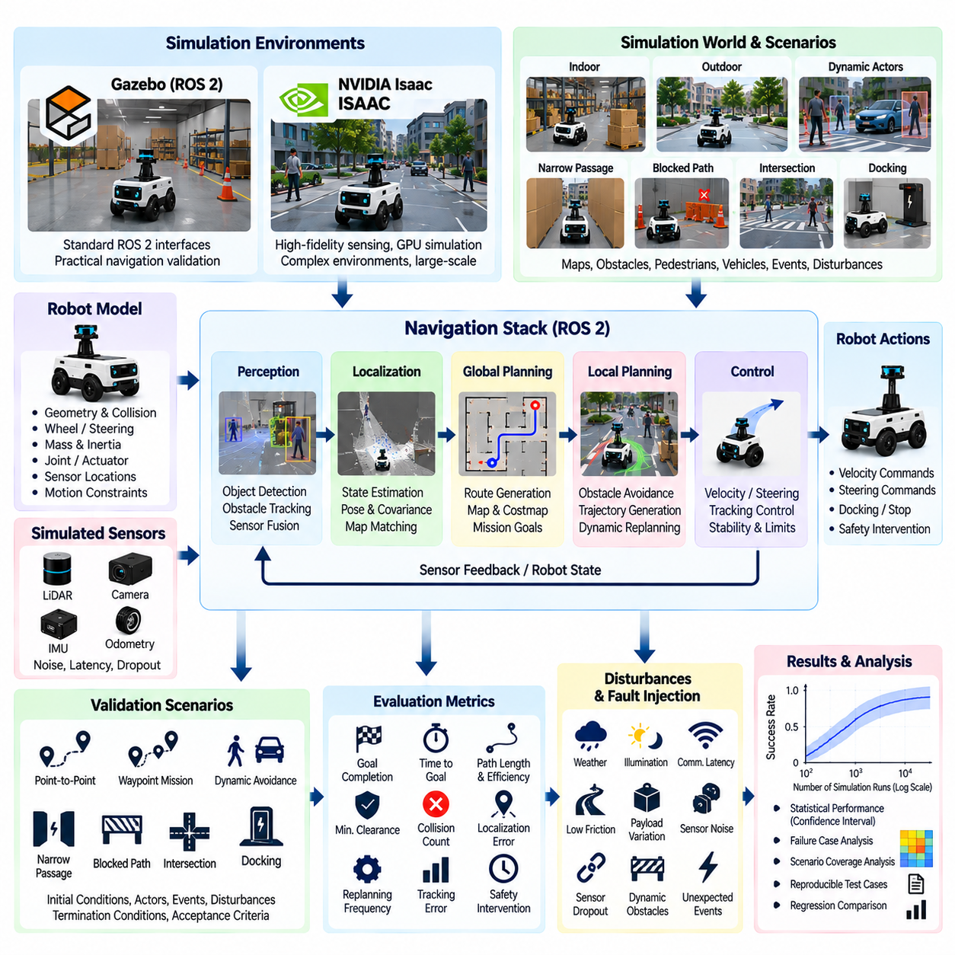
Navigation stack validation in Gazebo and Isaac simulation environments evaluates the complete autonomous navigation pipeline before deployment on physical robots. Rather than testing localization, planning, perception, and control independently, simulation allows these components to operate together under repeatable environmental conditions. This exposes integration failures that may only appear when sensing, estimation, decision making, and motion execution interact dynamically.
A representative validation environment begins with a sufficiently accurate robot model. Geometry, collision boundaries, wheel configuration, steering constraints, joint properties, sensor locations, mass distribution, and actuator characteristics should reflect the target platform at the fidelity required by the test objective. Incorrect robot dimensions or motion constraints can produce apparently successful navigation results that cannot be reproduced by the physical system.
Gazebo can provide a practical simulation environment for ROS 2 navigation testing by connecting virtual sensors and robot dynamics to the same middleware interfaces used by deployed software. Navigation components can consume simulated LiDAR, camera, IMU, odometry, and transform data while publishing velocity or steering commands through standard interfaces. This enables much of the production navigation stack to execute without simulation-specific control logic.
Isaac-based simulation can extend validation toward GPU-accelerated sensing, complex environments, synthetic perception, and large-scale parallel execution. High-detail scenes and configurable sensor models are useful when navigation behavior depends strongly on perception or environmental appearance. The appropriate simulator should therefore be selected according to validation objectives rather than assuming that higher visual fidelity automatically produces stronger navigation evidence.
The validation architecture should preserve the complete navigation data flow. Simulated sensors provide observations to localization and perception modules, localization estimates the robot state, global planning generates a route, local planning or trajectory generation responds to nearby conditions, and controllers convert the selected motion into executable commands. Monitoring each stage makes it possible to determine where a navigation failure originates rather than observing only final mission success.
Localization validation should measure both accuracy and behavioral consequences. Pose error, orientation error, covariance consistency, convergence time, and recovery after disturbance can be recorded while the robot moves through representative environments. Sensor noise, wheel slip, ambiguous geometry, temporary observation loss, or incorrect initial pose can be introduced to determine whether localization degradation remains bounded and whether downstream navigation reacts appropriately.
Global planning validation examines whether the navigation stack produces feasible routes that respect maps, cost representations, restricted regions, robot dimensions, and mission constraints. Tests should include ordinary routes as well as blocked corridors, alternative paths, narrow passages, disconnected regions, and dynamically changing accessibility. Route length alone is insufficient because a short path may provide poor clearance or create difficult conditions for local control.
Local planning and obstacle avoidance require dynamic scenarios because their behavior depends on continuously changing observations. Pedestrians, mobile robots, carts, vehicles, or other moving objects can cross or partially obstruct the robot's route. Validation should determine whether the robot maintains required clearance, avoids oscillatory behavior, selects reasonable detours, stops when necessary, and resumes progress when the obstruction disappears.
Controller validation connects planned motion to simulated physical response. Tracking error, velocity error, angular response, overshoot, oscillation, acceleration, jerk, and stopping distance can be monitored while terrain friction, payload, actuator response, and command latency are varied. This is important because a geometrically safe trajectory may still become unsafe when controller dynamics and physical motion deviate from the assumptions used by the planner.
Costmaps and environmental representations should be validated as intermediate products rather than treated as invisible implementation details. Incorrect inflation, stale obstacles, missing sensor observations, transform errors, or unsuitable update rates can cause navigation failures even when planning algorithms operate correctly. Recording costmap states alongside sensor and trajectory data provides valuable evidence for diagnosing unexpected route selection or obstacle avoidance behavior.
Scenario-based navigation validation should cover representative mission structures such as point-to-point travel, waypoint sequences, docking approaches, corridor traversal, intersection handling, recovery from blocked paths, and navigation through shared spaces. Each scenario should define initial conditions, goals, environmental configuration, dynamic actors, disturbances, termination conditions, and measurable acceptance criteria so that execution remains reproducible.
Pass and fail criteria should combine mission-level and safety-level metrics. Useful measurements include goal completion, time to goal, path length, path efficiency, collision count, minimum obstacle clearance, localization error, replanning frequency, recovery frequency, controller tracking error, and safety intervention. A robot that reaches its destination after repeated unsafe approaches or excessive recovery behavior should not automatically be classified as successful.
Fault injection can test navigation robustness beyond nominal scenarios. LiDAR dropout, camera degradation, delayed transforms, corrupted odometry, localization jumps, communication latency, map inconsistencies, or temporary planner failures can be introduced at controlled times. The resulting behavior reveals whether the stack detects degraded conditions, activates recovery mechanisms, transitions to a safe state, or continues operating with unacceptable assumptions.
Recovery behavior deserves explicit validation because autonomous navigation frequently encounters situations that cannot be solved by ordinary planning. Tests can intentionally create planner failure, local deadlock, temporary obstruction, localization degradation, or unreachable goals. The validation framework should observe whether recovery actions improve the situation, whether retries remain bounded, and whether the system eventually reports failure or enters a safe condition instead of looping indefinitely.
Navigation tests should also include boundary and corner cases. Narrow clearances, high obstacle density, low-friction surfaces, poor localization geometry, delayed sensor updates, fast-moving actors, and simultaneous disturbances can expose weaknesses that nominal warehouse or laboratory maps do not reveal. Parameterized simulation allows these factors to be varied systematically and helps identify transitions between robust navigation and unstable behavior.
Gazebo and Isaac scenarios should remain reproducible across software revisions. Robot descriptions, world assets, maps, sensor configurations, navigation parameters, simulator versions, random seeds, and software commits should be versioned or recorded with each execution. Without this information, a failed simulation may be difficult to reconstruct and comparisons between navigation-stack revisions may become unreliable.
Automated execution transforms simulator-based navigation testing from interactive debugging into regression validation. A test runner can launch the simulator, initialize the robot, configure navigation, send goals, inject scenario events, collect telemetry, evaluate metrics, and generate a verdict without manual intervention. Selected scenarios can then execute whenever localization, planning, perception, control, or middleware software changes.
Parallel simulation can substantially increase navigation coverage. Independent scenarios can execute across multiple CPU or GPU workers with variations in maps, initial poses, obstacle arrangements, sensor noise, and dynamic actors. Lightweight scenarios can provide rapid regression feedback, while computationally expensive high-fidelity cases can be reserved for scheduled validation campaigns or release qualification.
Comparison between Gazebo and Isaac results can also reveal simulator sensitivity. A navigation behavior that succeeds in one environment and fails in another may indicate differences in physics, sensor models, timing, contacts, or environmental representation. Cross-simulator agreement does not prove real-world validity, but disagreement provides useful evidence that assumptions or simulator-specific dependencies require investigation.
Simulation results should eventually be correlated with physical robot measurements. Representative trajectories can be repeated on hardware and compared for localization accuracy, controller response, stopping distance, obstacle clearance, sensor behavior, and mission completion. Differences should feed back into robot dynamics, sensor noise, latency, friction, and other simulation parameters so that virtual validation remains connected to measured physical behavior.
Navigation-stack simulation therefore serves as an intermediate validation layer between software integration testing and physical field testing. Gazebo and Isaac can provide repeatable environments for evaluating complete navigation behavior, while scenario generation, fault injection, quantitative metrics, reproducibility, and automated regression convert those environments into systematic validation infrastructure capable of supporting increasingly complex autonomous robot systems.

04.06. Manipulation Policy Validation RLBench [w/Code]
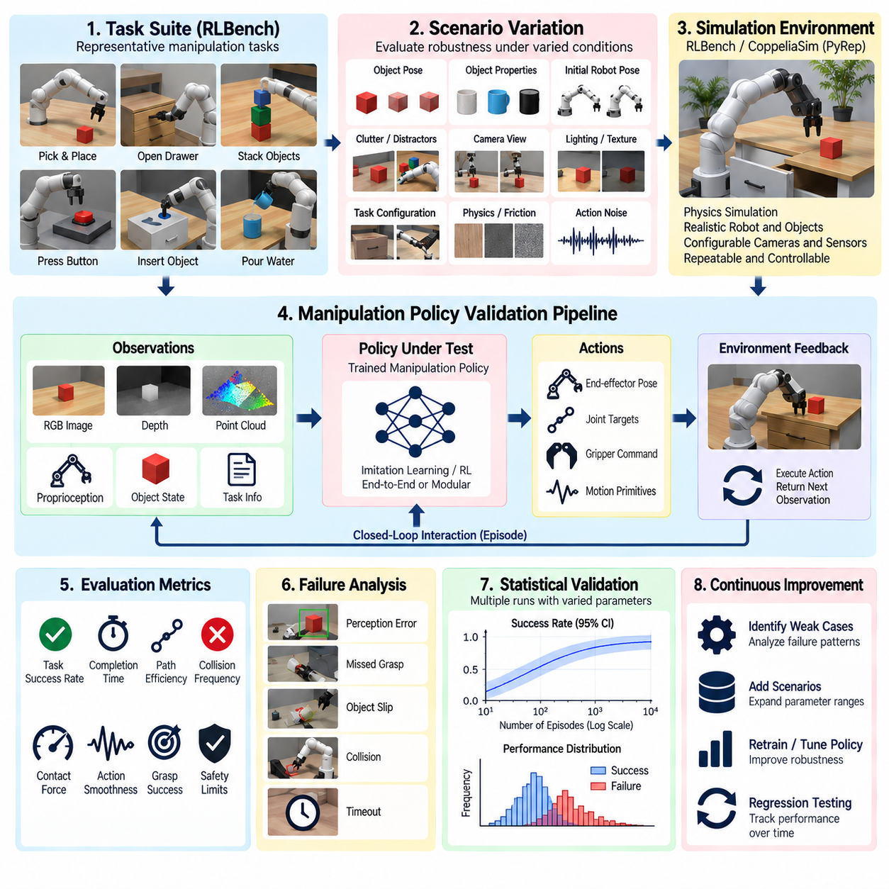
Manipulation policy validation in RLBench evaluates whether a robot manipulation policy can execute tasks reliably across variations in objects, poses, observations, and interaction conditions before deployment on physical hardware. Within simulation-based validation, RLBench provides task-oriented environments in which perception, action generation, motion execution, grasping, and task completion can be assessed together rather than as isolated algorithmic components.
A manipulation validation architecture should connect the policy under test to simulated observations, robot state, action interfaces, task definitions, and quantitative evaluation logic. The policy receives visual, proprioceptive, or task-related information and generates actions such as end-effector poses, joint targets, trajectories, or gripper commands. The simulator executes these actions and returns updated observations, creating a closed-loop interaction suitable for repeatable policy evaluation.
Validation should begin with clearly defined task semantics and success conditions. A task such as opening a drawer, inserting an object, stacking items, pressing a button, or transferring an object requires more than reaching a target pose. Completion may depend on contact state, object configuration, spatial relationships, gripper state, or the final condition of the environment. Explicit success definitions prevent visually plausible but functionally incomplete executions from being counted as successful.
Task success rate is a fundamental metric, but it should not be the only measure of policy quality. Two policies may achieve similar success rates while differing significantly in execution time, path efficiency, collision frequency, grasp retries, contact force, action smoothness, or recovery behavior. Validation should therefore combine task-level outcomes with trajectory, interaction, safety, and efficiency metrics to characterize the behavior that produces the final result.
Initial-condition variation is essential for determining whether a manipulation policy has learned a robust task strategy or merely memorized narrow configurations. Object position, orientation, robot starting pose, distractor placement, container state, and workspace arrangement can be randomized within valid ranges. Repeated evaluation across these variations reveals whether performance remains stable when the scene differs from the configurations encountered during policy development.
Visual robustness can be evaluated by varying camera viewpoints, illumination, textures, backgrounds, object appearance, clutter, and occlusion when supported by the simulation setup. Such variation is especially important for vision-conditioned manipulation policies because small changes in observations can alter object localization or action predictions. Performance degradation should be measured systematically rather than inferred from a few successful demonstrations.
Object-level variation provides another important validation dimension. Policies can be evaluated across different object poses, geometries, sizes, or task-relevant configurations while preserving the intended manipulation objective. A policy that succeeds only for a small subset of object states may exhibit high nominal performance but poor generalization. Validation should therefore report performance distributions across object configurations rather than only an aggregate average.
Manipulation policies should also be evaluated over the complete temporal horizon of a task. Long-horizon tasks can fail even when individual actions appear reasonable because small errors accumulate through successive stages. Grasping slightly off-center may affect later placement, an incomplete drawer opening may prevent the next interaction, or an unnecessary collision may change object configuration. Episode-level evaluation captures these dependencies across the full task sequence.
Action representation influences validation results and should be recorded explicitly. A policy producing joint commands may exhibit different sensitivities from one predicting Cartesian end-effector targets or higher-level motion primitives. Action frequency, interpolation, controller behavior, gripper timing, and command limits can also affect task success. Consequently, policy performance should be interpreted together with the execution interface rather than attributed exclusively to the learned model.
Collision and contact behavior require explicit monitoring. A task may technically succeed while the robot collides with the table, pushes unintended objects, penetrates simulated geometry, or creates excessive contact. Validation should distinguish intended task contacts from undesirable collisions and record their frequency, location, and severity. This is particularly important when simulation success criteria do not automatically encode every operational or safety constraint.
Failure classification makes aggregate success statistics more useful. Failed episodes can be categorized according to perception error, unreachable action, missed grasp, object slip, collision, planning failure, incorrect task sequence, timeout, or unsuccessful recovery. These categories help identify whether additional training data, improved perception, different action representations, controller changes, or task-specific recovery strategies are most likely to improve policy robustness.
Parameterized scenario generation can systematically expose difficult manipulation conditions. Object pose, clutter density, target tolerance, initial robot configuration, visibility, friction, or action noise can be varied across controlled ranges. Instead of asking only whether the policy succeeds, validation can identify the boundary at which performance begins to deteriorate. These failure boundaries provide useful evidence about the practical operating envelope of the manipulation system.
Randomized trials support statistical characterization of manipulation performance. Each evaluation episode should preserve the random seed, task identifier, variation parameters, policy version, simulator configuration, robot model, and relevant environment state. When a rare failure occurs, the complete configuration can then be replayed deterministically for debugging and root-cause analysis rather than relying on an approximate manual reconstruction of the scene.
Demonstrations can provide useful reference behavior when interpreting policy execution. Policy trajectories may be compared with successful demonstrations in terms of task progression, end-effector motion, interaction sequence, or final state. The objective is not necessarily to reproduce the demonstrated trajectory exactly, because multiple valid strategies may exist, but demonstrations can help reveal inefficient, unstable, or semantically incorrect behavior that still approaches the goal.
Generalization testing should separate familiar conditions from deliberately modified conditions. Evaluation sets can vary task instances, object configurations, visual properties, initial states, or combinations that were not represented during policy development. Reporting these conditions separately avoids hiding poor generalization behind strong performance on familiar scenarios and provides a clearer picture of whether the learned policy can tolerate meaningful distribution shifts.
Noise and disturbance injection can evaluate robustness beyond nominal RLBench execution. Observation noise, pose perturbations, delayed actions, imperfect gripper timing, or small execution errors can be introduced to approximate uncertainties expected in physical deployment. The objective is not to claim exact real-world equivalence, but to determine whether modest deviations cause graceful performance degradation or sudden catastrophic failure.
Recovery behavior should be evaluated separately from first-attempt success. A robust manipulation policy may detect an unsuccessful grasp, reposition the end effector, reacquire an object, or retry a subtask. Validation should measure the number of retries, additional execution time, recovery success rate, and whether recovery creates new hazards. Policies that can recover from moderate disturbances may provide greater practical reliability than policies optimized only for nominal execution.
Large evaluation campaigns benefit from automated and parallel execution. Independent RLBench episodes can be distributed across simulation workers using different tasks, seeds, variations, and policy checkpoints. Standardized result records can capture success, duration, action count, collisions, failure categories, and relevant traces. Parallel execution makes it practical to evaluate thousands of episodes and compare multiple policy versions using consistent conditions.
Regression validation should preserve representative successful, difficult, and failing episodes. When a software or policy update is introduced, the same deterministic scenarios can be executed again to identify behavioral regressions. Newly discovered failures should be added to the regression set, allowing the evaluation suite to evolve alongside the manipulation system instead of repeatedly testing only the original benchmark conditions.
Policy comparisons require identical evaluation protocols. Candidate models should use the same task definitions, scenario distributions, random seeds where appropriate, observation configuration, action interface, termination rules, and metric calculations. Without controlled conditions, differences in reported success may reflect evaluation setup rather than genuine policy improvement. Reproducible protocols are therefore essential for meaningful benchmark and release decisions.
Simulation results should not be interpreted as direct proof of physical manipulation performance. Differences in contact dynamics, friction, sensing, calibration, latency, actuator behavior, object properties, and controller execution can produce a Sim-to-Real gap. Important RLBench scenarios and failure modes should therefore inform later physical validation, while real-robot observations can identify which simulation assumptions require refinement or additional uncertainty modeling.
Manipulation policy validation in RLBench ultimately provides a structured bridge between learned-policy development and physical robot evaluation. By combining task success, scenario variation, failure analysis, robustness testing, reproducible execution, statistical evaluation, and regression management, the framework can determine not merely whether a policy works in simulation, but where it works, how reliably it works, how it fails, and which cases require further Sim-to-Real validation.

04.07. Flight Control SW SiL AirSim Validation [w/Code]
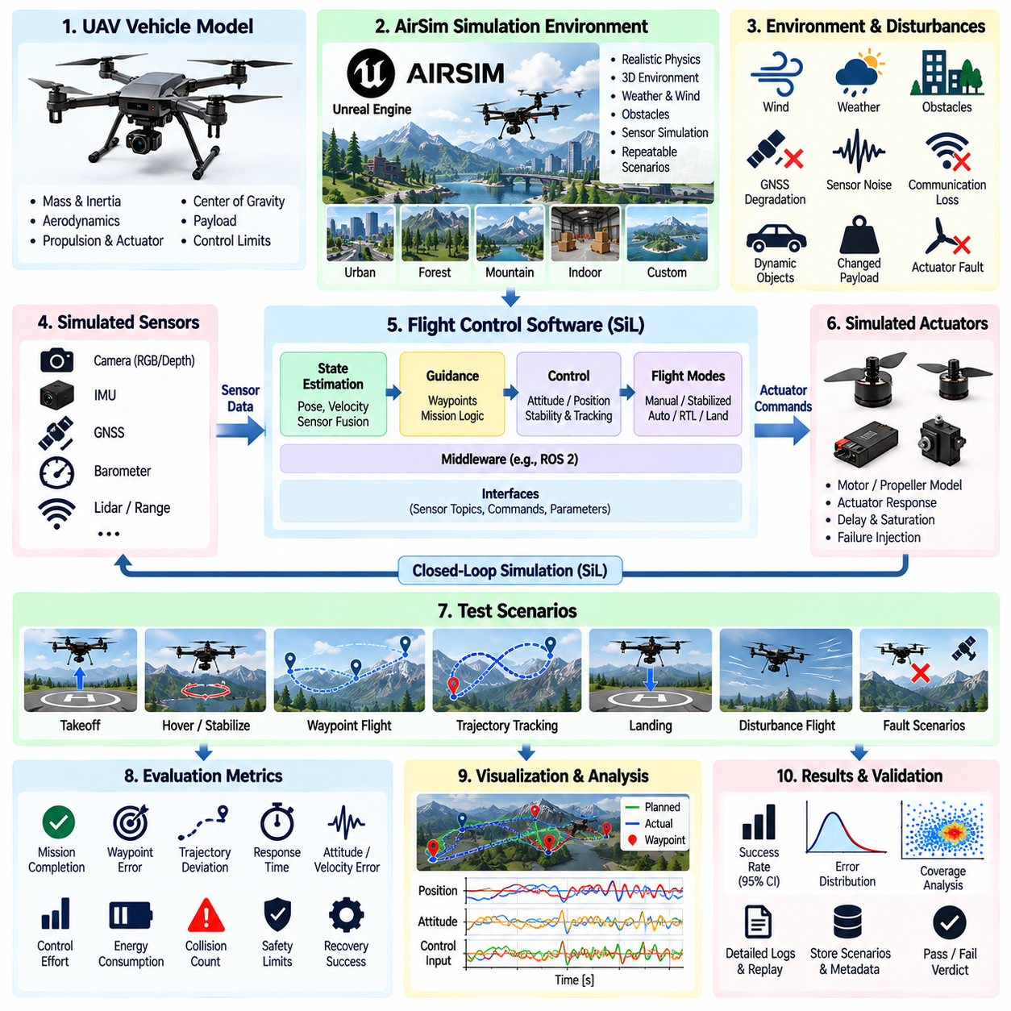
Flight-control software validation in Software-in-the-Loop (SiL) simulation evaluates the implemented flight stack before it is connected to physical avionics or an aircraft. An AirSim-based environment can place production-oriented control, estimation, guidance, navigation, and mission software in a closed virtual flight loop, allowing developers to exercise normal and abnormal behavior repeatedly without exposing a real UAV to early-stage software risks.
The SiL architecture should preserve the essential interfaces of the target flight system. The simulator represents vehicle dynamics, environment, sensors, and physical disturbances, while the flight software processes simulated measurements and produces actuator or motion commands. Position, attitude, velocity, IMU, GNSS, barometric, camera, and other observations can therefore participate in the same logical feedback chain expected during real flight operation.
Vehicle modeling quality strongly affects the credibility of flight-control validation. Mass, inertia, center of gravity, propulsion characteristics, actuator response, aerodynamic behavior, payload, and control limits should be represented at a fidelity appropriate to the test objective. An unrealistic vehicle model may allow a controller to appear stable even though its commanded accelerations, angular rates, or actuator demands would be difficult to achieve on the physical platform.
Flight-control SiL testing should begin with fundamental stabilization behavior. Attitude hold, altitude hold, velocity regulation, position control, heading control, and trajectory tracking can be exercised under controlled initial conditions. Rise time, settling time, overshoot, steady-state error, oscillation, control effort, and tracking error provide quantitative evidence about whether the implemented controller behaves consistently with its intended design.
Guidance and navigation functions should then be evaluated as part of the complete flight stack. Waypoint following, route transitions, loitering, takeoff, approach, landing, and mission-phase changes can be executed repeatedly in simulation. Validation should determine not only whether the UAV reaches commanded locations but also whether trajectories remain dynamically feasible, geographically valid, sufficiently smooth, and compatible with configured flight constraints.
State-estimation validation is critical because flight control depends directly on estimated position, velocity, orientation, and motion. Simulated IMU noise, GNSS error, barometric variation, sensor bias, delayed measurements, and temporary signal loss can be introduced systematically. The resulting estimation error, convergence behavior, covariance, drift, and recovery can be measured together with their downstream effects on guidance and controller stability.
AirSim-based scenarios can introduce environmental disturbances that are difficult or risky to reproduce consistently in physical testing. Wind direction, wind speed, gusts, visibility, obstacle configuration, and mission geometry can be varied across repeated trials. The objective is to determine whether control performance degrades gradually within acceptable limits or whether particular environmental combinations produce unstable, unsafe, or unpredictable flight behavior.
Wind-response testing should examine more than simple position error. Crosswind can affect path tracking, heading, energy consumption, control effort, and landing accuracy, while gusts can excite transient controller behavior. Parameterized wind scenarios allow engineers to identify performance boundaries and determine whether controller margins remain sufficient as disturbances approach the intended operational limits of the aircraft.
Fault injection expands SiL validation beyond nominal flight. GNSS dropout, IMU bias, delayed sensor messages, actuator degradation, communication interruption, invalid commands, estimator divergence, or mission-data errors can be introduced at precisely controlled times. The flight stack can then be observed to determine whether faults are detected, whether fallback or degraded modes activate correctly, and whether the aircraft transitions toward an appropriate safe state.
Mode-transition behavior requires explicit testing because failures frequently occur at boundaries between otherwise stable operating modes. Transitions between manual assistance, stabilized flight, position control, autonomous mission execution, return-to-home, landing, or emergency behavior should be exercised under different vehicle states. Tests should verify transition conditions, command continuity, state consistency, and the absence of unexpected control discontinuities.
Takeoff and landing deserve dedicated scenarios because they combine flight-control behavior with proximity to the ground and limited recovery margin. Validation can vary initial attitude, payload, wind, target location, sensor uncertainty, and approach geometry while measuring altitude error, lateral deviation, descent behavior, touchdown accuracy, and control saturation. Aborted approaches or unsuccessful landing conditions should also produce predictable recovery behavior.
Mission-level validation should evaluate the interaction between flight control and higher-level autonomy. A route may contain multiple waypoints, altitude changes, obstacle constraints, mission events, and return conditions. The UAV should maintain acceptable flight behavior while mission logic changes objectives. This helps reveal integration defects that are invisible when individual controllers or mission-management functions are tested separately.
Acceptance criteria should combine mission, control, and safety metrics. Useful measurements include mission completion, waypoint error, trajectory deviation, altitude error, attitude error, velocity tracking, landing accuracy, control saturation, minimum obstacle clearance, safety-mode activation, and execution time. A completed mission should not be classified as fully successful if the aircraft repeatedly exceeds configured control or safety limits while reaching its destination.
Scenario-based validation can systematically vary initial position, heading, velocity, payload, route geometry, wind, sensor uncertainty, communication conditions, and environmental obstacles. Each scenario should preserve its initial state, event sequence, parameter values, expected behavior, and termination criteria. This makes failures reproducible and supports direct comparison between flight-software revisions under identical operating conditions.
Monte Carlo execution can extend deterministic flight scenarios into statistical validation. Sensor errors, wind, initial states, actuator variations, and other uncertain parameters can be sampled repeatedly to estimate distributions of tracking error, mission success, safety intervention, or landing performance. Rare failures discovered during these campaigns can then be frozen as deterministic scenarios for detailed diagnosis and permanent regression testing.
Timing behavior should be monitored because flight software depends on periodic control loops and correctly ordered sensor information. Simulation should expose excessive computation time, missed deadlines, delayed observations, irregular update rates, or synchronization problems where relevant. A controller that performs correctly under ideal timing may behave differently when estimator, guidance, and actuator command paths experience realistic delays.
Logging should capture enough information to reconstruct both the aircraft state and internal software decisions. Sensor measurements, estimator outputs, reference commands, controller outputs, actuator commands, flight modes, mission events, fault flags, and relevant timing information should be associated with each execution. This enables root-cause analysis when a visible trajectory failure is actually caused by an earlier estimation, mode-management, or command-processing error.
Automated SiL execution allows flight validation to become part of regression testing. A test framework can launch the simulation, initialize the vehicle, configure the flight stack, execute missions, inject disturbances, collect telemetry, calculate metrics, and assign verdicts without manual piloting. Selected smoke scenarios can run frequently, while larger flight campaigns can execute periodically or before important software releases.
Parallel simulation can increase coverage by running independent flight scenarios across multiple workers. Different routes, environmental conditions, fault combinations, initial states, and software configurations can be evaluated simultaneously. High-volume execution is especially valuable for detecting low-frequency interactions that would require excessive time, cost, and risk to reproduce through repeated physical flights.
Reproducibility requires each run to preserve the AirSim configuration, vehicle model, environment, flight-software revision, control parameters, mission definition, random seed, and relevant dependencies. When a failure is discovered, the exact virtual flight should be replayable. Once corrected, that scenario should remain in the regression suite so future changes cannot silently reintroduce the same failure mechanism.
SiL evidence must remain separated conceptually from proof of real-aircraft performance. Differences in aerodynamics, propulsion, vibration, sensor characteristics, latency, communication, actuator dynamics, and environmental conditions create a Sim-to-Real gap. Important behaviors discovered in AirSim should therefore guide subsequent HIL and controlled flight tests, while measurements from physical testing should be used to refine simulation assumptions and parameters.
Flight-control software SiL validation ultimately provides a scalable intermediate layer between software-level verification and physical flight testing. By combining closed-loop simulation, scenario variation, fault injection, quantitative metrics, statistical execution, reproducibility, and automated regression, AirSim-based validation can expose flight-software weaknesses early and provide structured evidence for deciding which behaviors are ready to progress toward HIL and real-world flight validation.

04.08. SOTIF Scenario Coverage in Simulation [w/Code]
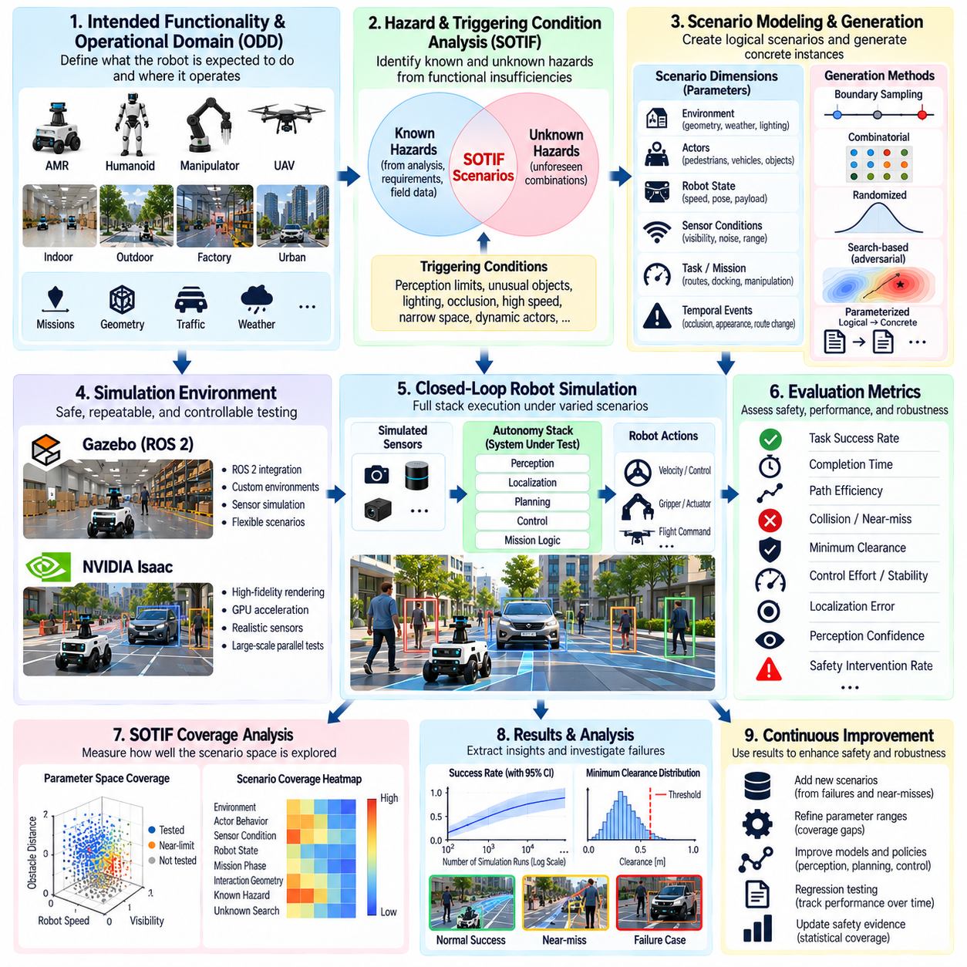
Safety of the Intended Functionality (SOTIF) scenario coverage in simulation evaluates whether an autonomous robot remains acceptably safe when its hardware and software are functioning as designed but limitations of perception, prediction, planning, control, or environmental understanding create hazardous behavior. Unlike validation focused primarily on component faults, SOTIF-oriented testing investigates hazards arising from functional insufficiencies and foreseeable operating conditions.
Simulation is particularly valuable for SOTIF because potentially hazardous situations can be reproduced without exposing people, robots, vehicles, or infrastructure to unnecessary risk. Large numbers of environmental and behavioral variations can be executed repeatedly while preserving exact initial conditions. This makes simulation suitable for exploring rare combinations of circumstances that may be difficult, expensive, or ethically unacceptable to reproduce directly in physical testing.
A SOTIF validation process begins by defining the intended functionality and the conditions under which it is expected to operate. For an autonomous mobile robot, these conditions may include facility geometry, pedestrian behavior, obstacle characteristics, illumination, surface conditions, sensor visibility, robot velocity, payload, and traffic density. The resulting scenario space should reflect the intended operational domain rather than arbitrary simulator capabilities.
Scenario analysis should distinguish conditions that are known or unknown and safe or potentially hazardous. Known hazardous scenarios can be derived from requirements, hazard analysis, previous failures, field observations, and engineering knowledge. Unknown hazardous scenarios are more difficult because their triggering conditions have not yet been identified. Simulation supports systematic exploration intended to discover these previously unrecognized combinations before deployment exposes them in real operation.
Triggering conditions are central to SOTIF scenario generation. A perception system may function correctly in ordinary scenes but become insufficient when an object is partially occluded, poorly illuminated, unusually shaped, or positioned near the sensor's effective range. Similarly, planning may become unsafe when uncertain perception combines with high speed or restricted clearance. Validation should therefore examine combinations that activate functional limitations rather than considering each variable independently.
The scenario model should represent relevant actors, environmental conditions, system states, mission context, and temporal events. Pedestrians may cross unexpectedly, objects may emerge from occlusion, lighting may change, routes may narrow, or localization confidence may degrade during a maneuver. Temporal sequencing matters because an individually manageable condition can become hazardous when it occurs during a critical phase such as turning, docking, overtaking, landing, or object transfer.
SOTIF coverage cannot be demonstrated simply by counting executed simulations. Coverage should describe which meaningful regions of the scenario space have been exercised and how those regions relate to identified hazards and triggering conditions. Dimensions can include environmental classes, actor behaviors, sensor conditions, robot states, mission phases, interaction geometries, and functional limitations. This provides stronger evidence than reporting only a large number of simulation runs.
Logical scenarios are useful for representing SOTIF coverage because they define parameter ranges rather than single configurations. A pedestrian-crossing scenario, for example, may contain ranges for pedestrian velocity, crossing angle, initial distance, robot speed, visibility, and sensor uncertainty. Concrete scenarios can then be generated from this logical definition to explore how different combinations influence safety margins and system responses.
Boundary conditions deserve particular attention because functional insufficiencies often become visible near performance limits. Simulation can vary visibility, obstacle distance, relative velocity, localization uncertainty, sensor noise, or available stopping distance around critical thresholds. Observing where behavior changes from safe to unsafe helps identify operational margins and reveals whether safety performance degrades gradually or fails abruptly.
Corner-case generation complements predefined SOTIF scenarios by searching combinations that engineers may not anticipate manually. Parameter sweeps, combinatorial generation, randomized testing, optimization-based search, and adversarial scenario generation can all contribute. Search objectives may minimize obstacle clearance, time-to-collision, perception confidence, or available reaction time while maximizing trajectory error, intervention frequency, or another indicator associated with hazardous behavior.
Near-miss metrics are valuable because SOTIF analysis should not depend only on actual collisions or mission failures. Minimum clearance, time-to-collision, braking margin, perception confidence, localization uncertainty, control saturation, or emergency intervention can reveal scenarios approaching unsafe boundaries. Continuous safety indicators also provide useful signals for automated search algorithms seeking vulnerable regions of the scenario space.
Perception-related SOTIF scenarios can vary object appearance, scale, orientation, occlusion, contrast, illumination, clutter, weather, sensor range, and observation angle. The objective is not merely to calculate detection accuracy but to determine how perception limitations propagate into robot behavior. A missed or delayed detection becomes safety-relevant when it causes insufficient braking, inappropriate planning, unsafe manipulation, or another hazardous system response.
Prediction and planning should likewise be evaluated under uncertainty. Human or vehicle motion may deviate from expected trajectories, multiple actors may interact simultaneously, or a previously valid path may become constrained. Simulation can determine whether prediction uncertainty is represented appropriately and whether planning maintains adequate safety margins when future behavior cannot be estimated confidently rather than assuming deterministic actor motion.
Control-related SOTIF scenarios should examine situations in which planned actions are theoretically valid but available physical margins become small. High speed, low friction, increased payload, tight curvature, short stopping distance, or delayed commands may reduce the ability to execute a safe trajectory. These cases demonstrate why SOTIF coverage should extend across the complete perception-to-action chain instead of stopping at algorithm-level performance metrics.
Human interaction scenarios require particular attention because human behavior is variable and difficult to enumerate. Simulation can model pedestrians who hesitate, reverse direction, stop unexpectedly, enter restricted areas, or approach the robot from occluded locations. Multiple behavior models should be considered because validating only predictable scripted motion can create an unrealistic impression of coverage in environments shared with people.
Monte Carlo simulation can quantify behavior across uncertain SOTIF scenario parameters. Repeated sampling of actor behavior, environmental conditions, sensor uncertainty, and system state produces distributions of safety metrics rather than isolated outcomes. Stratified or importance sampling can increase representation of rare but safety-relevant conditions, while preserving the statistical assumptions needed to interpret the resulting evidence appropriately.
Coverage gaps should actively guide subsequent test generation. If analysis shows limited sampling of particular interaction geometries, environmental conditions, mission phases, or functional limitations, new scenarios can be generated specifically for those regions. This creates a closed validation loop in which execution produces coverage information, coverage information identifies weaknesses, and those weaknesses determine the next simulation campaign.
Every significant hazardous or near-hazardous scenario should be reproducible. The scenario definition, random seed, actor behavior, environment configuration, robot state, software revision, model versions, and simulator configuration should be preserved. Reproducibility allows engineers to investigate the triggering condition, evaluate mitigation strategies, compare software revisions, and determine whether the hazardous behavior has actually been eliminated.
Mitigation validation is an essential part of the SOTIF process. When a hazardous scenario reveals a functional insufficiency, the response may involve improved perception, modified planning, reduced operational speed, increased safety distance, additional monitoring, or restriction of the operational domain. The same scenario and neighboring parameter combinations should then be rerun to verify that the mitigation removes or sufficiently reduces the identified risk without creating new hazardous behavior.
Discovered scenarios should become part of the regression suite. A case originally found through randomized or search-based exploration can be converted into a deterministic test with explicit acceptance criteria. Future software releases can then be checked against the same triggering conditions. This prevents accumulated SOTIF knowledge from being lost and gradually transforms field experience and simulation discoveries into reusable validation assets.
Simulation fidelity remains a limitation of SOTIF evidence. Sensor models, human behavior models, dynamics, friction, latency, environmental effects, and interaction physics may differ from reality. A simulation campaign can therefore provide strong evidence about the modeled scenario space without proving that every relevant real-world triggering condition has been represented. Important findings should be correlated with HIL, controlled physical testing, and field observations where appropriate.
SOTIF scenario coverage should consequently be treated as an iterative argument rather than a claim that every possible situation has been tested. The objective is to demonstrate systematic identification of relevant functional limitations, structured exploration of triggering conditions, measurement of safety margins, discovery of previously unknown hazardous scenarios, and verification that identified risks are reduced through technical or operational measures.
Simulation-based SOTIF validation ultimately connects scenario engineering, safety analysis, statistical exploration, corner-case discovery, and regression testing into a unified process. By continuously expanding scenario coverage and converting discovered hazards into reproducible tests, the validation framework provides structured evidence that intended autonomous functionality remains acceptably safe across increasingly diverse and challenging operating conditions.

04.09. Sim to Real Validation Gap Analysis [w/Code]
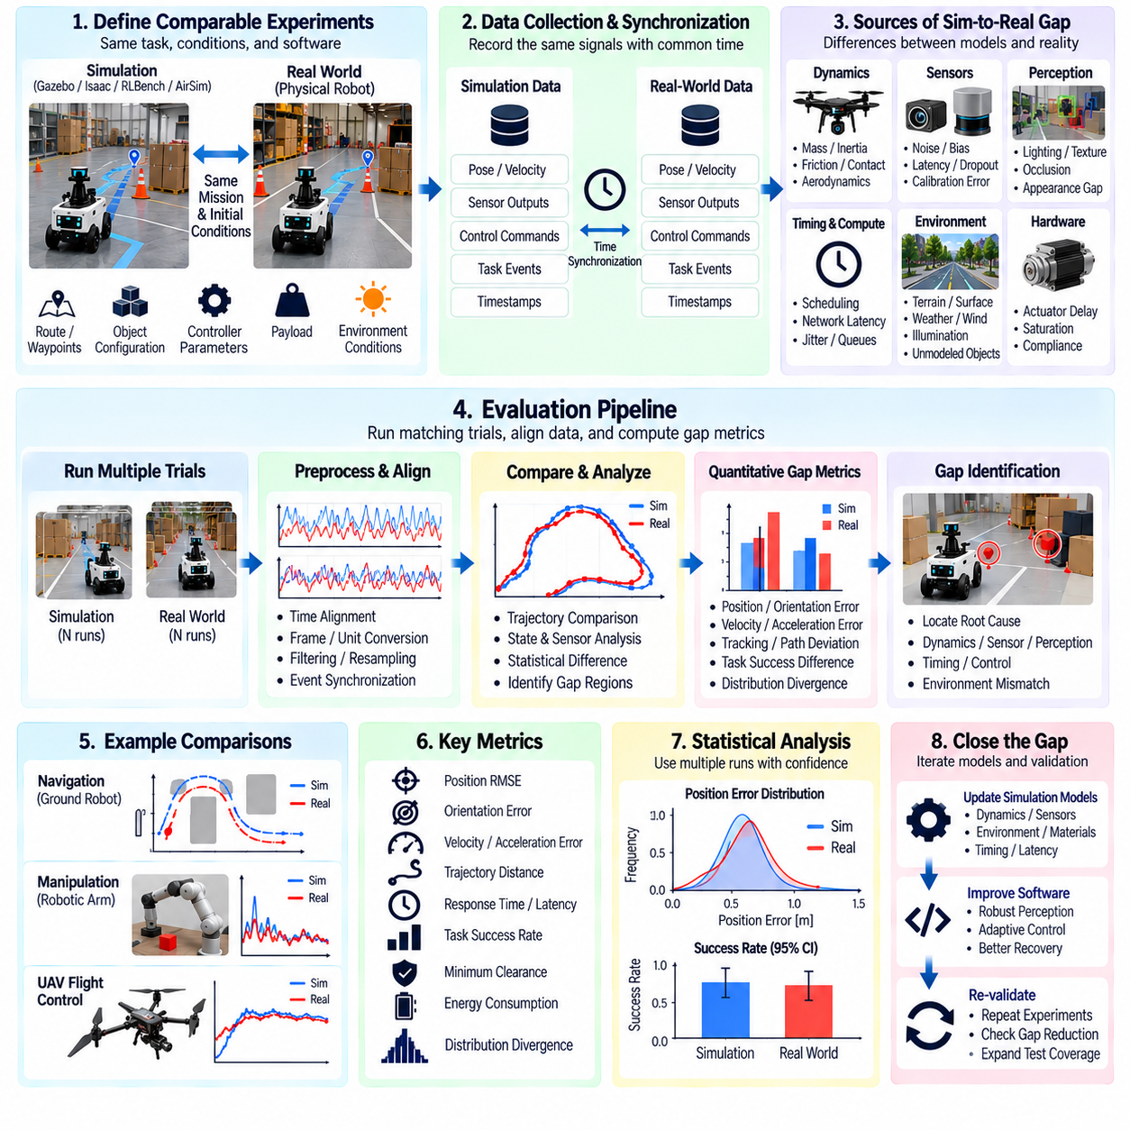
Sim-to-Real validation gap analysis examines the differences between behavior observed in simulation and behavior measured on a physical robot. Simulation can provide repeatability, scalability, and controlled variation, but its results remain dependent on models of dynamics, sensors, environments, timing, and interactions. Gap analysis determines which differences materially affect validation conclusions and where simulation evidence requires physical confirmation.
The analysis begins by establishing comparable simulation and real-world experiments. The same mission objective, initial conditions, route, object configuration, controller parameters, payload, and environmental conditions should be reproduced as closely as practical. Exact equivalence is rarely possible, so differences in experimental setup must be documented explicitly rather than assuming that similarly named scenarios represent identical operating conditions.
A useful comparison requires synchronized and compatible measurements. Robot pose, velocity, acceleration, joint states, actuator commands, sensor outputs, controller references, perception results, task events, and timestamps should be recorded in both environments. Common coordinate frames, units, sampling conventions, and event definitions simplify comparison and prevent data-processing differences from being mistaken for genuine Sim-to-Real discrepancies.
Dynamics are a major source of validation gaps. Simulated mass, inertia, friction, compliance, backlash, wheel slip, aerodynamic effects, actuator delay, motor saturation, and contact behavior may differ from the physical system. These differences can alter trajectory tracking, stopping distance, manipulation contact, energy consumption, or flight stability even when exactly the same control software and command sequence are used.
Sensor modeling introduces another important gap. Real sensors contain noise, bias, drift, quantization, latency, dropped measurements, calibration error, motion artifacts, and environment-dependent failure modes. A simulated LiDAR or camera may produce cleaner and more consistent observations than physical hardware. Validation should therefore compare not only nominal sensor accuracy but also distributions, timing characteristics, missing data, and degradation patterns.
Perception systems can experience substantial gaps because simulated appearance rarely captures every property of real scenes. Lighting, reflections, shadows, texture, transparency, weather, motion blur, occlusion, lens characteristics, and unexpected objects can change perception performance. A model that performs reliably on synthetic images may therefore exhibit detection, segmentation, depth, pose-estimation, or tracking errors when exposed to physical observations.
Timing differences should be treated as first-class validation variables. Simulation may execute with idealized synchronization, deterministic scheduling, or simplified communication delays, whereas a physical robot experiences operating-system scheduling, network jitter, sensor transport delays, GPU inference time, middleware queues, and actuator communication latency. Small timing differences can propagate through closed-loop autonomy and produce significant behavioral divergence.
Environmental models also contribute to the gap. Floor friction, terrain deformation, wind, illumination, temperature, surface reflectivity, acoustic conditions, and electromagnetic interference may be simplified or omitted in simulation. Gap analysis should identify which environmental properties strongly influence the function under test and determine whether their modeled ranges sufficiently represent conditions measured during physical operation.
Navigation gap analysis can compare localization error, path geometry, velocity profile, minimum obstacle clearance, replanning events, controller tracking error, stopping distance, and mission completion. A simulated robot may follow a smooth trajectory while the real robot experiences wheel slip, sensor occlusion, delayed costmap updates, or localization fluctuations. Comparing intermediate navigation states helps locate the origin of the final trajectory difference.
Manipulation gap analysis should examine end-effector trajectories, grasp pose, contact timing, force, object motion, slip, collision, and placement accuracy. Contact-rich tasks are particularly sensitive because small errors in friction, compliance, object geometry, or calibration can change the outcome. A successful simulated grasp therefore requires physical confirmation when task success depends strongly on contact dynamics or tight geometric tolerances.
For UAV systems, relevant comparisons include attitude response, altitude tracking, position error, wind response, actuator demand, energy consumption, and landing accuracy. Simplified aerodynamic or propulsion models can produce optimistic controller performance. Flight measurements should therefore be used to identify where simulated disturbance response, vehicle dynamics, or actuator behavior diverges from the physical aircraft.
Gap metrics should be defined before drawing conclusions from visual comparison. Position root-mean-square error, orientation error, velocity difference, trajectory distance, latency difference, perception accuracy difference, stopping-distance error, task-success difference, or distribution divergence can provide quantitative evidence. Metrics should correspond to the validation objective because a visually noticeable difference may be irrelevant while a small timing discrepancy may be safety-critical.
Repeated physical and simulated trials are necessary when stochastic variation is significant. Comparing one simulation run with one real run can confuse natural variability with systematic model error. Multiple trials allow distributions of trajectories, sensor measurements, task outcomes, and safety metrics to be compared. Confidence intervals and variance estimates can help determine whether observed differences are persistent or consistent with normal experimental variation.
Gap decomposition helps identify where discrepancies originate. Differences can be classified into dynamics, sensing, perception, timing, environment, controller execution, software configuration, or experimental setup. A final mission-level discrepancy may result from several interacting sources, so intermediate signals should be analyzed rather than tuning a single simulator parameter until the final trajectory appears similar.
Sensitivity analysis can prioritize model improvements. Simulator parameters such as friction, actuator delay, sensor noise, mass, latency, or wind can be varied to determine how strongly they influence validation metrics. Parameters with little effect may not justify expensive calibration, while highly sensitive parameters should receive more accurate measurement and modeling. This prevents unnecessary pursuit of uniform simulator fidelity across every subsystem.
System identification and calibration can reduce important gaps. Physical measurements may be used to estimate inertial parameters, actuator response, friction coefficients, sensor noise, communication delays, or controller execution characteristics. Updated parameters are then introduced into the simulator and the comparison is repeated. Calibration should target measurable physical properties rather than arbitrary tuning performed only to reproduce one recorded trajectory.
Domain randomization can address residual uncertainty that cannot be modeled precisely. Instead of assuming a single exact value for friction, latency, lighting, object properties, or sensor noise, simulation can sample plausible ranges. Validation can then determine whether the robot remains robust across uncertainty surrounding the measured real system. The randomized ranges should be justified by physical observations whenever practical.
Model uncertainty should remain visible in validation conclusions. Improving correlation does not mean that the simulator has become an exact digital copy of reality. Some phenomena remain unmodeled, poorly measured, or computationally impractical to reproduce. Validation reports should therefore state which aspects have demonstrated acceptable correlation, which retain uncertainty, and which require direct hardware or field testing.
A gap threshold can determine when simulation evidence is sufficiently representative for a specific validation purpose. The acceptable difference depends on the function and risk. A small geometric discrepancy may be acceptable for high-level route planning but unacceptable for precision insertion or safety-critical stopping distance. Simulator validity should therefore be defined relative to particular requirements and use cases rather than through one universal fidelity score.
Regression monitoring is important because the Sim-to-Real relationship can change over time. Robot hardware revisions, sensor replacements, firmware updates, controller tuning, simulator upgrades, and software changes may invalidate earlier correlation results. Representative correlation scenarios should be rerun periodically so that previously validated simulation assumptions do not silently become outdated.
Gap analysis can also guide the allocation of physical testing resources. Scenarios showing strong simulation-to-real agreement may be explored extensively in simulation, while poorly correlated or safety-critical conditions should receive more HIL and physical testing. This risk-based allocation uses simulation where it provides credible evidence without allowing computational convenience to replace necessary real-world validation.
Traceability should connect each important simulation claim to supporting correlation evidence. The simulator configuration, robot configuration, physical test conditions, datasets, metrics, calibration parameters, software versions, and analysis results should be preserved. This makes it possible to determine which simulation campaigns remain valid after system changes and which conclusions require renewed physical evidence.
The Sim-to-Real gap should therefore be treated as a measurable engineering property rather than a vague limitation of simulation. Structured experiments, synchronized data, quantitative metrics, sensitivity analysis, calibration, uncertainty modeling, and repeated correlation testing transform discrepancies into actionable information about simulator validity and the confidence that can be assigned to virtual validation results.
Sim-to-Real validation gap analysis ultimately establishes the boundary between what simulation can credibly demonstrate and what must still be proven on physical hardware. By continuously comparing virtual and real behavior, refining influential models, preserving uncertainty, and directing high-risk scenarios toward HIL or field testing, the validation process creates a defensible transition from simulation-based evidence to real-world robot assurance.

04.10. Simulation Validation CI Pipeline Regression [w/Code]
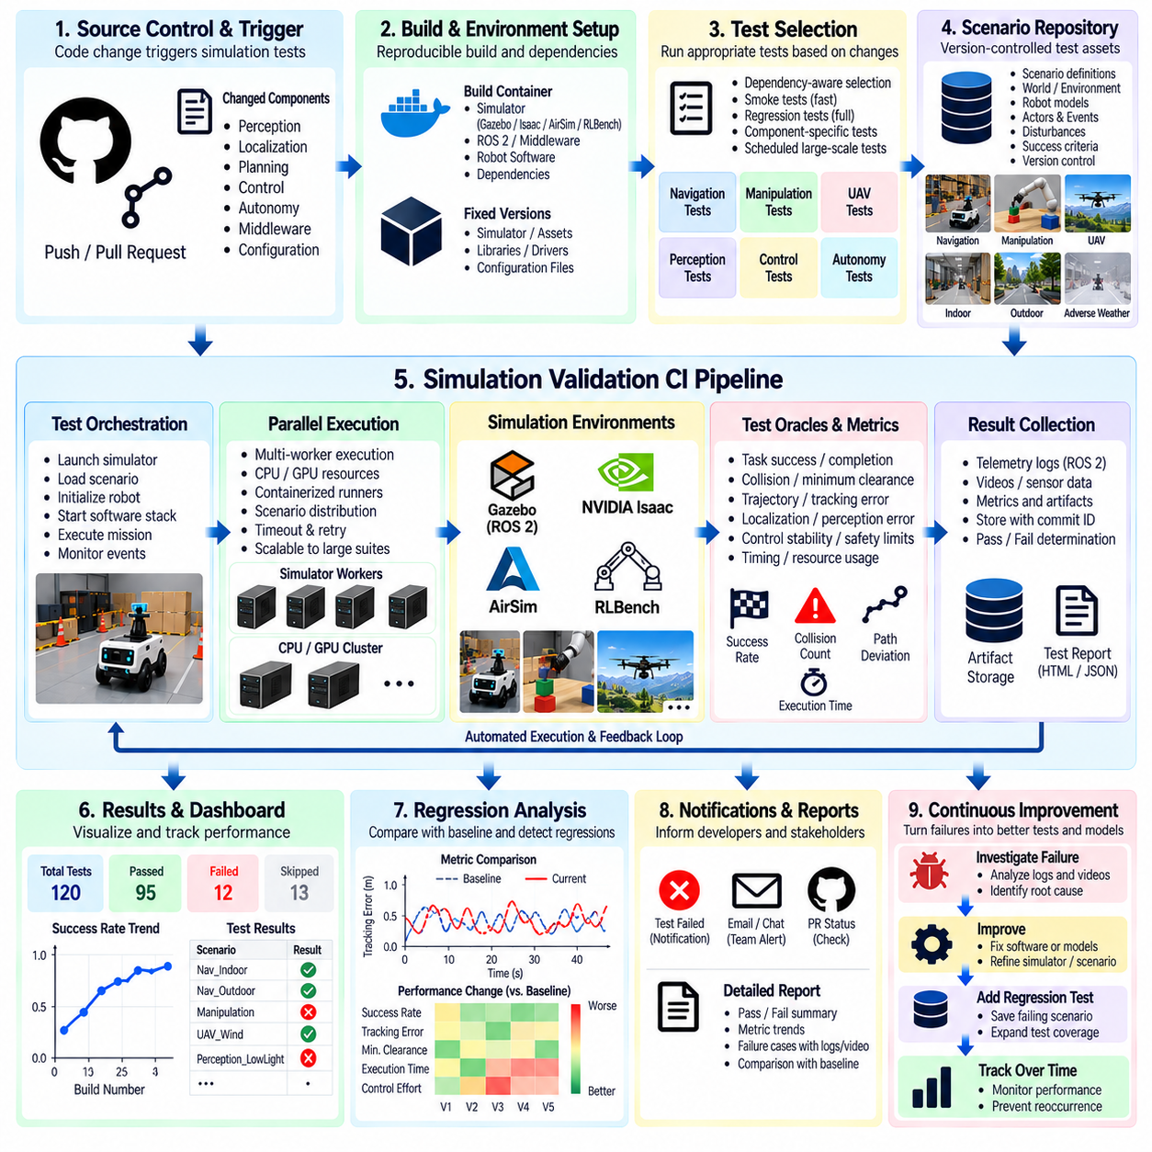
A simulation validation continuous integration pipeline transforms virtual robot testing from an occasional engineering activity into an automated regression process executed throughout software development. Every relevant change to perception, localization, planning, control, autonomy, or middleware can trigger selected simulation tests. The objective is to detect behavioral regressions before changed software reaches HIL, physical robots, or field environments where failures become more expensive and risky.
The pipeline should connect source control, build automation, simulation environments, scenario repositories, test orchestration, metric evaluation, and result storage. A software commit initiates a reproducible build, after which appropriate simulation scenarios are selected and executed. Telemetry and test artifacts are collected automatically, acceptance criteria are evaluated, and the resulting verdict is associated with the exact software revision that produced the behavior.
Not every commit requires the complete simulation validation suite. Fast smoke scenarios can verify that essential robot behaviors still operate after routine changes, while larger regression suites can run periodically or before integration milestones. Computationally expensive Monte Carlo, high-fidelity perception, or large scenario campaigns can execute on scheduled infrastructure, allowing validation depth to increase without making ordinary development feedback excessively slow.
Test selection can be based on the software components affected by a change. Modifications to localization may prioritize pose-estimation and navigation scenarios, while controller changes can trigger trajectory tracking, stopping, and dynamic-response tests. Changes to perception models may require sensor-rich scenarios and visual variations. Dependency-aware selection reduces unnecessary computation while maintaining strong coverage around software regions most likely to be affected.
Simulation scenarios should be treated as version-controlled validation assets. Each scenario should define initial conditions, robot configuration, environment, actors, events, disturbances, goals, termination conditions, and expected metrics. Scenario changes require review because modifying a test environment can alter regression results as significantly as changing robot software. Versioning allows historical results to be interpreted against the exact test definition used at that time.
The execution environment must also be reproducible. Simulator versions, robot models, world assets, middleware dependencies, configuration files, container images, GPU libraries, and test tools should be controlled or recorded. Otherwise, a regression may appear because the simulation infrastructure changed rather than because robot software changed. Reproducible environments make it possible to separate behavioral regressions from changes in the validation platform.
A CI simulation runner should automate the complete test lifecycle. It launches the required simulator, loads the scenario, initializes the robot, starts the software stack, waits for readiness, issues mission commands, injects scheduled events, records telemetry, monitors termination conditions, and shuts down resources after completion. Automation eliminates manual differences between runs and enables the same validation procedure to scale across many workers.
Test oracles convert simulation behavior into objective regression verdicts. They can evaluate mission completion, collision, minimum clearance, localization error, trajectory deviation, task success, controller stability, safety intervention, timing, or resource limits. Acceptance thresholds should be explicit and version controlled so that a test does not silently change from passing to failing because an analyst applied different criteria after execution.
Regression evaluation should compare more than binary pass or fail results. A software revision may continue passing while path length, localization error, execution time, control effort, perception confidence, or safety margin gradually deteriorates. Trend monitoring can identify these slow regressions before they cross formal failure thresholds. Baseline distributions are especially useful for metrics that naturally vary across randomized simulation runs.
Deterministic regression scenarios provide rapid and repeatable evidence for previously identified failures. When a collision, deadlock, missed grasp, unsafe trajectory, estimator divergence, or other defect is discovered, the triggering configuration and random seed should be preserved. After correction, the scenario becomes a permanent regression test that future software versions must pass, converting historical failures into reusable validation knowledge.
Randomized regression complements deterministic testing by exploring variations that fixed scenarios cannot cover. Seeds, object poses, pedestrian behavior, sensor noise, friction, wind, or initial robot states can be sampled across repeated executions. The pipeline should preserve every generated configuration so that a newly discovered failure can immediately be converted from a random event into a deterministic and reproducible diagnostic case.
Parallel execution is essential when regression suites become large. Independent scenarios can run simultaneously across CPU or GPU workers, containers, workstations, or compute clusters. A scheduler should distribute workloads according to resource requirements, enforce execution timeouts, retry infrastructure failures where appropriate, and aggregate standardized results. Parallelism allows validation coverage to grow without proportionally increasing release time.
Infrastructure failures must be distinguished from robot-system failures. A simulator crash, unavailable GPU, missing asset, container startup error, or network failure should not automatically be classified as a failed autonomy test. The pipeline should identify invalid executions separately and retry or escalate them according to policy. This prevents unstable validation infrastructure from contaminating statistics about actual robot software quality.
Artifacts from failed tests should support immediate diagnosis. Relevant logs, ROS 2 topics, trajectories, sensor streams, screenshots when required, simulator state, configuration files, random seeds, and metric summaries can be preserved automatically. Engineers should be able to reproduce a failure locally or on dedicated infrastructure without reconstructing its conditions manually from incomplete CI output.
Flaky simulation tests require active management because nondeterministic failures can reduce confidence in the entire validation pipeline. Timing races, uncontrolled randomization, asynchronous startup, resource contention, or simulator nondeterminism may cause inconsistent verdicts. Repeated execution and seed preservation can help distinguish genuine stochastic system behavior from unreliable test infrastructure, but persistent flaky tests should be investigated rather than simply ignored.
Performance baselines should be defined for important robot behaviors. A navigation scenario may establish reference distributions for completion time, minimum clearance, path efficiency, and localization error, while manipulation tests may track success rate, action count, collisions, and task duration. New software revisions can be compared against these baselines to identify statistically or operationally significant degradation even when functional requirements remain satisfied.
Safety-related regression scenarios should receive higher priority than ordinary performance tests. Cases involving emergency stopping, restricted-area entry, collision avoidance, actuator limits, degraded sensing, or safety-mode transitions can be configured as release gates. A failure in such a scenario may block progression regardless of improvements in less critical metrics, reflecting the risk-based priorities of the overall validation strategy.
Large statistical campaigns can be integrated as asynchronous validation stages. Monte Carlo or SOTIF-oriented simulations may require thousands of trials and therefore need not block every developer commit. Instead, they can run nightly, periodically, or against release candidates. Significant failures or changes in statistical safety metrics can then create investigation tasks and prevent promotion to higher validation stages until reviewed.
Sim-to-Real correlation tests should also be represented in the pipeline where practical. Selected simulation scenarios with corresponding physical measurements can monitor whether simulator assumptions remain valid after software, robot model, sensor, or simulator changes. If correlation metrics exceed defined limits, simulation results depending on those assumptions may require review before they continue to be accepted as reliable validation evidence.
Result storage should support traceability across the complete validation history. Each execution should link software commit, scenario version, simulator configuration, robot model, random seed, environment, metrics, verdict, and artifacts. This information allows teams to determine when a regression first appeared, compare releases, reproduce historical failures, and establish which evidence supported a particular release decision.
Dashboards and automated reports can summarize validation status without replacing detailed artifacts. Useful views include pass rates, failing scenarios, metric trends, coverage changes, flaky tests, execution duration, and infrastructure health. Release-oriented reports can distinguish newly introduced failures from known issues and show whether safety-critical, functional, performance, and statistical validation gates have been satisfied.
Pipeline maintenance is itself part of validation engineering. Obsolete scenarios should be reviewed, duplicated tests consolidated, new field failures incorporated, acceptance thresholds updated through controlled processes, and simulator dependencies maintained. A CI suite that never evolves may continue producing green results while becoming progressively less representative of the robot's actual software, hardware, and operating domain.
The pipeline should ultimately implement staged evidence generation. Fast deterministic tests provide immediate feedback, broader scenario suites provide integration confidence, randomized campaigns explore variation, SOTIF and Monte Carlo stages investigate uncertainty, and Sim-to-Real correlation determines how much confidence can be transferred toward physical operation. Each stage contributes a different form of evidence rather than attempting to replace all other validation methods.
A simulation validation CI regression pipeline therefore creates a continuously operating safety and quality feedback loop around robot software development. By combining reproducible environments, versioned scenarios, automated execution, quantitative oracles, parallel scaling, failure artifacts, statistical monitoring, and traceability, simulation becomes an engineering gate that continuously detects regressions and prepares validated software for HIL and physical testing.

